Finishing Construction Work
Level-II
Based on March 2022, Curriculum Version I
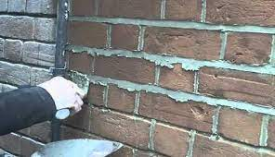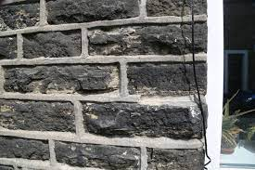
Module Title: - Carry out pointing
Module code: EIS FCW2 M07 0822
Nominal duration: 40Hours

Prepared by: Ministry of Labor and Skills

August, 2022
Addis Ababa, Ethiopia

Contents
Acronym………………………………………………………………………….3
Acknowledgment 4
Introduction to the Module 5
Unit one: Prepare for work 6
1.1.Work instruction according to pointing work 7
1.1.1.work instructions Error! Bookmark not defined.
1.2.Safety (OHS) requirements 8
1.2.1 Safety requirements 8
1.3.Signage and barricade for pointing work 9
1.3.1. Safety Signage Requirements 10
1.4.Tools and equipment for pointing work 11
1.5. Prepare and handle work materials 14
1.5.1 Materials used for pointing Error! Bookmark not defined.
1.5.2 Handling work materials 14
1.6.Calculate material quantity 15
1.7. Environmental protection 16
1.7.1. Identify environmental protection Error! Bookmark not defined.
Self check-1 (unit one) 19
Unit Two: Apply putty pointing material to bed joints 20
2.1.Background for Pointing Error! Bookmark not defined.
2.1.1.Definition of pointing 21
2.1.2.Procedure of pointing work 21
2.1.3.Type of pointing 23
2.2.Prepare materials for beading 26
2.2.1.Materials used for beading 26
2.3.Apply pointing putty to joint 29
2.4.Remove surplus pointing 31
Self check – 2 (Unit two) 32
Operation sheet 1: Apply putty pointing material to bed joints 33
Lap Test- 1 34
Unit Three: Clean up 36
3.1. Clear and clean completed pointing work area 37
3.2.Maintain, store tools and equipments 39
3.2.1. Techniques for Maintaining and storing tools and equipment’s: 39
3.2.2.General Rules in the Use of Cleaning Equipment 39
Self check-3 (Unit three) 40
Reference 41

Acronym

OHS = Occupational Health Standard
PPE = Personal Safety Equipment
MSDS = Material Safety Data Sheet
TTLM = Teaching, Training and Learning Materials

Acknowledgment

Ministry of Labor and Skills wish to extend thanks and appreciation to the many representatives of TVET instructors and respective industry experts who donated their time and expertise to the development of this Teaching, Training and Learning Materials (TTLM).

Introduction to the Module

The carrying out pointing work helps to know how to prepare for work; how to apply putty pointing material to bed joints and to know how to clean up in finishing construction field. This module covers skill, knowledge and attitude requires to carryout pointing works in different background.
This module is designed to meet the industry requirement under the Finishing construction work occupational standard, particularly for the unit of competency: Carry out pointing.
This module covers the units:
- Prepare for work
- Apply putty pointing material to bed joints and
- Clean up
Learning Objective of the Module
- How to Prepare for work
- Apply putty pointing material to bed joints and
- Perform clean up for pointing work
Module Instruction
For effective use this modules trainees are expected to follow the following module instruction:
- Read the information written in each unit
- Accomplish the Self-checks at the end of each unit
- Perform Operation Sheets which were provided at the end of units
- Do the “LAP test” giver at the end of each unit and
- Read the identified reference book for Examples and exercise

Unit one: Prepare for work
This unit is developed to provide you the necessary information regarding the following content coverage and topics:
- Work instructions
- OHS requirements
- Signage and barricade for pointing work
- Tools and equipment
- Quantity of materials
- Handle work materials
- Environmental protection
This unit will also assist you to attain the contents stated in the title. Specifically, upon completion of this learning guide, you will be able to:
- Obtain, confirm and apply work instructions
- Follow OHS requirements
- Implement signage and barricade
- Select tools and equipment
- Calculate materials quantity
- Prepare and handle work materials
- Identify environmental protection

Work instruction for pointing work

Work Instructions are documents that clearly and precisely describe the correct way to perform certain tasks that may cause inconvenience or damage if not done in the established manner.
That is, describe, dictate or stipulate the steps that must be followed to correctly perform any specific activity or work.
However, most work instructions consist of these essential parts:
- Title and short description of the task.
- Objectives or expected results.
- Purpose of the pointing work
- Scope of the pointing work
- Tools or skills required.
- Safety requirements.
- Step-by-step instructions for the task.
- Expected outcome for each step.

1.2. Safety (OHS) requirements

1.2.1 Safety requirements
Safety in the workshops is subject to a number of various risk assessments and safe codes of working practices which have to be observed and adhered to by all workshop users and enforced by the person in charge of these areas.
- Due to high risk activities taking place in the workshops access to these areas is restricted to authorized personnel only. No other person may enter the workshops without permission.
- OHS requirements are followed in accordance with safety plans and policies.
- Plant, tools and equipment selected to carry out tasks are consistent with the requirements of the job, checked for serviceability and any faults are rectified or reported prior to commencement.
Before starting work:-
- Wear Protective clothing and equipment,
- Use functional tools and equipment and know handling of materials
- Keep Workplace environment and safety,
- Prepare Organizational first aid, Hazard control and hazardous materials and substances
- If the eyes are involved during pointing work rinse eyes with clean water for 20 minutes. Seek professional medical attention without delay.
- Provide the medical personnel with a product Material Safety Data Sheet (MSDS) which explains the skin hazards of pointing work.

1.3. Signage and barricade of pointing work

Workplace signage and barricades are used to protect and warn workers, site visitors and the public of any hazards.
Barriers also protect materials from damage caused by site traffic and/or machinery.
Pre-planning the type and quantity of signage and what sort of barricades may be required enables efficient commencement of work at a site.
- When planning to prepare surfaces for waterproofing the following situations may require signage and barricades.
- A secure storage location for materials that minimizes obstruction to traffic movement ƒ around site
- Directional signage to provide smooth traffic flow ƒ
- Barriers to protect other workers from possible injury through contact with materials ƒ
- Special allowances for dangerous goods or hazardous materials, including providing correct signage for the safe storage of these items.
For example, preparing a surface for waterproofing may require the use of hazardous substances such as acid etching compounds or cleaning and degreasing agents. Some of these substances may be classed as flammable liquids and hazardous substances and require appropriate signage and barricades.
- Whenever working in a publicly accessible area then they must be informed and kept away from any Danger to their Health. This can be done using signs & barricades. People will not always read signs so barricades are the better solution, especially in keeping children away.
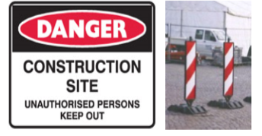 Figure 1.1 danger signs
Barricading and safety signage shall be used:
- When there are no other practical control measures available to control a hazard
- As an interim measure until a more effective way of controlling the risk can be used or the hazard is no longer present; and
- As a secondary control measure to supplement higher level control measures.
- The type and number of barricading or safety signage erected must be assessed adequately and positioned to be suitable for the intended purpose.

Safety Signage Requirements
- Safety signs are erected to warn workers or the public of specific hazards and to communicate necessary precautionary measures and emergency actions. Safety signage, in accordance with Ethiopian work Health and Safety Regulation required for:
- Construction sites, confined spaces, asbestos, hazardous areas, hazardous chemicals, site specific Personal Protective Equipment (PPE) requirements, fire protection equipment, emergency and first aid information, emergency eyewash shower & traffic management and pedestrian control.

1.4. Tools and equipments

There are different kinds of tools and equipments used for pointing work.
- Spirit level
It is used to control the horizontal and vertical alignment of wall surface and edges. The length is at least 80 to 120cm long. It is made of metal, synthetic material or wood. It has two measuring bubbles: one is located at mid length is used to check horizontal positions. While the second one, at the end, is used to check vertical position. This tool requires always to be handled with care and needs to be checked from time to time weather it is still working accurate or not.
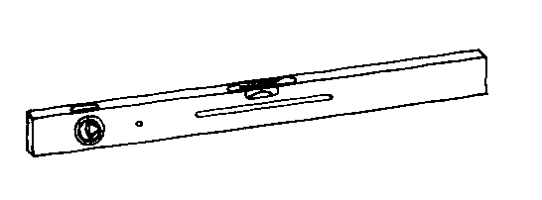

Figure 1.2 Spirit level
- Try Squares
It is used to measure a right angle (90º) of a corner. Used in laying masonry units or blocks at corners of masonry wall.
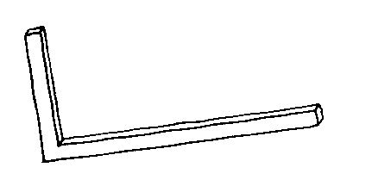
Figure 1.3Square 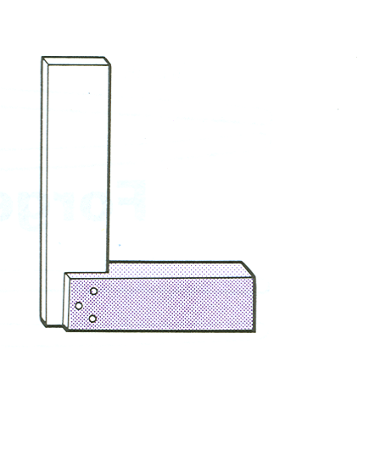 Steel square
- Floats
Used to smooth out concrete surface before the concrete fully cure It is about 30cm long and 15 cm wide with a handle. Floating concrete is an operation of concrete finish work after draying on bull floating to remove slight imperfection, fill small holes, level etc on the surface of concrete.
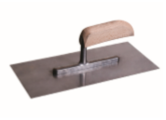
Figure 1.4 Steel float:-This does the same as wooden
Float except that it points a slick on the concrete. You may prefer this for patios and concrete slabs when ever smooth concrete surfaces are required.
Edge float:- It is made of metal like the metal float, but it has bent – over at right angles to the flat part or at one edge. It is used along the edge of a walk a slab to polish and have, finished look to the work, it makes slightly rounded edges and border about 10 cm.

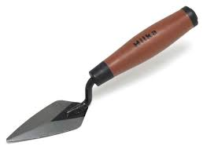 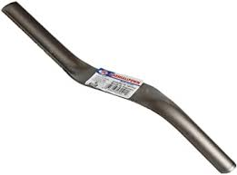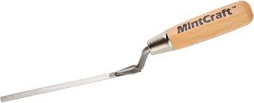figure 1.5 Pointing tool

- Putty knife
Used for filling joint

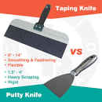 Figure 1.6
Tools:- Brushes, buckets, sponges, float, Gauging equipment, sieve, Frenchman tools, jointer tools, measuring tapes/rules, hammers (brackish, club, scotch), Spirit levels, pointing trowels, straight beveled edges, plugging chisels, straight edges, pointing tools, Squares, hawks, profiles, line blocks, line pins, string lines, scaffolds and pointing or raking tools
Equipments:- Wheelbarrows, concrete mixers, and Small petrol/diesel engines/compressors/mixers

1.5. Prepare and handle work materials

- Mortar (mixture of cement, sand and water),
- Coloring agents and pigments and slaked rock lime

Handling work materials
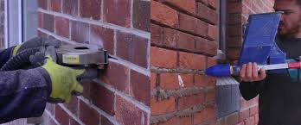
Figure 1.6 material handling

1.6. Calculate material quantity

The volume of dry mortar required for pointing depends upon the type of surface i.e. either brick work or masonry work.
For pointing ( which may be flush, struck or keyed) to the brick work, the dry volume of mortar , including wastage, required for 10 sq.m area is about 0.036 cum. and for random rubble masonry it is 0.076 cum.
Thus knowing the proportion of the mix of the mortar as 1:3, the quantity of cement and sand can be found out as follows:
- For pointing to brick work
Volume of cement required = 0.036 / (1+4) = 0.009 cum.
= 0.009 x 30 = 0.270 bags
and, Volume of sand required = [0.036 / (1+3)] x 3 = 0.027 cum.
- For pointing to random or coursed rubble masonry, the volume of dry mortar required = 0.076 cum.
Therefore, For pointing in cement mortar (1:3) proportion,
Quantity of cement required = 0.076 / (1+3) = 0.019 cum.
= 0.019 x 30 = 0.57 bags = 0.60 bags of cement
and, Quantity of mortar required = [0.076 / (1+3)] x 3 = 0.057 cum.
Therefore, For pointing in cement mortar (1:3) proportion, Quantity of cement required = 0.076 / (1+3) = 0.019 cum. and, Quantity of mortar required = [0.076 / (1+3)] x 3 = 0.057 cum.

1.7. Environmental protection

Environmental protection is the practice of protecting the natural environment by individuals, organizations and governments.
Its objectives are to conserve natural resources and the existing natural environment and, where possible, to repair damage and reverse trends.
- Waste management, Noise, dust, vibration and clean-up management
- Environmental protection saves lives
- Is the practice of protecting the natural environment by individuals, organizations and governments?
- Its objectives are to conserve natural resources and the existing natural environment and, where possible, to repair damage and reverse trends. Environmental protection requirements are identified for the project in accordance with environmental plans and regulatory obligations and applied tools and equipment selected to carry out tasks are consistent with the requirements of the job.
- Environment: surroundings which can be natural, man-made or a combination of these.
- Built Environment: created by man with or without the aid of the Natural environment.
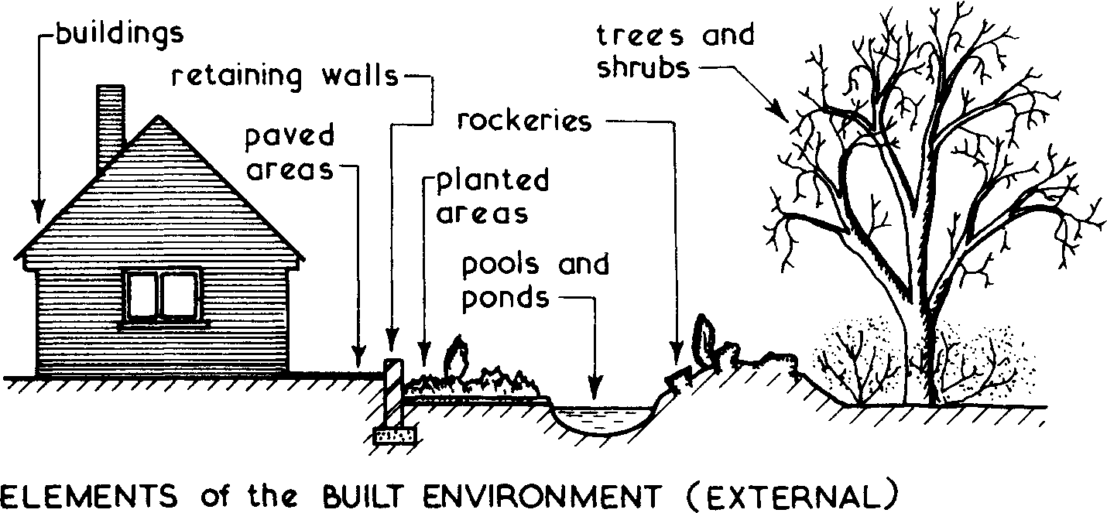
Figure 1.1
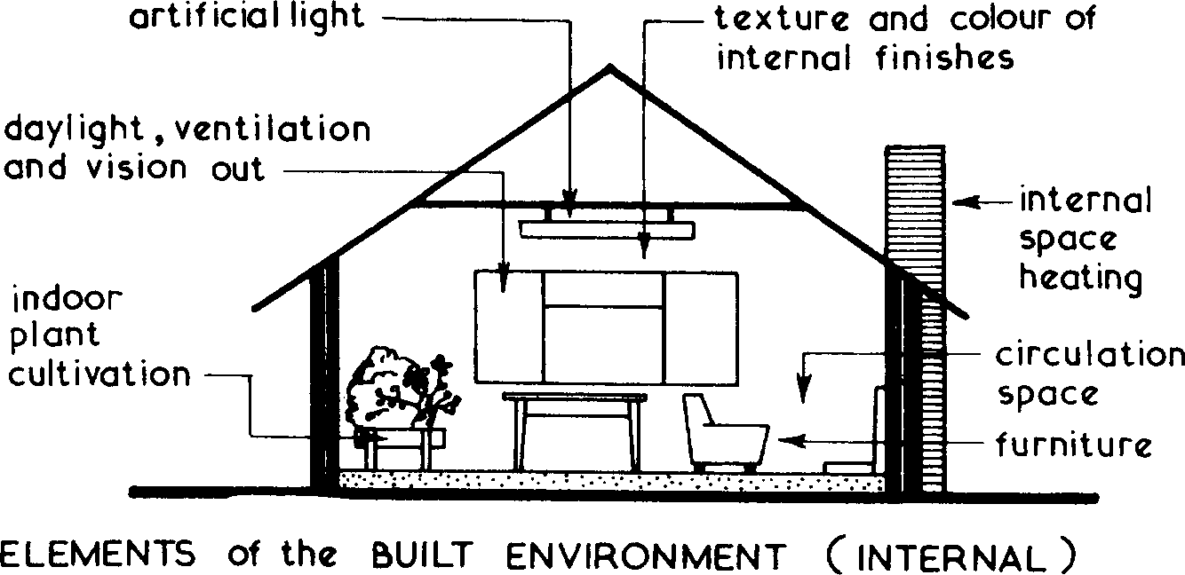
Figure 1.6

Environmental Considerations
- Planning requirements.
- Building Regulations.
- Land restrictions by vendor.
- Availability of services.
- Local amenities including transport.
- Subsoil conditions.
- Levels and topography of land.
- Adjoining buildings or land.
- Use of building.
- Daylight and view aspects
- World hunger, global warming, increasing natural disasters, polluted air, water and soil, pesticide use in the fields, Species extinction, and crop failures - we must not believe that we, as the only living beings on a sick planet, remain healthy. In nature, everything is interrelated.

Here are some ways in which you can take control of your future, and protect our environment and ecosystems:
- Start Your Own Initiative or Volunteer With Environmental Organizations.
- Reduce/Recycle Paper.
- Recycle More Often.
- Save Resources.
- Buy Sustainable Products.
- Decrease Meat & Dairy Consumption.
- Only Buy What You Need.

Self check-1 (unit one)
Test-I Matching
Instruction: select the correct answer for the given choice. You have given 1 Minute for each question. Each question carries 2 Point.
A | B
---------1. Mortar | - A. Cleaning tools
---------2. Sponge | - B. Occupational Health Standard
---------3. OHS | - C. Mixture of cement + sand + water
 | - D. Safety
Test II: Short Answer writing
Instruction: write short answer for the given question. You are provided 3 minute for each question and each point has 5 Points.
- What is safety in work shop?
- Write down at least three cleaning tools?
Part III: Short answer writing
Direction: Give short answer to the following questions. Time allotted for each item is 2minute and each question carry 4 point.
- Personal Protective equipment
Note: Satisfactory rating – above 60% Unsatisfactory - below 60%
You can ask you teacher for the copy of the correct answers

Unit Two: Apply putty pointing material to bed joints
This unit to provide you the necessary information regarding the following content coverage and topics:
- Background for Pointing
- Materials for beading
- Point putty to joint
- Remove surplus pointing
- Clean completed pointing work area
This guide will also assist you to attain the learning outcomes stated in the cover page. Specifically, upon completion of this learning guide, you will be able to:
- Preparing background for Pointing
- Preparing materials for beading
- Applying pointing putty to joint
- Removing surplus pointing
- Cleaning completed pointing work area

Pointing background

Definition of pointing

Pointing is the process of chiseling or scrapping the existing mortar joints surface in the masonry work, and refilling them with the rich mortar.
Pointing is the term given to the 'finish' that is between the bricks or stone used to build your house. Depending on the age of the building, the mortar used to lay the stone or brick will either be made from lime, or more recently, cement.
Pointing is the art of finishing the mortar joints of the walls or similar structures with the groove is filled with lime putty which projects by 3 mm.

Procedure of pointing work
- Before starting the pointing work, joints are raked down up to a depth, Loose material is then removed, space is cleaned with water.
- When constructing a new wall, the joints should be pointed while the inner masonry work is still green.
- All of the joints on the face are raked out to a depth of about ³/₄ inch with a specific pointing tool to provide a correct and firm grip for the pointing mortar.
- To produce the appropriate adhesion, the joints and the wall surface are thoroughly wetted and cleaned with a brush.
- With a tiny trowel, the mortar is applied within the joint and pressed firmly to make a solid contact with the internal joint, leaving no hollow at the junction.
- This is critical since a loose filling will always result in the pointing pulling off at a later stage.
- Watering should be done on a regular basis to keep the work moist for roughly a week.
- Background Preparation:- The surfaces to be pointed (existing bricks and mortar) must first be moistened to minimize loss of water in the mortar through capillary action. Next, the mortar must be pushed to the end of the cavity and firmly compressed, in fairly thin layers applied right after the previous layer hardens but before it dries.
- The surface of the mortar must be set when doing the finishing, in other words, when profiling the pointing (giving it a concave, V-shaped, oblique or other form of joint).
- Hard pointing can possibly be cut out with hand tools, such as chisels or quirks and a light club hammer. The use of a hammer and bolster is not recommended. An alternative technique involves the use of a handsaw, particularly for fine joints.
- As a general rule, the pointing to be repaired must be dug out to a minimum depth of about two-and-a-half times its thickness, in other words ¾ inch to one inch for regular 3/8-inch pointing. You need to dig at least ¾ inch deep for thinner pointing.
- Weak mortar must be removed completely, leaving a vertical surface at the end of the cavity. Using an electric grinder creates less risk of damaging the brick. A single cut should be made in the centre of the pointing using a 1/8-inch-thick disc, with the removal completed manually with a hammer and chisel. Be careful with percussive tools, which can weaken the brickwork. These tools should be used with the greatest care and only by experienced workers.
- If the mortar turns out to be decayed over more than half its depth, it is preferable to dislodge the bricks and reinstall them on a new bed.
- During digging, any particle that is dislodged must be removed completely using a brush or a low-intensity water or air jet.
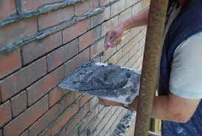
Picture 2.1 Pointing on brick background of wall
- Pointing is a type of front of the house exposed finish on masonry work. The finished pointing work is kept wet for about 3 days
- Background preparation for pointing work have a procedure, for example: When constructing a new wall, the joints should be pointed while the inner masonry work is still green.

Type of pointing
There are different types of pointing work:
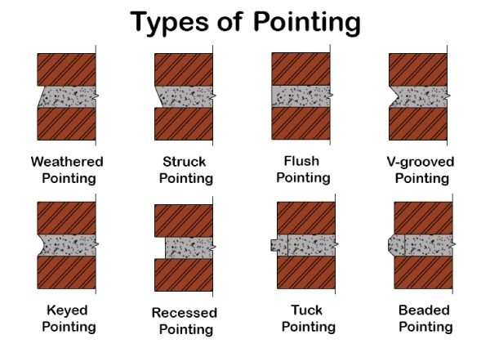
Figure 2.2 Type of pointing
- Weathered pointing:- is a modification of flush pointing. The face of the pointing is kept inclined, with its upper edge pressed inside the face by about 10 mm. Weathered pointing throws off rain water and is considered fairly durable; however, it's fairly difficult to achieve.
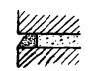Figure 2.3 weathered pointing
This style of pointing is fairly common. Instead of keeping the face of the point upright, the top line is pressed slightly inside, causing the face of the pointing to slope outwards. This improves the effect of throwing off the rain as well as the effect in the recess left at the top. By pressing the bottom line inside the joint, a weathered or struck pointing can be generated. This has the advantage of preventing rainwater from accumulating in the V-recess.

- Struck Pointing:- This is a modification of flush pointing in which the face the pointing is kept inclined, with its upper edge pressed inside the face by 10mm which drains water easily.
- Flush or Flat Pointing: - is when mortar is pressed hard in the raked joints, and finished off flush with the edge of masonry units. The edges are then neatly trimmed with a trowel and straight edge.
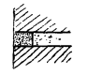 Figure 2.4 flush pointing
A simple way of pointing consists of forcing the mortar into the previously opened out joint with a trowel and then removing the excess mortar beyond the face of the wall, leaving the joint flat with the face.
- V- Grooved Pointing:- (V Pointing) are similar to keyed pointing work. The mortar filled and pressed into a joint. After that, the V-shaped groove is formed in the joint by use of V shape tool.
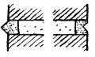 Figure 2.5 V-grooved pointing
There are two varieties of V-pointing: one constructed by projecting the pointing face’s V-shape outside the wall face and the other by pressing the V-inside, as shown in figure.
- Rubbed or grooved or keyed Pointing:- In this type of pointing, the mortar is pressed on the joints joined and finished with the face of the wall. While the pressed mortar is still green, a groove is formed, passing the folded end of a small steel bar (6 mm in diameter) straight along the centerline of the joints.
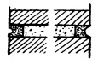 Figure 2.6 keyed pointing
The above-mentioned flat or flushed pointing is enhanced by lines or keyed grooves made by pressing a specific instrument known as ‘Naila’. This effect is said to improve the appearance from a distance by producing artificial gloomy lines, particularly in the case of brick masonry work. The groove on the face of grooved pointing is larger than that of keyed pointing.
- Recessed Pointing:- sometimes referred to as raked joints, is when the mortar joint is raked back a certain depth from the face of the brick. The mortar is first made flush with the brick and then raked out to the desired depth.
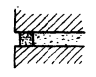 Figure 2.7 recessed pointing
Instead of being slanted, the face of the pointing is placed behind the plane of the wall and left vertical.
- Tuck pointing:- sometimes referred to as re pointing or brick pointing, is a process to finish or repair mortar joints between bricks or stones with a narrow ridge of lime putty or fine lime mortar.
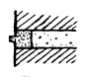 Figure 2.8 tuck pointing
After pressing the mortar into the joint, a tiny channel or groove is cut in the mortar. The groove is then filled in with white lime putty, which is allowed to protrude ¹/₈ inch beyond the face of the joint.
- Beaded pointing:- means masonry pointing that forms a protruding bead.

Prepare materials for beading

In Beaded Pointing, the mortar pressed into masonry joint and in the raked joints concave grooves are formed into a joint by using a steel tool having a concave shape.
- Beaded pointing gives an excellent appearance to the mortar joint but is liable to get damaged quickly. The craft or pastime of stringing beads together to make jeweler or other decorative items. “They’ll have wire or string and the other tools you need to get into beading" decoration or ornamental molding resembling a string of beads or having a semicircular cross section.
- Although it gives a good appearance, it is unstable and easily gets damaged in comparison to other types, but is difficult to maintain.
- It gives resistance to bricks and stones used in construction for weather.

Materials used for beading
- Glass beads, concrete beads, liquid cement mortar, PVC, Gypsum board are common beading materials in finishing construction work
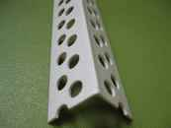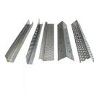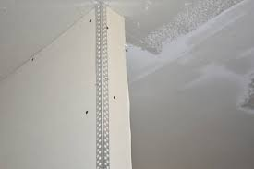
Figure 2.9 Glass Corner beads for construction Gypsum board
- It is preferable to select a mortar that is specially formulated for re pointing (one part Portland cement and two parts lime for every eight or nine parts sand). Compared to normal bedding mortar, it provides increased waterproofing, excellent moisture permeability and great flexibility. Premixed and sold in bags, it offers the advantage of a uniform mixture of all ingredients, batch after batch. In addition, mixing it requires little water. This is an important characteristic, since a drier mortar is easier to compact for pointing, less likely to tarnish the brick and less likely to shrink while drying.
- It may be colored in the factory or on site, helping harmonize it with the existing mortar, especially when the re pointing covers only a portion of a wall.
- It is important to let the contractor know if a brick wall to be re pointed was coated with a waterproofing product, which could compromise the adhesion of the mortar. Mortar is used for bead pointing work. Pointing mortar can be made of lime or cement, and it is usually richer in proportion than masonry mortar. If lime mortar is used, it should be double-ground, meaning that it should be reground after about 10 days following the first grinding.
- One part of cement to two parts of fine and clean sand (1:2) should be used for cement pointing, and one part of good well-burnt lime to one part of sharp clean sand (1:1) should be used for lime pointing. However, it should be recalled that pointing work does not persist indefinitely and must be replaced periodically by re pointing.

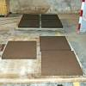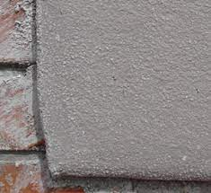
Concrete beads materials
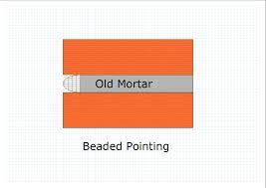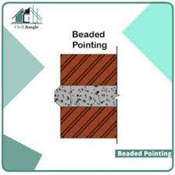
Figure 2.10 Beading materials
Making beads on the wall surface of building by using liquid cement mortar
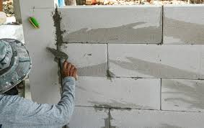
Figure 2.11 making beads by using cement mortar

Apply pointing putty to joint

Today, most brickwork is 'jointed' which means that the joints are finished as the work proceeds and therefore require no further attention. 'Pointing' is a term used to describe the process of finishing off joints that were raked out on the day the brickwork was built.
- Pointing is the art of finishing the mortar joints of the walls or similar structures with the groove is filled with lime putty which projects by 3 mm.
- Pointing, in building maintenance, the technique of repairing mortar joints between bricks or other masonry elements. When aging mortar joints crack and disintegrate, the defective mortar is removed by hand or power tool and replaced with fresh mortar, preferably of the same composition as the original.
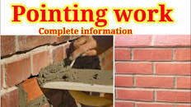
Figure 2.12 Putty knife used for filling joint
- Pointing is the implementing of joints to a depth of 10 mm to 20 mm and filling it with better quality mortar in desired shape. It is done for cement mortar and lime mortar joints. In exposed masonry, joints are considered to be the weakest and most vulnerable spots from which rainwater or dampness can enter.
- Putty knives are used to apply putty or surfacing compound into cracks and nail holes, patch divots with wood filler, and spread drywall mud into drywall joints and seams. Putty knives come in a variety of sizes.
- A putty knife is a specialized tool used when glazing single glazed windows, to work putty around the edges of each pane of glass.
- Putty knives, have a thinner blade that is too flexible for scraping.
- Apply pointing to joint of stone masonry wall
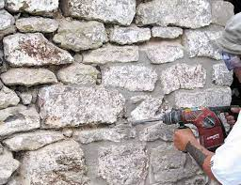
Figure 2.13 pointing stone masonry surfaces

Remove surplus pointing

Once all the joints are filled, any surplus can be moved on to the next section or removed from the area. After removing all the old pointing, use a stiff-bristled brush to all paving joints, use a stiff brush to sweep aside any surplus.
- Re pointing, also known simply as "pointing” or somewhat inaccurately "tuck pointing"*, is the process of removing deteriorated mortar from the joints.
- Re pointing is the process of renewing the pointing, which is the external part of mortar joints, in masonry construction. Over time, weathering and decay cause voids in the joints between masonry units, usually in bricks, allowing the undesirable entrance of water.
- Replacing damaged mortar in a brick joint is called re pointing. use a stiff brush to remove excess mortar from around the joints.
- Steps for re pointing brick with hand tools: Chisel out the existing mortar down to about ¾”. Start with all the head joints before moving to the bed joints.
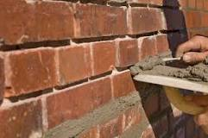
Figure 2.14 Re pointing the joint of old brick wall

Self check – 2 (Unit two)
Test-I Matching
Instruction: select the correct answer for the give choice. You have given 1 Minute for each question. Each question carries 2 Point.
A | B
---------1. Tuck pointing | - The process of renewing pointing
---------2. Keyed pointing | - Referred to as raked joints
---------3. Beaded pointing | - The form of protruding bead
---------4. Re pointing | - V grooved pointing
---------5. Recessed pointing | - Rubber pointing
 | - The process of finish joint

Test II: short Answer writing
Instruction: write short answer for the given question. You are provided 3 minute for each question and each point has 5 Points.
- Define pointing?
- What is beaded pointing?
- What is the use of putty knife for pointing work?
Part III: Short answer writing
Direction: Give short answer to the following questions. Time allotted for each item is 2minute and each question carry 4 point.
- Re pointing
- Weathered pointing
Note: Satisfactory rating – above 60% Unsatisfactory - below 60%
You can ask you teacher for the copy of the correct answers

Operation sheet 1: Apply putty pointing material to bed joints

- Operation title: Applying putty pointing material to bed joints
- Purpose: To practice and demonstrate the knowledge and skill required to apply putty pointing material to bed joints
- Instruction: Apply pointing work on brick surface. You have given 3hours for the task/practical work
- Tools and equipment
- Scraper
- Stiff brush
- Measuring tape
- Sponge
- Putty knife
Steps in doing the task/procedure
- Clean the area of pointing
- Use the functional tools
- Prepare mortar
- Apply the mortar in the joint by using putty knife
- Check your work
- Complete Your work and cleaning working area
- Quality Criteria: the given tasks of pointing work must have good appearance and strength.
- Precautions: use the given tools and materials for a task.

Lap Test- 1
Name: _____________________________ Date: ________________
Time started: ________________________ Time finished: ________________

Instructions: Given necessary templates /guide, workshop, tools and materials you are required to perform the following tasks within 1:00 hours.
- Task-1: Prepare working area for pointing
- Task-2: Calculate quantity of material
- Task-3: Apply mortar on brick surface by using putty knife
- Task-4: Clean the joint and excess mortar from surface

Unit Three: Clean up
This learning guide is developed to provide you the necessary information regarding the following content coverage and topics:
- Clear and clean completed pointing work area
- Maintain, store tools and equipment
This guide will also assist you to attain the learning outcomes stated in the cover page. Specifically, upon completion of this learning guide, you will be able to:
- Clear and clean completed pointing work area
- Maintain, store tools and equipment

3.1. Clear and clean completed pointing work area

During the construction of masonry work, whether of brick or stone, the joints near the faces of walls are frequently left rough. This is done for specialized treatment later. This also allows the masonry work to move very quickly. After the wall is completed, precise finishing of joints in a desirable manner is often required to improve the appearance of the construction.
- However, the subsequent treatment at the joints, known as pointing, is mostly a structural need. It ensures long-term durability by preventing rainwater and frost from penetrating the interior of the masonry construction through the joints.
- It should be noted that the joints are weak spots in the structure and should be adequately guarded from the corrosive effects of the sun, rain, and frost. The joint is generally struck as the process progresses. This is not a good method to support a clean final treatment.
- Stiff bristles help to dislodge dirt that's dried in or hard to shift.

Figure 3.1 stiff bristles
- Cement pointing should be picked out with care. Narrow joints can often be cleaned.
- The work should begin at the highest point and continue downwards.
Pointing mortar is formulated to cause less dirtying, cleaning the surfaces should be fairly easy, but it requires four steps:
- Wetting the wall
- Applying a detergent with a low acid concentration
- Rubbing with a hard non-metallic brush
- Rinsing.
- Doing the last step manually is not as hard on fresh re pointing as using a water jet.
- A 48- to-72-hour period of good weather should precede the cleaning.
- The joints and surface are cleaned and then thoroughly wetted.
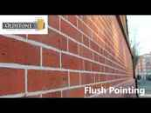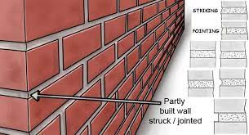
Figure 3.2 cleared and cleaned pointed area

Maintain, store tools and equipments

Techniques for Maintaining and storing tools and equipment’s:
Step 1- wear PPE.
Step 2- Identifies tools and equipment’s depends on their type.
Step 3- set in order by placing the tools and equipment’s in proper places.
Step 4- clean each tools and equipment.
- The purpose of an inspection is to identify whether work equipment can be operated, adjusted and maintained safely, with any deterioration detected and remedied before it results in a health and safety risk the need for inspection and inspection frequencies should be determined through risk assessment
- Explanation: It is really important to check our tools, equipment, and other stuff because if we don't, there is a high chance of it not working, make accidents, or don't know how to use or operate it.

General Rules in the Use of Cleaning Equipment
- Never use any appliance that is defective.
- Handle equipment with care and make sure it does not bump on hard surfaces.
- Clean and store equipment in their custodial room immediately after use.
- Empty dust bags of dry vacuum cleaners before they overload and after each use.
- Maintenance and storage of cleaning tools and equipment Use, care & maintenance of cleaning tools
- Dry clean. Remove visible and gross soils and debris.
- Pre-rinse. Rinse all areas and surfaces until they are visibly free of soil.
- Wash (soap and scrub).
- Post-rinse.
- Inspect.
- Sanitize.
- Dry.
- Verification

Self check-3 (Unit three)
Test I: short Answer writing
Instruction: write short answer for the given question. You are provided 5 minute for each question and each point has 5 Points.
- What is the use of stiff bristle tools for pointing work?
- Write at least three (3) techniques of maintaining tools.
- _______________________
- _______________________
- _______________________

Note: Satisfactory rating – above 60% Unsatisfactory - below 60%
You can ask you teacher for the copy of the correct answers

Reference
- Building construction by Dr.Punmia
- Building design and construction hand book by Feredericks. Merritt & Jonattan T.Rickets
- BUILDING CONSTRUCTION HANDBOOK Tenth edition Roy Chudley And Roger Greeno
- BUILDING CONSTRUCTION HANDBOOK Seventh edition R. Chudley MCIOB and R. Greeno BA (Hons) FCIOB FIPHE FRSA

Participants of this Module (training material) preparation
No | Name | Qualification (Level) | Field of Study | Organization/ Institution | Mobile number | E-mail
1 | Betel Tariku | BSC | COTM | Sidama (Hawasa poly technic college) | 0926298840 | betelbotora2@gmail.com
2 | Yazachew Geneti | MSC | COTM | BGRS (Assosa poly technic college) | 0917858176 | Yazachew17@gmail.com
3 | Shiferaw Yohannes | BSC | COTM | Sidama (Daye poly technic college) | 0932425937 | shiferawyohannes@gmail.com
4 | Mihiretab Gashaw | BSC | BCT | Addis abeba (Addis ketema industrial college) | 0922079011 | mihiretabgashaw@gmail.com
5 | Adisu Ruda | BSC | BCT | Oromia (Nekemte poly technic college) | 0924227161 | adisunagari@gmail.com

