FINISHING CONSTRUCTION WORKS Level III
Based on, October 2023Curriculum Version II,
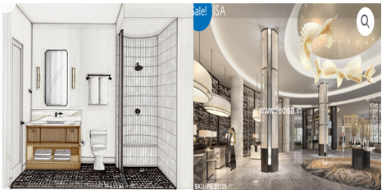
Module Title: Tiles for Curved Surface
Module Code: EIS FCW3 M04 1023
Nominal duration: 80 Hours
Prepared By: Ministry of Lobar and Skill
October, 2023
Addis Ababa, Ethiopia

Acknowledgement
The Ministry of Labour and skills wishes to thank and appreciation to MoLS leaders and experts, Regional Labour and skill/training Bureaus leader, experts, TVET College Deans, Instructors and industry experts who contribute their time and professional experience to the development of this Curriculum for Packing and Labelling Service.

Acronym
BIS British international standard
CPR Cardiopulmonary Resuscitation
ISO International Standardization Organization
MDE Medium density fiberboard
MEP Mechanical electrical and plumbing
OHS Occupational Health and Safety
PPE Personal protection equipment

Content
Acknowledgement 2
Acronym 3
Introduction to Module 5
UNIT ONE: General Concepts In Laying Tile In Curved Surface 6
1.1 Introduction curved surface 7
1.2 Safety requirements 8
1.2 Material, tools and equipment 9
1.4 Working plan and drawing 24
1.5 Laying method for different type of tiles 26
Self – Check 34
UNIT TWO: Tile Curved Wall, Floor Surfaces And Circular Columns 36
2.1 Extent of curve in walls and floor surface for tilling 38
2.2 Calculating quantity of materials 43
2.3 Cut and fix curved tiles for well and floor 47
2.4 Preparing mortar and adhesive. 48
2.5 Techniques for setting out and fixing tiles to curved surfaces 54
Self - Check 1 59
Operation sheet # one 61
LAP Test 62
Operation sheet #Two 63
LAP Test 64
Practical Demonstration 64
UNIT THREE: 65
MAINTENANCE AND REPLACEMENT OF TILES 65
3.1 Maintenance of ceramic tiles 66
3.2 Reasons for cracks in tiles 67
3.3 Replacement of broken tiles 68
3.4 Specification for Ceramic Tiles 69

Introduction to Module
This module guides to curved tiles better facilitate water drainage and reduce the risk of water permeating the surface of the tiles. In dry climates, tiles made from clay or synthetic materials are better able to handle the harsh sun, than asphalt or wood. It supports training inspecific units of competence.
The module covers skills, knowledge and attitude to set out, cut, fix and grout of tiles to curved walls and floor surfaces, circular columns and archways.
This module covers the units:
- Plan prepare forCut and Fix Tiles
- Tile curved wall, floor surfaces and circular columns
- Maintenance and Replacement of Tiles
Learning Objective of the Module
At the end of the module the trainees will be able to
- Identify Plan prepare forCut and Fix Tiles
- Implement Tile curved wall, floor surfaces and circular columns
- Implement Maintenance and Replacement of Tiles
Module Instruction
For effective use this modules trainees are expected to follow the following module instruction:
- Read the specific objectives of this Learning Guide.
- Follow the instructions described below.
- Read the information written in the information Sheets
- Accomplish the Self-checks
- Perform Operation Sheets
- Do the “LAP test”

UNIT ONE: General Concepts In Laying Tile In Curved Surface
This unit is developed to provide you the necessary information regarding the following content coverage and topics:
- Introduction to laying tile in curved surface
- Safety requirements
- Materials, tools and equipment
- Working plan and drawing
- Laying method for different type of tiles
This unit will also assist you to attain the learning outcomes stated in the cover page. Specifically, upon completion of this learning guide, you will be able to:
- Introduce to laying tile in curved surface
- Apply Safety requirements
- Identify Materials, tools and equipment
- Implement Working plan and drawing
- Identify Laying method for different type of tiles

Introduction curved surface
Tiles are widely used as an attractive and durable finishing material for floor and as walls. They are available in different sizes and colures to match the décor of any room and provide years of maintenance-free use besides being fairly easy to install. Tiles are desirable choice where there is need to have cleanliness and hygiene and in areas which are in contact with running water or dampness. It is easier to keep the tiled area clean and dry. Properly fixed tiles also look attractive and pleasing to the eye. Various types of tiles are available in the market i.e. mosaic tiles, glazed tiles and ceramic tiles. Since, tiles are available in so many sizes, shapes, color, texture and design; it's possible to create unique patterns. They can be mixed in sizes, colures and shapes to add a border around a room, or to create a 'central' area, or monotone pattern in different shapes, or pattern in contrasting colures to provide attractive and modern feel of decor.
Pre- requisite for tiling work
- Ensure the MEP clearance obtained and all other under laying installations are approved prior to start of tiling works.
- Working area to be restricted for unauthorized entry.
- The surface to which the tiles are to be fixed shall be thoroughly dry before fixing commences and free from all defects.
- The areas to be tiled shall be brushed clean and all traces of grease, oil, loose particle, etc. must be removed.
- Ensure that the laying of tiles shall be as per the direction and pattern agreed with the consultant.
- Before laying tiles obtain approval of setting out by consultant. Provide symmetry about center lines of the space or areas and adjust to minimize tile cutting.
- Lay out tile work so that tiles than ½ full size do not occur and with minimum of cutting. Carefully grind edges of cut tile. Ensure cut tiles are in corners and are equal on each wall face.
- Tile layout on floors/walls shall follow the layout on floors/walls as per approved shop drawing.

Safety requirements
Safety requirements are those requirements that are defined for the purpose of risk reduction. Like any other requirements, they may at first be specified at a high level, for example, simply as the need for the reduction of a given risk. Then they must be refined so that their full details are provided to designers. The totality of the safety requirements for all risks forms the safety requirements specification. At the design stage, the safety requirements are provided by means of safety functions. These are implemented in “safety-related systems”
“OHS” Occupational health and safety
Health: is the protection of the bodies and minds of people from illness resulting from the materials, processes or procedures used in the workplace.
Safety: is the protection of people from physical injury. The borderline between health and safety is ill-defined and the two words are normally used together to indicate concern for the physical and mental well-being of the individual at the place of work.
Accidents: is defined as an unexpected and desirable event resulting in damage.

1.2.1 Protective clothing and equipment
Personal protective equipment (PPE) is protective clothing, helmets, goggles, or othergarments or equipment designed to protect the wearer's body from injury or infection. The hazards addressed by protective equipment include physical, electrical, heat, chemicals, biohazards, and airborne particulate matter. Protective equipment may be worn for job-related occupational safety and health purposes, as well as for sports and other recreational activities. "Protective clothing" is applied to traditional categories of clothing, and "protective gear" applies to items such as pads, guards, shields, or masks, and others.

Material, tools and equipment
Tiles material
Tiles are usually thin, square or rectangular coverings manufactured from hard-wearing material such as ceramic, stone, metal, baked clay, or even glass. They are generally fixed in place in an array to cover roofs, floors, walls, edges, or other objects such as tabletops. Alternatively, tile can sometimes refer to similar units made from lightweight materials such as perlite, wood, and mineral wool, typically used for wall and ceiling applications.
    - Types of tiles/ material
Ceramic
These are made from fired clay and finished with a glaze. They are hard-wearing, waterproof and fireproof. They are available in a wide range of designs, colures, sizes and finishes, and at a range of different prices.
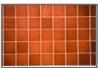
Figure1.1Ceramic tile
Porcelain tiles
Porcelain tiles are made from hard, finer clays. They used to be made using a different manufacturing method which resulted in the design running all the way through the tile - but these days they are usually glazed and fired in the same way as ceramic tiles. They tend to be harder and denser than ceramic tiles. The difference between ceramic and porcelain tiles can cause confusion. In my experience, ceramic tiles can often give the same effect as porcelain tiles but at a lower cost. However, the choice is yours, and I can give an equally beautiful result with either type of tile. Porcelain tiles are made from hard, finer clays. They used to be made using a different manufacturing method which resulted in the design running all the way through the tile - but these days they are usually glazed and fired in the same way as ceramic tiles. They tend to be harder and denser than ceramic tiles. The difference between ceramic and porcelain tiles can cause confusion. In my experience, ceramic tiles can often give the same effect as porcelain tiles but at a lower cost. However, the choice is yours, and I can give an equally beautiful result with either type of tile.
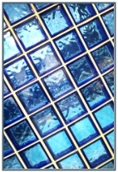
Figure1.2Porcelain tiles
Quarry tiles
True quarry tiles are extruded (that is, squeezed out) rather than pressed, as most ceramic tiles are. This gives a slightly rougher finish and greater variability in shape. Traditionally a reddish brown color, they are now available in various shades of grey and black, too.
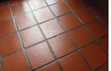
Figure1.3Quarry tiles
Terracotta or Mexican tiles
Terracotta or Mexican tiles are traditionally fired at lower temperatures and have more natural variation in the individual tiles. Modern terracotta tiles can be finished with a glaze, or can require a surface treatment to seal them once installed. They tend to give a more rustic, less formal effect.
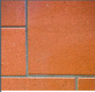
Figure1.4Terracotta or Mexican tiles
Natural stone tiles
Natural stone tiles are just that - slabs of natural stone that have been cut to size andshape. Stone tends to be heavier than ceramics, and has a natural variability in color and surface finish
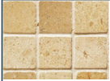
Figure1.5Natural stone tiles
Travertine tiles
Travertine tiles are natural limestone, laid down in layers over millions of years as a sedimentary rock. Although technically incorrect, their appearance means they are often counted as a marble tile,. They are usually a lighter color, varying from pale to darker pinks and creams.
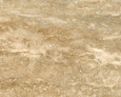
Figure1.6Travertine tiles

Marble tiles
Marble is similar to travertine, but is a metamorphic rather than a sedimentary rock. This means that it has been compressed, heated and cooled during its time in the ground, so that it is actually a mass of little crystals. It is harder, denser and less porous than travertine, and has a different color palette. Marble tiles give a very classical appearance, with a natural variation in the color inclusions.
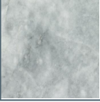
Figure1.7Marble tiles
Slate tiles
Slate was formed in layers at the bottom of the ancient seas, then compressed and heated. It comes in a range of colures, including greys, greens, pinks and purples. Slate is notable in having more natural variability than almost any other flooring material, both in surface finish and in thickness. This means that it is impossible to achieve a completely even finish with a slate floor. This may be an effect you want to achieve - but this can be a disappointment to some people. Slate can look wonderful in the right setting, but it is important that you are aware of the inherent variation if you choose it for your home.
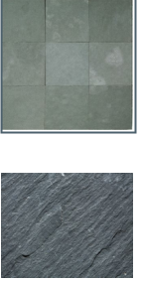
Figure1.8Slate tiles
Waterjet tiles are a luxurious and artistic choice. They are stone-based and can include a gorgeous metal inlay like brass, steel, or mirror. Due to the nature of the materials, they undergo a special cutting process. The stone is cut precisely with high-pressure water jets and without any damage to the natural appearance, resulting in beautiful design. This process is what makes the waterjet tile so unique.
Mosaic tiles are another staple like subway style. Mosaic tiles differ from regular tiles because there are multiple pieces that appear on each sheet.Mosaics come with a mesh backing and consists of varying size tile pieces, finishes, and materials all on one sheet. This type of tile provides an easier application than most since it has a mesh backing. That makes laying the tile a bit less messy and it also allows the ability for tiles to be separated, adding to style flexibility.
Mosaic tiles make the perfect match for walls or shower floors thanks to the increased number of grout lines. Plus, mosaics are known for their vibrancy often coming in mixed color palettes that captivate the eyes. You can enhance any space with almost any color imaginable with options ranging from turquoise blues to sandy beiges.
Glass tilesare an extremely versatile option due to the nature of the material. It’s glass, after all. While it may seem like a more basic tile, it is quite the opposite. Glass tile can be found in handfuls of tile shapes from mosaics to subway tile and comes in opaque or reflective options with frosted or shiny finishes. There’s a wide range of styles that glass can be used for including modern, retro, and traditional.
Terrazzo tiles composite material of marble chippings set into cement, terrazzo originated in 16th-century Italy as a way to reuse stone offcuts. It is either poured in situ by hand or precast into blocks that can be cut to size. You can also buy it as ready-made tiles, easy to apply straight to floors and walls.
PVC tile is actually just another name for vinyl tile. And just like vinyl tiles, they combine exceptional durability and practicality with the authentic beauty of materials like stone and concrete. There is a wide choice of PVC (or vinyl) tile floors in a range of styles, colors, and finishes.
Using Texture and Pattern
Texture – this is the visual or tactile surface characteristic of something, be it fabric, timber carpet or glass. Tactile means that it is perceptible by the sense of touch. Every surface has a texture.
There are two types of texture – rough and smooth – and through using texture, we can create quite different effects.
Rough textures – linoleum flooring, molded textured glass, timber look textured wall covering, plaster look handmade wallpaper, worsted wool patterned fabric, rough sawn timber boarding, brick, boucle wool blend upholstery fabric, wool carpets,perforated slim line blind, tread plate vinyl flooring, non-slip floor tile.
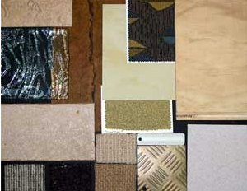
Figure1.9Rough textures tiles
Smooth textures – black granite, paint finish, leather, prefinished hardboard, chrome tap, aluminum blind, glass tile, polished aluminum tile, polished brass tile, modern clock, 100% silk, stainless steel with checker design, gloss granite laminate, prefinished board, polished copper tile, 100% plush wool carpet, prefinished melamine board, red fabric – polyester & polyurethane composition.
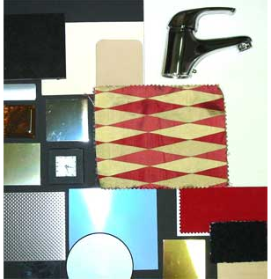
Figure1.10Smooth textures tiles
Types and uses of Tools
There are several type tools used by a tile. Hand tools, in general, ease the work and accelerates the process, improves quality of work significantly and they are very important for everybody who wants to do decent work so that keep tools in perfect order. In addition tools and equipment also represents highly valued assets.
Tools required for tiling work Different types of tools required for fixing/laying of tiles on floors/walls are:
Measuring tapes/rules
Tape is used to measure dimensions of building parts and distances in site. It is manufactured from steel, plastic or fiber in lengths of 1m, 2m, 3m, 5m, 30m, etc. and 50m. In using tapes for measurements, the two points should be aligned perfectly. In addition, when long horizontal measurements are needed, care should be taken to avoid sag on the tape meters.
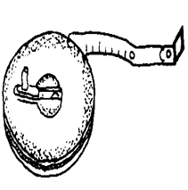
Figure1.11Measuring tapes/rules
Spirit level
It is used to control the horizontal and vertical alignment of wall surface and edges. The length is at least 80 to 120cm long. It is made of metal, synthetic material or wood. It has two measuring bubbles: one is located at mid length is used to check horizontal positions. While the second one, at the end, is used to check vertical position. This tool requires always to be handled with care and needs to be checked from time to time weather it is still working accurate or not.
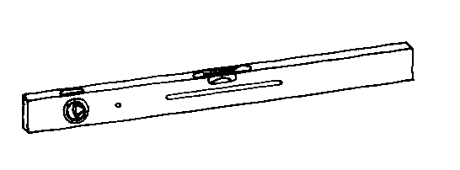

Figure1.12Spirit level
Floats
It is used for spreading the mortar on the surface of the concrete slab. The size of float is about 30 cm x 10 cm and thickness is about 10 mm
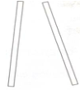
Figure1.13 Floats
Plumb Bob
It is used to check the verticality of the surface in case of fixing tiles on vertical surfaces

Figure1.14 Plumb Bob
Tile cutter
It is used to cut the tiles manually wherever odd size gaps are required to be filled.
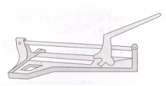
Figure1.15 Tile Cutter

Cutting Machine
This electrically operated equipment is used for cutting the tile.
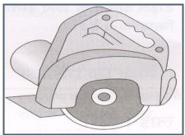
Figure1.16Cutting Machine
Chisels and Hammers
They are used for cutting and dressing the natural or manufactured tiles, which have larger thickness.
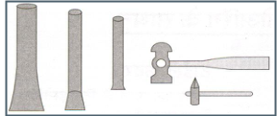
Figure1. 17Chisels and Hammers
Wooden Mallet
It is used for hammering the tile in proper line and level.
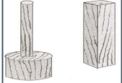
Figure1.18Wooden Mallet

Electrically operated machine
This electrically operated machine is used for polishing the cement-based tiles i.e. mosaic tiles or natural stone tiles fixed on the floor.
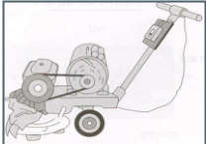
Figure1.19 Electrically operated machine
Squares
It is used to measure a right angle (90º) of a corner. Used in laying masonry units or blocks at corners of masonry wall.
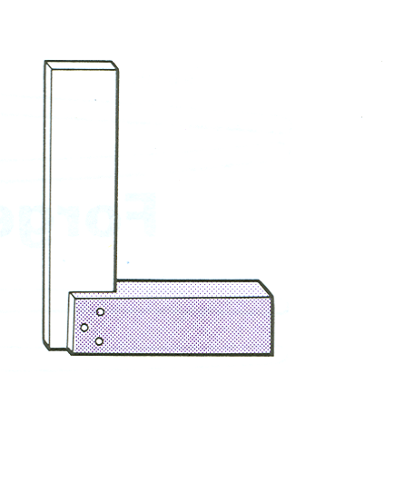
Figure1.20Squares tools
Trowels
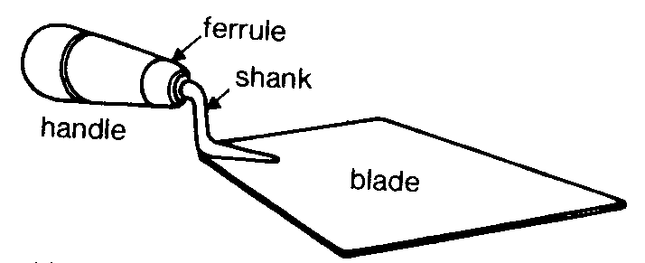
This is a tool, which every mason needs. Used for picking up mortar out of the barrel, spreading mortar on the wall, bed joints and cutting off excess mortar. In addition to the picture shown, a Triangular and rectangular trowel are also used by the plaster.

Figure1.21Trowels

Floats
Used to smooth out concrete surface before the concrete fully cure it is about 30cm long and 15 cm wide with a handle. Floating concrete is an operation of concrete finish work after draying on bull floating to remove slight imperfection, fill small holes, level etc on the surface of concrete.
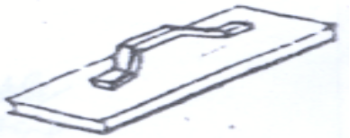
Figure1.22Floats
Mortar spade
Buckets: It is used as an informal way or as slang and it is believed that the idiom comes from method of execution such as hanging.
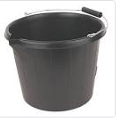
Figure1.23Mortar spade
Sponge
To clean tiles after scratching and brooming, and to clean the tools after work.
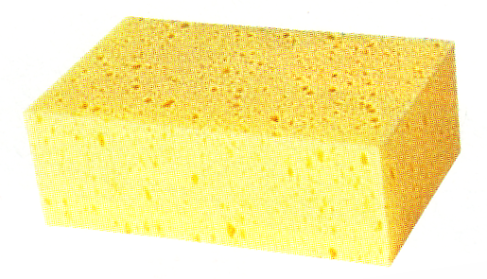

Figure 1.24Sponge

Grouting float
For fast and efficient filling of joint with grouting mortar
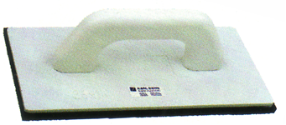
Figure 1.25 Grouting float
Wheelbarrow
Wheelbarrow is used to dispose disposal materials from working place, to Transport or serve materials and tools during construction activities in the site. It is the most efficient way in transporting materials or items. ; In comparison to a barilla, (commonly used in the country), a wheelbarrow is much more efficient. For this reason, it is operated by one person and can be carried up to 100 kg at once. So that it saves operation cost; it is time effective and therefore in general.
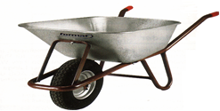
Figure 1.26 Wheelbarrow
Brush and Broom (Cleaning tools)
Used for cleaning the joints of the tiles and to clean the tools. Multipurpose tool
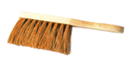

Figure 1.27 Brush and Broom (Cleaning tools)
Spirit level
A spirit level consists of a body (generally made from aluminum) with an inset glass tube filled with a liquid that contains a bubble of air.
The position of the bubble in relation to permanent markings on the glass indicates whether a surface is plumb (vertical) or level (horizontal).
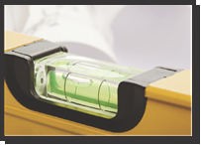
Figure 1.28 Spirit level
Water level
Due to the effects of gravity, still water is level, so a clear plastic tube filled with water is a very simple tool that can be used to transfer heights on a construction site from one point to another.
Water levels are particularly useful to quickly transfer height measurements from one room to another when there is no clear line of sight.
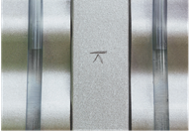
Figure 1.29 Water level

Line level
A line level is a miniature spirit level with a hook on each end to allow the instrument to be suspended on a taut string line. It’s used to transfer height levels from one point to another. Line levels are not very accurate and are used mostly used to, for example, check falls in concrete paths
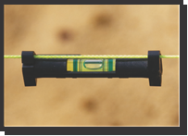
Figure 1.30 Water level
Types and use of leveling equipment
Leveling equipment
A level is an optical instrument used to establish or verify points in the same horizontal plane in a process known as leveling. It is used in conjunction with a leveling staff to establish the relative height or levels (the vertical separation) of objects or marks.

Dumpy Level
Dumpy level is the most commonly used instrument in leveling. In this level the telescope is restricted against movement in its horizontal plane and telescope is fixed to its support. A bubble tube is provided on the top of the telescope. But however, the leveling head can be rotated in horizontal plane with the telescope. The telescope is internal focusing telescope is a metal tube contains four main parts as given below.
- Objective lens
- Negative lens
- Diaphragm
- Eye-piece

Figure 1.31 Leveling equipment
Cushing’s level, the telescope is restricted against rotation in its longitudinal axis and it is non-removable. But, the object end and eye piece end can be interchangeable and reversible.
Tilting level consist a telescope which enabled for the horizontal rotation as well as rotation about 4 degree in its vertical plane. Centering of bubble can be easily done in this type of level. But, for every setup bubble is to be centered with the help of tilting screw. The main advantage of tilting level is it is useful when the few observations are to be taken with one setup of level.
Automatic level is like the dumpy level. In this case the telescope is fixed to its supports. Circular spirit can be attached to the side of the telescope for approximate leveling. For more accurate leveling, compensator is attached inside the telescope.
Angel grinder
Grinders are available as one hand and two hands. They are operating with high speed rotary cutting discs. The protecting hood must not be removed by all means. A grinder is very useful for cutting hard material like concrete, steel, natural stones or tiles. It is effective to cut blocks or bricks perfectly than cutting with hands.

Figure 1.32 Angel grinder
Drilling machine
It is used to make or drill holes in concrete, stones and other building elements or material. Drilling holes is depending up on the size and materials to be drilled, i.e. the drill bits are of different size and types. Types of drill bit can be classified as bits for metal, wood and stone or concrete).
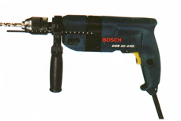
Figure 1.33 Drilling machine

Working plan and drawing
Plans are a set of drawings or two-dimensional diagrams used to describe a place or object, or to communicate building or fabrication instructions. Usually plans are drawn or printed on paper, but they can take the form of a digital file.
Plans are used in a range of fields: architecture, urban planning, landscape architecture, mechanical engineering, civil engineering, industrial engineering to systems engineering.
The term "plan" may casually be used to refer to a single view, sheet, or drawing in a set of plans. More specifically a plan view is an orthographic projection looking down on the object, such as in a floor plan.
Specification
Specification is defined as the designation or statement by which written instructions are given distinguishing and/or limiting and describing the particular trade of work to be executed. In short specification is a statement of particular instructions of how to execute some task. Specification is one of the contract documents.
Specifications are written based on the prepared design, drawings, general and scientific trends of workmanship, quality expected equipment involved and materials to be used for the particular trade of work
The specifications should clearly specify:-
- Design and drawing
- Labor employment
- Materials to be used
- Construction method
- Equipment used
Specifications should be clear, concise, and brief descriptions of what is required to execute the proposed trade of work. The information that is needed for construction is usually conveyed by two basic communication lines. They are Drawings (pictorial) and Specifications (written).
Working drawings form an addition layer(s) of detail over the planning-approved drawing, structural and building regulation drawings. They show the dimensional detailed specifications about every aspect of the build. Done properly, they should read as a how-to manual for the Builder on site.
House Plans 10×11 Floor Plans
Anice Terrace entrance in front of the house size 1.8×3.5 meters When we are going from front door, a Living 3.8×3.5 meters is very perfect for this house it is nice and modern. Dining room 2.2×3.5 meter, and Brightly Kitchen 2.4×3 meters, it is clean and beautiful. Multi Bathroom 1.8×1.9 meter. Washing room 2×3 meters
Finally, the Master Bedroom 1 size is 3.3×3.5 meters attached with bathroom 2.4×1 meters, it also has a big slide glass window with a king size bed, Makeup desk and closet 2.1×3 meter. Bedroom 2 size 3×3.5 meters, and bedroom 3 sizes is 3×3.5 meter.
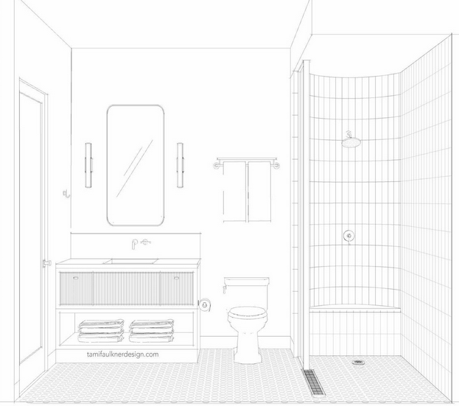
Figure 1.34House Plans

Laying method for different type of tiles
Laying of Ceramic Tiles
Ceramic tiles are widely used throughout the home, in the living rooms, corridors and passages, fireplaces, as decorative elements on walls, and of course, the bathrooms and kitchens. Ceramic tiles are also used widely in commercial places for office floors, shopping malls, cinemas, hospitals and hotels and also as exterior cladding on walls of commercial buildings. In essence, the usage is only limited by ones own imagination. They come in many different sizes and colors to match the décor of any room.
The ceramic tiles are now available:
- In various surface textures like Luster, Satin Matt, Rustics, Mirror Finish, Raindrop effect, Water resistant, Glaze Polish, Antiskid, Cobblestone, etc.
- In designs emulating, Natural Stone designs like Italian Marble, Indian Marble & Granite.
- In concept based pattern & large format type.
- Also as Vitrified & Porcelain tiles.
Laying methods
Tile flooring is a little difficult to install compared to other flooring options. Even a simple fault in placing the tile on the floor, can be blemished and it may ruin the entire pattern. Follow the below tips to install tile flooring.
Start from the center: While installing the tile floor the finished area should appear symmetrical. To achieve this we need to take dimensions of room and calculate the center of the surface. The center is required even for smaller areas to make the installation perfect and simple.
Adjust the surface by squaring: While tiling, the surface area should be in a square, this makes our work a bit easier by finding the center of the room.Particularly the houses of olden days you may observe that surface is not in a squared manner. It makes the installation a bit tough. In that case, use a wall as a base and that is an obvious solution for rooms that are not in a perfect square.
Divide into quarters: After finding the center or baseline of your work. Draw perpendicular lines with chalk or marker. These lines will make the room into four quadrants. Try to work

outward from the center of the room.
There will be a small change in tiling a wall; your concern should be on top-line, not a center or baseline. Use a level for drawing the line and start working on it. But some walls may not be straight so be cautious while drawing a top line.
Stepping: The last step to be followed after finding the center and squared the room, arrange tiles in rows for every quadrant before mixing the adhesive. Complete the tiling row-wise accordingly of each wall. In this last step, you may face bit difficulty in the arrangement and centering the room. Check the centering at the layout stage itself otherwise it will be a major problem at the end. Follow the same procedure for tiling walls also with vertical and horizontal distances.
In some cases, if the tile length is exceeding the gap between the walls and fixed tiles then you should follow the tile cutting procedure to fill those gaps.
Tile Cutting Procedure: For cutting a tile as per requirements one needs some patience and little practice to make it perfect.
- Measure the length of the tile and mark the outlines of the tile perfectly for cutting.
- Use the lever to handle the tile without any force on the tile and position it clearly.
- Use cutter perfectly along the marked area and cut the edges clearly without any pressure on the tile.
Tile curved wall and floor surfaces
The normal application of tile on vertical surfaces is straight walls that are plumb. However, occasionally you will find yourself designing elements or moving into a new home that already has the design finished where a curved wall section needs to be covered with tile. A common example of curved wall tiles is the faces of Jacuzzi surrounds or specially designed bathrooms. While the normal way of curving wall tile in this instance is to use 1-inch tiles on a sheet, you can also modify larger tiles to work in the same fashion.
Step1. Install sheet tile as normal to curve it around a wall. Sheets of 1- or 2-inch tiles will easily bend and fold around inside and outside corners. Spread thinset on the wall with the notched trowel and press the sheets into the thinset. Work your way from the bottom up and use a grout float to tamp the tile firmly into the thinset mortar
Step2. Prepare larger tiles to work with the curvature of the wall. Set the gauge on the tile wet saw and cut several strips at 3 inches in width. Check those pieces against the wall to see if your curve is gentle enough to accommodate the width of your pieces. You want the tile to be just wide enough to make the curve with the majority of the backside of the tile having contact with the wall for mortar adhesion.
Step3. Adjust the size of the strips accordingly. Remember that inside curves will fold the tiles against each other, and outside corners away from each other, which affects the size of the grout joint. A gentle curve may use 6-inch strips, while a sharp curve may require your strips cut down to 1 inch for complete mortar adhesion.
Step4. Cut your pieces of tile on the wet saw. Stone the cut edges with a rubbing stone and dry each piece off completely with an old towel. Install the pieces as normal. Work your way from the bottom of the wall up. Spread thinset on the wall with a notched trowel and place the strips of tile into the thinset. Use tile spacers between them to help guide your grout joint width.
Quality of ceramic tiles
The size, design, color and texture of ceramic tiles to be used for the work shall be as laid down in the drawing or as specified. Tile used for the work shall be of appropriate grade/ group and shall conform to surface quality, dimensions, physical, chemical & thermal properties as specified.
Laying of floor
It involve following operations:
Marking of reference and level lines
After completing the preparatory activities as mentioned the marking of reference and level lines shall be carried out as mentioned for mosaic tiles.
Preparation of sub-grade
It shall be carried out as mentioned for mosaic tiles.
Laying of mortar bed
It shall be carried out as mentioned in for mosaic tiles except that the surface shall be wood finished, and the rendering and curing completed at least two weeks prior tiling. In no case tiles shall be fixed on fresh floor.
Laying of tiles
It consists of following operations:
- Marking of layout lines
- Plan/pattern for the tile application
- Fixing of tiles
Marking of layout line
To ensure attractive quality work it is essential that the tiles are laid so that there are full size tiles in highly visible areas and all edge (border) tiles are of atleast half tile width or more. Accordingly, layout is planned as under:
- Marking of exact center
Locate the exact center on each wall and mark that center spot. In rooms with offsets or irregularities, ignore the irregularities in the measuring process.
Hold a chalk line at the center position on facing walls, as marked and snap it on the floor. The exact center will be marked at the point where the two lines cross.
To check for accuracy, measure 3' in one direction and 4' in the opposite (90°) direction. When measured from true center, the distance from the 3' marking to the 4' point will be exactly 5'. If not, re-measure and re-chalk each wall to find the true center.
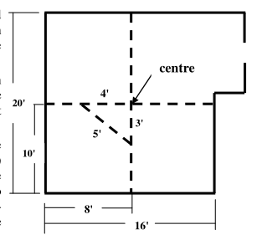
Figure 1.35 layout plan

- Make a final check with loose tile
Lay loose tiles along marked lines from center, as shown in figure. It provides an opportunity to make adjustments if the center is not correctly marked
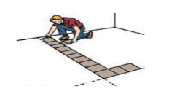
Figure 1.36 Check with loose tile
After have laid a full run of loose tiles along the chalk lines toward each wall, measure the remaining distance between the edge of the last tile and the wall on each run
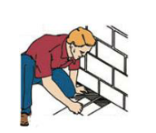
Figure 1.37 Measure remaining distance
If the distance between the last tile and the wall is too less or more then extremely narrow cut of tile will be required. To correct, adjust the center-line that is parallel to the corresponding wall closer to the wall and re-mark.
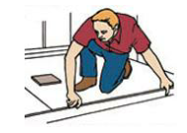
Figure 1.38 Check and cut piece

Plan/pattern for tile application
Before fixing the tiles, it is essential to lay them out in the desired pattern and make sure that they give an acceptable blend of color and design/pattern. Open all cartons of tiles that are to be used. Conveniently arrange them so you select tiles out of each carton on an alternating basis. This will help to prevent any noticeable color variation in tiles boxed together.
Next, study the tile patterns and plan laying pattern. If the tiles are all one color, plan the pattern according to the grain. Either alternate run of the patterns (as shown), or patterns in one direction can be chosen. Whichever pattern is chosen, it is critical to plan it in advance.
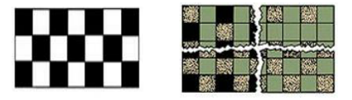
Figure 1.39 Plan/pattern for tile application
For tiles of varying colors, plan the design carefully before applying the first tile. This will influence the selection of starting tiles.
Fixing of tiles
The tiles can be fixed either by dry or wet fixing. In dry fixing the tiles are fixed by using conventional cement mortar. In wet fixing this is done by using special adhesives that can fix tiles directly on the existing flooring. For fixing of tiles, first of all, it is ensured that the corners are square. If it is not, then from the corner, which is accurately square, snap/mark perpendicular lines at one tile length or width of edge tile as decided above, away from both the adjacent wall with the use of square and thread line.
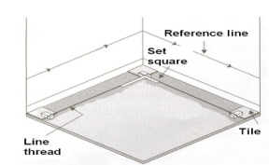
Figure 1.40 Fixing tiles of floor
After marking the square lines tiles are laid in the central area and the edges (border) in following sequence.
  - For wet fixing, using tile-fixing adhesives, for best results, follow the instruction provided along with the adhesives by the manufacturers. For dry fixing, using sand and cement paste, following sequence shall be observed:
  - Use cement and sand mortar in the ratio of 1:1 or 1:2 or as specified. Add some water to create a consistent paste. Do not use neat cement for fixing tiles.
  - Once the mixing has been completed, do not add any further water and use the same within one hour.
  - Soak the tiles in clean water for at least 30 minutes before fixing. § Remove the tiles from water and allow them to drain to ensure that there is no film of water on the tile surface.
  - Apply the bedding material evenly and tap the tile firmly into position to ensure proper contact between the tile and floor.
  - Backing material between tile joints should be cleaned before the tile is fixed. It is advisable to maintain a gap of 1.5 mm between two tiles to allow for possible expansion. Remove all excess cement from joints.
The surface of the flooring during laying/fixing shall be frequently checked with the straight edge, so as to obtain a true surface of required slope.
Fixing on walls
It involves following operations:
Preparation of surface
After completing the preparatory activities as mentioned plastering of the wall surface to be tiled shall be completed to a wood finish and cured for at least two weeks prior tiling. Do not fix tiles on fresh wall.
Marking of reference and level line
Before fixing up the tiles, check right angles of all corners and the verticality of the plaster with the help of square and plumb bob.
Then, decide from where to begin fixing the tiles on the wall depending on the general design and the shape of the tiles. This will avoid an enforced cut, which would cause critical points in the laying of the tiles and would give a strange effect when looking at the overall design.
Based on the proposed layout and with the help of a rule, measure where to begin tiling (the border). Then, mark on the wall the total measurement for the border. With this measurement, mark the levels on all the walls with the help of water tube, to ensure that there is no deviation in the height of the border, as the border itself will be the starting point for all the wall tiling from the bottom towards the top, until the end.
Fixing of tiles
After marking the starting line as above, provide leveling markers on the top portion of the wall and with plumb bob & string (line do) at few more level.
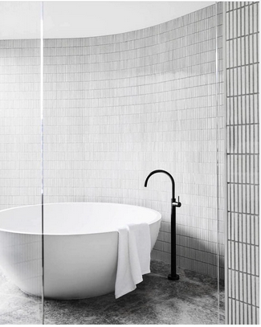
Figure 1.41 Fixing tiles of wall
The tiles are then fixed by wet or dry method as under
For wet fixing, using tile-fixing adhesives, for best results, follow the instruction provided along with the adhesives by the manufacturers. For dry fixing, using sand and cement paste, following sequence shall be observed:
Use cement and sand mortar in the ratio of 1:1 or 1:2 or as specified. Add some water to create a consistent paste. Do not use neat cement for fixing tiles.
Once the mixing has been completed, do not add any further water and use the same within one hour.
Soak the tiles in clean water for at least 30 minutes before fixing.
Remove the tiles from water and allow them to drain to ensure that there is no film of water on the tile surface.
Cover the tile back uniformly with cement mortar paste. The tile should then be pressed gently on the plastered base and fixed into position by tapping the tile into correct position. All corners should not sound hollow when gently stroked with mallet on the tile. Hollow sound is the indication of voids due to bad workmanship. It is necessary to match vertical and horizontal lines of the tiles. If any corner of a tile is projecting out, then tap the tile with the help of wooden mallet to remove the projection.
Backing material between tile joints should be cleaned before the tiles are fixed. It is advisable to maintain a gap of 1.5 mm between two tiles to allow for possible expansion. Remove all excess cement from joints.
Wait for adequate time after fixing the tiles preferably for 24 hours. For wet fixing, after this period, fill the joints with grout. Fifteen minutes after the grouting process, wipe off the excess grout with a damp sponge and polish the tiles with a soft & dry cloth. For dry fixing, after waiting period clean all joints and refill the joints with white or colorcement paste neatly. Press the paste with finger, so that cement paste is pressed within the joints properly. After removing excess paste & cleaning the tiles, curing should be done thoroughly for about 15 days.
For cleaning tiles, use water or dilute soap solution followed by water with soft, moist cloth or sponge, do not scrub or scratch. Do not use acid/alkali/solvent/oils/ cleaning powders etc for cleaning tiles.

Self – Check
# Part one choose the best answer for the following equations
    - What is the purpose of brushing the surface before tiling?
    - To make the project more complicated
    - To remove any defects or debris
    - To make the tiles stick better
    - To save time and money
    - What is the purpose of personal protective equipment?
- To increase employee productivity
- To save money on insurance costs
- To reduce employee exposure to hazards
- To make employees look professional
    - What is the purpose of safety requirements?
- To increase risk
- To save money
- To reduce risk
- To make the project more complicated
    - What is the pre-requisite for tiling work?
- Using the most expensive tiles
- Having a lot of experience
- Obtaining MEP clearance
- Having a large budget
    - What is the benefit of using tiles as a finishing material?
- They are easy to install
- They are durable and attractive
- They require a lot of maintenance
- They are expensive

# Part two define the following equations
- Explain the benefits of using tiles as a finishing material?
- Reflect on the importance of personal protective equipment (PPE)?
- Define 'pre-requisite' and its importance in tiling work?
- Determine steps for proper tile installation?
- Identify the types of tiles and their uses?
# Part three true or false
  - The surface to which the tiles are to be fixed shall be thoroughly dry before fixing commences and free from all defects?
  - Quality in construction industry can be defined as the attainment of acceptable levels of performance from construction activities?
  - Marble tiles are hard-wearing, waterproof and fireproof. They are available in a wide range of designs, colures, sizes and finishes, and at a range of different prices?
  - Tile cutter is used for spreading the mortar on the surface of the concrete slab. The size of float is about 30 cm x 10 cm and thickness is about 10 mm?
  - Specification is defined as the designation or statement by which written instructions are given distinguishing and/or limiting?

UNIT TWO: Tile Curved Wall, Floor Surfaces And Circular Columns
This unit is developed to provide you the necessary information regarding the following content coverage and topics:
- Extent of curve in walls and floor surface for tilling
- Material quantity requirements
- Cut and fix tiles
- Mortar and adhesive.
- Techniques for setting out
This unit will also assist you to attain the learning outcomes stated in the cover page. Specifically, upon completion of this learning guide, you will be able to:
- EstablishExtent of curve in walls and floor surface for tilling
- Calculate Material quantity
- Implement Cut and fix tiles
- Prepare mortar and adhesive.
- Apply techniques for setting out and fixing tiles to curved surfaces

Extent of curve in walls and floor surface for tilling
Tiling a curved wall with conventional or large format tiles can be labor intensive and time consuming. The solution is to use mosaics. Curved walls are often found in the bathroom, entrance hall,
The Survey – Inspection / Testing Procedures and Analysis
The first step in evaluating surface preparation requirements is to make a visual inspection to determine the condition of the concrete surface.
It is important to know the history of the existing concrete. This should include not only the chemicals to which it has en exposed (if old concrete) but also construction details such as: was the concrete placed directly on soil or clay or is there a sand or gravel drainage bed? Is there a vapor barrier? How far under the floor is the water table?
The concrete should be inspected for porosity, exposed aggregate, cracks, laitance, evidence of surface hardeners or the presence of a curing compound membrane.
Any evidence of moisture or damp or wet spots on the floor should also be noted.
Testing for Surface Soundness - Determine the soundness of the surface by scratching it with a screwdriver, file or pocketknife.The metal object should ride over the surface without loosening any particles, leaving no more than a shiny mark. If this process leaves a gouge, the surface is not sound and will not support a polyurethane or epoxy high performance coating system.
Testing For Moisture - Inspect the floor and wall for moisture by first looking for damp or wet spots on the floor. Note any leakage from other areas which must be eliminated prior to the application of the coating system. Check for hidden dampness byusing a polyethylene cover test: tape an 18”x 18” sheet of 4 mil thick (minimum) polyethylene to the floor at various locations wheremoisture conditions may vary, such as near exterior walls, near the center of the building, and on any below grade areas.
Make sure that the sheet is completely sealed to the floor. Check the sheet after 16 -24 hours.
If beads of water show on the underside of thesheet, there is sufficient water vapor present to interfere with the adhesion of a coating system.
Testing for suitable cleaning methodbefore deciding on any particular method, cleanseveral relatively small areas to assess the efficiency of the method and the appearance and condition of the surface after cleaning. The reasons for cleaning must be considered carefully because results with methods intended to improve only the appearance of the surface can differ substantially fromresults obtained with methods intended to prepare the surface for a heavyduty urethane or epoxy coating.
The floor and wall surface should be tested in a number of places to ensure that the entire area to be coated does not contain oil or greasecontamination. Areas around machinery, pumps and equipment subject to heavy spillage of oils and other contaminants should be closely inspected and tested
    - Minimum voids in mortar tile beds and tiles.
Before you can fix tile onto a background you have to check it very well. There are certain conditions the background should meet. If the bed surface is void please file the void space as required.
The background should be
Tough, Stable, Sound, Not too smooth, Too smooth, Free from oil paint, Free from oil or grease, Free from dust, Not brittle no loosen substances, Free from gypsum lumps, Straight and even, Closed masonry joints, Tension cracks
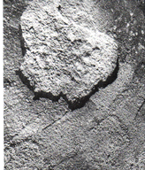
Figure2.1rough background
The thin bed mortar can only compensate differences not more than 2 mm. That issue demands a very even and level background it should be strait and perpendicular. If not the walls or the floors must be leveled; if the underground is too oblique it demands re plastering.

Checking and cleaning the surface
The main criteria required when fixing curved floor and wall tiles with mortar is that on completion of the job the work is of a standard acceptable within the industry and to the client. In order to obtain this requirement many points must be taken into consideration.
- Setting out involves
- Working out the position of cuts
- Setting out tiles to work correct bond·
- Checking walls for parallel, square, plumb, level and straightness; and ·
- Establishing levels and working points
Depending on the type of work being carried out it may be necessary to establish a datum point.
- The datum point could be
- A set floor level
- The ceiling level
- Actual height of the tiles
Having established the datum, a datum line can be produced around the room. A datum line is a level line from which all vertical measurements can be taken. When striking a datum line it is usual to start at a given point and work around the room finishing at the starting point. If the finishing point is higher or lower than the starting point then the line cannot be level and you would have to go through the procedure again until the line is accurate.

    - Making Curve template
To erect a vertical wall inside and outside a room that has a curved ceiling and curved walls. Is there some super easy way to transfer the contour that we need right onto a piece of cardboard or plywood, or do we need to go through the procedure of trimming cardboard to make a template.
Put the piece of wood against the curved ceiling, now there should be a gap between the wood and the ceiling.
Get a thin piece of wood and tape a pen on one of the long sides.
Now use the thin piece of wood, take the end with no pen on it against the roof and press the other end against the big piece of wood. Move it diagonally whilst pressing against the ceiling.
Draw the curve on to the wood, saw of what you don't need and finish the wall. Use some filling if there is a gap at the top, paint it after.
Plastic template
  - First take measurement the circumference of the curved surface.
  - Cutting the plastic template according to the above measurement
  - Stretching the plastic template by wire both side
  - Tight the wire both side tight the wire on nail and chisel.
  - Checking the leveling of curved wall and floor.
  - Start the tile.
Note: when staring the tile laying the tile size is less than 5cm width.
Kerf Spacing
The spacing between kerfs (or the width of the ribs) not only will affect the maximum radius that you can bend, but also how smooth the bent piece will look.
Flats are caused by the difference in flexibility between the thick ribs and the thin webs. As the wood is bent around a form, the webs are flexible and will bend in an attempt to follow the curve. But the ribs are much more rigid and won't bend. This creates a flat surface on the face of the curved piece.
Small flats can be easily removed by sanding. But the wider the flat is, the more sand-youhave to do. To reduce this problem, choose the tightest spacing possible without making the ribs so narrow that they'll crack and break off.
As a general rule, the closer the kerfs are together, the tighter the radius you can bend. But more important, closely spaced kerfs provide a smooth curve.
Note: Unless the radius is extremely large, we wouldn't space the kerfs greater than W. Any greater and you risk creating flats that you'll never be able to remove.
Sanding
If you space the kerfs together closely, you may still experience flats to some degree — even if you can't see them. But they may become visible when you apply a finish.
When sanding plywood, there's another problem. Since face veneers on hardwood
It's very easy to sand right through the face veneer. So sand cautiously — checking regularly to see if the flats have disappeared.
And again, don't use power sanders. They can remove too much wood, too quickly.
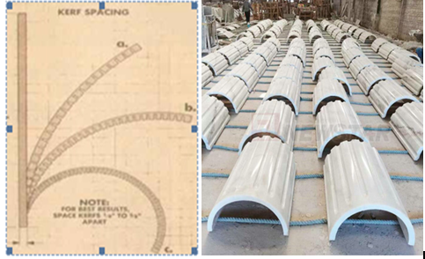
Figure2.2Curve template

Bend plywood for template
Bent plywood can be used to give furniture and cabinetry a sleek, seamless appearance. The easiest way to bend plywood at home is using clamps and a form made out of medium density fiberboard, or by using a ratchet strap. For a stronger, sturdier bend, you may want to glue multiple pieces of plywood together so the piece you’re bending is thicker. Whichever method you use, it’s important you give the plywood enough time to bend.
- Create a form out of MDF (medium density fiberboard). Use a pencil to draw the shape of the curve you want to bend the plywood to on a piece of MDF. Cut out the shape using a bandsaw. Trace the shape onto more MDF and cut out more layers for the form. You want enough layers that the height of the form is about the same as the width of the plywood you’re trying to bend. Glue the layers of MDF together to complete the form
- Clamp the plywood to the form using bar clamps. Place the piece of plywood next to the curved side of the form. Place one end of a bar clamp onthe far side of the form, and the other end of the clamp on the outside-facing part of the plywood directly across from it. Spin the handle on the clamp clockwise to tighten the plywood into place against the form. Continue adding clamps to the plywood until it’s completely clamped along the curved side of the form.
- Leave the plywood clamped to the form overnight. This will give the plywood enough time to bend under the pressure of the clamps. Don't rush this step; if you take the clamps off early the plywood may not hold its curve.
- Unclamp the plywood from the form. Twist the handles on the bar clamps counterclockwise to loosen and remove them
Sheet metal curve template parts from a template that has predefined attributes, including material, bend relief, bend radius, corner relief, gap values, punch representations, and unfolding rules. Sheet metal-specific commands streamline work on both the folded and unfolded model.

Calculating quantity of materials
A standard unit of measurement for tiling work is as follows for floor, wall, skirting and etc. Materials required for tiling work are usually calculated based on their state, as meter square.
Floor & wall tiles and skirting
A. Flooring
a) Terrazzo tile (cement tile) flooring bedded in cement mortar 1:4
1) Terrazzo tile (cement tile) with 2% wastage
Size 20 x 20 = 26pcs/m2
2) 2.5cm thick mortar with 10% wastage for laying.
2.1) Cement = 10.12Kgs /m2
2.2) Sand =0.0275m3/m2
3) Mortar 1:3 for grouting with 20% wastage = 0.001m3/m2
3.1) Cement = 0.46kgs/m2
3.2) Sand =0.001m3/m2
b) Cement screed flooring with an average thickness of 2.5cm
1) Mortar 1:3 with 20% wastage = 0.03m3/m2
1.1) Cement = 13.78kgs/m2
1.2) Sand = 0.03m3/m2
c) 2cm thick marble slate flooring bedded in cement sand screed 1:4
1) Marble slate with 2% wastage = 1.02m2/m2
2) 2.5cm thick mortar with 10% wastage = 0.027m3/m2
2.1) cement = 10.12kgs/m2
2.2) Sand =0.029m3/m2
3) Polish = 0.03kgs/m2
d) 2cm thick marble chips flooring bedded in cement mortar 1:4
1) Marble chips with 20% wastage = 1.2m2/m2
2) Mortar with 10% wastage = 0.0275m3/m2
2.1) cement = 10.12kgs/m2
2.2) Sand = 0.029m3/m2
3) Polish = 0.03kgs/m2
e) 1.5mm,2mm or 2.5mm thick plastic tile flooring.
1) Plastic with 5% wastage size 25x25 = 17pcs/m2
2) Plastic with 5% wastage size 25x25 = 12pcs/m2
3) Adhesive including wastage = 0.3kgs/m2
4) Polish = 0.3kgs/m2
f) Woira wood per-quit flooring
1) Woira wood with 3% wastage =1.03m2/m2
2) Adhesive glue including wastage = 0.4kgs/m2
3) Polish = 0.6kgs/m2
g) Wooden flooring
1) Boarding wastage 2% =1.02m2/m2
2) Nails 4-6cm length
3) Floor joint at 50cm apart with =2.05ml/m2
5% wastage size 5x7cm
4) Nails for joint
h) Carpet flooring
1) Carpet with 5% wastage =1.05m2/m2
B. Wall Tiles
a. Ceramic wall tile
i. Ceramic tile with 5% wastage size
15x15cm = 47pcs/m2
7 ½ x15cm =94pcs/m2
5x10cm =210pcs/m2
10x10cm =105pcs/m2
ii. Mortar 1:4 for bedding with 10% wastage = 0.001m3/m2
1. Cement = 0.37kgs/m2
2. Sand =0.001m3/m2
iii. Cement for grouting the joints = 0.01kgs/m2
b. Mosaic wall tile
i. Mosaic tile with 2% wastage =1.02m2/m2
ii. Mortar 1:4 for bedding with 10% wastage = 0.001m3/m2
1. Cement = 0.37kgs/m2
2. Sand =0.001m3/m2
iii. Cement for grouting the joints = 0.02kgs/m2
C. Skirting
a. Terrazzo tile (Cement tile) for skirting bedded in cement mortar 1:4
i. Tile with 10% wastage size 10x20cm = 11pcs/ml
ii. Mortar 1:4 for bedding with 10% wastage =0.006m3/pcs
1. Cement=0.22kgs/pcs
2. Sand =0.006m3/pcs
b. Plastic tile skirting
i. Plastic tile with 2% wastage =1.02m/ml
ii. Adhesive including wastage =0.01kgs/ml
c. Marble slate skirting
i. Marble slate with 10% wastage =1.10m/ml
ii. Mortar with 10% wastage =0.003m3/ml
1. Cement =1.10kgs/pcs
2. Sand=0.003m3/pc

Cut and fix curved tiles for well and floor
When cutting curves to fit around a toilet, pedestal, or other fitting, you need a profile. There are various types of profiles on the shelf at your local hardware depot or tile store, but I have found the one shown here to be the best. It is long and wide enough to be able to use around many items.
How to cut curves in tile: determine what type of tile you’re using

There are four main types:
Ceramic
Porcelain
Glass
Marble

Ceramic and porcelain are the most commonly used tiles out of these options. They’re both easy to clean, and come in a wide variety of patterns and finishes. Also, they are the easiest of the four to cut and install in the home.
Step 1: measure and mark
The first thing you need to do is measure your cut and mark where you’ll make the cut. It’s best to do this with a pencil. For clean lines, tracing a round object like a cup or bowl is helpful.
Step 2: position the tile on the manual cutter
The tile should be placed with its visible side up on the manual cutter, and it should be placed far enough from the ends of the manual cutter to rotate it as much as will be necessary to execute the cut.
Step 3: score
The scoring wheel on a manual tile cutter only moves in one straight line. As you score for a curved cut, you will need to rotate the tile so that, as you push the handle of the manual cutter forward, the scoring wheel scrapes along the line that you marked in step 2, creating the curve
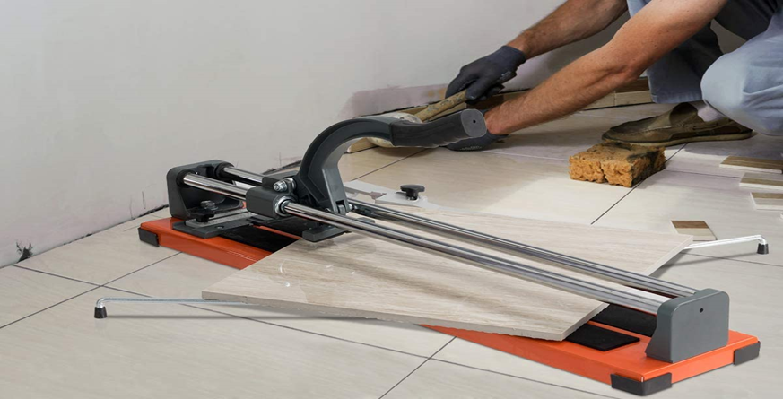
Figure2.3 tile cutting process
Step 4: break
Move the tile to the end of the cutter where the separator works strongest and position the tile so that the end of the scored line is centered beneath the breaker. Then press down over the score with the breaker until the tile separates along the line you marked. You might need to do this at both ends to ensure a clean break.
Step 5: smooth
The edges of the tile after they’ve been cut with a manual tile cutter are very sharp. You need to smooth them down once you’ve finished your curved cut.
It’s a good idea to see how the curved cut matches up to its intended shape, like the edge of the toilet or shower drain, before you smooth.

Preparing mortar and adhesive.
Mortar is a thick paste made from mixing cement, water, and sand. It's primarily used as a sort of glue when building structures with stone, brick, or blocks. While it's the traditional material, it also takes a fair amount of time and labor to mix and apply.
Types of mortar
In tile laying we have two techniques and so two types of mortar
  - Thin bed method
  - Thick bed method
Thin bed method
A part from the mortar method we know the thin bed method, which developed during the last 40 years. For this method a prefabricated dry mortar called adhesive, glue or thin set is necessary. This fine mortar is a mixture of fine sand (grain sizes slammer than 1mm, distinguished cement and different types of chemical additives to provide workability and setting properties. Before use it is advisable to read the used instruction on the backside of every bag.
Advantages:
  - Very fast during installation of tiles
  - Short learning time for the workers
Disadvantages:
  - Material is not available everywhere in Ethiopia
  - The mortar is more expensive than simple sand and cement
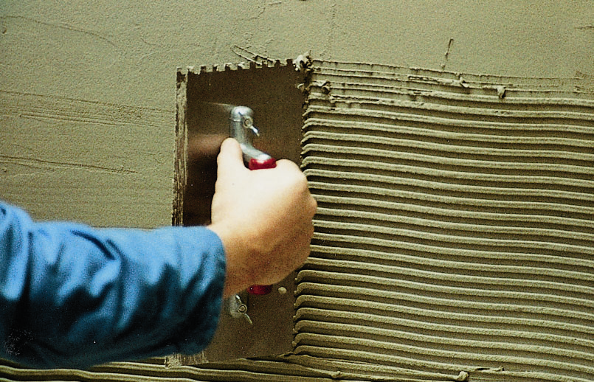
Figure2.4Application of thin bed mortar on a curved wall
Adhesive (Thin bed method)
Adhesive may be used interchangeably with glue, cement, mucilage, or paste, and is any substance applied to one surface, or both surfaces, of two separate items that binds them together and resists their separation. Adjectives may be used in conjunction with the word "adhesive" to describe properties based on the substance's physical or chemical form, the type of materials joined, or conditions under which it is applied.
Adhesive &primer selection involves the following considerations:
  - Substrates: What are you trying to bond? Are the surfaces the same or dissimilar, porous or smooth? Are you covering a large area? Do you have heat or solvent sensitive surfaces?
  - Application restrictions: How do you intend to apply the adhesive- examples: spray, roll, heat gun, cartridge, squeeze bottle?
  - Use Requirements: How does the bonded piece get used? How much strength is required? For example, bonding wood requires much more strength than decorative paper crafts do. What kind of environments might it see? Will it experience temperature extremes or water/steam?
Types of adhesives
There are a large number of adhesive types for various applications. They may be classified in a variety of ways depending on their chemistries (e.g. epoxies, polyurethanes, polyimides), their form (e.g. paste, liquid, film, pellets, tape), their type (e.g. hot melt, reactive hot melt, thermosetting, pressure sensitive, contact, etc.), or their load carrying capability (structural, semi-structural, or non-structural).
Thick bed method
The thick bed method is an old technique that is used since a long time. The mortar only consists from sand, cement and water, properties of sand and cement as mentioned above.
Advantages:
- Material is everywhere available
- Unevenness up to 2 cm can be covered from the mortar easily
- Cheap
Disadvantages:
- The mortar method is very slow
- Is needs a lot of experience
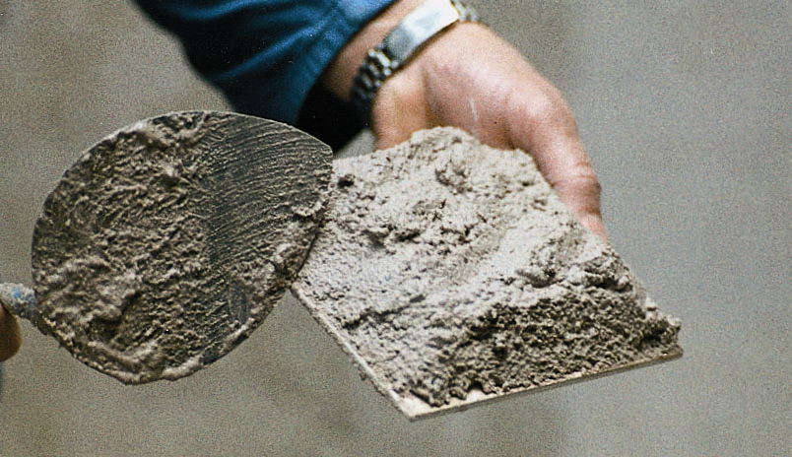
Figure2.5Thick Bed Mortar Applied on curved surface Tile
Cement mortar (thick bed method)
Mortar consists of the body or aggregate, which is fine sand; and the binding material, which is cement mixed thoroughly with water.
Mortar is used to bed tiles as well as for plastering. A good mortar should be easy to use and should harden fast enough that it does not cause delays in the construction. It must be strong enough, long lasting and weatherproof.
  - It is a name given to a mixture of sand or similar inert particles with cementing material and water, having a capacity of hardening into a rock like mass.
  - The maximum size of the inert particles in a mortar is less than 5mm
  - The cementing material is Portland cement and/ or lime
Uses of Mortar
It has many uses in tiling, such as:-
  - Jointing between in tiles
  - Laying tiles
  - The main function of the thick bed mortar used to binding material between the curved wall and tiles
  - In tiling an even surface can be obtained by applying floor and wall tile in different surface.
Cement mortar = P. cement + Sand + water
This sets quickly and develops great strength. It is used in proportions of one part cement to one parts sand (1: 1), which makes quite a strong and workable mix.
Manual mix of mortar
Mixing is one of the most important stages in the process of making mortar because the workability and strength of mortar depend so much on the way it is mixed and on the amount of water added to the mix.
Materials used for making mortar should be accurately measured especially mortar for tiling.
Batching can be done either by weight or by volume.
- By weight:- the most accurate method for high class work, plastering and tiling.
- By volume: - often used in most construction site b/se of it is convenient.
The measured quantities should be first mixed /until the mass is uniform
Dry mix= cement/lime + sand = mix1
Wet mix = mix1 + water.
What water does: Water in the mix does two things: it makes the mortar workable and it combines chemically with the cement to cause hardening. How— ever, only about half the water is required for the chemical reaction and the rest will remain or evaporate slowly as the mortar hardens, leaving small holes or “voids” in the cement. Obviously, the more water there is in the mix, the greater will be the number of voids and the weaker the mortar.
For your 1: 1mixtures, a maximum of 10 liters of water should be added (almost one head painful); never any more than this even if the mix appears to be too dry, as sometimes happens in the first stage of mixing.
Three times dry: The sand and cement is measured on one end of the mixing platform. With two men facing each other across the pile and working their shovels together, turn the whole heap over once to form a pile at the other end of the slab (Figs. 1 & 2). This turning must be repeated twice and results in a so—called ‘dry mix”. The correct method for turning over is to slide the shovel along the top of the platform, pick up a load and spill the load over the top of the new pile. The main point is that each shovelful runs evenly down the sides of the cone. This is the best and easiest way of mixing dry mortar and all other motions should be eliminated. When the dry mix is a uniform color throughout, it is considered to be well mixed.
Three times wet: Form the heap of dry mix into a crater or pool, with the sides drawn out towards the edges of the mixing platform. There should be no mixture left in the centre of the pool. Now gently pour about 3/4 of the total required water into the crater.
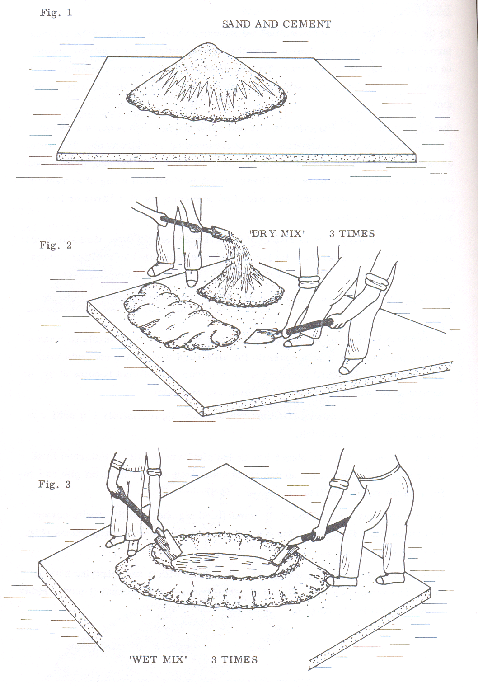
Figure2. 6 Cement mortar hand mix procedures

Techniques for setting out and fixing tiles to curved surfaces
    - Performing specified finish of surfaces ready for tiling
The surface to be tiled needs to be clean to ensure a good bond. Check and remove old coverings like paint, gypsum plaster, bitumen adhesive etc by chipping to expose at least 80% of the surface. Wash off any dust and cement particles with a high pressure washer.
Basics steps to take before tiling a wall
- Removing any screws/photo hooks/nails or other fittings.
- Remove any loose plaster.
- Remove old wallpaper.
- Fill any large cracks/holes in the wall.
- Ensure the wall is level and sand if required.
- Remove any dust with a vacuum and wipe clean the walls.
    - Setting out curves
Tile curved wall and floor Surfaces Extent to curve accurately established from site inspection; Level line set out around wall by intermediate marking using either a spirit level, water level or leveling equipment;
Location of tiles set out to determine balanced design and Identify cutting requirements, if applicable; Template made to form accurate curve line for tiled surface around the wall; Method of laying tiles with identification of location of first tile, determined; Mortar and/or adhesive, prepared where applicable to manufacturer’s specifications;
Where to start tiling is very important so spend some time planning the layout of the tiles before you begin.
There is no definitive way to do this and it may well depend on your particular circumstances like positions of windows, curved walls and alcoves, etc.

Set out and start tiling on curved wall
At a point low down, approx. ¾ the Heightof a tile from the bottom make a true horizontal using a laser level (or spirit level). Lightly nail a timber or plastic template to the wall. This will be your start point and all other tiles will line with this.
Measure the mid-point curved surface. The aim is to start tiling in the middle along your timber or plastic template and end at each side with a part tile. Try laying out your tiles on the template to measure out the positioning, or you could mark the position on the template. When you're happy you can apply the adhesive and lay the first tile. Once you've got the first row of tiles on the rest should follow nicely. Use tile spacers to get each tile line up perfectly.
    - Grouting methods and techniques
Grouting is a construction technique used to fill the gaps or voids between tiles, stones, or other materials to create a strong, durable, and visually appealing surface. It involves the application of a dense fluid material called grout, which is typically a mixture of cement, water, and sometimes sand or other additives. The primary purpose of grouting is to provide stability and support to the tiles or stones, preventing them from shifting or becoming loose.
Types of Grout
Grout can be sanded or unsanded and can have color or an epoxy seal. Choosing the right kind for your project depends on the amount of space between the tiles. Consider these four types of grout:
  - Sanded grout: Sanded grout is stronger than unsanded and adds durability and thickness to tiles with gaps wider than an eighth of an inch. You can use sanded grout with floor tiles or bathroom tiles.
  - Unsanded grout: Tiles with a gap smaller than an eighth of an inch use unsanded grout. It is less thick than sanded grout, making it easier to apply, but it’s less durable over time. You can use unsanded grout on countertops if the grout lines are small enough.
  - Colored grout: Modern grout comes in various colors, from bright white to charcoal black. Darker colors will be easier to keep clean, as stains will be less visible, and they also tend to accentuate lighter tile colors. Lighter grout can blend with light tiles or provide an eye-catching contrast to darker-colored tile.
  - Epoxy grout: Epoxy grout is a pre-sealed grout that requires additional sealant after application. Epoxy is a fast-drying resin that forms a waterproof barrier, protecting this type of grout from mildew and making it more stain-resistant.
Mix Grout
Grout comes in a dry form and must be mixed with water to form the smooth, spreadable medium to fill in the gaps between tiles. Different types and brands will have varying instructions on mixing the grout, including how much water to use. Follow these general steps to mix grout:
  - Prepare a bucket. Have a bucket large enough to contain the dry grout and the volume of water that you will use. Keep in mind that you should only prepare as much grout as you think you can apply in about a half-hour period. After thirty minutes, it will start to dry, making it hard to work with and compromising the final product.
  - Add the grout and mix in the water. Put the dry grout into your container first, and then add the water. It can be helpful to use about a quarter less water than is recommended by the label, since this can be easier to mix initially and will give you extra control over your final product. You are looking for wet grout that has the consistency of peanut butter.
  - Use a grout float to mix up the grout. A grout float is a flat, rectangular trowel with a handle that can be useful for mixing, spreading, and cleaning up your grout.
Grout Tile Procedures
Grouting tile involves some knowledge of the material and a bit of technique. With the right preparation and setup, it can be a straightforward task. Follow these steps to grout tile:
  - Prepare the surface area for the grout. Are you grouting tile in a new space, or are you replacing old, damaged, or stained grout? If you have old grout, remove it before applying new grout. Use a grout saw or a powered rotary tool, and a putty knife to clean out any remaining residue. Ensure that these spaces, called the grout joints, are as clean as possible for the application of the new grout.
  - Start in the corner of project space. Scoop some grout onto a small area of your tiling. It’s useful to start in a corner of your project space and work outward from that point.
  - Spread the grout. Once the grout is on the surface, use your grout float to spread itthrough the length of the gap. Keep your grout float at a 45-degree angle to allow the grout to spread easily without becoming uneven and to prevent the edge of the float from digging into the soft grout.
  - Work diagonally across the gaps. Move in a steady, fluid motion to prevent gouging or digging and to help ensure an even application.
  - Clean up the project area. Once you have all the gaps filled with grout, it’s clean-up time. You can use your grout float to wipe away any extraneous grout on the surface of your tile.
  - Go over the space with a damp sponge. After your grout has mostly dried, prepare two buckets of water. Using a circular motion, sponge away the excess grout on the surface of your tiles. Wring your sponge in one bucket and leave the other for clean water to rehydrate the sponge. You can do a second round of this sponging process about three hours after the initial one is complete to ensure that your tiles are clean and free of grout haze.
  - Seal the grout. Once your grout is completely dry, seal it. Grout sealer ensures that your grout will not absorb or retain moisture. Grout sealer comes in brush, roller, or spray-on applications.
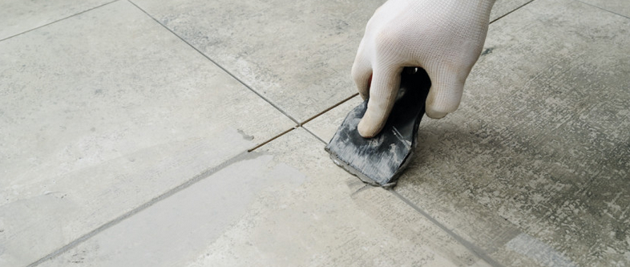
Figure2.7Seal the grout process
    - Polishing tiled surface
Polished floor tiles is a bright tile made from the surface of the whole tile’s body.Hardand Wear-Resistant. It is suitable for use in most indoor spaces, toilets and kitchens. Due to the factors of aesthetics, the ceramic tile market has always been dominated by large and large size polished tiles. It is not only a luxurious atmosphere, magnificent, large space visual effect, to a certain extent, is also a representative of identity and image.
Prep and Test
- Measure your floor to ensure that you have enough polish. Bona Floor Polishes cover anywhere from 350-550 sq. ft. depending on the size of the bottle.
- Clear furniture. Sweep/dry mop and give your floor a good cleaning with your favorite tile floor cleaner.
- Clean grout with a brush and cleaner (a paste of baking soda and water works as well)
- Do a small test area in an inconspicuous spot before applying Bona Polish.
Polish
- Use a microfiber pad for the polish application that is separate from what you use to clean your tile floors.
- Be gentle. Don’t work the polish into the floor. Let the polish do all the work when applying.
- Divide the floor into smaller sections, being sure to give yourself an exit.
- Pour polish directly on the floor in an S pattern. Dampen the microfiber pad with polish to start.
- Keep applicator pad damp with polish to avoid streaking.
- Don’t apply polish too thin – it needs to be a nice, even layer.
- After 1 to 2 hours after polishing, you can walk on the floor with socked feetafter 24 hours, the product is fully cured, ready for furniture, regular foot trafficand pets.

Figure2.8Polish Floor Tiles

Self - Check 1
# Part one choose the best answer for the following equations
  - What is the first step in cutting curves in tiles?
  - Score
  - Position the tile on the manual cutter
  - Measure and mark
  - Smooth
  - What is the primary purpose of a profile when cutting curved tiles?
- To measure the tile
- To guide the cutting tool
- To mark the tile
- To hold the tile in place
  - What is the main difference between ceramic and porcelain tiles?
  - Durability
  - Cost
  - Ease of installation
  - Cleaning requirements
  - Which type of grout is best for tiles with gaps wider than an eighth of an inch?
  - Unsanded grout
  - Sanded grout
  - Epoxy grout
  - Colored grout
  - What is the first step to take before tiling a wall?
- Removing old coverings
- Filling cracks and holes
- Leveling the wall
- Cleaning the surface

# Part two define the following equations
- Define the four main types of tiles: ceramic, porcelain, glass, and marble?
- Determine the appropriate adhesive and primer for different substrates?
- Define surface preparation and its significance in tiling?
- Identify the different types of profiles used for cutting curved tiles?
- Identify the various tests used to assess surface condition?
- Explain the process of cutting curves in tiles?
# Part three true of false
- Before you can fix tile onto a background you have to check it very well?
- Bent plywood can be used to give furniture and cabinetry a sleek, seamless appearance?
- Mortar is a thick paste made from mixing cement, water, and sand. It's primarily used as a sort of glue when building structures with stone, brick, or blocks?
- Polishing is a construction technique used to fill the gaps or voids between tiles, stones, or other materials to create a strong, durable, and visually appealing surface?
- Polish use a microfiber pad for the polish application that is separate from what you use to clean your tile floors.

Operation sheet # one
Operation title:set out and start tiling on curved wall
Instruction: Confirm set out and start tiling on curved wall
Purpose:To acquire the trainees with set out and start tiling on curved wall
Required tools
  - Template ,string ,tape,sprit level ,Plumb bob,
  - nail with hammer, trowel and bucket,clinker tile,spacer
Procedures
  - At a point low down, approx. ¾ the height of a tile from the bottom make a true horizontal using a laser level (or spirit level).
  - Lightly nail a timber or plastic template to the wall. This will be your start point and all other tiles will line with this.
  - Measure the mid-point curved surface. The aim is to start tiling in the middle along your timber or plastic template and end at each side with a part tile.
  - Try laying out your tiles on the template to measure out the positioning, or you could mark the position on the template. When you're happy you can apply the adhesive and lay the first tile.
  - Once you've got the first row of tiles on the rest should follow nicely.
  - Use tile spacers to get each tile line up perfectly.
Precautions:
- Take precaution against weather
- Preparing materials, tools and equipment used for start tiling a curved wall
Quality criteria:
- It should wear personal protective equipment to start tiling a curved wall and apply tiles
- Did trainees proper the trainees proper set out curved surface.

LAP Test

Name: __________________________ Date: ____________
Time started: ____________________ Time finished: _______________
Instruction I:
      - Apply site and equipment safety rules
      - Access tools and equipment appropriate to testing materials
      - Take appropriate samples material for a given task
      - Apply mathematical procedure/solution
Time allowed: 6houres
Task 1:Polish wall or floor tiled surface
Task 2:Apply grouting methods and techniques

Operation sheet #Two
Operation title: lay floor tile
Instruction: laying floor tiles
Purpose: To acquire the trainees with Setting floor tile in easy way
Required tools
- Meter trowel and bucket adhesive water tile cutter template laser level and sprite level
Procedures
  - Spread Mortar
  - Setting Tile
  - Work Progresses
  - Keep the grout joints clear of any setting material.
  - Grout joints should have at least two-thirds of the tile thickness clear for application of the grouting material.
  - Avoid disturbing or walking on tiles.
  - Follow the setting material manufacturer’s directions on curing time before grouting.
  - Curing or drying times will vary due to temperature, humidity and porosity of tile and substrate, in addition to the tile size and the setting material used
Precautions
- Take precaution against weather
- Preparing materials, tools and equipment Setting your floor tile in easy way
Quality criteria
- It should wear personal protective equipment to start tiling a curved wall and apply tiles trainees proper the trainees proper set out curved surface

LAP Test
Name: __________________________ Date: ____________
Time started: ____________________ Time finished: _______________
Instruction I:
      - Apply site and equipment safety rules
      - Access tools and equipment appropriate to testing materials
      - Take appropriate samples material for a given task
      - Apply mathematical procedure/solution
Time allowed: hours
Task 1: Prepare mortar and adhesive for tiling work
Task 2: Cut and fix tile for curved or circular surface

UNIT THREE: Maintenance and Replacement Of Tiles
This unit is developed to provide you the necessary information regarding the following content coverage and topics:
- Maintenance of ceramic tiles
- Reasons for cracks in tiles
- Replacement of broken tiles
- Specification for Ceramic Tiles
This unit will also assist you to attain the learning outcomes stated in the cover page. Specifically, upon completion of this learning guide, you will be able to:
- Implement Maintenance of ceramic tiles
- Identify Reasons for cracks in tiles
- Implement Replacement of broken tiles
- Specify Specification for Ceramic Tiles

Maintenance of ceramic tiles
After laying, ceramic tiles floor /wall shall be kept clean and free from cement, oil, paint, distemper, plaster droppings and all materials likely to stain or spoil the tiles. If appliances, such as trestles, ladders, steps etc, have to be used for electricians, plumbers and other light work, it shall be ensured that parts in contact with the flooring are padded and no sliding of the appliances on the finished flooring occurs. Stair finishes, particularly nosing, are liable to be damaged by dragging or dropping of articles up or down the stairs. It is, therefore, necessary to protect the stairs against such causes of damage. Polished tile-floors shall be regularly swabbed with clean water followed by brisk rubbing with dry linen. If they are very dirty, water and soap may be used. Care shall be taken to remove any soap film deposited in washing, as failure to do so will result in the floor becoming slippery and dull-looking. Use of soda, acid, etc, shall be avoided.

Problems
The most serious problems with ceramic tiles are incomplete bonding of the tile to the base material and differential movements between tiles and the concrete sub-floor supporting them. If the bond is incomplete, as may result; if the bond coat is applied to a dirty base material or tiles are laid too dry, too wet, or not tapped (beaten in) sufficiently, the tiles will not fix strongly in place and slight pressure or impact will be sufficient to break them loose. The bond may also be broken as a result of differential movements between the tiles and the concrete sub-floor. Concrete shrinks as it dries and ages, whereas ceramic tiles expand. The resulting stresses set up between the tiles and the concrete may lead to the shearing off of the tiles, either where they contact the bond coat or in the bond coat itself. The tiles then lift free of the sub-floor in an "arching" pattern or buckle in a ridge.

The stress developed between the tiles and the concrete sub-floor as a result of differential movement increases with increasing expanse of floor. In a small floor it is unlikely that enough stress will develop to shear the tiles from the concrete; a large floor can therefore be designed to negate the effects of differential movement by treating it as a number of relatively small floor areas, separated by joints designed to accommodate movement. Normally to cater this requirement, it is recommended to keep a gap of 1.5 mm between two tiles while laying/fixing.
However, for application on large areas, for detailed information on the need for control joints and their design, the recommendations of the supplier of particular floor tile materials should be sought and followed.
Maintenance
Ceramic tiles are easy to maintain and normally require little maintenance efforts. A tile surface may be washed with warm water to remove minor soiling or with warm water containing detergent when soiling is heavy. Mildly abrasive scouring powder can be used on unglazed tiles but not on glazed ones. A cleaning solution should not be left on the surface any longer than is necessary; and after cleaning, the surface should be rinsed thoroughly and the water mopped up to leave the surface as dry as possible. Heavy stains are usually not difficult to remove. Stains of ink, blood, coffee, mustard oil and food juice may be taken off by the use of household bleach; the surface is washed for 5 to 10 minutes then rinsed with water. Grease and fat, can be removed by washing with a solution of 10 per cent sodium carbonate in water or 5 per cent caustic soda, allowing the solution to be in contact with the surface for about an hour, then rinsing thoroughly. Wax, tar and asphalt can be loosened and scraped off by applying kerosene, naptha or carbon tetrachloride. Iron stains such as rust stains and tool marks may be removed by washing with a 5 per cent solution of hydrochloric acid in water; the same remedy is used for the removal of hard water deposits and efflorescence of calcium or magnesium carbonate. This solution or other acid should not be used on glazed tile, and when used on other tiles must be rinsed thoroughly.
The application of linseed oil or a polish to ceramic tile floors is not recommended. Such treatments not only make the surface slippery and dangerous to walk on but also make the tiles more difficult to clean.

Reasons for cracks in tiles
- Cracks are often observed on tiles and they can occurs due to several reasons, such as: Uneven settlement of the wall backing the tiled work.
- Rusting of concealed pipelines or reinforcement causes sapling of concrete or masonry leading to cracks in concrete or masonry base as well as on the tiled work over it.
- Expansive chemical reaction due to use of poor quality zero or any other material mixed with cement can cause tiles to crack.
- Excessive thickness of paste used to fix the tile, which often shrinks and cracks the tile. Uneven application of adhesive paste leaving voids. If load or impact is given on this hollow area it will cause the tile to crack.
- Poor quality of tiles can also crack easily.

Replacement of broken tiles
Replacement of damaged tiles shall be carried out as under:
- First of all, broken tile shall be removed with the use of chisel and hammer, taking care that not to damage the adjoining tiles or their bond. To provide required space to set the new tiles in level with the floor surface, enough of the bed, beneath the damaged tiles shall be removed.
- Then, after cleaning and wetting of bedding, fix new tile with cement sand paste or cement slurry, tapping the tile gently with a wooden mallet till it is properly bedded and in level with the adjoining tiles.
- After filling the joints, tile shall be cured, cleaned and polished.

Specification for Ceramic Tiles
Specification for ceramic tiles with different water absorption (E) are covered in the following BIS standards:
- E > 10% - BIS 13753 of 1993
- 6% < E < 10% BIS - 13754 of 1993
- 3% < E < 6% BIS - 13755 of 1993
- E < 3% BIS - 13756 of 1993
Properties of tiles
Besides shape, size and surface quality following properties are normally checked:
- Friction Coefficient is the relative slip resistance of a Ceramic Tile. The friction test is a laboratory or field test to provide comparable slip resistance values for floor tiles. The measurements provide a valuable insight in evaluating slip resistance. The higher the friction coefficient more is the slip resistance of the tile.
- Abrasion Resistance measures the hardness of the glaze and the overall durability of the tile. Based on the results of this test and anti-skid properties,tiles are graded in various groups/grade as per Porcelain Enamel Institute (P.E.I.) rating with their recommended areas of use, as under.
- Scratch hardness of a tile refers to the exterior surface of the tile and how easily it will mar. It is important for floor tiles. Higher the number the better is the tile. A value of 7 or greater is normally recommended for commercial applications.
- Water Absorption measures the susceptibility of the body of the tile to absorb water. Tiles range from impervious (less than 0.5%) to Non-Vitreous (more than 7.0%). Exterior applications will require an impervious tile. The water absorption may impact the installation method, as well. It is also used as a measure of stain resistance of unglazed tiles. Generally, for unpolished, unglazed tile, lower is the water absorption the greater is the stain resistance.
- Bending/Breaking Strength measures the expected load bearing capacity. The higher the breaking strength, the stronger and more durable is the tile.
- Chemical Resistance measures the resistance of the tile to various chemicals. An application where there is exposure to staining chemicals and substances, tiles resistant to them, shall be used.
Table3.1recommendation of tiles for difference application
Group | Group Recommended applications
I | Light traffic areas – residential rooms, bedrooms, living, drawing rooms.
II | Medium- light traffic areas - residential rooms, bedrooms, kitchen, living, drawing rooms.
III | Medium – heavy traffic areas with low abrasion – bathrooms, lobbies, balconies and all rooms in private residences.
IV | IV Medium- heavy traffic areas with high abrasion – offices, classrooms, hospital rooms, hotel rooms, showrooms, banks, and all heavy foot traffic interiors.
V | Intense and heavy traffic areas having intensive foot traffic – office lobbies, schools, hospitals, hotels, supermarkets, commercial complexes, all reception areas, corridors, gymnasiums, parking, and heavy traffic exteriors.

Quality requirement
Normally tiles used for the work shall satisfy following surface quality & dimensional requirements, physical, chemical and thermal properties
Table3.2 quality requirement in difference properties
Sr. | Characteristics | Wall Tile |  | Floor Tile |  | Vitrified Tile
A | Dimension & Surface Quality
1 | Deviation in length |  | +/- 0.5% |  | +/- 0.5% |  | +/- 0.6%
2 | Deviation in thickness |  | +/- 0.5% |  | +/- 0.5% |  | +/- 0.5%
3 | Straightness of sides |  | +/- 0.3% |  | +/- 0.5% |  | +/- 0.5%
4 | Rectangularity |  | +/- 0.5% |  | +/- 0.5% |  | +/- 0.6%
5 | Surface flatness (warpage) |  | +/- 0.5% |  | +/- 0.5% |  | +/- 0.5%
6 | Surface quality |  | Min.95% free from defects |  | Min.95% free from defects |  | Min.95% free from defects
B | Physical Properties
1 | Water absorption (%) |  | >10% &< 20% |  | 3% - 6% |  | < 0.5%
2 | Bending strength (N/sq.mm) |  | > = 15 |  | > = 22 |  | >=27
3 | Scratch hardness (Mohs) >= 3 |  | Min.3 |  | Min.5 |  | Min.6
4 | Resistance to surface abrasion |  | Grade II |  | To be specified by manufacturer |  | To be specified bymanufacturer
5 | Crazing resistance |  | Min. 2 cycles |  | Min. 2 cycles |  | required
C | Chemical Properties
1 | Resistance to staining |  | Min. class 2 |  | Min. class 2 |  | -----
2 | Resistance to household chemicals |  | Min. class B |  | Min. class B |  | required
D | Thermal Properties
1 | Thermal shock resistance |  | Resistance to 10 cycles |  | Resistance to 10 cycles |  | No damage
2 | Thermal expansion |  | Max. 9 x 10-6 K-1 at 1000C |  | Max. 9 x 10-6 K-1 at 1000C |  | Max. 9 x 10-6 K-1 at 1000C

Self – check 3.1
# Part one choose the best answer for the following questions
- What is the main cause of problems with ceramic tile installation?
  - Incomplete bonding of tiles
  - Improper cleaning methods
  - Excessive use of cleaning solutions
  - Lack of control joints
- What is the recommended method for cleaning polished ceramic tile floors?
  - Wiping with a dry cloth
  - Using a mild detergent
  - Scrubbing with a brush
  - Mopping with warm water
- What is the purpose of measuring the friction coefficient of a tile?
  - To assess its chemical resistance
  - To determine its water absorption
  - To measure its bending strength
  - To evaluate its slip resistance
- What is the recommended gap between tiles for large areas to accommodate differential movement?
  - 15 mm
  - 10 mm
  - 1.5 mm
  - 5 mm
- What is the impact of water absorption on tile installation?
  - It impacts the slip resistance
  - It affects the surface quality
  - It determines the bending strength
  - It may impact the installation method

#Part Two define and least the following questions
- Recognize the need for control joints in large areas of ceramic tile flooring?
- Reflect on recommended maintenance methods for ceramic tiles?
- Explain the importance of protecting surfaces during construction work?
- Identify proper cleaning methods for ceramic tile floors and walls?
- Define potential problems with ceramic tile installation?
- Reflect on recommended maintenance methods for ceramic tiles?
#Part three say true or false
  - The most serious problems with ceramic tiles are incomplete bonding of the tile to the base material?
  - Ceramic tiles are easy to maintain and normally require little maintenance efforts?
  - Expansive chemical reaction due to use of poor quality zero or any other material mixed with cement can cause tiles to crack?
  - Physical Resistance measures the resistance of the tile to various chemicals?
  - Water Absorption measures the susceptibility of the body of the tile to absorbwater?

Reference
https://en.wikipedia.org/wiki/Tile
https://theconstructor.org/surveying/types-of-levels-leveling-surveying/14690/
https://www.bona.com/en/homeowner/how-to/how-to-polish-tile-floors1/
https://www.ehow.com/how_6396718_install-stainless-steel-sheets.html
https://www.ehow.com/how_7262499_grout-edges-tile-backsplash.html
https://www.interiordezine.com/color/texture-pattern/
https://www.linkedin.com/pulse/importance-fire-fighting-equipment-protection-john-holt-plc
https://www.masterclass.com/articles/how-to-grout-tile
https://www.rubi.com/en/blog/how-to-cut-curves-in-tile/
https://www.tilebar.com/learn/ultimate-guide-to-the-different-tile-types/
https://www.tileshop.com/blog/tile-patterns-and-layouts/
ps://emergencyresponseafrica.com/10-organizational-benefits-of-cpr-first-aid-training/
Safe work procedurewalk behind rotary cultivator (petrol)

Developer Profile

Name | Qualification  (Level) | Field of study | Institute | Phone number | Email
Birhanu Demelash | A | M.Sc. COTM  BSc Road construction, | woldeya poly technic | 0910686578 | birhanudemelash14@gmail.com
Mihiretab Gashaw | B | BSc building construction technology and Computer engineering | Addis ketema industrial | 0922079011 | mihiretabgashaw@gmail.com
Nasir Amane | B | BSC construction technology | Shashemane poly technic | 0916005870 | nasiraman5870@gmail.com
NIGUSSIE TESHOME | A | Geotechnical enginer(M.sc)  Civil engineering (B.sc) | Arbaminch PTC | 0913767770 | teshomeng@gmail.com
Tesfaye Ayalew | A | MSc in COTM  BSC in Building Construction Technology | Debre Brhan poly technic | 0910469898 | tesfaye.ay21@gmail.com
WONDWESN GIRMA | A | COTM(M.sc)  Civil engineering (B.sc) | Harar polytechnic College | 0912778365  0703608365 | wondwesngirma@gmail.com

