Finishing Construction Works
Level- III
Based on October 2023, Curriculum Version- II
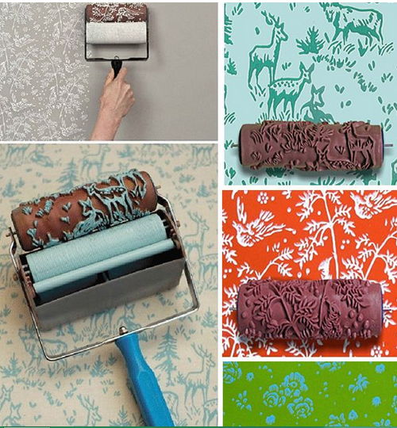

Module Title: Decorative texture coat Paint Finishing
Module Code: EIS FCW3 M10 0322
Nominal Duration: 150 Hours

Prepared by: Ministry of Labor and Skill

October, 2023
Addis Ababa, Ethiopia

ACKNOWLEDGEMENTS
The Ministry of Labor and Skills wishes to thank MoLS experts, regional labor and skill bureaus, Regional TVET bureaus, Universities, TVET Colleges, TVT trainers, university lecturers, and industry experts who contributed their time and professional experience to the development of this curriculum for basic finishing.
We would like to express our appreciation to the Ministry of Labor and Skills for their technical and financial support and workshop facilitation of this training module's development.

ACRONYMS

LAP Test Learning Activity Performance Test
LG Learning Guide
OSH Occupational Safety and Health
PPE Personal Protective Equipment
SWMP Site Waste Management Plan
OPC Ordinary Portland cement
FIG Figure
WHS Work Health and Safety
UV Ultraviolet
PVC polyvinyl chloride
HDP High density polystyrene
VOC Volatile organic compound

Contents
ACKNOWLEDGEMENTS 2
ACRONYMS 3
INTRODUCTION TO THE MODULE 6
Unit One: Concept of decorative paint 7
1.1 Introduction to Decorative Paint Finishing 8
1.2 Types of decorative paint 9
1.3 OHS requirement 13
1.4 Materials, Tools, and Equipment 16
1.5. Materials quantity 24
Self-Check -1 27
Unit: Two Preparation of Materials and Surfaces 28
2.1 Set out painting area 29
2.2. Surface Preparation for Paint Application 31
2.3 Maintaining Proper Ventilation in the Working Area 36
Self-Check 2 39
Unit Three: Apply mirror paint finish and texture coat by brush and roller 40
3.1. Adjusting paint viscosity 41
3.2. Coats of paint 44
3.3 Mix and apply texture paint 50
Self-Check 3 55
Unit four: Apply broken color effects and texture coat by spray 56
4.1 Preparing back ground coat surface 57
4.2 Applying clear coating sheen level finishing 64
4.3 Operating spray equipment 68
Self-Check 4 72
5.1. Preparation of back ground surface ground coat surface 74
5.2. Mixing designed proportions for wood and marble 75
5.3. Applying clear coating sheen level finishing 81
Self-Check 5 84
OPERATION SHEET-2 85
OPERATION SHEET-3 86
LAP Test -2 87
Unit six: Apply stencils 88
6.1 Selecting and laid stencil design material 89
6.2 Apply and design location of stencil 93
6.3. Applying stencils pattern separate color 98
Self-check -6 103
OPERATION SHEET-6 104
LAP Test -6 105
Unit seven: Apply lining by brush 106
7.1. Selecting and set out lining work 107
7.2. Selecting paint materials 110
7.3. Lining work techniques 112
Self-check-7 117
OPERATION SHEET-7 118
LAP Test -7 120
Developer profile 121

INTRODUCTION TO THE MODULE
Applying Decorative texture coat Paint Finishinghelps to Concept of decorative paint Preparation of material and surface Apply mirror paint finish and texture coat by brush and roller Apply broken color effects and texture coat by spray Produce imitation for marble and wood grain effect Apply stencils Apply lining by brush Infinishing construction work this module covers skill knowledge and attitude required toApplying Decorative texture coat Paint Finishing. This module is designed to meet the industry requirement under the occupational standard, particularly for the unit of competency: Applying Decorative texture coat Paint Finishing
MODULE UNITS
- Concept of decorative paint
- Preparation of material and surface
- Apply mirror paint finish and texture coat by brush and roller
- Apply broken color effects and texture coat by spray
- Produce imitation for marble and wood grain effect
- Apply stencils
- Apply lining by brush
LEARNING OBJECTIVES OF THE MODULE
At the end of this session, the students will able to:
- Understand Concept of decorative paint
- Prepare material and surface
- Apply mirror paint finish and texture coat by brush and roller
- Apply broken color effects and texture coat by spray
- Produce imitation for marble and wood grain effect
- Apply stencils
- Apply lining by brush
MODULE LEARNING INSTRUCTIONS
- Read the specific objectives of this learning guide (LG).
- Follow the instructions described below.
- Read the information written in the information sheet.
- Accomplishment the self-check questions.
- Accomplishment operation sheet (if any).
- Accomplishment learning activity performance (LAP) test (if any).

Unit One: Concept of decorative paint
This unit to provide you the necessary information regarding the following content coverage and topics:
- Introduction to decorative pant finishing
- Types of paint
- OHS requirement
- material , tools and equipment
- materials quantity
- work instruction
Preservation of Fibrous Plaster This guide will also assist you to attain the learning outcomes stated in the Above topic contact. Specifically, upon completion of this learning guide, you will be able to:
- Introduce decorative pant finishing
- Identify Types of paint
- Follow OHS requirement
- Select material , tools and equipment
- Identify materials quantity
- Obtain work instruction

1.1 Introduction to Decorative Paint Finishing
    - Introduction
Decorative paint finishing is a specialized technique used to enhance the aesthetic appeal of surfaces, creating visually appealing and unique effects. It involves applying various decorative coatings and textures to walls, ceilings, furniture, and other surfaces to achieve desired decorative effects.
Decorative paint finishes offer a wide range of creative possibilities, allowing individuals to personalize their living or working spaces. These finishes can mimic natural materials like marble, wood grain, or metal, or they can incorporate abstract designs, patterns, or textures. They can be used in residential, commercial, or public spaces to create stunning visual effects and add depth and character to the environment.
Fig 1.1 decorative wall paint

    - Importance of Decorative Paint Finishing:
1. Aesthetics: Decorative paint finishes add beauty and visual interest to any space. They can transform ordinary surfaces into unique works of art, enhancing the overall aesthetics of the interior or exterior.
2. Personalization: Decorative finishes allow individuals to express their personal style and create a customized look. They provide an opportunity to infuse personality and creativity into the design of a space.
3. Versatility: With a wide range of techniques and materials available, decorative paint finishing offers versatility in design. It can be used to achieve various effects, from subtle and understated to bold and dramatic, depending on the desired outcome.
4. Value Addition: Decorative finishes can significantly increase the value of a property. They can create a high-end and luxurious look, making a space more desirable and appealing to potential buyers or tenants.
    - Characteristics of Decorative Paint Finishing:
1. Texture: Decorative paint finishes often incorporate texture, adding tactile interest to surfaces. Textured finishes can create depth, dimension, and a sense of richness, making the surface more visually appealing.
2. Durability: Quality decorative paint finishes are designed to be durable and long-lasting. They are formulated to withstand wear and tear, resist fading, and maintain their visual appeal over time.
3. Customization: Decorative paint finishes offer a high degree of customization. They can be tailored to suit the specific design requirements and preferences of individuals or clients, allowing for unique and personalized results.
4. Application Techniques: Decorative paint finishes require specialized application techniques. Skilled craftsmen or painters are trained to apply these finishes using various tools, brushes, rollers, or sprayers to achieve the desired effects.
In summary, decorative paint finishing is a creative and versatile technique that adds beauty, personalization, and value to spaces. It offers a wide range of design possibilities and allows individuals to create unique and visually stunning effects on various surfaces.

1.2 Types of decorative paint
There are several types of decorative paint that are commonly used to create various effects and finishes. Here are some of the most popular types:
1. Emulsion Paint: Emulsion paint, also known as latex paint, is a water-based paint that is widely used for interior wall surfaces. It is available in various finishes, including matte, eggshell, satin, and gloss. Emulsion paint is easy to apply, dries quickly, and offers good durability.
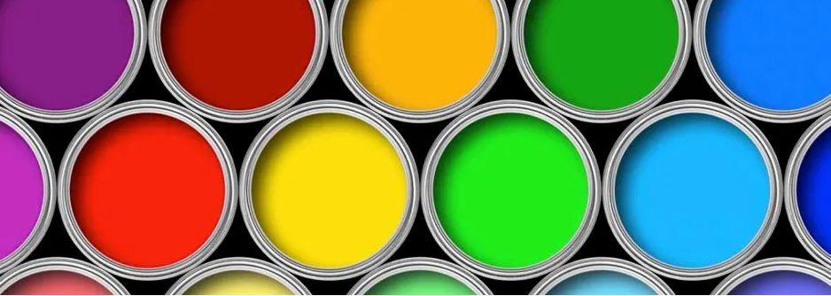
Fig .1.2 Emulsion Paint
2. Enamel Paint: Enamel paint is a solvent-based paint that provides a hard, glossy finish. It is commonly used for painting furniture, doors, trim, and other surfaces that require a durable and smooth finish. Enamel paint is available in both oil-based and water-based formulations.
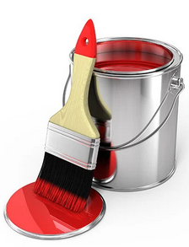
Fig .1.3.Enamel Paint
3. Metallic Paint: Metallic paint contains metallic pigments or flakes that create a shimmering or reflective effect on surfaces. It is often used to add a touch of glamour and sophistication to interior walls, furniture, and decorative accents.
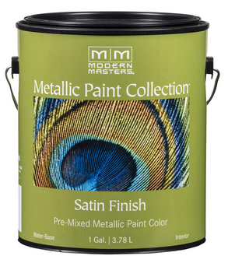
Fig .1.4 Metallic Paint
4. Chalk Paint: Chalk paint is a unique type of paint that creates a matte, chalky finish. It is known for its excellent coverage and ability to adhere to various surfaces without the need for extensive surface preparation. Chalk paint is popular for creating vintage, distressed, or shabby-chic looks.
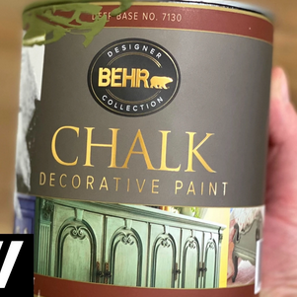
Fig .1 .5 Chalk Paint
5. Textured Paint: Textured paint contains additives or aggregates that create texture and depth on surfaces. It is commonly used to add visual interest to walls and ceilings, creating effects like sandstone, stucco, or textured patterns.
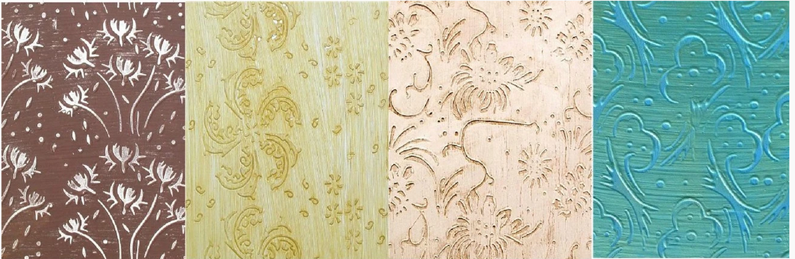
Fig .1.6 Textured Paint
6. Glaze Paint: Glaze paint is a translucent paint that is applied over a base coat to create depth and dimension. It is often used for decorative finishes such as faux finishes, marbling, or antiquing. Glaze paint allows for intricate detailing and can be used to create various effects.
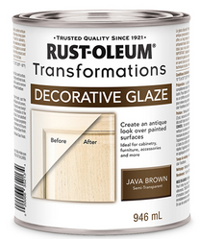
Fig .1.7 Glaze Paint
7. Spray Paint: Spray paint is a versatile type of paint that is applied using a spray can or spray gun. It provides a smooth and even finish and is commonly used for small projects, furniture, or surfaces that are difficult to paint with a brush or roller. Spray paint is available in various colors and finishes.
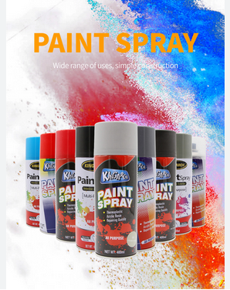
Fig .1.8 Spray Paint
8. Stencil Paint: Stencil paint is specifically formulated for stenciling techniques. It is often used to create intricate patterns, designs, or lettering on walls, furniture, or other surfaces. Stencil paint is available in a wide range of colors and can be used with different stencil materials.
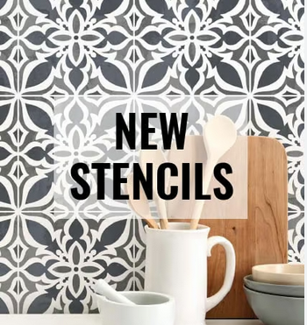
Fig .1.9 Stencil Paint
These are just a few examples of decorative paint types. Each type offers unique characteristics and application methods, allowing for a wide range of creative possibilities in decorative paint finishing.

OHS requirement
    - Concept of OHS:
The concept of OHS, or Occupational Health and Safety, refers to a system of practices, policies, and regulations designed to protect and promote the health, safety, and well-being of individuals within a workplace. It involves identifying and managing workplace hazards, implementing safety measures, providing appropriate training and education, and ensuring compliance with relevant laws and regulations.

    - Personal Protective Equipment
During painting activities, several examples of personal protective equipment (PPE) should be used to ensure the safety and well-being of workers. Some common examples of PPE for painting include
1. Respiratory Protection: Depending on the type of paint being used and the potential for airborne particles or fumes, respiratory protection may be necessary. This can include disposable or reusable respirators or masks designed to filter out paint particles or chemicals.
2. Eye Protection: Eye protection is essential to prevent paint or debris from coming into contact with the eyes. Safety glasses or goggles with side shields should be worn to provide adequate protection.
3. Hand Protection: Hands are often directly exposed to paint and paint-related chemicals, so wearing appropriate hand protection is crucial. Disposable or reusable gloves made of materials such as latex, nit rile, or neoprene can provide a barrier between the skin and the paint.
4. Skin Protection: Exposed skin should be protected from contact with paint, which could potentially cause irritation or allergic reactions. Wearing long-sleeved shirts, long pants, and closed-toe shoes can help minimize skin exposure. Additionally, coveralls or protective clothing specifically designed for painting may be used.
5. Hearing Protection: In some cases, painting activities can be accompanied by loud noise, such as when using power tools or operating in a noisy environment. Earplugs or earmuffs should be used to protect hearing from excessive noise levels.

It's important to note that the specific PPE requirements may vary depending on the type of paint, the application method, and any additional hazards present in the painting environment. Employers should conduct a thorough risk assessment and provide workers with the appropriate PPE based on the identified hazards and regulatory requirements. Workers should be trained on the proper use, maintenance, and limitations of the PPE provided.

Fig.1.10 personal protective equipment

    - Safety Signage and Barricades:
Safety signage and barricades play a crucial role in maintaining a safe working environment during painting activities. Some OHS requirements related to safety signage and barricades include:
- Clearly displaying signs to indicate potential hazards such as wet surfaces, falling objects, or restricted areas.
- Using barricades or barriers to prevent unauthorized access to hazardous areas or work zones.
- Providing directions and emergency exit signs to ensure safe evacuation routes.
- Displaying warnings and instructions related to the use of personal protective equipment (PPE) or specific safety procedures.
These measures help to communicate potential risks and ensure that workers and others in the vicinity are aware of the necessary precautions to take.
    - Environmental Protection:
Environmental protection is an important aspect of OHS in painting activities. It involves taking measures to minimize the impact of painting processes on the environment. Some OHS requirements related to environmental protection in painting include:
- Using environmentally friendly paint products that have low volatile organic compound (VOC) content and are less harmful to air quality.
- Properly storing and handling paint and paint-related materials to prevent spills, leaks, or contamination.
- Implementing procedures for the safe disposal or recycling of paint waste, brushes, and other materials.
- Taking precautions to prevent air, water, or soil pollution during painting activities, such as using containment systems or appropriate ventilation.
By adhering to these requirements, painters can reduce the potential negative environmental impacts associated with their work and contribute to a healthier and safer workplace.

1.4 Materials, Tools, and Equipment
    - Materials
- Decorative paint: This can include various types such as latex paint, acrylic paint, enamel paint, or specialty decorative paints like metallic or textured finishes.
- Primer: Used for preparing the surface before applying the decorative paint.
- Paint additives: These can include extenders, retarders, or flow agents to modify the paint's properties.
- Paint thinner or solvent: Used for thinning the paint or cleaning brushes and tools.
- Drop cloths or plastic sheeting: Used to protect surfaces and furniture from paint spills or splatters.
- Sandpaper or sanding blocks: Used for surface preparation and smoothing rough areas.
- Patching compound: Used for filling cracks, holes, or imperfections in the surface.
- Painter's tape: Used for masking off areas that should not be painted, such as trim or windows.
    - Tools and Equipment:
- Synthetic brushes
Versatile, long-lasting and well suited to the application of water-based paints, a small collection of synthetic brushes will do for most interior projects. Buy a four to six-inch brush for large flat areas, a two to three-inch one for door edges and skirting boards, and a one-inch brush for cutting in. For longevity, source good quality brushes to lower the risk of bristles falling out.
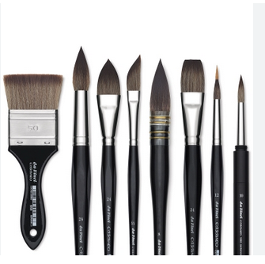
Fig .1.11 Synthetic brushes

- Dust sheets
It’s always best to remove furniture from the room you want to paint. However, you still need to cover the floors and anything you can’t move. Invest in quality dust sheets so you can reuse them for every project. They’re a great addition to your DIY toolkit and a more eco-friendly option than disposable ones.
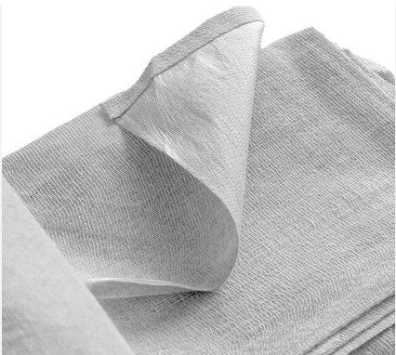
Fig .1.12 Dust sheets

- Fillers and putty knife
No matter what type of surface you’re painting, it’s likely to have holes, bumps and cracks. For a smooth finish on surfaces, it’s crucial to repair any damage first. Decorators’ caulk is the most flexible solution for filling gaps. You’ll need a putty-filling knife to apply it and a damp sponge to wipe away excess.
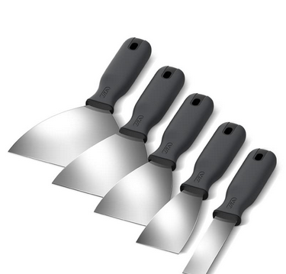
Fig .1.13. Fillers and putty knife

- Sandpaper and block
Without sanding surfaces, bumps and imperfections are likely to show up through your fresh paint. Add different types and grades of sandpaper to your decorating toolbox, including flexible blocks to help smooth rough surfaces quickly. Your paint finish will thank you for it!
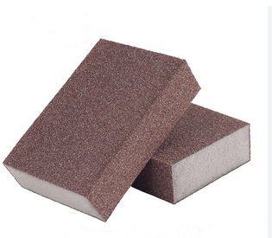
Fig .1.14 Sandpaper and block

- Absorbent cloths and dusting brush
The very first things you need to do before painting is thoroughly wipe down surfaces. You’ll also need to do this after filling and sanding. Make sure you have a dusting brush and absorbent cloths before you start. While you can’t fit it in your decorating toolbox, having the vacuum cleaner on hand helps too.
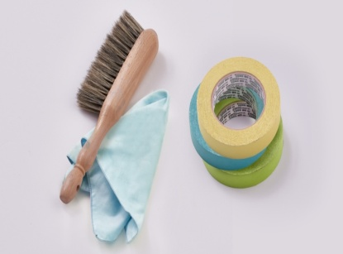
Fig .1.15 Absorbent cloths and dusting brush
- Tapes
Low-tack masking or decorators’ tape is a must for protecting surfaces you don’t want to accidentally paint. This includes skirting boards, ceilings and fixtures you’d like to paint in a different colour. It pays to get a higher quality tape with good adhesive for easy removal.
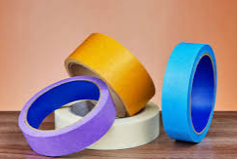
Fig .1.16 Tapes
- Mixing stick for stirring
It’s important to stir your paint before applying it, as it can separate in the tin. Don’t forget to give it a stir with a mixing stick each time, to ensure the colour and consistency are as they should be.
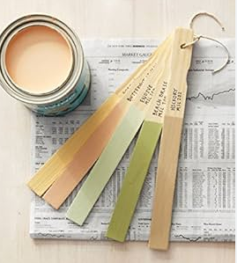
Fig .1.17 mixing stick for stirring

- Ladder
Even if you can reach higher surfaces, your neck and arms won’t thank you for trying after a day of painting. Buy a good-quality step ladder to paint all areas of a room in safety and give your body a break.
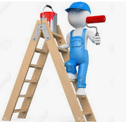
Fig .1.18.Lader
- Paintbrushes: Different sizes and types of brushes for cutting in edges, corners, and details.
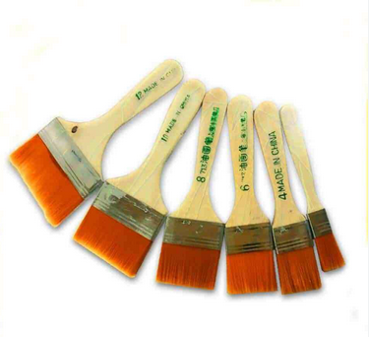
Fig .1 .19 Paintbrushes
- Rollers and roller covers: Used for applying paint to larger areas quickly and efficiently.
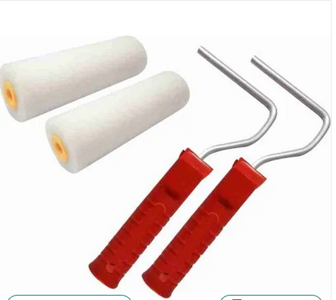
Fig .1.20 Rollers and roller covers
- Paint trays or buckets: Used for holding and loading paint for brush or roller application.
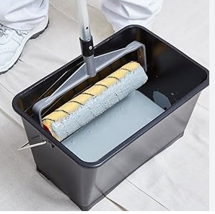
Fig .1.21 Paint trays or buckets
- Paint sprayer: Optional equipment for larger projects or achieving a more even and professional.
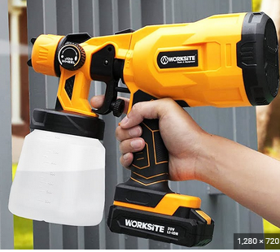
Fig .121.Paint sprayer

- Extension poles: Used to reach high or difficult-to-access areas when using a roller or paintbrush.

Fig .1.22 Extension poles
- Cleaning supplies: Rags, sponges, or brushes for cleaning surfaces, tools, and equipment.
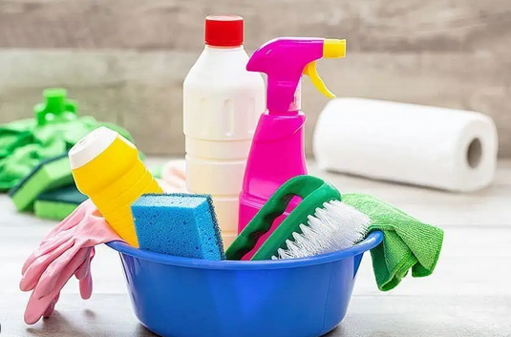
Fig .1.23 Cleaning supplies
- spirit level
Using a plumb line and spirit level allows you to make sure you are hanging your wallpaper perfectly straight. Use the plumb line and mark with a pencil to mark where the wall is straight. Then use your spirit level and pencil and draw a straight line down the entire wall. You can now follow this line with your paper so you know you are applying it perfectly straight.

Fig .1.24.Sprit Level
16. Pattern roller brush

A pattern roller brush, also known as a textured roller brush or decorative roller brush, is a type of paint roller brush that is designed to create patterned or textured finishes on walls, ceilings, and other surfaces. It is commonly used in decorative painting techniques to achieve unique and visually interesting effects.
Pattern roller brushes typically consist of a cylindrical roller with a textured or patterned surface. The roller is attached to a handle or frame that allows it to be easily rolled across the surface being painted. As the roller is applied, the textured surface transfers the pattern or texture onto the painted surface, creating the desired effect.

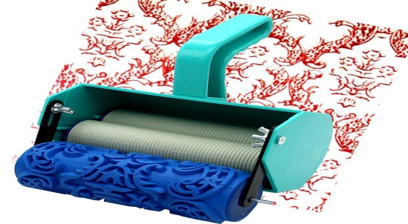
Fig 1.25. Pattern roller brush
- Comb Tool: A comb tool is a specialized tool with multiple teeth or ridges that can be dragged through wet paint to create comb-like patterns. These tools are often made of plastic or rubber and are available in various designs, allowing you to experiment with different textures.
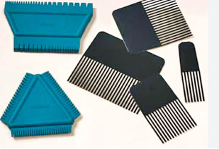
Fig ..26. Comb Tool
3. Texture Comb: Texture combs are brushes with notched or serrated edges that can create distinctive textures when dragged through paint. These brushes are designed specifically for creating textured effects such as wood grain or fur.
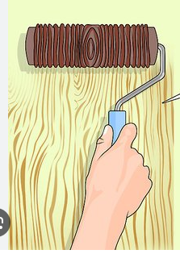
Fig 1.27. Texture Comb

Materials quantity
To calculate the quantity of material needed for decorative painting, follow these steps:
1. Determine the Coverage Rate: Check the manufacturer's instructions or the product label for the coverage rate of the specific decorative paint you're using. The coverage rate is typically provided as a coverage area per unit (e.g., square meters per liter, square feet per gallon). This information will help you determine how much surface area the decorative paint can cover with a specific volume.
2. Calculate the Total Area: Measure and calculate the total area of the surfaces you plan to paint using the steps mentioned earlier. Add up the areas of all the surfaces to be painted in square meters.
3. Divide the Total Area by the Coverage Rate: Divide the total area by the coverage rate to estimate the quantity of decorative paint needed. This will give you the approximate volume or quantity required to cover the calculated area.
For example, if the coverage rate is 8 square meters per liter and the total area is 40 square meters, you would divide 40 square meters by 8 square meters per liter to get 5 liters. This means you would need approximately 5 liters of decorative paint to cover the specified area.
4. Consider Multiple Coats: If you plan to apply multiple coats of decorative paint, multiply the calculated quantity by the number of coats. This accounts for additional material needed for each coat.
5. Account for Wastage and Touch-ups: It's advisable to add a little extra material to account for wastage during application, touch-ups, or if you want to have some leftover for future use. The amount of extra material will depend on your experience and judgment.
Always refer to the manufacturer's instructions for the specific decorative paint you're using as they may provide specific guidance on coverage rates and application techniques. It's also a good idea to consult with professionals or experts in decorative painting for accurate calculations and efficient material usage.
Using unit standards estimating materials quantity, a standard unit of measurement for panting work is as Follows for paint, primer thinner & anti-rust etc. liter & gallon is used, whereas for stucco and glue, gram &kilogram is used.
- estimating paint... how much do I need to determine how much paint you need for your project you will need thefollowing information:
1. Surface area of the surface to be painted (excluding areas where there are windows, doors etc).
2. Spreading rate of the paint being used.
3. The number of coats required.
Once you have the above information, you can calculate the amount required as follows: Total surface area (in square meters) Divided by ÷ Spreading rate of paint (in square meters per liter) Multiplied by x Number of coats Equals =Total liters required Porous, rough and textured surfaces (e.g. corrugated iron or rough plaster) will require more paint. Materials required for painting work are usually calculated based on their state, as liquid, thinner or as solid,
stucco. 4lit = 1gallon
Example 1.Two coats plastic emulsion paint to internal newly plastered surface.
    - Data: - Stucco = 50 g/m2
    - ▪ Animal glue = 12.5g/m2
    - 1st coat = 0.07 lit/m2
    - 2nd coat =0.06 lit/m2
Let the area to be painted is 100m2. Estimate quantity of primer & quantity of paint.
Solution
Quantity of primer
- Stucco = 50g/m2x100m2 = 5000g = 5kg
- Animal glue = 12.5g/m2 x100m2 = 1250g = 1.25kg
Quantity of paint
- 1st coat = 0.07 lit/m2 x 100m2 = 7lit
- 2nd coat =0.06 lit/m2x100m2= 6lit
- Total paint = 1st coat + 2nd coat= 7 lit + 6 lit = 13 lit or 3.25 gallon
Example 2: -Three coat of synthetic enamel paint to steep surface. Let the area to be
Painted be 100m2.
- Primary coat /antirust/ = 0.04 lit/m2
Thinner for antirust = 0.5 lit/gallon
Solution
- Antirust = 0.04 lit/m2x100m2= 4 lit = 1 gallon
- Thinner = 0.5 lit/gallon x 1 gallon = 0.5 lit
- Total paint = 12lit = 3gallon
- Thin = 0.5 lit/gallon x 3gallon = 1.5 lit

Self-Check -1
Part: one multiple choice
Directions: Answer all the questions listed below.
- _____________ one of following is safety tools used to protect head of the worker from hazard.
- helmet
- Safety sign
- Regulatory sign
- Engineering safety
- _____________ are erected to warn workers or the public of specific hazards and to communicate necessary precautionary measures and emergency actions
  - Barricading C. Regulatory sign
  - Safety signs D. Regulatory sign
- _____________is to protect our self, co-worker, tools, equipment’s & materials from danger or risk.
  - Safety
  - Injury
  - Accident
  - Engineering safety
Part two: short answer
- Write quality requirement for decorative paint
- Identify types of paint
- Write tools and equipment used for painting at least five

Unit: TwoPreparation of Materials and Surfaces
This unit to provide you the necessary information regarding the following content coverage and topics:
- Set out the Painting Area
- Surface Preparation for Paint Application
- Proper Ventilation for Working Area
This guide will also assist you to attain the learning outcomes stated in the Above topic contact. Specifically, upon completion of this learning guide, you will be able to:
- Setting up the Painting Area
- Prepare Surface for Paint Application
- Maintain Proper Ventilation in the Working Area

Set out painting area
The setting out for painting area is the process of measuring dimension required area and adjusting method of application .this is general outline of work instructions for decorative paint work. The specific details and steps may vary depending on the project requirements and industry standards.
To set out an area for decorative painting work, follow these steps:
1. Clear the space: Remove any furniture, objects, or obstacles from the area where you will be working. Clearing the space will give you a clean and unobstructed area to work in.
2. Protect the surrounding surfaces: Cover the floors, furniture, and any other surfaces that are not being painted with drop cloths, plastic sheets, or painter's tape. This will prevent accidental paint splatters or spills from damaging or staining the surrounding areas.
3. Prepare the walls or surface: Ensure that the walls or surface you'll be painting are clean and smooth. Clean the surface with soap and water to remove any dirt, dust, or grease. If there are any imperfections such as cracks or holes, fill them with an appropriate filler and sand them down until the surface is even.
4. Prime the surface (if necessary): Depending on the type of surface and the type of decorative painting you plan to do, you may need to apply a primer. Priming helps create a smooth and even base for your decorative paint and enhances adhesion.
5. Plan and mark the design: Before you start painting, plan and mark out your design on the surface using a pencil or chalk. This will serve as a guide for your decorative painting work and help ensure accurate placement of patterns, motifs, or other design elements.
6. Gather your painting supplies: Collect all the painting supplies you'll need for your decorative painting work, such as brushes, rollers, paint trays, paint colors, stencils, or any other tools specific to your design. Organize your supplies within easy reach to make the painting process more efficient.
7. Set up proper lighting: Ensure that the painting area is well-lit. Good lighting is essential for accurately seeing colors and details while working on your decorative painting.
8. Maintain proper ventilation: If you're using paint that emits fumes, make sure the area is well-ventilated. Open windows or use fans to circulate fresh air and help dissipate any odors or fumes.

9. Start painting: Begin applying your decorative paint according to your planned design. Take your time, work systematically, and pay attention to detail. Follow the specific techniques or methods associated with the decorative style you're using.
10. Clean up and protect your work: Once you've completed the decorative painting, allow the paint to dry according to the manufacturer's instructions. Clean your brushes and tools promptly to maintain their condition. Remove any protective coverings from the surrounding surfaces and inspect your work for any touch-ups or refinements that may be needed.
By following these steps, you can effectively set out an area for decorative painting work and create a space that is conducive to your artistic process.
Preparing the Room for Painting
- Painting high ceilings and hard-to-reach areas can be a daunting task. However, with the right preparation and tools, it doesn’t have to be an uphill battle – it just takes some elbow grease!
- Like any painting job, you’ll need to set up your workspace before getting started. Preparing the room for painting is like setting sail on a voyage: you want to make sure all of the necessary elements are in place so that your journey will go smoothly.
- Before starting, first, remove anything from the walls or ceiling that could get in the way of your paintbrush. This includes items such as furniture, pictures, curtains, outlet covers, and light switch plates. Cover them with plastic sheeting if they cannot be removed entirely.
- Then use painter’s tape along baseboards and trim pieces to ensure crisp lines when you’re finished with each wall. And don’t forget about drop cloths – these come in handy both during and after painting. To help protect surfaces around windows and doors, apply masking paper over them; this will also keep dust at bay while working in those tight spaces!

2.2. Surface Preparation for Paint Application
Surface preparation
Surface preparation is a crucial step before applying paint, as it ensures proper adhesion, smoothness, and durability of the paint finish. The specific method of surface preparation depends on the type of surface you are working with.
    - Surface preparation methods
1. Walls (Interior):
- Clean the surface with soap and water to remove dirt, grease, and stains.
- Patch any holes or cracks with spackling paste or joint compound. Sand the patched areas until smooth.
- Remove any loose or peeling paint by scraping or sanding.
- Apply a coat of primer to create a uniform surface and improve paint adhesion.
2. Walls (Exterior):
- Clean the surface using a pressure washer or a scrub brush with a mild detergent to remove dirt, mold, mildew, and loose paint.
- Repair any damaged areas with suitable filler or patching compound.
- Scrape or sand any loose or peeling paint.
- Apply a primer designed for exterior surfaces to enhance adhesion and protection against weather elements.
3. Wood:
  - Clean the wood surface by removing dust, dirt, and grime with a damp cloth.
  - Sand the wood to smooth out any rough areas or previous coatings.
  - Fill any cracks, holes, or imperfections with wood filler or putty.
  - Remove any dust or debris from sanding and wipe the surface clean.
  - Apply a primer to seal the wood and provide a suitable base for the paint.
4. Metal:
  - Clean the metal surface using a degreaser or solvent to remove oil, grease, or rust.
  - Sand the metal with sandpaper or a wire brush to remove any rust, paint, or rough spots.
  - Wipe the surface clean to remove dust and residue.
  - Apply a rust-inhibiting primer to prevent future rust formation and improve paint adhesion.
  - For galvanized metal, use a special primer designed for galvanized surfaces.
5. Concrete:
  - Clean the concrete surface by sweeping or using a pressure washer to remove dirt, dust, and debris.
  - Repair any cracks or damaged areas using a concrete patching compound.
  - Etch the surface using an acid-based etching solution to promote paint adhesion.
  - Rinse the surface thoroughly and allow it to dry completely.
  - Apply a concrete primer or sealer to prepare the surface for paint application.

    - Surface preparation for wall paint
These are general guidelines for surface preparation, but it's important to refer to the specific product instructions and manufacturer recommendations for the most accurate and effective surface preparation methods.
To prepare a wall surface for painting, you can follow the following step-by-step method of preparation:
    - Clear the area
Remove any furniture, decorations, or obstacles from the area to ensure easy access to the walls and to protect them from accidental paint splatters or damage.
    - Gather the necessary tools
Equip yourself with the required tools and materials, such as drop cloths, painter's tape, putty knife, sandpaper, cleaning solution, sponge or cloth, filler, and a primer, in addition to your chosen paint.
    - Protect adjacent surfaces
Cover the floor and any adjacent surfaces with drop cloths or plastic sheets to protect them from paint splatters or spills. Use painter's tape to mask off areas that you don't want to paint, such as baseboards, trims, or windows.

    - Repair surface imperfections
Inspect the walls for any cracks, holes, or dents. Use a putty knife to apply an appropriate filler, such as spackling compound, to repair these imperfections. Follow the manufacturer's instructions for application and drying time. Once dry, sand the filled areas lightly with sandpaper to achieve a smooth and even surface.
    - Clean the walls
Dust, dirt, grease, or any other contaminants on the walls can affect paint adhesion and finish. Clean the walls thoroughly using a mild cleaning solution mixed with water. You can use a sponge or cloth to wipe down the walls, paying special attention to areas that may have accumulated grime or stains. Rinse the walls with clean water and allow them to dry completely.
    - Sand the walls
Lightly sand the entire wall surface using fine-grit sandpaper. This step helps to remove any remaining roughness, gloss, or texture, ensuring better paint adhesion. It also helps to smooth out any brush or roller marks from previous paint jobs. After sanding, wipe the walls with a damp cloth to remove any dust or debris.
    - Apply a primer (if necessary)
Primer is recommended for certain situations, such as when painting over a porous surface, covering stains or discolorations, or when applying a significantly different paint color. Apply a coat of primer using a brush or roller, following the manufacturer's instructions. Allow the primer to dry completely before proceeding to the next step.
    - Start painting
Once the surface is properly prepared, you can begin painting. Stir the paint thoroughly, and pour it into a paint tray. Use a brush or roller to apply the paint evenly, working from top to bottom and from one side to the other. Apply multiple coats as needed, allowing sufficient drying time between each coat.
    - Prepare metal surface for paint
The best way to remove rust from metal surfaces depends on the severity of the rust and the type of metal involved. Here are several effective methods you can try:
1. Mechanical Methods:
  - Wire Brushing: Use a wire brush or steel wool to scrub away surface rust. This method works well for light rust or small areas.
  - Sanding: Sand the rusted surface with sandpaper or an abrasive pad to remove the rust. Start with a coarse grit and gradually move to finer grits for a smooth finish.
2. Chemical Methods:
  - Vinegar: Soak the rusted metal in white vinegar for several hours or overnight. The acidic nature of vinegar helps dissolve rust. Scrub the surface with a brush or sponge to remove loosened rust.
  - Lemon Juice and Salt: Make a paste by mixing lemon juice and salt. Apply the paste to the rusted area and let it sit for a few hours. Scrub the surface with a brush or sponge and rinse thoroughly.
  - Commercial Rust Removers: There are various rust removal products available in the market. Follow the instructions on the product for proper application and safety precautions.
3. Electrolysis:
- Electrolysis is an effective method for removing rust from larger or heavily rusted metal objects. This method requires a container, a sacrificial anode (such as a piece of iron or steel), and a power source. Submerge the rusted metal and the sacrificial anode in an electrolyte solution (such as a mixture of water and baking soda), and then apply a low voltage electrical current. This process helps to convert the rust back into iron and remove it from the metal surface.
After removing the rust, it's essential to protect the metal from further corrosion. Apply a rust-inhibiting primer or a protective coating such as paint or a clear sealant.
    - The importance of surface preparation
1. Adhesion: Adequate surface preparation promotes good adhesion between the paint and the substrate. It helps remove any contaminants, such as dirt, grease, oil, or loose old paint, which can hinder paint adhesion. Painting over a poorly prepared surface can result in paint peeling, cracking, or flaking, leading to an unsightly and short-lived finish.
2. Smooth and Even Finish: Surface preparation helps create a smooth and even surface for the paint application. It involves filling in cracks, holes, or imperfections with appropriate fillers, and sanding the surface to create a uniform texture. A well-prepared surface ensures that the paint spreads evenly, resulting in a more aesthetically pleasing and professional-looking finish.
3. Durability and Longevity: Proper surface preparation enhances the durability and longevity of the decorative paint job. By removing loose or deteriorated materials from the surface, it prevents premature paint failure. Additionally, surface preparation allows for the application of primers or sealers, which improve paint adhesion, provide better coverage, and offer added protection against moisture, stains, and other environmental factors.
4. Color and Sheen Uniformity: Surface preparation plays a vital role in achieving color and sheen uniformity across the painted surface. It helps eliminate variations in texture, porosity, or absorbency, which can cause the paint to appear uneven or blotchy. A well-prepared surface allows the paint to dry uniformly, resulting in consistent color and sheen throughout the painted area.
5. Cost-Effectiveness: Investing time and effort in surface preparation before applying decorative paint can save money in the long run. By properly preparing the surface, you reduce the likelihood of paint failure or the need for premature repainting. This minimizes the cost of additional materials, labor, and time associated with fixing or redoing a poorly executed paint job.
In conclusion, surface preparation is essential for achieving a successful decorative paint finish. It ensures proper adhesion, promotes an even and durable paint application, enhances the appearance of the painted surface, and contributes to a longer lifespan of the paint job. Taking the time to prepare the surface properly before painting is a worthwhile investment that can significantly improve the overall quality and longevity of the decorative paint project.
    - Common types of fillers used for surface preparation before painting.
The choice of filler depends on the specific requirements of the surface and the nature of the imperfections that need to be addressed. Here are some commonly used filler:
- Spackling Compound
Spackling compound, often referred to as spackle, is versatile filler used to repair small holes, cracks, and minor surface imperfections. It is typically composed of gypsum, calcium carbonate, or a combination of both. Spackling compound is easy to apply, dries quickly, and can be sanded smooth to create a seamless surface.
- Wood Filler:
Wood filler, also known as wood putty or wood dough, is specifically designed to repair imperfections on wooden surfaces. It is usually made from a combination of wood fibers or wood dust mixed with a binder, such as epoxy or vinyl. Wood filler is used to fill nail holes, gouges, cracks, and other blemishes in wood surfaces. It can be stained or painted to match the surrounding wood.
- Joint Compound
Joint compound, commonly used in drywall installations, is a gypsum-based filler that is excellent for repairing larger cracks, seams, and joints. It has a smooth and creamy consistency, making it easy to spread and work with. Joint compound comes in different drying times, including fast-drying options, and allowing for efficient surface preparation.
- Polyester Filler
Polyester filler, also known as polyester putty or automotive body filler is a two-component filler widely used in automotive repairs and other applications. It consists of a resin and a hardener that need to be mixed together before use. Polyester filler is highly durable, resistant to shrinking, and provides excellent adhesion to various surfaces. It is primarily used to repair dents, scratches, and other damages on metal, fiberglass, or plastic surfaces.
- Epoxy Filler
Epoxy filler is two-component filler that consists of a resin and a hardener. It is known for its high strength, durability, and resistance to moisture and chemicals. Epoxy filler is commonly used for repairing cracks, holes, and damaged surfaces in concrete, metal, and wood. It can be shaped, sanded, and painted once it cures.

Maintaining Proper Ventilation in the Working Area
2.3.1 Maintain proper ventilation
Maintaining proper ventilation in a working area where paint is being used is essential to ensure the health and safety of the individuals involved. Adequate ventilation helps to minimize the concentration of paint fumes and airborne particles, which can be harmful if inhaled in large quantities. Here are some tips to maintain proper ventilation:
1. Open windows and doors: If possible, open windows and doors to allow fresh air to circulate into the working area. This helps to remove airborne contaminants and improve air quality.
2. Use exhaust fans: Utilize exhaust fans to expel air from the working area. Position the fans strategically to create a cross-ventilation effect and promote the removal of fumes and particles from the space.
3. Portable ventilation systems: Consider using portable ventilation systems, such as air scrubbers or industrial fans with built-in filters. These devices help to capture and filter airborne particles and fumes, improving the air quality in the working area.
4. Create a negative pressure environment: In situations where significant amounts of paint fumes are generated, it may be beneficial to create a negative pressure environment. This is achieved by using exhaust fans to draw air out of the space, reducing the likelihood of fumes spreading to adjacent areas.
5. Personal protective equipment (PPE): In addition to maintaining proper ventilation, it is important to provide appropriate personal protective equipment to individuals working with paint. This may include respiratory masks, gloves, and eye protection, depending on the specific hazards associated with the paint being used.
6. Follow manufacturer guidelines: Always follow the manufacturer's guidelines and recommendations regarding ventilation requirements for the specific type of paint being used. Different paints may have different requirements, and it is important to adhere to the provided instructions.
7. Allow sufficient drying time: After painting, allow sufficient time for the paint to dry before occupying the area. This helps to minimize the release of volatile organic compounds (VOCs) into the air.
Remember, maintaining proper ventilation is crucial for the health and safety of everyone involved in painting activities. If you have specific concerns or are working in a particularly hazardous environment, it is best to consult with occupational health and safety professionals for guidance tailored to your specific situation.
2.3.3 Specific guidelines for ventilation when using oil-based paints
1. Adequate airflow: Ensure that the working area has sufficient airflow to dilute and remove the fumes produced by oil-based paints. Open windows and doors, if possible, to allow fresh air to circulate.
2. Mechanical ventilation: Utilize mechanical ventilation systems, such as exhaust fans, to remove fumes from the working area. Position the fans strategically to direct the airflow towards the source of the fumes.
3. Local exhaust ventilation: Consider using local exhaust ventilation, such as fume extractors or hoods, near the painting area. These systems capture and remove fumes directly at the source, minimizing their spread into the surrounding air.
4. Negative pressure: In situations where a significant amount of fumes are being generated, it may be beneficial to create a negative pressure environment. This involves using exhaust fans to draw air out of the space, reducing the likelihood of fumes spreading to adjacent areas.
5. Personal protective equipment (PPE): Always wear appropriate personal protective equipment when working with oil-based paints. This may include a respirator with organic vapor cartridges, gloves, and protective eyewear. PPE helps to provide an additional layer of protection against inhalation and skin contact with the paint and its fumes.
6. Follow manufacturer guidelines: Always follow the manufacturer's recommendations regarding ventilation requirements for the specific oil-based paint you are using. Different paints may vary in terms of their solvent content and fume generation, so it is important to adhere to the provided instructions.
7. Allow for proper drying time: After applying oil-based paints, allow ample drying time as specified by the manufacturer. Proper drying helps to reduce the release of volatile organic compounds (VOCs) into the air.
These guidelines should help minimize the health risks associated with oil-based paints. However, it is crucial to refer to safety data sheets (SDS) provided by the paint manufacturer for detailed information on potential hazards and recommended ventilation practices specific to the product you are using. If you have any concerns or questions about ventilation requirements, it is advisable to consult with occupational health and safety professionals or experts in the field.

Self-Check 2
Part: 1: Multiple Choices

- from the following one is Specific guidelines for ventilation when using oil-based paints

  - Adequate airflow
  - Local exhaust ventilation
  - Mechanical ventilation
  - all
- ----------------is an effective method for removing rust from larger or heavily rusted metal objects

- Wire brush
- Sanding
- A&B
- Electrolysis

- ---------------- is the process of measuring dimension required area and adjusting method of application

- Surface preparation
- Sanding
- marking
- Setting out for painting area

Part: 2: Short Answer

- Write at least five importance of surface preparation. (5pts)
- Identify method of surface preparation for painting? (5pts)
- Write Specific guidelines for ventilation when using oil-based paints(3pts)

Part three:trueor false
    - Primer is recommended for certain situations, such as when painting over a porous surface, covering stains or discolorations, or when applying a significantly different paint color
    - Adequate ventilation helps to minimize the concentration of paint fumes and airborne particles, which can be harmful if inhaled in large quantities
    - Surface preparation is a crucial step before applying paint

Answer Sheet
Name: _________________________ Date: ______________

Unit Three: Apply mirror paint finish and texture coat by brush and roller
This unit to provide you the necessary information regarding the following content coverage and topics:
  - paint viscosity
  - Coats of paint
  - Mix and apply texture paint
This guide will also assist you to attain the learning outcomes stated in the Above topic contact. Specifically, upon completion of this learning guide, you will be able to:
  - Adjust paint viscosity
  - identify Coats of paint
  - Mix and apply texture paint

Adjusting paint viscosity
    - Paint viscosity
Paint viscositycan be defined as the resistance of a liquid to spilling. This resistance to flowing is due to the friction between its molecules, which move at different speeds, and collide with each other making motion difficult. Viscosity could be understood as opposite to fluidity.In this sense, the greater the fluidity, the lower the viscosity of the liquid. Its unit of measurement is the Poise, although in the International System (SI), it is measured in Pascal-second (Pa·s): 1 Poise is equivalent to 0.1 Pa·s.With respect to the Poise, the use of its multiple, the centipoises (cP), is more common. This is mainly because the viscosity of water, the reference fluid, is 1,0020cP at 20 °C. From the point of view of equivalence: 1 cps = 1 mPa·s.When measuring the viscosity of paint (and that of any fluid) the measuring temperature must be included (as it has been pointed out in the case of water) as it has a great influence on the result. Normally, viscosity would be measured at 25 ºC.There are a number of devices that can measure viscosity. In the sector of paints and related products, the most used tools are: Orifice viscometers
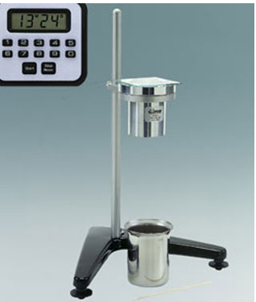
Fig3.1Orifice viscometers
    - Adjusting paint viscosity
Adjusting paint viscosity refers to the process of modifying the thickness or flow ability of paint to achieve the desired consistency for application. Paint viscosity is a measure of its resistance to flow and is influenced by factors such as the type of paint, its formulation, and environmental conditions.
Paint viscosity is typically specified by the manufacturer and is designed to be suitable for specific application methods, such as brushing, rolling, or spraying. However, there are instances where adjusting the viscosity becomes necessary to optimize the paint's performance or to accommodate specific application techniques.
Viscosity, specific weight or color is some of the characteristics specific to paint that must be controlled during the manufacturing process. Even if they have been previously determined during formulation, it is necessary to verify that the manufacturing process is correct and whether the desired result will be obtained once the paint is applied.
In this article we will analyze these fundamental characteristics that must be taken into account during the manufacturing process of paints.
    - Importance of adjusting paint viscosity
There are several reasons why adjusting paint viscosity may be required:
1. Ease of Application: Different application methods require different paint viscosities. For example, thinning the paint can make it easier to apply with a brush or roller, ensuring smooth and even coverage. On the other hand, thicker paint may be preferred for achieving texture or impasto effects.
2. Flow and Leveling: Adjusting the viscosity can impact the flow and leveling characteristics of the paint. Some projects may require a paint that flows easily and levels out evenly, resulting in a smooth and professional finish.
3. Spraying: When using a paint sprayer, the viscosity needs to be adjusted to ensure proper atomization and even distribution. Thinners or specific additives may be necessary to achieve the right spray viscosity.
4. Environmental Conditions: Temperature and humidity can affect paint viscosity. In colder temperatures, paint may become thicker and harder to work with, requiring slight thinning. Conversely, in warmer conditions, the paint may become thinner, potentially necessitating adjustments to maintain control during application.

    - Method of adjust paint viscosity
1. Thinning with Solvents: Adding a compatible solvent to the paint can reduce its viscosity and make it flow more easily. The specific solvent to use depends on the type of paint. For example, water is commonly used to thin water-based paints, while mineral spirits or turpentine are used for oil-based paints. It is important to follow the manufacturer's recommendations for the appropriate solvent and the correct ratio for thinning.
2. Adding Mediums: Paint mediums are substances designed to modify the characteristics of paint, including viscosity. Adding a specific medium to the paint can alter its flow and consistency. For example, acrylic mediums can be used to increase or decrease the flow of acrylic paints, while oil mediums can be used in oil-based paints to adjust viscosity.
3. Mixing with Extenders: Extenders or retarders are additives that slow down the drying time of paint, allowing for easier blending and manipulation. These additives can also affect viscosity by making the paint more fluid. Extenders are commonly used in acrylic and water-based paints.
4. Mixing with Thickeners: Thickeners or gels can be added to increase the viscosity of paint. These additives are often used in acrylic paints to create texture or impasto effects. Thickeners are available in various consistencies, from soft gels to heavy body pastes, allowing for precise control over the paint's viscosity.
5. Temperature Adjustment: Paint viscosity can be affected by temperature. Lowering the temperature of the paint can increase its viscosity, while raising the temperature can decrease it. However, it is important to note that extreme temperature changes can affect the paint's performance and drying time, so it is advisable to stay within the recommended temperature range for the specific paint.
It is important to follow the manufacturer's instructions and guidelines when adjusting paint viscosity. Different paints and additives may have specific recommendations and limitations for thinning or thickening. It is also recommended to conduct small test samples and adjustments to achieve the desired consistency before applying the paint to a larger surface.

Coats of paint
    - Priming coat
A priming coat, also known as a primer, is the initial coat of paint applied to a surface before the topcoat or finish coat. Its purpose is to prepare the surface for painting by providing a uniform, stable, and adherent base for the subsequent layers of paint.
Key points of priming coats
- Surface Preparation: Before applying a primer, it is essential to properly prepare the surface. This typically involves cleaning the surface to remove dirt, dust, grease, and other contaminants. Additionally, any loose or flaking paint should be scraped off, and any holes or cracks should be filled and sanded.
- Adhesion: Primers are designed to enhance the adhesion of the topcoat to the surface. They create a bond between the surface and the paint, ensuring that the topcoat adheres properly and lasts longer. This is particularly important when painting over surfaces with different materials, such as bare wood, metal, or previously painted surfaces.
- Sealing and Blocking: Primers can help seal porous surfaces, preventing the absorption of the topcoat into the substrate. This is especially useful when dealing with materials like drywall, masonry, or unfinished wood, which can absorb paint unevenly and result in a blotchy appearance. Primers also block stains from bleeding through the topcoat, such as water stains, smoke damage, or tannin stains from wood.
- Uniform Surface: Applying a primer creates a uniform surface, especially when dealing with surfaces that have different colors, textures, or sheens. It helps to create a consistent base for the topcoat, ensuring that the final paint color appears as intended.
- Improved Coverage: Primers can enhance the coverage of the topcoat, reducing the number of coats required to achieve the desired finish. They provide a neutral base color that allows the topcoat to show its true color without being influenced by the underlying surface.
- Durability and Longevity: Using a primer can improve the durability and longevity of the paint job. It helps to protect the surface from moisture, UV rays, and other environmental factors that can cause paint to deteriorate over time.
- Types of primer coat
Types of Primers: There are different types of primers available, each designed for specific applications. Examples include oil-based primers, water-based primers, stain-blocking primers, rust-inhibiting primers, and high-adhesion primers. The choice of primer depends on the surface material, the condition of the surface, and the type of topcoat being used.
A primer coat is an initial layer of paint or coating applied to a surface before the application of the finish coat. It serves several important purposes in the painting process.
- Water-Based Primer
Water-based primers are versatile and commonly used for both interior and exterior applications. They provide good adhesion, help to seal porous surfaces, and promote better paint adhesion for the topcoat. Water-based primers are generally low in volatile organic compounds (VOCs), making them environmentally friendly and less odorous.
- Oil-Based Primer
Oil-based primers are known for their excellent stain-blocking capabilities. They are particularly useful for covering stains caused by water, smoke, or tannins. Oil-based primers also provide good adhesion and are commonly used on surfaces that are difficult to adhere to, such as metal or glossy surfaces. However, they tend to have a strong odor and higher VOC content.
- Shellac-Based Primer
Shellac-based primers contain a natural resin called shellac, which is derived from the secretions of the less beetle. They are excellent at sealing stains, including those caused by water, smoke, and knots in wood. Shellac-based primers dry quickly and provide good adhesion. They are often used on interior surfaces like woodwork, cabinets, and furniture.
- Bonding Primer
Bonding primers are designed to promote adhesion on challenging surfaces such as glossy or slick surfaces, tile, or laminate. They have strong bonding properties and help the topcoat adhere more effectively. Bonding primers are commonly used in kitchen and bathroom remodels, where surfaces may be difficult to adhere to.
- Importance of Primer Coats:
- Improved Adhesion: The primary function of a primer coat is to create a bonding surface for the topcoat. It helps the paint adhere better to the substrate, reducing the risk of peeling, cracking, or flaking over time.
- Sealing and Stain Blocking: Primer coats help seal porous surfaces, preventing the topcoat from soaking into the substrate and resulting in uneven coverage. Certain types of primers, such as oil-based or shellac-based primers, also have stain-blocking properties, which prevent stains from bleeding through the paint.
- Enhanced Durability: Applying a primer coat can improve the overall durability and longevity of the paint job. It creates a protective barrier between the substrate and the topcoat, reducing the impact of moisture, chemicals, and other environmental factors.
- Uniform Appearance: Primer coats can help create a more uniform and even finish by providing a consistent base for the topcoat. They can help in hiding imperfections, such as patches, repairs, or color variations in the substrate.
- Cost and Time Efficiency: While it may seem like an additional step, using a primer coat can save time and money in the long run. Primers can reduce the number of topcoat layers required for full coverage, thereby reducing the amount of paint needed.
It's important to choose the appropriate type of primer for your specific project and surface conditions to achieve the best results. Always follow the manufacturer's instructions and consult with professionals if needed.
    - Intermediate coat
Intermediate coats of paint refer to additional layers of paint applied between the primer coat and the final or topcoat. These intermediate coats provide various benefits and contribute to achieving a high-quality and durable paint finish. Here are some common types and purposes of intermediate coats:
- Types of intermediate coat
1. Undercoat: The undercoat, also known as the intermediate or basecoat, is applied after the primer coat and before the final coat. It helps to even out the surface, enhance color richness, and improve the coverage of the final coat. Undercoats are commonly used when transitioning between colors or when the topcoat has a significant color change.
2. Build Coat: A build coat is an intermediate layer of paint that helps to fill in imperfections, such as surface roughness, small cracks, or minor repairs. It creates a smoother and more uniform surface for the final coat. Build coats are often used on substrates like drywall or wood that may have slight irregularities.
3. Sanding Coat: A sanding coat, also known as a sanding sealer, is an intermediate layer that is applied to create a smooth surface for sanding. It helps to fill in pores, grain lines, or small surface irregularities. The sanding coat is then sanded down to create a smooth and level surface before applying the final coat.
4. Tinted Coat: A tinted intermediate coat involves applying a colored or tinted paint layer between the primer and the final coat. It helps to enhance the color depth, richness, and uniformity of the final coat, especially when using translucent or light-colored topcoats. Tinted coats are commonly used in decorative finishes, such as faux painting or glazing techniques.
5. Barrier Coat: A barrier coat is an intermediate layer of paint that acts as a barrier between the substrate and the final coat. It helps to prevent any potential bleed-through of stains, tannins, or discolorations from the substrate, ensuring a clean and even appearance of the topcoat. Barrier coats are often used on surfaces prone to staining, such as wood with knots or water stains.
The specific types and number of intermediate coats required depend on various factors, including the condition of the substrate, the desired finish, and the type of paint being used. Following the manufacturer's instructions and considering the recommendations of painting professionals can help ensure the appropriate application of intermediate coats for a successful paint job.
    - Final coat(smoothing finish)
The final coat of paint, also known as the topcoat or finish coat, is the last layer of paint applied to a surface in a painting project. It is the coat that provides the desired color, finish, and overall appearance of the painted surface.
A "smoothing finish" or "final coat" paint refers to a type of paint that is specifically designed to provide a smooth and flawless surface appearance. It is typically used as the last coat of paint applied to a surface, such as walls, ceilings, or furniture, to achieve a polished and refined look.

Smoothing finish paints are formulated with special additives and ingredients that help to minimize surface imperfections, such as brush or roller marks, uneven texture, or minor flaws.
The final coat of paint is typically applied after any necessary preparation work, such as priming and intermediate coats. It is the coat that is visible and contributes to the aesthetic appeal of the space. The color and finish of the final coat can greatly impact the overall look and feel of a room or object.
In addition to its visual impact, the final coat of paint serves important functional purposes. It acts as a protective layer, providing durability and resistance against wear, moisture, UV rays, stains, and other environmental factors. The topcoat also makes the painted surface easier to clean and maintain.
The specific type of paint used for the final coat can vary depending on the project requirements and the desired outcome. Different finishes, such as matte, satin, semi-gloss, or high-gloss, can be chosen based on the desired look, lighting conditions, and functionality of the space of the visual appeal and protection to the painted surface.
- The common type of paint finish
There are several common types of finishes used for the final coat of paint. The choice of finish depends on personal preference, the desired look, and the functionality of the space. Here are some of the most common types of finishes:
- Matte Finish: Matte finishes have a low sheen and provide a non-reflective, flat appearance. They are great for concealing surface imperfections and can create a soft, elegant look. Matte finishes are commonly used in bedrooms, living rooms, and ceilings.
- Eggshell Finish: Eggshell finishes have a slight sheen that resembles the texture of an eggshell. They offer a subtle, velvety appearance and are easier to clean compared to matte finishes. Eggshell finishes are used in areas with moderate traffic, such as dining rooms, hallways, and family rooms.
- Satin Finish: Satin finishes have a smooth, subtle sheen that falls between matte and semi-gloss. They provide a soft glow and are more durable and easier to clean than matte or eggshell finishes. Satin finishes are commonly used in kitchens, bathrooms, and high-traffic areas.
- Semi-Gloss Finish: Semi-gloss finishes have a noticeable sheen and offer a shiny, reflective appearance. They are highly durable, moisture-resistant, and easy to clean, making them suitable for areas prone to splashes and stains. Semi-gloss finishes are commonly used in kitchens, bathrooms, trim, and doors.
- High-Gloss Finish: High-gloss finishes have a bright, mirror-like sheen that reflects light well. They provide a sleek and polished look and are extremely durable and resistant to stains. High-gloss finishes are commonly used on furniture, cabinets, doors, and trim for a dramatic effect.
- Satin Enamel Finish: Satin enamel finishes combine the smoothness of a satin finish with the durability of an enamel paint. They have a subtle sheen and offer excellent stain resistance, making them suitable for high-traffic areas and surfaces that require frequent cleaning.
- Importance of final coat
- Aesthetic Appeal: The final coat finish greatly impacts the overall aesthetic appeal of a painted surface. It defines the visual appearance and can significantly enhance or alter the look of a room or object. The choice of finish allows for customization, whether one desires a matte, satin, semi-gloss, or high-gloss appearance, and helps achieve the desired style and ambiance.
- Protection and Durability: The final coat finish acts as a protective layer, safeguarding the painted surface from various factors that can cause damage or wear. It provides a barrier against moisture, stains, UV rays, abrasion, and general wear and tear. By adding a durable finish, the paint job's longevity is extended, ensuring it remains intact and attractive for a longer period.
- Clean ability and Maintenance: Different finishes offer varying levels of cleanability and ease of maintenance. Finishes with higher sheen levels, such as semi-gloss or high-gloss, tend to be more resistant to stains and easier to clean. This is particularly beneficial in areas prone to spills, splashes, or heavy use, as they can be wiped clean more effortlessly, allowing for easier maintenance and upkeep.
- Light Reflection and Perception: The finish of the final coat affects how light interacts with the painted surface. Matte finishes absorb more light and provide a softer, more subdued look, while higher sheen finishes reflect light, creating a brighter and more vibrant appearance. The choice of finish can influence the perception of space, depth, and overall lighting in a room.
- Surface Smoothness and Hiding Imperfections: Different finishes can help mask surface imperfections or highlight them. Matte finishes tend to be more forgiving, as they do not reflect light and can hide minor flaws. On the other hand, higher sheen finishes, such as semi-gloss or high-g
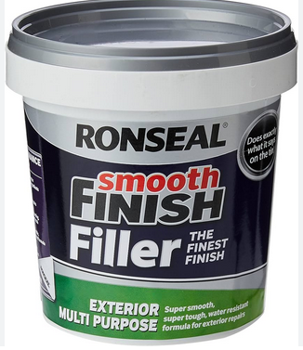
Fig 3.1 Smooth finish filler

Mix and apply texture paint
Texture paint refers to a type of paint that contains additives or materials designed to create a textured surface when applied. It is used to add visual interest, depth, and tactile qualities to walls, ceilings, furniture, or other surfaces. Texture paint is available in various forms, including premixed texture paints and additives that can be mixed with regular paint.
Texture paint contains substances such as sand, aggregates, polymers, or other texturizing agents that create different patterns, finishes, or textures when applied. These materials add a three-dimensional quality to the painted surface, resulting in a varied and visually appealing appearance.
The texture created by texture paint can range from subtle and smooth to more pronounced and rough, depending on the desired effect. Common textures achieved with texture paint include sand, popcorn, knockdown, stipple, swirl, or toweled finishes.
Texture paint serves both aesthetic and functional purposes. It can enhance the visual appeal of a space, add a decorative element, and help conceal surface imperfections such as cracks or uneven areas. Additionally, texture paint can provide durability and resistance to wear and tear, making it suitable for high-traffic areas.
Mixing and applying texture paint involves several steps and considerations. Let's break them down:
A) Mixing Texture Paint:
  - Select the texture paint: Texture paints come in various forms, such as premixed texture paints or additives that can be mixed with regular paint. Choose the type of texture paint that suits your project.
  - Prepare the paint: If you're using premixed texture paint, it should be ready to use. However, if you're using an additive, follow the manufacturer's instructions to mix it with your base paint. Use a clean container and stir the mixture thoroughly to achieve a consistent texture.
B) Applying Texture Paint:
  - Prepare the surface: Ensure that the surface you're painting is clean, dry, and free from dust or debris. If necessary, sand or repair any imperfections before applying the texture paint.
  - Protect surrounding areas: Cover or mask off any adjacent surfaces or areas that you don't want to be painted. Use painter's tape and drop cloths to protect surfaces from accidental splatters or spills.
  - Choose the application method: Texture paint can be applied using various methods, such as brushes, rollers, trowels, or spray equipment. The choice of method depends on the desired texture effect and the surface you're painting.
  - Apply the texture paint: Dip your brush, roller, or trowel into the texture paint and apply it to the surface using even strokes or patterns. If using a spray, follow the manufacturer's instructions for proper application technique.
C) Types of Texture Paint
1. Sand Texture Paint: Contains fine grains of sand or aggregate, creating a rough and grainy texture when dry.
2. Popcorn Texture Paint: Produces a bumpy, popcorn-like texture on the surface.
3. Knockdown Texture Paint: Applied with a roller or trowel and then lightly knocked down with a trowel to create a flattened texture.
4. Smooth Texture Paint: Creates a subtle texture that adds depth and dimension to the surface without being overly rough or prominent.
Application of Texture Paint
Texture paint can be applied using various methods depending on the desired texture and the tools available. Here are some common methods of applying texture paint:

1. Brush or Roller: One of the simplest methods is to use a brush or roller to apply texture paint. For a textured effect, choose a brush with stiff bristles or a roller with a thick nap. Apply the paint in a crisscross or random pattern to create texture. You can experiment with different brush or roller techniques to achieve the desired texture.
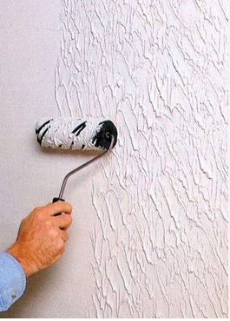
Fig 3.2 Brush or Roller
2. Trowel or Putty Knife: Another popular method is using a trowel or putty knife to create texture. Load the desired amount of texture paint onto the trowel or putty knife and apply it to the surface. You can spread it evenly for a smooth texture or create patterns and peaks by manipulating the tool.
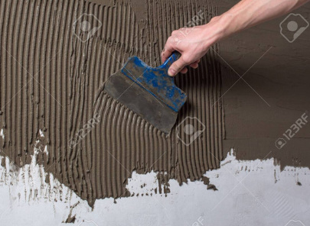
Fig 3.3 Trowel or Putty Knife
3. Spray Gun: Texture paint can also be applied using a spray gun, which allows for a more uniform and controlled application. Adjust the nozzle of the spray gun to achieve the desired texture pattern, such as a splatter, orange peel, or knockdown effect. Make sure to protect surrounding surfaces from overspray.
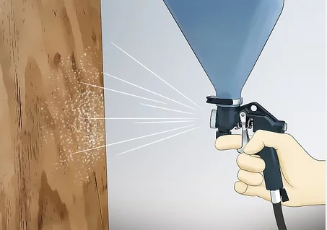
Fig 3.4 Spray Gun
4. Stippling: Stippling involves using a brush or sponge to dab the texture paint onto the surface, creating a stippled or dotted effect. Dip the brush or sponge into the paint and lightly press it onto the surface, repeating the process until the desired texture is achieved.
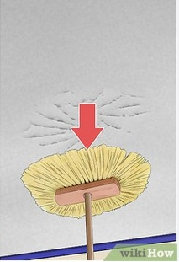
Fig 3.5 Stippling
5. Stenciling: If you want a specific pattern or design, you can use stencils with texture paint. Place the stencil on the surface and apply the paint using a brush, roller, or sponge. Carefully remove the stencil to reveal the textured pattern.
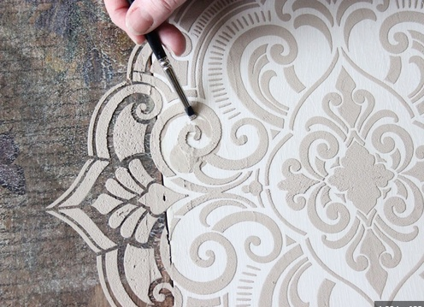
Fig 3.6. Stenciling
6. Combing or Dragging: This technique involves using a comb or a specialized texturing tool to create patterns by dragging it through wet texture paint. You can create various effects such as striations, waves, or even simulate wood grain.
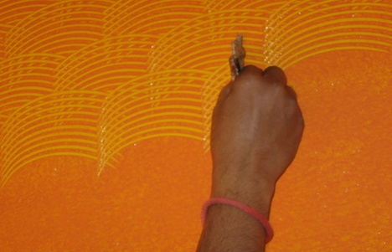
Fig 3.7 Combing or Dragging:
D) Importance of Texture Paint
- Aesthetic appeal: Texture paint adds visual interest and depth to surfaces, enhancing the overall appearance of a room or object.
- Concealing imperfections: Texture paint can help hide minor surface imperfections such as cracks, dents, or uneven patches.
- Durability: Textured surfaces are often more durable and resistant to wear and tear compared to smooth surfaces.
- Sound absorption: Certain types of texture paint, such as acoustic or soundproofing textures, can help reduce noise levels by absorbing sound waves.
- Customization: Texture paint allows for creative expression and customization, as different textures can be combined or modified to achieve unique effects.

Self-Check 3

Directions: Answer all the questions listed below. Use the Answer sheet provided in the next page

Part: 1: Multiple Choices

  - From the following which one is the Importance of Primer Coats
    - Improved Adhesion:
    - Sealing and Stain Blocking:
    - Enhanced Durability:
    - all
  - ---------- refers to a type of paint that is specifically designed to provide a smooth and flawless surface appearance
    - first coat
    - rendering coat
    - none
    - final coat paint

  - from the following one the cause defect Causes of paint
- Moisture or Humidity:
- Poor Surface Preparation:
- Inadequate Drying Time
- all

Part: 2: Short Answer
- Write at least three importance of final coat of paint (5pts)
- Identify Types of intermediate coat (5pts)
- Write the most common types of paint finishes (3pts)

Answer Sheet
Name: _________________________ Date: ______________

Unit four: Apply broken color effects and texture coat by spray
This unit to provide you the necessary information regarding the following content coverage and topics:
  - Preparing ground coat surface
  - Preparing and design scramble glaze ground
  - Applying clear coating sheen level finishing
  - Operating spray equipment
This guide will also assist you to attain the learning outcomes stated in the Above topic contact. Specifically, upon completion of this learning guide, you will be able to:
  - Preparing ground coat surface
  - Preparing and design scramble glaze ground
  - Applying clear coating sheen level finishing
  - Operating spray equipment

4.1 Preparing back ground coat surface
    - Preparing the Surface for Painting
Paintwork creates the final look and personality of your home so it’s worth taking your time to prepare surfaces properly. Read on for tips on how to prepare ceilings walls and other types of surfaces for a professional paint job.
- Preparing Walls
Plenty of preparation will be needed if a wall is to be painted. Even hairline cracks will require filling carefully and sanding. If the wall is a mass of cracks you may decide covering with lining paper or a heavy wallpaper before painting. Woodchip wallpaper is an excellent product for this purpose as it covers a multitude of lumps and cracks. It also takes paint very well.
If your wall isa new plaster wall it should always be left for a few weeks to dry thoroughly before painting.
Always use a primer on new plaster walls as the plaster needs to be sealed before the top coats go on.
- A previously painted wall must be washed down and rinsed first.
- Remove any old wallpaper with warm soapy water or a steamer.
- If there is mould, wash it down with bleach and rinse with water. Then treat with a fungicidal product. Use a heavy primer before you start your main coats.
- Surfaces must be free from dirt, stains and dust before you apply your paint.
- Always ensure surfaces are dry before painting.
- Preparing Ceilings
Although you can paint over existing wallpaper in most cases you will probably want to strip old wallpaper off before painting. Consider buying an electric steamer as these work wonders on difficult wallpaper. Wash off any remaining adhesive. Be aware that removing wallpaper or a suspended ceiling may reveal a ceiling surface in bad condition. If your ceiling is in a bad state you may decide on erecting plasterboard or a heavy wallpaper – you can then plaster or paint over these. To make preparing and painting a ceiling that bit easier use a scaffold board and two stepladders. If it is a big room you can hire decorator trestles or scaffolding.
- Remove light fittings (turn off mains first).
- If the surface is good simply clean with warm water and/or a mild detergent. Rinse thoroughly with clean water.
- Fat or grease stains will need to be removed as much as possible as this prevents paint from holding.
- Likewise any dirt should be scraped off/washed off.
- If the surface is discolored by nicotine apply a heavy primer first before top coats.
- Fill any minor cracks with filler.
- Major cracks may need plastering.
- Flaky or dusty surfaces can be painted with a special sealing primer first.
- Preparing Wood
All bare wood needs to be treated with primer even if it is old wood which has been stripped. For a smooth finish rub down with glass paper, fine sandpaper and brush down or clean with a slightly damp cloth. Always brush/clean along the grain. A pink or white wood primer is usually OK. Resinous woods may need aluminum primer. Aluminum primer is also useful for stained surfaces, from nicotine, etc. Wood knots need to be painted with shellac to prevent resin staining the paintwork. You can also fill cracks and wood knots with woodfiller. Always use the recommended undercoat for your top coat paint. You may need more than one undercoat if you want a smooth finish on wood.
- Stripping Old Paint
This is not always necessary for a smooth finish. If the gloss on the surface is solid and smooth you can simply sand down and paint over. Obviously if the existing paint is a darker colour, say pink, and you wish to paint your surface white then you will need several coats to hide the original paintwork. Old whitewash if it is flaky can often be washed off with soap and water. If the paint is heavy you can try a combination of scraping, a chemical solvent or heatgun.
- Scraping is time consuming and you can scratch/damage surfaces.
- A heat gun is efficient but you have to be careful not to overheat as you could scorch the surface, especially wood.
- Chemical strippers are less toxic than they used to be and are very efficient. You simply paint the liquid on. It peels off the paint which you then scrape off with ease. Useful for tricky surfaces too like banisters and stair rails.

- .Preparing Metal
Rust is a big problem for metal surfaces. Remove as much as you can with wire wool or an emery cloth. You must treat the surface with a primer formulated for rust. Give a couple of coats to be on the safe side if you wish to tackle the problem thoroughly. Non ferrous metals such as copper should be washed down with white spirit, cleaned and given a coat of primer.
4.1.2. Preparation of back ground surface for Appling broken color effect
Remember, a proper amount of time spent preparing your surfaces is crucial if you wish to achieve a quality appearance. Any time saved on preparation is counter-productive, if you are left dissatisfied, or have to go back to strip surfaces and start all over again.
To prepare a ground coat surface for applying broken color effects of paint, you can follow these general steps:
1. Clean the surface: Ensure that the surface is clean and free from dirt, dust, grease, or any other contaminants. You can use a mild detergent or cleaner along with water to clean the surface. Rinse it thoroughly and allow it to dry completely before proceeding.
2. Repair any damage: Inspect the surface for any cracks, holes, or imperfections. Fill in any gaps or repair any damage using an appropriate filler or patching compound. Follow the manufacturer's instructions for application and drying times.
3. Sand the surface: Once the repairs are completed and the filler is dry, use sandpaper or a sanding block to smooth out the patched areas and create an even surface. Sand any rough spots or high points on the surface to ensure a uniform finish. Wipe away any dust resulting from sanding.
4. Apply a primer: Applying a primer is recommended to enhance adhesion and create a uniform base for the broken color effects. Choose a primer suitable for the type of surface you are working on (e.g., wood, metal, drywall). Follow the manufacturer's instructions for application, drying time, and any specific preparation steps.
5. Base coat application: After the primer is dry, apply a base coat of paint in a solid color of your choice. This base coat will serve as the background for the broken color effects. Use a paintbrush, roller, or spray gun depending on the size and nature of the surface. Allow the base coat to dry completely before proceeding.
6. Prepare broken color effects: Determine the colors and techniques you want to use for the broken color effects. This could involve using multiple colors, blending techniques, or creating textured effects. Prepare your paints, brushes, sponges, or any other tools you'll need for the desired effect.
7. Apply broken color effects: Use your chosen tools and techniques to apply the broken color effects over the dry base coat. Experiment with different brushstrokes, stippling, dabbing, or other methods to create the desired effect. Layer and blend the colors as needed, allowing each layer to dry before adding the next.
8. Finishing touches: Once the broken color effects are applied and dry, inspect the surface for any areas that may need additional touch-ups or adjustments. Make any necessary corrections, and allow the paint to cure fully according to the paint manufacturer's instructions.

  - Preparing and design scramble glaze ground
To prepare and design a scrambled glaze ground for painting, you can follow these steps:
1. Choose your surface: Select a canvas or a wooden panel as your painting surface. Make sure it is properly prepared, primed, and ready for painting.
2. Gather your materials: You will need the following materials:
  - Acrylic or oil paints in various colors
  - Paintbrushes
  - Palette or mixing surface
  - Water or paint medium (depending on the type of paint you're using)
  - Rags or paper towels for cleaning
3. Decide on your color scheme: Determine the colors you want to use for your scrambled glaze ground. You can choose complementary colors or a harmonious palette based on your painting's theme or desired effect.
4. Apply the base layer: Start by applying a base layer of paint to your canvas or panel. This layer will serve as the foundation for your scrambled glaze. Use a large paintbrush or roller to cover the entire surface evenly. You can use a single color or create a simple gradient by blending two or more colors.
5. Mix your glaze colors: Prepare several small containers or palettes to mix your glaze colors. Glazes are thin, transparent layers of paint that will be applied over the base layer. Mix your colors with a paint medium or water to achieve a transparent consistency.
6. Apply the glazes: Using a clean brush, apply the glazes in a random, scrambled pattern over the base layer. You can use a variety of brushstrokes, including swirling, dabbing, or crisscrossing motions. Be spontaneous and experiment with different techniques to create an interesting and textured effect.
7. Layer and blend: Apply multiple layers of glazes, allowing each layer to dry before adding the next. As you layer the glazes, they will interact and create depth and complexity in the colors. Blend the glazes together by softly brushing over the edges where they meet, creating smooth transitions or subtle gradations.
8. Add details or highlights: Once you are satisfied with the scrambled glaze ground, you can proceed with your painting by adding details, highlights, or any other elements you desire. Use opaque paint if you want to cover some areas or create contrast with the transparent glazes.
9. Let it dry: Allow your painting to dry completely before varnishing or framing it. The drying time will depend on the type of paint you used and the number of layers applied.
Remember to experiment and have fun with the process. Scrambled glaze grounds can create unique and captivating effects, adding depth and interest to your paintings.
Specific techniques for glazes scrambled pattern
1. Dry Brushing: Load a small amount of glaze onto a dry brush and lightly drag it across the surface in a random and irregular manner. This technique creates broken and textured brushstrokes, adding a sense of movement to the glaze.
2. Stippling: Dip the bristles of a stiff brush or a sponge into the glaze and lightly tap or dab it onto the surface. This technique creates a speckled or stippled effect, resembling a scattered pattern.
3. Splattering: Load a brush with a good amount of glaze and then flick or splatter it onto the surface using your fingers or a brush handle. This technique creates random specks and splatters of color, adding an element of spontaneity and energy to the glaze ground.
4. Sponging: Dip a natural sea sponge or a synthetic sponge into the glaze and gently press it onto the surface. Twist and turn the sponge to create a mottled effect with varying degrees of transparency. This technique can create interesting textures and organic patterns.
5. Palette Knife: Use a palette knife to apply the glaze in a textured and impasto manner. Scrape or spread the glaze across the surface, creating random patterns and ridges. This technique can add a sculptural quality to the glaze ground.
6. Layering and Smudging: Apply multiple layers of glazes in different colors, allowing each layer to dry partially before adding the next. While the glazes are still wet or slightly tacky, use a soft cloth or your fingers to smudge or blend the colors together. This technique can create a beautifully blended and scrambled effect.
Remember, the key to creating a scrambled pattern is to embrace spontaneity and randomness. Experiment with different tools, brushstrokes, and combinations of colors to achieve the desired effect. Don't be afraid to make mistakes and let the process guide you to unexpected and fascinating results.
Scrambling and Glazing
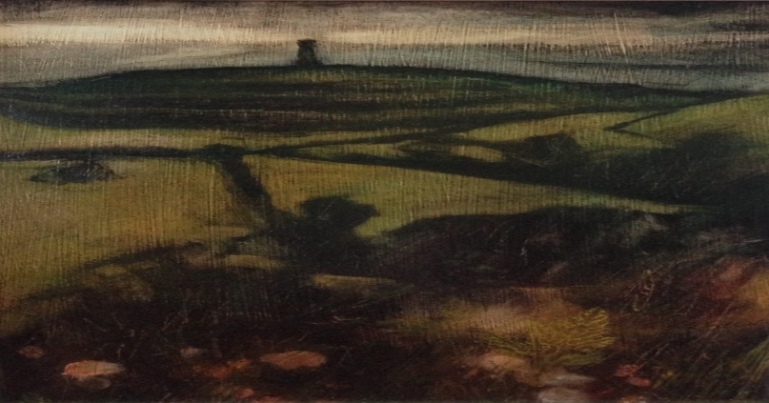
Fig 4.1 Scrambling and Glazing
On the left you see a painting where the final surface is mostly scumbled, on the right, one which is glazed.
Both started off as tonal under paintings – as described in a previous post.
A scum bledlayer is where paint – usually opaque – has been brushed on without the addition of medium, allowing parts of the underneath layers to show through.
A glaze is a thin layer of paint – which has been mixed with medium – brushed over a previous layer or layers. A glaze is like a wash of watercolor which allows underneath colors to show through.
Scrambles and glazes can be used together in one painting. The students experimented with their colors to find out which may be best suited for using in scrambling – intrinsically opaque – and those best suited to using in glazing – intrinsically translucent.
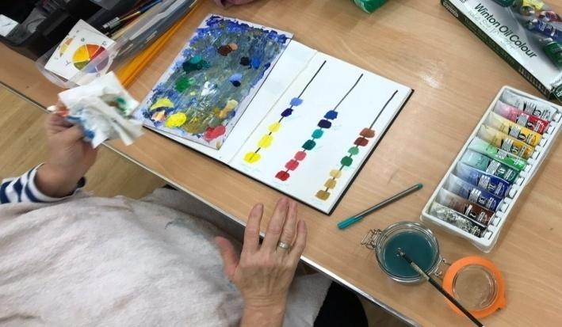
Fig 4.2 experimentation of scrambling

Extraordinary and vivid effects were achieved through experiment and play. The results and experiences can be added to the students’ repertoire for future use.
A glaze is a thin transparent or semi-transparent layer on a painting which modifies the appearance of the underlying paint layer. Glazes can change the chroma, value, hue and texture of a surface. Glazes consist of a great amount of binding medium in relation to a very small amount of pigment.Drying time will depend on the amount and type of paint medium used in the glaze. The medium, base, or vehicle is the mixture to which the dry pigment is added.
Oil painting
In oil painting, the simplest form of a glaze is a thin, oily, transparent layer of paint spread over the top of an opaque passage that has been given some time to dry. Light travels through the glaze and is reflected back off of the opaque layer below. This can cause a glowing effect similar to looking at a brightly lit white wall behind a film of colored cellophane.

Applying clear coating sheen level finishing
    - Sheen or gloss
Wood sheen and gloss terminology are often used interchangeably, but they are actually different.
Sheen levels can be thought of as categories that house varying levels of gloss.
Common wood sheens are matte, satin, semi-gloss and gloss. Specific gloss levels are referred to using a numerical value. We'll dig deeper into this in a moment.
Unfortunately, it can be a little confusing picking out sheen these day. Different manufacturers create names for a specific gloss level in a coating they produce. A satin (the actual gloss-level) from one manufacturer may be different from another's satin sheen.
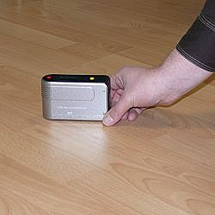
Fig 4.3 Gloss is typically measured with a gloss meter.
A gloss meter projects a beam of light, typically at a 60-degree angle, on a surface. Deflected light gets captured in a receptor. The amount of deflected light that is captured gets expressed in units from 0 (no gloss) to 100 (perfect mirror-like – highest possible gloss).
With very low gloss levels (like a matte finish), a 60-degree angle is often too great to measure deflected light very accurately. Therefore, an 85-degree angle setting in the gloss meter is sometimes used for more accurate readouts.
When applying a clear coating with a specific sheen level for paint finishing, there are a few key steps to follow.
General guide to help you achieve the desired sheen level:
1. Prepare the surface: Ensure that the surface you're applying the clear coating to is clean, dry, and free from any dust, dirt, or contaminants. Use appropriate cleaning methods such as sanding or washing to achieve a smooth and even surface.
2. Choose the right clear coating: Clear coatings come in various sheen levels, such as high gloss, semi-gloss, satin, or matte. Select the coating that matches your desired sheen level. Read the product instructions and specifications to confirm its sheen level.
3. Test on a sample: Before applying the clear coating to your entire project, it's advisable to test it on a small, inconspicuous area or a sample piece. This test will help you assess if the sheen level is what you're looking for and if it complements the underlying paint or substrate.
4. Apply the clear coating: Follow the manufacturer's instructions for the specific clear coating you're using. Typically, you'll need to apply it with a paintbrush, roller, or spray gun. Ensure that you apply the coating evenly and consistently across the surface.
5. Maintain consistent application: To achieve a uniform sheen level, maintain a consistent application technique throughout the entire project. Avoid applying the clear coating too thickly or too thinly in different areas, as this can result in uneven sheen levels.
6. Allow for proper drying and curing: After applying the clear coating, allow it to dry and cure according to the manufacturer's instructions. This will ensure that the coating develops the desired sheen level and durability over time.
7. Assess the final sheen level: Once the clear coating has fully cured, assess the final sheen level. Step back and examine the surface from different angles and lighting conditions to ensure it meets your expectations.
4.3.2. The techniques that making sheen level
It's worth noting that different clear coatings and application techniques can yield slightly different results, so it's always a good idea to consult the product instructions and conduct small-scale tests before applying the coating to your entire project.
To achieve an even and consistent sheen level when applying a clear coating, here are some 4.3.3. Common application techniques sheen level
1. Brush application: Using a high-quality paintbrush specifically designed for clear coatings, apply the coating in long, smooth strokes, following the grain or direction of the surface. Avoid excessive brushing or overlapping, as this can create visible brush marks or uneven sheen. Work methodically in small sections, maintaining a wet edge to ensure a seamless finish.
2. Roller application: Select a high-quality, lint-free roller cover suitable for clear coatings. Roll the coating onto the surface using a crisscross or "W" pattern, followed by light and even strokes in one direction. Be mindful of the roller pressure and avoid pressing too hard, as this can create roller marks. Work in manageable sections and maintain a wet edge to blend the coating properly.
3. Spray application: When using a spray gun for applying the clear coating, ensure that you have proper ventilation and wear appropriate personal protective equipment (PPE). Adjust the spray gun settings according to the manufacturer's recommendations for the specific product. Apply the coating in even passes, moving the spray gun smoothly and consistently across the surface. Overlapping each pass slightly helps achieve an even sheen. Practice proper spraying techniques, such as maintaining the correct distance from the surface and controlling the spray pattern, to achieve a uniform application.
4. Flow and tipping technique: This technique is commonly used when applying clear coatings to large surfaces or areas where brush or roller marks are more likely to occur. After applying the coating with a brush or roller, lightly run a high-quality brush over the freshly applied coating in long, smooth strokes. This helps to level the coating and eliminate any visible brush or roller marks, resulting in a smoother and more even sheen.
4.3.4 Clear coat
A clear coat is a type of paint that is applied over the top of another color to protect it from scratches and UV rays. It’s a great choice for surfaces that are frequently exposed to scratches, like metal, plastic, and glass.
The surface must be properly prepared before a clear coat can be applied – this includes cleaning and sanding the area.
Applying a clear coat is a simple process, but it’s important to follow the instructions carefully to achieve the best results. Make sure to sand the surface until it’s smooth and free from any imperfections, and apply a clear coat in the desired color.
Be sure to wait until the clear coat is completely dry before using the surface. The clear coat is a great way to protect your investments, and it can make your project look even better!
Why do you need to prepare the surface for a clear coat?
Prepping the wall surface for a clear coat is essential if you want a smooth and shiny finish.
To get the best results, sand down the surface to remove any imperfections.
This will give you a clean slate to work on and ensure a smooth finish. Make sure to use fine-grit sandpaper to avoid damaging thepaint job underneath. Now you’re ready to apply your clear coat!
Preparing the surface for a clear coat
- It’s important to prepare the surface you’re going to apply a clear coat to properly. Follow these tips to ensure a smooth and flawless finish.
- First, make sure the surface is clean. Remove any wax or grease with a degreaser. Next, sand the surface smoothly with a fine-grit sandpaper.
- Finally, wipe the dust off with a damp cloth before applying a clear coat. Be sure to apply a clear coat in a well-ventilated area to avoid fumes. And that’s all you need to know to get a great clear coat finish on your projects!

Operating spray equipment

    - Method of Operation of Spray Equipment for Painting

Spray equipment for painting is commonly used in various industries and applications to efficiently apply paint or coatings onto surfaces. The method of operation of spray equipment involves the following components:

1. Spray Gun: The spray gun is the primary tool used in spray painting. It consists of a nozzle, fluid needle, and an air cap. The paint or coating material is atomized by passing it through the nozzle, which is then mixed with compressed air and released as a fine spray.
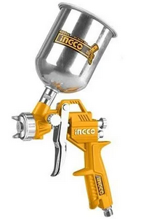
Fig 4.4 Spray Gun
2. Compressed Air Source: Spray equipment requires a reliable source of compressed air to atomize the paint or coating material. Compressed air is supplied from an air compressor and is regulated to achieve the desired pressure and flow rate for optimal spray performance.

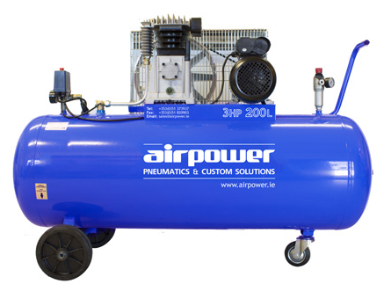
Fig 4.5 Compressed Air Source
3. Fluid Delivery System: The fluid delivery system consists of a paint reservoir or cup, a fluid pump or pressure regulator, and hoses that connect the spray gun to the paint source. The paint or coating material is delivered to the spray gun through these components, ensuring a constant and controlled supply.
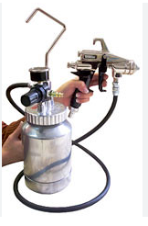
Fig 4.6 Fluid Delivery System
4. Control Mechanisms: Spray equipment is equipped with various control mechanisms to adjust and optimize the spray process. These include controls for air pressure, paint flow rate, spray pattern width, and fan shape. These adjustments allow the operator to achieve the desired coverage, finish, and texture.
    - Method Of Operating Spray Gun
Operating a spray gun typically involves the following steps:
1. Preparation: Start by gathering all the necessary equipment and materials. This includes the spray gun, paint or coating, appropriate solvent or thinner, safety equipment (such as goggles, gloves, and a respirator), and any other tools or supplies required for the specific job.
2. Safety Measures: Before operating the spray gun, ensure that you are in a well-ventilated area or a designated spray booth. Wear the necessary safety equipment to protect yourself from fumes, chemicals, and overspray.
3. Gun Assembly: If the spray gun is not pre-assembled, follow the manufacturer's instructions to assemble it correctly. This typically involves attaching the spray tip, fluid nozzle, and air cap to the gun body. Make sure all connections are tight and secure.
4. Adjustments: Depending on the type of spray gun, you may need to adjust various settings to achieve the desired spray pattern and atomization. These settings may include air pressure, fluid flow rate, fan width, and spray pattern shape. Consult the manufacturer's instructions for specific guidance on adjusting these settings.
5. Material Preparation: Prepare the paint or coating according to the manufacturer's instructions. This may involve mixing it with a solvent or thinner to achieve the desired consistency. Strain the material through a paint strainer to remove any impurities that could clog the spray gun.
6. Test Spray: Before applying the paint or coating to the target surface, perform a test spray on a scrap piece of material or a test panel. This allows you to ensure that the spray gun is properly adjusted and the desired spray pattern is achieved. Make any necessary adjustments based on the test spray results.
7. Application: Once you are satisfied with the test spray, you can begin applying the paint or coating to the target surface. Hold the spray gun at a consistent distance from the surface, typically 6 to 12 inches (15 to 30 cm), and move in a smooth, continuous motion to achieve an even coating. Overlap each pass slightly to avoid streaks or uneven coverage.
8. Cleaning: After you have finished using the spray gun, it is essential to clean it thoroughly to prevent clogs and ensure its longevity. Follow the manufacturer's instructions for cleaning, which typically involve disassembling the gun, flushing it with an appropriate solvent or cleaner, and removing any residual paint or coating.
    - Importance of Spray for Painting
Spray painting offers several advantages over traditional painting methods like brushing or rolling. The importance of spray painting can be summarized as follows:
1. Efficiency and Speed: Spray painting enables large areas to be covered quickly and efficiently. The atomized paint or coating material is evenly distributed over the surface, resulting in uniform coverage and reduced painting time compared to manual methods.
2. Smooth and Even Finish: Spray painting produces a smooth and even finish with minimal brush marks or roller texture. The fine spray particles ensure better adhesion and a uniform coating thickness, resulting in a professional-looking surface.
3. Versatility: Spray equipment allows for versatile application, as it can be used on various surfaces, including walls, furniture, automotive parts, machinery, and more. It is suitable for a wide range of materials, such as wood, metal, plastic, and ceramics.
4. Waste Reduction: Spray painting minimizes waste by optimizing the paint application process. The controlled spray pattern and adjustable settings help reduce overspray and paint consumption, resulting in cost savings and environmental benefits.
5. Accessibility: Spray equipment allows paint to reach areas that are difficult to access with traditional methods. The fine spray can penetrate corners, crevices, and complex shapes, ensuring complete coverage and protection.
6. Consistency: Spray painting provides consistent results, as the spray pattern and paint flow can be precisely controlled. This helps maintain a consistent color, texture, and finish throughout the painted surface.
Overall, spray equipment for painting offers efficiency, speed, uniformity, versatility, and improved finish quality, making it a preferred choice in many industries and applications.

Self-Check 4
Directions: Answer all the questions listed below. Use the Answer sheet provided in the next page

Part: 1: Multiple Choices

1. One of the following isImportance of Spray for Painting
  - Efficiency and Speed
  - Smooth and Even Finish
  - Versatility
  - all
- From the following one is the Preparing the surface for a clear coat
- It’s important to prepare the surface you’re going to apply a clear coat to properly.
- First, make sure the surface is clean.
- Finally, wipe the dust off with a damp cloth before applying a clear coat.
- all
- The method of operation of spray equipment involves the following components:
- Spray Gun
- Compressed Air Source.
- Fluid Delivery System
- All
Part: 2: Short Answer
    - Write at least three Common application techniques sheen level (5pts)
    - Write Importance of Spray for Painting? (5pts)
    - Identify The techniques that making sheen level 5pts)
-------------------------------------------------------------------

Answer Sheet
Name: _________________________ Date: ______________

Unit five :Produce imitation for marble and wood grain effect
This unit to provide you the necessary information regarding the following content coverage and topics:
  - Preparation of back ground surface ground coat surface
  - Design proportions for wood and marble
  - Clear coating sheen level finishing
This guide will also assist you to attain the learning outcomes stated in the Above topic contact. Specifically, upon completion of this learning guide, you will be able to:
  - Preparation of back ground surface ground coat surface
  - Design proportions for wood and marble
  - Clear coating sheen level finishing

5.1. Preparation of back ground surface ground coat surface
The preparation of a background coat surface for wood and marble effects refers to the process of creating a suitable base or foundation on a substrate to achieve realistic wood grain or marble patterns. It involves priming, sanding, and applying specific base coats to ensure the desired effects can be successfully achieved.
5.1.1 Method of Surface Preparation for Wood Grain
To prepare a surface for a wood grain effect, the following steps can be taken:
- Clean the Surface: Ensure the surface is clean and free from dust, dirt, grease, or any other contaminants. Use a suitable cleaner or degreaser if necessary.
- Sanding: Lightly sand the surface to create a smooth and even texture. This step helps in removing any existing finishes, roughness, or imperfections on the surface.
- Apply a Primer: Apply a suitable primer to the sanded surface. The primer helps in promoting adhesion and provides a consistent base for the subsequent layers.
- Base Coat: Apply a base coat of paint in a color that resembles the desired wood grain. Use a paintbrush, roller, or spray gun to ensure even coverage. Allow the base coat to dry completely.
- Wood Grain Technique: Once the base coat is dry, use a wood graining tool or a brush to create the desired wood grain effect. This technique involves dragging the tool or brush through the wet glaze or paint in a pattern that mimics the natural grain of wood.
- Finishing: Allow the wood grain effect to dry thoroughly. Apply a clear protective topcoat, such as varnish or polyurethane, to protect the wood grain and provide a durable finish.
5.1.2 Method of Surface Preparation for Marble Effect Color:
To prepare a surface for a marble effect color, the following steps can be followed:
- Clean the Surface: Clean the surface thoroughly to remove any dust, dirt, or debris. Ensure that the surface is completely dry before proceeding.
- Apply a Primer: Apply a primer specifically formulated for creating a marble effect. Primers designed for this purpose provide a suitable base for the subsequent layers and enhance the adhesion of the marble effect paint.
- Base Coat: Apply a base coat of paint in a desired color that will serve as the background for the marble effect. This color can be a neutral shade that complements the marble colors you intend to create.
- Marble Effect Technique: Once the base coat is dry, use a variety of techniques to create the marble effect. This can involve using a feathering technique with a brush, sponge, or rag, or using a specialized marble effect tool or comb. Experiment with different techniques to achieve the desired marble patterns and veining.
- Finishing: Allow the marble effect to dry completely. Apply a clear protective topcoat, such as a varnish or sealant, to protect the marble effect and provide durability.
5.1.3. Importance
The preparation of a background coat surface is essential for wood and marble effects for several reasons:
  - Adhesion: Properly preparing the surface ensures good adhesion of the subsequent layers. This helps in preventing peeling, cracking, or flaking of the wood grain or marble effect.
  - Smooth Finish: Surface preparation helps in creating a smooth and even base, which is crucial for achieving realistic wood grain or marble patterns.
  - Durability: By using primers, base coats, and protective topcoats, the prepared surface becomes more resistant to wear, scratches, and other forms of damage.
  - Professional Appearance: Adequate surface preparation ensures that the wood grain or marble effect looks professional and aesthetically pleasing.
  - Longevity: A well-prepared background coat surface enhances the longevity of the wood grain or marble effect, allowing it to maintain its beauty and quality over time.

5.2. Mixing designed proportions for wood and marble
5.2.1 Marble Effect Designed Proportions:
Designed proportions for wood and marble paint refer to the intentional and deliberate ratios or ratios of colors and materials used in the application of wood grain or marble effects. These proportions are determined based on the desired outcome and the specific technique being used.

In the context of wood grain paint, designed proportions involve determining the appropriate ratios of base colors and graining colors to achieve the desired wood species and grain patterns. This includes selecting the right hues, tones, and intensities to replicate the natural wood look accurately.

For marble paint, designed proportions involve determining the ratios of base colors and veining colors to achieve the desired type of marble and veining patterns. This includes selecting the appropriate colors to mimic the distinctive appearance of different marble varieties, such as Carrara, Calacatta, or Emperador marble.
The designed proportions take into account factors like the color intensity, contrast, and distribution of colors to create a realistic and visually appealing wood grain or marble effect. These proportions can vary depending on personal preference, the specific technique used, and the desired outcome.
By carefully considering and applying the designed proportions, painters can achieve a more accurate and convincing representation of wood grain or marble, enhancing the overall aesthetic quality of the finished surface.
The material used for production of wood grain effect and marble
Wood Grain Effects
1. Clear Varnish or Polyurethane: Applying a clear varnish or polyurethane topcoat can help protect the wood grain effect and provide durability. Choose a product specifically formulated for interior or exterior wood surfaces, depending on the location of your project.
2. Clear Lacquer: Lacquer is another option for protecting and sealing wood grain effects. It provides a protective layer while enhancing the appearance of the wood grain. Look for lacquers designed for decorative finishes or faux wood techniques.
3. Water-based Topcoats: Water-based topcoats, such as water-based polyurethane or acrylic varnishes, are also commonly used for protecting wood grain effects. They offer quick drying times, low odor, and easy clean-up.
      - Marble Effects:
1. Clear Sealants: Depending on the specific type of paint or technique used for the marble effect, you can consider using clear sealants or varnishes designed for protecting decorative finishes. Look for sealants that are compatible with the type of paint or glaze used.
2. Epoxy Resin: In some cases, epoxy resin can be used to seal and protect marble effects. Epoxy provides a durable and glossy finish, enhancing the appearance of the marble patterns. However, it's important to follow the manufacturer's instructions and ensure compatibility with the specific paint or glaze used.
When selecting topcoats or sealers, consider factors such as the desired level of sheen (e.g., matte, satin, or gloss), the intended location of the project (interior or exterior), and the compatibility with the base coats and paints used for the wood grain or marble effects.
- Method of Mixing:
When creating marble effects, the proportions of colors and materials can vary depending on the desired outcome and the specific technique being used. Here is a general guideline for mixing marble effect colors:
1. Base Color: Start by selecting a base color that will serve as the background for the marble effect. This color can be a neutral shade such as white, beige, or gray.
2. Veining Colors: Choose one or more colors that will represent the veins in the marble. Common options include shades of gray, black, brown, or even metallic colors like gold or silver.
3. Mixing Technique: Marble effects can be achieved through various techniques, including feathering, sponging, or ragging. The specific method of mixing will depend on the chosen technique. For example, if feathering is used, you may lightly brush or drag the veining colors through the base color to create the desired marble pattern.
b) Types of Marble Effects and Colors:
There are numerous types of marble effects that can be created, each replicating the appearance of different types of natural marble. Some popular types include Carrara marble (white with gray veins), Calacatta marble (white with bold gold veins), or Emperador marble (brown with lighter veins). The choice of colors and techniques will depend on the specific type of marble you are trying to emulate.

- Operation
To create the marble effect, follow these general steps:
1. Prepare the Surface: Ensure the surface is clean, smooth, and properly primed.
2. Apply the Base Color: Apply the chosen base color as the background for the marble effect. Allow it to dry completely.
3. Mix and Apply Veining Colors: Mix the veining colors according to your desired proportions. Apply the veining colors using the chosen technique, such as feathering or sponging, to create the veins and patterns of the marble. Work in layers, allowing each layer to dry before applying the next.
4. Finishing Touches: Once the desired marble effect is achieved, allow it to dry completely. Apply a clear protective topcoat or sealer to protect the finish and enhance its durability.
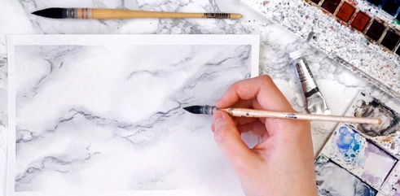
Fig5.1 marble effect design
5.2.2 Wood Graining Designed Proportions
Method of Mixing
When creating wood grain effects, the proportions of colors and materials are typically focused on replicating the appearance of different wood species. Here is a general guideline for mixing wood graining colors
1. Base Color: Start with a base color that resembles the general hue of the wood species you want to emulate. This can be achieved by mixing different shades of browns, such as raw sienna, burnt sienna, or burnt umber.
2. Graining Colors: Mix additional colors to create the grain patterns and highlights of the wood. This may include darker browns, black, or even gray for certain wood species.
3. Mixing Technique: Wood graining techniques involve creating the appearance of wood grain patterns using tools like brushes, combs, or graining tools. The specific method of mixing will depend on the chosen technique and the desired wood species.
b) Types of Wood Grain Effects and Colors:
There are countless wood species with unique grain patterns and colors. Some popular wood grain effects include oak, mahogany, walnut, or pine. Each wood species has its characteristic colors and grain patterns. Researching specific wood species will help you determine the appropriate colors and proportions for achieving the desired wood grain effect.
Operation
To create the wood grain effect, follow these general steps:
1. Prepare the Surface: Ensure the surface is clean, smooth, and properly primed.
2. Apply the Base Color: Apply the chosen base color as the background for the wood grain effect. Allow it to dry completely.
3. Mix and Apply Graining Colors: Mix the graining colors according to your desired proportions. Apply the graining colors using the chosen technique, such as brushing or combing, to replicate the grain patterns of the desired wood species. Work in layers, allowing each layer to dry before applying the next.
4. Finishing Touches: Once the wood grain effect is achieved, allow it to dry completely. Apply a clear protective topcoat or sealer to protect the finish and enhance its durability.
Remember, the specific proportions and techniques may vary depending on the desired wood or marble effect, the materials being used, and personal preferences. It's always a good idea to practice and experiment on sample boards before applying the effects to your intended surface.
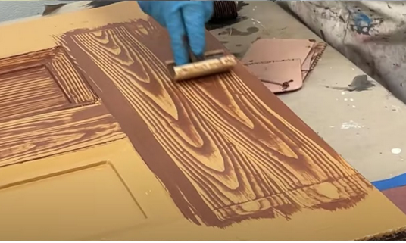
Fig 5.2 Wood grain effect design
The importance of marble and wood grain effect
Wood grain and marble effect paint can be important for a variety of reasons, including aesthetic appeal, cost-effectiveness, and versatility. Here are some key points highlighting the importance of these effects:
    - Wood Grain Effect Paint:
- Aesthetic Appeal: Wood grain effect paint allows you to replicate the natural beauty of wood on various surfaces, such as furniture, cabinetry, or architectural elements. It can add warmth, character, and a sense of authenticity to the space.
- Cost-Effectiveness: Using wood grain effect paint can be a more affordable alternative to using real wood. It eliminates the need for expensive wood materials and can be applied to surfaces that may not be suitable for genuine wood, such as MDF or laminate.
- Versatility: Wood grain effect paint offers a wide range of possibilities. It allows you to choose from various wood species, colors, and grain patterns, giving you the flexibility to achieve different looks and match existing wood elements in your space.
- Durability and Maintenance: Wood grain effect paint can provide a protective layer that enhances the durability of the painted surface. It can also be easier to maintain compared to real wood, as it doesn't require the same level of upkeep, such as refinishing or staining.
    - Marble Effect Paint:
- Elegance and Luxury: Marble effect paint can bring a touch of elegance and luxury to interior spaces. It allows you to replicate the sophisticated appearance of natural marble, which is often associated with high-end design.
- Cost Savings: Using marble effect paint instead of real marble can be a cost-effective solution. Natural marble can be expensive and challenging to install, especially for large surfaces. Marble effect paint provides a more affordable option while still achieving a similar visual impact.
- Customization: Marble effect paint offers the advantage of customization. You can choose from various marble types, colors, and veining patterns, allowing you to match existing décor or create unique designs that suit your personal style.
- Versatility: Marble effect paint can be applied to a wide range of surfaces, including walls, countertops, furniture, or decorative accents. This versatility allows you to incorporate the luxurious look of marble into different areas of your space.
- Low Maintenance: Unlike natural marble, marble effect paint is typically easier to maintain. It doesn't require the same level of sealing, polishing, or ongoing maintenance that real marble often needs.

Applying clear coating sheen level finishing
Applying clear coating sheen level finishing refers to the process of achieving a desired level of gloss or shine on a surface by using a clear coating product. The sheen level refers to the degree of light reflection and can range from high gloss to matte.

    - Material used for clear coating sheen leveling
The material used for clear coating sheen leveling can vary depending on the specific product and the desired finish. Here are some common materials used:
1. Clear Polyurethane: Clear polyurethane coatings are popular for achieving various sheen levels, from high gloss to satin or matte finishes. They provide excellent durability and protection against wear, moisture, and chemicals.
2. Lacquer: Lacquer coatings, such as nitrocellulose lacquer or acrylic lacquer, are known for their fast-drying properties. They can provide a smooth and glossy finish with different sheen levels.
3. Varnish: Varnishes are typically made from a combination of resins, oils, and solvents. They offer a durable and protective clear coating with different levels of sheen, ranging from high gloss to satin or matte.
4. Epoxy Coatings: Epoxy coatings are commonly used for high-performance applications that require superior durability and resistance to chemicals, abrasion, and moisture. They can provide a glossy finish and are often used on floors, countertops, and other surfaces.
5. Water-based Clear Coatings: Water-based clear coatings, such as water-based polyurethane or acrylic finishes, have gained popularity due to their low VOC (volatile organic compound) content and ease of use. They can provide different sheen levels and offer good durability and protection.
Method of applying
The method of applying clear coating sheen level finishing can vary depending on the type of coating and the surface being coated. Some common methods include:

  - Brushing: Using a brush to apply the clear coating in smooth, even strokes.
  - Spraying: Utilizing a spray gun or aerosol can to apply the clear coating in a fine mist.
  - Rolling: Applying the clear coating with a paint roller, typically used for larger surface areas.
    - Importance of Clear coating sheen level finishing
  - Protection: Clear coatings provide a protective layer on the surface, guarding it against scratches, moisture, UV rays, and other environmental factors.
  - Aesthetics: The sheen level of a clear coating contributes to the overall appearance of the surface. It can enhance the natural beauty of wood, metal, or other materials, providing a glossy, satin, or matte finish.
  - Durability: Clear coatings with proper sheen levels can improve the durability and longevity of the surface, extending its lifespan and reducing the need for frequent maintenance.
  - Easy maintenance: Clear coatings with the appropriate sheen level are often easier to clean and maintain, as they can be more resistant to stains and dirt buildup.
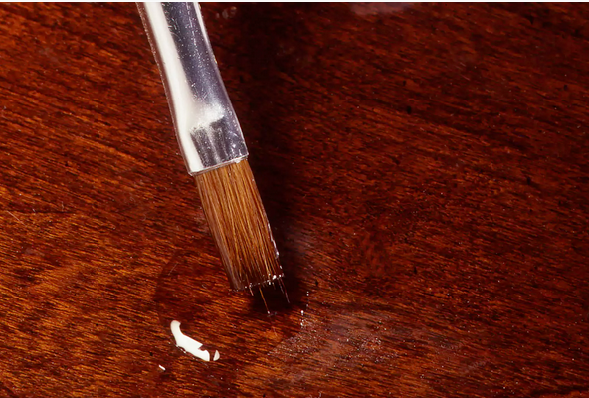
Fig 5.3.Clear coating sheen level finishing

Self-Check 5
Directions: Answer all the questions listed below. Use the Answer sheet provided in the next page

Part: 1: Multiple Choices

    - From the following one is the Method of Surface Preparation for Marble Effect Color:
- Clean the Surface
- Apply a Primer
- A&B
- All
    - ----------------is theImportance of Clear coating sheen level finishing

  - Aesthetics
  - Durability
  - Easy maintenance
  - all
    - one of the following are the Method of Surface Preparation for Wood Grain
- Clean the Surface
- Sanding
- Apply a Primer
- All
Part: 2: Short Answer
    - Write at least five importance Clear coating sheen level finishing. (5pts)
--------------------------------------------------------------------
    - Material used for clear coating sheen leveling? (5pts)
--------------------------------------------------------------------
    - Method of mixing marble effect colors:(5pts)
-------------------------------------------------------------------

Answer Sheet
Name: _________________________ Date: ______________

OPERATION SHEET-2
OPERATION TITLE:- Produce imitation for wood grain effect
PURPOSE:- to ensure that the proposed create the wood grain effectfinishing work is appropriate to the building
CONDITIONS OR SITUATIONS FOR THE OPERATIONS:-
Wear appropriate clothes, shoe.
Ensure the work shop hazard free
Ensure the working area is bright
Make workstation comfortable..
EQUIPMENT TOOLS AND MATERIALS : -
Brush ,sponge ,sand paper, paint, roller brush
PROCEDURE,
create the wood grain effect
1. Prepare the Surface:
2. Apply the Base Color:
3. Mix and Apply Graining Colors:
4. Finishing Touches:
PRECAUTIONS:-
Wear working cloths which properly fit with your body.
Make working area hazard free.
Read and interpret manual which guide you how to disassemble and tag engine system components.
The trainees should fulfill safety conditions.
QUALITY CRITERIA: Improperly done create the wood grain effectsafely according to the requested standard

OPERATION SHEET-3
OPERATION TITLE:- Produce imitation for marble effect
PURPOSE:- to ensure that the proposed create the wood grain effectfinishing work is appropriate to the building
CONDITIONS OR SITUATIONS FOR THE OPERATIONS:-
Wear appropriate clothes, shoe.
Ensure the work shop hazard free
Ensure the working area is bright
Make workstation comfortable..
EQUIPMENT TOOLS AND MATERIALS : -
Brush ,sponge ,sand paper, paint, roller brush
PROCEDURE,
1. Prepare the Surface
2. Apply the Base Color.
3. Mix and Apply Veining Colors.
4. Finishing Touches
PRECAUTIONS:-
Wear working cloths which properly fit with your body.
Make working area hazard free.
Read and interpret manual which guide you how to disassemble and tag engine system components.
The trainees should fulfill safety conditions.
QUALITY CRITERIA: Improperly done create the marble grain effect safely according to the requested standard

LAP Test -2

Name: _____________________________ Date: ________________
Time started: ________________________ Time finished: ________________

Instructions: Given necessary templates /guide, workshop, tools and materials you are required to perform the following tasks within 1:00 hours.
Task.1. Create the wood grain effect
Task.2. Create the marble grain effect

Unit six: Apply stencils
This unit to provide you the necessary information regarding the following content coverage and topics:
- Selecting and laid stencil design material.
- Applying transfer method and design
- placing stencil design location and paint
- Applying stencils pattern separate color
This guide will also assist you to attain the learning outcomes stated in the Above topic contact. Specifically, upon completion of this learning guide, you will be able to:
- Selecting and laid stencil design material.
- Applying transfer method and design
- placing stencil design location and paint
- Applying stencils pattern separate color

Selecting and laid stencil design material
    - Selecting Stencil Material
When selecting stencil material, consider the following factors:
1. Durability: Choose a material that is sturdy and can withstand repeated use without tearing or warping.
2. Transparency: The material should be transparent enough to allow easy visibility of the design or pattern being stenciled.
3. Flexibility: The stencil material should be flexible to conform to different surfaces and shapes.
4. Thickness: Opt for a material that is thick enough to be durable but not too thick to make cutting difficult.
5. Reusability: Look for a material that can be easily cleaned and reused multiple times.
    - Common stencil materials include
  - Mylar: A type of polyester film that is durable, transparent, and can be easily cleaned and reused.
  - Acetate: A clear plastic sheet that is transparent and relatively inexpensive.
  - Cardstock: A stiff paper material that is suitable for one-time use stencils.
  - Stencil vinyl: A self-adhesive vinyl material that is easy to cut and can be used on various surfaces.
    - Types of Stencils
There are various types of stencils available, depending on the design and application. Some common types include:
1. Letter and number stencils: These stencils feature alphabets and numerical characters, often used for signage or labeling.
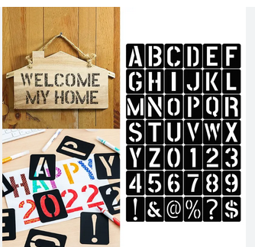
Fig 6.1 Letter and number stencils
2. Decorative stencils: These stencils contain ornamental designs, patterns, or motifs used for home decor, crafts, or art projects.
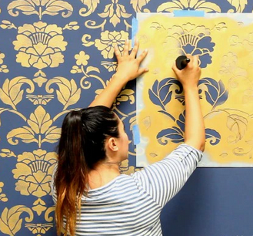
Fig 6.2 Decorative stencils
    - Border stencils: These stencils have repeated patterns or borders that can be used to create decorative edges or border
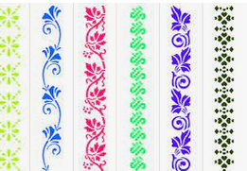
Fig 5.3 Border stencils
    - Spray paint stencils: These stencils are specifically designed for use with spray paint, often used for street art or graffiti.
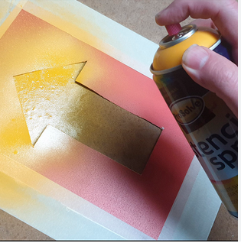
Fig 6.4 Spray paint stencils
- Floor stencils: These stencils are larger in size and used for creating patterns or designs on floors or pavements.
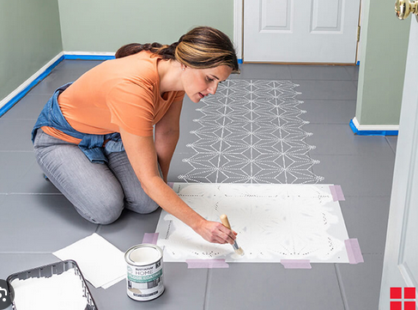
Fig 6.5 Floor stencils

    - Tools Used for Stenciling
The tools commonly used for stenciling include:
1. Cutting tools: Such as craft knives, precision cutters, or stencil cutters, used to cut out the design from the stencil material.
2. Stencil brushes: Special brushes with short, stiff bristles used to apply paint or ink over the stencil.
3. Spray adhesive: A temporary adhesive used to hold the stencil in place during painting.
4. Painter's tape: Used to secure the stencil to the surface and prevent paint bleed.
5. Paint or ink: Depending on the project, you can use acrylic paint, fabric paint, spray paint, or specialized stencil inks.
    - Laid Method of Stenciling
The "laid" method of stenciling refers to the process of positioning the stencil on the surface and applying paint or ink over it. Here's a general step-by-step process:
            - Prepare the surface: Ensure that the surface is clean, smooth, and free from dust or debris.
            - Secure the stencil: Use painter's tape or a spray adhesive to secure the stencil in place, ensuring it doesn't shift during painting.
            - Load the brush: Dip the stencil brush into the paint or ink of your choice, then blot off any excess on a paper towel or palette.
            - Apply paint: Hold the stencil firmly with one hand and use a gentle tapping or swirling motion with the brush to apply the paint or ink over the stencil openings. Avoid applying too much pressure to prevent paint bleed.
            - Finish the design: Once you've painted the entire stencil, carefully lift it off the surface to reveal the finished design. Allow the paint to dry before removing or repositioning the stencil for additional layers or colors.
    - Importance of Stenciling
Stenciling offers several benefits and is commonly used in various applications:
1. Versatility: Stenciling can be used on a wide range of surfaces, including walls, fabric, wood, metal, and more.
2. Reproducibility: Stencils allow for consistent reproduction of a design or pattern, ensuring uniformity across multiple items or surfaces.
3. Creativity: Stencils provide a way to easily incorporate intricate or complex designs into projects, even for those with limited artistic skills.
4. Customization: Stenciling allows for customization and personalization of items, whether it's adding names, monograms, or unique designs.
5. Time and cost-effective: Stenciling can be a quicker and more cost-effective alternative to hand-painting or other decorative techniques, especially for larger projects.

Apply and design location of stencil
6.2.1. Applyand design the location of a stencil
1. Determine the purpose: Clarify the purpose of the stencil and what you intend to use it for. Stencils can be used for various applications, such as lettering, artwork, or signage.
2. Choose the stencil design: Select or create a stencil design that suits your needs. You can find pre-made stencils in craft stores or online, or you can design your own using software or drawing tools.
3. Prepare the surface: Clean the surface where you plan to apply the stencil. Ensure it is smooth, dry, and free of any dust or debris. If necessary, use tape to secure the stencil in place to prevent it from shifting during the application process.
4. Position the stencil: Decide on the desired location for the stencil. You can use a pencil or chalk to lightly mark the area where the stencil will be placed. This will serve as a guideline for proper alignment.

5. Secure the stencil: If your stencil has adhesive backing, carefully peel off the backing and press the stencil firmly onto the surface. If the stencil doesn't have adhesive, you can use masking tape or painter's tape to secure it in place.
6. Apply the paint or medium: Choose the appropriate paint or medium for your project. Depending on the surface and application, you may use spray paint, a brush, a sponge, or a roller. Use light, even pressure to apply the paint over the stencil, being careful not to go beyond the edges of the stencil design.

7. Remove the stencil: Once you've finished applying the paint, carefully lift the stencil away from the surface. It's important to remove the stencil slowly and evenly to avoid smudging or smearing the design.
8. Clean and repeat: If you plan to reuse the stencil, clean it immediately after use to prevent the paint from drying and clogging the stencil openings. Follow the manufacturer's instructions for cleaning the stencil, as different materials may require specific cleaning methods. If you need to apply the stencil in multiple locations, repeat the process, ensuring proper alignment each time.
Remember to exercise caution when working with paints and chemicals, and always follow safety guidelines and instructions provided by the manufacturer.
When stenciling on fabric, it's important to use paint or mediums specifically designed for fabric to achieve the best results. Here are a few options you can consider:
1. Fabric Paint: Fabric paints are formulated to adhere well to fabric fibers and withstand washing without fading or cracking. They come in a variety of colors and finishes, such as matte, metallic, or glitter. Fabric paints are typically available in bottles or tubes and can be applied with a brush, sponge, or even a stamp. Look for fabric paints labeled as suitable for stenciling.
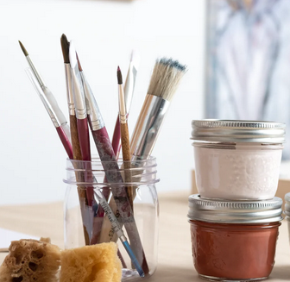
Fig 6.6 Fabric Paint
2. Fabric Markers: Fabric markers are another option for stenciling on fabric. They are available in different tip sizes and colors. Fabric markers allow for more precise control and fine details. They work well for smaller stencils or when you need to add intricate designs.
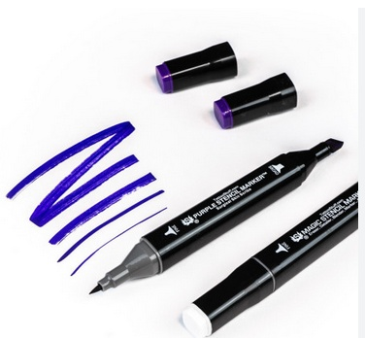
Fig 6.7 Fabric Markers
3. Fabric Spray Paint: Fabric spray paints provide an even and smooth application. They come in aerosol cans and are convenient for larger stenciling projects or for creating gradient effects. Fabric spray paints are available in various colors and finishes. Shake the can well before use and spray from a distance to achieve an even coverage.
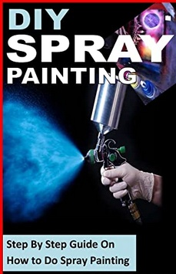
Fig 6.8 Fabric Spray Paint
- Fabric Screen Printing Ink: If you're looking for vibrant and professional-looking results, you can use fabric screen printing ink. This type of ink is specifically designed for fabric screen printing but can also be used for stenciling. It provides excellent color saturation and durability. Apply the ink with a squeegee or a brush, and make sure to follow the recommended curing instructions.
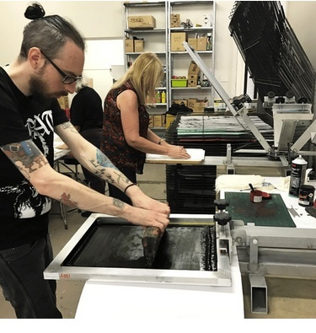
Fig 6.9.Fabric Screen Printing Ink
The recommended drying time for fabric paint
The recommended drying time for fabric paint on fabric can vary depending on several factors, including the specific brand and type of fabric paint used, the thickness of the paint application, and the environmental conditions such as temperature and humidity. However, as a general guideline, fabric paint usually requires several hours to dry completely. Here are some approximate drying times to consider:
1. Air drying: Fabric paint applied in thin layers typically dries within 1-2 hours when left to air dry. However, thicker applications or multiple layers may require longer drying times, possibly up to 24 hours or more.
2. Heat setting: Many fabric paints require heat setting to ensure proper adhesion and durability. This process involves applying heat to the painted fabric using an iron or a heat press. Follow the instructions provided by the manufacturer for the specific fabric paint you are using. Typically, heat setting involves ironing the painted fabric on the appropriate temperature setting for a specified amount of time, often around 2-5 minutes. This step helps to cure the paint and make it more resistant to washing and fading.
Tools for design a stencil
1. Pencil or Pen: You will need a pencil or pen to sketch out your stencil design on paper before transferring it to the stencil material. These tools allow you to create the initial outline and details of your design.

2. Paper: A sheet of paper is essential for sketching and refining your stencil design. You can use plain white paper or graph paper, depending on your preference.
3. Stencil Material: Stencil material is the medium on which you will create your stencil design. There are various options available, including plastic sheets, mylar sheets, or stencil paper. Choose a material that suits your needs and is compatible with the tools you plan to use for cutting.
4. Cutting Tools: You will need cutting tools to cut out the design from the stencil material. The choice of cutting tool depends on the stencil material you are using and your personal preference. Common options include:
  - Scissors: Suitable for cutting out simple stencil designs on thinner stencil materials like stencil paper.
  - Craft Knife/Utility Knife: A sharp craft knife or utility knife with a replaceable blade can be used for cutting more intricate designs on various stencil materials. Make sure to use a cutting mat or a protective surface when using a craft knife to avoid damaging your working area.
  - Cutting Machine: If you are working on more complex or detailed stencil designs, you may consider using a cutting machine like a vinyl cutter or a laser cutter. These machines can create precise cuts based on digital designs.
5. Cutting Mat: A cutting mat is a self-healing mat made of a durable material like rubber or plastic. It protects the surface you're working on and provides a smooth cutting surface for your stencil material. It is particularly useful when using a craft knife or utility knife.

6. Ruler or Straight Edge: A ruler or straight edge can help you create clean and straight lines in your stencil design. It is especially useful when drawing geometric shapes or aligning elements in your design.

7. Eraser: An eraser is handy for making corrections or adjustments to your stencil design during the sketching phase. It allows you to remove unwanted lines or marks easily.

8. Optional: If you plan to transfer your design from paper to the stencil material, you may need transfer paper or carbon paper to trace the design accurately.

6.3. Applying stencils pattern separate color
6.3.1 Stencil
At its core, a stencil is a tool that helps you apply a particular design onto a surface. The basic stencil designs can range from letters and words to floral and geometric patterns. Patterns proved to be the most popular design. The method of repeating a design through a cut-out shape is called stenciling. In the visual arts, this technique involves the use of ink or paint over cut-outs or holes in cardboard or metal onto a surface, therefore reproducing or transferring the design on it. This crafty tool tends to work best on a flat surface and, depending on the ink or paint you use, can be used on metal, cardboard, or any other material.
    - Different Types of Stencils in Paper Crafting
Background stencils could be a full 6” x 6” pattern that you can use as a background or a single design. The most popular designs are flowers and leaves. These are a staple in any paper crafter, and cardmaker’s crafting stash since it allows them to easily and instantly create a background on their DIY projects.
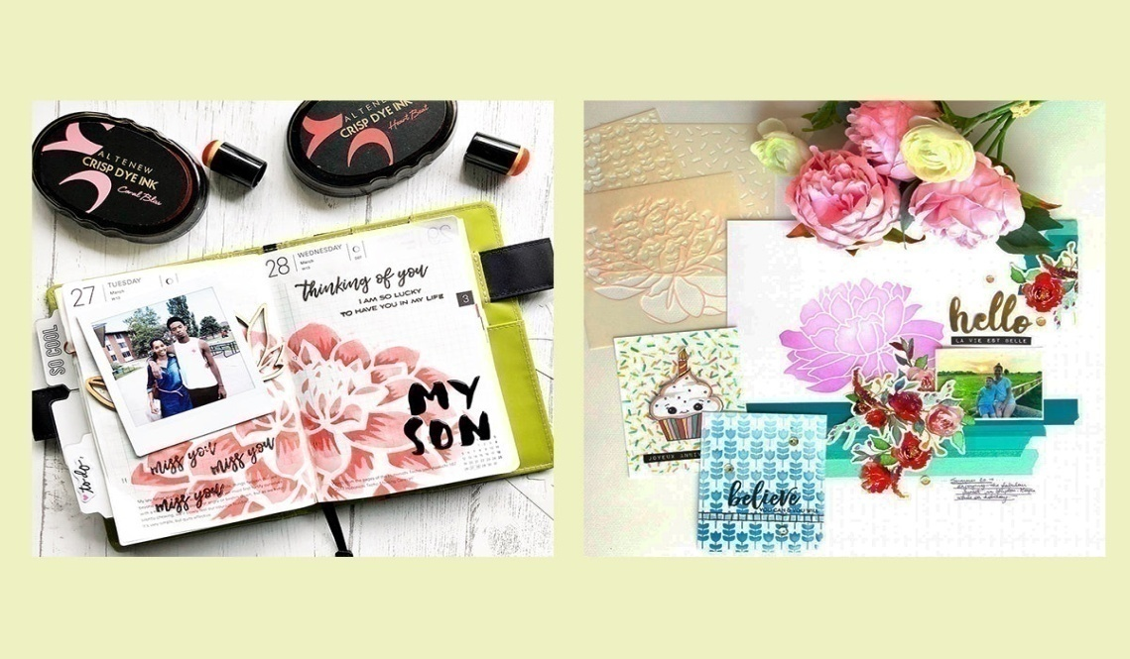
Fig 6.10 Background stencils
2. Layering stencils might appear intimidating for beginners but are actually fun and easy to use once you get the hang of them. As the name implies, two stencils with two different designs can be used together to create a beautiful and unique design. The beauty of layered stencils is that you can choose to use just one layer or use both layers. The designs you create will definitely beunique.

Fig6.11Layeringstencils
Make sure to properly adhere it onto the surface using a painter’s tape, wash tape, or any repositionable adhesive.
- Using the right color combinations is also vital.
- Before adding another color, let the first color dry completely. This way, the two colors won’t mix, and the design will pop off the page.
- Use a light hand, especially when ink blending. You want the color blending to be seamless and smooth; if you are too heavy-handed when ink blending, you might see some rough edges here and there.
- Always clean them after use. Baby wipes, clean wet cloth, or stamp shammy will do. It’s essential to clean these afterward to avoid smudging or color.
- Builder stencils might not look much at first, but once you start using them on your handmade cards, you will see the incredible 3D result and will surely love it. These often create geometric patterns and shapes that will look good on neutral or masculine handmade cards. If you need cool stencil designs that will be perfect for every and any occasion, then this is for you.

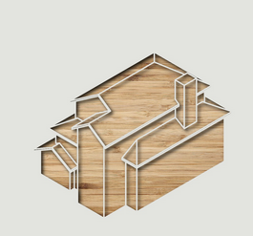
Fig. 6.12 Builder stencils
a) Method of Applying Different Patterns of Stencil:

            - Prepare the surface: Clean the surface where you want to apply the stencil pattern. Make sure it is free from dust, dirt, and any other debris. If necessary, sand and prime the surface to create a smooth and even base.
            - Choose your stencil design: Select the stencil design or pattern you want to apply. Stencils are available in various designs, sizes, and materials. You can purchase pre-made stencils or create your own using stencil blanks.
            - Secure the stencil: Place the stencil on the surface and secure it in place using painter's tape or adhesive spray. Make sure the stencil is flat against the surface to avoid any paint bleed.
            - Select your colors: Decide on the colors you want to use for your stencil pattern. You can use a single color or multiple colors, depending on your design preference.
            - Apply the first color: Dip a stencil brush or foam brush into the paint, ensuring that it is evenly coated but not overloaded. Lightly dab the brush onto a paper towel to remove excess paint. Then, using an up-and-down stippling motion, apply the paint over the stencil openings. Be careful not to apply too much pressure or drag the brush, as it may cause paint bleed under the stencil.
            - Remove the stencil: Once you have finished applying the first color, carefully remove the stencil while the paint is still wet. Peel it off slowly and gently to avoid smudging the design.
            - Let it dry: Allow the first color to dry completely before moving on to the next color. Follow the drying time recommended by the paint manufacturer.
            - Repeat with different colors: If you want to apply multiple colors, repeat steps 3 to 7 with each additional color, making sure to align the stencil properly for each layer. Take care to clean the stencil between colors to avoid any color mixing or contamination.
            - Touch up and clean: Once all the colors have been applied and the paint is dry, inspect the stencil pattern for any imperfections or areas that may need touch-ups. Use a small brush or sponge to fix any flaws. Clean your brushes, stencils, and work area thoroughly to prevent any paint buildup or damage.
Cleaning stencils between colors to avoid color mixing
            - Act quickly: Clean the stencil as soon as you finish applying a color. It's easier to remove wet paint than dried paint, so don't let the paint dry on the stencil.
            - Use a damp cloth or sponge: Moisten a clean cloth or sponge with water or a mild cleaning solution. Gently wipe the stencil surface to remove any excess paint. Be careful not to scrub too hard or use abrasive materials that may damage the stencil.
            - Avoid soaking: While it's important to keep the stencil damp during cleaning, avoid soaking it in water or any cleaning solution for an extended period. Excessive moisture can warp or damage the stencil material.
            - Q-tips or cotton swabs: For intricate or small areas of the stencil, you can use Q-tips or cotton swabs soaked in water or cleaning solution to carefully and precisely remove paint residue.
            - Stencil cleaning solutions: Some stencil manufacturers or art supply stores offer stencil cleaning solutions specifically designed to remove paint residue. These solutions can be effective in dissolving and loosening dried paint, making it easier to clean the stencil.
            - Pat dry: After cleaning the stencil, pat it dry with a clean cloth or paper towel. Make sure it's completely dry before using it again to prevent water droplets from diluting or mixing with the next color.
            - Test on a small area: If you're unsure about the cleaning solution's compatibility with your stencil material, it's a good idea to test it on a small, inconspicuous area of the stencil before applying it to the entire stencil.
            - Store properly: Once the stencil is clean and dry, store it flat or in a protective sleeve to prevent any damage or bending. Avoid stacking heavy objects on top of the stencil, as it may deform or distort its shape.

Self-check-6
Part one: multiple choices

            - From the following one is Method of Applying Different Patterns of Stencil(3pts)

            - Prepare the surface:.
            - Choose your stencil design:
            - Secure the stencil:
            - all

            - one of the following is Tools for design a stencil(3pts)

- Pencil or Pen:
- Paper
- Stencil Material:
- all

3. One of the following is the importance of stenciling(3pts)
- Versatility
- Reproducibility
- Creativity
- all

Part two: short answer
- write the importance of stenciling (3pts)
- write the Method of Applying Different Patterns of Stencil(3pts)
Part three : true or false
Say true if the statement is right and says false if the statement is wrong
1. Versatility Stenciling can be used on a wide range of surfaces, including walls, fabric, wood, metal, and more.(5pts)
2. Reproducibility Stencils allow for consistent reproduction of a design or pattern, ensuring uniformity across multiple items or surfaces.. (5pts)

OPERATION SHEET-6
OPERATION TITLE:- Apply stencils
PURPOSE:- to ensure that the proposed apply different type of stencilfinishing work is appropriate to the building
CONDITIONS OR SITUATIONS FOR THE OPERATIONS:-
Wear appropriate clothes, shoe.
Ensure the work shop hazard free
Ensure the working area is bright
Make workstation comfortable..
EQUIPMENT TOOLS AND MATERIALS : -
- Knife
- Stencil brushes
- paint
- Spray adhesive
- Painter's tape
- Paint or ink: brush
PROCEDURE,
            - 1. Prepare the surface
            - Choose your stencil design.
            - Secure the stencil
            - Select your colors
            - Apply the first color
            - Remove the stencil
            - Let it dry
            - Repeat with different colors
            - Touch up and clean
PRECAUTIONS:-
Wear working cloths which properly fit with your body.
Make working area hazard free.
Read and interpret manual which guide you how to disassemble and tag engine system components.
The trainees should fulfill safety conditions.
QUALITY CRITERIA: Improperly done apply different type of stencil safely according to the requested standard

LAP Test -6

Name: _____________________________ Date: ________________
Time started: ________________________ Time finished: ________________

Instructions: Given necessary templates /guide, workshop, tools and materials you are required to perform the following tasks within 1:00 hours.
Task.1. apply different type of stencil

Unit seven: Apply lining by brush
This unit to provide you the necessary information regarding the following content coverage and topics:
  - Selecting and set out lining work
  - Selecting paint materials
  - Lining work techniques
  - Identifying defects of paint and repair
This guide will also assist you to attain the learning outcomes stated in the Above topic contact. Specifically, upon completion of this learning guide, you will be able to:
  - Apply set out lining work
  - Select paint materials
  - Understand Lining work techniques

7.1. Selecting and set out lining work
a) Lining work in the context of paint refers to the process of creating precise lines, borders, or patterns on surfaces using paint. It involves marking and applying paint in a controlled manner to achieve desired visual effects or delineate specific areas.
    - Types of lining work
  - Decorative Lining: This involves creating decorative lines, borders, or patterns on walls, ceilings, furniture, or other surfaces to enhance aesthetics.
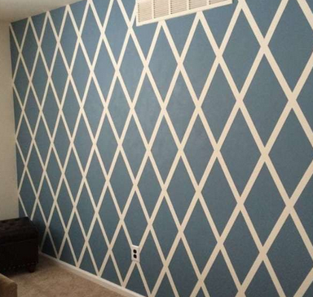
Fig 7.1 Decorative wall Lining
2. Signage and Lettering: Lining work can be used to create crisp, well-defined letters and signage on various surfaces, such as walls, boards, or vehicles.
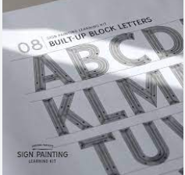
Fig 7.2 Signage and Lettering
3. Sports Field Markings: Painting lines and markings on sports fields, such as soccer fields, basketball courts, or tennis courts, to define playing areas and boundaries.
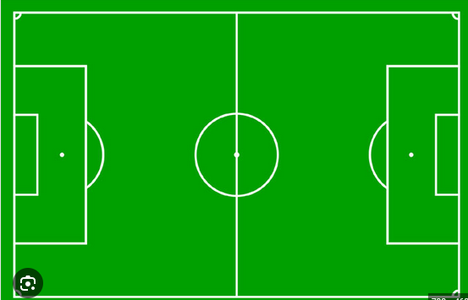
Fig . 7.3. Sports Field Markings lining
- Road Markings: This type of lining work involves painting lines, arrows, and symbols on roads and parking lots to regulate traffic flow and indicate driving lanes.
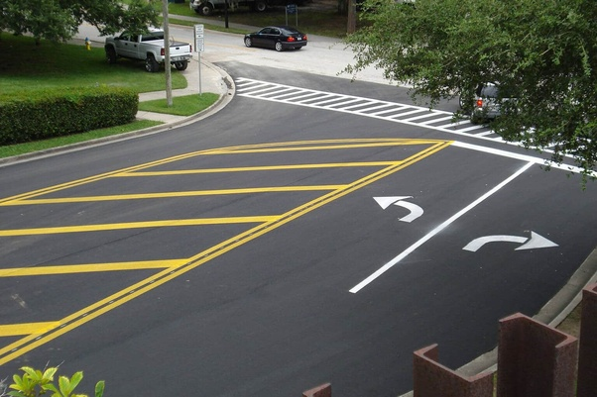
Fig 7.4 Road Markings
    - Setting out lining work
Setting out lining work in painting refers to the process of planning and preparing the surface, establishing guidelines or templates, and executing the painting work with accuracy.
When setting out lining work in painting, several common tools are used to achieve accuracy and precision. Some of these tools include:
1. Measuring Tape: A measuring tape is essential for taking precise measurements and marking guidelines on the surface. It helps ensure that lines are straight, evenly spaced, and aligned correctly.
2. Spirit Level: A spirit level, also known as a bubble level, is used to determine if a surface is level or plumb. It helps in setting horizontal or vertical guidelines for lining work, ensuring that lines are straight and properly aligned.
3. Chalk Line: A chalk line consists of a reel filled with chalk powder and a string. It is used to create long, straight lines over a large area. The string is coated with chalk powder, pulled tight, and snapped against the surface, leaving a clear chalk line.
4. Masking Tape: Masking tape is useful for creating clean, precise edges and boundaries. It is applied along the marked guidelines and acts as a barrier, preventing paint from bleeding outside the desired area. Once the paint is dry, the tape can be removed, leaving sharp lines.
5. Stencils: Stencils are pre-cut templates with specific shapes, letters, or patterns. They can be used to create consistent and uniform line work. Stencils are placed on the surface, and paint is applied over them using a brush or spray, resulting in accurate and repeatable designs.
6. Fine Brushes: Fine brushes with narrow tips and bristles are commonly used for intricate lining work. They allow for precise control and application of paint along guidelines, ensuring clean edges and sharp lines.
7. Liners and Riggers: Liners and riggers are specialized brushes with long, thin bristles that come to a fine point. They are ideal for creating thin, delicate lines or intricate details in painting.
8. T-Square or Ruler: T-squares or rulers are used to create straight lines and measure distances accurately. They can be used in conjunction with a pencil or chalk to mark guidelines on the surface.
9. Laser Level: Laser levels are modern tools that project a straight, level line onto a surface using laser technology. They are useful for setting precise horizontal or vertical guidelines over long distances.
    - The method of setting out lining work

  - Surface Preparation: The surface to be painted should be clean, smooth, and properly primed. Any imperfections or debris should be addressed before beginning the lining work.
  - Marking Guidelines: Depending on the desired lines or patterns, guidelines are marked on the surface using a pencil, chalk, masking tape, or stencils. These markings act as reference points during the painting process.
  - Choosing the Right Tools: Select appropriate brushes, rollers, or painting tools based on the type of lining work and the surface being painted. Finer lining work may require small brushes or specialized liners.
  - Applying Paint: Paint is applied carefully along the marked guidelines using steady strokes, ensuring even coverage and clean edges. Multiple coats may be required for opacity and durability.
  - Removing Guidelines: Once the paint has dried sufficiently, any temporary guidelines such as masking tape or stencils can be removed, revealing the precise lines or patterns.
The purpose of setting out lining work
- Visual Enhancement: Lining work can add decorative elements, patterns, or delineations that enhance the aesthetics of a space or object.
- Clarity and Organization: Lines and markings help provide clarity, organization, and structure in various contexts, such as sports fields or road markings.
- Branding and Identification: Lining work can be used to display logos, signage, or lettering that identify and promote brands, businesses, or organizations.
- Safety and Compliance: Properly marked lines and symbols on roads, parking lots, or sports fields contribute to safety by guiding and informing users about boundaries, lanes, or rules.
- Precision and Professionalism: Accurate lining work demonstrates attention to detail, skill, and professionalism, contributing to the overall quality of the painted surface or object.

Selecting paint materials
    - Material used for lining
The material used for lining work can vary depending on the specific application and requirements. Here are some commonly used materials for lining:
1. Epoxy: Epoxy coatings are commonly used for lining various surfaces, such as concrete floors, tanks, pipes, and industrial equipment. They provide excellent chemical resistance and durability.
2. Rubber: Rubber linings, such as natural rubber or synthetic elastomers like neoprene or butyl rubber, are used to line surfaces that require protection against abrasion, impact, or chemical attack. They are commonly used in tanks, chutes, and equipment handling corrosive substances.
3. Polyurethane: Polyurethane linings offer excellent resistance to abrasion and impact. They are often used in applications where high wear resistance is required, such as lining for mining equipment, conveyor belts, or hoppers.
4. PVC (Polyvinyl Chloride): PVC linings are used for lining surfaces that require chemical resistance, such as tanks, pipes, or containment structures. PVC offers good resistance to a wide range of chemicals and is relatively easy to install.
5. High-Density Polyethylene (HDPE): HDPE linings are commonly used in applications where excellent chemical resistance and impermeability are required. They are often employed for lining landfills, ponds, and containment areas.
    - The purpose of using lining materials
The purpose of using lining materials can vary based on the application, but here are some common purposes:
1. Corrosion protection: Lining materials are often used to protect surfaces from corrosive substances, preventing damage and extending the lifespan of the underlying structure or equipment.
2. Chemical resistance: Lining materials can provide resistance to a wide range of chemicals, protecting the underlying substrate from chemical attack and degradation.
3. Abrasion resistance: In applications where surfaces are subject to wear or abrasion, lining materials with high abrasion resistance can help extend the lifespan of the surface and reduce maintenance costs.
4. Containment: Lining materials are used to create barriers that prevent leaks or seepage, ensuring containment of liquids or gases within tanks, pipes, or containment structures.
5. Hygiene and sanitation: Lining materials are employed in areas where cleanliness and sanitation are crucial, such as food processing facilities or healthcare environments, to provide smooth, easily cleanable surfaces that meet regulatory standards.
It's important to note that the selection of lining materials should be based on the specific requirements of the application, including factors like the type of chemicals involved, temperature, abrasion potential, and other environmental conditions. Consulting with experts or professionals in the field is advisable for selecting the most suitable lining material for a specific project.

Lining work techniques
Lining work techniques refer to the various methods and procedures used to install linings on surfaces or structures. The specific technique employed depends on the type of lining material, the surface being lined, and the intended purpose of the lining. Here are some common lining work techniques:
Applying decorative paint as a lining work involves specific techniques to achieve the desired aesthetic effect. Here are the general steps for applying decorative paint as a lining:
1. Surface Preparation: Just like with any paint application, start by preparing the surface. Ensure it is clean, dry, and free from dirt, dust, grease, or any other contaminants. If necessary, patch and repair any imperfections on the surface and sand it smooth.
2. Primer Application (if needed): Depending on the type of decorative paint and the surface being lined, applying a primer may be necessary. The primer helps to enhance adhesion, promote an even finish, and improve the durability of the decorative paint. Follow the manufacturer's instructions for the specific primer being used.
3. Base Coat: Apply the base coat to the surface evenly. The base coat can be a solid color or a neutral background, depending on the desired decorative effect. Use a brush, roller, or sprayer, depending on the size and texture of the surface. Follow the manufacturer's recommended application techniques and coverage rates.
4. Lining Technique: There are various techniques for creating decorative lines, patterns, or designs on the painted surface. Some common techniques include:
  - Freehand: Use a brush or fine-tipped paint applicator to create lines, swirls, or other designs directly onto the base coat. This technique requires a steady hand and precision.
  - Stenciling: Use pre-cut stencils to apply decorative patterns or designs onto the base coat. Secure the stencil in place and apply the paint using a brush or sponge, making sure to keep the paint within the stencil's openings.
  - Tape Method: Apply painter's tape or masking tape in desired patterns or lines onto the base coat. Paint over the tape, ensuring good coverage. Once the paint is dry, carefully remove the tape to reveal the lined design.
  - Sponging: Dip a sponge into a contrasting or complementary color and lightly dab it onto the base coat to create a textured or mottled effect. This technique can be used to create subtle lines or patterns.
  - Toweling: Use a trowel or a similar tool to apply the decorative paint in thin, even layers, creating texture or patterned lines on the surface.
- Choose the technique that suits your desired decorative effect and follow the specific instructions for that technique.
- Drying and Finishing: Allow the decorative paint to dry completely according to the manufacturer's instructions. Once dry, you may choose to apply a clear protective topcoat to enhance durability and protect the decorative paint from wear, moisture, or other environmental factors.
Always refer to the manufacturer's instructions for the decorative paint you are using, as different products may have specific application techniques and drying times. Additionally, practice the chosen lining technique on a sample or test surface before applying it to the final project to ensure the desired result.
  - Identifying defects of paint and repair
Defects of paint refer to various undesirable conditions or imperfections that can occur on a painted surface. These defects can affect the appearance, durability, and performance of the paint. Some common defects of paint include:
    - Defects of Paint
- Blistering: Formation of bubbles or blisters on the painted surface.
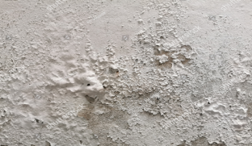
Fig 3.8 Blistering
- Cracking: The appearance of fine lines or cracks on the paint film.
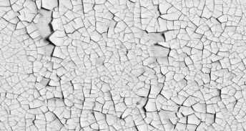
Fig 3.9 Cracking
- Peeling: Paint film detaching or coming off from the substrate.
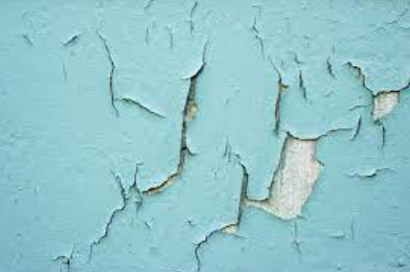
Fig 3.10 Peeling
- Chalking: Formation of a powdery residue on the paint film surface.
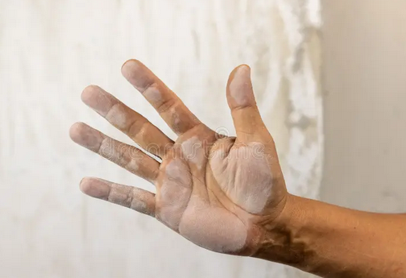
Fig 3.11 Chalking
- Fading: Loss of color intensity or change in color due to exposure to sunlight.
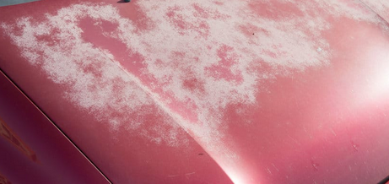
Fig 3.12 Fading
- Sagging or Running: Uneven or excessive thickness of paint resulting in drips or runs.
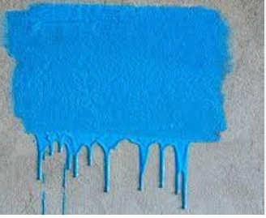
Fig .3.13 Sagging or Running
- Orange Peel: Texture resembling the surface of an orange skin.
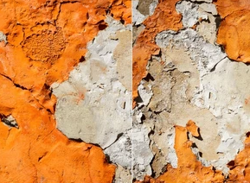
Fig 3.14 Orange Peel
- Wrinkling: Formation of wrinkles or creases on the paint film.
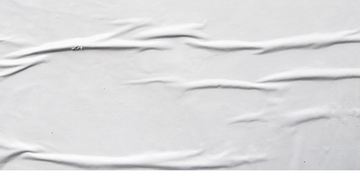
Fig 3.15 Wrinkling
- Efflorescence: Formation of white crystalline deposits on the paint surface due to water-soluble salts.
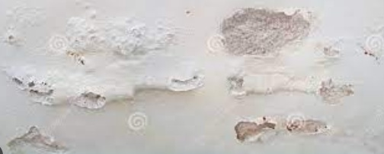
Fig 3.16 Efflorescence

- Staining: Discoloration of the paint film caused by substances like water, smoke, or chemicals.
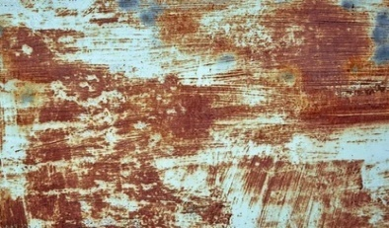
Fig 4.17 Staining

    - Causes of Defects:
- Moisture or Humidity: High humidity or moisture trapped beneath the paint film can cause blistering, peeling, or cracking.
- Poor Surface Preparation: Insufficient cleaning, inadequate priming, or failure to remove loose paint or contaminants can lead to adhesion issues and paint failure.
- Inadequate Drying Time: Applying subsequent coats of paint before the previous coat has dried properly can result in wrinkling or poor adhesion.
- Incompatible Paint Layers: Applying incompatible paint types or incompatible products within the paint system can cause cracking or peeling.
- UV Exposure: Continuous exposure to sunlight can cause fading, chalking, or deterioration of the paint film.
- Incorrect Application: Applying paint too thickly, using the wrong brushes or rollers, or not following manufacturer instructions can lead to defects.
- Environmental Factors: Extreme temperatures, pollution, chemicals, or atmospheric conditions can impact the paint's performance and appearance

    - Repairing Methods for Paint Defects:
- Surface Preparation: Properly clean the affected area, remove loose paint, and sand the surface to create a smooth and clean base for repainting.
- Blistering: Remove the blistered paint, sand the area, apply a suitable primer, and repaint.
- Cracking: Scrape off the cracked paint, sand the surface, apply a flexible filler, sand again, and repaint.
- Peeling: Remove the peeling paint, sand the area, apply a primer, and repaint.
- Fading: Repaint the affected area using a paint color that matches the original shade or consider repainting the entire surface.
- Sagging or Running: Sand the affected area, remove the excess paint, allow it to dry, sand it again, and apply a new coat of paint.
- Orange Peel: Sand the affected area, apply a thin coat of paint, and use a fine-grit sandpaper to achieve a smooth finish.
- Wrinkling: Sand the wrinkled area, apply a suitable filler, sand again, and repaint.
- Efflorescence: Remove the efflorescence by washing the surface with a mild acid solution, rinse thoroughly, allow it to dry, and repaint.
- Staining: Clean the stained area, use appropriate stain-blocking primer if necessary, and repaint with a suitable paint.

Self-check-7

Part one: multiple choices

            - From the following one is the various techniques for creating decorative lines, patterns, or designs on the painted surface.(3pts).
  - Freehand
  - Stenciling.
  - Tape Method
  - all
  - From the following one the Material used for lining.(3pts)
- Epoxy
- Rubber
- Polyurethane:
- all
  - -----------of the one is The purpose of setting out lining work .(3pts)
- Visual Enhancement
- Clarity and Organization
- Branding and Identification
Part two: short answer
            - Write at least three purpose of using lining materials.(3pts)
            - Identify various techniques for creating decorative lines.(3pts)
            - Describe The purpose of setting out lining work .(3pts)
Part three: true or false
- Branding and Identification: Lining work can be used to display logos, signage, or lettering that identify and promote brands, businesses, or organizations.(3pts).
- Epoxy coatings are commonly used for lining various surfaces, such as concrete floors, tanks, pipes, and industrial equipment.(3pts)

OPERATION SHEET-7
OPERATION TITLE:- Apply lining by brush
PURPOSE:- to ensure that the proposed apply different type of lining work finishing work is appropriate to the building
CONDITIONS OR SITUATIONS FOR THE OPERATIONS:-
Personal protective equipment
Ensure the work shop hazard free
Ensure the working area is bright
Make workstation comfortable..
EQUIPMENT TOOLS AND MATERIALS : -
- Epoxy
- Rubber
- brush polyurethane
- PVC
- HDPE
- measuring tape
- chalk line
- masking tape
- stencil
- T-square

PROCEDURE,
- Prepare the surface
- Primer application
- Base coat
- Lining techniques
- Draying
- finishing
PRECAUTIONS:-
Wear working cloths which properly fit with your body.
Make working area hazard free.
Read and interpret manual which guide you how to disassemble and tag engine system components.
The trainees should fulfill safety conditions.
QUALITY CRITERIA: Improperly done apply different type lining worksafely according to the requested standard

LAP Test -7

Name: _____________________________ Date: ________________
Time started: ________________________ Time finished: ________________

Instructions: Given necessary templates /guide, workshop, tools and materials you are required to perform the following tasks within 1:00 hours.
Task.1. apply lining work

Developer profile
Name | Qualification  (Level) | Field of study | Institute | Phone number | Email
BirhanuDemelash | A | M.Sc. COTM  BSc Road construction, | woldeya poly technic College | 0910686578 | birhanudemelash14@gmail.com
MihiretabGashaw | B | BSc building construction technology and Computer engineering | Addis ketema industrial College | 0922079011 | mihiretabgashaw@gmail.com
NasirAmane | B | BSC construction technology | Shashemane poly technic College | 0916005870 | nasiraman5870@gmail.com
NigussieTeshome | A | Geotechnical engineer(M.sc)  Civil engineering (B.sc) | Arbaminch PTC | 0913767770 | teshomeng@gmail.com
TesfayeAyalew | A | MSc in COTM  BSC in Building Construction Technology | DebreBrhan poly technic College | 0910469898 | tesfaye.ay21@gmail.com
WondwesnGirma | A | COTM(M.sc)  Civil engineering (B.sc) | Harar polytechnic College | 0912778365  0703608365 | wondwesngirma@gmail.com

