

Finishing Construction work Level III
Based on October, 2023 curriculum version II

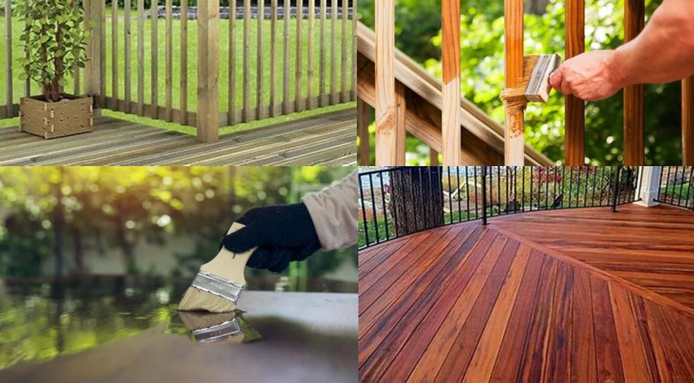
Module Title: Stains and Clear Timber Finishes Module Code: EIS FCW3 M 12 1023
Nominal duration: 50 Hours

Prepared By: Ministry of Lobar and Skill

October, 2023 Addis Ababa Ethiopia

Acknowledgement
The Ministry of Labor and skill wish to thank MOLS experts, regional labor and skill bureaus, TVT trainers, university lecturers and industry experts who contribute their time and professional experience to the development of this Training module for Road construction and maintenance.
We would like to express our appreciation to the Ministry of Labor and skill. for their technical and financial support and workshop facilitation of this training module development.

Acronym

FSC Forest stewardship council

VOC Volatile organic compound

OHS Occupational health and safety

UV Ultraviolet

PPE Personal protective equipment

HVLP High volume law presser

DIY Do it yourself

Table of Contents

Acknowledgement 1
Acronym 2
Introduction to Module 5
Module Instruction 6
UNIT ONE: INTRODUCTION 7
  - Introduction to Timber Finishing 8
  - The Importance of Using Stains and Clear Timber Finishes 14
  - Wood/timber finishing materials 17
Self-Check 1 20
UNIT TWO: Preparing Timber Surface 22
2.1 Assessing Timber Condition 24
2.1 Occupational Health and Safety (OHS) 26
  - Tools and equipment 28
  - Materials Quantity Calculation 33
  - Techniques of Sanding 35
  - Stripping Existing Stained or Finished Surfaces 38
  - Surface cleaning and dust removal 40
  - Match Stain Color to existing timber 42
Self-Check 2 45
UNIT THREE: Applying timber Stain 0
  - Techniques for applying stain evenly and consistently 0
  - Color Depth and Shading in Applying Timber Stain 3
  - Applying the stain evenly and consistently 5
  - Removing any excess stain 7
  - Allowing the stain to dry thoroughly 10
Self-Check 3 12
Operation sheet 3.1 Apply timber Stain 15
LAB TEST 1 17
UNIT FOUR: Applying Clear Timber Finishes 0
  - Applying Clear Timber Finishes 1
  - Pros and cons of each finish type 3
  - Preparing Stained Surfaces for Clear Finishes 6
  - Applying Clear Finishes 8
Self-Check 4 11
Operation sheet 4.1Apply clears timber finishing 13
LAB TEST 2 15
UNIT FIVE: Advanced Clear Finish Techniques 0
  - Applying multiple coats for durability and aesthetics 1
  - Identifying and Addressing Common Finishing Problems 3
  - Routine Maintenance and Care of Finished Timber Surfaces 5
  - Handling and storing finishing materials 8
Self-Check 5 11
Reference 14

Developer profile 0

Introduction to Module
This module guides the competence required to apply Stains and Clear Timber Finishes. trains learners in the applying methods of Stains and Clear Timber Finishes. It covers techniques, principles, and skills for creating visually appealing designs using small pieces of material. The module aims to develop learners' ability to professionally to apply Stains and Clear Timber Finishes.
This module covers skills, knowledge and attitude required to apply Stains and Clear Timber Finishesin accordance with regulatory and workplace requirements. It includes introduction to Stains and Clear Timber Finishes methods and principles of applying Stains and Clear Timber Finishes.
This module covers the units

- Introduction
- Preparing Timber Surface
- Applying timber Stain
- Applying Clear Timber Finishes
- Advanced Clear Finish Techniques Learning Objective of the Module
At the end of the module the trains will be able to

- Understand the significance of wood finishing
- Identify different types of wood finishes
- Comply with safety (OHS) requirements
- Calculate quantity of materials for a project.
- Identify techniques of Sanding
- Select the appropriate tools and equipment
- Match stain colors to existing timber
- Apply wood stain techniques evenly
- Apply clear finishes to stained surfaces
- Apply multiple coats of clear finishes

- Identify and address common finishing problems
- Maintain and care for finished timber surfaces

Module Instruction
For effectively use these modules trainees are expected to follow the following module instruction:

- Read the information written in each unit

- Accomplish the Self-checks at the end of each unit

- Perform Operation Sheets which were provided at the end of units

- Do the ―LAP test‖ giver at the end of each unit and

- Read the identified reference book for Examples and exercise

UNIT ONE: INTRODUCTION
This unit is developed to provide you the necessary information regarding the following content coverage and topics
- Introduction to Timber Finishing
- Importance of Using Stains and Clear Timber Finishes
- Wood/Timber Finishing Materials

This unit will also assist you to attain the learning outcomes stated in the cover page. Specifically, upon completion of this learning guide, you will be able to:
- Demonstrates an understanding of the basic concepts and terminology related to timber finishing.
- Explains the significance of applying stains and clear finishes to wood, considering both aesthetic and functional aspects.
- Identifies and describes various types of wood finishes, differentiating between stains and clear finishes.
- Lists and explains the essential materials and products used in wood finishing.

Introduction to Timber Finishing
Stains and clear timber finishes are fundamental components of woodworking and carpentry, playing a pivotal role in enhancing the natural beauty and durability of wood products. Whether you are crafting fine furniture, restoring an antique, or working on a home improvement project, understanding the principles of stains and clear finishes is essential for achieving the desired aesthetics and preserving the integrity of wooden surfaces.
Wood, with its unique grain patterns, colors, and textures, possesses an inherent visual appeal. Stains and clear timber finishes are the tools that allow craftsmen, artisans, and homeowners to unlock and showcase this natural beauty while safeguarding wood from environmental factors such as moisture, sunlight, and wear. These finishes are not just protective; they are also transformative, capable of elevating ordinary timber into exquisite pieces of art or functional structures that stand the test of time.
Timber, a versatile and renewable resource, has been a fundamental building material for centuries. It is admired for its natural beauty, durability, and adaptability, making it a prime choice for a wide range of applications, from furniture and flooring to structural elements in construction. However, the inherent beauty and longevity of timber can be further enhanced and protected through timber finishing. Timber finishing is a multi-faceted process that involves the application of various products and techniques to improve the appearance, durability, and performance of timber. In this three-page introduction, we will explore the importance of timber finishing, its historical context, different types of finishes, and the evolving role of sustainability in timber finishing practices.

The Significance of Timber Finishing

Timber finishing is not merely about aesthetics; it plays a crucial role in enhancing the longevity and performance of timber products. Here are some key reasons why timber finishing is a vital part of the timber industry:
      - Protection against Environmental Factors

One of the primary reasons for timber finishing is to protect wood from environmental elements. Unfinished wood is susceptible to moisture, sunlight, pests, and fungi. Timber finishes create a protective barrier that shields the wood from these destructive forces, extending the lifespan of timber products.

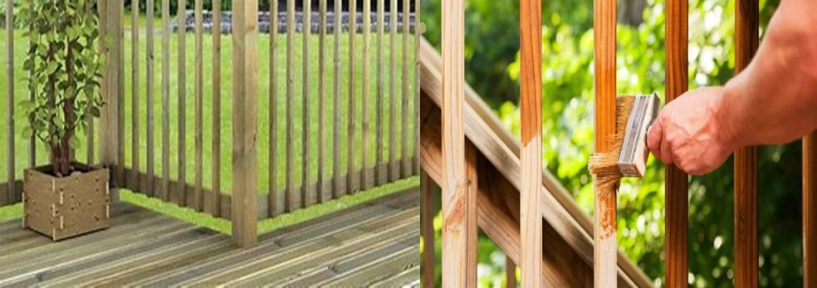

      - Aesthetic Enhancement

Figure 1-1Timber finishing

Timber's natural beauty is a major draw for using it in various applications. Timber finishes can accentuate and showcase the unique grain patterns and colors of different wood species, allowing for a wide range of design possibilities. Finishing can transform raw timber into exquisite, polished products that are both functional and visually appealing.
      - Performance Improvement

Timber finishes can improve the performance of wood products by adding strength, durability, and resistance to wear and tear. For example, finishes can make timber surfaces more resistant to scratches, stains, and moisture, enhancing the utility of timber in various applications.
      - Maintenance Simplification

Finished timber is easier to clean and maintain. Proper finishing reduces the need for frequent refinishing or costly repairs, making timber products more practical for homeowners and businesses.

      - Preservation of Historical and Cultural Heritage

In many cases, timber finishing is essential for preserving historical and cultural heritage. It helps protect and restore antique furniture, wooden artifacts, and architectural elements, ensuring that these valuable items endure for future generations.
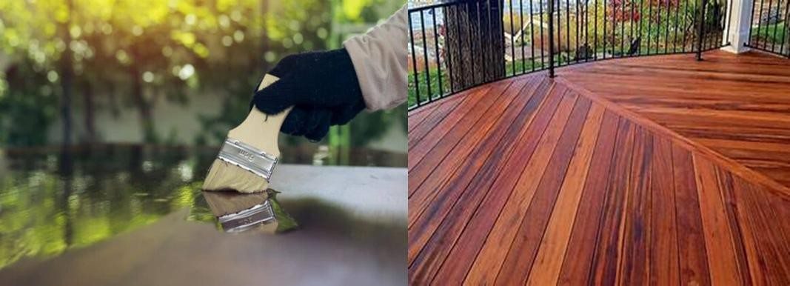

Figure 1-2 Stains and clear timber finishes

Historical Context of Timber Finishing

The practice of timber finishing has a rich historical background that reflects the evolving needs and cultural preferences of different societies. In ancient times, various natural substances like oils, waxes, and resins were used to protect and beautify timber. As civilizations advanced, so did the methods and materials used in timber finishing. The following are brief overview of how timber finishing has evolved over time:
      - Ancient Methods

In ancient civilizations, such as Egypt, Greece, and Rome, timber was finished with simple coatings of oils, beeswax, or shellac. These finishes provided a degree of protection and sheen but lacked the sophistication of modern finishes.
      - Medieval and Renaissance Periods

During the Middle Ages and the Renaissance, timber finishing techniques began to evolve. Varnishes made from resins like pine and amber were introduced, enhancing the luster and protective qualities of timber finishes. This period also saw the development of decorative techniques like marquetry and inlay.

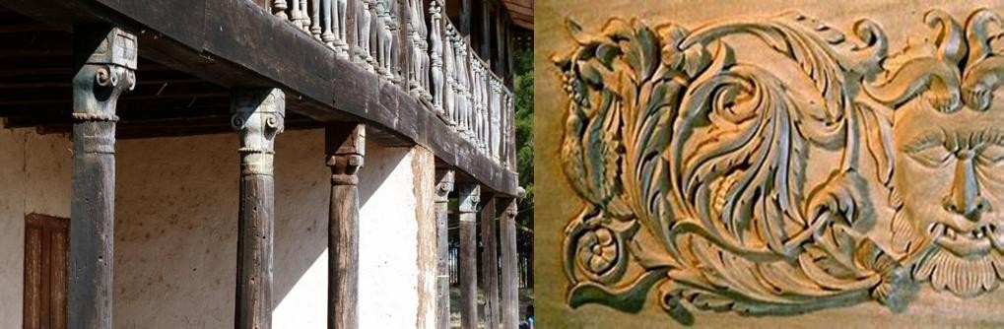

Figure 1-3Historical Context of Timber Finishing
      - Industrial Revolution

The Industrial Revolution in the 18th and 19th centuries brought about significant changes in timber finishing. Mass production and technological advancements led to the development of synthetic finishes, such as lacquers and polyurethanes, which offered improved durability and versatility.
      - Modern Era

In the modern era, the timber finishing industry has continued to advance. Water-based finishes have gained popularity due to their lower environmental impact, and the development of environmentally friendly products has become a priority. Additionally, digital technologies and automation have revolutionized finishing processes, making them more precise and efficient.
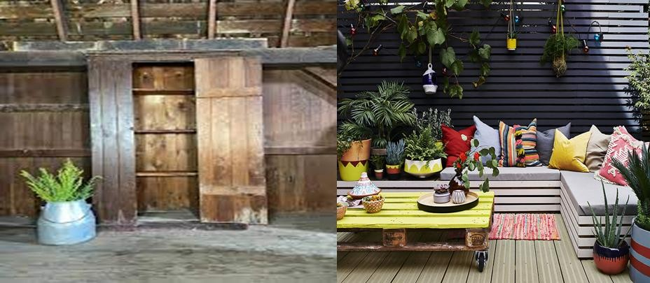

Figure 1-4 Industrial Revolution and Modern Era timber finishing
The evolution of timber finishing reflects the changing needs and preferences of societies throughout history. Today, timber finishing is a well-established industry with a wide range of products and techniques, from traditional hand-crafted methods to cutting-edge, environmentally conscious approaches.

Types of Timber Finishes

There are numerous types of timber finishes, each with its own unique characteristics and applications. Some of the most common types of timber finishes include:
      - Stains

Wood stains are used to change or enhance the color of timber while allowing the grain to show through. They come in a variety of colors and can be used to achieve a desired aesthetic, from dark and dramatic to light and natural.
      - Varnishes
Varnishes create a protective, transparent coating on timber surfaces. They are available in various sheens, from matte to high gloss, and are often used on furniture, cabinetry, and flooring.
      - Paints
While not technically a "finish" in the traditional sense, paints can be applied to timber surfaces for a durable and opaque color. Paints are commonly used on exterior applications where protection from the elements is essential.
      - Oils
Wood oils penetrate the timber, enhancing its natural beauty and providing protection against moisture and UV damage. Common wood oils include linseed, tung, and teak oil.
      - Lacquers
Lacquers are fast-drying, durable finishes that create a hard and glossy surface. They are often used on furniture and cabinetry for a sleek and modern look.
      - Shellac
Shellac is a natural resin-based finish that provides a warm and amber-toned appearance. It is commonly used for antique restoration and as a sealer for other finishes.
      - Polyurethane

Polyurethane finishes are highly durable and resistant to wear and moisture. They come in both oil- based and water-based forms, making them suitable for a variety of applications.

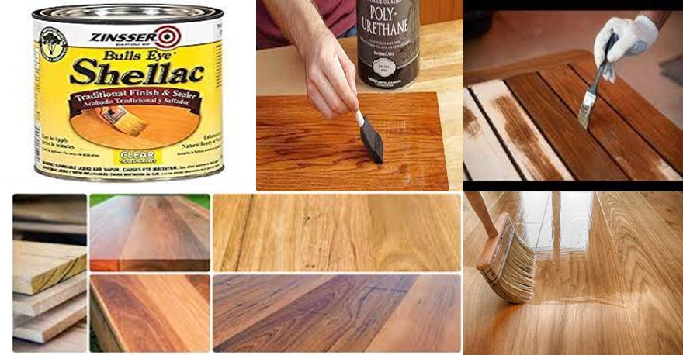

Figure 1-5 types of timber finishing
The choice of finish depends on the specific needs of the timber project, including the desired appearance, level of protection, and ease of maintenance. Each type of finish offers unique characteristics and can be tailored to meet the requirements of the project at hand.

Sustainability in Timber Finishing

In recent years, sustainability has become a central consideration in the timber industry, including timber finishing. As the world grapples with environmental concerns and limited resources, the responsible use of timber and timber finishes has gained significant importance. Sustainability in timber finishing involves several key principles:
      - Responsible Wood Sourcing

Sustainable timber finishing starts with the responsible sourcing of wood. This includes ensuring that timber is harvested from well-managed forests that practice sustainable forestry techniques. Certification programs like the Forest Stewardship Council (FSC) provide assurance that wood products come from environmentally and socially responsible sources.
      - Environmentally Friendly Finishes

The development of environmentally friendly finishes, such as low-VOC (volatile organic compound) and water-based products, has gained momentum. These finishes reduce the emission of harmful chemicals into the environment and improve indoor air quality.
      - Durability and Longevity

Sustainable timber finishing also emphasizes the longevity of finished products. Durable finishes that require infrequent maintenance or refinishing contribute to reduced resource consumption over time.
      - Recycling and Reuse

Efforts are being made to recycle and reuse timber and timber finishes whenever possible. This reduces waste and conserves resources while extending the lifespan of timber products.
      - Education and Awareness

Educating consumers, manufacturers, and industry professionals about sustainable practices in timber finishing is vital. Increased awareness can drive demand for environmentally responsible products
  - The Importance of Using Stains and Clear Timber Finishes
Timber, one of the oldest and most versatile building materials known to humanity, has been used for centuries to create functional and aesthetically pleasing structures. While the intrinsic beauty of natural wood is undeniable, it is susceptible to damage from environmental factors, wear and tear, and the passage of time. This is where stains and clear timber finishes play a crucial role. These treatments not only protect wood but also enhance its appearance and extend its lifespan. In this discussion, we will explore the importance of using stains and clear timber finishes, both in terms of preserving the wood and creating visually appealing surfaces.

Preservation and Protection

      - Protection Against Environmental Factors

Wooden structures, furniture, and surfaces are constantly exposed to environmental elements such as sunlight, moisture, and temperature variations. Unprotected wood can warp, crack, or rot when exposed to these elements. Stains and clear finishes form a protective barrier that shields the wood from these potential sources of damage. Stains, in particular, provide an added layer of protection by penetrating the wood fibers and preventing water infiltration.

      - Resistance to Insects and Fungi

One of the significant threats to timber is the infestation of insects and the growth of fungi. Stains and clear finishes, especially those containing appropriate chemicals, serve as a deterrent to wood-boring insects and molds. The preservation of wood not only ensures its durability but also reduces the need for expensive and time-consuming maintenance.
      - Increased Durability

By using stains and clear finishes, wood's natural longevity is greatly enhanced. These treatments can extend the life of wooden surfaces, which is particularly vital in applications such as outdoor decking, where exposure to the elements is constant. This increased durability means lower long-term maintenance costs and a more sustainable use of resources.

Aesthetics and Visual Appeal

      - Enhancing the Grain and Color

One of the most striking aspects of using stains and clear finishes is their ability to enhance the natural beauty of wood. Stains come in a variety of shades, allowing you to customize the appearance of wood surfaces. Whether you want to bring out the rich, warm tones of mahogany or emphasize the pale, light colors of pine, stains can help achieve the desired aesthetic. Clear finishes, on the other hand, emphasize the wood's natural grain patterns, providing a glossy or matte sheen that adds depth and character.
      - Creating Unique Finishes

Stains offer endless possibilities for creating unique finishes. Whether you prefer a rustic, weathered appearance or a sleek, modern finish, stains can be tailored to your specific design goals. This flexibility is invaluable in architectural and interior design, allowing for a wide range of styles and moods.
      - Maintenance of Visual Appeal Over Time

Natural wood can fade, become discolored, or lose its luster over time due to exposure to light and the elements. Stains and clear finishes act as a shield, preventing these undesirable changes. This maintenance of visual appeal ensures that wooden surfaces and structures remain attractive and inviting, making them ideal for both residential and commercial applications.

Sustainability and Environmental Considerations

      - Reducing the Need for Replacement

The use of stains and clear finishes extends the life of wood, reducing the frequency of replacement or disposal. This conservation of resources aligns with the principles of sustainability and responsible resource management. It is more environmentally friendly to preserve and enhance the longevity of wood than to continually replace it.
      - Reduced Chemical Treatments

The protective qualities of stains and clear finishes can reduce the need for chemical treatments or preservatives, which may harm the environment. This is particularly relevant in outdoor applications where wood is exposed to the elements, and traditional wood treatment methods often involve hazardous chemicals.
      - Lower Carbon Footprint

When wood is used as a building material, the carbon footprint of the structure can be lowered through the use of stains and clear finishes. By extending the life of wooden components, less energy and raw materials are required for replacements, resulting in a reduced environmental impact.
Stains and clear timber finishes are integral to preserving and enhancing the utility and aesthetic qualities of wood. From protecting against environmental damage to elevating the visual appeal and contributing to sustainability, the importance of these treatments cannot be overstated. As we continue to use wood in various applications, we must recognize the pivotal role of stains and clear finishes in ensuring the longevity and beauty of this timeless material. Their benefits extend beyond immediate aesthetics, offering long-term protection and an eco-friendly approach to working with wood.

The difference between stain and clear finishing

Stain and clear finishing are two distinct processes used in woodworking and furniture-making to enhance the appearance and protect the surface of wood. Each serves a different purpose and offers specific advantages, and the choice between the two depends on the desired outcome and the characteristics of the wood being worked on.
      - Stain Finishing:
        - Color Enhancement: Staining involves applying a pigmented liquid to the wood's surface. This imparts color to the wood, altering or enhancing its natural hue. Stains are available in a wide range of colors, allowing for customization to match the desired aesthetic.

        - Grain Emphasis: Stain can be used to emphasize the wood's natural grain patterns. By darkening the pores and grain lines, the beauty of the wood is accentuated.
        - Opacity: Stain can vary in opacity, from translucent to opaque, depending on the type and application method. Translucent stains allow the wood's grain to show through, while opaque stains provide a solid, paint-like finish.
        - Versatility: Stains can be used to create various decorative effects, such as antiquing, distressing, or faux finishes. This versatility makes it a popular choice for achieving different looks.
        - Protection: While stain enhances the wood's appearance, it offers limited protection. It primarily provides color and minimal protection from moisture and UV radiation. To achieve adequate protection, an additional clear finish is often applied on top of the stain.
      - Clear Finishing:
        - Natural Appearance: Clear finishes, such as varnish, lacquer, shellac, or polyurethane, are designed to preserve the wood's natural appearance. They provide a transparent coating that doesn't alter the wood's color.
        - Protection: Clear finishes are primarily used for their protective properties. They create a durable, moisture- resistant, and UV-resistant barrier that shields the wood from environmental factors, such as water, sunlight, and abrasion.
        - Wood Grain Preservation: Clear finishes allow the wood's grain to be seen without alteration. This makes them an ideal choice when the natural beauty of the wood is a primary consideration.
        - Durability: Clear finishes are known for their long-lasting qualities and are more durable than stains alone. They can extend the lifespan of wood products by preventing moisture absorption, which can lead to warping, splitting, or rot.
        - Versatility: Clear finishes come in various types, each with its own characteristics. Some are more appropriate for indoor use, while others are better suited for outdoor applications.
In many cases, a combination of stain and clear finish is used. Woodworkers often apply a stain to achieve the desired color and grain effects and then add a clear finish on top to protect and seal the wood. The choice between stain and clear finish ultimately depends on the specific project's aesthetic goals and functional requirements.

Wood/timber finishing materials
Wood/timber finishing materials play a crucial role in woodworking and construction, serving to protect, enhance, and beautify wood surfaces. These materials are essential for preserving the natural beauty of wood while providing durability and protection against environmental factors. In this discussion, we will explore various wood/timber finishing materials, including paints, stains, varnishes, oils, and protective coatings.

      - Paints:
        - Description: Paints are versatile wood finishing materials that consist of pigments, binders, and solvents. They come in a wide range of colors and are typically opaque, covering the wood's grain.
        - Applications: Paint is often used to protect and enhance the appearance of wooden surfaces, such as doors, windows, cabinetry, and outdoor structures. It offers excellent protection against moisture, UV rays, and wear and tear.
        - Varieties: There are different types of paint, including oil-based and water-based paints. Water-based paints have gained popularity due to their low odor and environmental friendliness.

      - Stains:
        - Description: Stains are semi-transparent or transparent wood finishing materials that contain pigments or dyes. They are designed to add color to the wood while allowing its natural grain to show through.
        - Applications: Stains are commonly used on furniture, flooring, and woodworking projects to achieve a desired color and enhance the wood's appearance. They are available in various shades, from light to dark.
        - Varieties: Stains can be oil-based, water-based, or gel-based, each with unique characteristics and applications.

      - Varnishes
Description: Varnishes are clear or semi-transparent wood finishing materials that consist of resins, solvents, and drying agents. They create a protective, glossy, or satin sheen on the wood surface.
        - Applications: Varnishes are known for their durability and are often used on wooden furniture, cabinetry, floors, and outdoor structures. They offer excellent protection against moisture, UV rays, and general wear and tear.
        - Varieties: Varnishes come in different formulations, including polyurethane, alkyd, and phenolic, each with specific characteristics and uses.
      - Oils
        - Description: Oils are penetrating wood finishing materials that are absorbed into the wood to enhance its natural beauty. They provide a low sheen and a warm, natural appearance.
        - Applications: Oils are suitable for both softwoods and hardwoods and are often used on items like cutting boards, wooden utensils, and interior wooden surfaces. They require periodic reapplication to maintain their protective properties.
        - Varieties: Common wood oils include linseed oil, tung oil, and Danish oil, each with distinct characteristics.
      - Waxes
        - Description: Waxes are traditional wood finishing materials that provide a soft, low-luster sheen. They are often used on antiques and fine furniture to create a smooth and warm surface.
        - Applications: Wax finishes are relatively easy to apply and repair, making them suitable for indoor items with minimal exposure to environmental elements. They are used to enhance the visual appeal of wood without offering extensive protection.

        - Varieties: Beeswax, carnauba wax, and paraffin wax are common types of wood waxes.
      - Protective Coatings
        - Description: Protective coatings are specialized wood finishing materials designed to provide enhanced protection against specific elements. These coatings include polyurethane, epoxy, and acrylic sealants.
        - Applications: Protective coatings are used in outdoor applications, such as wooden decks and exterior siding, where wood is exposed to harsh environmental conditions. They offer excellent resistance to moisture, UV rays, and abrasion.
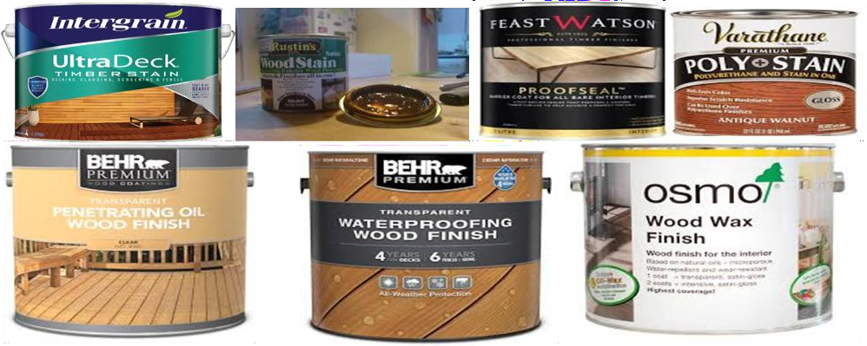

Figure 1-6 wood/timber finishing materials

wood/timber finishing materials are diverse and serve different purposes in woodworking and construction. The choice of finishing material depends on the specific project, the desired appearance, and the level of protection required. Whether it's the glossy finish of varnish, the rich color of a stain, the durability of a protective coating, or the natural look of oil, these finishing materials are essential for preserving and enhancing the beauty of wood while ensuring its longevity.

Self-Check 1

Part I Chose the Beast Answer

    - What is the primary purpose of timber finishing?

- Enhancing the natural beauty of wood

- Increasing the durability of wood

- Protecting wood from environmental factors

- All of the above

Answer: d) All of the above

    - Which type of finish creates a hard and glossy surface?

- Stains

- Varnishes

- Lacquers

- Shellac

Answer: c) Lacquers

    - What is the historical significance of timber finishing?

- It has remained unchanged throughout history

- It has evolved to reflect changing needs and preferences

- It was not practiced in ancient civilizations

- It only became important during the Industrial Revolution Answer: b) It has evolved to reflect changing needs and preferences
    - What is one of the key principles of sustainability in timber finishing?

- Responsible wood sourcing

- Use of synthetic finishes

- Regular refinishing of timber products

- Increased resource consumption Answer: a) Responsible wood sourcing
    - What is the role of stains and clear timber finishes?

- To protect wood from environmental damage

- To enhance the visual appeal of wood

- To increase the longevity of wood products

- All of the above

Answer: d) All of the above

Part- II: Short Answer Questions:

- What are some environmental factors that timber finishes protect wood from?

Answer: Timber finishes protect wood from moisture, sunlight, pests, and fungi.

- Name one type of environmentally friendly timber finish.

Answer: Water-based finishes are considered environmentally friendly.

- Explain the historical context of timber finishing.

Answer: Timber finishing techniques have evolved over time, from simple coatings in ancient civilizations to the development of synthetic finishes during the Industrial Revolution and the use of environmentally conscious approaches in the modern era.

UNIT TWO: Preparing Timber Surface

This unit is developed to provide you the necessary information regarding the following content coverage and topics
  - Assessing Timber Condition
  - Safety (OHS) Requirements
  - Tools and equipment
  - Materials Quantity Calculation
  - Techniques of Sanding
  - Stripping Existing Stained or Finished Surfaces
  - Surface cleaning and dust removal
  - Match Stain Color to existing timber

This unit will also assist you to attain the learning outcomes stated in the cover page. Specifically, upon completion of this learning guide, you will be able to:
  - Demonstrates the ability to assess the condition of timber surfaces, ensuring their suitability for finishing.
  - Adheres to occupational health and safety (OHS) requirements when working with wood finishes, tools, and equipment.
  - Selects and uses appropriate tools and equipment for timber preparation and finishing tasks effectively.
  - Accurately calculates the required quantity of materials for projects, minimizing waste and ensuring adequate supply
  - Applies sanding techniques effectively to prepare timber surfaces for staining and finishing, achieving a smooth and even texture
  - Demonstrates proper surface cleaning and dust removal practices to maintain a clean and smooth working environment.
  - Matches stain colors to existing timber effectively, achieving consistent and desired aesthetic results.

  - Assessing Timber Condition
Preparing timber surfaces is a fundamental and essential step in woodworking and construction processes. It involves carefully and methodically getting the wood surface ready for finishing, ensuring that the final result is not only visually appealing but also durable and long-lasting. Properly preparing timber surfaces is crucial for achieving optimal adhesion of paints, stains, varnishes, or other wood finishes, as well as for enhancing the wood's natural beauty. This introductory step sets the foundation for a successful and aesthetically pleasing woodworking project, making it an indispensable part of any woodworker's or builder's skillset.
Before undertaking any timber finishing work, it is essential to assess the condition of the wood to ensure the best possible results. Proper assessment allows for appropriate preparation and treatment, leading to a durable and aesthetically pleasing finish. In this article, we will discuss the steps involved in assessing timber condition for timber finishing work.

Types of timber condition assessing

      - Visual Inspection:

The first step in assessing timber condition is a thorough visual inspection. Examine the wood surface for any visible signs of damage, such as cracks, splits, knots, or decay. Look for discoloration, stains, or watermarks that may indicate moisture issues. Check for any existing finishes or coatings that might need to be removed before applying a new finish. Visual inspection provides an initial understanding of the wood's condition and helps determine the necessary steps for preparation and repair.
      - Moisture Content:

Timber moisture content is a crucial factor in timber finishing. Wood with high moisture content can affect the adhesion and performance of the finish. Use a moisture meter to measure the moisture content of the wood. The ideal moisture content for finishing work typically ranges between 6% and 12%. If the moisture content exceeds this range, it may be necessary to allow the wood to dry or acclimate before proceeding with the finishing process. Moisture content assessment ensures better finish adhesion, minimizes the risk of finish failure, and prevents issues like cracking or warping.
      - Surface Preparation:

Proper surface preparation is essential for achieving a successful timber finish. Assess the surface for any irregularities, such as roughness, unevenness, or raised grain. Sanding is often necessary to create a smooth and level surface. Evaluate the existing finish, if any, and determine whether it needs to be stripped or sanded before applying a new finish. Adequate surface preparation ensures proper adhesion of the finish and helps achieve the desired aesthetic result.
      - Structural Integrity:

Assessing the structural integrity of the timber is critical, especially for load-bearing or structural applications. Inspect the wood for signs of decay, insect infestation, or damage caused by rot or termites. Use a sturdy probe or awl to check for soft or weakened areas in the wood. If significant structural issues are detected, it may be necessary to consult a professional or consider repairing or replacing the affected timber before proceeding with finishing work. Ensuring the structural integrity of the timber is essential for long-term durability and safety.
      - Compatibility with Finishing Materials:

Consider the compatibility of the timber with the chosen finishing materials. Different wood species have varying characteristics that can affect the performance and appearance of the finish. Some woods may have open grain or high resin content, requiring specific preparation techniques or compatible finishes. Research or consult with experts to ensure that the selected finishing materials are suitable for the particular wood species and condition.
      - Environmental Factors:

Assess the environmental factors that may impact the timber and the chosen finishing materials. Consider the location of the wood, whether it is indoors or outdoors, and the exposure to sunlight, moisture, and temperature fluctuations. Exterior applications may require finishes with enhanced UV protection and greater resistance to moisture. Understanding the environmental factors helps in selecting finishes that can withstand the specific conditions and provide long-lasting protection.

      - Test Finishes:

Before applying the final finish, it is advisable to conduct a test application on a small, inconspicuous area of the timber. This allows you to evaluate the compatibility, appearance, and desired effect of the finish on the specific wood surface. Testing also helps identify any potential issues or adjustments needed before proceeding with the full application, ultimately ensuring satisfactory results.
Assessing timber condition is a crucial step in preparing for timber finishing work. A thorough assessment helps identify any issues that need to be addressed, such as surface preparation, repairs, or moisture content adjustment. By evaluating the timber's condition, structural integrity, compatibility with finishing materials, and environmental factors, you can make informed decisions and ensure the best possible outcome for your timber finishing project. Proper assessment and preparation lay the foundation for a durable, visually appealing finish that enhances the natural beauty and extends the lifespan of the wood.

Occupational Health and Safety (OHS)
Occupational health and safety (OH) are of paramount importance in any work environment, and this includes timber finishing work. The process of applying finishes to timber, whether for cabinetry, furniture, or flooring, involves various hazards that must be addressed to ensure the safety and well- being of workers. In this discussion, we will outline the key OHS requirements for timber finishing work and emphasize the importance of using appropriate personal protective equipment (PPE).

Hazard Identification and Risk Assessment

Before commencing any timber finishing work, it is essential to identify potential hazards and assess the risks involved. This process should include:
      - Chemical Hazards: Identify the type of finishes or solvents being used, as they may contain volatile organic compounds (VOCs) or hazardous substances. Ensure workers are aware of the risks and follow proper handling and disposal procedures.
      - Dust and Fumes: The sanding and finishing process generates dust and fumes, which can be harmful if inhaled. Adequate ventilation and respiratory protection may be required.
      - Fire Hazards: Many finishing products are flammable. It is crucial to store and handle them with care and to have fire-fighting equipment readily available.

Personal Protective Equipment (PPE)

To mitigate the risks associated with timber finishing work, the use of appropriate personal protective equipment is crucial. The specific PPE requirements may vary depending on the nature of the work, but common PPE includes:
      - Respiratory Protection: Workers must wear respiratory protection, such as dust masks or respirators, to safeguard against inhaling dust, fumes, or volatile chemicals.
      - Eye and Face Protection: Safety goggles or a face shield should be worn to protect against splashes from finishing products or debris generated during sanding.
      - Hand Protection: Gloves made of chemical-resistant materials may be necessary when handling finishing products or solvents to prevent skin contact.
      - Hearing Protection: If timber finishing work involves loud machinery, workers should wear ear protection, such as earmuffs or earplugs, to prevent hearing damage.
      - Clothing: Workers should wear appropriate work attire, including long-sleeved shirts and long pants to protect the skin from chemical exposure. Additionally, wearing a lab coat or coveralls can help prevent clothing contamination.
      - Footwear: Sturdy, closed-toe shoes with non-slip soles are essential to protect against spills, sharp objects, or falling debris.

Figure 2-1 PPE

Ventilation and Dust Control

Proper ventilation is essential in a timber finishing workspace. Adequate ventilation systems, such as exhaust fans and air filtration equipment, should be in place to remove fumes and dust from the work area. Dust control measures, such as dust collection systems on sanding equipment, can minimize airborne particulates and maintain a safer environment.

Training and Education

All workers involved in timber finishing work should receive comprehensive training in the following areas:

      - Safe Handling: Ensure that workers understand how to handle finishing products, including storage, disposal, and the use of personal protective equipment.
      - Emergency Procedures: Training should cover emergency response protocols, such as what to do in case of spills, fires, or chemical exposures.
      - First Aid: Workers should be familiar with basic first aid procedures and the location of first aid supplies.
      - Hazard Communication: Make sure that all workers are aware of labeling and safety data sheets for the finishing products they use.

2.1.4 Housekeeping and Maintenance

Maintaining a clean and organized workspace is essential for safety. Regular cleaning and inspection of equipment can help prevent accidents and maintain a safe environment. Spill containment kits should be readily available to address minor chemical spills.
Timber finishing work, while producing beautiful and durable products, comes with specific occupational health and safety (OHS) requirements. Workers should be well-informed about potential hazards, equipped with appropriate personal protective equipment (PPE), and trained in safe practices. Adhering to these safety measures ensures that timber finishing work is not only a creative and skilled process but also one that prioritizes the well-being of those involved. Proper OHS practices and the use of PPE are essential for the industry to thrive while keeping workers safe.

Tools and equipment
Stains and clear timber finishes are essential for enhancing the appearance and preserving the quality of wood surfaces. Whether you're working on a woodworking project or refinishing furniture, selecting the right tools and equipment is crucial to achieve the desired results. Here's a comprehensive guide on the tools and equipment used for stains and clear timber finishes.
    - Tools:
      - Sanding Tools:
        - Sandpaper: Various grits of sandpaper (ranging from coarse to fine) are used for smoothing the wood's surface and preparing it for finishing.

- Sandpaper Holder or Sanding Block: These provide even pressure and prevent over-sanding in specific areas.

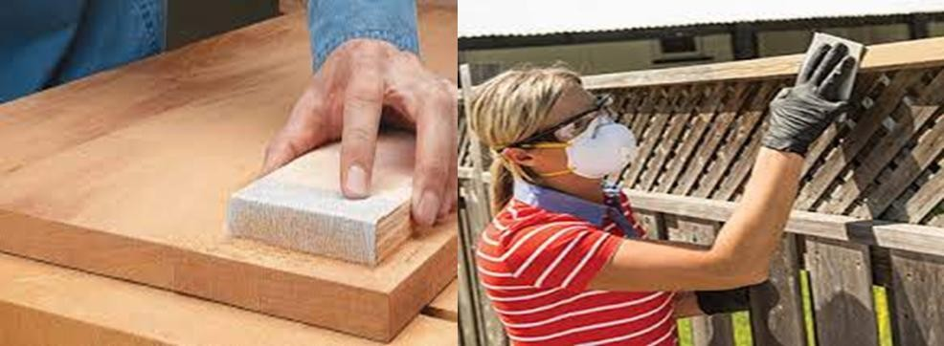

- Paintbrushes and Applicators:
Figure 2-0-2 Sanding Tools

  - Natural Bristle Brushes: Ideal for applying oil-based stains and finishes.
  - Synthetic Bristle Brushes: Suitable for water-based stains and finishes.
  - Foam Brushes: Great for a smooth, streak-free application of clear finishes.
  - Lint-free Cloths: Used for wiping and applying stains and finishes evenly.

Figure 2-3

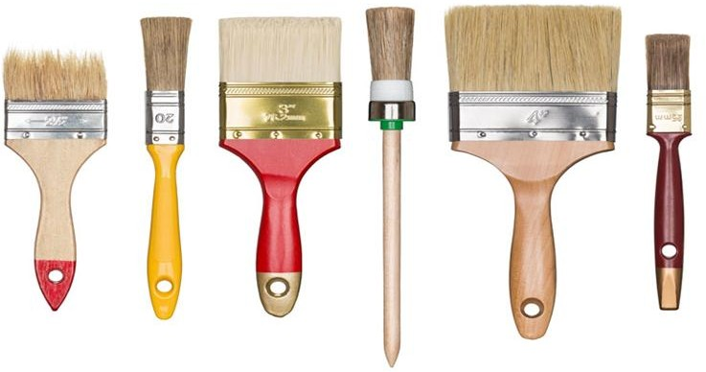
Paintbrushes

- Stirring and Mixing Tools:
  - Wooden Stir Sticks: Used to mix stains and finishes thoroughly before application.
  - Mixing Cups: For accurate measurement and mixing of different finishes.

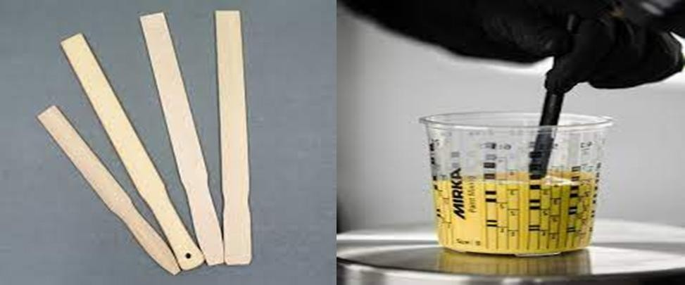
Figur e 2-4
Stirri ng and Mixi ng Tools
    - Wood
S
t a
in Applicators: To apply wood stain, there are various applicators available, including brushes, foam brushes, cloth rags, or staining pads. The choice of applicator depends on the project's size and the desired finish.
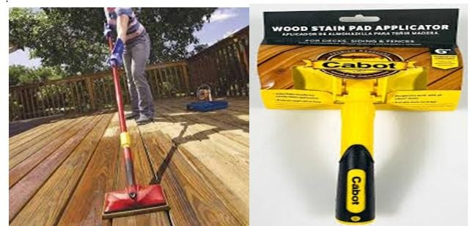

Figure 2-5Wood Stain Applicators

Wood Stains: Wood stains come in various forms, including oil-based and water-based options. They are used to add color to the wood while allowing its natural grain to show through.
Clear Finish Applicators: For clear timber finishes, applicators such as brushes, foam brushes, or lambswool applicators are used to apply varnishes, lacquers, or polyurethane coatings. These finishes protect the wood and enhance its appearance.

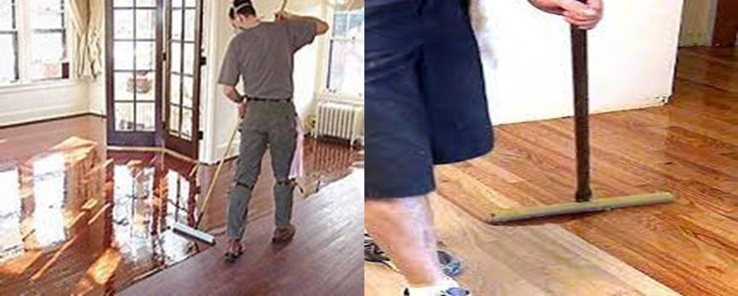

Figure 2-6 Clear Finish Applicators

    - Equipment:
      - Power Sanders:
        - Orbital Sander: Used for efficient and even sanding.
        - Belt Sander: Ideal for heavy material removal and larger surfaces.
        - Spray Gun or HVLP (High Volume, Low Pressure) System:
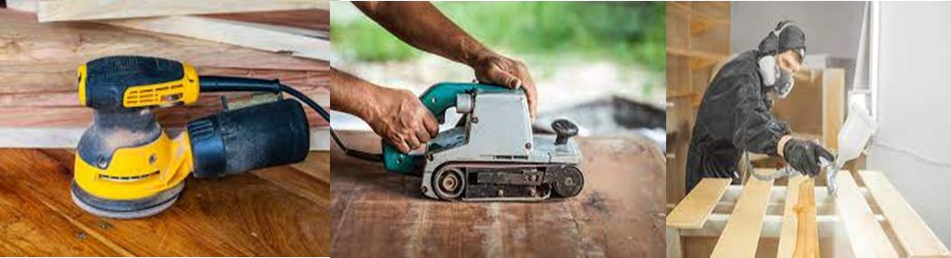

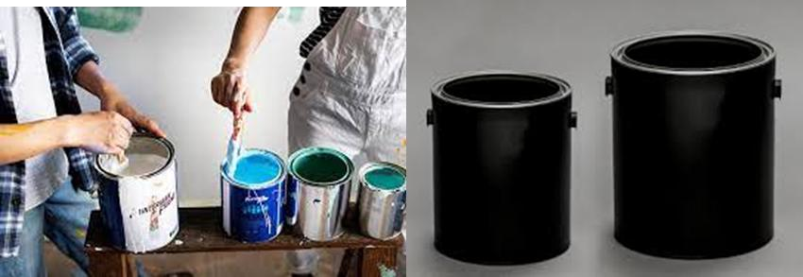
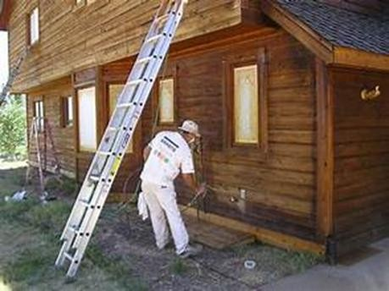
Figure 2-7Timber finishing equipment

Used for applying clear finishes when a smooth and even surface is essential. This is common for professional applications.
    - Buffing Equipment:
      - Polishing Machine: Used for buffing and polishing surfaces with clear finishes, especially for furniture.
    - Drying Racks or Hanging Systems:
Used to suspend the coated items during drying to prevent dust and debris from settling on the finish.
    - Ventilation System:
A well-ventilated workspace or a fume extraction system to disperse fumes and maintain air quality.
    - Lighting:
Adequate lighting to inspect the finish for imperfections and ensure even application. Temperature and Humidity Control:
In some cases, maintaining a specific temperature and humidity level in the workspace is crucial for achieving the best results.
    - Workbenches and Clamps:
These are used to secure the work piece, ensuring stability and ease of application.
- Cleaning Supplies:
Solvents, mineral spirits, or water (depending on the finish) for cleaning brushes and equipment.
Sel ecti ng the

appropriate tools and equipment for your project is essential to achieve a professional and long-lasting finish. The choice between oil-based and water-based stains and finishes will also impact the selection of brushes and applicators. Always follow safety precautions and manufacturer's instructions when working with stains and clear timber finishes ensuring the best results and protecting your health.
Figure 2-8 Timber finishing material mixing tools

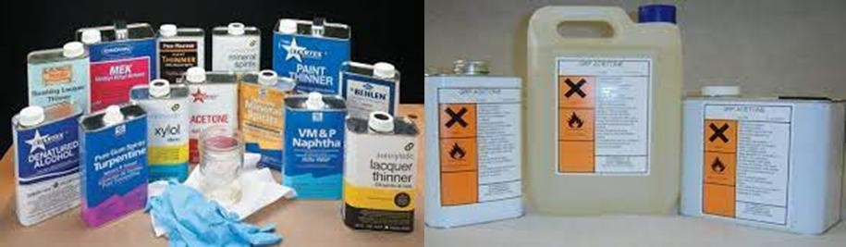

Figure 2-9wood finishing paint thinners

Materials Quantity Calculation
Materials quantity calculation for stains and clear timber finishes is a crucial aspect of any woodworking or finishing project. Accurately estimating the number of materials needed helps avoid wastage and ensures that you have enough to complete the job without interruption. Here's a step-by-step guide on how to calculate the quantity of materials required for stains and clear timber finishes:
    - Surface Area Measurement:

Start by measuring the surface area of the wood you intend to finish. Measure the length, width, and height of each component or section to be coated.
If you are working on multiple surfaces, break down your measurements into individual sections.

- Calculate Total Surface Area:

To determine the total surface area to be finished, add up the areas of all the individual components or sections.Use the formula for the area of common shapes (e.g., square feet or square meters) based on your measurement units.
  - Determine the Application Rate:

Consult the manufacturer's instructions for the specific stain or clear finish you intend to use. This will provide the recommended application rate, typically given in square feet or square meters per gallon or liter. The application rate may vary depending on factors like the type of wood, the desired finish intensity, and the porosity of the wood.
  - Calculate Material Quantity:

Divide the total surface area from step 2 by the application rate from step 3. The formula is:

Quantity (in gallons or liters) = Total Surface Area / Application Rate

  - Account for Multiple Coats:

If you plan to apply multiple coats, multiply the quantity calculated in step 4 by the number of coats required.
For example, if you need two coats, double the quantity.

  - Round Up for Safety:

It's advisable to round up the calculated quantity to ensure you have some extra material for touch-ups, testing, or any unexpected needs.
- Choose the Right Container Size:

Stains and clear finishes are typically sold in various container sizes, such as quarts, gallons, or liters. Select the container size that is closest to or slightly larger than your calculated quantity.
  - Purchase the Materials:

Once you've determined the quantity needed and selected the appropriate container size, purchase your stains and clear finishes.
  - Test the Finish:

Before applying the finish to your entire project, consider testing it on a small, inconspicuous area to ensure it meets your expectations.
Remember that the quality and type of wood, the number of coats, and the application method can affect the actual material consumption. Therefore, while the calculation provides a good estimate, it's always a good practice to have some extra material on hand for contingencies. Proper planning and accurate material quantity calculation are key to achieving a professional and satisfying result in your staining and finishing projects.

Techniques of Sanding
Sanding is a critical preparatory step in the process of applying stains and clear timber finishes. Proper sanding ensures a smooth, clean surface for the finish to adhere to, and it also helps remove imperfections and enhance the overall look of the wood. The following steps are some key techniques and types for sanding in the context of staining and applying clear timber finishes:

Types of Stains:

Stains are used to add color to wood while allowing its natural grain to shine through. There are several types of stains, each with its unique characteristics and techniques:
      - Oil-Based Stains:

Oil-based stains are a traditional choice for wood finishing. They contain natural oils, such as linseed or tung oil, combined with pigments or dyes to create various color options. These stains offer a rich, deep color and enhance the wood's natural beauty. Techniques for applying oil-based stains include:
        - Wipe-On Application: One common method is to apply the stain with a lint-free cloth, ensuring even coverage. Wiping off excess stain allows you to control the intensity of the color.
        - Brush Application: Natural bristle brushes are suitable for applying oil-based stains. Brush strokes should follow the wood grain for an even finish.

      - Water-Based Stains:

Water-based stains use water as the solvent, making them more environmentally friendly and low in VOCs (volatile organic compounds). These stains dry relatively quickly and are available in various colors. Techniques for water-based stains are similar to oil-based stains and can include wipe-on or brush applications.

      - Gel Stains:

Gel stains are thicker and offer greater control over the color intensity. They are ideal for vertical surfaces and intricate details. Gel stains are applied using either a brush or a lint-free cloth. The key is to apply a thin, even layer and wipe off any excess stain.
      - Penetrating Stains:

Penetrating stains, as the name suggests, deeply penetrate the wood, emphasizing the natural grain and color. Techniques for applying penetrating stains involve rubbing or brushing the stain into the wood, followed by wiping off any excess to achieve a uniform appearance.

Types of Clear Timber Finishes:

Clear timber finishes are used to protect the wood while enhancing its appearance. They come in various forms, each with its unique characteristics and application techniques:
      - Varnish:

Varnish is a classic clear finish known for its durability and glossy appearance. Techniques for varnish application include:
Brushing or Spraying: Apply multiple thin coats of varnish, allowing each coat to dry and sanding lightly between coats to achieve a smooth, glossy finish.
      - Polyurethane:

Polyurethane is a popular choice for its tough, moisture-resistant finish. It's available in different sheens, including satin, semi-gloss, and gloss. Techniques for polyurethane application include brushing, spraying, or wiping on thin coats. The key is to apply even layers and allow sufficient drying time between coats.
      - Lacquer:

Lacquer is a quick-drying finish that produces a smooth, high-gloss surface. Techniques for lacquer application involve spraying thin coats. Wet sanding between coats can help achieve an ultra-smooth finish.

      - Shellac:

Shellac provides a traditional, warm-toned finish. Techniques include brushing, spraying, or padding thin coats onto the wood. Shellac is often used in fine woodworking and antique restoration.
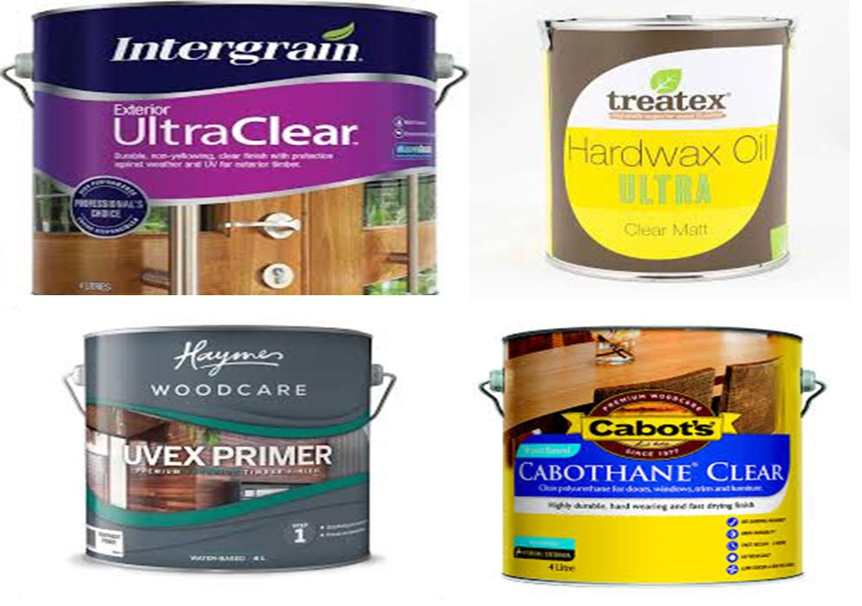

    - Sanding Techniques:
Figure 2-10 timber finishing material

Sanding plays a crucial role as a preparatory step before applying stains and clear finishes to wood surfaces. It is essential for creating a smooth and clean surface that allows the finish to adhere properly and enhances the overall appearance of the wood
- Pre-Sanding: Begin by using a coarser grit sandpaper, such as 80 or 120, to remove imperfections or old finishes. Progressively move to finer grits, like 180 or 220, for a smoother surface.
- Sanding with the Grain: Always sand in the direction of the wood grain to prevent creating visible scratches.
- Even Pressure: Apply even pressure on the sandpaper to ensure uniform sanding. Avoid pressing too hard, as it may create uneven spots.
- Consistent Motion: Use long, fluid strokes, moving the sandpaper back and forth in a straight line to prevent gouges and uneven surfaces.
- Dust Removal: Regularly remove dust during sanding to maintain visibility and prevent particles from becoming embedded in the wood. A tack cloth or a vacuum with a brush attachment is useful for this purpose.

- Progression of Grits: Start with the coarsest grit needed to remove any imperfections, then progressively move to finer grits for a smooth surface.
- Pre-Stain Conditioning: Some woods, like pine, may benefit from a pre-stain conditioner to achieve more uniform staining results by sealing the wood's pores.
- Prepare for Finish Application: After sanding is complete, thoroughly clean the surface of any dust or debris before applying the stain or clear finish.
- Apply the Finish: Depending on your project, apply the stain or clear finish using brushes, rags, or spray equipment, following the manufacturer's instructions. Apply thin, even coats and allow sufficient drying and curing time between coats for clear finishes.
Proper sanding, staining, and clear finish application techniques are essential for achieving a professional, high-quality result in woodworking projects. Always follow the manufacturer's instructions for the specific products you're using, as techniques may vary depending on the brand and type of stain or finish.


Figure 2-11 timber Sanding Techniques

Stripping Existing Stained or Finished Surfaces
Stripping existing stained or finished surfaces is a common step when preparing for the application of new stains or clear timber finishes. This process involves removing the old finish to ensure proper adhesion and to achieve the desired outcome. Here are some important points to consider when stripping existing stained or finished surfaces:

    - Assessment: Begin by assessing the condition of the existing finish. Determine whether it is necessary to completely remove the old finish or if it can be rejuvenated through cleaning and light sanding. If the finish is severely damaged, peeling, or incompatible with the new stain or finish, stripping is generally recommended.
    - Safety Precautions: Stripping products typically contain chemicals that can be harmful to human health. It is crucial to wear protective gear, including gloves, safety glasses or goggles, and a respirator, to shield yourself from the fumes and potential skin irritation.
    - Choosing a Stripping Product: There are various types of stripping products available, such as chemical strippers, gel-based strippers, or heat-based methods. Each has its own advantages and considerations. Read product labels carefully and select a suitable stripping method that aligns with the type of finish you are removing and the specific requirements of the project.
    - Surface Preparation: Before applying the stripping product, prepare the surface by cleaning it thoroughly to remove any dirt, grime, or wax. This will ensure that the stripping product can penetrate and work effectively.
    - Application of the Stripping Product: Follow the manufacturer's instructions for applying the stripping product. Typically, the product is brushed or sprayed onto the surface and left to dwell for a specified period. This allows the chemicals to break down the old finish.
    - Removing the Old Finish: Once the dwell time has elapsed, use a scraper or putty knife to gently scrape off the softened finish. Take care not to damage the wood surface while removing the old finish. It may be necessary to repeat the stripping process if multiple layers of finish are present.
    - Cleaning and Neutralizing: After removing the old finish, clean the surface with an appropriate cleaner or solvent to remove any residual stripping product. This step is crucial to ensure that the new stain or finish adheres properly. Some stripping products require neutralizing after use, so refer to the instructions provided.
    - Sanding and Surface Preparation: Once the surface is clean and dry, sand it lightly to smooth out any imperfections or raised grain caused by the stripping process. This step prepares the wood surface for the application of the new stain or clear finish.
    - Compatibility Testing: Before applying a new stain or finish to the entire surface, it is advisable to perform a compatibility test on a small, inconspicuous area. This allows you to ensure that the new product adheres well and achieves the desired appearance.

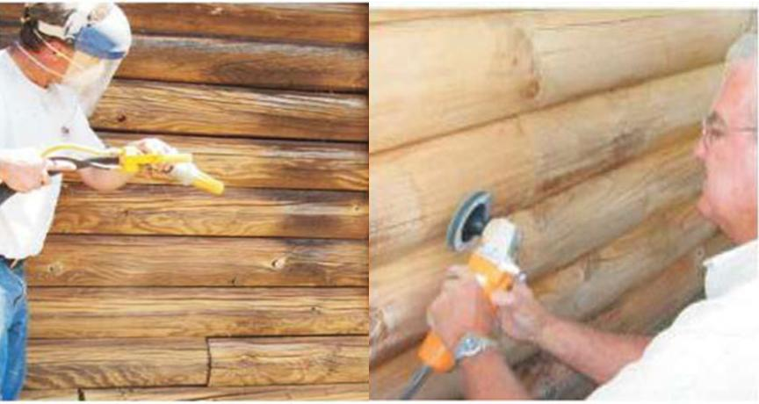

Figure 2-12 Stripping Existing Stained or Finished Surfaces
Stripping existing stained or finished surfaces is a critical step in the process of applying new stains or clear timber finishes. By following proper techniques and safety precautions, you can effectively remove the old finish and create a clean, well-prepared surface for the application of the new stain or finish.

Surface cleaning and dust removal
Surface cleaning and dust removal are critical steps in the process of applying stains and clear timber finishes. Proper cleaning ensures that the wood surface is free from contaminants, such as dust, debris, and residues, which can negatively impact the final finish. Here's a guide on how to effectively clean and remove dust from surfaces when working with stains and clear timber finishes:
    - Gather Your Materials:

Before you begin, ensure you have the necessary materials and tools ready for the task:

      - Clean, lint-free cloths or rags
      - A tack cloth (tack rag)
      - A vacuum cleaner with a brush attachment
      - A soft-bristle brush
      - Mild dish soap (if needed)
- Ensure a Clean Workspace:

Before you start cleaning the surface, make sure your workspace is clean and free of dust. A clean environment will help prevent new dust from settling on the surface during the finishing process.
    - Remove Loose Dust and Debris:

Before applying any cleaning solution, start by removing loose dust and debris from the surface. You can do this in several ways:
      - Use a soft-bristle brush to gently sweep away loose particles. Make sure the brush is clean and free of dirt itself.
      - Vacuum the surface with a vacuum cleaner fitted with a brush attachment. Use the lowest suction setting to prevent scratching the wood.
    - Wipe Down the Surface:
After removing loose dust and debris, wipe down the surface with a clean, lint-free cloth or rag. Make sure the cloth is clean and dry. Use smooth, gentle strokes to avoid scratching the wood.
    - Use a Tack Cloth (Tack Rag):
A tack cloth, which is a cloth treated with a sticky substance, is excellent for picking up fine dust particles and residue. Gently unfold the tack cloth and lightly drag it across the surface. Be careful not to press too hard to avoid leaving a sticky residue on the wood.
    - Check for Residue:
Inspect the surface for any remaining residues or contaminants, such as oils, wax, or adhesive residues. If you find any, use a mild solution of warm water and a few drops of mild dish soap on a clean cloth to wipe away the residue. Rinse the surface with a separate clean, damp cloth, and then dry it thoroughly.
    - Let the Surface Dry:
After cleaning and removing any residues, allow the wood surface to air dry completely before proceeding with staining or applying clear timber finishes. Ensure the area remains clean during this drying process to avoid new dust or contaminants settling on the surface.
    - Final Inspection:
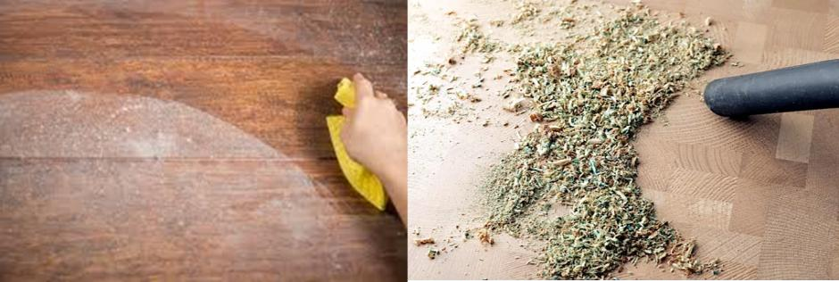
Before applying the stain or clear finish, perform a final inspection of the surface. Check for any remaining dust or contaminants. If you spot any issues, gently remove them with a tack cloth or a clean, lint-free cloth.

Figure 2-13 Surface cleaning and dust removal

Proper surface cleaning and dust removal are essential for achieving a professional and flawless result when working with stains and clear timber finishes. These steps ensure that the wood surface is clean and free of contaminants, allowing the finish to adhere evenly and provide a smooth and attractive final appearance. Taking the time to prepare the surface properly will lead to a more satisfying and long- lasting finish.

Match Stain Color to existing timber
Matching stain color to existing timber can be a challenging but rewarding task when you want to preserve or restore the natural appearance of wood. Whether you're working on a refinishing project, repairing damaged areas, or trying to achieve a consistent look across different wood components, here's a guide on how to match stain color to existing timber:

    - Identify the Type of Wood:

The first step in matching stain color is to identify the type of wood you're working with. Different wood species have varying grain patterns, colors, and characteristics. Understanding the wood's species can help you select a stain color that closely resembles the original wood.
    - Gather Stain Samples:

Collect samples of the existing wood or leftover pieces from your project if available. These samples will be crucial for testing and matching the stain color accurately.

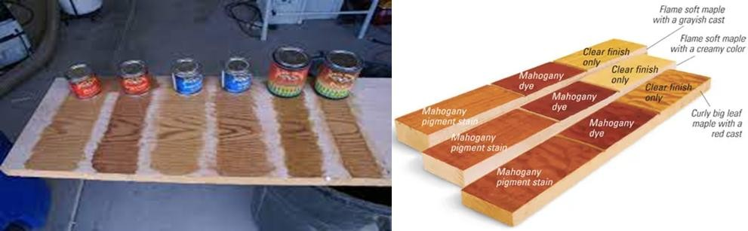

Figure 2-14 Match Stain Color to existing timber

    - Understand Stain Types:

There are various types of wood stains, including oil-based, water-based, gel, and penetrating stains. Each type may produce different results in terms of color and penetration. Understanding the characteristics of these stains can help you choose the right one for your project.
    - Test on Hidden Areas:

Before applying the stain to the visible areas, test it on an inconspicuous or hidden section of the wood. This allows you to assess how the stain color will interact with the existing wood and whether any adjustments are needed.
    - Adjust the Stain Color:

If the initial test doesn't produce a perfect match, you can make adjustments to the stain color. Some ways to do this include:
      - Mixing Stains: You can blend different stain colors to create a custom shade that closely matches the existing wood.
      - Diluting or Intensifying: Depending on the stain type, you can dilute it with a compatible thinner to make it lighter or add more pigment to make it darker.
      - Layering Stains: Applying multiple layers of stain with varying colors can achieve the desired shade and depth.
    - Consider Pre-Stain Conditioner:

Some woods, like pine or maple, may require a pre-stain conditioner to achieve a uniform stain color. This conditioner helps to seal the wood's pores and prevent blotching.
    - Prepare the Wood Surface:

Before applying the stain, ensure that the wood surface is clean, smooth, and free of contaminants, as discussed in a previous response about surface cleaning and dust removal.
    - Apply the Stain:

Apply the stain to the wood using a brush, cloth, or applicator, following the manufacturer's instructions. Ensure an even and consistent application. You can often control the stain's intensity by adjusting the duration you leave it on the wood.

    - Allow Drying Time:

Let the stain dry completely, as this can affect its final color. Some stains may look lighter when wet but will darken as they dry.
    - Evaluate the Match:

After the stain has dried, compare the color to the existing wood samples or components. The match may not be perfect, but strive for a close resemblance in terms of hue, tone, and grain patterns.
    - Finish with a Clear Topcoat:

Once you've achieved the desired stain color, protect the wood by applying a clear topcoat, such as varnish, lacquer, or polyurethane. This not only enhances the appearance but also safeguards the wood surface.
Matching stain color to existing timber requires patience and careful consideration. It may take some trial and error to achieve the perfect match, but the results are worth the effort when you preserve the natural beauty of the wood and create a seamless, harmonious look in your woodworking project.

Self-Check 2

Part I Multiple Choice Questions:

- When assessing timber condition for finishing work, what is the purpose of a visual inspection?

- To measure the moisture content of the wood

- To identify potential hazards and risks

- To evaluate the structural integrity of the timber

- To examine the wood surface for visible signs of damage

- What is the ideal moisture content range for timber finishing work?

A) 0% to 5%

B) 6% to 12%

C) 13% to 18%

D) 19% to 25%

- Which factor is important to consider when assessing the compatibility of timber with finishing materials?

- Environmental factors

- Moisture content

- Surface preparation

- Structural integrity

- What is the purpose of conducting a test finish on a small area of timber before applying the final finish?
- To evaluate the compatibility and appearance of the finish

- To measure the moisture content of the wood

- To assess the structural integrity of the timber

- To identify potential hazards and risks

4. Which type of personal protective equipment (PPE) is necessary to protect against inhaling dust and fumes during timber finishing work?
- Respiratory protection

- Eye and face protection

- Hand protection

- Hearing protection

Part- II: Short Answer Questions:
- Why is proper surface preparation important for achieving a successful timber finish?

- What are some environmental factors to consider when selecting finishes for timber?

- Why is it important to have adequate ventilation and dust control in a timber finishing workspace?

Self-Check 2 Answers

Part I Multiple Choice Questions:

- Answer: D) To examine the wood surface for visible signs of damage

- Answer: B) 6% to 12%

- Answer: B) Moisture content

- Answer: A) To evaluate the compatibility and appearance of the finish

- Answer: A) Respiratory protection

Part- II: Short Answer Questions:
- Answer: Proper surface preparation ensures proper adhesion of the finish and helps achieve the desired aesthetic result.
- Answer: Some environmental factors to consider include the location of the wood (indoors or outdoors), exposure to sunlight, moisture, and temperature fluctuations.
- Answer: Adequate ventilation and dust control help remove fumes and dust from the work area, minimizing health hazards associated with inhalation and maintaining a safer environment.

UNIT THREE: Applying timber Stain
This unit is developed to provide you the necessary information regarding the following content coverage and topics
- Techniques for applying stain evenly and consistently
- color depth and shading
- Applying the stain evenly and consistently
- Removing any excess stain
- Allowing the stain to dry thoroughly
This unit will also assist you to attain the learning outcomes stated in the cover page. Specifically, upon completion of this learning guide, you will be able to:
- Applies staining techniques to achieve even and consistent results, considering color depth and shading.
- Achieves the desired color depth and shading with stains, enhancing the overall appearance of the timber surface.
- Applies stain uniformly, ensuring consistent and desired visual effects.
- Demonstrates the ability to remove any excess stain for a clean and professional finish.
- Recognizes the importance of allowing the stain to dry thoroughly for a long-lasting finish.

  - Techniques for applying stain evenly and consistently
Applying timber stain is a fundamental process in woodworking and finishing that involves enhancing the color and appearance of wood while preserving its natural grain and character. Timber stain application is a skilled art that can transform raw wood surfaces into beautiful, rich, and customized finishes. This process not only adds visual depth and character to wood but also protects it from moisture, UV rays, and wear and tear. Whether you're working on furniture, cabinetry, flooring, or other wood projects, the application of timber stain is a critical step in achieving a professional and aesthetically pleasing result.
Applying stain evenly and consistently to wood surfaces is a crucial skill in woodworking and finishing. Achieving a smooth and uniform finish not only enhances the beauty of the wood but also ensures the longevity of the protection it provides. In this comprehensive guide, on this topic explore various techniques and best practices for applying stain evenly and consistently to achieve professional results.
    - Surface Preparation

The foundation for an even and consistent stain application is thorough surface preparation:

- Sanding: Before you start staining, ensure the wood surface is properly sanded. Begin with coarser grits (80-120) to remove imperfections and then progress to finer grits (180-220) for a smoother surface. Sanding evens out the wood grain and allows the stain to penetrate uniformly.
- Dust Removal: After sanding, clean the surface thoroughly to remove any dust, dirt, or debris. Dust particles can interfere with the stain's adherence and lead to an uneven finish. A tack cloth or a vacuum with a brush attachment is useful for this purpose.
- Wood Conditioner: Some woods, like pine or maple, can be prone to blotching when stained. Applying a pre-stain wood conditioner can help prevent uneven stain absorption by sealing the wood's pores.
  - Selecting the Right Stain

Choosing the right stain is a fundamental step in achieving an even and consistent result:

    - Type of Stain: Different types of stains, such as oil-based, water-based, gel, or penetrating stains, offer varying characteristics. Understanding the properties of each type is crucial for selecting the one that best suits your project and desired finish.
    - Testing: Always perform a test on a hidden or inconspicuous area of the wood with the selected stain to ensure it provides the desired color and coverage. Stains can behave differently on various wood species.
  - Application Techniques

The techniques for applying stain evenly and consistently depend on the type of stain being used. Here are some common methods:
    - Wipe-On Stains:
      - Use a Lint-Free Cloth: Apply the stain using a clean, lint-free cloth, such as a cotton rag or an old T-shirt. The cloth should be folded to create a pad for uniform coverage.
      - Wipe Off Excess: After applying the stain, wipe off any excess with a clean cloth. This process helps control the intensity of the color and ensures an even finish.
- Brush Application:
  - Choose the Right Brush: Use a high-quality natural bristle brush. The bristles should be clean and free of any debris that could affect the finish.
  - Work with the Grain: Apply the stain following the wood grain to ensure an even application. Avoid leaving brush strokes that can create uneven lines.
- Spray Application:
  - Spray Equipment: If you're using a spray gun or aerosol spray, it's essential to have proper equipment and maintain the correct pressure and nozzle settings.
  - Even Passes: Apply the stain in even passes, ensuring full and uniform coverage. Overlapping passes can help create an even finish.
- Gel Stains:
  - Brush or Rag Application: Gel stains are thicker and provide more control over color intensity. Apply the stain evenly with a brush or lint-free cloth and wipe off excess for consistency.
- Penetrating Stains:
  - Rub or Brush Application: For penetrating stains, rub or brush the stain into the wood and wipe off excess. This technique allows the stain to penetrate deeply into the wood, enhancing the grain and achieving an even look.
  - Layering and Testing

Achieving the exact color and consistency you desire may require layering and additional testing:

    - Layering: If the initial coat doesn't achieve the desired color, consider applying a second or third coat, allowing the stain to dry between coats.
    - Small Tests: Perform small tests on scraps or hidden areas to ensure the stain behaves consistently across the entire project.
  - Drying and Sealing
    - Drying Time: Allow the stain to dry completely before proceeding with any additional coats or finishing steps. The drying time may vary based on the type of stain and environmental conditions.

    - Sealing: Once you've achieved the desired stain color and consistency, protect the wood by applying a clear topcoat, such as varnish, lacquer, or polyurethane. This not only enhances the appearance but also provides long-lasting protection.
  - Common Mistakes to Avoid

Avoiding common mistakes is crucial for achieving an even and consistent stain application:

    - Overloading the Surface: Applying too much stain at once can result in uneven coverage and pooling. Apply thin, even coats.
- Inadequate Mixing: Properly mix the stain before use, especially if it's a pigmented or gel stain. Inadequate mixing can lead to inconsistent color.
- Uneven Application: Rushing the application process can lead to uneven results. Take your time and ensure each area receives the same attention.
- Failure to Test: Never skip the testing phase. Skipping this step can result in surprises and inconsistencies.
- Lack of Patience: Rushing the drying time and applying additional coats too soon can lead to problems. Follow the manufacturer's recommended drying times for the best results.
- Inadequate Cleaning: Neglecting to clean the wood surface properly before applying the stain can lead to adhesion issues and uneven coloring.
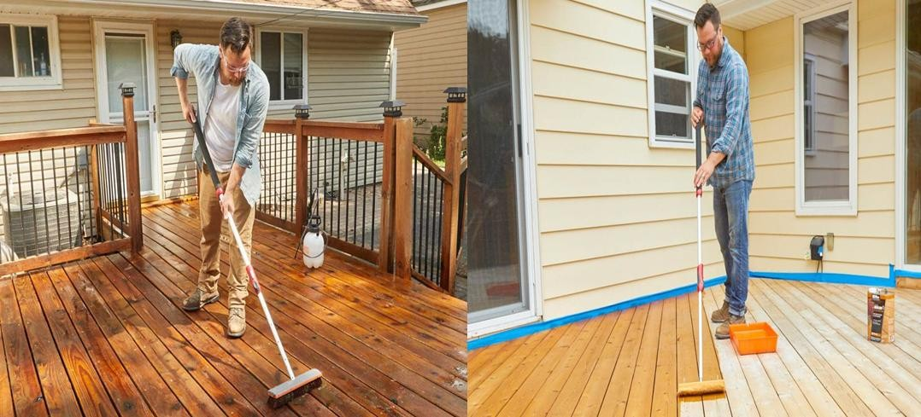

Figure 3-1Applying stain

Applying stain evenly and consistently requires a combination of preparation, technique, and patience. By following these techniques and best practices, you can achieve professional results that highlight the natural beauty of the wood while ensuring a durable and attractive finish.

Color Depth and Shading in Applying Timber Stain
When it comes to woodworking and finishing, applying timber stain is an art form that goes beyond the simple act of changing the color of wood. It's about creating depth, enhancing character, and achieving a harmonious balance between colors. In this exploration, we delve into the concepts of color depth and shading and how they play a pivotal role in the process of applying timber stain.

Understanding Color Depth

Color depth in the context of applying timber stain refers to the intensity, richness, and vibrancy of the color on the wood's surface. Achieving the right color depth is a crucial aspect of staining, and several factors influence it:
      - Stain Type: The type of stain you choose greatly impacts the color depth. Oil-based stains tend to provide a richer and deeper color compared to water-based stains. This richness is often sought after for its ability to bring out the wood's natural beauty.
      - Number of Coats: The number of coats you apply plays a significant role in determining color depth. Applying multiple coats of stain can deepen the color, with each coat adding to the saturation of the hue. This approach allows you to fine-tune the depth of color according to your preferences.
      - Wood Species: The type of wood you're working with influences the final color depth. Some wood species naturally have deeper and more vibrant colors than others. For example, oak is known for its rich and bold hue, while maple tends to be lighter in color. Recognizing the inherent qualities of the wood is vital when trying to achieve specific color depth.
      - Stain Penetration: The extent to which the stain penetrates the wood fibers can affect the color depth. This penetration depends on factors like the wood's porosity and the amount of time the stain is allowed to sit before excess is wiped off. In some cases, allowing the stain to penetrate deeply can result in a more profound and richer color.
      - Wood Prep: Properly preparing the wood surface through sanding is essential for even color depth. An evenly sanded surface allows the stain to be applied consistently, preventing uneven absorption.

The Role of Shading

Shading is an element of the staining process that can add character and dimension to wood surfaces. It involves variations in color and tone within the stained wood, creating depth and visual interest. Shading is often achieved through:
      - Blotching and Uneven Absorption: Wood surfaces are rarely perfectly uniform in their ability to absorb stain. Some areas may absorb more stain than others, leading to variations in color. This natural unevenness can result in shading, especially in woods with pronounced grain patterns.
      - Wood Prep: How you prepare the wood before staining plays a critical role in shading. For instance, sanding a surface unevenly or neglecting to use a pre-stain conditioner on porous woods like pine can lead to blotching and uneven stain absorption, which in turn creates shading.
      - Layering Stains: You can intentionally create shading by applying different shades of stain or stain colors. For example, you might apply a lighter stain as a base coat and then selectively apply a darker stain to specific areas or accents. This technique can be used to create depth and contrast.
      - Ragging On and Off: When using a staining rag, you can vary the pressure and technique to achieve shading. Applying more pressure in certain areas and less in others can result in differences in color intensity. The artistry lies in controlling the amount of stain left on the wood and how it interacts with the wood's natural features.

Guidelines for Achieving the Right Color Depth and Shading

Achieving the desired color depth and shading in your timber staining projects requires attention to detail and a creative touch. Here are some tips to help you achieve the desired effects:
      - Test and Experiment: Always begin with a test on scrap wood to fine-tune the color depth and shading to your liking before applying stain to your project.
      - Layer and Blend: If you're aiming for specific shading effects, consider layering and blending different stains or techniques to create depth and visual interest.
      - Proper Wood Preparation: The way you prepare the wood surface before staining can greatly impact shading. Ensure the wood is evenly sanded and consider using a wood conditioner if needed.
      - Patience is Key: Take your time when applying stain. Allow each coat to dry before adding another to control color depth. Be patient when wiping off excess stain to achieve your desired shading.
      - Work with Nature: Embrace the natural variation of the wood's grain and color. These inherent features contribute to the wood's unique character and are essential for creating a genuine and eye-catching finish.
Color depth and shading in the application of timber stain are integral to creating beautiful, captivating, and distinct wood finishes. By understanding the factors that influence these characteristics and by using proper techniques, you can bring out the inherent beauty of the wood while adding depth, character, and personality to your woodworking projects. Mastering these aspects of staining can elevate your work to a higher level of craftsmanship and aesthetics.

Applying the stain evenly and consistently
Achieving a flawless and consistent finish when applying stain to wood is a fundamental skill in woodworking and finishing. The way you apply the stain can significantly impact the final appearance of your project. In this topic, we'll explore the key principles, techniques, tools, and tips for applying stain evenly and consistently to wood surfaces.
    - Preparation for Staining

Before you start applying stain, it's crucial to prepare your wood surface. Proper preparation ensures that the stain adheres uniformly and enhances the wood's natural beauty.
      - Sanding

Sanding is the first step in preparing the wood for staining. Proper sanding not only smooths the surface but also opens up the wood's pores, allowing the stain to penetrate evenly.
        - Selecting the Right Grit: Begin with a coarse grit sandpaper (around 80-120) to remove any imperfections, and then progress to finer grits (180-220) for a smoother surface. Be consistent in the sanding direction to maintain an even grain pattern.
        - Controlling Dust: Clean the surface thoroughly after sanding to remove any dust, which can affect stain application. A tack cloth or a vacuum cleaner with a brush attachment is useful for this purpose.
- Wood Conditioner

Some woods, like pine or maple, can be prone to blotching when stained. A pre-stain wood conditioner can help prevent uneven stain absorption by sealing the wood's pores. It's particularly useful when striving for a uniform finish.

    - Selecting the Right Stain

Choosing the right stain is essential for achieving the desired color and consistency in your project. Understanding the characteristics of different types of stains is crucial:
      - Types of Stains: There are various types of wood stains, including oil-based, water-based, gel, and penetrating stains. Each type offers unique properties, such as drying time and ease of application. Select the one that suits your project and desired finish.
      - Sample Testing: Always perform a test on a hidden or inconspicuous section of the wood with your chosen stain. This helps you assess the color, coverage, and compatibility with your project.
    - Techniques for Even and Consistent Stain Application

The actual process of applying stain is where the magic happens. Here are various techniques to achieve even and consistent results:
    - Wipe-On Stains
      - Using a Lint-Free Cloth: Apply the stain using a clean, lint-free cloth, such as a cotton rag or an old T-shirt. The cloth should be folded to create a pad for uniform coverage.
      - Wiping Off Excess: After applying the stain, wipe off any excess with a clean cloth. This process helps control the intensity of the color and ensures an even finish.
    - Brush Application
      - Choosing the Right Brush: Use a high-quality natural bristle brush to apply the stain. Make sure the brush is clean and free of any debris that could affect the finish.
      - Working with the Grain: Apply the stain following the wood grain to ensure an even application. Avoid leaving brush strokes that can create uneven lines.
    - Spray Application
      - Spray Equipment: When using a spray gun or aerosol spray, it's essential to have proper equipment and maintain the correct pressure and nozzle settings.
      - Even Passes: Apply the stain in even passes, ensuring full and uniform coverage. Overlapping passes can help create an even finish.
    - Gel Stains

Brush or Rag Application: Gel stains are thicker and provide more control over color intensity. Apply the stain evenly with a brush or lint-free cloth and wipe off excess for consistency.
    - Penetrating Stains

Rub or Brush Application: For penetrating stains, rub or brush the stain into the wood and wipe off excess. This technique allows the stain to penetrate deeply into the wood, enhancing the grain and achieving an even look.
    - Tips for Applying Stain Evenly and Consistently

To ensure a professional and consistent result, consider these tips:

      - Test on Scrap Wood: Always perform a test on scrap wood before applying stain to your project. This allows you to fine-tune the color and technique to your liking.
      - Layer and Blend: For specific shading effects or depth, consider layering and blending different stains or using a combination of techniques.
      - Wood Preparation: Properly prepare the wood surface before staining by sanding and, if necessary, using wood conditioners. This will reduce blotching and create a more even base for stain application.

      - Patience: Take your time when applying stain. Allow each coat to dry before adding another to control color depth. Also, be patient when wiping off excess stain to achieve your desired shading.
      - Natural Wood Variation: Embrace and work with the natural variation of the wood's grain and color. These features contribute to the wood's unique character and should be celebrated in your project.
      - Consistent Lighting: Ensure consistent lighting when assessing your work. Uneven lighting can make it challenging to identify and remove excess stain.
    - Final Steps

Once you've achieved your desired stain application, consider these final steps:

      - Drying Time: Allow the stain to dry completely before proceeding with any additional coats or finishing steps. The drying time may vary based on the type of stain and environmental conditions.
      - Sealing: Protect the wood by applying a clear topcoat, such as varnish, lacquer, or polyurethane. This not only enhances the appearance but also provides long-lasting protection.
    - Common Mistakes to Avoid

Avoiding common mistakes is essential for achieving an even and consistent stain application:

      - Overloading the Surface: Applying too much stain at once can result in uneven coverage and pooling. Apply thin, even coats.
      - Inadequate Mixing: Properly mix the stain before use, especially if it's a pigmented or gel stain. Inadequate mixing can lead to inconsistent color.
      - Uneven Application: Rushing the application process can lead to uneven results. Take your time and ensure each area receives the same attention.
      - Failure to Test: Never skip the testing phase. Skipping this step can result in surprises and inconsistencies.
      - Lack of Patience: Rushing the drying time and applying additional coats too soon can lead to problems. Follow the manufacturer's recommended drying times for the best results.
      - Inadequate Cleaning: Neglecting to clean the wood surface properly before applying the stain can lead to adhesion issues and uneven coloring.
In conclusion, applying stain evenly and consistently is a complex yet rewarding process that requires careful planning, the right techniques, and attention to detail. By following the steps outlined in this guide and practicing patience, you can achieve professional and stunning results in your woodworking and finishing projects. Remember that each project is unique, and with experience, you'll become adept at customizing your approach to match your creative vision.

Removing any excess stain
    - A Crucial Step in Timber Staining

Staining wood is a meticulous process that requires careful attention to detail to achieve the desired finish. One of the essential steps in this process is removing any excess stain. Properly handling this aspect of staining ensures that the final result is not only aesthetically pleasing but also functional, as excessive stain can lead to problems such as uneven coloring, drying issues, and poor adhesion of protective coatings. In this comprehensive guide, we will delve into the significance of removing excess stain, the methods and tools used, and tips for a successful staining project.

The Significance of Removing Excess Stain
      - Removing excess stain is a critical step in the timber staining process for several important reasons:
      - Preventing Uneven Coloration: When excess stain is left on the wood surface, it can lead to uneven coloration. Some areas may appear darker or more intense in color than others, creating an unsightly finish. By removing excess stain, you ensure a uniform appearance.
      - Enhancing Durability: Excess stain can interfere with the adhesion of protective coatings like varnish or polyurethane. If left on the surface, it can lead to premature wear and degradation of the finish. By removing excess stain, you create a smooth foundation for topcoats, enhancing the finish's durability.
      - Improving Drying Time: Properly removing excess stain allows the remaining stain to dry more efficiently. This reduces the risk of the stain becoming tacky or drying unevenly, which can be problematic for both the appearance and functionality of the wood.
      - Minimizing Environmental Impact: Excess stain that is not removed may end up in the environment. This can have adverse effects on your surroundings, making it vital to clean up thoroughly and responsibly.

Methods for Removing Excess Stain

Several methods can be used to remove excess stain effectively. The choice of method depends on the type of stain, the project, and personal preferences. Here are the primary techniques:
      - Wiping with a Cloth: This is one of the most common methods for removing excess stain. After applying the stain to the wood, take a clean, lint-free cloth, such as a cotton rag or an old T-shirt, and gently wipe off the excess stain. Always follow the wood grain to avoid disrupting the evenness of the finish.
      - Brushing: A high-quality natural bristle brush can be used to apply stain and also to remove excess. When brushing, use light, even strokes that follow the wood grain. Be sure that the brush bristles are clean and free of debris, as any foreign matter can affect the finish.
      - Ragging On and Off: In some cases, especially when creating shading or varying color intensity, you might use a staining rag to apply the stain and then adjust the pressure and technique to remove excess. By controlling the amount of stain left on the wood, you can create shading effects.
      - Steel Wool or Abrasive Pads: For stubborn areas with excess stain that is difficult to remove with a cloth, fine steel wool or abrasive pads can be used. Be cautious not to scratch the wood; only use this method if the wood can withstand abrasion.

Tools for Removing Excess Stain

The tools for removing excess stain are relatively simple and readily available. Here are the primary tools used:
      - Lint-Free Cloths: These are essential for wiping off excess stain. They should be clean, dry, and free of lint to prevent any contamination of the finish.
      - Brushes: High-quality natural bristle brushes are used to apply stain and remove excess. Ensure the bristles are in good condition and clean.
      - Staining Rags: Staining rags, made of lint-free materials like cotton, are useful for wiping on and off stain. They provide control and precision.
      - Steel Wool or Abrasive Pads: Fine steel wool or abrasive pads are effective for more stubborn excess stain. Use with caution, as they can be abrasive.

To Successful Excess Stain Removal follow this stapes

To ensure that you remove excess stain effectively and achieve a smooth, even finish, consider the following tips:
      - Use Proper Technique: Always follow the wood grain when removing excess stain to maintain an even finish.
      - Take Your Time: Don't rush the process of removing excess stain. Work carefully and attentively to ensure thorough removal without creating smudges or streaks.
      - Regularly Check Your Tools: Make sure your tools, such as brushes and rags, are clean and in good condition to prevent contamination of the finish.
      - Test on Scrap Wood: Before staining your project, it's a good practice to test the staining process on a scrap piece of the same type of wood to get a feel for the stain's behavior and the effectiveness of your excess stain removal technique.
      - Consistent Lighting: Ensure consistent lighting when assessing your work. Uneven lighting can make it challenging to identify and remove all excess stain.
      - Dispose of Staining Materials Properly: Dispose of used staining materials responsibly to minimize environmental impact.
Removing excess stain is a critical aspect of timber staining that contributes to the overall quality and durability of the finish. By understanding the importance of this step, choosing the right method and tools, and following best practices, you can achieve a professional and flawless result in your staining

projects. Properly executed excess stain removal enhances the wood's natural beauty and ensures a long- lasting and attractive finish.

Allowing the stain to dry thoroughly
One of the crucial yet often overlooked steps in the process of staining wood is allowing the stain to dry thoroughly. This step is integral to achieving a successful and durable finish on your woodworking project. In this guide, we'll explore the significance of allowing the stain to dry, factors influencing drying times, and tips for ensuring a thorough drying process.

The Significance of Drying Stain

Properly drying the stain is essential for several reasons:

      - Color Fixation: Allowing the stain to dry ensures that the color becomes fixed within the wood fibers. It prevents the stain from smudging, smearing, or transferring onto other surfaces.
      - Enhancing Adhesion: A thorough drying process allows the stain to bond securely with the wood. This enhanced adhesion is crucial for the next steps in your finishing process, such as applying a protective topcoat.
      - Avoiding Surface Imperfections: Insufficient drying time can lead to issues like raised grain or rough patches. These imperfections can mar the final finish if not addressed.
      - Preventing Tackiness: Incomplete drying can result in a tacky or sticky finish. This not only affects the appearance but also makes the wood susceptible to damage during handling.
      - Ensuring Uniformity: Thorough drying leads to a consistent color and appearance, which is vital for achieving the desired aesthetic.

Factors Influencing Drying Times

Several factors can influence the drying times of wood stains:

      - Type of Stain: Different types of stains, such as oil-based, water-based, and gel stains, have varying drying characteristics. Oil-based stains generally take longer to dry compared to water-based alternatives.
      - Wood Species: The type of wood being stained can impact drying times. Some woods, like pine, may absorb stain more slowly, extending the drying process.
      - Humidity and Temperature: Environmental conditions play a significant role. High humidity and low temperatures can slow down drying, while low humidity and higher temperatures can accelerate it.
      - Number of Coats: Applying multiple coats of stain requires additional drying time between coats to achieve the desired color and depth.
      - Stain Penetration: Drying time may vary based on how deeply the stain penetrates the wood. A stain that has penetrated deeply might take longer to dry completely.

To ensure that your stain dries thoroughly, follow these tips:

      - Read the Manufacturer's Guidelines: Always start by reading and following the manufacturer's recommended drying times. These guidelines are specific to the type of stain you're using.
      - Allow for Ample Time: Don't rush the drying process. Give the stain adequate time to dry based on the type of stain and environmental conditions.
      - Test Before Proceeding: Before moving on to the next step in your project, perform a test to ensure the stain is dry to the touch. This can prevent issues down the line, such as smudging or uneven application of a topcoat.
      - Optimal Environmental Conditions: Control the environment to the extent possible. Ensure good ventilation, moderate humidity levels, and suitable temperatures for faster drying.
      - Avoid Dust and Debris: During the drying process, cover the stained surface or work in a clean, dust-free environment to prevent debris from settling on the stain.
      - Use a Fan or Dehumidifier: If you need to expedite drying, you can use a fan or a dehumidifier to enhance air circulation and reduce humidity.
      - Light Sanding (if necessary): If you notice any raised grain or rough spots during drying, light sanding may be required to achieve a smooth surface before applying a topcoat.
      - Test the Surface: Before applying a protective topcoat, always test the stained surface to ensure it is completely dry and ready for the next step.

Common Mistakes to Avoid

To prevent common mistakes that can hinder the drying process:

      - Applying a Topcoat Too Soon: Rushing to apply a topcoat before the stain is fully dry can result in issues like smudging or poor adhesion.
      - Neglecting Environmental Conditions: Inconsistent environmental conditions, such as high humidity, can significantly prolong drying times and impact the quality of the finish.
      - Ignoring the Manufacturer's Recommendations: Each type of stain has its specific drying requirements. Neglecting these recommendations can lead to problems during the drying process.
Allowing the stain to dry thoroughly is a critical step in achieving a successful wood staining project. Proper drying ensures that the stain's color is fixed, enhances adhesion, and prevents surface imperfections. By understanding the factors influencing drying times and following the manufacturer's guidelines and best practices, you can achieve a beautiful and durable wood finish that stands the test of time.

Self-Check 3

Part I Multiple Choice Questions:

- What is the purpose of applying timber stain in woodworking?

a) To protect wood from moisture and UV rays b) To create a smooth and uniform finish

c) To enhance the color and appearance of wood d) All of the above

- Which of the following is NOT a technique for applying stain evenly?

a) Sanding the wood surface b) Using a lint-free cloth for wipe-on stains

c) Applying multiple coats of stain d) Rushing the application process

- What is the purpose of applying a wood conditioner before staining?

a) To prevent uneven stain absorption b) To enhance the natural grain of the wood

c) To create a glossy finish d) To remove dust and debris from the surface

- Which type of stain provides more control over color intensity?

- Oil-based stain

- Water-based stain

- Gel stain

- Penetrating stain

- What should be done after applying stain to achieve the desired color?

- Apply a clear topcoat for protection

- Sand the wood surface again

- Clean the surface with a tack cloth

- Apply a second coat of stain

Part- II: Short Answer Questions:
- What factors can influence the color depth of timber stain?

- How can shading be achieved in the staining process?

- Why is it important to perform a test before applying stain to the entire wood surface?

Self-Check 2 Answers

Part I Multiple Choice Questions:

- Answer: d) All of the above

- Answer: d) Rushing the application process

- Answer: a) To prevent uneven stain absorption

- Answer: c) Gel stain

- Answer: a) Apply a clear topcoat for protection

Part- II: Short Answer Questions:

- Answer: The type of stain, the number of coats applied, the wood species, stain penetration, and wood surface preparation.
- Answer: Shading can be achieved through uneven stain absorption, intentional layering of different stains, and varying pressure and techniques when applying the stain.
- Answer: Performing a test helps ensure that the selected stain provides the desired color and coverage, and it allows for adjustments before committing to the entire project.

Operation sheet 3.1 Apply timber Stain Operation Title: Applying timber Stain
Purpose: To Applying timber Stain

Condition or situation for the operation
  - Safe working area
  - Properly operated tools and equipment
  - Appropriate working cloths fit with the body

Equipment Tools and Materials:
  - Safety Equipment: Safety goggles, Gloves, Dust mask or respirator
  - Mixing Tools: Mixing container, stirring stick or spatula and Measuring cups or spoons
  - Sanding Tools, Sandpaper.
  - Sandpaper Holder or Sanding Block Grouting Tools: Notched trowel, Grout float, Grout sponge
  - Protective Coating Tools: Paintbrush or foam brush

Equipment:
    - Power Sanders:
      - Orbital Sander
      - Belt Sander
      - Spray Gun or HVLP (High Volume, Low Pressure) System:
      - Polishing Machine

Steps in doing the tasks
Step 1 Preparation for Staining: Before you start applying stain, it's crucial to prepare your wood surface

Step 2. Selecting the Right Stain: Choosing the right stain is essential for achieving the desired color and consistency in your project.
Step 3. Wipe-On Stains

- Using a Lint-Free Cloth: Apply the stain using a clean, lint-free cloth, such as a cotton rag or an old T-shirt. The cloth should be folded to create a pad for uniform coverage.
- Wiping Off Excess: After applying the stain, wipe off any excess with a clean cloth. This process helps control the intensity of the color and ensures an even finish.

Step 4. Brush Application

- Choosing the Right Brush: Use a high-quality natural bristle brush to apply the stain. Make sure the brush is clean and free of any debris that could affect the finish.
- Working with the Grain: Apply the stain following the wood grain to ensure an even application. Avoid leaving brush strokes that can create uneven lines.

Step 5. Spray Application
- Spray Equipment: When using a spray gun or aerosol spray, it's essential to have proper equipment and maintain the correct pressure and nozzle settings.
- Even Passes: Apply the stain in even passes, ensuring full and uniform coverage. Overlapping passes can help create an even finish.
Step 6. Gel Stains

- Brush or Rag Application: Gel stains are thicker and provide more control over color intensity. Apply the stain evenly with a brush or lint-free cloth and wipe off excess for consistency.

Step 7. Penetrating Stains

- Rub or Brush Application: For penetrating stains, rub or brush the stain into the wood and wipe off excess. This technique allows the stain to penetrate deeply into the wood, enhancing the grain and achieving an even look.
Quality Criteria: Assured performing of all the activities according to the procedures

Precautions:

- Wearing proper clothes, eye glass, glove
- Make working area hazard free
- Read and interpret manual which guide you how to use tools and equipment.

LAB TEST 1
Instruction: Given necessary templates, tools and materials you are required to perform the following tasks accordingly.
Task 1 Apply stain on the existing timber work
Task 2 Apply stain evenly and consistently on the new timber work

UNIT FOUR: Applying Clear Timber Finishes
This unit is developed to provide you the necessary information regarding the following content coverage and topics
- Clear Finishes
- Pros and cons of each finish type
- Preparing stained surfaces for clear finishes
- Applying clear finishes
This unit will also assist you to attain the learning outcomes stated in the cover page. Specifically, upon completion of this learning guide, you will be able to:
- Understands the purpose and types of clear finishes, including their pros and cons.
- Identifies and describes different types of clear finishes, demonstrating an understanding of their characteristics and applications.
- Evaluates and communicates the advantages and disadvantages of various clear finish types.
- Effectively prepares stained surfaces for the application of clear finishes, ensuring a clean and suitable foundation.
- Demonstrates proficiency in applying clear finishes, using appropriate techniques such as brushing, wiping, and spraying.

  - Applying Clear Timber Finishes
Applying clear timber finishes is a transformative process that brings out the natural beauty of wood while protecting and enhancing its features. Whether you're working on furniture, cabinetry, or any wood project, clear timber finishes provide an opportunity to showcase the wood's unique grain, color, and texture. In this guide, we'll explore the art of applying clear timber finishes, from selecting the right product to mastering the application techniques, ensuring that your woodworking projects radiate timeless elegance and durability.
Enhancing and Protecting Wood's Natural Beauty

Clear finishes are a category of wood coatings that serve the dual purpose of enhancing the natural beauty of wood and protecting it from environmental elements. They are designed to provide a transparent and durable layer over wood surfaces while allowing the wood's unique grain, color, and texture to shine through. In this comprehensive guide, we will explore the world of clear finishes, including their types, applications, benefits, and key considerations.

Types of Clear Finishes

Clear finishes come in various forms, each with its distinct properties, applications, and aesthetics. Here are some of the most commonly used types:
      - Varnish

Varnish is a traditional and well-known clear finish. It offers a glossy and durable coating that provides excellent protection to wood surfaces. Varnish is often used on furniture, boats, outdoor woodwork, and fine woodworking projects. It is available in different sheen levels, from high-gloss to satin, allowing for flexibility in achieving the desired aesthetic.
      - Lacquer

Lacquer is known for its quick-drying properties and the ability to produce a glossy, clear finish. It is commonly used on fine furniture, musical instruments, and decorative woodwork. Lacquer dries rapidly and can be easily applied, making it a favorite among woodworkers seeking a high-quality, transparent finish with a smooth surface.

      - Shellac

Shellac is a natural and renewable finish derived from the resin secreted by the lac beetle. It is appreciated for its warm and lustrous appearance. Shellac is often used on fine woodworking projects, antiques, and wood surfaces where the preservation of wood's natural characteristics is desired. It imparts a beautiful, amber hue to the wood.
      - Polyurethane

Polyurethane finishes are versatile and come in both oil-based and water-based varieties. They offer exceptional durability and protection. Oil-based polyurethanes tend to add a warm, amber tone to the wood, while water-based options remain clearer. Polyurethane finishes are widely used on floors, tabletops, and other high-traffic wood surfaces.
      - Catalyzed Finishes

Catalyzed finishes are advanced, professional-grade coatings designed for superior durability. They are often used in commercial applications and high-end woodworking projects where exceptional resistance to wear, chemicals, and moisture is required. Catalyzed finishes are known for their long-lasting and robust protection.

Benefits of Clear Finishes

      - Clear finishes provide several significant benefits for wood surfaces:
        - Enhanced Aesthetics: One of the primary advantages of clear finishes is their ability to accentuate the natural beauty of wood. They highlight the wood's grain, color, and texture, creating a visually captivating result.
        - Protection: Clear finishes act as a protective shield, guarding wood surfaces against various environmental factors. They help prevent moisture penetration, resist UV damage, and provide a barrier against daily wear and tear.
        - Durability: Clear finishes are known for their durability. They create a hard and long-lasting surface that can withstand abrasion, scratches, stains, and impact, ensuring that the wood remains in excellent condition.
        - Ease of Maintenance: Clear finishes are relatively easy to clean and maintain. Regular cleaning and occasional reapplication can keep the wood looking fresh and vibrant for years.
        - Versatility: Clear finishes can be applied to a wide range of wood projects, from furniture and cabinetry to wooden floors and outdoor structures. Their versatility makes them a valuable choice for woodworkers and DIY enthusiasts.

Considerations When Using Clear Finishes

While clear finishes offer numerous benefits, there are essential considerations to keep in mind:

      - Preparation: Proper surface preparation is crucial. Sanding, cleaning, and ensuring a dust-free environment is key steps in achieving a flawless finish.
      - Ventilation: Adequate ventilation is essential when applying clear finishes. It helps with drying and minimizes exposure to potentially harmful fumes.
      - Environmental Factors: Environmental conditions, such as humidity and temperature, can impact drying times and the overall quality of the finish. Maintaining consistent conditions is advisable.
      - Compatibility: Clear finishes should be compatible with the wood species and type of project. Always test the finish on a sample piece to ensure it meets your expectations.
      - Safety: When working with clear finishes, it's essential to follow safety precautions, including using appropriate personal protective equipment and ensuring a well-ventilated workspace.
Clear finishes are a valuable tool in woodworking, providing both aesthetic enhancement and protection to wood surfaces. Whether you're working on a piece of fine furniture or a durable outdoor structure, clear finishes allow you to showcase the inherent beauty of wood while ensuring its longevity. Understanding the types of clear finishes, their benefits, and the key considerations for their use is essential for achieving outstanding woodworking results.
  - Pros and cons of each finish type
Choosing the right finish for your woodwork project is a critical decision that can significantly impact the final appearance, durability, and maintenance of the piece. There are various types of wood finishes available, each with its own set of advantages and disadvantages. In this comprehensive guide, we'll explore the pros and cons of some of the most common finish types, including varnish, lacquer, shellac, polyurethane, and oil.
- Varnish
  - Pros:
    - Durable: Varnish is known for its exceptional durability. It forms a tough, protective coating that can withstand heavy use and exposure to the elements.
    - Enhanced Aesthetics: Varnish provides a glossy, high-gloss finish that accentuates the wood's natural beauty, grain, and color. It's often used on furniture and outdoor woodwork.
    - Versatility: Varnish can be applied to a variety of wood types and surfaces, making it a versatile choice for many projects.
  - Cons:

    - Application Complexity: Applying varnish can be more challenging compared to other finishes due to its slow drying time and potential for brush strokes.
    - AmBering Effect: Some varnishes may impart a yellow or amber tint to the wood, which may not be desired for all projects.
    - Maintenance: Varnish can be more challenging to repair if it becomes damaged, and recoating may require thorough surface preparation.
- Lacquer
  - Pros:
    - Rapid Drying: Lacquer dries quickly, allowing for multiple coats in a short time. This makes it an attractive option for projects with tight deadlines.
    - High Gloss: Lacquer provides a high-gloss, mirror-like finish that is exceptionally smooth and glossy.
    - Ease of Repair: If damaged, lacquer can be easily repaired by reapplication, as it dissolves in its own solvent, making touch-ups seamless.
- Cons:
  - Toxic Fumes: The solvents in lacquer can release strong and potentially harmful fumes. Adequate ventilation and protective gear are necessary when working with lacquer.

  - Limited Outdoor Use: Lacquer is not suitable for outdoor projects, as it is susceptible to UV damage and moisture.
  - Skill Requirement: Applying lacquer requires some skill to achieve a smooth finish, and it may not be as forgiving as other finishes for beginners.
- Shellac
  - Pros:
    - Warm Finish: Shellac provides a warm and lustrous finish that enhances the natural appearance of wood. It imparts a subtle amber hue, which is often considered attractive.
    - Renewable: Shellac is a renewable finish, meaning you can apply a new coat over an old one without the need for extensive stripping or sanding.
    - Low Toxicity: Shellac is relatively low in toxicity compared to some other finishes, making it safer to work with.
- Cons:
  - Limited Durability: Shellac is not as durable as some other finishes and may not hold up well in high-traffic areas or outdoor environments.
  - Solubility: Shellac is susceptible to damage from alcohol, water, and some household chemicals. This makes it less suitable for pieces that may come into contact with such substances.

  - Application Challenges: Shellac dries quickly, which can make application challenging, especially for large surfaces.
- Polyurethane
  - Pros:
    - Durability: Polyurethane is highly durable and resistant to abrasion, making it an excellent choice for high-traffic areas, floors, and tabletops.
    - Moisture Resistance: Polyurethane provides a barrier against moisture, making it suitable for bathroom and kitchen applications.
    - Variety: It is available in both oil-based and water-based forms, offering versatility in terms of application and appearance.

- Cons:
  - Ambering: Oil-based polyurethane can add a slight amber tint to the wood, which may not be desired for all projects.
  - Long Drying Time: Some polyurethane finishes can have longer drying times, requiring patience and meticulous application to avoid imperfections.
  - Challenging Repairs: Repairing polyurethane finishes can be more complex compared to some other finishes, and recoating may require extensive preparation.
- Oil Finishes
  - Pros:
    - Natural Appearance: Oil finishes preserve the wood's natural appearance, enhancing its grain and color without adding a glossy finish.
    - Ease of Application: Oil finishes are typically easy to apply, making them suitable for DIY enthusiasts and beginners.
    - Low Toxicity: Oil finishes are generally low in toxicity, making them safer to work with.
  - Cons:
    - Limited Protection: Oil finishes provide less protection compared to other finishes and may not be suitable for high-traffic areas or outdoor use.
    - Frequent Maintenance: Oiled wood may require more frequent reapplication and maintenance to maintain its appearance and protection.
    - Drying Time: Oil finishes can have longer drying times, which may necessitate more extended project timelines.
The choice of wood finish depends on the specific project, desired aesthetics, and the intended use of the piece. Each type of finish has its own set of advantages and disadvantages, and

understanding these characteristics is crucial in achieving the desired results in your woodworking projects.

  - Preparing Stained Surfaces for Clear Finishes
The process of preparing stained surfaces for clear finishes is a crucial step in achieving a flawless and long-lasting wood finish. Whether you're working on furniture, cabinetry, or any wood project, the quality of your preparation can significantly impact the final result. In this comprehensive guide, we'll explore the key steps, techniques, and considerations for properly preparing stained surfaces to ensure that your clear finishes adhere well and create a stunning end product.
- Importance of Surface Preparation

Preparing stained surfaces for clear finishes serves several important purposes:

  - Adhesion: Proper preparation creates a suitable surface for the clear finish to adhere to. This is crucial for ensuring the finish bonds securely and does not peel or blister over time.
  - Smoothness: Surface preparation helps create a smooth and even canvas for the clear finish. This is essential for achieving a polished and professional appearance.
  - Stain Removal: Stained surfaces may have irregularities, spots, or uneven color distribution. Proper preparation can address these issues and ensure that the final clear finish is uniform and blemish-free.
  - Protection: Clear finishes protect the wood beneath them, and proper preparation can enhance the longevity and effectiveness of this protective barrier.
- Key Steps in Preparing Stained Surfaces

To prepare stained surfaces for clear finishes effectively, follow these key steps:

  - Evaluate the Stained Surface

Begin by carefully assessing the stained surface. Examine it for any irregularities, damaged areas, or stains that may affect the finish's adhesion or appearance. Take note of any raised grain, scratches, or areas where the stain may not have adhered properly.

  - Sanding

Sanding is a fundamental step in surface preparation. It helps achieve two primary goals:

    - Smoothness: Sanding ensures that the surface is even and free of rough spots. It also removes any raised grain or rough patches on the stained wood.
    - Stain Removal: Light sanding can help remove some of the surface stain, especially if there are uneven areas or excess stain that hasn't been absorbed by the wood. This can help create a more uniform base for the clear finish.
  - Use the following guidelines for sanding:
    - Select the Right Grit: Start with a coarse-grit sandpaper (typically 80-120) to remove imperfections and gradually work your way up to finer grits (180-220) to achieve a smoother surface. Be consistent in your sanding direction to maintain an even grain pattern.
    - Clean After Sanding: After sanding, clean the surface thoroughly to remove any dust and debris. A tack cloth or a vacuum cleaner with a brush attachment is helpful for this purpose. Dust can negatively impact the adhesion and appearance of the clear finish.
- Consider Wood Conditioners

Some wood types, such as pine or maple, can be prone to blotching when stained. To prevent uneven stain absorption, consider using a pre-stain wood conditioner. This conditioner helps seal the wood's pores and prepares the surface for more consistent stain absorption. It can be especially useful when striving for a uniform clear finish.
- Repair Damaged Areas

Inspect the stained surface for any damaged or uneven areas that may require repair. Common issues include scratches, dents, or areas where the stain didn't take evenly. Depending on the severity of the damage, you may need to address these areas with appropriate wood fillers, patching compounds, or sanding techniques. After making repairs, ensure the surface is smooth and even.

- Clean the Surface

Before applying the clear finish, it's essential to clean the surface thoroughly to remove any residual dust, debris, or contaminants. Cleaning ensures that the finish adheres well and creates a clean and consistent appearance. Use a clean, lint-free cloth and an appropriate cleaning

solution to wipe down the entire surface. Ensure that the surface is completely dry before proceeding with the application of the clear finish.
- Common Challenges and Considerations

While preparing stained surfaces for clear finishes is a critical process, it can be accompanied by certain challenges and considerations:
  - Compatibility: Ensure that the clear finish you intend to use is compatible with the stain applied to the wood. Some finishes may not adhere well to certain types of stain, so testing on a small, inconspicuous area is advisable.
  - Sanding Carefully: Avoid over-sanding, as this can damage the wood and affect the stain's appearance. Sand gently, and aim for a smooth surface without removing excessive material.
  - Spot Sanding: In some cases, spot sanding may be required, particularly in areas where there is raised grain or excess stain. Be cautious and blend the spot-sanded areas with the rest of the surface.
  - Proper Ventilation: When cleaning the surface and applying the clear finish, ensure proper ventilation in your workspace to prevent the inhalation of fumes and to aid in drying.
  - Patience: Take your time during the preparation process. Rushing can lead to mistakes and imperfections that may be difficult to correct once the clear finish is applied.
Properly preparing stained surfaces for clear finishes is an essential step in achieving a beautiful and long-lasting wood finish. This process ensures adhesion, smoothness, and stain removal while addressing any damage or irregularities on the stained surface. By following the outlined steps and considering the specific needs of your project, you can set the stage for a clear finish that

Applying Clear Finishes
Applying clear finishes to wood surfaces is an art that transforms ordinary wood into stunning, durable pieces of craftsmanship. Clear finishes are designed to protect the wood while allowing its natural beauty, grain, and color to shine through. Whether you're working on furniture, cabinetry, or other wood projects, understanding how to apply clear finishes correctly is essential for achieving a professional and enduring result.

The Importance of Clear Finishes

      - Clear finishes offer several key advantages:

        - Enhanced Aesthetics: Clear finishes amplify the wood's natural beauty, emphasizing its grain and color. They create a visually captivating result that enhances the wood's inherent charm.
        - Protection: Clear finishes serve as a protective barrier against environmental factors, such as moisture, UV rays, and everyday wear and tear. They help extend the lifespan of wood surfaces.
        - Durability: Clear finishes provide a durable, long-lasting coating that can withstand frequent use and resist damage, such as scratches, stains, and water.
        - Ease of Maintenance: Clear finishes are relatively easy to clean and maintain. Regular cleaning and occasional reapplication can keep the wood looking fresh and vibrant.
        - Versatility: Clear finishes can be applied to a wide range of wood projects, from furniture and cabinetry to wooden floors and outdoor structures. Their versatility makes them a valuable choice for woodworkers and DIY enthusiasts.

Applying Clear Finishes: Step by Step

Applying clear finishes requires careful preparation and attention to detail. Here is a step-by- step guide to help you achieve the best results:

      - Surface Preparation:
        - Assess the Wood: Carefully inspect the wood surface for any imperfections, blemishes, or areas that require repair. Ensure it's clean and free of dust and debris.
        - Sanding: Lightly sand the surface to create a smooth canvas for the finish. Start with coarser grits and gradually move to finer ones for a polished result. Ensure you remove any dust from the sanding process.
- Wood Conditioner:

For woods prone to blotching, like pine or maple, consider using a pre-stain wood conditioner to prevent uneven stain absorption.
- Apply Clear Finish:

Select the Appropriate Finish: Choose the type of clear finish that aligns with your project and desired aesthetics.
  - Use the Right Tools: Depending on the finish, you can apply it using a brush, cloth, or sprayer. Ensure your tools are clean and free of debris.

  - Even Application: Apply the finish in even, thin coats, following the wood grain. Avoid leaving visible brush strokes or uneven areas.
- Drying Time:

Allow the finish to dry according to the manufacturer's guidelines. The drying time may vary based on the type of finish and environmental conditions.
- Additional Coats:

Depending on the desired level of protection and appearance, you may need to apply multiple coats of clear finish. Sand lightly between coats for a smoother finish.
- Final Inspection:

Carefully inspect the finished surface under consistent lighting to ensure it's free of imperfections or uneven spots.
- Topcoat:

For added protection and sheen, consider applying a clear topcoat, such as varnish or polyurethane.
- Successful Application methods

To ensure a professional and consistent result when applying clear finishes:

- Read the Manufacturer's Guidelines: Always follow the manufacturer's recommended application and drying times.
- Practice on Scrap Wood: Before applying the finish to your project, perform a test on scrap wood to refine your technique.
- Natural Variation: Embrace the natural variation in wood grain and color. It contributes to the wood's unique character.
- Proper Ventilation: Ensure good ventilation when working with finishes to prevent inhaling fumes and to aid in dying.
- Patience: Take your time during each step, and follow the recommended drying times for the best results.

Applying clear finishes is a skill that enhances wood's natural beauty while providing protection and durability. Whether you're working on a treasured piece of furniture or a functional wood surface, understanding the types of clear finishes, their applications, and proper techniques will

help you achieve outstanding woodworking results. Clear finishes not only protect your projects but also ensure that they stand the test of time with beauty and resilience.
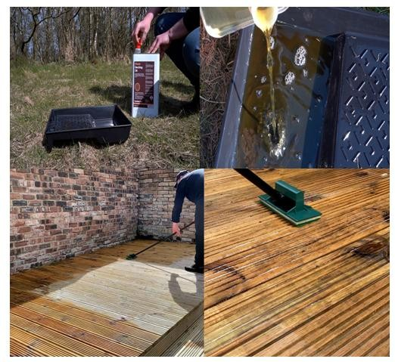

Self-Check 4
Figure 4-1Applying clear timbre finishing

Part I Multiple Choice Questions:

- Which clear finish type is known for its quick-drying properties and glossy, clear finish?

a) Varnish b) Lacquer c) Shellac d) Polyurethane e) Catalyzed Finishes

- Which clear finish type is derived from the resin secreted by the lac beetle and imparts a warm and lustrous appearance to the wood?
a) Varnish b) Lacquer c) Shellac d) Polyurethane e) Catalyzed Finishes

- Which clear finish type is known for its versatility, exceptional durability, and ability to add a warm, amber tone to the wood?
a) Varnish b) Lacquer c) Shellac d) Polyurethane e) Catalyzed Finishes

- Which clear finish type is considered an advanced, professional-grade coating known for its superior durability and resistance to wear, chemicals, and moisture?
a) Varnish b) Lacquer c) Shellac d) Polyurethane e) Catalyzed Finishes

- Which clear finish type provides a high-gloss finish that accentuates the wood's natural beauty and is often used on furniture and outdoor woodwork?

a) Varnish b) Lacquer c) Shellac d) Polyurethane e) Catalyzed Finishes

Part- II: Short Answer Questions:
- What are some benefits of clear finishes for wood surfaces?

- What are some key considerations when using clear finishes?

- What are the pros and cons of using lacquer as a clear finish?

Self-Check 2 Answers

Part I Multiple Choice Questions:

- Answer: b) Lacquer

- Answer: c) Shellac

- Answer: d) Polyurethane

- Answer: e) Catalyzed Finishes

- Answer: a) Varnish

Part- II: Short Answer Questions:
- Answer: Clear finishes enhance aesthetics, provide protection against environmental factors, offer durability, are easy to maintain, and are versatile in their applications.
- Answer: Important considerations include proper surface preparation, adequate ventilation, maintaining consistent environmental conditions, ensuring compatibility with the wood species and project type, and following safety precautions.
- Answer: Pros of lacquer include rapid drying, high gloss, and ease of repair. Cons include toxic fumes, limited outdoor use, and the need for some skill to achieve a smooth finish.

Operation sheet 4.1Apply clears timber finishing
Operation Title: Apply clear timber finishing

Purpose: To Apply clear timber finishing

Condition or situation for the operation
  - Safe working area
  - Properly operated tools and equipment
  - Appropriate working cloths fit with the body

Equipment Tools and Materials:
  - Tools
    - Safety Equipment: Safety goggles, Gloves, Dust mask or respirator
    - Mixing Tools: Mixing container, stirring stick or spatula and Measuring cups or spoons
    - Sanding Tools, Sandpaper, Sandpaper Holder or Sanding Block Grouting Tools, Notched trowel, Grout float, Grout sponge
    - Natural Bristle Brushes, Synthetic Bristle Brushes, Foam Brushes,
    - Lint-free Cloths: Used for wiping and applying stains and finishes evenly

Equipment:
    - Power Sanders:
      - Orbital Sander

      - Belt Sander
      - Spray Gun or HVLP (High Volume, Low Pressure) System:
      - Polishing Machine

Steps in doing the tasks
  - Step 1 Surface Preparation:

    - Assess the Wood: Carefully inspect the wood surface for any imperfections, blemishes, or areas that require repair. Ensure it's clean and free of dust and debris.
    - Sanding: Lightly sand the surface to create a smooth canvas for the finish. Start with coarser grits and gradually move to finer ones for a polished result. Ensure you remove any dust from the sanding process.
- Step 2. Wood Conditioner: For woods prone to blotching, like pine or maple, consider using a pre-stain wood conditioner to prevent uneven stain absorption.
- Step 3 Apply Clear Finish: Select the Appropriate Finish:

  - Use the Right Tools: Depending on the finish, you can apply it using a brush, cloth, or sprayer. Ensure your tools are clean and free of debris.
  - Even Application: Apply the finish in even, thin coats, following the wood grain. Avoid leaving visible brush strokes or uneven areas.
- Step 4 Drying Time: Allow the finish to dry according to the manufacturer's guidelines. The drying time may vary based on the type of finish and environmental conditions.
- Step 5 Additional Coats: Depending on the desired level of protection and appearance, you may need to apply multiple coats of clear finish. Sand lightly between coats for a smoother finish.
- Step 6 Final Inspection: Carefully inspect the finished surface under consistent lighting to ensure it's free of imperfections or uneven spots.
- Step 7 Topcoat: For added protection and sheen, consider applying a clear topcoat, such as varnish or polyurethane.
Quality Criteria: Assured performing of all the activities according to the procedures

Precautions:

- Wearing proper clothes, eye glass, glove
- Make working area hazard free
- Read and interpret manual which guide you how to use tools and equipment.

LAB TEST 2
Instruction: Given necessary templates, tools and materials you are required to perform the following tasks accordingly.
Task 1 Apply clear finishing

UNIT FIVE: Advanced Clear Finish Techniques
This unit is developed to provide you the necessary information regarding the following content coverage and topics
- Clear Finishes
- Pros and cons of each finish type
- Preparing stained surfaces for clear finishes
- Applying clear finishes
This unit will also assist you to attain the learning outcomes stated in the cover page. Specifically, upon completion of this learning guide, you will be able to:
- Demonstrates the knowledge and skills required to maintain and care for finished timber surfaces, ensuring their long-term quality.
- Applies multiple clear finish coats to enhance durability and aesthetics, achieving a high- quality finish.
- Understands the importance of sanding between clear finish coats and performs the process effectively.
- Demonstrates the ability to achieve a mirror-like finish for wood surfaces, showcasing a high-gloss appearance.
- Safely handles and stores finishing materials to prevent accidents and maintain product quality.



Applying multiple coats for durability and aesthetics

Advanced clear finish techniques are a set of refined and specialized methods used to enhance the appearance, durability, and overall quality of wood and other surfaces. These techniques go beyond basic clear coating and varnishing, incorporating intricate processes, innovative materials, and skilled craftsmanship to achieve outstanding results. Whether applied to furniture, flooring, or various decorative items, advanced clear finish techniques aim to create flawless, long-lasting finishes that not only protect but also highlight the natural beauty of the underlying material. This introduction offers a glimpse into the world of craftsmanship and artistry that elevates clear finishing to an exceptional level of expertise and aesthetic appeal.

In the world of finishing, whether it's for wood, metal, or other surfaces, the application of multiple coats is a technique that has been cherished for centuries. This practice is not merely a matter of routine, but rather an art that combines both functionality and aesthetics. Multiple coats serve two primary purposes: enhancing durability and improving aesthetics. In this exploration, we will delve into the significance of applying multiple coats and how it contributes to achieving remarkable results in terms of longevity and visual appeal.
    - The Science of Durability

Multiple coats are often employed to enhance the durability of surfaces, and this is particularly evident in woodworking, where the lifespan of furniture and other wooden items is a critical consideration.
      - Protective Barrier: The first coat in a series of multiple coats typically serves as a protective barrier. It shields the underlying material from environmental factors such as moisture, UV radiation, and physical abrasion. Depending on the specific application, this protective layer might consist of primers, sealers, or clear base coats. These initial coats act as a shield against the elements, ensuring that the underlying surface remains intact over time.
      - Layered Strength: Each additional coat builds upon the protective foundation laid by the initial layer. It adds depth to the finish and reinforces the surface's resistance to wear and tear. By layering coats, it's possible to create a composite structure that can withstand prolonged

      - use and exposure. The synergy between these
layers is what contributes to the remarkable durability of well-finished products.
      - Adhesion and Bonding: Another crucial aspect of applying multiple coats is the adhesion between each layer. Proper surface preparation and compatibility between products are essential to ensure that these coats bond effectively. Adhesion promotes cohesion, preventing delamination or peeling of the finish over time. When each coat bonds securely to the one beneath it, it adds to the overall strength of the finish.
    - Aesthetic Advantages

While durability is a primary consideration when applying multiple coats, aesthetics also play a pivotal role. Multiple coats can transform ordinary surfaces into works of art by enhancing their visual appeal.
      - Depth and Luster: One of the most striking aesthetic benefits of multiple coats is the creation of depth and luster. Each coat, when applied correctly, contributes to the optical illusion of depth. This depth can be further intensified with the use of techniques such as wet sanding and polishing. The result is a finish that seems to have layers of color and dimension, producing a mesmerizing visual effect.
      - Gloss Control: Multiple coats provide the opportunity to control the level of gloss or sheen in a finish. From high-gloss to satin or matte finishes, each additional coat can be tailored to achieve the desired aesthetic effect. This versatility allows for customization to match the style and decor of a particular project.
      - Flaw Concealment: Imperfections in the surface can often be concealed through the application of multiple coats. Irregularities, scratches, or minor blemishes are gradually covered as each coat is added. This is especially useful in the restoration of antique furniture, where preserving the authenticity of the piece while improving its appearance is paramount.
    - The Process of Applying Multiple Coats

The application of multiple coats is a meticulous process that requires attention to detail and an understanding of the specific materials and techniques involved.
      - Surface Preparation: Proper preparation is the foundation of a successful multiple-coat finish. This includes sanding, filling, and ensuring a clean and dust-free surface. In the case of wood, grain-filling might also be necessary to achieve a smooth, even finish.
      - Primer and Sealer: Depending on the project, a primer or sealer coat may be applied first. This helps in adhesion and uniformity. In some cases, a primer coat may also add color to the finish, which can impact the final appearance.
      - Building Layers: Multiple coats are added, each carefully applied with attention to drying times and sanding between coats. The choice of finish materials, such as polyurethane, lacquer, or varnish, will influence the final look and feel of the project.

      - Intermediate Sanding: Sanding between
coats is crucial to create a smooth and level surface. It also promotes adhesion between coats. The choice of sandpaper grit and the technique used play a role in achieving the desired finish.
      - Polishing and Final Coat: After building up the desired number of coats, a final coat may be applied. Depending on the desired finish, polishing and buffing can be used to enhance the luster and depth of the surface.
      - Curing and Drying: Allowing the finish to cure and dry properly is essential for achieving both durability and aesthetics. The curing time will vary depending on the type of finish used.
    - Challenges and Considerations

While applying multiple coats offers numerous advantages, it also presents challenges that need to be considered.
      - Dust and Debris: Dust particles and debris can easily become trapped in the finish as each coat dries. This can lead to imperfections that require additional sanding and refinishing.
      - Skill and Technique: Achieving a flawless finish with multiple coats requires skill and experience. Inexperienced individuals may encounter issues with streaks, bubbles, or uneven application.
      - Compatibility: Ensuring compatibility between products is crucial. Using products from different manufacturers or with incompatible formulations can lead to problems with adhesion and finish quality.
Applying multiple coats for durability and aesthetics is an age-old practice that continues to be essential in the world of finishing. Whether protecting wooden furniture or enhancing the beauty of a cherished antique, the art of layering coats has a profound impact on both longevity and visual appeal. It's a testament to the craftsmanship and attention to detail that can transform everyday surfaces into extraordinary works of art, offering a combination of resilience and elegance that stands the test of time.

Identifying and Addressing Common Finishing Problems
Stains and clear timber finishes are essential components of woodworking and carpentry projects, serving to enhance the aesthetic appeal and protect the wood. However, achieving a flawless finish can be challenging, as several common problems can arise during the finishing process. This article explores these issues and provides practical solutions to address them.

The Importance of Proper Finishing

Proper finishing not only enhances the appearance of wood but also serves critical functional purposes. It protects the wood from moisture, UV damage, and wear and tear, ultimately extending the lifespan of the wood. Therefore, understanding and addressing common finishing problems is crucial for both novice and experienced woodworkers.

      - Blotchiness

One of the most prevalent problems when applying stains to wood is blotchiness. Blotchiness occurs when the stain is absorbed unevenly by the wood, resulting in dark and light patches. This issue is particularly noticeable on softwoods and less dense hardwoods.
- Causes:
  - Uneven wood porosity: Softwood and hardwood have varying densities and grain patterns, leading to uneven stain absorption.
  - Insufficient surface preparation: Failing to sand the wood properly or neglecting to use a pre-stain conditioner can result in blotchy staining.
  - Inconsistent application: Not applying the stain evenly or leaving excess stain on the surface can lead to blotches.
- Solutions:
  - Sand the wood evenly: Use a progression of sandpaper grits, starting with a coarse grit and moving to finer ones to create a uniform surface.
  - Pre-stain conditioner: Apply a pre-stain conditioner to the wood before staining, especially when working with softwoods.
  - Even application: Wipe the stain evenly and consistently across the wood, and remove excess stain with a clean cloth.
- Brush Marks and Bubbles

Brush marks and bubbles in clear timber finishes can mar an otherwise perfect finish. These issues can be frustrating, as they are often only noticeable after the finish has dried.
  - Causes:
    - Incorrect brush selection: Using the wrong type or quality of brush can leave unsightly marks and bubbles.
    - Over brushing: Continuously brushing or rebrushing the finish can create bubbles and marks.
    - Inadequate surface preparation: Dust, debris, or raised grain on the wood can be trapped in the finish, causing imperfections.
  - Solutions:
    - Choose the right brush: Select a high-quality brush designed for the specific finish you are using, such as a natural bristle brush for oil-based finishes.
    - Apply in a controlled environment: Minimize dust and airborne particles by applying finishes in a clean, controlled space.
    - Work in thin, even coats: Apply the finish in thin, even coats, allowing each coat to dry before applying the next.

Gently sand the surface between coats with fine-grit sandpaper to remove imperfections and improve adhesion.
- Uneven Sheen

Achieving a consistent sheen across a finished wood surface can be a challenge, especially with clear finishes like varnish or lacquer.
  - Causes:
✓
    - Inadequate mixing: Failing to mix the finish thoroughly can result in uneven sheen.
    - Uneven application: Applying the finish with inconsistent pressure or brush strokes can lead to variations in sheen.
    - Dust and debris: Particles settling on the wet finish can cause imperfections.
  - Solutions:
    - Mix the finish well: Stir the finish thoroughly before use to ensure an even distribution of the components.
    - Apply evenly: Use a brush, roller, or spray gun to apply the finish evenly, paying attention to maintain a consistent pressure and technique.
    - Work in a clean environment: Minimize dust and debris by working in a clean space with proper ventilation.
Finishing wood is both an art and a science, and common problems can arise during the process. Understanding the causes of issues like blotchiness, brush marks, bubbles, and uneven sheen is the first step in addressing them effectively. By employing the recommended solutions and practicing good finishing techniques, woodworkers can achieve professional-quality finishes that not only enhance the beauty of the wood but also protect it for years to come. Ultimately, patience, attention to detail, and proper preparation are key to overcoming common finishing problems in stains and clear timber finishes.

Routine Maintenance and Care of Finished Timber Surfaces
Wood is a timeless and versatile material that, when properly finished, can add warmth, beauty, and durability to various items, from furniture to flooring. Routine maintenance and care are essential to preserve the integrity and aesthetics of finished timber surfaces. This article delves into the importance of maintaining wood finishes and provides a comprehensive guide on how to do so.

The Significance of Maintenance

reasons:

      - Aesthetic Preservation

One of the primary reasons for finishing wood is to enhance its appearance. Over time, however, exposure to environmental factors, UV rays, and everyday wear and tear can dull the finish and cause it to lose its luster. Routine maintenance helps retain the original beauty of the wood.
      - Longevity

Proper maintenance can significantly extend the life of the finish and, in turn, the underlying wood. A well-maintained finish serves as a protective barrier, shielding the wood from moisture, pests, and physical damage.
      - Cost-Efficiency

Regular upkeep is far more cost-effective than extensive repairs or refinishing. Neglected timber surfaces may deteriorate to a point where extensive restoration is necessary, incurring higher costs and more effort.

Routine Maintenance Tasks

Maintaining finished timber surfaces involves a combination of preventive measures and periodic tasks. Here's a comprehensive guide to routine maintenance:
      - Preventative Measures
        - Place Protective Pads

Use furniture pads or coasters under the legs of chairs, tables, and other items to prevent scratches, dents, and moisture damage. Felt pads work well on hard floors, while rubber or plastic protectors are suitable for carpeted areas.
        - Use Trivets and Cutting Boards

In the kitchen, always use trivets or hot pads under hot dishes and cutting boards when preparing meals. These protective measures prevent heat and moisture from damaging the wood.
        - Wipe Up Spills Promptly

Accidents happen, and spills are inevitable. To prevent stains and warping, promptly wipe up any spills or moisture from finished wood surfaces with a clean, dry cloth.

        - Protect Against Sunlight

Direct sunlight can cause wood finishes to fade or discolor. Use curtains, blinds, or UV-blocking window films to protect timber surfaces from excessive exposure to sunlight.
      - Regular Cleaning
        - Dusting

Dust can accumulate on the surface of finished wood, dulling its appearance. Regularly dust timber surfaces with a soft, lint-free cloth or a microfiber duster.
        - Cleaning Solutions

When cleaning is necessary, use a mild solution of water and a gentle, pH-neutral cleaner. Avoid harsh chemicals or abrasive cleaning agents that can damage the finish. Apply the solution sparingly to a clean cloth rather than directly onto the wood surface to prevent oversaturation.
      - Periodic Maintenance
        - Waxing and Polishing

Depending on the type of finish, applying a wax or polish can restore the shine to the wood. Follow manufacturer recommendations for the specific product you're using.
        - Spot Repair

For minor scratches or small areas where the finish has worn away, you can use a touch-up marker or a similar product to fill in the imperfections. Make sure the color matches the finish.
        - Reapplication of Finish

Over time, the finish may wear down, particularly in high-traffic areas. In such cases, refinishing may be necessary. This process involves stripping the old finish and applying a fresh coat. Seek professional help for refinishing large or valuable items.
      - Humidity Control

Wood is sensitive to changes in humidity. Maintain a consistent indoor humidity level to prevent the wood from expanding and contracting excessively, which can lead to cracking and warping. A humidity level between 30-50% is generally recommended.
Finished timber surfaces add timeless beauty and functionality to our homes and surroundings. Maintaining these surfaces is an investment in their longevity and continued aesthetic appeal. By adhering to preventive measures and following a routine maintenance schedule, you can ensure that your wood surfaces remain in top condition for years to come. Whether it's your antique wooden furniture, hardwood floors, or other wood items, the care you provide will help preserve their natural beauty and extend their lifespan, making them a cherished part of your living space.

Handling and storing finishing materials
Handling and storing finishing materials is a critical aspect of any timber finishing project. Proper storage and care of these materials ensure that they remain in optimal condition and that the finished product achieves the desired results. In this article, we will explore best practices for handling and storing finishing materials in timber finishing work.
    - Significance of Proper Handling and Storage
      - Material Integrity: Many finishing materials are sensitive to environmental conditions. Failure to store them correctly can result in changes to their composition, rendering them less effective or even unusable.
      - Quality Finish: The quality of the final finish is directly influenced by the state of the materials used. Well- maintained materials are more likely to produce a consistent and attractive finish.
      - Cost Savings: Proper storage and handling extend the shelf life of finishing materials. This, in turn, saves money as you can use them over a more extended period without degradation.
    - Handling Finishing Materials
      - Safety Precautions

Before handling any finishing materials, it's essential to take safety precautions:

        - Ventilation: Ensure proper ventilation in your workspace when working with potentially hazardous materials, like solvent-based finishes, to avoid inhaling harmful fumes.
        - Protective Gear: Wear appropriate personal protective equipment (PPE) such as gloves, safety glasses, and a mask or respirator when necessary.
        - Read Labels: Always read and follow the manufacturer's instructions and safety recommendations on the product label.
      - Mixing and Agitating

Some finishing materials, like varnishes and paints, may require thorough mixing before use. It's important to follow the manufacturer's instructions for agitation to ensure uniform consistency. This can be done by gently stirring or shaking the material without introducing excessive air bubbles.

- Application Tools

Select the right tools for applying the finishing material. Brushes, rollers, and sprayers should be clean and in good condition. Clean your application tools promptly after use to maintain their quality for future projects.
    - Storing Finishing Materials
      - Temperature and Humidity

Maintain a consistent temperature and humidity level in your storage area. Finishing materials are sensitive to extreme conditions, which can cause separation, spoilage, or crystallization. Ideally, store materials in a temperature-controlled environment with a consistent humidity level. Avoid freezing or excessively hot conditions.
      - Sealing Containers

Properly seal containers to prevent air from entering and reacting with the finishing materials. This is especially important for water-based products that can be contaminated by airborne particles. Ensure that lids are tightly closed and free from any residual material before sealing.
      - Labeling

Label all containers with the name of the finishing material, its date of purchase, and any relevant instructions or safety precautions. This will help you keep track of your inventory and ensure that you are using materials within their recommended shelf life.
      - Storage Location

Store finishing materials in a dedicated area away from direct sunlight, heat sources, and open flames. Keep them on shelves or in cabinets to prevent accidental spills and contamination.
- Shelf Life

Be aware of the shelf life of different finishing materials. Some materials have a limited time frame during which they are effective, and using expired products may lead to undesirable results.
- Disposal

Proper disposal of unused or expired finishing materials is also essential. Some materials may be considered hazardous waste and should be disposed of in accordance with local regulations. It's important to research and follow the guidelines for the disposal of finishing materials in your area.
Handling and storing finishing materials properly is vital to the success of any timber finishing project. By following best practices in material handling and storage, you can ensure that your finishing materials remain in optimal condition, resulting in high-quality finishes on your timber surfaces. Additionally, adhering to safety precautions not only protects the materials but also safeguards your health and the environment. It's a worthwhile investment of time and effort that will yield better outcomes and long-term cost savings.

Self-Check 5

Part I Multiple Choice Questions:

- What are the primary purposes of applying multiple coats in finishing?

- Enhancing durability and improving aesthetics

- Creating depth and luster

- Concealing flaws and irregularities

- All of the above

- Which of the following is NOT a factor to consider when applying multiple coats?

- Dust and debris

- Skill and technique

- Compatibility between products

- Type of wood used

- What is the purpose of the first coat in a series of multiple coats?

- To add depth and luster

- To conceal imperfections

- To act as a protective barrier

- To enhance adhesion between layers

- What technique can be used to control the level of gloss or sheen in a finish?

- Wet sanding and polishing

- Applying a primer coat

- Using different types of wood

- Adding more layers of clear finish

- What is the importance of proper surface preparation in applying multiple coats?

- It improves adhesion between coats

- It enhances the visual appeal of the finish

- It reduces the curing and drying time

- It prevents compatibility issues between products

Part- II: Short Answer Questions:
- What are some common problems that can occur when applying stains to wood?

- How can brush marks and bubbles be prevented in clear timber finishes?

- What are the causes of uneven sheen in clear finishes, and how can it be addressed?

Self-Check 2 Answers

Part I Multiple Choice Questions:

- Answer: d) All of the above

- Answer: d) Type of wood used

- Answer: c) To act as a protective barrier

- Answer: d) Adding more layers of clear finish

- Answer: a) It improves adhesion between coats

Part- II: Short Answer Questions:
- Answer: Some common problems include blotchiness, uneven stain absorption, and inconsistent application.
- Answer: Brush marks and bubbles can be prevented by using the right type and quality of brush, applying the finish in a controlled environment, working in thin, even coats, and sanding between coats.

- Answer: Uneven sheen can be caused by inadequate mixing, uneven application, and dust and debris settling on the wet finish. It can be addressed by thoroughly mixing the finish, applying it evenly with consistent pressure and technique, and working in a clean environment.

Reference
- Flexner, B. (2010). Understanding Wood Finishing: How to Select and Apply the Right Finish. Fox Chapel Publishing.
- Allen, M. (2014). The Complete Guide to Wood Finishes: How to Apply and Restore Lacquers, Polishes, Stains, and Varnishes. GMC Publications.
- Fine Woodworking. (2012). Fine Woodworking's Fine Finishes: Tips and Techniques from the Experts. Taunton Press.
- Jewitt, J. (2004). Taunton's Complete Illustrated Guide to Finishing. Taunton Press.

- Flexner, B. (2019). Wood Finishing 101: The Step-by-Step Guide. Popular Woodworking Books.

- Kyler, S. J., & Marks, D. J. (2009). The Fine Art of Wood: A Guide to Understanding and Using the Beautiful Woods of the World. Fox Chapel Publishing.
Videos

- https://www.youtube.com/watch?v=IzLtpszZ-h0

- https://www.youtube.com/shorts/eZWqRuK8ft8?feature=share

- https://www.youtube.com/watch?v=9vIWYUiL4LE

- https://www.youtube.com/watch?v=vt3WtAxmfzM

Developer profile

Name | Qualification  (Level) | Field of study | Institute | Phone  number | Email
BirhanuDemelash | A | M.Sc. COTM  BSc Road construction, | woldeya poly  technic | 0910686578 | birhanudemelash14@gmail.com
MihiretabGashaw | B | BSc building construction  technology and Computer engineering | Addis ketema industrial | 0922079011 | mihiretabgashaw@gmail.com
Nasir Amane | B | BSC construction  technology | Shashemane  poly technic | 0916005870 | nasiraman5870@gmail.com
NIGUSSIE TESHOME | A | Geotechnical enginer(M.sc)  Civil engineering (B.sc) | Arbaminch  PTC | 0913767770 | teshomeng@gmail.com
Tesfaye Ayalew | A | MSc in COTM BSC in Building  Construction Technology | Debre Brhan poly technic | 0910469898 | tesfaye.ay21@gmail.com
WONDWESN GIRMA | A | COTM(M.sc)  Civil engineering (B.sc) | Harar polytechnic  College | 0912778365  0703608365 | wondwesngirma@gmail.com

