Finishing Construction Works
Level-lll
Based onOctober 2023, Curriculum Version 2

Module Title:Repairing and Maintaining Fibrous Plaster Works
Module Code: EIS FCW M131023
Nominal Duration: 70 Hours
Prepared by: Ministry of Labor and Skill

October, 2023
Addis Ababa, Ethiopia

Acknowledgements
The Ministry of Labor and Skills wishes to thank MoLS experts, regional labor and skill bureaus, Regional TVT bureaus, Universities, TVT Colleges, TVT trainers, university lecturers, and industry experts who contributed their time and professional experience to the development of this curriculum for basic finishing.
We would like to express our appreciation to the Ministry of Labor and Skills for their technical and financial support and workshop facilitation of this training module's development.

ACRONYMS

LAP Test Learning Activity Performance Test
LG Learning Guide
OSH Occupational Safety and Health
PPE Personal Protective Equipment
WHS Work Health and Safety
SWMP Site Waste Management Plan
OPC Ordinary Portland cement
FIG Figure

Contents

Acknowledgements 2

ACRONYMS 3
Unit One: Introduction to Fibrous Plaster Works 6
1.1. Overview of Fibrous Plaster Work 6
1.2. Types of Fibrous Plaster Works 10
1.3. Health and Safety Considerations 13
1.4. Material, Tools and equipment 20
Unit Two: Assessment of Fibrous Plaster Damage 38
2.1. Techniques for identifying damaged areas 39
2.2. Assessing the extent and cause of damage 39
2.3. Importance of proper assessment before repair 42
2. One of the flowing is Importance of proper assessment before repair 49
Unit Three: Remove damaged structure 52
3.1. Safe removal methods 53
3.2. Proper Handling and Disposal of Debris 55
3.3. Techniques for Minimizing Further Damage during Removal 55
1. One of the following is Proper Handling and Disposal of Debris 57
Unit four: Repair Techniques for Fibrous Plaster 60
4.1. Surface preparation 61
4.2. Patching and filling 64
4.3. Reinforcement 65
4.4. Matching textures and patterns 68
Unit five: Preservation of Fibrous Plaster 73
2.2. Cleaning and Maintenance Practices 74
2.3. Protecting Against Moisture and Environmental Factors 75
2.4. Periodic Inspections and Preventive Measures 76
1. Reference 79

INTRODUCTION TO THE MODULE
Repairing and Maintaining Fibrous Plaster helps to Works Overview fibrous plaster work Types of Fibrous PlasterWorksHealthandSafetyConsiderationsMaterial, Tools and equipment
In finishing construction work this module covers skill knowledge and attitude required to Repairing and Maintaining Fibrous Plaster in different back ground. This module is designed to meet the industry requirement under the irrigation and drainage occupational standard, particularly for the unit of competency: applying internal & external plastering.
MODULE UNITS
- Introduction to Fibrous Plaster Works
- Assessment of Fibrous Plaster Damage
- Remove damaged structure
- Repair Techniques for Fibrous Plaster
- Preservation of Fibrous Plaster
LEARNING OBJECTIVES OF THE MODULE
At the end of this session, the students will able to:
- Understand Overview fibrous plaster work
- Identify Types of Fibrous Plaster Works
- Follow Health and Safety Considerations
- Select Material, Tools and equipment
MODULE LEARNING INSTRUCTIONS
Read the specific objectives of this learning guide (LG).
- Follow the instructions described below.
- Read the information written in the information sheet.
- Accomplishment the self-check questions.
- Accomplishment operation sheet (if any).
- Accomplishment learning activity performance (LAP) test (if any).

Unit One: Introduction to Fibrous Plaster Works
This unit to provide you the necessary information regarding the following content coverage and topics:
- Introduce to Fibrous Plaster Works
- Assesses of Fibrous Plaster Damage
- Remove damaged structure
- Repair Techniques for Fibrous Plaster
Preservation of Fibrous PlasterThis guide will also assist you to attain the learning outcomes stated in the Above topic contact. Specifically, upon completion of this learning guide, you will be able to:
- Introduce to Fibrous Plaster Works
- Assesses of Fibrous Plaster Damage
- Remove damaged structure
- Repair Techniques for Fibrous Plaster
Learning Instructions:
- Read the specific objectives of this Learning Guide.
- Follow the instructions
- Read the information written in the information “Sheet
- Accomplish the “Self-check 1, Self-check t 2, and Self-check 3”
- If you earned a satisfactory evaluation from the “Self-check” proceed to “Operation Sheet 1, Operation Sheet 2 and Operation Sheet 3”
- Do the “LAP test” (if you are ready).

Overview of Fibrous Plaster Work
Fibrous plaster work refers to the use of fibrous plaster materials to create decorative elements and architectural features in buildings. It is a traditional technique that has been used for centuries to add elegance and sophistication to interior spaces. Fibrous plaster is a composite material consisting of plaster reinforced with natural or synthetic fibers, such as hessian or glass fibers. These fibers enhance the strength and durability of the plaster, allowing it to be molded into intricate shapes and designs. Fibrous plaster can fail for several reasons: defects in the structure to which it is fixed; degraded materials within the plaster casts; inadequate fixing methods; imposed load; and physical damage. This section summaries s some of the main problems affecting the deterioration of fibrous plaster ceilings in particular Of course, other types of ceilings can also fail, under poor conditions or with lack of monitoring and maintenance. Harmful environmental conditions and physical stresses can compromise the integrity of fibrous plasterwork
1.1.1 Properties and Characteristics of Fibrous Plaster
Fibrous plaster possesses several properties and characteristics that make it suitable for decorative applications
A. Versatility
Fibrous plaster can be molded and shaped into various forms, including cornices, ceiling roses, corbels, columns, and decorative panels. It allows for intricate detailing and customization, making it versatile for different design styles.
B.Lightweight
Despite its strength and durability, fibrous plaster is relatively lightweight compared to other materials like solid plaster or stone. This characteristic makes it easier to handle during installation and reduces the stress on the building's structure.
C. Fire Resistance
Plaster itself is inherently fire-resistant, and the addition of fibers further enhances its fire resistance. Fibrous plaster can provide an extra layer of protection in case of a fire.
D. Acoustic Properties
Fibrous plaster has sound-absorbing qualities, making it useful for improving the acoustic properties of a room. It can help reduce echoes and enhance sound quality.
E. Smooth Finish
Fibrous plaster surfaces can be finished to a smooth and seamless appearance, providing a polished and refined look to the interior.
    - Common Applications of Fibrous Plaster
Fibrous Plastering is a method or process used to produce decorative plasterwork on a bench in a workshop. The casts produced in the workshop are taken to site and put in place by fibrous plaster fixers.
The three component parts of fibrous plaster casts are casting plaster, timber laths and canvas or hessian scrim. The plaster forms the body of the casts which is reinforced with the fabric scrim to prevent cracking and the laths assist in fixing as mechanical fixings can be run through the timber laths concealed in the casts.
The use of timber laths and fabric scrim gave rise to the term rag and stick for fibrous plastering.
When fixing casts on site the fibrous fixers should always use two or more methods of fixing so there is a back up if one method of fixing fails.
Methods of Fixing
The fixing methods available are strong plaster adhesives, mechanical fixings such as screws and for larger work the use of wires, brackets and wads of scrim soaked in plaster. With large fibrous works on ceilings all the methods may be employed together as it is essential that large heavy sections of plaster do not fall down endangering people below.
Method of applying fibrous plaster
1. Preparation: Begin by preparing the surface where you plan to apply the fibrous plaster. Ensure that it is clean, dry, and free from any loose debris or contaminants. If necessary, use a primer or sealer suitable for the surface to create a suitable base for the plaster.
2. Mixing the plaster: Follow the manufacturer's instructions to mix the fibrous plaster. Typically, you will need to add the plaster powder to clean water in a clean bucket or mixing container. Use a paddle mixer or a mechanical mixer to blend the plaster and water thoroughly until you achieve a smooth, lump-free consistency. Allow the plaster to rest for a few minutes before applying.
3. Application: Once the plaster is mixed, you can start applying it to the surface. Most commonly, fibrous plaster is applied in layers using a trowel or hawk and trowel combination. Begin by loading the plaster onto the hawk, and then transfer a small amount onto the trowel.
4. First coat: Start by applying a thin, even layer of plaster to the surface using the trowel. Hold the trowel at a slight angle and use upward strokes to spread the plaster smoothly. The thickness of the first coat will depend on the desired final thickness of the plasterwork. Typically, the first coat is thinner than subsequent coats.
5. Reinforcing: If necessary, embed reinforcement materials such as fiberglass mesh or metal lath into the first coat of plaster to enhance its strength and prevent cracking. Press the reinforcement material gently into the wet plaster, ensuring it is fully embedded and covered with an additional layer of plaster.
6. Building up layers: After the first coat, allow it to dry partially, but not completely. Apply subsequent coats of plaster, gradually building up the thickness and smoothing the surface between coats. Feather the edges of each layer to create seamless transitions and avoid visible seams.
7. Finishing: Once the desired thickness is achieved, allow the final coat of plaster to dry fully. Use sandpaper or a plastering float to smooth any imperfections or irregularities in the surface. You can also use wet sponges or damp cloths to achieve a polished finish.
8. Decoration: Once the plaster is completely dry, you can proceed with any desired decorative finishes, such as painting, gilding, or applying wallpaper.
Remember to follow safety guidelines and wear appropriate protective gear, such as gloves and a dust mask, while working with plaster. Additionally, consult professional plasterers or reference guides for specific techniques and recommendations based on the type of fibrous plaster you are working with.
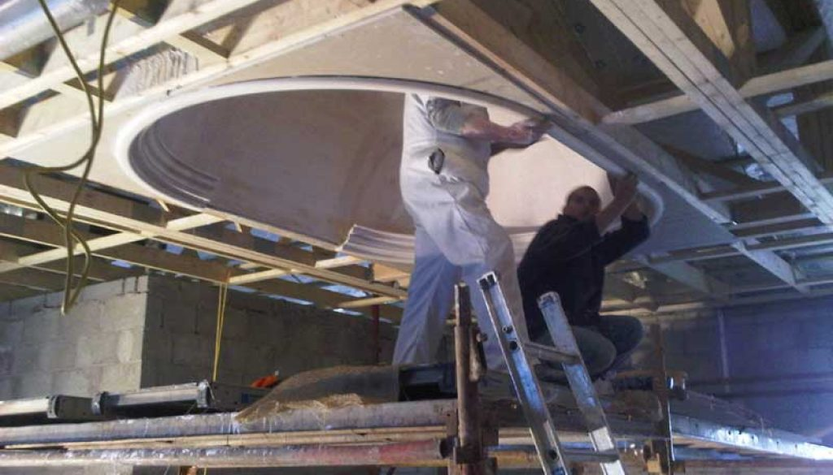
Fig 1.1 fixing fibrous plaster

Types of Fibrous Plaster Works
Fibrous plaster works involve the use of plaster of Paris or a similar material mixed with fibers to create decorative elements for interior spaces.
There are several types of fibrous plaster works:
- Cornices
Cornices are decorative moldings that are installed at the junction between the walls and ceilings. They add visual interest and can vary in style and design.
Common styles of cornices include
- Victorian cornices: These cornices feature intricate designs with floral motifs, scrolls, and dentil patterns.
- Georgian cornices: Georgian cornices are characterized by simple, elegant lines and classical motifs such as acanthus leaves.
- Art Deco cornices: Art Deco cornices have geometric patterns and sleek lines, reflecting the style of the Art Deco era.
- Ceiling roses
Ceiling roses are circular decorative elements that are installed on the ceiling, usually around light fixtures. They can serve as a focal point and add a touch of elegance to a room. Ceiling roses come in various designs and sizes, ranging from simple floral patterns to more elaborate motifs.
- Panels and friezes
Panels and friezes are decorative elements that can be installed on walls or ceilings. They often feature intricate patterns, relief work, or sculptural elements. Panels are larger decorative sections, while friezes are narrower bands that can be installed at the top or middle of a wall. They can be customized to suit different architectural styles and design preferences.
- Columns and pilasters
Fibrous plaster columns and pilasters are architectural elements used to create the illusion of structural support or to enhance the aesthetics of a space. They are typically installed against a wall and can be plain or adorned with decorative details such as fluting, capital designs, or ornate bases. Columns are cylindrical in shape, while pilasters are flat rectangular or square columns that are often used for decorative purposes.
These are some of the common types of fibrous plaster works. Each of these elements can be customized and combined to create unique and visually appealing designs for interior spaces.
Different between gypsum ceiling and fiber ceiling
Both gypsum and fiber ceilings have become an integral part of the home construction process, especially in urban homes. Along with adding beauty they also keep away the excess heat, cold temperatures, and all the noise from the beautiful place called home. They are also used to conceal electrical wires while installing modern home equipment like the central air-conditioning system. Both have their own beauty and purpose. Now you know you can opt any, let’s understand the key points to consider before installing gypsum and fibre ceilings-
Gypsum Ceilings
Fig1.2Gypsum Ceiling

Gypsum is one of the most preferred materials for a false ceiling. It is the main component that forms the base of the structure and is slightly different from the other. As the name indicates, these ceilings are made up of gypsum, i.e., hydrated calcium sulphate and have significant quality of withstanding steadily for a longer period. Gypsum boards which come in prefabricated form are manufactured in a factory first and then assembled on the site as per the design with the help of metal frames.
Here are a few points that you should consider about gypsum ceilings:
The gypsum boards give a flawless look to your ceiling without too many visible joints. You can expect consistency when it comes to the finish of the material, as they are manufactured in factories.
They are very easy to install, clean, and maintain.
Their installation may be easier, but repairing it may be a cumbersome process as the whole ceiling has to be broken down.
Moisture can also seep into gypsum boards if there is any leakage or through air conditioning pipes, but this can be avoided by opting for moisture-resistant boards and proper sealing.
Gypsum is a bit on the expensive side.
Fiber Ceilings
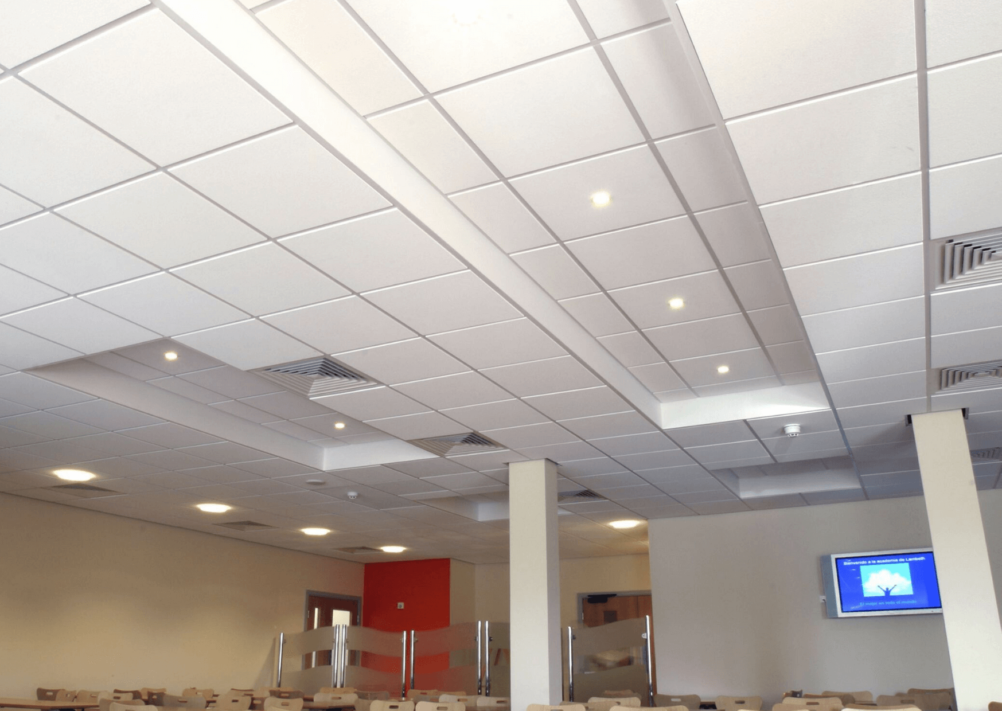
Fig1.3.Fibrous Ceilings
Be it a residential or a commercial building, false ceilings add an extra star to the interiors. In addition to aesthetics, false ceilings also offer functional features depending on the material. One such material for commercial false ceilings is mineral fibre. The fibre ceilings allow the customers to get that attractive look and acoustic comfort and hence enhance the utility of the area in many ways. In the age of Social Networking, where word of mouth plays an important role, you can make your business the talk of the town with designer fibre ceilings.
Few important points that you should consider about Fiber ceilings:
Installing and cleaning these ceilings is easier.
Its finishing quality often depends on the engineers/workers, and if not handled carefully, it may look odd.
They are a bit on the affordable side.
These come in different designs & patterns, and you can choose one depending on the feel you want to create.
They have high insulation against sound and fire.
When installing a false ceiling made up of gypsum or fiber or any other material, you must get it done from the professionals. Get in touch with an efficient, and cost-effective suspended ceiling contractor.

Health and Safety Considerations
- Handling fibrous plaster safely
Handling fibrous plaster safely involves following specific guidelines to minimize the risk of injury or exposure to harmful substances. Fibrous plaster is a material commonly used in construction and contains gypsum, fibers, and additives that can pose health hazards if mishandled. Here are some general safety measures to consider when working with fibrous plaster:

1. Personal Protective Equipment (PPE): Always wear appropriate PPE, including safety goggles, a dust mask or respirator, gloves, and protective clothing. PPE helps protect against inhalation of dust particles, skin contact, and eye irritation.
2. Work in a well-ventilated area: Fibrous plaster work should be done in well-ventilated spaces or outdoors to minimize the concentration of airborne dust. Good ventilation helps reduce the risk of inhaling harmful particles.
3. Minimize dust generation: Fibrous plaster can generate dust when cut, sanded, or handled. To minimize dust, consider using cutting tools with dust collection systems and wet sanding techniques. Using low-dust or pre-mixed plaster compounds can also help reduce dust generation.
4. Wet down materials: Before cutting or sanding fibrous plaster, dampen the surface with a fine mist of water. This helps to suppress dust and prevents it from becoming airborne.
5. Use proper cutting techniques: When cutting fibrous plaster, use sharp tools and make controlled, precise cuts. Avoid excessive force or sudden movements that can cause the material to break apart and generate more dust.
6. Clean up properly: After working with fibrous plaster, ensure thorough cleanup. Use a damp cloth or vacuum cleaner with a HEPA filter to remove dust from surfaces. Avoid dry sweeping or using compressed air, as these methods can disperse dust into the air.
7. Dispose of waste safely: Dispose of fibrous plaster waste according to local regulations. It may be classified as hazardous waste due to the presence of gypsum and other additives. Follow proper procedures for containment, packaging, and disposal.

8. Training and awareness: Ensure that workers who handle fibrous plaster are trained in safe handling practices. Educate them about potential hazards, appropriate PPE usage, and safe work procedures.
Remember, these guidelines are general recommendations, and specific safety requirements may vary depending on local regulations and the scale of the project. It is crucial to consult relevant safety guidelines, regulations, and professional advice before working with fibrous plaster.
- Proper use of personal protective equipment (PPE)
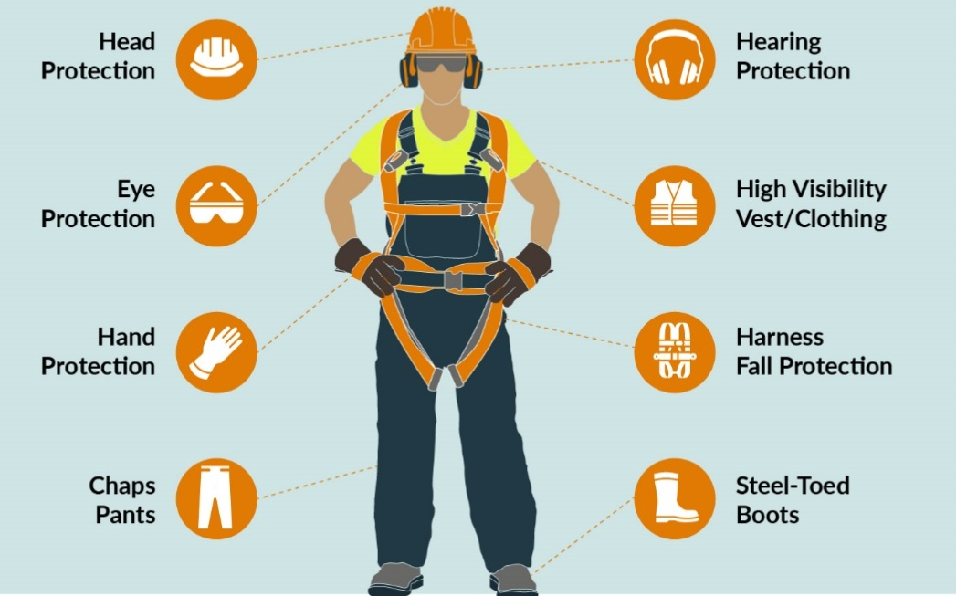
Fig 1. 4Personal Protective Equipment
To stay safe, workers may have to wear PPE such as safety helmets, gloves, eye or hearing protection, high-visibility clothing, safety footwear and harnesses. PPE may then be needed to reduce the risk of injury from breathing in dust, mist, gas or fume, falling materials hitting people Flying particles or splashes of corrosive liquids getting into people’s eyes, skin contact with corrosive materials, excessive noise, and extremes of heat or cold. Some of PPE are listed below.
- Overall Cloth: Protects the normal clothes from dust, grease and other spilling materials.
- Hard Hat: Protects head of the worker from any falling objects dropping from high level during construction.
- Safety Shoe (Boot): Protects the worker form nail, sharp objects and heavy falling objects by hard-rolled leather shoes with metal toe caps.
- Mask: Protects eyes of the worker from other endangering object and dust during construction.
- Goggle: Protects eyes of the workers during welding of metal works and when placing reinforcement in the form work.
- Glove: Protects the workers from oils, chemicals, and dust and other dangerous material that affect the skin.
- Safety Belt: Secures laborers working in a plane where the construction is done at high level.
- First Aid
All workplaces, leisure centers, homes and cars should have first aid kits. The kits for workplaces or public places must conform to legal requirements and be clearly marked in a green box with a white cross and easily accessible. Any first aid kit must be kept in a dry place, and checked and replenished regularly. All first aid kits should contain essential equipment to protect yourself and client from harm in an emergency.
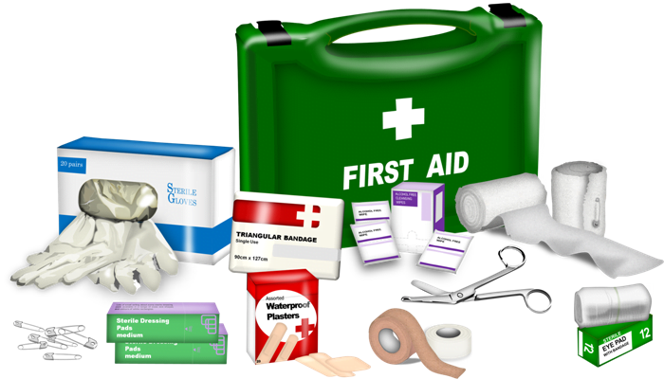
Fig 1.5 First Aid Kit

- Safety Signage Requirements
Safety signs are erected to warn workers or the public of specific hazards and to communicate necessary precautionary measures and emergency actions. Safety signage, in accordance with Ethiopian work Health and Safety Regulation required for: construction sites; confined spaces; asbestos; hazardous areas; hazardous chemicals; site specific personal protective equipment (PPE) requirements; fire protection equipment; emergency and first aid information; emergency eyewash shower; and traffic management and pedestrian control.
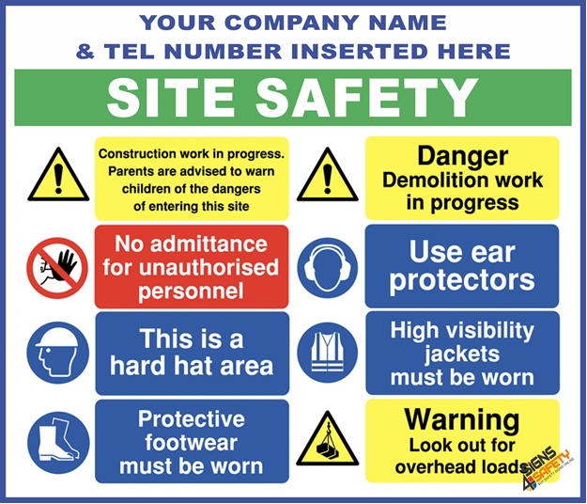
Fig1. 6 Safety Signage Requirements
- Workplace Safety an hazardous
Environment is most of workplace free from obstacle or tidy and neat or clean up for work.
The importance of a clean workplace. The workplace environmentinfluencesemployees’productivity, performance and well-being. No matter the industry, maintaining a clean workplace may help keep staff members safe, healthy and efficient. However, busy production schedules and increasing workloads may cause standards to dip.
Good Practice
Chemical hazards and environmental safety / protection
- Segregate the different types of waste that arise from your works.
- Minimizing the quantity of waste that you produce will save your money on raw materials & disposal costs.
- Label all waste storage/ make it clear to everyone which waste type should be disposed of in each location.
- Don’t leave materials on site when your work is complete.
- By leaving materials behind, then you maybe discarding waste & as the producer of that waste you will be responsible for it.
- Chemical Hazards
We will now discuss some examples of workplace Chemical Hazardsinvolving: Solids, liquids and gases.
- Solids: Solid hazards can be dust, fumes or solid components in a material.
- Dusts: are visible solid particles produced by sawing, grinding, crushing, etc. Some dusts are harmful, such as Synthetic Mineral Fibers, Asbestos and many woods. Breathing in harmful dusts can cause respiratory (breathing) irritation or difficulties. The chronic effects of this could be cancer. Work practices must be changed to reduce toxic dust. You must wear appropriate protection of dust (e.g. breathing mask or Respirator).
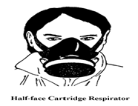
Figure 1.7 Half-face cartridge respiratory
- Fumes: are tiny particles in the air, which are often difficult to see. Fumes are produced by heating metals, when welding or soldering. Breathing in these fumes can also cause respiratory (breathing) difficulties and possibly cancer. If you have to work in areas where these fumes are present, you should wear Appropriate PPE (e.g. respirators).
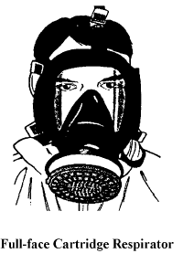
Figure 1.8Full-face cartridge respiratory
- Solid:Some construction materials, such as wet concrete, contain toxic solid Components. These can cause burns to skin, dermatitis or skin cancer with continual contact. You must wear appropriate PPE, for example, gloves if handling wet concrete or Some concreting equipment.
.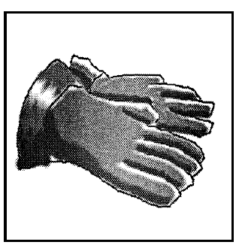
Figure 1.9Glove
- Liquids: Toxic liquid hazards in the form of some adhesives (glues), paints and solvents (such as glue for PVC pipes) can be absorbed into the body through the skin. These hazards can also cause burns to skin, dermatitis and skin cancer. They can also burn or do permanent damage to eyes if splashed into them. you must reduce contact of these hazards with the skin or eyes by wearing the appropriate PPE, for example, gloves, goggles etc.
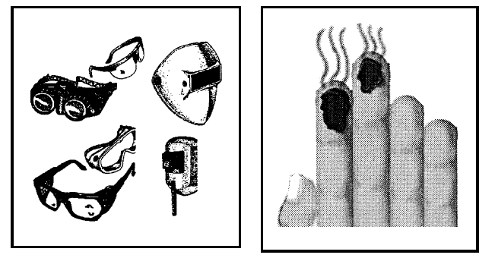
Figure 1.10 Liquids
- Gases: Toxic gases and vapors are hazardous to your health. Exhaust gases, such as those made by machine engines (e.g. carbon monoxide) are toxic. You should not have to work where machinery gases cannot escape immediately into the open air. Vapors, from substances such as some adhesives, paints and solvents can also be toxic. Breathing in toxic gases and vapors can cause respiratory problems, lung diseases, and liver damage, cancer and even death. As a last resort, if you have to work for short periods with toxic gases/vapors, you must wear the appropriate PPE for the type of gas or vapor.

Material, Tools and equipment
Fibrous plaster work involves the use of plaster and various tools and equipment to create decorative or architectural features. Here are some common materials, tools, and equipment used for fibrous plaster work:
Material for fibrous plaster
There are several types of fibrous plaster used for different types of plastering work according to recommendation. Those are blow here:
A. Gypsum plaster
Gypsum plaster also known as plaster of Paris, is a building material widely used in construction and interior decoration. It is made from the mineral gypsum, which is a soft sulfate mineral composed of calcium sulfate dehydrate (CaSO4·2H2O). Gypsum is found in various forms in nature, including as large rock deposits and in smaller quantities as a component of sedimentary rock layers.
To make gypsum plaster, gypsum is first mined, crushed into a fine powder, and then heated to remove most of the water content, leaving behind a dry powder. This process is known as calcinations. The resulting powder is called "calcined gypsum" or "calcined plaster."
Types of Gypsum Plaster
There are different types of gypsum plaster, including:
Casting Plaster: Used for creating molds and casts for sculptures and decorative items.
Pottery Plaster: Used in pottery and ceramics for making molds.
Construction Plaster: Used in construction for wall and ceiling finishes.
Gypsum Board: Gypsum plaster can also be used to create gypsum boards, commonly known as drywall or plasterboard.
Advantages of Gypsum Plaster
Ease of Application: Gypsum plaster is relatively easy to work with, whether applied manually or with the help of machines. It spreads smoothly and evenly, which makes it a preferred choice for many builders and contractors.
Quick Setting: Gypsum plaster sets and hardens relatively quickly when mixed with water. This rapid setting time allows for faster construction progress and reduces downtime.
Smooth Finish: Gypsum plaster provides a smooth and uniform surface finish, making it ideal for interior wall and ceiling applications. This smooth finish reduces the need for extensive sanding and surface preparation.
Versatility: Gypsum plaster is versatile and can be used for various purposes. It can serve as both a base coat for further finishes, such as paint or wallpaper, and as a final decorative finish itself. It is also used for creating ornamental moldings and decorative elements.
Disadvantages of Gypsum Plaster
Moisture Sensitivity: Gypsum plaster is highly sensitive to moisture. It can deteriorate and lose its strength if exposed to prolonged or excessive moisture. As a result, it is not suitable for wet areas like bathrooms, kitchens, or exterior applications unless it is specifically formulated for moisture resistance.
Cracking: Gypsum plaster is prone to cracking, especially if the underlying structure experiences movement or settling. Proper reinforcement and the use of control joints can help mitigate this issue.
Brittleness: Gypsum plaster can be relatively brittle compared to some other building materials. This makes it susceptible to damage from impacts and heavy loads. Care should be taken to avoid hitting or placing heavy objects against gypsum plaster surfaces.
Not Load-Bearing: Gypsum plaster is not a load-bearing material. It cannot support structural loads, so it must be applied over a suitable substrate like drywall, masonry, or concrete.
Hessian ( Fibrous Reinforcement)
This can include materials such as hessian (jute), scrim, or fiberglass mesh, which are used to reinforce the plaster and provide strength.
Hessian, traditionally referred to as 'scrim' in the trade, is a natural wovenfabric composed of bestfibers (the inner bark) of the jute plant, a woodyspecies that is mostly grown commercially in the delta of the Ganges River. It is basically a wood fiber consisting of cellulose, hemicelluloses and moderate lignin content. However, jute fibers have none of the chemicals that confer durability to the heartwood of timber. Jute fibers are flexible, naturally strongwith a high tensile strength, capable of carrying large loads, resist stretching, and are strongly absorbent. To make hessian, jute fibers are formed into threads that are woven into fabrics of different thicknesses and weights. With its natural fibers and loose weave, it readily allows both liquid water and water vapor to pass through it
Function of hasein with fibrous plaster
- Provides tensile strength to the cast
- Holds timber laths in position within the cast
- Forms ties, or wads, to fix the panels to structure above
- Laps joints between adjacent panels
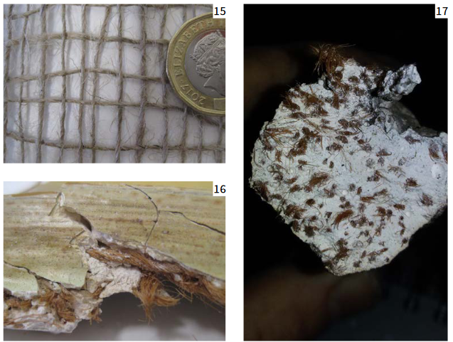
Fig 1.11 Fibrous material
Timber
One late-19th-century source stated that timber laths used for strengthening and fixing plaster casts were generally from ‘second pine’ (essentially second quality material, not suitable for joinery), red-wood or ‘any old wood not liable to twist or warp’, cut and left rough. Softwood was machine-sawn throughout the 19th century.
Release Agents
These are substances used to prevent the plaster from sticking to molds or templates during casting. Examples include petroleum jelly or silicone-based release agents.. Generally, these produce casts that are much stronger thinner and lighter than traditional ones, enabling the production oflarger pieces.
1.4.1 Production of fibrous plaster
Gypsum is an extremely useful mineral that occurs naturally in nature. Formed between layers of sedimentary rocks, it is a soft (so easy to scratch), chalky rock that appears almost white. The impurities embedded in gypsum may give it gray to a yellowish color. In terms of its chemical composition, it consists of calcium sulfate (CaSO₄) combined with 2 molecules of water (H₂O). It is also known as calcium sulfate hydrate.
1.4.2 Chemical Formula of Gypsum
The main components of gypsum are calcium (Ca), sulfur (S), oxygen (O₂), and hydrogen (H). Calcium and sulfur combine to form calcium sulfate, and hydrogen and oxygen together form water. So its chemical formula is:
Gypsum → CaSO₄ + 2(H₂O)

    - Tools and Equipment
Plasterers Equipment and Their Uses
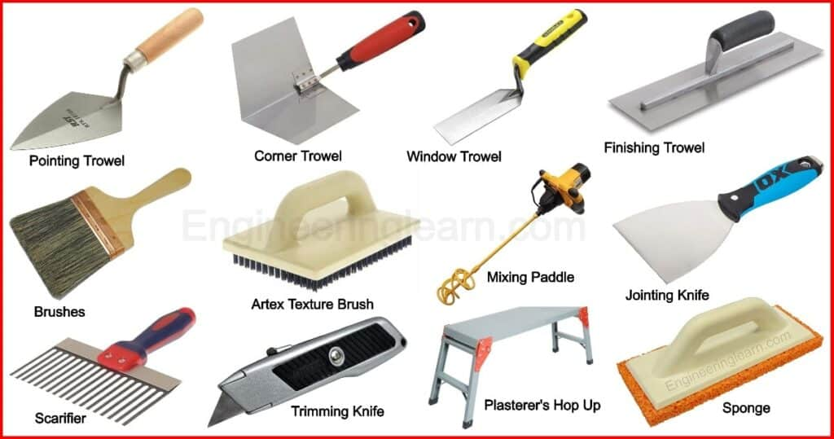
Plasterers Equipment
Introduction
Plasterers Equipment and Their Uses
Plaster might be characterized as Lean Mortar utilized for the most part for covering masonry surfaces. They are lean mixes of binding materials (Lime or Concrete) with fillers material, for example, Sand or crushed stones and the most common way of covering surfaces with plaster is called plastering. Plasters are applied to act as a thick defensive coating on walls and metal surfaces. It very well may be very simple to get confused by what you do and don’t require, on the grounds that there are such countless tools out there to choose from, in this way, first and foremost, it’s a good idea to start with the basics and build your kit up as you go.
Types of Plasterers Equipment / Types of Plasterers Tools
These are the fundamental plastering tools for novice plasterer. You will ultimately require parts all the more however this is the essential rundown of tools you will want to start plastering Let’s find out what every one of those equipment’s and explore various choices accessible.
1. Pointing Trowel
A plasterer utilizes a pointing trowel for trimming small areas that required additional consideration. They are normally between 5-6 inches (12-15cm) long. The pointing trowel gets its name due to the activity it permits the user to complete called ‘pointing’. At first, they are designed for builders to fill and shape in the middle between blocks, the pointing trowel has been adapted by plasterers toward intricately trimmed and shape mortar.
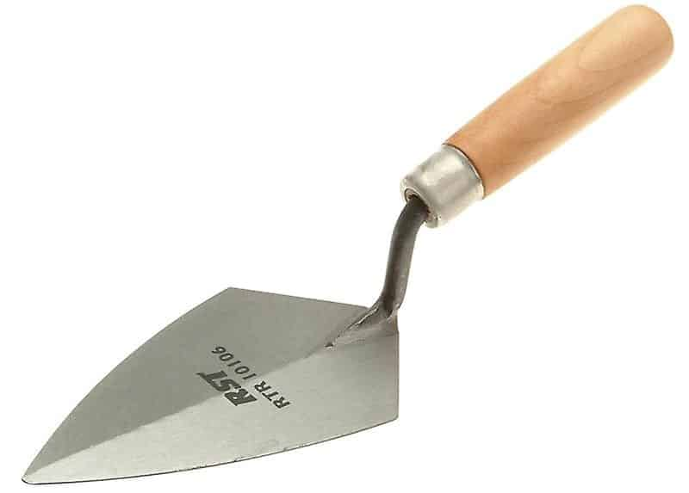
Fig. 1.13 Pointing Trowel
2. Corner Trowel

To finish the inner and external corners of a surface with accuracy and ease, corner trowels are the best option for you. A plasterers nature of work is normally decided on how smooth the completion is despite how well the corners of the surface are sealed or fixed. A corner trowel is a high-priority tool for a plasterer to ensure or guarantee a smooth fill-in to each edge of the surface.
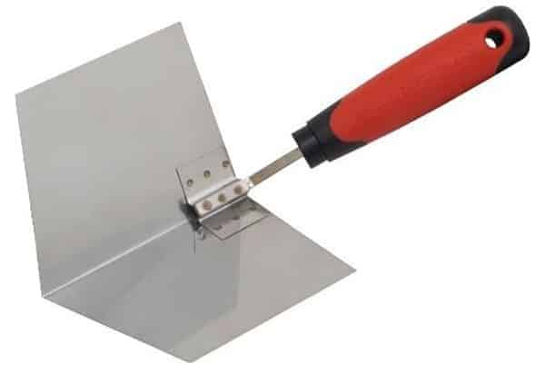
Fig.1.14 Corner Trowel
3. Window Trowel

A plasterer would reach for his window trowel when he is unable to use a large trowel. It has a smaller face which provides you better control while plastering in tight spaces. The window trowel is otherwise called a tuck pointer or ‘joint filler’. Its design of a long thin shank provides plasterers the ability to precisely level plaster over precarious joints and in difficult-to-reach places.
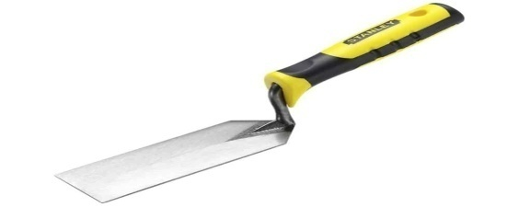
Fig.1.15Window Trowel
4. Finishing Trowel

The plasterer’s one of essential tools is the finishing trowel. A wide, level, rectangular blade permits you to spread, smooth, and level your plaster. You will utilize this tool a lot, so invest in a decent-quality one with a comfortable grip. Top-quality trowels are not welded through and are imperceptibly convexed.
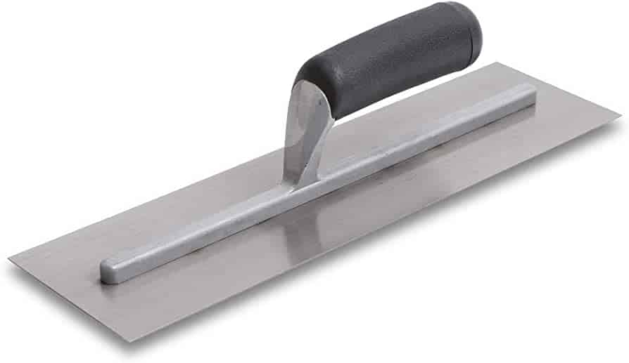
Fig.1.16Finishing Trowel
5. Hand-Board (Hawk)

Hand-Board (Hawk)
A Hawk is a straightforward portable surface that provides you with a flat plate on which to store a limited amount of plaster material for simplicity of use on walls and roofs. This can assist with accelerating work by allowing plasterers to finish sections without having to constantly get back to any place the blended plaster is put away. This is especially helpful while trying to show up at areas as it allows for high walls or roof corners to be plastered in one go to ensure or guarantee the quality of completion.
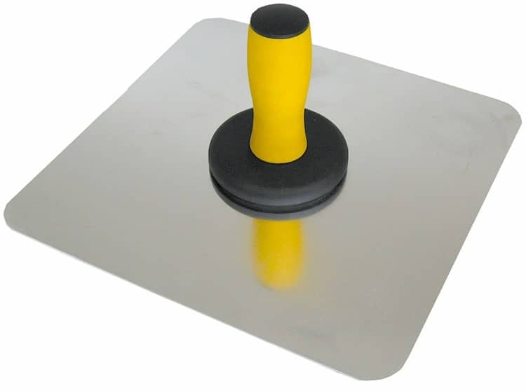
Fig.1.17Hand-Board (Hawk)

6. Straight Edge
A straight edge is utilized to even off rendered floors and can cover a large area in a brief time frame. They are typically utilized to measure distances, removes, a plasterer’s straight edge is moreover utilized to help with ensuring surfaces are smooth. A plasterers straight edge is commonly made utilizing aluminum and is an extraordinary tool to use in the last strides of plastering to ensure an entirely smooth completion.
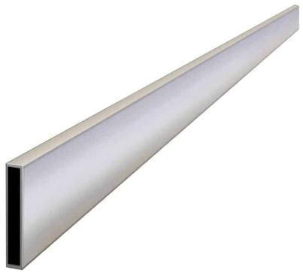
Fig 1.18 Straight Edge
7. Spirit Level
A spirit level is significant if you have any desire to have flat surfaces and even finishes. The reputation of plasterer’s quality and nature of work is crucial for extending your client base and repeat work. Spirit levels permit you to ensure that you get perfectly even plaster completion without fail.
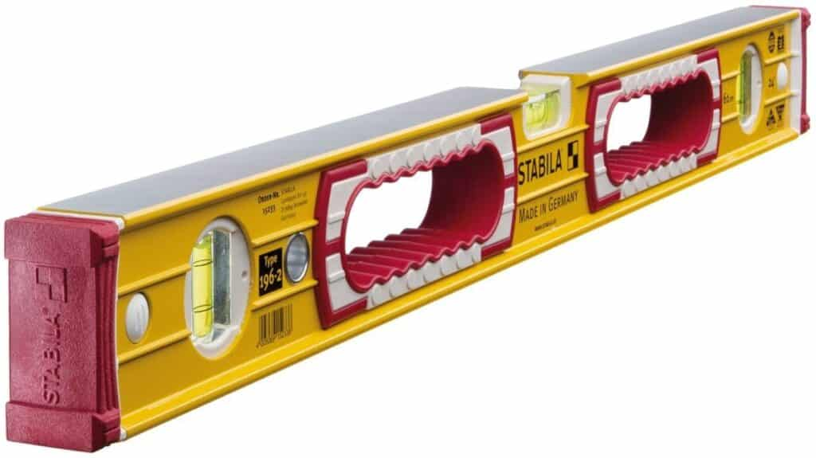
Fig.1.19Spirit Level
8. Bucket
A bucket has different uses and applications. You’ll need basically a 10-liter bucket relying on your requirements yet this size would be suitable or reasonable for most broadly useful positions. Ensure your bucket is clean and dry prior to mixing it to ensure that your plaster mix is smooth and ready for application.
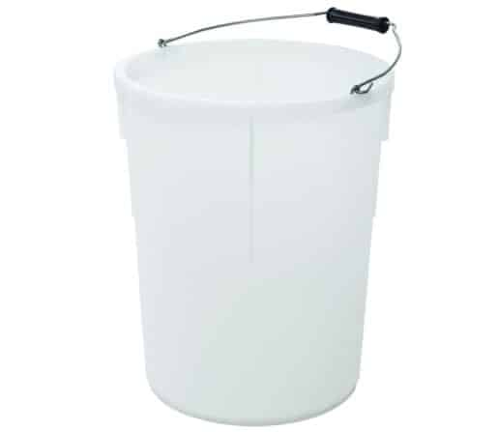
Fig.20Bucket
9. Tin Snips
Tin snips are a sort of shears utilized for cutting sheet metal. Their long handles give higher leverage and influence as well as certain models have a compound-activity handle which builds the mechanical advantage. A plasterer will need a good set of these for trimming up beading.
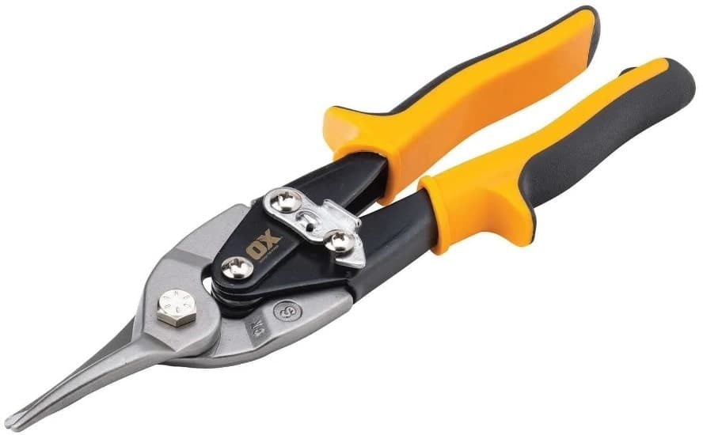
Fig 1.21 Tin Snips

10 . Scraper
It isn’t generally viable to whip out the power tools, so having the choice for manual driving is an incredible resource. A bunch of great screwdrivers will provide you with long periods of service. Most cheap screwdrivers will quite often be made using softer metals and the points will strip out after only a couple of uses. At the point when you really want to try something open, you can utilize your pry bar, not your screwdrivers!
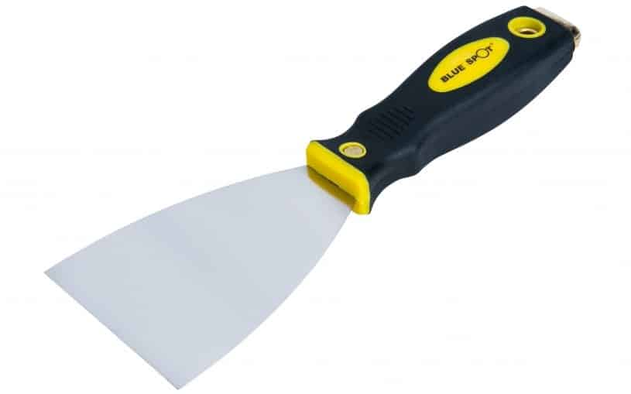
Fig 1.22 Scrapers

11. Brushes
Having a fair arrangement of brushes in your arsenal never hurt anybody, and you will require them for keeping your freshly plastered walls damp. You need to keep them perfect and free from rust, any other way, you might end up with dirty walls.
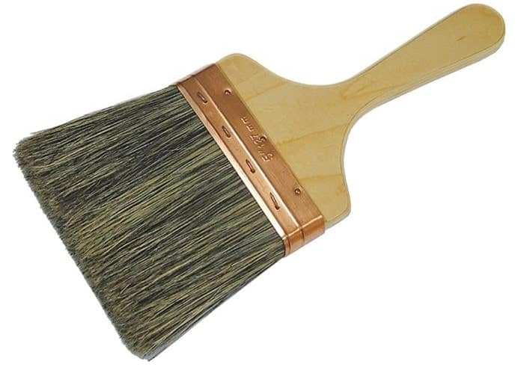
Fig 1.23 Brushes
12. Artex Texture Brush:
A texturing brush is basically used to add texture to a coated roof, giving an alter. A native finish to the typical smooth walls.Artex completion is a famous offering for a one-of-a-kind completion to a room.
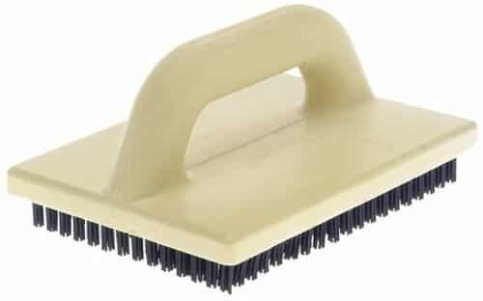
Fig 1.24 Artex Texture Brush
13. Plaster Float
The plastering float is another vital tool that each plasterer needs to claim. These will be used on each job in the application and completing stages to ensure the flattest completion conceivable. Plaster floats can be utilized on two walls or roofs and are a plasterer’s closest companion when smoothing surface
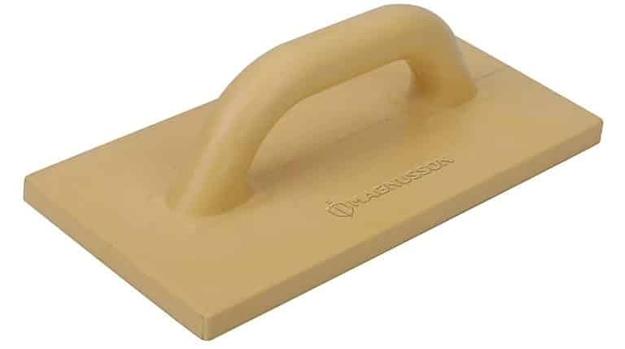
Fig 1.25 Plaster Float
14. Jointing Knife / Taping Knife
For the laying of drywall tape jointing blades are designed. They help to seal the joints among boards and provide consistent completion. All plasterers need a few of these within there reach, preferably an large taping knife and a more modest jointing knife for those restricted spaces.
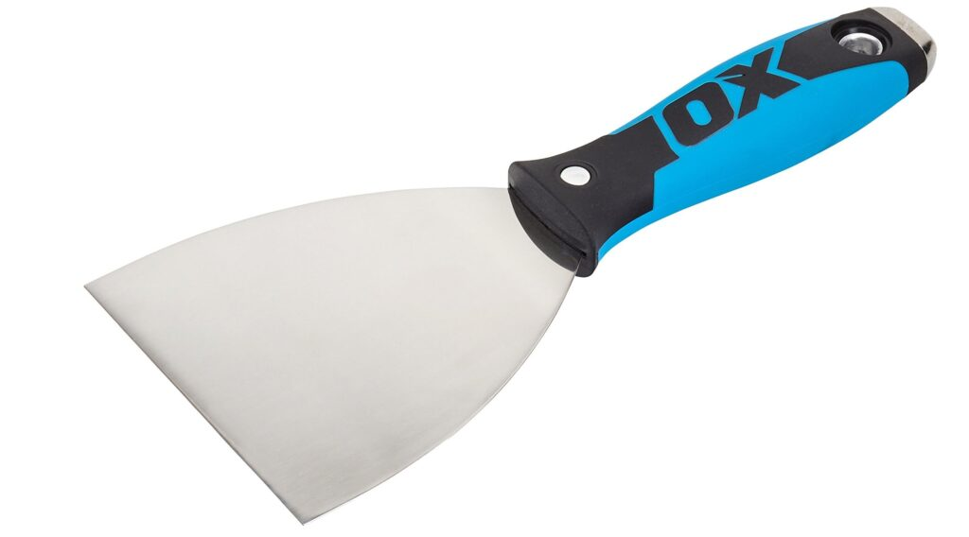
Fig 1.26 Jointing Knife
15. Sponge
It’s generally valuable to have a sponge wipe with the goal that you can clean down your tools and mortar stand after a messy day’s worth of effort. Keeping up with your tools and keeping their surfaces clean ensures that no bits are left finished, keeping them from mixing with the plaster the next time you use them.
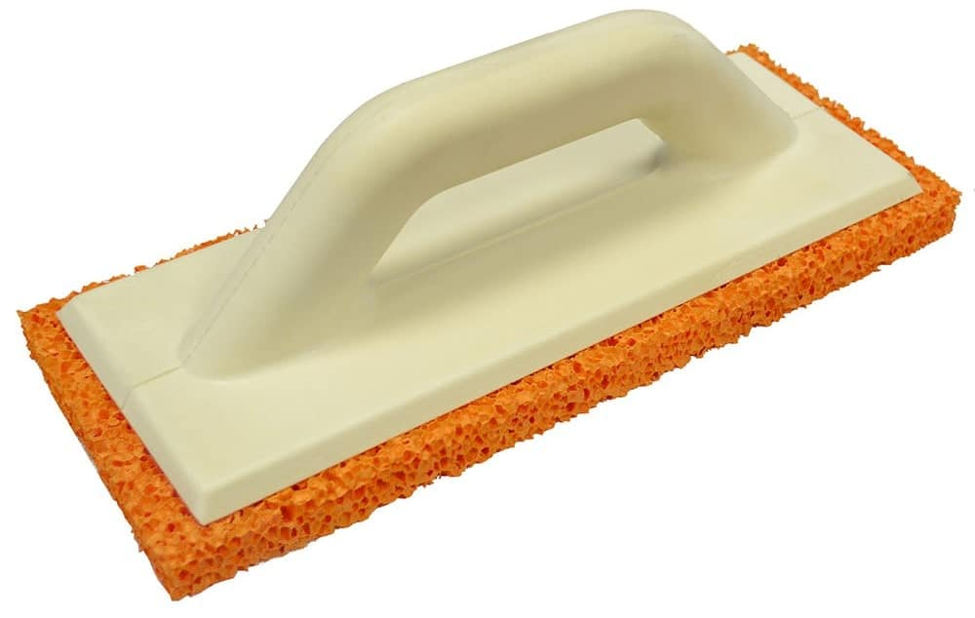
Fig 1.27 Sponges
16. Cordless Combi Drill
All experts need a decent quality cordless combi drill ready for good measure. A couple of plasterers could need to remove or eliminate fittings as well as fixtures before they start the process of plastering or to get excessively difficult to arrive at places. A Cordless combi drill is a handy power tool that can drill as well as drive. Additionally, as it is cordless the battery is battery-powered and can be utilized in any place you like.
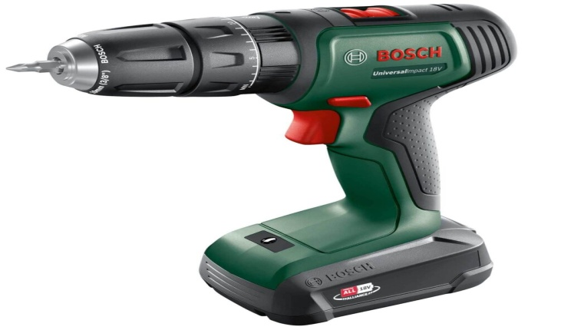
Fig 1.28 Cordless Combi Drill
17. Mortar Stand
A mortar stand is a simple and basic foldable table on which plaster material or grout can be stored for simple or straightforward passage while plastering. Mortar stands save plasterers from persistently bending down when mixing and fetching plaster to a handy surface to place tools and a place for gypsum production
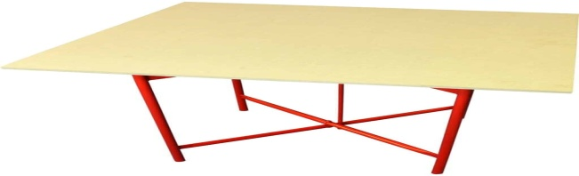
Fig 1.29 Mortar Stand
18. Dust Sheet:
A dust sheet is significant for keeping a perfect and clean working space. You can show your customers how steady you are by not covering their treasured possessions in plaster.
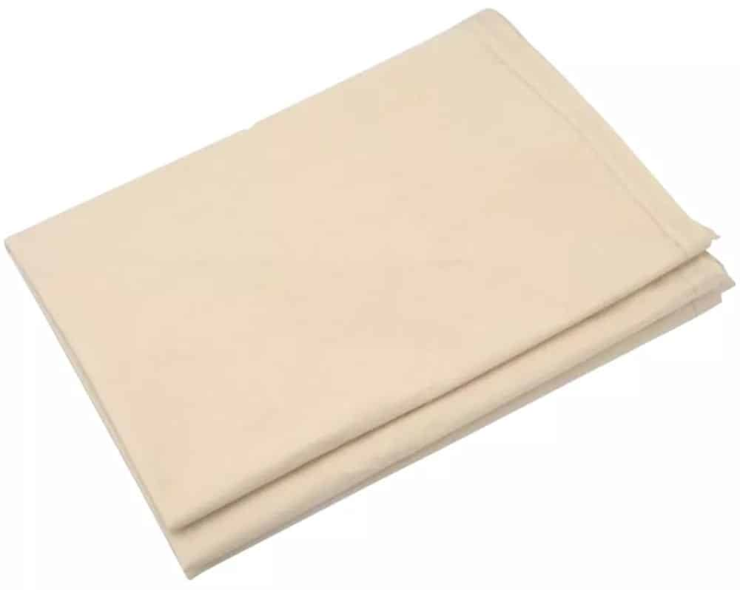
Fig 1.30 Dust Sheet
19. Drywall Saw
A drywall saws rough blade can cut or slice through plasterboard easily and its razor-sharp point is great for puncturing drywall, giving you fast access or admittance to wall cavities. There are likewise electric variants that assist with reducing the workload while preparing a wall for plastering.
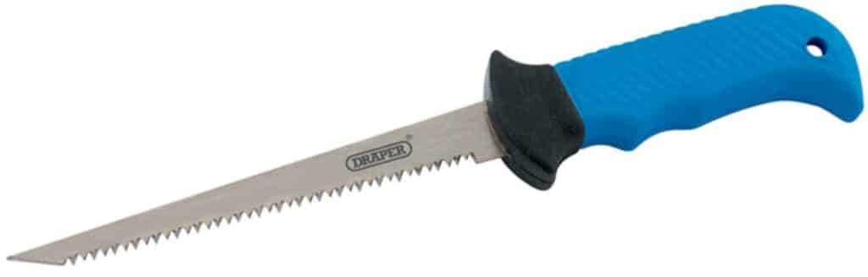
Fig 1.31 Drywall Saw
20. Hack Saw
All plasterers ought to have a hacksaw simply because they are so useful. They can cut or slice through drywall, plastic, wood, metal, and considerably more.
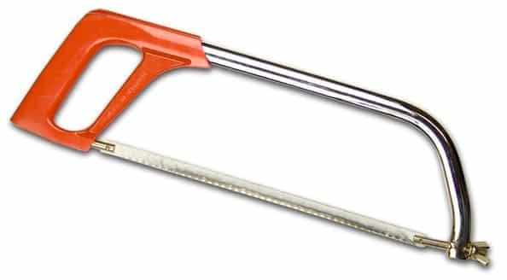
Fig 1.32 Hack Saw
21. Claw Hammer
A standard piece of equipment for any worker is a claw hammer. The blunt end and claw end are for driving as well as prying simultaneously. A decent quality one will last you a lifetime.
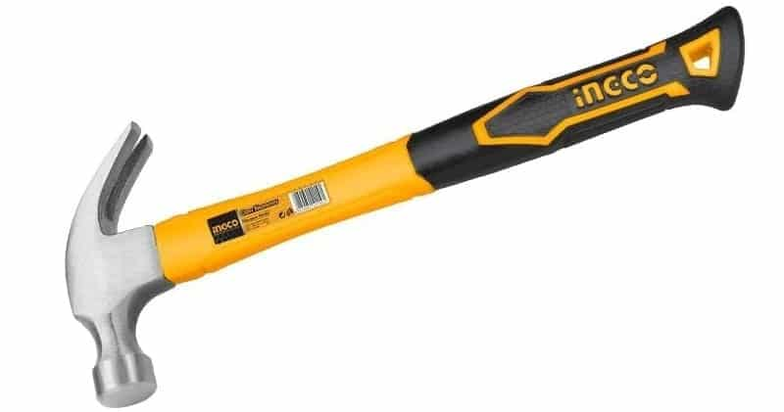
Fig 1.33 ClawHammers
22. Retractable Trimming Knife
This pocket-sized perforator can cut or slice through the string, wire, and even plasterboard. Its blades are unassuming and can be replaced or supplanted without any problem. A priority tool for all experts to have close to hand to be prepared retractable for whatever you could confront.
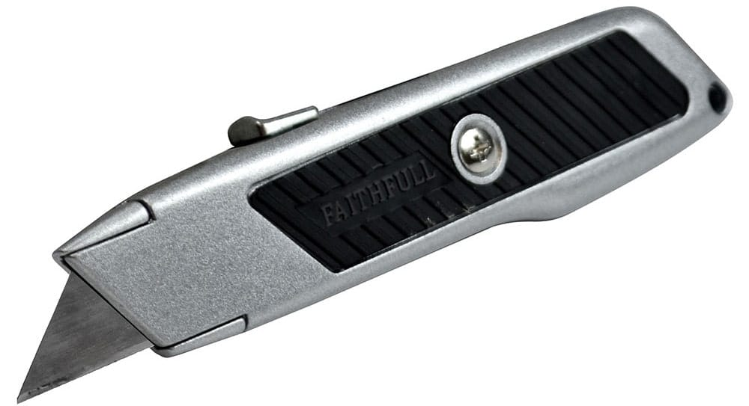
Fig 1.34 Retractable Trimming Knife
23. Scarifier
A scarifier is a significant tool for a plasterer since it permits them to prepare the second coat on a rendered wall or roof by scratching or combining lines into the render, this will make a stronger bond when the following layer is applied.
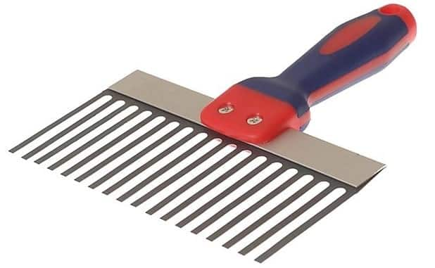
Fig 1.35 Scarifier
24. Mixing Paddle
A mixing paddle is utilized in combination with your mixer or blender drill for mixing up plaster to your ideal consistency. Plasterers should keep their mixing or blending paddle clean between uses to ensure that their plaster blend is basically as smooth as could really be expected.

Fig 1.36 Mixing Paddle
25. Step Ladder
A step ladder is completely helpful in almost any circumstance and in the event that you buy a decent quality one they can be both lightweight and durable. Plasterers need to arrive at high walls as well as roofs so a decent-quality step ladder is basic. The most valuable size is 1.5 meters (5 feet) since it will furnish you with the reach you want for ceiling work without being excessively cumbersome. It very well may be effortlessly folded up and stored away.
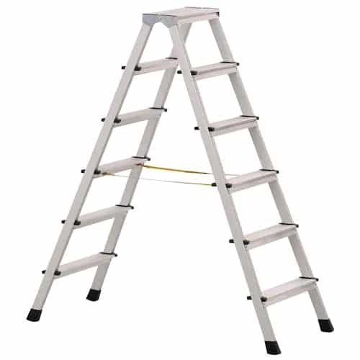
Fig 1.37 Step Ladder

Self-Check -1
Written Test
Part One: Multiple Choices
Directions: Answer all the questions listed below.
- _____________ is one of the risk control measures used to protect personnel from hazard.

- Barricading
- Safety sign
- Regulatory sign
- Engineering safety

- _____________ are erected to warn workers or the public of specific hazards and to communicate necessary precautionary measures and emergency actions
  - Barricading C. Regulatory sign
  - Safety signs D. Regulatory sign
- _____________is to protect our self, co-worker, tools, equipment’s & materials from danger or risk.

  - Safety
  - Injury
  - Accident
  - Engineering safety

- _____________ is defined as an unplanned, non-controlled, and an undesirable event or a sudden mishap which interrupts an activity or a function.

  - Safety
  - Injury
  - Accident
  - Engineering safety

Part Two: True or False
Say true if the statement is right and says false if the statement is wrong
- Casting Plaster Used for creating molds and casts for sculptures and decorative items.(3pts)
- 2.Pottery Plaster Used in pottery and ceramics for making molds.(3pts)
- 3. Construction Plaster Used in construction for wall and ceiling finishes.(3pts)
Part Three: Short Answer
- write at least five tools and equipment used for fibrous plaster (3pts)
- identify types of plastering material and their uses(3pts)

Unit Two: Assessment of Fibrous Plaster Damage
This unit to provide you the necessary information regarding the following content coverage and topics:
  - Techniques for identifying damaged areas
  - Assessing the extent and cause of damage
  - Understanding the importance of proper assessment before repair
This guide will also assist you to attain the learning outcomes stated in the Above topic contact. Specifically, upon completion of this learning guide, you will be able to:
  - Techniques for identifying damaged areas
  - Assessing the extent and cause of damage
  - Understanding the importance of proper assessment before repair

Techniques for identifying damaged areas
When assessing fibrous plaster damage, there are several techniques you can use to identify the affected areas:
    - Method of identifying damaged area
- Visual Inspection
Perform a thorough visual examination of the fibrous plaster to identify any visible signs of damage. Look for cracks, chips, bulges, or any areas where the plaster has separated from the substrate.
- Touch and Sound Test
Gently press on the surface of the plaster to check for any areas that feel soft, hollow, or have a different texture. Tap on the plaster with a small tool or your knuckles and listen for hollow sounds, which could indicate delimitation or loose plaster.
- Moisture Detection
Use a moisture meter to detect any abnormal moisture content in the plaster. Elevated moisture levels can indicate water damage, which may lead to the deterioration of the fibrous plaster.

Assessing the extent and cause of damage
Once you have identified the damaged areas, you need to assess the extent and cause of the damage to develop an appropriate repair plan.
2.1.2. Steps to consider assessing damage area
Document the Damage
Take detailed notes, photographs, and measurements of the damaged areas. This documentation will help you track the progress of repairs and serve as a reference for future assessments.

Determine the Cause
Investigate and determine the underlying cause of the damage. Common causes include moisture infiltration, structural movement, impact, or improper installation. Understanding the cause will help you address the root problem and prevent further damage.
Structural Integrity
Examine the structural integrity of the fibrous plaster. Check for any signs of compromised stability or load-bearing capacity. Structural issues may require additional reinforcement or support during the repair process.
    - Cause of damage
Fibrous plaster, also known as plaster of Paris, can be damaged by various factors. Here are some common causes of damaging fibrous plaster:
- Moisture and Water Damage
Exposure to excessive moisture or water can cause fibrous plaster to soften, crack, warp, or disintegrate. This can occur due to water leaks, high humidity levels, or improper ventilation in the surrounding environment.
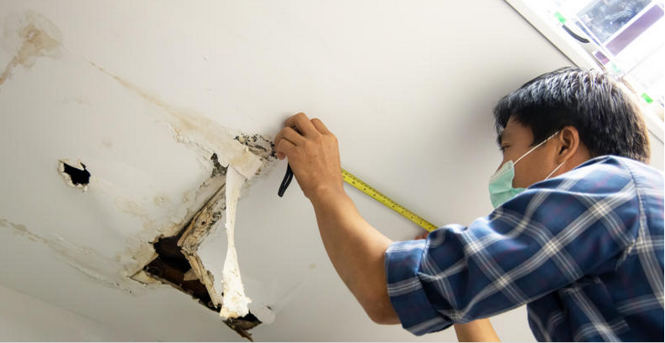
Fig .2.1 moisture and water damage
- Impact or Physical Damage
Fibrous plaster is relatively fragile and can be easily damaged by impact or physical force. Accidental bumps, knocks, or objects falling onto the plaster can result in cracks, chips, or even complete breakage.
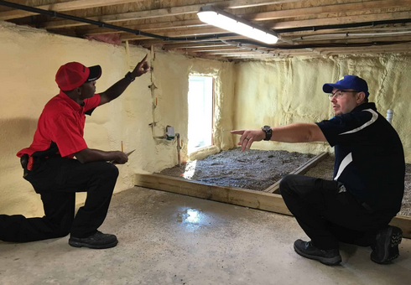
Fig2.2.impact of physical damage
- Structural Movements
Buildings and structures naturally undergo movements due to factors like settling, temperature changes, or ground shifts. These movements can cause stress on fibrous plaster, leading to cracks or detachment from the underlying surface.
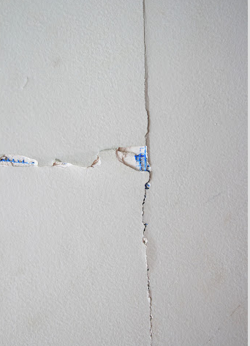
Fig.2.3 Impact of structural movement
- Age and Deterioration
Over time, fibrous plaster can naturally deteriorate due to aging and exposure to environmental elements. It may become brittle, develop cracks, or lose its structural integrity, especially if it hasn't been properly maintained or if it has been subjected to harsh conditions.
- Incorrect Installation or Poor Workmanship
Improper installation techniques or poor workmanship during the initial application of fibrous plaster can result in weak spots, inadequate adhesion, or uneven surfaces. These issues can make the plaster more prone to damage or failure.
- Pest Infestation
Certain pests, such as termites or wood-boring insects, can infiltrate and damage fibrous plaster. They may tunnel through the material, causing it to weaken, crumble, or become hollow.
- Vibrations or Structural Stress
Vibrations from nearby construction work, heavy machinery, or vehicular traffic can transmit through buildings and affect fibrous plaster. Prolonged exposure to these vibrations can lead to cracks or dislodgment of the plaster.
- Inadequate Maintenance
Lack of regular maintenance, such as failure to address minor cracks or perform necessary repairs, can contribute to the deterioration and damage of fibrous plaster over time.

Importance of proper assessment before repair
Proper assessment before repair is crucial for several reasons
- Accuracy: A thorough assessment ensures that you have identified all the damaged areas and understand the underlying causes. This accuracy allows you to develop an appropriate repair strategy and avoid missing any critical issues.
- Effective Repair Planning: Understanding the extent of the damage helps you plan the repair process effectively. It enables you to allocate resources, estimate costs, and determine the required materials and techniques.
- Preventing Further Damage: Assessing the cause of damage helps you address any underlying issues, preventing future deterioration. By identifying and addressing the root cause, you can ensure that the repaired fibrous plaster remains stable and secure.
- Preservation of Historical Value: In cases where the fibrous plaster has historical or cultural significance, a proper assessment is essential to preserve its authenticity. Assessing the damage accurately allows for appropriate restoration techniques that respect the original craftsmanship and materials.
- Safety: Assessing the structural integrity of the damaged fibrous plaster ensures that any necessary repairs or reinforcements are carried out to maintain safety standards. It helps prevent accidents or further damage caused by unstable or weakened plaster.
In conclusion, a comprehensive assessment of fibrous plaster damage using appropriate techniques is essential for identifying damaged areas, understanding the extent and cause of the damage, and planning effective repairs. Proper assessment ensures accuracy, effective
2.1.3 Repair fibrous gypsum with Water Damage
To repair gypsum dry wall, you’ll need a laundry list of tools and materials to complete the job, includingIf you have the skills, tools, and materials needed to repair drywall on your own and you’re up to the task, take these eight steps:
- Before you start cutting out the damaged drywall, locate the wall studs and check for pipes and electrical wires. Remember to wear a face mask to prevent dust and other small particles from entering your lungs.
- Measure how big of a replacement patch is needed on the wall itself, then mark it out on the new piece of drywall panel.
- Using a utility knife or drywall saw, cut out the damaged drywall and cut a new piece of drywall using the measurements taken before.
- Place the furring strips inside the hole in the wall and attach the new piece of drywall to the strip using drywall screws.
- Using drywall tape, tape the border of the patch where the old and new drywall now meet.
- Apply a thin coat of joint compound over the tape and patch it using the taping knife. After it dries, scrape off any rough parts and repeat this process one to two more times.
- Using your drywall sander, sand the new area to smooth it out. Goggles may be needed during this process to protect your eyes.
- Prime and repaint your drywall.
    - Ceiling Water Damage Repair
You were probably going about your day like usual when all of a sudden you noticed something strange-looking on your ceiling. Nothing’s worse than being faced with water damage to your home, especially when that damage is on your ceiling where it can be difficult to reach or inspect. Fortunately, the team at Total Restore Inc. is here to help you deal with this challenging situation with several useful tips and strategies. You can count on our water damage restoration service and state-of-the-art equipment to help get your home back to the way it was prior to the ceiling damage.
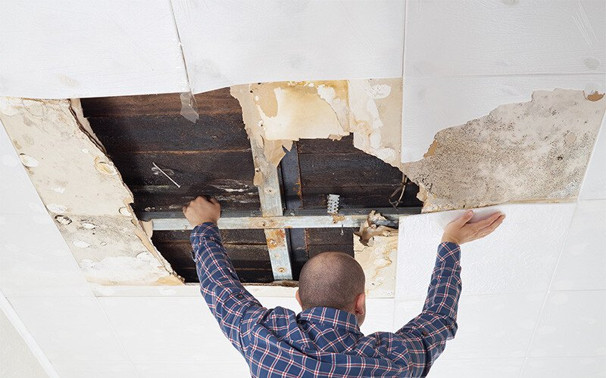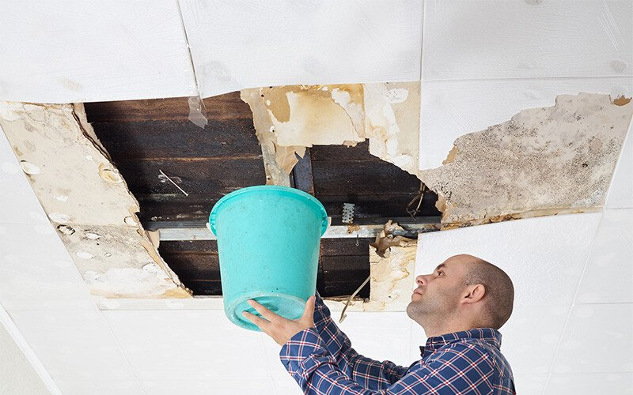
Fig. 2.4 repair damaged area
Method of repairing damage area
    - Assess the Situation
After spotting the damage, your first concern is wondering how to repair ceiling water damage. The first step is to move any valuables, furniture, or other items out from underneath the damaged area. Next, grab a mop and bucket to clean up as much of the residual water on the floor as possible. After the initial cleanup, placing a waterproof tarp below the leaking ceiling can help contain the mess.
There’s a good chance that your ceiling covering is made of drywall or plaster. These types of materials are known to absorb water once they get wet and then disperse it in all directions. If the ceiling continues to leak, it’s a good idea to control exactly where the leaking water goes. This can be achieved by making a small hole directly in the center of the leak by using a screwdriver or a similar item. Controlling the flow of the leak is a great way to contain the damage and reduce health risks from standing water, moisture, or even mold growth until your home can receive professional attention.
Locate the Source of the Leak
The next step in the process is to identify and locate the source of the ceiling water leak. When it comes to ceiling leaks in particular, tracking down the source of the leak can be difficult. This is due to the water’s unique ability to travel long distances from the initial source of the leak. Even when the solution seems simple, such as a bathroom located directly above the leak, you may still run into challenges. In this bathroom example, the leak could be originating from a leaking faucet, failed caulk line, or a loose supply line.
If the leak cannot be identified, professionals will likely be required to drill a hole and remove a section of your ceiling to spot it. One old trick you can use to spot the leak is to lay sheets of toilet paper across the ceiling joists or where pipes run. You’ll be able to see how the toilet paper reacts to the moisture, helping you track down the source of the leak.
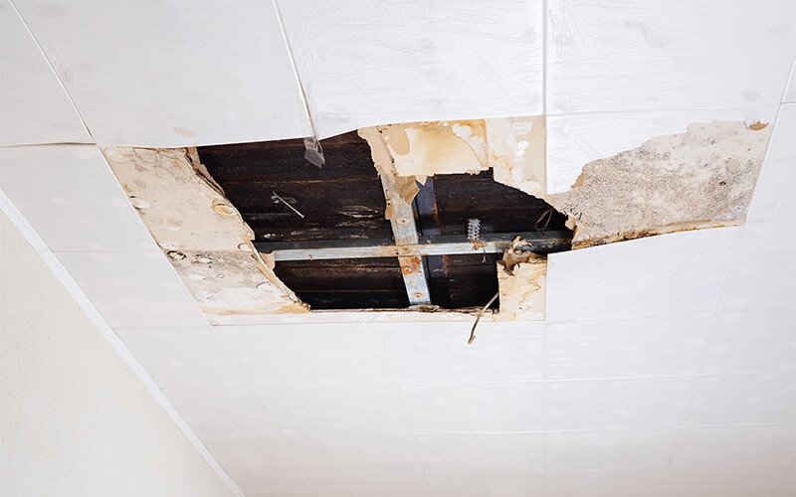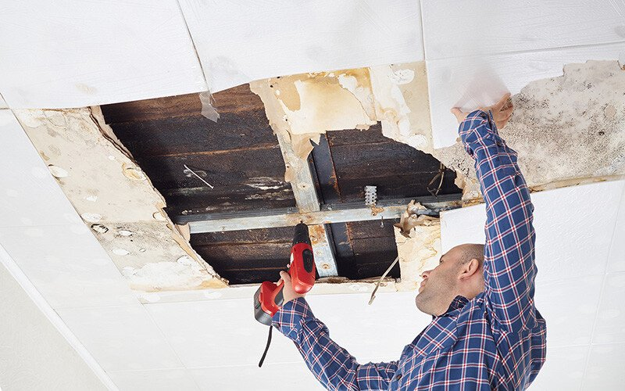
Fig 2.5 Assess water leakage
    - Dry the Leak
After identifying the source of the leak, it’s essential that you begin the process of drying out the wet or damaged areas of your ceiling to prevent further risks to your health. Especially vital for ceiling cavities, moisture can become trapped above the drywall and create the potential for mold growth. A small leak may dry on its own but larger leaks will require opening the ceiling. Once opened, the best way to dry the area is with a commercial dehumidifier. These specialized units work by pulling moisture out of the air and out of the damaged drywall while simultaneously releasing heat. We recommend contacting the professionals at Total Restore Inc. before attempting any major ceiling structure removals to prevent the risk of injury. Our team has the latest repair tools and equipment to get the job done safely and promptly to get your home back to normal.
    - Repair the Ceiling
Once the damage has been repaired and dried, it’s time to get your ceiling back to the way it was prior to the leak. It’s frequently easier to simply remove all of the damaged drywall and replace it with new material. The same is true for painting as well since larger areas are easier to blend compared to small patches. These new materials will give your ceiling a brand-new appearance, helping to erase the memory of a water-damaged ceiling!

    - Repairing damaged walls
Repairing water-damaged walls typically involves several steps to assess the extent of the damage and restore the wall to its original condition. Here's a general guide to help you repair water damage on a wall:
1. Safety first: Before starting any repairs, ensure that the power supply to the affected area is turned off to prevent electrical hazards.
2. Identify and fix the source of water: Determine the source of the water damage and fix any leaks or plumbing issues to prevent further damage.
3. Remove damaged materials: Carefully remove any wet or damaged materials from the wall, such as wet drywall, insulation, or baseboards. Use a utility knife to cut along the edges of the damaged area and remove the affected materials.
4. Dry the area: Thoroughly dry the affected area using fans, dehumidifiers, or other drying equipment. It's crucial to completely dry the area to prevent mold growth.
5. Treat for mold: If you notice any signs of mold growth, it's essential to address it promptly. Wear protective gear such as gloves and a mask, and use a mold cleaner or a mixture of bleach and water to clean the affected area. Follow the manufacturer's instructions for proper usage and safety precautions.
6. Repair or replace damaged drywall: If the water damage has affected the drywall, you'll need to repair or replace it. Cut out the damaged section using a utility knife, making sure to create clean edges. Measure and cut a replacement piece of drywall to fit the opening and attach it using screws or nails. Use joint compound to fill any gaps or seams and smooth it out with a putty knife. Allow it to dry, then sand it down until it's smooth and level with the surrounding wall.
7. Prime and paint: Once the repairs are complete, prime the repaired area to ensure proper adhesion of the paint. Once the primer has dried, paint the wall to match the existing color or repaint the entire wall for a uniform appearance.
8. Replace baseboards and trim: If the baseboards or other trim were damaged, replace them with new ones to complete the restoration process. Measure and cut the new trim to fit, then attach it using a nail gun or screws.
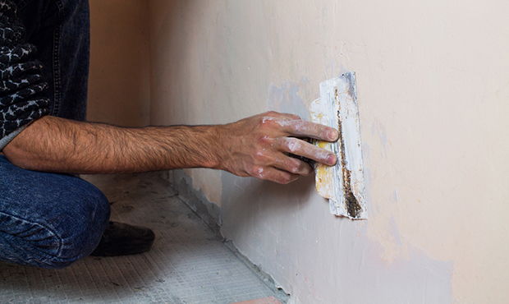
Fig.2.6. Repairing damage wall

Self-Check - 2
Directions: Answer all the questions listed below. Use the Answer sheet provided in the next page
Part: oneshort answer
            - From the following one is Repairing water-damaged walls typically involves several steps to assess the extent of the damage and restore the wall to its original condition.
            - Safety first.
            - Identify and fix the source of water
            - Remove damaged materials
            - All
One of the flowing is Importance of proper assessment before repair

- Accuracy:
- Effective Repair Planning
- Preventing Further Damage
- All

Part: two short answer
1. How to repair ceiling? (5p)
2. Write Proper assessment before repair is crucial for several reasons(5p)
3. Write at list three method of repairing damage ceiling (5p)

OPERATION SHEET-2
OPERATION TITLE:- Repair fibrous gypsum with Water Damage
PURPOSE:- to ensure that the proposed reappointing work is both physically and visually appropriate to the building
CONDITIONS OR SITUATIONS FOR THE OPERATIONS:-
Wear appropriate clothes, shoe.
Ensure the work shop hazard free
Ensure the working area is bright
Make workstation comfortable..
EQUIPMENT TOOLS AND MATERIALS : -
Troll, hammer, chisel, sprit level, water level, lime, cement , gypsum, water ,
PROCEDURE,
Identify job specifications.
Select and use hand tools & materials.
Assess the Situation
Locate the damaged area.
Dry the leakage
Repair and finishing the place damaged
PRECAUTIONS:-
Wear working cloths which properly fit with your body.
Make working area hazard free.
Read and interpret manual which guide you how to disassemble and tag engine system components.
The trainees should fulfill safety conditions.
QUALITY CRITERIA: Improperly done Repair fibrous gypsum with Water Damage safely according to the requested standard

LAP Test -2

Name: _____________________________ Date: ________________
Time started: ________________________ Time finished: ________________

Instructions: Given necessary templates /guide, workshop, tools and materials you are required to perform the following tasks within 1:00 hours.
Task 1.repairing damaged fibrous ceiling

Unit Three: Remove damaged structure
This unit to provide you the necessary information regarding the following content coverage and topics:
  - Safe removal methods for damaged fibrous plaster components
  - Proper handling and disposal of debris
  - Techniques for minimizing further damage during removal
This guide will also assist you to attain the learning outcomes stated in the Above topic contact. Specifically, upon completion of this learning guide, you will be able to:
  - Safe removal methods for damaged fibrous plaster components
  - Proper handling and disposal of debris
  - Techniques for minimizing further damage during removal
Learning Instructions:
- Read the specific objectives of this Learning Guide.
- Follow the instructions
- Read the information written in the information “Sheet
- Accomplish the “Self-check 1, Self-check t 2, and Self-check 3”
- If you earned a satisfactory evaluation from the “Self-check” proceed to “Operation Sheet 1, Operation Sheet 2 and Operation Sheet 3”
- Do the “LAP test” (if you are ready).

Safe removal methods
When it comes to removing damaged fibrous plaster components, there are several safe methods and techniques to consider. Here are some guidelines for safe removal, proper handling and disposal of debris, as well as techniques to minimize further damage during the process
Remember, when working with fibrous plaster or any construction material, it's important to prioritize safety. Wear appropriate protective gear, such as goggles, gloves, and a dust mask, to protect you from dust and debris. Additionally, it's advisable to consult with a professional or refer to specific guides or resources for your specific situation to ensure the best results.
    - The common approach Damaged Fibrous Plaster Components
When it comes to saving damaged fibrous plaster components, there are several methods that can be employed depending on the extent and nature of the damage. Here are a few common approaches:
1. Patching and filling: Small cracks or holes in fibrous plaster components can often be repaired by patching and filling. This involves using a suitable filler material, such as plaster of Paris or a specialized plaster repair compound, to fill the damaged area. The filler is carefully applied, shaped, and smoothed to match the surrounding surface.
2. Reinforcement: If the fibrous plaster component has suffered significant damage or has weakened over time, reinforcement may be necessary. This can be achieved by applying a layer of fiberglass mesh or similar material to the back of the component. The mesh is embedded in a layer of plaster or adhesive, providing structural support and preventing further cracking or deterioration.
3. Mold-making and casting: In cases where a fibrous plaster component is severely damaged or missing altogether, it may be necessary to create a mold of an intact section and cast a replacement piece. This method requires skill and expertise in mold-making and casting techniques, as well as a thorough understanding of the original design and composition of the component.
4. Stabilization and consolidation: If the fibrous plaster component is showing signs of delaminating or detachment from its substrate, stabilization and consolidation techniques can be employed. These methods involve injecting a consolidate material, such as a specialized adhesive or consolidating agent, into the affected areas to reattach and reinforce the plaster.
5. Surface cleaning and restoration: Over time, fibrous plaster components can accumulate dirt, grime, or discoloration. Surface cleaning techniques, such as gentle brushing, vacuuming, or the use of specialized cleaning agents, can help restore the original appearance of the plaster. However, it's important to exercise caution and test any cleaning products on a small, inconspicuous area before applying them to the entire component.
It's worth noting that the successful restoration of damaged fibrous plaster components often requires the expertise of a professional conservator or skilled craftsman familiar with the specific material and techniques involved. They can assess the damage, determine the most appropriate method of restoration, and ensure that the work is carried out safely and effectively.
Method restores damage structure
a. Assess the condition: Before starting the removal process, carefully assess the extent of the damage to determine the appropriate removal method.
b. Take safety precautions: Wear personal protective equipment (PPE) such as gloves, goggles, and a dust mask to protect yourself from any potential hazards.
c. Secure the area: Make sure the surrounding area is properly secured to prevent accidents or injuries during the removal process.
d. Use hand tools: Utilize hand tools like chisels, putty knives, or pry bars to carefully remove the damaged plaster components. Avoid using power tools that may cause excessive vibration or damage to the surrounding areas.
e. Gradual removal: Remove the damaged plaster components in small sections or pieces to minimize the risk of further damage or collapse.
f. Seek professional help if needed: For more extensive or complex removals, it is advisable to consult a professional contractor or restoration specialist who has experience in working with fibrous plaster.

Proper Handling and Disposal of Debris
a. Contain the debris: Place a drop cloth, tarp, or other protective covering on the floor to catch falling debris and prevent it from spreading to unaffected areas.
b. Bagging and sealing: Carefully collect the debris and place it in heavy-duty plastic bags. Double-bagging may be necessary for added strength and to prevent any dust or particles from escaping.
c. Labeling and disposal: Clearly label the bags as "damaged plaster debris" for easy identification. Check local regulations and guidelines for proper disposal methods and locations. Contact your local waste management or recycling center for specific instructions.

Techniques for Minimizing Further Damage during Removal
When it comes to removing various objects or components, it is important to take precautions to minimize further damage. The techniques for minimizing further damage during removal can vary depending on the specific object or material involved, but here are some general techniques that can be applied:
a. Stabilize the structure: If the damaged plaster is part of a larger structure, take measures to stabilize the surrounding areas to prevent any additional collapse or damage.
b. Support the remaining plaster: Use temporary supports, such as props or braces, to secure any remaining plaster components during the removal process.
c. Work in sections: Divide the removal process into manageable sections to avoid putting excessive strain on the remaining plaster.
d. Controlled removal: Take your time and use gentle, controlled force when removing damaged plaster to minimize the risk of causing further damage to adjacent areas.
e. Monitor the structure: Regularly inspect the surrounding areas for any signs of shifting or additional damage during the removal process. Make any necessary adjustments or reinforcements as needed.
Remember, if you're unsure about the removal process or if the damage is extensive, it's recommended to seek professional assistance from contractors or restoration specialists with experience in working with fibrous plaster.

Self-Check 3

Directions: Answer all the questions listed below. Use the Answer sheet provided in the next page
Part one: multiple choice
  - One of the following is Proper Handling and Disposal of Debris
              - Contain the debris
              - Bagging and sealing
              - Labeling and disposal:
              - all
2. From the following one is the Method of restores damage structure
              - Assess the condition
              - Take safety precautions
              - Secure the area

Part two: short answer
1. Write the techniques for minimizing further damage during removal of fibrous plaster? (5p)
2. Write Method restores damage structure (5p)
3. Write at list three common approach of damaged fibrous plastering work (5p)

Answer Sheet
Name: _________________________ Date: ______________

OPERATION SHEET-2
OPERATION TITLE:- removing damage structure
PURPOSE:- to ensure that the proposed reappointing work is both physically and visually appropriate to the building
CONDITIONS OR SITUATIONS FOR THE OPERATIONS:-
- Wear appropriate clothes, shoe.
- Ensure the work shop hazard free
- Ensure the working area is bright
- Make workstation comfortable..
EQUIPMENT TOOLS AND MATERIALS : -
Troll, hammer, chisel, sprit level, water level, lime, cement , gypsum, water ,
PROCEDURE,
- Assess the condition
- Take safety precautions
- Secure the area
- Use hand tools
- Gradual removal .
- Seek professional help if needed.
PRECAUTIONS:-
- Wear working cloths which properly fit with your body.
- Make working area hazard free.
- Read and interpret manual that repair damaged plastering work
- The trainees should fulfill safety conditions.
QUALITY CRITERIA: Improperly done Repair damage area safely according to the requested standard

LAP Test -1
LAP Test 1 | Practical Demonstration

Name: _____________________________ Date: ________________
Time started: ________________________ Time finished: ________________

Instructions: Given necessary templates /guide, workshop, tools and materials you are required to perform the following tasks within 1:00 hours.
Task 1.repairing damaged structure

Unit four: Repair Techniques for Fibrous Plaster
This unit to provide you the necessary information regarding the following content coverage and topics:
- Surface preparation
- Patching and filling
- Reinforcement
- Matching textures and patterns
This guide will also assist you to attain the learning outcomes stated in the Above topic contact. Specifically, upon completion of this learning guide, you will be able to:
- Surface preparation
- Patching and filling
- Reinforcement
- Matching textures and patterns
Learning Instructions:
- Read the specific objectives of this Learning Guide.
- Follow the instructions
- Read the information written in the information “Sheet
- Accomplish the “Self-check 1, Self-check t 2, and Self-check 3”
- If you earned a satisfactory evaluation from the “Self-check” proceed to “Operation Sheet 1, Operation Sheet 2 and Operation Sheet 3”
- Do the “LAP test” (if you are ready).

Surface preparation
Surface preparation for cleaning and removal of loose or damaged plaster typically involves several steps. Here's a general outline of the process:
- Gather necessary tools and materials
You'll need protective gear such as gloves, safety goggles, and a dust mask. Additionally, gather a ladder, drop cloths, a scraper or putty knife, a wire brush, a stiff-bristle brush, a vacuum cleaner with a brush attachment, and plastic bags or containers for debris disposal.
- Prepare the area
Clear the surrounding area of furniture, fixtures, and any other items that may obstruct your work. Cover floors and furniture with drop cloths to protect them from dust and debris.
- Inspect the plaster
Assess the condition of the plaster to determine the extent of damage and identify areas where it is loose or crumbling. Use a scraper or putty knife to gently probe the surface and identify any loose sections.
4. Remove loose plaster: Using a scraper or putty knife, carefully remove any loose or damaged plaster from the surface. Work methodically, taking care not to apply excessive force that could damage the underlying structure. Dispose of the removed plaster in plastic bags or containers.
5. Clean the surface: After removing the loose plaster, use a wire brush to scrub the surface and remove any remaining debris or loose particles. Follow up with a stiff-bristle brush or a vacuum cleaner with a brush attachment to thoroughly clean the area and eliminate dust.
6. Repair or patch
If necessary, repair any deep cracks or holes in the plaster using an appropriate patching compound or joint compound. Follow the manufacturer's instructions for application and drying times. Allow the repaired areas to dry completely before proceeding.
7. Smooth the surface
Once the repaired areas have dried, use a sanding block or sandpaper to smooth the surface and create an even texture. Take care to feather the edges of the repaired areas to blend them with the surrounding plaster.
- Clean up
Remove the drop cloths and clean the surrounding area, ensuring that all debris and dust are properly disposed of. Vacuum the area again to remove any remaining dust particlesRemember, the specific steps may vary depending on the condition of the plaster and the size of the project. It's always a good idea to consult professional advice or refer to specific product instructions for more detailed guidance.
Method of repairing water damaged plaster ceiling
- Eliminate all damaged pieces from the ceiling – Make sure the ceiling is dry before you start repairing. Begin by removing with the putty knife cracked paint and plaster that the water has damaged. The surface needs to be completely smooth for the patching.
- Fill up holes and cracks – When the area is completely clean, you might notice cracks and even holes. Mix the joint compound in the mud pan and fill those up. Leave to dry before moving forward.
- Cover up the surface – Add one coat of primer, then apply the joint compound with the putty knife. It needs approximately 10-15 minutes to harden, and then you can add another coat. Make sure the layers are thin, or it will take too long to dry.
- Sand the area – Once the compound is fully dry, put on your safety glasses and use the sanding block to remove any imperfections on the ceiling. Then, dampen the cloth and wipe it to remove the dust.
- Add another coat of primer – Make sure you cover up the whole area.
- Retouch with waterproof paint – Wait a little bit for the primer to dry completely, and then you can start painting until the repaired area blends with the rest of your ceiling. If you need tips on how to do it, you can check our Ceiling Painting: Learn from the Prosguide.
How to repair water damaged drywall ceiling
Plasterboard is very porous and can easily absorb water. Still, a joint compound can fix the smaller damages in the form of cracks or holes. However, severe ones like softening or crumbling of the material and sagging of the ceiling will require cutting and installing new drywall sheets. Here is how to do it!
Additional things you will need to repair

- Drywall sheets
- Drywall saw
- Tape measure
- Plasterboard screws
- Mesh tape
- Utility knife
- Cordless drill
- Taping knife
- Plywood strips
- Ceiling paint

- Clean out the area – Remove any damaged pieces that are hanging from the ceiling.
- Decide how much to cut out – To make things easier you can measure and draw to have a clear view. Use the drywall saw to cut all the damaged plaster out.
- Cut the plywood strips – Next, you need to measure the size of the hole and cut the plywood strips accordingly. Leave a little extra on both sides for stability.
- Attach the material to the strips – Place the former inside the hole and secure the drywall by driving the plasterboard screws through it into the wood with the drill.
- Add the new plasterboard – Carefully measure the hole and, based on that, cut the new drywall piece from the sheet. Attach it with the screws to the wood, as well.
- Cover with the joint compound – Mix the joined compound, also known as mud. Apply some on the joined areas with the putty knife, stroking forward and backwards. Cover with the drywall mesh tape. Smooth it out with the knife. Finally, apply the mud over the whole area using the taping knife.
- Sand, reapply and paint – Let dry, sand the area and then reapply. Once the area is completely smooth and dry, you can move on to painting.

Patching and filling
When it comes to repairing cracks, holes, and damaged areas of fibrous plaster, there are several methods you can use. Here are a few common techniques for patching and filling:
Method of repairing and filling the hole
1. Patching small cracks and holes:
- Clean the damaged area by removing any loose plaster and debris.
- Use a putty knife or scraper to apply a thin layer of premixed joint compound or spackling paste over the crack or hole.
- Smooth the compound with the putty knife, feathering the edges to blend it with the surrounding plaster.
- Allow the compound to dry completely, then sand it lightly with fine-grit sandpaper to achieve a smooth finish.
- If necessary, repeat the process with additional layers of compound until the repaired area is level with the surrounding surface.
2. Filling larger holes:
- Clean the damaged area and remove any loose plaster or debris.
- Cut away any loose or damaged plaster edges around the hole to create a clean, even surface.
- Measure and cut a piece of drywall or plasterboard slightly larger than the hole.
- Apply a layer of adhesive or plaster bonding agent to the back of the patch piece and press it firmly into the hole.
- Use joint compound or plaster to fill the gaps around the patch, feathering the edges to blend with the surrounding plaster.
- Allow the compound to dry completely, then sand it smooth.
3. Reinforcing and stabilizing cracks:
- For wider or recurring cracks, it may be necessary to reinforce and stabilize the area before patching.
- Use a utility knife to widen the crack slightly, creating a V-shaped groove.
- Clean the crack and remove any loose materials.
- Apply a crack repair compound or plaster adhesive along the length of the crack, using a putty knife or caulking gun.
- Embed a strip of fiberglass mesh tape into the compound, pressing it firmly to ensure good adhesion.
- Apply another layer of compound over the tape, feathering the edges.
- Allow the compound to dry, then sand it smooth.
Remember to always follow the manufacturer's instructions for any specific products you use, and consider consulting a professional plasterer or contractor for complex repairs or if you're unsure about the best approach for your specific situation.

Reinforcement
Reinforcement fibrous for gypsum plaster refers to the inclusion of fibers within the gypsum plaster mix to enhance its performance and durability. These fibers are typically made of materials such as glass, polymer, or natural fibers and are added during the mixing process.
The fibers act as a reinforcement network within the plaster, providing additional strength and improving its resistance to cracking, shrinkage, impact, and other forms of stress. They help distribute stress throughout the plaster, reducing the likelihood of cracks forming and improving its overall structural integrity.
Reinforcement fibers can vary in type, length, and dosage depending on the specific requirements of the plaster application. Manufacturers and engineers consider factors such as the intended use, expected stress levels, and environmental conditions when selecting the appropriate fibers and determining the optimal dosage.
When sections of fibrous plaster become weakened, it is often due to factors such as age, moisture damage, or physical impact. Weakened areas can manifest as cracks, sagging, or crumbling plaster. Reinforcing these sections involves the following steps:
1. Clean and prepare the area: Begin by cleaning the weakened section of any loose or crumbling plaster. Remove any debris, dust, or old adhesive that might affect the bonding of the reinforcement material.
2. Apply adhesive: Apply a suitable adhesive to the weakened area. The adhesive should be compatible with the fibrous plaster and provide a strong bond. Common choices include epoxy-based adhesives or specialized plaster adhesives. Follow the manufacturer's instructions for proper application.
3. Apply reinforcement material: Once the adhesive is applied, reinforce the weakened section with a suitable material. Common options include fiberglass mesh, metal lath, or strips of wood. The choice of reinforcement material depends on the severity of the damage and the specific requirements of the project.
- Fiberglass mesh
Cut a piece of fiberglass mesh slightly larger than the weakened section. Press it firmly into the adhesive, ensuring full coverage and good adhesion.
- Metal lath
Metal lath is often used for larger or more severe damage. Secure it to the adhesive using nails or screws, ensuring it is properly anchored and provides a stable surface for plaster application.
- Wood strips
In some cases, wood strips can be used to reinforce weakened areas. These strips are typically attached to the surrounding solid plaster using adhesive and screws, creating a framework for plaster application.
4. Apply additional layers of plaster: Once the reinforcement material is in place, apply additional layers of plaster to rebuild the weakened section. This typically involves applying multiple thin layers of plaster, allowing each layer to dry before applying the next. Smooth and shape the plaster to match the surrounding surface.
5. Finish and paint: Once the plaster has fully cured, finish the surface by sanding and smoothing it. Prime and paint the repaired section to match the surrounding area, ensuring a seamless integration.
It is important to note that the process of reinforcing weakened sections of fibrous plaster may vary depending on the specific circumstances and the severity of the damage. It is recommended to consult with a professional or experienced contractor for guidance and assistance to ensure a successful repair.
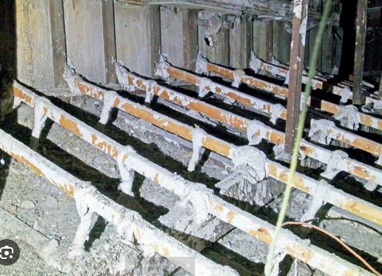
Fig.4.1 Fibrous material
Reinforcement is a process of strengthening weakened sections of fibrous plaster to restore its structural integrity and prevent further damage. Fibrous plaster is a material commonly used in interior construction, consisting of a mixture of plaster and fibers, such as hessian or jute, which provide additional strength.
It is important to note that the process of reinforcing weakened sections of fibrous plaster may vary depending on the specific circumstances and the severity of the damage. It is recommended to consult with a professional or experienced contractor for guidance and assistance to ensure a successful repair.
Importance of reinforcement fibers for gypsum plaster
  - Crack resistance
  - Impact resistance
  - Shrinkage control
  - Enhanced structural strength
  - Durability
It's worth noting that the type, length, and dosage of reinforcement fibers can vary depending on the specific requirements of the plaster application. Manufacturers and engineers consider factors such as the intended use, expected stress levels, and environmental conditions when selecting the appropriate fibers and determining the optimal dosage.

Matching textures and patterns
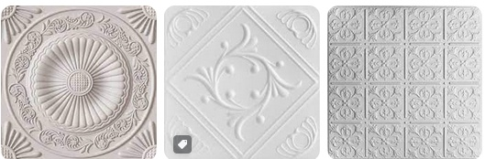
Fig 4.2 different types of texture finish
When it comes to replicating original designs for fibrous plaster, matching textures and patterns requires careful attention to detail and skillful execution.
Method of Appling texture and pattern matching
1. Mold Making: Start by creating a mold of the original design. This can be done using silicone rubber or other mold-making materials. Carefully press the mold onto the original design to capture all the intricate details.
2. Casting: Once the mold is ready, use it to cast a replica of the original design using fibrous plaster. Mix the plaster according to the manufacturer's instructions and pour it into the mold. Allow the plaster to set and cure before removing it from the mold.
3. Surface Preparation: Before applying the replica to the desired surface, make sure the surface is clean and free from any debris. Sand down any rough areas and ensure the surface is smooth and even.
4. Adhesive Application: Apply an appropriate adhesive to the back of the replica and carefully position it onto the prepared surface. Press firmly to ensure good adhesion.
5. Texture Matching: To match the texture of the original design, various techniques can be used. One approach is to use texture tools such as brushes, sponges, or trowels to recreate the specific texture pattern. Experiment with different tools and techniques to achieve the desired texture.
6. Surface Finishing: Once the replica is in place and the texture is matched, it's important to pay attention to surface finishing. Use sandpaper to smooth out any rough edges or imperfections. Apply a thin layer of plaster over the entire surface and use a trowel or sponge to create a seamless transition between the replica and the surrounding area.
7. Painting and Coloring: Finally, match the color of the replica to the surrounding area. Use appropriate paints or pigments to achieve a seamless blend. Apply multiple layers if necessary, allowing each layer to dry before applying the next.
Remember, achieving an exact match may require practice and experimentation. It's essential to have good observational skills and the ability to replicate the texture and pattern accurately.
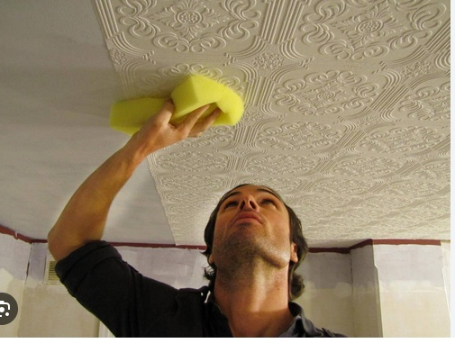
Fig 4.3 Appling match pattern in ceiling

Self-Check 4
Directions: Answer all the questions listed below. Use the Answer sheet provided in the next page

I Answer The Following With What Are Asked For.

1.write method of Appling texture and pattern matching (5p)
2. What isPeriodic inspections of fibrous plaster (2p)
3. what is Surface Preparation (5p)
---------------------------------------
--------------------------------------------------
----------------------------------------------------
3. Write at list three method of repairing damage ceiling (5p)

Answer Sheet
Score = ___________
Rating: ____________

Name: _________________________ Date: ______________

OPERATION SHEET-3
OPERATION TITLE:- Patching and filling the hole
PURPOSEAppling texture and pattern matching for by using fibrous plaster components for decorative of building structure
CONDITIONS OR SITUATIONS FOR THE OPERATIONS:-
- Wear appropriate clothes, shoe.
- Ensure the work shop hazard free
- Ensure the working area is bright
- Make workstation comfortable..
EQUIPMENT TOOLS AND MATERIALS : -
Troll, hammer, chisel, sprit level, water level, lime, cement , gypsum, water ,
PROCEDURE,
- Identify job specifications.
- Select and use hand tools & materials.
- Mold making
- casting
- surface preparation
- applying adhesive material
- texture matching
- surface finishing
- painting and coloring
PRECAUTIONS:-
- Make working area hazard free.
- The trainees should fulfill safety conditions.
QUALITY CRITERIA: Improperly done Repair fibrous gypsum with Water Damage safely according to the requested standard

LAP Test -3

Name: _____________________________ Date: ________________
Time started: ________________________ Time finished: ________________

Instructions: Given necessary templates /guide, workshop, tools and materials you are required to perform the following tasks within 1:00 hours.
Task 1. Appling texture and pattern matching

Unit five: Preservation of Fibrous Plaster
This unit to provide you the necessary information regarding the following content coverage and topics:
- Cleaning and maintenance practices
- Protecting against moisture and environmental factors
- Periodic Inspections and Preventive Measures
Periodic inspections and preventive measures This guide will also assist you to attain the learning outcomes stated in the Above topic contact. Specifically, upon completion of this learning guide, you will be able to:
- Cleaning and maintenance practices
- Protecting against moisture and environmental factors

Cleaning and Maintenance Practices
Preserving fibrous plaster involves taking steps to protect and maintain its structural integrity and appearance. Here are some methods for preserving fibrous plaster:
Preservation of fibrous plaster involves implementing cleaning and maintenance practices, protecting against moisture and environmental factors, and conducting periodic inspections and preventive measures. Here's a breakdown of each aspect:
- Regular Cleaning: Dust and dirt can accumulate on fibrous plaster surfaces over time, so regular cleaning is important to preserve its appearance. Use a soft brush or a vacuum cleaner with a brush attachment to gently remove dust and debris. Avoid using abrasive materials or harsh cleaning agents that can damage the plaster.
- Avoid Water Exposure: Fibrous plaster is susceptible to water damage, so it's important to avoid excessive moisture. Keep the plaster dry and prevent water from seeping into it, as this can cause the plaster to deteriorate or delaminate. Be cautious when cleaning near plaster surfaces and avoid using excessive amounts of water.
Maintain Stable Environmental Conditions: Fibrous plaster is sensitive to fluctuations in temperature and humidity. Aim to maintain stable environmental conditions within a reasonable range. Avoid exposing the plaster to extreme heat, cold, or humidity levels, as this can cause expansion, contraction, or moisture-related issues.
. The most common method for removing damaged fibrous plaster is Manual Removing that used for small areas of damage, you can use hand tools like chisels, scrapers, or putty knives to carefully chip away the damaged plaster. Start by creating a clean edge around the damaged area to prevent further cracking or damage. Then, using the tools, gently pry or scrape away the damaged plaster until you reach the solid substrate below.
Regular Dusting: Fibrous plaster should be dusted regularly using a soft brush or a vacuum cleaner with a brush attachment. This helps remove surface dust and prevents it from accumulating.
Gentle Cleaning: If the fibrous plaster requires more than dusting, a gentle cleaning approach should be followed. Use a mild detergent mixed with water and a soft cloth or sponge to gently wipe the surface. Avoid using abrasive cleaners or scrubbing vigorously, as they can damage the plaster.
Stain Removal: For stains on fibrous plaster, it's important to use appropriate stain removal techniques based on the type of stain. It's recommended to consult a professional conservator or a specialist for guidance on specific stain removal methods to avoid causing further damage.
- Repairing Damaged Areas: Any damaged areas, such as cracks or chips, should be repaired promptly to prevent further deterioration. Consult a professional plasterer or conservator experienced in working with fibrous plaster to ensure proper restoration.

Protecting Against Moisture and Environmental Factors
Moisture Control: Fibrous plaster is susceptible to damage from moisture. Ensure that the plaster is not exposed to excessive humidity or water leaks, as they can cause the plaster to soften, warp, or develop mold. Maintain a stable indoor environment with controlled humidity levels.
Adequate Ventilation: Proper ventilation helps in maintaining a balanced environment and prevents the buildup of excess moisture. Ensure that the area with fibrous plaster has adequate ventilation, especially in areas prone to high humidity, such as bathrooms or kitchens.
Avoid Direct Water Contact: Fibrous plaster should not come into direct contact with water. Take precautions while cleaning nearby areas or during other activities where water may be splashed onto the plaster.
Method of protecting moisture

1. Surface Sealants: Apply a surface sealant or moisture-resistant coating to the fibrous plaster. These sealants create a barrier that prevents moisture from penetrating the surface and affecting the moisture content of the material. Look for products specifically designed for use on plaster surfaces.
2. Waterproof Membrane: Install a waterproof membrane between the plaster and the substrate or backing material. This membrane acts as a barrier, preventing moisture from reaching the plaster. It can be especially useful in areas prone to high humidity or water exposure, such as bathrooms or kitchens.
3. Proper Ventilation: Ensure that the area where the fibrous plaster is installed has adequate ventilation. Good airflow helps to regulate moisture levels and prevent the accumulation of excess moisture, which can lead to mold or deterioration of the plaster. Install ventilation fans or open windows when necessary to promote air circulation.
4. Moisture Barriers: If the fibrous plaster is being installed in an area where moisture is a significant concern, such as a basement or a room with high humidity levels, consider using moisture barriers. These barriers, such as plastic sheets or vapor barriers, are installed behind the plaster and help to prevent moisture from migrating through the walls and affecting the plaster.
5. Proper Installation: Ensure that the fibrous plaster is installed correctly, following the manufacturer's guidelines and best practices. Proper installation techniques, including appropriate joint treatment and sealing, can help minimize the risk of moisture-related issues.
6. Regular Maintenance: Perform regular inspections of the fibrous plaster to identify any signs of moisture damage or issues. Promptly address any leaks, water damage, or areas of concern to prevent further moisture infiltration and protect the plaster.

Periodic Inspections and Preventive Measures
Periodic inspections of fibrous plaster are important to identify any signs of damage, deterioration, or potential issues that may require attention. These inspections help ensure the longevity and structural integrity of the plaster.
    - Periodic inspection of fibrous plaster
  - Visual examination
  - Moisture assessment
  - Surface condition
  - Paint or finish assessment.
  - Professional consultation
Remember that regular inspections are crucial for identifying and addressing issues in a timely manner, helping to preserve the fibrous plaster's structural integrity and aesthetic appeal.
Regular Inspections: Conduct periodic visual inspections of the fibrous plaster to identify any signs of damage, cracks, or deterioration. Catching issues early can help prevent further damage and the need for extensive repairs.
Professional Assessment: It is advisable to seek the expertise of a professional conservator or plaster specialist for a comprehensive assessment of the fibrous plaster periodically. They can provide guidance on specific maintenance needs and address any concerns.
Protective Coatings: In some cases, applying a suitable protective coating, such as a clear varnish or sealant, may help in providing an additional layer of protection to the fibrous plaster. However, it's crucial to consult an expert before applying any coatings to ensure compatibility and avoid unintended damage.
Remember, the preservation of fibrous plaster is a specialized field, and for valuable or historically significant installations, it's best to consult professionals with expertise in conservation and restoration to ensure appropriate care and preservation practices are followed.
To prevent damage to fibrous gypsum plaster, also known as fibrous plaster, you can take several preventive measures. These measures are aimed at maintaining the integrity and stability of the plaster, and minimizing the risk of damage.
    - Preventive method for fibrous gypsum plaster
1. Avoid excessive moisture
2. Regular inspections: Periodically inspect the fibrous plaster for signs of damage, such as cracks, bulges, or delimitation.
3. Proper installation
4. Avoid excessive weight or pressure:.
5. Protective measures during construction or renovations
6. Regular cleaning and maintenance
7. Education and awareness.
8. Professional care and maintenance:
By implementing these preventive measures, you can help prolong the life of fibrous gypsum plaster and minimize the risk of damage. Regular maintenance and prompt attention to any signs of deterioration are key to preserving its integrity

Self-Check 1
Directions: Answer all the questions listed below. Use the Answer sheet provided in the next page
Part one: multiple choices
1. One of the following is the Periodic inspection of fibrous plaster

  - Visual examination
  - Moisture assessment
  - Surface condition
  - all

  - from the following is one is the Preventive method for fibrous gypsum plaster

  - Avoid excessive moisture
  - Regular inspections:
  - Proper installation
  - All

  - one of the following is the Method of protecting moisture

  - Surface Sealants
  - Waterproof Membrane
  - Proper Ventilation
  - .all

Part two: short answer
1 writes Preventive method for fibrous gypsum plaster (5p)
2. What is a Periodic inspection of fibrous plaster (2p)
3. What is proactive coating (5p)
Part three: true or false
  - Maintain Stable Environmental ConditionsFibrous plaster is sensitive to fluctuations in temperature and humidity.(5pts)
  - Periodic inspections of fibrous plaster are important to identify any signs of damage, deterioration, or potential issues that may require attention.(5pts)

Answer Sheet
Name: _________________________ Date: ______________

Reference
Mahnke, F. (1996).Color, Environment and Human Response. New York: John Wiley & Sons.
^ Ballantine, Patti (2005). If It's Purple, Someone's Gonne Die Elsevier, Focal Press.
O'Connor, Z. (2010). "Color Psychology and Color Therapy: Caveat Emptor". Color Research and Application
"Pigments Through the Ages - Renaissance and Baroque (1400-1600)”. Www. Webexhibits.Org.
Albers, Josef (2006). Interaction of Color. Revised and Expanded Edition. Yale University
EIS BBCW 1 M020LO1-LG-93 Version -1 October 2019
UNIDO, UNIDO Green Industry – Policies for Supporting Green Industry (201

Developer Profile
Name | Qualification  (Level) | Field of study | Institute | Phone number | Email
BirhanuDemelash | A | M.Sc. COTM  BSc Road construction, | woldeya poly technic College | 0910686578 | birhanudemelash14@gmail.com
MihiretabGashaw | B | BSc building construction technology and Computer engineering | Addis ketema industrial College | 0922079011 | mihiretabgashaw@gmail.com
NasirAmane | B | BSC construction technology | Shashemane poly technic College | 0916005870 | nasiraman5870@gmail.com
NigussieTeshome | A | Geotechnical engineer(M.sc)  Civil engineering (B.sc) | Arbaminch PTC | 0913767770 | teshomeng@gmail.com
TesfayeAyalew | A | MSc in COTM  BSC in Building Construction Technology | DebreBrhan poly technic College | 0910469898 | tesfaye.ay21@gmail.com
WondwesnGirma | A | COTM(M.sc)  Civil engineering (B.sc) | Harar polytechnic College | 0912778365  0703608365 | wondwesngirma@gmail.com

