PLUMBING INSTALLATION
LEVEL - I
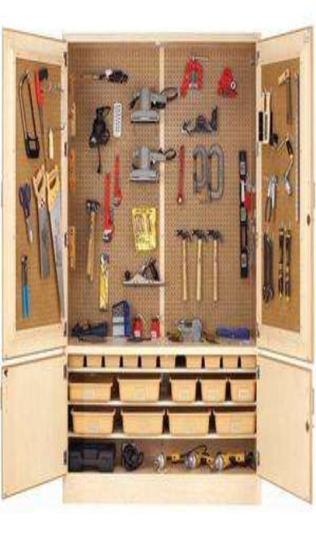
Based on August 2022, Curriculum Version 1
Module Title: Applying 5S Procedures
Module code: EISPLI1 M 01 0322
Nominal duration: 70 Hour
Prepared by: Ministry of Labour and Skill

August, 2022
Addis Ababa, Ethiopia

Acknowledgment
Ministry of Labor and Skills and Ministry of Health wish to extend thanks and appreciation to the many representatives of TVET instructors and respective industry experts who donated their time and expertise to the development of this Teaching, Training and Learning Materials (TTLM).

Table of Content
Acknowledgment 2
Table of Content 2
Introduction to the Module 4
Module Instruction 5
Unit One: Prepare for work 5
1.1 Work instructions 6
1.1.1 Job Specification 7
1.2 OHS requirements 8
1.2.1 Workplace hazards 9
Self-Check 1 12
Unit Two: Sort Items. 13
2.1 Definition of Sort 14
2.2 Benefits of sort activity 14
2.3 Preparing and implementing plan 15
2.4 Identify all items. 16
2.5 Listing Necessary and unnecessary items. 16
2.5.1 Places of where unnecessary items accumulate 17
2.6 Use Red tag strategy. 19
2.6.1 Red-tag Holding areas 19
2.6.2 Steps/procedures in Red tagging 20
Self-Check-2 26
Operation sheet 2 27
LAP Test 2 27
Unit Three: Set all items in order. 28
3.1 Explanation of the second pillar of 5S – Set in order 29
3.2 Benefits of set in order 29
3.3 Implementing the Second Pillar of 5S – Set in order 31
3.3.1 Plan and procedures for set in order 32
3.3.2 Evaluating current locations and deciding best locations 35
3.4 Set in order strategies 36
3.4.1 Motion Economy strategy 37
3.4.2 Visual control Strategy 37
Self-Check 3 38
Operation sheet 3 38
LAP Test 3 39
Unit Four: Perform shine activities. 40
4.1 Definition of Shine 40
4.2 Benefits of shine 41
4.3 Tools and materials used to implement shine 43
4.4 Plan and procedures for shine activities 45
4.4.1 Implements shine activity procedures. 45
4.4.2 Inspection 48
4.4.3 Inspection steps 49
Self-Check 4 53
Operation sheet 4 54
LAP Test 4 54
Unit Five: Standardize 5S 55
5.1 Standardizing 5S activities 56
5.2 Implementing 5S Workplace Organization and Standardization 56
5.2.1 5S Standardization in the Seiri/Sort 57
5.2.2 5S Standardization in the Seiton/Set in Order 57
5.2.3 5S Standardization in the Seiso/Shine 57
5.2.4 5S Standardization in Seiketsu/Standardize 58
5.2.5 5S Standardization in Shitsuke/Sustain 58
Self-Check -5 59
Unit Six: Sustain 5S 60
6.1. Preparing plan and sustaining 5S activities. 61
Self-check:6 64
Reference 66

Introduction to the Module
Assign and Integrate In order to ensure the first three stages of “5S” are maintained; responsibilities must be assigned and integrated into the regular work routines. Ensure daily sweeping of the area is part of the job duties if required. Ensure all tools are put away at the end of the day. Now that the clutter is gone and the place is clean and organized, 5S standardization will help to ensure the first three steps are maintained. This is critical as you don’t want to waste all the previous efforts from the first three steps. In order to accomplish this step, you will need to assign and integrate 5S responsibilities, schedule 5S tasks and audit the results.
This module is applying 5S Procedures to meet the industry requirement under the plumping installation occupational standard, particularly for the unit of competency: This module convers the knowledge, skills and attitude required to apply 5S techniques to his/her workplace. It covers responsibility for the day-to-day operations of the workplace and ensuring that continuous improvements of Kaizen elements are initiated and institutionalized.
This module covers the units:
- Prepare for work.
- Sort items.
- Set all items in order.
- Shine activities.
- Standardize 5S.
- Sustain 5S.
Learning Objective of the Module
- Determine Prepare for work.
- Identify Sort items.
- Set all items in order.
- Perform shine activities.
- Implements of Standardize 5S.
- Determine Sustain 5S.

Module Instruction
For effective use this modules trainees are expected to follow the following module instruction:
- Read the information written in each unit
- Accomplish the Self-checks at the end of each unit
- Perform Operation Sheets which were provided at the end of units
- Do the “LAP test” giver at the end of each unit and
- Read the identified reference book for Examples and exercise

Unit One: Prepare for work
This unit is to provide you the necessary information regarding the following content coverage and topics:
  - Work instructions. .
  - OHS requirements.
  - Prepare tools and equipment.
  - Implementing 5S.
  - Check safety equipment and tools.
  - Prepare and using kaizen board
This unit will also assist you to attain the learning outcomes stated in the cover page. Specifically, upon completion of this learning guide, you will be able to:
  - Use and determine work instructions.
  - Observe OHS requirements.
  - Prepare tools and equipment.
  - Implementation of 5S.
  - Identify and check safety equipment and tools.
  - Preparing and using kaizen board.

Work instructions
The Information of about the work, describe what workers need to be able to do on the job.
- Work functions
- Key activities of each work function
- Performance indicators
Describe what task to be done or work roles in a certain occupation Work instruction is a description of the specific tasks and activities within an organization. A work instruction in a business will generally outline all of the different jobs needed for the operation of the firm in great detail and is a key element to running a business smoothly. In other words it is a document containing detailed instructions that specify exactly what steps to follow to carry out an activity. It contains much more detail than a Procedure and is only created if very detailed instructions are needed. For example, describing precisely how a Request for Change record is created in the Change Management software support tool
- Procedures vs. Work Instructions
Many people confuse “procedures” with “work instructions”. In fact, most people write work instructions and call them procedures. Knowing the differences of procedures vs work instructions can help you understand the documentation process much better and, therefore, procedure documentation.
Procedures describe a process, while a work instruction describes how to perform the conversion itself. Process descriptions include details about the inputs, what conversion takes place (of inputs into outputs), the outputs, and the feedback necessary to ensure consistent results. The PDCA process approach (Plan, Do, Check, Act) is used to capture the relevant information.
- Questions that need to be answered in a procedure include:
- Where do the inputs come from (suppliers)?
- Where do the outputs go (customers)?
- Who performs what action when (responsibilities)?
- How do you know when you have done it right (effectiveness criteria)?
- What feedback should be captured (metrics)?
- How do we communicate results (charts, graphs and reports)?

Job Specification
A statement of employee/workers characteristics and qualifications required for satisfactory performance of defined duties and tasks comprising a specific job or function.

Table 1.1 Specification Sample
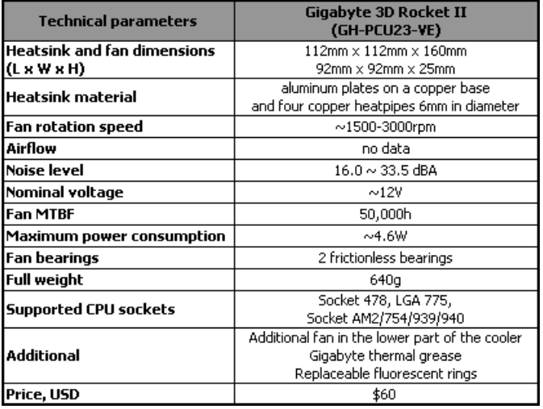

OHS requirements
OHS requirements are legislation/regulations/codes of practice and enterprise safety policies and procedures. This may include protective clothing and equipment, use of tooling and equipment, workplace environment and safety, handling of material, use of firefighting equipment, enterprise first aid, hazard control and hazardous materials and substances
Personal protective equipment includes those prescribed under legislation/ regulations/codes of practice and workplace policies and practices. Safe operating procedures include the conduct of operational risk assessment and treatments associated with workplace organization. Emergency procedures include emergency shutdown and stopping of equipment, extinguishing fires, enterprise first aid requirements and site evacuation.
Occupational safety and health (OSH) also commonly referred to as occupational health and safety (OHS) or workplace health and safety (WHS) is an area concerned with the safety, health and welfare of people engaged in work or employment. The goals of occupational safety and health programs include fostering a safe and healthy work environment. OSH may also protect co-workers, family members, employers, customers, and many others who might be affected by the workplace environment. In the United States the term occupational health and safety is referred to as occupational health and occupational and non-occupational safety and includes safety for activities outside work
Occupational safety and health can be important for moral, legal, and financial reasons. In common-law jurisdictions, employers have a common law duty (reflecting an underlying moral obligation) to take reasonable care for the safety of their employees. Statute law may build upon this to impose additional general duties, introduce specific duties and create government bodies with powers to regulate workplace safety issues: details of this will vary from jurisdiction to jurisdiction. Good OSH practices can also reduce employee injury and illness related costs, including medical care, sick leave and disability benefit costs
As defined by the World Health Organization (WHO) "occupational health deals with all aspects of health and safety in the workplace and has a strong focus on primary prevention of hazards." Health has been defined as "a state of complete physical, mental and social well-being and not merely the absence of disease or infirmity. Occupational health is a multidisciplinary field of healthcare concerned with enabling an individual to undertake their occupation, in the way that causes least harm to their health. It contrasts, for example, with the promotion of health and safety at work, which is concerned with preventing harm from any incidental hazards, arising in the workplace.

Workplace hazards
Although work provides many economic and other benefits, a wide array of workplace hazards also present risks to the health and safety of people at work. These include "chemicals, biological agents, physical factors, adverse ergonomic conditions, allergens, a complex network of safety risks," and a broad range of psychosocial risk factors
- Physical and mechanical hazards
Physical hazards are a common source of injuries in many industries. They are perhaps unavoidable in certain industries, such as construction and mining, but over time people have developed safety methods and procedures to manage the risks of physical danger in the workplace. Employment of children may pose special problems. Falls are a common cause of occupational injuries and fatalities, especially in
- construction,
- extraction,
- transportation,
- healthcare,
- building cleaning and
- Maintenance.
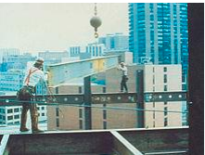
Figure 1.1 At-risk workers without appropriate safety equipment

The transportation sector bears many risks for the health of commercial drivers, too, for example from vibration, long periods of sitting, work stress and exhaustion. These problems occur in Europe but in other parts of the world the situation is even worse. More drivers die in accidents due to security defects in vehicles. Long waiting times at borders cause that drivers are away from home and family much longer and even increase the risk of HIV infections.

Confined spaces also present a work hazard. The National Institute of Occupational Safety and Health defines "confined space" as having limited openings for entry and exit and unfavorable natural ventilation, and which is not intended for continuous employee occupancy. Spaces of this kind can include storage tanks, ship compartments, sewers, and pipelines. Confined spaces can pose a hazard not just to workers, but also to people who try to rescue them.

Noise also presents a fairly common workplace hazard: occupational hearing loss is the most common work-related injury in the United States, with 22 million workers exposed to hazardous noise levels at work and an estimated $242 million spent annually on worker's compensation for hearing loss disability. Noise is not the only source of occupational hearing loss; exposure to chemicals such as aromatic solvents and metals including lead, arsenic, and mercury can also cause hearing loss.
Temperature extremes can also pose a danger to workers. Heat stress can cause heat stroke, exhaustion, cramps, and rashes. Heat can also fog up safety glasses or cause sweaty palms or dizziness, all of which increase the risk of other injuries. Workers near hot surfaces or steam also are at risk for burns. Dehydration may also result from overexposure to heat. Cold stress also poses a danger to many workers. Over-exposure to cold conditions or extreme cold can lead to hypothermia, frostbite, trench foot, or chilblains. Electricity poses a danger to many workers.
- Electrical injuries can be divided into four types:
- fatal electrocution,
- electric shock,
- Burns, and falls caused by contact with electric energy.
Vibrating machinery, lighting, and air pressure (high or low) can also cause workrelated illness and injuries. Asphyxiation is another potential work hazard in certain situations. Musculoskeletal are avoided by the employment of good ergonomic design and the reduction of repeated strenuous movements or lifts. Ionizing (alpha, beta, gamma, X, neutron), and non-ionizing radiation (microwave, intense IR, RF, UV, laser at visible and non-visible wavelengths), can also be a potent hazard
The Act: The Occupational Health and Safety Act 2004 (the Act) is the cornerstone of legislative and administrative measures to improve occupational health and safety in Victoria. The Act sets out the key principles, duties and rights in relation to occupational health and safety. The general nature of the duties imposed by the Act means that they cover a very wide variety of circumstances, do not readily date and provide considerable flexibility for a duty holder to determine what needs to be done to comply.
The Regulations: The Occupational Health and Safety Regulations 2007 are made under the Act. They specify the ways duties imposed by the Act must be performed, or prescribe procedural or administrative matters to support the Act, such as requiring licenses for specific activities, keeping records, or notifying certain matters.
Guidance: Effective OHS regulation requires that Work Safe provides clear, accessible advice and guidance about what constitutes compliance with the Act and Regulations. This can be achieved through Compliance Codes, Work Safe Positions and non-statutory guidance ("the OHS compliance framework"). For a detailed explanation of the OHS compliance framework, see the Victorian Occupational Health and Safety Compliance Framework Handbook.
Policy: Not every term in the legislation is defined or explained in detail. Also, sometimes new circumstances arise (like increases in non-standard forms of employment, such as casual, labour hire and contract work, or completely new industries with new technologies which produce new hazards and risks) which could potentially impact on the reach of the law, or its effective administration by Work Safe. Therefore, from time to time Work Safe must make decisions about how it will interpret something that is referred to in legislation, or act on a particular issue, to ensure clarity. In these circumstances, Work Safe will develop a policy. A policy is a statement of what Work Safe understands something to mean, or what Work Safe will do in certain circumstances.

Self-Check 1
Instructions: I
Directions: Answer all the questions listed below.
- What is the meaning of job?
- List the requirements of job.
- What is the meaning of work? (2 points)
- Describe work instruction in your own words. (5 points)
- Explain the difference between procedure and work instruction? (5 points)
- Define job specification? (3 points)
- Prepare specification samples. (10 points

Unit Two: Sort Items.
This unit is developed to provide you the necessary information regarding the following content coverage and topics:
- Prepare and implementing plan.
- Performing cleaning.
- Identify all items.
- List Necessary and unnecessary items.
- Red tag strategy.
- . Evaluate and placing unnecessary items.
- Record and quantifying necessary items.
- Report performance results.
- Check regularly necessary items.
This unit will also assist you to attain the learning outcomes stated in the cover page. Specifically, upon completion of this learning guide, you will be able to:
- Prepare and implementing plan.
- Perform cleaning.
- Identify all items.
- List Necessary and unnecessary items.
- Use red tag strategy.
- . Evaluate and placing unnecessary items.
- Record and quantifying necessary items.
- Report performance results.
- Check regularly necessary items.

Definition of Sort
Sort, the first pillar of 5S, means classifying items in the workplace in to two categories – necessary and unnecessary - and removing all the unnecessary items that are not needed for current operations. It corresponds to the just in time (JIT) principle of “only what is needed, only in the amount needed, and only when it is needed.” The workplace is full of unused machines, jigs, dies, rejects, work-in-process, raw materials, supplies, parts, shelves, containers, desks, workbenches, files, carts, racks, pallets and other items.

Benefits of sort activity
Implementing this first pillar creates a work environment in which space, time, money, energy, and other resources can be managed and used most effectively. Sorting can lead to a much safer workplace. By clearing out the items you no longer need, people will have more room to work and things like trip hazards and items falling off shelves will be greatly reduced. Sorting also improves work flow since there is less clutter to deal with and will most definitely increase productivity in both production and office environments.
Problems and annoyances in the work flow are reduced, communication between workers is improved, and product quality is increased, and productivity is enhanced. If the first pillar is not well implemented, the following types of problems occur:
- The factory or a workshop becomes increasingly crowded and hard to work in.
- Unnecessary lockers, shelves, cabinets and items make communication between employees difficult.
- Time is wasted in searching for parts and tools.
- Increase unnecessary maintenance cost of unneeded inventory and machinery.
- Excess stock-on-hand hides other types of problems in production.
- Unneeded items and equipment make it harder to improve the process flow

Preparing and implementing plan
Implementing sort activity is not always easy to identify unneeded items in a factory or workshop. Workers seldom know how to separate items needed for current production from unnecessary items. The following procedures will help in implementing sort activity based on the Plan Sort activity and plan sheet (sample
Table 2-1 Sort activity plan sheet (sample
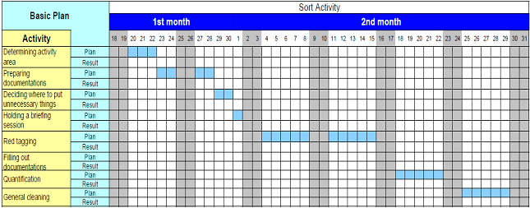

- Procedure for Sort activity
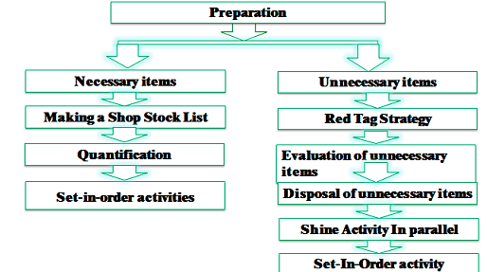
- Steps implementing sorties
- Evaluate and take pictures of the work area. It’s extremely important to take pictures during this evaluation step since referencing them after improvements have been made can be very enlightening. To help you get started use also a 5S evaluation form.
- Identify and red tag the items you no longer need.
- Decide what to do with the tagged items.

Identify all items.
Depend up on the workshops material; device and equipment identify the all of the items disposed follow the following of checklist table.
Table 2-2 list of all the items at the work shop
No. | Name of items | Unit | QYT | Category
 |  |  |  | Equipment’s | Tools/device | materials
1
2
3
4
5
6

Listing Necessary and unnecessary items.
Some of types of unnecessary items are:
- defective or excess quantities of small parts and inventory
- outdated or broken jigs and dies
- worn-out bits
- outdated or broken tools and inspection gear
- old rags and other cleaning supplies
- electrical equipment with broken cords
- outdated posters, signs, notices, and memos
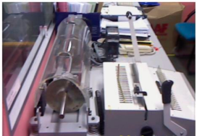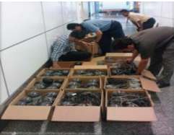
Figure 2.1 Unused machinery or equipment Figure 2.2 Obsolete equipment

Places of where unnecessary items accumulate
Some locations where unneeded items tend to accumulate are:
- in rooms or areas not designated for any particular purpose
- in corners next to entrances or exists
- Along interior and exterior walls, next to partitions, and behind pillars.
- Under the eaves of warehouses.
- under desks and shelves and in desk and cabinet drawers
- near the bottom of tall stacks of items
- on unused management and production schedule boards
- in tools boxes that are not clearly sorted

Sample of format for records necessary items at the workplace
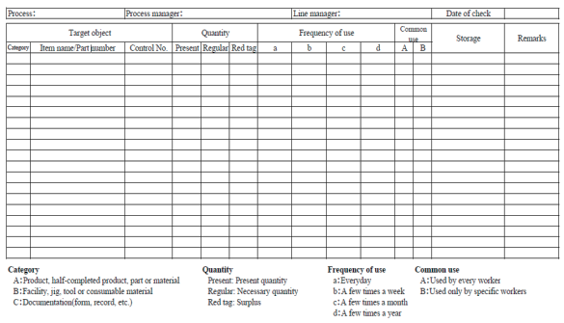
A sample format for recording unnecessary items in the workplace
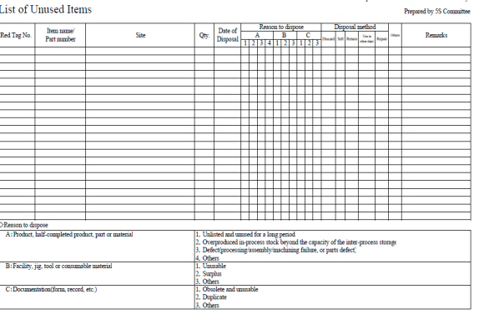

Use Red tag strategy.
The Red-Tag Strategy is a simple method for identifying potentially unneeded items in the factory or workshop, evaluating their usefulness and dealing with them appropriately. Red-tagging means putting red tags on items in the factory or workshop that need to be evaluated as being necessary or unnecessary. A Red tag is a red colored tag used to identify items no longer needed in a particular work area. The red tags catch people’s attention because red is a color that stands out. An item with a red tag is asking three questions:
- Is this item needed?
- If it is needed, is it needed in this quantity?
- If it is needed, does it need to be located here?
Once these items are identified, they can be held in a “Red Tag Holding Area” for a period of time to see whether they are needed, disposed of, relocated, or left exactly where they are.

Red-tag Holding areas
In order to implement the red-tag strategy effectively, a red-tag holding area must be created. A red-tag holding area is an area set aside for use in storing red-tagged items that need further evaluation. Red-tagging is helpful when the need or frequency of need for that item is unknown. When an item is set aside in a red-tag holding area and watched for an agreed-upon period of time people tend to be more ready to let it go when that time is over.
There are two red-tag holding areas: local and central holding areas. Local red-tag holding area is used to manage the flow of red-tagged items with in a local department or production area. Central red-tag holding area is used to manage the flow of items that cannot or should not be disposed of by individual departments or production area. Usually central red-tag holding area is used by an organization that is launching a companywide red-tagging effort
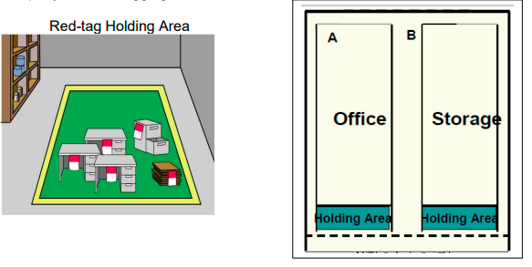
Figure 2.3 two red-tag holding areas

Steps/procedures in Red tagging
The red-tagging process in a department or work area can be broken down into seven steps
Step 1: Launch the red-tag project.
Step 2: Identify the red-tag targets.
Step 3: Set red-tag criteria.
Step 4: Make red tags.
Step 5: Attach red tags.
Step 6: Evaluate red-tagged items.
Step 7: Document the results of red-tagging
Step 1: Launch the red-tag project
Red-tag campaigns are started and coordinated by the upper-level management of a company. Even when a red-tag campaign is companywide, local campaigns need to be organized in each department or production area. This involves
- Organizing a team
- Organizing supplies
- Organizing a time or schedule to perform red-tagging
- Deciding a local-tag holding area
- Planning for disposal of red-tagged items
People from outside a department can be valuable members on a red-tagging team since they tend to see the area with a fresh eye. Hence, it is helpful to partner with other departments or production areas Items:
Step 2: Identify red-tag targets
There are two red-tag targets
- In the manufacturing area items like inventory (warehouse and inprocess inventory), equipment, and space are targets for red tags. Warehouse inventory include material, parts, products etc.
- Areas: It is better to define a smaller area and evaluate it well than to define a larger area and not be able to evaluate it fully in available time. in creating red-tagging teams.
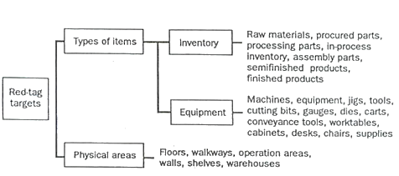
Figure 2.4 creating red-tagging teams.

Step 3: Set red-tag criteria
As already mentioned, the most difficult thing about red-tagging is differentiating what is Needed from what is not. This issue can be managed by establishing clear-cut criteria for What is needed in particular area and what is not. The most common criterion is the next Month’s production schedule
- Items needed for that schedule are kept in that location.
- Items not needed for the schedule can be disposed of or stored in a separate location.
Three main factors determine whether an item is necessary or not. These factors are:
- The usefulness of the item to perform the work at hand. If the item isn’t needed it
- Should be disposed of.
- The frequency with which the item is needed. If it is needed infrequently it can be
- Stored away from the work area.
- The quantity of the item needed to perform this work. If it is needed in limited
- Quantity the excess can be disposed or stored away from the work area.
Each company must establish its own red-tagging criteria and each department may customize this standard to meet its local needs.
Step 4: Make red-tags
Each company has specific needs for documenting and reporting the movement, use, and value of materials, equipment, tools, inventory and products. The company’s red Tags should be designed to support this documentation process.
Various types of information on a red tag may include:
- Category: provides a general idea of the type of item (e.g., a warehouse item or
- Machine). Categories include raw materials, in-process inventory, products,
- Equipment, jigs, tools and dies.
- Item name and manufacturing number.
- Quantity: indicates the number of items included under this red tag.
- Reason: describes why a red tag has been attached to this item.
- Division: includes the name of the division responsible for managing the red-tagged item.
- Value: includes the value of the red-tagged item.
- Date: includes the red-tagging date
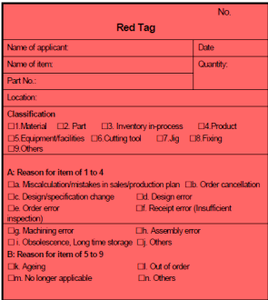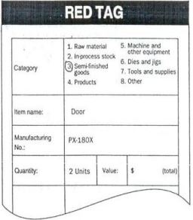
Figure 2.5 Make red-tags
The material used for red tags can be red paper, thick red tape, or others. Red tags can be laminated with plastic or another material to protect them during repeated use.
Step 5: Attach the red tags
The best way to carry out red-tagging is to do the whole target area quickly, if possible, in one or two days. In fact, many companies choose to red-tag their entire factory during a one or two day period. Red-tagging should be a short and powerful event. You should red-tag all items you question, without evaluating what to do with them
Step 6: Evaluate the red-tagged items
In this step, the red-tag criteria established in step 3 are used to evaluate what to do with red-tagged items. Options include:
- Keep the item where it is.
- Move the item to a new location in the work area.
- Store the item away from the work area.
- Hold the item in the local red-tag holding area for evaluation.
- Dispose of the item.

Disposal methods include:
- Throw it away.
- Sell it.
- Return it to the vendor.
- Lend it out.
- Distribute it to a different part of the company.
- Send it to the central red-tag holding area
The next table shows disposal methods.
Table 2.3 disposal methods
Treatment | Description
Throw it away | Dispose of as scrap or incinerate items that are useless or unneeded for any purpose.
Sell | Sell off to other companies items that are useless or unneeded for any purpose
Return | Return items to the supply company
Lend out | Lend items to other sections of the company that can use them on a temporary basis
Distribute | Distribute items to another part of the company on a permanent basis.
Central red-tag area | Send items to the central red-tag holding area for redistribution, storage, or disposal.

Ideally, unnecessary equipment should be removed from areas where daily production activities take place. However, large equipment and equipment or machine attached to the floor may be expensive to move. It is sometimes better to leave this equipment where it is unless it interferes with daily production activities or prevents workshop improvements. Label this unneeded and difficult to move equipment with a “freeze” red tag, which indicates that its use has been “frozen,” but that it will remain in place for the time being.

Step 7: Document the results of red-tagging
Each company or organization needs to create its own system for logging and tracking necessary information as red-tagging takes place. The documentation system may involve a written logbook in each department and in the central red tag holding area. Or it may involve entering data from the red-tags into a computer system. Whatever the system, documenting results is an important part of the red-tagging process. It allows the company to measure the improvement and savings produced as a result of the restaging effort. As it is indicated in step 4, the red-tags should be designed to support the documentation process.
Determine in advance approximately how many red-tags each workplace should use. An average of four red-tags per employee should be used. This means a workshop with 30 employees should need about 120 red tags. In addition when you find a shelf full of items which are difficult to decide, we don’t have to be tempted to attach one red-tag for the whole shelf. Because this can lead to confusion when we want to dispose of these items in the shelve. Therefore, avoid this temptation and attach individual tags to individual items.
When red-tagging is completed the factory or workshop is usually dotted with empty spaces – a sign of real progress. Then the layout of equipment’s and worktables can be changed to occupy the free space. Companies or organizations who think they need to build a new factory for a production of new products/ services should first apply the sort activity or the red-tag strategy so that they could get plenty of free space.

Self-Check-2
Instructions I:
Answer all the questions listed below. Illustrations may be necessary to aid some explanations/answers. Write your answers in the sheet provided in the next page.
- Define the first pillar of 5S – Sort. (2 points)
- write the benefits of implementing sort of activity (4 points)
- What problems occur in a workshop if sort activity is not implemented?(6 points)
- What are the reasons for the accumulation of unnecessary items in a workshop? (3 points)
- write the procedures of sort activity (5 points)
- define the red-tagging strategy (3 points)
- What are red-tag holding areas and explain the types? (4 points)
- List the steps of red-tagging strategy. (7 points)
- List at least seven items that are considered as unnecessary. (2 points
- Name places where unnecessary items are accumulated? (3 points)

Operation sheet 2
- Operation title : Sort
- Purpose: To implement sort in the work place
- Instruction: By following steps in implementing sort, apply them at your work place.
- Tools and requirement:
- PPE
- Camera
Steps in doing the task
1. Use the straight edge of the line a
2. Record the result on the line a
3. Repeat the step for line b, c and d
4. Check for the second time for the second round
5. Complete your work by confirming the recorded measurement
•Quality Criteria: Taking photos before and after to inspect thorough implementation of sort.
•Precautions: Utilizing PPEs carefully..

LAP Test 2
Instructions: Given necessary templates, workshop, tools and materials you are required to perform the following tasks.
Task 1: Perform a sorting stage in 5S of materials, tools and equipment at your work place.

Unit Three: Set all items in order.
This unit is developed to provide you the necessary information regarding the following content coverage and topics:
- Prepare plan
- General clean activities.
- Location, storage and indication methods.
- Prepare and use tools/ equipment.
- Place and assign Items.
- Return and assign items.
- Report performance of results.
- Check each item.
This unit will also assist you to attain the learning outcomes stated in the cover page. Specifically, upon completion of this learning guide, you will be able to:
- Prepare plan.
- Perform general cleaning activities.
- Decide location, storage and indication methods.
- Prepare and use tools or equipment.
- Place and assign Items.
- Return and assign items.
- Report performance results.
- Check each item

Explanation of the second pillar of 5S – Set in order
Set in order means arranging necessary items so that they are easy to use and labeling them so that anyone can find them and put them away. The key word in this definition is “anyone”. Set in order can be implemented only when the first pillar- sort is done first. No matter how well you arrange items, set in order can have little impact if many of the items are unnecessary and not sorted. Similarly, if sorting is implemented without setting in order, it is much less effective. Where necessary items should be placed should be made clear for anyone to immediately find them and return them easily. Hence, Sort and Set in order work best, when they are implemented together.

Benefits of set in order
Setting in order is important because it eliminates many kinds of waste from operations in a workplace. These include searching time waste, waste due to difficulty in using items, and waste due to difficulty in returning items. In general, the following problems and wastes are avoided when set in order is well implemented.
- Motion wastes
- Searching time wastes
- The waste of human energy
- The waste of excess inventory
- The waste of defective products
The waste of unsafe conditions The set in order step is actually at the core of so many important business principles such as safety, ergonomics, quality, inventory control, productivity, standard work, the visual workplace and employee morale. Also it is the core of standardization. This is because the workplace must be organized before any type of standardization can be implemented effectively. Standardization means creating a consistent way of doing or carrying out tasks. When we think of standardization, we have to think about anyone. Lock the following figure how to set in order of materials and equipment’s
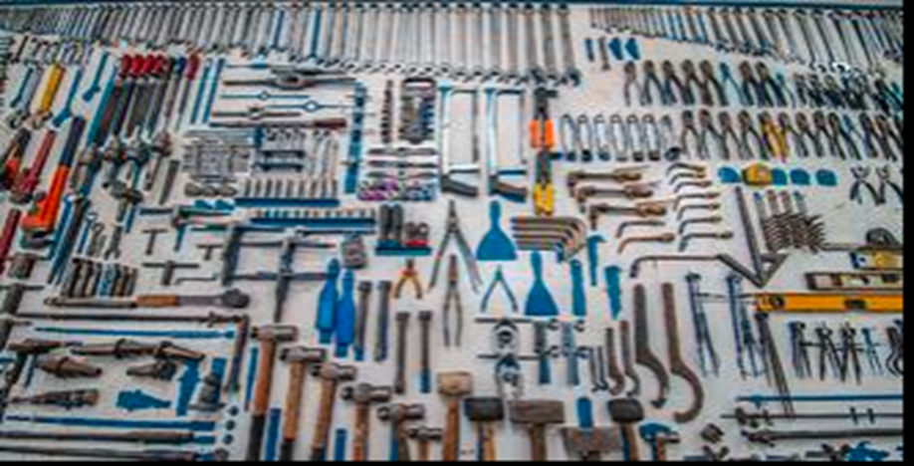
Figure 3.1 Set in Order of material and equipment’s
For example, machinery standardization means anyone can operate the machinery. Also if we have operation standardization this means anyone can perform the operation. Even for people to get along together, they need to standardize their behaviors, at least to some extent

Figure 3.2 Set in order is the core of standardization.

In implementing set in order pillar, we use visual controls so that communications became easy and smooth. For example, we can visually know where items are placed and where to return them and so on. A visual control is any communication device used in the workplace that tells us at a glance how work should be done. Through visual controls, information such as where items belong, how many items should be placed there, what the standard procedure is for doing something, the status of work in process etc. can be communicated.
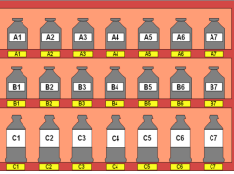
Figure 3.3 communication standardization

Implementing the Second Pillar of 5S – Set in order
To make sure you carry out the first 3 pillars of 5S correctly, you need to provide a consistent approach that employees can follow. An important prerequisite here is giving employees standardized guides and checklists, as well as supporting documentation so that they can integrate these best practices into their work routine

Plan and procedures for set in order
Set in order activity plan sheet (sample)
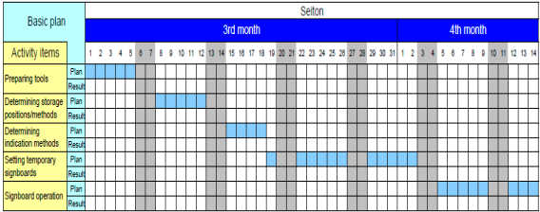

The Procedures for Set in order is implements follow as
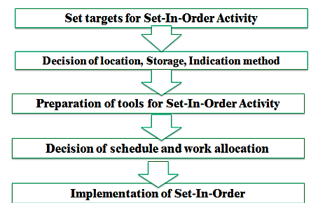

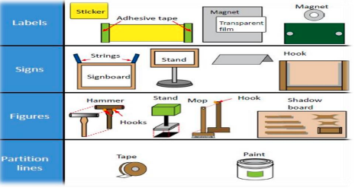

There are some principles for deciding best locations for tools and equipment’s. Jigs, tools and dies differ from materials, equipment’s, machinery and parts in that they must be put back after each use. Some of the principles for jigs, tools and diesel so apply to parts, equipment’s, and machinery. These’re:
- Locate items in the workplace according to their frequency of use.
- Place frequently used items near the place of use.
- Store infrequently used items away from the place of use.
- Store items together if they are used together, and store them in sequence in which they are used.
- Device a just let go arrangement for tools. This approach involves suspending tools from a retractable cord just within reach so that they will automatically go back in to their correct storage position when released.
- Make storage places larger than the items stored there so that they are physically easy to remove and put back
- Eliminate the variety of jigs, tools and dies needed by creating a few jigs, tools and dies that serve multiple functions.
- Store tools according to function or product. Function-based storage means storing tools together when they have similar functions. This works best for job-shop production. Product-based storage means storing tools together when they are used on the same product. This means works best for repetitive production.
There are principles helpful in deciding the best locations for parts, equipment’s, and machinery, as well as tools by removing motion wastes. Motion wastes are unnecessary movements created when people move their trunks, feet, arms, and hands more than needed to perform a given operation. These wastes lead to waste of time, energy and effort. These motion wastes can be minimized by locating parts, equipment’s, and machinery in the best locations possible. More important than removing motion wastes is asking why it occurs. By asking ‘why’ we can find the methods of manufacturing that work and approach the zero-waste mark. Eliminating the unnecessary motions from existing operations is called Motion improvement. And finding ways to eliminate the whole operations to remove the wastes is called Radical improvement.
The principles that are helpful to eliminate or reduce motions that operators make are:
- Principle 1: Start and end each motion with both hands moving at once.
- Principle 2: Both arms should move symmetrically and in opposite directions.
- Principle 3: Keep trunk motions to a minimum.
- Principle 4: Use gravity instead of muscle.
- Principle 5: Avoid zigzagging motions and sudden changes in direction.
- Principle 6: Move with a steady rhythm.
- Principle 7: Maintain a comfortable posture with comfortable motions.
- Principle 8: Use the feet to operate on and off switches for machines where practical.
- Principle 9: Keep materials and tools close and in front
- Principle 10: Arrange materials and tools in the order of their use.
- Principle 11: Use inexpensive methods for feeding in and sending out materials.
- Principle 12: Stand at a proper height for the work to be done.
- Principle 13: Make materials and parts easy to pick up.
- Principle 14: Make handles and grips in efficient, easy-to-use shapes and positions.
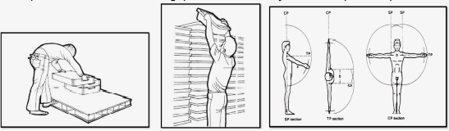
Figure 3.4 Motion wastes Figure 3.5 No waste of motion

Evaluating current locations and deciding best locations
The 5S Map is a tool that can be used to evaluate current locations of parts, jigs, tools, dies, equipment, and machinery, and to decide best locations. 5S Map involves creating two maps before map and after map. The before map shows the layout of the workplace before implementing set in order. The ‘after map’ shows the workplace after implementing set in order. The 5S Map can be used to evaluate the locations in small or large workplaces, like in single workstations, on a production line, or in a department.
The steps of using the 5S Map:
- Make a floor plan or area diagram of the workplace you wish to study. Show the location of specific parts, inventory, tools, jigs, dies, equipment and machinery.
- Draw arrows on the plan showing the work flow between items in the workplace. There should be at least one arrow for every operation performed. Draw the arrows in the order that the operations are performed, and number them as you go.
- Look carefully at the resulting “spaghetti diagram”. Can you see places where there is congestion in the work flow? Can you see ways to eliminate waste?
- Make a new 5S Map to experiment with a better layout for this work place. Again, draw and number arrows to show the flow of operations performed.
- Analyze the efficiency of the new layout (the after map), based on the principles explained in the above.
- Continue to experiment with possible layouts (after maps) using the 5S Map until you find one which you think will work well.
- Implement this new layout in the work place by moving parts, tools, jigs, dies, equipment, and machinery to their new locations.
- Continue to evaluate and improve the layout in the workplace.

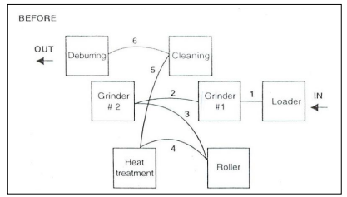
Figure 3.6 5S Map of old layout in machining operations (‘before map’)
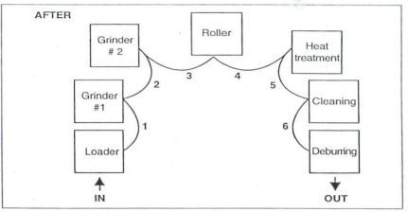
Figure 3.7 5S Map of old layout in machining operations (‘after map’)

Set in order strategies
Once best locations have been decided, it is necessary to mark these locations so that everyone knows what goes where, and how many of each item belongs in each location. There are several strategies for marking or showing what, where and how many.

Motion Economy strategy
Following the principles explained in the above, we can remove motion waste from existing operation. By using human body appropriately, by organizing the workplace and by redesigning of tools and equipment’s, we can minimize motion waste.

Visual control Strategy
A visual control is any communication device used in the work environment that tells us at a glance how work should be done. There are several strategies for setting in order items so that to easily identify what, where and how many (visual control). These visual control strategies are discussed in the next contents
Signboard strategy: uses signboards to identify what, where, and how many. The three main types of signboards are:
- Location indicators that show where items go.
- Item indicators that show what specific items go in those places.
- Amount indicators that show how many of these items belong there.
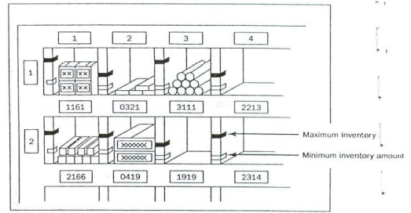
Figure 3.8 Amount indicators

Self-Check 3
Instructions 1: Answer all the questions listed below. Illustrations may be necessary to aid some explanations/answers. Write your answers on the sheet provide.
- write the three main types Signboard strategy
- Defined the principles of helpful to eliminate or reduce motions.
- Writes The Procedures of Set in order implements.
- defined the Implements of the Second Pillar of 5S – Set in order

Operation sheet 3
• Operation title: Set-in order
• Purpose: To implement Set-in order in the work place
• Instruction: By following steps in implementing Set-in order, apply them at your work place.
• Tools and requirement:
1. PPE
2. Cart
3. Ladder
Steps in doing the task
- Locate items in the workplace according to their frequency of use.
- Place frequently used items near the place of use.
- Store infrequently used items away from the place of use.
- Store items together if they are used together, and store them in sequence in which they are used.
- Device a just let go arrangement for tools. This approach involves suspending tools from a retractable cord just within reach so that they will automatically go back in to their correct storage position when released.
- Make storage places larger than the items stored there so that they are physically easy to remove and put back
- Eliminate the variety of jigs, tools and dies needed by creating a few jigs, tools and dies that serve multiple functions.
- Store tools according to function or product. Function-based storage means storing tools together when they have similar functions. This works best for job-shop production. Product-based storage means storing tools together when they are used on the same product. This means works best for repetitive production.
• Quality Criteria: Taking photos before and after to inspect thorough implementation of se-in order.
• Precautions: Utilizing PPEs carefully and taking care for tools and equipments.

LAP Test 3
Instructions: Given necessary templates, workshop, tools and materials you are required to perform the following tasks.
Task 1: Perform Set in Order of materials, tools and equipment at your work place.

Unit Four: Perform shine activities.
This unit is developed to provide you the necessary information regarding the following content coverage and topics:
- Prepare plan.
- Implement shine activities.
- Prepare tools and equipment.
- Shine activity procedures.
- Report performance results
- Conduct regular shining activities
This unit will also assist you to attain the learning outcomes stated in the cover page. Specifically, upon completion of this learning guide, you will be able to:
- Prepare plan.
- Implement shine activities.
- Prepare necessary tools and equipment.
- Implement shine activity procedures.
- Report performance results
- Conduct regular shining activities

.

Definition of Shine
The third pillar of 5S is shine. Shine means sweeping floors, wiping off machinery and generally making sure that everything in the factory stays clean. In a manufacturing company, shine is closely related to the ability to produce quality products. Shine also includes saving labor by finding ways to prevent dirt, dust, and debris from piling up in the workshop. Shine should be integrated in to daily maintenance tasks to combine cleaning checkpoints with maintenance checkpoints.
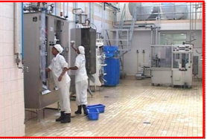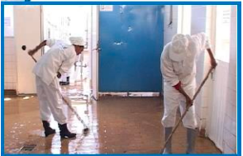
Figure 4.1 Workers shinning machines. Figure 4.2 For Workers shinning the floor
Cleaning is so important because when we clean an area, we are also doing some inspection or checking of machinery, equipment, and work conditions. An operator cleaning a machine can find many mal-functions. When a machine is covered with oil, soot, and dust, it is difficult to identify any problems that may be developing. While cleaning the machine, however, one can easily spot oil leakage, a crack developing on the cover, or loose nuts and bolts. Once these problems are recognized, they are easily fixed.
It is said that most machines breakdowns begin with vibration (due to loose nuts and bolts), with introduction of foreign particles such as dust (due to the crack on the cover, for instance), or with inadequate oiling and greasing. For this reason shine is useful to make discoveries while cleaning machines. Hence, shine means cleaning the workplace’s floors, equipment and facilities, provide inspection at the same time, and ensure that they are in good operating condition.

Benefits of shine
One of the more obvious purposes of shine is to turn the workplace in to clean, bright place where everyone will enjoy working. Another key purpose is to keep everything in top condition so that when someone needs to use something, it is ready to be used. Companies or organizations should avoid the tradition of annual at the end of the year or on spring cleanings. Instead, cleaning should become a deeply ingrained part of daily work habits, so that tools, equipment, and work areas will be ready for use all the time.

Figure 4.3 Workers cleaning machines
Cleanliness for factories and offices is a lot like bathing for human beings. It relieves stress and strain, removes sweat and dirt, and prepares the body and mind for the next day. Cleanliness is important for physical and mental health. Just as you would not bath only once a year, performing shine procedures in a factory should not be an annual activity. Cleaning should be done on daily basis.
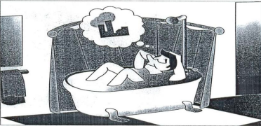
Figure 4.4 Shine activities relieves stress and strain
Shine activities can play an important part in bringing work efficiency and safety. Cleanliness is also linked with the morale of employees and their awareness of improvements. Factories or workshops that do not implement the shine pillar suffer the following types of problems:
- Poor morale and inefficiency at work. This could be due to dirty windows that can pass only little light.
- Unable to see or find defects in dark and messy workplaces.
- Slipping and injuries can be created due to puddles of oil and water on the floor.
- Frequent breakdown of machines due to insufficient check-ups and maintenances which in turn leads to late deliveries.
- Low and unsafe operating machines due to insufficient checkups and maintenance which in turn leads to hazard and accidents.
- Defects will result due to shaving cuts getting mixed in to production or assembly processes.
- Shaving cuts can get in to people’s eyes and create injuries.
- Low morale due to filthy work environments.

Tools and materials used to implement shine
The following are some tools and materials used to implement the third pillar of 5S Shine.
- Sponge oil
- Broom detergent s
- Brush spade
- vacuum cleaner bolts
- garbage containers floor scrubber cleaning Pads
- Screws etc…

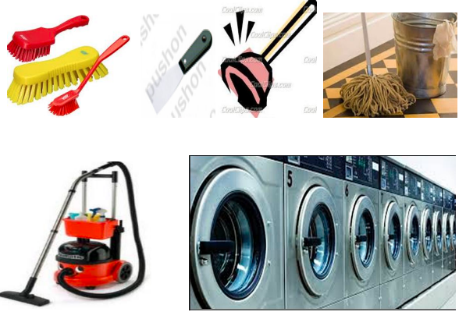
Figure 4.5 Tools and materials


Plan and procedures for shine activities
Shine activities should be taught as a set of steps and rules that employees learn to maintain with discipline. The following sample format can be used to prepare a plan for implementing shine activities.
Shine activity plan sheet (sample)
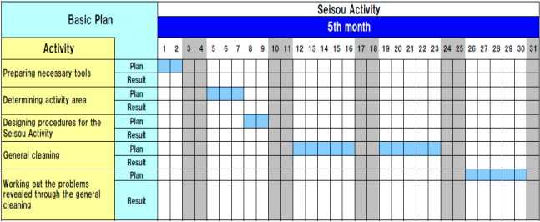
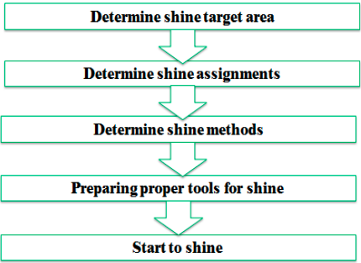

Implements shine activity procedures.
Step 1: Determine shine target areas Shine target areas are grouped in to three categories: warehouse item, equipment’s and space. Warehouse items include raw materials, procured subcontracted parts, parts made in-house, and assembly components, semi-finished and finished products. Equipment includes machines, welding tools, cutting tools, conveyance tools, and general tools, measuring instruments, dies, wheels and casters, worktables, cabinets, desks, chairs and spare equipment. Space refers to floors, work areas, walkways, walls, pillars, ceilings, windows, shelves, closets, rooms and lights.
Step 2: Determine Shine Assignments Workplace cleanliness is the responsibility of everyone who works there. Each employee should be assigned specific area to clean. To do these two methods can be used:
A 5S Assignment Map – shows all the target areas for shine activity and who is responsible for cleaning them. By marking on 5S Map, the shine assignments can be shown.
- A 5S schedule – shows in detail that is responsible for cleaning which areas on which days and times of the day. Then this schedule should be posted in the work area.
- A 5S schedule – shows in detail that is responsible for cleaning which areas on which days and times of the day. Then this schedule should be posted in the work area.
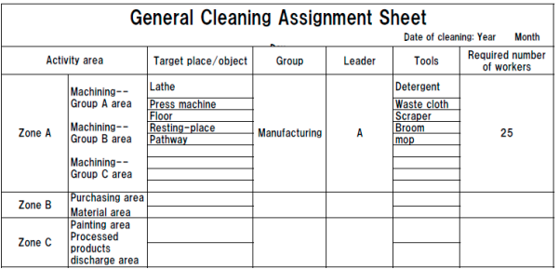
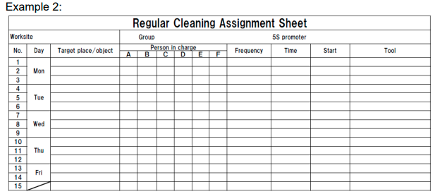

Step 3: Determine shine methods Shine activities should be a natural part of the daily work. Shine activities and inspection should be done before a shift starts, during work time and at the end of the shift.
The Determining is shine methods include:
- Choosing targets and tools. Define what will be cleaned in each area and what supplies and equipment will be used.
- Performing the five-minute shine. Cleaning should be practiced daily and should not require a lot of time.
- Creating standards for shine procedures. People need to know what procedures to follow in order to use their time efficiently. Otherwise, they are likely to spend most of their time getting ready to clean.
Step 4: prepare tools the cleaning tools should be placed properly or set in order where they are easy to find, use and return.
Step 5: Start to shine

When implementing the shine procedures, consider the following suggestions:
- Be sure to sweep dirt from floor cracks, wall corners, and around pillars.
- Wipe off dust and dirt from walls, windows, and doors.
- Be thorough about cleaning dirt, scraps, oil, dust, rust, cutting shavings, sand,
- Paint and other foreign matter from all surfaces.
- Use cleaning detergents when sweeping is not enough to remove dirt.

Inspection
As discussed earlier, it is natural to do a certain amount of inspection while implementing shine activities. Once daily cleaning and periodic major cleanups become a habit, we can start incorporating systematic inspection procedures in to the shine procedures. Even when equipment in the workplace appears to function normally, it may be developing many problems. Always when machines or other equipment begin to show sign of minor, sporadic malfunctions, the operators not the maintenance people notice it first. Therefore, it is important to consider the operators information about the equipment.

The following types of equipment problems frequently exist in factories:
- Oil leaks from the equipment on to the floor.
- Machines are so dirty that operators avoid touching them.
- Gauge displays and other indicators are too dirty to be read.
- Nuts and bolts are either loose or missing.
- Motors overheat.
- Sparks flare from power cords.
- V-belts are loose or broken.
- Some machines make strange noises.
Daily cleaning or inspection can help to find these problems and solve them.
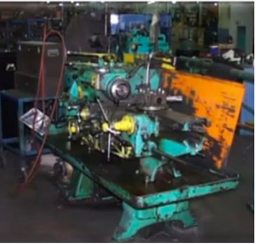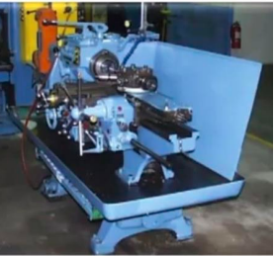
Figure 4.6 Daily cleaning or inspection

Inspection steps
The steps of inspection and shine procedures are parallel. But the steps of inspection give greater emphasis on the maintenance of machines and equipment. These steps are:
Step 1: Determine inspection targets
The targets for inspection are similar to the targets of shine activities. These include machines, equipment’s, jigs, and dies, cutting tools and measuring instruments.
Step 2: Assign inspection activities
In principle, the people who carry out inspection on a particular machine should be the same people who operate the machine. But most often one person can operate several machines at a time (as in multi-process handling). In this case, it is good to involve line supervisors and group leaders in the inspection duties. Once inspection activities are assigned, they have to be written up on a large signboard for the workshop or on small signboards that are attached to each target machine.
Step 3: Determine inspection methods
First all of the items to be inspected should be listed then an inspection checklist should be prepared based on the listed inspection items. The following shows an example of an inspection checklist.
Table 4.4.1 Sample of inspection checklist
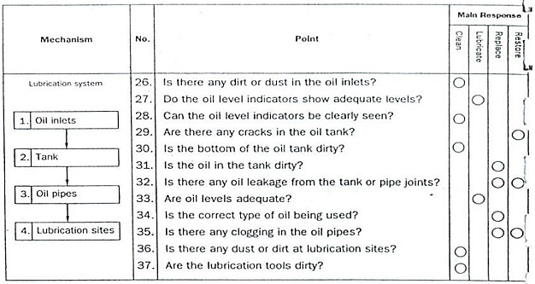

Step 4: Implement inspection
When implementing inspection, use all your senses to detect abnormalities. Inspection is not simply a visual activity. There are some ways to detect abnormalities. These are
- Look closely at how the machine works and watch for slight defects (e.g. oil leakage, debris scattering, deformation, wear, warping, mold, missing items, lopsidedness, inclinations, color changes).
- Listen closely for changes in the sounds the machine makes while operating (e.g. sporadic sounds, odd sounds).
- Use your nose to detect burning smells or other unusual odors (e.g. burning rubber)
- Touch the machine where it is safe during operation and during downtime to detect deviations from normal conditions (e.g. strange vibrations, wobbling, looseness, excessive heat, shifting)
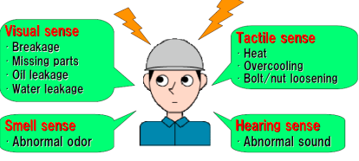

Step 5: Correct equipment problems
All equipment abnormalities or slight defects should be fixed or improved. There are two approaches to do these:
Instant Maintenance: whenever possible, an operator should immediately fix or improve a problem he or she discovers during inspection. But the operators should know what level of maintenance work they can handle by themselves and immediately.
Requests of Maintenance: In the some cases, a defect or problem may be difficult for the operator to hand alone and immediately. In this situation, the operator should attach a maintenance card to the site of the problem in order to make it visible. He or she can also issue maintenance company to request help from the maintenance department. It is also good to log requested maintenance on to a checklist of needed maintenance activities. Once a requested maintenance is taken care and its result confirmed, the activity should be checked off in the ‘confirmation’ column of the checklist. The maintenance card should then be retrieved from the machine where it is attached
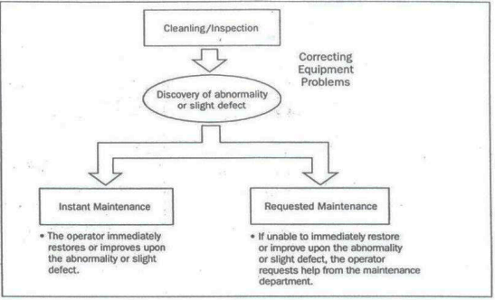
Figure 4.7 Two approaches for solving equipment problems

Self-Check 4
Instructions 1: Answer all the questions listed below. Illustrations may be necessary to aid some explanations/answers. Write your answers on the sheet provide.
- Write the definition of the third pillar shine. (2 points)
- What problems occur in a workshop if shine is not implemented? (8 points)
- What are the steps/procedures for implementing shine? (5 points)
- Described the methods of used to assign shine activities to employees? (2 points)
- What are the most frequent problems of equipment’s/machines? (4 points)
- List the steps of inspection. (5 points)
- How do you detect abnormalities in a workplace or machine? (4 points)

Operation sheet 4
• Operation title: Shine
• Purpose: To implement shine in the work place
• Instruction: By following steps in implementing shine, apply them at your work place.
• Tools and requirement:
1. PPE
2. Cart
3. Ladder
4. Cleaning tools, equipment and agents
5. Paints and brush
- Steps in doing the task
- Determine shine target areas; Shine target areas are grouped in to three categories: warehouse item, equipment’s and space.
- Determine Shine Assignments; Workplace cleanliness is the responsibility of everyone who works there. Each employee should be assigned specific area to clean.
- Determine shine methods; Shine activities should be a natural part of the daily work. Shine activities and inspection should be done before a shift starts, during work time and at the end of the shift.
- Prepare tools the cleaning; tools should be placed properly or set in order where they are easy to find, use and return.
- Start to shine
- Quality Criteria: Taking photos before and after to inspect thorough implementation of shine.
• Precautions: Utilizing PPEs carefully and taking care for tools and equipment.

LAP Test 4
Instructions: Given necessary templates, workshop, tools and materials you are required to perform the following tasks.
Task 1: Identify and prepare tools and materials for implementing shine activity.
Task 2: Prepare plan for shine and Sample plan
Task 3: Implement shines activity.

Unit Five: Standardize 5S
This unit is developed to provide you the necessary information regarding the following content coverage and topics:
- Preparing and using plan.
- Standardizing 5S activities.
- Preparing Tools and techniques.
- Standardize 5S.
- Implementing relevant procedures.
- Standardizing and reporting activities.
This unit will also assist you to attain the learning outcomes stated in the cover page. Specifically, upon completion of this learning guide, you will be able to:
- Preparing and using plan.
- Standardizing 5S activities.
- Preparing Tools and techniques.
- Standardize 5S.
- Implementing relevant procedures.
- Standardizing and reporting activities.
- Kept workplace.

Standardizing 5S activities
The last step of 5S workplace organization and standardization is called Sustain or Shitsuke which concentrates on covering every former step of 5S, with the standardized processes, and converting them into continuing practices to guarantee continuous improvement. It addresses describing a new outlook and a standard in place of work.
Standardize is an essential bridge between Shine and the last step of 5S is to standardize. By systematizing the method to 5S through standardization, it can be confirmed that organizational efforts are continued in due course through a sustainable approach. If an organization fails to standardize work processes then it can cause disordered and inefficient work over time. It is helpful to give employees opportunities to play a dynamic role in the standards development. An outstanding technique to accomplish this is to plan and print out 5S sheets of audit that can be used by anyone who is examining an area on a particular day. Lock at the following picture
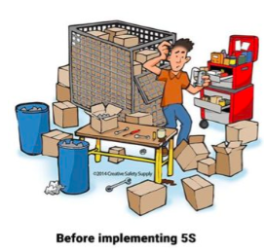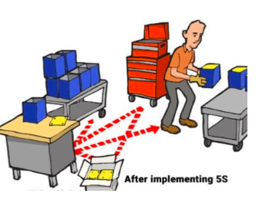

Implementing 5S Workplace Organization and Standardization
Basically 5S is a philosophy and an approach of organizing and managing the workplace and course of work with the commitment of increasing efficiency by reducing waste, enhancing flow and decreasing process irrationality. It uses a list of five Japanese words: Seiri (Sort) Seiton (Set in Order), Seiso (Shine), Seiketsu (Standardize), and Shitsuke (Sustain).

5S Standardization in the Seiri/Sort
The first step in 5S workplace organization and standardization emphasizes on reducing unneeded items from the workplace. Here the equipment, furniture and tool in workplace are categorized into the 3 categories which are necessary, unnecessary and may not be necessary. Moreover, this step can also be beneficial with the “just in case” approach. Industrial bins are required for an exact class. On the basis of the standard method, three to four “bins” or organizing sorts are used when performing a 5S category that comprises of keep, remove, and probation and to move. It is a key point to audit the categorization process dynamically of any 5S’d space to make sure precision and focus. At times, a focus on organization can dominate further main areas so it must be ensured to register on tool standardization, expiration dates of supply, and possible safety risks while areas are going through audit organization.

5S Standardization in the Seiton/Set in Order
The term “Set” is based on determining efficient and effective storage of essential articles. It uses the idea of “can see, can take out, and can return”. By following this philosophy time and energy can be saved when we want to find something. An effective approach to initiate this step is to plan the space where the tools and equipment will be going back to. It is very important to truly consider the jobs being done in or around every station during this stage. This approach must be used to design the most suitable and easy areas for employees to go. Furthermore, employees’ most commonly used tools must be located in convenient and easily accessible areas with the minimum possible limitations.

5S Standardization in the Seiso/Shine
This step means cleaning up the workplace on every day basis with the intention of having no dust on floors, machines or tools. By following this approach ownership can be created and pride can be built among the workers. Approximately in any case, there is no doubt that an uncontaminated workplace is a safer place of work. For example, when the floors are maintained clear of dirt and residues it facilitates to lessen the hazard of tours, slips, and falls which are a very common source injuries in the workplace. It is useful to post images in the proximate areas displaying the entirely cleaned or “shined” workplace condition. It can be a useful approach to have this communication successful even when nobody is actually around to provide it. Likewise, an information board can also be used which illustrates step-by-step guidelines for cleaning specific areas or equipment’s.

5S Standardization in Seiketsu/Standardize
An essential bridge between Shine and the last step of 5S is to standardize. By systematizing the method to 5S through standardization, it can be confirmed that organizational efforts are continued in due course through a sustainable approach. If an organization fails to standardize work processes then it can cause disordered and inefficient work over time. It is helpful to give employees opportunities to play a dynamic role in the standards development. An outstanding technique to accomplish this is to plan and print out 5S sheets of audit that can be used by anyone who is examining an area on a particular day.

5S Standardization in Shitsuke/Sustain
The last step of 5S workplace organization and standardization is called Sustain or Shitsuke which concentrates on covering every former step of 5S, with the standardized processes, and converting them into continuing practices to guarantee continuous improvement. It addresses describing a new outlook and a standard in place of work. It must be kept in mind that anything anticipated from workers must be shown properly by a qualified and experienced professional. Additionally, employees must be observed in their first efforts to check the 5S daily routines that are being made are the precise practices required and looked-for. More to the point, mistakes must be fixed. Occasionally continuous unwanted behavior or unwanted outcomes occur as a result of a defective system. In that case, the fault must be found in the actual system and it must be corrected as necessary.

Self-Check -5
Directions: choose the best answer for the following question (1 point each):
- ___________ is Arrangement / organization of necessary items in good order for use.
- What is the use of arranging necessary items in good order in implementing the 5S?
- _______________________
- _______________________
- _______________________
- _______________________

Unit Six: Sustain 5S
This unit is developed to provide you the necessary information regarding the following content coverage and topics:
- Plan and sustain 5S activities.
- Implementing techniques and procedures.
- Cleaning up workplace.
- Identifying unlikely Situations.
- Sustaining and reporting activities
This unit will also assist you to attain the learning outcomes stated in the cover page. Specifically, upon completion of this learning guide, you will be able to:
- Plan and sustain 5S activities.
- Implement techniques and procedures.
- Clean up workplace.
- Identify unlikely Situations.
- Sustaining and reporting activities

Preparing plan and sustaining 5S activities.
Previously, we have discussed 5S in general, the phases Sort and Straightens, and the phases Sweep and Standardizing in previous units. This unit will discuss the final phase of 5S the sustain phase. All these units are covered in the modules of Sustainable 5S.

The fifth and final S in the 5S model stands for SUSTAIN, and this is the most difficult of the stages to implement in practice. It is difficult because this stage circles back on all the prior stages to ensure that they are being appropriately maintained and updated as necessary. The sustain stage therefore has two main objectives:
- sustaining the current standard as they were agreed upon by the team and
- Identifying improvements when the standards are no longer relevant or complete.
An aid that can be used to check whether the standards are sustained is a mini-audit. By writing short questions on a T-card (a small card in the shape of a T so that it can easily fit a plan board) everyone can perform a mini audit in an area of their choosing. The cards can include questions such as; “Are all materials placed at their specified location?”, “is there something missing that you need to do your job properly or better?”, “are the tools on the shadow board cleaned according to standard?”

The easiest way to perform such an audit is by linking each T-card to the standards defined in the previous step, leading to one T-card per standard.

Figure 4 shows an example of a T-card system that is used in a Dutch factory. On the left, a board with different T-cards is shown on which the mini-audit cards are kept and can be accessed on the shop floor.
he right picture shows an example of one T-card in the hand of an operator, on which the use of a team board is assessed.

check | checklist
check | yes | no
- Device and equipment are cleaned during at activity continuously?
- All obsolete, broken or unnecessary equipment not required for current projects are removed from the area or red tagged for removal?
Equipment/machinery is clearly identified (numbered, named, color-coded, etc.) and placed in a properly identified location. Critical maintenance points are clearly marked.
All tripping hazards such as electrical wires and equipment cables are removed from all working, standing, and walking areas.

Generally Sustaining is the end result of how well we have performed the previous four S’s. In the sustainability stage, think of ways to eliminate effort in maintaining an area.Doing things spontaneously without being told and Educate people so that 5S expands beyond initial limits and turns into natural standard behavior.
PROCESS/PROCEDURE:
Step 1: - Create reasonable rules.
- Create reasonable rules of behavior in the workplace.
- Engage everyone concerned in the creation of rules not just the department heads or supervisors.
- Discuss the rules with everyone concerned. This will result to a feeling of involvement.
- Show rules and standards clearly and attractively using illustrations, photographs and color-coding.
Step 2: - Exhibit before and after 5S photos where everyone will see them.
Step 3: - Recognize good practices and good performance.
Train people to follow good housekeeping rules autonomously.
- Enhance autonomous management activities
- Maintain the discipline needed to do a good job
- Upgrade productivity and quality consciousness
- Wash hands after going to the toilet
- Wash hands before and after meals
- Eat and smoke at designated places
- Keep workplace always clean and tidy
- Wear clean uniform and shoes
- Follow safety rules
- Put things back in their proper places
- Work according to standards
- Observe proper office decorum

Self-check:6
Instruction .I
Write the correct answer on the blank space.
- ____________ is a process-centered approach to ensuring that a company or organization is providing the best possible products or services.
- _____________typically require a strong knowledge of the business processes of an organization.
- Write the 5S in Japanese and English terms.
- ____________________
- ____________________
- ____________________
- ____________________
- ____________________
- 5S is a systematized approach to:
- _____________________
- _____________________
- _____________________
- What can a company gain from 5S?
P. __________________
Q. __________________
C. ___________________
D. ___________________
S. ___________________
M. ___________________
- What are the benefits of 5S?
- _______________
- _______________
- ________________
- ________________
- ________________
- ________________

No | Name | Qualification (Level) | Field of Study | Organization/ Institution | Mobile number | E-mail
- 1 | Abebe Endalew | A(Msc) | Civil | Misrak Poly Technic Collage | 0933007756 | Abebeaware09@gmail.Com
- 2 | Teshale mulugeta | A |  | DTC | 0920469129 | teshamulu909@gmail.com
- 3 | Million Aklilu | A | Electrical | APTC | 0910688925 | milion.akililu@gmail.com
- 4 | Sileshi kassahun | B | Con. technology | MTC | 0931862151 | Sileshikassahun21@gmail.com

Reference

  - 5S for operators (1995)
  - Ethiopia Kaizen Manual (2011)
  - Journal 5S for operators (1995)
  - Journals/publications/magazines
  - Job specifications
  - Safety Manual and Guide als/publications/magazine
  - Journals/publications/magazines
  - job specifications
  - Safety Manual and Guide

