PLUMBING INSTALLATION
LEVEL - I
Based on March 2022, Curriculum Version 1


Module Title: - Handle and store plumbing materials
Module code: EIS PLI02 0322
Nominal duration: 100Hour

Prepared by: Ministry of Labour and Skill
August, 2022
Addis Ababa, Ethiopia

Contents
Acknowledgment 4
Introduction to the Module 6
Unit one: Prepare for work 8
1.1. Safety (OHS) requirements. 9
1.2. Selecting personal protective equipment (PPE) 13
1.3. Identify quality assurance. 17
1.4. Applying environmental waste management 22
1.5. Selecting, checking tools and equipment. for handling materials 28
1.6. Determining install and maintain device. 37
1.7. Locating and interpreting plumbing materials 49
Self check-1 53
Operation sheet 1 54
Lap Test-1 55
Unit TWO: Identify hazard and risk control information and measures. 56
2.1 Recogniz and report hazards. 58
2.2 Identify procedures, instructions and information. 61
2.3 Adhere hazards and risks. 65
2.4 Dealiand adhering accidents, fires and emergencies. 66
Self check- 70
Unit 3: Handle, sort and stack materials. 72
3.1 Identifying and Selecting of Plumbing Materials 73
3.2 Identify and applying techniques. 90
3.3 Applying and handling requirements and protection for non-Hazardous materials 94
Treatment and Disposal 96
3.3 Protecting materials. 97
3.4 Erecting signage and barricades. 101
3.5 Identifying and handling hazardous material. 106
3.6 Minimizing health risk. 108
Self check-3 112
Unit FORE: Store and transport materials 113
4.1 Toring and transporting materials according to msds implementing authority. 114
4.2 Identifying and handling Hazardous material. 117
4.3 Identifying, storing and allocating flammable materials. 120
4.4 Transporting and handling hazardous materials. 123
4.5 Protecting storm water system. 126
Self check-4 130
Unit 5: Clean up. 131
5.1 Cleaning, checking, maintaining, and storing tools and equipment. 132
5.2 Clearing, disposing and recycling materials. 136
5.3 Disposal in the Sanitary Sewer 138
5.4 Accessing and completing documentation. 140
Self check-5 142
Reference Materials 143

Acknowledgment
Ministry of Labor and Skills wish to extend thanks and appreciation to the many representatives of TVET instructors and respective industry experts who donated their time and expertise to the development of this Teaching, Training and Learning Materials (TTLM).

TTLM Teaching, Training and Learning Materials
PPE personal protective equipment
QA Quality assurance
TQM Total quality management
SQM Statistical process control
ISO International Organization for Standardization
AS Automated Storage
RS Retrieval Systems
MSDS Material Safety Data Sheet
ABS Acrylonitrile Butadiene Styrene
PVC Polyvinyl chloride
CPVC Chlorinated – polyvinyl – chloride

Introduction to the Module
Construction is a material based process and plumbing involves the use of a wide variety of materials in order to provide the services covered by the trade handling and storing materials involve diverse operations such as hoisting tons of steel with a crane; driving a truck loaded with concrete blocks; carrying bags or materials manually; and stacking palletized bricks or other materials such as drums, barrels, kegs, and lumber. The efficient handling and storing of materials are vital to industry. In addition to raw materials, these operations provide a continuous flow of parts and assemblies through the workplace and ensure that materials are available when needed. Unfortunately, the improper handling and storing of materials often result in costly injuries.

This module covers the units :
- Prepare for work.
- Identify hazard and risk control information and measures.
- Handle, sort and stack materials.
- Store and transport materials.
- Clean up.
Learning Objective of the Module
- Prepare for work.
- Identify hazard and risk control information and measures.
- Handle, sort and stack materials.
- Store and transport materials.
- Clean up.
Module Instruction
For effective use this modules trainees are expected to follow the following module instruction:
- Read the information written in each unit
- Accomplish the Self-checks at the end of each unit
- Perform Operation Sheets which were provided at the end of units
- Do the “LAP test” giver at the end of each unit and
- Read the identified reference book for Examples and exercise

Unit one: Prepare for work
This unit is developed to provide you the necessary information regarding the following content coverage and topics:
- Describing Safety (OHS) requirements.
- Selecting personal protective equipment (PPE)
- Identifying quality assurance.
- Applying environmental waste management
- Selecting, checking tools and equipment.
- Determining install and maintain device.
- Locating and interpreting plumbing materials
- Handling plumbing materials.
This unit will also assist you to attain the learning outcomes stated in the cover page. Specifically, upon completion of this learning guide, you will be able to:
- Safety (OHS) requirements.
- Select personal protective equipment (PPE)
- Identify quality assurance.
- Environmental waste management
- Select, checking tools and equipment for handling plumbing materials
- Install and maintain device.
- Locate and interpret plumbing materials

Safety (OHS) requirements.
Definition
Safety is a concept that includes all measures and practices taken to preserve the life, health, and bodily integrity of individuals.In the workplace, safety is measured through a series of metrics that track the rate of near misses, injuries, illnesses, and fatalities. In order to improve these metrics, employers and safety officials must also conduct investigations following any incident to ensure that all safety protocols and measures are being followed or to implement new ones if needed.
Workplace Environmental Requirements
1 Work Layout
The layout of the workplace is required to allow persons to enter and exit the workplace and move within safely, both under normal work conditions and in an emergency.
  - Entry and Exit Entries and exits are required to be safe to allow impeded access and
egress for all workers, students and visitors including those with special needs. In particular:

Fig:-1.1 Entry and Exit
1.2 Housekeeping Untidy workplaces may lead to injuries e.g. slips and trips, therefore good housekeeping practices are essential for all workplaces. For example: spills on floors should be cleaned up immediately, walkways should be kept clear of obstructions, work materials should be neatly stored , any waste should be regularly removed, suitable containers for waste should be conveniently located and regularly emptied.


Fig:1.2 :-House keeping tag
1.2 Work Areas
The layout of the work area should be designed to provide sufficient clear space between furniture, fixtures and fittings so workers can move freely without strain or injury also evacuate quickly in case of an emergency. In determining how much space is required, the following should be considered:
1.2.1 Floors and Other Surfaces
Floor surfaces shall be suitable for the work area and be chosen based on the type of work being carried out at the workplace, as well as the materials used during the work process, the likelihood of spills and other contaminants, including dust and the need for cleaning.
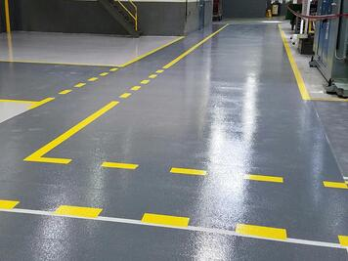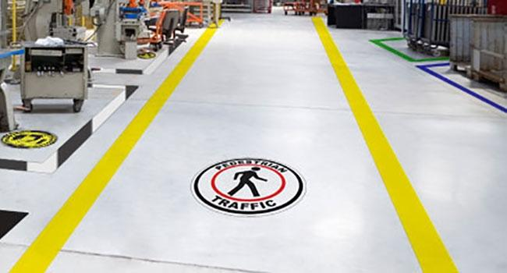
Fig :1.2.1:- Work shop lay out

1.2.2 Workstations
Workstations should be designed so workers are comfortable undertaking their task and allow for a combination of sit and standing tasks. For tasks undertaken in a seated position, workers should be provided with seating that:
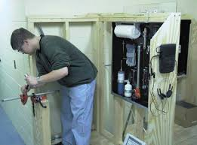
Fig:1.2.2 Work station

1. 2.3 Lighting
Sufficient lighting is required to allow safe movement around the workplace and to allow workers to perform their job without having to adopt awkward postures or strain their eyes to see.

Fig: 1.2.3 Lighting at work shop

1.2.4 Air Quality
Workplace are to be adequately ventilated which includes provision of fresh, clean air drawn from outside the workplace, uncontaminated from flues or other outlets and be circulated through the workplace. Workplace inside buildings may have natural ventilation, mechanical ventilation or air-conditioning.

Fig 1.2.4:- Indoor air quality

Selecting personal protective equipment (PPE)

Definition
PPE (Personal Protective Equipment) is equipment that will protect the user against health or safety risks at work. It can include items such as safety helmets, gloves, eye protection, high-visibility clothing, safety footwear and safety harnesses. It also includes respiratory protective equipment (RPE).
Selecting of PPE Correct selection of PPE is the first critical step. Follow the pesticide product label carefully when certain types of gloves, respirators, and/or other PPE are specified. For example, a specific type of glove material may be highly chemical-resistant to some pesticide products but not others. A respirator suitable for one task may not be suitable for another. A “water-resistant” material is different than a “chemical-resistant” material.“Chemical-resistant” PPE is “material that allows no measurable movement of the pesticide being used through the material during use.” However, “chemical-resistant” aprons, coveralls, eye protection, footwear, gloves, and headgear are not equally resistant to all pesticides, under all conditions, and for the same length of time.
- Make Sure PPE is Working Properly It is very important to select the correct PPE. Just as important, the PPE must be working correctly every time you use it, either alone or in combination with other PPE. When several pieces of PPE are used together, they must not interfere with each other. For example, protective goggles must not interfere with the operation of a respirator.
- Read the PPE user instructions carefully before every use, and seek assistance if needed.
- Before and after every use, check for any type of deterioration of or damage to all the components, seams, etc. of the specific reusable PPE and, if necessary, dispose of properly.
Using of PPE Use PPE always and anywhere where necessary. Observe the instructions for use, maintain them well and check regularly if they still offer sufficient protection. But when do you use what type of protection?

1. Safety for the head


Wearing a helmet offers protection and can prevent head injuries. Select a sturdy helmet that is adapted to the working conditions. These days you can find many elegant designs and you can choose extra options such as an adjustable interior harness and comfortable sweatbands.

2. Protect your eyes


The eyes are the most complex and fragile parts of our body. Each day, more than 600 people worldwide sustain eye injuries during their work. Thanks to a good pair of safety glasses, these injuries could be prevented. Do you come into contact with bright light or infrared radiation? Then welding goggles or a shield offer the ideal protection!

3. Hearing protection



Do you work in an environment with high sound levels? In that case it is very important to consider hearing protection. Earplugs are very comfortable, but earmuffs are convenient on the work floor as you can quickly put these on or take them off.

4. Protect your hands with the right gloves



Hands and fingers are often injured, so it is vital to protect them properly.
Depending on the sector you work in, you can choose from gloves for different applications:
- protection against vibrations
- protection against cuts by sharp materials
- protection against cold or heat
- protection against bacteriological risks
- protection against splashes from diluted chemicals.

5. Protection for the feet

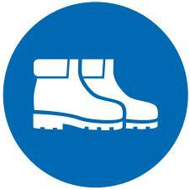
Even your feet need solid protection. Safety shoes (type Sb, S1, S2 or S3) and boots (type S4 or S5) are the ideal solution to protect the feet against heavy weights. An anti skid sole is useful when working in a damp environment, definitely if you know that 16,2% of all industrial accidents are caused by tripping or sliding. On slippery surfaces, such as snow and ice, shoe claws are recommended. Special socks can provide extra comfort.

7 Wear the correct work clothing
Preventing accidents is crucial in a crowded workshop. That is why a good visibility at work is a must: A high-visibility jacket and pants made of a strong fabric can help prevent accidents. Just like the hand protection, there are versions for different applications.



Identify quality assurance.
Definition of Quality Assurance
Quality assurance (QA) is any systematic process of determining whether a product or service meets specified requirements.QA establishes and maintains set requirements for developing or manufacturing reliable products.
A quality assurance system is meant to increase customer confidence and a company's credibility, while also improving work processes and efficiency, and it enables a company to better compete with others.
The ISO (International Organization for Standardization) is a driving force behind QA practices and mapping the processes used to implement QA.
QA is often paired with the ISO 9000 international standard. Many companies use ISO 9000 to ensure that their quality assurance system is in place and effective.
the concept of QA as a formalized practice started in the manufacturing industry, and it has since spread to most industries, including software development.
Importance of quality assurance
Quality assurance helps a company create products and services that meet the needs, expectations and requirements of customers. It yields high-quality product offerings that build trust and loyalty with customers. The standards and procedures defined by a quality assurance program help prevent product defects before they arise.
Quality assurance methods
Quality assurance utilizes one of three methods: Failure testing,which continuallytests a product to determine if it breaks or fails. For physical products that need to withstand stress, this could involve testing the product under heat, pressure or vibration. For software products, failure testing might involve placing the software under high usage or load conditions.

Statistical process control (SPC), a methodology based on objective data and analysis and developed by Walter Shewhart at Western Electric Company and Bell Telephone Laboratories in the 1920's and 1930's. This methodology uses statistical methods to manage and control the production of products.
- Total quality management (TQM), which applies quantitative methods as the basis for continuous improvement. TQM relies on facts, data and analysis to support product planning and performance reviews.
QA vs. QC
Some people may confuse the term quality assurance with quality control (QC). Although the two concepts share similarities, there are important distinctions between them.
In effect, QA provides the overall guidelines used anywhere, and QC is a production-focused process for things such as inspections. QA is any systematic process for making sure a product meets specified requirements, whereas QC addresses other issues, such as individual inspections or defects.
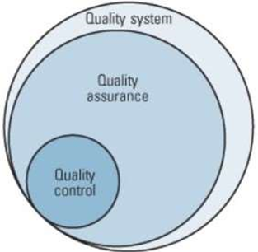
Fig :- 3.1 Quality System, Quality Assurance, and Quality Control Relationships

Process Quality Assurance
Quality assurance has a defined cycle called PDCA cycle or Deming cycle. The phases of this cycle are:
- Plan
- Do
- Check
- Act
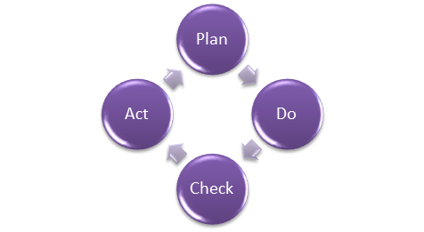
Fig : 3.2 Process Quality Assurance
These above steps are repeated to ensure that processes followed in the organization are evaluated and improved on a periodic basis. Let's look into the above steps in detail -
- Plan;-Organization should plan and establish the process related objectives and determine the processes that are required to deliver a high-Quality end product.
- Do:-Development and testing of Processes and also "do" changes in the processes
- Check:- Monitoring of processes, modify the processes, and check whether it meets the predetermined objectives
- Act :- implement actions that are necessary to achieve improvements in the processes an organization must use quality assurance to ensure that the product is designed and implemented with correct procedures. This helps reduce problems and errors, in the final product.

Quality Assurance Functions:
There are 5 primary Quality Assurance Functions:
- Technology transfer: This function involves getting a product design document as well as trial and error data and its evaluation. The documents are distributed, checked and approved
- Validation: Here validation master plan for the entire system is prepared. Approval of test criteria for validating product and process is set. Resource planning for execution of a validation plan is done.
- Documentation: This function controls the distribution and archiving of documents. Any change in a document is made by adopting the proper change control procedure. Approval of all types of documents.
Assuring Quality of products
Quality improvement plans
Quality Assurance Certifications:
ISO (International Organization for Standardization), is an international standard-setting body based in Geneva, Switzerland. It’s made up of a bunch of different representatives from a wide range of proprietary, industrial, and commercial standard organizations.
Basically, it’s the organization responsible for defining and implementing all of these standards. The ISO itself doesn’t actually certify anything. Certifications are all done by third-party organizations.
9001 The number after ISO is the identifier of the standard. ISO 9001 is one of the most well-known ISO standards, defining criteria for general quality management systems.
ISO 9001 is also the only standard in the 9000 family that can be certified to. This certification is not a requirement, and organizations can still implement principles of ISO 9001 informally, without getting certified.

Benefits of an ISO 9001 certification
There are a wide range of benefits that make ISO 9001 certification an important consideration for any organization. I’ve listed the main benefits below.
- Increased profit potential and market share
- Time saved from more efficient resource management
- Recurring problems and anomalies reduced or eliminated
- Brand image and credibility improved
- Manual work is reduced with process integration and process automation
- Organizational efficiency and effectiveness is improved by using data and evidence to inform decision making Here some certification license are below

Applying environmental waste management
The first step in reducing your carbon footprint is to look at the existing water pipes. In order to minimize waste and leaks, you want to ensure pipes are the correct size. Additionally, the materials matter. steel pipes are durable and are able to hold heat well, which is a trait that comes in handy during the winter. PEX pipes, which is perhaps the most significant revolution in home plumbing since the toilet, is also well-suited to maintain heat.
If pipe replacement isn't a viable option, you can reduce heat loss by installing pipe insulators around copper or plastic piping.
The Impact of Plumbing Materials on the Environment
home you may be interested in having a sustainable home, and one of the most important aspects that you should not overlook the plumbing systems. With water contamination getting more and more common lately, it’s important to understand how plumbing systems work and their impact on the environment. Drinking water is carried through these pipes everyday and when choosing plumbing materials we must consider ecological toxicity, air pollution, fossil fuel depletion, and global warming.

Low Cost
When buying a home you may be looking for the cheapest way to be sustainable. Although some environmentalists friendly products may be somewhat more expensive than their competitors, money will be saved in the form of reduced water usage and decreased energy consumption in the long run.
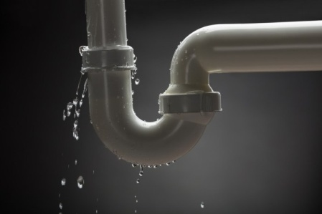
Fig:4.1 :- syphon
A Life Cycle Inventory of residential plumbing systems done in 2011 showed that CPVC systems demonstrate 5% less energy waste than PEX systems and 17% less than copper. This study also indicated that CPVC systems wanted 30% less water than copper and 15% less than a PEX system. These numbers are likely due to the differences in thermal conductivity between these materials.
Copper has a thermal conductivity that is hundreds of times higher than plastics. PEX materials are the least thermal conductive of the three tested and this is why it is better in conserving water and energy.
Sustainability
While environmental performance is important, people can still be concerned about the sustainability of their home. The use of proper plumbing materials when building a home can greatly affect the future sustainability of the home, which can also affect future costs and bills.
A relatively new factor in plumbing, eco-friendly pipe materials can reduce both energy costs, and the overall environmental footprint of your home. These materials are not as widely available due to their recent introduction to the industry, but an understanding of the benefits of each can help save both money and the environment later down the line.

Environment-Friendly Materials
The two most common types of piping material in use today are metals like iron and copper, and PVC piping. Of the two, metal piping is more environmentally friendly and sustainable, but not without drawbacks.
PVC piping however, is notorious for low sustainability, contaminating water with chemicals, and increased waste or “Grey water”. While PVC is recyclable, the process is expensive and not in high demand due to the cheap price of fresh PVC.
Metal piping however, has a longer lifespan with less chance of deterioration and no harmful chemical waste that could contaminate your water and potentially harm you or your family. Metal piping is susceptible to corrosion however, usually after a long fifty year lifespan.
The best alternative to these two piping is relatively new eco-friendly plastics like the ones mentioned earlier. Polyethylene and polypropylene are the two main ingredients in these pipes which are recognized by Greenpeace, an environmental organization, to be the only “future-friendly” piping material on the market.
Waste Management Requirement
Management of building-related waste is expensive and often presents unintended consequences. However, common sense suggests that failure to reduce, reuse and recycle societal wastes is unsustainable. It stands to reason that efficient and effective elimination and minimization of waste, and reuse of materials are essential aspects of design and construction activity. Creativity, persistence, knowledge of available markets and businesses, and understanding of applicable regulations are important skills for design and construction professionals.

Process of Waste Management
Job site Sorting
Efficient identification and sorting of materials is an important factor in managing the economic viability of diverting construction debris from disposal. Job site protocols are identified in contracts and subcontracts, and implemented at the project level by superintendents and project managers. Superintendents and project managers utilize project specifications prepared by architects and engineers for information on diversion target rates, and general performance requirements. Building owners and contractors may have corporate guidelines and policies which improve upon project specific requirements. Materials may be sorted into a number of containers provided by service companies that specialize in management of specific types of waste at the job site. Generally the least number of containers is desirable both to keep container volumes high to reduce transportation trips and costs, and to keep the job site clear of obstructions.
Collection and Hauling
Containers containing construction and demolition waste are collected and transported to diversion facilities via truck. Light and medium duty trucks are most commonly used for this purpose in the US and Canada. Trucks and containers of various types are mated to allow for maneuverability and modular interoperability.

Tipping
Identification of loads on arrival at construction and demolition debris diversion facilities is an important step in ensuring materials are appropriately handled. Facility management plans typically describe materials that can be accepted. Loads which contain materials that are not accepted may be turned away, in which case the materials likely will be disposed in a sanitary landfill. The four hazardous waste characteristics are: corrosivity, ignitability, reactivity, and toxicity.

Picking
Materials are typically handled with equipment specifically designed to support heavy loads and resist abrasion. Materials are discharged from containers onto a tipping or receiving floor, usually beneath a roof cover or inside an industrial building. Once on the floor, a wheel loader operator will stockpile materials which will be picked through with a hydraulic excavator or a grapple. Materials such as steel reinforcing bar, carpeting, large pieces of wood, concrete and materials with dimensions greater than 3 feet are usually picked before the sorting process can begin in earnest.

Sorting
Sorting generally involves loading materials onto an inclined metal belt—a chain belt—and passed across a manual sort line consisting of a flexible rubber belt and integral sort stations providing a place for several workers to stand, usually opposite from one another down the length of the belt. Materials are identified, grabbed, and deposited in vertical openings at each sort station. The effectiveness of the manual sort line is largely determined by the performance of the picking operation which precedes it; for example large materials on the belt can be difficult to manage and or obstruct recoverable materials passing by on the belt beneath.

Containerization and Transport
Picked and sorted materials are deposited by means of equipment and manual labor into industrial containers of various types. Combination compactor-balers are used in some applications to produce dense bales of materials which are then loaded into intermodal shipping containers for transport. Heavy interstate trucks are an important part of the transportation system. Containers of all types are destined for transport locally, regionally, nationally and internationally via road, rail, or barge via inter modal facilities such as rail yards and ports. Once containerized, recyclable materials are commoditized and traded in the global marketplace.

Diversion or Disposal
Diverted materials are destined for incorporation in new products as recycled material, or are processed for reuse. Materials destined for disposal in landfills include refuse, materials contaminated with waste or which have been ruined, and materials for which markets do not exist.

Selecting, checking tools and equipment. for handling materials
Material handling equipment is any tool used to aid in the movement, protection, storage, and control of materials and products. The equipment used to do so can be broken down into four main categories. Each category has a wide variety of useful equipment that makes safely moving heavy materials or large volumes of materials easier.
Storage and Handling Equipment
The title of this equipment category is pretty self-explanatory. Storage equipment is used to hold materials while they wait to be transported from the manufacturer or wholesaler to their final destination. Having the right storage equipment can increase efficiency on the production floor and maximize space utilization- two very important factors in any production environment.
Examples of storage and handling equipment include:
• Racks: such as pallet racks, drive-through or drive-in racks, push-back racks, and sliding racks
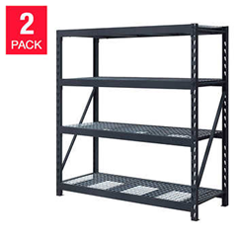
Fig 5.1 Racks
• Stacking frames: these are interlocking units that enable stacking of a load so crushing doesn’t occur
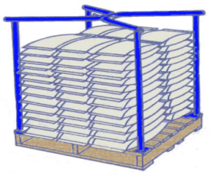
Fig : 5.2 Stacking frames

Bins and drawers
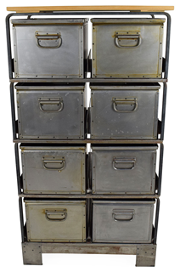
Fig : 5.3 Bins and drawers
• Mezzanines: elevated floor systems that are installed between the production floor and ceiling in order to provide additional storage space. Most of these structures can be dismantled and moved with ease.
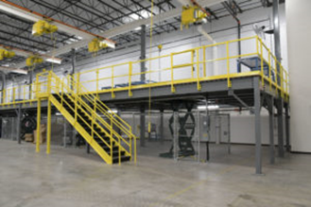
Fig : 5.4 Mezzanines
Engineered Systems
This type of material handling equipment are typically automated units that work together to enable efficient storage and transportation of large materials or large volumes of materials around the production floor. Examples of engineered systems include:

• AS/RS: Automated Storage and Retrieval Systems (abbreviated as AS/RS) are large automated structures that involves racks, aisles and shelves that are accessible by a type of mechanized shuttle system (like a cherry picker) for the quick retrieval of items.
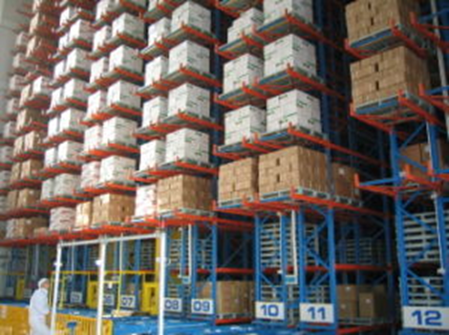
Fig : 5.5 Automated Storage and Retrieval Systems
• Conveyor systems: Automated conveyor systems carry heavy materials to specified destinations using belts, flexible chain, or live rollers. It is a highly efficient equipment to move large volumes of material quickly.
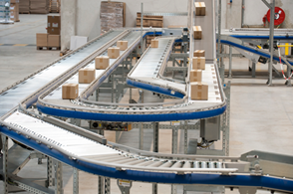
Fig : 5.6 Conveyor systems

These automated systems are ideal for moving products on an assembly line or transporting goods throughout a plant or warehouse.
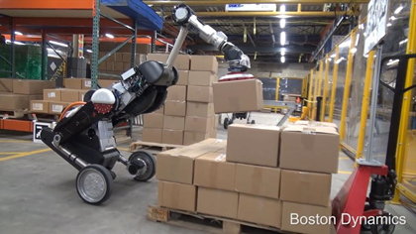
Fig :5.7 :-Robotic delivery systems
Automatic guided vehicles– These vehicles are mobile robots that follow specific markers or wires in the floor to move large materials around a manufacturing facility or warehouse. Vision, magnets, or lasers can also be used as methods for AGV navigation.
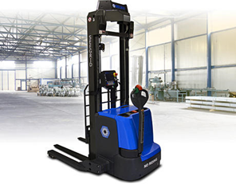
Fig: 5.8 :-Automatic guided vehicles

Industrial Trucks
Powered industrial trucks, such as forklifts, are used to move large materials or large quantities of materials around the manufacturing floor. They are also utilized to efficiently load (or unload) heavy objects onto delivery trucks. Industrial trucks are very useful when there is insufficient flow volume to justify the implementation of a conveyor system. Examples of industrial trucks include:
• Hand trucks– Also known as a dolly, or box cart. Hand trucks are l-shaped box-moving handcarts with handles at one end, wheels at the base, and a ledge to set objects on.
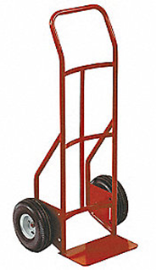
Fig: 5.9:-Hand trucks
• Pallet trucks– Manual operated or powered industrial forklifts.
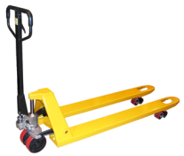
Fig:5.10 Pallet trucks

• Walking stacker– A pedestrian walk-behind stacker with a mast for lifting pallets to heights.These are similar to a two wheeled dolly, but with an extended deck.
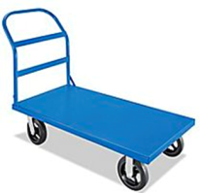
Fig:5.10:- Platform trucks

• Order picker An electric lift truck specifically designed for filling individual customer orders. This requires piece-part picking rather than selecting full pallets or unit loads.

Fig:5.11:- Order picker

• Side loader– Automated tool similar to a fork lift that loads and unloads from the side of the machine rather than the front.
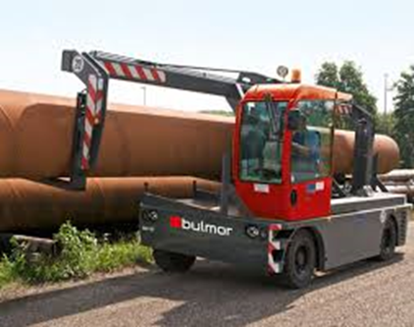
Fig::-5.12 Side loader
Bulk Material Handling Equipment
Equipment that deals with bulk handling aids in the control and transportation of large volumes of material either in bulk or loose form. In general the equipment is used to move loose parts from one area of the production floor to another. Drums and hoppers can also be used to funnel loose items so they can be easily manipulated or packaged. Bulk Material Handling Systems can also utilize conveyor belts for horizontal transportation and elevators for vertical transportation. Examples of bulk material handling equipment are:
• Conveyor belts
• Stackers– Similar to forklifts, stackers help to lift and stack heavy loads on the dock or in the warehouse.
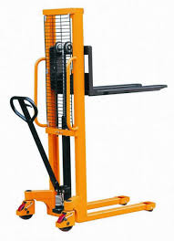
Fig::-5.13 Stackers

• Reclaimers– These are large machines used to recover bulk materials from a stockpile.
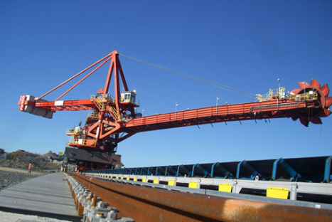
Fig::-5.13 Reclaimers
• Bucket elevators– Also known as a grain leg. These elevators haul flow able bulk materials vertically.
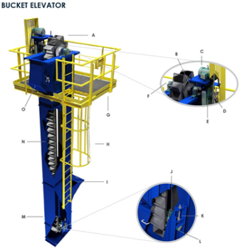
Fig:-5.13 Bucket elevators

• Grain elevators– This type of equipment is used to store and move grain and other similar materials throughout a production pathway.
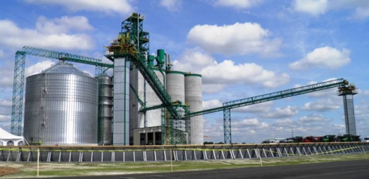
Fig:-5.13Grain elevators
• Hoppers– Hoppers are a container for bulk material such as grain, that tapers and discharges it’s materials at the bottom.
• Silos– A tower used to store grain and other materials such as coal, sawdust, wood chips, and food products.

Determining install and maintain device.
6.1 Installing and maintaining Run-off devices
Run-off devices is a device which is commonly and repeatedly used for the specific type of work. there for here we will see the installation and maintenance of run-off devices in plumbing installations as follow.
Gate valves
- The gates valves installation location, the height and the directions of inlet and outlet must accord to design requirements, and the connection should be tight and strong.
- All kinds of hand valves installed on insulation pipeline, the handles should not downwards.
- Before installation, outlook check is necessary, the gate valve nameplate should according to the national standards. When the working pressure exceed 1.0 MPa or the gate valve used for cutting off on main pipe, you must do strength and sealing performance test before installation.
- The hand wheel, handle and drive mechanism can not use for lifting, and forbidden to collision.
- The installation of gate valve with drive mechanism should strictly accord the operation instruction.
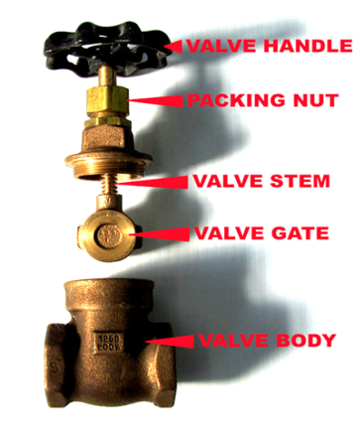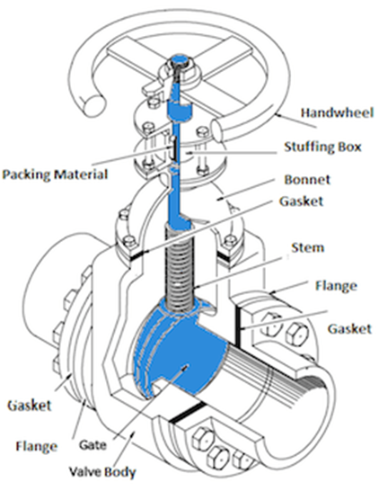
Fig:6.1 Gate valve

Mixer Tap
Mixer Tap Repairs. This easy DIY guide explains how to go about repairing a mixer tap. We show you how to repair a dripping mixer tap or a leaking mixer tap in your kitchen or bathroom. There are different ways to dismantle a mixer tap, and we show you fix some of the most common styles.
Mixer taps comprise of three separate areas when it comes to repair. The individual water controls (hot and cold) on either side are repaired and serviced as individual taps and repair information for leaks and failure here can be found in our repairing a dripping tap project. When it comes to repairing a mixer tap, the spout is the weak link and can sometimes leak at the base. This can be repaired quite easily and details are covered below

Step 1 Remove The Mixer Spout From The Tap
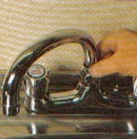
Fig 6.2 Mixer Tap Nozzle

Step 2 replace the seal at the base of the spout
The first two mentioned above have normally got a seal ring within the base. This seal ring, over time, will wear and cause leaks, usually from the base of the spout.
As you may imagine from the above, to resolve any leaks of this kind you will need to replace the seal ring. Once you have removed the spout, look down inside the neck and locate the seal ring. In some cases you will be able to hook the seal out with your finger but if you are unable to use a small flat edge screwdriver to hook the seal out.
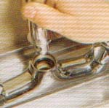
Fig 6.2 Removing Mixer Spout
Step 3 replace the old seal with a new one
Depending on the make and model of your mixer tap will in some cases depend on the size of replacement seal ring you will need to use. The quickest and easiest way to get an exact match replacement is to keep the old one and take a trip down to your local plumbers merchants and ask them for an exact replacement or a plumbers repair kit (seen below).
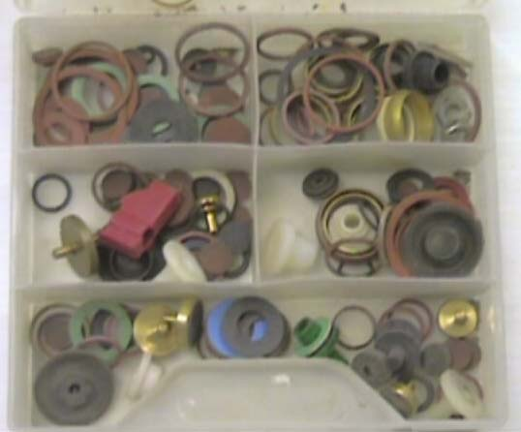
Fig: 6.3 Kitchen Tap Valve
Step 1
Make sure to turn OFF the hot and cold water supply to the Tap.
Step 2
With a lot of Kitchen Taps the hot and cold indicators on the handles can be “popped” off with a screwdriver or unscrewed by hand. Here is a more detailed blog too How to remove the Handle on your Kitchen Tap.
Note: We would strongly recommend trying first with something small e.g very small glasses type screwdriver or your finger nail to avoid scratching the surface finish of your Kitchen Tap.
When these are removed you will be able to see a small brass screw in the centre of the handle. Unscrew this and you should be able to remove the handle. Where there is no indicator to pop off: check UNDERNEATH the handle as often the screw is there instead.

Fig: 6.4 Removing Indicator from Tap Handle to access screw underneath.

Fig 6.5 Removing Handle by Loosening the grub screw underneath with an Allen Key

Step 3
When the handle is removed there may still be a shroud (valve cover) covering the valve. This can be removed by either twisting off anti-clockwise OR there maybe a grub screw on the underside of this cover which you will remove with an Allen key. Then the valve should be exposed. Also here is a more detailed blog How to remove the handle on your Kitchen Tap.

Fig: 6.6 Shroud still covering the Valve which also needs to be removed.

Fig :6.7 Twisting off Shroud covering the valve (or remove if there is a grub screw underneath that you will loosen with Allen Key).

Fig : 6.8. Shroud removed exposing Valve.

Perrin & Rowe recommend for their taps / Franke Triflow models: If you cannot remove the hood (shroud) that covers the valve due to build up of limescale – try soaking it for max 30 mins at a time in a solution of 50% lemon juice and 50% water. You can repeat this as often as required provided that in between you completely wash away the solution.
Step 4
You screw a valve out ‘anti-clockwise’ – which means on a standard 2 lever tap where you pull both levers towards you to turn on, and push back up to turn off (and hot on the left and cold on the right – on the hot side you have to push away from you i.e. towards the wall behind the tap, and for the cold side to loosen the valve you would have to pull towards you and downwards to loosen the valve . [Note, to screw in a valve it goes in ‘clockwise’ which is the reverse of what you do to loosen the valves]. As you loosen the Valve some water may start to ‘seep’ out. Don’t panic. It’s just some water left in the tap chamber (P.S. some taps have a brass bush that surrounds the Valve and it may come out with it.
If this happens you can order a brass bush from our Taps spares section on our store or email me directly. Here is our guide to removing a Brass Bush Removing Brass Bush Ring from Valve


Fig: 6.9 Remove Valve with adjustable Spanner (gripping the Nut underneath the Splines)

Fig :6.10 Example of Valve stuck inside Brass Bush
Step 5
Replace the old Valve with your new Valve and tighten it into the body of the kitchen tap (You don’t have to over tighten).
Step 6
Then all you have to do is replace the handle, re-tighten the small brass screw and replace your indicator.
Step 7
Turn your mains water b0ack on.

Water Meter
In this instruct able we will try to see how to install a home water meter. In this case i decide to install a water meter because the payment fixed fee it´s very expensive according to usage.
Step 1: Materials

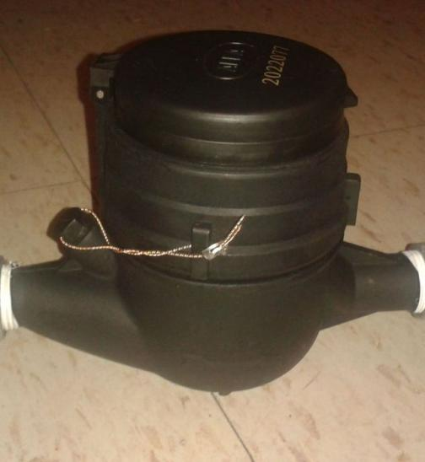
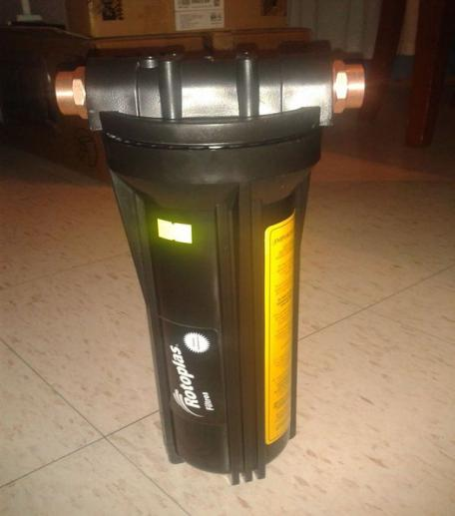
Fig: 6.11 Water meter

You need this material:
- A water meter (of course!) in mi case a 3/4 new generation polymer home water meter.
- 1st step water filter (this can be removed) but i considered usefull.
- 2 3/4 galvanized union nut. (it can be copper but it´s more expensive)
- 2 3/4 copper elbows.
- 1 3/4 copper elbow with rope.
- 4 3/4 copper weldable coupling. If you removed water filter only use 2.
- 3/4 copper tuber. The quantity that you need.
- Teflon tape.
- Anti-seize can
- Blowtorch, welding and solder paste.
Step 2: Preparing the Parts
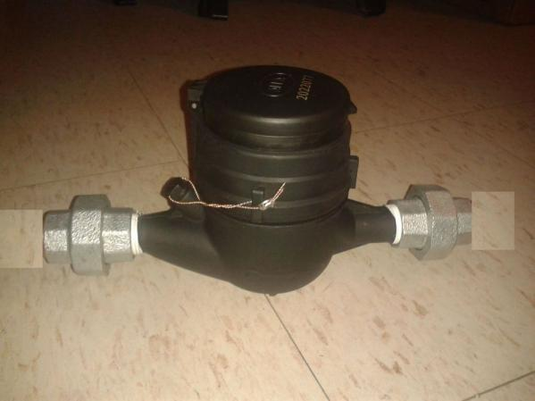
Fig :-6.12 Water meter part

Joint union nut to water meter one each side using Teflon tape. Maybe you need to use a parrot key or stillborn wrench.
Joint approximately a half of the thread.
Step 3: Examining and Measuring
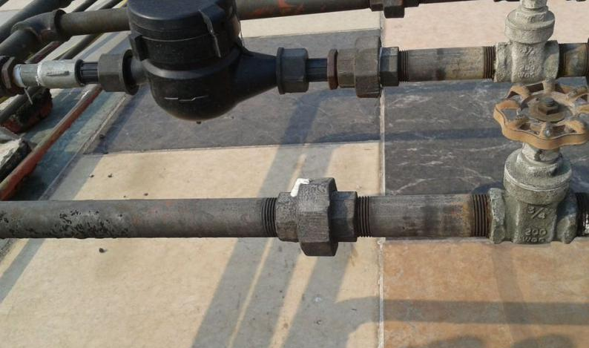
Fig: 6.13 Examining and Measuring
- We need to see how the situation it´s going to be. In this case i eliminate all the galvanized tube after stopcock to the copper tube.
- I sprayed a bit of anti-seize in all the junctions. DONT FORGET CLOSE THE STOPCOCK.
- After that i used parrot key and stillborn wrench to remove all the tubes that i don´t need.
- I proceeded to weld the elbows, coupling and put it together with the water meter.
- You need to bee very carefully in this step because you need to consider the order placement.
- First i put the copper elbow with rope then weld the copper tube, the elbows and the coupling.
- Joint the water meter to the coupling using the union nut. In the other side the union nut to the coupling and the elbow.
- Ending with the union between the two cooper coupling.

Step 4: Well Done
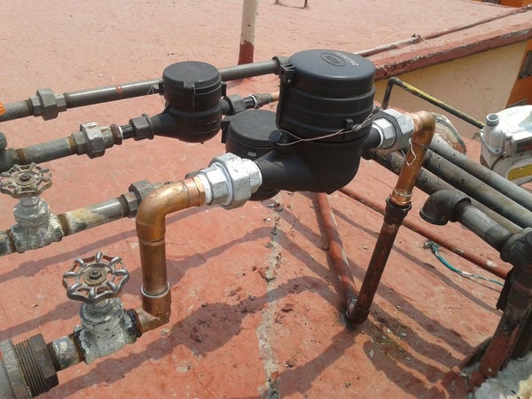
Fig: 6.14 Well Done
- If everything it´s OK it´s look´s like the pictures above.
- The final step it´s test it opening the stopcock and let the water run.
- I hope it´s understandable and useful.

Locating and interpreting plumbing materials

.Introduction
A Material Safety Data Sheet (MSDS) provides basic information on a material or chemical product. A MSDS describes the properties and potential hazards of the material, how to use it safely, and what to do in an emergency. The purpose of this document is to assist employees in understanding and interpreting this type of information.
the types of information may be in a different order and under slightly different headings.

1. Product and Company Identification
The product identifier (normally the product name) appears both on the MSDS and on the WHMIS label. To locate the correct MSDS, always use the product identifier, not a shortened name that may be used at your workplace. Check that the name of the manufacturer and/or supplier matches the label as well. The MSDS and label may also display other identification, such as a product code or catalog number.

2. Hazards Identification
The Hazards Identification section describes the ways you may be exposed to the material and the harmful health effects it can have. Effects observed in experimental animals may be included, if they are considered relevant to people.

Emergency Overview
The material’s appearance (e.g. colour, physical form, odour) and the most significant immediate concerns, including fire, reactivity and health and environmental hazards are described in this subsection.

Regulatory Status
Information on the regulatory status of the material under the Controlled Products Regulations (WHMIS) and/or the US Hazard Communication Standard may be included in this subsection.

Potential Health Effects
The possible routes of exposure are skin contact, eye contact, inhalation (respiratory system), and ingestion (swallowing). How important each route of entry is for a particular material depends on many factors, such as the physical properties of the material and how it is used.
Effects of Acute Exposure to Product
An acute exposure is one that takes place over a short period of time (minutes, hours or days). Health effects caused by an acute exposure are usually seen at the time of exposure. Sometimes, they may not appear for several hours or even days after an exposure.
Effects of Chronic Exposure to Product
A chronic exposure is a long-term exposure (months or years). Chronic exposures may be described as prolonged, meaning very long, or repeated, meaning many exposures. Any illness related to a chronic exposure may develop very slowly or may not appear until many years after the exposure has stopped.

Irritancy of Product
Some products can cause irritation (reversible reddening, swelling and pain) if they come into direct contact with the skin, eyes or respiratory tract (nose, breathing airways and lungs).

Sensitization to Product
Sensitization is the development, over time, of an allergic reaction to a chemical. Sensitizers may cause a mild response on the first few exposures but, as the sensitivity develops, the response becomes worse with subsequent exposures. Eventually, even short exposures to low concentrations can cause a very severe reaction.

Carcinogenicity
Materials are identified as The lists of carcinogens published by these organizations include known human carcinogens and some materials which cause cancer in animal experiments. Certain chemicals may be listed as suspect or possible carcinogens if the evidence is limited or inconclusive.

Reproductive Toxicity
Eproductive toxicity includes effects on the reproductive process of adult males and/or females. Possible reproductive effects include reduced fertility and menstrual changes.

Teratogenicity and Embryotoxicity
A teratogen is a substance that can cause birth defects. An embryotoxin is a substance which can cause toxic effect on the developing embryo. Both teratogenicity and embryotoxicity result from a harmful effect on the embryo or the developing fetus during pregnancy.

Mutagenicity
A mutagen is a substance that can cause changes (mutations) in the DNA of cells. DNA determines the characteristics that children inherit from their parents and also determines how cells in the body divide or reproduce. Mutagenicity is the ability of a substance to cause mutations.

Toxicologically Synergistic Products
Synergism means that exposure to more than one chemical over the same period of time can result in health effects greater than expected when the effects of exposure to each chemical are added together.

Potential Environmental Effects
this subsection describes the potential effects of the material if it is released into the environment, for example whether it will harm fish or wildlife or accumulate in the environment.

Self check-1
Test I: T/F
Instruction: T/F
- Metal piping has a longer lifespan with less chance of deterioration and no harmful chemical waste
- Metal piping is more environmentally friendly and sustainable material
- Handling Equipment are used to makes safely moving heavy materials or large volumes of materials easier.
- Sufficient lighting is required to allow safe movement around the workplace and to allow workers to perform their job.
- Workplace is Not to be adequately ventilated which includes provision of fresh, clean air drawn from outside the workplace.
Test II: short Answer writing
Instruction: write short answer for the given question. You are provided 1 minute for each question and each point has 3Points.
- Write abbreviation of ISO
- What are the steps in Process Quality Assurance
- What type of PPE used during the work in an environment with high sound levels?
- Write abbreviation of PPE
- List down at lest 5 PPE
Test II: short Answer writing
Directions: Answer all the questions listed below.Time allotted for each item is 1mniut and each question carry 2 point.
- _______Is defined as the process of assessing the risks associated with each of the hazards identified so the nature of the risk can be understood.
- ______ Taking actions to eliminate health and safety risks so far as is reasonably practicable.

Operation sheet 1
OPERATION TITLE: - • Adjust Water Meter
PURPOSE: - To Adjust Water meter in accordance with all appropriate standards, include all landscape demands.
PROCEDURE,
- Secure work site manuals, Specifications, and tools and equipment;
- Prepare the workstations for selecting tools and equipment
- Identify type of Water meter
- Assemble All parts correctly
- Test the adjustment is correct

Lap Test-1
Instructions: Given necessary templates /guide, tools and materials you are required to perform the following tasks within 1:00 hours.
Task 1. Materials
Task 2. Preparing the Parts
Task 3. Examining and Measuring
Task 4. Check Well the Adjustment

Unit TWO: Identify hazard and risk control information and measures.
This unit is developed to provide you the necessary information regarding the following content coverage and topics:
- Recognizing and reporting hazards.
- Identifying procedures, instructions and information.
- Adhering hazards and risks.
- Dealing and adhering accidents, fires and emergencies.
This unit will also assist you to attain the learning outcomes stated in the cover page. Specifically, upon completion of this learning guide, you will be able to:

- Recogniz and report hazards.
- Identify procedures, instructions and information.
- Adhere hazards and risks.
- Adher accidents, fires and emergencies.

2.1 Recogniz and report hazards.

Definition
A hazard is any object, situation, or behavior that has the potential to cause injury, ill health, or damage to property or the environment.
Health and safety hazards exist in every workplace. Some are easily identified and corrected, while others are necessary risks of the job and must be managed in other ways (for instance, by using protective equipment).
Most occupational hazards are inactive or have a low potential of actually occurring; however, employers must be prepared to deal with them since a hazard becoming active can generate an emergency situation.
Hazards can be classified as:
- Physical Hazards: These are the most common hazards and they include extremes of temperature, ionizing or non-ionizing radiation, excessive noise, electrical exposure, working from heights, and unguarded machinery.
- Mechanical Hazards: These are usually created by machinery, often with protruding and moving parts.
- Chemical Hazards: These appear when a worker is exposed to chemicals in the workplace. Some are safer than others, but for workers who are more sensitive to chemicals, even common solutions can cause illness, skin irritation, or breathing problems.
- Biological Hazards: These include the viruses, bacteria, fungus, parasites, and any living organism that can infect or transmit diseases to human beings.
- Ergonomic Hazards: Including considerations of the total physiological demands of the job upon the worker, even beyond productivity, health, and safety.
- Psycho-social Hazards: These may arise from a variety of psychosocial factors that workers may find to be unsatisfactory, frustrating, or demoralizing.

Hazard Reporting Systems
Hazard reporting systems are very common among most industries focusing on improving either safety, compliance or quality. When managers design their hazard reporting system, they must ask themselves:

Templates for Hazard Reporting Forms
Hazard reporting forms must be designed with the end user in mind. When a hazard reporting form is too long or is not easily available, then management is less likely to receive many reports. There must be a fine line between asking the right questions and making the hazard report form too labor intensive.
Reporting form templates are useful to system designers to ask the right questions. Templates are:
- Easy to find and use;
- Useful to get the first reporting form draft started;
- Based on best industry practices; and
- A great source for inspiration.

Hazard Report Form
Name: | Date:
Location:
Equipment:
Description of the hazard:

Suggested corrective action:
Signature:
Supervisor's remarks:
Corrective action taken:
Signature of Supervisor: | Date:

2.2 Identify procedures, instructions and information.
2.2 Hazard Identification:
This is the process of examining each work area and work task for the purpose of identifying all the hazards which are “inherent in the job”. Work areas include but are not limited to machine workshops, laboratories, office areas, agricultural and horticultural environments, stores and transport, maintenance and grounds, reprographics, and lecture theatres and teaching spaces. Tasks can include (but may not be limited to) using screen based equipment, audio and visual equipment, industrial equipment, hazardous substances and/or teaching/dealing with people, driving a vehicle, dealing with emergency situations, construction. This process is about finding what could cause harm in work task or area.
Risk: The likelihood, or possibility, that harm (injury, illness, death, damage etc) may occur from exposure to a hazard.
Risk Assessment: Is defined as the process of assessing the risks associated with each of the hazards identified so the nature of the risk can be understood. This includes the nature of the harm that may result from the hazard, the severity of that harm and the likelihood of this occurring.
Risk Control: Taking actions to eliminate health and safety risks so far as is reasonably practicable. Where risks cannot be eliminated, then implementation of control measures is required, to minimize risks so far as is reasonably practicable. A hierarchy of controls has been developed and is described below to assist in selection of the most appropriate risk control measure/s.
Monitoring and Review: This involves ongoing monitoring of the hazards identified, risks assessed and risk control processes and reviewing them to make sure they are working effectively.
Risk Assessment Procedure
The risk assessment procedure can best be illustrated in the following way.
Step 1: Identify Hazards
WHS legislation in New South Wales requires that PCBUs, in consultation with workers identify all potentially hazardous things or situations that may cause harm. In general, hazards are likely to be found in the following;
- Physical work environment,
- Equipment, materials or substances used,
- Work tasks and how they are performed,
- Work design and management
In order to identify hazards the following are recommended:
- Past incidents/accidents are examined to see what happened and whether the incident/accident could occur again.
- Employees be consulted to find out what they consider are safety issues, I.e. ask workers about hazards near misses they have encountered as part of their work. Sometimes a survey or questionnaire can assist workers to provide information about workplace hazards.
- Work areas or work sites be inspected or examined to find out what is happening now. Identified hazards should be documented to allow further action. The work environment, tool and equipment as well as tasks and procedures should be examined for risks to WHS.
- Information about equipment (e.g. plant, operating instructions) and Material Safety Data Sheets be reviewed to determine relevant safety precautions.
- Welcome creative thinking about what could go wrong takes place, i.e. what hazardous event could take place here?

Step 2: Assess Risks
Risk assessment involves considering the possible results of someone being exposed to a hazard and the likelihood of this occurring. A risk assessment assists in determining:
- How severe a risk is
- Whether existing control measures are effective
- What action should be taken to control a risk
- How urgently action needs to be taken.
Factors that A risk assessment should include:
- Identify may be contributing to the risk,
- Review health and safety information that is reasonably available from an authoritative source and is relevant to the particular hazard,
- Evaluation of how severe the harm could be.This includes looking at the types of injuries/illnesses/harm/damage that can result from the hazard, the number of people exposed, possible chain effects from exposure to this hazard.
- Evaluation of how a hazard may cause harm.This includes examining how work is completed, whether existing control measures are in place and whether they control the harm, looking at infrequent/abnormal situations as well as standard operating situations. A chain of events related to a risk may need to be considered.
- Determining the likelihood of harm occurring. The level of risk will increase as the likelihood of harm and its severity increases. The likelihood of harm occurring may be affected by how often the task is completed, in what conditions, how many people are exposed to the hazard and for what duration.
- Identify the actions necessary to eliminate or control the risk; and
- Identify records that it is necessary to keep to ensure that the risks are eliminated or controlled.

Step 3: Controlling Risks
Once a risk rating is determined, each hazard must have its existing risk control measures evaluated using the Evaluation of Control Effectiveness Table. This allows for determination of any additional requirement necessary.
Step 4: Implement additional risk controls
Having identified the hazards in your workplace, assessed their risks and reviewed the existing controls, all hazards must be managed before people are hurt, become ill or there is damage to plant, property or the environment.
The management of risks in the workplace requires eliminating risks so far as reasonably practicable in the first instance. Where elimination is not possible, then risks should be minimized, so far as reasonably practicable.
All hazards that have been assessed should be dealt with in order of priority. The most effective control option/s should be selected to eliminate or minimize risks.
The Hierarchy of Controls (see diagram below) ranks control options from highest level of protection and reliability to lowest. This should be used to determine the most effective control/s.

2.3 Adhere hazards and risks.

Drivers involved in minor accidents with no serious injuries should move cars to the side of the road and out of the way of oncoming traffic. Leaving cars parked in the middle of the road or busy intersection can result in additional accidents and injuries. If a car cannot be moved, drivers and passengers should remain in the cars with seat belts fastened for everyone's safety until help arrives. Make sure to turn on hazard lights and set out cones, flares or warning triangles if possible.

Exchange Information
After the accident, exchange the following information: name, address, phone number, insurance company, policy number, driver license number and license plate number for the driver and the owner of each vehicle. If the driver's name is different from the name of the insured, establish what the relationship is and take down the name and address for each individual. Also make a written description of each car, including year, make, model and color and the exact location of the collision and how it happened.

Photograph and Document the Accident
Use your camera to document the damage to all the vehicles. Keep in mind that you want your photos to show the overall context of the accident so that you can make your case to a claims adjuster. If there were witnesses, try to get their contact information; they may be able to help you if the other drivers dispute your version of what happened. Call the Police to File an Accident Report

2.4 Dealiand adhering accidents, fires and emergencies.
Even if the accident was not serious, or there was minimal damage, call the police to ensure that the accident is thoroughly investigated and that all parties’ interests are protected. If the accident was minor, you and the other drivers may decide to handle the damages yourselves without the involvement of an insurance company or the police. But this is not a good idea, for several reasons:
While the other driver may agree to pay for the damage to your car on the day of the accident, they may see the repair bills and decide it's too high. At this point, time has passed and your insurance company will have more difficulty piecing together the evidence if you file a claim.
Also, keep in mind that you have no way of knowing whether another driver will change their mind and report the accident to their insurance company. They may even claim injuries that weren't apparent at the scene of the accident. This means that your insurance company may end up paying a hefty settlement or worse yet, you could be dragged into a lawsuit.
Additionally, without the assistance of the police you have no way of knowing if the information the other driver is providing you is accurate. You may be getting a false name, false contact information or false insurance information

What to Put on the Report
- Date, time, and location of accident
- Your driver's license, registration, and insurance information
- Other driver's license, registration, and insurance information
- A description of what happened to include your direction of travel, other driver's direction of travel, whether the accident happened at an intersection or mid-block, and location of damage on the vehicles. (Example: "I was going west on Main Street in the right lane through the intersection of Parker Road. The other car came from my right on Parker Road and hit the passenger side front door with its driver's side front end.")
- Name, address, and phone number of any passengers in your car
- Name, address, and phone number of any witnesses

Fire procedure Red notices are fitted alongside all fire alarm points and detail the action to be taken in case of fire. These instructions are repeated below:

On discovering a fire Operate the nearest fire alarm point.

Ensure that the Fire Brigade is called by dialing XXX on the internal phone, It is important to state the address of the fire Attempt to extinguish the fire with the nearest suitable fire appliance. Do not attempt to control the fire if it has reached such proportions as to endanger life or escape, but immediately proceed to the assembly point.

On hearing the alarm
- Close all doors and windows, switch off all non-essential services.
- Proceed to the nearest assembly point:

Know
- Your nearest means of escape (Guides should brief their visitors on the point)
- The nearest fire alarm point
- The nearest fire appliance and how to use it
- The assembly point (Guides should brief their visitors on the point)

In the event of a fire
- Maintain silence
- Do not rush or panic
- Do not attempt to pass others
- Do not use the lift
- Remember to call the Fire Brigade

Evacuation

On hearing the bells, staff should:
- close all doors and windows;
- switch off all non essential services;
- proceed to the assembly point outside the building as instructed on the 'Action in Case of Fire' notices alongside the 'break glass' fire alarm points;
- proceed swiftly yet without running;
- Not use the lifts must in case the fire should have adversely affected the lifts themselves or their power supplies;
- Not return to the building until the person in charge of the evacuation has given permission. They will have taken advice from the Police or Fire Services as appropriate. In cases where the period of evacuation is likely to be long, staff may be advised to return home.
Essential personal belongings e.g. car keys, wallets, handbags should be collected up and carried on one's person in case the evacuation is prolonged but not if it is to be at the expense of a quick and orderly exit.
Staff who have control of students or visitors are responsible for ensuring that those people have evacuated the building and are in a place of safety and report that fact to the person in charge of the incident.

Disabilities
Where staff, students or visitors with disabilities, which may make evacuation difficult or impossible by normal means, are present in the building, this must be considered in the fire risk assessment for that building.
Where such persons regularly visit another building or department e.g. to attend lectures, then the 'parent' department must ensure that the visited building is aware of the disabled person's presence.

Self check-
Test I: T/F

Instruction: T/F
- Accidents, fires and emergencies report are include: date, time, and location of accident
- A hazard is any object, situation, or behavior that has the potential to cause injury, ill health, or damage to property or the environment.
- Chemical hazards is appear when a worker is exposed to chemicals
Test II: short Answer writing
Instruction: write short answer for the given question. You are provided 1 minute for each question and each point has 3Points.
- Write Accident procedure?
- What should I do if I notice a hazard?
- Write at least three (3) Hazard classification?

- _______Is defined as the process of assessing the risks associated with each of the hazards identified so the nature of the risk can be understood.

- ______ Taking actions to eliminate health and safety risks so far as is reasonably practicable.

Unit 3: Handle, sort and stack materials.
This unit is developed to provide you the necessary information regarding the following content coverage and topics:
- Identifying and selecting Materials.
- Identifying and applying techniques.
- Handling materials.
- Handling non-hazardous materials and chemicals.
- Protecting materials.
- Erecting signage and barricades.
- Identifying and handling hazardous material.
- Minimizing health risk.
This unit will also assist you to attain the learning outcomes stated in the cover page. Specifically, upon completion of this learning guide, you will be able to:
- Identify and Select Materials
- Identify and applying techniques.
- Handle materials.
- Handle non-hazardous materials and chemicals.
- Protect materials.
- Erecti signage and barricades.
- Identify and handling hazardous material.
- Minimiz health risk.

3.1 Identifying and Selecting of Plumbing Materials
Types & Uses of Plumbing Materials
  - Pipes
The selection of a particular material will depend upon the purpose of a pipeline, character of water to be conveyed, nature of the ground in which pipes are to be laid and the cost of each class of pipe.
Types of pipes
- Galvanized iron pipes
- Cast iron pipes
- Steel pipes
- Copper pipes
- Plastic pipes
- Reinforced concrete pipes
- Galvanized pipes of steel or wrought iron
Are widely used for distribution systems and give service where the water is hard, And where exposed to corrosive conditions such as the presence of seawater. It is manufactured in sizes of from 8mm to 100mm(15mm to 65mm are common) diameter. Approximate weight and thickness of medium grade GI water pipes per meter length.
Nominal size in mm | 1/2” 5/8” ¾” 1” 11/4” 11/2” 2” 21/2” 3” 4”
Nominal size in mm | 10 15 20 25 32 40 50 65 80 100
Thickness in mm | 2.35 2.65 2.65 3.25 3.25 3.25 3.65 3.65 4.05 4.50
Weight in kg/m | 0.85 1.21 1.57 2.42 3.11 3.59 5.07 6.49 8.43 12.0
Tabel: 3.1 sizes Galvanized pipes

Cast iron pipes
Are suitable for water supply pipes of moderate diameter and where frequent branches are required. The most extensively used for water mains as they are known to have good durability (are not subjected to corrosion), good strength, low cost of maintenance, and can be easily tapped for making service connections.
Cast iron pipes are generally suitable for working pressure of up to 130m of vertical head of water, and up to 1000mm diameter.
Cast iron pipes have been standardized in three classes according to the pressure for which the pipes are manufactured. Class LA, Class A & Class B.
Nominal diameter of pipe (mm)3”, 4”, 5”, 6”, 8”, 10”, 12”, 14”, 16”, 18”, 20”, 24”, 28”, 30”, 32”, 36”, 40”
- Steel pipes
Are used for large diameters and high pressures
- Copper pipes
Are generally used for hot water installation and for interior works in small diameter. They have high tensile strength, light weight, easily joined, corrosion resistant and may therefore be of thin walls, which make them comparatively cheap.copper pipes arte easily bent by a machine or spring, they are neat in appearance.
Copper plumbing tube is available in either drawn or annealing tempers. Drawn copper tubing is called “hard copper” (straight 5 to 6 m), while annealed copper is called “soft copper” (straight 5 to 6 m and coils up to 5m with a diameter upto25mm). It is manufactured in the sizes shown here.

Inside diameter /mm | 13 | 19 | 25 | 32 | 40 | 50
Outside diameter /mm | 15 | 21 | 27 | 35 | 44 | 54
Weight meter /kg | 0.360 | 0.530 | 0.695 | 0.950 | 1.120 | 1.370

Tabel: 3.2 size Copper pipes
- Plastic pipes
It is made of synthetic organic chemicals; the basic raw materials are oil, natural gas and coal. The raw materials are made into resins, which are generally classified in two basic groups;
Thermosetting materials: once their shape is fixed and cured, cannot be reformed.
Thermoplastic materials: can be reformed repeatedly by application of heat. Which is mostly used in the manufacture of plastic pipes.
Types of plastic pipe
- Four types of plastic commonly used for plumbing pipes ABS = Acrylonitrile – Butadiene – Styrene
- Black plastic pipe is used to construct sanitary drainage and vent pipe systems, but not water supply system available in diameters of 32mm to 150mm.PVC= Polyvinyl chloride
- Light in color used for waste pipes, drainage and vent pipes available in diameters of 32mm to 150mm.CPVC= Chlorinated – polyvinyl – chloride
- A light gray or cream colored plastic that has been specially developed to withstand high temperatures and high pressure. It is used for cold water supply systems in buildings. Available in 3 to 4 m in 15mm, 20mm, 25mm and 32mm diameter.PE – Plastic Tubes = polyethylene
- A flexible black plastic pipe and is available in 50m coils in 20mm, 25mm, 32mm, 40mm and 50mm diameter. It is used for water supply piping below ground in yard areas (service pipes to buildings)

Reinforced concrete pipes
Are used for water mains carrying moderate pressures

  - PIPE FITTINGS
The term pipe fitting is used to indicate all those fittings that may be attached to water pipes:
- To change the direction of a pipe
- To connect a branch with a main water supply pipe
- To connect two or more pipes of different sizes
- To close pipe ends
There are many different types and sizes of pipe fittings. These various pipe fitting range in size as follows: ½”, ¾”, 1”, 11/4”, 11/2”, 2”, 21/2”, 3”, 4”. The different types of pipe fittings materials are classed as follows:
- Malleable iron(hot and cold water installation)
- Cast iron(heating installation)
- Brass (copper and zinc)
- Copper
- Steel
- Plastic

The different types of pipe fittings are classed as follows:
- Socket – coupling a threaded sleeve is used to connect two pipes. They have internal threads at both ends to fit external threads on pipes.
- Reducing socket a fitting with internal threads is used to connect t two pipes with different diameters.
- Tee- piece a fitting that has one side outlet (branch), at right angles to the run.
- Reducing tee- piece a fitting that has two or three different outlet sizes. When ordering, state the run first 1”, ½”, and ¾”
- Cross a fitting with four branches in pairs each pair on one axis and the axis at right angles.
- Twin or double elbows a pipe fitting with two long radius elbows, each at 900 to the run. All threads are internal.
- Pitcher –tee piece a fitting that has at one side a long radius outlet at right angles to the main run.
- Side outlet elbow an elbow with a third opening, the axis of which is at 900 to the plane of the run.
- Elbow (f + f) a fitting that makes an angle between adjacent pipes. The angle is 900 unless another angle is specified. Both ends have internal (female) threads.
- Elbow (m + f) a fitting that makes an angle between adjacent pipes. The angle is 900 unless another angle is specified with internal thread and external thread.
- Elbow 450 or spring (f + f) a pipe fitting as before, only the angle is 45⁰.both ends have internal (female) threads.
- Elbow 45⁰ or spring (m + f) a fitting as above, only one end has an internal thread and the other end has an external thread.
- Bend (f + f) a pipe fitting used to change direction with a long radius at right angle. Both ends have internal threads.
- Bend (m + f) a fitting used as before, but with one external thread and one internal thread.
- bend 45⁰ (f + f) a pipe fitting to change direction with a long radius only the angle is 45⁰.both ends have internal threads.
- bend 45⁰ (f + m) a pipe fitting as before only one end has an external thread and the other end has internal thread.
- union elbow (m + f) a pipe fitting with a male union at one end and internal or female thread elbow end.
- union (f + f) A device used to connect pipes, which usually consists of three pieces:
- the thread end fitted with interior and exterior threads
- the bottom end fitted with interior threads
- the ring, which has an inside flange at one side union is extensively used because they permit connections with little change to the position of the pipe.
- reducing – bush or bushing a pipe fitting used for connecting a pipe with a female fitting of large size. it is a hollow plug with internal and external threads.
- hexagonal nipple a pipe fitting used to make a tight joint. the hexagonal nut in the center of the nipple is for tightening with a pipe wrench.
- Nipples a tubular pipe fitting threaded at both ends and under 250mm or 10” in length. pipes over 250mm or 10” long are regarded as cut pipes. with respect to length, nipples may be classed as:
- close 30mm to 50mm
- short 50mm to 120mm
- long 120mm to 240mm
- long screw a pipe fitting used to connect two fixed pipes, both having right hand treads. it is a pipe nipple with a tread on one end and a tread long enough to make a lock nut and socket on the other end.
- locknut a lock nut is made with a faced end for use on long screw nipples with sockets, and with a recessed or grooved end to hold packing where it is necessary to make a tight joint.
- capa fitting used for closing the end of a pipe or fitting which has an external or male thread.
- plug a fitting used for closing a fitting that has a female tread.

3) TAPS AND VALVE

TAPS
Taps are usually used at the end of a pipeline for draw off purposes. There are several types of types of taps, sometimes referred to as "screw down" types, which are designed to shut off the supply and thus prevent water hammer.
- Screw down bib-tap
A "bib tap" used for fitting over a sink, or for washing down purposes when it is then fitted with a hose outlet, the tap can be plain brass or chromium plated.
- Swivel sink tap
Dual flow swivel sink taps may be used, which separate the flow of hot and cold water, until the water discharges through the nozzle. This prevents the risk of hot water being drawn in to the cold - water main.
- Spray taps
These are used for hand washing in factories schools & offices and result in the saving of a proximately 5 percent of the water that would be used with ordinary taps; because less hot water is used there is also a saving in fuel. Hot and cold water supplies are connected to the same value and are blended together before being discharged through a spry out let.

- Piller tap
Is variation of an ordinary bib is fitting to baths, basins and sink units.
- Stop tap
It is used to control the flow of water in a section of pipe work. They shall be of screw down type and shall open in anti clockwise direction and have inlets and outlets. The word inlet, or alternatively a direction arrow, must be stamped on the body of the valve. This is most important for should the tap be fixed the wrong way round no water will be able to pass through.
- Mixer taps
Many combination hot and cold mixer sets are available for all sanitary appliances, in which the hot and cold supplies are separately controlled. Standard sizes: - the nominal bore of the pipe outlet to which the tap is to be fitted designates the standard size of taps. 3/8”, ½”, 5/8”, ¾”, 1”, 1 1/4”, 1 1/2”, 2”.

VALVES
A valve is a lid or cover to an aperture, so formed as to open a communication in one direction, and close it in the other bby lifting, or sliding the cover. Valves are usually used to control the flow along a pipeline. close slowly and ther fore do not usually give rise to problems of water hammer.
The most common types of valves are globe valve and gate valves. These two types of valves are extensively used in piping systems for water air and steam. Globe valve and gate valves are manufactured in different forms and shape and are available for threaded steel pipe, copper pipe and plastic pipe.

Types of valve depend on the function
Drain valves: - these are used to drain boilers, cyclometers (cylinder) and sections of pipe work
Safety valves: - These are used to relive excess on boilers tanks and pipe work.
Ball valves: - These are used to supply water to storage and flushing cisterns and to automatically shut off the supply when the correct water level has been reached. The valve is operated by a float, which allows the valve to be fully open when it is in the lower position. As the water level rises which gradually closes the valve and shuts off the supply of water.
Globe valves These are used on high - pressure systems the metal to metal seating type is often used for heating systems and the composition value for very high pressure is stop value systems where a complete shut off is required. A stop valve used for domestic water installations. When the valve is used on cold-water service pipe work the upper should be loose which tends to act as a non - return value and prevent back flow in to the main.
Globe valve (f + f) A brass stop valve with female ends for treaded steel pipe. Screw down type with a hand wheel manufactured in diameters of ½” to 2 ½”.
Globe valve (f + f) Chromium plated brass stopcock with female ends for treaded steel pipe. Screw down type with three cornered handle and chromium plated protective shield manufactured in diameters of ½” to 1 ½”.
Globe valve (f + f) a long type chromium plated brass stop cock with a star cross handle manufactured in diameters of ½” to 1 ½”
Globe valve (m + m) A brass stopcock with male ends for treaded steel pipe. Screw down type with crutch handle manufactured in diameters of ½” to 2”.
Globe valve (f + m) a brass stopcock with female and one male end for treaded steel pipe. Screw down type with crutch handle manufactured in diameters of ½” to 2”.

Globe valve (f + f) a brass stop valve with female ends for treaded steel pipe, ferrule guard type with loose key and square spindle head for the key. Manufactured in diameters of ½” to 2”.
Globe valve (f + m) A brass stopcock with female and one male end for treaded steel pipe, ferrule guard type with a square iron head for a loose, heavy-duty 300-1200 long key. Manufactured in diameters ½” to 2”.
Angle glove valve (f + f)
A brass angle valve, which is also, a stop cock, in which the inlet and outlet openings are at 90⁰ angle to one another with female ends for treaded steel pipes. This screw down type valve is used where it is necessary to control the flow at the junction of a main line and a branch. Manufactured in diameters of ½” to 1 ½”.
Globe valve ferrule A brass or cast iron ferrule stopcock with a male tread on the inlet and a union connection on the outlet. The ferrule, which is a screw down type stop co0ck, is situated on the main service pipe. This valve controls the water supply to the house or building. The spindle and metal disk are always made from brass. Nominal working pressure is 16 bar. Manufactured in diameters of ¾”, 1”, 1 ¼”, 1 ½”, 2”, and 2 ½”.
Gate valves
The gate valve is one of the most common valves found on a water distribution system. It takes its name from the gate like disk that moves across the path of the flow. Gate valves are best suited to main supply lines and pump lines, where constant water pressure and flow is necessary.
These are used for the control of fluids in low-pressure systems, such an on distribution pipe work from storage cisterns, or on low pressure heating systems. They offer much less resistance to the flow of fluids than the globe value.

4) FIXTURES
In any plumbing installation there are numerous familiar devices called fixtures. The fixtures ordinarily installed are:
- Lavatory
- Shower bath
- Urinal
- Bathtub
- Toilet
- Bidet
The plumber is usually concerned more with how to install and how to connect the fixtures than with their construction. However, he/she must be aware of the construction and working principles of the various units in order to make the proper water supply, waste, and soil connections.
- A.LAVATORIES

By definition, a lavatory is a bowl or basin used for washing. The term is now applied to the entire unit, which may include supporting legs, a counter top and/or a cabinet, and the appropriate faucets.
Lavatories are now available in many styles, sizes, and colors to suit nearly any available space and decoration scheme. One type of lavatory designed to install in a counter top, and a wall-hung unit, complete with towel bars, lavatories are made from pressed steel, cast iron, vitreous china, or plastic.
Bowl designs generally include
- Waste outlet only
- Waste and overflow outlets
- Integral waste and overflow passage

- BATH TUBS
Bathtubs are available in various styles, sizes, colors, and materials.
The most popular type of bathtub is standard oblong-shape model, ranging in length from 4 to 6 feet. Square model such as the tub are available where space limited or for special installations. Although this type of bathtubs usually referred into a square, it actually may be slightly longer in one dimension than in the other:
Bathtubs are manufactured from either cast iron or pressed steel. An exception is the recent appearance of plastic tubs and lavatories developed chiefly for installation in the lower priced motel and housing units. Although these plastic fixtures may be as durable and attractive as those made from the metals, some building cods prohibit their use. Therefore, a check with local authorities should be made before installing this type of fixture.

- SHOWER BATHS with respect to their manner of disposition of waste water, shower baths are generally classified as:
- Those which discharge into the bathtub
- Those that discharge into a separate receptor or floor pan.
Strictly speaking, only the latter type constitutes a shower bath or shower stall, because the other type mentioned is actually an attachment to the bathtub. Persons who have studied the hygienic effects produced by the action of the jets or steams of water on the surface of the human body strongly believe that the impact of the water results in a stimulating action of the skin.

- D.TOILETS
The toilets or water closet is probably the most important of all the sanitary fixtures; therefore, its construction, installation, and operation are important factors in determining the health and well being of the occupants of the building. Manufacturers have accomplished the task of building toilets that carry off human waste, and at the same time are self- cleansing, sanitary, and noiseless in their operation. It should be remembered that a toilet operated by a flush valve couldn’t be absolutely quiet; the siphon-jet type of toilet is nearest to meeting this requirement.
TOILET BOWELS
Four different general types of toilet bowls are available. They are:
Siphon-Jet, Blowout, Reverse-Trap; and Wash down

SIPHON-JET
The flushing action in the siphon-jet bowl is accomplished by directing a jet of water through the upward leg of the trap way, which fills the trepway and starts the siphoning action at the same time. The strong, quick, and relatively quit action of the siphon-jet bowl, together with its deep water seal and large water surface, is recognized universally by sanitation authorities as the most satisfactory toilet bowl in existence.

BLOWOUT Since the blow out type of toilet bowl depends entirely on a driving jet action for its efficiency, rather than on siphoning action in the trap way, it cannot be compared favorably with the other type of toilet bowls. It is economical in its use of water: however, it does have a large water surface that reduces fouling space, a deep-water seal, and a large unrestricted trap way. The blowout bows are well suited for use in schools, offices and public buildings. Only flush valves operate them.

REVERSE-TRAPThe general appearance and the flushing action of the reverse-trap toilet bowl are similar to the siphon-jet bowl. The water surface and the size of the trap way are smaller. And the depth of the water is less; therefore, less water is required for operation. The reveres- trap bowls usually are suitable for installation with either a flush valve or a low supply tank.

WASH DOWN
The wash down – type bowl is simple in construction, and it is highly efficient within its limitations. Proper functioning of the bowl is dependent on siphoning action in the trap way, accelerating by the force of water from the jet directed over the dam. Wash down bowls is used widely where low cost is a major factor. They operate efficiently with either a flush valve or a low supply tank.
Stoppages in toilet bowls usually are a result of foreign objects falling into the bowl. Normally, either a force cup or an auger can clear these obstructions. If neither the force cup nor the auger can remove the obstruction, removal of the toilet bowl may be necessary.
- E. URINAL
Since urinals are commonly installed in public rest rooms and are subjected to hard usage, it is essential that they posse’s features which enable them to be kept as clean and free of debris as possible. Frequently, the toilet is used (rather than the urinal0, which may be an entirely sanitary practice; however, the toilet is too low for convenient use as a urinal.
Urinal should be constructed from a material that is nonabsorbent and no corrosive. Wood should never be used, because it is absorbent and iron is corrosive. The two materials that are best suit for this purpose are earthenware and vitreous china.Several different types of urinals are in use. These are known as Trough, Individual wall type, Pedestal and Stall.

TROUGH
The trough – type urinal is provided with a polished brass beehive-type strainer and a concealed perforated brass flush pipe. Typical roughing-in dimensions may vary and should for a trough-type urinal. Roughing-in dimensions may vary and should be in accord with the latest literature provided with the fixture. On-site conditions should also consider.

INDIVIDUAL WALL-TYPE Several different types of individual wall-type urinals are used. The wall type unit usually consists of a bowl that is attached to the wall at a convenient height and means for flushing and discharging the waste. Two general shapes (round and lipped) of bowls are commonly used, with a latter type being more desirable. The two common methods of flushing used are:
1.The wash down type
2.The siphon-jet type
The lip-type urinals should be of the flushing –rim type. This permits thorough cleansing of the entire interior surface of each flushing.
Since the bowl of the wash down type of urinal does not carry a standing body of water, an offensive odor may result, unless the urinal is flushed each time that it is used. This is not a disadvantage in the siphon –jet type of urinal, because a quantity of water remains in the bowl after each flushing.
The urinal made of, preferably, from vitreous china. This is a clay material that is fired to a high temperature and becomes extremely hard. After the first firing, the hard vitrified body is covered with a glaze and fired again. It should be kept in mind that this firing occurs at such high temperatures that the piece reaches a molten stage, and the hard body and glaze become a single homogeneous mass.
Vitreous china does not craze, crack, or discolor under sever usage. Acids are not injurious to vitreous china. The surface is actually a part of the body, which is hard, non-porous, and impervious to moisture as the name vitreous implies. Also, blows received from falling cups, tumblers, and bottles, which sometimes break lavatories that are made from common earthen ware, do not damage vitreous china. Since the body and glaze cannot be separated on vitreous china, there is no enamel or other surface to loosen, chip or peel off.

PEDESTAL- TYPE
The basic construction of the pedestal-type urinal is similar to the toilet bowl. Since it is flushed and cleaned by siphon-jet action. It is probably the most sanitary of all the different types of urinals, because all waste material is removed with each flushing action. The passage through the trap is just as large as that most toilets, and because of the siphon –jet action, clogging is almost impossible.

STALL-TYPE
These are usually made of vitreous china and are designed with careful consideration of the hygienic principles that are essential to good health. The sloped front design encourages closer approaches over the lip of the urinal; consequently, improvement in rest-room cleanliness and easier maintenance result. The drip receptor is unusual large, and the sides are straight, facilitating tile setting
These urinals are available with integral flushing rims, which distribute the flushing action evenly to cleanse the stall interiors thoroughly.
- BIDET
The bidet is a relatively new fixture can be a valuable contribution to personal cleanliness and sensible living for every member of the family.
The bidet is designed for cleanliness of the localized parts of the body, and it serves many useful purposes .Its use is a clear habit for men, women, and children. Its frequent application is advisable for comfort and health and in keeping with a mode of sanitary living. The bidet is equipped with valves for both hot and cold water and with a pop-up type waste plug either for retaining the water or for draining it as desired. The inside walls of the bowl are washed by a flushing rim that uses the same basic principle of operation as the toilet bowl; however, the bidet is neither designed nor intended to carry away human waste material.

3.2 Identify and applying techniques.

Identifying Handling characteristics of materials and manual handling techniques
Manual handling accidents, as a result of pushing, pulling or lifting heavy objects or machinery, account for more than a third of all reported accidents each year. This short guide provides the best manual handling techniques to follow in the workplace so that you can reduce the likelihood of injury occurring.

What is Manual Handling?
Moving and handling, also known as ‘manual handling’, is any action involving physical effort to move or support an object or person by:
- Lifting
- Pushing
- Pulling
- Manoeuvring
- Steadying
- Carrying
- Transporting
By law, employers are required to undertake a risk assessment and do everything that is reasonably practicable in order to reduce the risks associated with manual handling. Among other actions, this includes introducing control measures to ensure workers understand how to lift, push and pull correctly, using mechanical aids where available and reducing the need for manual handling altogether.

Manual Handling Techniques for Lifting
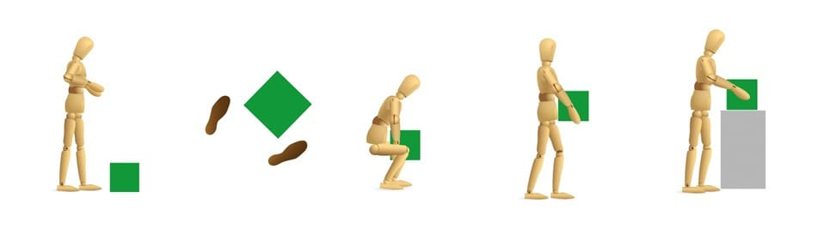
Fig:- 3.2 Manual Handling Techniques
- Before lifting an item, think: Can you use a manual handling aid instead? Where is the load being moved to? Are there any obstructions that may get in the way?
- Adopt a stable position with feet apart and one leg slightly forward to maintain stability. Make sure that you are wearing suitable footwear.
- Get a good hold on the load and hug it close to your body where possible. At the start of the lift, bending at the back, knees and hips is preferable to fully bending the back or squatting.
- When carrying, keep the load close to your waist for as long as possible. Put the heaviest side of the load closest to your body. Keep your head up and look ahead, not down at the load, and avoid twisting or leaning sideways.
- If you need to, put the load down and adjust your grip before continuing the lift.

Pushing or Pulling Loads
When pushing or pulling a load, the Health and Safety Executive provides the following guidance:
- Use an aid with a handle height that is between shoulder and waist height.
- Ensure that pushing or pulling equipment is well maintained.
- As a guide, the amount of force that needs to be applied to move a load over a flat surface is at least 2% of the load weight. For example, if the load is 400kg, then the force needs to be 8kg.
- The force for pushing or pulling will be greater over imperfect conditions.
- Always try to push rather than pull where possible.
- When negotiating a slop or ramp, get help from another worker.
- On an uneven surface, increase the pushing/pulling force to 10% of the load weight.
- To make it easier to push or pull, keep your feet well away from the load and move no faster than walking speed.
precautions should workers take when moving materials manually
When moving materials manually, workers should attach handles or holders to loads. In addition, workers should always wear appropriate personal protective equipment and use proper lifting techniques. To prevent injury from oversize loads, workers should seek help in the following:
- When a load is so bulky that employees cannot properly grasp or lift it,
- When employees cannot see around or over a load, or
- When employees cannot safely handle a load.

Using the following personal protective equipment prevents needless injuries when manually moving materials:
- Hand and forearm protection, such as gloves, for loads with sharp or rough edges.
- Eye protection.
- Steel-toed safety shoes or boots.

Employees should use blocking materials to manage loads safely. Workers should also be cautious when placing blocks under a raised load to ensure that the load is not released before removing their hands from under the load. Blocking materials and timbers should be large and strong enough to support the load safely. In addition to materials with cracks, workers should not use materials with rounded corners, splintered pieces, or dry rot for blocking.

3.3 Applying and handling requirements and protection for non-Hazardous materials
Before discarding used materials, consider whether they can be reused in any way. If the used materials can be safely and effectively reused, this will decrease the company’s total waste levels and conserve resources while saving money.
If a product cannot be reused or re purposed, the key to sustainable waste disposal lies in separating waste into these categories:
Recyclables: A recyclable is any material that can be recycled. Recycling is the reprocessing of materials into new products, which generally prevents the waste of potentially useful materials, reduces the consumption of raw materials, lowers energy usage and decreases greenhouse gas emissions compared to virgin production.
Compost able: A compost able is any material that can be used to create compost. Compost is the natural byproduct of decomposition, whereby natural systems break down organic matter – including both animal and plant materials – into a rich, dark brown material that nourishes soil and aids in growing strong, healthy plants and foods. This process is nature’s way of recycling organic waste, and requires carbon and nitrogen ingredients that can be provided through compost able materials.

Residual Waste: Any non-hazardous waste that cannot be recycled or composted
Step 1: Remove Hazardous Wastes
Since hazardous wastes require specific treatment for disposal, it is important to keep them segregated from non-hazardous wastes. Part III provides details on internationally-accepted safe methods for the storage and disposal of hazardous waste.
Step 2: Recycle and Compost
Of all non-hazardous waste, a company should identify any materials that can be recycled or composted. Recycling and composting allow discarded materials to be used as inputs into newly manufactured products or productive organic material, respectively. By contributing such inputs,
Benefits of recycling include:
- Preventing the emission of many greenhouse gases and water pollutants;
- Saving energy;
- Supplying valuable raw materials to industry;
- Creating jobs;
- Stimulating the development of greener technologies;
- Conserving resources for our children's future; and
- Reducing the need for new landfills and combustors.

Treatment and Disposal
Prior to disposal, treatment can help reduce the volume and toxicity of waste. Treatments can be
- physical (e.g., shredding),
- chemical (e.g., incineration), and
- biological (e.g., anaerobic digestor).
Landfills are the most common form of waste disposal and are an important component of an integrated waste management system. Modern landfills are well-engineered facilities located, designed, operated, and monitored to ensure compliance with state and federal regulations. Landfills that accept municipal solid waste are primarily regulated by state, tribal, and local governments.

3.3 Protecting materials.
3.4 General Requirements and Restrictions on Storage and Handling
- Materials required in construction operations shall be stored, and handled in a manner to prevent deterioration and damage to the materials, ensure safety of workmen in handling operations and non-interference with public life including safety of public, prevention of damage to public property and natural environment.
- Materials shall be stored and placed so as not to endanger the public, the workers or the adjoining property. Materials shall be stacked on well -drained, flat and unyielding surface. Material stacks shall not impose any undue stresses on walls or other structures.
- Materials shall be separated according to kind, size and length and placed in neat, orderly piles. High piles shall be staggered back at suitable intervals in height. Piles of materials shall be arranged so as to allow a minimum 800 mm wide passageway in between for inspection and removal. All passageways shall be kept clear of dry vegetation, greasy substance and debris.
- For any site, there should be proper planning of the layout for stacking and storage of different materials, components and equipments with proper access and proper maneuverability of the vehicles carrying the material. While planning the layout, the requirements of various materials, components and equipments at different stages of construction shall be considered.
- Stairways, passageways and gangways shall not become obstructed by storage of building materials, tools or accumulated rubbish.
- Materials stored at site, depending upon the individual characteristics, shall be protected from atmospheric actions, such as rain, sun, winds and moisture, to avoid deterioration.
- Special and specified care should be taken for inflammable and destructive chemicals and explosive during storage

Manual Handling
When heavy materials have to be handled manually each workman shall be instructed by his foreman or supervisor for the proper method of handling such materials. Each workman shall be provided with suitable equipment for his personal safety as necessary. Supervisors shall also take care to assign enough men to each such job depending on the weight and the distance involved.

Material Handling & Storage Safety
For an effective materials handling and storage program, managers must take an active role in its development. First-line supervisors must be convinced of the importance of controlling hazards associated with materials handling and storing and must be held accountable for employee material handling safety training. Safe lifting is only one aspect of material handling; transporting the load safely is the other. How you move or carry and put down the load is just as important as how you pick it up.ently.

Moving, Handling, and Storing Materials
- When manually moving materials, employees should seek help when a load is so bulky it cannot be properly grasped or lifted, when they cannot see around or over it, or when they cannot safely handle the load.
- Handles or holders should be attached to loads to reduce the chances of getting fingers pinched or smashed. Workers also should use appropriate protective equipment. For loads with sharp or rough edges, wear gloves or other hand and forearm protection. In addition, to avoid injuries to the eyes, use eye protection. When the loads are heavy or bulky, the mover also should wear steel-toed safety shoes or boots to prevent foot injuries if he or she slips or accidentally drops a load.
- When stacking and piling materials, it is important to be aware of such factors as the materials’ height and weight, how accessible the stored materials are to the user, and the condition of the containers where the materials are being stored. Non-compatible material must be separated in storage.
- When stacking materials, height limitations should be observed. For example, lumber must be stacked no more than 16 feet high if it is handled manually; 20 feet is the maximum stacking height if a forklift is used. For quick reference, walls or posts may be painted with stripes to indicate maximum stacking heights.

Material Handling with Conveyors
- When using conveyors, workers’ hands may be caught in nip points where the conveyor medium runs near the frame or over support members or rollers; workers may be struck by material falling off the conveyor; or they may become caught on or in the conveyor, being drawn into the conveyor path as a result.
- To reduce the severity of an injury, an emergency button or pull cord designed to stop the conveyor must be installed at the employee’s workstation. Continuously accessible conveyor belts should have an emergency stop cable that extends the entire length of the conveyor belt so that the cable can be accessed from any location along the belt.

Flammable Material Handling & Storage
- In adhering to fire safety precautions, employees should note that flammable and combustible materials must be stored according to their fire characteristics. Flammable liquids, for example, must be separated from other material by a fire wall. Also, other combustibles must be stored in an area where smoking and using an open flame or a spark-producing device is prohibited. Dissimilar materials that are dangerous when they come into contact with each other must be stored apart.

- Ergonomics of Material Handling
- Ergonomics is defined as the study of work and is based on the principle that the job should be adapted to fit the person, rather than forcing the person to fit the job. Ergonomics focuses on the work environment, such as its design and function, and items such as design and function of workstations, controls, displays, safety devices, tools, and lighting to fit the employees’ physical requirements and to ensure their health and well being.

3.4 Erecting signage and barricades.
Most people are familiar with construction and barricade signs, because we run into them on the road and sidewalk all the time. Advertising banners, for example, are commonly seen along sidewalks or roads on the fencing around a construction site. These are highly effective forms of advertising and often serve to both enlighten the public about the project and advertise for the construction companies. For construction sites, there are a lot of different types of signs for different situations. Often, the need is just to have basic signs for accident prevention and workplace efficiency.
From danger and construction zone signs, to hazardous material and detour signs, there are a lot to choose from. If you have a big project or a job site that you will need construction signs, we can help. We can take all the hassle out of figuring out which types of signs you need in order to be compliant with local code, so you can just focus on running your business and job site.
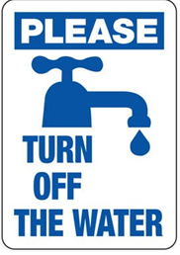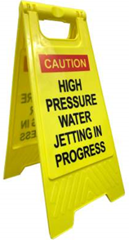
Fig 3.5 Signage and barricade

- Barricading and signage shall only be used:
- when there are no other practical control measures available;
- as an interim measure until a more effective way of controlling the risk can be used or the hazard is no longer present; and
- to supplement higher level control measures or as a secondary control measure.
It shall be ensured that barricading and signage is visible and legible to all concerned. Illumination of barricades and signs should be considered where general lighting, either natural or artificial, does not provide suitable visibility.
It shall be ensured that:
- processes are in place to instruct workers not to enter barricaded areas unless authorized to do so;
- barricading and signage is reviewed periodically to make sure it remains effective in controlling the risk; and
- barricades and signage that are no longer required are removed as soon as practicable.
Barricading Requirements
- Barricading controls shall be implemented and authorized as part of the safe work system to protect persons from hazards such as:
- being struck by falling objects;
- being struck by moving plant;
- fall from height, including falling into open excavations, penetrations, and falls from unprotected edges such as removed flooring, walkways, stairs and / or hand railings.
- exposure to hazardous chemicals;
- unauthorized entry into a confined space or work area; and
- any potentially hazardous work processes, for example, hot works, scaffolding, radiation work and work involving asbestos.
- Barricading controls shall also be implemented and authorised as part of the incident management and emergency response procedures.
- Selection of Barricade
- When selecting the type of barricade (soft or hard), the following factors are to be considered as part of a risk assessment:
- risk associated with the hazard;
- visibility of the hazard;
- required strength of the barrier, for example, impact potential; and
- the amount of clearance provided from the hazard by the barricade.
In addition it shall be ensured that hard/solid barricading is used for:
- a fall from height risk greater than two metres; and
- excavations greater than 1.5 metres deep.
It shall be ensured that barricading is designed, installed and used in accordance with the relevant Australian Standards and Appendix B- Barricading Selection Requirements:
Note: Where a risk assessment determines that a safety barrier system capable of physical protection is required, the barricade system shall be designed in accordance with the relevant Standard for the application of the barrier system:
Erection and Use of Barricade
- The barricade shall encompass the entire potentially affected area of the hazard and take into account factors such as:
- possible deflection of an object if it falls;
- slag or sparks created from hot work activities;
- distance from the hazard; and
- creating an additional hazard, for example, access and egress. Sites shall make sure that barricades are erected so that all sides of the hazard are protected from unauthorized access.
- Signs or tags shall clearly display the following information:
- the name of the person in charge of the barricaded area;
- the hazards that are within the barricaded area;
- the date; and
- the contact details of the person in charge of the area.
Safety Sign Requirements
It shall be ensured that safety signs are erected to warn workers of specific hazards and to communicate necessary precautionary measures and emergency actions. As a minimum, it shall be ensured that safety signs are erected in accordance with Queensland Work Health and Safety Regulation 2011, including, but not limited to:
- confined spaces;
- specific personal protective equipment (PPE) requirements; hazardous chemicals;
- asbestos;
- lead;
- fire protection equipment;
- hazardous areas;
- emergency and first aid information;
- emergency eyewash and shower; and
- traffic management and pedestrian control.

3.5 Identifying and handling hazardous material.
Identifying Hazardous materials
It is hard to manage the unknown, so managers first must know the hazardous materials present in their departments and facilities, including quantities and locations.
Managers can achieve this goal through an audit of hazardous materials. Managers can start by having employees generate a list of chemicals purchased for use in the department, perform a walk through inspection of the department, and focus on storage areas, tool kits, and carts. Once inspectors have identified chemicals, managers can get material safety data sheets (MSDS) and review them to determine if the chemicals are hazardous.
- This review should ensure:
- labels clearly identify original product names or full chemical names and hazards
- containers of non-hazardous substances, such as water, are labeled explicitly to avoid confusion
- all segregated chemicals liquids are kept in secondary containment
- no hazardous materials are stored next to or above sinks
- all chemical containers are capped and sealed, except when workers are adding or removing materials from them
- flammable liquids, including flammable liquid wastes, are stored outside of a storage cabinet if more than 5-10 gallons
- employees have completed hazard-communication training
- full-size compressed-gas cylinders are chained or strapped in a one-third, two-thirds manner.

A hazardous waste is a waste that poses substantial or potential threats to public health or the environment. Hazardous wastes are more explicitly defined as wastes with certain characteristics to the Basel Convention. (Radioactive wastes and wastes from ships are excluded from the scope of the convention.) These characteristics include substances that are:
- Explosive
- Flammable
- Poisonous
- Toxic
- Eco toxic
- Infectious
Common hazardous wastes include acids, disinfectants, glues, heavy metals, paint, pesticides, petroleum products, solvents, batteries and other electronic products. All hazardous materials are required to be labeled as such by the manufacturer so that they can be easily identified by final users of the product.

3.6 Minimizing health risk.
3.7 Definition
The construction industry is often criticized for being one of the heavy polluters that generate dust to the atmosphere from construction works. Construction dust emission (CDE) originates from many types of on-site activities such as excavation, drilling, bulk material transportation, loading and unloading, open-air material storage, concrete and mortar making, cutting and filling, and the movement of equipment.
Maintain your health

Maintain your health. Work related exposure to any sort of dust can never be good for your health, however exposure to some dusts can cause serious health problems including dermatitis, asthma, Chronic Obstructive Pulmonary Disease (COPD) and silicosis. Working in the construction industry regardless of your trade, means your risk of being exposed to dust containing a mineral called silica is increased and with it the potential of developing a disabling respiratory disease
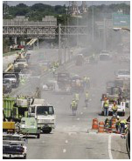

Fig 3.7 Maintain your health

RCS particles become embedded in the alveoli deep within the lungs

When you breathe in air containing dust, the hairs and mucus in your nose and throat trap the large dust particles but the fine RCS particles are ‘respirable’ meaning they are carried deep into the lungs where oxygen is extracted from the air. The RCS particles are deposited here causing inflammation and scarring known as silicosis, which makes breathing more difficult and increases the risk of developing lung infections and lung cancer. Silicosis can vary in severity from mild to severe depending on the levels of exposure. Typically, the symptoms do not develop until after twenty or more years of constant exposure and often after retirement. The early symptoms are shortness of breath, a dry cough and a general feeling of ill health and as the disease progresses the symptoms become more severe.
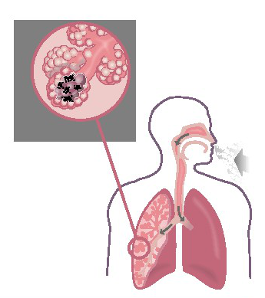

F Fig:- 3.10 Impact of dust

Polymers as Dust Control
Can be an effective practice for areas that do not receive vehicle traffic. Dry applied polymers must be initially watered for activation to be effective for dust control. This method bonds the individual soil particles together, and when it dries, it forms a flexible "crust" that strengthens the surface of the soil. It has been determined that the effectiveness of this solutions ranges from 70-90 percent.

Tackifiers and Soil Stabilizers
This dust control method can create a fiber-to-seed-to-soil bond (without hardening) that reduces the need for re-seeding and minimizes soil erosion. During a wetting event, the polymer material absorbs water, which allows the tackifier to go back into solution. Upon drying, there is a new seal over the soil solving the dust control problem on construction sites.

Chlorides
Chloride retains moisture for prolonged periods helping you fighting against dust and erosion problems. The unique property of chlorides helps to hold down dust and stabilize unpaved road surfaces, creating smooth-riding roads that last.

Barriers
A board fence, wind fence, sediment fence or similar barrier can control air currents and blow soil. All of these fences are normally constructed of wood. Perennial grass and stands of existing trees may also serve as wind barriers. Barriers prevent erosion by obstructing the wind near the ground and preventing the soil from blowing off-site. Barriers shall be placed at right angles to prevailing wind currents at intervals of about 15 times the barrier height. Solid board fences, snow fences, burlap fences, crate walls, bales of hay and similar material can be used to control air currents and blown soil.

Stone
Stone can be an effective dust deterrent for construction roads and entrances or as a mulch in areas where vegetation cannot be established. In areas of high wind, small stones are not as effective as 8-inch stones.

Sweep Equipment
Normally used in highways or paved roads, sweep equipment can be used to clean debris and dust from paved or roadways. I am not a huge fan of this method, as sometimes it seems that more dust is being released into the air rather than sweep or vacuum. However, it is another tool available for you.

Self check-3
Test I: TRUE/FALSE
Instruction: True /False. you are provided 1 minute for each question and each point has 3Points.
- Objects are most vulnerable to damage when they are being moved even over short distances
- Planning and care minimize risk and reduces the chance of accidents happening.
- when moving materials manually there is no precautions should workers take

Test II: short Answer writing
Instruction: write short answer for the given question. You are provided 1 minute for each question and each point has 3Points.

- Write down at least four (4) types of pipe
- Write abbreviation of PVC

Unit FORE: Store and transport materials
This unit is developed to provide you the necessary information regarding the following content coverage and topics:
- Implementing statutory plumbing authority.
- Storing and transporting materials.
- Identifying and handling Hazardous material.
- Handling and storing plumbing materials.
- Identifying, storing and allocating flammable materials.
- Transporting and handling hazardous materials.
- Protecting storm water system.

This unit will also assist you to attain the learning outcomes stated in the cover page. Specifically, upon completion of this learning guide, you will be able to:
- Implementing statutory plumbing authority.
- Storing and transporting materials.
- Identify and handling Hazardous material.
- Handl and storing plumbing materials.
- Identify, storing and allocating flammable materials.
- Transport and handling hazardous materials.
- Protect storm water system.

4.1 Toring and transporting materials according to msds implementing authority.
Objects are most vulnerable to damage when they are being move even over short distances. Although it seems unlikely that damage could occur when an object is being moved only a short distance, there are many examples of it happening. Try carrying a single sheet of paper from one room to another. If you hold it by one corner, it can very easily crease while you are walking. This irreversible damage may be acceptable on a sheet of blank paper, but would be disastrous on a valuable print or watercolour. Think about what can happen if someone rushes out of a door right into your path while you are carrying a glass bowl.
Accidents do occur so it is important to:
- handle objects with care;
- provide adequate support to objects;
- plan your movements;
- ensure the route is clear; and
- ensure there is a space to place the items when you arrive.
Planning and care minimize risk and reduces the chance of accidents happening. This section summarize the do’s and don’t of handling for a range of objects.
Provide support and protection to your objects
Examine the object you’re going to handle or move, and note its weakness or any damage; then ensure that you support it so that handling and movement don’t make the object weaker.
Never put both light-weight and heavy objects in the same carrying-box or container. The heavy object could fall over and severely damage the lighter ones.
Always use separation battens, foam padding or some kind of cushioning material between pieces when you have more than one object in a single box. All padding must be resilient and capable of absorbing and dissipating shock.

When you have finished the move, never discard any packing material until it has been thoroughly searched. It would be awful to throw away a small item or part of an item which was caught up in the packing.
Note any damage that occurs during the move
Remember, no matter how small a broken or rough edge is, it may be sharp enough to damage an item nearby.
All accidents should be recorded. when reporting a damage, describe it briefly, noting the nature, location and severity of the damage and record the date of your report. A sample report form follows.
Remember that fine arts insurance policies do not cover loss or damage caused by unskilled handling. Don’t ask volunteers to handle valuable objects without first giving them some instructions. They need to read this information, and be helped and supervised.
You can’t replace a unique object, even if your insurance claim is successful.
Transporting of Materials
The chapter on handling objects explained how objects are most vulnerable to damage when being moved—even over short distances. The risk of damage increases when objects are moved over long distances.
Objects moved interstate or overseas are susceptible to damage from:
- vibration;
- fluctuations and extremes of relative humidity and temperature;
- repeated handling;
Transporting objects
If you are going to transport objects, it is important to provide:
- full support for each object;
- protection from vibration and impact;
- protection from environmental and climatic extremes; and
- protection from light and UV radiation.
There are ways of protecting objects, whichever way you’re transporting them—whether by truck and forklift, plane, or in your car.
Preparing objects for travel
Before an object travels, it is important to determine whether it is fit to withstand the rigours of the journey. Access to collections is a high priority and it is sometimes difficult to turn down requests for loans. But if an object is too fragile to travel, it should not go. Remember, if it is irreparably damaged, no-one will have access to it.
Once you have decided that the object can travel, make sure you know:
- where it is going and when;
- who will take responsibility for it while it is there;
- what the environmental conditions are like at the destination/s: if your object is fragile and likely to be damaged by adverse conditions, specify that the borrower meets your requirements;
- how it is travelling, which may affect the way you pack it and the size of the crates or packages;
- whether insurance has been arranged; and
- who is paying for packing, transport and replacement if necessary.
Loan agreements are often drawn up between lenders and borrowers, to cover these and other issues.

4.2 Identifying and handling Hazardous material.

Hazards | Description
1 | Explosive Materials
2 | Gases – Flammable/Non-Flammable/Toxic
3 | Flammable Liquids
4 | Flammable Solids, Pyrophoric/Dangerous When Wet Materials
5 | Oxidizers and Organic Peroxides
6 | Poisons and Infectious Materials
7 | Radioactive Materials
8 | Corrosive Liquids and Solids
9 | Miscellaneous
Table 4.2 Hazardous materials
Hazardous Materials Handling and Storage
- Regulatory Considerations
- Management Issues
- Pollution Prevention and Hazardous Wastes Storage
Even chemicals that are generally considered to be benign have potential to be hazardous under specific circumstances. Lab staff should ensure that stock chemicals and other hazardous materials are stored properly in order to prevent spills, uncontrolled reactions and minimize worker exposures. Labs are particularly challenged because of the number and variety of chemicals that are handled.

Management Issues
In order to effectively manage chemicals, small labs should establish a program based on the following three principals:
- Minimize Exposures Take the necessary precautions when working with and storing chemicals. As a means of minimizing the potential for exposure, pursue opportunities for product substitution.
- Do Not Underestimate Risks Ensure that the risk associated with each chemical is assessed, understood and communicated. It is prudent to assume all chemicals are hazardous and handle them accordingly.
- Use Proper Control Measures Eliminate the hazard through engineering controls, personal protective equipment, and administrative procedures. Ensure that all staff are properly trained in accordance with regulatory requirements (e.g., Laboratory Standard) so that they can operate safety at their job.
The following are key management issues for the storage and handling of hazardous materials including hazardous chemicals, flammable liquids, and compressed gases. Regulations regarding the proper storage of hazardous materials are complex.

The Chemical Hygiene and Hazard Communication Plan
requirements for the communication of chemical hazards to employees in the workplace. The programs include a number of common elements. These are:
- Establishment of documented programs. For labs subject to the Lab Standard, this is in the form of a Chemical Hygiene Plan (CHP);
- Preparation and periodic update of an inventory of all hazardous chemicals;
- Labeling of all containers of hazardous chemicals (including materials transferred from the manufacturer's container to end user container such as spray bottles);
- The availability of Material Safety Data Sheets (MSDS’s) for workers on all shifts and in all locations;
- Employee chemical hazard training and documentation; and
- Processes to review and update the program on a periodic basis.

Chemical Storage in the Lab
Centralized chemical storage is recommended. Chemical storage inside labs should be limited to those chemicals and quantities necessary to complete task requirements. Key consideration for lab storage and handling include:
- Chemicals should not be stored on floors or benches since they could be knocked over. Storage on open shelves should be avoided. When necessary, lips or restraining devices should be used. Do not store chemicals in the lab above eye level;
- When possible, segregate toxic chemicals from other chemicals and store in closed cabinets. Label the cabinets “TOXIC CHEMICALS" or with a similar warning;
- Maintain chemicals per manufacturer requirements;
- Ensure containers are labeled in accordance with the OSHA Laboratory Standard;
- Make sure containers are closed when not in use;
- Use secondary containment such as acid carriers when transporting liquid chemicals more than a very short distance; and
- Central chemical storage areas (e.g., rooms) require specific design and equipment such as construction materials, lighting, ventilation, fire extinguishers, and housekeeping procedures such as aisle space.

Flammable and Combustible Liquids
Additional requirements apply to those chemicals that are classified as flammable or combustible liquids.
- Regardless of experimental or production requirements and even when NFPA allows higher quantities, prudent practice is that the quantity of these materials in a lab room not exceed a total of 60 gallons or one months supply (for all such chemicals combined);
- Flammable and combustible liquids should be stored in glass, metal or plastic containers that meet NFPA requirements. More than 10 gallons of flammable and combustible liquids should be stored in a flammables cabinet or specially designed room. Prudent practice is to store these materials in a flammables cabinet when ever possible;
- Storage in flammable cabinets must not exceed design quantities (e.g., 60 gallons). Cabinets should be properly vented if there is the potential for the buildup of hazardous vapors; and
- Refrigerators and freezers used to store flammable liquids should be explosion.

Compressed Gases
Compressed gas cylinder storage should meet the requirements in the Compressed Gas Association Pamphlets C-6 1968 and C-8 1962.
- Properly label the cylinders with their contents; store upright and away from heat sources;
- Cylinders should be chained to the wall or otherwise secured from falling;
- Do not store cylinders so as to block exits, obstruct aisles, or otherwise interfere with egress; and
- Cylinders should be separated based on their contents. Incompatible materials (e.g., oxygen and propane, chlorine and helium) should be segregated. In addition, full, partially full and empty cylinders should be labeled as to their status and separated.
Acceptable hazardous materials Transportation Practices
- Transporting hazardous materials carries with it some risk to the driver and occupants of the vehicle and others on the road.
- Spilled chemicals within a vehicle can quickly create dangerous concentration levels that can either overcome the occupants or cause a flammable atmosphere. Spilled chemicals on a public roadway can also lead to expensive cleanup and traffic delays.

4.3 Identifying, storing and allocating flammable materials.
Flammable and Combustible Liquids
Since the advent of the industrial revolution, the use of non-water-based chemicals has increased dramatically. Exposure to the hazards associated with these chemicals has also increased. One potential hazard is flammability. To prevent fires, hazardous liquids need special precautions taken for their storage, handling and use. The National Fire Protection Agency (NFPA) and the International Code Council (ICC) have developed guidelines for the safe storage and use of flammable and combustible liquids under the Uniform Fire Code. These guidelines are not mandatory unless a fedeal, state or local authority chooses to use them.
Mandatory regulations have been developed, however, by Occupational Safety and Health Administration (OSHA). OSHA has specified safe handling practices in three (3) separate mandatory regulations for:
- General Industry
- Construction Industry
- Shipyard Industry
Defining Flammable and Combustible Liquids
To understand OSHA requirements for the safe storage of flammable and combustible liquids, we must begin by defining the two. The flashpoint and boiling point determine the class of a liquid. A flammable liquid is any liquid having a flashpoint below 100° F (37.8°C) (except any mixture having components with flash points of 100°F (37.8°C) or higher.
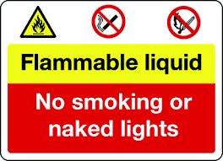
Fig 4.1 Flammable and Combustible Liquids
Flammable liquids are categorized into three groups, as follows:
- Class I Flammable Liquid
Class IA Flammable Liquid
Liquids having flash points below 73°F (22.8°C) and having boiling points below 100°F (37.8°C). Examples: Acetaldehyde, ethyl ether and cyclohexane.
Class IB Flammable Liquid
Liquids having flash points below 73°F (22.8°C) and having boiling points at or above 100° F (37.8°C). Examples: Acetone, benzene and toluene.
Class IC Flammable Liquid
Liquids having flash points at or above 73°F (22.8°C) and below 100° F (37.8°C). Examples: Hydrazine, styrene and turpentine.
A combustible liquid is any liquid having a flashpoint at or above 100°F (37.8°C). Combustible liquids are divided into two classes:
- Class II Combustible Liquid
Liquids having flash points at or above 100°F (37.8°C) and below 140°F (60°C), except any mixture having components with flash points of 200°F (93.3°C) or higher, the volume of which make up 99 percent or more of the total volume of the mixture. Examples: Acetic acid, naphtha and stoddard solvent.
- Class III Combustible Liquid
Liquids having flashpoints at or above 140°F (60°C). Class III liquids are subdivided into two subclasses:
Class IIIA Combustible Liquid
Liquids having flashpoints at or above 140°F (60°C) and below 200°F, except any mixture having components with flashpoints of 200°F (93.3°C) or higher, the total volume of which make up 99 percent or more of the total volume of the mixture. Examples: Cyclohexanol, formic acid and nitrobenzene.
Class IIIB Combustible Liquid
Liquids having flashpoints at or above 200°F (93.3°C). Examples: Formalin and picric acid. "Class IIIB liquids" shall include those with flashpoints at or above 200°F (93.3°C). This section does not cover Class IIIB liquids. Where the term "Class III liquids" is used in the section, it shall mean only Class IIIA liquids.
Flammable gas
Flammable gases are explosive when they are mixed with air or oxygen in the right proportions. Examples of flammable gases are propane, hydrogen, butane, methane, ethylene, acetylene, ammonia, ethane and silane.

Types of flammable gas
- Propane
- Hydrogen
- Butane
- Methane
- Ethylene
- Acetylene
- Ammonia
- Ethane
- Silone
As mentioned in the definition of flammable gases there are different sorts of flammable gases. Gases that will burn under the right circumstances are propane, hydrogen, butane, methane, ethylene, acetylene, ammonia, ethane and silane.
How to store flammable gas
Storing a flammable gas needs more precautions than regular gas types. Because of the fact that propane, hydrogen, butane, methane, ethylene, acetylene, ammonia, ethane and silane gas are all flammable, and therefore dangerous gas, it is essential to store these gas safely and correctly. Store flammable gas in a cold, closable and dark area is critical. Keep the cylinders away from any form of heat, sparks, flames or hot surfaces

4.4 Transporting and handling hazardous materials.

Transporting Chemicals
Technically speaking, DOT only regulates hazardous materials “shipped in commerce” (i.e., for business purposes or via a shipping carrier). As a University, the majority of our materials are not “shipped in commerce”. This means that there are regulatory exceptions that allow materials to be transported on campus. However, these activities still require safe procedures and training.

Receiving materials
- Packages should be opened by the addressee only.
- They shall be inspected for visible signs of damage or leaking. If the package shows any evidence of leaking it should be rejected. If the delivery has already been accepted before noticing leakage, move into a fume hood and follow emergency procedures for a chemical spill.
- Note the presence of any special handling requirements including cold storage or “store under inert gas” prior to opening.
- Hazardous material packages should never be left in an unsecured location. They should not be left in hallways, unattended and unlocked storage areas, etc.
- The package is suspicious, contact SMU Police immediately and do not touch it.

Intra-building movement of hazardous materials
- Anyone transporting hazardous materials must have either Hazard Communication training or Laboratory Safety Training.
- Do not open outer packaging until you have reached your laboratory or shop.
- Use a cart with raised sides for transporting hazardous materials that are at risk of spilling. Safety totes may be used for single bottles.
- Use freight elevators where feasible and do not transport hazardous materials up and down stairs.

- Inter-building movement of hazardous materials (non-vehicular)
- SMU employees and students transporting hazardous materials between buildings on campus by foot should use a cart with sidewalls to ensure that the bottles are protected from tipping.
- Avoid high pedestrian and vehicular traffic areas. Also, avoid high traffic times such as during campus events that draw heavy pedestrian traffic or directly after classes let out.

Inter-building movement of hazardous materials (vehicular)
Periodically, it may be necessary for employees or students to transport hazardous materials to other campuses, research sites, or job locations.
NOTE: In this case, the term “hazardous material” does not apply to hazardous waste or radioactive materials. These materials cannot be transported in the following fashion as special regulatory requirements exist.
All other hazardous materials may be transported safely following the below practices:
- All personnel transporting hazardous materials must have taken Laboratory Safety Training.
- All containers must be labeled as to their contents.
- Avoid transporting compressed gas cylinders without prior approval from EHS.
- Hazardous Materials shall NOT be transported in passenger compartments of vehicles. The trunk or bed shall be used.
- Drivers must have a copy of the SDS with them during transport.
- Do not, under any circumstances, leave chemicals stored in a vehicle. Plan routes and travel times appropriately.

Transporting Bio hazardous Materials
Separate instructions guide the transport of bio hazardous materials between buildings.

Training and Record keeping
All employees and students that handle hazardous materials must take either Hazard Communication training (for non-laboratory personnel) or Laboratory Safety training prior to transporting or working with hazardous materials.
- Hazard Communication training is taken via Law Room, In order to sign up for this training, please contact EHS. A link from Human Resources will be directed to you with information and instructions about the training course.
- For all individuals working in laboratories, Laboratory Safety Training is necessary.
- In both cases, training records will become a part of your permanent file.
- For those individuals that routinely prepare hazardous materials shipment, please contact EHS for specific information regarding training requirements, record keeping, etc.

4.5 Protecting storm water system.
Definition
Storm water, is water that originate from precipitation events, including snow and ice melt. Storm water can soak into the soil (infiltrate), be stored on the land surface in ponds and puddles, evaporate, or runoff. Most runoff is conveyed directly to nearby streams, rivers, or other water bodies (surface water) without treatment.

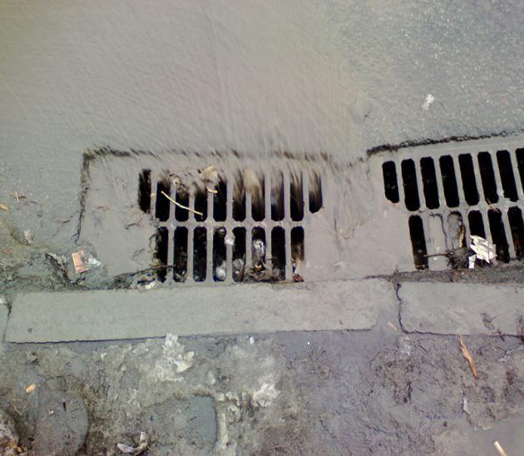

Fig 4.2 Storm water

In natural landscapes, such as forests, soil absorbs much of the storm water. Plants also reduce storm water by improving infiltration, intercepting precipitation as it falls, and by taking up water through their roots. In developed environments, un managed storm water can create two major issues: one related to the volume and timing of runoff (flooding) and the other related to potential contaminants the water is carrying (water pollution).
Storm water is also an important resource as human population and demand for water grow, particularly in arid and drought-prone climates. Storm water harvesting techniques and purification could potentially make some urban environments self-sustaining in terms of water.

.
Storm Drain Protection
Urban runoff has been identified as a potential source of pollutants, including trash, metals, sediment, chemicals, and oils, and can also be a transporter of pollutants already on the ground. Urban runoff can contribute to ocean pollution if proper methods are not used to control and contain the water.
Keep Pollutants Out of Storm Drains
Many people think that when water flows into a storm drain it is treated, but the storm drain system and the sanitary sewer system are not connected. Everything that enters storm drains flows untreated directly into our creeks, rivers, bays, beaches and ultimately the ocean. Storm water often contains pollutants, including chemicals, trash, and automobile fluids, all of which pollute our beaches and harm fish and wildlife.
Whether at home or work, you can help reduce pollution and improve water quality by using the above Best Management Practices (BMP’s) as part of your daily clean up and maintenance routine.

Self check-4
Test I: TRUE/FALSE
Instruction: write short answer for the given question. You are provided 1 minute for each question and each point has 3Points.

- To prevent fires, hazardous liquids need special precautions taken for their storage, handling and use
- Flammable and combustible materials must be stored according to their fire characteristics.
- Silica is one of the most abundant minerals on earth and found naturally in masonry, stone, sand and aggregates

Test II: short Answer writing
Instruction: write short answer for the given question. You are provided 1 minute for each question and each point has 3Points.
- .________ is a waste that poses substantial or potential threats to public health or the environment
- Define the word Ergonomics means

Unit 5: Clean up.
This unit is developed to provide you the necessary information regarding the following content coverage and topics:
- Cleaning, checking, maintaining, and storing tools and equipment.
- Clearing work area
- Clearing, disposing and recycling materials.
- Removing and disposing waste material.
- Accessing and completing documentation.
This unit will also assist you to attain the learning outcomes stated in the cover page. Specifically, upon completion of this learning guide, you will be able to:
- Cleaning, checking, maintaining, and storing tools and equipment.
- Clearing work area
- Clearing, disposing and recycling materials.
- Removing and disposing waste material.
- Accessing and completing documentation.

5.1 Cleaning, checking, maintaining, and storing tools and equipment.
Maintenance can be defined as working on something to keep it in a functioning and safe state and preserving it from failure or decline. The “something” could be a workplace, work equipment, or means of transport (e.g. a ship).
- Preventive – or proactive – maintenance is carried out to keep something functional. This type of activity is usually planned and scheduled
- Corrective – or reactive – maintenance is repairing something to get it working again. This is an unscheduled, unplanned task, usually associated with greater hazards and higher risk levels.
Maintenance is not the exclusive domain of fitters and mechanics. It is the responsibility of almost all workers in every sector and is carried out in almost every working environment. Workers’ health and safety can be affected during the maintenance process, but also by lack of maintenance or inadequate maintenance. Design of equipment and the work area also has a significant impact on the health and safety of workers performing maintenance.

Hazards and risks associated with poorly maintained portable tools on
construction sites
Poorly maintained portable tools in construction (either hand tools or powered tools present significant health and safety risks to the workers using them.
These risks are proportional to the state of repair of the tools and increase through time. repair of damaged equipment is often carried out on construction sites to keep the work going.
Such repairs are frequently done in hurry, in an offhand manner, often involving improvised solutions (e.g. replacing a fuse with a nail, taping up damaged electric cable). Unprofessionally repaired equipment can be dangerous.
Hazards and risks induced by lack of or inadequate maintenance include:
Hand tools:
- Mechanical failure or loss of control when using a tool with defective parts. Examples of unsafe tools are hammers with loose or damaged heads, screwdrivers with broken handles or blunt edges, chisels with mushroomed heads, and blunt saws.

Power tools:
- Malfunctioning of safety devices such as emergency button (red button), protective covers, guards, etc. In case of emergency these devices will not work properly or will provide limited protection to the worker, which in some cases can be worse than no protection at all because it gives a false sense of security.
- Risks of electrocution, shock or burns due to electrical malfunctions, torn cables and lack of proper insulation or proper earthing.
- Cracked or broken grinding wheels or cracked blades can cause injuries. E.g. cracked abrasive wheels could fly apart in operation, which could lead to serious injury or death.
- Emissions of chemical substances such as toxic fumes or dust, etc.

- Noise and vibration emitted by almost all portable tools that can lead to hearing loss and hand–arm vibration syndrome respectively. Vibration can cause “white-finger” disease, which arises from damage to the muscles and nerves that control the blood flow. Poorly maintained tools can cause a significant increase in noise and vibration emissions (e.g. a cutting tool that is not sharp emits higher levels of vibration). Also, damaged anti-vibration mountings in a tool can increase transmission of vibration to the worker.
OSH management and maintenance
The Framework directive obliges the employers to take the necessary measures to ensure the health, safety and welfare of all their workers including those involved in maintenance. Employers have to carry out a workplace risk assessment to identify hazards related to the use and maintenance of portable tools and take preventive measures to eliminate or minimize the risks. Companies contracting out maintenance work have to make sure that the contractor is managing occupational health and safety according to the legal requirements.
Maintenance and inspection programme
The key to safe maintenance is putting in place a maintenance programme, integrating safety and health aspects of maintenance and including inspection, reporting and record keeping procedures. Records must be kept to provide information for planning maintenance and replacement activities so that they occur at the proper time. Proper maintenance management of equipment requires a detailed inventory of all major items, including among other things information on manufacturer, model, year and number, and a list of the parts required for normal service and major repairs respectively.

An important part of the maintenance program is the inspection program setting out the frequency of formal inspections to be carried out by competent and trained maintenance technicians
Portable tools must be checked:
- Before the tool is put into use for the first time
- After servicing and changing parts
- At regular intervals appropriate for each tool.
Factors to consider when making the maintenance plan
Type of tool and power source
- Manufacturer’s instructions and recommendations
- Age of the tool
- Frequency of use and the work cycle of the tool
- Working environment in which the tool is used (e.g. wet or dusty), or likelihood of mechanical damage
- Foreseeable misuse of the tool
- Effects of any modifications or repairs to the tool
- Analysis of previous records of maintenance.
- Frequency of use and the work cycle of the tool
- Working environment in which the tool is used (e.g. wet or dusty), or likelihood of mechanical damage
- Foreseeable misuse of the tool
- Effects of any modifications or repairs to the tool
- Analysis of previous records of maintenance.

5.2 Clearing, disposing and recycling materials.
- Clean:Untreated and unpainted; not contaminated with oils, solvents,
caulk, paint, or the like.
- Construction Waste: Building and site improvement materials and other solid waste resulting from construction, remodeling, renovation, or repair operations. Construction waste includes packaging.
- Demolition Waste: Building and site improvement materials resulting from demolition or selective demolition operations
- Disposal: Removal off-site of demolition and construction waste and subsequent sale, recycling, reuse, or deposit in landfill or incinerator acceptable to authorities having jurisdiction
Recyclable materials include many kinds of glass, paper, cardboard, metal, plastic, tires, textiles, batteries, and electronics. The composting or other reuse of biodegradable waste—such as food or garden waste—is also a form of recycling.
Reuse and recycling of C&D materials is one component of a larger holistic practice called sustainable or green building construction. The efficient use of resources is a fundamental tenet of green building construction. This means reducing, reusing, and recycling most if not all materials that remain after a construction or renovation project.
Green building construction practices can include salvaging dimensional lumber from the project, using aggregates reclaimed from crushed concrete or grinding drywall scraps for use on site as a soil amendment.
At the end of a building’s life, demolition generates large amounts of materials that can be reused or recycled, principally wood, concrete and other types of masonry, and drywall. Rather than demolish an entire building, consider “deconstructing” all or part of the structure. Deconstruction is the orderly dismantling building components for reuse or recycling. In contrast to demolition, where buildings are knocked down and materials are either land filled or recycled, deconstruction involves carefully
Taking apart portions of buildings or removing their contents with the primary goal being reuse. It can be as simple as stripping out cabinetry, fixtures, and windows, or as involved as manually taking apart the building frame.

Recycling
Recycling is the process of converting waste materials into new materials and objects. It is an alternative to "conventional" waste disposal that can save material and help lower greenhouse gas emissions. Recycling can prevent the waste of potentially useful materials and reduce the consumption of fresh raw materials, thereby reducing: energy usage, air pollution (from incineration), and water pollution (from land filling).
Recycling is a key component of modern waste reduction and is the third component of the "Reduce, Reuse, and Recycle" waste hierarchy. Thus, recycling aims at environmental sustainability by substituting raw material inputs into and redirecting waste outputs out of the economic system.

Recycling and reuse
Recycling involves the collection of used and discarded materials processing these materials and making them into new products. It reduces the amount of waste that is thrown into the community dustbins thereby making the environment cleaner and the air fresher to breathe
Disposal is the critical last step in handling PPE. Ensure that you remove and discard PPE without causing contamination to yourself, garbage collectors, or the environment. PPE may have an expiration date, while other PPE requires careful inspection – read the PPE manufacturer directions and be diligent about disposal of PPE that will no longer provide protection.
Storage instructions from the PPE manufacturer must be followed for both reusable and disposable PPE. Most PPE must be protected from chemicals, sunlight, extreme temperatures, excessive humidity, and moisture, or the specified shelf-life will be reduced. Disposable, reusable, or limited-use PPE must be discarded if not stored properly.
.

5.3 Disposal in the Sanitary Sewer
Waste disposal, the collection, processing ,and recycling or deposition of the waste materials of human society. Waste is classified by source and composition. Broadly speaking, waste materials are either liquid or solid in form, and their components may be either hazardous or inert in their effects on health and the environment. The term waste is typically applied to solid waste, sewage (waste water) and hazardous waste.
Disposal in the sewer system (down the drain) had been a common method of waste disposal until recent years. However, environmental concerns, the viability of publicly owned treatment works (POTW), and a changing disposal culture have changed that custom markedly. In fact, many industrial and academic laboratory facilities have completely eliminated sewer disposal. Again, like trash disposal, most sewer disposal is controlled locally, and it is therefore advisable to consult with the POTW to determine what is allowed. Yet, it is often reasonable to consider disposal of some chemical waste materials in the sanitary sewer. These include substances that are water-soluble, that do not violate the federal prohibitions on disposal of waste materials that interfere with POTW operations or pose a hazard, and that are allowed by the local sewer facility.
Chemicals that may be permissible for sewer disposal include aqueous solutions that readily biodegrade and low-toxicity solutions of inorganic substances. Water-miscible flammable liquids are frequently prohibited from disposal in the sewer system. Water-immiscible chemicals should never go down the drain.
Disposal of regulated hazardous waste into the sanitary sewer is allowed only in limited situations. The total waste water must be a mixture of domestic sewage along with the waste whose amount and concentration meet the regulations and limits of the POTW. If approved of by the local district, it may be allowable to dispose of dilute solutions of metals and other hazardous chemicals into the sanitary sewer.
Under the Clean Water Act, some exemption from regulation as a hazardous waste for waste water containing laboratory-generated listed waste is allowed. In 1993, this exemption was expanded to include corrosive and ignitable wastes. For the exemption to apply, these laboratory wastes must be 1% or less of the annual total waste water quantity reaching the facility's head works or have an annualized average concentration of no more than 1 part per million (ppm) of the waste water generated by the facility.
Waste should be disposed of in drains that flow to a POTW, never into a storm drain and seldom into a septic system. Waste should be flushed with at least a 100-fold excess of water, and the facility's waste water effluent should be checked periodically to ensure that concentration limits are not being exceeded.

Release to the Atmosphere
The release of vapors to the atmosphere, via, for example, open evaporation or fume hood effluent, is not an acceptable disposal method. Apparatus for operations expected to release vapors should be equipped with appropriate trapping devices. Although the disposition of laboratories under the Clean Air Act is not established at this time, it is reasonable to expect that releases to the atmosphere will be controlled.
Fume hoods, the most common source of laboratory releases to the atmosphere, are designed as safety devices to transport vapors away from the laboratory in case of an emergency, not as a routine means for volatile waste disposal. Units containing absorbent filters have been introduced into some laboratories, but have limited absorbing capacity. Redirection of fume hood vapors to a common trapping device can completely eliminate discharge into the atmosphere.

5.4 Accessing and completing documentation.
DEFINITION
Documentation is a set of documents provided on paper, or online, or on digital or analog media, such as audio tape or CDs. Examples are user guides, white papers, on-line help, and quick-reference guides. It is becoming less common to see paper (hard-copy) documentation. Documentation is distributed via websites, software products, and other on-line applications.
Professionals educated in this field are termed documentalists. This field changed its name to information science in 1968, but some uses of the term documentation still exists and there have been efforts to reintroduce the term documentation as a field of study.

Principles for producing documentation

While associated ISO standards are not easily available publicly, a guide from other sources for this topic may serve the purpose. David Berger has provided several principles of document writing, regarding the terms used procedure numbering and even lengths of sentences, etc.

Procedures and techniques
The procedures of documentation vary from one sector, or one type, to another. In general, these may involve document drafting, formatting, submitting, reviewing, approving, distributing, re posting and tracking, etc., and are convened by associated SOPs in a regulatory industry. It could also involve creating content from scratch. Documentation should be easy to read and understand. If it's too long and too wordy, it may be misunderstood or ignored. Clear, Short, Familiar words should be used to a maximum of 15 words to a sentence. Only gender hyper neutral word should be used and cultural biases should be avoided. Procedures should be numbered when they are to be performed.

Producing documentation
Technical writers and corporate communicators are professionals whose field and work is documentation. Ideally, technical writers have a background in both the subject matter and also in writing and managing content (information architecture). Technical writers more commonly collaborate with subject matter experts (SMEs), such as engineers, technical experts, medical professionals, or other types of clients to define and then create content (documentation) that meets the user's needs. Corporate communications includes other types of written documentation that is required for most companies

Self check-5
Directions: Answer all the questions listed below. Use the Answer sheet provided in the next page:
- ------- is the process of converting waste materials into new materials and objects.
- Cleaning
- Recycling
- Reusing
- All
2. --------- is the critical last step in handling PPE
A. Disposal
B. Cleaning
C. Kaizen
D. None

- Documentation is a set of documents provided on paper, or online, or on digital or analog media, such as audio tape or CDs
- True B. False

Reference Materials
- https://aiccm.org.au/sites/default/files/docs/reCollections/6_htsd.pdf
- https://www.csbsju.edu/environmental-health-safety/policies/haz-mat

The Trainers Who Developed This TTLM
No | Name of trainer | Qualification /study | Organization/ Institution | Mobile number | E-mail
1 | TESHALE MULUGT | MSc Construction technology management |  | 0920469129 | Teshamulu909@gmail.com
2 | Abebe Endalew | Civiv | Misrak Poly T. C | 0933007756 | Abebeaware09@gmail.Com
3 | Million Aklilu | Construction technology management | BTC | 0920469129
4 | Sileshikassahun |  | MTC |  | Sileshikassahun21@gmail.com

