PLUMBING INSTALLATION
LEVEL - I
Based on March 2022, Curriculum Version 1

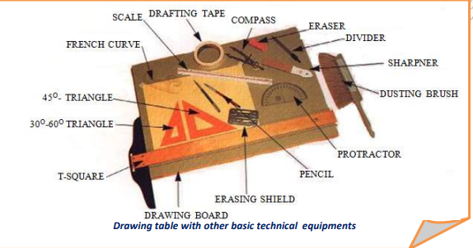
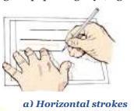
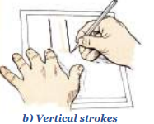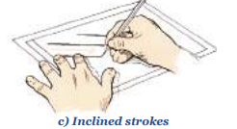
Module Title: - Drawn and Interpret Drawings
Module code: EIS PLI1 M03 0322
Nominal duration: 100Hour

Prepared by: Ministry of Labour and Skill
AUGUST, 2022
Addis Ababa, Ethiopia
Contents
Acknowledgment 4
Introduction to the Module 6
Unit one: Prepare for drawing. 8
1.1. Selecting drawing Equipments 9
1.2. Alphabet of lines. 19
1.3. Performing measurements 25
Self check-1 26
Operation Sheet 28
LAP Test 1 29
Unit two Draw simple drawing. 30
2.1. Construction complete drawing. 31
Fig. 2.2 33
2.2. Finish draw is neat and clear. 34
Self check-2 38
Operation sheet- 2 39
Lap Test- 2 40
Unit Three :Construct multi-view. 41
3.1 Three views drawings. 42
3.2 Constructions multi-view drawing. 46
3.3 Corrects view orientation (isometric). 50
3.4 Develop pictorial (3D) drawing. 51
Self check-3 54
Operation sheet- 3 55
Lap Test-3 56
UnitFour: Prepare freehand sketch. 58
4.1. Sketching and drawn appropriate views. 59
4.2. Conveying necessary dimensions and information. 61
Self check-4 63
Operation sheet- 4 64
Lap Test-4 65
Unit 5: Interpret details from sketches and drawings 66
5.1. Identify components, assemblies and objects. 67
5.2. Recognize symbols and abbreviations. 67
5.3. Identify dimensions and instructions. 70
5.4. Identify dimensions and instructions. 71
Identifying material requirements. 72
Self check-5 73
Operation sheet- 5 74
Lap Test-5 75
Reference Materials 76

Acknowledgment

Ministryof Labor and Skills wish to extend thanks and appreciation to the many representatives of TVET instructors and respective industry experts who donated their time and expertise to the development of this Teaching, Training and Learning Materials (TTLM).

Acronym
- TTLM-Teaching, Training and Learning Material.
- TVT – Teaching Vocational Training.
- LAP- Learning Activity Performance.
- CAD- Computer Aided Design.

Introduction to the Module
Technical drawing teaches the principle of accuracy and clarity in presenting the information necessary to produce products. In general, technical drawing helps students to understand a Drawnand Interpreting Drawingsmeans of transmission of accurate information from designers to those who develop the objects or plumbing drawing that are described by drawing. Therefore, the course enables students to be motivated for further studies pertinent to drawing
A student who successfully completed this course can use drawings to communicate technical information with engineers, designers, draft persons and other professionals. By studying technical drawing, a student becomes aware of how industry communicates technical information.

This module is designed to meet the industry requirement under the irrigation and drainage occupational standard, particularly for the unit of competency: Drawn and Interpreting Drawings

This module covers the units :
- Prepare for drawing.
- Draw simple drawing.
- Construct multi-view.
- Prepare freehand sketch.
- Interpret details from sketches and drawings.
Learning Objective of the Module
- Prepare for drawing.
- Draw simple drawing.
- Construct multi-view.
- Prepare freehand sketch.
- Interpret details from sketches and drawings.
Module Instruction
For effective use this modules trainees are expected to follow the following module instruction:
- Read the information written in each unit
- Accomplish the Self-checks at the end of each unit
- Perform Operation Sheets which were provided at the end of units
- Do the “LAP test” giver at the end of each unit and
- Read the identified reference book for Examples and exercise

Unit one: Prepare for drawing.
This unit is developed to provide you the necessary information regarding the following content coverage and topics:
- Identifying and selecting drawing equipments(instruments.)
- Identifying and applying alphabet of lines.
- Performing Measurements.
This unit will also assist you to attain the learning outcomes stated in the cover page. Specifically, upon completion of this learning guide, you will be able to:
- Selection drawing (equipments) instruments.
- Alphabet of lines.
- Perform Measurements.

Selecting drawing Equipments
Difference between and types materials and instruments of drawing;
Technical drawings must be prepared in such a way that they are clear, concise, and accurate. In order to produce such drawings equipment (i.e. materials and instruments) are used. Because time is an important factor in any of work,a clear understanding of all drawing equipment and their uses is important to speed up the process of drawing preparation. In this chapter, the different types of drawing instruments and materials and their uses will be discussed.
Selection of drawing materials
The basic drawing materials which are necessary to prepare a drawing are:
- Drawing paper
- Drawing pencil
- Drafting or masking tape
- Eraser and erasing shield
- Rapidograph
Drawing Papers
Drawing papers are the materials on which the drawings are made.depending on its application different types of drawing papers are available.these are:
- white plain paper
- file paper, plan/profile paper, crosssection paper and
- tracing paper.

- White plain papers: are generalpurpose for office uses and drawings. They are manufactured according to ISO (International Organization for Standardization) standard paper sizes. Standard drawing sheet sizes are in three series, designated An, Bn, and Cn. Paper frames and drawing frames are standardized for each size of papers. Table 1.1 shows frames of the A-series and their particular application.
- Profile, Plane/ Profile and Cross section papers: are referred to as gridded papers. The first two are used for road design and the later one is used for drawing road cross sections, rough design, sketching, preparing schedules, plotting graphs, etc.
- Tracing paper: is a high-grade white transparent paper, upon which copies or “tracings” are made for the purpose of reproducing by blueprinting or by other similar processes. Tracing may be made in ink, usually it takes ink well, and from which pencil lines can easily be erased. Reproductions (printing) can be made directly from pencil drawings on tracing paper (see Fig. 1.1); however, for better results in production, a pencil drawing on tracing paper is usually inked over. This paper must not be folded

Table 1.1 Paper and frame sizes for A-series
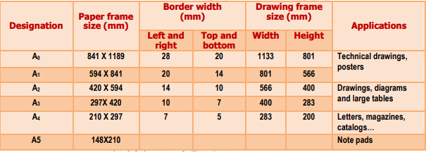
Drawing Pencils
One of the most important drawing materials is the drawing pencil. The two types of pencils used in drawing are mechanical and wooden pencils (see Fig1.1).drawing pencils with different grades of hardness are available. the grade of a pencil is designated by a number and a letter. The grades are 9B (very soft), 8B, 7B, 6B, 5B, 4B, 3B, 2B, B, HB, F, H, 2H, 3H, 4H, 5H, 6H, 7H, 8H, to 9H (very hard) see fig.1.3.
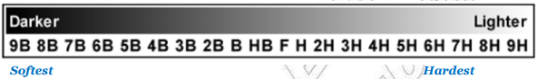 Fig.1.1
Generally speaking, the soft (B) grades are used for freehand sketching and the hard (H) grades are used for instrumental drawings. For mechanical pencils a wide variety of lead grades are available in different sizes, such as 0.3, 0.5, 0.7, and 0.9 diameters. Here, no sharpening of leads is necessary. The most common type of pencil is the wooden pencil shown in Fig.1.2 (a). To use this pencil,
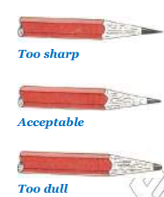
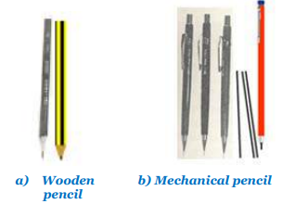
Fig.1.2 Fig 1.3a Wooden Fig.1.4b Mahanical

Identifying and selecting drawing instruments.
Drawing Instruments
Technical drawing instruments allow drafters to produce precise drawings. Technical drawing instruments are the tools used by professional and student drafters to render the precision graphics needed to manufacture a product or structure. These instruments take many forms because of the variety of lines and graphics needed for designs. Some instruments are manual, while others are computer-based. All professional quality drafting instruments are manufactured with precision because the drawings they're used to make must be precise. The following information assumes a right-handed drafter. Wherever "left" or "right" is written, the opposite direction may be substituted to apply to a left-handed drafter.
Selection of Drawing Instruments
The list of main drawing instruments is shown below:
- Drawing board
- Dusting brush
- Templates
- Pencil sharpener
- Scale
- Set square
- Protractor
- French curve
- French curve
- T-Square
- Divider
- Compass

Drawing Board
Drawing boards are usually made of white pine, but are sometimes made of other soft woods. The drawing surface may be the table top itself or a separate board. In both cases, the working surface (the drawing surface) should be flat, smooth and firm.For this reason, the working surfaces of drawing boards or table tops are made of soft white pine or basswood.
The working edge of a drawing board must be straight and should be tested with a steel straight edge. To prevent wear of the working edge some boards and table tops are furnished with a hardwood edge or steel insert on the working edge.
Drawing boards are made in various sizes. those usually used in school measure 23 × 30 cm, 40 × 53 cm or 46 × 60 cm. The smallest size is mostly used for field work or sketching.
Depending on their design, drawing tables may be fixedin height or can be adjusted toany desired working height.
Most industrial drawing drafting is done on tables similar to that shown in Fig. 1.5(b). Portable drawing boards are very handy for professionals as well as students. You can use these small drawing boards as tabletop drawing boards, handy reference boards, and drawing holders. The tracing table shown in Fig. 1.5(d), is another accessory that facilitates the draftsman work. A tracing table allows us to trace another work too blurred or dirty on a new paper. It provides the advantage of rectifying errors, such as stains or mistaken lines of ink, or other mistakes non correctable in some other surfaces. Sometimes it simply helps us to improve the presentation of the drawings
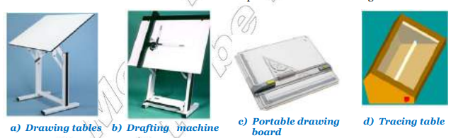
Fig. 1.5
Dusting Brush
During erasing, particles coming from the eraser will remain on the drawing paper. These particles are removed or cleaned using a dusting brush such as shown in Fig.1.10. It is poor practice to use fingers or palm of the hand for cleaning the drawing paper.
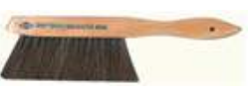
Fig 1.6
Drawing Templates
A template is a thin and flat piece of plastic containing various cutout shapes. It is designed to increase the speed and accuracy of the drafter.
Templates are available for drawing geometric shapes (Fig.1.7a), plumbing fixtures, bolts, nuts, screw threads, electronic symbols (Fig1.7b), springs, gears and much more. A template should be used whenever possible to increase the accuracy and the speed. The most commonly used type of drawing templates are shown in Fig. 1.7

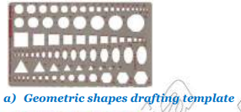
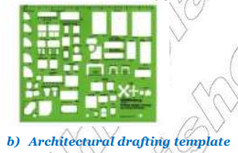
Fig.1.7a Fig1.8b

Pencil Sharpeners
Pencil sharpeners are drawing instruments used for sharpening pencils and they may be operated manually or by an electric motor and therefore a mechanical pencil sharpener is hand-powered. A common, portable variety is usually small and in the shape of a rectangular prism, with a conical hole on the small end. A sharp blade is mounted in a recess on the largest side such that its sharp edge just enters the cone.
The body of the sharpener is often contoured, ridged or grooved to make it easier to grip firmly. It has no moving parts - the tip of the pencil is inserted into the hole of the sharpener and twisted, while the sharpener is held motionless.
The blade inside the sharpener shaves the wood of the pencil, thus sharpening the tip, while the shavings emerge through a slot along the blade edge. An important feature is a larger clearance hole at the end of the cone allowing sections of the pencil lead which break away to be removed with only minor inconvenience.
There are different types of pencil sharpeners out of which the two most commonly used are shown in Fig.1.9
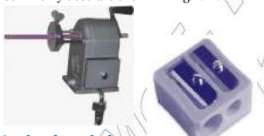

Fig.1.9 pencil sharpner

Scales
A scale is an item of drawing instrument that has been carefully graduated (marked) and calibrated (labeled) in convenient increments for the user. Scales enable a user to make size reductions or enlargements rapidly and accurately.
Scales are graduated in such a way that they can be used to draw objects to scale by direct measurement without any calculation.
Depending on its size, the drawing of an object may be the same size as the object, larger or smaller than the object.
When one unit on the object equals one unit on the drawing, we say the object is drawn to full size scale; written as 1:1. When one unit on the object is equal to two units on the drawing, we say the object is drawn to a magnification scale of 2:1.
Where as when two units on the object is equal to one unit on the drawing, we say the object is drawn to a reduction scale of 1:2. Similarly, a scale of 1:10 means one unit on the drawing is equivalent to ten units on the object and so on. Designation of a scale consists of the word “scale” followed by the indication of its ratio, as shown in the Table 1.2:

Table 1.2 Scales

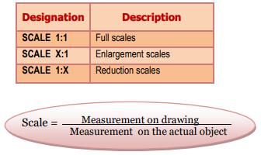

Drawing Scales
Generally, it is easier to produce and understand a drawing if it represents the true size of the object drawn. This is of course not always possible due to the size of the object to be drawn, that is why it is often necessary to draw enlargements of very small objects and reduce the drawing of very large ones, this is called “SCALE”. However, it is important when enlarging or reducing a drawing that all parts of the object are enlarged or reduced in the same ratio, so that the general configuration of the object is saved. Thus, scales are multiplying or dividing of dimensions of the object. The scale is the ratio between the size represented on the drawing and the true size of the object.
Scale= Dimension to carry on the drawing ÷ True Dimension of the object.
Examples: 1.
Dimension carried on the drawing = 4mm. True dimension= 40mm Scale = 4 ÷ 40 = 1:10
Triangles (Set-squares)
Triangles are sometimes called setsquares. The capability of rapidly producing straight lines on instrument drawings is provided by the 30-600 and 450 triangles (Fig.1.11).
Whereas adjustable triangles have a movable leg that is held in place with a thumbscrew and a scale for measuring angles.
These instruments are useful for drawing such inclined lines as the slope of a stair or the pitch of a roof. using the triangles as a pair, you can generate parallel and perpendicular lines and produce angles of a multiple of 150. Parallel lines are produced by establishing one side of a triangle along the given line or line direction. The supporting triangle is then fixed against one of the other sides of the first triangle.
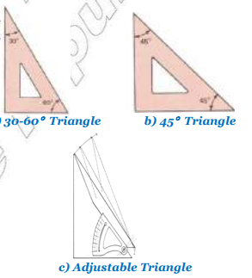
Fig 10 Triangles (Set-squares)

Protractor
For measuring or setting off angles other than those obtainable with the triangles, the protractor is used. Atypical protractor used for measuring angles is shown in Fig.1.12 You have most likely used this instrument in a geometry or trigonometry course.
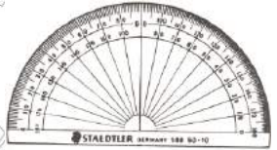
Fig.2.11 Protractor

French Curve
When it is required to draw mechanical curves other than circles or circular arcs, a French curve is generally employed. Many different forms and sizes of French curves are manufactured, as suggested by the more common forms illustrated in Fig.1.12
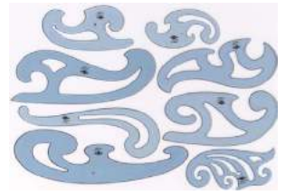

Fig.1.12 French Curve

Alphabet of lines.
- Explain the types and purpose of different weight of lines in making drawings
- Produce the lines with various line weights
- Apply alphabet of lines for making proper working drawings.
Lines of various forms and thickness are used as alphabets of the graphic language. If these lines are properly and systematically composed, they have the capacity to describe the shape of an object adequately. It is beneficial to develop the capacity of discriminating each line in shape and thickness. The alphabet of lines may be categorized into three groups based on their weights or thickness. The object line, the cutting plane line, and the short break lines should be drawn thick.
Lettering
Lettering is the process of writing an alphabet A, B,C…Z/a,b,c…z or a number 0.1, 2, 3…9.
Lettering is used to provide easy to read and understand information to supplement a drawing in the form of notes and annotations. Lettering is an essential element in both traditional drawing and Computer Aided Design (CAD) drawing. Name, notes and dimensions are all lettered.
Thus, it must be written with:

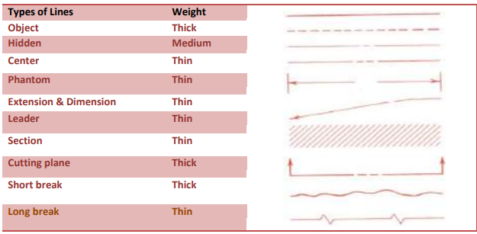
Fig1.13Types of Lines
The center lines, dimension lines, extension lines, long-break lines, and phantom lines should be thin and the hidden should have an intermediate thickness between the thin and the thick lines. In fact, thick lines are (0.5 to 0.8 mm) wide, thin lines between (0.03 to 0.5 mm) wide. The actual width each line is governed by thesize, the style of the drawing and the smallest size to which it is to be reduced.The description and illustrations shown in Fig. 1.14would be of great help to understandthe function of each line.
- All the main line types are listed below:
  - Visible
  - Hidden
  - Center
  - Dimension
  - Extension
  - Cutting plane
  - Section
  - Break
  - Phantom
      - Object lines:
are dark, heavy solid lines used to show the out line and shape of an object and define features you can see in a particular view. these lines are the most prominent lines on drawings. The object line is also identified as visible line.
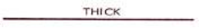
Fig. 1.14 Object lines
- Hidden lines:
are medium weight short dashed lines. They are used to show the out line of a feature that can not be seen in a particular view and help clarify a feature, but can be omitted if they clutter a drawing.
The dashes of hidden lines should be drawn approximately 3 mm long with a space of 1.0mm left between each dash. However, the length may vary slightly to suit the size of the drawing.
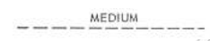
Fig. 1.15 Hidden lines
- Center lines:
Are thin lines composed of one long dash and one short dash spaced alternately. It is used to indicate axis of circles and symmetrical surfaces of an object. depending up on the size of the drawing, the length of the long dash approximately ranges from 20-40mm. The short dash is about 3mm and the spacing between the long and short dashes is about 1.5mm
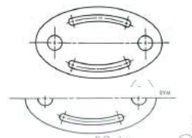Fig. 1.16 Center lines

- Dimension lines:
Are thin lines with arrowheads at its ends. It is used to Show the length, width, and height of the features of an object.
Fig. 1.17 Dimension line
- Extension lines:
Are thin solid lines used to show the starting and stopping points of a dimension. Extension line is drawn approximately 1.5mm away from object line and is extended 3mm long beyond the outermost arrowhead.
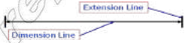
Fig. 1.18 Extension Line
- Leader Lines:
Thin lines ,used to show the dimension of a feature or a note that is too large to be placed beside the feature itself.
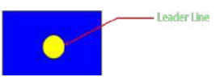

Fig. 1.19 leader

Cutting plane lines:
Areused to indicate the location of the cutting of cutting plane in the process of sectioning. two forms of lines may be used.
The first one is a dark line composed of one long and two short dashes spaced alternately.the long dashes are drawn approximately 20 to 40mm long or little more depending upon the size of the drawing.
The short dashes are drawn approximately 3mm long, with a space of 1.5mm between each dash. The second form of cutting plane line is composed of equal dashes approximately 6mm long with spaces of 1.5mm between each dash. the ends of the cutting plane lines are bent 900 angle and are terminated by arrowhead to indicate the direction of sight.
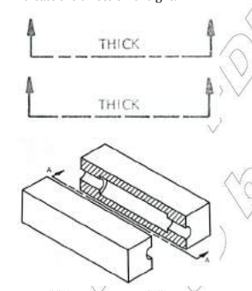

Fig. 1.20 Cutting plane lines:

8 Section Lines:
are used to indicate the cut surface of an object in sectional view. the section lines are usually drawn thin at 45 degree angle to produce a contrast with visible line. It should be equally spaced and proportional to the mass of the sectional surface.
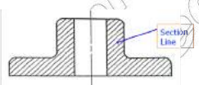
Fig. 1.21 section

Long Break Lines:
Are long and thin lines. It is used to show that the middle section of an object has been removed so it can be drawn on a smaller piece of paper.

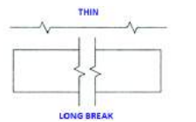

Fig. 1.22 long break

Performing measurements
Capital letters are preferred to lower case letters since they are easier to read on reduced size drawing prints although lower case letters are used where they from of a symbol or an abbreviation. Attention is drawn the standard to the letters and characters. Table (1.3) below give the recommendation for minimum size on particular drawing sheets:

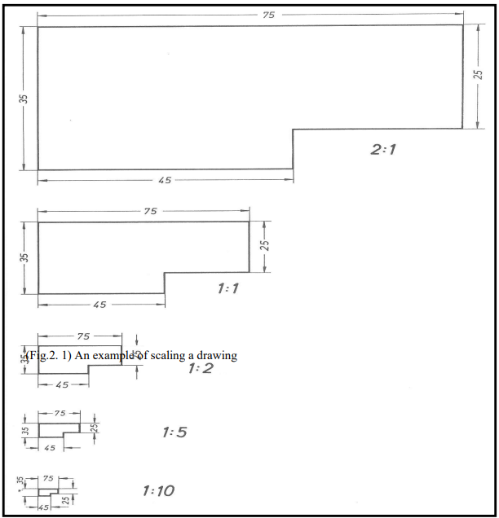

Self check-1
Name: _________________________ Date: _______________
Test-IChoose
Instruction: Choose the correct answer from the following Questions you have given 1 Minute for each question. Each question carries3 Point.
- Which one is used to mark or measure angles between 0 and 180
A. Protractor B. Divide
C. Ellipse template D. Circle Template
- Which one of the following is the largest size of drawing sheets
A. A4 B. A0
C. A5 D. all
- ________is a thin, flat piece of plastic containing various cutout shapes
A. Template B. French curve set squares
C. T-square D. curve set squares

- ________is a thin, flat piece of plastic containing various cutout shapes

Test-II short Answer writing
Instruction: write short answer for the given question. You are provided 3 minute for each question and each point has 5Points.
- Mention types drawing and explain each with example.
- List at least 3 drawing instrument and write its purposes.
- Mention two classification of lettering.
- List some alphabets of line in technical drawing.
- List all types drawing materials.

Test-III Matching
Instruction: select the correct answer for the give choice. You have given 1 Minute for each question. Each question carries2 Point.
A  - Object line  - Hidden line  - Center line  - Phantom line  - Break line  - Extension line  - Cutting plane line  - Section line  - Dimension line | B  - Used when it is necessary to show all of a part.  - The lines which shows the visible parts in a view  - It is used in combination with a cutting plane line to depict theinner structure of an object.  - Used to show the location of a cut for a sectional view  - Shows the course through which center travels.  - A thin line that extends from the part or feature being dimensioned.  - It is used to indicate edges, intersections  - Used to conjunction with the extension lines to indicate a linear distance.  - It is the gap from the object to the start of the dimension.

Operation Sheet
Operation Title: Methods of Using Drawing instruments (Fastening Paper to Drafting Board)
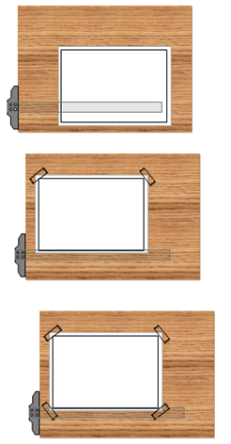
The steps of fastening Paper to Drafting Board are as follows:
- Place the paper close to the table’s left edge.
- Move the paper until its lower edge place about the top edge of T-square.

- Align the top edge of the paper with T-square blade.
- Attach the paper’s corners with tape

- Move T-square down to smooth the paper
- Attach the remaining paper’s corners with tape

Materials.
- Drafting Board
- T-square

LAP Test 1
Practical Demonstration
Instructions:
Using the drawing instrument, you are required to do the following exercises:
Task1: Create the drawing template (Title Block), shown with the following dimensions
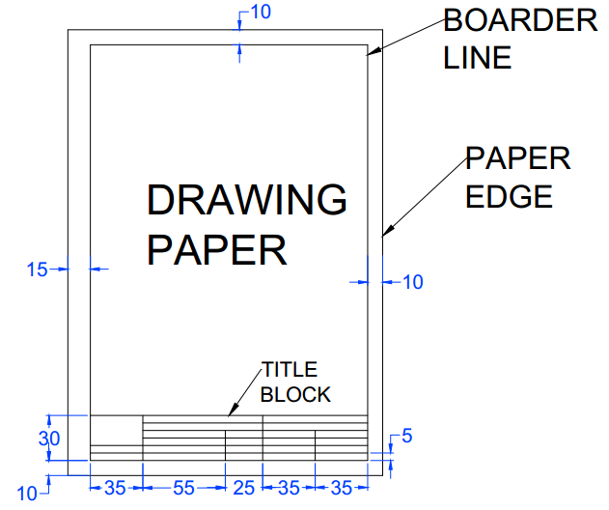
Materials.
- HB drawing pencil lead
- 4H drawing pencil lead
- 45º x 90º triangle
- 30º x 60º triangle
- Eraser
- T-square
- Drafting pens
- Drawing table
- Drawing papers

Unit two Draw simple drawing.
This unit is developed to provide you the necessary information regarding the following content coverage and topics:
- Illustrating complete drawing.
- Finishing drawing is neat and clear.
This unit will also assist you to attain the learning outcomes stated in the cover page. Specifically, upon completion of this learning guide, you will be able to:
- Construction complete drawing.
- Finishes draw neat and clear

Construction complete drawing.
The geometric construction forms the basis for all technical drawings. the purpose of the geometric construction is to accurately develope plane geometric shapes ranging from squares, triangles, and threedimensional cylinders to complex irregular curves and ellipses.
These constructions are normally produced without the aid of a scale, but rather with simple drafting tools. Engineers, designers, and drafters regularly perform the task of producing geometric construction in their work, applying the principles of plane geometry.
The process involved in the production of geometric constructions requires a basic understanding of plane geometry. Geometric construction skills can be acquired and demand precision and the correct use of drafting instruments. In developing geometric constructions it is important that drafting tools be in good condition. 4H to 6H leads are normally used for constructions that produce very lightweight lines.
These lines need not necessarily be erased when the construction is completed. A small error or inaccuracy in the solving of a geometric problem could result in a serious error in the final construction. There are a number of basic geometric constructions with which the student should be familiar. At the beginning the student should follow the basic sequence in each illustration that follows the learner how to develop the various

Construction of Point, Line and Angle
Points
The construction of geometric figures begins from representation of points on drawings. A point represents an exact location in space which has neither width, height nor depth. Points are commonly represented by intersection of two lines, a short cross bar on a line or by small cross
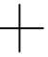 Fig.2.1 Points
Lines
A line can be defined as:
- A path between two points
- A moving point Geometric figure that has only one dimension: length.
Line may be straight, curved, or a combination but the shortest distance between two points is called straight line and it is commonly referred simply as a ‘’line’’. If the length of line is indefinite or without fixed endpoint, its length is any distance you select. If the line has fixed end points mark them with small mechanically drawn cross hairs.
A straight line drawn from left to right relative to a horizontal reference line is called a horizontal line and when drawn from top to bottom perpendicular to the horizontal iscalled vertical line. If two lines are equidistant throughout their length and will never meet or cross are called parallel lines.
The symbol for parallel line is //. Two or more lines crossing each other are called intersecting lines. The exact location where two lines intersect is called point of intersection.
Lines that intersect or cross and form a 90◦ or right angle are called perpendicular lines. The symbol for perpendicularity is ⊥. Fig. 2.2 shows the types of lines mentioned above.

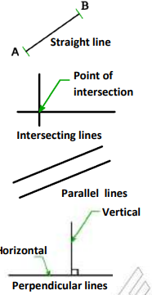

Fig. 2.2 Lines
Drawing Parallel Lines
- To draw a line parallel to a given line through a given distance Method 1
- Draw a line AB at any angle.
- Locate point E near A and point F near B on line AB.
- E and F as centers and radius CD, draw two arcs.
- Draw a line (GH) tangent to the arcs using any straight edge
Drawing Parallel Lines Method 2 (preferred method)
- Draw line AB at any angle.
- Open your compass to radius = CD.
- With any point E on AB as a center, and radius = CD, strike an arc.
- Align your set square with line AB with the T-square or another set square as a support.
- Slide the set square until it is tangent to the arc.
- Draw line GH using the edge of your set square.

Drawing Perpendicular Lines
Constructing perpendicular to a line through a point on the line (Fig. 2.3)
- Draw line AB and locate point P on it.
- With arbitrary radius r and p as a center, strike arcs to intersect AB at C and D.
- With radius greater than ½ CD, and centers at C and D, draw arcs to intersect at E. Use straight edge to draw line EP. EP ⊥ AB
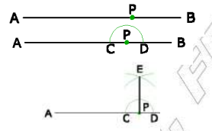(Fig. 2.3 Perpendicular Lines

Finish draw is neat and clear.
Constructing a perpendicular bisector of a given line
- Draw line or arc AB.
- Adjust your compass to a radius greater than ½ AB.
- With centers at A and B, draw intersecting arcs at D and E.
- Draw a line DE. DE ⊥ AB and AC=CB
Constructing a perpendicular to a line from a point outside the line
Method 1
- Draw line AB and locate point P anywhere but not on AB.
- P as a center and with arbitrary radius R, strike arcs on AB to get points C and D on the left and right side of P.
- Adjusting the compass radius r to greater than ½ CD, and C and D as a center, strike two arcs intersecting at E.
- Use straight edge to draw line

Method 2 Draw line AB at any angle and locate point P.
- Draw a convenient inclined line from P to intersect AB at point C.
- Locate the midpoint 0 off line PC as described in previous discussion.
- With 0 as cener and radius OP, draw an arc that intersect line AB at E.
- Connect P and E. PE ⊥ AB

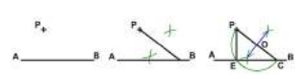
Fig. 2.4
Trisecting a Straight Line
Using 30-60° set square. (Fig. 2.9) 1. Draw a straight line AB. 2. Draw 30◦ lines from points A and B. 3. Extend them to intersect at C. 4. Draw 60◦ lines with the horizontal from point C in both direction and extend them to intersect AB at D and E. Check that AD=DE=EB.
Angles are formed by the intersection of two lines
The point of intersection is called the vertex. Angles are measured in degrees (◦), minutes (′), and seconds (′′). There are 360◦ in a full circle, 60 minutes in a degree, and 60 seconds in a minute. 26◦43 ′36′′ is read as 26 degrees, 43 minutes, 36 seconds. The concept of dividing angle by minutes and seconds is based on the fact that, the earth completes its rotation (360°) in 24 hours. A straight angle is an angle of 180° and appears as a straight line. Obtuse angles are angles less than 180° but more than 90°. An angle of 90° is referred to as a right angle because of the relationship between the two intersecting lines. Acute angles are angles less than 90°. When two angles are combined to total 90°, they are referred to as complimentary angles. Supplementary angles form when two angles combine to total 180°. You may draw angles at any degree of angularity using triangles or a protractor
Construction of Regular Polygons
Most of the construction methods for regular polygons are simple and memorable. This is because they can be inscribed in or circumscribed around a circle. Under this section, first we will discuss special construction methods for particular regular polygons and then common construction methods for any regular polygons. Constructing a regular pentagon in a given circumscribing circle
  - Draw horizontal diameter AB and vertical diameter CD intersecting at O.
  - Draw the circle with radius equal to half of AB.
  - Construct the midpoint of OB and mark as E.
  - With E as a center and radius equal to CE, strike the arc CF to intersect AB at F.
  - With C as a center and CF as a radius, strike the arc FG to intersect the circle at G. Note: A line from G to C is one side of the pentagon.
  - Set a compass to GC and lay off this interval from C around the circle.
  - Connect the points of intersection
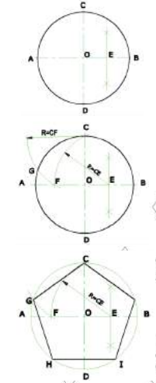
Fig. 2.5 circumscribing circle

Constructing a regular hexagon
Given the distance across corners (Fig. 2.6)
  - Draw a circle with AB as a diameter.
  - With A and B as centers and radius ½ AB, draw arcs to intersect the circle at C, D, E and F.
  - Connect the A, C, E, B, F and D to complete the hexagon.
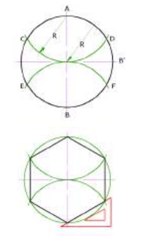
Fig. 2.6 regular hexagon
Finishes draw neat and clear.
- The pencil should be held naturally, about 40mm from general direction of the line down.
- Place the paper rotated position so the horizontal edge is perpendicular to the natural position of your forearm.
- When ruled paper is being used for sketching try to locate the sketched line on ruling line Use your imagination and common sense when choosing the most suitable angle of view. Figures 10.2 to 10.7 are the demonstration of different sketching techniques of lines and shapes.

Self check-2
Test-IMatching
Instruction: select the correct answer for the give choice. You have given 1 Minute for each question. Each question carries3 Point.
AB
_____ 1, Bisecting A) Polygon is outside the circle
_____ 2. Square B) Bounded by straight line
_____ 3 Inscribed C) Divide it two equal parts
_____4.Circumscribed D) Regular polygon
_____5.Polygon E) Polygon is inside the circle

Test- II True or false
Instruction: True /False You are provided 1 minute for each question and each point has 2 Points.
- The construction methods for regular polygons are simple and memorable
- The process involved in the production of geometric constructions is not requires a basic understanding of plane geometry
- The constructions is important that drafting tools be in good condition
Test III: short Answer writing
Instruction: write short answer for the given question. You are provided 2 minute for each question and each point has 10 Points.
- what are the drowning neat ?
- List types of lines?
- List all types drawing materials.?

Operation sheet- 2
Operation Title: Constructing heptagon. figures,
Procedures
Step1- Draw a line AB equal in length to one of the sides
Step1 -From a, erect a semi circle, radius AB to meet BA produced in P.
Step1- Divide the semi circle into the same number of equal parts as the proposed polygon has sides. This may be done by trial and error or by calculation (1800 /7 = 25 50 /7 for each arc).
Step1 -Draw a line from A to point 2 (For all polygons). This forms a second side to the polygon.
Step1-Bisect AB and A2 to intersect in O.
Step1-With centre O draw a circle, radius OB ( =OA = O2). • Step off the sides of the figure from B to C, C to D etc. ABCDEFG is the required heptagon.

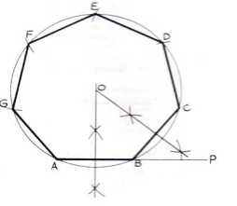

Lap Test- 2
Direction: Solve the following questions on A4 paper.
Task-1
- Draw horizontal diameter AB and vertical diameter CD intersecting at O.
- Draw the circle with radius equal to half of AB.
- Construct the midpoint of OB and mark as E.
- With E as a center and radius equal to CE, strike the arc CF to intersect AB at F.
- With C as a center and CF as a radius, strike the arc FG to intersect the circle at G. Note: A line from G to C is one side of the pentagon.
- Set a compass to GC and lay off this interval from C around the circle.
- Connect the points of intersectionTask-1:

Unit Three :Construct multi-view.
This unit is developed to provide you the necessary information regarding the following content coverage and topics:
- Illustrating three views drawing.
- Constructing multi-view drawing.
- Corrects view orientation (isometric).
- Developing pictorial (3D) drawing.

This unit will also assist you to attain the learning outcomes stated in the cover page. Specifically, upon completion of this learning guide, you will be able to:
- Three views drawing.
- Constructions multi-view drawing.
- Corrects view orientation (isometric).
- Develop pictorial (3D) drawing.

Three views drawings.
One and Two View Drawing
One view drawings
One view drawings are drawings that consist of one view of the object with additional notes. these drawings are often suitable to represent flat and cylindrical objects.
For example, constant thickness parts such as shown in Fig.3.1(a) can be represented by a single view showing the characteristic shape.
The thickness is specified by a note adjacent to the view. Fig.3.1(b) shows another example on a cylindrical object which can be represented by a single view.
The single view shows the axis of the cylindrical part as a center line, and the diameter symbol (Ø) along with the diameter dimensions.
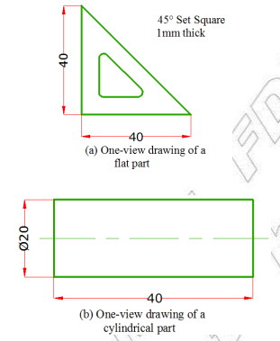
Fig 3.1 One view drawings

Two view drawings
On some objects only two of the views might represent the outline clearly.in such cases only the front view and one additional side or top view will be enough to describe the object completely.
These views should be selected in accordance with the guidelines discussed in section 6.4.4. To lay out one view and two view drawings centrally, the distance between the object and the borderline is necessary and it can be laid as follows. A = B and C = D
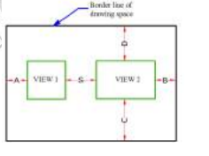(Fig. 3.2) Two view drawings

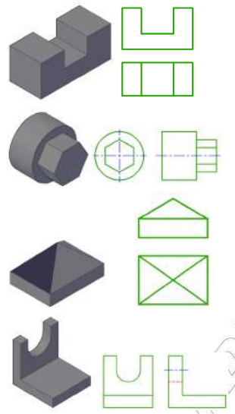

Fig 3.3 Two view drawings

Three-View Drawing
Three-view drawings are multi-view drawings that consist of three views of an object. These drawings are prepared for objects which require three views for their complete description.
Fig.6.20 shows a typical example of an object which requires three views
Invisible Lines and Arcs Invisible edges in multi-view drawings are represented by dashed or hidden lines. When drawing views of objects, invisible lines and visible lines may intersect. Hidden lines may also intersect each other. In such case lines should be drawn according to the correct practices shown in

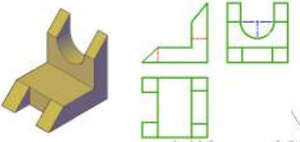

Fig.3.4 Three-View Drawing

Constructions multi-view drawing.
Multi-view drawings are conventional projections of a three dimensional object on a two dimensional plane. Anything which is going to be produced or constructed is based on the proposal given by multi-view drawings.
By this projection convention engineers, architects, draftsman can communicate with each other even if they don’t speak common language.
The basic rules and principles of orthographic projection will be discussed on this chapter
Types of projection
A projection is a drawing of an object which is three dimensional on a two dimensional surface or plane. The two dimensional surface used for the projection is called plane of projection or the picture plane. There are different types of projections which are classified depending on:
- The angle the lines of sight (projectionline) make with the projection plane,
- The angle the lines of sight make witheach other,
- The relative position of the object to beprojected with respect to the projection plane.
Projection methods are broadly classified into two:
- Parallel projection and Central projection.
In central projection, the observer is assumed to be located at some finite location.
Hence the visual rays projected from the different corners of the object converge to the single point of viewing, this is the actual viewing mechanism and therefore the projection possesses realistic appearance like camera picture. Central projection is commonly called Perspective projection.
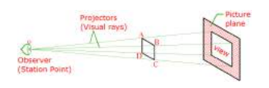
Fig.3.5 projection

Perspective projection is further classified as linear perspective and aerial perspective. As the observer moves further and further away from the object, the angle between the visual rays reflected from the different corners of the object becomes more and more gentle. If we can therefore place the observer at very large distance from the object we can assume that these visual rays become parallel with each other.
Parallel projection is based on the assumption of observer being at large distance without losing the ability to see the object. this assumption will bring about some distortion to the pictorial appearance of the projection as compared to actual appearance.
Parallel projection is further classified into orthographic and oblique projection. If the lines of sight are parallel to each other and perpendicular to the picture plane, the resulting projection is called an orthographic projection. If the lines of sight are parallel to each other but inclined to the picture plane, the resulting projection is called an oblique projection.
Orthographic projection is further classified into multi-view projection and axonometric projection. In multi-view projection more than one projection is used to give complete size and shape description of the object while in axonometric projection a single view is sufficient to describe the object complet
- Orthographic Projection
- Planes of Projection
There are three planes perpendicular to each other, which are the basis of multi-view projection. These are:
- Horizontal projection plane.
- Frontal projection plane.
- Profile projection plane.
The position of these planes is illustrated on the figure below (Fig. 3.5). The lines of intersection of these three planes are called reference lines
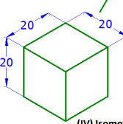
Fig.3.6 basic planes of projection
In multi-view projections, lines of sight (projectors) are perpendicular to the planes of projection. The projection of an object on the vertical/frontal projection plane is commonly known as front view. Similarly, horizontal projection of an object is called top view and the profile projection of an object is known as side view.
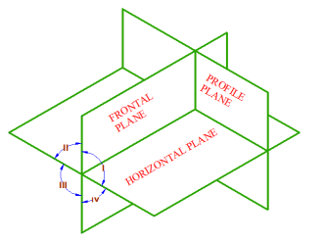
Fig.3.7 multi-view projections

First Angle Projection
The three principal planes of projection form four quadrants (Fig.3.8). The multi-view of an object can be done by placing the object on one of the quadrants. But usually the first and the third quadrants are the conventional quadrants used.
When the object is assumed to be placed in the first quadrant it is known as first angle projection system. In this case the observer is placed in front of the vertical plane, the object will appear to be between the observer and the projection plane. In Fig. 3.8, the three views of a simple object on the three principal planes of projection are shown pictorially.
Then to represent all the views in one plane, the horizontal plane and the profile plane are rotated to the vertical plane as shown in Fig. 3.8.
The views are then drawn in their true shape as shown in Fig.3.9 (b). Note that the views are arranged in such a way that the top view is always directed below the front view and the left side view is directly to the right of the front view.

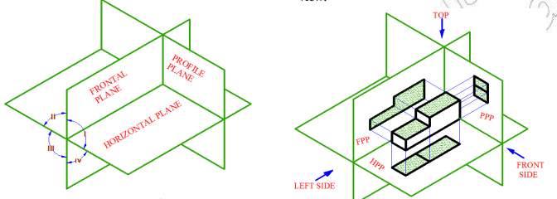
Fig.3.8 First Angle Projection Fig3.9 Projection planes

Third Angle Projection
When the object is placed in the third quadrant it is known as third angle projection system.the projection plane is placed between the observer and the object.
Therefore, in the projection process it is necessary to assume the plane of projection to be transparent. Here again the projections are perpendicular to the projection planes
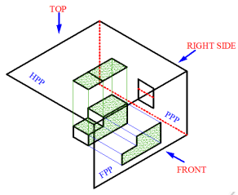
Fig.3. 10

Corrects view orientation (isometric).
Observe that some of the six views of an object may be enough to represent the object completely. Note the following points to determine the essential views for the complete description of the object.
- Orientation of the object
- Place the object in its most natural (stable) position.
- Place the object with its main faces parallel to the planes of projection
- Choice of views
- Select those views (in addition to thefront view) that provide the clearest information about the shape of the object.
- Do not use more views than the necessary views which describe the object.
- If the left side and right side views are identical in terms of information and line work, select the view to be drawn to the right of the front view, in accordance with tradition.
- If the top view and bottom view are identical in terms of information and line work, select the top view.
- If the top and side views are identical in terms of information and line work, select the one that best utilizes the available drawing space.
- If two views are identical in terms ofinformation, but one contains more hidden line work than the other, select the view with fewer hidden lin

Develop pictorial (3D) drawing.
Types of Pictorial Drawing
Pictorial drawing, as discussed earlier, is a means by which the three principal faces and dimensions of an object are represented on a single 2D projection plane (sheet of paper). Pictorial drawing is divided into three classifications:
- Axonometric projection,
- Oblique projection, and
- Perspective or central projection. the difference among the three projection types is illustrated pictorially as shown in Fig. 3.12

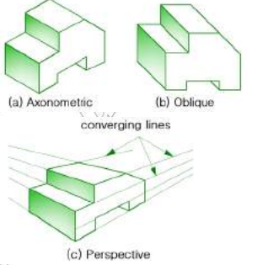
Fig. 3.12 Axonometric, oblique and perspective projections
Axonometric Projection
It is a form of orthographic projection that shows the three principal faces of an object on a single projection plane (picture plane) unlike multi-view projection which uses three different projection planes for the three principal faces. In axonometric projection, the object is placed in an inclined position with respect to the plane of projection so that its principal faces will be displayed principally in axonometric projection. The following three steps should be considered in placing the object when trying to display the axonometric projection of an object on a picture plane as shown in

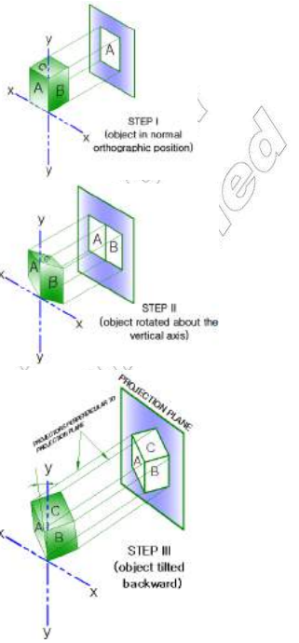
Fig 3.13
Step1:The object is first placed in its customary position, with one principal face made parallel to the picture plane.
Step2: It is then rotated from its ordinary position about the vertical axis through any proper angle so as to display the two lateral faces on the projection.
Step3: Finally the object is tilted forward or back ward through again any desired angle so as to display the third face i.e. top or bottom and then projected on the picture plane.

Self check-3
Test-IChoose the correct answer from the following Questions
1 .One of the following views gives length and width of dimensions
A. side view C. Front view
B. top view D. none
2. Which one of common standards used in orthographic projection of drawings
A. First Angle Projection B. European projection
C. Third Angle Projection D. A and C
3. __________ is a diagram, picture, schematic or technical drawing of an object, that shows the relationship or order of assembly of various parts.
A. Perspective drawing B. Exploded drawing
C. Isometric Drawing D. Axonometric drawing
Test-IIMatching :
Instruction: select the correct answer for the give choice. You have given 1 Minute for each question. Each question carries 2 Point.
A  - Parallel projection and Central projection.  - Perspective projection  - Parallel projection  - Parallel projection  - Axonometric Projection | B  - the object is placed in an inclined position with respect to the plane of projection  - the object is placed in the third quadrant  - the lines of sight are parallel to each other  - The assumption of observer being at large distance without losing the ability to see the object  - The visual rays reflected from the different corners of the object becomes more and more gentle

Operation sheet- 3

Operation Title: To draw One Point Perspective. Isometric view and Multi view drawing.

Procedure:
Step1. Set up the drawing paper on top of the drawing board.
Step2. Check to see that the paper edges are parallel to the left and bottom edges of the board respectively.
Step3. Properly secure the paper on top of the table by using masking tape or tacks or the likes.
Step4. Using the set of triangles and T-square, draw the border line around the drawing paper, and title block at the bottom part.
Step5. Be sure to check the sharpness of your pencil lead. Use standard sharpening for good aesthetic result of your work.
Step6. For normal drafting or lettering use the soft lead pencil (HB) for final results. Use the harder lead pencil (4H) for guidelines drawing only.
Step7. For inking, drafting pens of 0.1, 0.3 and 0.5 pen points are needed.
Step8. Use the set of triangles, T-square and lead pencil this activity.
Step9. Always remember that construction lines and guidelines are necessary in sketching and drafting, so utilize this knowledge.
Step10. Apply the knowledge on line quality in your work.
Step11.Accuracy and aesthetics always go hand in hand with drafting, so do your work with quality.
Step12. You may submit your finish work once you are true but should be within the time specified for submission.

Lap Test-3
Task 1 Consider the simple object whose six principal views were given in Fig. 3.11.the front view is necessary and should be drawn always. then, therear view is not necessary since it shows no additional information. the left side view is preferred to the right side view because there is no hidden line in the left side view.the top view is preferred to the bottom view because there is no hidden line on the top view. therefore, the three necessary views of the object are the front, top and left side views as shown in Fig. 3.14
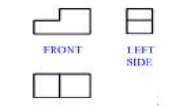
Fig. 3.14
Task 2 Let us consider the object whose six views were shown in Fig 3.13. The right side view is preferred to the left side view because it has less number of hidden lines. Likewise, the top view is preferred to the bottom view.
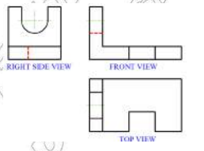

Fig 3.13.

Task 2 Draw the Orthographic views of the Isometric view shown in the following figure

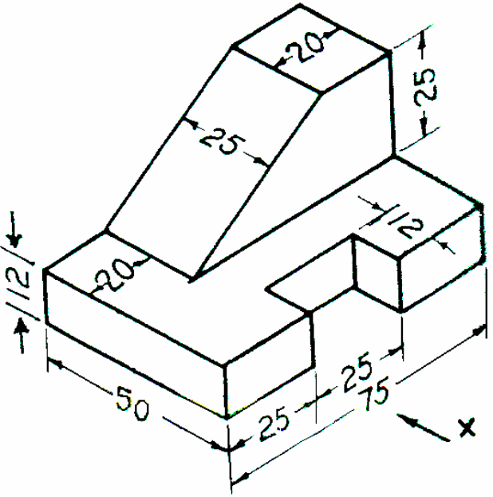

UnitFour: Prepare freehand sketch.
This unit is developed to provide you the necessary information regarding the following content coverage and topics:
- Sketching and drawn appropriate views.
- Conveying necessary dimensions and information.

This unit will also assist you to attain the learning outcomes stated in the cover page. Specifically, upon completion of this learning guide, you will be able to:
- Sketching and drawn appropriate views.
- Conveying necessary dimensions and information.

Sketching and drawn appropriate views.
Consider an Architect who wants to design a building, a plumber who wants to design a wetar splay and draing or a plumbing inst; an Industrial Engineer who wants to design a plant layout; how would he/she start the design? Practically all starts and put their idea with freehand sketch.
Freehand sketching is one of the most effective ways to communicate a pictorial or verbal idea to a workman. Sketching may be schematic, expressing new ideas, or instructional to convey ideas to draftsmen.
After these ideas, concepts, and details for a project have been finalized, precise technical drawings are produced using instruments so that parts may be manufactured or constructed. Freehand sketches are also used by engineers to clarify, evaluate and record preliminary ideas and concepts. Sketches can be used by all persons irrespective of their specialization to support their ideas with figures.
The fundamental concepts in technical drawing are the same weather instrumental or freehand drawing is used in representing or transferring ideas.
But freehand sketching is preferable to draw easily and freely as hand writing, and the mind of the sketcher would be free to concentrate upon an idea,
not upon the technique of sketching the idea. Sketching, similar to writing, is a skill that can be developed through practice. Some examples of analytical sketches are illustrated.
These represent the type of sketches you might be asked to produce in industry or on the job site. In this unit the basic techniques of both two-dimensional sketching and pictorial sketching are discussed

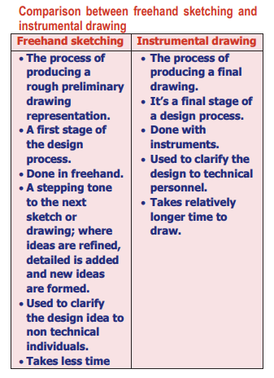
Table 4.1

Uses of Freehand Sketching
What do you think is the use of sketching for engineers and designers?
Sketching is as much a thinking process as it is a communication technique and it is a rapid method of drawing. In addition to gaining speed freehand sketches have the following uses;
  - Transferring information, obtained in the field or shop, to the engineering office.
  - Conveying the ideas of the designer to the draftsman.
  - Making studies of the layout of the views required in an instrumental drawing.
  - A means of making preliminary studies of a design to show how it functions.
  - Furnishing a three-dimensional picture of an object; this will help to interpret the orthographic views.

Types of Freehand Sketching
Freehand sketches can be categorized into three: 1. Sketches which communicate technical data such as charts, graphs, maps, and diagrams as shown in Fig.4.1.

Conveying necessarydimensions and information.
An engineering drawing must be properly dimensioned in order to convey the designer’s intent to the end user. Dimensions provide the information needed to specify the size and location of every feature on the object. A properly dimensioned drawing ensures that the part produced in the manufacturing phase matches the part asked for by designer. There are a few simple guidelines to be followed when dimensioning a drawing and these guidelines covers the majority of cases you will encounter.
- Keep the dimension line about 10mm apart from the object.
- Do not repeat dimensioning same distance.
- If possible do not dimension hidden lines.
- Stagger dimensioning values.
- Create a logical arrangement of dimensions.
Dimensioning Tolerance and Notation
The purpose of dimensioning is to provide a clear and complete description of an object. A complete set of dimensions will permit only one interpretation needed to construct the part. Dimensioning should follow these guidelines.
- Accuracy: correct values must be given.
- Clearness: dimensions must be placed in appropriate positions.
- Completeness: nothing must be left out, and nothing duplicated.
- Readability: the appropriate line quality must be used or legibility

Type of tolerances
- General Tolerance
If no tolerances are specified at the dimension level, then general tolerances may be applied by deliberately controlling the number of values past the decimal point on each dimension.

- Geometric tolerance
The use of linear tolerances when dimensioning the part can control the size of a product. It is however possible for limits of size to be maintained while the shape of a part or feature deviates significantly from the intended form. To control this deviation, a method of specifying the acceptable tolerance of form is required and this is done using geometric dimensioning and tolerance symbols. These enable the designer to specify on the drawing, the geometry or shape of a component and they provide a precise definition of what constitutes a functionally good part.
3. Angular tolerance
In a mechanical drawing of a part, angularity tolerance allows the designer to specify the degree to which the orientation of an angled part feature may vary. The angularity symbol is often used to insure that the part can properly mate with another.

Self check-4
Test- I Choose
- Which of the following true about freehand sketching
- Transferring information, obtained in the field or shop, to the engineering office.
- Conveying the ideas of the designer to the draftsman.
- Making studies of the layout of the views required in an instrumental drawing
- All true
- Which of the following about type of sketches
- two-dimensional sketching
- pictorial sketching are discussed
- A and b
- Drawing
3.______________ is used to provide easy to read and understand information to supplement a drawing in the form of notes and annotations.
A. Dimensioning B. Drawing
C. Lettering D. Sketching

Test- II True or False
Instruction: T/F You are provided 1 minute for each question and each point has 2 Points
- The use of linear tolerances is dimensioning the part can control the size of a product.
- Dimensions is provide the information needed to not specify the size and location of every feature on the object
- The purpose of dimensioning is to provide a clear and complete description of an object

Operation sheet- 4
Operation title: sketching straight line
Procedures:
Step-1:Mark the end points
Step-1:Make a few trial motions between the marked points to adjust the eye and hand to the contemplated line.
Step-1:Sketch a very light line between the points by moving the pencil in two or three sweeps. When sketching the trial line, the eye should be on the point toward which the movement is directed.
Step-1:Darken the finished line, keeping the eye on the pencil point on the trial line. The fnal line, replacing the trial line, should be distinct, black, uniform, and straight.

Lap Test-4
The following steps are recommended for sketching straight line:
Step 1: Mark the end points
Step 2: Make a few trial motions between the marked points to adjust the eye and hand to the contemplated line.
Step 3: Sketch a very light line between the points by moving the pencil in two or three sweeps. When sketching the trial line, the eye should be on the point toward which the movement is directed.
Step 4: Darken the finished line, keeping the eye on the pencil point on the trial line. The final line, replacing the trial line, should be distinct, black, uniform, and straight.

Unit 5: Interpret details from sketches and drawings
This unit is developed to provide you the necessary information regarding the following content coverage and topics:
- Identifying Components, assemblies and objects.
- Recognizing symbols and abbreviations.
- Identifying dimensions and instructions.
- Identifying material requirements.

This unit will also assist you to attain the learning outcomes stated in the cover page. Specifically, upon completion of this learning guide, you will be able to:
- Identify Components, assemblies and objects.
- Recognize symbols and abbreviations.
- Identify dimensions and instructions.
- Identify material requirements.

Identify components, assemblies and objects.
A Drawing of an object is prepared to define its shape and to specify its size. A complete drawing of an object gives its shape descripttion and also a complete size description.
The shape description is based upon the theory of projection. The size description is based upon the theory of dimensioning. A dimension is the art by which the dimensions of an object are written on its drawing.
The correct dimensioning requires a systematic way in which the dimensions are written on the drawing. All the discussions throughout this text is supported by an illustration to explain the basic principle of dimensioning however those detail drawings not helpful for this explanation have been omitted.

Recognize symbols and abbreviations.
There is a number of common engineering terms and expression, which are frequently replaced by abbreviation or symbols on drawing, to save space and drafting time. This will include the electrical, electronic, pneumatic and hydraulic symbols.

Lines and Symbols
For a proper size description of an object, one must have basic knowledge and skill how to use the various symbols, forms and elements of dimensioning on its drawing.
The basic symbols, forms and elements used in dimensioning are dimension lines, extension lines, leaders, arrowheads, dimension (numerical values), symbols explaining a feature’s size and notes. All these concepts are explained graphical on Fig 5.1
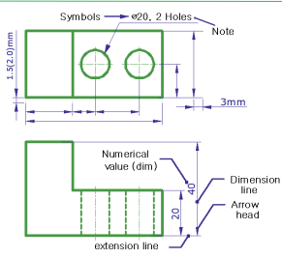
Fig 5.1
Forms of dimensioning
The two basic dimension forms while giving a size of a feature are a dimension and a note as shown on the above figure.
Dimension: refers to the numerical value used to give distance information between two specified points or size of a particular feature. It is placed centrally above or by breaking dimension line.
Note: Refers to the written word or Phrase used along with a dimension as explanatory information.
Leader: is a thin continuous line leading from a dimension value or an explanatory note to the feature on the drawing to which it applies. Leader lines start from a size or a note ends:
- with an arrow head when it stops touching outline of view of a part and
- with a dot when rests on a surface with in the outline of a part crossing its outline or
- without any arrow and dot mark when rests on a dimension line as shown on figure below.
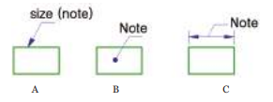

Avoid the use of long leader line even if it means repeating features. Leaders should not cross each other rather one drawn parallel to the other.
Dimension line: is a thin continues line terminating commonly with an arrow head in a machine drawing and oblique stroke/ dot in architectural and structural drawing to indicate direction and extension of dimension.
Extension line/projection line: is a thin continuous line that extends from a point on a drawing to which a dimension refers to and providing a boundary for the dimension line. It is usually drawn perpendicular to the outline and dimension line and there should be a gap of about 1.5 (2.0) mm from the outline of the object and 2mm extension beyond the dimension line.
Arrowheads: are terminators of dimension lines where they stop touching extension lines or features lines. They should be uniform in size and style throughout the drawing. The length of arrow head should be three times its width.there are basically two styles of arrow heads namely open and closed; as shown in Fig 5.3. In fact there are very different styles of arrow head terminators.
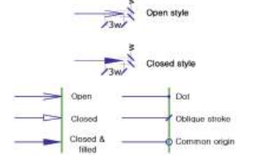
Most often the closed filled in type is used for general purpose and oblique stroke for architectural and structural drawings.

Identify dimensions and instructions.
Reading Direction of Figures
- There are two systems of placing dimension based on the reading direction of figures.

- Unidirectional dimension
Here dimension and notes should be placed to be read from the bottom of the drawing. This system in majority cases used for engineering drawing as show in Fig 5.4 (a) below.
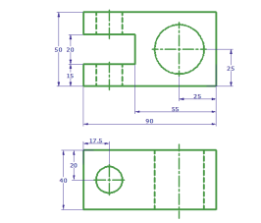A) Unidirectional dimensioning

- Aligned dimension
In this system, all the dimensions are so placed that they may be read from the bottom or right hand edge of the drawing.
All the dimension should stand normal to the dimension line as shown below on Fig.5.4 (b). Mostly this system of dimen-sion is used for architectural and structural drawings.

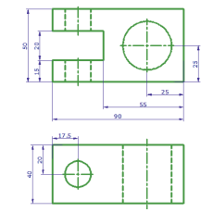
b) Aligned dimensioning

Identify dimensions and instructions.
Theory of dimensioning
All objects are composed of one or more of the following different basic geometric shapes such as prism, cylinder, cone, pyramid and sphere. So dimensioning an object becomes relatively easy if you first break it down into its component geometric shapes as shown on Fig.5.1
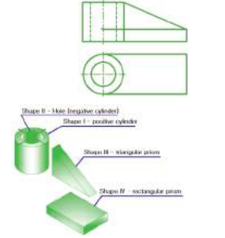
Eig. 4.5 An object broken down into its component parts

The object is said to be fully dimension when the two types of dimensions i.e. size dimension and location dimension are included.
- Size Dimensioning
It is used to describe size of an object such as height, width, depth, thickness, length, radius, diameter etc, with regard to its form and other features like holes and slots.
- Location Dimensioning
It is a type of dimension used to locate the various features like hole, slot etc, of an object relative to each other from center of one feature to centerline of another similar/ different feature or to a reference edge. It can be given in all width, height and depth direction

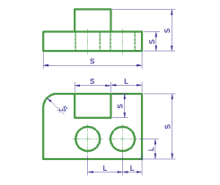

Identifying material requirements.

N.B---- Pales student refers unit one in LO-1

Self check-5
Test-ITrue or false
Instruction:True or false for each question.each question carries2 Point.
- The purpose of dimensioning is to provide a clear and complete description of an object.
- Complete set of dimensions will permit only different interpretation needed to construct.
- The drawing of an object is prepared to no define its shape and to specify its size
Test-IChoose correct answer make it circle on the answer
- Which of the following reading direction of figures
- Unidirectional dimension
- Aligned dimension
- Circles dimension
- ALL
- Which of the following is dimension linecontinues line terminating commonly with an arrow head in a machine drawing
- T
- F
- One of the following views gives length and width of dimensions
A. side view C. Front view
B. top view D. none

Operation sheet- 5
Operation Title: To perform dimensioning of different features of Views.
Procedure:
Step1- Set up your drawing paper on top of the drawing board.
Step2 - Use the drawing template format given to you by your teacher.
Step3 - Be sure to check the sharpness of your pencil lead. Use standard sharpening for good aesthetic result of your work.
Step4 -Using the basic drawing instruments and materials, perform the drawing task in the given following task 1 under LAP test 5.
Step5 - Use appropriate pencil lead in your drafting works.
Step6 - provide the 3 basic orthographic views (top, front and side/end views) given the isometric view.
Step7- Provide appropriate dimension for each views accordingly.
Step8 - You may submit your finish work once you are complete but should be within the time specified for submission..

Lap Test-5
Task1:draw the orthographic projections needed to fully describe the part. Choose the best view for the front view. Use a scale of 1:1 with 50 mm spacing between the views. Apply all dimensioning style. Note: All Dimensions in mm.
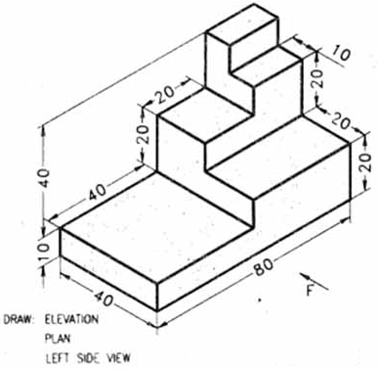

Reference Materials
- Basic technical drawing student textbook grade 11
- Basic technical drawing student textbook grade 12
- Building Construction Handbook’ (6th ed.),CHUDLEY, R. And GREENO, R., Butterworth-Heinemann (2007
- French, Thomas E.; Vierck, Charles J.; et al. (1953), A manual of engineering drawing for students and draftsmen (8th ed.), New York, New York, USA: McGraw-Hill

The Trainers Who Developed This TTLM
No | Name of trainer | Qualification /study | Organization/ Institution | Mobile number | E-mail
1 | TESHALE MULUGT | MSc Construction technology management |  | 0920469129 | Teshamulu909@gmail.com
2 | AbebeEndalew | Civiv | Misrak Poly T. C | 0933007756 | Abebeaware09@gmail.Com
3 | Million Aklilu | Construction technology management | BTC | 0920469129
4 | Sileshikassahun |  | MTC |  | Sileshikassahun21@gmail.com

