PLUMBING INSTALLATION
LEVEL - I
Based on August 2022, Curriculum Version 1
Module Title: Perform banche wok.
Module code: EISPLI1 M 05 0322
Nominal duration: 90 Hour
Prepared by: Ministry of Labour and Skill

August, 2022
Addis Ababa, Ethiopia

Acknowledgment
Ministry of Labor and Skills and Ministry of Health wish to extend thanks and appreciation to the many representatives of TVET instructors and respective industry experts who donated their time and expertise to the development of this Teaching, Training and Learning Materials (TTLM).

Table of Content
Acknowledgment 2
Table of Content 2
Introduction to the Module 4
Module Instruction 5
Unit One: 5
1. Perform Bench Works 5
1.1 Principle of Work value /ethic 5
1.1.1 Work ethic characteristics 6
1.1.2 Improve work ethic skills 7
1.2 Undertaking work practices 7
1.3. Conduct of personal behavior relationships with co-workers. 8
Self-Check-1 9
Unit Two 10
2. Layout and mark dimensions/ features on work piece. 10
2.1 Types and uses of tools and materials 10
2.1.1 Clamping tools 11
2.1.2 Measuring and marking tools 13
2.2 Performing lay out and marking 17
2.2.1 Making Lines on Metal 17
2.2.2 Steps in Making a Layout 19
Self-Check-2 19
Unit Three 21
3. Cut chip and file rectangular or round blocks. 21
3.1 Avoid damage and accidents in the work hold devices 21
3.2 Cutting, chipping, and work pieces 23
3.2.1 Cutting metals 24
3.2.2 Cutting process 25
3.2.3 Making the Cut with a Hacksaw 25
3.3 Perform bench work operations 28
3.3.1 Chipping 28
3.3.2 Chisel and Types 29
3.3.3 Filing 30
3.3.4 Scraping 34
Self-Check-3 35
Unit Four: 36
4. Drill, ream and lap hole 36
4.1 Drill, ream, spot-facing and lapping hole 36
4.1.1 Differences between drilling and reaming 38
4.1.2 Drill press 39
Self-check-4 41
Lap Test: 4 42
Unit Five: 43
5 Cutting threads using tap and stock and die 43
5.1 Cutting thread and fit gage system 43
5.2 Perform the Sequence of tapping 45
5.2.1 Hand Tap: 45
5.2.2 Tapping of Hole: 46
5.2.3 Threading Dies 47
5.2.4 Thread with a Hand Die Working Steps 49
Self-Check -5 49
Unit Six: 51
6. Off-hand grind cutting tools 51
6.1. Perform Hone and Cutting edges. 51
6.1.1 Functions of cutting edge in machining 52
6.2 Single point, double point and multi-point cutting tools 53
Reference 56

Introduction to the Module
The term 'bench work' refers to production of components by hand on the bench, whereas fitting deals which the assembly of mating parts, through removal of metal, to obtain the required fit. Both the bench work and fitting requires the use of number of simple hand tools and considerable manual efforts. Bench work and fitting have important roles to play to complete the production of our articles by hand on the bench. Fitting if the assembling to gather of parts and remove metal to secure the necessary fits and may or may not be carry out at the bench .The working of metals is made possible by the manipulation of tools and machines. Hand tools are the basic tools normally used in the school and college workshop to realize designed artifacts. The first part of this chapter covers bench work tools such as files.
This module is perform bench work to meet the industry requirement under the plumping installation occupational standard, particularly for the unit of competency: performing of basic bench wok Operations of lay-out; cuting by hacksaw and chisel; filing; drilling; tapping and checking the components for conform to spécifications.
This module covers the units:
- Reaffirm work values/ethics of work values and ethics.
- Layout and mark dimensions/ features on work piece
- Cut, chipping and file flat, rectangular or round blocks.
- Drill, ream and lap holes.
- Cut threads using tap and stock and die.
- Off-hand grinds cutting tools.
Learning Objective of the Module
- Classify and reaffirm work values/ethics
- Make Layout and mark dimensions/ features on work piece.
- Perform Cut, chip and file flat, rectangular or round blocks.
- Perform Drill, ream and lap holes.
- Make Cut threads using tap and stock and die.
- Perform Off-hand grinds cutting tools.

Module Instruction
For effective use this modules trainees are expected to follow the following module instruction:
- Read the information written in each unit
- Accomplish the Self-checks at the end of each unit
- Perform Operation Sheets which were provided at the end of units
- Do the “LAP test” giver at the end of each unit and
- Read the identified reference book for Examples and exercise

Unit One:

Perform Bench Works
This unit is to provide you the necessary information regarding the following content coverage and topics:
- Principle of work values and ethics.
- Undertaking work practices.
- Conduct personal behavior and relationships.
This unit will also assist you to attain the learning outcomes stated in the cover page. Specifically, upon completion of this learning guide, you will be able to:
- Classify and reaffirm work values/ethics.
- Undertake work practices.
- Conduct of personal behavior and relationships.

Principle of Work value /ethic
What is work ethic? Work ethic is an attitude of determination and dedication toward one’s job. Those with a strong work ethic place a high value on their professional success. They exhibit moral principles that make them outstanding employees in any position. If you have a strong work ethic, you believe in the importance of your job and typically feel that hard work is essential to maintaining a strong character.
Work ethic is an attribute that employers value in every industry. Showing the values associated with a good work ethic can increase your employability and help you position yourself for better job opportunities. Employees with an excellent work ethic are often considered by employers for special projects because these people are viewed as reliable, dedicated and disciplined.
In this module, we discuss what a work ethic is, its most valuable components and steps to improve yours.

Work ethic characteristics
Employees with a strong work ethic exhibit a particular set of values and behaviors. These characteristics make them stand out as highly coveted team members and praise-worthy employees.
- Reliability
Employees with a strong work ethic are very reliable. You can expect these individuals to be on time for shifts and meetings. They meet their deadlines and offer quality work. A reliable coworker makes an excellent teammate because they contribute fairly to projects.
- Dedication
Part of a good work ethic is commitment and dedication to the job. They know how to focus on tasks without being distracted. These employees usually work until they finish their duties. They stay with one company for long periods.
- Discipline
Discipline is an essential part of showing a good work ethic. Highly disciplined employees show determination and commitment to the job. They strive to meet or exceed expectations and seek opportunities to learn new skills and improve their performance.
- Productivity
A strong work ethic translates to outstanding productivity. Productive employees often have a higher output than their counterparts. They complete projects early and do more than the minimum requirements.

- Cooperation
A good work ethic is something that employees often spread to those around them by cooperating willingly on projects. They show good and readily assist others when needed.
- Professionalism
Employees with a good work ethic almost always maintain their professionalism. They exhibit a professional attitude clear in the way they dress, speak and carry themselves. They’re respectful, focused, organized and neat.

Improve work ethic skills
- Act as an ambassador of the company
- Prioritize your professional responsibilities
- Seek professional development
- Review your work
- Show respect to others

Undertaking work practices
Work practices refer to the execution of specific duties and tasks related to a job description, leveling potential hazards or risk factors that can compromise health and safety standards. Employers may conduct a job safety analysis (JSA) or hazard risk assessment (HRA) as a means to identify, develop, and implement safe work practices within the framework of different job sectors where various hazards may exist.
According to 8 ideal workplace practices to follow in 2016, the happy workplace is a huge asset. In such places, something happens that transcends policies and practices. It isn’t what the companies are doing; it is how their leaders are doing it. Best workplace practices include the day to day relationships that the employees experience, and not a checklist of policies, programmers and benefit

The 8 ideal workplace practices Expressed as
- Provide Clear Expectations
- Give People The Opportunity To Use Their Skills
- Support Your Team
- Encourage People To Contribute Ideas And Get Involved In Decisions
- Encourage Feedback and Recognition
- Do people have fun at work?
- Encourage learning and development
- Create a great workplace from an employee’s view

Conduct of personal behavior relationships with co-workers.
Personal relationships in the workplace are relationships that are outside the formal, involuntary interactions co-workers have with one another as a requirement of their jobs. Personal relationships can range from friendships to intimate relationships to acrimonious relationships.
Personal work relationships can include
- Friendships,
- Intimate relationships and
- positive of relationship
Work friendships can increase group cohesion and job satisfaction, but can also shift. The courteous behavior in the workplace is rather, courteous behavior recognizes that people with different backgrounds, interests and personal values need to get along with each other in the workplace. Workplace harassment entails offensive, belittling or threatening behavior directed at an individual or group of employees.

Self-Check-1
Instructions I:
Answer all the questions listed below. Illustrations may be necessary to aid some explanations/answers.
- write the types of Personal work relationships
- define The eight ideal workplace practices
- defines how to Improve work ethic skills
- What is personal protection equipment’s?

Instructions II:
From Alternative Question Choose the Correct Answer
- A good work ethic is something that employees often spread to those around them by _________willingly on projects
- Cooperating B. Professionalism C. Friendships D. all
- which one of the followings to expresses the types of Work ethic characteristics
- Professionalism B. Cooperation C. Dedication D. No answer
- from the following listed statements which we uses to Improve work ethic skills
- Act as an ambassador of the company
- Prioritize your professional responsibilities
- Seek professional development
- Review your work
- all

Unit Two

Layout and mark dimensions/ features on work piece.
This unit is developed to provide you the necessary information regarding the following content coverage and topics:
- Selected and specified drawing material.
- Laid-out and marked dimensions/features on the work piece
- Performing lay out and marking.
- Using personal protective devices.
This unit will also assist you to attain the learning outcomes stated in the cover page. Specifically, upon completion of this learning guide, you will be able to:
- Select material for drawing
- Layout Dimensions/features for bench work device and equipment
- marking the place of features for bench work device and equipment
- Personal protective devices.

Types and uses of tools and materials
Types and characteristics of materials for Bench working and fitting shop is a very important work in engineering. In fitting shop unwanted material is removed with the help of hand tools. The person working in fitting shop is called fitter. A fitter should have the complete knowledge of the tools used in the shop commonly used tools are hacksaw, files, chisels etc.
Fitting shop tools are classified as:-
- clamping tools
- measuring and marking tools
- cutting tools
- striking tools
- holding
- drilling tools
- Threading tool and etc.

Clamping tools
- Bench vice: - it is a common tool used for holding jobs. It consists of cast iron body and cast iron jaws. Two jaw plats are fitted on both the jaws. Jaw plates are made up of high carbon steel and are wear resistant. One jaw is fixed to the body and the second slider on a square threaded screw with the help of a handle.
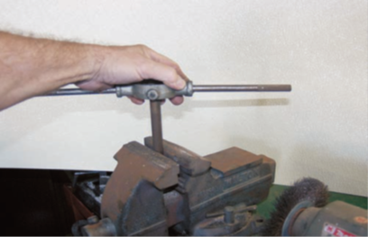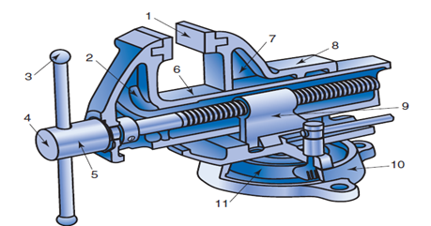
Figure 2.1 Bench vice Figure 2.2 internal Bench vice

The jaw is opened up to require length job is placed in the two jaws and is fully tightened with handle.
- Hand vice:-used to grip very small objects. These are made in different shape and sizes. Commonly used hand at the bottom. A spring is provided between two legs. The jaws may be adjusted from a flange nut.
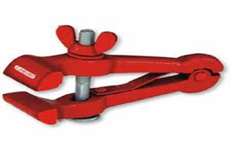
Figure 2.3 Hand vice
- Pin vice: - pin vice is used to hold wire or small diameter rods. It is also used for grinding small drills. It consists of a small chuck made up to tools steels and a mild steel handle.
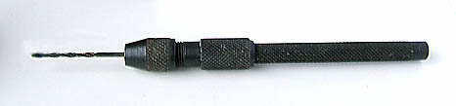
Figure 2.4 Pin vice
- Pipe vice: - it is used to hold pipes. It consists of a vertical screw with guar threads. A handle is attaché on the top of the screw. A movable jaw is fixed on the lower end of the screw.
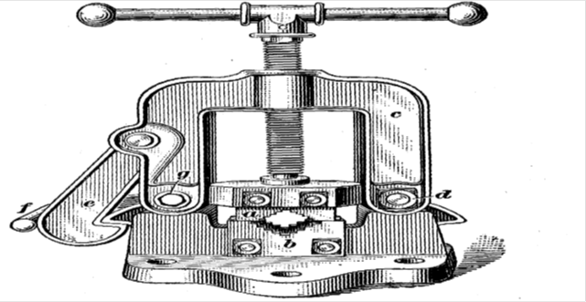
Figure 2.5 Pipe vice

Measuring and marking tools
- Try-square: - is used for checking the squareness of two surfaces. It consists of a blade made up of steel which is attached to a base at 90º. The base is made up of cast iron and steel try square is also used for marking right angle and measuring straightness of surfaces.

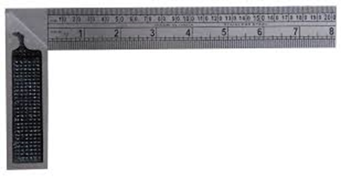
Figure 2.6 Try-square
- Combination square:-It is a multipurpose instrument that can be use a level, miter, and try square

Figure 2.7 Combination square
- Scriber: - it made up of height carbon steel and hardened from the front edge. It used to marking line.
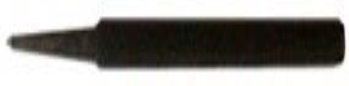
Figure 2.8 Scriber:

- Center punch: - it is like dot punch except the angle of the punching end is 90o. It is used to make the center of the hole before drilling.

Figure 2.9 Center punch
Center Punch uses principle is
- Using the divider or trammel, scribe in all circles and arcs.
- If angular lines are necessary, use the proper protractor type tool, or locate the correct
- points by measuring, and connect them by using a rule or straightedge.
- Scribe in all other internal openings.
- Use only clean sharp lines

- Steel rules: - these are made up of stain less steel are available in many sizes ranging from ½ ft to 2ft. these are marked in inches or millimeters.
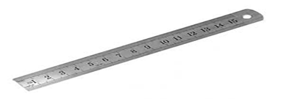
Figure 2.8 Steel rules
- Venire caliper:- venire caliper is a precision instrument used for measuring length and diameter.it can be used for measuring external and internal dimensions
Parts of venire caliper
- Outside jaw:-is used to measure external diameter or width of an object.
- Inside jaw/ear: - is used to measure internal diameter of an object.
- Main scale: - is used to scale marked every millimeter, inches & fractions.
The Venire of scale/movable scale is gives interpolated measurements to the division of 1/10, 1/20, 1/50mm etc.
- Depth gauge: - is used to measure depth of an object or a hole.
- Locking screw: - it is tighten & loosening of the sliding parts.
Methods of Reading venire caliper
The main scale is accurately graduated in 1 millimeter. A movable jaw is fixed to a caliper jaw. The movable scale is equally divided in to 10, 20, 50 divisions.
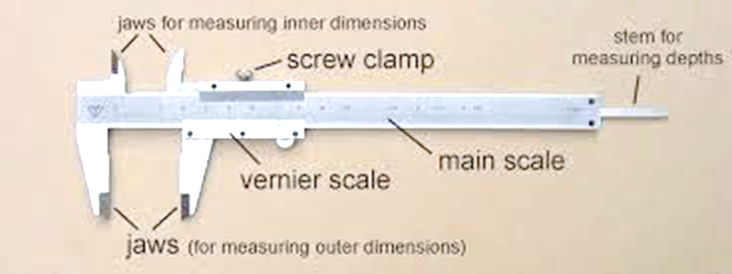
Figure 2.9 Venire caliper

Steps of reading vernier caliper
- Read the large numbered from the main scale & multiply by 10 mm.
- Read the un numbered division from the main scale before zero counted & add the large number
- Read the vernier scale which concedes from the main scale& count un numbered division added & also multiply by the accuracy $0.05or 0.02mm.$
- Last step is total value are added all steps.
In ten division parts the length is only nine millimeter. Therefore one division on the vernier scale is equivalent to 0.9mm. These means the difference b/n one graduation on the main scale & one graduation on the vernier scale is, $1.0-0.9 = 0.1mm.$
- calipers: there are two types of capillary inside and out put capillary
Outside calipers, as shown in are used for measuring external dimensions such as the length, diameter, or even the thickness of a solid
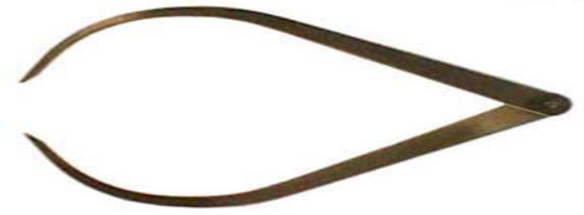
Figure 2.10 Outside calipers
Inside calipers, as shown in are used for measuring internal dimensions such as the diameter of a hole, or the width of a slot etc.
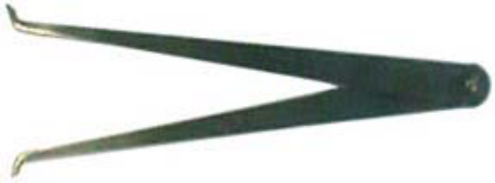
Figure 2.11 Inside calipers

It can be used for measuring external and internal dimensions. It consists of a graduated bar of rectangular section. It has two jaws one is movable with a small vernier head and the other is fixed. A fine adjustment nut is also attached to the head. The dimension is measured by the jaw and is indicated on graduated bar. Minimum dimension that can be expressed on veriner caliper is $0.001 or 0.02mm$ generally. The material of the part is stainless steel.

- Divider: - these are a made up of steel. Dividers have two legs having sharp feet. These are hinged at the top. It is used for marking arcs dividing a line or transferring the dimensions. The blade should be tightened sufficiently.
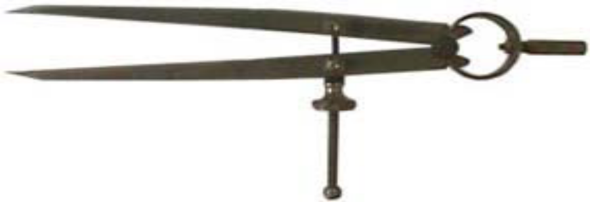
Figure 2.12 Divider

Performing lay out and marking
Laying Out: is described the locating and marking out of the lines such as circles, arcs and points for drilling holes. These line stand reference points on the metal show as the mechanism of machine. The tools used for this work are known as layout tools. Many common hand tools fall into this category. The accuracy of the job will depend upon the proper and careful used

Making Lines on Metal
What is marking in bench work? Marking is the basic and one of the most important operations in bench work. It should be remembered that how accurately and carefully one tries to perform other operations it will be of no help until and unless the piece has been properly and accurately marked.
The shiny finish of metal makes it difficultto distinguish the layout lines from the metal.
Layout Dye: is probably easy to use of the many coating devised to make the lines stand out better. This blue colored fluid, when applied to the metal, offers an excellent contrast between the metal and the layout lines.
All grease and oil must be removed before applying the dye; otherwise it will not adhere properly. In a pinch, layout fluid can be made by dissolving the coating on spirit duplicator carbons in alcohol. Chalk can be used on hot rolled metal as a layout back round. A layout, to be accurate, requires fine lines that must be scribed or scratched in the metal. A Scriber is used to produce these lines
A scriber is used to scratch on the surface of metal and plastic lightly. If you are using a scriber on metal, it is a good idea to apply a coat of engineer’s blue. This is a spirit-based liquid that is applied to a metal surface. When the scriber is dragged across the engineer‘s blue it leaves a clean line, which can be easily seen

Figure 2.14 Scriber

Steps in Making a Layout
Each layout job has its peculiarities and requires some planning before the operation can be started.
- Study the drawings carefully.
- Cut the stock to size and remove all burrs and sharp edges.
- Clean the work surface of all oil and grease and apply layout dye.
- Locate and scribe a Reference Or Base Line. Make all of your measurements from
- this line. If the material has one true edge, it can be used in place of the reference line.
- Locate the center points of all circles and arcs.
- Use the Prick Punchto mark the point where the center lines intersect.
- The sharp point (30 to 60 deg.) of this punch makes it easy to locate this position.
- After the prick punch mark has been checked and found on center, it is enlarged with the

Self-Check-2
Instructions I:
Answer all the questions listed below. Illustrations may be necessary to aid some explanations/answers.
  - Explain at least three types of bench vice?
  - What is the use of combination square?
  - Describe methods of reading dernier caliper?
  - List parts of dernier caliper?
  - Explain inside and outside caliper?

Instructions II:
Choose the best answer for the questions (2 point each):
- A marking out tool used for checking the squareness of many types of small works when extreme accuracy is not required is .
- Scriber b. Try square c. Caliper d. Punch
- Is a marking out tool used to scratch on the surface of metals and plastics lightly.
a. punch b. Steel rule c. Try square d. Scriber
3. Which one of the following steel is a more precise measuring instrument than the others?
  - Micrometer c. Steel rule
  - Vernier caliper d. Divider
- A marking (laying) out tool used for marking (making) circles and arcs on metal surface is;
  - Center punch b. Divider c. prick punch d. chisel
- Which one of the following is used to make an indent in the surface where holes are to be drilled in metal?
a. Chisel b. Drilling machine c. Center punch d. Hack saw

Unit Three

Cut chip and file rectangular or round blocks.
This unit is developed to provide you the necessary information regarding the following content coverage and topics:
- Avoid damage and accidents
- Cutting, chipping, and work pieces
- Replacing broken and dull hacksaw blades
- Bench work operations.
This unit will also assist you to attain the learning outcomes stated in the cover page. Specifically, upon completion of this learning guide, you will be able to:
- Avoid damage and accidents in the work hold devices
- Cutting, chipping, and work pieces
- Making the Cut with a Hacksaw
- perform bench work operations

Avoid damage and accidents in the work hold devices
How to avoid workplace accidents? In lines of work like construction, shipping, manufacturing and repair, using dangerous equipment can’t be avoided. However, workplace accidents don’t have to be an inevitable part of the job. Perform regular inspections of machinery, equipment and tools.
Accidents are unplanned occurrences that result in injuries, illness, death, and loss of property and/or production. While there is no way to completely eliminate accidents, there are certain plans, preparations, and actions that can be taken to reduce them.

To Know the Hazards
- Be aware of surroundings.
- Look around and identify workplace hazards that could cause harm.
- Look for ways to reduce or eliminate hazards, and implement them.
- Report unsafe areas or practices.
- Dress for the weather.
- Create a Safe Work Area
- Keep an orderly workplace. Poor housekeeping can cause serious health and safety hazards.
- The layout of the workplace should have adequate egress routes and be free of debris.
- Inspect vehicles before and after use.
- Continually cultivate a safety standard.
- Take breaks and move around regularly throughout the day. Small breaks (standing up and moving around) can make a big difference in combating the dangers of staying in a static position all day long.
- Pay attention to workstation ergonomics.

Use Safe Lifting Techniques
Follow the following safe lifting practices:
  - Lift from a position of power
  - Keep the load close
  - Use a staggered stance
  - Don’t twist while lifting
  - Training in body mechanics can reduce strain injuries and keep employees safe during lifting and moving.
- Personal Protective Equipment
The proper use of Personal Protective Equipment (PPE) can dramatically reduce the risk of injury. Examples of PPE include gear such as earplugs, hard hats, safety goggles, gloves, air-purifying respirators and safety shoes.

Regular Communication
- Notify supervisors about safety hazards.
- Speak up and be involved in safety planning.
- Continually cultivate a safety standard.

Cutting, chipping, and work pieces
Threads may be cut internally using a tap externally using a die. The proper selection and use of these threading tools is an important phase of machine shop work.
Honing is a finishing process performed by a honing tool, which contains a set of three to a dozen and more bonded abrasive sticks. The sticks are equally spaced about the periphery of the honing tool. They are held against the work surface with controlled light pressure, usually exercised by small springs. The honing tool is given a complex rotational and oscillatory axial motion, which combine to produce a crosshatched lay pattern of very low surface roughness:
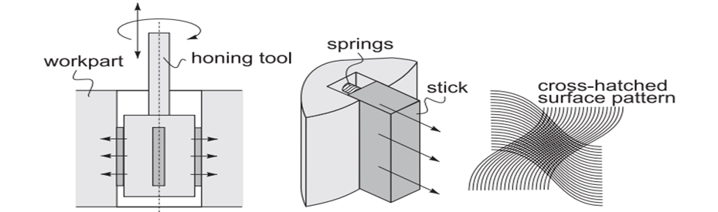
Figure 3.1 Schematics of honing process
Schematics of honing process showing the honing tool, how the abrasive sticks are pressed against the work surface by springs, and the resulting surface pattern. In addition to the surface finish of about 0.1 µm, honing produces a characteristic crosshatched surface that tends to retain lubrication during operation of the component, thus contributing to its function and service life.
A cutting fluid must be used in honing to cool and lubricate the tool and to help remove the chips. A common application of honing is to finish the holes. Typical examples include bores of internal combustion engines, bearings, hydraulic cylinders, and gun barrels.

Cutting metals
Sawing is the process of cutting metal stock that is impractical to use a file, a chisel or a machine with a multi-point cutting tool called a hand hack saw. A hand hack saw can also be used for cutting off a jammed bolt, pipes, tubing and rods for special or custom fittings on the job (on the field work). Some of the most common tools used to cut metals are hacksaws, band saws, cold chisels, bolt cutters, tin snips, and abrasive saws. Large stock is sawed, while bar stock is either sawed or cut with a cold chisel. Sheet metal is usually cut with metal snips. In fabrication facilities, large Page 65 of 167 Federal TVET Agency Author/Copyright Basic constriction work level-1 Version -1 October 2019 amounts of metal are cut with horizontal band saws or metal shears, commonly called “ironworkers. Layout tools are used to measure and mark metal stock before cutting, shaping, and doing other types of work with cold metal
Hacksaws: are used to cut material that is not needed away from material which is Saw blades have alternate teeth bent out or ‘set’ in opposite directions. This is so that when they cut, they make a gap, called the kerfs. The kerfs must be wider than the saw blade so that the blade cannot get stuck. When using a saw, you should always cut to the waste side of the marked line so that you leave a small amount for finishing by either sanding or filing. Whatever you are cutting, it is important to keep as many teeth in contact with the piece being cut as possible. You should choose the correct saw for the type of material you are using
Cutting process the saw is moved from the right to left and shows how the chip is formed. The cutting process is the result of the horizontal cutting direction and the pressure on the work piece. The angle of the teeth enables the saw to cut the material effectively. The teeth are set (bent out) that they do not get jammed in the cut.

Cutting process
The saw is moved from the right to left and shows how the chip is formed. The cutting process is the result of the horizontal cutting direction and the pressure on the work piece. The angle of the teeth enables the saw to cut the material effectively. The teeth are set (bent out) that they do not get jammed in the cut.
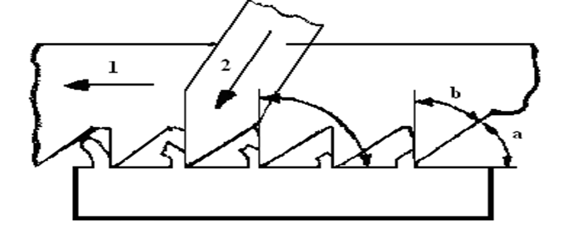
Figure 3.2 Teeth setting
a = clearance b = cutting angle
Forces on a saw blade:
1 = indicates the cutting direction
2 = indicates the pressure on the work piece

Making the Cut with a Hacksaw
Place the metal to be cut in a vise and mark it. The mark should be placed near the jaws, especially if the metal is thin. It may be necessary to use boards between the vise jaws to prevent scarring the work. Mark over the original mark with a file.
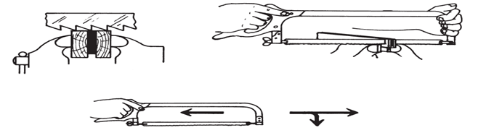
Figure 3.3 Cut with a Hacksaw
Depending upon the direction of cut, blades are classified as:
- Forward cut
- Backward cut.
Depending upon the pitch of the teeth (Distance between the two consecutive teeth) blades is classified as:
- Coarse (8-14 teeth per Inch)
- Medium (16-20 teeth per inch)
- Fine (24-32 teeth per inch)
Replace broken and dull hacksaw blades
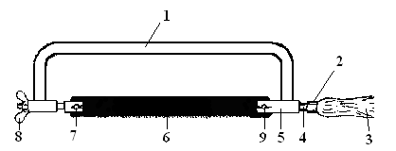
- Parts of a hacksaw
Figure 3.4 Parts of hack saw
- Saw frame
- Handle protector
- Handle
- Tang
- Blade holder
- Blade
- Pins
- Wing-Nut
- Pins

Figure 3. 5 Types of hack saw blades
One side toothed both sides toothed
- How to handle a hacksaw?
1 and 3 indicate the forward stroke with pressure
2 and 4 the backward stroke without pressure the circle shows the direction of teeth (facing the front of the hacksaw) all strokes should be in a straight line and along the whole length of the blade.
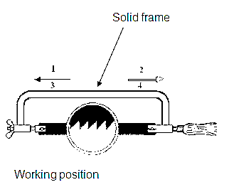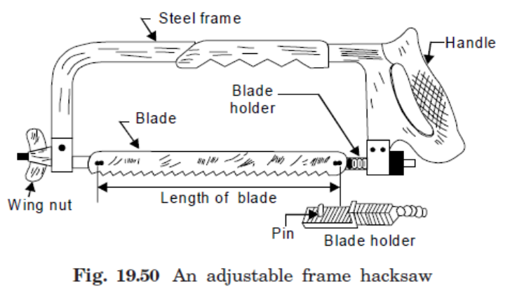
Figure 3.6 Adjustable frame Figure 3.7 Non- adjustable frame (fixed frame
The work piece must be clamped to allow free movement when sawing. Left-handed people clamp their work to the right of the vice and right-hander people to the left.
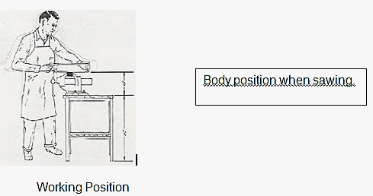
Figure 3.8 Working position

Table 3.1 Saw teeth for different materials
No of teeth /inch | Functions
14 | For solid sections of soft materials
18 | Suitable for general use. Solid sections of soft materials and large sections of hard materials (e.g. alloy steel)
24 | Small solid sections, between 3 and 6 mm(e.g. heavy tubing and sheets)
32 | For sections less than 3 mm thick

At least three consecutive teeth should be in contact with the material. If the material is soft and has a large section, use a blade with few teeth per 25 mm (14 or 18 teeth per 25 mm) Use a fine-tooth blade when cutting a fairly thin section.
- Hacksaw blades are made of high-speed steel.
There are two types: all-hard and flexible. The difference between the two is that the all-hard snaps easily, and it is therefore not recommended for school work. The blades come in the following lengths: 200, 250 and 300 mm. They are also available with 14, 18, 24 and 32 teeth per 25 mm for cutting different materials

Perform bench work operations
Bench work includes various cutting processes that machinists complete by hand rather than on a machine when creating part features that require less power and force. Common bench work operations include hand tapping, hand reaming, hand filing, and engraving. Manually machined work pieces often require bench work and layout operations.

Chipping
Removing the metal with a chisel is called chipping and is normally used where machining is not possible. While chipping, safety goggles must be put on to protect eyes from the flying chips. To ensure safety of others, a chip guard is placed in position. Care should be taken to see that the chisel is free from mushroom head.
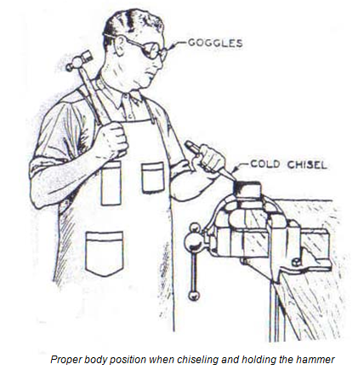
Figure 3.9 Proper body positions when chipping

Chisel and Types
These are sometimes referred to as cold chisels because they are used to cut cold metals. They are made of cast steel or alloy steel, with a hardened and tempered cutting edge.
- Types of chisel: based on their shapes:
1. The flat chisel: used for general-purpose chiseling;
2. The cross-cut chisel: used for cutting grooves such as keyways, and for chipping;
3. The half-round-nosed chisel: used for cutting grooves (which are either curved or half-round);
4. The diamond-pointed chisel: used for working into corners and cutting small grooves.

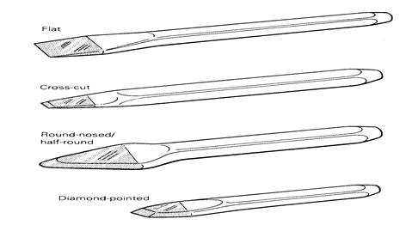
Figure 3.10 Common types of chisel

Filing
Filing is a method of removing metal, and the file (Figure 3.9), which is the most widely used hand tool in the school workshop, is used for this cutting operation. It is made of carbon tool steel containing about 1.3 per cent carbon.
The Main Parts: A file is a hand cutting tool made of high-carbon steel, having a series of teeth cut on the body by parallel chisel cuts. The parts of a file are shown in figure. 3.9. Files are used to remove surplus metal and to produce finished surfaces.
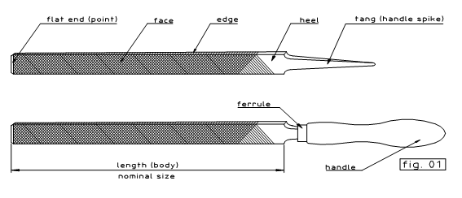
Figure 3.11 Filing

Methods of filing:
There are several methods of filing, each with a specific purpose. With reference to the figure, the following may be noted:
- Holding the file: For heavy work and to remove more metal, a high pressure is used.
For light and fine work, a light pressure is applied.
- Filing internal curves: A part of half round file only makes contact as shown during
filing operation. Movement of the file is indicated by arrows.
- Cross filing: It is the most common method of filing. Cross filing is carried out across two diagonals, to produce medium surface finish. It is used when large an amount of metal is to be removed. By cross filing ‘rounding’ the surface is reduced.
- Straight filing: When a short length of work piece is required to have a flat surface,
straight filing is used. File marks made during cross filing may be removed, to produce a relatively smooth surface.
- Draw filing: It is done to get a finely finished surface. It produces a smoother surface
finish than straight filing. A smooth or dead smooth flat file is used for this.
Use the single cut on softer materials (such as brass and aluminum) and the double cut for general filing, especially on iron and steel.
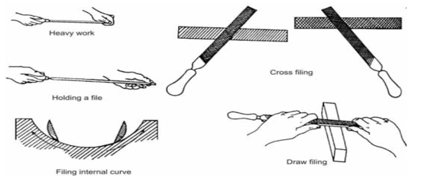
Figure 3.12 Methods of filing
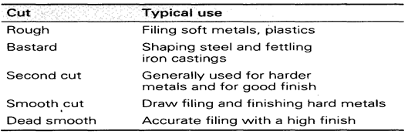

Types of file based on their shapes:
While making a selection of file for a specific job, some important points should be considered. In other words, we can say that files can be classified into the following categories:

Figure 3.13 Types of based on shape

    - classification According to Grade
Following are the different types of file tools according to the basis of the number of teeth:
- Rough File
In this type of file, teeth are of big size and less in number. It is used for cutting soft materials because its cutting is rough. Because of rough cutting, it cannot be used for hard metal.
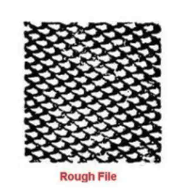
Figure 3-14 Rough File

Bastard File
Teeth of this file are comparatively smaller than those of the rough file. It is used initially to shed metal (through filing) in large quantity
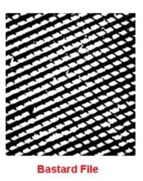
Figure 3.15 Bastard File
- Second-cut File
This is a file of medium grade. In the filler trade, this file is mostly used to bring the job in the proper size. As compared to the bastard file, filing done with this file makes the surface plain.
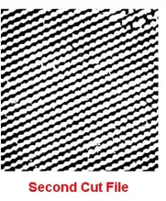
Figure 3.16 Second-cut File

Smooth File
This file makes the surface quite plain, in addition to making a job of accurate size through filing.
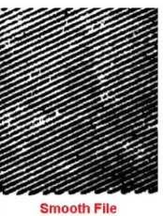
Figure 3.17 Smooth File

Scraping
Scraping is the process of removing high spots on the surface of a piece of work. It is a difficult operation, and is not often performed in the school workshop.

Types of scrappers:
These sharp edged tools are used to remove uneven spots on the surfaces. They are of different shapes.
- Flat scraper: It is used for removing metal from flat surfaces. The blade must have a slight curvature at the cutting edge. The corners are rounded to help the user, scrape at the exact spots.
- Half round bearing scraper: This is used for scraping curved and cylindrical surface split bearings, big bush bearings etc.
- Triangular scraper: this is used for scraping curved surfaces, holes and bores. Specification is by length. Example: 200 mm, 300 mm etc.
Figure 3.18 scraper
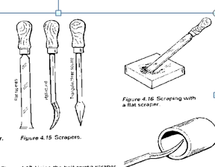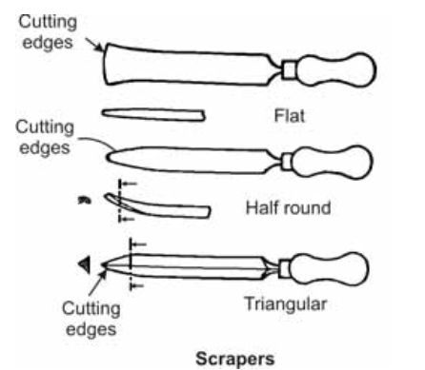

Self-Check-3
Instructions I:
Answer all the questions listed below. Illustrations may be necessary to aid some explanations
- write the Types of scrappers
- Identifies the methods of filing system.
- write the types of files based on their shapes:
Instructions II:
From the following alternative question choose the correct answers
- depend up on the shapes of scraper which one of them are uncludeded
    - Flat scraper B. Half round bearing scraper C. Triangular scraper D. all of them are included.
  - Removing the metal with a chisel is called __________________
    - Chipping B. Filling C. Drilling D. all
  - Half round bearing scraper used to ______________
    - used for scraping curved and cylindrical surface split bearings, big bush bearings
    - Used for scraping curved surfaces, holes and bores. Specification is by length
    - Used for removing metal from flat surfaces.
    - all

Unit Four:

Drill, ream and lap hole
This unit is developed to provide you the necessary information regarding the following content coverage and topics:
- Drill, ream, spot-facing and lapping hole.
- Performing sequence.
- Performing and applying operations
This unit will also assist you to attain the learning outcomes stated in the cover page. Specifically, upon completion of this learning guide, you will be able to:
- Drilling, reaming, spot-facing and lapping hole.
- Performing sequence.
- Performing and applying operations
.

Drill, ream, spot-facing and lapping hole
In order to make a macro-scale hole on a solid surface, a series of different machining processes are carried out depending on the finish and tolerance level requirement. One typical series of hole production can be
- Centering,
- Drilling,
- Boring,
- Reaming, and
- Honing.
The Centering is performed to locate the hole center, drilling is carried out to originate a hole and boring is carried out to enlarge the hole diameter. Reaming and honing are carried out to improve the finish of the hole surface at different levels and to improve the dimensional accuracy and tolerance.
Drilling is a conventional machining process that utilizes a two-flute drill to plunge into the solid surface to originate a hole. Diameter of the hole is limited by the drill diameter; in fact, they are equal. Sometimes to enlarge the hole diameter, boring is carried out after drilling. Both of these processes offer bulk removal that indicates high material removal rate (MRR). However, neither drilling nor boring can provide high levels of dimensional accuracy and surface finish. For improving surface quality and tolerance level, reaming is sometimes carried out after drilling or boring. Sometimes very high accuracy and tight tolerance are required for assembly purposes, particularly in press fit or leak-proof joining.
Reaming process utilizes a multi-point cutter (called reamer) to remove very small volume of material to improve upon dimensional accuracy and tolerance. Since reaming smoothens the hole surface, so a hole is prerequisite for reaming, and thus drilling must be carried out prior to reaming. As usual reaming produces better surface finish as compared to drilling. Following sections elaborate various similarities and differences between drilling and reaming.
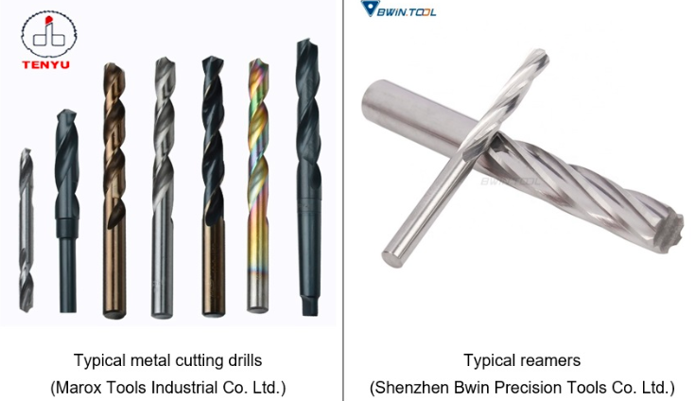
Figure 4.1 Drill, ream

Differences between drilling and reaming
Drilling | Reaming
Drilling is performed to originate a hole on a solid surface. | Reaming is performed to finish internal surface of an existing hole.
Drilling is the first step of hole making. After drilling either boring or reaming can be carried out depending on the requirement. | Reaming can be carried out only if a hole exists. So reaming is performed only after drilling (or boring).
Cutting tool used in drilling operation is called Drill. | Cutting tool used in reaming operation is called Reamer.
Metal cutting drill usually consists of two cutting edges. So drill is considered as a double point cutting tool. | Reamer contains large number of cutting edges (minimum 4). So reamer is a multi-point cutting tool.
Surface of a drilled hole is not highly finished (i.e. high surface roughness). | Reaming is performed to highly finish (i.e. reducing the roughness) the internal surface of the holes.
Tight tolerance cannot be obtained by drilling operation alone. Sometimes tight tolerance is required for assembly, especially for press fit applications. | Reaming can easily provide tight tolerance.
Axial length of hole can be easily increased by drilling operation. | Axial length of the hole cannot be altered by reaming. Only diameter of the hole can be increased slightly.
Material Removal Rate (MRR) in drilling is significantly higher. | MRR in reaming operation is comparatively lower.

Drill press
A drill press is typically used to drill holes of varying sizes into materials like wood, plastic, and metal. Often, holes are made in preparation for screws or other fasteners. A drill press consists of a motor that spins a spindle with an attached chuck. The chuck secures the drill to the spindle. While the drill is spinning, the user rotates a handle which lowers the drill into the material. The user has fairly fine control over the depth and speed of the drill. A drill press can be safely used by a person who is tall enough to comfortably reach the material table and handle, and is able to physically support and secure the material to the table. The motor provides the power to cut the material, not the operator. Though some strength is required, good technique and proper set up are the keys to using a drill press safely and effectively
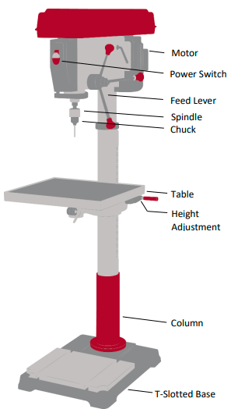
Figure 4.2 drill press

HOW TO USE:
  - Mark the center of desired hole on material
  - Select drill bit of desired size from drill index.
  - Attach drill bit to drill press by loosening chuck, tightening it around drill bit, then securing it with the chuck key. Insert drill bit as far as possible leaving the flutes of the drill bit completely exposed.
  - Decide how the material will be fixture (held in place) on the table. Common methods include using a drill-press vise, c-clamps, or holding the part securely by hand.
- Cylindrical material can be held in a drill press vise to keep it from rotating. The vise is then held by hand or clamped to the table.
- b. Small pieces of any shape can be held in a drill-press vise, which is then secured to the table by hand or with a clamp.
- Large pieces can be held by hand as long as the piece is big enough to hold securely
- Small or hard to hold pieces can be clamped to the table.
- Small pieces of any shape can be held in a drill-press vise, which is then secured to the table by hand or with a clamp
- Large pieces can be held by hand as long as the piece is big enough to hold securely
- Small or hard to hold pieces can be clamped to the table
  - Adjust height of table so drill will travel the desired distance into the material.
  - Check that you have secured clothing, jewelry, hair, etc. that will get close to the machine.
  - Turn on drill press
  - Check to see that drill bit is not wiggling. Turn off machine and re-install drill bit if needed
  - Lower handle to drill hole to desired depth. For deep holes, lower and raise the drill at intervals to clear the chips from the drill bit
  - Raise handle to remove drill bit from material and turn off drill press
  - Unclamp material and clean up chips
  - Remove drill bit and replace in drill index.

Self-check-4

Test-I Matching
Instruction: select the correct answer for the give choice. You have given 1 Minute for each question. Each question carries 2 Point
A B
- Centering a. carried out to originate a hole
- drilling b. performed to finish internal surface
- Reamer c. performed to locate the hole center

Operation sheet 4: Practice applications for drill pressed
Purpose: To practice and Operation title: Procedures drill pressed steps
Demonstrate the knowledge and skill required how to uses drilling press
- Instruction: your Teacher is gives sheet metal or plastic for sample with follow as measurements. Depend up on the instruction Apply the following procedure.
Safety Guidelines for Operating a Drill Press:
- Always use safety goggles
- Remove the chuck key and replace in storage area after tightening chuck
- Always check that the cutting edge of the drill bit is sharp and undamaged
- Avoid getting the bit jammed or the part heating up by clearing the hole in sections
- Check that the material is fixture securely
- Never touch an active drill bit
- Never wear gloves near the active drill
- Wear a mask when operating for long periods of time or working with harmful material
- Immediately lift drill and turn off machine if the bit becomes loose

Lap Test: 4
- Specify desired hole, select appropriate drill bit
- Install drill bit into drill press chuck
- Use key appropriately and put away
- Determine appropriate fixture for material to be drilled and secure material
- Drill-press vise
- Clamp to table
- Drill a blind hole
- Drill a through hole
- Remove the drill bit and replace in the drill index.

Unit Five:

Cutting threads using tap and stock and die
This unit is developed to provide you the necessary information regarding the following content coverage and topics:
- Cut thread and fit gage.
- Sequence of tapping.
- Perform thread cutting operations.
This unit will also assist you to attain the learning outcomes stated in the cover page. Specifically, upon completion of this learning guide, you will be able to:
- Cutting thread and fit gage.
- Perform the Sequence of tapping.
- Perform and apply thread cutting operations.

Cutting thread and fit gage system
Another one of the most commonly used methods for producing or cutting threads is with the use of a die. Dies can be used in lathes, screw machines and CNC lathes to produce both internal and external threads by cutting or by rolling. When using a die, there are several thread chasers that cut the thread then back away from the work to permit fast removal of the tool.

Dies: are made either of high-carbon steel or of high-speed steel. Unlike taps, dies are used for cutting external (male) threads. There are three types (Figure blow). The circular split die is a circular piece with a split across one of the flutes. The split is provided to enable small adjustments to be made, using three set screws in the stock. The half die comprises two loose pieces, which are held in the stock. There is a small screw on the stock for adjustment. The die nut has a hexagonal body. This type, strictly speaking, does not cut new threads but is used to 'clean up' threads that are damaged.
Taps and dies: Screwing is a temporary method of fastening parts together. Methods for cutting screw threads include the use of the center lathe. For bench work, however, taps and dies are used.
Taps: These are the tools used for cutting internal (female) threads. They are made of high-carbon steel or high-speed steel. The tap has a shank with a square end to take the tap wrench or holder. The shank is smaller than
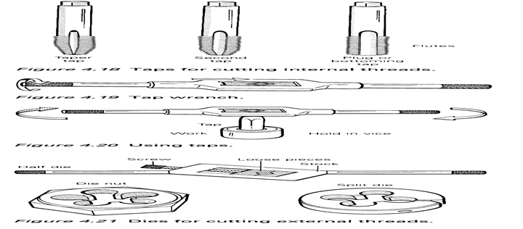
Figure 3.2 Taps

- The procedure for cutting external threads is as follows.
- Square the end of the work and chamfer it (using a file, grinding machine or center lathe) for an easy start.
- Grip the die, held in the stock, firmly and squarely on the work.
- Turn clockwise, about a quarter-turn, and ease back to remove chippings.
- Apply a good supply of oil (lubricant).
- Make adjustments of the screws after making a full cut until the depth required is achieved.
- Care and maintenance is important:
- Do not use either the stock or the die as a hammer; the threads may be broken.
- Remove the die from the stock after every thread cutting, clean them and pack them into their boxes.
- Use plenty of oil during cutting to reduce friction.

Perform the Sequence of tapping
Tap Drill Size: Before a tap is used, the hole must be drilled to the correct tap drill size. This is the drill size that would leave the proper amount of material in the hole for a tap to cut a thread. When a chart is not available, the tap drill size for the ISO (International Standards Organization) thread can be found easily by applying this simple formula:
TDS = tap drill size
TDS = M - P M = metric diameter of the tap
P = pitch of the thread in millimeters

Hand Tap:
A tap is a cutting tool used to cut internal threads. Normally it’s made of high-speed steel (HSS). Hand taps are usually made in sets of three, because it is better to distribute all the cutting work during the thread−process to three taps.
No. 1 (taper) tap: 1 ring on shank
No. 2 (plug) tap: 2 rings on shank
No. 3 (bottoming) tap: without ring
The most common taps have two or three flutes in order to form the cutting edges, transport the chips out of the hole and give way for the lubricant. The end of the tap is square so that a tap wrench can be used to turn it into a hole.
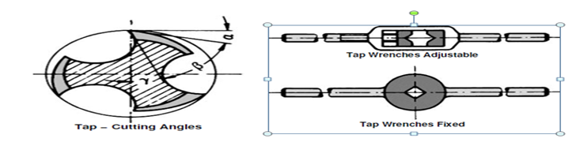
Figure 3.3 Hand Tap.

Tapping of Hole:
Before a tap is used, a hole must be drilled in the work piece to the correct tap drill size. The tap drill size (T.D.S.) is the size of the drill that should be used to leave the proper amount of material in the hole for a tap to cut threads. Then countersink both sides of the hole.
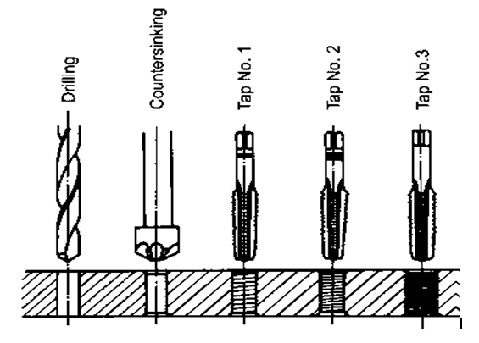
Figure 3.4 Tapping of Hole

Working Steps for Hand Tapping
- Select the correct size and type of tap for the job (blind hole or through hole).
- Select the correct tap wrench for the size being used.
- Use a suitable cutting fluid (No cutting fluid for brass or cast iron).
- Place the tap in the hole as near to vertical as possible.
- Apply equal down pressure on both handles, and turn the tap clockwise (for right-hand thread) for about two turns.
- Remove the tap wrench and check the tap for squareness. Check at two positions 90 degree to each other.
- If the tap has not entered squarely, remove it from the hole and restart it by applying slight pressure in the direction from which the tap leans. Be careful not to exert too much pressure in the straightening process, otherwise the tap may be broken.
- Turn the tap clockwise one−half turn and then turn it backward about one−quarter of a turn to break the chip. This must be done with a steady motion to avoid breaking the tap.
- Turn the die forward one turn, and then reverse it approximately one half of a turn to break the chip.
- Apply cutting fluid frequently during the threading process.

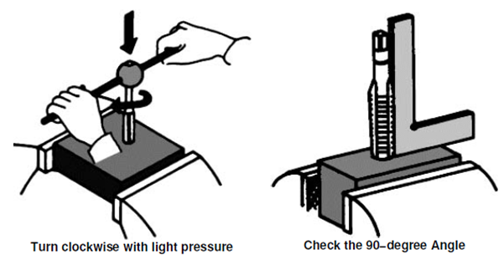
Figure 3.5 Working Steps for Hand Tapping

Threading Dies
A threading die is used to cut external threads on round work pieces. The most common threading dies are the adjustable and solid types. The round adjustable die is split on one side and can be adjusted to cut slightly over or undersized threads. It is mounted in a die stock, which has two handles for turning the dies onto the work. The solid die, cannot be adjusted and generally used for re cutting damaged or oversized threads. Solid dies are turned onto the thread with a special diestock, or adjustable wrench.
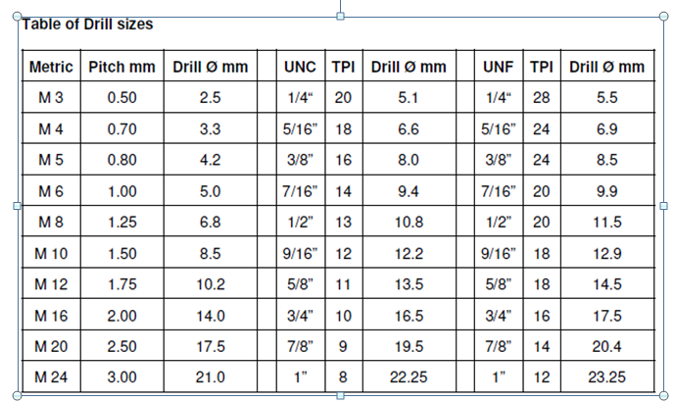

Figure 3.6 Threading Dies

Thread with a Hand Die Working Steps
The threading process requires the machinist to work carefully to produce usable parts and avoid damage. The following describes the procedure to be used.
- Chamfer the end of the work piece with a file or on the grinder. Consider that a 3/4” thread requires a bolt with an outside diameter of 3/4”.
- Fasten the work piece securely in a vise. Hold small diameter work short to prevent it from bending.
- Select the proper die and die stock.
- Lubricate the tapered end of the die with a suitable cutting lubricant.
- Place the tapered end of the die squarely on the work piece.
- Apply down pressure on both die stock handles and turn clockwise several turns.
- Check the die to see if it has started squarely with the work.
- If it is not square, remove the die from the work piece and restart it squarely, applying slight pressure while the die is being turned.

Self-Check -5
Directions: choose the best answer for the following question (1 point each):
    - Removing the metal with a chisel is called________
      - Scrapping
      - Filling
      - Chipping
      - All
    - Some of the most common tools used to cut metals are_______
      - hacksaws
      - tin snips
      - cold chisels,
      - all
    - ______a file is used when large an amount of metal is to be removed.
      - Cross filing
      - Straight filing
      - Draw filing
      - All
    - _____ is used to mark the center of a hole and make an indentation for a twist drill.
      - Scriber
      - Center punch
      - Trammel point
      - None
    - _____is used for scraping curved and cylindrical surface split bearings, big bush etc.
      - Flat scraper
      - Half round bearing scraper
      - Triangular scraper
      - All

Unit Six:

Off-hand grind cutting tools
This unit is developed to provide you the necessary information regarding the following content coverage and topics:
- Hone and Cutting edges.
- Sharps Cutter.
- Cools Cutter.
- personal protective devices
This unit will also assist you to attain the learning outcomes stated in the cover page. Specifically, upon completion of this learning guide, you will be able to:
- Perform Hone and Cutting edges.
- Make Sharping Cutter.
- Apply Cooling Cutter.
- use personal protective devices

Perform Hone and Cutting edges.
Edge honing, also referred to as edge rounding or radiusing, stabilizes the cutting edge of cutting tools made from brittle materials such as carbide to greatly extend their flake and wear resistance. This increases cutting tool life to save you money, raises productivity by reducing tool changes and improves quality through better cutting action.
What is a cutting edge? It’s Function, Sharpness, and Numbers Cutting edge is the intersection of two tool point surfaces. Cutting Tool is basically a wedge shaped device that actually removes (shears off) excess material from a preformed blank in order to obtain desired shape, size and accuracy.
What is Cutting Edge in Cutting Tool? It’s Function, Sharpness, and Numbers Cutting edge is the intersection of two tool point surfaces. Cutting Tool is basically a wedge shaped device that actually removes (shears off) excess material from a preformed blank in order to obtain desired shape, size and accuracy. During machining or metal cutting operation, the cutting tool forcefully compresses a thin layer of material of the work piece and shears it off.
Every cutting tool consists of at least two surfaces, namely, rake surface and flank surface. Rake surface is the chip flowing surface; whereas, flank surface slides over the finished surface of the work piece. Intersection of these surfaces produces cutting edge.

Functions of cutting edge in machining
As the name suggests, the primary function of the cutting edge is to cut or shear off material in order to fulfill ultimate objective of machining. However, all cutting edges may not equally participate in cutting action. For example, in a turning tool, principal cutting edge usually removes material, whereas auxiliary cutting edge partially removes material only in some specific operations. In fact, a turning tool has two different cutting edges, as provided below.
- Principal cutting edge: The intersection between rake surface and principal flank surface produce principal cutting edge. This cutting edge cuts material during machining.
- Auxiliary cutting edge: It occurs at the intersection of rake surface and auxiliary flank surface. It can also perform cutting action in some specific type of operations, such as thread cutting.
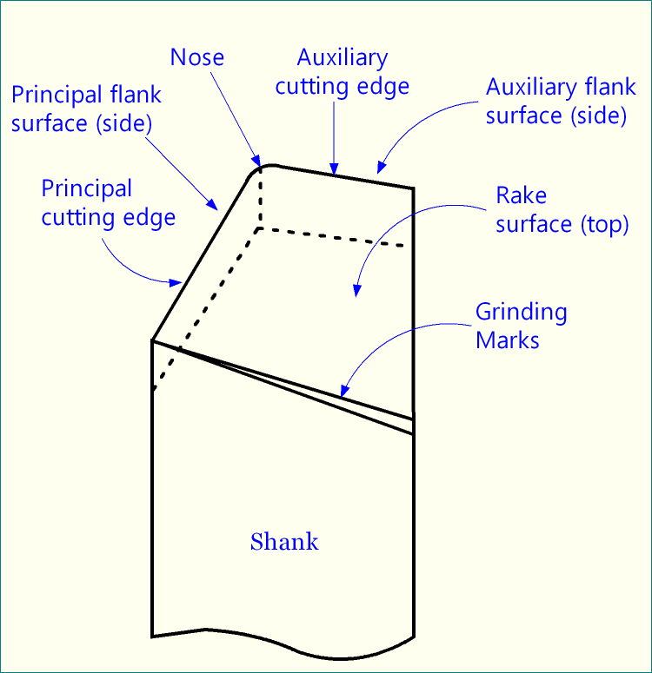
Schematic of representation a single point turning tool (SPTT) that indicates two cutting edges.
Does the cutting edge always straight? The cutting edge may or may not be a straight line. For example, for a single point turning tool (SPTT), the cutting edges are straight. Similarly, in milling cutter and drill, it is usually straight. However, if you consider abrasive cutters, it may not necessarily straight.
How sharp a cutting edge is? Can you directly measure sharpness? No! The sharpness of any physical object is indicated by edge radius and they are inversely proportional. That means, the small is the edge radius, the sharper it is. Therefore, theoretically, the maximum sharpness or minimum edge radius is limited to atomic radius of the material. You cannot go below it.
Although atom radius is too small (few nm), in high precision cutting tools, the cutting edges are sharp in that range. Edge radius of precision turning diamond cutter is 10 – 100nm, while that for micro-end mills is 1 – 5µm. However, in convention turning, milling, drilling, etc. cutters, the edge radius usually much higher, around tens of microns. It is worth mentioning that sharper tools need lesser cutting power for material removal but are very prone to catastrophic breakage.

Single point, double point and multi-point cutting tools
A cutting tool may have one or more cutting edges, and therefore, it can be classified into three categories those are
- Single point cutting tools
- Double point cutting tools:
- multi-point cutting tools
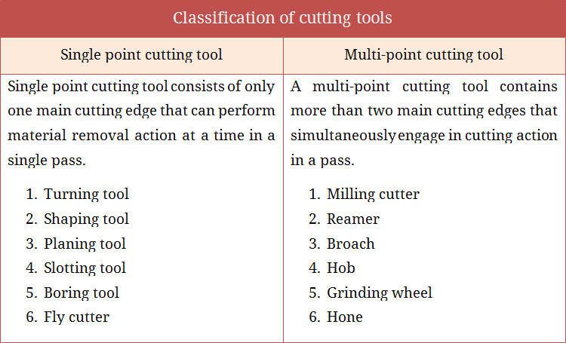
Single point cutting tools: these tools consist of only one cutting edge that can perform metal removal action at a time. Turning tool is the perfect example of a single point tool. Shaping, planning, slotting, boring tools are also single point tool.
Double point cutting tools: These tools have two cutting edges and both the edges can perform material removal action simultaneously. Drill is the only example for this category.
Self-Check -6
Instructions I:
Answer all the questions listed below. Illustrations may be necessary to aid some explanations

- wire the procedure of Single point cutting tools
- defined the different between Single point cutting tools and Double point cutting tools
- compare and contrast multi - cutting tools and Single point cutting tools

No | Name | Qualification (Level) | Field of Study | Organization/ Institution | Mobile number | E-mail
- 1 | Abebe Endalew | A(Msc) | Civil | Misrak Poly Technic Collage | 0933007756 | Abebeaware09@gmail.Com
- 2 | Teshale mulugeta | A |  | DTC | 0920469129 | teshamulu909@gmail.com
- 3 | Million Aklilu | A | Electrical | APTC | 0910688925 | milion.akililu@gmail.com
- 4 | Sileshi kassahun | B | Con. technology | MTC | 0931862151 | Sileshikassahun21@gmail.com

Reference

- Book: Manufacturing Processes by J. P. Kaushish (PHI).
- Book: Manufacturing Science by M. I. Haque and S. Khan (PHI)
- http://www.simondssaw.com/handfiles/hand%20files%20publications/simonds-file%20catalog.pdf
- https://www.bing.com
- Workshop Technology Parts 1, 2 and 3, Author : WAJ Chapman Publisher : London: Edward Arnold, 1972
- Manufacturing Technology Author: G Bram & C Downs Publisher: London: MacMillan, 1975
- http://ecoursesonline.iasri.res.in/mod/page/view.php?id=3783
- https://www.youtube.com/watch?v=VW6a1TIqjxA
- https://www.youtube.com/watch?v=J5_AYavfIUM

