Structural construction work
Level-III
Based on October 2023, Curriculum Version 2
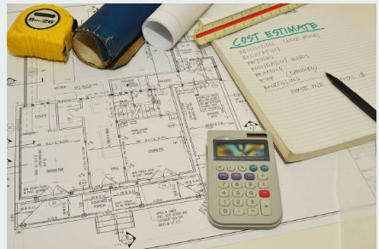

Module Title: Job Estimation and Costing
Module code: EIS SCW4 M12 1023
Nominal duration: 120 Hours

Prepared by: Ministry of Labor and Skill

October, 2023
Addis Ababa, Ethiopia

Contents
Acknowledgment 4
Acronym 5
Introduction to Module 6
Unit One: Basic concepts of job estimation and cost prepartion 7
1.1Introduction to Job Estimation and Costing 9
1.1.1Defintions of job estimation and costing 9
1.1.2 Purpose of cost estimation 9
1.1.3 Information required for cost estimation 10
1.1.4 Knowledge and managerial skills for cost estimation 10
1.1.5 Factors Affecting Cost Estimation 11
1.1.6Types of Costing or Estimation 12
1.1.7 Components of cost estimation 13
1.2 Plan and specification 14
1.3Quantities Measurement 16
1.4 Fundamental approach to construction cost Estimation 18
Self-check 1.1 24
Unit two Job estimation and cost prepartion 27
2.1Material cost 28
2.1.1Types of construction material 28
2.1.2Material quantity calculation 37
2.1.3Material cost 39
Direct material cost = ∑Total material quantity × Material unit cost 40
2.2 Labor cost calculation 41
2.2.1 Introduction 41
2.2.2Types of Construction Labor 41
Table 2.2 Worker Classification Definition Sheet 42
2.2.3Components of Labor Costs 44
2.2.4Basic Principle for Estimating Labor 45
Direct Labor Unit Cost (F) calculation 46
2.3Equpment cost calculation 50
2.3.1Introduction 50
2.3.2 Classification Construction equipment 50
Direct Equipment Cost (G) calculation 51
2.4 Head office overhead 53
2.5 Site overhead costs 55
Site Overhead Cost (I) Calculation 56
2.6Risk Allowance Cost 57
2.7 Profit and Income Tax 58
Gross Profit (M) calculation 58
2.8 Total unit price without VAT(N) 59
2.9 Developing unit costs analysis for each items of work and material 60
Self-check 2.1 65
Operation 2.1 67
Lap Tests 68
Reference 69

Acknowledgment

The Ministry of Labor and skill wishes to thank and appreciation to MoLS leaders and experts, Regional Labor and skill/training Bureaus leader, experts, TVT College Deans, Instructors and industry experts who contribute their time and professional experience to the development of this Training Module.

Acronym
LAP test ……………………………………Leanring Activity performance Test

Introduction to Module
In structural construction work, Preparing Job estimation and costing are a fundamental element in predicting a structure's overall construction costs. It helps to know Material cost, Labor cost, Equipment cost, Overhead cost and constructer’s profit of construction project.
This module is designed to meet the industry requirement under the structural construction work occupational standard, particularly for the unit of competency: Preparing Job estimation and costing.
This module covers the units:
- Basic concepts of job estimation and cost prepartion
- Job estimation and cost prepartion
Learning Objective of the Module
- Identify prepartion of job estimation and costing
- Preper Job estimation and cost
Module Instruction
For effective use this modules trainees are expected to follow the following module instruction:
Read the information written in each unit
Accomplish the Self-checks at the end of each unit
Perform Operation Sheets which were provided at the end of units
Do the “LAP test” giver at the end of each unit and
Read the identified reference book for Examples and exercise

Unit One: Basic concepts of job estimation and cost prepartion
This unit is developed to provide you the necessary information regarding the following content coverage and topics:
  - Introduction to Job Estimation and Costing
- Project plans and Specifications
- Measurements and quantities
  - Fundamental approach to construction cost Estimation
This unit will also assist you to attain the learning outcomes stated in the cover page.
Specifically, upon completion of this learning guide, you will be able to:
  - Identify to Job Estimation and Costing
- Reade and understande project plans and Specifications
- Making measurements and identifying quantities
  - Identify Fundamental approach to construction cost Estimation

1.1Introduction to Job Estimation and Costing

1.1.1Defintions of job estimation and costing
Construction job costing is a detailed pricing method used to accurately calculate project expenses by looking at all the granular costs for each project. This level of specificity helps you more precisely bid similar projects in the future and improve budgeting by monitoring the many individual costs that go into a large construction project. Job costing also helps construction businesses manage their cash flow and protect their profit margins, especially when new requests and changes occur while a project is in progress.
Construction businesses use job costing to calculate project expenses. Job costing gives you a complete picture of all costs associated with a specific job and looks at labor, materials and overhead. The more detailed the breakdown, the more accurately a business can track expenses and identify issues that could affect its profitability — for example, an unexpected expense or ballooning worker hours.

1.1.2 Purpose of cost estimation
Over all the main purpose of cost estimation can be summarized as follow:
- know the volume of work in reference to the fund available
- determine actual cost per unit of item
- identifying engineering estimate of the work for bidding purpose
- work out economical use of materials , labor and equipment
- in cases of variations to determine the extra cost to be incurred
- when there is escalation, to work out the escalation in cost

1.1.3 Information required for cost estimation

The following information is required to define cost per unit of work
- Correct information of the market price of the materials at the time of need to be used as a basic price
- Correct information of the rates of various categories of skilled and unskilled laborers as wage rates to be used for daily work rate
- Output of laborers per day for various types of items (productivity)
- Correct information of the rates of various categories of equipments and tools as rental rates to be used for major items of rates
- Up-to-date knowledge of the construction methods.

1.1.4 Knowledge and managerial skills for cost estimation
The following knowledge, managerial talents, and degree of construction experience make a good estimator.
- Ability to read and understand contract documents, with special skills in reading construction drawings for all specialties and related specifications.
- Ability to accurately take off the quantities of construction work for which he or she is preparing the detail estimate.
- Ability to visualize the future building from drawings, which usually requires some years of construction site experience.
- Knowledge of arithmetic, basic geometry, and statistics.
  - Familiarity with estimating software in depth and with available building cost databases.
  - Knowledge of building construction methods.
  - Knowledge of labor productivity, crew composition, and impacts of various forecasted site conditions on crew output.
  - Possession of office managerial skills in organizing project-related cost information.
  - Ability to work under pressure and to meet all bid requirements and deadlines.

1.1.5 Factors Affecting Cost Estimation
Factors which affect the cost estimation are summarized as follow:
      - Type and documentation of the project
      - Construction scheduling
      - Bidding environment
      - Quality and availability of material and labor (given in specification)
      - Construction facilities /tools and method of construction
      - Location of the site: Transportation charges
      - Proper management
      - Land charges (lease)
      - Nature of subsurface condition

1.1.6Types of Costing or Estimation
Estimation can be broadly classified as preliminary (approximate) and detailed.
- Preliminary /approximate costing
This type of cost estimation is required to know the financial position of the client before costly detailed designs are carried out.
Such estimates are based on practical knowledge and cost of similar previous works. Examples of approximate cost estimations are as follows:
A. Cost per functional unit
Hospital =cost per bed, Dormitory = cost per student, Cinema or theatre = cost per seat, residential buildings = cost per area, road works = cost per kilometer length, culverts or bridges = cost per meter span, water supply or sewerage projects = cost per head of population.
B. Plinth area method – cost per m²
Based on Plinth Area- roof area or external dimensions at the plinth level (Courtyard & open area shall not be included)
The rate per meter square is deduced from the cost of similar building projects in the locality.
C. Cubical Content method – cost per m³
Based on cubical contents of various buildings, i.e. Plinth area of the building x height x cubic content rate.
Height should be taken from the top of flat roof (or halfway of the sloped roof) to the top of concrete in foundation.
- Detailed Cost Estimate (Based on Item Rate)
This is the most reliable and accurate type of estimate.
The quantities of items are carefully prepared from the drawings and the total cost worked out from up to date market rates.
- A detail cost estimate thus requires:
- Quantity surveying and
- Analysis of the different rates for the quantities prepared.

1.1.7 Components of cost estimation
- Materials
From the estimate of a work it is possible to determine what materials and in what quantities will be required for the work so that the arrangements to acquire them can be made.
- Labor
The number and kind of workers of different categories who will have to be employed to complete the work in the specified time can be found out from the estimate.
- Plant
An estimate will help in determining amount and kind of equipment needed to complete the work.
- Time
The estimate of a work and the past experience enable one to estimate quite closely the length of time required to complete an item of work or the work as a whole. Whereas the importance of knowing the probable cost needs no emphasis, estimating materials, labor, plant and time is very useful in planning and implementation of any work.

1.2 Plan and specification
- Plans
Plan are the documentation prepared to convey physical information so that designers, reviewers, and the public can understand both the existing conditions and the project. Plans also allow a contractor to construct the project and define the right-of-way available or to be acquired.

Key Components of Construction Drawings
As you might imagine, a set of construction drawings is not just a random assortment of blueprints. Rather, it’s a carefully crafted collection of documents that work together to tell a complete story of a construction project. This set includes several key components, each serving a unique purpose in painting a comprehensive picture of the project.
Floor Plans: Think of these as the ‘Google Maps’ of construction drawings. Floor plans provide a bird’s-eye view of each building level, showing the arrangement of rooms, hallways, and other spaces. They also indicate the locations of doors, windows, and stairs. They’re vital for understanding the flow of the building and the functional relationship between different spaces.
Elevations: These are the face of the building—literally! Elevations provide a flat view of the building’s exterior from each side, illustrating the structure’s design, materials, and height. They give an idea of what the finished building will look like from the outside.
Sections: These are the ‘X-ray’ view of the building. Sections are cutaway views that show the building from the inside, revealing elements like floor and ceiling heights, wall thickness, and the relationship between different parts of the building.
Details: Ever heard the saying, “The devil is in the details?” That’s what this component is all about. Details provide a close-up view of specific parts of the building, focusing on complex or unique areas that need special attention. These could be things like custom window installations or intricate ceiling designs.
Schedules: Don’t let the term ‘schedules’ throw you off. In construction drawings, schedules are essentially detailed lists of specific elements in the building, like windows, doors, or finishes. They provide information like quantities, sizes, materials, and locations.
Legends and Symbols: These are like the Rosetta Stone of the construction drawings world. Legends and symbols decode the specific language used in the drawings, explaining what various abbreviations and symbols mean. They ensure everyone reading the drawings is on the same page.
- Specification
A specification defines the materials and methods to be used by the contractor when constructing a project and is discussed.
A specification is a general term applying to all directions, provisions, and requirements appropriating to the performance of the work and payment for the work.
Specification is defined as the designation or statement by which written instructions are given distinguishing and/or limiting and describing the particular trade of work to be executed. In short specification is a statement of particular instructions of how to execute some task. Specification is one of the contract documents.
Specifications are written based on the prepared design, drawings, general and scientific trends of workmanship, quality expected, equipment involved and materials to be used for the particular trade of work.
The specifications should clearly specify: -
- Design and drawing
- Labor employment
- Materials to be used
- Construction method
- Equipment used
Specifications should be clear, concise, and brief descriptions of what is required to execute the proposed trade of work. The information that is needed for construction is usually conveyed by two basic communication lines. They are Drawings (pictorial) and Specifications (written).
In so doing the methods of communication should complement each other and neither should overlap or duplicate the other. Specifications are devices for organizing the information depicted on the drawings and they are written descriptions of the legal and technical requirements forming the contract documents.
Their difference is that the drawings should generally show the following:
- Dimensions, extents, size, shape, and location of component parts
- Location of materials, machineries, and fixtures
- Interaction of furniture, equipments and space
- Schedules of finishes, windows and doors
Specifications generally describe the following:
- Type and quality of materials, equipments, labor or workmanship
- Methods of fabrication, installation and erection
- Standards, codes and tests
- Allowance, submittals and substitutions
- Cost included, insurance and bonds
- Project records and site facilities.

1.3Quantities Measurement
Measurement
Measurement of works holds a very important place in the planning and implementation of any civil engineering work.
It is vitally important that measurement practice applied to buildings is both accurate and consistent.
There are a number of situations that require a quantity surveyor to measure and record dimensions from both drawings as well as on site, depending on the stage of the project.
The main system of measurement today is the metric system.
Metric system is very simple as the units are a multiple of ten or one tenth of the other.
For construction works the units which are commonly used are:
- Meter for Length
- Square meter for Area
- Cubic meter for Volume
- Kilogram for Mass
- Liter for Capacity
General Rules of measurement
Unless otherwise stated all works shall be measured net as fixed in position.
Same work done under different conditions or stages shall be measured separately.
The measurement of wall finishing is taken from floor to ceiling.
Area Measurements
Measuring an area is measuring a two dimensional object or a plane surface, and is expressed in square unit. (Length & width or Length & Height or width & Height)
Unless otherwise mentioned the following works shall be measured in square meters.
- Form work. – ( m ²)
- Concrete finishing and curing. – ( m²)
- Pre-cast roof slabs, floor and wall panel. – ( m²)
- Light weight partition. – (m²) stating thickness
- Site clearing
- Top soil excavation
- Wall, floor and ceiling finishes, where the width exceeds 300mm.
- Ceiling works and etc
Volume Measurements
Volume is the amount of space occupied by a three-dimensional object or region of space, expressed in cubic units.
Unless otherwise mentioned measurements of the following works are measured with cubic meters.
- Earth work
- All concrete works except lean concrete
- Brick pillars or columns
- Stone masonry works
- Deep excavation
- Back filling
- Disposal of excavation materials and etc.
Enumerated items
- Switches, socket outlets, light points (luminaries) and other accessories
- Appliances: heater and electric heating units
- Equipment: boilers and cylinders
- Sanitary appliances: wash basins, shower trays and sinks
- Valves and etc.

1.4 Fundamental approach to construction cost Estimation
Efficient construction cost estimates shall address properly the required project quality, time for completion of works and of course the construction cost of the project.
In deciding to participate in the intended project tender, the contractor shall carefully assess the impact of the following key factors:
- Type of project
- Method of tendering
- Type of construction contract
- Number and progress of contracts already at hand
- Resource availability i.e. skilled manpower, plants and machineries
- Financial position
Once decision is made to participate in the intended tender, the contractor shall give due attention to the following major items listed below
    - General and particular conditions of contract contained in the bidding documents
    - Technical specifications
    - Drawings
    - Estimated bill of quantities
    - Method of measurement
    - Supporting documents such as information regarding geological formations and hydrological data
    - Site visits
    - Construction method statements
A. General and particular conditions of contract
Proper understanding of the general and particular conditions of contract is mainly important for construction cost estimation in identifying the responsibilities and cost implications on the project
      - Amount and type of performance security
      - Amount of advance payment and type of advance repayment guarantee
      - Time for completion of the whole project
      - Limit of liquidated damages
      - Retention money
      - Claims and disputes settlement
      - Price escalation
      - Tax exemptions
      - Insurance of the works
      - Owner’s risks
      - Applicable laws
B. Technical Specification
Technical specifications specify the following crucial information to the contractor and it is the sole basis both for the construction methods to be adapted and the construction cost of the project.
- Quality of materials
- Quality of machineries and plants
- Quality of workmanship
- Erection and installation methods
- Test and inspection requirements and methods
Technical specifications basically have restricted applications, which usually define specific work items. Therefore, for a better understanding and cost estimation of the project, the contractor must check the given specifications for:
      - Technical accuracy and adequacy
      - Define and clear stipulations
      - Fair and equitable requirements
      - Formats which can be easily used during bidding and construction
      - Legal enforceability
C. Drawings
The contractor mainly understands from the drawings what type of construction methods to be adapted during cost estimation as well as construction of the project. Some of the construction methods which need to be addressed during cost estimation of this building project are:
      - Concrete production
      - Concrete transportation and placement
      - Transportation of construction materials to different floors
      - Methods and type of scaffolding
      - Types and methods of shuttering works
      - Erection and installation of glazing works
      - Temporary access for manpower working at different floors
      - Skilled manpower requirement
D. Estimated Bill Quantities
Estimated quantities of work are also the basis to determine the type and number of resources to be deployed during construction of the project.
Moreover, construction methods shall be selected in such a way the given quantity of works can be executed during the completion time of the project.
Based on the estimated quantity of works, the contractor shall decide the method of construction to be adapted during executing of the project such as:
    - Type and size of crushing plants
    - Type and size of mechanical mixers or batching plants
    - Type, size and number of machineries such as dozers, graders, loaders, rollers, dump trucks and so on.
    - Skill and number of manpower requirement
    - Type and quantity of construction materials
    - And so on
E. Supporting Documents
Supporting documents such as geological formations, hydrological data and other technical reports like socio-economic studies are usually provided by the owner to contractors for their own interpretations for heavy construction projects.
Therefore, the contractor shall have the technical ability and experience in interpreting the technical data provided to determine construction methods to be adapted which directly affects the construction cost estimates.
F. Site Visit
In order to prepare competent and reasonable construction cost estimates, the contractor must visit the project site unless the site is familiar to the contractor with previous reliable site information.
Site visits are critically important especially when the contractor is working with heavy construction project cost estimates such as road works and hydropower projects.
The contractor shall prepare his own checklists during the site visit which shall address, but not limited to, the following issues which have direct impact on the construction costs of the intended project.
i. Location of the site:
- It helps to determine the mobilization and demobilization costs.
- It also helps to determine the transportation cost of materials from main material suppliers.
- Availability and expected wages of daily labors can be fairly estimated based on the location of the site.
- Site location also helps to determine the type of camp facilities required to be constructed such as project offices, living areas, food accommodations and so on.
- Having proper understanding of site location and local weather condition helps the contractor to determine salaries and benefits of staffs, skilled manpower and daily laborers.
ii. Location of local construction material
- The contractor shall identify the location and quality of local construction materials such as quarry area for gravel production, sand, selected material, water as well as sub base and base course materials in the case of road projects.
- Moreover, the contractor shall have the general understanding of the site layout for different plants such as batching and crushing plants.
iii. Access Roads
Site access roads to the main works, quarry areas, water supply, sand, and the like shall be identified which incurs additional construction and maintenance costs. These costs are extremely high, in case of heavy construction sites such as road works, hydropower projects and
iv. Water and power supply
v. Communication facilities
vi. Environmental protection
vii. Existing facilities

Self-check 1.1

Part I Multiple choose
Instruction: Choose the correct answer
- Is a detailed pricing method used to accurately calculate project expenses by looking at all the granular costs for each project.
- Specification B. Construction job costing C. Drowning D. Take off sheet
- The main purpose of cost estimation is
- know the volume of work in reference to the fund available
- determine actual cost per unit of item
- work out economical use of materials , labor and equipment
- All
3. Which one of the following is a factor that affects cost estimation
- Type and documentation of the project
- Construction scheduling
- Bidding environment
- All

Part II match column B to column A.
A B
      - Approximate costing A . Gantt charts
2. Detailed Cost Estimate B. Cost per functional unit
3. Components of cost estimation C. Elevation plan
4. Working drawings . D. BOQ Development Guideline
E. Taking Off
Part III Give short answer
Write at list 4 Knowledge and managerial skills for cost estimation
- ------------------------
- ------------------------
- ------------------------

Unit two Job estimation and cost prepartion
This unit is developed to provide you the necessary information regarding the following content coverage and topics:
      - Material cost calculation
      - Laboe cost calculation
      - Equpment cost calculation
      - Head office overhead costs
      - Site overhead costs
      - Risk Allowance
This unit will also assist you to attain the learning outcomes stated in the cover page.
Specifically, upon completion of this learning guide, you will be able to:
      - Identifay and calculete Material cost
      - Identifay and calculete Laboe cost
      - Identifay and calculete Equpment cost
      - Identifay and calculete Head office overhead costs
      - Identifay and calculete overhead costs
      - Identifay and calculete Risk Allowance
      - Identifay and calculete Profit and Income Tax

2.1Material cost

2.1.1Types of construction material
Many types of building materials are used in the construction industry to create buildings and structures. These categories of materials and products are used by architects and construction project managers to specify the materials and methods used for building projects.
Some building materials like cold rolled steel framing are considered modern methods of construction, over the traditionally slower methods like block work and timber.
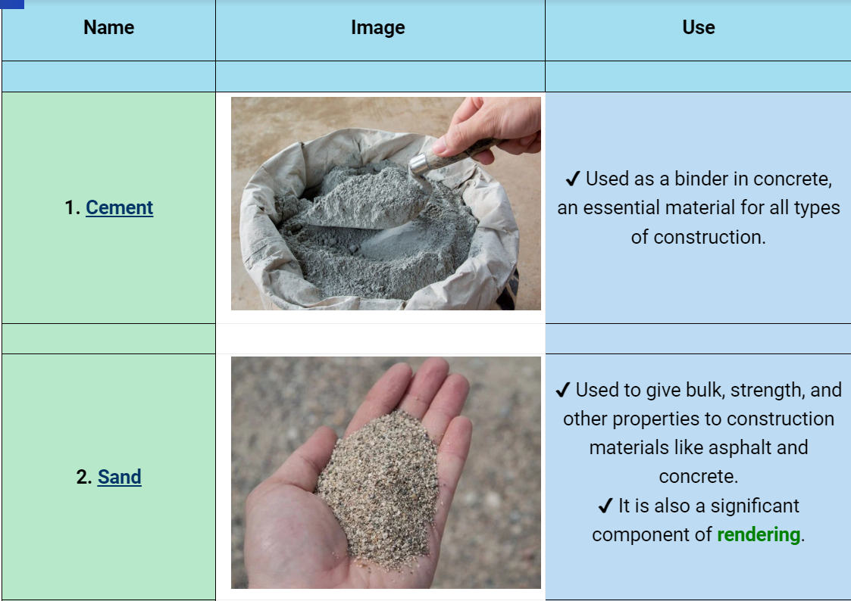
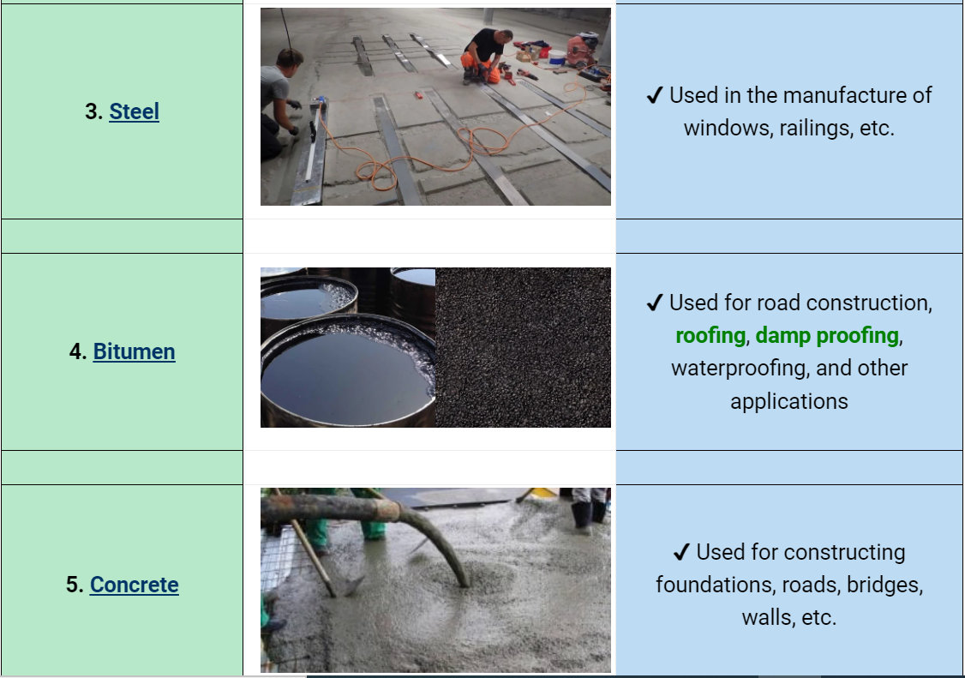
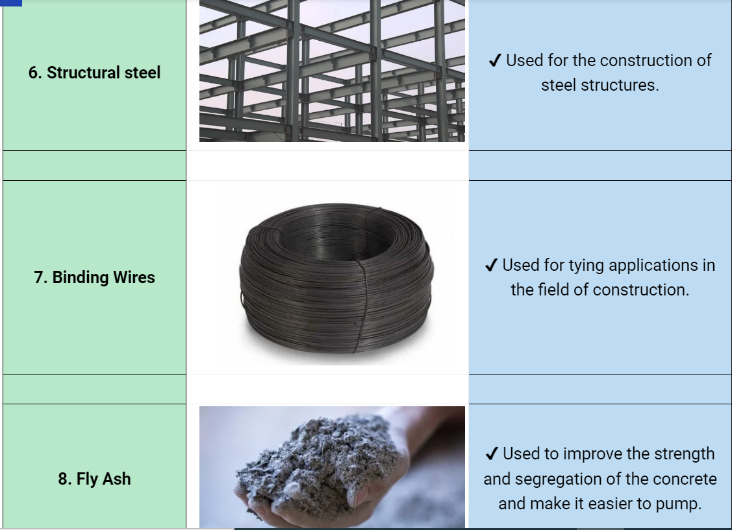
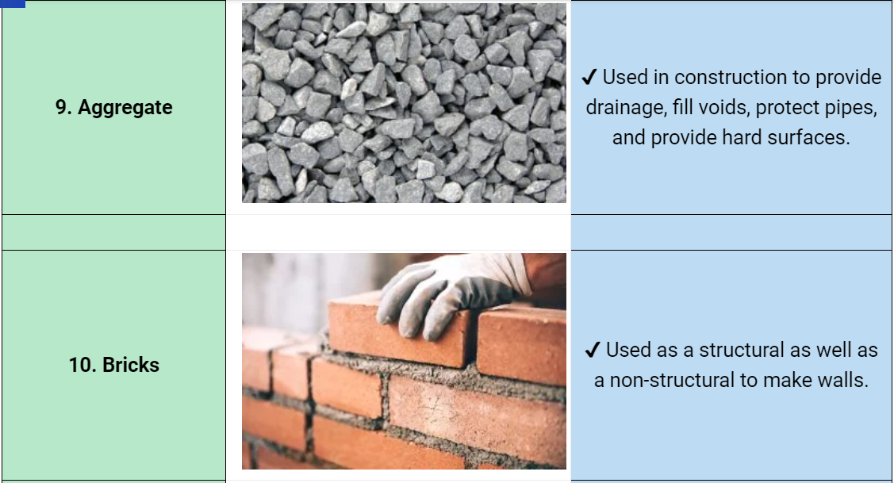

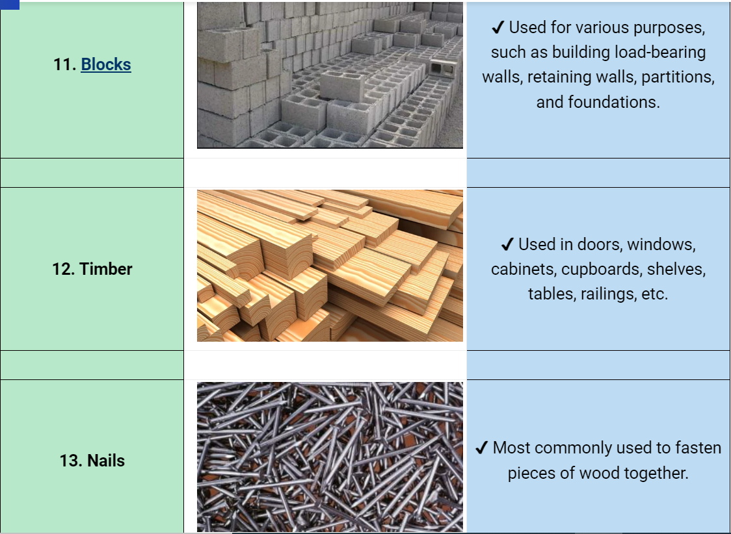

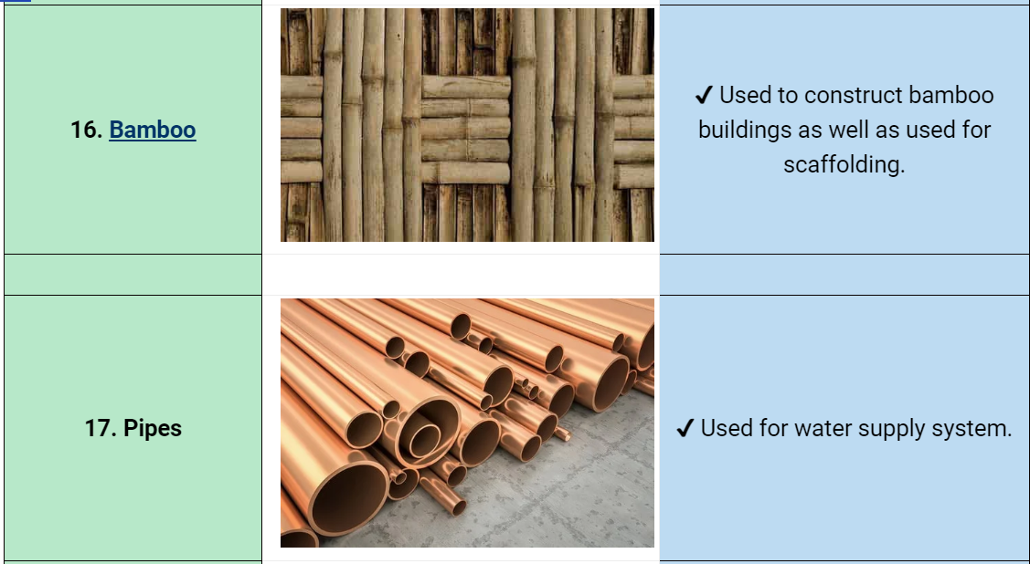

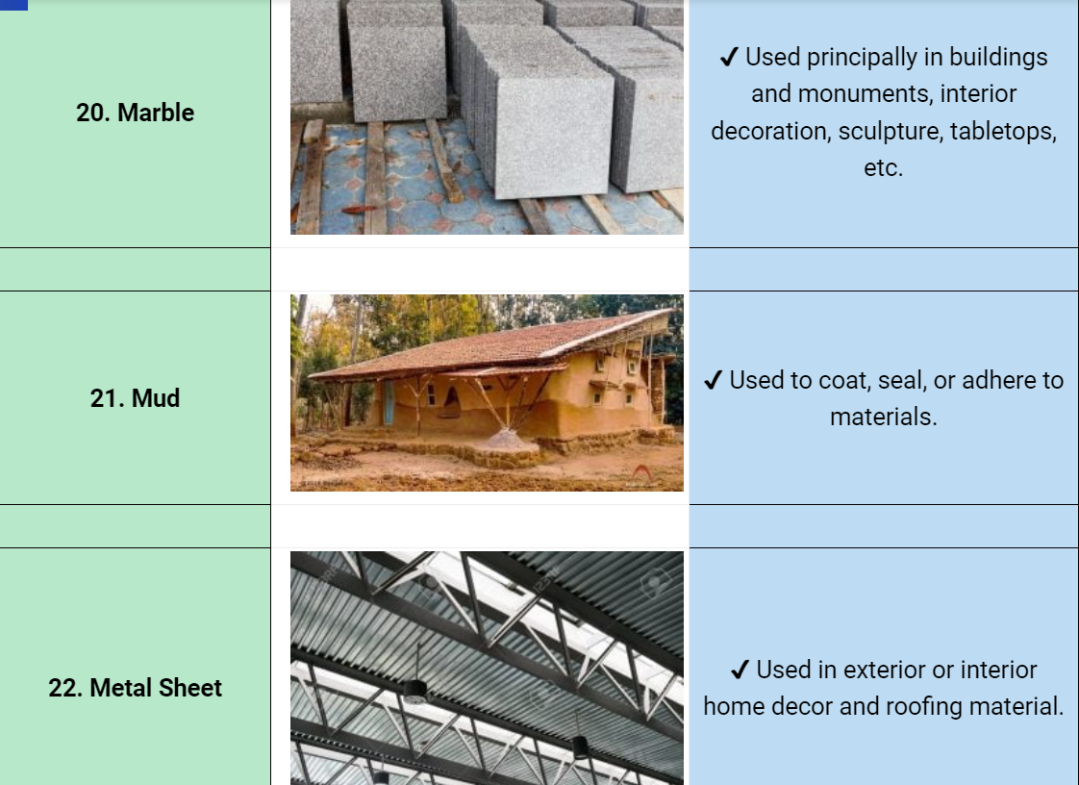
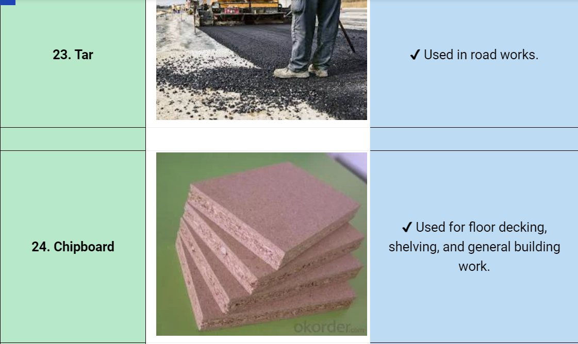

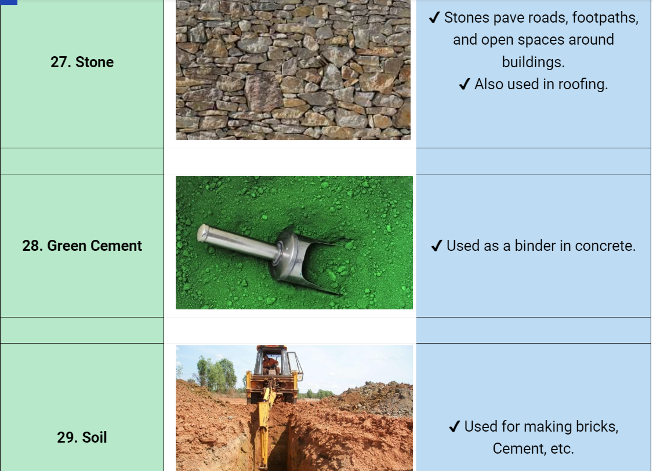
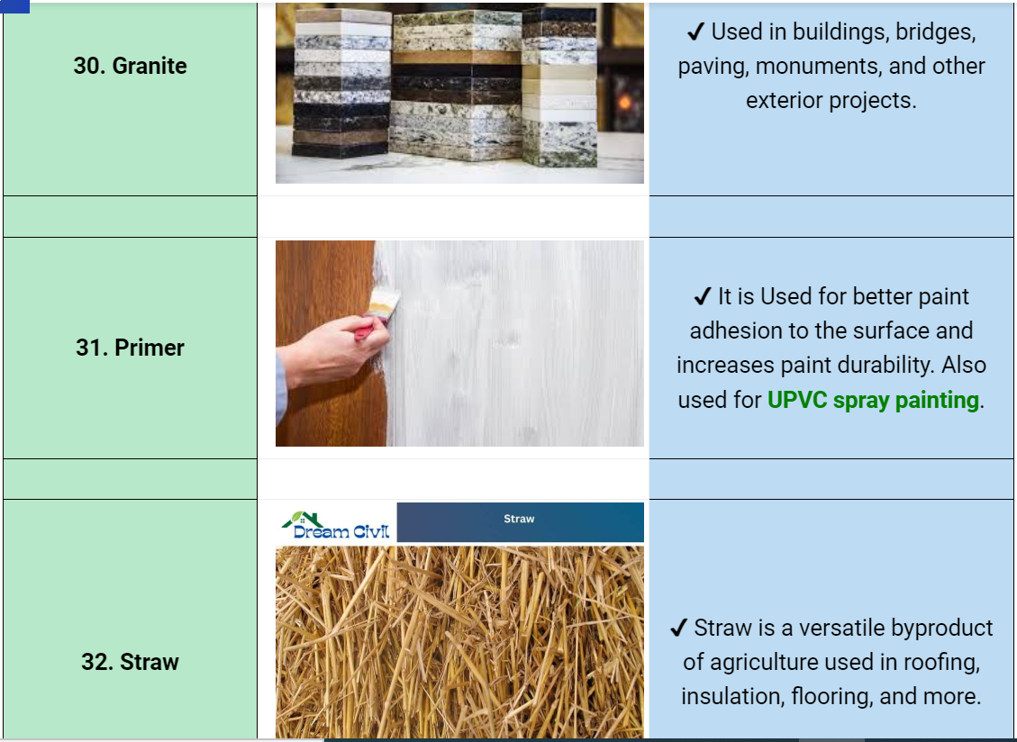
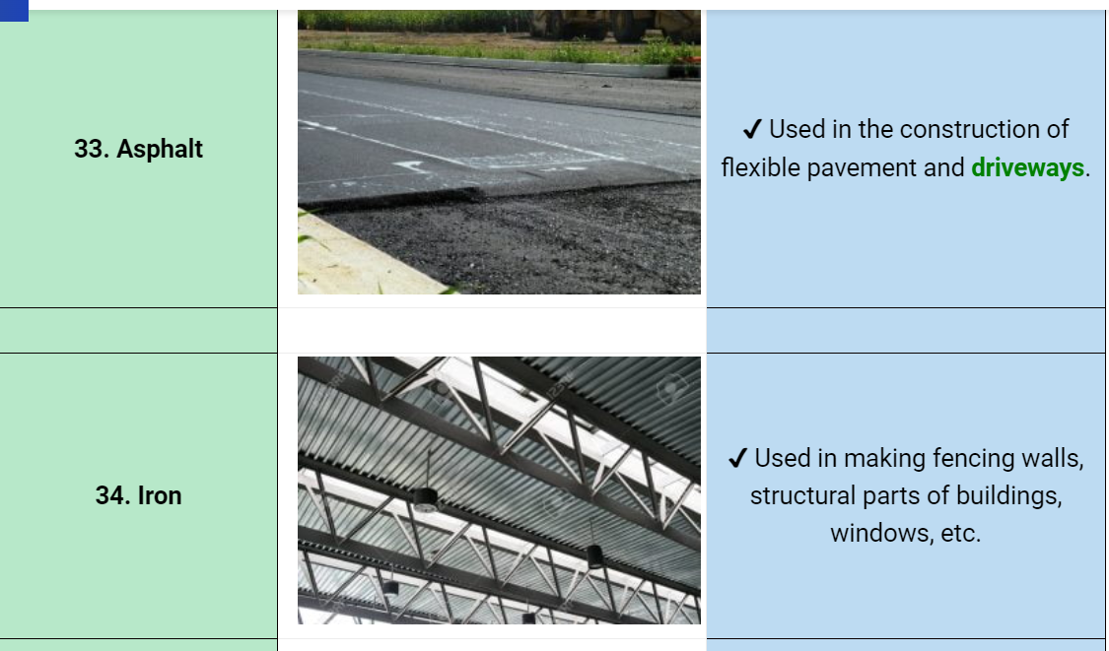
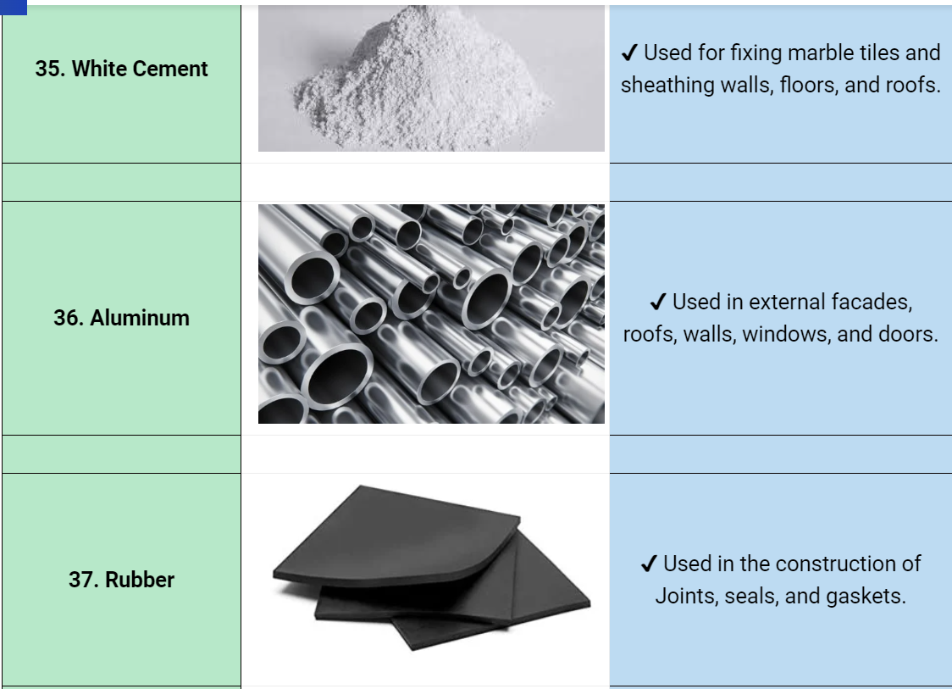
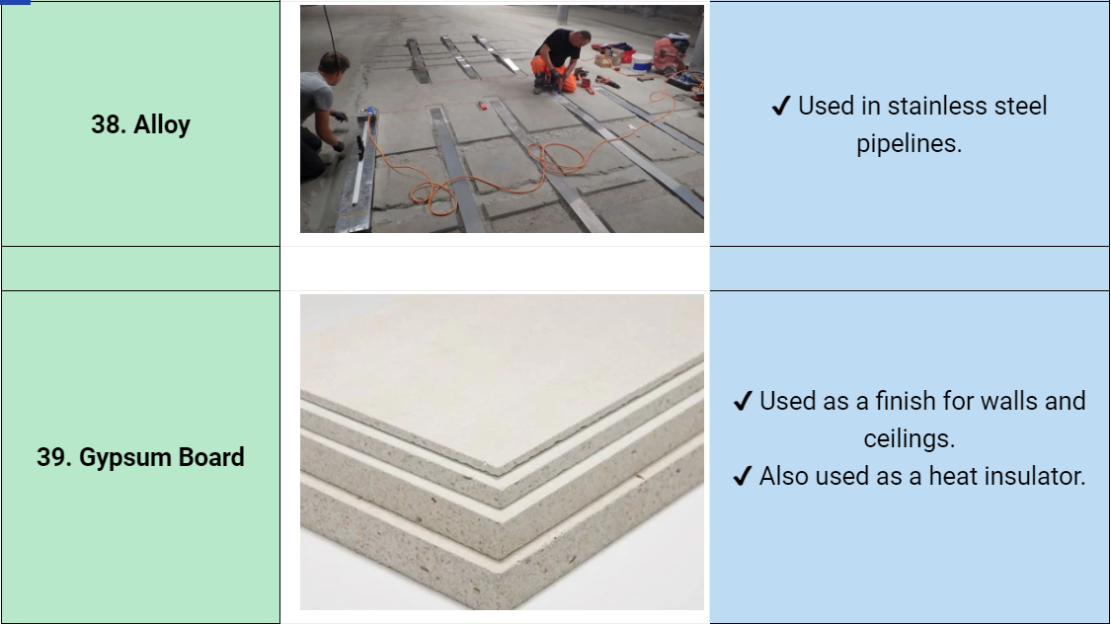



2.1.2Material quantity calculation

The first part of an estimating task is to determine the amount of materials that will be required. Material quantities are the fundamental data forming the foundation on which all estimating processes build. This first step in determining the necessary amount of materials is called quantity take off.
- Quantity Take Off
Quantity take off is an extremely important task with direct implications for the many estimating tasks that follow it.
The unit prices and the total prices of materials to procure, labor and equipment requirements and the scheduling of each activity are all based on the quantity take off. Therefore, it is clear that quantity take off is the foundation and the basis for all other estimating work and ultimately affects the total cost estimate of a project. Therefore, a quantity surveyor must be careful and thorough in her work in order to produce the most accurate calculations for the quantities of all the materials in the project.
- Quantity Take off Procedures
The quantity surveyor performs quantity take off from drawings and specifications. Drawings provide a graphical representation of the details of the project, including dimensions, type of materials, and location information of a component. Specifications complement the drawings by providing additional vital information that is difficult to show on the drawings, such as a specific type of paint to be used and the number of coatings for interior finishes.
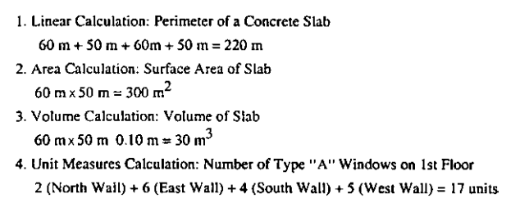
The calculations involved in quantity take off can be categorized into four basic components:
      - linear,
      - area,
      - volume, and
      - unit measures.
Linear calculations are used in determining perimeter, length, width, and height, and are the most basic type of construction calculation. Area calculations are obtained by multiplying two linear measurements.
Volume calculations are obtained by multiplying three linear measurements.
Unit measures are applied to construction items, such as the number of bricks, blocks, windows, and doors. When performing quantity take off, a quantity surveyor should visualize the entire project, thinking in terms of actual field procedures that will take place during construction.
- Pricing materials
After making a list of materials and their proposed quantities, the next step in determining the cost of materials is to price each and every item.
- Pricing
Pricing is a process of assigning a birr value to a work item based on given specifications and the predetermined quantity required.
- The pricing of each work item should include the cost of each of these subcomponents: Permanent and temporary materials to be procured,
- Labor required for installing the materials,
- Equipment required for moving and installing materials, and
- Other consumables, such as fuel and tools.

2.1.3Material cost

Material costs are obtained by getting quotations from suppliers, generally in a unit price of birr per unit of measure of a specified material. Many unit prices may be provided for the same material depending on the volume of purchase at a given time. Generally, the more the amount of purchase, the lower the unit price is.
This is called quantity discount. When using the unit price, the contractor has the responsibility of determining the quantities of materials to be purchased.
The cost of materials includes not only the direct cost of the material items, but the contractor shall add the following costs to the material supplier’s price to get the material unit cost at the project site:
- Loading expenses at the supplier’s place of delivery
- Transportation costs to the project site
- Insurance charges during transportation to the project site
- Unloading expenses at the project site

- Direct material unit cost(E) calculation
Direct material cost is the total cost of construction materials required to execute a unit of specific activity in a project.
In estimating the direct material cost, the contractor shall obtain the quantity and quality of materials required to produce the specific unit of an activity.
General formula to calculating direct material cost

Example
- Calculete direct material cost for 1.3 m3 coarse aggregete.
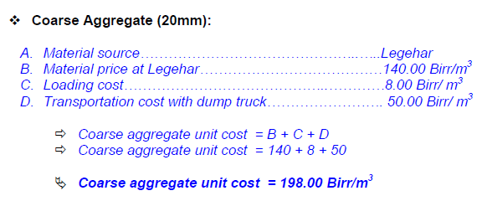

Direct material cost = ∑Total material quantity × Material unit cost
= 1.3m3×198.00birr/m3 = 257.40birr

Activity 1.
- Calculete Direct material cost for the follwing slab case.
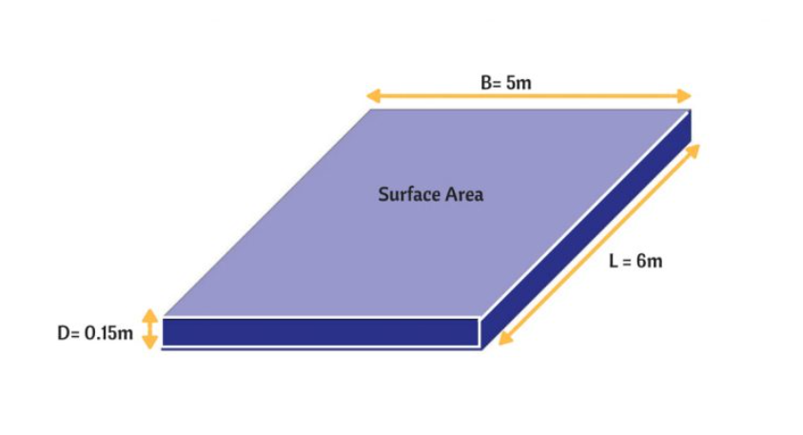

2.2 Labor cost calculation

2.2.1 Introduction

The construction industry, to which crafts men belong, is one of the most labor- intensive industries in the world. The labor cost component of a building project often ranges from 30-50%, and can be as high as 60% the overall project cost. Therefore, it is clear that construction labor is a vital component of a construction project.
A building is a very complex product, made of many different systems, such as the structural, exterior enclosure and interior enclosure system. These system can be broken down into many more sub-systems and sub- subsystems. In this way, a building construction project is divided into numerous work packages. These work packages can then be assigned to and completed by an individual worker, or a crew. A crew is a team of workers, which can be of the same trade or a composite of many different trades.

2.2.2Types of Construction Labor

A building is a very complex product, made up of many different systems, such as the structural system, exterior enclosure system, and HVAC system. These systems can be broken down into many more subsystems and sub subsystems. In this way, a building construction project is divided into numerous work packages. These work packages can then be assigned to and completed by an individual worker or a crew.
A crew is a team of workers, which can be of the same trade or a composite of many different trades. Due to the diverse nature of the different tasks associated with all the building systems, many types of craftsmen from many different trades are required in a building construction project. Table 2.1 provides a list of types of workers that can be involved in a building construction project, along with their description.

Table 2.2 Worker Classification Definition Sheet

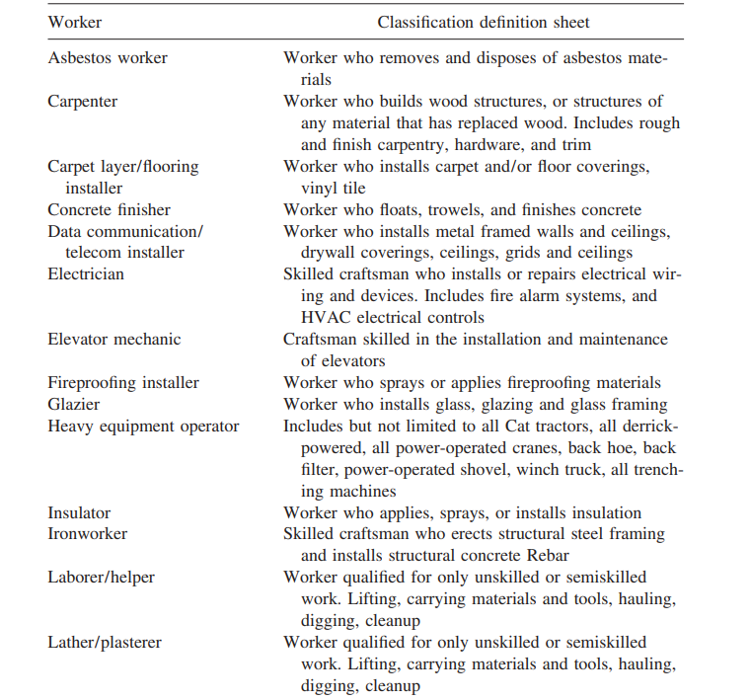
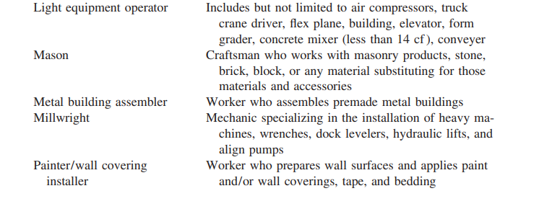

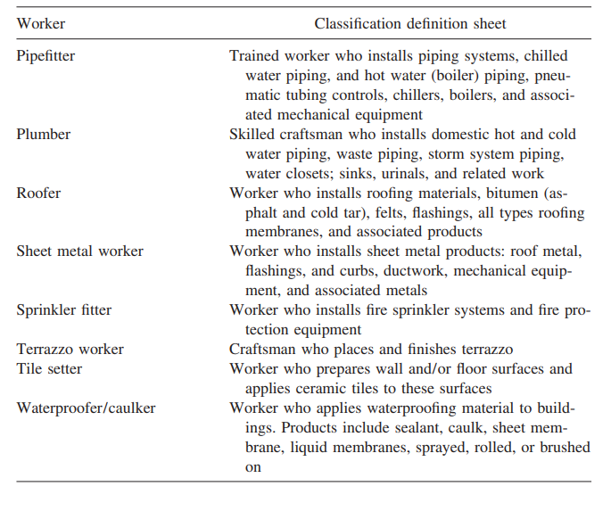

2.2.3Components of Labor Costs
Labor costs in construction are determined by two factors:
- Monetary and
- Productivity.
- Monetary
The monetary factor is related to hourly wage rates, wage premiums, insurance, fringe benefits, and taxes. Estimating the components of the monetary factor are more difficult in construction industry .This is due to the variety of work involved in construction, as well as the many types of trades involved. The problem is further complicated by the presence of the unions with their craft structures and collective bargaining processes. Although the computational process of this component seems complex and tedious, it is only a matter of accounting as the needed numbers (such as wage rates, fringe benefits, and insurance) are readily available.
2. Productivity
The second factor, which is much more difficult to deal with, is productivity. In the most general sense, productivity is the ratio of input versus the respective output. In construction, the input is often the work hours of a worker or a crew, such as the 8 hours of a bricklayer. The output is the amount of work produced, such as laying 500 bricks. Thus construction productivity is defined as the quantity of work produced in a given amount of time by a worker or a specific crew, that is, the quantity of construction output units produced in a given amount of time or a unit time. In the latter case, labor productivity is identified with value of construction birr per labor hour.
The formula for labor productivity shown in equation ( Eq 2.1 )
Construction productivity = Quantity of work produced ÷ Time duration
Example1
If a bricklayer can lay 500 bricks in 8 hours, the associated construction productivity is 500bricks divided by 8 hours, which is 62 bricks/bricklayer hour.
To accurately estimate productivity, an estimator not only needs a good historical record, but a lot of experience.

2.2.4Basic Principle for Estimating Labor
The formula for computing the total cost of labor is quite simple. It requires the knowledge of the total work hours or labor hours needed to perform all the tasks and then applying the corresponding wage rates. The formula for calculating the total cost of labor shown in equation (Eq 2.2) 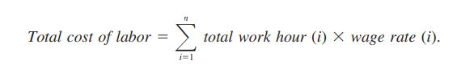
For example, assume that a crew for a work item includes three bricklayers and two helpers. The crew works for three days under straight time (8-hr day) to complete the work package. The wage rate for each bricklayer is 28.55birr and each helper is 22.40birr. In this instance, the total cost of labor is 3131 birr as determined by computations shown in 4.1.
Work description | Hour | Straight time birr/ hr | Total cost
 | 3brick layers × 3 day× 8hr/day = 72hr | 28.55 birr | 2055.60 birr
Brick layer | 2 helpers × 3 day × 8hr/day = 48hr | 22.40 birr | 1075.20birr
Heliper

Determining the total work hours for a task involves knowledge of the quantity of work required for the task and the productivity rate for the specific crew that will be performing the work. The quantity of work associated with the material quantity is determined by the quantity take off discussed
. For example, the quantity of work for placing concrete would be associated with the amount of concrete to be placed.
The formula for calculating the total work hours (Eq 2.3)
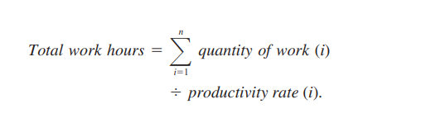
Work hours computation example
Work description | Quantity | Productivity per hour | Unit | Total work hours
Exterior Plastering | 440 | 11 | M² | 40
Interior plastering | 378 | 14 | M² | 27
 |  |  |  | 67

Direct Labor Unit Cost (F) calculation
In calculating the direct labor cost, contractors need to calculate the direct labor hourly cost which is the total hourly cost of labor crew required to execute a specific activity in the project.
In estimating the direct labor hourly cost, the contractor shall obtain the:
      - Number of labor,
      - Skill and labor utilization factor (UF)
      - Labor basic salary and
      - Labor index from his previous records and the labor market.


Labor index is a multiplying factor of the basic salary which represents the additional benefits whereby a worker gets from the contractor such as:
- Severance pay
- Annual leave
- Occupational accident expenses
- Occupational disease expenses
- Overtime pay
- Occupational safety, health and working environment
- Benefits resulting from collective agreements
Labor Index Calculation
1. Regular Salary = |  | 25.71 days/ mth | = | 1.00
 |  | 25.71 days/ mth | = | 1.00
2. Annual Leave = |  | 2.0 days/ mth | = | 0.078
 |  | 25.71 days/ mth | = | 0.078
3.Public Holidays = |  | 0.92 days/ mth | = | 0.036
 |  | 25.71 days/ mth | = | 0.036
4. Miscellaneous Leave = |  | 1.5 days/ mth | = | 0.058
 |  | 25.71 days/ mth | = | 0.058
5 Benefits
5.1. Closing & supplies = |  | 0.08 days/ mth | = | 0.003
 |  | 25.71 days/ mth | = | 0.003
5.2. Avg Annual Increase = |  | 3.43 days/ mth | = | 0.133
 |  | 25.71 days/ mth | = | 0.133
6. Rainy Season Salary = |  | 5 days/ mth | = | 0.1945
 |  | 25.71 days/ mth | = | 0.1945
Sub Total |  |  |  | 1.50
Contingency ( for work injury, dispute & labor union)
5 % of the total indexed cost |  |  | = .05*1.46 | 0.08
Grand Total Indexed Factor |  |  |  | 1.58

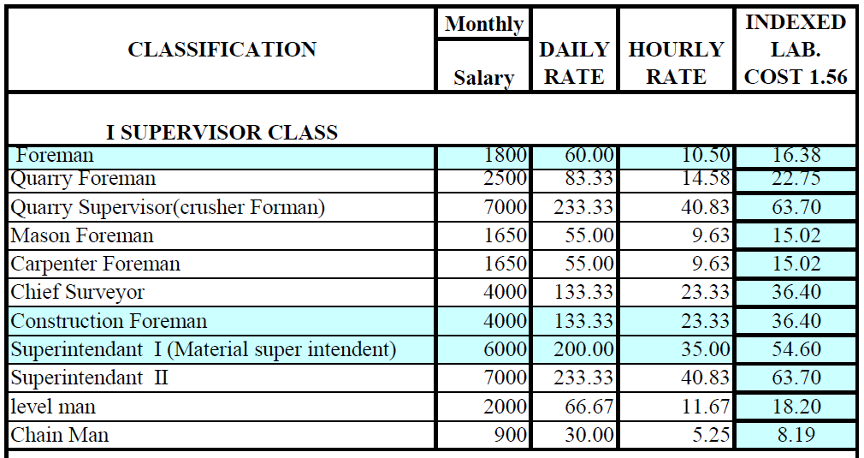

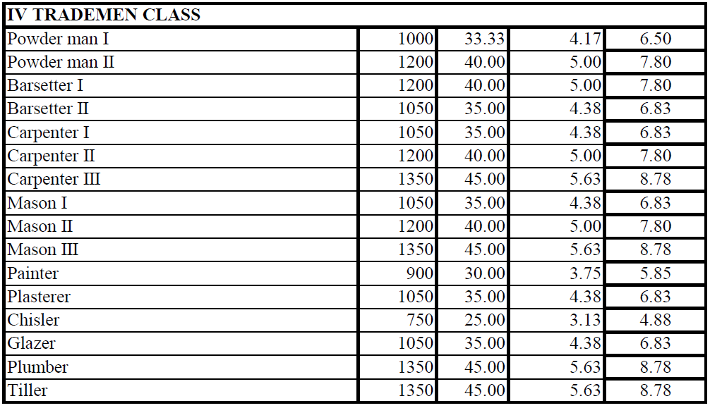

2.3Equpment cost calculation

2.3.1Introduction
Modern construction is characterized by the increasing utilization of equipment to accomplish numerous construction activities. According to Means’ Illustrated Construction Dictionary, equipment refers to all the equipment, tools, and apparatus necessary for the proper construction and acceptable completion of a project.
In a construction project, equipment costs are typically divided into portions. The first and bigger portion covers the cost of equipment and is often referred to as equipment cost. The cost of equipment is one of the major cost categories in a construction project. It represents the cost of acquiring the equipment and the cost of operating that equipment during the construction processes.
The second and smaller portion covers the cost of hand tools. This represents a smaller portion of the project cost and is often calculated as a percentage of payroll costs. It is added to the indirect cost under the jobsite overhead.

2.3.2 Classification Construction equipment
Equipment can be classified as specific use or general use
- Specific Use Equipment
Specific use equipment, as the name implies, is for a specific work item or items on the job. Units are assignable to jobs and are not shared by other subcontractors. This equipment is only for specific construction operations and is removed from the jobsite soon after the task is completed. Its usage is shorter term when compared to general use equipment. These works are voluminous, repetitive, and are ideal for equipment utilization.
Some typical equipment used for site work includes:

- Tractors,
- Scrapers,
- Front shovels,
- Hoes,
- Loaders and backhoe loaders,
- Hauling units, and
- Compactors

- General Use Equipment
General use equipment has shared utilization by all subcontractors on the construction site and is not associated with any particular work item or items. These pieces of equipment are kept on the site over a longer period of time, throughout almost the entire construction phase.
Some examples of general use equipment include:
- Cranes,
- Air compressors,
- Floodlights and light towers,
- Forklifts and Pumps.

Direct Equipment Cost (G) calculation
In order to calculate the direct equipment cost, contractors need to calculate the direct equipment hourly cost which is the total hourly cost of equipment crew required to execute a specific activity in a project.
In estimating the direct equipment hourly cost, the contractor shall obtain
- The number of equipment,
- Capacity and equipment utilization factor (UF), and
- The equipment hourly cost.


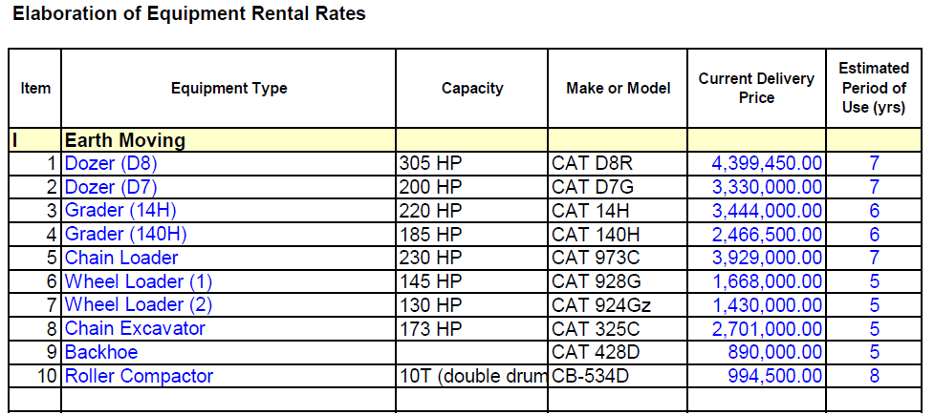

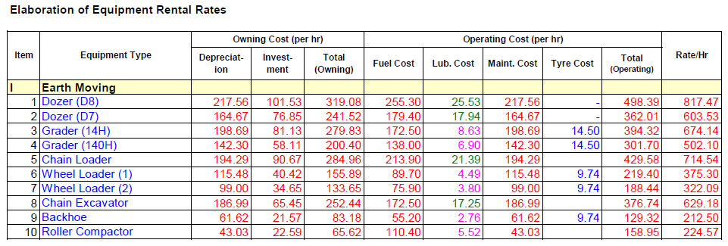
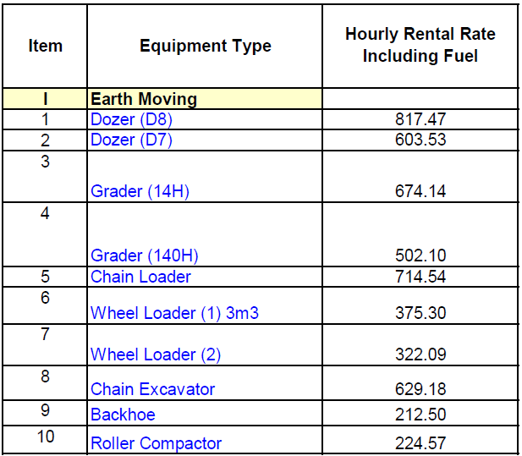

2.4 Head office overhead
Head office overhead costs are all costs required to run the whole operation of the construction company, which usually administers different projects at a time.
These costs are not usually associated with specific project but rather shared proportionally by all projects under the company.
Some of the checklists for head office overhead costs are given below with further clarifications.
Senior management costs – These refer to costs related with salaries and benefit packages of the senior management in the head office.
Indirect labor costs – Staffs other than the senior management members working at the head office such as the technical, administrative, marketing, finance and supply staffs.
Head office building costs – In both cases, costs are incurred in such a way either rental costs will be paid, if the building is rented and building depreciation will be considered, if the building is owned.
Bidding Expenses – These costs are usually associated with bid document purchases, site visit expenses, bid bonds and so on. These costs are sometimes called sunk costs.
Expertise service costs – These costs will be incurred when professional services are required such as the services of external auditors, lawyers, management consultants and external trainings.
Office furniture and equipment – Different office furniture and equipments are required depending on the size and standard of the company.
Office running expenses – The head office operation requires lots of miscellaneous expenses such as telephones, fax, internet services,
Workshops, garages and warehouses – Costs related to central workshops, garages and warehouses such as the depreciation costs of the buildings or rental expenses.
Bank charges – It is very natural that companies may borrow money from banks. Therefore, the interest to be paid on the borrowed capital shall be considered under the head office costs.
Insurance charges – Employees medical insurance, office building and small vehicles insurance.
Transportation and travel expenses –costs related to transportation, per diem and living expenses.
Sundry expenses – These are miscellaneous expenses such as advertisement expenses, reception parties and donations.
- Head Office Overhead Cost (J) calculation


2.5 Site overhead costs
Identifying Site overhead costs
Site overhead costs are all costs required to run the whole operation of a specific construction project at site level.
These costs are not associated with specific activity in a project but rather shared proportionally by all activities within the project. Some of the site overhead costs are listed below with further clarifications.
Site management costs – These costs refer to costs related with salaries and benefit packages of the site management members in the project site.
Indirect labor costs – salaries and benefits of staffs other than the site management members working at the project site such as site engineers, office engineers, administrative and finance staffs, data collectors and so on.
Mobilization and demobilization costs –These costs are mainly transportation costs.
Tender Expenses – These costs are related with the costs of the contract performance security, advance repayment guarantee, contractor’s all risk insurance, insurance of the works and third party insurance depending on the contract conditions agreed.
Site offices –site offices are constructed from different materials such as corrugated iron sheets, prefabricated materials, material packing steel containers, steel structure and normal hollow concrete blocks.
Expertise service costs – These costs will be incurred when professional services are required at the project site such as lawyers, claim experts and so on.
Office furniture and equipment – Different office furniture and equipment are required depending on the size and location of the project.
Office running expenses - The site office operation requires different expenses such as telephones, fax, internet service, mail service and stationery.
Radio communications - If the coverage area of the construction project is vast, hand held and stationed radio communications may be used within the site and with the head office.
Camp facilities – The costs of construction and operation of other facilities such as restaurants, recreational centers and playgrounds are also included under the camp facilities.
Access roads – Depending on the topography and location of the project site, different access roads may be required to construct such as detour roads, access roads to quarry and disposal areas, etc.
Water and power supply – All the site offices, camp facilities, the construction itself requires water and power supply for operating the whole project properly.
Workshops garages and warehouses, Bank charges, Transportation and travel expenses, Insurance charges, etc…

Site Overhead Cost (I) Calculation
It is easier to express the site overhead costs as a percentage of the direct unit cost of an activity.
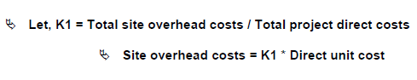

2.6Risk Allowance Cost
Identifying risk allowance
Usually contractors incorporate risk allowances in their tender prices to compensate the negative impacts of different risks such as contractual, technical, political and economic risks.
Contractual risks are usually stemming from the contract agreements with the project owner, subcontractors and suppliers.
Technical risks are associated usually with the clarification of the technical specifications, working drawings, construction technology and difficulties in understanding new method of constructions.
Political and economic risks reflect the impact of political situations, stability of economic policies, inflation and price escalation on the execution of the intended construction project.
Risk Allowance (L) Calculation
Let’s assume the following factors represent the percentage cost increment of each cost component and the risk allowance will be calculated as follows:

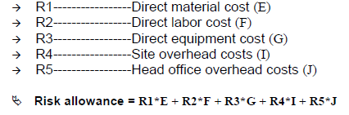

2.7 Profit and Income Tax
Identifying Profit and Income Tax
Construction projects are executed by contractors whereby these contractors will commit to invest their capital to get maximum possible profit from the contracts to be performed.
A profit margin entirely depends on the market competitiveness and company strategies.
Any construction company operating a profitable business in Ethiopia shall pay 30% of its gross profit as an income tax as per the income tax proclamation No. 286/2002.
If the contractor is registered for VAT, which is usually the case, the contractor’s construction cost estimate shall also include Value Added Tax which is 15% of the tender amount in accordance with the Value Added Tax proclamation No. 285/2002.

Gross Profit (M) calculation
As an illustration, if the net profit margin is assumed to be P% of the breakeven cost (direct costs + indirect costs + risk allowances), the gross profit (net profit + income tax) can be calculated as follows, which is X% of the breakeven cost

2.8 Total unit price without VAT(N)
If the contractor is registered for VAT but the contract is VAT exempted, the contractor’s unit price in his tender is the sum of direct unit cost (H), indirect unit cost (K), risk allowance (L) and gross profit (M).
IX. Total unit price without VAT
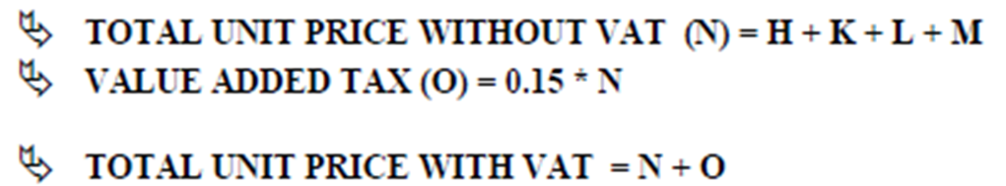

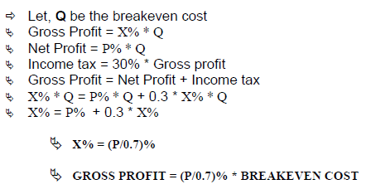

2.9 Developing unit costs analysis for each items of work and material
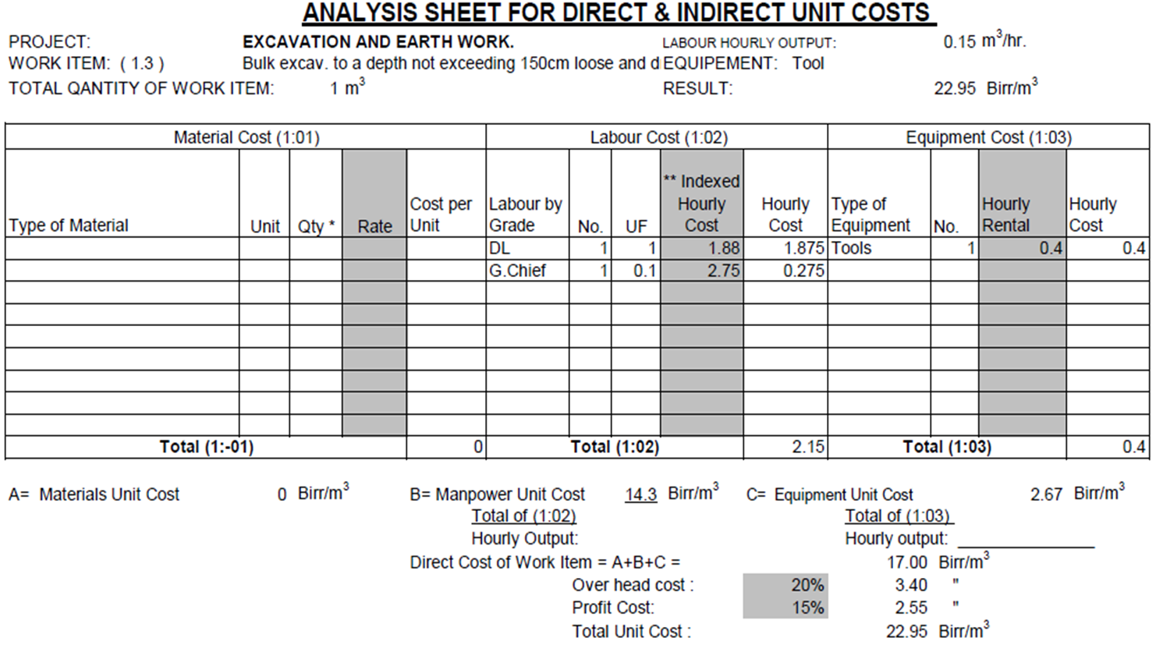
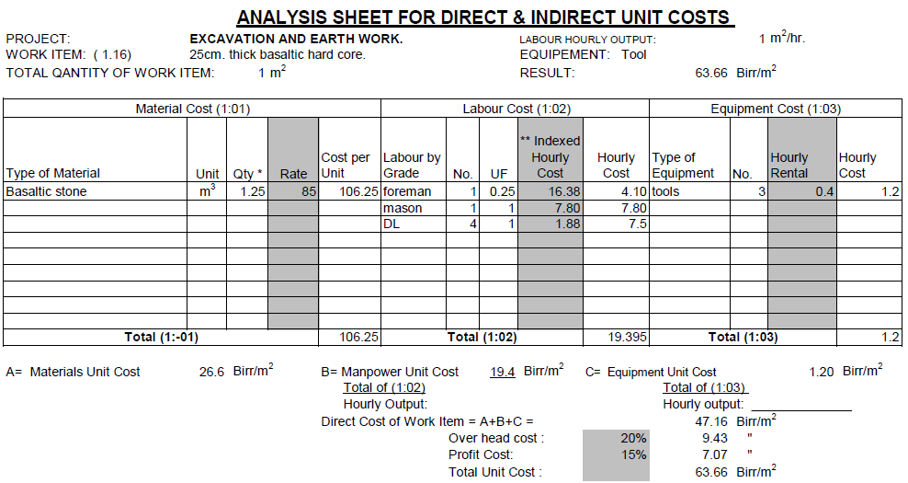

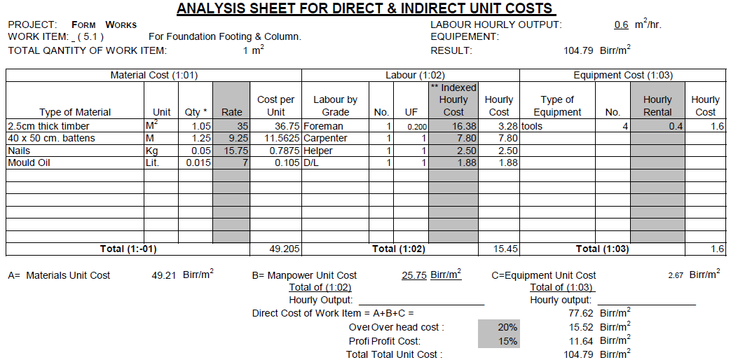

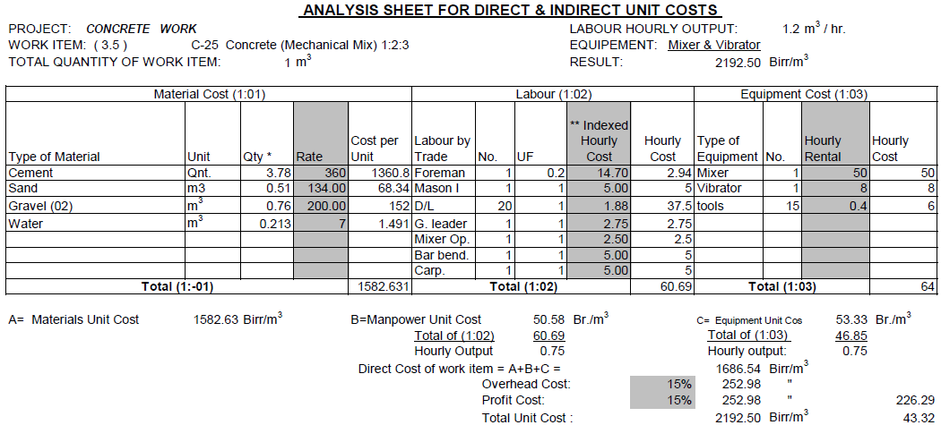

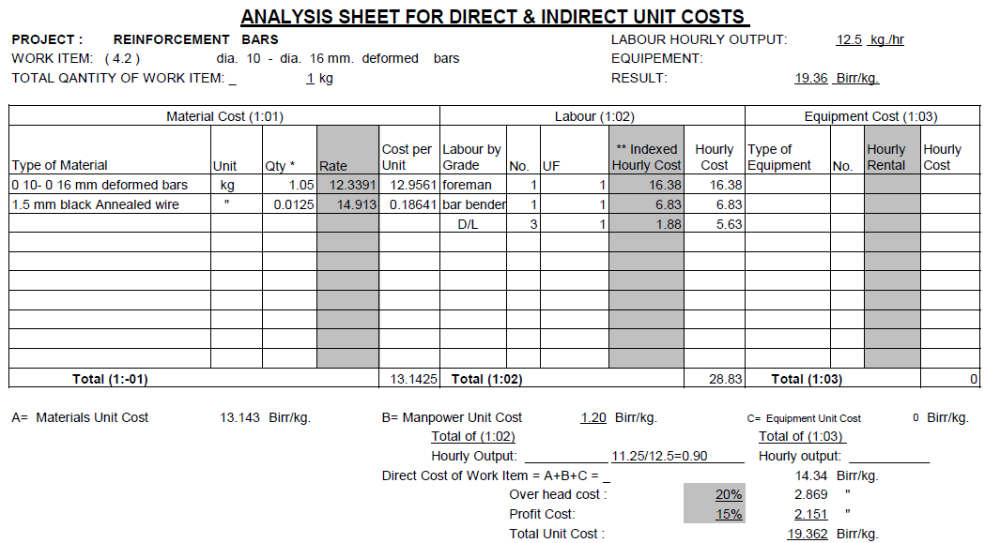

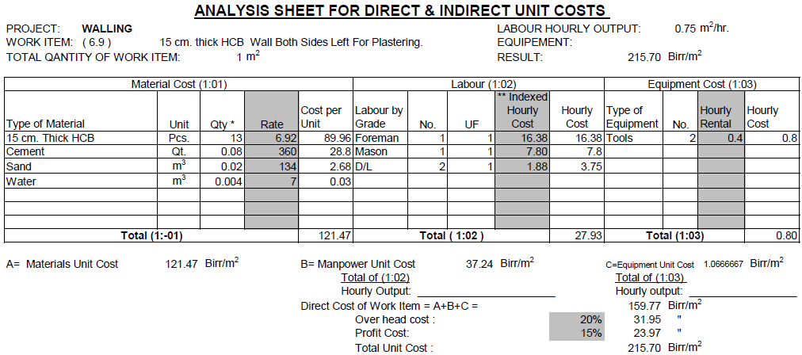

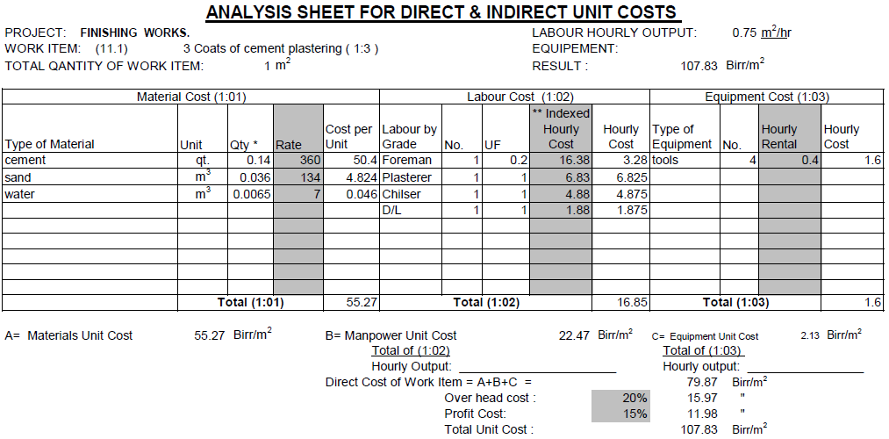

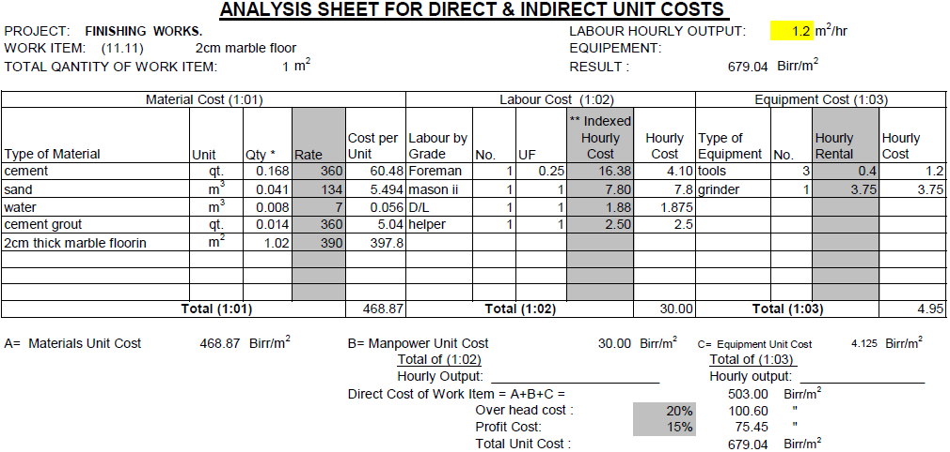

Self-check 2.1

Part I Multiple choose
Instruction: Choose the correct answer
- Used in the construction industry to create buildings and structures.
- Material B. Specification C. Drowning D. Take off sheet
- Is an extremely important task with direct implications for the many estimating tasks that follow it.
- Material B. Specification C. Drowning D. Take off sheet
3. Are obtained by multiplying three linear measurements.
- Area B. Volume C. Mater length D. Pcs
4. Is a process of assigning a birr value to a work item based on given specifications and the predetermined quantity required?
A. Pricing B. Costing C. Estimation d. All

Part II match column B to column A.
A B
      - team of workers A. Mason
2. Laying stone in buildings. B. A crew
3. Builds wooden structures C. Finisher
4. Laying Ceramic in building D. Carpenter
. E. Painter

Part III Give short answer
- Write at list 6 Construction making materials
- ------------------------
- ------------------------
- ------------------------
- ------------------------
- ------------------------
- ------------------------

2. Write the difference between
- Monetary and
- Productivity

Operation 2.1
Operation Title: Labor cost estimation
Purpose: To calculate the time and cost it takes the crew
Conditions or situations for the operations:
- Safe working area
- Check working drawing
Equipment Tools and Materials:
- A4 paper
- Pen
- Pencil
- Calculator
- Eraser
Instruction
If the daily production rate for a crew that works in an activity is 175units per day and the total crew cost per day is 1800Birr. The material needed for daily work is 4.5units and 100Birr/unit.
1. Calculate the time and cost it take the crew to finish 1400units
2. Calculate the total unit cost. Consider an eight hour work day.
Steps in doing the task
- Calculate Duration (units of time)
- Calculate Cost (labor cost)
- Calculate Total direct cost

Lap Tests
Instructions: Given necessary templates, tools and materials you are required to perform the following tasks accordingly. Duration 4hrs
Activity. If the daily production rate for a crew that works in an activity is 175units per day and the total crew cost per day is 1800Birr. The material needed for daily work is 4.5units and 100Birr/unit.
Task 1: Calculate the time and cost it take the crew to finish 1400units
Task 2. Calculate the total unit cost. Consider an eight hour work day.

Reference

Frederic C. Jelen, James H. Black, Cost and Optimization Engineering, Third Edition, McGraw-Hill Book Company, 2028
Risk Management Manual, International Federation of Consulting Engineers,2023, Pg 52
Cost Estimating Guide for Program and Project Management, U.S. Department of Energy, Office of Management, Budget and Evaluation, DOE G 430.1-1X, April 2016
Standard Classification for Cost Estimate Classification System, ASTM E2516-11
Cost Estimate Classification System, AACE International Recommended Practice No. 17R-97

No. | Name of Trainer | Sex | Educational Background In Level and Profession | Trainer Address
 |  |  |  | Region | College | Phone | E-Mail Address
1 | Bekalu Yibeltal | M | M.Sc. in Structural Engineering | Addis Ababa | Federal Technical and Vocational Training Institute | 0921988863 | fikruyibeltal@gmail.com
2 | Desalegn Alemu | M | B.Sc. in Construction Management | Oromia | Woliso Polytechnic College | 0926771683 | dasalegnalemu&gmail.com
3 | Muluken Solomon | M | M.Sc. in Construction Management | Oromia | Batu Polytechnic College | 0912289146 | mulecot99@gmail.com
4 | Solomon Urga | M | B.Sc. in Building Construction Technology | Oromia | Woliso Polytechnic College | 0921207462 | samuelsolomon071@gmail.com
5 | Tesfaye Assegidew | M | M.Sc. in Construction Technology & Management | Centeral Ethiopia | Butajira Polytechnic College | 0913442444 | tesfayeassegidew@gmail.com
6 | Tibebnesh Gebremichael | F | M.Sc. in Construction Management | Sidama | Hawassa Polytechnic College | 0916116049 | tibebineshg1@gmail.com
7 | Zekarias Gebre | M | B.Sc. in Civil Engineering | Addis Ababa | General Wingate Polytechnic College | 0912421317 | zekarias1502@gmail.com

