STRUCTURAL CONSTRUCTION works

Level – I
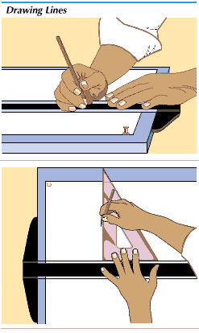
Based on March 2022, Curriculum Version 1
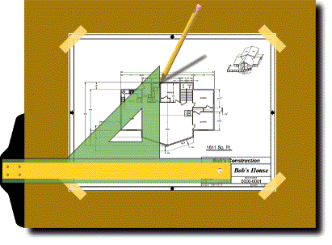

Module Title: - Prepare Technical Drawings
Module code: EIS SCW1 02 0322
Nominal duration: 80Hour

April, 2022
Prepared by: Ministry of Labor and SkillAddis Ababa, Ethiopia
Table of Content
Level – I 1
Introduction to the Module 6
Unit one: Drawing equipment and their use 7
1.1 OHS requirement 8
1.1.1 Safety requirements 8
1.1.2 Regulatory requirements 8
1.1.3 Environmental protection 9
1.2 Tools and equipment for technical drawing 11
1.3 Quality requirements 16
1.4 Types of drawings 18
1.4.1 Construction drawings/working drawings 18
1.6 purpose of technical drawing material 27
Self-check-1 32
operation sheet # 1 33
Lap test-1 36
Unit Two: Free hand sketching and views 37
2.1 Definition and purpose of drawing medium 38
2.1.1 Drawing media 38
2.1.2 Types of drawing lines (Alphabet of Lines) 42
2.2 Two dimensional drawings and sketches 48
Prepare title panel 63
Self-check # 2 64
Self-check #3 66
operation sheet # 2 67
Unit Three: Identify projection and sectioning 69
3.1. Isometric and orthographic projection 70
3.1.1 Isometric Projection 70
3.1.2 Orthographic Projection 71
3.2 Classification of surfaces and Lines in Orthographic Projections 78
3.3 apply Pictorial Projections 83
Self-check-4 97

Acknowledgment

Ministry of Labor and Skills wish to extend thanks and appreciation to the many representatives of TVET instructors and respective industry experts who donated their time and expertise to the development of this Teaching, Training and Learning Materials (TTLM).

Acronym
ABBREVIATIONS
ACT Acoustical Ceiling Tile
AFF above Finished Floor
ALU Aluminum
ANSI American National Standards Institute
ARC Architectural, Architect
ASTM American Society For Testing And Materials
BOA Board
BL Base Line
BM Beam
BTTM Bottom
BRG Bearing
BF Built Up Roof
CJ Control Joint
CL Center Line
CLG Ceiling
SF Square Foot/Feet
SHT Sheet
RCP Reflected Ceiling Plan
RD Roof Drain
REF Reference, Refrigerator
REINF Reinforcing
REQD Required
REV Reverse, Revised, Revision
RHR Right Hand Reverse
RL Roof Ladder
RM Room
RO Rough Opening

BO M OR BOM bill of materials also called a list of materials (lm or l/m).
C-c or c-to-c center-to-center; on centers defines center-to-center distance of two features
DWG, d w g drawing
Pc,p c s piece, pieces
QMS quality management system
qty or qty quantity
R radius
THK or t h k thickness
ACV aggregate crushing value
BOQ bill of quantities
CR crushing ratio
Dia diameter
Hr hour
LS linear shrinkage
Mc moisture content
MDD maximum dry density
OMC optimum moisture content
OPC ordinary Portland cement

Introduction to the Module

Drawing is graphic representation of a real thing. To draw some thing as a figure by means of lines expressing same ideas on the paper is the drawing. The purpose of drawing is to define and specify the shape and size of a particular object by means of lines, other information about the object, which cat note be expressed by line are given side by side on the drawing in a simples and shortest way.
This module is designed to meet the industry requirement under the structural construction work occupational standard, particularly for the unit of competency: prepare technical drawing
This module covers the units:
- Drawing equipment and their use
- Free hand sketching and views
- projection and sectioning
Learning Objective of the Module
- Drawing equipment and their use
- Free hand sketching and views
- Identity projection and sectioning
Module Instruction
For effective use this modules trainees are expected to follow the following module instruction:
Read the information written in each unit
Accomplish the Self-checks at the end of each unit
Perform Operation Sheets which were provided at the end of units
Do the “LAP test” giver at the end of each unit and
Read the identified reference book for Examples and exercise

Unit one: Drawing equipment and their use
This unit is developed to provide you the necessary information regarding the following content coverage and topics:
  - OHS requirements
  - Tools and equipment for technical drawings
  - Quality requirements
  - Type of drawing
  - Key features in drawings
  - Purpose of technical drawing materials
This unit will also assist you to attain the learning outcomes stated in the cover page. Specifically, upon completion of this learning guide, you will be able to:
  - Adhere OHS requirements
  - Understand tools and equipment for technical drawings
  - Recognize and adhere quality requirements of the company operation
  - Select type of drawing
  - Identify Key features in drawings
  - Know different technical drawing materials

OHS requirement

Safety requirements
Safety in the workshops is subject to a number of various risk assessments and safe codes of working practices which have to be observed and adhered to by all workshop users and enforced by the person in charge of these areas. Due to high risk activities taking place in the workshops access to these areas is restricted to authorized personnel only. No other person may enter the workshops without permission.
OHS requirements are followed in accordance with safety plans and policies. Plant, tools and equipment selected to carry out tasks are consistent with the requirements of the job, checked for serviceability and any faults are rectified or reported prior to commencement.

Regulatory requirements
All work performed pursuant to specifications shall comply with the requirements of the relevant local acts, regulations, standards and codes of practice of all authorities having jurisdiction over the work.
Technical data
The design drawings and technical specifications should include;-
• design drawings – these set out design information and procedures which are required
To be used on the works.
• Bill of quantities: – this itemizes the quantity of materials to enable a tendered to
Accurately cost the work for which they are bidding.
• Material specifications; – such as diameter, type and grade of material for pipes
(E.g. polyethylene pipes or up VC), joining methods (e.g. electro-fused
Or compression fittings etc.), or 28-day compressive strength of concrete.
- Requirements for material testing;- e.g. testing required for earth works (i.e. minimum required compaction and moisture range to be achieved), frequency of testing (e.g. one soil density test per 1,000 m3 of bulk earthworks) or the number of tests per 1,000 m2 of area for hydraulic conductivity tests in sedimentation ponds.
• Construction and installation methods.

- Design documents
Design documents relate to the design, construction and commissioning of the project works. Typically, the documents should include
- design drawings
- construction specifications

Environmental protection
Is the practice of protecting the natural environment by individuals, organizations and governments? .
Its objectives are to conserve natural resources and the existing natural environment and, where possible, to repair damage and reverse trends. Environmental protection requirements are identified for the project in accordance with environmental plans and regulatory obligations and applied tools and equipment selected to carry out tasks are consistent with the requirements of the job.
Material quantity requirements are calculated in accordance with plans and specifications .materials appropriate to the work application are identified. The work man site preparation begins before you starting any work,
1. Building has been designed
2. Constriction documents have been approved
3. Main contractor has been appointed by the client to construct the building.

This chapter describes the plan and prepare is detailed from the worker view point.
Due to the pressures of overconsumption, population growth and technology, the biophysical environment is being degraded, sometimes permanently. This has been recognized, and governments have begun placing restraints on activities that cause environmental degradation. Since the 1960s, environmental movements have created more awareness of the various environmental problems. There is disagreement on the extent of the environmental impact of human activity and even scientific dishonesty occurs, so protection measures are occasionally debated.

Importance of Drawing
Technical Drawing is known to be one of the basic languages of technology, namely math, science and drawing. Through this application a technology task can be performed correctly. Examples of it is the schematic diagram of a circuit for electronics technician & electrician, detailed plan of an object for carpenters and machinist, technical and furniture plans for carpenters and construction workers etc.

Tools and equipment for technical drawing

OBJECTIVE
After completion of this unit, you should be able to identify basic drafting tools, use and care for various drafting tools.
Competencies will be demonstrated by completing the assignment sheets, job sheets, and the unit tests with a minimum score of 85 percent.

SPECIFIC OBJECTIVES

After completion of this unit, the student should be able to:

- Match terms related to drawing tools and equipment with their correct definitions.
- Identify basic drawing tools.
- Identify the parts of a standard protractor head.
- Select true statements concerning rules for maintenance and care of drafting machines.
- Identify types of compasses.
- Identify types of dividers.
- Identify types of irregular curves.
- List types of common templates.
- Distinguish between types of drafting pencils.
- Match types of leads with the devices used to sharpen them.
- Identify tools used for inking.
- List types of pen points.

Basic Drawing Tools
- Adjustable Triangle - used for drawing vertical or inclined lines that is not at the standard 15° increment.
- Cleaning Pad - A loosely woven bag of ground art gum eraser used to remove loose graphite from a drawing.
- Compass - Used to draw circles and arcs.
- Compass Adapter - A device which holds a technical pen in a proper position in a compass
- Divider - Used to transfer dimensions
- Drafting tape - A specially-prepared tape used to adhere drawing media to the working surface
- Dusting brush - Used to brush loose graphite and eraser dust from a drawing
- Eraser - Used to remove pencil lines and graphite smudges from a drawing
- Eraser shield - A metal plate with various slots and openings used to protect line work when a portion of a drawing is to be erased
- Irregular curve - Used to lay out any noncircular curve
- Lead pointer - Used for sharpening mechanical pencils
- Lettering guide - Used to lay out guidelines for lettering
- Mechanical pencils – Used to hold leads of various hardness
- Protractor - Used to measure angles
- Scales - Used to measure the length of a line
- Template - A thin, flat, plastic tools with various size openings of different shapes used to expedite the drawing of standard features
- Triangle - A thin, flat, right-angled piece of plastic or metal with acute angles of 45°, or 30° and 60° used for drawing vertical or inclined lines that are multiples of 15

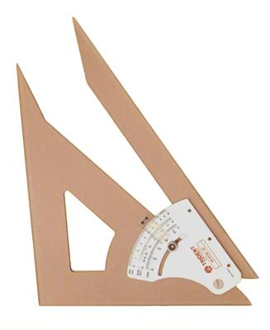
Basic Drawing Tools

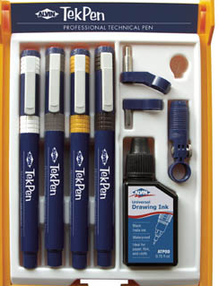
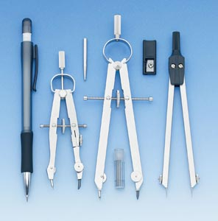

Adjustable Triangle
Compass & Dividers
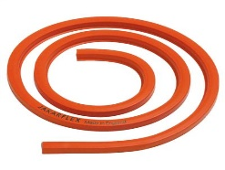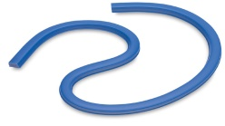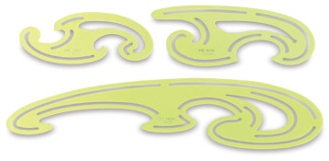
Technical Pens
Dusting Brush




Lead Pointer
Cleaning Pad
Drafting Tape
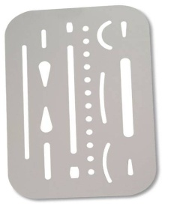
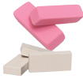


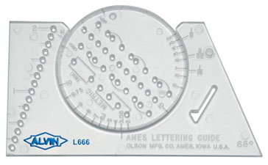
Irregular Curves

Lettering Guide
Eraser

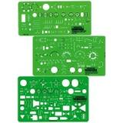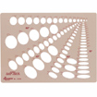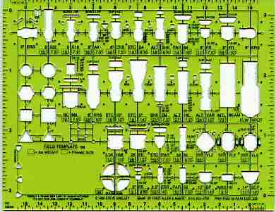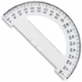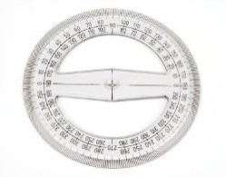

Erasing Shield

Templates
Protractors
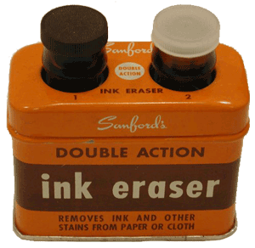
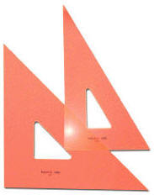

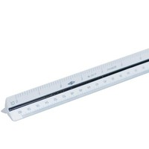
Liquid Ink Eraser

Scale
Regular Triangles

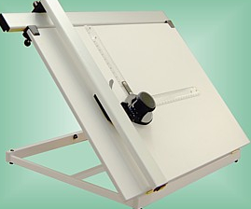
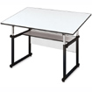
Basic Drawing Equipment

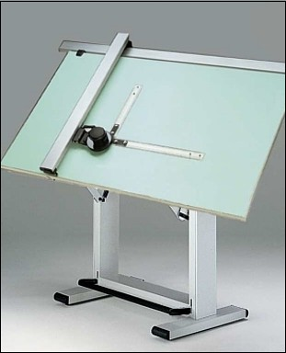

Drawing Board
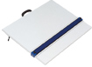

Drafting Table

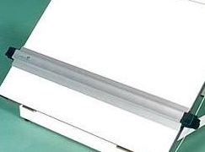

Parallel Bar Drafting Machine

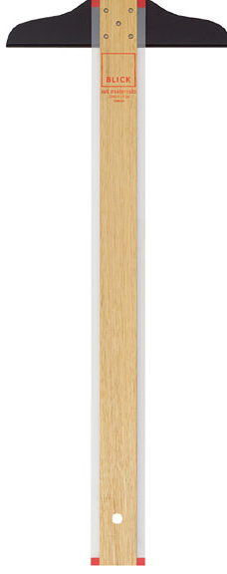
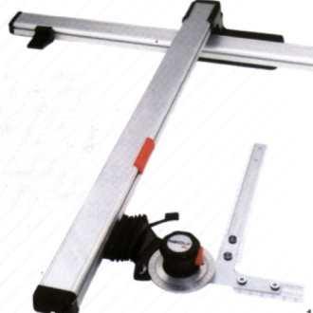
Elbow Drafting Machine
T-Square
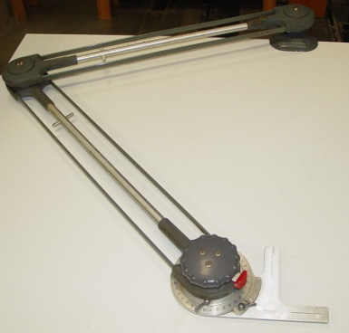
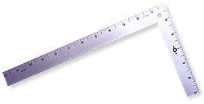

V-Track Drafter

L-Square

Quality requirements

Quality requirement is a common term in project management. It is defined as the condition used to assess the conformance of the project by validating the acceptability of an attribute or characteristic for the quality of a particular result.
The quality requirement defines the expectations of the customer for quality, the internal processes as well as the attributes of products that indicate whether the quality factors are satisfied or not.
Quality requirements are specifications of the quality of products, services, processes or environments. Quality is any element, tangible or intangible, that gives things value beyond their functionality and features.
The following are illustrative examples of quality requirements.
- Reliability enduring and consistent performance in real world conditions. For example, a drum designed to maintain its sound for at least 150,000 strikes.
- Consistency the requirement that units be the same or those units is internally consistent. For example, apples that is mostly the same size with similar appearance and taste.
- Usability requirements related to ease of use such as a can of coffee that is easy for everyone to open and reseal.
- customer experience requirements that make a product or service more pleasing to customers

Quality assurance vs. quality control
Quality assurance and quality control are two very closely related concepts and because of that close relationship they are often confused and one is inappropriately used as a substitute for the other.
Quality assurance is a process focused concept, where the processes are put in place to ensure the correct steps are done in the correct way. if the correct processes are in place there is some assurance that the actual results will turn out as expected.
Quality control is a product focused concept, where checking of the actual results are done to ensure that things are as expected. if the correct controls are in place you can know for certain that the actual results have been achieved because the actual results have been checked.
Quality assurance processes are put in place to provide some comfort that the end product is what you want. Quality control is making sure the end product really is what you want. That can still be a bit confusing so this article will walk through some examples to clarify the difference between quality assurances vs. quality control.

Types of drawings

Introduction
Drawing is graphic representation of a real thing. To draw some thing as a figure by means of lines expressing same ideas on the paper is the drawing. The purpose of drawing is to define and specify the shape and size of a particular object by means of lines, other information about the object, which cat note be expressed by line are given side by side on the drawing in a simples and shortest way.
Many different types of drawing can be used during the process of designing and constructing buildings. Some of the more commonly-used types of drawing are listed below, with links to articles providing further information.

1.4.1 Construction drawings/working drawings
Working drawings or construction drawings provide dimensioned, graphical information that can be used; by a contractor to construct the works, or by suppliers to fabricate components of the works or to assemble or install components. Along with specifications and bills of quantities or schedules of work, they form a part of the 'production information’ that is prepared by designers and passed to the construction team to enable a project to be constructed.
- Design drawings design drawings are used to develop and communicate ideas about a developing design. In the early stages they might simply demonstrate to the client the ability of a particular design team to undertake the design. They may then be used to develop and communicate the brief, investigate potential sites and assess options, develop the approved idea into a coherent and co-ordinate design, and so on.
- Electrical drawing an electrical drawing, also known as a wiring diagram, is a type of technical drawing that provides visual representation and information relating to an electrical system or circuit. They are used to convey the engineering design to the electricians or other workers who will use them to help install the electrical system.
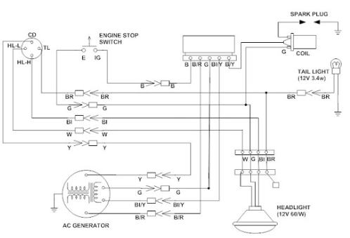
Figure1.1 electrical drawing diagram
- Detail drawings detail drawings provide a detailed description of the geometric form of a part of an object such as a building, bridge, tunnel, machine, plant, and so on. They tend to be large-scale drawings that show in detail parts that may be included in less detail on general arrangement drawings.

- Elevations the term ‘elevation’ refers to an orthographic projection of the exterior (or sometimes the interior) faces of a building, that is a two-dimensional drawing of the building’s façades. as buildings are rarely simple rectangular shapes in plan, an elevation drawing is a first angle projection that shows all parts of the building as seen from a particular direction with the perspective flattened. Generally, elevations are produced for four directional views, for example, north, south, east, west.
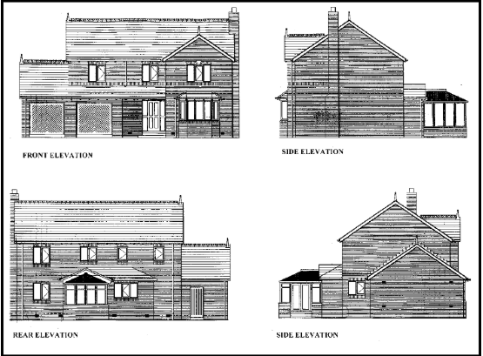
Figure1. 2 elevation drawing diagram
Floor plans the most important step in the building is the floor plan.
It contain more information than all the other working drawings.
Essentially the floor plan of a building s a horizontal section through the window, openings& door ways of the building taken a bout 150cm above the field line.
This is done course to out through the majority of openings in walls& to provide a view of the equipment installed in side.
The working drawing enables the work man to known many rooms a building should contain the rooms& the overall dimensions of the building.
In most building drawing each floor has its own plan& these are designated as ground floor plan, first floor plan, second floor plan……..etc.

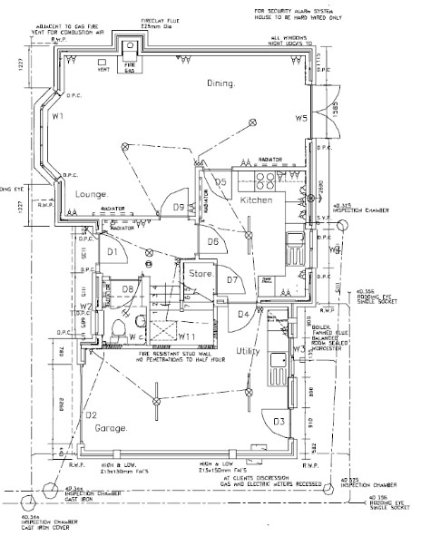
Figure 1.3 floor plan diagrams
- Engineering drawing an engineering drawing is a type of technical drawing used to define the requirements for engineering products or components. Typically, the purpose of an engineering drawing is to clearly and accurately capture all geometric features of a product or component so that a manufacturer or engineer can produce the required item.
- Installation drawing installationdrawings present the information needed by trades to install part of the works. This may be particularly important for complex installations such as plant rooms, data centers, ventilation systems, under floor heating, and so on.
- Location plan a location plan is a supporting document that may be required by a planning authority as part of planning application. a location plan provides an illustration of the proposed development in
It’s surrounding context.
- Perspective drawing is a technique for depicting three-dimensional volumes and spatial relationships based on the eye level and vanishing point (or points) of the viewer. it can give a realistic impression of what a volume or space will look like in reality.
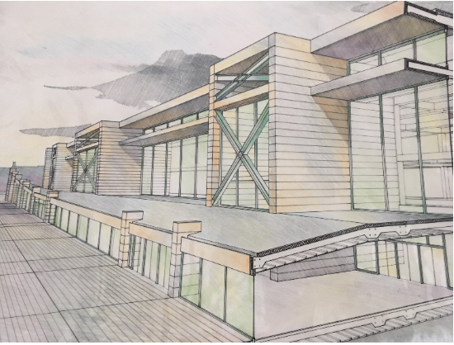
Figure1. 4 perspective view

- Scale drawing scale drawing is a generic term used to describe any drawing that illustrates items at less than (or more than) their actual size. this is generally necessary where the items are so large or small that it is not useful or convenient to draw it at its actual size.
- Section drawings a section drawing shows a view of a structure as though it had been sliced in half or cut along another imaginary plane. this can be useful as it gives a view through the spaces and surrounding structures (typically across a vertical plane) that can reveal the relationships between the different parts of the buildings that might not be apparent on plan drawings.
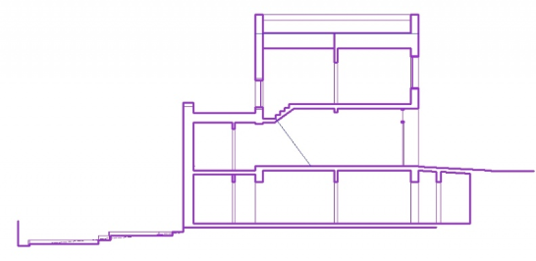
Figure1. 5 section drawing diagram
- Shop drawing shop drawings might be prepared by contractors, subcontractors, suppliers, manufacturers or fabricators. They generally relate to pre-fabricated components, showing how they should be manufactured or installed. They take design intent drawings and specifications prepared by the project design team and develop them to show in detail how the component will actually be manufactured, fabricated, assembled or installed.
- Site plans a site plan is a large-scale drawing that shows the full extent of the site for an existing or proposed development. Site plans, along with location plans, may be necessary for planning applications. In most cases, site plans will be drawn up following a series of desk studies and site investigations.
- Technical drawings the term ‘technical drawing’ has a very broad meaning, referring to any drawing that conveys the way that something functions or how it is constructed. Technical drawings are intended to convey one specific meaning, as opposed to artistic drawings which are expressive and may be interpreted in a number of ways. Most drawings prepared during the design and construction of buildings might be considered to be technical drawings.

Drawing sheets and layout features are standardized. It is essential that certain basic information be shown on every drawing. While some features may vary slightly, most drawings should have the following:-
- Floor plan: -the most important step in the building is the floor plan. It contains more information than all the other working drawings. Essentially the floor plan of a buildings a horizontal section through the window, openings& door ways of the building taken a bout 150cm above the field line. in most building drawing each floor has its own plan& these are designated as ground floor plan, first floor plan, second floor plan……..etc.
- Elevation drawing: - elevation drawing shows the width, the height, of structural the exterior material found on the structural & the exterior design elements. front& side views are drawn to give frontal & side look of the structural the of windows, doors, verandah, openings, parapets etc. normally four view as show front, rear, right side, left side,
- Section drawing;-section of the building obtained with the aid of vertical cutting planes, serve to show the construction of certain elements of the building. Section is the orthographic projection that has been cut a part to show interior features.
- Purpose of section: -describe the construction material of the structure.
Describe method of construction.
for examples: floor heights, elevations, landings windows, and doors etc….cutting planes lines with arrowheads at their ends which indicated the direction of the sectional view. Section is usually designated by letters.
For examples: section a-a section b-b
- Site plan: - site plan is the top view of building which shows the location of the house on the site together with information on terraces, walks, driveways, contours, elevations& utilities.
Checklist site plan
1, property lines each side direction
2, adjoining building streets, side walk parking, curbs park ways.
3, existing structures& proposed structure
4, all utilities lines (sewer, electric, telephone)
5, contours, existing, new: contour elevations.
6, dimension
7, fences, structural retaining walls, area ways & pools.
8, north arrow
9, drainage lines.
10, tree, shrubs, if exist
11, legend showing all symbols & material used on the site

shapes of site
Shapes are drawing elements, such as rectangles, circles, polygons, and lines. To create a drawing, get a shape by its service name at the service factory of a drawing document and add it to the appropriate drawplate.
Drawing sizes vary, usually ranging from a0 to a4. The size of drawing sheets should be consistent within a single set of project drawings. Sometimes drawings or diagrams of components and construction details are provided in a4 and bound in with specification data (for example, a specific engineering construction detail)

Dimensioning

Is the process of specifying parts information by using of figures, symbols and notes
This information is such as:
1. Sizes and locations of features 2. Material’s type 3. Number required
4. kind of surface finishes 5. Manufacturing process 6. Size and geometric tolerances

    - Designation and relative position of views
an object in space may be imagined as surrounded by six mutually perpendicular planes. So, it is
possible to obtain six different views by viewing the object along the six directions, normal to the six
planes. fig.(a) shows an object with the six possible directions to obtain the six different views
which are designated as follows.
1. View in the direction a = front view
2. View in the direction b = top view
3. View in the direction c = left side view
4. View in the direction d = right side view
5. View in the direction e = bottom view
6. View in the direction f= rear view
the relative position of the views in first angle projection are shown in fig. (b ).
note: a study of the figure (b) reveals that in both the methods of projection, the views are
identical in shape and size but their location with respect to the front view only is different.
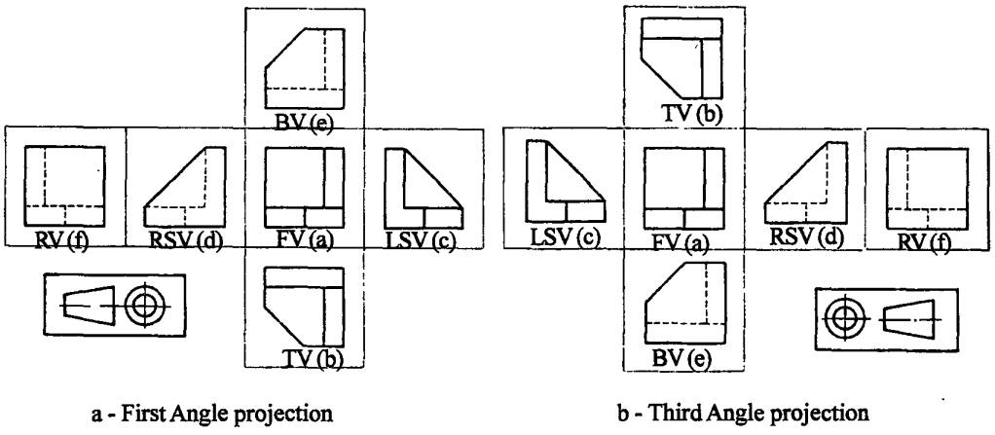
Figure 4.1.1 (a) and (b) relative positions of views
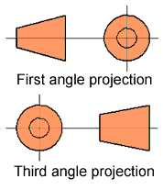
Both systems of projection are approved internationally and the system used is clearly indicated on all engineering drawings with the following illustrations:
figure 2.4.2 projection symbol
in which projection architectural and builders working drawings are represented is generally in significant. However, it is important that you understand the basic principles of orthographic projection and be able to construct orthographic views of objects.
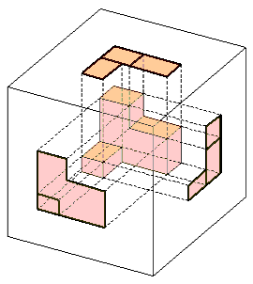  figure 2.1 imagine box | the easiest way to explain the development of a orthographic drawing is to place an object in a glass cube as shown in the opposite figure. the object surfaces are then projected on the faces of the cube. the cube like any card box can be unfolded so that all six surface areas are shown as blow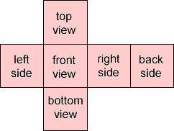  figure 2.2 six side separation view
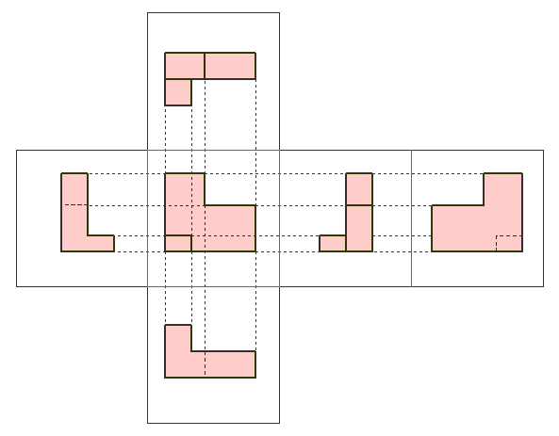

Figure 2.3 six side projection view

1.6 purpose of technical drawing material

T-Squares are use to draw horizontal lines. They are especially useful when constructing accurate orthographic drawings or architectural drawings. A T-Square is normally used with a drawing board, set squares and clips.
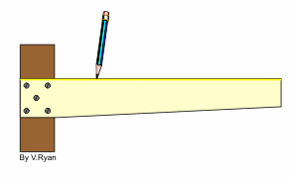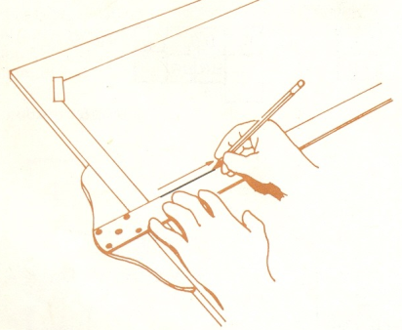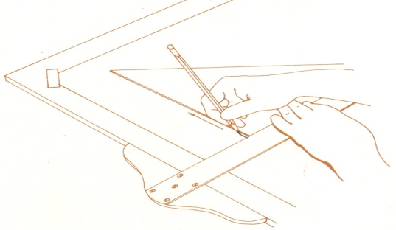

Set Squares are used to draw accurate angles. The most common are 45 and 60/30 degrees. When using set squares they should always use along with a T-Square.
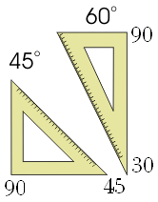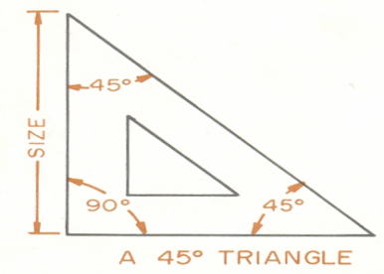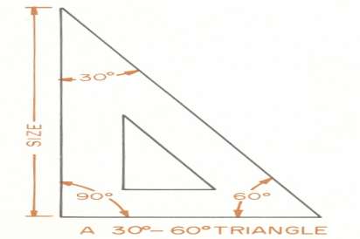
A compass is an absolute essential piece of equipment. It includes at least two compasses allowing the drawing of small circles arcs and large circles arcs
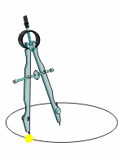
Dividers are similar to the compass. The dividers, as the name implies, are used for dividing distances into a number of equal parts. They are also used for transferring distance or for setting off a series of equal distance.
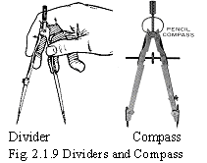
Engineering Scales are used only for measuring different scales.. It is important that drafters draw accurately to scale.
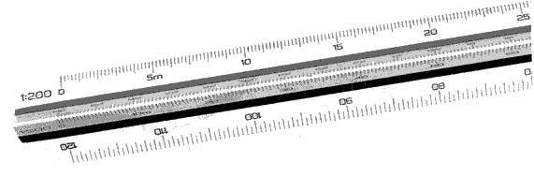
A protractor is used to measure angles. A typical protractor is a semi-circular piece of plastic
with 180 degrees printed around its curve. This piece of equipment is not only used in
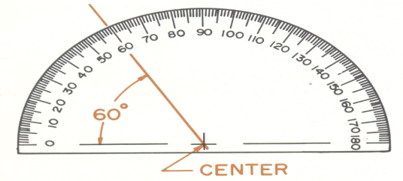
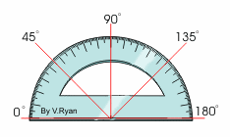
graphics for constructing accurate drawings but is also used in subjects like Mathematics.

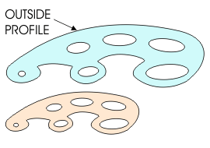
French curve is used to draw irregular curves.
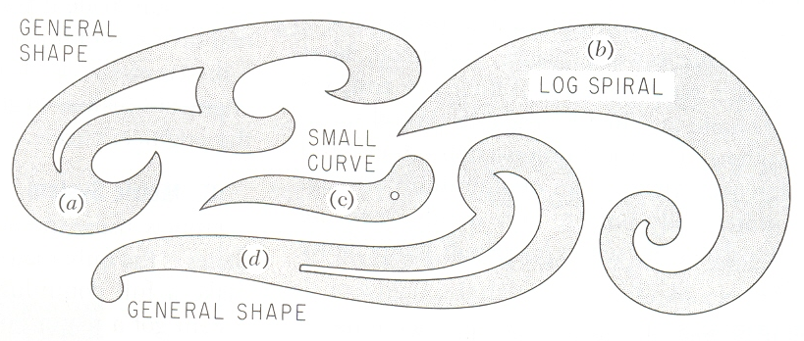

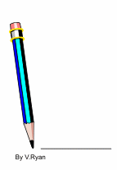
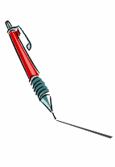
Drawing Pencils are a basic requirement of any graphics course. Ranging from 2B to 2H. This refers to the hardness of the pencil lead & sharp edge for longer and produces very fine lines.


Pencil sharpeners are essential for sharpening pencils.

A ruler should only to use to measure distances with lines being drawn with T-Squares and Set Squares.
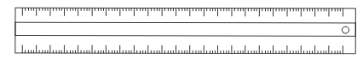
Erasers remove surface dirt.

Circle templatesthey are plastic with a number of accurate circles cut out.

Ellipse templates are similar to circle templates and these are useful for drawing ellipse / oval shapes accurately
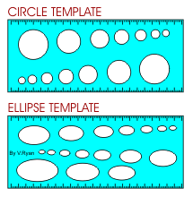

Papers: Each smaller size has an area half of the preceding size, and the length to width ratio remains constant. (A0, A1, A2, A3, A4).
Types of drawing papers: - There are two classes of papers.
- Detail paper: Its primarily for pencil work that is not used in reproduction processes that require a degree of transparency of the paper.

B. Translucent paper also known as tracing paper: which is designed so that it can be used in common reproduction process.
It can be used for both pencil and ink work. Only limited erasing may be done on it before damage occurs to the paper’s surface. Lead lines erase well, but inked lines do not.
The most common A-series sheet sizes are:-
A-Size | Dimensions in “mm”
A₀ | 841x1189
A₁ | 594x841
A₂ | 420x594
A₃ | 297x420
A₄ | 210x297
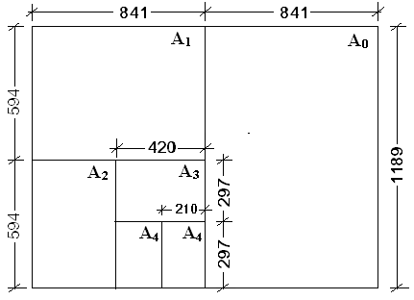

- Setting up paper on a drawing board

Drawing paper must be set up on a drawing board using a T-square. Once in position, the paper is clipped to the board with board clips or masking tape.
1. The T-square must be placed up against the edge of the drawing board. There must be no gaps
Otherwise the paper will not be set up correctly and drawing accurate horizontal and vertical lines will be impossible.
2. The paper is then allowed to rest on the T-square. Check that the paper rests properly on the T-square and that there are no gaps between the T-square and the paper or the T-square and the side of the drawing board.
The clips can then be positioned holding the paper securely to the board.
3. A 2H pencil can then be used to draw faint horizontal lines across the page. Try to keep the lines to the same size by measuring them with a ruler.
Each time you draw a line check that the T-square is pressed completely against the edge of the board. There should be no gaps.
4. To draw vertical lines a T-square and set -square are used together. Be careful to check that there no gaps between the T-square and the board and the set- square and the T-square.

Self-check-1
- Identify the following basic drafting tools.

a. _______________ b. _______________
c. _______________ d. _______________
e. _______________ f. _______________
g. _______________ h. _______________
i. _______________ j. _______________

Match 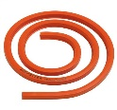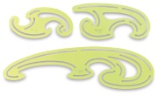
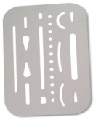
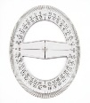

f
e
d
c
b
a

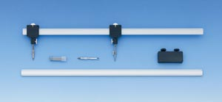
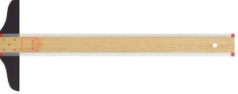
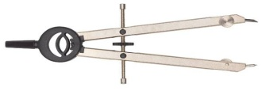

j
h
i
g

Module answer #1
1.
a. curves | b. eraser | c. erasing  shield | d. protractor | e. template
f. drafting  table | g. L-square | h. bow  divider | i. beam | j. T-square

OPERATION SHEET # 1 Interpret details from freehand sketch

Purpose:
Procedure: Interpret details from freehand sketch
How to sketch drawing
Problem 1:
Line A-B is divided into 6 equal parts.
Line A-D is divided into 9 equal parts.
D
C

4”

B
4”
A

(NOTE: Accuracy is a “must” for a drafter. Work on accuracy of spacing and keep all corners clean and sharp.)

(NOTE: Accuracy is a “must” for a drafter. Work on accuracy of spacing and keep all corners clean and sharp.)

5”

5”

Problem: Construct a 3 1/2” square centered on the vellum and constructs a figure like the one shown below in that space. Draw 1 3/4” radius arcs at A, B, C, and D, and construct small arcs so that they intersect as shown in the below. Complete the problem by adding center lines.

(NOTE: Omit radius lines A, B, C, and D from finished drawing.)
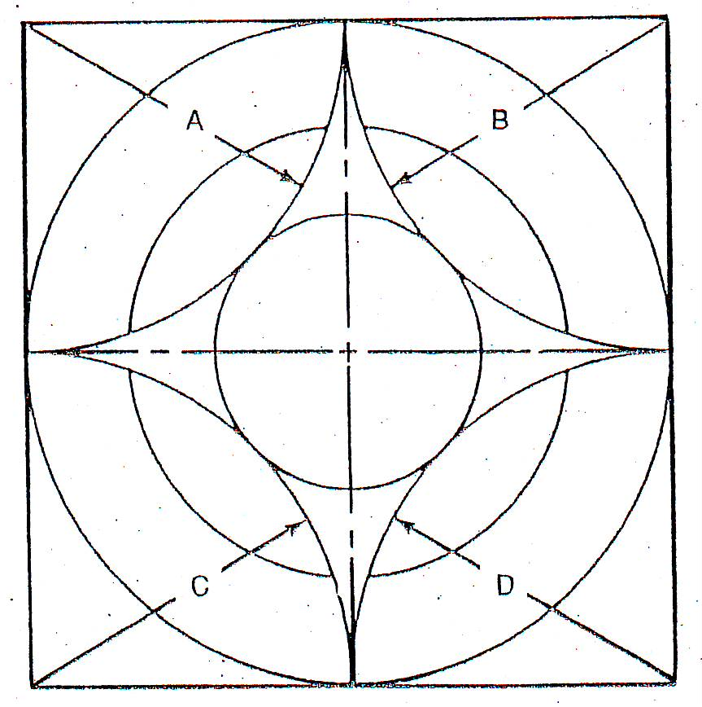

  - Problem- Construct a 4” square in the center of the working space. Using the figure below as an example, divide lines A-D and B-C into seven equal parts locating the corners of the squares. Construct the squares and complete the figure by adding center lines.
A
B
C
D

- Property locates end points of line.

- By trial movement from left point to right point, position arm without marking on the paper.

- Keep your eye on the point where the line will end and sketch short, light lines between points.
(NOTE: Do not permit your eye to follow the pencil.)

- Erase unneeded lines with a soft eraser and darken the remaining line to form one uniformly wide, continuous line.

(NOTE: At this stage, your eye needs to lead the pencil along the light sketch line.)

- Draw straight lines that are parallel to the drafting table edge (border lines) by aligning the paper on the drafting board edge and letting the third and fourth fingers of the drawing hand act as a guide by sliding them along the edge of the board while drawing the line.

(CAUTION: This should be done only on tables with proper edging material.)
Equipment, Tools and Materials:
- Paper 7. scales
- pencils 8. protractor
- erasers 9. compass
- drawing board 10. triangle
- T-square
- Irregular curves

Lap test-1
Task 1.Interpret details from freehand sketch

Unit Two: Free hand sketching and views
This unit to provide you the necessary information regarding the following content coverage and topics:
  - Definition and Purpose of drawing medium
  - Two dimensional drawings and sketches
  - Three dimensional drawing and sketches.
  - Symbols and abbreviations
  - Prepare title panel
This guide will also assist you to attain the learning outcomes stated in the cover page. Specifically, upon completion of this learning guide, you will be able to:
  - Select drawing medium
  - Prepare two dimensional drawings and sketches
  - Prepare three dimensional drawing and sketches
  - Include symbols and abbreviations
  - Prepare title panel

Definition and purpose of drawing medium

2.1.1 Drawing media
Drawing is the process or technique used while medium is the actual material used to create the artwork. There are a variety of different drawing media that can be used to create drawings. Each medium has different characteristics and produces different effects. There are also different drawing techniques associated with each medium.
Graphite- most commonly referred to as pencil or lead. Graphite is a grayish material that is available in a variety of different grades. “HB" is most commonly called a #2 pencil and is found in the middle of the grades. Softer graphite pencils are named "b" pencils and range from "b" (soft) to "9b" (extremely soft). "B" pencils generally make darker marks because of the softness of the graphite. One downside to "b" pencils is that they become dull easily. "H" pencils are made of harder graphite and range from "h" (hard) to "9h" (hardest). "H" pencils make lighter marks but keep a sharp point for a longer period of time. Graphite also comes in large chunks that are not in pencils. This graphite is used for covering large areas of a surface quickly.
- Pencil
Standard pencils are often used for sketching. Pencils come in a variety of lead styles, ranging from very soft to hard. The lower the number, the softer the lead. Soft leads are used for adding shades and tones, while the harder leads are used to draw outlines. Many artists use a combination of these pencil types in their sketches. Some artists use colored pencils for sketching, or combine colored pencil with lead pencil in some instances.
- charcoal and graphite
Charcoal and graphite are two drawing mediums that emphasize the use of shading. Charcoal is black and extremely messy to use. Many artists use charcoal pencils to help create lines, but a lot of artists use blocks of charcoal to create drawings by applying the charcoal in wide strokes that lack distinct lines.
- pen and ink
Pen and ink drawings use ink pens and jar inks, such as India ink. Pen artists use a range of pens in a variety of colors for sketching techniques, calligraphy pens for lettering and India ink for shading. You’ll find pens for artists available in many different tip styles, to provide the same variations of line and shading as pencil artists are afforded.
- markers
Children may use colored markers in their coloring books, but artists can work in marker, as well. the range of tip sizes in markers allows an artist to select smaller, harder-tipped markers suitable for tackling a drawing project from beginning to end, including the drawing and coloring elements of the work.
- Lettering
Lettering, dimensioning, geometrical constructions, and scales are the integral parts of engineering drawing. Lettering is required to give information and description about a particular drawing, dimensioning is done to indicate the size of the object being represented by its drawing at some suitable scale, and the geometrical constructions are needed to draw certain geometrical shapes.
In engineering drawing, the lettering is done free-hand. Therefore, some of the general guidelines for free-hand lettering will only be discussed. For dimensioning there are certain rules which must be followed, and the same has been presented to help the students for correct dimensioning. There are many geometrical shapes which come across in making the drawings of various objects, and readers are advised to refer to any book on engineering drawing. The only method of dividing an arc of circle in odd equal parts developed by the author has been discussed as there was no method available prior to the author’s method which is based on proper geometrical principles. In the last, the scales which play important role in making and reading the drawings have been discussed briefly.
Lettering in engineering drawing
In engineering drawing, the details about the object drawn, title of the drawing, scale, and some other relevant information to supplement the drawing in the form of notes, and annotations are given using free-hand lettering. The size of letters and numerals should be in proportion to the size of the body of drawing; neither too large or nor too small. Generally, the guidelines are drawn to maintain uniformity in height, and spacing of the letters and numerals. The following are some of the guidelines for lettering in technical drawings:
1. Standard height for uppercase or capital letters and numerals according to the Bureau of
Indian Standards (BIS) is
1.8, 2.5, 3.5, 5, 6, 10, 14, 20 mm.
1
- Drawing numbers, title block, and letters denoting the cutting planes and sections are written
in 10 mm size.
3. Drawing title is written in 7 mm size.
4. Hatching, subtitles, materials, dimensions, notes, etc., are written in 3.5 mm size.
5. Space between the lines is 3/10 h (height of capital letters).
6. Space between the words may be equal to the width of the alphabet M or 3/5 h (height of
capital letters).
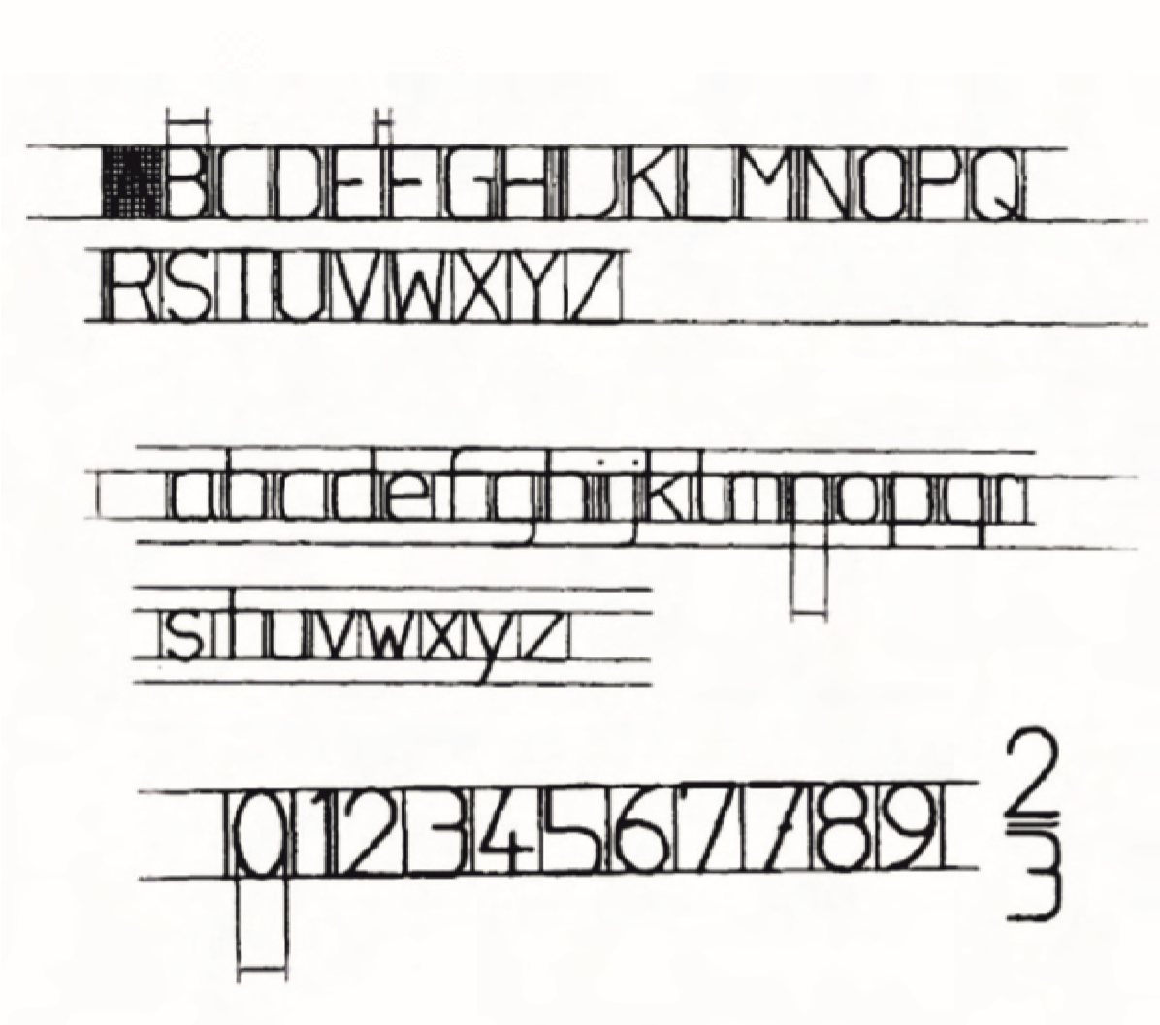
Fig. 1.1 Guidelines for lettering
8. Extremely light horizontal lines to regulate the height of the letters are drawn. In addition,
light vertical lines are also drawn to keep the letters uniformly vertical (Fig. 1.2). After the
lettering has been completed, the guidelines are not erased.
9. For technical drawings, single stroke vertical capital Gothic letters are used.
10. The order of strokes for various letters and numerals is shown in Fig. 1.3.
11. Spacing between the characters is normally 2/10 h (height of capital letters), and the spacing
between the words is generally 6/10 h.
12. Letter uniformity in style, size, weight, and space should be maintained to produce a good
drawing.

7.

The guidelines shown in Fig. 1.1 are drawn to maintain the height of letters, spacing, and
uniformity.
Fig. 1.1

Guidelines for lettering
n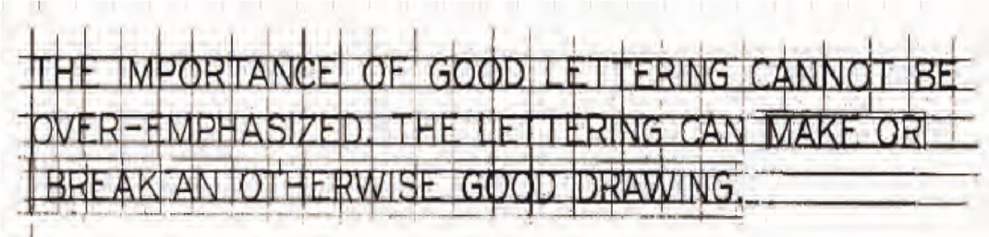
Fig. 1.2 Single stroke Gothic lettering
, 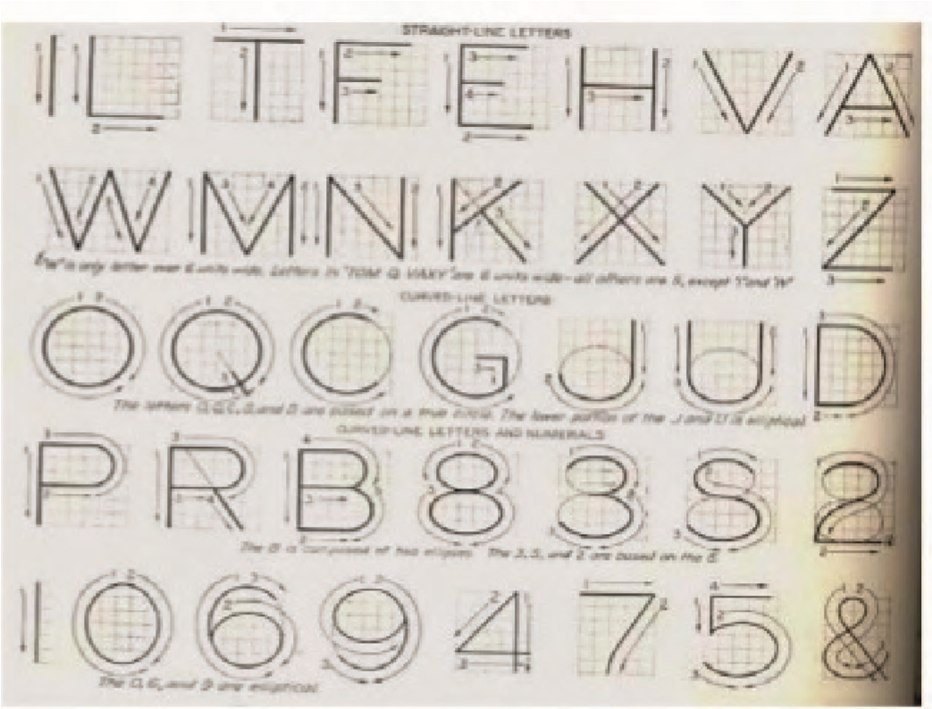
Fig. 1.3 Order of strokes for single stroke Gothic lettering
3
Chapter 1
Fig. 1.2 Single stroke Gothic lettering
Fig. 1.3 Order of strokes for single stroke Gothic lettering

2.1.2 Types of drawing lines (Alphabet of Lines)
Each line on a drawing has a special meaning. In order to help make and read drawings, standard line symbols were developed. The line symbols in Fig. 2.1 are the actual thickness they should be on a finished drawing.
There are two thicknesses of lines: thick and thin.
The thick lines: are used for visible, cutting-plane, and short break lines.

The thin lines: are used for long break, hidden, center, section, extension, and dimension.
- Object line (Visible lines): are used to show the main outline of a building and all interior walls. They are used for porches, patios, driveways, and construction details. All outlines of any major part which should stand out on the drawing should use a visible line.
- Hidden line Hidden lines: show edges and surfaces which are not visible to the eye but are hidden below a visible surface. They are made of short dashes about (3 mm) long. The spacing between dashes is about (1 mm).

- Dimension lines: are thin, solid lines. They are used to show the distance represented by a size dimension. They usually have arrowheads on each end.
- Extension lines:are thin, solid lines used with dimension lines. They extend to a point on a drawing to which the dimension line refers.
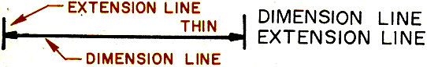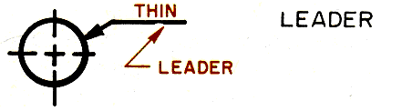

- Center lines: are thin lines used to locate the center of holes or cylindrical solids. They are made of long and short dashes. The long dashes can be from (19 mm) to (38 mm). The short dashes are about (1.6 mm) long.
- Section lines: are used to show a surface that has been cut in a section view. They are thin lines drawn parallel and spaced (1.6 mm) to (3 mm) apart.

- Cutting-plane lines: show where a section has been taken on a drawing. They are thick lines with arrows on the end to show the direction in which the section was taken. Two symbols are in use. One is a series of dashes of equal length and the other is a series of long and short dashes.
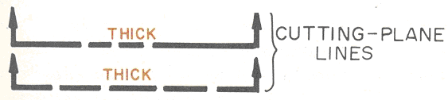
- Break lines: are used to show the edge where part of the drawing has been removed. Short breaks are made with a thick, freehand, jagged line. Long breaks are made with a thin, solid line with a z symbol located every several points..
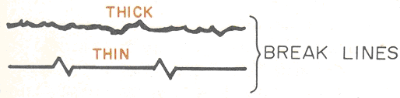
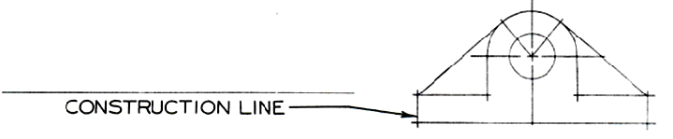
- Construction lines: are thin lines which can easily erase after construction of the desired object.

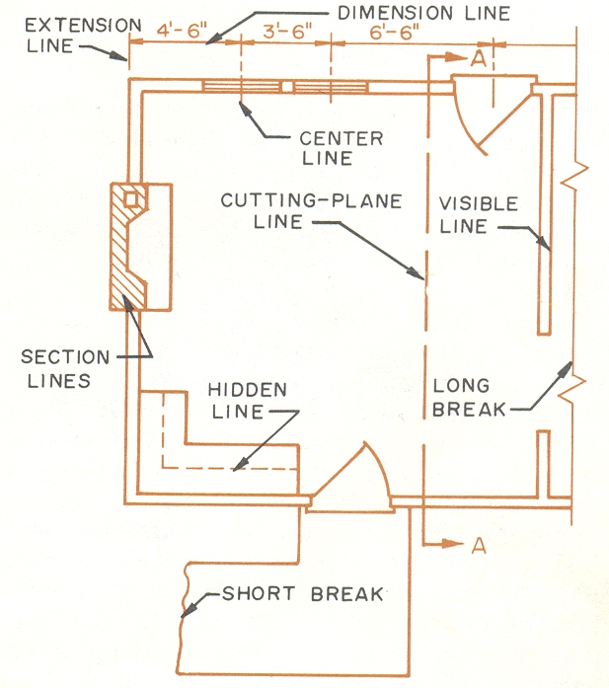

DIMENSION LINE

OBJECT/VISIBLE LINE
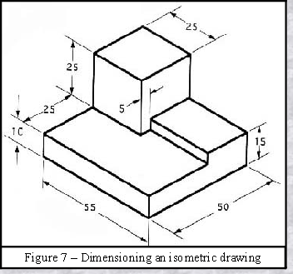

EXTENSION LINE

SECTION LINE

LEADER LINE

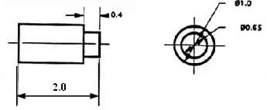

CENTER LINE

Factors in center line usage
- Used to show axis of symmetry
(NOTES: Center lines are sometimes called symmetry lines.)
- Used to show the center line of both circles and paths motion.
C
L
- Symbol for center line is

- The center line should be extended ¼” past the visible line.
- Long dashes should begin and terminate center lines.
(NOTE: Center lines for small holes can be thin solid lines.)

- A gap must be present when a center line is a continuation of a visible or hidden line.
(NOTE: Center lines need not be shown on filleted corners because they are self – locating.)
Ways to interpret the meaning of lines
- A visible or hidden line can mean (indicate) the intersection of two surfaces.
- A visible or hidden line can mean (indicate) an edge view of a surface.
- A visible or hidden line can mean (indicate) a contour view of a curved surface.
(NOTE: It is necessary to examine all views carefully to determine their meaning since no shading is used on working drawings.)
- SCALES
A scale drawing is enlarged or reduced drawing of an object that is similar to an actual object. Maps and floor plans are smaller than the actual size, and they are drawn on reducing scale whereas a scale drawing of a human cell is larger than the actual size, and such objects are drawn on enlarging scale. A scale is the ratio that compares a length in a drawing to the corresponding length in the actual object. If a 50 km road is 1 cm long on a map, the scale can be expressed in three different ways:
i. Unit equivalents 1 cm = 50 km ii. Dimensionless representative fraction (R.F.) 1/500000
iii. Dimensionless ratio 1 : 500000
The scale S is defined as the ratio of the length abof an object on the drawing to its actual length AB, i.e.,
Scale S = ab/AB
- Types of Scale
There are two types of scale as below:
Engineer’s Scale: In the engineer’s scale, the relation between the dimension on the drawing and
the actual dimension of the object is mentioned numerically (like 10 mm = 15 m).
Graphical Scale: The graphical scale is the scale drawn on the drawing itself. This takes care of the shrinkage of the engineer’s scale when the drawing becomes old.

Types of Graphical Scale
There are four types of scales as follows but for drawing purposes only the first two are used:
i. Plain scale, ii. Diagonal scale, iii. Vernier scale, and iv. Comparative scale.
Plain Scale
A plain scale consists of a line divided into suitable number of equal units (Fig. 1.8). The first unit is subdivided into smaller parts. The zero should be placed at the end of the 1st main unit. From the zero mark, the units should be numbered to the right and the subdivisions to the left. The units and the subdivisions should be labeled clearly. The R.F. should be mentioned below the scale.

Fig. 1.8 Plain scale
Diagonal Scale
A diagonal scale consists of a set of parallel lines with other lines crossing them obliquely so that their intersections furnish smaller subdivisions of the unit of measure that could not be conveniently read on a plain scale. In Fig. 1.9 the lower part of the scale is a plane scale, and the upper part having the diagonals as oblique lines, makes the plane scale a diagonal scale. On the plane scale only up to 1/10th
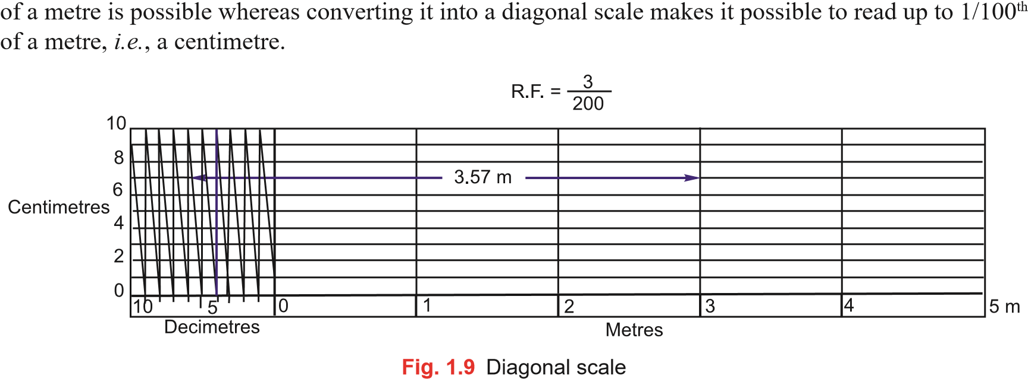

2.2 Two dimensional drawings and sketches

The objects around us come in various different shapes and sizes. We can see triangles, squares, and circles everywhere. Some of these shapes like the shape of a house have length, breadth, and height and are the 3d or the three-dimensional objects. Others like a sheet of paper can be imagined to have a length and a breadth only. Such objects are the two-dimensional objects and form the 2d shapes. Let’s learn more about them
Everyone is familiar with the most common shapes: square, circle, rectangle, and triangle. Each of these shapes is created by combining specific amounts of lines and/or curves.
a square, for example, is a four sided figure created by connecting four line segments. All of the line segments are of the same length and they come together to form four right angles.
a circle, on the other hand, has no straight lines. it is a combination of curves all connected. There are no angles to be found in a circle
a triangle consists of three line segments connected. Unlike a square and a rectangle the angles in a triangle can be of various measurements and are not always right angles.
a polygon is a shape that is closed and is made up of only lines (no curves). it can have no open parts
a parallelogram is named because the opposite sides of the shape are parallel

2D shapes
a shape or a figure that has a length and a breadth only is a 2d shape. the sides are made of straight or curved lines. They can have any number of sides. Plane figures made of lines are called polygons. Triangle and squares are the examples of polygons. We will classify figures we have seen in terms of what is known as the dimension. A plane object that has a length and a breadth only has 2 dimensions. The following are examples of two-dimensional shapes you should be able to recognize
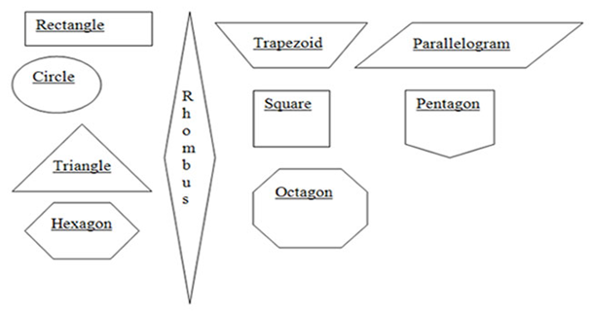
Figure 2.1 geometrical shape

Basic freehand sketching
Sketching is the creation of graphic images that are approximate graphic representations models. Freehand sketching is manual sketching with the minimum of tools such as paper and pencil. Technical sketching is the art of creating technical drawing using freehand without special instruments. Technical sketching requires correct shape or form and more so correct size indication.
Generally, drawing tools refer to the materials used as aids when creating drawings and they vary from simple to complex instruments and equipment. However, the drawing needs of today have changed dramatically due to the availability of computers. Traditional design and drafting has largely given way to computer design drafting but design sketches will always be needed. rough sketching tools
Rough or freehand sketching tools are quite few and require minimum investment. They are pencil, paper, eraser, and pencil sharpener. fig. 1 shows sketches of pencil, eraser and pencil sharpener. a) Wooden pencils b) eraser c) pencil sharpener
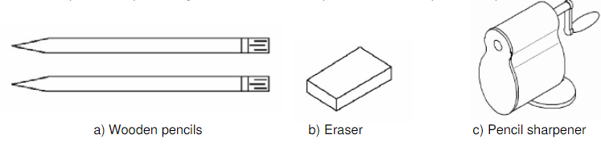
Fig. 2.2 shows sketching instrument
- Freehand sketching
Freehand sketching is one of the effective methods to communicate ideas irrespective of the
branch of study. The basic principles of drawing used in freehand sketching are similar to those
used in drawings made with instruments.
Terms and Definitions
A. Arc- Any portion of the circumference of a circle.
ARC

B. Diameter- The distance across a circle passing through its center point.
DIAMETER

D. Ellipse- A foreshortened circle having a major axis and a minor axis.
Major Axis

Minor Axis

E. Focus (Foci) - Point(s) which lines come toward each other or move away from each other.
F. Freehand technical sketching- Making a drawing without the use of instrument, yet with care taken to obtain the correct line widths.
J. Isometric sketch- A sketch based on the object being drawn on three axis spaced 120 apart.
L. Major axis- The axis passing through the foci of an ellipse.
N. Minor axis- The chord of an ellipse passing through the center perpendicular to the major axis.
O. Oblique sketch- A sketch that shows the face of the object parallel with the plane of projection.
P. Origin - An X, Y, or X, Y, Z coordinate from which all geometry is referenced.
Q. Proportioning- Drawing parts of an object in the same size relationship as the object itself.
R. Radius – The distance from the center point of a circle to the Outside circumference.

Radius

V. Sketch lines – Freehand connections between two or more points.
Types of sketches
Pictorial – A picture like, three –dimensional drawing of an object as it appears to the eye.
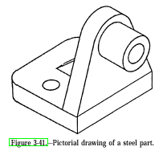

Multi-view - A drawing showing the separate views of an object, arranged so each view is related to the other views.

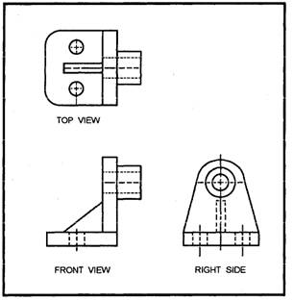

Purpose of Sketching
- Preliminary approach to a problem before going to the expense of making an instrument drawing.
- To give the drafter a better picture of the object to be drawn
- For recording notes and technical information in the shop or field for the future use in the drafting department.
As an aid to “think through” the solution to an engineering-type problem
- rules in sketching
- a scale is not required.
- Sketches are drawn in proportion. (Note: gridded paper can be helpful to keep objects proportional.)
- Small objects are sketched larger than their normal size.
- Freehand lines are rough, not rigid.
- Line contrast should be used.
- A soft pencil should be used.
- Finished line work should be dark and conform to line alphabet standard.
- Sketches are dimensioned the same as machine drawings.
- steps in completing a drawing
- Select necessary views.
- Block in lightly the shape of the object.
- Block in details in each view.
- Erase unwanted construction lines.
- Darken lines.
Methods for proportioning a sketch
- approximation by eye method
  - Object is studied for its various shapes.
  - Size of each shape is compared to each other.
  - Size of shape is compared with overall width, height, and depth of object. (note: use part of the object as reference point to compare against.)
- Pencil and eye method – the pencil is used as measuring stick to proportion height, width, depth and angels. (Note: this is commonly known as an artist technique.)
- actual measurement methods
  - scale proportional divider calipers
Types of grids available for freehand sketching
- Graph paper- 4, 5, 8 or 10 squares per inch.
- Isometric grid – graph paper with guide lines at 30 angels from the horizontal.
- Perspective grid- graph paper that provides vanishing points and projection lines for one-two-point perspective.
Radius
Radius

- sketch arcs
- guidelines for sketching arcs
1. Sketch a box corner.
2. Mark off radius distance from corner point.
3. Swing a rough arc from center point.
4. Darken arc.
- sketch circles
- Guidelines for sketching circles.
1. Sketch in center lines.
2. Box in circle at a diameter required.
3. Put in diagonal lines and marks radius points from center.\
4. Rotate wrist in a circular motion and connect arcs
5. Erase construction lines and darken outline.
Guidelines for sketching ellipses
1. Mark off major and minor axes on center lines.

2. Box in outlines of the ellipse.

3. Sketch in major and minor arcs of ellipse.

4. Rotate wrist in a curving motion and connect arcs.

    - Erase construction lines and darken ellipses outline.

- sketch an isometric cube
- guidelines for sketching an isometric cube
1. Lay out the isometric axes.
2 sketches an isometric box so the height, width, and depth of the box, are the same as the object (cube).
LENGTH

HEIGHT

WIDTH

3. Darken all final lines.

4. Erase construction lines.

- sketching an oblique cube
- guidelines for sketching an oblique cube
45°
1 sketches the front view of the object (cube). the height
And width is the same as the object.
HORIZONTAL
2 sketch receding axis lines.
(Note: 45◦ angle is a common angle to use.)
3 estimate the depth. Then draw the back edges.
4 sketch all details and darken final lines
. 5 erase construction lines.

Three dimensional drawing and sketches

An orthographic drawing represents a three-dimensional object using several two-dimensional views of the object. it is also known as an orthographic projection. for example, you can see in this image the front, top and side views of a simple object.
Orthographic building/construction drawings are a two dimensional representation of a structure.
the projection box is an imaginary box wherein the object shall be placed in to easily identify the three principal views needed the top, front and side views. (shown in the figure /illustration below)

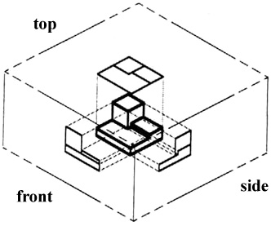figure 2.3 imaginary box
Assembling the drawing
Sometimes there are given parts of an object using the orthographic illustration, your concern will be identifying the perspective figure to complete a task. an example figure below is given to find the perspective
- steps in assembling the parts
TOP

Figure 2.3 assembling part

Step 1: follow the procedures of isometric drawing. create first the 30º angles
Used in creating isometric figures.
30º
30º
90º
Stape 1

Step 2: draw the front view first, following the given measurements.
project the side view after completing the front view.
Step 3: draw the side view according to the details or measurements given.

Stape 3
Stape 2

step 4: project the remaining lines that will complete the top view. after completing the figure, erase all unnecessary lines or the projection lines.

Stape 4

Stape 5

Symbols& abbreviations

Drawing abbreviations and symbols are used to communicate and detail the characteristics of an engineering drawing. This list includes abbreviations common to the vocabulary of people who work with engineering drawings in the manufacture and inspection of parts and assemblies.
Technical standards exist to provide glossaries of abbreviations, acronyms, and symbols that may be found on engineering drawings. Many corporations have such standards, which define some terms and symbols specific to them
- Symbols
Symbol | meaning
 | Job datum level - indicates the altitude at a specific point, relative to a universal reference point known as a 'datum'.
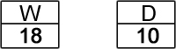 | window and door references - a reference to specific window and door diagrams (numbers indicate which diagrams
 | graduated scale - used to indicate the size and scale of objects and structures in the diagram
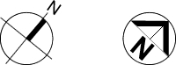 | compass - shows the orientation of the plan diagram and the structures it depicts
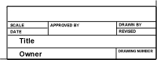 | title block - provides details about the project, the specific plan revision you're looking at, the architect or designer, the date etc.

window
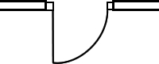 | 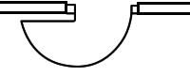
single-swing door (90 degrees) | single-swing door (180 degrees)
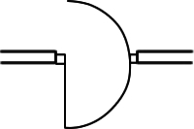 | single double-acting door
 | pocket / cavity door - a sliding door that slides into the wall cavity
 | exposed sliding door
 | b if old / concertina doors centered on a track
 | b if old / concertina doors fixed to one side on a track
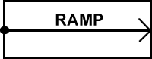 | ramp - arrow points upwards
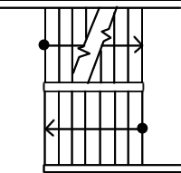 | stairs - arrow points upwards
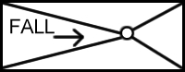 | fall / drainage - arrow points downwards, towards floor waste / drain.
 | Archway
 | Lintel
 | access hatch
 | Recessed object - an object recessed into a particular wall or surface.
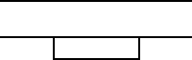 | Surface-mounted object - an object mounted directly on a wall or surface.
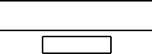 | Free-standing object - an object not connected to the adjacent wall or surface.
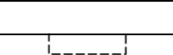 | Object mounted over - an object mounted over the area shown.
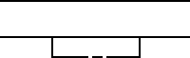 | Object sitting above the plane of the depicted section - a surface mounted object sitting higher than the plane of the diagram.
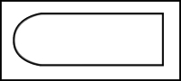Bathtub

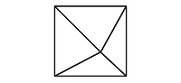 | Shower stall - lines in the center of this diagram indicate drop for drainage.
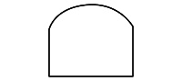 | basin
 | vanity with basin
 | toilet
 | bidet
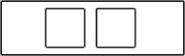 | sink with two bowls
 | sink with one bowl
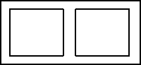 | double tub or trough
 | single tub or trough
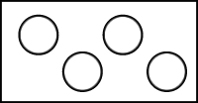 | hotplates

Elevation view - doors and windows
symbol | meaning
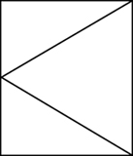 | right-side hinged window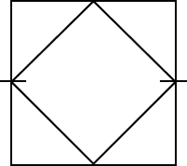 side pivoted window
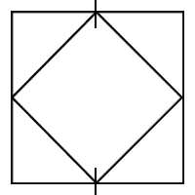 | top and bottom pivoted window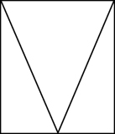 top hinged w
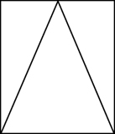 | bottom hinged window
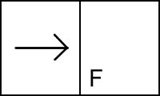 | horizontal sliding window with fixed sash
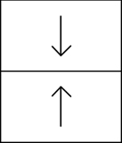 | vertical sliding sash window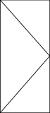 left hinged door
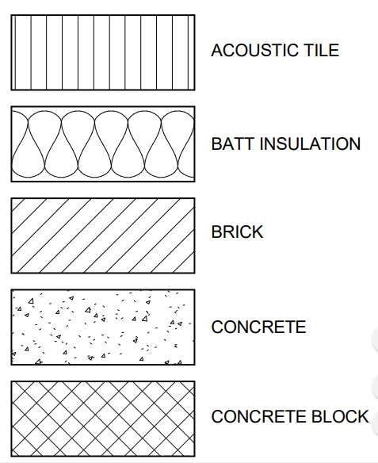
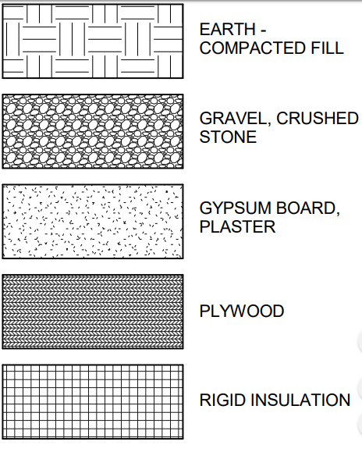
- abbreviations
- the following abbreviations are used in these specifications.
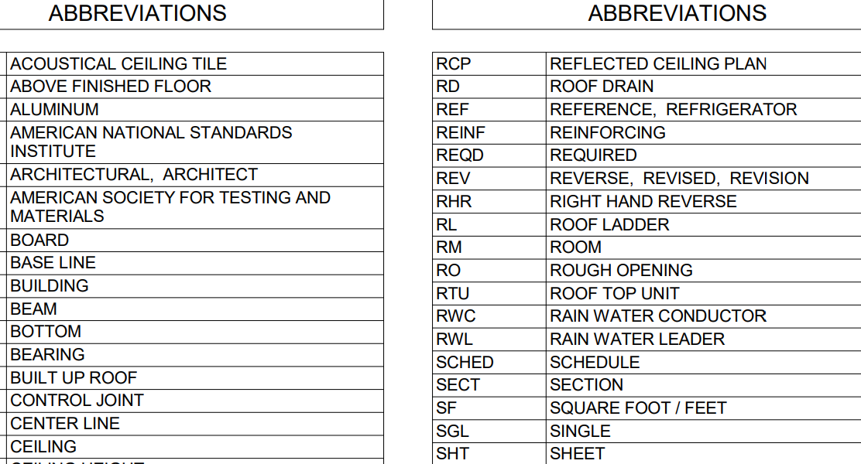
Table 1 abbreviations
BO M OR BOM | = bill of materials | Also called a list of materials (lm or l/m).
c-c or c-to-c = center-to-center; on centers defines center-to-center distance of two features,
DWG, d w g = |  |  |  | drawing
pc, p c s = |  |  | piece, pieces
QMS = |  |  |  |  | quality management system | .
qty or qty = |  |  |  |  | quantity
r = | radius
THK or t h k = thickness
ACV = aggregate crushing value BOQ = bill of quantities CR= crushing ratio
di a = diameter hr = hour LS = linear shrinkage mc= moisture content
MDD = maximum dry density OMC = optimum moisture content
OPC = ordinary Portland cement

Prepare title panel

A border is a line drawn around the inside edge of the paper. Usually this is 10mm (20mm) from the edge of the paper (left side of the paper) and (from bottom, top and right side of the paper) 5mm. It is basically a rectangle drawn precisely and inside this rectangle is the design area.
A title block is normally drawn at the bottom of the paper. Inside the title block is printed important information such as Name, Title and Date. The measurements for the title block can be seen below (these can vary depending on the type of title block being used). All the lines are dark with the exception of the guidelines between which the printing is positioned.
The border line and title block ensures that the design sheet looks more professional and includes vital information such as the designers name, the title of the sheet and the date.
Laying drawing paper (sheet).
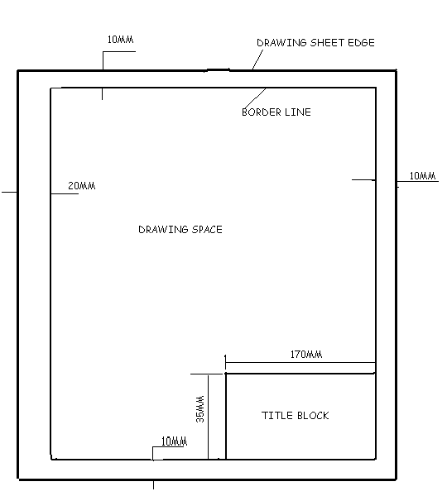

Self-check # 2

Part I: Matching
Column A

- Match the terms below with their correct definitions.
__ A. a point at which lines come toward each other or move away from each other.
__ B. a foreshortened circles having a major axis and a minor axis.
__ C. making a drawing without the use of instruments, yet with care taken to obtain the correct line widths
__ D. The chord of an ellipse passing through the center & perpendicular to the technical major axis.
__ E. The distance from the center point of the circle to the outside circumference.
__ F. The axis passing through the foci of an ellipse.
__ G. Any portion of the circumference of a circle.
__H. The distance across a circle passing through its center point
__ I. A sketch based on the object being drawn on three axis spaced 120◦ apart.
_ J. Drawing parts of an object in the same size relationship as the object itself.
Column B
1. Arc 7. Diameter 13. Digitize

2. Major axis 8. Minor axis 14. Ellipse

3. Oblique 9. Focus 15. Origin

4. Geometry 10. Proportion 16. Grid

5. Radius 11. Isometric 17. Scale

6. Freehand 12. Key file 18. Repaint

Module answer #5

1, Foci 6. Major axis
2. Ellipse 7. Arc
3. Freehand 8. Diameter
4. Minor axis 9. Isometric
5. Radius 10. Proportioning

Self-check #3
Identify the Following Lines; write the names of each line in the opposite blank box.

OBJECT
2.0
A
A
OBJECT

Module answer

    - Center line 6, Dimension line
    - Short break 7,line White metal
    - Cutting plane 8, line Leader line
    - Phantom line 9, Long break line
    - Steel 10, Extension line

OPERATION SHEET # 2
Interpret technical drawing
Purpose: Preparation of good quality drawings is primarily based on the proper selection and utilization of drawing instruments
Equipment, Tools and Materials:
Paper pencils erasers drawing board T-square
Irregular curves scales protractor compass& triangle

Procedure: Interpret technical drawing
- Procedure

- Place the drawing media on the drafting surface.
- Set the drafting machine at the “0” mark with parallel scale approximately horizontal to the drawing surface.
- Align the bottom edge of the drawing media with the parallel scale.
- Tape the drawing in place.
- Draw horizontal lines using the parallel scale as a guide.

- Draw vertical lines by placing a triangle against the parallel scale and using the vertical 90° angle side of the triangle to trace along.
Equipment, Tools and Materials:
1. Paper 2. Pencils 3. Erasers 4.drawing board 5. T-square
6. Irregular curves 7. Scales 8. Protractor 9. Compass 10. Triangle

Unit Three: Identify projection and sectioning
This learning guide is developed to provide you the necessary information regarding the following content coverage and topics:
  - Isometric and orthographic projection
  - classification of surface and lines
  - Apply pictorial projections
  - Section the object
This guide will also assist you to attain the learning outcomes stated in the cover page. Specifically, upon completion of this learning guide, you will be able to:
  - Identify Isometric and orthographic or multi view of projection.
  - Identify classification of surface and lines in orthographic projections
  - Apply Pictorial projections
  - Make imaginary cut

Isometric and orthographic projection

3.1.1 Isometric Projection
To produce an isometric projection (Isometric means “equal measure”), it is necessary to place the object so that its principal edges or axes, make equal angles with the plane of projection, and are therefore foreshortened equally. In this position the edges of a cube would be projected equally and would make equal angles with each other (120⁰).

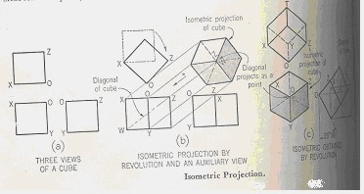

Figure 3.1.1 Isometric Projection
In the figure above, the projections of the axes OX, OY and OZ make angles of 120⁰ with each other, and are called the isometric axes. Any line parallel to one of these is called an Isometric line; a line which is not parallel is called a nonisometric line. It should be noted that the angles in the isometric projection of the cube are either 120⁰ or 60⁰ and that all projections of 90⁰ angles. In an isometric projection of a cube, the faces of the cube or any planes parallel to them are called Isometric planes.

3.1.2 Orthographic Projection
Basically, Orthographic projection could be defined as any single projection made by dropping perpendiculars to a plane. In short, orthographic projection is the method of representing the exact shape of an object by dropping perpendiculars from two or more sides of the object to planes, generally at right angles to each other; collectively, the views on these planes describe the object completely.
Descriptive geometry is basically the use of orthographic projection in order to solve for advanced technical data involving the spatial relation ship of points, lines, planes, and solid shapes. The most common means of understanding these types of orthographic projection is The Glass Box method.
The Glass Box method, used primarily for descriptive geometry problems, requires that the user imagine that the object, points, lines, planes etc are enclosed in a transparent “box”. Each view of the object is established on its corresponding glass box surface by means of perpendicular projectors originating at each point of the object and extending to the related box surface. The box is hinged so that it can be unfolded on to one flat plane (the paper).
The lines of sight representing the direction from which the object is viewed. In figure 5.7, the vertical lines of sight (A) and horizontal lines of sight (B) are assumed to originate at infinity. The line of sight is always perpendicular to the image plane, represented by the surfaces of the glass box (top, front, and right side). Projection lines(c) connect the same point on the image plane from view to view, always at right angle.
A point is projected up on the image plane where its projector, or line of sight, pierces that image plane. In the figure 5.8, point 1, which represents a corner of the given object, has been projected on to the three primary image planes. Where it is intersects the horizontal plane (top image plane), it is identified as 1_{H}, when it intersects the frontal plane (front image plane), it is identified as 1_{F}, and where it intersects the profile plane (right side image plane), it is labeled 1_{P}.

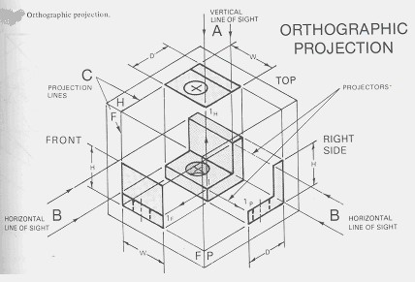

Figure 3.1.2 Glass box methods

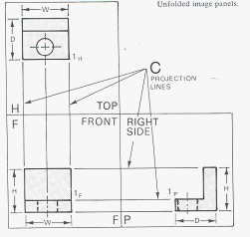

Figure 3.1.3 Orthographic projection of objects
- Orthographic views
It is the picture or view or thought of as being found by extending perpendiculars to the plane from all points of the object. This picture, or projection on a frontal plane, shows the shape of the object when viewed from the front but it does not tell the shape or distance from front to real. Accordingly, more than one protection is required to describe the object.
If transparent plane is placed horizontally above the object, the projection on this plane found by extending perpendiculars to it from the object, will give the appearance of the object as if viewed from directly above and will show the distance from frontal plane. Then the horizontal plane is now rotated into coincidence with the frontal plane. Now again a third plane, perpendicular to the first two called profile plane are used to view an object from the side.

- The Six Principal Views
Let us surround the object entirely by asset of six planes, each at fight angles to each other. On these planes, views of the object can be obtained as is seen from the top, front, and right side, left side, bottom and rear.
Think now of the six sides, or the plane of the paper. The front is already in the plane of the paper, and the other sides are, as it were, hinged and rotated in position as shown. The projection on the frontal plane is the front view vertical projection, or front elevation, that on the horizontal plane, the top view, horizontal projection, or plan, that on the side, profile view, side view, profile projection, or side elevation. By reversing the direction of sight, a bottom view is obtained instead of a top view, or a rear view instead of a front view.

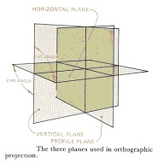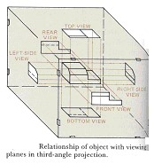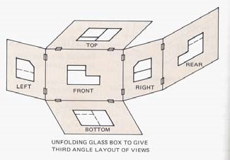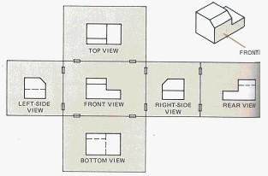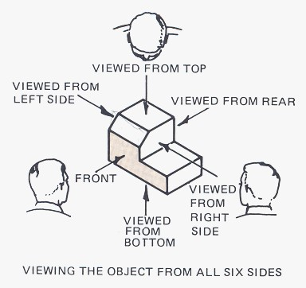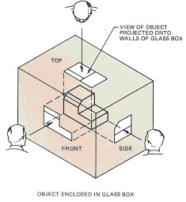

Figure 3.1.4 Principal Picture Planes In actual work, there is rarely an occasion when all six principal views are needed on one drawing. All these views are principal views. Each of the six views shows two of the three dimensions of height, width and depth.
In general, when the glass box is opened, its six sides are revolved outward so that they lie in the plane of the paper. And each image plane is perpendicular to its adjacent image plane and parallel to the image plane across from it. Before it is revolved around its hinged fold line (reference line). A fold line is the line of intersection between any hinged (adjacent) image planes.
The left side, front, right side, and back are all elevation views. Each is vertical. The top and bottom planes are in the horizontal plane. But in most cases the top, front, and right sides are required.
D. COMBINATION OF VIEWS
The most usual combination selected from the six possible views consists of the top, front, and right side views some times the left- side view helps to describe an object more clearly then the light side view.
N.B: The side view of the front face of the object is adjacent to the front view and the side view of a point will be at the same distance from the front surface as its distance from the front surface on the top view.
The six principal views of an object or the glass box have previously been presented in the type of orthographic projection known as Third Angle Orthographic Projection. This form of projection is used throughout this lecture note and is primary form of projection found in all American Industry with the exception of some special cases in the architectural and
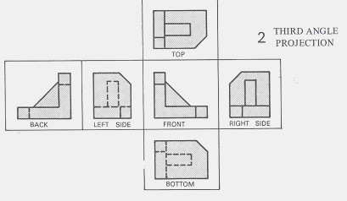
structural fields.

Figure 3.1.5 Third angle projections
The type of projection used in most foreign countries and on many American Structural and architectural drawings is called First Angle Orthographic Projections.
In this form of projection, the object is assumed to be in front of the image plane. Each view is formed by projecting through the object and on to the image plane.

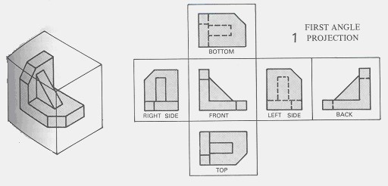

Figure 3.1.6 First angle projections

Classification of surfaces and Lines in Orthographic Projections
Any object, depending upon its shape and space position may or may not have some surfaces parallel or perpendicular to the planes of projection.
Surfaces are classified according to their space relation ship with the planes of projection i.e. horizontal, frontal and profile surfaces. When a surface is inclined to two of the planes of projection (but perpendicular to the third, the surface is said to be auxiliary or inclined .It the surface is at angle to all three planes, the term oblique or skew is used
Although uniform in appearance, the lines on a drawing may indicate three different types of directional change on the object. An edge view is a line showing the edge of a projection. An intersection is a line formed by the meeting of two surfaces where either one surface is parallel and one at an angle or both are at an angle to the plane of projection. A surface limit is a line that indicates the reversal of direction of a curved surface.
- Horizontal, Frontal and Profile Surfaces
The edges (represented by lines) bounding a surface may be in a simple position or inclined to the planes of projection depending up on the shape or position, the surface takes is name from the plane of projection. Thus, a horizontal line is a line in a horizontal plane; a frontal line is a line in a frontal plane; and a profile line is a line in a profile plane. When a line is parallel to two planes, the line takes the name of both planes as horizontal frontal, horizontal- profile, or frontal – profile.
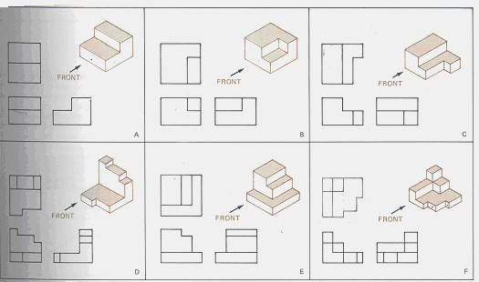

Figure 5.12 Examples of objects having parallel surfaces to the principal planes
- Inclined Surfaces
An edge appears in true length when it is parallel to the plane of projection, as a point when it is perpendicular to the plane and shorter than true length when it is inclined to the plane. Similarly, a surface appears in trey shape when it is parallel to the planes of projection, as alien when it is perpendicular to the plane, and fore shortened when it inclined to the plane. An object with its face parallel to the plans of projection as figure 5.12; a top, front, and right side surfaces are shown in true shape and the object edges appear either in true length or as points. The inclined surface of the object as figure 5.13 does not show true shape in any of the views but appears as an edge in front view. The front and rear edges of the inclined surface are in true length in the front view and fore shortened in the top and side views. The top and bottom edges of the inclined surface appear in true length in top and side views and as points in the front view.

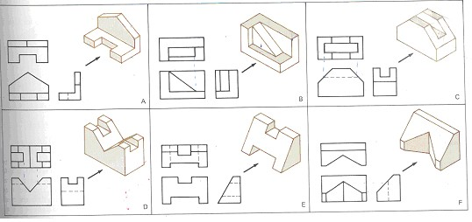

Figure 5.13 Examples of objects having inclined surfaces

- Oblique Surfaces
A line that is not parallel to any plane of projection is called an oblique skew line and it does not show in true shape in any of the views, but each of the bounding edges shows interval length in one view and is fore shortened in the other two views,
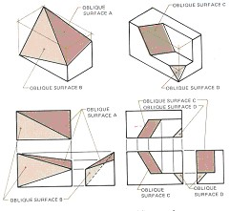

Figure 5.14 Examples of obje
cts having oblique surfaces
D. Hidden Surfaces
To describe an object with complex internal features completely, a drawing should contain lines representing all the edges, intersections, and surface limits of the objects In any view there will be some parts of the object that can not be seen from the position of the observer, as they will be covered by station of the object closer to the observer’s eye. The edges, intersections, and surface limits of these hidden parts are indicated by a discontinuous line called a dashed line. In figure 5.15, the drilled hole that is visible in the top-side view is hidden in the front and right side views, and there fore it is indicated in these views by a dashed line showing the hole and the shape as left by the drill.
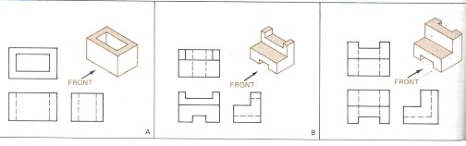

Figure 5.15 Examples of objects having hidden surfaces
Particular attention should be paid to the execution of these dashed lines. It carelessly drawn, they ruin the appearance of a drawing. Dashed lines are drawn lighten full lines, of short dashes uniform in length with the space between there very short, about ¼ of the length of the dash.
This view shows the shape of the object when viewed from the side and the distance from bottom to top and front to rear. The horizontal and profile planes are rotated in to the same plane as the frontal plane. Thus, related in the same plane, they give correctly the three dimensional shape of the object.
E. Curved Surfaces
To represent curved surfaces in orthographic projections, center lines are commonly utilized. All the center lines, which are the axes of symmetry, for all symmetrical views are a part of views.
- Every part with an axis, such as a cylinder will have the axis drawn as center line before the part is drawn.
- Every circle will have its center at the intersection of two mutually perpendicular center lines.

The standard symbol for center lines on finished drawings is a
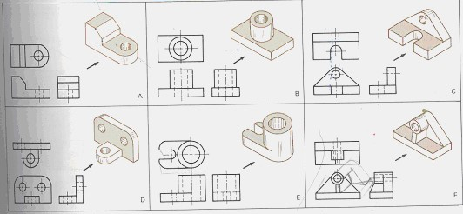
fine line made up of alternate long and short dashes.

Figure 5.16 Examples of objects having curved surfaces

3.3 apply Pictorial Projections

By means of multi view drawing, it is possible to represent accurately the most complex forms by showing a series of exterior views and sections. This type of representation has, however, two limitations: its execution requires a through understanding of the principles of multi view projection, and it’s reading requires a definite exercise of the constructive imagination.
Frequently it is necessary to prepare drawings that are accurate and scientifically correct, and that can be easily understood by persons with out technical training. Such drawings show several faces of an object at once, approximately as they appear to the observer. This type of drawing is called pictorial drawing. Since pictorial drawing shows only the appearances of objects, it is not satisfactory for completely describing complex or detailed forms.
As we have seen in the previous chapters, the four principal types of projection are:
♦ Multi view projection
♦Axonometric projection
♦ Oblique projection
♦ Perspective projection
All except the regular multi view projection are pictorial types since they show several sides of the object in a single view. In all cases the view or projections are formed by the piercing points in the plane of projection of an infinite number of visual rays or projectors. In this chapter, we will focus on the common types of pictorial projection i.e. isometric projection.

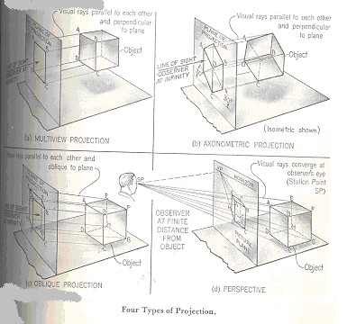

Figure 5.17 types of projection
In both multi view projection and axonometric projection, the observer is considered to be at infinity, and the visual rays are perpendicular to the plane of projection. There fore, both are classified as Orthographic Projections.
In Oblique projection, the observer is considered to be at infinity, and the visual rays are parallel to each other but oblique to the plane of projection.
In Perspective, the observer is considered to be at a finite distance from the object, and the visual rays extend from the observer’s eye, or the station point (SP), to all points of the object to form a so-called “cone of rays.”
The distinguishing feature of axonometric projection, as compared to multi view projection, is the inclined position of the object with respect to the plane of projection. Since the principal edges and surfaces of the object are inclined to the plane of projection, the lengths of the lines, the sizes of the angle, and the general proportions of the object vary with the infinite number of possible positions in which the object may be placed with respect to the plane of projection. Three of these are shown below.
In these cases the edges of the cube are inclined to the plane of projection, and therefore foreshortened. The degree of foreshortening of any line depends on its angle with the plane of projection; the greater the angle the greater the foreshortening. If the degree of the foreshortening is determined for each of the three edges of the cube which meet at one corner, scales can be easily constructed for measuring along these edges or any other edges parallel to them. It is customary to consider the three edges of the cube which meet at the corner nearest to the observer as the axonometric axes.
Axonometric projections are classified as
- Isometric projection
- Dimetric Projection
- Trimetric Projection, depending up on the number of scales of reduction required.
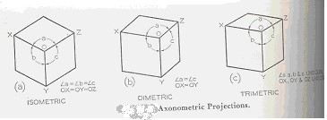

Figure 5.18 Axonometric projections
Since the most widely used method of axonometric projection is Isometric, we will only see isometric projection in detail.

3.4 section the object

- Sectioning
It is defined as an imaginary cut made through an object to expose the interior or to reveal the shape of a portion.
- Sectional view
It is a view in which all or a substantial portion of the view is sectioned. There are many times when the interior details of an object cannot be seen from the outside (figure 6.1).

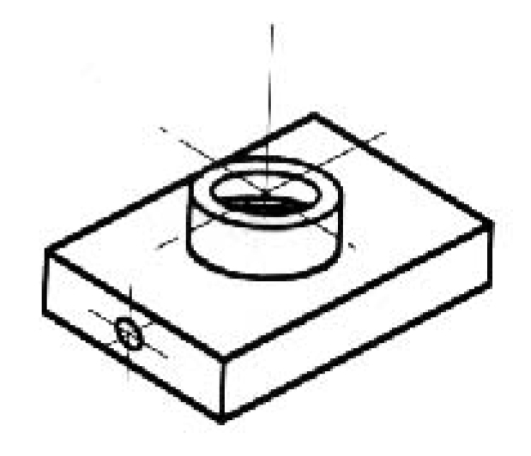
Figure 6.1 An isometric drawing that does not show all details

We can get around this by pretending to cut the object on a plane and showing the "sectional view". The sectional view is applicable to objects like engine blocks, where the interior details are intricate and would be very difficult to understand through the use of "hidden" lines (hidden lines are, by convention, dotted) on an orthographic or isometric drawing.
Imagine slicing the object in the middle (figure 6.2)
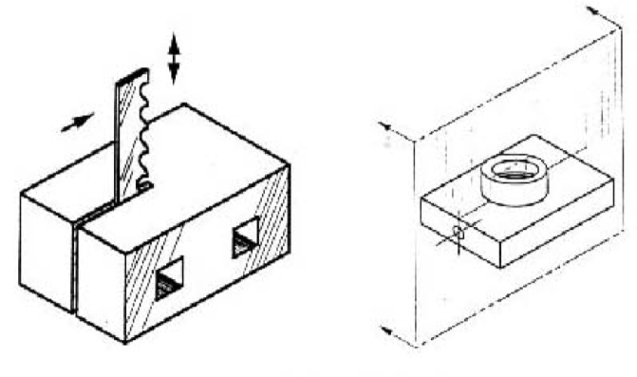
Figure 6.2 Sectioning an object
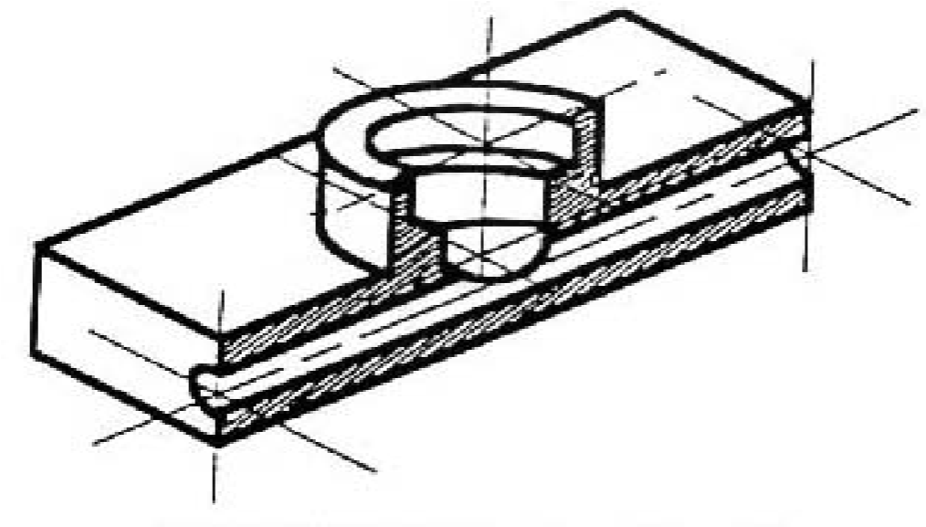
Figure 6.3 sectioning the object in figure 6.1
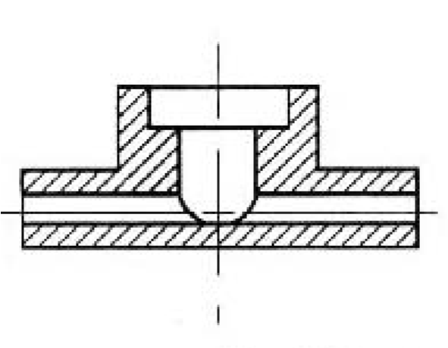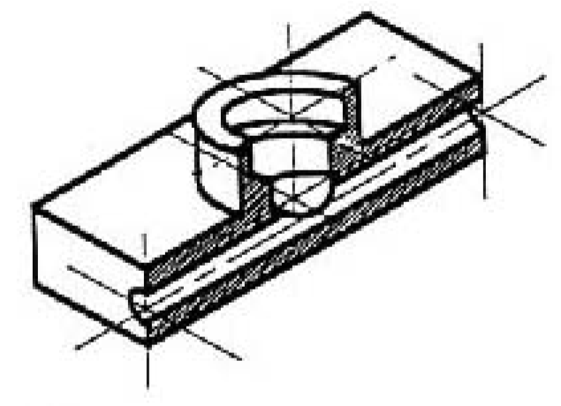
Take away the front half (figur
e 6.3) and what you have is a
full section view (figure 6.4).

Figure 6.4 Sectioned isometric and orthogonal views
The cross-section looks like figure 6.4 when it is viewed from straight ahead.
In short, when the interior of the object is complicated or when the component parts of a machine are drawn assembled, an attempt to show hidden portions by the customary dashed lines in regular or graphic views often results in a confusing networks, which is difficult to draw and almost impossible to read clearly.
In case of this kind, to aid in describing the object, one or more views are drawn to show the object as if a portion has been cut away to show the interior.
For some simple objects where the orthographic un sectioned views can be easily read, sectional views are often preferable because they show clearly and emphasis the solid portions, the voids, and the shape.
- Cross-Sectional Views
A cross-sectional view portrays a cut-away portion of the object and is another way to show hidden components in a device.
Imagine a plane that cuts vertically through the center of the pillow block as shown in figure 6.5 (a) and (b). Then imagine removing the material from the front of this plane, as shown in figure 6.5 (b).

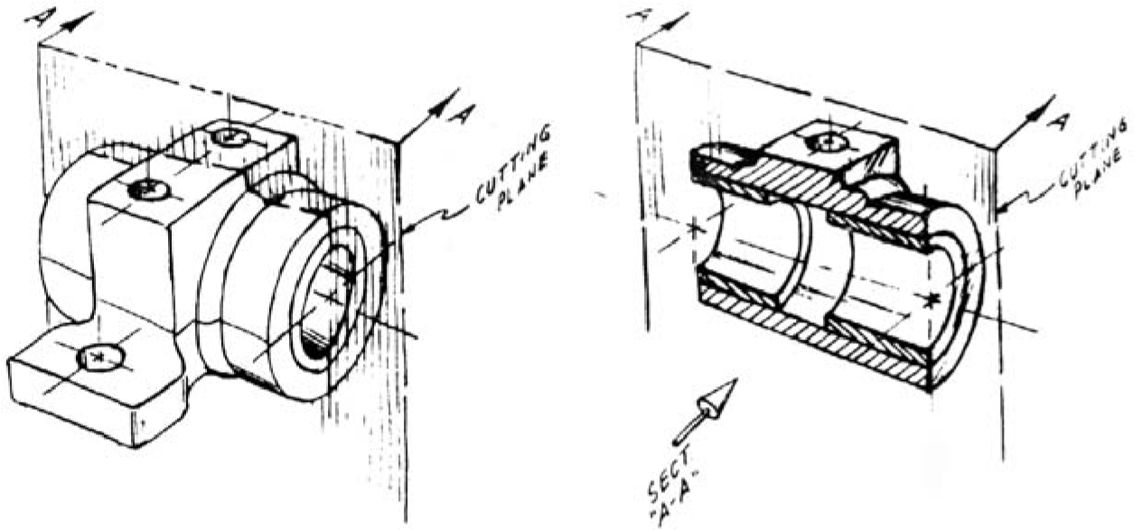

Figure 6.5 Section of an object with circular holes
This is how the remaining rear section would look. Diagonal lines (cross-hatches) show regions where materials have been cut by the cutting plane.
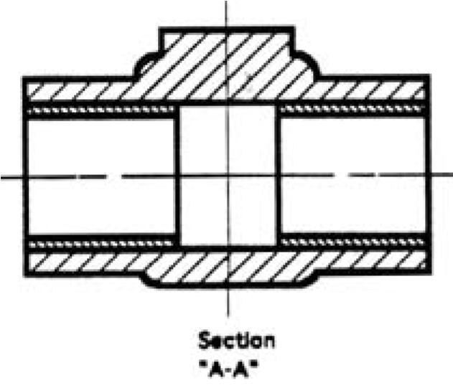
Figure 6.6 Section A-A
This cross-sectional view (section A-A, figure 6.6), one that is orthogonal to the viewing direction, shows the relationships of lengths and diameters better. These drawings are easier to make than isometric drawings. Seasoned engineers can interpret orthogonal drawings without needing an isometric drawing, but this takes a bit of practice.
The top "outside" view of the bearing is shown in figure 6.7. It is an orthogonal (perpendicular) projection. Notice the direction of the arrows for the "A-A" cutting plane.
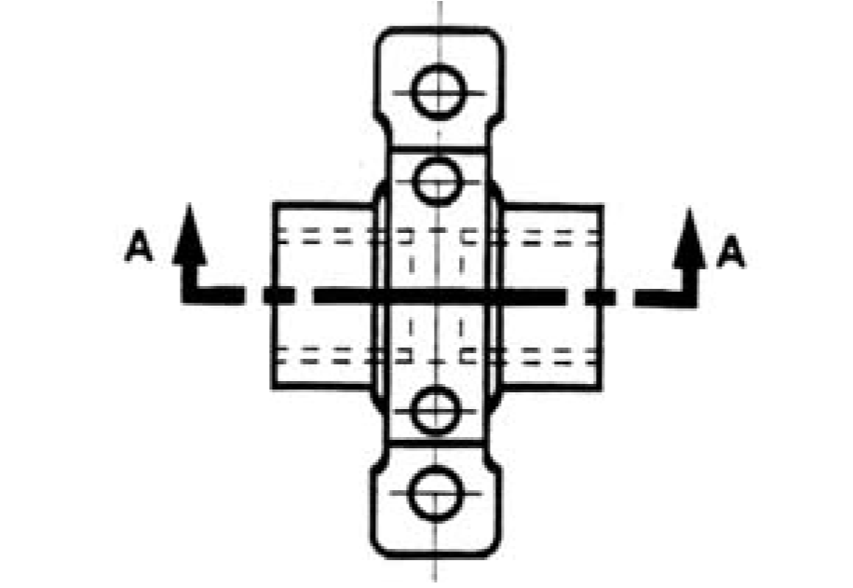
Figure 6.7 The top “out side” view of the bearing

- HOW SECTIONS ARE SHOWN
To clearly draw the sectional views, we have to understand the following terminologies.
A. Cutting Plane Lines
The cutting plane line indicates the path that an imaginary cutting plane follows to slice through an object. Think of the cutting plane line as a saw blade that is used to cut through the object. The cutting-plane line is represented by a thick
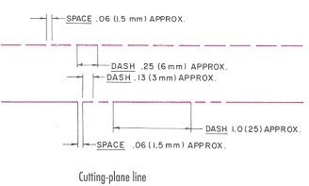
black dashed line.

Figure 6.8 cutting plane lines
B .Direction of Sight
The drafter must indicate the direction in which the object is to be viewed after it is sliced or cut through. This is accomplished by adding a short leader and arrowhead to the ends of the cutting-plane. And these arrows indicate the direction of sight.

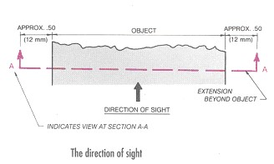
Figure 6.9 The direction of sight

C. Section Lining
Section lining shows where the object is sliced or cut by the cutting plane line. Section lining is represented by thin, black lines drawn at 45⁰ to the horizontal. Section lining is spaced by eye from 1.5mm to 6mm apart, depending up on the overall size of the object. The average spacing used for most drawings is 3mm. Section lines must be of uniform thickness (thin black) and evenly spaced by eye.
If the cutting plane passes through more than two parts, section lining of each individual part must be drawn at different angles. Where an angle other than 45⁰ is used, the angle should be 30⁰ or 60⁰. Section lining should not be parallel with the sides of the object to be section lined.

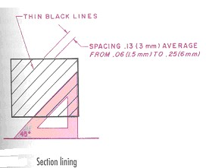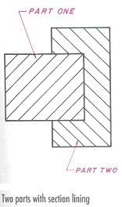

Figure 6.10 Section lining
- MULTSECTION VIEWS

The different kinds of sections used today are:
♦ | Full section
♦ | Offset section
♦ | Half section
♦ | Broken-out section
♦ | Revolved section
♦ | Auxillary section etc.
In this part, we only consider the most commonly used types of sections.

- Full Section
It is simply a section of one of the regular multi-views that sliced or cut completely in two.

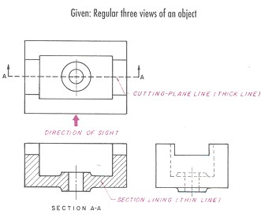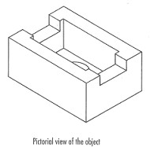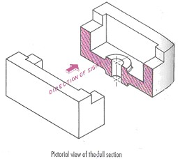

Figure 6.11 Full Section
- Offset Section
Many times, important features do not fall in a straight line as they do in a full section. These important features can be illustrated in an offset section by bending or offsetting the cutting-plane line. An offset section is very similar to a full
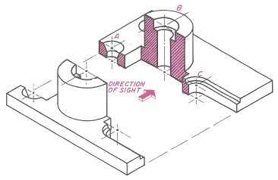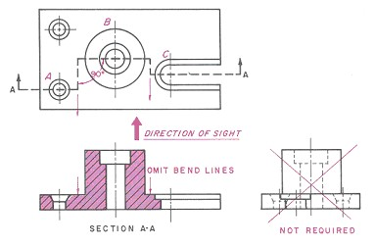
section, except that the cu
tting plane line is not straight.

Figure 6.12 Offset sections
- Half-Sections
A half-section is a view of an object showing one-half of the
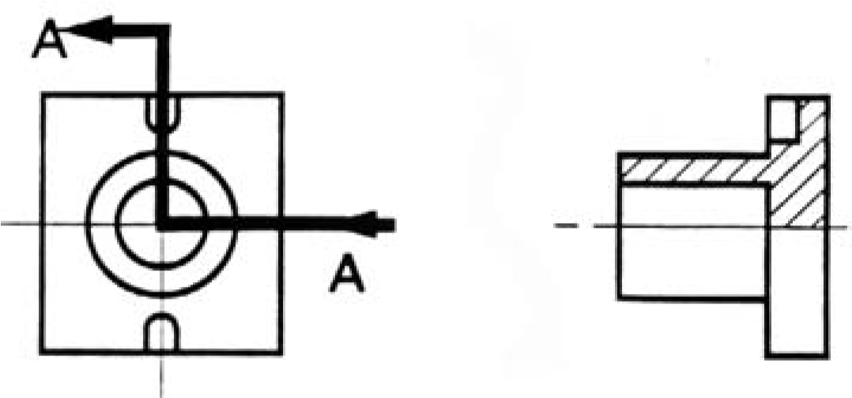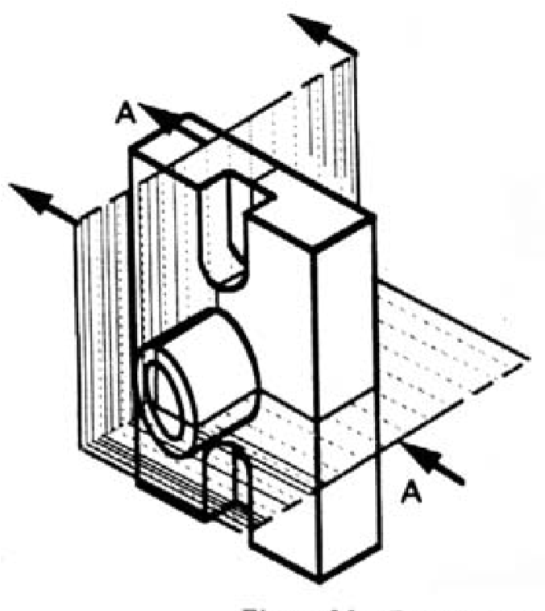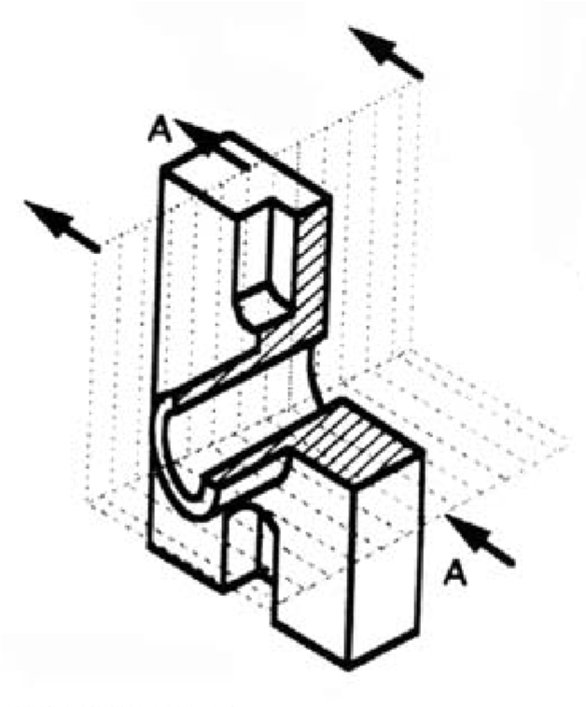
view in section, as in figure 6.13 (a) and (b)

(
a)

(
b)

Figure 6.13 (a) Full and sectioned isometric views (b) Front
view and half section

The diagonal lines on the section drawing are used to indicate the area that has been theoretically cut. These lines are called section lining or cross-hatching. The lines are thin and are usually drawn at a 45-degree angle to the major outline of the object. The spacing between lines should be uniform.
A second, rarer, use of cross-hatching is to indicate the material of the object. One form of cross-hatching may be used for cast iron, another for bronze, and so forth. More usually, the type of material is indicated elsewhere on the drawing, making the use of different types of cross-hatching unnecessary.
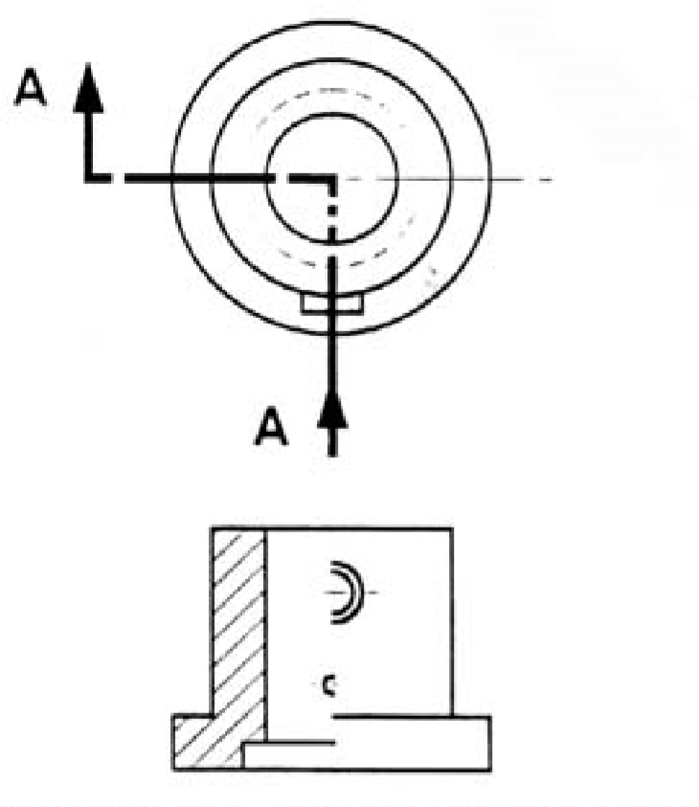

Figure 6.14 Half section without hidden lines

Usually hidden (dotted) lines are not used on the crosssection unless they are needed for dimensioning purposes. Also, some hidden lines on the non-sectioned part of the drawings are not needed (figure 6.13) since they become redundant information and may clutter the drawing.

Self-check-4
short Answer writing
- Explain the purpose and theory of multi view projections
- Construct a box for isometric and oblique drawings based on the technical drawing procedure.
- Describe “Glass box method“ of orthographic projections.

- Describe the purpose of sectioning in technical drawings
- What is “direction of sight” in sectioning?
- Mention the difference between offset section and full section.

Reference

-Basic Engineering Drawings, RS Rhodes,LB cook, long man Scientific& Technical,
  - -Technicaldrawing1,plain&solid geometry,A.Bankole,S.Bland,Longman,©1992
  - - Technical drawing2,Mechanical Drawing,A.Bankole,S.Bland,Longman,©1990
Models and Charts

Participants of this Module (training material) preparation
No | Name | Qualification (Level) | Field of Study | Organization/ Institution | Mobile number | E-mail
1 | HabtamuWendmagegn | B(BSC) | Civil Engineering | Ethio Italy poly | 0948284573/0910797363 | wendimagegnhabtamu@ gmil.com
2 | DerbabawMulaw | A(MSC) | Con Mgt | Gonder | 0967593066 | Derbabawmulaw2020@ gmil.com
3 | Tibebnesh G/ Micael | A(MSC) | Con Mgt | Awasa | 0919116033 | Tibebnesh1 @ gmil.com
4 | Seblewengelbekele | A(MSC) | Con Mgt | Bishoftu | 0934916466 | Seblewengelb4@gmail.co
5 | Remedan Mohamed | B(BSC) | Con Mgt | Harer poly | 0974720826 | Mohamed remedan82@ gmil.com

