STRUCTURAL CONSTRUCTION works

Level – I
Based on March 2022, Curriculum Version 1

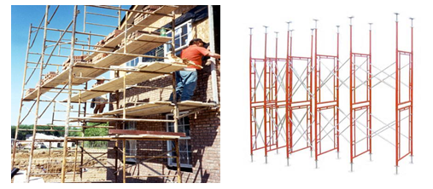

Module Title: - Erect and dismantle scaffolding and form work
Module code: - EIS SCW1 08 0322
Nominal duration: 70 Hour

Prepared by: Ministry of Labor and Skill August, 2022
Addis Ababa, Ethiopia
Table of content
Contents
Level – I 1
Acronym 4
Acknowledgment 5
Introduction to the Module 7
Unit one:- Work instructions 8
Work instructions Error! Bookmark not defined.
Introduction to Work instruction 9
1.2. OHS requirements 10
1.2.1 Rules, Regulations and requirements 10
1.2.2 Personal protective equipment 13
1.3. Tools and equipment 14
1.1.3. Types, characteristics and uses of materials, tools and equipment. 14
1.4.Safe handles materials 19
1.5. Environmental protection requirements 1.5.1.Local Air Pollution Prevention and Control (LAPPC) 20
Self check-1 21
Unit Two: Erect formwork and scaffolding 23
2.1. Scaffolding/form work 24
2.1.1. Purpose of scaffolding 24
2.1.2Classes of scaffold 27
2.2Site access and egress routes 30
2.3Assemble formwork 30
2.3.1 Definition of Form work 30
2.3.2Types of form work 31
1.4. Block outs and cast in-services 35
2.5. Remove waste materials 35
2.5.1 Debris and Dust 35
2.6. Set-out and assemble Scaffolding 36
2.6.1. Setting out, erection with regulatory and manufacturer requirement 36
2.7. Erect Scaffolding 36
2.7.1 Definition of Erect scaffolding 36
Self check 2 40
Operation sheet 2 41
LAB TEST 2 42
Unit Three: Inspect, repair and alter erected scaffolding 43
3.1. Erect modular scaffolding 44
3.2. Use of scaffolding 45
3.2. 1. Check Use of scaffolding 45
3.3. Scaffolding stability 45
3.3.1. Confirming scaffolding stability 45
3.4. Carry- out repair of scaffolding 46
3.4.1. Repairing scaffolding 46
3.5. Complete inspection 46
Self check 3 48
Operation sheet 3 49
LAB TEST 3 50
Unit Four: Dismantle Scaffolding 51
4.1. Isolate and sign scaffolding 52
4.1.1. Isolating, appropriately sing and barricade to ensure safe dismantling 52
4.2. Erection scaffolding system 53
4.2.1. Dismantle modular scaffolding system 53
4.2.2. Dismantling use reverse procedure as for erection 53
4.2.3. Dismantling a scaffold safely 53
4.3. Dismantle modular scaffolding system 55
4.3.1. Definition if dismantle 55
4.3.2. Dismantling use reverse procedure as for erection 55
Fig 4.2.2 Dismantling scaffolding 56
4.3.3. Dismantling a scaffold safely 56
4.3.4. Dismantling procedures and technique 57
Self check 4 59
Operation sheet 4 60
LAB TEST 4 61
Unit Five: - Clean- up 62
5.1. Clear work area 63
5.1.1. Clean work area and work site 63
5.1.2. Clean‑up procedure 64
5.1.3. Disposing & recycling waste materials 64
5.2. Maintain and store plant, tools and equipment 66
5.2.1. Maintaining tools and equipment 66
Self check 5 67
Reference 68

Acronym
LAPPC Local Air Pollution Prevention and Control
OHS Occupational health and safety
WHS World health and safety

.

Acknowledgment

Ministry of Labor and Skills wish to extend thanks and appreciation to the many representatives of TVET instructors and respective industry experts who donated their time and expertise to the development of this Teaching, Training and Learning Materials (TTLM).

Acronym

Introduction to the Module
In Structural construction works level I filed; erect and dismantle scaffolding and form work,
Helps to know the Work instructions, Erect formwork and scaffolding, Inspect, repair and alter erected scaffolding, Dismantle scaffolding and Clean up This module is designed to meet the industry requirement under the Structural construction works occupational standard, particularly for the unit of competency: erect and dismantle scaffolding and form work.
This module covers the units:
- Work instructions
- Erect formwork and scaffolding
- Inspect, repair and alter erected scaffolding
- Dismantle scaffolding
- Clean up
Learning Objective of the Module
- Obtain work instruction
- Erect formwork and scaffolding
- Perform Inspect, repair and alter erected scaffolding
- Dismantle scaffolding
- Clean up
Learning Module Instruction
For effective use this modules trainees are expected to follow the following module instruction:
- Read the information written in each unit
- Accomplish the Self-checks at the end of each unit
- Perform Operation Sheets which were provided at the end of units
- Do the “LAP test” giver at the end of each unit and
- Read the identified reference book for Examples and exercise

Unit one:- Plan and prepare
This unit is developed to provide you the necessary information regarding the following content coverage and topics:
- Work instructions
- OHS requirements
- Tools and equipment
- Safe handles materials
- Environmental protection requirements.
This unit will also assist you to attain the learning outcomes stated in the cover page. Specifically, upon completion of this learning guide, you will be able to:
- Apply work instructions
- Follow OHS requirements
- Identify tools and equipment
- Safe handles materials
- Identify environmental protection requirements

- Work instruction
    - Introduction
Work Instructions are documents that clearly and precisely describe the correct way to perform certain tasks that may cause inconvenience or damage if not done in the established manner. That is, describe, dictate or stipulate the steps that must be followed to correctly perform any specific activity or work.

The purpose of this works instruction is to set down procedures that must be followed to ensure that erection and dismantling of scaffold is carried out safely and to further see that whilst a scaffold is in place it is inspected regularly to ensure that it is safe to use. Specific responsibilities are put upon members of the Estate Operations to see that systems and procedures are followed. Naturally the workplace cannot be kept under permanent surveillance and it is thus important that action is taken by anyone who sees a potentially dangerous incident occurring whilst a scaffold is in use.

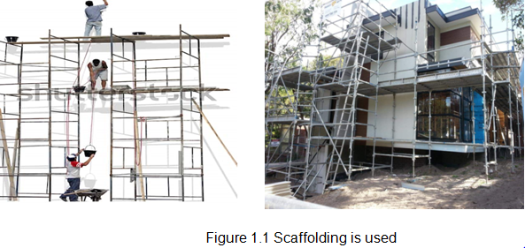

OHS requirements
Working on scaffolding/ form work is one of the most dangerous building activities. Building workers can accidentally fall off a plate form or parts of scaffolding can drop and injure someone underneath. The workers on scaffolding must always place stay alert and check that they can place their feet and hands safely. Self-employed persons also have duties under the law in relation to their own Health and Safety and ensure that their work does not put others at risk.

Rules, Regulations and requirements
Every job on a construction site requires a strong understanding of the rules, Regulations and requirements. Failure to follow these can lead to serious consequences for employers and/or workers .Scaffolding work can present many hazards, not only with erecting and working on the scaffold itself, but also from the site or area where the scaffold is located.
Before you pick up your first piece of scaffold, you need to be familiar with:-

  - The world standards for scaffolding.
  - Work health and safety (WHS) Regulations
  - Codes of practice
  - Environmental requirements
  - Company policies and procedures
  - Manufacturers’ instructions.

Fig:1.2.1 Rules, Regulations and requirements
All these can change over time, and new rules can be created; so you’ll need to make sure you keep up to date. These Standards provide guidance on different aspects of scaffolding, including their design and manufacture, and how scaffolding installations should be designed, erected, managed and used. Many other scaffolding guidelines, such as manufacturers’ instructions, are based on or refer to these Standards. While you don’t need to know them by heart, it’s important that you know they exist and consult them when you need them.
- Scaffolding codes of practice
Codes of practice are created by states, territories and industry bodies. They set out industry standards of conduct and give detailed practical guidance on how to comply with the requirements of legislation, including things like the preferred method or course of action to be taken to manage hazards. They are not law, but should be followed. Safe Work Canada or Australia a Commonwealth Government agency responsible for the development of national policy to improve WHS across Canada /Australia is developing a code of practice for scaffolding and scaffolding work, which will have a specific focus on the WHS Regulations relating to scaffolding.
- Information, instruction and training for workers using scaffolds
Where work is performed from a scaffold, you must ensure that the relevant workers understand:-
- What loads the scaffold can safely take. 2. Not to make any unauthorized alterations to the scaffold (such as removing guard rails, planks, ties, toe boards and braces)
- The working platforms need to be kept clear of debris and obstructions along their length,
- The incomplete or defective scaffolds must never be accessed. Where work is performed
- Using mobile scaffolds, workers should be trained to ensure the scaffold
- Codes of practice and Ethiopian Standards for Scaffolding
- Manufacturers’ instructions
- Work health and safety (WHS) Regulations
- Site-specific rules and requirements.
- Environmental requirements
All these can change over time, and new rules can be created; so you’ll need to make sure you keep up to date.
- Work health and safety Regulations
Scaffolding can be very effective protection in preventing falls; however, there are specific requirements that apply under the OHS Regulations.
A person with management or control of a scaffold must not allow the use of a scaffold from which a person or object could fall more than four meters unless a competent person provides written confirmation that the scaffold has been completed.
- Work health and safety
It’s the responsibility of every worker to take every possible measure to keep them and their fellow workers safe in the workplace. There are a range of rules to be followed and actions to be taken to support this.
Hazards and risks there are hazards and risks in any workplace, but construction sites are among the most dangerous. Knowing some of the things to watch out for,
Figure2.3 Personal protectionequipment

Ways to minimise risk and what to do if something goes wrong are important things to learn as soon as you can, if you want a long, successful and accident-free career. If you have an accident, a near-miss or see any potential hazards on site, you should let your employer or supervisor know immediately
- The hierarchy of hazard control
The hierarchy of hazard control is a systematic approach to managing safety and is standard practice in many workplaces. It provides a structure to help workers select the most effective ways to eliminate or reduce the risk of hazards. The most effective measure elimination, i.e. removal of the hazard completely is at the top of the hierarchy. The least effective measure is at the bottom. The idea is you choose a measure from as close to the top as possible to control the hazard you’re dealing with. Take a look at the following diagram, which shows the hierarchy of hazard control.
- Site hazard assessment
You need to assess a site for hazards before the erection of scaffolding, as well as continuously monitor the area while the scaffold is in use to ensure that nothing has changed to make the site unsafe.

When you conduct an initial site assessment, you should look for the following:
- Surfaces that may be affected by weather Example, asphalt may become soft in hot weather; ground may become boggy in wet weather
- Soft or uneven ground surfaces
- The possibility of scaffolds / trades people falling or dropping equipment on others below.
- The proximity of power lines to the intended scaffold location.
- The movement of vehicles, forklifts, cranes and other plant or equipment; open trenches or areas that have been trenched and backfilled.
- Areas likely to be excavated while the scaffold is still in place.
The minimum distance required between scaffolding and power lines is three metres for a power line less than 33 kv; six metres for over 33 kv and eight metres for over 133 kv. These requirements differ across Australia.

Personal protective equipment
Various forms of accidents occur at various stages of construction and in various operations. In order to avoid these accidents, we have to follow the following safety precautions. .You must wear PPE at all times when you’re erecting and dismantling scaffold. This includes:
As scaffolding is predominantly an outside job, it’s also a good idea to wear a long‑sleeved, collared shirt and sunscreen. On noisy worksites, remember to use hearing protection. If site conditions are dusty, wear a dust mask
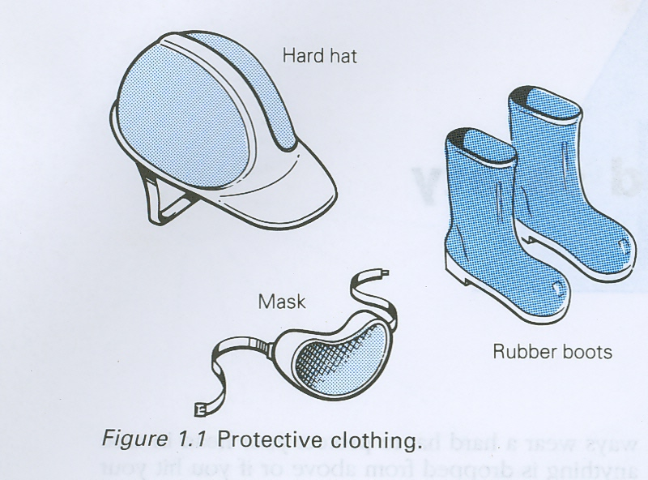
- Helmets: - helmets should be worn especially in areas where there is likelihood of objects falling from roofs or multistory building.

Fig 1.2 1 a) Helmet
- Goggles or face shields: - Goggles or face shields should be worn during drilling, chiseling or grinding operation on metal, store, and concrete. These operations produce dust and flaying chips which could be injurious to eye.
- Safety shoe:- Safety shoe The feet should be protected from nails and other sharp objects and from heavy falling objects by hard-rolled leather boots with metal toe-cap
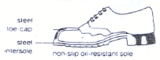

Fig 1.2 1 c) Safety shoe
- Glove - Glove protects the workers from oils, chemicals, and dust and other dangerous material that affect the skin
- Mask - Mask Protects eyes of the worker from other endangering object and dust during construction.

Fig 1.2 1 d) Mask
- Goggle:–Goggle Protects eyes of the workers during welding of metal works and when placing reinforcement in the form work.

Basic safety signs for personal protection
- Keep Tools, Materials, Equipment’s, etc., in proper way at working area and keep them all neat/tidy/.
- Ware tight clothes during work
- Ware safety boots
- Ware Helmet
- Do not stop under lifted loads
- Use only proper and safe tools
- Report safety deficiencies immediately
- Obey safety signs and signals
- Do not drink alcohol at work

Tools and equipment

1.1.3. Types, characteristics and uses of materials, tools and equipment.
Tools used to erect scaffolding need to be small, light and able to be carried easily. They can be kept in a special safflower’s belt to keep them handy when moving around and working above the ground. As with all tools, the tools used for scaffolding need to be well maintained and checked for damage before and after use. The following provides some information about the basic tools used for erecting scaffolding. There are a range of tools and maintenance equipment you can use for the various different tasks need to construct scaffolding or cantilevered hoist.
(a) Tools for tightening and loosening fastening (e.g. Nuts and Bolts):- Referred to as a shifter or an adjustable spanner, you use a wrench to loosen and tighten the nuts of couplers. The head of the wrench is adjustable to suit different size nuts.

- Spanners used for turning fasteners such as nuts and bolts. This tool is also known as wrenches in different parts of the world

Fig 1.3.1 (b) 1 Spanner
- Box Spanners commonly made of steel tube; the box spanner is typically used for removing spark plugs. They normally feature a six-sided ring-type head that fits the nut that has been pressed out of the steel tube during the manufacturing process.
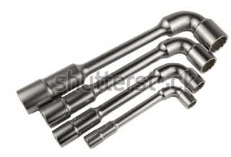

Fig 1.3.1 (b) 2 Box Spanners

- Adjustable spanner (Wrenches) an adjustable spanner is an open-ended wrench with a moveable jaw. Its function is the same as any regular spanner - to grip fasteners, such as nuts and bolts

Fig 1.3.1 (b) 3 Adjustable spanners (Wrenches)
.
b) Tools used for Cutting Wire And other Equipment:-
- A hacksaw:- is a fine-tooth saw with a blade held under tension in a frame, used for cutting materials such as metal or plastics. .
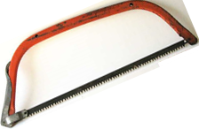

Fig 1.3.1 (b) 1 Hack saw
- A Wire nips Cutters:- designed to properly cut either wire or cable with minimal damage to the insulation or internal conductors of the wire or cable.
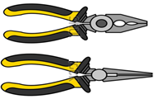

Fig 1.3.1 (b) 2. Wire nips cutter
- A Bow saw: - is designed for cutting green wood such as tree branches and shrubs, or sawing logs to size. They are most commonly used for applications where speed is more important than a neat finish.



Fig 1.3.1 (b) 3. Bow saw

c) Impact tools: -You use a claw hammer to hammer down joining pins to make sure they’re fixed securely.
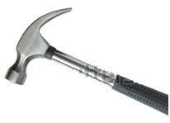
- Hammers: - are used for general carpentry, framing, nail pulling, cabinet making, assembling furniture, upholstering, finishing, riveting, bending or shaping metal, striking masonry drill and steel chisels, and so on.

Fig 1.3.1 (b) 1. Hammer
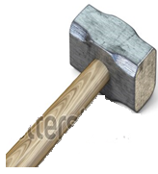
- Sledge Hammers :- used to Demolition of drywall, concrete, wood, etc, Driving steel wedges for splitting firewood or building stone, Dislodging firmly stuck items, Driving fence posts into the ground and Straightening bent metal objects

,

Fig 1.3.1 (b) 2 Sledge Hammers
- Hammer Drills:- used by many primitive societies as a fire drill to start a fire. It is still often learned as a useful survival skill. A hand drill could also be used as a tool for drilling holes in hard materials such as wood, stone, or bone.


Fig 1.3.1 (b) 3Hammer Drills
Figure1.3.1 (c) tools used for impact

d) Tools For Moving Materials:-
- Shovels:- is a tool used to dig as well as to move loose, granular materials (like dirt, gravel, grain, or snow) from one spot to another.
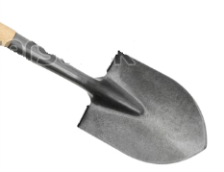

Figure1.3.1 (d) 1 Shovels
- Wheel barrows:- are used for a variety of things, such as moving rock


Figure1.3.1 (d) 1
Figure1.3.1 (d) tools used for Moving Materials
- Measures instrument: - You use a tape measure to measure distances when you’re setting up the base and constructing the scaffold.

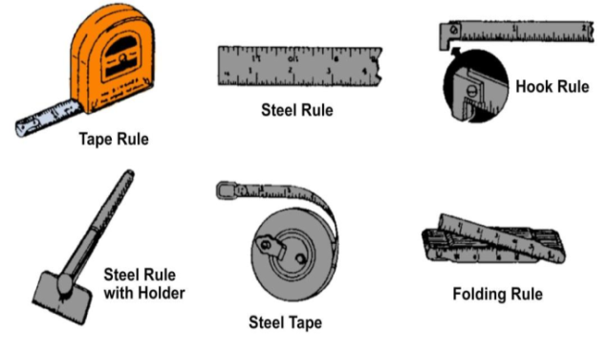

Figure 1.3.1 (e) tools used for Measures
- Spirit level: - You use the spirit level during scaffold erection to check that the frames and standards are level and plumb (vertically straight). A small (300 mm) level that fits into the saffloler’s tool belt is the easiest size to use when you’re climbing about on scaffolding.

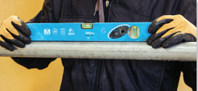
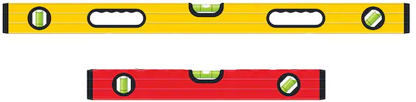

Figure 1.3.1(f) tools used for level

- Scaffolding tool belts: - This is a safflower’s belt worn around the waist to keep tools in order and at hand while the safflower’s climbing and building the scaffold at height. Frogs are the leather pouches the tools sit in.

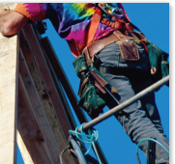

Fig 1.3.1 (g) Scaffolding tool belt
h) Tools for scaffolding podger: - Podger spanners / podger tools are hand tool usually used for erecting scaffolding and other steel structures

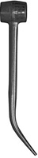
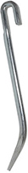

Fig 1.3.1(h) Scaffolding podgier tools

Safe handles materials
Material handling is the process of moving, protecting, storing, and controlling materials throughout the construction process. It includes the steps taken when dealing with construction materials from when they're delivered to the construction site until when they're disposed of.

Keep storage areas in a clean and orderly condition.
Do not put scaffold components (especially planks) into storage when wet. Always dry component parts before storing away. Planks that remain wet for long periods of time (months) are likely to mildew and decay.
- Avoid lifting materials from the floor or while seated.
- Make use of available handling aids.
- Refrain from using sudden or jerky movements.
- Never lift a load over an obstacle.
- Perform lifts in areas with adequate footing, space and lighting.
- Modify objects and redesign jobs to make moving easier.
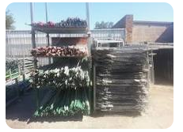

Fig safe handle material

Environmental protection requirements

Local Air Pollution Prevention and Control (LAPPC)
These regulations apply to smaller industrial activities, known as Part BInstallations, such as concrete batching or concrete crushing. Localauthorities, as the regulators, are responsible for controlling emissionsfrom these premises and set conditions in permits they issue to achievethis. Conditions are based on Best Available Technique(BAT), whichrequire that the cost of applying a technique is not excessive in relation tothe environmental protection it provides. The Secretary of State forEnvironment, Food and Rural Affairs has produced Process GuidanceNotes, which form the statutory guidance on what constitutes BAT foreach regulated process. If the regulator believes the operator hascontravened, or is likely to contravene any permit conditions, enforcementaction can be taken.Local authorities should be aware that certain installations, such asconcrete batching, are not covered by authorisations on demolition andconstruction sites, but must be included as planning conditions.

Self-check-1
Directions: Answer all the questions listed below.
- It is platforms at different levels, to enable the construction worker to work at different heights of a building
- Scaffolding B) Formwork C)Timber D) All

- In what height recommend to be done more than this height, builder and labor required a temporarily platform.

- 1.5-1.7m B) 1.2m -1.5m. C) 1.7m- 2m D)All

- What point we must be known before use scaffolding in the first time?

- Site specific rules and requirements
- The world standards for scaffolding
- Work health and safety (WHS) Regulations
- All
- __________ is the most dangerous working activity in building site?
- Concrete work B)Scaffolding work C)sitting out work D) All
- What types PPE wear at all times when erecting and dismantling scaffold?
A) Steel cap boots B) Hard hat C) Gloves D) All
Test-I Matching
Instruction: select the correct answer for the give choice. You have given 1 Minute for each question. Each question carries 1. Point.
Column “A” Column “B”
_____ 1. Loosening fastening A) Hack saw
___. 2. Moving tool B) Safety shoe
____3. Protected from nails and other sharp objects C) Spanner
_____ 4 prepared by an individual or group of individuals D) Hammer
E) Shovel
Test II: short Answer writing
Instruction: write short answer for the given question. You are provided 3 minute for each question and each point has 5Points.
- Write down defection of work instruction.
- Write down At Impact Material.
- What Is OHS Requirements?

Unit Two: Erect formwork and scaffolding
This unit to provide you the necessary information regarding the following content coverage and topics:
- Scaffolding and form work
- Site access and egress routes
- Assemble formwork
- Block outs and cast in-services
- Remove waste materials
- Set-out and assemble Scaffolding
- Erect scaffolding

This guide will also assist you to attain the learning outcomes stated in the cover page. Specifically, upon completion of this learning guide, you will be able to:
- Purpose Scaffolding/form work
- Identify Site access and egress routes
- Assemble formwork
- block outs and cast in-services
- Remove waste materials
- Set-out and assemble Scaffolding
- Erect Scaffolding

Scaffolding/form work

Purpose of scaffolding
Updates existing standard to include types of scaffolds such as centenary and step trestle
Allows flexibility in the use of fall protection systems to protect employees
Simplifies language, eliminates duplicative outdated provisions, and consolidates overlapping requirements Allows employers’ compliance flexibility
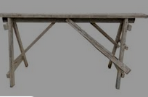
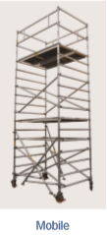
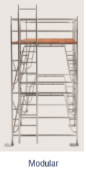
There are several types or systems of scaffolding used in Ethiopia. Some are pictured here and explained in this section. This guide focuses on modular scaffolding, as this is the type most often used for restricted height work.

Wood scaffolding
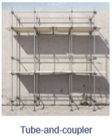
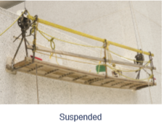

- Modular scaffolding
Modular scaffolds are lightweight systems assembled from prefabricated components, including frames, braces and accessories. They include: - A frame and H frame systems.
Modular Scaffold and a range of proprietary systems Scaffolding components are described in more detail later in this section. Modular systems are simpler and faster to set up than other types of scaffold, which is why they’re the most common scaffolds used on residential building sites.
They’re used by many trades, including:-

- Bricklayers and carpenters constructing walls.
- Plasterers applying render to external walls.
- Roof tillers requiring a safe structure and path around the edge of a roof.
- Painters painting gables or eaves
- Modular scaffolding components are most often made from aluminum, which makes them light and easy to lift. It can be erected up to a height equal to three times the width of the base. So, for example, if the width of the base is 1.5 m, the maximum height the scaffold can be is 4.5 m.
Let’s look at some types of modular scaffold you may use
Framed scaffolding A framed scaffold is by far the quickest system to set up but it does have limitations; the main ones being that it’s a set shape and size and can be used only on sites that are fairly level.
There are two main types of framed scaffold.
      - .A frames are in the shape of an A. Taller A frames are often called ‘WALKTHROUGHS’, because there is room to walk through them.
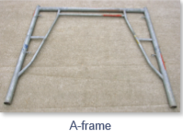

      - H frames are in the shape of an H.
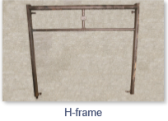

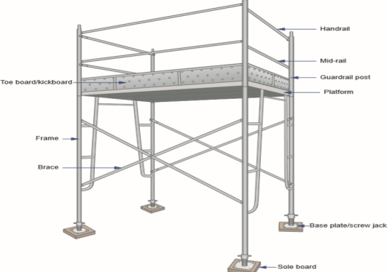

Fig 2.1.2 Framed modular scaffolding
- Mobile scaffolding
Mobile scaffolding is another type of modular scaffolding. It’s built using frames, lockable wheels (casters) and platforms rather than planks. The wheels mean that this scaffold can be used safely only on level, firm ground, so it’s not often used outdoors on construction sites.
A mobile scaffold might be used by:
- Ceiling fixers fixing ceiling sheets
- Painters painting cornices and ceilings
- Plasterers plastering upper walls and ceilings
- Sign writers installing signs or applying artwork to walls.
Ladders on mobile scaffolding should be inside the scaffolding and not touch the ground, so that the scaffold can be moved without the ladder being dragged along the ground or dislodged. They may be built into the platform or have hooks at the top and bottom that attach to the frame

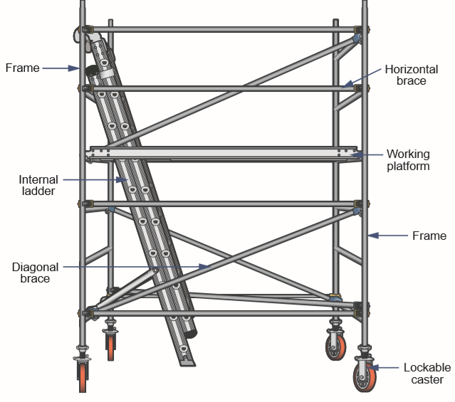

Fig 2.1.2 Mobile scaffolding
C) Suspended scaffolds
Suspended scaffold is a platform suspended by ropes that can be raised or lowered when in use. A swing stage scaffold is an example of a suspended scaffold. Suspended scaffold is fixed or anchored at the top and a scaffolding hoist is used to raise and lower it. Suspended scaffolds are often used for construction or maintenance of high rise buildings, bridges and other large structures
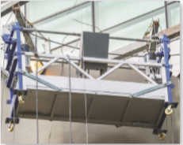

Fig 2.1.2 C) Suspended scaffolds

Classes of scaffold
Scaffolding is classified by the amount of weight or loads each working platform or bay can support. Rather than the workers using the scaffold, it’s actually the materials, plant and equipment, plus the weight of the scaffold itself, which contribute the greatest load on a scaffold. The three classes of scaffold are light duty, medium duty and heavy duty.
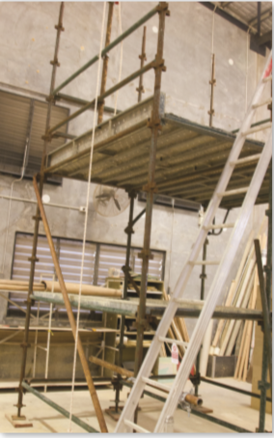
- Light duty scaffold
Light duty scaffold can support only lightweight tools and materials. It’s used by trades such as electricians, painters and sign writers.
- Medium duty scaffold
Medium duty scaffold is used by trades such as carpenters, tillers and roof tillers who have a range of tasks, equipment and materials. It is wider than light duty scaffold and can support a greater load. Figure 2.1.2medium duty scaffold
Figure 3.9

- Heavy duty scaffold
Heavy duty scaffold (pictured here) is most often used by trades such as bricklayers, concreters and plasterers who use heavy materials, or those whose work generates impact forces, such as demolition workers. There are rules regarding the maximum size and spacing of the bays or platforms
In each class as well as the load they can carry.

Table 2.1.2:-These are listed in the load scaffolding.
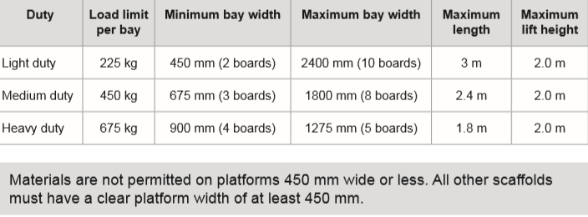

Ordinary scaffoldings consist of the following components: -
- Standards: - Vertical pole erected at a distance of about 1.2 to 1.5 meters from the structure are known as standards. All the loads are to be final taken by standards. As such, they should be strong, ridged and properly buried in to the ground.
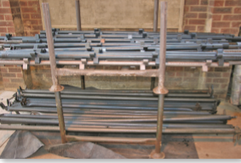

Fig 2.1.3(a) Standards
- Ledgers: - These are the members played horizontal parallel to the wall. They are raggedly to the standards either by rods or by other methods. These ledgers connect all the standards as height where temporary working plat form is required.

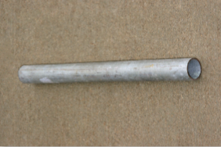

Fig 2.1.2 (b) Ledgers
- Put logs: - These are the cross or lateral pieces, one end of which remains supported on ledgers and other end on the wall. Thus a hole is left in the masonry for keeping the putlogs. Such holes are filled only after completing the entire work including plastering and then filled by inserting header in cement mortar. In the case of double scaffolding two sets of standards, one very close to the wall and the other away provided. Two sets of ledgers are used to connect all standards. As such put logs remains supported on both the ledgers and there is no need to have a hole in the wall. Put logs, in the case of double scaffolding are known as transoms.
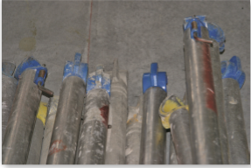
- Braces: - these are diagonal or cross pieces fixed on the standards to provided stiffness to the scaffolding.

Fig 2.1.3 (d) Braces.
- Ranker: - It is an inclined support given to the scaffolding or structure.
Planks or Boarding: - they form horizontal plate form for supporting men, materials and
Other tools.

Site access and egress routes
- Ladders
- Stair towers
- Ramps & walkways
Provide access when scaffold platforms are more than 2 feet above or below a point of access.
Ladders – such as portable, hook-on (must be positioned so as not to tip), attachable (hook-on and attachable ladders must be specifically designed for use with the type of scaffold on which they are used) , stairway type (must be positioned so that the bottom step is not more than 24 inches above the scaffold support level and have rest platforms at vertical intervals of 12 feet), and built-ins (specifically designed and build for use as ladder rungs, not be used as a work platform, rest platforms provided at a maximum of 35 foot vertical intervals).
Stair Towers – must have a stair rail consisting of a top rail and a mid rail on each side of the stairwell. Top rail shall be capable of serving as a handrail.
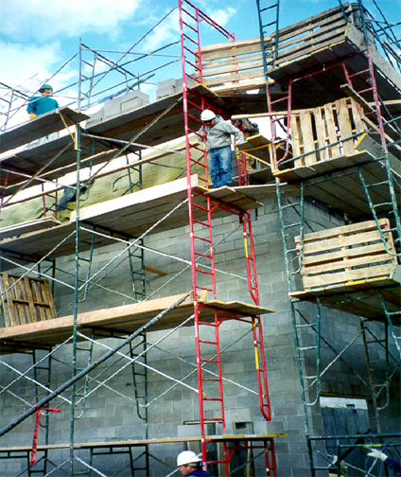
Ramps & walkways – when 6 feet or more above a lower level must have guardrails.

Fig.2.2. Site access and egress routes

Assemble formwork

Definition of Form work
Formwork is a mold or open box, like container into which fresh concrete is poured and compacted. When the concrete is set, the formwork is removed and a solid mass is produced in the shape of the inner face of the formwork. The top of the formwork is normally left open. False work is the necessary support system that holds the formwork in the correct position.

Types of form work
Formwork may be made of wood, metal, plastic, or composite materials: Traditional timber formwork. The formwork is built on site out of timber and plywood or moisture-resistant particleboard. It is easy to produce but time-consuming for larger structures, and the plywood facing has a relatively short lifespan
Requirement for Good formwork (Shuttering)
A good formwork should satisfy the followings requirements:
- The material of the formwork should be cheap and it should be suitable for reuse several times.
- The form should be practically waterproof so that it does not leak and absorb water from concrete. Also, its shrinkage and swelling should be minimal.
- It should easily carry the load of concrete and live load of pouring, vibration, compaction, and curing.
- It should have enough stiffness and rigidity so that deflection is minimum.
- As soon as possible it should be light in weight, smooth and should be easily stoppable.
- All the joints in formwork should be leak proof.
- The formwork should rest on non-movable supports
Loads on Formwork (Shuttering)
Apart from its own load following loads occur on formwork:
- Live load due to labor etc.
- The deadweight of wet concrete,
- Impact due to pouring concrete.
- Vibration Load due to vibrator during work.
- Erection stresses due to movable equipment.
Shuttering (Formwork) for Concrete Column
Shuttering for a column is simple as compare to other complex structural elements.
Column Formwork consists of the following main components:
- Sheeting all around the column periphery,
- Side yokes and end yokes,
- wedges, and
- Bolts with washers.
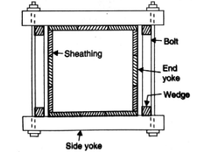

Fig 2.3.5:-Form work for square / rectangular column

Shuttering For Beam and Slab Floor
The formwork for the beam and slab floor: As shown in the fig the slab is continuous over a number of beams. The slab is supported on 2.5 cm thick sheathing laid parallel to the most beams. Normally, the sheathing is held on wooden battens which are laid between the beams, at some suitable spacing.
In order to scale back deflection, the battens could also be propped within the middle of the span through joists. In the side forms of the beam, 3 cm thick sheathing is used. The bottom sheathing of the beam form maybe 5 to 7 cm thick.
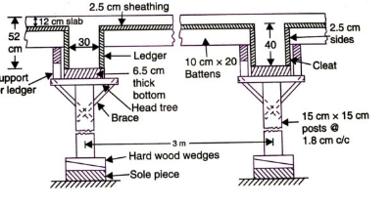

Fig 2.3.6. :-Shuttering For Beam and Slab Floor
  - Place bracing of formwork
Bracing for formwork is needed for stability and alignment when storms and strong winds hit. Experience has left some important lessons for contractors working with wall formwork. One lesson is to avoid working in strong winds. Be sure to use adequate bracing and pay attention to the connection details. Anchor braces to something solid. With double-sided formwork, ties hold the forms together, resisting the lateral pressure of the concrete, but external supports are needed to resist applied working loads and wind pressure. Supports are needed not only when the formwork is erected in position, but also when it is merely standing on site awaiting next use.
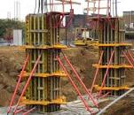
The wall form is most vulnerable during erection of the first side, before any of the reinforcing steel has been placed. Bracing should be put in place as soon as possible for such forms, particularly when there is any possibility of strong wind. Wind can come from any direction and the bracing system must be ready for it. If braces are positioned on only one side of the wall, they must be able to take either tension or compression and their connections have to do the same.

Fig 2.4.:-Bracing of column
  - Formwork support system
The sequence of work should be planned and followed for each type of form work to be constructed. The sequence of work should include consideration of the following unless you have developed an alternative process that provides an equivalent or higher level of work health and safety.
Erecting a scaffold safely will include preparing the foundations for the scaffold, installing sole boards and base plates where required, and erecting the scaffold including for adequate access and work platforms that minimize the risk to those doing the scaffolding work and people who will use the scaffold.
- Standards should be made to rest on hard and firm ground. If such surface is not available, standards may be made to on timber sole plated. Sometimes they are buried in to the ground to sufficient depth.
- Scaffolding should not be loaded heavily.
- Scaffolding should be tied to the building at suitable level. Scaffolding can be tied to building by providing horizontal or vertical wooden members inside the building. Rankers may be provided to give lateral support to the scaffold.
- Lengthening standards and providing additional ledgers should raise working platforms and put logs.
Hole left in the walls, after put logs have been withdrawn should be filled with masonry work immediately.
  - Construct formwork shutters
The construction of form work normally involves the following operation
- Propping and centering maybe of steel timber posts or bullies
- Shuttering
- Provision of camber
- Surface treatment
  - Oil formwork
Shuttering Oil is used for the following reasons
- Application of shuttering oil prevents sticking of formwork to the concrete surface thereby permitting easy stripping of formwork after the concrete has hardened.
- Shuttering oil protects the formwork and hence the formwork can be reused several times.
- Shuttering oil helps provide good finishing surface of the concrete with minimum defects.
- In the case of wooden formwork, shuttering oil prevents water absorption from concrete by the wooden formwork.
- Shuttering oil reduces leakage of water during the curing process.
- Shuttering oil prevents steel formwork from corrosion
The performance of shuttering oil is largely dependent on the type of formwork that is being used. For wooden formwork, straight refined, pale, paraffin-based mineral oil and oil-phase emulsion have been successfully used. The oil that is chosen should be capable of penetrating the wood to some extent while leaving the surface slightly greasy to touch. There should not be any free oil on the wood surface. The form release agents that are good for wooden formwork are not always suitable for steel formwork. And hence the shuttering oil or form release agents should be chosen based on the type of formwork that is to be used for construction. The shuttering oil for steel formwork should be free of water and should contain rust inhibitor.
- De-Shuttering Oil (DSO)
This is a water-based mould releasing agent which gives clean and stain free high-quality concrete. It is available in a spray able form and ready to use as a direct application on required places. It should be applied in light film either by brush or mould oil sprayer. If it is over applied, excess oil should be drained before it dries. Pools of DSO cannot be allowed to dry as it causes surface retardation of concrete. Advantages of De-Shuttering Oil are as follows:
- DSO is economical to use.
- It is non-toxic and non-hazardous.
- It can be used for all types of concrete formworks.
- It helps reduce the cleaning efforts before reusing of the formwork.
DSO provides a damp proof interface that protects the formwork and ensures even texture and color of concrete.

1.4. Block outs and cast in-services
A block out is recess at a joint gap edge to accept different types of expansion joint profile. Also refer to by regional terminology such as knock out, cut out and other.

2.5. Remove waste materials

2.5.1 Debris and Dust
When debris is dropped though holes in the floor with out the use of chutes ,the area on to which the material is dropped shall be completely enclosed with barricades not less than 42 inch high and not less than 6 feet back from the projected edge of the opening above. Signs warning of the hazard of falling materials shall be posted at each level. remove shall not be permitted in this lower area units debris is handling ceases above.
- All scarab lumber, waste material and rubbish shall be removed from the immediate work area as the work progresses.
- Disposal of waste material or debris by burning shall comply with local fire regulation.
- All solvent waste oily rags and flammable liquids shall be kept in fire resistant covered container until removed from work site.

2.6. Set-out and assemble Scaffolding

2.6.1. Setting out, erection with regulatory and manufacturer requirement
Once you’ve completed your design plan and had it checked by your supervisor, you’ll be able to get on with selecting the components, tools and equipment you need to start erecting the scaffold. In this section, we’ll look at the materials, tools and equipment required, and the process involved for erecting of scaffold.

2.7. Erect Scaffolding

2.7.1 Definition of Erect scaffolding
The sequence of work should be planned and followed for each type of scaffold to be constructed. The sequence of work should include consideration of the following unless you have developed an alternative process that provides an equivalent or higher level of work health and safety.
Erecting a scaffold safely will include preparing the foundations for the scaffold, installing sole boards and base plates where required, and erecting the scaffold including for adequate access and work platforms that minimize the risk to those doing the scaffolding work and people who will use the scaffold.
- Standards should be made to rest on hard and firm ground. If such surface is not available, standards may be made to on timber sole plated. Sometimes they are buried in to the ground to sufficient depth.
- Scaffolding should not be loaded heavily.
- Scaffolding should be tied to the building at suitable level. Scaffolding can be tied to building by providing horizontal or vertical wooden members inside the building. Rankers may be provided to give lateral support to the scaffold.
- Lengthening standards and providing additional ledgers should raise working platforms and put logs.
- Hole left in the walls, after put logs have been withdrawn should be filled with masonry work immediately.
- Standards should be spaced according to the loads they have to carry, and also according to the section of the standards.
- For structures like domes, towers, chimneys etc. especial patented scaffolding should be used.
Erecting procedure for scaffolding
Now it’s time to erect the scaffold. Remember to follow your plan, as well as the rules and Regulations that apply in your location. Pay particular attention to the hazard prevention and safety elements of all these documents throughout the entire erection process, and always check with your supervisor if there’s anything you’re not sure of Safe handling
Don’t forget your manual handling technique to ensure you’re lifting safely.
• When you’re carrying scaffold, it’s a good idea to distribute the weight evenly on both sides of your body.
• Carry frames so that the center of the frame is in line with the center of your body.
• When you’re carrying a piece of scaffold in one hand, carry another piece in the other. When you’re erecting and handling scaffold, there’s a high possibility of you pinching your hands or fingers between the parts. Care, gloves and good communication with your workmates can help to prevent this. Remember to set up barricades if you need to carry scaffold through potentially hazardous areas, e.g. along vehicle access ways.
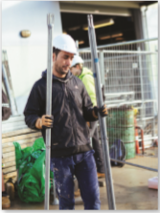

Figure 2.6.1 Erecting framed scaffold
- Erecting framed scaffold let’s look at this process step by step

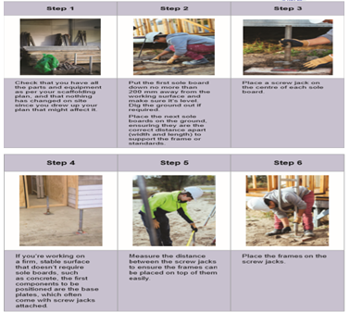

.

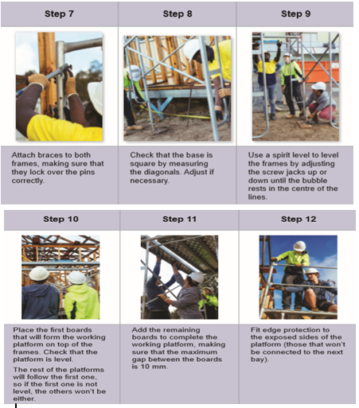

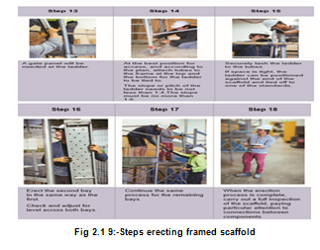

.

Self- check 2
Directions: I answer all the questions listed below.
1. Vertical posts that provide fixing points for all the other edge protection is ------------
A) Guardrail posts B) Toe board C) Ladder
- Diagonal or cross pieces fixed on the standards to provided stiffness to the scaffolding.
A) Brace B) Plate form C) put logs D) Ledgers
3. Edge protection prevents workers and their tools or materials from falling off the scaffold
A) False B) True
Direction I I:-Mach Column “A” with Column “B”
Column “A” Column “B”
_____ 1. Modular scaffolds are lightweight systems A) mesh board
___2. The members played horizontal parallel to the wall B) Hand rail
____ 3. It’s used in framed scaffold and some modular scaffold C) Modular scaffolding

Operation sheet 2
- Operation title: Procedures of Erect and dismantle scaffolding and form work
- Purpose: To practice and demonstrate the knowledge and skill required Erect scaffolding
- Instruction: Use given the tools and equipment erect the scaffolding for this operation you have given 6 Hour and you are expected to provide the answer on the given table.
- Tools and requirement:
- Hammer
- Circular saw
Procedures for Erecting framed scaffolding
Steps 1- Checking all the parts and equipment as per your scaffolding plan.
Step 2 -.put the first sole board no more than200 mm away from the working surface
Step 3 - Place a screw jack on the center of each sole board.
Step 4 - Screw jacks attached.
Step 5 - Measure the distance between the screw jacks.
Step 6 - Place the frames on the screw jacks.
Step 7- Attach braces to both frames, making sure that they lock over the pins correctly.
Step 8-Check that the base is square by measuring the diagonals.
Step 9 -.Level the frames.
Step 10 - Place and level the first boards.
Step 11 - Add the remaining boards the maximum gap between the boards is 10 mm.
Step 12 - Fit edge protection
Step 13 - a gate panel will be needed at the ladder.
Step 14 - Attach tubes to the frame at the top and the bottom for the ladder to be tied.
Step 15 - Securely lash the ladder to the tubes.
Step 16 - Erect the second bay
Step 17 - Continue the same process for the remaining bays.
Step 18 - Carry out a full inspection of the scaffold

LAB TEST 2
Task 1.Setting out for framed scaffolding
Task 1. Erecting framed scaffolding

.

Unit Three: Inspect, repair and alter erected scaffolding
This learning guide is developed to provide you the necessary information regarding the following content coverage and topics:
- Erect modular scaffolding.
- Use of scaffolding.
- Scaffolding stability.
- Carry- out repair of scaffolding
- Complete inspection
This guide will also assist you to attain the learning outcomes stated in the cover page. Specifically, upon completion of this learning guide, you will be able to:
- Inspecting erect modular scaffolding.
- Checking use of scaffolding
- Confirming scaffolding stability.
- Carrying out repair of scaffolding
- Completing inspection

3.1. Erect modular scaffolding
3.1.1 Inspection damage, corrosion, wear and compatibility for erect scaffolding
- Inspecting components
Scaffolding components and tools need to be in good working order or they won’t operate the way they should and could be dangerous, so you need to inspect each component carefully before you use it. If anything appears to be in poor condition, stop using it immediately. Defects or damage to look for include:
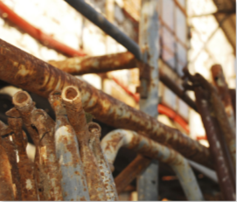
• Rust or cracking around weld areas of frames
• Dented tubes • bent standards or frames
• Bent or twisted ladders
• Split or warped planks or sole boards
• Seized couplers
• Broken toggles
Figure3.1.1 inspection component
The following is a list of check points to be covered when making a final and daily inspection of scaffolding prior to use. All points should be carefully checked to insure a safe and accident-free job and be periodically rechecked.
  - Check to see that there is proper support under every leg of every frame on the job. Check also for possible washout due to rain.
  - Check to make certain that all base plates and adjustment screws are in firm contact with their supports. All adjustment nuts should be snug against the legs of the frame.
  - Frames should be checked for plumpness in both directions.
  - If there is a gap between the lower ends of one frame and the upper end of another frame it indicates that one adjustment screw must be adjusted to bring the frames in Contact. If this does not help it indicates the frame is out of square and should be replaced.
  - Each leg of each frame should be cross braced to the corresponding leg of the next frame.
  - While checking the cross braces also check the locking devices to assure that they are all in their closed position or that they are all tight.
  - Check to be certain that all planking and accessories are properly installed.
  - Check to make certain all ties are secured between the structure and the scaffolding
  - Check to be certain all guard rails are in place.
  - If scaffolding is enclosed, check to see that additional precautions have been taken as noted in Section of Erection. Recheck periodically ties, clamps, etc., for movement.
  - Insure that safe access to work platform(s) is provided.

3.2. Use of scaffolding

3.2. 1. Check Use of scaffolding
Scaffolding Frames is a temporary structural frame for loading, stacking and construction work that is set up outside the outer line of the outer wall for building construction. Scaffolding is a working platform erected to ensure the smooth progress of each construction process.
Compared with the general structure, the working conditions of Scaffolding Frames have the following characteristics:
- The load has great variability;
- The fastener connection node is semi-rigid, and the rigidity of the node is related to the quality of the fastener and the installation quality, and the performance of the node has a large variation;
- There are initial defects in the structure and components of Scaffolding Frames, such as initial bending, corrosion, erection size error, load eccentricity, etc., all of which are relatively large;
- The connection point with the wall has a large constraint variation on the scaffolding.

3.3. Scaffolding stability

3.3.1. Confirming scaffolding stability
A) Stability
All free-standing scaffolds must be stabilized against overturning forces. The factor of safety against overturning in any direction shall be not less than:
- 1.5 for scaffolds not exceeding 3 m in height; and
- 3 for scaffolds exceeding 3 m in height.
Note:
- The factor of safety against overturning is the ratio of the righting moment to the overturning moment from forces acting on the scaffold;
- The overturning moment may be due to eccentric dead and live loads on the scaffold, and/or wind; and The righting moment is provided by the self-weight if suitably centre, added counterweight and the forces in the rake or anchor, if any

3.4. Carry- out repair of scaffolding

3.4.1. Repairing scaffolding
Sometimes the scaffold will need to be repaired. In most cases, you’ll need to safely remove the damaged part and either fix or replace it. If this requires the scaffold to be partially dismantled, follow safe dismantling procedures which are covered in the next section of this guide. If you have to leave the scaffold area to repair a component or find a replacement, hang an ‘out of service’ or ‘scaffolding incomplete’ tag so that no one uses the scaffold until it’s been repaired.
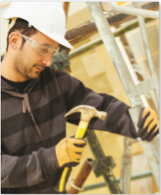

.

Fig 3.4.1 Repairing

3.5. Complete inspection
The following is a list of check points to be covered when making a final and inspection
All points should be carefully checked to insure a safe and accident-free job and be periodically rechecked.
      - Check to see that there is proper support under every leg of every frame on the job. Check also for possible washout due to rain.
      - Check to make certain that all base plates and adjustment screws are in firm contact with their supports. All adjustment nuts should be snug against the legs of the frame.
      - . Frames should be checked for plumpness in both directions
      - If there is a gap between the lower end of one frame and the upper end of another frame it indicates that one adjustment screw must be adjusted to bring the frames in contact. If this does not help it indicates the frame is out of square and should be replaced.
      - Each leg of each frame should be cross braced to the corresponding leg of the next frame.
      - . While checking the cross braces also check the locking devices to assure that they are all in their closed position or that they are all tight.
      - Check to be certain that all planking and accessories are properly installed.
      - Check to make certain all ties is secured between the structure and the scaffolding.

Self- check 3
Directions: Answer all the questions listed below.
1. Vertical posts that provide fixing points for all the other edge protection is----------
A) Guardrail posts B) Toe board C) Ladder
- Diagonal or cross pieces fixed on the standards to provided stiffness to the scaffolding.
A) Brace B) Plate form C) put logs D) Ledgers
3. Edge protection prevents workers and their tools or materials from falling off the scaffold
A) False B) True

Test II: short Answer writing
Instruction: write short answer for the given question. You are provided 3 minute for each question and each point has 5Points.
- Write down defection of work dismantle scaffolding.
- Write down some defects of scaffolding

Operation sheet 3
- Operation title: Procedures of Erect and dismantle scaffolding and form work
- Purpose: To practice and demonstrate the knowledge and skill required Erect scaffolding
- Instruction: Use given the tools and equipment erect the scaffolding for this operation you have given 6 Hour and you are expected to provide the answer on the given table.
- Tools and requirement:
- Hammer
- Circular saw
- Hand saw

Procedures for inspect scaffolding
Steps 1- Check legs, posts, frames and uprights to see if they are on base plates and mudsills.
Step 2 -.Check metal component for bends, cracks holes, rust, welding parts.
Step 3 – Check for safe access do not use the cross braces as a ladder for access or exit.

LAB TEST 3
Task 1.check inspection procedures
Task 2. Inspect old scaffolding

Unit Four: Dismantle Scaffolding
This learning guide is developed to provide you the necessary information regarding the following content coverage and topics:
- Isolate and sign scaffolding
- Erection scaffolding system
- Dismantle modular scaffolding system
This guide will also assist you to attain the learning outcomes stated in the cover page. Specifically, upon completion of this learning guide, you will be able to:
- Isolating and signing scaffolding
- Completing erection scaffolding system
- Dismantling of a modular scaffolding system

4.1. Isolate and sign scaffolding

4.1.1. Isolating, appropriately sing and barricade to ensure safe dismantling
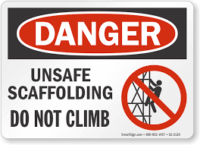
A) Signs and barricades
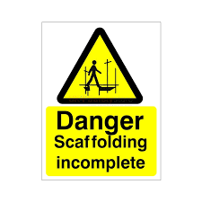
Signs and barricades should be used on or near scaffolding to help keep everyone in the vicinity safe. They provide warning of any potential danger, give direction as to what to do and direct both pedestrians and vehicles safely around scaffolding work areas. Signs should be positioned at eye level so they’re easily seen.

When you’re planning to erect and dismantling scaffolding, you need to determine which signs to use and whether barricades will be required – both during erection and dismantling of the scaffold and while it’s in use.
- You can get this information from a site inspection, by looking at the project plans (particularly site and location plans) and talking with supervisors.
- If you’re erecting and dismantling scaffolding near roads or any other area where vehicles are moving close by, you may need a spotter or flagman to control the traffic and keep people in the area safe during the erection process.
- A spotter’s job is to be the eyes and ears of the workers. They will direct them,
- Example: - to stop or wait if a vehicle’s approaching.
- A flagman directs traffic, Example: - stops traffic so that scaffolding can be carried safely across a road.
- Spotters and flagmen may use mobile phones, two-way radios and hand signals to communicate with workers.

4.2. Erection scaffolding system

4.2.1. Dismantle modular scaffolding system
All scaffolding, whether modifiable or not, must be erected, altered and dismantled by competent workers under proper supervision. Scaffolding must not be used unless the employer or employer’s representative on the work is satisfied that it is safe for use and complies with the regulations.
Scaffolding must not be altered or interfered with except on the instructions of the employer or employer’s representative. Safflowers must ensure that members of the public are not endangered while they are erecting, altering or dismantling scaffolds. They should also ensure that the lower working. Platforms are not used while the upper lifts are being worked on unless a fully decked platform, with screens if necessary, separates the part being erected or dismantled from the lower part in use.

4.2.2. Dismantling use reverse procedure as for erection
When the scaffold is no longer required, it can be dismantled and packed up. This often needs to happen quite quickly to allow access for trades and materials for the next stage of construction. Proper procedures should be followed to ensure that the scaffold is dismantled safely and readied for its next use, and the location is left as you found it. You will need to dismantle, clean, inspect and organize the scaffolding then clean up the area, according to requirements of the worksite, your employer or supervisor and the Regulations applicable in your area.

4.2.3. Dismantling a scaffold safely
The following safe work practices should be used when dismantling a scaffold: -„
- Edge protection and a way to enter the scaffold can be removed as the scaffold is dismantled, provided it is removed at the last possible stage. „
- Where possible a platform of at least 450 mm wide at the level the dismantling has reached should be in place. „
- Ensure when dismantling the scaffold the platform immediately below the level the worker is standing on has a full set of planks across its width and is no lower than 2 meters. „
- A section of the scaffold may be left open to allow the lowering of planks or other scaffolding between levels. „
- Scaffolding should never be dropped in an uncontrolled way when dismantling the scaffold
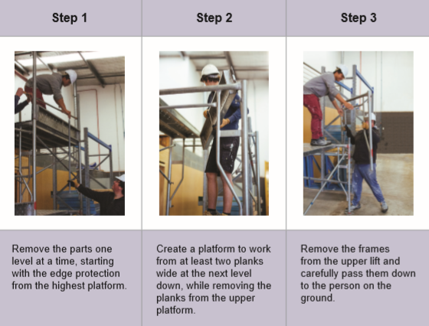

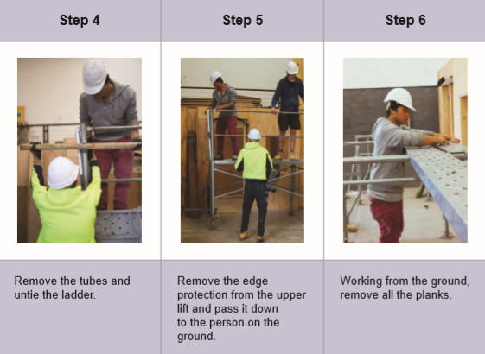

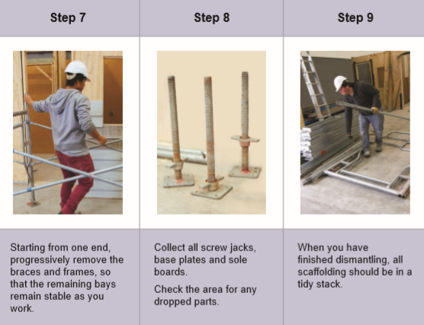

Fig 4.2.2 Dismantling scaffolding

4.3. Dismantle modular scaffolding system

4.3.1. Definition if dismantle

All scaffolding, whether modifiable or not, must be erected, altered and dismantled by competent workers under proper supervision. Scaffolding must not be used unless the employer or employer’s representative on the work is satisfied that it is safe for use and complies with the regulations.
Scaffolding must not be altered or interfered with except on the instructions of the employer or employer’s representative. Safflowers must ensure that members of the public are not endangered while they are erecting, altering or dismantling scaffolds. They should also ensure that the lower working. Platforms are not used while the upper lifts are being worked on unless a fully decked platform, with screens if necessary, separates the part being erected or dismantled from the lower part in use.

4.3.2. Dismantling use reverse procedure as for erection
When the scaffold is no longer required, it can be dismantled and packed up. This often needs to happen quite quickly to allow access for trades and materials for the next stage of construction. Proper procedures should be followed to ensure that the scaffold is dismantled safely and readied for its next use, and the location is left as you found it. You will need to dismantle, clean, inspect and organize the scaffolding then clean up the area, according to requirements of the worksite, your employer or supervisor and the Regulations applicable in your area.

Fig 4.2.2 Dismantling scaffolding

4.3.3. Dismantling a scaffold safely
The following safe work practices should be used when dismantling a scaffold: -„
- Edge protection and a way to enter the scaffold can be removed as the scaffold is dismantled, provided it is removed at the last possible stage. „
- Where possible a platform of at least 450 mm wide at the level the dismantling has reached should be in place. „
- Ensure when dismantling the scaffold the platform immediately below the level the worker is standing on has a full set of planks across its width and is no lower than 2 meters. „
- A section of the scaffold may be left open to allow the lowering of planks or other scaffolding between levels. „
- Scaffolding should never be dropped in an uncontrolled way when dismantling the scaffold

4.3.4. Dismantling procedures and technique

The work of dismantling scaffolding should be under the supervision of an individual with proper experience and aptitude. The following procedures should be observed while dismantling scaffolding.
- Check to see if scaffolding has been structurally altered in any way which would make it unsafe, an if so reconstruct where necessary before commencing with the dismantling procedures.
- Dismantle scaffold from the top down. Begin by removing all accessories from that lift being dismantled at the time.
- Always work from a minimum of two plank placed on the tier of frames below those being removed. Move the planking down as dismantling progresses.
- Do not remove ties until dismantling has reached the tier to which they are attached.
- Always stay within the inside of the scaffold. Do not climb on the outside for any reason when dismantling. Do not climb on ties, braces or un braced frames.
- Only remove fastening devices from bottom of frames being removed.
- Lower scaffolding components in a safe manner as they are dismantled. Avoid dropping or throwing the components as this could result in damage to the equipment, or injury to personnel below.
The work of dismantling scaffolding should be under the supervision
- The work of dismantling scaffolding should be under the supervision of an individual with proper experience and aptitude. The following should be observed while dismantling.
1. Check to see if scaffolding has been structurally altered in any way which would make it unsafe, and if so reconstruct where necessary before commencing with the dismantling procedures
- Dismantle scaffold from the top down. Begin by removing all accessories from that lift being dismantled at the time
- . Always work from a minimum of two plank placed on the tier of frames below those being removed. Move the planking down as dismantling progresses.
- Do not remove ties until dismantling has reached the tier to which they are attached.
- Always stay within the inside of the scaffold. Do not climb on the outside for any reason when dismantling. Do not climb on ties, braces or un braced frames.
- Only remove fastening devices from bottom of frames being removed.
- Lower scaffolding components in a safe manner as they
are dismantled. Avoid dropping or throwing the components as this could result in damage to the equipment, or injury to personnel below.

Self check 4
Directions: Answer all the questions listed below.
1 .It used on or near scaffolding to help keep everyone in the vicinity safe
A) Scaffolding B) Form work C) Barricade
2. Edge protection and a way to enter the scaffold can be removed when?
A) Scaffolding is dismantle B) Scaffolding is Erect C) A and B D) None
3. Dismantling use reverse procedure as for erection.
A) False B) True

Direction I I:-Mach Column “A” with Column “B”
Column “A” Column “B”
_____ 1. Modular scaffolds are lightweight systems A) mesh board
___2. The members played horizontal parallel to the wall B) Hand rail
____ 3. It’s used in framed scaffold and some modular scaffold C) Modular scaffolding
D) Suspended Scaffolding

Operation sheet 4
Operation title: Procedures of Erect and dismantle scaffolding and form work
- Purpose: To practice and demonstrate the knowledge and skill required Erect scaffolding
- Instruction: Use given the tools and equipment erect the scaffolding for this operation you have given 6 Hour and you are expected to provide the answer on the given table.
- Tools and requirement:
- Hammer
- Circular saw
- Hand saw
Procedures for dismantle scaffolding
Steps 1- Make room for the dismantled scaffolding part. Clear a space nearby to store the dismantled scaffold parts
Step 2 – Put on safety gear
Step 3 – Remove scaffold components from top to bottom
Step 4- Remove scaffold anchors
Step 5- Check the scaffold parts

LAB TEST 4

Task 1.check dismantle procedures
Task 2. Dismantle scaffolding

Unit Five: - Clean- up
This learning guide is developed to provide you the necessary information regarding the following content coverage and topics:
  - Clear work area
  - Maintain and store plant, tools and equipment
This guide will also assist you to attain the learning outcomes stated in the cover page. Specifically, upon completion of this learning guide, you will be able to:
  - Clearing work area
  - maintaining and storing plant, tools and equipment

5.1. Clear work area

5.1.1. Clean work area and work site
- Because scaffolding is reused over and over again, it’s important that it’s looked after properly.
- As with all aspects of building and construction, clean‑up procedures apply to scaffold components and tools, and the work area.
- Your company or the site you’re working on will have clean‑up procedures to follow, so make sure you’re familiar with them. There are also local, state and national Regulations that must be followed. For example, the approving authority, such as the local council, will include clean‑up requirements in the building license for the project.
- Try to minimize water use and suppress dust as much as possible during clean‑up to protect the environment.
These are some of the ways you can do this.
- Use fittings such as spray nozzles on hoses to direct water accurately.
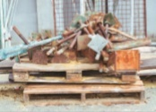
- Don’t leave hoses running when they’re not being used.
- Sweep dust, dirt and rubbish into containers nearby so that they’re disposed of quickly.
- If dust needs to be swept up on a windy day, wet the area lightly before you sweep to prevent the dust from becoming airborne. Figure 5.1 un clean work area
- Cover bins or skips or put heavier items on top of lighter items to prevent rubbish from blowing out.
- Erecting and dismantling scaffolding doesn’t usually involve any hazardous materials or produce any hazardous waste that needs specific handling or clean‑up procedures. A load of well used scaffolding like this (pictured left) may look like rubbish that needs to go in the skip, but pieces of scaffold that are too damaged or worn out to be repaired and/or reused may be able to be recycled. All waste from on or near the scaffolding needs to put in the correct collection area, skip or bin. Check recycling practices in your local area.
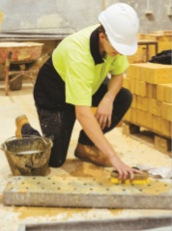

5.1.2. Clean‑up procedure
      - Clean down all pieces of plant and equipment, and all tools. This might involve brushing, scraping or hosing.
      - Check all parts for any damage.
      - Place any damaged parts aside to be repaired or tagged and reported.
      - Sort and stack all parts neatly so they’re easy to find when needed next.
      - Look over the entire area for any remaining parts, materials, tools, equipment or rubbish.

5.1.3. Disposing & recycling waste materials
Disposal methods adopted depend on the nature of the material. To obtain this information, a comprehensive sampling and analysis program is required so that the correct route for disposal can be determined.
- Contaminated Material and wastes
To ensure that all contaminated material uncovered on a construction site are excavated and disposed of in an environmentally responsible manner.
Excavate material in a manner which avoids off-site environmental problems.
Seal remaining contaminated material or wastes, where only part of the tip has been excavated, to ensure that there is no off-site effect now or in the future.
Dispose of contaminated material in a land fill licensed to take the type of contaminated material or wastes uncovered.
- Recyclability
Recyclability measures a material’s capacity to be used as a resource in the creation of new products. Steel is the most commonly recycled building material, in large part because it can be easily separated from construction debris.
Many building materials that cannot be reused in their entirety can be broken down into recyclable components. Often, it is the difficulty of separating rubble from demolition that pre- vents more materials from being recycled.
When choosing between waste minimization options, the following hierarchy for waste management is preferred Waste avoidance and/or reduction
- Reuse
Recycling Diverting the waste stream in these ways means that waste treatment and waste disposal options can be reduced. Construction sites should follow this hierarchy and seek out waste reduction opportunities. To identify opportunities it is necessary to consider all aspects of the project and the wastes it generates. Waste can be minimized by using improved technology, recycled or reused on-site, or by making purchasing decisions that favor recycled products. Wherever possible, include performance measures and targets for reduction, reuse and recycling options in the environmental management plan
- Waste minimization opportunities include:
- using contaminated water out of sediment dams for dust suppression and irrigating adjacent vegetated land
- sending waste concrete from demolition activities to a concrete recycler instead of landfill
- segregating and recycling solid wastes generated by construction activities,
- Working in the building industry can be dangerous, but here are some general rules to follow in order to work safely:
- Always wear the appropriate Personal Protective Equipment (PPE) as instructed; this could be as simple as wearing gloves to carry off-the-saw (OS) timber.
- Always keep your working area tidy
- Always report any hazard you see
- Never carry on, or lark about on a site or in a workshop
- Always take care of, clean and maintain the tools you use
- Don’t talk to others, be distracted by or distract others while you are working

5.2. Maintain and store plant, tools and equipment

5.2.1. Maintaining tools and equipment
- Proper tools and equipment are essential for the effective operation of any civil works site. Equipping the construction site with the correct tools and equipment plays an essential role in achieving timely and good quality results. For every construction activity there is an optimal combination of tools, equipment and labor. Depending on the nature and content of the works, the technical staff needs to know which tools to use and how to effectively combine them with manual labor.
- Once on site, equipment requires trained operators and supervisory staff who are proficient in its operation and maintenance.
- Faulty equipment is a common reason for delays on construction sites. A major responsibility of the project management is to ensure that tools and equipment are maintained in a good condition and are readily available when required for the various work activities.
- For certain construction activities, particularly hauling of materials and compaction, high labor productivity and good quality of work may be difficult to achieve using only manual labor and hand tools. In such cases, using light construction equipment can increase the efficiency of work.
- Site supervisors need to know how to use the tools and how to operate the equipment in order to secure good work progress and the expected high quality results. It is also important that staff know the full potential, as well as the limitation, of the use of manual and equipment-based works methods.
- Finally, tools and equipment need regular maintenance, requiring good workshop facilities, a reliable supply of spare parts and qualified mechanical staff.

Self check 5
Directions: Answer all the questions listed below.
1. Turning an item in to raw material which can be used again is ________
A) Reduce B) Recycle C) Reuse
2. Using an object as it is
A) Reduce B) Recycle C) Reuse
3. What is clean up?
A) Make something neat B) Restore order or morality C) A and B

Test II: short Answer writing
Instruction: write short answer for the given question. You are provided 3 minute for each question and each point has 5Points.
- What are waste minimize mechanism?
- Write the difference between recycle and reuse.
- Write Clean‑up procedure.

Reference
- Safe use scaffolding program/ Department of Facilities Management Occupational Health and Safety
- Instructional Scaffolding /to Improve Learning Northern Illinois University, Faculty Development and Instructional Design Center
- Safety and health in construction /Copyright © International Labour Organization 1992 First published 1992
- Scaffolding General Requirements /This Joint Australian/New Zealand Standard was prepared by Joint Technical Committee BD-036, Scaffolding. It was approved on behalf of the Council of Standards Australia on 2 October 2009 and on behalf of the Council of Standards New Zealand on 5 March 2010. This Standard was published on 19 March 2010.
- Training Requirements in OSHA Standards/Occupational Safety and Health Administration U.S. Department of Labor
- Part 12 Scaffolds and Scaffold Platforms by Miosha education and training servicesJuly 10, 2017
- CODE OF PRACTICE FOR ACCESS AND WORKING SCAFFOLD
.

Participants of this Module (training material) preparation
No | Name | Qualification (Level) | Field of Study | Organization/ Institution | Mobile number | E-mail
1 | Seblewengel Bekele | A(MSC) | Con Mgt | Bishoftu | 0934916466 | Seblewengelb4@gmail.co
2 | Derbabaw Mulaw | A(MSC) | Con Mgt | Gonder | 0967593066 | Derbabawmulaw2020@ gmil.com
3 | Tibebnesh G/ Micael | A(MSC) | Con Mgt | Awasa | 0916116033 | Tibebnesh1 @ gmil.com
4 | Habtamu Wendimagegn | Civi.engneering |  | Ethio Italy poly | 09482844573 | wendimagegnhabtamu@ gmil.com
5 | Remedan Mohamed |  | Con Mgt | Harer poly | 0974720826 | Mohamed remedan82@ gmil.com
6
7

ሙያ | የሙያ ደረጃ | የብቃት አሃዶች/ ሞጂል ርዕስና መለያ | From curriculum | Changed on TTLM
Structural construction works | Level one | Erect and dismantle scaffolding and form CON SCW1 M08 0322  Unit two | - Confirming purpose of scaffolding/form work | - Scaffolding/form work
Structural construction works | Level one |  | - Identifying site access and egress routes. | - Site access and egress routes
Structural construction works | Level one |  | - Assembling formwork | - Assemble formwork
Structural construction works | Level one |  | - Placing bracing of formwork | - Place bracing of formwork
Structural construction works | Level one |  | - Erecting formwork support system sequentially | - Erect formwork support system
Structural construction works | Level one |  | - Constructing formwork shutters | - Construct formwork shutters
Structural construction works | Level one |  | - Installing block outs and cast in-services | - Oil formwork
Structural construction works | Level one |  | - Removing debris, sawdust and other waste materials | - block outs and cast in-services
Structural construction works | Level one |  | - Oiling formwork | - Remove waste materials
Structural construction works | Level one |  | - Clearing work area and preparing surface | - Clear work area
Structural construction works | Level one |  | - Setting-out and assembling Scaffolding | - Set-out and assemble Scaffolding
Structural construction works | Level one |  | - Placing bracing of form work and scaffolding | - Erect scaffolding
Structural construction works | Level one |  | - erect scaffolding sequentially | - Place bracing of scaffolding
Structural construction works | Level one | Clean- up  Unit Five | - Clearing work area | - Clean work area
Structural construction works | Level one | Clean- up  Unit Five | - Disposing, reusing & recycling materials. | - Disposing, reusing & recycling materials
Structural construction works | Level one | Clean- up  Unit Five | - Cleaning, checking, maintaining and storing plant, tools and equipment | - maintaining and storing plant, tools and equipment

