STRUCTURAL CONSTRUCTION works
Level – II
Based on March, 2022 Curriculum Version 1
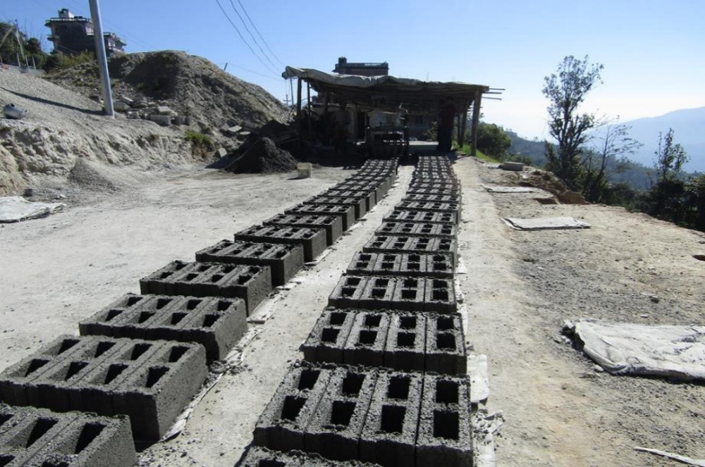

Module Title: - Produce Bricks and Blocks
Module code: EIS SCW2 M 02 0322
Nominal duration: 100 Hour

Prepared by: Ministry of Labour and Skill
August, 2022
Addis Ababa, Ethiopia
Contents
Acknowledgment………………………………………………………………..4
Introduction to the Module 6
Module Instruction 7
Unit one: Plan and prepare 8
INTRODUCTION 9
1.1 Work instructions 13
1.1.1 Following procedures 13
1.1.2 Works procedure 13
1.1.3 SPECIFICATION (technical standard) 15
1.2 Safety requirements 15
1.2.1 Classification of safety 15
1.2.2 Definition Of Hazards and Risk 16
1.2.3 Safety Rules and Regulations 17
1.3 Tools and equipment 22
1.3.1Hand-operated tools 22
1.3.2 Concrete block producing equipment 24
1.4 Material Requirement 28
1.4.1 Materials Used for the Production of Concrete Block 28
1.4.2 Materials Measurement Units 34
1.4.3 Calculating Material Quantity Requirements 34
1.5 Environmental protection 38
1.5.1 Environmental Guideline on Block Making Plant Manufacturing 38
1.5.2 Mitigation of Environmental Impacts 40
Self check-1 43
Operation sheet -1 45
LAP Test -1 46
Unit Two: Mix ingredient and cement 47
2.1 Inspect and select Ingredients 48
2.2 Quantities of ingredients 49
2.3 Set up and operate Mixing equipment 50
  - Mixing ingredients 51
2.4.1 Mixing Procedure 51
2.5 Monitor water content of mixture 54
2.5.1 Water content 54
Self check-2 55
Operation sheet 2 56
LAP Test -2 58
Unit Three: Cast ingredients into molds 59
3.1 Block making machine 60
3.1.1 Block making Machines 60
3.2 Pour and compact concrete 63
3.3 De-molding or removal of mold 65
3.4 Installing protection of freshly cast bricks/blocks 70
Self check-3 71
Operation Sheet-3 72
LAP Test -3 74
Unit Four: Cure and stack bricks/blocks 75
4.1 Removing bricks and blocks production area 76
4.2 Covering brick and block. 77
4.2.1 Covering 77
4.2.1 Curing of bricks and block 77
Self check-4 79
Unit Five: Assess quality of bricks/blocks 80
5.1 Inspecting brick and block 81
5.2 Testing brick and block quality 84
5.2.1 Bricks test 84
5.2.2 blocks test 85
Self check-5 88
Unit six: Clean up 89
6.1 Clearing work area 90
6.2 Disposing and reusing and recycling of material 91
6.3 Maintenance and storage of plant, tools and equipment 92
6.3.1 Maintenance 92
6.3.2 Important of maintenance plant and equipment 92
6.3.3 Necessary consideration 92
Self check-6 95
List of Reference Materials 96

Acknowledgment

Ministry of Labor and Skill swish to extend thanks and appreciation to the many representatives of TVET instructors and respective industry experts who donated their time and expertise to the development of this Teaching, Training and Learning Materials (TTLM).

Acronym

Introduction to the Module

This module contains information and suggested learning activities on structural construction works II. It includes instructions and procedure on how produce bricks and blocks.

It is specifically focusing on the practical implementation level and provides a wide range of essential information as well as dos and don’ts for trainers to communicate to masons and supervisors during theoretical and on the job trainings. It also contains figures and sketches/ drawings that add clarity to the context. These figures and sketches have been collected from various reference sources and are therefore, not of uniform character in its present form.

The module consists of six units. Each unit contains learning activities supported by information sheets.

This module covers the units:
- Plan and prepare
- Mixing ingredient and cement
- Cast ingredients into molds
- Cure and stack bricks/blocks
- Assess quality of bricks/blocks
- Clean up
Learning Objective of the Module
- Plan and prepare
- Mix ingredient and cement
- Cast ingredients into molds
- Cure and stack bricks/blocks
- Assess quality of bricks/blocks
- Clean up

Module Instruction

Read the specific objectives of this Learning Guide.
- Follow the instructions described below.
- Read the information written in the “Information Sheets”. Try to understand what are being discussed. Ask your trainer for assistance if you have hard time understanding them
- Accomplish the “Self-checks” which are placed following all information sheets.
- Ask from your trainer the key to correction (key answers) or you can request your trainer to correct your work. (You are to get the key answer only after you finished answering the Self-checks).
- If you earned a satisfactory evaluation proceed to “Operation sheets
- Perform “the Learning activity performance test” which is placed following “Operation sheets” ,
- If your performance is satisfactory proceed to the next learning guide,
- If your performance is unsatisfactory, see your trainer for further instructions or go back to “Operation sheets”.

Unit one: Plan and prepare
This unit is developed to provide you the necessary information regarding the following content coverage and topics:
- Work instructions
- Safety requirements
- Signage or marks
- Tools and equipment
- Material quantity
- Environmental protection
This unit will also assist you to attain the learning outcomes stated below. Upon completion of this unit, you will be able to:
- Apply Work instructions
- Follow safety requirements
- Identify and implement signage or marks
- Select tools and equipment
- Calculate material quantity
- Identify environmental protection

INTRODUCTION

Product Description: Concrete Blocks and Bricks
Now days, hollow concrete blocks and bricks are becoming very popular. These blocks are being widely used in construction of residential buildings, factories and multi-storied buildings. These hollow blocks are commonly used in compound walls due to its low cost. These hollow blocks are more useful due to its lightweight and ease of ventilation. Concrete blocks are wall constructing material made up of sand, cement, gravel, pumice and water with different kinds and types of mix ratio. Depending upon the required strength and purposes of the block, these ingredients may vary with mix ratio. It is sometimes called a concrete masonry unit (CMU). Most concrete blocks have one or more hollow cavities, and their sides may be cast smooth or with a design. In use, concrete blocks are stacked one at a time and held together with fresh concrete mortar to form the desired length and height of the wall.
Type of Concrete Block
Concrete blocks can be classified and divided in many ways, for example depending on their size, material of production, compressive strength and purpose.
- Depending on their weight and shape: Concrete block is divided into solid and hollow concrete blocks based on its surface shape and size.
Hollow concrete block (HCB): this type of concrete block is the most common type and widely used type that have one or two hollow cores. They are light weight, economical and needs semiskilled laborers. Hollow concrete blocks are weak against lateral loads. The advantages of using HCB is that they are readily available product, sound and thermal resistance, high fire resistance, can be increased the lateral load resistance by reinforcement and has a 20+ years lifespan.
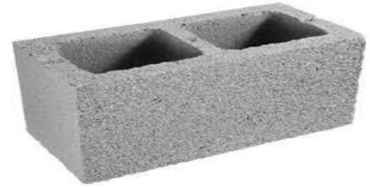Fig.1.1 hollow concrete block
Solid concrete block: Solid concrete blocks are heavier than hollow concrete blocks. Mostly manufactured solid block size is 400mmx200mmx150 mm size. These blocks are mostly used for load bearing wall construction.
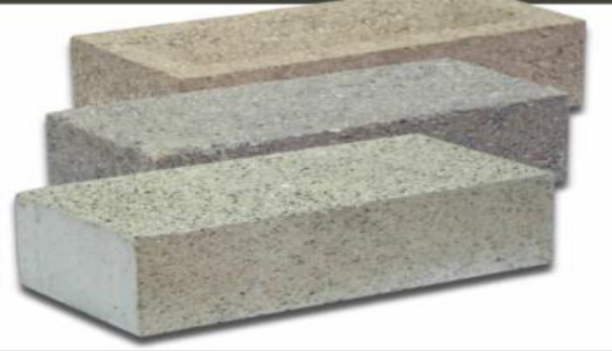
Fig.1.2. Solid Block
- Depending on their size or thickness
Concrete blocks mostly hollow concrete blocks have usually three different dimensions depending on their thickness according to EBCS (Ethiopian Building Code Standard).
- 20 cm x 20 cm x 40 cm
- 15 cm x 20 cm x 40cm
- 10 cm x 20 cm x 40 cm
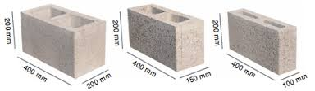

Fig.1.3 size of HCB
- Depending on their Classification:
Hollow concrete blocks are classified into the following classes:
- Class A and B are load bearing HCB units and suitable for
      - External walls pointed, rendered and plastered
      - The inner leaf of cavity walls or stone masonry
      - Internal walls or partitions
      - Panels in steel framed and reinforced steel framed buildings
- Class C and D are non- load bearing HCB units and suitable for
- Non- load bearing internal panels in steel framed and reinforced concrete buildings
    - Brick
A brick is building material used to make walls, pavements and other elements in masonry construction. Traditionally, the term brick referred to a unit composed of clay, but it is now used to denote rectangular units made of clay-bearing soil, sand, and lime, or concrete materials. Bricks can be joined together using mortar, adhesives or by interlocking them. Bricks are produced in numerous classes, types, materials, and sizes which vary with region and time period, and are produced in bulk quantities. Two basic categories of bricks are fired and non-fired bricks.
Block is a similar term referring to a rectangular building unit composed of similar materials, but is usually larger than a brick. Lightweight bricks (also called lightweight blocks) are made from expanded clay aggregate.
Fired bricks are one of the longest-lasting and strongest building materials, sometimes referred to as artificial stone, and have been used since circa 4000 BC. Air-dried bricks, also known as mud bricks, have a history older than fired bricks, and have an additional ingredient of a mechanical binder such as straw.
Bricks are laid in courses and numerous patterns known as bonds, collectively known as brickwork, and may be laid in various kinds of mortar to hold the bricks together to make a durable structure.
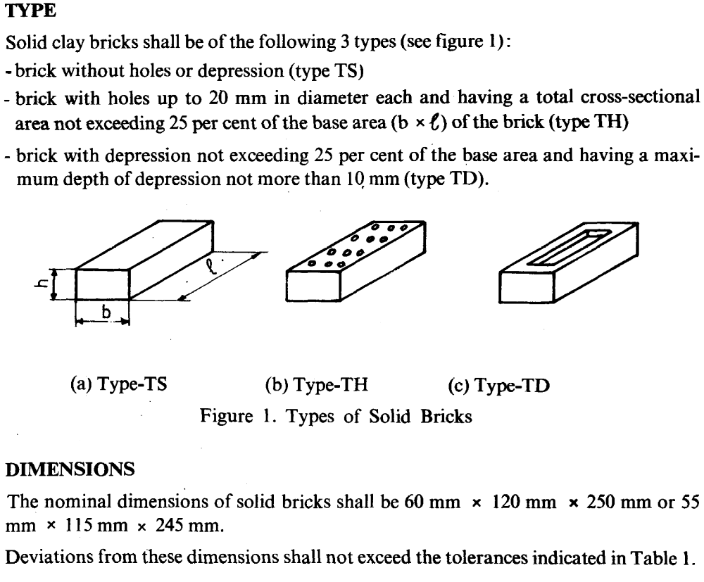

1.1 Work instructions

A work instruction describes how a task will performed within a process (Process – any activity or set of activities that uses resources to transform inputs into outputs). Work instructions include Plan/ Drawing, specification and quality.

1.1.1 Following procedures
Procedures are a form of communication set out by a company to inform its employees of a
Particular way the organization wants a task or tasks to be performed.
Procedures may include:
- Safety procedures
- Environmental procedures
- Quality procedures
- Maintenance procedures
An example why following procedure is advantageous
A company has a procedure in place to inspect and lubricate a concrete mixer daily when in use following the manufactures recommendations.
They are procedure is followed and regular inspections are made and the mixer is lubricated to prevent parts ceasing up and wearing.
If this procedure is not followed the parts in the mixer can wear or cease and the equipment could break down in the middle of a project, when it is required to be used impacting on time to complete a job.

1.1.2 Works procedure
Before any work commences on the job, the supervisor should prepare a ‘WorksProcedure’. This is a written document that considers many aspects of the task and isbased on a risk assessment and should include the following:
- The name of the competent person in regard to the concreting job.
- A list of supervisory staff available on site and instructions as how they are to ensure strict compliance with the procedure and daily inspections of the work site.
- An emergency response plan, this plan must include:
Details of a communication system (either telephone or two-way radio) that willprovide assistance in the event of an accident in the shortest possible time.
All personnel must familiarize themselves with the communication system and who to
Involve.
- Provision for additional equipment to be kept on site in case of an emergency.
- Provision for temporary protection for workers who are required to enter the site before long-term protection is installed.
- A direction that no one enters the site unless authorized.
- Methods and procedures to ensure scaffolding and associated work systems are installed with the minimum possible delay.
- Instructions for all scaffolding and equipment be regularly inspected by workplace management directly in charge of the work.
- The type of machinery that will be required for the job.
- Access arrangements for machinery and equipment.
- Traffic control requirements these may include:
- On-site traffic control and management
- Traffic control of public roads to provide entry and exit to the site.
- Transportation of workers to and from the site.
- Amenities for the workers, these may include:
- Change room
- Lunch/tea room
- Toilets
- Availability of services, which may include:
- Power
- Water
The Work Procedure may also include a code of conduct for the workers.
It should be stressed that the Work Procedure described is the minimum requirement. Many
Work Procedures may cover greater detail and cover more items relevant to the site location

1.1.3 SPECIFICATION (technical standard)
A specification often refers to a set of documented requirements to be satisfied by a material, design, product, or service. A specification is often a type of technical standard.

There are different types of technical or engineering specifications (specs), and the term is used differently in different technical contexts. They often refer to particular documents, and/or particular information within them. The word specification is broadly defined as "to state explicitly or in detail" or "to be specific".
Using the term "specification" without a clear indication of what kind is confusing and considered bad practice.
A requirement specification is a documented requirement, or set of documented requirements, to be satisfied by a given material, design, product, service, etc.It is a common early part of engineering design and product development processes, in many fields.
A functional specification is a kind of requirement specification, and may show functional block diagrams.
A design or product specification describes the features of the solutions for the Requirement Specification, referring to either a designed solution or final produced solution. It is often used to guide fabrication/production. Sometimes the term specification is here used in connection with a data sheet (or spec sheet), which may be confusing. A data sheet describes the technical characteristics of an item or product, often published by a manufacturer to help people choose or use the products. A data sheet is not a technical specification in the sense of informing how to produce.

1.2 Safety requirements

Safety is the first essential requirement and every personnel must learn the safety measures even before he/she starts working on a machine or on equipments. Safety is an attitude, a form of mind of worker. If the attitude of worker towards safety is good and he/she is safety conscious, then he/she him/her self will develop the safe working habits. Before you can use equipment and tools or attempt practical work in a workshop you must understand basic safety rules. These rules will help keep you and others safe in the workshop.

1.2.1 Classification of safety
    - Personal safety(PPE & HSE)
    - Safety hand tools &equipments
    - Safety working area
    - Safety rules & regulation of in the construction site.
    - First aid. (Plaster, disinfectant, bandage, ointment).

1.2.2 Definition Of Hazards and Risk
Hazards and risks are terms used on a daily basis, however, because their true meaning is not realized, by many we will look at the definition of each.
- Hazard
The term hazard may be defined by any, or all of the following
- An energy source over which control has been lost
- The potential for harm
- A source of potential damaging
- Risk
The term risk can be defined as:
- The potential for the realization of unwanted negative consequences of an event
- The probability of an event occurring and the maximum reasonable consequences should it occur
- The combination of the likelihood that an event will occur and the consequences if it does.
- Work Hazards
The exact nature of the hazards may vary from site to site, so it is important to assess eachnew task that you are about to undertake for hazards and the risks that may result fromexposure to these hazards. If a hazard is identified and the risk is assessed at being highto yourself or others, you should take steps to eliminate it, or adjust your operation to reduce the risk to an acceptable level.
Some of the more common hazards that you are likely to encounter on site include:
  - Falling objects
  - Slip/trip hazards
  - Fall hazards
  - Laser radiation
  - Suspended loads
  - Power tools/equipment
  - Hand tools
  - Mobile equipment
  - Hazardous substances.

1.2.3 Safety Rules and Regulations
General Safety Rule
General safety rule is very important to reduce the accident while you working in workshop. Some of them are listed below,
- Follow directions:-understanding the procedures of using by hand tools & machines.
- Stay alert: -Watch what you are doing, and use common sense when operating a power tool. Do not use a power tool while tired or under the influence of drugs,
- Alcohol or medication. A moment of inattention while operating power tools may result in serious personal injury.
- Use safety equipment:- Always wear eye protection. Dust mask, non-skid safety shoes, hard hat, or hearing protection must be used for appropriate conditions.
- Always dress properly: - Dress properly for your work. While you must wear your aprons are provided so that you can work on the machines. Remove any jeweler, neckties, chains, bracelets, and rings. Roll up your sleeves and tie any hair back in a ponytail before beginning any work
- Keep the shop clean: - Put your tools back where they belong when you finished.
- Keep the floor clear of debris and sawdust: - the floor should be clear of scrap blocks, excessive material, and sawdust. Keep projects, sawhorses, and other equipment and materials you are using out of travel lanes. Wipe up any spilled liquids immediately.
- Learn to use the tools correctly
- Understanding using of hand tools in proper ways.
- Avoid house play
- Report all accidents
- Practice lending a cheerful helping hand when requested by someone

1.3 Signage or marks
This section provides information on the signs that you can encounter on the work site. Most
Signs are self-explanatory, but if you encounter a sign where the meaning is not clear, seekadvice before you commence work in the area covered by the sign.
Why Do We Need Safety Signage?
Safety signs draw your attention to objects and situations affecting your health and safety.
Safety signs are placed in strategic locations as close as possible to hazardous areas. Ifthey become damaged or unreadable, please report this to your supervisor so that the sign/s can be replaced. If a sign displays a distinct safety message, it will carry the sameauthority as a direct instruction from your Supervisor.
What are the different types of signs?
We all see many signs everyday but how many signs do we take notice of? The answer ismost likely many, however we do not admit to this. Signs are put in place to assist people.
It is not the intention of this note to attempt to teach all about all signs and the category they fit under. However some knowledge of signs and how to use them is essential.
Identify signs and respond as necessary and appropriately
Signs may be:
- Picture (symbol)
- Written (words)
- Picture and written
Picture signs are universal in language
Written signs may have a language barrier
Picture and written where the writing has the ability to clarify the picture.
There are many categories of signs that the Australian Standards have developed. The
Correct titles for these signs are:
- Prohibition signs (don’t do)
- Mandatory signs (must do)
- Restriction signs (limiting)
- Hazard signs (warning signs)
- Danger hazard signs (life threatening)
- Emergency signs (medical, exit etc.)
- Fire signs (fire fighting)

Safety signs
Safety Signs are generally either screen-printed or poly vinyl applied to aluminum, PVC. Some are reflective or glow in the dark.
Must do Signs
Are WHITE with a BLUE circle Restriction Signs
Are RED circle with BLACK writing

Fig. 1.5must do Signs & Restriction Signs
What is important is that you appreciate and know how to respond to signs. It is just asimportant that you follow the meaning of the signs. People who do not respond to signs area risk to themselves and others
Hazard Warning Signs
Are Triangular YELLOW with BLACK writing

Fig.1.6Hazard Warning Signs

Signs should be placed where they will be effective and at a height that is readily visible.
This usually means that they need to be close, but before, to where the danger is and itshould be fixed to a stable object. Consider the effectiveness of placing a number of signs atthe entrance of a large commercial job. This means that everyone has the opportunity toread the signs before entering the site, but what happens an hour later when they actuallycome across the danger? Will they remember the details of the sign or will it be too late.
Signs are best located near to the danger but not that close that it is too late. The following sign is typical of a cluster of signs that may be found on large commercial building sites.

Signs and barricades to control access to a site
Control of access and egress to and from the worksite is imperative for the operationalactives and for of all safety concerned. Signage and barriers are available in numerous,types, sizes and color. To select the most appropriate signage and barriers for the taskconsultation should be carried out with the supervisor. In addition, there will be various acts,regulations, and code of practice that will need to be adhered to. Furthermore, there may be various permits and or licenses required to perform at the site.

Fig.1.7 safety sign
Above is a typical safety sign seen at QLD residential construction sites that advise people of certain conditions and restrictions onsite and who to contact for entry.

Temporary fencing is used on construction sites to restrict the entry of the general public. At the site entry signage like the safety sign shown above is displayed to advise of site conditions and who to contact for entry to the site and what PPE is required to be worn.
Barricading can also be on construction sites to restrict the entry of the general public. Note the signage at the site entry to give safety and entry conditions for the site.
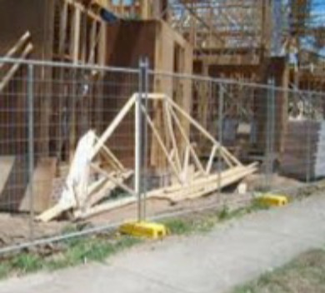
Fig.1.8 Signs and barricades to control access to a site
Emergency Signs
Wherever ‘lifesaving’ equipment exists, it is critical to ensure that it is ready to perform in the event of an emergency.
For those responsible for workplaces, there are strict requirements for the maintenance ofessential services such as fire safety equipment. Responsibilities can include maintainingequipment to specific standards, keeping maintenance records and completing necessarycompliance reports. One of the very important signs for every one is the emergency assembly area on the next page.

Fig.1.9 Fighting Signs

1.4 Tools and equipment

1.4.1 Hand-operated tools
Spade;-is used to mix small Amount of mortar &concrete

fig.1.10 spade
Bucket
A Bucket is used to serve small amount of water or material and to takethe tools after work.
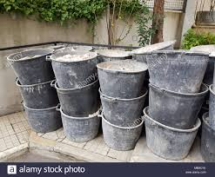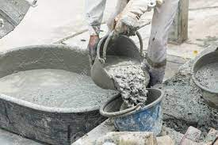
fig.1.11 bucket
Brush
To clean hand tools before and after use and to clean dust on surfaces of tools and equipments.

fig.1.12.brush
Wheelbarrow is used to services material and to take the tools after work.

fig.1.13 wheel barrow
Mixing box is used to measure ingredients
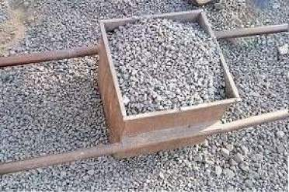
fig.1.14 mixing box

Meter- is used to take measurement.

fig.1.15 meter

Sprit level- used to check whether the surfaces are level (horizontal) or plumb (vertical).Available in various length with either traditional bubble gauges or electronic display.


fig.1.16 sprit level
Trowel - uses for lifting and filling mortar in the mold.
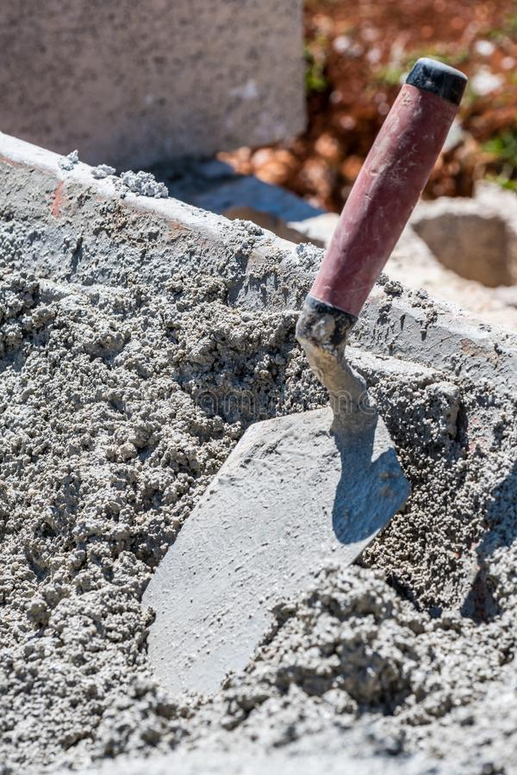
Fig.1.17 Trowel

1.4.2 Concrete block producing equipment
In small-scale backyard block making no special equipment is generally needed for making concrete blocks, if the concrete is mixed by hand and simple wooded or steel moulds are used. But with certain equipment the production process can be facilitated and the quality of blocks improved considerably.
Mixers
The quality of concrete blocks depends largely on the type of mixer and period of mixing. The free fall, revolving drum type mixers are not suitable, because of the semi-dry nature of the mix. Pan mixers have a quick moving action and are thus recommended. Trough mixers are also suitable.
Mixer: -are used to mix more amount of mortar and to save the time
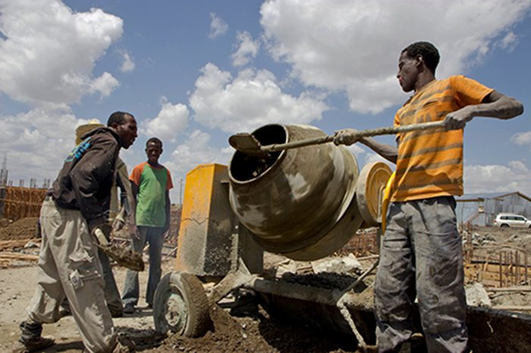
fig.1.18 portable mixer
I. Hand-operated molding equipment
These are relatively inexpensive, simple and robust devices, which are especially suited for on-site production of concrete blocks. Output rates for 40 x 20 x 20 cm blocks can range from 10 to 80 blocks per hour, depending on the efficiency of the machine, rate of supply of concrete and number of workers involved. There are basically three types:
  - Steel moulds that can be carried around by one person and used on a raised working surface (eg table) or on the ground; the mix is tamped with the help of special tampers that fit on the mould, but is more usually compacted by means of a vibrator fixed to the mould or to the working surface (vibrating table).
  - Stationary machines with the block mould (into which a wooden pallet is inserted) at about table height; the mix is usually compacted by the tamper lid-plate, which is brought down with a few sharp blows; after compacting, the sides of the mould fold back to release the block, or it is ejected by means of a lever, which pushes the base plate upwards, so that the fresh block can be taken away on the pallet for drying. Some of these machines are equipped with a tray above the mould for preparing the mix and filling it directly into the mould.
  - Stationary machines that are similar to the previous type, but have an engine operated jolting mechanism or vibrator for more efficient compaction.

Advantages of hand-operated equipment:
- Low capital and operational costs.
- Quick delivery (possibly available locally).
- Low weight and small size, thus easy to transport, requires little storage space.
- Simple to use with a little training.
- Low maintenance needs, apart from regular cleaning and lubrication of moving parts.
- Possibility of repairs in local workshops, no special parts required.
Problems of hand-operated equipment:
- Low rate of production.
- In case of manual tamping, possibility of non-uniform compaction of concrete; since production rate is low and the use of fresh concrete mixes is limited to the setting time, relatively few blocks are produced per mix, which can differ in quality each time.
- Tiring operation which can lead to a drop in the quality of blocks, if the work is carried out by a single person for too long.
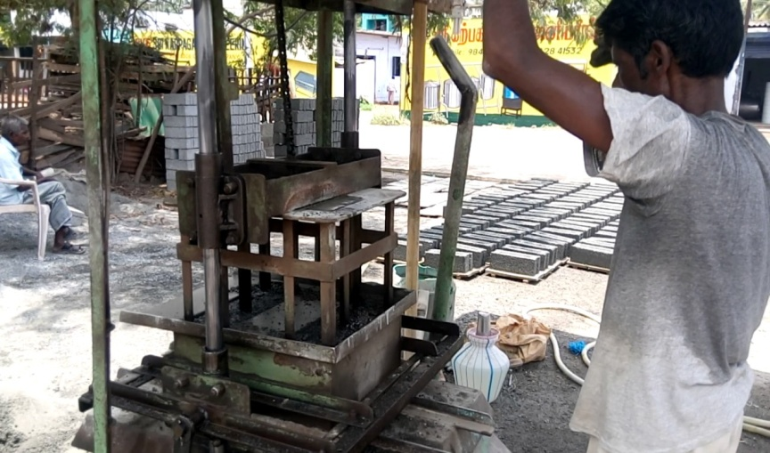
Fig. 1.19 hand-operated equipment
II. "Egg-laying" mobile machines
These are machines designed for medium-scale production, either on-site or in a factory. The name was given to these machines, because they leave the blocks to dry where they are produced on a flat production surface and move a short distance away to produce the next batch of blocks, and so on. The machines, which can be manually operated or fully automatic, have output rates for 40 x 20 x 20 cm blocks ranging from 60 to 400 blocks per hour, depending on the size of machine, the degree of automation, availability of continuous supplies of concrete and production site organization.
Advantages of egg-laying machines:
- Relatively high output of blocks.
- Uniform quality of blocks, since more blocks are made from each concrete mix and most of the operations are mechanized.
- Fairly easy to operate with a little training.
- Suitability for use on-site or in a factory.
Problems of egg-laying machines:
- Rarely available locally, usually imported.
- Higher capital and operational costs than those of hand-operated equipment.
- Requirement of large flat production area.
- Dependency on the weather, if not under a roof: in dry regions, if the blocks are not covered with plastic sheets, premature drying and cracking are inevitable; if it rains, production must cease, otherwise the green blocks will disintegrate.
- The higher the degree of automation, the greater the dependency on energy supplies.
- Repairs not likely to be possible in local workshops, if spare parts are not available.
III. Fully mechanized, stationary machines
These are automatic and very versatile machines used for the medium- and large-scale production of superior quality concrete components. They can be of various sizes, but are generally far more expensive than egg-laying machines of comparable sizes. The filling of the moulds, the compaction (vibration) and ejection of the blocks is done automatically, and output rates for 40 x 20 x 20 cm blocks can range from 200 to 800 blocks per hour. These high output rates are only possible with sophisticated ancillary equipment for transportation, handling, stacking, etc, a well-trained staff, efficient management and sound financial base. Space is saved by stacking the green blocks in shelves, where they are usually steam cured for better product quality and quicker turnover.
Advantages of fully mechanized machines:
- Very high output rates.
- Superior and uniform quality of products.
- Greater adaptability to the production of special concrete products.

Problems of fully mechanized machines:
- Not available locally, have to be imported.
- Very high capital and operational costs.
- Dependency on uninterrupted energy supplies, high standard of ancillary equipment, skilled labor, good management and, above all, continuous high demand for the products.
- Limited mobility.
- Need for specialists for maintenance and repairs; spare parts usually expensive and difficult to get, or only after long delivery time.
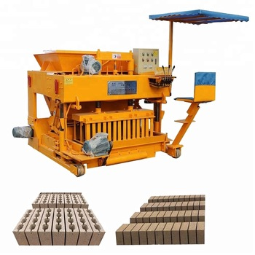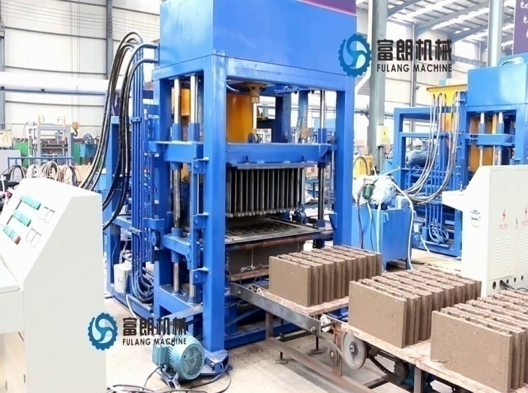
Fig.1.20fully mechanized machines

1.5 Material Requirement

1.5.1 Materials Used for the Production of Concrete Block
Concrete block can be produced from different construction materials with different mixingratio. Most of concrete blocks are produced depending on the intended purpose. The mostcommonly used materials for the production of concrete blocks are:
- Cement
- Sand
- Gravel/aggregate
- Pumiceand
- Red ash
- water
- Cement
The following cements are commonly used in concrete block making:
Ordinary Portland cement (OPC). Cheapest and most common type used.
Rapid hardening Portland cement (RHPC): more finely ground cement, which hardens much faster than OPC. It is especially useful:
- where storage space is limited,
- when rapid production is important, and
- To produce good strength blocks despite poor gradation of aggregate.
Block mix cement: marketed especially for block making, but can vary from one manufacturer to another. It has the high early strength qualities of RHPC, but is lower in price.
Special cements: such as Portland blast furnace cement, sulphate-resisting Portland cement and others, used where special properties are of importance. The partial replacement of cement by a pozzolana, eg rice husk ash, fly ash, may be acceptable in certain cases, but should not be implemented without prior laboratory testing.
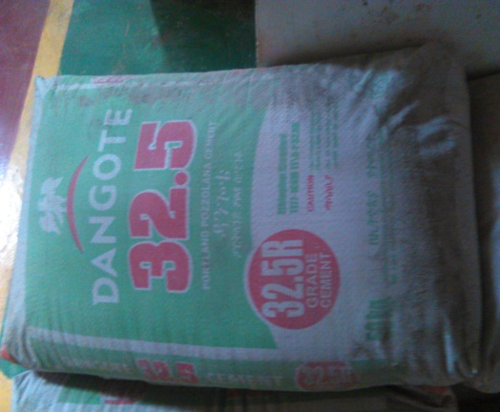

Fig.1,21Ordinary Portland cement (OPC) Dangote
- Aggregates
There are a number of types of aggregates that can be used for brick and block making. These aggregates may need to be blended to suite the quality of the final product. Never use aggregate that has clay, organic matter or excessive salts in it.
Sand
There are different types of sand. Some types are more suitable than others for use in brick and block making. Some types of sand may need to be blended with other aggregates to get the correct consistency and suitability.

- Coarse River Sand
This sand is usually very good for block/brick making. It should have particle sizes ranging evenly in proportion from fine dust up to 5mm in size.

Suggestions for use:-
      - o Unblended
      - o Mixed with fine sand
      - o Mixed with ash or slag
      - o Mixed with crusher sand and dust

Some coarse river sands do not have enough fines in them. This could result in the block/brick sagging and/or breaking. Add crusher sand or dust to help prevent this.

- River Sand

River sand of medium or fine grade can be used for block/brick making but choose sand that is evenly graded from fine dust up to 3 or 4mm in size. River sands are not as cohesive as crusher run sands and natural mined sands.
Suggestions for use:-
  - o Unblended
    - o Mixed with fine sand
  - o Mixed with ash or slag
  - o Mixed with crusher sand and dust

- Crusher Run Sand

This is usually very good for block/brick making. It tends to be more consistent than other sands. This means that the block/brick compacts down well and the freshly made product does not fall apart easily. Crusher sand is also evenly graded from dust to larger particles. Always check that the crusher sand does not contain clay. Particle sizes should all be smaller than 5mm.

Suggestions for use:-
  - o Unblended
  - o Mixed with river or natural sands
  - o Mixed with a little stone

- Natural Mined Sand

This sand is mined from quarries and occurs naturally. Slightly coarse evenly graded natural sand is the best for use with blocks and bricks. Natural sand is usually consistent and makes a strong fresh product. Make sure the natural sand does not contain clay.

Suggestions for use:-
o Unblended
      - o Mixed with crusher run
            - o Mixed with a little stone

- Fine Sands, Sea Sand

These sands are not good for making blocks/bricks for the following reasons. They tend to have a high cement demand. They do not compact well and they do not produce a very consistent mix.

Suggestions for use:-
  - o Always try and blend this sand with crusher run sand

Stone

Stone ranging from 5mm to 8mm can be used to blend in with finer aggregates. Stone used on its own will not work. Adding stone will often add strength to your cured product but could make the surface of the blocks/bricks more rough and porous.

Ash and Slag

Ash and slag by products from power stations, metal works and other industries are often used in block production. These materials are usually obtainable for very low costs.

It is important to get any ash or slag you use tested for its suitability for use with cement and other aggregates. Ash or slag may contain high quantities of unsuitable chemicals.

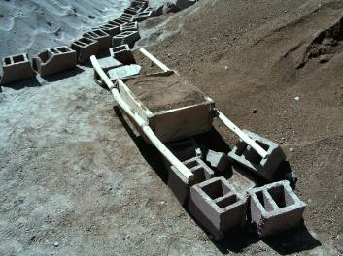
Fig.1.22light weight aggregate and River sand

General Requirements and Restrictions on Storage and Handling
Materials required in construction operations shall be stored, and handled in a manner to prevent deterioration and damage to the materials, ensure safety of workmen in handling operations and non-interference with public life including safety of public, prevention of damage to public property and natural environment.

Materials shall be stored and placed so as not to endanger the public, the workers or the adjoining property. Materials shall be stacked on well‐drained, flat and unyielding surface. Material stacks shall not impose any undue stresses on walls or other structures.

Materials shall be separated according to kind, size and length and placed in neat, orderly piles. High piles shall be staggered back at suitable intervals in height. Piles of materials shall be arranged so as to allow a minimum 800 mm wide passageway in between for inspection and removal. All passageways shall be kept clear of dry vegetation, greasy substance and debris.

For any site, there should be proper planning of the layout for stacking and storage of different materials, components and equipments with proper access and proper maneuverability of the vehicles carrying the material. While planning the layout, the requirements of various materials, components and equipments at different stages of construction shall be considered.

Stairways, passageways and gangways shall not become obstructed by storage of building materials, tools or accumulated rubbish. Materials stored at site, depending upon the individual characteristics, shall be protected from atmospheric actions, such as rain, sun, winds and moisture, to avoid deterioration. Special and specified care should be taken for inflammable and destructive chemicals and explosive during storage.

Storage Requirement by Classification Of Materials
Stored materials shall be separately stored under following classifications, with appropriate care necessary precautions to each Classification:
  - Climatically Sensitive Materials
  - Durable Materials
  - Materials Vulnerable to Rough Handling
  - Inflammable and/or Fire Sensitive Materials
  - Hazardous Materials

Cement Storage
Cement-Cement should be stored in a dry place, moisture free.

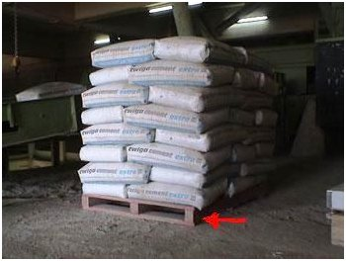
Fig.1.23 cement stacking
Cement can be supplied in 50kg bags or in bulk.

Bags of cement should be stored on a pallet and under cover off the floor and away from any damp conditions. Packing the bags close together also prevents any moist air circulation around the bags.
Always store the cement bags so that they are used on a first in first out basis. This will ensure that the oldest cement is used first.

Aggregate storage

The stockpile of aggregate should be protected from rain by storing it under a roof or covering it with plastic. Do not let the aggregate get contaminated with ground soil or any organic matter such as leaves from a tree. Position your aggregate close to your mixing plant.
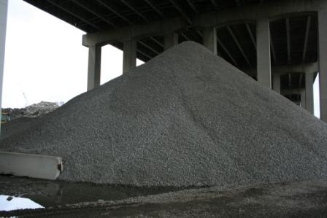
Fig.1.24 Aggregate handling system

1.5.2 Materials Measurement Units
Introduction
Measurements are the size of something to be measured or simply pertaining to its size, quantity, length, or rate of something that has been measured. It is very important to know how to measure and calculate the particular object, with a particular measuring instrument needed in the job requirements.
The most common measurement of block production is measure by volume unless other ways area & length.
- Volume: is measured in meter cube(m3)
- Area: is measured in meter square(m2)
- Length : is measured in meter (m)

Units of Materials available in market
- stone---------------------------m3
- aggregate----------------------m3
- sand-----------------------------m3
- cement---------------------------kg or bag
- oil---------------------------------lit
- water------------------------------lit
- brick-------------------------------pcs
- HCB------------------------------pcs

1.5.3 Calculating Material Quantity Requirements
Basic Mathematical Formulas
Before anything else, you should learn what are the four fundamental basic mathematical operations; addition, subtraction, multiplication and division.
Addition (+) is the process of calculating the sum of two or more numbers or amounts.
Example: a. 10+15= 25
b. 15 Birr + 5 Birr= 20 Birr
Subtraction (-) is the process or act of deducting one number or quantity of another and withdrawal from a larger whole..
Example: - a. 25 – 10= 15
b. 20 Birr – 10 Birr = 10 Birr
Multiplication (*, x) is a mathematical operation symbolized by an integer “*”, “x” and its equivalent to adding a number to itself a particular number of times and it is extended to expressions such as functions or matrices that are not numbers.
Example: a. 6*3 = 18
b. 5 Birr x 4 Birr = 20 Birr
Division (/,÷) is one of the mathematical operation also that an act of separating or splitting something into parts or an any instances, or an operation used to calculate the number of times one number is contained in another (dividing one number by another).
Example: a. 30 /6 = 5
b. 10÷5 = 2
c. 10Birr ÷2 Birr = 5 Birr
AREA
Area is a quantity that expresses the extent of a two dimensional surface or shape in the plane and can be understood as the amount of material with a given thickness
Perimeter is about the distance around all of a shape (sum).
Shape | Formula | Variables
circle |  | Where∏ is pi, r is the radius.
triangle |  | Where a, b and c are the lengths of the  sides of the triangle.
square | 4l | where l is the side length
rectangle | 2l + 2w | wherel is the length and w is the width.
Formula
Table-1.1

Volume is the quantity of three-dimensional space enclosed by some closed boundary, for example, the space that a substance (solid, liquid, gas) or shape occupies or contains. Any unit of length gives a corresponding unit of volume namely the volume of a cube whose side has the given length.
Calculation of Materials used for conventional Block
Let us assume that you have decided to mould your own blocks, and you have been faced with the challenge of estimating the quantity of cement and sand to sale that will satisfy the construction requirement. Here will give you a guide on how to make such estimate. This is steps, so that you will be able to make calculations just in case you are using standard size of blocks.
Example-1
Assume Number of blocks required = 3000pieces
To produce class B ratio (1:4)
Recommended quantity production = 1 bag of cement to produce- 17pcs blocks
Step 1: Calculate the volume of the block
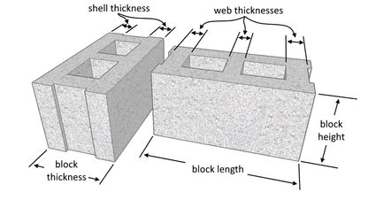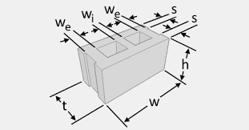
Fig.1.25. sectional view shows sizes of HCB thickness, width, length and Height
For the block size shown above;
where; t and h=20cm
W=40
W_{e},w_{i},w_{e} and s=3

Volume of block without holes = (0.4m × 0.2m × 0.2m) = 0.016 m³
Volume of holes = 2(0.200 × 0.125 × 0.15) = 0.0075 m³
Therefore volume of the block = 0.016-0.0075= 0.0085 m³

Step 2: Calculate the volume of the 17 blocks
If the volume of 1 block is 0.0143, the volume of 17 blocks = (0.0085m³× 17pcs) = 0.1445m³
Step 3: Calculate the volume sand required for the 17 blocks
The volume of 1 bag of cement is 34.72 litres = 0.03472m³.
This is obtained by knowing that the mass of 1 bag of cement = 50kg, and the density = 1440 kg/m³
The volume of a standard builder’s wheel barrow is 0.065 m³ (unheaped). We assume that approximately 2 bags of cement will fill one builder's wheel barrow.
Now, we can estimate the number of wheel barrow trips of sand that the molder should provide in order to make 17 blocks from one bag of cement.
Total volume of 17 blocks required = 0.1445 m³
Let the number of wheel barrow trips of sand be x
Hence, (volume of 1 bag of cement) + (Total volume of sand) = Volume of 17 blocks
Hence, 0.03472 + x (0.065) = 0.1445m³
On solving, x = 1.6889 un heaped wheelbarrow trips of sand
The volume of sand required to make 17blocks = 1.6889 × 0.065 = 0.10978 m³

Step 4: Calculate the total volume of materials required
We can therefore estimate the quantity of materials to be purchased;
If 1 bag of cement is needed for 17 blocks, therefore 176.47 bags of cement is needed to mould 3000 blocks (gotten by 3000/17)
If 0.10978 m³ of sand is required to make 17 blocks, therefore, 41 m³ of sand (about 67.60 tones assuming density of dry sand = 1600 kg/m³) is needed to make 3000 blocks.
For a 5 tone tipper of 3.8 m³ capacity, we have to order for 11 trips of sharp sand.
Therefore summarily, we need 176.47 bags of cement and 11 trips of sand to mould about 3000 pieces of (20*20*40) cm blocks with holes (for 1 bag = 17 blocks) B-Class blocks.

1.6 Environmental protection

Environmental protection is the practice of protecting the natural environment by individuals, organizations and governments. Its objectives are to conserve natural resources and the existing natural environment and, where possible, to repair damage and reverse trends.

Due to the pressures of overconsumption, population growth and technology, the biophysical environment is being degraded, sometimes permanently. This has been recognized, and governments have begun placing restraints on activities that cause environmental degradation. Since the 1960s, environmental movements have created more awareness of the various environmental problems. There is disagreement on the extent of the environmental impact of human activity and even scientific dishonesty occurs, so protection measures are occasionally debated.

1.6.1 Environmental Guideline on Block Making Plant Manufacturing
A block making plant is involved in the manufacture of concrete blocks.
The basic processes comprise:-
- Mixing the right proportions of cement, water and aggregates, namely rock sand and gravel.
- Conveying the mixed aggregates into a block making machine, where they are compressed and moulded to give the blocks, the desired shape.
- Curing of the blocks for a reasonable period of time to gain the desired strength and durability. The curing process is designed primarily to keep the concrete block moist by controlling the loss of moisture normally by the use of water sprayers or accelerated curing can also be carried out by the use of steam in curing chambers.
The block making plant layout usually comprises the:-
- Block production and curing platform
- Batching plant
- Feeding cement silos
- Raw material storage area
The construction and operation of a block making plant is associated with several environmental issues, namely:-
- Site selection
- Dust and air emissions
- Noise
- Wastewater and storm water run-off
- Solid wastes
- Waste Oil, hydrocarbon and oil spills from vehicles and equipment
- Energy and water consumption

Location and Siting
- The site should be located in industrial areas or at a suitable site outside the defined settlement boundary/residential areas or within the buffer of bad neighbourhood activities/ development.
- The existing development context of the site should be compatible with the activity.
- At the design stage of new block making plants, consideration should be given to the site lay-out, with a view to avoiding disturbances to the surrounding environment. In particular, attention should be paid to the location of entrances, exits, car parks, access roads and amenities.
- The site should not be located within any Environmentally Sensitive Area (ESA) and its prescribed buffer zone as per ESA Study 2009 such as wetland, steep slope and in areas that are likely to be affected by hazards such as inland flooding, landslide and storm surges, amongst others.
- On-site wastewater disposal facility such as septic tanks and absorption pits/leaching fields shall be located not less than 30 m from any water course as per Rivers and Canals.
- Existing natural drains and watercourses on or in the vicinity of the site shall not be tampered with.

1.6.2Mitigation of Environmental Impacts
1.6.2.1 Dust nuisances and air pollution
The main sources of dust nuisances are:-
- fugitive dust from cement storage silo
- Dust from vehicular movement within the premises
Air emissions are from operation of the equipment and exhaust of vehicles.
Necessary abatement measures should be taken such that all emissions from the plant comply with the Environment Protection (Standards for Air) Regulations 1998.
Mitigating measures include:-
- Fitting the silo with dust-restraining bag filters
- Sprinkling of the premises with water, preferably harvested rain water
- The premises and access roads should be kept clean and free of dust at all times.
      - Noise abatement
Noise from the block making plant arises from:-
- Use of mechanical equipment and electric motors (compressor, vibrator, hammer)
- Compaction / compression of cement mortar within the block moulds in the block laying machine
Mitigating measures include:-
- All operations should be carried out during normal working hours as determined by the respective Local Authority.
- Noise generating equipment should be provided with appropriate noise attenuating materials/ structures.
- Proper and regular maintenance of equipment and use of exhaust silencers
- Provision of protective equipment and regular medical screening for staff to the satisfaction of Ministry of Labour, Industrial Relations, Employment and Training.
Noise monitoring using calibrated noise meter should be carried out on a regular basis.

      - Wastewater management
- Wastewater generated on-site is of both domestic and industrial nature.
- Domestic wastewater is generated by staff employed at the plant
Industrial wastewater comprises effluents from cleaning of equipment and sprinkling of water for dust abatement.
Mitigating measures include:
- Provision of appropriate domestic wastewater treatment and disposal facility to the satisfaction of the Wastewater Management Authority.
- Installation of grease traps or oil water separators for removal of floatable solids from water.
Note: -Maintenance of the grease trap or oil water separator is to be carried out by the owner / promoter.
- Wash water should be channeled into a sedimentation tank. The effluent from the sedimentation tank should be treated and reused for dust abatement and the settled solids be reused.

      - Solid wastes
Solid wastes are mainly domestic wastes generated by the staff as well as cracked/ broken blocks.
Mitigating measures include:-
- Domestic solid wastes to be regularly collected in bins or waste handling receptacles and disposed of to the satisfaction of the Local Authority.
- No waste of any type to be disposed of in any watercourse including drains, canals and the surrounding environment.
- The cracked/ broken blocks to be reused for backfilling purposes.

      - Other mitigating measures
- Necessary precautions should be taken to avoid disturbance to the neighborhood by way of mud, traffic or other nuisances during construction and operation phase.
- Provision to be made for adequate parking, loading and unloading facilities.
- Safe storage of materials on site and stored materials not unduly visible or intrusive in the street scene.
- Provision for a proper drainage scheme for evacuation of stormwater to avoid any risks of flooding/water-logging of site and adjoining areas to the satisfaction of the Local Authority.
- Installation of bait stations/ traps to control pests and rodents.

Self check-1

Part I:- Multiple item questions
Directions:Instruction: select the correct answer for the give choice. You have given 1 Minute for each question. Each question carries 3 Points.
- .______often refers to a set of documented requirements to be satisfied by a material, design, product, or service. (3 points)
A Plan B Specification C Schedule D all
- Hollow concrete blocks are classified into the following classes(3points)
A Class 1,2,3&4 B Type I,II,II C Class A,B,C&D D A&C

It will help keep you and others safe in the workshop (3 points)
- Personal safety (PPE & HSE)
- Safety hand tools &equipments
- Safety working area
- Safety rules & regulation of in the construction site
- All the above
- The term hazard may be defined by the following; except(3 points)
- An energy source over which control has been lost
- The potential for harm
- A source of potential damaging
- The potential for the realization of unwanted negative consequences of an event
- Stored materials shall be separately stored under following classifications; except? (3 points)
- Climatically Sensitive Materials
- Durable Materials
- Materials Vulnerable to Rough Handling
- Hazardous Materials
- All are correct answer
- The construction and operation of a block making plant is associated with several environmental issues, namely:- (3 points)
- Dust and air emissions
- Noise
- Solid wastes
- A &C
- All the above
Part II:- Filling the blank space
- _________ are universal in language (3 points)
- ________Signs are triangular YELLOW with BLACK writing (3 points)
- The most common measurement of block production is measure by_________ (3 points)
- _________is about the distance around all of a shape (sum)(3 points)
Part III:- Short item questions
Instruction: write short answer for the given question. You are provided 3 minute for each question and each point has 5Points.
1. List down the necessary tools required for HCB productions?
2. Mention all the equipments required for HCB productions?

Note: Satisfactory rating – above 20 points Notsatisfactory - below 20 points
You can ask you teacher for the copy of the correct answers.

Name: _________________________ Date: _______________

Operation sheet -1 | Calculating ingredient quantity

Purpose: - To determine the amount of cement and sand required producing 2000pcs of B-Class Concrete block. ( block size 40*20*20 )
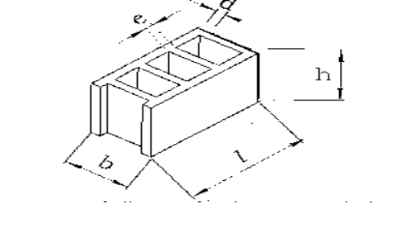
Conditions or Situations For The Operations:-
- Ensure the working area is bright / good visibility.
- Make workstation comfortable.

Equipment and Tools
- Ruler,
- Pencil.
- Pen
- Calculator
Materials: -
- Paper,
- Learning guide
Procedure,
- Step 1: Calculate the volume of the block
- Step 2: Calculate the volume of the 17 blocks
- Step 3: Calculate the volume sand required for the 17 blocks
- Step 4: Calculate the total volume of materials required

LAP Test -1 | Enumeration
Name: _____________________________ Date: ________________
Time started: ________________________ Time finished: ________________
Instructions: Given necessary templates, tools and materials you are required to perform the following tasks within 30 minutes.
Task 1:Calculate ingredient quantity

Unit Two: Mix ingredient and cement
This unit to provide you the necessary information regarding the following content coverage and topics:
- Inspect and select Ingredients
- Quantities of ingredients
- Set up and operate Mixing equipment
- Mixing ingredients
- Water content of mixture
This guide will also assist you to attain the learning outcomes stated below.Upon completion of this learning guide, you will be able to:
- Inspect and select Ingredients of block making
- Determine the quantities of ingredients
- Set up and operate Mixing equipment
- Mix ingredients according to job requirements
- Monitor water content of mixture

2.1 Inspect and select Ingredients

2.1.1 Input materials for a cement block or brick
- Aggregate
Definitions
An aggregate is a produced product having specific physical and gradational properties and is created by manipulation of material through a processing operation. The material may be from natural sand and/or gravel deposits, quarried bedrock, slag from steel mills or copper refineries, debris from mining operations, or crushed Portland cement concrete.
It is the stone, sand and ash you want to compact down and bind together with the cement. A good aggregate is an aggregate that is free from chemicals, clay and organic material. A good aggregate will bond well with the cement paste and not react with it.
You must choose your aggregates according to your needs.
To achieve a dense block with an aggregate that can be compacted down easily you need to have an aggregate with evenly graded particles ranging from fine dust up to larger stone of around 8mm. Blending different aggregates often produces the best results.

River-bed sand
The best sand is clean river-bed sand composed of many different size particles. If it is dirty, the sand should be washed, or sifted through a fine screen (4-5mm square), since dirt will weaken the blocks. Do not use ocean sand
- Cement
Cement is your most costly material and by doing trials with different aggregates you will be able to minimize on cement content and so decrease your costs.
Cement should always be stored in dry place, off the floor and should be use within three months of the date of manufacture.
Never use cement that has lumps in it and only use cement from a well-known brand.

- Water
Only clean clear drinkable water should be used in the manufacture of the blocks and bricks.
Any organic material in water will prevent the cement from setting. Chemicals and impurities could also affect the strength of the end product.
Never use salty or brak water.
It is advisable to get your water tested for impurities.

2.2 Quantities of ingredients

Batch mixing

Aggregates can be matched by volume or by weight, but the latter is more accurate. For this reason, cement should only be matched by weight, or preferably by using only whole bags of 50 kg. In backyard block production, with less stringent quality standards, batching by volume using buckets, tins, wooden boxes or wheelbarrows is quite acceptable, if done with care to ensure uniform proportions of mix.
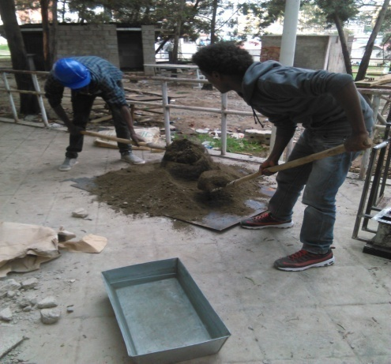
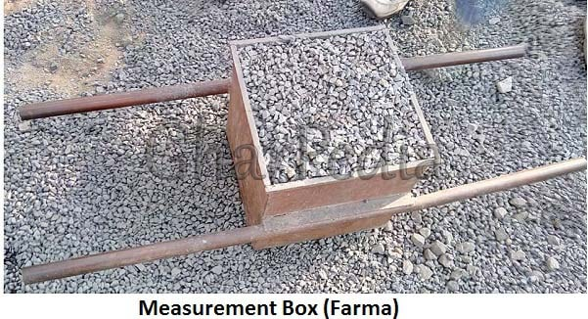Fig.2. 1 Batching box fig 2.2 mixing sample
For high quality bricks and blocks a pan mixer should be used. For low quality bricks and blocks hand mixing on the ground can be used.
Always run a series of trials with different mix proportions. By evaluating your results you can adapt your mix to be more cost effective.
Start you trial mixes with 1 part cement to 6 parts aggregate. This translates to one bag of cement to 3 level wheelbarrows of aggregate. Test your block or brick strengths at 28 days.

Method to Calculate output
Calculate the density of your aggregate by weighing a known volume of the aggregate.
Density = mass / volume = kg per cubic meter
So if one 20 litre bucket of aggregate weighs 25kg then Density = (25/20) x 1000 = 1250kg/cubic meter
So for a 1 to 6 mix the calculation would be as follows:
Batch for 1 cubic meter of aggregate | Mass (kg)
1 cubic meter of aggregate (see above) | 1250
5 bags cement at 50kg per bag 250
140 liters of water at 1kg per litre140
Total Mass1640
Weigh a freshly made wet brick to get its mass.
So say the mass of one wet maxi brick = 7.9 kg therefore 1640/7.9 = 207 bricks from one cubic meter of aggregate

2.3 Set up and operate Mixing equipment

Mixing equipment is set up and operated in line with manufacturers’ instructions.
Mixing Equipments of the materials has to be set up operated as close as mixing place.
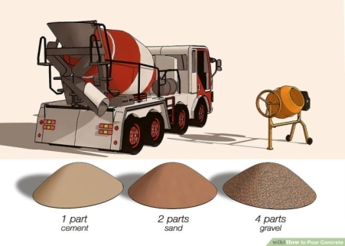
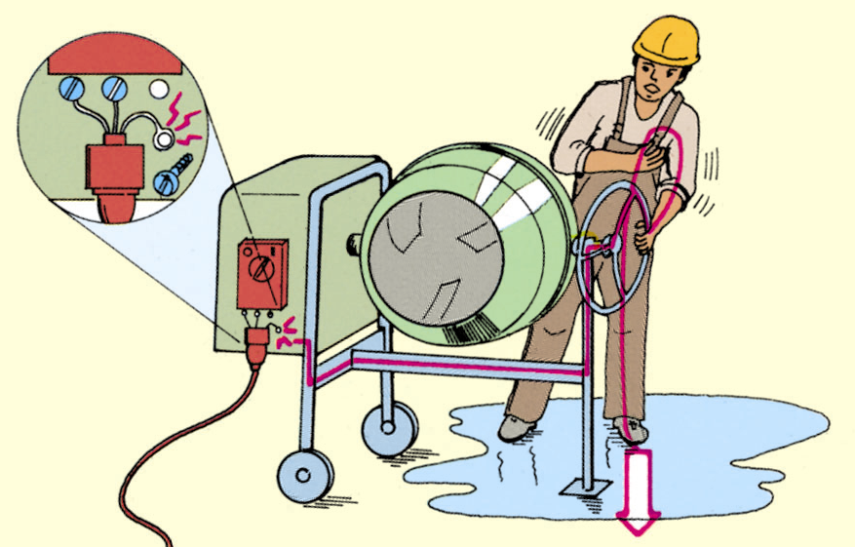
Fig.2.3 mixing equipment

Mixing ingredients

Mixing Procedure
A Mixing Area
Concrete should be mixed on a flat surface that will not absorb water. Mix it on a wooden platform about2 meters by 2 meters. Or, mix it on a cement-sand platform.
Cement-sand platforms must be made a week before concrete can be mixed on them. To build a platform, mix cement and sand on the ground in a1:6 ratio, cement to sand. Add water, and spread the mixture in a circle about 2 meters in diameter.
B Choosing a Measuring Unit
Since the dry ingredients' of concrete, cement, sand, and gravel, are mixed by volume, the easiest way to be sure that the proportions are right is to decide on a standard measuring unit such as a box or wheelbarrow.
Once the unit is chosen, simply fill it to the appropriate level with each ingredient in turn.
Generally, the easiest measuring unit to use is a gauge box or wheel barrow that holds 1 bag of cement. The box or wheelbarrow should be approximately 40cm x 40cm x 40cm.Note: to avoid confusion, once the size of the measuring unit has been chosen, do not use different size boxes or wheelbarrows on the site for any purpose.
When using a box:
- the box should have handles on both sides for easy lifting by two people;
- If the materials are close enough to the platform so that they do not have to be carried, it is easier to use a bottom less box: set the box directly on the mixing platform and fill it to measure; then, lift it up to empty the ingredients into the mixture.

Mixing proportions for HCB production:
The following mixing proportions for the production of hollow concrete blocks are used in accordance to ESC D3.301:
Table 2.1 mixing proportions
Class | Proportions by volume of
Class | Sand | Gravel 00 | Gravel 01 | Red ash or pumice | Cement
A | 2 | 1 | 1 |  | 1
A | 2 | 1 |  | 1 | 1
B | 2 | 1 | 2 |  | 1
B | 2 | 1 |  | 2 | 1
C | 3 | 1 | 2 |  | 1
C | 3 | 1 |  | 2 | 1

C Mixing process
Machine Mixing
When working with cement-based products, always wear eye protection and waterproof gloves. Machine mixed concrete should be mixed in a barrel-type mixer.
Step 1
Measure the recommended water amount for the number of bags to be added to the mixer and pour half of the water into the mixer (each 80-pound bag will require about 3 quarts of water). If using liquid cement color, add to the mixing water.
NOTE: water should be added to the mixer before the dry mix.
Step 2
Turn the mixer on and add the dry mix into the mixer. Allow the concrete to mix for about a minute and then add the remaining water as necessary.
Step 3
Mix the concrete for about 3-5 minutes, until a uniform, workable consistency is achieved. If additional water is needed, add small amounts of water sparingly. Properly mixed concrete should look like thick oatmeal and should hold its shape when it is squeezed in a gloved hand.
NOTE: the more water that is added to the mix the weaker it becomes; adding one extra
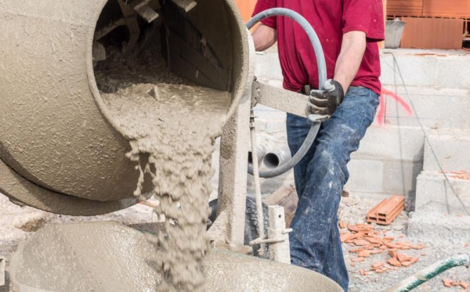
Fig. 2.4 mechanical mix
By Hand
Spread your aggregate out over a concrete surface. Then add your cement by spreading it over your aggregate evenly. Shovel your aggregate up into a pile. Spread the pile out again and build it up into a second pile. Spread the second pile out again and add water by sprinkling it evenly over the spread out aggregate. Mix water into aggregate and then pile the mixture up for a third time. This method usually adequately mixes your batch. Hand mixing is labour intensive and time consuming. It also tends to be more wasteful.

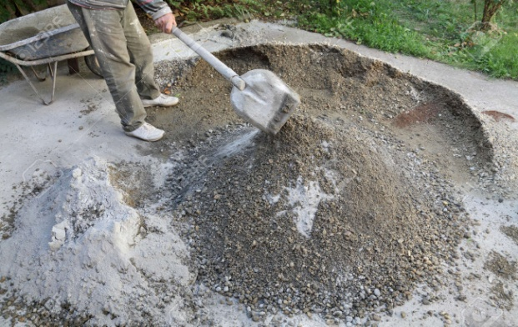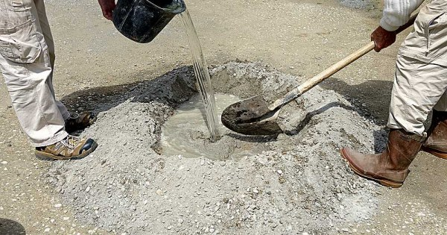
Fig.2.5 hand mixing

2.5 Monitor water content of mixture

2.5.1 Water content
The moisture content within your mix is crucial. It is important for the following reasons:-
- The correct water content allows for good dense compaction by lubricating the aggregate. Too much water will lubricate the aggregate to such an extent that the block/brick will fall apart or sag when removed from the mould.
- With the correct water content the block/brick will release easily from the mould. No suction between the mould and block will be created.
- A very slight water rippling effect can be seen on the sides of the blocks/bricks when the correct moisture content is reached.
Do not allow your mixed batch to stand for more than half an hour. This will prevent strength loss in your cement and the lubricating water will not dry off.
Your mix and aggregate may need to be adjusted to get a quality looking block.
Before production can commence, all materials have to be approved by an official concrete lab. The mixing and batching will be strictly done on the mix ratio provided by the official concrete lab.
The mixing (best results are with a compulsory mixer) should be done thoroughly, until a uniform consistence of the mortar is achieved

Self check-2

Part I:- Multiple item questions
Directions: Instruction: select the correct answer for the give choice. You have given 1 Minute for each question. Each question carries 3 Points.
- One is not true of the main characteristics of the most common types of concrete? (6 points)
- Resistance to weathering, impact and abrasion;
- Capability of being moulded into components of any shape and size;
- Good fire resistance.
- Cracking
  - mixing proportions for the production of hollow concrete blocks Class A?(6 points)
- Sand (2) Gravel 00(1) Gravel 01(1) Red ash or pumice(0) Cement(1)
- Sand (3) Gravel 00(1) Gravel 01(2) Red ash or pumice (0) Cement(1)
- Sand (4) Gravel 00 (3) Gravel 01 (2) Red ash or pumice(1) Cement(1)
- Sand (4) Gravel 00 (3) Gravel 01 (3) Red ash or pumice(2) Cement(1)
Part II:- Short item questions
Instruction: write short answer for the given question. You are provided 3 minute for each question and each point has 5Points.
- Mixing Equipments of the materials has to be set up operated as close as mixing place?
- What are ingredients of hollow concrete block making?

Note: Satisfactory rating –8 and above points Unsatisfactory - below 8 points
You can ask you teacher for the copy of the correct answers.

Name: _________________________ Date: _______________

Operation sheet 2– Mixing Ingredients of Block Making

Operation sheet 2

PURPOSE: -To make the concrete mass homogeneous and uniform in colour while maintaining the required consistency
CONDITIONS OR SITUATIONS FOR THE OPERATIONS:-
- Ensure the work shop hazard free
- Wear appropriate clothes,
- Steel toe-capped boots.
- A dust mask
- Gloves ,
- Safety glasses

EQUIPMENT AND TOOLS
- Builders shovel.
- Buckets.
- Polythene sheeting
- Wheelbarrow or buckets
MATERIALS: -
- Cement
- Sand
- Aggregate
- Red-ash
- Water
PROCEDURE,
- Identify job specifications
- Spread a plastic sheet on the ground.
- Measure out the materials.
- Place the aggregate and sand into a pile on the sheet.
- Place the cement on top of the pile of sand and aggregate.
- Shovel the material in the pile to one side, creating a new pile and repeat three times.
- Make a deep crater in the pile and add water.
- Fold the mix in from the sides.
- Continue to fold inwards and "chop" the pile to distribute water through the mix.

PRECAUTIONS:-
- Wear working cloths which properly fit with your body
- Wear Mask
- Make working area hazard free.
- The water used for mixing should be free from all harmful organic substances
- Mixed materials must be laid at the required site within 30 minutes after adding water to the cement.
QUALITY CRITERIA:
- The concrete should be mixed thoroughly to from a homogeneous mix.
- The water cement ratio should be appropriate, considering the strength and workability criteria.
- The concrete mix should be designed properly and should have all the ingredients in right proportions.

LAP Test -2 | Practical Demonstration
Name: _____________________________ Date: ________________
Time started: ________________________ Time finished: ________________
Instructions: Given necessary templates, tools and materials you are required to perform the following tasks within 30 minutes

Task-1: Mix Ingredients of Block Making

Unit Three: Cast ingredients into molds
This learning guide is developed to provide you the necessary information regarding the following content coverage and topics:
- Brick and block making machine.
- Pour and compact concrete
- De-molding or removal of mold
- Bricks/blocks production test
- Install protection of freshly cast bricks/blocks
This guide will also assist you to attain the learning outcomes stated in the cover page. Specifically, upon completion of this learning guide, you will be able to:
- Select and inspect brick and block making machine.
- Pour and compact concrete into mold
- Complete de-mold or removal of mold
- Assess bricks/blocks production test
- Install protection of freshly cast bricks/blocks

Block making machine

3.1.1Block making Machines
Several types of machines are available, ranging from simple hand-operated ones to complex stationary or mobile plants. The simpler machines are generally mechanically operated using electric, petrol or diesel power, while the larger machines are usually electrically operated. In most of the block making machines, the concrete is compacted by vibration.
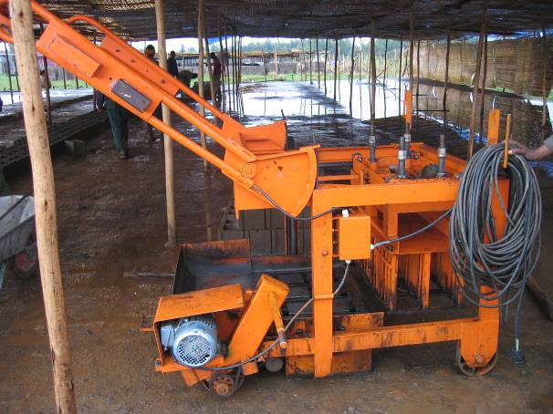
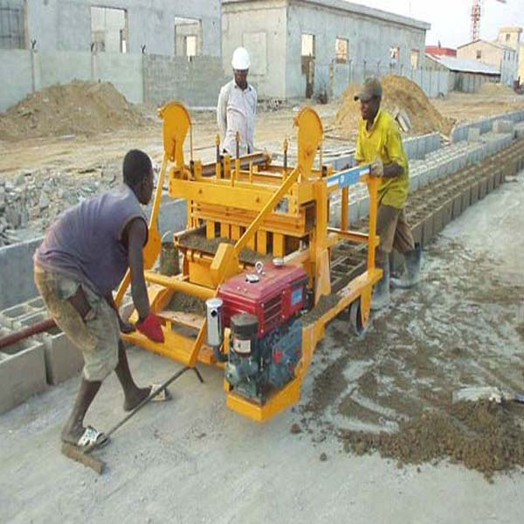

Fig.3.1 Block producing machine used to produce HCB

Table 3.1 Machine set up and operation
OPERATION
  DESCRIPTION
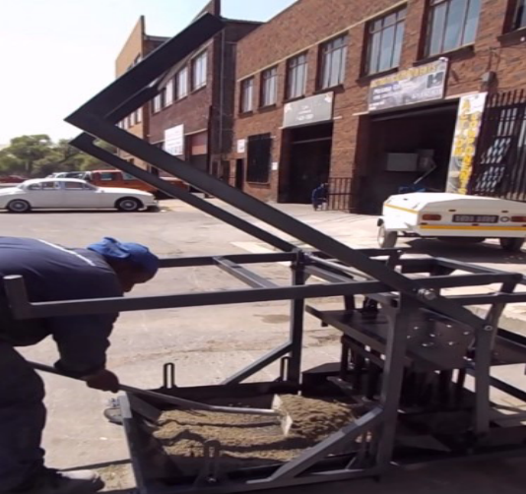
  Fill up the mould box and rake the mixture level.
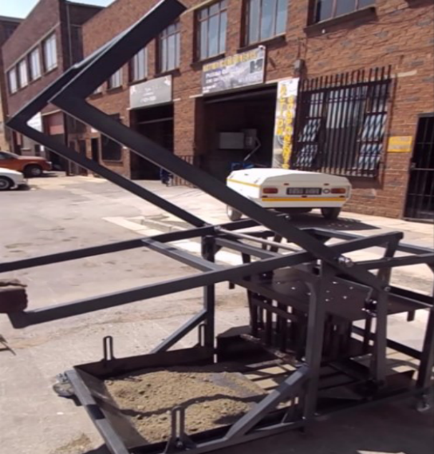  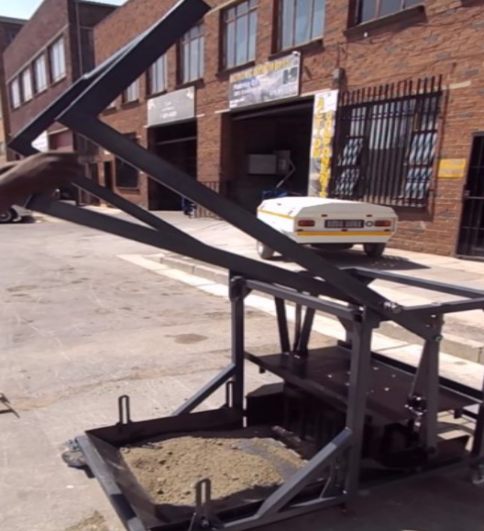
  Pull inside handle(tamper lever) down to release the tamper, it will unhook.
  Once it has unhooked drop the tamper down onto the mixture inside the mould.
  
  Hooked in
  
  Unhooked
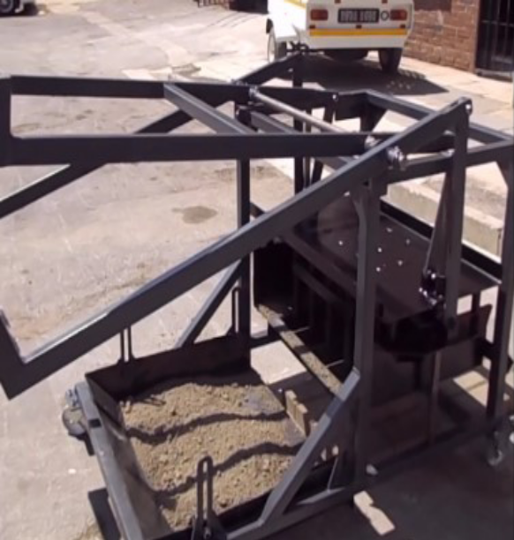  
  Drop the tamper 3 to 5 times down until the lever is laying flat on the welded plate that looks like a triangle.
  See image.
  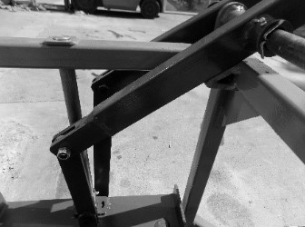
  This will indicate that the brick/block has reached its correct height.
  Release the block by pulling the outside handle down and pull the machine back.

3.2 Pour and compact concrete

Molding Sand-Cement Blocks

Sand-cement blocks may be molded byhand or with a simple hand-press.Blocks made by press are generallystronger and more durable.Butblocks made by either method areacceptable.

Forms
The most common nominal size of concrete blocks is 20cm x 20cm x 40cm.

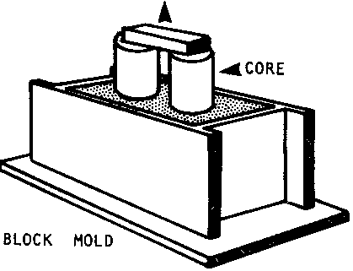
Fig.3.2 Block mold

The forms should be made of wood 2.5cm thick, with removable cores(or dowels) to create holes in the block.
Hand Molding
If a commercially made mold is not available, a mold' can be made out of 2.5-5cm lumber in the dimensions desired. Typically, these blocks are:
Table 3.2
NOMINAL SIZE, cm
20x20x40
15x20x40
10x20x40

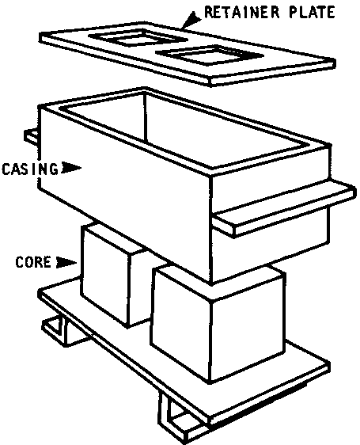
Fig. 3.3 Mold made out of lumber
Placing
Once the molds of the correct size have been built, shovel the wet mixture into the mold and shake them old to settle the contents.

Then re-fill the mold slightly over the top and pack the mixture down with a spade or shovel. Scrape any excess off after packing thoroughly.
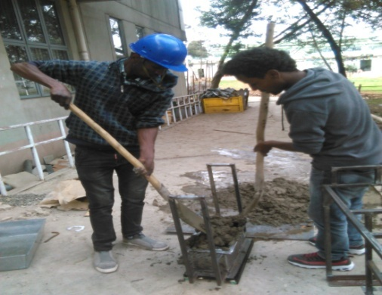
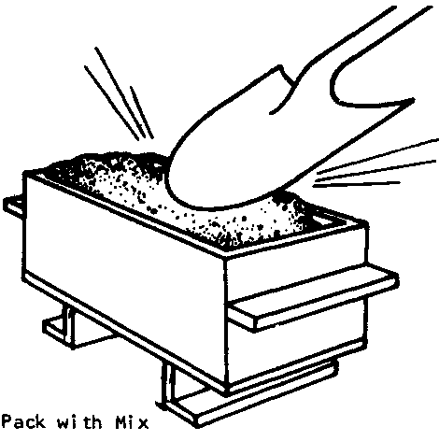

Fig.3.4 packing mold with mix
Compaction
According to Indian standard IS: manual compaction, the mixture shall be placed into the mould in layers of about 50 to 75 mm and each layer thoroughly tamped with suitable tampers until the whole mould is filled up and struck off level with a trowel.
In the case of mechanical compaction, the mould shall be filled up to overflow, vibrated or
Mechanically tamped and struck off level. After remolding the blocks shall be protected against sun and wind by placing on the shade until they are sufficiently hardened to permit handling without damage. On the other hand, GTZ low cost housing manual Volume I specify to vibrate the mixture for 60 second before extruded as hollow concrete block and transported and remains for 24 hours on wooden pallet then it is be cured covered by plastic sheet to enhance the curing process and preventing the water from evaporation.

Adequate care must be taken when compacting the concrete in the moulds of the block making machine. Too little or poor compaction will result in greatly reduced strengths.

3.3 De-molding or removal of mold

The moulds should be removed carefully so that the fresh blocks are not damaged.
Next, carry the full mold to the curing area.
Turn it upside down gently, and place it a few centimeters awayfrom any previous blocks.
Then, lift the mold off:
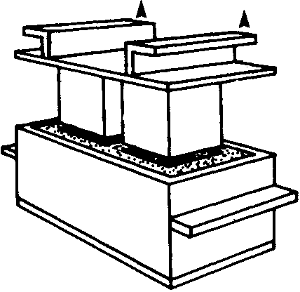
Fig.3.5 De-molding

First the core;
then, the casing Repeat the process until enough blocks have been made. Using several molds simultaneously will greatly speed the process.

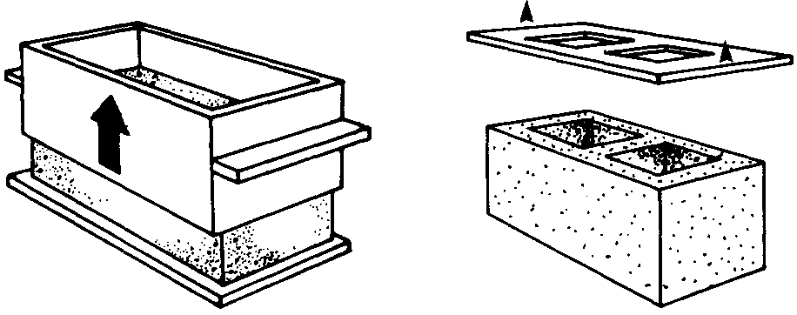
Fig.3.6 removal of mold component
Using several molds
Molding With A Hand Press
There are several types of hand press available for making strong sand cement blocks. Cinva-Ram and TekBlock presses are the most common, but any similar press will work as well.
There are three basic steps in the operation of most hand presses:
• loading the mold box;
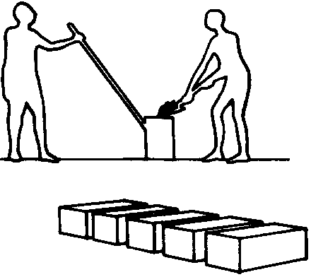
Fig. 3.7 loading the mold box
Loading the mold box
  - Compressing the mix;
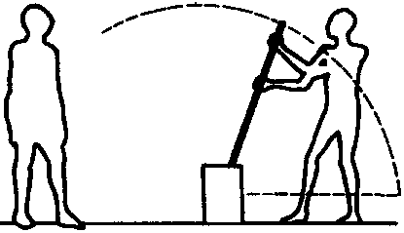
Fig. 3.8 Compressing the mix
Compressing the mix
- Ejecting the block.
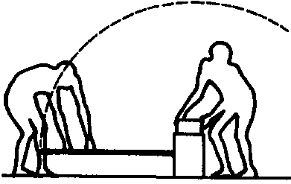
Fig. 3.9 Ejecting the block

Ejecting the block
With any hand press, it is a good idea to make a few test blocks before starting production in order to determine the correct amount of mix needed to make a strong block.
Curing Sand-Cement Blocks
Sand-cement blocks should be sprinkled with water after they have set for about 12 hours. They should be dampened at least once a day for 7 days. They should not be laid up in a wall for at least 12 days after being molded.

MANUFACTURING PROCESS OF BRICKS

There are four different operations are involved in the process of manufacturing of bricks:
  - Preparation of clay
  - Molding
  - Drying
  - Burning

Preparation of clay for brick manufacturing:
Preparation of clay for bricks manufacturing is done in six steps:
- Unsoiling of clay we need pure clay for the preparation of bricks. The top layer of soil may contain impurities, so the clay in top layer of soil about 200mm depth is thrown away. This is called unsoiling.
- Digging After the removal of top layer, the clay is dug out from the ground and spread on the plain ground.
- Cleaning In this stage, the clay is cleaned of stones, vegetable matter etc. if large quantity of particulate matter is present, then the clay is washed and screened. The lumps of clay are converted into powder with earth crushing rollers.
- Weathering The cleaned clay is exposed to atmosphere for softening. The period of weathering may be 3 to 4 weeks or a full rainy season. Generally, the clay is dug out just before the rainy season for larger projects.
- Blending If we want to add any ingredient to the clay, it is to be added in this stage by making the clay loose and spread the ingredient over it. Then take small portion of clay into the hands and tuning it up and down in vertical direction. This process is called blending of clay.
- Tempering In this stage, water is added to clay and pressed or mixed. The pressing will be done by cattle or with feet of men for small scale projects, pug mill is used as grinder for large scale projects. So, the clay obtains the plastic nature and now it is suitable for molding.
Molding of clay for brick manufacturing
In the molding process, prepared clay is mold into brick shape (generally rectangular). This process can be done in two ways according to scale of project.
  - Hand molding ( for small scale)
  - Machine molding ( for large scale)
Hand molding of bricks
If manufacturing of bricks is on a small scale and manpower is also cheap then we can go for hand molding. The molds are in rectangular shape made of wood or steel which are opened at the top and bottom. The longer sides of molds are projected out of the box to serve it as handles. If we take durability in consideration steel molds are better than wooden molds. In hand molding again there are two types and they are
  - Ground molded bricks
  - Table-molded bricks

3.4 Installing protection of freshly cast bricks/blocks

Installing shade for freshly cast block protection
Protection of freshly cast bricks/blocks is installed to minimize damage from rain and the drying impact of sun and wind.
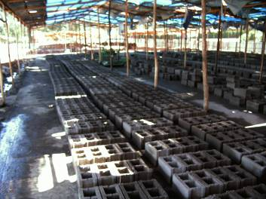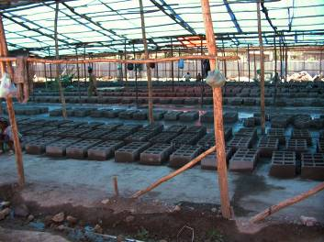
Fig.3.10 shade for freshly cast block protection

Self- check-3

Part I:- Short item questions
Instruction: write short answer for the given question. You are provided 3 minute for each question and each point has 6 Points.
  - Why freshly cast bricks/blocks is installed under shade?
  - DefinePouring?
  - Describe steps of brick production?
  - Explain purpose of conducting tests on block?
  - What is the most common nominal size of concrete blocks?

Note: Satisfactory rating – 15 and above points Unsatisfactory - below 15 points
You can ask you teacher for the copy of the correct answers.

Name: _________________________ Date: _______________

Operation Sheet-3 | Casting concrete into moulds

PURPOSE: -To produce Handmade Hollow Concrete Block
CONDITIONS OR SITUATIONS FOR THE OPERATIONS:-
- Ensure the work shop hazard free
- Wear appropriate clothes,
- Steel toe-capped boots.
- A dust mask
- Gloves ,
- Safety glasses

EQUIPMENT AND TOOLS
- Builders shovel.
- Buckets.
- Mold
- Compaction rammer
- Wheelbarrow or buckets

MATERIALS: -
- Concrete mixture
PROCEDURE,
Step-1-Identify job specifications
Step 2 -Place empty mould on a flat surface
Step 3 -Applying oil to the inside of the mould
Step 4 -Placing /Pouring the concrete
Step 5-Compacting
Step 6-Levelling
Step 7-De-molding or removal of mold

PRECAUTIONS:-
- Wear working cloths which properly fit with your body
- Wear Mask
- Make working area hazard free.
- The water used for mixing should be free from all harmful organic substances
- Mixed materials must be laid at the required site within 30 minutes after adding water to the cement.
- Wear water prove gloves
QUALITY CRITERIA:
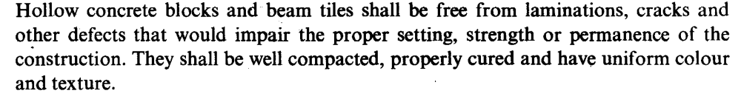

LAP Test -3 | Practical Demonstration
Name: _____________________________ Date: ________________
Time started: ________________________ Time finished: ________________
Instructions: Given necessary templates, tools and materials you are required to perform the following tasks within 40minutes

Task-1: Cast concrete into moulds

Unit Four: Cure and stack bricks/blocks
This learning guide is developed to provide you the necessary information regarding the following content coverage and topics:
- Removing and Stacking
- Stacking bricks and blocks
- Covering brick and block.
This guide will also assist you to attain the learning outcomes stated in the cover page. Specifically, upon completion of this learning guide, you will be able to:
  - Remove bricks and blocks production area
  - Stack bricks and blocks
  - Cover brick and block.

4.1 Removing bricks and blocks production area

Removing and Stacking
The blocks are either left to set and harden where they were moulded, or carried away on pallets to the curing place. In all cases it is important to keep the concrete moist, for example, by regularly spraying with water, until the concrete has obtained sufficient strength.
Concrete blocks can be demoulded by several methods, manually concrete on wooden or steel palliate to large-scale production with 'egg-laying' mobile machines by chain systems
A very basic form of storage, in which objects are placed on a surface (usually a flat floor) and stacked on top of one another in blocks, is known as block stacking.
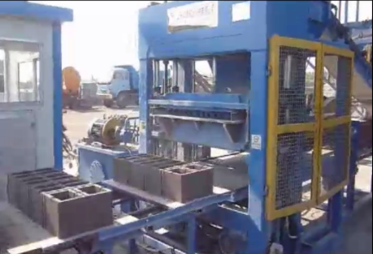
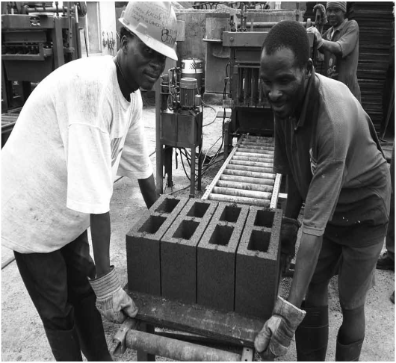
Fig.4.1 carefully removing compacted HCB
Purpose
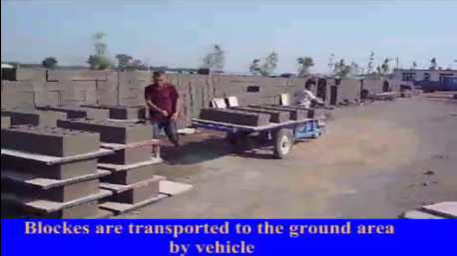
The blocks are demoulded immediately after compaction, so that they have to maintain their shape even before the concrete hardens and Transported to stacking area to cure.

Fig.4.2Block Transported to stacking area to cure

Covering brick and block.

4.2.1 Covering
Fresh blocks should be protected from the rain and from the drying effects of the sun and wind during the first day with plastic sheets or any suitable covering.

In some cases, it may be necessary to protect blocks from frost damage. Covering with plastic sheeting with the edges held down is normally sufficient.

To minimize breakages in cold weather, increase the cement content of the mix or thecuring period before moving blocks.

Curing of bricks and block
Curing is one of the most essential parts of brick and block production. Correct curing has a big effect on the quality of the end product and also the cost of the end product. Often with good curing the cement content of your blocks can be reduced drastically.

It is recommended that the freshly made blocks are covered immediately with a 250micron black plastic and cured by keeping the plastic over the bricks/blocks for a minimum of 7 days. Remove the curing plastic briefly to thoroughly wet the blocks/bricks twice a day starting from the day after production.
A record should be kept with the curing block of when they were produced so the curing plastic can be removed on the morning of the eighth day after production.
With 7 days curing the bricks/blocks will have reached approximately 75% of their final strength.
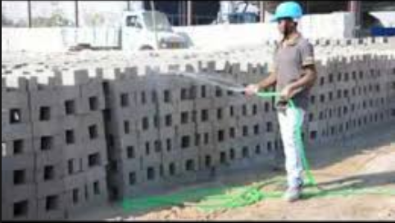
Water curing is the most commonly used practice. It is the system that is most appropriate for house construction and does not require any special infrastructure or skill. However, water curing requires a lot of water, which is not always easy at hand and might be even expensive.

Fig 4.3.curing techniques
In order to economize on water it is important that all measures are taken to prevent water evaporation of cement products. E.g. concrete must be protected from direct sunshine and winds to prevent rapid water evaporation. Methods such as covering the concrete with wet, earth, sand, sawdust, grass and leaves are inexpensive, still quite effective. Further, plastic, jute bags, hessian clothes too are common used material to prevent rapid water evaporation of cement products. Wood forms left in place also furnish good protection if they are loosened and flooded with water at frequent intervals.
It is of paramount importance that the entire cement product (concrete blocks, pavement tiles, stone masonry, brick masonry, plaster work, cement flooring work etc.) is kept wet and that it does never fully dry out, otherwise the final strength of the cement product will suffer. If the hydration process has prematurely ended due to overheating (no curing), sprinkling water onto the fully dried out cement product will not reactivate the hydration process, the loss in strength will be permanent. In water curing, the cement product must be kept fully wet (e.g. by covering the products with plastic canvas) for at least 7 days.

Self -check-4

Part I:- Short item questions
Instruction: write short answer for the given question. You are provided 3 minute for each question and each point has 6 Points.
    - Define the term stacking?
    - What are Purpose of Covering freshly casted blocks?

Note: Satisfactory rating – 6 and above points Unsatisfactory - below 6 points
You can ask you teacher for the copy of the correct answers.

Name: _________________________ Date: _______________

Unit Five: Assess quality of bricks/blocks
This learning guide is developed to provide you the necessary information regarding the following content coverage and topics:
- Inspecting brick and block.
- Applying proper curing
- Testing brick and block quality.
This guide will also assist you to attain the learning outcomes stated in the cover page. Specifically, upon completion of this learning guide, you will be able to:
- Inspect brick and block.
- Apply proper curing
- Test brick and block quality.

5.1 Inspecting brick and block

The manufacture of concrete blocks requires constant monitoring to produce blocks that have the required properties. The raw materials are weighed electronically before they are placed in the mixer. The trapped water content in the sand and gravel may be measured with ultrasonic sensors, and the amount of water to be added to the mix is automatically adjusted to compensate. In areas with harsh temperature extremes, the water may pass through a chiller or heater before it is used.
As the blocks emerge from the block machine, their height may be checked with laser beam sensors. In the curing kiln, the temperatures, pressures, and cycle times are all controlled and recorded automatically to ensure that the blocks are cured properly, in order to achieve their required strength.
Strength:
The quality of blocks should be controlled so that the strengths are adequate to avoid breakages or rejection by customers and the mixes are as economical as possible Ideally, blocks should be regularly tested for strength and mixes, and production processes modified if necessary. If testing is not practical or unaffordable, block strength should be continually assessed by looking to see if the corners and edges, or even the whole bricks, tend to break in handling. Knocking two bricks together can also be used to assess strength.
Dimensions:
The length and width of the units are determined by the mould and will not varygreatly. However, the height can vary and should be monitored using a simple gauge.Units of inconsistent height will lead to difficulties during building and possibly causerain penetration.
Shrinkage:
Concrete masonry units shrink slightly after manufacture. In order to avoid this fromhappening in the wall, cured blocks should be allowed to dry out for at least seven daysbefore being used for construction.
Compressive Strength
According to Ethiopian standards hollow concrete block shall conform four classesdepends on their strength, as Class A, B, C and D and their requirements are defined below and their minimum comprehensive strength listed in Table 5.1. On the other hand Indian standard recommended classes of hollow concrete blocks as A, B, and C but class D manufactured as solid block used for the purpose of load bearing wall having a minimum density of 1800 kg/m3.
- Class A used for load bearing wall construction above or below ground level in damp
proof course, in exterior walls that may or may not be treated with weather- protective
coating and for interior walls and density of Class A blocks must conform between the range of 900 – 1200 kg/m3 on the other hand Indian standard recommended minimum density 1500 kg/m3.
- Class B and C are used for load bearing wall construction above ground level in damp proof course in exterior walls that are treated with suitable weather- protective coating and their density should be between 900 – 1200 kg/m3 on the other hand Indian standard recommended minimum density within the range of 1000-1500 kg/m3 but class C is recommended for non load bearing wall.
- Class D are used for non load bearing interior walls and exterior panels walls in steel or reinforced concrete framed construction when protected from weather by rendering or by some other efficient treatment and their density should be between 600 - 900 kg/m3.

Table 5.1 Comprehensive strength of hollow concrete blocks at 28 days ES.
Type of hollow  concrete block | Class | Minimum comprehensive strength (N/mm2)
Type of hollow  concrete block | Class | Average of 6 units | Individual units
Load bearing | A | 5.5 | 5.0
Load bearing | B | 4.5 | 4.0
Load bearing | C | 3.5 | 3..0
Non load bearing | D | 20 | 1.8

Block Density
For hollow concrete, low density is probably the most characteristic feature. This is due to the
holes. In addition, it depend primary on the aggregate density and the proportions of aggregate because the particle density of individual grading fraction can differ considerably and thus will affect the density of concrete. This property also influenced by the cement, water and air contents.

The density of a block can only be obtained after the casting process by taking three blocks taken randomly from the selected samples and then dried to constant mass in a suitable oven heated to approximately 105°C. After cooling the blocks to room temperature, the dimensions of each block shall be measured in centimeters (to the nearest millimeter) and the overall volume computed in cubic centimeters. According to Ethiopian standard and Indian standard three blocks shall be taken for average density and it should conform to the requirements specified in Table 5.2 below. The blocks shall then be weighed in kilograms (to the nearest 10 g) and the density of each block calculated as follows:

Table 5.2 density classification of concrete masonry units [ES] and [IS]
Class of Hollow  concrete block | Ethiopian standard  ES 596:2001  (kg/m3) | Indian standard  IS: 2185-1979  (kg/m3)
A | 900-1200 | 1500
B | 900-1200 | 1000-1500
C | 900-1200 | 1000-1500
D | 600-900 | 1800

Note- According to Ethiopian standard Class A, B, C are load bearing units but class D is non load bearing unit but in case of Indian standard class A and B are load bearing units but Class C is for non load bearing units

Testing brick and block quality

5.2.1 Bricks test
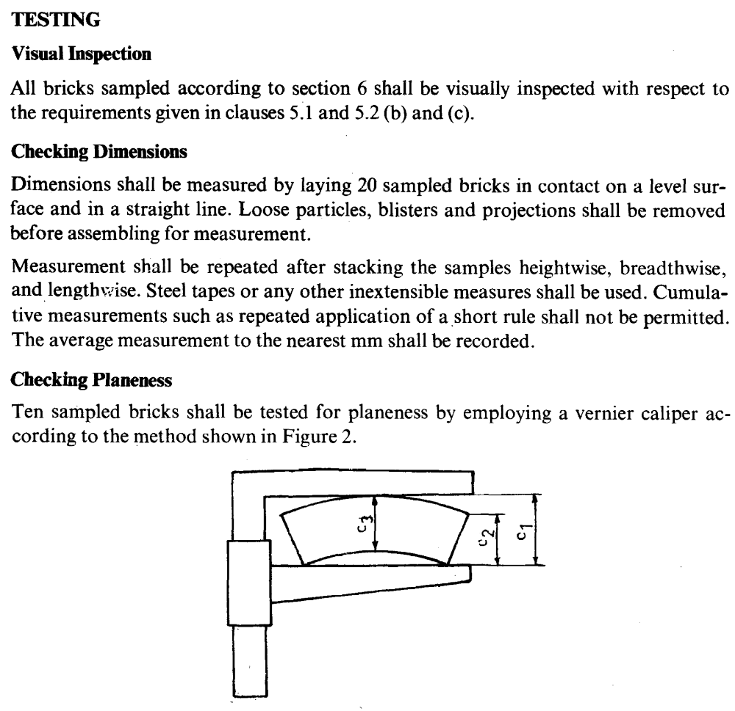
Fig.5.1 method of testing plainness

blocks test
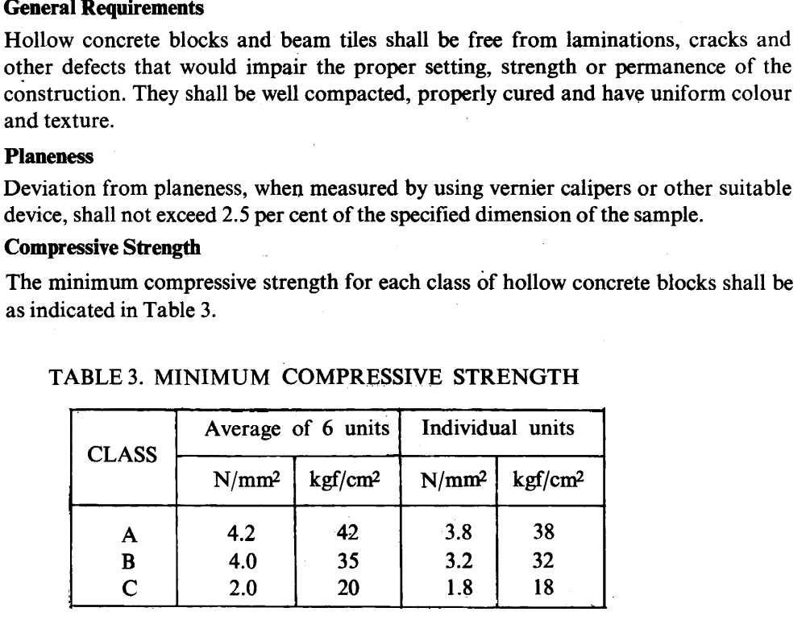
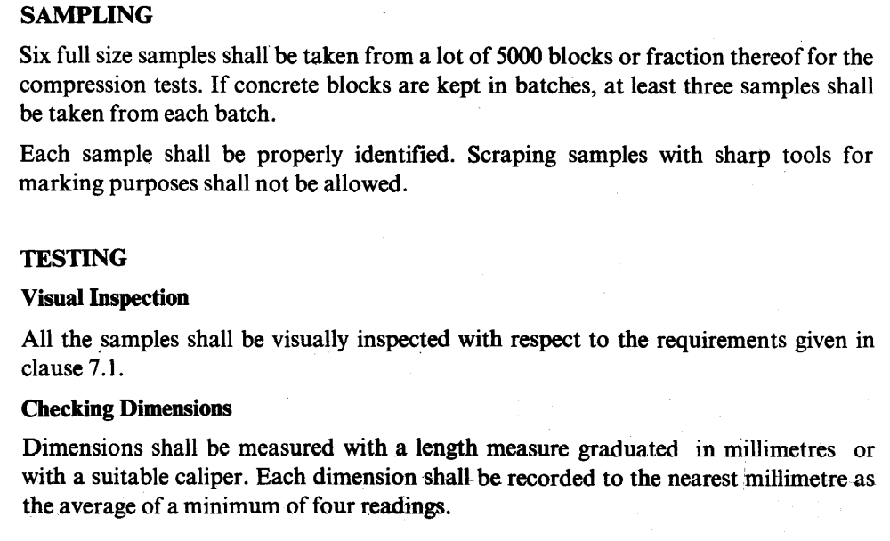
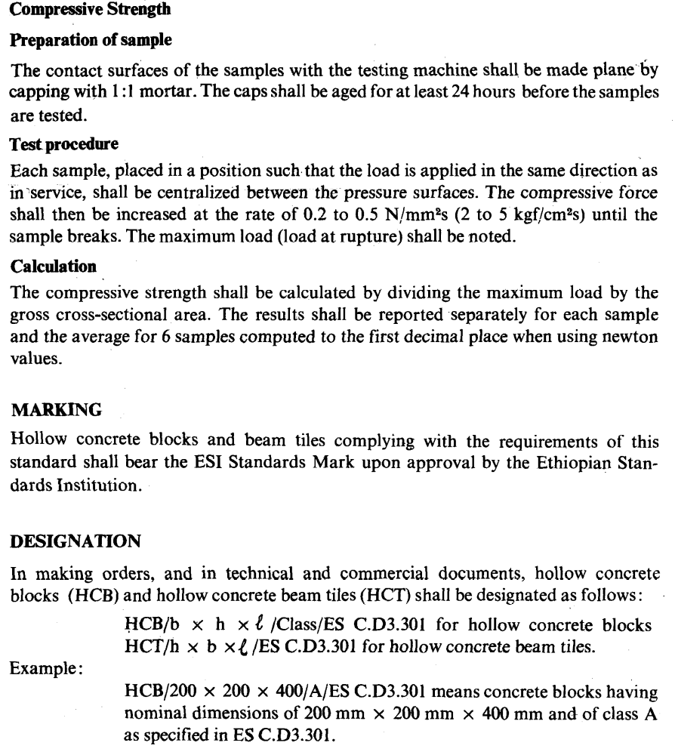

Self -check-5

Part I:- Short item questions
Instruction: write short answer for the given question. You are provided 3 minute for each question and each point has 6 Points.
- What are the quality requirements of produced concrete block?
- Write the standard dimensions hollow concrete block according to EBCS?
- What is the purpose of Inspecting blocks for strength, dimension and shrinkage?
- List classes of HCB according to Ethiopian Standard?

Note: Satisfactory rating – 12 and above points Unsatisfactory - below 12 points
You can ask you teacher for the copy of the correct answers.

Name: _________________________ Date: _______________

Unit six: Clean up
This learning guide is developed to provide you the necessary information regarding the following content coverage and topics:
- Clearing work area
- Disposing and reusing and recycling of material
- Maintenance and storage of plant, tools and equipment

This guide will also assist you to attain the learning outcomes stated in the cover page. Specifically, upon completion of this learning guide, you will be able to:
- Clear work area
- Dispose ,reuse and recycle material
- Maintain and store of plant, tools and equipment

6.1 Clearing work area

Safety of Working Area
Working place or area is whole building/construction/ site including tools,equipment, machines, storerooms, etc. Within the general working place there is a personal working area /space/, where someone is building up a wall or other related activities. Working space is essentially required for all construction workers, to accommodate materials and equipments for the process; therefore, it is a crucial and necessary to keep them all in proper manner.
A neat and tidy site safes time, eases the work and avoids accidents. If things like tools, battens, boards, stones, cables, steel bars etc. are not used or kept improperly they are obstacles for the construction process and can be the cause for accident.
Relevant legislation, regulations and job specifications
The Producer (she/he) shall, during the production period maintain and clean up both permanent and temporary facilities. He/she shall provide temporary site drainage to leave the facilities free of standing water, accumulation of scrap, debris, waste material, and maintain good standards of hygiene.
Inspection shall be carried out daily to ensure that sufficient workmen/women, tools and facilities are provided to maintain the standard of hygiene.
Final cleaning of the site and removal of all temporary facilities shall be carried out to approval at completion of works.

6.2 Disposing and reusing and recycling of material

Definition
Disposing Removing and destroying or storing damaged, used or other unwanted domestic, agricultural or industrial products and substances
Recycling means turning an item into raw materials which can be used again, usually for a completely new product. This is an energy consuming procedure.
Reusing refers to using an object as it is without treatment. This reduces pollution and waste, thus making it a more sustainable process.

Purpose
When looking into environmental sustainability, cutting consumption or reducing rubbish during a house clearance, it’s more than likely that you’ll come across the following 3Rs: reduce, reuse and recycle.
Reusing (R), and recycling (R) can help you, your community, and the environment by saving money, energy, and natural resources.
Recycling is the process of collecting and processing materials that would otherwise be thrown away as trash and turning them into new products. Recycling can benefit your community and the environment.
Recycling reduces waste disposal by transforming useful materials such as plastic, glass and paper into new products
The reusing process is not just about re-purposing materials, but the object as it is. This includes buying and selling used goods and repairing items rather than discarding them. Reusing is better than recycling because it saves the energy that comes with having to dismantle and re-manufacture products. It also significantly reduces waste and pollution because it reduces the need for raw materials, saving both forests and water supplies.
Waste that cannot be reused or recycled in some form eventually finds its way to disposal. This disposal includes landfills, but an increasing number of municipalities have elected to divert waste into resource recovery. These recovery methods use the waste to generate electricity or produce raw materials for industry.

6.3Maintenance and storage of plant, tools and equipment

6.3.1 Maintenance
Maintenance on plant and equipment is carried out to prevent problems arising, to put faults right, and to ensure equipment is working effectively.
Maintenance may be part of a planned programme or may have to be carried out at short notice after a breakdown.

Important of maintenance plant and equipment
An effective maintenance programme will make plant and equipment more reliable. Fewer breakdowns will mean less dangerous contact with machinery is required, as well as having the cost benefits of better productivity and efficiency.
Additional hazards can occur when machinery becomes unreliable and develops faults. Maintenance allows these faults to be diagnosed early to manage any risks. However, maintenance needs to be correctly planned and carried out. Unsafe maintenance has caused many fatalities and serious injuries either during themaintenance or to those using the badly maintained or wrongly maintained/repaired equipment.

Necessary consideration
If you are an employer and you provide equipment for use, from hand tools and ladders to electrical power tools and larger plant, you need to demonstrate that you have arrangements in place to make sure they are maintained in a safe condition.
Think about what hazards can occur:
- if tools break during use
- machinery starts up unexpectedly
- there is contact with materials that are normally enclosed within the machine, ie caused by leaks/breakage/ejection etc
Failing to correctly plan and communicate clear instructions and information before starting maintenance can lead to confusion and can cause accidents.
Establishing a planned maintenance programme may be a useful step towards reducing risk, as well as having a reporting procedure for workers who may notice problems while working on machinery.
Some items of plant and equipment may have safety-critical features where deterioration would cause a risk. You must have arrangements in place to make sure the necessary inspections take place.
Clean and Check
- Release any stored energy, such as compressed air or hydraulic pressure that could cause the machine to move or cycle
- Support parts of plant that could fall, eg support the blades of down-stroking bale cutters and guillotines with blocks
- Allow components that operate at high temperatures time to cool
- Place mobile plant in neutral gear, apply the brake and chock the wheels
- Safely clean out vessels containing flammable solids, liquids, gases or dusts, and check them before hot work is carried out to prevent explosions. You may need specialist help and advice to do this safely
- Avoid entering tanks and vessels where possible. This can be very high-risk work. If required, get specialist help to ensure adequate precautions are taken
- Clean and check vessels containing toxic materials before work starts

Dos and don’ts of plant and equipment maintenance
Do…
- Ensure maintenance is carried out by a competent person (someone who has the necessary skills, knowledge and experience to carry out the work safely)
- Maintain plant and equipment regularly – use the manufacturer’s maintenance instructions as a guide, particularly if there are safety-critical features
- Have a procedure that allows workers to report damaged or faulty equipment
- Provide the proper tools for the maintenance person
- Schedule maintenance to minimise the risk to other workers and the maintenance person wherever possible
- make sure maintenance is done safely, that machines and moving parts are isolated or locked and that flammable/explosive/toxic materials are dealt with properly
Don’t…
- Ignore maintenance
- Ignore reports of damaged or unsafe equipment
- Use faulty or damaged equipment
Dos and don’ts of machinery safety for workers
Do…
- Check the machine is well maintained and fit to be used, ie appropriate for the job and working properly and that all the safety measures are in place – guards, isolators, locking mechanisms, emergency off switches etc
- Use the machine properly and in accordance with the manufacturer’s instructions
- Make sure you are wearing the appropriate protective clothing and equipment required for that machine, such as safety glasses, hearing protection and safety shoes
Don’t…
- Use a machine or appliance that has a danger sign or tag attached to it. Danger signs should only be removed by an authorized person who is satisfied that the machine or process is now safe
- Wear dangling chains, loose clothing, rings or have loose, long hair that could get caught up in moving parts
- Distract people who are using machines
- Remove any safeguards, even if their presence seems to make the job more difficult

Self check-6

Part I:- Short item questions
Instruction: write short answer for the given question. You are provided 3 minute for each question and each point has 6 Points.
- What is the 3R Define? 6 points
- Describe the important of maintenance plant and equipment?
- Define the terms dispose,reuse and recycle ofmaterial?

Note: Satisfactory rating – 9 and above points Unsatisfactory - below 9 points
You can ask you teacher for the copy of the correct answers.

Name: _________________________ Date: _______________

List of Reference Materials

- Beall. (2000). New masonry products,materials.progress in structural engineering and materials.
- Environment Protection Guidelines for Construction and Land Development in the ACT retrieved from https://ginninderry.com/wp-content/uploads/2017/03/EPA-Guidelines-for-Construction-and-Land-Development-ACCESS.pdf. accessed on Oct 30/2017.
- Eshetu, A. (2005). Concrete Production and Quality Control in Building Construction industry of Ethiopia. Addis Ababa University press.
- Formoso, C.T., Isatto, E.L., and Hirota, E.H. ( 1999). Method for waste Control in theBuilding Industry, IGLC-7 proceedings, University of California, Berkeley, CA,
- HeiniMüller 2004;BasicConstruction Training Manual for Trainers; module 2USA276.
- Storing, stacking and handling practice from
https://law.resource.org/pub/bd/bnbc.2012/gov.bd.bnbc.2012.07.02.pdf
- Compressive Strength Test on Concrete Core – Calculation and Results
- Methods of Testing Compressive Strength of Masonry
- http://www.afrisam.co.za/uploads/documents/p8132_your_guide_to_concrete_brick_and_block_making_r.pdf
- Mid rand, 2013. How to make concrete bricks and blocks.Published by the concrete institute.
Testing of Concrete Masonry Blocks for Compressive Strength and Density from
- https://theconstructor.org › How to Guide.1 Nov 2016.
- C. R. C. Mohanty, UNCRD ;9 May 2011,
- REDUCE,REUSE AND RECYCLE(3R) AND RESOURCE EFFICIENCY AS THE BASIS FOR Sustainable Waste Management. New York.
- Workplace Housekeeping - Basic Guide; Document confirmed current on June 6, 2014.

Participants of this Module (training material) preparation
No | Name | Qualification (Level) | Field of Study | Organization/ Institution | Mobile number | E-mail
1 | Tesfaye Assegidew | A | Construction Mgt | Butajira PTC | +251913442444 | tesfayeassegidew@gmail.com
2 | Melsew Keba | Msc | Construction Mgt | Assosa PTC | +251913283335 | melsewkeba@gmail.com
3 | Dawit showafera | Msc | Construction Mgt | DDPTC | +251986314667 | dawitshowafera835@gmail.com
4 | Muluken Solomon | Msc | Construction Mgt | Batu PTC | +2519-12289146 | mulecot99@gimal.com
5 | Tiruneh Asebe | Msc | Construction Mgt | Hossana PTC | 0911422557 | tirunehasebe@gamial.com

