STRUCTURAL CONSTRUCTION works
Level – II
Based on March, 2022 Curriculum Version 1
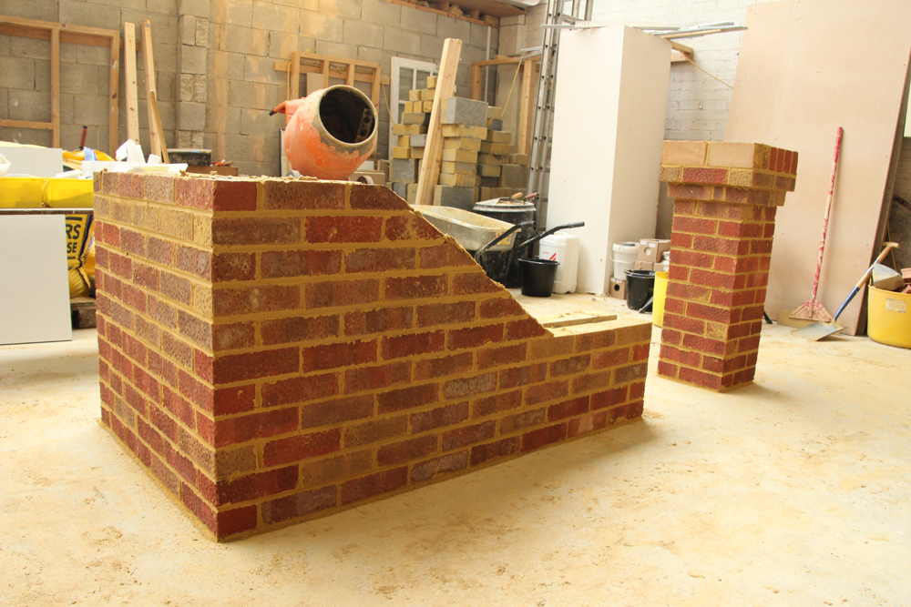
Module Title: - Lay Multi-thickness Walls and Piers
Module code: EIS SCW2 M04 0322
Nominal duration: 100 Hour

Prepared by: Ministry of Labour and Skill
August, 2022
Addis Ababa, Ethiopia
Contents
Acknowledgment 4
Introduction to the Module 6
Module Instruction 8
Unit one: Prepare for work 9
Introduction 10
1.1Work instructions 13
1.2Workplace safety requirements 18
1.3Plant, tools and equipment 23
1.4Materials of brick masonry 32
1.5Material quantity 34
1.6 Environmental protection requirements 37
Self check-1 40
Unit Two: Set out brickwork 42
2.1.Erecting work platform 43
2.2. Location and structural details of brickwork 44
2.3.Setting out 46
Self check-2 48
Operation sheet -2.1 49
LAP Test -2 50
Unit Three: Construct walls and attached piers 51
3.1.Mixing mortar 52
3.2.Constructing multi-thickness wall 63
3.3. Bonding piers to wall 69
3.4.Damp proof 72
3.5.Constructing openings and installing lintels 75
3.6.Tie down and lateral support systems 79
Self check-3 82
Operation Sheet-3.1 83
Operation Sheet-3.2 85
Operation Sheet-3.3 87
LAP Test -3 89
Unit Four: Construct isolated piers 90
4.1.Constructing piers 91
Self check-4 100
Unit Five: Finish joints 101
5.1.Cleaning surfaces of brickwork and cavities 102
5.2.Raking joints of laid brickwork 103
5.3.Brushing brickwork 104
Self check-5 105
Unit six: Clean up 106
6.1.Clearing work area 107
6.2. Disposing and reusing and recycling of material 110
6.3. Maintenance And Storage Of Plant, Tools And Equipment 111
Self check-6 117
List of Reference Materials 119

Acknowledgment

Ministry of Labor and Skills wish to extend thanks and appreciation to the many representatives of TVET instructors and respective industry experts who donated their time and expertise to the development of this Teaching, Training and Learning Materials (TTLM).

Acronym

Introduction to the Module

This module contains information and suggested learning activities on structural construction works II. It includes instructions and procedure on how Lay Multi-thickness Walls and Piers.

It is specifically focusing on the practical implementation level and provides a wide range of essential information as well as dos and don’ts for trainers to communicate to masons and supervisors during theoretical and on the job trainings. It also contains figures and sketches / drawings that add clarity to the context. These figures and sketches have been collected from various reference sources and are therefore, not of uniform character in its present form.

The module consists of six units. Each unit contains learning activities supported by information sheets.

This module covers the units:
- Plan and prepare
- Mixing ingredient and cement
- Cast ingredients into molds
- Cure and stack bricks/blocks
- Assess quality of bricks/blocks
- Clean up
Learning Objective of the Module
- Plan and prepare
- Mix ingredient and cement
- Cast ingredients into molds
- Cure and stack bricks/blocks
- Assess quality of bricks/blocks
- Clean up

Module Instruction

Read the specific objectives of this Learning Guide.
- Follow the instructions described below.
- Read the information written in the “Information Sheets”. Try to understand what are being discussed. Ask your trainer for assistance if you have hard time understanding them
- Accomplish the “Self-checks” which are placed following all information sheets.
- Ask from your trainer the key to correction (key answers) or you can request your trainer to correct your work. (You are to get the key answer only after you finished answering the Self-checks).
- If you earned a satisfactory evaluation proceed to “Operation sheets
- Perform “the Learning activity performance test” which is placed following “Operation sheets” ,
- If your performance is satisfactory proceed to the next learning guide,
- If your performance is unsatisfactory, see your trainer for further instructions or go back to “Operation sheets”.

Unit one: Prepare for work
This unit is developed to provide you the necessary information regarding the following content coverage and topics:
  - Work instructions
  - Safety requirements
  - plant, tools and equipment
  - Materials of brick masonry
  - Material quantity
  - Environmental protection requirements
This unit will also assist you to attain the learning outcomes stated below. Upon completion of this unit, you will be able to:
  - apply work instructions
  - Follow safety requirements
  - Select plant, tools and equipment
  - identify materials of brick masonry
  - Calculate material quantity
  - Identify environmental protection requirements

Introduction

The term masonry is used to indicate the art of building the structure. Masonry work is one of the major building crafts and one of the oldest. Masonry is defined as the construction of building units bonded together with mortar. The building units are stones, bricks or precast blocks of concrete. When stones are used as the building units it is called stone masonry. Similarly in brick masonry bricks are used as the building units. Even though new principles of construction and new materials become prominent in building construction practices, masonry has got the highest importance in building industry.

Terms Used In Masonry Work
- COURSE: A horizontal layer of similar bricks or stones that are bonded with mortar is known as course.
- QUOINS: Quoins are the stones used for the corners of the walls.
- BED: The horizontal layer of mortar where brick or stone units are laid is known as bed.
- BACK: The inner surface of a brick wall which is not exposed termed as back. The material forming back is known as backing.
- FACE: The exterior surface of a brick wall which is exposed to weather termed as face. The material used in the face of the wall is known as facing.
- HEARTING: The interior portion of a wall between the facing and backing is termed as hearting.
- JOINT: The junction of two or more bricks or stones is called joint. There are eight types of mortar joints-
- Concave
- Vee
- Flush
- Raked
- Extruded
- Beaded
- Struck
- Weathered
- HEADER: The shorter side or end face of a brick that is exposed is termed as header.
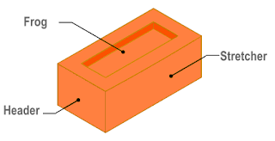
- STRETCHER: The longer narrow side or face of a brick that is exposed is termed as stretcher.
- FROG: An indentation or depression on the top face of the brick made with the object of forming a key for the mortar is termed as frog. The depth of frog is usually between 10-20 mm.
- BOND: This is the method of arranging bricks so that the individual units are tied together.
- ARRIS: The sharp corner edges of brick are known as arris.
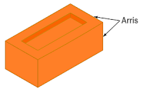
- SPALLS: Spalls are the chips of stones used for filling the interstices in stone masonry.
- BAT: The portion of bricks cut across the width is termed as bat.
- Three Quarter Bat: It is the form of brick bat having its length equal to three quarter of length of a full bricks.
- Half Bat: If the length of the bat is equal to half the length of the full bricks.
- Bevelled Bat: A brick bat is called bevelled bat when its width has bevelled.
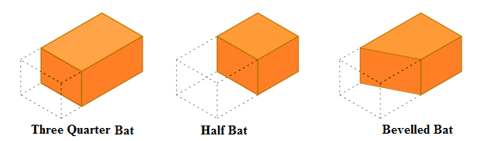
- CLOSER: Closer is the small piece of brick cut lengthwise in such a manner that its one long face remains uncut and used at the end of masonry wall to maintain bond pattern.
- QUEEN CLOSER: When a brick is cut along its length, making it two equal pieces then it is called queen closer.
- QUEEN CLOSER QUARTER: When a queen closer is cut in to two equal pieces then it is called as queen closer quarter.
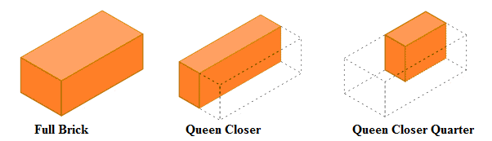
- KING CLOSER: King closer are the portion of a brick obtained by cutting off the triangular piece between center of one end and the center of one side.
- BEVELLED CLOSER: Similar to king closer with the only difference that the whole length of the brick bevelled for maintaining the half width at one end and full width at the other.
- MITRED CLOSER: It is a brick whose one end is cut splayed or mitred for full width. The angle of splay varies from 45 to 60 degree.
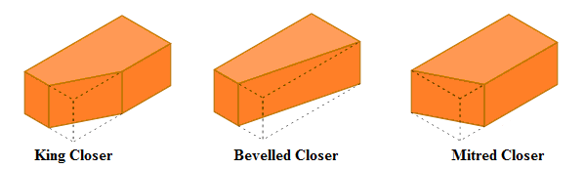
- ROWLOCK: The head is visible and the long narrow sides are on bottom and top.
- ROWLOCK STRETCHER: When the thinner stretcher sides are on bottom and top faces on the sides.
- SAILOR: The heads are on top and bottom and the stretcher faces are on the side. Mostly used for decoration.
- SOLDIER: The stretcher side is visible and the heads are at the bottom and top. It is usually used for decoration.
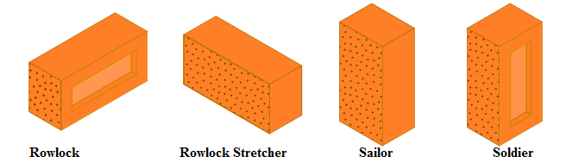

- BUTTERING: Placing of mortar in on masonry block with trowel is termed as buttering.

1.1 Work instructions

Definition of Terms
- Accessing – the process of entering information or data
- Application - the observance of or putting into the work or job specifications provided for in the manual of instruction
- Catalogues - the book containing list of items, object or materials /parts
- Construction sector - the group or field of specialization
- Data - the factual information or applied to any given task
- Instructional materials - reading materials, such as books, manuals, video tapes, cd‟s and other related items
- Manual - book catalogue that explains how to use certain materials, tool or equipment
- Specification - the descriptive characteristics of a certain manual, job or type of work
- Store - the process of keeping the manuals or any documents to prevent them from being damaged
- Storing cabinet - a wooden or steel enclosure where manuals and catalogues are stored
- Version - the style or way on how certain data are encoded
- TABS - labels or tags attached at the edge of certain pages of a book or compilation
- Warranty period - the number of days, months or years that a certain item purchased or delivered is guaranteed by the supplier or the source for repair or replacement if found
- damaged or destroyed under normal conditions

1.1.1 Identify access and interpret specification materials

Manual
A manual contains a systematic process that which describes in a very clear and step-by-step procedure. Otherwise, it will be a confusing manual which leaves the reader no better able to complete the process after reading it than he or she was before. Normally, it uses diagrams to clarify information that would be difficult to convey accurately in words. Also, use them for information that is so complex as to be confusing to the reader without a visual representation of the item, part or process to which he can refer as he carries out the manual's instructions.

Manuals /catalogues should be identified per job description. They must be updated and checked to ensure their content is updated. Manuals /catalogues should be stored properly to avoid damage.

Types of manual
1. Operator’s Manual is called owner‟s manual, instructional book, and handbook. It shows how to safely operate and use a machine. Usually it includes basic maintenance, safety information and specifications. The biggest and most important sections of an operator‟s manual should include: company policies, topics off limits for representatives and detailed answers to the most common questions
2. Parts Manual is also called parts book, parts catalog, or spare parts list used by representatives or dealer. It contains exploded parts, their relationship and location. Usually, it includes the part number and their brief description.
3. Service Manual is also called shop, repair, workshop and technical manual. Some of the types are very detailed, while some are shortened versions or specific areas of
repair –ex. Hydraulic system only.

A repair manual which is a service manual has the following sections: parts guide, symptom/solution troubleshooting matrix, contact information, routine maintenance, document conventions section, glossary, table of contents.

Signs and Symbols
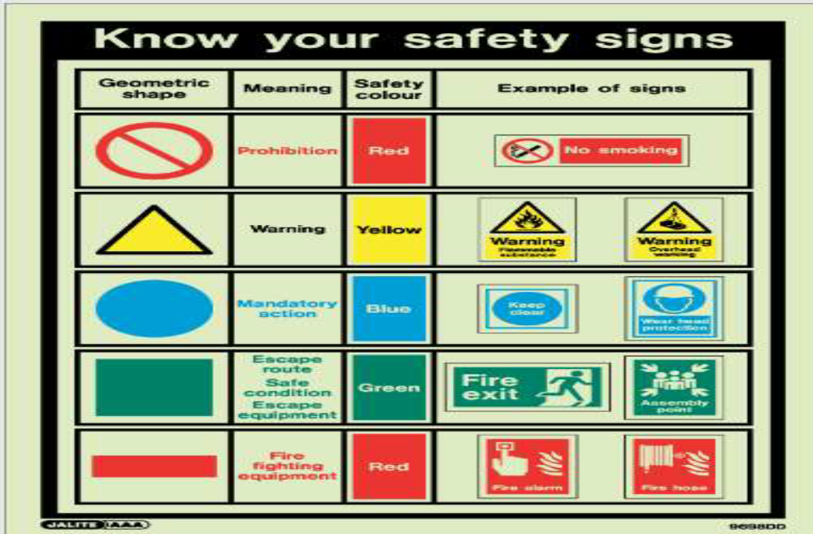
Fig 1. Signs and Symbols

Most manuals of any type contain instructions, specifications, or certain information accompanied by different signs and symbols for clarity and emphasis. Some are used to caution or alarm the reader. Signs and symbols used are dependent upon the type of manual. However, there are similar symbols and signs which are found in almost all manuals of different types.

Application of specification from the manuals
An owner‟s manual (also called as instructional manual) is an instructional book or booklet that is supplied with almost all technologically advanced consumer product such as vehicles, appliances and computer peripherals. It is a reference tool which means it is supplied with TABS printed on the edges of each page for each section. These sections are well-arranged for easy reference especially of the first-time owner.

Generally, these sections include the following:
- What's in the Box. It is what the customers need to know when they open the box in case something is missing. Parts are in full basic form. Example: Player, remote, cable, manual, and batteries. There are pictures of these parts for facility purposes as some users may be inexperienced and need assistance in identifying parts.
- Getting Started. It explains to the readers what needs to be done first before the continue with the manual. This includes removing hidden packing material inside the device, removing a transit screw or installing a part that must be installed before starting such as an ink cartridge, or removing clear protective plastic film over displays or other parts.
- Connections (or Installing). It includes the step-by-step directions. In case of connecting or installing a device, it shows action photos of the product being installed. Photos are very important. The manual is of great help due to its photos.
- Setup (or Configuration). In this section, the step-by-step directions with images on how to configure or setup your product are included. Detailed steps are enumerated with clear photos or screen shots.
- Basic Use (or Operation). ). In this section, all basic operations are listed. These basic operations are to be used daily.
- Advanced Use (or Operation). In this section, all advanced operations are listed which will be performed mainly by advanced users.
- Special Features. These are those that set the product apart from others.
- Troubleshooting. This section is a large table that lists common problems user might encounter with a known cause and solution. It includes general issues like "Sound but no video", "Video but no sound", "Starts up but shuts itself off again".
- Specifications. In this area, list of electrical specifications, physical dimensions, weight, fidelity specs is found. Also, list of limitations such as a sound meter's range, the maximum power output of an amplifier or maximum speed of a drill or saw is specified.
- Parts List. This area provides an exploded view of the device. The parts listed cover all detailed parts with part numbers and names. This page also includes a phone number, website, and email address to obtain replacement parts as appropriate for the product.
- Warranty information. This is sometimes provided as a separate sheet.

Until the last decade or two of the twentieth century, it was common for an owner‟s manual to include detailed repair information such as a circuit diagram. However, as products became more complex, this information was gradually relegated to specialized service manual, or dispensed with entirely , as devices became too inexpensive to be economically repaired.

Owner manuals for simpler devices are often multilingual so that the same boxed product can be sold in many different markets. Sometimes, the same manual is shipped with a range of related products such that the manual contains a number of sections that apply only to some particular models in the product range.

1.2 Work place safety requirements

While not always considered high-risk work, bricklaying still comes with a high potential for workplace injury.
Bricklayer Safety Overview
For this reason a Safe Work Method Statement (SWMS) that outlines all risks and control measures should be prepared prior to commencing work. This way all potential hazards and risks can be identified and eliminated as far as possible.
It is also important that all relevant workers are involved in the development of the SWMS.
Here are just some of the risks faced by bricklayers, along with the hazards, and possible control measures to reduce the risk of injury to bricklayers.

Manual handling
Manual handling is a leading form of workplace injury for bricklayers. Manual handling encompasses a wide range of actions including lifting, lowering, pulling, pushing, and carrying awkward and heavy objects.
Both laying bricks and moving bricks around the worksite are likely causes for workers to experience manual handling injuries such as:
- back injuries
- wrist strain
- shoulder strain
- long-term pain
Some possible steps taken to reduce manual handling injuries include:
- using other methods to transport bricks and mortar (e.g. trolley, telehandler)
- covering bricks with a tarp to prevent soaking up water
- spot boards raised to a comfortable working height
- making arrangements for any blocks or lintels over 20kg

Tools and plant
The use of tools and plant for bricklayers also presents the risk for workplace injury. Brick saws and cement mixers can be dangerous if proper safety precautions are not taken.
- Instability of machine
- Flying blade fragments
- Cuts, crush injuries, eye injuries
- Over-exertion/strain injury
- Amputations / lacerations
- Wet from water spray off saw
- Electrocution
All serious threats to worker health posed by machines can usually be mitigated with safety precautions like:
- Appropriate training for equipment
- Use of proper PPE
- All equipment is tagged and tested / properly maintained
Falls from height
Bricklayers are often required to work at heights. Falls from height are a major risk when working on ladders and scaffolds, and a leading cause of death and injury among those working at heights.
Falls typically involve uncontrolled hazards like:
- Unprotected edges
- Weather conditions (wind and rain)
- Trip hazards
All of these hazards pose significant threat to workers, but can be controlled with measures such as:
- Avoiding or reducing time spent working at heights
- Fall prevention devices (scaffolding, guard rails, Elevated Working Platforms)
- Work positioning systems (travel restraints)
- Fall arrest systems (harnesses, anchor points)
Along with SWMS and High-Risk Work Licenses, other ways of ensuring that workers have adequate understanding of safety on the worksite include:
- Toolbox talks
- Safety checklists
- Daily Safety notices
Maintaining a safe work environment is important, particularly in the high-risk work environment faced by bricklayers.
It is important that every hazard is met with elimination or at the minimum, a control measure to mitigate any potential risk.

Personal Protective Equipment at Work
PPE is described in the previous module as the Personal Protective Equipment which includes clothing affording protection against the weather. It is intended to be worn or held by a person at work to protect him against one or more risks to his health and safety. Furthermore, PPE includes equipment such as safety footwear, hard hats, high visibility waistcoats, goggles, life jackets, respirators and safety harnesses.

Suitability of PPE
To be able to choose the right type of PPE, the hazards involved in the task or work environment must be considered carefully. PPE must also meet the needs of the individual. The following factors should be considered in assessing the suitability of PPE:
- Is the PPE appropriate for the risk involved and conditions at the place where exposure may occur? e.g. goggles are not suitable when full-face protection is required
- Does the PPE prevent or adequately control the risks involved without increasing the overall risk? e.g. gloves should not be worn when using a pillar drill, due to the increased risk of entanglement
- Can the PPE be adjusted to fit the wearer correctly? e.g. if a person wears glasses, ear defenders may not provide a proper seal to protect against noise hazards
- Has the state of health of those using it been taken into account?
- What are the needs of the job and the demands it places on the wearer? How long will the PPE need to be worn? What are the requirements for visibility and communication?
- If more than one item of PPE is being worn, are they compatible? For example, does a particular type of respirator make it difficult for eye protection to fit properly?

Hazards and Types of PPE to Be Used
1. Eyes
Hazards: chemical or metal splash, dust, projectiles, gas and vapor, radiation.
Options: Use safety spectacles, goggles, face shields, visors.

2. Head
Hazards: impact from falling or flying objects, risk of head bumping, hair entanglement.
Options: Use a range of helmets and bump caps.

Fig 2 Hard hat
3. Breathing
Hazards: dust, vapor, gas, oxygen-deficient atmospheres.
Options: Use disposable filtering face piece or respirator, half- or full face respirators, air-fed helmets, breathing apparatus.

4. Protecting the Body
Hazards: temperature extremes, adverse weather, chemical or metal splash, spray from pressure leaks or spray guns, impact or penetration, contaminated dust, excessive wear or entanglement of own clothing.
Options: Use conventional or disposable overalls, boiler suits, specialist protective clothing, e.g. chain-mail aprons, high-visibility clothing.


Fig. 3 overalls
5. Hands and Arms
Hazards: abrasion, temperature extremes, cuts and punctures, impact, chemicals, electric shock, skin infection, disease or contamination.
Options: Use gloves, gauntlets, mitts, wrist cuffs, armlets.


Fig. 4 gloves

6. Feet and Legs
Hazards: wet, electrostatic build-up, slipping, cuts and punctures, falling objects, metal and chemical splash, abrasion.
Options: Use safety boots and shoes with protective toe caps and penetration-resistant mid-sole, gaiters, leggings, spats.
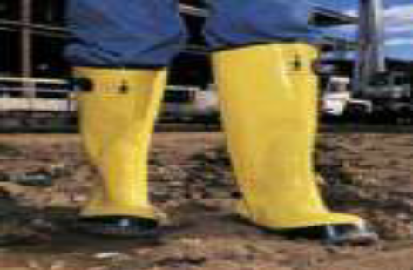
Fig.5 safety boot
Safety shoe:-Protects the worker form nail, sharp objects and heavy falling objects by hard-rolled leather shoes with metal toe caps.

Fig.6 Safety shoe

1.3 Plant, tools and equipment

Tools are defined as implements used to modify raw materials for human use. Tools can be considered as extension of the human hand thereby increasing its speed, power, and accuracy.
I. Advantages of using the proper tools
- Efficiency of the work
- High quality of the work
- Speed of accomplishment
- Accuracy
II. Hand Tool
A hand tool is a device or an instrument used to do a particular job that does not require a motor, but is intended for hand held operation by one individual. Virtually every type of tool can be considered a hand tool. It provides a mechanical advantage in accomplishing a physical task. Automotive hand tools are fast gaining popularity among woodworkers and craftsman.

III. Types
There are three main types of tools/equipment in the shop. One type is known as hand tools because your hand supplies the energy to operate them. The other type is called machine or power tools/equipment which uses either electricity, compressed air, or hydraulic pressure to make them operate. The last type is referred to as measuring tools.
- Manual Hand Tools: Manual hand tools are the most basic form of equipment. They do not require the speed of powered hand tools or do not have access to power sources but are perfect for operations. These include hoes, screwdrivers, chisels, wedges, drift pins, hammers and others.
- Pneumatic Hand Tools: Pneumatic hand tools perform the operation task at the push of a lever. They are powered by compressed air. They include chippers, drills, hammers, sanders etc.
- Power Hand Tools: Tools which are hand held but are powered by electricity. These include chainsaws, high grade motors, electric drills, angle grinders, jigsaw cutters, tappers, and fasteners.

What Tools Are Needed To Lay Bricks?

Every bricklayer needs useful quality tools for laying bricks, tools that will stand the test of time.
Bricklayers rely on their tools, and they are like there bread on butter, so to say, with no means, they cant lay bricks, so a bricklayer knows that the devices are essential.
Bricklayers spend a lot of money on tools as they need to rely on them. They may cost more money, but it is worthwhile in the long run. Here is a selection of tools that a bricklayer needs for laying bricks.
Brick Trowel
They are used for spreading mortar and laying bricks or blocks and stone. The bricklayer's trowel stays in the bricklayer's hand all day and is the most used brick layers tool.
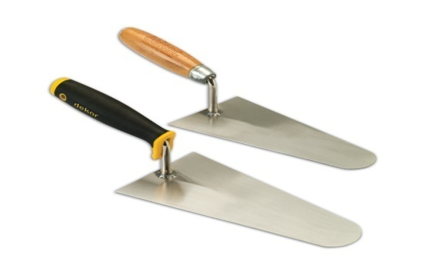
Fig. 7 Brick Trowel
Pointing Trowel
It is used to strike the mortar joint and used in restoration to fill in the void or repointing.
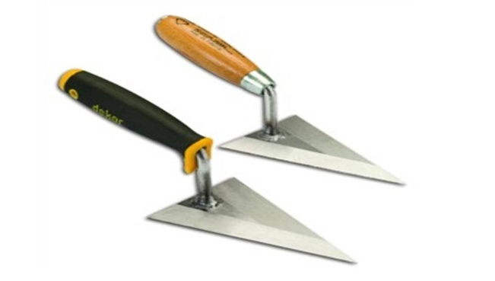
Fig. 8 Pointing Trowel
Spirit Level
It is used to control the horizontal and vertical alignment of wall surface and edges. The length is at least 40, 80 to 120cm long. It is made of metal, synthetic material or wood. It has two measuring bubbles: one is located at mid length is used to check horizontal positions. While the second one, at the end, is used to check vertical position. This tool requires always to be handled with care and needs to be checked from time to time weather it is still working accurate or not. 

Fig. 9 Spirit Level
Lump Hammer
The lump hammer is used for hitting almost anything. The lump hammer is used for hitting chisels and also demoliion.

Fig. 10 lump hammer
Brick Hammer
Used by a bricklayer to chip bricks or trim bricks to size, a good bricklayer can cut brick with one hit of the brick hammer as a quick way to cut bricks.
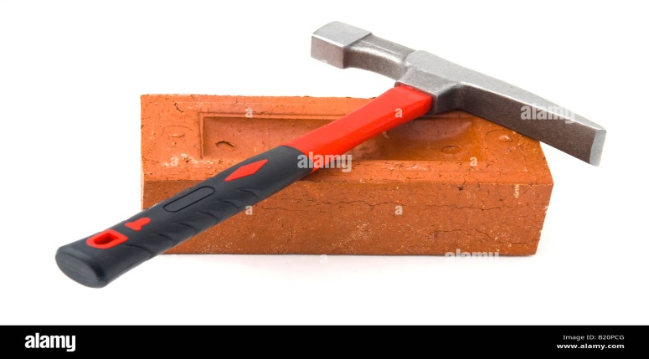
Fig. 11 brick hammer
Scutch hammer
The scutch hammer is used to remove and shape masonry after cutting bricks by bolster, for greater accuracy.
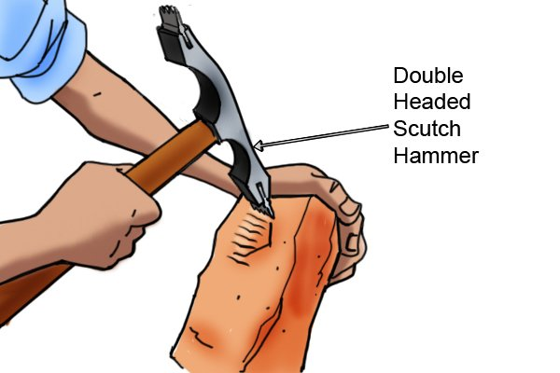
Fig. 12 scutch hammer
Bolster
The bolster is used for cutting bricks and blocks and knocking off old mortar or cleaning old brickwork, mainly used in restoration work.
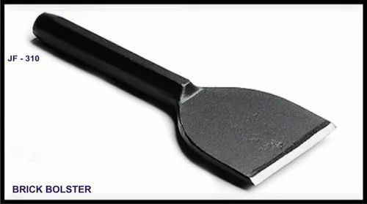
Fig.13 bolster
Tape Measure
They are used for measuring the length of walls and marking the gauge of brick and block courses.

Fig. 14 Tape Measure
Line Pins
They are used for pinning a line to brick or block work and used with bricklayers line
.  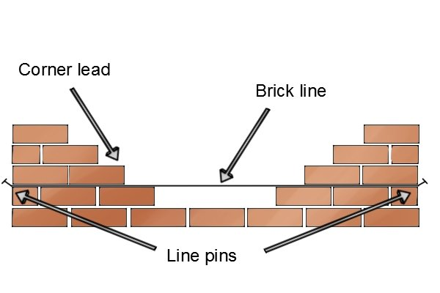.
Fig.15 Line Pins
Bricklayers Line
Brick layers line is used to build masonry straight and accurately and also as a guide to work to.
Alignment string /masons’ line/
Alignment string /mason line/, sometimes called, Fish line, is a rope used to transfer horizontal & vertical alignments or lines, i.e., use to mark base line on the floor or vertical point alignments of wall. In other wards, it is used to align the walling blocks, (stone, bricks, concrete blocks, hydra form etc). It is available in different thickness & sizes in theMason



Fig.16 line/alignment string
Straight edge/Level/
This is a perfectly straight metal/aluminium/ with all long and short edges parallel to its centreline. It is employed to check straight alignments of walls. Its length ranges from 2m up to 4m. Together with the sprit level, it can be used to bridge over the point to be checked. A straight edge/Level/ can also be made from a wooden plank with perfectly parallel edges.

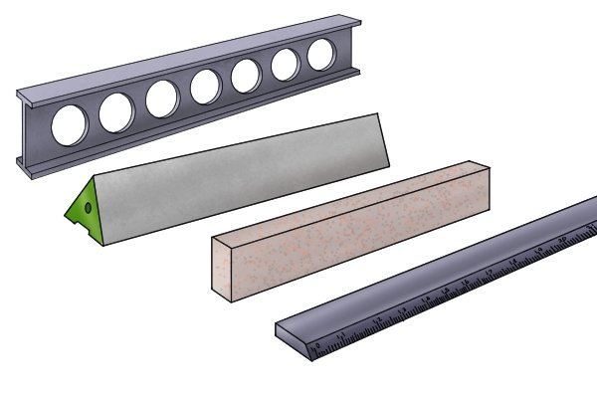
Fig. 17 Straight edges

Angle / Try square
It is used to measure a right angle (90º) of a corner. Used in laying masonry units or blocks at corners of masonry wall.
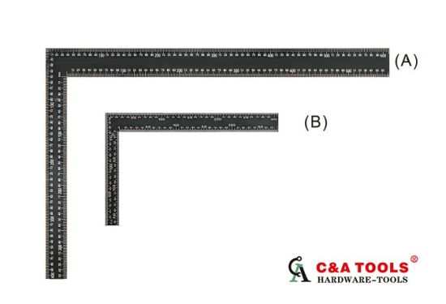
Fig.18 Try square
Mortar barrel/ drum

This is used by mason, plasterer, tiller, etc, and serves to prepare small amount of mortar right at the working place. It is also used as temporary mortar storage, supplied from mixing station, and to control water ratio of the mix when it gets dry. Always, keep it workable and clean.

Fig.19 Bucket
A Bucket is used to serve small amount of water or material and to take the tools after
Bricklayers brush
Good quality bricklayers brush needed for brushing down masonry to remove snots and smears, and it is also used for cleaning tools.

Fig.20 bricklayers brush

EQUIPMENT/MACHINERY
Extension cable

To connect all electrical driven equipment properly

Fig.21 Extension Cable Drum
Wheelbarrow
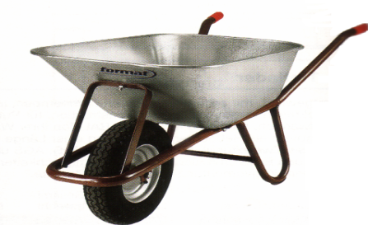
Wheelbarrow is used to dispose disposal materials from working place, to transport or serve materials and tools activities in the during construction site. It is the most efficient way in transporting materials or items. ; In comparison to a barilla, (commonly used in the country), a wheelbarrow is much more efficient. For this reason, it is operated by one person and can be carried up to 100 kg at once. So that it saves operation cost; it is time effective and therefore in general.

.

Fig.22 Wheelbarrow /85Lit
Angel grinder
Grinders are available as one hand and two hands. They are operating with high speed rotary cutting discs. The protecting hood must not be removed by all means. A grinder is very useful for cutting hard material like concrete, steel, natural stones or tiles. It is effective to cut blocks or bricks perfectly than cutting with hands.


Fig.23 Angle grinder
Drilling machine
It is used to make or drill holes in concrete, stones and other building elements or material. Drilling holes is depending up on the size and materials to be drilled, i.e, the drill bits are of different size and types. Types of drill bit can be classified as bits for metal, wood and stone or concrete).
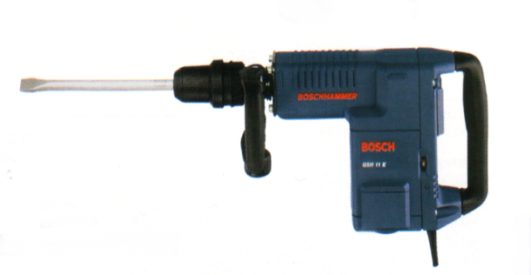
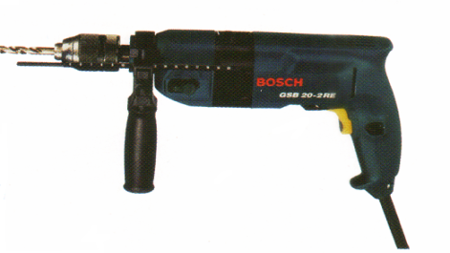

Fig.24 Electrical drilling machine
Concrete/ Mortar Mixer
Concrete mixers are available in from of different capacities. Small mixers can produce 250Lit of mortar or concrete and the big ones produces more and more, up to 6000Lit.; widely used, small mixers up to a capacity of 1000Lit. Mixers are driven with diesel, benzene engine or electrical power.
The cement mixer is used for mixing mortar and cement; usually, a sand and cement mixture is mixed and used by the bricklayer to build the masonry.

Fig.25 Mixer

1.4 Materials of brick masonry

Materials for Brickwork
Bricks
The quality of bricks to be used in masonry construction should be of standard specifications (good brick earth, thoroughly burnt and deep cherry red or copper in color). Bricks should be regular in shape and their edges should be sharp. Bricks should emit a clear ringing sound on being struck and should be free from cracks, chips, flaws and lumps of any kind.
Bricks should not absorb water more than one-sixth of their weight after one-hour soaking by immersing in water. Standard bricks should have a crushing strength of 105 kg/sq.cm or 1500 lbs/sq.in.
Mortar
Mortar should be of the specified grade and materials used for mortar should be of standard specifications.
For cement mortar, cement should be fresh Portland cement or pozzolana Portland cement of standard specifications. Sand should be sharp, clean, and free from organic and foreign matters. Coarse or medium-sized sands should be used for rich mortar, and local fine sand may be used for weak mortar.
The proportion of cement-sand for mortar can vary from 1:3 to 1:6 or as specified. Materials of mortar should be measured to have required proportion with measuring box. Cement and sand should first be dry-mixed to have a uniform color on a clean masonry platform and then mixed by adding clean water slowly and gradually to have workable consistency and mixed thoroughly by turning at least three times.
Only freshly mixed mortar should be used for construction; old and stale mortar should not be used. Mortar for one hour’s work should only be mixed with water so that they can be used before setting starts.

Cement mortar
Mortar consists of sand and cement, which forms a pliable mass after mixing with water. Mortar hardens (cures) gradually.
Good mortar used for masonry consists of cement, sand and water in the correct proportions. The sand needs to be clean and of a certain grain size, small enough to pass through a 2.36mm sieve. It is important to separate debris and organic matter from the sand by sieving it. Best is to use river sand.
When mixing mortar, a uniform mixture of sand and cement (turned at least 3 times) is first prepared before adding water. Mortar mixed with water must be used within one hour, after which the mortar hardens and can no longer be used.
Water should be added sparingly to avoid the mortar becoming too fluid. If too much water is added, the mortar not only looses its strength but also spills out when the bricks are positioned.
The specification of cement mortar is defined in terms of the proportions of cement and sand. For example, the ratio of 1:6 implies that the mortar consists of one part of cement and six parts of sand.

1.5Material quantity

Calculating Materials for brick Masonry
- Mortar
- Lime Mortar Mix Ratio = 1:4
Let Volume of Lime Mortar = Ym³
Then:-
A) Lime = 1/5 x Ym³ x 1900 kg/m³ x 1.20 Shrinkage x 1.05 wastage
= 479 kgs Y
= 0.25 m³ Y
B) Sand = 4/5 x ym³ x 1840 kg/m³ x 1.20 Shrinkage x 1.50 wastage
= 1855 kgs Y
= 1.01 m³ Y

- Cement Mortar Mix ratio = 1:4
Let volume of cement mortar = W
Then:-
A) Cement = 1/5 x Wm³ x 1400kg – m³ x 1.25 Shrinkage x 1.05 wastage
= 368 kgs W
= 0.26 m³W
B) Sand = 4/5 x Wm³ x 1840 kg/ m³ x 1.25 Shrinkage x 1.05 wastage
= 1932 kgs W

- Compo-mortar mix ratio = 1:2:9
Let volume of Compo-mortar = X
Then:-
A) Cement = 1/12 x Xm³ x 1400 kg/m³ x 1.20 Shrinkage x 1.05 wastage
= 147 kgs X
= 0.015 m³ X
B) Lime = 2/12 x Xm³ x 1900 kg/m³ x 1.20 Shrinkage x 1.05 wastage
= 399 kgl X
= 0.21 m³ X
C) Sand = 9/12 x Xm³ x 1840 kg/m³ x 1.20 Shrinkage x 1.05 wastage
= 1739 kgs X
= 0.95 m³ X

Basic data
Assuming - 30% shrinkage
5% wastage
For mechanical mix, water = 0.4 – 0.5
Cement
Hand mix , water = 0.4 – 0.65
Cement

- Cement Mortar
Table 1
Item | Type of Work | Material required to produce 1m³ mortar
1  2  3  4 | Cement Mortar 1:3  Cement Mortar 1:4  Cement Mortar 1:5  Cement Mortar 1:6 | Cement = 460kgs  Sand = 0.99m³  Cement = 308kgs  Sand = 1.05m³  Cement = 306kgs  Sand = 1.10m³  Cement = 263kgs  Sand = 1.13m³

- Compo-Mortar
Assuming - 20% Shrinkage
5% Wastage
Table 2
Item | Type of Work | Material Required to produce 1m³ Compo-Mortar
1  2  3 | Compo-mortar1:1:6  Compo-mortar 1:2:9  Compo-mortar ½: 1:3 | Cement = 221 kgs  Lime = 300 kgs  Sand = 0.95m³  Cement = 147 kgs  Lime = 399 kgs  Sand = 0.95m³  Cement = 195 kgs  Lime = 528 kgs  Sand = 0.89m³

Light Weight Screed
Assuming - 25% Shrinkage
5% Wastage
Table 3
Item | Type of Work | Material required to produce 1m³ mortar
1  2 | Cement Pumice 1:6  Cement Pumice 1:8 | Cement = 263 kgs  Pumice = 1.13m3  Cement = 205 kgs  Pumice = 1.17m³

- Brick Masonry for Super-structure
- ½ brick wall bedded in compo- mortar 1:2:9 both sides left for plastering
  - Brick with 5% wastage = 58 pcs/m²
  - Compo-mortar (10mm joints) = 0.0353m³/m² 15% wastage
  - Cement = 5kgs/m²
  - Lime = 14kgs/m²
  - Sand = 0.034m³/m²
- One brick wall bedded in compo-mortar 1:2:9 both sides left for plastering.
- Brick with 5% wastage = 115pcs/m²
- Compo-mortar with 15% wastage =0.085m³/m² (10mm joints)
2.1 Cement = 12.5kgs/m²
2.2 Lime =34kg/m²
  - Sand =0.081m³ /m²

1.6 Environmental protection requirements

Environmental protection is a practice of protecting the natural environment on individual, organizational or governmental levels, for the benefit of both the natural environment and humans. Due to the pressures of population and technology, the biophysical environment is being degraded, sometimes permanently. This has been recognized, and governments have begun placing restraints on activities that cause environmental degradation. Since the 1960s, activity of environmental movements has created awareness of the various environmental issues. There is no agreement on the extent of the environmental impact of human activity, and protection measures are occasionally criticized.
Academic institutions now offer courses, such as environmental studies, environmental management and environmental engineering, that teach the history and methods of environment protection. Protection of the environment is needed due to various human activities. Waste production, air pollution, and loss of biodiversity (resulting from the introduction of invasive species and species extinction) are some of the issues related to environmental protection. Environmental protection is influenced by three interwoven factors: environmental legislation, ethics and education. Each of these factors plays its part in influencing national-level environmental decisions and personal-level environmental values and behaviors. For environmental protection to become a reality, it is important for societies to develop each of these areas that, together, will inform and drive environmental decisions.

Environmental management
An environmental management plan may be required for a project, depending on the type of project and where it is located. Environmental management includes the following controls:
Land disturbance – for example management of storm water, dust control and erosion.
Noise and vibration – for example working only during prescribed site operating hours and monitoring noise and vibration levels of vehicles and equipment.
Waste management – for example minimizing waste, sorting waste into the appropriate bins and leaving the site clean and tidy at the end of each day.
Hazardous goods – for example ensuring material safety data sheets (MSDS) are available and ensuring correct storage procedures are followed.
An environmental management plan can be either a separate written document,
included in the specifications, or depicted as a plan similar to the project site plan.
Everyone involved in a project needs to follow the environmental management plan.

Environmental Protection Construction and Maintenance Works
It is the responsibility of all individuals to comply with environmental regulations and
for preventing pollution of air, land and water. Many thousands of pollution incidents
occur each year and each one is an offence which can result in prosecution as well
as environmental damage. Most cases however are avoidable given careful planning of operations, responsible waste management and suitable facilities to reduce the risk of spillage - along with simple precautions to deal with any spillages, should they occur.

Concrete and cement are very alkaline and corrosive and can cause serious pollution in watercourses. It is essential to ensure that the use of wet concrete and cement in or close to any watercourse is carefully controlled so as to minimise the risk of any material entering the water, particularly from the washing of equipment. The use of quick setting mixes may be appropriate. For long- term projects involving on-site concrete production, careful initial siting of concrete mixing facilities is vital. A settlement and recirculation system for water reuse should be considered. This will minimise the risk of pollution and reduce water usage. Washing out and cleaning of concrete batching plant or ready mix lorries should be carried out in a contained area as far from the watercourse as practical. There must be no release of runoff from these facilities during their operation.

Oil / Fuel pollution is the main cause of pollution incidents, and care should be
taken to prevent vandalism and the risk of damage by manoeuvring vehicles on sites
where oil or fuel is stored. Any fuel/oil storage tank and fuel/oil stored in drums should be sited on an impervious base within an oil-tight bund with no drainage outlet. All fill pipes, draw pipes and sight gauges should be enclosed within the bund, and the tank vent pipe should be directed downwards into it. Oil and Fuel storage must be in secure locations well away from watercourses and surface water drains. Further advice can be obtained from the Project Manager or Environmental Manager. All new oil storage facilities must comply with the Control of Pollution (Oil Storage) (England) Regulations 2001.

Paints and varnishes – as well as glues, bituminous based substances, cleaning materials and other substances used in the maintenance and upkeep of buildings and roofs should not be allowed to be discharged to the surface water drains. Any unused or unwanted paint should be disposed of as hazardous waste. On no account should any brush-cleaning agent, such as white spirit, be poured directly into any drain. Any left-over paint should be removed from site.

Pollution prevention – Contractors should undertake all precautions necessary to prevent pollution. Where vehicles carry liquids, the vehicles should be specifically designed for this purpose and/or liquids should always be carried in secondary containment, e.g. plastic boxes or trays. Vehicles which routinely carry liquids should carry spill kits / containment controls such as drain mats/covers and absorbent materials.

All wastes must be stored in designated areas that are isolated from surface drains. The wastes should be placed into these areas so that accidental spillages will not occur and that any loose material will not be subject to unwanted action by the elements. Also, precautions should be taken in order to ensure that the waste is not accessible to un authorized individuals.

Self check-1

Part I:- Multiple item questions
Directions: Instruction: select the correct answer for the give choice. You have given 1 Minute for each question. Each question carries 2 Points.
      - It is also called owner‟s manual.
        - parts manual C. operator‟s manual
        - service manual D. diagnostic manual
- Which is NOT included in an operator‟s manual?
        - basic maintenance C. specification
        - safety information D. parts number
- It is a type of manual where the part number and brief description are indicated.
        - operator C. service
        - part D. repair
- It is also called the shop/repair manual
        - service C. part
        - repair D. operator
- Which is NOT included in the service manual?
        - shop C. technical
        - repair D. none of them
- This refers to the steps performing certain task.
        - procedure C. specification
        - instruction D. manual
- It is a type of manual where entries are very detailed.
        - parts C. operator
        - service D. shop
- It is also called book manual or catalog manual.
        - repair C. parts
        - service D. shop
- This refers to the descriptive characteristics or materials/tools.
        - specification C. data
        - version D. manual
- It is a type of manual where basic maintenance and safety information are specified.
        - service C. repair
        - shop D. open book

Note: Satisfactory rating – above 10 points Not satisfactory - below 10 points
You can ask you teacher for the copy of the correct answers.

Name: _________________________ Date: _______________

Unit Two: Set out brickwork
This unit to provide you the necessary information regarding the following content coverage and topics:
- Erecting work platform.
- Location and structural details of brickwork
- Setting out brickwork
This guide will also assist you to attain the learning outcomes stated in the cover page. Specifically, upon completion of this learning guide, you will be able to:
- Erect work platform.
- Determine location and structural details of brickwork
- Set out brickwork

2.1.Erecting work platform
What is a scaffold.?
A scaffold is a temporary structure erected to support access or working platforms. Scaffolds are commonly used in construction work so workers have a safe, stable work platform when work cannot be done at ground level or on a finished floor.
Scaffolding means the individual components, for example tubes, couplers or frames and materials that when assembled form a scaffold. Scaffolding is classified as plant under Work Health and Safety (WHS) Act.
Scaffolding work is erecting, altering or dismantling a temporary structure erected to support a platform and from which a person or object could fall more than 4 metres from the platform or the structure.
What is a working platform?
The work at height regulations define a working platform as any platform used as a place of work or as a means of access to or egress from a place of work, including any scaffold, suspended scaffold, cradle, mobile platform, trestle, gangway, gantry and stairway that is so used.
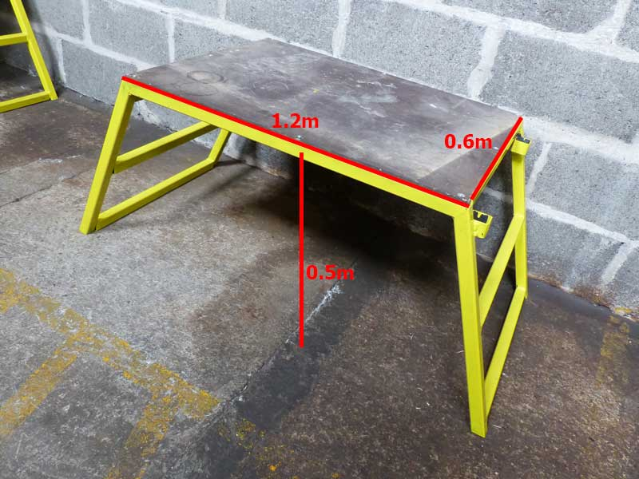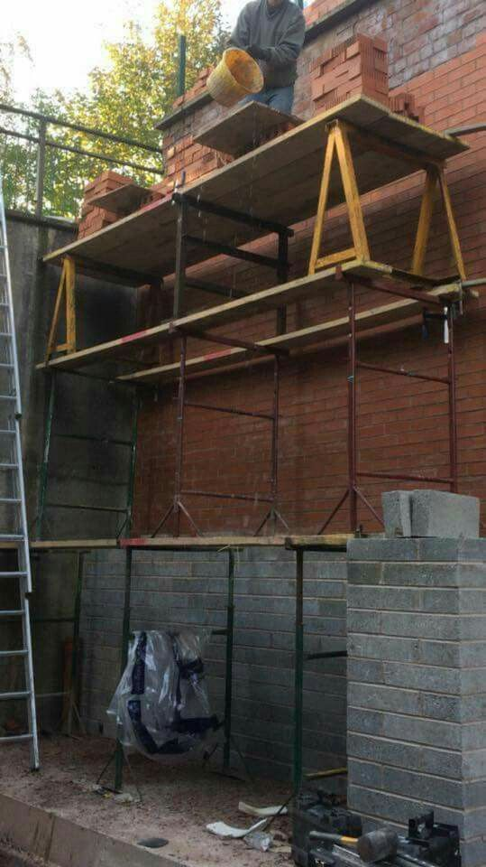
Fig. 2.1 working platform

2.2. Location and structural details of brickwork

2.2.1 Reading and interpreting construction drawings
This section describes how to:
- Read and interpret basic work drawings, sketches and basic specifications,
- Identify and interpret abbreviations and symbols on plans and work drawings;
- Identify any preliminary work from plans, and drawings; and
- Use plans, drawings and specifications to determine the quality and types of materials required.
Construction drawings for houses consist of:
  - Plans; showing all walls and openings as seen from top (bird’s eye view) with dimensions;
  - Sections; showing levels, dimensions and construction details in a vertical view (as if cut through with a knife). To show the important details of a structure, several sections may be required;
  - Elevations: showing the outside (face) of the building.

2.2.2 Reading and interpreting basic working drawings and sketches
The purpose of drawings is to present clear, concise and easily readable information on a proposed building project. This way everyone involved in the project is informed of what exactly is required. Various types of drawing methods are used to communicate this information.

Construction drawings are used to communicate ideas and information in a graphic form. Sketches are prepared first, then final working drawings are completed once the design details have been decided. Each drawing should be neat and clearly labelled. Sketches are not always drawn to scale.

The exact location, dimensions and levels are shown on the construction drawings. These usually include a plan and cross-sections. The drawings or sketches include all essential structures, e.g. walls, windows, doors and columns. It also show
Unlike sketches, building drawings are presented at a specific scale. When preparing a set of work drawings it is not possible to draw the building elements at full size. Therefore the drawings are reduced proportionally to a size allowing it to fit on conveniently sized drawing paper. This reduction process is called scaling. The extent to which the drawings have been reduced from their real size is clearly marked on the drawing. For example, a scale of 1:100 means 1cm on the drawing represents 100cm of the object in real terms.

All dimensions should be precisely indicated on the drawing irrespective of the scale. In house construction the most common units of measure are metres, centimetres or millimetres. Dimensions on drawings are usually only meant to be read, not measured.

The plan is the view seen when looking directly down from above. It provides information about:
- Overall length and width;
- Dimensions of parts of the construction;
- Position and size of windows and doors;
- Function of areas such as kitchen, toilet, etc.;
- Scale of the plan.

2.3.Setting out

Setting out is bringing the dimensions from a plan to the real situation. The activity consists of establishing the exact location and measurements of the house to be built. Setting out the building perimeter
The first activity of setting out is to clear the ground of any debris, vegetation and other obstructions. Ideally the ground should be level, although in hilly areas houses can also be constructed on slopes.
Before starting construction works it is necessary to know the exactly location and size of the house. Therefore, the exact position of the corners of the house is defined and marked on the ground. This is usually done by fixing reference points outside the actual perimeter of the building From these reference points it is always possible to re-measure and check the exact position of the foundation and walls.
According to the measurements on the construction plan the building is set out with stone or brick pedestals that indicate the exact position of the centrelines of the walls.

Setting out brickwork

Setting out in bricklaying is not as difficult as it looks as long as you follow the correct procedures. Below is a step by step guide on how to mark up and build footings on a house, when finished it should be square, plumb, level and to gauge.
Step 1
Start off by marking the thickness of your wall around your footing, for instance if your wall is 300mm wide including cavity space and your foundation is 600mm wide, then you will want 150mm of concrete either side of your wall, as it goes up this will maximize spreading out the weight of the house evenly.
Step 2
Start off by marking the front of the house out by banging a wooden stake in at each end and fixing a bit of string line to each stake using a nail. Sometimes you can mark the front out by taking a measurement off an existing house, road or pavement if not then it doesnt matter.
Step 3
Now by using a set square or the formula 3:4:5 you can put a mark down so your two front corners are square. The best way to do this is to skim a thin layer of mortar on the floor and mark out with your trowel.
Step 4
Now attach a piece of line to one of the corners and measure back the length of the side of your house and put a mark down, now pick up the line and move it from left to right a couple of times until it crosses over your mortar mark, when its directly above the mortar mark, hold it and bang another peg in, attach the line to this peg so you have your second mark, repeat this process down the other end and you now have three sides of your house marked up.
Step 5
Now pull a line in from the pegs at the back of your house and nail them in, your building is now roughly set out, all it requires now is to check the diagonals.
Step 6
If the building is square then the 2 diagonal angles from corner to corner should be the same length, if they are different then adjust one by moving it in or out to make it shorter or longer, once they are the same length then your building is truly square now. You now have your relevant markings and can begin with your brickwork.

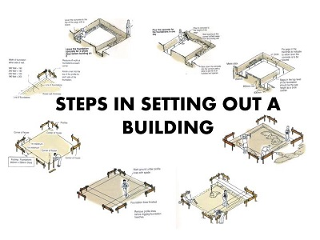
Fig.2.2 steps of setting out a building

Self check-2

Part I:- Short item questions
Instruction: write short answer for the given question. You are provided 3 minute for each question and each point has 10 Points.
      - Describe steps of setting out?
      - Mention the basic Construction drawings for houses consist of?

Note: Satisfactory rating – 10 and above points Unsatisfactory - below 10 points
You can ask you teacher for the copy of the correct answers.

Name: _________________________ Date: _______________

Operation sheet -2.1

Operation Title: - Setting out a right angle
Conditions Or Situations For The Operations:-
- Wear appropriate clothes, shoe ...
- Ensure the work shop hazard free
Tools
- Water level
- String
- Sprit level
- Claw hammer
- Tape measure
- Hammer
Materials: -
- String
- Pegs
Precautions:-
Wear working cloths which properly fit with your body
- Make working area hazard free
- Read and interpret manual which guide you how to disassemble and tag engine system components.
- Read the working drawing.
- Identify job specifications.
- select and use hand tools & materials

Work method/procedures:
Ensuring right angles (90 degrees) is important when setting out the initial perimeter of the house. This can easily be achieved using the 3:4:5 triangle method.
A triangle, which has sides of length 3 metres, 4 metres and 5 metres, will always have a right angle between the 3-metre side and the 4-metre side. One can therefore construct a right angle using only a tape measure as follows:
  - Measure the length A to B of 4 metres along the line from where a perpendicular line needs to be defined. Place pegs exactly at points A and B,
  - Hold the zero point of the tape measure on the peg A,
  - A second person holds the mark 8.0 metres on the tape measure on peg B,
  - A third person holds the tape measure on mark 5.0 metres, which will lead to point C when the tape measure is pulled tight. Set a peg on point C.
  - Extend the now perpendicular line from point B to point C to any length as required.
Quality checkpoints:
- After constructing the right angle check again that the triangle lengths represent exactly the 3:4:5 proportions.
- Ensure that all reference pegs are firmly fixed.

LAP Test -2 | Practical Demonstration
Name: _____________________________ Date: ________________
Time started: ________________________ Time finished: ________________
Instructions: Given necessary templates, tools and materials you are required to perform the following tasks within 40 minutes

Task-1: Set out a right angle

Unit Three: Construct walls and attached piers
This learning guide is developed to provide you the necessary information regarding the following content coverage and topics:
- Mixing mortar
- Constructing multi-thickness wall
- Bonding piers to wall
- Damp proof
- Constructing openings and installing lintels
- Tie down and lateral support systems
This guide will also assist you to attain the learning outcomes stated in the cover page. Specifically, upon completion of this learning guide, you will be able to:
- Mix mortar
- Construct multi-thickness wall.
- Bond piers to wall
- Build damp proof courses
- Construct openings and installing lintels
- Install tie down and lateral support systems

3.1. Mixing mortar

3.1.1 Mortar

Mortar is a binding material in masonry work. It is a homogeneous mixture, produced by uniform mixing of a binder with inert material (such as sand) and water to make a paste of required consistency and is used to bind a masonry unit. Choice of mortar and its grade for binding masonry units is governed by several considerations such as type of masonry, situations of use, load intensity, degree of exposure to weather, bond and durability requirements, and other special considerations like fire resistance, insulation, rate of setting and hardening etc.

Types of Mortar

Mortar is required for cementation of brick or stone masonry.
It is required for covering exposed surface of wall with plaster or for pointing of brick or stone joints.
    - Cement mortar
Cement mortar is made up of cement, sand and water. Cement mortar has to be used up within one hour of mixing. Otherwise its setting property deteriorates and it becomes weak. The common types of cements used for preparing cement mortars are:
- Ordinary Portland cement
- Rapid hardening cement
- Blast furnace slag cement
- Portland pozzolzana cement
- Masonry or triy cement.

    - Cement –lime mortar
In cement – lime mortar 50 % of the quantity of cement in a mortar is replaced by equal volume of lime for sake of economy without detriment to the safety of a small building. It spreads more easily and produces a more plastic material. This type of mortar is workable and sets earlier.

    - Lime-mortar
Lime is mixed with sand in the same manner as that for cement, but mixing with lime has to be done days in advance of its use to allow time for ‘Souring’. The wet mix of lime mortar is stored to ‘sour’ for at least two days for being used in masonry and for at least three days for being used in plastering.
    - Lime-mortar gauged with cement
The mortar in which cement is included as an ingredient in addition to lime is known as gauged mortar or composite mortar. The rate of stiffening of lime mortar is improved by gauging the lime with cement.
    - Mud mortar
Mud mortar has been successfully used for brick masonry in walls of many small buildings even with R.C.C. roof. Mud mortar shall be made of good ‘brick-earth’ free from grass, roots, gravel, etc. The earth shall not contain any efflorescent salts. Selected clay mixed with water shall be well kneaded and pulddled until a thoroughly uniform mortar of easily workable and satisfactory consistency is produced

Consistency of Mortars
The quantity of water to be added to the mortar should be such that working consistency is obtained. The working consistency of the mortar is usually judged by the mason during application. The water should be just enough to maintain the required fluidity of mortar during application. The consistency of the mortar to maintain required fluidity depends upon the joints of masonry. For Example, thinner joints will require greater fluidity while joints subjected to heavy pressure intensity require stiffer mortar with less fluidity.

The mortars with cement as an ingredient should be used as early as possible, preferably within half an hour from the time, water is added to the cement during mixing operations or at the latest within one hour of its mixing. Cement mortar is generally more suitable for making high strength mortars. In addition to sand, pozzolana may also be added.

Lime motars are prepared from hydraulic and semi-hydraulic limes. Prepared lime motars shall be kept damp and shall never be allowed to go dry. This may be ensured. Partly set or dried motar shall never be retempered for use. Strength of lime motar depends upon mix proportions.

3.1.2 Setting out Brickwork
The setting out of brick is an important part of the design process and will guide the dimensions of walls, windows, doors and other features on a building’s elevation. Setting out varies according to the different bonds and patterns used in the brick work. The more complicated the brick pattern or arrangement, usually the more complicated the setting out. There are plenty of guides available some of which listed below.

    - Setting Out Stretcher Bond Brickwork
Stretcher bond brickwork is one of the most common bonds used in modern buildings. When designing these masonry walls, the designer should set out openings, window and door dimensions to full or half brick lengths where possible. This will avoid wasting material and the unnecessary cutting of bricks on site whilst making the wall as structurally stable as possible.
The following illustrations demonstrate the difference between using the correct coordinating, and using an uncoordinated approach.

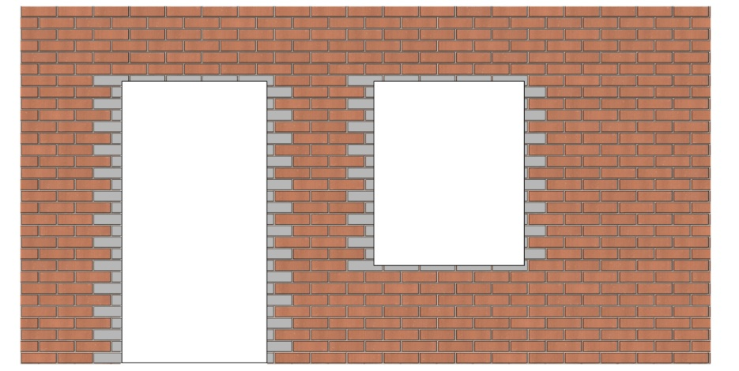
Fig. 3.1 uncoordinated brick sizing
The image above shows how when not co-ordinated correctly you can be left with cut bricks and poorly finished openings. All the grey bricks in the example above represent bricks that are neither whole or half bricks and would have to be cut to size on site.
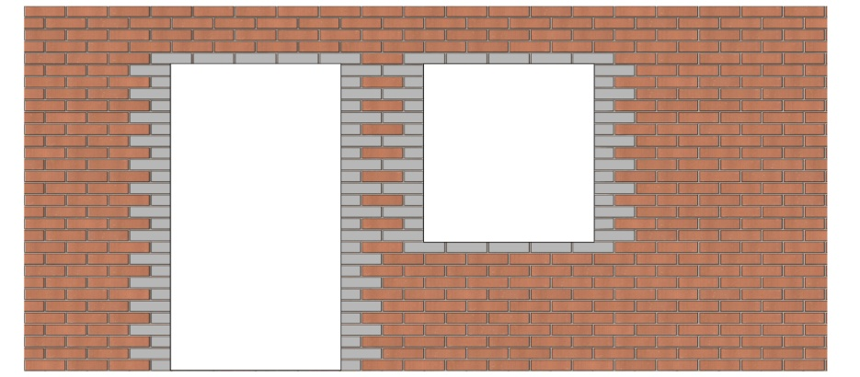
Fig. 3.2 co-ordinate brick sizing
The above image shows co-ordinated brick sizing to ensure all openings align to 1 or 1/2 brick size.
In early design stages, brick dimensions are often not considered, leaving the complete external envelope needing to be re-adjusted or re-drawn at detailed design stage. However, setting out the building to brick dimensions as early as possible — even before planning — can save time and money!

    - Setting Out Flemish Bond Brickwork
For other types of bonds, different techniques and measurements have to be applied to set out brickwork correctly. Another very common type of bond is Flemish Bond.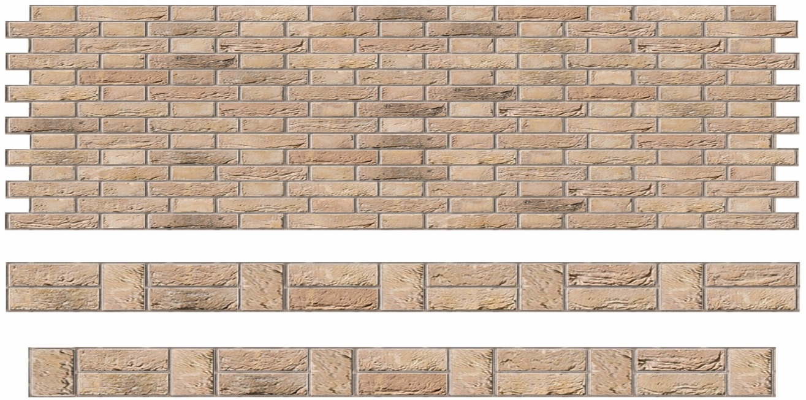
Fig.3.3 Flemish Bond
Whilst Flemish walls must also try to maintain as many whole bricks as possible when being set out, when creating corners or openings, ¾ bricks and closer bricks may need to be used.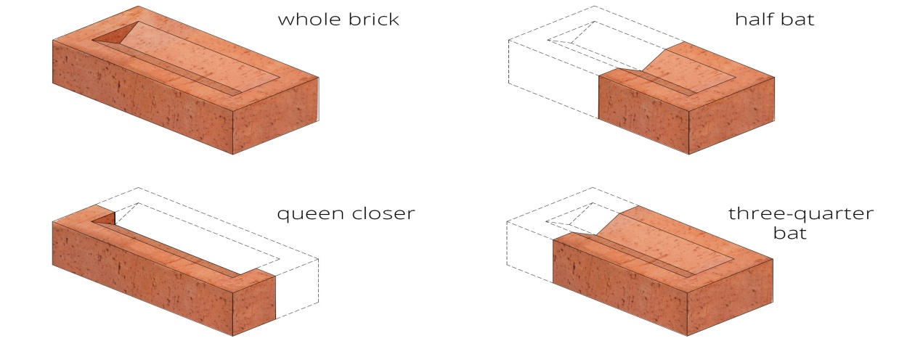

Traditionally these types of walls were one brick length deep and require a queen closer or king closer at corners even out the brickwork whilst maintaining a structurally strong wall. Below is an example of a section of wall showing a brick return, end of wall and internal wall junction along with the queen closers where necessary. Other forms of Flemish bond setting out exist depending on the desired elevation required.

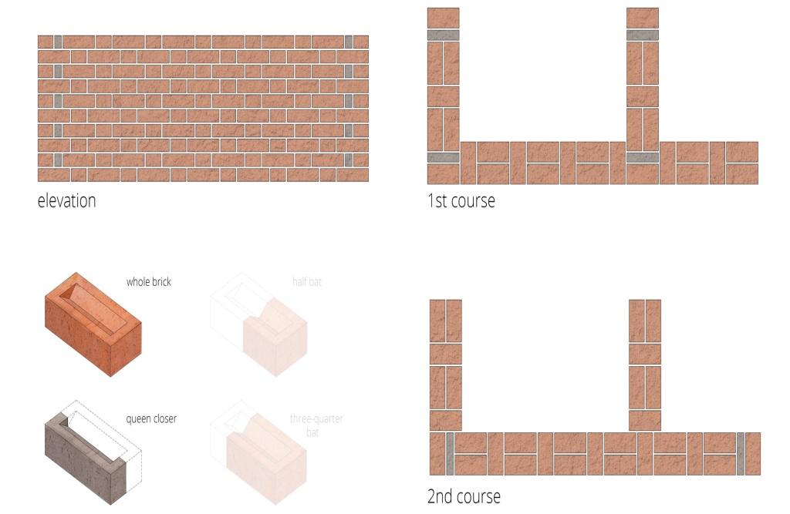
Fig.3.4 plans of Flemish bond

Flemish bond walls can also be built out of single-leaf brickwork (half brick thickness), although this does require different types of cut bricks and possible extra wall ties as advised by the structural engineer. Below is an example of a section of wall showing a brick return, end of wall and internal wall junction.

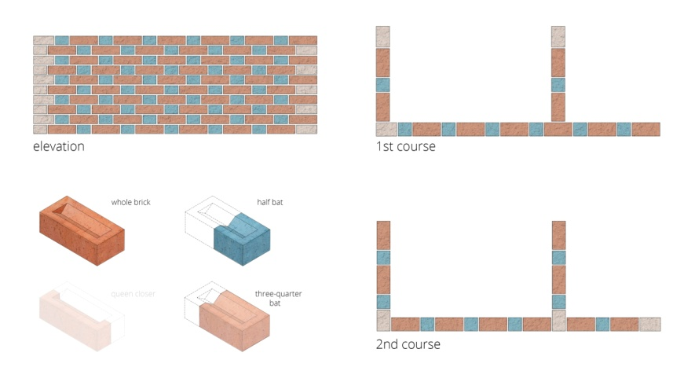

Fig.3.5 a brick return, end of wall and internal wall junction.

3.1.3 Bonds in Brick Work

Bond is the interlacement of bricks, formed when they lay those immediately below or above them. It is the method of arranging the bricks in courses so that individual units are tied together and the vertical joints of the successive courses do not lie in same vertical line. Bonds of various types are distinguished by this elevation or face appearance. Bricks used in masonry are all of uniform size. If they are not arranged (or bonded) properly, continuous vertical joints will result. An unbounded wall, with its continuous vertical joints has little strength and stability. Bonds help in distributing the concentration loads over a larger area. Since bricks are small units, having uniform dimensions, the process of bonding is easily performed.

Types of Bonds
Laying of Bricks
Bricks shall generally be laid in English Bond unless a different appearance at face is required as per Architectural requirements.
Half or cut bricks shall not be used except as closers to complete the bond. Closers in such cases, shall be cut to the required size and used near the ends of the wall. Header bond shall be used preferably in all courses in curved plan for ensuring better alignment.
Header bond shall also be used in foundation footings unless the thickness of walls (width of footing) makes the use of headers impracticable. Where the thickness of footing is uniform for a number of courses, the top course of footing shall be headers.
All loose materials, dirt and set lumps of mortar which may be lying over the surface on which brick work is to be freshly started, shall be removed with a wire brush and the surface wetted. Bricks shall be laid on a full bed of mortar. When laying, each brick shall be properly bedded and set in position by gently pressing with the handle of a trowel. It’s inside face shall be buttered with mortar before the next brick is laid and pressed against it. Joints shall be filled and packed with mortar such that no hollow space is left.

  - Stretcher Bond
Stretcher Bond or stretching bond is the one in which all the bricks are laid as stretchers on the faces of the walls. The length of the bricks are thus along the direction of the wall. This pattern is used only for those walls which have thickness of half brick (i.e. 12cm) such as those used as partition walls, sleeper walls, division stacks. The bond is not possible if the thickness of the wall is more.

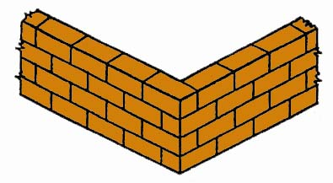
fig. 3.6 Stretcher Bond
  - Header Bond
Header bond or Heading bond is the one in which all the bricks are laid as header on the faces of walls. The width of the brick are thus along the direction of the wall. The pattern is used only when the thickness of the wall is equal to one brick (i.e.25cm). This bond does not have strength to transmit pressure in the direction of the length of the wall. As such, it is unsuitable for load bearing walls. This type of bond is especially useful for curved brick work where the stretchers, if used, would project beyond the face of the wall and would necessitate inconvenient cutting. This is also used in construction of footings.
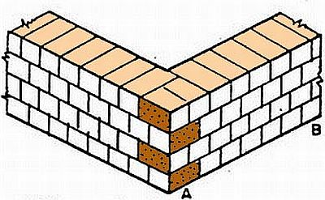
Fig. 3.7 Header bond
  - English Bond
This is the most commonly used bond for all wall thickness. This bond is considered to be the strongest. The bond consists of alternate courses of headers and stretchers. In this bond, the vertical joints of the header courses come over each others; similarly, the vertical joints of the stretchers courses also come over each others. In order to break the vertical joints in the successive courses, it is essential to place queen closer after the first header (quoin header) in each heading courses. Also, only headers are used for the
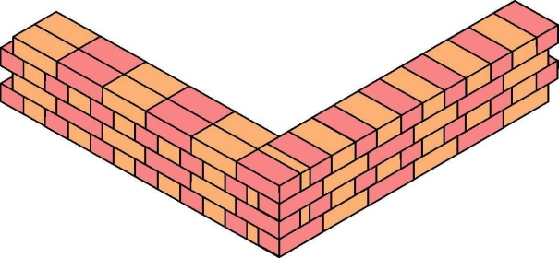
Fig. 3.8 English Bond
The essential features of English bond are:-
- Alternative courses will show either headers or stretchers in elevation.
- Every alternative header comes centrally over the joint between two stretchers in courses below.
- In the stretcher courses, the stretchers have a minimum lap of ¼th of their length over headers.
- There is no continuous vertical joint.
- Walls of even multiple of half bricks (i.e 1 brick thick wall, 2 – brick thick wall, 3-Brick thick wall) present the same appearance on both faces. Thus a course showing stretchers on the front face will also show stretchers on the back face.
- Wall of odd multiple of half bricks (i.e. 1 ½ Brick thick wall, 2 ½ Brick thick wall etc.) will show stretchers on one face and headers on the other face.
- The hearting (middle portion) of each of the thicker walls consists entirely of headers.
- At least every alternate transverse joint is continuous form face to face.
- A header course should never start with queens closer, as it will get displaced. The queens closer should be placed just next to the quoin header. Queens closers are not required in stretchers courses.
- Since the number of vertical joints in the header courses are twice the number of vertical joints in the stretchers course, the joint in the header course are made thinner than the joints in the stretcher course.

  - Flemish Bond
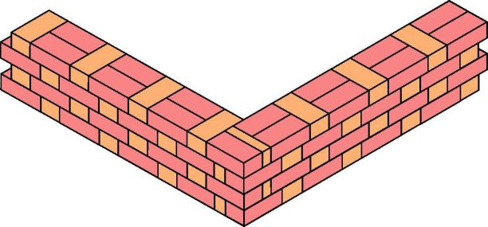
In Flemish bond, each course is comprised of alternate headers and stretchers. Every alternate course starts with a header at the corner (i.e. quoin header). Quoin closers are placed next to the quoin header in alternate courses to develop the face lap. Every header is centrally supported over the stretcher below it. Flemish bonds are of two types
Fig.3.9 Flemish bond
- Double Flemish bond
In the double Flemish bond, each course presents the same appearance both in the front face as well as in the back face. Alternate headers and stretchers are laid in each course. Because of this, double Flemish bond presents better appearance than English Bond.

Special features of double by Flemish bond are
- Every course consists of headers and stretchers placed alternately.
- The facing and backing of the wall, in each course, have the same appearance.
- Quoin closers are used next to quoin headers in every alternate course.
- In walls having thickness equal to odd multiple of half bricks, half bats and three-quarter bats are amply used.
- For walls having thickness equal to even multiple of half bricks, no bats are required.
- A header or stretcher will come out as header or stretcher on the same course in front as well as back faces.

- Single Flemish Bond
Single Flemish bond is comprised of double Flemish bond facing and English bond backing and hearting in each course. This bond thus uses the strength of the English bond and appearance of Flemish bond. However, this bond can be used for those walls having thickness at least equal to 1 ½ brick. Double Flemish bond facing is done with good quality expensive bricks. However, cheaper bricks can be used for backing and hearting.

Comparison of English Bond and Flemish Bond
- English Bond is stronger than Flemish bond for walls thicker than 1 ½ brick.
- Flemish Bond gives more pleasing appearance than the English bond.
- Broken bricks are used in the form of bats in Flemish bond. However, more mortar is required.
- Construction with Flemish bond requires greater skill in comparison to English bond.

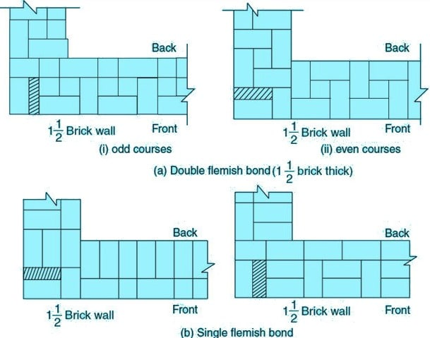

Fig. 3.10 Double and Single Flemish Bond

3.2. Constructing multi-thickness wall

Before you begin your project, you’ll need to figure out the number of bricks required. Standard types are 250mm x 120mm x 60mm.
To get an accurate picture of the number of bricks required, you’ll also need to account for a 10mm mortar bed. So to come up with the correct calculations, input your brick size as 260mm x 102.5mm x 70mm for standard products.
You’ll then want to add an allowance for cuts and wastage. Typically, you might overorder by 5% for a house or garage wall where there will be structural openings (such as windows).

Brick wall step-by-step
Step 1: Start your brick wall at the corners
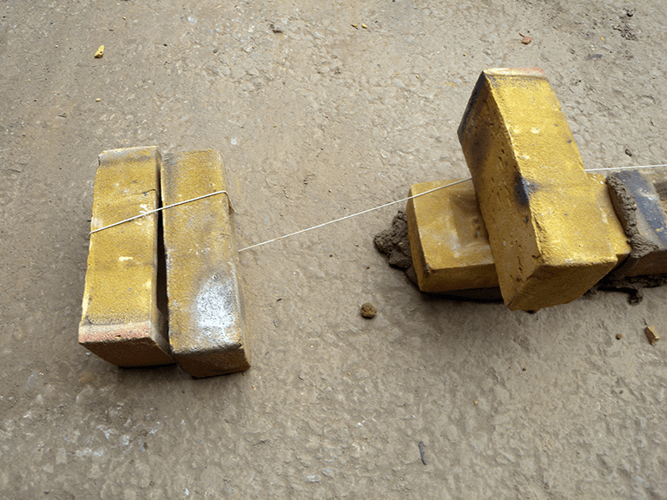
Fig.3.11
Firstly, lay out the bricks at both ends of your wall where the pillars will start. This should be done after any necessary foundations have been prepared. Using your string line, make a straight guideline at brick height between the two outside bricks.
Step 2: Mix the mortar
Following this, heap five shovels full of sand and one of cement on an old board. Turn shovel to mix to a consistent colour. Form a central hollow, pour in water and mix. Repeat for a smooth, creamy texture that’s wet but not too loose.
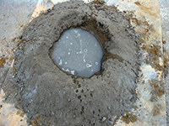
Fig.3.12 mixture of mortar
Step 3: Lay the first course of bedding mortar
Next you should lay a 1-2cm mortar bed along the string line. Starting at one end, lay the first brick and tap slightly to ‘bed in’. ‘Butter up’ one end of the next brick with mortar and abut it to the first. Repeat using string line as a guide.
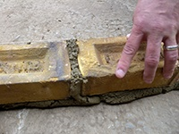
Fig. 3.13 laying the first
Step 4: Create the brick pillars
At the point where you want your pillars to start, place a brick side-on to the end of the wall. As you build up the wall, each consecutive course of pillar bricks must be laid in the opposite direction.
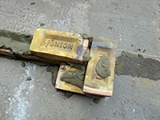
Fig. 3.14
Step 5: Cutting bricks
When building pillars, at certain courses you’ll need to lay half-bricks. To make a cut, place the brick on its side, locate the bolster at the split point and strike the head firmly with a club hammer. It should split cleanly first time.
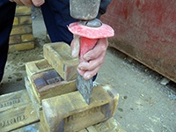
Fig.3.15 cutting brick
Step 6: Keep the pillars one course ahead
Always build at least a course higher on the pillars than the rest of the wall. Move the string line up as you build, bedding it into the mortar on the pillars. For a stretcher bond, the end of each brick should be over the centre of the one beneath.
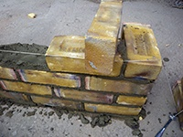
Fig. 3.16
Step 7: Make sure you’re sticking to 10mm mortar joints
Horizontal and vertical mortar joints should be 10mm thick. With standard bricks there should be 75mm from the top of each brick to the top of the one beneath. If your bricks soak up moisture fast, you may want to ‘joint up’ (step 10) as you go.
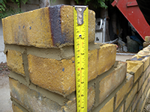
Fig. 3.17 checking mortar joints

Step 8: Add a coping stone
You may want to add a coping stone to finish when you reach the top of the pillars. Alternatively, you could create a pleasant effect at less cost by bedding bricks into the mortar on their sides
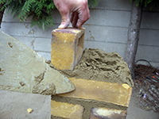
Fig .3.18
Step 9: Decorative brick soldier course
Adding a ‘soldier course’ is an attractive option to top the main part of a garden wall. Turn your bricks vertically lengthways and lay along the full length. Use a second, higher string line to keep a uniform finish
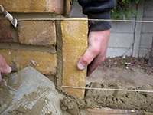
Fig. 3.19
Step 10: How to finish the mortar beds
To finish the beds, use the rounded edge of a brick jointer to scrape mortar into the joints. Start with the horizonal lines and follow with the vertical – it’s easier to remove any excess mortar this way
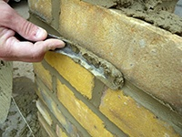
Fig. 3.21 finishing joints
Step 11: Clean up
Lastly, give the finished wall a gentle brush over and clean up any mortar that has fallen onto the floor before it dries. You can use water to wash cement away from the floor, but be sure to keep it away from your newly-built wall!
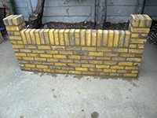
Fig. 3.22 finished wall

3.3. Bonding piers to wall

3.3.1 Double Attached Piers in Flemish Bond
The bonding of the double pier in Flemish bond (see Fig 3.23) clearly requires a lot of brick cutting, but it is possible to simplify the bonding arrangement and reduce the amount of cutting involved. The alternative arrangement (see Fig 3.24) completely goes against the principles of bonding previously described; this example would require the pier bond to be set-out first. Simplifying the bond does increase the number of vertical straight joints within the pier, which reduces its strength, but not to the point where the purpose of the pier is significantly compromised or undermined. Strictly speaking, in terms of the principles of bonding, this alternative approach is incorrect, but the bond does ‘work’ and the pier still does its job. As a result, it does tend to be more common practice on site.
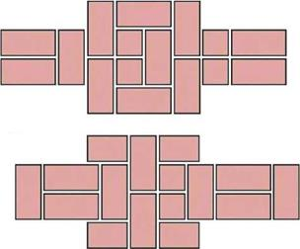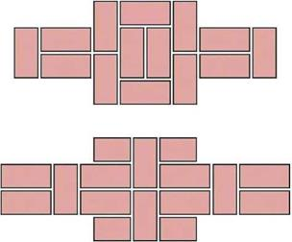
Fig 3.23 Flemish bond, two-brick wide double attached pier. Fig 3.24 Flemish bond, two-brick wide double attached pier .

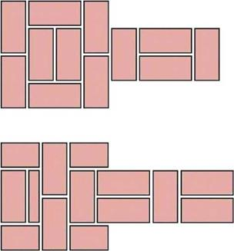
Fig. 3.25 Flemish bond two-brick wide double end pier.
Running-in Walls with Attached Piers
A boundary wall that is long enough to incorporate attached piers in the middle will be run-in to a string-line. When this is done, the attached pier is always kept one course behind the main wall — that is to say, each course of the wall is run-in to the line, then the line is removed so that the corresponding course of the attached pier can be completed. Constructing the wall in any other order would mean that the pier brickwork would interfere with the positioning of the string-line, preventing the main wall being run-in in one go.

3.3.2 Single Attached Piers in English bond
Single attached piers project on one face of the wall only. The example in Fig 193 shows the outline of a 1%-brick wide pier to be attached to an English bond wall (left), without any consideration given to ‘bonding in’ the pier. By removing bricks ‘A’ and ‘B’ and repositioning them (right), a bond for the pier into the main wall is achieved without significantly affecting the bonding of the main wall. The bond is completed by introducing header ‘C’ and half-brick ‘D’.
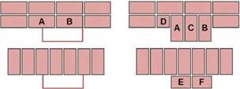
Fig.3.26 Method of bonding attached piers.

It is structurally necessary to tie the pier into the main wall only on alternate courses (in other words, on the stretcher course), so all that remains is to complete alternate courses of the pier by arranging bricks to maintain a suitable face bond on the front of the pier. In the example, this is achieved by two three-quarter bricks, ‘E’ and ‘F’. Figs 3.27 and 3.28 illustrate the bonding arrangements for two-brick wide single attached piers in English bond.

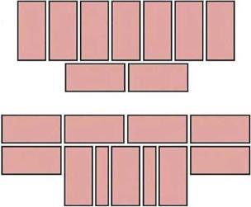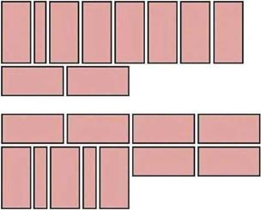
Fig.3.27 English bond, two-brick wide single attached pier

3.4.Damp proof

Introduction
A house is not just a building; it is a place of dwelling where comfort is the most important requirement. It should remain dry, free from moisture and unhygienic conditions. Dampness in the building is one of the most unwanted conditions. Dampness is the presence of hygroscopic or gravitational moisture. Dampness gives rise to unhygienic conditions, and also reduces the strength of structural components of the building. Damp prevention is one of the important items of building design. Hence, this is considered to be one of the important items of work in the construction of a building. The treatment given to prevent leakage of water from roof is generally termed as water- proofing, whereas the treatment given to keep the walls, floors and basement dry is termed as damp – proofing. Every building should be damp proof to allow the inmates enjoy every moment of their life in it.

Damp Proof Course (DPC) -Methods of DPC Installation in Construction

What is DPC?
The damp proof course (DPC) is generally applied at basement levels, which restricts the movement of moisture through walls and floors. The selection of materials for the damp proof course and its various methods of applications in buildings is discussed.
Materials for Damp Proof Course (DPC)
Properties of Materials for DPC
An effective damp proofing material should have the following properties;
- It should be impervious.
- It should be strong and durable and should be capable of withstanding both dead as well as live loads without damage.
- It should be dimensionally stable.
- It should be free from deliquescent salts like sulfates, chlorides, and nitrates.

Types of Materials for Damp Proof Course
The materials commonly used to check dampness can be divided into the following three categories:
- Flexible Materials: Materials like bitumen felts (which may be hessian based or fiber/glass fiber-based), plastic sheeting (polythene sheets), etc.
- Semi-rigid Materials: Materials like mastic, asphalt, or a combination of materials or layers.
- Rigid Materials: Materials like first-class bricks, stones, slate, cement concrete, etc.
Selection of Materials for Damp Proof Course in Buildings
The choice of material to function as an effective damp proof course requires a judicious selection. It depends upon the climate and atmospheric conditions, nature of the structure, and the situation where DPC is to be provided.
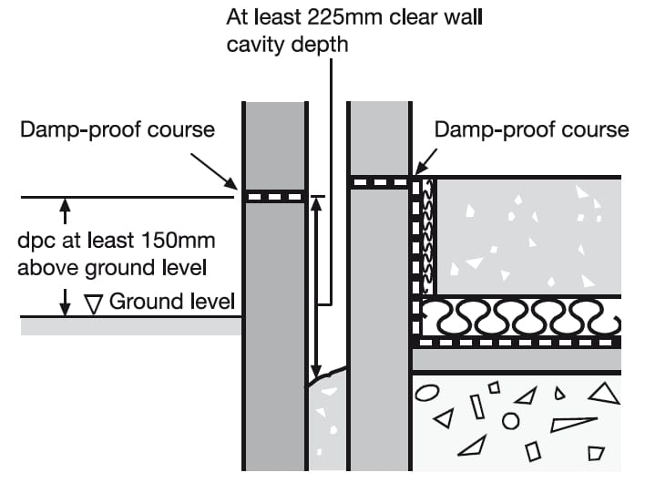
Fig 3.29: Cross section of Damp Proof Course
The points to be kept in view while making selection of DPC materials are briefly discussed below:
1. DPC above ground level
For DPC above ground level with wall thickness generally not exceeding 40 cm, any one of the types of materials mentioned above may be used. Cement concrete is however, commonly adopted material for DPC at plinth level, 38 to 50mm thick layer of cement concrete M15 (1:2:4 mix) serves the purpose under normal conditions.
In the case of a damp and humid atmosphere, a richer mix of concrete should be used. The concrete is further made dense by adding waterproofing materials like Pudlo, Impermo, Waterlock, etc. in its ingredients during the process of mixing. It is used to apply two coats of hot bitumen over the third surface of the concrete DPC.

2. DPC Material for floors, roofs etc.
For greater wall thickness or where DPC is to be laid over large areas such as floors, roofs, etc., the choice is limited to flexible materials that provide a lesser number of joints like mastic, asphalt, bitumen felts, plastic sheets, etc.
The felts, when used, should be adequately bonded to the surface with bitumen and laid with joints properly lapped and sealed.
3. DPC Material for situations where differential thermal movements occur
In parapet walls and other such situations, materials like mastic, asphalt, bitumen felts, and metal (copper or lead) are recommended.
It is vital to ensure that the DPC material is flexible to avoid any damage or puncture of the material due to differential thermal movement between the material of the roof and the parapet.
4. DPC material for Cavity Walls
In cavity wall construction, like cavity over the door or window should be bridged by flexible material like bitumen felt, strips or lead, etc.
Methods of Damp Proof Course Installation in Construction
The general principles to be observed while laying a damp proof course are:
- The DPC should cover the full thickness of the walls, excluding rendering.
- The mortar bed upon which the DPC is to be laid should be made level, even and free from projections. Uneven base is likely to cause damage to DPC.
- When a horizontal DPC is to be continued up a vertical face, a cement concrete fillet 75mm in radius should be provided at the junction before the treatment.
- Each DPC should be placed in correct relation to other DPC to ensure a complete and continuous barrier to the passage of water from floors, walls, or roof.

3.5. Constructing openings and installing lintels

What Is a Lintel?
A lintel is a beam that is used above the openings for doors or windows in order to support the weight of the structure above.
Without a lintel, the entire load of the brickwork about a door or window would have to be carried by the window or door frame itself. A lintel spreads that load into the masonry on either side of the door or window, ensuring that door and window frames aren’t placed under undue pressure.
A lintel must be properly installed in order to function correctly.

Classification Of Lintels
Lintels can be classified based on the materials used in the construction as
- Wooden Lintels
- Stone Lintels
- Brick Lintels
- Reinforced Brick Lintels
- Steel Lintels
- Reinforced Cement Concrete(RCC) Lintels

Steps to installing a Lintel
Proper lintel installation requires numerous steps. We’ll take a look at some of the basics below.
Minimum End Bearing
In order for a lintel to provide the correct support, it needs to extend far enough onto the brickwork at the side of the door or window.
The lintel should normally extend a minimum of 150mm beyond the opening on either side although down to 100mm is permissible under certain circumstances (check with the supplier or manufacturer if you need a reduced bearing). It’s not advisable to extend too far beyond this as you’ll be paying for more than you need.

Bedded on Mortar
You must bed your lintel on mortar.
By installing a lintel on a bed of mortar, it ensures that the loads are evenly distributed. The thickness of the mortar should be sufficient to accommodate any unevenness that there might be between the lintel and the support.
The lintel should be bedded on both leaves to ensure that load is spread symmetrically.

Make Sure the Lintel is Level
Once you’ve placed the lintel on the bed of mortar, you need to ensure that it’s perfectly level. If the lintel isn’t level, the load will not be evenly distributed and may place undue stress on parts of the supporting walls.

Use a spirit level to ensure that lintel is placed perfectly horizontally across the opening. You’ll also need to confirm that the lintel is level cross-wise too; in other words, you should confirm that neither leaf is higher than the other. If this is the case, it will put undue pressure on one of the leaves.

Allow Mortar to Cure Before Applying Loads
Once your lintel is level, you’ll need to allow the mortar to cure before applying any loads.
Until the mortar is completely cured, the load won’t be correctly transferred through the lintel and into the masonry on either side of the opening. If you’re in a rush and can’t wait for the mortar to cure, then you must ensure you place appropriate supports beneath the lintel before applying any loads.

Lay Bricks on Both Sides
Once the mortar is dry, or you have supports in place, you can start laying bricks.
You must ensure that you lay bricks on both sides simultaneously so that the load on each leaf does not get too far out of balance. In other words, once you’ve laid one or two rows of bricks on one side, you should stop and lay the same amount on the other side. You’ll need to repeat this process to ensure that the load is always the same or similar on each leaf.
If you put too much load on one side at once, you may damage the lintel or have an even worse problem. Don’t take the risk and always keep the loads on each leaf balanced.

Install a Damp Proof Course if Necessary
If the lintel is being installed as part of a cavity wall, then you should install a damp proof course.
Cavity walls are designed such that the outer leaf is intended to be damp, and the inner leaf dry, with the cavity ensuring that this remains the case. That’s why anything that bridges this cavity—such as a lintel—should be installed such that moisture doesn’t track between the two.
BS 8215 states that DPCs in masonry buildings should have a minimal fall of 150mm. This should be sufficient to prevent any moisture tracking inwards.

Propping Lintels
Some lintels will need to be propped until the mortar in the supported masonry has cured. This will normally be the case for “channel” lintels (those with a “C” shaped portion to one or both leaves) where the masonry built into the channel contributes to the strength of the lintel.
Where this is the case, the manufacturer will normally provide guidance in the form of a label applied to the lintel or give guidance within their technical literature. Please always check prior to installation if you are unsure.
Whilst not required, propping can also be beneficial for other lintels. Allowing the mortar to cure whilst propped will reduce the deflection of the lintel, which could be particularly noticeable for longer openings.

Key takeaways and guidance on installing a Lintel
Installation should always be in line with the manufacturer’s guidelines. If you are in doubt as to the structural performance or suitability of a lintel then please contact the manufacturer’s technical department before ordering/installation.
- Each lintel is different but most steel lintels should be propped at 1.2m ctrs and not removed until the mortar has cured.
- Minimum recommended end bearing = 150mm. The lintel should be bedded on mortar and levelled both along the lintel and across its width. Full bricks, blocks or pad stones should be used as bearing areas. Do not bear onto cut blocks.
- All external wall lintels MUST be installed with a flexible damp proof course (DPC) or cavity tray. In the case of cavity walls the cavity tray should extend not less than 50mm beyond the cavity return.
- Inner and outer leaves supported by lintels should be raised together to avoid excessive eccentricity of loading.
- Masonry must not overhand any flange by more than 25mm.
- Masonry above the lintel should be allowed to cure before applying floor or roof loads

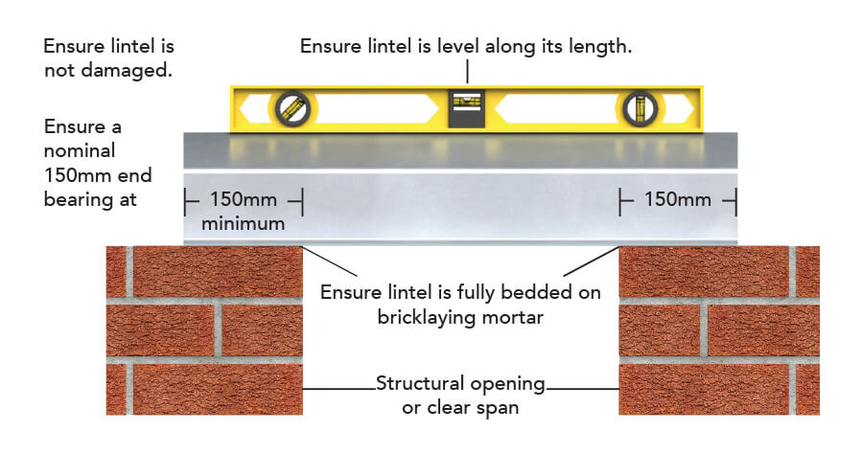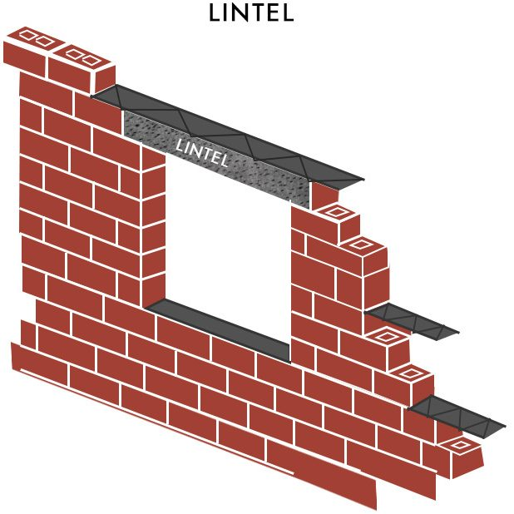

Fig.3.30 steel lintel installation Fig.3.31 lintel beam

3.6. Tie down and lateral support systems

How to ensure lateral support to walls when constructing floors and roofs

When constructing floors and roofs it is important to bear in mind that they provide lateral support to walls.
So when it comes to floors and joists being ‘built in’ or where walls require lateral restraint straps, do you know what to look out for?
Here are some best practice tips to make sure your lateral restraints are in check.
Where floors and joists are “built in” or supported by hangers off the wall the following should be taken into account:
- Shrinkage of joists – members must be secure to prevent twisting.
- Joists should be protected against moisture.
- Gaps formed in the wall construction should be sealed with a compressible filler to ensure air tightness.
The bearings of all floors, joists and roof members must not be less than 90mm onto a load bearing wall.

When are lateral restraint straps required?
At floor and roof constructions, walls require lateral restraint by tension straps in accordance with the provisions in BS EN 1996-2:2006 and Building Regulation requirements.
Lateral restraint straps are required at floor and rafter or flat roof member levels. If you are building a pitched roof you will also need to use straps at ceiling joist levels. Provision is necessary, should the height of the wall exceed recommended values found in BS EN 1995-1-1:2004 and current Building Regulations.

Best practice of lateral restraint straps
- Ensure all restraint straps fit tightly against the masonry face within the cavity.
- Use blocking in the gap between the joist / rafter and the parallel wall at all lateral restraint strap positions as well as in between joist / rafters for the length of strap required.
- Lateral restraint straps at floor or roof level must not be retro fitted by plug and screwing the strap to the masonry.
- Restraint straps must turn down the cavity by at least 100mm and be tight against the face of the wall.
Timber floor / wall detail
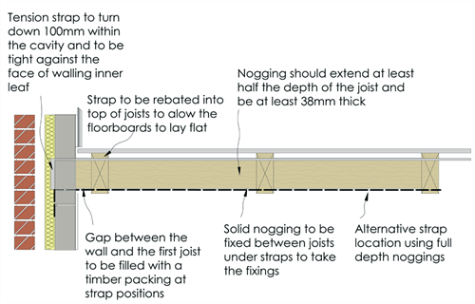
fig. 3.32 Timber floor / wall detail
Suspended concrete beam and block floor / wall detail
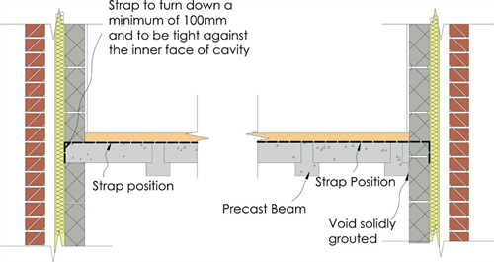
Fig. 3.33 Suspended concrete beam and block floor / wall detail
Rafter/gable wall detail
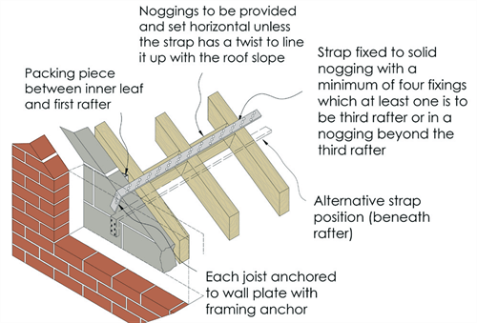
Fig.3.34 Rafter / gable wall detail
For more information please refer to our Technical Manual and check out our blog on how to use lateral restraints during construction.

Self- check-3

Part I:- Multiple item questions

Instruction: write short answer for the given question. You are provided 3 minute for each question and each point has 5 Points.
  - What is Damp Proof Course?
  - What is the abbreviation of DPC in Construction?
  - What are the desirable properties of DPC Material?
  - Describe the purpose of tie down and lateral support systems ?
  - Write components of mortar making materials?
  - Mention types of bonds in brick masonry?

Note: Satisfactory rating – 15 and above points Unsatisfactory - below 15 points
You can ask you teacher for the copy of the correct answers.

Name: _________________________ Date: _______________

Operation Sheet-3.1 | Mixing mortar

Work method:
- Place and spread six parts of sand on a clean platform or hard surface.
- Add one part of cement on top of the sand.
- Thoroughly mix the sand and cement until a uniform grey mixture is achieved. The general rule is that sand and cement is mixed dry together at least three times before adding water. It is important to achieve a consistently uniform mix.
- Rake the mix together and dig a well in the centre of the heap and carefully add water. Add the water in portions to avoid ending up with a too wet mix.
- Carefully shovel the dry mix into the water in the middle of the heap and continue mixing until the mortar has a uniform mass with the preferred consistency.

Caution:
- Always use fresh and lump free cement.
- First mix the dry ingredients (sand and cement) before adding water.
- Protect the mortar-mixing place from wind, rain and sunshine.
Since the mortar sets relatively quickly, it should never be mixed in larger quantities than what can be used during the next hour. Do not use mortar that has already hardened.
Tools:
- Clean platform for mixing
- Shovels
- An appropriate size box or measured buckets for batching
- Water buckets
Material:
- Cleaned and sieved sand
- Cement
- Clean water (no salt water)
- Canvas to protect mixed mortar subshine
Quality checkpoints:
- Check that the cement has not expired and does not contain any lumps.
- Check that the sand is clean and with correct grain size.
- Ensure that the water is clean - no salt water.
- Check that batching is done correctly, to an appropriate amount and with the desired mix ratio.
- Continuously check consistency when mixing and avoiding a too wet or too dry mix.
- Ensure that the mortar used is fresh.

Operation Sheet-3.2 | Constructing Brick masonry- English bond to course 10

PURPOSE: - to construct the brick masonry wall and maintaining bond to job specifications.

CONDITIONS OR SITUATIONS FOR THE OPERATIONS:-
- Wear appropriate clothes, shoe ...
- Ensure the work shop hazard free
- Ensure the working area is bright / good visibility
- Make workstation comfortable
- Use rages ,kerosene clearing purpose

TOOLS

- Standard masonry tool set
- Shovel
- Buckets with water to soak bricks
- Mortar pans for carrying and keeping mortar
- Gunny bags to cover wall from direct sunshine
- Water level
- String
- Sprit level
- Claw hammer
- Brick cuter
- Wheel barrow

MATERIALS : -
- Brick
- Cement
- Lime
- water
WORK METHOD/PROCEDURES

      - Set out the exact position of the structure (wall) by marking the external side of the walls on the plinth.
      - Lay the first two courses using ‘dry’ bricks – without mortar. This allows you to arrange proper bonding, identify where bricks need to be cut and to check the thickness of the vertical joints.
      - Always begin a wall with a stretcher course. Start work at a corner by first laying the corner bricks. Use a spirit level to check that the corner bricks are horizontal in both directions and vertical at the corner line.
      - Continue with the following bricks off the corner in both directions. In one direction it will be a stretcher course and in the other direction a header course. In the header course you have to place as the second brick a half-size brick to ensure the bonding becomes correct.
      - Start with the second course again in the corner, but now place the corner bricks in the opposite direction from the corner bricks in the first course. Again check horizontal and vertical directions and ensure the correct thickness of the joints (not more than 15mm).
      - The third course is exactly the same as the first course and the fourth course is identical to the second course.
      - Build all walls simultaneously for better bonding.

PRECAUTIONS:-
- Wear working cloths which properly fit with your body
- Make working area hazard free
- Read and interpret manual which guide you how to disassemble and tag engine system components.
- Read the working drawing.
- Identify job specifications.
- First Free from other secondary problems like depression .
- select and use hand tools & materials

QUALITY CHECKPOINTS:
- Check that all corners remain vertical at all times.
- Check that the level of each course is correct (height of courses = one brick plus one joint)
- Ensure the mason’s line is tightly pulled to avoid any sagging.
- Make sure that the joints are not less than 10mm and not more than 15mm.
- All joints should be fully filled with mortar.
- Use a plumb bob to check that every wall is vertical.
- Immediately remove excess mortar protruding from the joints.
- In hot weather, cover the completed wall with wet gunny bags at the end of the day.

Operation Sheet-3.3 | Constructing Brick masonry- Flemish bond to course 10

PURPOSE: - to construct the brick masonry wall and maintaining bond to job specifications.

CONDITIONS OR SITUATIONS FOR THE OPERATIONS:-
- Wear appropriate clothes, shoe ...
- Ensure the work shop hazard free
- Ensure the working area is bright / good visibility
- Make workstation comfortable
- Use rages ,kerosene clearing purpose

TOOLS

- Standard masonry tool set
- Shovel
- Buckets with water to soak bricks
- Mortar pans for carrying and keeping mortar
- Gunny bags to cover wall from direct sunshine
- Water level
- String
- Sprit level
- Claw hammer
- Brick cuter
- Wheel barrow

MATERIALS : -
- Brick
- Cement
- Lime
- water
WORK METHOD/PROCEDURES

      - Set out the exact position of the structure (wall) by marking the external side of the walls on the plinth.
      - Lay the first two courses using ‘dry’ bricks – without mortar. This allows you to arrange proper bonding, identify where bricks need to be cut and to check the thickness of the vertical joints.
      - Always begin a wall with a stretcher course. Start work at a corner by first laying the corner bricks. Use a spirit level to check that the corner bricks are horizontal in both directions and vertical at the corner line.
      - Continue with the following bricks off the corner in both directions. In one direction it will be a stretcher course and in the other direction a header course. In the header course you have to place as the second brick a half-size brick to ensure the bonding becomes correct.
      - Start with the second course again in the corner, but now place the corner bricks in the opposite direction from the corner bricks in the first course. Again check horizontal and vertical directions and ensure the correct thickness of the joints (not more than 15mm).
      - The third course is exactly the same as the first course and the fourth course is identical to the second course.
      - Build all walls simultaneously for better bonding.

PRECAUTIONS:-
- Wear working cloths which properly fit with your body
- Make working area hazard free
- Read and interpret manual which guide you how to disassemble and tag engine system components.
- Read the working drawing.
- Identify job specifications.
- First Free from other secondary problems like depression .
- select and use hand tools & materials

QUALITY CHECKPOINTS:
- Check that all corners remain vertical at all times.
- Check that the level of each course is correct (height of courses = one brick plus one joint)
- Ensure the mason’s line is tightly pulled to avoid any sagging.
- Make sure that the joints are not less than 10mm and not more than 15mm.
- All joints should be fully filled with mortar.
- Use a plumb bob to check that every wall is vertical.
- Immediately remove excess mortar protruding from the joints.
- In hot weather, cover the completed wall with wet gunny bags at the end of the day.

LAP Test -3 | Practical Demonstration
Name: _____________________________ Date: ________________
Time started: ________________________ Time finished: ________________
Instructions: Given necessary templates, tools and materials you are required to perform the following tasks within 3 hours

Task-1: mix mortar
Task-2: Construct brick masonry- English bond to course 10
Task-3: Construct brick masonry- Flemish bond to course 10

Unit Four: Construct isolated piers
This learning guide is developed to provide you the necessary information regarding the following content coverage and topics:
  - Setting out for pier
  - Constructing piers
This guide will also assist you to attain the learning outcomes stated in the cover page. Specifically, upon completion of this learning guide, you will be able to:
  - Set out for piers
  - Construct piers

4.1.Constructing piers

Bond in Brick Piers
Piers of brick masonry are provided to have supports for beams, trusses or other structural members. Piers are also known as columns or pillars. These piers may be of two types depending upon their location with reference to the adjoining load bearing wall
- Isolated Piers: Through piers may be constructed in any type of bond.
Generally English bond or double Flemish bond is adopted. The size of the pier as well as its shape (i.e. square, rectangular or circular) depends upon the magnitude of the bond as well as architectural requirements.
An isolated pier or pillar is the opposite of an attached pier in that it stands on its own with no connection to, or support from, any other walling. An isolated pier may be constructed as a support for a beam, as a gate pillar or as a decorative feature to provide a base for an ornamental feature such as a sundial, bird bath or statue.

In order to be structurally stable a pier must not be too slender and, in practical terms, the height of an isolated pier must not exceed eight times its least thickness. Also, a pier ceases to be regarded as such when its effective length exceeds four times its effective thickness; after this, it becomes classified as a wall.
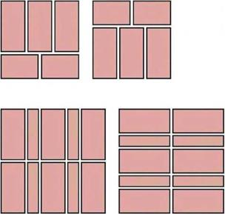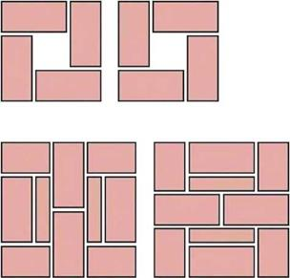
Fig. 4.1 English bond isolated piers. Fig. 4.2 Flemish bond isolated piers.

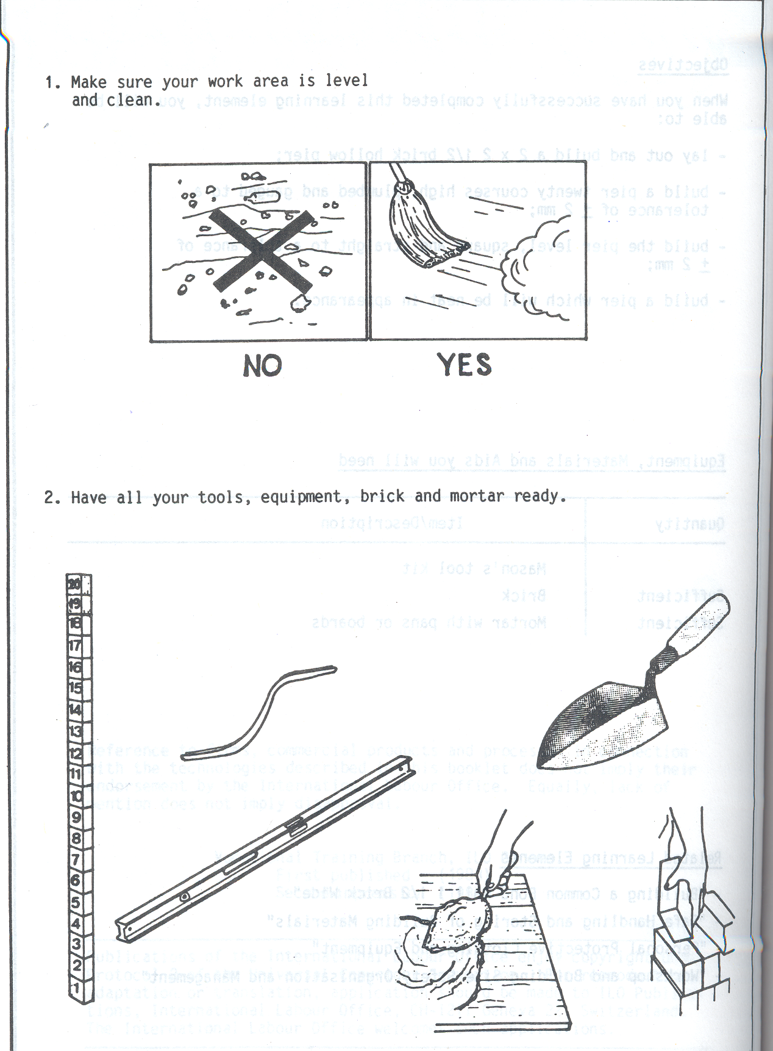
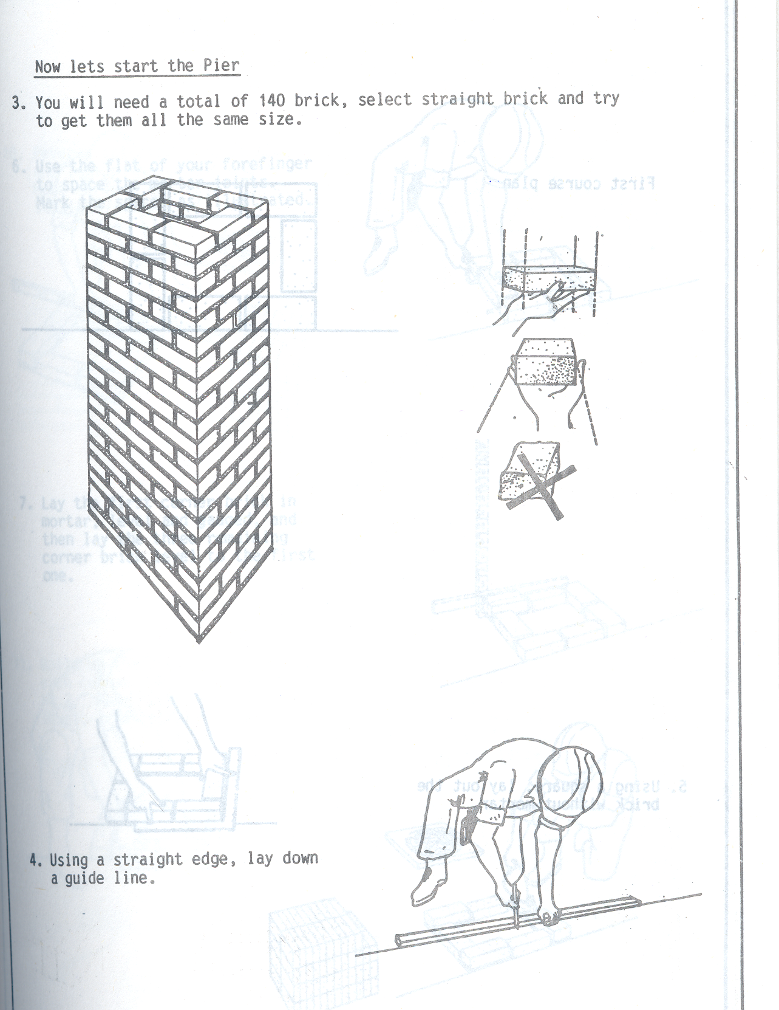
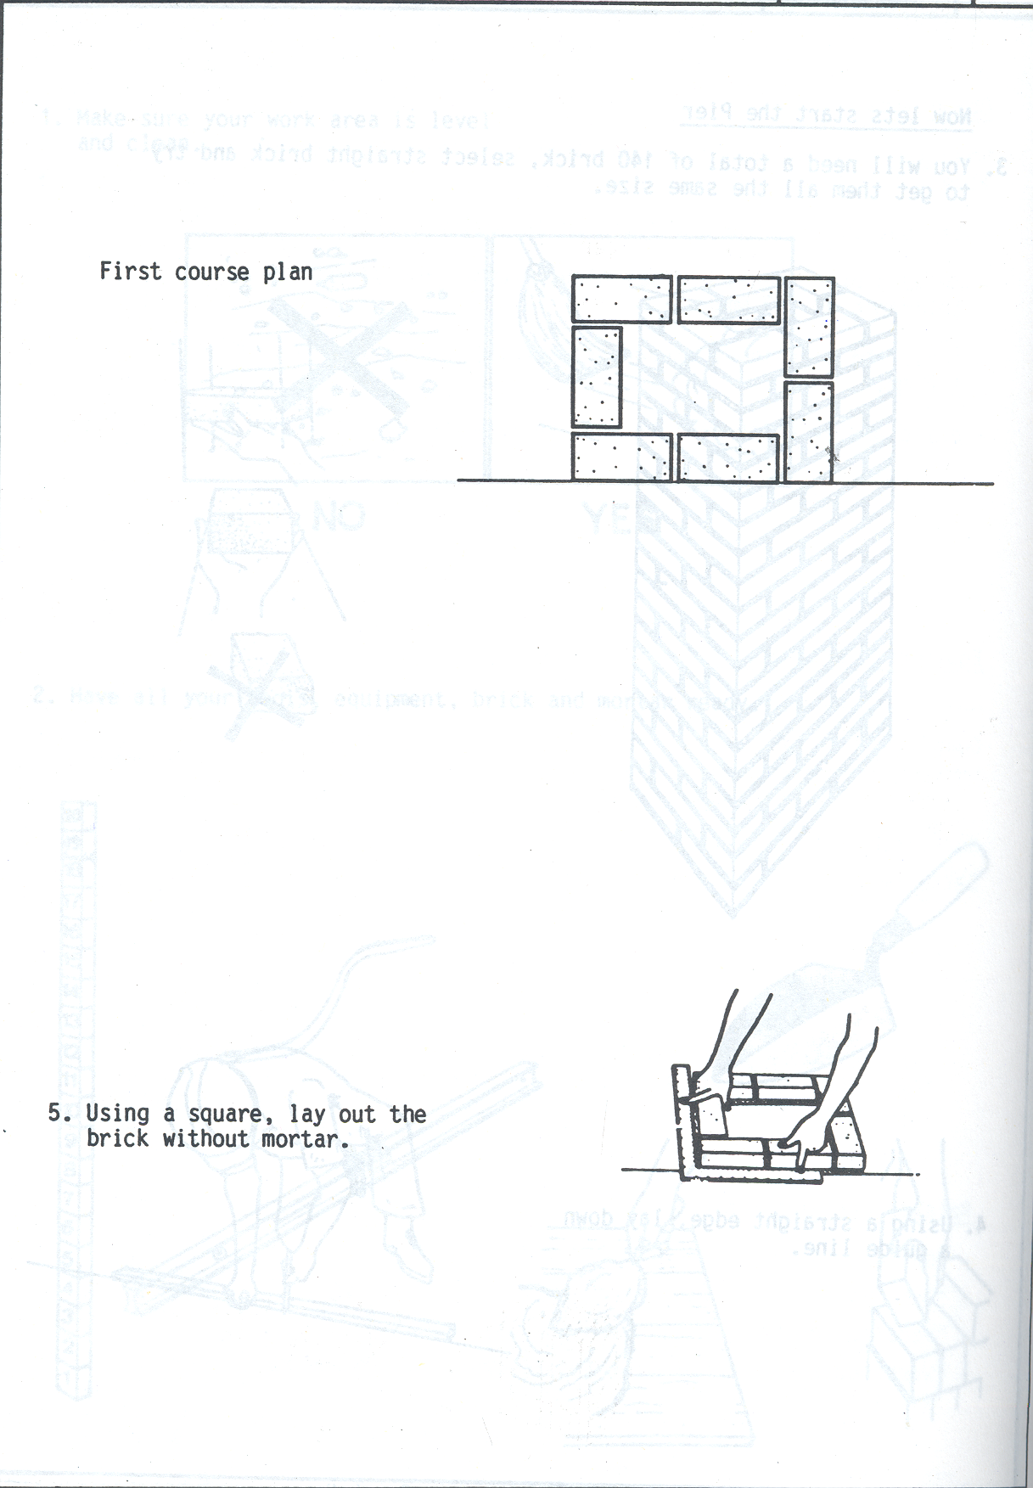
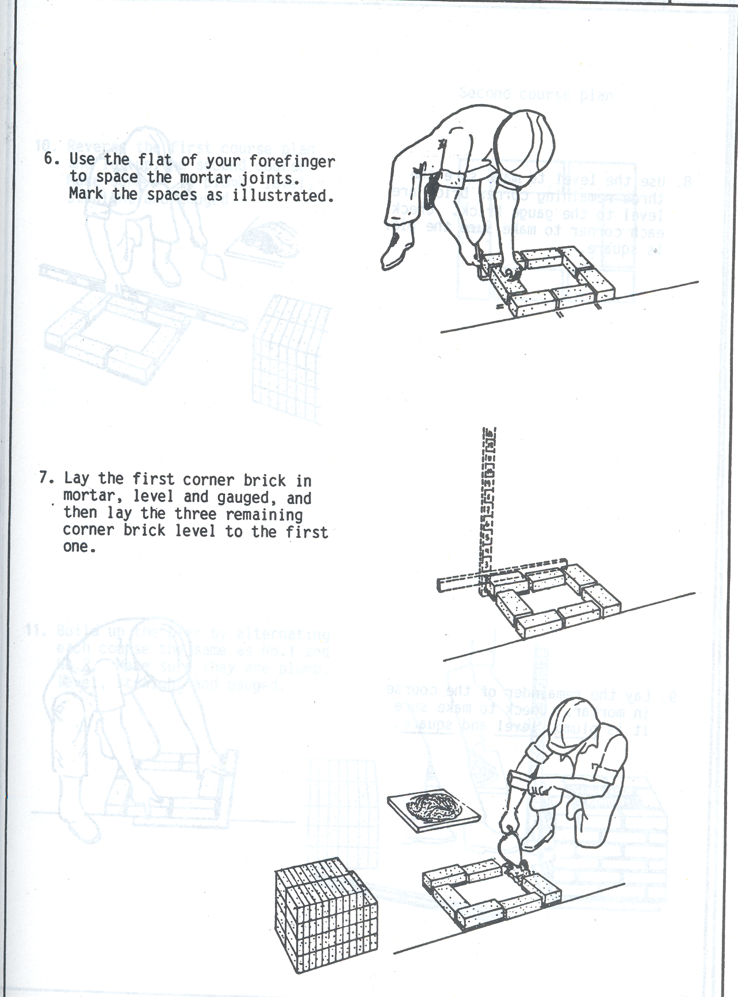
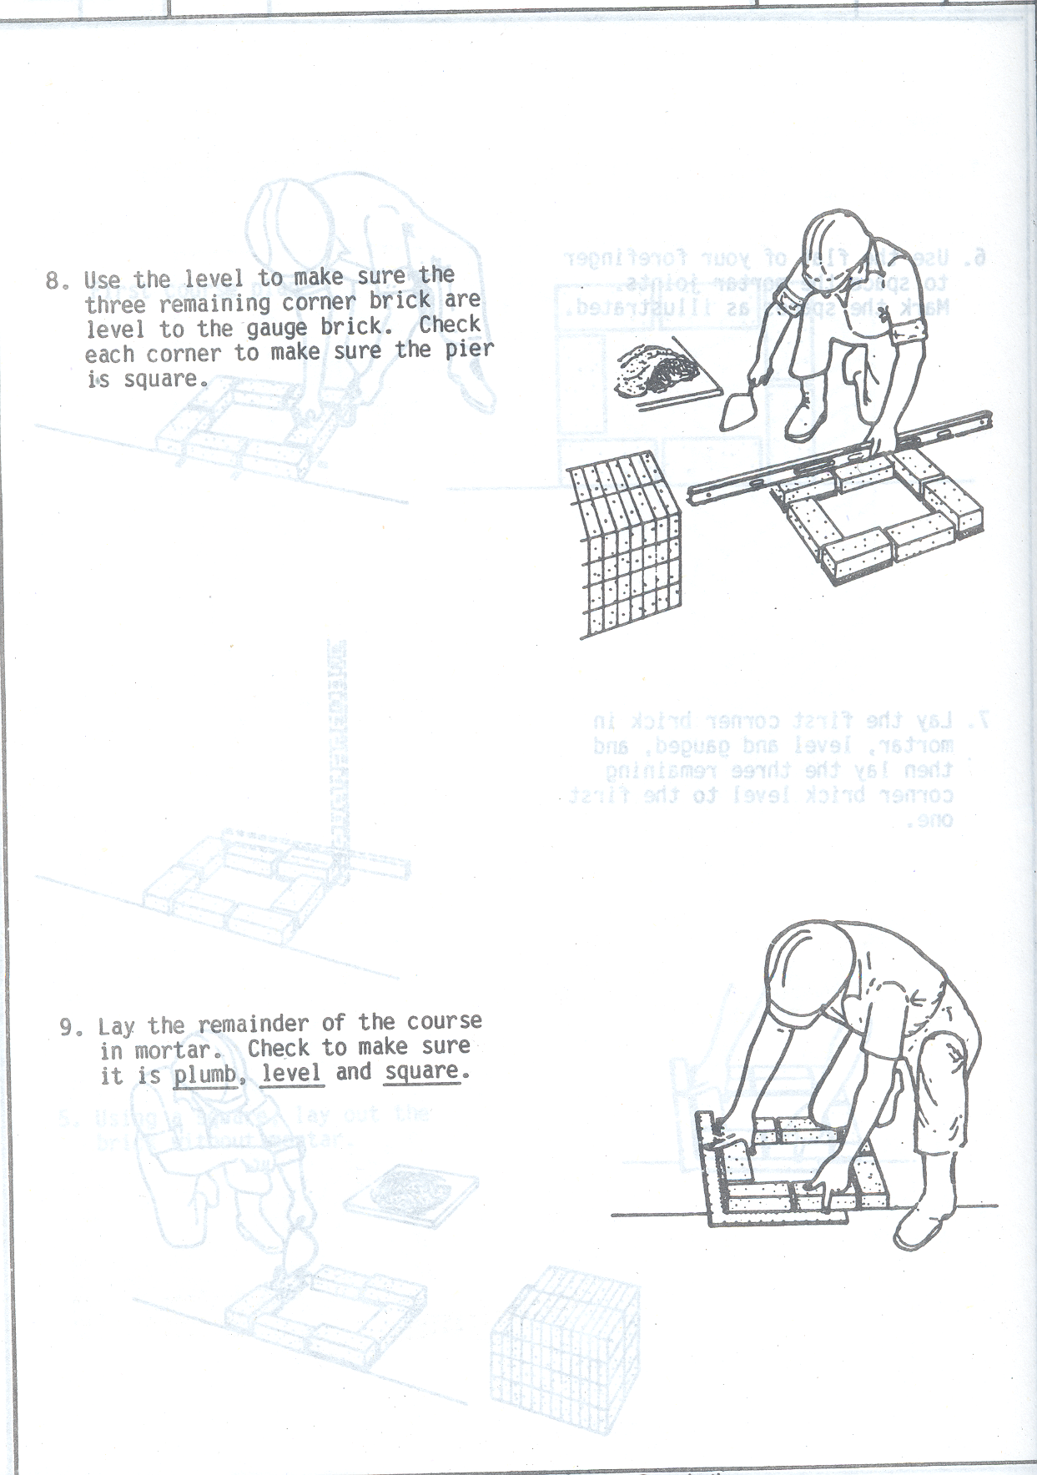
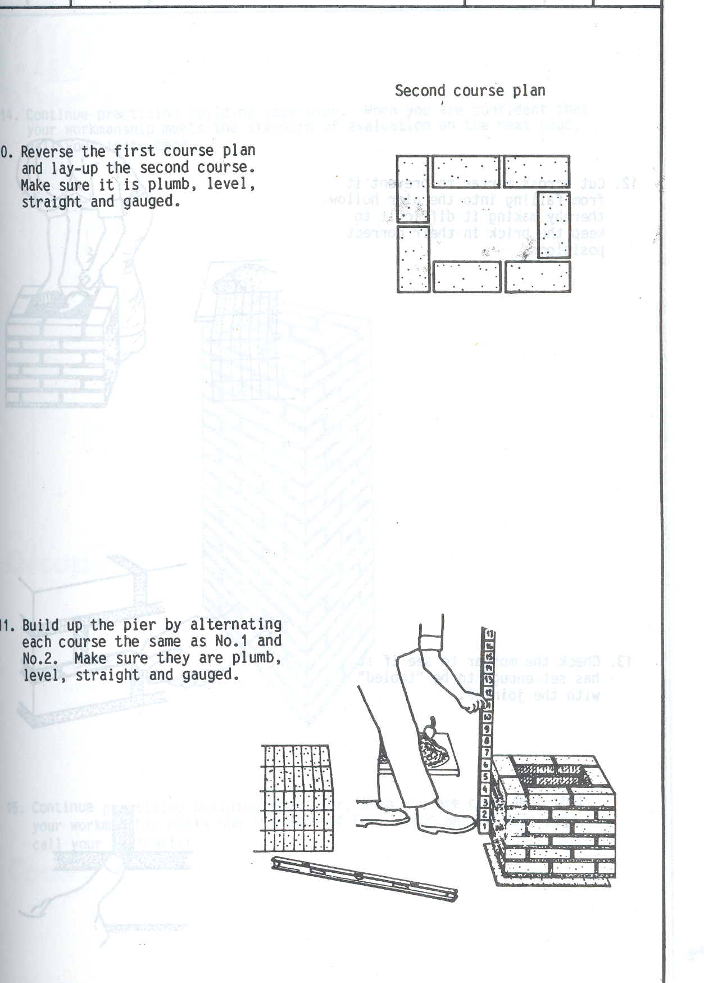
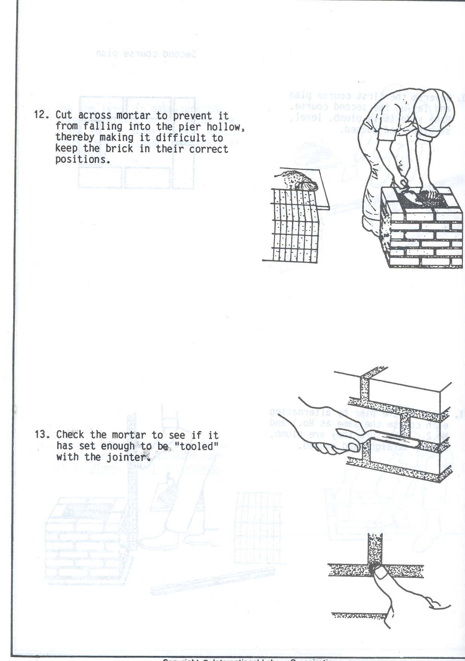
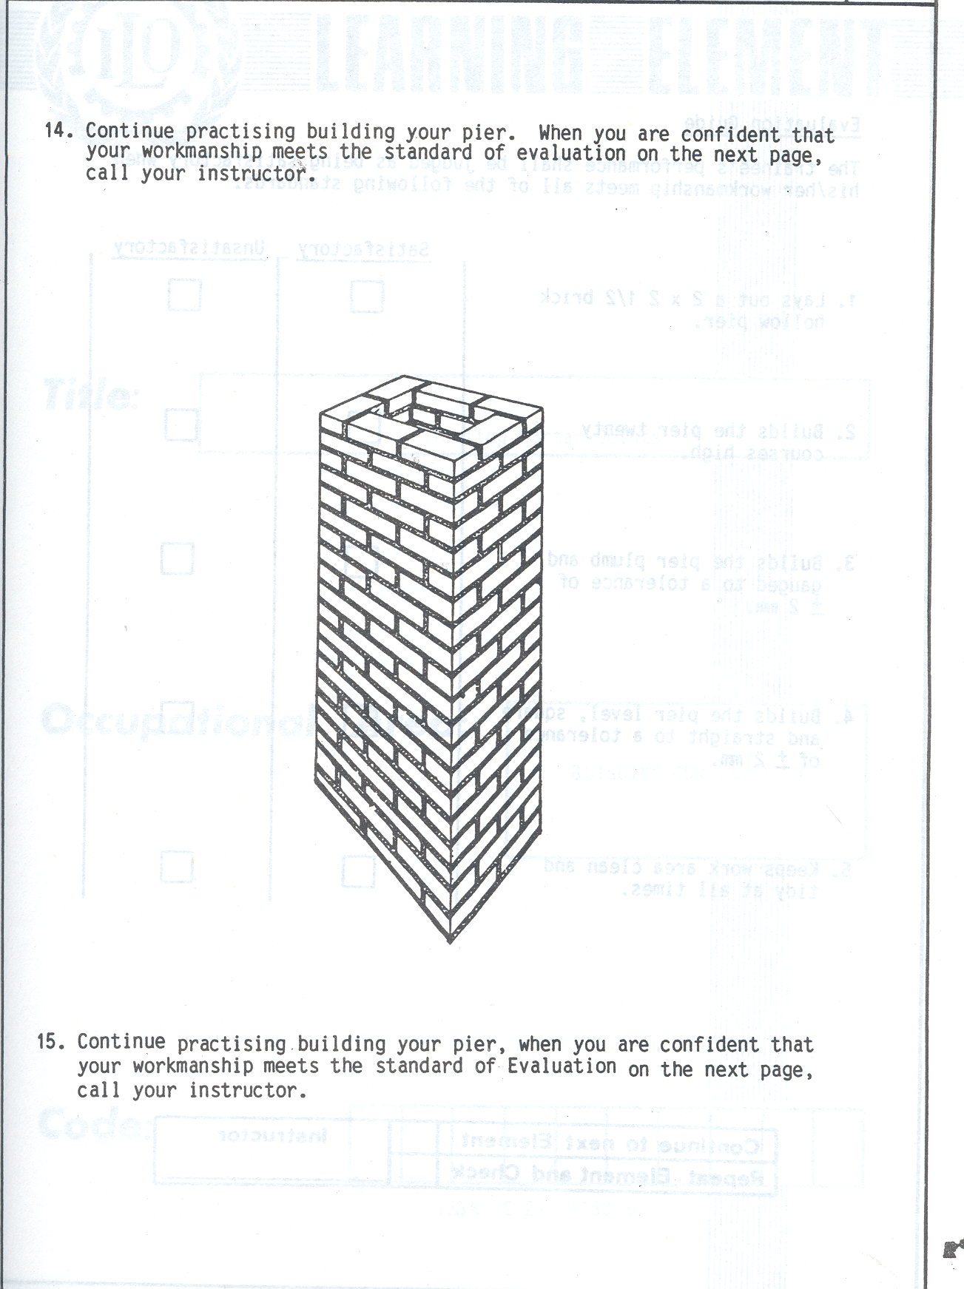

Self check-4

Part I:- Short item questions
Instruction: write short answer for the given question. You are provided 3 minute for each question and each point has 6 Points.
- Write types of piers?
- Describe piers based on their bonding arrangement?
- Write the difference of isolated pier and attached pier?

Note: Satisfactory rating – 9 and above points Unsatisfactory - below 9 points
You can ask you teacher for the copy of the correct answers.

Name: _________________________ Date: _______________

Unit Five: Finish joints
This learning guide is developed to provide you the necessary information regarding the following content coverage and topics:
- Cleaning surfaces of brickwork and cavities
- Raking joints of laid brickwork
- Brushing brickwork
This guide will also assist you to attain the learning outcomes stated in the cover page. Specifically, upon completion of this learning guide, you will be able to:
- Clean surfaces of brickwork and cavities
- Rake joints of laid brickwork
- Brush brickwork

5.1. Cleaning surfaces of brickwork and cavities

Cleaning Techniques
Water Cleaning
Hot water and detergent will likely be the first cleaning solution for most stains. Cleaning should not be carried out in frosty conditions unless adequate measures are taken to protect the wet brickwork from becoming frozen.

During hot weather it is preferable that brickwork to be cleaned should be shaded from sunlight, in order to prevent the areas being treated from drying out prematurely.
Water cleaning is generally low risk, but some simple rules must be observed:
- Avoid using metal tools to clean brick surfaces.
- If brushing, only use stiff bristled brushes, never wire brush.
- Never use excessive pressure, especially on sand faced bricks, as this can change the appearance and texture of the brick.
- Make sure that mortar is sufficiently matured so that it is not spread across the face.
- Always test on an inconspicuous area first.

Chemical Cleaning
When using any chemical solutions it is important to follow the manufacturers directions on the packaging and be certain that the product is suitable for the desired application. If there is any doubt then a specialist cleaning contractor should be consulted.
Some simple rules must be observed:
- Always test on an inconspicuous area first.
- All health, safety and environmental guidelines from the cleaning solution manufacturer should be strictly followed.
- Normally brickwork should be pre-dampened before application.
- Never use on brickwork that may have Vanadium stain present without further investigation – see vanadium.
- Ensure that there is an adequate supply of absorbent material to control runoff

Raking joints of laid brickwork

Racking of masonry joints

Insert the nail head on the rake you made into a vertical joint. Pull the board straight down to created a raked joint. Remove any mortar you pull away from the joint. Repeat this process for all the vertical joints, and then move the rake from side to side do all the horizontal joints.

Pointing for brick masonry

The main reasons for pointing the surface of block or brickwork joints are to increase its weather resistance and to provide a neat and good-looking finish to the wall.
Pointing can be carried out as a part of construction of the brickwork using ordinary mortar in which the bricks are bedded.
Another method is to finish the masonry works first and then carry out the pointing with a 1:2 cement mortar later. The joints are then be raked out, brushed, washed and filled with fresh mortar. Ideally to save cement and mason-days it is better to take up pointing simultaneously with the actual brick laying.

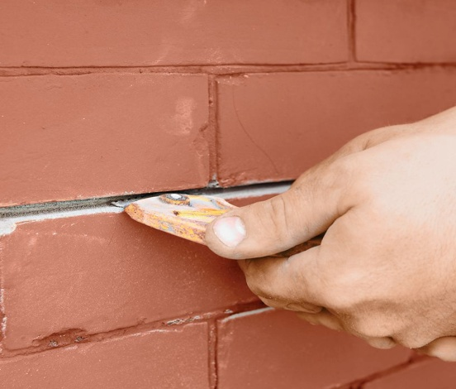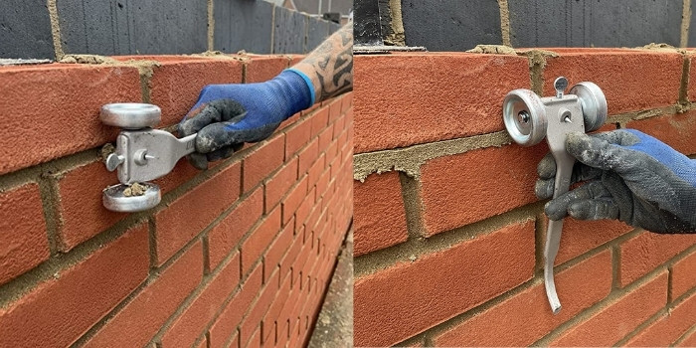
Fig.5.1 Raking

Brushing brickwork

Brick Dust
Dust produced from the cutting of brick sometimes adheres to the surface of brickwork. A soft fiber brush is recommended to remove dust particles from the brick surface. Wire brushes should not be used to remove dust because they can damage the brick surface. When removing dust, it is important to wear a dust mask or respirator to ensure that dust particles are not inhaled. Afterward, the surface should be wiped down using a dust mop or a damp cloth. Use of compressed air to clean dust is not recommended due to the increased risk of particle inhalation.

Self check-5

Part I:- Short item questions
Instruction: write short answer for the given question. You are provided 3 minute for each question and each point has 6 Points.
  - Write basic Cleaning Techniques
  - What do we mean bay raking? Explain
  - What do we mean by brushing brickwork?
Note: Satisfactory rating – 9 and above points Unsatisfactory - below 9 points
You can ask you teacher for the copy of the correct answers.

Name: _________________________ Date: _______________

Unit six: Clean up
This learning guide is developed to provide you the necessary information regarding the following content coverage and topics:
- Clearing work area
- Disposing and reusing and recycling of material
- Maintenance and storage of plant, tools and equipment
This guide will also assist you to attain the learning outcomes stated in the cover page. Specifically, upon completion of this learning guide, you will be able to:
- Clear work area
- Dispose, reuse and recycle material
- Maintain and store of plant, tools and equipment

6.1.Clearing work area

Definition of Terms
- Barricades – small structures made of metal, wood, or other possible materials which are used purposely to convey a message of caution or restriction to all concerned
- Doable – set of best or workable shop practices in order to achieve work simplification
- First aid – includes all forms of remedies given immediately to humans in order to minimize or prevent casualties or fatalities caused by accidents or normal course of time
- Hazard – involves unforeseen incident that is physically unfavorable to humans or animals
- Risk management – scientific technique of assessing, minimizing, and preventing accidents or loss of lives or limbs in the performance of tasks or jobs
- Sanitize – maintain high standard of housekeeping
- Self-Discipline – doing things spontaneously without being told or ordered
- Signs – objects made by flat sheet metal or wood suspended by a stand or nailed on the post or wall which are located strategically
- Sort – take out unnecessary items and dispose the same
- Sweep – clean the workshop
- Symbols – common illustrations printed on the signs which sometimes carry a descriptive word or few words
- Systematize – arrange necessary items in good order for use
- Work simplification – application of workable principles that increases the awareness and ability of the workers to be more productive and efficient without compromising their safety and the product quality

Work Safety
Introduction
We have heard of the slogans: “Watch your Step!- Look before you Leap-Take it easy!” and dozens of others which mean the same thing. We have also heard of a very important slogan “Safety First”

A. Avoiding Hazard in the Shop Area. When working in the shop, we should become acquainted with the things that may cause trouble. If we know about them, we could avoid them. Avoid hazards and treat them with respect. Hand tools and power tools are accounted for many shop accidents that could be prevented easily.
B. Attitude. Carelessness is caused by a poor working attitude. Your carelessness can cause injury to you or cause accident to someone else. Be aware that only proper conduct and good working attitude can prevent accident. Thinking about safety reduces carelessness.

Keep your work area clear of unnecessary tools and other parts which are not needed in your work. It is not a good thing to let the shop floor become strewed with scraps and debris. Under such conditions the worker may slip and fall.

If nails are removed from boards, the unwary may step on them. Do not leave boards lying around that have nail points sticking out beyond the surface. Chisels are dangerous if not properly handled. The workers should always take care to use the chisel in such a way that the cutting is performed in the direction away form the parts of his body. Clamping the stock firmly in place and using two hands to operate a chisel obviously eliminate the danger of cutting the hand which might otherwise be used as the holding agent.

When handling a sharp tool to another person, extend the handle first. This shows both courtesy and sound practice toward accident prevention.

Use the proper tool for the right job. The wrong tool can cause personal injury or damage the part. Do not place sharp tools in your pocket. Sharp tools will cut or stab into your skin. Be sure that your tools are in good condition. There is always danger with heads of hammers, mallet and hatchets if not properly attached will fly out and seriously injure someone.
A Healthy Shop Is a Safe Shop
The shop should be pleasant place where you will enjoy your work. Large manufacturing companies have learned that the shop accidents are greatly reduced when the shop itself is well-lighted and well-ventilated. The introductions of ventilating and blower systems, which free the air of dust and particles of dirt, have gone a long way toward reducing accidents. Good lighting, both natural and artificial, likewise safeguards the worker.
The healthy shop is a safe shop. After all, the protection of health is the first rule of “Safety First in the Shop”.

6.2. Disposing and reusing and recycling of material

Recycled Content
Many environmentally preferred product listings focus on materials that incorporate recycled content. By utilizing recycled materials, the assumption is that the environmental impact is lowered. Brick units may incorporate recycled materials such as sawdust, fly ash, recycled brick and metallic oxides. Mortar and grout can include recycled materials, such as fly ash, and most steel reinforcement used in reinforced brick masonry has a high recycled content.

Construction Waste and Recyclability
Building construction can generate significant amounts of waste. Because of the small, modular nature of brick, on-site construction waste can be dramatically reduced through careful design and detailing. Packaging from brick is minimal and easily recycled. Brick can be recycled in many ways. Scrap brick and brick from demolition can be crushed and recycled into new brick or used as brick chips for landscaping.

6.3. Maintenance And Storage Of Plant, Tools And Equipment

Definition of Terms
- Cleaning solvent – liquid, gas, or solid used to free the object or material from unwanted element or substance
- Handheld tools – collective term for masonry tools which are usually handy, lesser in weight and in size, and operated manually
- Lubricant – liquid or substance applied to prevent corrosion or occurrence of unwanted element
- Lubrication – method of applying oil or other pertinent liquid or substance to prevent or minimize occurrence of rust or unwanted element on the object or material treated
- Non-functional tools /equipment – collective term for non-serviceable or defective tools/equipment which includes tools/equipment that cannot anymore produce or perform an accurate result according to their uses or purposes
- Preventive maintenance – set of method or procedure performed or applied on to keep a tool or tools in good or perfect condition always that contributes to lengthening their life span or serviceable period
- Routine service – form of maintenance regularly given to equipment and tools
- Suitability – the act of satisfying certain requirements or specifications either in task/job performance or needs
- Synthetic – something produced as variation or alternative from what is real or common
- Techniques – proven procedures, approaches or methods used for a purpose of task/job accomplishment or performance
- Tips – proven suggestions or keys given purposely to facilitate task/job performance in reduced resource utilization

Kinds, Uses And Properties Of Cleaning Solvents
Kinds of Cleaning Solvents
Solutions are homogeneous mixture of two or more components; can be gaseous, liquid or solid. When we speak of a solution, we usually think of a solid dissolved in water. While water is the most common solvent, other liquids are frequently employed as solvents for certain substances. The dissolved material in a solution is termed as solute (e.g. wax) while the dissolving medium is called solvent (e.g. gasoline). However, the term can be interchanged depending on which substance is of greater amount.

Solvent is a component of a solution that dissolves solute and is usually present in large proportion or amount. It can be classified as polar or non-polar. Polar solvents are solvents which dissolve/are soluble in water; while non-polar solvents are solvents which do not dissolve/are insoluble in water.

Solvents are usually used for cleaning in automotive shops like water, gasoline, kerosene, thinner and detergent soap.

The table below shows the kinds of cleaning solvent based on their solubility in water.
Cleaning Solvents | Solubility in Water | Polar | Nonpolar
a. water  b. gasoline  c. kerosene  d. thinner  e. detergent soap | soluble  insoluble  insoluble  insoluble  soluble | x  x | X  X  x

Properties of Cleaning Solvents
A useful generalization much quoted is that “Like dissolves like”. More specifically, high solubility occurs when the molecules of the solute are similar in structure and electrical properties to the molecules of the solvent.

When there is a similarity of electrical properties (e.g. high dipole element between solute and solvent) the solute-solvent attractions are particularly strong. When there is dissimilarity, solute-solvent attractions are weak. For this reason, a polar substance such as water is a good solvent for a polar substance such as detergent soap and a poor solvent for a non-polar substance such as gasoline.

Uses of Cleaning Solvents

Cleaning Solvents Uses
1. Gasoline - used to wash oil/greasy tools/ equipment
2. Diesoline - used to wash oil engine, transmission and other parts of the vehicle
3. Kerosene - used to remove dust, grease oil, paint, etc.
4. Thinner - used to remove spilled paint on the floor, walls and tools
5. Soap and water - used to wash/clean upholstered furniture such as seats, tables, cabinets, etc.

Tools and Equipment Maintenance

Tools and equipment in the shop are classified into three main types. One type is known as hand tools because your hand supplies the energy to operate them. The other type is called machine or power tools/equipment which uses either electricity, compressed air, or hydraulic pressure to make them operate. The last type is referred to as measuring tools.

Tips and Techniques
The best way to keep the tools in good condition is to just clean them. If you take care of your tools, they last longer, bringing value to the masons. If mortar builds up on the tools and is not cleaned in a timely manner, special cleaners may be needed.
Basically, advantages outweigh the disadvantages on the proper usage of tools and equipment. Below are some common advantages:
1. Efficiency of the work
2. High quality of the work
3. Speed of accomplishment
4. Accuracy

Water and More
- Water is the best cleaning agent for small and larger tools. In most cases, nothing more than water is required to keep the tools in top condition.
- If mortar has hardened on the tools, and water is not sufficient to remove it, muriatic acid can be used to clean the tools. This acid can cause damage, so it should be used sparingly and rinsed off thoroughly. Muriatic acid is not safe on aluminum, zinc or stainless steel.
- If the mortar sits too long and builds up on the mortarboard, any kind of concrete dissolver will work to clean it.
- A non-porous, smooth surface with a concave at the middle portion helps the mortar board to keep water for greater workability.
- Masonry mortar does not bond to the working surface. You might get a 1/8-inch thick skim coat, but it is easily removed by knocking the mortarboard on the ground or hitting it with a hammer, noting that if water doesn't completely clean the surface, a heavy-duty cleaner is needed.

Preventive Maintenance
- Preventive maintenance using preservatives can keep wooden tools in top shape by preventing the wood from splitting.
- Linseed oil is recommended for wooden levels and wooden handles. It protect against splitting and spalling when the wooden part gets wet repeatedly due to constant use.
- However, some metal tools like trowels are prone to rust. But if they are used almost every day, rust and other unwanted elements will wear off naturally which keeps them clean always.

Routine Service for Handhelds
- If a hammer handle becomes loose, it should be replaced immediately. The hammers should be sharpened by a blacksmith and never through a grinder since the temper of the hammer is lost through grinding.
- Good maintenance of your carbide chisels lets you cut faster and accurately.
However, improper grinding can damage the carbide and cause tool failure. Never forget to grind the shank end or strike the head frequently to maintain the correct shape for safer performance.
- If you need to tighten up a wooden handle, insert another wedge into the end of the handle or immerse the hammer head into a bucket of water overnight to expand the wood.
- For striking tools with carbide tips, storing properly is important. Extra care must be exercised not to strike carbide tools against each other since this may break the carbide into pieces.
Maintain and Service Motorized Product
Frequently used equipment also needs a squirt of grease. They require minimum and periodic maintenance. You have to change the engine oil occasionally so as the tires once worn out. Tire pressure should be checked regularly for safety reason as well as prolonging their lifespan.

Check conditions of tools and equipment
It is highly recommended that you must inspect all the tools, instruments and equipment before using them to ensure that they are used to specification. Avoid using defective hand tools and equipment to prevent accidents.

Methods of Identification
  - Visual inspection. It refers to the visual observation of an expert on the appearance of the tools and equipment.
  - Functionality. Vibration or extra noise from the operation means problems on parts and accessories started to develop.
  - Performance. When there is something wrong with the performance of either hand tools or equipment they need an immediate repair or maintenance.
  - Power supply (for electrically operated equipment). Failure to meet the required power supply, malfunction will occurs in the part of hand tools or equipment.
  - Person’s involved. It refers to the technical person who has the knowledge and skills about the technology.

Store Tools And Equipment
A. Tools and Equipment Inventory
Some companies often spend more time in tracking and managing their inventory. Others --- such as manufacturers, producers and construction companies --- may use specific equipment for specific jobs. This creates a difficult situation of attempting to manage inventory at multiple job locations. Business owners and managers typically create systems or processes that employees must follow when using the company's shop tools.

Depending on the type of company, owners or managers may require employees to use own tools for certain jobs. For example, construction companies may require employees to have their own items such as a hammer, painting equipment or welding supplies. This reduces inventory management.

Whatever is the type of company or shop, inventory taking is very important. On this context, inventory is defined as a detailed list of all the items in stock.

Reason for Maintaining Tools and Equipment Inventory

The most important point to consider is to purchase top-grade tools. They must be made of high-quality steel and manufactured for precision. Special consideration is given to balance so that the tool/equipment will be properly maintained and prevent loses. Since the technician must work with his tools daily, regular inventory of tools/equipment is very important.

The initial cost of a minimum number of tools is high but there is accompanying warranty guarantees satisfaction and many years of service. It is better, in the long run, to start with a few carefully selected tools that will take care of your most common needs and then gradually build-up to a complete set. It is sometimes hard to identify and memorize the huge number of tools and equipment in the workshop, maintaining the inventory record is of great value.

Self check-6

Part I:- Short item questions
Instruction: write short answer for the given question. You are provided 3 minute for each question and each point has 2 Points.
  - How many types of tools and equipment are there in masonry?
        - 2 C. 3
        - 3 D. 4
  - Which is an advantage of the proper use of tools and equipment?
        - Accuracy in job/task performance is achieved. C. There is high quality of work.
        - Shop efficiency is promoted. D. All of the above.
  - Which is the best way to keep the tools in perfect condition?

        - Keep them immediately without cleaning.
        - Clean them while they are in the tool cabinet.
        - Clean them before storage.
        - Place them in a bucket of water.

  - What will happen if mortar is not cleaned?

        - The mortar will build up and harden.
        - The mortar will build up but can be removed too easily.
        - The tools cannot anymore be used.
        - Just ignore it for it won‟t matter anyway
  - Most handheld masonry tools can be cleaned by___
        - Kerosene C. Oil
        - clean water D. Cleaning agent provided
  - When do we use a muriatic acid in masonry?

        - To harden up mortar.
        - To remove hardened mortar on the tools.
        - To get rid off of harmful elements from the mortar.
        - To wash off the masonry materials.

  - What is used as preventive maintenance for wooden tools?
        - Water C. Linseed oil
        - Kerosene D. muriatic acid
  - Why do we have to check frequently the hammers for signs of chipping, cracking or unusual signs of defects?

        - To assure that there are no missing tools.
        - To ensure that they are well classified.
        - To ensure that they are in good condition.
        - To maintain their cost value.

  - What is the best way to prevent tools from rusting?
        - Wipe the tools with oil.
        - Keep the tools in an air conditioned room.
        - Keep them in their boxes always.
        - Keep the tools clean and dry before and while in the storage.
  - It is a method of identifying non-functional tools.
        - Visual inspection C. Performance
        - Functionality D. All of the above

Note: Satisfactory rating – 10 and above points Unsatisfactory - below 10 points
You can ask you teacher for the copy of the correct answers.

Name: _________________________ Date: _______________

List of Reference Materials
- OSHA Construction Safety & Health Standards OSHA 29 CFR 192
- National Institute of Occupational Health & Safety (NIOSH – USA)
- The ILO Code of Practice – Safety and Health in Construction.
- Health and Safety in Construction – Health and Safety Executives (HSE) Books.
- Safety, Health and Welfare – A training manual – ILO.
- The Occupational Safety and Health Act 2005
- Regulation for Building and Excavation Work – GN 358 of 1980.
- http://www.lboro.ac.uk/sustainability/policy/Incident.html
- A Text book of Building Construction, S.P. Arora and S.P. Bindra, Dhanpat Rai & Sons.
- 1 A Text Book of Building Materials, C.J. Kulkarrni 2 Building Materials, P. C. Varghese, PHI, Pvt. Ltd.
- Building Construction, P. C. Varghese, PHI, Pvt. Ltd.
- Sushil Kumar. (1988). Building Construction. (Pp-). New Delhi: Standard Publishers Distributors.
- Rangwala , S. C. (1980). Building Construction. (pp-).New Delhi: R. C. Patel Charotar Bookstall and Anand.
- Punmia B.C, Ashok Kumar Jain and Arun Kumar Jain. (2008). Building Construction. (Pp-). New Delhi: Lakshmi Publications Pvt. Ltd.
- Technical Details: An Architect’s Guide to Setting Out Brickwork
- https://www.brick.org.uk/technical/guides
- https://www.brick.org.uk/admin/resources/designing-to-brickwork-dimensions.pdf
- https://www.brick.org.uk/technical/design-details
- https://www.brick.org.uk/technical/structural-brickwork
- https://www.brick.org.uk/technical/brick-calculator
- https://www.ibstockbrick.co.uk/technical-services-technical-information/
- https://www.ibstockbrick.co.uk/wp-content/uploads/2015/08/TIS-A2-BRICKWORK-DIMENSIONS-TABLES-STANDARD-BRICK.pdf
- https://www.ibstockbrick.co.uk/wp-content/uploads/2015/08/Ibstock-TIS-A2-BRICKWORK-DIMENSION-TABLES-Standard-brick-sizes.pdf

Participants of this Module (training material) preparation
No | Name | Qualification (Level) | Field of Study | Organization/ Institution | Mobile number | E-mail
1 | Tesfaye Assegidew | A | Construction Mgt | Butajira PTC | +251913442444 | tesfayeassegidew@gmail.com
2 | Melsew Keba | Msc | Construction Mgt | Assosa PTC | +251913283335 | melsewkeba@gmail.com
3 | Dawit showafera | Msc | Construction Mgt | DDPTC | +251986314667 | dawitshowafera835@gmail.com
4 | Muluken Solomon | Msc | Construction Mgt | Batu PTC | +2519-12289146 | mulecot99@gimal.com
5 | Tiruneh Asebe | Msc | Construction Mgt | Hossana PTC | 0911422557 | tirunehasebe@gamial.com

