STRUCTURAL CONSTRUCTION WORKS

Level – IIi

Based on October 2023, Curriculum Version II
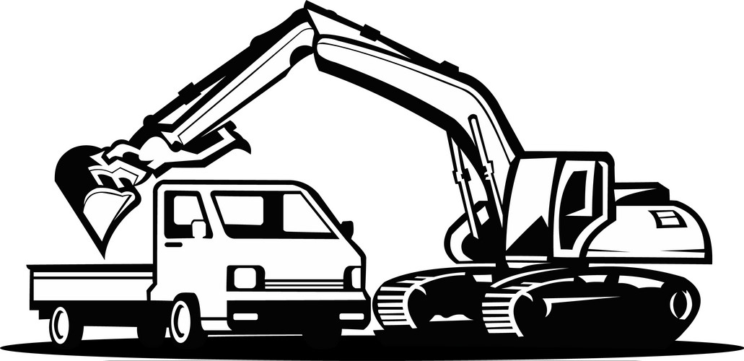
Module Title: Perform Excavation
Module code: EIS SCW3 03 1023
Nominal duration: 60 Hours

Prepared by: Ministry of Labor and Skill
October 2023
Addis Ababa, Ethiopia

Table of content
Acknowledgment 2
Acronym 3
Introduction to the Module 4
Unit one: Basic Concept and of Monitor Excavation 5
1.1. Introduction to excavation work 6
1.2. Applying work instructions 9
1.3. Selecting tools, equipment and materials 10
1.4. Calculating quantity materials 15
1.5. Applying environmental protection 17
Self-check 1 18
Operation Sheet 1.1 27
LAP Test 1 28
Unit Two: Locate Excavation Site and Erect Safety Equipment 29
2.1. Occupational Health and Safety and signage requirements 30
2.2. Excavation route line and location 35
2.3. Setting out of excavation work 37
2.4. Establishment of temporary drainage system 42
2.5. Identifying service markers or taped areas 45
Self-check 2 47
Operation Sheet 2.1 38
LAP Test 2 Error! Bookmark not defined.
Unit Three: Dig Excavations 41
3.1. Using Excavations Safely. 42
3.2. Assist machine operator to insure excavation quality 44
3.3. Installing trench excavation support 47
3.4. Clearance and wastege management 55
Self-check 3 57
Operation Sheet 3.1 Error! Bookmark not defined.
LAP Test 3 Error! Bookmark not defined.
Reference 59
Acknowledgment
The Ministry of Labor and skill wishes to thank and appreciation to MoLS leaders and experts, Regional Labor and skill/training Bureaus leader, experts, TVT College Deans, Instructors and industry experts who contribute their time and professional experience to the development of this Training Module.

Acronym
SWI Site work instruction
GRP glass-reinforced plastic
PMW project management web
PMIS project management information systems
PEP project execution plan
PPE personal protective equipment
OH&S occupational health and safety
JHA Job Hazard Analysis
GPR Ground Penetrating Radar
DNO Distribution Network Operator
LOT Land of owner tenure
JHA job hazard analysis
GPS Global Positioning System

Introduction to the Module
This module course is an introduction to the methods of excavation of shallow and deep excavations. You will learn about the two basic types of excavations: "open excavations" where stability is achieved by providing stable side slopes, and "braced excavations" where vertical or sloped sides are maintained with protective structural systems that can be restrained laterally by internal or external structural elements. It will be introduced to the methodology for selecting and designing excavation systems including consideration of soil type and strength parameters, groundwater conditions, slope protection, side and bottom stability, vertical and lateral movements of adjacent areas, and effects on existing structures.
This module course is intended for tvet trainees and construction professionals interested to learn the fundamentals of excavation in soils for stability and safety, as they relate to open cut excavations, trenching, rock excavation, excavation stabilization and safety, embankment cross-section design, and borrow excavation.
This module covers the following units:
- Basic concept of monitor excavation
- Excavation site and safety of equipment
- Dig excavations
- Materials handling, storage and waste management
Clean up Learning Objective of the Module
- Understand Basic concept of excavation
- Identify Excavation site and safety of equipment
- Dig excavations
- Clearing and waste management
Module Instruction
Trainees are expected to follow the following module instructions for effective use of these modules:
1. Read the information written in each unit.
2. Complete the self-checks at the to of each unit.
3. Read the identified reference book for examples and exercises.

Unit one: Basic Concept and of Monitor Excavation
This unit is developed to provide you the necessary information regarding the following content coverage and topics:
- Introduction to excavation
- work instructions
- Select tools, equipment and materials
- Materials quantity and calculating
- environmental protection
This unit will also assist you to attain the learning outcomes stated below. Specifically, upon completion of this learning guide, trainees will be able to:
- Apply work instructions
- Follow OH &S requirements
- Select tools and equipment
- Calculate quantity materials
- Apply environmental protection

Introduction to excavation work
Excavation is “the process of removing earth, rock, or other materials from a given area, commonly to create a foundation or structure.” It’s the first step in many construction projects.It is a key component of many industries, including construction, restoration, mining, landscaping, and more. Skilled workers, ranging from laborers to heavy machinery operators, prepare the earth for concrete and other crews to come in after and build.
Excavation plays a fundamental role in the construction industry: it is a practice that involves the removal of rocks or soil from the ground in order to prepare foundations for buildings, by excavation, splitting, trench digging and also for wells and tunnels.
Excavation is the preliminary excavation for the construction of any type of foundation: it is a large-scale work; involving deep excavation to ensure the solidity of the building or structure to be built.
Excavation work generally means work involving the removal of soil or rock from a site to form an open face, hole or cavity, using tools, machinery or explosives.
Excavation work can occur anywhere, including:
- On construction sites
- On business premises
- In public areas.

Excavation work for building construction is categorized into two:
Shallow excavations: are defined as being anything less than 1.5 metres deep, which really is not very deep at all; a relatively short person could comfortably see over the top. Shallow excavations can be made without supporting the surrounding material if there is adequate space to establish slopes at which the material can stand. The steepness of the of the slopes is a function of the type and character of the soil or rock., the climate and weather condition, the depth of the excavation, and the length of time the excavation must remain open. As a rule, construction slopes are made as steep as the material will permit because the occurrence of a few small slides is generally not serious. The cost of time removing the material affected by the slider may be considerably less than that of the additional excavation required to provide flatter slopes.
The steepest slopes that can be used in a given locality are best determined by experience. Most sands contain a small amount of cementing material or display a small amount of apparent cohesion because of moisture they contain. This cementation or cohesion cannot safely be dependent on for the stability of permanently exposed slopes, but it is ordinarily utilized for the periods during which excavation stands open.
The maximum slope at which a clay soil can stand is a function of the depth of the cut and of the shearing resisting of the clay. If the clay is soft below the base level of the excavation, flat slopes may be required to avoid a rise of the bottom. Furthermore, stiff or hard clay commonly possess or develop cracks near the ground surface. If these cracks become filled with water, the hydro-static pressure greatly reduces the factor of safety of the slope is likely to decrease with time. For these reason, bracing is often used to support the sides of excavation in clay, even though the clay would stand briefly to the necessary height without lateral support.
Sheet for shallow depth
Many building sites extend to the edges of the property lines or are adjacent to other site on which structures already exist. Under these circumstances, the site of the excavation must be made vertical and must usually be supported. Several methods of bracing are common use.
If the hole is not extend to a depth greater than about 12 ft, it is common practice to drive vertical planks known as sheeting around the boundary of the proposed excavation. The depth to which the sheeting is driven is usually kept near that of the bottom of the hole as excavation progresses. The sheeting is held in place by means of horizontal beams called wales that in turn are commonly supported by horizontal struts extending from side to side of the excavation. The struts are usually of timber, but if the excavation is not more than about 5 ft wide, extensible metal pipes called trench are commonly used. Their usage requires the soil in the base of the excavation to be firm enough to provide adequate support for the inclined members.
Deep Excavation: building construction requiring deep excavation such as the total extraction of the soil is complicated in nature because of its exposure to the elements of the nature and manmade restrictions.
Elements of the nature refer to the weather conditions, while manmade restrictions refer to the laws that regulate all activities within the area of construction.
The site must be excavated to build the foundation below ground. Excavation is normally done by hand or with mechanical diggers.
At this stage, the contractor already has two important sources of information about excavations:
- The trial holes, which revealed the type of soil underground;
- The working drawings which indicated the depth required for foundations.
Excavation calculation
Excavation is the process of digging, excavation will be understood as the process of excavating and removing volumes of earth or other materials for the conformation of spaces.
Excavation is used in construction to create building foundations, reservoirs and roads. Some of the different processes used in excavation include trenching, digging, and dredging and site development. The processes used will depend upon the structure that will result from the construction process. For construction work excavation services are important.
We determine excavation method to use to find the volume. In this case we are dealing with a rectangular box because it describes a length, width and depth.
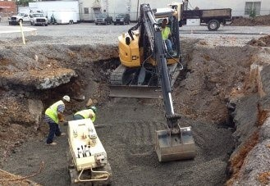
Figure: 1.1.
Excavation, earthwork and concrete work are typically measured by volume. These items contain three dimensions which ideally are arranged in the order of length by width by depth. Again, the sets of three dimensions are identified by the horizontal line under the third dimension of the set. The concrete foundations in Figure 1 identify two separate trenches where the longer trench is 900mm wide and the shorter trench is 1200mm wide.
The convention of underlining indicates which unit of measurement is being used and removes the need to stipulate whether the measurements are lengths, areas, volumes or numbers. Where each dimension is underlined the unit of billing is the metre, where the second dimension in a pair is underlined the unit is square metres, and where the third dimension in a set is underlined the unit is cubic metres.abor costs are calculated on a crew day basis with a typical crew being made up of the operators,
Skilled and unskilled laborers and a superintendent Labor costs should include all applicable wage rates.

Excavation Calculation
Volume of Excavation =Length×Width×Depth
Trench excavation:
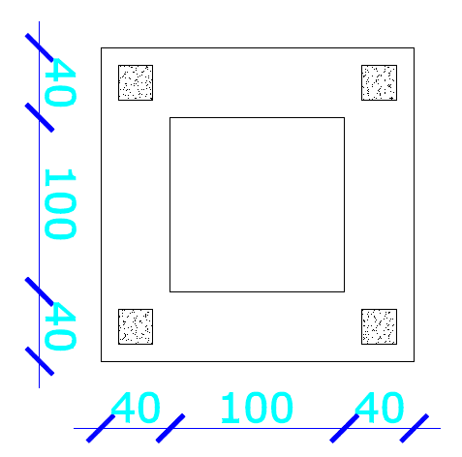
The depth of Foundation wall is 0.80m from ground level. Find the length of wall from the foundation plan. Assume 10cm working space in both sides.
Total volume of trench excavation is:
V= L*W*h
First the total length of foundation wall should be calculated using wall method:
L= 2(1) + 2(1.8) = 5.60m
Then; V= 5.60m x 0.6m x 0.80m
V= 2.688m³

Work instructions
Site Work Instructions (SWI) is written technical instructions issued to the contractor by the engineering consultant to execute a particular job or work, which does not involve adjustment of the contract sum or time. All SWIs must be copied to the project owner or the project management consultant upon issuing to the contractor. The process for who should be involved and copied on the SWI should be outlined in the project execution plan (PEP). On some projects, SWI is also known as Field Orders.
Upon receipt of the SWI, the contractor evaluates the received instruction and advises the engineering consultant, with a copy to the project owner or the project management consultant, of the acceptance to carry out the work as outlined in the SWI without additional time or cost, when to commence the work and its duration for completion and whether it has any effect on other activities or work elements. Should the contractor consider that a change in the contract sum or contract time is required, and then the contractor must submit a change order request to the project owner or his authorized representative immediately and before proceeding with the Site Work Instruction
This Site Instruction is issued for clarifying drawings, specifications, or contract requirements and non-variation instructions, etc. regarding safety, cleaning, etc. Site Work Instructions involve neither Cost nor Time.
Work instructions are vital in an organization’s operations for various reasons. For one, they’re key to standardizing work processes in all construction areas. Departments with repetitive tasks can significantly benefit from this tool, as it ensures everyone follows the same procedures.
Moreover, work instructions help improve workplace productivity. Through clear and detailed directions, employees can accurately and efficiently carry out tasks without having to guess or make assumptions about the next steps. And when everyone completes their jobs correctly, it flows to the rest of the business, creating a positive domino effect in the overall operations.
Lastly, this document serves as an aid in promoting safety in the workplace. It outlines specific steps on how to complete tasks safely, making it instrumental in reducing the risk of accidents and injuries on the field.

Tools, equipment and materials
Proper tools and equipment are essential for the effective operation of any civil works site. Equipping the construction site with the correct tools and equipment plays an essential role in achieving timely and good quality results. For every construction activity there is an optimal combination of tools, equipment and labour. Depending on the nature and content of the works, the technical staff needs to know which tools to use and how to effectively combine them with manual labour.
    - Tools and equipment
These are generally used for smaller depths of excavations in small areas. Man power is required to operate these tools. The tools come under this category are explained below.
Name of tools and equipments | Use of tools and equipments | Picture of tools and equipments
Spade | Spade is a tool which consists metal plate having sharp edges, the plate is attached to long handle which is generally made up of wood. Because of its sharp edges the soil can be dig easily. The metal plate having less curvature in the spade so, we cannot lift the soil by spade. | 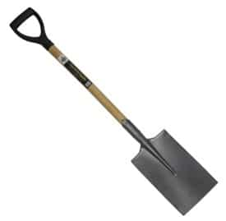
Shovel | Shovel is tool which is used for the purpose of lifting of excavated soil. It is also similar to spade the difference between spade and shovel is the difference in leading edge. The curvature of metal plate of shovel is generally higher when compared to spade so we can hold the soil easily and lifted it. Shovel can also be used for digging purpose in case of soft soils, sand etc. | 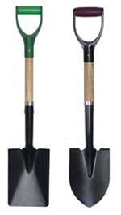
Hoe | Hoe is an excavating tool which consists a metal plate attached to a long handle with acute angle. The plate having sharp edge is used to excavate the soil. For small work of excavation it is widely preferred tool. Sometimes metal plate is replaced by fork type plate. | 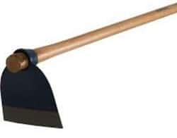
Trowel | Trowel is hand sized tool which is generally used to dig the small trenches in soil or to remove the shallow roots in soil. | 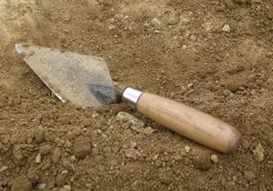
Pick axe | Pick axe consists hard spike attached perpendicular to handle. They are used for excavating small trenches in soil. Pick axe can cut the soil even if the soil is of hard type. The metal spike is pointed on one side and wide blade is provided on the other side. | 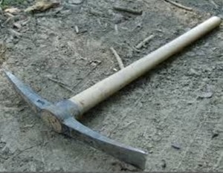
Mattock | This looks like pickaxe. But serious digging is not possible with mattock. Generally it is used as lifting tool because of its curve shapes metal at its bottom. | 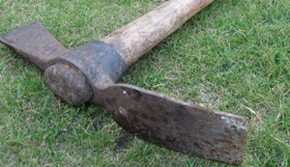
Alignment string /masons’ line/ | Alignment string /mason line/, sometimes called, Fish line, is a rope used to transfer horizontal & vertical alignments or lines, i.e., use to mark base line on the floor or vertical point alignments of wall. In other wards, it is used to align the walling blocks, (stone, bricks, concrete blocks, hydra form etc). It is available in different thickness & sizes in the market. | 

Machinery Tools for Soil Excavation:
These are the tools which are operated by mechanical force and are used for the larger depths of excavations. There are so many types of machine tools with ease of operation are designed in this modern day period.

TrackedExcavator | This is also called as track hoe. It consists of cabinet and long arm. Long arm again consists of 2 parts. The first part which is closure to cabinet is called as Boom and the other part is called as Dipper-stick. Digging bucket is attached to the end of dipper. This entire system can rotate 360 degrees. In this case Vehicle is moved by traction, so we can use this equipment in mines, forestry, pipeline industries etc. the function of excavator is done by hydraulic fluid so, it is also called as hydraulic excavators. | 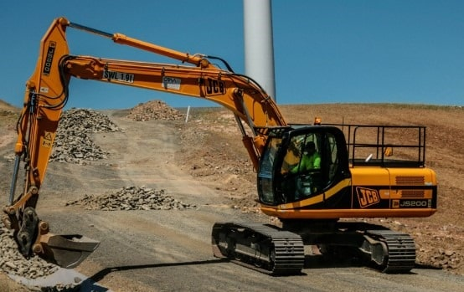
WheeledExcavator | This whole arrangement is similar to the tracked excavator except that the movement of vehicle is done by wheels. It can move quickly when compared to tracked excavator but it is not suitable for uneven grounds or hilly areas because of slippery nature. So these are generally used for road constructions etc.. | 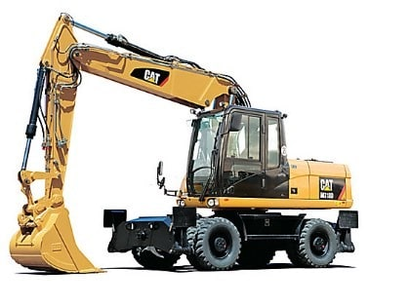
BackHoeExcavator | In case of back hoe excavator, the hoe arrangement is on back side and loader bucket is arranged in front of the vehicle. So two operations digging and loading or lifting is done by hoe and loader. This is widely used equipment nowadays because of its small size and versatility. This is moved with the help of wheels. so, moving from one workstation to another is quickly done. | 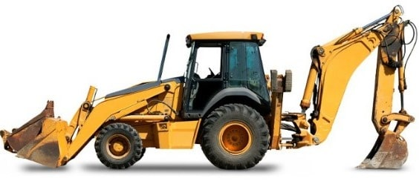
Bulldozer | Bulldozer consists of hard steel plate with sharp edge at its front. This sharp edge is helps the plate to cut the soil and for excavation. The metal plate can be raised and lowered with the help of hydraulic arms. The bulldozers are available in both tracked and wheeled form. These are widely used for the works of soil excavations, weak rock strata removal, lifting of soil etc. | 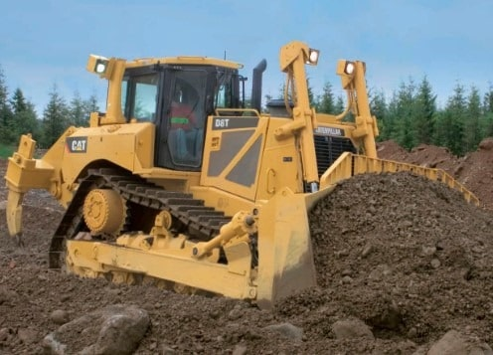
Figure 1.2: Tools and equipment
    - Matrial for excavation
Materials management is an important element in project planning and control. Materials represent a major expense in construction, so minimizing procurement or purchase costs presents important opportunities for reducing costs. Poor materials management can also result in large and avoidable costs during construction. First, if materials are purchased early, capital may be tied up and interest charges incurred on the excess inventory of materials. Even worse, materials may deteriorate during storage or be stolen unless special care is taken.

Timber in excavation
Timber is generally the type of material which has can be processed into beams, planks and boards. It is also known as lumber in many countries, Timber or Lumber is a derived from trees. It is cut and shape in various dimension sizes, in the process of wood production.
Timbers are used for the structural and non-structural purpose. Timber which are used for excavation purposes are said to be finished timber, it is made and supplied in standard sizes for domestic, commercial and industrial.
Timber is used widely for building houses, making furniture, structural members for building and civil engineering construction such as Piles, Beams, Post, and Roof. In the Gothic Architectural age, timber was for Foundation and excavation support.
There is high demand for timber especially as a building and furniture material some tropical countries depend largely for timber as one main source of export, obtaining market shares and most importantly as income economic generating revenue. With these numerous uses, timber is considered as one of the important construction materials.

Timbering is a method to prevent trench side soil against collapse. During deep excavation, the sides of the trench collapse if the soil is not hard. The timbering prevents the side of the trenches against collapse.
The requirement or importance of timbering is as follows:
- For the safety of excavation workers
- For the safety of the surrounding property
- For the safety of passersby and vehicles
- For the safety of public service property such as telephone cable, water pipes, electric cable.

Advantage of timber:
- Timber is a renewable resource and is grown in countries around the globe. Timber has a fast growth rate with softwood varieties able to replenish at a faster rate than hardwoods.
- Timber is easy to harvest and can be managed effectively to assure regrowth and replenishment.
- Timber is easy to handle, cut, and shape with readily available tools, lending to its ability to have widespread use.

Disadvantage of wood formwork
- It is susceptible to insect and fungi attack.
- It warps, Swell and shrink especially when it is not well seasoned.
- It is not economical for repetitive work.
- Types of Nails: Materials, Sizes, and Uses
While a hammer and nail may seem as simple as it gets, sizes and types of nails to use for different applications? Just as hammers require some knowledge for using them effectively; it helps to know which nail would serve you and your task best. Nails are available in different sizes and shaft configurations to maximize their holding power in different applications. The shaft configuration, strength, and nail size you need will depend on the project at hand.

Materials quantity Calculating

Timber calculation refers to the process of determining the quantity and dimensions of timber required for a specific project or application. It involves estimating the amount of timber needed based on various factors such as the dimensions of the structure, type of timber, and any additional requirements.
Steps need calculate timber
step1. Determine the project requirements: The first step is to clearly define the project requirements. This includes understanding the purpose of the timber, such as construction, furniture making, or woodworking. Additionally, consider any specific design or structural requirements that may impact the timber calculation.
step2. Measure the dimensions: Accurate measurements are crucial for calculating timber. Measure the length, width, and height of the structure or item for which timber is needed. If there are multiple components or sections, measure each one separately.
step3. Select the type of timber: Different types of timber have varying properties and uses. Consider factors such as strength, durability, appearance, and cost when choosing the appropriate type of timber for your project. Common types of timber include softwood and hardwood
step4. Calculate volume: To determine the volume of timber required, multiply the length, width, and height measurements obtained in step 2. This will give you the total volume in cubic units
step5. Account for wastage: It is important to account for wastage during timber calculation to ensure sufficient material is available for any errors or unforeseen circumstances. The amount of wastage can vary depending on factors such as complexity of design and skill level. A common practice is to add a percentage (e.g., 10-20%) to the calculated volume to account for wastage.
step6. Convert volume to board feet: Board feet is a standard unit used in the timber industry to measure wood volume. To convert the calculated volume to board feet, divide it by the specific conversion factor for the chosen unit of measurement. For example, if using cubic feet, divide by 12 to obtain board feet.
step7. Consider additional requirements: Depending on the project, there may be additional requirements such as specific timber grades, treatments (e.g., pressure treatment for outdoor use), or special cuts (e.g., angled cuts). These factors should be taken into account during the timber calculation process.
8. Consult with professionals: If you are unsure about any aspect of timber calculation or need assistance, it is advisable to consult with professionals such as architects, engineers, or experienced woodworkers. They can provide guidance and ensure accurate calculations based on their expertise.
Step 9.Calculate the excavated area
To estimate how much timber you need to buy, you need to multiply the perimeter by the height to get the surface area needed for one excavation area, finally, you need to estimate how much timber this would take.
Total area = excavation area x one side of excavation
Total area = 2 x 0.3
Total area = 0.6m²

Step 10: Calculate the timber surface area
Calculate the surface area of the size of timber you're using. This example uses 1.2m x 2.4m timber.
Timber area = length x width
Timber area = 2 x 0.3
Timbr area = 0.3 x 2 = 1.2m²
Lime is not freely available in nature but is obtained by burning naturally available materials such as:
- Limestone found in limestone hills
- Limestone boulders found in the bed of old rivers
- Kankar found below ground and
- Shells of sea animals.
Clay It is the material which gives the property of producing hydraulicity in lime. In small quantity it retards slaking and is also capable of arresting slaking when it is in excess. It gives the property of insolubility for lime in water. In order to get the best quality lime it is recommended to have 8–30% of clay. In genera lime is important for marking the boundry during excavation

Environmental protection
The environment is an important consideration wherever industrial works need to be carried out. Whether its bulk excavation or demolition, responsible firms should always put in place measures to reduce their environmental impact.
Excavation is an earthworks service. It involves the removal and moving of large quantities of media from the ground by machine. It can also include the adding of media to the ground, such as sand, stone, concrete and soil.
Have an erosion and sedimentation control plan
Erosion and sedimentation control is an important part of excavation. Adequate drainage is required to ensure run-off water doesn’t run into the surrounding environment. Water shouldn’t pond on the site. It’s also important that the site remains wet. If it dries out too much this creates dust which is carried with the wind.
The aim here is to keep eroded soil on the construction site. If you don’t control this, eroded soil can cause nearby water pollution by leaking into streams and rivers. This can damage wildlife. You can control water pollution, flooding, stream channel damage and decreased ground water storage with an erosion and sedimentation control plan.

Self-Check 1
Directions: Answer all the questions listed below.
- Write true if the statement is correct and write false if the statement is incorrect
- Timber has a fast growth rate with softwood varieties able to replenish at a faster rate than hardwoods.
- Heads are designed to help the nails function for specific applications
- Special coatings lubricate the shank to improve drive and strength.
- Shoring System is a structure such as a metal hydraulic and mechanical
- Sheet pile shoring is one of the more widely used excavations supporting
      - Choose correct answer from the following question
- process of removing earth, rock, or other materials from a given area

- drainage
- slope
- excavation
- all

- Excavation which is deeper than it is wide, and open to the surface along its length.

- Pit excavation
- Trench excavation
- Retaining wall
- Open excavation

- Improve and standardizing work processes in all construction areas

- Site work instruction
- Equipment
- Consultant
- Contractor

- Used for excavating small trenches in soil

- Pick axe
- Hacksaw
- Bow saw
- Bucket

- Material which has can be processed into beams, planks and boards.

  - Hacksaw
  - Bow saw
  - Bucket
  - Timber

II. Essay
Give short answer for the following question
      - Write at least 3 typr of excavation in construction
      - List type of materials use in shoring system

Operation Sheet 1.1

Operation Title: Calculate quantity materials
Purpose: To insuring how to Calculate of material neened for excavation support
Instruction:
- Calculate the area of a rectangular timber piece with dimensions 5 meters by 3 meters.
- Find the area of a square timber piece with a side length of 8 centimeters.
- Determine the area of a circular timber log with a radius of 10 inches.
- Calculate the total area of an irregularly shaped timber piece by breaking it down into smaller regular shapes.
Conditions for the operations:
- Safe working area
- Properly operated tools
Equipment Tools and Materials:  - Paper  - Pencil  - Pen |  | - Table  - Chair
Quality Criteria: Assured performing of all the activities according to the procedures
Precautions:
- Wearing proper clothes, eye glass, glove
- Make working area hazard free
- Read and interpret manual which guide you how to use tools and equipment
Steps in doing the task  - Determine the project requirements  - Measure the dimensions  - Select the type of timber  - Calculate volume:  - Account for wastage | - Convert volume to board feet  - Consider additional requirements  - Consult with professionals  - Calculate the excavated area  - Calculate the timber surface area

LAP Test 1
Practical Demonstration
Name: __________________________ Date: ____________
Time started: ____________________ Time finished: _______________
Instruction: Perform the following tasks
Task 1: Calculate quantity materials

Unit Two: Site Excavation and Safety Equipment
This unit is developed to provide you the necessary information regarding the following content coverage and topics:
- OH&S requirements and signage/barricade
- Setting out for excavation work
- Excavation route line and Location
- Using site pegs/profiles and marking excavation limits
- Establishment of temporary drainage system
- Identify underground service and relevant marks
This unit will also assist you to attain the learning outcomes stated below. Specifically, upon completion of this learning guide, trainees will be able to:
- Follow OH&S requirements and signage/barricade
- Set out for excavation work
- Excavate route line and Location
- Use pegs/profiles for marking excavation limits
- Establishing t of temporary drainage system
- Identify underground service and relevant marks

Occupational Health and Safety and signag
Before preparing a bid, employers should know as much as possible about the jobsite and the materials they will need to have on hand to perform the work safely and in compliance with OH&Sstandards.
Employers can gather the information they need through jobsite studies, observations, test borings for soil type or conditions, and consultations with local officials and utility companies. This information will help employers determine the amount, kind, and cost of safety equipment they will need to perform the work safely.
Personal protective equipment
PPE should only be used as a last resort after considering all other control methods. PPE can also be used to protect against any residual risks that remain after other control methods have been employed.
Protective equipment that must be available
These include:
- Rubber gloves or leather gloves
- Overalls.
- Face shields.
- Face mask and ear protectors
- Steel capped boots/shoes
- sunscreen lotion
First aid
First aid can save lives, reduce pain and help an injured person make a quicker recovery. The Health and Safety (First Aid) Regulations require you to provide adequate and appropriate equipment, facilities and personnel to enable first aid to be given to your employees if they are injured or become ill at work. The minimum provision for all sites is:
- a first aid box with enough equipment to cope with the number of workers on site;
- an appointed person to take charge of first-aid arrangements;
- Information telling workers the name of the appointed person or first aider and where to find them. A notice in the site hut is a good way of doing this.

Table. 2.1. Number of first aid personnel
Numbers employed at any location | Number of first aid personnel
Fewer than five | At least one appointed person
5 to 50 | At least one first aider
More than 50 | One additional first aider for every 50 employed

General Signs and symbols shall be visible at all times when work is being performed, and shall be removed or covered promptly when the hazards no longer exist.
Danger signs shall be used only where an immediate hazard exists. Danger signs shall have red as the predominating color for the upper panel; black outline on the borders; and a white lower panel for additional sign wording.
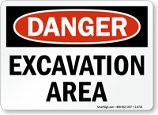

Figure. 2.2. Danger signs
Caution signs shall be used only to warn against potential hazards or to caution against unsafe practices. Caution signs shall have yellow as the predominating color; black upper panel and borders: yellow lettering of "caution" on the black panel; and the lower yellow panel for additional sign wording. Black lettering shall be used for additional wording.



Figure 2.3. Caution signs
Exit signs, when required, shall be lettered in legible red letters, not less than six inches high, on a white field and the principal stroke of the letters shall be at least three-fourths inch in width.


Figure 2.4. Exit signs
Safety instruction signs, when used, shall be white with a green upper panel with white letters to convey the principal message. Any additional wording on the sign shall be black letters on the white background. Directional signs, other than automotive traffic signs, shall be white with a black panel and a white directional symbol. Any additional wording on the sign shall be black letters on the white background. Construction areas shall be posted with legible traffic signs at points of hazard.
Accident prevention tags shall be used as a temporary means of warning employees of an existing hazard, such as defective tools, equipment, etc. They shall not be used in place of, or as a substitute for, accident prevention signs.
Excavated material and loads near excavations
Mechanical plant, vehicles and storage of materials including excavated material or other heavy loads should not be located in the ‘zone of influence’ of an excavation unless the ground support system installed has been designed by a competent person.
The zone of influence will depend on the ground conditions. It is the zone in which there may be an influence on the excavation including possible ground collapse.

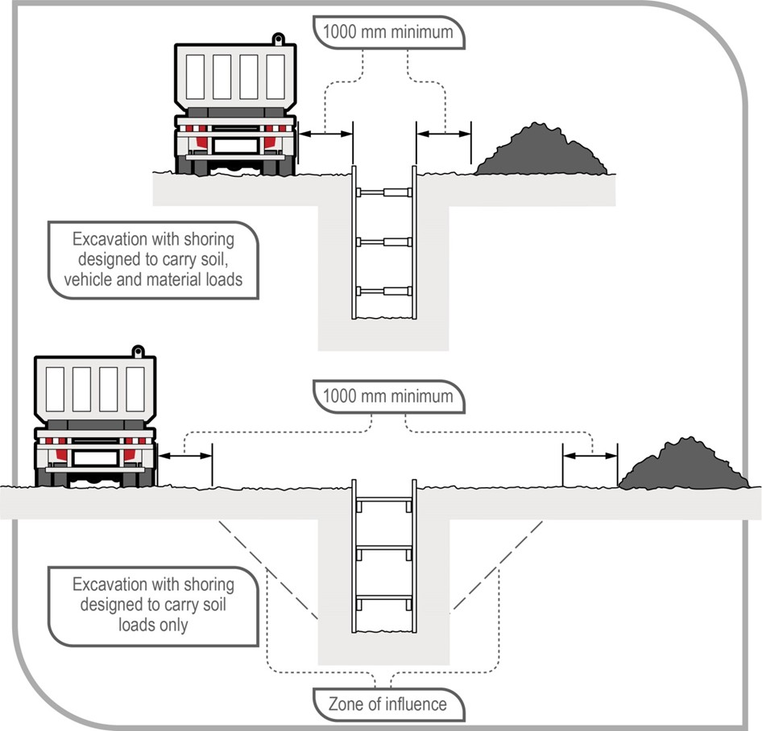
Figure 2.5: Excavated material and loads near excavations
In the top diagram, an excavation with shoring designed to carry vehicle and material loads—this may be required where there is limited space around the excavation for vehicle movement and material storage In the bottom diagram, an excavation with shoring designed only to carry the load of the excavated faces and the related zone of influence.
Any material will add a load to the area where it is placed. It is important materials are not placed or stacked near the edge of an excavation as this would put persons working in the excavation at risk, including by potentially causing a collapse of the side of the excavation.
To minimise the risk of ground collapse, excavated or loose material should be stored away from the excavation. Excavated material should be placed outside the zone of influence. Alternatively, a ground support system should be designed and installed to carry the extra loads including groundwater pressures, saturated soil conditions and saturated materials.
If excavating in sloping ground, decide which side of the excavation to place the excavated material. Things to consider include:
- ground conditions
- access to the excavation
- existing underground services
- the need for earthmoving machinery or vehicles to work or move beside the excavation
- service installation and backfilling requirements
- Manual work being carried out in the excavation.
Placing material on the lower side of the excavation will reduce the effective height of the excavation and reduce the risk of material falling or being washed into the excavation.
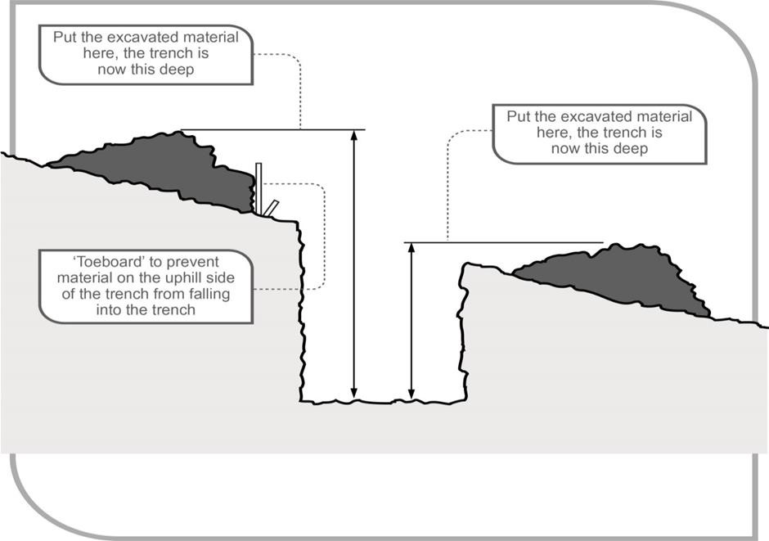
Figure 2.6: Excavated material impact on effective excavation depth
Care should be taken to ensure material placed on the high side of the excavation does not increase the risk of ground collapse, or flooding by ponding or holding back run-off water. Excavated material should be placed so it channels rainwater and other run-off water away from the excavation.
When a trench is being excavated beside an old service line, the excavated material should be placed on the side opposite the old service line to prevent excessive loading on previously weakened ground.
If excavated material is placed close to a trench due to obstructions, for example fences, buildings or trees, the weight of the excavated material may overload the sides of a trench. In this case, the ground support system should be strengthened at these locations and barriers, for example toe boards may need to be provided to prevent the material falling into the excavation.

When dumped in heaps, different soils will assume a characteristic shape and settle naturally at different slopes. The angle which a sloping face of loose earth makes with the horizontal is sometimes referred to as the angle of repose. However, it is poor practice to relate the safe slope of an excavation to the angle of repose, even though the safe slope may be similar in some types of soil to the angle of repose.
Barricades: act as warning devices that alert others of the hazards created by construction
Activities and should be used to control traffic, both vehicular and pedestrian, safely through
Or around construction work sites
Barricades are required around all construction sites and all excavations, holes, openings in floors or roofs, raised platforms, for certain types of overhead work, restriction of access areas and wherever it is necessary to warn people against the potential of falling. Barricades must be suitable for each area of use. Examples of barricades are plastic safety fencing, temporary cyclone fencing and portable manhole barricades. Yellow caution tape and/or cones are not considered acceptable barricades and should be used only temporary until suitable barricades are erected. Signs and illumination should be used appropriately.
The following are examples of activities where barricades may be required:
- Wherever construction debris is dropped without the use of an enclosed chute.
- Areas with temporary wiring operating at more than 600 volts.
- Work areas for electrical equipment with exposed energized parts.
- The swing radius of the rotating superstructure of cranes or other equipment.
- Wherever equipment is left unattended near a roadway at night.
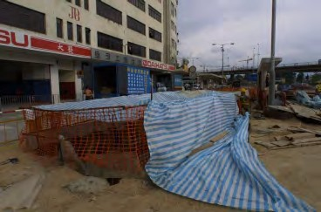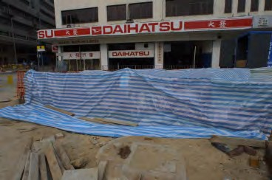

Figure 2.7: barricade sign

Excavation route line and location
Information on the location of underground services may be obtained by contacting the Dial before You Dig organisation in your state or territory. Any underground service plans that are obtained including information on underground essential services must be provided to the principal contractor and/or the excavation contractor. Other relevant parties including any subcontractors and plant operators carrying out the excavation work should also be provided with information about essential services and other plans so the information is considered when planning all work in the area. Underground essential services information obtained must be: „ made available to any worker,
How can employers avoid hitting underground utility lines and pipes during excavation work?
Before starting work, the Excavation standards require employers to do the following:
- Determine the approximate location(s) of utility installations including sewer, telephone, fuel, electric, and water lines.
- Before You Dig” number, to establish the location of any underground utility installations in the work area.
- If you are digging or disturbing the earth you should take care to avoid damaging underground services. Underground electrical cables can be particularly hazardous because they often look like pipes and it is impossible to tell if they are live just by looking at them.
Damage to underground electrical cables can cause fatal or severe injury and the law says you must take precautions to avoid danger.
Excavation work should be properly managed to control risks, including:
- Planning the work
- Using cable plans
- Cable locating devices
- Safe digging practices
Planning the work
Most service cables belong to a Distribution Network Operator (DNO). However, some cables belong to other organisations such as the highways authority, Ministry of Defence or Network Rail.
Careful planning and risk assessments are essential before the work starts. Risk assessments should consider how the work is to be carried out, ensuring local circumstances are taken into account.

Using cable plans
Plans or other suitable information about all buried services in the area should be obtained and reviewed before any excavation work starts.
If the excavation work is an emergency, and plans and other information cannot be found, the work should be carried out as though there are live buried services in the area.
Symbols on electricity cable plans may vary between utilities and advice should be sought from the issuing office. Remember that high-voltage cables may be shown on separate plans from low-voltage cables.
Plans give only an indication of the location, and number of underground services at a particular site. It is essential that a competent person traces cables using suitable locating devices.
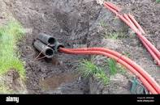

Figure 2.8: cable under ground

Cable locating devices
Before work begins, underground cables must be located, identified and clearly marked.
The position of the cable in or near the proposed work area should be pinpointed as accurately as possible by means of a locating device, using plans, and other information as a guide to the possible location of services and to help interpret the signal.
Remember: Locators should be used frequently and repeatedly during the course of the work.
People who use a locator should have received thorough training in its use and limitations. Locating devices should always be used in accordance with the manufacturer's instructions, regularly checked and maintained in good working order.


Figure 2.9: cable locating devices

Setting out of excavation work
Setting out and excavation are crucial steps in the construction process. They involve preparing the site for construction by marking the boundaries, levels, and positions of structures, as well as removing any existing obstructions or materials from the ground. This comprehensive process ensures that the construction project is executed accurately and efficiently.
Setting out refers to the initial stage of site preparation, where the boundaries and positions of structures are established. It involves surveying and marking the ground to indicate where the foundations, walls, columns, and other elements of the building will be located. The setting out process typically follows architectural drawings or engineering plans.
To begin setting out, a surveyor uses various tools such as a theodolite, total station, or GPS (Global Positioning System) to accurately measure distances, angles, and elevations. These measurements are then transferred onto the ground using pegs, stakes, or other markers. The surveyor ensures that the positions are aligned with the design specifications provided by architects or engineers.
The setting out process also includes establishing reference points known as benchmarks. These benchmarks serve as fixed points of reference for future measurements during construction. They are typically permanent features like existing buildings or structures that will not be affected by the construction work.
Identifying and marking the boundary
The first task in the process of setting out a building is identifying the exact size and shape of the lot. Boundaries are used as reference lines from which measurements are made to determine the position of the building.
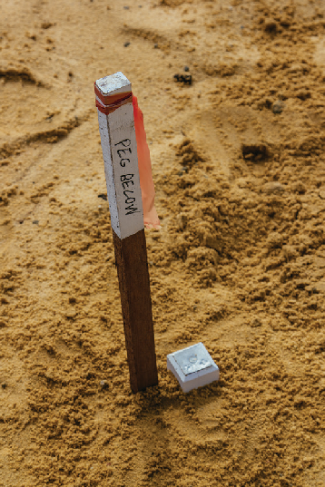
CERTIFICATE OF SURVEY

Vestibulum ante ipsum primis ifaucibus orci luct

Vestibulum ante ipsum primis ifaucibus
Vestibulum ante ipsum primis in faucibus orci
ratio quam sem
Morem ipsum dolor sit amet, conse Buam sem partos
Morbi placerat quam sem Buam sem partos
acerat quam
Lorem ipsum dolor sit amet, consectetur adipiscing elit.
Morbi placerat quam sem, eu aliquam odio.
Morbi placerat quam sem
Lorem ipsum
N
Lorem ipsum dolor sit amet, dolor sit amet, consectetur adipiscing elit. consectetur Morbi placerat quam sem, adipiscing elit.
Figure 2.10: The boundary mark
Locating the boundary markers
The size and shape of building lots are determined by a licensed surveyor from the registered plan of the area. The surveyor identifies the site features by driving survey pegs into the ground at appropriate points, eg boundary corners and easement positions, and issues a survey certificate showing where the site boundaries are and how they can be identified. The survey certificate is used by the architect when designing the building and creating a site plan.

Reading the site plans: A site plan shows the entire lot or at least the part of the lot where the building will be. It provides most of the important information for setting out a building and includes the:
- size and shape of the lot
- position of boundary lines
- position and distance between the boundary pegs
- direction the building is facing
- contour lines showing the topography of the lot
- Proposed building outline in relation to the boundaries.
Locating and reading boundary: pegs Boundary pegs are short, wooden pegs driven into the ground by the surveyor to mark the beginning and end of the site boundaries.
There are two types
- Corner peg
- Truncated corner pegs.
Corner pegs: are used to mark the main corners of the lot. They have a metal or plastic plate fixed to the top with one or more numbers corresponding to the lot number of the lots it separates. Corner pegs are approximately 50 mm × 50 mm and have a clout nail in the top which marks the exact point the boundary lines intersect. They’re usually painted white for easy identification.

LOT 1
LOT 2
LOT 3

Figure 2.11: Corner pegs

Boundary marking
Once survey pegs have been located and identified, stringlines can be set up to mark the boundary and provide a guide for finding the position of the proposed building.

LOT 1
LOT 3
Metres

PROPOSED BUILDING
Metres
Figure 2.12: Marking the boundary
Stringlines are some of the oldest and most basic hand tools used in building and construction. They’re usually made from nylon or fine cotton string about 2–3 mm in diameter and used to create a straight line between two points.
A stringline is set up by attaching one end of the string to a nail fixed into the top of a timber peg that’s been driven into the ground. The string is then pulled taut (tight) and securely fastened to another peg.
The site should be cleared of all unwanted obstacles before stringlines are set out and care should be taken to avoid any distortion to the line caused by wind, uneven ground, plants and grass, or debris.
Set stringlines to identify the site boundaries will depend on different factors, including:
- the shape of the land
- the position of the proposed building
- obstacles such as trees or existing structures
- buildings built on the existing boundary line on adjacent lots
- Fences on the boundary line of adjacent lots.

Identifying the building location
Lots with level ground and boundary lines at 90° to one another are the easiest environment on which to set out a building. In this situation, you only need to set stringlines on two sides of the lot, as all building measurements can be taken from these two reference lines.
OSED DING
PROP BUIL

Figure 2.13: Building location
Step 1 Locate the two boundary pegs that identify the front boundary and set a taut stringline between these two points.
LOT 1
LOT 3

PROPOSED BUILDING

PROPOSED BUILDING

Key
Boundry peg
Temporary peg
Stringline

Figure 2.14: Building location
Don’t attach string directly to the boundary pegs as this may disturb their position. Use temporary timber pegs with the string running above the exact centre of the boundary pegs (over the clout nail). The position of the string can be checked by using a spirit level to plumb down (check vertically) from the stringline to the centre of the boundary peg.
Step 2 Locate the two survey pegs that identify the side boundary and set a taut stringline between these two points. Use temporary timber pegs running over the centre point of the boundary pegs.
LOT 1
LOT 3

PROPOSED BUILDING

PROPOSED BUILDING

Key
Boundry peg
Temporary peg
Stringline

Figure 2.15: Building location

Temporary drainage system
Drainage: measures to prevent ingress of surface runoff must be provided regardless of the excavation depth. These measures are particularly important to ensure the stability of any man-made or natural slope located below and in the vicinity of the trench excavation works and when the trench is open during any part of the wet season. The possible flooding condition in the area, especially at depression points of roads, should be estimated and considered in the drainage design. The drainage measures are intended to minimise water runoff from the surface into the open trench, and to control infiltration of collected rainwater and runoff from the open trench into the slope; both scenarios are likely to have some adverse effects on the stability of the slope.
To deal with surface runoff, upstands placed along either side of the trench are effective. The upstands are normally made of mass concrete blocks, or in the form of sandbags or compacted earthfill bunds cemented together. The designer/contractor should determine the required height of the upstand depending on site conditions, but in no circumstances should the height be less than 100 mm. Standard details are provided

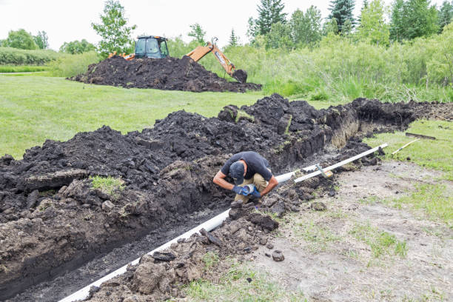
Figure 2:16. Drainage system
Groundwater Control
Where a high ground water table is encountered, the water may be controlled by dewatering. Dewatering may cause the lowering of groundwater in the area around the excavation, which will result in an increase in effective stress of soil and hence settlement of the ground. In cases where there is a concern on the adverse effects of ground settlement near the excavation adjoining sensitive structures, like old buildings on shallow foundations, gas and water mains, busy roads, etc. an assessment of the possible adverse effects of the dewatering is required.
Controlling groundwater during excavation is extremely important in the construction industry. Dewatering helps provide temporary reductions in groundwater levels for structures that must extend below groundwater level. There is a variety of dewatering and groundwater control methods used on major construction sites and in this blog we’ll outline a few of the more popular methods.

Different methods of Groundwater control and dewatering
- Sump pumping
The most basic form of groundwater control is sump pumping, which is simply a method where groundwater is collected using a sump and pumped away from the construction site. This type of groundwater control can be inexpensive, but ground loss as well as excessive seepage can be time consuming and expensive to deal with. Pre-drainage methods may be used for situations where sump pumping may pose a threat to the instability of the ground or adjacent structures.
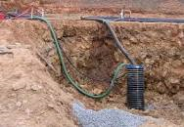
Figure 2.17: Sump pumping
- Wellpoint systems
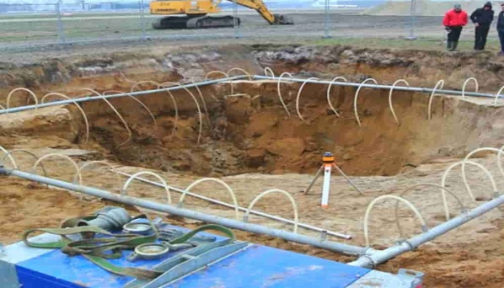
These are used to lower groundwater levels and help provide safe working conditions during excavation. Wellpoint systems consist of a number of small diameter wells, which are connected with a header pipe to a wellpoint pump. The wellpoint pump then creates a vacuum that draws water up from the ground.
Figure 2.19: Wellpoint systems
Siphon draining
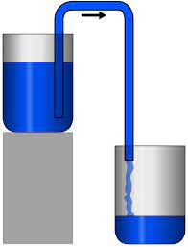
Works by pumping water by gravity along siphon pipes. Siphon draining is most often used where there are unstable slopes. Wells are typically installed in or above the unstable zone of a slope and are then pumped using siphons that utilize the natural slope of the area.
Figure 2.20: Siphon draining

- Deep well systems
Consist of a number of bored wells, each using a submersible borehole pump. As water is pumped from each well, the groundwater is lowered creating a cone of depression.
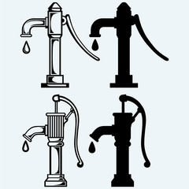
Figure 2.21: Deep well systems
- Ejector systems
Similar to deep well systems, ejector systems are based on wells which lower the groundwater level to provide safe working conditions. Ejectors utilize air in the wells to create a vacuum that draws water out of the soil.
Various factors such as soil type and the nature of the construction site will effect the type of dewatering method that will be ideal for your project.
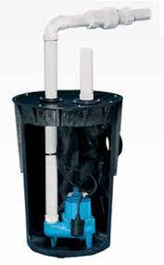
Figure 2.22: Ejector systems

Identifying service markers or taped areas
Data indicates underground utility lines across the nation are damaged every six minutes. This means a lot of money and time that have to be put in to fix the damages. Fixing damaged underground utility lines can be a very lengthy process depending on the severity of the damage. In some areas, there aren’t enough people to fix underground utility issues, which results in repairs taking longer than expected.

Controle underground Utilities and Damaged
When general excavation is done without following the correct steps, it can lead to underground utilities being damaged. This can be a headache for any homeowner or contractor. There is high importance for buried utility lines as they are not just going to one single home or business. Underground utility lines are typically connected to service a larger area of connected homes and businesses.
Depending on the level of damage, the cost to fix damaged utility lines can be really expensive, and the cost usually falls onto the individuals involved in damaging the utilities.
Before any excavation work can begin, they are liable to contact the concerned companies and organisations to notify them about the proposed excavation activity so that the existing underground utilities can be determined and marked.

Underground utility colour codes and mapping
Different section and location methods are used due to the fact that utilities are made of different types of materials.
For metal pipes and similar cables, electromagnetic equipment with a transmitter and receiver is used. For plastics and concrete, radio location and ground penetrating radars are used.
Utilities such as petroleum products are permanently marked using posts and bollards due to the nature of their content. There are maps to locate these utilities but certain equipment is required in order to have a precise and accurate location.
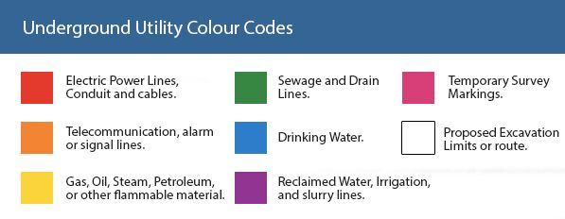
Figure: 2.23 Colour Coding System for underground utilities

Self-check 2
Directions: Answer all the questions listed below.
  - Choose correct answer from the following question
- protect an individual from hazards associated with their work tasks

- Clothe
- Shelters
- Personal protective equipment
- All

- One of the following is not the method to pirating risk during excavation

- Planning the work
- Using cable plans
- Cable locating devices
- Roughly digging

- process of laying down the excavation lines and center lines

- Setting out
- Profile board
- Peg
- Batten board

- Used to lower groundwater levels and help provide safe working conditions during excavation.

- Sump pumping
- WellPoint systems
- Siphon draining
- Deep well systems

  - Matching part
 | A | Answer |  | b
1 | Blue |  | A | Electric power lines, cables, conduit, and lighting cables
2 | Orange |  | B | Natural gas, oil, steam, petroleum, or other gaseous or flammable materials
3 | Green |  | C | Sanitary sewers and drain lines
4 | Yellow |  | D | Telecommunication, alarm or signal lines, cables, or conduits
5 | Red |  | E | Potable water

Operation Sheet 2.1

Operation Title: setting out for excavation work

Purpose: To insuring how to tranees understand setting out and excavation
Conditions for the operations:
- Safe working area
- Properly operated tools and equipment
- Appropriate working cloths fit with the body
Instruction
Set out excavation boundary with the given diamansion
Equipment Tools and Materials:  - hammers  - profiles  - water meter  - picks | - measuring tapes/rules  - shovels  - string lines  - wheelbarrows  - straight edges
Quality Criteria: Assured performing of all the activities according to the procedures
Precautions:
- Wearing proper PPE
- Make working area hazard free
- Read and interpret manual which guide you how to use tools and equipment
Steps in doing the task
Steps in doing the task
  - Measure the setback distances from the front and side boundaries and place a temporary peg at the first corner.
LOT 1
LOT 3
3 m
6 m

PROPOSED BUILDING

  - Identify the width of the building from the site plans and place a temporary peg at corner 2 by measuring the distances from corner 1 (width) and the front boundary (setback).
LOT 1
PROPOSED BUILDING
LOT 3
1
6 m
2
6 m

  - Identify the depth of the house from the site plans and place a temporary peg at corner 3 by measuring the distances from corner 1 (depth) and the side boundary (setback).

3 m 3
LOT 1
PROPOSED
8 m BUILDING
LOT 3
1
2

  - Place a temporary peg at corner 4 by measuring the distances from corner 3 (width) and corner 2 (depth).
3
6 m
4
LOT 1
PROPOSED BUILDING
8 m
LOT 3
1
2

LAP Test 2
Practical Demonstration
Name: __________________________ Date: ____________
Time started: ____________________ Time finished: _______________
Instruction:
Verify that the planned positions and dimensions of the structure or feature are correctly implemented on the ground. It involves comparing the actual measurements on-site with the design specifications to identify any discrepancies and make necessary adjustments before proceeding with further construction.

Unit Three: Dig Excavations
This unit is developed to provide you the necessary information regarding the following content coverage and topics:
- Using excavations safely.
- Assist machine operator to insure excavation quality
- Install trench excavation support
- Tamping
- Instruction requirements and free loose material
- Wastage management
This unit will also assist you to attain the learning outcomes stated below. Specifically, upon completion of this learning guide, trainees will be able to:
- Use excavations safely.
- Assist machine operator to insure excavation quality
- Install trench excavation support
- Doing damping
- Instruction requirements and free loose material
- Wastage management

Excavations Safely
Most important and primary objective in the case of excavation monitoring program is to ensure there is safety factors from the start to end of excavation work. Any calamity or issues that is going to occur as a result of excavation process surely brings some symptoms or warning before the occurrence.
These conditions must be monitored and evaluated by the monitoring system members so that the engineers can adopt effective measures for stopping the calamity from happening. Every sign of danger must not be ignored by the monitoring team.
The essential tips to be followed while planning for excavation are:

Study the Soil Layers
Conduct a proper study to determine what lies beneath the soil where excavation is planned. For example, modern pavements have complex pipelines and cables beneath them. Properly planned excavation is essential in such areas. Studying the soil layers gives an idea about the magnitude of precautionary measures to be taken while excavating. In modern construction, the history of the soil along the depth is studied by a GPR.
Ground Penetrating Radar (GPR) is a modern technique used to determine the buried services that exist below the soil surface.
The study of soil type can help determine the critical depth of excavation, which gives an idea about the safe depth up to which excavation can be done without external support.

Effective Planning of Work
Excavation procedures can have more risk factors. Perform all the planning and work activities by undergoing proper risk assessment. Make a note of all the dangers associated with the existing underground services and events. The risk factors vary with the type of site and project.

Prepare the Workers
Damage to underground services unexpectedly during the excavation process results in many deaths and injuries. Proper direction and preparation of workers and staff can help to avoid this issue.
It is essential to brief the staff about the expected risk situation during excavation and prepare them to avoid danger to life.

Selection of Excavation Method
The method employed for excavation is not decided by chance. It is an adequately planned procedure taking into consideration objective, safety, economy, and time constraints. A small excavation can be conducted using a shovel or spade, while a complex digging requires special excavation techniques.
One such popular excavation method is by vacuum or suction method. It is a technique that reduces the contact between the site workers and underground services. With modern excavation techniques, the activity becomes quick, efficient, and minimizes the chances of costly service strikes.

Drawings Required for Excavation
Gridline drawings are required for the excavation operation on a building site. These detailed plans mark out the ground on a grid system and are invaluable for safely excavating below ground. One of the huge benefits of vacuum excavators over more traditional types of excavating is that if the site plans do not show the utilities in the correct place, then the risk is far less. With traditional excavating, the risk of cable strikes is high and can have catastrophic consequences. With vacuum excavating, your risk is massively reduced. It is a safer and more sensible option if you have any doubts about the accuracy of your site drawings.

Scope of Work for Excavation
Excavating does not simply involve the removal of earth or materials to create a cavity. It also comprises the correct study of the site, marking out the boundary lines precisely, and ensuring that the excavating is carried out within the markers and to the correct depth. After the material has been excavated, it must be removed, and the space created needs to be correctly shored up so that it is safe. Always ensure that you work with a professional company such as our selves, so that your finished work is completed to a high standard and ready for the building work to proceed.

Procedure of Excavation
The work procedure on a construction site involves more than just moving earth. A thorough understanding of the process, procedure, and expected outcome are necessary to achieve a good result. It is essential to:
- understand the centre line and excavation drawings
- Setting out of the plan on the ground.
- The site must be cleared of weeds, bushes, and plants
- Excavation is carried out in the desired location.
- Benchmarks are set so that correct levels can be maintained.
- Once everything is correctly marked up, then the excavation job can begin.
- After this is done, then the earth and material must be removed, and any necessary shoring up carried out, to ensure the cleared area is safe and stable.

Excavation Techniques in Construction
- Cut and Fill Excavation (or Stripping Excavation) is used to clear large areas in construction. This process involves removing layers of wide and shallow rocks, sand and topsoil, as well as other materials.
- Trench Excavation is where the length of which the excavated areas exceed the depth and is typically used to access or bury services lines, as well as installing or repairing pipelines and sewers. Vacuum Excavation is perfectly suited to this type of work as it removes the risk of breaking power lines or utilities, typically associated with diggers and manual excavation which dramatically improves on-site safety.
- Basement Excavation is all about the layer below ground level in an existing building. This type of excavation is used when the construction is set to be completed partially below ground level. It is worth noting that this excavation can be complicated depending on the size of the property in question.
- Borrow Excavation is quite different to other types of excavation. The goal here is not to just excavate the material as it also needs to be removed from the area.
- Drainage Excavation is used for draining ditches, wastage around structure as well as storm drains, which are located at the shallower depths of combined sewers. With the drainage systems being notoriously small and difficult to reach, Vacuum Excavators, are ideal for this type of excavation.

Assist machine operator and excavation quality
Stable platform for the excavator is an essential element of site setup. Make sure the machine will sit on even ground and that the ground is stable. If needed, pack dirt under one of the tracks to ensure a level surface.
When digging a trench, take time to create some form of guide, whether that be offset stakes, a chalk line or stringline. Then align the front and back of the machine to the line you’re referencing to ensure you’re tracking straight.
Training Tips for Safe, Efficient Trenching
Position the machine at a productive height for loading material. The bench height should be about the height of the haul vehicle’s sideboards. Most experts recommend setting up for the trucks to come down the left side of the excavator, which is best for loading angle and visibility.

Safety First

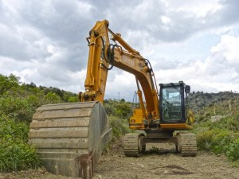

Earth Excavation Checklist
The following checklist should be used as a guide for better quality control over earth excavation.
- Prior to the start of excavation operations, take photographs of the construction area, make sure that sufficient cross—sections are taken, and continue to take progress photographs during construction.
- Review the log of borings to ascertain the elevation of the water table and to determine if unsuitable soils are likely to be encountered. Dewatering equipment may be necessary, and disposal for unsuitable material must be provided.
- Check Post utility maps prior to the start of excavation to ascertain existing lines not shown on contract drawings.
- Evaluate materials being excavated against logs of borings. If differences are noted, consult your supervisor for determination of action to be taken.
- Check that approved disposal areas and haul roads are used.
- Check for location of required protection to sanitary and storm drains, electrical cables, communications cables and gas lines subject to damage by heavy earth-moving equipment.
- Insure the utilization of satisfactory materials from excavations.
- Determine moisture condition of suitable excavated materials in advance of needs.
- Insist that excavation is performed in specified sequence.
- (10) Assure that drainage is provided continually as excavation progresses.
  - Do not permit ponded water in any construction area.
  - Be sure that drainage ditches are maintained free flowing.
- Insure that required tests for soil bearing characteristics are made upon completion of excavation.
- Coordinate planning of borrow excavation to insure that the right materials will be available as needed for embankment construction, and that borrow will not be unnecessarily used when excavated material is available.
- Inspect borrow pits for:
- Adequate stripping.
- Orderly removal of materials.
- Satisfactory drainage.
- After total material removal, check borrows pit areas for conformance with final shaping and drainage requirements.
- Determine average volume hauled for each type of hauling equipment. Record daily load count for various classifications of excavation when required for partial payments.
- Take final cross-sections.
- Provide that quantity surveys are made for payment purposes.
- Examine all excavating equipment for compliance with General Safety Requirements.

Trench excavation support

Installation of Support

Support of trench excavation should be constructed strictly in accordance with the design and contract specifications. In no circumstances should workers be permitted to work in an unsupported trench which is deeper than 1.2 m.

In ground composed of moderately firm to firm soil, vertical trench sides may stand unsupported for a considerable period of time, and hence half timber board support or half sheet pile support may be adequate provided that the groundwater level is below the bottom of the trench. When the ground condition is poor and has little or no “free-standing” time, full timber board support or full sheet pile support should be installed in such a way that the sides of the trench are supported at all times. That is, installation of sheeting, excavation and insertion of walings and struts proceed by stages until the full excavation depth is achieved.

Installation of support ahead of the excavation to the full depth is of advantage where the soil and sheeting sections allow this. Use of sheet piles rather than timber boards makes it possible to drive to full depth ahead of excavation in most ground and to greater depths. This is considered advantageous where the trench is to be constructed in poor ground and where there are few crossing services. Where existing services crossing a trench line are encountered, timber board support should be provided as far as possible to the exposed excavation face surrounding the services. If decking for traffic or pedestrians is not required, support frames should ideally protrude above ground level.

Stability of an Excavation: An excavated face’s stability depends on the strength of the soil in the face being greater than any stresses.

Some situations that increase soil stress in an excavated face and may lead to failure in bad weather, under extra load or vibration are:
- deep cuts and steep slopes, by removing the natural side support of the excavated material
- loads on the ground surface near the top of the face, such as excavated material, digging equipment or other construction plant and material
- shock and vibration, caused by pile-driving, blasting, passing loads or vibration producing plant (eg compacting and drilling plant)
- water pressure from groundwater flow, which fills cracks in the soil, increases horizontal stresses and may undermine the excavation
- Saturated soil increasing the soil’s weight and sometimes the volume > natural hazards like floods or earthquakes (eg earthquakes can cause soil liquefaction).
- Some conditions that may reduce soil strength are:
- excess water pressure in sandy soil which may cause boiling and saturate the soil and increase its plasticity
- soil dryness may reduce cohesion in sandy soil and soils with high organic content, which then crumble easily
- prolonged stress, may cause plastic deformity (squeezing or flowing)
- Prolonged inactivity at an excavation site; reassess the soil before work begins.

Ground Investigations: Weak, saturated, or otherwise unfavourable ground can have a significant effect on the construction and performance of an excavation. Consider having ground investigations and geotechnical assessments for excavations that are complex or may affect nearby structures or harm workers and others nearby.

The ground investigation and geotechnical assessments should include:
- advice on the suitability of different sites or distinct areas of a site for placing structures or services
- suitable and economic design of both temporary and permanent works
- a method to identify and evaluate possible problems in constructing temporary and permanent works
- A process to reduce the risk of unforeseen ground conditions. This will decrease the need for changes in design and construction methods.

Prevent ground collapse
If excavation work is planned without shoring, the continuing safety of the excavation will depend on the conditions arising during construction. If the conditions during construction are not as expected, or if conditions change during the course of the work (eg different soils, heavy rain/flooding) take immediate action to protect workers, other people and property.
Excavations shallower than 1.5 m have been known to collapse. If a worker is in the excavation and bending over or crouching down at the time of the collapse, he or she may suffer serious injury.

Managing the risk
There are three main types of controls to prevent ground collapse. Make sure to use one or more of the following controls to support all sides of the excavation:
- Benching and battering stepping or sloping of the face, side, or wall of an excavation.
- Shorting prevents collapse by maintaining positive pressure on the sides of the excavation, protecting workers.
- Shields do not ensure stability but protect workers from ground collapse, by preventing the collapsing material falling onto them.
Competent person can provide information on the stability and safety of an excavation. The report should include:
- details of the soil conditions
- any shoring or excavation support requirements
- dewatering requirements
- Any longer term effects on stability and safety of the excavation.
Excavated face more than 1.5 m high to be shored, so far as is reasonably practicable, unless:
- the face is cut back to a safe slope, or
- the material in the face is of proven good standing quality under all reasonably foreseeable conditions of work and weather, or
- by reason of the nature of the work and the position of any worker in the vicinity, there is no danger to any worker, or
- Shoring is impracticable or unreasonable and other precautions have been taken to make the face as safe as possible in the circumstances.
Benching is a method of preventing ground collapse by excavating the sides of an excavation to form one or more horizontal steps with vertical surfaces between levels.

Regular Inspection
The condition of soil surrounding excavations can change quickly when the soil dries out, the water table changes or water saturates the soil. A competent person should frequently check the soil condition and the state of shoring, benching, battering, and excavated faces for signs of earth fretting, slipping, slumping, or ground swelling.

Shoring
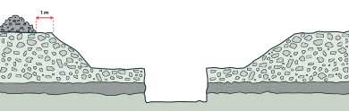
Figure 3.2: Combination of benching and battering controls

Benching and battering
Benching and battering of excavation walls can minimise the risk of soil or rock slipping onto the excavation.
A competent person should design controls considering:
- soil type
- soil moisture content
- planned height of the excavated face
- Any surcharge loads acting on the excavated face.
It is not necessary to bench or batter excavated faces which a competent person determines are in stable rock, or has assessed there is no risk of collapse. If benching or battering excavated walls, do not exceed the soil type’s angle of repose unless designed by a competent person and certified in writing.
Benches should be wide enough to stabilise the slope to prevent spoil falling into the excavation. They should also be sloped to reduce the possibility of water scouring. When designing the face, slopes and widths of benches, consider any earthmoving machinery that may be used and any related haul routes.
Sometimes it may be appropriate to use a combination of benching and battering on an excavation.
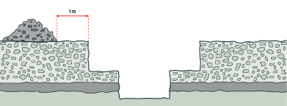
Figure 3.3: Benching control
Battering is where the wall of an excavation is sloped back to a predetermined angle to ensure stability. Battering reduces the risk of ground collapse by cutting the excavated face back to a safe slope.
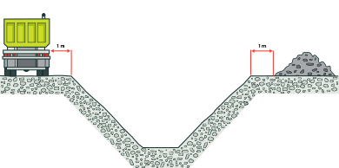
Figure 3.4: Battering controls
Shoring provides support to excavated faces to prevent soil moving and ground collapsing. If the ground is not self-supporting, and benching or battering is not suitable, use shoring to manage the risk of a person being buried or trapped during excavation work.

Flying Shoring
When using shoring, it may be possible to excavate below the base of the shoring, that is: ‘flying shoring’.
To do this, excavate to a maximum depth of 600 mm below the base of the shoring, if:
- the shoring is designed to resist the forces calculated for the full depth of the excavation, and
- there are no indications, while the excavation is open, of instability below the bottom of the shoring.
Control the risk of ground collapse and carefully visually inspect for any effects of:
- bulging
- base heave
- boiling
- surcharge loading
- vibration and other forces.
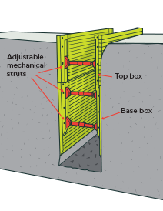
Figure 3.5: Flying trench-shoring box

Types of Shoring
Trench-shoring box: is able to withstand the forces imposed by ground, water, or surcharge loads. It will protect workers within it, as well as prevent ground collapse. This is achieved by ‘digging and pushing’ the box into the ground as the excavation proceeds, maintaining positive pressure on the excavated faces at all times.
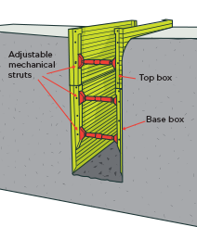
Figure 3.5: Trench-shoring box
Manhole boxes: are a subset of trench-shoring boxes. They are designed and constructed using the same methods and materials as trenchshoring boxes. Most manhole boxes are installed using the ‘dig and drop’ method. If ground conditions are poor enough that the dig and drop method is not practical, consider digging and pushing manhole box shoring, corner-slide rails or hydraulic brace and sheet systems.
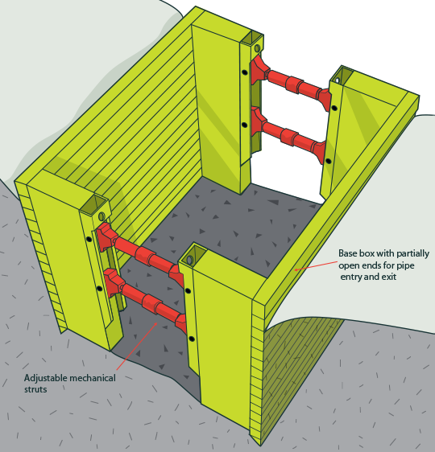
Figure 3.6: Manhole box
Trench shields: are different to trench-shoring boxes as they are only designed to protect workers if a collapse occurs. Trench shields are designed to be installed using the dig and drop method and dragged along as work progresses.
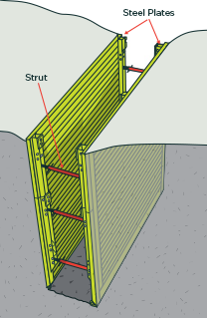
Figure 3.7: Trench shield
  - Tamping
Tamping is a common technique used in excavation to compact the soil or other materials in order to increase its density and stability. It involves applying pressure or force to the surface of the excavation area using specialized equipment such as a tamper or compactor.
The process of tamping is typically performed after the initial excavation has been completed and before any construction or installation work takes place. It is an important step in preparing the ground for various types of structures, including buildings, roads, and foundations.
Tamping serves several purposes in excavation. Firstly, it helps to remove air voids or pockets within the soil or material being compacted. These air voids can weaken the stability of the ground and lead to settling or shifting over time. By eliminating these voids, tamping improves the overall strength and load-bearing capacity of the excavated area.
Secondly, tamping helps to increase the density of the soil or material. When soil is excavated, it is often loose and not densely packed. This can result in poor compaction characteristics and reduced stability. Tamping compacts the soil particles together, reducing their volume and increasing their density.
There are several methods and equipment used for tamping in excavation. One common method is hand tamping, where workers use handheld tampers or compactors to manually apply pressure to the surface. This method is suitable for smaller areas or when access for larger machinery is limited.
For larger excavation areas, mechanical tampers or compactors are used. These machines are designed to deliver a high level of force to the ground surface, effectively compacting the soil or material over a larger area. Mechanical tampers can be operated by hand or attached to heavy machinery such as excavators or rollers.
In addition to traditional tamping methods, there are also specialized techniques available for specific types of excavation projects. For example, vibratory plate compactors use vibrations to enhance the compaction process, particularly for granular soils. This method helps to achieve a higher degree of compaction in less time compared to traditional tamping methods.
It is important to note that the specific tamping requirements and techniques may vary depending on the type of soil or material being compacted, as well as the intended use of the excavated area. Different soil types have different compaction characteristics, and it is essential to determine the appropriate compaction specifications for each project.
In conclusion, tamping is a crucial step in excavation that helps to improve the stability and load-bearing capacity of the ground. By eliminating air voids and increasing the density of the soil or material, tamping creates a solid foundation for construction. Various methods and equipment are available for tamping, ranging from manual handheld tampers to mechanical compactors. The choice of tamping technique depends on factors such as the size of the excavation area, soil type, and project requirements.

Clearance and wastege management
Maintenance of tools and equipment
Proper storage entails shielding tools from harsh weather conditions, damage and theft. It is particularly crucial for metallic tools to be kept away from moisture to avoid rusting.
Having a cabinet where these tools and equipment are stored will be vital to ensuring a secure storage area. Also, greasing, lubricating or oiling metallic tools and equipment is essential to prevent rust from forming while keeping the tools in the best condition for future tasks.
Tools must be checked, maintained or, if necessary, repaired when a job is completed to ensure they:
- Remain in a good working condition
- Are safe to use
- Are ready for the next project.
Regular maintenance helps to preserve the quality of the tools, keep them safe and extend their life. Doing a little maintenance each time you complete a job or project can prevent costly and time‑consuming repairs or replacement.
Complete the following procedures as routine maintenance at the end of every task.
- Wipe all tools to clear away dust or debris, and remove substances like grease or sap.
- Pay particular attention to tools that have been used in wet or damp conditions.
- They should be cleaned with an oily rag to prevent rust and, if rust exists, it should be removed with steel wool or a wire brush.
- Sharpen blades and replace damaged or worn components.
- Lubricate moving or adjustable parts of tools to allow smooth, continuous operation. Lubrication reduces friction between moving parts, helps them to last longer and makes the machine more energy efficient.
- Store tools and equipment properly so that they’re protected against weather and theft, easy to find when needed and not a hazard to you, other workers or members of the public.

Clean Excavated Surface
The excavated soil or debris must be properly moved from the area to a safe place. Modern methods of excavation like the vacuum method excavate around the buried surface fast and safely. Using high powered truck with excavation arms makes the process fast.
Irrespective of the method the project employs, it is necessary to make the workers aware of the potential risk associated with the improper placement of disposal. If time permits, manual digging is the safest excavation technique compared with the use of dangerous power tools.
Reuse materials
Before your project commences, a full site survey should be performed to determine the make up of the site. A survey will determine the quantity of materials in the ground, what they are and whether they can be reused. An easy material to reuse is loose soil, sand and clay. A difficult material to reuse is broken rock and boulders.
What many surveys find is inconsistencies in the make up of the site. For example, one area might be 90% soil and clay, the other 50% rock. The goal with bulk excavation is to create sites that are suitable for building on. If you have the opportunity to reuse materials, doing so will reduce your environmental impact.
Recycle materials
If materials can’t be reused onsite you can recycle them. There are companies who take rubble and debris for free. They grind these down into a usable product for construction on other projects. It’s also important to mention general waste. Plastics and metals may be dug up onsite. These should be taken to a local recycling centre.
Whether it’s crushing sandstone or chipping wood, most ground materials can be recycled and reused in some way or another. Even plastics, which are found as waste, can be sent to a local recycling centre for use elsewhere. If you find your site unearthing loads of different materials, you will need to separate these before you recycle them.

Self-check 3
Directions: Answer all the questions listed below.
- Write true if the statement is correct and write false if the statement is incorrect
- Storing dirty tools without cleaning them can cause them to deteriorate
- Using a tools for the task it is not intended helps to keep it in its best condition
- Benching and battering of excavation walls can minimise the risk of soil or rock slipping onto the excavation.
- Choose correct answer from the following question
- Studying the soil layers gives an idea about the magnitude of precautionary measures to be taken while excavating

- SCW
- GPR
- SWI
- PMW

- From the following one is not main types of controls to prevent ground collapse

- Benching
- Shorting
- Shields
- Covering

- Provides support to excavated faces to prevent soil moving and ground collapsing.

- Shoring
- battering
- Flying Shore
- Benching

- Shoring that slightly compresses soil without allowing the soil to move outward can produce an arching effect in the soil

- Shoring
- battering
- Flying Shore
- Benching

- Reduces the risk of ground collapse by cutting the excavated face back to a safe slope.

- Shoring
- battering
- Flying Shore
- Benching

Operation Sheet 3.1

Operation Title: Calculate quantity materials
Purpose: To insuring how to Calculate of material neened excavation support
Instruction: Determine the dimensions: Measure the length, width, and depth of the area to be excavated. For instance, let's assume we have an area that is 10 meters long, 5 meters wide, and needs to be excavated to a depth of 2 meter
- Calculate the volume: To find the volume of the excavation, multiply the length, width, and depth together. In this case, the volume would be calculated as follows:
Volume = Length x Width x Depth
- Volume = 10m x 5m x 2m = 100 cubic meters
Conditions for the operations:
- Safe working area
- Properly operated tools
- Appropriate working cloths fit with the body
Equipment Tools and Materials:  - Pick axe  - Shovel  - wheel barrow  - string | - peg  - profile board  - batten board  - mater  - hoose level
Quality Criteria: Assured performing of all the activities according to the procedures
Precautions:
- Wearing proper clothes, PPE
- Make working area hazard free
- Read and interpret manual which guide you how to use tools and equipment
- Identify service line before excavation
Steps in doing the task
- Setting corner benchmarks.
- Surveying ground and top levels.
- Excavation to the approved depth.
- Dressing the loose soil.
- Marking up the cut-off level.
- The construction of dewatering wells and interconnecting trenches.
- Marking the boundaries of the building.
- The construction of protection drains.

LAP Test 3
Practical Demonstration
Name: __________________________ Date: ____________
Time started: ____________________ Time finished: _______________
Instruction:
Used to assess the stability and safety of excavated slopes or walls. It involves conducting a series of tests to determine the strength and integrity of the soil or rock mass surrounding the excavation. The purpose of this test is to ensure that the excavation can withstand the applied loads and remain stable during construction or throughout its intended lifespan.

Reference
  - Civil engineering construction

  - By j.m. Antill, paul ryan and g.r. Easton (mcgraw hill 1988) 2. Civil engineering technology

  - By b.g. Fletcher and s.a. Lavan; (butterworths 1982); 3. Civil engineering construction

  - by b.g. Fletcher and s.a. Lavan (heinemann: london 1987) 4. Introduction to civil engineering construction
  - By roy holmes (college of estate management, 1996)

  - Authoritative Reference Publications or Domain Names Used in Answering this Question:
1. Construction Knowledge (www.constructionknowledge.net)
2. Civil Engineering Portal (www.engineeringcivil.com)
3. The Constructor (www.theconstructor.org)

  - Construction Methods and Planning" by J.R. Illingworth
. "Excavation Systems Planning, Design, and Safety" by Joe M. Turner
. "Setting Out: The Essential Guide to Construction Site Engineering" by Stuart Doughty

Participants of this Module (training material) preparation
No. | Name of Trainer | Sex | Educational Background In Level And Profession | Trainer Address
 |  |  |  | Region | College | Phone | E-Mail Address
1 | Solomon Urga | M | B.Sc. in Building Construction Technology | Oromia | Woliso Polytechnic College | 0921207462 | samuelsolomon071@gmail.com
2 | Muluken Solomon | M | M.Sc. in Construction Management | Oromia | Batu Polytechnic College | 0912289146 | mulecot99@gmail.com
3 | Bekalu Yibeltal | M | M.Sc. in Structural Engineering | Addis Ababa | Federal Technical and Vocational Training Institute | 0921988863 | fikruyibeltal@gmail.com
4 | Desalegn Alemu | M | B.Sc. in Construction Management | Oromia | Woliso Polytechnic College | 0926771683 | dasalegnalemu&gmail.com
5 | Tesfaye Assegidew | M | M.Sc. in Construction Technology & Management | Centeral Ethiopia | Butajira Polytechnic College | 0913442444 | tesfayeassegidew@gmail.com
6 | Tibebnesh Gebremichael | F | M.Sc. in Construction Management | Sidama | Hawassa Polytechnic College | 0916116049 | tibebineshg1@gmail.com
7 | Zekarias Gebre | M | B.Sc. in Civil Engineering | Addis Ababa | General Wingate Polytechnic College | 0912421317 | zekarias1502@gmail.com

