STRUCTURAL CONSTRUCTION WORKS

Level – IIi

Based on October 2023, Curriculum Version II
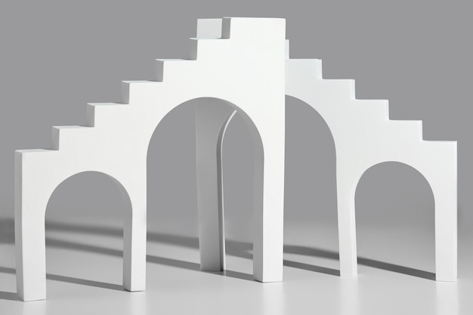
Module Title: Constructing Masonry Arches and curve walls
Module code: EIS SCW 3 051023
Nominal duration: 120 Hours
Prepared by: Ministry of Labor and Skill
October 2023
Addis Ababa, Ethiopia

Table of Contents
Acknowledgment 3
Acronym 4
Introduction to this module 5
Unit one: Curve Wall and Arch 7
1.1. Concept of masonry arch and curve 8
1.2. Work instructions 11
1.3. Occupational health &Safety requirements and signage 12
1.4. Tools, equipment and materials 17
1.5. Materials quantity Calculation 23
1.6. Environmental protection requirement 24
Self-Check 1 25
Operation Sheet 1.1 23
Operation Title: Calculate quantity materials 23
LAP Test 1 24
Unit 2. Set out First Course and Curve. 25
2.1. Location for masonry wall 26
2.2. Plot key plan for curve wall. 29
Self-Check 2 33
Operation Sheet 2.1 23
LAP Test 2 24
Task 1: Set out location and For masonry wall 24
Unit 3. Construct Wall to Arch Level. 25
3.1 Masonry unit Chisel and cut. 26
3.2 Mortar mix and lay masonry units 32
3.3 Specifications and standards 53
3.4 Gauge of abutting walls 54
3.5 Alignment of vertical wall face 57
Self-Check 1 60
Operation Sheet 3.1 23
LAP Test 1 24
Unit 4 Set up Arch Center 25
4.1. Springing line and crown of arch 26
4.2. Formworks supports arch centre 28
4.3. Central key of brick/block 29
Self-Check 1 31
Operation Sheet 4.1 32
LAP Test 4 33
Unit 5 Construct Arch Center 34
5.1. Arch centre and drawing of curve 35
5.2. Transfer plan to material and cut to shape. 37
5.3. Bull's eye, segmental and Gothic type arches 46
Self-Check 1 48
Operation Sheet 5.1 45
LAP Test 5 46
Unit 6 Cut and Place Masonry Materials 47
6.1. Cutting and laying masonry unit for centre arch 48
6.2. Striking and maintain joint equal size and parallel 49
6.3. Maintain same size wedge shape 53
6.4. Centre line of key masonry unit wedge 55
6.5. Waste Management 56
Self-Check 1 58
Operation Sheet 6.1 23
LAP Test 6 25
Reference 26

Acknowledgment
The Ministry of Labor and skill wishes to thank and appreciation to MoLS leaders and experts, Regional Labor and skill/training Bureaus leader, experts, TVT College Deans, Instructors and industry experts who contribute their time and professional experience to the development of this Training Module.

Acronym
GPS Global Positioning System
PPE personal protective equipment

Introduction to this module
This course is designed to provide you with a deep understanding of the principles, techniques, and best practices involved in building and maintaining masonry arches and curb walls.
Masonry arches have been used for centuries as a reliable and durable structural element in various types of construction, including bridges, tunnels, and buildings. The unique properties of masonry, such as its strength, durability, and aesthetic appeal, make it an ideal choice for creating arches that can withstand heavy loads and provide long-lasting support.
Curb walls, on the other hand, are commonly used in urban infrastructure projects to define boundaries, retain soil, or provide structural support. They are typically constructed using masonry materials such as bricks or concrete blocks and play a crucial role in ensuring the stability and functionality of roads, sidewalks, and other urban structures.
Throughout this course, we will delve into the fundamental concepts of masonry arch and curb wall construction. We will explore topics such as the different types of arches and their structural behavior, the selection of appropriate materials for construction, the design considerations for arches and curb walls, as well as the construction techniques involved.
By the end of this course, you will have gained a comprehensive understanding of masonry arch and curb wall construction. You will be equipped with the knowledge and skills necessary to plan, design, and construct these structures with precision and efficiency.
This module covers the following units:
- Curve walls and arch
- Set out first course and curve.
- Construct wall to arch level.
- Set up arch center
- Construct arch center
- Cut and place masonry materials
Clean up Learning Objective of the Module
- Understand the concept of Construct Curve walls and arch
- Identify Set out first course and curve.
- Understand Construction wall to arch level.
- Understand Setting up arch center
- Understand Construction arch center
Cut and place masonry materials
Module Instruction
Trainees are expected to follow the following module instructions for effective use of these modules:
1. Read the information written in each unit.
2. Complete the self-checks at the to of each unit.
3. Read the identified reference book for examples and exercises.

Unit one: Curve Wall and Arch
This unit is developed to provide you the necessary information regarding the following content coverage and topics:
  - Concept of masonry arch and curve
  - Work instructions
  - Following OH &S requirements and signage
  - Tools, equipment and materials
  - Materials quantity calculation
  - Environmental protection requirement
This unit will also assist you to attain the learning outcomes stated below. Specifically, upon completion of this learning guide, trainees will be able to:
  - Understand concept of masonry arch and curve
  - Apply work instructions
  - Follow OH &S requirements signage
  - Select tools, equipment and equipment
  - Calculate quantity materials
  - Apply environmental protection

Concept of masonry arch and curve
Masonry arch is a structural element that consists of wedge-shaped blocks or stones arranged in a curved shape. It is one of the oldest and most enduring architectural forms, dating back to ancient civilizations such as the Egyptians, Greeks, and Romans. The concept of the masonry arch revolves around the principle of distributing loads and forces in a way that allows for stability and structural integrity.
The curve of the arch is essential to its functionality. When a load is applied to an arch, the weight is transferred along the curve and distributed outward to the supports on either end. This distribution of forces allows the arch to withstand significant loads without collapsing. The curved shape also helps to dissipate stress and prevent concentrated points of weakness.
The strength of a masonry arch lies in its ability to convert vertical loads into horizontal thrusts. As the load pushes down on the arch, it transfers some of its force horizontally along the curve. This horizontal thrust is then absorbed by abutments or piers at each end of the arch, which provide support and prevent the arch from spreading apart
To construct a masonry arch, individual blocks or stones are carefully shaped and fitted together to form a continuous curve. The stones are typically cut with wedge-shaped sides called voussoirs, which allow them to fit snugly against each other while maintaining the desired curvature. The center stone at the top of the arch is known as the keystone, and it plays a crucial role in maintaining stability by locking all the other stones in place.
The construction process involves building temporary supports called centering or scaffolding to hold the stones in place until they are set and secured with mortar or another type of bonding material. Once the mortar has cured, the centering can be removed, and the arch will be self-supporting.
Masonry arches can be found in various architectural structures, including bridges, tunnels, aqueducts, and buildings. They have been used throughout history due to their strength, durability, and aesthetic appeal. The use of arches allows for larger open spaces without the need for additional supporting columns or walls, making them ideal for creating grand and spacious interiors.
The concept of the masonry arch has been refined and perfected over centuries, with advancements in engineering and construction techniques. Modern arches may incorporate additional reinforcement materials such as steel bars or concrete to enhance their load-bearing capacity. However, the fundamental principles of distributing forces along a curved shape remain unchanged.
In conclusion, the concept of the masonry arch revolves around the use of wedge-shaped blocks or stones arranged in a curved shape to distribute loads and forces. The curve of the arch allows for the conversion of vertical loads into horizontal thrusts, which are absorbed by supports at each end. Masonry arches have been used for centuries due to their strength, durability, and architectural beauty.
In masonry arch and curved wall construction, there are several key terminologies that are commonly used to describe different elements and aspects of these structures. These terminologies help in understanding the design, construction, and behavior of masonry arches and curved walls. Explanation of some important terminologies in this field:
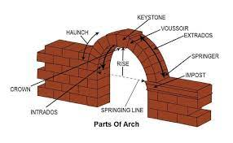
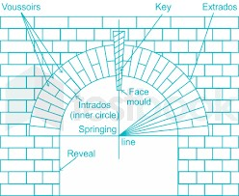
Arch: An arch is a curved structural element that spans an opening and supports the weight above it by transferring the load to its supporting abutments or piers on either side. It consists of individual wedge-shaped units called voussoirs, which are held together by mortar or other bonding materials. The arch shape provides inherent strength and stability to the structure, allowing it to bear heavy loads.

Figure 1.1 arch construction

Intrados: The intrados refers to the inner curve or surface of an arch. It is the concave side of the arch that faces inward towards the span or opening it covers.
Extrados: The extrados refers to the outer curve or surface of an arch. It is the convex side of the arch that faces outward away from the span or opening.
Keystone: The keystone is the central voussoir at the top of an arch that locks all other voussoirs in place. It is typically wedge-shaped and plays a crucial role in distributing the load evenly across the arch.
Springing line: The springing line is an imaginary horizontal line where an arch starts to rise from its supporting abutments or piers. It marks the point where the vertical support transitions into a curved form.
Crown: The crown refers to the highest point on an arch's intrados. It is located at the centerline of the span and is often used as a reference for determining the overall height and shape of the arch.
Spandrel: The spandrel is the triangular-shaped area between the outer curve of an arch and the horizontal line connecting the springing points. It is often filled with masonry or other materials to provide additional support and stability to the arch.
Haunches: The haunches are the portions of an arch that lie between the springing line and the crown. They are typically wider than the rest of the arch and play a significant role in distributing the load from the crown to the supporting abutments or piers.
Soffit: The soffit refers to the underside or intrados of an arch. It is often finished with decorative elements or left exposed, depending on the architectural design.
Skewback: The skewback is a sloping surface at the springing line where an arch rests on its supporting abutments or piers. It provides a stable base for the arch and helps in transferring the load to the vertical supports.
Rise: The rise of an arch is the vertical distance between the springing line and the crown. It determines the overall height and shape of the arch.
Span: The span of an arch is the horizontal distance between its supporting abutments or piers. It defines the width or length of the opening that an arch covers.
Ring stones: Ring stones are voussoirs that form a complete circle around an arch. They are usually located near the crown and help in distributing loads evenly across the structure.
Impost: An impost is a horizontal member that supports an arch at its springing line. It acts as a transition element between the vertical supports and the curved form of the arch.

Work instructions
Work instructions are an essential part of any construction project, including masonry unit laying tasks. These instructions provide detailed guidance on how to carry out the work, ensuring that it is done correctly and meets the required standards. In order to determine the required masonry unit laying tasks, relevant information needs to be obtained, confirmed, and applied.
Obtaining the necessary information involves gathering all the relevant documents and resources that provide details about the project. This can include plans, specifications, quality requirements, and operational details. Plans outline the overall layout and design of the project, while specifications define the materials and methods to be used. Quality requirements specify the standards that need to be met in terms of durability, strength, and appearance. Operational details provide step-by-step instructions on how to carry out specific tasks.
Once the information is obtained, it needs to be confirmed to ensure its accuracy and applicability to the project at hand. This may involve consulting with architects, engineers, or other relevant parties who can verify the information. It is crucial to confirm that the information aligns with the project's goals and requirements.
After confirming the information, it can be applied to determine the required masonry unit laying tasks. This involves analyzing the plans, specifications, quality requirements, and operational details to identify the specific tasks that need to be performed. For example, based on the plans, it may be determined that a certain number of masonry units need to be laid in a particular pattern or arrangement. The specifications may dictate the type of mortar or adhesive to be used for bonding the units together. Quality requirements may specify certain tolerances or standards for alignment and levelness.
Applying this information also involves considering other factors such as site conditions, safety regulations, and environmental considerations. For instance, if there are specific safety requirements for working at heights or in confined spaces, these need to be taken into account when determining the masonry unit laying tasks.
In summary, work instructions, including plans, specifications, quality requirements, and operational details, are obtained, confirmed, and applied from relevant information to determine the required masonry unit laying tasks. This process ensures that the work is carried out correctly and meets the necessary standards.

Occupational health &Safety requirements and signage
Safety Requirements for Masonry Arch and Curve Wall Construction
During the construction of masonry arch and curve walls, it is essential to follow strict safety requirements to ensure the well-being of workers and the quality of the final product. The following are some of the key safety requirements that should be adhered to during such construction:
Hazard Identification and Risk Assessment: Before commencing construction, a thorough hazard identification and risk assessment should be conducted to identify potential hazards and assess the risks associated with them. This should include identifying potential fall hazards, electrical hazards, and hazards related to the use of tools and equipment.
Safety Plans and Policies: Based on the hazard identification and risk assessment, a comprehensive safety plan should be developed and implemented. This plan should include policies and procedures for safe work practices, emergency response, and accident reporting. The plan should also be communicated to all workers and supervisors involved in the construction process.
Personal Protective Equipment (PPE): Workers involved in masonry arch and curve wall construction should be provided with appropriate PPE, such as hard hats, safety harnesses, safety glasses, and steel-toed boots. The PPE should be worn at all times during construction and should be inspected regularly to ensure that it is in good condition.
Fall Protection: Fall protection is a critical safety requirement during masonry arch and curve wall construction. Workers should be provided with appropriate fall protection equipment, such as guardrails, safety nets, or personal fall arrest systems, to prevent falls from heights.
Electrical Safety: Electrical hazards should be identified and mitigated during construction. This may include de-energizing power lines, using lockout/tag out procedures, and ensuring that electrical equipment is properly grounded.
Tool and Equipment Safety: Tools and equipment used during construction should be inspected regularly to ensure that they are in good condition and properly maintained. Workers should be trained on the proper use and maintenance of tools and equipment to prevent accidents.
Material Handling and Storage: Materials used in masonry arch and curve wall construction should be handled and stored safely to prevent accidents. This may include using appropriate lifting techniques, securing materials during transportation, and storing materials in a safe location.
Weather Safety: Weather conditions can pose a significant hazard during masonry arch and curve wall construction. Workers should be aware of weather forecasts and warnings, and construction should be suspended during severe weather conditions.
First Aid and Emergency Response: First aid kits should be readily available on site, and workers should be trained in first aid and emergency response procedures. Emergency response plans should be developed and communicated to all workers and supervisors.
Accident Reporting and Investigation: All accidents and near misses should be reported and investigated to identify root causes and prevent future incidents.
- Signage Requirements:
Warning Signs: Warning signs are essential for alerting individuals to potential dangers in the construction area. These signs often feature bold text or symbols to grab attention and convey a clear message. They may include phrases such as "Construction Zone," "Danger," "Keep Out," or "Authorized Personnel Only." Warning signs should be placed at appropriate intervals around the construction site to ensure maximum visibility.
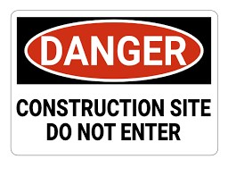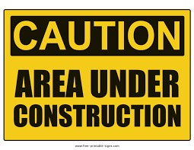
Figure 1.2. Warning Signs
Directional Signs: Directional signs are used to guide pedestrians and motorists safely around the construction site. These signs typically provide information about detours, alternative routes, or temporary road closures. They may include arrows, text indicating the direction of travel, and distance information to help people navigate through the area.

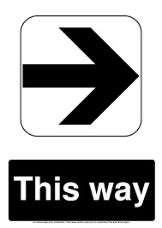
Figure 1.3. Directional Signs
Informational Signs: Informational signs provide important details about the ongoing construction project. They may include information such as project name, contractor details, contact numbers, expected completion dates, or any other relevant information that can help individuals understand the purpose and duration of the construction work.
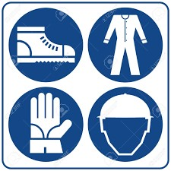
Figure 1.4: Informational Signs
Safety Signs: Safety signs are crucial for reminding workers and visitors about safety protocols and precautions within the construction site. These signs may include messages such as "Hard Hats Required," "Safety Glasses Must Be Worn," "No Smoking," or "Watch Your Step." Safety signs should be strategically placed at entrances, exits, and areas where specific safety measures are necessary.

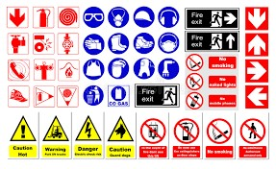
Figure 1.5: Safety Signs
Traffic Control Signs: In cases where construction activities impact traffic flow on adjacent roads or streets, traffic control signs become necessary. These signs help regulate the movement of vehicles and pedestrians, ensuring safety and minimizing disruptions.
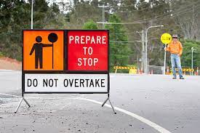
Figure 1.6: Traffic Control Signs
- Barricade Requirements:
Fencing Barricades: Fencing barricades are commonly used to restrict access to construction sites. They provide a physical barrier that prevents unauthorized entry and keeps pedestrians and motorists at a safe distance from potential hazards. Fencing barricades should be sturdy, durable, and clearly visible. They are typically made of materials such as metal, plastic, or wood.

Figure 1.2: Fencing Barricades
Traffic Barriers: Traffic barriers are specifically designed to redirect or block vehicular traffic around construction zones. These barriers can be temporary or permanent and are often made of concrete or water-filled plastic. They are placed strategically to create a safe buffer zone between the construction area and the flow of traffic.

Figure 1.8: Traffic Barriers
Pedestrian Barriers: Pedestrian barriers are used to guide foot traffic safely around construction sites. These barriers help create designated walkways and prevent pedestrians from entering hazardous areas. Pedestrian barriers can be made of materials such as metal, plastic, or wood and should be highly visible to ensure maximum effectiveness.
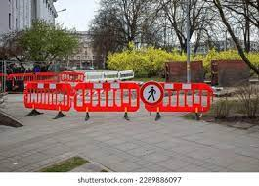
Figure 1.9: Pedestrian Barriers
It is important to note that specific signage and barricade requirements may vary depending on local regulations, project specifications, and the nature of the construction work being carried out. It is crucial for contractors and project managers to consult relevant authorities and adhere to the specific guidelines applicable to their jurisdiction.

Tools, equipment and materials
Select tools, equipment, and materials are essential components of any construction project. These items are chosen based on their ability to perform specific tasks efficiently and effectively. The selection of the right tools, equipment, and materials can significantly impact the quality and timeliness of a project. In this section, we will discuss the definition of select tools, equipment, and materials and their importance in construction projects.
Tools:
Tools are hand-held devices used to perform various tasks such as drilling, cutting, shaping, and fastening materials. The selection of tools is critical to ensure that the work is done accurately and efficiently. Some common types of tools used in construction include hammers, saws, drills, wrenches, and pliers.
Equipment:
Equipment refers to larger machines used on construction sites to perform heavy-duty tasks such as excavation, lifting, and hauling. Examples of equipment commonly used in construction include cranes, bulldozers, backhoes, and concrete mixers.
Table 1.1 tools and equipment
Name of tools and equipments | Use of tools and equipments | Picture of tools and equipments
Spirit level | It is used to control the horizontal and vertical alignment of wall surface and edges. The length is at least 80 to 120cm long. | 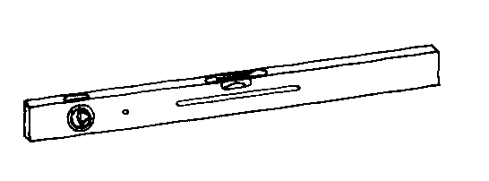
Plumb bob | A plum bob is made of metal. When suspended from a vertically attached string, it is employed to check the vertical alignment of corners and surface of walls. | 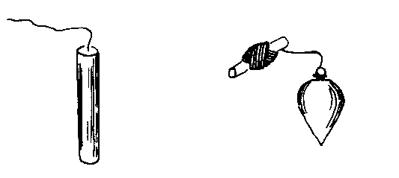
Alignment string /masons’ line/ | Alignment string /mason line/, sometimes called, Fish line, is a rope used to transfer horizontal & vertical alignments or lines, | 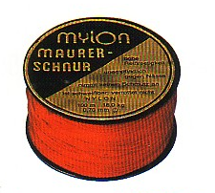
Graphite Pencil | This is used for marking in wall construction. It is specially produced for this purpose in such a way that it will not wear out fast. | 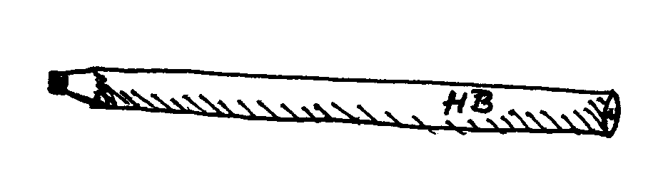
Water level | The rubber water tube is filled with water until the level is half way up both glass tubes and them sealed when not tin use. | 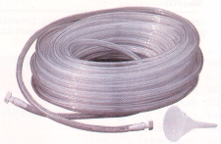
Straight edge /Strike-off broard :- | Professional uses are made of metal or wooden board to strike off the tip concrete after pouring and spreading. | 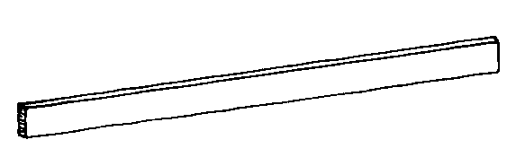
Angle Try square | It is used to measure a right angle (90º) of a corner. Used in laying masonry units or blocks at corners of masonry wall. | 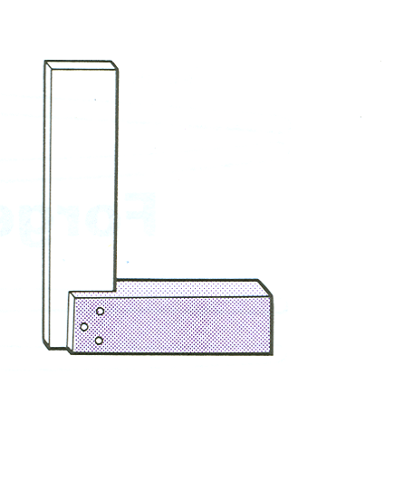
Measuring tape | Tape is used to measure dimensions of building parts and distances in site. It is manufactured from steel, plastic or fiber in lengths of 1m, 2m, 3m, 5m, 30m, etc. and 50m. In using tapes for measurements | 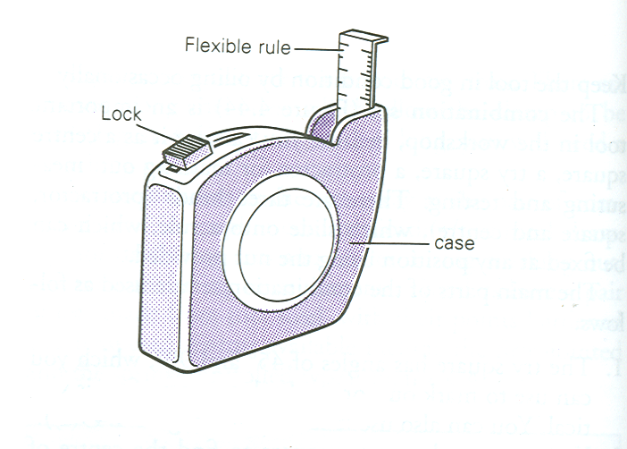
Block laying trowel | This is a tool, which every mason needs. Used for picking up mortar out of the barrel, spreading mortar on the wall | 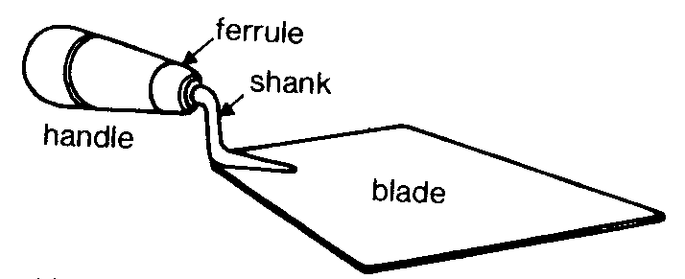
Walling Hammer/Mason hammer/ | Walling Hammers are used especially to knock of parts of walling unit blocks, /brick, concrete blocks etc/. | 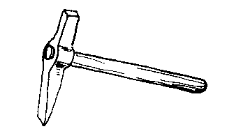
Club hammer and bolster | Is used to strike marrow – headed chisels and brick set or for driving stakes into the ground. | 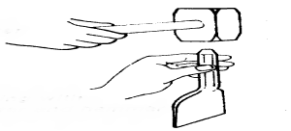
Chisel | Used to cut concrete blocks, bricks, plaster surface and to remove mortar or concrete projections etc. | 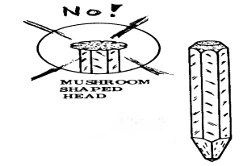
Mortar spade/Shovel | Mortar spade is used to stir the mortar paste, prepared in the barrel or drum and keeps the mix to right and uniform consistency. | 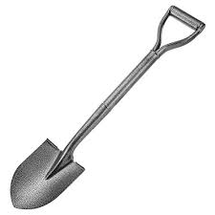
Bow saw: | Carpenters usually use Bow saw in the construction site in order to cut like eucalyptus wood. | 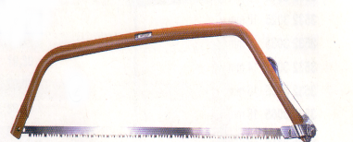
General propose trowel | It has pointed end and used for general surface of construction works. It can be used also for spreading mortar and concrete over large area | 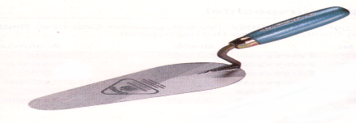
Pointing Trowel | It has pointed tip and used for small repair of concrete work and Patching. | 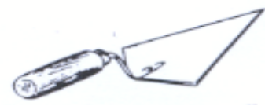
Raking tools | Raking tools are essential gardening implements used for various tasks, such as collecting leaves, debris, and grass clippings, leveling soil, and spreading mulch. | 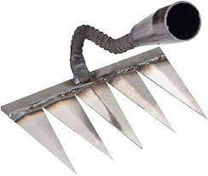
Pointers | Pointers are powerful tools in programming that allow you to store memory addresses as variables. Here are some of the benefits of using pointers: | 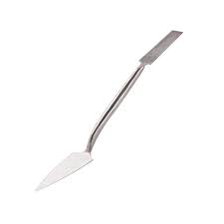
pallet trolleys | A pallet trolley, also known as a pallet jack or pallet truck, is a manual or electric-powered device used to lift and transport pallets within a warehouse or industrial setting. It is designed to make the movement of heavy loads on pallets more efficient and less physically demanding for workers. | 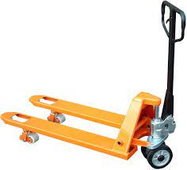
brick buggies | Brick buggies are a type of off-road vehicle that is built using LEGO bricks. These miniature vehicles are designed to be fully functional and can be controlled remotely. | 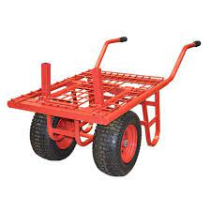
Forklift | A forklift, also known as a lift truck or a powered industrial truck, is a type of vehicle that is primarily used for lifting and moving heavy loads in various industries such as warehousing, manufacturing, construction, and logistics. Forklifts are designed to handle materials efficiently and safely, making them an essential tool in many workplaces. | 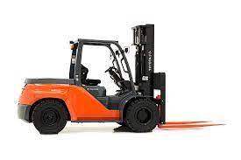
scaffolds | Scaffolds are temporary structures used in construction, engineering, and other industries to provide support and access during the building or maintenance of structures. They are typically made of metal tubes or poles, along with wooden planks or platforms, and are erected around the perimeter of a building or structure. | 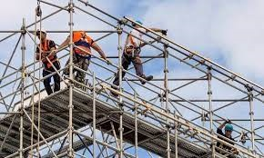
Bucket | A Bucket is used to serve small amount of water or material and to take the tools after work. | 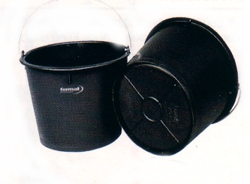
Concrete/ Mortar Mixer | Concrete mixers are available in from of different capacities. Small mixers can produce 250Lit of mortar or concrete and the big ones produces more and more, up to 6000Lit.; widely used, small mixers up to a capacity of 1000Lit. Mixers are driven with diesel, benzene engine or electrical power. | 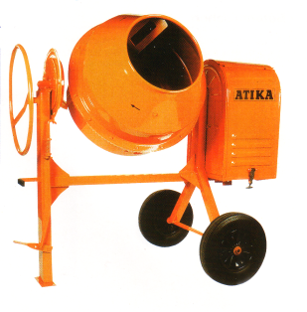
Wheelbarrow | Wheelbarrow is used to dispose disposal materials from working place, to transport or serve materials and tools during construction activities in the site. | 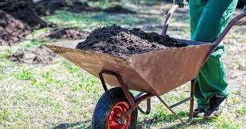

Materials: refer to the physical components used in construction such as wood, steel, concrete, and glass. The selection of materials is crucial to ensure that the final product meets the required strength, durability, and aesthetic standards.
Materials appropriate to the work application are identified
When it comes to the construction of masonry arch and curb walls, various materials are used to ensure structural integrity and durability. These materials are carefully selected based on their properties, compatibility with the surrounding environment, and the specific requirements of the project. The following is a comprehensive list of materials commonly used in the construction of masonry arch and curb walls:
Bricks: Bricks are one of the primary materials used in masonry construction. They are typically made from clay or concrete and come in various sizes, shapes, and colors. Bricks provide strength, stability, and aesthetic appeal to arches and curb walls. They are laid in courses using mortar to create a solid structure.
Mortar: Mortar is a mixture of cement, sand, and water that acts as a bonding agent between bricks or other masonry units. It provides cohesion, strength, and weather resistance to the masonry structure. The type of mortar used depends on factors such as the load-bearing capacity required, exposure to weather conditions, and aesthetic considerations.
Concrete: Concrete is often used in the construction of masonry arches and curbs walls for their foundations or footings. It is a composite material made from cement, aggregates (such as sand or crushed stone), water, and sometimes additives or admixtures. Concrete provides strength, durability, and resistance to compression.
Reinforcement: In some cases, masonry arches and curb walls may require reinforcement to enhance their structural integrity. Reinforcement can be achieved by incorporating steel bars or mesh within the masonry units or by using reinforced concrete elements such as beams or columns.
Stone: Natural stone can be used as an alternative to bricks in masonry construction. Stones like granite, limestone, or sandstone offer unique aesthetics and durability. They are often used for decorative purposes or in historical restoration projects.
Coping: Coping refers to the protective covering or cap placed on top of a masonry wall or arch. It helps to prevent water penetration, protects the underlying masonry from weathering, and enhances the visual appearance. Coping materials can include bricks, stones, precast concrete, or metal.
Flashings: Flashings are thin, waterproof materials used to prevent water infiltration at vulnerable points in a masonry structure, such as where the arch or curb wall meets a roof or another surface. Common flashing materials include metal (such as aluminum or copper) and synthetic membranes.
Damp-proofing and waterproofing: To protect masonry arches and curb walls from moisture-related issues, damp-proofing and waterproofing measures are often employed. These can include the application of coatings, sealants, or membranes that create a barrier against water penetration.
Anchors and Ties: Anchors and ties are used to connect masonry arches and curb walls to adjacent structures or to provide additional stability. They can be made of metal (such as stainless steel) and are designed to withstand the forces acting on the masonry system.
Grout: Grout is a fluid mixture of cement, sand, and water used to fill voids between masonry units, such as bricks or stones. It provides additional strength and stability to the overall structure by improving load transfer and reducing water infiltration.
Expansion Joints: Expansion joints are flexible materials placed at regular intervals in masonry arches and curb walls to accommodate thermal expansion and contraction. They help prevent cracking or damage caused by temperature variations.
Adhesives: Adhesives may be used in certain situations where traditional mortar is not suitable or desired. These adhesives are specifically formulated for bonding masonry units together and can provide high strength and durability.
It is important to note that the selection of materials for masonry arch and curb wall construction should be based on the specific project requirements, local building codes, and the recommendations of structural engineers and architects. Additionally, proper installation techniques and regular maintenance are crucial to ensure the longevity and performance of the masonry structure.

Materials quantity Calculation
Material quantity requirements are calculated in accordance with plans, specifications and quality requirements for a masonry arch and curb wall, several factors need to be considered, including the plans, specifications, and quality requirements. The material quantity estimation is crucial in ensuring that the right amount of materials is procured and used during construction, avoiding wastage and cost overruns. This comprehensive response will outline the key considerations and steps involved in calculating the material quantity for masonry arch and curb wall.
Understanding Plans and Specifications: The first step in calculating material quantity is to thoroughly review the architectural plans and specifications provided for the masonry arch and curb wall. These documents will provide essential information such as dimensions, elevations, cross-sections, and any specific design requirements. Understanding these details is crucial for accurate material estimation.
Identifying Materials: Once the plans and specifications are understood, it is necessary to identify the materials required for constructing the masonry arch and curb wall. Common materials used in masonry construction include bricks or blocks, mortar, reinforcement bars (rebar), grout, flashing, damp proofing materials, and any additional components specified in the plans.
Calculating Brick or Block Quantity: The quantity of bricks or blocks needed depends on the dimensions of the arch and curb wall. To calculate this quantity accurately, consider the following steps:
For a given plan find (i) No. of bricks (ii) C:M required for Brick work with ratio 1:5.
D = 1.0 X 2.10
Height of Ceiling = 3.0 m
Solution:
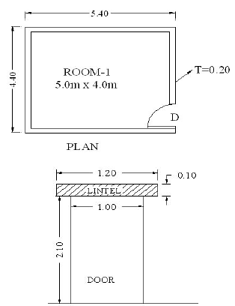
Length of wall (L ) = 5.40 x 2 + 4.0 x 2 = 18.80 m

L = 18.80 m
B = 0.20 m
D = 3.0 m

Volume of brickwork = Length x width x Thickness of wall
= 18.80 x 3.0 x 0.20
= 11.28 m³
Deduction of Door = L x B x D = 1.0 x 2.10 x 0.20 = ‐0.42 m 3
Deduction of Door Lintel = L x B x D = 1.20 x 0.10 x 0.20 = ‐0.024 m 3
Since, Breadth of Lintel = thickness of wall = 0.20 m
Total Volume of brick work after deductions = 11.28 ‐ 0.42 ‐ 0.024 = 10.836 m3
Assuming:-
- Brick size = 19cm x 19cm x 19cm
- Thickness of mortar = 10 mm
Quantity of Bricks:-
No. of bricks = Volume of brickwork
Volume of 1 brick with mortar
= 10.836/0.002
∴ No. of bricks = 5418 bricks
Estimating Mortar Quantity: Mortar is used to bond the bricks or blocks together. To estimate the mortar quantity, follow these steps:
Volume of 1 Brick with mortar = 0.20×0.10×0.10=0.002 m³
CM required for brickwork:-
Volume of total no. of bricks = (0.19×0.09×0.09) x 5418
= 0.001539 x 5418
= 8.3383 m³
Quantity of mortar = Quantity of brickwork – Volume of bricks
Quantity of mortar = 10.836 – 8.3383
= 2.4977 m³ ≅ 2.5 m³
Mix Ratio –> 1:6
Dry volume of mortar = Wet volume x 1.33
∴Dry volume of mortar = 2.5 m³x 1.33
= 3.325 m³
Quantity of cement:-
Quantity of Cement = Dry Volume of mortar x Cement ratio
Sum of the ratio
∴Quantity of cement = (3.325 x 1) /(1+6)
= 0.475 m³
Density of Cement = 1440 kg/m³
∴ Weight of Cement = 1440 x 0.475
= 684 Kg
1 bag of cement contains 50 kg of cement
∴ Number of bags = 684 Kg / 50 kg
= 13.68 No’s
Quantity of Sand:-
Cement: Sand:: 1:6
Quantity of Sand = Quantity of Cement x 6
Quantity of Sand = 0.475 m³x 6
= 2.85 m³

Environmental protection requirement
Environmental requirements are identified for the project in accordance with environmental plans and statutory and regulatory authority obligations, and are applied.
Environmental requirements play a crucial role in construction projects, ensuring that the project is carried out in a manner that minimizes negative impacts on the environment. When constructing masonry arches and curb walls, it is essential to identify and adhere to these environmental requirements. This involves following environmental plans and complying with statutory and regulatory authority obligations
To begin with, environmental plans are developed to outline the specific measures and actions that need to be taken to protect the environment during construction activities. These plans are typically created based on an assessment of the potential environmental impacts of the project. They may include provisions for mitigating pollution, conserving natural resources, managing waste, and protecting sensitive habitats or species.
Statutory and regulatory authority obligations refer to the legal requirements imposed by government bodies or other regulatory authorities. These obligations are put in place to ensure that construction projects comply with environmental laws and regulations. They may cover a wide range of aspects, such as air and water quality standards, noise pollution limits, waste management practices, and protection of biodiversity.
During the construction of masonry arches and curb walls, several environmental requirements need to be considered and applied. One important aspect is the selection of materials. It is essential to choose materials that have minimal environmental impact throughout their lifecycle, from extraction or production to disposal or recycling. For example, using locally sourced materials can reduce transportation-related emissions and support local economies.

Self-Check 1
Directions: Answer all the questions listed below.
- Write true if the statement is correct and write false if the statement is incorrect
- The masonry arch is one of the oldest architectural forms.
- The curve of the arch helps to dissipate stress.
- The strength of a masonry arch lies in its ability to convert vertical loads into horizontal thrusts.
- The keystone plays a crucial role in maintaining stability in a masonry arch.
- Masonry arches can be found in bridges, tunnels, aqueducts, and buildings.
  - Choose correct answer from the following question
      - What are the two ancient civilizations mentioned in the document that used masonry arches?

- Egyptians
- Greeks

      - What are some architectural structures where masonry arches can be found?

- Bridges
- Tunnels
- Aqueducts
- Buildings

      - What are some key elements of a masonry arch?

- Keystone
- Voussoirs
- Intrados
- Extrados
- Spandrel

III. Write short answer for the following question
a) Describe the concept of a masonry arch.
b) What is the role of the keystone in a masonry arch?
c) Why is the curve of the arch important?
d) How are masonry arches constructed?
e) What are some advantages of using masonry arches in construction?

Operation Sheet 1.1

Operation Title: Calculate quantity materials
Purpose: To calculate the quantity of bricks, mortar, cement, and sand required for brickwork.
Instruction:
Calculate the amount of brick,sand and cement required for a masonry project covering an area of 4 square meters, consider the ratio of sand to cement, as well as the thickness of the mortar joint 10mm.
Assuming use the 1:3 ratio, calculate the quantities as follows:
- Determine t volume of mortar
- Calculate the amount of cement, sand and brick
Conditions for the operations:
- Safe working area
- Properly operated tools
Equipment Tools and Materials:  - Paper  - Pencil  - Pen | - Table  - Chair
Quality Criteria: Assured performing of all the activities according to the procedures
Precautions:
- Wearing proper clothes, eye glass, glove
- Make working area hazard free
- Read and interpret manual which guide you how to use tools and equipment
Steps in doing the task
- Measure the dimensions of the curve wall.
- Calculate the volume of the brickwork.
- Determine the size of the bricks and the thickness of the mortar.
- Calculate the number of bricks needed.
- Estimate the quantity of mortar.
- Determine the mix ratio for the mortar.
- Calculate the dry volume of mortar.
- Calculate the quantity of cement.
- Calculate the weight of cement.
- Determine the number of cement bags needed.
- Calculate the quantity of sand.

LAP Test 1
Practical Demonstration
Name: __________________________ Date: ____________
Time started: ____________________ Time finished: _______________
Instruction: Perform the following tasks
Task 1: Calculate quantity materials

Unit 2. Setting out First Course and Curve.
This unit is developed to provide you the necessary information regarding the following content coverage and topics:
- Setting out location for masonry wall
- Plot key plan for curve wall.
This unit will also assist you to attain the learning outcomes stated below. Specifically, upon completion of this learning guide, trainees will be able to:
- Set location and line of masonry unit work wall
- Plot key plan curve points of curve masonry wall.

Location for masonry wall
Constructing a masonry wall is essential to accurately set out the location and line of the wall on the concrete footing, column, slab, or ground as per the provided drawings and specifications. This process ensures that the wall is built in the correct position and alignment, resulting in a structurally sound and aesthetically pleasing finished product.
To begin with, the location of the masonry wall is determined based on the architectural plans and site requirements. The drawings provide information on where the wall should be positioned in relation to other elements of the building or site. This includes measurements from property boundaries, adjacent structures, or any other relevant reference points.
Once the location is established, the line of the wall is marked out on the concrete footing, column, slab, or ground. This line represents the outer edge of the wall and serves as a guide for laying the masonry units. The line can be marked using various methods such as chalk lines, string lines, or laser levels, depending on the accuracy required and available resources.
The positioning of the masonry units along the line is crucial for maintaining a consistent and level wall. The specifications provided in the construction documents outline the required dimensions and spacing between units. These specifications may include details such as unit size, mortar joint thickness, bond pattern and any special considerations for openings or corners.
To ensure accurate placement of masonry units, builders often use tools such as plumb bobs, spirit levels, or laser levels. These tools help align each unit vertically and horizontally with respect to the line and adjacent units. Proper alignment is essential for achieving structural stability and preventing irregularities in the finished wall.
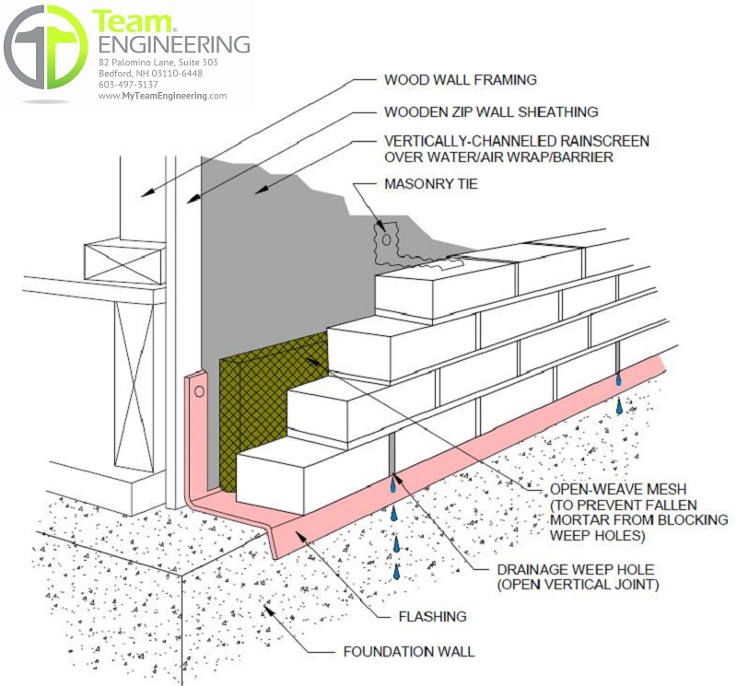
Figure 2.1: Location for masonry wall

Masonry arches and Span determination
The span of a masonry arch is determined by adding a specific amount to the prepared allotted arch center. This additional amount is typically 4mm.
When constructing a masonry arch, it is crucial to accurately determine its span. The span refers to the distance between the two supports or piers that hold the arch in place. To ensure proper construction and stability, an additional measurement is added to the prepared allotted arch center.
The prepared allotted arch center is the initial measurement taken for the arch span. It is usually determined based on architectural plans and design specifications. This measurement represents the desired span of the arch as per the design requirements.
To account for any potential variations or discrepancies during construction, an additional 4mm is added to the prepared allotted arch center. This extra allowance helps accommodate any minor deviations that may occur during the construction process, such as slight inaccuracies in measurements or adjustments needed for mortar joints.
It is important to note that this additional allowance of 4mm may vary depending on specific construction practices, regional building codes, or project requirements. Architects, engineers, or masonry professionals should always refer to applicable regulations and guidelines to determine the appropriate margin to be added to the prepared allotted arch center.
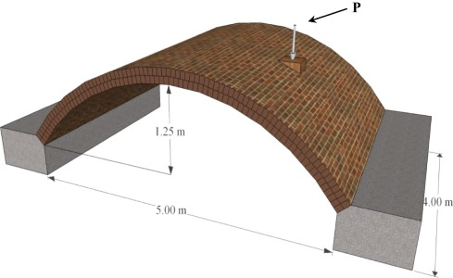
In conclusion, when determining the span of a masonry arch, it is common practice to add 4mm to the prepared allotted arch center. This additional allowance accounts for minor variations during construction and ensures a proper fit and stability of the final structure.
Figure 2.2: Masonry arch and Span

Set out first course for arch span
Arch spans are typically set out to determine the location for the first course of an arch structure. The first course, also known as the springing course, is the lowest course of stones or bricks that form the base of an arch. It serves as the foundation upon which the rest of the arch is built.
Setting out arch spans involves determining the position and dimensions of the arch in relation to its surroundings. This process is crucial for ensuring that the arch fits properly within its intended space and functions structurally as intended.
To set out arch spans, several factors need to be considered:
Design considerations: The design of the arch, including its shape, size, and intended purpose, plays a significant role in determining the span. Different arch types, such as semicircular, pointed, or segmental arches, have different span requirements. The span is typically measured as the horizontal distance between the two supports or abutments that hold up the arch.
Structural considerations: The structural integrity of an arch depends on various factors, including the materials used, load-bearing capacity, and overall stability. The span should be determined based on these structural considerations to ensure that the arch can safely support its own weight and any additional loads it may bear.
Site conditions: The location where the arch will be constructed also influences how arch spans are set out. Factors such as ground conditions, topography, and existing structures nearby can impact the placement and dimensions of the arch. It is essential to assess these site conditions to ensure that the arch fits harmoniously into its environment.
To set out arch spans for the first course, several methods can be employed:
      - Surveying techniques: Surveying plays a crucial role in accurately determining the position and dimensions of an arch. Various surveying tools and techniques, such as total stations or GPS (Global Positioning System), can be used to measure distances and angles with precision. These measurements help in setting out the arch spans accurately.
      - Templates and centering: Templates or centering are often used to guide the construction of arches. These temporary structures provide a framework for shaping the arch and ensure that the correct span is achieved. By using templates or centering, builders can accurately position the first course and subsequent courses of the arch.
      - Mathematical calculations: In some cases, mathematical calculations may be employed to determine the optimal span for an arch. Engineers and architects use mathematical formulas and principles to calculate the appropriate dimensions based on factors such as load-bearing capacity, material strength, and desired aesthetics.
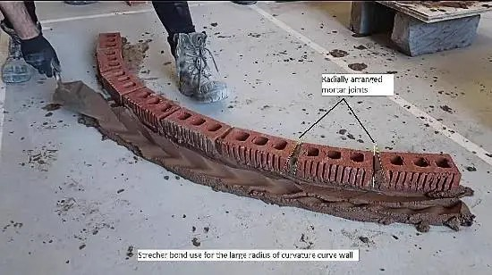
Figure 2.3: Set out first course for arch span

Plot key plan for curve wall.
When constructing a curved masonry wall, the process typically involves plotting key plan curve points from job drawings and establishing trammel centers on the footing slab. These steps are crucial for ensuring accurate construction and achieving the desired curvature of the wall.
To begin, the key plan curve points are plotted based on the job drawings. These points indicate the specific locations where the wall will curve or change direction. The drawings provide the necessary dimensions and angles to accurately plot these points on the construction site.
Once the key plan curve points are established, trammel centers are set up on the footing slab. Trammel centers consist of two adjustable arms that can be moved to different positions to create various curves. They are typically made of metal and have pivot points at each end.
To set up the trammel centers, they are first positioned at the plotted key plan curve points on the footing slab. The pivot points of the trammel centers are then secured to ensure stability during construction. The arms of the trammel centers can be adjusted to match the desired curvature of the wall.
With the trammel centers in place, masons can begin laying bricks or stones along the curved path. The trammel centers act as guides for maintaining a consistent curvature throughout the construction process. Masons can adjust the position of the trammel centers as needed to accommodate changes in direction or radius.
It is important to note that constructing a curved masonry wall requires skilled craftsmanship and attention to detail. Masons must carefully align each brick or stone with the curvature defined by the trammel centers. This ensures that the wall remains structurally sound and visually appealing.
In conclusion, when constructing a curved masonry wall, key plan curve points are plotted from job drawings, and trammel centers are established on the footing slab. These steps provide guidance for accurately shaping and building the curved wall.
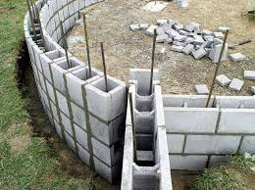
Figure 2.4: curve wall

Plane curve wall to specify location
To plan the curve of a wall and mark its exact location, several steps need to be followed. These steps involve using trammel or plotted points to determine the desired curve and then transferring it onto the intended surface, whether it is a beam, slab, or the ground.
Determining the Curve: The first step is to determine the desired curve of the wall. This can be done using various methods, such as mathematical calculations or by referencing architectural drawings. The curve can be defined by specifying key points along its path or by using a mathematical equation that describes the shape of the curve.
Using Trammel Points: Trammel points are a tool commonly used in construction to draw curves or arcs of a specific radius. They consist of two arms connected by a pivot point, with one arm holding a pencil or marker. To use trammel points for marking the curve on the wall's location, follow these steps:
- Determine the radius of the desired curve.
- Adjust the trammel points' arms to match this radius.
- Place one arm of the trammel points at the starting point of the curve.
- Rotate the other arm around the pivot point, keeping it in contact with the surface.
As you rotate, mark points along the curve at regular intervals until reaching the endpoint.
By following these steps, you will have marked a series of points that define the curve on the specified location.
Step 1 Using Plotted Points:
Another method to plan and mark a curved wall is by using plotted points. This method involves determining specific coordinates for multiple points along the desired curve and then transferring those coordinates onto the surface where the wall will be constructed. Here's how to use plotted points:
- Determine the coordinates (x, y) for each point along the curve.
- Measure and mark these coordinates on a grid or graph paper.
- Transfer the marked points onto the surface where the wall will be located.
- Connect the plotted points to form the curve.
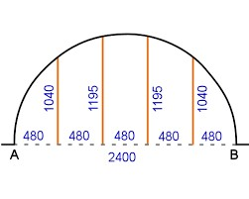
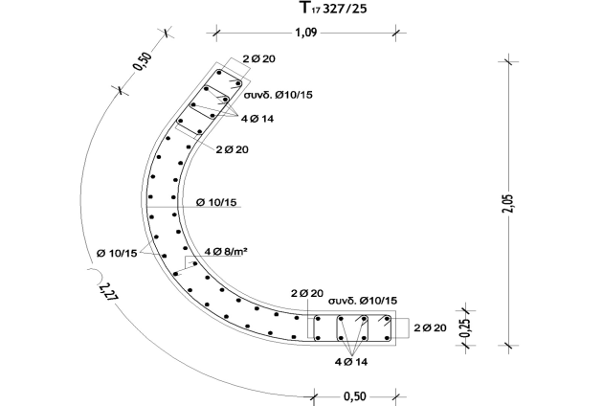
This method allows for precise control over the shape and position of the curve, as it relies on accurate measurements and plotting.
Figure 2.5 Using Plotted Points:

Step 2 Marking on Exact Location:
Once the curve has been determined using either trammel or plotted points, it needs to be marked on the exact location where the wall will be constructed. The marking process depends on the surface type:
- Beam or Slab: If the wall is to be built on a beam or slab, use a straightedge or chalk line to connect the marked points along the curve. This will create a clear guideline for construction.
- Ground: If the wall is to be constructed directly on the ground, use stakes or pegs to mark each point along the curve. Connect these markers with string or a flexible material to outline the curve's path.

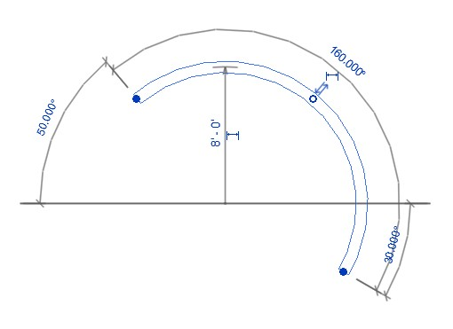
Figure 2.1: Marking on Exact Location

Self-Check 2
Directions: Answer all the questions listed below.
  - Write true if the statement is correct and write false if the statement is incorrect
      - The location of a masonry wall is determined based on architectural plans and site requirements. –
      - The span of a masonry arch is determined by adding 4mm to the prepared allotted arch center.
      - The first course of an arch is also known as the springing course. –
      - Trammel centers are used to establish the location of the first course of an arch.
      - When constructing a curved masonry wall, key plan curve points are plotted from job drawings.
  - Choose correct answer from the following question
      - What tools can be used to mark the line of a masonry wall?

  - Chalk lines,
  - string lines,
  - laser levels.
  - All

      - What considerations should be taken into account when setting out arch spans?

  - Design considerations,
  - structural considerations,
  - site conditions.
  - All

      - What methods can be employed to set out arch spans for the first course?

  - Surveying techniques,
  - templates and centering,
  - Mathematical calculations.
  - site conditions

      - How can the curvature of a curved masonry wall be marked on the location?

- Using trammel points
- plotted points.
- Surveying techniques
- All

      - How can the curve of a wall be marked on a beam or slab?

- Using a straightedge
- chalk line.
- A and B
- All

  - Write short answer for the following question
a) What is the purpose of setting out the location and line of a masonry wall?
b) How is the span of a masonry arch determined?
c) What is the first course of an arch and why is it important?
d) What are trammel centers used for in the construction of an arch?
e) How can the curve of a curved masonry wall be marked on the ground?

Operation Sheet 2.1
Operation Title: Masonry Wall Construction
Purpose: To provide step-by-step instructions for constructing a masonry wall.
Instruction:
- Prepare the construction site by clearing any debris and ensuring a stable foundation.
- Mark the location and line of the wall on the footing, column, slab, or ground based on the provided drawings and specifications.
- Set up the necessary tools and equipment, including plumb bobs, spirit levels, or laser levels for accurate placement of masonry units.
- Follow the specifications provided in the construction documents regarding unit size, mortar joint thickness, bond pattern, and any special considerations.
- Use appropriate techniques, such as chalk lines, string lines, or laser levels, to mark the line of the wall and position the masonry units accordingly.

Conditions for the operations:
- Adequate lighting and weather conditions for safe and efficient construction.
- Availability of construction drawings and specifications.
- Proper storage and handling of materials and tools.
Equipment Tools and Materials:  - Masonry units (bricks or stones)  - Mortar mix  - Trowel  - Plumb bobs |  | - Spirit levels  - Laser levels (if available)  - Chalk lines or string lines  - Safety equipment (gloves, goggles, etc.)
Quality Criteria: The masonry wall should be built in the correct position and alignment as per the provided drawings and specifications.
Precautions:
- Wearing proper clothes, eye glass, glove
- Make working area hazard free
- Read and interpret manual which guide you how to use tools and equipment
Steps in doing the task  - Prepare the construction site.  - Mark the location and line of the wall.  - Set up the necessary tools and equipment.  - Follow the specifications for masonry units and mortar.  - Mark the line of the wall using appropriate techniques. | - Align and level each unit with respect to the line and adjacent units.  - Lay the masonry units, applying mortar between each unit.  - Check and adjust the alignment and levelness of the wall.  - Allow sufficient curing time before proceeding to the next course.  - Repeat the above steps for each course until the desired height is achieved.

LAP Test 2
Practical Demonstration
Name: __________________________ Date: ____________
Time started: ____________________ Time finished: _______________
Instruction: Perform the following tasks

Task 1: Set out location and For masonry wall

Unit 3. Construction Wall to Arch Level.
This unit is developed to provide you the necessary information regarding the following content coverage and topics:
- Specification for chisel and cut masonry unit.
- Mortar mix and lay masonry units
- Specifications and standards
- Gauge of abutting walls
- Alignment of vertical wall face
This unit will also assist you to attain the learning outcomes stated below. Specifically, upon completion of this learning guide, trainees will be able to:
- Cut and chisel masonry unit.
- Prepare mortar mix and laying masonry units
- Carry out all work specifications and standards
- Maintain gauge of abutting walls
- Maintain plumb and alignment of vertical wall face

Masonry unit Chisel and cut.
Masonry units, such as bricks or stones, are commonly cut and chiseled to achieve specific joint patterns and shapes. This process is an essential part of masonry construction, allowing for precise fitting and alignment of the units.
Cutting and chiseling masonry unit is typically done to create joints that are aesthetically pleasing and structurally sound. The joints between the units play a crucial role in distributing loads and accommodating movement, while also contributing to the overall appearance of the finished structure.
One common method of cutting masonry units is through the use of a masonry saw. Masonry saws are specifically designed for cutting through hard materials like bricks or stones. These saws feature diamond-tipped blades that can make clean and precise cuts. They are available in various sizes, allowing for different cutting depths and angles.
Chiseling is another technique used to shape masonry units. Chisels are handheld tools with a sharp edge that can be struck with a hammer or mallet to remove material from the unit. This method is often used to create specific shapes or profiles on the edges or faces of the units.
      - Measure the area where you’ll install the cut cinder block. If you’re using cinder blocks to build a wall or patio space, cutting cinder blocks to a precise size will ensure they fit perfectly. Take a tape measure and measure the length of the space where the cut cinder block will fit.
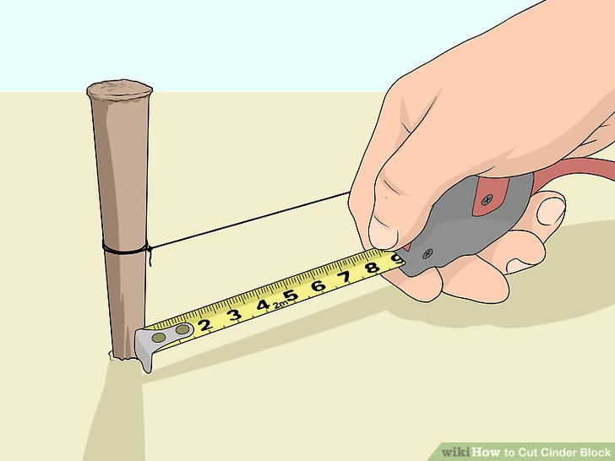
Figure 3.1: Measure the area where you’ll install the cut cinder block
Don't worry about measuring the width of the space since cinder blocks are commonly a uniform size. Cinder blocks come in various sizes and shapes, but the most common size is 8 by 8 by 16 inches (20 × 20 × 40cm).
      - Mark the measurement onto the cinder block in white chalk. Use the chalk to mark the spot where you’ll cut the block. For example, if the space that the cinder block needs to fit into is 8 inches (20 cm) long, measure 8 inches (20 cm) in from the end of a cinderblock and make a chalk mark.
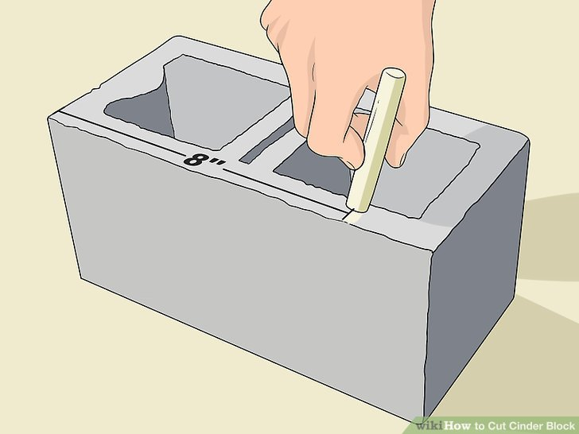
Figure 3.2: Mark block in white chalk
If you’d like to be as accurate as possible, hold the straight edge of a ruler across the block at the 8 in (20 cm) mark. Drag your chalk along the ruler’s edge to make a line that crosses the block.
      - Insert a masonry blade into the circular saw. This specific type of blade allows you to cut through a cinder block. Lift up the spring-loaded protective plastic sheath that covers the currently-installed blade. Remove the retaining bolt at the center of the circular blade with a ³⁄₄ in (1.9 cm) wrench. Once the bolt is off, lift the blade out of its housing and set the masonry blade in its place. Set the bolt back in place over the center of the blade and screw it back into position with the wrench. Then, release the blade cover so it snaps back into place over the blade.

If you don’t have a masonry blade (or a circular saw), purchase one at a local hardware store. If you only plan to use the circular saw for this single task, you may be able to rent one instead of buying it.
      - Put on safety equipment before you begin cutting the block. Cutting a cinder block with a circular saw will be loud and create a lot of concrete dust. Always wear a mask with ventilation to protect your lungs when splitting or cutting cinder blocks

Figure 3.3: safety to be consider
The dust that this kicks up can damage your lungs if you inhale it. To protect your hearing from the loud saw, also wear a pair of sound-blocking earmuffs or ear plugs.
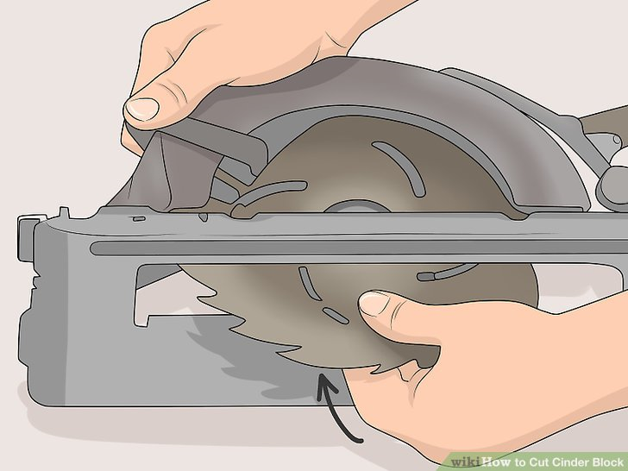
Figure 3.3: Cutting block equipment

      - Line up the blade with the chalk mark on the cinder block. Hold the cinder block in place
with your non-dominant hand, and use your dominant hand to align the saw. When you’re looking down on the circular saw from above, you’ll see a notch in front of the metal surface in front of the blade indicating where it will cut. Carefully align this mark with the chalk mark that you made earlier.
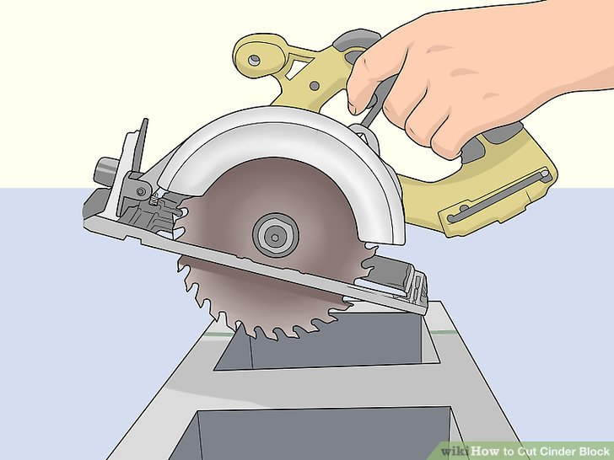
figure 3.5: Line up the blade with the chalk
      - Cut through the cinder block in 1 slow, accurate stroke. Squeeze the trigger inside of the saw’s hand guard to start the blade spinning. Once it’s at full speed, press the saw forward so it cuts through the cinder block. As you cut, the protective covering will be pushed back, allowing more of the blade to contact the cinder block. In most cases, you can cut through the block in 1 go. If the cinder block isn’t quite cut, though, make another 2 or 3 cuts to finish bisecting it.
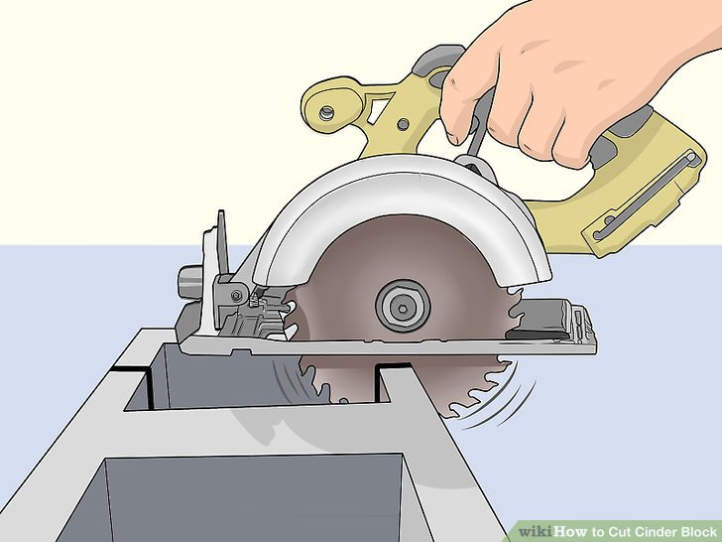
Figure 3.6: Cut through the cinder
      - Wipe the cinder block clean with a damp rag. When you’ve finished cutting, the block will be covered with fine dust. Dampen a rag by running it under water and then wringing it out. Run the rag lightly over the cut halves of the cinder block to clean them up. At this point, you’re ready to install the block in whatever project you’re working on.
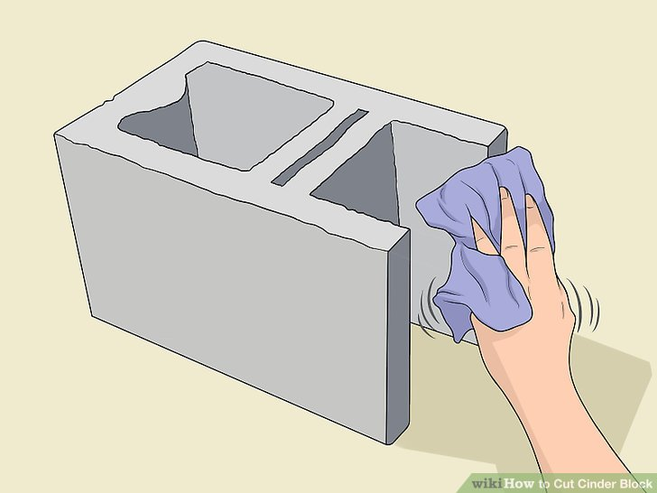
Figure 3.7: block clean with a damp rag

Splitting Blocks with a Chisel
      - Put on a pair of safety goggles to protect your eyes. While splitting a cinder block with a chisel won’t kick up dust, it will send small bits of cinder block flying through the air. To keep your eyes from being damaged, wear a pair of protective plastic goggles.
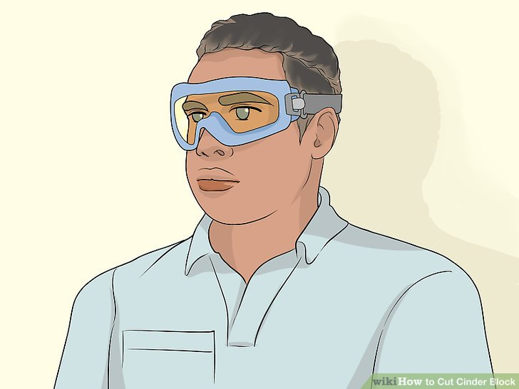
Figure 3.8: safety goggles to protect eyes.
      - Position the chisel where you’d like to cut the cinder block. Use your non-dominant hand to set the sharp edge of the chisel at the point where you’d like to cut the cinder block. In most cases, it will be easiest to split the cinder block at the halfway point. If you’re not cutting the block in half, though, position the chisel wherever you’d like to cut the block.
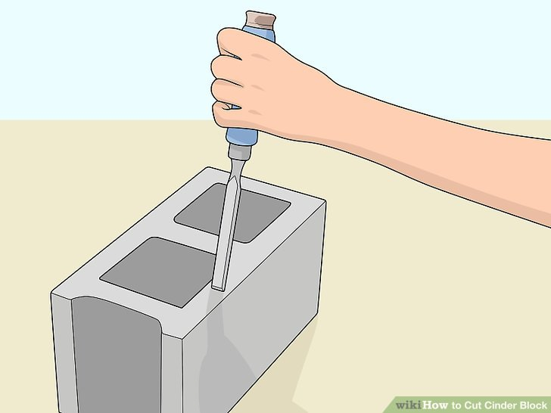
Figure 3.9: Position the chisel on block
      - Strike the butt of the chisel with a hammer until the block splits. An ordinary household claw hammer works nicely for this. Any kind of masonry chisel will do, but a flat masonry chisel will work best. Bring the hammer down firmly on the butt of the chisel to deliver as much of an impact to the block as possible. Strike the chisel with 3 or 4 firm hammer blows to split the cinder block.
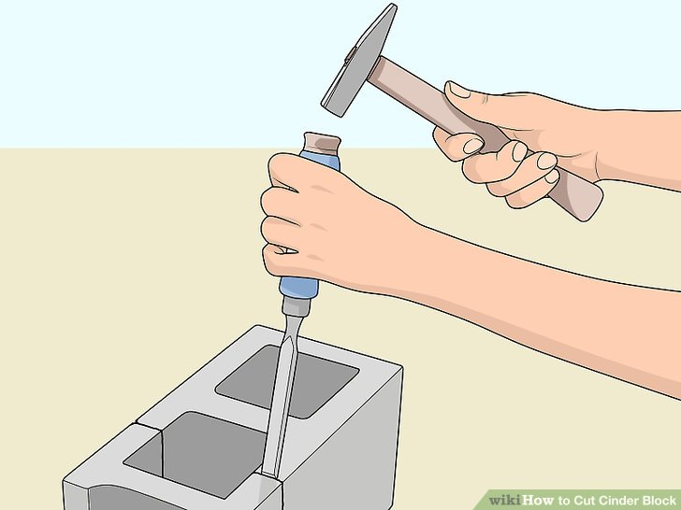
Figure 3.10: Strike the butt of the chisel with a hammer
      - Rotate the block and strike it again if it didn’t split. If you’re dealing with a particularly thick cinder block, striking it with a chisel on the top side may not be enough to break it. Flip the block 180 degrees so that the side that was facing downward is now facing up. Strike it with the hammer and chisel in the same spots that you struck on the front of the block
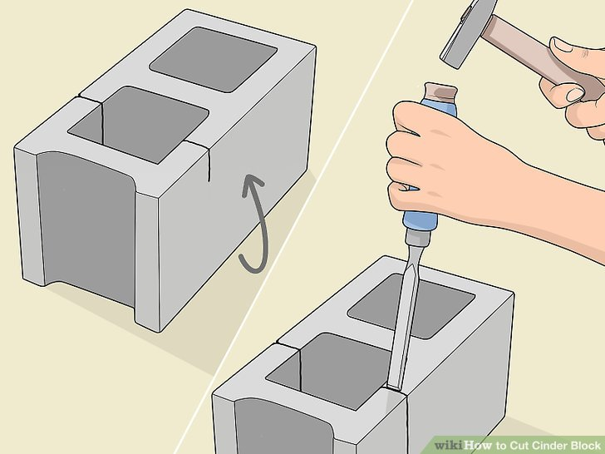
Figure 3.11: Rotate the block and strike it again if it didn’t split

Mortar mix and lay masonry units
Mortar mix is a crucial component in masonry construction, as it is used to bind masonry units together and create a strong and durable wall structure. The process of preparing mortar mix and laying masonry units to form a wall is known as setting out.

Preparing Mortar Mix:
To prepare mortar mix, several key ingredients are combined in specific proportions. The primary components of mortar mix include cement, sand, and water. Cement acts as the binding agent, while sand provides bulk and strength to the mixture. Water is added to activate the cement and allow it to harden.
The first step in preparing mortar mix is to measure the required quantities of cement and sand. The ratio of cement to sand varies depending on the desired strength of the mortar and the type of masonry units being used. Common ratios include 1:3, 1:4, or 1:6 (cement: sand). These ratios indicate the number of parts cement to parts sand.
Once the cement and sand are measured, they are thoroughly mixed together in a clean container using a shovel or hoe. It is important to ensure that the mixture is homogeneous, with no clumps or uneven distribution of materials.
After the dry ingredients are mixed, water is gradually added to the mixture while continuously stirring. The amount of water required depends on factors such as temperature, humidity, and the specific type of cement being used. It is essential to add water gradually and avoid over-watering, as excessive water can weaken the mortar's strength.
      - Preparing mortar mix is to measure the required quantities of cement.

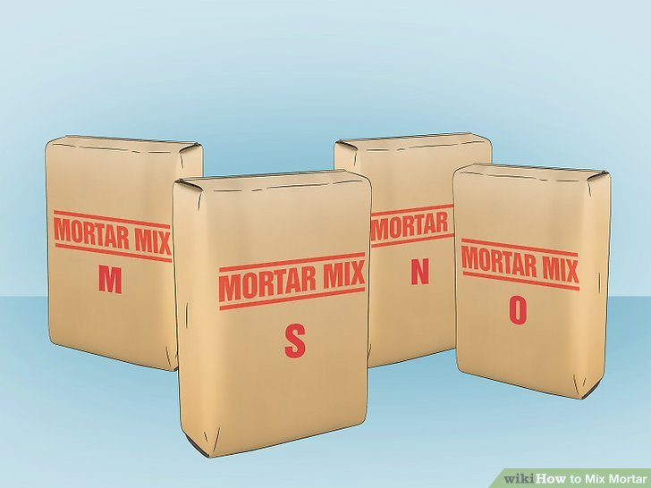
Figure 3.12 Type of cement
      - Pre-wet the bucket or wheelbarrow you're using for mixing. Spraying your containers down with water keeps your dry mix from sticking to the container. This ensures that your mortar is consistent throughout.
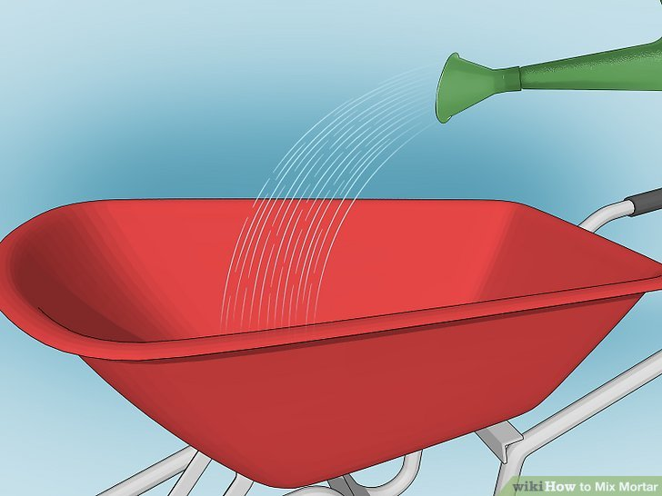
Figure 3.13: Pre-wet wheelbarrow
      - Put on your gloves, mask, and goggles. Because concrete can cause chemical burns, it's important to protect yourself. Mixing it stirs up clouds of dust that can cause serious lung damage if inhaled. It can also burn your eyes.

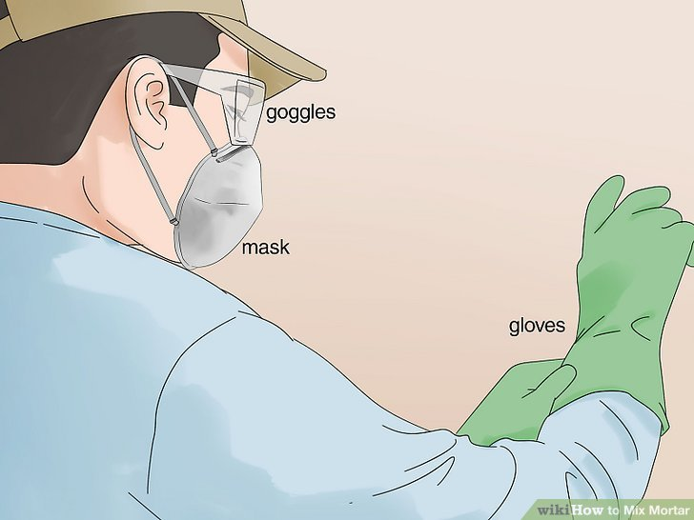
Figure 3.14: PPE
      - Dump the dry mix into the container. Make sure the wind is blowing away from you when you dump the bag of mix to keep the dust from blowing directly towards you. Pour it out slowly so it won't cloud up too much.
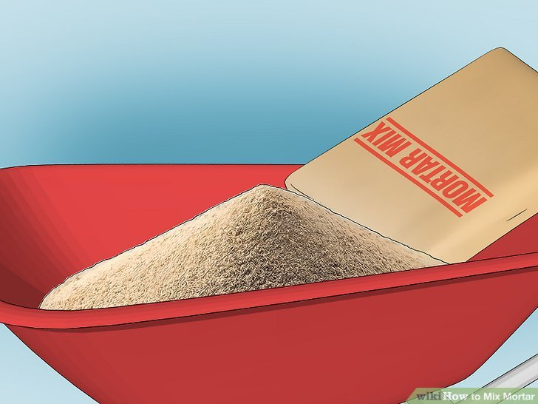
Figure 3.15: Dump The Dry Mix
      - Add water gradually until the mortar is the consistency of toothpaste. Pour the water into the center of the container and fold the mortar from the outside in using a trowel or shovel. Make sure you dig all the way to the bottom to fold the mortar toward the center.
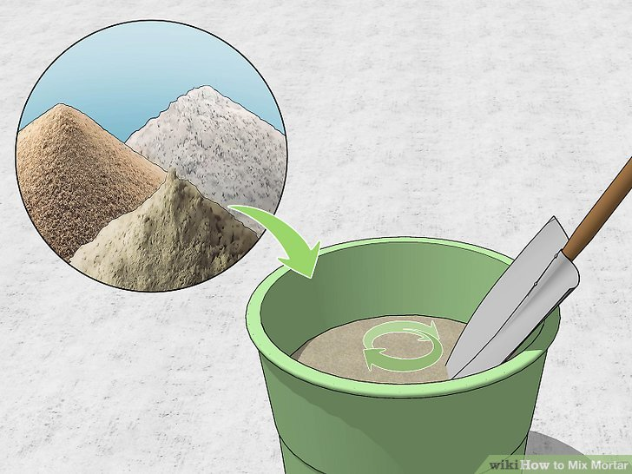
Figure 3.17: water control
      - Use the mortar within 2 hours of mixing it. Masons typically transfer the mortar to a flat piece of wood known as a "mortarboard." On the mortarboard, you can work the mortar and make sure the consistency is correct. Scoop some mortar on your trowel, then flip it to 90 degrees. If the mortar stays on the trowel, it's good to go.
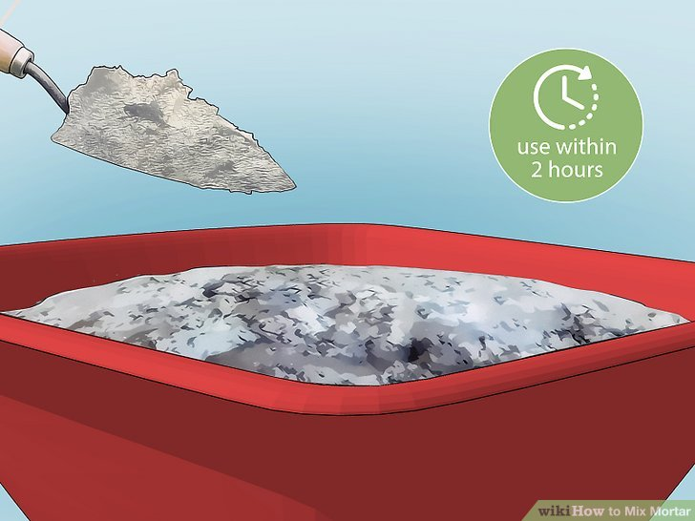
Figure 3.18: cement mix

Making Mortar from Scratch

      - Use the correct ratio of material for your project. All mortar is made of various proportions of Portland cement, lime, and sand. Portland cement is simply a type of cement made from limestone and clay—it's not a brand.
The ratios are always measured in parts per volume and always list the parts of Portland cement first, followed by the parts of lime, then the parts of sand. Each type of mortar uses different proportions:
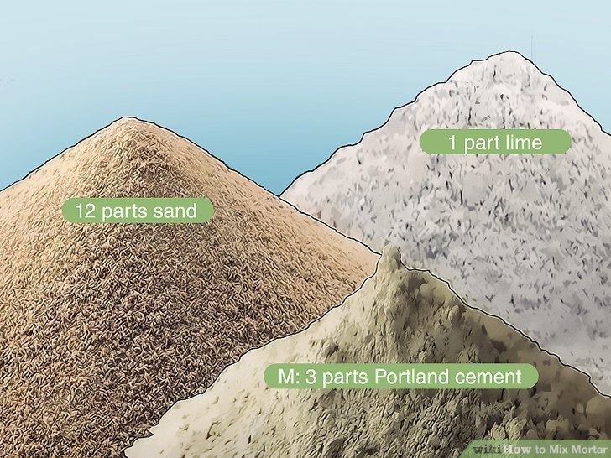
Figure 3.19: ratio of material
      - Put on safety gear before getting started. Wear waterproof work gloves, long sleeves, a respirator mask, and safety goggles. Cement can cause chemical burns on any part of your
      - Add water to the dry ingredients gradually. Pour water into the center of your dry ingredients, then fold them slowly into the water, spreading the water throughout the mix. Continue this process until your mortar is the consistency of toothpaste or thick peanut butter.

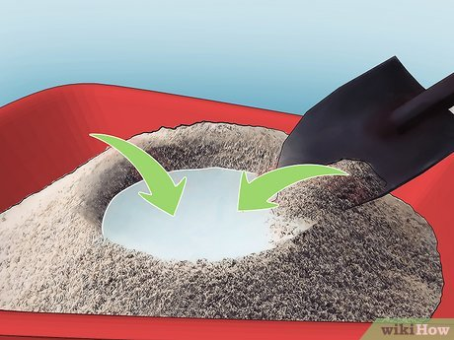
Figure 3.20: mortar mix
      - Use your mortar within 30min of finishing it. Mortar will set after 30min or so, at which point it becomes unusable. You can add a little drizzle of water to the mortar as you go to keep it workable, but after it sets, you have to throw it out. Adding any water at this point would make it too weak.

Laying Masonry Units:
Once the mortar mix is prepared, it is time to lay the masonry units and form the wall. Masonry units can include bricks, concrete blocks, stones, or any other type of material used in masonry construction.
Before laying the units, it is crucial to ensure that the foundation or base surface is clean and free from debris. This helps to create a solid and stable foundation for the wall.
The mortar mix is then applied to the base surface using a trowel. A layer of mortar, known as a bed joint, is spread evenly on the base surface. The thickness of the bed joint depends on the size and type of masonry units being used.
Once the bed joint is prepared, the masonry units are carefully placed on top of it. They are pressed firmly into the mortar to ensure good adhesion and proper alignment. A rubber mallet or wooden block may be used to tap the units gently into place.
As each unit is laid, mortar is applied to the vertical joints between them. These vertical joints are known as perpends or head joints. The mortar is spread evenly along the joint using a trowel, and excess mortar is removed.
      - Dig below the frost line. The footing is the solid concrete perimeter that your concrete blocks will sit on. Check with your county to see how far down the frost line is, then dig beneath that line to start your footing.
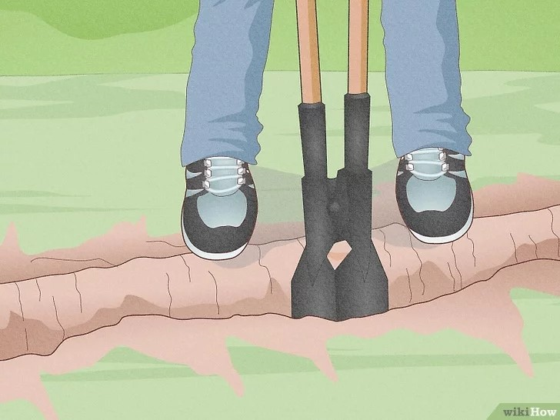
Figure 3.21: dig ground
      - Make your footing twice as wide as your concrete blocks. If you're using standard blocks, which are 8 in (20 cm), make your footing at least 16 in (41 cm) wide. Dig the perimeter where your concrete wall is going to go that’s at least twice as wide as your blocks.
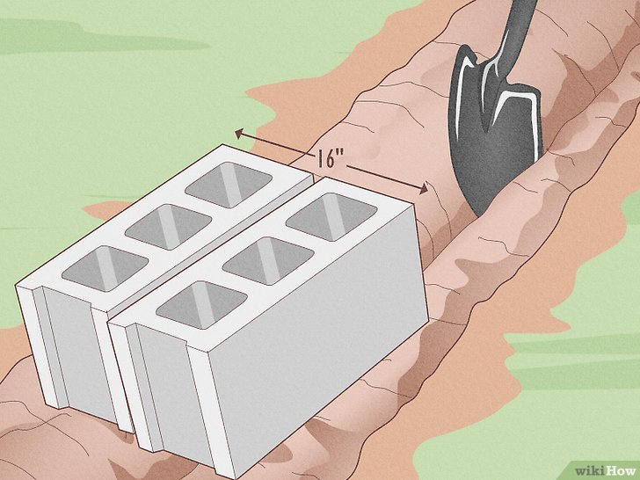
Figure 3.22: make footing
      - Place in the hole to keep the concrete in place. Grab eight 2x4s and place them inside of the hole that you dug for the footing. Use the 2x4s around the perimeter as a guide to hold the concrete in place while it dries.
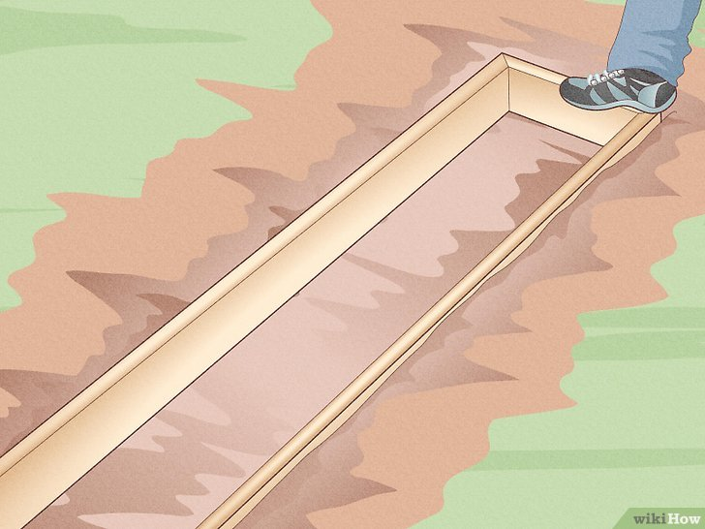
Figure 3.23: place formwork in hole
      - Pour the base concrete. Mix a batch of concrete in a wheelbarrow with a shovel. Fill the frame that you just dug up to the edge. Level the freshly poured concrete by running a 2x4 across the top, and fill any spots that are low with additional concrete
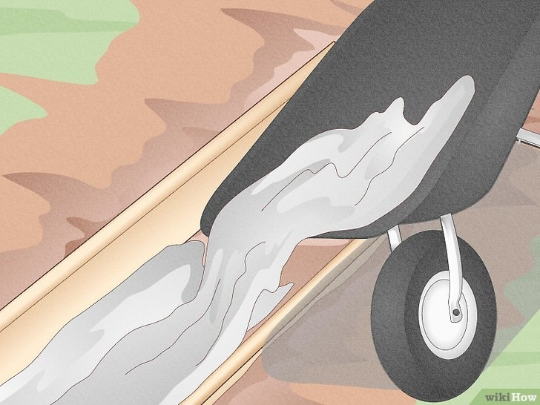
Figure 3.23: Pour the base concrete
      - Wait 3 days for the footing to dry. Before you can begin building, you'll need to give the concrete ample time to dry. Building on wet concrete can lead to sagging, and your concrete wall may not be as sturdy as it needs to be.
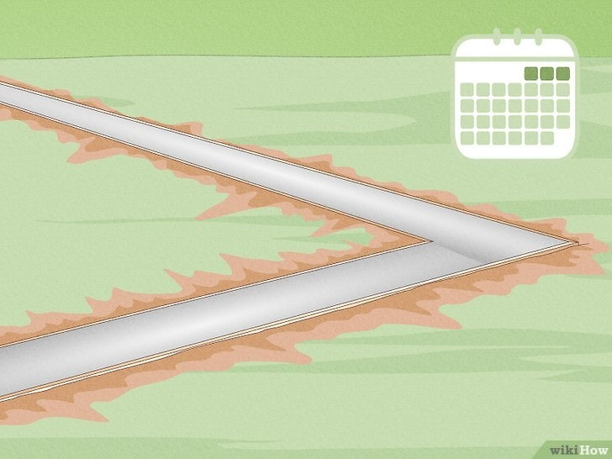

Figure 3.24: footing to dry

Laying Concrete Blocks with Mortar
      - Section off the corners with wooden stakes. Before you begin laying the blocks, visualize all the corners of your frame. Place a wooden stake in each corner, and use a cord or string to tie off exactly where the corners’ edges will be. Attach a cord or string to the wooden stake used to mark the corners and lay out a perimeter.
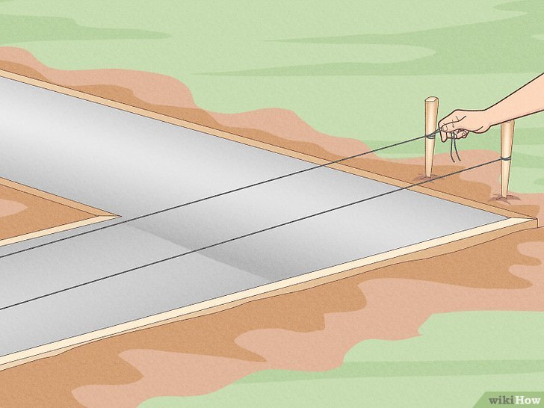
Figure 3.25: wooden stakes.
      - Mix cements mortar with water. Take the bag of dried concrete, and look at the bag's specifications to find the ratio of mortar to water. Use a 5-gallon bucket or a wheelbarrow to mix the mortar with a shovel until it’s thick and paste-like.

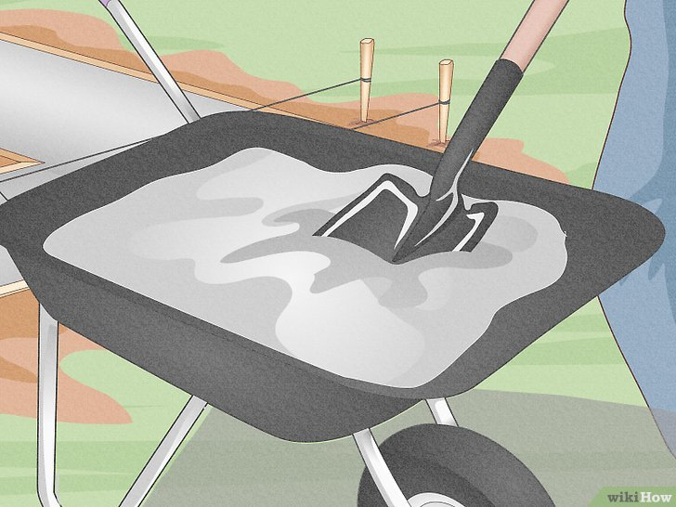
Figure 3.26: Mix cements mortar
      - Spread the mortar along 1 corner of the footing. Use your trowel to spread a few slabs of mortar around the corner's base of the footing. Spread the mortar 1 in (2.5 cm) deep and 8 in (20 cm) wide in the marked area. Continue to spread the mortar to account for the distance of about 3 to 4 blocks.
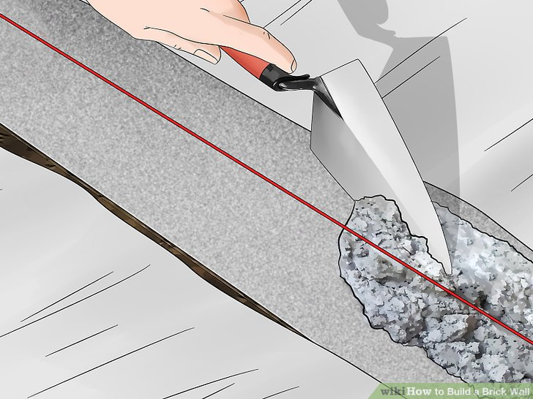
Figure 3.27: Spread the mortar
      - Center the corner block on the footing. Stand over the footing and gently set the concrete block down, making sure it’s level and flat. Center the corner block in the footing by measuring around the block and making sure it’s even.
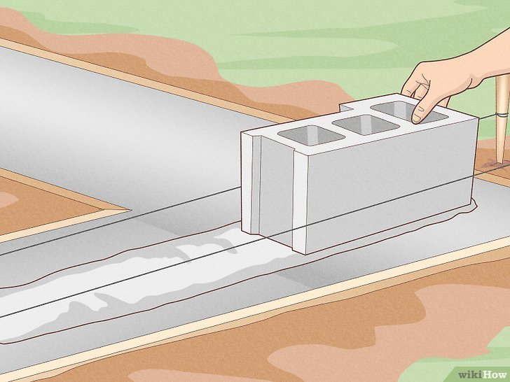
Figure 3.28: corner block
      - Continue to lay the concrete blocks in a line out from the corner. Start laying blocks from the corner or edge of the wall to work in one direction. Apply a 1 in (2.5 cm) thick layer of mortar to the sides of each block as you go.
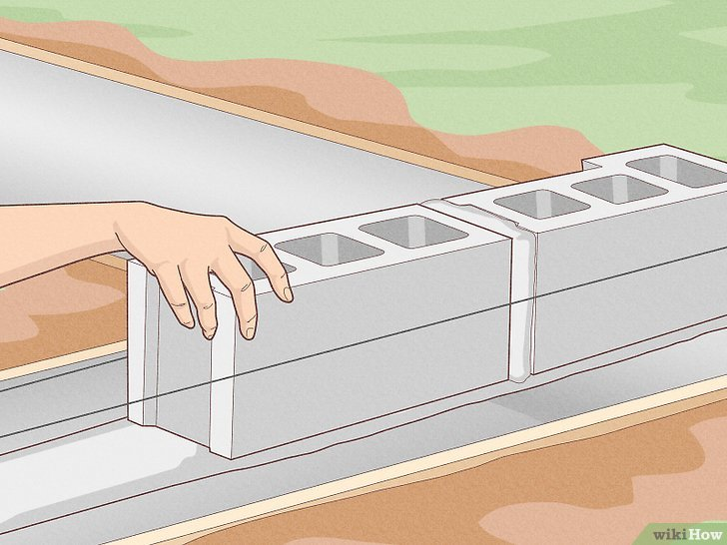
Figure 3.29; corner block
      - Check the alignment of the blocks with a level. Before stacking more concrete blocks on top of your initial foundation, check if everything is aligned Use your mason's level by laying it on the first set of blocks. Check both the outside and center section of the bricks.
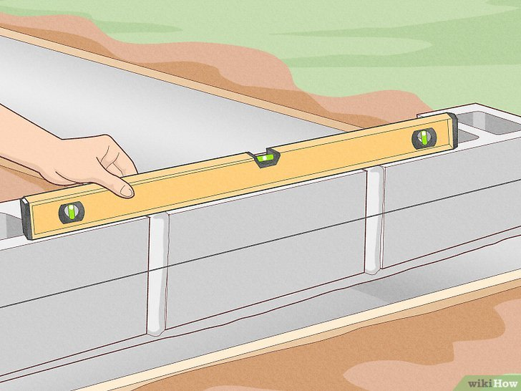
Figure 3.30: alignment of the blocks
- Apply mortar to the top of the blocks. Use your trowel to spread 1 in (2.5 cm) of mortar over the entire width of the block. Then, spread the mortar so it covers the length of about 3 blocks in the direction that you are laying the bricks.
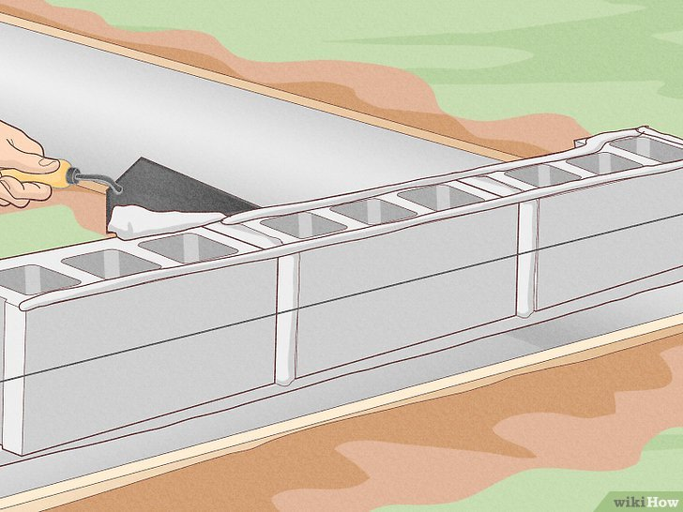
Figure 3.31: Apply mortar to the top of the blocks
      - Stack the blocks on top of each other. Lay the block down on top so the edge of the top block aligns with the halfway mark of the bottom block. You'll recognize the pattern as a standard among the construction sites. The top block will fit in between 2 bottom blocks.
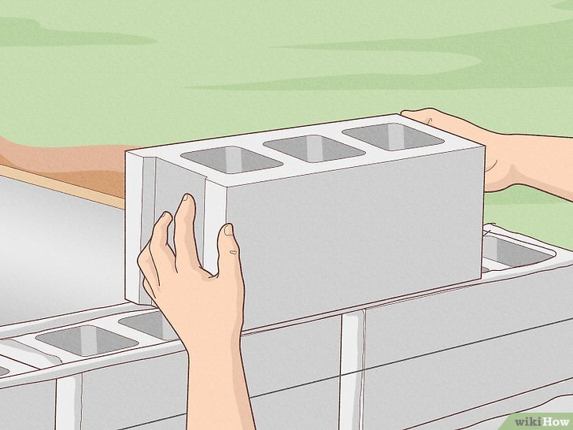
Figure 3.32: Stack the blocks on top of each other
      - Strike the mortar joints. The mortar joints are the spaces between the bricks that are filled with mortar. Once the mortar mix has set enough so you can leave a thumbprint in it, run a concave jointing tool along each joint to remove the excess mortar. Start with the horizontal joints, then move to the vertical joints
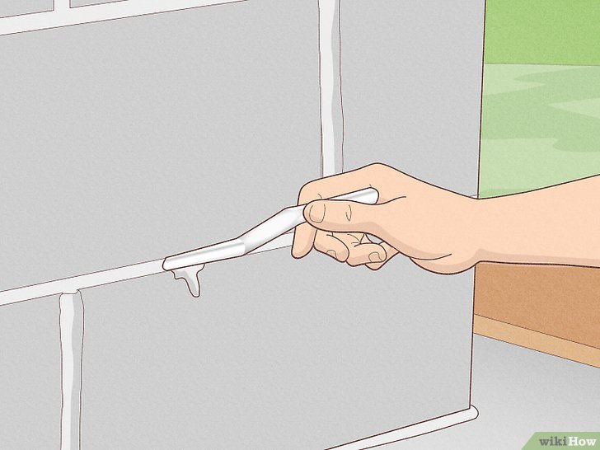
Figure 3.33: Strike the mortar joints
      - Wait 24 hours for the mortar mix to cure. Mortar mix will start drying within 20 to 40 minutes, but it’s best to wait at least 24 hours before adding anything on top of your walls. After 1 day or so, the mortar mix will be mostly cured, and it will be strong enough to support other construction materials.
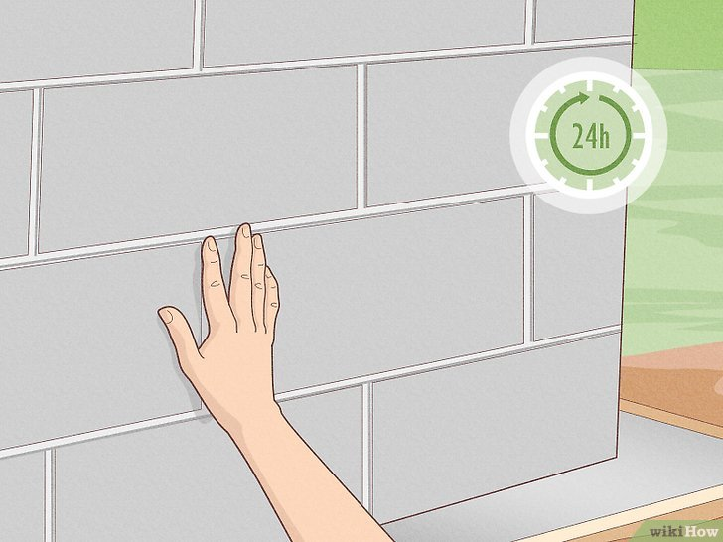
Figure 3.34: Wait 24 hours for the mortar mix to cure

Lay masonry unit in stretcher bond
Masonry units are often laid in stretcher bond when constructing an arch, with the perpendicular joints maintained in a vertical line. This technique is commonly used to create a strong and visually appealing structure.
Stretcher bond is a type of brickwork pattern where the bricks are laid lengthwise, with the long face of the brick exposed. In this bond, each brick is placed directly over the center of the brick below it, creating a continuous vertical line of joints. This arrangement helps to distribute the load evenly across the arch and provides stability to the structure

Building The First Row
      - Put down tarps or plywood to catch mortar. Lay down tarps or 2 ft wide plywood at the base of the wall to catch excess mortar as it falls. Keep this surface clean and avoid walking on it so you can reuse this mortar.

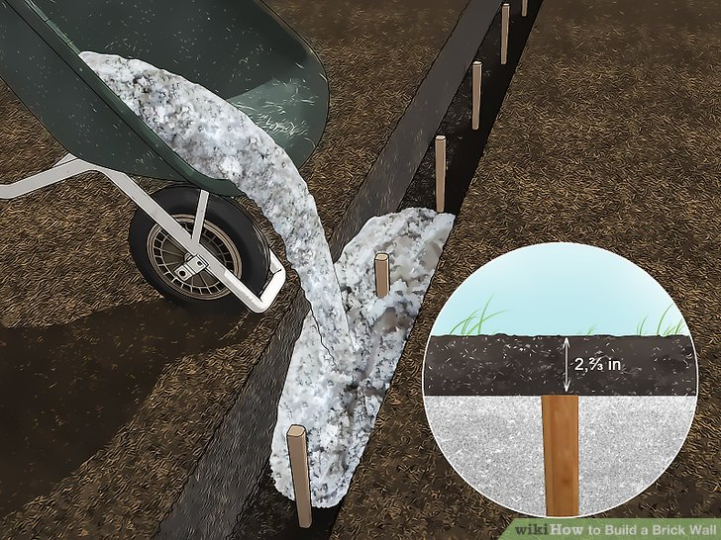
Figure 3.35: pore mortar for base
      - Lay your first row of bricks in the foundation for a dry run. Space them out appropriately, accounting for the mortar. Use your tape measure to make sure that they are the correct distance apart, and make sure that they fit in the trench snugly. Plan out the whole first row like this before you start any work.

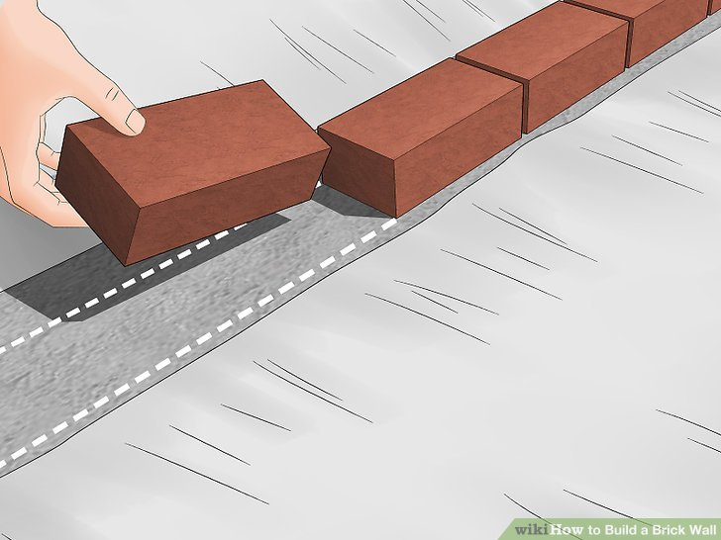
Figure 3.36: dry bond of brick
      - Clamp a string on your first guideline. This is going to be for the second layer of bricks, as the first one will be buried in the trench. Run the string from one gauging rod to the other so that you have a straight, level line to work with.
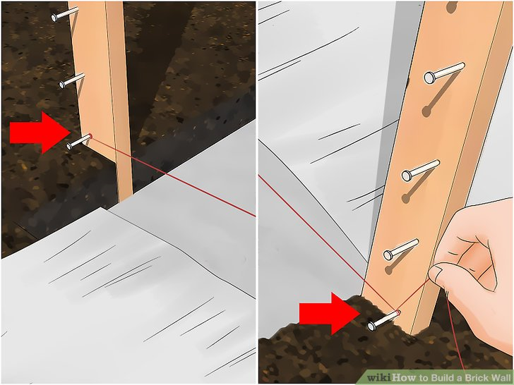
Figure 3.37: guideline
      - Soak the bricks and let dry. Soak the bricks in water, then lay them out to drip dry. The bricks should be thoroughly wet so the mortar bonds correctly. That said, wait until there is no more water running off the bricks, or the mortar may become too runny.

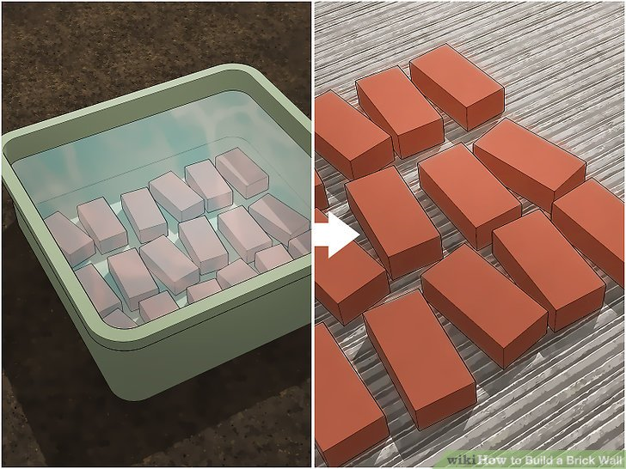
Figure 3.38: Soak the bricks
      - Lay the first 1/2 inch of mortar along the base of the foundation. When in doubt, add a little bit extra mortar, as you will be pushing the brick down slightly. Use your trowel to lightly press into the mortar along the center line, leaving little intents. The mortar will look like little waves.^{[8]}
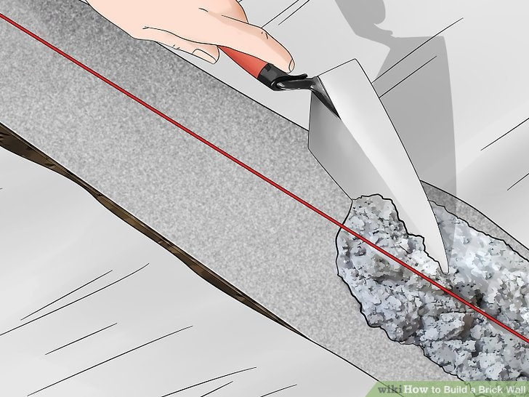
Figure 3.39: Lay the first 1/2 inch of mortar
      - Press the first brick into the mortar. Push down slightly, then use your level to check that the brick even with the ground. To do so, press the level up against the side of the brick and then check it with your string sting line.
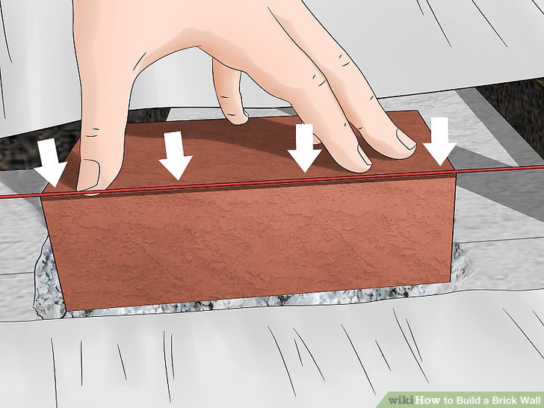
Figure 3.40: Press the first brick into the mortar
- Lay mortar down for the next 2-3 bricks. Once you're sure your first brick is set, lay down some mortar for the next few. You only want to work with 2-3 bricks worth of mortar at a time.

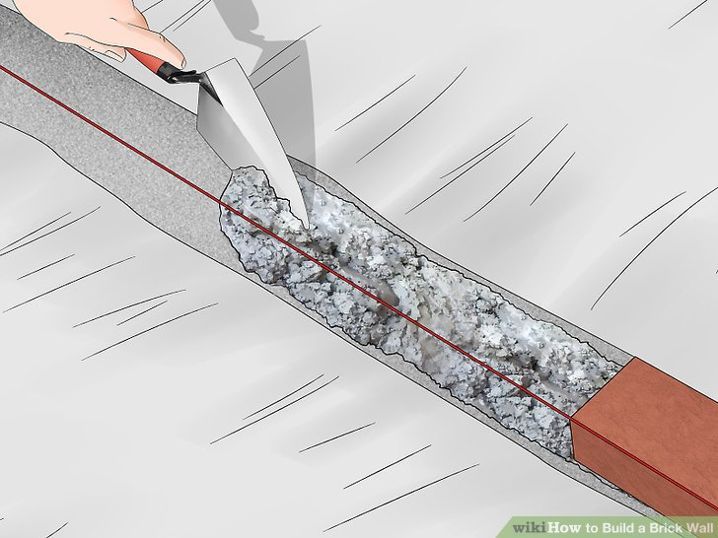
Figure 3.41; Lay mortar down for the next 2-3 bricks
- Butter the end of the next brick with mortar and press it into place. Take a slab of mortar and coat the end of the brick that will be pushed up against the first brick. You want a nice, even pat of mortar, just a little more than a 1/2" worth. Press it into place against to the first brick and use your tape measure to make sure they are 1/2" apart and joined by mortar.

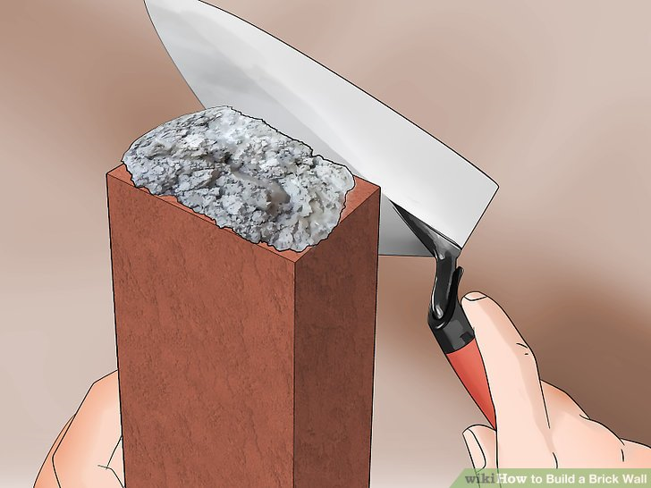
Figure 3.42: place mortar the head of brick

- Press the brick lightly into the 1/2" of mortar you've laid down so that it is level with the first brick. Use the level to ensure that the bricks are flush and at an even height, pushing on them lightly to make sure that they are perfect.

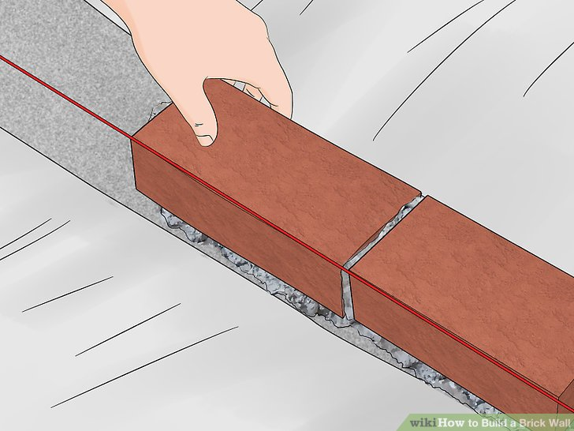
Figure 3.43: Press the brick lightly into the 1/2" of mortar
- Scrape away any excess mortar as you work. You've pressed the bricks together, you'll notice that mortar starts to squeeze out as you work to get 1/2" joints. Use your trowel to scrape the mortar away and down onto the tarp or plywood at the base of the wall. As long as that surface is kept clean, you can reuse the mortar for the next brick.^{[9]}
- Keep adding bricks until the row are finished. Continue laying bricks down in this fashion mortar bottom and side, press in, check evenness with the level-- until your first row, or course, is complete.

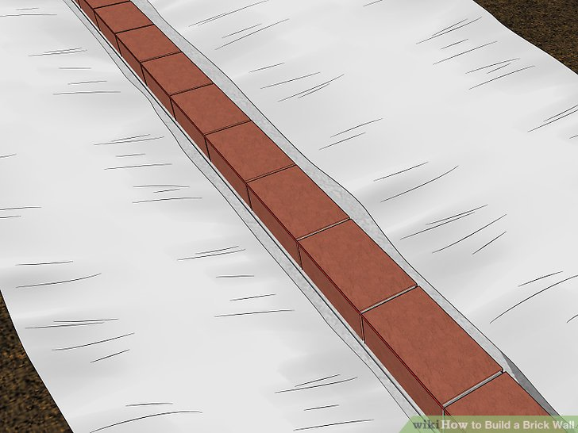
Figure 3.44:first coarse brick work
- Move your guideline up to the next marker. It should be the 1/2 mortar marker that joins your 1st and 2nd rows. For the second row it should already be in place, but you need to remember to move the line each time you move up a row so that you know the height you have to hit.

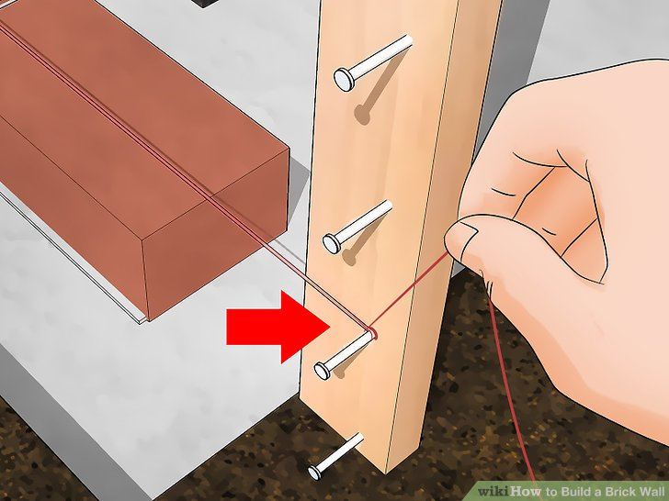
Figure 3.45: guideline
- Cut a brick in half with a firm tap from the pointed end of a hammer. You can also use a bolster, which may make a cleaner cut. Still, bricks are meant to break cleanly. Tap on the point you want to cut the brick with the back of a hammer until you see a crack, then hit this spot hard, once, to cut the brick in half.^{[10]}

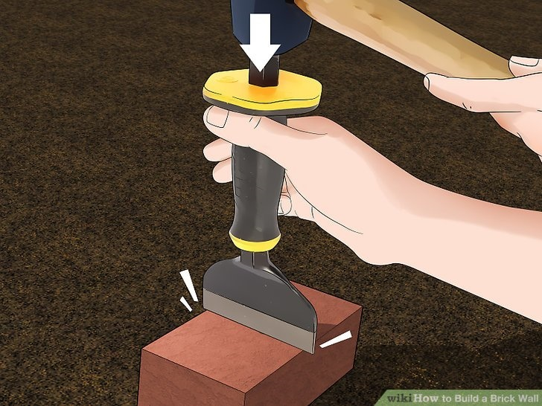
Figure 3.45:Cut a brick in half

- Start the second row with 1/2 a brick on both ends. You do not want to make the next row right on top of the first one, so that the joints line up. Mortar and place the half brick, then place a full brick next it like normal. Do this on both ends of the wall, so that each side has a half brick and a full brick in place.

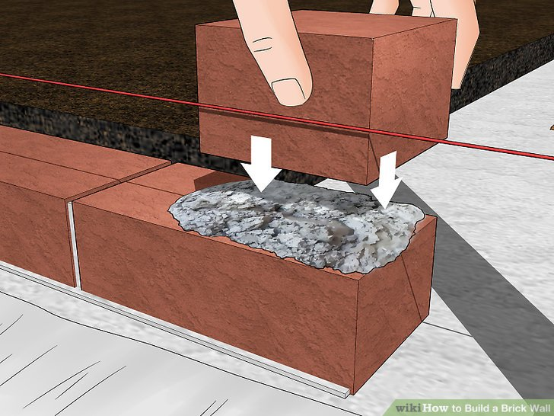
Figure 3.46: second row with 1/2 a brick
- Mortar and place one full brick on top of your ends. To help you stay level, you build the ends of the wall up a course higher than you're working on, making it appear like there are staircases on the ends of the wall. You then fill in the bottom row, build the sides up a little higher, then continue until you reach the top.
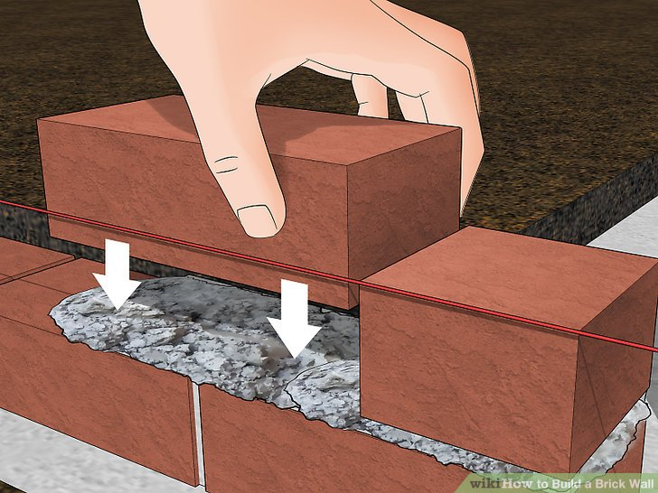
Figure 3.47: full brick on top of your ends
- Fill in the entire bottom row. Place roughly 1/2" of mortar down, press the brick into place, check the straightness with the guideline and level, and wipe up any excess mortar. Then repeat until the second row is done.

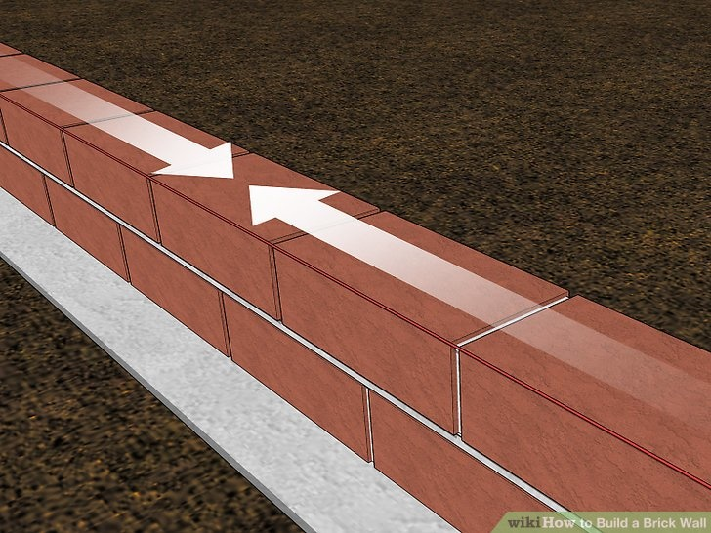
Figure 3.48: Fill in the entire bottom row
- Continue building your wall from the ends inward. You want to have the ends of your wall one course higher than the row you are currently working on. This is especially important if the wall has pillars on either end. With each row, the process is the same. However, remember to use half-bricks every other row to ensure that the joints in each row are not perfectly lined up.

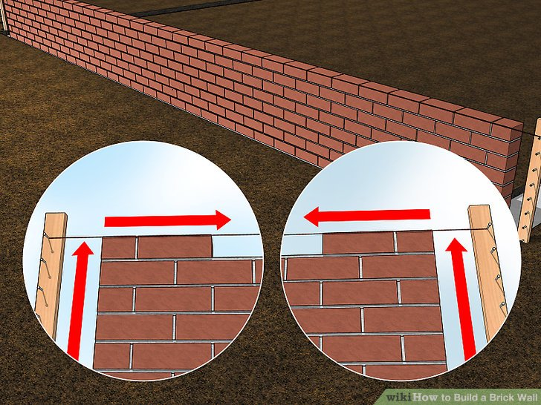
Figure 3.49: wall from the ends inward
- Use a brick jointer to indent the mortar professionally. Brick jointers are cheap little tools that help you get the professional, curved in joints on your wall. Firmly press the tool into the joints and run it down the mortar, trimming and polishing your wall.^{[14]}

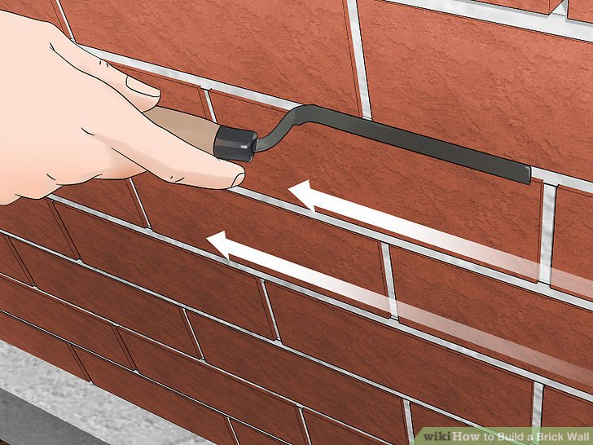
Figure 3.50: brick jointer to indent the mortar professionally

Specifications and standards
When constructing masonry arches and curved walls, it is crucial to ensure that all work is carried out according to specifications and standards. This ensures the structural integrity, stability, and aesthetic appeal of the finished product. Various guidelines and industry standards exist to provide detailed instructions on how to construct masonry arches and curved walls correctly.
One important aspect of constructing masonry arches and curved walls is the selection of appropriate materials. The choice of materials depends on factors such as the intended use of the structure, the load-bearing requirements, and the desired appearance. Common materials used in masonry construction include bricks, stones, concrete blocks, and mortar.
The first step in constructing a masonry arch or curved wall is to establish a solid foundation. The foundation should be designed to support the weight of the structure and distribute it evenly to prevent settlement or collapse. It is essential to follow local building codes and regulations when designing and constructing the foundation.
Once the foundation is in place, the next step is to lay the base course. The base course provides a stable platform for building the arch or curved wall. It is crucial to ensure that the base course is level and properly aligned to maintain the structural integrity of the entire structure.
The construction of a masonry arch involves carefully arranging bricks or stones in a curved shape. The key to a successful arch lies in achieving proper geometry and maintaining stability throughout the construction process. This requires precise measurements, accurate cutting of bricks or stones, and careful placement.
To construct a masonry arch, an arch formwork may be used as a temporary support structure during construction. The formwork helps maintain the shape of the arch until it becomes self-supporting. It is important to ensure that the formwork is properly aligned and securely fastened to prevent any movement or deformation during construction.
During the construction of a curved wall, it is essential to pay attention to both horizontal and vertical alignment. The curvature should be consistent and smooth, without any abrupt changes or irregularities. This can be achieved by using a template or guide to ensure accurate placement of bricks or stones.

Gauge of abutting walls
During the construction of an arch or curve, it is crucial to maintain the gauge of abutting walls within standard measurements. The gauge refers to the distance between two parallel lines or surfaces, in this case, the walls that are adjacent to the arch or curve. By ensuring that the gauge is maintained within standard, builders can ensure structural integrity and prevent potential issues such as cracking, instability, or uneven load distribution.
To maintain the gauge of abutting walls during the construction of an arch or curve, several key considerations should be taken into account. These include:
Accurate Measurements: Precise measurements are essential when determining the dimensions of the arch or curve and its relationship to the abutting walls. This involves measuring both the width and height of the arch or curve at various points along its span. Additionally, measurements should be taken from multiple angles to ensure accuracy.
Proper Formwork Installation: Formwork is used to shape and support the concrete during construction. It plays a critical role in maintaining the desired shape and dimensions of the arch or curve. When installing formwork, it is important to ensure that it aligns with the abutting walls and follows the specified dimensions precisely. Any deviations can result in variations in gauge.
Skilled Craftsmanship: The construction of arches and curves requires skilled craftsmanship to ensure that the desired shape is achieved accurately. Experienced workers who specialize in masonry or concrete construction are typically responsible for executing these complex elements. Their expertise allows them to carefully manipulate materials and adjust formwork as needed to maintain proper gauge.
Quality Control: Regular quality control checks should be conducted throughout the construction process to verify that the gauge of abutting walls is being maintained within standard. This can involve using measuring tools such as laser levels, plumb bobs, or string lines to check for any deviations from the intended dimensions.
Material Considerations: The choice of materials can also impact the maintenance of gauge during construction. For example, if using masonry units, it is important to select bricks or blocks that have consistent dimensions and are suitable for creating curves. Additionally, the mortar used should be properly mixed and applied to ensure uniformity and prevent any variations in gauge.

Requirement of Abutment jambs and piers vertical
When constructing masonry curved wall, abutment jambs or piers are laid vertically up to the springing line. The springing line refers to the point where the curve of the arch begins. This construction technique is commonly used to provide support and stability to the curved wall, ensuring that it can withstand the loads and pressures placed upon it.
Abutment jambs or piers serve as vertical supports that help distribute the weight of the curved wall and any additional loads it may bear. By extending these supports up to the springing line, they effectively transfer the load from the curved portion of the wall to the foundation or other supporting structures.
The use of abutment jambs or piers in this manner helps maintain the structural integrity of the curved wall. By providing vertical support at regular intervals along the curve, they prevent excessive bending or deformation of the masonry units.
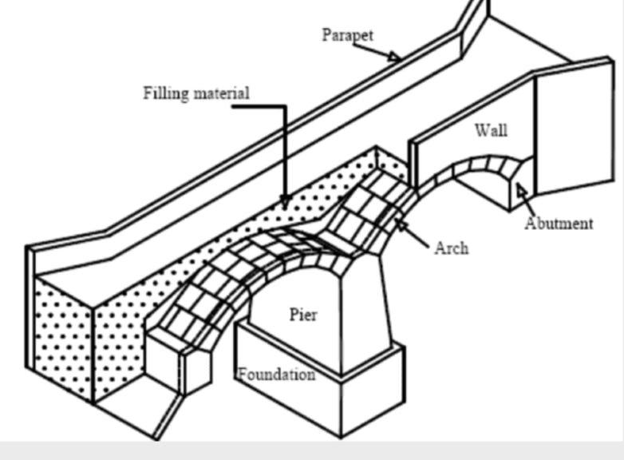
Figure 3.51: Abutment jambs and piers vertical
To maintain plumb, which refers to the vertical alignment of a wall, on a curved masonry wall, several methods can be employed:
Layout and Design: Proper layout and design are crucial to achieving a well-aligned curved wall. The curvature of the wall should be carefully calculated and planned to ensure that it meets the desired specifications. This involves determining the radius of the curve, establishing reference points, and using specialized tools such as a transit or laser level for accurate measurements.
Mortar Consistency: The consistency of mortar plays a crucial role in maintaining plumb on any masonry wall, including curved ones. The mortar should have an appropriate mix ratio and consistency to provide sufficient workability while still retaining its strength. Properly mixed mortar allows for precise adjustments during the construction process, ensuring that each brick or block is positioned accurately.
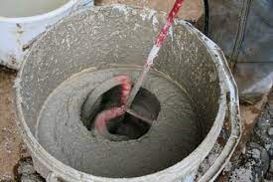
Figure 3.52: Mortar Consistency
In addition to maintaining plumb, it is equally important to ensure alignment along the vertical face of a curved masonry wall. Alignment refers to the horizontal positioning of each brick or block relative to its neighboring units.

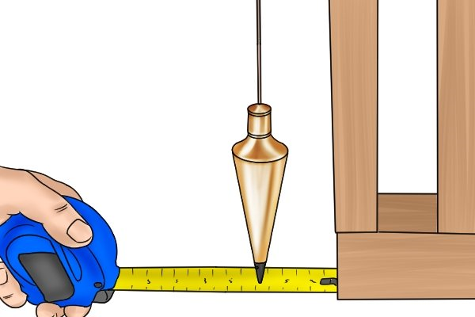
Figure 3.53: plumb bob checking

Alignment of vertical wall face
The alignment of a vertical curve wall face refers to the positioning and orientation of the wall face in relation to the vertical curve it is built upon. Vertical curves are commonly found in transportation infrastructure, such as highways and railways, where changes in elevation occur. The purpose of a vertical curve wall face is to provide support and stability to the embankment or cut slope, preventing erosion and ensuring the safety of the structure.
The alignment of a vertical curve wall face is crucial for several reasons. Firstly, it affects the overall stability and integrity of the structure. A properly aligned wall face will distribute the forces exerted by the soil or rock mass evenly, minimizing the risk of failure or collapse. On the other hand, an improperly aligned wall face may concentrate these forces in certain areas, leading to localized instability and potential structural damage.
String Lines: Masons often use string lines as guides for maintaining alignment during construction. These lines are stretched taut along the wall's surface and act as references for positioning each brick or block horizontally. By aligning each unit with the string line, masons can ensure a consistent and straight appearance along the wall face.
secondly, the alignment of a vertical curve wall face also plays a role in controlling water drainage and runoff. By aligning the wall face appropriately, engineers can ensure that water flows away from the structure, reducing the risk of erosion and water-related damage. Additionally, proper alignment can help prevent water from seeping into the embankment or cut slope, which could weaken the soil or rock mass over time.
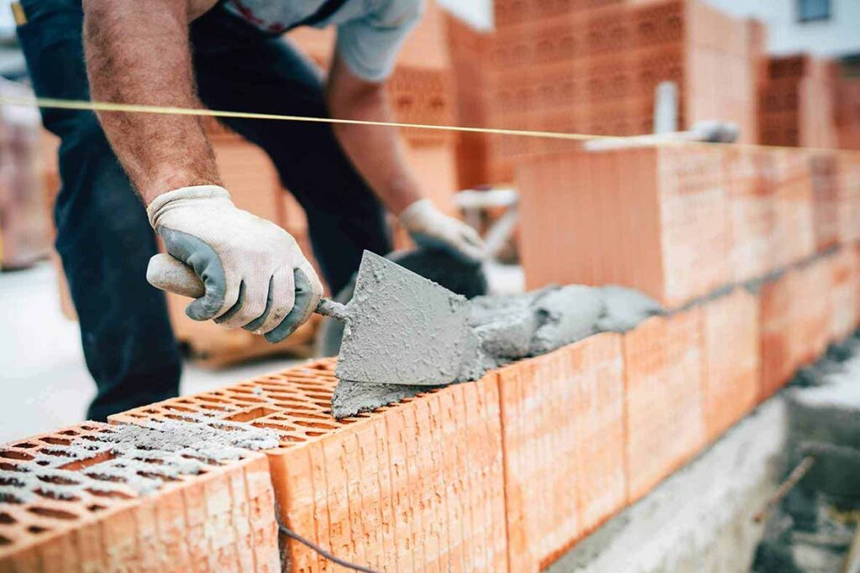
Figure 3.54: Maintain alignment
Leveling Tools: Masons may also use leveling tools such as a spirit level or laser level to check the horizontal alignment of each course. These tools help identify any deviations from the desired alignment and allow for adjustments to be made before the mortar sets.
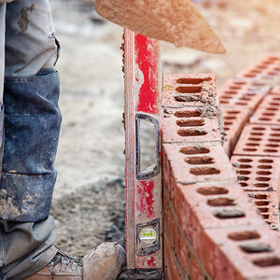
Figure 3.55: Leveling Tools
Proper Jointing: The jointing technique used in masonry construction can also contribute to maintaining alignment on a curved wall. By carefully tooling the mortar joints, masons can create a smooth and uniform appearance that enhances the overall alignment of the wall.
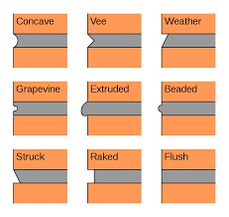
Figure 3.56: joint type

Self-Check 1
Directions: Answer all the questions listed below.
    - Write true if the statement is correct false if statement is in correct
- Masonry saws are commonly used to shape masonry units.
- Chiseling is a technique used to create specific shapes on the edges or faces of masonry units.
- Cinder blocks are commonly a uniform size and come in various sizes and shapes.
- Safety goggles should be worn when splitting a cinder block with a chisel.)
- Water is added to the mortar mix to activate the cement and allow it to harden.
    - Choose correct answer for the following question
- What tool is typically used to cut through hard materials like bricks or stones?
- a) Chisel
b) Circular saw
c) Ruler
d) Hammer

- What is the most common size of cinder blocks?
- a) 4 by 8 by 16 inches
b) 10 by 10 by 20 inches
c) 8 by 8 by 16 inches
d) 6 by 12 by 24 inches

- Which protective equipment should be worn when cutting a cinder block with a circular saw?
- a) Safety goggles
b) Earplugs
c) Gloves
d) All of the above

- What is the primary binding agent in mortar mix?
- a) Sand
b) Water
c) Cement
d) Chalk

- What is the purpose of pre-wetting the container when preparing mortar mix?
- a) To prevent dust clouds
b) To ensure consistent mortar consistency
c) To protect the container from chemical burns
d) To activate the cement

    - write Short Answer for the following question :
- What are the primary components of mortar mix?
- What is the purpose of gradually adding water to the mortar mix?
- How should the cement and sand be mixed together?
- Why is it important to wear safety goggles when splitting a cinder block with a chisel?
- What is the recommended consistency of mortar mix?

Operation Sheet 3.1

Operation Title: Chiseling and Cutting Masonry Units
Purpose: To achieve precise fitting and alignment of masonry units by cutting and chiseling them to create specific joint patterns and shapes.
Instruction:
- Measure the area where the cut masonry unit will be installed.
- Mark the measurement onto the masonry unit using white chalk.
- If desired, use a straight edge ruler to ensure accuracy and create a line.
- Insert a masonry blade into a circular saw or obtain a masonry blade if needed.
- Put on safety equipment such as a mask and sound-blocking earmuffs or earplugs.
- Align the saw blade with the chalk mark on the masonry unit.
- Cut through the masonry unit in one slow and accurate stroke, or make additional cuts if necessary.
Conditions for the operations:
- Safe working area
- Properly operated tools
Equipment Tools and Materials:  - Masonry saw with a diamond-tipped blade  - Circular saw (if applicable)  - Chisels  - Hammer or mallet |  | - White chalk  - Straight edge ruler  - Safety equipment (mask, goggles, sound-blocking earmuffs or earplugs)  - Damp rag for cleaning
Quality Criteria:
- Precise and accurate cuts or chiseling according to the desired joint patterns and shapes.
- Clean and smooth surfaces on the cut masonry units.
- Proper disposal of waste materials.
Precautions:
- Wearing proper clothes, eye glass, glove
- Make working area hazard free
- Read and interpret manual which guide you how to use tools and equipment
Steps in doing the task  - Measure the area and mark the masonry unit.  - Set up the appropriate equipment and put on safety equipment.  - Align the saw blade or chisel with the marked point. | - Perform the cutting or chiseling operation.  - Clean the masonry unit.  - Dispose of waste materials properly.

LAP Test 1
Practical Demonstration
Name: __________________________ Date: ____________
Time started: ____________________ Time finished: _______________
Instruction: Perform the following tasks

Task 1: Chisel and Cut Masonry Units

Unit 4 Set up Arch Center
This unit is developed to provide you the necessary information regarding the following content coverage and topics:
- Height of springing line and crown of arch
- Formworks supports and ensure arch centre
- position of central key brick/block
This unit will also assist you to attain the learning outcomes stated below. Specifically, upon completion of this learning guide, trainees will be able to:
- Determine Height to springing line
- Lay formworks and supports
- Establish position of central key brick/block

Springing line and crown of arch

Height of springing
The springing line of an arch refers to the horizontal line from which the arch begins to curve upwards. It is the lowest point on the arch where the curve starts to form. The springing line is an essential element in the construction and stability of an arch, as it determines the overall shape and strength of the structure.
When constructing an arch, the springing line serves as a reference point for determining the height and width of the arch. It is typically marked on the supporting walls or piers before the construction process begins. The position and levelness of the springing line are crucial for achieving a symmetrical and stable arch.
In masonry arch construction, the crown refers to the highest point or apex of the arch. It is the point where the two sides of the arch meet and is typically located at the center of the span. The crown plays a crucial role in distributing the weight and forces exerted on the arch, ensuring its stability and structural integrity.
The crown of a masonry arch is designed to withstand compressive forces and maintain its shape under load. It is usually constructed with specially shaped bricks or stones that are carefully laid to form a smooth curve. The curvature of the crown is essential for evenly distributing the weight of the structure and preventing any concentrated stress points.
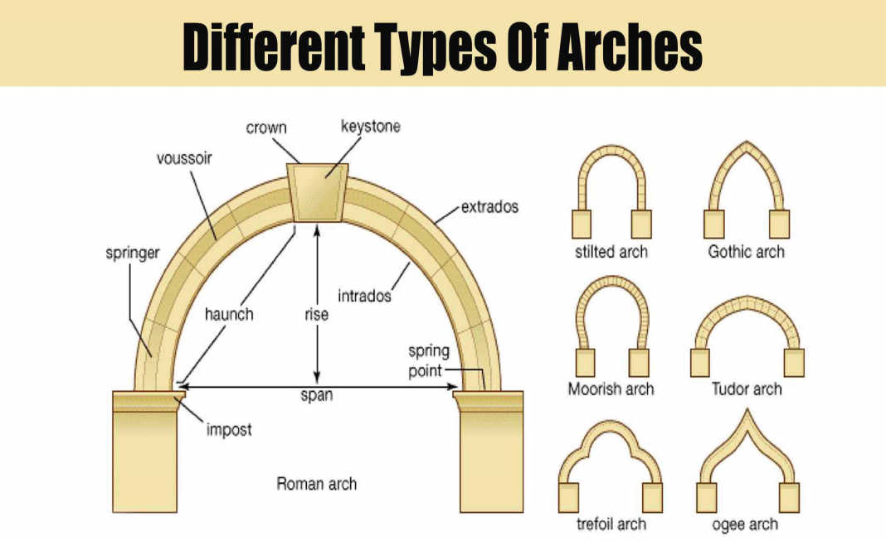
Figure 4.1: springing point

confirm height crown of arch
The height of the crown in a masonry arch refers to the vertical distance from the intrados (the inner curve of the arch) to the highest point on the arch. It is an important measurement in the design and construction of masonry arches as it determines the overall shape and structural stability of the arch.
The height of the crown is influenced by various factors, including the span of the arch, the rise (vertical distance between the springing points and the crown), and the desired profile or shape of the arch. The height of the crown is typically determined during the design phase based on structural considerations and aesthetic preferences.

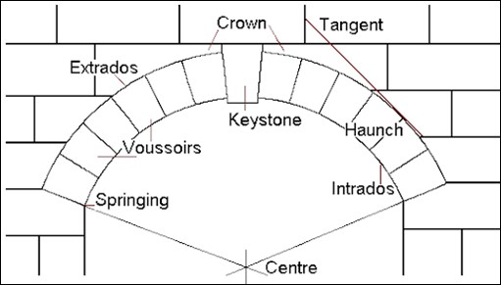
Figure 4.2: crown of arch

Height of toms, packers and wedges and their location
In masonry arch construction, toms, packers, and wedges play important roles in providing support and stability to the arch structure. These elements are strategically placed at specific heights within the arch to distribute the load and ensure the structural integrity of the arch.
Toms are horizontal timber or steel members that are inserted between the voussoirs (the wedge-shaped stones or bricks that form the arch) to provide temporary support during construction. Toms are typically placed at regular intervals along the length of the arch, parallel to its intrados (the inner curve of the arch). The height of toms varies depending on the size and span of the arch, as well as the specific construction method being employed. The purpose of toms is to prevent the voussoirs from collapsing inward before they are permanently secured in place.
Packers, also known as shims or wedges, are small pieces of material that are used to adjust the height and levelness of individual voussoirs. Packers are inserted between the top surface of a voussoir and the supporting surface above it. By adding or removing packers, masons can ensure that each stone or brick is properly aligned and that the arch is structurally sound. The height of packers can vary depending on the specific requirements of each individual voussoir.
Wedges are tapered pieces of wood or metal that are used to tighten and secure the arch structure once all the voussoirs have been properly positioned. Wedges are driven into vertical slots, called keyways or key joints, which are cut into the sides of adjacent voussoirs near their springing points (the points where the arch begins to rise from its supports). As wedges are driven deeper into the keyways, they exert lateral pressure on the voussoirs, forcing them tightly together and creating a stable arch structure. The height of wedges depends on factors such as the size and material of the voussoirs, as well as the desired degree of tightness and stability.

Formworks supports arch centre
Formwork is a temporary structure or mold that is used to support and shape concrete or masonry during the construction process. It provides the necessary support and stability to ensure that the concrete or masonry elements are formed correctly and maintain their shape until they are able to support themselves.
When it comes to masonry arches, formwork plays a crucial role in supporting the center of the arch during construction. An arch is a curved structural element that spans an opening and supports the weight above it by transferring the load to its supports, known as abutments. The center of the arch is typically the highest point and requires additional support to prevent it from collapsing during construction.
Formwork for masonry arch centers is designed to provide temporary support to the center of the arch until it is able to support itself. This is achieved by using a combination of formwork materials such as timber, steel, or aluminum, along with adjustable supports called props or shores. The formwork is carefully designed and installed to ensure that it can withstand the weight of the masonry materials and any additional loads during construction.
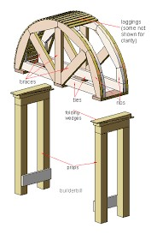
Figure 4.3: Formworks supports arch centrer

Central key of brick/block
The position of the central key brick or block in a masonry arch is crucial for the stability and structural integrity of the arch. The central key brick, also known as the keystone, is the final brick or block that is placed at the top center of the arch. It is shaped differently from the other bricks or blocks in the arch, often with a wedge-like or tapered shape.
The central key brick plays a significant role in distributing the weight of the arch evenly and transferring it to the supporting piers or abutments on either side. When properly positioned, it locks all the other bricks or blocks in place, preventing them from shifting or collapsing. The pressure exerted by the weight of the arch pushes against the sides of each brick or block, creating a compressive force that is ultimately transferred to the supporting structure.
To determine the correct position for the central key brick, several factors need to be considered. These include the size and shape of the arch, as well as the type and strength of the mortar used. The central key brick should be placed precisely at the highest point of the arch's intrados (the inner curve), ensuring that it aligns with the centerline of the arch.
The process of positioning the central key brick involves careful planning and construction techniques. The arch is typically built using temporary wooden supports called centering or scaffolding. As each course of bricks or blocks is laid, adjustments are made to ensure that they are level and properly aligned. The central key brick is usually left out until all other bricks or blocks are in place.
Once all other bricks or blocks have been laid and checked for alignment, the central key brick can be inserted. It may require some adjustments to fit snugly into its position. Special care must be taken during this step to avoid any damage to neighboring bricks or blocks.
When placing the central key brick, it is important to ensure that there is sufficient space for the mortar to be applied around it. The mortar acts as a bonding agent, providing additional strength and stability to the arch. Proper mortar composition and application techniques are essential to ensure a durable and long-lasting arch structure.

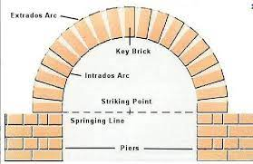
Figure 4.4: center key of brick

Self-Check 1
Directions: Answer all the questions listed below.
  - Write true if the statement is correct false if statement is in correct
- The springing line of an arch is the highest point on the arch.
- The crown of a masonry arch is designed to withstand compressive forces.
- Packers are used to adjust the height and levelness of individual voussoirs.
- Wedges are driven into horizontal slots called keyways or key joints.
- The height of the crown in a masonry arch is determined during the construction phase.
  - Choose correct answer for the following question
  - What is the purpose of toms in masonry arch construction?
a) To provide temporary support during construction
b) To adjust the height and levelness of individual voussoirs
c) To distribute the load and ensure structural integrity
d) To tighten and secure the arch structure
  - What is the position of the springing line in an arch?
a) The lowest point where the curve starts to form
b) The highest point where the two sides of the arch meet
c) The center of the span
d) The vertical distance from the intrados to the highest point on the arch
  - What is the function of wedges in masonry arch construction?
a) To provide temporary support during construction
b) To adjust the height and levelness of individual voussoirs
c) To distribute the load and ensure structural integrity
d) To tighten and secure the arch structure
  - What determines the height of the crown in a masonry arch?
a) The span of the arch
b) The rise of the arch
c) The desired profile or shape of the arch
d) All of the above
  - What is the purpose of packers in masonry arch construction?
a) To provide temporary support during construction
b) To adjust the height and levelness of individual voussoirs
c) To distribute the load and ensure structural integrity
d) To tighten and secure the arch structure
  - write Short Answer for the following question :
- What are the two primary components of mortar mix?
- How should the cement and sand be mixed together?
- Why is it important to add water gradually when preparing mortar mix?
- What is the recommended consistency of mortar mix?
- What is a mortarboard used for in masonry work?

Operation Sheet 4.1
Operation Title: Height of Springing Line and Crown of Arch
Purpose: To determine and measure the height of the springing line and crown of an arch in masonry construction.
Instruction:
- Identify the springing line of the arch, which is the lowest point where the curve of the arch begins to form.
- Measure the vertical distance from the springing line to the highest point on the arch, known as the crown.
- Use appropriate measuring tools, such as a tape measure or a laser level, to ensure accurate measurements.
- Record the measured height of the crown for documentation and future reference.
Conditions for the operations:
- Safe working area
- Properly operated tools
Equipment Tools and Materials:
- Tape measure or laser level for height measurement
- Pen and paper or electronic device for recording measurements
Quality Criteria:
- The height measurements should be accurate and consistent.
- The measurements should be recorded clearly for future reference.
Precautions:
- Wearing proper clothes, eye glass, glove
- Make working area hazard free
- Read and interpret manual which guide you how to use tools and equipment
Steps in doing the task
- Prepare the measuring tools and ensure they are in proper working condition.
- Locate the springing line of the arch.
- Measure the vertical distance from the springing line to the highest point of the arch, which is the crown.
- Record the measured height of the crown accurately.
- Double-check the measurements for accuracy.
- Store the recorded measurements in a safe and accessible location for future reference.

LAP Test 4
Practical Demonstration
Name: __________________________ Date: ____________
Time started: ____________________ Time finished: _______________
Instruction: Perform the following tasks

Task 1: Determine Height of Springing Line and Crown of Arch

Unit 5 Construct Arch Center
This unit is developed to provide you the necessary information regarding the following content coverage and topics:
- Set out arch centre and drawing up curve
- Transfer plan to material and cut to shape.
- Bull's eye, segmental and Gothic type arches
This unit will also assist you to attain the learning outcomes stated below. Specifically, upon completion of this learning guide, trainees will be able to:
- Set out arch centre and drawing up curve
- Transfer plan to material and cut to shape.
- Make bull's eye, segmental and Gothic type arches

Arch centre and drawing of curve
set out a masonry arch center and draw up the curve in accordance with specifications and drawings, several steps need to be followed. This process ensures that the arch is accurately positioned and constructed as per the given requirements. The following is a comprehensive guide on how to set out a masonry arch center and draw up the curve.
Gather the necessary information: Before starting the process, it is essential to have access to the specifications and drawings provided for the construction project. These documents will contain crucial details such as the dimensions, radius, and location of the arch. Familiarize yourself with these specifications to ensure accurate execution.
Establish the centerline: Begin by establishing the centerline of the arch. This can be done by measuring and marking the midpoint of the span where the arch will be constructed. Use a measuring tape or laser level to ensure precise measurements.
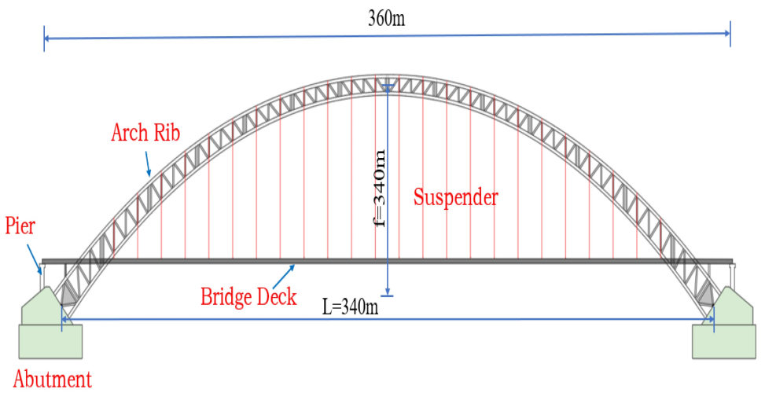
Figure 5.1: Establish the centerline
Determine the rise and span: The rise refers to the height of the arch, while the span represents its width or length. Measure these dimensions as specified in the drawings and mark them on either side of the centerline.
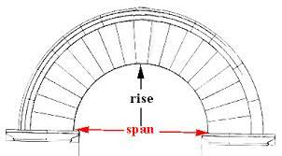
Figure 5.2: Determine the rise and span
Calculate the radius: The radius is a critical parameter for setting out a masonry arch center. It determines the curvature of the arch and can be calculated using mathematical formulas or specific design software. Once you have determined the radius, mark it on both sides of the centerline.

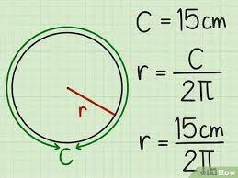
Figure 5.3: Calculate the radius
Establish reference points: To accurately draw up the curve of the arch, establish reference points along its length. These points should be evenly spaced and aligned with both sides of the centerline. The number of reference points will depend on the complexity and size of the arch.
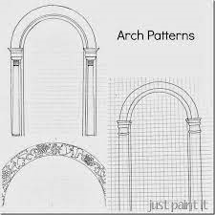
Figure 5.4 arch
Connect reference points: Using a flexible material such as a string or thin wooden batten, connect each reference point on one side of the centerline to its corresponding point on the other side. Ensure that these connections are smooth and follow a consistent curve.
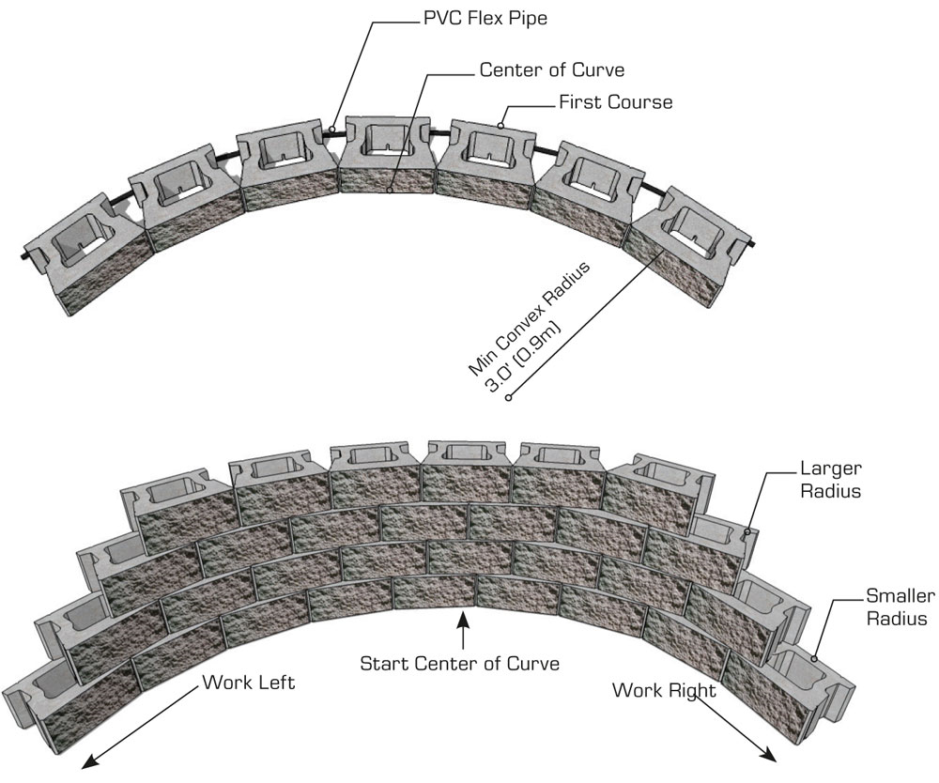
Figure 5.5: Connect reference points
Adjust and refine the curve: Once the initial connections are made, step back and assess the overall shape of the arch. Make any necessary adjustments to ensure that the curve is symmetrical and matches the desired design. This may involve slight modifications to the position of reference points or the radius.

Transfer plan to material and cut to shape.
o transfer a plan to material and cut it to shape for a masonry arch, several steps need to be followed. This process involves transferring the design from the plan onto the material, marking the necessary measurements, and then cutting the material to shape accordingly. Here is a detailed explanation of each step involved in this process:
    - Gather the necessary materials: Before starting the transfer and cutting process, gather all the required materials. This typically includes the plan or blueprint of the masonry arch, the material to be used (such as bricks or stones), measuring tools (such as a ruler or tape measure), marking tools (such as chalk or pencil), and cutting tools (such as a masonry saw or chisel).
    - Understand the plan: Carefully examine the plan or blueprint of the masonry arch. Familiarize yourself with all the dimensions, angles, and specific details mentioned in the design. It is crucial to have a clear understanding of how the arch should look before proceeding with any transfer or cutting.
Prepare the material: Ensure that the material you are using for the masonry arch is clean and free from any debris or dust. If necessary, clean and prepare the surface of each brick or stone that will be used in constructing the arch.
    - Transfer measurements from plan to material: Begin by selecting a reference point on both the plan and material. This reference point should be easily identifiable on both surfaces. Measure and mark this point on both the plan and material.
    - Use proportional scaling: To accurately transfer measurements from the plan to the material, it is often necessary to use proportional scaling. Determine a suitable scale factor based on the size of your plan and desired size of your arch. Multiply each measurement on your plan by this scale factor to obtain corresponding measurements for your material.
    - Mark key points and lines: Using your measuring tools, mark key points and lines on your material according to the transferred measurements. These points and lines will serve as guides for cutting and shaping the material.
- Create templates if needed: In some cases, it may be helpful to create templates for complex shapes or curves in the arch. Templates can be made from sturdy materials such as plywood or cardboard. Transfer the measurements onto the template and then use it as a guide for marking and cutting the actual material.
- Cut the material: Once all the necessary measurements and markings are in place, it is time to cut the material to shape. Use appropriate cutting tools based on the type of material being used. For example, a masonry saw may be used for bricks or stones, while a chisel and hammer may be used for more intricate cuts.
- Check accuracy: After cutting each piece of material, double-check its accuracy by comparing it to the plan or blueprint. Ensure that all dimensions and angles are correct before proceeding with the construction of the masonry arch.
Step to prepare archway
  - Find the dimensions of doorway to determine the height of your arch. Put the end of the measuring tape at the top of the doorway, and extend it down to the floor to find the height. Then, check the width of the opening at the top of the frame since that’s where you’ll install your arch. Aim to have the top of the arch extend about 4 inches (10 cm) down from the frame so people can comfortably walk through it
- Avoid extending the arch down too far in your doorway since taller people may not be able to fit through it comfortably. Try to keep the top of your arch about 78–80 inches (200–200 cm) from the floor.
- If you’re adding an arch to an existing door, remove the trim with a pry bar and take off the drywall around it to expose the frame.^{[3]}

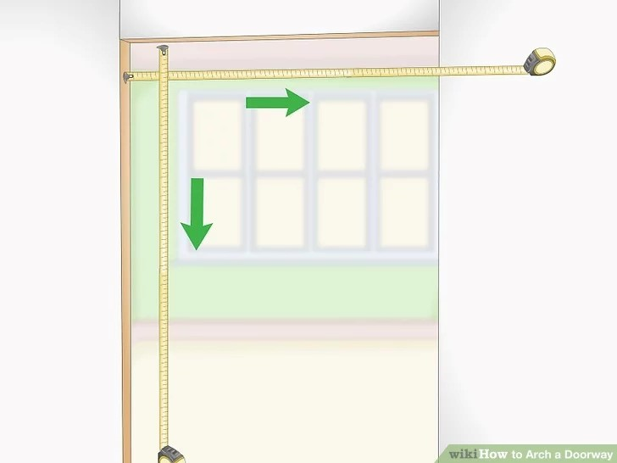

Figure 5.6. height and width of arch
  - Mark the top and bottom edges of arch on a sheet of plywood. Use a sheet of ¹⁄₂ in (1.3 cm) plywood that’s the same width as your doorway for the frames of your arch. Use your measuring tape to mark 4 inches (10 cm) in from the short side of the plywood sheet. Then make another mark 10 inches (25 cm) down from the first one for the bottom corner of your arch. Snap a chalk line across the plywood so you have 2 parallel lines.
- Buy chalk lines from hardware or home improvement stores.
- Also use a pencil and a straightedge to draw your lines.
- Buy a prefabricated kit that provides the pieces you need for your archway. Search for a kit that’s adjustable or matches the width of your doorway.

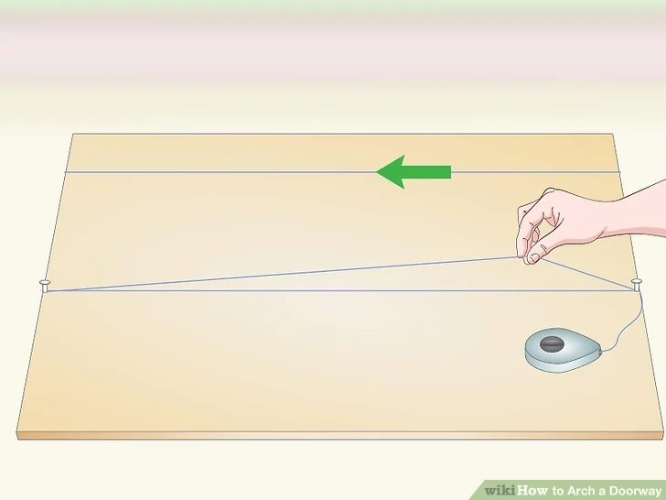
Figure 5.7 Mark the top and bottom edges of arch on a sheet of plywood

  - Draw lines from the center of the arch to the bottom corners. Divide the width measurement of the doorway by 2 and measure that distance in from the edge of the plywood. Make a mark on the top line you drew for the middle of your arch. Use a straightedge or your chalk line to draw a line from the mark you just made down to the ends of the line for the bottom edge of your arch. These lines will help you draw a perfect curve for your arch.

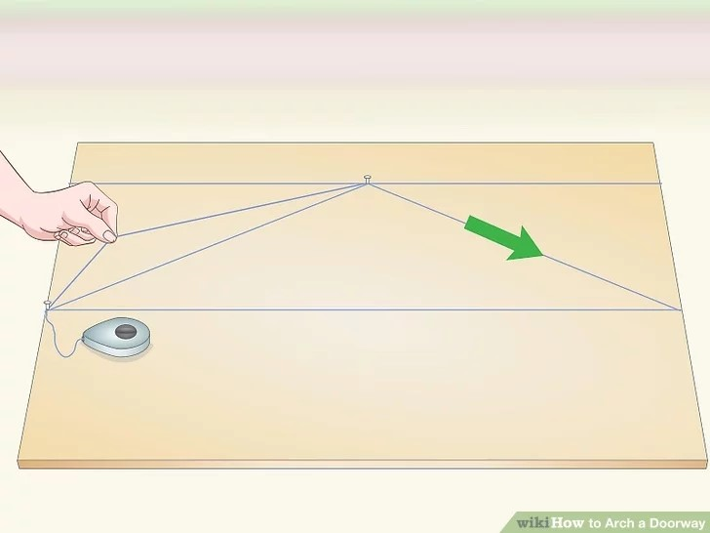
Figure 5.7: Draw lines from the center of the arch to the bottom corners
  - Make perpendicular lines extending from the midpoints of the lines you drew. Find the midpoint of one of the lines you just drew and mark it with a pencil. Place the right angle of a speed square on the mark you made and start drawing a perpendicular line with your pencil. Repeat the process with the line on the other side of the arch to make another perpendicular line. Use a straightedge or a chalk line to extend the lines down the plywood until they intersect.
- Double check your measurements to make sure they are accurate before moving on. That way, you can catch any errors before you make any cuts.

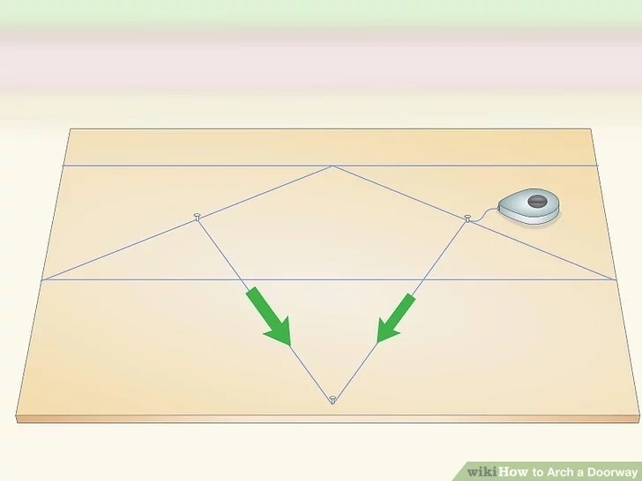

Figure 5.8: Make perpendicular lines
  - Place a nail where the lines intersect and hook your tape measure to it. Find the point where the lines intersect one another and tap a nail into the plywood. The nail acts as a pivot point and will help you draw a curve for the top of your archway. Make sure the nail is deep enough in the plywood so it doesn’t come out when you pull on it. Slide the end of the tape measure over the nail and make sure it doesn’t slip off easily.
- Tape measures have holes in the end so you can easily attach them to a nail.
- If your tape measure doesn’t have a hole in the end, then you can wrap a string around the nail instead.

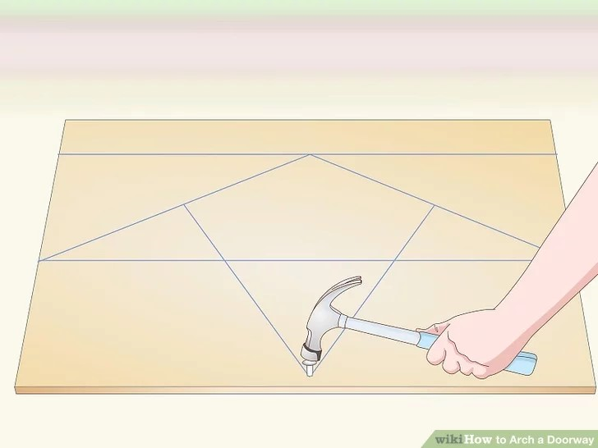
Figure 5.9: Place a nail
  - Trace the curve of the arch with the measuring tape and a pencil. Extend the tape measure until it reaches mark at the top of your arch, and then lock it in place so the tape can’t retract. Hold a pencil on the mark next to your tape measure, and move it toward the side of the plywood. Since the tape measure is locked in place, it will draw a curve that stops at the end of the bottom line. Move the tape measure to the other side to finish the other side of the arch.
- Be gentle with the tape measure since it may still extend slightly if you pull on it hard enough.
- If you’re using a string instead of a tape measure, tie it to your pencil.

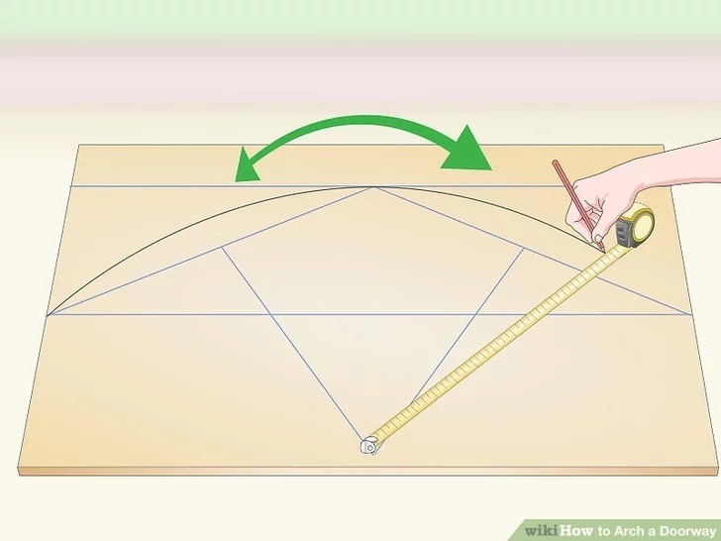

Figure 5.10: Trace the curve of the arch

Assembling the Arch
  - Use a jigsaw to cut out the side of your archway. Set the plywood on a workbench so the area you’re cutting hangs over the edge. Turn on your jigsaw and slowly follow along the line you drew to make a precise cut. When you’re about to finish your cut, hold onto the piece of plywood so it doesn’t drop onto the floor.
- If you don’t have a jigsaw, you can try using a circular saw instead.
Warning: Wear safety glasses whenever you work with power tools so you don’t get injured.

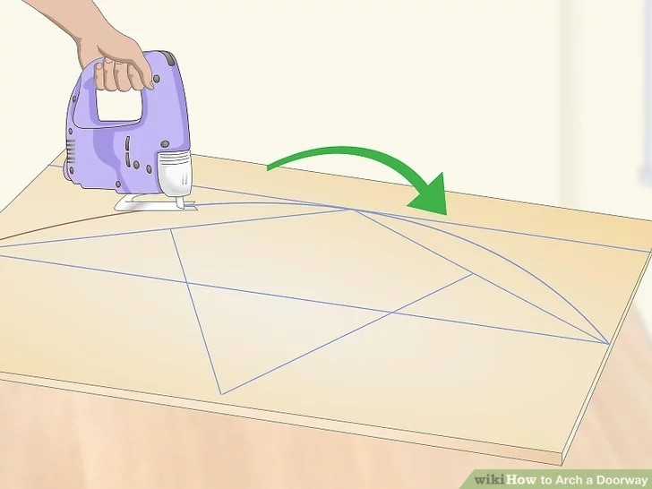
Figure 5.11: Cut out the side of archway
  - Trace the piece you just cut out to make the other side of the arch. Once you have the first piece of your archway cut out, trace it onto the plywood with a pencil so your pieces are identical. Use your jigsaw to cut the other piece out from the plywood. After you make the cut, hold the 2 pieces together to ensure that they’re the same size, and make any additional cuts to even them out if you need to.
- Clamp the 2 pieces of plywood together if you need to make adjustments to both to ensure that they stay the same.
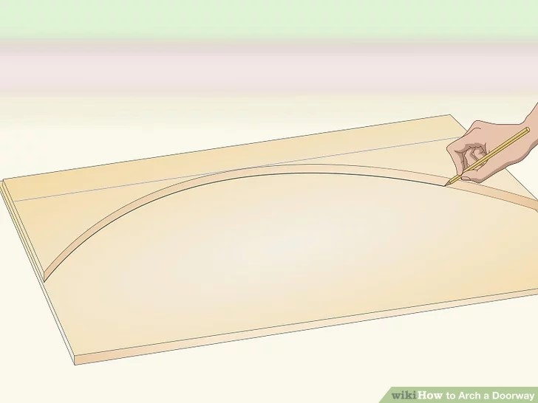
figure 5.12: Trace side of the arch
- Attach 2 ¹⁄₂ in (6.4 cm) wood pieces along the curve to use as spacers. Since most doorways are framed with 2 in × 4 in (5.1 cm × 10.2 cm) boards, you need to space the plywood pieces apart to fit. Line the curved edge of the archway with 2 ¹⁄₂ in (6.4 cm) thick wood pieces and nail them in from each side. Leave about 2–3 inches (5.1–7.6 cm) between each of your spacers so it’s the same thickness as the doorway.^{[9]}
- Cut down scrap pieces of 2 in × 4 in (5.1 cm × 10.2 cm) boards for your spacers so you don’t need to buy additional wood.

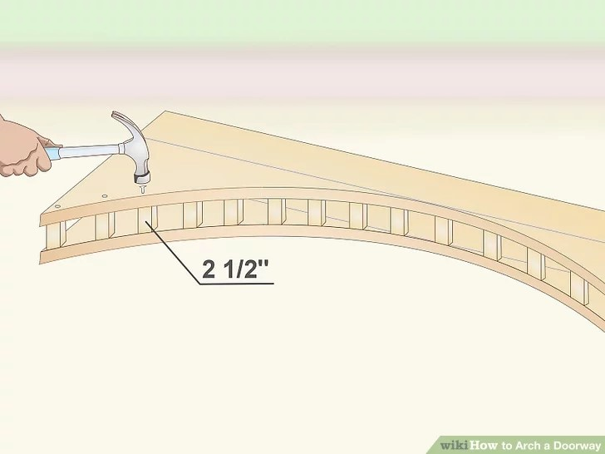
Figure 5.13: spacers
- Screw 2 ¹⁄₂ in (6.4 cm) boards onto the corners of your door frame. Hold a board that’s the same width as your doorway at the top of the door frame so there’s ¹⁄₂ in (1.3 cm) of space on either side of it. Drive screws into the middle of the board every 3–4 inches (7.6–10.2 cm) to secure it in place. Then screw 2 vertical boards that are each 10 inches (25 cm) long on the sides of the frame so the short edges are flush with the top board.^{[10]}
- These boards allow you to easily attach the plywood to the door frame so your archway is flush with the rest of your wall.

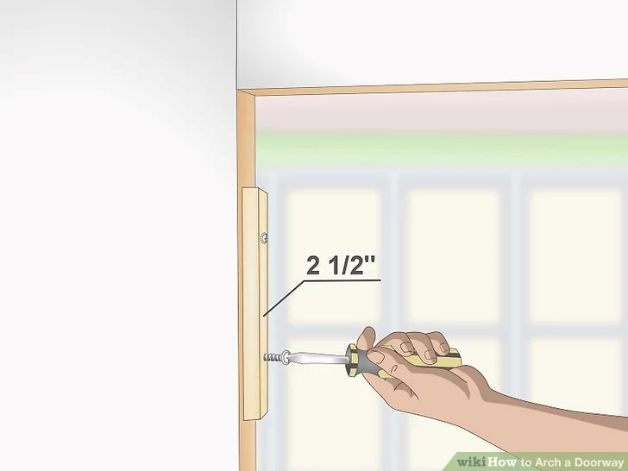
Figure 5.14: boards onto the corners
- Slide the archway you built over the board on the frame and nail it in place. Carefully guide the archway you built over the 2 ¹⁄₂ in (6.4 cm) boards so the plywood is flush with the door frame. Once your archway is at the correct height, have a helper hold it in place while you drive 3 in (7.6 cm) nails through the plywood into the boards every 4 inches (10 cm).
- If you don’t have a helper, use a nail gun to secure the arch in place. Be sure to wear safety glasses when using a nail gun.
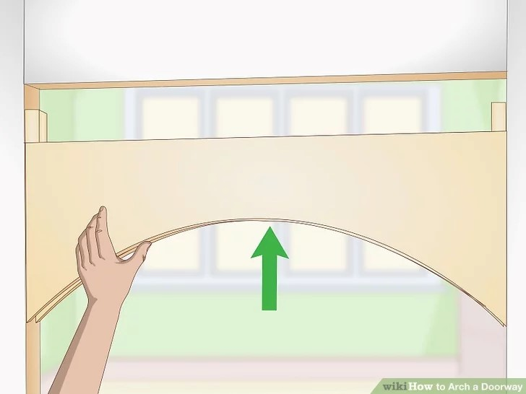
Figure 5.15: Slide the archway

- Apply mortar to your archway. Buy a container of premixed mortar and stir it together with a flat trowel. Scoop out some of the mortar and spread it evenly over archway brick to help hold them together construct carefully until the end of course.
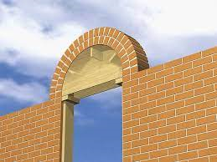
Figure 5.16: arch

Bull's eye, segmental and Gothic type arches
Bull's Eye, Segmental, and Gothic Type of Masonry Arches: A Comprehensive Comparison
Masonry arches have been a cornerstone of architecture for centuries, and there are several types that have gained popularity over the years. Among them, the bull's eye, segmental, and Gothic arches are three of the most commonly used and admired. In this answer, we will delve into the characteristics, differences, and applications of each type of arch, providing a comprehensive comparison to help you understand their unique features and uses.
Bull's Eye Arches
Bull's eye arches, also known as circular or ring arches, are characterized by a circular or semi-circular shape. They are typically used in small openings, such as doorways, windows, and niches. The circular shape of the arch provides even distribution of weight and stress, making it an ideal choice for load-bearing applications.
.
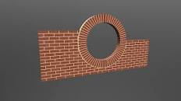
Figure 5.17: Bull's Eye Arches

Segmental Arches
Segmental arches, also known as horseshoe or pointed arches, are characterized by a curved shape that is less than a full circle. They are commonly used in larger openings, such as doorways, windows, and entries. The curved shape of the arch distributes weight and stress more evenly than a rectangular arch, making it an ideal choice for load-bearing applications.
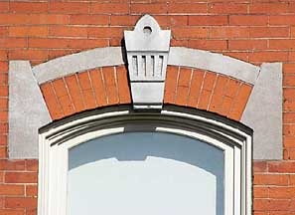
Figure 5.18 Segmental Arches
Gothic Arches
Gothic arches, also known as pointed arches, are characterized by a pointed shape that tapers towards the top. They are commonly used in larger openings, such as doorways, windows, and entries. The pointed shape of the arch distributes weight and stress more evenly than a rectangular arch, making it an ideal choice for load-bearing applications.

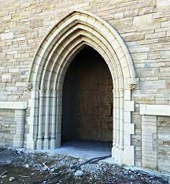
Figure 5.19: Gothic Arches

Self-Check 1
Directions: Answer all the questions listed below.
    - Write true if the statement is correct false if statement is in correct
- The rise of an arch refers to its width or length.
- Proportional scaling is not necessary when transferring measurements from a plan to material.
- Creating templates for complex shapes or curves in the arch can be helpful during the cutting process.
- The top of the arch should extend about 4 inches (10 cm) down from the frame of the doorway.
- A jigsaw can be used to cut out the side of the archway.
    - Choose correct answer for the following question
- What is the first step in setting out a masonry arch center?
a) Establishing the centerline
b) Calculating the radius
c) Determining the rise and span
d) Gathering the necessary materials

- Which tool is commonly used for cutting bricks or stones?
a) Ruler
b) Laser level
c) Masonry saw
d) Chisel

- How many reference points should be established along the length of the arch?
a) It depends on the complexity and size of the arch.
b) Two reference points are sufficient.
c) Four reference points are necessary.
d) Reference points are not required.

- What should be done after the initial connections of the reference points are made?
a) Assess the overall shape of the arch and make any necessary adjustments.
b) Cut the material to shape.
c) Establish the centerline.
d) Calculate the radius.

- What is the purpose of marking the top and bottom edges of the arch on a sheet of plywood?
a) To determine the height and width of the arch
b) To create templates for complex shapes or curves
c) To transfer measurements from the plan to the material
d) To cut the material to shape

    - write Short Answer for the following question :
- What are the necessary materials for transferring a plan to material and cutting it to shape for a masonry arch?
- Why is it important to understand the plan before proceeding with the transfer and cutting process?
- How can proportional scaling be used when transferring measurements from a plan to material?
- What is the purpose of creating templates in the cutting process?
- How can the accuracy of the cut material be checked before proceeding with the construction of the masonry arch?

Operation Sheet 5.1
Operation Title: Setting out arch center and drawing up the curve.
Purpose: To accurately position and construct a masonry arch according to specifications and drawings.
Instruction:
- Gather the necessary information, including specifications and drawings.
- Establish the centerline of the arch by measuring and marking the midpoint.
- Determine the rise and span of the arch and mark them on either side of the centerline.
- Calculate the radius of the arch and mark it on both sides of the centerline.
- Establish reference points along the length of the arch.
Conditions for the operations:
- Safe working area
- Properly operated tools
Equipment Tools and Materials:
- Specifications and drawings
- Measuring tape or laser level
- Chalk or pencil
- Flexible material (string or thin wooden batten)
- Suitable cutting tools (masonry saw, chisel, etc.)
Quality Criteria:
- Accurate positioning of the arch centerline.
- Correct determination and marking of the rise, span, and radius.
- Evenly spaced and aligned reference points.
- Smooth and consistent curve connections.
- Symmetrical and aligned final curve of the arch.

Precautions:
- Wearing proper clothes, eye glass, glove
- Make working area hazard free
- Read and interpret manual which guide you how to use tools and equipment
Steps in doing the task
- Gather necessary information from specifications and drawings.
- Establish the centerline of the arch.
- Determine and mark the rise and span on either side of the centerline.
- Calculate and mark the radius on both sides of the centerline.
- Establish evenly spaced reference points along the length of the arch.
- Connect the reference points on each side of the centerline using a flexible material.
- Adjust and refine the curve of the arch for symmetry and alignment.

LAP Test 5
Practical Demonstration
Name: __________________________ Date: ____________
Time started: ____________________ Time finished: _______________
Instruction: Perform the following tasks

Task 1: Set out arch center and draw up the curve

Unit 6 Cut and Place Masonry Materials
This unit is developed to provide you the necessary information regarding the following content coverage and topics:
- Cutting and laying masonry unit for centre arch
- Striking and maintain joint equal size and parallel
- Maintain same size wedge shape
- Centreline of key masonry unit wedge
- Clearance And Waste Management
This unit will also assist you to attain the learning outcomes stated below. Specifically, upon completion of this learning guide, trainees will be able to:
- Cutting and laying masonry material centre arch
- Striking and maintaining joint equal size and parallel
- Maintaining same size wedge shape
- Maintaining centreline of key masonry unit wedge
- Clearance And Waste Management

Cutting and laying masonry unit for centre arch
Masonry materials are cut and laid on centre to form arch to specifications
Masonry materials are commonly used in construction to create arches. An arch is a curved structure that spans an opening and supports the weight above it. The process of constructing an arch involves cutting and laying masonry materials in a specific manner.
To form an arch, masonry materials such as bricks or stones are cut into wedge-shaped pieces called voussoirs. These voussoirs are then laid on center, meaning that they are positioned with their center points aligned along the curve of the arch. The voussoirs are arranged in a way that allows them to distribute the load evenly and create a stable structure.
The key to constructing a successful arch lies in the proper placement and alignment of the voussoirs. Each voussoir must be cut and positioned accurately to ensure a precise fit. The shape and size of the voussoirs may vary depending on the design and specifications of the arch.
Once the voussoirs are cut and laid on center, they are typically held together using mortar. Mortar is a mixture of cement, sand, and water that acts as a binding agent between the masonry units. It helps to secure the voussoirs in place and provides additional strength to the arch.
The process of constructing an arch requires careful planning and attention to detail. The specifications for an arch may include factors such as the desired height, width, and curvature. These specifications are determined based on structural requirements, architectural design, and aesthetic considerations.
Centreline of key masonry unit wedge and vertical centre line of arch.
The statement "Centerline of key masonry unit wedge is maintained through vertical centre line of arch" refers to the construction technique used in masonry arches. In this technique, a wedge-shaped masonry unit, known as the key, is placed at the crown of the arch to provide stability and maintain the structural integrity of the arch.
Masonry arches have been used for centuries in various architectural structures due to their strength and aesthetic appeal. They are typically constructed using individual masonry units, such as bricks or stones, which are arranged in a curved shape to form the arch.
The key is a crucial component of a masonry arch. It is usually a larger and thicker masonry unit that is strategically placed at the highest point or crown of the arch. The purpose of the key is to distribute the load from above evenly across the entire arch, ensuring that no single masonry unit bears excessive weight. By doing so, it helps prevent any localized stress concentration that could lead to failure.
To maintain the stability and structural integrity of the arch, it is essential to align the centreline of the key with the vertical centreline of the arch. This alignment ensures that the load transmitted through the key is distributed symmetrically along the curve of the arch. If there were any deviation from this alignment, it could result in uneven load distribution and potential instability.
By maintaining the centreline alignment, any vertical forces acting on the arch are evenly distributed across all masonry units, including both those below and above the key. This distribution helps prevent any localized areas of weakness or excessive stress within the arch structure.
In addition to maintaining load distribution, aligning the centreline of the key with the vertical centreline of the arch also helps maintain visual symmetry and aesthetic appeal. When viewing an arch from below or from a distance, this alignment ensures that the arch appears balanced and visually pleasing.
To achieve the desired alignment, masons carefully position the key during construction. They may use temporary supports or scaffolding to hold the key in place until the surrounding masonry units are laid and set. The masons must also ensure that the key is securely bonded to the adjacent masonry units to prevent any movement or displacement.
In conclusion, the statement "Centerline of key masonry unit wedge is maintained through vertical centre line of arch" highlights the importance of aligning the centreline of the key with the vertical centreline of a masonry arch. This alignment ensures even load distribution, prevents localized stress concentration, and maintains visual symmetry. By following this construction technique, masons can create stable and aesthetically pleasing masonry arches.

Striking and maintain joint equal size and parallel
Joints are maintained to equal size and parallel on the extrados of an arch.
Joints are not typically maintained to equal size and parallel on the extrados of an arch. The extrados refers to the outer curve or surface of an arch, while the intrados refers to the inner curve or surface. In arch construction, joints are usually designed and placed in a way that ensures structural stability and proper load distribution rather than focusing on equal size and parallelism.
When it comes to striking joints evenly to depth and shape, it is crucial to follow specifications to ensure proper functionality and aesthetics. Striking joints refers to the process of creating a clean and precise separation between two adjacent surfaces, typically found in construction or woodworking projects. This technique is commonly used in various applications, such as masonry, concrete work, carpentry, and metalworking.

Types of joints
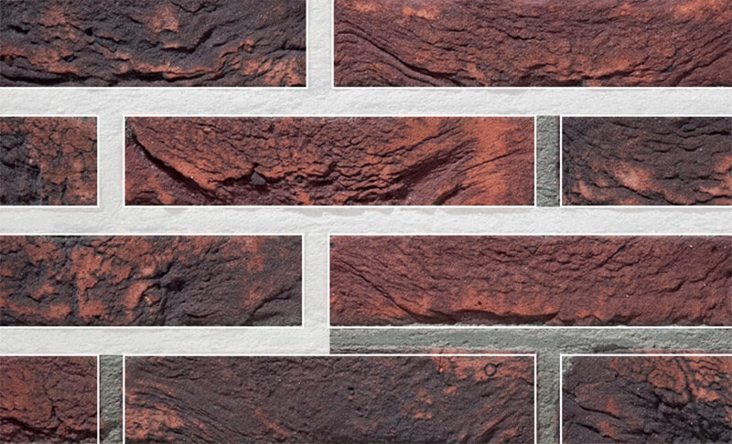
Figure 6.1:joint
The form of the joint also influences the appearance of a facade. Of course the height of the joint plays an important role, but the depth is also important. The deeper the joint, the more it will end up in the background. This creates a shadow play between the joint and the facing brick, which especially emphasizes the colour of the brick. There are various standard types of joints. The price depends of course on the labour intensiveness.
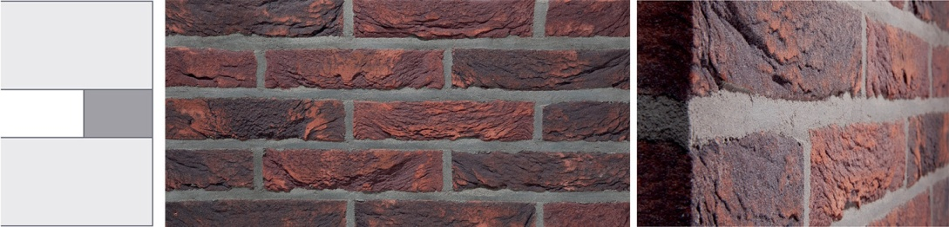
Figure 6.2: Flush joint
Working method
The mortar is generously applied and leveled in a smooth way so that the mortar is flush to the brickwork.
Effect
this form of pointing is often used with coloring on coloring joint mortars. The even surface that is desired is emphasized this way.
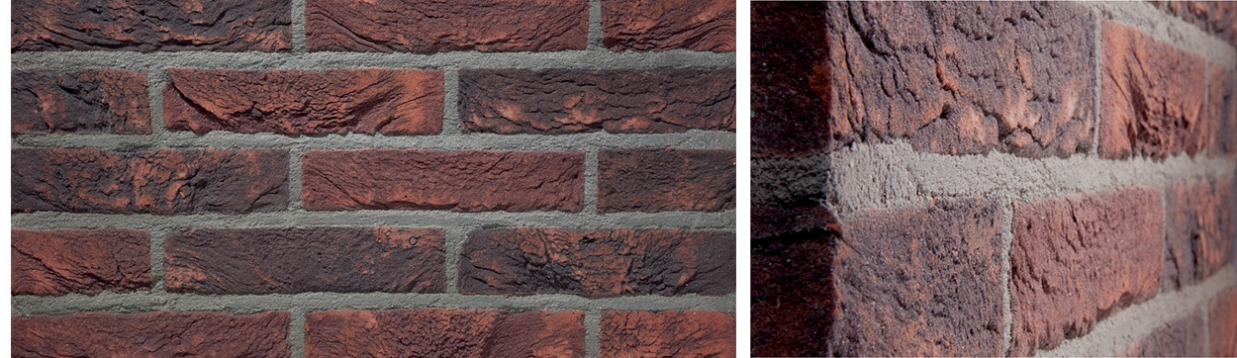

Figure 6.3:Flush brushed joint
Working method
The mortar is generously applied but not levelled smoothly. Brushing the excess mortar creates a more rough joint with more texture.
Effect
Here also this type of pointing creates an even surface when using colouring on colouring mortar. In addition, the brushed effect creates facade with more character.
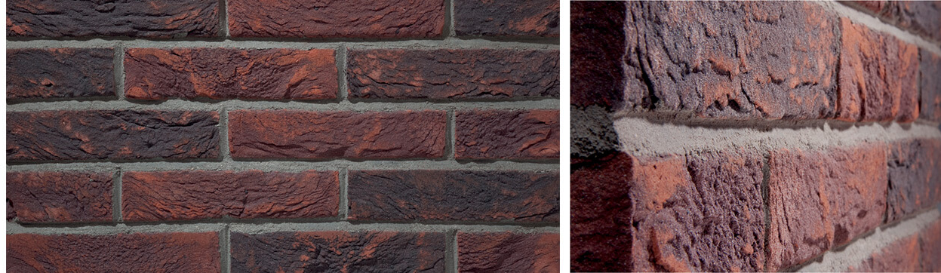
Figure 6.4: Weather struck joint
Working method
The mortar is applied partially recessed in an angle of 45°.
Effect
this creates a shadow effect. The horizontal lines of the facade are emphasized.
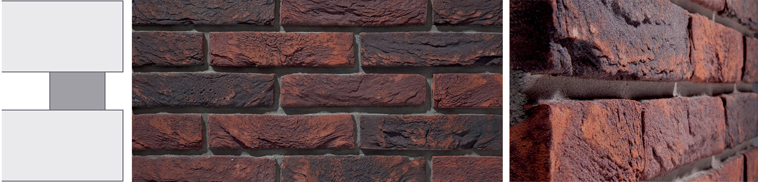

Figure 6.5: Recessed joint

Working method
This is an extra raked joint. The mortar is applied 2 to 5 mm deeper than the visible surface of the facade.
Effect
The emphasis is laid on the horizontal aspect of the facade, especially in combination with full vertical head joints or even no vertical head joints at all.
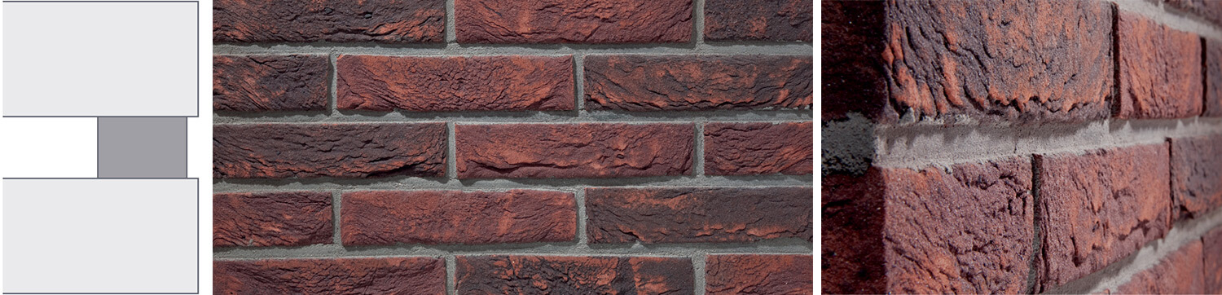

Figure 6.6: Raked joint

This is also a very common type of pointing.
Working method
The mortar is pressed a bit inwards so that it is approximately 2 mm recessed compared to the facing brick.
Effect
This creates more shadow between the joint and the brick and gives a very well-cared-for appearance. Can be done smooth or brushed.
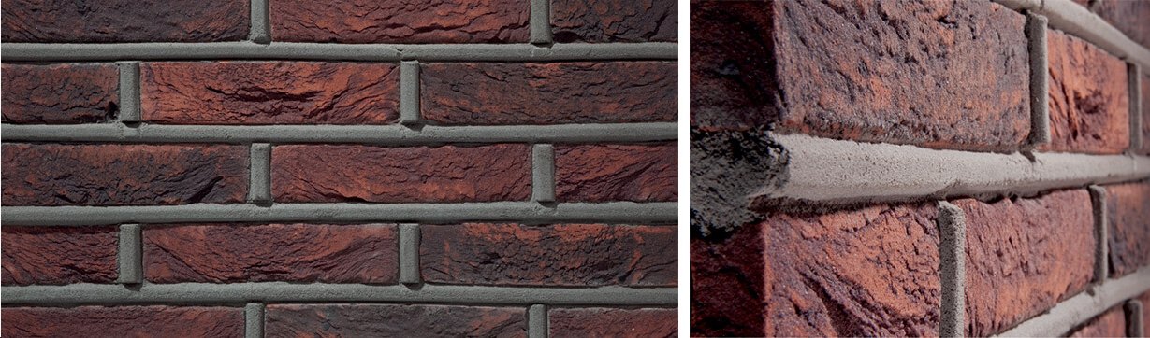

Figure 6.7: Convex joint
This is a type of joint that is less common because it requires more time and expertise.
Working method
The mortar is generously applied but not levelled smoothly. Brushing the excess mortar creates a more rough joint with more texture.
Effect
Here also this type of pointing creates an even surface when using colouring on colouring mortar. In addition, the brushed effect creates facade with more character.

Maintain same size wedge shape
When maintaining a same size wedge shape on a masonry face, several factors need to be considered to ensure structural integrity and aesthetic appeal. The process involves carefully cutting and shaping the masonry units to create a consistent wedge shape throughout the surface. This technique is commonly used in architectural designs to add visual interest and create unique patterns on masonry structures.

To maintain a same size wedge shape, the following steps can be followed:
    - Planning and Design:
Before starting the construction process, it is essential to have a well-thought-out plan and design. This includes determining the desired size and angle of the wedge shape, as well as considering any specific patterns or arrangements that need to be incorporated into the masonry face. Proper planning ensures that the final result meets the desired specifications.
    - Selection of Masonry Units:
Choosing the right type of masonry units is crucial for achieving a consistent wedge shape. Common options include bricks, concrete blocks, or natural stone. The selected units should have uniform dimensions and be compatible with the desired design. It is important to consider factors such as strength, durability, and color when selecting the masonry units.
    - Cutting and Shaping:
Once the masonry units are selected, they need to be cut and shaped to create the desired wedge shape. This can be done using various tools such as saws, chisels, or specialized cutting equipment. Care should be taken to ensure precise cuts and accurate angles to maintain consistency throughout the masonry face.
    - Mortar Application:
After cutting and shaping the masonry units, they are laid in place using mortar. The mortar acts as a bonding agent between the units and provides stability to the structure. It is important to use an appropriate mortar mix that matches the strength and color of the masonry units. The mortar should be applied evenly and consistently to maintain a uniform appearance.
- Joint Finishing:
To enhance the overall look of the masonry face, the joints between the units can be finished in a specific manner. This can include techniques such as raking, striking, or tooling the joints to create different textures and patterns. The joint finishing should complement the wedge shape and contribute to the desired aesthetic effect.
- Maintenance:
Once the same size wedge shape is achieved on the masonry face, regular maintenance is necessary to ensure its longevity. This includes inspecting for any cracks or damage and repairing them promptly. Additionally, routine cleaning and sealing can help protect the masonry from weathering and staining.

Centre line of key masonry unit wedge
The statement "Centreline of key masonry unit wedge is maintained through vertical centre line of arch" refers to the construction technique used in masonry arches. In this technique, a wedge-shaped masonry unit, known as the key, is placed at the crown of the arch to provide stability and maintain the structural integrity of the arch.
To understand this concept better, let's delve into the construction and mechanics of masonry arches. Masonry arches have been used for centuries in various architectural structures due to their strength and aesthetic appeal. They are typically constructed using individual masonry units, such as bricks or stones, which are arranged in a curved shape to form the arch.
The key is a crucial component of a masonry arch. It is usually a larger and thicker masonry unit that is strategically placed at the highest point or crown of the arch. The purpose of the key is to distribute the load from above evenly across the entire arch, ensuring that no single masonry unit bears excessive weight. By doing so, it helps prevent any localized stress concentration that could lead to failure.
To maintain the stability and structural integrity of the arch, it is essential to align the centreline of the key with the vertical centreline of the arch. This alignment ensures that the load transmitted through the key is distributed symmetrically along the curve of the arch. If there were any deviation from this alignment, it could result in uneven load distribution and potential instability.
By maintaining the centreline alignment, any vertical forces acting on the arch are evenly distributed across all masonry units, including both those below and above the key. This distribution helps prevent any localized areas of weakness or excessive stress within the arch structure.
In addition to maintaining load distribution, aligning the centreline of the key with the vertical centreline of the arch also helps maintain visual symmetry and aesthetic appeal. When viewing an arch from below or from a distance, this alignment ensures that the arch appears balanced and visually pleasing.
To achieve the desired alignment, masons carefully position the key during construction. They may use temporary supports or scaffolding to hold the key in place until the surrounding masonry units are laid and set. The masons must also ensure that the key is securely bonded to the adjacent masonry units to prevent any movement or displacement.

Waste Management
During the construction of a masonry arch and curved wall, clearance and waste management play crucial roles in ensuring the successful completion of the project. Clearance refers to the process of removing any obstructions or debris from the construction site, while waste management involves the proper handling and disposal of construction waste generated during the construction process.
Clearance is an essential step before commencing any construction activity. It involves clearing the site of any existing structures, vegetation, or other obstacles that may hinder the construction process. This includes demolishing any existing buildings or structures, removing trees and shrubs, and clearing away any debris or rubble. The clearance process ensures that the construction site is free from any obstructions and provides a clean slate for the construction of the masonry arch and curved wall.
Waste management is another critical aspect of construction projects, including those involving masonry arches and curved walls. Construction activities generate a significant amount of waste materials such as concrete, bricks, timber, metal, and packaging materials. Proper waste management practices are necessary to minimize environmental impact, ensure worker safety, and comply with regulations.
The first step in waste management is to segregate different types of waste materials at the source. This allows for easier recycling or disposal of specific materials. For example, concrete and bricks can be crushed and recycled for use as aggregate in new construction projects. Timber waste can be reused or repurposed for various applications. Metal waste can be recycled to reduce the demand for virgin materials.
Once waste materials are segregated, they should be stored in designated areas on-site to prevent mixing and contamination. Proper storage ensures that hazardous materials are kept separate from non-hazardous ones, reducing potential risks to workers and the environment. It is important to follow local regulations regarding storage requirements for different types of waste materials.
When it comes to disposal, it is crucial to adhere to local regulations and guidelines. Construction waste should be disposed of at authorized facilities such as recycling centers or landfills. Some materials may require special handling or treatment due to their hazardous nature. For instance, asbestos-containing materials should be handled by licensed professionals and disposed of in accordance with specific regulations.
In addition to proper disposal, construction projects should also prioritize waste reduction and recycling. Implementing strategies such as lean construction practices, material reuse, and recycling programs can significantly reduce the amount of waste generated during the construction process. This not only benefits the environment but also helps to minimize project costs.
To effectively manage clearance and waste during the construction of a masonry arch and curved wall, it is essential to have a comprehensive waste management plan in place. This plan should outline procedures for clearance, waste segregation, storage, disposal, and recycling. It should also include provisions for monitoring and auditing waste management practices to ensure compliance with regulations and identify areas for improvement.

Self-Check 1
Directions: Answer all the questions listed below.
    - Write true if the statement is correct false if statement is in correct
- The key masonry unit in an arch is typically placed at the highest point or crown of the arch.
- Maintaining the centerline alignment of the key masonry unit in an arch helps prevent localized stress concentration.
- Joints on the extrados of an arch are usually maintained to equal size and parallel.
- The process of striking joints involves creating a clean separation between two adjacent surfaces.
- The depth of a joint in a masonry facade can affect the appearance of the facade.
    - Choose correct answer for the following question
- Which material is commonly used for constructing masonry arches?
a) Steel
b) Wood
c) Concrete
d) Bricks or stones

- What is the purpose of maintaining the centerline alignment of the key masonry unit in an arch?
a) To enhance the visual symmetry of the arch
b) To prevent excessive weight on individual masonry units
c) To distribute the load evenly across the arch
d) All of the above

- Which type of joint creates a shadow effect and emphasizes the horizontal lines of a facade?
a) Flush joint
b) Flush brushed joint
c) Weather struck joint
d) Recessed joint

- What is the process of creating a clean and precise separation between two adjacent surfaces called?
a) Joint finishing
b) Joint striking
c) Joint alignment
d) Joint bonding

- What factors should be considered when maintaining a consistent wedge shape on a masonry
face?
a) Size and angle of the wedge shape
b) Type and color of the masonry units
c) Cutting and shaping techniques
d) All of the above

    - write Short Answer for the following question :
    - What is the purpose of the key masonry unit in an arch?
    - How does maintaining the centerline alignment of the key masonry unit contribute to the stability of the arch?
    - Name two techniques used for finishing joints in a masonry facade.
    - What are the factors that need to be considered when selecting masonry units for maintaining a consistent wedge shape?
    - Briefly explain the process of cutting and shaping masonry units to create a wedge shape on a masonry face.

Operation Sheet 6.1
Operation Title: Cutting and Laying Masonry Units for Centre Arch
Purpose: To construct a stable and aesthetically pleasing masonry arch by cutting and laying masonry units in a specific manner.
Instruction:
- Plan and design the arch, considering the desired height, width, curvature, and structural requirements.
- Select appropriate masonry units, such as bricks or stones, that are compatible with the design and meet the desired specifications.
- Cut the masonry units into wedge-shaped pieces called voussoirs.
- Align the center points of the voussoirs along the curve of the arch, laying them on center.
- Arrange the voussoirs in a way that evenly distributes the load and creates a stable structure.
Conditions for the operations:
- Safe working area
- Properly operated tools
Equipment Tools and Materials:
- Masonry units (bricks or stones)
- Cutting tools (saws, chisels, etc.)
- Mortar mix (cement, sand, water)
- Trowel for applying mortar
- Measuring and leveling tools
- Temporary supports or scaffolding (if required)
Quality Criteria:
- Precise cutting and shaping of masonry units to achieve a consistent wedge shape
- Proper alignment and centerline maintenance of the key masonry unit
- Even load distribution across the arch
- Secure bonding of masonry units with mortar
- Uniform and well-finished joints

Precautions:
- Wearing proper clothes, eye glass, glove
- Make working area hazard free
- Read and interpret manual which guide you how to use tools and equipment
Steps in doing the task
- Plan and design the arch, considering the desired specifications.
- Select and prepare the masonry units, cutting them into wedge-shaped voussoirs.
- Lay the voussoirs on center, aligning their center points along the arch's curve.
- Arrange the voussoirs in a manner that ensures even load distribution.
- Apply mortar between the masonry units, securing them in place.
- Maintain the centerline alignment of the key masonry unit with the vertical centerline of the arch.
- Check and adjust the alignment as necessary during construction.
- Finish the joints between the masonry units to enhance the appearance of the masonry face.

LAP Test 6
Practical Demonstration
Name: __________________________ Date: ____________
Time started: ____________________ Time finished: _______________
Instruction: Perform the following tasks

Task 1: Cut and Lay Masonry Units for Centre Arch

Reference
OSHA (2020): Occupational Safety and Health Administration. (2020). Masonry Construction. Retrieved from <https://www.osha.gov/SLTC/masonryconstruction/index.html>
2. CPWR (2020): The Center for Construction Research and Training. (2020). Masonry Construction Safety. Retrieved from <https://www.cpwr.com/sites/default/files/2020-01/CPWR_Masonry_Construction_Safety_Guide.pdf>
3. ANSI (2018): American National Standards Institute. (2018). A10.9-2018: Standard for Masonry Construction. Retrieved from <https://www.ansi.org/standards/a10/a10.9-2018>
Occupational Safety and Health Administration. (n.d.). Hazardous Materials. Retrieved from <https://www.osha.gov/SLTC/hazardousmaterials/index.html>
2. National Institute for Occupational Safety and Health. (n.d.). Hazardous Materials Handling, Storage, and Disposal. Retrieved from <https://www.cdc.gov/niosh/topics/hazardous-materials/handling-storage-disposal.html>
3. American Industrial Hygiene Association. (n.d.). Material Safety Data Sheets. Retrieved from <https://www.aiha.org/get-informed/industrial-hygiene-fundamentals/material-safety-data-sheets
1. American Concrete Institute (ACI) - www.concrete.org
2. Construction Technology Laboratories (CTL) - www.ctlgroup.com
3. The Institution of Structural Engineers (IStructE) - www.istructe.org
1. Construction Knowledge: www.constructionknowledge.net
2. Timber Framers Guild: www.tfguild.org
3. Structural Timber Magazine: www.structuraltimber.co.uk

Participants of this Module (training material) preparation
No. | Name of Trainer | Sex | Educational Background In Level And Profession | Trainer Address
 |  |  |  | Region | College | Phone | E-Mail Address
1 | Solomon Urga | M | B.Sc. in Building Construction Technology | Oromia | Woliso Polytechnic College | 0921207462 | samuelsolomon071@gmail.com
2 | Muluken Solomon | M | M.Sc. in Construction Management | Oromia | Batu Polytechnic College | 0912289146 | mulecot99@gmail.com
3 | Bekalu Yibeltal | M | M.Sc. in Structural Engineering | Addis Ababa | Federal Technical and Vocational Training Institute | 0921988863 | fikruyibeltal@gmail.com
4 | Desalegn Alemu | M | B.Sc. in Construction Management | Oromia | Woliso Polytechnic College | 0926771683 | dasalegnalemu&gmail.com
5 | Tesfaye Assegidew | M | M.Sc. in Construction Technology & Management | Centeral Ethiopia | Butajira Polytechnic College | 0913442444 | tesfayeassegidew@gmail.com
6 | Tibebnesh Gebremichael | F | M.Sc. in Construction Management | Sidama | Hawassa Polytechnic College | 0916116049 | tibebineshg1@gmail.com
7 | Zekarias Gebre | M | B.Sc. in Civil Engineering | Addis Ababa | General Wingate Polytechnic College | 0912421317 | zekarias1502@gmail.com

