STRUCTURAL CONSTRUCTION WORKS LEVEL-III
Based on October 2023, Curriculum Version 2
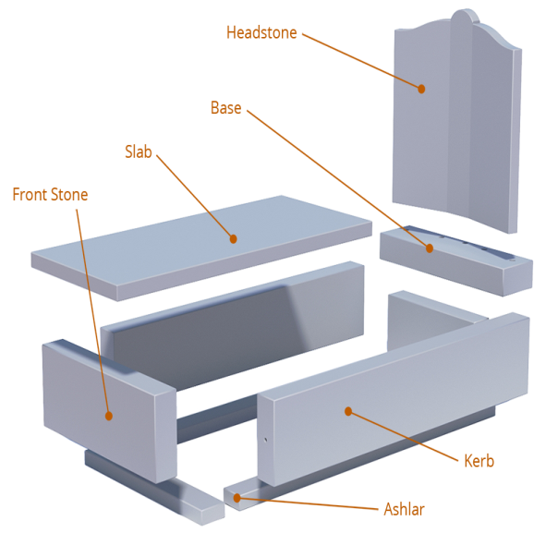
Module Title: Erecting Stone Memorials and Monuments
Module code: EIS SCW3 M05 1023
Nominal duration: 60 Hours

Prepared by: Ministry of Labour and Skill (MoLS)
October, 2023
Addis Ababa, Ethiopia
Table of Contents
Acknowledgment 5
Acronym 6
Introduction to the Module 7
Unit One: Preparing for work 9
1.1 Over view of stone memorials and monuments 10
1.2 OHS requirements 17
1.3 Job material and tools and equipment requirements 18
Self-Check -1 21
Unit Two: Constructing footings and preparing monument stones 23
2.1 Setting out and excavating monument footing 24
2.2 Placing and fixing reinforcements 26
2.3 Fixing formworks and pouring concrete 28
2.4 Checking delivered stone 29
2.5 Setting out layout on footings 31
2.6 Installing and testing lifting equipment 32
Self-Check -2 34
Operation sheet: 2.1 36
LAP TEST: 2 38
Unit Three: Setting up side stones into place 39
3.1 Standing up side stones into position 40
3.2 Checking side stones for plum bob 42
3.3 Checking measurement for diagonals and parallel 42
3.4 Checking stone alignment 44
Self-Check -3 46
Unit Four: Preparing dowel joints and Standing up front and back stones 48
4.1 Checking measurement of dowel holes depth 49
4.2 Measuring and marking dowels to length 50
4.3 Inserting dowels 51
4.4 Mixing Mortar 53
4.5 Inserting designated dowels into mortared holes 56
4.6 Placing mortar to fill holes 57
4.7 Maneuvering back stone and adjusting packing 58
4.8 Locating, raising and maneuvering front stone 59
Self-Check-4 61
Operation sheet: 4.1 63
Operation sheet: 4.2 65
LAP TEST: 4 68
Unit Five: Grouting base and joints 69
5.1 Preparing and mixing grout 70
5.2 Packing kern stones joints 71
5.3 Cleaning Krebs joints 75
Self-Check -5 76
Operation sheet: 5.1 78
LAP TEST: 5 80
Unit Six: Fixing headstone 81
6.1 Measuring and cutting dowel joints 82
6.2 Filling dowel holes with mortar and placing dowel 83
6.3 Raising and lowering Headstone 84
6.4 Finishing headstone plumb and level 87
Self-Check -6 88
Operation sheet: 6.1 90
LAP TEST: 6 93
Unit Seven: Filling center and finishing with chip top 94
7.1 Filling and finishing center area 95
7.2 Placing brick or concrete in corner 96
7.3 Mixing and spreading bluestone and granite screening 97
Self-Check -7 99
Operation sheet: 7.1 101
LAP TEST: 7 103
Unit Eight: Fitting cover stone and finishing monument 104
8.1 Introduction To Cover Stone 105
8.2 Measuring And Cutting Dowels Joints 106
8.3 Filling Center Area 106
8.4 Filling dowel holes with mortar and placing dowels 108
8.5 Lifting cover stone into place 109
8.6 Lowering cover stone into place 110
8.7 Preparing and applying pointing/grouting material 111
8.8 Cleaning and waste management 114
Self-Check -8 117
Operation sheet: 8.1 119
LAP TEST: 8 121
References 122

Acknowledgment
Ministry of Labor and Skills wish to extend thanks and appreciation to the many representatives of TVET instructors and respective industry experts who donated their time and expertise to the development of this Teaching, Training and Learning Materials (TTLM).

Acronym
NAMM National Association of Memorial Masons
OHS Occupational Health and Safety
PPE Personal Protective Equipment
BRP Balance Rock Pitched
Rebar Reinforcement bars

Introduction to the Module
The module of erecting stone memorials and monuments helps the trainee to acquire the knowledge and experience in working with stone, including cutting, shaping, and carving techniques and understanding of structural principles and techniques for securely erecting and stabilizing stone structures.
It designed to meet the industry requirement under the Structural construction works occupational standard, particularly for the unit of competency erection of stone memorials and monuments.
This module covers the units:
- Preparing for work
- Constructing footings and preparing monument stones
- Setting up side stones into place
- Preparing dowel joints and Standing up front and back stones
- Grouting base and joints
- Fixing headstone
- Filling center and finishing with chip top
- Fitting cover stone and finishing monument
Learning Objective of the Module
- Prepare for work
- Construct footings and prepare monument stones
- Set up side stones into place
- Prepare dowel joints and Stand up front and back stones
- Grout base and joints
- Fix headstone to back stone
- Fill center and finish with chip top
- Fit cover stone and finish monument

Module Instruction
For effective use this modules trainees are expected to follow the following module instruction:
- Read the information written in each unit
- Accomplish the Self-checks at the end of each unit
- Perform Operation Sheets which were provided at the end of units
- Do the “LAP test” giver at the end of each unit and
- Read the identified reference book for Examples and exercise

Unit One: Preparing for work
This unit is developed to provide you the necessary information regarding the following content coverage and topics:
- Over view of stone memorials and monuments
- OHS requirements
- Job material and tools and equipment requirements
This unit will also assist you to attain the learning outcomes stated in the cover page. Specifically, upon completion of this learning guide, you will be able to:
- Recognize the concept of stone memorials and monuments
- Follow OHS requirements
- Prepare job material and tools and equipment requirements

1.1 Over view of stone memorials and monuments
General concept of Erection of Stone Memorials and Monuments
The erection of stone memorials and monuments is a practice that has been carried out throughout history to commemorate and honor important events, individuals, or ideas. These structures serve as lasting tributes and symbols of remembrance, and they often hold cultural, historical, or artistic significance.
Here is a general concept of the erection process for stone memorials and monuments:
- Planning and Design: The process begins with careful planning and design. This involves determining the purpose, size, and location of the memorial or monument, as well as considering any relevant cultural or historical context. Architects, artists, and designers are often involved in creating the concept and visual representation of the structure.
- Material Selection: Stone is a common choice for memorials and monuments due to its durability, aesthetic appeal, and symbolic value. Various types of stone, such as granite, marble, or limestone, may be considered based on factors like color, texture, and availability. The selection of the stone is important as it can impact the overall appearance and longevity of the structure.
- Foundation and Site Preparation: Before the erection process begins, the site needs to be prepared. This typically involves clearing the area, leveling the ground, and constructing a solid foundation to support the weight of the monument. The foundation is essential for stability and longevity, especially for larger and heavier structures.
- Stone Cutting and Shaping: The selected stone is then cut and shaped according to the design specifications. Skilled craftsmen or stonemasons use various tools and techniques to create the desired shapes, contours, and details. This process may involve cutting blocks of stone, carving intricate patterns or inscriptions, and smoothing or polishing the surfaces.
- Transportation and Installation: Once the stone components are ready, they are transported to the site. Large and heavy stones may require specialized equipment like cranes or lifting machinery for safe transportation and installation. The stones are carefully positioned and aligned according to the design plan, ensuring proper stability and structural integrity.
- Finishing and Preservation: After the stones are installed, additional finishing touches may be applied. This can include further polishing, engraving inscriptions or artwork, and adding protective coatings to enhance the appearance and protect the stone from weathering and deterioration over time.
- Unveiling and Dedication: Once the erection process is complete, the memorial or monument is typically unveiled and dedicated in a formal ceremony. This event may involve speeches, performances, or other commemorative activities to honor the purpose or significance of the structure. It provides an opportunity for the community or relevant stakeholders to come together and pay tribute to the memorialized event, individual, or idea.
A Complete Guide to Headstone and Monument Terms & Meanings
Definitions you need to know:
Common Terms for Memorials
- Headstone
- Gravestone
- Tombstone
- Monument or Full Monument
What is a monument?
A monument is a structure that has been erected to commemorate a person or event that has passed. It is placed over a grave to remember a person’s life and can be a statue or other type of construction. A monument generally refers to the entire physical memorial, this could be a selection of things from just a headstone with base, to what is called a ‘full monument’.
What are full monuments?
A full monument is exactly how it sounds. A full monument is more elaborate than your standard plaque or headstone. A full monument is generally identified by a headstone with a base or slab, but the major identifier is the kerb or border which runs around the entire boundary of the grave. These also feature a full-length slab covering the entire grave or in some cases a garden bed or pebbles/chipping.
These aren’t the only items that can be found on a full monument. There are many monument accessories that are often added including crucifixes and other religious motifs, vases & flowers, lamps and solar lights, statues, urns etc.
Aren’t memorial and monument the same thing?
The words ‘memorial’ and ‘monument’ are regularly used interchangeably, although they are slightly different things. A memorial is a structure, such as a monument, that is intended to celebrate the memory of a person or an event.
On the other hand, a monument is a structure that is built for symbolic or commemorative reasons, but it can be used as a memorial (confusing we know!).

What's the difference between gravestones & tombstones?
A gravestone, also known as a tombstone, is the term used for an entire monument, including both the base and the headstone. It is generally used as an indicator for where a deceased person has been buried, with details of their life and/or death.
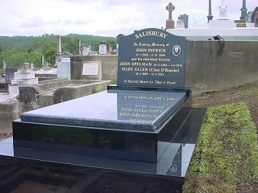
Fig.1.1 Gravestone
Information about headstones
The term ‘headstone’ is quite a common one but can mean a few different things to different people. The words headstone, tombstone, and gravestone are used interchangeably (although this is technically incorrect), however generally a headstone is the part of a gravestone that has an inscription on it. They can be of varying sizes and materials and are traditional grave additions in some religions.

Fig. 1.2 blank headstone

Urns or Vases
The terms ‘urn’ and ‘vase’ can be used interchangeably, or even together such as a marble urn vase. An urn is, in essence, a vase that has a cover on the top. It can be of varying shapes and sizes, as well as different structures and materials. If someone uses the term urn, instead of vase, they are usually referring to how the object is used rather than what it looks like. Urns are used to hold cremation returns and are seen as things of beauty to hold loved ones in.
What are plaques?
Plaques can go by many names when it comes to remembrance purposes, including commemorative plaque and memorial plaque. A plaque is generally attached to a stone, wall or other vertical surface and can be made of a variety of materials, including stone, wood or ceramic. They are used to indicate the resting place of a loved one and commemorate their life. They can be used in place of headstones or in addition to other memorial options.
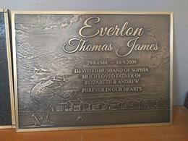
Fig.1.3 plaques
Inscription
The words written on the gravestone. This usually includes the deceased’s name, date of birth, date of death, and a few kind words about them. Sometimes the names of their relatives (partner, parents, siblings, children) are also included.
Grave
The site at a cemetery where a coffin is buried.

Hand Etching
An engraving on the gravestone, carried out by an artisan who specialises in the area. They use a diamond-tipped tool.
Monument Mason
A stonemason who creates and installs headstones and monuments. They also repair monuments.
Laser Etching
Like hand etching, but done by a computer-guided laser instead of by an artisan.
Wings
Two separate headstones that either mirror each other or are symmetrical and make up one solid shape. They are installed on a shared base, and are typically used by partners (ie. Husband and wife, wife and wife, husband and husband).
Monolith
A monument that is installed directly into the ground. It doesn’t have a base, and it stands upright.
Columbarium
A columbarium is a monument that includes vases or housing to store ashes. This can sometimes look like a bookshelf, with different slots for each deceased person.
Mausoleum
A free-standing building that houses the remains of a deceased person.
Crypt
A specific area within a mausoleum where the person’s body is entombed.

Pol
This refers to the finish of the stone chosen for the memorial. Usually ‘pol’ refers to a shiny or glossy finish.
Steel
Nope, this doesn’t refer to the material ‘steel’. Instead, it’s a different type of stone finish (an alternative to ‘pol’). This finish is a smooth one, made by frosting parts of the stone with a sandblaster. It has a velvety feel to it.
Balance Rock Pitched (BRP)
This is a more rustic finish than ‘steel’ and ‘pol’. It’s commonly used on the sides of a monument and exposes the natural stone.
Ledger
A long and flat stone that covers the grave (the bottom part of the monument). Inscriptions can be written on this, as well as on the headstone.
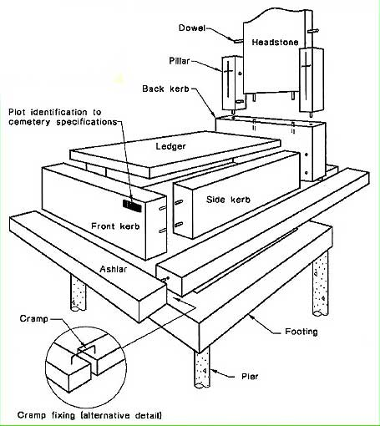
Fig.1.4 part of the monument

1.2 OHS requirements
When erecting stone memorials and monuments, it is important to adhere to occupational health and safety (OHS) requirements to ensure the safety of workers and the public. While specific regulations may vary depending on the jurisdiction, here are some general OHS considerations:
Risk Assessment: Conduct a thorough risk assessment of the work area and tasks involved in erecting the stone memorial or monument. Identify potential hazards such as falling objects, unstable ground, or heavy machinery operation.
Personal Protective Equipment (PPE): Provide appropriate personal protective equipment to workers, which may include hard hats, safety glasses, gloves, and steel-toed boots. The specific PPE requirements should be determined based on the identified hazards.
Safe Lifting and Handling: Proper lifting techniques are crucial to prevent injuries. Train workers on safe lifting and handling practices, and provide mechanical aids such as cranes, hoists, or slings to assist in lifting heavy stone pieces.
Fall Protection: If working at heights, implement fall protection measures such as guardrails, safety harnesses, or safety nets to prevent falls. Ensure that workers are trained in fall prevention and have the necessary equipment and knowledge to use it properly.
Equipment Safety: Regularly inspect and maintain all equipment used during the erection process to ensure it is in good working condition. Follow manufacturer guidelines for safe operation and provide appropriate training to workers.
Hazardous Materials: If any hazardous materials, such as adhesives or solvents, are used during the installation process, follow proper handling, storage, and disposal procedures in accordance with relevant regulations.
Communication and Signage: Clearly communicate any potential hazards or restricted areas to workers and the public through signage and barriers. Ensure that warning signs and safety instructions are clearly visible and understood.
Training and Supervision: Provide comprehensive training to workers on OHS procedures, safe work practices, and emergency protocols. Assign competent supervisors or managers to oversee the erection process and ensure compliance with safety requirements.
Emergency Preparedness: Develop an emergency response plan that includes procedures for dealing with accidents, injuries, or other emergencies. Make sure workers are aware of the plan and know how to respond appropriately.
It is important to consult local OHS regulations and guidelines specific to your jurisdiction, as they may provide additional requirements or recommendations for erecting stone memorials and monuments. Additionally, engaging with experienced professionals in monument erecting or contracting specialized services can ensure compliance with safety standards and best practices.

1.3 Job material and tools and equipment requirements
When erecting stone memorials and monuments, various materials, tools, and equipment are commonly used to ensure compliance with OHS requirements. Here are some examples:
Materials:
- Stone pieces: These include the main components of the memorial or monument, such as large stones, slabs, or blocks.
- Mortar or adhesive: Used to secure and bond the stone pieces together.
- Rebar or steel reinforcements: Provide structural support and stability to the monument, particularly for larger or freestanding structures.
- Gravel or aggregate: Used as a base or foundation material to create a stable surface for the monument.
Tools and Equipment:
- Lifting equipment: Cranes, hoists, or winches are often employed to lift and position heavy stone pieces.
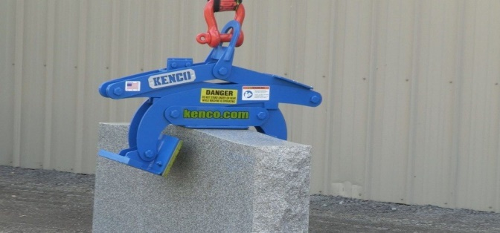
Fig.1.5 Monument and headstone Lifting clamp
- Scaffolding: Provides a safe working platform at elevated heights during construction or installation.
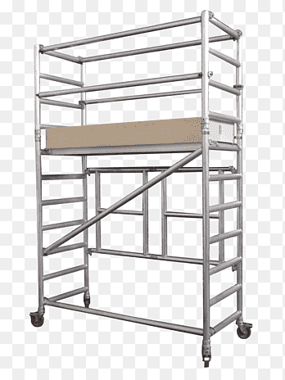
Fig.1.6 Scaffolding
- Hand tools: Various hand tools may be required, including hammers, chisels, drills, levels, measuring tools, and masonry saws for cutting and shaping stone.
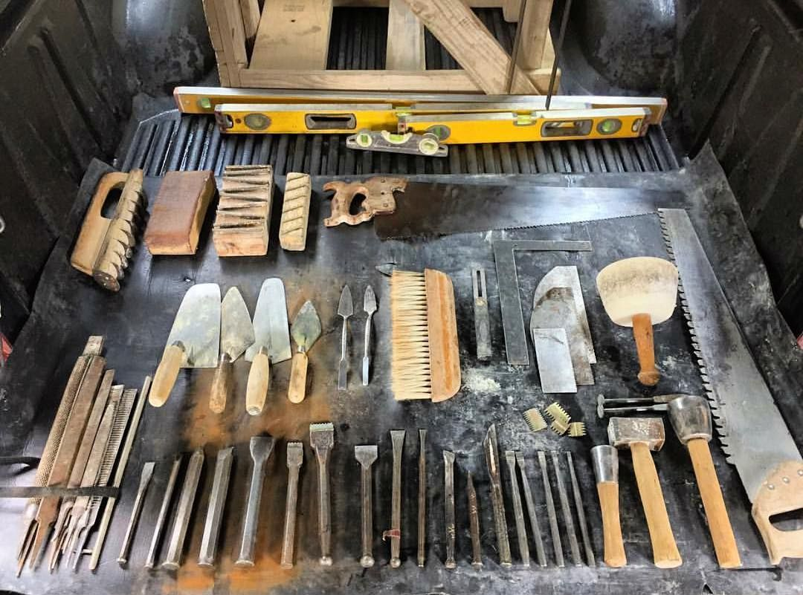
Fig.1.7 stonemason tools
- Mortar mixers: Mechanical mixers that blend mortar or adhesive components to the desired consistency.
- Safety equipment: Personal protective equipment (PPE) such as hard hats, safety glasses, gloves, and steel-toed boots for workers.
- Fall protection equipment: Includes safety harnesses, lanyards, anchor points, and guardrails to prevent falls from heights.
- Ladders: Used for accessing different levels of the monument or working at lower heights.
- Concrete or stone cutting equipment: Tools such as diamond saws or grinders may be necessary for precision cutting or shaping of stone pieces.
- Surveying equipment: Laser levels, measuring tapes, or theodolites can be used to ensure accurate positioning and alignment of the monument.
It's important to note that the specific materials, tools, and equipment required may vary depending on the size, complexity, and design of the monument, as well as local regulations and project specifications. Additionally, the use of specialized equipment and services may be necessary for more intricate or large-scale monument installations. Consulting with experienced professionals or contractors familiar with monument construction can help determine the specific requirements for a given project.
Self-Check -1 | Written Exam

Part –I: - Multiple Choice
Instruction: Select the best answer and encircle the letter/ each 2pts
  - Which of the following is NOT a common material used for stone memorials and monuments?

a) Granite
b) Marble
c) Concrete
d) Limestone

  - What is the purpose of the foundation in the erection process of stone memorials and monuments?

a) To add decorative elements
b) To stabilize the structure
c) To transport the stones
d) To polish the surfaces

  - What is the difference between a memorial and a monument?
a) Memorials are larger than monuments.
b) Memorials are made of stone, while monuments are made of metal.
c) Memorials celebrate events, while monuments commemorate individuals.
d) Memorials are temporary, while monuments are permanent.
  - What is the term used for the words written on a gravestone?

a) Inscription
b) Etching
c) Epitaph
d) Dedication

  - What is a columbarium?

a) A type of monument without a base
b) A structure used to store ashes
c) A specific area within a mausoleum
d) A type of stone finish for memorials
Part –II: Matching
Instruction: select the correct answer for the give matching. You have given 1 Minute for each question. Each question carries /each 2pts
“A” “B”
- Headstone A. Structure commemorating a person or event
- Gravestone B. Entire monument, including base and headstone
- Tombstone C. Stone with inscription on a gravestone
- Monument D. Indicator for burial site with details of life and death
- Inscription E. Engraving on the gravestone

Part –III: Short Answer Questions/ each 2pts
- What are some common considerations for occupational health and safety (OHS) when erecting stone memorials and monuments?
- Describe the general process of stone cutting and shaping in the erection of stone memorials and monuments.
- Explain the difference between a headstone and a gravestone.

Unit Two: Constructing footings and preparing monument stones
This unit is developed to provide you the necessary information regarding the following content coverage and topics:
- Setting out and excavating monument footing
- Placing and fixing reinforcements
- Fixing formworks and pouring concrete
- Checking delivered stone
- Setting out layout on footings
- Installing and testing lifting equipment
This unit will also assist you to attain the learning outcomes stated in the cover page. Specifically, upon completion of this learning guide, you will be able to:
- Set out and excavating monument footing
- Place and fix reinforcements
- Fix formworks and pour concrete
- Check delivered stone
- Set out layout on footings
- Install and test lifting equipment

2.1 Setting out and excavating monument footing
Setting out and excavating monument footings involves several steps to ensure proper placement and stability. Here is a general outline of the process:
  - Design and Planning: Review the design and specifications of the monument footings. Determine the required dimensions, depth, and location of the footings based on the size and weight of the monument.
  - Marking Out: Use surveying equipment, such as a theodolite or laser level, to mark the exact positions of the footings on the ground. This involves driving stakes or placing markers at the corners or edges of the footings.
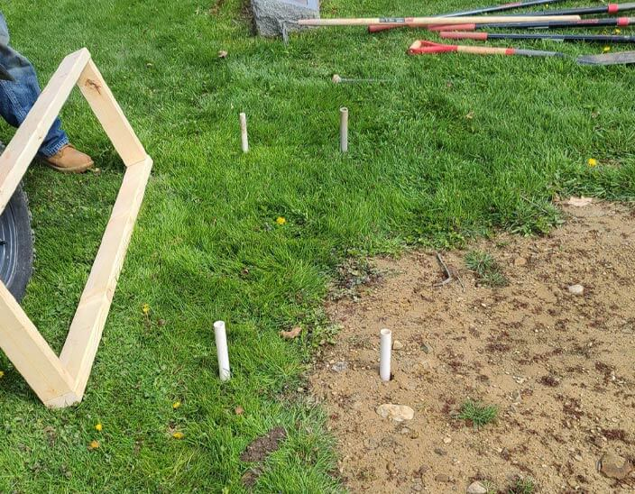
Fig.2.1 Marking footings on the ground
  - Excavation: Begin excavating the marked areas to the required depth for the footings. Use appropriate excavation equipment such as excavators, backhoes, or shovels, depending on the scale of the project. Take care to avoid damaging underground utilities or structures during excavation.

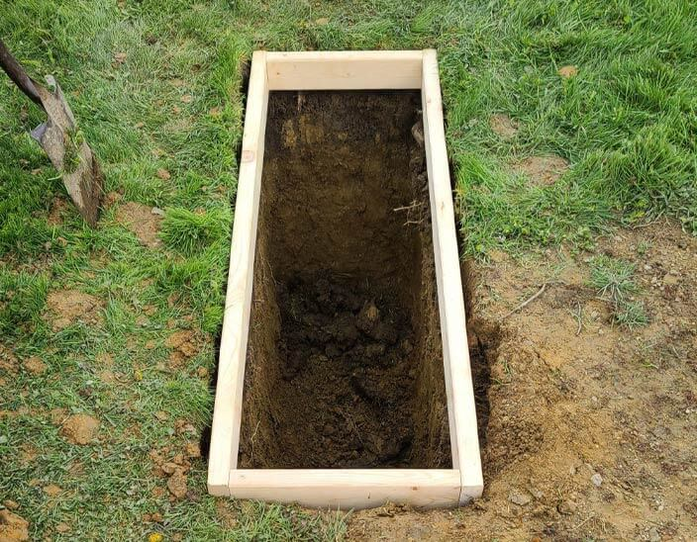
Fig.2.2 excavating monument footing
  - Leveling and Compaction: Ensure the bottom of the excavated area is properly leveled and compacted. This may involve using compacting equipment, such as a plate compactor or a vibrating roller, to achieve a firm and stable base.

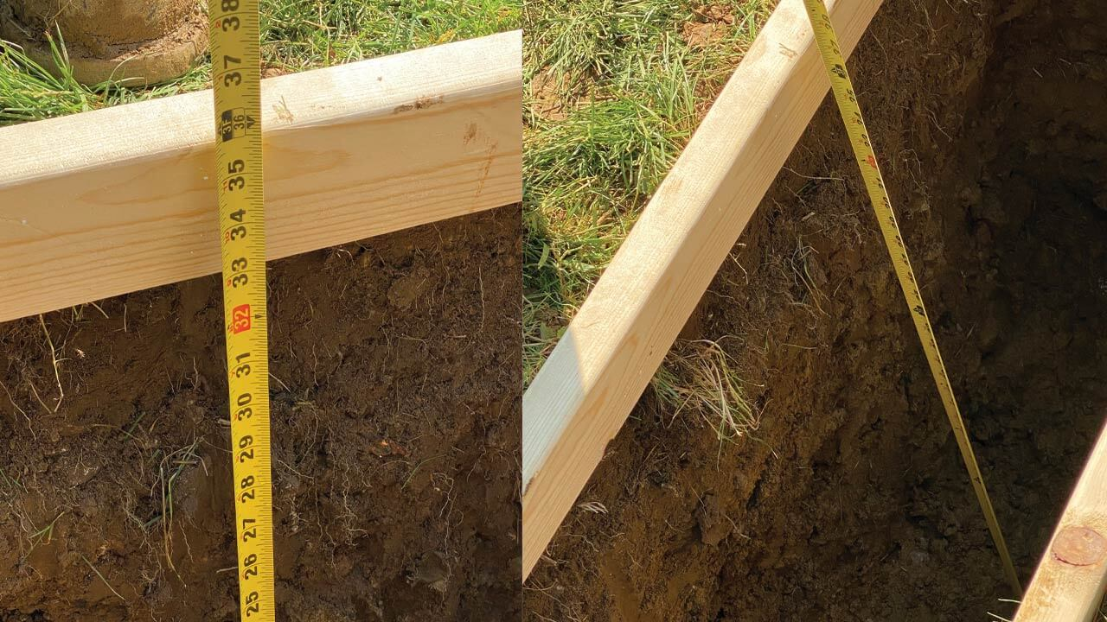
Fig.2.3 measuring depth of excavation

2.2 Placing and fixing reinforcements
Placing and fixing reinforcements in monument footing is an essential step to enhance the structural integrity and strength of the foundation. Here are the key considerations and needs for this process:
  - Structural Design: The reinforcement placement should follow the structural design and engineering specifications for the monument footing. This includes the size, type, and layout of the reinforcement bars (rebar) as specified by the structural engineer.
  - Reinforcement Bars: Use high-quality, corrosion-resistant rebar that complies with applicable standards and codes. The rebar should have proper dimensions, such as diameter and length, as specified in the design.
  - Reinforcement Layout: Follow the prescribed reinforcement layout provided in the structural drawings. This includes the spacing, arrangement, and orientation of the rebar within the footing. The layout ensures the distribution of loads and prevents cracking or failure.
  - Clearances and Cover: Maintain the required clearances between the rebar and the excavation walls, adjacent reinforcement bars, and any embedded items such as anchor bolts. Also, ensure that the rebar is adequately covered by the concrete to protect it from corrosion and provide sufficient structural strength.
  - Reinforcement Tying: Securely tie the rebar intersections using appropriate tying methods, such as wire ties or mechanical connectors. Adequate tying ensures that the reinforcement bars remain in their intended positions during concrete pouring and compaction.
  - Reinforcement Supports: Use reinforcement supports, such as chairs or spacers, to maintain the desired vertical position of the rebar within the footing. These supports prevent the rebar from sinking or moving during concrete placement.
  - Alignment and Plumbness: Ensure that the reinforcement bars are aligned and positioned correctly according to the design. Use plumb bobs, levels, or laser alignment tools to verify the vertical alignment of the rebar.
  - Overlapping and Splicing: If necessary, provide proper overlapping or splicing of the reinforcement bars to achieve the required continuity and strength. Follow the recommended lap lengths or splicing methods specified by the design.
  - Inspection and Quality Control: Conduct regular inspections during reinforcement placement to verify compliance with the design, codes, and quality standards. Inspect for proper bar placement, tie integrity, clearances, and cover requirements.
  - Safety Considerations: Implement appropriate safety measures during the placement and fixing of reinforcement. This includes providing personal protective equipment (PPE) to workers, ensuring a safe work environment, and following safe work practices to prevent injuries.
It's important to note that the reinforcement placing and fixing process should be carried out by trained personnel or experienced contractors who are familiar with the applicable codes and regulations. Engaging the services of a qualified structural engineer or consultant is also recommended to ensure the reinforcement design and installation meet the specific requirements of the monument footing.
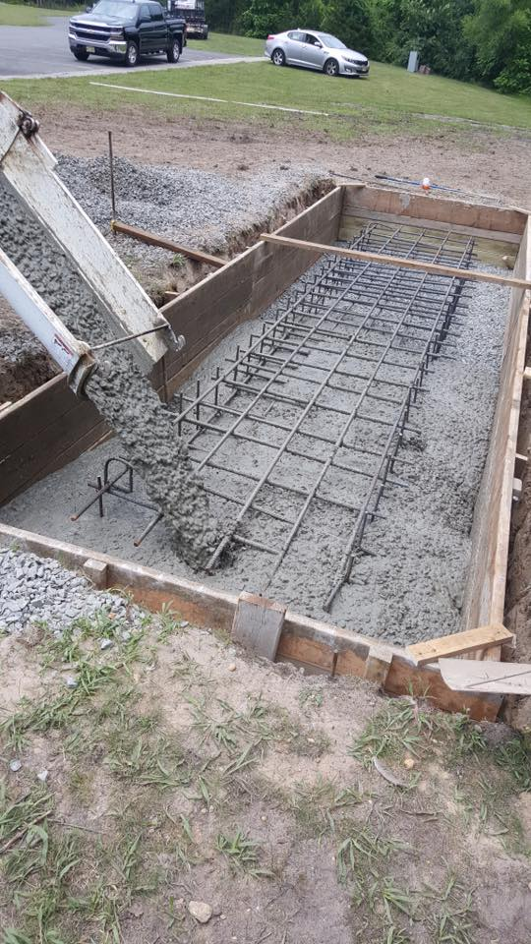
Fig.2.4 Reinforcements in monument footing

2.3 Fixing formworks and pouring concrete
Fixing formworks and pouring concrete in monument footing requires careful planning and execution to ensure a strong and stable foundation for the monument. Here is a step-by-step guide to help you with the process:
  - Clear the area: Start by clearing the area where the monument footing will be constructed. Remove any vegetation, debris, or obstacles that may hinder the construction process.
  - Install formwork: Construct formwork using wooden planks or metal panels to create a mold for the concrete. The formwork should be strong and rigid to hold the concrete in place during pouring.
  - Check alignment and leveling: Before pouring the concrete, double-check the alignment and leveling of the formwork. Use a spirit level and measuring tools to ensure that it is perfectly level and aligned with the design plans.
  - Pouring concrete: Prepare the concrete mix according to the recommended proportions and consistency. Pour the concrete into the formwork gradually, ensuring that it fills all corners and voids evenly. Use a vibrator or rod to remove any air bubbles and ensure proper compaction.
  - Finishing: After pouring the concrete, smoothen the surface using a trowel or float. Remove any excess concrete and make sure the top surface is level and even.
  - Curing: Cover the freshly poured concrete with plastic sheets or use a curing compound to prevent rapid moisture loss. This allows the concrete to cure slowly and gain strength over time. Follow the recommended curing period specified by the concrete supplier or engineer.
  - Removing formwork: Once the concrete has cured sufficiently, carefully remove the formwork. Start by loosening the formwork and then gradually dismantle it to avoid damaging the concrete.
  - Inspect and repair: Inspect the monument footing for any cracks or defects. If any issues are identified, consult with a structural engineer or contractor to determine the appropriate repairs.
Remember to follow all safety guidelines and regulations while working with concrete and heavy machinery. It is recommended to seek professional assistance or guidance if you are not experienced in handling such construction tasks.

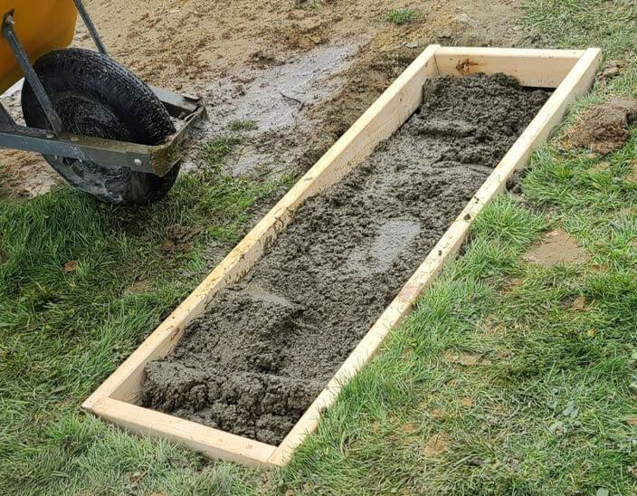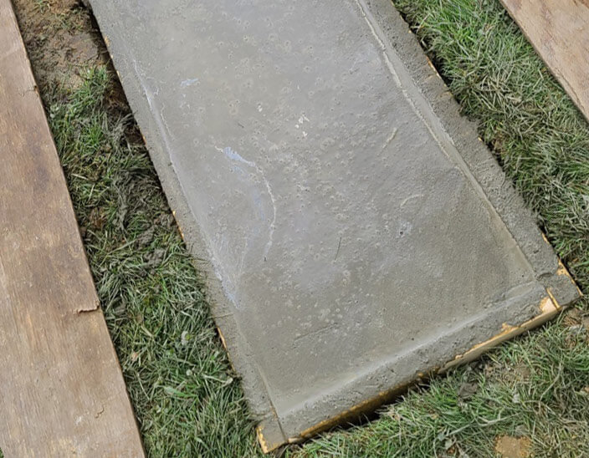
Fig.2.5 fixing formworks and pouring concrete in monument footing

2.4 Checking delivered stone
The term "delivered stone" refers to the process of transporting and delivering the stone materials required for the construction of a monument. When a monument is being built, large stone pieces, such as slabs, blocks, or columns, are typically sourced from quarries or suppliers and transported to the construction site.
The delivered stone may vary in size, shape, and material depending on the design and specifications of the monument. It could be natural stone, such as granite, marble, limestone, or sandstone, which are commonly used in monument construction due to their durability, aesthetic appeal, and availability in various colors and textures.
The delivery process involves several steps:
  - Sourcing: The stone materials are sourced from quarries or suppliers based on the specific requirements of the monument project. Factors such as stone type, quality, size, and color are considered during the selection process.
  - Extraction and Processing: The stone is extracted from quarries through mining or quarrying methods. It is then processed and cut into desired shapes, sizes, and finishes, such as polished, honed, or textured, according to the project requirements.
  - Packaging and Transport: The stone pieces are carefully packaged and loaded onto trucks or shipping containers for transportation to the construction site. Proper packaging and securing techniques are used to protect the stone from damage during transit.
  - Unloading and Storage: Upon arrival at the construction site, the delivered stone is unloaded and stored in a designated area. It may be temporarily stored on pallets or racks to ensure easy access and organization during the construction process.
  - Handling and Installation: The stone pieces are then handled and installed by skilled stonemasons or construction workers according to the monument design. This involves lifting, positioning, and securing the stone components using appropriate equipment, tools, and techniques.
Generally checking the delivered stone of a monument refers to inspecting the quality, size, shape, and condition of the stones that will be used in the construction of the monument. This is done to ensure that the stones meet the required specifications and are suitable for use in the monument. The checking process may involve examining the stones for any cracks, chips, or other defects, as well as verifying that they match the desired color and texture. It is important to carefully inspect the delivered stone to ensure that it meets the design requirements and will contribute to the overall aesthetic and structural integrity of the monument.

2.5 Setting out layout on footings
Setting out the layout on the footing of a monument involves marking the precise positions and dimensions of the foundation on the ground. Here are the steps to set out the layout on the footing:
  - Obtain the Design and Specifications: Acquire the architectural and engineering drawings, plans, or specifications for the monument footing. These documents provide the necessary information on dimensions, shape, and location of the footing.
  - Gather Required Tools and Equipment: Prepare the tools and equipment needed for setting out, which may include measuring tapes, string lines, stakes, pegs, marking paint or chalk, and a measuring instrument (such as a theodolite or laser level).
  - Establish the Reference Point: Identify a reference point near the construction site that aligns with the layout of the monument. This could be an existing benchmark or a known fixed point. Ensure it is stable and will not be disturbed during the construction process.
  - Transfer Dimensions: Use the measurements from the architectural drawings to transfer the dimensions accurately onto the ground. Begin by measuring the distance from the reference point to the corners or edges of the footing. Mark these positions on the ground using stakes or pegs.
  - Establish the Base Line: Set up a base line by stretching a string line between two stakes positioned at the corners or edges of the footing. Ensure the string is taut and level, using a spirit level if necessary. This baseline will serve as a guide for the layout.
  - Mark the Footing Corners: Measure the distances along the base line from the initial reference point to mark the corners of the footing. Use measuring tapes or a measuring instrument to achieve accuracy. Place stakes or pegs at the corners to clearly indicate their positions.
  - Ensure Alignment and Squareness: Check the alignment and squareness of the footing layout by measuring the diagonals between opposite corners. The diagonals should be equal in length, indicating that the footing is square.
  - Confirm Dimensions: Double-check the dimensions and positions of the footing layout against the design drawings to ensure accuracy. Make any necessary adjustments before proceeding.
  - Mark Additional Features: If the footing includes additional features, such as anchor bolt locations or trenches, mark their positions on the ground using appropriate measurements and references. Ensure that these features align with the overall layout.
  - Verify Layout Accuracy: Review the entire layout to ensure it matches the design specifications, including dimensions, angles, and positions. Seek the input of an experienced supervisor, engineer, or architect to confirm the accuracy of the layout.
Setting out the layout on the footing is a critical step to ensure the monument is constructed according to the intended design. Accurate markings and measurements are essential for positioning the monument securely and maintaining its structural integrity.

2.6 Installing and testing lifting equipment
Lifting equipment is essential for handling and moving heavy stone components during the construction of a monument. Here are some common types of lifting equipment used for handling stone:
  - Cranes
  - Hoists
  - Forklifts
  - Vacuum Lifters
  - A-Frames and Lifting Clamps
  - Lifting Slings and Shackles
  - Pneumatic or Hydraulic Lifters
When using lifting equipment for stone handling, it is crucial to ensure that the equipment is appropriately sized and rated for the weight and size of the stone components. Trained and experienced operators should operate the equipment safely, following all necessary safety precautions and regulations.
Installing and testing lifting equipment for a stone monument refers to the process of setting up and evaluating the machinery and tools used to lift and position the stones during the construction of the monument. This involves installing cranes, hoists, slings, and other equipment necessary for lifting heavy stones safely and efficiently.
Testing the lifting equipment involves conducting various inspections and trials to ensure that the machinery is in proper working condition and meets safety standards. This may include load testing to determine the maximum weight capacity of the equipment, checking for any mechanical issues or malfunctions, and verifying that all safety features are functioning correctly.
By installing and testing lifting equipment, construction teams can ensure that they have the necessary tools and machinery to handle the weight and size of the stones, minimizing the risk of accidents or damage during the monument's construction.
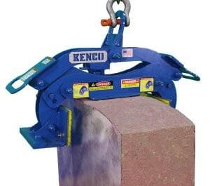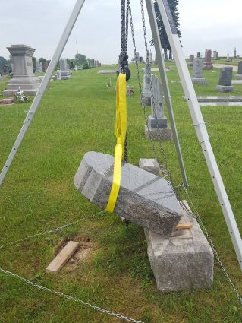
Fig.2.6 lifting equipment

Self-Check -2 | Written Exam

Part –I: - Multiple Choice
Instruction: Select the best answer and encircle the letter/ each 2pts
- What is the purpose of excavating monument footings?
a. To mark the exact positions of the footings
b. To pour concrete into the footings
c. To enhance the structural integrity of the foundation
d. To install reinforcement bars in the footings
- What is the recommended material for reinforcement bars in monument footings?

a. Wood
b. Corroded rebar
c. High-quality, corrosion-resistant rebar
d. Steel cables

- What is the purpose of formwork in monument footing construction?
a. To level and compact the excavated area
b. To mark the exact positions of the footings
c. To hold the concrete in place during pouring
d. To install reinforcement bars in the footings
- What is the recommended method to achieve proper compaction of the concrete?

a. Using a vibrating roller
b. Using a plate compactor
c. Using a trowel or float
d. Using a spirit level

- What should be done after pouring the concrete into the formwork?

a. Install the reinforcement bars
b. Mark the exact positions of the footings
c. Smooth the surface with a trowel or float
d. Remove the formwork gradually

Part –II: Matching
Instruction: Match the following terms related to monument construction with their corresponding descriptions/each 2pts
“A” “B”
- Rebar A. Ensures even distribution of loads
- Excavation B. Removing excess concrete and leveling the surface
- Formwork C. Placing and fixing reinforcement bars
- Compaction D. Digging and removing soil to create space for footings
- Finishing E. Creating a mold to hold concrete during pouring
Part –III: Short Answer Questions/each 2pts
- Why is it important to use high-quality, corrosion-resistant rebar in monument footings?
- What are some safety considerations that should be taken during the placement and fixing of reinforcement in monument footings?
- Explain the purpose of curing the poured concrete in monument footings and how it contributes to the strength of the foundation.

Operation sheet: 2.1
Operation Title: Constructing footing and preparing monument stones
Purpose: To construct footings and prepare monument stones for the installation of a structure or monument.
Instructions: Use the given tools and equipment to construct footings and prepare monument stones by following procedures described below. For this operation you have given 3 hours and you are expected to provide the project on the given time.
Conditions or Situations for the Operations:
  - Ensure that the site is accessible for excavation equipment, delivery of materials, and movement of workers.
  - Evaluate the soil conditions to determine if any additional measures, such as soil stabilization or reinforcement, are necessary for the footings.
  - Consider the impact of weather conditions, such as rain or extreme temperatures, on the curing of concrete and the preparation of monument stones.
Tools and Equipment: The following tools and equipment may be required for the operation:
  - Excavation equipment (e.g. Shovel, backhoe)
  - Compaction equipment (e.g., plate compactor)
  - Formwork materials (e.g., timber, plywood, metal)
  - Reinforcement bars (rebar)
  - Concrete mixing equipment (e.g., concrete mixer)
  - Concrete vibrator
  - Stone-cutting tools (e.g., saws, chisels)
  - Safety equipment (e.g., hard hats, gloves, safety glasses)
Materials: The materials required for the operation may include:
  - Concrete mix (cement, aggregates, water)
  - Formwork materials (timber, plywood, metal)
  - Reinforcement bars (rebar)
  - Plastic sheets (for curing)
  - Curing compound
  - Monument stones (if applicable)
Procedure: The general procedure for the operation involves:
- Excavate the footing area to the required dimensions and depth.
- Level and compact the bottom of the footing trenches.
- Install formwork around the footing trenches.
- Place reinforcement bars within the formwork
- Prepare and pour the concrete mix into the formwork.
- Use a concrete vibrator to remove air pockets and achieve proper compaction.
- Cover the footings with plastic sheets or apply curing compound for proper curing.
- Select and prepare monument stones according to the design requirements using appropriate stone-cutting tools and techniques.
Precautions: Some precautions to consider during the operation include:
  - Follow safety guidelines and ensure workers wear appropriate personal protective equipment.
  - Adhere to local building codes and regulations.
  - Provide proper bracing and support to the formwork to prevent collapse during concrete pouring.
  - Monitor weather conditions and take necessary measures to protect the concrete and the monument stones from adverse effects.
  - Properly handle and store materials to maintain their quality and integrity.

Quality Criteria: The quality of the constructed footings and prepared monument stones can be assessed based on the following criteria:
  - The footings should provide a stable and secure foundation for the structure or monument.
  - The footings and monument stones should meet the specified dimensions and tolerances.
  - The cured concrete should achieve the required strength based on the structural design and specifications.
  - The monument stones should exhibit the desired finish and appearance according to the design requirements.

LAP TEST: 2
Name: _____________________________ Date: ________________
Time started: ________________________ Time finished: ________________
Instructions: - Given necessary templates, tools and materials you are required to perform the following tasks within 3 hours.

Task 1. Construct footing and prepare monument stones

Unit Three: Setting up side stones into place
This unit is developed to provide you the necessary information regarding the following content coverage and topics:
- Standing up side stones into position
- Checking side stones for plum bob
- Checking measurement for diagonals and parallel
- Checking stone alignment
This unit will also assist you to attain the learning outcomes stated in the cover page. Specifically, upon completion of this learning guide, you will be able to:
- Stand up side stones into position
- Check side stones for plum bob
- Check measurement for diagonals and parallel
- Check stone alignment

3.1 Standing up side stones into position
Side Stones
In the context of monument erection, "side stones" typically refers to the stone elements or components that are positioned alongside or adjacent to the main central feature of the monument. These side stones are often used to enhance the overall design and aesthetics of the monument.
Here are a few common examples of side stones in monument erection:
  - Flanking Columns
  - Pedestals or Bases
  - Wing Walls
  - Decorative Panels
  - Steps or Staircases
  - Boundary Markers
Standing up side stones into position during monument construction requires careful planning, coordination, and the use of appropriate equipment and techniques. Here is a general outline of the process:
  - Preparation: Ensure that the foundation or base where the side stones will be installed is properly prepared and leveled. Clear any debris or obstacles from the area to allow for safe and unobstructed installation.
  - Lifting Equipment: Arrange the necessary lifting equipment based on the size and weight of the side stones. This may include cranes, hoists, forklifts, or other lifting devices suitable for the specific stones and site conditions.
  - Positioning: Carefully position the lifting equipment near the side stone to be installed, ensuring that it has sufficient reach and capacity to lift and maneuver the stone safely.
  - Attachments: Determine the appropriate lifting attachments or rigging techniques for the side stone. This may include slings, straps, clamps, or specialized lifting devices designed to securely grip the stone without causing damage.
  - Lifting and Guidance: Engage the lifting equipment to gradually lift the side stone off the ground, keeping it stable and balanced. Use guide ropes or additional personnel to help guide and control the stone's movement during the lifting process.
  - Alignment and Leveling: As the side stone is raised, carefully align it with the designated position on the monument. Adjust the lifting equipment and guide ropes as needed to ensure proper alignment and levelness.
  - Lowering and Placement: Once the side stone is aligned, slowly lower it into position. Maintain control over the stone's descent to prevent sudden impacts or shifts that could damage the stone or surrounding structures.
  - Securing: Once the side stone is in place, secure it to the monument's structure using appropriate methods. This may involve using mortar, epoxy, or mechanical fasteners to ensure a secure and durable connection.
  - Leveling and Adjustments: Check the levelness and alignment of the side stone after placement. Make any necessary adjustments to ensure it is properly aligned with adjacent stones and the overall monument design.
  - Repeat Process: Repeat the above steps for each side stone, taking into account the specific requirements and design of each stone.
It is important to note that the process may vary depending on the size, weight, and complexity of the side stones, as well as the specific lifting equipment and techniques employed on the construction site. Adhering to safety protocols and working with experienced personnel is crucial to ensure a successful and safe installation of the side stones in the monument construction process.

3.2 Checking side stones for plum bob
To check side stones for plum bob, follow these steps:
  - Set up a plum bob: A plum bob is a weighted object attached to a string or line. Hang the plum bob from a fixed point above the side stone you want to check. Ensure that the string is long enough to reach the ground.
  - Align the plum bob: Allow the plum bob to hang freely and come to a complete stop. The weighted object should be directly above the center of the side stone.
  - Observe the alignment: Stand back and visually inspect the alignment of the side stone with the plum bob. Check if the side stone is perfectly aligned with the vertical line created by the plum bob.
  - Make adjustments if necessary: If the side stone is not aligned with the plum bob, it may indicate that it is not plumb (vertical). Adjustments will be required to correct its alignment. This can involve using shims or other leveling tools to bring the stone into proper alignment.
  - Repeat the process: Check each side stone individually using the plum bob method to ensure that all stones are properly aligned.
It is important to note that checking for plumb bob alignment is just one aspect of ensuring the correct positioning of stones during monument construction. Other factors such as levelness, stability, and overall structural integrity should also be considered and evaluated during the installation and testing process.

3.3 Checking measurement for diagonals and parallel

To measure the diagonals and parallel sides of a monument, you will need some measuring tools and techniques. Here's a general overview of the process:
  - Gather the necessary tools: You will need a measuring tape or a laser distance measurer, a level, and possibly stakes and strings for marking reference points.
  - Establish a reference point: Choose a fixed reference point on the monument from where you will take your measurements. It could be a corner, an edge, or any other clearly identifiable point.
  - Measure the diagonals: To measure the diagonals, start from your reference point and extend your measuring tape or laser distance measurer along one side of the monument to the opposite corner. Take note of the measurement. Then, repeat this process for the other diagonal, starting from your reference point to the opposite corner.
  - Measure parallel sides: To measure the parallel sides, place your measuring tape or laser distance measurer along one side of the monument and measure the distance between the two endpoints. Take note of the measurement. Repeat this process for the other parallel side.
  - Verify parallelism: To verify that the sides are parallel, you can use a level. Place the level on each side and check if the bubble is centered. If it is, then the sides are parallel. If not, adjustments may need to be made.
  - Mark the measurements: If necessary, use stakes and strings to mark the measurements on the monument. This can be helpful if you need to reference the measurements later or if you are making any modifications based on the measurements.
Remember to take accurate measurements by ensuring that your measuring tape or laser distance measurer is straight and level. Take multiple measurements to ensure accuracy, and consider seeking professional assistance if precise measurements are crucial or if the monument is particularly large or complex.

3.4 Checking stone alignment
Alignment
Alignment refers to the arrangement or positioning of objects or elements in a straight, parallel, or harmonious manner. It involves ensuring that the components or parts of a system are correctly positioned or oriented relative to each other or to a reference point.
Alignment during setting up side stones in monument work refers to the process of positioning and arranging the side stones in a precise and visually pleasing manner.
To check the stone alignment at both the front and back ends of side stones during the construction of a monument, you can follow these steps:
  - Establish reference points: Identify reference points on the monument that will help guide the alignment process. These could be corners, edges, or any other prominent features that will serve as a guide for aligning the side stones.
  - Use a string line or straightedge: Stretch a taut string line or place a straightedge horizontally across the front face of the side stones, aligning it with the desired position of the stones.
  - Check alignment at the front end: Stand at the front end of the side stones and visually inspect the alignment of the stones with the string line or straightedge. Ensure that the edges or corners of the stones are in line with the reference points and the string line or straightedge.
  - Adjust the stones if necessary: If the alignment is off, make necessary adjustments by tapping or shifting the stones. Use a rubber mallet or wooden block to avoid damaging the stones. Continuously check the alignment as you make adjustments.
  - Secure the front end alignment: Once you are satisfied with the alignment at the front end, temporarily secure the stones in place using wooden wedges or shims. This will help maintain the alignment while you proceed to check the back end.
  - Move to the back end: Go to the back end of the side stones while keeping the string line or straightedge in place at the front. Visually inspect the alignment of the stones with the string line or straightedge, ensuring they align with the reference points.
  - Adjust the stones at the back end: If the alignment is off at the back end, make necessary adjustments to bring the stones into alignment. Tap or shift the stones as needed, checking the alignment from different angles.
  - Verify overall alignment: Step back and visually inspect the alignment of the side stones from multiple perspectives. Ensure that the front and back ends are parallel and that the stones form a straight line. Make further adjustments as required.
  - Secure the final alignment: Once you are satisfied with the alignment, securely fix the stones in place using mortar, adhesive, or any other appropriate method specified for the monument construction.
It is crucial to periodically check the alignment throughout the construction process and make adjustments as necessary to ensure the monument's structural integrity and aesthetic appeal. Additionally, consulting with a professional stone mason or construction expert can provide valuable guidance for achieving precise alignment.

Self-Check -3 | Written Exam

Part –I: - Multiple Choice
Instruction: Select the best answer and encircle the letter/ each 2pts
- When standing up side stones during monument construction, what is the purpose of using lifting equipment?

a. Enhancing the design and aesthetics
b. Securing the stones to the monument
c. Aligning the stones with adjacent ones
d. Safely lifting and maneuvering the stones

- What is a plum bob used for in monument construction?

a. Checking side stone alignment
b. Measuring diagonal distances
c. Leveling the monument base
d. Lifting heavy stones into position

- How can you verify if parallel sides of a monument are aligned?

a. Check the levelness of the sides
b. Measure the distance between endpoints
c. Use a plum bob to check alignment
d. Verify the vertical alignment with a string line

- What is the purpose of using reference points when checking stone alignment?

a. To secure the stones in place
b. To measure the diagonal distances
c. To guide the alignment process
d. To ensure parallelism of the sides

- Why is it important to periodically check the alignment during monument construction?
a. To enhance the overall design and aesthetics
b. To ensure the structural integrity of the monument
c. To measure the distances between the stones
d. To secure the stones in their final positions

Part –II: Matching
Instruction: Match the following terms with their corresponding descriptions/each 2pts
“A” “B”
- Flanking Columns A. Stone elements positioned alongside the main central feature of the monument.
- Pedestals or Bases B. Stone components used to enhance the overall design and aesthetics.
- Wing Walls C. Stone elements used as boundary markers.
- Decorative Panels D. Stone elements used as steps or staircases.
- Boundary Markers E. Stone elements used to support and elevate the monument's main central feature.
Part –III: Short Answer Questions
- What are some of the key steps involved in standing up side stones into position during monument construction?
- How can you check side stones for plum bob alignment?
- Describe the process of checking the measurement for diagonals and parallel sides of a monument.

Unit Four: Preparing dowel joints and Standing up front and back stones
This unit is developed to provide you the necessary information regarding the following content coverage and topics:
- Checking measurement of dowel holes depth
- Measuring and marking dowels to length
- Inserting dowels
- Mixing mortar
- Inserting designated dowels into mortared holes
- Placing mortar to fill holes
- Maneuvering back stone and adjusting packing
- Locating, raising and maneuvering front stone
This unit will also assist you to attain the learning outcomes stated in the cover page. Specifically, upon completion of this learning guide, you will be able to:
- Check measurement of dowel holes depth
- Measure and mark dowels to length
- Insert dowels
- Mix mortar
- Insert designated dowels into mortared holes
- Place mortar to fill holes
- Maneuver back stone and adjust packing
- Locate, raise and maneuver front stone

4.1 Checking measurement of dowel holes depth
Dowel
In monument construction, a dowel refers to a cylindrical rod or pin that is used to join or align two separate stone or concrete elements. It is typically made of metal, such as stainless steel or carbon steel, or sometimes wood.
Dowels serve as a means of connecting structural components or aligning stone elements to ensure stability, strength, and proper positioning in monument construction. They are commonly used in the following scenarios:
  - Joint reinforcement
  - Alignment and leveling
  - Connection between elements
  - Seismic stability
Checking dowel hole depth
To check the measurement of dowel hole depth in monument works, you can follow these steps:
  - Gather the necessary tools: You will need a tape measure or a depth gauge and a flashlight if the holes are not easily visible.
  - Locate the dowel holes: Identify the dowel holes in the monument where the dowels are to be inserted. They are typically pre-drilled or carved holes in the stone or concrete elements.
  - Measure the depth: Insert the tape measure or depth gauge into the dowel hole and extend it until it reaches the bottom of the hole. If the hole is deep and not easily visible, use a flashlight to help you see the bottom.
  - Read the measurement: Once the tape measure or depth gauge is in place, read the measurement at the point where it extends out of the hole. This will give you the depth of the dowel hole.
  - Repeat for other dowel holes: If there are multiple dowel holes, repeat the process for each one, ensuring accurate measurements for all the holes.
  - Verify depth requirements: Compare the measured depths to the specified requirements for the dowel holes. The depth requirements are typically specified in the construction plans or design documents. Ensure that the measured depths meet the specified criteria.
  - Make adjustments if necessary: If the measured depths do not meet the specified requirements, adjustments may need to be made. This could involve drilling the hole deeper or filling the hole to reduce the depth, depending on the situation.
It is essential to accurately measure the dowel hole depths to ensure proper installation of the dowels and the structural integrity of the monument. Precise measurements will help achieve the desired strength, alignment, and stability in the monument construction. If you are unsure or working on a complex project, it is recommended to consult with a structural engineer or a monument construction professional for guidance.

4.2 Measuring and marking dowels to length

To measure and mark dowels to the appropriate length in monument works, you can follow these steps:
  - Determine the required dowel length: Refer to the construction plans or design documents to identify the required length for the dowels. The length will depend on the specific application and the depth of the dowel holes.
  - Prepare the tools: Gather the necessary tools, including a measuring tape or ruler, a marker or pencil, and a cutting tool suitable for the dowel material (e.g., a hacksaw or a power saw).
  - Measure the dowel length: Using a measuring tape or ruler, measure the required length for the dowel from one end to the other. Ensure that you are measuring the entire length accurately.
  - Mark the dowel: Once you have determined the correct length, use a marker or pencil to make a clear and visible mark on the dowel at the measured length. Make sure the mark is easily visible and distinguishable.
  - Double-check the measurement: Before cutting the dowel, double-check the marked length to ensure it matches the required length specified in the construction plans or design documents. Accuracy is essential to ensure proper fit and alignment.
  - Cut the dowel: Using an appropriate cutting tool, carefully cut the dowel at the marked location. Follow safety precautions and use proper techniques to achieve a clean and accurate cut.
  - Smooth the cut end: After cutting the dowel, you may need to smooth the cut end to ensure a clean finish. Use sandpaper or a file to remove any rough edges or splinters.
  - Verify the length: Once the dowel is cut, verify its length by measuring from the cut end to the opposite end. Ensure that it matches the required length specified in the construction plans or design documents.
  - Repeat for other dowels: If there are multiple dowels to be cut, repeat the measurement and marking process for each one, ensuring accurate lengths for all the dowels.
It is crucial to measure and mark dowels accurately to ensure proper fit and alignment when inserting them into dowel holes during monument construction. If you are unsure or working on a complex project, it is recommended to consult with a monument construction professional for guidance.

4.3 Inserting dowels

Inserting dowels in monument works involves the following steps:
  - Prepare the dowels: Ensure that the dowels are cut to the appropriate length and have been smoothed at the cut ends, as discussed in the previous response.
  - Prepare the dowel holes: Verify that the dowel holes have been properly drilled or carved in the stone or concrete elements of the monument. The dowel holes should match the diameter and depth required for the dowels.
  - Apply adhesive (if necessary): Depending on the specific project requirements, you may need to apply an adhesive to the dowel holes. The adhesive helps create a strong bond between the dowels and the holes, enhancing the stability and strength of the connection.
  - Insert the dowels: Take a dowel and apply a small amount of adhesive (if required) to the end that will be inserted into the dowel hole. Insert the dowel into the dowel hole, ensuring that it goes in straight and fully seats into the hole.
  - Check alignment: As you insert the dowels, periodically check their alignment to ensure they are properly positioned and aligned with adjacent stone or concrete elements. Use visual inspection or a level to verify alignment, depending on the specific requirements.
  - Tap the dowels (if necessary): In some cases, you may need to tap the dowels gently with a mallet or hammer to ensure they are fully seated and to create a tight fit in the dowel holes. Use caution to avoid damaging the stone or concrete elements.
  - Wipe away excess adhesive: If adhesive was used, wipe away any excess adhesive that may have squeezed out during the dowel insertion process. This will help maintain the cleanliness and appearance of the monument.
  - Allow for curing (if applicable): If an adhesive was used, allow sufficient time for the adhesive to cure as per the manufacturer's instructions. This ensures that the dowel connection achieves maximum strength and stability.
  - Repeat for other dowels: If there are multiple dowels to be inserted, repeat the process for each dowel, ensuring accurate placement and alignment.
Proper insertion of dowels is crucial for maintaining the structural integrity and stability of the monument. It is recommended to consult with a monument construction professional or follow any specific guidelines provided by the project engineer or architect to ensure the correct installation of dowels in your specific monument works.

4.4 Mixing Mortar
Mortar
Mortar is a building material used in construction that consists of a mixture of cement or lime, sand, and water. It serves as a binding agent or adhesive to join together bricks, stones, or other masonry units in various construction projects, including monuments, buildings, walls, and structures.
The primary purpose of mortar is to fill the gaps and spaces between masonry units, providing structural integrity, stability, and cohesion to the overall construction. It acts as a bond between the individual units, distributing loads, and transferring forces between them.
Mortar is typically mixed on-site or in a controlled environment using specific proportions of cement or lime, sand, and water. The specific composition and ratio of these materials can vary depending on factors such as the desired strength, application, and environmental conditions.
Once mixed, mortar is applied to the surfaces of masonry units using trowels or other tools. It is then compacted into the joints, filling them completely. As the mortar cures, it hardens and develops strength, creating a solid and durable connection between the masonry units.
Mortar can also be customized with additives or admixtures to enhance specific properties such as workability, strength, durability, or water resistance, depending on the requirements of the construction project.
Cement Mortar
Mortar is a homogenous mixture of cement, sand and water. Different types of mortars are used in masonry construction based on their applications, binding materials, strength, bulk density and their purposes.
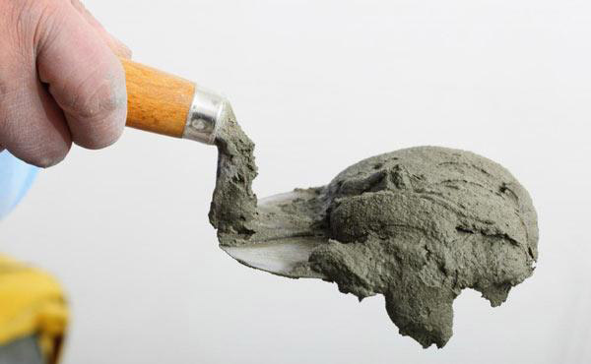
Fig.4.1 Cement Mortar
Nowadays, cement mortars are most commonly used as mortar in construction. Cement mortar is used in all types of construction work due to its strong and durable properties.
Preparation of Cement Mortar
According to ‘Satheesh Gopi’ (Author of Basic Civil Engineering), the preparation of the cement mortar involves following steps:
- Selection of Raw Materials
- Proportion of cement mortar
- Mixing of ingredients
- Selection of Raw Materials
Although there are different types of materials available for the preparation of Cement Mortar, it is necessary to ensure that the right materials are selected based on the type of construction and its purpose.
The Portland cement is used to make mortar. Ordinary Portland cement is most suitable for common construction purposes. For making composite mortars, Lime is also used.
Sand must be of good quality and it should be free of impurities like clay, dust, oxide of irons etc. It must be cleaned completely before mixing with cement.
Sand provides strength, resistance against shrinkage and cracking. It provides bulk to mortars, hence, making it economical. Using just cement would not only make it extremely costly, but also impractical.
- Proportion of Cement Mortar
The Proportion means the relative quantity of different components to be mixed to make good mortar, or simply the ratio between different materials.
Following are the proportions of cement mortar which is commonly recommended for masonry Construction:
- For ordinary masonry work with brick/ stone as a structural unit. – 1:3 to 1:6
- For reinforced brick work – 1:2 to 1:3.
- For all work in moist situations – 1:3
- For Architectural work – 1:6
- For Load Bearing structures – 1:3 or 1:4

- Mixing of Ingredients
To prepare cement mortar, cement and sand are properly mixed in dry condition. Water is then added gradually and mixed using a shovel. The water should be free from clay and other impurities.
Cement mortar can either be mixed manually (Hand Mixing) or mechanically (Machine Mixing). For small construction, hand mixing is commonly used. Mechanical mixing is required when the mortar is needed in large quantities and needs to be used in continuous order.
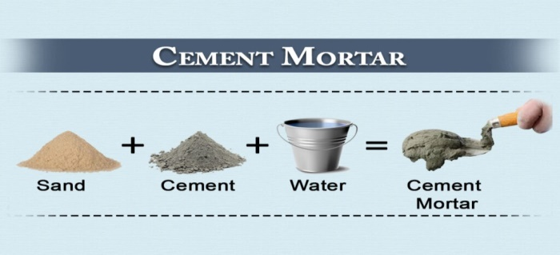
Fig.4.2 Ingredients of cement mortar

4.5 Inserting designated dowels into mortared holes

To insert designated dowels into mortared holes, you can follow these steps:
  - Prepare the dowels: Ensure that the dowels are cut to the appropriate length and have been smoothed at the cut ends. Verify that they meet the required specifications for diameter and length.
  - Prepare the mortared holes: Make sure the mortared holes are clean and free from debris or excess mortar. If needed, use a brush or other tools to remove any loose material from the holes.
  - Apply mortar adhesive (if necessary): Depending on the specific project requirements, you may need to apply a mortar adhesive to the mortared holes. The adhesive helps create a strong bond between the dowels and the surrounding mortar.
  - Insert the dowels: Take a dowel and apply a small amount of mortar adhesive (if required) to one end. Insert the dowel into the mortared hole, ensuring that it goes in straight and fully seats into the hole.
  - Tap the dowels (if necessary): In some cases, you may need to tap the dowels gently with a mallet or hammer to ensure they are fully seated and to create a tight fit within the mortared holes. Use caution to avoid damaging the dowels or the surrounding masonry.
  - Check alignment: As you insert the dowels, periodically check their alignment to ensure they are properly positioned and aligned with adjacent masonry units or structural elements. This helps maintain the desired aesthetics and structural integrity of the monument.
  - Wipe away excess mortar: If mortar adhesive was used, wipe away any excess mortar that may have squeezed out during the dowel insertion process. This helps maintain the cleanliness and appearance of the monument.
  - Allow for curing: If mortar adhesive was used, allow sufficient time for the adhesive to cure as per the manufacturer's instructions. This allows the dowel connection to achieve maximum strength and stability.
  - Repeat for other designated dowels: If there are multiple dowels to be inserted, repeat the process for each dowel, ensuring accurate placement and alignment.
Proper insertion of designated dowels into mortared holes is crucial for the stability and longevity of the monument. It is recommended to consult with a monument construction professional or follow any specific guidelines provided by the project engineer or architect to ensure the correct installation of dowels in your specific monument works.

4.6 Placing mortar to fill holes

When placing mortar to fill holes in monument stone works, it is important to follow best practices to ensure a proper and long-lasting repair. Here are some guidelines to consider:
  - Clean the area: Before applying mortar, clean the holes and surrounding area thoroughly. Remove any loose debris, dirt, or old mortar using a brush or a soft cloth. This will ensure better adhesion of the new mortar.
  - Choose the right mortar mix: Select a mortar mix that is suitable for stone repairs. It should have the right consistency and strength to provide a durable repair. Consult with a professional or a local supplier to determine the appropriate mortar mix for your specific stone.
  - Prepare the mortar mix: Follow the manufacturer's instructions to prepare the mortar mix. Typically, it involves mixing the mortar powder with water to achieve the desired consistency. Use a clean container and mix the mortar thoroughly to ensure a uniform blend.
  - Apply the mortar: Using a trowel or a pointing tool, carefully fill the holes with the prepared mortar mix. Press the mortar firmly into the holes, ensuring that there are no voids or air pockets. Smooth the surface of the mortar to match the surrounding stone.
  - Allow for curing: After applying the mortar, allow it to cure according to the manufacturer's instructions. This usually involves keeping the repaired area moist and protected from extreme temperatures for a certain period of time. Follow the recommended curing time to ensure the mortar sets properly.
  - Monitor and maintain: Regularly inspect the repaired area to ensure the mortar is holding up well. If any cracks or deterioration occur, address them promptly to prevent further damage. Additionally, consider applying a protective sealant to the repaired area to enhance its longevity.
It is important to note that these guidelines provide general recommendations. For more specific advice or complex repairs, it is advisable to consult with a professional stone mason or restoration specialist.

4.7 Maneuvering back stone and adjusting packing

When it comes to maneuvering back stone and adjusting packing, there are several best practices that can help ensure a safe and efficient process. Here are some tips to consider:
  - Assess the weight and size of the stone: Before attempting to maneuver the stone, it's important to assess its weight and size. This will help determine the appropriate equipment and techniques to use.
  - Use proper lifting techniques: When lifting heavy objects like stones, it's crucial to use proper lifting techniques to avoid injury. This includes bending at the knees, keeping the back straight, and using the legs and core muscles to lift the stone.
  - Use lifting equipment: Depending on the size and weight of the stone, it may be necessary to use lifting equipment such as straps, slings, or a forklift. These tools can provide additional support and make maneuvering the stone easier.
  - Clear the path: Before moving the stone, ensure that the path is clear of any obstacles or debris. This will help prevent accidents and make it easier to maneuver the stone.
  - Secure the stone during transport: Once the stone is lifted and ready to be moved, it's important to secure it properly to prevent shifting or falling. This can be done using straps, chains, or other securing methods.
  - Adjust packing: If the stone is being packed or transported in a container or crate, it's important to ensure that it is properly packed and secured. This may involve using padding or cushioning materials to protect the stone from damage during transport.
Remember, safety should always be the top priority when maneuvering heavy objects like stones. If you are unsure about the best approach or lack the necessary equipment, it may be advisable to seek professional assistance.

4.8 Locating, raising and maneuvering front stone
Locating, raising, and maneuvering a front stone in construction or monument work typically involves the following steps:
  - Planning and preparation: Before you begin, ensure you have a clear understanding of the desired location and orientation of the front stone. Take measurements and mark the intended placement on the foundation or base. Gather the necessary tools and equipment for lifting and maneuvering the stone safely.
  - Lifting equipment: Depending on the size and weight of the front stone, you may need specialized lifting equipment such as a crane, forklift, or hoist. Ensure that the lifting equipment is appropriate for the load and that operators are trained and qualified to operate it safely.
  - Positioning the lifting equipment: Position the lifting equipment in a suitable location, considering factors such as stability, clearance, and accessibility. Ensure that the lifting equipment is properly set up and securely anchored to prevent accidents.
  - Attaching lifting slings or clamps: Use appropriate lifting slings or clamps to secure the front stone to the lifting equipment. Ensure that the slings or clamps are positioned securely and evenly to distribute the load evenly.
  - Lifting the stone: Engage the lifting equipment to slowly and steadily lift the front stone off the ground. Coordinate with the operator of the lifting equipment and communicate effectively to ensure a controlled and safe lifting process.
  - Transporting the stone: Once the stone is lifted, carefully maneuver it to the designated location using the lifting equipment. Make sure to clear any obstacles or obstructions along the path to avoid accidents or damage to the stone or surrounding structures.
  - Lowering the stone: Once the stone reaches the desired location, use the lifting equipment to lower it gently onto the foundation or base. Ensure that the stone is properly aligned and positioned according to the planned orientation.
  - Adjusting and leveling: Once the stone is in place, use shims, wedges, or other leveling devices as needed to ensure the stone is level and aligned correctly. Make necessary adjustments to achieve the desired position and stability.
  - Securing the stone: Once the front stone is properly positioned and leveled, secure it in place using appropriate methods such as mortar, adhesive, anchors, or fasteners, depending on the specific requirements of the project.
It's important to note that the process of locating, raising, and maneuvering a front stone can vary depending on the size, weight, and specific project requirements. It is recommended to consult with experienced professionals or follow guidelines provided by architects, engineers, or monument construction experts to ensure safe and accurate execution.

Self-Check-4 | Written Exam

Part –I: - Multiple Choice
Instruction: Select the best answer and encircle the letter/ each 2pts
    - What is the purpose of dowels in monument construction?

a. Decorative elements
b. Weatherproofing
c. Connecting structural components and aligning stone elements
d. Enhancing visual appeal

- How can you check the measurement of dowel hole depth?
a. Using a tape measure or depth gauge
b. Visual inspection only
c. Consulting with a structural engineer
d. Using a flashlight to see the bottom of the hole
- What tool is commonly used to cut dowels to the appropriate length?

a. Hacksaw
b. Screwdriver
c. Pliers
d. Level

- What should be done if the measured dowel hole depths do not meet the specified requirements?

a. Leave them as they are
b. Fill the holes with adhesive
c. Drill the holes deeper or fill them to reduce the depth
d. Remove the dowels and start over

- What is the primary purpose of mortar in construction?

a. Providing structural integrity and stability
b. Enhancing visual appearance
c. Protecting against weather elements
d. Acting as a decorative element

Part –II: Matching
Instruction: Match the following terms with their corresponding descriptions/each 2pts
“A” “B”
- Dowel A. A cylindrical rod or pin used for joining or aligning elements
- Alignment B. Ensuring proper fit and alignment of dowels into dowel holes
- Mortar C. A mixture of cement or lime, sand, and water used as a binding agent
- Alignment and leveling D. Ensuring proper positioning and leveling of stone elements
- Dowel hole E. A hole drilled or carved in stone or concrete for inserting dowels

Part –III: Short Answer Questions
    - Why is it important to measure the dowel hole depths accurately in monument construction?
    - What are the essential steps involved in inserting dowels in monument works?
    - Briefly explain the purpose of mortar in construction and its role in creating a solid connection between masonry units.

Operation sheet: 4.1
Operation Title: Preparing dowel joints
Purpose: To prepare dowel joints for joining two or more pieces of wood or other materials securely and accurately.
Instructions: Use the given tools and equipment to prepare dowel joints by following procedures described below. For this operation you have given an hour and you are expected to provide the project on the given time.
Conditions or Situations for the Operations: The specific conditions or situations for preparing dowel joints may vary depending on the project requirements. Some common conditions or situations to consider include:
  - Different types of wood or materials may require adjustments in dowel size, drilling techniques, or glue selection.
  - Consider the moisture content of the wood, as excessive moisture can affect the strength and durability of the joint.
  - Ensure that the operation takes place in a suitable environment, with appropriate temperature and humidity levels for glue curing.
Tools and Requirements:
  - Marking gauge or combination square
  - Dowel drilling jig
  - Drill press or handheld drill
  - Drill bits (matched to dowel diameter)
  - Woodworking glue or adhesive
  - Small brush or glue applicator
  - Clamps or other clamping devices
Materials:
  - Wood or other material for the work pieces
  - Dowels (matching the desired size and quantity)
  - Woodworking glue or adhesive
Procedure:
    - Determine the joint type.
    - Mark dowel hole locations on the work pieces.
    - Select dowel size and quantity.
    - Drill dowel holes in the marked locations.
    - Apply glue to the dowel holes.
    - Insert dowels into the holes.
    - Assemble the joint, aligning the dowels with the corresponding holes in the mating work piece.
    - Apply clamps to secure the joint.
    - Allow the glue to cure for the recommended time.
Precautions:
  - Ensure accurate marking and drilling of dowel holes for proper alignment and fit.
  - Use sharp drill bits to avoid splintering or damaging the work pieces.
  - Apply an even coat of glue to ensure a strong bond between the dowels and the work pieces.
  - Use clamps or other clamping devices to maintain pressure on the joint while the glue cures.
  - Follow the manufacturer's guidelines for glue curing time and avoid applying excessive stress on the joint until the glue has fully cured.
Quality Criteria:
  - The dowels should align accurately with the corresponding dowel holes and provide a tight fit.
  - The joint should be structurally sound and provide sufficient strength for the intended application.
  - The glue bond between the dowels and the work pieces should be strong and durable.
  - The joint should have a neat and professional appearance, with no visible gaps or misalignments.

Operation sheet: 4.2
Operation Title: Standing up front and back stones
Purpose: To stand up front and back stones, which involves the vertical positioning and installation of stones for various applications such as walls, facades, or other structures.
Instructions: Use the given tools and equipment to stand up front and back stones by following procedures described below. For this operation you have given 2 hours and you are expected to provide the project on the given time.
Conditions or Situations for the Operations:
  - Ensure that the work area is accessible and cleared of obstacles. The ground should be stable and level, especially for larger or heavier stones.
  - Take into account weather conditions such as rain, extreme temperatures, or high winds, which can affect the installation process and the curing of the mortar or adhesive.
  - Consider any structural specifications or load-bearing requirements when positioning and securing the stones.
  - Adhere to safety guidelines and ensure the use of appropriate personal protective equipment, especially when handling heavy stones or working at heights.
Tools and Equipment:
  - Mortar or adhesive (specific type based on project requirements)
  - Trowel or appropriate tool for applying mortar or adhesive
  - Shims or wedges
  - Temporary supports (if needed)
  - Cleaning tools (such as brushes or sponges)
Materials:
  - Front and back stones
  - Mortar or adhesive
  - Shims or wedges
Procedure:
    - Plan and layout the desired positioning of the stones.
    - Prepare the work area and gather the appropriate stones.
    - Mix the mortar or prepare the adhesive according to instructions.
    - Apply the mortar or adhesive to the back surface of the front stone and the front surface of the back stone.
    - Carefully position and align the stones, ensuring plumb and level positioning.
    - Secure the stones temporarily with shims, wedges, or supports.
    - Allow the mortar or adhesive to cure and set.
    - Remove temporary supports and make any necessary adjustments or repairs.
    - Clean the stone surfaces for a finished appearance.
Precautions: Some precautions to consider during the operation include:
  - Ensure proper lifting techniques and use appropriate lifting equipment or assistance when handling heavy stones.
  - Follow safety guidelines and wear appropriate personal protective equipment, especially when working at heights or with power tools.
  - Use caution when using sharp tools or handling mortar or adhesive to avoid injuries.
  - Check the compatibility of the mortar or adhesive with the type of stones being installed to ensure a strong and durable bond.
  - Monitor and adjust the alignment and leveling of the stones during the installation process to achieve a visually pleasing result.
Quality Criteria:
  - The stones should be properly aligned and positioned according to the planned layout.
  - The stones should be securely and stably installed, meeting any structural requirements for the specific application.
  - The mortar or adhesive should provide a strong and durable bond between the stones.
  - The stones should be vertically straight (plumb) and horizontally level, creating a visually pleasing and well-balanced installation.
  - The finished installation should have a clean and professional appearance, with consistent joints and a uniform overall look.
  - The standing front and back stones should be stable and resistant to movement or displacement.

LAP TEST: 4
Name: _____________________________ Date: ________________
Time started: ________________________ Time finished: ________________
Instructions: - Given necessary templates, tools and materials you are required to perform the following tasks within 3 hours.

Task 1. Prepare dowel joints
Task 2. Stand up front and back stones

Unit Five: Grouting base and joints
This unit is developed to provide you the necessary information regarding the following content coverage and topics:
- Preparing and mixing grout
- Packing kern stones joints
- Cleaning Krebs joints
This unit will also assist you to attain the learning outcomes stated in the cover page. Specifically, upon completion of this learning guide, you will be able to:
- Prepare and mixing grout
- Pack kern stones joints
- Clean Krebs joints

5.1 Preparing and mixing grout
What is grout?
Grout is a type of mortar, usually made from sand and cement, that’s used to fill the joints between tiles or stones. It provides protection against moisture getting into your home as well as filling in any gaps that may exist. If you have tile floors in your house, chances are there’s some grout involved; it can also be found on exterior walls and other structures such as chimneys or gutters.
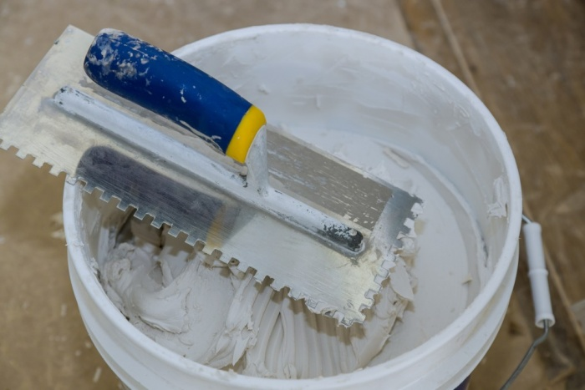
Fig.5.1 grout

There are two types of grouts: cement-based (for outdoor use) and water-based (for indoor use). The best time to replace old grout with new is when you’re about to put new tile down over it because the old will be removed along with the tiles themselves.
Grout is defined as:
“a hydrous mortar whose consistency allows it to be placed or pumped into small joints or cavities, as between pieces of ceramic clay, slate, and floor tile”
To prepare and mix grout, follow these steps:
  - Choose the right grout for your project: There are different types of grout available, such as sanded and unsanded grout. Sanded grout is recommended for joints larger than ⅛ inch, while unsanded grout is suitable for smaller joints.
  - Gather the necessary materials: You will need grout powder, water, a mixing bucket, a grout-mixing knife or small trowel, and a sponge.
  - Add water to the grout powder: Follow the manufacturer's instructions for the correct water-to-powder ratio. It is recommended to pour about a quarter or half of the grouting powder into the mixing bucket and add water gradually.
  - Mix the grout: Tilt the mixing bucket at a 45-degree angle and use a grout-mixing knife or small trowel to thoroughly mix the grout and water. Continue mixing until all the powder is blended and there are no lumps.
  - Adjust the grout consistency: Check the grout's consistency. For floors, it should have a "smooth peanut butter consistency," while for walls, it should be slightly thicker. If the grout is too slack or liquid-y, add more powder. If it is too dry and clumpy, moisten the sponge with water and add a small amount of water to the mix.
  - Let the grout rest: Allow the grout to rest for five to ten minutes. This process, known as slaking, allows the chemicals to bond and ensures a stronger grout.
  - Mix thoroughly once more: After the resting period, use a grout knife to mix the grout thoroughly one more time before applying it to your project.

5.2 Packing kern stones joints
Kern Stones
In monument construction, "kern stones" refer to the stones or blocks that form the central or core structure of a monument. They are typically positioned at the heart of the monument and serve as the primary load-bearing elements.
Kern stones are strategically placed to provide stability, strength, and support to the overall structure. They often form the foundation or base upon which other stones or architectural elements are added. The term "kern" comes from the Middle English word "kirn," which means "core" or "center."
These stones are carefully selected based on their durability, density, and load-bearing capacity. They are typically larger and more solid than the surrounding stones, as they are responsible for supporting the weight of the monument and distributing it evenly.
The joints between the kern stones and surrounding stones are often sealed or filled with grout or mortar to enhance the structural integrity and appearance of the monument. This helps to ensure that the stones are tightly connected and maintain their position over time.
Overall, kern stones play a crucial role in providing stability and strength to monuments, ensuring their longevity and ability to withstand environmental forces.

Construction Techniques Used For Kern Stones
Certainly! Here are some additional details about the construction techniques used for kern stones:
  - Quarrying and Shaping: Kern stones are typically quarried from suitable sources, such as limestone or granite quarries, depending on the desired strength and durability. The stones are then carefully shaped and cut into large blocks or slabs using various tools and techniques, including sawing, chiseling, and drilling.
  - Lifting and Placement: Due to their size and weight, lifting and placing kern stones require specialized equipment and techniques. In ancient times, ramps, levers, and pulleys were often employed to lift and position the stones. In modern construction, cranes, hoists, and other heavy machinery are commonly used.
  - Dry or Wet Construction: Kern stones can be incorporated into a monument using dry or wet construction methods. In dry construction, the stones are typically placed and stacked without the use of mortar or grout. The precise shaping and fitting of the stones allow them to interlock and provide stability. In wet construction, mortar or grout is used to fill the joints between the stones, enhancing the structural integrity and preventing movement.
  - Anchoring and Doweling: To further secure the kern stones, anchoring and doweling techniques may be employed. Anchoring involves using metal rods or structural connectors embedded within the stones or attached to the foundation to provide additional stability. Doweling involves inserting metal or wooden dowels into drilled holes in adjacent stones, creating a mechanical connection that helps prevent displacement.
  - Grouting and Pointing: As mentioned earlier, the joints between kern stones can be filled with grout or mortar. This process involves carefully applying the grout or mortar mix into the joints using tools like grout floats or pointing trowels. The grout fills any gaps, provides structural cohesion, and helps protect the stones from moisture ingress and weathering.
  - Finishing and Surface Treatments: Once the kern stones are in place, surface treatments and finishes may be applied to enhance their appearance and protect them from environmental factors. This could include polishing, sanding, sealing, or applying protective coatings, depending on the desired aesthetic and functional requirements.
It's important to note that construction techniques can vary depending on the time period, cultural practices, and available technology. Each monument may have its own unique construction methods, and the techniques used can also evolve over time as new technologies and materials are introduced.
Packing Joints between Kern Stones and Base
To pack joints between kern stones and the base with grout, follow these general steps:
  - Prepare the area: Ensure the surface is clean and free from dust, debris, and loose particles. Use a brush or vacuum cleaner to remove any loose material from the joints.
  - Choose the right grout: Select a grout that is suitable for the specific application. Consider factors such as the joint width, expected movement, and color preference. Read the manufacturer's instructions on the grout packaging for specific mixing and application guidelines.
  - Mix the grout: Follow the manufacturer's instructions to mix the grout. Typically, you'll add water to the grout powder gradually while stirring until you achieve a smooth, lump-free consistency. Use a mixing paddle or a low-speed drill with a mixing attachment.
  - Apply the grout: Use a grout float or a pointing trowel to apply the grout to the joints. Hold the float or trowel at a slight angle and press the grout into the joints, ensuring they are completely filled. Work in small sections to prevent the grout from drying out before you can finish it.
  - Pack the joints: After applying the grout, use a grout packer or a pointed tool to firmly pack the grout into the joints. This step helps eliminate air pockets and ensures a solid, durable bond. Press the grout into the joints by moving the tool back and forth, applying moderate pressure.
  - Clean the surface: Once you have packed the joints, use a damp sponge or a grout cleaning tool to remove excess grout from the surface of the stones. Rinse the sponge or tool frequently to avoid smearing grout onto the stones. Be gentle to avoid dislodging the grout from the joints.
  - Cure the grout: Follow the grout manufacturer's instructions for curing time. It is important to allow the grout to cure properly before subjecting it to heavy use or exposing it to moisture. This typically involves keeping the grout moist for a specific period or covering it with a curing compound.
Remember to always refer to the specific grout manufacturer's instructions, as different grout products may have variations in mixing ratios, application methods, and curing times.

5.3 Cleaning Krebs joints
After packing the joints between kern stones and the base with grout, it's essential to clean the excess grout from the surface to achieve a neat and finished appearance. Here's how you can clean the area:
  - Wait for the grout to partially set: Allow the grout to cure for a specific period of time as recommended by the grout manufacturer. Typically, this can range from 15 minutes to an hour, depending on the grout type. The grout should be firm but not fully hardened.
  - Prepare your cleaning tools: Get a bucket of clean water and a sponge or a grout cleaning tool. Make sure the sponge or tool is clean and dampened but not soaking wet.
  - Begin cleaning: Gently wipe the surface of the stones with the damp sponge or grout cleaning tool. Use light pressure and circular motions to remove the excess grout from the surface while being careful not to disturb the freshly packed joints. Rinse the sponge or tool frequently in the bucket of clean water to prevent smearing grout back onto the stones.
  - Repeat as needed: Depending on the amount of grout residue, you may need to rinse and wring out the sponge or tool multiple times during the cleaning process. Continue wiping the surface until you have removed most of the excess grout.
  - Final cleanup: Once you have removed the majority of the grout residue, use a clean, damp cloth or sponge to carefully go over the surface one final time. This step helps to ensure that any remaining traces of grout are removed, leaving a clean and polished appearance.
  - Allow the grout to fully cure: After cleaning, allow the grout to fully cure according to the manufacturer's instructions. This typically involves keeping the grout protected from excessive moisture and avoiding heavy use of the area for a specified period of time.Remember to exercise caution while cleaning to avoid dislodging or damaging the freshly packed grout. If needed, consult the specific grout manufacturer's instructions for any additional cleaning recommendations or products that may be recommended for specific grout types.
Self-Check -5 | Written Exam

Part –I: - Multiple Choice
Instruction: Select the best answer and encircle the letter/ each 2pts
    - What is the purpose of grout in tile installation?

a) Adding color to the tiles
b) Providing stability to the structure
c) Protecting against moisture
d) Enhancing the appearance of the tiles

    - Which type of grout is recommended for smaller joints?

a) Sanded grout
b) Cement-based grout
c) Water-based grout
d) Unsanded grout

    - What is the function of kern stones in monument construction?

a) Providing decorative elements
b) Acting as load-bearing elements
c) Serving as weatherproofing materials
d) Enhancing the monument's color

    - Which construction technique involves filling the joints between stones with grout?

a) Dry construction
b) Wet construction
c) Anchoring and doweling
d) Quarrying and shaping

    - What is the purpose of cleaning the excess grout from the surface after packing joints?

a) To prevent moisture ingress
b) To achieve a neat and finished
c) To enhance the color of the stones
d) To strengthen the bond b/n stones appearance
Part –II: Matching
Instruction: Match the following terms with their corresponding descriptions/each 2pts
“A” “B”
- Sanded grout A. Mortar used between stones
- Unsaned grout B. Mortar used for outdoor projects
- Quarrying C. Mortar consistency for walls
- Anchoring D. Process of extracting stones from the earth
- Mortar E. Mortar consistency for floors
Part –III: Short Answer Questions/2pts
    - What are the two types of grout mentioned in the document, and what are their recommended uses?
    - Briefly explain the term "kern stones" and their role in monument construction.
    - Name two construction techniques used for securing kern stones in a monument.

Operation sheet: 5.1
Operation Title: Grouting base and joints
Purpose: To grout the base and joints
Instructions: Use the given tools and equipment to grout the base and joints by following procedures described below. For this operation you have given an hour and you are expected to provide the project on the given time.
Conditions or Situations for the Operations:
  - Material type: Different materials, such as ceramic tiles, natural stone, or mosaic, may require specific grouting techniques or types of grout.
  - Joint size: The size of the joints between the tiles or materials may affect the choice of grout type and the application technique.
  - Environmental conditions: Consider the temperature, humidity, and ventilation of the space where grouting will take place. These factors can influence the grout curing time and the overall quality of the installation.
Tools and Equipment:
  - Grout mixers or mixing paddle
  - Grout float or rubber grout trowel
  - Grout cleaning tools (such as a sponge or grout brush)
  - Bucket or mixing container
  - Damp cloth or sponge for cleaning
Materials:
  - Grout (cement-based, epoxy, or polymer-modified grout)
  - Grout sealer
Procedure: The general procedure for grouting the base and joints involves the following steps:
    - Prepare the surface and ensure it is clean and dry.
    - Select the appropriate type of grout for the project.
    - Mix the grout according to the manufacturer's instructions.
    - Apply the grout diagonally across the joints, pressing it into the gaps.
    - Remove excess grout from the surface using a grout float or trowel.
    - Clean the surface with a damp sponge or grout cleaning tool, smoothing the joints and removing grout residue.
    - Allow the grout to cure and dry according to the manufacturer's instructions.
    - Consider applying a grout sealer to protect the grout (if necessary).
Precautions:
  - Follow the manufacturer's instructions for the grout mixing ratio and curing time to ensure proper performance and durability.
  - Wear appropriate personal protective equipment, such as gloves and safety glasses, when working with grout.
  - Avoid mixing excessive amounts of grout that cannot be applied and cleaned within the working time specified by the manufacturer.
  - Use caution when applying and cleaning the grout to prevent damage to the surrounding tiles or materials.
  - Test the grout on a small, inconspicuous area before applying it to the entire surface to ensure compatibility and desired results.
Quality Criteria:
  - The grout should be evenly applied and fill the joints completely.
  - The grout lines and surface should have a smooth and visually pleasing appearance.
  - The grout should cure and dry according to the manufacturer's instructions, ensuring a strong and durable bond.
  - The surface should be free from excess grout residue and have a clean finish.
  - The grout should fill the joints completely, preventing gaps or voids.
  - The grout should provide long-term durability and resistance to staining, cracking, or deterioration.
  - The grout should be compatible with the tiles or materials, ensuring a cohesive and visually appealing installation.

LAP TEST: 5
Name: _____________________________ Date: ________________
Time started: ________________________ Time finished: ________________
Instructions: - Given necessary templates, tools and materials you are required to perform the following tasks within an hour.

Task 1. Grout base and joints

Unit Six: Fixing headstone
This unit is developed to provide you the necessary information regarding the following content coverage and topics:
- Measuring and cutting dowel joints
- Filling dowel holes with mortar and placing dowel
- Raising and lowering Headstone
- Finishing headstone plumb and level
This unit will also assist you to attain the learning outcomes stated in the cover page. Specifically, upon completion of this learning guide, you will be able to:
- Measure and cut dowel joints
- Fill dowel holes with mortar and place dowel
- Raise and lower Headstone
- Finish headstone plumb and level

6.1 Measuring and cutting dowel joints
To measure and cut dowel joints for fixing a headstone to a back stone, follow these steps:
  - Determine the dowel size: The dowel size will depend on the weight and size of the headstone. It's important to choose a dowel that is strong enough to support the weight of the headstone. Consult with a professional or refer to local regulations or industry standards to determine the appropriate dowel size for the specific application.
  - Measure the dowel length: Measure the desired length of the dowel that will be inserted into both the headstone and the back stone. The length will depend on the thickness of the stones and the depth of the joint you want to create. Make sure to account for any additional depth required for adhesive or mortar.
  - Mark the dowel length: Use a pencil or marker to mark the measured length on the dowel. This will serve as a guide for cutting.
  - Cut the dowel: Secure the dowel in a vise or clamp to ensure stability during the cutting process. Use a saw suitable for cutting the dowel material (e.g., a handsaw or power saw) and carefully cut along the marked line to achieve the desired dowel length. Ensure the cut is clean and straight.
  - Test the fit: Place the cut dowel in the pre-drilled holes of both the headstone and the back stone to test the fit. The dowel should fit snugly in the holes without being too loose or too tight. Make any necessary adjustments to the dowel length if needed.
  - Install the dowel joints: Apply an appropriate adhesive or mortar to the holes in both the headstone and the back stone. Insert the dowel into one hole and then carefully align the stones so that the dowel can be inserted into the corresponding hole in the other stone. Ensure the stones are properly aligned and the dowel joints are fully inserted.
  - Allow for curing: Follow the curing instructions provided by the adhesive or mortar manufacturer. This typically involves allowing sufficient time for the adhesive or mortar to set and cure, ensuring a strong and secure bond between the stones.
It's important to note that the specific process and techniques for dowel joints can vary depending on the materials, design, and requirements of the headstone and back stone. If you are unsure or unfamiliar with the process, it is recommended to consult with a professional in monument construction or stonemasonry for guidance and assistance.

6.2 Filling dowel holes with mortar and placing dowel
When filling dowel holes with mortar and placing dowels during the process of fixing a headstone to a back stone, you can follow these steps:
  - Prepare the mortar: Mix the mortar according to the manufacturer's instructions. Use a mortar mix suitable for stonework or a specialized stone adhesive recommended for the specific application. Ensure that the consistency of the mortar is appropriate for filling the dowel holes.
  - Clean the dowel holes: Ensure that the dowel holes in both the headstone and the back stone are clean and free of any debris or loose material. Use a brush or compressed air to remove any loose particles from the holes.
  - Apply mortar in the dowel holes: Using a small trowel or a pointing tool, carefully apply the mortar into the dowel holes in the back stone. Fill the holes completely, ensuring that the mortar is evenly distributed and tightly packed. Smooth the surface of the mortar if necessary.
  - Insert the dowels: Take the cut dowels and insert them into the dowel holes in the back stone, pushing them gently but firmly. Ensure that the dowels are fully seated in the holes and make contact with the mortar. The mortar will act as a bonding agent, securing the dowels in place.
  - Apply mortar on the headstone: Apply a layer of mortar onto the corresponding dowel holes in the headstone. Make sure to cover the entire area where the dowels will be inserted.
  - Position the headstone: Carefully position the headstone onto the back stone, aligning the dowel holes in the headstone with the dowels in the back stone. Apply slight pressure to ensure a snug fit between the two stones and proper contact between the dowels and the mortar.
  - Adjust and level: Make any necessary adjustments to align the headstone properly. Use a level to ensure that the headstone is straight and plumb. Make any additional adjustments as needed.
  - Clean off excess mortar: Use a damp cloth or sponge to clean off any excess mortar that may have squeezed out during the placement of the headstone. Wipe gently to avoid disturbing the dowel joints. Allow the mortar to cure according to the manufacturer's instructions.

6.3 Raising and lowering Headstone
To raise and lower a headstone carefully into place, follow these steps:
  - Assess the condition: Before attempting to move the headstone, evaluate its condition and stability. If there are any cracks, loose pieces, or signs of damage, consult a preservation professional for guidance.
  - Gather the necessary equipment: You will need a lifting mechanism such as a tripod, pulley, or gantry, along with straps or chains to secure the headstone. Ensure that the equipment is in good working condition and appropriate for the weight of the headstone.
  - Prepare the area: Clear the area around the headstone, removing any debris or vegetation. If needed, use a shovel to carefully remove a small amount of dirt from around the stone, taking care not to touch the stone with the shovel to avoid damage.
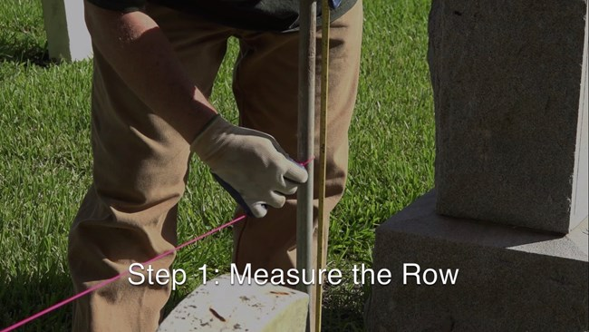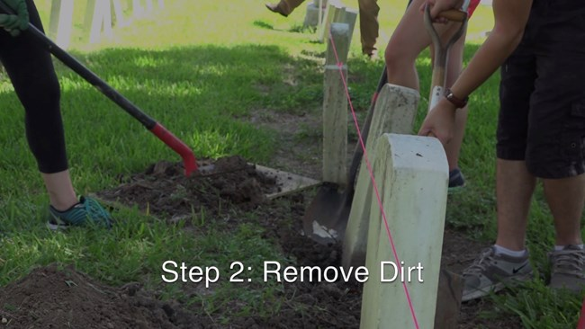
Fig.6.1 Measure the row and removing dirty
  - Secure the lifting mechanism: Set up the lifting mechanism on solid, level ground. Follow the manufacturer's instructions for proper setup and ensure that all footings are stable. If the ground is soft or unstable, consider placing large pieces of wood under the feet to distribute the weight
  - Attach the lifting straps or chains: Carefully secure the lifting straps or chains around the headstone, ensuring a secure and balanced attachment. Use a basket hitch or other appropriate method to prevent slippage during lifting.
  - Lift the headstone: With the lifting mechanism in place and the headstone securely attached, slowly and evenly raise the headstone, taking care to minimize stress on the stone. Avoid allowing the headstone to lean or list, as this can cause cracking or breaking, especially with older stones. Once lifted, the headstone can be laid flat on the ground nearby.
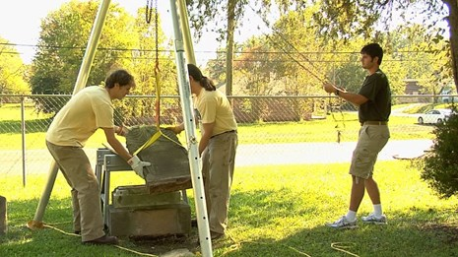
Fig.6.2 Lift the headstone
  - Prepare the grave site: While the headstone is lifted, widen and deepen the hole left behind to accommodate gravel. Tamp down the soil and add about 4 inches of gravel for proper drainage and stability. Tamp the gravel down as well.
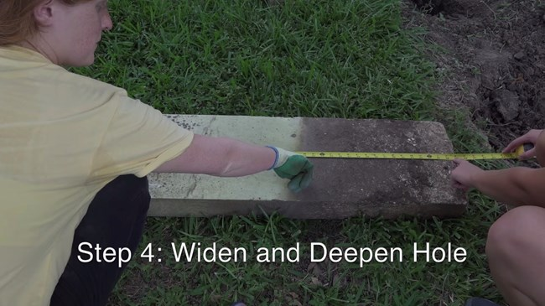
Fig.6.3 Widen and Deepen Hole
  - Lower the headstone into place: Using the lifting mechanism, carefully lower the headstone back into the hole, ensuring it is aligned properly. If moving the stone manually, have at least two people to handle the weight.
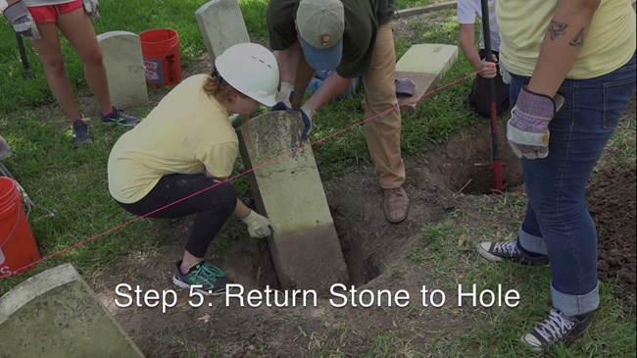
Fig.6.4 Returning stone to hole
If you're moving the stone manually, make sure at least 2 people are there to move the heavy stone
  - Backfill and clean: Leave a few inches of space around the headstone to add sand, soil, or the original sod back around it. Once the headstone is properly reset, clean it carefully to remove any dirt or debris.

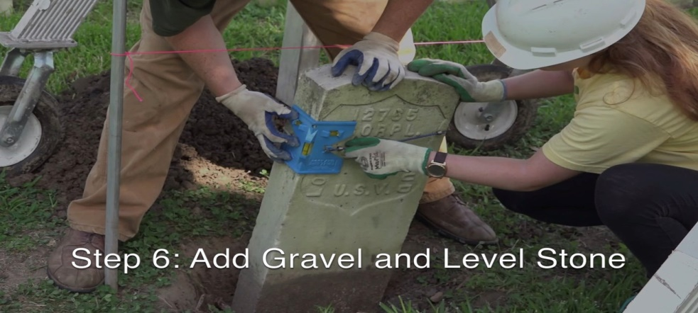
Fig.6.5 using a post level to monitor that the stone stays plumb and level while gravel is placed around it

6.4 Finishing headstone plumb and level
Set alignment:
  - Create a system of guide strings running the length of the row where the headstones will be placed.
  - Attach each string to a metal stake at each end of the row to ensure a straight line.
  - These guide strings will serve as a reference for the exact placement of each headstone.
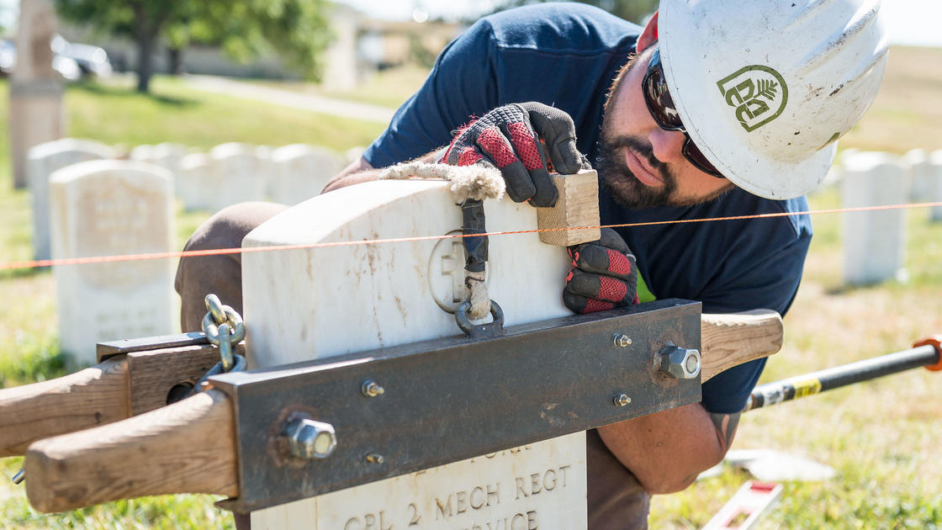
Fig.6.6 Setting alignment
Finishing touches
  - Clean the headstone and remove any excess adhesive or mortar.
  - Inspect the headstone for any remaining imperfections and make necessary adjustments.
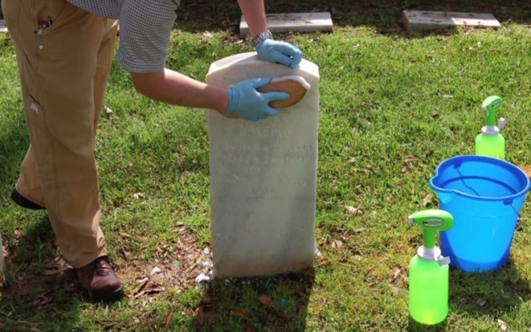
Fig.6.7 Clean the headstone
Self-Check -6 | Written Exam

Part –I: - Multiple Chose
Instruction: Select the best answer and encircle the letter/ each 2pts
- When measuring and cutting dowel joints, what should be taken into consideration when determining the dowel size?

a. The color of the stones.
b. The type of adhesive used.
c. The weight and size of the headstone.
d. The temperature of the environment.

- What should be done to ensure a proper fit of the dowel in the pre-drilled holes?

a. Apply adhesive to the dowel.
b. Use a larger dowel size.
c. Make necessary adjustments to the dowel length.
d. Use a hammer to force the dowel into the holes.

- What is the purpose of allowing for curing after installing the dowel joints?

a. To allow the adhesive or mortar to dry.
b. To test the strength of the dowel joints.
c. To clean excess mortar from the stones.
d. To adjust the alignment of the stones.

- What type of material is suitable for filling dowel holes?

a. Water.
b. Sand.
c. Mortar.
d. Oil.

- What should be done to clean off excess mortar after placing the headstone?

a. Use a damp cloth or sponge.
b. Apply more mortar to cover it up.
c. Use a brush to scrub it off.
d. Leave it as it is.
Part –II: Matching
Instruction: Match the following terms with their corresponding descriptions/each 2pts
“A” “B”
- Dowel size A. Secure the dowel in a vise or clamp.
- Dowel length B. Apply an appropriate adhesive or mortar.
- Cut the dowel C. Measure the desired length of the dowel.
- Test the fit D. Determine the appropriate dowel size.
- Install the dowel joints E. Place the cut dowel in the pre-drilled holes.
Part –III: Short Answer Questions
    - What are two important factors to consider when measuring the dowel length for dowel joints?
    - How should the dowel joints be aligned during the installation process?
    - Why is it recommended to consult with a professional in monument construction or stonemasonry when unsure or unfamiliar with the dowel joint process?

Operation sheet: 6.1

Operation Title: Fixing headstone to back stone
Purpose: To fix a headstone to a back stone, ensuring a secure and stable installation of the headstone on a grave or memorial.
Instructions: Use the given tools and equipment to fix a headstone to a back stone by following procedures described below. For this operation you have given 2 hours and you are expected to provide the project on the given time.
Conditions or Situations for the Operations:
  - The type of stone used for the headstone and back stone may influence the choice of fixing method and the tools and materials required.
  - The weight and size of the headstone will impact the choice of fixing method and the level of support required.
  - Consider the weather conditions, such as temperature and humidity, during the installation process. Extreme temperatures or adverse weather conditions may affect the curing time of adhesives or the stability of the installation.
Tools and Equipment: The following tools and equipment may be required for fixing a headstone to a back stone:
  - Level
  - Drill with appropriate drill bits
  - Adhesive (if applicable)
  - Dowels, pins, or anchors (if applicable)
  - Shims or leveling materials
  - Cleaning materials (such as a brush or cloth)
Materials: The materials required for fixing a headstone to a back stone may include:
  - Adhesive (such as epoxy or stone adhesive)
  - Dowels, pins, or anchors (if applicable)
  - Shims or leveling materials
Procedure: The general procedure for fixing a headstone to a back stone involves the following steps:
    - Prepare the back stone and ensure it is clean, stable, and properly positioned.
    - Clean the bottom surface of the headstone and remove any debris or dirt.
    - Determine the appropriate fixing method based on the design and requirements of the headstone and back stone.
    - Apply adhesive (if applicable) to the bottom surface of the headstone or the top surface of the back stone.
    - Insert dowels, pins, or anchors (if applicable) by drilling corresponding holes in both the headstone and back stone.
    - Carefully lower the headstone onto the back stone, aligning it with the desired position.
    - Use a level to ensure the headstone is straight and level, making any necessary adjustments.
    - Allow the recommended curing or setting time for the installation to become secure.
Precautions: Some precautions to consider during the operation include:
  - Follow the manufacturer's instructions for the adhesive or fixing method to ensure proper performance and durability.
  - Ensure the headstone and back stone are clean and free from debris before fixing.
  - Take care when drilling holes to prevent damage to the stones or injury to yourself.
  - Use appropriate personal protective equipment, such as safety goggles and gloves, when working with tools and materials.
  - Consider consulting with professionals or experienced stonemasons for complex or delicate installations.
Quality Criteria:
  - The headstone should be securely fixed to the back stone, with no movement or instability.
  - The headstone should be aligned properly and levelled, creating a visually pleasing and balanced appearance.
  - The adhesive or fixing method should have sufficient curing or setting time to ensure a strong bond and stability.
  - The installation should have a clean and professional appearance, with no visible excess adhesive or uneven gaps.
  - The fixing method should provide long-term durability and resistance to weathering, vibrations, and other external factors that may impact the stability of the installation.
  - The fixing method and materials used should be compatible with the type of stones being used, ensuring a secure bond without causing damage or discoloration.
  - Ensure that the fixing method and installation meet any applicable local regulations or cemetery guidelines.

LAP TEST: 6
Name: _____________________________ Date: ________________
Time started: ________________________ Time finished: ________________
Instructions: - Given necessary templates, tools and materials you are required to perform the following tasks within 2hours.

Task 1. Fix headstone to back stone

Unit Seven: Filling center and finishing with chip top
This unit is developed to provide you the necessary information regarding the following content coverage and topics:
- Filling and finishing center area
- Placing brick or concrete in corner
- Mixing and spreading bluestone and granite screening
This unit will also assist you to attain the learning outcomes stated in the cover page. Specifically, upon completion of this learning guide, you will be able to:
- Fill and finish center area
- Place brick or concrete in corner
- Mix and spread bluestone and granite screening

7.1 Filling and finishing center area
To fill the center and finish with a chip top in monument works, follow these steps:
1. Prepare the monument surface:
  - Clean the surface of the monument to remove any dirt, debris, or previous coatings.
  - Repair any cracks or damages in the monument using appropriate materials and techniques.
2. Fill the center:
  - Choose a suitable filler material that matches the color and texture of the monument.
  - Apply the filler material to the center of the monument using a trowel or putty knife.
  - Smooth and level the filler material to create a seamless transition with the surrounding areas.
  - Allow the filler material to dry and cure according to the manufacturer's instructions.
3. Finish with a chip top:
  - Select a chip top material that matches the composition and appearance of the monument.
  - Apply a thin layer of adhesive or mortar to the filled center area.
  - Carefully place the chip top material onto the adhesive or mortar, ensuring a secure bond.
  - Press the chip top material firmly into place, making sure it is level with the surrounding surface.
  - Allow the adhesive or mortar to dry and cure completely.
4. Final touches:
  - Inspect the filled center and chip top for any imperfections or unevenness.
  - Use sandpaper or a polishing tool to smooth and blend the filled area with the rest of the monument.
  - Apply a protective sealant or coating to the entire monument surface, including the filled center and chip top, to enhance durability and appearance.

7.2 Placing brick or concrete in corner
To place corner support for a monument with a reinforced concrete slab or brick, you can follow these steps:
- Determine the location: Choose the exact spot where you want to place the monument. Ensure that it is level and stable.
- Excavation: Dig a hole at each corner of the monument's base. The depth of the hole will depend on the size and weight of the monument. It should be deep enough to provide a stable foundation.
- Reinforced concrete slab: If you are using a reinforced concrete slab as the corner support, follow these steps:
- Prepare the formwork: Build a wooden formwork around each hole. The formwork should be sturdy and level.
- Reinforcement: Place steel reinforcement bars (rebar) inside the formwork. The rebar should be properly spaced and tied together to provide strength and stability.
- Pour concrete: Pour concrete into the formwork, ensuring that it completely fills the hole. Use a vibrating tool to remove air bubbles and ensure proper compaction.
- Finishing: Smooth the surface of the concrete using a trowel. Allow the concrete to cure and harden according to the manufacturer's instructions.
- Brick support: If you are using bricks as the corner support, follow these steps:
- Prepare the foundation: Ensure that the excavation hole is deep enough to accommodate a stable foundation for the bricks.
- Lay the bricks: Start by laying a layer of mortar at the bottom of the hole. Place the first layer of bricks on top of the mortar, ensuring they are level and aligned properly. Use a spirit level to check for accuracy.
- Build the corners: As you continue to lay the bricks, pay special attention to the corners. Use a corner brick or cut bricks to create a strong and stable corner support.
- Mortar and jointing: Apply mortar between each brick and use a pointing trowel to create strong and neat joints. Remove any excess mortar.
- Allow for curing: Regardless of whether you used a reinforced concrete slab or bricks, allow the corner supports to cure and harden for the recommended time before placing the monument on top.

7.3 Mixing and spreading bluestone and granite screening
To mix and spread bluestone and granite screening on a finished level of concrete poured on the corner of a monument, you will need to follow these steps:
1. Prepare the area:
  - Clean the concrete surface to remove any debris or dirt.
  - Ensure that the concrete is level and free from any cracks or unevenness.
2. Gather the materials:
  - Bluestone: This is a type of natural stone commonly used for paving and landscaping.
  - Granite screening: This is a crushed granite material that is often used as a base for paving stones.
3. Mix the bluestone and granite screening:
  - In a wheelbarrow or mixing container, combine the bluestone and granite screening in a ratio of approximately 1:1. Adjust the ratio as needed to achieve the desired consistency and color.
  - Use a shovel or rake to thoroughly mix the materials together until they are evenly distributed.
4. Spread the mixture:
  - Start at one corner of the monument and begin spreading the mixture over the concrete surface.
  - Use a rake or trowel to spread the mixture evenly, ensuring that it covers the entire area and is at the desired thickness.
  - Work in small sections at a time to ensure proper coverage and control.
5. Compact the mixture:
  - Use a compactor or tamper to compact the bluestone and granite screening mixture. This will help to ensure a solid and stable surface.
  - Apply firm pressure and make multiple passes over the entire area to achieve proper compaction.
6. Level and smooth the surface:
  - Use a straightedge or level to check the surface for any unevenness or high spots.
  - If necessary, add more mixture to low areas and use a trowel or float to level and smooth the surface.
7. Allow the mixture to set:
  - Give the mixture some time to set and cure before subjecting it to heavy foot traffic or other loads.
  - Follow the manufacturer's instructions for curing time, which may vary depending on the specific materials used.

Self-Check -7 | Written Exam

Part –I: - Multiple Choice
Instruction: Select the best answer and encircle the letter/ each 2pts
    - What should be done before filling the center of a monument?

a. Apply a protective sealant.
b. Repair any cracks or damages.
c. Smooth and level the surrounding areas.
d. Choose a suitable chip top material.

    - What is the purpose of using a trowel or putty knife when applying filler material?

a. To remove dirt and debris.
b. To create a seamless transition.
c. To repair cracks and damages.
d. To level the surface of the monument.

    - Which step comes after finishing with a chip top?

a. Applying a protective sealant.
b. Inspecting for imperfections.
c. Polishing the filled area.
d. Cleaning the surface of the monument.

    - What is the recommended material for filling the center of a monument?

a. Water-based paint.
b. Acrylic adhesive.
c. Epoxy resin.
d. Filler material matching the monument.

    - What should be done to enhance the durability and appearance of the filled center and chip top?

a. Apply a protective sealant or coating.
b. Use sandpaper to smooth the surface.
c. Apply additional layers of filler material.
d. Inspect for imperfections and repair if needed.
Part –II: Matching
Instruction: Match the following terms with their corresponding descriptions/each 2pts
“A” “B”
- Formwork A. Build a wooden structure around the hole.
- Reinforcement bars B. Steel bars for strength and stability.
- Excavation C. Digging a hole in the ground.
- Mortar D. Material used for joining bricks or stones.
- Compaction E. Process of making a surface solid and stable.

Part –III: Short Answer Questions
    - What are the recommended steps for preparing the monument surface before filling the center?
    - Explain the process of placing corner support using a reinforced concrete slab.
    - What materials are required to mix and spread bluestone and granite screening, and what is the purpose of this mixture in monument construction?

Operation sheet: 7.1
Operation Title: Filling center and finishing with chip top

Purpose: The purpose of this operation is to fill the center of a designated area and finish it with a chip top, creating a visually pleasing and durable surface.

Instructions: Use the given tools and equipment to filling center and finishing with chip top by following procedures described below. For this operation you have given 2 hours and you are expected to provide the project on the given time.

Conditions or Situations for the Operation:

  - The designated area should be properly prepared, with a clean and level surface suitable for filling and finishing.
  - The weather conditions should be favorable for the curing and drying process, avoiding rain, extreme temperatures, or high humidity that may affect the quality of the work.
  - Consider any specific requirements or restrictions related to the filling material, such as temperature limitations or application guidelines.
Tools and Equipment:
  - Trowel or other appropriate tools for spreading and leveling the filling mixture.
  - Hand tools for removing excess chips and refining the chip top layer.
  - Mixing equipment or tools, depending on the type of filling material used.
  - Protective equipment, including gloves, goggles, and masks, as necessary.
Materials:
  - Filling material: Concrete, epoxy resin, or a combination of aggregates and binding agents.
  - Chips or aggregates: Small stones, pebbles, or other decorative materials for the chip top layer.
  - Curing and drying agents, if required by the chosen filling material.
Procedure:
    - Prepare the work area by clearing debris and ensuring a clean and level surface.
    - Select and prepare the filling material according to the manufacturer's instructions or established practices.
    - Apply the filling mixture to the center of the designated area, ensuring an even and consistent layer. Level and smooth the surface as needed.
    - Sprinkle or broadcast small chips or aggregates over the filling material, ensuring even distribution and coverage.
    - Gently press the chips into the filling material to embed them securely.
    - Allow the filling material to cure and dry according to the manufacturer's recommendations.
    - Once cured, use hand tools to carefully remove any excess chips or aggregates from the surface.
    - Refine the chip top layer using appropriate tools to achieve the desired texture and appearance.

Precautions:
  - Follow all safety guidelines and wear appropriate protective equipment during the operation.
  - Adhere to manufacturer's instructions for the filling material and any additional agents used.
  - Take precautions to protect the surrounding area from damage during the filling and finishing process.
  - Avoid overworking the filling material or applying excessive pressure, as it may affect the final result.
  - Ensure proper ventilation during the application and drying process, if required by the filling material.

Quality Criteria:

  - The filled center should have an even and consistent layer, free from visible gaps or irregularities.
  - The chip top layer should be evenly distributed and securely embedded in the filling material.
  - The surface should have a visually appealing texture and appearance, in line with the desired aesthetic requirements.
  - The filled area should be durable and resistant to environmental factors, such as weathering, moisture, or abrasion.
  - The completed work should meet industry standards and any specific requirements set by the client or relevant authorities.

LAP TEST: 7
Name: _____________________________ Date: ________________
Time started: ________________________ Time finished: ________________
Instructions: - Given necessary templates, tools and materials you are required to perform the following tasks within 2 hours.

Task 1. Fill center and finish with chip top

Unit Eight: Fitting cover stone and finishing monument
This unit is developed to provide you the necessary information regarding the following content coverage and topics:
- Introduction to cover stone
- Measuring and cutting dowels joints
- Filling center area
- Filling dowel holes with mortar and placing dowels
- Lifting cover stone into place
- Lowering cover stone into place
- Preparing and applying pointing/grouting material
Cleaning and waste management This unit will also assist you to attain the learning outcomes stated in the cover page. Specifically, upon completion of this learning guide, you will be able to:
- Identify cover stone
- Measure and cut dowels joints
- Fill center area
- Fill dowel holes with mortar and place dowels
- Lift cover stone into place
- Lower cover stone into place
- Prepare and apply pointing/grouting material
- Clean and waste management

8.1 Introduction to Cover Stone
In monument construction, a cover stone refers to a specific type of stone that is used to cover or protect the underlying structure of a monument. It serves as a protective layer and adds aesthetic value to the monument. The cover stone is typically placed on top of the main body or base of the monument, providing a finishing touch to the overall design.
Here are some key points about cover stones in monument construction:
  - Purpose: The primary purpose of a cover stone is to protect the underlying structure of the monument from weathering, erosion, and other environmental factors. It acts as a shield, preventing damage to the monument's core materials.
  - Material: Cover stones can be made from various types of stone, depending on the desired aesthetic and durability. Common materials include granite, marble, limestone, and sandstone. These stones are chosen for their strength, resistance to weathering, and ability to be carved or shaped.
  - Design and Placement: Cover stones are often designed to complement the overall style and theme of the monument. They can be carved or engraved with decorative elements, inscriptions, or symbols. Cover stones are typically placed on top of the monument's base or main body, providing a visually appealing and protective layer.
  - Installation: Cover stones are carefully installed by skilled craftsmen or stonemasons. They are securely attached to the underlying structure using appropriate techniques such as adhesive bonding, dowels, or other mechanical fasteners.
  - Maintenance: Like any other part of a monument, cover stones require regular maintenance to ensure their longevity and appearance. This may include cleaning, sealing, and periodic inspections to identify any signs of damage or deterioration.

8.2 Measuring And Cutting Dowels Joints
To measure and cut dowel joints to fit a cover stone and finish a monument, follow these steps:
  - Measure the dimensions: Start by measuring the dimensions of the cover stone and the monument where the dowel joints will be placed. This will help you determine the length and diameter of the dowels needed.
  - Choose the dowel material: Select a suitable dowel material that is strong and durable, such as hardwood or metal. Consider the aesthetic requirements and durability of the material for the specific monument.
  - Mark the dowel positions: Use a pencil or marker to mark the positions where the dowels will be inserted on both the cover stone and the monument. Ensure that the marks are aligned accurately.
  - Drill the dowel holes: Use a drill with a bit that matches the diameter of the dowels. Carefully drill holes at the marked positions on both the cover stone and the monument. Make sure the holes are deep enough to accommodate the length of the dowels.
  - Cut the dowels: Measure and mark the length of the dowels based on the depth of the holes and the desired fit. Use a saw or dowel cutter to cut the dowels to the appropriate length. Ensure that the cuts are clean and straight.

8.3 Filling Center Area
When it comes to filling the center area to fit a cover stone and finish monuments, there are several methods and techniques that can be employed. These methods ensure that the cover stone fits securely and seamlessly into the center area, providing a finished and polished look to the monument. Here are some common methods used in this process:
- Measurement and Planning:
  - Accurate measurements of the center area and the cover stone are essential to ensure a proper fit.
  - Planning the placement and alignment of the cover stone is crucial to achieve a visually pleasing result.
- Shimming:
  - Shimming involves using thin pieces of material, such as metal or plastic, to fill gaps and create a level surface.
  - Shims are placed strategically in the center area to support the cover stone and ensure it sits flush with the surrounding surface.
- Mortar or Adhesive:
  - Mortar or adhesive can be used to secure the cover stone in place.
  - The center area is filled with mortar or adhesive, and the cover stone is carefully placed on top, ensuring proper alignment and levelness.
  - The mortar or adhesive sets and hardens, providing a strong bond between the cover stone and the monument.

8.4 Filling dowel holes with mortar and placing dowels

To fill dowel holes with mortar and place dowels to cover stone and finish monuments, follow these steps:
    - Prepare the dowels:
  - Select dowels that are appropriate for the size and weight of the stone. The dowels should be made of a durable material such as stainless steel or brass.
  - Cut the dowels to the desired length, ensuring they are long enough to penetrate both the stone and the mortar.
    - Prepare the stone:
  - Clean the surface of the stone to remove any dirt, debris, or loose material.
  - Use a drill with a masonry bit to create holes in the stone where the dowels will be inserted. The size and depth of the holes should match the diameter and length of the dowels.
    - Mix the mortar:
  - Follow the manufacturer's instructions to mix the mortar to the desired consistency. The mortar should be workable but not too wet or dry.
    - Fill the dowel holes with mortar:
  - Using a trowel, carefully fill the dowel holes with mortar, ensuring that the holes are completely filled.
  - Smooth the surface of the mortar to create a flush and even finish.
    - Insert the dowels:
  - While the mortar is still wet, insert the dowels into the dowel holes, ensuring they are fully embedded in the mortar.
  - Gently tap the dowels with a rubber mallet to ensure they are securely in place.

8.5 Lifting cover stone into place
To lift a cover stone into place and fit it onto a monument, there are several steps involved. While the specific techniques may vary depending on the monument and its design, here is a general outline of the process:
- Preparations:
  - Gather all the necessary tools and materials, including lifting equipment, straps, and any additional support structures.
  - Ensure that the area around the monument is clear and safe for lifting operations.
- Assess the cover stone:
  - Examine the cover stone to determine its weight, dimensions, and any specific handling requirements.
  - Plan the lifting process accordingly, considering the weight-bearing capacity of the lifting equipment and the manpower available.
- Position the lifting equipment:
  - Set up the lifting equipment, such as cranes or hoists, in a suitable location near the monument.
  - Ensure that the lifting equipment is properly secured and stable.
- Attach lifting straps:
  - Carefully attach lifting straps or slings to the cover stone, ensuring that they are securely fastened and evenly distributed to prevent any damage.
  - Use appropriate padding or protective materials to avoid scratching or chipping the stone surface.
- Lift the cover stone:
  - Activate the lifting equipment to gradually lift the cover stone off the ground.
  - Coordinate the lifting process with the assistance of trained personnel to ensure a smooth and controlled lift.
- Position the cover stone:
  - Guide the cover stone into its designated position on the monument, aligning it with the surrounding stones or structures.
  - Make any necessary adjustments to ensure a proper fit and alignment.

8.6 Lowering cover stone into place

To lower and cover a stone into place using wedges to finish monuments, follow these steps:
- Prepare the area: Ensure that the foundation or base where the stone will be placed is properly prepared and leveled.
- Position the stone: Carefully position the stone on top of the prepared area, making sure it is aligned correctly.
- Use wedges for height adjustment: Place wooden wedges under the stone to raise it to the desired height. Start with a few wedges and gradually add or remove them to achieve the desired height.
- Level the stone: Use a level to check if the stone is perfectly level. Adjust the wedges as needed to achieve a level surface.
- Pitch the stone for water runoff: If the stone needs to be pitched for water runoff, adjust the wedges accordingly to create the desired slope.
- Fill the voids: Place smaller stones or stone fragments underneath the stone to fill any gaps or voids. Tap them in gently to ensure good contact and stability.
- Secure the stone: Once the stone is in the desired position and level, secure it in place using mortar or adhesive, following the manufacturer's instructions.
- Repeat the process: Continue these steps for each stone until the monument is complete.

8.7 Preparing and applying pointing/grouting material
Pointing/grouting
In monument works, pointing or grouting refers to the process of filling the joints between stones or bricks with a mortar or grout mixture. It is done to improve the appearance, structural integrity, and weather resistance of the monument. Here's a brief overview of pointing/grouting in monument works:
Purpose of pointing/grouting: Pointing or grouting serves several purposes, including:
- Enhancing the visual appeal: It helps create a uniform and aesthetically pleasing appearance by filling gaps and voids between stones or bricks.
- Strengthening the structure: The mortar or grout mixture helps bond the stones or bricks together, providing additional stability and structural support.
- Protecting against weathering: Pointing/grouting helps prevent water penetration into the joints, reducing the risk of moisture-related damage, such as cracking, spalling, or deterioration.
Tools and Equipment Used For Applying Pointing/Grouting Materials to Monuments
Yes, there are specific tools and equipment commonly used for applying pointing/grouting materials to monuments. These tools help ensure precise application and efficient work. Here are some of the commonly used tools and equipment:
- Pointing Trowel: A pointing trowel is a small, flat-bladed tool with a pointed tip. It is used to scoop and apply the pointing/grouting material into the joints. The pointed tip allows for precise placement of the material.
- Grouting Bag: A grouting bag, also known as a mortar bag, is a flexible bag made of canvas or plastic. It is filled with the pointing/grouting material and then squeezed to apply the material into the joints. Grouting bags are particularly useful for narrow joints or hard-to-reach areas.
- Mortar Gun: A mortar gun, also called a grout gun or pointing gun, is a tool that uses pressure to apply pointing/grouting material. It typically consists of a tube or barrel with a nozzle at the end. The material is loaded into the gun, and then pressure is applied to force it out through the nozzle and into the joints.
- Jointing Tool: A jointing tool, such as a jointing iron or jointing bar, is used to smooth and shape the pointing/grouting material after it has been applied. It helps create a neat and uniform finish by removing excess material and shaping the joints.
- Brush: A brush, such as a stiff-bristle brush or a pointing brush, is used for cleaning and finishing the joints. It helps remove any excess material, smooth the surface, and blend the pointing/grouting material with the surrounding masonry.
Finishing Monuments
When it comes to finishing monuments, pointing and grouting materials are commonly used to fill and seal the joints between the stones or bricks. These materials not only provide a finished appearance but also help to protect the monument from water infiltration and structural damage. Here is some information about the preparation and application of pointing/grouting materials for monuments:
    - Types of pointing/grouting materials: Various materials can be used for pointing or grouting, depending on the specific requirements and desired outcome. Common materials include:
- Cement-based mortar: A mixture of cement, sand, and water is commonly used for pointing or grouting in monument works. It provides strength and durability.
- Lime-based mortar: Lime mortar is preferred for historic or conservation projects as it closely matches the original materials used in older monuments. It allows for some flexibility and breathability.
- Epoxy resin: Epoxy-based grouts are used for their superior strength, chemical resistance, and low water absorption. They are often employed in high-stress or specialized applications.
    - Preparation of Pointing/Grouting Materials:
  - Mixing: The pointing/grouting material is prepared by mixing the appropriate proportions of lime or cement, sand, and water. The mixture should be well-blended to achieve a consistent and workable consistency.
  - Additives: Depending on the specific requirements of the monument, additives such as plasticizers or water repellents may be added to enhance the performance of the pointing/grouting material.
    - Application of Pointing/Grouting Materials:
  - Cleaning: Before applying the pointing/grouting material, the joints and surfaces of the monument should be thoroughly cleaned to remove any dirt, debris, or loose material.
  - Joint Preparation: The joints may need to be raked out or widened to create a suitable depth and width for the pointing/grouting material.
  - Application: The pointing/grouting material is applied to the joints using a pointing trowel or grouting bag. It is pressed firmly into the joints to ensure proper adhesion and filling.
  - Finishing: Excess pointing/grouting material is typically scraped off the surface of the monument using a jointing tool or a pointing trowel. The joints are then smoothed and shaped to achieve a neat and uniform appearance.

8.8 Cleaning and waste management
Cleaning and waste management are two interconnected processes that involve the proper handling and disposal of waste materials to maintain cleanliness and hygiene in various settings.
Cleaning
Cleaning refers to the process of removing dirt, dust, stains, and other unwanted substances from surfaces, objects, or environments. It involves the use of cleaning agents, tools, and techniques to achieve a clean and sanitary condition. Cleaning can be performed in various settings, including residential, commercial, industrial, and public spaces.
Waste Management
Waste management encompasses the activities and actions required to manage waste from its source to its final disposal. It involves the collection, transport, treatment, and disposal of waste, as well as the monitoring and regulation of the waste management process. Waste management also includes the development and implementation of waste-related laws, technologies, and economic mechanisms to minimize the adverse effects of waste on human health, the environment, and resources.
Key Principles of Waste Management:
  - Waste Hierarchy: The waste hierarchy refers to the "3 Rs" - Reduce, Reuse, and Recycle. It classifies waste management strategies based on their desirability in terms of waste minimization. The aim is to extract maximum practical benefits from products and generate the minimum amount of end waste.
  - Life-cycle of a Product: Waste management considers the entire life-cycle of a product, from design and manufacture to distribution, use, and disposal. Each stage offers opportunities for policy intervention to minimize waste generation.
  - Resource Efficiency: Resource efficiency aims to reduce the environmental impact of production and consumption by optimizing the use of limited resources. It involves minimizing waste generation throughout the entire product life-cycle.
  - Polluter-Pays Principle: The polluter-pays principle states that the party responsible for generating waste should bear the cost of its appropriate disposal. This principle encourages waste generators to take responsibility for their waste and promotes environmentally sustainable practices.
Cleaning and waste management after completing monument works typically involve the following steps:
  - Removal of Construction Debris: Remove any construction debris, such as leftover materials, packaging, and equipment, from the monument site. Dispose of these items properly according to local waste management regulations.
  - Cleaning the Monument: Clean the monument surfaces to remove any dust, dirt, or stains that may have accumulated during the construction process. The cleaning method will depend on the type of material used for the monument, such as stone, metal, or concrete. Use appropriate cleaning agents and techniques to avoid damaging the monument.
  - Waste Sorting and Recycling: Separate waste materials generated during the construction process for recycling, if applicable. This may include sorting materials such as metal, wood, plastic, and paper. Follow local recycling guidelines and regulations to ensure proper waste management.
  - Disposal of Hazardous Materials: If any hazardous materials were used during the construction process, such as paints, solvents, or chemicals, ensure they are disposed of safely and in accordance with local regulations. Contact local authorities or waste management facilities for guidance on proper disposal methods.
  - Restoration of Surrounding Areas: Restore any disturbed or damaged areas surrounding the monument, such as landscaping, pathways, or vegetation. This may involve reseeding grass, replanting trees or shrubs, or repairing any infrastructure that was affected during the construction process.
  - Final Inspection: Conduct a final inspection of the monument and its surroundings to ensure that all waste has been properly removed, the site is clean and safe, and the monument is in its desired condition.
It's important to note that specific cleaning and waste management practices may vary depending on the location, regulations, and the nature of the monument project. It's recommended to consult with local authorities or professionals experienced in monument construction and maintenance for guidance on specific requirements and best practices.

Self-Check -8 | Written Exam

Part –I: - Multiple Choice
Instruction: Select the best answer and encircle the letter/ each 2pts
  - What is the primary purpose of a cover stone in monument construction?
a) To enhance the monument's aesthetic value
b) To provide structural support to the monument
c) To protect the underlying structure from environmental factors
d) To serve as a decorative element
  - Which of the following materials can be used for making cover stones?

a) Concrete
b) Aluminum
c) Sandstone
d) Glass

  - How are cover stones typically installed on a monument?
a) By stapling them to the underlying structure
b) By using adhesive bonding or mechanical fasteners
c) By placing them loosely on top of the monument
d) By burying them underground
  - What is the purpose of filling dowel holes with mortar in monument construction?
a) To reinforce the dowel joints
b) To create a decorative pattern on the monument
c) To prevent water penetration into the dowel holes
d) To make it easier to remove the cover stone in the future
  - What is the final step in lifting a cover stone into place?
a) Attaching lifting straps to the cover stone
b) Lowering the cover stone onto the monument
c) Positioning the lifting equipment near the monument
d) Assessing the weight and dimensions of the cover stone
Part –II: Matching
Instruction: Match the following terms with their corresponding descriptions/each 2pts
“A” “B”
- Shimming A. Filling gaps between stones with mortar
- Mortar B. Placing thin material to create a level surface
- Dowels C. Thin pieces used to fill gaps in joints
- Pointing D. Material used to secure the cover stone
- Grouting E. Metal or wooden pegs used for alignment

Part –III: Short Answer Questions
    - What are some common materials used for cover stones in monument construction?
    - Describe the steps involved in measuring and cutting dowel joints for a cover stone.
    - What are the purposes of pointing/grouting in monument works?

Operation sheet: 8.1

Operation Title: Fitting Cover Stone and Finishing Monument

Purpose: To securely fit the cover stone onto the monument and complete the finishing touches to ensure a polished and visually appealing appearance.

Instructions: Use the given tools and equipment to fit cover stone and finish monument by following procedures described below. For this operation you have given 3 hours and you are expected to provide the project on the given time.

Conditions or Situations for the Operation:
  - Ensure that the monument's foundation is stable and capable of supporting the weight of the cover stone.
  - The cover stone should be of appropriate dimensions and designed to fit the specific monument.
  - The weather conditions should be suitable for the operation, avoiding extreme temperatures, rain, or strong winds that could affect the adhesion or quality of the work.

Tools and Equipment:
  - Lifting equipment or tools for handling the cover stone safely.
  - Measuring tools, such as a level and tape measure.
  - Fastening tools, like screws, anchors, or adhesives, depending on the chosen method of attachment.
  - Hand tools for finishing, such as sandpaper, polishing pads, and brushes.
  - Protective equipment, including gloves, goggles, and masks, as needed.

Materials:
  - Cover stone: Typically made of materials like granite, marble, or other suitable stone.
  - Fasteners or adhesives: Choose appropriate materials based on the type of cover stone and monument.
  - Sealing material: Silicone, mortar, or other suitable sealant to seal the joints.
  - Finishing materials: Sandpaper, polishing compounds, coatings, or other materials required for the desired finish.

Procedure:
    - Prepare the work area by clearing debris and ensuring a clean workspace.
    - Position the cover stone over the designated area on the monument, ensuring proper alignment.
    - Securely attach the cover stone using appropriate fastening techniques or adhesives.
    - Check the levelness and adjust as necessary.
    - Seal the joints between the cover stone and the monument using a suitable sealing material.
    - Use hand tools and techniques to refine the surface of the cover stone for a polished finish.
    - Apply any desired protective coatings or finishes.

Precautions:
  - Follow all safety guidelines and wear appropriate protective equipment during the operation.
  - Ensure proper lifting techniques and use lifting equipment when necessary to prevent injuries.
  - Adhere to manufacturer's instructions for adhesives, sealants, and other materials used.
  - Take precautions to protect the surrounding area from damage during the operation.
  - Follow local regulations and guidelines for monument installation and construction.

Quality Criteria:
  - The cover stone should be securely and evenly attached to the monument, with no visible gaps or misalignment.
  - The joints between the cover stone and the monument should be properly sealed to prevent water infiltration.
  - The surface of the cover stone should be smooth, polished, and free from scratches or blemishes.
  - The overall appearance of the monument should be visually appealing and meet the desired aesthetic standards.
  - The completed work should meet industry standards and any specific requirements set by the client or relevant authorities.

LAP TEST: 8
Name: _____________________________ Date: ________________
Time started: ________________________ Time finished: ________________
Instructions: - Given necessary templates, tools and materials you are required to perform the following tasks within 3 hours.

Task 1. Fit Cover Stone and Finish Monument

References
- Reconsideration of Memorials and Monuments. A special edition of History News 71, no. 4 (Autumn 2016).
- Complete Guide to Lifting Heavy Objects Safely | Family Handyman] (https://www.familyhandyman.com/project/heavy-lifting/)
- (https://savingplaces.org/stories/eight-tips-for-re-setting-headstones).
- (https://www.nps.gov/articles/000/resetting-ground-supporting-headstones.htm)
- [Monument Terms - SuperNova] (https://supernovaintl.com/monument-terms/)
- [Type of Stone Used to Make Monuments | Sciencing](https://sciencing.com/type-stone-used-make-monuments-8219343.html)
- [Construction of the Lincoln Memorial - Lincoln Memorial (U.S. National Park Service)](https://www.nps.gov/linc/learn/historyculture/lincoln-memorial-construction.htm)
- [How to Install a Flat Grave Marker - Trigard Memorials](https://www.trigardmemorials.com/blog/how-to-install-a-flat-grave-marker/)
- [How Monument Setting Works - Family Memorials By Gibson](https://gibsonmonuments.com/how-monument-setting-works/)
- [Pre-Arranged Cemetery Monument Plan for Pre-Need Headstones](https://www.romemonuments.com/pre-arranged_cemetery_monument_plan)
- [A Guide To Dowel Joints & How To Make Them - MT Copeland](https://mtcopeland.com/blog/a-guide-to-dowel-joints-how-to-make-them/)
- [Natural Stone 101: Terminology, Dimensions, Finishes & More](https://www.champlainstone.com/stone-101/)
- To fill dowel holes with mortar and place dowels to cover stone and finish monuments, follow these steps:
[Mortar & Steel] (https://www.buildingconservation.com/articles/mortarandsteel/mortarandsteel.htm)
- [How Monument Setting Works - Family Memorials By Gibson](https://gibsonmonuments.com/how-monument-setting-works/)
- [Working With Stone Part 4: Cutting Wedges - Stone Arch Bridges](https://stonearchbridges.com/023/03/10/working-with-stone-part-4-cutting-wedges/)
- [Feathers and Wedges: Ancient Stone Splitting : 3 Steps - Instructables](https://www.instructables.com/Feathers-and-Wedges-Ancient-Stone-Splitting/)
- [Pointing with NHL - Guide - LimeWorks.us](https://www.limeworks.us/pointing-with-nhl-guide/)
- [Grout - Designing Buildings](https://www.designingbuildings.co.uk/wiki/Grout)
- [Waste management - Wikipedia](https://en.wikipedia.org/wiki/Waste_management)

Participants of this Module (training material) preparation
No. | Name of Trainer | Sex | Educational Background In Level And Profession | Trainer Address
 |  |  |  | Region | College | Phone | E-Mail Address
1 | Muluken Solomon | M | M.Sc. in Construction Management | Oromia | Batu Polytechnic College | 0912289146 | mulecot99@gmail.com
2 | Bekalu Yibeltal | M | M.Sc. in Structural Engineering | Addis Ababa | Federal Technical and Vocational Training Institute | 0921988863 | fikruyibeltal@gmail.com
3 | Desalegn Alemu | M | B.Sc. in Construction Management | Oromia | Woliso Polytechnic College | 0926771683 | dasalegnalemu&gmail.com
4 | Solomon Urga | M | B.Sc. in Building Construction Technology | Oromia | Woliso Polytechnic College | 0921207462 | samuelsolomon071@gmail.com
5 | Tesfaye Assegidew | M | M.Sc. in Construction Technology & Management | Central Ethiopia | Butajira Polytechnic College | 0913442444 | tesfayeassegidew@gmail.com
6 | Tibebnesh Gebremichael | F | M.Sc. in Construction Management | Sidama | Hawassa Polytechnic College | 0916116049 | tibebineshg1@gmail.com
7 | Zekarias Gebre | M | B.Sc. in Civil Engineering | Addis Ababa | General Wingate Polytechnic College | 0912421317 | zekarias1502@gmail.com

