Electrical/Electronic Equipment Servicing level II
Based on March, 2022 Curriculum Version 1
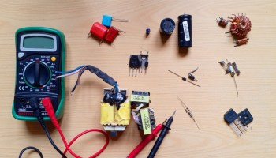
Module Title: Testing Electrical and Electronic components
Module Code: EISEEES2 M03 0322
Nominal duration: 70 hours

Prepared By: Ministry of Lobar and Skill
August, 2022
Addis Ababa, Ethiopia

Table of Content
Acknowledgment 4
Introduction to the module 6
Unit one: Prepare to test electrical/electronic components/parts 8
1.1. OHS and safety guidelines 9
1.1.1. OHS (Occupational health and safety) 9
1.1.2. Safety guidelines 10
1.2. Appropriate tools and test instruments 12
1.2.1. Hand tools 12
1.2.2. Tester instruments 17
1.3. Specification and tasks of materials 32
1.3.1. Major reasons why specification is crucial to construction 33
1.4. Electrical/electronic components 34
1.4.1. Passive components 34
1.4.2. Active components 60
Unit Two : Methods of Testing electrical/electronic components/parts 82
2.1. Undertake Work safely with the workplace 83
2.1.1 Employer responsibilities 83
2.1.2. Worker responsibilities 84
2.2. Test Electrical/Electronic Components/parts 84
2.2.1. Test Passive component 84
2.2.2. Test active components 93
2.3. Test electrical /electronic circuits & parts 103
2.3.1. Test power supply circuit 103
2.3.2. Test rectifier circuit 105
2.4. Correct use of test/measuring instrument 109
2.5. Read and interpret specification of electronic component 110
Self check 2.1 113
Operation sheet 2.1 115
Lab test 2.1 117
Unit Three: Test the construction of electrical/ electronic circuits 118
3.1. Assemble electrical/electronic circuit 119
3.2. Cheek Operations of electrical/electronic circuit 120
3.3. Test the completed electrical/electronic circuits 122
3.4. Construction of basic electrical/electronic circuit 123
3.5. Respond unplanned events 126
3.5.1. Main causes of electrical accidents 128
Self-check 3.1 129
References 130

Acknowledgment

Ministry of Labor and Skills wish to extend thanks and appreciation to the many representatives of TVT instructors and respective industry experts who donated their time and expertise to the development of this Teaching, Training and Learning Materials (TTLM).

Acronym
OHS----------------------------------------------Occupational health and safety
DMM -------------------------------------------- Digital multimter
GFCI ----------------------------------------------Ground Fault Circuit Interrupter
LCD ---------------------------------------------liquid crystal display
AC -------------------------------------------------alternating current
DC ------------------------------------------------direct current
CH------------------------------------------------ channel
LCR----------------------------------------------- inductor, capacitor, resistor meter
RF------------------------------------------------- radio frequency
IC-------------------------------------------------- Integrated circuits
ESR ------------------------------------------------equivalent series resistance
VDR ---------------------------------------------voltage dependent Resistors
LDR ---------------------------------------------Light Dependent Resistors

Introduction to the module

In Electrical/Electronic Equipment Servicing field; Testing Electrical and Electronic components/parts helps to know every piece of electronic equipments has electronic components/parts. Electrical/Electronic part/component is a basic electrical/electronic element usually packaged in a discrete form with two or more connecting leads or metallic pads. Components are intended to be connected together, usually by soldering to a printed circuit board, to create an electrical/electronic circuit with a particular function (for example an amplifier, radio receiver, or oscillator).
This module is designed to meet the industry requirement under the Electrical/Electronic Equipment Servicing occupational standard, particularly for the unit of competency: Testing Electrical and Electronic components/parts
This module covers the units
- Prepare to test electrical/electronic components
- Test electrical/electronic components
- Test the construction of electrical/ electronic circuits
Learning Objective of the Module
- Prepare electronic components
- Test electronic components
- Test constructed electronic circuit

Module Instruction
For effective use this modules trainees are expected to follow the following module instruction:
- Read the information written in each unit
- Accomplish the Self-checks at the end of each unit
- Perform Operation Sheets which were provided at the end of units
- Do the “LAP test” giver at the end of each unit and
- Read the identified reference book for Examples and exercise

Unit one: Prepare to test electrical/electronic components/parts
This unit is developed to provide you the necessary information regarding the following content coverage and topics:
- OHS and safety guidelines
- Appropriate tools and test instruments
- Specification and tasks of materials
- Electrical/electronic components
- Passive components
- Active components
This unit will also assist you to attain the learning outcomes stated in the cover page. Specifically, upon completion of this learning guide, you will be able to:
- Follow OHS and safety guidelines
- Use appropriate tools and test instruments
- Know Specification and tasks of materials
- Identify Electrical/electronic components

  - OHS and safety guidelines
    - OHS (Occupational health and safety)
Occupational health and safety (OHS) is a branch of public health aimed at improving workplace health and safety standards. It studies injury and illness trends in the worker population and offers suggestions for mitigating the risks and hazards they encounter on the job.
Accidents
An accident is an unplanned, unforeseen, undesired, non-value added, interrupting activity which may or may not result in personal injury / property damages
Accident Categories
1. Minor accident
- There is injury or illness to operator
- Immediate medical attention Required
- With or without loss to property,
- Where the operator returns to duty immediately.
2. Major accident
- It includes death, loss of limb may have loss of property or production.,
- where the operator takes leave beyond 48 hours
3. Dangerous occurrence
- which do not cause death or injury but loss to property or production to a huge extent (e.g.., Bursting of boilers, Collapse of buildings )
- Except the minor accidents others must be reported to the relevant Govt. Authorities like Factory Inspector / Local authority.
Effects of Accidents
- Pain / loss of part of body which can’t be shared
- Loss of Pay and medical expenses
- Loss of experience and knowledge
- Strain to family and others
Causes of Accidents
- unsafe Condition
- Unsafe Act
- Natural Reasons
Occupational health and safety (OHS) is a branch of public health aimed at improving workplace health and safety standards. It studies injury and illness trends in the worker population and offers suggestions for mitigating the risks and hazards they encounter on the job. Every occupation has health or safety risks associated with it, and it is every employer’s responsibility to ensure that their employees can carry out their work as safely as possible
Some of the topics covered by OHS include the following:
- Appropriate use of PPE - It is the employer's responsibility to ensure that workers have the personal protective equipment required to work safely. Depending on the job and work environment, this can include fall protection devices, hard hats, high-visibility clothing, or safety gloves.
- Safe operation of the work equipment - Safety procedures ensure that employees can use heavy machinery, power tools, and other work equipment with minimal risk of injury. This includes not only the appropriate handling of the equipment, but also regular inspections and maintenance to ensure that it functions optimally.
- Maintaining hydration - Since they are at work for extended periods of time, workers are at risk of dehydration if clean drinking water isn't provided for them. While this affects all workers, it is especially important for those who do intense physical labor, wear heavy PPE, or work in high-heat environments.
- Good bodily movements - Musculoskeletal disorders are an extremely common type of workplace injury. To prevent them, workers need to follow ergonomic best practices. This includes safe lifting techniques, good posture, and avoiding repetitive motions while carrying out their work tasks.
    - Safety guidelines
The following safety Guidelines should be understood and strictly followed to avoid accidents while working
  - Don't work alone - in the event of an emergency another person's presence may be essential.
  - Always keep one hand in your pocket when anywhere around a powered line-connected or high voltage system.
  - Wear rubber bottom shoes or sneakers.
  - Don't wear any jewellery or other articles that could accidentally contact circuitry and conduct current, or get caught in moving parts.
  - Set up your work area away from possible grounds that you may accidentally contact.
  - Know your equipment: TVs and monitors may use parts of the metal chassis as ground return yet the chassis may be electrically live with respect to the earth ground of the AC line.
  - If circuit boards need to be removed from their mountings, put insulating material between the boards and anything they may short to. Hold them in place with string or electrical tape. Prop them up with insulation sticks – plastic or wood.
  - If you need to probe, solder, or otherwise touch circuits with power off, discharge (across) large power supply filter capacitors with a 2 W or greater resistor of 5-50 ohms/V approximate value (e.g., for a 200 V capacitor, use a 1K-10K ohm resistor). Monitor while discharging and/or verify that there is no residual charge with a suitable voltmeter.
  - Connect/disconnect any test leads with the equipment unpowered and unplugged. Use clip leads or solder temporary wires to reach cramped locations or difficult to access locations.
  - If you must probe live, put electrical tape over all but the last 1/16" of the test probes to avoid the possibility of an accidental short which could cause damage to various components.
  - Use a proper high voltage probe or high voltage meter to measure voltages which are potentially beyond the capabilities of your DMM or VOM - not something cobbled together from 1/4 watt resistors! Note that fault conditions or even testing at *reduced* input voltage may result in greatly excessive voltage on one or more outputs due to lack of regulation.
  - It may be possible to perform some of the tests at greatly reduced voltage (e.g., 30 VDC to the chopper instead of 300 VDC) by supplying external power to the controller chip (if used) and injecting base/gate drive from a signal generator. This would greatly reduce the shock hazard as well as equipment damage from a slipped probe or missed faulty component.
  - Perform as many tests as possible with power off and the equipment unplugged. For example, the semiconductors in the power supply section of a TV or monitor can be tested for short circuits with an ohmmeter.
  - Use an isolation transformer if there is any chance of contacting line connected circuits. A Variac is not an isolation transformer! The use of a GFCI (Ground Fault Circuit Interrupter) protected outlet is a good idea but will not protect you from shock from many points in a line connected TV or monitor, or the high voltage side of a microwave oven, for example. (Note however, that, a GFCI may nuisance trip at power-on or at other random times due to leakage paths (like your scope probe ground) or the highly capacitive or inductive input characteristics of line powered equipment.) A fuse or circuit breaker is too slow and insensitive to provide any protection for you or in many cases, your equipment.
  - Finally, never assume anything without checking it out for yourself! Don't take shortcuts!
  - Appropriate tools and test instruments
    - Hand tools
Hand tools are non-powered, which includes axes, wrenches, screw drivers, hammers, etc. The greatest hazards posed by hand tools results from misuse and improper maintenance. Employee instruction/training programs shall provide detailed training in the proper use of hand tools for the specific area of operations in which they will be working in. Attention will be given to tool selection, tool use, and proper personal protective equipment that are required to be used when operating the specific tool as outlined in the following sections.
    - Metal-Cutting Hand Tools
- Chisels
- Factors determining the selection of cold chisels are the materials to be cut, the size and shape of the tool, and the depth of the cut to be made.
- The chisel should be made heavy enough so that it will not buckle or spring when struck.
- A chisel no larger than the material should be selected so that the blade is used rather than the point or corner. Also, a hammer heavy enough to do the job should be used.
- Employees are required to wear safety goggles when using a chisel and should set up a shield or screen to prevent injury to other employees from flying chips. If a shield does not give protection to all exposed employees, then all employees in the work area are required to wear glasses with side protection.
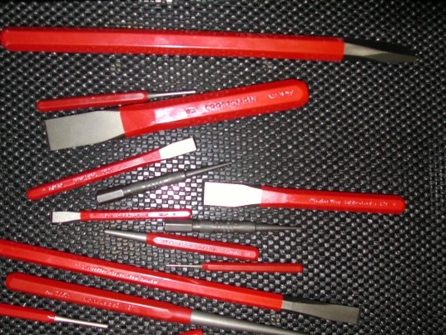

Figure 1.1 Chisels
- Hack Saws
- Hacksaws should be adjusted in the frame to prevent buckling and breaking, but should not be tight enough to break off the pins that support the blade.
- Install blade with teeth pointing forward.
- Pressure should be applied on the forward stroke not on the back stroke.
If the blade is twisted or too much pressure is applied, the blade may break and cause injury to the hands or arms of the user.
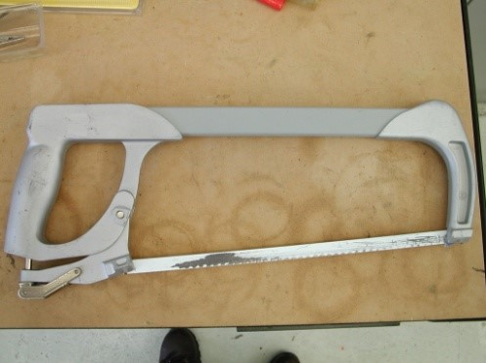
Hacksaw

Figure 1.2 Hack Saws
- Files
- Selection of the right kind of file for the job will prevent injuries and lengthen the life of the file.
- The file should never be cleaned by being struck against a vise or other metal object due to file chips becoming possible flying debris.
- A file-cleaning card or brush should be used.
- A file is not to be hammered or used as a pry. Use of a file in this manner frequently results in the file chipping or breaking causing injury to the user.
- A file should not be made into a center punch, chisel, or any other type of tool because the hardened steel may fracture in use.
A file is never to be used without a smooth, crack-free handle; if the file were to get hung up, the tang may puncture the palm of the hand, the wrist, or other part of the body. Under some conditions, a clamp-on raised offset handle may be useful to give extra clearance for the hands.
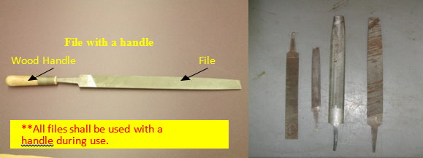

Figure 1.3 Files
Files are not to be used on lathe stock turning at high speed (faster than three turns per file stroke) because the end of the file may strike the chuck, dog, or face plate and throw the file (or metal chip) back at the operator hard enough to inflict serious injury
- Cutters
- Cutters used on wire, reinforcing rods, or bolts should have ample capacity for the stock; otherwise, the jaws may be sprung or spread.
- Chips may fly from the cutting edge and injure the user.
- Frequently lubricate cutters.
- To keep cutting edges from becoming nicked or chipped, cutters are not to be used as nail pullers or pry bars.
- Cutter jaws should have the hardness specified by the manufacturer for the particular kind of material to be cut.
By adjustment of the bumper stop behind the jaws, cutting edges are to be set to have a clearance of 0.003 inch when closed
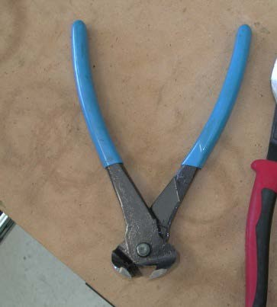
Wire
Cutters
Bolt
Cutter

Figure 1.4 Cutters
    - Torsion Tools
- Open-End or Box Wrenches
- Open-end or box wrenches shall be inspected to make sure that they fit properly and that the jaws are not sprung or cracked.
- When defective, the wrench is required to be taken out of service until repaired.
Open End
Wrench

Figure 1.5 Open-End or Box Wrenches
- Adjustable Wrenches
- Adjustable wrenches are used for many purposes, but are not intended to take the place of standard open-end, box or socket wrenches.
- They are used mainly for nuts and bolts that do not fit a standard wrench.
- Pressure is always applied to the fixed jaw.



Figure 1.6 Adjustable Wrenches
- Pliers
- Side-cutting pliers sometimes cause injuries when short ends of wires are cut.
- A guard over the cutting edge and the use of safety glasses will help prevent eye injuries.
- The handles of electricians' pliers are to be insulated. In addition, employees shall wear the proper electrical rated gloves if they are to work on energized lines.
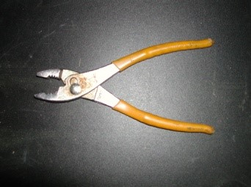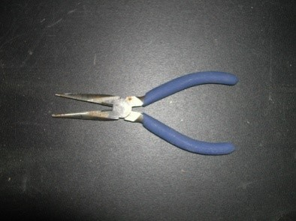
Long Nose Pliers
with
Side Cutter

Figure 1.7 Pliers
- Screwdrivers
- The practice of using screwdrivers for punches, wedges, pinch bars, or pry-bars shall not be allowed.
- Cross-slot (Phillips head) screwdrivers are safer than the square bit type, because they have fewer tendencies to slip. The tip must be kept clean and sharp, however, to permit a good grip on the head of the screw.
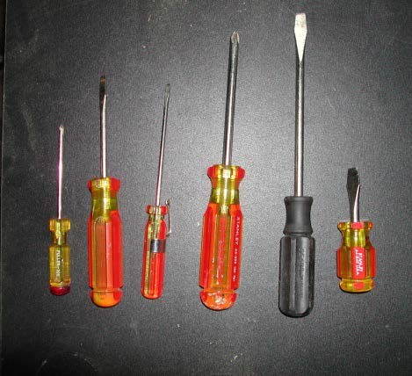
Screwdrivers

Flat
Head
Phillips

Head

Figure 1.8 Screwdrivers
    - Tester instruments
Electrical tester tools are used for measuring various electrical parameters. These parameters include current, voltage, resistance, continuity, etc. It is commonly used by professional electricians and electrical contractors to test live wires, circuit breakers, electrical panels or power transformers. They are both multi-function and single-function devices that can conduct typical electrical testing duties. The various types of an electrical tester include clamp meters, insulation testers, multimeters, ohmmeters, voltage detectors, etc. The purpose of writing this article is to discuss and guide you with the functionality and uses of all electrical testers. It will help you in selecting the right tester for your project.
The testing equipment used to detect faults in the operation of electronic devices by creating stimulus signals and capture responses from electronic devices under test is known as electronic test equipment. If any faults are detected, then identified faults can be traced an rectified using electronic testing equipment. Most often all electrical and electronic circuits are tested and troubleshooted to detect faults or abnormal functioning if any.
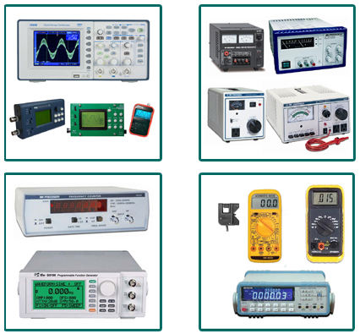
Figure 1.9 Basic Electronic Testing Equipments
The Basic Electronics Testing Equipments under this Category Include the Following
- Multimeter
A multimeter is an electronic instrument used to measure the three basic electrical characteristics: voltage, current and resistance. It has multiple functions and acts like ohmmeter, voltmeter and ammeter and also used for household wiring, electric motors, testing batteries an
power supplies. The multimeter is a handheld device with a needle over a numeric LCD digital display for indication purpose. It is also used to test continuity between two points in an electrical circuit. There are three types of multimeters made available in the market such as: digital multimeter, analog multimeter and fluke multimeter.
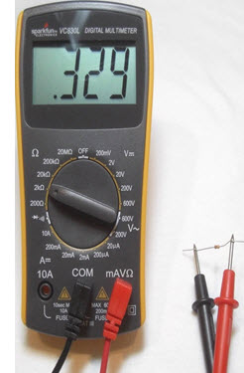
Figure 1.10 Digital Multimter

- Oscilloscope
The oscilloscope is a unique instrument designed to graphically measure time-varying voltage and current values. This method of measurement permits the operator to actually see voltage and current signal traces instead of viewing the results on a deflection meter or a digital display instrument.
i. Applications of oscilloscope
1. You can determine the time and voltage values of a signal.
2. You can calculate the frequency of an oscillating signal.
3. You can see the “moving parts” of a circuit represented by the signal.
4. You can tell if a malfunctioning component is distorting the signal.
5. You can find out how much of a signal direct current (DC) or alternating current (AC) is.
6. You can tell how much of the signal is noise and whether the noise is changing.
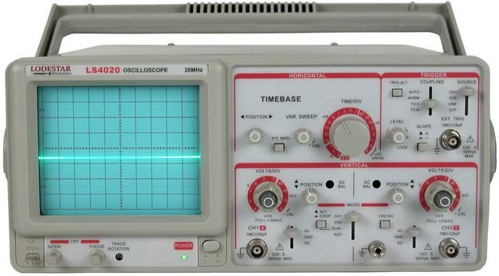
Figure 1.11 Oscilloscopes
As illustrated, the screen of this oscilloscope has 8 squares or divisions on the vertical axis, and
10 squares or divisions on the horizontal axis, usually, these squares are 1 cm in each direction:

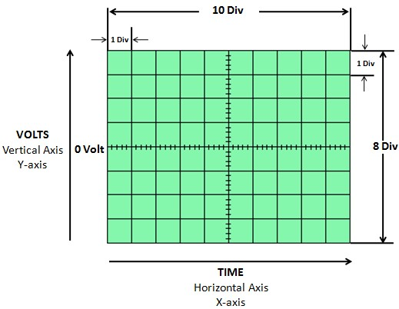
Figure 1.12 Oscilloscope display
Take a look at the oscilloscope display. Notice the grid markings on the screen. These markings create the graticule. Each vertical and horizontal line constitutes a major division. The graticule is usually laid out in an 8-by-10 division pattern. Labeling on the oscilloscope controls (such as volts/div and time/div) always refers to major divisions. The tick marks on the center horizontal and vertical graticule lines are called minor divisions.
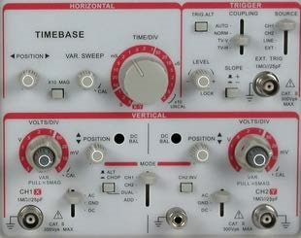
Figure 1.13 Controls of Analog Oscilloscope

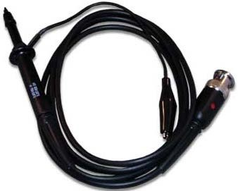
Figure 1.14 Oscilloscope Probe

ii. Setting-up your oscilloscope
- Someone else may have been twiddling knobs and pressing buttons before you. Before you switch the oscilloscope on, check that all the controls are in their “normal” positions. Vertical and Horizontal controls must be CENTERED (The display may not appear if these controls are not properly set).

Vertical
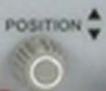

CH 1 CH 2

Horizontal
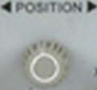
CH 1 CH 2
Figure 1.15 Vertical and Horizontal adjustment

The central TIME/DIV and VOLTS/DIV and the HOLD OFF controls are in the calibrated, or CAL position
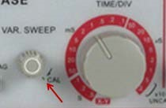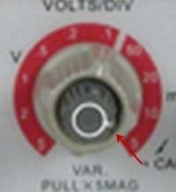
Figure 1.16Vertical Mode must be at channel 1 or channel 2.
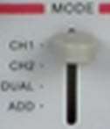
Figure 1.17Ground Button must be IN at channel 1 or channel 2.
If vertical mode is set in channel 1 (channel A for other oscilloscope), and your input probe is connected in channel1, the controls in channel 2 is disabled.

iii. Calibrating procedures of Oscilloscope
Calibrating your test instruments is important because it gives accurate reading. So before measuring voltage, time, and frequency, calibrates your oscilloscope first.
1. Set the channel 1 input coupling to DC.
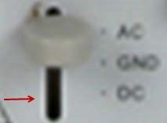 Figure 1.18 input coupling
2. Set the trigger mode to auto.
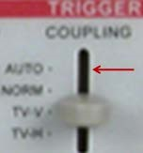Figure 1.19 trigger mode
3. Set the intensity control to a nominal viewing level and adjust the focus control for a sharp display.
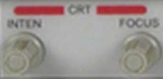
Figure 1.20 focus control
4. The display may appear as shown in graphs A & B. If this happens, adjust the horizontal and vertical controls to achieve the graph as shown in graph C.
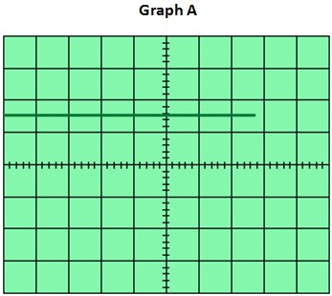

Figure 1.21 graph A
Adjust HORIZONTAL control until the line appears as graph B
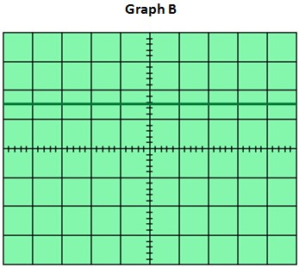
Figure 1.22 graph B

Vertical

CH 1
Adjust vertical control until the line appears as graph C
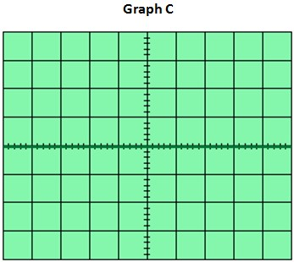
Figure 1.23 graph C
5. Release the ground button (GND)
6. Connect the probe to input BNC jack to channel 1. Then clip the oscilloscope probe to Calibrator as shown below. The voltage and frequency in this oscilloscope is 2 volts peak-topeak at 1 KHz.
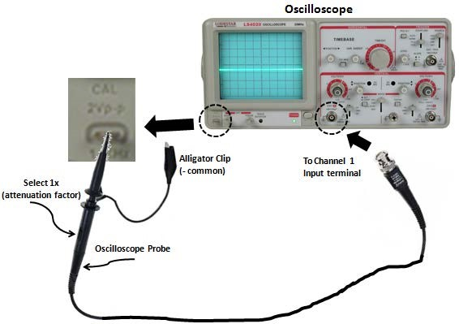
Figure 1.24 Calibrated oscilloscope
7. Set the VOLTS/DIV to 1 volt and TIME/DIV to 1 ms as shown.
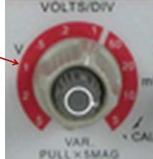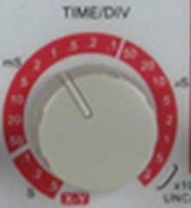
Figure 1.25 Volt/Div and Time/Div
Why the settings set to 1 Volt/Div and 1 ms Time/Div?
Since the CALIBRATION delivers 2 volts peak-to-peak at 1 KHz frequency, for determining time/div settings,
F = 1 / T in Hz T = 1 / F in seconds
Since F = 1 KHz or 1000 Hz

T = 1 / F
T = 1 / 1 KHz
T = 0.001 second or 1 ms TIME/DIV setting
Where:
F=frequency
T = time
ms = millisecond
This is a well-calibrated waveform coming from the calibrator at 1 VOLT/ DIV and 1 ms TIME/DIV settings.
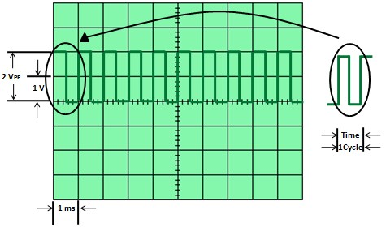
Figure 1.26 well-calibrated waveform
- Frequency counter
Digital frequency counter is electrical test equipment used for measuring the frequency of repetitive signals and elapsed time between events. Digital frequency counters are also used to measure the radio frequency where it is important to measure the precise frequency of a particular signal.
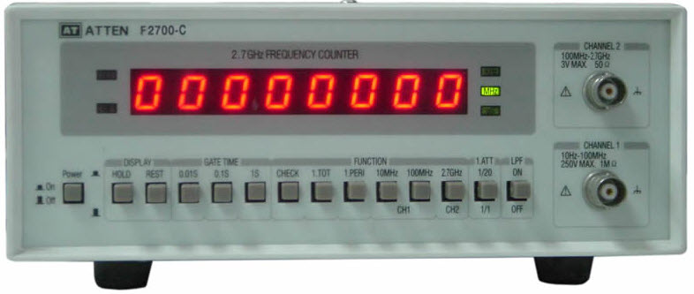
Figure 1.27 Frequency counter
There is a slight difference between the timers and frequency counters in the electronic industry. It is often possible to use both timers and frequency counters to perform the both functions: to measure the time and frequency. Frequency counters are mostly used as general purpose laboratory test equipment to measure higher frequencies.
- LCR Meter
LCR Meter name itself indicates that it is used to measure the inductance, capacitance and resistance of electronics components. The inductance, capacitance and resistance are denoted by the letters L, C, and R so it is named as LCR Meter. A variety of meters are made available in the market, but simple versions of LCR meters indicate impedance only for converting the values to capacitance or inductance.
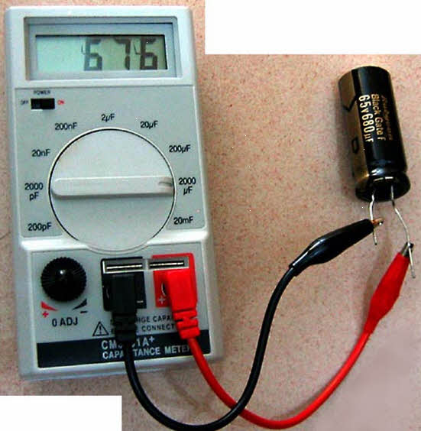
Figure 1.28 LCR Meter
More designs are available and used to measure the capacitance or inductance, and also the equivalent series resistance of capacitors and the Q factor of inductive components. These conditions make the LCR meters valuable for measuring the quality and overall performance of the component.
- Insulation Testers :- It is used to prevent the users from hazards like an electric shock, short circuits that occurs when the insulation in electrical parts are used in industrial plants, buildings, etc. The portable type of tester is used for testing insulation resistance, continuous current, alternating current, etc. Also, it is used for testing supply lines to protect the user and ensure the proper functioning of the system.
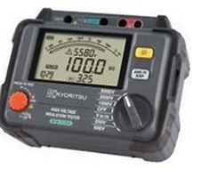
Figure 1.29 Insulation Testers
- RF Power Meter (Wattmeter)
The RF power meter or Wattmeter measures the RF signal in transmission lines. It is used in FM, AM, and CW modulation applications. The reading is shown in watts for different powers and frequencies.
The RF Wattmeter is used to measure:
- RF power in 50-ohm transmission lines.
- To know the power level in watts.

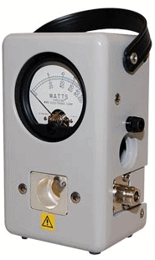
Figure 1.30 RF Power Meter
- Functions Generator A function generator which can generate different waveforms such as sine wave, square wave, triangular wave, sawtooth wave, ramp, and pulses. It can be used with the oscilloscope to test and troubleshoot electronic devices and circuits.
To verify the cut-off frequency while designing the op-amp filters, a function generator can be used to vary the input frequency and oscilloscope can be used to view the output signals
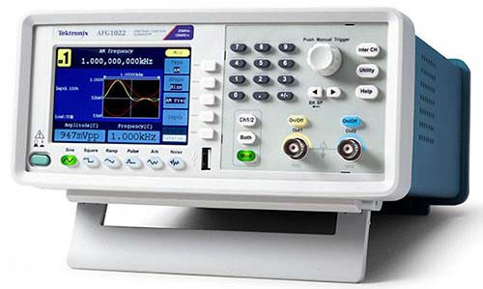
Figure 1.31 Functions Generator
- Logic analyzer – This may be used to test complex digital and logic circuits and display the relative timing of a large number of signals.
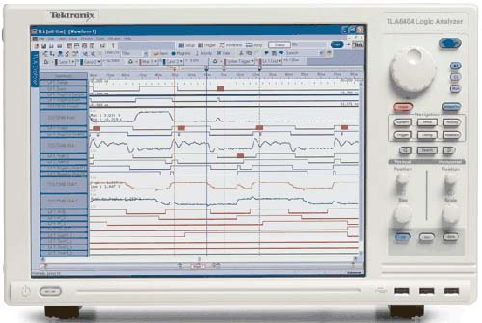
Figure 1.31Logic analyzer
Component tester
This is a very interesting tool to have in your lab. It basically speeds up the testing process very well.
With a decent component tester, we can actually test, verify, and analyze a lot of fundamental components.
Following is the example of a component tester:
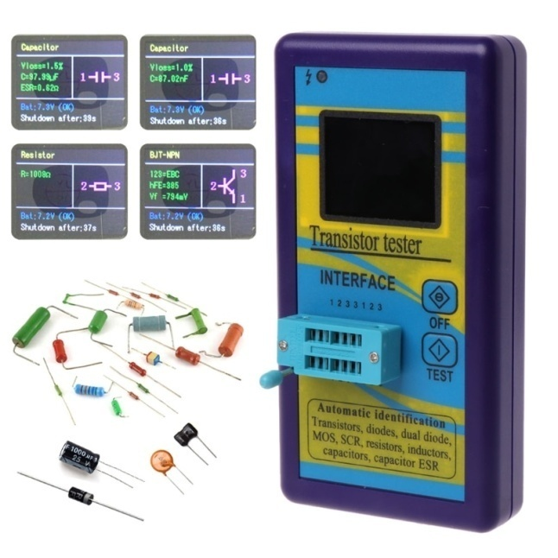
Figure 1.32 M328 transistor tester
With this tester, we can easily test the following components just by putting the component in it and pressing the test button.
- Resistors
- Capacitors
- Also, measure its capacitance value (uF) and ESR value.
So, with M328 not only you can identify a bad capacitor off circuit but also in-circuit using its ESR value.
- Diodes
- SCR
- LEDs – all types and colors
- Inductors
- And much more.
We will be using this component tester a lot in later sections of this article.
Remember m328 tester is for through whole components. If you want to test smd component then you would need to have a separate SMD tester as well. The testing for SMD tester are the same as we saw above.
Integrated circuits (ICs) tester
Integrated circuits are almost everywhere in electronics. I am sure you have seen them plenty of times. They look like black small boxes in electronics circuits.
IC itself is a discrete circuit with its own functions and feature. We use ICs in circuits to reduce the circuit space and improve efficiency.
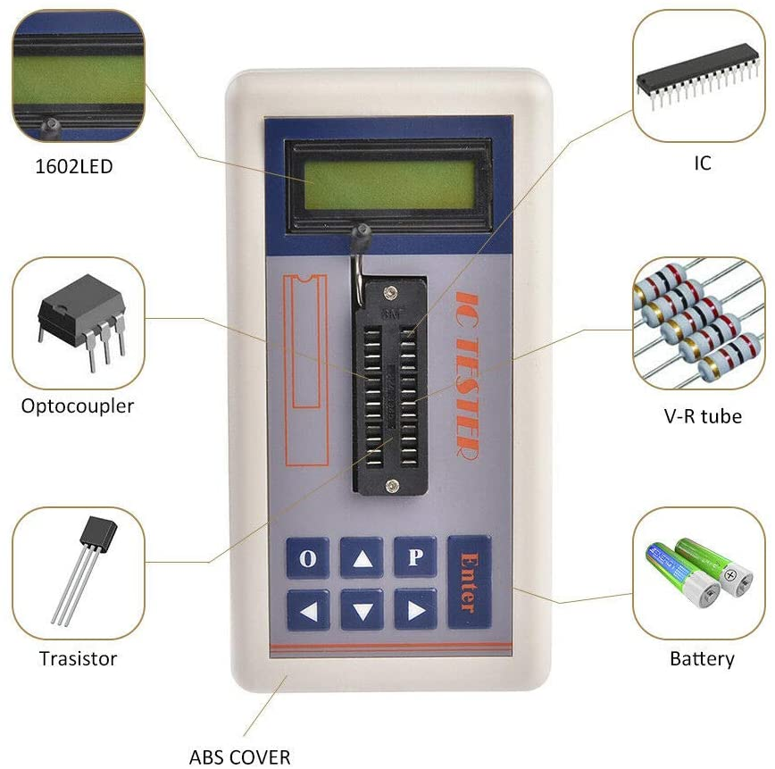
Figure 1.33 IC Tester
K.ESR meter
ESR stands for equivalent series resistance. This parameter is very useful when testing a capacitor inside the circuit board.
An ESR meter is just a device that helps us measure this value. So, we need an ESR meter to properly test in circuit and off circuit capacitors.
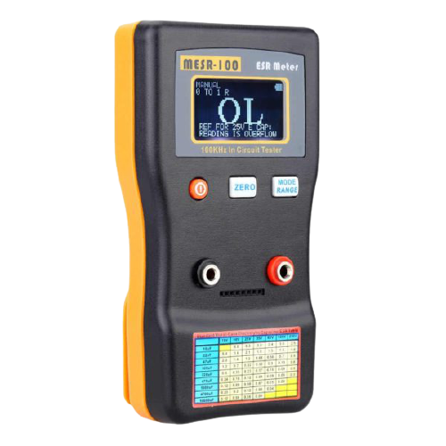
Figure 1.34 MESR 100
Actually, the ESR value of a capacitor increase if something bad happens to the capacitor. And by the change in this value, we can tell with surety if the bad is bad or good.
  - Specification and tasks of materials
"Specification: A detailed description of the dimensions, construction, workmanship, materials etc., of work done or to be done, prepared by an architect, engineer etc."
A specification is the document that describes in words what cannot be visualized or explained on a drawing or model. This is not only applicable to construction; the same principles apply to all industries, from aerospace and oil and gas to automobiles and manufacturing. In construction, the specification can cover everything:
- Site establishment.
- Contract type.
- Asset performance criteria.
- Systems and product quality.
- Applicable standards and how they are executed.
- Specific products to be used.
The type of specification can relate to the project or the procurement route – whether it is performance-based, prescriptive or proprietary – depending on project requirements.
Specifications:
- Are required during the design stage.
- Form part of the contract documentation.
- Play a key role in project fulfillment.
    - Major reasons why specification is crucial to construction
Let’s look at some of the primary reasons why specification is essential to the construction process:
- The specification provides clear instructions on project intent, performance and construction.
- It can reference the quality and standards which should be applied.
- Materials and manufacturers’ products can be clearly defined.
- Installation, testing and handover requirements can be identified.
- Classification within the specification can be used to support handover and asset management.
- It eliminates the need for information overload on the drawing or model, making identifying information easier.
- A specification can support project costing, not only the materials and products but the performance and workmanship.
- Along with the drawings, the specification forms part of the contractual documents, helping minimize project risk and providing support should there be any legal disputes.
- It supports client brief interpretation and gives the client assurance that their commissioned asset is the one being delivered.
- It is essential for the construction phase and an important part of the soft-landing process, subsequent asset management and the lifecycle plan.
- By being clear, concise and information-rich, a specification provides answers to many onsite construction questions, saving the project team, client and contractor time and money.
- After project finish, office masters can incorporate best practices and lessons learnt, improving efficiency, providing quality assurance and ensuring project consistency.
- Office masters also save the team time and money because they can be developed over time and adapted to suit a project's specifics, drawing on specialist knowledge when needed.
- The specification is a living document to be used by the complete project team throughout the construction phase; its value does not end at the design phase.
- Along with any variations or value engineering, it becomes a part of the project audit trail and a crucial part of the handover documents, forming the basis for asset management, asset maintenance, and even feeding into staff training and human resources policies.
Example: - Specifications of resistor
1. Resistance value: This is the value of the resistance expressed in ohms. Ex: 10O, 1MO
2. Tolerance: This is the variation in the value of the resistance i.e. expected from exact indicated value usually tolerance is represented in % ex: 1%, 2%, and 20%.
3. Power rating: The power rating is very important in the sense that it determines the maximum correct that a resistor can withstand without being destroyed. The power rating of resistor is specified as so many watts at a specific temperature such as one or two watts at 70 degree.
  - Electrical/electronic components
An electronic component is any basic discrete device or physical entity in an electronic system used to affect electrons or their associated fields. Electronic components are mostly industrial products, available in a singular form and are not to be confused with electrical elements, which are conceptual abstractions representing idealized electronic components and elements. Electronic components are mainly divided in to two they are active and passive components
    - Passive components
A passive element is an electrical component that does not generate power, but instead dissipates, stores, and/or releases it. Passive elements include

Basic Components | Electromechanical Components
- Resistors (All Types)  - Capacitors (All Types)  - Inductors / Coil  - Memristor / Network  - Sensors  - Detectors  - Transducers  - Antennas  - Assembly Modules | - Piezoelectric devices  - Crystals  - Resonators  - Terminals and Connectors  - Cables  - Switches  - Circuit Protection Devices  - PCB  - Mechanical Devices such as a Fan, Lamp
Passive Components Applications
1. Resistors are used to control the flow of current in electrical and electronic circuits. They are also used as heating elements in some devices.
2. Capacitors are used for power factor control, filter circuits, used as a transducer, etc.
3. Inductors are used in filter circuits, power factor control for capacitive load, current limiting elements, Relay, etc.
  - Resistors
Resistors are used in virtually all electronic circuits and many electrical ones. Resistors, as their name indicates resist the flow of electricity and this function is key to the operation most circuits
The two main characteristics of a resistor are :-
- Its resistance, R, in ohms and
- Its power rating, P, in Watts.
The resistance, R, provides the required reduction in current or the desired drop in voltage. The wattage rating indicates the amount of power the resistor can safely dissipate as heat. The wattage rating is always more than the actual amount of power dissipated by the resistor, as a safety factor
A resistor is a component or device designed to have a known value of resistance. OR, those components and devices which are specially designed to have a certain amount of resistance and used to oppose or limit the electric current flowing through it are called resistors.
Good to know: Resistance of a resistor depends on their length (l), resistivity (ρ) and its cross sectional area (a) which is also known as laws of resistance … R = ρ (l/a).
IEEE & IEC symbols of Resistors
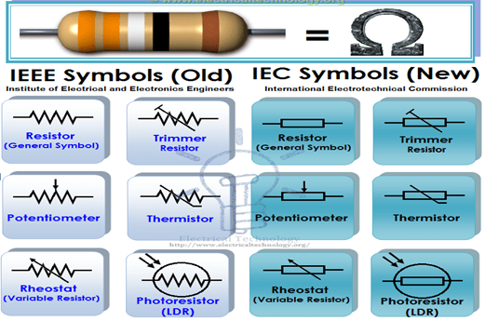
Figure 1.35 IEEE & IEC Symbols of Different Types of Resistors.
Types of Resistors:
Resistors are available in different size, Shapes and materials. We will discuss all possible resistor types one by one in detail with pro and cons and application as follow.
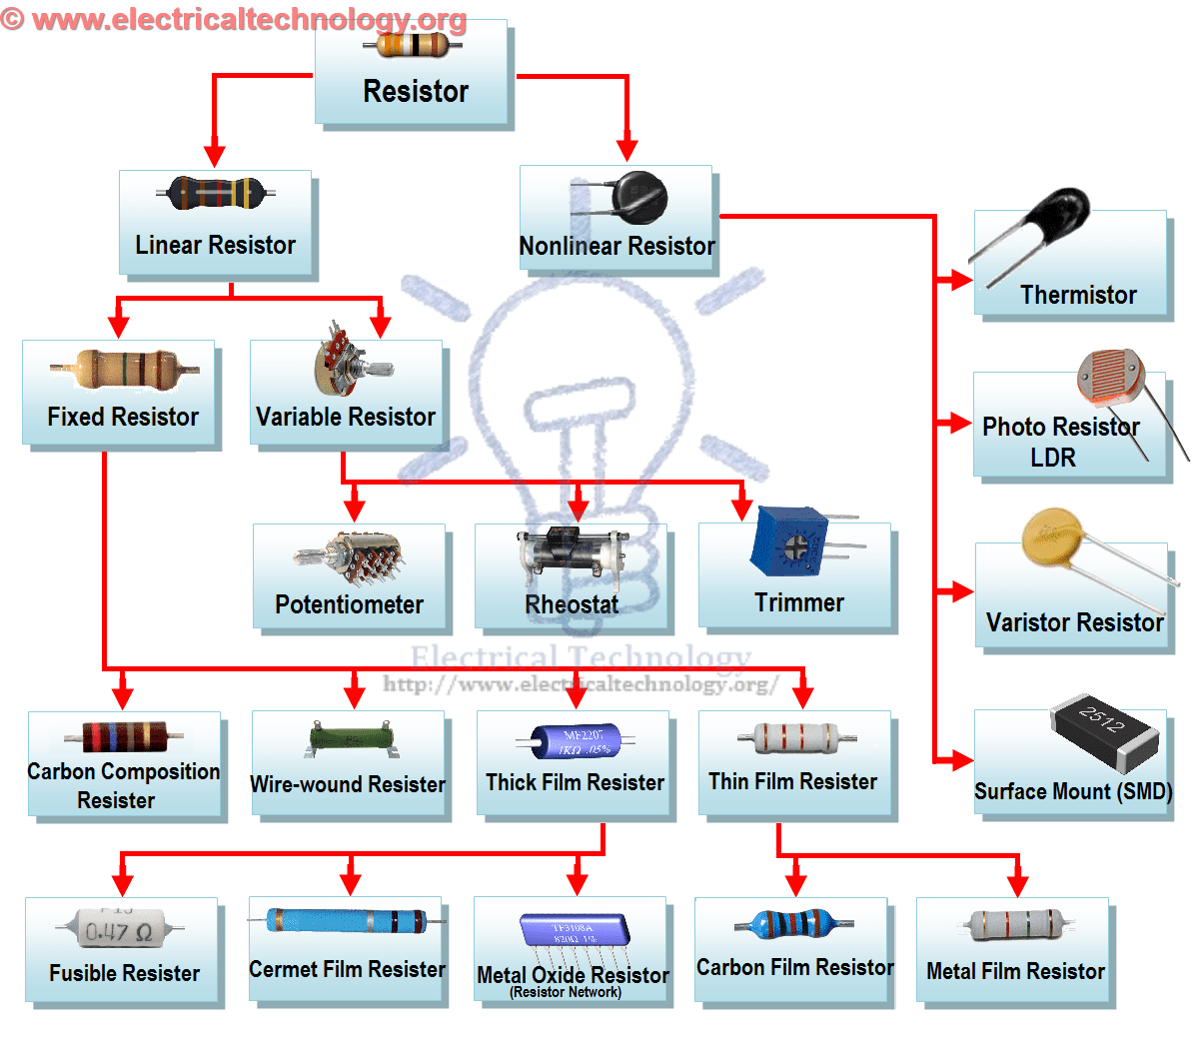
Figure 1.36 Different Types of Resistor Chart/Tree.

There are two basic types of resistors.
- Linear Resistors
- Non Linear Resistors
      - Linear Resistors:
Those resistors, which values change with the applied voltage and temperature, are called linear resistors. In other words, a resistor, which current value is directly proportional to the applied voltage is known as linear resistors.
Generally, there are two types of resistors which have linear properties.
- Fixed Resistors
- Variable Resistors
  - Fixed Resistors
As the name tells everything, fixed resistor is a resistor which has a specific value and we can’t change the value of fixed resistors.
Types of Fixed resistors
- Carbon Composition Resistors
- Wire Wound Resistors
- Thin Film Resistors
- Thick Film Resistors
- Carbon Composition Resistors
A typical fixed resistor is made from the mixture of granulated or powdered carbon or graphite, insulation filler, or a resin binder. The ratio of the insulation material determines the actual resistance of the resistor. The insulating powder (binder) made in the shape of rods and there are two metal caps on the both ends of the rod.
There are two conductor wires on the both ends of the resistor for easy connectivity in the circuit via soldering. A plastic coat covers the rods with different color codes (printed) which denote the resistance value. They are available in 1 ohm to 25 mega ohms and in power rating from ¼ watt to up to 5 Watts.
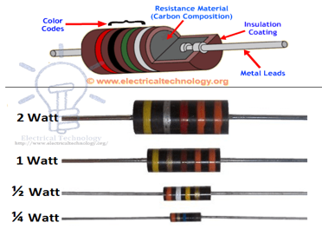
Figure 1.37 Constructions and Wattage Rating of Carbon Composition Resistors.
Characteristic of Fixed Resistors
Generally, they are very cheap and small in size, hence, occupy less space. They are reliable and available in different ohmic and power ratings. Also, fixed resistor can be easily connected to the circuit and withstand for more voltage.
- Wire wound Resistors
Wire wound resistor is made from the insulating core or rod by wrapping around a resistive wire. The resistance wire is generally Tungsten, manganin, Nichrome or nickel or nickel chromium alloy and the insulating core is made of porcelain, Bakelite, press bond paper or ceramic clay material.
The manganin wire wound resistors are very costly and used with the sensitive test equipment e.g. Wheatstone bridge, etc.
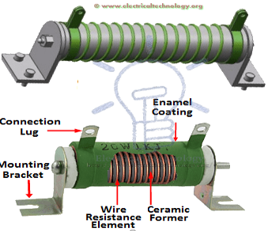
Figure 1.38 Construction of Wire wound Resistors
Advantages and Disadvantage of Wire wound Resistors
Wire wound resistors make lower noise than carbon composition resistors. Their performance is well in overload conditions. They are reliable and flexible and can be used with DC and Audio frequency range. Disadvantage of wire wound resistor is that they are costly and can’t be used in high frequency equipment.
Application of Wire Wound Resistors
Wire wound resistors used where high sensitivity, accurate measurement and balanced current control is required, e.g. as a shunt with ampere meter. Moreover, Wire wound resistors are generally used in high power rating devices and equipment, Testing and measuring devices, industries, and control equipment.
- Thin Film Resistors
Basically, all thin film resistors are made of from high grid ceramic rod and a resistive material. A very thin conducting material layer overlaid on insulating rod, plate or tube which is made from high quality ceramic material or glass. There are two further types of thin film resistors.
- Carbon Film Resistors
- Metal Film Resistors

Carbon Film Resistors
Carbon Film resistors contains on an insulating material rod or core made of high grade ceramic material which is called the substrate. A very thin resistive carbon layer or film overlaid around the rod. These kinds of resistors are widely used in electronic circuits because of negligible noise and wide operating range and the stability as compared to solid carbon resistors.

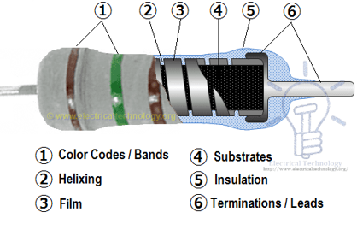
Figure 1.39 Construction of Carbon Film Resistors & Its labels.
Metal Film Resistors
Metal film resistors are same in construction like Carbon film resistors, but the main difference is that there is metal (or a mixture of the metal oxides, Nickel Chromium or mixture of metals and glass which is called metal glaze which is used as resistive film) instead of carbon. Metal film resistors are very tiny, cheap and reliable in operation. Their temperature coefficient is very low (±2 ppm/°C) and used where stability and low noise level is important.

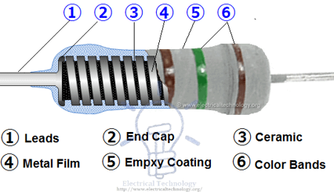
Figure 1.40 Construction and internal parts of Metal Film Resistor.

- Thick Film Resistors
The production method of Thick film resistors is same like thin film resistors, but the difference is that there is a thick film instead of a thin film or layer of resistive material around. That’s why it is called Thick film resistors. There are two additional types of thick film resistors.
- Metal Oxide Resistors
- Cermet Film Resistors
- Metal Oxide Resistors
By oxidizing a thick film of Tin Chloride on a heated glass rod (substrate) is the simple method to make a Metal oxide Resistor. These resistors are available in a wide range of resistance with high temperature stability. In addition, the level of operating noise is very low and can be used at high voltages.
- Cermet Oxide Resistors (Network Resistors)
In the cermet oxide resistors, the internal area contains on ceramic insulation materials. And then a carbon or metal alloy film or layer wrapped around the resistor and then fix it in a ceramic metal (which is known as Cermet). They are made in the square or rectangular shape and leads and pins are under the resistors for easy installation in printed circuit boards. They provide a stable operation in high temperature because their values do not change with change in temperature.
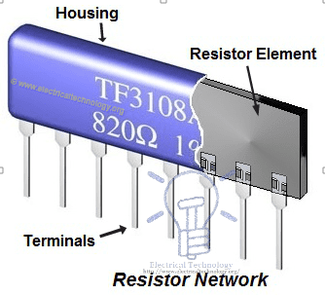
Figure 1.41 Cermets Film Resistor Network Construction

Fusible Resistors
These kinds of resistors are same like a wire wound resistor. When a circuit power rating increased than the specified value, then this resistor is fused, i.e. it breaks or open the circuit. That’s why it is called Fusible resistors. Fusible restores perform double jobs means they limit the current as well as it can be used as a fuse.
They used widely in TV Sets, Amplifiers, and other expensive electronic circuits. Generally, the ohmic value of fusible resistors is less than 10 Ohms.
  - Variable Resistors
As the name indicates, those resistors which values can be changed through a dial, knob, and screw or manually by a proper method. In these types of resistors, there is a sliding arm, which is connected to the shaft and the value of resistance can be changed by rotating the arm. They are used in the radio receiver for volume control and tone control resistance. Following are the further types of Variable Resistors
A. Potentiometers
B. Rheostats
C. Trimmers
  - Potentiometers
Potentiometer is a three terminal device which is used for controlling the level of voltage in the circuit. The resistance between two external terminals is constant while the third terminal is connected with moving contact (Wiper) which is variable. The value of resistance can be changed by rotating the wiper which is connected to the control shaft.
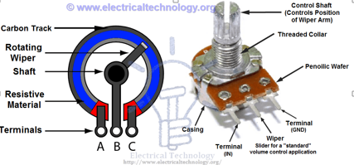
Figure 1.42 Potentiometer Construction
This way, Potentiometers can be used as a voltage divider and these resistors are called variable composition resistors. They are available up to 10 Mega Ohms.
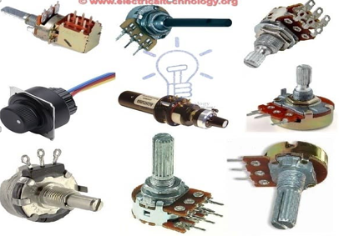
Figure 1.43 Different Types of Potentiometers
  - Rheostats
Rheostats are a two or three terminal device which is used for the current limiting purpose by hand or manual operation. Rheostats are also known as tapped resistors or variable wire wound resistors.
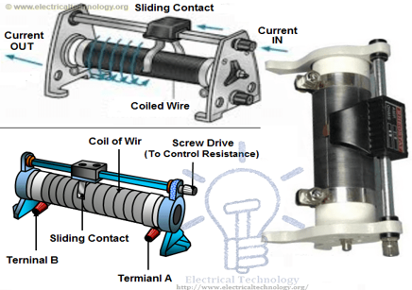
Types of Rheostats resistor and construction of Screw Drive Rheostat
To make a rheostats, they wire wind the Nichrome resistance around a ceramic core and then assembled in a protective shell. A metal band is wrapped around the resistor element and it can be used as a Potentiometer or Rheostats (See the below note for difference between Rheostat and Potentiometer).
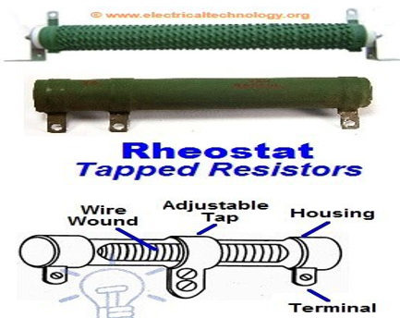
Figure 1.44 Construction of Tapped Rheostat
Variable wire wound resistors are available in the range of 1 ohm up to 150 Ohms. The available power rating of these resistors is 3 to 200 Watts. While the most used Rheostats according to power rating is between 5 to 50 Watts.
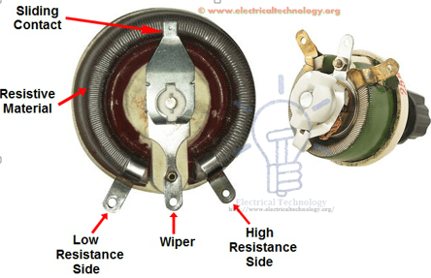
Wire wound Rheostat Construction
The main Difference between Potentiometer and Rheostats
Basically, there is no difference between Potentiometer and Rheostat. Both are variable resistors. The main difference is the use and circuit operation, i.e. for which purpose we use that variable resistor?
For example, if we connect a circuit between resistor element terminals (where one terminal is a general end of the resistor element while the other one is sliding contact or wiper) as a variable resistor for controlling the circuit current, then it is Rheostats.
On the other hand, if we do the same as mentioned above for controlling the level of voltage, then this variable resistor would be called a potentiometer.
  - Trimmers
There is an additional screw with Potentiometer or variable resistors for better efficiency and operation and they are known as Trimmers. The value of resistance can be changed by changing the position of screw to rotate by a small screwdriver.
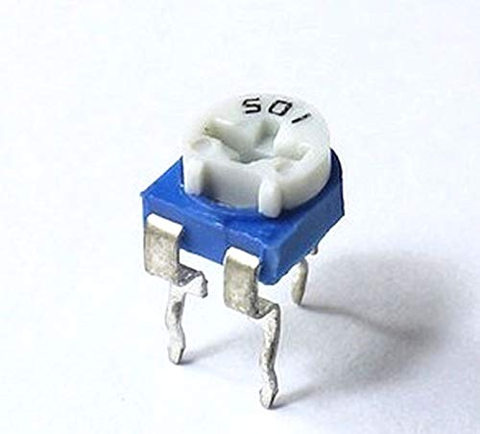
Figure 1.45 Trimmer potentiometer Resistor
They are made from carbon composition, carbon film, cermet and wire materials and available in the range of 50 Ohms up to 5 mega ohms. The power rating of Trimmers potentiometers are from 1/3 to ¾ Watts
      - Non Linear Resistors
We know that, nonlinear resistors are those resistors, where the current flowing through it does not change according to Ohm’s Law but, changes with change in temperature or applied voltage. In addition, if the flowing current through a resistor changes with change in body temperature, then these kinds of resistors are called Thermistors. If the flowing current through a resistor change with the applied voltages, then it is called a Varistor or VDR (Voltage Dependent Resistors).
Following are the additional types of Non Linear Resistors.
- Thermistors
- Varistor (VDR)
- Photo Resistor or Photo Conductive Cell or LDR
- Thermistor
The Thermistor is a solid state temperature sensing device which acts a bit like an electrical resistor but is temperature sensitive. Thermistor can be used to produce an analogue output voltage with variations in ambient temperature and as such can be referred to as a transducer. This is because it creates a change in its electrical properties due to an external and physical change in heat.
The thermistor is basically a two-terminal solid state thermally sensitive transducer constructed using sensitive semiconductor based metal oxides with metalized or sintered connecting leads formed into a ceramic disc or bead.
This allows the thermistor to change its resistive value in proportion to small changes in ambient temperature. In other words, as its temperature changes, so too does its resistance and as such its name, “Thermistor” is a combination of the words THERM-ally sensitive res-ISTOR.
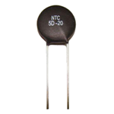
Figure 1.46 Thermistor
It means, Thermistor has a negative temperature coefficient (NTC) but there is also a PTC (Positive Temperature Coefficient) which a made from PID Barium Titanate semiconductor materials and their resistance increases when increases in temperature.
- Varistor
Varistor are voltage dependent Resistors (VDR) which is used to eliminate the high voltage transients. In other words, a special type of variable resistors used to protect circuits from destructive voltage spikes is called Varistor. When voltage increases (due to lighting or line faults) across a connected sensitive device or system, then it reduces the level of voltage to a secure level i.e. it changes the level of voltages.
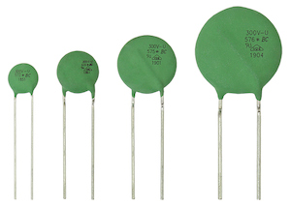
Figure 1.47 Varistor
- Photo Resistor or Photo Conductive Cell or LDR
Photo Resistor or LDR (Light Dependent Resistors) is a resistor which terminal value of resistance changes with light intensity. In other words, those resistors, which resistance values changes with the falling light on their surface is called Photo Resistor or Photo Conductive Cell or LDR (Light Dependent Resistor). The material which is used to make these kinds of resistors is called photo conductors, e.g. cadmium sulfide, lead sulfide etc.
Construction of LDR (Light Dependent Resistor), Photo-resistor or photo conductive cell
When light falls on the photoconductive cells (LDR or Photo resistor), then there is an increase in the free carriers (electron hole pairs) due to light energy, which reduce the resistance of semiconductor material (i.e. the quantity of light energy is inversely proportional to the semiconductor material). It means photo resistors have a negative temperature coefficient.
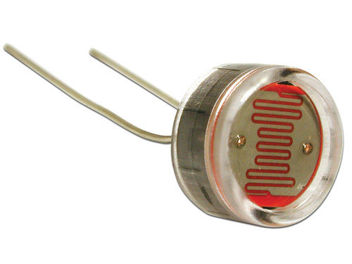
Figure 1.48 Photo Resistors
Application of Resistors
Practically, both types of resistors (Fixed and Variable) are generally used for the following purposes.
Resistors are used:
- For Current control and limiting
- To change electrical energy in the form of heat energy
- As a shunt in Ampere meters
- As a multiplier in a Voltmeter
- To control temperature
- To control voltage or Drop
- For protection purposes, e.g. Fusible Resistors
- In laboratories
- In home electrical appliances like heater, iron, immersion rod etc.
- Widely used in the electronics industries
Resistor color code
Resistor values are often indicated with color codes. Practically all leaded resistors with a power rating up to one watt are marked with color bands. The coding is defined in the international standard IEC 60062. This standard describes the marking codes for resistors and capacitors
The color code is given by several bands. Together they specify the resistance value, the tolerance, and sometimes the reliability or failure rate. The number of bands varies from three to six. At a minimum, two bands indicate the resistance value and one band serves as multiplier.
Resistor Color Code Chart
The chart below shows how to determine the resistance and tolerance for resistors. The table can also be used to specify the color of the bands when the values are known.
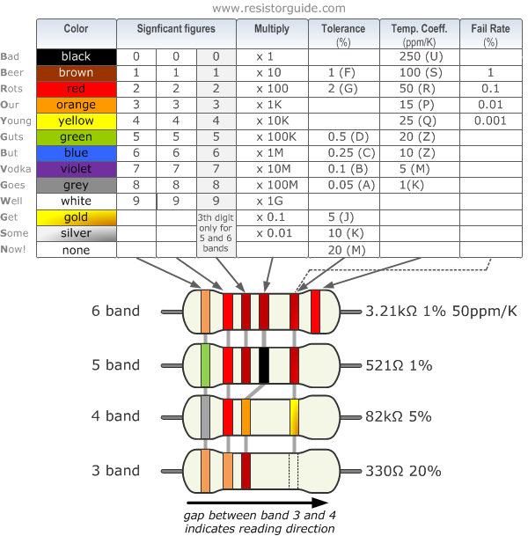
Figure 1.49 Resistor Color Code
Tips for Reading Resistor Codes
In the sections below, examples are given for different numbers of color bands. But, first, here are some general tips for reading the color code: The reading direction might not always be clear. Sometimes the increased space between bands 3 and 4 provides an indication of the reading direction. Also, the first band is usually the closest to a lead. A gold or silver band (the tolerance) is always the last band. It is a good practice to check the manufacturer’s documentation to be sure about the color coding system used.
When in doubt, measure the resistance with a ohmmeter. In some cases this might even be the only way to figure out the resistance; for example when the color bands are burnt off.
4 band resistor
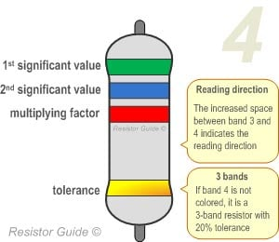
Figure 1.50 four band resistor
The four band color code is the most common variation. These resistors have two bands for the resistance value, one multiplier and one tolerance band. In the example shown here, the 4 bands are green, blue, red and gold. By using the color code chart, one finds that green stands for 5 and blue for 6. The third band is the multiplier, with red representing a multiplier value of 2 (10²). Therefore, the value of this resistor is 56 · 10² = 56 · 100 = 5600 Ω. The gold band means that the resistor has a tolerance of 5%. The resistance value lies therefore between 5320 and 5880 Ω (5560 ± 5%). If the tolerance band is left blank, the result is a 3 band resistor. This means that the resistance value remains the same, but the tolerance is 20%.
5 band resistor
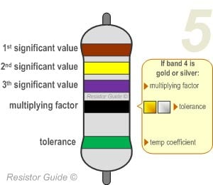
Figure 1.51 five band resistor
Resistors with high precision have an extra band to indicate a third significant digit. Therefore, the first three bands indicate the significant digits, the fourth band is the multiplication factor, and the fifth band represents the tolerance. For the example shown here: brown (1), yellow (4), violet (7), black (x 10⁰ = x1), green (0.5%) represents a 147 Ω resistor with a 0.5% tolerance.
There are exceptions to this 5-band color system. For example, sometimes the extra band may indicate failure rate (military specification) or temperature coefficient (older or specialized resistors). Please read the subsection “Color Code Exceptions" below for more information.
6 band resistor
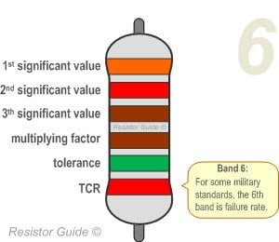
Figure 1.52 six band resistor

Resistors with 6 bands are usually for high precision resistors that have an additional band to specify the temperature coefficient (ppm/˚C = ppm/K). The most common color for the sixth band is brown (100 ppm/˚C). This means that for a temperature change of 10 ˚C, the resistance value can change 1000 ppm = 0.1%. For the 6 band resistor example shown above: orange (3), red (2), brown (1), brown (x10), green (1%), red (50 ppm/°C) represents a 3.21 kΩ resistor with a 1% tolerance and a 50 ppm/°C temperature coefficient.
Example1:
For a 470 ohms resistors with a tolerance of 10% : the first band would be the first digit (4) which is yellow and the second band is the second digit (7) which is violet. We currently have a value of 47 and the third band is the multiplier. We need to multiply 47 by 10Ω to get 470Ω. The 4th band is the tolerance and would be silver for a tolerance of 10%. Figure 1 is an illustration of how these bands would be arrange on a real resistor.
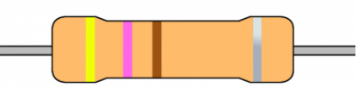
Example 2:
For a 499 ohms resistors with a tolerance of 1% : the first band would be the first digit (4) which is yellow, the second band is the second digit (9) which is white and the third band would be the third digit (9) which is white. We currently have a value of 499 and the fourth band is the multiplier. We need to multiply 499 by 1Ω (black) to get 499Ω. The 5th band is the tolerance and would be brown for a tolerance of 1%. Figure bellow is an illustration of how these bands would be arrange on a real resistor.
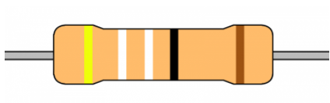

  - Capacitors
A capacitor is one of the most used electronic components which is used in almost any kind of circuit. Its uses & characteristics rely upon the type of the capacitor. In this article, we will briefly discuss different types of capacitors.
A capacitor is a two-terminal passive electronic component that stores charge in an electric field between its metal plates. it is made up of two metal plates (electrodes) separated by an insulator known as the dielectric. The capacitance is the ability of a capacitor to store charge in its metal plates (Electrodes). Its unit is Farad F
Properties of Capacitor
Capacitors are widely used in electrical & electronic circuits. Therefore, being a science person, you must know some important properties of capacitors. These are as follows.
- When a capacitor is connected in a circuit across a voltage, an electric field is created around dielectric. It causes net positive charge on one plate and negative charge on the other plate.
- Unlike an resistive element, a capacitor does not dissipate energy, rather stores it in the form of electric field.
- In an AC voltage (time varying voltage) applied across a resistor, at steady state (after long time) source effect ceases. Then capacitor discharges across the circuit and flow of current in the circuit is due to the capacitor.
Uses of Capacitors
In present scenario, an electronic capacitor comes in several styles, forms, lengths and materials in order to perform efficiently as per the requirement.
Capacitors are commonly used for filtering. It means a capacitor will provide power to the the systems it is embedded in, by increasing its quality. Like in micro controller, capacitors save the micro controller and it doesn’t reboot due to voltage drop. Detailed uses of capacitors are as follows.
Small value capacitors are in use as:
- As components in power supply systems so that the current flows smoothly.
- As a part of electric filters as well as tuned circuits.
- To bound signals amid stages of amplifiers.
On the other hand, a large value capacitor is useful in following manner:
- As a part in several types of electric motors.
- For storing energy in applications like strobe lights.
- For correcting power factor in various types of AC power distribution systems.
Now before learning the different types of capacitors, let us first understand the concept of parallel plate capacitor
Main Types of Capacitors
There are several different types of capacitors and each type of capacitor has its own advantage as well as applications. Few major and widely used types of capacitors are listed below.
  - Ceramic Capacitors
- It is one of the most common types of capacitors generally used in almost every application right from audio to RF.
- The operating range of this type of capacitor is in between few pico farads to 0.1 micro farads.
- This type of capacitors is less costly.
Also they are more reliable when compared with other types of capacitors
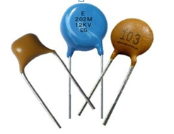
Figure 1.53 Ceramic Capacitors

  - Electrolytic capacitors
Electrolytic capacitors represent the special type of capacitors with fixed capacity value

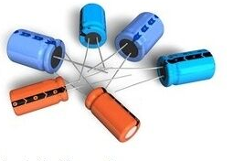
Figure 1.54 Electrolytic Capacitors

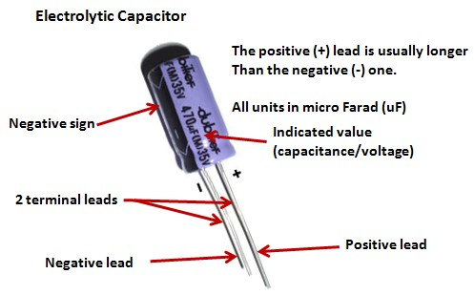
Figure 1.55 parts of Electrolytic Capacitors
- This type of capacitors is polarized.
- The best thing about electrolytic capacitors is that they provide high capacitance values.
- Along with this, Electrolytic Capacitors can easily be used in low frequency applications such as audio coupling & decoupling applications, power supplies etc.

  - Silver Mica Capacitor
- This type of capacitors is not in vogue but is still able to offer accuracy, low loss and high level of stability.
- Generally, silver mica capacitors are used in such places where space is not an issue. That is they eat lot of space in installation.
- A silver mica capacitor is limited to maximum of 1000 pF.
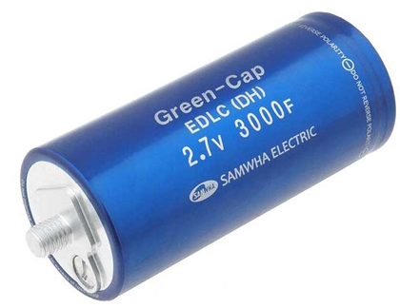
Figure 1.56 Super capacitors
- This type of capacitor is also known by several other names like super cap or ultra capacitor.
- Super-capacitors holds very large values of capacitance due to which these are generally used in big electrical components where requirement of capacitance is always high.
  - Variable Capacitors
- LC circuits generally use these capacitors.
- The main characteristic of a variable capacitor is that we can change its capacitance electronically or mechanically.
- A variable capacitor comes in several mechanical special forms. Few of them are multiple sections, split stator, differential and butterfly.
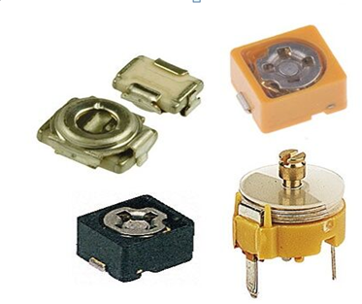
Figure 1.57 Variable Capacitors
  - Tantalum Electrolytic Capacitors
- This type of capacitors is same as electrolytic capacitors and comes in both surface and leaded mount formats.
- Manufacturer of a Tantalum Electrolytic Capacitor design special circuit rules in order to execute it in safe environment.
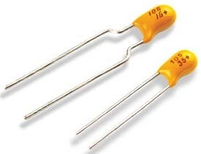
Figure 1.58 Tantalum Electrolytic Capacitors
  - Polyester film (Mylar) capacitors
This capacitor uses a thin polyester film as a dielectric. Not as high a tolerance as polypropylene, but cheap, temperature stable, readily available, widely used. Tolerance is approximately 5% to 10%. It can be quite large depending on capacity or rated voltage and so may not be suitable for all applications.
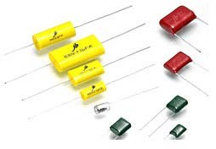
Figure 1.59 Polyester film (Mylar) capacitors
  - Tantalum capacitors
Made of Tantalum Pentoxide. They are electrolytic capacitors but used with a material called tantalum for the electrodes. It is superior to electrolytic capacitors, excellent temperature and frequency characteristics. Like electrolytic, tantalum are polarized so watch the “+” and “-“indicators. Mostly used in analog signal system because of the lack of current-spike-noise. Small size fits anywhere, reliable, most common values readily available. Expensive, easily, damaged by spikes, large value exist but may be hard to obtain.
Applications of Capacitors
Capacitors have many uses in electrical and electronic systems. The importance of capacitors is of high level. You may wonder that an electronic device without at least a capacitor is not possible. Following is the list of some common applications.
Energy Storage
- A capacitor charges itself when voltage is given to it. But after it disconnects from the charging unit, it starts supplying the stored energy.
- Also capacitors act like temporary battery when batteries get change.
- In audio systems of car, large capacitors store energy for amplifier.
Power Conditioning
- In power supplies, we use reservoir capacitors. They smooth the output of rectifiers (Full wave and Half Wave Rectifiers).
- These act like filters in dc circuits to smoothen the output.
Power Factor Correction
- Capacitors improve power factor in electrical power system.
- These capacitors have unit as VAR (volt-ampere reactive), rather than Farad.
Some more important applications are:
- Smoothing power supply’s output
- Signal coupling and decoupling
- Snubber and noise filters
- Low pass and high pass filters
- Pulsed power and weapons
  - Inductors
An inductor is a passive component that is used in most power electronic circuits to store energy in the form of magnetic energy when electricity is applied to it. One of the key properties of an inductor is that it impedes or opposes any change in the amount of current flowing through it. Whenever the current across the inductor changes it either acquires charge or loses the charge in order to equalize the current passing through it. The inductor is also called a choke, reactor or just coil.
An inductor is described by its distinctive nature of inductance, which is defined as the ratio of the voltage to the rate of change of current. Inductance is a result of the induced magnetic field on the coil. It is also determined by several factors such as;
- The shape of the coil.
- The number of turns and layers of the wire.
- The space that is given between the turns.
- Permeability of the core material.
- The size of the core.
The S.I. unit of inductance is Henry (H) and when we measure magnetic circuits it is equivalent to Weber/ampere. It is denoted by the symbol L.
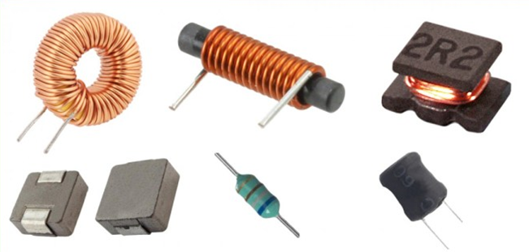
Figure 1.60 Types of inductors
Functions of an Inductor
Inductors can be used for two primary functions.
- To control signals.
- To store energy.
- Controlling Signals
Coils in an inductor can be used to store energy. The function of the inductor depends upon the frequency of the current passing through it. That is for higher frequency signals will be passed less easily and vice versa. This function tells that it blocks AC Current and passes DC Current. Hence, it can be used to block AC signals.
Inductors can be used along with capacitors to form LC filters.
- Storing Energy
Inductor stores energy in the form of magnetic energy. Coils can store electrical energy in a form of magnetic energy using the property that an electric current flowing through a coil produces a magnetic field, which in turn produces an electric current. In other words, coils offer a means of storing energy on the basis of inductivity.
Here are the things where inductors are evident and are used for:
- They are used in any circuit that uses alternating current to power loads, like motors, LCDs, and speakers.
- They are also used in circuits that deal with high-frequency signals, like radio transmitters and receivers.
- Other than that, inductors are used in a wide variety of different applications, such as in electric motors, transformers, electromagnetic relays, and power supplies.
- They can be used to filter out high-frequency noise from signal circuits. However, this noise will be present in the form of a voltage drop across the inductor, and we will be able to measure this voltage with a multimeter.
    - Active components
Active components require a source of energy, typically in the form of a direct current, in order to perform their specific function. They are able to manipulate the flow of electricity in some way. Most active components consist of semiconductor devices, such as
  - Transistors (All)
    - Photo Transistor
    - Darlington Transistor
    - Compound Transistor
    - Field-Effect Transistor (FET)
    - JFET (Junction Field-Effect Transistor)
    - MOSFET (Metal Oxide Semiconductor FET)
    - Composite Transistors
  - Thyristors
- SCR
- SCS
- Triac,
- Diac
  - Diodes (All)
- Rectifier Diode
- Schottky Diode
- Zener Diode
- Unipolar / Bipolar Diode
- Varicap
- Varactor
- Light-Emitting Diode (LED)
  - Integrated Circuits (All)
    - Digital Circuit
    - Analog Circuit
    - Hall Effect Sensor
    - Current Sensor
    - BGA Packages
    - Processor
    - Power ICs
    - Optoelectronic Components
Active Components Applications
1. An active component such as PN Junction Diode is used to convert AC to DC, used as a freewheeling diode, etc.
2. There is a huge application of Transistor in the electronics field. They used for amplifying and switching purpose.
3. SCRs are used in controlled rectifier circuits, Inverter circuits, Chopper Circuits, speed control of DC Motor.
4. Active components such as DIAC, TRIAC are used in light dimmer circuits, speed control of the motor, etc.
  - Transistors
- A transistor is a semiconductor device used to amplify or switch electronic signals. Transistors are broadly divided into three types: bipolar transistors (bipolar junction transistors: BJTs), field-effect transistors (FETs), and insulated-gate bipolar transistors (IGBTs).
- A bipolar transistor is a type of transistor that uses both electrons and holes as charge carriers. Two types of bipolar transistor are manufactured: npn and pnp.
- A field-effect transistor is a unipolar device constructed with no pn junction in the main current-carrying path. Also, two types of field-effect transistor are manufactured: N-channel and P-channel
The transistor is an active component and that is establishing all over electronic circuits. They are used as amplifiers and switching apparatus. As the amplifiers, they are used in high and low level, frequency stages, oscillators, modulators, detectors, and in any circuit need to perform a function. In digital circuits, they are used as switches. There are a huge number of manufacturers approximately the world who produces semiconductors (transistors are members of this family of apparatus), so there are exactly thousands of different types.
The transistor is electronic equipment. It is made through a p and n-type semiconductor. When a semiconductor is placed in the center between the same type of semiconductors the arrangement is called transistors. We can say that a transistor is the combination of two diodes it is a connection back to back.
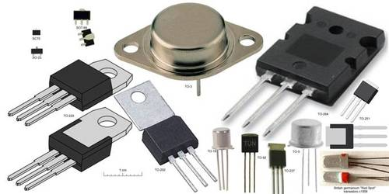
Figure 1.61Types of Transistors
Transistors consist of three layers of a semiconductor device, each capable of moving a current. A semiconductor is a material such as germanium and silicon that conducts electricity in a “semi-enthusiastic” way.
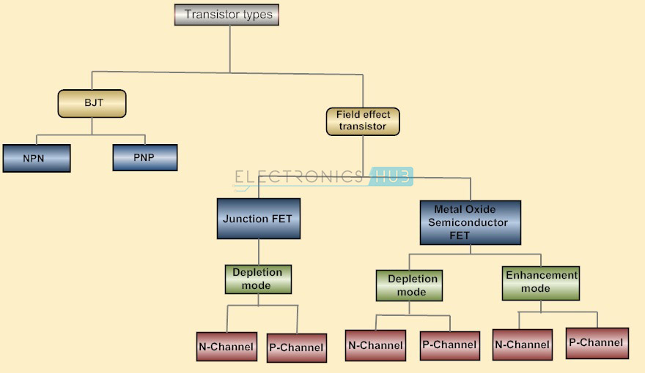
Figure 1.62 Transistor Tree Diagram
Transistor Symbol
A diagrammatic form of n-p-n and p-n-p transistor is exposed. In-circuit is a connection drawn form is used. The arrow symbol defined the emitter current. In the n-p-n connection, we identify electrons flow into the emitter. This means that the conservative current flows out of the emitter as indicated by the outgoing arrow. Equally, it can be seen that for the p-n-p connection, the conservative current flows into the emitter as exposed by the inward arrow in the figure.
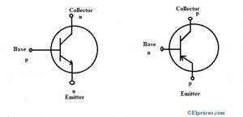
Figure 1.63 PNP and NPN Transistors
There are so many types of transistors and they each vary in their characteristics and each has its possess advantages and disadvantages. Some types of transistors are used mostly for switching applications. Others can be used for both switching and amplification. Still, other transistors are in a specialty group all of their own, such as phototransistors, which react to the amount of light shining on it to produce current flow through it. Below is a list of the different types of transistors; we will go over the characteristics that create them each up Transistors are classified into two types like BJTs and FETs.
Bipolar Junction Transistor (BJT)
Bipolar Junction Transistors are transistors that are built up of 3 regions, the base, the collector, and the emitter. Bipolar Junction transistors, different FET transistors, are current-controlled devices. A small current entering the base region of the transistor causes a much larger current flow from the emitter to the collector region. Bipolar junction transistors come in two major types, NPN and PNP. An NPN transistor is one in which the majority of the current carriers are electrons.
Electron flowing from the emitter to the collector forms the base of the majority of current flow through the transistor. The further types of charge, holes, are a minority. PNP transistors are the opposite. In PNP transistors, the majority of current carrier holes. BJT transistors are available in two types namely PNP and NPN
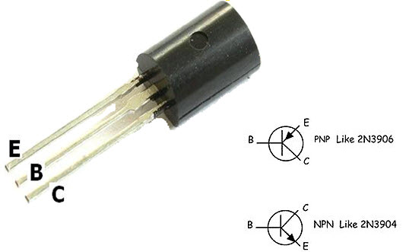
Figure 1.64 Bipolar Junction Transistor pins
PNP Transistor
This transistor is another kind of BJT – Bipolar Junction Transistors and it contains two p-type semiconductor materials. These materials are divided through a thin n-type semiconductor layer. In these transistors, the majority charge carriers are holes whereas the minority charge carriers are electrons.
In this transistor, the arrow symbol indicates the conventional current flow. The direction of current flow in this transistor is from the emitter terminal to the collector terminal. This transistor will be turned ON once the base terminal is dragged to LOW as compared with the emitter terminal. The PNP transistor with a symbol is shown below.

NPN Transistor
NPN is also one kind of BJT (Bipolar Junction Transistors) and it includes two n-type semiconductor materials which are divided through a thin p-type semiconductor layer. IN the NPN transistor, the majority charge carriers are electrons whereas the minority charge carriers are holes. The electrons flow from the emitter terminal to the collector terminal will form the current flow within the base terminal of the transistor.
In the transistor, the less amount of current supply at the base terminal can cause supply huge amount of current from the emitter terminal to the collector. At present, the commonly used BJTs are NPN transistors, as the electrons mobility is higher as compared with the mobility of holes. The NPN transistor with a symbol is shown below.
Field Effect Transistor
Field Effect Transistors are made up of 3 regions, a gate, a source, and a drain. Different bipolar transistors, FETs are voltage-controlled devices. A voltage placed at the gate controls current flow from the source to the drain of the transistor. Field Effect transistors have a very high input impedance, from several mega ohms (MΩ) of resistance to much, much larger values.
This high input impedance causes them to have very little current run through them. (According to ohm’s law, the current is inversely affected by the value of the impedance of the circuit. If the impedance is high, the current is very low.) So FETs both draw very little current from a circuit’s power source.
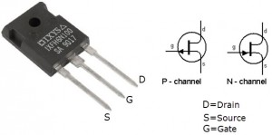
Figure 1.65 Field Effect Transistors
Thus, this is ideal because they don’t disturb the original circuit power elements to which they are connected to. They won’t cause the power source to be loaded down. The drawback of FETs is that they won’t provide the same amplification that could be gotten from bipolar transistors.
Bipolar transistors are superior in the fact that they provide greater amplification, even though FETs are better in that they cause less loading, are cheaper, and easier to manufacture. Field Effect Transistors come in 2 main types: JFETs and MOSFETs. JFETs and MOSFETs are very similar but MOSFETs have even higher input impedance values than JFETs. This causes even less loading in a circuit. FET transistors are classified into two types namely JFET and MOSFET.

JFET
The JFET stands for Junction-Field-Effect transistor. This is simple as well as an initial type of FET transistors which are utilized like resistors, amplifiers, switches, etc. This is a voltage-controlled device and it doesn’t use any biasing current. Once the voltage is applied among gate & source terminals then it controls the current flow among the source & drain of the JFET transistor. The Junction Field Effect Transistor (JUGFET or JFET) has no PN-junctions but in its place has a narrow part of high resistivity semiconductor material forming a “Channel” of either N-type or P-type silicon for the majority carriers to flow through with two ohmic electrical connections at either end normally called the Drain and the Source respectively.
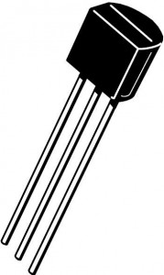
Figure 1.66 Junction Field Effect Transistors
There are two basic configurations of a junction field-effect transistor, the N-channel JFET and the P-channel JFET. The N-channel JFET’s channel is doped with donor impurities meaning that the flow of current through the channel is negative (hence the term N-channel) in the form of electrons. These transistors are accessible in both P-channel and N-channel types.

MOSFET
MOSFET or Metal-Oxide-Semiconductor Field-Effect Transistor is most frequently used among all kinds of transistors. As the name suggests, it includes the terminal of the metal gate. This transistor includes four terminals like source, drain, gate & substrate, or body.
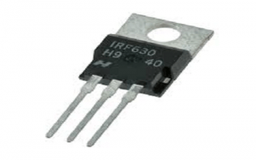
Figure 1.67 Mosfet
As compared with BJT and JFET, MOSFETs has several benefits as it provides high i/p impedance as well as low o/p impedance. MOSFETs are mainly used in low power circuits especially while designing chips. These transistors are available in two types like depletion & enhancement. Further, these types are categorized into P-channel & N-channel types.
The main features of FET include the following.
- It is unipolar because the charge carriers like either electrons or holes are accountable for transmission.
- In FET, the input current will flow because of the reverse bias. Therefore the input impedance of this transistor is high.
- When the o/p voltage of the field-effect transistor is controlled through the input voltage of the gate, then this transistor is named the voltage-controlled device.
- In the conduction lane, there are no junctions present. So FETs have less noise as compared with BJTs.
- The characterization of gain can be done with transconductance because it is the ratio of o/p change current and input voltage change
- The o/p impedance of the FET is low.

Advantages of FET
The advantages of FET as compared with BJT include the following.
- FET is a unipolar device whereas the BJT is a bipolar device
- FET is a voltage-driven device whereas the BJT is a current-driven device
- The i/p impedance of the FET is high whereas BJT has low
- The noise level of FET is low as compared with BJT
- In FET, thermal stability is high whereas BJT has low.
- The gain characterization of FET can be done through transconductance whereas in BJT with a voltage gain

Applications of FET
The applications of FET include the following.
- These transistors are used within different circuits to decrease the loading effect.
- These are used in several circuits like Phase shift Oscillators, Voltmeters & Buffer amplifiers.
FET Terminals
FET has three terminals like source, gate, and drain which are not similar to the terminals of BJT. In FET, the Source terminal is similar to the Emitter terminal of BJT, whereas the Gate terminal is similar to the Base terminal & Drain terminal to the Collector terminal.
Source Terminal
- In FET, the source terminal is the one through which the charge carriers enter the channel.
- This is similar to the emitter terminal of BJT
- The source terminal can be represented with ‘S’.
- The flow of current through the channel on the source terminal can be specified like IS.
Gate Terminal
- In a FET, the Gate terminal plays an essential role to control the flow of current throughout the channel.
- The flow of current can be controlled through the gate terminal by providing an external voltage to it.
- Gate terminal is a blend of two terminals which are internally connected and are doped heavily. The conductivity of the channel can be modulated through the Gate terminal.
- This is similar to the base terminal of BJT
- The gate terminal can be represented with ‘G’.
- The flow of current through the channel at the Gate terminal can be specified as IG.

Drain Terminal
- In FET, the drain terminal is the one through which the carriers leave the channel.
- This is analogous to the collector terminal in a Bipolar Junction Transistor.
- The Drain to Source voltage is designated as VDS.
- The Drain terminal can be designated as D.
- The flow of current moving away from the channel at the Drain terminal can be specified as ID.
Power Transistors
These transistors are applicable where a lot of power is used. The collector terminal of this transistor is allied to the base terminal of metal so that it works like a heat sink to dissolve surplus power. The range of typical power ratings mainly ranges from approximately 10 W to 300 W including frequency ratings which range from 1 MHz – 100 MHz.
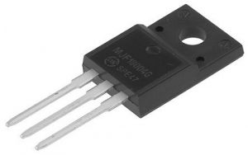
Figure 1.68 Power Transistors
The values of the highest collector current will range between 1A – 100 A. Power transistors are available in PNP & NPN forms whereas the Darlington transistor comes in either PNP or NPN forms.
High-Frequency Types of Transistors
High-Frequency Transistors are used especially for small signals that work at high frequencies and used in high-speed based switching applications. These transistors are applicable in high-frequency signals & should be capable of turning ON/OFF at extremely high speeds.
The applications of high-frequency transistors mainly include HF, UHF, VHF, MATV, and CATV amplifier as well as oscillator applications. The range of maximum frequency rating is about 2000 MHz & the highest collector currents range from 10 mA – 600mA. These are obtainable in both PNP & NPN forms.
Phototransistor
These transistors are light-sensitive and a common type of this transistor looks like a bipolar transistor where the base lead of this transistor is removed as well as changed through a light-sensitive region. So this is the reason that a phototransistor includes simply two terminals in place of the three terminals. Once the outside region is kept shady, then the device will be turned off.
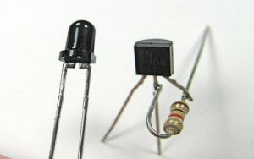
Figure 1.69 Phototransistor
Basically, there is no flow of current from the regions of the collector to the emitter. But, whenever the region of light-sensitive is exposed toward daylight, then a small amount of base current can be produced to control a much high collector to emitter current.
Similar to normal transistors, these can be both FETs and BJTs. FETs are light-sensitive transistors, not like photo bipolar transistors, photo FETs utilize light to produce a gate voltage that is mainly used for controlling a drain-source current. These are very responsive to changes within light as well as more delicate as compared with bipolar phototransistors.
Darlington Transistor
A Darlington transistor sometimes called a “Darlington pair” is a transistor circuit that is made from two transistors. Sidney Darlington invented it. It is like a transistor, but it has a much higher ability to gain current. The circuit can be made from two discrete transistors or it can be inside an integrated circuit.
The hfe parameter with a Darlington transistor is every transistor hfe multiplied mutually. The circuit is helpful in audio amplifiers or in a probe that measures a very small current that goes through the water. It is so sensitive that it can pick up the current in the skin. If you connect it to a piece of metal, you can build a touch-sensitive button.
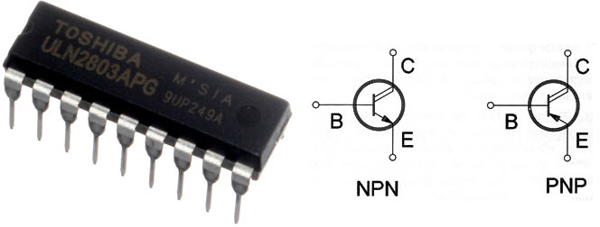
Figure 1.70 Darlington Transistors
B.Thyristors
Thyristors are high-speed semiconductor switching devices that are made up of four layers of alternating p and n-type materials. They are used in AC/DC switching and AC power control applications. The thyristors symbol is a diode symbol that has three terminals, the gate, anode, and cathode
A thyristor is a four-layer device with alternating P-type and N-type semiconductors (P-N-P-N).
In its most basic form, a thyristors has three terminals: anode (positive terminal), cathode (negative terminal), and gate (control terminal). The gate controls the flow of current between the anode and cathode.
The primary function of a thyristor is to control electric power and current by acting as a switch. For such a small and lightweight component, it offers adequate protection to circuits with large voltages and currents (up to 6000 V, 4500 A).
It is attractive as a rectifier because it can switch rapidly from a state of conducting current to a state of non-conduction.
In addition, its cost of maintenance is low and, operating under the right conditions, remains functional in the long term without developing a fault.
Thyristors are used in a wide range of electric circuits, from simple burglar alarms to power transmission lines.
Despite being physically small devices, thyristors can control high voltages and levels of current and so are used in high voltage, direct current power transmission lines.
Other uses include:
- Power switches in factories and similar industrial settings
- Vehicle ignition switches
- Controlling the speed of electric motors
- Liquid level regulators
- Pressure control systems
- Surge protectors
These devices are also widely used in a range of electrical circuitry. Applications include:
- Inverter circuits
- Oscillator circuits
- Chopper circuits
- Power switching circuits
- Relay replacement circuits
- Level-detector circuits
- Logic circuits
- Phase-control circuits
- Speed control circuits
- Timer circuits
Working principles of thyristors
A thyristor with a P-N-P-N structure has three junctions: PN, NP, and PN. If the anode is a positive terminal with respect to the cathode, the outer junctions, PN and PN are forward-biased, while the center NP junction is reverse-biased. Therefore, the NP junction blocks the flow of a positive current from the anode to cathode. The thyristor is said to be in a forward blocking state. Similarly, the flow of a negative current is blocked by the outer PN junctions. The thyristor is in a reverse blocking state.
Basic types of thyristors and applications
I. DIAC
Diac is a full-wave or bi-directional semiconductor switch that can be turned on in both forward and reverse polarities.
The name DIAC comes from the words DIode AC switches. The DIAC is an electronics component that is widely used to assist even triggering of a TRIAC when used in AC switches and as a result they are often found in light dimmers such as those used in domestic lighting. These electronic components are also widely used in starter circuits for fluorescent lamps.
Although the term is not often seen, DIACs may also be called symmetrical trigger diodes - a term resulting from the symmetry of their characteristic curve.
DIACs come in a variety of formats. As discrete components they may be contained in small leaded packages, they can be obtained in surface mount packages, in large packages that bolt to a chassis, or a variety of other packages. As they are often used as a DIAC TRIAC combination, they are often integrated into the same die as a TRIAC.
DIAC symbol
The DIAC symbol used to depict this electronic component in circuit diagrams can be remembered as a combination of what may appear to be two diodes in parallel with each other but connected in opposite directions.
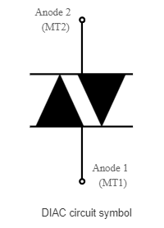
Figure 1.71 DIAC circuit symbol
Owing to the fact that DIACs are bi-direction devices the terminals cannot be labeled as anode and cathode as they are for a diode. Instead they may be labeled as A1 and A2 or MT1 and MT2, where MT stands for "Main Terminal."
DIAC operation
Electronic circuit designs incorporating DIACs use the fact that a DIAC only conducts current only after a certain breakdown voltage has been exceeded. This is marked as V_{BO} on the diagram.
The actual breakdown voltage will depend upon a variety of factors in its fabrication, but it will be given in the specification for the particular component type.
When the DIAC breakdown voltage occurs, the resistance of the component decreases abruptly and this leads to a sharp decrease in the voltage drop across the DIAC to V_{F}.
There is a corresponding increase in current. This can be clearly seen on the I/V characteristic for the device below.
The DIAC will remain in its conducing state until the current flow through it drops below a particular value known as the holding current. When the current falls below the holding current, the DIAC switches back to its high resistance, or non-conducting state.
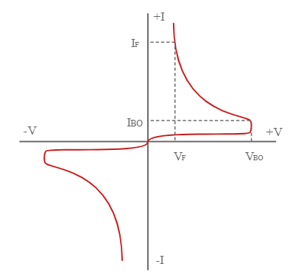
Figure 1.72 DIAC voltage- current characteristic
DIACs are widely used in AC applications and it is found that the device is "reset" to its non-conducting state, each time the voltage on the cycle falls so that the current falls below the holding current.
As the behavior of the device is approximately equal in both directions, it can provide a method of providing equal switching for both halves of an AC cycle, e.g. for TRIACs.
  - Triac
A Triac is defined as a three terminal AC switch which is different from the other silicon controlled rectifiers in the sense that it can conduct in both the directions that is whether the applied gate signal is positive or negative, it will conduct. Thus, this device can be used for AC systems as a switch.
This is a three terminal, four layers, bi-directional semiconductor device that controls AC power. The Triac of maximum rating of 16 kw is available in the market
Triac is similar to SCR but it conducts in both directions, means that it can switch AC and DC currents. The Triac remain in ON state only when there is current in gate G and switched OFF when this current is removed. Current is flowing in both directions between MT1 and MT2.
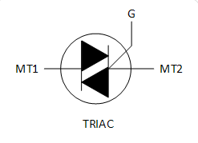
Figure 1.73 Triac symbol
Like other electronic components, the Triac has its own circuit symbol for use on circuit diagrams and this indicates its bi-directional properties. The Triac symbol can be seen to be a couple of thyristor symbols in opposite senses merged together.
Like a thyristor, a Triac has three terminals. However the names of these are a little more difficult to assign, because the main current carrying terminals are connected to what is effectively a cathode of one thyristor, and the anode of another within the overall device.
There is a gate which acts as a trigger to turn the device on. In addition to this the other terminals are both called Anodes, or Main Terminals These are usually designated Anode 1 and Anode 2 or Main Terminal 1 and Main Terminal 2 (MT1 and MT2). When using triacs it is both MT1 and MT2 have very similar properties.
Triac applications
Triacs are used in many applications. These electronic components are often used in low to medium power AC switching requirements. Where large levels of power need to be switched, two thyristors / SCRs tend to be used as they can be controlled more easily.
Nevertheless triacs are widely used in many applications:
- Lighting control - especially domestic dimmmers.
- Control of fans and small motors.
- Electronic switches for general AC switching and control
There are naturally many other Triac applications, but these are some of the most common.
  - Diodes
The diode is the most used semiconductor device in electronics circuits. It is a two-terminal electrical check valve that allows the flow of current in one direction. They are mostly made up of silicon but germanium is also used. Usually, they are used for rectification. But there are different properties & characteristics of diodes which can be used for different application. These characteristics are modified to form different types of diodes. Nowadays, several different types of diodes having different properties are available
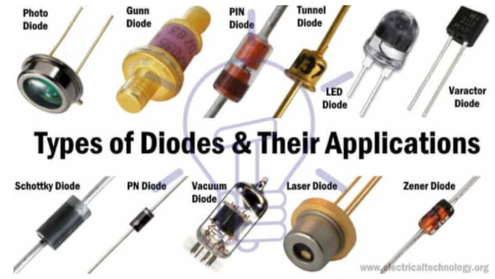
Figure 1.74 Main types of diodes
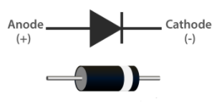
Figure 1.75 Diode Symbol

I. Light Emitting Diode (LED)
When an electric current between the electrodes passes through this diode, light is produced. In other words, light is generated when a sufficient amount of forwarding current passes through it. In many diodes, this light generated is not visible as there are frequency levels that do not allow visibility. LEDs are available in different colours.
II. Laser Diode
It is a different type of diode as it produces coherent light. It is highly used in CD drives, DVDs and laser devices. These are costly when compared to LEDs and are cheaper when compared to other laser generators. Limited life is the only drawback of these diodes.

Avalanche Diode
This diode belongs to a reverse bias type and operates using the avalanche effect. When voltage drop is constant and is independent of current, the breakdown of avalanche takes place. They exhibit high levels of sensitivity and hence are used for photo detection.

Zener Diode
It is the most useful type of diode as it can provide a stable reference voltage. These are operated in reverse bias and break down on the arrival of a certain voltage. If current passing through the resistor is limited, a stable voltage is generated. Zener diodes are widely used in power supplies to provide a reference voltage.

Schottky Diode
It has a lower forward voltage than other silicon PN junction diodes. The drop will be seen where there is low current and at that stage, voltage ranges between 0.15 and 0.4 volts. These are constructed differently in order to obtain that performance. Schottky diodes are highly used in rectifier applications.

Photodiode
A photo-diode can identify even a small amount of current flow resulting from the light. These are very helpful in the detection of the light. This is a reverse bias diode and used in solar cells and photometers. They are even used to generate electricity.

P-N Junction Diode
The P-N junction diode is also known as rectifier diodes. These diodes are used for the rectification process and are made up of semiconductor material. The P-N junction diode includes two layers of semiconductors. One layer of the semiconductor material is doped with P-type material and the other layer with N-type material. The combination of these both P and N-type layers form a junction known as the P-N junction. Hence, the name P-N junction diode.
P-N junction diode allows the current to flow in the forward direction and blocks the flow of current in the reverse direction.
Characteristics of Diode
The following are the characteristics of the diode:
- Forward-biased diode
- Reverse-biased diode
- Zero biased diode
Diode Applications
Following are the applications and uses of the diode
- Diodes as a rectifier
- Diodes in the clipping circuit
- Diodes in clamping circuits
- Diodes in logical gates
- Diodes in reverse current protection
D. Integrated circuits(IC)
An integrated circuit (IC), sometimes called a chip, microchip or microelectronic circuit, is a semiconductor wafer on which thousands or millions tiny resistors, capacitors, diodes and transistors are fabricated. An IC can function as an amplifier, oscillator, timer, counter, logic gate, computer memory, microcontroller or microprocessor. An IC is the fundamental building block of all modern electronic devices. As the name suggests, it's an integrated system of multiple miniaturized and interconnected components embedded into a thin substrate of semiconductor material (usually silicon crystal).
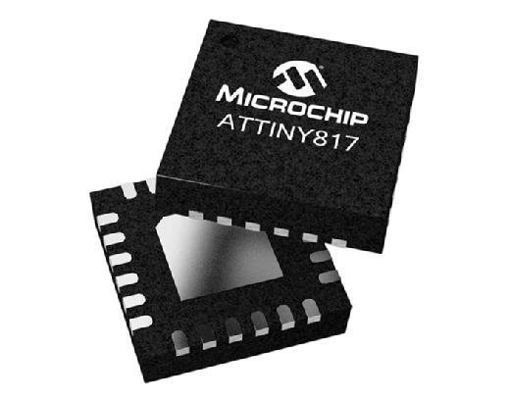
Figure 1.76. Integrated circuits
Microcontrollers are integrated circuits that govern specific operations in embedded systems, consisting of a processor, memory and input/output peripherals on a chip. This image shows a Microchip Technology ATtiny817 microcontroller.

A single IC could contain thousands or millions of:
- Transistors
- Resistors
- Capacitors
- Diodes
Additional components may also reside on it, all interconnected through a complex web of semiconductor wafers, silicon, copper and other materials. Size-wise, each component is small, usually microscopic. The resulting circuit, a monolithic chip, is also tiny -- often just enough to occupy a few square millimeters or centimeters of space.
One common example of a modern-day IC is the computer processor, which typically contains millions or billions of transistors, capacitors, logic gates, etc., connected together to form a complex digital circuit. Although the processor is an IC, not all ICs are processors

Self-check 1
Test I: - choose the correct answer
--------1. _____ is a type of voltage tester.
A. ammeter B. ohmmeter C. voltmeter D. no answer
-------2. _____is used to prevent the users from hazards like an electric shock,
A. ammeter B. Insulation Testers C. voltmeter D. no answer
--------3. The meter used to measure the inductance, capacitance and resistance of electronics components
A. Ammeter B. Insulation Testers C. LCR D. no answer
Test II Match from column ‘’B’’ to column ‘’A’’
“A” “B”
------1. LCR A. Megger
------2.volt B .unit of voltage
-------3.insulation tester C. inductor, capacitance, resistance
------4. Triac meter
-------5. Dide D. iron core
------6. Resistor E. similar to SCR
------7. Capacitor F. active component
G. store electrical charge
H. passive component
I. Volt

Test III.fill in the blank space
1. -------- is a branch of public health aimed at improving workplace health and safety standards.
2. -------- is that which is capable of delivering power to some external device.
3. -------- is an electrical/electronic passive component used to limit the flow of current.

Unit Two : Testing electrical/electronic components/parts
This unit is developed to provide you the necessary information regarding the following content coverage and topics:
- Undertake Work safely with the workplace
- Test Electrical/Electronic Components/parts
    - Passive components & active components
- Test electrical /electronic circuits & parts
    - Power supply circuit, Rectifier circuit and Amplifier circuit
- Correct use of test/measuring instrument
- Read and interpret specification of electronic component
This unit will also assist you to attain the learning outcomes stated in the cover page. Specifically, upon completion of this learning guide, you will be able to:
- Undertake Work safely
- Test Electrical/Electronic Components
- Test electrical /electronic circuits
- use test/measuring instrument
- Read and interpret specification of electronic component

  - Undertake Work safely with the workplace
Safe work practices are generally written methods that define how tasks are performed while minimizing risks to people, equipment, materials, environment, and processes. Safe Work Procedures are documented procedures for performing tasks.
Safe Work Procedures are documented procedures for performing tasks. The purpose of a safe work procedure is to reduce the risk to health and safety in the workplace and reduce the likelihood of an injury by ensuring that employees know how to work safely when carrying out the tasks involved in their jobs. Safe work procedures may also be called safe work method statements (SWMS)
Maintaining a safe workplace is everyone’s responsibility. Regular communication between management and workers is crucial to keeping health and safety top of mind in your workplace. Add it as an item to your regular team meetings so workers feel comfortable bringing up any issues as they arise.
    - Employer responsibilities
Employers should:
- Regularly carry out workplace inspections
- Ensure equipment and tools are safe to use, regularly serviced (if required) and maintained in good working condition
- Provide workers with easy to understand information and training on how to do their job safely
- Have a hazard, near miss and injury reporting process – see sample incident and hazard report form
- Talk to their workers about ideas for promoting a healthy workplace
- Communicate expected workplace behaviors and conduct for the prevention of bullying, harassment and violence
- Plan and test emergency procedures
- Keep workers informed of any changes, and provide training opportunities when anything new at work is introduced
- Have an injury notification system, with everyone aware of it so that if something happens the process can be followed
- Assess new and emerging hazards and identify the effectiveness of existing control measures
Business owners / employers also must notify Safe Work SA of all notifiable work-related incidents. See Safe Work Australia's incident notification information sheet which provides information on mandatory reporting requirements.

2.1.2. Worker responsibilities
Workers should:
- Report hazards, near misses and injuries
- Participate in workplace inspections
- Notify if there are any problems with machinery, equipment and tools
  - Test Electrical/Electronic Components/parts
Electrical testing can be used to identify suspect parts and aid in counterfeit mitigation.
The first step in any repair or troubleshooting job is to disconnect the appliance from the power source. This is true whether the device plugs into the wall or is hardwired into the house; in that circumstance, you’ll need to turn off the circuit breaker. This keeps you and the customer safe, as well as the appliance and the house
    - Test Passive component
Once you have the component out of the appliance, you’re ready to use the multi-meter. These devices test a lot of things, and the most common are continuity, voltage, and resistance:
- Continuity tests measure if electricity can flow through the part. Plug the two probes into the multimeter and set the dial to ‘continuity.’ If you place the red and black probes on either side of the part (some parts have diodes and are one-directional so you need to arrange the probes accordingly), and you get a read of approximately zero, electricity can flow through the part. If it can’t, your multimeter will go towards one or displays OL for open loop. The question is whether electricity is supposed to flow through or not.
- Resistance tests how much current is lost as electricity flows through a component or circuit. It’s measured in ohms, and it is slightly more complicated to test than continuity. Whereas continuity works on a range of zero to one (or OL), resistance can come in different strengths so you need to know how much resistance a given part should have. Then you’d manually set the range on your multimeter around that amount so the multimeter can provide a readout of if the resistance is lower or higher than that amount. You can fine tune the range by making it lower if the multimeter reads close to zero or by making it higher if it read one or OL (overload). Once you have a range in the device, place the probes on either side of the device to find the ohms of resistance. The component should be isolated from any power source otherwise you can ruin your meter. We prefer the use of an analog meter to accomplish this.
- The third common test is for voltage, or the force of the electric pressure. You’ll need to know whether the appliance is DC (direct current) or AC (alternating current). Checking voltage can be very dangerous, be sure to get the proper training before attempting. Just like with resistance testing, you’ll need to manually set the expected range and make sure both the multimeter can handle the maximum expected voltage. Some components can be electrically ok, but a voltage check can ensure it is mechanically ok.

Testing Resistor using Digital Multimeter
Why measure resistance to determine the condition of a circuit or component. The higher the resistance, the lower the current flow, and vice versa. In general, the resistance of components used to control circuits (such as switches and relay contacts) starts out very low and increases over time due to factors such as wear and dirt. Loads such as motors and solenoids decrease in resistance over time due to insulation breakdown and moisture.
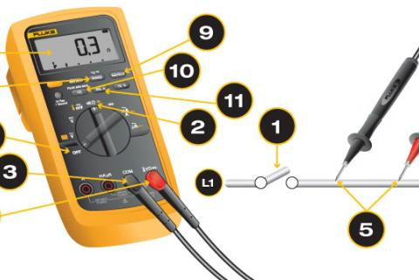
Figure 2.1 resistor testing
To measure resistance:
1. Turn power to circuit OFF.
- If a circuit includes a capacitor, discharge the capacitor before taking any resistance reading.
2. Turn digital multimeter dial to resistance, or ohms, which often share a spot on the dial with one or more other test/measurement modes (continuity, capacitance or diode; see illustration below).
- The display should show OLΩ because, in Resistance mode, even before test leads are connected to a component, a digital multimeter automatically begins taking a resistance measurement.
- The MΩ symbol may appear in the display because the resistance of open (unattached) test leads is very high.
- When the leads are connected to a component, a digital multimeter automatically uses the Auto range mode to adjust to the best range.
- Pressing the Range button allows a technician to manually set the range.
- Best results will be achieved if the component to be tested is removed from the circuit. If the component is left in the circuit, the readings could be affected by other components in parallel with the component to be tested.

3. First insert the black test lead into the COM jack.
4. Then insert the red lead into the VΩ jack.
- When finished, remove the leads in reverse order: red first, then black.
5. Connect test leads across the component being tested.
- Make sure that contact between the test leads and circuit is good.
Ω to 0.5 Ω. Ideally, if test leads touch (are shorted together), the display should show 0 Ω.
Other factors that can affect resistance readings: Foreign substances (dirt, solder flux, oil), body contact with the metal ends of the test leads, or parallel circuit paths. The human body becomes a parallel resistance path, lowering total circuit resistance. Thus, avoid touching metal parts of test leads to avoid errors.
6. Read the measurement on the display.
7. When finished, turn the multimeter OFF to prevent battery drain.
Advanced digital multimeter options
8. Press the RANGE button to select a specific fixed measurement range.
- Be sure to note the annunciator (such as K or M) after the measurement in the display.
9. Press the HOLD button to capture a stable measurement—it can be viewed later.
10. Press the MIN/MAX button to capture the lowest and highest measurement.
- The multimeter beeps each time a new reading is recorded.
11. Press the relative (REL) button to set the multimeter to a specific reference value.
- Measurements above and below the reference value are displayed.
Resistance Measurement Analysis
The significance of a resistance reading depends on the component being tested. In general, resistance of any one component varies over time and from component to component. Slight resistance changes are usually not critical but may indicate a pattern that should be noted. For example, as the resistance of a heating element rises, the current passing through the element decreases, and vice versa. See diagram below.
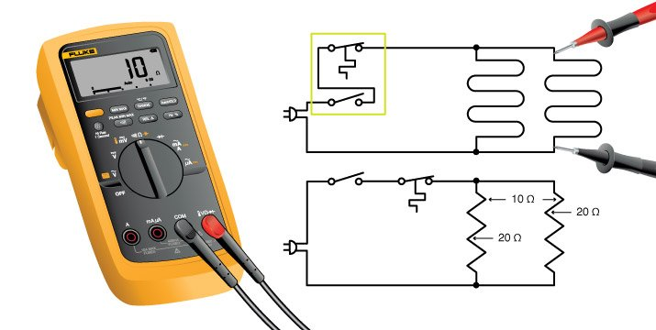
Figure 2.2 resistor testing
When working on a circuit board, it may be necessary to lift one of the leads of the resistor from the board to measure the correct resistance of the resistor. The resistance measurement displayed by a digital multimeter is the total resistance through all possible paths between the test lead probes.
Resistors must be properly sized and intact to perform these functions. Use these tips to learn how to test resistors.
Steps of testing resistors
- Remove power from the circuit containing the resistor. This can be done by unplugging it from the mains or by removing the batteries if it is a portable device. Keep in mind that some devices still can be charged with a potentially harmful voltage until minutes after removing its power!
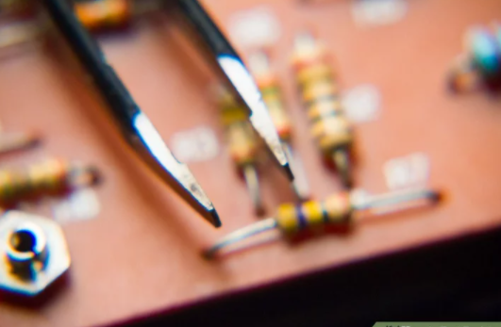
Figure 2.3 Remove power from the circuit
- Isolate the resistor from the circuit. An attempt to measure a resistor that is still connected to the circuit can yield an incorrect calculation, as part of the circuit might also be measured.
Disconnect one end of the resistor from the circuit. It does not matter which end of the resistor is disconnected.
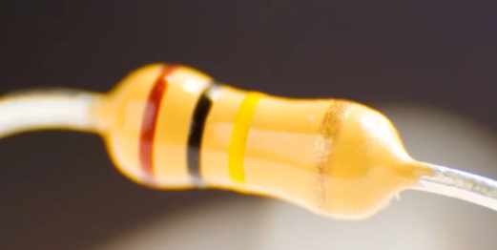
Figure 2.4 isolate the resistor from the circuit
- Inspect the resistor. If the resistor shows signs of blackening or charring, it may be damaged by excess current flow. A resistor showing blackening or charring should be replaced and discarded.
- Read the resistor value visually. The resistor value will be printed on the resistor. Smaller resistors may have their value indicated by color coded bands.
  - Note the resistor tolerance. No resistor is precisely the value indicated on it. The tolerance indicates how much the printed value may vary and still be considered a properly sized resistor. For example, a 1,000 ohm resistor with a 10 percent tolerance indication is still considered to be accurate if it measures no less than 900 ohms and no more than 1,100 ohms.
- Prepare a digital multimeter (DMM) to measure the resistor. DMMs are available at electronics parts and hobby stores
  - Ensure that the DMM comes on and does not indicate a low battery condition.
  - Set the adjustable scale of the DMM to the next setting higher than the expected resistor value. For example, if the DMM may be set to scales that are multiples of 10 and a resistor marked as 840 ohms is to be measured, set the DMM to the 1,000 ohm scale.
- Measure the resistance. Connect the 2 leads of the DMM to the 2 legs of the resistor. Resistors have no polarity, so it does not matter which DMM lead is connected to which resistor leg.
- Determine the actual resistance of the resistor. Read the result shown on the multimeter. In determining whether or not the resistor is within the allowable range for that resistor, do not forget to take the resistor tolerance into account.
- Reattach a resistor that gives an accurate reading. Reconnect it to the circuit by pressing it back into place if you pulled it free with your fingers. If the solder joint had to be melted and the resistor had to be disconnected using pliers, melt the solder with the soldering iron and use the needle nose pliers to push the resistor back in to place.
- Replace a resistor that measures outside of the acceptable value range. Discard the old resistor. Resistors are available in electronics parts stores and hobby stores. Note that replacing the malfunctioning resistor will not necessarily fix the problem, if the resistor fails again the source of the problem should be sought elsewhere in the circuit

Test capacitor using digital multimeter
Step 1:- First look at the value of the capacitance value (ie.1000uF) of the capacitor undergoing test.
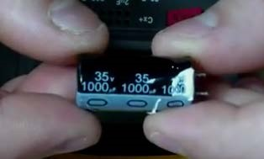
Figure 2.5 capacitance value
Step 2:- Set the selector switch of the meter above the capacitance value of the component under test (ie.2000uF).
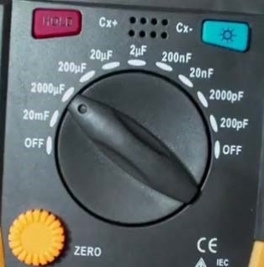
Figure 2.6 selector switch
Step 3:- Connect the negative probe of the meter to the negative lead of the capacitor and the positive probe of the meter to the positive lead of the capacitor.
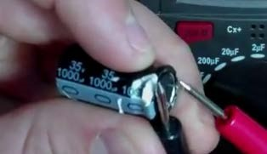
Figure 2.7 connections of capacitor and meter
Step 4:- The reading of the capacitance value should be at least 90% for a Good capacitor (ie.938uF). The reading is less than 90%, for a Defective capacitor.

Test inductor using digital multimeter
You have a digital multimeter, you have an inductor, and you want to test the inductor. Instead of trying to explain how to test an inductor using a digital multimeter by boring you with a bunch of electronics theory, we’ll just tell you the steps to do it and what you’ll see on the digital multimeter display.
Using a digital multimeter to test an inductor is a two-step process:
- You need to determine the inductance of the inductor using the multimeter’s resistance function.
- You have measured the inductance; you can use the multimeter’s diode test function to verify that the inductor is free of shorts.
Testing an inductor using a digital multimeter is a great way to make sure that an inductor is producing the values it is supposed to. It is also a great way to confirm that your inductor is working properly before you install it in a circuit. There are several ways to test an inductor, but the one I prefer is the “no load” test. You can conduct this test using a digital multimeter, but you will need to have a separate test probe or make sure your multimeter has an additional lead
There are two values of inductors that are frequently used:
- High-Value Inductors – High-value inductors are used to perform high-frequency filtering. A good high-value inductor is made with thick wire, and it has a low resistance. These are designed to handle larger currents than conventional inductors. In some cases, high-value inductors are designed to handle a given current from a voltage source with a lower voltage than would be possible with a conventional inductor.
- Low-Value Inductors – They can be used to make various low-frequency filters, and those with a high-value inductor can be used to make various high-frequency filters. They can also be used to control the flow rate of DC current or to increase the output power of the electronic device.
To check an inductor’s resistance, take a multimeter and put it on the ohmmeter setting then connect the multimeter probes on any two terminals of an inductor you will find the resistance of an inductor’s terminals. The polarity of probes on terminals doesn’t matter because we are interested into only finding resistance.
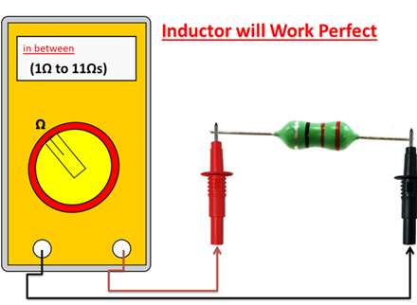
Figure 2.8 Measurement of an inductor with a multimeter
If the measured value is in few ohms than the Inductor is working properly because functional inductors normally show the resistance of few ohms. Usually, it should be greater than 1Ω and less than 11Ω (1Ω to 11Ωs).
If you find values near to these values then it’s perfect :). And your inductor will work perfectly otherwise you need to replace your inductor in order to perform the operations.
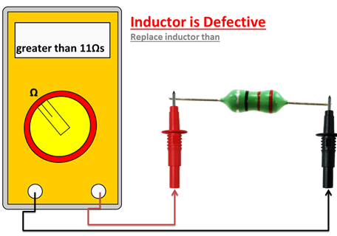
Figure 2.9 Measurement of an inductor with a multimeter
- If the measured inductor’s resistance is high, then the inductor is defective and you must replace it.
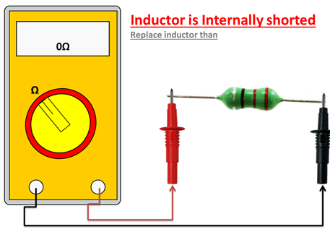
Figure 2.10 Measurement of an inductor with a multimeter
- If the measured inductor’s resistance is very, very low almost 0Ωs. This indicates that the inductor is internally shorted and you need to replace it.
    - Test active components
Ask any field or bench technician what their most-used piece of test equipment is and they will probably say a DMM (Digital Multimetir). These versatile devices can be used to test and diagnose a wide range of circuits and components. In a pinch, a DMM can even substitute for expensive, specialized test equipment.
- Test Transistor
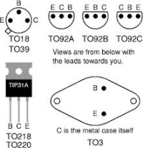
Figure 2.11Transistor Pin outs

Fortunately, using a DMM to get a basic pass/fail reading from a suspected faulty NPN or PNP bipolar transistor is a simple and quick task. Some multimeters have a built-in transistor testing function, if yours does, you can skip this blog post – simply insert your transistor into the socket on the multimeter and set the meter to the correct mode. You will probably get information such as the gain (hFE) that could be checked against the datasheet as well as a pass/fail reading. If your meter does not have a transistor testing function, fear not – transistors can easily be checked with the “Diode” testing setting. (Some meters have the diode test function coupled with the continuity test – this is OK).
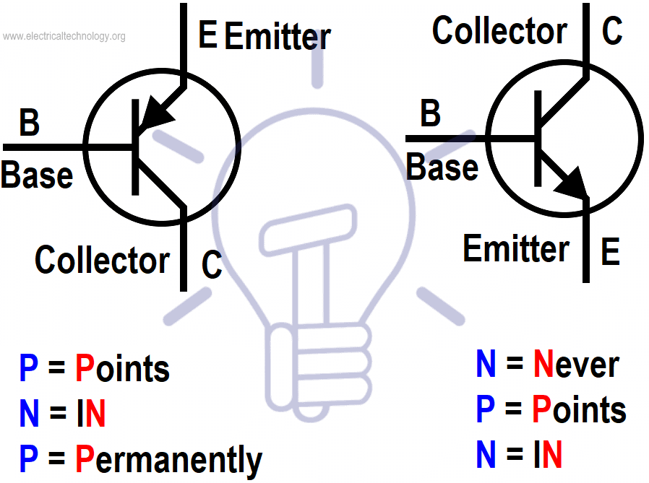
Figure 2.12 NPN and PNP transistors
Steps to test transistors
Remove the transistor from the circuit for accurate test results.
Step 1: (Base to Emitter)
Hook the positive lead from the multimeter to the to the BASE (B) of the transistor. Hook the negative meter lead to the EMITTER (E) of the transistor. For an good NPN transistor, the meter should show a voltage drop between 0.45V and 0.9V. If you are testing PNP transistor, you should see “OL” (Over Limit).
Step 2: (Base to Collector)
Keep the positive lead on the BASE (B) and place the negative lead to the COLLECTOR (C).
For a good NPN transistor, the meter should show a voltage drop between 0.45V and 0.9V. If you are testing PNP transistor, you should see "OL" (Over Limit).
Step 3: (Emitter to Base)
Hook the positive lead from the multimeter to the to the EMITTER (E) of the transistor. Hook the negative meter lead to the BASE (B) of the transistor. For an good NPN transistor, you should see “OL” (Over Limit).If you are testing PNP transistor, the meter should show a voltage drop between 0.45V and 0.9V.
Step 4: (Collector to Base)
Hook the positive lead from the multimeter to the to the COLLECTOR (C) of the transistor. Hook the negative meter lead to the BASE (B) of the transistor. For a good NPN transistor, you should see “OL” (Over Limit).If you are testing PNP transistor, the meter should show a voltage drop between 0.45V and 0.9V.
Step 5: (Collector to Emitter)
Hook the positive meter lead to the COLLECTOR (C) and the negative meter lead to the EMITTER (E) – A good NPN or PNP transistor will read "OL"/Over Limit on the meter. Swap the leads (Positive to Emitter and Negative to Collector) – Once again, a good NPN or PNP transistor should read “OL”.If your bipolar transistor measures contrary to these steps, consider it to be bad.
You may also be able to use the voltage drop to determine which lead is the emitter on an unmarked transistor, as the emitter-base junction typically has a slightly higher voltage drop than the collector-base junction.

Test a Transistor using Digital Multimeter in Diode or Continuity Mode
To do so, follow the instructions given below.
- Remove the transistor from the circuit i.e. disconnect the power supply across the transistor which has to be tested. Discharge all the capacitors (by shorting the capacitor leads) in the circuit (If any).
- Set the meter on “Diode Test” Mode by turning the rotary switch of the multimeter.
- Connect the Black (common or -Ve) test lead of the multimeter to the 1st terminal of the transistor and Red (+Ve) test lead to the 2nd terminal (Fig below). You have to perform 6 tests by connecting the Black (-Ve) test lead and Red (+Ve) test lead to 1 to 2, 1 to 3, 2 to 1, 2 to 3, 3 to 1, 3 to 2 respectively by just replacing the multimeter test leads or reverse the transistor terminals to connect, test, measure and note the reading in the table (shown below). Numbers in Red colors are Red Test Lead and numbers in Black are connected to Black (-Ve) test lead of multimeter.
- Test, measure and note the display reading shown in the multimeter in the table below.
We have the following data from the table given below.
Out of 6 tests, we got data and results only on two tests i.e. points 2 to 1 and 2 to 3. Where we got at points 2 to 1 is 0.733 VDC and 2 to 3 0.728 VDC. Now, we can easily find the type of transistor as well as their collector, base and emitter.
- Point 2 is Transistor Base in BC55 Transistor.
- BC 557 is a PNP Transistor where the 2nd (middle terminal is base) connected to Red (+Ve) test lead of the multimeter.
- At all, Terminal 1 = Emitter, Terminal 2 = Base, and Terminal 3 = Collector (BC 557 PNP Transistor) because, the test result for 2-1 = 0.733 VDC and 2-3 = 0.728 VDC, i.e. 2-1 > 2-3.
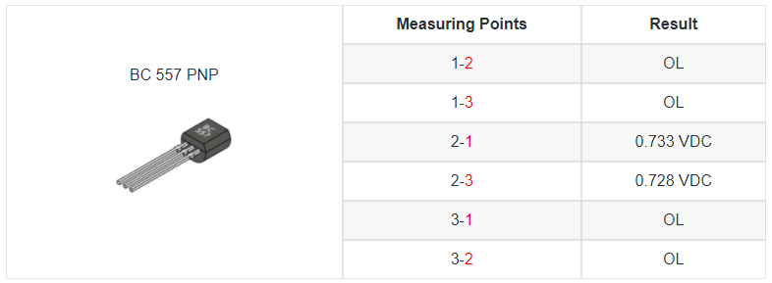

Finding BASE of Transistor
As mentioned in the above tutorial, the common number found in the tests above is base. In our case, 2nd terminal is Base and 2 is common out of 1-2 and 2-3.
- Test Diac
One of the best ways to determine if a Diac is good or bad is through a digital multimeter. Follow the steps below if you like to test a Diac.
- Get your digital multimeter and set it on the Ω scale.
- Attach the leads of your digital multimeter to the leads of the Diac and record the resistance reading.
- Now, reverse the leads of your multimeter and record the resistance reading on display.
Remember that both of the resistance readings you have performed must give high resistance, as the Diac is two Zener diodes connected in series. Testing a Diac in this fashion only demonstrates the concept is shorted.
Testing Diac using DMM & Oscilloscope
A digital multimeter (DMM) may be used to test a Diac for a short circuit.. To test a Diac for a short circuit, the following procedure is applied:
A digital multimeter (DMM) may be used to test a Diac for a short circuit. To test a Diac for a short circuit, the following procedure is applied:
- Set the DMM on the Ω scale.
- Connect the DMM leads to the leads of the Diac and record the resistance reading.
- Reverse the DMM leads and record the resistance reading.

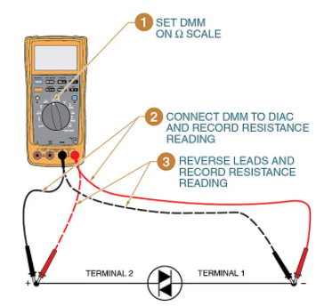
Figure 2.13 a Diac tested by DMM
Both resistance readings should show high resistance because the Diac is essentially two zener diodes connected in series. Testing a Diac in this manner only shows that the component is shorted. If a Diac is suspected of being open, it should be tested using an oscilloscope. To test a Diac using an oscilloscope, the following procedure is applied:
- Set up the test circuit.
- Apply power to the circuit.
- Adjust the oscilloscope.
- Analyze traces.

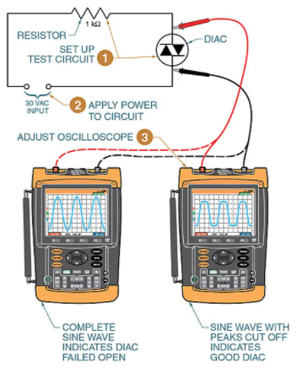
Figure2.14 A Diac should be tested using an oscilloscope
Test Triac
TRIAC (Triode for AC) is a semiconductor device widely used in power control and switching applications. It finds applications in switching, phase control, chopper designs, brilliance control in lamps, speed control in fans, motors, etc.
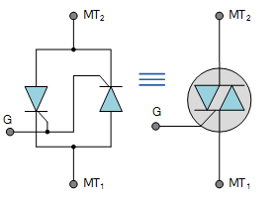
Figure 2.15 Figure testing of Triac
Step by step Procedure to test the Triac:
- Keep the digital multimeter into Ohmmeter mode.
- Using a junction diode determine which ohmmeter lead is positive and which is negative. The ohmmeter will indicate continuity only when the positive lead is connected to the anode and the negative lead is connected to the cathode.
- Connect the positive lead of Ohmmeter to MT2 and the negative lead to MT1. The ohmmeter should indicate no continuity through the Triac.
- Using a jumper lead connect the Gate of the Triac to MT2. The multimeter should indicate a forward diode junction.
- Reconnect the Triac so that MT1 is connected to the positive lead of ohmmeter and MT2 is connected to the negative lead. The multimeter should indicate no continuity through a Triac.
- Using a jumper lead, again connect the gate to MT2. The ohmmeter should indicate a forward diode junction.
- Test Diode
The diode testing using a Digital Multimeter (DMM) can be carried in two ways because there are two modes available in DMM to check the diode. These modes are:
- Diode Mode
- Ohmmeter Mode (or Resistance Mode)
The Diode Test Mode is the best way to test a diode as it relies on the characteristics of the Diode. In this method, the diode is put in forward bias and the voltage drop across the diode is measured, using a Multimeter. A normally working diode will allow current to flow in forward bias and must have voltage drop.
In the Resistance Mode Test of the diode, both the forward and reverse bias resistances of the diode are measured. For a good diode, the forward bias resistance should be few hundreds of Ohms to few Kilo Ohms and the reverse bias resistance should be very high (usually indicated as OL – open loop in a multimeter).
    - Diode Mode Testing Procedure
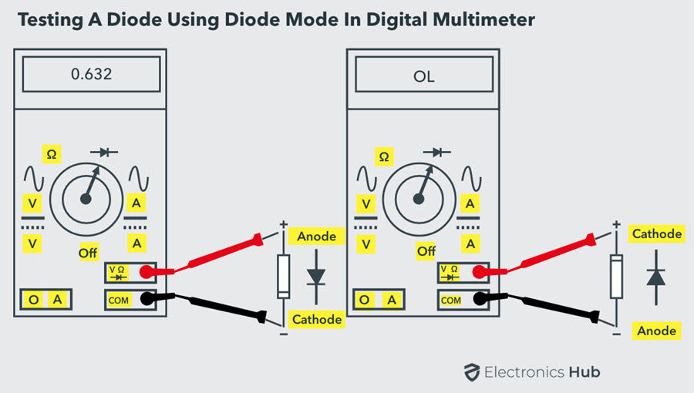
Figure 2.16 Diode Mode Testing Procedure
- Identify the anode and cathode terminals of the diode.
- Keep the Digital Multimeter (DMM) in diode checking mode by rotating the central knob to the position where the diode symbol is indicated. In this mode, the multimeter is capable to supply a current of approximately 2mA between the test leads.
- Connect the red probe of the multimeter to the anode and black probe to the cathode. This means the diode is forward-biased.
- Observe the reading on multimeter’s display. If the displayed voltage value is in between 0.6 to 0.7 (for a Silicon Diode), then the diode is healthy and perfect. For Germanium Diodes, this value is in between 0.25 to 0.3.
- Now, reverse the terminals of the meter i.e., connect the red probe to cathode and black to anode. This is the reverse biased condition of the diode where no current flows through it. Hence, the meter should read OL or 1 (which is equivalent to open circuit) if the diode is healthy.
If the meter shows irrelevant values to the above two conditions, then the diode is defective. The defect in the diode can be either open or short.
Open diode means the diode behaves as an open switch in both reverse and forward biased conditions. So, no current flows through the diode in either bias condition. Therefore, the meter will indicate OL (or 1) in both reverse and forward-biased conditions.
Shorted diode means diode behaves as a closed switch, so the current flows through it irrespective of the bias and the voltage drop across the diode will be between 0V to 0.4V. Therefore, the multimeter will indicate zero voltage value, but in some cases it will display a very little voltage as the voltage drop across the diode.
    - Ohmmeter (Resistance) Mode Testing Procedure
Similar to the Diode Test method, the Resistance Mode is also a simple method to check the diode whether it is good, short or open.
- Identify the terminals of the diode i.e., anode and cathode.
- Keep the Digital multimeter (DMM) in resistance or ohmmeter mode by rotating the central knob or selector to the place where ohm symbol or resistor values are indicated. Keep the selector in low resistance (may be 1K ohm) mode for forward-bias and keep it in high resistance mode (100K ohm) for the reverse bias testing procedure.
- Connect the red probe to the anode and black probe to the cathode. This means diode is forward-biased. When the diode is forward-biased, the resistance of the diode is so small.
If the meter displays a moderately low value on the meter display i.e., a few tens of ohms, then the diode is not good. But if the resistance reading is few hundred ohms to few kilo ohms, then the diode is good and working properly.
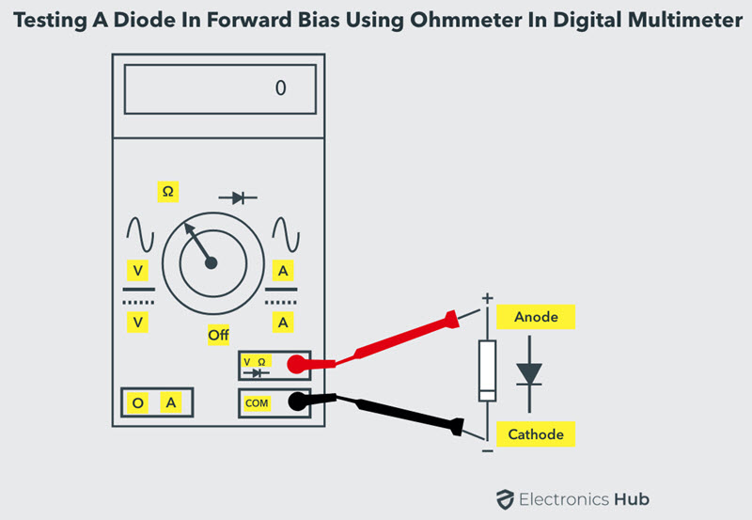

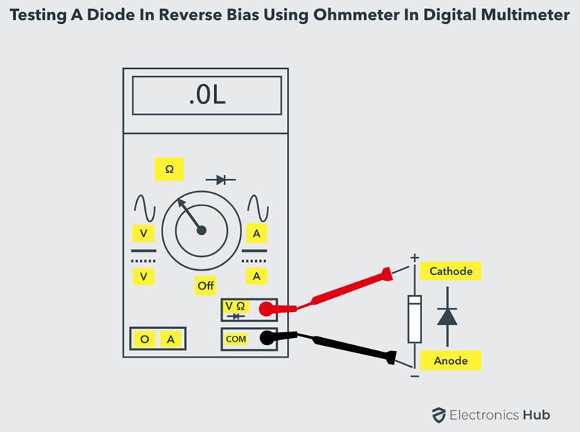
Figure 2.17 Ohmmeter (Resistance) Mode Testing Procedure
- Now reverse the terminals of the multimeter such that anode is connected to black probe and cathode to red probe. So the diode is reverse biased.
- If the meter shows a very high resistance value or OL on meter display, then the diode is good and functions properly. Since in reverse biased condition diode offers a very high resistance.
From the above it is clear that for proper working of the diode, DMM should read some low resistance in the forward-biased condition and a very high resistance or OL in reverse-biased condition.
If the meter indicates a very high resistance or OL in both forward and reverse-biased conditions, then the diode is said to be opened. In other hand, if the meter reads a very low resistance in both directions, then the diode is said to be shorted.
  - Test electrical /electronic circuits & parts
An electronic circuit is composed of individual electronic components, such as resistors, transistors, capacitors, inductors and diodes, connected by conductive wires or traces through which electric current can flow.
    - Test power supply circuit
A Psu or dc power supply mainly energizes internal components of a pc or other electronics components after conversion of ac mains voltage to dc 5v,12v. In case of power failure of a computer in presence of electricity, the first step should be to check its power source. Here we’ll tell you a manual method to test dc power supply by multimeter.
After that, you can evaluate if the supply is working well or has to be replaced. The good point is it doesn’t require you to be an experienced electrician to execute this test. With some simple steps and minor multimeter know how you can certainly do it.
Below, we have mentioned some simple steps involved in “how to test a power supply with multimeter”.
- Do all necessary safety measures (wearing safety gloves, shoes etc) first as you have to deal directly with live voltage points.
- Now power off the computer, also disconnect power plugs from mains supply. Disconnect all other data cables coming to psu or cpu unit.
- Short pin 15 and 16 of power supply with 24 pin motherboard connecter to check power flow further.
- Some countries have 115v general household power supply, other run on 220v systems so confirm that your power supply is adjusted on yours country mains voltage.
- After turning on multimeter set its range to ac 200 to 300 v and checks voltage coming from outlet.
- Now connect power supply unit plug with outlet mains supply, this should result into turning on of fan inside power supply.
- Turn multimeter’s range from ac to dc volts up to 20vdc.
- Now connect black or neutral probe of multimeter to ground point and red probe to any point in 24 pin connector. It should give various voltage outputs like 3vdc, 5vdc, -3vdc, -5vdc, 12vdc and -12vdc.
- Check every point for confirmation that all supply points are working well.
- If you found one or more points missing output voltage or giving abnormal volts that will indicate some problem in power supply.
- Turn of power supply to psu and reconnect all plugs, devices with psu.
- Connect power plugs to psu and turn on your computer.
- Make sure to turn off multimeter as well to safe battery timings

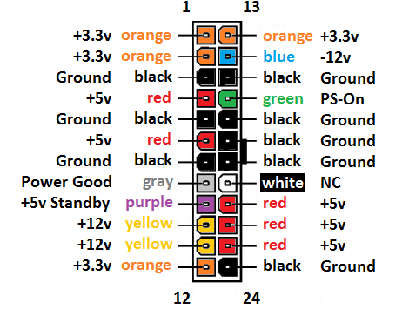
Figure 2.18 24 pin power supply connector
    - Test rectifier circuit
An awesome rectifier ranges from four to 7, assuming your diode suggests readings like this. Then it is a good quality diode to use. You can use it with no difficulty at all. This type of diode will not cause any discomfort in the future regarding the bridge rectifier.
You need to remember this specific standard range of best diode written in this article. It will help determine whether your bridge rectifier is ideal or no longer.
Step 1: a multimeter
You require a properly functioning multimeter. Make sure it does not show any flawed readings or defections. Start by using the multimeter on some perfectly working diodes. Through this step, it will be sure that your diode is giving accurate readings.
Step 2: See the voltage drop
Make sure that the multimeter is running nicely. You can see the voltage drop with the help of any form of diodes found in domestic already. You could use silicon diodes or another according to your comfort.
Step 3: diode mode
Set the multimeter on diode mode. In this manner, you can easily degree the diode cutting-edge. Companies layout the multimeter in a modernized way. These multimeters can measure the current of the best diode. This technique is most effective when it comes to testing bridge rectifiers.
Step 4: Use a lead to measure the current
You may need a lead to measure the current passing at the diodes. You want two kinds of electrical leads. The positive and negative electrical or copper lead. One is positive to lead. So you can place it on a negative diode. At the same time, the opposite one is the negative lead. We connect it to the AC of the diode. We will discuss it in the below-cited steps.
Ensure that all the equipment and devices are running in the best condition. The condition is essential because if any of the tools are malfunctioning. They will show incorrect reading. And those wrong readings can be deadly.
Step five: placing the negative and positive leads
In this technique, you need to place the positive copper lead on the negative diode. After this, connect the negative copper lead to the AC. The multimeter will display the voltage drop as discussed in the second step. Now, you will repeat this procedure but with a little bit of alternate. Just exchange the positions of diodes. You will notice that there is no voltage drop.
Looking forward, different pins of the bridge rectifier diode. Now repeat the technique. Put the high-quality lead on the opposite diode AC. And place the negative copper lead at the positive diode of the bridge rectifier. In case the current shows. Meaning that voltage drops. Thus it indicates that your diodes are best.
And they are in top condition. Now you will change the positions of leads. (You will not detect any voltage drop.) Then you will observe that no analysis will appear at the multimeter.
As long as your multimeter shows two times the voltages drop in the reading. Your bridge rectifier is in top-notch shape
If order to rectify ac power so as to use both half-cycles of the sine wave, a different rectifier circuit configuration must be used. Such a circuit is called a full-wave rectifier. Its output is also a pulsed dc signal, but at twice the frequency of the half-wave signal.
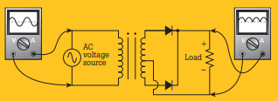
Figure 2.19. Figure. Full-wave rectifier circuit (center-tap design).
    - Test amplifier circuit
1. Initial check.
Visually double check the circuit; especially the capacitor connections Switch on and re-check the transistor voltages to make sure the circuit is operating as predicted.
2. Gain (Voltage Amplification Av).
Gain can be measured using the set up shown in Fig below. The generator is set to a mid-band frequency of 1 kHz and a small amplitude sine wave signal applied to the amplifier input. With the oscilloscope attached to the output terminals, the input signal is adjusted to give a large amplitude output signal that still has an undistorted waveform. The peak-to-peak amplitude of the output signal is measured and then the oscilloscope probes are transferred to measure the input. The two values are compared, and the Small Signal Voltage Amplification (Av) is calculated using the formula on the Amplifier Design Record sheets. A_{v} is simply the ratio of output to input, so does not have any units.
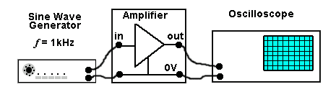
Figure 2.20 Measuring the Amplifier
Input Impedance.
Since the input of the amplifier will be mainly resistive at frequencies around or below 1kHz the input impedance Zin can be represented in the diagram of the amplifier (Fig. 2.3.2) as a resistor across the input terminals. To find the value of Z_{in} (at 1 kHz) a variable resistor of about 10K ohms (a larger value than the amplifier input impedance is expected to be), or a decade resistance box can be connected between the generator and the amplifier input
Initially the variable resistor is set to zero ohms and the generator is adjusted to give a large undistorted display on the oscilloscope. The amplitude of the display on the oscilloscope should be adjusted to fit exactly between an even number of the horizontal graticule markings.
The variable resistor is now adjusted until the peak-to-peak of the output wave is exactly half its original value. Disconnect the variable resistor taking care not to disturb the slider position, and measure its resistance value with the multi-meter. As the variable resistor and the input impedance must both be the same value to give 50% of the amplitude across each, the resistance value of the variable resistor is therefore the same value as Z_{in}.
Output Impedance Z_{out}
The output of the amplifier is developed across the load resistor R_{L} so this resistor is effectively the output resistance (and approximately the output impedance Z_{out} at 1kHz) of the amplifier. The output coupling capacitor C2 will not have a significant effect on Z_{out} as it will have a very low reactance at 1 kHz.
C4 (when fitted later), will effectively be in parallel with R_{L} but as it will have a very high reactance over most of the amplifier’s bandwidth, it will not greatly affect the output impedance Z_{out} at 1kHz.
    - Bandwidth.
Checking the bandwidth of the amplifier requires the same equipment set up but this time the frequency of the input will be varied.
  - Initially set the generator frequency to 1khz and adjust the generator amplitude and the oscilloscope controls to view a large, undistorted waveform, adjust the amplitude of the waveform to fit exactly between an even number of horizontal graticule lines on the oscilloscope display.
  - Calculate the −3db level by multiplying the V_{pp} value observed in a.) By 0.707.
  - Without altering the generator amplitude, reduce the frequency of the input wave and observe its V_{PP} amplitude on the oscilloscope. Keep reducing the frequency until the amplitude of the output wave falls to 0.707 of that observed at 1 kHz. This is the low frequency −3db limit of the bandwidth
  - Increase the frequency past 1 kHz until the output V_{PP} again falls to 0.707 of the 1 kHz value (this may be up to 100 kHz or even be higher). This frequency is the high frequency −3db limit of the bandwidth.
It is quite probable that the tests will show that the amplifier bandwidth will not conform to a nice 20Hz to 20 kHz specification, or that there may be variations in maximum gain over the frequency range.
  - Correct use of test/measuring instrument
Measuring instruments are devices, used for measuring certain physical quantities, such as length, weight, temperature, pressure, voltage, etc. With their help, we indicate the value of these quantities, form up an understanding and take actions based on what we have just found out.
Measuring instruments must be set right and have clear work instructions. Each employee using the measuring instrument should know exactly what its purpose is, how to use it and how to leave it after done measuring.
Digital measuring instruments, on the other hand, indicate the values in digital format; so in numbers. Everyone can read and understand them without prior knowledge or training. Readings are given in one or more decimals. There is no human error involved, which makes them more accurate than analog measuring instruments
A work instruction for measuring instruments typically starts with a brief description of the instrument and its purpose. It then further specifies the technical calibration conditions. Calibration conditions might include information about the environment the instrument should be in, how the instrument is supposed to be set up and how to accurately perform the measurement. Setting up the instrument includes cleaning it and calibrating it to zero setting. The last parts outline the treatment of results and possible information on periodic measurements or auditing.
The work instruction content for measuring instruments would look something like this:
- Description and purpose of the measuring instrument
- Technical specifications
- Environment
- Setting up the instrument
- Measurement procedure
- Interpretation of the results
  - Read and interpret specification of electronic component
A specification often refers to a set of documented requirements to be satisfied by a material, design, product, or service. A specification is often a type of technical standard
The specification can (and normally does) also set some of the physical parameters that the design must meet, such as size, weight, moisture resistance, temperature range, thermal output, vibration tolerance, and acceleration tolerance.
The specifications of resistors are:
All resistors will have three main specifications that are to be considered. They are
1. Resistance value
2. Tolerance
3. Power rating
    - Resistance Value: It gives the value of resistor R in ohms. It's value is either printed or color coded over the body depending upon the type of resistor. In general resistors from 1Ω to many MΩ are available.
    - Tolerance: It gives the variation of resistance value from the indicated value. It is generally expressed in percentage. It's typical values are ranging from ±1% to ±20%. Resistors with low tolerance values are preferred.
    - Power Rating: The power rating of a resistor is given by the maximum wattage. The resistor can dissipate without excessive heat. It is expressed in watts. The resistors with power ratings ranging from 0.1 watts to hundreds of watts are available. The power rating depends on the size of the resistor. Since it is current which produces heat, power rating also gives some indication of the maximum current a resistor can safely carry. However there are some other specifications that are to be considered while selecting a resistor.
    - Temperature Coefficient of Resistance: It gives the variation of resistance with a change in temperature. It is usually measured with reference to resistance at 25°C.
    - Voltage Coefficient: It is measured as the change of resistance of a resistor with a change in the applied voltage.
    - High Frequency Performance : Even though resistors are insensitive to frequency but at higher frequencies some factors like distributed capacitances in carbon resistors and inductive reactance in wire wound resistors are become dominant causing a change in resistance. Generally the resistors with lower resistance values will have better high frequency performance.
    - Noise Figure: When a d.c current is passed through a resistor R the voltage drop across the resistor is not only Ids. R, but it is superimposed by fluctuations called noise. Noise in resistors is of two types (1) Thermal agitation noise and (2) Current noise. Wire wound resistors exhibit little current noise when compared with carbon composition resistor.
    - Stability: A resistor under test is said to be more stable, if it is used for a long period under atmospheric condition, and its value measured at room temperature is nearer to its initial measured value. Carbon film, metal film and wire wound resistors are more stable than carbon composition resistors.
    - Size, Shape and Leads: Resistors are available in different sizes (small, big) and shapes (rod, disc, washer) with different types (axial, radial, lug) of leads or terminals. The selection of particular type of resistor depends on the requirement

The specifications of capacitors are:
      - Capacitor Value
It provides the value of a capacitor C as farads moreover printed or colour coded over the body of the capacitor. It's units are Farads. Practical capacitors are available from 1pf to 1000 mF
      - Tolerance The variation in capacitance value from the indicated value.
      - Dielectric Constant:
It is defined as the ratio of capacitance of a capacitor containing the dielectric material, to the capacitance of the same capacitor with air or vacuum as the dielectric. It is denoted by the letter K. It may be expressed as
K = Capacitance of the capacitor with dielectric/ Capacitance of the capacitor with air dielectric.
The dielectric constant is also known as relative permittivity Ɛ_{r}.
4. Dielectric Strength:
It is very important specification of a capacitor (insulator or dielectric medium), which gives the maximum voltage gradient that a unit thickness of the medium can withstand without breaking down. It’s unit is Volt/metre (V/m) although it is usually expressed in KV/m.m.

Factors affecting the Dielectric Strength:
a. It decreases with increase in the thickness of dielectric material.
b. It decreases with increase in frequency.
c. It decreases with humidity and temperature
d. It decreases with increasing time of application of electric current.
5. Power Factor:
It gives the fraction of input power dissipated as heat loss in the capacitor. The quality of a capacitor in terms of minimum loss is often indicated by its power factor. The lower the numerical value of the power factor the better is the quality of the capacitor.
There are some other specifications that are to be considered while selecting a capacitor. They are.
6. Temperature Coefficient: Variation of capacitance value with the temperature.

Self check 2.1
Test I:-Choose the best answer
          - The _____________ of a resistor is determined mainly by its physical size.
- Resistance
- Power
- Current
- a & b are correct
        - The capacitors stores energy in the form of:
- Magnetic field
- Electric field
- Both magnetic and Electric field
- None of the above
        - Resistor is an _________________ component/device.
- Active
- Passive
      - The unit of capacitance is:
- Farad
- Micro Farad
- Farad
- Nano Farad
      - There are two main characteristics of a resistor are _______________________.
- Current and Voltage
- Current and Power
- Resistance and Power
- Resistance and Current
Test II:- Answer the following questions
- ____________ are generally written methods that define how tasks are performed while minimizing
- ____________is can be used to identify suspect parts and aid in counterfeit mitigation.
- _____________is the best way to test a diode as it relies on the characteristics of the Diode.
- _____________ is composed of individual electronic components, such as resistors, transistors, capacitors, inductors and diodes, connected by conductive wires or traces through which electric current can flow.
Test III: - explain in brief
- What are Measuring Instruments?
- What is the difference between Diac and Triac
- List four steps To test a Diac using an oscilloscope

Operation sheet 2.1
Operation sheet title:-Test 9 volt battery and resistor
Purpose: - To test 9 volt battery and resistor
Instruction: - Using the given equipments and components test 9 volt battery and resistors
You have given 30 Minuts for the task and you are expected to write the answer on the given line.
Tools and requirements
- Digital multimter
- 9 volt battery
- Different value resistors
Steps doing the task
- Strip one-half inch of insulation from the ends of the wire.
- Turn on multimeter
- Set AMM/ DVOM to volts DC
- Place the red (positive) multimeter lead on the positive battery terminal. Place the black (negative) multimeter lead on the negative battery terminal. Check the multimeter display; the multimeter should show approximately 6 volts as the voltage measurement.

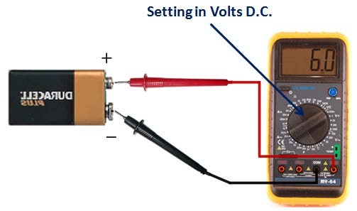
- Remove the multimeter leads from the battery.
- Set/ change the measurement scale to "Ohms" or "resistance."
- Place one of the multimeter leads on one of the resistor leads. Place the other multimeter lead on the remaining resistor lead. Check the multimeter display; the resistance measurement should be approximately 1,500 Ω.
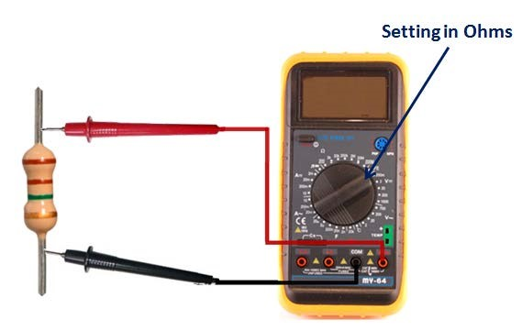
- Remove the multimeter leads from the resistor.
- Twist one of the resistor leads to one end of the wire.
- Attach the other end of the wire to the positive terminal on the battery.
- Change the multimeter measurement scale to "Amps DC" or "DC Current."
- Place the positive multimeter lead on the free end of the resistor. Place the other multimeter lead on the negative battery terminal. Check the multimeter display; the current measurement will be approximately 4 milliamps.
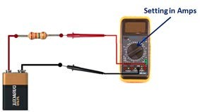
- Disconnect the multimeter leads from the battery and from the resistor. Disconnect the wire from the battery.
- Turn the multimeter off.

Lab test 2.1
Task 1:- Strip insulation from the ends of the wire
Task 2:- Turn on multimeter
Task 3:- Set DVOM to volts DC
Task 4:- test 9 volt battery
Task 5:- Set the measurement scale to "Ohms" or "resistance."
Task 6:- test the resistor
Task 7:- Change the multimeter scale to "Amps DC" or "DC Current
Task 8:- Place the positive multimeter lead on the free end of the resistor. Place the other multimeter lead on the negative battery terminal.
Task 9:- test and read the value
Task 10:- Turn the multimeter off.

Unit Three: Test the construction of electrical/ electronic circuits
This unit is developed to provide you the necessary information regarding the following content coverage and topics:
- Assemble electrical/electronic circuit
- Checking Operations of electrical/electronic circuit
- Testing the completed electrical/electronic circuits
- Construction of basic electrical/electronic circuit
- Responding unplanned events
This unit will also assist you to attain the learning outcomes stated in the cover page. Specifically, upon completion of this learning guide, you will be able to:
- Assemble electrical/electronic circuit
- Check operations of the circuits
- Test the completed electrical/electronic circuits
- Construct basic electrical/electronic circuit
- Respond unplanned events

3.1. Assemble electrical/electronic circuit
All electronic devices feature circuit assembly. Even the smallest electronic device has circuit assembly. It is important we understand the basics of circuit assembly design. Irrespective of the type of circuit board, all circuit boards feature the layers below;
i. Substrate
This is the foundational material for circuit assembly. The substrate provides the circuit board with rigidity. Fiberglass is the primary material for the substrate layer of any circuit board. Asides from flexible PCBs, most boards use fiberglass for their substrate.
  - Copper
Printed circuit boards feature a layer of copper foil. The manufacturer laminates the copper foil to the board using heat. The number of copper layers for a PCB depends on the type of PCBs. For example, single-sided PCBs require a layer of copper on one side of the board.
  - Solder
The yellow or green color of circuit boards is a result of solder mask. The manufacturer places the solder mask on top of the circuit board. This helps to insulate the copper layer. Doing this will prevent the copper from any contact with other metals on the board. The solder mask layer helps the manufacturer to solder the components to the appropriate places.
  - Silkscreen
The silkscreen is the final and uppermost layer of all circuit boards. This layer features components in symbolic or textual form. It helps engineers to have a better understanding of the board. The silkscreen adds symbols, letters, and numbers to the board. This helps to understand the functions of various LEDs and pins.
Electronic assembly is the process of taking a PBC or printed circuit board and turning it into a PCBA or a printed circuit board assembly. This is done by connecting electrical components onto the circuit board. There are many small circuits that connect electricity in different intensities and different frequencies from point A to point B. After the electronic assembly process, printed circuit board assemblies are used in many different
There are 5 main steps in the electronic assembly process.

Step 1: Printed Circuit Board
In electronic assembly, you start with a printed circuit board and the components that go on it. The printed circuit board is a small board that looks something like this picture below.
Step 2: Add Solder Paste
After you have your printed circuit board paste is applied to it using a screen-printer. A thin stencil is used so the paste only goes on the board in places where it is needed.
Step 3: Pick-and-Place
Next, the components are placed on the circuit board. This is done by a machine called a Pick-and-Place that does exactly that, it picks them up and places them where they are supposed to be on the circuit board. Whatever the machine can’t do is done by hand by a technician.
Step 4: Inspection
After the components have been placed on the circuit board, it goes through an automated optical inspection process where it’s confirmed that everything is where it’s supposed to be, that it’s oriented correctly and that nothing is missing.
Step 5: Soldering
The step in the electronic assembly process is to put the PCBA in the oven. The oven melts the paste, which is made up of micro beads of metal. When the paste heats up in temperature, the metal melts and becomes one solid piece of connection. This connects components to the PCB.
After Printed Circuit Board Assembly
After the printed circuit board assembly process is completed and the components have been placed and soldered, the printed circuit board becomes much more functional. It can be used in any number of situations that require electrical parts from phones to cars. If you are looking for the right company to help in your next PCB assembly project, Implementing Ideas is the way to go. We specialize in having short turnaround times. The usual turnaround time for a PCB assembly project is anywhere from 8 to 12 weeks. With Implementing Ideas, you can plan on having a turnaround from a couple of days to a couple of weeks depending on the size of the project.
  - Cheek Operations of electrical/electronic circuit
Troubleshooting of an electronic circuit is a process of having a special outlook on components that comes out with remedies to repair it. The unexpected behavior exhibited by the circuit is due to improper locating or soldering of components, component damage due to aging, faults, overheat, and so on. Such a type of behavior can cause undesired results or even circuit damage.
Techniques to cheek Electronics Circuit
Troubleshooting is a technique used for tracing out, identifying, and fixing the most common problems that occur in an electronic circuit, resulting in its malfunctioning.
Step 1:-Confirm the Problem in the Circuit
Start the troubleshooting process only after confirming the problem in the circuit, which may be about the desired results or improper working conditions of the circuit.
Step 2:-Consider Visual Inspection First
This step might be involved in getting physical contact with the circuit. So it is better to remove the power supply to the circuit and wait for some time to discharge current in some components so that you can hold it without fear.
Check for the exploded or burnt parts of the circuit by seeing and smelling them.
Look for the loose, bad connections and also check the ground paths.
Check for the overlapped traces on the PCB.
Observe the soldered points whether they are correctly soldered or not.
Check for the shorts or touches on the adjacent soldered points.
Note: If anyone of the above-mentioned conditions requires an immediate repair, then go for the required action like de-soldering the shorted points, soldering the loose parts or the connections, replacing the burnt components with the new ones, etc. If not, it has to be confirmed that the problem in the circuit is a major one, and now you can proceed to go through the below steps.
Step 3:-Select Troubleshooting Tools
Troubleshooting process involves checking the terminal voltage across different components and devices in the circuit; checking the continuity of the current for open circuit faults, components like resistor, capacitor, transistors, and their status checking whether they are functioning or not, and so on. Some of these tools are:
- Digital or Analog multimeter
- Oscilloscope
- LCR meters
- Variable Power supply with a metered indication

Step 4:-Power up the Circuit
Before checking with the above tools, plug the circuit to the main power supply so that it is possible to test it in different ways.
Step 5:-Check the Power Supply Block
Keep the multimeter probes across the transformer, diodes, capacitor, and regulator IC, and check whether appropriate values are found or not by inserting the multimeter in volts mode.
Step6:-Check the Individual Components
Check the voltage across the individual components, and if any component doesn’t show any voltage across it, then switch off the supply, and then again test the components by respective meters like LCR for the capacitor, diode by multimeter, and so on.
Step7:-Check the Main Controller
Test the main controller base power supply with respect to the ground without placing a controller on it. And also, check whether some pins are shorted or not for special ICs like timer and Op-Amps – and, for the microcontroller, check respective power supply pins voltage. Place the ICs on the base, and give the input to the controller and then check whether the output control signals are coming or not at appropriate pins.
Step 8:-Check the Loads by Metered Power Supply
Check the outputs by removing the main controller like a microcontroller signal to final control devices and apply the metered-power supply so that the problem area can be easily recognized.
  - Test the completed electrical/electronic circuits
A test of circuit-board components, such as capacitors, resistors, transistors and integrated circuits, can be done to some extent without removing the components from the circuit board. More comprehensive testing can be performed on these components when the component is removed. Most technicians, though, when attempting to diagnose if a circuit board component is faulty, use a volt meter to measure its input and output voltages.
Step 1
Disconnect the power from the printed circuit board and discharge all inductors and capacitors that may present a safety hazard. Confirm that the circuit board's wiring has been done correctly by examining the physical condition of each of the components on the board. Look for cracked, charred or loose components. Replace any damaged components and rewire any wiring mistakes.
Step 2
Connect and turn on the power to your circuit board again and measure the voltages on the inputs and outputs of each of the components on the board. Use your voltmeter (see Tips) to check the voltage level of all of components' input and output pins.
Step 3
Determine, for each voltage level checked, if the voltage level is the right voltage level. Rule out a component as a defective component if all the voltage level inputs and outputs are at the right voltage level.
Step 4
Turn off the power. Remove a component if all its input pins have the right voltage level but one or more of the output pins is at the wrong output voltage. Turn the power back on. Measure the voltage where the measured components pins once were. Replace a component if the voltage measurements are at the right voltage levels with the component removed.
Step 5
Measure the voltage levels of the output pins of the component (component B) that connects to the input pins of the first component (component A) checked. Do this if, and only if, component A's input pins have an incorrect voltage level.
Step 6
Repeat the procedure in Steps 3, 4 and 5 for each component and its preceding component until all of the faulty components and all of the faulty wiring have been located. Proceed in a systematic backwards fashion from the pin where the first incorrect voltage level is found, checking output pins first than input pins of each preceding component.
  - Construction of basic electrical/electronic circuit
A circuit is any loop through which matter is carried. For an electronic circuit, the matter carried is the charge by electronics and the source of these electrons is the positive terminal of the voltage source. When this charge flows from the positive terminal, through the loop, and reaches the negative terminal, the circuit is said to be completed.
Steps in building the circuit
Step 1: Circuit Designing
To design a circuit, we need to have an idea about the values of each component required in the circuit. Let us now see how we are designing a regulated DC power supply circuit.
1. Decide the regulator to be used and its input voltage.
Here we require having a constant voltage of 5V at 20mA with the positive polarity of the output voltage. For this reason, we need a regulator that would provide a 5V output. An ideal and efficient choice would be the regulator IC LM7805. Our next requirement is to calculate the input voltage requirement for the regulator. For a regulator, the minimum input voltage should be the output voltage added by a value of three. In that case, here to have a voltage of 5V, we need a minimum input voltage of 8V. Let us settle down for input of 12V.
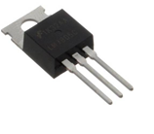
Figure 3.1 7805 regulator
2. Decide the transformer to be used
Now the unregulated voltage produced is a voltage of 12V. This is the RMS value of the secondary voltage required for a transformer. Since the primary voltage is 230V RMS, on calculating the turn’s ratio, we get a value of 19. Hence we have to get a transformer with 230V/12V, i.e. a 12V, 20mA transformer.
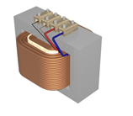
Figure 3.2 Step down transformer
3. Decide the value of the filter capacitor
The value of the filter capacitor depends on the amount of current drawn by the load, the quiescent current (ideal current) of the regulator, the amount of allowable ripple in the DC output, and the period.
For the peak voltage across the transformer primary to be 17V (12*sqrt2) and the total drop across the diodes to be (2*0.7V) 1.4V, the peak voltage across the capacitor is about 15V approx. We can calculate the amount of allowable ripple by the formula below:
∆V = VpeakCap- Vmin
As calculated, Vpeakcap = 15V and Vmin is the minimum voltage input for the regulator.
Thus ∆V is (15-7) = 8V.
Now, Capacitance, C = (I*∆t)/ ∆V,
Now, I am the sum of the load current plus the quiescent current of the regulator and I = 24mA (Quiescent current is about 4mA and load current is 20mA). Also ∆t = 1/100Hz = 10ms. The value of ∆t depends upon the frequency of the input signal and here the input frequency is 50Hz.
Thus substituting all the values, the value of C comes to be around 30microFarad. So, let us select a value of 20microFarad.
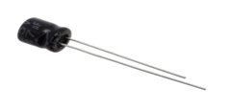
Figure 3.3 an electrolyte capacitor

4. Decide the PIV (peak inverse voltage) of the diodes be used.
Since the peak voltage across the transformer secondary is 17V, the total PIV of the diode bridge is about (4*17) i.e. 68V. So we have to settle down for diodes with a PIV rating of 100V each. Remember PIV is the maximum voltage that can be applied to the diode in its reverse biased condition, without causing breakdown.
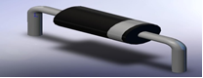
Figure 3.4 PN Junction diode by
Step2. Circuit Drawing and Simulation
Now that you have the idea of the values for each component and the whole circuit diagram
Circuit diagrams are pictures with symbols that have differed from country to country and have changed over time, but are now to a large extent internationally standardized. Simple components often had symbols intended to represent some feature of the physical construction of the device. For example, the symbol for a resistor dates back to the time when that component was made from a long piece of wire wrapped in such a manner as to not produce inductance, which would have made it a coil. These wire wound resistors are now used only in high-power applications, smaller resistors being cast from carbon composition (a mixture of carbon and filler) or fabricated as an insulating tube or chip coated with a metal film.
  - Respond unplanned events
Unplanned Event: An unexpected occurrence that is not normal behavior or anticipated condition for the process.
Unplanned Events refers to events or upset conditions that are not part of any activity or normal operation of the Project as has been planned by North cliff. Even with the best planning and the implementation of preventative measures, the potential exists for accidents, malfunctions or unplanned events to occur during any Project phase, and if they occur, for adverse environmental effects to result if these events are not addressed or responded to in an environmentally appropriate manner. Many accidents, malfunctions and unplanned events are, however, preventable and can be readily addressed or prevented by good planning, design, emergency response planning, and mitigation. By identifying and assessing the potential for these events to occur, North cliff can also identify and put in place prevention and response procedures to minimize or eliminate the potential for significant adverse environmental effects, should an accidental event occur.
Unplanned electrical accidents
An unplanned electrical accident is an undesired, unexpected event that has been caused by an electrical current and has resulted in either injury or property damage. Electrical accidents are more common than you expect. In fact, according to Electrical Safety First, there are over 20,000 accidental domestic fires in the UK each year with an electrical-related cause, whether this may be faulty leads or misuse of appliances. This is why it’s so important to ensure that you understand the types and causes of electrical accidents and how you can’t prevent them.
There are three main types of unplanned electrical accidents that you may encounter at home or even in the workplace. Each of these can vary from mild to severe depending on the strength of the electrical current and factors such as water enhancing the danger.
        - Electrical shock: this occurs when a person (or animal) comes into contact with a live part. In this instance, the electrical current will flow through the body and travel to the nearest earthed source. Exposure to electrical energy may result in no injury at all or may result in devastating damage or death. A mild electric shock will leave a slight tingling sensation in the area that made contact with the current. A moderate electric shock will cause your muscles to contract, making it hard to pull away from the electric current. A severe electric shock can cause heart failure.
- Electrical burn: this usually coincides with a moderate or severe electric shock as the shock causes tissue to burn. Electric burns to the skin can leave scarring, but burns can also be internal as the electric current can travel through the bone and burn surrounding deep tissue.
- Electrical fires: although electrical fires may not initially harm you, they can cause severe damage to any property and are a health and safety hazard for everyone in the building. Electrical fires occur when a current ignites a flammable material. The natural reaction for onlookers may be to try to extinguish the fire with water; however, this may increase the risk of further injuries to all involved as water conducts electricity and can make the flames worse. We would always urge anyone to contact the emergency services in these circumstances.

    - Main causes of electrical accidents
In a world where we use electrical devices, appliances and equipment in almost all aspects of everyday life, electrical accidents are understandably common. Yet most can be prevented by understanding the dangers. Typically, electrical accidents are caused by contact with water, faulty wiring, attempting to fix electrical devices yourself, naked cords and damaged plugs. So, let’s take a closer look at each of these causes.
- Water
Water is a conductor of electricity and can, therefore, be extremely dangerous when put into contact with an electrical current.
- Faulty wiring
Faulty wiring can occur for many reasons, including poorly installed equipment, incorrect use and a lack of maintenance. Particularly in the workplace, wires and cables should be regularly inspected by a professional electrician to ensure that health and safety standards are met.
- Attempting to fix electrical faults
Many people believe that using DIY methods on electrical wiring and cabling is as easy as hammering a nail into the wall, but this is most definitely not the case. In fact, by attempting to fix electrical equipment without any training, you can put yourself at serious risk of an electric shock and, if not correctly resolved, more severe consequences.
- Naked cords & damaged plugs
Damaged cords can occur when an electrical appliance is overused or misused, causing the protective outer sheath to split, exposing the wires inside. This can be extremely dangerous as the sheath is designed to insulate the conductors and prevent injury.

Self-check 3.1
Test I: - Say ‘’true’’ if the statement is correct and ‘’false’’ if the statement is not correct
______1. Water is a conductor of electricity and can, therefore, be extremely dangerous when put into contact with an electrical current.
______2. Electrical shock occurs when a person (or animal) comes into contact with a live part.
______3. The silkscreen is not the final and uppermost layer of all circuit boards
______4. Unplanned Events refers to events or upset conditions that are part of any activity or normal operation of the Project
______5. Damaged cords can occur when an electrical appliance is overused or misused, causing the protective outer sheath to split, exposing the wires inside.
Test II mach from column ‘’B’’ to column ‘’A’’
A B
______1. Final and uppermost layer of all circuit boards a. Solder mask layer
______2. Helps the manufacturer to solder the components b. Copper
______3. Foundational material for circuit assembly c. Substrate
______4. The process of taking a printed circuit board d. Silkscreen
______5. Can occur poorly installed equipment e. Electronic assembly
f. Faulty wiring

Test III Explain in brief
- List and explain four Troubleshooting Tools.
- List 5 main steps in the electronic assembly process.
- List 8 Techniques to cheek Electronics Circuit.
- List Main causes of electrical accidents

References
- https://www.power-and-beyond.com/introduction-to-electronic-compontents-active-vs-passive-components-a-893768/
- https://www.irf.com/electronics/active-components
- https://www.yamanelectronics.com/electronic-components-testing/
- https://www.electricaltechnology.org/2015/01/resistor-types-resistors-fixed-variable-linear-non-linear.html
- https://eeeproject.com/types-of-capacitors/
- https://www.fluke.com/en-us/learn/blog/digital-multimeters/how-to-measure-resistance
- https://studentsheart.com/how-to-test-an-inductor/
- https://meterreviews.com/how-to-test-a-power-supply-with-a-multimeter/
- https://www.elprocus.com/8-techniques-to-troubleshoot-your-electronics-circuit/
- https://www.dummies.com/article/technology/electronics/circuitry/how-to-build-a-simple-electronic-circuit-180237/

The trainers who developed the Module (training material) preparation
No | Name | Qualification | Educational background | Region | College | Mobile number | E-mail
1 | Tesfahun Ayalew Denigdine | B.SC -Applied Electrical/Electronic Technology  M.Sc. -Electronics and comm Eng. |  | BGRS | Assosa poly TVT College | 0912132308 | tesfugps44@gmial.com
2 | Yidnekachew Regassa Hirpa | B.Sc - Applied Electrical/Electronic Technology  M.Sc. - Electronic & communication Technology |  | Harari | Harari poly TVT College | 0910343909 | Yidne888@gmail.com
3 | Mohammed Seid Hussen | B.SC – Electrical/Electronic Technology  M.Sc – in electrical & communication Techno.mag,t |  | Ahmara | w/sihen Poly TVT College | 0913174837 | Tofikfuad606@gmail.com
4 | Berihun  Belaynew mesganaw | BA.T - Electronic & communication Technology. |  | Oromia | M.G.Mulugata Buli Poly TVT Collge | 0912836044 | berihunbelaynew@gamil.com

