Electrical/Electronic Equipment Servicing
Based on March, 2022 Curriculum Version 1
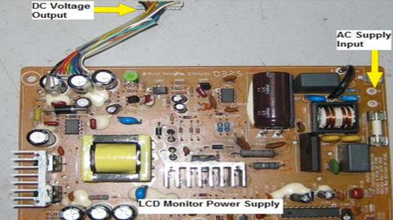
Module Title: Troubleshoot AC/DC power supply with single phase input
Module Code: EIS EEES2 05 0322
Nominal duration: 60 hours

Prepared By: Ministry of Lobar and Skill
August, 2022
Addis Ababa, Ethiopia
Table of Content
Acknowledgment
Introduction to the module 7
Unit one: product and work station for troubleshooting 9
1.1. Materials tools and equipments 10
1.2. OH&S policies and procedures 10
1.2.1Safety procedures 10
1.2.2 Effect of Electric Current on the Human Body 12
1.2.3 Measures to Protect Against Accidents with Electric Current 13
1.3. Consult to effective and proper work coordination 14
1.3.1 The main purposes of coordination: 15
1.3.2. Introduction to Power Supply 16
1.3.3. Types of Power Supplies 16
Self-check-1 20
Unit two: Diagnose parts of power supply 21
2.1 Techniques of Troubleshooting AC/DC Power supply 22
2.1.1 Application of trouble shooting technique 22
2.1.2 General Trouble shouting Guide lines 22
2.2 Instruments used to test AC/DC Power supply 24
2.2.2 Types of Multimeter 24
2.2.3 Oscilloscope 26
2.3. Troubleshoot defects/faulty parts 27
2.3.1. Major Sections of Power Supply 29
2.3.2. Construction Of Power supply using different Voltage Regulators 41
2.4. Advice to customers 48
2.5. Documentation of diagnose results and testes 49
Self-check-2.1 51
Operation sheet 2.1: Techniques of Troubleshooting AC/DC Power supply 52
LAB test 2.1 53
Unit Three: Maintenance of power supply unit 54
3.1. Personal protective equipment’s (PPE) 55
3.1.1. PPE Definition and Meaning 55
3.1.2 Four basic types of PPE 55
3.2. Methods for replacing defective electronic parts/component 61
3.2.1. Visual Inspection (Checking) 61
3.2.2 Signal Tracing 62
3.3. Systems of Soldering repaired or replaced parts/components 66
3.3.1. Introduction 66
3.4. Perform control settings/adjustments 68
3.5. Perform cleaning 69
Self-cheek 3.1 72
Operation sheet 3.1: Maintenance of power supply unit 74
LAB test 3.1 76
Unit Four: Rewind low power transformer 77
4.1 Process of rewinding Low power transformer 78
4.1.1 Voltage turns ratio and Transformer ratings 85
4.2. Check rewind low power transformer 87
4.3. Measuring instruments of low power transformer 89
Self-cheek 4.1 90
Operation sheet 4.1: - Rewind low power transformer 91
Lab test 4.1 93
Unit five: Assemble low-power transformer 94
5.1. Process of assembling low power transformer 95
5.2. Methods of Checking assembled transformer 96
5.3. Check the assembled transformer 97
Operation sheet 5.1 Assemble low-power transformer 99
LAP Test 5.1 100
Unit six: Test and inspect repaired products 101
6.1 . Inspect and test Assembled transformer 102
6.2 . Document work completion 102
6.3. Applying 5S 103
6.4. Disposing of waste materials 105
Self-Check- 6.1 107
References 110

Acknowledgment
Ministry of Labor and Skills wish to extend thanks and appreciation to the many representatives of TVT instructors and respective industry experts who donated their time and expertise to the development of this Teaching, Training and Learning Materials (TTLM).

Acronym
TTLM …………………………Teaching, Training and Learning Materials
AC...…………………………….Alternating current
DC……………………………… Direct current
OHS ………………………………Occupational health and safety
LAP ……………………………… learning assistance program
LED………………………………light emitting diode
PCB………………………………printed circuit boar
ESD………………………………electrostatic discharge
DMM………………………………digital multimeter
VOM………………………………volt ohm meter
GFCI ……………………………. Ground Fault Circuit Interrupter
SMPS………………………………switched mode power supply
IC…………………………………..integrated circuit

Introduction to the module

In Electrical/Electronic Equipment Servicing field; Troubleshoot AC/DC power supply with single phase input helps to know every piece of electronic equipment has a power supply circuit. The power supply circuit produces the DC voltage needed to operate electronic components. Of course, batteries can be and are used in portable equipment, but in larger systems, where considerable power is needed, batteries are an inconvenience and expensive.
Electronic circuits normally require a different type and value of voltage than is available from standard 220V AC wall socket. The function of the electronic power supply is to take the input voltage and convert this to the proper type and value of voltage that is needed to operate circuits.
This module is designed to meet the industry requirement under the Electrical/Electronic Equipment Servicingoccupational standard, particularly for the unit of competency: Troubleshoot AC/DC power supply with single phase input
This module covers the units
- Product and work station for troubleshooting
- Diagnose parts of power supply
- Maintenance of power supply unit
- Rewind low power transformer
- Assemble low-power transformer
- Test and inspect repaired products
Learning Objective of the Module
- Apply troubleshooting
- Diagnose faults
- Perform maintenance
- Rewind transformer
- Assemble transformer
- Test repaired product

Module Instruction
For effective use this modules trainees are expected to follow the following module instruction:
- Read the information written in each unit
- Accomplish the Self-checks at the end of each unit
- Perform Operation Sheets which were provided at the end of units
- Do the “LAP test” giver at the end of each unit and
- Read the identified reference book for Examples and exercise

Unit one: product and work station for troubleshooting
This unit is developed to provide you the necessary information regarding the following content coverage and topics:
- Materials tools and equipment’s
- OH&S policies and procedures
- Consulting to effective and proper work coordination
This unit will also assist you to attain the learning outcomes stated in the cover page. Specifically, upon completion of this learning guide, you will be able to:
- Use materials tools and equipment’s
- Follow OH&S policies and procedures
- Consult customers

Materials tools and equipments
The required materials, tools and equipments for trouble shouting AC/DC power supply are as follows in the table below.
Consumable materials | Tools | Equipments
- Copper wires  - Stranded wires  - Diodes  - Capacitor  - Resistor  - Transformer  - Solder  - Flux  - LED  - Regulator ICs  - Fuse  - DC-Battery For multi-meter | - Utility knife/stripper  - Wrenches (assorted)  - Allen wrench/key  - Screws (assorted)  - Pliers (assorted)  - Ball-peen hammer  - Tweezers/for saves/  - Brush  - Cutters  - Micrometer Caliper  - Pliers | - Multi meter  - Single phase power supply  - Conventional E-I Transformer Assembly  - Soldering and disordering equipments  - ESD-free work bench with mirror Caliber  - Ppes(glove, apron, goggle, face mask)  - Printed circuit board (PCB)  - Clamp ammeter  - Magnifying Lamp  - Digital capacitor meter  - Industrial socket(male & female)

These materials, tools and equipments should be check for their appropriateness and normal state for specific operation

1.2. OH&S policies and procedures

1.2.1Safety procedures
The following safety rules should be understood and strictly followed to avoid accidents while working
1. Don't work alone - in the event of an emergency another person's presence may be essential.
2. Always keep one hand in your pocket when anywhere around a powered line-connected or high voltage system.
3. Wear rubber bottom shoes or sneakers.
4. Don't wear any jewellery or other articles that could accidentally contact circuitry and conduct current, or get caught in moving parts.
5. Set up your work area away from possible grounds that you may accidentally contact.
6. Know your equipment: TVs and monitors may use parts of the metal chassis as ground return yet the chassis may be electrically live with respect to the earth ground of the AC line.
7. If circuit boards need to be removed from their mountings, put insulating material between the boards and anything they may short to. Hold them in place with string or electrical tape. Prop them up with insulation sticks – plastic or wood.
8. If you need to probe, solder, or otherwise touch circuits with power off, discharge (across) large power supply filter capacitors with a 2 W or greater resistor of 5-50 ohms/V approximate value (e.g., for a 200 V capacitor, use a 1K-10K ohm resistor). Monitor while discharging and/or verify that there is no residual charge with a suitable voltmeter.
9. Connect/disconnect any test leads with the equipment unpowered and unplugged. Use clip leads or solder temporary wires to reach cramped locations or difficult to access locations.
10. If you must probe live, put electrical tape over all but the last 1/16" of the test probes to avoid the possibility of an accidental short which could cause damage to various components. Clip the reference end of the meter or scope to the appropriate ground return so that you need to only probe with one hand.
11. Use a proper high voltage probe or high voltage meter to measure voltages which are potentially beyond the capabilities of your DMM or VOM - not something cobbled together from 1/4 watt resistors! Note that fault conditions or even testing at *reduced* input voltage may result in greatly excessive voltage on one or more outputs due to lack of regulation.
12. It may be possible to perform some of the tests at greatly reduced voltage (e.g., 30 VDC to the chopper instead of 300 VDC) by supplying external power to the controller chip (if used) and injecting base/gate drive from a signal generator. This would greatly reduce the shock hazard as well as equipment damage from a slipped probe or missed faulty component.
13. Perform as many tests as possible with power off and the equipment unplugged. For example, the semiconductors in the power supply section of a TV or monitor can be tested for short circuits with an ohmmeter.
14. Use an isolation transformer if there is any chance of contacting line connected circuits. A Variac is not an isolation transformer! The use of a GFCI (Ground Fault Circuit Interrupter) protected outlet is a good idea but will not protect you from shock from many points in a line connected TV or monitor, or the high voltage side of a microwave oven, for example. (Note however, that, a GFCI may nuisance trip at power-on or at other random times due to leakage paths (like your scope probe ground) or the highly capacitive or inductive input characteristics of line powered equipment.) A fuse or circuit breaker is too slow and insensitive to provide any protection for you or in many cases, your equipment. However, these devices may save your scope probe ground wire should you accidentally connect it to a live chassis.
15. Don't attempt repair work when you are tired. Not only will you be more careless, but your primary diagnostic tool - deductive reasoning - will not be operating at full capacity.
16. Finally, never assume anything without checking it out for yourself! Don't take shortcuts!

1.2.2 Effect of Electric Current on the Human Body

When a person touches a live part, an electric circuit is completed see Illustration Below. An electric current I flow through the person's body. The effect of electric current on the human body increases with the intensity of the current and with the length of time in contact with the current. The effects are grouped according to the following threshold values:
- Below the threshold of perception, electric current has no effect on the human body.
- Up to the let-go threshold, electric current is perceived but there is no danger to human health.
- Above the let-go threshold, muscles become cramped and functioning of the heart is impaired.
- Above the threshold of non-fibrillation, the effects are cardiac arrest or ventricular fibrillation, cessation of breathing and unconsciousness. There is an acute risk to life.
A.Electrical Resistance of the Human Body
The human body offers resistance to the flow of current. Electric current may enter the body through the hand, for example; it then flows through the body to re-emerge at another point (such as the feet - see Fig a). Accordingly, the electrical resistance RM of the human body (Fig. c) is formed by a series circuit comprising the entry resistance RÜ1, the internal resistance RI and the exit resistance RÜ2 (Fig b). It is calculated using the following formula:
RM = RÜ1 + RI + RÜ2
The contact resistances RÜ1 and RÜ2 vary greatly depending on the contact surface and the moistness and thickness of the skin. This affects the total resistance RM. It may range between the following extremes:

• Less than 1000 ohms (large contact surfaces, wet, sweaty skin)
• Several million ohms (point contact, very dry, thick skin)
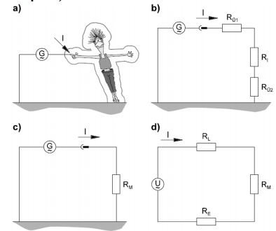

Figure 1.1 Resistance of the Human Body

1.2.3 Measures to Protect Against Accidents with Electric Current
A. Protection against Direct Contact
There are a wide variety of protective measures which prevent the operator of electrical control
System from being put at risk from electric current. Protection against touching live parts is prescribed for both high and low voltages. Such protection can be ensured in the following ways:
  - Insulation
  - Covering
  - Sufficient clearance
B. Grounding
Components which are liable to be touched by anyone must be grounded. If a grounded housing
becomes live, the result is a short circuit and the overcurrent protective devices are tripped, interrupting the voltage supply. Various devices are used for overcurrent protection:
- Fuses
- Power circuit-breakers
- Fault-current-operated circuit-breakers
- Fault-voltage-operated circuit-breakers
There is no risk to life when touching an electric conductor carrying a voltage of less than approximately 30 V because only a small current flows through the body. For this reason, control systems are not normally operated at the voltage of the electrical supply network (such as 230 V AC) but at 24 V DC. The supply voltage is reduced by a power supply unit with an isolating transformer.
Warning: Despite this precaution, the electrical wiring at the inputs to the power supply unit carries high voltage.
  - Consult to effective and proper work coordination
- Proper work coordination is not a separate function but the very essence of management. It is present in all the functions.
- Need for co-ordination arises due to inter-dependency of various functional departments.
- Co-ordination is a dynamic process and it is to be exercised all the time to ensure smooth functioning of departments.
- The managers across the level have to consciously exercise co-ordination.
- It is required in group efforts and not in individual effort. Hence it involves orderly arrangement of group effort.
- The objective of coordination is to facilitate accomplishment of overall objectives. It works on the fulcrum of unity of purpose.

1.3.1 The main purposes of coordination:
(a) Reconciliation of Goals:
This can be done by the coordination only. The conflict of goals arises because everybody perceives the organizational goals differently and tries to achieve them in his own way. This may lead to confusion and chaos in the organization. Therefore, coordination is necessary to bring unity of action in the organization.
(b) Total Accomplishment:
Through coordination it is possible to bring about total accomplishment which will be far in excess of the sum of the individual parts. It has been observed that the total accomplishment of ten employees of a department whose efforts are properly coordinated will be far greater than the mathematical sum of their individual accomplishment. This happens because through coordination, duplication of efforts is prevented and the time and energy thus saved are better utilized in more creative tasks.
(c) Economy and Efficiency:
Through coordination, it is possible to bring about economy and efficiency in the organization. Coordination will avoid duplication of efforts due to which there will be economy in labour, time and equipment. When the activities are properly integrated, there will be lest delays which will bring efficiency in the business organization.
(d) Good Personal Relations:
Coordination is achieved through systematic efforts. Good coordination gives job satisfaction to the employees which keep their morale high. Moreover, there are good human relations because the authority-responsibility relationships are clear. The conflict between line and staff personnel can also be avoided through proper coordination of their efforts.
(e) Retention of Managerial and Other Personnel:
It has been pointed out that sound coordination has a significant effect on the development and retention of good personnel in business. If the total organization is so designed and patterned that each executive and employees derives job satisfaction, there will be tendency on the part of the executive and employees and employees to stay with the organization. The absence of this will create suffocating conditions in which it would be difficult for any person to stay r for long in the organization.

1.3.2. Introduction to Power Supply
A power supply is a device that supplies electric power to an electrical load. The term is most commonly applied to electric power converters that convert one form of electrical energy to another, though it may also refer to devices that convert another form of energy (mechanical, chemical, solar) to electrical energy. A regulated power supply is one that controls the output voltage or current to a specific value; the controlled value is held nearly constant despite variations in either load current or the voltage supplied by the power supply's energy source.

1.3.3. Types of Power Supplies
A. Battery
A battery is a device that converts stored chemical energy to electrical energy. Batteries are commonly used as energy sources in many household and industrial applications.
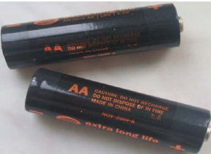
Figure 1.2 Battery
B. AC power supply
An AC power supply typically takes the voltage from a wall outlet (mains supply) and lowers it to the desired voltage. Some filtering may take place as well.
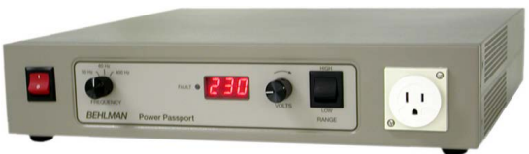
Figure 1.3 AC power supply
C. DC power supply
An AC powered unregulated power supply usually uses a transformer to convert the voltage from the wall outlet (mains) to a different, nowadays usually lower, voltage. If it is used to produce DC, a rectifier is used to convert alternating voltage to a pulsating direct voltage, followed by a filter, comprising one or more capacitors, resistors, and sometimes inductors, to filter out (smooth) most of the pulsation.
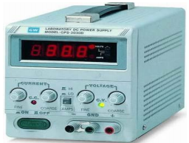
Figure 1.4 DC power supply
D. Linear regulated power supply
The voltage produced by an unregulated power supply will vary depending on the load and on variations in the AC supply voltage. For critical electronics applications a linear regulator may be used to set the voltage to a precise value, stabilized against fluctuations in input voltage and load.
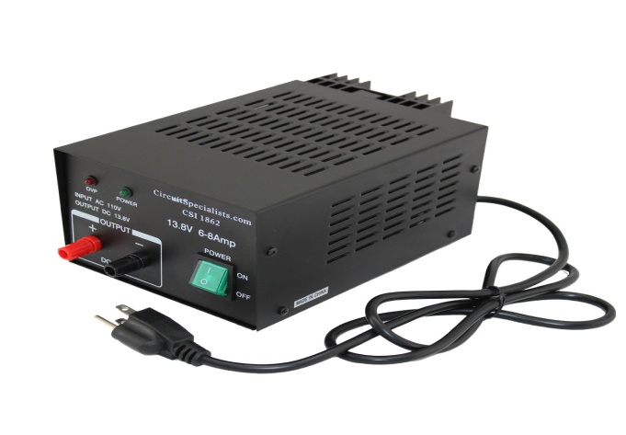
Figure 1.5 Linear regulated power supply
Linear power supplies are widely used for applications where low noise and ripple are required. As the name suggests, they use linear technology - typically a series linear regulator element to drop voltage. As such they dissipate power, but without any switching mode, they are able to offer high levels of performance.
Applications Where Linear Regulators Are Preferable
There are many applications in which linear regulators provide superior solutions to switching supplies, including:
1. Simple/low cost solutions. Linear regulator solutions are simple and easy to use, especially for low power applications with low output current where thermal stress is not critical. No external power inductor is required.
2. Low noise/low ripple applications. For noise-sensitive applications, such as communication and radio devices, minimizing the supply noise is very critical. Linear regulators have very low output voltage ripple because there are no elements switching on and off frequently and linear regulators can have very high bandwidth. So, there is little EMI problem.
3. Fast transient applications. The linear regulator feedback loop is usually internal, so no external compensation is required. Typically, linear regulators have wider control loop bandwidth and faster transient response than that of SMPS.
4. Low dropout applications. For applications where output voltage is close to the input voltage, linear regulators are more efficient than an SMPS. In summary, designers use linear regulators because they are simple, low noise, low cost, easy to use and provide fast transient response.
E. Switched-mode power supply
In a switched-mode power supply (SMPS), the AC mains input is directly rectified and then filtered to obtain a DC voltage. The resulting DC voltage is then switched on and off at a high frequency by electronic switching circuitry, thus producing an AC current that will pass through a high-frequency transformer or inductor
A SMPS uses semiconductor switches to switch the voltage across the transformer that typically has these features:
  - Fewer turns.
  - Ferrite cores with a lower saturation flux density, but a higher resistance to eddy currents and thus does not need to be laminated.
  - A smaller cross-sectional area.
The SMPS can greatly reduce the size and weight of the power supply. The following four categories compare the significant performance differences between linear power supplies and SMPSs
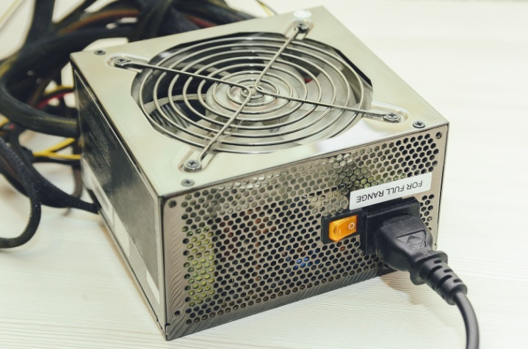
Figure 1.6 Switched-mode power supply
Generally SMPS can be classified into four types according to the input and output waveforms:
- AC in, DC out: rectifier, off-line converter input stage
- DC in, DC out: voltage converter, or current converter, or DC to DC converter
- AC in, AC out: frequency changer, cycloconverter, transformer
- DC in, AC out: inverter
Note: Depending on the specific application, a designer can choose either a linear regulator (LR) or a switching mode power supply (SMPS) solution.

Self-check-1
Part I. True false
________1. Always examine the tool for damages before use.
________2. It is OK to wear loose clothing, dangling objects and jewellery using hand tool.
________3. Keep cords and hoses away from heat, oil and sharp edges.
________4. Use only tools and equipment in good condition.
________5. It is OK to make adjustments or clear a jam while the power tool is running.
Part –II Write a short answer and give explanation when needed
- _______ is very useful in cutting excess components terminal lead.
- ________ is used to remove solder from a joint.
- _________is useful in getting components in or out of confined areas.
- _________ is a tool having a head with a cross slot or its corresponding Screwdriver.
- _________Rated in 20 to 40 watts, tip can be replaced with the same wattage rating.
- ………….is a device that supplies electric power to an electrical load.
- ……………….is a device that converts stored chemical energy to electrical energy
Test-III Short answer writing
- What is the purpose of hand tools?
- Write down at least five hand tools.
- Write down at least three safety materials

Unit two: Diagnose parts of power supply
This unit is developed to provide you the necessary information regarding the following content coverage and topics:
- Techniques of Troubleshooting AC/DC Power supply
- Instruments used to test AC/DC Power supply
- Troubleshoot defects/faulty parts
- Advise to customers
- Documentation of diagnose results and testes
This unit will also assist you to attain the learning outcomes stated in the cover page. Specifically, upon completion of this learning guide, you will be able to:
- Follow trouble shooting techniques
- Use AC/DC Power supply testing instruments
- Identify defects/fault parts
- Advise to customers
- Document diagnose results and testes

  - Techniques of Troubleshooting AC/DC Power supply
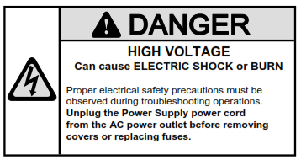

2.1.1 Application of trouble shooting technique
Troubleshooting is a method of finding the cause of a problem and correcting it. The ultimate goal of troubleshooting is to get the equipment back into operation. This is a very important job because the entire production operation may depend on the troubleshooter's ability to solve the problem quickly and economically, thus returning the equipment to service. Although the actual steps the troubleshooter uses to achieve the ultimate goal may vary, there are a few general guidelines that should be followed.
There are often cases where a familiar piece of equipment or system breaks down. In those cases, an abbreviated five-step troubleshooting process can be used to find the fault, get the system up and running. It is important to note that, although it is a five-step approach, the same basic guidelines of the seven-step troubleshooting method are followed. The steps are simply combined to be specific to the problem at hand.

2.1.2 General Trouble shouting Guide lines
The general guidelines for a good troubleshooter to follow are:
Use a clear and logical approach
- Work quickly
- Work efficiently
- Work economically
- Work safely and exercise safety precaution

The five-step troubleshooting techniques consist of the following:
- Verify that a problem actually exists.
- Isolate the cause of the problem.
- Correct the cause of the problem.
- Verify that the problem has been corrected.
- Follow up to prevent future problems.
Within the four general guidelines previously mentioned, there are several action items that are important to the successful achievement of the goal of troubleshooting:
1. Verify that something is actually wrong.
A problem usually is indicated by a change in equipment performance or product quality. Verification of the problem will either provide you with indications of the cause if a problem actually exists or prevent the troubleshooter from wasting time and effort on "ghost" problems caused by the operator's lack of equipment understanding. Do not simply accept a report that something is wrong without personally verifying the failure. A few minutes invested up front can save a lot of time down the road. Troubleshooting any piece of equipment involves a systematic approach of observing the symptom, analyzing the possible causes, and checking these failures by test and measurement.
2. Identify and locate the cause of the trouble.
Trouble is often caused by a change in the system. A thorough understanding of the system, its modes of operation, and how the modes of operation are supposed to work, the easier it will be to find the cause of the trouble. This knowledge allows the troubleshooter to compare normal conditions to actual conditions.
3. Correct the problem.
It is very important to correct the cause of the problem, not just the effect or the symptom. This often involves replacing or repairing a part or making adjustments. Never adjust a process or piece of equipment to compensate for a problem and consider the job finished; correct the problem!

4. Verify that the problem has been corrected.
Repeating the same check that originally indicated the problem can often do this. If the fault has been corrected, the system should operate properly.
5. Follow up to prevent further trouble.
Determine the underlying cause of the trouble. Suggest a plan to a supervisor that will prevent a future recurrence of this problem.
  - Instruments used to test AC/DC Power supply
    - Multi meter
Multimeter is known as a multitester or VOM (Volt- Ohm Milliammeter). It is an all-in-one electronic measuring instrument that combines several measurement functions. Thus, it’ll be able to troubleshoot issues with your circuit or electronic designs!
There are two types of multimeter, but a typical multimeter is capable of measuring voltage, current and resistance. We will go into more detail in the latter part of this guide.
A typical multimeter nowadays looks like this:
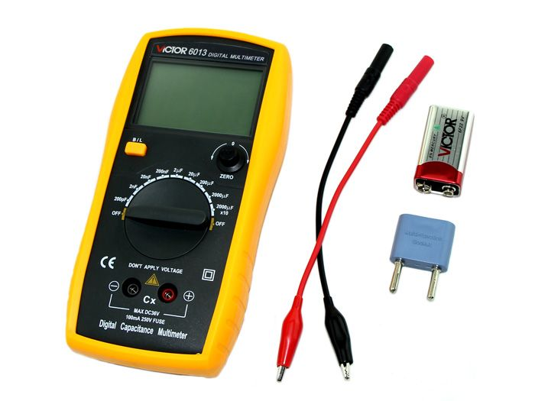
Figure 2.1 Digital Capacitance Meter

Types of Multimeter
Although we mainly use digital multimetir these days, as I briefly mentioned earlier, there are two types of multimeter:
- Analog
- Digital
Let’s talk about Resolution in multimetir before stating their differences: The resolution of a multimeter is the smallest part of the scale which can be shown, which is scale-dependent.

Analog Multimeter
The analog multimeters are more responsive to changes than digital multimeters, thus it is able to give a more accurate reading. However, because it is so sensitive, this makes it hard to read and gives delays.
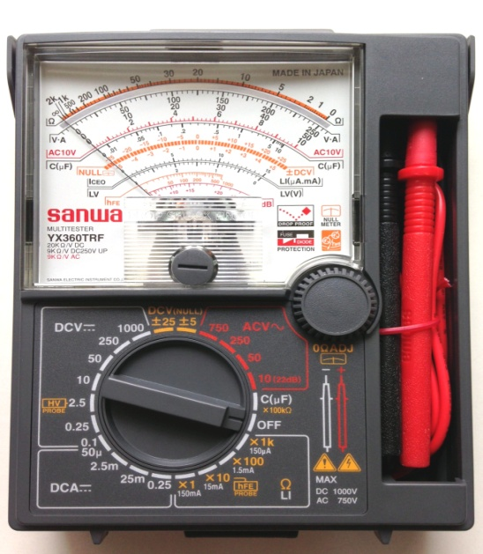
Figure 2.2 Typical Analog Multimeter

Digital Multimeter

The resolution of a multimeter is often specified in the number of decimal digits resolved and displayed. Some digital multimeter is able to configure its resolution as well!
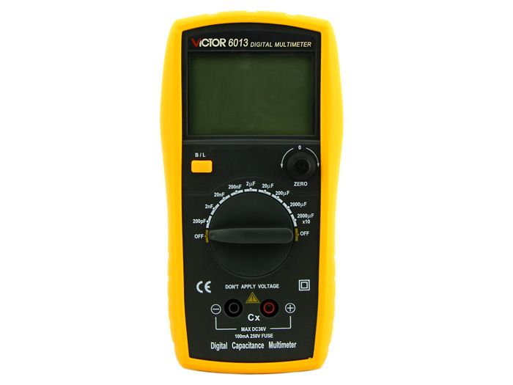
Figure 2.3 Digital Capacitance Meter
Parts of a Digital Multimeter
A Multimeter is made up of 3 main portions:
- Display: Measurements are displayed here
- Selection Knob: Allows you to select what to measure
- Ports: Where you plug in the probes
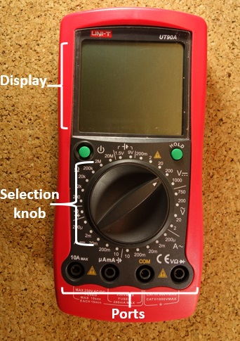
Figure 2.4 Parts of a Digital Multimeter
It should also come with probes, and note that the color does not matter!
    - Oscilloscope
An analog oscilloscope is typically divided into four sections: the display, vertical controls, horizontal controls and trigger controls. The display is usually a CRT with horizontal and vertical reference lines called the graticule. CRT displays also have controls for focus, intensity, and beam finder.
The vertical section controls the amplitude of the displayed signal. This section has a volts-per-division (Volts/Div) selector knob, an AC/DC/Ground selector switch, and the vertical (primary) input for the instrument. Additionally, this section is typically equipped with the vertical beam position knob.
The horizontal section controls the time base or "sweep" of the instrument. The primary control is the Seconds-per-Division (Sec/Div) selector switch. Also included is a horizontal input for plotting dual X-Y axis signals. The horizontal beam position knob is generally located in this section
.. 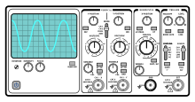
Figure 2.5 Parts of a Digital Multimeter

2.3. Troubleshoot defects/faulty parts
Many times equipment failure is caused by troubles in the power supply. If an electrical device ceases to operate, the most probable fault is power supply. Diagnosis it systematically mentioned below.
1. Verify that the power supply is faulted or not.
Troubleshooting any piece of equipment involves a systematic approach of observing the symptom, analyzing the possible causes, and checking these failures by test and measurement. Given that the system power is available and the power supply is connected to it,

Figure 2.6 AC/DC Power supply
check the output of the power supply. If the output voltage is zero, or highly deviated value from its rated value the device is faulted.
2. Identify and locate the cause of the trouble
First check the fuse. If the fuse blows investigate the root cause of it before replacing. If the fuse is normal perform voltage test starting from the input side to the output side stage by stage until you get abnormal reading which is also the symptom of fault. Recall the transformer stages bellow, and apply voltage measurement at each stage using the following steps:
Power supply block diagram (stages)
- Adjust your multimeter at AC range and >220v
- Measure AC voltage at the input of the transformer between point A and B at (V_{AB})
3. Measure transformer output (reduced AC voltage) between point C and D (V_{CD} )
4. Adjust your meter at voltage greater than the expected rectifier output in DC voltage range.
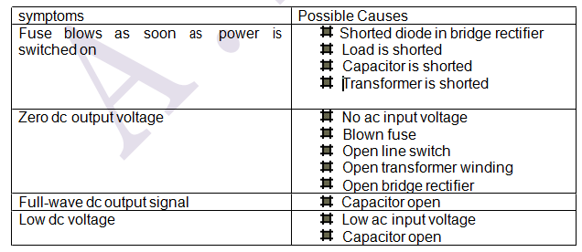
5. Measure DC voltage between point E and F,G and H, Iand J, C and D respectively, until
you get the fault area.
Once faulty sage is identified, continue to investigate in the component level in that specific faulty stage. The possible cause of fault and their symptoms are shown above in the table.
3. Correct the problem.
Once the root cause of a given fault is found, obviously the next task is to correct (trouble shoot) it. It is act of connecting the disconnecting circuit or replacing the faulted component with the same rated components. This is actually one type of maintenance task.
4. Verify that the device reverts to its normal condition. This is simply done by measuring the output voltage. If the fault still exist, repeat step 2 and 3 for the other fault.
5. Follow up to prevent further trouble.
If the fault is expected to be created by misuse of the power supply, for example if it were overloaded, consults the user how to use it in order to prevent the same fault in the future.

    - Major Sections of Power Supply
It is a well-known fact, that all the electronic devices (i.e. diodes, transistors, ICs. etc.) and circuits require a constant DC voltage for their operation. The DC voltage can be supplied from dry cell or batteries. But these are expensive as compared to conventional regulated DC power supplies. The regulated DC power supply is made by converting the domestic AC supply to DC supply. This is what a power supply does.
Most of the modern equipment may need one or more of the voltages in three ranges, ±5V for operation of digital and logic circuits, ±12V or ±15V for operation of linear integrated circuits and transistors, higher voltages for operation of specialized circuits, say 24V for operation of certain types of solenoids, 100V for driving deflection coils on a video monitor and 2KV for extra high tension supply in an oscilloscope.
The block diagram of a basic power supply. Most power supplies are made up of four basic sections: a TRANSFORMER, a RECTIFIER, a FILTER, and a REGULATOR.
Block diagram of Linear Power Supply with Single-Phase Input
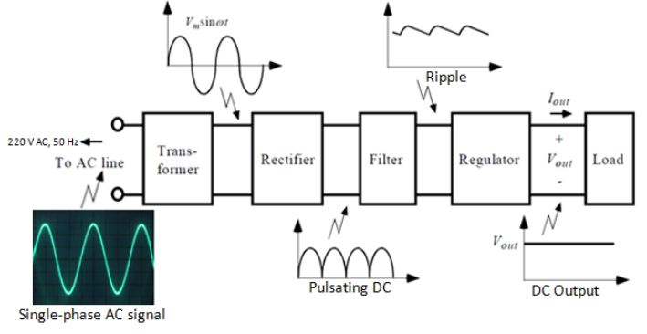
Figure 2.7 Block diagram of Linear Power Supply
In every electronic circuit you will always encounter a DC power source such as 3V, 4.5V, 6V, 7.5V, 9V, 12V, etc. You cannot operate a particular electronic device or circuit without DC power supply. A low voltage power supply converts AC input to DC output voltage. A transformer is used to step down the AC voltage from the AC line. This low AC voltage needs rectifier to convert AC to pulsating DC and filter to smoothen pulsating DC to pure DC output voltage and sometimes regulate the Voltage.
Parts of power supply and its function
1. AC line (220 V AC, 50 Hz) `
- Is a common AC supply in AC outlet.
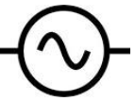
Schematic Symbol
2. Transformer
This is used to reduce the 220 volts AC into smaller voltage. A transformer consists of two coils (often called 'windings') linked by an iron core, as shown in figure below. There is no electrical connection between the coils; instead they are linked by a magnetic field created in the core Step down transformers is to reduce a voltage. Most power supplies use a step-down transformer to reduce the dangerously high mains voltage to a safer low voltage. The input coil is called the primary and the output coil is called the secondary.
The ratio of the number of turns on each coil, called the turn’s ratio, determines the ratio of the voltages. A step-down transformer has a large number of turns on its primary (input) coil which is connected to the high voltage mains supply, and a small number of turns on its secondary (output) coil to give a low output voltage.
Below is transformers formula,
 | turns ratio = | Vp | = | Np | = |  | Is | and |  | power out = power in
 | turns ratio = | Vs | = | Ns | = |  | Ip |  |  | Vs × Is = Vp × Ip
Vp = primary (input) voltage  Np = number of turns on primary coil  Ip = primary (input) current |  |  |  |  |  |  |  |  | Vs = secondary (output) voltage  Ns = number of turns on secondary coil  Is = secondary (output) current
If we see the effect of “Transformer alone” in the power supply unit it only transfers the voltage. For example as we can see below the transformer step down the voltage.
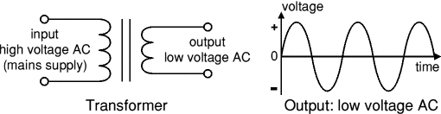
Figure 2.8 the effect of Transformer alone
Transformers have two great advantages over other methods of changing voltage:
1. They provide total electrical isolation between the input and output, so they can be safely used to reduce the high voltage of the mains supply.
2. Almost no power is wasted in a transformer. They have a high efficiency (power out / power in) of 95% or more.
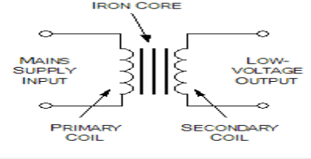
Figure 2.9 chematic Symbol of transformer
A standard transformer electrically isolates the primary and secondary circuits.
Isolation Gives electrical separation between ac neutral or ground input and the power supply output common. In transformer, the ac line voltage is connected to the primary coil to create a changing magnetic field that induces voltage in the secondary coil. The primary and secondary coils are not connected physically, but simply are magnetically linked. if a high voltage is applied to the primary coil of a step-down transformer, the low secondary voltage is completely isolated from the high primary voltage. If a person touched either wire of the secondary coil he/she would not be shocked by the high primary voltage (as shown in the figure bellow)
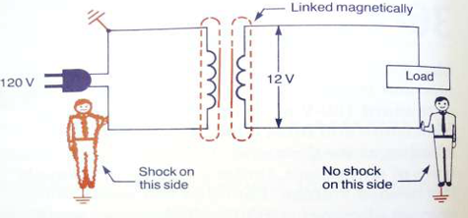
Figure 2.10 Transformer voltage isolation
3. Rectifier
This circuit converts AC voltage to pulsating DC voltage. Diode is the perfect device used as rectifier because of its capability to conduct current in one direction. Four diodes are arranged so that both the positive and negative parts of the AC waveform are converted to DC.
When the AC input is positive, diodes A and B are forward-biased, while diodes C and D are reverse-biased. When the AC input is negative, the opposite is true - diodes C and D are forward-biased, while diodes A and B are reverse-biased.
One disadvantage of the full-wave rectifier is that there is a voltage loss of 1.4V across the diodes. Why not 2.8V as there are four diodes, that is because there is only two of the diodes are passing current at any one time.
A bridge rectifier makes use of four diodes in a bridge arrangement to achieve full-wave rectification. This is a widely used configuration, both with individual diodes wired as shown and with single component bridges where the diode bridge is wired internally. So, it will use 4 x 1N4001 diode.
From previous discussions, you should know that rectification is the conversion of an alternating current to a pulsating direct current. Now let's see how the process of rectification occurs in both a half-wave and a full-wave rectifier.
A rectifier is a part of power supply unit which uses one or more diodes to convert AC voltage into pulsating DC voltage. It may be broadly categorized in the following two types:
- Half wave rectifier, and
- Full wave rectifier
- Half wave rectifier
Since silicon diode will pass current in only one direction, it is ideally suited for converting alternating current (ac) to direct current (dc). When ac voltage is applied to a diode, the diode conducts only on the positive alternation of voltage; that is, when the anode of the diode is positive with respect to the cathode. This simplest type of rectifier is the half-wave rectifier.
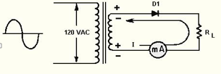
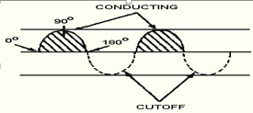

Figure 2.11 Half-wave rectifier with output waveform
During the negative alternation of input voltage (dotted polarity signs), the anode is driven negative and the diode cannot conduct. When conditions such as these exist, the diode is in cutoff and remains in cutoff for 180 degrees, during which time no current flows in the circuit. The circuit current therefore has the appearance of a series of positive pulses, as illustrated by the shaded areas on the waveform in view B. Notice that although the current is in the form of pulses, the current always flows in the same direction. Current that flows in pulses in the same direction is called pulsating dc. The diode has thus rectified the ac input voltage.

Rms, Peak, and Average Values

View below figure is a comparison of the Rms, peak, and average values of the types of waveforms associated with the half-wave rectifier. Ac voltages are normally specified in terms of their Rms values. Thus, when a 115-volt ac power source is mentioned in this Project, it is specifying the Rms value of 115 volts ac. In terms of peak values,
E_{rms} = Epeakx0.707

The peak value is always higher than the rms value. In fact,
Epeak = E_{rms}x 1.414
Therefore, if the rms value is 115 volts ac, then the peak value must be:
Epeak = E_{rms}x 1.414
Epeak = 115 volts ac x 1.414
Epeak = 162.6 volts
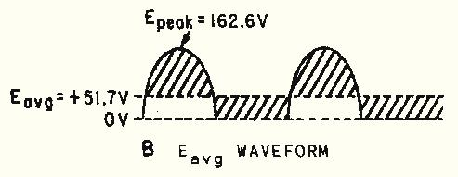
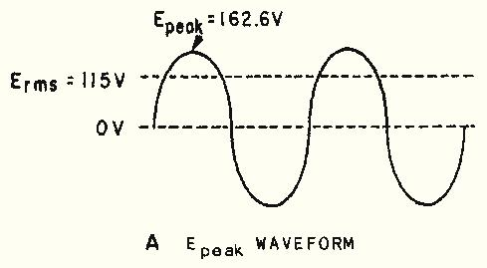

Figure 2.12 Comparison of Epeak to Eavg in a half-wave rectifier
The average value of a sine wave is 0 volts. View B of figure 2.5 shows how the average voltage changes when the negative portion of the sine wave is clipped off. Since the wave form swings positive but never negative (past the "zero-volt" reference line), the average voltage is positive. The average voltage (E_{avg}) is determined by the equation:
Where: E_{avg}=E_{peak}x0.31
Thus: E_{avg}=162.6x0.318
E_{avg}=51.7volts
Ripple Frequency
The half-wave rectifier gets its name from the fact that it conducts during only half the input cycle. Its output is a series of pulses with a frequency that is the same as the input frequency. Thus when operated from a 60-hertz line, the frequency of the pulses is 60 hertz. This is called ripple frequency.
- Full-Wave Rectification
A full-wave rectifier converts the whole of the input waveform to one of constant polarity (positive or negative) at its output. Full-wave rectification converts both polarities of the input waveform to DC (direct current), and is more efficient. There are two types of full-wave rectifiers namely bridge and center tapped rectifier.
- Conventional (center tapped) full wave rectifier
A full-wave rectifier is a device that has two or more diodes arranged so that load current flows in the same direction during each half cycle of the ac supply. A diagram of a simple full-wave rectifier is shown in figure bellow. The transformer supplies the source voltage for two diode rectifiers, D1 and D2. This power transformer has a center-tapped, high-voltage secondary winding that is divided into two equal parts (W1 and W2). W1 provides the source voltage for D1, and W2 provides the source voltage for D2. The connections to the diodes are arranged so that the diodes conduct on alternate half cycles.
During one alternation of the secondary voltage, the polarities are as shown in view A. The source for D2 is the voltage induced into the lower half of the secondary winding of the transformer (W2). At the specific instant of time shown in the figure, the anode voltage on D2 is negative, and D2 cannot conduct. Throughout the period of time during which the anode of D2 is negative, the anode of D1 is positive. Since the anode of D1 is positive, it conducts, causing current to flow through the load resistor in the direction shown by the arrow.

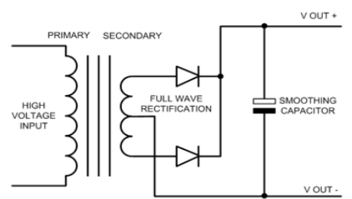

Figure 2.13 center tapped full wave rectifier
View B above Figure 2.12 shows the next half cycle of secondary voltage. Now the polarities across W1 and W2 are reversed. During this alternation, the anode of D1 is driven negative and D1 cannot conduct. For the period of time that the anode of D1 is negative, the anode of D2 is positive, permitting D2 to conduct. Notice that the anode current of D2 passes through the load resistor in the same direction as the current of D1 did. In this circuit arrangement, a pulse of load current flows during each alternation of the input cycle. Since both alternations of the input voltage cycle are used, the circuit is called a full-wave rectifier.
The higher frequency at the output of a full-wave rectifier offers a distinct advantage: Because of the higher ripple frequency, the output is closely approximate to pure dc. The higher frequency also makes filtering much easier than it is for the output of the half-wave rectifier. In terms of peak value, the average value of current and voltage at the output of the full-wave rectifier is twice as great as that at the output of the half-wave rectifier. The relationship between the peak value and the average value is illustrated in Figure 2.12. Since the output waveform is essentially a sine wave with both alternations at the same polarity, the average current or voltage is 63.7 percent (or 0.637) of the peak current or voltage.
Peak and average values for a full-wave rectifier
As an equation:
Where:
E_{max} = the peak value of the load voltage pulse
E_{avg} = 0.637 x E_{max} (the average load voltage)
I_{max} = the peak value of the load current pulse
I_{avg} = 0.637 x I_{max} (the average load current)
Example: The total voltage across the high-voltage secondary of a transformer used to supply a full-wave rectifier is 300 volts. Find the average load voltage (ignore the drop across the diode).
Solution: Since the total secondary voltage (E_{S}) is 300 volts, each diode is supplied one-half of this value, or 150 volts. Because the secondary voltage is an rms value, the peak load voltage is:
E_{max} = 1.414 x E_{S}
E_{max} = 1.414 x 150
E_{max} = 212 volt
The average load voltage is:
E_{avg} = 0.637 x E_{max}
E_{avg} = 0.637 x 212
E_{avg} = 135 volts
4. Filter Circuits
The pulsating dc output of rectifier circuits is not smooth enough to properly operate most electronic devices. They do not produce pure dc. The power supply output still has an ac component, which is called ripple (as in the next figure shown ) a filter is used to reduce the amount of ripple thus providing a relatively pure form of dc.
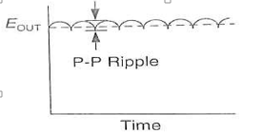
The most common filter device is a capacitor connected in parallel with the output of the rectifier circuit. The filter capacitor is a large value electrolytic capacitor. It makes an excellence filter because of its ability to store electric charge. The schematic diagram for a simple capacitive filter is shown in next figure. it works by charging the capacitor when the diode does not conduct. When the rectifier circuit is conducting, the capacitor charges rapidly to approximately the peak voltage of the input wave. As the voltage in the rectifier drops, between the pulsations in the wave, the capacitor then discharges through the load.
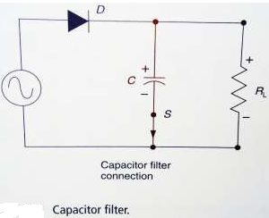
Figure 2.14 Filter Circuits
The capacitor in effect, acts like a storage tank that accepts electrons at peak voltage and supplies them to the load when the rectifier output is low. The larger the load current, the larger the capacitor needed to provide adequate filtering. The capacitance value is determined from the value of the peak ripple voltage permitted
The fact that a filter capacitor charges to the peak value of the ac waveform means that the capacitor must be rated for the peak voltage value. Most filter capacitor charges are of the polarized type and can explode when connected backwards.
Always connect the negative lead of the capacitor to the negatives side of the circuit and positive lead to the positive side. Also charged capacitor can represent a shock hazard in high-voltage power supply circuit even if the power is turned off. Always drain the charge from such capacitors before assuming that the circuit is dead.
If full-wave rectification is used, less capacitor storage is required. This is because the full-wave output has a little off time compared to the half-wave. The filtering action of the capacitor filter circuit can be improved by connecting a choke or coil in series with the load. This coil in series with the load. This coil acts to resist any change in current. A rise in current through the coil produces a counter voltage, which opposes the rise; a decrease in current produces a counter voltage, which opposes the rise; a decrease in current produces a counter voltage, which opposes the decreases. Used together the capacitor and choke provide a very effective filtering circuit.

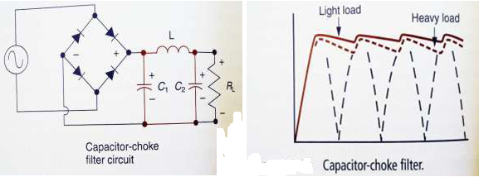

Figure 2.15 filter capacitor out put
The dc input voltage of a filtered power supply is higher than the output of a non- filtered supply. This is due to the fact that the filter capacitor charge to the peak value of the waveform, therefore, when calculating the appropriate dc output voltage, assumes it is equal to the peak value of the ac input.
- Voltage Regulation
The dc output of an unregulated power supply (directly from the filter) has a tendency to change value under normal operating conditions (it is rippled DC). Changes in ac input voltage and variations in the load are primarily responsible for these fluctuations. In some power supply applications, voltage changes do not represent a serious problem. In many electronic circuits, voltage changes may cause improper operation. When a stable dc voltage is required, power supplies must employ a voltage regulator. A number of voltage regulator circuits have been developed for use in power supplies.
Load Regulation
In practice the voltage regulator will also experience a slight change in output voltage when there is a change in load current demand. The load regulation indicates the change in output voltage that will occur per unit change in load current. It is expressed as,
Load regulation= (V_{NL}-V_{FL})/I_{L} where; V_{NL}=no load output voltage
V_{FL}=the full load output voltage
I_{L}=the change in load current demand

Line Regulation:
In actual practice, a change in input voltage to a voltage regulator will cause a change in its output or load voltage. The line regulation rating of a voltage regulator indicates the change in output voltage that will occur per unit change in the input voltage. The line voltage regulator is given by,
Line regulation=∆V_{L}/∆V_{S}
Where: ∆V_{L}=change in output voltage usually in millivolts or micro volts
∆ V_{S}=change in input voltage, usually in volts
Example 2.1
The change in output voltage of a voltage regulator is measured at 100 μV when the input voltage changes by 5 V. Determine the value of line regulation for this regulator.
Solution:
Given ∆V_{L}=100μV=100x10⁻⁶V and ∆V_{in} = 5 V
We know that live regulation,
∆V_{L} =100 X 10⁻⁶ = 20 X 10⁻⁶ V/V
∆V_{s} 5
=20μV/V
Example 2.2
A voltage regulator is rated for an output (or load current) of I_{L}=0 to 40mA. Under no load conditions, the output voltage from the circuit is 8V. Under full-load conditions, the output voltage drops to 7.995V. What is the value of load regulation for this voltage regulator?
Solution:
Given: ∆I= 40mA; V_{NL} = 8V and ∆V_{FL} = 7.995V.
We know that load regulation of a voltage regulator regulation,
Load regulation= (V_{NL}-V_{FL})/∆I_{L}
= (8-7.995)/40mA=0.005V/40mA
= 125μV/mA
    - Construction Of Power supply using different Voltage Regulators
A number of voltage regulator circuits have been developed for use in power supplies. Some of the most common types of voltage regulators are:
1. Zener diode shunt regulator
2. Series transistor regulator
3. Shunt transistor regulator
4. IC voltage regulator
1. Zener diode shunt regulator
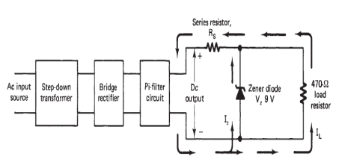
For low current power supplies a simple voltage regulator can be made with a resistor and a Zener diode connected in reverse as shown in the diagram. The zener diode is located between the filter and the load. The zener diode is connected in parallel or shunt with RL. This regulator requires only a zener diode DZ and a series resistor (RS). Notice that DZ is placed across the filter circuit in the reverse bias direction. Connected in this way, the diode will go into conduction only when it reaches the zener breakdown voltage VZ. This voltage then remains constant for a large range of zener current IZ. Regulation is achieved by altering the conduction of IZ and load current IL must all pass through the series resistor (the resistor series limits the current). This current value then determines the amount of voltage drop across RS. Variations in current through RS are used to keep the output voltage at a constant value.

Figure2.16 Zener diode shunt regulator
2. Series Transistor Regulator
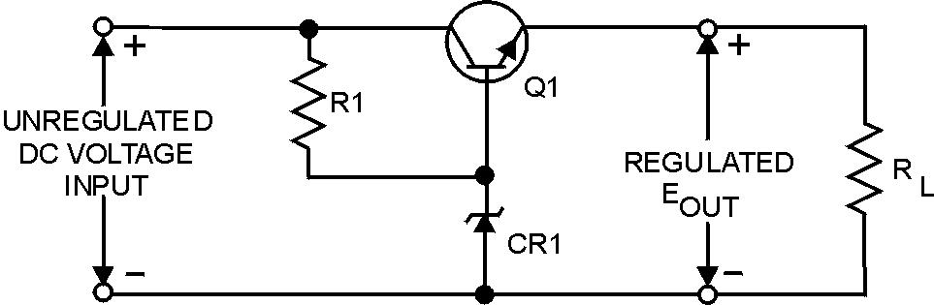
The schematic for a typical series voltage regulator is shown in figure 4-34. Notice that this regulator has a transistor (Q1) in the place of the variable resistor found in figure 4-32. Because the total load current passes through this transistor, it is sometimes called a "pass transistor." Other components which make up the circuit are the current limiting resistor (R1) and the Zener diode (CR1).you get the fault area. you get the fault area.

Figure 2.17 Series voltage regulator.
Recall that a Zener diode is a diode that block current until a specified voltage is applied. Remember also that the applied voltage is called the breakdown, or Zener voltage. Zener diodes are available with different Zener voltages. When the Zener voltage is reached, the Zener diode conducts from its anode to its cathode (with the direction of the arrow).
In this voltage regulator, Q1 has a constant voltage applied to its base. This voltage is often called the reference voltage. As changes in the circuit output voltage occur, they are sensed at the emitter of Q1 producing a corresponding change in the forward bias of the transistor. In other words, Q1 compensates by increasing or decreasing its resistance in order to change the circuit voltage division.
Now, study figure Voltages are shown to help you understand how the regulator operates. The Zener used in this regulator is a 15-volt Zener. In this instance the Zener or breakdown voltage is 15 volts. The Zener establishes the value of the base voltage for Q1. The output voltage will equal the Zener voltage minus a 0.7-volt drop across the forward biased base-emitter junction of Q1, or 14.3 volts. Because the output voltage is 14.3 volts, the voltage drop across Q1 must be 5.7 volts.
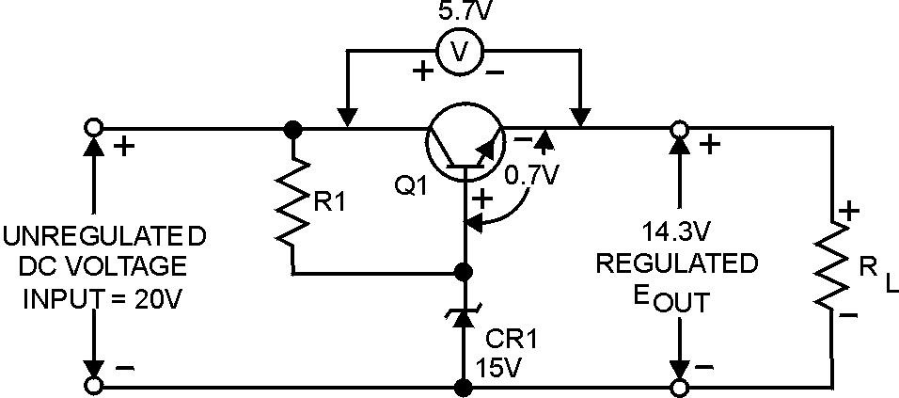

Figure 2.18 output of voltage series transistor regulator
3. Shunt Transistor Regulator
The schematic shown in figure 2.14 is that of a shunt voltage regulator. Notice that Q1 is in parallel with the load. Components of this circuit are identical with those of the series voltage regulator except for the addition of fixed resistor R_{S}. As you study the schematic, you will see that this resistor is connected in series with the output load resistance. The current limiting resistor (R1) and Zener diode (CR1) provide a constant reference voltage for the base-collector junction of Q1. Notice that the bias of Q1 is determined by the voltage drop across R_{S} and R1. As you should know, the amount of forward bias across a transistor affects its total resistance. In this case, the voltage drop across R_{S} is the key to the total circuit operation.
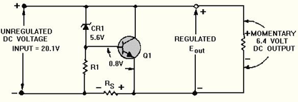

Figure 2.19 Shunt voltage regulators
4. IC Voltage Regulators
Due to low-cost fabrication technique, many commercial integrated-circuit(IC) regulators are available since the past two decades. These include fairly simple, fixed-voltage types of high quality precision regulators. These IC regulators have much improved performances as compared to those made from discrete components. They have a number of unique build-in features such as current limiting self-protection against over temperature, remote control operation over a wide range of input voltages and fold back current limiting.
Now we will study the following types of IC voltage regulators:
- Fixed positive linear voltage regulators
- Fixed negative linear voltage regulators
- Adjustable positive linear voltage regulators
- Adjustable negative linear voltage regulators
    - Fixed Positive Linear Voltage Regulators
There are many IC regulators available in the market that produces a fixed positive output voltage. But 7800 series of IC regulators is representative of three terminal devices that are available with several fixed positive output voltages making them useful in a wide range of applications. Fig.2.23 (a) shows a standard configuration of a fixed positive voltage IC regulator of 7800 series. Notice that it has three terminals labeled as input, output and ground. The last two digits (marked xx) in the number designate the input voltage. For example, IC 7805 is a + 5V regulator. Similarly IC 7812 +12 V regulator and IC 7815 is a +15 V regulator. The capacitor C₁ (typically 0.33μF) is required only if the power supply filter is located more than 3 inches from the IC regulator. The capacitor (typically 0.01μF) acts basically as a line filter to improve transient response.

Part number | Output voltage
7805 | +5.0
7806 | +6.0
7808 | +8.0
7809 | +9.0
7812 | +12.0
7815 | +15.0
7818 | +18.0
7824 | +24.0
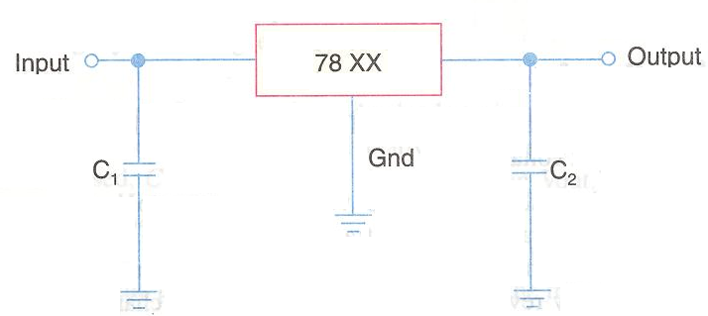

- (b)
Figure 2.20 Fixed Positive Linear Voltage Regulators
Fig. 2.15 (b) shows the part number and the Input output voltage of 7800 series IC voltage regulators. As seen from this figure, the 7800 series has IC regulators that can produce output voltages ranging from +5.0 to +24.0 volt. It may be carefully noted that although these regulators are designed primarily to produce fixed output voltage but they can be used with external components to obtain adjustable output voltage and current.
Fig. 2.16 shows the circuit indicating the use of 78XX as an adjustable voltage regulator. The output voltage is given by the equation, V_{out}=V_{fixed}+ (V_{fixed}/R₁+I_{Q}) R2.
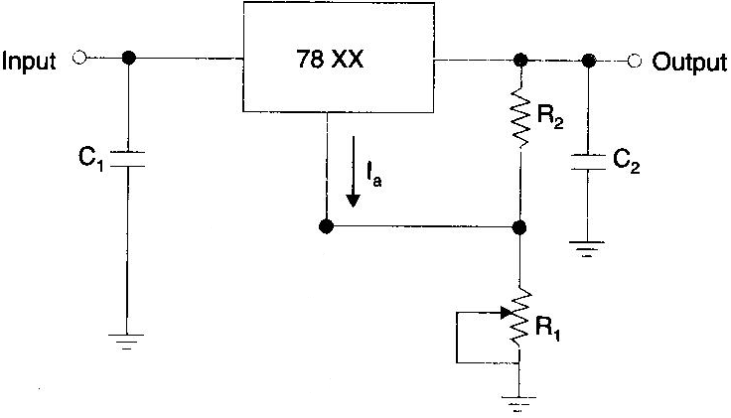

Figure 2.21 Linear Voltage Regulator using 78xx
Example, for a 7805 IC regulator, V_{fixed} = 5V. Let R₁ = R₂ = 1 kΩ and I_{Q} = 2 mA, then its output voltage is,
V_{out}=5+ (5/1KΩ+5mA) x1KΩ
Thus output voltage of IC 7805 regulator can be adjusted anywhere between 5V to 15V.
This example indicates that the output of IC 7805 regulator is adjusted to 15 V using external resistances R₁ and R₂.
    - Fixed Negative Linear Voltage Regulators
The 7900 series is typical of three-terminal IC regulators that provide a fixed negative voltage. This series is a negative-voltage counterpart of the 7800 series and shares most of the features, characteristics and package types. Fig. 2.25 (a) indicates the standard configuration and fig. 2.25 (b), the part numbers with corresponding output voltages that are available in 7900 series.

Part number | Output voltage
7905 | -5.0
7905.2 | -5.2
7906 | -8.0
7908 | -9.0
7912 | -12.0
7915 | -15.0
7918 | -18.0
7924 | -24.0
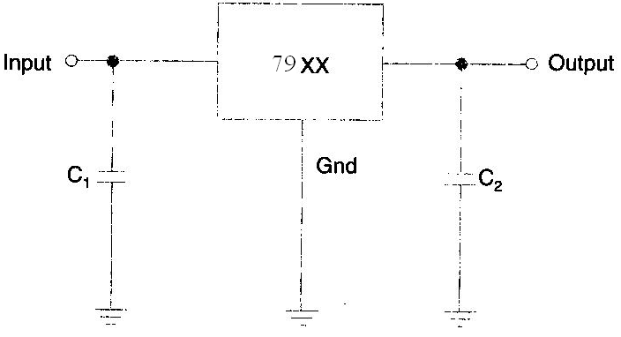

Figure 2.22 Fixed Negative Linear Voltage Regulators
The capacitor C_{l} (typically 0.22 μF) is required only if the power supply filter is locate than 3 inches away from the IC regulator. The capacitor C₂ (typically 1 μF) is required for stab the output voltage. Both capacitors C₁ and C₂ must be solid tantalum capacitors.
    - Adjustable Positive Output Linear Voltage Regulators
By adding external resistors, we can adjust the output voltage of 7800 series IC regulators higher than their fixed (or set) voltages. For example, the output voltage of 7805 can be adjusted higher than 5 V. But the performance and reliability of 7800 series to produce voltage higher than its fixed value is not considered to be good.
The LM 317 and LM 723 are IC regulators whose output voltage can be adjusted over a wide range. The output voltage of LM 317 can be adjusted from 1.2V to 37V, it can supply output current of 100mA and is available in TO-92 package i.e., it is also a 3 terminal IC regulator. On the other the output voltage of LM 723 can be adjusted from 2V to 37V, it can supply output current of 150mA without external transistor. But with the addition of external transistor, the output current capability can be increased in excess of 10A. The LM 723 is available in dual-in-line package and in a metal can package.
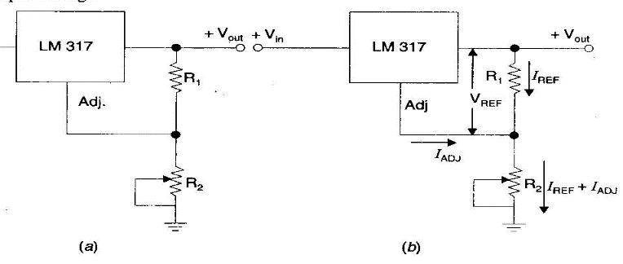

Figure 23 LM 317 Adjustable Positive Output Linear Voltage Regulators
In operation, the LM 317 develops a constant 1.25 V references voltage (V_{REF}) between the output and adjustment terminal. This constant reference voltage produces a constant current, (I_{REF}) through R₁, regardless of the value of R₂, Fig. 23 (b). Notice that the value of current through R₂ is the sum and I_{ADJ} is a very small current at the adjustment terminal. The value of I_{ADJ} is typically around 100mA. It can be shown that the output voltage.
V_{out}=V_{REF} (1+R₂/R₁) +I_{ADJ}xR₂
It is evident from the above equation that the output voltage is a function of R₁ and R₂. Usually the value of R₁ is recommended to be around 220Ω. Once the value of R₁ is set, the output voltage is adjusted by varying R₂.
    - Adjustable Negative Output Linear Voltage Regulators
A good example of this type of regulators is LM 337. The regulator is a -V_{in} negative output counter part of LM 317. The 337 (like LM 317) requires two external resistors for adjustment of output voltage as shown in Fig. 20.38. The output voltage can adjusted anywhere from - 1.2 V to - 37 depending upon the external resistor values. The LM 723 can also be used as an, adjustable negative output voltage regulator. Output voltage of this i.e regulator can adjusted anywhere from - 2.0 V to - 37 depending upon the external resistor uses.
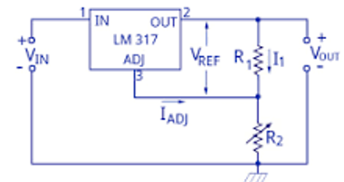
Figure 2.24 Adjustable Negative Output Linear Voltage Regulators
An adjustable voltage regulator produces a DC output voltage, which can be adjusted to any other value of certain voltage range. Hence, adjustable voltage regulator is also called as a variable voltage regulator.
  - Advice to customers
Advice is a noun that means guidance about what someone should do. Advise is a verb that means to give someone advice about something. Despite their very similar spelling, advice and advice are pronounced differently.
Below listed are few handling procedures of televion advice to customers’
● scratch Damage: Handle the display device with care to avoid scratching it.
● Moisture Damage: Gently wipe off any moisture or let the device dry before using it.
● Dirt and Stain: Gently wipe off the stain with a soft lint-free cloth.
● Temperature Difference: High temperature and humidity will degrade the performance of a display device.
● Pressure and Heat: Display device should be mounted 4 mm or more away from Printed Circuit Boards.
● Accessories Usage: Use only attachments and accessories specified or recommended by manual
● While Lightening: Unplug the TV during lightning storms or when unused for long periods of time.
● Climate Change: If the TV is moved from a cold place, do not turn it on for a few hours so any internal condensation can evaporate.
● Installation Procedure: Install the TV upright on a horizontal, solid, flat surface away from excessive heat, dust, and vibration.
● Air Flow: Keep a clearance of at least 10 cm (4 inches) between the vents on the back of the TV and nearby walls or enclosures.

Documentation of diagnose results and testes
- Diagnose documentation is a technical communication document intended to give a user or customer information on how to solve and prevent those problems. It’s commonly written for computer hardware, electronic goods, and software but they can be written for any product.
- Proper documentation would list every stage in the process from start to end. As we discussed troubleshooting is a logical and step by step process that must be followed every time. If problems and customers are not the same, then how can even the best troubleshooting staff survive without proper documentation? It is the life support for troubleshooting.
- Troubleshooting documentation is more often than not, lengthy and can be tiring to read. Anyone who is referring to such a document for a particular problem and its resolution should not need to go through the entire documentation to find it. A well-defined and crisply laid out index should be in place to make locating the area of interest easier. The index must also have some help words that describe in layman terms some of the tongue twisting troubleshooting terminology.
- Clearly worded documentation is important to improve efficiency. Even if memory fails under pressure, the troubleshooting staff can quickly recover from that by referring to the documentation. The customer will never need to know that the staff ‘ran short’ to start with. The end perception will be one of knowledge and efficiency. Happy staff and happier customer!
- The importance of documentation in troubleshooting and other areas comes from the fact that it is a recording of a crucial and creative process that focuses on problem resolution and problem prevention. It helps members of the same team or different teams work collaboratively on customer issues or internal troubleshooting issues for quicker resolutions.
- Documentation can be very inspiring and thought provoking if written well. They provide invaluable and indispensable data that make the entire troubleshooting process and customer service for a company more robust and sustainable.
Although it is often neglected in the troubleshooting process, documentation is as important as any of the other troubleshooting procedures. Documenting a solution involves keeping a record of all the steps taken during the fix-not necessarily just the solution.
For the documentation to be of use to other network administrators in the future, it must include several key pieces of information. When documenting a procedure, include the following information:
- Date-When was the solution implemented? It is important to know the date because if problems occur after your changes, knowing the date of your fix makes it easier to determine whether your changes caused the problems.
- Why-Although it is obvious when a problem is fixed while it is done, a few weeks later, it might become less clear why that solution was needed. Documenting why the fix was made is important because if the same problem appears on another system, you can use this information to reduce time finding the solution.
- What-The successful fix should be detailed, along with information about any changes to the configuration of the system or network that were made to achieve the fix. Additional information should include version numbers for software patches or firmware, as appropriate.
- Results-Many administrators choose to include information on both successes and failures. The documentation of failures can prevent you from going down the same road twice, and the documentation of successful solutions can reduce the time it takes to get a system or network up and running.

Self-check-2.1
Test –I choose the best answer
- ………is used to reduce the 220 volts AC into smaller voltage.
- AC voltage B) Rectifier C) Transformer D) DC voltage
- ………….is circuit converts AC voltage to pulsating DC voltage.
- Filter B) Regulator C) Transformer D) Rectifier
- The filter, which serves to smooth out the pulses received from the rectifier and this can be implemented by using……………….
- Inductor B) Capacitor C) Combination of inductor and capacitor D)ALL
- ……… consist in one inductor in series with the load
- Capacitive filter B) Inductive filter C) Combination of the two
- ………. is the perfect device used as rectifier because of its capability to conduct current in one direction.
- Transistor B) Diode C) Capacitor D) Inductor
Test –II Short answer writing
- What is the purpose of AC/DC power supply
- Write down four stages of AC/DC power supply
- What is the difference between rectifier and filter
Test-III Short answer writing
1.__________ is a technical communication document intended to give a user or customer information on how to solve and prevent those problems.
2. _________is a noun that means guidance about what someone should do
3._________ is typically divided into four sections: the display, vertical controls, horizontal controls and trigger controls.

Operation sheet 2.1: Techniques of Troubleshooting AC/DC Power supply
- Operation title: Troubleshooting AC/DC power supply
- Purpose: To troubleshoot faults of power supply
- Instruction: Using the figure below and given equipments troubleshoot faults of power supply. You have given 30Minut for the task and you are expected to write the answer on the given line.
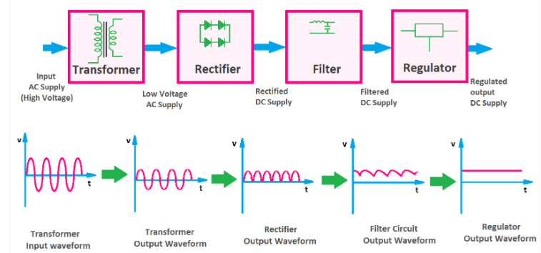
Tools and requirement
- Single phase power supply
- Multimeter
- Soldering iron
- Flux
- Lead
Steps in doing the task
Step1. Adjust your multimeter at AC range and >220v
Step2. Measure AC voltage at the input of the transformer
Step3. Measure transformer output (reduced AC voltage)
Step4. Adjust your meter at voltage greater than the expected rectifier output in DC voltage range.
Step5. Measure proper DC voltage after rectifier, filter and regulator.
Step 6. Troubleshoot up to identify faults
- Quality Criteria: the given Single phase power supply is troubleshoot properly.
- Precautions: use the given multimter without damage.

LAB test 2.1
Task -1: Adjust multimeter at AC range
Task -2: Measure the input of the transformer
Task -3: Measure transformer output
Task -4: Adjust multimeter at DC range
Task 5: Measure proper DC voltage after rectifier, filter and regulator
Task 6: Troubleshoot up to identify faults

Unit Three: Maintenance of power supply unit
This unit is developed to provide you the necessary information regarding the following content coverage and topics:
- Personal protective equipment’s (PPE)
- Methods for replacing defective electronic component
- Systems of Soldering repaired or replaced components
- Performing control settings/adjustments
- Performing cleaning of work area
This unit will also assist you to attain the learning outcomes stated in the cover page. Specifically, upon completion of this learning guide, you will be able to:
- Use Personal protective equipment’s
- Replace defective electronic parts/component
- Solder repaired or replaced parts/components
- Control settings/adjustments
- Clean work area

Personal protective equipment’s (PPE)

PPE Definition and Meaning
A Personal Protective Equipment (PPE) is clothing or equipment designed to reduce employee exposure to chemical, biological, and physical hazards when on a worksite. It is used to protect employees when engineering and administrative controls are not feasible to reduce the risks to acceptable levels.
Importants of PPE
According to the hierarchy of controls by the National Institute for Occupational Safety and Health (NIOSH), PPE is recommended to be the last level of defense to prevent occupational injuries, illnesses, and fatalities, but some businesses combined it with other control measures to ensure a safe and healthy environment for their workers. Here are some benefits of using PPEs:
- prevent unnecessary injury in the workplace;
- protect employees from excessive chemical exposure;
- prevent the spread of germs and infectious diseases including COVID-19;
- help businesses comply with regulatory requirements(e.g., The Personal Protective Equipment at Work Regulations 1992 that’s recently been extended to limb workers); and
- Improve employee productivity and efficiency.

3.1.2 Four basic types of PPE
However, even the strictest controls will not necessarily eliminate all the risks associated with most job tasks and this is where the need for PPE must be evaluated. A hazard assessment can help identify which specialized PPE will be required. There are numerous types of workplace safety equipment available depending on the hazard exposure and work conditions. The following are basic PPE that can help protect employees:

Figure 3.1 Personal protective equipment’s
- Face and Eye Protection
PPE includes safety goggles and face shields and should be used for tasks that can cause eye damage or loss of vision, sprays of toxic liquids, splashes, and burns.
Safety Tips:
- Check if safety glasses comply with the ANSI Z87.1 eye protection standard.
- Ensure that there are no cracks or deformities on the lenses.
- Ensure the strap is in good working condition and is firmly sealed to the cheek and forehead.
- Clean and disinfect after use.

- Respiratory Protection
PPE includes full-face respirators, self-contained breathing apparatus, gas masks, N95 respirators, and surgical masks are used for a task that can cause inhalation of harmful materials to enter the body. This includes harmful gas, chemicals, large-particle droplets, sprays, splashes, or splatter that may contain viruses and bacteria such as COVID-19, viral infections, and more.
Safety Tips:
- Ensure that the equipment is fit-tested and the employee has undergone proper training before wearing one.
- Carefully read the instructions to determine if it is designed to help protect against the hazards you may face.
- Change filters on half-mask or full-mask respirators frequently.
- Replace disposable respirators with every use.
- Surgical masks are not to be shared with anyone.
- Avoid touching the surgical mask after wearing it.
- Change surgical mask timely and should be disposed of after use.
- Replace the mask immediately if it is damaged or soiled.


- Skin and Body Protection
PPE includes the following categories to protect employees from physical hazards:

Head Protection
PPE includes hard hats and headgears and should be required for tasks that can cause any force or object falling to the head.
Safety Tips:
- Ensure that there are no dents or deformities on the shell and connections are tightened inside.
- Do not store in direct sunlight as extreme heat can cause damage.
- Choose appropriate cleaning agents as it can weaken the shells of hard hats and may eliminate electrical resistance.
- Always replace a hard hat if it was used for any kind of impact, even if the damage is unnoticeable.
- Body Protection
PPE includes safety vests and suits that can be used for tasks that can cause body injuries from extreme temperatures, flames and sparks, toxic chemicals, insect bites and radiation.
Safety Tips:
- Ensure that they are clean and free from cuts and burns.
- Always get a good fit to ensure full body protection.
- Ensure bodysuit is heat-resistant clothing when working with high-temperature hazards.
- Hands ProtectionPPE includes safety gloves and should be used for tasks that can cause hand and skin burns, absorption of harmful substances, cuts, fractures or amputations.
Safety Tips:
- Ensure hand protection fits perfectly with no spaces and is free from cuts, burns and chemical residue.
- Always replace them if any sign of contamination was observed.
- Use rubber gloves when working with heat and electricity to reduce the risk of burn or electrical shock.
- Foot Protection
PPE includes knee pads and safety boots and should be used for tasks that can cause serious foot and leg injuries from falling or rolling objects, hot substances, electrical hazards, and slippery surfaces.
Safety Tips:
- Ensure boots have slip-resistant soles that can protect against compression and impact.
- Ensure the sole plate is in good condition to prevent punctures.
- Fall Protection
PPE includes safety harnesses and lanyards and should be strictly used for tasks that can cause falling from heights and serious injury or death.
Safety Tips:
- Ensure that the straps are free from tears, deformities and burn marks.
- Check the buckles if connected securely and tightly.
- Dispose of the equipment if used after a falling incident.


Figure 3.2 Fall Protection
- Hearing Protection
PPE includes ear muffs and plugs and should be used for tasks that can cause hearing problems and loss of hearing.
Safety Tips:
- Ensure the equipment fit the ear canal perfectly.
- It is recommended to use formable earplugs to fit on different sizes of ear canals.
- Use protectors that reduce noise to an acceptable level to have a room for communication.
- Ensure earplugs are clean and in good condition.

Figure 3.3 Hearing Protection
PPE safety requirement
To promote PPE safety in their workplace, safety officers will need to do the following:
- Check work sites regularly for the need of PPE.
- If PPE is needed, provide employees with properly-fitted PPE.
- Train employees on OSHA PPE standards.
- Provide protective goggles or face shields when there is a danger of flying particles or corrosive materials.
- Require that safety glasses are worn at all times in worksites that pose risk of eye punctures, abrasions, contusions, or burns.
- Provide and require protective gloves in situations where employees could be cut or be possibly exposed to corrosive liquids, chemicals, blood, and other potentially infectious materials.
- Require the use of foot protection when there is risk of foot injury from hot, corrosive, or poisonous substances, and falling objects.
- Inspect hard hats periodically for damage to the shell and suspension system.
- Maintain PPE in sanitary and ready-to-use conditions.
- Ensure that eyewash facilities and quick drench showers are easily accessible for employees when they are accidentally exposed to corrosive materials.
- Establish safe work procedures for disposing of or decontaminating PPE after hazardous exposures.

Methods for replacing defective electronic parts/component
Whenever you are working with electricity, the proper use of safety precautions is of the utmost importance to remember. In the front of all electronic technical manuals, you will always find a section on safety precautions. Also posted on each piece of equipment should be a sign listing the specific precautions for that equipment. Always remember, when you are working with power supplies safety first. You are working with high power and a silly mistake could cause a series shock or death.
Testing
There are two widely used checks in testing and replacing electronic components , visual and signal tracing.

Visual Inspection (Checking)
The importance of the visual check should not be underestimated because many technicians find defects right away simply by looking for them. A visual check does not take long. In fact, you should be able to see the problem readily if it is the type of problem that can be seen. You should learn the following procedure. You could find yourself using it quite often. This procedure is not only for power supplies but also for any type of electronic equipment you may be troubleshooting. (Because diode and transistor testing was covered in the previous sections, it will not be discussed at this time. If you have problems in this area, refer back.)
I. Before you energize the equipment, look for
- Shorts—any terminal or connection that is close to the chassis or to any other terminal should be examined for the possibility of a short. A short in any part of the power supply can cause considerable damage. Look for and remove any stray drops of solder, bits of wire, nuts, or screws. It sometimes helps to shake the chassis and listen for any tell-tale rattles. Remember to correct any problem that may cause a short circuit; if it is not causing trouble now, it may cause problems in the future.
- Discolored or leaking transformer—this is a sure sign that there is a short somewhere. Locate it. If the equipment has a fuse, find out why the fuse did not blow; too large a size may have been installed, or there may be a short across the fuse holder.
- Loose, broken, or corroded connection—any connection that is not in good condition is a trouble spot. If it is not causing trouble now, it will probably cause problems in the future. Fix it.
- Damaged resistors or capacitors—a resistor that is discolored or burnt has been subjected to an overload. An electrolytic capacitor will show a whitish deposit at the seal around the terminals. Check for a short whenever you notice a damaged resistor or a damaged capacitor. If there is no short, the trouble may be that the power supply has been overloaded in some way. Make a note to replace the part after signal tracing. There is no sense in risking a new part until the trouble has been located.
  - Energize the equipment and look for
- Smoking parts—if any part smokes or if you hear any boiling or sputtering sounds, remove the power immediately. There is a short circuit somewhere that you have missed in your first inspection. Use any ohmmeter to check the part once again. Start in the neighborhood of the smoking part.
- Sparking—tap or shake the chassis. If you see or hear sparking, you have located a loose connection or a short. Check and repair.
    - Signal Tracing
If you locate and repair any of the defects listed under the visual check, make a note of what you find and what you do to correct it. It is quite probable you have found the trouble. However, a good technician takes nothing for granted. You must prove to yourself that the equipment is operating properly and that no other troubles exist. If you find none of the defects listed under the visual check, go ahead with the signal tracing procedure. The trouble is probably of such a nature that it cannot be seen directly-it may only be seen using an oscilloscope.
Tracing the a.c. signal through the equipment is the most rapid and accurate method of locating a trouble that cannot be found by a visual check and it also serves as check on any repairs you may have made. The idea is to trace the a.c. voltage from the transformer, to see it change to pulsating d.c. at the rectifier output, and then see the pulsations smoothed out by the filter. The point where the signal stops or becomes distorted is the place look for the trouble. If you have no d.c. output voltage, you should look for an open or a short in your signal tracing. If you have a low d.c. voltage, you should look for a defective part and keep your eyes open for the place where the signal becomes distorted. Signal tracing is one method used to localize trouble in a circuit. This is done by observing the waveform at the input and output of each part of a circuit.
Let's review what each part of a good power supply does to a signal, as shown in figure below. The a.c. voltage is brought in from the power line by means of the line cord. This voltage is connected to the primary of the transformer through the ON-OFF switch (S1). At the secondary winding of the transformer (points 1 and 2), the scope shows you a picture of the stepped-down voltage developed across each half of the secondary winding-the picture is that of a complete sine wave. Each of the two stepped-down voltages is connected between ground and one of the two anodes of the rectifier diodes. At the two rectifier anodes (points 4 and 5), there is still no change in the shape of the stepped-down voltage-the scope picture still shows a complete sine wave.
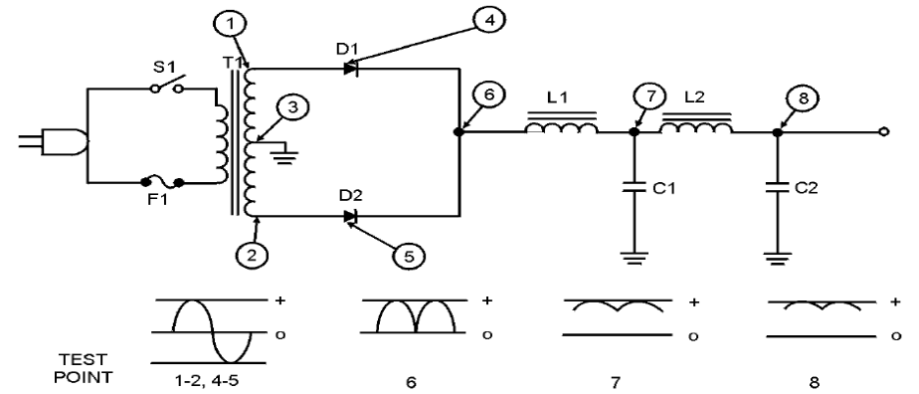
Figure 3.4 Complete power supply
However, when you look at the scope pattern for point 6 (the voltage at the rectifier cathodes), you see the wave shape for pulsating direct current. This pulsating dc is fed through the first choke (L1) and filter capacitor (C1) which remove a large part of the ripple as shown by the waveform for point 7. Then dc voltage is fed through the second choke (L2) and filter capacitor (C2), which remove nearly all of the remaining ripple. (See the waveform for point 8, which shows almost no visible ripple.) You now have almost pure dc. Finally the out put from the filter is feed to the rectifier to get pure DC (not shown on the diagram above). No matter what power supplies you use in the future, they all do the same thing—they change ac voltage into dc voltage.
- Component problems
The following paragraphs will give you an indication of troubles that occur with many different electronic circuit components.
II. Transformer and choke troubles—as you should know by now, the transformer and the inductor (choke) are quite similar in construction. Likewise, the basic troubles that they may develop are comparable.
  - A winding can open.
  - Two or more turns of one winding can short together.
  - A winding can short to the casing, which is usually grounded.
  - Two windings (primary and secondary) can short together. This trouble is possible, of course, only in transformers.
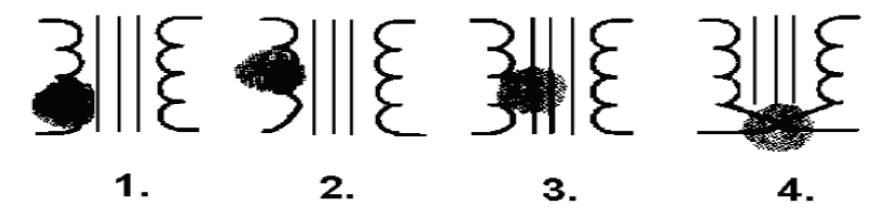
Figure 3.5 burned transformer
When you have decided which of these four possible troubles could be causing the symptoms, you have definite steps to take. If you guess that there is an open winding, or windings shorted together or to ground, an ohmmeter continuity check will locate the trouble. If the turns of a winding are shorted together, you may not be able to detect a difference in winding resistance. Therefore, you need to connect a good transformer in the place of the old one and see if the symptoms are eliminated. Keep in mind that transformers are difficult to replace. Make absolutely sure that the trouble is not elsewhere in the circuit before you change the transformer.
Occasionally, the shorts will only appear when the operating voltages are applied to the transformer. In this case you might find the trouble with a megger-an instrument which applies a high voltage as it reads resistance.
III. Capacitor and resistor troubles—just two things can happen to a capacitor:
  - It may open up, removing the capacitor completely from the circuit.
  - It may develop an internal short circuit. This means that it begins to pass current as though it were a resistor or a direct short.
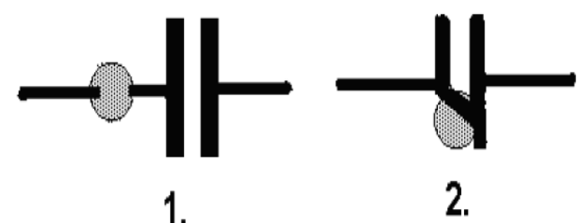

Figure 3.6 Open (1) and short (2) capacitor
You may check a capacitor suspected of being open by disconnecting it from the circuit and checking it with a capacitor analyzer. You can check a capacitor suspected of being leaky with an ohmmeter; if it reads less than 500 kilohms, it is more than likely bad. However, capacitor troubles are difficult to find since they may appear intermittently or only under operating voltages. Therefore, the best check for a faulty capacitor is to replace it with one known to be good.
Resistor troubles are the simplest. However, like the others, they must be considered.
- A resistor can open.
- A resistor can increase in value.
- A resistor can decrease in value.
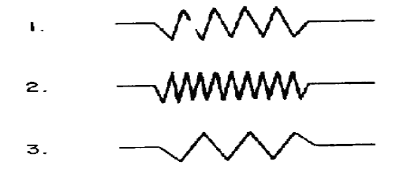

Figure 3.7 Faulty resistor
You already know how to check possible resistor troubles. Just use an ohmmeter after making sure no parallel circuit is connected across the resistor you wish to measure. When you know a parallel circuit is connected across the resistor or when you are in doubt disconnect one end of the resistor before measuring it. The ohmmeter check will usually be adequate. However, never forget that occasionally intermittent troubles may develop in resistors as well as in any other electronic parts. Although you may observe problems that have not been covered specifically in this chapter, you should have gained enough knowledge to localize and repair any problem that may occur.

Systems of Soldering repaired or replaced parts/components

Introduction
Soldering is a process of joining two different types of metal by melting solder. It is used for creating a permanent form of a fixed connection between any electronic components. Solder is a metal alloy, which is used for various metals. And it is created by melting hot iron and tin-lead. Soldering creates permanent connection things like circuit boards and copper joints.
The metals that are used in soldering are lead-based solders like brass, copper, and tin. Soldering is necessary to create a connection, which can allow an electric current to flow.

Soldering is a bit tough process but good soldering can be learned through practice. The most important thing about soldering one should remember is that both parts of the joint should be at the same temperature.
The solder is responsible for creating a good electrical or mechanical joint. Soldering is a process, which joins the two certain materials. The procedure can be used in electrical boards or mechanical areas as there are variations on how you can use it. In this article, we are going to learn more about Soldering in detail.
I. Soft Soldering – This method is generally used in electronics and plumbing. It creates an electrical connection and connects electronic components in circuit boards. In all the soldering systems, it is the process in which the lowest metal melting point is what everyone uses.
The fillers are generally the alloys, which often contain lead with liquid temperature under 350-degree Celsius. The lower temperature creates a strong joint while the high temperature creates a less strength and melts the bond.
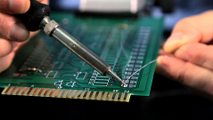
Figure 3.8 Soft Soldering
II. Hard Soldering – Hard soldering forms a strong connection as compared to the soft soldering. The material that is used in this is usually silver or brass. To strengthen the connection, it requires a blowtorch to increase temperature and melt the main metal that is used to create a strong joint, called as base metal. It gets heated in a point to create a durable joint as it gets cool. It should be used with silver solder while joining parts of brass or copper.

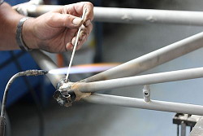
Figure 3.9 Hard Soldering
III.Brazing in high temperature – This type of soldering acquires a higher melting point if one compares it to the hard or soft soldering. The material needs to be heated sufficiently to get the best outcome

Figure 3.10 Brazing in high temperature
IV. Flux in Solder – The flux core is what you can say a coil or a wire, which is used at the site as a reducing agent. Flux is something that is released at the time of soldering. It reverses the oxidation of metals at a particular site of contact to give a clear electrical connection.

Figure 3.11. Flux in Solder

  - Perform control settings/adjustments
Compared with linear supplies, switched-mode power supplies (SMPSs) not only provide a substantial boost to energy efficiency but are also smaller and lighter – advantages that have seen SMPSs completely replace their linear counterparts in many applications.
The offline AC/DC supply shown below is an example of a SMPS with power factor correction (PFC). Power factor is a unit less quantity that measures the ratio of AC power dissipated by the load (true power) to the total amount of AC power sent to the load (apparent power). A purely resistive, i.e. non-reactive, load dissipates 100% of the apparent power, which means the circuit has a unity power factor. In this case, the voltage and current are both sinusoidal and completely in phase. However, a reactive load causes a phase shift between the supplied AC voltage and current, effectively reducing power efficiency. This is undesirable, so circuits are designed to add power factor correction (PFC) to power supplies.
The power factor is “corrected” by a PFC control circuit which forces the current waveform to follow the voltage waveform as accurately as possible by pulse-width modulating the current with a power MOSFET or IGBT. In this way the PFC circuit drives the power factor much closer to 1, increasing overall energy efficiency. Designs using PFC can yield extremely efficient AC/DC supplies, while SMPSs without PFC may have a power factor of 0.6 or lower.
The secondary or output side of the power supply uses a fly back topology to achieve the appropriate output voltage. This voltage is regulated using an opto-isolated feedback loop to a pulse-width modulation (PWM) controller, which adjusts the supply’s switching duty cycle accordingly. This design is for reference only. The design, as well as the products suggested, has not been tested for compatibility or interoperability.AC/DC Power Supplies
Pulse Width Modulation (PWM) is widely used in switch mode power supplies that use digital control to provide the switching action. PWM itself is a controlled digital output signal. The PWM controller controls the rapid switching in a power supply by sending a pulse to the gate driver that drives a power MOSFET (or other switching device likes a bipolar transistor, IGBT, etc.) One advantage of PWM is that the signal is digital. Digital signals are more immune to noise, because a digital signal is either a binary “1” or “0.” Therefore noise can only change a digital signal if it is big enough to change a logical “0” to register at the receiving end as a logical “1”, or vice versa

Perform cleaning
Floors require regular cleaning and finishing retaining their appearance and durability. According to the type of flooring used different methods and type of cleaning procedures need to be practiced.
There are different types of floor cleaning machines which are designed for scrubbing, buffing, burnishing, scarifying and spray maintenance.
Mopping: Floors should be mopped daily with a damp mop or with a chemically treated dust mop. Mop heads comes with a variety of natural or synthetic fibers (Types of Mops ).
New mop heads should be soaked in water for 1 hrs and the mop heads should be rotated so that they can be cleaned and dried after each use.
Scrubbing: Requires a stiff scrubbing brush or pad fitted to a rotary floor cleaning machine, The bristle tips of a brush or the surface of a pad scrape and cut the dirt to remove it with a circular motion.
Burnishing (Polishing): This new kind of floor cleaning method which is similar to buffing but here it is a dry method without any use of any polish spray. Additionally the speed in which the rotary floor cleaning machine head is set to spin faster for burnishing.
The tips of a brush or the surface of a pad abrade and cut the floor surface to create a smooth surface with a glossy finish. In case of a polished surface, it will involve the removal of a surface layer of polish.
Buffing: Usually followed after scrubbing or burnishing, Buffing involves spraying the floor with a polishing solution and buffing the floor with a rotary floor machine. Latest rotary cleaning machines have an ability of spraying the polishing solution as well as buff the floor.
While buffing the bristle tips of a brush or the surface of a pad create a high-gloss finish on the floor surface. In case of a surface on which a polish has been applied, it will involve generation of a local heat to harden waxes and resins.
Scarifying: Scarifying is a floor cleaning method by which the thick layer of soil is removed by breaking up the surface of the topsoil by a chisel like action of a wire brush cutting tool.
The bristle tips or edge of a cutting tool, cut into impacted soiling and remove it by means of a chisel-like action.
Spray cleaning : This is similar to spray cleaning, but the term is applied to the maintenance of floors where a buff able or semi-buff able polish has been applied and the bristle tips of a brush or the surface of a pad remove both soiling and the surface layer of polish to leave a smooth, glossy surface.

Self-cheek 3.1
1. What are the commonly used filter circuits?
a. inductor
b.Capacitor input
c.RLC filtor
d. All
2. _____________ are used in power supplies to eliminates ripples / fluctuation and produce constant DC voltage at output.
- Filters
- Transformer
- Rectifier
- a & b are correct
3. ___________ opposes any change in current.
- Inductor
- Capacitor
4.. L-Type Filter consists of ____________________.
- One Capacitor Plus One Inductor
- Two Capacitors Plus One Inductor
- One Capacitor plus Two Inductor
- Two Inductors Plus Two Capacitors
5. L-Type Filter is also called L-Type Choke Input Filter.
    - True
    - /False
6. . _______________ consists of two 2 capacitors and one inductor.
- Pie Type Filter
- Series Inductor Filter
- L-Type Filter
- Shunt Capacitor
7. Bleeder capacitor having multiple advantages ______________.
- Improve voltage regulation
- Safety
- Filter Capacitor to discharge
- All are correct
Part II: short answer questions
- List at least five Personal protective equipment’s with its safety tips
- List and explain Systems of Soldering repaired or replaced parts
- What are the common faults of resistor
Part III: Black space type questions
    - ___________is creates an electrical connection and connects electronic components.
    - is clothing or equipment designed to reduce employee exposure to chemical, biological, and physical hazards when on a worksite.
    - _____________is what you can say a coil or a wire, which is used at the site as a reducing agent.

Operation sheet 3.1: Maintenance of power supply unit
- Operation title: Maintaining/repairing Flat Screen TV power supply
- Purpose: To maintain, troubleshoot and repair Flat Screen TV power supply problem and return to its good working condition
- Instruction: Using the following flat screen TV power supply board and given equipments maintain/repair Flat Screen TV – Blacked out with blinking red light.
You have given 60 Minuts for the task.



Equipment, Tools and Materials:
- Descriptions Qty
- DMM or VOM 1 set
- Soldering Iron 1 set
- Soldering lead 60/40 1 meter
- Long nose pliers 1 pc
- Philips screw driver 1 pc
- Capacitor (220uF, 25V) 5 pieces
Steps in doing the task
Step 1. Plug the Flat screen TV to AC supply and then turn on to observe and verify the defect. You will notice that the picture is blacked out or no picture with blinking red light.
Step 2. Unplug the Flat screen TV from AC source and turn off. Remove the back cover
Using screwdriver.
Step 3. Locate the power supply section or board.
Step 4. While locating the power supply board clean all the PCB dirt/dust using air duster.
Step 5. Once power supply board is located. Manually disconnect all cable connections and remove screws using screw driver of the power supply board.
Step 6. Observe all the components in the power supply. Notice the BAD capacitors have stain and bulging on top. Also notice the capacitance value = 220uF, 25V
Step 7. De-solder to remove BAD capacitors from the power supply board using soldering iron.
Step 8. Replace the BAD capacitor with the GOOD capacitor having the same capacitance value = 220uF, 25V and size. When inserting the capacitor follow the polarity in the PCB marking.
Step 9. Properly solder the GOOD capacitor into the PCB using soldering iron and 60/40(Sn/Pb) solder lead.
Step 10. Put back the power supply PCB in the Flat screen TV chassis and return all the screws & cable connection. Use screwdriver to return all screws.
Step 11. Return all the cover of the Flat screen TV using screwdriver.
Step 12. Insert the plug to AC source to check the Flat screen TV if functioning properly.
Precautions
Observe the polarity of the new/good capacitors during the mounting of the component
Quality Criteria:
Replace with GOOD capacitor the defective capacitors with the same capacitance value: 220uF, 25V and size

LAB test 3.1
Task 1: Disassemble flat screen tv
Task 2: Locate the power supply section or board.
Task 3: De-solder to remove BAD capacitors
Task 4: Replace the BAD capacitor with the GOOD capacitor
Task 5: Solder the GOOD capacitor
Task 6: Put back the power supply PCB in the Flat screen TV chassis
Task 7: Return all the cover of the Flat screen TV
Task 8: Insert the plug to AC source to check the Flat screen TV

Unit Four: Rewind low power transformer
This unit is developed to provide you the necessary information regarding the following content coverage and topics:
- Process of rewinding Low power transformer
- Methods of Checking rewind transformer
- Measuring instruments of low power transformer
This unit will also assist you to attain the learning outcomes stated in the cover page. Specifically, upon completion of this learning guide, you will be able to:
- Rewind Low power transformer
- Check rewind low power transformer
- Measure rewind low power transformer

  - Process of rewinding Low power transformer
One of the most important parts of a power supply, whether it be for a project or for your bench, is the transformer. If you’ve had much building experience, however, you know that getting the right transform one with appropriate voltage and current ratings can be difficult and/or expensive. That’s doubly true if you need something other than a “standard” voltage. The easiest and most economical way to solve those problems is to rewind a readily available or inexpensive transformer. This article focuses on two aspects of the task; specification, and the general guidelines for rewinding transformers
Step 1: Materials and Tools
- A transformer to modify
- Wire for re-winding the transformer
- Lubricant to get the last of the laminations back in Insulation, ideally yellow transformer tape.
- Terminations for your new winding
- A chisel you don't mind damaging
- A mallet
- A bit of thin, strong steel
Step 2: Dismantle the Core
This is tricky
The core is made of steel laminations in E and I shapes. If you are lucky, you get a transformer where the E’s entire are stuck together, and all the I's are stuck together. It's far more common however to find that they alternate. Getting the first E out is the hard part. All the laminations will be stuck together and tightly wedged into the bobbin. You need to crack the adhesive and drive out the laminations without damaging them - particularly without bending them.
I used a woodworking chisel to split each lamination from the stack. I drove out the first one part way using a small steel ruler as a drift, and then gripped the edge in a vice. I then tapped the transformer upwards on alternate corners using a mallet, so it came out in small stages. After the first lamination is out, the rest are much easier as there is a space for them to go into when you crack the bond between them. Once all the laminations are out, put them somewhere safe
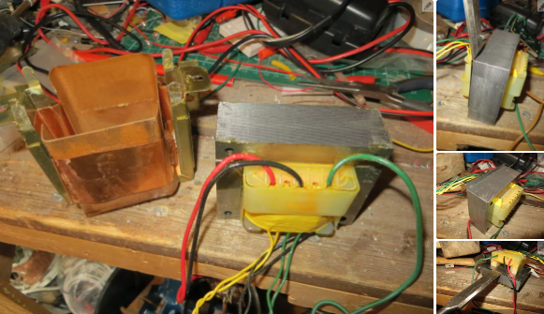
Step 3: Unwind the Old Secondary
This particular transformer uses a split bobbin construction, with flying leads, making it very easy to dismantle. You may find you have one where the secondary is laid on top of the primary, in which case you can just start unwinding. With a split bobbin, you get the primary and secondary coils wound onto separate bobbins, which are stuck together in a plastic holder. A bit of prizing and a few taps with the mallet, and the secondary bobbin came out.
Remove any tape and other insulation as you go. Save any useful looking bits of insulation, you can re-use them. Knowing the voltage from each secondary winding, and by counting the turns from each of them as I unwound it, I was able to obtain a turns per volt figure by dividing the number of turns by the measured voltage.
we actually obtained 3 slightly different figures, so we averaged them and obtained a value of 4.26. To obtain a 24 volt output I therefore need 4.26*24=102.24 turns. A little experimentation to obtain the exact number may be required.
Carefully wind the wire onto something, since you may need to re-use it, for either re-winding this transformer, or for something else.

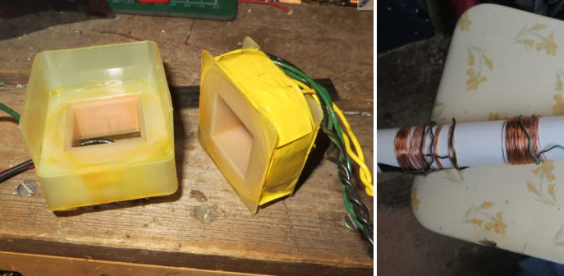

Step 4: Determine the Wire Thickness
Wire is specified as having "ampacity". This means the current it can safely carry without getting dangerously hot. This figure is generally given for conditions of normal wiring, and is far too high for transformer winding. The reason this figure is far too high is because in a transformer, many current carrying turns of wire are tightly packed side by side, all generating heat in a parallel manner. Ampacity ratings are given for the wire laid out in a cable run, where it is far easier for the heat to escape.
Rather than get involved in a lot of maths involving current densities, I took the rule of thumb figure from the Wikipedia entry on magnet wire of 2.5A per square mm. I need the wire to carry 2.08A, so it's sectional area needs to be .832 square mm. This gives a diameter of 1.03mm - the nearest standard sizes are 19SWG (in practice, 18SWG) or 18AWG. As previously stated, the wire quite expensive, so this is where the idea comes in of using many coils of thin wire which I already had.
I weighed and measured the wire I have, and concluded it is nearest in size to 26 AWG. The diameter is 0.4 to 0.45 mm, giving a cross sectional area of around 0.126 square mm. Since the current capacity of wire is directly related to it's cross sectional area, it's simply a case of seeing how many strands will make up the area I need. In this case it's 7 strands, which I can wind on as a minimum of 7 coils connected in parallel.
For current capacity, the thicker the winding the better, so I'll be adding as many windings as possible. I estimated that I have enough wire for 9 or possibly 10 windings, so that's how many I'm going to try to fit.
The amount of space the winding takes up needs to be considered. The amount of space on the bobbin I have is 17 x 11mm. This allows room for 1665 turns of 26AWG wire, however, due to the space taken up by insulation and wasted space at least a couple of hundred turns are easily removed from this figure.
The number of turns required is estimated as around 103 (given that I don't know the exact turns ratio, and I chose to round up rather than down), and with the correct wire gauge that would be it. However, with 7 windings, the total number of turns is 721.
Another factor that needs to be considered is the resistance of the wire. I measured the average turn as 17cm. multiplying this by 103 gives 1751cm, or 17.5 meters. At approximately 138 ohms per kilometer, the resistance of this length is 2.4 ohms. Since I'm using 7 windings in parallel, this is divided by 7, giving 0.34 ohms. At 2A of output current, the loss due to this resistance is 0.7 volts - about 3 turns worth of voltage, so I'll add this onto the winding. Obviously there is a tradeoff here between the increase in resistance due to the extra wire, and the increase in voltage due to the extra turns, however for this purpose it's not important.
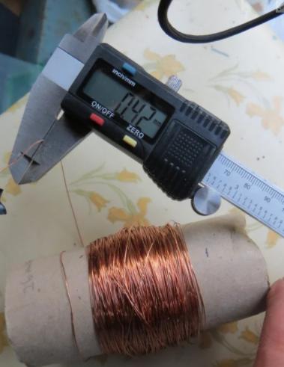
Step 5: Test Winding
We wasn’t going to wind hundreds of turns without checking that the voltage would be correct!
We wound the first coil with 104 turns and held it in place with transformer tape, since this was the figure given by the lowest turns ratio from the original 3 windings.
We quickly discovered that doing this in the living room with distractions of the TV and my other half is a very bad idea. I'd keep losing count after a few turns.
The ideal solution to the problem would be to mount the bobbin on a spindle with a turns counter. Lacking this, I used a permanent OHP pen to make a dot on every tenth turn - much easier to count when I lost my place!
This particular transformer needs to deliver 24 volts at full load. Since the winding is only at 1/7th of it's final thickness, only 1/7th of the load is needed, so I tested it with a load resistor consisting of 5 x 470 ohm resistors in parallel - not quite full load but it will do - actually more appropriate to 8 windings in parallel.
You can see in the two photos, 23.7 volts, which was the no-load output, and 23 volts, which was the output with a test load. It could really do with being a volt higher, so I'll add on another 4 turns, making 108 turns per winding.
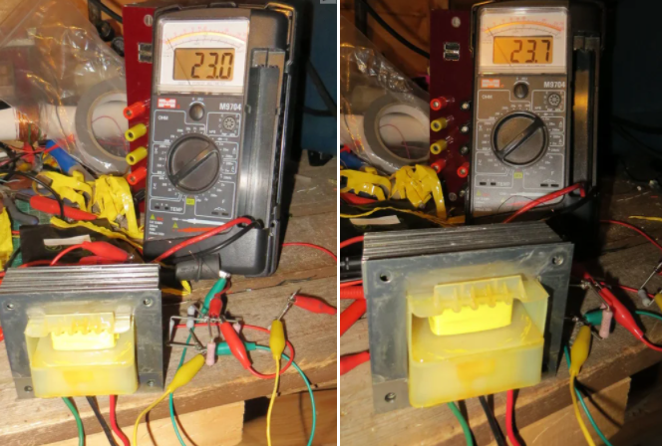
Step 6: Rest of the Windings, Core Reassembly
As this is a "many windings in parallel" design, it now only remains to wind on the rest of the coils. A pretty boring and tedious job by any standard! I actually managed to fit 8 windings onto the core.
We took a photo of the second winding so you can see where I've made a dot every tenth turn. I did this because of numerous distractions, which caused me to keep losing count! At least with the dots I have a record of where I recently got up to.
we tried to start each winding at the place where the previous one finished, in order to keep it flat, however this plan began to fail on only the third winding, and I just had to fill odd spaces when I was able to.
I tested every winding using a partly reassembled core, to ensure each one produced exactly the same voltage. This is really important; a miss-match would lead to losses and heating! Good job I did, nearly every winding needed adjustment.
I joined all the start of winding ends together, and end of winding ends together, and connected them to flying leads. I used the pieces of card from the original windings to safely separate the soldered joints from the coils, before wrapping the whole thing in transformer tape.
You can see how the card works. First a wide piece to protect the windings. Next a narrower piece. The ends of the windings are hooked over this, so that if the leads get pulled, they are pulling against the card, not the winding. Finally a wide piece again to insulate it on the outside.
Put the core back together the same way it was built originally, slotting E's in from alternate sides.
Put in the 3rd and 2nd to the last pieces the same way, then you can slot the last piece between them, rather than up against the bobbin. You may need to file the edges a bit so it will go in. Mine was such a tight fit I ended up driving one of the I pieces in the other way to open up the gap, pulling it out when the final piece was part-way in. I squirted in some switch cleaner as a lubricant to help things along.
Slot the I pieces in, then tap it all together with a hammer. You don't want to see any gaps between the edges of the E's and the I's.
And there you have it. You can see the transformer connected to a 100 ohm load. With the full 2A load connected the voltage dropped to about 23.5 volts, which although not ideal, is adequate for my needs. Another couple of turns per winding would have been a good idea. The load (a soldering iron) gets nice and hot, and whilst the transformer laminations get warm - I suspect due to the iron loss having gone up due being dismantled and reassembled, but the winding stays nice and cool - just what is needed!
You can also see that the bobbin is quite full. I was wildly optimistic about how many turns would fit! If it was a single winding, the amount I reckoned on may have been more realistic.

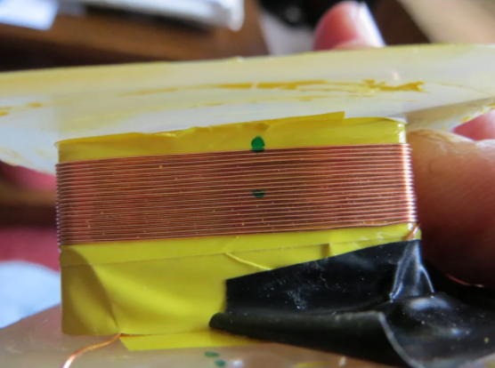

    - Voltage turns ratio and Transformer ratings
  - Voltage turns ratio
The input winding to a transformer is called the primary winding. The output winding is called the secondary winding. If there are more turns of wire on the primary than on the secondary, the output voltage will be lower than the input voltage. This is illustrated in Figure 14-8 for a step-down and a step-up transformer. Notice that the winding with the greater number of turns has the higher voltage. In Figure 4.1, one winding has twice as many turns as the other. In one case the voltage is stepped down to half, while in the other the voltage is. Stepped up to double. It is important to know the ratio of the number of turns of wire on the primary winding as compared to the secondary winding. This is called the turn ratio of the transformer,
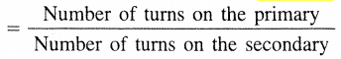
Turns ratio

The step-down transformer of Figure 4.1 has 14 turns on the primary, and 7 turns on the secondary; there-fore, the turn’s ratio is 2 to l, or just 2. The step-up transformer has 7 turns on the primary and 14 on the secondary; therefore, the turn’s ratio is 1 to 2, or 0.5. If one voltage and the turns ratio are known, the other volt-age can be determined with Equations
Primary voltage = Secondary voltage x turns ratio

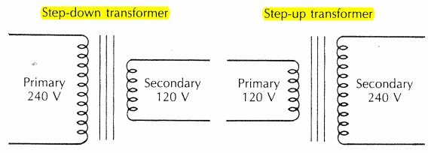
Figure 4.1 Voltage and turns ratio

Secondary voltage=Primary voltage/ Turns ratio

  - Transformer ratings
Transformers are rated in volt-amperes (VA) or kilo-volt-amperes (kVA). This means that the primary and the secondary winding are designed to withstand the VA or kVA rating stamped on the transformer nameplate. The primary and secondary full-load currents usually are not given. The installer must be able to calculate the primary and secondary currents from the nameplate information.
When the volt-ampere (or kilovolt-ampere) rating is given, along with the primary voltage, then the primary full-load current can be determined, using Equation 14.4 (for a single-phase transformer)
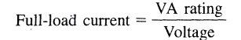 Or Primary
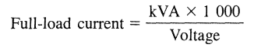 Secondary
  - Check rewind low power transformer
To test your transformer, you use your multimeter to check for AC voltage readings at the input source and output terminals when the transformer is plugged in. You also use your multimeter to check for continuity within the transformer when it is not connected to any power source.
Input and output tests
Ordinarily, this test is supposed to be carried out on only the output terminals on the transformer. However, to ensure you get accurate readings from the output terminals, you have to be sure that the voltage coming into it is also accurate. This is why you test your input source.
For home appliances, input sources are typically sockets in walls. You want to check that these are providing the accurate amount of voltage.
To do this, follow the next steps
- Set your multimeter to 200 VAC
- Place your multimeter leads on the leads of the power source. For wall sockets, you simply place the leads into the socket holes.
You expect to see a value between 120V and 240V, but this depends.
If the reading is inaccurate, then your power source may be the cause of your problems. If the reading is accurate, proceed to check the output terminals on your transformer. To do this,
- Plug in your transformer to the power source
- Reduce your voltage range on the multimeter
- Place the multimeter leads on the output terminals of your transformer
- Check for readings
When looking at the multimeter reading, you check whether the output being produced is appropriate. Here, you look at the transformer’s recommended output specifications to make a conclusion.
Transformer continuity test
The transformer continuity test is carried out to ensure that there is no break or shortage in the coils. You run this test while the transformer is disconnected from the power source. What do you do?
- Set your multimeter dial to Ohm or Resistance. This is usually represented with the (Ω) symbol
- Place the multimeter leads on each of your transformer’s input terminals
Where the transformer has a short circuit, the multimeter produces a very high or infinite reading. An infinite reading is represented by “O.L,” which means “Open Loop.”
If the input terminals seem okay, you repeat this process for the output terminals.
In case any of these terminals produces a high or infinite reading, the transformer needs to be replaced. Here is a video showing this procedure

  - Measuring instruments of low power transformer
A.Multimeter
The multimeter usually consists of two types: analog and digital multimeter. The transformer takes the responsibility of transforming the high voltage of the electric current into a reliable and consumable electric supply. Because the leading powerhouse directly sends the high-intensity voltages to the transformer.
Then it further decreases the intensity of the charges before it enters your house. It keeps your house safe and prevents any possible issues. So, you have to consider the digital multi-meter to have greater ease comparably in the said process.
Because the analogue multimeter involves many manual things, make sure to keep the whole process simple as far as possible. Digital multimeter has become a good source of testing the transformers to check out the faults in the present moment.
B. clamp meter
A clamp meter is an electrical test tool that combines a basic digital multimeter with a current sensor. Clamps measure current. Probes measure voltage. Having a hinged jaw integrated into an electrical meter allows technicians to clamp the jaws around a wire, cable or other conductor at any point in an electrical system, then measure current in that circuit without disconnecting/reenergizing it. Beneath their plastic moldings, hard jaws consist of ferrite iron and are engineered to detect, concentrate and measure the magnetic field being generated by current as it flows through a conductor

Self-cheek 4.1

Test I: Answer all the questions listed below
1. What are the factors that determine the induced voltage in the secondary winding of the transformer? Write its mathematical relation
2. What are the transformer losses that should be considered to be minimized during design and construction of transformer?
3. From the constructional point of view, list and explain two type of transformer
4. Write Procedural activities of transformer rewinding
Test II: work out
  - A step-down transformer has a turn’s ratio of 4 to 1 or 4. If the transformer secondary voltage is 120 V, deter-mine the primary voltage.
2. A single-phase transformer with a 2-kVA rating has a 480-V primary, and a 120-V secondary. Determine the primary and secondary full-load currents of the trans-former

Operation sheet 4.1: - Rewind low power transformer
Operation title:-Rewinding transformer
PURPOSE: - To rewind the damage transformer
Conditions or situations for the operations: - Clean, safe working area and equipped workshop with sufficient materials, tools and equipments for the required task.
Equipment, materials and tools:
Tools | Equipments | Consumable materials
- Flat and Philips screwdriver  - Adjustable Wrench  - side cutting pliers | - Digital Multimeter  - PPEs  - Faulted power supply  - Clean and ESD free work bench  - Blower  - Coil winder (if any)  Soldering iron ,soldering iron stand | - Rag, sponge  - Solder, flux, strained wire, faulted transformer  - Varnish  - Insulator
Procedures to Rewinding
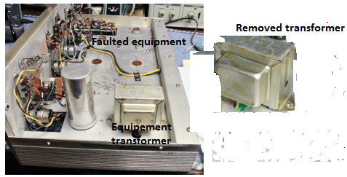
Step 1. Remove the faulty transformer from the equipment
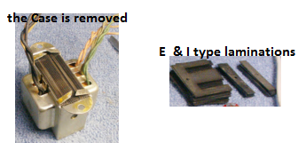

Step 2. Remove the case
Step 3. Remove the E and I type Laminations
Step 4. Strip the burned out Windings and at the same time take data of numbers of turns and measure diameters of both secondary and primary windings
Step 5. Select the correct size of enamelled Copper wire for both windings and
Prepare bobbin. Cheeks should be attached to its edges for lateral temporary support of windings. It will be removed after winding.
Step 6. Start to wind the secondary 1st on the bobbin (form)
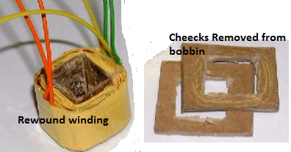

Step 7. Insulate the secondary with insulator
Step 8. Wind the primary winding
Step 9. Cover the outer insulation
Step 10. Prepare terminals (leads) for external Connections
Step 11. Perform temporary test. i.e., open circuit (continuity) test, insulation or short circuit test.
Step 12. Remove the temporary cheeks
Step 13. Spray varnish to increase insulation and strength of the coil
Step 14. Dry it. Use natural heat (sunlight).
Now the winding task is completed and ready for assembling.
Precautions:-
You should not forget to wear your PPEs. Use instruments properly according to manufacturer specification. Take care not to injure yourself by sharp edge of laminations.
Quality criteria:-
Perform the rewinding quickly, efficiently, economically and safely according to the manufacturer specification and stand dared.

Lab test 4.1
Task 1: Disassemble transformer
Task 2: Remove the case
Task 3: Remove the E and I type Laminations
Task4: Rewind wind the secondary
Task.5: Insulate the secondary
Task6: Wind the primary
Task 7: Cover the outer insulation
Task 8: Cover the outer insulation
Task9 .Prepare terminals
Task10: Perform temporary test
Task 11Spray varnish to increase insulation
Task 12: Dry rewind transformer
Task 13: test rewind transformer

Unit five: Assemble low-power transformer
This unit is developed to provide you the necessary information regarding the following content coverage and topics:
- Process of assembling low power transformer
- Methods of Checking assembled transformer
- Checking the assembled transformer
This unit will also assist you to attain the learning outcomes stated in the cover page. Specifically, upon completion of this learning guide, you will be able to:
- Assemble low power transformer
- Apply methods of assembling transformer
- Check the assembled transformer

  - Process of assembling low power transformer
Power Transformer cores are assembled by inserting a plurality of lamination inserts between the upper yoke laminations and the leg laminations in the transformer core assembly process. The arrangement allows the upper yoke to be readily removed for inserting the transformer windings over the core legs. The upper yoke is then reassembled with the inserts reinserted to complete the transformer core
The process of assembling is the reveres process of disassembling the product.
The following steps can be used as main guide lines of assembling procedures the previous rewind transformer
1. Prepare the laminations for assembly.
Clean and straighten them up.
2. Prepare stack E type of lamination together and
Insert it in the bobbin.
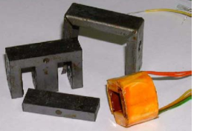

Figure 5.1 E type of lamination
- In similar fashion assemble I type lamination and fix from the 4th open side of the core
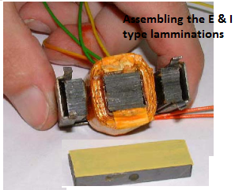

Figure 5.2 assemble I type lamination
- Assemble the frame (case)
6. Perform open circuit test, short circuit test
7. Perform power test
  - Methods of Checking assembled transformer
Testing transformers is more important than many people realize, and whenever CT or PT testing is conducted, it’s important to ensure that technicians use the correct transformer testing equipment to ensure that all electrical, mechanical, and thermal standards are being met.For each different type of transformer, the inspector should conduct the specific recommended tests to ensure efficient and safe inspection and operation. Today we’ll be covering four of these methods so that you can have a better idea of the most common testing transformers procedures.
1. Turns Ratio Testing
Turns ratio transformer testing is commonly used to ensure that the winding ratio between the primary and secondary coils are aligned to recommended specifications. This type of transformer testing also ensures the transformer will provide either step-up or step-down voltage. A step-down transformer, for instance, comprised of 100 primary turns and 10 secondary turns will work to reduce the voltage by a factor of 10 — corresponding to the secondary coil — while multiplying the current by 10 as well.
2. Insulation Resistance Testing
Insulation resistance transformer testing, also known as the Megger test, is used to determine the quality of insulation within the transformer itself. These tests are conducted with a megohmmeter, one of the necessary transformer test instruments, that operates similar to a multi-meter. In order to pass the test, the insulation of a transformer must be determined to have a greater resistance than defined by international standards for that transformer type. If it measures any lower it could signify an issue with the insulation which may require replacement.
3. Power Factor Testing
Power factor transformer testing is the process wherein the power loss of the insulation system is tested by measuring the angel the resulting current of power that occurs when AC voltage is applied. For the test results to be optimal, the angle of the current should measure 90 degrees; however, more often than not, insulation is never perfect. As a rule, the closer to 90 that the current is, the better the insulation is.
This test is completed with a power factor test kit, and it can be completed regularly throughout the life of the transformer. This can help detect deteriorating or malfunctioning insulation over time and give you an idea of when the transformer will need to be replaced.
4. Resistance Testing
This type of transformer testing once a transformer has been left to settle at the same temperature of the surrounding air. The reason for this is to check for any differences between the opens and windings within the transformer. This helps ensure that all the circuits are still wired and connected correctly. This test is conducted using an ohmmeter.
Overall there are eight types of transformer testing; however, these are four of the most common. All of these tests are critical for maintaining the integrity of the transformer and without them, the operation can be severely hindered.
  - Check the assembled transformer
To test your transformer, simply touch the red and black pins of your ohmmeter to the opposite ends of the transformer's wiring. Read the display and compare the resistance on your ohmmeter to the resistance stated on the transformer's data sheet. This is sometimes listed on the transformer's enclosure.
The insulation resistance test (meggering) is of value for future comparison and also for determining if the transformer is to be subjected to the applied voltage test. The winding insulation resistance test is a DC high voltage test used to determine the dryness of winding insulation system
Test Preparations
To test a transformer, however, you will need to disconnect it from the circuit before doing anything else. This will prevent inaccurate readings and ensure your own safety. Put your ohmmeter on its lowest scale and after removing the plastic sheaths from the conductors, touch its leads together to verify that it is ready for testing. If the reading is zero, you can continue. If it is not zero, adjust the variable knob to make the ohmmeter read zero before proceeding.
Simple Testing
To test your transformer, simply touch the red and black pins of your ohmmeter to the opposite ends of the transformer's wiring. Read the display and compare the resistance on your ohmmeter to the resistance stated on the transformer's data sheet. This is sometimes listed on the transformer's enclosure. If there is a dramatic difference between the reading and the listed resistance, it is likely that the transformer is faulty and should be removed and replaced as soon as possible. Check three times before drawing a conclusion, as your ohmmeter may not be perfectly accurate.

Operation sheet 5.1 Assemble low-power transformer
Operation title: - Assemble transformer
PURPOSE: - To Assemble transformer
Instructions: Given necessary, workshop, tools and materials and equipments you are required to perform maintain power supply according to the instruction given bellow for each task
Equipments, materials and tools:
Tools | Equipments  Consumable materials  Digital Multimeter  Faulted power supply  PPEs  Clean and ESD free work bench  Blower  Soldering iron ,soldering iron stand  Equipment whose power supply is repaired
Flat and Philips screwdriver
Adjustable Wrench
side cutting pliers
Procedure
Step1. Prepare the laminations
Step2. Prepare stack E type of lamination
Step3. Assemble I type lamination
Step4. Assemble the frame
Step5. Perform open circuit test, short circuit test
Step6. Perform power tes

LAP Test 5.1

Task 1: Assembling the repaired transformer with correct procedures and safety.
Task 2: perform final testing without power line. Perform continuity test, resistance test, open circuit test, short circuit test.
Task 3: perform power test (functional test of the assembled transformer)

Unit six: Test and inspect repaired products
This unit is developed to provide you the necessary information regarding the following content coverage and topics:
- Inspecting and testing Assembled transformer
- work completion Document
- Applying 5S
- Disposing of waste materials
This unit will also assist you to attain the learning outcomes stated in the cover page. Specifically, upon completion of this learning guide, you will be able to:
- Test transformer
- Document work completion
- Apply 5S
- Dispose waste materials

  - . Inspect and test Assembled transformer
The transformer is ready to install to its place in the equipment to do that:
- Disconnect power from the equipment
- Place the repaired transformer to its place in correct position
- Fix it with its fixing accessories, i.e. install securely the mechanical installation.
- Perform the electrical connection, i.e. connect the primary and secondary leads to its previous connection points.
- Clean the equipment with blowers and cleaning rags (clothes)
- Inspect the repaired and any other components of the equipment. Check for wear out, broken, burned parts and any sign of abnormality electrical components or mechanical parts. If there something seems to be wrong (abnormal), perform additional investigation closely to prove or disprove the expectation. If there is loosen part, components which need replacement, or mechanical moving parts which need lubrication...take for all appropriate remedial action.
- Connect the equipment to power source and perform input output voltage measurement.
- Test the equipment for correct operation (functional test of the equipment).
  - . work completion Document
Documentation: is a record or the capturing of some event or thing so that the information will not be lost.
Maintenance documentation
Service contract or in-house preventive maintenance is documented. This documentation is required for annual maintenance. Maintenance performed at other times, with the exception of routine cleaning, is documented.
The documentation includes:
- Description of the maintenance;
- Date it was done; and
- Name of the service representative and company, or name of the analyst if maintenance provided internally
The documentation includes:
- Initials of the analyst, and the date the problem was observed,
- Description of the problem;
- Date and initials of the analyst or service represent at performing the repair;
- Synopsis of the repair; and
- Cost of repair, copy of the invoice and any additional information (not required).

6.3. Applying 5S
5S is a set of principles that are intended to put a workplace in proper order. These principles involve everyone in eliminating unneeded materials, putting everything in its proper place, and standardizing workplace upkeep practices.
The 5 Steps are:
- Sort: Segregating Necessary and Unnecessary items from the workplace. Removing unnecessary items. Red tagging the doubtful items.
- Set In Order: Arranging materials according to the usage. A place for everything and everything in its place.
- Shine: Cleaning and Inspection - Maintaining the workplace without dust, Cleaning the machines daily, fixing leakages and abnormalities
- Standardize: Make the above 3 points easier to follow by all the employees in the company, Creating Visual Indicators, SOPs, Shadow Boards, etc.
- Sustain: Follow 5S daily. Regular Audits, Internal Competitions and Rewards and Recognitions for people would help in sustaining the 5S
5S is very simple to understand, but very difficult to Implement. It requires involvement from everyone in the unit - from the Top management to the bottom most layer.
The Top 10 Benefits of implementing 5S are:
- Clean and Pleasant Environment: 5S creates an organized and clean environment. Employees love to work in a clean and pleasant workplace.
- Self Discipline: Employees acquire self-discipline, they need to maintain the standards (put the tools pack in their positions, daily cleaning, Regular Audits, etc).
- Identify and Eliminate Wastes: 5S would bring a lot of wastes to the surface (Overproduction, excess motion, etc.) Employees can start reducing the wastes and improve the Productivity
- Create More Space: removal of unwanted items and organizing the necessary materials release space. We have found 5S releasing around 10% to 20% more floor space in most of our engagements.
- Identify Abnormalities: Oil Leaks, Air Leakages and Vibration of machines can be identified easily and fixed immediately.
- Identify issues in the flow of the materials: Shortage of Parts, Line Imbalances, excess inventory etc. would come to light once we implement 5S.
- Improvement in Safety: 5S helps in creating a safe workplace by reducing accidents caused by Slippery floors, eliminating oil leaks and creating visual indicators.
- Improves Machine Uptime: By following daily cleaning and fixing the abnormalities, the breakdowns of the machines would significantly reduce. From our experience we have found more than 60% reduction in breakdowns after 5S implementation.
- Improves Quality: By making the workplace visible and clean, the overall quality improves as defects cannot be hidden. Defects starts reducing and improvement in First Time Acceptance (FTA) would improve.
- Improvement in Employee Morale and Positive Attitude: 5S creates a positive attitude and starts a culture change in the company. Employees starts owning the workplace and their machines and they have a sense of belongingness to the company.

6.4. Disposing of waste materials
Landfill
In this process, the waste that cannot be reused or recycled are separated out and spread as a thin layer in low-lying areas across a city. A layer of soil is added after each layer of garbage. However, once this process is complete, the area is declared unfit for construction of buildings for the next 20 years. Instead, it can only be used as a playground or a park.
Incineration
Incineration is the process of controlled combustion of garbage to reduce it to incombustible matter such as ash and waste gas. The exhaust gases from this process may be toxic; hence it is treated before being released into the environment. This process reduces the volume of waste by 90 per cent and is considered as one of the most hygienic methods of waste disposal. In some cases, the heat generated is used to produce electricity. However, some consider this process, not quite environmentally friendly due to the generation of greenhouse gases such as carbon dioxide and carbon monoxide.
Waste Compaction
The waste materials such as cans and plastic bottles are compacted into blocks and sent for recycling. This process prevents the oxidation of metals and reduces airspace need, thus making transportation and positioning easy.
Biogas Generation
Biodegradable waste, such as food items, animal waste or organic industrial waste from food packaging industries is sent to bio-degradation plants. In bio-degradation plants, they are converted to biogas by degradation with the help of bacteria, fungi, or other microbes. Here, the organic matter serves as food for the micro-organisms. The degradation can happen aerobically (with oxygen) or an aerobically (without oxygen). Biogas is generated as a result of this process, which is used as fuel, and the residue is used as manure
Composting
All organic materials decompose with time. Food scraps, yard waste, etc., make up for one of the major organic wastes we throw every day. The process of composting starts with these organic wastes being buried under layers of soil and then, are left to decay under the action of microorganisms such as bacteria and fungi.
This results in the formation of nutrient-rich manure. Also, this process ensures that the nutrients are replenished in the soil. Besides enriching the soil, composting also increases the water retention capacity. In agriculture, it is the best alternative to chemical fertilizers.
Vermicomposting
Vermicomposting is the process of using worms for the degradation of organic matter into nutrient-rich manure. Worms consume and digest the organic matter. The by-products of digestion which are excreted out by the worms make the soil nutrient-rich, thus enhancing the growth of bacteria and fungi. It is also far more effective than traditional composting.

Self-Check- 6.1
Test I:
1.__________ is a set of principles that are intended to put a workplace in proper order
2. _________ is the process of controlled combustion of garbage to reduce it to incombustible matter such as ash and waste gas.
3. ____________ is the process of using worms for the degradation of organic matter into nutrient-rich manure.
Test II: short Answer writing

Instructions: Answer all the questions listed below.
1. Discuss what activities you should additionally perform before the repaired power supply starts its function in its previous equipment
2. What data should be documented during preventive and corrective (repair) maintenance
3. List and explain 5s stapes

Operation sheet 6.1: - Test and inspect repaired products
Operation title: - Test and inspect transformer
PURPOSE: - To verify the operation of the repaired equipment
Conditions or situations for the operations: - Clean, safe working area and PPE.
Equipment t, materials and tools:
- Flat and Philips screwdriver
- Faulted power supply
- Ppes
- Blower
- Repaired transformer with its equipment
PROCEDURE:-
I. Follow the following procedures to perform to inspect and test repaired product.
Step 1. Disconnect source supply
Step2. Disassemble the equipment
Step3. Install the repaired transformer
Step 4.Inspect the equipment components to investigate any other abnormality or area of suspection, if there is any rectify it
Step 5. Clean any dust, dirt and rust
Step 6. Connect power supply and test the equipment output.
Step 7.Assemble the equipment
Step8. Perform functional test
Step9. Document work completion
PRECAUTIONS:-
You should not forget to wear your PPEs. Use instruments properly according to manufacturer specification. Take care not to contact any part of your bare body to live circuit.
QUALITY CRITERIA:-
Perform the inspection, cleaning, correction and testing the equipment quickly, efficiently, economically and safely according to the manufacturer specification and stand dared.
Lab test 6.1
Task 1: Disconnect power
Task 2: Disassemble transformer
Task 3: Install repaired transformer
Task 4: Inspect the components
Task 5: Clean any dust, Dirt and rust
Task 6: connect power and test
Task 7: assemble
Task 8: Test
Task: Document work completion

References
- Basic Electronics 7thEdition c, 2008, Bernard Grob
- Electronics Circuits and Application c, 2009, Bernard Grob
- Principles of Electronic devices c, 2007, William D. Stanley
- Introduction to Circuit Analysis 4thEdition c, 2006, Robert L. Boylestad
- Practical Electronics, Solid State Servicing, Marconi Pagarigan
- Basic Electronics by Malvino
- Simple Electronics (Basic), Michael Q. Enriquez, Fred T. Gantalao, Rommel M. Lasala
- Internet Website thru Google
- https://www.linkedin.com/pulse/top-10-benefits-5s-implementation-ananth-palaniappan
- https://www.etechnog.com/2021/11/regulated-power-supply-block-diagram-working.html
- https://www.instructables.com/An-experiment-in-transformer-rewinding/

The trainers who developed the Module (training material) preparation
No | Name | Qualification | Educational background | Region | College | Mobile number | E-mail
1 | Tesfahun Ayalew Denigdine | B.SC -Applied Electrical/Electronic Technology  M.Sc. -Electronics and comm Eng. |  | BGRS | Assosa poly TVT College | 0912132308 | tesfugps44@gmial.com
2 | Yidnekachew Regassa Hirpa | B.Sc - Applied Electrical/Electronic Technology  M.Sc. - Electronic & communication Technology |  | Harari | Harari poly TVT College | 0910343909 | Yidne888@gmail.com
3 | Mohammed Seid Hussen | B.SC – Electrical/Electronic Technology  M.Sc – in electrical & communication Techno.mag,t |  | Ahmara | w/sihen Poly TVT College | 0913174837 | Tofikfuad606@gmail.com
4 | Berihun  Belaynew mesganaw | BA.T - Electronic & communication Technology. |  | Oromia | M.G.Mulugata Buli Poly TVT Collge | 0912836044 | berihunbelaynew@gamil.com

