Electrical/Electronic Equipment Servicing Level II
Based on March 2022, Curriculum Version 1
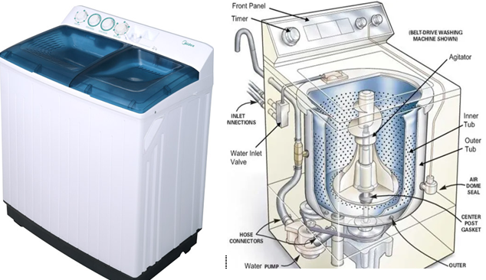
Module Title: - Maintain and Repair Washing Machine
Module code: EISE EES2 M10 0322
Nominal duration: 60Hour

Prepared by: Ministry of Labour and Skill
August, 2022
Addis Ababa, Ethiopia
table of content
Introduction to the Module 5
Unit one: Tools, equipments and workstation 6
1.1. Arrangements of workplace and equipments 7
1.1.1. Work place 7
1.1.2 Equipments/accessories 8
1.2 Repair/maintenance history of washing Machine 8
1.3 Service manuals for repair/maintain washing Machine 10
1.4. Arrangement of workplace based on company standard procedures 11
1.4.1. Water inlet arrangement for washing machine 11
1.5. Necessary tools and test instruments with PPE 12
Self cheek 1.1 18
Unit two: Diagnosis faults of Washing Machine 19
2.1. prepare to check-up faults of Washing Machine 20
2.2. Pre-testing procedures of Washing Machines 21
2.2.1. Main washing machine parts and components 21
2.3. System defects/ fault symptoms 26
2.3.1. Common fault symptoms of washing Machine 26
2.3.2. Test points of washing Machine 26
2.4. Test instruments of washing Machine 27
2.5. Troubleshooting procedures of washing Machine 28
2.6. Check and isolate Circuits using testing procedures 42
2.7. Defects and faults of washing machine 46
2.8. Check Control settings/adjustments. 48
2.9. Documentation of diagnosis and testing 49
2.10. Advice to customers 51
Self cheek 2.1 52
Operation sheet 2.1 53
Lab test 2.1 54
Unit Three: Maintain/repair Washing Machine 55
3.1. Occupational Health and Safety 56
3.2. Electro-static discharge (ESD) protection procedures 57
3.3. Replace defective parts/components 58
3.4. Solder/mount and repairing defective parts & components 62
3.5. Control settings/adjustments 63
3.6. Repair activity within the time frame 63
3.7. Care and extreme precaution in handling the unit/product 64
Self cheek 3.1 66
Operation sheet 3.1 67
Lab test 3.1 68
Unit Four : Test repaired unit 69
4.1. Repair and reassemble washing machine 70
4.2. Test and clean the final reassembled unit 71
4.2.1. Testing procedure of washing machine 71
4.2.2. Cleaning procedure of repaired washing machine 73
4.2.3. Methods of cleaning a washing-machine pump filter 73
4.3. Compile final documentations 74
4.4. Dispose waste materials 76
4.4.1. Methods of Dispose Waste materials 76
Self-check 4.1 78
Operation sheet 4.1 80
LAB test 4.1 81
Reference 82

Acknowledgment
Ministry of Labor and Skills wish to extend thanks and appreciation to the many representatives of TVET instructors and respective industry experts who donated their time and expertise to the development of this Teaching, Training and Learning Materials (TTLM).

Introduction to the Module
In Electrical/Electronic Equipment Servicing filed; Maintain and Repair Washing Machine helps to know about operation and maintenance of washing machine it is a huge time saver when compared to hand washing. You don't have to do anything except dump your clothes in the machine, turn on the power, and pick your cycle. There is virtually no labor required.
This module is designed to meet the industry requirement under the Electrical/Electronic Equipment Servicing occupational standard, particularly for the unit of competency: Maintain and Repair Washing Machine
This module covers the units:
- Tools, equipments and workstation
- Diagnose faults of washing machine
- Maintain/Repair washing machine
- Test repaired washing machine
Learning Objective of the Module
- Identify proper unit, tool and , equipments
- Able to Diagnose faults of washing machine
- Repair washing machine
- Able to test washing machine
Module Instruction
For effective use this modules trainees are expected to follow the following module instruction:
- Read the information written in each unit
- Accomplish the Self-checks at the end of each unit
- Perform Operation Sheets which were provided at the end of units
- Do the “LAP test” giver at the end of each unit and
- Read the identified reference book for Examples and exercise

Unit one: Tools, equipments and workstation
This unit is developed to provide you the necessary information regarding the following content coverage and topics:
- Arrangements of workplace/equipments
- Repair/maintenance history of washing Machine
- Service manuals for repair/maintain washing Machine
- Arrangement of workplace based on company standard procedures
- Necessary tools and test instruments with PPE
This unit will also assist you to attain the learning outcomes stated in the cover page. Specifically, upon completion of this learning guide, you will be able to:
  - Ready workplace/equipment
  - Know history of washing Machine
  - Use Service manuals of washing Machine
  - Arrange workplace for maintenance
  - Identify Necessary tools and test instruments

  - Arrangements of workplace and equipments
    - Work place
Effective housekeeping can help control or eliminate workplace hazards. Poor housekeeping practices frequently contribute to incidents. If the sight of paper, debris, clutter and spills is accepted as normal, then other more serious hazards may be taken for granted.
Housekeeping is not just cleanliness. It includes keeping work areas neat and orderly, maintaining halls and floors free of slip and trip hazards, and removing of waste materials (e.g., paper, cardboard) and other fire hazards from work areas. It also requires paying attention to important details such as the layout of the whole workplace, aisle marking, the adequacy of storage facilities, and maintenance. Good housekeeping is also a basic part of incident and fire prevention.
Effective housekeeping is an ongoing operation: it is not a one-time or hit-and-miss cleanup done occasionally. Periodic "panic" cleanups are costly and ineffective in reducing incidents
Poor housekeeping can be a cause of incidents, such as:
- Tripping over loose objects on floors, stairs and platforms
- Being hit by falling objects.
- Slipping on greasy, wet or dirty surfaces
- Striking against projecting, poorly stacked items or misplaced material
- Cutting, puncturing, or tearing the skin of hands or other parts of the body on projecting nails, wire or steel strapping
To avoid these hazards, a workplace must "maintain" order throughout a workday. Although this effort requires a great deal of management and planning, the benefits are many
Some benefits of good workplace housekeeping
Effective workplace housekeeping results in:
- Reduced handling to ease the flow of materials
- Fewer tripping and slipping incidents in clutter-free and spill-free work areas
- Decreased fire hazards
- Lower worker exposures to hazardous products (e.g. Dusts, vapors)
- Better control of tools and materials, including inventory and supplies
- More efficient equipment cleanup and maintenance
- Better hygienic conditions leading to improved health
- More effective use of space
- Reduced property damage by improving preventive maintenance
- Less janitorial work
- Improved morale
- Improved productivity (tools and materials will be easy to find)
    - Equipments/accessories
Washing Machine Accessories
- Laundry and Dryer Balls
- Detergents
- Stand or Trolley
- Cover
- Hard Water Protection
- Smart Plug
- Laundry Basket
- Laundry Bag
- Socks Clips
- Laundry Additives
- Iron
  - Repair/maintenance history of washing Machine
A washing machine, otherwise known as a clothes washer, is an apparatus used to wash dirty laundry, such as clothing and bed sheets. The term is mostly applied only to machines that use water as opposed to dry cleaning or ultrasonic cleaners.
Washing entails immersing, dipping, rubbing, or scrubbing in water, usually accompanied by detergent or bleach. The simplest machines simply agitate clothes in water, while automatic machines fill, empty, wash, spin, and heat in a cycle. Most modern washing machines remove substantial amounts of water from the laundry at the end of a wash cycle, but do not completely dry it. Washing machines have come a long way from their humble, simple, and sometimes dangerous predecessors though. Ancient people cleaned their clothes by pounding them on rocks or rubbing them with abrasive sands, and then washing the dirt away in local streams, and the earliest washing machines were just a slightly more advanced version of this process.
The earliest machines were hand-operated and constructed from wood, while later machines made of metal permitted a fire to burn below the washtub, keeping the water warm throughout the day’s washing. In fact, until the mid-1800s, the most advanced piece of washing equipment was the scrub board, invented in 1797. By the 1850s, steam-driven commercial laundry machinery was on sale in the UK and US, although technological advances in machinery for commercial washers proceeded much faster than domestic washer design, especially throughout Europe. The US was the first to focus heavily on the development of washers for the home though. As electricity was not commonly available until at least 1930, most early washing machines were operated by a low-speed single-cylinder hit and miss gasoline engine. After the items were washed and rinsed, water had to be removed by twisting. To help reduce this labor, the wringer/mangle machine was developed which used two rollers to squeeze water out of clothing, operated by a manual or powered hand crank. As implied by the term “mangle,” these early machines were quite dangerous, especially if powered and not hand-driven. A user’s fingers, hand, arm, or hair could become entangled in the laundry being squeezed, resulting in horrific injuries.
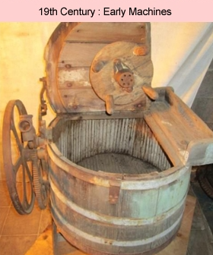
Figure 1.1 old washing machines
General Electric introduced a selection of front-loading and top-loading units in the 1950s, which included most of the features that are incorporated into modern machines. Since then, the basic design and features of washing machines hasn’t changed much, simply improved upon, with the addition of different bells and whistles offered by competing manufacturers. Most modern washers offer predefined programs for different laundry types, variable water temperatures, and adjustable rotation speed settings. Today, most of us take these appliances for granted, and the biggest decision one has to make when purchasing a new washer is what incredible bells and whistles we think will make life the easiest. We should be forever thankful though for the advances in appliance technology which have made our domestic lives more convenient, especially when it comes to washing machines.
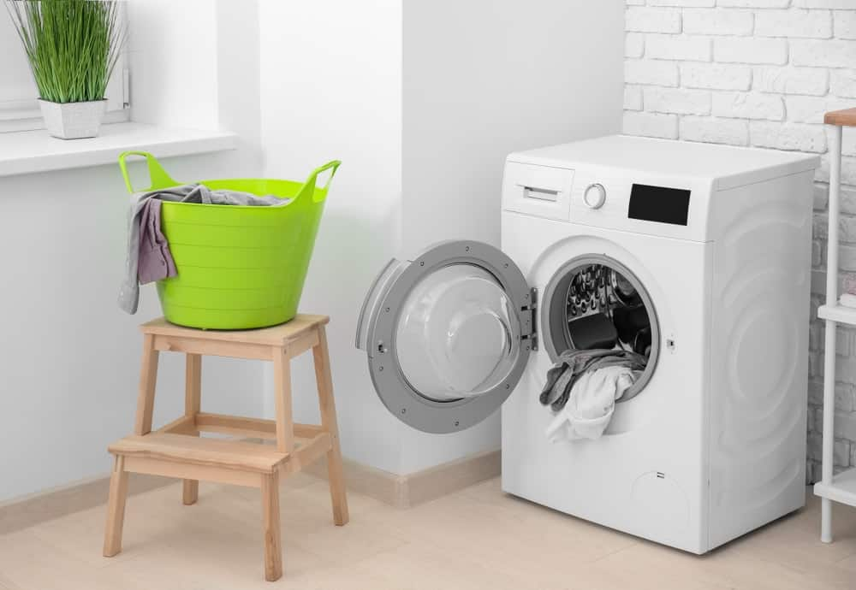
Figure 1.2 Modern washing machines
  - Service manuals for repair/maintain washing Machine
Alternatively referred to as documentation or end-user documentation, a manual is a book or pamphlet containing information about a program or piece of hardware. For example, a computer case may come with documentation explaining what sizes of motherboard it can hold. Or, a video game may come with a manual explaining how to play it.
Today, most manufacturers and developers no longer include printed manuals with their products. They instead rely on electronic documentation and online documentation, which are usually included as a PDF or available for download on the manufacturer's website.
Different types of manuals include:
One of the most widely-spread types of technical documentation is manual. Nowadays, practically everything that surrounds us has a manual. Whether we use a mobile phone or buy a kitchen gadget. Manuals help customers, and technical specialists use and maintain products and devices. They help managers develop their companies. But do we know all kinds of manuals that exist? Let us see!
- Service manual — helps technicians and other trained people service, maintain, and repair equipment. It usually contains information on the problems and breakages that may occur and guidelines on how to fix them.
- User manual — assists people to use a particular system or device. It provides instructions for both skilled and unskilled users for setup, operation, and maintenance of a product. It may have precautions and problem guidelines.
- Operation manual — provides guidance for the staff to perform their functions correctly and efficiently. It describes what and how should be done, which is especially important for the quality of goods and services. Moreover, it contributes to the safety of products and services.
- Training manual — contains instructions to improve the quality of performed tasks and processes. It is aimed at teaching and upgrading the skills of employees. It can be used as a reference document in the workplace or by a trainer to revise the material.
- Policy manual — contains policy guidelines, rules, resolutions, and procedures of a company. It helps the management run the business and make decisions; it regulates the course of development of a company.
- Organizational manual — describes positions in the company, their responsibilities, duties, functions, relations. In other words, it defines job descriptions and functions of all employees in a company, which enables it to perform all the functions in an effective way.
- Administrative practice manual — gives standard methods and procedures for the personnel to fulfill the functions and cooperate effectively. It may contain instructions for different departments or guidelines for corporate correspondence. Sometimes, it may contain instructions on how to improve the knowledge and skills of the employee.
Here are the most popular types of manuals that you can meet. Of course, you may come across some other types, but this information is enough for you to have the basic knowledge on the topic. I hope you find it helpful!
  - Arrangement of workplace based on company standard procedures
    - Water inlet arrangement for washing machine
A clothes washing machine, in particular of the household type, includes a washing tub, a drum holding the wash load, a water inlet conduit from the water supply mains, and an electromagnetic valve provided in the conduit, an offshoot conduit downstream of the electromagnetic valve an air break.
A water dispenser is located above a plurality of compartments for holding washing and rinsing agents. A siphon is installed between the compartments and the washing tub, and a conduit is positioned between the siphon and the water dispenser. A second water offshoot conduit is provided with a respective air break and is situated between the electromagnetic valve
And the air gap wherein the second water offshoot conduit flows into the conduit. The air gap is formed by an interruption through an injector located in a vertical descending section of the second offshoot conduit, whereas water issuing from the injector flows into the conduit.
The most convenient and comfortable option remains the location of the washing machine under the sink or countertop. Arrangement of household appliances in this way will bring many benefits:
- Connecting the machine to utilities will be very simple;
- The space under the sink, often free, will be used to good effect;
- The interior will look stylish and harmonious.
Much attention should be paid to the selection of a washing machine. If the bathroom’s quadrature is very small, it is advisable to purchase a modest-sized machine with a depth of not more than 45 cm. Of course, small-sized automatic machines are characterized by a small capacity, but in such a situation you will have to compromise. It’s better to wash the laundry in two passes with a machine than to clean things manually. In general, it is possible to place a standard size washer, but having acquired such an aggregate, you will have to go to tricks to install it as comfortable and ergonomic as possible.
  - Necessary tools and test instruments with PPE
Appliance repair involves a number of specialty tools. You may need a resettable fuse, condenser brushes, canned air, and calipers for specialty jobs – and there are more than a few specialty jobs to be done every year. However, the vast majority of appliance repairs can be performed with a short and common list of tools. Those who are unfamiliar with the many disassembly instructions for appliances would be surprised to discover that you can perform most standard repairs with a pair of screwdrivers, a putty knife, and a handful of other very simple toolbox supplies.

  - Necessary tools
There are nine most common tools you need on-hand for appliance repairs.
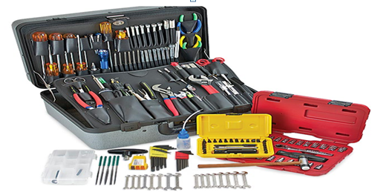
Figure 1.3 Necessary tools
  - Slot and Phillips Screwdrivers
First, you’ll need both types of screwdriver. Phillips head screwdrivers sporting the cross (+) are your primary repair tool. This is how you will remove most of the mounting screws both inside and outside of most appliances. That said, we advise a small variety of size, sharpness, and handle-length depending on the depth and width of each screw – and how easy it is to reach.
Slot screws are rare for appliance hardware, but slot screwdrivers are often essential for releasing tiny metal and plastic clips inside appliance cabinetry. Get a full set of screwdrivers just to be safe.
  - Putty Knife
The putty knife is, surprisingly, the second-most-called-for tool in repairs. A putty knife and slot screwdriver is often used for the same purpose – slipping under a seam in the appliance cabinet and releasing the small clips holding the panels together. To disassemble a washer, dryer, or stove – for example – it’s often necessary to use a putty knife.
Pro Tip: Wrap your putty knife in painter’s or masking tape to prevent scratching appliances.
  - 1/4″ Nut Driver (Nut Driver Set)
When appliances are built for normal users not to gain access, nut-topped screws are used. Some models of appliance and some specific components are often secured with a nut-driver head instead of a screwdriver head. Because not all appliances are the same, it’s best to have a full nut driver set.
That said, the vast majority of the time a nut driver is called for, it’ll be the 1/4 inch. So have your 1/4″ nut driver in your toolkit and ready to go when appliance repair time comes around. You’ll be glad it’s there as back up if you find yourself removing nut-sealed panels or components.
  - Combination Wrench Set
The next set of tools you’ll want is a rack of combination wrenches. These are not always listed on your mandatory tools list, but it’s extremely helpful to have the right wrench size when you need it, both in open and socket ends. One rack of combination wrenches is always a smart addition to the appliance repair toolkit. When you don’t need them to open or close something, you may need them to brace a bolt while you work two sides of a problem.

  - Work Gloves
The outside of appliances are all rounded and smooth-edged to protect the hands of residential users. However, the insides are not so designed for safety. Even the edges of appliance cabinet panels can be sharp and potentially dangerous to touch. In addition to the edges of thin metal panels, there are also sharp small components, circuit boards, and wires that can damage your hands. If there is any current still running through the appliance, you might get a shock
Work gloves protect you from all or most repair-related injuries. Work gloves that fit well and have a tough protective layer are designed to keep your hands safe from both sharp and hot objects. In addition, many work gloves provide at least a minor layer of insulation against electric shock.
  - Needle-Nose Pliers
Needle-nose pliers are sometimes necessary for a repair and sometimes they just make repairs a lot easier. A good, sturdy pair of needle-nose pliers can help you hold pieces together, shape wires, and of course, hold and retrieve smaller components. Sometimes a pair of pliers is essential to open a clasp, or close a stiff metal clasp when reassembling. Pliers can also hold two pieces together while you or a friend fastens them with the correct nuts and bolts. Never head out to a repair without at least one set of sturdy needle-nose pliers.
Believe it or not, towels are a big part of appliance repair. You lay a towel on the floor to protect it when pulling out the dishwasher. You lay a towel on the table or counter to place a removed panel, or to work on a removed component. A towel will prevent a big mess when you need to drain water lines and drips are inevitable. A towel can also clean up your workspace before a repair is done – so there’s a safe and cleaner place to work – and after a job is done to clean up behind yourself.
  - Wire Cutters
Last but not least, don’t forget a pair of wire cutters. Wire cutters may be included in your pliers but a dedicated set can be vital. There are a surprising number of repairs where a strong pair of wire cutters would have solved the problem. You can cut and clip a new dryer duct, trim and cap dishwasher tines, and may be surprised at the other wire-cutting necessities that come up along the way.
  - Test instruments
    - Multimeter
A multimeter is an appliance technician’s best friend. Your multimeter’s primary function is to tell you which parts are working as intended and which have stopped functioning in the electrical circuit. A fully broken or burnt-out component will not pass current through, and you can test this with the positive and negative probes of your multimeter.
You can also test components to see if they are channeling the right amount of electricity or creating the right amount of resistance. Use a manual to test each part to discover how well it is functioning. This will tell you if a part needs to be replaced, repaired, or if you should seek the trouble’s cause in a different component.
    - Ball Bearing Rotating Endurance Tester
To simulate failure, quality and reliability of the ball bearing elements load, speed and forces in axial and radial direction, friction of bearing to be verified by using torque transducer, speed transducer and temperature sensor
    - Belt Tester
Introduction this testing equipment will be use to test performance, environment and durability of the belt elements of the washing machine.
    - Spring Tester
KS Testing’s Digital Display Tension& Compression Testing Machine is a new spring testing instrument, which is adapted to almost kinds of tension & compression spring test
    - Pressure Sensor Tester
Test the Water Level Switch The water level senses (switch) the water level in the wash tub. As water climbs inside the tube, it pushes on the air trapped inside and increases the air pressure.
  - PPE(personnel protective equipments)
Proper Use, Laundering and Care Guide of PC & PPE
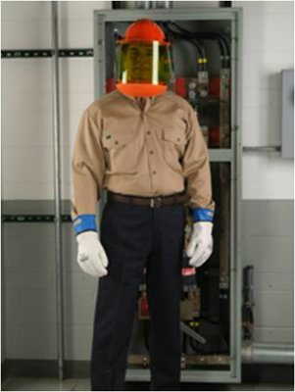
Figure 1.4 Proper Uses of PC and PPE
Proper use of PC and PPE is a key part of safety practices in substations.
- For full body protection, the Protective Clothing shall be worn close/fastened and other suitable PC (Protective Clothing) & PPE (Personal Protective Equipment) shall be used (e.g. helmet and face screen, gloves with cuffs, footwear etc.)
- Sleeves must NEVER be rolled up during use of the garment.
- Each item must be of an equal or higher arc rating than that required by the Arc Flash protection boundary rating (read more on the arc flash suit ratings).
- No undergarments which can melt should be used.
- For repairs/alterations, only FR fabric and thread must be used.
- PC & PPE must be stored in a dry, clean and ventilated area.
- Wear only clean, unsoiled and undamaged PC and PPE.
- Clean garment thoroughly.
- Use Detergent only.
- Dry cleanable.
- Turn garment inside out before washing.
- Wash up to 60°C (140°F) for Woven and 40°C (104°F) for Knitted or Fleece fabrics.
- No chlorine bleach or hydrogen peroxide either separately or in detergents.
- No softeners or starch.
- Garments should be washed with like colours.
- Recommended to be washed with garments that are similarly soiled.
- Garment can be tumble dried or line dried.
- Failure to launder properly could adversely affect the flame resistance of the arc flash clothing material.
- Please note that the wash care instructions on the label attached to the garment must be adhered to first, in addition to the above complementary information.

Self cheek 1.1
Test I: say ‘true’ if the statement is correct and ‘false’ if the statement is not correct
__________1. Decreased fire hazards is the result of Effective workplace housekeeping
__________2.Effective housekeeping cannot help to control or eliminate workplace hazards
__________3. The other name of washing machine is known as a clothes washer
__________4.The earliest machines were hand-operated and constructed from wood
__________5.A multimeter is an appliance technician’s best friend
Test II: Short answer
- ______________helps technicians and other trained people service, maintain, and repair equipment.
- ______________assists people to use a particular system or device.
- ______________provides guidance for the staff to perform their functions correctly and efficiently.
- _________________contains instructions to improve the quality of performed tasks and processes.
- ___________________contains policy guidelines, rules, resolutions, and procedures of a company.
Test III: Explain briefly
- List at least four cause of incidents in work place
- List and explain five Necessary tools for maintenance
- Explain proper use of PC and PPE
- List and explain two Test instruments

Unit two: Diagnosis faults of Washing Machine
This unit is developed to provide you the necessary information regarding the following content coverage and topics:
- Prepare to check-up faults of Washing Machines
- Pre-testing procedures of Washing Machines
- System defects/ fault symptoms
- Common faults of washing Machine
- Test points of washing Machine
- Test instruments of washing Machine
- Troubleshooting procedures of washing Machine
- Check and isolate Circuits using testing procedures
- Defects and faults of washing Machine
- Check Control settings/adjustments.
- Documentation of diagnosis and testing
- Advising Customers
This unit will also assist you to attain the learning outcomes stated in the cover page. Specifically, upon completion of this learning guide, you will be able to:
  - Check faults of Washing Machines
  - Testing procedures of Washing Machines
  - Identify fault symptoms
  - Know test instruments
  - Perform Troubleshooting procedures
  - Check and isolate Circuits
  - Document diagnosis and testing results
  - Advising Customers
  - Check Control settings/adjustments.

  - prepare to check-up faults of Washing Machine
Testing of washing programs in the machine is possible only when it is connected to the water supply. However, the question arises, how to check the washing machine when buying or when delivering home, because if this is not done, then you can purchase non-working goods. In fact, checking the washing machine needs to pay special attention to how to do this, let's discuss.
What needs to be checked?
The first check of the washing machine should take place in the store where you buy it. It is necessary to check:
- Housing for damage and defects;
- Drum;
- Operability when connected to the network;
- Availability of a warranty card and its correct filling.
Upon delivery of the washing machine by store employees, it is also checked:
- The availability of all components;
- Legs;
- Integrity of the drain and inlet hose;
- Transportation bolts in place;
- Housing for defects.
If you yourself will deliver the machine to your home, then pay attention to the above items immediately at the place of purchase.
Then choosing a washing machine in a store, the first is to inspect it from all sides. There should be no scratches, dents, or stubborn stains and dirt on the machine body. Inspect the drum hatch, close and open it. It should close well and open without problems. Check the cuff for tears.
Be sure to check the detergent tray, try pulling it out and inspecting it. Smell the smell of the hole under the tray. The new car should not have any smell. In a used machine, the smell of powder or rinse aid is possible. But if you smell mold or another putrefactive smell, then you should not take such a machine.
For external inspection, be sure to pay attention to the drum of the washing machine. Its inner surface should be perfectly smooth so that washing delicate and silk items does not turn into a problem in the form of torn items. Such a check can be carried out using a female nylon stocking. Putting it on your hand, swipe along the surface of the drum, if the stocking remains intact, without puffs, then everything is in order. Also twist the drum by hand in order to see how it rotates, there is no play, is it well centered, are the bearings operational.
  - Pre-testing procedures of Washing Machines
Washing machine is a complex appliance. Various washing machine components and parts co-operate with each other to clean the clothes during a pretty complicated process. Here we are going to introduce the main washing machine parts and their function. Since every washing machine has its own design and characteristics, we will introduce washing machine parts which are common among all of them. one of the main procedure of Pre-testing procedures of Washing Machines is properly identify the main washing machine parts and their function.
    - Main washing machine parts and components
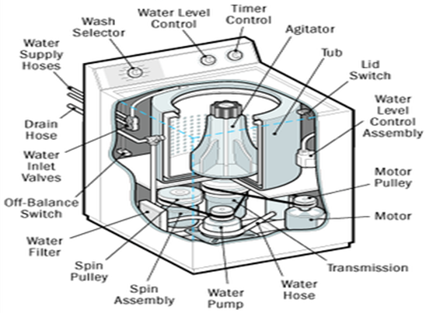
Figure 2.1 parts of washing machine
- Drum or tube
Let's start with the biggest washing machine part, the drum or tub. Do you know your washing machine has two tubs? The one that you see and put your clothes in is the inner tube which rotates and has some holes for water inlet and outlet. The outer tub contains the inner one, protects it and prevents the water from leaking to other washing machine parts. The outer tub is stuck to the appliance body.

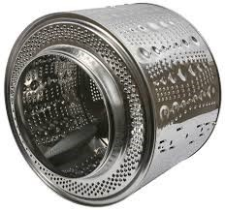
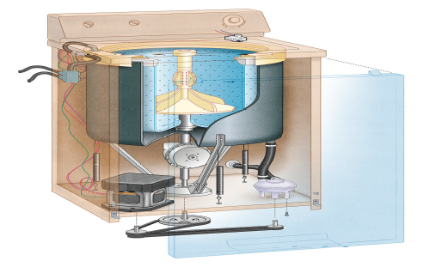
Figure 2.2 Drum
Tip: since the inner tube is moving and vibrating while working, the outer one should be installed in a way to prevent the movement transfer to other washing machine parts.
- Water inlet valve
After turning on the washing machine and setting the washing program, the inlet valve opens automatically to enter water into the inner tube. The water level in the tub is assigned according to the washing machine model and the selected program

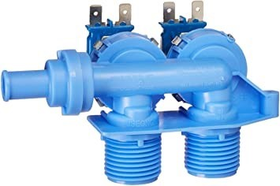
Figure 2.3 Water inlet valve
- Drain pump
As the name indicates the duty of this washing machine part during washing and spinning cycles, is water draining.

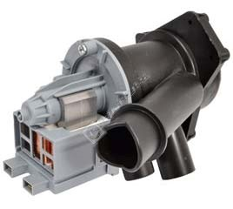
Figure 2.4 Drain pump

- Drain hose
The water will leave the washing machine after the washing cycle is completed with the help of the drain pump and the drain hose. This is a very simple washing machine part but a very useful one.
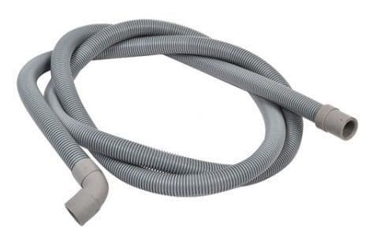
Figure 2.5 Drain hose
- Heater element
This washing machine part heats up the water inside the tub to the desired temperature according to the washing program. It is located under the main tub and is completely sealed
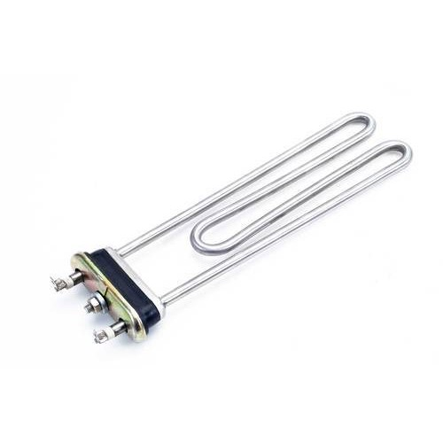
Figure 2.6 Heater element

- thermostat
This washing machine part measures the inlet water temperature and orders the elements to heat the water if necessary. In fact, thermostat is in charge of the temperature control. When the temperature reaches the desired level, it stops the electric current to the element.
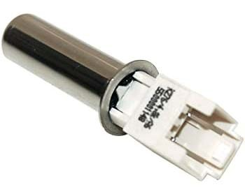
Figure 2.7 thermostat
  - Electronic board
The information in this washing machine part is programmed to help the washing machine with its operations according to the clothes’ type. This component is in fact the brain of the washing machine.
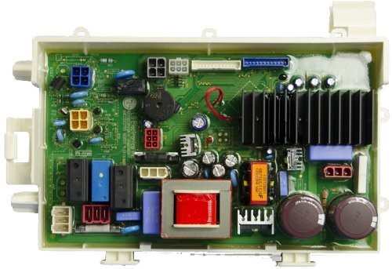
Figure 2.8 Electronic board
  - Hydrostat
This washing machine part is responsible for adjusting the level of inlet water to the appliance. It stops the water inlet when the water level in the tub reaches the adjusted level.
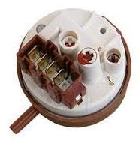
Figure 2.9 Hydrostat
  - Micro switch
The main duty of this washing machine part is to make sure the washing machine door is completely closed to start the washing operation. If the door is not closed, it prevents the electricity from reaching the water inlet valve. So, water doesn't enter the tub. The micro switches inside the washing machine, control the water level in the tub, the tub angle and the filters.
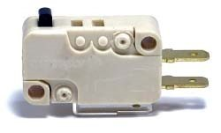
Figure 2.10 Micro switch
Warning: if the washing machine door opens when the water temperature in the tub is too high, you may be burnt.
Warning: if the micro switch doesn't work properly and washing machine door opens while the tub is spinning, inserting your hand inside the tub is too dangerous and can break your bones.
  - Pulley
Pulley is the washing machine part which looks like a big wheel locating at the back of the tub. It is connected to the motor with a belt around it. When pulley starts rotating, the inner tube rotates too. In other words, the small and big pulleys of the washing machine transfer power between the motor and the tub.

Figure 2.11 Pulley

  - Belt
This washing machine part connects the motor to the pulley at the back of the tub and makes it rotate during the washing cycle.
Now that you are almost familiar with washing machine main parts, let's have a short description of its operation in washing your clothes.
  - System defects/ fault symptoms
    - Common fault symptoms of washing Machine
- Washing machine cannot start up
- Door cannot be opened
- Heating fault
- Water leakage
- Indicator or does not light.
- Detergent residues in the box
- Washing effects are not good
- Abnormal noise Great vibration
- Water injecting problem when washing (water injecting time exceeds 7minutes)
    - Test points of washing Machine
The following parts of the washing machines are the main test point during troubleshooting
- Lid switch
- Water level control switch
- Timer troubles
- Valve
- Agitator
- Water leaks
- Water pump
- Belts and pulleys
- motor
- Driver belt
- Water pump
  - Test instruments of washing Machine
Test or Test Instrument: A systematic procedure for measuring a sample of an individual's behavior, such as multiple-choice, performance test, describe some instruments bllow:-
    - Multimeter
A multimeter is an appliance technician’s best friend. Your multimeter’s primary function is to tell you which parts are working as intended and which have stopped functioning in the electrical circuit. A fully broken or burnt-out component will not pass current through, and you can test this with the positive and negative probes of your multimeter.
You can also test components to see if they are channeling the right amount of electricity or creating the right amount of resistance. Use a manual to test each part to discover how well it is functioning. This will tell you if a part needs to be replaced, repaired, or if you should seek the trouble’s cause in a different component.
    - Ball Bearing Rotating Endurance Tester
To simulate failure, quality and reliability of the ball bearing elements load, speed and forces in axial and radial direction, friction of bearing to be verified by using torque transducer, speed transducer and temperature sensor
    - Belt Tester
Introduction this testing equipment will be use to test performance, environment and durability of the belt elements of the washing machine.
    - Spring Tester
KS Testing’s Digital Display Tension& Compression Testing Machine is a new spring testing instrument, which is adapted to almost kinds of tension & compression spring test
    - Pressure Sensor Tester
Test the Water Level Switch The water level senses (switch) the water level in the wash tub. As water climbs inside the tube, it pushes on the air trapped inside and increases the air pressure.
  - Troubleshooting procedures of washing Machine
As we mentioned, washing machines are complex, but there are some simple steps you can take to diagnose common washer problems.
The first line of defense for any electrical repair is the sincere hope that it's as simple as a loose plug, damaged cord or malfunctioning wall outlet. If all of these check out, it could be a blown fuse or circuit breaker. Either of these can still be a pretty simple fix. But if the machine is receiving power and still not operating, then it's probably time to get to know your washing machine on a deeper level.
After checking for power, the next thing to look at is the water supply. Knobs may get turned inadvertently or hoses could become kinked, so a quick inspection of these parts may yield an answer. Make sure that both water faucets are turned on and that all hoses are properly extended, without kinks. If the washer has a water-saver button, make sure the button is depressed.
If it's not a power or water source issue, the next logical problem may be that the washing machine is not working properly because it needs to be cleaned. In the next section, we'll discuss how to keep dirty clothes from creating a dirty washer.
Washing Machines Need Cleaning, Too, A clean washer is a happy washer
We interrupt this scintillating mechanical exploration of washing machine mechanics to bring up a very important matter: why your laundry might stink even after a fresh wash. It may be that your washer is dirty. Here's how to clean a washing machine.
Regularly clean the top and door of the washer to prevent the buildup of dirt and detergent. When you wash very linty materials, pull lint from the tub after removing the laundry. Built up lint can keep water and detergent from properly circulating and soap deposits themselves may cause laundry to smell bad. To solve this problem, fill the tub with water and add 1/2 cup of baking soda or 3 cups of white vinegar; then run the machine through the complete wash cycle sans laundry.
Finally, run the machine through a complete wash cycle before you put any more laundry in. Hopefully, you were able to address your issue with these simple steps. But if your problem persists, don't despair. In the next section, we'll discuss disassembling the washer for more thorough repairs.
    - Disassembling the Washer
Washing machines: Some disassembly required.
For most repairs and maintenance, the washer cabinet usually requires disassembly. The washer cabinet is where the magic happens, and houses all of the electrical components of the washer. Location varies by manufacturer, but typically this can be found on the top of the machine behind the control panel. This can be relatively simple based on the make and model, but be sure to consult the owner's manual to find out how to disassemble your particular machine properly. Here are three steps for basic washer disassembly:
Step 1. Removing the control panel, typically located on top of the machine, usually requires loosening and/or removing a set of retaining screws. These may be located under a piece of molding or trim that needs to be removed in order to see them. Knobs on the control panel are usually friction-fit and will pull off, while others are held by small setscrews, which do not have heads like a typical slotted screw, at the base of the knob. Loosen the setscrews with a screwdriver or Allen wrench and pull the knobs straight off the shafts.
Step 2. To remove the service panel, you also need to remove the retaining screws. First, make sure the machine and the hoses are drained of water. Tip the washer over on its front or side to gain access through the bottom of the machine, which is generally open and doesn't have a service panel.
Step 3.To remove the top of the cabinet, insert a stiff-bladed putty knife into the joint between the top and side panels and give the knife a rap with your fist. This should release the spring clips so that the top can be removed.
Part of what makes washers so hard to repair is that they have so many control devices (components that control other functions, such as switches and timers). Now things start to get a bit more complicated, but don't give up yet. In the next section we will walk you through servicing these slightly more sophisticated parts.
Washing machines run through elaborate cycles with multiple settings, which makes them different from your typical household appliance, a toaster for instance, that may perform just one or two functions. Here's how to repair some of the common switches and timers.
    - Lid Switch
The lid switch on a washer often serves as a safety switch, and if it's not working, or if the switch opening in the lid is clogged with detergent, the machine will not run. To check and repair the lid switch:
Step 1.Unplug the machine. You can clean out the lid switch port using a wooden manicure stick or even a chopstick.
Step 2.If cleaning doesn't help; remove the top of the cabinet to access the switch itself. With the switch exposed, check to make sure the screws have not become loose. Loose screws can cause the switch to move when the lid is closed or as the machine goes through its cycles. Check the terminals of the switch to make sure they're tight.
    - Temperature Selector Switch
This control panel switch regulates the temperature of the water in the tub. It also plays a role in controlling the fill cycle. If you suspect this switch is faulty, remove it and take it to a professional service person for testing because this takes special equipment.
If there's a problem with both water temperature and tub filling cycles, both the temperature switch and the timer may be faulty. Procedures for testing the timer can be found on the following page.
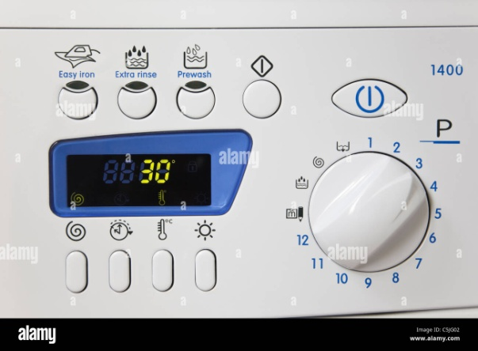
Figure 2.12 Temperature Selector Switch
    - Water Level Control Switch
This is another control panel switch, usually located next to the temperature switch. There should be a small hose connected to this switch, and sometimes, this hose becomes loose and falls off the connection. When this happens, the water in the tub usually overflows. To solve this problem, cut about 1/2 inch off the end of the hose and use a push fit to reconnect it to the switch. A push fit is a simple metal fitting that fastens into place by a row of small teeth that grip the tubing. The switch itself can also malfunction, resulting in tub overflow and other water-level trouble in the tub. If you suspect this switch is faulty, remove it by backing out the screws holding it in place and take it to a professional service person for testing.
If you've gotten this far and your washer is still broken, don't give up now. We're only getting started, and your laundry isn't going anywhere. Keep reading because in the next section we'll discuss why it may just be bad timing.
    - Timer
A washing machine timer looks a little different from this kitchen timer, but the principle is the same: Timing is crucial.
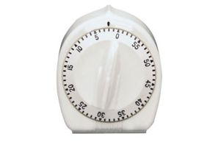
Figure 2.13 Timer
The timer controls most of the operations of the washer: water level, tub filling and emptying, length of cycles and cycle-setting sequences. However, there are a couple of checks you can make yourself when you suspect the timer is faulty.
Step 1: Unplug the washer. To access the timer, remove the control knobs and the panel that covers the controls. This is usually the same control panel we discussed earlier, but may also be accessed be through a panel at the back of the unit. Carefully examine the wires that connect the timer to the other parts of the washer. If the wires are loose or disconnected, try pushing them into position; they usually fit into their terminals like plugs. Use long-nosed pliers to push them into position in order to avoid breaking the wire connections -- never pull a wire by hand.
Step 2.To test the timer, use a volt/ohm meter (VOM) set to the RX1 scale. The RX1 scale is the lowest and should be the default setting of the meter. Disconnect the power leads to the timer and clip one probe of the VOM to each lead. The VOM should read zero if the timer is working. Since the timer is a multipurpose switch, turn it through its cycle and test each pair of terminals in turn. The meter should read zero at all of these points. If one or more readings are above zero, the timer is faulty and should be replaced.
Step 3.To replace the timer, unscrew and disconnect the old one. Install a new timer made specifically for the washing machine. Disconnect the old wires one at a time, connecting each corresponding new wire as you work to make sure the connections are properly made. After all the wires are connected, check the connections again for correctness and screw the timer assembly into place.
Now we're having some serious fun! Actually, you're probably thinking about which is more painful, reading about laundry or actually doing it. Take heart -- we're approaching the spin cycle and you'll be done soon.
    - Tube and Valves
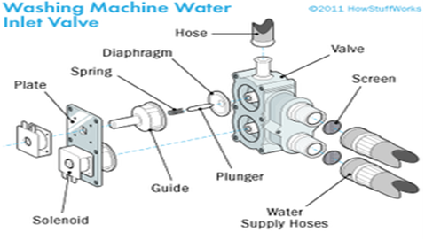
Figure 2.13 water inlet valves
If an inlet valve is faulty, check the water connection and the valve screens. Try gently tapping the solenoids; if this doesn't work, replace the inlet valve assembly.
If your washer is overflowing or is excessively noisy, the tips on this page may be able to help you solve your problem.
If the washer won't fill or fills very slowly, if it overfills, or if the water is the wrong temperature, the water inlet valves could be faulty. These components are easy to locate and very easy to replace, at little cost. When you suspect an inlet valve is broken, first check to make sure the water faucets are fully turned on and properly connected to the hot and cold inlets of the valves. Then check the screens in the valves; if they're clogged, clean or replace them. If water doesn't enter the tub, set the temperature control to the HOT setting. If there is no water, set the control to the WARM setting. If all that comes out is cold water, the hot-water inlet valve is not working. Reverse the procedure to test the cold-water valve, setting the control first on COLD and then on WARM. If the tub overfills, unplug the washer. If water still flows into the tub, the valve is stuck open. In any of these cases, the valves should probably be replaced.
    - Valve assembly
Step 1.Remove the back service panel and disconnect the hot-water and cold-water hoses to the valves.
Step 2. Remove the hoses connected to the valves inside the cabinet. Also disconnect the wires from the terminals. Back out the screws holding the valves to the machine. The inlet valves have solenoids (coil of wire that carries a current) inside the housing.
Step 3.Tap the solenoids with a screwdriver handle. If this doesn't work, replace the entire inlet valve assembly. Install it in the reverse order of the way you disconnected the old one.
    - Agitator
Replace a damaged agitator with a new one of the same type. Unscrew the cap on top of the agitator and pull straight up; the agitator should lift off.
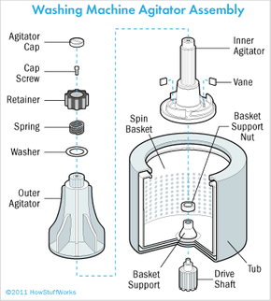
Figure 2.14 agitator assembly

The agitator -- the finned part that fits on the tub shaft -- can also tear laundry if the fins are cracked or broken. You may be able to solve the problem temporarily by pinching off the splinters with pliers and lightly filing the plastic smooth, but this is just a stopgap measure; the agitator should be replaced. Replace a damaged agitator with a new one of the same type. To do this, unscrew the cap on top of the agitator. With the cap off, pull straight up on the agitator; it should lift off. If it doesn't move, rap its side with a hammer. If it still won't lift off, drive wedges under the bottom rim of the agitator to dislodge it. Then, set the new agitator into place and replace the agitator cap.
Damage to the snubber a pad-like device sometimes located under the agitator cap, can cause the machine to vibrate excessively. The snubber may have a suspension spring in it. Lift off the agitator cap and examine the snubber. If the spring is broken, or if the pad is visibly worn, replace the entire snubber. Snubber might also be found at the top of the tub, under the transmission, or as part of the water-pump housing. Look around until you see it.
If the machine doesn't have a snubber, listen for noise at the suspension unit between the tub and the machine cabinet. The suspension unit has fins or pads that may need replacement. In some cases, the entire unit may have to be replaced. Another noise point is the basket support nut, which holds the basin in place. You can imagine what kind of punishment that sucker takes. Tighten the nut or, if you can't tighten it, replace it.
Sudden tub stops can be caused by a broken motor belt, but they are usually due to poor tub loading. Check to see if wet laundry is wadded around the bottom of the tub shaft, or under the basket or agitator assembly. Remove the basket or agitator in order to remove the laundry easily.
Next, we'll take a look at water-related problems, starting with troubleshooting water leaks.
    - Water Leaks
Water leaks in a washer are often difficult to trace. The problem could be a loose connection, a broken hose, a cracked component or a defective seal. It could also be a hole in the tub. If that's the culprit, it's usually best to replace the washer.
Tightening water connections can eliminate most leaks. Here's how to do it:
Step 1 Check the lid seal. If faulty, replace with a new gasket.
Step 2.Check the hoses at faucet connections. Tighten connections or replace hoses.
Step 3. Check the hoses at water valve connections. Tighten connections or replace hoses.
Step4. Check the drain hoses. Tighten connections or replace hoses.
Step 5.Check the inlet nozzles. Tighten connections or replace nozzles.
Step6. Check the splash guard. Tighten connections or replace.
Step 7.Check any plastic valve. Tighten connections or replace.
Step8.Check the outlet hose to drain. Tighten connections or replace hose.
Step 9.Check the water pump, using the procedures that follow on the next page
Now that you've checked the most likely sources for a water leak, you can reasonably rule out that as the culprit. On the following pages, we will cover tips for servicing the water pump, the belts and pulleys, and the motor.
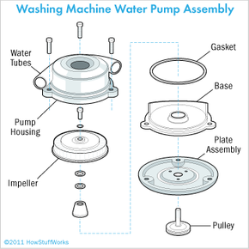
    - Water Pump
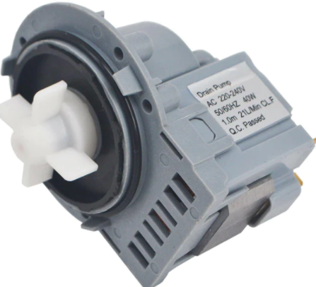
Figure 2.15 Water Pump
Take the pump apart and clean away all debris inside it. Clear away debris from the water tubes, too. The water pump probably takes the most punishment because it's constantly in use. When the pump fails, you can hear or see the trouble: a loud rumbling inside the machine, or a failure of the water to drain out of the tub. Here's what you can do to fix the problem:
Step 1. Check the drain hoses to make sure they're draining properly. Remove the water supply hoses from the back of the washer. With long-nosed pliers, extract the filter screens from the valve ports in the washer or from the hoses themselves. These screens keep debris from collecting in the hoses and can become clogged. Wash the screens thoroughly. Then, replace them and reattach the hoses. If the machine still rumbles or doesn't drain, examine the pump.
Step 2.To access the pump, first bail and sponge out any water in the machine's tub. Then tip the washer over on its front, using a heavy blanket or pad to protect the washer's finish. Remove the back service panel. The pump is usually located along the bottom of the machine, but with the unit tipped on its front, it's easier to remove the pump through the back than through the bottom of the washer.
Step 3.Locate the pump. It has two large hoses attached to it with spring or strap clips. If the clips are the spring type, pinch the ends of the clips together with pliers to release them, and slide the clips down the hoses. If the hoses are kinked or crimped at these connections, straighten them as best you can and reconnect them. Then, try the machine again to see if this kinking was causing the problem. If the machine still doesn't drain, you'll have to remove the water pump.
Step 4.To remove the pump, loosen the bolt that holds the drive belt taut and move the washer motor on the bracket to loosen the belt. Move the motor out of the way and unbolt the pump. As you loosen the last mounting bolt, support the pump with your hand. Then, lift the pump out of the washer.
Step 5.You should take the pump apart if you can because the trouble could be lint, dirt or pieces of cloth. Clean away all debris inside the pump and clear any debris out of the water tubes. Reassemble and hook up the pump again and test it. If cleaning the pump doesn't put it back into working order, or if the pump housing can't be removed, replace the pump with a new one of the same kind.
Step 6.To install the new pump, set it into position and connect the mounting bolts to the pump housing. Move the motor back into position. Tighten the drive belt (the rubber belt that connects two shafts of the motor) by prying it taut with a hammer handle or pry bar; it should give about 1/2 inch when you press on it at the center point between the two pulleys.
Step 7.Reconnect the hoses leading to the pump.
If the pump's not your problem, other mechanical issues may be afoot. If your belts and pulleys are to blame, find out how to fix them on the next page.
    - Belts and Pulleys and
The drive belt (or belts) of a washing machine may become worn or damaged, causing noisy operation or stopping the washer entirely. Fortunately, a damaged drive belt is easy to replace. Remove the back panel of the washer to gain access to the belt and then follow these steps to remove it:
Step1. Loosen the bolt on the motor bracket and move the motor to put slack in the belt. The motor bracket is a simple metal brace that holds the motor housing in place.
Step 2.Remove the old belt and stretch a new one into place on the pulleys.
Step 3.To put tension on the new belt; use a hammer handle or a short pry bar to push the motor into position while you tighten the bolt in the adjustable bracket. The belt should have about 1/2 inch deflection, or give, when you press on it at the center point, midway between the pulleys. If the belt is too loose, it will slip on the pulleys, causing the machine to malfunction. If the belt is too tight, it will wear very quickly and will probably become so hot that it will start to smoke or smell.
Loose pulleys can also cause problems. Most pulleys are fastened to shafts with setscrews around the hub of the pulley. Remember, setscrews do not have heads so you might have to look closely to see them. These screws must be tight, or else the pulley or belt will slip. The resulting malfunction may seem to be caused by a faulty motor, but it can be corrected by tightening the pulleys and adjusting the belt. For this reason, always check the belts and pulleys before working on the motor.
In most cases, motor malfunctions should be handled by a professional. If the motor is a universal model, however, you can change worn carbon brushes when sparking occurs, as detailed in how to Repair Appliances. To save yourself the expense of a service call, remove the motor from the washer and take it to a professional service person, then reinstall the repaired or new motor yourself. To access the motor, remove the back panel of the washer. The motor is mounted on an adjustable bracket.
    - Motors
The universal motor is a type of electric motor that can operate on either AC or DC power. It is a commutated series-wound motor where the stator's field coils are connected in series with the rotor windings through a commutator.It. It is often referred to as an AC series motor. The universal motor is very similar to a DC series motor in construction, but is modified slightly to allow the motor to operate properly on AC power.
This type of electric motor can operate well on AC because the current in both the field coils and the armature (and the resultant magnetic fields) will alternate (reverse polarity) synchronously with the supply
How to connect, use and repurpose an electric motor found in most of the washing machines, an electric motor that wired properly can run on AC and DC with comparisons
Step 1: The Washing Machine Motor
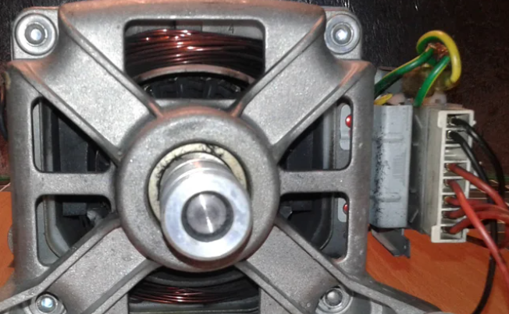
Figure 2.16 universal motor
Step 2: Washing Machine Motor Tacho Coil
In the back side of the motor you can find the tacho coil with we will not use but is good to know if you need to replace it with a spare parts if this one is gonna break. By the name you are guessing that with this component the washing machine controller is sensing the rpm of the motor and it regulates the speed according to the phase of the program.
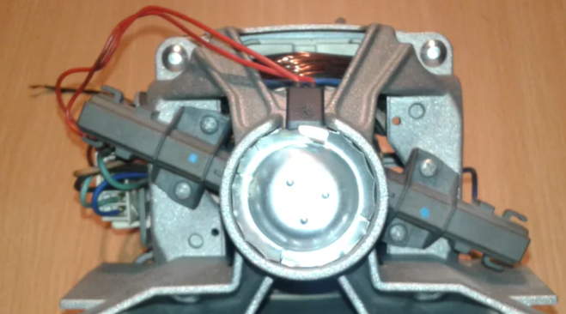
Figure 2.17 Tacho Coil
Step 3: Washing Machine Motor Specs
Universal motors have high starting torque, can run at high speed, and are lightweight and compact. They are commonly used in portable power tools and equipment, as well as many household appliances. They're also relatively easy to control, electromechanically using tapped coils, or electronically. However, the commutator has brushes that wear, so they are much less often used for equipment that is in continuous use. In addition, partly because of the commutator, universal motors are typically very noisy, both acoustically and electromagnetically.
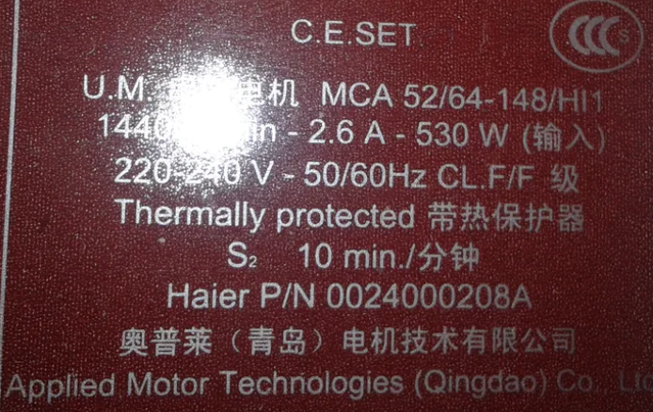
Figure 2.18 Motor Specs
Step 4: Universal Motor Wiring Diagram
This picture is from a washing machine motor in desit repurposed in a dc operated motor by watching the original connection we will find that is got 8 pins starting with the tacho coil 8+7 that i showed previously we will not use in this configuration. Moving down 6 is not connected 5+4+3 are the stator connection wich loochs like a single coil with 2 connection and another additional center tap connection. The last 2+1 pins are the brushes that you will find on the side a carbon road in castrated in a black plastic cover.
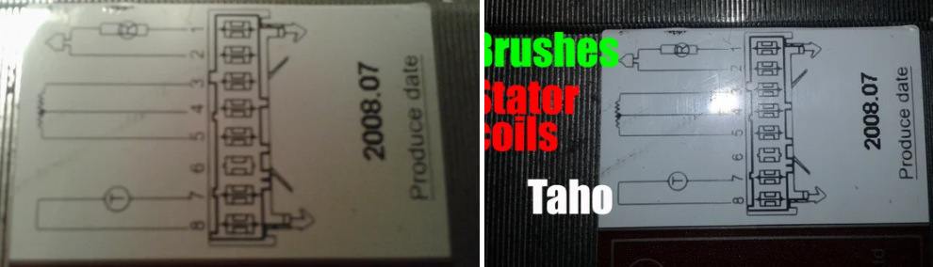
Figure 2.18 Universal Motor Wiring Diagram
Step 5: Washing Machine Motor Direct Wire
Even when used with AC power these types of motors are able to run at a
rotation frequency well above that of the mains supply, and because most electric motor properties improve with speed, this means they can be lightweight and powerful. However, universal motors are usually relatively inefficient: around 30% for smaller motors and up to 70-75% for larger ones. The connection of this motor for direct drive using it for a period of time with no controller in low application like belt sander, electric bike, electric boat, wood splitter and more. We will connect one terminal of the stator 3 with one of the brush 2 then the ends 1 will be connected to the plus terminal of the battery or AC power source and then the last stator terminal 5 to the minus terminal of the battery or the other connector of AC 220v/120v source.
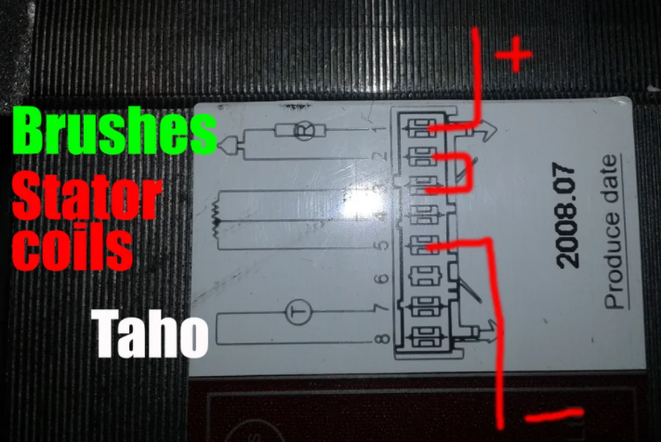
Figure 2.19 Washing Machine Motor Direct Wire
Step 6: Washing Machine Motor Uses
Operating at normal power line frequencies, universal motors are often found in a range less than 1000 watts. Their high speed makes them useful for appliances such as blenders, vacuum cleaners, and hair dryers where high speed and light weight are desirable. They are also commonly used in portable power tools, such as drills, sanders, circular and jig saws, where the motor's characteristics work well. Many vacuum cleaner and weed trimmer motors exceed 10,000 RPM, while many Dremel and similar miniature grinders exceed 30,000 RPM.Universal motors also lend themselves to electronic speed control and, as such, were an ideal choice for domestic washing machines. The motor can be used to agitate the drum (both forwards and in reverse) by switching the field winding with respect to the armature. The motor can also be run up to the high speeds required for the spin cycle. Nowadays, variable-frequency drive motors are more commonly used instead
  - Check and isolate Circuits using testing procedures
Here we are going to see the electric washing machine wiring diagram, connection procedure, and internal circuit. A washing machine is one that washes and dries the clothes. Nowadays almost every house uses a washing machine to wash their clothes. A washing machine can save our so much time and effort. A washing machine is an electrical machine consisting of different types of electric motors, switches, times, buzzers, etc. So, as an electrician, you must know the internal working function of a washing machine. This will help you a lot to repair a washing machine. There are different types of washing machines from the different manufacturer are available in the market, but all the washing machine works almost in the same principle. So, in this article, we are going to know the general knowledge and circuitry. First, of all let's see the diagram.
Washing Machine Wiring and Connection Here, you can see the internal components and circuit of a washing machine.

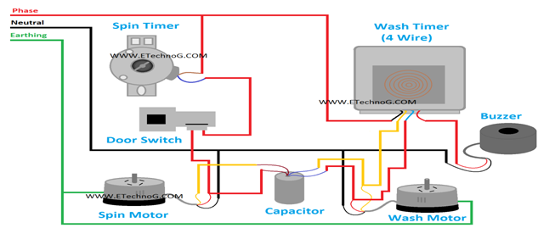
Figure 2.20 Washing Machine Wiring and Connection

Spin Motor
Spin Motor is also known as a dryer motor. It is used to dry the clothes. A spin motor is a single-phase induction motor. It has two windings Starting winding and running winding. It required a capacitor to start. Generally, a capacitor is used with this spin motor. Also, you can see in the above wiring diagram, a capacitor is connected to the spin motor. The spin motor is low power rated than the wash motor.
Wash Motor
A Wash motor is used to wash the cloth. It is more powerful than the spin motor because it has to make the movement of wet clothes with water. The wash motor is also a single-phase induction motor, it also has two windings - running winding and starting winding. Here also, a capacitor is required for its operation. The wash motor is subjected to rotate in both directions and it is done by the wash timer. The speed and torque of the Wash motor are more than the spin motor.
Spin Timer
Spin Timer is used to operate the Spin motor. A spin timer is a two-terminal device; it is to be connected with the spin motor and the power supply. Spin motor and Spin timer are used in both semiautomatic and automatic washing machines.
Wash Timer
The Wash Timer is used to operate the wash motor. The function of the wash timer is to rotate the wash motor with a preset time, change the direction of the rotation of the motor, and turn on the buzzer or alarm when washing is completed. There are different types of wash timers are available such as three-terminal wash timers, four-terminal wash timers, and six terminal wash timers
Door Switch
The door switch provides the function to operate the washing machine when the door is only in closed condition. You can see the door switch is connected in series with the spin motor so, until the door is closed, the spin motor will not work.
Nowadays, commercially available washing machines are provided with features like the auto-off timer, reversible impeller, etc. Most of them have mechanical timers, reverses, etc. Some are equipped with electronic timers. But they are very expensive and out of reach of the average consumer.
Electronic Washing Machine Control circuit provides all the facilities provided by reputed companies and even more. The circuit has a timer circuit that can be set to any duration from 0 to 15 minutes and can be extended to any length of time by merely changing a capacitor. The circuit has switching circuits that run the impeller in one direction for 25 seconds and stop the motor for five seconds. This cycle repeats until the time set in the timer has elapsed.
An optional switch is provided to select normal/strong washes. During ‘normal’ washing, the impeller rotates in both directions alternatively with the five-second gap between reversals. This type of wash is suitable for delicate clothes. During ‘strong’ washing, the impeller rotates in one direction only with a five-second push after every 25 seconds.
Another switch is provided to select the ‘continuous’ facilities. In this mode, the impeller rotates in one direction only continuously. This mode is suitable for blankets, rugs, etc. You can also check another washing machine motor control circuit.
Circuit Description of Electronics Washing Machine Control
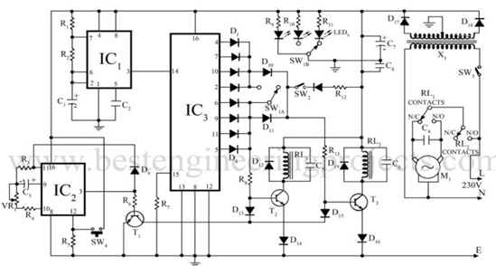
Figure 2.21 Washing Machine Control circuit
Circuit Description of Electronics Washing Machine Control
The heart of the circuit is IC₃ which is a CMOS decade counter cum decoder. The IC provides ten outputs that go high one at a time for every clock pulse applied at pin 14. The clock pulses are obtained by IC₁ NE555 wired in astable multivibrator mode. The second, third, fourth, and fifth outputs are OR’ed by four 1N4148 diodes (D₁ – D₄). Similarly, the 7th, 8th, 9^{th,} and 10th outputs are OR, ed by another four 1N4148 diodes (D₅ – D₈). The first and sixth outputs are left unused.
When IC₃ starts counting, the first pulse is not received by any diode, and during that period transistors T₃ and T₂ are off and the relays are also off, disabling the motor. During counts from the second to the fifth pulse, T₃ is on and T₂ is off. The motor runs in one direction for four clock pulses. During the sixth pulse, once again T₃ and T₂ are off and the motor stops. During seventh to tenth pulses, T₃ and T₂ are on and the motor runs in the opposite directions due to the switching of winding by relay RL₁ contacts. The timer is based on IC₂ CD4060 which divides by 16384 counters. The timer can be set by a 1M potentiometer. After the set-time T₁ switches T₂ and T₃ off, thus disabling the motor. The 4060 can be reset by the push-to-on switch provided.
Capacitor C₄ is a starting capacitor already fixed to the motor. Relay RL₁ and RL₂ are 6V, 100 Ω, and 6A rated relays. The circuit can be assembled on the general-purpose PCB. Mains wiring should be made with high current stranded copper wire. The circuit being fairly simple does not pose any problem.
Note: SW₁ = Normal/Strong Selector
SW₂ = Continuous Selector
SW₄ = Reset
PARTS LIST of Electronic Washing Machine Control
Resistors (all ¼-watt, ± 5% Carbon)
R₁, R₆ = 1 KΩ
R₂, R₄ = 100 KΩ
R₃ = 1 MΩ
R₅ = 4.7 KΩ
R₇ = 10 KΩ
R₈, R₁₂, R₁₃ = 470 Ω
R₉-R₁₁ = 750
VR₁ = 1 MΩ Lin.
Capacitors
C₁ = 47 µF, 25V (Electrolytic Capacitor)
C₂, C₅, C₆ = 0.01 µF (Ceramic Disc)
C₃ = 1 µF, 25V (Electrolytic Capacitor)
C₄ = starting capacitor already connected with motor
C₆ = 1000 µF, 25V (Electrolytic Capacitor)
C₈ = 0.1 µF (Ceramic Disc)
Semiconductors
IC₁ = NE555 (Timer IC)
IC₂ = CD4060 (14-stage Binary Ripple Counter IC)
IC₃ = CD4017 (Decade Counter IC)
T₁ – T₃ = BC148B (General Purpose NON Transistor)
D₁ – D₁₁, D₁₃, D₁₅ = 1N4148 (Signal Switching Signal Diode)
D₁₂, D₁₄, D₁₆ – D₁₉ = 1N4001 (Rectifier Diode)
Miscellaneous
X₁ = 220V C primary to 9V-0-9V 500mA secondary transformer
M = 230V AC, ¼ HP reversible induction motor
RL₁, RL₂ = 6V, 100Ω Relay
SW₁ = DPDT switch
SW₂ = SPST witch
SW₃ = ON/OFF switch
SW₄ = Push-To-On switch
  - Defects and faults of washing machine
Below are the most common Samsung washer problems and troubleshooting solutions.
However, most of the issues have been found in front load Samsung washing machines.
1. The Electrical Circuit
Samsung front load washers have been recalled due to the risk of tripping a household electrical circuit. The main reason was the internal water leakage in the machine. If water spills on the washer’s electrical connections, it might cause the circuit board to burn, posing a fire hazard in your home. Samsung received various complaints on this issue, but luckily no injuries or deaths are reported.
Solution
If this is the case, you must immediately unplug your washer from the electrical outlet until you receive a Ground Fault Circuit Interrupt (GFCI) breaker from Samsung. The new ground fault circuit interrupt breaker will prevent potential fire hazards to consumers.
2. Washer is not spinning
Your washing machine’s spin performance may not be as good as it should be for several reasons. The machine has sensors that detect a problem and automatically slow or stop the spin cycle. Suspension wear, drain pump failure, faulty door lock, drum nut loosening, and maybe a broken plastic bracket at the back of the machine can all influence the spinning cycle.
The solution: Before calling a technician, you must detect the problem by yourself. To check this:
- You need to run a spin cycle with no load and no detergent.
- Once the cycle begins, keep an eye on the drum as initially the machine fills the water, and look carefully through the door to see if the drum is spinning. It is normal for the machine to stop and start several times during the rotation.
- Then, try out putting small and large loads to detect the spin cycle. Some Samsung washers operate well on large loads and require more water during the spin cycle to compensate for the small loads.
- If the drum still does not rotate during the wash cycles, it is a major issue requiring a technician’s services.
3. Washer Leaking Water
Water leakage is another prevalent issue reported by homeowners.
During the wash cycle, it frequently leaks, and there could be several reasons for this.
How to check and fix water leakage?
In this case, double-check that the door is properly closed and make sure the hose connections are fully tight.
Also, check the drain hose connection to the drainage system as it often causes leakage in the washer. Using too much or wrong detergent, which causes excess foaming, might also lead to leaks.So, reduce the detergent quantity or try another detergent brand to detect the real problem. If your washing machine uses too much water during the wash cycle, it can also cause a leak in the machine’s inner lines. So, try to lower the water level to avoid puncturing the drain pipes.
4. The Detergent Remains in the Dispenser after the Wash Cycle
This problem occurs when there is insufficient water pressure to wash the detergent thoroughly. If you are using old detergent in the machine, it can also cause blockage in the dispenser. So, you may need a proper cleaning of the detergent drawer.
How to clean the detergent drawer in Samsung Washing Machine?
Check out the following steps for cleaning the detergent drawer in the Samsung washers.
- Firstly, open the detergent drawer.
- There will be a release lever (A) on the inside of the drawer; press it
- Pull out the detergent drawer at the same time you press it.
- After that, remove the liquid detergent guide (optional) and the softener division from the drawer.
- Now, all parts should be washed under running water.
- Clean the blockage in the detergent drawer with an old toothbrush.
- Now, firmly push the liquid detergent guide and the softener division into the detergent drawer.
- Finally, push the detergent drawer back where it belongs.
5. Washer Not Starting
This is a common problem with front load washers, and there could be several reasons for it.
Make sure your washer is plugged in, and the door is firmly closed. Also, double-check that the water faucets are turned on. If these don’t work, the problem could be a blown fuse. So, you might need to reset the electrical circuit breaker to start the machine. If the problem persists, you should seek help from a technician.
  - Check Control settings/adjustments.
Your washing machine has three main settings: agitation, length, and temperature. These are the main features your machine has which allow you to tailor your wash to the fabrics you’re cleaning.
- Setting Agitation. For delicates, you need less agitation. Sturdy items, cotton, synthetics, and heavily soiled garments need the most.
- Setting length. Fast cycles are great for lightly soiled garments and emergency washes.
- Setting temperature. With Ariel, you can wash at different temperature settings and get brilliant stain removal while saving energy. You cannot set the temperature higher than the wash default, only lower.
However, most washing machines also come with other useful features such as a:
- Digital display. This display tells you how much time remains on your wash program.
- Time delay. This setting is useful if you want to run a wash cycle at night when electricity is cheaper, or you want the machine to wash your clothes just before you get home.
- Load detection. Some washing machines detect the washing load weight in the drum and can select the optimal cycle. This feature helps you save water and energy but is a feature found on premium models only.
- Child lock. This feature helps keeps curious little hands from using the controls or playing with the doors
  - Documentation of diagnosis and testing
- Diagnose documentation is a technical communication document intended to give a user or customer information on how to solve and prevent those problems. It’s commonly written for computer hardware, electronic goods, and software but they can be written for any product.
- Proper documentation would list every stage in the process from start to end. As we discussed troubleshooting is a logical and step by step process that must be followed every time. If problems and customers are not the same, then how can even the best troubleshooting staff survive without proper documentation? It is the life support for troubleshooting.
- Troubleshooting documentation is more often than not, lengthy and can be tiring to read. Anyone who is referring to such a document for a particular problem and its resolution should not need to go through the entire documentation to find it. A well-defined and crisply laid out index should be in place to make locating the area of interest easier. The index must also have some help words that describe in layman terms some of the tongue twisting troubleshooting terminology.
- Clearly worded documentation is important to improve efficiency. Even if memory fails under pressure, the troubleshooting staff can quickly recover from that by referring to the documentation. The customer will never need to know that the staff ‘ran short’ to start with. The end perception will be one of knowledge and efficiency. Happy staff and happier customer!
- The importance of documentation in troubleshooting and other areas comes from the fact that it is a recording of a crucial and creative process that focuses on problem resolution and problem prevention. It helps members of the same team or different teams work collaboratively on customer issues or internal troubleshooting issues for quicker resolutions.
- Documentation can be very inspiring and thought provoking if written well. They provide invaluable and indispensable data that make the entire troubleshooting process and customer service for a company more robust and sustainable.
Although it is often neglected in the troubleshooting process, documentation is as important as any of the other troubleshooting procedures. Documenting a solution involves keeping a record of all the steps taken during the fix-not necessarily just the solutionDate-When was the solution implemented? It is important to know the date because if problems occur after your changes, knowing the date of your fix makes it easier to determine whether your changes caused the problems.
- Why-Although it is obvious when a problem is fixed while it is done, a few weeks later, it might become less clear why that solution was needed. Documenting why the fix was made is important because if the same problem appears on another system, you can use this information to reduce time finding the solution.
- What-The successful fix should be detailed, along with information about any changes to the configuration of the system or network that were made to achieve the fix. Additional information should include version numbers for software patches or firmware, as appropriate.
- Results-Many administrators choose to include information on both successes and failures. The documentation of failures can prevent you from going down the same road twice, and the documentation of successful solutions can reduce the time it takes to get a system or network up and running.
- Who-It might be that information is left out of the documentation, or someone simply wants to ask a few questions about a solution. In both cases, if the name of the person who made a fix is in the documentation, the person can easily be tracked down
  - Advice to customers
- Advice is guidance about what someone should do. Advise is a verb that means to give someone advice about something. Despite their very similar spelling, advice and advice are pronounced differently.
- Below listed are few handling procedures of televion advice to customers’
- Scratch Damage: Handle the display device with care to avoid scratching it.
- Moisture Damage: Gently wipe off any moisture or let the device dry before using it.
Dirt and Stain: Gently wipe off the stain with a soft lint-free cloth.
- Temperature Difference: High temperature and humidity will degrade the performance of a display device.
- Pressure and Heat: Display device should be mounted 4 mm or more away from Printed Circuit Boards.
- Accessories Usage: Use only attachments and accessories specified or recommended by manual
- While Lightening: Unplug the TV during lightning storms or when unused for long periods of time.
- Climate Change: If the TV is moved from a cold place, do not turn it on for a few hours so any internal condensation can evaporate.
- Installation Procedure: Install the TV upright on a horizontal, solid, flat surface away from excessive heat, dust, and vibration.
- Air Flow: Keep a clearance of at least 10 cm (4 inches) between the vents on the back of the TV and nearby walls or enclosure.

Self cheek 2.1
Test I: for the following questions write ‘true’ if the statement is correct and ‘false’ if the statement is incorrect and explain the reason.
________1. The first step to fix Water Pump problem is Check the drain hoses to make sure draining properly.
________2. The drive belt of a washing machine is can’t damage.
________3. Universal motor is a type of electric motor that can operate on either AC or DC power.
________4. A spin motor is a three-phase induction motor.
________5. The door switch provides the function to operate the washing machine when the door is only in closed condition.
Test II answer the following questions
1._________________is a technical communication document intended to give a user or customer information on how to solve and prevent those problems.
2.________________is a guidance about what someone should do.
3. _______________ is used to operate the Spin motor.
Test III: Explain the following questions in brief
- Describe six Common faults symptoms of washing Machine.
- List ten main test point of washing machine during troubleshooting.
- List and explain two steps when we check and repair the lid switch.

Operation sheet 2.1
Operation sheet title:-Trouble shoot water leak problem of washing machine
Purpose: - To troubleshoot faults water leak problem of washing machine
Instruction: - Using the given equipments troubleshoot faults washing machine water leak. You have given 70 Minuts for the task and you are expected to write the answer on the given line.
Tools and requirement
- gasket
- hose
- Nozzles
- plastic valve
Steps in doing the task
Step 1 Check the lid seal. If faulty, replace with a new gasket.
Step 2.Check the hoses at faucet connections. Tighten connections or replace hoses.
Step 3. Check the hoses at water valve connections. Tighten connections or replace hoses.
Step4. Check the drain hoses. Tighten connections or replace hoses.
Step 5.Check the inlet nozzles. Tighten connections or replace nozzles.
Step6. Check the splash guard. Tighten connections or replace.
Step 7.Check any plastic valve. Tighten connections or replace.
Step8.Check the outlet hose to drain. Tighten connections or replace hose.

Lab test 2.1
Task1: Check the lid seal
Task2. Check the hoses
Task3: Check the hoses at water valve connections
Task4: Check the drain hoses
Task5: Check the inlet nozzles
Task6: Check the splash guard
Task7: Check any plastic valve
Task8: Check the outlet hose to drain

Unit Three: Maintain/repair Washing Machine
This unit is developed to provide you the necessary information regarding the following content coverage and topics:
- Occupational Health and Safety
- Electro-static discharge (ESD) protection procedures
- Replace defective parts/components
- Solder/mount and repairing defective parts & components
- Control settings/adjustments
- Repair activity within the time frame
- Care and extreme precaution in handling the unit/product.
This unit will also assist you to attain the learning outcomes stated in the cover page. Specifically, upon completion of this learning guide, you will be able to:
- . Use Occupational Health and Safety
- Identify Electro-static discharge (ESD) protection procedures
- Replace defective parts/components
- Solder/mount and repairing defective parts & components
- Control settings/adjustments
- Perform Repair activity within the time frame
- Care and extreme precaution in handling the unit/product.

  - Occupational Health and Safety
Occupational health and safety is the field of public health that studies trends in illnesses and injuries in the worker population and proposes and implements strategies and regulations to prevent them. Its scope is broad, encompassing a wide variety of discipline from toxicology and epidemiology to ergonomics and violence prevention.
Workplace safety is an important part of any job and requires that everyone in the company adhere to the safety guidelines and policies in place. Carefully following appropriate safety guidelines can go a long way toward preventing workplace injuries. Here are some ways you can work to stay safe on the job.
Core OHS principles
Occupational health and safety is an extensive multidisciplinary field, invariably touching on issues related to scientific areas such as medicine
- including physiology and toxicology
- Ergonomics, physics and chemistry, as well as technology, economics, law and other areas specific to various industries and activities. Despite this variety of concerns and interests, certain basic principles can be identified, including the following:
• All workers have rights. Workers, as well as employers and governments, must ensure that these rights are protected and must strive to establish and maintain decent working conditions and a decent working environment. More specifically:
    - Work should take place in a safe and healthy working environment;
    - Conditions of work should be consistent with workers’ well-being and human dignity;
    - Work should offer real possibilities for personal achievement, self fulfillment and service to society
• Occupational health and safety policies must be established. Such policies must be implemented at both the national (governmental) and enterprise levels. They must be effectively communicated to all parties concerned.
• A national system for occupational safety and health must be established. Such a system must include all the mechanisms and elements necessary to build and maintain a preventive safety and health culture. The national system must be maintained, progressively developed and periodically reviewed.
• A national programme on occupational safety and health must be formulated. Once formulated, it must be implemented, monitored, evaluated and periodically reviewed.
• Social partners (that is, employers and workers) and other stakeholders must be consulted. This should be done during formulation, implementation and review of all policies, systems and programmes.
• Occupational safety and health programmes and policies must aim at both prevention and protection. Efforts must be focused above all on primary prevention at the workplace level. Workplaces and working environments should be planned and designed to be safe and healthy.
• Continuous improvement of occupational safety and health must be promoted. This is necessary to ensure that national laws, regulations and technical standards to prevent occupational injuries, diseases and deaths are adapted periodically to social, technical and scientific progress and other changes in the world of work.
  - Electro-static discharge (ESD) protection procedures
Protecting against the effects of electrostatic discharge is an essential requirement for any manufacture, home construction, service, repair and any other area in contact with electronic boards and components.
Today electronics equipment reliability levels must be very high to meet the expectations of the market, but at the same time the small size of the components means that they are very sensitive to ESD and they must be treated as Static Sensitive Devices, SSDs. This means that it is essential to protect electronics equipment from the effects of ESD.
It is essential to apply ESD protection to all stages of the life of equipment from the inception of the design, through the production and testing of the electronics equipment, to its final installation and use. For the home hobbyist or student a good knowledge of ESD helps preventing damage to a PCB that represents many hours of labour.
There are many ways in which ESD protection can be applied to electronics circuits and assemblies, as well as to the areas in which they are build, stored and tested. ESD protection is therefore a key element of any electronics organization. Without sufficient ESD protection measures, not only will equipment show a poor yield in production, but will also exhibit a poor reliability when in service as a result of the latent failures that ESD can cause.
There are many ways in which ESD protection can be implemented. These can broadly be grouped into the following main areas:
- ESD protection at circuit and assembly design: In order that electronics circuits can survive electrostatic discharges encounter in normal use, it is essential that protection is built in to the circuitry. This is normally important on any connections to the outside world.
It is also necessary that sub-assemblies and boards have some measure of ESD protection so that when they are handled, the boards or sub-assemblies have some level of ESD protection.
Build and test equipment in an EPA: When building electronics equipment, it is necessary that the components and subassemblies are all handled in a way that prevents them from being exposed to ESD. Often companies these days treat all components as static sensitive devices. The level of ESD protection required in an environment is normally achieved by using what is termed an EPA or ESD protected area. Within an EPA strict controls are employed to ensure that ESD dissipated and that the environment provides protection for any electronics components and assemblies. The use of an EPA or ESD protected area is now standard in any electronics production facility these days.
- Store components in an ESD controlled area: It is not only necessary to ensure that electronics assemblies are built within an environment in which ESD protection is paramount. It is also necessary to ensure that all components are stored and transported within an environment in which ESD protection is implemented. Similarly the ESD protection must also be applied to any sub-assemblies that are stored.
- Introduce an ESD control process: While the installation of equipment and physically generating a static dissipative environment is the first step in creating an ESD protected area, it is also necessary to introduce the right processes and provide training. Only when the personnel using the area known and understand way in which to handle components, assembles and equipment to prevent damage from ESD, will the area work. ESD training and ESD processes are the key to this, as it is absolutely imperative that people know, understand and follow the right processes.
  - Replace defective parts/components
The reasons to repair something
- To save money - not my favorite motive because I've to spend time to save money...
- No waste - The pos-World War II era developed an economy based on premature obsolescence, was and mass production. And we know what that is doing to our beloved fragile planet.
- It's funny and we learn a lot!
The equipment to repair
When you started a washing program the machine started to work, loading water but immediately after that started putting the water out and the programming knob start to rotate and the LED start flashing without stopping.
Step 1: Opening the Machine and Test Components
Before open any electrical equipment be sure to unplug from main power supply. Make sure you are working according the safety rules to avoid any electrical accident. Inside all electric machines powered by main AC supply there are capacitors that maintain high voltage charge after unplugging the machine from main supply. Be careful on identifying these capacitors and make sure they are safely discharged before starting any your work.
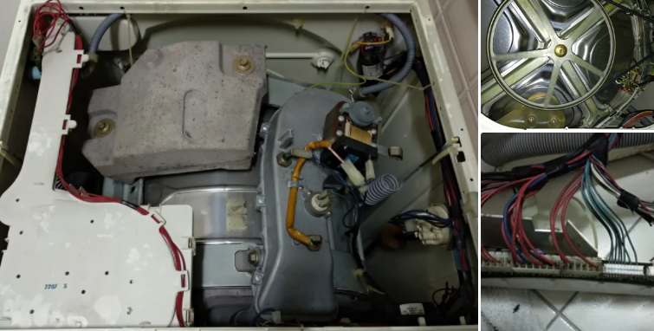
Figure 3.1 internal parts of washing machine
Step 2. Opening the machine and test components
After opening the machine, on the top and the back, I've tested all the electromechanical components, to verify if they were good.
The machine has different types of components:
- Solenoid valves
- Heating resistors
- Motors
- Resistive temperature sensors
- Pressure switch
You can test all of these components just by measuring the resistance between terminals, using the ohmmeter function from a multimeter.
On my case all the components seemed to be good and the suspect falls on electronic controller board.
Step 2: Inspect the Electronic Board
The electronic board was easy to disassemble and inspect. Immediately I observed that two tracks on the PCB where melted. Good! I found the problem! Bad! Something is burned .Then I follow the tracks and observed the components on the circuit and found a "black component" (TO-92 type of package) that was cracked.
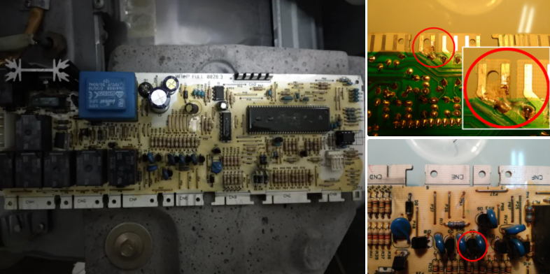
Figure 3.2 parts of burned transistor
The cause of the fail
This board worked for many years, but a design problem caused the fail. Two tracks were too close. The clearance between this two tracks wasn't enough and with humidity and because the solder mask of this PCB was of bad quality, a surge current caused a short circuit on a weak spot. The surge caused the two tracks to melt and caused the "black component" to conduct very high current that cause the component to heat very fast and explode!
However the designer of this circuit include a special component, called MOV (Metal-oxide Varistor) that absorbed the energy of the surge current and avoid that the components of the circuit burn, specially the IC's that are more sensitive than other discreet components and more difficult to find a replacement.
Step 3: Identify the Burned Component and Testing
Usually a component encapsulated on TO-92 casing is a transistor, but on this case after a close look on other similar components on the board I found this reference: Z0607After googling "Z0607 data sheet.
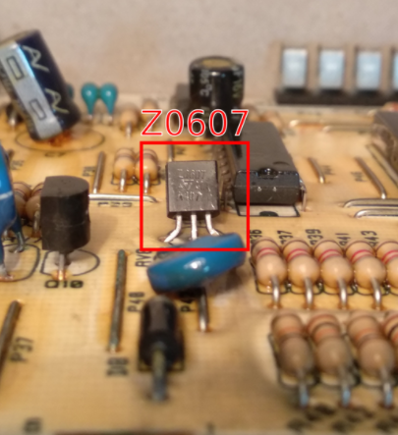
Figure 3.3 Z0607 model transistors
Testing a resistor is easy. You only have to use the ohmmeter function of your multimeter to read the value and confirm if is according the color coding stripes of the component, but testing a "black component" is much more difficult, right?
No. Can be very easy. On this case I had the luck of knowing the component reference and found the data sheet with pin out.
Step 4: Repairing the Electronic Board
The circuit that burned was an output signal and apparently I only have to replace the explode Triac, but I realized that this board had 6 similar output circuits and one of them was not being used. This was pure luck since I saw that the connector was missing some wires. One output circuit was not being used on this machine model!
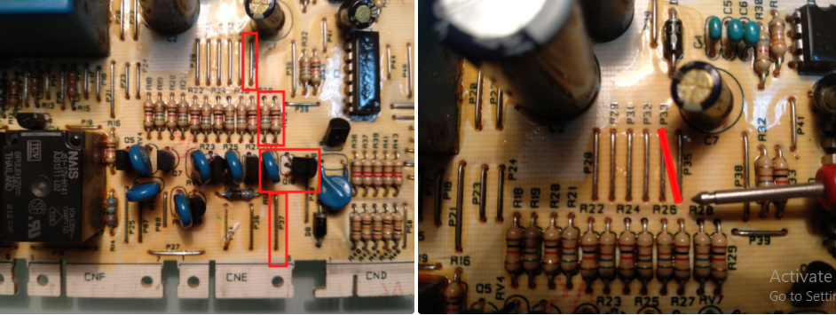
Figure 3.4 repaired board
Step 5: The Tools You Need
You don't need many tools to make this kind of repair.
- Digital Multimeter
- Tweezers
- Soldering Iron
- Isolating varnish
  - Solder/mount and repairing defective parts & components
Soldering is a process used for joining metal parts to form a mechanical or electrical bond. It typically uses a low melting point metal alloy (solder) which is melted and applied to the metal parts to be joined and these bonds to the metal parts and forms a connection when the solder solidifies.
The goal of any soldering process is to melt the solder between the metal pins of the component and the metal pads on the circuit board so that when it hardens there is a strong metal bond between the two surfaces. With the wave process the board and its pins to be soldered were passed over a wave of molten solder.
For a more thorough overview of soldering techniques, check out my other Intro to Soldering instruct able.
Step 1: Solder. For Simple Bots, the ideal solder is
Step 2: Turn It On
Step 3: Picking It Up
Step 4: Putting It Down
Step 5: Tin the Tip
Step 6: Strip Wires
Step 7: Twist
Step 8: finally solder the components
  - Control settings/adjustments
What your washing machine control panel does: Your washing machine has three main settings: agitation, length, and temperature. These are the main features your machine has which allow you to tailor your wash to the fabrics you're cleaning. Setting Agitation. For delicates, you need less agitation
The speed/temperature control is pretty simple. Each plastic rocker engages two sets of contacts, either opening or closing the circuit connected to those contacts. For each switch, there is always one closed and one open set of contacts. The level sensor uses a pressure switch to detect the water level in the tub
  - Repair activity within the time frame
Scheduled maintenance is any repair and service work performed within a set timeframe. It details when given maintenance tasks are performed and by who. Scheduled maintenance may occur at repeating intervals or in response to a work request. In addition to managing the time at which maintenance tasks should occur, scheduled maintenance also deals with who performs those tasks. The time it takes for the job to be completed is compared with available work hours, which are factored into the schedule.
The most important aspects of a successful planned maintenance programme are:
- Identifying what to do and why – including what not to do
- Ensuring the availability of spares, tools and other equipment, such as scaffolding
- Continuing to inspect machinery during repairs and replacement, to uncover other areas which need attention.

  - Care and extreme precaution in handling the unit/product
Before cleaning or carrying out maintenance, unplug the appliance from the electrical outlet or set the (On/Off) button to off.
- Make sure that the pockets of all clothing to be washed are empty. Hard, sharp objects, such as coins, safety pins, nails, screws, or stones can cause extensive damage to the appliance.
- Always unplug the appliance and turn off the water after use.
- Before you open the door of the appliance, check that the water has drained. Do not open the door if you can still see water.
- Pets and small children may climb into the appliance. Check the appliance before each use.
- The glass door becomes very hot during the washing cycle. Keep children away from the appliance while it is in use.
- Do not attempt to repair the appliance yourself. Repairs made by inexperienced or unqualified persons may cause injury and/or make more serious repairs to the appliance necessary
- If the plug (power supply cord) is damaged, it must be replaced by the manufacturer or its service agent or a similar qualified person in order to avoid a hazard.
- This appliance should only be serviced by an authorized service center, and only genuine spare parts should be used.
- If this appliance is supplied from a cord extension set or an electrical portable outlet device, the cord extension set or electrical portable outlet device must be positioned so that it is not subject to splashing or ingress of moisture. Additionally, the cord extension set or electrical portable out let device must be of a current rating suitable for the appliance.
- This appliance is not intended for use by young children or infirm persons unless they have been adequately supervised by a responsible person to ensure that they can use the appliance safely. Young children should be supervised to ensure that they do not play with the appliance.
- This appliance has to be connected to the plug endurable to proper power consumption.
- This appliance has to be positioned so that the plug is accessible after installation.
- Do not use processed water containing oil, cream or lotion, which is usually found in skin-care shops or massage clinics. Otherwise this will cause the packing to be deformed, which causes a malfunction or water leak.
- A stainless washing tube does not usually rust. However if some metal such as a hair pin is left in the tube for an extended time, the tube could rust. Do not leave water or bleach containing chlorine in the tube for an extended period of time. Do not regularly use or leave water containing iron in the tube for an extended period of time. If rust starts appearing on the surface of the tube, apply a cleansing agent (neutral) to the surface and use a sponge or soft cloth to clean it. (Under no circumstances use a metal brush)

Self cheek 3.1
Test I: for the following questions write ‘true’ if the statement is correct and ‘false’ if the statement is incorrect and explain the reason.
_________1. Workplace safety is an important part of any job and requires that everyone in the company adhere to the safety guidelines and policies in place
_________2. Occupational health and safety is not an extensive multidisciplinary field.
_________3. Occupational health and safety policies must be implemented at both the national (governmental) and enterprise levels
________4. ESD stands for Electro-static discharge
________5. Soldering is a process used for joining metal parts to form a mechanical or electrical bond
Test II: - Explain short answer for the following questions
  - List and explain at least three core Occupational health and safety principles.
  - Mention three reasons to repair something.
  - List process of soldering.
  - List four tools used to repair washing machine circuit board

Operation sheet 3.1
Operation sheet title: - Replace defective parts/components of washing machine board
Purpose: - To replace defective burned transistor of washing machine
Instruction: - Using the given equipments Replace defective burned transistor, of washing machine board. You have given 60 Minuts for the task.
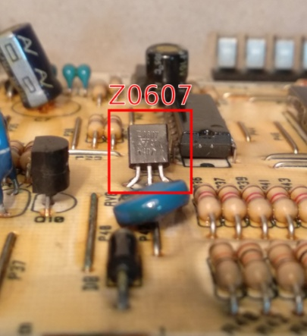
Tools and requirement
- Digital Multimeter
- Transistor
- Faulty washing machine
- Tweezers
- Soldering Iron
- Isolating varnish
Steps in doing the task
Step 1: Disassemble the Machine and Test Components
Step 2: Inspect the Electronic Board
Step 3: Identify the Burned Component (transistor) and Testing
Step 4: Repairing the Electronic Board
Step 5: De-solder burned transistor
Step 6: place and solder new transistor with similar model number

Lab test 3.1
Task1: Disassemble washing machine
Task 2: Troubleshoot the Electronic Board
Task 3: Identify the Burned Component and Testing
Task4: Repairing the Electronic Board
Task 5: De-solder burned transistor
Taskn6: place and solder new transistor

Unit Four : Test repaired unit
This unit is developed to provide you the necessary information regarding the following content coverage and topics:
- Repair and reassemble washing machine
- Test and clean the final reassembled unit
- Compile final documentations
- Dispose waste materials
This unit will also assist you to attain the learning outcomes stated in the cover page. Specifically, upon completion of this learning guide, you will be able to:
- Repair and reassemble
- Test and clean
- Compile document
- Dispose west materials

4.1. Repair and reassemble washing machine
4.1.1. Reassembling procedure
1. After replacing the defective component of the appliance, prepare the parts for reassembling. Make sure that there are no missing parts and as well as the screw/s.
2. Fix all the disassembled parts in the housing/compartment, considering the fittings/locks.
3. Wires and loose parts should be in proper place to avoid damaged due to misaligned compartment.
4. All sides of the housing should fit accordingly. Moving parts must move as it can be moved by hand and free from obstructions.
5. Tighten screw/s accordingly.
Clean the unit before doing the post-testing procedure.
Post-testing Procedure:
- Test the resistance at the AC plug to determine the continuity of the power line to the AC motor. A resistance reading must be observed as you turn the timer switch to ON position. This indicates that the circuit connection is good.
- In the case of electronically-controlled washing machine, there is no resistance reading as you test the AC plug. The reason is that there is a low-voltage power supply circuit that controls the functions of the appliance.
- Energize the unit to check its functionality. Plug the AC cord to the power source (the timer switch is at OFF position and power ON button for electronically-controlled must be OFF too). Turn the timer switch accordingly and observe if the unit functions as it should be. In the case of electronically-controlled, press button one at a time observing the behavior. This time, the unit should operate normally. If not, review the documentation and the problem for the second time.
- Test the resistance at the AC plug to determine the continuity of the power line to the AC motor. A resistance reading must be observed.
- Energize the unit to check its functionality. Press button one at a time observing the behavior.
- This time, the unit should operate normally. If not, review the documentation and the problem for the second time.

  - Test and clean the final reassembled unit
    - Testing procedure of washing machine
- Test a washing machine that fills with water but will not drain
Many homeowners have had the unpleasant experience of lifting the washing machine lid only to discover clothes floating in a tub filled with murky gray water. If you catch the machine early enough, the water is still hot or lukewarm.
  - Look for Clogs
Your machine's pump may be clogged with a piece of fabric or some other item related to washing. Bail the water out with a kitchen measuring cup and then unplug the machine. Take off the screws on the front panel. Tilt the machine up and prop the front of the machine on 2x4 boards or bricks for easier access. Your machine's pump housing may be easily visible, making it simple to assess whether you have a clog in the pump. If so, use pliers to gently untwist the clog from the pump.
  - Check the Tube
Alternatively, the clog may be located in the corrugated tube that leads to the pump. Unclamp the tube. Have a bucket or bin nearby, because this tube will be filled with water. Drain the water. If there is a clog in the hose, it will usually be at the end of the hose. Pull it out by hand or with pliers.
- Test a Washing Machine That Vibrates, and Shakes
When your washing machine is running, particularly during the spin cycle, it may violently shake or vibrate, often so much that the machine walks. This may be pronounced if you have a high-efficiency machine, which has a faster spin cycle than top-loading machines. Walking machines are very dangerous because they can become detached from the water lines or the drainage line, or they might strain at the power cord and cause an electrical fire.¹
  - Check the Machine Is Balanced
Your machine may need to be rebalanced. Use a bubble level to assess the level of the machine from side to side and front to back. Readjust the machine's level by turning the machine's legs up or down. Unlike the dryer, which has just two front adjustable legs, most washing machines have four adjustable legs
  - Tighten Any Connection Straps
With stacking washer-dryer combinations, the connection straps may have loosened, causing the unit to shake violently. This can be a dangerous situation, since the dryer may fall off of the washer. Tighten the connection straps or replace the straps if necessary.
  - Check the Load is balanced
The classic and most easily fixable cause of a shaking clothes washer is an imbalanced load. Drape long, heavy items around the central agitator so that they are not grouped on one side. Move large items to the other side of equally large items.
  - Consider an Anti-Vibration Pad
Consider purchasing an anti-vibration pad. Independent testing has shown that pads that are 3 inches thick do an excellent job of deadening the shaking and vibration.² While not inexpensive, anti-vibration pads can be a valuable tool for reducing the transmission of washer vibration on your home's floor
- Test a Washing Machine That Will Not Start
It is the most basic of all washing machine breakdowns: The machine will not start. You have put the clothes in the washing machine basin, pressed the "ON" button, or turned the dial, but nothing happens.
Step 1. Make Sure the Machine Is Plugged In
Check the power cord behind the washer to make sure that it is plugged in. Due to washers' vigorous movements, especially when the load is imbalanced, machines may move. When a machine moves, it may inadvertently unplug the power cord. Cords that have been shortened with ties have no give. In this case, untie the cord to allow for more flexibility.
Step 2. Check the Circuit Breaker
Is the circuit breaker to the washer flipped off? To reset a circuit breaker, find the electrical service panel. Locate the correct circuit breaker, flip it in the "OFF" direction, and then back to the "ON" position.
Step 3. Check the Lid
Your front loader washer's lid switch strike may be faulty. This is the area of the door frame that communicates to the machine that the door is properly closed and it is okay to begin filling with water. Close the lid and watch as the part on the door connects with the part on the machine. The top part should seat into the bottom part. If you have a top loader, test the lid by setting the machine to "ON" and then pushing into the hole with the blunt end of a pen. If working correctly, the water should begin filling even though the lid is open.
    - Cleaning procedure of repaired washing machine
Common methods of cleaning washing machine
- Lower washing temperatures and non-biological detergents do cause a build-up of soap, so wipe your detergent drawers with a damp cloth or kitchen paper as often as possible.
- Every two months, carefully pull out the drawer (check manufacturer’s instructions) and soak in hot water.
- Check your drain filters regularly for fluff, hair, lint and general debris.
- Inspect your hoses, checking for kinks and signs of wear and tear. Most manufacturers recommend changing hoses every five years.
- Keep your washing-machine’s glass door clean inside and out as dust can be a fire hazard.
- Regularly examine the door seal and remove any stray objects.
- Leave the washing-machine door ajar between wash cycles to allow air to flow and prevent mould.
- Run a maintenance wash once a month to eliminate detergent build-up. With the machine empty, set it to the highest-temperature cotton wash.
- Lower temperature washes can mean detergent residues can build up in the appliance and other parts that aren’t easy to see.
We recommend regularly cleaning the washing machine. For regular use this Super Care product works to keep the appliance and rescaled and clean. If the appliance hasn’t been maintained on a regular basis then using this Super Clean product will give the product a powerful deep clean.
    - Methods of cleaning a washing-machine pump filter
Most modern washing machines have a filter to protect the pump from obstructions.
- Check your instructions to find where yours is and how to find the retractable pipe.
- Place a towel or two on the floor, then unscrew the filter. Remove any obstructions then wash in hot, soapy water. Replace.
- If there’s no obvious filter at the front, you can remove the kick-strip at the front of the washing machine to see if it’s hidden there. It usually clips into place with three or so tabs. You may need to use a flat-bladed screwdriver, but be very careful, because kick-strips are brittle and may snap easily.
  - Compile final documentations
- Diagnose documentation is a technical communication document intended to give a user or customer information on how to solve and prevent those problems. It’s commonly written for computer hardware, electronic goods, and software but they can be written for any product.
- Proper documentation would list every stage in the process from start to end. As we discussed troubleshooting is a logical and step by step process that must be followed every time. If problems and customers are not the same, then how can even the best troubleshooting staff survive without proper documentation? It is the life support for troubleshooting.
- Troubleshooting documentation is more often than not, lengthy and can be tiring to read. Anyone who is referring to such a document for a particular problem and its resolution should not need to go through the entire documentation to find it. A well-defined and crisply laid out index should be in place to make locating the area of interest easier. The index must also have some help words that describe in layman terms some of the tongue twisting troubleshooting terminology.
- Clearly worded documentation is important to improve efficiency. Even if memory fails under pressure, the troubleshooting staff can quickly recover from that by referring to the documentation. The customer will never need to know that the staff ‘ran short’ to start with. The end perception will be one of knowledge and efficiency. Happy staff and happier customer!
- The importance of documentation in troubleshooting and other areas comes from the fact that it is a recording of a crucial and creative process that focuses on problem resolution and problem prevention. It helps members of the same team or different teams work collaboratively on customer issues or internal troubleshooting issues for quicker resolutions.
- Documentation can be very inspiring and thought provoking if written well. They provide invaluable and indispensable data that make the entire troubleshooting process and customer service for a company more robust and sustainable.
Although it is often neglected in the troubleshooting process, documentation is as important as any of the other troubleshooting procedures. Documenting a solution involves keeping a record of all the steps taken during the fix-not necessarily just the solution.
For the documentation to be of use to other network administrators in the future, it must include several key pieces of information. When documenting a procedure, include the following information:
- Date-When was the solution implemented? It is important to know the date because if problems occur after your changes, knowing the date of your fix makes it easier to determine whether your changes caused the problems.
- Why-Although it is obvious when a problem is fixed while it is done, a few weeks later, it might become less clear why that solution was needed. Documenting why the fix was made is important because if the same problem appears on another system, you can use this information to reduce time finding the solution.
- What-The successful fix should be detailed, along with information about any changes to the configuration of the system or network that were made to achieve the fix. Additional information should include version numbers for software patches or firmware, as appropriate.
- Results-Many administrators choose to include information on both successes and failures. The documentation of failures can prevent you from going down the same road twice, and the documentation of successful solutions can reduce the time it takes to get a system or network up and running.
- Who-It might be that information is left out of the documentation, or someone simply wants to ask a few questions about a solution. In both cases, if the name of the person who made a fix is in the documentation, the person can easily be tracked down. This is more of a concern in environments in which there are a number of IT staff, or if system repairs are performed by contractors instead of company employees.
  - Dispose waste materials
Waste disposal, the collection, processing, and recycling or deposition of the waste materials of human society. Waste is classified by source and composition. Broadly speaking, waste materials are either liquid or solid in form, and their components may be either hazardous or inert in their effects on health and the environment. The term waste is typically applied to solid waste, sewage (wastewater), hazardous waste, and electronic waste.
In industrialized countries, municipal liquid waste is funneled through sewage systems, where it undergoes wastewater treatment, or sewage treatment. This process removes most or all of the impurities from wastewater, or sewage, before they can reach groundwater aquifers or surface waters such as rivers, lakes, estuaries, and oceans. (For more information on sewage systems and treatment, see wastewater treatment

Methods of Dispose Waste materials
Landfill
In this process, the waste that cannot be reused or recycled are separated out and spread as a thin layer in low-lying areas across a city. A layer of soil is added after each layer of garbage. However, once this process is complete, the area is declared unfit for construction of buildings for the next 20 years. Instead, it can only be used as a playground or a park.
Incineration
Incineration is the process of controlled combustion of garbage to reduce it to incombustible matter such as ash and waste gas. The exhaust gases from this process may be toxic, hence it is treated before being released into the environment. This process reduces the volume of waste by 90 per cent and is considered as one of the most hygienic methods of waste disposal. In some cases, the heat generated is used to produce electricity. However, some consider this process, not quite environmentally friendly due to the generation of greenhouse gases such as carbon dioxide and carbon monoxide.
Waste Compaction
The waste materials such as cans and plastic bottles are compacted into blocks and sent for recycling. This process prevents the oxidation of metals and reduces airspace need, thus making transportation and positioning easy.
Biogas Generation
Biodegradable waste, such as food items, animal waste or organic industrial waste from food packaging industries is sent to bio-degradation plants. In bio-degradation plants, they are converted to biogas by degradation with the help of bacteria, fungi, or other microbes. Here, the organic matter serves as food for the micro-organisms. The degradation can happen aerobically (with oxygen) or an aerobically (without oxygen). Biogas is generated as a result of this process, which is used as fuel, and the residue is used as manure.
Composting
All organic materials decompose with time. Food scraps, yard waste, etc., make up for one of the major organic wastes we throw every day. The process of composting starts with these organic wastes being buried under layers of soil and then, are left to decay under the action of microorganisms such as bacteria and fungi.
This results in the formation of nutrient-rich manure. Also, this process ensures that the nutrients are replenished in the soil. Besides enriching the soil, composting also increases the water retention capacity. In agriculture, it is the best alternative to chemical fertilizers.
Vermicomposting
Vermicomposting is the process of using worms for the degradation of organic matter into nutrient-rich manure. Worms consume and digest the organic matter. The by-products of digestion which are excreted out by the worms make the soil nutrient-rich, thus enhancing the growth of bacteria and fungi. It is also far more effective than traditional composting.

Self-check 4.1
Test I: Choose and encircle the best answer from the given alternatives
- When the washing machine fills with water but will not drain, you must check
- Look for Clogs
- Check the Tube
- Check motor
- a and b
- your washing Machine is Vibrates, and Shakes what is your solution
  - Check the Machine is Balanced
  - Tighten any Connection Straps
  - Consider an Anti-Vibration Pad
  - Check the load is balanced
  - All
- Which one of the following is not methods of cleaning a washing-machine pump filter
- Check your instructions to find where yours is and how to find the retractable pipe.
- Place a towel on the floor, and then unscrew the filter. Remove any obstructions then wash in hot, soapy water. Replace.
- If there’s no obvious filter at the front, you can remove the kick-strip at the front of the washing machine to see if it’s hidden there.
- All
- Documenting procedure include the following information except
- Date
- Why
- What
- Input

Test II: Answer the following questions
1._______________is an essential requirement for any manufacture, home construction, service, repair and any other area in contact with electronic boards and components.
2._______________ is the process of using worms for the degradation of organic matter into nutrient-rich manure.
3. _____________is the process of controlled combustion of garbage to reduce it to incombustible matter such as ash and waste gas.
Test III: Answer the following questions briefly
- list and explain two steps of testing washing machine that will not start
- List and explain four Methods of Dispose Waste materials

Operation sheet 4.1
- Operation sheet title: - Test a Washing Machine problems of Vibrates, and Shakes
Purpose: - To test Vibrates, and Shakes problems of Washing Machine
Instruction: - Using the given equipments test Vibrates, and Shakes problems of Washing Machine. You have given 75 Minuts for the task.
Tools and requirement
- washing machine
- power source for checking
Steps in doing the task
Step1: Balance the placement of washing machine
Step 2: Tighten Any Connection Straps
Step3: Balance the Load of washing machine
Step4: finally check the problem is corrected
Step5: adjust Anti-Vibration Pad

LAB test 4.1
Task1: make it balance washing machine
Task2: Tighten Connection Straps
Task3: Balance Load of washing machine
Task4: check the problem is corrected
Task5:adjust anti vibration pad

Reference
- De Carlo, F., Borgia, O., Tucci, M. (2013) Accelerated degradation tests for reliability estimation of a new product: A case study for washing machines. Proc. Inst. 3.Mech. Eng. Part O J. Risk Reliab. 228, 127–138. doi:10.1177/1748006X13500650
- EN 60456:2016 Clothes washing machines for household use - Methods for measuring the performance (IEC 60456:2016, modified).
- WRAP (2011) Specifying durability and repair in washing machines — A case study of two washing machines by Siemens and Bosch to illustrate and encourage durability and repair.
- https://www.electronics-notes.com/articles/constructional_techniques/electrostatic-discharge/esd-protection.php
- https://www.etechnog.com/2021/11/washing-machine-wiring-connection-circuit.html
- https://bestengineeringprojects.com/electronics-washing-machine-control-circuit-diagram/
- https://www.instructables.com/How-to-Use-a-Washing-Machine-Motor/
- http://www.wrapcymru.org.uk/sites/files/wrap/Washing%20machine%20case%20study %20AG.pdf (Accessed on 2 October 2018)

The trainers who developed the Module (training material) preparation
No | Name | Qualification | Educational background | Region | College | Mobile number | E-mail
1 | Tesfahun Ayalew Denigdine | B.SC -Applied Electrical/Electronic Technology  M.Sc. -Electronics and comm Eng. |  | BGRS | Assosa poly TVT College | 0912132308 | tesfugps44@gmial.com
2 | Yidnekachew Regassa Hirpa | B.Sc - Applied Electrical/Electronic Technology  M.Sc. - Electronic & communication Technology |  | Harari | Harari poly TVT College | 0910343909 | Yidne888@gmail.com
3 | Mohammed Seid Hussen | B.SC – Electrical/Electronic Technology  M.Sc – in electrical & communication Techno.mag,t |  | Ahmara | w/sihen Poly TVT College | 0913174837 | Tofikfuad606@gmail.com
4 | Berihun  Belaynew mesganaw | BA.T - Electronic & communication Technology. |  | Oromia | M.G.Mulugata Buli Poly TVT Collge | 0912836044 | berihunbelaynew@gamil.com

