Electrical/Electronic Equipment Servicing Level-II
Based on April, 2022 Curriculum Version 1

Module Title: - Install and Repair Multimedia Equipment
Module code: EIS EEES2 11 0322
Nominal duration: 150Hour

Prepared by: Ministry of Labor and Skill
August, 2022
Addis Ababa, Ethiopia

Table of Contents
Table of Contents 2
Acknowledgement 4
Acronym 5
Introduction to the unit 6
Unit one Prepare unit, tools and workstation 9
1.1 Identify, obtain and understand OHS procedures 9
1.2 Prepare necessary tools and test instruments with PPE. 11
1.2.1. Tools and Test Equipment 11
1.2.2. Test Instrument 14
1.3 Identify and conduct, audio systems and products defects 16
1.3.1. Symptoms 17
1.3.2.Fault 18
1.4. Audio-equipment and Systems 18
1.4.1.GEEPAS and Amplifier 18
1.4.2 Electronic musical instruments/keyboards 35
1.4.3 Professional audio/Public-address (PA) systems and Mixer 51
1.4.4 Mixer 57
1.5 Verify repair/maintenance history. 73
1.5.1. General information 74
1.6 Require and obtain Service manuals for repair/maintenance. 79
1.6.1. Instructions for normal or intended operations. 81
Self-Check 1 83
Operation sheet 1 84
Lap test 1 85
Unit two Diagnose Faults 87
2.1 Systematic pre-testing procedure is observed 87
2.2 Identifying system defects/fault symptoms. 88
2.3. Using test instruments with user manuals. 90
2.4 checking and isolating Circuits using specific testing procedures 93
2.5 Identifying defects and faults. 98
2.6 Checking Control settings/adjustments 106
2.7 Completing documentation 107
2.8 Advising Customers 109
Self-Check 2 112
Operation sheet 2 113
Lap test 2 114
Unit Three Install and repair product 116
3.1 Using personal protective equipment with OHS practices 116
3.2 Following electro-statics discharge (ESD) protection procedure 117
3.3 . Replacing defective parts/components with appropriate equivalent ratings 119
3.4 Solder replaced defective components 122
3.5 Performing Control settings/adjustments 123
3.6 Installing and configuring multimedia components/equipment’s 126
3.7 Performing Repair Activity 127
3.8 Observing Care and Extreme Precaution 131
Self-Check 3 135
Operation sheet 3 136
Lap test 3 137
Unit Four Test repaired Product 139
4.1 Repairing and reassembling units. 139
4.2 Testing and cleaning the final reassembling units 140
4.3 Service completion procedures and documentations are complied 141
4.4 Dispose Waste materials 142
Self-Check 4 144
Operation sheet 4: 145
Lap test 4 146
Reference 147

Acknowledgement
Ministry of Labor and Skills wish to extend thanks and appreciation to the many representatives of TVT instructors and respective industry experts who donated their time and expertise to the development of this Teaching, Training and Learning Materials (TTLM).

Acronym
PCB --------------------------------------------------------- Printed Circuit Board
MH ---------------------------------------------------------- Milli Henery
SMD ----------------------------------------------------------Surface Mounted components
LCR---------------------------------------------------------- Inductance Capacitance Resistance
LED --------------------------------------------------------- light Emitting Diode
AC ----------------------------------------------------------- Alternating Current
DC ----------------------------------------------------------- Direct Current
PA ----------------------------------------------------------- public Address
RF ----------------------------------------------------------- Radio Frequency
DAC ---------------------------------------------------------Digital Analog Converter
FET ---------------------------------------------------------- Field Effect Transistor
IF ------------------------------------------------------------ Intermodulate Frequency
DB ---------------------------------------------------------- Deci Bill
GHZ--------------------------------------------------------- Giga Hertz
IQ ------------------------------------------------------------In-Phase Quadrature
LTC --------------------------------------------------------- Low Temperature Confired
BOM--------------------------------------------------------- Bill off Materials
ATE---------------------------------------------------------- automated Test Equipment
ESD --------------------------------------------------------- Electro static Discharge
LCD--------------------------------------------------------- Liquid Crystal Display

Introduction to the unit
In Electrical/electronic equipment servicing filed;;the install and repair multimedia equipment helps to know ; Identifying and conducting, audio systems and products defects like Geepas amplifier Electronic musical instruments/keyboards, Professional audio/Public-address (PA) systems and Mixer, Verifying repair/maintenance history, Requiring and obtaining Service manuals for repair/maintenance, Diagnose faults, Observing systematic pre-testing procedure with in manufacturer’s instructions, Install and repair product, test repaired product.
This module is designed to meet the industry requirement under the performing of install and repair multimedia equipment..
This unit covers the topics :
- Prepare unit, tools and workstation
- Diagnose faults
- Install and repair product
- Test repaired product
Learning Objective of the unit
- Prepare unit, tools and workstation
- Diagnose faults
- Install and repair product
- Test repaired product
unit Instruction
For effective use this unit trainees are expected to follow the following unit instruction:

1. Read the specific objectives of this unit.

2. Follow the instructions described below

3. Read the information written in the “unit”. Try to understand what are being

discussed.

Ask you teacher for assistance if you have hard time understanding them.

4. Accomplish the “Self-checks” in each units.

5. Ask from your teacher the key to correction (key answers) or you can request your

teacher to correct your work. (You are to get the key answer only after you finished

answering the (Self-checks).

6. If you earned a satisfactory evaluation proceed to “Operation sheets and LAP Tests

if any”. However, if your rating is unsatisfactory, see your teacher for further

instructions or go back to Learning Activity.

7. After you accomplish Operation sheets and LAP Tests, ensure you have a formative

assessment and get a satisfactory result

8.Then proceed to the next unit.

Unit one- Prepare unit, tools and workstation
This unit is developed to provide you the necessary information regarding the following content coverage and topics:
- Preparing workstation and work specifications for repair job
- Preparing necessary tools and test instruments with PPE.
- Identifying and conducting, audio systems and products defects
- Audio-equipment and Systems
- GEEPAS and Amplifier
- Electronic musical instruments/keyboards
- Professional audio/Public-address (PA) systems and Mixer
- Verifying repair/maintenance history.
- Requiring and obtaining Service manuals for repair/maintenance.
This unit will also assist you to attain the units stated in the cover page. Specifically, upon
completion of this unit, you will be able to:
- Prepare workstation and work specifications for repair job
- Prepare necessary tools and test instruments with PPE.
- Identify and conduct, audio systems and products defects
- Audio-equipment and Systems
- GEEPAS and Amplifier
- Electronic musical instruments/keyboards
- Professional audio/Public-address (PA) systems and Mixer
- Verify repair/maintenance history.
- Require and obtain Service manuals for repair/maintenance.

Unit one Prepare unit, tools and workstation

1.1 Identify, obtain and understand OHS procedures
OHS procedures for a given work area are identified, obtained and understood through established routines Occupational safety and health (OSH), also commonly referred to workplace health and safety (WHS), is a multidisciplinary field concerned with of people at work.
Safety Using Hand Tools and Equipment
- All tools must be kept in good condition with regular maintenance.
- Right tool must be used for job.
- Each tool must be examined before use and damaged or defective tools not to be used.
- Tools must be operated according to manufacturer’s instruction.
- The right protective equipment for the tool and activity must be used.
The following is a list of the minimum safety precautions for using a voltmeter:
- Always connect voltmeters in parallel.
- Always start with the highest range of a voltmeter.
- Reenergize and discharge the circuit completely before connecting or disconnecting the voltmeter.
- In dc voltmeters, observe the proper circuit polarity to prevent damage to the meter.
- Never use a dc voltmeter to measure ac voltage
OSH may also protect co-workers, family members, employers, customers, and many others who might be affected by the workplace environment.
Many people have been scalped in this type of accident.
- Do not wear rings or wrist watches while on the job.
- Such item can be caught by moving machinery.
- It is extremely dangerous to wear them in certain types of work.
- You may lose your fingers.
- Do not wear earrings, neck chains, pendants and bracelets.
- All items or personal jewelry worn at work have the potential to cause an accident or aggravate an injury sustained by an accident.
- Wear personal protective equipment suitable to the kind of work to be done.
- Learn the purpose of each item from the wide range of protective devices available.
The term occupational health and safety is referred to as occupational health and occupational and non-occupational safety and includes safety for activities outside of work.
- Employers have a common law duty to take reasonable care of the safety of their employees.
- Statute law may in addition impose other general duties, introduce specific duties, and create government bodies with powers to regulate workplace safety issues.
All organizations have the duty to ensure that employees and any other person who may be affected by the organization's activities remain safe at all times.
As defined by the World Health Organization (WHO) "occupational health deals with all aspects of health and safety in the workplace and has a strong focus on primary prevention of hazards.
"The main focus in occupational health is on three different objectives:
- The maintenance and promotion of workers’ health and working capacity;
- The improvement of working environment and work to become conducive to safety and health.
- Development of work organizations and working cultures in a direction which supports health and safety at work and in doing so also promotes a positive social climate and smooth operation and may enhance productivity of the undertakings.
The concept of working culture is intended in this context to mean a reflection of the essential value systems adopted by the undertaking concerned. Such a culture is reflected in practice in the managerial systems, personnel policy, principles for participation, training policies and quality management of the undertaking."Occupational health should aim at:
- The promotion and maintenance of the highest degree of physical, mental and social well-being of workers in all occupations.
- the prevention amongst workers of departures from health caused by their working conditions;
- the protection of workers in their employment from risks resulting from factors adverse to health;
- the placing and maintenance of the worker in an occupational environment adapted to his physiological and psychological capabilities; and, to summarize,
- the adaptation of work to man and of each man to his job
Arrangements of an organization or enterprise to meet their legal and ethical obligations of ensuring the workplace is safe and without risk to health. This may include:
- hazardous and risk assessment mechanisms
- implementation of safety regulations
- safety training
- safety systems incorporating,
- work clearance procedures
- isolation procedures
- gas and vapor
- monitoring/testing procedures
- use of protective equipment and clothing Ethiopia electronics code
- It is the employer’s responsibility to provide protective clothing and equipment
- Work clothes and specially designed protective clothing designed for your protection.
- Wear the correct clothing and equipment to protect you from possible serious injury.
- Do not interfere with or misuse any item provided by your employer for health and safety.
- Wear plain, tough clothes that are closefitting and keep them buttoned up.
- Loose sleeves, unbuttoned or torn shirts or sweaters, ties or loose belts can easily be caught in revolving machinery.
- Your work clothes should be cleaned regularly.
- Wear cuff less trousers.
- Trouser cuffs may cause you to trip or they may catch sparks or harmful substances.
- Wear suitable footwear and keep it in good repair.
- Wear safety shoes or boots with insulated sole for electrical work.
Burning from hot turning drops of molten metal Safety shoes and boots will reinforce toecaps to protect against heavy falling objects.
Keep long hair under a tight fitting cap or net, as required by the regulations. It is your employer’s duty to ensure that machineries have guards to protect employees who work closely to the machine. More so, if your hair is long, it can be easily caught by the machinery, like the frilling machine.

1.2 Prepare necessary tools and test instruments with PPE.

1.2.1. Tools and Test Equipment
The tools and test equipment needed for electronic troubleshooting. You will need an assortment of tools and test equipment ranging from simple tool such as the screwdriver to sophisticated equipment like the Digital oscilloscope. Some simple fault of electronic equipment can be repaired by using only basic tools and test equipment. But if you are repairing electronic equipment for a living or you want to be ready to repair all kinds of electronic problems that come your way, you will need to invest in some specialized equipment. You can then be ready to move quickly when trouble strikes!!
Tools
Tools are the basic requirement of a service technician or engineer. Without tools, one cannot even open the cabinet and have access to the circuits.
- Soldering Irons
Overheating can easily destroy transistor and ICs. For this reason, you must choose carefully when you select a soldering iron for use with digital circuit like CMOS IC. Use a low- powered iron, with a rating of about 30 watts. Do not use a high-powered iron, because it can easily overheat an IC or other parts. If you overheat a trace on a circuit board, the heat can cause the trace to lift from the board. Soldering tips can be manufactured in a wide range of shapes and sizes. Before you select the best tip for the job, you must understand the ideal soldering conditions. Remember to turn off the equipment before you make any solder repairs.
- Sponges
Always keep a damp sponge near your soldering station, and wipe the tip of the hot iron frequently while you’re soldering. This will keep the tip clean and shinny for maximum heat transfer.
- Soldering Iron Holders
If you have a soldering iron with no switch, (some soldering irons have a switch, where each press will increase the power from 30w to 120w), it will remain hot all the time when it is plugged in. Sometimes the solder iron becomes too hot and it melts the plastic case of the soldering iron. The holder is often formed into a spiral, with lots of air space to radiate the heat from the iron and also to prevent the soldering tip from touching other parts which can sometimes cause fire.
- Solder
Solder is related by the proportion of lead to tin. For example, “60/40” solder is 60% tin and 40% lead. The diameter of the solder that I usually used is 0.8mm. Most solders are manufactured with a hollow center that contains “flux”. As a solder melts, the flux cleans the parts and prevents oxidation to ensure a good connection. Always use resin-core solder and under no circumstances should you use paste flux containing acids or solvents or use solder containing acid flux. Harsh solvents destroy delicate components leads and circuit traces.
- Heat guns
You can often use temperature as a diagnostic tool. Many intermittent are thermal. That is, they appear at one extreme temperature or another. If the problem shows up only at a high temperature, it may be very difficult to find with the cover removed. With the cover removed, the circuits usually run much cooler, and a thermal intermittent will not show. In this case, it may be necessary to use a little heat to identify the problem. A home hair dryer works well if you use the lowest possible heat setting. Be careful not to overheat the circuits. Certain plastic materials can be easily damaged.
- Freeze Sprays
Freeze sprays or spray coolers are available for tracing thermal intermittent. They use chemicals such as Freon to rapidly cool circuit components. A spray tube is included to control the application closely. Thus, it is easy to confine the spray to a specific component at one time. Be very careful not to use just any spray coolant. Some can generate static charges in the thousands of volts when they are used. Sensitive devices can be damaged by static discharges, so buy a brand that is specified as “anti-static”.
- Dental Mirrors
A small, adjustable dental mirror is helpful when you need to look into out-of-the-way places especially if the components are located under the belly of the CRT.
- Screwdrivers
Screws are made in different sizes, and they’re designed to be turned by screwdrivers of the corresponding sizes. You will need a good set of screwdrivers with both Philips and flat slotted heads. Many people have the habit of trying to turn a screw with whichever screwdriver they have. Most screws can be turned easily if you use a screwdriver of the right size.
A power screwdriver is also useful in electronic servicing because some equipment have numerous screws, that your hand will get tired unscrewing them.
- Long-Nose Pliers
A long-nose plier is needed to remove components once they are desoldered from the PCB board. They are very useful for reaching into tight spaces inside the equipment. For example, components located under the belly of the CRT are very difficult to remove without pliers.
- Wire Cutters
Wire cutters are useful for cutting wires, wire ties, and lead on large parts, such as resistors and capacitors.
- Wire Strippers
Before you can make connections with a piece of wire, you must “strip” away the plastic insulation on a wire. Resist the temptation to strip insulation using wire cutters. Even if insulation should be removed successfully, wire cutters often leave a nick or pinch in the conductor, which later might fatigue and break.
- Magnifying Lamp
A magnifying lamp not only provides light, but also makes it easier to read component marking especially the surface mounted components (SMD) and small resistor color code. A magnifying lamp also can be use to check for cracks, broken solder joints or burnt components in a PCB board.
- Spray Cleaner
The wiper at a variable resistor might accumulate dust after operating for a certain amount of time. This can result in all types of erratic or intermittent circuit problem. A spray cleaner can be used to solve this kind of problem. However if symptom persists, replace the variable resistor.
Toothbrush
You may use a toothbrush to look for intermittent or bad connection in a PCB board. Simply run the toothbrush over the PCB board until you push the bad connection into working. Most of the time you can locate the fault using this way.
In addition to the above listed tools, some tools like table vice, hammer with nail extractor and drill machine are also used in workshops especially for installation and dismantling work.

1.2.2. Test Instrument
In this section, we highlighted general equipment for electronic servicing. Some equipment, such as a multimeter, is an absolute necessity for the test bench. Other equipment, such as a transistor tester, is useful but not imperative to have. In any case, the more equipment you have, the more prepared you will be to troubleshoot all kinds of electronic equipment problems.
- Multi meters
There are two types of multi meters in the market, one is the analog while the other is digital. Some people call them multi meters or just meters, while other might refer to them as volt ohm meters (VOMs) or multi testers. Regardless of which name you choose to call them, multi meters are the handiest and most versatile piece of test equipment that you will ever use.
The analog meter can measure ac and dc voltage, current, and resistance, and uses a meter to read out the test results. A digital multi meter (DMM) performs the same functions, but it produces a digital display. DMM are ranked by the number of digits they display. A “3½ digit” DMM will indicate three numbers for each reading. The “half digit” is reserved for character like “+1” or “-1”. The more sophisticated meters automatically choose the correct voltage or resistance range. This feature is called “auto-ranging”. DMM are easier to read, more tolerant of operator error, and more precise than their analog multi meters.
A good DMM also include features like a capacitance checker, frequency meter, continuity checker and transistor checker. The diode setting is used for checking all solid-state devices such as ICs, diodes, transistors, SCRs and so forth.
- Oscilloscope
Oscilloscopes offer a tremendous advantage over multi meters. An oscilloscope or “scope” can give you a “picture” of a changing electronic signal. Instead of reading signals in numbers or lighted indicators, an oscilloscope will show voltage versus time on a graphical display. Not only can you observe ac and dc voltages, but is also very helpful for checking the “shape” of an electronic signal. If you know what kind of signal to expect, and the scope shows you a different signal, you know something is wrong. The scope may be used to check the operating characteristics of parts like transistors and capacitors. Oscilloscopes have been used for many years to troubleshoot power supply, amplifiers, and other analog devices.
Don’t get the idea that you will need an oscilloscope for every repair. For example, you need to check the presence of horizontal and vertical signal in the input and output of a microprocessor IC. It is also useful in checking the proper Red, Green and Blue (RGB) signal in the video circuit. Without an oscilloscope, it is difficult or almost impossible to trace the problem. The better the scope, the higher the frequency of the signals that it can display and much more expensive. Analog scope with 40 to 60 megahertz (MHz) bandwidth will serve you well. Some “dual trace” scopes can display two signals at once. This allows to you check the timing relationship of two related signal. If you have used an oscilloscope, then you probably know just how useful they can be.
DC Power Supply
In your servicing work, you will sometimes need to provide power to parts of a circuit board, without using the equipment output supply for troubleshooting purposes. The output of the power supply should be regulated so that the output voltage doesn’t change as the power supply is loaded. I use a digital type of DC power supply, which is a regulated power supply. It has a voltage range of between 0 and 30 volts and current range from 0 to 5A. The adjustable current that limits of up to 5A amps, protects both the power supply and the device under test from damage.
A power supply is useful in troubleshooting; for example, when you suspect that the microprocessor causes the Monitor cannot be turned on. You can always place a +5 volts to its VCC input pin of the microprocessor and check if the outputs are producing any signals. The power supply can be used with other circuits, such as circuit in power section, video drivers, oscillators and etc.
Capacitance Meter
Without a capacitance meter, it is sometimes difficult to determine a capacitor’s value. Choose a capacitance meter that accurately measures the value of any capacitor between 0.1PF to 20,000UF. Capacitance meter will usually display capacitance in microfarad (uf), nanofarad (nf) or picofarad (pf). As long as your reading is within the tolerance of the capacitor’s marked value, you know the part is good. It is best used to check fixed capacitor (ceramic, mylar, etc). For electrolytic type of capacitor, an ESR meter is preferred. Some DMM is also equipped with a built-in capacitor checker. Always discharge a capacitor before testing.
Inductance Meter
Most inductance meter comes together with the resistance and capacitance measurement/range. It is also called the LCR meter. Inductance meter is required to determine a coil or a winding value. Winding’s value in Flyback, power transformer, horizontal and vertical yoke coil can be checked with the inductance meter. An inductance meter will usually display inductance value directly in Henry (H), milihenry (MH) or microhenry (µH).
Specialized Test Equipment
In this section we highlight specialized equipment for repairing certain types of electronic equipment. These test equipments are specially designed to tackle only on certain type of circuit or component. Some repairs cannot be attempted without the help from the equipments. The required specialized test equipment depends upon which part of the electronic repairing field the technician or engineer wants to specialize in.

1.3 Identify and conduct, audio systems and products defects
Fault detection and diagnosis is a key component of many operations in electronic fault detection systems.
A “fault” is another word for a problem. A “root cause” fault is a fundamental, underlying problem that may lead to other problems and observable symptoms. (It might not be directly observable). A root cause is also generally associated with procedures for repair.
A "fault" or "problem does not have to be the result of a complete failure of a piece of equipment, or even involve specific hardware. For instance, a problem might be defined as non-optimal operation or off-spec product. In a process plant, root causes of non-optimal operation might be hardware failures, but problems might also be caused by poor choice of operating targets, poor feedstock quality, poor controller tuning. A symptom is an observed event or variable value, needed to detect and isolate faults. If a symptom is the response to a question or an on-demand data request (when actively testing a system instead of just passively monitoring it), it is referred to as a test or test result.
Fault detection is recognizing that a problem has occurred, even if you don't yet know the root cause. Faults may be detected by a variety of quantitative or qualitative means. This includes many of the multivariable, model-based approaches discussed later. It also includes simple, traditional techniques for single variables, such as communication and multimedia equipments and other electronics.
Fault diagnosis is pinpointing one or more root causes of problems, to the point where corrective action can be taken. This is also referred to as “fault isolation”, especially when emphasizing the distinction from fault detection. In common, casual usage, "fault diagnosis" often includes fault detection, so “fault isolation” emphasizes the distinction. Symptoms, faults and causes

1.3.1. Symptoms
When we diagnose a problem, we look at the symptoms of the fault and try to find the cause of them. What do these words mean?
A symptom is a clue that something is wrong.
It is a noticeable change - we might see, hear, smell or feel something different.
2
The engine cuts out!
3
2
Tran
Filter and IF Amplifier
The clutch feels funny...

These are both symptoms of a problem. The owner or driver recognizes them as abnormal. They won’t know what the fault is, but will know that something about the car is different.
A problem or fault in a vehicle is usually first noticed by the regular driver of the vehicle, because they are most familiar with the way it normally operates, and spend a lot of time behind the wheel.
It is the technician’s job to look at the symptom and work out what fault has caused it.

In fifth gear, the engine revs hard but the car won’t accelerate normally.
The front tyres have worn out very quickly.

The engine stopped suddenly, and it won’t re-start.

These symptoms are the abnormal things that the driver has noticed about the performance of her/his vehicle. They all point to some problem which has produced the symptom.
The common symptom for the system units selected for this UC is discussed in the information sheet above 1 above. Refer for more information.

1.3.2.Fault
A fault is an abnormal condition in a system or component. Something has gone wrong which we need to identify and repair.
Faults may be:
Hardware faults - Physical faults that we can observe or measure, such as parts which are broken, worn, out-of-specification, damaged, incorrectly adjusted or assembled.
Software faults - May not be directly observable, such as faulty, incorrect or corrupted programs in electronic modules.

1.4. Audio-equipment and Systems

1.4.1.GEEPAS and Amplifier
Amplifier is the generic term used to describe a circuit which produces and increased version of its input signal. However, not all amplifier circuits are the same as they are classified according to their circuit configurations and modes of operation.

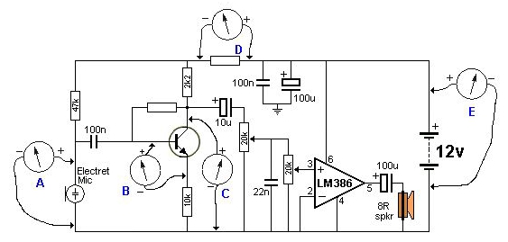

Fig 1.1 measuring voltage of amplifier circuit
In “Electronics”, small signal amplifiers are commonly used devices as they have the ability to amplify a relatively small input signal, for example from a Sensor such as a photo-device, into a much larger output signal to drive a relay, lamp or loudspeaker for example.
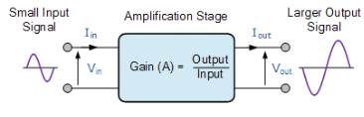
Fig 1.2 amplifier block diagram
There are many forms of electronic circuits classed as amplifiers, from Operational Amplifiers and Small Signal Amplifiers up to Large Signal and Power Amplifiers. The classification of an amplifier depends upon the size of the signal, large or small, its physical configuration and how it processes the input signal, that is the relationship between input signal and current flowing in the load.
The type or classification of an Amplifier is given in the following table.
Table 2.1. Classification of Signal Amplifier
Type of Signal | Type of  Configuration | Classification | Frequency of  Operation
Small Signal | Common Emitter | Class A Amplifier | Direct Current (DC)
Large Signal | Common Base | Class B Amplifier | Audio Frequencies (AF)
 | Common Collector | Class AB Amplifier | Radio Frequencies (RF)
 |  | Class C Amplifier | VHF, UHF and SHF  Frequencies

Amplifiers can be thought of as a simple box or block containing the amplifying device, such as a Bipolar Transistor, Field Effect Transistor or Operational Amplifier, which has two input terminals and two output terminals (ground being common) with the output signal being much greater than that of the input signal as it has been “Amplified”.
An ideal signal amplifier will have three main properties: Input Resistance or (R_{IN}), Output Resistance or (R_{OUT}) and of course amplification known commonly as Gain or (A). No matter how complicated an amplifier circuit is, a general amplifier model can still be used to show the relationship of these three properties.

Ideal Amplifier Model
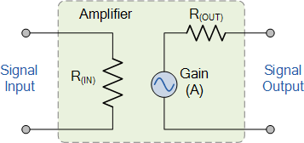
Fig 1.3 Simple representation of ideal amplifier
The amplified difference between the input and output signals is known as the Gain of the amplifier. Gain is basically a measure of how much an amplifier “amplifies” the input signal. For example, if we have an input signal of 1 volt and an output of 50 volts, then the gain of the amplifier would be “50”. In other words, the input signal has been increased by a factor of 50. This increase is called Gain.
Amplifier gain is simply the ratio of the output divided-by the input. Gain has no units as its a ratio, but in Electronics it is commonly given the symbol “A”, for Amplification. Then the gain of an amplifier is simply calculated as the “output signal divided by the input signal”.
Amplifier Gain
The introduction to the amplifier gain can be said to be the relationship that exists between the signal measured at the output with the signal measured at the input. There are three different kinds of amplifier gain which can be measured and these are: Voltage Gain ( Av ), Current Gain ( Ai ) and Power Gain ( Ap ) depending upon the quantity being measured with examples of these different types of gains are given below.
Amplifier Gain of the Input Signal
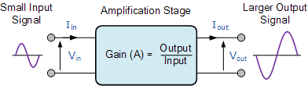
Voltage Amplifier Gain

Current Amplifier Gain

Power Amplifier Gain

Note that for the Power Gain you can also divide the power obtained at the output with the power obtained at the input. Also when calculating the gain of an amplifier, the subscripts v, i and p are used to denote the type of signal gain being used.

Ideal Amplifier
We can know specify the characteristics for an ideal amplifier from our discussion above with regards to its Gain, meaning voltage gain:
- The amplifiers gain, (A) should remain constant for varying values of input signal.
- Gain is not be affected by frequency. Signals of all frequencies must be amplified by exactly the same amount.
- The amplifiers gain must not add noise to the output signal. It should remove any noise that is already exists in the input signal.
- The amplifiers gain should not be affected by changes in temperature giving good temperature stability.
- The gain of the amplifier must remain stable over long periods of time.

Electronic Amplifier Classes
The classification of an amplifier as either a voltage or a power amplifier is made by comparing the characteristics of the input and output signals by measuring the amount of time in relation to the input signal that the current flows in the output circuit.
- Class A Amplifier – has low efficiency of less than 40% but good signal reproduction and linearity.
- Class B Amplifier – is twice as efficient as class A amplifiers with a maximum theoretical efficiency of about 70% because the amplifying device only conducts (and uses power) for half of the input signal.
- Class AB Amplifier – has an efficiency rating between that of Class A and Class B but poorer signal reproduction than Class A amplifiers.
- Class C Amplifier – is the most efficient amplifier class but distortion is very high as only a small portion of the input signal is amplified therefore the output signal bears very little resemblance to the input signal. Class C amplifiers have the worst signal reproduction.
Voltage amplifier
A voltage amplifier in simplest form is any circuit that puts out a higher voltage than the input voltage. When you are forced to work with a set amount of voltage, these amplifiers are commonly used to increase the voltage and thus the amount of power coming out of a circuit. This is useful for reading and adapting small signals such as boosting an audio signal before sending it on its way to speakers. The voltage amplifier is a form of the common emitter amplifier, which relies on the transistor; the amplification of voltage is dependent on the ratio of resistors on the collector and emitter of this transistor.
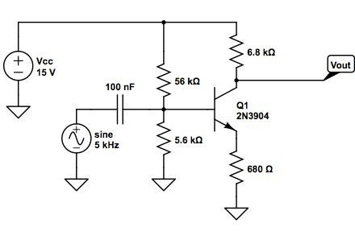
Fig 1.4 Voltage amplifier circuit schematic diagram

Current Amplifiers and Buffers
A Current amplifier is an electronic circuit that increases the magnitude of current of an input signal by a fixed multiple, and feeds it to the succeeding circuit/device. This process is termed as current amplification of an input signal.
The input can either be a constant signal or a time varying waveform. Ideally, during this process of current amplification, the current amplifier will keep the voltage component of the input signal unchanged.
Below is the circuit diagram of a simple 2-stage current amplifier circuit that uses npn and pnp transistors as the amplifying element.
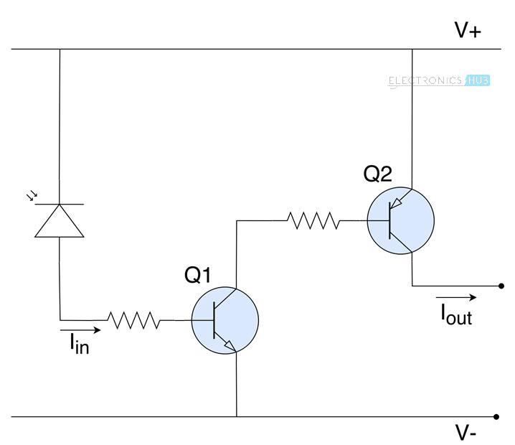
Fig 1.5 Current amplifier circuit
The photodiode absorbs energy from light and releases electrons, thereby acting as an input current source. This current from the photodiode is first amplified by the transistor Q1 and is further amplified by the transistor Q2. The resistors at the bases of both the transistors are used to adjust the gain. The number of times a signal is amplified is same as stages in an amplifier. Here the current is amplified twice, so this is a 2-stage current amplifier.

Following are some of the practical applications of current amplifiers:
- In amplifier systems, current amplifiers are used to obtain a better bass output, by increasing the intensity with which the speakers are driven.
- Current amplifiers with variable gain are used in many industrial manufacturing systems like laser and water jet cutting machines to control the intensity with which the fabrication is done
- In sensor systems, current amplifiers are used to strengthen weak input signals, for use in subsequent circuits
Current Buffer
Current buffer is an electronic circuit that is used to transfer electric current from input source having very less impedance (effective resistance) to output loads with high impedance. It is designed to prevent signal sources from getting affected because of any differences in the amount of current drawn by output loads.In most scenarios it acts as a bridge between weak input signals (like signals from sensors) and output loads that might draw larger currents. Below is the diagram of an ideal current buffer.
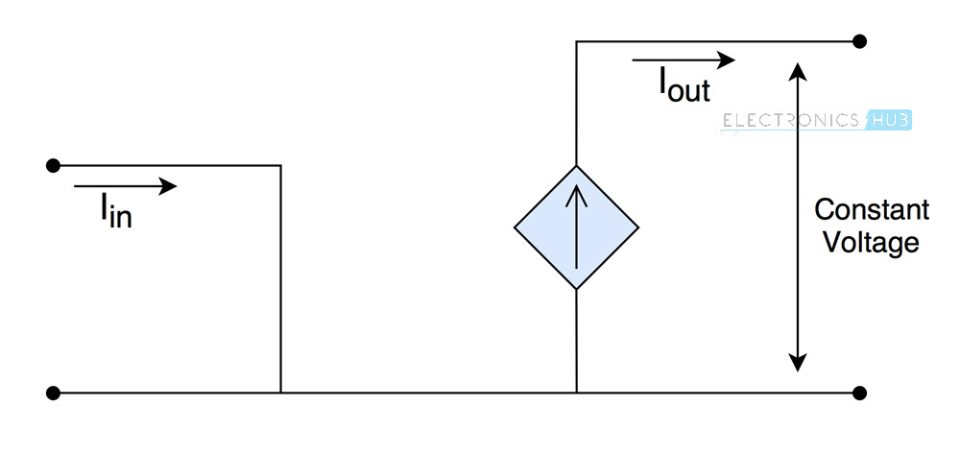
Fig 1.6 Ideal current buffer
It is primarily designed to remove the influence of output load on the input source. So you can think of current buffer as a circuit that isolates input and output circuitries while allowing the required flow of current to the output load in order to maintain a constant voltage across it.
Practical Use of a Current Buffer
Consider a circuit that uses an LDR sensor to drive a robot. The current consumed by the motors of robot is not constant and depends on the surface inclination or roughness i.e load on the motors.
Therefore, if the motors are directly coupled with the temperature sensor using a current amplifier or other similar drivers, the motors might sometimes draw more current, which affects the accuracy of the sensor. The voltage across the motors will change as well, which in turn changes speed of the robot.
In order to prevent that from happening, current buffers are used. They can provide desired current to the motors without affecting accuracy of the sensor, while maintaining a constant voltage across the terminals of motors i.e. output loads.
Current Follower
A current buffer circuit with a Gain of 1 (i.e. the input and output currents are the same) is named as a current follower. It means that a current follower circuit does not provide any amplification of current to the input signal.
You might be wondering why a current follower circuit is used as the input and output currents from the current follower are the same.
The reason is that a current follower not used to increase the output current.
But it is used to isolate input and output terminals while allowing the same amount of current flow into the input, and from the output. This is the reason why current follower circuits are also called as isolation buffers.
Below is the circuit diagram of a simple MOSFET current buffer.
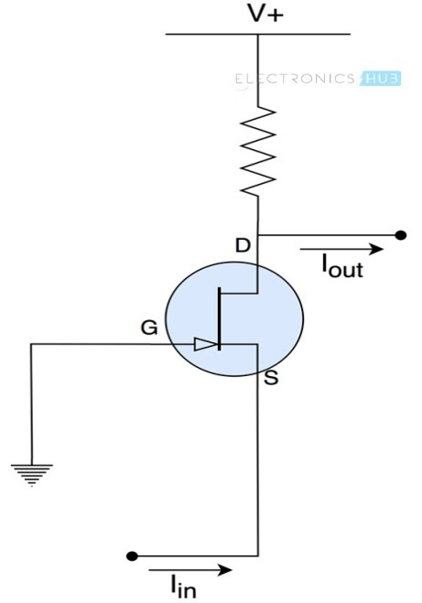
Fig 1.7 A simple MOSFET current buffer circuit
This arrangement provides very less impedance to the input signal and high impedance at the output terminal, making it a near ideal current buffer.

Applications of Current Buffers
Following are some of the practical applications of current buffers:
- In digital logic gates, current buffers are used to isolate input signals from the succeeding circuits
- Current buffers are used in high precise sensor systems in order to reduce the influence of voltage/current fluctuations because of varying output impedances
- In motor drivers and other electrical actuator systems
Power Amplifier
A power amplifier is an electronic amplifier designed to increase the magnitude of power of a given input signal. The power of the input signal is increased to a level high enough to drive loads of output devices like speakers, headphones, RF transmitters etc. Unlike voltage/current amplifiers, a power amplifier is designed to drive loads directly and is used as a final block in an amplifier chain.
The input signal to a power amplifier needs to be above a certain threshold. So instead of directly passing the raw audio/RF signal to the power amplifier, it is first pre-amplified using current/voltage amplifiers and is sent as input to the power amp after making necessary modifications. You can observe the block diagram of an audio amplifier and the usage of power amplifier below.
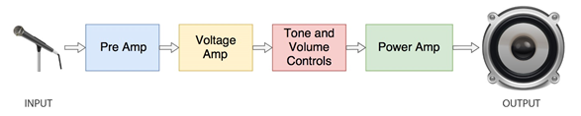
Fig 1.8 Block diagram of an audio amplifier
In this case a microphone is used as an input source. The magnitude of signal from the microphone is not enough for the power amplifier. So first it is pre-amplified where its voltage and current are increased slightly. Then the signal is passed through tone and volume controls circuit which makes aesthetic adjustments to the audio waveform. Finally the signal is passed through a power amplifier and the output from power amp is fed to a speaker.

Types of Power Amplifiers
Depending on the type of output device that is connected, power amplifiers are divided into the following three types.

Audio Power Amplifiers
This type of power amplifiers are used for increasing the magnitude of power of a weaker audio Signal. The amplifiers used in speaker driving circuitries of televisions, mobile phones etc. come under this category.
The output of an audio power amplifier ranges from a few mill watts (like in headphone amplifiers) to thousands of watts (like power amplifiers in Home theatre systems).

Radio Frequency Power Amplifiers
Wireless transmissions require modulated waves to be sent over long distances via air. The signals are transmitted using antennas and the range of transmission depends on the magnitude of power of signals fed to the antenna.
For wireless transmissions like FM broadcasting, antennas require input signals at thousands of kilowatts of power. Here, Radio Frequency Power amplifiers are employed to increase the magnitude of power of modulated waves to a level high enough for reaching required transmission distance.

DC Power Amplifiers
DC power amplifiers are used to amplify the power of a PWM(Pulse Width Modulated) signals. They are used in electronic control systems which need high power signals to drive motors or actuators. They take input from microcontroller systems, increase its power and feed the amplified signal to DC motors or Actuators.
Power Amplifier Classes
There are multiple ways of designing a power amplifier circuit.
The operation and output characteristics of each of the circuit configurations differ from each other.
To differentiate the characteristics and behavior of different power amplifier circuits, Power Amplifier Classes are used in which letter symbols are assigned to identify the method of operation.
They are broadly classified into two categories. Power amplifiers designed to amplify analog signals come under A, B, AB or C category. Power amplifiers designed to amplify Pulse Width Modulated (PWM) digital signals come under D, E, F etc.
The most commonly used power amplifiers are the ones that are used in audio amplifier circuits and they come under classes A, B, AB or C. So let’s take a look at them in detail.

Class A Power Amplifier
Analog waveforms are made up of positive highs and negative lows. In this class of amplifiers, the entire input waveform is used in the amplification process.
A single transistor is used to amplify both the positive and negative halves of the waveform. This makes their design simple and makes class A amplifiers the most commonly used type of power amplifiers. Although these classes of power amplifiers are superseded by better designs, they are still popular among hobbyists.
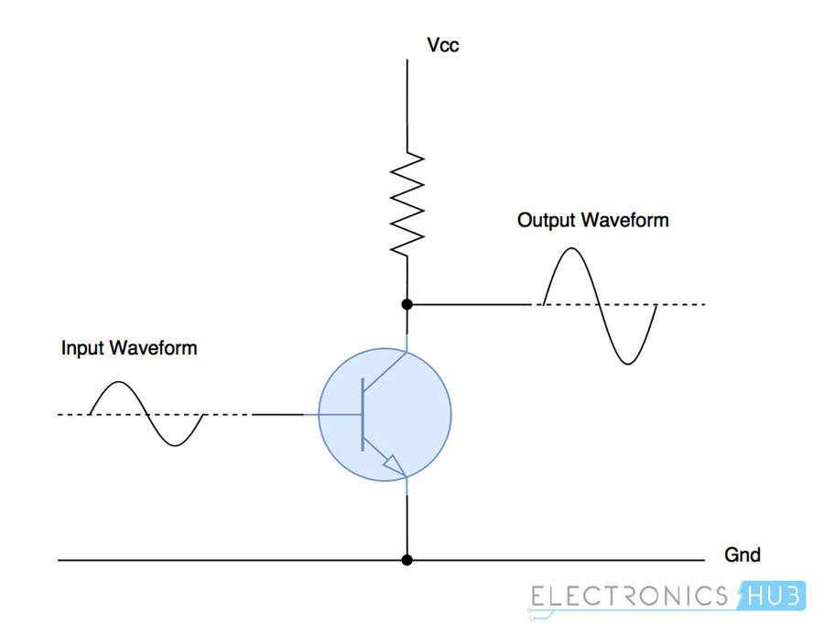

Fig 1.9 Class a Power Amplifier
In this class of amplifiers, the active element (the electronic component used for amplifying, which is transistor in this case) is in use all the time even if there is no input signal. This generates lot of heat and reduces the efficiency of class A amplifiers to 25% in normal configuration and 50% in a transformer coupled configuration.
The conduction angle (the portion of waveform used for amplification, out of 360°) for class A amplifiers is 360°. So the signal distortion levels are very less allowing better high frequency performance.

Class B Power Amplifier
Class B power amplifiers are designed to reduce the efficiency and heating problems present in the class A amplifiers. Instead of a single transistor to amplify the entire waveform, this class of amplifiers uses two complementary transistors.
One transistor amplifies positive half of the waveform and the other amplifies negative half of the waveform. So each active device conducts for one half (180°) of the waveform and two of them when combined amplify the entire signal.
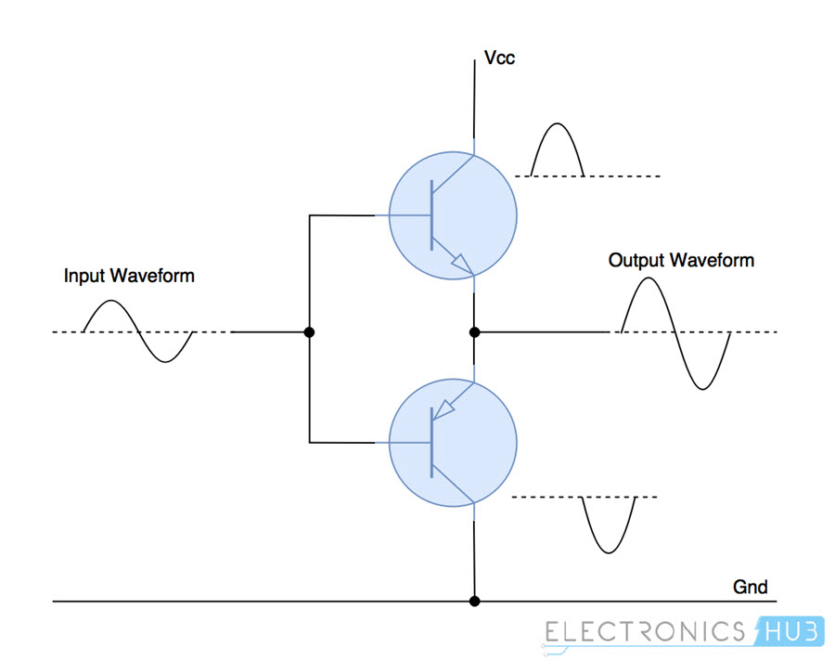

Fig 1.10 Class B Power Amplifier
The efficiency of class B amplifiers is improved a lot over class A amplifiers because of two transistor design. They can reach at AAQ theoretical efficiency of about 75%. Power amplifiers of this class are used in battery operated devices like FM radios and transistor radios.
Because of superposition of two halves of the waveform, there exists a small distortion at the crossover region. To reduce this signal distortion, class AB amplifiers are designed.

Class AB Power Amplifier
Class AB amplifiers are a combination of class A and class B amplifiers.
These classes of amplifiers are designed to reduce the less efficiency problem of class A amplifiers and distortion of signal at crossover region in class B amplifiers.
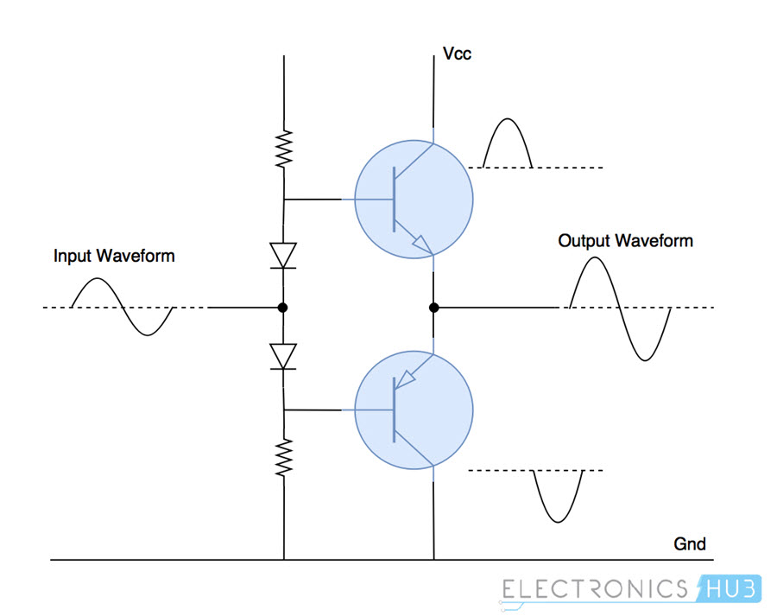

Fig 1.11 Class AB Power Amplifier
It maintains high frequency response like in class A amplifiers and good efficiency as in class B amplifiers. A combination of diodes and resistors are used to provide little bias voltage which reduces the distortion of waveform near the crossover region. There is a little drop in efficiency (60%) because of this.

Class C Power Amplifier
The design of class C power amplifiers allows greater efficiencies but reduces the linearity/conduction angle, which is under 90°. In other words, it sacrifices quality of amplification for increase in efficiency.
Lesser conduction angle implies greater distortion and so these classes of amplifiers are not suited for audio amplification. They are used in high frequency oscillators and amplification of Radio Frequency signals.
Class C amplifiers generally contain a tuned load which filters and amplifies input signals of certain frequency, and the waveforms of other frequencies are suppressed.
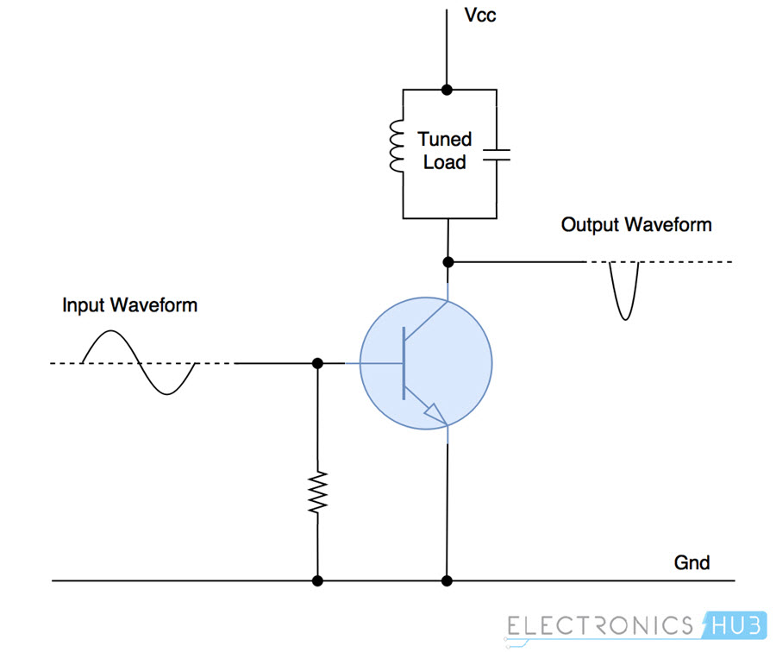

Fig 1.12 Class C Power Amplifier
In this type of power amplifier, the active element conducts only when the input voltage is above a certain threshold, which reduces power dissipation and increases efficiency.
Other Power Amplifier Classes
Power amplifier classes D, E, F, G etc. are used to amplify PWM modulated digital signals. They come under the category of switching power amplifiers and turn the output either constantly ON or constantly OFF without any other levels in between.
Because of this simplicity, power amplifiers falling under the above mentioned classes can reach theoretical efficiencies of up to (90-100)%.
Applications
Below are the applications of power amplifiers across different sectors:
- Consumer Electronics: Audio power amplifiers are used in almost all consumer electronic devices ranging from microwave ovens, headphone drivers, televisions, mobile phones and Home theatre systems to theatrical and concert reinforcement systems.
- Industrial: Switching type power amplifiers are used for controlling most of the industrial actuator systems like servos and DC motors.
- Wireless Communication: High power amplifiers are important in transmission of cellular or FM broadcasting signals to users. Higher power levels made possible because of power amplifiers increases data transfer rates and usability. They are also used in satellite communication equipment.
Oscillator
An oscillator is a circuit which produces a continuous, repeated, alternating waveform without any input. Oscillators basically convert unidirectional current flow from a DC source into an alternating waveform which is of the desired frequency, as decided by its circuit components.
The basic principle behind the working of oscillators can be understood by analyzing the behavior of an LC tank circuit shown in Figure 1 below, which employs an inductor L and a completely pre-charged capacitor C as its components. Here, at first, the capacitor starts to discharge via the inductor, which results in the conversion of its electrical energy into the electromagnetic field, which can be stored in the inductor. Once the capacitor discharges completely, there will be no current flow in the circuit.
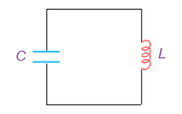
Fig 1.13 LC tank circuit
However, by then, the stored electromagnetic field would have generated a back-emf which results in the flow of current through the circuit in the same direction as that of before. This current flow through the circuit continues until the electromagnetic field collapses which result in the back-conversion of electromagnetic energy into electrical form, causing the cycle to repeat. However, now the capacitor would have charged with the opposite polarity, due to which one gets an oscillating waveform as the output.
However, the oscillations which arise due to the inter-conversion between the two energy-forms cannot continue forever as they would be subjected to the effect of energy loss due to the resistance of the circuit. As a result, the amplitude of these oscillations decreases steadily to become zero, which makes them damped in nature.
This indicates that in order to obtain the oscillations which are continuous and of constant amplitude, one needs to compensate for the energy loss. Nevertheless, it is to be noted that the energy supplied should be precisely controlled and must be equal to that of the energy lost in order to obtain the oscillations with constant amplitude.
This is because, if the energy supplied is more than the energy lost, then the amplitude of the oscillations will increase (Figure 2a) leading to a distorted output; while if the energy supplied is less than the energy lost, then the amplitude of the oscillations will decrease (Figure 2b) leading to unsustainable oscillations.
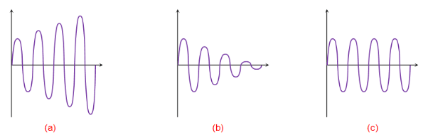
Fig 1.14 (a)Increasing oscillations (b)Decaying oscillations (c)Constant-Amplitude oscillation
Practically, the oscillators are nothing but the amplifier circuits which are provided with a positive or regenerative feedback wherein a part of the output signal is fed back to the input (Figure 3). Here the amplifier consists of an amplifying active element which can be a transistor or an Op-Amp and the back-fed in-phase signal is held responsible to keep-up (sustain) the oscillations by making-up for the losses in the circuit.
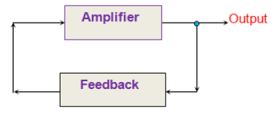
Fig 1.15 Typical Oscillator
Once the power supply is switched ON, the oscillations will be initiated in the system due to the electronic noise present in it. This noise signal travels around the loop, gets amplified and converges to a single frequency sine wave very quickly. The expression for the closed-loop gain of the oscillator shown in Figure 3 is given as:
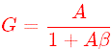
Where A is the voltage gain of the amplifier and β is the gain of the feedback network. Here, if Aβ > 1, then the oscillations will increase in amplitude (Figure 2a); while if Aβ < 1, then the oscillations will be damped (Figure 2b). On the other hand, Aβ = 1 leads to the oscillations which are of constant amplitude (Figure 2c). In other words, this indicates that if the feedback loop gain is small, then the oscillation dies-out, while if the gain of the feedback loop is large, then the output will be distorted; and only if the gain of feedback is unity, then the oscillations will be of constant amplitude leading to self-sustained oscillatory circuit.

1.4.2 Electronic musical instruments/keyboards
The AK-900 Electronic Keyboard is a electronic music system that you put together. It has 37 keys, 8 instrument sounds (piano, flute, violin, organ, French horn, banjo, music box, guitar), 8 tempo adjustable rhythms (pop music, disco, march, rhumba, tango, waltz, swing, ballad), 4 percussion effects (bass drum, close cymbals, open cymbals, indian snare drum), and 1 demonstration routine along with stereo, vibrato, and tempo effects. Most of these sounds may be combined. The user can add his/her own music to a background tune. It uses 6 “AA” batteries (not included) or an optional AC/DC adapter. The Keyboard is mechanically assembled by the user with no soldering required. The only tool needed is a phillips screwdriver.
Recommended for ages 10 and up. However, after the assembly and lesson are completed it will be suitable for ages 3 and up.

THEORY OF OPERATION

What is Sound?
Sound is a variation in air pressure created by a mechanical vibration. (For a demonstration of this, lay one of your stereo speakers on the floor, place your hand on it, and turn up the volume. You should feel the speaker vibrate. Now place a piece of paper on the speaker; if the volume is loud enough, you will see the paper vibrate). Since the vibrations usually last for some amount of time we call the result sound waves. If the vibration occurs at a certain rate, then the sound wave will repeat itself at the same rate; we refer to this as the frequency of the sound wave. Nearly all sound waves have their energy spread unevenly across a range of frequencies. You can compare sound waves from your voice to waves in a pond. When you speak, the movements in your mouth create sound waves just as tossing a rock into the pond creates water waves. Sound waves travel through air as water waves travel across the pond. If someone is nearby, then their ears will feel the pressure variations caused by your sound waves just as a small boat at the other side of the pond will feel the water waves. When you say a word, you create a sound wave with energy at various frequencies, just as tossing a handful of various-sized rocks into the pond will create a complicated water wave pattern.
Just as there are sound waves caused by mechanical vibrations, there are also electrical waves caused by electrical variations. Just as sound waves travel through air, electrical waves travel through wires. A microphone senses pressure variations from sound waves and creates electrical waves at the same frequencies. A speaker uses the energy in electrical waves to create mechanical vibrations (sound waves) at the same frequencies. In addition, electrical variations at high frequencies (referred to as radio frequencies) can be used to create electromagnetic radio waves which travel through air and are used for many forms of communication.
The subject of music is one where the worlds of art and science come together. Unfortunately, the artistic/musician field works with qualities that depend on our feelings and so are difficult to express using numbers while science/engineering works with the opposite - clearly defined, measurable qualities. As a result, some of the terms used may seem confusing at first, but you will get used to them.
Let’s talk about frequency some more. Frequency is the number of repetitions per second (for sound or electrical waves), expressed in units called hertz (Hz). The metric prefixes can be used, so 1000 repetitions per second is 1 kilohertz (kHz) and 1,000,000 repetitions per second is 1 megahertz (MHz). The range of frequencies that can be heard by the human ear is approximately 16 to 16,000 Hz and is referred to as the audio range. The musical world’s equivalent to frequency is pitch. The higher the frequency, the higher the pitch of the sound. Frequencies above 3000 Hz can be considered to provide treble tone. Frequencies about 300 Hz and below provide bass tone. Loudness (the musical term) or amplitude (the electronics term) is increased by simply sending more electrical power to the speaker.

Fundamentals of Music
What is Music? Music is when vibrations (creating sound waves) occur in an orderly and controlled manner forming a pattern with their energy concentrated at specific frequencies, usually pleasant to listen to. Noise is when the vibrations occur in an irregular manner with their energy spread across a wide range of frequencies, usually annoying to hear (static on a radio is a good example). Notice how some people refer to music that they don’t like as noise.
Another way to think of this is that the ear tries to estimate the next sounds it will hear. Music with a beat, a rhythm, and familiar instruments can be thought of as very predictable, hence we find it pleasant to listen to. Notice also that we always prefer familiar songs to music that we are hearing for the first time. Sudden, loud, unpredictable sounds (such as gunfire, a glass breaking, or an alarm clock) are very unnerving and unpleasant. Most electronic speech processing systems being developed use some form of speech prediction filters.
Take a piece of string or rope roughly 4 feet long and tie one end of it to a chair or other piece of furniture. Swing the other end up and down so that you have a cyclic pattern, as shown:
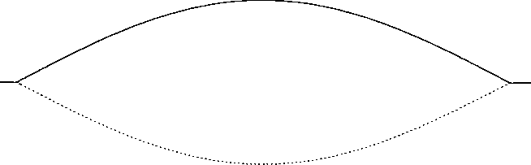
Now swing it three times as fast (three times the frequency), to produce this pattern:
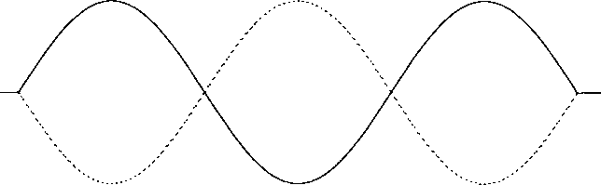
Now try to swing it five times as fast (five times the frequency), to produce this pattern:

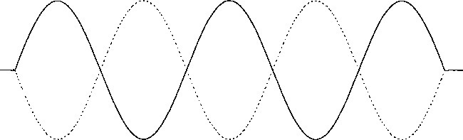

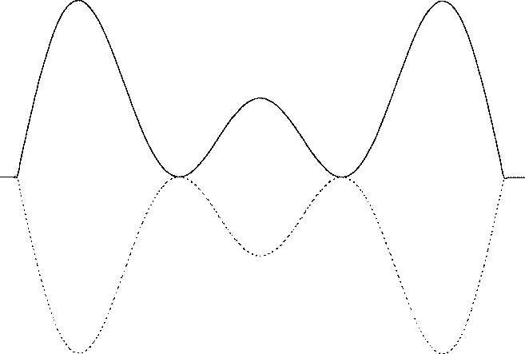
Since the later patterns are frequency multiples of the first, we refer to them as overtones (the music term) or harmonics (the electronics term) and the original pattern is called the fundamental. If you could combine all three of the above patterns onto the string then you would get a pattern which looks like this:

This combined pattern (a single fundamental with overtones) is called a tone (and a pure tone is a single fundamental with no overtones). Notice that each pattern is more difficult to produce than the one before it, with the combined pattern being quite complicated. And also notice that the more complicated patterns are much more interesting and pleasing to look at than the simpler ones. Well the same thing applies to sound waves. Complex patterns that have many overtones for each fundamental are more pleasant to listen to than simple patterns.
All traditional music instruments use this principle, with the instrument shapes and materials perfected through the years to produce many overtones for each fundamental chord or key that is played by the user. Grand pianos sound better than upright pianos since their larger shape enables them to produce more overtones, especially at lower frequencies. Concert halls sound better than small rooms because they are designed for best overtone performance and to take advantage of the fact that sound waves can reflect off walls to produce different overtone relationships between both of your ears. The same thing applies to stereo sound. You may have heard the term acoustics, this is the science of designing rooms for best sound effects.
The most widely used musical scale (which measures pitch) will now be introduced; for more information please refer to the references. This scale is called the equal temperament scale, expressed in hertz. You might think of this as a conversion table between the artistic and scientific worlds since it expresses pitch in terms of frequency. Each overtone (overtone 0 being the fundamental) is divided into 12 semitones: C, C# (“C-flat”), D, D#, E, F, F#, G, G#, A, A#, and B. The semitones increase by the ratio 12√2, or 1.05946. Musical notes (tones) are the measure of pitch and are expressed using both the semitone and the overtone, such as A3, G#4, D6, A#1, and E2. Your AK-900 Electronic Keyboard plays notes from C3 to C6, in order across the keyboard.(frequency in hertz and rounded off)
Up to now, the musical measures of pitch and loudness have been discussed. But many musical sounds have
over- | C | C# | D | D# | E | F | F# | G | G# | A | A# | B
tone
0 | 16.4 | 17.3 | 18.4 | 19.4 | 20.6 | 21.8 | 23.1 | 24.5 | 26.0 | 27.5 | 29.1 | 30.9
1 | 32.7 | 34.6 | 36.7 | 38.9 | 41.2 | 45.7 | 46.2 | 49.0 | 51.9 | 55.0 | 58.3 | 61.7
2 | 65.4 | 69.3 | 73.4 | 77.8 | 82.4 | 87.3 | 92.5 | 98.0 | 104 | 110 | 117 | 123
3 | 130 | 139 | 147 | 156 | 165 | 175 | 185 | 196 | 208 | 220 | 233 | 247
4 | 262 | 27 | 294 | 311 | 330 | 349 | 370 | 392 | 415 | 440 | 466 | 494
5 | 523 | 554 | 587 | 622 | 659 | 698 | 740 | 784 | 831 | 880 | 932 | 988
6 | 1047 | 1109 | 174 | 1245 | 1319 | 1397 | 1480 | 1568 | 1661 | 1760 | 1865 | 1976
7 | 2093 | 2217 | 2344 | 2489 | 2637 | 2794 | 2960 | 3136 | 3322 | 3520 | 3729 | 3951
8 | 4186 | 435 | 4698 | 4978 | 5274 | 5588 | 5920 | 6271 | 6645 | 7040 | 7459 | 7902
9 | 8372 | 8870 | 9397 | 9956 | 10548 | 11175 | 11840 | 12542 | 13290 | 14080 | 14917 | 15804
the same pitch and loudness and yet sound very different. For example, the sound of a guitar compared to that of a piano for the same musical note. The difference is a quality known as timbre. Timbre describes how a sound is perceived, its roughness. Scientifically it is due to differences in the levels of the various overtones, and so cannot be expressed using a single number.
Now consider the following two tones, which differ slightly in frequency:
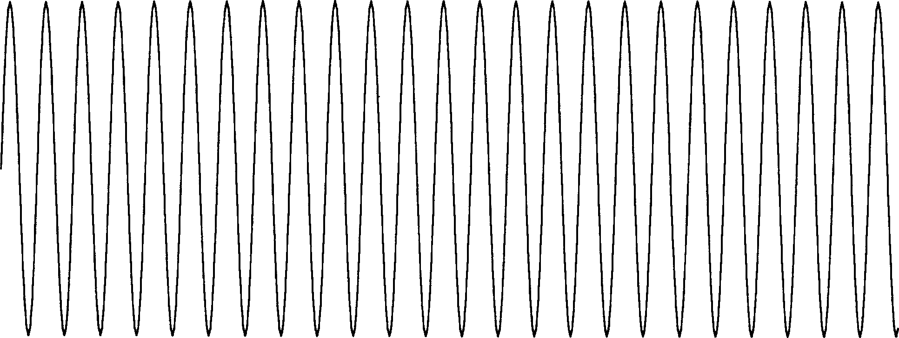

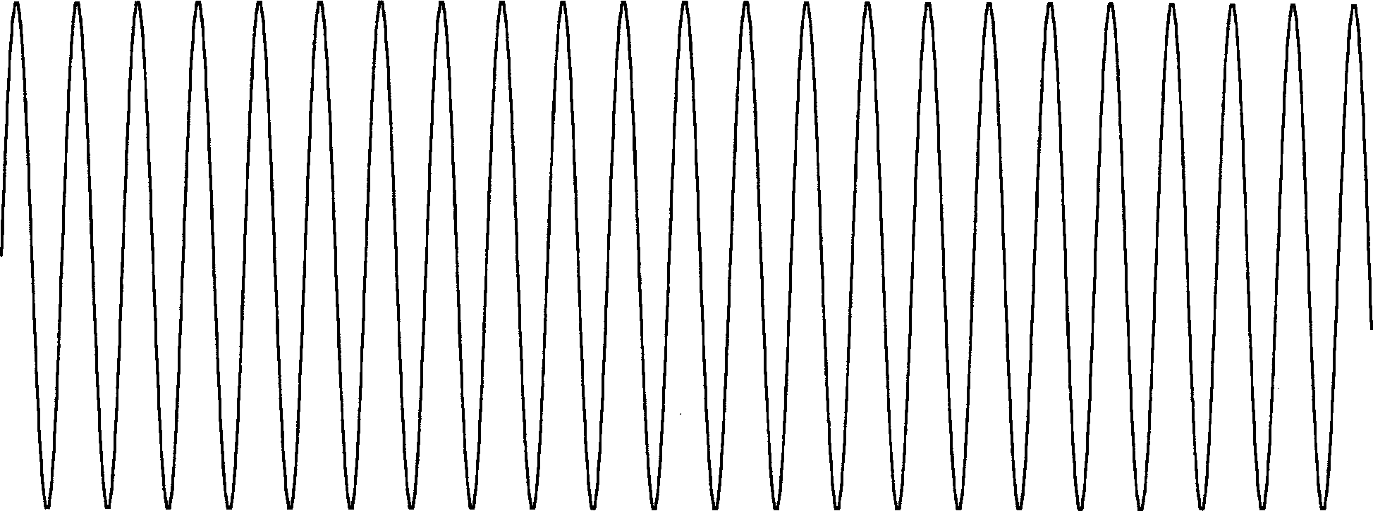

If they are played at the same time then their sound waves would be added together to produce:

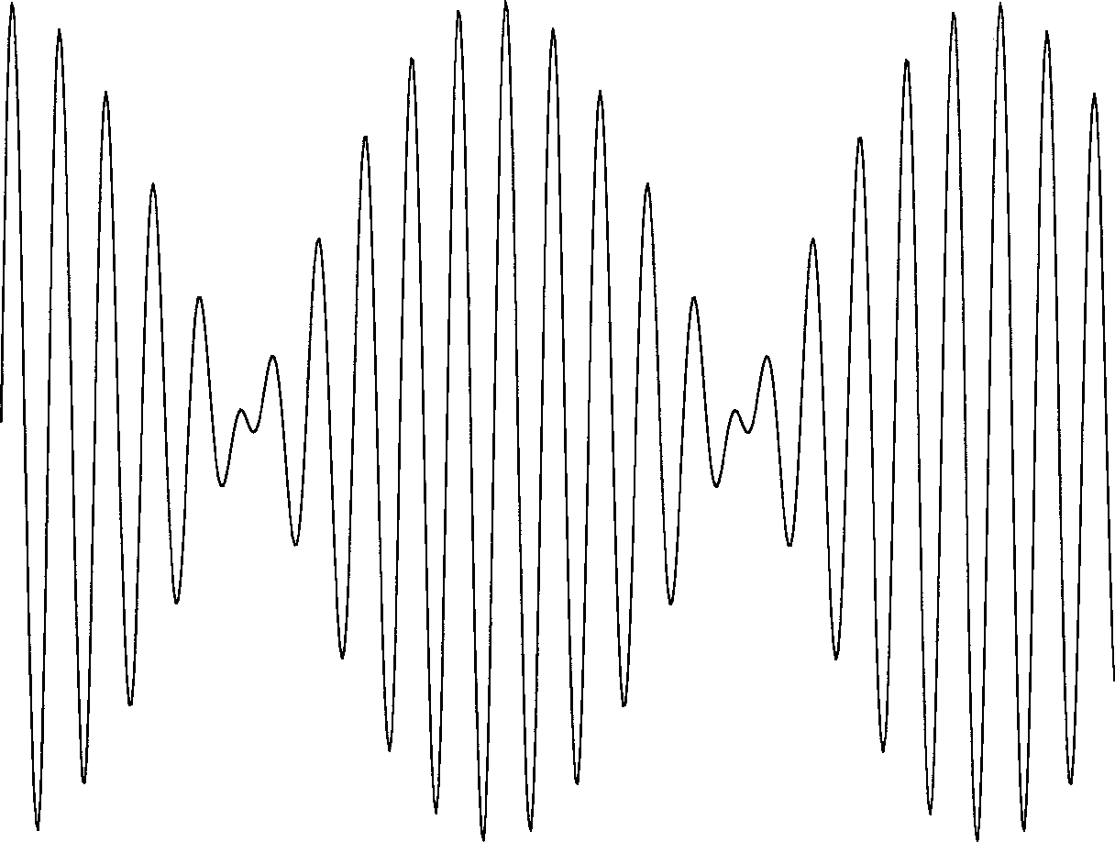
Notice that the combined wave has a regular pattern of where the two tones add together and where they cancel each other out. This is the effect that produces the beat you hear in music. Two tones (that are close in frequency and have similar amplitude for their fundamental and for each of their overtones) will beat at the rate of their frequency difference. Rhythm is the pattern of regular beat that a song has.
Now observe this tone:
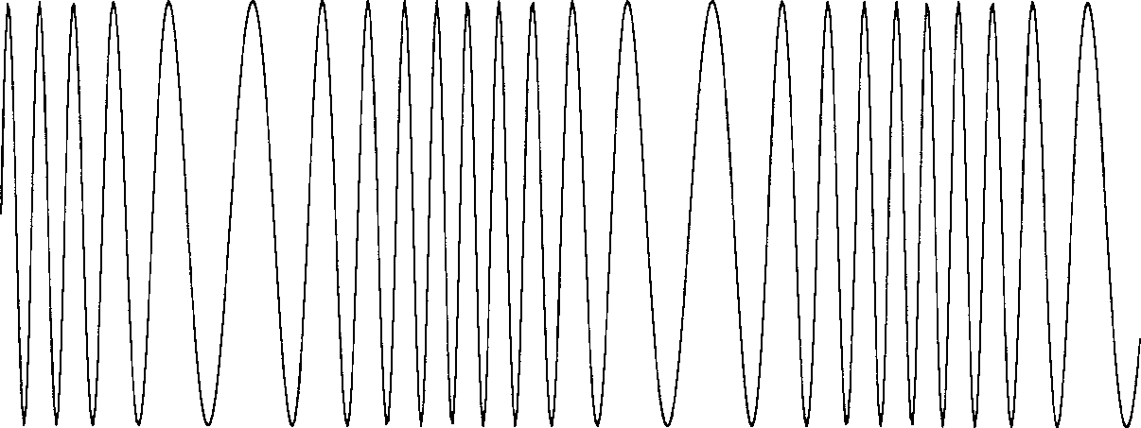
The frequency is slowly increasing and decreasing in a regular pattern. This is an example of vibrato. If the frequency is changing slowly then it will sound like a varying pitch; a fast vibrato (several times a second) produces an interesting sound effect.
Tempo is a musical term which simply describes how quickly a song is played.

The Electronic Keyboard Implementation:
The AK-900 electronically creates sounds that closely resemble those from traditional musical instruments. A quick look at the schematic (a graphical representation of an electronic circuit) on page 17 will show the reader that the IC 9037 is the heart of the product. This part is a 68-pin silicon Large-Scale Integrated Circuit made with CMOS (Complementary Metal-Oxide-Semiconductor) technology. For more information about CMOS and integrated circuits please refer to the references. Please refer to the schematic and the IC 9037 block diagram and pin description on page 17 to help understand the following:
The IC 9037 is specifically designed for electronic keyboard applications. It generates a 523.252 kHz signal which is used as a master timing reference for all operations. The 37 keyboard keys represent musical notes C3 to C6 in the musical scale table shown earlier. These are connected directly to the IC 9037 and may be played anytime. These tones are produced by dividing the 523.252 kHz reference down to the appropriate frequency and then adjusting the levels of the overtones based on which instrument is being played. When you play a note on an instrument the sound produced is initially rather loud and then decreases with time. This effect is simulated in the envelope block in the IC 9037 and the resulting output tone also decreases with time. As can be seen from the block diagram, there are two sets of the circuits just described to allow two notes to be played at the same time; once additional notes are played the earlier notes will be discontinued. Since the two most recent notes will be the loudest, this simplification from traditional instruments (such as a piano where the strings continue to vibrate until played again) will not be easily noticed by the listener. More complex electronic instruments will have more circuitry to simulate more notes at the same time as well as more advanced techniques for producing overtones.
All of the button selections are handled using ten control lines in a matrix. A matrix is similar to the rows and columns of a table. The matrix is as follows:

 | Column 0  pin 66 | Column 1  pin 67 | Column 2  pin 68 | Column 3  pin 1 | Column 4  pin 2
Row 0  pin 7 | Pop rhythm | Swing rhythm | Piano timbre | Horn timbre | Cow-Bell sound
Row 1  pin 6 | Disco rhythm | Tango rhythm | Flute timbre | Banjo timbre | High-Hat sound
Row 2  pin 5 | March rhythm | Ballad rhythm | Violin timbre | Music-Box timbre | Bass-Drum sound
Row 3  pin 4 | Rhumba rhythm | Waltz rhythm | Organ timbre | Guitar timbre | Snare-Drum sound
Row 4  pin 3 | Tempo up | Tempo down | Rhythm start | Rhythm stop | Vibrato ON/OFF
On power-up, the rhythm is stopped, rhythm selection is set to Pop, timbre selection is set to Piano, Tempo is set to medium, and Vibrato is OFF.
Percussion (drum-like) sounds are created by playing a short pattern stored in the IC 9037’s electronic memory. All four percussion sounds may be played at the same time. If the demo or one of the rhythms is selected then a much longer pattern is played from the part’s memory in a similar manner. This will include both the tone and percussion circuitry just described and will be repeated until the user presses the stop button. The tempo is adjusted by changing the rate at which this tone pattern is played from memory (by dividing the 523.252 kHz timing reference differently). The vibrato effect is created by varying the divide ratio to the tone circuitry slightly, which will vary the tone frequency and hence the pitch of the sound.
The outputs from the two tone circuits and the percussion circuits are combined. The two volume control switches adjust the strength of the tone and percussion signals before combination; weaker electrical signals will resulting in weaker sound waves from the speaker. The combined result is smoothed (to remove unwanted higher frequency signals that were created along with the desired tone and percussion signals), increased in strength (amplified), and applied to the speaker where it is converted from electrical waves to sound waves.
If you are unfamiliar with printed circuit boards (PC boards) then observe the advantages that the AK-900 board provides. Notice all of the long, thin copper traces on the board; these are equivalent to having wires connecting all of those points but is much easier to manufacture, much smaller, more reliable, easier to inspect for mistakes, looks nicer, and costs much less. This board has only a single layer of copper traces; circuit board technology has progressed to where boards with 6 layers of traces are not unusual. The board also provides stable mounting for all of the other components. Solder is used to connect the copper traces to the components mounted on the board; it is metal that melts at temperatures typically between 400F and 800F. Electronics manufacturers have refined their soldering processes into a fine art through the years. Observe that IC 9037 is the only component in the AK-900 mounted directly on the printed circuit side of the board with no holes through the board; this is called surface-mounting and today many electronics products have ALL of their components surface-mounted due to its advantages in saving space (this was not a concern on the AK-900 due to the space required for the keys and buttons).

ASSEMBLY INSTRUCTIONS
- Take a look at each of the parts bags and compare to the Parts List. Be sure that nothing was damaged during shipping and handling. Contact Elenco Electronics if you have any problems. DO NOT contact your place of purchase as they will not be able to help you.
- Lay the Circuit Board in front of you, circuit side (green side) up. Locate the Button Cushions and Piano Cushions from Bag #1. Place them onto the Circuit Board one at a time in the arrangement shown in Figure

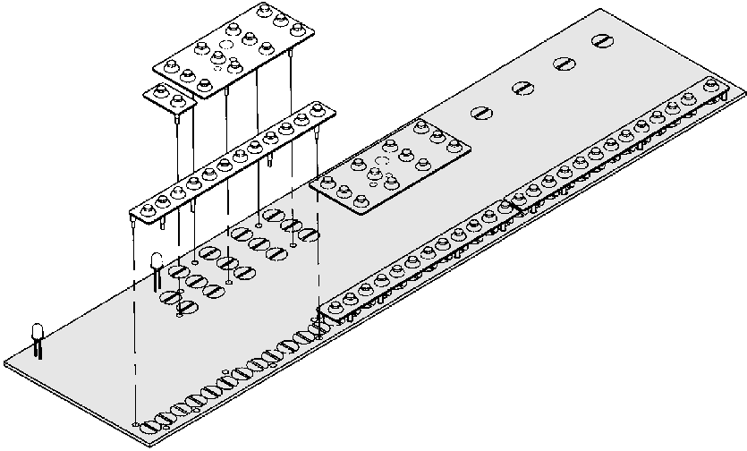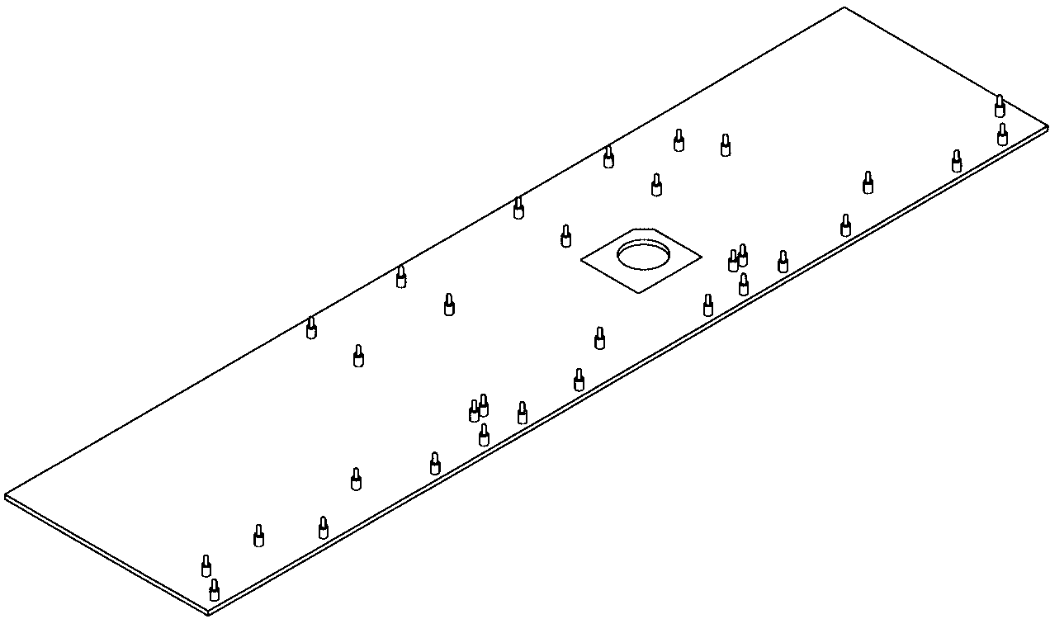A. The pegs on the Cushions fit into the holes in the Circuit Board but will be loose; flip the Board over to the components side and pull on each of the pegs (be careful not to bend the red LEDs on the circuit side while doing so), see Figure B. The Cushions should now be flush on the Circuit Board.
Button Cushion w/ 12 Contacts
Button Cushion w/ 2 Contacts
Green Side of
Piano Cushion
w/ 13 Contacts
Piano Cushion w/ 12 Contacts
Component Side
of the PC Board
Piano Cushion
w/ 12 Contacts
Figure A
Pegs
Figure B
LEDs
the PC Board
- Lay the Top Case upside-down in front of you. Locate the Switches (Bag #4), Switch Covers (Bag #4), Switch Springs (Bag #3), and Switch Ball Bearings (Bag #3). Make sure the metal contacts are bent up 45O (otherwise they may not contact the circuit board), and that they are not damaged. Place a Spring into the hole in the side of one of the Switches (as shown in Figure C). Place some Vaseline or grease into the ball grooves in the switch slots on the inside of the Top Case (to ensure the Switch will switch smoothly) and a drop on the Switch Spring. Place a Ball Bearing onto the Spring (the Vaseline helps hold the Bearing in place) and carefully place the Switch into one of the switch slots, being sure not to drop the Bearing while doing so. Next, press a Switch Cover into the Switch from the outside of the Top Case while holding the Switch in place on the inside of the Case (as shown in Figure D). Be sure the Switch moves properly between each of the switch settings and then install the other two Switches in the same manner.
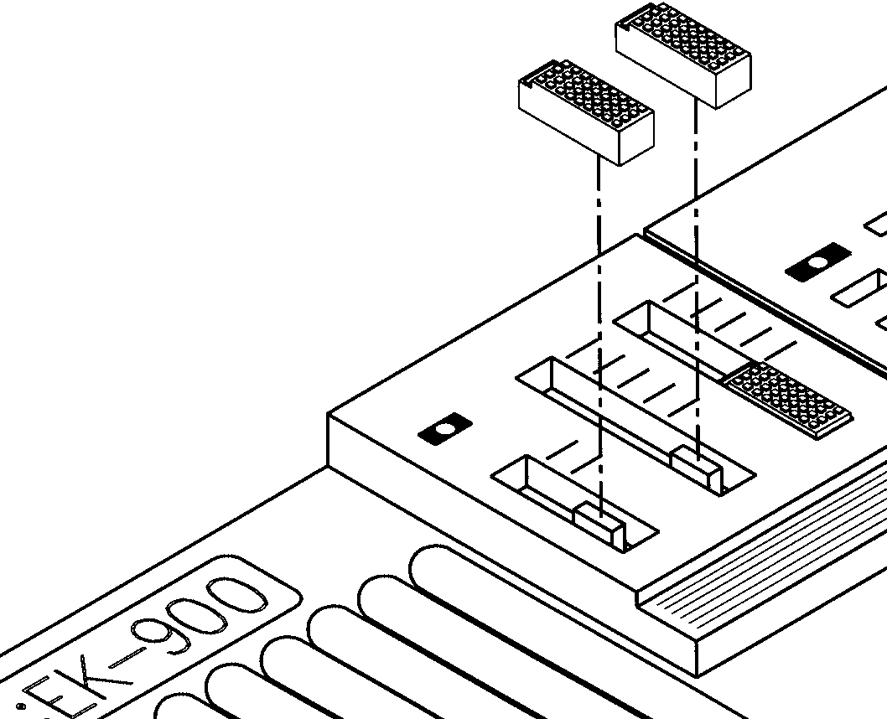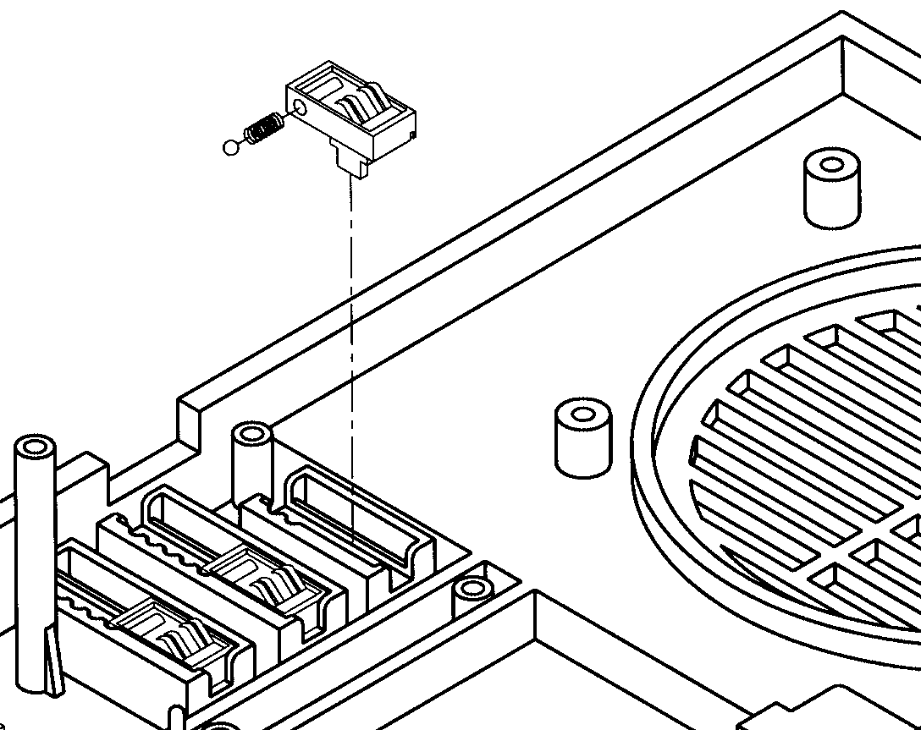 Figure C Figure D
Switch Covers
Switches
Switch
Ball Bearing
Spring
- Locate the Black and White Piano Key Clips (Bag #2). Place the White Clips into the inside of the Top Case (as shown in Figure Ea). There are 3 small pegs (one for each clip) on the inside for alignment. The tab at the end of each key must slide into its slot on the front of the Case (the “bottom of the keyboard”) so that it will not be visible (as shown in Figure Ea). The White Clip with 8 keys (the others have 7) will have to be placed so that its “extra” key is the most distant key from the speaker slot. Next, lay the Black Clips onto the White Clips from the inside, using the alignment pegs again (as shown in Figure Eb).
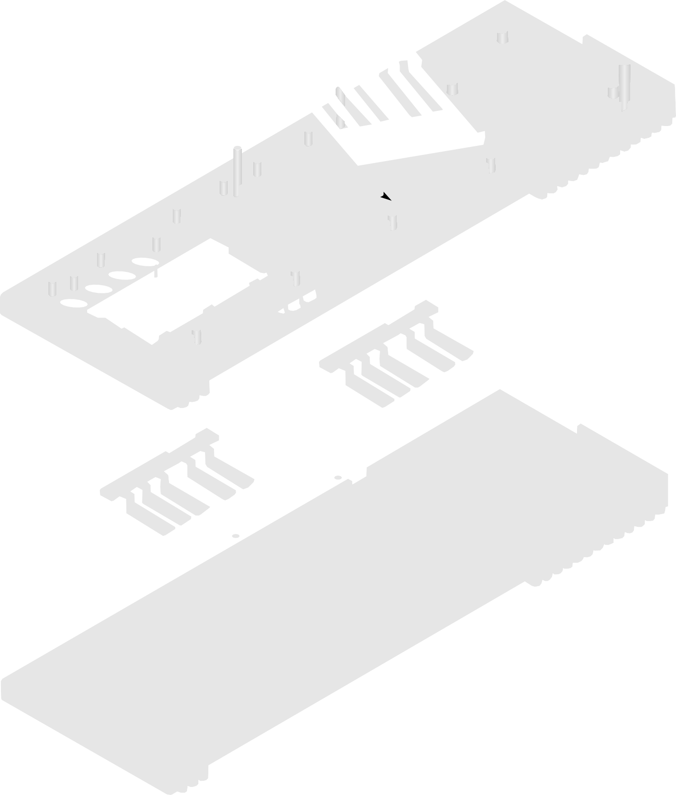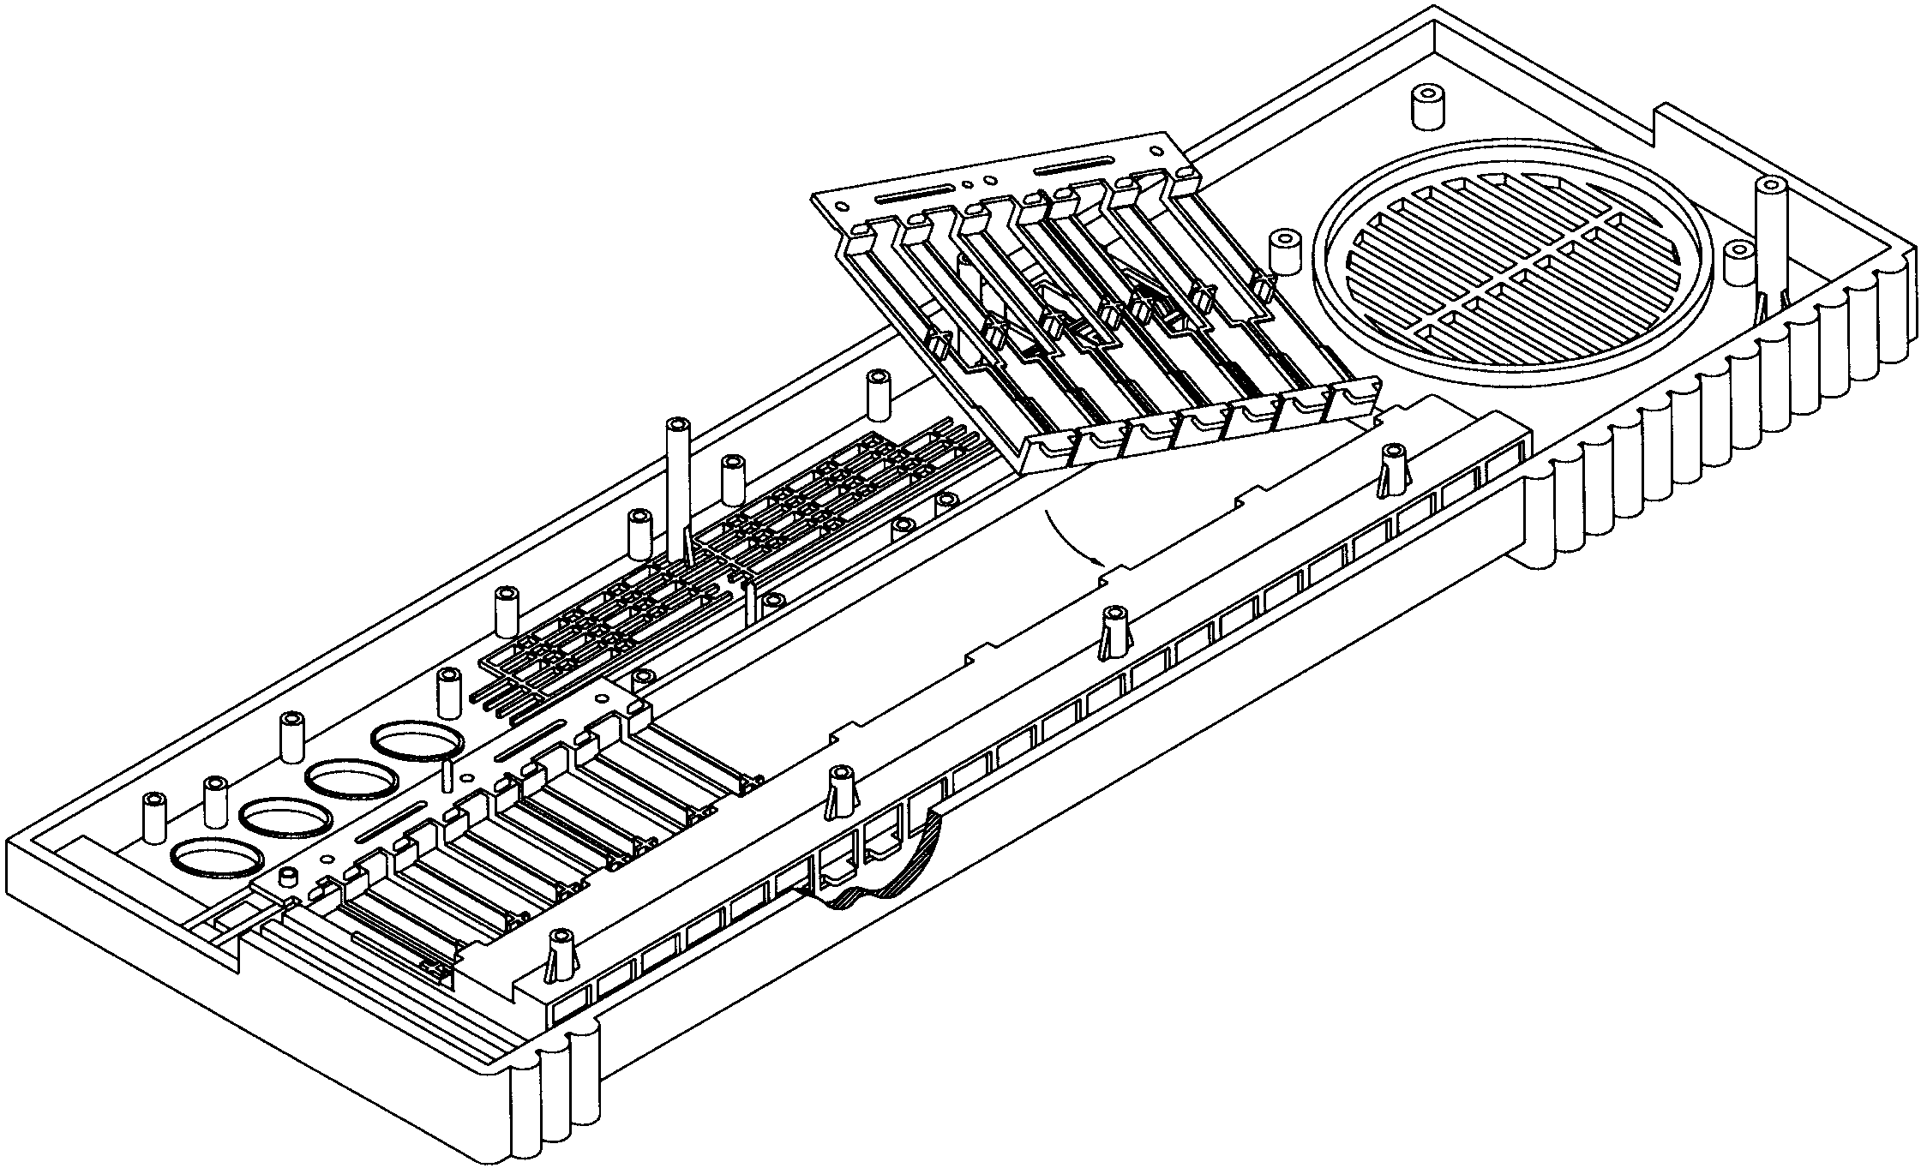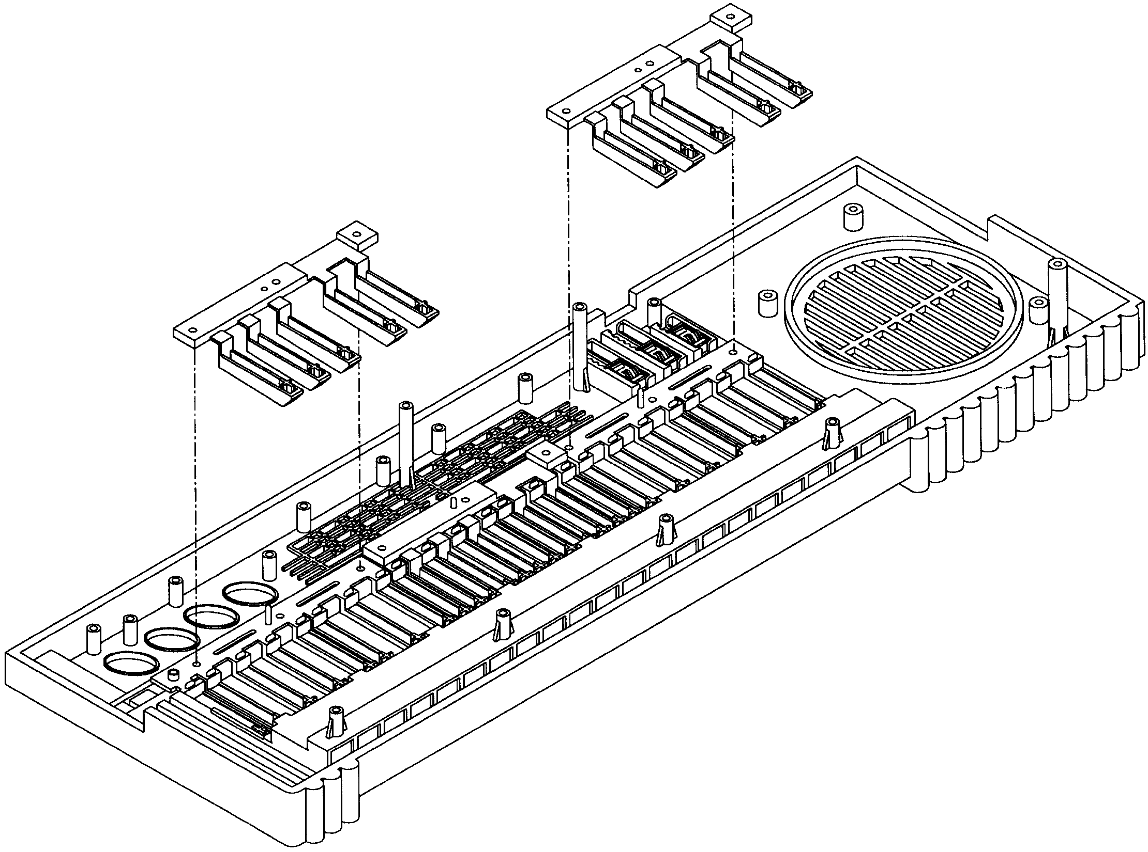
White Piano Key
Clip w/ 7 Keys

Figure Ea

Alignment Pegs
Top Case

- Locate the buttons (Bag #4). Attach the 4 Large Pink Button Contacts to the Large Pink Buttons as shown in Figure F. Now place the 4 Large Pink Buttons, the 8 Small Green Buttons, the 8 Small Orange Buttons, the 4 Medium Blue Buttons, and the 2 Small Pink Buttons into the inside of the Top Case as shown in Figure F. Carefully lift up the Top Case without tipping it (so that the buttons don’t fall out) and compare it to the picture on the box for your Electronic Keyboard. It should match, except for 2 small holes for the red LEDs which will be added with the Circuit Board. Correct your buttons arrangement now if necessary.
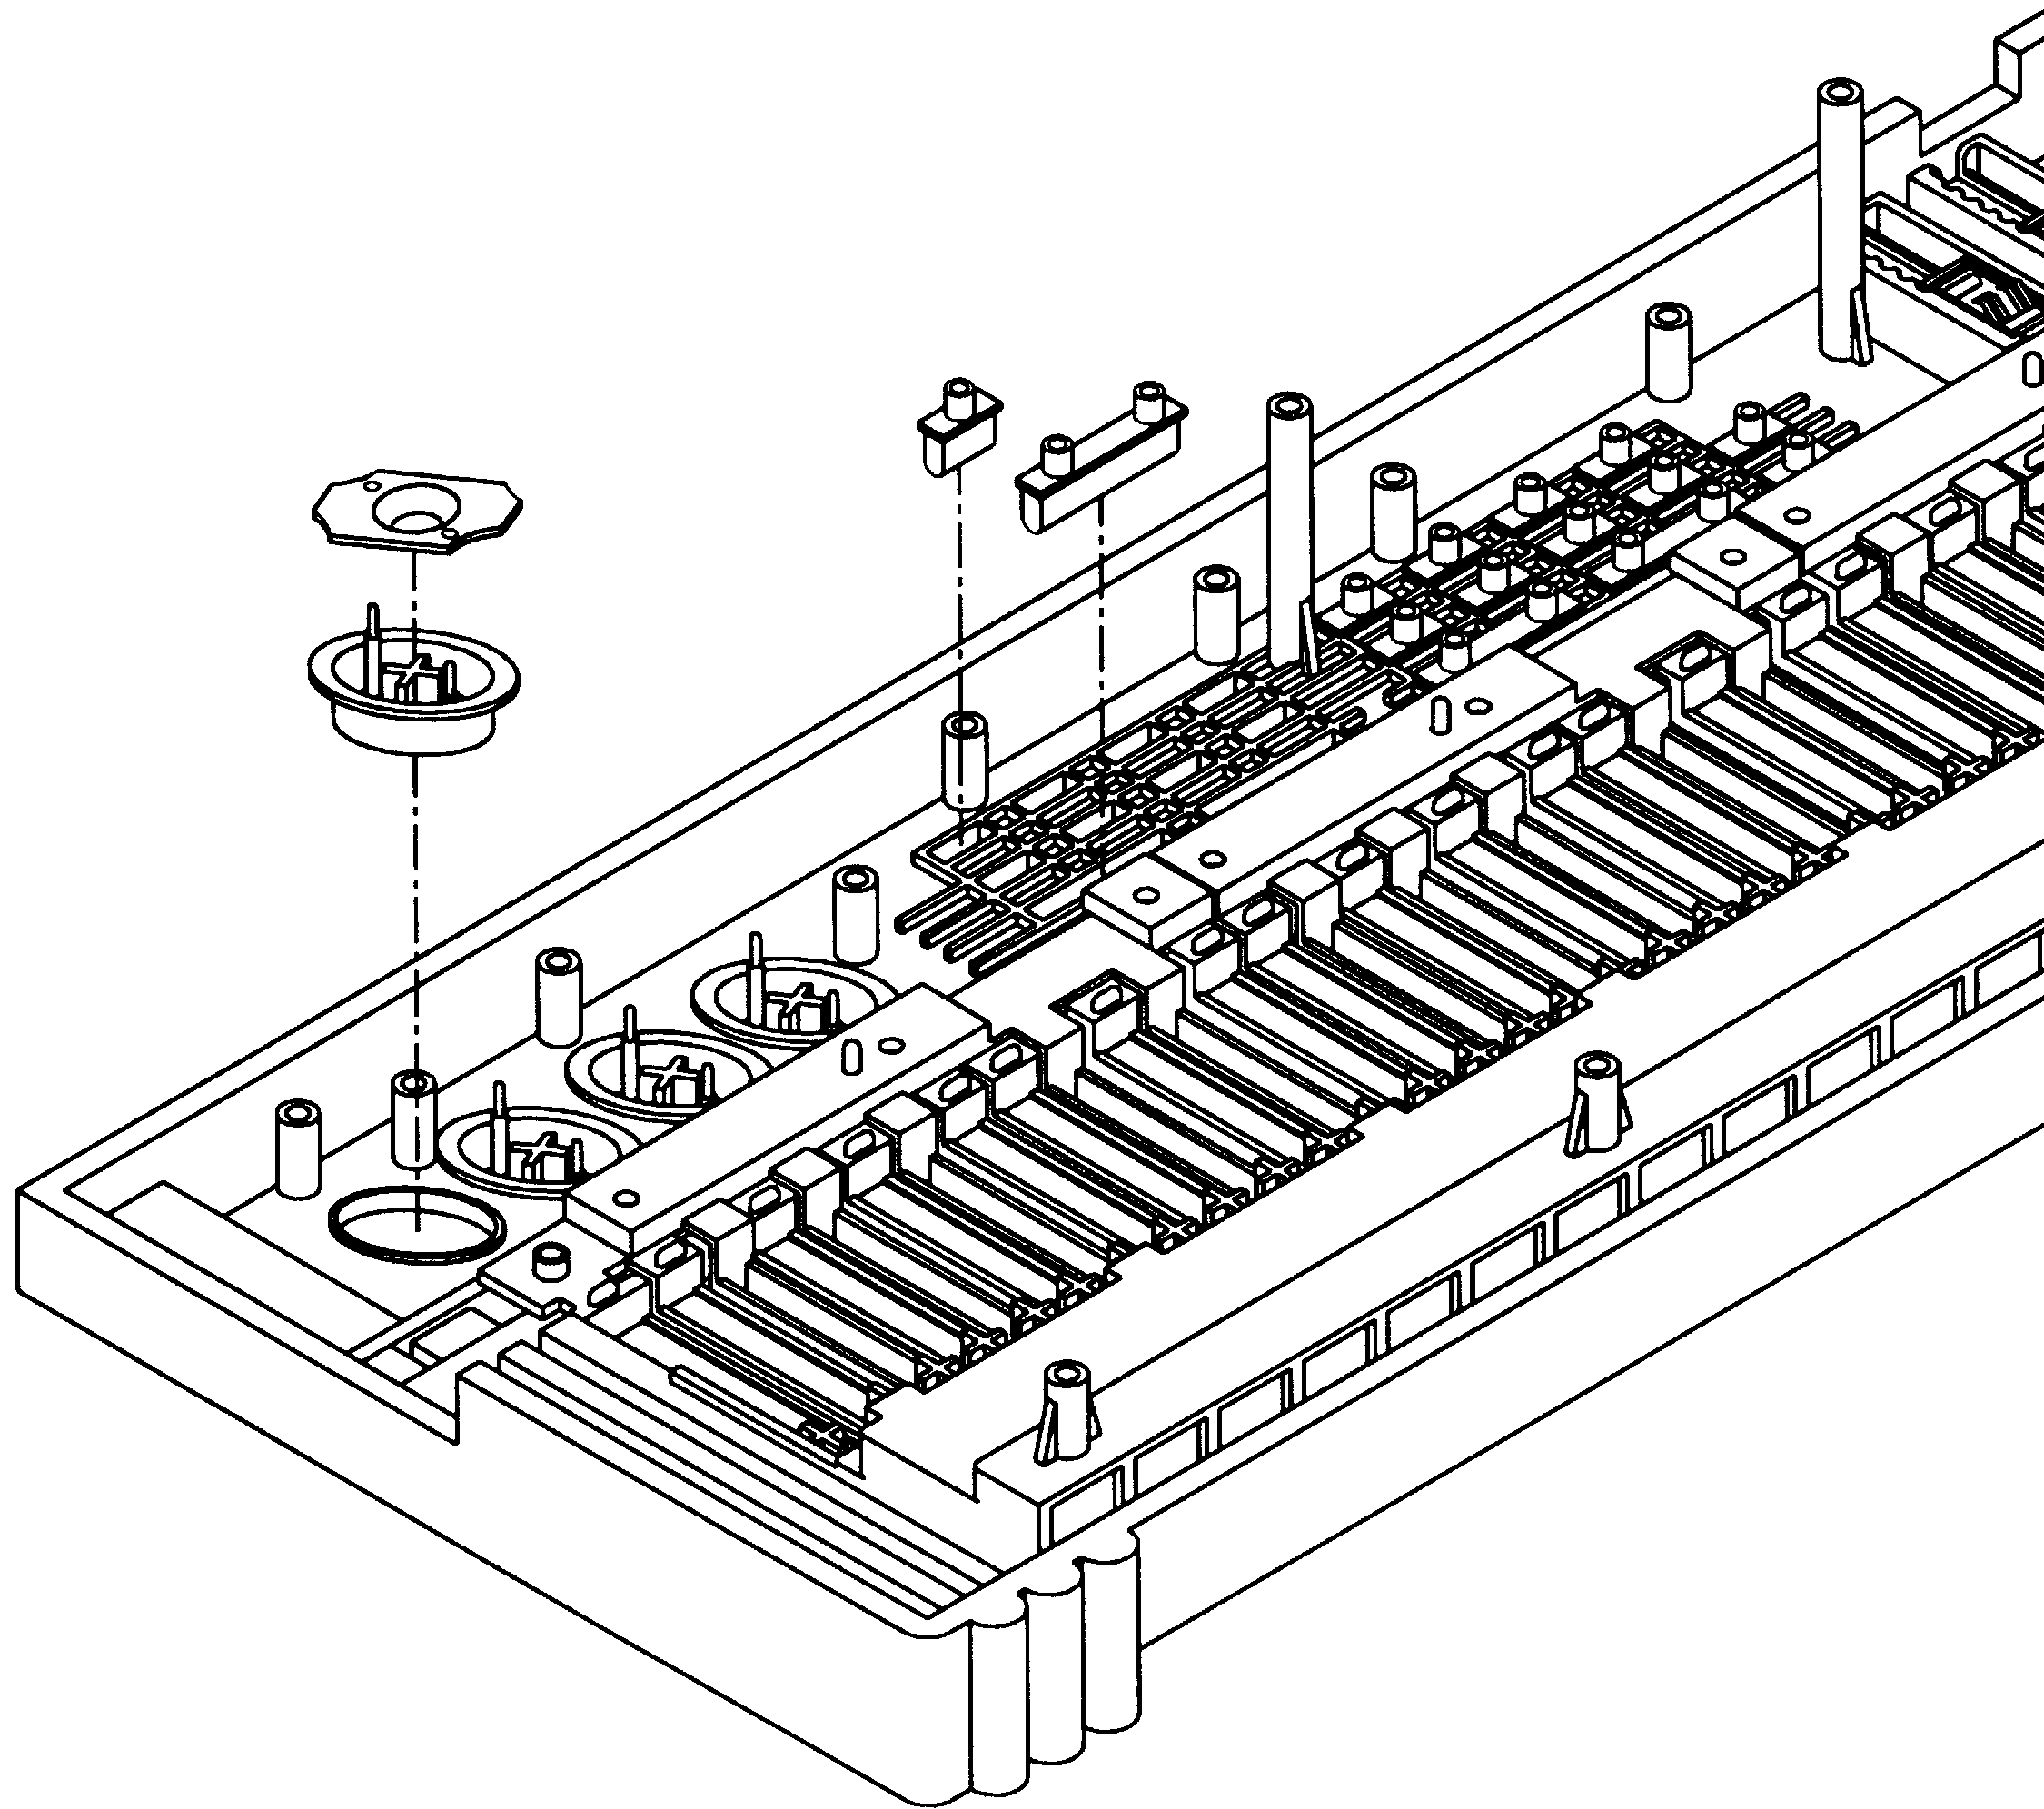
Small Pink Buttons

Small Orange Buttons

Medium Blue Button
Small Green Button
Large Pink Button Contact

Large Pink Button

- Straighten the red LEDs (Light-Emitting-Diodes) on the Circuit Board so that they are standing straight up (they may have been bent to protect them during shipping). Place the Circuit Board into the Top Case, components side facing you, as shown (it is aligned using 8 tabs on one side and 2 tall screw holes on the other side). Make sure the red LEDs are still straight and will be visible from the outside and that you don’t knock any of the buttons out of position. It is a good idea to elevate the unit enough so that it isn’t resting on any of the buttons (otherwise, some buttons might be knocked out of position and won’t work properly). Secure with 3 small side Screws (0.2” x 0.1” or 0.3” x 0.1”, from Bag #3) and then 9 large Screws (0.4” x 0.1”, also Bag #3) as shown. Note that not all of the screw holes are used. Now flip the Top Case over and again compare it to the picture of it on the box. It should look the same. Press each of the buttons to be sure they depress properly. If not, unscrew the Circuit Board and check the arrangement of your buttons.
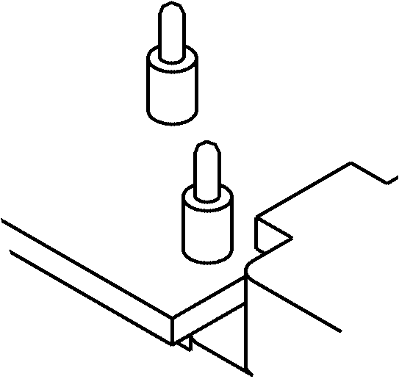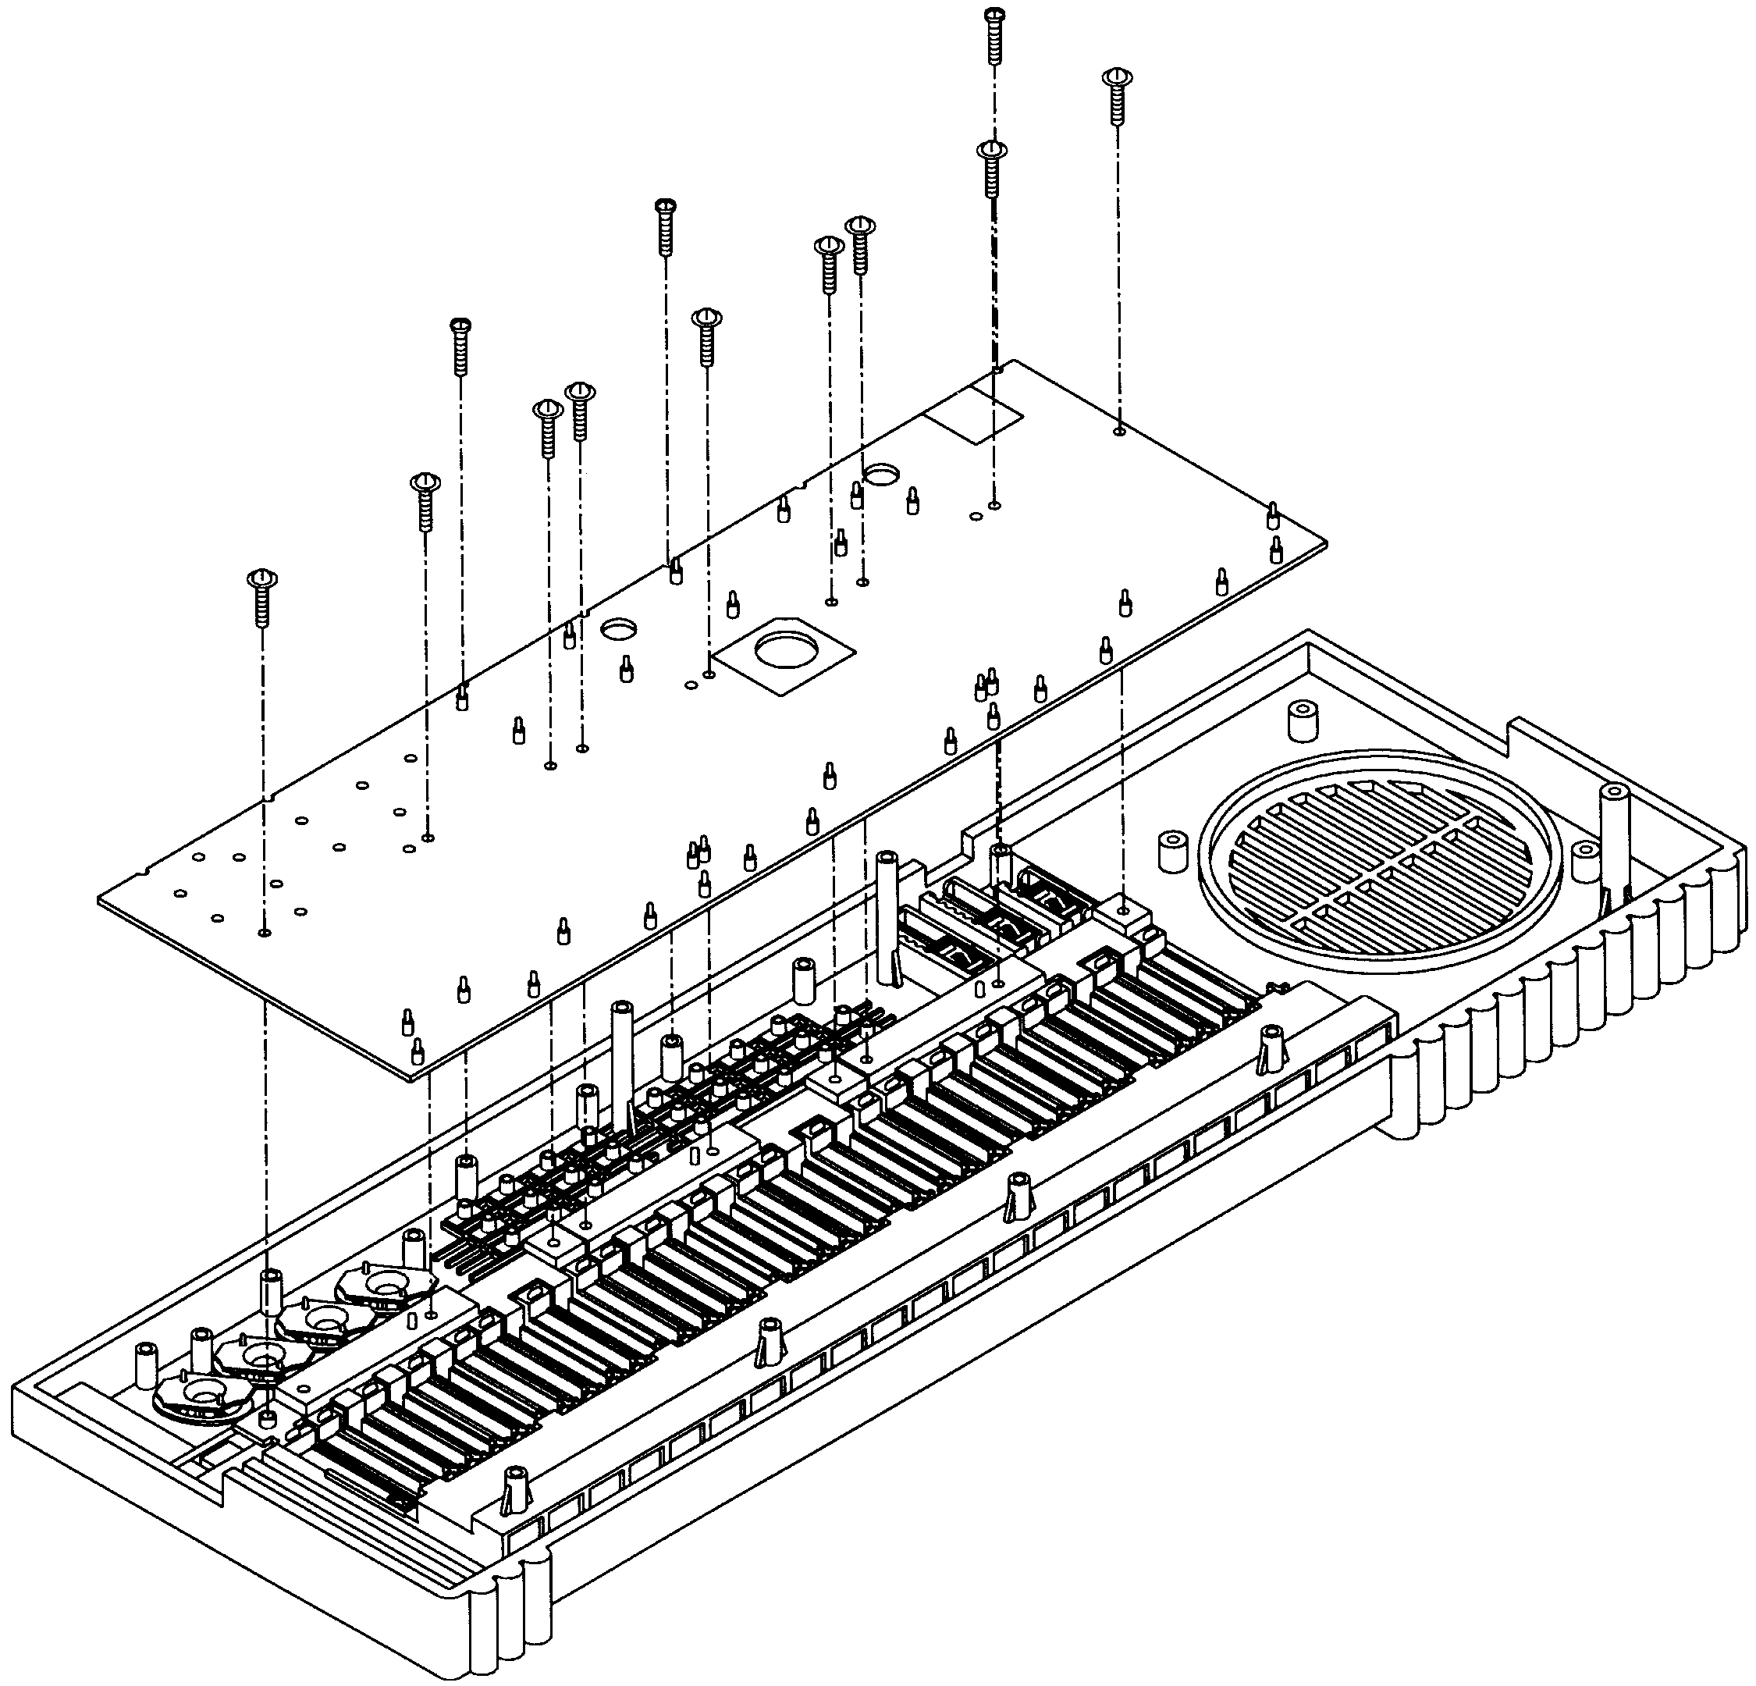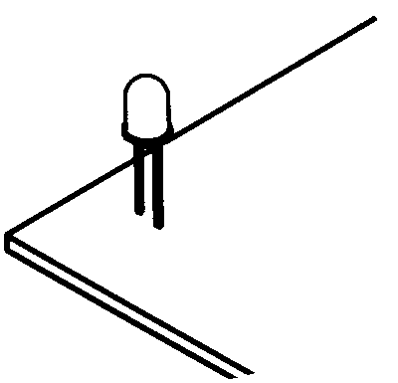

Figure G
Small Side Screws
LED

- 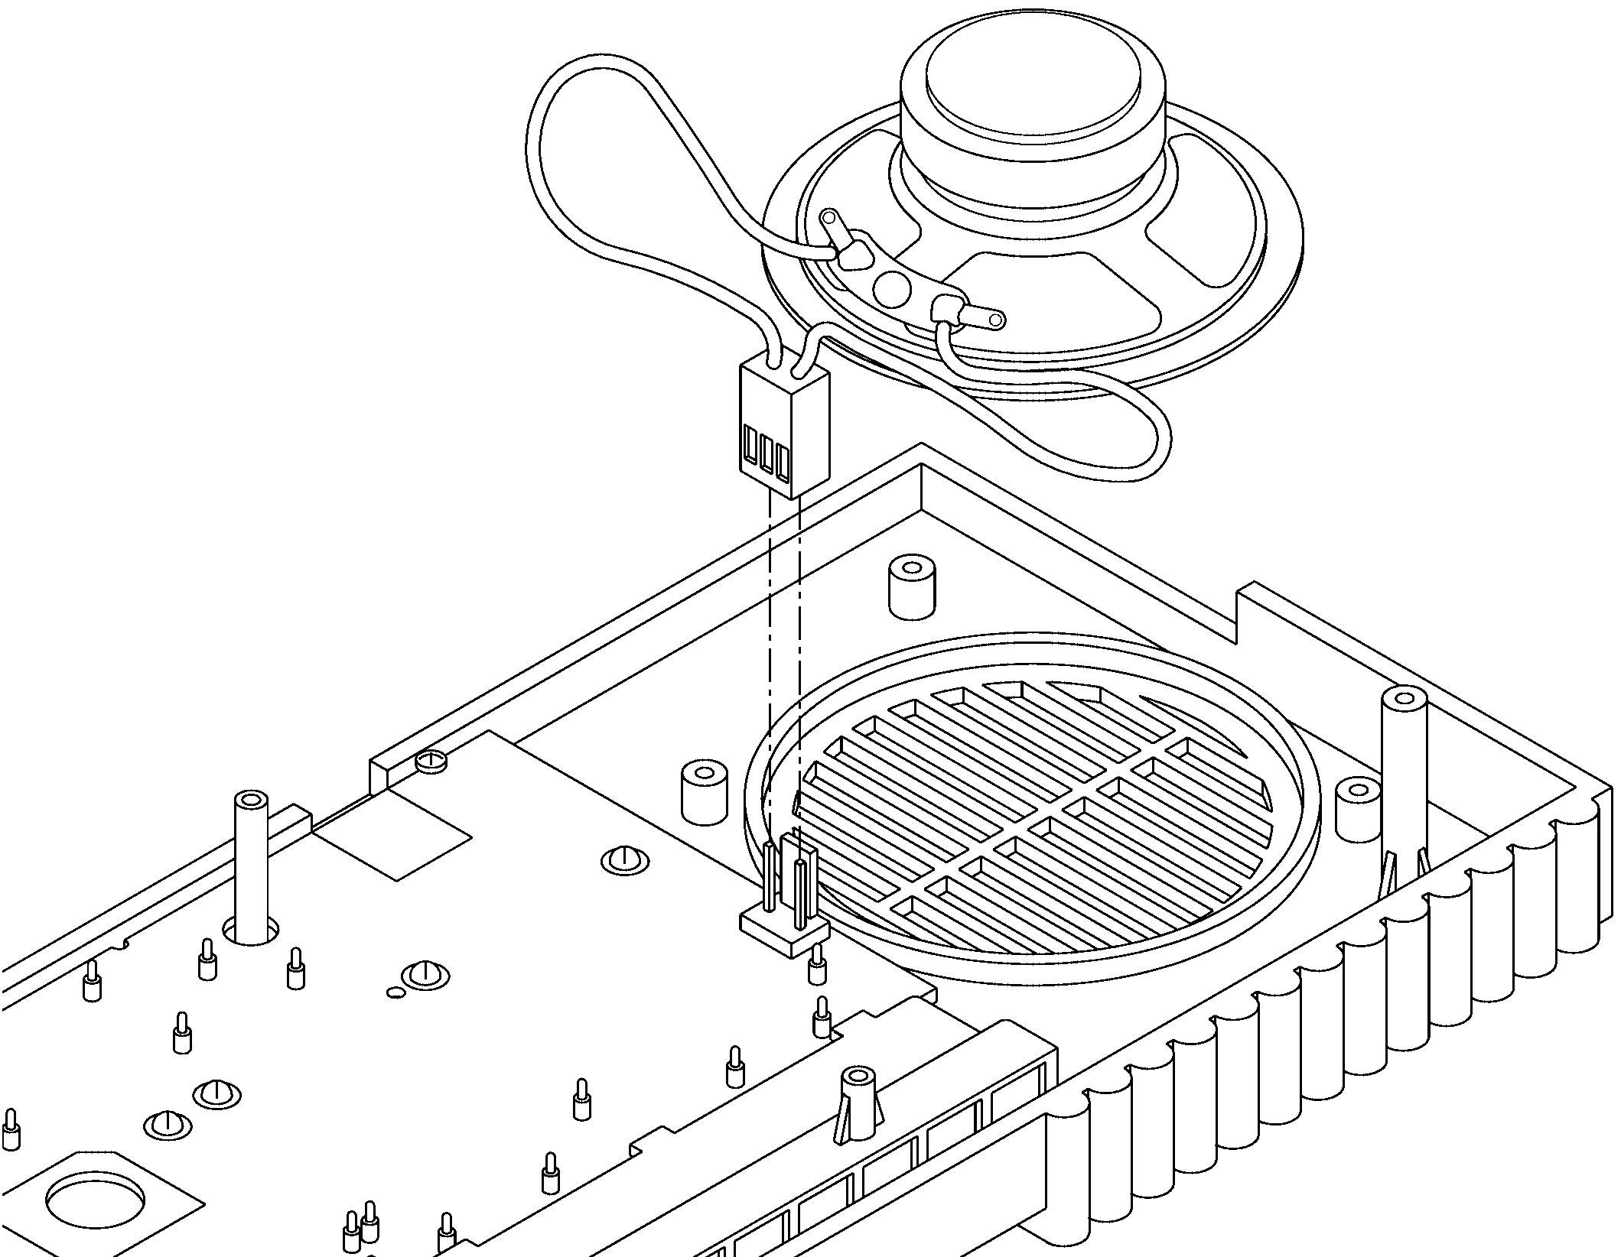Place the Speaker (Bag #5) in its slot next to the Circuit Board and plug its connector into the Circuit Board. The tab on the speaker connector should be facing the Speaker so that the connectors “lock” together. If the tab is on the wrong side then the Speaker will be wired incorrectly and will not work.
Figure H
Connector
Connector
Speaker
- 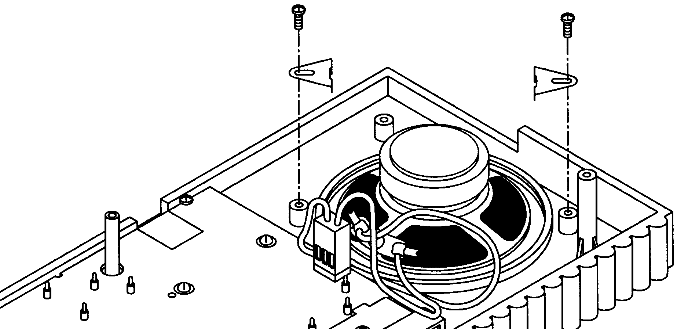Place the Speaker Clamps (Bag #3) as shown in Figure I to hold the Speaker in place and secure with two Screws (0.2” x 0.1” or 0.3” x 0.1”, also Bag #3).
Small Screws

Speaker Clamps
Figure I

- 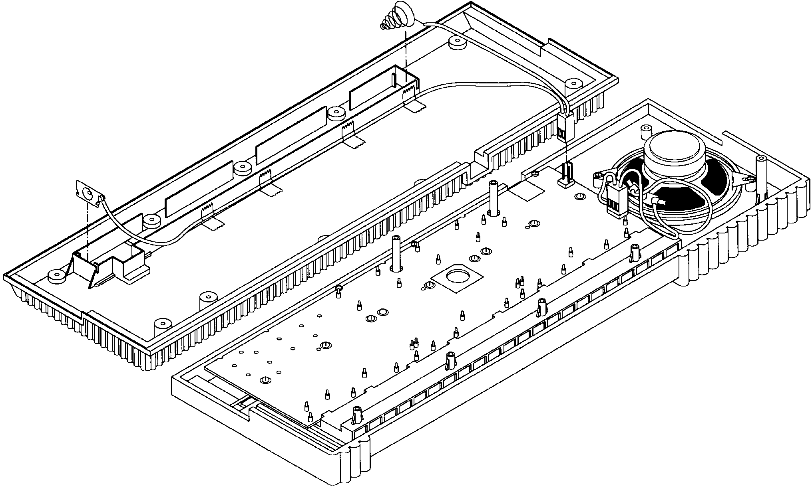Connect the Battery Wires (Bag #5) to the Circuit Board by plugging in the connector (as shown in Figure J). The tabs on the connector should be facing the Speaker so that the connectors “lock” together. If the tabs are on the wrong side then the product will be wired incorrectly and will not work. Now place the Bottom Case alongside the Top Case. Spread the Battery Wires into the Bottom Case (using the small pegs as a guide for the long wire) and press the battery contact spring and battery contact clip into position without breaking the wires, as shown. The clip will be a snug fit and you may need to tap it with a screwdriver to get it in all the way. Hold the long wire into position using several pieces of tape.
Battery Contact Spring
Scotch Tape
Battery Contact Clip
Figure J
Connector
Bottom Case
- 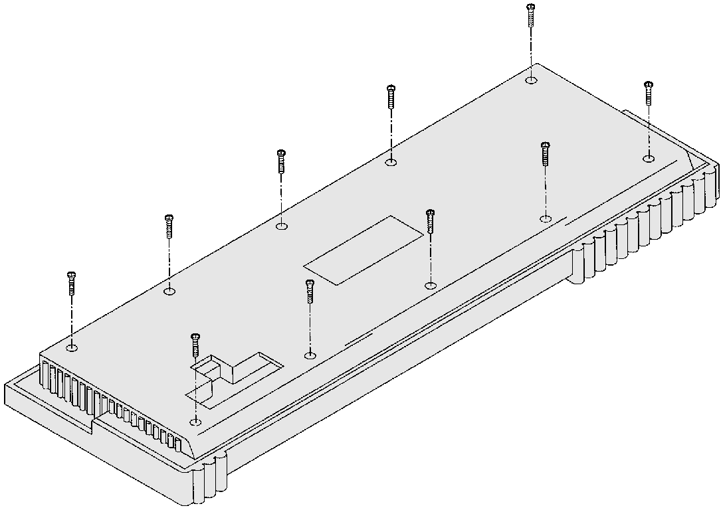Place Bottom Case onto Top Case (upside down) and secure with ten Screws (0.3” x 0.1” or 0.2” x 0.1”, Bag #3), as shown in Figure K.
Small Screw
Figure K

- 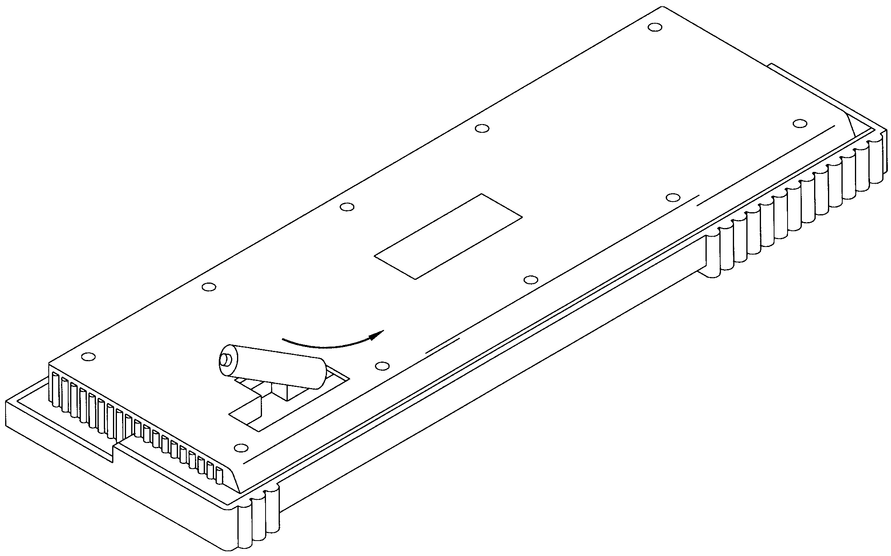Make sure the Power switch is OFF. Insert 6 AA batteries into the back of the unit being sure to orient their positive and negative terminals properly, as shown in Figure L (if you intend to use the optional AC/DC Adapter then you don’t need batteries). Remove the backing from the Battery Pad and stick it on the Battery Cover, then place the Cover in its slot on the Bottom Case to secure the batteries. Place the AK-900 Label in the center of the Bottom Case.
Label
AA Battery
Figure L

OPERATING INSTRUCTIONS
Turn the unit on and adjust the speaker volume as needed (you may adjust the rhythm and master volumes separately). You may use the keyboard and custom drummer (the big pink buttons) by themselves or combined with background music. The orange buttons provide background dance music; press one of them and then the start button. The blue DEMO button plays the demonstration tune “Green sleeves”; to stop the demo, press the DEMO button again. The green buttons select which instrument the keyboard is simulating (piano, flute, violin, organ, french horn, banjo, music box, guitar). Use the small pink buttons to change the tempo of the demo or the dance music. The Vibrato button turns the vibrato effect ON/OFF.
This product operates with six AA batteries. The unit will not sound as usual if the batteries are weak, in this case try changing the batteries. For longer battery life take out the batteries if the unit will not be used for a long time and use alkaline batteries.
You may also operate this product with an AC/DC Adapter that has a 9V output voltage and 400mA current rating. This may be purchased through Elenco Electronics or at your local electronics store.
WARNING FOR USE OF AC/DC ADAPTER:
The Adapter should be regularly examined for potential hazards of damaged cable, plug, and enclosure. In the event of such damage the adapter must not be used until such damage has been properly removed.
The Adapter must comply with CEE publication -15.

1.4.3 Professional audio/Public-address (PA) systems and Mixer
Public Address is a centralized amplifier-based system designed to provide voice paging and broadcast alarm tones during emergencies. The system can transmit alarm tones and voice messages in a reliable and safe manner from a central location to all or selected areas of the facility via loudspeakers. The entire operational area can be divided into one or more zones, which can be accessed independently either for announcements or alarm broadcasting. Loudspeakers are installed in these zones. There are no limitations to the number of zones in a system or number of loudspeakers in each zone. The system is designed to offer clear reproduction of sound and intelligibility, even in high noise areas.
There are many kinds of PA systems. One type of these devices is 120W RMS /180W Max. The most common features of this PAS are as follows.
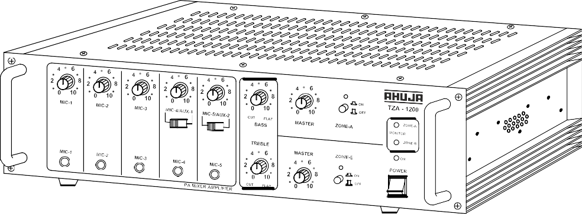

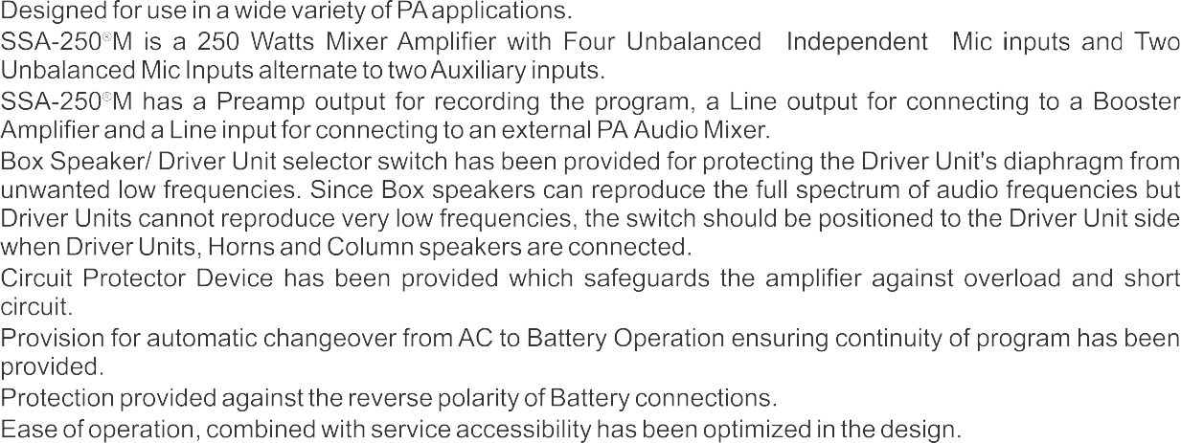

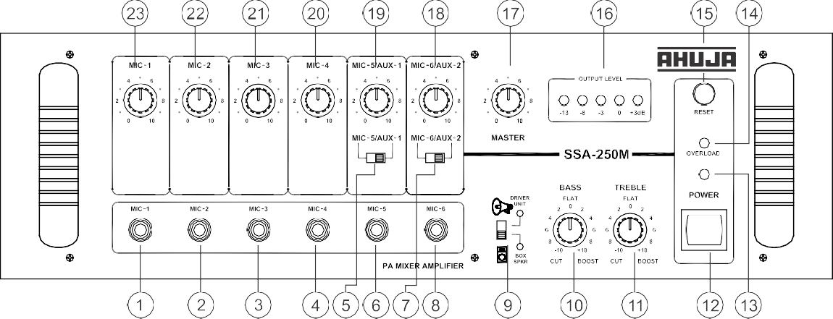

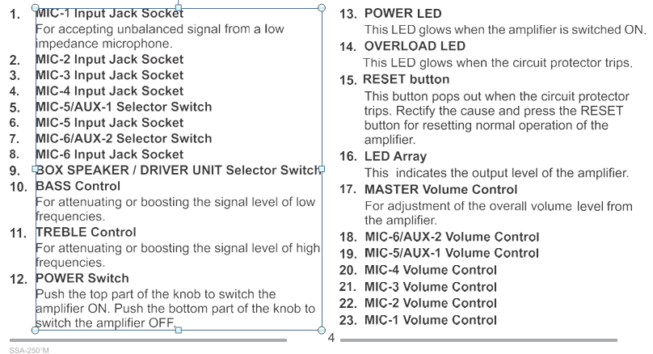

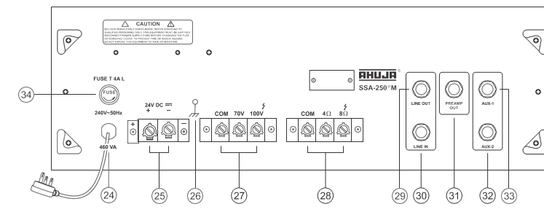
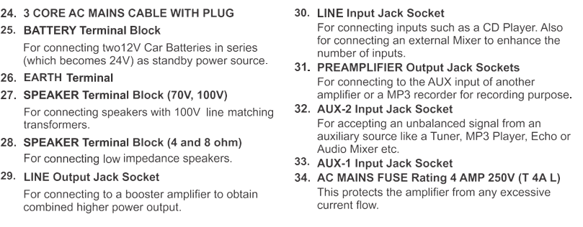

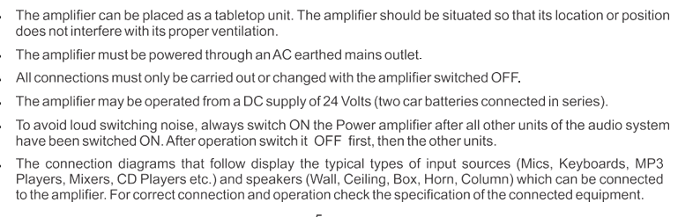

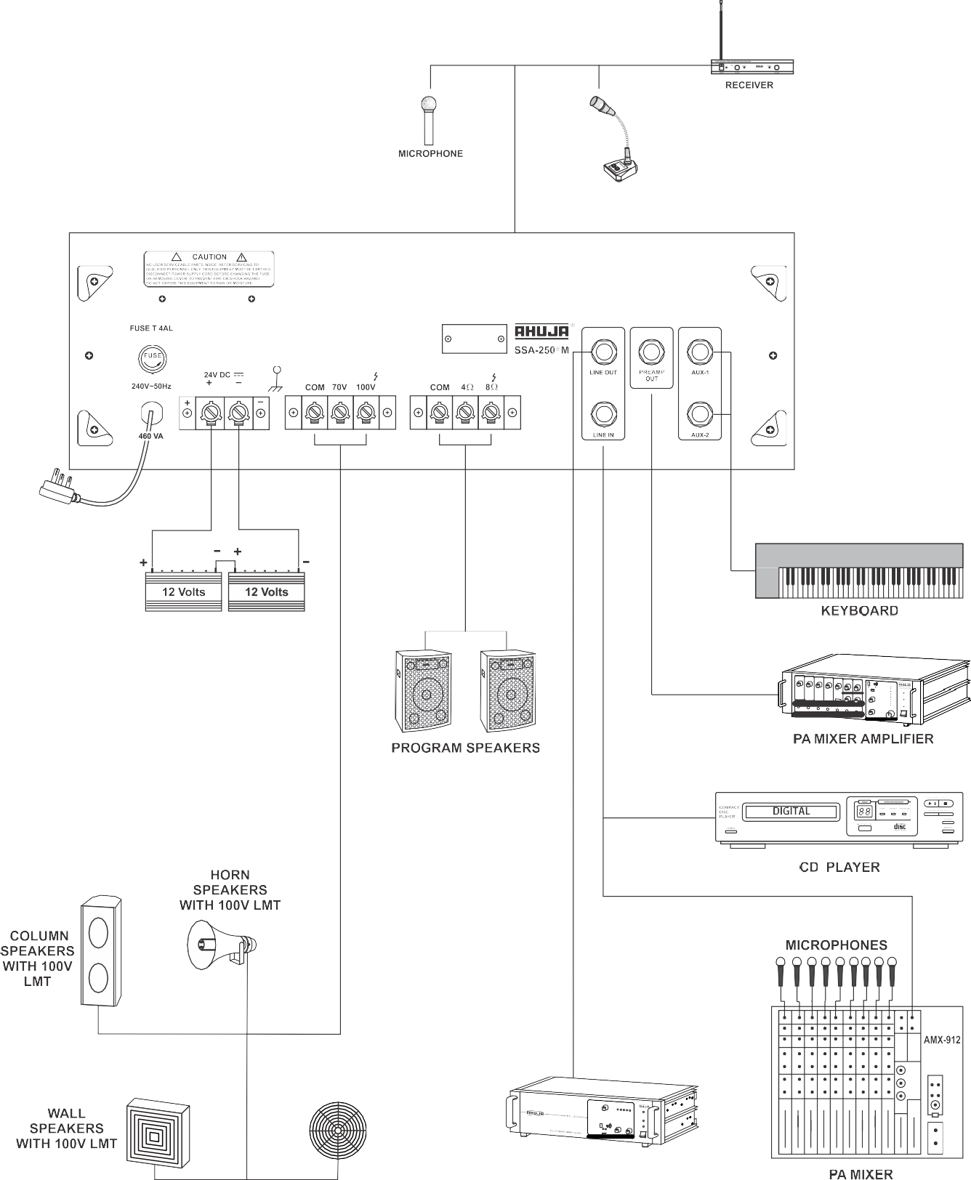
1.4.4 Mixer

.Introduction
Figure 1 shows the typical block diagram of a Transmitter and a Receiver. It can be seen that in both cases frequency translation is achieved by the use of a Mixer. The mixers can be either passive mixers using diodes or they can be active mixers using transistors or FETs. In many receivers and transmitters, a succession of mixing and filtering stages are used, to ensure that the filtering requirements can be satisfied.
A mixer is used as an up-converter when the output frequency is higher than the input frequency. This is typical in a transmitter. A mixer is used as a down-converter when the output frequency is lower than the input frequency. This is typical for a receiver.

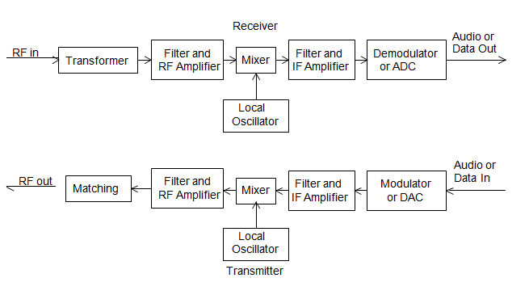
Fig 1.17 Typical Transmitter and Receiver Block Diagram
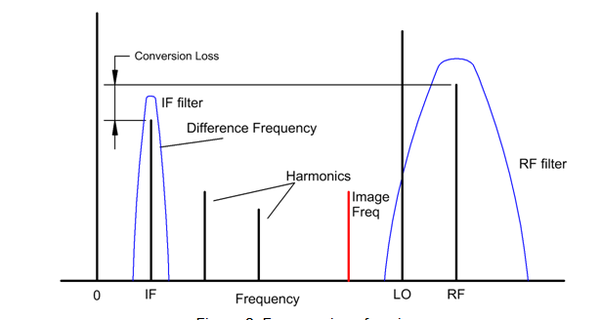Fig. 1.18 Frequencies of a Mixer
signal to produce sum and difference frequencies. The sum frequency is outside the operating frequency range of the system and the difference frequency is the required Intermediate Frequency (IF) signal, which is filtered and amplified using an IF filter and its associated amplifiers.
The RF filter should be sufficiently narrow so that the image frequency is not passed through the RF filter, since the difference frequency of the image frequency and the local oscillator is at exactly the same frequency as the required IF signal.
An ideal multiplier is a perfect mixer since when the LO signal is multiplied by an RF signal then sum and difference frequencies are generated, the difference frequency being the required IF signal and the sum signal being an unwanted high frequency component, which is normally filtered out. For an up-converter, the LO signal is multiplied by an IF signal and a double sideband suppressed carrier RF signal results. The aim in mixer design is thus to make the mixer behave as close to an ideal multiplier as possible.
There are two types of mixers: 1) Passive mixers, using diodes, where the LO power provides the power for the mixer. 2) Active mixers, where transistors or FETs supplied with DC power provide the mixing action.

Definition of Terms
Conversion Loss
For a down-converter, the conversion loss is the ratio of the wanted IF output signal to the RF input signal. Most mixers are used in receivers, for which this definition is applicable. For up-conversion, the conversion loss is the ratio of one of the wanted RF output signal spectral components to the IF input signal. For an ideal mixer, half the input power is frequency shifted to the difference frequency and half the power is shifted to the sum frequency. The conversion loss is the ratio of either the sum or the difference component to the input signal. An ideal passive mixer will thus have a conversion loss of 3 dB. Practical balanced or double balanced mixers typically have a conversion loss of less than 6 dB. The conversion loss does depend on the amount of LO signal power applied to the LO port. The mixer is normally operated at a LO power close to that giving the lowest conversion loss. Active mixers can have a conversion gain.
The conversion loss must be taken into account in noise figure calculations of a receiver. A mixer with a 6 dB conversion loss typically has a 6.5 dB noise figure. For high quality receivers, an amplifier with a gain much greater than the conversion loss is normally used before the mixer, to ensure that the mixer does not dominate the noise performance of the receiver.
Isolation
In practice it is desirable to have isolation between the LO, RF and IF ports of the mixer. Typical double balanced mixers have more than 30 dB isolation between all ports. Single diode mixers have virtually no isolation between ports. Since single diode mixers are used in TV receivers, the LO signal is coupled to the antenna, which radiates the LO signal. In countries where TV licenses are required, the “detector vans” look for the LO radiation and match the radiation coming from a house with any license fee.

payment. One can also do a good survey to find out what TV channel people are watching by simply driving around a street with a spectrum analyzer and noting the LO frequencies. For a balanced mixer, the isolation is directly related to the match between the diodes used. As a result many manufacturers sell matched sets of diodes, specially for use in mixers. In many cases two or 4 diodes come as one package.

Compression Point
For an ideal down-conversion mixer the IF output produced should be directly proportional to the RF input signal. However as the RF input approaches about 10 dB below the LO power. The IF output starts to saturate and the conversion loss starts to decrease, as is shown in figure 3. Most manufacturers of mixers specify the 1 dB compression point for their mixers. The 1 dB compression point is typically 6 dB below the LO level for mixers up to +23 dBm LO power.
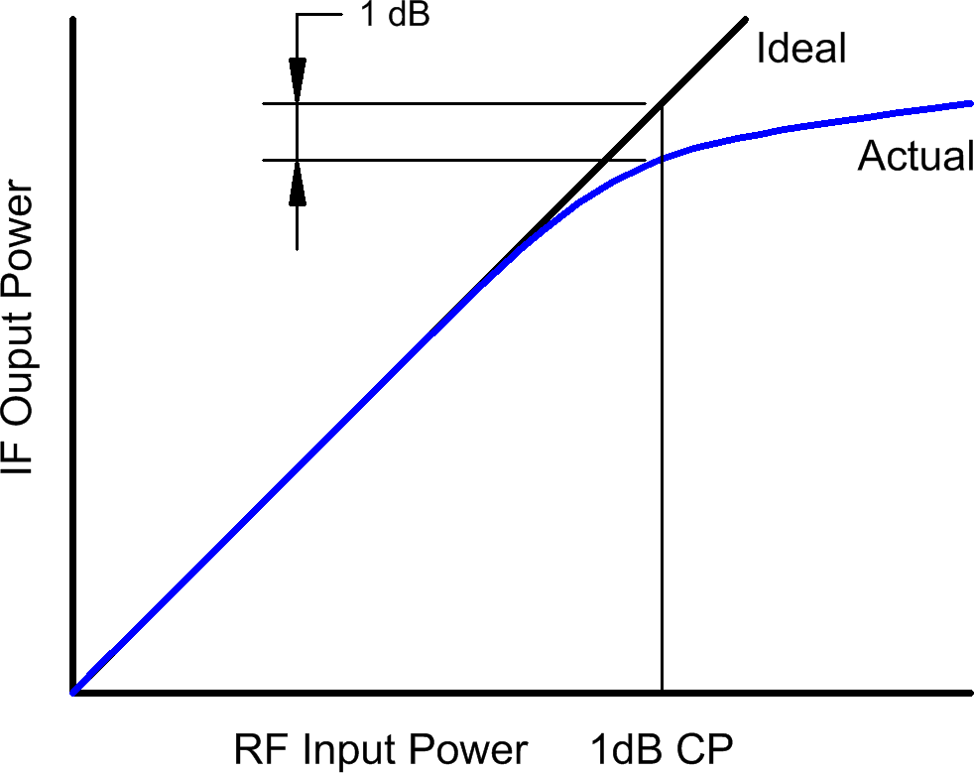
Since the 1 dB compression point is related to the LO drive, a higher LO level results in a higher 1 dB compression point and as a result a bigger dynamic range of the mixer.

Figure 1.19 dB Compression Point of a mixer.

Dynamic Range
Dynamic range is the range over which a mixer provides useful operation. The upper limit of the dynamic range is determined by the 1 dB compression point. The lower limit of the dynamic range is limited by the noise figure of the mixer. Since the mixer noise figure is only about 0.5 dB higher than its conversion loss, the lowest conversion loss is desirable to obtain the largest dynamic range. High and Extra High level mixers have a higher 1 dB compression point and thus a bigger dynamic range. Higher level mixers are significantly more expensive and require more LO power, so that a compromise between cost, power consumption and dynamic range exists.

Two-tone Third Order Intermodulation Distortion
In this section one considers the mixer as a “linear” device, since the for a down- converter, the IF mixer output amplitude is directly related to the RF input amplitude. The output Y(t) of a mixer or amplifier will depend on the input X(t). The gain of the device, relating the output to the input is a₁. In addition a DC component and harmonics of the input may be created due to the distortion of the device. The output is thus:
The frequencies of these spectral components are shown in figure 4.

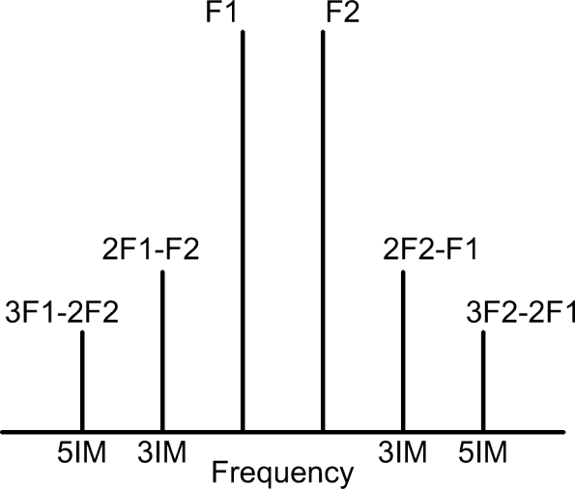
Figure 1.2.0 IM distortion of an amplifier or mixer.
The second order inter modulation (2IM) and the fourth order inter modulation (4IM) distortion produced by the amplifier or mixer does not create any components near the desired frequency components an as a result the 2IM and 4IM performance is less important for an amplifier. The second order inter modulation produces the required mixing action in a mixer and is thus of utmost importance.
The third order IM (3IM) and fifth order IM performance is very important in linear amplifiers since when two tones are used as an input to the amplifier, the 3IM and 5IM distortion results in additional frequency components, which again cannot be filtered out, as can be seen in figure 4. The 5IM components are often too small to be observed in a spectrum like figure 4. For mobile phone base-stations, these IM signals are likely to create interference in adjacent mobile phone channels, as a result the IM performance of amplifiers and mixers are a critical part of their specification.

Third Order Intercept Point
A popular method of determining the “linearity” of a mixer is the "third-order intercept" approach. The Third-Order Intercept Point is a theoretical point on the RF input versus IF output curve where the desired input signal and third-order products become equal in amplitude as RF input is raised.
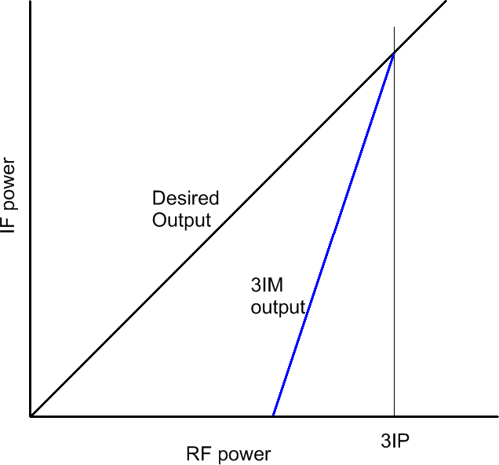
Figure 1.21. Third order intercept point.
As the RF signal increases by 1 dB, the 3IM distortion component increases 3 dB. The Third Order Intercept Point is determined by increasing the RF level and noting both the desired and the 3IM levels. The third order intercept point is the point where the extension of the plotted desired output and 3IM output level versus RF input meet, as shown in figure 5. It is not possible to drive the mixer to those RF levels. As a rule of thumb the third order intercept point is about 8 to 10 dB above the LO level for a typical diode based double balanced mixer and up to 15 dB above the LO level for passive FET mixers. Passive FET mixers however have a much narrower bandwidth.
The third order intercept point is useful in determining the RF level required for a specified 3IM distortion performance. If for example, the 3IM signal is to be 40 dB below the required signal, then the RF level must be 20 dB below the Third Order Intercept Point, since then the desired signal will be 20 dB below the intercept point and the 3IM signals will be 3*20 = 60 dB below the intercept point.
LO Level
Mixer manufacturers make mixers to operate at different LO power levels. For standard level mixers, the LO power required is +7 dBm. Other mixer power levels are +10, +13, +17, +23, +27 dBm. Mini circuits denote their mixer according to the LO power required, so a Level 7 mixer requires a LO power of +7 dBm. For a good Double Balanced Mixer, the third order intercept point (IP3) is 10 dB above the LO level. By having a higher power level available, the manufacturers are able to control the diode I-V characteristics more to ensure that the a₂ coefficient in the binomial expansion of the diode I-V characteristic shown as Equation 1, 2, 6 and 7 is maximized in relation to the other terms, thus minimizing the unwanted components.

Single Diode Mixer
Single diode mixers use a single diode to produce the required frequency components.
Single diode mixers are often used in cost critical applications, such as Radio or TV receivers, where the low cost is more important than good performance. With the advent of low cost active mixer IC’s, single diode mixers are progressively being used less. Single diode mixers are very suitable for microwave applications like speed guns and shopping centre door openers, where the transmitted signal is used as the LO for the received signal, and the receiver diode is simply mounted in the antenna horn. The resulting IF signal is the difference frequency, which is due to the speed of the car being detected or the speed of the person moving towards the door.
A single diode mixer requires a diplexer to separate the high frequency RF and LO signal from the low frequency IF signal. Since the single diode mixer is normally a lower cost consumer type application, the diplexer is normally kept simple with either a first or second order high pass and low pass filters.
Figure 1.22 shows a simple diplexer consisting of second order high pass and low pass filters. The crossover frequency is chosen to be 20 MHz, allowing baseband signals up to 15 MHz to be used. To obtain the best impedance looking into port 1, series elements are required to connect to port 1. A Butterworth high pass and low pass filter design is a good starting point and optimisation can be used to improve the impedance matches resulting in the diplexer performance .
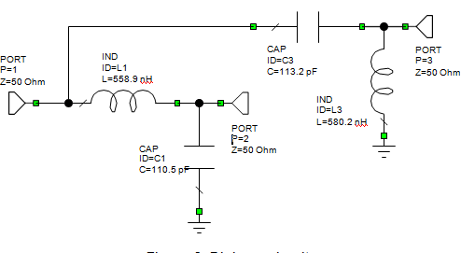
Fig. .1..22 Duplex Mixer

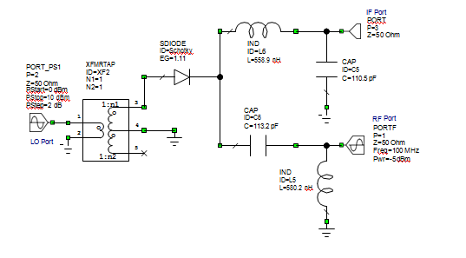
Fig. 1.23 Circuit Diagram of a single diode mixer as a down converter

Computer simulation of Mixers
The advanced RF Computer simulation programs like MWO and ADS allow mixers to be simulated accurately. A mixer requires two inputs, both at different frequencies and the output is normally at a frequency that is different from both the inputs to the mixer. The simulation is thus very different from that of a linear device, like a transformer, hybrid or filter.
The frequencies used for the simulation are set by the Project Options menu. For the single diode mixer of figure 8, these frequencies are used by the PORT_PS1 port element, which is applied to the LO port (Port 2). The PORT_PS1 element allows the signal power to be varied as specified by the parameters for the PORT_PS1 element.

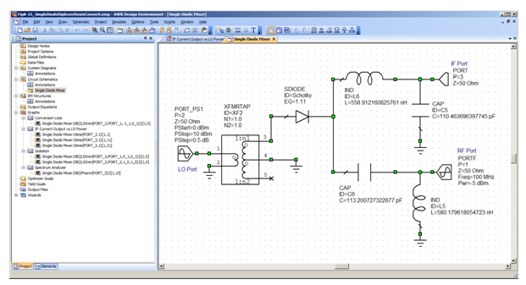
Fig. 1.24 Typical Measurement for a Mixer
To operate the mixer as an up-converter, the PORTF element is applied to the IF port and the signal generated by that port is set to 5 MHz and a power of -5 dBm. The mixer output is then at the RF port. The resulting circuit diagram for the single diode mixer as an up-converter is shown in figure 16. The same measurements can be performed as for the down-converter.

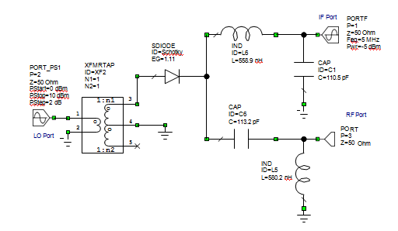
Fig. 1.25 Circuit diagram of a single diode as an Up-Converter
Advantages of single diode mixers:
- Can be used at very high (microwave) frequencies.
- Low cost, one diode.
Disadvantages of single diode mixers:
- High Conversion loss.
- High level of unwanted components.
- No RF to LO isolation, IF to LO and IF to RF isolation only due to diplexer.
Balanced Mixer
Adding a second diode to the circuit shown in figure 19 results in a balanced mixer. The first diode has V_{a}+V_{b} across it and the second diode has V_{a}-V_{b} where voltage V_{a} is the LO and V_{b} is the RF voltage. The currents through the diodes are thus:
3
2
Tran
Filter and IF Amplifier
The clutch feels funny...

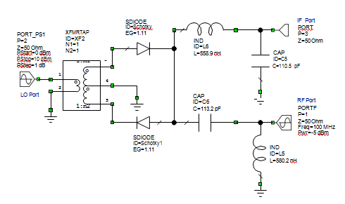
Fig. 1.26 circuit diagram of a balanced Mixer

Double balanced Mixer
Double balanced mixers, together with the active mixers are the dominant mixers used in non-consumer oriented transmitters and receivers. There are several companies making double balanced mixers, Mini circuits is one of the largest of these. It is interesting to see the change in price for the SRA-1. For many years this was $1.95 (US). In recent years the price has risen significantly, reflecting cost increases for that style of packaging, while the cost of surface mount packages is decreasing.
The circuit diagram of a Double Balanced Mixer is shown in figure 1.27. The two transformers provide isolation for all ports. Four diodes are now required.

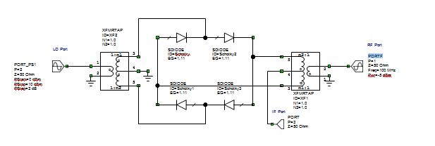
Fig. 1.27 Circuit diagram of a Balanced Mixer
Figure 1.28 shows the construction of a simple home made double balanced mixer, the transformers are held in-place with Silastic (Silicone Sealant). The diodes are conventional Shottky-Barrier diodes that have been matched for their V-I characteristic in order to obtain the best LO ⇨ RF isolation.
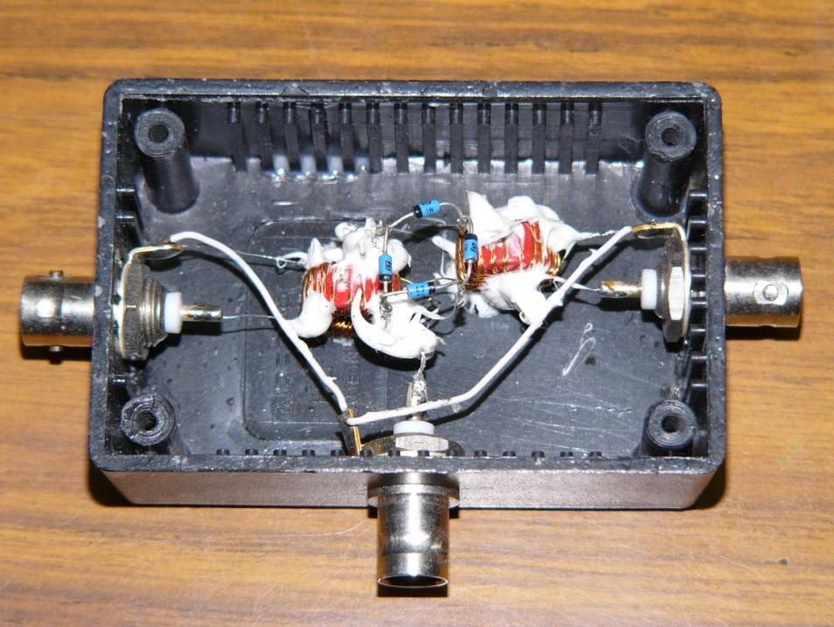
Figure 1.28. Construction of a Double Balanced Mixer for use in Practical Sessions.

Microwave Mixers
At microwave frequencies (>1 GHz) transformers become difficult to make. In addition the capacitance associated with the diodes used in the mixer cause the diodes to become less efficient as a mixer. As a result, mixers at microwave frequencies have higher conversion losses than mixers used at lower frequencies. Conversion losses of 6 to 10 dB are typical. Transformer based mixers are available for frequencies up to 12 GHz.
At microwave frequencies, transmission lines are often used to produce the two outputs with a 180 phase shift, to provide a replacement for the transformer in the balanced mixer shown the figure 19. The circuit for the corresponding microwave mixer is shown in figure 36. In this design, the mixer is used for a down-converter for a weather satellite receiver and uses a 1565 MHz Local Oscillator to shift a 1700 MHz RF signal to a 135 MHz IF frequency.

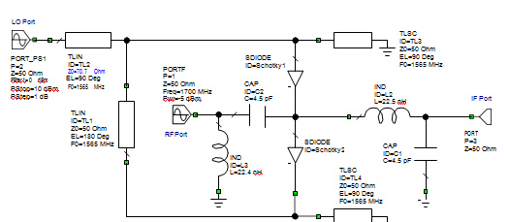
Fig. 1.29 Circuit diagram of a Microwave Mixer

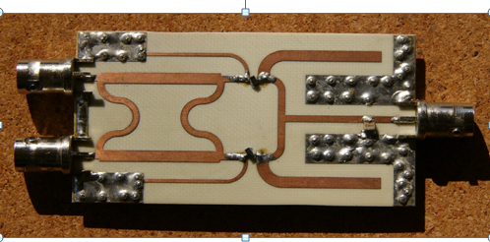
Fig. 1.30 Hardware Realization of the balanced Mixer using Branch line coupler
Quadrature Mixers
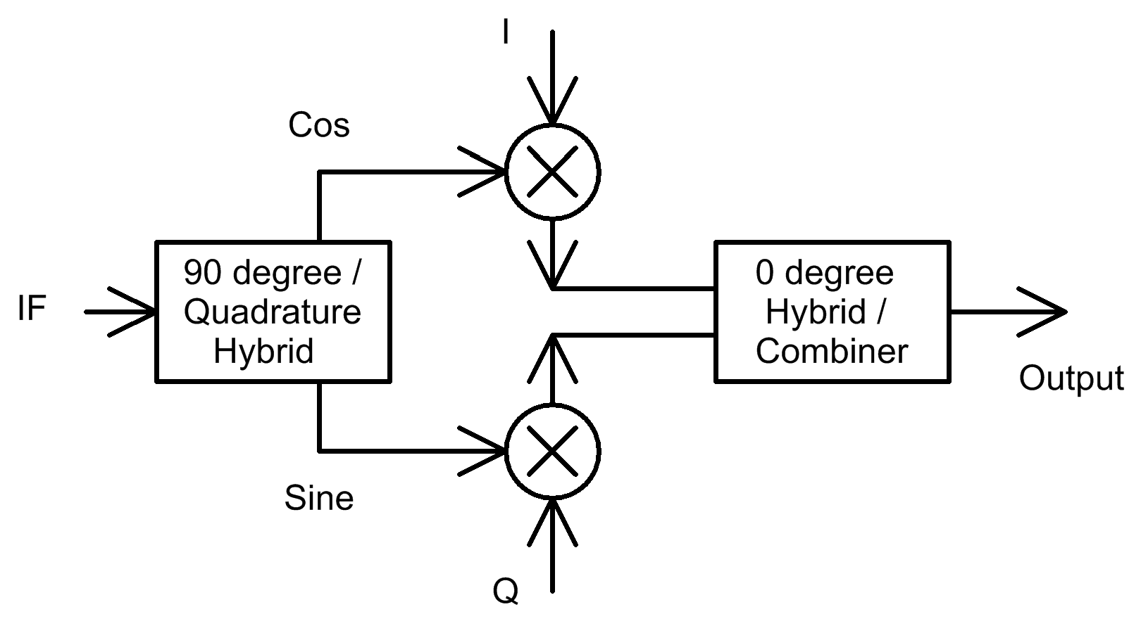
In quadrature mixers a 90 degree hybrid, like a Branchline coupler is used to produce two LO signals, corresponding to Sine and Cosine of the LO frequency. The Cosine signal is then multiplied with the In-Phase (I) component of the baseband signal, and the Sine signal is multiplied with the Quadrature (Q) component of the baseband signal, as shown in figure 54. The resulting signals are then added using a combiner like a Wilkinson hybrid to produce the RF signal. When the I and Q signals are the Hilbert transform of each other, then a Single Sideband RF signal results. When the I and Q signals are an RF signal that is passed through a 90 hybrid then the image frequency components are suppressed. When the I and Q signals are individually controlled baseband signals a vector modulated RF signal results. In most cases the I and Q signals are produced using Digital Signal Processing techniques. Quadrature mixers are thus required for the vector modulation used in many modern communication systems

Active IQ Mixers
The RF2850 IQ mixer, is used as an up-converter for mobile radio applications. This mixer used Gilbert cells for the mixers. Using an IQ mixer allows the required RF output signal to be produced, without the need to filter out unwanted sidebands. In addition a zero IF frequency can be used, so that the LO is at the centre of the RF band, again avoiding the need for filters. Such RF filters are large and heavy. It is desirable to have a small and light mobile phone. An I and Q signal, up to 250 MHz can be used, together with a LO signal in the range 1.7 GHz to 2.5 GHz, to produce a quadrature modulated RF signal in the range 1.7 GHz to 2.5 GHz. A typical carrier suppression of 25 dB unadjusted and 55 dB adjusted is obtained. The mixer has a typical (unadjusted) unwanted sideband suppression of 45 dB. The mixer performance satisfies all the mobile radio standards. These are low cost devices aimed for a consumer market.
For modern signal generators, IQ modulation is used to produce the complex modulated waveforms used in modern communication systems. The mixers used in such signal generators are often active (Gilbert cell) IQ mixers. Computer controlled DC bias (control and calibration) signals are used to ensure that the carrier feed-through, Quadrature phase shifts and I and Q gains are correct. The design of such IC’s can cost more than one million dollars. The resulting devices have a better performance than those of figure 55 or 56, but each mixer will also be more expensive.
LTC Mixers
At higher frequencies, it becomes more difficult to wind the transformers required for the mixers. Low Temperature Cofired (LTC) thick film technology allows a circuit to be made up from multiple layers of ceramic materials. By depositing conductive of magnetic inks, a set of layers can form a strip-line transmission line, a ferrite loaded hybrid or it can contain semiconductor elements like diodes. Because high dielectric constant materials are used, the resulting package can be made small. Since the process can be automated, lower production costs result. Mini circuits use this technology for producing high frequency mixers. A typical example is their IQBG-2000 I&Q modulator. This device is designed for the 1.8 GHz to 2 GHz mobile phone market.

1.4 Verify repair/maintenance history.
Every company, no matter which industry it belongs to, relies on the health of its equipment in one way or the other. The downtime or unavailability of equipment leads to time wastage and potentially lost sales. This is why taking good care of the equipment you own should be a top priority.
However, it can be quite a struggle to ensure that all these important assets are maintained and inspected as often as needed. It is crucial to maintain an equipment maintenance log for many reasons. For starters, it helps ensure that the revenue-generating operations are constantly progressing as required without any disruptions in the form of unexpected downtime.
Moreover, keeping track of equipment maintenance can also help decrease the risk of injuries at the job sites. It is believed that equipment failures have an immense effect on the severity and number of accidents in different industries.
What is an equipment maintenance log?
The equipment maintenance log is a simple document that contains a list of all actions that have been performed on a certain piece of equipment. It helps keep track of the maintenance history. It generally contains the following two different sections, each containing different types of information:

1.4.1. General information
The first section has to do with general information. This information is used to identify the piece of equipment. It most commonly includes:
Name of equipment
Model or manufacturer
Serial number
Location
Person responsible for equipment
Some equipment maintenance logs also include the Purchase date and Purchase price in this section.
1.4.2. List of maintenance actions
The second section lists all the maintenance actions performed on the equipment. It commonly includes the following fields:
Date when the action was performed
Description of the action itself
Name of the person performing the actions
Lastly, some logs also include a Remarks section. This section is useful in case the person performing the maintenance might have any special notes to add for future reference.
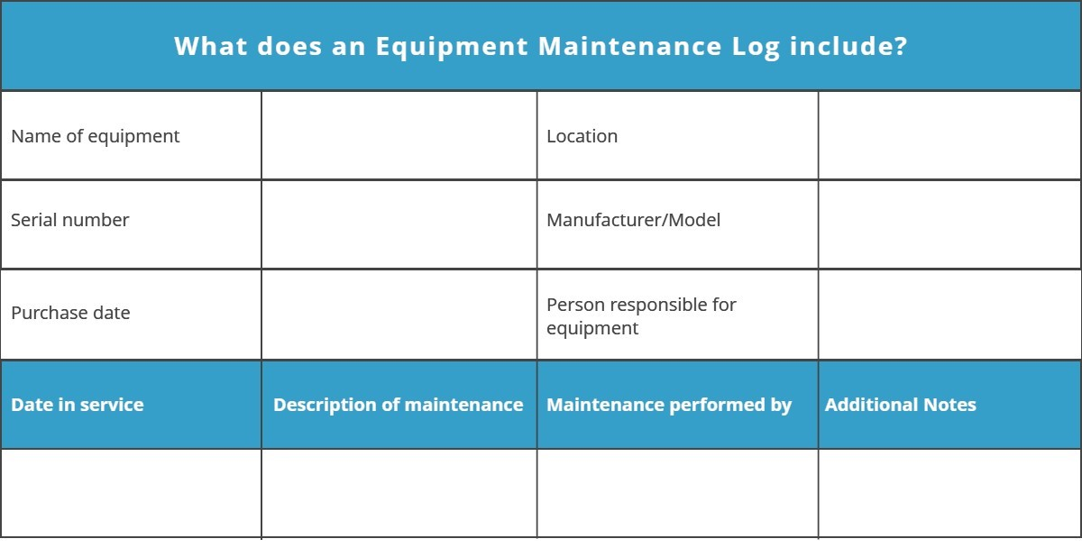
Fig 3.1 Equipment maintenance Log
Shortcomings of the traditional equipment maintenance log
The traditional equipment maintenance log takes us back to the pen and paper era. It goes without saying; filling out a maintenance blog manually with a pen takes up an excruciatingly long amount of time. Furthermore, there is also an increase in mistakes. Human errors become quite commonplace when everything has to be written down manually.
Apart from these, there are several other problems with the traditional paper-based maintenance log. There is limited flexibility and the data on there is not that easily accessible when needed. Lastly, paper can easily get lost, burnt, destroyed, spilled on the list goes on and on. If something of that sort happens, you’re going to lost precious data.
Instead, you can choose to move forward with the times and consider software that automates such manual processes for you. Such software will help save precious time and effort that can be better used elsewhere.
Equipment maintenance log and tracking software
Maintenance tracking software eases and simplifies the process of dealing with maintenance issues of your equipment via equipment maintenance log. It records each and every maintenance issue that arises in each of your equipment, thereby leaving a trail of maintenance history. This history can then be utilized by technicians or key personnel who are responsible for fixing the equipment.
Proper maintenance records help to:
- Minimize the number of expensive repairs
- Identify inventory trends
- Increase operator safety
- Pitifully impact resale value
- Enhance the health visibility of each piece of equipment

A robust equipment maintenance feature comes with a scheduler that automatically sends inspection, repair and maintenance alerts to key personnel in case a problem arises. This enables you to take an action to quickly repair or fix the equipment and make it operational again.
Furthermore, the automation of processes ensures monthly and annual maintenance along with timely inspections and required checks.
Recording accurate equipment maintenance logs drive awareness about an item’s maintenance. They also narrow down what elements and parts of your equipment are resulting in performance issues. Several problems in equipment are exposed with the help of maintenance logs.
The equipment tracking solution also helps you save money. It tracks the maintenance history of each asset. Then it actively warns you if certain equipment is costing you more to maintain as compared to the amount of revenue it is generating.
The use of equipment maintenance log
- It increases resale value of equipment
Proper maintenance and tracking of the equipment maintenance log help your equipment to run in optimal condition. Record keeping also proves to be useful when you decide to replace your current equipment with newer versions.
What directly influences the resale decision for a buyer knows about the care put into the equipment by the previous owner. Maintaining records of repairs and maintenance helps to sketch a clearer picture for the buyer about the attention given to the asset to keep it in the best possible condition.
Keeping an updated equipment maintenance history may sound complicated. However, equipment tracking software makes it simple and easy. It keeps adding details of each and everything your equipment goes through, thereby keeping the maintenance records up to date at all times.
Moreover, well-documented maintenance increases the worth of the used equipment as compared to other used equipment that has no maintenance records. To maximize resale value, a complete and consistent record of everything, including repair schedules, usage logs, and maintenance records, is very important. Such records help boost the buyer’s confidence in the seller’s assets.
- It saves the upfront costs
Having a complete equipment maintenance log lets you know when the time is right to replace equipment. This, in turn, helps you save money. The data that is gathered over time unveils patterns of failure, expenditure, and repair.
Let’s assume a piece of equipment tends to break down every two weeks. It costs $2500 per year to repair. Instead of throwing money away on its maintenance, it will be much more cost-effective to simply replace that machine for $4000. Not to mention, buying a new machine will come with equipment upgrades and a new warranty, thereby minimizing costs and equipment breakdowns.
On the other hand, with equipment maintenance software you might also discover that maintenance is a lot cheaper than actually replacing the whole equipment. The absence of proper maintenance records can lead to frequent unexpected downtimes. These downtimes are going to inevitably result in missing deadlines, halting the production lines and keeping employees idle.
On top of all that, you even have to pay technicians overtime for such unexpected failure plus the extra money for urgent delivery of parts.
- It identifies trends across makes, models, or components
The equipment maintenance log throws light on the common trends in your equipment across models, components, makes, operators and more. The data on equipment maintenance log tracked by a maintenance management solution highlights which models and makes of certain equipment incur the lowest cost per hour of ownership.
On the flip side, there can be a certain part of the same model of a machine that requires consistent replacement after a comparable number of hours or mileage. This way you can predict that replacement or repairs are going to be required at the same interval for the same model of equipment approaching its benchmark.
Such insight can help companies know the parts that are needed to be in stock and to perform replacement and repairs before any equipment failure.
- It increases the safety of operators
All sorts of machinery that you use is prone to wear and tear. Routine inspections let you see into repair issues and small damages before they turn into bigger problems. Even documenting these small repairs and inspections goes a long way in tracking all maintenance tasks that your equipment goes through.
Yet another benefit of documenting maintenance records is being able to find self-inflicted damage. Self-inflicted damage means damage as a result of the negligence of operators and employees that interact with that particular piece of equipment. If you have records about such damage, you can keep an eye on those operators who don’t take good care of your equipment and those who do.

Many accidents that take place in industries are because of unplanned equipment failures. Timely repairs, routine checks, and scheduled maintenance help to make sure that your equipment is safe to operate and to eliminate the risk of such accidents. It also increases the general safety of your business landscape.
Routine inspections, such as checking friction material, lubricating gears, and conducting periodic scans, help to improve the overall health of the machines you own. With a well-documented equipment maintenance log, you can make sure that the equipment is safe to work with.
An equipment tracking system allows you to schedule inspections when required so as to maintain the operator’s safety. It also holds the operator accountable for performing required inspections and reduces the chances of accidents or incidents due to faulty machinery.
You will also be able to print analysis reports whenever you need them and save yourself countless hours of manual reporting. You’ll have all the equipment maintenance information is right at your fingertips. This easy-to-use software solution saves you a ton of time and frees you from the clutches of stress.
EZ Office Inventory comes with numerous features to optimize equipment maintenance. You can easily schedule future maintenance, either by date or hours/miles. Moreover, other helpful features include monitoring operating costs and automating your preventive maintenance system with ease.

1.5 Require and obtain Service manuals for repair/maintenance.
Service manuals are the manuals provided by manufacturers, which cover the servicing, maintenance and repair of their products. They were not originally offer to the public as they were developing for the dealerships so that their mechanics were able to fix their own products.
If you have a maintenance manual, using it to make repairs or do maintenance on equipment can make the job much easier and more efficient. Most manuals are self-explanatory, but here are some tips on getting more out of yours.
When we use the service manual, the following steps will be following
Make sure you have the right manual in front of you.
Look for specific sections detailing the type of service or repair you are going to perform.
Read the section, which describes the task you are undertaking before you actually
Start. This will help you understand what is involved and what tools you'll need to have on hand.
Follow instructions carefully when performing any maintenance until you are familiar with the procedure.
Look for specific warnings.
Look for references to specific tools, gauges, or other specialized equipment required to perform your maintenance or repair.
Schematic diagram: is a drawing showing all significant components, parts, or tasks (and their interconnections) of a circuit, device, flow, process, or project by means of standard symbols. Schematic diagrams for a project may also be use for preparing preliminary cost estimates. Schematic diagrams may also be used to explain the general way that an electronic functions without detailing the hardware or software used in the actual electronic.
Parts list:
Parts list is known as a bill of materials (BOM) is a tabular list of the items used to make an assembly. Parts list is usually combined with the assembly drawing, but it is a separate and individual document, can be, and provides a complete list of all parts needed to build the complete project.
The four elements listed below is the most common items and placed in the assembly drawing. The information associated with the parts list generally includes:
Item number: are based on the assembly structure, that is, the order in which parts are displayed in assembly.
Part number: is a reference back to the detail drawing.
Description: is usually a part name or a complete description of purchase part or stock specification, including size and dimensions.
Quantity: The number of that particular part used on this assembly.
Operating instructions/User’s/Owner’s manual
User documentation, be it called a user manual, user guide, or other, is usually provided to customers once they buy a product or services. The User Manual contains all essential information for the user to make full use of the information system. This manual includes a description of the system functions and capabilities, contingencies and alternate modes of operation, and step-by-step procedures for system access and use. An owner's manual is an instructional book or booklet that is supplied with almost all technologically advanced consumers.
Information contained in the owner's manual typically includes:
Safety instructions; for liability reasons these can be extensive, often including
Assembly instructions; for products that arrive in pieces for easier shipping.
Installation instructions; for products that need to be installed in a home or workplace.
Setup instructions; for devices that keep track of time or which maintain user accessible state.

1.5.1. Instructions for normal or intended operations.
- Maintenance instructions.
Troubleshooting instructions; for when the product does not work as expected.
Service locations; for when the product requires repair by a factory authorized technician.
Regulatory code compliance information; for example with respect to safety or electromagnetic interference.
- Product technical specifications.
Warranty information; sometimes provided as a separate sheet.
Service Information was a regular program used to give out technical information for the technician. Service information includes the following basic points:
Job report sheets: is blank quantity for the worker to fill up during or after performing the job.
A bill of materials (BOM) provides a list of all the raw materials or components, sub-components, assemblies, and sub-assemblies required to build or repair a product or service. It is a comprehensive list of parts, items, assemblies and other materials required to create a product, as well as instructions required for gathering and using the required materials. The bill of materials explains what, how, and where to buy required materials, and includes instructions for how to assemble the product from the various parts ordered.
Customer index is a measure of how products and services supplied by a company meet or surpass customer expectation. Customer satisfaction is defined as "the number of customers, or percentage of total customers, whose reported experience with a firm, its products, or its services (ratings) exceeds specified satisfaction goals."
Customer Index is an economic indicator that measures the satisfaction of consumers across the country. The four crucial things a customer needs are: Fair price. Good service. Good product.
Service Flowchart is a kind of diagram showing how steps in a process fit together, through which you can build a step-by-step picture of the process for analysis, discussion, or communication. A flowchart is a formalized graphic representation of a logic sequence, work or manufacturing process, organization chart, or similar formalized structure..
Stock deals with products that are sold as part of the business's daily operation, inventory includes sale products and the goods and materials used to produce them.
A material requisition form lists the items to be picked from inventory and used in the production process or in the provision of a service to a customer, usually for a specific job. The form usually has three purposes: To pick items from stock. To relieve the inventory records in the amount of the items picked. Requisition slip is a form for ordering material to be used for certain purpose.
Supplier Index is a leading indicator and predictor of future growth or contraction. A rising Supplier Deliveries Index over time usually signals future supply problems. A decreasing Supplier Deliveries Index usually signals increased supply availability — and possibly decreased economic activity.

Self-Check 1 | Written test
I. choose the correct answer from the following alternatives
1. ___is provided by manufacturers which cover the servicing, maintenance and repair of their products.
A. Information B. Schematic diagram C. Customer index D. Service manual
2. _____is used to measure how products and services supplied by a company meet customer expectation
A. Customer index B. Stock C. Material requisition form D. Bill of materials
3. Which one of the following is showing all significant components, parts, or tasks of a circuit,/device
A. Customer index B. Bill of materials C. Schematic diagram D. Supplier Index
4._______ Information contained in the owner's manual typically includes
A. Safety instructions C. Troubleshooting instruction
B. Installation instructions D. Service location E. All
5. Which one of the following are not the steps of service manual
A. Make sure you have the right manual in front of you.
B. Look for specific sections.
C. Read the section which describes the task you are undertaking before you actually start.
D.Look for general warnings
II. Say true or false for the following questions
1. To measure voltage, the voltmeter is always connected in parallel
2. During soldering over heating easily destroy transistors and IC;S.
3.An oscilloscope offer a tremendous advantage over a multi meter is it can give you a picture of a changing electronic signal.
III. Math the following from column 'A' to its similarity in column 'B'
'A' 'B'
1. Class A Amplifier – A. has low efficiency of less than 40% but good signal reproduction
and linearity.
2. Class B Amplifier – B. is twice as efficient as class A amplifiers
3. Class AB Amplifier – C. has an efficiency rating between that of Class A and Class B
4. Class C Amplifier – D. is the most efficient amplifier class but distortion is very high

Operation sheet 1: Identifying and conducting, audio systems and products defects
Purpose: To Identify and conduct, audio systems and products defects
Instruction Using the given equipment to identify and conduct audio systems products defects ,you are given 2 hours to do the work
PROCEDURE:-
Step1. Follow safety/PPE procedure and rule
Step2. Make your working area free from dust and unwanted objects
Step3. Select the appropriate tools and testing instrument
Step4. Repaired units are reassembled
Step 5 solders the replaced component or part
Step 6 clean and test the repaired unit
Step7complied the completion procedure and documentation
Step 8 Dispose waste material

PRECAUTIONS:-
You should not forget to wear your PPEs.

QUALITY CRITERIA:-
Set each tools on safe areas
The project must be functional
Finish on time

Lap test 1 | Identifying and conducting, audio systems and products defects

Name ___________________________ Date __________________
Time started _____________________ Time Finished ________________
Instructions Given the necessary templates tools and materials you are required to perform the following tasks within 4hrs.
Task 1. perform tests to identify defective parts of audio systems
Task 2.Remove the defective part and Solder with the new component
Task 3. test the functionality of the system

Unit Two- Diagnose faults
This unit is developed to provide you the necessary information regarding the following content coverage and topics:
- Observing systematic pre-testing procedure with in manufacturer’s instructions
- Visual inspection of the unit with power off
- Interview of customer re history of unit
- Identifying system defects/fault symptoms.
- Using test instruments with user manuals.
- checking and isolating Circuits using specific testing procedures
- Identifying defects and faults.
- Checking Control settings/adjustments.
- . Completing documentation.
- Advising Customers..
This unit will also assist you to attain the units stated in the cover page. Specifically, upon
completion of this unit, you will be able to:
- Observe systematic pre-testing procedure with in manufacturer’s instructions
- Visual inspection of the unit with power off
- Interview of customer re history of unit
- Identify system defects/fault symptoms.
- Use test instruments with user manuals.
- check and isolate Circuits using specific testing procedures
- Identify defects and faults.
- Check Control settings/adjustments.
- . Complete documentation.
- Advise Customers..Require and obtain Service manuals for repair/maintenance.

Unit two Diagnose Faults

2.1 Systematic pre-testing procedure is observed
There are several approaches that troubleshooters use. They may have different steps or processes but they have the following in common: They all approach problems systematically and logically thus minimizing the steps and ruling out trial and error.
- Visual Inspection
Observe most faults provide clues as to their cause. There could be visual clues such as signs of damage or improper operation. Don't forget to use your other senses; sounds and smells can also provide valuable clues. Through careful observation and a some reasoning, most faults can be identified to the actual component with very little testing.
Define Problem Area At this stage you apply logic and reasoning to your observations to determine the problem area of the malfunctioning equipment.
Identify Possible Causes Once you have the problem area(s) defined it is necessary to identify all the possible causes of the malfunction.
Determine Most Probable Cause Once the list of possible causes has been made it is necessary to prioritize the items as to the possibility of them being the actual cause of the malfunction.
Test and Repair Once you have determined the most probable cause, you must test it to prove it to be the problem or not. Understand how to use tools such as prints, diagrams and test instruments to identify defective components. Let's first look at prints and diagrams. Some of the key things you should be able to determine from these are:
- how the circuit should operate
- what kind of features the circuit has
- what voltages you should expect at various points on the circuit
- where components are physically located
- how the components are actually wired together
Practice! Troubleshooting, like any skill, requires practice to become proficient. Practice can be difficult to get. Depending on your job, you may not have the opportunity for enough troubleshooting practice. And even if you do, your employer may not want you to practice troubleshooting on equipment they depend on. Until you become reasonably competent, it is best to practice troubleshooting in a controlled environment.
One option is to build or purchase equipment that can be used for troubleshooting. This equipment is designed with the ability to apply faults to it. Here you can practice your skills in a very realistic environment without affecting equipment in use.
  - Interview of customer repair history of unit
Interview of the customer about the component to be repaired is for important as it helps you to identify the defected area of the unit. The customer may give you the clue what was happed during the fault occurred. What he/she see, smell, and heard and so on. Again he/she may tell you the maintenance history of the unit if it has.
- Operate the unit according to manual to confirm defects
Using the right service manual is mandatory for the to maintain the unit in the given time frame and safety of the unit to be maintained/repair

2.2 Identifying system defects/fault symptoms.
Fault detection and diagnosis is a key component of many operations in electronic fault detection systems.
A “fault” is another word for a problem. A “root cause” fault is a fundamental, underlying problem that may lead to other problems and observable symptoms. (It might not be directly observable). A root cause is also generally associated with procedures for repair.
A "fault" or "problem does not have to be the result of a complete failure of a piece of equipment, or even involve specific hardware. For instance, a problem might be defined as non-optimal operation or off-spec product. In a process plant, root causes of non-optimal operation might be hardware failures, but problems might also be caused by poor choice of operating targets, poor feedstock quality, poor controller tuning. A symptom is an observed event or variable value, needed to detect and isolate faults. If a symptom is the response to a question or an on-demand data request (when actively testing a system instead of just passively monitoring it), it is referred to as a test or test result.
Fault detection is recognizing that a problem has occurred, even if you don't yet know the root cause. Faults may be detected by a variety of quantitative or qualitative means. This includes many of the multivariable, model-based approaches discussed later. It also includes simple, traditional techniques for single variables, such as communication and multimedia equipments and other electronics.
Fault diagnosis is pinpointing one or more root causes of problems, to the point where corrective action can be taken. This is also referred to as “fault isolation”, especially when emphasizing the distinction from fault detection. In common, casual usage, "fault diagnosis" often includes fault detection, so “fault isolation” emphasizes the distinction. Symptoms, faults and causes
Symptoms
When we diagnose a problem, we look at the symptoms of the fault and try to find the cause of them. What do these words mean?
A symptom is a clue that something is wrong.
It is a noticeable change - we might see, hear, smell or feel something different.
The engine cuts out!
The clutch feels funny...

These are both symptoms of a problem. The owner or driver recognizes them as abnormal. They won’t know what the fault is, but will know that something about the car is different.
A problem or fault in a vehicle is usually first noticed by the regular driver of the vehicle, because they are most familiar with the way it normally operates, and spend a lot of time behind the wheel.
It is the technician’s job to look at the symptom and work out what fault has caused it.
The front tyres have worn out very quickly.

The engine stopped suddenly, and it won’t re-start.
In fifth gear, the engine revs hard but the car won’t accelerate normally.

These symptoms are the abnormal things that the driver has noticed about the performance of her/his vehicle. They all point to some problem which has produced the symptom.
The common symptom for the system units selected for this UC is discussed in the information sheet above 1 above. Refer for more information.
Fault
A fault is an abnormal condition in a system or component. Something has gone wrong which we need to identify and repair.
Faults may be:
Hardware faults - Physical faults that we can observe or measure, such as parts which are broken, worn, out-of-specification, damaged, incorrectly adjusted or assembled.
Software faults - May not be directly observable, such as faulty, incorrect or corrupted programs in electronic modules.
2.3. Using test instruments with user manuals.
Consumer reports currently tests about consumer electronic products every year, in a dozen or so categories. We cover everything from TVs to cell phones, computers, digital cameras, and newer emerging categories. No one conducts hands-on tests of as many products as we do.
Models Test
- We decide which product categories to test based on current trends.
- Our experienced product specialists consider market data to help them select specific models, with a focus on representative brands, price ranges, and important features.
- They also contact manufacturers to make sure products will still be available when our ratings are published.
- We also provide information on the services integral to the use of electronic products, including cell-phone carriers, internet service providers, cable and satellite TV providers, and computer tech support.

When we Test
- For our most popular categories, we produce new ratings almost every month, and we update our ratings of other types of products several times a year.
- We also test innovative, high-interest products — such as the latest Apple iPhone — individually as soon as they are available.
- When time is of the essence, we occasionally buy a new product directly from the manufacturer before it is released to stores, but we always test a retail model when it becomes available to validate the results on the pre-retail sample.
Where we Test
- We conduct our tests in designed for the demands of specific products.
- For example, TVs are tested in rooms with controlled lighting and a video distribution system that feeds various signal sources to the sets
- We evaluate audio products in environments that simulate a typical living room setting and in an anechoic (echo-free) chamber that isolates the sound produced by a device.
- Cameras and camcorders are tested in studios designed to simulate the wide range of shooting environments and lighting that you'll encounter in normal use
How we Test
- Products are tested by engineers and technicians with years and sometimes decades of expertise in their field.
- They work with the products for several weeks, putting them through a battery of objective tests using scientific measurements
- We test products against existing industry or government standards and develop our own benchmarks when we encounter new technologies or issues that require further testing.
- All models within a category go through exactly the same tests, side by side, so they're judged on a level playing field and test results can be compared.
- Testers focus on a product's primary function (evaluating image quality for TVs and cameras, for example) and some secondary functions, too (sound quality for TVs or photos shot with a cell-phone camera).
- We use a product as any consumer would. For example, we assess how long a laptop computer's battery will last when running everyday applications, such as word processing and photo editing, or how quickly a digital camera can shoot photos at a fast-moving soccer game.
- Consumer electronics repair technicians use electrical equipment to diagnose malfunctions and test functionality of consumer electronics such as TVs, video and audio systems and digital cameras. They read manufacturers' instructions and conduct the necessary repairs or replacements.
Skills
Repair equipment on site
Identify malfunctions and repair or replace multi-media, audio-visual and computer systems, hardware and equipment on site
Replace defect components
Remove defective parts and replace them with functioning components.
Maintain equipment
Regularly inspect and perform all required activities to maintain the equipment in functional order prior or after its use.
Set up consumer electronics
Connect electronic devices, such as TVs, audio and video equipment and cameras, to the electricity network and perform electrical bonding to avoid dangerous potential differences. Test the installation for proper functioning.
Create solutions to problems
Solve problems which arise in planning, prioritizing, organizing, directing/facilitating action and evaluating performance. Use systematic processes of collecting, analyzing, and synthesizing information to evaluate current practice and generate new understandings about practice.
Provide customer follow-up services
Register, follow-up, solve and respond to customer requests, complaints and after-sales services.
Apply company policies
Apply the principles and rules that govern the activities and processes of an organization.
Provide customer information related to repairs
Inform customers about necessary repairs or replacements, discuss products, services and costs, and include accurate technical information.
Use repair manuals
Apply the information, such as periodic maintenance charts, step by step repair instructions, troubleshooting information and overhaul procedures to perform routine maintenance and repairs.
Maintain customer service
Keep the highest possible customer service and make sure that the customer service is at all times performed in a professional way. Help customers or participants feel at ease and support special requirements.

2.4 checking and isolating Circuits using specific testing procedures
Electrical equipments can be isolated using opto couplers , isolating transformers or any other device which isolates two electrical circuits from one another.
Electrical isolation is required to prevent damage to either electrical circuit when one of them is under fault conditions. It is also done to isolate high voltage and low voltage circuits. Types of isolation are
- Obtain permission to start work (a Permit may be required in some situations)
- Identify the source(s) of supply using an approved voltage indicator or test lamp.
- Prove that the approved voltage indicator or test lamp is functioning correctly.
- Isolate the supply(s)
- Secure the isolate
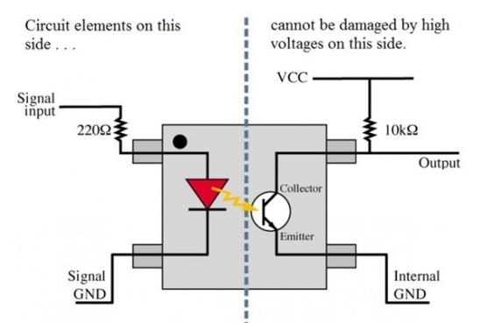
Fig 2.1 isolation circuit
An optocoupler is shown in the above circuit which isolates the low voltage and high voltage sides. Let us assume that the signal input on left side is connected to a micro controller and on the right side we have a BJT connected to VCC = 24 v. Here, we know that a typical micro-controller can handle a maximum of 5 volts. So, we cannot interface the base of the BJT with the micro-controller directly because if the collector and base regions are shorted due to some fault, the micro-controller will have 24 volts on its interfaced pins which damages the micro-controller
There are lots of such applications of electrical isolation. From simple circuits like the one above to complicated circuits or electrical equipments, electrical isolation provides better safety and cheaper replacement cost.
Largely isolation will prevent shock hazards. With no common reference and each device floating you cannot build up a harmful voltage difference between two independent systems to get a shock.
Isolation will help prevent ground loops. This is a shock hazard and a electromagnetic (RF Interference) issue.
Isolation is very important in medical instruments like machines where you have electrodes ttached to you and the machine. You don't want stray currents to flow from one electrode to another and to another ground point in the room where you might touch and get stray currents directed through our body.
Isolation of Electrical equipment is nothing but disconnecting electrical Equipment from Electrical Energy…This enables Hazard free maintenance or troubleshooting of equipment
Steps to perform circuit isolation
- Ensure that there is a ‘Permit to Work’ in place.
- Check with the duty holder/ authorized person that it is acceptable to isolate the circuit/ equipment.
- Identify the type of supply system.
- Locate and identify the circuit/ equipment to be isolated including any alternative sources.
- Fit appropriate lock off device and locks.
- Person carrying out works to retain key.
- Fit warning label for isolation and identified work. Issue permit to work.
- Isolate circuit / equipment by(switching off circuit-breakers &withdrawing fuse).
- Identify suitable means of isolation.
- Verify the circuit/equipment is functional.
- If the circuit is not operational, dead testing may be required to verify the circuit.
- Verify the circuit/equipment is isolated. Use the approved voltage indicator device to verify circuit is dead.
- Re-check the approved voltage indicator device is still functional
- Circuit/equipment should be safe to carry out the work.
- Always remain vigilant and recheck with voltage indicating device when moving away and returning to the circuit/equipment.

Testing procedure
- Test procedure will normally start with the specification of the product and test that the specified features are actually delivered.
- This testing may be a repeat of part of the overall functional test procedure carried out by Design engineer.
- Handover should be used as an opportunity for the designer to demonstrate the prototype to the client, ticking off as many of the Incoming test procedure items as possible, and covering the remainder verbally.
- - Its aim is to prove that the design meets the specification.
- Overall tests are usually good for this objective.
- The correct test procedure is attempting to isolate any faults in the design.
- This requires testing by section and thorough characterization of the design rather than just meet spec/miss spec result
There are four basic types of "testing “procedure
Visual Inspection Its simple, it’s cheap, and everyone should do it.
- Having a skilled person inspect the PCBs will find most of the faults.
- For one or two units in the manufacturing run the visual should be pretty exhaustive, checking every component against the equivalent on the production sample and questioning even if the logo on an IC looks different.
- Visual inspection for the bulk of the manufacturing run is a quick process looking for orientation, solder defects and ensuring the correct parts are in the correct place.
Operational Test (Sometimes called Go/No go) with appropriate firmware, powering up a board will test a fair amount of circuitry even without a test jig.
- The response can be compared to the production sample.
Test Jig This is a standard test method.
- A Jig is made that plugs into the PCB to be tested, and exercises the inputs and outputs.
- Often the test is more functional than parametric - that is, it does not attempt to test if an output can deliver full power for instance.
- A test jig finds most faults, and finds them quickly.
- Test jigs are normally not expensive in unit cost, so it is possible to make one for the client as well as
one or more for the manufacturer.
Fig 2.2 PCB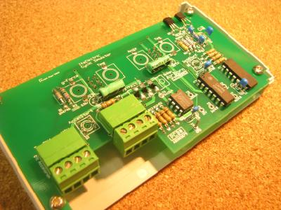
- However, test jigs are quite expensive in terms of engineering time to develop.
- Given current technology and the sorts of example boards on the AirBorn website, it is our rough estimate that a test jig will cost 8-12% of the cost that it took to develop the original PCB.
- Test jigs are normally not factored into the development cost.
- Two different test jigs are shown here - the one above is an older type, hand built (but works just as well).
- The one to the right is built on a circuit board - so more than one could be made easily.
Automated Test Equipment (ATE) This is the best test method. ATE will have pin drivers that can exercise inputs and load outputs to do parametric testing in addition to functional testing.
- ATE will also be made to probe connections inside the circuit under test using a bed of nails.
- ATE is not cheap, and jigs and the programming for the equipment are an ongoing cost, but it is superior to a plain functional test.
- It is really quite difficult for a fault to get past a well constructed ATE test.

2.5 Identifying defects and faults.
The most important skills for an electronic maintenance technician needs in order to be successful in the workplace
Clearance
- Acquired secret clearance and account.
- Issued a secret clearance in order to work with crypto logical equipment.
- Worked as a specialized mechanical technician primarily to repair and maintain route clearance
- Received security clearance necessary for the ability to repair air data systems on military aircraft.
Technical knowledge
- Applied skills and technical knowledge of electronic principles in determining malfunctions and restoring equipment to normal operations.
- Provided technical guidance and assistance to lower-grade technicians and provided assistance to engineers based on technical knowledge and experience.
- Applied advanced technical knowledge of electronic principles in determining equipment malfunctions, and applies skill in restoring equipment operations.
- Performed individual duties based on acquired technical knowledge using schematics, circuit/wiring diagrams and other planning documentation.
Electrical systems
- Researched information to solve unusual electronics problems by analysis and tests on various electronic and electrical systems.
- Provided support for facility maintenance including electrical systems, mechanical systems, and cooling tower maintenance.
- Installed and repaired electrical systems, apparatuses and electrical and electronic components of machinery and equipment
Technical guidance
- Provided technical guidance to Army commanders on equipment capabilities and employment.
- Supervised and provided technical guidance to lower level technicians.
- Performed supervision of lower grade colleagues and provided technical guidance to assist them in the accomplishment of their duties.
- Obtained technical guidance, as required, from supervisor or higher-level technician
Test equipment
- Conducted fault analysis on extensive networks and complex electronic systems; utilized test equipment and diagnostic software to verify operational solutions.
- Incorporated and trained personnel on a previously unused piece of test equipment giving the company increased capabilities.
- Utilized diagnostic test equipment to identify malfunctioning component and replaced as necessary.
- Utilized sophisticated test equipment and complex schematics to correct system malfunctions
Facility
- Documented the test stand as installed in the test facility using AutoCad.
- Inspected the fire safety equipment in the facility and checked them for their condition.
- Developed and maintained a PM schedule for equipment throughout the facility
Level technicians
Received orders from lead tech III, relayed and implemented orders with lower level tech.
Maintenance is coordinate by maintenance planning
Identify the problem
- The need for maintenance can be triggered by a failure, a noisy bearing or an oil leak. Once identified, the problem must be reported to the maintenance department. This is normally done through a work request so that planning and scheduling can take place.
Plan the maintenance task
- ‘Planning’ involves deciding on what exactly needs to be done, determining priority, and defining the sequence of activities and skills required. Ensure that all the resources, material, labor, contract services, specialist equipment, tools and information are available. There may even be a need for outside contractors, items to be purchased or work permits to be obtained, all of which must be arranged in advance.
- A maintenance planning function is a critical tool for reducing downtime and maximizing the value of preventive maintenance. The maintenance planner must therefore have the technical skills and equipment knowledge to do this planning.
Schedule the work
- ‘Scheduling’ involves deciding when to do the work. This will depend on the priority level of the task, and the availability of both the resources and the equipment to be repaired. Many organizations schedule maintenance for a specific period during the working week or month. Weekend maintenance is never desirable because, in many cases, suppliers are not available and personnel are expensive.
- The legal requirements with regard to statutory inspections are generally quite rigid, so try and devise a 52-week maintenance plan at the beginning of each year. Review this plan periodically to improve the accuracy and quality of the information. Communicate the preventive and corrective maintenance requirements to production so that they fully understand the need for the maintenance window.
Allocate the task to specific people
- Although this will depend on organizational arrangements, consider the following:
- Allocate your maintenance personnel to specific areas or pieces of equipment
- Ensure the allocated person has the skills to perform the task
- Be very clear about the type of work that will be allocated to outside contractors
- Where necessary, undertake hazard analyses to identify risks and formulate action plans to control access to high-risk areas; your plans should include hot work permits, confined space permits and lockout procedures.
- Ensure the work is executed properly
- It is usually the responsibility of the maintenance supervisor to confirm that the maintenance work meets the required quality standards, usually through selected planned job observations.
- The planner (or, in some instances, a maintenance scheduler) should monitor outstanding schedules or work requests to ensure that the planned work was actually done.
Analyze the problem and decide how to prevent it from happening again
- Analyze the root cause of major failures and take corrective action to prevent recurrence. Corrective action could include training, a change to the preventive maintenance program or equipment redesign. Breakdown or failure of the management process is often overlooked in a major failure. In those cases, corrective action may be a systems upgrade.
Procedures and work instructions hierarchy of these terms and how to efficiently categorize the workings of a management system within them. Simply put:
A process states what needs to be done and why
A procedure states how the process needs to be done
A work instruction explains how to carry out the procedure.
Consider a process as a high level, strategic method of control, in effect a summary of objectives, specifications, and broad resources needed. The procedure adds more specifics such as responsibilities, specific tools, methods, and measurement. And a work instruction is a step-by-step guideline to implement the process and procedure, often segmented in some way to focus those who are doing the actual work.
Process
A process is any activity or set of activities that use resources to transform inputs into outputs. The ISO 9001 standard is based on a process approach. (Establishing effective and efficient processes that are consistently followed and improved upon is the basis for most management standards.)
Processes must have defined (and hopefully measurable) objective(s), input(s), output(s), activities, and resources. These key elements should be present when defining a process:
Inputs/Resources:
Specified requirements (needs), for example:
What information do you need to start work?
Where does that information come from?
Activities:
Interrelated or interacting activities that use resources needed to achieve a specific output
All of the operations, activities, and sub-processes carried out to produce the desired result, for example:
What are the basic jobs carried out in your department?
Can you explain to me your operations here?
Outputs:
Satisfying requirements (results), for example:
Who receives the result of your work?
How do you know if you’ve done your job correctly? (met objectives)
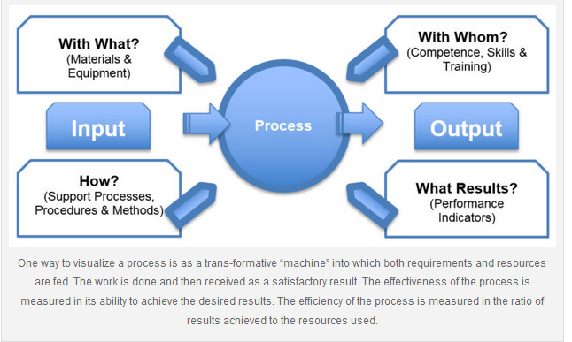

Procedure
A procedure is a uniform method that outlines how to perform a process, such as how you control your suppliers. It typically contains elements such as:
- Why the procedure is required
- What needs to be accomplished and how it will be executed
- Who performs what action
- Where the inputs come from and where the outputs go
- Any locational requirements (i.e. where an activity is performed)
- The criteria (requirements) they must meet
- Tools, information or other resources required
- Terminology, definitions, explanations, etc.
While requirements and supporting processes are often cited in the ISO 9001:2015 standard, the mandate for creating specific procedures has been removed and replaced with the term “Documented information” However, that does not lessen the need for, or effectiveness of, formally specifying procedures. Procedures are used when there is a definite operation that should be followed on a consistent basis. (There may be times when a procedure is not necessary. For example, if it doesn’t matter how new employees are recruited, just that there is a means for doing so, then a process could be written for that without a procedure.

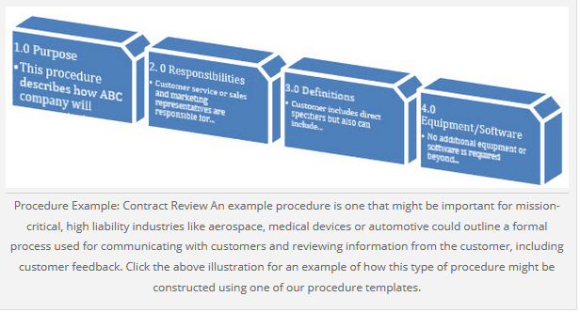
Work Instruction
A work instruction describes how to perform a task within a process, which is a more detailed portion of the procedure such as “Completing a PO” or “Ordering supplies.” The reasons for work instructions are both organizational and explanatory:
- There are times more detail is needed than that which is described in the procedures. Many organizations include work instructions to detail specific tasks referenced in a procedure, aid in training and to reduce mistakes since the step-by-step instructions needed for accomplishing something may be missing from more generally drafted procedures.
- However, this functional division between procedure and work instruction can be a good organizational tool – if there is an advantage to dividing up procedure(s) into many “sub-procedures” that are related, but cover different aspects.
A work instruction will often repeat many of the elements of a procedure to help describe where it fits into the process such as:
- Purpose
- Definitions
- Responsibility
- Requirements
- Tools and information
But at its core, a work instruction contains the step-by-step detail that is not advantageous to put into a procedure because it requires such a limited scope.
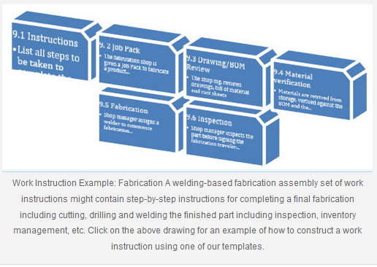
Fig 2..3 work instruction

2.6 Checking Control settings/adjustments
For quality assurance, with respect to instruments and other equipment the following requirements should be met:
- Apparatus used for generation of data, and for controlling environmental factors relevant to the study should be suitably located and of appropriate design and adequate capacity.
- The apparatus used should be periodically inspected, cleaned, maintained, and calibrated according to Standard Operating Procedures. Records of procedures should be maintained.
Apparatus and methods to adjust the lateral clearance between upper and lower blades of shearing machines are described. An example apparatus includes a first blade opposite a second blade and movably coupled to a frame of the shear press via a ram, wherein the first and second blades are to receive a strip material. A lateral clearance adjustor slidably coupled to the ram shifts the first blade laterally relative to the second blade. A sensor determines a clearance position and a first drive member moves the lateral clearance adjustor from an initial position to the clearance position. A second drive member operatively coupled to the ram drives the first blade toward the second blade to shear the strip material.

- .An apparatus comprising: a circuit having a pulse train output; an adjusting circuit having an input, a control input, and an output, said adjusting circuit input coupled to said pulse train output; a real-time clock having an input, a plurality of set inputs, and a plurality of counter outputs, said real-time clock input coupled to said adjusting circuit output, and said plurality of counter outputs producing a usable tangible result for a user; and a proportional integral derivative time processor having a first output and a second output, said first output operatively coupled to said adjusting circuit control input, and said second output operatively coupled to said plurality of set inputs.
- The apparatus of claim 1 wherein said adjusting circuit control input can leave said pulse train un altered.
- The apparatus of claim 2 wherein said adjusting circuit control input can remove one or more pulses from said pulse train.
- The apparatus of claim 3 wherein said adjusting circuit control input can add one or more pulses to said pulse train.
- The apparatus of claim 4 wherein said pulse train output is a 32768 Hz pulse train output.
2.7 Completing documentation
For any equipment hire company, your fleet is the lifeblood of your business. Keeping equipment at optimum working condition minimizes the risk of having unscheduled downtime. If maintenance is needed, it's important to keep a comprehensive record - whether scheduled or unscheduled - to help you understand the importance of your equipment’s up keep works. Here we list the benefits of keeping a maintenance record. Prevent expensive repair works from happening With constant use, your equipment is prone to wear and tear. Performing routine inspections allow you to see and repair small damages before they become a big problem. Documenting these inspections and small repairs help you keep track of all the maintenance work that your equipment has undertaken, ensuring that each machine is in tip-top shape before putting them to work.
Helps you create specialized maintenance programs
Each equipment go under different working conditions and they have different limitations as well. With the help of routine check-ups, you will be able to determine and record the differences of each individual equipment with regards to maintenance works. In turn, this information will help you in creating maintenance programs specifically catering to each individual equipment on your fleet.
Prevent problems regarding warranty claims. Documenting every repair or maintenance work done on your equipment will help you process warranty claims much easier. Keep a record of the type of maintenance work done to your equipment as well as the exact time and date repairs were done as this information will help determine your rights for the warranty claims. It increases the safety of operators If a piece of plant or equipment is well maintained, the risk of accidents occurring due to malfunctioning machinery is reduced. When incidents involving faulty machinery occur, there’s a big chance that the operator is the first one to be affected. Having equipment’s maintenance history documented will help you keep track of your machinery’s health. This enables you to schedule an inspection when needed, at the same time it ensures that your equipment are safe to work with.
Helps you track who is accountable for a piece of equipment One machine might have multiple operators. Performing a routine inspection and documenting the findings after every project will help you track down who is accountable for any damage inflicted on your machinery. Keeping these types of records will also encourage operators to take better care of the equipment.
It increases the resale value of the equipment. Keeping a detailed record of all the maintenance and repairs that a piece of equipment went through will help increase its resale value. Buyers thoroughly assess a piece of equipment before purchasing it, most especially if the machines have already been used. Presenting potential buyers a documentation of your equipment’s maintenance history lets them know that the equipment they are planning to buy have been well taken care of Teamwork is one of the key drivers of maintaining a healthy fleet. Make sure to cover this topic on your next toolbox talk agenda to ensure that each member of your team is informed about the advantages of recording your equipment's maintenance history. You can use the downloadable template below to where you can list relevant topics you want to discuss with your construction team.

2.8 Advising Customers
The world is full of businesses promoting themselves on social networks and trying to keep in touch with their customers via email. Keeping connected is great but sometimes businesses go for overkill and ‘pester’ their customers. With so many businesses getting it wrong you have to ask why do they do it?
The truth is that these businesses have the right idea but are not approaching the situation in the right way. They are aware of the importance of keeping customers well informed and though they go over the top sometimes, the rewards they get from people who aren’t so easily frustrated outweigh the negative impact of their actions.
We believe that when carried out in moderation, keeping your customers well informed about what is going on in your business is key to a healthy relationship resulting in an increase in customer retention and a rise in business turnover.
Here’s why it is a good thing to keep your customers informed:
- Customers are like your social media friends, they always want to know what’s going on Your customers are every bit as nosy about your business and your life as any of your friends might be. People are curious by nature and they like to know what goes on within your company, especially if they expect to part with their money in exchange for your services. Keeping your customers informed of news, latest offers and even problems affecting your business will show them that your business is active and it will make sure they don’t feel left out.
Informing a customer about a problem is better than them finding out on their own
It is a hard thing to admit when you’re wrong or that something isn’t working and it’s even harder when you are admitting that to paying customers. Sometimes though, the hard thing to do and the right thing to do are the same thing. Informing your customers that you are aware of a problem and are working hard to fix it can indeed upset some and even put them off your company. It’s a risk. After all, no one likes to use a product that isn’t working. But by keeping your customers informed about a problem you are proactively showing them that you are aware there’s an issue, that you aren’t afraid to hold your hands up to it and that you are doing something about it. For most customers, this is enough for them to give you the benefit of the doubt and they will give you the time (a limited amount at least) you need to fix the issue.
The alternative is to ignore your customers and hope they don’t notice. But customers notice everything! If they find a problem and they think you have been hiding it from them, then you will get no grace period to fix the issue, they will simply start looking somewhere else.
- People are inherently lazy
The standard setting of the human race is to follow the path of least resistance. People generally don’t want to spend time and energy doing something they don’t have to and because of that, you can never rely that your customers are going to search for the information that they need from you.
If you have information that your customers need to know, you can’t hope that they will find that information on their own, you need to tell them about it. For example, if your business closes on a bank holiday then you need to let your customers know that you will be closed. The last thing you want is for customers to be trying to contact you and not being able to. As soon as they can’t get in touch with you and they don’t know why frustration will lead them to start searching for someone they can get hold of; they are going to take their business elsewhere.
- Keeping people informed reminds customers that you are there
Not every business is one that customers will use on a daily or even weekly basis. For these businesses, customer retention can be a real problem as it is a case of ‘out of sight, out of mind.’ Setting up social media pages and updating them regularly, blogging and sending emails about your company can remind people that you are there and (especially if they have used you before) bring customers back for more.
- 5. Your priority is customer service and you put your customers first
If you run an offer that you don’t actively tell your existing customers about, you run the risk of letting them find out on their own and thinking that you were trying to hide it from them. The same is true for many other aspects of your business and this leads to the key reason to keep your customers informed: you need to remind them that they come first.
Customers are needy creatures, they want to be coddled and made to feel special. By keeping them informed you are keeping the focus on them, showing them that you value them as a customer and you will do what it takes to keep them with your business. If done right, keeping your customers informed can make them feel special and they will reward your business for it.
At Switchboard FREE we like to take a variety of approaches to keep our customers up-to-date with regard to our latest offers, new services and product updates. We regularly use social media, email campaigns and banner advertising on email alerts. But there are more ways to keep your customers informed and ‘in-the-loop’.

Self-Check 2 | Written
I. Choose the correct answer for the following questions
1. In visual inspection of Pre-testing system, . the key things you should be able to determine are:
A. how the circuit should operate B. how the components are actually wired together
C. where components are physically located D. what kind of features the circuit has E. all
2. which one of the following is not part of the steps to perform circuit isolation
A. Identify suitable means of isolation. B. Person carrying out works to retain key.
C. Fit appropriate lock off device and locks. D. None
3. The ________ contains all essential information for the user to make full use of the information system
A. Operating instructions B. User’s manual C. Owner’s manual D. all
II. Say true or false for the following questions
1. Schematic diagram: is a drawing showing all significant components, parts, or tasks (and their interconnections) of a circuit, device, flow, process, or project by means of standard symbols.
2. Hardware faults - Physical faults that we can observe or measure, such as parts which are broken, worn, out-of-specification, damaged, incorrectly adjusted or assembled.
III. Give the necessary answers for the following questions.
1. A work instruction will often repeat many of the elements of a procedure to help describe where it fits into the process such as:
A. _________________________ D. ____________________________
B.__________________________ E. ___________________________
C.__________________________
2. ___________ involves deciding on what exactly needs to be done, determining priority, and
defining the sequence of activities and skills required.

Operation sheet 2: Diagnosing faults
Purpose: To Diagnose faults In multimedia equipment systems
Instruction Using the given equipment to identify and conduct audio systems products defects diagnosing ,you are given 2 hours to do the work

PROCEDURE:-
Step1. Follow safety/PPE procedure and rule
Step2. Make your working area free from dust and unwanted objects
Step3. Select the appropriate tools and testing instrument
Step4. diagnose the fault from the system
Step 5 clean and test system
Step7complied the completion procedure and documentation
Step 8 Dispose waste material

PRECAUTIONS:-
You should not forget to wear your PPEs.

QUALITY CRITERIA:-
Set each tools on safe areas
The project must be functional
Finish on time

Lap test 2 | Identify audio system fault symptoms
Name ___________________________ Date __________________
Time started _____________________ Time Finished ________________
Instructions Given the necessary templates tools and materials you are required to perform the following tasks within 4hrs.
Task 1. perform tests to identify defective parts of audio systems fault symptoms
Task 2.Differntiate the type of fault based on the symptom
Task 3 Remove the defective part and Solder with the new component

Unit Three- Install and repair product
This unit is developed to provide you the necessary information regarding the following content coverage and topics:
- Using personal protective equipment with OHS practices.
- Following electro-static discharge (ESD) protection procedure
- . Replacing defective parts/components with appropriate equivalent ratings
- soldering and Repairing defective parts & components
- Performing Control settings/adjustments
- Installing and configuring multimedia components/equipment’s
- Performing repair activity
- Observing care and extreme precaution
This unit will also assist you to attain the units stated in the cover page. Specifically, upon
completion of this unit, you will be able to:
- Use personal protective equipment with OHS practices.
- Follow electro-static discharge (ESD) protection procedure
- . Replace defective parts/components with appropriate equivalent ratings
- solder and Repair defective parts & components
- Perform Control settings/adjustments
- Install and configuring multimedia components/equipment’s
- Perform repair activity
- Observe care and extreme precaution

Unit Three Install and repair product

3.1 Using personal protective equipment with OHS practices
Whenever you’re working on any electronic equipment, your own safety has to come first. Every electronic technician must always take safety precautions before he or she starts work. Electricity must be handled properly, or else it can injure or cause fatalities.
The purpose of the Health and Safety policies and procedures is to guide and direct all trainees to work safely and prevent injury, to themselves and others. All employees are encouraged to participate in developing, implementing, and enforcing Health and Safety policies and procedures.
Ex. Goggles: Goggles or safety glasses are forms of protective eyewear that usually enclose or protect the area surrounding the eye in order to prevent particulates, water or chemicals from striking the eyes.
- 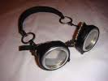
Fig 3.1. Goggles
Glove: is a garment covering the hand. Gloves have separate sheaths or openings for each finger and the thumb. Gloves protect and comfort hands against cold or heat, damage by friction, abrasion or chemicals, and disease; or in turn to provide a guard for what a bare hand should not touch.

Fig 3.2 Gloves

3.2 Following electro-statics discharge (ESD) protection procedure
Electrostatic discharge (ESD) is the sudden flow of electricity between two electrically charged objects caused by contact, an electrical short or dielectric breakdown. A buildup of static electricity can be caused by electrostatic induction.
The diagram below shows a typical static-safe work bench. The table top is covered by a static dissipative mat which is grounded through a 1 Meg-ohm resistor. This resistor is required in order to protect the users of the static-safe work bench – in the event that the ground becomes electrically live, the resistor will prevent electrical shock at the work bench. The same safety requirement holds true for the antistatic wrist-strap as well.
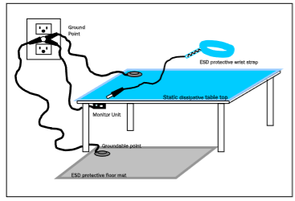
Fig 3.3 work bench
. The ESD occurs when differently-charged objects are brought close together or when the dielectric between them breaks down, often creating a visible spark.
ESD can create spectacular electric sparks (lightning, with the accompanying sound of thunder, is a large-scale ESD event), but also less dramatic forms which may be neither seen nor heard, yet still be large enough to cause damage to sensitive electronic devices. Electric sparks require a field strength above approximately 40 kV/cm in air, as notably occurs in lightning strikes.
establish electrostatic protective areas free of static, using measures to prevent charging, such as avoiding highly charging materials and measures to remove static such as grounding human workers, providing antistatic devices, and controlling humidity.
Anti-static procedures for connector manufacturing include four elements of control.
1. Anti-Static Mats
2. Wrist Bands for Grounding
3. Storage and Handling
4. Packaging Material
1. The first control procedure is the use of anti-static mats on all work benches, tables and storage shelves throughout the production factories.
2. The second element of control is the procedure which requires all employees to wear grounding wrist bands. The grounding wrist band is attached to the employee's wrist and a cord from the wrist band attaches to a metal ground on the work bench or anti-static mat.
3. Anti-static plastic bags and trays are used to store all parts and finished goods.
4. The fourth element of ESD control is the packaging used in shipping connectors to our customer. This element of ESD control is addressed by the use of anti-static packaging material in the packaging.
To use the ESD wrist strap:
Place the elastic band around your wrist.
Connect the clip on the flexible grounding cord to an unpainted frame ground point on the rack.
Keep the strap on and connected while you touch, insert, or remove any ESD-sensitive part.
Do not open the static-protective package that contains the component until you are instructed to do so.
Limit your movement. Movement can cause static electricity to build up around you.
Always handle components carefully. Never touch any exposed circuitry, including the gold connectors along the bottom edge of the PCI adapters.
Prevent others from touching the component.

3.3 . Replacing defective parts/components with appropriate equivalent ratings
Replace the part that has been disconnected from the circuit board. Solder the new part into position, ensuring that each terminal is making contact with the correct port in the circuit. Repair is mainly setting the device back to the condition of normal operation; Defective parts/components are replaced with identical or appropriate equivalent ratings.
Replace the part that has been disconnected from the circuit board. The old part should come out of the board easily. If it does not, make sure that all of the solder has been removed. Solder the new part into position, ensuring that each terminal is making contact with the correct port in the circuit.
Many problems that circuit boards have may be repaired by replacing defective parts.. Parts that commonly need to be replaced include capacitors, transistors and various electronic chips. If, through visual inspection or through circuit analysis, you can identify which part is defective, you can usually repair a circuit board.
Identify which part you want to replace on your circuit board and the soldering points of the part you intend to replace. Finally replace the defective parts/components.
The way of replacing defective components are shown below based on their section
Table 3.1.
1.Horizontal circuit
PROBLEM | DESCRIPTION |  | DEFECTS |  |  | REMEDY | ILLUSTRATION
Total black-out | - |  | - Due to open or shorted horizontal transistor.  -Defective safety capacitors or damper diode around HOT. |  |  | -Replace new horizontal transistor. | 
Vertical line on the screen | - |  | Defective horizontal amplifier due to old aging hardware |  |  | Replace new horizontal transistor | 
Lack of width | - |  | Defective horizontal transistor.  - Due to a low voltage power supply problem, bad connection |  |  | Replace the horizontal transistor | 
2.Low voltage
Totally dead set |  | The voltage applied to the circuit is too low |  | A blown fuse or tripped circuit breaker due to some other fault, switched outlet and the switch is off, or bad cord set | Plug a lamp into the outlet to make sure it is live. If the lamp works, then the problem is the TV. It not, the outlet is defective or the fuse is blown or the circuit breaker is tripped. |  |  | 
Poor filtering |  |  |  | Open or leaky filter capacitors, defects in rectifier circuits.  . | Replace filter capacitors, check rectifier circuits |  |  | 
Picture is reduced over all |  | A dried up main filter capacitor |  | Defective low voltage regulator allowing excessive ripple. The regulator IC could be bad or filter capacitor following the IC could be dried up. | Check or replace the rectifier or tube |  |  | 
3 High voltage
Totally blackout or dead set |  |  |  | Defective horizontal transistor or the fuse due to high voltage traveled into the circuit | Check properly and replace defective components and supply the right amount of voltage. |  |  |  | 
Horizontal line on screen |  |  |  | Damaged vertical output ICdue to excessive high voltage on the circuit. | Check the fly back transformer if it is damage replaced it and also the fuse resistor if it is shorted |  |  |  | 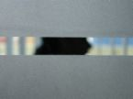
4. Audio section
.Raster and video OK but no sound |  | Open wire connection from volume control |  | Defective or open circuit speaker.  - Defective audio output tuner.  - Defective sound discriminator/detector tube. | Replace a quality of stranded wire for speaker connection.  - Replace the audio output tube/ transistor.  - Re solder the open wire to the volume control.
Reduction in sound after warm-up |  |  |  | Defective audio amplifier and output tubes/ transistor. | Replace new audio amplifier and output tubes/ transistor
5.Video section
Sound OK but no raster |  |  |  | Defective video output tubes/transistor. | Check and replace the video output tube/transistor
Raster Ok but no sound or video |  |  |  | Defective video detector diode | Replace a new video detector diode.

3.4 Solder replaced defective components
Soldering is a technique of melting a soft metal to join two pieces of harder metal. Tinning is a
process of coating the two surfaces to be joined with a thin layer of solder to help the main mass of
solder flow an melt into the joint Heat your soldering iron to operational temperature. Place the
circuit board, with the solder side up, on a flat and well-lit surface.
Press the tip of your soldering iron against the solder point that is supporting the part you want to
remove. Suck up the liquid solder using a de-soldering device. There are several types of de
soldering devices, but they all generally work with suction. Replace the part that has been
disconnected from th circuit board. Solder the new part into position, ensuring that each terminal is
making contact with the correct port in the circuit.
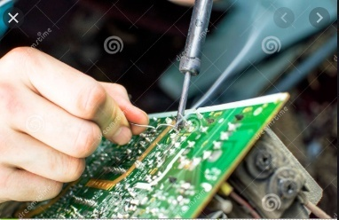
Fig 3.4 soldering technique
Steps In Soldering
1. Prepare the following materials:
- Soldering Iron,
- Solder paste
- Long Nose Pliers,
- PCB holder,
- Electronic Components (Resistors, Diode etc.)
2. Plug and pre-heat the soldering iron.
3. Heat both items at the same time by applying the soldering iron tot he copper pad and the component lead.
4. Continue heating and apply a few millimeter o f solder. Remove the iron and all o the solder joint to cool naturally.
5. It only takes a second or to make the perfect joint ,which should appear shiny. Disordering is the removal of solder and components from a printed circuit board for troubleshooting ,repair, replacement, and salvage.

3.5 Performing Control settings/adjustments
If an error is displayed when you press a remote control button that is related to network services such as YouTube™ or Netflix, check whether the TV is connected to the Internet correctly. For details about connecting to the Internet or troubleshooting,
Top tip - our quick recommended solution
Before trying any of the troubleshooting steps below, we recommend that you remove the batteries from the remote control for approximately 1 minute. Then, reinsert the batteries again according to the polarity (-/+).
Our complete troubleshooting guides
First check whether the problem is due to the TV or the remote control. If the problem is due to the remote control, you will be guided in Section by remote control type. Start checking from Section A.
- Section A: Check whether or not the TV is in operation
- Section B: Checking items of the remote control (common)
- Section C: Select remote control type (common)
Section A
Check whether or not the TV is in operation
- Check that TV buttons can be operated.
- If TV buttons can be operated, proceed to
- Section B: Checking items of the remote control.
  - If TV buttons cannot be operated, proceed to Step2.
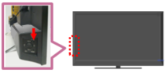
  - NOTE: Depending on the model, the positions of TV buttons vary. Check the sides, back, front, and top of your TV.
- Check that the lamp (power lamp/standby lamp) on the front/bottom of the TV is on.

NOTE: Depending on the model, the name, position, and shape of the lamp varies. The
lamp on the diagram is an example.
  - If the lamp is lit or is blinking in red, proceed to Step 3.
- If the lamp is not on, check whether or not the power cable or AC adaptor is not disconnected or loose.
If there is no issue with the above connection, proceed to Step 3.
Perform a power reset on the TV.
If it caused by an external factor, such as network service/data broadcasting/connected device, it may be improved by resetting your TV.
  - For how to reset Android TV, refer to: How to reset an Android TV?
  - For how to reset the other TV models, refer to: How to perform a power reset on a Sony television.
- Remove external devices to confirm whether there aren't influences of external devices.
Remove connected devices (external USB hard disk, HDMI connection device, etc.) and cables from the TV terminal.
NOTES:
  - Do not remove the TV power cable.
  - If connections are complicated, take note of them, and make sure you can reassemble them before removing.
  - When a specific device is connected and the TV flashes, there is a possibility there is a problem with the connected device.
The same fashion should repeated for other remote control based units
If you cannot operate after confirming the above, service may be required.

3.6 Installing and configuring multimedia components/equipment’s
In the field of servicing, time is money. You can waste it, or you can make money out of it. The less the time you take on one job, the more number of jobs you can do and hence, the more you can earn. Anytime the technician or engineer spends over one hour on a given electronics problem without locating the faulty component, time is lost. Time can be lost due to:
- Intermittent problem
- Sometimes a fault might be intermittent. Dry solder joints,
- heating, loose connectors, etc may cause intermittent faults. Such faults are the most difficult to locate.
- Non-availability of spare parts
After spending countless hours of repair, you’ve been told by your supplier that the defective part that you need is no longer available in the market.
Callbacks or repeated repairs
This will usually cost the electronic technician extra money. The technician has to repair the problem without additional charge unless it is a different problem. It is advised that doing a good repair job at the beginning eliminates repeated callbacks.
Equipment that had been badly repaired someone
An inexperienced technician will usually cause more trouble than solving the original problem. Many sets come in with by missing components, cables connected to the wrong. Location, components installed in the opposite direction; unsolder tracks, wrong part numbers as substitute for the original components and etc. The technician might take extra time to locate the faults and time is loss during the repairing process. A half an hour job might take him three or more hours to solve it and at times, the equipment is beyond repair.
Understanding new
Understanding the new design of electronic circuit may take design of electronic you time. For example, a technician who is good in repairing circuit Analog Television may have difficulty in repairing Digital.
Television. He will takes a longer time to analyze the new circuit, to learn new ways of troubleshooting digital circuit problem and learn how to replace surface mount components (SMD). All these will consume his time. What about the latest technology of PLASMA TV? It may be even more time consuming to understand the new design and circuit.

New symptom which have not seen
I believe you will agreed with me that even though you have you been in the repairing field for more than 10 years, some before symptoms you might have not seen before whether you are
Servicing TV, Monitor, VCR, DVD and etc. Due to the new symptom, it will take you a long time in finding the exact location of the fault.
In order to speed up your repairing job and make additional money, you must master the correct techniques of servicing and learn the logical approach to identifying fault quickly. You must equip yourself with knowledge of the right kind of tools and test equipment in servicing field and do your best to repair it.

3.7 Performing Repair Activity
  - Care and extreme precaution
Whenever you’re working on any electronic equipment, your own safety has to come first. Every electronic technician must always take safety precautions before he or she starts work. Electricity must be handled properly, or else it can injure or cause fatalities. Here are some basic steps that show you how to avoid accidents from occurring.
Electrical Shock
Once you open up a set cover, you’re actually exposing yourself to the threat of electric shock. Always keep in mind that safety has to come first.
A serious shock may stop your heart and if large electric current flows through your body, you will receive serious burns. Here are some rules, which should help you to avoid electricity hazards.
Always turn off the equipment and unplug it before you begin to work.
If you have to run tests while the equipment is operating, turn the equipment on, make your test carefully, and then turn the equipment off again.
Wear rubber bottom shoes or sneakers.
Try to do the work with one hand, while keeping the other in your pocket. That keeps the possible current paths away from the heart.
Don’t attempt repair work when you are tired or rushed.
Always assume that all the parts in the power supply are “HOT”.
Use only plastic screwdriver for shock protection during service operation.
Discharging Switch Mode Power Supply (SMPS) Capacitors
Most SMPS have a resistor to drain the charge in the main filter capacitor. But some resistors may fail and the capacitor can hold this charge even after you have turned off the equipment. This capacitor has a range of about 150uf to 330uf at 400 working voltage.
Before you start to work on a power supply, always turn off the power and discharge the capacitor. You can do this by placing a resistor across the two legs of the capacitor. The resistor value can be around 2.2 to 4.7 kilo ohms 10watt. It takes only a few seconds to fully discharge a capacitor. Double-check the capacitor with a voltmeter after every discharge.
Do not discharge capacitor with screwdriver because:
It may melt the tip of the screwdriver.
It will damage the capacitor and its terminal.
If we are too near to the point of discharge, the heavy spark generated may cause injury to our eyes.

Hot Ground Problem
Modern equipment consists of two grounds, one of which is a “hot” ground while the other is a “cold” ground. Hot ground is in the primary side of a switch mode power supply while the cold ground is the equipment ground.
Be careful when taking voltage measurements around these grounds. For example, if you want to check the primary circuit of a power supply with power on, always ground your meter or scope to the hot ground, while check the secondary side using the cold ground.
If the “Hot” ground is not used and you use only the cold ground, the voltage measurement might not be correct and it may destroy your meter. One way to prevent this is to use an “isolation transformer”.
Isolation Transformer
When servicing any electronic equipment, always use an isolation transformer to protect yourself from an electrical shock. During servicing, the isolation transformer is connected between the equipment and ac power line. An isolation transformer is a transformer that has a 1:1 turn ratio to provide the standard line voltage at the secondary outlet. This means that it does not change the voltage. The transformer still produces 240V AC at its outputs, but both sides of this AC lines are independent of ground. If you were to accidentally touch one of these outputs, you would be protected. The isolation transformer must be rated to handle the power of any equipment connected to it. Typical ratings are 250 to 500W.
Note: A variable transformer or variac is not an isolation transformer.
Discharging The Cathode Ray Tube (CRT) Anode
The CRT of a Monitor and TV can hold a dangerous charge, even if the Monitor and TV have not been used several days. All CRT have graphite coating on the internal and external surfaces of the glass bell. These conductive graphite coatings are commonly known as aquatic coating and it forms the two plates of a high voltage filter capacitor using the glass in between as dielectric. The external coating is always connected to the Monitor and TV chassis ground by a spring arrangement around the CRT.
This high voltage filter capacitor has very low leakage. Before removing a CRT, ensure that you discharge this capacitor in order to prevent shocks or serious injuries.
High Voltage
Monitors and TV have sections that use very high DC voltages. This high voltage is needed to be applied to the CRT to attract the electron beam to the phosphor. This high voltage could be as low as 12,000 volt in a monochrome Monitor or as high as 30,000 volt in large color Monitor. Flyback Transformer is the part that is used to generate the high voltage.
Wearing Goggles
The CRT has a complete vacuum inside. It must be handled carefully and safely. Always wear goggles, to protect the eyes from flying glass, in the event of an implosion when removing and old tube from the set and installing a replacement. Do not lift the CRT by the neck, instead hold the CRT with both hands on the heavy glass front of the tube. Also be sure to place the CRT facing downwards on a soft surface.
Electrostatic ally Sensitive Devices (ESD)
Integrated circuits (IC) & some field-effect transistors are examples of ESD devices. These components can be easily damaged by static electricity. There are several techniques, which can reduce the incidence of component damage, caused by static electricity.
Immediately before handling any ESD devices, drain the electrostatic charge from your body by touching a known earth ground.
Store ESD devices in conductive foam pad until installation in circuit.
Wear a grounding strap, attached to your wrist.
Use only a grounded tip soldering iron to solder or de solder ESD devices. (Some suggest using a battery powered soldering iron when working on ESD circuits).
Fire
Before returning the equipment to the user, every reasonable precaution is taken to avoid fire hazards. Be sure to use only direct replacements and not one that defeats some safety measure. For example, the fuses in your equipment are carefully designed. Fuses must be replaced only with the same size, type and ratings. Should you install a fuse that is too large than the original rating, chances are that the equipment will be flammable.

3.8 Observing Care and Extreme Precaution
Perform Cleaning of unit
Cleaning a circuit board can seem like a difficult task to tackle, but these boards get dirty all the time. A slew of different materials are hazardous to the performance and safety of these devices. Watching out for such dangers and addressing the damage they cause can keep your work productive and the tools needed for the job functioning properly. Read on to learn how to clean your circuit boards while also maintaining your own safety standards. How Do Circuit Boards Get Dirty?
Circuit boards are found in nearly all electrical devices, including computers and industrial equipment. Over time, water, dust and grime can find their way into your company’s devices and build up to a point where you must take action to prevent permanent damage to the equipment.
The fans responsible for keeping equipment’s temperature at a cool environment suitable for proper functionality can draw in debris found in the air and any dirt clinging to nearby surfaces. The build-up of unwanted material leads to overheating and component failure.
A liquid such as water is not nearly as detrimental to electronics as the additives it almost always contains. Even plain drinking water contains ions such as sodium chloride and a slew of other minerals that heighten its reaction to electronic devices.
Once a liquid with good conductive qualities contacts an active device, electrical connections travel through currents to deactivated regions of the circuit board that can lead to short-circuiting. This harms a circuit and damages your device.
Prevention and Safety with Circuit Boards
To avoid dirty circuit boards, you can take preventative steps. Get in the habit of ensuring any electronics not in use are set to the “OFF” position, as the likelihood of adverse repercussions resulting from water damage significantly drop if the affected areas dry before reactivation.
Exercise caution when handling circuit boards:
Disconnect the device from its power source
Avoid standing near any water
Wear dry clothes
Disassembling hardware can be hazardous for the electronics, so make sure you understand how to properly handle the devices you work with and how to reassemble them back to their functioning state.
How Do You Clean Circuit Boards?
Cleaning a PCB (Printed Circuit Board) effectively relies on using the right methods and tools. The easiest ways will use:
Compressed air
Baking soda
Isopropyl alcohol
Distilled water
House ploy a soft brush and lint-free cloth, too, to ensure nothing gets damaged.
Using Compressed Air to Clean PCBs
For simple repairs, compressed air provides an unobtrusive way to free up any dust resting on the electronics or inside the machines and blow it out. Use short bursts to spray the air inside the ventilation ports. If you’re not satisfied with the dust removed, open the device with a screwdriver and work your way around the components, carefully cleaning the circuitry with the air.
behold cleaners
Using Baking Soda to Clean PCBs
Baking soda, or sodium bicarbonate, is an effective means of removing grime with minimal risk of damaging the board. It possesses mild abrasive qualities that excel in removing corrosion or residue that will otherwise not come off with simpler means such as a brush and distilled water. Baking soda is most effective when treating corrosion, as it dissolves the troubled area and neutralizes the acidic qualities of the residue.
Using Isopropyl Alcohol to Clean PCBs
Isopropyl alcohol is a great PCB cleaner because it is inexpensive and evaporates quickly. Compared to other cleaners used for similar purposes, alcohol contains fewer chemicals. It is important that isopropyl alcohol used to clean your circuit board is 90% or better. High-percentage isopropyl alcohol can cause adverse effects in contact with the body, so be sure to handle it with care and use latex gloves and goggles.
Using Distilled Water to Clean PCBs
Distilled water triumphs over any other form of liquid. When mixing your cleaning solution due to the absence of ions conductive to electric devices. Pure distilled water will not degrade electronic devices, as it is a very poor conductor.
It also can become contaminated quickly by dirt found on your hands or in the air, so seal your reserve of distilled water when not in use and to avoid contact with your bare hands.
Using Household Cleaners to Clean PCBs
A phosphate-free household cleaner should also be in your arsenal. While phosphates can be an effective chemical to protect against corrosion and possess other helpful cleaning properties, phosphorous pollution in lakes has become a real concern for the United States since the 1970s and many manufacturers have moved away from including them in cleaning products. Since then, companies have adapted to create phosphate-free cleaners that do the job just fine.
Tools for Cleaning Printed Circuit Boards


Fig 3.5 cleaning brush
Your choice of brush is also important in the cleaning process. Selecting a brush that has soft bristles and is small enough to reach small places is the best pick. A toothbrush or paint brush are the best choices if your company does not have some sort of specialized scrubbing tool. Cutting a paintbrush diagonally is a good strategy so you can reach difficult angles with the long side while scrubbing with the short side.
Lint-free towels like microfiber cloths should be handy to rub down and dry off your delicate circuit boards. Even with extensive use, this type of cloth does not shed debris, which would be counterproductive as your goal is to remove the unwanted material from inside the affected devices.
You can also utilize household appliances such as the oven to accelerate the speed of drying. An oven actively heating should never be used to dry electronics, but after the appliance is shut off, the heated environment is a great place to dehydrate any excess moisture after cleaning. Substituting a blow drier or desk lamp in place of an oven as the catalyst for drying is fine too.
Take similar steps no matter what material has dirtied your circuit board. The device should be removed from the environment it has been soiled in, disassembled and scrubbed with various cleaners appropriate for each job.

Self-Check 3 | Written Test

I. Choose the correct answer for the following questions
1. The material that is used to Clean Circuit Boards is;
A. Compressed air B. Baking soda C. Isopropyl alcohol D. Distilled water E. all
2. The techniques, which can reduce the incidence of component damage, caused by static electricity is.
A. drain the electrostatic charge from your body by touching a known earth ground.
B. Store ESD devices in conductive foam pad until installation in circuit.
C. Wear a grounding strap, attached to your wrist.
D. Use only a grounded tip soldering iron to solder or de solder ESD devices. E. all
3. __________ protect and comfort hands against cold or heat, damage by friction, abrasion or chemicals,
and disease; or in turn to provide a guard for what a bare hand should not touch.
A. Goggle B. Glove C. Safety shoes D. None
II. say true or false
1. Soldering is a technique of melting a soft metal to join two pieces of harder metal.
2. Electrostatic discharge (ESD) is the sudden flow of electricity between two electrically charged
objects caused by contact,
III. Give the necessary answers
1. ______________ is pinpointing one or more root causes of problems, to the point where corrective action can be taken.
2. Anti-static procedures for connector manufacturing include four elements of control. These are;
A. ________________ B. ___________________ C. __________________ D. ______________
3. ___________ is a process of coating the two surfaces to be joined with a thin layer of solder to help the main mass of solder flow an melt into the joint.

Operation sheet 3: Installing and Repairing product
Purpose: To Install and repair products
Instruction Using the given equipment to install and repair the product audio systems products defects with the new component, you are given 4 hours to do the work

PROCEDURE:-
Step1. Follow safety/PPE procedure and rule
Step2. Make your working area free from dust and unwanted objects
Step3. Select the appropriate tools and testing instrument
Step4. Repaired units are reassembled
Step 5 solders the replaced component or part
Step 6 clean and test the repaired unit
Step7complied the completion procedure and documentation
Step 8 Dispose waste material

PRECAUTIONS:-
You should not forget to wear your PPEs.

QUALITY CRITERIA:-
- Set each tools on safe areas
- The project must be functional
- Finish on time

Lap test 3 | Install and Repair product
Name ___________________________ Date __________________
Time started _____________________ Time Finished ________________
Instructions Given the necessary templates tools and materials you are required to perform the following tasks within 4hrs.
Task 1. perform tests to identify defective parts of audio systems fault symptoms
Task 2.Differntiate the type of fault based on the symptom
Task 3 Remove the defective part and Solder with the new component
Task-4 install the new component/product to the defective part.

Unit Four- Test repaired product
This unit is developed to provide you the necessary information regarding the following content coverage and topics:
- Repairing and reassembling units.
- Testing and cleaning the final reassembling units
- Compiling documentations.
- Disposing waste materials
This unit will also assist you to attain the units stated in the cover page. Specifically, upon
completion of this unit, you will be able to:
- Repairing and reassembling units.
- Testing and cleaning the final reassembling units
- Compiling documentations.
- Disposing waste materials

Unit Four Test repaired Product

4.1 Repairing and reassembling units.
Reassembling is the process of putting the parts of (something) back together to assemble something again.
Steps for disassembling and reassembling Parts
When you perform repairs, you need a procedure that helps you take things apart and get them back together. The procedure here works for repairs that require you to take something apart and put back together again.
Allow yourself plenty of time. If things get rough, have some water or a cup of coffee. You may get a whole new perspective when you go back to work. Limit distractions: If the parts fit together before, they’ll fit together again.
Follow these instructions, to reassemble the products:
Lay a clean, lint-free rag down on a flat surface, near enough to reach without having to get up or walk to it.You’ll lay each part on this rag as you remove it. Consequently, the rag shouldn’t be in an area where oil or dust or anything else can fall on it and foul up the parts
As you remove each part, note (on paper, so you won’t forget) where the part came from, how it was attached, and how tightly it was fastened or screwed down.
As you remove each part, lay it down on the rag in clockwise order, with each part pointing in the direction it was in before you removed it.
This is the key to the whole system. When you’re ready to reassemble things, the placement and direction of each part tells you when to put it back and how it was oriented.
If you’re making notes, assign each part a number indicating the order in which you removed it — Part #1, Part #2, and so on.
You can even put numbers on the parts with masking tape if you’re afraid that the rag may be moved accidentally
When you’re ready to reassemble everything, begin with the last part you removed, and proceed counterclockwise through the parts on the rag.
If you’ve numbered the parts, they should go on in reverse order
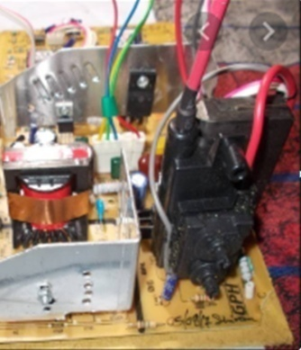

Fig 4.1 Reassembled units are subjected to final testing and Cleaning
Test the equipment thoroughly after repair. After the equipment has been repaired, the equipment
must be carefully re-assembled and tested. Run a thorough test to check the equipment and
determine if the problem is solved. Thorough checking of the equipment is called ‘servicing.’
Do not be discouraged if the equipment still does not work. Simply walk away, clear your mind,
and star again by defining your symptoms

4.2 Testing and cleaning the final reassembling units
Perform the final test for reassembled units in conformity with manufacturer’s specifications service manual (information)
Reassembling and testing repaired
Reassembling Procedure:
- After replacing the defective component of the unit, prepare the parts for
re assembling. Make sure that there are no missing parts and as well as the screw/s.
- Fix all the disassembled parts in the housing/compartment, considering the fittings/locks.
- Wires and loose parts should be in proper place to avoid damaged due to misaligned compartment.
- All sides of the housing should fit accordingly.
Moving parts must move as it can be moved by hand and free from obstructions.
- Tighten screw/s accordingly.
- Clean the unit before doing the post-testing procedure.
Post-testing Procedure:
- Test the resistance at the AC plug to determine the continuity of the power line to the unit.
- The reason is that there is a low-voltage power supply circuit that controls the functions
of the appliance.
- . Energize the unit to check its functionality. Plug the AC cord to the power source. This time, the unit should operate normally. If not, review the documentation and the problem for the second time.
Testing Procedure:
- Test the resistance at the AC plugs to determine the continuity of the power line to the AC the unit. A resistance reading must be observed.
- Energize the unit to check its functionality.
Press button on at a time observing the behavior. This time, the unit should operate normally. If not, review the documentation and the problem for the second time.

4.3 Service completion procedures and documentations are complied
A Piece of complicated equipment without some service literature. It is possible to repair electronic equipment without the service manual, but it can be very
Time-consuming. You can lose a lot of valuable servicing time if you are without a good service manual. The service manual is a set of document prepared by the manufacturer to help the service engineers to repair or service that set of equipment. A well-written manual is the best servicing aid. It contains the following information:
Describe how a circuit works
Block diagram of the equipment Circuit diagrams
Signal and voltage test points Adjustment procedure
List of accessories
List of spare parts with the part numbers, values, tolerances and ratings
Fault diagnosis steps, generally in the form of flow charts
Preventive maintenance layout
Safety precautions to be observed while handling the equipment
And much, much more
A service manual can be very expensive, but it is worth the investment. With the help of a service manual, a service technician or engineer can:
Align, calibrate and test the equipment correctly to get the optimum output
Locate a fault quickly
Use the correct replacement part
Conduct preventive maintenance correctly
By using the right service manual, as well as with the assistance of good tools, testing equipment and your own experience, you are set to multiply your troubleshooting power!!!

4.4 Dispose Waste materials
It is inevitable during normal laboratory operations some chemical waste will be generated. This waste may take a number of forms including chemicals, solvents, stock solutions and items contaminated with chemicals such as paper, filters and contaminated laboratory equipment. The improper disposal of chemical waste can pose a number of potential hazards both to the environment and to the safety of staff and students.
• Strong smelling substances such as mercaptans can give off strong-smelling, unpleasant vapors that can linger in drains and pipe work moving throughout the building and escaping in other areas.
• Flammable / reactive substances can give rise to a build-up of flammable vapors in drainage systems which could lead to a risk of fire or explosion in extreme cases.
• Corrosive substances including acids and alkalis can damage pipe work and fittings as well as reacting with other chemicals released into the drainage system potentially leading to the release of harmful vapors.
• Radioactive substances can be released to drains under controlled circumstances but in the event that the licensing of this is very strictly controlled to reduce the risk of radioactive contamination.
• Unexpected reactions may occur when chemicals are released to drain, for example bleach can mix with some common drain cleaning compounds to release the toxic gas chlorine.
• Poisonous substances may enter the environment if released to drain and can either have a toxic affect on watercourses or other discharge sites, they may also introduce toxic residues into drinking water that can persist even after water treatment.
As a result discharging chemicals to foul water drains should be avoided wherever practical and only considered where there is no viable alternative or for relatively innocuous substances.

Self-Check 4 | Written Test

I. Give the necessary answers for the following questions
1. Mention the types of waste materials that should be disposed
2. Explain about the testing procedures of equipments.

II. say true or false
1.One of the post testing system is test the resistance at the AC plug to determine the continuity of
the power line . to the unit.
2. Radioactive substances can be released to drains under controlled circumstances.

Operation sheet 4: test repaired product
Purpose: To test repaired product
Instruction Using the given equipment to test repaired products of the audio , you are given 4 hours to do the work

PROCEDURE:-
Step1. Follow safety/PPE procedure and rule
Step2. Make your working area free from dust and unwanted objects
Step3. Select the appropriate tools and testing instrument
Step4. Repaired units are reassembled
Step 5 solders the replaced component or part
Step 6 clean and test the repaired unit
Step7 test the functionality of the product
Step 8 complied the completion procedure and documentation
Step 8 Dispose waste material

PRECAUTIONS:-
You should not forget to wear your PPEs.

QUALITY CRITERIA:-
- Set each tools on safe areas
- The project must be functional
- Finish on time

Lap test 4 | Testing repaired product
Name ___________________________ Date __________________
Time started _____________________ Time Finished ________________
Instructions Given the necessary templates tools and materials you are required to perform the following tasks within 4hrs.
Task 1. perform tests to identify defective parts of audio systems fault symptoms
Task 2.Differntiate the type of fault based on the symptom
Task 3 Remove the defective part and Solder with the new component
Task-4 install the new component/product to the defective part.
Task-5 test the repaired product

Reference

1. PracticalElectronicsHandbook,2 and 3thEdition
2. .http://lrf.fe.uni-lj.si/fkkt_ev/Literatura/Electrical_and_Electronics_Measurment.pdf
3. https://ntrs.nasa.gov/archive/nasa/casi.ntrs.nasa.gov/19720011865.pdf
4. http://s1.nonlinear.ir/epublish/book/Electronic_Troubleshooting_0071819908.pdf
5.https://www.clemson.edu/cecas/departments/ece/document_resource/undergrad/electronics/CInq
uiryLabManual.pdf
6. https://www.youtube.com/watch?v=GW_-ycgJXhg
7. http://learn.skillman.eu/pluginfile.php/1471/mod_resource/content/0/20170509%20-
%20Unit%202.3%20Maintenance%20Principles.pdf

Participants of this Module (training material) preparation
No | Name | Qualification (Level) | Field of Study | Organization/ Institution | Mobile number | E-mail
1 | Mohammed Seid | A(MSC) | Electronics And Communication Technology management | W/ro Siheen PTC | 0913174837 | Tofikfuad606@g.mail.com
2
3
4

