ELECTRICAL/ELECTRONIC EQUIPMENT SERVICING
LEVEL III

October 2023, Curriculum Versions - I

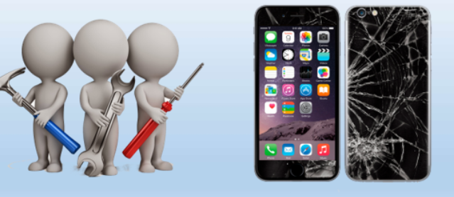

Module Title: Service and Repair Mobile Phones
Module code: EIS EEES3 M01 0322
Nominal duration: 120 Hour

Prepared by: Ministry of Labor and Skills
October, 2023
Addis Ababa, Ethiopia

Contents
ACKNOWLEDGMENT iii
Acronym iv
Introduction to the Module 1
1 OVER VIEW OF MOBILE PHONES 2
1.1 Basic concept of Service and Repair of Mobile Phones 3
1.2 Preparation for Workplace 6
1.3 Tools, Test instruments and PPE. 7
1.4 Service Manuals and Information 17
1.5 Service and Repair Manuals 19
1.6 History of Verifying Repair/Maintenance 20
Self-check 1 Error! Bookmark not defined.
Operation sheet Error! Bookmark not defined.
LAP Test # 1 Error! Bookmark not defined.
2 UNIT TWO: DIAGNOSE FAULTS 27
2.1 Basic concept of Diagnose 28
2.2 Systematic Pre-Testing Procedure 47
2.3 Diagnosing Faults 57
2.4 Methods of mobile phone faults finding. 61
2.5 Identifying System Defect/Fault Symptoms 64
2.6 Defect/fault symptoms 66
2.7 Diagnosis and Tests 68
2.8 Status and Serviceability of Mobile Phones 73
Self-check 2 Error! Bookmark not defined.
Operation Sheet 2 Error! Bookmark not defined.
3 UNIT THREE: SERVICING /REPAIR CELLULAR PHONE 80
3.1 Electrostatic Discharge (ESD) Protection Procedure 81
3.2 Disassembling a Mobile Phone 83
3.3 Soldering, Mounting, and Repairing Parts/Components 92
3.4 Repair units using appropriate application software. 97
3.4. Cleaning and Check-up of unit. 106
Self-check 3 Error! Bookmark not defined.
Operation sheet 3 Error! Bookmark not defined.
Operation sheet 4 Error! Bookmark not defined.
Lap test 3 Error! Bookmark not defined.
LAP Test 4 Error! Bookmark not defined.
4 UNIT FOUR: TESTING REPAIR UNIT 116
4.1 Reassembly Procedure for Mobile Phones Repair 117
4.2 Testing and cleaning reassemble units. 119
4.3 Proper Disposal of Waste Materials 122
Self-check 4 125
Operation sheet 5 128
Lap Test No. 3 128
5 UNIT FIVE: ADDITIONAL/ ENHANCEMENT FEATURES 129
TRAINING OUTCOME 129
5.1 Installing Enhancements and Applications 130
5.2 Advising/Orienting Customers 132
Self-check 5 Error! Bookmark not defined.
References: 136

ACKNOWLEDGMENT
The Ministry of Labor and skill, to Prosperity wish to thank MoLS experts, regional labor and skill bureaus, TVT trainers, university lecturers and industry experts who contribute their time and professional experience to the development of this Training module for ELECTRICAL / ELECTRONICS EQUIPMENT SERVICING LEVEL III
We would like to express our appreciation to the Ministry of Labor and skill to Prosperity Ethiopia for their technical and financial support and workshop facilitation of this training module development.

Acronym

AC | Alternate Current.
BGA | Ball Grid Array
BSI | Battery Status Indicator
CDMA | Code Division Multiple Access
CPU | Central Processing Unit
DCT | Digital Core Technology
DC | Direct Current
ESD | Electro Static Discharge
FM | Frequency Modulation
GSM : | Global System for Mobile phones IC :
IMEI | The International Mobile Station Equipment Identity
IC | Integrated circuit
LCD | Liquid Crystal Device
LED | Light Emitting Diode
MIC | Microphone
PDA | Personal Digital Assistance
PCB | Printed Circuit Board
PFO | Power Frequency Oscillator
RAM | Random Access Memory
RTC | Real Time Clock
SMD | Surface Mount Device
SIM | Subscriber identification module

Introduction to the Module
Electrical/electronic equipment servicing encompasses a wide range of activities, including the service and repair of mobile phones. In today's digital age, mobile phones have become an integral part of our lives, and their proper functioning is crucial. This essay provides an introduction to the field of electrical/electronic equipment servicing, with a specific focus on the service and repair of mobile phones. We will explore the importance of this specialized area, the skills required, and the significance of maintaining and repairing mobile phones to ensure their optimal performance.
Service and repair of mobile phones.
This module covers the units:
- Over view of mobile phone
- Diagnose faults of cellular phone unit
- Service/repair cellular phone unit
- Test repaired unit
- Install additional/ enhancement features
Learning Objective of the Module
- Prepare unit and workplace
- Diagnose faults of cellular phone unit
- Service/repair cellular phone unit
- Test repaired unit
- Install additional/ enhancement features
Module Learning Instructions:
- Read the specific objectives of this Learning Guide.
- Read the information written in the information Sheets
- Accomplish the Self-checks
- Perform Operation Sheets
- Do the “LAP test”

UNIT ONE: OVER VIEW OF MOBILE PHONES
This learning guide is developed to provide you the necessary information regarding the following content coverage and topics:
- Basic concept of Service and Repair of Mobile Phones
- Preparation for Workplace
- Tools, test instruments and PPE.
- Service Manuals and Information
- Service and Repair Manuals
- History of Repair/Maintenance
This guide will also assist you to attain the learning outcomes stated in the cover page. Specifically, upon completion of this learning guide, you will be able to:
- Understand Over view of Mobile Phones
- Arrange Preparation for Workplace
- Select tools, test instruments and PPE.
- Acquire Service Manuals and Information
- Verify Service and Repair Manuals in Mobile Phone Maintenance
- Verify History of Repair/Maintenance

Basic concept of Service and Repair of Mobile Phones
Introduction to mobile phones
Communication is an active process where information (such as ideas, requirements, goals, feelings, job orders, etc.) is exchanged between two or more individuals. The greatest tool for this activity is a mobile phone. Mobile phone is a portable, hand-held communication device connected to a wireless network that allows users to make voice calls, send text messages and run applications at any location, while stationary or in motion.
Understanding mobile phone components and creating a safe and efficient workspace are crucial for technicians to excel in this field.
- Understanding Mobile Phone Components: Technicians must have knowledge of mobile phone components, include
- Display and touchscreen,
- Battery and power management, and
- Motherboard with integrated circuits.
- Creating a Safe and Efficient Workspace: A well-prepared workspace is essential for efficient mobile phone service and repair.
- Technicians should have the necessary tools and equipment,
- Implement ESD protection measures, and
- Maintain an organized workstation.
- Unit Preparation for Service and Repair: Technicians should follow steps such as
- Data backup,
- Careful disassembly and
- Component removal, and
- Cleaning and inspection to ensure a smooth service and repair process.

- Main parts of mobile phone:
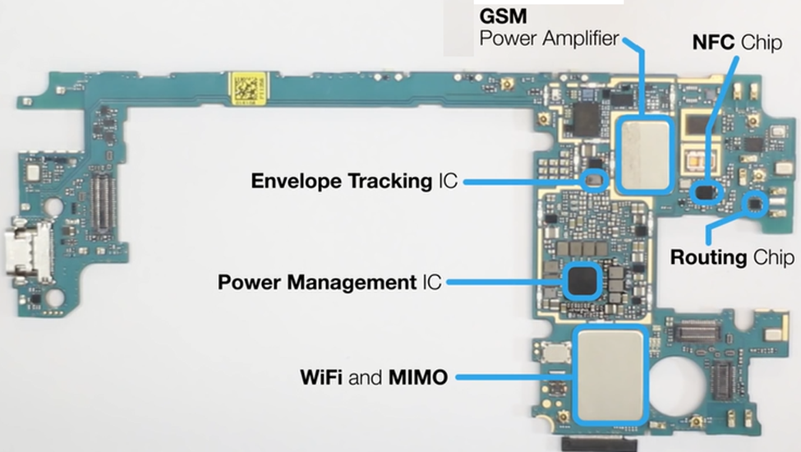
Figure 1-1Main parts of mobile phone:
- Mobile phone classification
The major types of mobile phones are:
- Bar phone: It also known as the slab, block, or slate phone. It takes the shape of a cuboid, usually with rounded corners and/or edges.
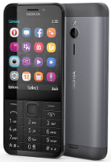
Figure 1-2bar phone

- Flip phone: A flip or clamshell phone consists of two or more sections that are connected by hinges.
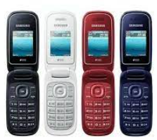
Figure 1-3flip phone
- Slider Phone: It is composed of usually two, but sometimes more, sections that slide past each other on rails.

Figure 1-4slider phone.
- Touch screen phone: A touch screen, or slate phone is a subset of the bar form. Like the tablet computer, a touchscreen phone has minimal buttons and instead relies on an electronic visual display known as a touch screen.
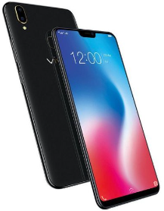
Figure 1-5Touch screen phone

Preparation for Workplace
The successful repair of mobile phones requires a well-prepared and organized workplace. This module focuses on the importance of setting up and arranging the workplace in line with company requirements and standards. It also emphasizes the need for demonstrating the necessary skills and knowledge to prepare the workplace, units, materials, tools, and equipment properly. This content will discuss the key aspects of workplace preparation for mobile phone repair jobs, including the importance of organization, safety, and efficiency in ensuring successful repairs.
- Importance of Workplace Preparation:
- Proper workplace preparation is crucial for efficient and effective mobile phone repair jobs.

- It ensures that technicians have easy access to the necessary tools, equipment, and materials, reducing the time required for repairs and minimizing the risk of errors or accidents.
- A well-organized workplace also promotes a professional image and enhances customer satisfaction.
- Setting Up the Workplace:
To prepare the workplace for mobile phone repair jobs, technicians should consider the following:
- Workstation Layout:.
- Ergonomics:
- Safety Measures:
- Unit Preparation:
Before starting a repair job, technicians should ensure that the mobile phone units are prepared appropriately:
- Cleaning:.
- Documentation:

Tools, Test instruments and PPE.
- Tools of mobile phone
- Power Supply - Variables: A variable power supply is a crucial tool in the mobile phone service and repair industry.
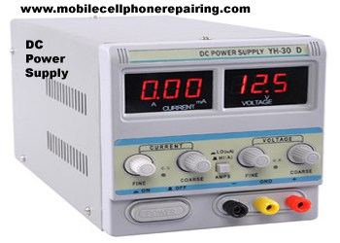
Figure 1-6Power Supply - Variables:
- . Hot Air Blower: It has control to regulate or manage temperature and flow or hot air. Always buy a good quality ESD-Safe hot air blower.
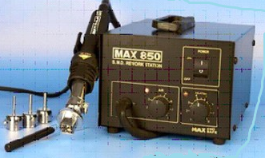

Figure 1-7Hot Air Blower
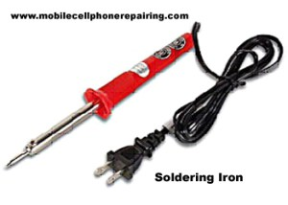
- Soldering Iron: It is used to solder small components like capacitor, resistor, diode, transistor, regulator, speaker, microphone, display etc.

Figure 1-8Soldering iron
- Soldering Iron/Weller w/Stand: A soldering iron is an indispensable tool for repairing mobile phones. It is used to solder and Soldering electronic components on the circuit board.
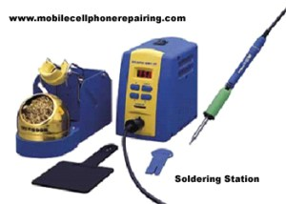

Figure 1-9Soldering Iron/Weller w/Stand
- De-soldering Tools: De-soldering tools, such as desoldering pumps or desoldering wicks, are essential for removing solder from circuit boards.
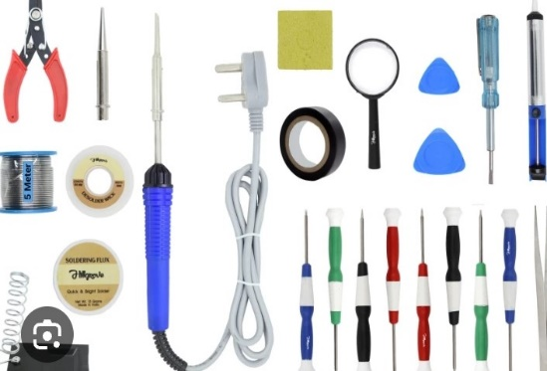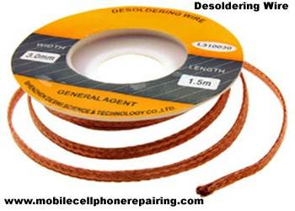
Figure 1-10De-soldering Tools:
- Tweezers (Assorted): Assorted tweezers are necessary for handling small and delicate components during mobile phone repairs.

Figure 1-11Assorted tweezers
- T-Screwdrivers (Assorted): A set of T-screwdrivers and assorted wrenches are essential for disassembling and reassembling mobile phones.
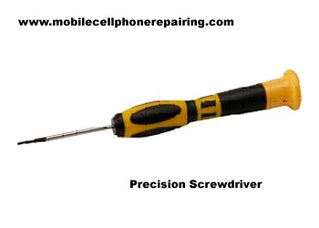
Figure 1-12T-Screw drivers
- ESD-Free Work Bench with Mirror: An ESD (Electrostatic Discharge)-free workbench is crucial for protecting sensitive electronic components from static electricity.
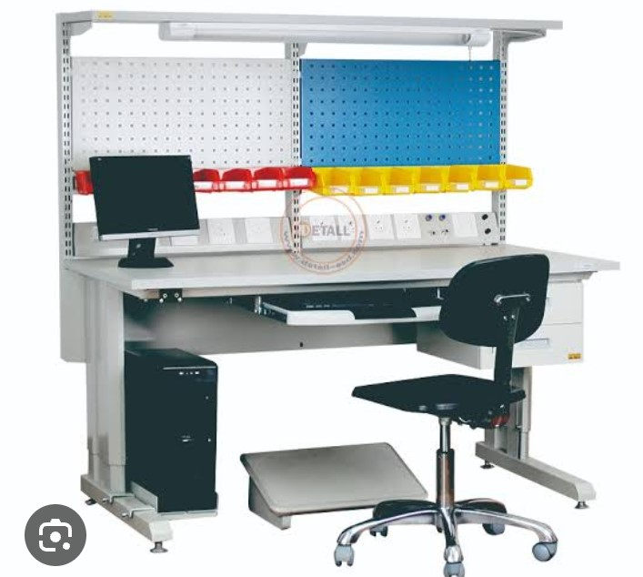
Figure 1-13ESD-Free Work Bench with Mirror:
- Microscope and High-Grade Magnifying Glass with Lamp: A microscope and a high-grade magnifying glass with a lamp are essential for detailed inspection and identification of small components and circuitry.


Figure 1-14microscope and a high-grade magnifying glass
- Cleaning Tools and Agents: Cleaning brushes, cotton rugs, and cleaning agents are necessary for removing dust, debris, and contaminants from the mobile phone's internal components.

Figure 1-15Cleaning brushes, cotton rugs, and cleaning agents
- Assorted Cell Phone Spare Parts: Having a stock of assorted cell phone spare parts is essential for quick and efficient repairs. These spare parts include LCD screens, batteries, charging ports, buttons, and other commonly replaced components.
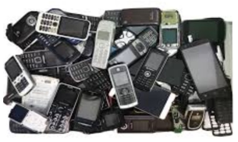
Figure 1-16Assorted Cell Phone Spare Parts:
- Set of Torks /Star Bit: A set of Torks or star bits is essential for opening mobile phones and accessing internal components.
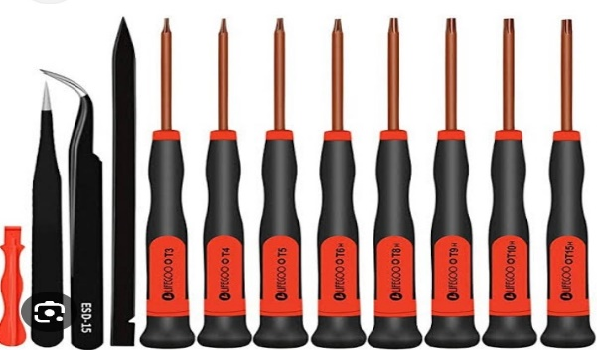
Figure 1-17Set of Torks /Star Bit
- Open Tool 6600/7650: The Open Tool 6600/7650 is a specialized tool used for opening specific models of Nokia mobile phones.
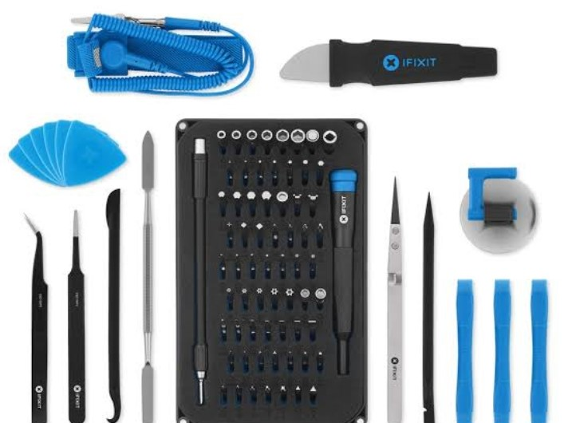
Figure 1-18Open Tool 6600/7650:
- Allen Wrench/Key: An Allen wrench or key is a versatile tool used for various purposes in mobile phone repair.
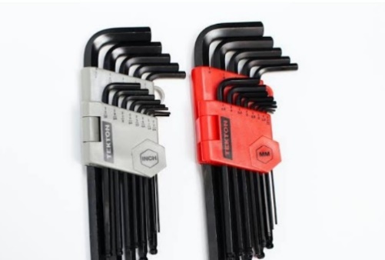
Figure 1-19Allen Wrench/Key:
- Utility Knife/Stripper: A utility knife or stripper is a handy tool used for cutting and stripping wires during mobile phone repairs.

Figure 1-20Utility Knife/Stripper:
- Pliers (Assorted): Assorted pliers, including needle-nose pliers, cutting pliers, and combination pliers, are indispensable tools for mobile phone repair..

Figure 1-21Pliers (Assorted)
- Cutter: A cutter, such as a precision knife or wire cutter, is used for various purposes in mobile phone repair
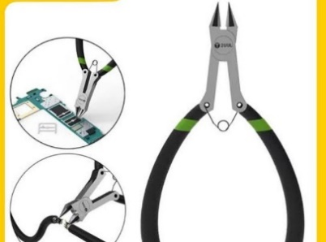

Figure 1-22Cutter
- Test Instruments:

- Multi-testers:- Various test instruments, such as multi-testers (analog/digital), signal generators, and oscilloscopes, are used to diagnose and troubleshoot mobile phone issues. These instruments help technician’s measure voltage, current, resistance, and other electrical parameters, allowing them to identify faulty components and circuits accurately.
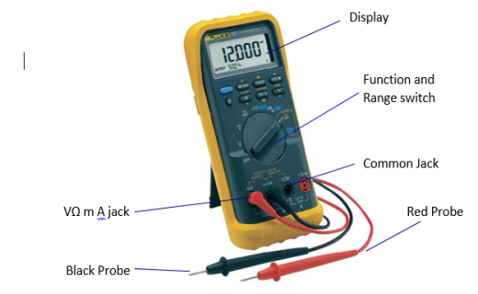
Figure 1-23multi-testers
- Signal Generator - AF/RF: A signal generator is an essential test instrument used for troubleshooting and diagnosing mobile phone signal-related issues. It generates specific frequencies and signals that help technicians identify problems with the phone's antenna, receiver, or transmitter. The AF (Audio Frequency) and RF (Radio Frequency) capabilities of the signal generator allow technicians to test both audio and wireless signal functionalities (Mobile Phone Repairing, n.d.).
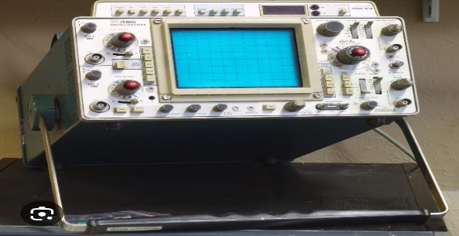
Figure 1-24Signal Generator - AF/RF
- Test Jig: A test jig is a specialized tool used for testing and diagnosing mobile phone components and circuits. It provides a stable platform for connecting and testing different parts of the phone, such as the display, buttons, or charging port. Test jigs ensure accurate and efficient testing, reducing the risk of damage to the phone during the diagnostic process (Mobile Phone Repairing, n.d.).
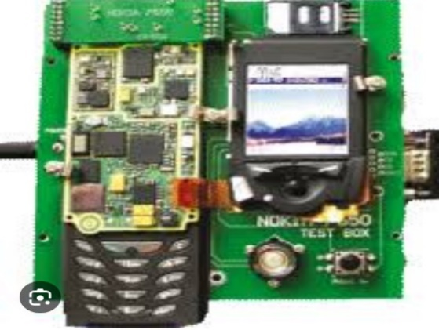
Figure 1-25 Test Jig
- Bluetooth: Bluetooth technology is essential for testing wireless connectivity in mobile phones. It allows technicians to check the phone's Bluetooth functionality, ensuring proper pairing and data transfer capabilities
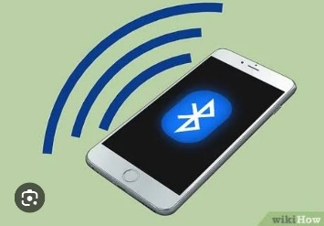
Figure 1-26Bluetooth:
- Oscilloscope: An oscilloscope is an advanced test instrument used for analyzing and measuring electronic signals in mobile phone circuits. It displays waveforms, voltages, and frequencies, allowing technicians to identify abnormalities or malfunctions in the phone's electrical system.
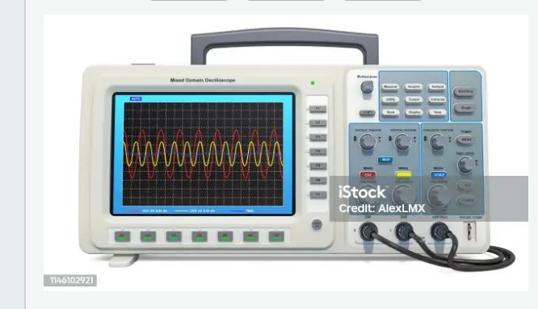
Figure 1-27 Oscilloscope
- Battery Booster: It is used to boost the power of battery of a mobile phone
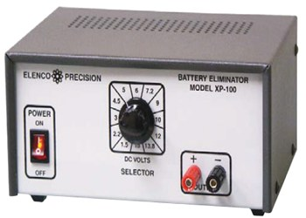
Figure 1-28 Mobile Phone Battery Booster
- Battery Tester: This device is used to test and analyze status or condition of battery of a mobile cell phone.
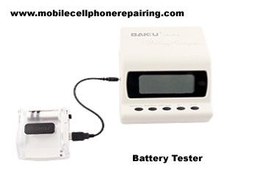
Figure 1-29 Battery Tester
- Personal Protective Equipment
Personal Protective Equipment in Accordance with Occupational Health and Safety Practices
Personal protective equipment (PPE) plays a crucial role in ensuring the safety and well-being of technicians involved in the service and repair of mobile phones. Adhering to occupational health and safety practices is essential to minimize the risk of injury or harm. This section focuses on the use of personal protective equipment in accordance with these practices. Here are the key points to consider:
- Selection of Personal Protective Equipment:
- Based on the risk assessment, select appropriate personal protective equipment that can mitigate identified hazards.
- Common personal protective equipment used in mobile phone service and repair include:
  - Safety Glasses or Goggles: Protect the eyes from potential hazards, such as flying debris or chemical splashes.
  - Gloves: Shield the hands from cuts, abrasions, and chemical exposures. Choose gloves suitable for the specific tasks, considering factors such as material compatibility and dexterity requirements.
  - Electrostatic Discharge (ESD) Protection: Use ESD wrist straps, mats, and ESD-safe tools to prevent damage to sensitive electronic components and protect against electrostatic discharge.
  - Respiratory Protection: Depending on the work environment and potential exposure to dust, fumes, or chemicals, respiratory protection such as masks or respirators may be necessary.
  - Protective Clothing: Consider wearing protective clothing, such as lab coats or coveralls, to protect against chemical splashes or other potential hazards.
  - Hearing Protection: In environments with high noise levels, use appropriate hearing protection, such as earmuffs or earplugs, to prevent hearing damage.
- Training and Guidelines:
- Provide comprehensive training to technicians on the proper use, maintenance, and limitations of personal protective equipment.
- Ensure technicians understand the risks associated with their tasks and how PPE can mitigate those risks.
- Develop and communicate guidelines or standard operating procedures for the correct usage and storage of personal protective equipment.
- Fit and Comfort:
- Personal protective equipment should be properly fitted to ensure effectiveness and comfort.
- Ensure that PPE is available in various sizes to accommodate the individual needs of technicians.
- Encourage technicians to report any discomfort, issues, or concerns related to the fit or usability of PPE to address them promptly.
- Maintenance and Replacement:
- Regularly inspect personal protective equipment for damage, wear, or deterioration.
- Replace damaged or worn-out PPE promptly to maintain its effectiveness.
- Establish a system for tracking and managing the maintenance, repair, and replacement of PPE.
- Compliance with Regulations:
- Familiarize yourself with applicable occupational health and safety regulations and guidelines related to personal protective equipment.
- Ensure that your practices align with these regulations and implement any necessary updates or changes.
- Stay informed about emerging best practices and industry standards regarding personal protective equipment.
- Safety Culture:
- Foster a safety culture within the workplace by
- Promoting awareness, accountability, and
- Active participation in occupational health and safety practices.
- Encourage open communication and feedback regarding safety concerns or suggestions from technicians.
- Regularly review and update safety protocols to address changing needs and technologies.

Service Manuals and Information
In the module "Service and Repair Mobile Phones," acquiring service manuals and relevant information at the commencement of activities is crucial for ensuring successful repair and maintenance processes.
- Service Manuals, Schematic Diagrams, and Parts Lists
- Service manuals are comprehensive guides that provide
- Detailed information about the internal components,
- Circuitry, and
- Functionality of mobile phones.
They often include schematic diagrams, which illustrate the electrical connections and pathways within the device.
- Operating Instructions/User's/Owner's Manual
Operating instructions, user's manuals, or owner's manuals are documents provided by the mobile phone manufacturer. These manuals offer guidance on how to operate and maintain the device properly.
- Acquiring these manuals at the commencement of activities allows
- Technicians to familiarize themselves with the specific features,
- Functions, and
- Settings of the mobile phone model they are repairing.
- Repair Handbooks for Cellular Phones
Repair handbooks specifically cater to the repair and maintenance of cellular phones. These handbooks provide step-by-step instructions, troubleshooting techniques, and best practices for repairing various mobile phone models.
- These handbooks often include tips for common issues, such as
- Screen replacements,
- Battery replacements,
- Software troubleshooting.
- Importance of Service Manuals and Information:
Acquiring service manuals, schematic diagrams, and parts lists, operating instructions, users/owner's manuals, and repair handbooks for cellular phones at the commencement of
- repair and maintenance activities offers several significant benefits:
- Accurate Diagnosis
- Efficient Repair
- Quality Assurance
- Enhanced Customer Satisfaction

Service and Repair Manuals
In the fast-paced world of mobile technology, the need for efficient and effective service and repair of mobile phones is paramount. To ensure smooth operations and customer satisfaction, it is crucial to have comprehensive service and repair manuals and service information readily available. These manuals provide technicians with the necessary guidance and instructions to carry out repairs and maintenance tasks accurately and efficiently.
- Job Report Sheets
Job report sheets are essential documents that record all the necessary details about a specific repair or maintenance task.
- These sheets include information such as
- The customer's contact details,
- Phone model,
- Problem description, and
- Any additional notes.
Job report sheets serve as a reference for technicians, enabling them to track the progress of each job and ensure that all necessary steps are taken to resolve the issue.
- Job Order
A job order is a formal document that authorizes the initiation of a repair or maintenance task.
- the customer's request,
- the estimated time required for completion, and
- Any special instructions.
Job orders help technicians prioritize tasks, allocate resources effectively, and ensure that all customer requests are addressed promptly.

- Bill of Materials
The bill of materials (BOM) is a comprehensive list of all the components and parts required for a specific repair or maintenance task.
- Part numbers,
- Descriptions,
- Quantities, and
- Sometimes even prices.
The BOM helps technicians ensure that they have all the necessary parts readily available, reducing the time spent searching for components and improving overall efficiency.
- Customer Index
A customer index is a database or record that contains information about all the customers who have availed of the mobile phone service or repair.
- Contact information,
- Service history, and
- Any specific preferences or requirements.
The customer index helps technicians provide personalized service, track customer interactions, and maintain a strong customer relationship.

History of Verifying Repair/Maintenance
In the field of mobile phone service and repair, it is crucial to properly verify the repair and maintenance history of a unit before proceeding with any further work. This verification process ensures that technicians have a comprehensive understanding of the unit's previous issues, repairs, and maintenance, enabling them to make informed decisions and provide effective solutions.
- Identification of the Unit
The first step in verifying the repair/maintenance history of a mobile phone unit is to accurately identify the unit.
This involves recording the unique identifiers such as
- IMEI (International Mobile Equipment Identity) number,
- Serial number, or
- Model number.
- Gathering Information from the Customer
Once the unit is identified, technicians should engage in a detailed conversation with the customer to gather information about the unit's repair and maintenance history.
This information may include
- Previous issues,
- Repairs performed,
- Parts replaced, and
- Any recurring problems.

- Reviewing Service Records:
Service centers often maintain detailed service records for each unit they have serviced.
These records include
- information about the repairs performed,
- parts replaced, and
- Any additional notes or recommendations from previous technicians.
Technicians should review these service records to gain a comprehensive understanding of the unit's repair/maintenance history. This step helps identify any recurring issues, patterns, or unresolved problems that may require special attention.
- Checking Manufacturer's Database
- In addition to service records, technicians should also check
- The manufacturer's database for any available information about the unit.
- Manufacturers often maintain databases that store information about each unit's history, including repairs performed at authorized service centers.
Accessing this database can provide valuable insights into the unit's repair/maintenance history and any specific recommendations or updates from the manufacturer.

- Diagnostic Testing:
To further verify the repair/maintenance history, technicians can perform diagnostic tests on the unit. These tests help identify any underlying issues or potential problems that may not be evident from the service records alone.
Figure 1-30Diagnostic Testing
Diagnostic testing can include
- Hardware tests,
- Software scans, and
- Performance evaluations.
By conducting these tests, technicians can ensure that all aspects of the unit are thoroughly examined and any hidden issues are addressed.
Documenting the Verified History:
Once the repair/maintenance history is properly verified, it is essential to document the findings.
Technicians should create a detailed record that includes
- All relevant information gathered from the customer,
- Service records,
- Manufacturer's database, and
- Diagnostic testing.

Self-check No.1.1
Part one: Say True/False:
- Mobile phones are only used for voice calls and text messages.
- Bar phones are also known as flip phones.
- Touch screen phones rely on an electronic visual display.
- Ergonomics in the workplace focuses on proper lighting.

Part Two: Multiple Choice:
- Which of the following is NOT a component of a mobile phone?
  - Display and touchscreen
  - Battery and power management
  - Motherboard with integrated circuits
  - Keyboard and mouse
- What is the primary function of a flip phone?
- Making voice calls
- Sending text messages
- Running applications
- Taking photos
- What is the purpose of unit preparation in mobile phone service and repair?
- Data backup
- Component removal
- Cleaning and inspection
- All of the above
- What is the importance of personal protective equipment (PPE) in mobile phone repair?
- It enhances customer satisfaction.
- It reduces the risk of accidents and injuries.
- It improves the efficiency of repairs.
- It extends the lifespan of mobile phones.

- Which tool is used to solder small components in mobile phone repair?
- Power supply
- Hot air blower
- Soldering iron
- De-soldering toots
- What is the purpose of a desoldering pump or desoldering wick?
- Removing dust and debris
- Cleaning the circuit board
- Removing solder from circuit boards
- Soldering electronic components
- What type of screwdrivers are essential for disassembling and reassembling mobile phones?
- T-screwdrivers
- Phillips screwdrivers
- Flathead screwdrivers
- Allen wrenches
- What is the purpose of an ESD-free workbench in mobile phone repair?
- Protection against static electricity
- Providing a stable and controlled heat source
- Inspecting internal components
- Cleaning the circuit board
- Which tool is used for detailed inspection and identification of small components?
- Microscope
- Magnifying glass
- Cleaning brush
- Tweezers
- What is the purpose of cleaning tools and agents in mobile phone repair?
- Removing fingerprints
- Enhancing customer satisfaction
- Maintaining cleanliness of the circuit board
- Charging the battery
Part Three: Matching
Match the mobile phone classification with its description.
Match A. Match B
_______1. Bar phone (a) Takes the shape of a cuboid
_______2. Flip phone (b) Consists of two or more sections connected by hinges
_______3. 3Slider phone (c) Composed of sections that slide past each other on rails
_______4.Touch screen phone (d) Minimal buttons and relies on a touch screen
Part Four: Fill in the Blank:
    - Technicians must have knowledge of mobile phone ____________.
    - A well-prepared workspace is essential for efficient mobile phone ____________ and repair.
    - Documentation of the condition of mobile phone units helps avoid disputes with ____________.
    - An ESD-free workbench is crucial for protecting sensitive electronic components from ____________.
    - Cleaning tools and agents are necessary for removing dust, debris, and ____________.

Operation sheet 1.1
Operation Title: identify materials, tools, testing & measuring instruments
Instruction:
Purpose: to differentiate different types of mobile phone repairing materials, tools, testing & measuring instruments
Required tools and equipment: unit one of this module, tools from workshops like screw drivers, tweezer, multimeter, measuring instruments
Precautions:
- use safety precaution while touching had tools
- Properly handle the tools
Procedures:
Step 1: Bring the materials, tools, testing & measuring instruments from supply room
Step 2: Put each materials, tools, testing & measuring instruments separately on the table
Step 3: Shaw the materials, tools, testing and measuring instruments that your instructor asks you to display
Quality criteria:

LAP Test # 1.1

Name: __________________________ Date: ____________
Time started: ____________________ Time finished: _______________

Instruction I: Given necessary templates, tools and materials you are required to perform the following tasks within 3 hours.

Task 1: identify mobile phone repairing materials
Task 2: identify mobile phone repairing Tools
Task 2: identify mobile phone repairing testing & measuring instruments

UNIT TWO: DIAGNOSE FAULTS
This learning guide is developed to provide you the necessary information regarding the following content coverage and topics:
- Basic concept of Diagnose
- Pre-Testing Procedure
- Methods of mobile phone faults finding.
- Identifying system defect/fault symptoms
- Diagnosis and test
- Status and Serviceability of Mobile Phones
This guide will also assist you to attain the learning outcomes stated in the cover page. Specifically, upon completion of this learning guide, you will be able to attain :
- Understand Basic concept of Diagnose
- Follow Pre Test procedures
- Identify Methods of mobile phone faults finding.
- Identify system defect/fault symptoms
- Document Diagnosis and test
- Advise / inform Status and Serviceability of Mobile Phones

Basic concept of Diagnose
- Introduction of diagnose
Diagnosing mobile phone issues involves identifying and troubleshooting problems that can occur with the device's hardware or software. Here is a concise and precise overview of the basic concepts involved in diagnosing mobile phone problems:
- Hardware Issues: Hardware problems refer to physical defects or malfunctions in the mobile phone's components. Common hardware issues include a broken screen, faulty battery, malfunctioning buttons, or a damaged charging port. Diagnosing hardware problems often requires visual inspection, testing with specialized tools, or replacement of faulty components.
- Software Issues: Software problems arise from issues with the operating system (OS), applications, or firmware on the mobile phone. Symptoms of software issues may include freezing, crashing, slow performance, or unresponsive touch screen. Diagnosing software problems involves analyzing error messages, checking for software updates, and performing troubleshooting steps such as clearing cache, resetting settings, or reinstalling applications.
- Network Connectivity: Mobile phones rely on network connectivity to function properly. Diagnosing network-related problems involves checking cellular signal strength, Wi-Fi connectivity, and Bluetooth connections. Issues with network connectivity may result in dropped calls, slow internet speeds, or inability to connect to Wi-Fi or Bluetooth devices.
- Battery and Power: Battery-related problems can significantly impact a mobile phone's performance. Diagnosing battery issues includes checking battery health, monitoring power consumption, and identifying abnormal battery drain. Problems may arise due to a faulty battery, power-hungry applications, or system settings that contribute to excessive power usage.
- Data and Storage: Mobile phones store a significant amount of data, including contacts, messages, photos, and applications. Diagnosing data and storage issues involves identifying problems related to data corruption, insufficient storage space, or issues with data synchronization. Troubleshooting steps may include clearing cache, deleting unnecessary files, or performing data backups.
It's important to note that the above concepts provide a general overview, and specific diagnostic procedures may vary depending on the mobile phone model and operating system version. Additionally, some issues may require professional assistance from authorized service centers or technical support.
- Parts of mobile phone, its functions and faults.
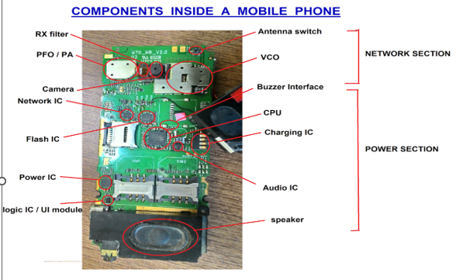
A printed circuit board (PCB) of a mobile phone showing the different internal parts. As you can see from this diagram the PCB is divided into two parts, the network section and the power section. The network section controls the incoming and outgoing phone calls, while the power section controls the memory and power related functions of the phone.

Figure 2-1Parts of mobile phone
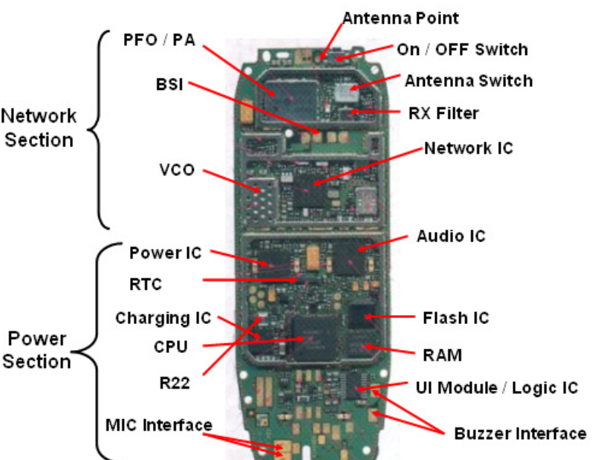
Figure 2-2 hard ware parts of mobile phone
- Hardware Parts
- Antenna Switch
It is found in the Network Section of a mobile phone and is made up of metal and non-metal. In GSM sets it is found in white color and in CDMA sets it is found in golden metal.

Figure 2-3Antena switch
- P.F.O
It is found near the Antenna Switch in the Network Section of the PCB of Mobile Phone. It is also called P.A (Power Amplifier) and Band Pass Filter.
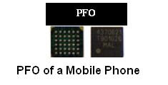
Figure 2-4 PFO
- RF IC / Hagar / Network IC
This electronic component found near the PFO in the Network Section of a Mobile Phone. It is also called RF signal processor
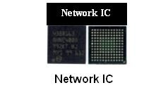
Figure 2-5 Network IC
- 26 MHz Crystal Oscillator
It found near the PFO in the Network Section of a Mobile Phone. It also called Network Crystal. It made up of metal.
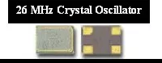
Figure 2-6MHz Crystal Oscillator
- VCO
It is founds near the Network IC in the Network Section of a Mobile Phone

Figure 2-7VCO
- RX Filter
It found in the Network Section of a Mobile Phone

Figure 2-8RX Filter
- TX Filter
It is found in the Network Section of a Mobile Phone
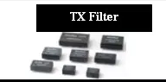
Figure 2-9TX Filter
- ROM
It is found in the Power Section of a Mobile Phone.

Figure 2-10ROM
- RAM
It is found in the Power Section of a Mobile Phone.
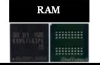
Figure 2-11 RAM
- Flash IC
It is found in the Power Section of a Mobile Phone. It is also called EEPROM IC, Memory IC, RAM IC and ROM IC.
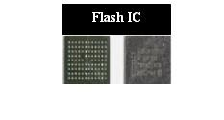
Figure 2-12Flash IC

- Power IC
It is found in the Power Section of a Mobile Phone. There are many small components mainly SMD capacitor around this IC. RTC is near the Power IC.
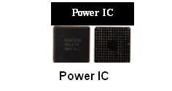
Figure 2-13 Power IC
- Charging IC
It is found in the Power Section near R22.
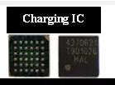
Figure 2-14Charging IC
- RTC (Simple Silicon Crystal)
It is Real Time Clock and is found in the Power Section near Power IC. It is made up of either metal or non-metal. It is of long shape
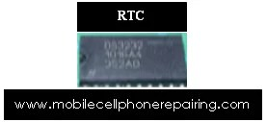
Figure 2-15 RTC
- CPU
It is Central Procession Unit of the Phone and is found in the Power Section. It is also called MAD IC, RAP IC and UPP.
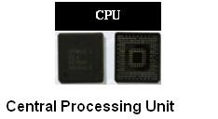
Figure 2-16CPU
- Logic IC / UI IC
It is found in any section of a mobile phone. It has 20 pins or legs. It is also called UI IC and Interface IC
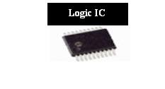
Figure 2-17 Logic IC / UI IC
- Audio IC
It is found in Power Section of a mobile phone. It is also called Cobba IC and Melody IC.
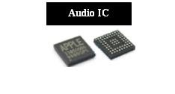
Figure 2-18Audio IC
- Charging Connector
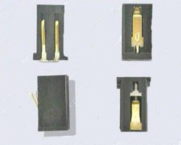
Figure 2-19Charging Connector
- Data Cable Connector:
It helps to connect the mobile to another device such as a computer, laptop, table etc. using a data cable.
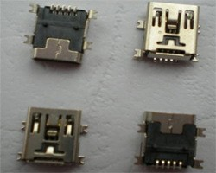
Figure 2-20 Cable Connector
Battery:
It supplies power or DC current to the mobile phone.
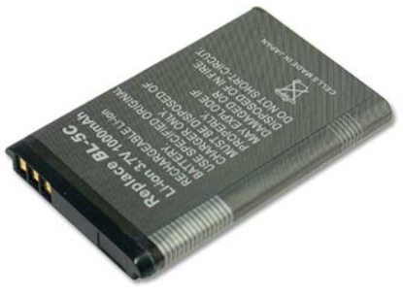
Figure 2-21 Battery
- Battery Connector:
It connects the battery to the internal circuit tracks of the PCB of a mobile phone.
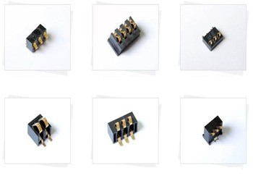
Figure 2-22Battery Connector
- SIM Card:
Subscriber Identification Module. This is a small rectangular chip with circuit and information of user of the card. A SIM card is necessary to make or receive phone calls with a mobile phone.
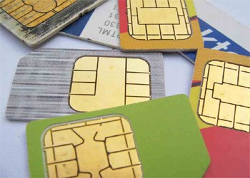
Figure 2-23 SIM Card
- SIM Card Connector:
It connects the SIM card to the Circuit or PCB of a mobile phone
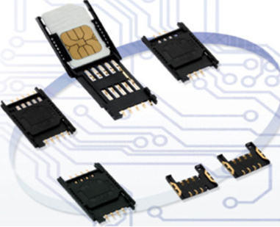
Figure 2-24SIM Card Connector
- Memory Card:
It is used to store data like document, music, videos etc. These are available in different capacities like 1GB, 2GB, 4GB, 8GB, 16GB, 32 GB etc
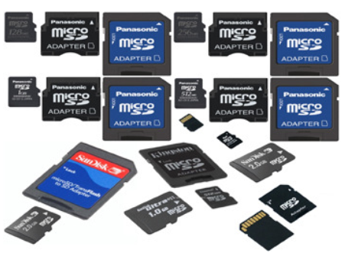
Figure 2-25Memory Card
- Memory Card Connector:
It connects the memory card to the PCB of a mobile phone.
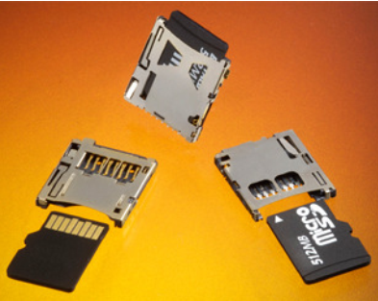
Figure 2-26Memory Card Connector
- Camera:
It is used to capture still images or record videos. These are available in different megapixel.
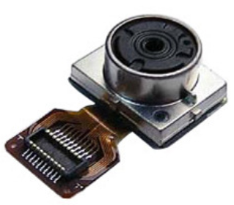
Figure 2-27Camera
- Camera Connector:
It connects the camera to the PCB of the mobile phone.
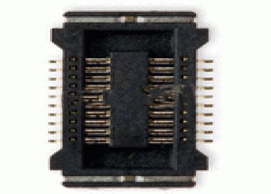
Figure 2-28Camera Connector
- Keypad Button:
It is connected to the keypad carbon to enter numbers to make phone calls and other data.
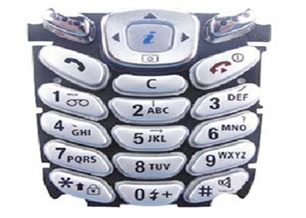
Figure 2-29Keypad Button
- Keypad:
Type of component that helps to operate a mobile phone. Some mobile phones are screen touch and are operated by PDA.
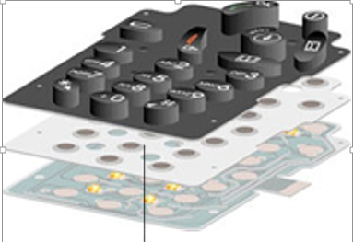
Figure 2-30Keypad Carbon / Tickly
- Keypad Connector:
It connects the keypad to the PCB of the cell phone
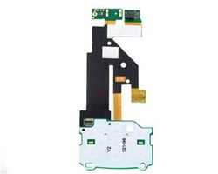
Figure 2-31Keypad Connector

- ON / OFF Switch:
It is made of tiny metal that conducts connectivity when press. It is being used as a power on and off, Volume control switch and camera shutter switch on various mobile phones.
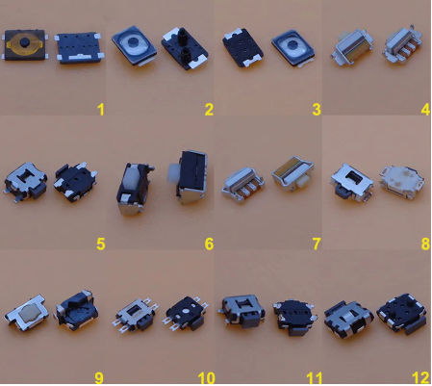
Figure 2-32ON / OFF Switch
- Display Connector:
It connects display of screen to the PCB of a Mobile Phone
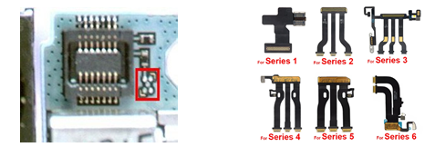
Figure 2-33 Display Connector
- Antenna:
It helps to capture network frequency.
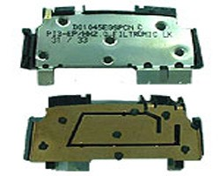
Figure 2-34Antenna
- LED:
Type of component that generates light in the Mobile Phone. These are generally LED or Light Emitting Diode.
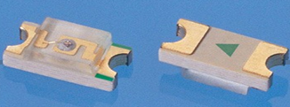
Figure 2-35 LED
- Headphone / Earphone Connector:
Type of component that does the job of Mic and Speaker separately. When we insert Headphone, then Speaker and Microphone of the Mobile Phone Gets Disconnected. Headphone is control by C.P.U.
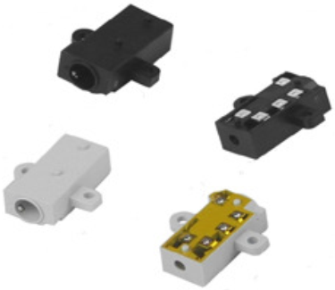
Figure 2-36Headphone / Earphone Connector
- Ringer / Loudspeaker
Type of component that rings or plays loud sound is called Ringer. It is also called by several other names like – I.H.F Speaker, Buzzer, and Melody etc.

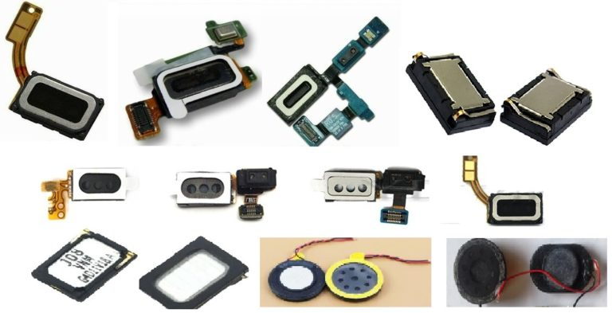
Figure 2-37 Ringer / Loudspeaker
- Speaker / Earpiece
Earpiece: Type of component that helps to listen to sound during phone call. It is also called Speaker or Ear Speaker. Earpiece is controlled by Audio IC or Power IC (UEM).
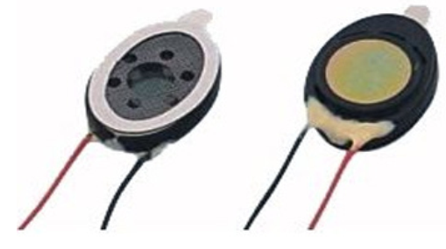
Figure 2-38Speaker / Earpiece
- Mic / Microphone:
Function: Type of component that helps to transmit sound from one mobile phone to another during phone call.

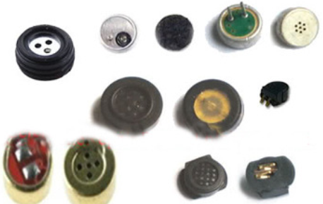
Figure 2-39 Mic / Microphone
- Vibrator / Motor:
Type of component that vibrates. It is also called Motor. Vibrator is controlled by Logic IC or Power IC.
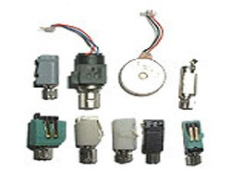
Figure 2-40Vibrator / Motor
- Display:
The Display Section of a Mobile Phone is controlled by the CPU. In some Mobile Phones, there is an Interface IC called Display IC between the Display and the CPU.
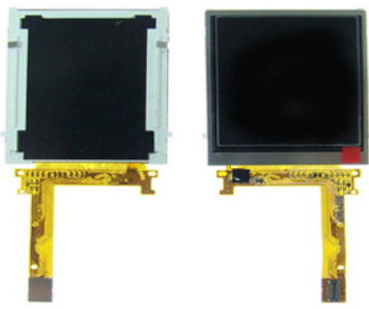
Figure 2-41 Display
- Touch Screen (PDA):
Touch Screen (PDA) Type of component that helps to operate a mobile phone by touching the screen. Touch Screen is available in different sizes. It normally has 4 Points namely: - (+), (-), (RX), (TX). Screen Touch is also called PDA. It is controlled by the CPU. In some Mobile Phones there is an Interface IC called PDA IC or Screen Touch IC.
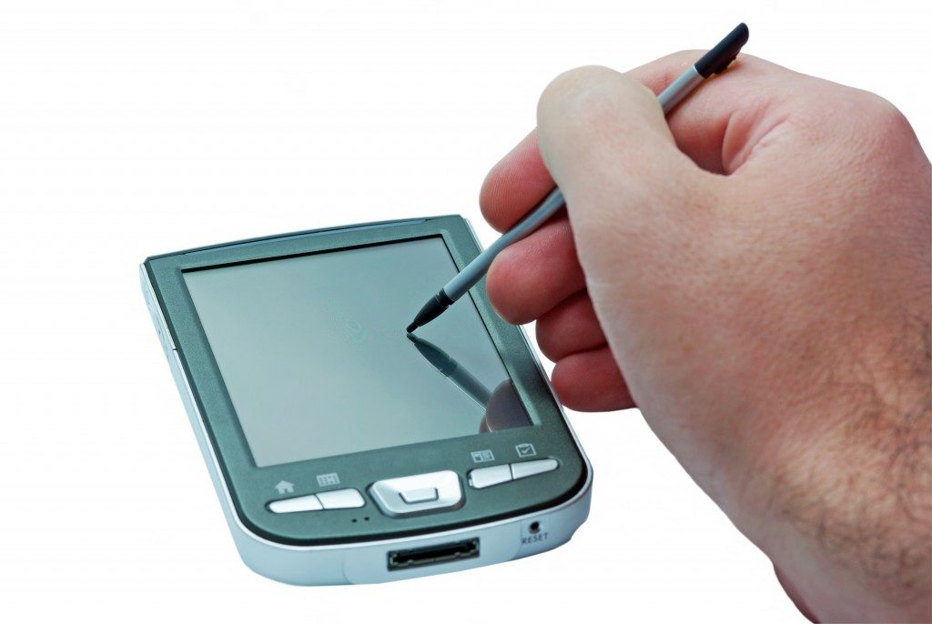
Figure 2-42Display Touch Screen
- PCB: -
Printed Circuit Board of the Mobile Phone. It contains most of the mobile components and parts
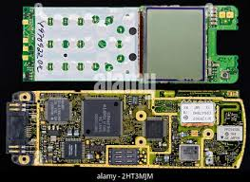
Figure 2-432.41: PCB

Systematic Pre-Testing Procedure
In the field of mobile phone service and repair, a systematic pre-testing procedure is crucial to accurately diagnose and address any issues with the device. This essay will outline the key steps involved in this procedure, focusing on visual inspection, customer interview, and operating the device according to the manual. By following these steps in accordance with the manufacturer's instructions, technicians can ensure a comprehensive assessment of the mobile phone's condition and identify any defects or malfunctions.
- Visual Inspection
- Interview of Customer
- Operating Manual:
- Visual Inspection
The first step in the pre-testing procedure is to visually inspect the mobile phone with the power turned off. This inspection aims to identify any visible physical damage or irregularities that may affect the device's functionality. Technicians should carefully
- examine the exterior of the phone,
- The screen,
- Buttons,
- Ports, and
- Casing.
- Common issues to look for
- Cracked screens,
- Water damage indicators,
- Loose connections, and
- Signs of wear and tear.
This visual inspection provides an initial assessment of the device's condition and helps determine the appropriate course of action for further testing and repair.

- Interview of Customer
The next step involves conducting an interview with the customer to gather information about the mobile phone's history.
- This conversation is essential as it provides
- Valuable insights into the device's usage patterns,
- Any previous repairs or modifications, and
- Any specific issues or symptoms experienced by the customer.
By understanding the unit's history, technicians can narrow down the potential causes of the problem and focus their testing efforts accordingly.
- Operating Manual
After completing the visual inspection and customer interview, technicians proceed to operate the mobile phone according to the manufacturer's manual. This step involves following the prescribed procedures for testing various functions and features of the device. By adhering to the manual's instructions, technicians can confirm the presence of defects or malfunctions reported by the customer. It is important to note that this step should be performed cautiously to avoid causing further damage to the device. Technicians should pay close attention to any abnormal behavior or errors displayed during the testing process
- Pretesting
Pretesting is an important way to pinpoint problem areas, reduce measurement error, reduce respondent burden, determine whether or not respondents are interpreting questions correctly, and ensure that the order of questions is not influencing the way a respondent answers
- Unit of Current: Ampere or Amp (A).
- Unit of Voltage: Volt (V).
- Current: Flow of Electric Charge through a Conductive Medium.
- Types of Current: (1) Alternate Current (AC) and (2) Direct Current
- Alternate Current (AC): The Movement of Electric Charge Periodically Reverses Direction. E.g: Power
- Direct Current (DC): The Movement of Electric Charge is in One Direction. E.g: Power from Battery.
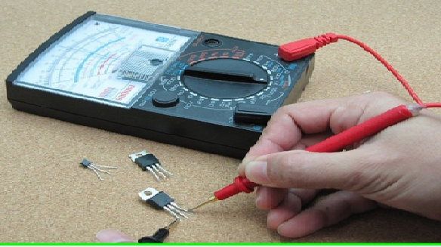
Figure 2-44 pre testing method
- Common Mobile phone System defect/faults
A fault is a defect (a failure in a circuit) or an electronic device.
Failures can be caused by any of the following:
- excess temperature,
- excess current or voltage,
- ionizing radiation,
- mechanical shock,
- stress or impact,
- contamination,
- mechanical stress,
- short circuits,
- imperfect connections,
- poor insulation or wiring caused by grounding.
- There are three types of mobile phone faults:
- Hardware faults: occur due to hardware malfunctioning
- Software faults: occur due to problems with software
- Settings faults: occur due to wrong/invalid settings
- Hardware Faults
There are many hardware faults that can occur in a mobile phone, but in this section, we shall discuss the following:
- Battery charging faults/problems
- Mobile phone battery problem (faults)
- Network not working problem
- Overheating problem
- Sound faults
- Ear piece, ringer and microphone problem
- Display problems
- Lighting or LED problems
- Touchscreen problems
- Keypad problems
- SIM faults
- WiFi problem and internet connectivity problems
- Software Faults
A software is a set of programs, routines and symbolic language that control the functions of hardware and directs its operations.
- The common software problems are:
- Display problems
- No signal message
- Dead phone set
- Phone on test mode Phone not charging
- Phone has message to contact service provider
- Phone hangs, goes off, freezes or has slow processing
- How to solve these problem:
- Check the downloaded applications and note when the problem happened.
- Note whether the problem is happening when a certain application is running.
- Remove the application that is causing the problem
If the problem is still not solved then reset the factory settings of the mobile phone and update the software. You have now come to the end of our topic on common mobile phone problems or faults. Before you move on, do the following activity to evaluate your understanding of this section.
  - Network Not Working Problem in Mobile Phone
- There is no network at all in the phone.
- There is less or weak network signal.
- Sometimes there is signal and sometimes there is no network signal.
- There is network signal for some time and then there is no signal at all.
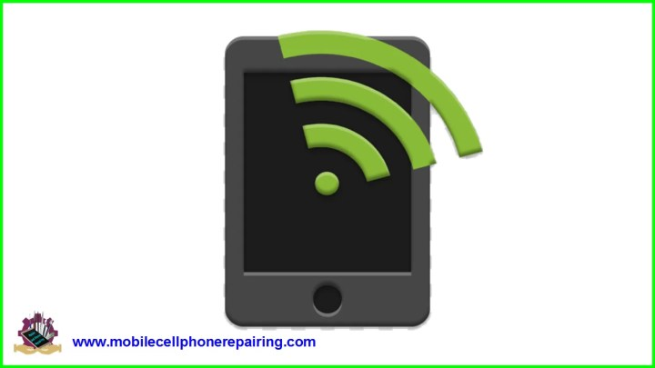

Figure 2-45mobile network fault
- Mobile phone SIM Fault / Error / Problem
These Problems and Solution apply to all brands and make of mobile phones
- SIM stands for Subscriber Identification Module.
- SIM is inserted but still there is a message saying “Insert SIM”.
- The Mobile Phone goes OFFLINE when the SIM Card is inserted.
- SIM works for some time and then it stops working.
- There is a message that says “Invalid SIM”.
- SIM Card Not Working.
- SIM Card not Detected in any Phone.
- Android Phone can’t Detect SIM Card
- SIM Access Error
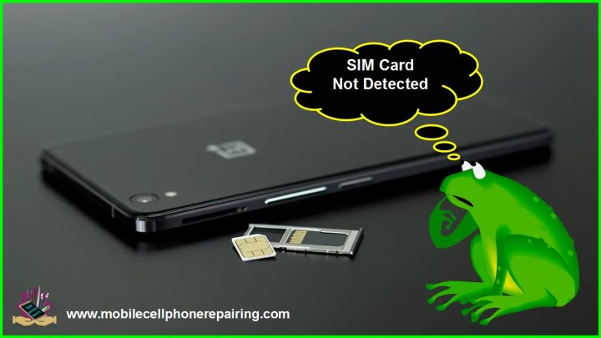
Figure 2-46 SIM Card Track to Fix SIM Card Not Detected Problem
- Mobile Phone Overheating
A mobile phone may overheat either inside or on the body. To solve this problem, you should proceed as follows:
- Check if the mobile phone overheats when a particular application is running or if the overheating happens all the time.
- Upgrade the mobile phone software operating system to the latest version. This may solve the overheating problem.
- Smartphones overheat if too many applications are running at the same time. Close all the applications and try to run 1 application at a time
- If overheating persists, then there is some internal hardware problem. Change the PCB or Logic Board to solve the heating problem.
- Sound Faults
We shall consider the following types of sound faults:
• Earpiece or ear speaker problem
• Ringer problem/ loud speaker problem
• Vibration problem
• Microphone problem
- Ringer Fault/Loud speaker
There can be several types of faults or problems in the ringer of a mobile cell phone:
- Ringer / Loud Speaker not working
- Less sound from the Ringer
- Sound coming from Ringer but with interruption
- Sound not clear
- Cannot Play Music or No Sound from Video
- Android Phone Not Ringing
- Android Smartphone or Apple iPhone Vibrate but won’t ring
- Ear Speaker (Earpiece) Problem
These problem and solution apply to all brands and make of mobile phones
Earpiece is controlled by Audio IC or Power IC (UEM).
- No sound during phone call.
- Less sound during phone call.
- Sound with interruption.
- MIC Sound Fault/ Problems if Microphone Not Working
- No sound or Less Sound during phone call.
- The other Person cannot hear your Voice / Sound.
- Sound with interruption or Changed sound.
- Vibrator Fault / Problems in Mobile Phone Ringer
Vibrator is controlled by Logic IC or Power IC.
There can be several types of faults or problems in the ringer of a mobile cell phone:
- Vibrator not working.
- Vibration with interruption.
- Vibration Hangs.
- Phone will ring but won’t vibrate.
- Mobile Phone Vibration not working is most common in following Samsung Models – Samsung b313, Samsung j7, Samsung b313e, Samsung b310e, and Samsung e1200.

- Micro SD Card Fault / MMC Fault
Micro SD Card, Micro Card Connector, Micro Card Detector Switch, Micro Card Detector Signal components, CPU etc.
- USB and Bottom Connector fault
USB and Bottom Connector, USB and Signal Interface Connector Components, USB Signal Interface IC, USB Driver IC, CPU etc.
- Keypad Fault/ Keypad Problems
The keypad enables you to enter data, such as, phone numbers and names in your mobile phone.
- Faults or Problems when Mobile Phone Keypad Not Working
- No Key Working or only Some Key Working.
- Keys need more pressure to work. Or when pressed a key works continuously.
- One key is pressed and some other key works OR when one key is pressed, some other key works simultaneously.

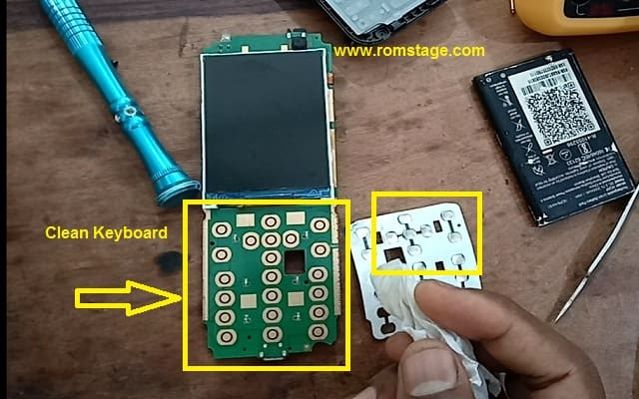
Figure 2-47mobile phone keypad fixing
- Display Fault
Mobile Phone Display not working or Touch Screen Not Working or Screen is Black / Blank but Phone is ON – No Problem. These problem and solution apply to all brands
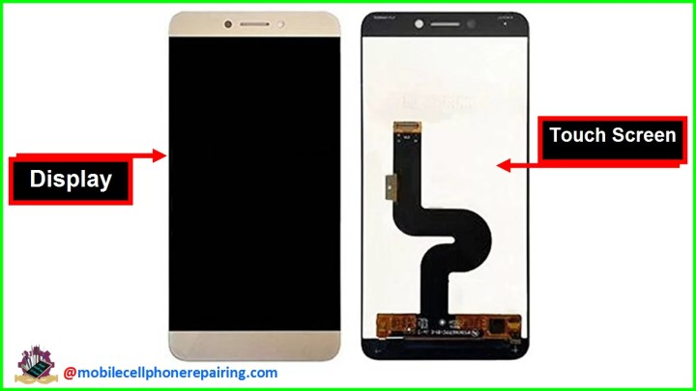
Figure 2-48Mobile Phone Display and Touch Screen
- Problems if Mobile Phone Display Not Working
- Mobile Phone Display Not Working (Phone Dead)
- Nothing shows on the Display or Display is Black / Blank
- Only Half Display Working
- Display Broken or Crack
- Sometimes Display Works and Sometimes it doesn’t work
- There is only light in the Display and nothing else
- Touch Screen Not Working
- Phone is ON but the Screen is Black
- You Dropped Your Phone and the Screen is Black
- Part of the Mobile Phone Screen doesn’t work
- Mobile Phone Light LED Problem
The common symptoms of LED problems are:
- No Light.
- Light only in the Keypad or Display.
- Some lights not working
- Mobile Wi-Fi Wireless Internet Connection Problem:
This problem may present in the following ways:
  - No internet
  - Low Wi-Fi signal
  - Wi-Fi cannot be enabled
- Bluetooth Fault
- iPhone Bluetooth Problems
Though Apple iPhone is a great smartphone, there are some common problems associated with all versions of the iPhone including – iPhone 5, iPhone 6, iPhone 7, iPhone 8, iPhone X. iPhone Bluetooth Not Working is a very common problem. Following are some of the errors associated with this problem:
- iPhone Bluetooth spinning wheel
- iPhone 6 Bluetooth not discovering devices
- iPhone 6S Bluetooth not finding devices
- iPhone 7 Bluetooth not working
- iPhone 6 Bluetooth cutting out
- iPhone 8 Bluetooth not working
- iPhone X Bluetooth not working
- Bluetooth unavailable in iPhone
- Bluetooth icon not showing on iPhone
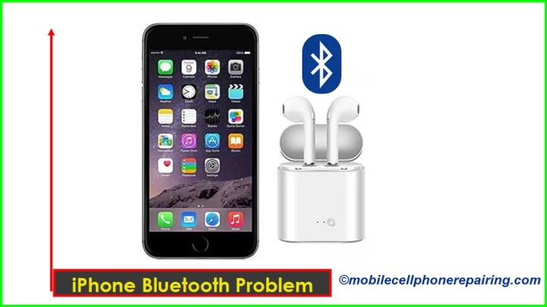
Figure 2-49 i-Phone Bluetooth Not Working
- FM Radio Fault
Hands Free Lead, Hands Free Connector, FM and Bluetooth IC, FM Driver IC, CPU etc.
- Mobile Phone Dead Problem
A Dead Mobile Phone is a Cell Phone that is not switch ON. It won’t turn ON and won’t Charge. A mobile phone can get dead for several reasons:
- If the mobile phone is dropped down on the floor or on some hard surface.
- If the mobile phone gets wet or is dropped in rain or water.
- If there is any kind of short ( in + and – ) or shorting in the Mobile Phone PCB

- Phone Touch Screen (PDA) fault
The following are the faults associated with the Touch Screen
- Touch Screen not working.
- Only half the Touch Screen works.
- When one key is pressed, another key works.

Figure 2-50touch screen
If the Display is a Combo Set (Main Display and PDA Combined), then they cannot be separated or there are chances of getting damaged. In such situation it is better to replace the Whole Combo Set. They are not very expensive and are Easily Available in Local Markets and even Online

Diagnosing Faults
Mobile phone service and repair, it is essential to possess the skills and knowledge required to diagnose and repair various faults that may occur in cellular phone units. This essay will focus on the process of diagnosing faults using appropriate diagnostic software, tools, and equipment in accordance with manufacturers' specifications. Specific and clear content will be provided for each fault category, including system defects, defective user interface components, software-related troubles, auto-shut-off issues, and flexible wire connections.
- Diagnosing System Defects
When diagnosing system defects or fault symptoms in cellular phone units, it is crucial to utilize appropriate diagnostic software, tools, and equipment in accordance with the manufacturers' specifications. Some common system defects and their possible causes include:
- Power
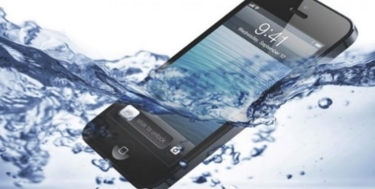
- Wet Unit: If a mobile phone has been exposed to water or any other liquid, it may result in a loss of power. In such cases, the technician should follow proper water damage repair procedures, which may include cleaning and drying the internal components (Mobile Phone Repair, 2021).
Figure 2-51Wet Unit mobile phone
- Dropped Unit: A mobile phone that has been dropped or subjected to physical impact may experience power-related issues. The technician should inspect the internal components for any loose connections or damaged parts that may be causing the power failure (Mobile Phone Repair, 2021).
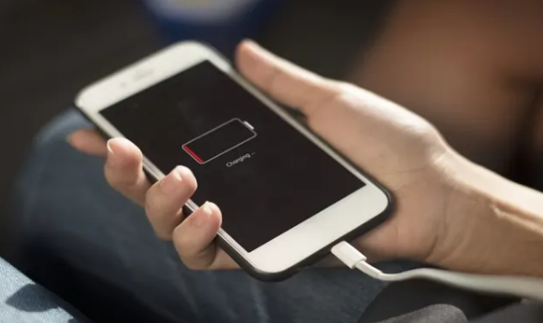
Figure 2-52 power dropped
- Over-Downloaded Unit: If a mobile phone is overloaded with excessive applications or data, it may lead to power-related issues. The technician should assess the phone's memory capacity and recommend appropriate steps to optimize its performance (Mobile Phone Repair, 2021).
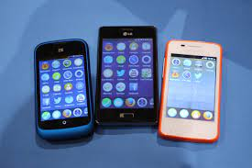
Figure 2-53mobile phone is overloaded
- System Error: System errors can occur due to software glitches or conflicts. The technician should use appropriate diagnostic software to identify and resolve the system error, which may involve updating the phone's firmware or performing a factory reset (Mobile Phone Repair, 2021).
- Contact Service/Contact Retailer
- No Signal: If a mobile phone is unable to establish a signal connection with the network provider, it may display a "No Signal" message. The technician should check the phone's network settings, SIM card, and antenna connections to resolve the issue (Mobile Phone Repair, 2021).
- No Transmission/Reception: If a mobile phone is unable to transmit or receive calls or messages, it may indicate a problem with the phone's radio frequency circuitry or network settings. The technician should diagnose and repair the faulty components or adjust the network settings accordingly (Mobile Phone Repair, 2021).
- Intermittent Signal: An intermittent signal can be caused by various factors, including network coverage issues or a faulty antenna. The technician should investigate and resolve the underlying cause, which may involve adjusting the phone's network settings or replacing the faulty antenna (Mobile Phone Repair, 2021).
- Diagnosing Defective User Interface Components:
The user interface of a mobile phone consists of various components that allow users to interact with the device. When diagnosing faults related to the user interface, the technician should focus on the following components:
1. Defective User Interface
- Buzzer: A faulty buzzer can result in no sound alerts or notifications. The technician should replace the defective buzzer component to restore sound functionality (Mobile Phone Repair, 2021).
- Vibrator: If the vibrator is not functioning, the phone may not vibrate. The technician should replace the faulty vibrator motor to resolve this issue (Mobile Phone Repair, 2021).
- Keypad: A malfunctioning keypad can lead to unresponsive or malfunctioning buttons. The technician should clean the keypad contacts or replace the keypad module if necessary (Mobile Phone Repair, 2021).
- Backlights: Backlight issues can result in a dim or non-functional display.The technician should replace the faulty backlight module or repair the backlight circuit to resolve this problem (Mobile Phone Repair, 2021).
- Earpiece: A faulty earpiece can result in poor or no sound during phone calls. The technician should replace the defective earpiece component to restore sound functionality (Mobile Phone Repair, 2021).
- Microphone: A faulty microphone can result in poor or no sound transmission during phone calls. The technician should replace the defective microphone component to resolve this issue (Mobile Phone Repair, 2021).
- LCD Problem: LCD problems can include a blank screen, dead pixels, or a distorted display. The technician should troubleshoot by reseating the LCD connector, replacing the faulty LCD module, or repairing the display circuit (Mobile Phone Repair, 2021).
- Camera Problem: Camera issues can range from blurry images to a complete failure of the camera module. The technician should troubleshoot by cleaning the camera lens, replacing the camera module, or repairing the camera circuit (Mobile Phone Repair, 2021).
- Bluetooth, infrared, and Radio: Faulty Bluetooth, infrared, or radio modules can result in connectivity issues. The technician should replace the defective module or repair the related circuit to restore connectivity (Mobile Phone Repair, 2021).
- Diagnosing software-related troubles
Software-related troubles can cause various issues in mobile phones. The technician should utilize appropriate diagnostic software and techniques to diagnose and resolve the following problems:

- Software-Related Troubles
- Hang-up: A phone that frequently freezes or becomes unresponsive is experiencing a hang-up issue. The technician should perform a software reset, update the phone's firmware, or reinstall the operating system to resolve this problem (Mobile Phone Repair, 2021).
- Virus: Mobile phones can be susceptible to viruses and malware, resulting in various issues such as slow performance or unexpected pop-ups. The technician should run antivirus software, perform a factory reset, or seek professional assistance to resolve virus-related troubles (Mobile Phone Repair, 2021).
- Blinking Display: A blinking display can indicate a software issue. The technician should update the phone's firmware, reinstall the operating system, or repair the display driver to resolve this problem (Mobile Phone Repair, 2021).
- Rebooting: If a phone continuously restarts or enters a reboot loop, it is experiencing a rebooting issue. The technician should clear cache partitions, perform a factory reset, or update the phone's firmware to address this problem (Mobile Phone Repair, 2021).

Methods of mobile phone faults finding.
When it comes to finding faults in mobile phones, there are several methods you can use to diagnose and troubleshoot the issues.
- Common Methods
- Observation and Visual Inspection:
- Visually inspect the mobile phone for any physical damage, such as
- Cracks,
- Dents, or
- Signs of water damage.
- Observation Check for
- Loose connections or cables,
- Damaged buttons, or
- Any other visible abnormalities.
- Functional Testing:
- Perform functional tests on various components of the mobile phone, such as
- Display,
- Touch screen,
- buttons,
- Speakers,
- Microphones,
- Cameras, and
- Sensors.
- Test the connectivity features, such as
- Wi-fi,
- Bluetooth, and
- Cellular network reception.
- Check the performance and responsiveness of the operating system and applications.
- Software Analysis:
- Examine the mobile phone's software for
- Any glitches,
- Errors, or
- Conflicts that could be causing the issue.
- Update the operating system and applications to the latest versions to eliminate known software bugs.
- Use diagnostic software tools to analyze system logs and identify any software-related issues.
- Battery and Power Testing:
- Check the battery health and performance using specialized tools or software.
- Measure the voltage and current output of the battery and charging circuit to ensure they are within the specified range.
- Test the power button and charging port for proper functionality.
- Network Testing:
- Verify network connectivity
- By checking signal strength,
- Network registration, and
- Data transfer speed.
- Test the SIM card in another compatible device to rule out network-related issues.
- Check for any network-related settings or configurations that could be causing connectivity problems.
- Hardware Component Testing:
- Use specialized tools and equipment to test individual hardware components, such as
- The display,
- Touch screen,
- Cameras,
- Speakers,
- Microphones,
- Sensors, and
- Connectors.
- Measure the resistance, continuity, or voltage levels of specific components to identify faulty or malfunctioning parts.
- Firmware Analysis:
- Analyze the firmware or firmware updates provided by the manufacturer to identify any known issues or patches related to the reported problem.
- Verify compatibility between different firmware versions, if applicable.

- Data and Settings Backup:
- Before performing any repairs or modifications, ensure to back up the user's data and settings to prevent data loss.

- Professional Diagnostic Tools:
- Utilize professional diagnostic tools, such as
- Multimeters,
- Oscilloscopes, and
- Specialized software,
- To perform in-depth testing and analysis of mobile phone components.
- Consultation and Documentation
- Consult manufacturer documentation,
- Service manuals, or online forums for known issues and
- Recommended troubleshooting steps.
- Maintain detailed records of the diagnostic process, including
- Observed symptoms,
- Test results, and
- Any actions taken during the diagnosis.

Identifying System Defect/Fault Symptoms
To effectively diagnose faults in cellular phone units, it is crucial to identify and understand the symptoms indicating system defects. Here are some common symptoms that may indicate underlying faults:
- Power-Related Symptoms:
- The phone does not power on or fails to boot up.
- Sudden and unexpected shutdowns or restarts.
- Rapid battery drain or short battery life.
- Inconsistent charging or failure to charge.
- Display Symptoms:
- Blank or black screen.
- Flickering or flashing display.
- Lines, discoloration, or artifacts on the screen.
- Unresponsive touch screen or erratic touch inputs.
- Audio Symptoms:
- No sound or distorted audio during calls or media playback.
- Speakerphone or earpiece not functioning properly.
- Microphone issues, such as muffled or no audio during calls or recordings.
- Connectivity Symptoms:
- Weak or no signal strength for cellular network.
- Wi-Fi connectivity issues, such as frequent disconnections or inability to connect.
- Bluetooth pairing problems or failure to detect nearby devices.
- GPS or location services not working accurately.
- Performance Symptoms:
- Slow or laggy performance when navigating through apps or menus.
- Apps crashing or freezing frequently.
- Delayed response to touch inputs or button presses.
- Overheating during normal usage or charging.
- Camera Symptoms:
- Blurry or out-of-focus images or videos.
- Camera app not opening or crashing.
- Flash not functioning properly.
- Front or rear camera producing distorted or low-quality images.
- Software Symptoms:
- Operating system errors or crashes.
- Inconsistent behavior of apps or settings.
- Pop-up ads or unwanted notifications.
- Inability to install or update apps.
- Button or Sensor Symptoms:
- Unresponsive or malfunctioning physical buttons (e.g., power, volume).
- Proximity sensor not working correctly during calls.
- Ambient light sensor failing to adjust screen brightness.

- Storage and Data Symptoms:
- Inability to access or retrieve data from internal storage or SD card.
- Files or apps disappearing or becoming corrupted.
- Insufficient storage space errors.
- Miscellaneous Symptoms:
- Physical damage, such as cracked or shattered screen, water damage, or broken connectors.
- Continuous device reboot loop.
- Unusual noises, vibrations, or odors.

Defect/fault symptoms
Identifying system defects or fault symptoms in a mobile phone can help pinpoint the underlying issue. Here are some common symptoms that may indicate a fault:
- Power-related issues:
- Phone doesn't turn on,
- Doesn't hold a charge, or
- Has erratic power behavior such as random shutdowns or restarts.
- Display problems:
- The screen is blank,
- Flickering, distorted, or
- Unresponsive to touch inputs.
- Dead pixels or discoloration can also indicate display issues.
- Audio-related problems:
- The phone produces no sound,
- Has distorted or
- Low-quality audio output, or
- Experiences issues with microphones or speakers.
- Connectivity issues:
- The phone has trouble connecting to
- Wi-Fi networks,
- Bluetooth devices,
- Cellular networks.
It may also experience slow or intermittent data speeds.
- Overheating:
- The phone becomes excessively hot during normal usage or charging,
- Potentially indicating a problem with the battery or internal components.
- Slow performance:
- The phone operates sluggishly,
- Freezes,
- Experiences lag, or takes a long time to open apps
- Camera problems:
- The camera app crashes,
- Produces blurry or distorted images, or
- Fails to focus properly.
Issues with front or rear cameras can indicate hardware or software faults.
- Unresponsive buttons or touch screen:
The phone's physical buttons (e.g., power, volume) or the touch screen are unresponsive or intermittently stop working.
- Software glitches:
- The phone experiences frequent app crashes,
- Error messages, or
- Unusual behavior that cannot be attributed to hardware issues.

Diagnosis and Tests
- Result of Diagnosis
After conducting a thorough diagnosis and tests on a cellular phone unit, the results obtained can help determine the underlying issues. Here are potential outcomes based on different scenarios:
- Hardware Fault Identified:
- If a hardware fault is discovered, it means that there is a physical problem with one or more components of the mobile phone.
- The specific faulty component(s) will be identified, such as a defective screen, malfunctioning battery, faulty charging port, or damaged motherboard.
- The recommended course of action may involve repairing or replacing the faulty component(s) to resolve the issue.
- Software Issue Identified:
- If the diagnosis points to a software-related problem, it means that there is a glitch, conflict, or corruption in the operating system or applications.
- The specific software issue will be identified, such as a buggy application, incompatible firmware, or corrupted system files.
- The recommended solution may involve updating the software, reinstalling problematic applications, performing a factory reset, or applying software patches or updates.
- User Error or Misconfiguration:
- In some cases, the diagnosis might reveal that the reported problem is due to user error or misconfiguration of settings.
- Guidance and instructions can be provided to the user on how to resolve the issue by correctly operating the phone or adjusting settings appropriately.
- No Fault Found:
- Occasionally, the diagnosis and tests may not identify any specific faults or issues.
- This outcome indicates that the cellular phone unit is functioning normally, and the reported problem may have been temporary or caused by external factors.
- Recommendation may be given to monitor the phone's performance or seek further assistance if the issue persists.
- Additional Testing or Consultation Required:
- In instances where the initial diagnosis and tests do not provide conclusive results, further testing or consultation with experts, service manuals, or online forums may be necessary.
- This allows for a more in-depth investigation to identify and address complex or rare issues.

- Testing Methods for Fault Finding of Mobile Components
There are two methods that you can use to find out faulty or damaged components in a mobile phone. These are:
  - The cold testing method
  - The hot testing method
- The Cold Testing Method:
Cold testing is when we use a multimeter to check the value of resistance at the time of repairing a fault in a mobile phone. During cold testing do not power the phone from any equipment. Use the diode range and beep sound from the multimeter to find fault in the mobile phone. During cold testing, you should connect the RED probe of the multimeter to the ground of the mobile phone PCB, and use the BLACK probe to touch the testing points of the mobile phone. During the fault-finding and repairing process of each part, component or section, you should receive the following correct values:
- Ear Phone Connector Tip (+ , -): .500 to .700
- Loud Speaker / Ringer Connector Tip (+,-): .300 to .600
- Battery Connector Tip (+): .400 to .500
- Battery Connector Tip (Sense): above .800
- Display Connector Supply Pins: .250 to .400
- Display Connector Signal Pins: .500 to .800
- Camera Connector Supply Pins: .250 to .400
- Camera Connector Signal Pins: .600 to .900
- Key Tip (Row and Column): .400 to .800
- Charger Connector Tip: .600 to .700
- Vibrator Motor Connector: .40 to .500
- Power ON / OFF Switch Point (+): .600 to .900
- MIC Connector Tip (Analog MIC) (+,-): .700 to .900
- Battery Charging Out Point (+,-): .300 to .400
- SIM Card Connector Pin 1 (VSim): .500 to .700
- SIM Card Connector Pin 2,3,6: .400 to .800
- SIM Card Connector Pin 4 (GND): .00 (Beep)
- Micro SD Card Connector Pin 4: .500 to .600
- Micro Card Connector Pin 6 (GND): .00 (Beep)
- Micro Card Connector Pin 1, 2,3,5,7,8: .600 to .800 21. RTC: .400 to .500
- Hot Testing:
The hot testing method is adopted when the fault cannot be found or when the cell phone cannot be repaired using the cold testing method. In this method, the VOLTAGE of the damaged part or component is checked. The fault is found by powering the mobile phone with a battery which has a DC power supply. Once you power the phone, you should select the DCV (DC Volt) range of the Multimeter.
Then you should connect the BLACK probe of the Multimeter to the ground of the phone’s PCB and ensure the ‘ED Probe touches the Testing Points. During hot testing, the voltage of different part or sections should be as follows (all values in Volt):
- Ear Phone Connector Tip (+ , -) when working: .0 to 2.5
- Loud Speaker / Ringer Connector Tip (+,-) when working: .0 to 2.5
- Battery Connector Tip (+): 3.7
- Display Connector Supply Pins: 1.8 to 2.9
- Display Connector Signal Pins when working: .0 to 1.8
- Camera Connector Supply Pins: 1.8 to 2.9
- Camera Connector Signal Pins when working: .0 to 1.8
- Key Tip (Row and Column) One Side: 1.8 to 2.8
- Charger Connector Tip: 5 to 6
- Vibrator Motor Connector Tip when Working: 1.9 to 3.6
- Power ON / OFF Switch Point (+): 3 to 3.6
- MIC Connector Tip (Analog MIC) (+,-): 1.8 to 3.0
- Battery Charging Out Point (+,-): 3.7 to 4.2
- SIM Card Connector Pin 1 (VSim) when SIM Connected: 1.8 to 3.0
- SIM Card Connector Pin 2,3,6 when working: 0 to 2.8
- Micro SD Card Connector Pin: 2.8
- Micro Card Connector Pin 1,2,3,5,7,8: 0 to 2.8
- Documenting Results of Diagnosis and Test
Accurate documentation of the results obtained from the diagnosis and testing process is crucial in the service and repair of mobile phones. It helps in maintaining a record of the identified issues, their corresponding solutions, and any further actions taken.
Here are some key steps to effectively document the results of diagnosis and testing:
- Comprehensive Notes:
- Keep detailed notes during the diagnosis and testing phase, capturing all relevant information, including
- Observed symptoms,
- Test results, and
- Any actions taken.
- Document the specific tests performed, the test outcomes, and any abnormal or unexpected behavior observed during the testing process.
- Clear and Organized Format:
- Use a clear and organized format to record the information, such as
- A digital or physical document,
- Spreadsheet, or dedicated software tool.
- Ensure that the documented information is easy to read, understand, and navigate.
- Systematic Identification:
- Clearly identify the cellular phone unit being diagnosed, including its make,
- Model, and
- Any unique identifiers, such as serial numbers or imei numbers.
- Assign a unique identifier or reference number to the diagnostic case to track and retrieve the information easily in the future.
- Fault Description:
- Provide a detailed description of the identified faults or issues.
- Specific symptoms,
- Error messages,
- Abnormal behaviors observed during the diagnosis.
- Use clear and concise language to describe the problems, avoiding technical jargon whenever possible for better user comprehension.
- Test Results:
- Document the results of each specific test conducted during the diagnosis process. Include both positive and negative outcomes.
- Record the specific tests performed, their expected outcomes, and the actual results obtained.
- Note any variations, discrepancies, or inconsistencies between the expected and actual results.
- Identified Faults or Issues:
- Clearly list and describe the identified faults or issues based on the diagnosis and testing results.
- Include specific hardware or software components that have been identified as faulty or problematic.
- Provide a summary or overview of the root causes or underlying reasons for the identified faults.
- Recommended Solutions:
- Document the recommended solutions or actions to address the identified faults or issues.
- Include detailed instructions, steps, or procedures for implementing the recommended solutions.
- Specify any required replacement parts, tools, or software updates necessary for the repairs.
- Follow-up Actions:
- Record any follow-up actions taken or planned, such as ordering replacement parts, scheduling repairs, or further consultations with experts.
- Document any additional testing or diagnostic steps that may be required to confirm the effectiveness of the recommended solutions.

Status and Serviceability of Mobile Phones
When diagnosing faults in cellular phone units, it is important to assess and communicate the status and serviceability of the device to the customer or relevant stakeholders. Here are key considerations for addressing the status and serviceability of mobile phones:
- Device Status:
- Determine the overall status of the mobile phone based on the diagnosis and testing results.
- Classify the device as either "functional" or "non-functional" based on its ability to perform essential functions.
- Provide a clear and concise statement regarding the device status to the customer, indicating whether it is operational or requires repairs.
- Serviceability Assessment:
- Evaluate the serviceability of the mobile phone by considering factors such as the availability of spare parts, repair complexity, and cost-effectiveness.
- Assess whether the identified faults can be repaired within a reasonable timeframe and at a justifiable cost.
- Determine if the repairs are feasible and whether they would restore the device to its expected functionality.
- Repair Recommendations:
- Based on the diagnosis and assessment, provide repair recommendations to the customer or relevant stakeholders.
- Clearly communicate the recommended repairs, including the specific components or parts that need to be replaced or repaired.
- Provide an estimated timeline and cost for the repairs, highlighting any potential risks or limitations.
- Alternatives to Repair:
- If the mobile phone is deemed non-serviceable or if the repairs are not economically viable, present alternative options to the customer.
- Explore possibilities such as device replacement, trade-in programs, or upgrading to a newer model.
- Provide information on any promotional offers, warranties, or service plans that may be available to the customer.
- Customer Consent:
- Obtain the customer's consent before proceeding with any repairs or alternative solutions.
- Clearly explain the implications, costs, and potential outcomes of the recommended course of action.
- Address any questions or concerns the customer may have and ensure they understand the options available to them.
- Serviceability Documentation:
- Document the status, serviceability assessment, repair recommendations, and customer consent in a clear and organized manner.
- Include relevant details such as the customer's name, contact information, device identification, and any other pertinent information.
- Maintain a copy of the documentation for future reference and to ensure accurate record-keeping.
- Regular Updates:
- Provide regular updates to the customer during the repair process, especially if unexpected issues or delays arise.
- Keep the customer informed about the progress, any additional repairs or parts required, and revised timelines if necessary..

Self-check 2.1
Part one: True/False Questions:
- 1Diagnosing mobile phone problems only involves analyzing error messages.
- 2Network connectivity issues on a mobile phone can result in slow internet speeds.
- 3Battery-related problems on a mobile phone are always caused by a faulty battery.
- 4User-induced errors on a mobile phone can be caused by misconfiguring settings.
- 5The systematic pre-testing procedure in mobile phone service and repair includes visual inspection, customer interview, and operating the device according to the manual.
Part two: Multiple Choice Questions:
1. Diagnosing mobile phone hardware issues often requires:
- Analyzing error messages
- Clearing cache
- Visual inspection and specialized tools
- Reinstalling applications
- Software problems on a mobile phone can result in:
- Dropped calls and slow internet speeds
- Faulty battery and power drain
- Data corruption and insufficient storage space
- User-induced errors and misconfigured settings
- Diagnosing network connectivity issues involves checking:
a). Cellular signal strength, Wi-Fi connectivity, and Bluetooth connections
b). Battery health and power consumption
c). Data synchronization and backups
d). Visual inspection of the screen and buttons
- Battery-related problems on a mobile phone can be caused by:
- User error and misconfiguring settings
- Insufficient storage space and data corruption
- Hardware malfunctioning and faulty battery
- Water damage and signs of wear and tear

- Diagnosing data and storage issues on a mobile phone may require:
- Testing with specialized tools and replacement of faulty components
- Clearing cache, deleting unnecessary files, or performing data backups
- Checking cellular signal strength and Wi-Fi connectivity
- Analyzing user behavior and guiding users through troubleshooting steps
- User-induced errors on a mobile phone can be caused by:
- Accidentally enabling airplane mode and activating performance-impacting features
- Insufficient storage space and data corruption
- Faulty battery and power consumption
- Network connectivity issues and dropped calls
- The systematic pre-testing procedure in mobile phone service and repair includes:
- Visual inspection, customer interview, and operating the device according to the manual
- Analyzing error messages and checking for software updates
- Testing various functions and features of the device with specialized tools
- Clearing cache, resetting settings, and reinstalling applications
- The first step in the pre-testing procedure is:
- Conducting an interview with the customer
- Operating the mobile phone according to the manual
- Visual inspection of the mobile phone with the power turned off
- Checking cellular signal strength and network connectivity
Part three: Matching
Match the following mobile phone issues with their corresponding diagnostic steps:
Match A: Match B:
_______1. Hardware issues a) Checking for software updates
_______2.Software issues b) Visual inspection and specialized tools
_______3. Network connectivity c) Analyzing error messages
_______4. Battery and power d) Testing cellular signal strength and Wi-Fi connectivity
_______5. Data and storage e) Monitoring power consumption and checking battery
Health

Part four: Fill in the Blank Questions
- Diagnosing mobile phone __________ refers to identifying and troubleshooting problems that can occur with the device's hardware or software.
- __________ Problems arise from issues with the operating system, applications, or firmware on the mobile phone.
- Mobile phones rely on network __________ to function properly.
- Diagnosing battery issues includes checking battery health, monitoring power consumption, and identifying abnormal battery __________.
- Diagnosing data and storage issues involves identifying problems related to data __________, insufficient storage space, or issues with data synchronization.

Operation Sheet No. 2.1
Title: Mobile Phone Diagnosing Operation Sheet
Instruction:
This operation sheet provides instructions for diagnosing mobile phone issues. It outlines the necessary procedures, tools, precautions, and quality criteria to ensure accurate and efficient diagnosis.
Purpose:
The purpose of this operation sheet is to guide technicians in diagnosing hardware and software problems, network connectivity issues, battery and power-related issues, data and storage problems, and user-induced errors in mobile phones. By following the procedures outlined in this sheet, technicians can identify and troubleshoot common mobile phone faults effectively.
Precautions:
- Ensure the mobile phone is disconnected from any power source before starting the diagnosis process to prevent electric shock or damage to the device.
- Handle the mobile phone with care to avoid further damage or causing additional issues during the diagnosis.
- Adhere to safety guidelines when working with specialized tools or equipment to prevent accidents or injuries.
- Keep the work area clean and organized to avoid misplacing components or causing unnecessary delays in the diagnosis process.
Tools and Requirements:
- Visual inspection tools (e.g., magnifying glass, flashlight)
- Specialized diagnostic tools (e.g., multimeter, oscilloscope)
- Screwdrivers and other necessary tools for disassembly and reassembly
- Cleaning materials (e.g., lint-free cloth, compressed air canister)
- Software diagnostic tools (e.g., diagnostic software, firmware update tools)
- Spare parts (if necessary)
- Manufacturer's manuals and technical documentation

Procedures:
Visual Inspection:
- Examine the mobile phone exterior, screen, buttons, ports, and casing for any visible physical damage or irregularities.
- Look for common issues such as cracked screens, water damage indicators, loose connections, or signs of wear and tear.
- Document any findings for further analysis.
Interview of Customer:
- Conduct an interview with the customer to gather information about the mobile phone's history, including previous repairs, modifications, or specific issues experienced.
- Note down any relevant details provided by the customer.
Operating Manual:
- Follow the manufacturer's manual to operate the mobile phone and perform prescribed procedures for testing various functions and features.
- Pay attention to any abnormal behavior, error messages, or display issues during the testing process.
Document the results of the tests and observations.
Quality Criteria:
- Accurate identification and documentation of hardware and software issues.
- Thorough assessment of network connectivity problems, battery and power-related issues, data and storage problems, and user-induced errors.
- Clear communication with the customer to understand their concerns and provide appropriate solutions.
- Adherence to safety precautions and guidelines during the diagnosis process.
- Proper documentation of the diagnosis results, including any recommended repairs or replacements.
- Effective troubleshooting steps provided to rectify identified issues.
Note: This operation sheet provides general guidelines, and specific procedures may vary depending on the mobile phone model and operating system version.

UNIT THREE: SERVICING /REPAIR CELLULAR PHONE
This learning guide is developed to provide you the necessary information regarding the following content coverage and topics:
Unit 3. Servicing / repair Mobile phone
  - Electro-static discharge (ESD) protection procedure.
  - Defective parts/components.
  - Soldering, mounting and repairing parts/components..
  - Repairing units using appropriate application software.
  - Cleaning and Check-up of unit.
This guide will also assist you to attain the learning outcomes stated in the cover page. Specifically, upon completion of this learning guide, you will be able to:
  - Follow Electro-static discharge (ESD) protection procedure.
  - Replace defective parts/components.
  - Repair or replace Soldering, mounting and repairing parts/components..
  - Repair units using appropriate application software.
  - Perform cleaning of unit.

Electrostatic Discharge (ESD) Protection Procedure
Electrostatic discharge (ESD) is a significant concern when performing service and repair tasks on mobile phones. ESD can damage sensitive electronic components, leading to malfunctions or permanent failures. This chapter focuses on the ESD protection procedures necessary to prevent ESD-related damage. Here are key considerations for implementing an ESD protection procedure:
- ESD Awareness and Training:
- Provide comprehensive training to technicians on ESD risks, prevention measures, and the importance of following ESD protection procedures.
- Educate technicians about common ESD sources, such as clothing, work surfaces, and tools, and discuss the potential damage caused by ESD.
- ESD-Safe Workspace:
- Establish an ESD-safe workspace dedicated to mobile phone service and repair.
- Ensure that the workspace has proper ESD control measures, including an ESD protective mat or workbench surface, grounded wrist straps, and grounding points.
- Grounding:
- Implement proper grounding procedures to prevent the buildup of static charges. This includes connecting the ESD protective mat, workbench, and grounding points to a reliable grounding system.
- Technicians should wear properly fitted and grounded wrist straps that are connected to the ESD protective mat or workbench.
- ESD-Safe Tools and Equipment:
- Use ESD-safe tools and equipment designed to minimize the risk of ESD. These may include ESD-safe screwdrivers, tweezers, and probes.
- Regularly inspect tools for damage, and replace any worn-out or damaged tools to maintain their ESD protection capabilities.
- ESD Protective Packaging:
- Store and transport sensitive electronic components and devices in ESD protective packaging, such as anti-static bags or containers.
- Use ESD-safe trays or containers to organize and store small electronic components during service and repair tasks.
- ESD Control Measures for Technicians:
- Ensure technicians are properly dressed for ESD protection. This may include wearing ESD-safe footwear, avoiding clothing made of static-generating materials (e.g., wool or synthetic materials), and using ESD-safe smocks or lab coats.
- Minimize movement and friction that can generate static charges, and avoid handling electronic components with bare hands.
- Workstation Maintenance:
- Regularly clean and maintain the ESD control measures in the workspace, including the ESD protective mat, grounding points, and ESD-safe tools.
- Inspect and replace worn-out or damaged ESD control items, such as wrist straps or grounding cords, as needed.
- ESD Audit and Compliance:
- Conduct periodic audits to ensure compliance with ESD protection procedures and identify areas for improvement.
- Implement an ESD monitoring system to regularly measure and verify the effectiveness of ESD control measures.
- Continuous Improvement:
- Encourage feedback from technicians regarding ESD-related concerns, challenges, or suggestions for improvement.
- Stay updated on industry best practices and advancements in ESD protection technologies to enhance the overall ESD protection procedure.
By implementing a robust ESD protection procedure, technicians can significantly reduce the risk of ESD-related damage during mobile phone service and repair tasks. This helps ensure the reliability and longevity of repaired devices, ultimately leading to customer satisfaction and a reputation for high-quality service.

Disassembling a Mobile Phone
The following are the steps that you should take when disassembling a mobile phone:
  - Switch off the phone
  - Remove the battery cover
  - Remove the battery, SIM card memory card (if any)
  - Remove all the screws from the phone
  - Lift back the cover with the help of a flat screwdriver
  - Remove the strips (buzzer strip, display, camera, volume and speaker button strips)
  - Remove the antennae wire from the outside
  - Remove the motherboard and vibrator.
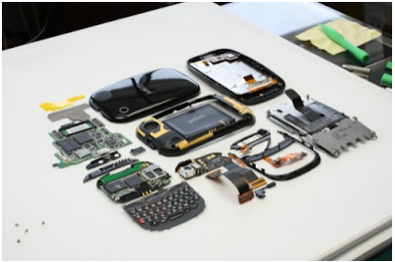
Figure 3-1Disassemble features of Mobile Phone
To successfully disassemble a phone, you need to understand the various internal sections of a mobile phone and how they are connected to the CPU.

- How to Disassemble Mobile Phone
- Take OFF, remove the battery cover, and back facial of the mobile phone. You should use a mobile opener tool to remove the back Facia.

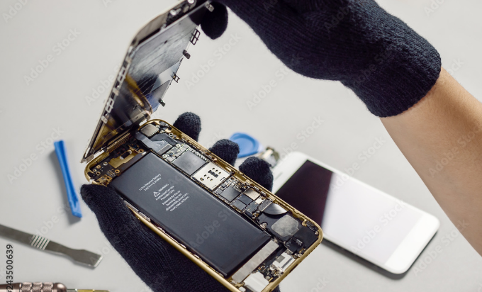
Figure 3-2 remove the battery cover
- Remove the battery, SIM card and memory card.

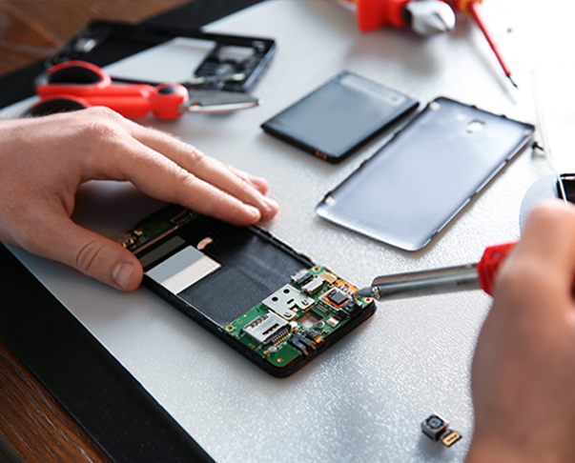
Figure 3-3Remove the battery,
- You will find several small screws at the back. Using suitable precision screwdriver, unscrew and remove all the screws and keep them in a safe box. These screws must be kept very carefully so that they do not get lost.
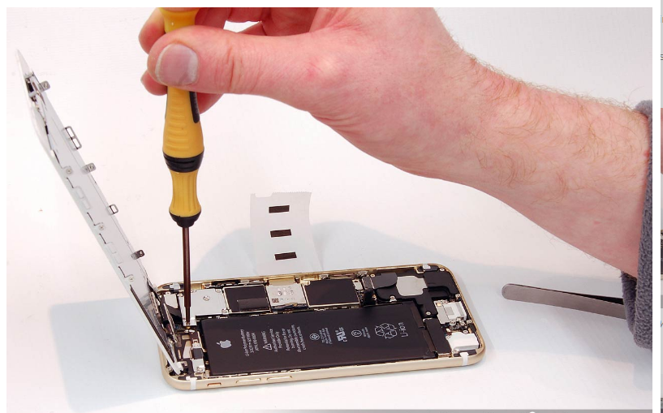
Figure 3-4Suitable precision screwdriver,
- Once all the screws are open, remove the front cover or the front Facia of the mobile phone.
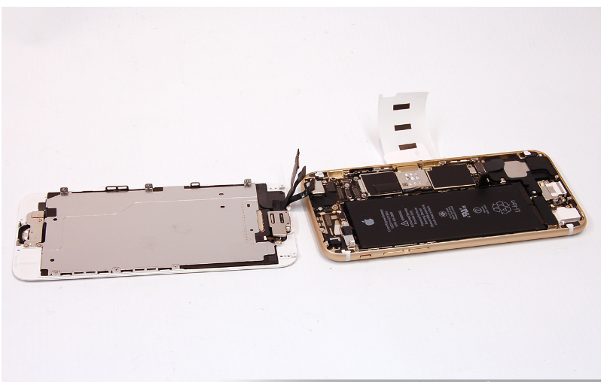
Figure 3-5remove the front cover
- Now you have the internal Facia or skeleton of the mobile phone. It is attached to the mobile phone PCB with screws. Unscrew and open all the screws.

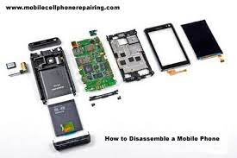
Figure 3-6internal Facia or skeleton
- Remove connectors for display and camera and pull the display and the camera out
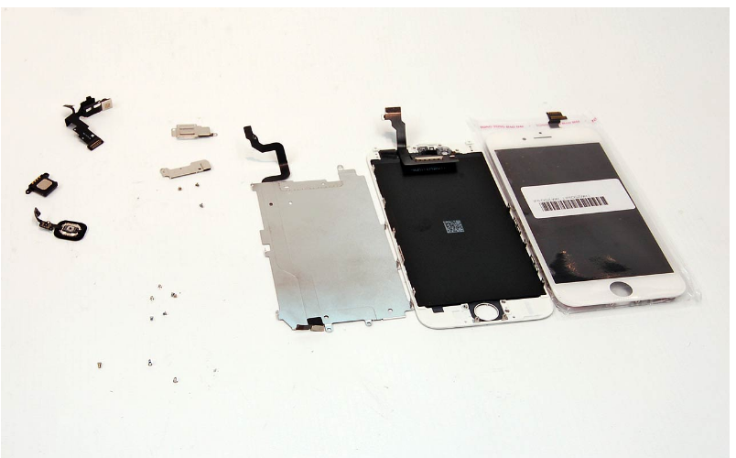
Figure 3-7Remove connectors for display and camera
- Techniques
The correct diagnosis of mobile cell phone faults is the key to successful and cost- effective repair of the phone. Let us start by looking at the skills that you need to have to be able to diagnose and repair a mobile phone.
Skills Needed to Diagnose and Repair a Mobile Phone
Before you can diagnose and repair a phone, there are some skills that you need to learn. These skills are:
- Desoldering
- Soldering
- Desoldering
Desoldering is the removal of solder and components from a printed circuit board for troubleshooting, repair, replacement, and salvage
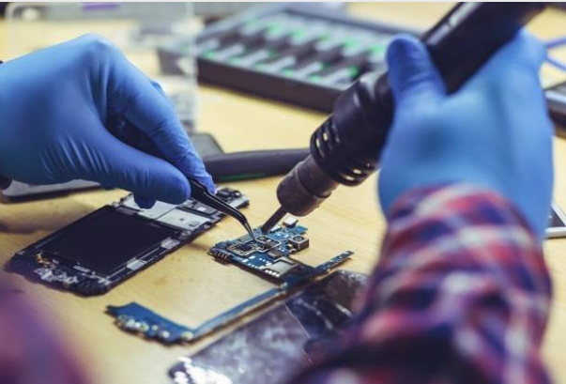
Figure 3-8Desoldering process
- Steps in desoldering
- Use a solder wick (finely braided copper) to wick away excess solder from a de- soldered connection.
- Apply the solder wick and use the soldering iron to the de-soldered connection. The solder wick will draw the excess solder off the PCB pad.
- Components Replacing Defective Parts
In the field of mobile phone repair and servicing, one of the primary tasks is to identify and replace defective parts or components. Mobile phones are complex devices that consist of various hardware components, and over time, these components may malfunction or become damaged. In this section, we will discuss the process of replacing defective parts or components in mobile phone repair.
- Diagnosis and Identification:
The first step in replacing defective parts is to diagnose the problem and identify the faulty component. This involves analyzing the symptoms, running diagnostic tests, and utilizing specialized tools and equipment to pinpoint the exact cause of the issue. Common problems in mobile phones include malfunctioning displays, faulty batteries, broken charging ports, non-responsive buttons, or damaged cameras.
- Sourcing Replacement Parts:
Once the defective component has been identified, the next step is to source the appropriate replacement part. It is important to obtain genuine and compatible parts to ensure proper functionality and compatibility with the specific mobile phone model. Replacement parts can be sourced from authorized suppliers, manufacturers, or reputable third-party vendors.
- Tools and Equipment:
To replace defective parts, specific tools and equipment are required. These may include precision screwdrivers, spudgers, tweezers, heat guns, soldering irons, and other specialized tools depending on the complexity of the repair. It is important to use the correct tools and handle them with care to avoid further damage to the mobile phone or its components.
- Disassembly
Before replacing a defective part, the mobile phone needs to be disassembled carefully. This involves removing the back cover, battery, and any other removable components. In some cases, additional steps may be required, such as removing the display assembly or mother board, to access the faulty component. It is crucial to follow proper disassembly procedures to avoid causing unnecessary damage.
- Component Replacement:
Once the faulty component is accessible, it can be replaced with the new one. This may involve unscrewing or detaching the defective part and disconnecting any cables or connectors. The replacement part is then connected or soldered into place, ensuring a secure and proper connection. It is important to handle the replacement part with care and follow any specific installation instructions provided by the manufacturer.
- Reassembly and Testing:
After the defective part has been replaced, the mobile phone is reassembled by reversing the disassembly steps. All screws, connectors, and cables should be properly secured to ensure the phone's structural integrity. Once reassembled, the phone should undergo thorough testing to ensure that the replacement part has resolved the problem and that the phone is functioning correctly. This may involve checking various features, such as the display, camera, audio, connectivity, and overall performance.
- Quality Assurance:
After the repair is completed, a quality assurance check should be performed to ensure that the mobile phone is functioning optimally. This includes verifying that all features and functions are working as expected, ensuring there are no loose connections or misaligned components, and conducting additional tests if necessary.
- No Power:
- When a mobile phone has no power, several factors could be causing the issue:
- Wet Unit: If the phone has come into contact with water or any other liquid, it may lead to a power failure. In this case, the defective component may be the battery or other power-related components such as the power IC or charging port.
- Dropped Unit: A dropped unit can result in loose connections or damaged internal components, leading to power loss. The defective parts may include the battery, power button, or internal circuitry.
- Over downloaded Unit: If the phone's software or firmware is corrupted due to excessive downloads or incompatible files, it can cause power issues. In such cases, the defective component may be the memory chip or the software itself.
- System Error: System errors can arise due to software glitches or conflicts. This may require troubleshooting the software or replacing faulty components such as the memory chip or system board.
- Contact Service/Contact Retailer:
When a mobile phone displays a "Contact Service" or "Contact Retailer" message, it typically indicates a software or hardware problem. The defective component may be the SIM card, memory chip, or system board. Troubleshooting the software, updating firmware, or replacing faulty hardware can often resolve this issue.
- No signal or weak signal reception can be attributed to various factors:
- No Transmission/Reception: This issue may stem from a faulty antenna, damaged RF (radio frequency) components, or network-related problems. The defective components may include the antenna module, RF chip, or network IC.
- Intermittent Signal: Intermittent signal loss may be caused by loose connections, damaged cables, or faulty internal components. The defective parts could be the antenna, coaxial cables, or connectors.
- Shorted/Grounded Unit: If the mobile phone has suffered from a short circuit or electrical damage, it may result in a loss of signal. The defective component may be the system board or related ICs responsible for signal processing.
- Not Charging:
When a mobile phone fails to charge, the issue can be traced to the charging port, battery, or charging IC. These components may become defective due to physical damage, water exposure, or wear and tear. Replacing the faulty charging port, battery, or charging IC can often resolve the problem.
- Defective User Interface
Various components contribute to the user interface of a mobile phone. When these components malfunction, they can affect user experience:
- Buzzer: A faulty buzzer can result in no sound or distorted audio output.
- Vibrator: If the vibrator motor fails, the phone may not vibrate or may vibrate excessively.
- Keypad: Non-responsive or faulty keypad buttons can hinder user input.
- Backlights: Defective backlighting can cause a dim or non-functional display.
- Earpiece: A malfunctioning earpiece can result in no sound during phone calls.
- Microphone: A faulty microphone can lead to muffled or no audio during calls or recordings.
- LCD Problem: Issues with the LCD display, such as dead pixels, discoloration, or a blank screen, may require LCD replacement.
- Camera Problem: Malfunctioning cameras can result in blurry images, black screens, or no image capture.
- Bluetooth: Faulty Bluetooth connectivity can cause pairing issues or intermittent connection drops.
- Infrared: A defective infrared module can result in no infrared communication or data transfer.
- Radio: If the FM or AM radio functionality is not working, it may indicate a faulty radio module.
- Software-Related Troubles:
Software-related issues can cause a range of problems:
- Hang-up: A hanging or frozen phone can be due to software conflicts or insufficient memory. Troubleshooting the software, clearing cache, or updating the firmware may help.
- Virus: Virus infections can lead to performance issues, unexpected behavior, or data corruption. Removing the virus through antivirus software or resetting the phone may be necessary.
- Four Blinks/Blinking Display: A blinking display can indicate software corruption or a faulty display module.
- Rebooting: If the phone constantly restarts or enters a boot loop, it may be due to software bugs, incompatible apps, or faulty hardware components.
- Auto-Shut-Off:
An auto-shut-off issue may occur due to battery-related problems, power management IC issues, or software conflicts. Troubleshooting the battery, power IC, or software can help identify and address the defective component.
- Flexible Wire Connection:
Flexible wire connections refer to the ribbon cables or flex cables that connect various components within the mobile phone. If these cables become loose, damaged, or disconnected, it can result in malfunctioning features or no connectivity. Reconnecting or replacing the faulty flexible wire connections may be necessary.
In mobile phone repair and servicing, accurately identifying and replacing defective parts or components is vital to restoring the phone's functionality. Proper diagnosis, sourcing genuine replacement parts, and employing the necessary tools and techniques are essential for successful repairs.

Soldering, Mounting, and Repairing Parts/Components
In mobile phone repair and servicing, soldering, mounting, and repairing parts/components are common tasks that technicians perform to fix various issues. This section will focus on repairing or replacing components related to the defective user interface and the associated parts or features.
- Repairing Parts/Components
The user interface of a mobile phone comprises various components that allow users to interact with the device. When these components malfunction, they can impact the user experience. Here are some examples of elements within the user interface that may require repair or replacement:
- Buzzer: The buzzer produces sound alerts, such as ringtones or notification tones. If the buzzer fails, it may result in no sound output or distorted audio. Repairing the buzzer typically involves desoldering the faulty component and soldering a new one in its place.
- Keypad: A non-responsive or faulty keypad can make it challenging to input commands or navigate through the phone's menus. Repairing the keypad may involve cleaning the contacts, replacing individual buttons, or replacing the entire keypad module.
- Backlights: The backlighting system illuminates the display, enabling users to see the screen in different lighting conditions. If the backlights fail, the screen may appear dim or not light up at all. Repairing the backlights requires identifying and replacing faulty components such as backlight LEDs or the backlight driver circuit.
- Earpiece: The earpiece speaker is responsible for producing sound during phone calls. If the earpiece is defective, users may not hear the other party's voice. Repairing the earpiece may involve replacing the speaker unit or addressing issues with the connection between the speaker and the main circuit board.
- Microphone: The microphone captures audio during phone calls or recordings. A faulty microphone can result in muffled or no sound during calls or recordings. Repairing the microphone involves locating the microphone module, testing its functionality, and replacing it if necessary.
- LCD Problem: LCD problems can manifest as dead pixels, discoloration, or a blank screen. Repairing LCD issues often requires replacing the LCD panel or addressing problems with the LCD driver circuitry.
- Camera Problem: Malfunctioning cameras can result in blurry images, black screens, or no image capture. Repairing camera issues may involve replacing the camera module or addressing issues with the camera sensor or associated circuitry.
- Bluetooth: Faulty Bluetooth functionality can cause pairing issues or intermittent connection drops. Repairing Bluetooth problems may involve diagnosing and repairing issues with the Bluetooth module, antenna, or related circuitry.
- Infra-Red (IR): A defective IR module can result in no infrared communication or data transfer. Repairing IR-related issues may involve replacing the IR module or addressing problems with the IR transmitter or receiver circuitry.
- Radio: If the FM or AM radio functionality is not working, it may indicate a faulty radio module. Repairing radio issues may involve diagnosing and repairing problems with the radio module, antenna, or related circuitry.
- Soldering, Mounting, Parts/Components
Repairing or replacing components within the mobile phone's user interface often requires soldering, mounting, and repairing processes. These tasks involve the following steps:
- Mounting:
Mounting refers to the process of installing new or replacement components onto the circuit board. This involves aligning the component correctly and soldering its leads or pads to the board
. 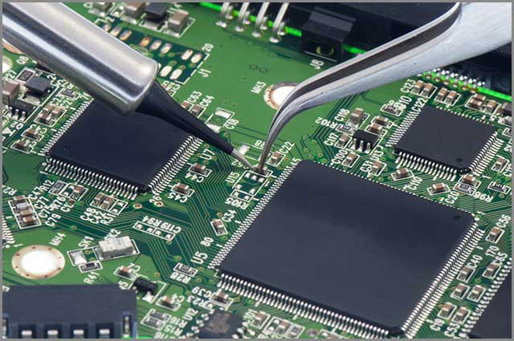
Figure 3-9Replacement components
- Repairing:
Repairing involves identifying and addressing faults within the components or their connections. It may include tasks such as replacing damaged wires, repairing broken traces on the circuit board, or addressing faulty solder joints.
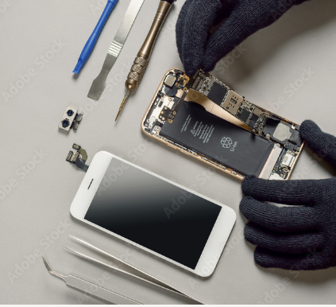
Figure 3-10Repairing mobile phone
- Soldering
Soldering is the process of joining electrical connections by melting solder and creating a solid bond between the component and the circuit board. It requires heat from a soldering iron and the
Application of solder to the joint.
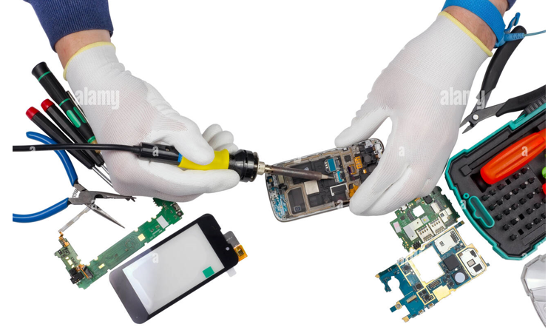
Figure 3-11Picture showing A technician Soldering

- Steps In Soldering
- Prepare the following materials:
  - Soldering Iron,
  - Solder paste
  - Long Nose Pliers,
  - PCB holder,
  - Electronic Components (Resistors, Diode etc.)
- Plug and pre-heat the soldering iron.
- Heat both items at the same time by applying the soldering iron to the copper pad and the component lead.
- Continue heating and apply a few millimeters of solder. Remove the iron and allow the solder joint to cool naturally.
It only takes a second or two to make the perfect joint, which should appear shiny.
- Assembling a Mobile Phone
The following are the steps that you should take when assembling a mobile phone:
- Fix the vibrator strips of speaker and volume button
- Fix the motherboard
- Connect the antenna with wire
- Place the camera and connect it
- Place the buzzer
- Put the camera cover
- Make sure that the LCD is working before you place the screen
- Put battery and battery cover
So far you have learnt about the hazards of mobile phone repair, the parts of a mobile phone, the tools to use and how to assemble a mobile phone.

Repair units using appropriate application software.
- Repair units: In the field of electrical/electronic equipment servicing, particularly in mobile phone repair and servicing, the ability to repair units using appropriate application software is crucial. This includes addressing software-related troubles that commonly occur in mobile phones. Let's explore some of these software-related issues and their corresponding solutions:
- Hang-up:A hang-up refers to a situation where the mobile phone becomes unresponsive and freezes, often resulting in the screen being stuck on a particular image or application. This issue can be caused by various factors, such as incompatible apps, insufficient memory, or software conflicts. To resolve a hang-up, technicians can attempt a soft reset by holding down the power button until the device restarts. If that doesn't work, a hard reset or factory reset may be necessary. It's important to note that a factory reset will erase all data, so it's advisable to back up important information before performing this step.
- Virus: phones, like any other electronic device, can be susceptible to viruses or malware. Symptoms of a virus-infected device may include slow performance, unexpected pop-up ads, or unusual behavior. To address this issue, technicians can run a reputable antivirus application to scan and remove any malicious software. In some cases, a factory reset may be required to completely eliminate the virus, followed by reinstalling the necessary applications and restoring data from a backup.
- Four blinks / blinking display: A four-blink or blinking display issue typically indicates a software problem related to the device's firmware or operating system. This issue can occur due to incomplete software updates, corrupted system files, or incompatible software. Technicians can attempt to resolve this problem by performing a software update or reinstalling the operating system. Recovery mode or specialized software tools may be required for these procedures, depending on the mobile phone model.
- Rebooting:Random or frequent rebooting of a mobile phone can be frustrating and disruptive. This issue can be attributed to various factors, such as software glitches, incompatible apps, or faulty hardware. Technicians can troubleshoot this problem by identifying potential software conflicts, clearing app caches, or uninstalling problematic applications. If the issue persists, further diagnostics may be needed to determine if the problem is hardware-related, such as a faulty battery or power management circuitry.
In all cases, it's important for technicians to have a good understanding of mobile phone operating systems (such as Android or iOS) and the specific diagnostic tools and software available for each platform. Staying updated with the latest software releases, patches, and security measures is crucial in providing effective repair and servicing for mobile phones.
- Install enhancements and applications.
Software in a mobile phone can be divided into two. These are:
- System software
- Application software
- Functions of Mobile phone Software
- Downloading mobile phone applications from websites
- Installing applications to mobile phones
- Backup and recovery of phone data to computer and servers
- Restore phones (restore factory/hardre set)
- Flashing/formatting phones
- Unlocking network locked phones
- IMEI Repair
- Root or Jailbreak
- System software
It is the main part of phone, that runs operates or influences the mobile phone hardware directly in order to provide basic functionality needed by users and other applications.
Example: Operating system software.
- Mobile Operating System
A mobile operating system allows the user to run other different application software on the mobile, tablets, etc. Moreover, we can say that it is a type of operating system which is specially designed for mobiles, tablets, smartwatches, etc. An operating system (OS) is a program that acts as an interface between the system hardware and the user. Moreover, it handles all the interactions between the software and the hardware.
- Functions of OS
It performs various tasks. The major functions of OS are:
- Memory Management: It is the management of the main or primary memory.. Therefore, there can be more than one program present at a time. Hence, it is required to manage the memory. The operating system:
  - Allocates and deallocates the memory.
  - Keeps a record of which part of primary memory is used by whom and how much.
  - Distributes the memory while multiprocessing.
- Processor Management/Scheduling: When more than one process runs on the system the OS decides how and when a process will use the CPU. Hence, the name is also CPU Scheduling. The OS
- Allocates and deallocates processor to the processes.
- Keeps record of CPU status.
- Device Management: The processes may require devices for their use. This management is done by the OS. The OS:
  - Allocates and deallocates devices to different processes.
  - Keep records of the devices.
  - Decides which process can use which device for how much time.
- File Management: The files on a system are stored in different directories. The OS:
  - Allocates and deallocates devices to different processes.
  - Keep records of the devices.
  - Decides which process can use which device for how much time.
- Security: The OS keeps the system and programs safe and secure through authentication. A user id and password decide the authenticity of the user.
- Other Functions: Some other functions of the OS can be:
- Error detection.
- Keeping a record of system performance.
- Communication between different software etc.

- Types of Popular Mobile Operating System
- Android OS: It is the most common operating system among the mobile operating system. Furthermore, Google is the developer of Android.
- Bada: Samsung is the launcher of this operating system.
- Apple iOS: After android, it is one of the most popular OS. It is designed to run on Apple devices such as iPhones, iPad tablets, etc.
- Windows Mobile OS: The developer of this OS is Microsoft. It is basically designed for pocket PCs and smartphones..
- Symbian OS: The developer of this OS is Symbian Ltd. Nokia was the first to use this OS on its mobile phones..
- Harmony OS: It is a latest OS moreover, Huawei is its developer. It is specifically designed for use in IoT devices.
- Web OS: Palm Ltd is its developer. Moreover, it is based on Linux kernel and HP uses it in its mobile devices and touchpads.
- Application software: A mobile application or app is a computer program or software application designed to run on a mobile device such as a phone, tablet, or watch.

- Repair units using appropriate software.
Software is a set of programs, routines and symbolic language that control the functions of hardware and directs its operations.
- The common software problems are:
- Display problems
- No signal message
- Dead phone set
- Phone on test mode
- Phone not charging
- Phone has message to contact service provider
- Phone hangs, goes off, freezes or has slow processing

- Procedures for mobile phone software maintenance and repair
  - Diagnose the software issue:
  - Backup data:
  - Update software
  - Reset settings.
  - Remove unnecessary apps
  - Clear cache and data
  - Boot into safe mode
  - Check for malware
  - Reinstall firmware
  - Consult manufacturer support center
- Mobile Phone Software Repair Tools
With These Software Tools for Mobile Phone Repairing, you can Flash Software of all Android Smartphone and iPhone. You Can Flash ROM (OS), IMEI, Unlock Forgotten Lock Pattern or Password, Repair Smartphone that Hangs at Logo.
Here are all the Software Tools for Mobile Phone Repairing. With these Software Tools you can do fix all software relates problems of all iPhone and Android Smartphones of any Brand and Model including – Samsung, Apple iPhone, All China Mobile Phone ( Vivo, Oppo, Honor, Huawei, Xiaomi, Meizu, OnePlus, Lenovo, Qiku 360, Smartisan), Micromax, Lava etc.
No flashing Box is needed for to use this software. Just download to your PC and start using with its easy software flashing GUI. It is universal mobile phone flashing software for all China made android mobile phones.
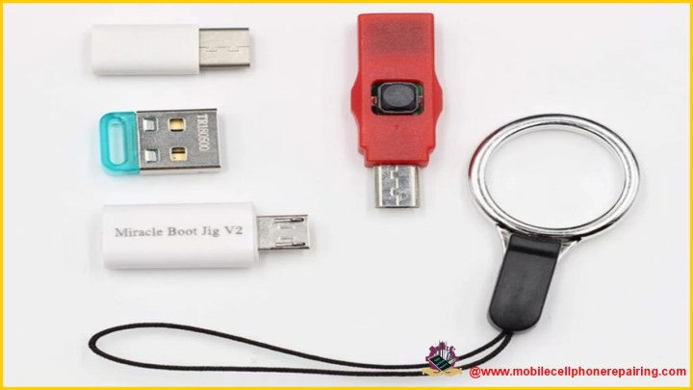
Figure 3-12SP flash tool
- SP Flash Tool (Smart Phone Flash Tool) is small-sized Easy to Use Software to flash Stock ROM, Custom recovery, upgrade or downgrade firmware version, unlock forgotten lock pattern or password and for fixing all software related Issues of android smartphones using MTK (Mediatek) processor.
- Requirements to use SP flash tool
- Laptop of Desktop PC
- USB Data Cable to Connect Smartphone with the PC
- MediaTek USB-VCOM Drivers (Available as a Bundle with the Software when you download. No need to Download Separately)
- Scatter File
- Software Files to be Flashed (Download Here)

Table 1 Other Software Tools for Mobile Phone Repairing
Processor | Software Tool
SpreadTrum | SPD Flash Tool
Qualcomm | QFlash Tool
Samsung | Odin Flash Tool
Apple iPhone | iTune Tool

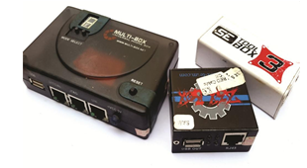
Figure 3-13Flasher boxes
- Flasher dongles
These are also used for mobile phone flashing but differ from the flasher boxes in their minimal functionality. Most dongles are used as extension cards to flasher boxes; can serve also for remote unlocking and de- branding of phones.
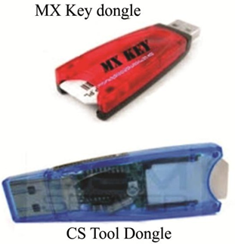
Figure 3-14Sample Flasher Dongles
- Flasher Cables and Interfaces
The flasher box typically connects to the mobile device through a special cable made for that phone model referred to as a ―Service cable‖. One end of the cable is the standard RJ-45 Ethernet networking cable interface which connects to the RJ-45 port on the flasher box. The other end is a matching phone‘s USB/Data port connector or a set of data test point contact pins that make contact with the mobile phone‘s Joint Test Action Group (JTAG) or the Mbus/Fbus connections.
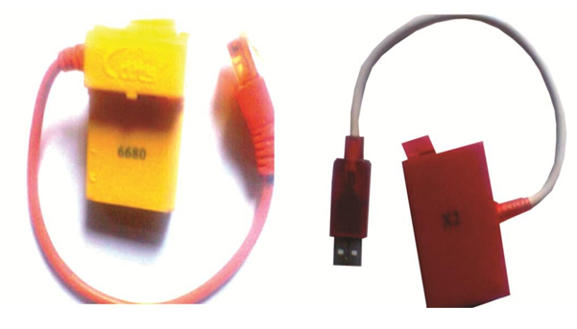
Figure 3-15Flasher Cables and Interfaces
- Mobile Phone Software Faults Diagnosis
- The following symptoms lead to the diagnosis of a phone‘s behavior as a software fault;
- When a phone is frequently restarting automatically.
- When a phone is frequently switching off automatically without the power switch pressed or switch-OFF initiated by the user.
- When the phone switches OFF or reboots as soon as a particular folder like gallery, message inbox or other is opened.
- When some of the phone‘s applications which came with the OS refuse to function properly.
- Incomplete booting stuck at logo.
- When a phone does not switch-ON, especially without physical damage related reason. This could be as a result of a corrupted OS.
- When a phone frequently freezes or hangs.
- When a phone processes its applications, user requests and commands very slowly.
- A phone starts up but is blank, inoperable and possibly with some indication light.
- A phone displays ―Contact Service‖ or ―Contact Retailer‖.

Computer System Requirements for Software Flash Repair
The following are the required provisioning on any desktop or laptop computer a technician wishes to use for mobile phone repair software flash programming.
  - Hardware Requirements
- 250 GB Hard Disk Drive- HDD (Minimum requirements) extensible with external storage up to 2 Terabytes or more of hard disk storage
- 2GB RAM (Random Access Memory) minimum requirement
- 2.30 GHz Processor (minimum requirement)

- Project Two. Flash IMEI Number in Android Mobile Phone
- Your mobile phone gets hanged too often.
- Your phone gets hanged at company logo and doesn’t boot.
- You want to update the latest software / operating system in your phone.
- You have forgotten the lock pattern or password and want to unlock the phone.
- Your Android Mobile phone or tablet is dead because of software issues.

- Hardware Needed
- The android phone to flash the IMEI number.
- An usb data cable to connect your phone to the computer or laptop.
- Software Needed
- Stock ROM / Firmware:
- SN Write Tool.
- AP BP Base for SN Write Tool
- Read & Write Tool
- AP BP Base for Read&Write Tool
- IMEI Number of your PhoneHow to Flash IMEI Number in Android Mobile Phone and Restore IMEI Number and Fix Invalid IMEI Number Problem
Step-1. Download SN Write Tool on your computer
Step-2. In the Extracted Folder, you will find – SN Writer.exe
Step-3 Now you will see following screen. Click on Comport and Select USB VCOM. In the “Target Type” you will get Options to Select Feature Phone, Smartphone and Other Android Devices. Select Smartphone if you are flashing the IMEI Number to an Android Phone.
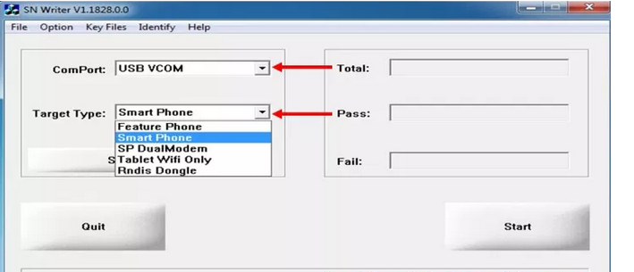
Figure 3-16install software
Step-4 Now selects System Configure Button.
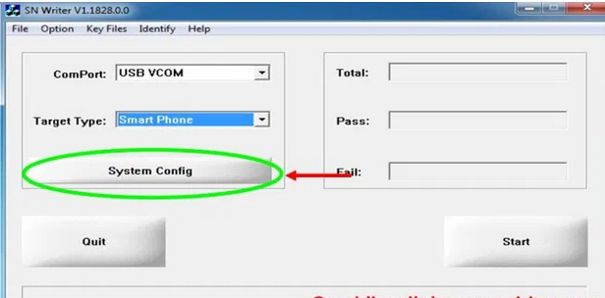
Figure 3-17installs software
Step-6.Now clicks Start Button on the Next Screen.
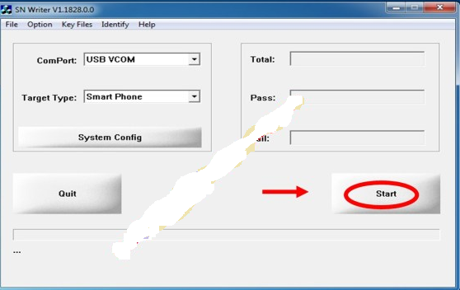
Figure 3-18 installs software
Step-7: Under Scan Data, Enter the 15 Digit IMEI Number. Once you have entered all the required Data, SWITCH OFF your Phone and Take out the Battery. Once the IMEI Number writing is done, you will see Green Pass Message.

Cleaning and Check-up of unit.
- Check-up
The module unit of Service and Repair of Mobile Phones focuses on diagnosing faults in cellular phone units and conducting a complete check-up of the device. This process involves identifying, verifying, and documenting defects against the customer's description. This essay will outline the steps involved in diagnosing faults, conducting a check-up, and documenting defects in mobile phones. Diagnosing Faults in Cellular Phone Units:
- Initial assessment
The first step in diagnosing faults is to conduct an initial assessment of the mobile phone. This includes
- examining the physical condition of the device,
- checking for any visible damage, and
- Listening to the customer's description of the problem.
- Testing and Troubleshooting
After the initial assessment, the technician proceeds to test and troubleshoot the device. This involves using specialized tools and software to identify and isolate the specific fault.
Common issues include
- Software glitches,
- Hardware malfunctions,
- Battery problems, or
- Network connectivity issues.
- Systematic approach
To ensure an accurate diagnosis, a systematic approach is followed.
The technician may start by testing the basic functions of the phone, such as
- Making calls,
- Sending messages, and
- Accessing the internet.
If the problem persists, further tests are conducted on specific components like the display, camera, microphone, or charging port. Conducting a Complete Check-up of Cellular Phones:
- Hardware Inspection: A thorough hardware inspection is conducted to identify any physical defects or damage.
This includes
- Checking the screen for cracks,
- Inspecting the buttons for functionality, and
- Examining the overall condition of the device.
- Software Analysis: The technician performs a software analysis to identify any issues related to the operating system, firmware, or installed applications.
This may involve
- Updating software,
- Clearing caches, or
- Performing a factory reset if necessary.
- Battery and Power Check: The battery and power-related components are examined to ensure proper functioning.
This includes
- Checking the battery health,
- Charging port, and
- Power management circuitry.
- Documenting Defects against Customer Description
- Defect Identification:
Once the faults are diagnosed, the technician compares them with the customer's description to ensure accuracy. Any additional defects or issues discovered during the check-up are also documented.
- Verification:
The identified defects are verified by conducting further tests or by replicating the reported issues. This step ensures that the documented defects are valid and can be addressed during the repair process.
- Documentation:
The defects, along with their corresponding details, are documented in a service report or repair ticket. This document serves as a reference for the technician and provides transparency to the customer regarding the identified issues.

- Performing cleaning of mobile phone units
Performing cleaning of mobile phone units is an essential aspect of electrical/electronic equipment servicing, particularly in mobile phone repair and servicing. Proper cleaning helps maintain the functionality and longevity of the device, as well as improve its overall appearance. Here are some key points to consider when performing cleaning on mobile phone units:
- External Cleaning:
The external surfaces of a mobile phone, including the display, back panel, buttons, and ports, can accumulate dirt, dust, fingerprints, and smudges over time. To clean the exterior, technicians should use a soft, lint-free microfiber cloth or screen cleaning wipes specifically designed for electronic devices. Gently wipe the surfaces to remove any debris, oils, or dirt. Avoid using harsh chemicals, abrasive materials, or excessive moisture that could damage the device.
- Cleaning Ports and Openings:
Ports and openings, such as the charging port, headphone jack, or speaker grille, can become clogged with dust, lint, or debris, hindering their functionality. Technicians can use small, soft brushes (such as a clean toothbrush or specialized brush) to gently remove any accumulated particles from these areas. Compressed air can also be used to blow away dust or debris from hard-to-reach spots. It's important to exercise caution and avoid applying excessive pressure to prevent damage to delicate components.
- Cleaning the Display:
The display is a critical component of a mobile phone, and keeping it clean is important for optimal visibility and touch sensitivity. Use a microfiber cloth to gently wipe the screen in a circular motion, removing fingerprints, smudges, or dust. For stubborn smudges, a small amount of distilled water can be applied to the cloth, but avoid excessive moisture that could seep into the device. Never use abrasive materials or harsh cleaners that may scratch the screen or damage any coatings.

- Internal Cleaning:
While cleaning the exterior is crucial, internal cleaning is typically performed by professionals in controlled environments. It involves disassembling the mobile phone and using specialized tools and cleaning agents to remove dust, debris, or moisture from the internal components. Internal cleaning should only be carried out by qualified technicians, as improper handling or cleaning techniques can cause damage or void warranties.
- Sanitization:
In certain situations, sanitization of mobile phone units may be necessary, especially in light of hygiene concerns or during a pandemic. Technicians can use disinfectant wipes or specialized cleaning solutions recommended by the manufacturer to sanitize the device's exterior surfaces. However, it's important to follow the manufacturer's guidelines to avoid damaging the device or affecting its functionality.

Self-check no. 3.1
Part one: True/False
________1. The reassembly process is the final step in mobile phone repair.
________2. Testing reassembled units is not necessary if the repair was successful.
________3. Cleaning the internal components of a mobile phone is optional.
________4. Compliance with environmental requirements is essential for proper waste disposal.
Multiple Choice: Part Two:
- Which step is NOT part of the reassembly procedure for mobile phones?
- Component Inspection
- Battery Installation
- Testing Repaired Unit
- Final Testing
- What should technicians use to clean the exterior surfaces of a mobile phone?
- Harsh chemicals
- Abrasive materials
- Soft, lint-free cloth
- Water and soap
- What is the purpose of conducting performance testing in mobile phone repair?
- To assess the quality of the repair work
- To verify the functionality of repaired components
- To evaluate the overall performance of the device
- To comply with documentation requirements
- What is the role of a repair log in the mobile phone repair process?
- To track the progress of the repair
- To document the results of functional tests
- To ensure proper disposal of waste materials
- To provide evidence for warranty claims

- Why is proper disposal of waste materials important in mobile phone repair?
- To reduce energy consumption
- To comply with environmental requirements
- To improve the performance of the device
- To minimize the cost of repairs
- Which step is NOT part of the reassembly process for mobile phones?
- Connectors and Cables
- Battery Installation
- Mainboard and Components
- Component Inspection
- What should technicians use to clean the internal components of a mobile phone?
- Compressed air or an anti-static brush
- Water and soap
- Harsh chemicals
- Soft, lint-free cloth
- What is the purpose of conducting functional testing in mobile phone repair?
- To verify the functionality of repaired components
- To evaluate the overall performance of the device
- To assess the quality of the repair work
- To comply with documentation requirements
- What should technicians use to wipe the screen of a mobile phone?
- Harsh chemicals
- Compressed air
- Soft, lint-free cloth
- Water and soap
- What is the purpose of a repair checklist in the mobile phone repair process?
- To track the progress of the repair
- To document the results of functional tests
- To ensure proper disposal of waste materials
- To provide evidence for warranty claims

Part Three: Fill in the Blank:
- _______________ testing helps identify any potential issues that may have arisen during the reassembly or that were not apparent during the initial repair.
- Proper _______________ of waste materials is crucial to ensure environmental sustainability in the mobile phone repair industry.
- Technicians should _______________ waste materials into different categories for proper disposal and recycling.
- _______________ involves assessing the overall performance of the repaired mobile phone, such as its speed, responsiveness, and battery life.
- The _______________ of waste materials can have detrimental effects on the environment, including contamination of soil, water bodies, and air.

Operation sheet 3.1
Operation Title: Identify hardware parts & their defects of mobile unit
Instruction:
Purpose: to identify hardware parts & problems of mobile units
Required tools and equipment: collect the necessary tools like precision screwdrivers, soldering iron, soldering station, mobile opener.
Precautions:
- use safety precaution while touching the mobile devices
- Properly compatible tools.
Procedures:
Step 1: Identify & inspect visually the diagnosing parts
Step 2: Collect diagnostic tools
Step 3: Testing Mobile Phone Components

Quality criteria:
Operation sheet 3.2
Operation Title: Flash mobile phone software
Instruction:
Purpose: to solve mobile phone software problems
Required tools and equipment: collect the necessary materials, applicable/compatible software’s, computer.
Precautions:
- use safety precaution while touching the mobile devices
- Properly install software
Procedures:
Step 1: Identify the Issue
Step 2: Restart mobile phone
Step 3: identify the root cause of the software issue & use the diagnose software and tools.
Step 4: Check for available software updates from the manufacturer or operating system provider
Step 5: Boot the mobile phone in safe mode.
Step 6: Provide step-by-step instructions on how to access the recovery mode and clear the cache
Step 7: Resort a factory reset to resolve persistent software issues
Step 8: If there is no other solutions install Firmware/ROM
Step 9: Finally test the mobile phone carefully to ensure the issue is resolved.
Lap test 3.1
Instruction I: Given necessary templates, tools and materials you are required to perform the following tasks within 3 hours.
Task 1: identify mobile phone repairing materials
Task 2: identify mobile phone repairing Tools
Task 2: identify mobile phone repairing testing & measuring instruments
LAP Test 3.2
Instruction I: Given necessary templates, tools and materials you are required to perform the following tasks within 5 hours.
Task 1: Collect information about the defect of mobile phone
Task 2: identify software used to mobile phone repairing
Task 2: Flashing mobile phone testing its functionality

UNIT FOUR: TESTING REPAIR UNIT
This learning guide is developed to provide you the necessary information regarding the following content coverage and topics:
Unit 4. Testing repair unit
- Reassembly Procedure for Mobile Phones Repair
- Testing and cleaning reassemble units.
  - Compiling documentations
  - Dispose waste materials.
This guide will also assist you to attain the learning outcomes stated in the cover page.
Specifically, upon completion of this learning guide, you will be able to attain:
- Follow Reassemble procedures
- Subject Testing and cleaning reassemble units.
- Compile documentations.
- Dispose waste materials.

Reassembly Procedure for Mobile Phones Repair
The reassembly process is a crucial step in mobile phone repair, as it involves putting all the components back together after troubleshooting and fixing any issues. This procedure aims to provide a step-by-step guide for technicians to ensure a successful reassembly of mobile phones. Procedure:
- Test Repaired Unit
- Component Inspection:
- Connectors and Cables:
- Battery Installation:
- Mainboard and Components:
- Back Cover or Housing:
- Final Testing:
- Component Inspection:
- Before reassembling, carefully inspect all components, including
- the display,
- battery,
- camera modules,
- Connectors, and buttons, for any damage or defects.
- Replace any damaged or faulty components with new ones to ensure optimal performance. .
- Test Repair Unit:
- Before proceeding with the reassembly, it is essential to perform a final test on the repaired unit to ensure that all the previously identified issues have been resolved.
- Test the functionality of the repaired components, such as the
- display,
- buttons,
- cameras,
- speakers,
- Microphone, and other features, to verify that they are working correctly.
- Conduct thorough testing to ensure that the repaired unit is fully functional and meets the expected performance standards.
- Connectors and Cables:
        - Begin by reconnecting the various cables and connectors, starting with the display and digitizer connectors.
        - Pay close attention to the alignment and orientation of the connectors to avoid any damage or misalignment.
        - Gently press the connectors into place until they are securely seated.
- Battery Installation:
- If the battery was removed during the repair process, carefully align it with the battery connector on the device.
- Ensure the battery is properly aligned and gently press it down until it is securely in place.
- Double-check that the battery connector is firmly connected.
- Mainboard and Components:
- Place the mainboard back into the device, aligning it with the appropriate screw holes and connectors.
- Reinstall any additional components such as
- camera modules
- speakers, and
- vibration motor
- Secure the mainboard and components in place using the appropriate screws, taking care not to overtighten them.
- Back Cover or Housing:
- If the device has a removable back cover or housing, align it with the device and gently press it into place.
- Ensure that all clips or screws are properly aligned and secured.
- Final Testing:
- Once the reassembly is complete, perform a thorough functional test to ensure that all components are working correctly.
- Test the display
- Test the buttons
- Test the cameras
- Test the speakers
- Test the microphone, and
- Test the features to verify proper functionality

Testing and cleaning reassemble units.
In the realm of mobile phone repair and servicing, testing and cleaning reassembled units play a crucial role in ensuring the quality and functionality of repaired devices.
Testing and Cleaning Reassembled Units in Mobile Phone Repair and Servicing In addition to the reassembly procedure outlined in the previous, it is crucial to emphasize the importance of testing and cleaning reassembled units in mobile phone repair and servicing. This note will provide an overview of the significance of these two steps in ensuring the quality and functionality of repaired devices.
- Testing Reassembled Units:
After completing the reassembly process, it is essential to conduct thorough testing to verify that all components are functioning correctly. This step helps identify any potential issues that may have arisen during the reassembly or that were not apparent during the initial repair.
- Functional Testing:
- Test all features and functionalities of the mobile phone,
- display,
- touch response,
- buttons,
- cameras
- speakers,
- microphone
- Wi-Fi,
- Bluetooth, and other hardware components.
- Use diagnostic tools and software to assess the performance and functionality of the device.
- Ensure that all repaired components are working as expected and that there are no new issues introduced during the reassembly process.
- Performance Testing:
- Evaluate the overall performance of the device, including its speed, responsiveness, and battery life.
- Run benchmark tests to assess the device's performance against industry standards and specifications.
- Verify that the repaired unit meets the expected performance standards and provides a satisfactory user experience.
- Cleaning Reassembled Units:
Cleaning the reassembled mobile phone is a crucial step to ensure the device's longevity, functionality, and aesthetic appeal. It helps remove any dirt, dust, or residue that may have accumulated during the repair process.
- External Cleaning:
- Use a soft, lint-free cloth or microfiber cloth to wipe the exterior surfaces of the device, including the screen, back cover, and buttons.
- Avoid using harsh chemicals or abrasive materials that could damage the device's finish or screen.
- Pay special attention to removing fingerprints, smudges, and any visible dirt or grime.
- Internal Cleaning:
- Inspect the internal components for any dust or debris that may have accumulated during the repair process.
- Use compressed air or an anti-static brush to gently remove any dust or debris from the internal components, connectors, and circuit boards.
- Ensure that all connectors and ports are clean and free from any obstructions that could affect the device's functionality.
- Service Completion Procedures and Documentation Compliance
In the field of mobile phone repair and servicing, service completion procedures and documentation play a crucial role in ensuring that repairs are carried out efficiently and accurately. This essay will explore the importance of adhering to service completion procedures and complying with documentation requirements based on the manual in the mobile phone repair and servicing industry.
- Service Completion Procedures:
Service completion procedures refer to the steps that technicians follow to ensure that a repair or servicing task is successfully completed. These procedures typically involve a series of checks and tests to verify that the mobile phone is functioning properly after the repair. Adhering to service completion procedures is essential to guarantee the quality and reliability of the repair work (Smith, 2019).
              - Functional Testing: Technicians should perform thorough functional testing to ensure that all repaired components are working correctly. This includes checking the display, touch screen, buttons, speakers, microphone, camera, and other essential features of the mobile phone.
              - Performance Testing: Performance testing involves assessing the overall performance of the device, such as its speed, battery life, and connectivity. Technicians should verify that the repaired mobile phone meets the expected performance standards.
              - Quality Assurance: Technicians should conduct a final quality assurance check to ensure that the repaired mobile phone meets the required standards. This includes inspecting the device for any cosmetic issues, ensuring that all components are properly secured, and verifying that any software updates or configurations have been correctly applied.
- Documentation Compliance
Complying with documentation requirements based on the manual is crucial for maintaining a record of the repair and servicing process. This documentation serves multiple purposes, including warranty claims, legal compliance, and customer satisfaction.
- Repair Log: Technicians should maintain a detailed repair log that includes information such as
- The customer's name,
- Contact details,
- Device model,
- Serial number, and
- A description of the reported issue.
This log helps track the progress of the repair and serves as a reference for future inquiries or warranty claims.
- Repair Checklist: Following a repair checklist based on the manual ensures that all necessary steps are completed during the repair process. This includes
- Documenting the specific repairs performed,
- The parts replaced, and
- Any additional services provided.
- Test Results: Technicians should document the results of the functional and performance tests conducted after the repair. This documentation provides evidence that the device has been thoroughly tested and is functioning properly.
- Customer Communication: Documenting customer communication is essential for maintaining a transparent and professional relationship. This includes recording any discussions, agreements, or instructions provided by the customer regarding the repair.

Proper Disposal of Waste Materials
Environmental Compliance Introduction: In the mobile phone repair and servicing industry, the proper disposal of waste materials is of utmost importance to ensure environmental sustainability. This essay will discuss the significance of disposing of waste materials in accordance with environmental requirements in the context of mobile phone repair and servicing.
- Environmental Impact of Improper Waste Disposal:
Improper disposal of waste materials from mobile phone repair and servicing can have detrimental effects on the environment. Mobile phones contain various hazardous substances, including heavy metals, toxic chemicals, and non-biodegradable materials (EPA, 2021). When these materials are not disposed of correctly, they can contaminate soil, water bodies, and air, posing risks to human health and ecosystems.
- Compliance with Environmental Requirements:
To mitigate the environmental impact of waste materials, mobile phone repair and servicing businesses must comply with environmental requirements for proper disposal. This involves following established guidelines and regulations set by local authorities and environmental agencies.
- Segregation of Waste: Technicians should segregate waste materials into different categories, such as electronic components, batteries, plastics, and metals. This segregation facilitates proper disposal and recycling of each waste type, minimizing environmental harm.
- Recycling: Mobile phone repair and servicing businesses should partner with certified recycling facilities to ensure that waste materials are recycled appropriately. Recycling helps recover valuable resources from mobile phones and reduces the need for raw materials extraction, conserving natural resources and reducing energy consumption (EPA, 2021).
- Hazardous Waste Disposal: Hazardous waste, such as batteries and certain electronic components, must be disposed of in accordance with specific regulations. Mobile phone repair and servicing businesses should identify authorized hazardous waste disposal facilities and adhere to proper disposal protocols to prevent contamination and ensure compliance with environmental requirements.
- Documentation: Maintaining proper documentation of waste disposal activities is essential for demonstrating compliance with environmental regulations. This includes recording the types and quantities of waste materials disposed of, the recycling facilities used, and any hazardous waste disposal certificates obtained.
- Environmental Benefits and Corporate Responsibility
- Pollution Prevention: By disposing of waste materials correctly, the release of hazardous substances into the environment is minimized, reducing pollution and protecting ecosystems.
- Resource Conservation: Recycling waste materials helps conserve valuable resources, such as metals and plastics, by reducing the need for new raw materials extraction.
- Corporate Responsibility: Demonstrating a commitment to environmental sustainability through proper waste disposal enhances the reputation and credibility of mobile phone repair and servicing businesses. It showcases their corporate responsibility and contributes to a greener and more sustainable future.

Self-check 4.1
Part One: Say True/False:
______1. The reassembly process is the final step in mobile phone repair.
______2. Testing reassembled units is not necessary if the repair was successful.
______3. Cleaning the internal components of a mobile phone is optional.
______4. Compliance with environmental requirements is essential for proper waste disposal

Part Two: Multiple Choice:
- Which step is NOT part of the reassembly procedure for mobile phones?
  - Component Inspection
  - Battery Installation
  - Testing Repaired Unit
  - Final Testing
- What should technicians use to clean the exterior surfaces of a mobile phone?
- Harsh chemicals
- Abrasive materials
- Soft, lint-free cloth
- Water and soap
- What is the purpose of conducting performance testing in mobile phone repair?
- To assess the quality of the repair work
- To verify the functionality of repaired components
- To evaluate the overall performance of the device
- To comply with documentation requirements
- What is the role of a repair log in the mobile phone repair process?
- To track the progress of the repair
- To document the results of functional tests
- To ensure proper disposal of waste materials
- To provide evidence for warranty claims

- Why is proper disposal of waste materials important in mobile phone repair?
- To reduce energy consumption
- To comply with environmental requirements
- To improve the performance of the device
- To minimize the cost of repairs
- Which step is NOT part of the reassembly process for mobile phones?
- Connectors and Cables
- Battery Installation
- Mainboard and Components
- Component Inspection
- What should technicians use to clean the internal components of a mobile phone?
- Compressed air or an anti-static brush
- Water and soap
- Harsh chemicals
- Soft, lint-free cloth
- What is the purpose of conducting functional testing in mobile phone repair?
- To verify the functionality of repaired components
- To evaluate the overall performance of the device
- To assess the quality of the repair work
- To comply with documentation requirements
- What should technicians use to wipe the screen of a mobile phone?
- Harsh chemicals
- Compressed air
- Soft, lint-free cloth
- Water and soap
- What is the purpose of a repair checklist in the mobile phone repair process?
- To track the progress of the repair
- To document the results of functional tests
- To ensure proper disposal of waste materials
- To provide evidence for warranty claims
Part Three: Matching:
Match the following components with their respective steps in the reassembly procedure:
Match A | Match B
____1. Battery | - Connectors and Cables
____2. Mainboard | - Final Testing
____3. Display | - Battery Installation
____4. Back Cover | - Component Inspection
____5. Connectors and Cables | - Mainboard and Components

Part four: Fill in the Blank:
    - _______________ testing helps identify any potential issues that may have arisen during the reassembly or that were not apparent during the initial repair.
    - Proper _______________ of waste materials is crucial to ensure environmental sustainability in the mobile phone repair industry.
    - Technicians should _______________ waste materials into different categories for proper disposal and recycling.
    - _______________ involves assessing the overall performance of the repaired mobile phone, such as its speed, responsiveness, and battery life.
    - The _______________ of waste materials can have detrimental effects on the environment, including contamination of soil, water bodies, and air.

Operation sheet 4.1
Project Title: Repair the defective hardware parts of mobile unit
Instruction:
PURPOSE: Maintain the defective hardware parts of mobile unit
Required tools and equipment: collect the necessary tools like precision screwdrivers, soldering iron, soldering station, mobile opener.
Precautions:
- use safety precaution while touching the mobile devices
- Properly compatible tools.
- You should not forget to wear your PPEs.
PROCEDURE: Solve Display Faults in a Mobile Cell Phone
Step1. Clean the display tips and display connector.
Step2. Resold the display connector
Step3. Change the display
Step4. Check the display Track.
Step5. Resold or change the display IC.
Step6. Heat, reball or change the CPU.

Lap Test No. 3
Name: __________________________ Date: _____________________
Time started: ____________________ Time finished: _______________

Instruction I: Given necessary templates, tools and materials you are required to perform the following tasks within 4 hours.

Task 1: Dismantle Mobile Handset
Task 2: Identifying Spare Parts on Mobile Phones Handsets
Task 3: Testing Mobile Phone Components
Task 4: assembly Mobile Handset

UNIT FIVE: ADDITIONAL/ ENHANCEMENT FEATURES
This learning guide is developed to provide you the necessary information regarding the following content coverage and topics:
TRAINING OUTCOME
- Installing Enhancements and Applications
- Advising/Orienting Customers
This guide will also assist you to attain the learning outcomes stated in the cover page. Specifically, upon completion of this learning guide, you will be able to attain :
- Install Enhancements and Applications
- Advise/Orient Customers

Installing Enhancements and Applications
In addition to diagnosing and repairing faults in cellular phone units, technicians may also be responsible for installing additional features or enhancements requested by customers. This section focuses on the steps involved in installing enhancements and applications on mobile phones. Here are the key procedures to follow:
- Customer Consultation:
- Engage in a consultation with the customer to understand their specific requirements for additional features or enhancements.
- Clarify the desired functionalities, applications, or upgrades they wish to have on their mobile phone.
- Provide recommendations or suggestions based on the customer's needs and the compatibility of their device.
- Compatibility Check:
- Verify the compatibility of the customer's mobile phone with the desired enhancements or applications.
- Ensure that the device meets the necessary hardware and software requirements for installation.
- Check for any potential conflicts or limitations that may prevent successful implementation.
- Research and Selection:
- Conduct research to identify suitable enhancements or applications that align with the customer's requirements.
- Consider factors such as reliability, performance, user reviews, and compatibility with the device's operating system.
- Provide the customer with options and recommendations based on the research.

- Backup and Data Protection:
- Advise the customer to back up their data before proceeding with the installation of enhancements or applications.
- Guide them through the backup process or recommend suitable backup methods, such as cloud storage or computer backups.
- Emphasize the importance of data protection to prevent any loss or corruption during the installation.
- Download or Installation:
- Assist the customer in downloading or installing the selected enhancements or applications.
- If the enhancements or applications are available through official app stores, guide the customer through the downloading and installation process.
- If the enhancements or applications are obtained from third-party sources, ensure that they are from reputable and trusted sources to minimize the risk of malware or security threats.
- Settings and Configuration:
- Help the customer configure the newly installed enhancements or applications according to their preferences.
- Walk them through the initial setup process, including granting necessary permissions, adjusting settings, and entering account information if required.
- Provide guidance on optimizing the settings to ensure optimal performance and usability.
- Testing and Troubleshooting:
- Test the installed enhancements or applications to ensure they are functioning as expected.
- Assist the customer in navigating and using the new features or applications.
- Address any issues or errors that may arise during the testing phase, troubleshooting them to ensure proper functionality.
- User Guidance and Support:
- Provide the customer with instructions or user guides for utilizing the installed enhancements or applications effectively.
- Offer ongoing support and assistance in case the customer encounters any difficulties or has further questions.
- Educate the customer on best practices for using the enhancements or applications to maximize their benefits.
- Documentation and Records:
- Maintain documentation of the enhancements or applications installed, including their versions, installation dates, and any relevant notes.
- Update the customer's service record or job sheet to reflect the installed enhancements or applications for future reference.
By following these procedures, technicians can effectively install additional features or enhancements requested by customers while ensuring compatibility, data protection, and proper functionality. Providing guidance and support throughout the process helps customers make the most of their mobile phone's capabilities.

Advising/Orienting Customers
In the process of installing additional enhancements or applications on mobile phones, technicians play a crucial role in advising and orienting customers. This section focuses on the steps involved in effectively advising and orienting customers regarding the installation of enhancements and applications. Here are the key procedures to follow:
- Active Listening:
- Engage in active listening when customers express their requirements or preferences for enhancements or applications.
- Pay attention to their needs, concerns, and any specific usage scenarios they mention.
- Take notes if necessary to ensure a thorough understanding of their expectations.
- Clarifying Customer Requirements:
- Seek clarification to ensure a clear understanding of the customer's requirements.
- Ask questions to gather specific details about the desired enhancements or applications.
- Confirm their expectations and ensure that you have a complete picture of what they are looking for.
- Assessing Feasibility:
- Assess the feasibility of the customer's requested enhancements or applications.
- Consider factors such as device compatibility, available resources, and technical limitations.
- If the requested enhancements are not feasible, explain the reasons to the customer and offer suitable alternatives.
- Providing Recommendations:
- Based on the customer's requirements and feasibility assessment, provide recommendations for suitable enhancements or applications.
- Explain the benefits, features, and potential impact on the device's performance for each recommendation.
- Offer multiple options whenever possible to give the customer a choice.
- Explaining Installation Process:
- Clearly explain the installation process to customers, highlighting the steps involved and any requirements.
- Describe the potential time frame for installation and any prerequisites, such as data backup or software updates.
- Address any concerns or questions the customer may have regarding the installation process.

- Educating about Potential Risks:
- Inform customers about any potential risks or consequences associated with installing enhancements or applications.
- Explain the importance of downloading from trusted sources and the potential security risks of third-party applications.
- Provide guidance on practicing safe browsing habits and avoiding malicious or unreliable sources.
- Setting Realistic Expectations:
- Set realistic expectations with customers regarding the performance and functionality of the installed enhancements or applications.
- Explain any limitations or constraints that may affect the desired outcome.
- Manage customer expectations by providing accurate information about the capabilities and potential impact on device performance.
- Demonstrating Usage:
- Demonstrate the usage of installed enhancements or applications to customers.
- Walk them through the basic functionalities, features, and settings.
- Provide tips and tricks to help them make the most of the enhancements or applications.
- Offering Ongoing Support:
- Assure customers that ongoing support will be available to address any questions, issues, or difficulties they may encounter.
- Provide contact information or direct them to appropriate channels for support and assistance.
- Encourage customers to reach out if they need further guidance or have additional inquiries.
- Documenting Customer Preferences:
- Maintain records of customer preferences, including the enhancements or applications they requested and any specific instructions or preferences they communicated.
- Use this documentation to ensure consistency in future interactions and to provide personalized recommendations and services.
By following these procedures, technicians can effectively advise and orient customers regarding the installation of enhancements and applications on their mobile phones. Clear communication, managing expectations, and providing ongoing support contribute to a positive customer experience and satisfaction with the installed features.

Self-check 5.1
Part One: True/False
______1. Active listening is not necessary when customers express their requirements for enhancements or applications.
______2. Technicians should recommend multiple options whenever possible to give customers a choice.
______3. Addressing potential risks and consequences associated with installation is not necessary when advising customers.
______4. Demonstrating the usage of installed enhancements or applications is not important for customer satisfaction.
______5. Documenting customer preferences is not necessary for future interactions and personalized services.
Part Two: Multiple Choice
- When installing enhancements or applications on mobile phones, what is the first step in the process?
- Compatibility Check
- Customer Consultation
- Research and Selection
- Backup and Data Protection
- What should technicians advise customers to do before proceeding with the installation of enhancements or applications?
- Configure the settings
- Perform a data backup
- Test the installed features
- Update the device's operating system

- What is the purpose of conducting testing and troubleshooting during the installation process?
- To assess the feasibility of enhancements
- To provide ongoing support to customers
- To ensure proper functionality of installed features
- To document customer preferences accurately
- What should technicians provide to customers to help them utilize the installed enhancements effectively?
- User guides and instructions
- Recommendations for alternative enhancements
- Additional applications for download
- Updates on the latest mobile phone models
Part Three: Matching
Match the following steps with their respective procedures in the document:
Match A: Match B:
_______1. Customer Consultation (a). Engage in active listening
_______2. Compatibility Check (b). Verify hardware and software requirements
_______3. Research and Selection (c). Conduct research and provide recommendations
_______4. Backup and Data Protection (d) Advise data backup before installation
_______5. Testing and troubleshooting (e) Test functionality and address issues
Part Four: Fill in the Blank
- Conducting _______________ helps technicians gather specific details about the desired enhancements or applications.
- Technicians should clearly explain the installation _______________ to customers, highlighting the steps involved.
- Advising customers about potential _______________ associated with installations helps them make informed decisions.

References:
[1]. www..hse.gov.uk (http://www.hse.gov.uk/toolbox/ppe.htm) Personal protective equipment (PPE) at work what the law says and how to use personal protective equipment at work.
[2]. Health and Safety Executive. (2019). Personal Protective Equipment (PPE) at Work. Retrieved from https://www.hse.gov.uk/toolbox/ppe.htm
[3]. Occupational Safety and Health Administration. (n.d.). Personal Protective Equipment. Retrieved from https://www.osha.gov/personal-protective-equipment.
[4]. I Fixit. (n.d.). Essential Electronics Repair Tools. Retrieved from https://www.ifixit.com Store/Tools
[5]. Mobile Phone Repairing. (n.d.). Tools and Test Equipment for Mobile Phone Repairing. Retrieved from https://www.mobilecellphonerepairing.com /tools-and-test-equipment-for-mobile-phone-repairing.html
[6]. Mobile Phone Repairing. (n.d.). Retrieved fromhttps://www.mobilecellphonerepairing.com/
[7]. I Fixit. (n.d.). Mobile Phone Repair Guides. Retrieved from https://www.ifixit.com /Device/Mobile Phone
[8]. Service Manual. (n.d.). Retrieved from https://www.techopedia.com definition /24603/ service - manual
[9]. Schematic Diagram. (n.d.). Retrieved from https://www.techopedia.com /definition/24604/ schematic-diagram
[10]. Parts List. (n.d.). Retrieved from https://www.techopedia.com/definition/24605/parts-list
[11]. User Manual. (n.d.). Retrieved from https://www.techopedia.com/definition/24606/user-manual
[12]. Repair Handbook. (n.d.). Retrieved from https://www.techopedia.com /definition/24607/ repair-handbook
[13]. "Service Manual vs. Repair Manual: What's the Difference?" Repair Pal, www.repairpal.com /blog/ service-manual-vs-repair-manual.
[14]. "The Importance of Job Sheets in Your Business." Jobber Academy, www.academy.getjobber.com /resources/articles/ the-importance-of-job-sheets-in-your-business/.
[15]. "What Is a Bill of Materials (BOM) and How Does It Work?" Arena Solutions, www.arenasolutions.com/resources/articles/ what-is-a-bill-of-materials-bom-and-how-does-it-work/.
[16]. "The Importance of Customer Relationship Management." Salesforce, www.salesforce.com /products/sales-cloud/ what-is-customer-relationship-management/.
[17]. "How to Create a Flowchart in 7 Easy Steps." Lucid chart, www.lucidchart.com/pages/ flowchart-tutorial.
[18]. "Inventory Management: The Complete Guide." Trade Gecko, www.tradegecko.com/ inventory-management-guide.
[19]. "What Is a Requisition Slip?" Bizfluent, www.bizfluent.com / info-12079558-requisition-slip.html.
[20]. "Supplier Index: Definition & Explanation." www.Study.com,study.com /academy/lesson/ supplier-index-definition-lesson-quiz.html.
[21]. "What Is an IMEI Number and What Is It Used For?" Tech walla, www.techwalla.com/articles/ what-is-an-imei-number-and-what-is-it-used-for.
[22]. "The Importance of Gathering Customer Information in Mobile Phone Repair." Repair Desk, www.repairdesk.co/blog/ the-importance-of-gathering-customer-information-in-mobile-phone-repair.
[23]. "How to Review Service Records for Mobile Phone Repair." Tech Republic, www.techrepublic.com/article/ how-to-review-service-records-for-mobile-phone-repair/.
[24]. "How to Access Manufacturer's Database for Mobile Phone Repair." iFixit, www.ifixit.com/Guide/How+to+Access+Manufacturer%27s+Database+for+Mobile+Phone+Repair/100969.
[25]. "Diagnostic Testing in Mobile Phone Repair." Phone Check, www.phonecheck.com/blog/ diagnostic-testing-in-mobile-phone-repair/.
[26]. "The Importance of Documentation in Mobile Phone Repair." Mobile Sentrix, www.mobilesentrix.com/blog/ the-importance-of-documentation-in-mobile-phone-repair.
[27]. "Basic Electronic Components Used in Mobile Phones." Electronics Hub, www.electronicshub.org / basic-electronic-components-used-in-mobile-phones/.
[28]. "Mobile Phone Repair Tools." Electronics Notes, www.electronics-notes.com/articles/electronic_components/mobile-phone-repairing/mobile-phone-repair-tools.php.
[29]. "Mobile Phone Repair Terminology." Electronics Notes, www.electronics-notes.com/articles/ electronic_components/mobile-phone-repairing/mobile-phone-repair-terminology.php.
[30]. Mobile Phone Repairing: A Comprehensive Guide for Beginners. (n.d.). Retrieved from https://www.elprocus.com/mobile-phone-repairing-a-comprehensive-guide-for-beginners/
[31]. Mobile Phone Repairing Course. (n.d.). Retrieved from https://www.gsmacademy.in/mobile-phone-repairing-course/
[32]. Mobile Phone Repair. (2021). Retrieved from https://www.mobilephonerepair.org/
[33]. Smith, J. (2019). The Importance of Standard Operating Procedures in the Workplace. Chron. Retrieved from https://smallbusiness.chron.com/importance-standard-operating-procedures-workplace-20865.html
[34]. Environmental Protection Agency (EPA). (2021). Electronics Donation and Recycling. Retrieved from https://www.epa.gov/recycle/electronics-donation-and-recycling
[35]. Wikipedia. 2010. Form factor (mobile phones). https://en.wikipedia.org/wiki/Form_factor_%28mobile_phones%29. mobile-phone-repairing-tools-equipment-tools-to-repair-mobile- cell-phone.html. http://www.mobilecellphonerepairing.com.
[ 36 ]. Service manuals, Schematics . 2010. Service manuals, Schematics > Mobile Phones > Nokia.
[37 ]. . http://www.s-manuals.com/phone/nokia.

Developer profile
Name | Qualification | Field of study | Institute | Phone No. | Email
Zekarias sisay | A | Electrical engineer(M.sc) | Harar PTC | 0703747163 | Szekarias07@gmail.com
Tesfahun | A
Mulugeta | B
peteros | B
shemils | B

