Electrical/Electronic Equipment ServicingLevel III
October 2023, CurriculumVersions - ll

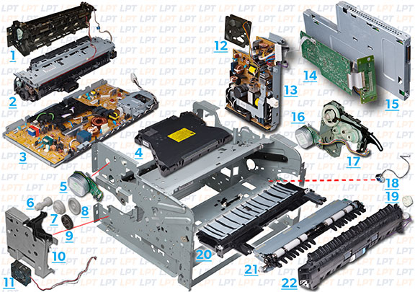

Module Title: Maintaining and repairing of Printers
Module code:EISE EES3 M04 0322 Nominal duration: 70 Hour

Prepared by: Ministry of Labor and Skill
October, 2023
Addis Ababa, Ethiopia

CONTENT
Contents
ACKNOWLEDGMENT 4
Acronym 5
1 UNIT ONE: OVER VIEW OF PRINTERS 7
1.1 Basic concept types and Image formation process 8
1.2 Preparing Service Manuals and Information 23
1.3 Parts and components of printer machines 23
1.4 Setting/preparingWorkstation for repair job: 25
1.5 Preparing necessary tools and test instruments 25
Self-check.1.1 27
Operation Sheet 1.2 29
2 UNIT TWO: DIAGNOSE FAULTS 31
2.1 Using PPE & OHS practices. 32
2.2 Pre-testing procedures 33
2.3 Disassembling the unit 34
2.4 Checking and identifying defects and Faults 55
2.5 Status-light patterns and Control settings and adjustments 57
2.6 Operating the unit to confirm defects 64
2.7 Documenting diagnosis and test Results 67
2.8 Informing Customers about the status and serviceability of the unit 68
Self-check.2.1 69
Operation Sheet 2.1 74
3 UNIT THREE: MAINTAIN AND REPAIR PRINTER 76
3.1 Electro-static discharge (ESD) protection procedure 77
3.2 Replacing Defective parts/components 81
3.3 Testing functionality of repaired part/components 93
3.4 Perform Cleaning and apply precaution in handling the unit 94
Self-check.3.1 97
Operation Sheet 3.1 100
4 UNIT FOUR: TESTING REPAIRED PRODUCT 103
4.1 Reassembling Repaired units 103
4.2 Final testing and cleaning 104
4.3 Service completion procedures and documentations 106
4.4 Disposing Waste materials 108
Self-check.1.1 110
Operation Sheet 4.1 111
References: 112
Developers Profile 113

ACKNOWLEDGMENT
The Ministry of Labor and skill, to Prosperity wish to thank MoLS experts, regional labor and skill bureaus, TVT trainers, university lecturers and industry experts who contribute their time and professional experience to the development of this Training module for ELECTRICAL / ELECTRONICS EQUIPMENT SERVICING LEVEL lll
We would like to express our appreciation to the Ministry of Labor and skill to Prosperity Ethiopia for their technical and financial support and workshop facilitation of this training module development.

Acronym
AC | Alternating current
BOM | Bill of materials
CD | Compact disk
CPU | Central processing unit
CDRH | Center for Devices and Radiological Health
DHHS | Department of Health and Human Services
DC | Direct current
ECU | Engine control system
EIO | Enhanced Input Out put
ESD | Electrostatic device
HVPS: | High voltage power supply
HVPS: | High voltage power supply
LED | Light emitting diode
PCA | Printed circuit assembly
PCB | Printed circuit board
PPE | Personal protective equipment
OHS | Occupational health and softy
ROM | Mead only memory
RAM | Random access memory

Introduction to the Module
Electrical/electronic equipment servicing encompasses a wide range of activities, including the service and repair of printer. In today's digital age, printer have become an integral part of our lives, and their proper functioning is crucial. This essay provides an introduction to the field of electrical/electronic equipment servicing, with a specific focus on the service and repair of printer. We will explore the importance of this specialized area, the skills required, and the significance of maintaining and repairing printer to ensure their optimal performance.
Maintaining and repairing of Printers
This module covers the units:
- Overview of printer machines
- Diagnose faults
- Maintain and repair printer
- Test repaired product
Learning Objective of the Module
- Identify Basic concepts and Image formation process of printer
- Diagnose faults of printer
- Perform Maintenance and repair of printer
- Describes Testing of repaired unit
Module Learning Instructions:
- Read the specific objectives of this Learning Guide.
- Read the information written in the information Sheets
- Accomplish the Self-checks
- Perform Operation Sheets
- Do the “LAP test”

UNIT ONE: OVER VIEW OF PRINTERS
This learning guide is developed to provide you the necessary information regarding the following content coverage and topics:
- Basic concepts, types and Image formation process of printer machines
- Preparation of Service manuals and service information
- Parts and components of printer machines
- Preparation ofWorkstation for repair job
- History of repair/maintenance.
- Preparation of tools and test instruments
This guide will also assist you to attain the learning outcomes stated in the cover page. Specifically, upon completion of this learning guide, you will be able to:
- Understand Basic concepts, types and Image formation process of printer machines
- Acquire Service manuals and service information
- VerifyParts and components of printer machines
- Arrange ofWorkstation for repair job
- Verify History of repair/maintenance.
- Select tools and test instruments

Basic concept types and Image formation process
A laser printer uses a low power sharply focused laser beam to scan one line at a time on the drum. Modern laser printers use infra−red solid state laser diodes similar to those used in CD players and optical disk drives while older ones used helium neon lasers.
The digital image is generated from a bit map stored in the printer's memory and modulates the laser beam. Scanning is mechanical − a high speed motor spins a multifaceted deflection mirror to get the X−axis and the paper moves to get the Y axis.
LED printers use a large array of LEDs as the image source but are otherwise similar to laser printers. Laser printers commonly use a negative process (a spot of light results in a dark mark on the paper). The photosensitive drum is the heart of the laser printer. In larger machines, it may be a separately replaceable unit. In most laser printers and smaller copiers, it is part of the 'toner cartridge' and is a throw−away (or may be recycled). The drum is coated with a photosensitive material which has an extremely high resistance when in darkness. Its resistance drops to a low value when illuminated. All of the following takes place as a continuous process as the drum rotates.
Note that the actual photosensitive drum in most copiers and laser printers has a circumference that is much smaller than the length of the printed page. Therefore, only a portion fits at any given time and the charging, exposure, transfer to the paper, cleaning, and erasing is a continuous process:
The drum's surface is charged to a high positive voltage (typically 5 to 6 kV) by a set of charging corona wires in close proximity to the drum.
The exposure process for laser printers: The negative image of the page stored in the printer's buffer memory (the laser is turned on where the print is to be black) is read out and scanned onto the drum one line (i.e., 1/300th or 1/600th of an inch) at a time.
Where the light hits the drum's surface, its resistance drops dramatically and the charge in these areas is dissipated. At this point, a swath of the image of your ultimate copied or printed page resides as areas of electrostatic charge on the drum. This is a 'latent' image and must be developed.
As the drum continues to turn, the latent image rotates past the 'developer unit' which contains a mixture of developer and toner. For the most part, developer is not really used up during the printing process but some is lost and may need to be replenished from time−to−time (depends on design).
Developer: is a material which includes powdered iron or other powder which is attracted by a magnet. Toner is the actual 'ink' and consists of very finely powdered thermo plastic particles. These are 'fixed' in the fuser by literally melting the image onto the paper.
Depending on design, the developer material may be separate or actually combined with the toner.
A magnet in the developer unit which is as long as the page is wide causes the developer along with trapped toner to stand out following its lines of force off of its long N−S pole pieces. This forms a kind of brush of toner and developer material which is in contact with the drum as it rotates with its latent image. Normally, the developer material brush is C−shaped, and toner particles are carried in the C−shape (the back of the 'C' is against the drum). For laser printers, the relative charges of the drum and toner are set up so that toner is drawn to the exposed (where the laser beam was turned on) portions of the drum resulting in a negative image on the paper.
The drum continues to rotate around and comes in contact with the paper.
Below the paper is another corona, the 'transfer corona'. Another high voltage is applied to the back of the paper (once again, around 7 or 8 kV DC) to draw the toner from the drum to the paper. (Remember, all this is going on in a continual cycle and it is all in motion).
Depending on the manufacturer of the machine, you may or may not have a third corona, the 'separation corona'. This is needed to separate the paper from the drum, but not disturb the toner on the paper (the separation corona is usually 4 or 5 kV AC (if it was DC, you would separate the paper, but have *very* smeared toner all over the page as to make it unreadable). The separation corona usually has guides over it to keep the paper from 'dipping' down too far into the corona shell.
Paper is then transported to the fuser which 'fixes' the toner to the paper via heat (to soften the toner particles) and pressure (to embed them in the paper fiber). There are parts in the fuser which also keep the paper from sticking to the hot rollers. A thermostatically controlled quartz tube lamp provides the heat inside the anti−stick (Teflon coated) fuser roller.
Finally, your copy or printed page is ready! However, we are not done as there is still some toner on the drum − it is not possible to get it all off electrically) so there is usually a rubber or plastic blade which rubs in direct contact with the drum. This 'drum blade' scrapes the toner off the drum, and the 'recovery blade' catches it to keep it from falling back into the machine. A 'used toner auger' transports the used toner (which is now changed both physically and electrically and is also contaminated with paper dust (don't reuse your used toner) because it can eventually damage the developer unit, cleaning blades, fuser sections and other parts of the mechanism.
• Now that all the toner has been scraped off the drum, there is still some residual charge on the drum from the previous exposure process. You can't scrape the static charge off the drum, so the cleaned drum is now fully exposed to a bright light to discharge the drum surface and prepare it again for a new charge, which comes right after the discharge lamps.
Laser printer operation summary: In general the principle of electrostatic laser printing is as follows:
1. Charging a photoconductive selenium (or other) coated drum.
2. Discharging the drum with the laser steering engine in accordance with the input image rasterized pattern. (The laser is modulated to generate a predefined pixel pattern on the face of the drum − the focal plane).
3. The rotating drum attracts toner to the charged pattern (latent image) generated by the laser.
4. The toner is transferred from the drum to the moving paper to generate a full image.
5. The paper carrying the toner moves through the heater to fuse the toner to a fine non−erasable image.
The laser steering engine is combined of the following components:
- Infra−red diode
- Laser, 3 to 4 mW in basic units, up to 30 mW or more for high performance printers.
- Beam expander to form the required size of the collimated input beam which generates the beam spot size in the focal plan.
- Cylindrical lens to reshape the laser elliptical beam to a round one.
- Spinning polygonal mirror to deflect the laser over the focal plan.
Types of printers
1. Impact printers
- Leave an image on the paper
- Physically strike an inked ribbon against the surface of the paper
- Relatively slow and noisy
- Used for multipart forms
2. Dot matrix printer
- Use an array of pins known as print wires to strike an inked printer ribbon and produce images
- The case that holds the print wires is called the print head
- Use either 9-pin (draft quality) or 24-pin (letter or near-letter quality)
3. Ink jet printer:Simple devices that consist of the following:
- Print head,
- Support electronics,
- A transfer mechanism, and
- A paper-feed component
- Work by ejecting ink through tiny tubes
- Ink is heated by tiny resistors or electro conductive plates at the end of each tube
- The resistors or plates boil the ink, which creates a tiny air bubble that ejects a droplet of ink onto the paper
- Some inkjets use mechanical methods to eject ink
- Most color printers are ink-jet and produce a high-quality image
Inkjet Key Features
- Print resolution
- Density of the ink
- Dots per inch (dpi)
- Print speed
- Pages per minute (ppm)
- Can print to almost anything
4. Laser jet printer
Laser printers use a mechanism called electro-photographic imaging
Produce high-quality and high-speed output of both text and graphics
More expensive than inkjet or impact printers
Use lasers as a light source
Laser Printer Parts
- Toner cartridge: Holds
- Aluminum cylinder coated with particles of photosensitive compounds
- The toner
- Many other parts that suffer the most wear and tear contained in toner cartridge

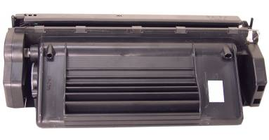
Fig 1.1Photosensitive drum
- Primary corona : Enables voltage to pass to the drum and charge the photosensitive particles on its surface
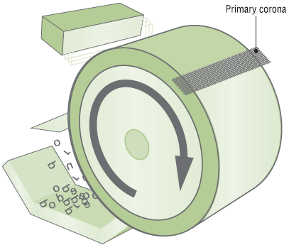
Fig 1.2 Primary corona
- Laser: Acts as the writing mechanism of the printer
- Toner: Fine powder made up of plastic particles bonded to iron particles
- Erase lamp: Exposes the entire surface of the photosensitive drum to light
- Transfer corona: Applies a positive charge to the paper
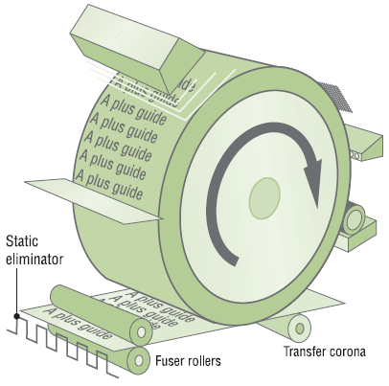
Fig 1.3.Transfer corona
- Fuser: Attaches the toner permanently to the paper using the pressure roller and heated roller
- Fuser assembly:Fuses the toner to the paper
- Primary power supply: Provides power to the motors that move the paper, system electronics, and transfer corona
- High-voltage power supply:Provides power to the primary corona
- Turning gears: Discrete units called gear packs or gearboxes
- System board:Contains the main processor, ROM, and RAM ROM can often be “flashed”Not enough RAM results in memory overflow error
- Sensors and Switches:Detects paper jams, empty paper trays, low toner levels, and so on
Note when inserting a new toner cartridge, always turn the laser printer off before opening it

Basic concepts of printers: This part presents an overview of the relationships between major components in the printer, and includes a detailed discussion of the image-formation system.
The following systems are discussed:
- Engine control system
- Laser/scanner system
- Pickup/feed/delivery system
- Image-formation system
Figure below illustrates the relationships among the four systems
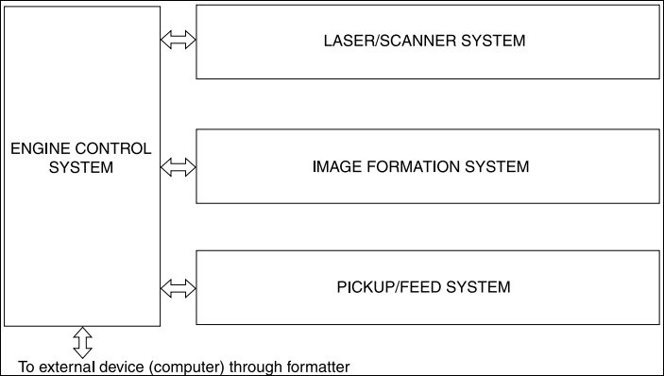
Fig.1.4 Internal components
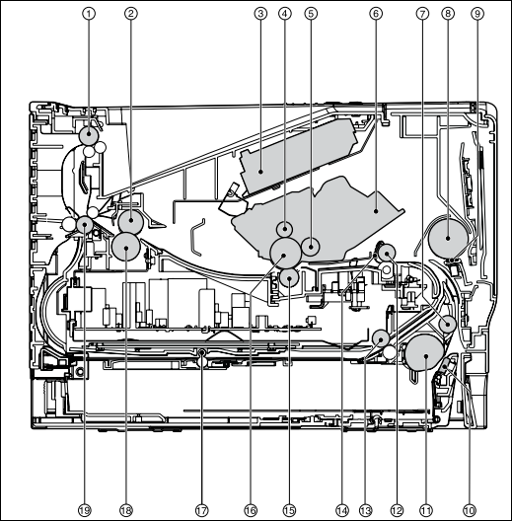
Figure 1.5-Cross-section of printer
- Top output bin delivery roller
- Fuser film
- Laser/scanner
- Primary charging roller
- Developer roller
- Print cartridge
- Feed roller
- Multipurpose pickup roller
- Multipurpose separation pad
- Separation pad
- Pickup roller
- Registration roller
- Duplexer pickup roller
- Registration shutter
- Transfer roller
- Photosensitive drum
- Duplexer feed roller
- Pressure roller
- Rear output bin delivery roller
Timing: Operation sequences are controlled by the microprocessor on the DC controller. Table 5-1 Sequence of operation on page 73 describes engine operations for each period of a print operation.
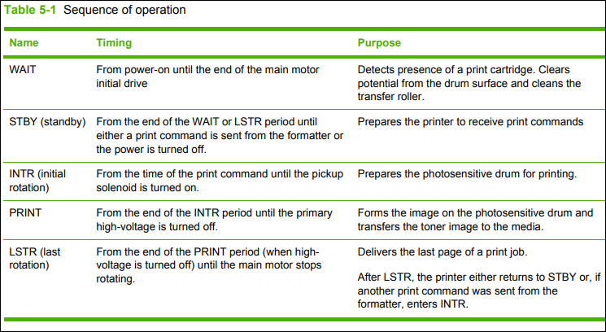
Table 1.1 sequence of operation

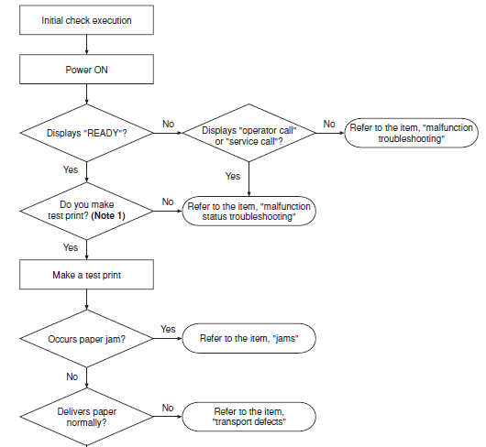
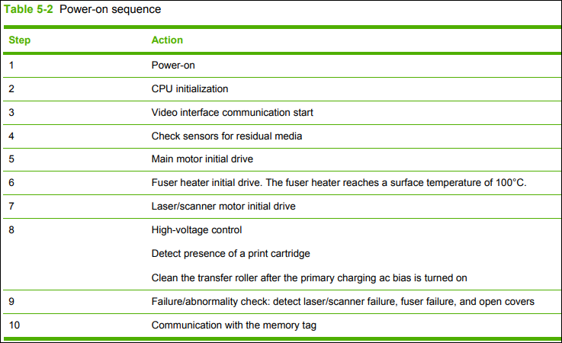

Table 1.2

Power-on sequence
Engine control system:The engine control system coordinates all printer functions, according to commands sent from the formatter. It drives the laser/scanner system, the image-formation system, and the pickup/feed/ delivery system. The engine control system contains the following components:
- DC controller
- High-voltage PCA
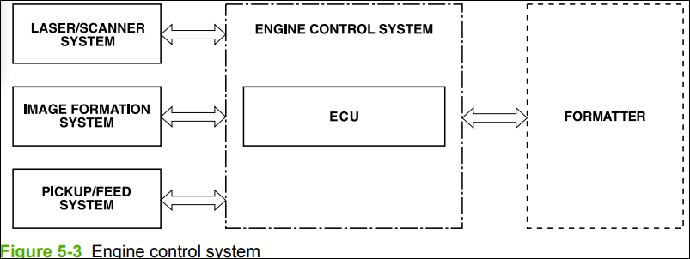
Fig.1.6 Engine control system
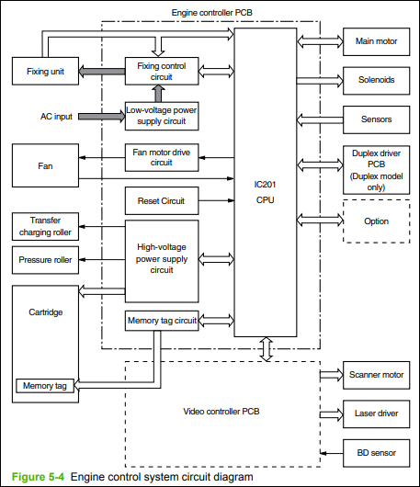
Fig1.7Engine control system circuit diagram
Laser/scanner system: The laser/scanner system receives video signals from the dc controller and the formatter and converts the signals into latent images on the photosensitive drum.
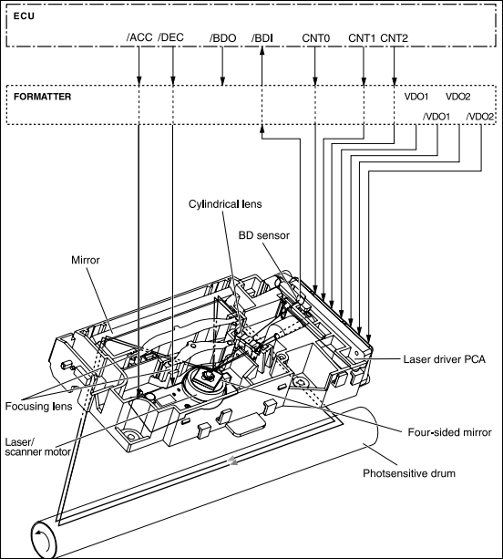
Fig 1.8Laser/scanner system
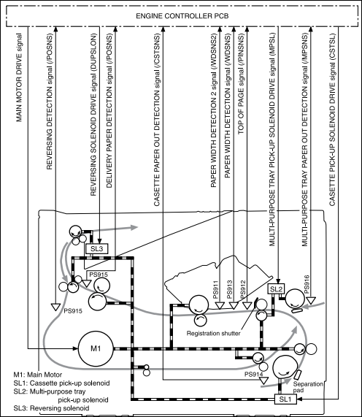
Fig 1.9Pickup/feed/delivery system
Image-formation system:Laser printing requires the interaction of several different technologies, including electronics, optics, and electrophotographics, to provide a printed page. Each process functions independently and must be coordinated with the other printer processes. Image formation consists of the following five processes:
- Electrostatic latent-image formation
- developing
- Transfer
- fusing
- drum cleaning
The five processes contain eight steps.
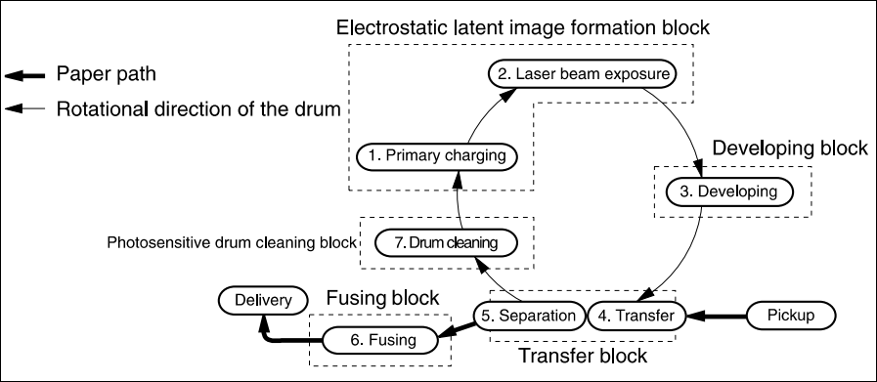
Fig.1.10Image-formation system
Step 1: Primary charging:DC and AC biases are applied to the primary charging roller, which transfers a uniform negative potential to the photosensitive drum.
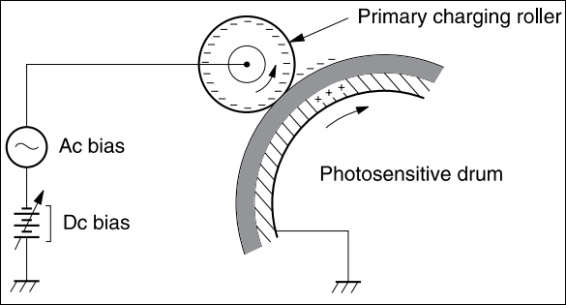
Fig.1.11 primary charging
Step 2: Laser beam exposure: The laser beam scans the photosensitive drum to neutralize negative charges on parts of the drum. An electrostatic latent image is formed on the drum where negative charges were neutralized.
NOTE the charges on the exposed area of the drum are shown as positive in Figure 5-9 Developing on page 80. The charges are actually negative, but they are more positive than the charges on the developing cylinder.
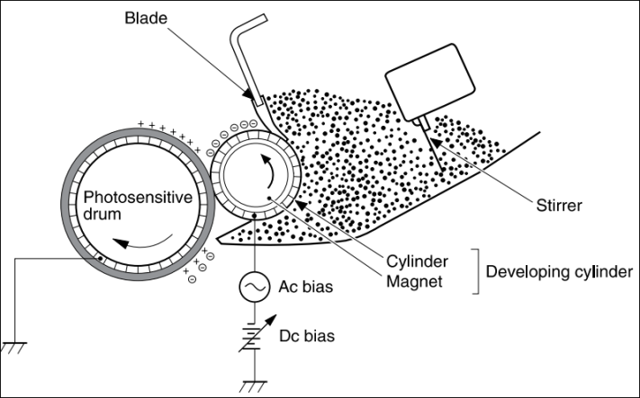
Fig.1.12Developing
Toner acquires a negative charge through friction from the developing cylinder and the blade. When the negatively charged toner comes in contact with the drum, the toner adheres to the electrostatic latent image. The image on the drum becomes visible because of the toner.
Step 4: Transfer: The transfer charging roller, to which a dc positive bias is applied, imparts a positive charge on the print media. When the print media comes in contact with the photosensitive drum, the toner is transferred to the print media.
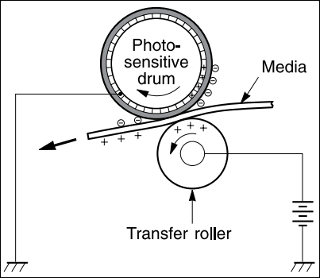
Fig.1.13Transfer
Step 5: Separation: The elasticity of the print media causes its separation from the photosensitive drum. A static charge eliminator aids separation by weakening any electrostatic adhesion.
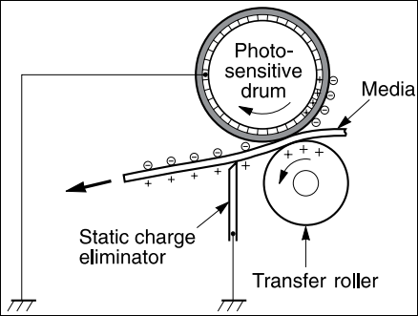
Fig.1.14Separation
Step 6: Fusing: The dc negative bias applied to the fusing film strengthens the holding force of the toner on the print media and prevents the toner from scattering.
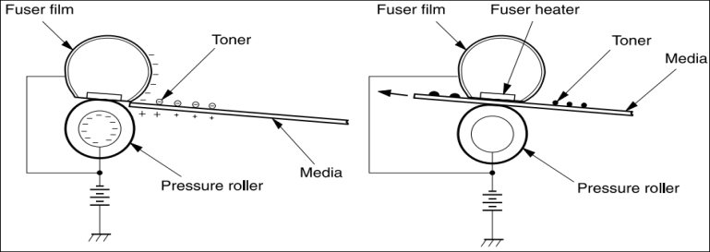
Fig 1.15Fusing
Step 7: Drum cleaning:The cleaning blade scrapes the residual toner off the photosensitive drum and deposits it into the waste toner case.
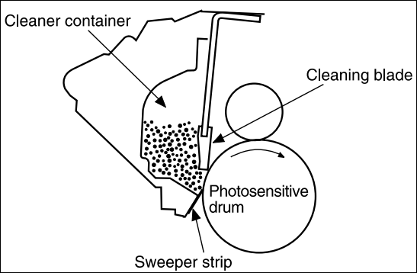
Fig 1.16Drum cleaning
Media detection: Media detection the model for media detection is essentially the same for all three trays. The paper sensor levers shown below detect the presence of media in the trays. If the sensor does not detect any media, the formatter illuminates the display LED until media is added.
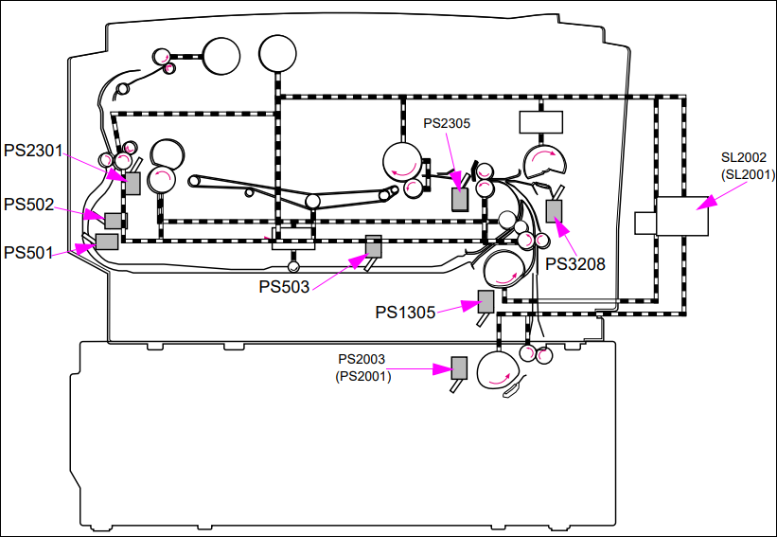
Fig 1.17. Media detection sensors
PS2305: Top-of-page sensor (printer)
PS2001: Paper feeder paper sensor (250-sheet)
PS2003: Paper feeder paper sensor (500-sheet)
SL2001: Paper feeder pickup solenoid (250-sheet)
SL2002: Paper feeder pickup solenoid (500-sheet)
PS502: Face-up sensor
PS501: Reversed paper sensor
PS1305: Cassette paper sensor
PS503: Duplex pickup paper sensor
PS3208: Tray 1 paper sensor
PS2301: Delivery sensor
Jam detection: The presence of media and paper-feed condition are detected by:
- Top-of-page sensor (PS2305)
- Delivery sensor (PS2301)
- Reversed paper sensor (PS501)
- Duplexer pickup paper sensor (PS503)
A jam is detected by the CPU checking for the presence of media through sensors at the timing stored in the CPU. If the CPU determines a jam, it stops the print operation and notifies the formatter of a jam.
Pickup sensors
Pickup delay jam: This printer performs retry control to readdress the pickup delay jam caused by pickup error. Pickup operation is conducted a maximum of twice at the all pickup sources except for the duplex feed unit. If the top-of-page sensor (PS2305) cannot detect the media leading edge within a specified period of time (T) the printer performs the pickup operation again. If PS2305 cannot detect the media leading edge within the specified period of time (T), a jam is indicated.
- Paper pickup from the tray1: T=about 2.5 seconds
- Paper pickup from the cassette: T=about 3.0 seconds
- Paper pickup from the paper feeder: T=about 4.4 seconds
- Paper pickup from the duplexer feed unit: T=about 4.5 seconds
Pickup stationary jam
- When WAIT period starts—a pickup stationary jam is assessed if the top-of-page sensor detects media when the WAIT period starts.
- During media feeding—a pickup stationary jam is assessed if the top-of-page sensor (PS2305) does not detect the trailing edge of the media within 3.8 seconds after detecting the leading edge
Delivery sensors
Delivery delay jam: A delivery delay jam is assessed if the media does not reach the delivery sensor (PS2301) within a specified period of time (T) after the top-of-page sensor (PS2305) detects the leading edge.
- Paper 270 mm or more: T=about 2.6 seconds
- Paper 200 mm to 270 mm: T=about 2.7 seconds
- Paper less than 200 mm: T=about 4.6 seconds
Delivery stationary jam
A. When WAIT period starts—a delivery stationary jam is assessed if the delivery sensor (PS2301) detects media when the WAIT period starts.
B. During media feeding—a delivery stationary jam is assessed if the delivery sensor (PS2301) does not detect the trailing edge of the media within a specified period of time (T) after the top-of page sensor (PS2305) detects the trailing edge.
- Paper 200 mm or more: T=about 2.7 seconds
- Paper less than 200 mm: T=about 5.2 seconds
C. When a pickup delay jam occurs—the printer enters the last rotation period to deliver the jammed media. A delivery stationary jam is assessed if the delivery sensor (PS2301) does not detect the trailing edge of the media within 8 seconds after the completion of the forced laser emission.
D. During pressure roller cleaning—a delivery stationary jam is assessed if the delivery sensor (PS2301) does not detect the trailing edge of the media within 8 seconds after the 35th feed operation.
Reversing sensors
Reversing delay jam: A reversing delay jam is assessed if the reversed paper sensor (PS501) does not detect the leading edge of the media within 3.9 seconds after the reversing motor starts rotating.
Reversing stationary jam: A reversing stationary jam is assessed when the reversed paper sensor (PS501) detects media after duplex pickup operation has been performed for about 0.77 seconds.
Duplexer sensors
Duplexer pickup delay jam: A duplexer pickup delay jam is assessed if the duplexer pickup paper sensor (PS503) does not detect media within 4.9 seconds after the reversed paper sensor (PS501) detects the leading edge.
Paper-feed sensor
Paper feeder jam detection: Jam detection for the paper feeders during the pickup and feed operations is same as that for the printer. For jam detection

Preparing Service Manuals and Information
In the module "Service and Repair printer," acquires service manuals and relevant information at the commencement of activities is crucial for ensuring successful repair and maintenance processes.
Service Manuals, Schematic Diagrams, and Parts Lists: Service manuals are comprehensive guides that provide
- Detailed information about the internal components,
- Circuitry, and
- Functionality of mobile phones.
They often include schematic diagrams, which illustrate the electrical connections and pathways within the device.
Operating Instructions/User's/Owner's manual:Operating instructions, user's manuals, or owner's manuals are documents provided by the printer manufacturer. These manuals offer guidance on how to operate and maintain the device properly. Acquiring these manuals at the commencement of activities allows
- Technicians to familiarize themselves with the specific features,
- Functions, and
- Settings of the printer model they are repairing.

Parts and components of printer machines
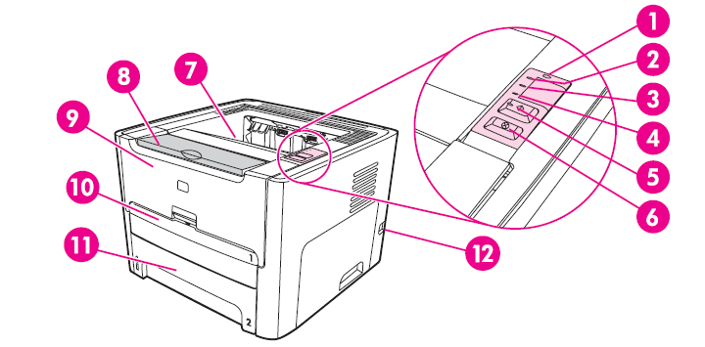
Fig 1.18 Front/right side view
1. Wireless light (only for 1320NW model)
2. Toner light
3. Attention light
4. Ready light
5. Go button and light
6. Cancel button
7. Output bin
8. Media support
9. Print cartridge door
10. single-sheet priority input slot (tray1)
11. Main input tray (tray 2)
12. on/off switch
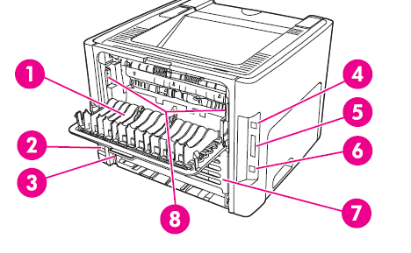
Fig 1.19 Rear/left side view
1. Straight –through output door
2. Power receptacle
3. Automatic two- sided printing media size selector.
4. USB port
5. Parallel port
6. Internal hp jet direct network port (1320n, 1320tn and 1320nw).
7. Rear automatic two -sided path door.
8. Jam -clearing levers.

Setting/preparingWorkstation for repair job:
Proper workplace preparation is crucial for efficient and effective printer repair jobs.It ensures that technicians have easy access to the necessary tools, equipment, and materials, reducing the time required for repairs and minimizing the risk of errors or accidents. A well-organized workplace also promotes a professional image and enhances customer satisfaction. To prepare the workplace for printer repair jobs, technicians should consider the following: Workstation Layout, Ergonomics and Safety Measures:
Unit Preparation: Before starting a repair job, technicians should ensure that the printer units are prepared appropriately:
Operating environment:The electrical and environmental specifications must be maintained to ensure the proper operation of printer. Consider the following points before installing the printer:
- Install in a well-ventilated, dust-free area.
- Install on a level, flat, and continuous surface that can support the printer’s weight.
- Make sure all four printer feet are level.
- Do not install on carpet or other soft surfaces.
- Ensure adequate power supply circuitry.
- Install where there is stable temperature and humidity, with no abrupt changes (away from water sources, humidifiers, air conditioners, refrigerators, or other major appliances).
- Install away from direct sunlight, areas with vibration, open flames, ultrasonic heaters, ammonia fumes, or magnets and devices that emit a magnetic field. If the printer is placed near a window, make sure the window has a curtain or blind to block any direct sunlight.
- Maintain enough space around the printer for proper access and ventilation.
- Verifying repair/maintenance history.

Preparing necessary tools and test instruments
Soldering Iron: It is used to solder small components like capacitor, resistor, diode, transistor, regulator, speaker, microphone, display etc.



Fig 1.20 Soldering iron
Soldering Iron/Weller w/Stand: A soldering iron is an indispensable tool for repairing mobile phones. It is used to solder and Solderingelectronic components on the circuit board.


Fig 1.21 Soldering Iron/Weller w/Stand:
De-soldering Tools: De-soldering tools, such as disordering pumps or disordering wicks, are essential for removing solder from circuit boards.
Screwdriver (assorted): A set of T-screwdrivers and assorted wrenches are essential for disassembling and reassembling printer
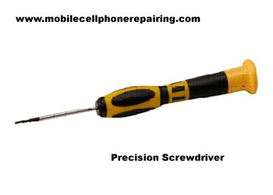
Fig 1.22 Screw drivers
ESD-Free Work Bench with Mirror: An ESD (Electrostatic Discharge)-free workbench is crucial for protecting sensitive electronic components from static electricity.
Cleaning Tools and Contact Cleaner: Cleaning brushes, cotton rugs, and cleaning agents are necessary for removing dust, debris, and contaminants from the printer's internal components.

Fig 1.23 Cleaning brushes, cotton rugs, and cleaning agents
- Multi-testers:- Various test instruments, such as multi-testers (analog/digital), signal generators, and oscilloscopes, are used to diagnose and troubleshoot printer issues. These instruments help technician’s measure voltage, current, resistance, and other electrical parameters, allowing them to identify faulty components and circuits accurately.
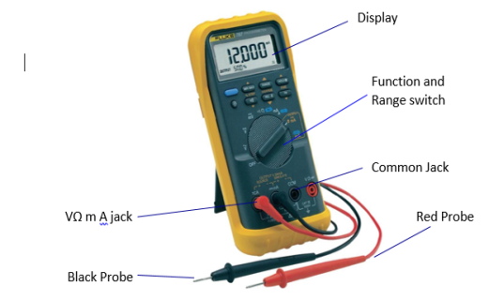
Fig 1.24 multi-testers

Self-check.1.1
Part I. True or False:

1. Laser printers commonly use a positive process.
2. LED printers use a large array of LEDs as the image source.
3. The developer material in a laser printer is always separate from the toner.
4. The transfer corona applies a negative charge to the paper.
5. Laser printers use electro-photographic imaging.

Part II. Choose the best answer
- The drum's surface is charged to a high positive voltage by
- Developer B. Corona wires C. Fuser D. Magnet
- ------------is a material which includes powdered iron or other powder which is attracted by a magnet.
- Developer B. Corona wires C. Fuser D.
- Toner is attracted to the charged pattern (latent image) by
- Magnet. B. The rotating drum C. Corona wires D. Fuser
- A type of printer which Use an array of pins known as print wires to strike an inked printer ribbon is called
- Impact printers B. Dot matrix printer C. Ink jet printer D. Laser jet printer
- Which parts of toner cartridge that suffer the most wear and tear
- Photosensitive drum B. Primary corona C. Erase lamp D. All of the above
Part IIIMatch the following components with their functions:
- Toner cartridge a) Holds the toner permanently to the paper
- Primary corona b) Applies a positive charge to the paper
- Laser c) Acts as the writing mechanism of the printer
- Erase lamp d) Exposes the drum surface to light
- Fuser e) Fuses the toner to the paper

March the items in B with the proper items in A

A
'------1. Fixes' the toner to the paper via heat
------.2. Writing mechanism of the printer
------.3. Applies a positive charge to the paper
------.4. Scrapes the toner off
------.5. Discrete units
B
- Turning gears
- Fuser
- Drum blade
- Transfer corona
- Ton
Part III Fill in the blank

- Laser printers use a low power sharply focused ________ beam to scan one line at a time on the drum.
- The digital image is generated from a bit map stored in the printer's ________.
- The drum's surface is charged to a high positive voltage by a set of charging ________ wires in close proximity to the drum.
- Inkjet printers work by ejecting ink through tiny ________.
- The primary corona enables voltage to pass to the drum and charge the photosensitive particles on its ________.
- ------------------------------------------ is the heart of laser printer
- The drum is coated with ------------------------------------- material which has an extremely high resistance when in darkness
- --------- coordinates all printer functions, according to commands sent from the formatter
- The four systems in printer Machen are
-----------------------------------------.
-----------------------------------------.
-----------------------------------------.
-----------------------------------------.
- List the five processes of Image formation
-----------------------------------------.
-----------------------------------------.
-----------------------------------------.
-----------------------------------------.
-----------------------------------------.

Operation Sheet 1.2
Operation Title: Laser Printer Maintenance
Instructions:
- Ensure the printer is turned off and unplugged before performing any maintenance procedures.
- Use caution when handling the toner cartridge to avoid contact with skin or clothing.
- Follow the manufacturer's instructions for replacing the toner cartridge and cleaning the drum.
- Avoid exposing the drum to direct light for an extended period.
- Keep the printer's interior clean and free from dust and debris.
Precautions:
- Do not touch the drum surface with bare hands.
- Avoid using sharp or abrasive tools when cleaning the printer.
- Do not reuse used toner as it may damage the printer's components.
Tools and Requirements:
- Replacement toner cartridge
- Soft lint-free cloth
- Isopropyl alcohol (for cleaning)
- User manual or manufacturer's instructions
Procedures:
- Turn off the printer and unplug it from the power source.
- Open the printer cover to access the toner cartridge.
- Carefully removethe old toner cartridge and set it aside.
- Clean the drum and the interior of the printer using a soft lint-free cloth lightly dampened with isopropyl alcohol.
- Follow the manufacturer's instructions to install the new toner cartridge.
- Close the printer cover and plug the printer back into the power source.
- Power on the printer and perform a test print to ensure proper functioning.
Quality Criteria:
- The toner cartridge is securely installed without any loose connections.
- The drum and printer interior are clean and free from dust or debris.
- The printer operates smoothly and produces high-quality prints without smudging or streaking.
- The test print shows clear and legible text or images.

UNIT TWO: DIAGNOSE FAULTS
This learning guide is developed to provide you the necessary information regarding the following content coverage and topics:
- Using PPE & OHS practices.
- pre-testing procedures
- disassembling the unit
- checking and identifying defects and Faults
- Control settings and adjustments
- Operating the unit to confirm defects
- Documenting diagnosis and test Results
- informing Customers about the status and serviceability of the unit
This guide will also assist you to attain the learning outcomes stated in the cover page. Specifically, upon completion of this learning guide, you will be able to attain :
- Use PPE & OHS practices.
- Follow pre-testing procedures
- Perform disassembling the unit
- check and identify defects and Faults
- Perform Control settings and adjustments
- Operate the unit to confirm defects
- Document diagnosis and test Results
- inform Customers about the status and serviceability of the unit

Using PPE & OHS practices.
Laser Safety Statement the Center for Devices and Radiological Health (CDRH) of the U.S. Food and Drug Administration has implemented regulations for laser products manufactured since August 1, 1976. Compliance is mandatory for products marketed in the United States. The printer is certified as a “Class 1” laser product under the U.S. Department of Health and Human Services (DHHS) Radiation Performance Standard according to the Radiation Control for Health and Safety Act of 1968. Since radiation emitted inside the printer is completely confined within protective housings and external covers, the laser beam cannot escape during any phase of normal user operation.
Using controls, making adjustments, or performing procedures other than those specified in this user’s guide may result in exposure to hazardous radiation.
Personal Protective Equipment
Personal protective equipment (PPE) plays a crucial role in ensuring the safety and well-being of technicians involved in the service and repair of printer. Adhering to occupational health and safety practices is essential to minimize the risk of injury or harm. This section focuses on the use of personal protective equipment in accordance with these practices. Here are the key points to consider:
Selection of Personal Protective Equipment:
- Based on the risk assessment, select appropriate personal protective equipment that can mitigate identified hazards.
- Common personal protective equipment used in printer service and repair include:
  - Safety Glasses or Goggles: Protect the eyes from potential hazards, such as flying debris or chemical splashes.
  - Gloves: Shield the hands from cuts, abrasions, and chemical exposures. Choose gloves suitable for the specific tasks, considering factors such as material compatibility and dexterity requirements.
  - Electrostatic Discharge (ESD) Protection: Use ESD wrist straps, mats, and ESD-safe tools to prevent damage to sensitive electronic components and protect against electrostatic discharge.
  - Respiratory Protection: Depending on the work environment and potential exposure to dust, fumes, or chemicals, respiratory protection such as masks or respirators may be necessary.
  - Protective Clothing: Consider wearing protective clothing, such as lab coats or coveralls, to protect against chemical splashes or other potential hazards.
  - Hearing Protection: In environments with high noise levels, use appropriate hearing protection, such as earmuffs or earplugs, to prevent hearing damage.

Pre-testing procedures
Troubleshooting the Print System
- Preliminary Operating Checks Prior to troubleshooting a specific printer problem, you should ensure that:
- The printer is being maintained on a regular basis.
- The printer is positioned on a solid, level surface.
- The line voltage does not vary more than 10% from the nominal rated value as specified on the Power Rating Label.
- The operating environment for the printer and paper is within the temperature and humidity specifications.
- The printer is never exposed to ammonia fumes such as those produced by diazo copiers or office cleaning materials.
- The printer is not exposed to direct sunlight.
- Non-HP components (such as refilled Toner Cartridges, font cartridges, and memory boards) are removed from the printer.
Note When moving the printer into a warm room from a cold location such as a warehouse, various problems can occur due to condensation in the printer. For example, if the photosensitive drum is cold, the resistance of the photoconductive layer will be high. This will lead to incorrect contrast. Leave the printer running for 10 to 20 minutes.

Visual inspection of the unit with power off
The first step in the pre-testing procedure is to visually inspect the mobile phone with the power turned off. This inspection aims to identify any visible physical damage or irregularities that may affect the device's functionality. Technicians should carefully examine the exterior of the printer,
- Common issues to look for
- Cracked parts,
- Loose connections, and
- Signs of wear and tear.
This visual inspection provides an initial assessment of the device's condition and helps determine the appropriate course of action for further testing and repair.
Interview of Customer
The next step involves conducting an interview with the customer to gather information about the printer's history.
- This conversation is essential as it provides
- Valuable insights into the device's usage patterns,
- Any previous repairs or modifications, and
- Any specific issues or symptoms experienced by the customer.
By understanding the unit's history, technicians can narrow down the potential causes of the problem and focus their testing efforts accordingly.

Disassembling the unit
Removal and replacement strategy
- Replace parts in the reverse order of their removal. Directions for difficult or critical replacement procedures are included.
- The sheet-metal edges of the product can be sharp. Use caution when working on the product.
- Note the length, diameter, color, type, and location of each screw. Be sure to return each screw to its original location during reassembly. Incorrectly routed or loose wire harnesses can interfere with other internal components and can become damaged or broken. Frayed or pinched harness wires can be difficult to locate. When replacing wire harnesses, always use the provided wire loops, lance points, or wire harness guides
- The product contains parts that are sensitive to electrostatic discharge (ESD). Always service the product at an ESD-protected workstation, or use an ESD mat. Watch for the ESD symbol to identify the parts that are sensitive to ESD. Protect these parts by using an ESD wrist strap and by placing ESD-sensitive parts into protective ESD pouches
Required tools
The following tools are needed to service this product:
- #2 Phillips screwdriver with magnetic tip
- Small flat-blade screwdriver
- Small needle-nose pliers
- ESD mat
- Penlight
Follow the pre-service procedures before you perform service.
- Remove all media from the product.
- Place the product on an ESD mat. If an ESD mat or an ESD-protected workstation is not available, discharge body static and ground the product chassis before servicing the product.
- Remove the print cartridge.
- Unplug the power cord and the interface cable.
- Lift the printer off optional tray 3 (if tray 3 is installed).
Parts removal order
Use the following diagram to determine which parts must be removed before removing other parts.
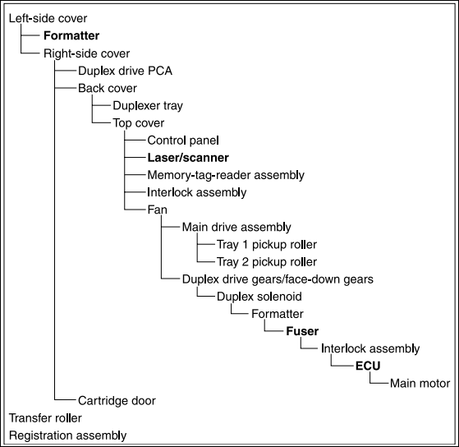
Covers:
Left-side cover
1. Open the print-cartridge door.
2. At the back of the printer, use a flat-blade screwdriver to release two tabs (1).
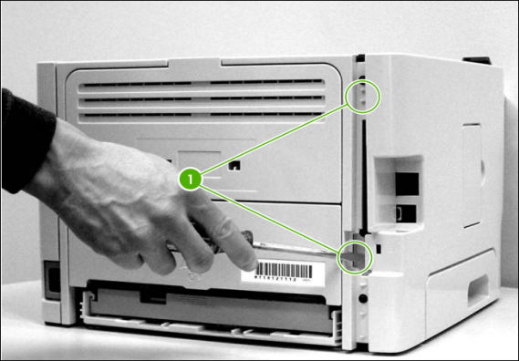
Figure 2-1 Removing the left-side cover (1 of 2)
3. Lift the cover away from the printer.
Right-side cover
1. Open the print-cartridge door.
2. Remove tray 2.
3. At the front of the printer, pop the front edge of the right-side cover over the two retaining tabs.
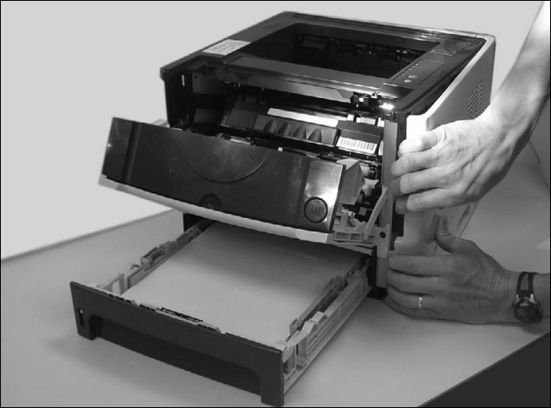
Figure 2-2 Removing the right-side cover
4. Lift the cover away from the printer.
Back cover
1. Remove tray 2.
2. Remove the left-side cover and the right-side cover.
3. Remove four screws (1).
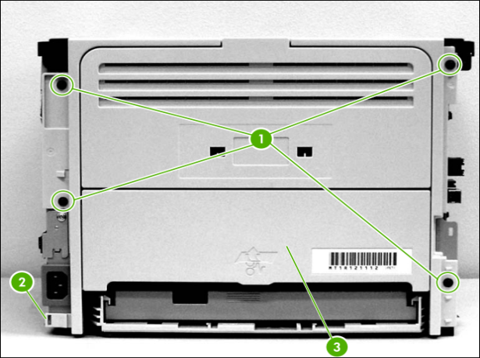
Figure 2-3 Removing the back cover (1 of 2)
4. Tip the printer so that it rests on its front.
5. Release the tab (2) at the back of the printer on the right side.
6. Open the duplex access door (3).
7. Slide the cover toward the right side of the printer to clear the tab (1) on the duplexer tray (duplex models only).
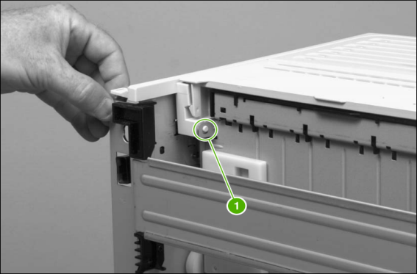
Figure 2-4 removing the back cover (2 of 2)
8. Lift the cover straight up and away from the printer.
Duplexer tray (HP LaserJet P2015d, P2015dn, and P2015x printers only)
1. Remove the left-side cover, the right-side cover, and the back cover.
2. Pull the duplexer tray release-tab (1) to release the duplexer tray magnets.
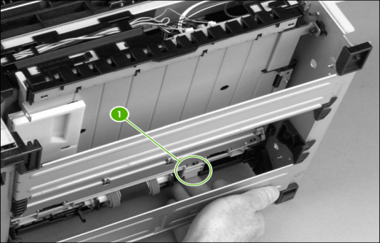
Figure 2-5 removing the duplexer tray
3. Pull out the duplexer tray.
Top cover
1. Remove the left-side cover, the right-side cover, the back cover, and the duplexer tray.
2. Remove two screws (1) at the back of the printer.
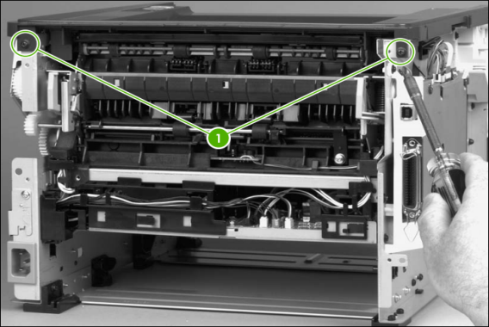
Figure 2.6 removing the top cover (1 of 4)
3. Remove one screw (1) on the left side of the printer, and remove one screw (2) on the right side of the printer.

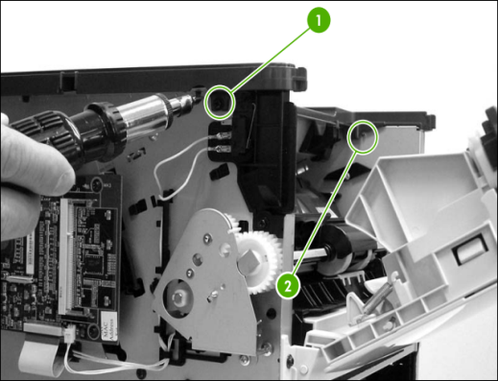
Figure 2-7 removing the top cover (2 of 4)
4. Release the control-panel cable (1) on the left side of the printer.
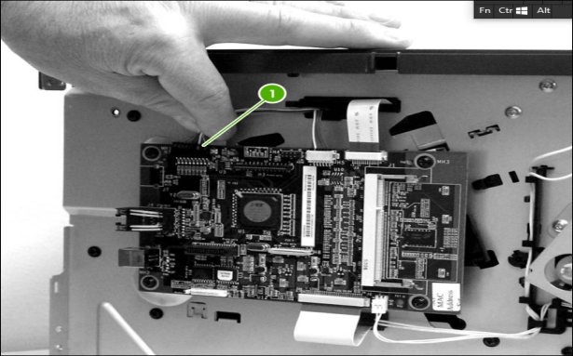
Figure 2.8 removing the top cover (3 of 4)
5. Lift the top cover off the printer.
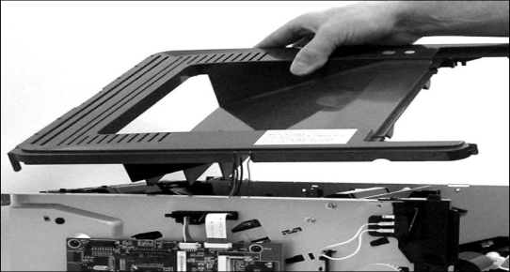
Figure 2.9 removing the top cover (4 of 4)
Control panel
1. Remove all covers.
2. On the bottom of the top cover, remove two screws (1).
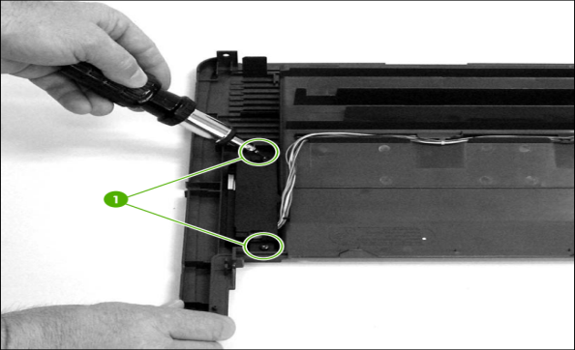
Figure 2.10 removing the control panel (1 of 2)
3. Remove the control-panel wires from the wire guides.
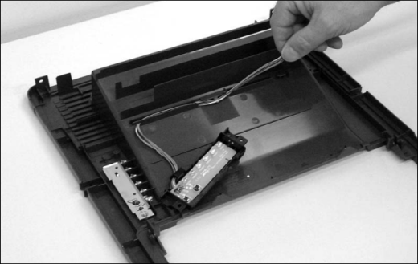
Figure 2.11 removing the control panel (2 of 2)
Formatter
1. Remove the left-side cover.
2. Disconnect one cable (1) at the top of the formatter.
3. Disconnect one flat, flexible cable (2) at the top of the formatter.
CAUTION do not fold flat, flexible cables. Also, do not straighten pre-folds in flat, flexible cables.
4. Disconnect one flat, flexible cable (3) at the bottom of the formatter.
5. Disconnect one cable (4) at the bottom of the formatter.
6. Remove four screws (5).
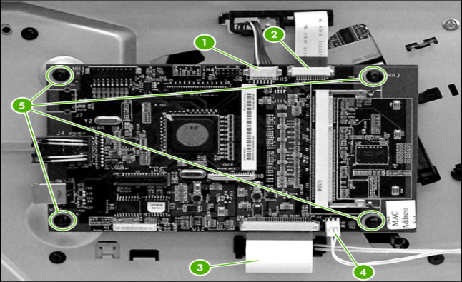
Figure 2.12 removing the formatter
7. Remove the formatter.
Laser/scanner
1. Remove all covers.
2. Disconnect one flat, flexible cable (1) from the laser/scanner PCA.
3. Disconnect one cable (2) from the top of the laser/scanner.
4. Unthread all cables (3) from the laser/scanner cable guides.
NOTE Examine the cable routing as you unthread the cables.
5. Remove four screws (4).
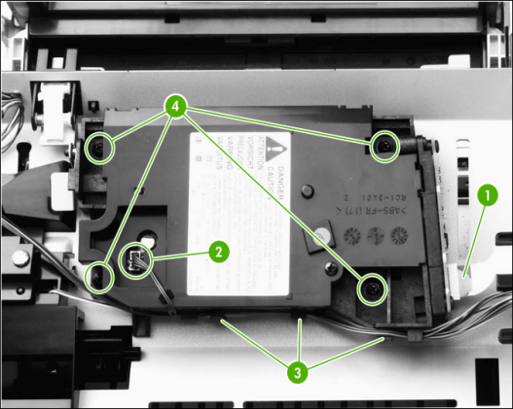
Figure 2.13 removing the laser/scanner
6. Lift the laser/scanner out of the printer.
NOTE Examine the shutter switch as you lift the laser/scanner out of the printer.
Memory-tag-reader assembly
1. Remove all covers.
2. Remove the fan from the printer chassis.
3. Remove one cable (1) from the top of the memory-tag-reader cover.
4. Disconnect one cable (2) from the formatter.
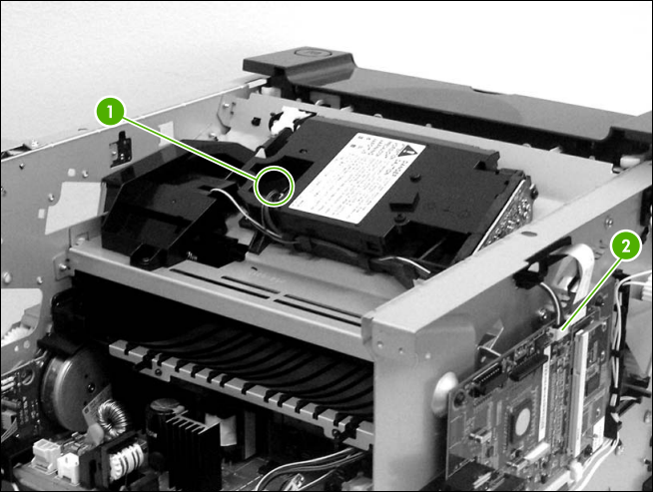
Figure 2.14 removing the memory-tag-reader assembly (1 of 2)
5. Remove one screw (1).
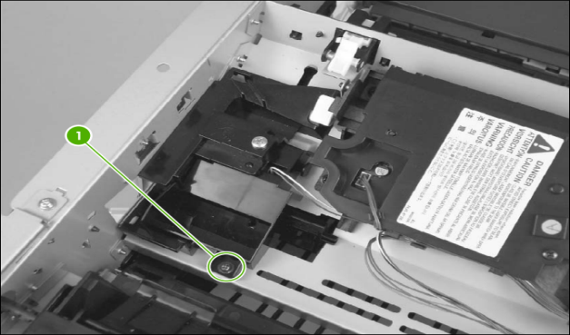
Figure 2.15 removing the memory-tag-reader assembly (2 of 2)
6. Lift the back of the memory-tag-reader assembly slightly, and then slide the assembly toward the back of the printer to release it from the laser/scanner plate.
Duplex-drive PCA (HP LaserJet P2015d, P2015dn, and P2015x printers only)
1. Remove all covers.
2. Disconnect the duplex-drive cable (1) at the ECU, and then route the cable through the hole in the chassis.
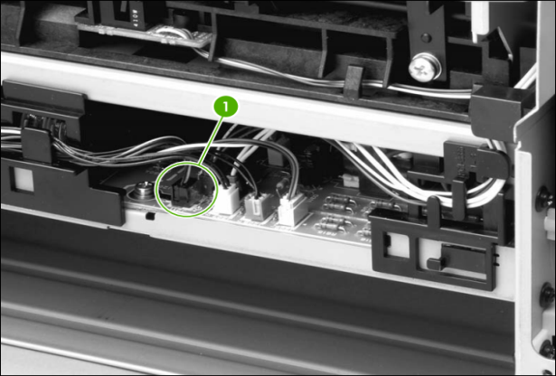
Figure 2.16 removing the duplex-drive PCA (1 of 2)
3. Disconnect one cable (1) from the duplex-drive PCA.
4. Remove one screw (2), and then lift the duplex-drive PCA off the printer.
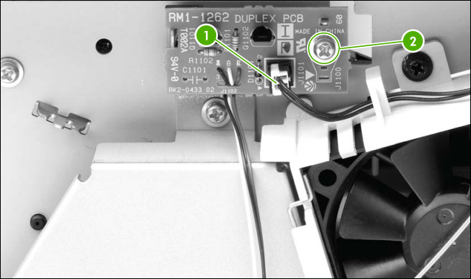
Figure 2.17 removing the duplex-drive PCA (2 of 2)
Fuser
Several parts must be removed before you can remove the fuser. The following parts are included in this section about removing the fuser:
● Fan
● Duplex-drive gears/face-down gears
● Duplex solenoid
● Fuser
Fan
1. Remove all covers.
2. Disconnect the fan cable (1) at the ECU.
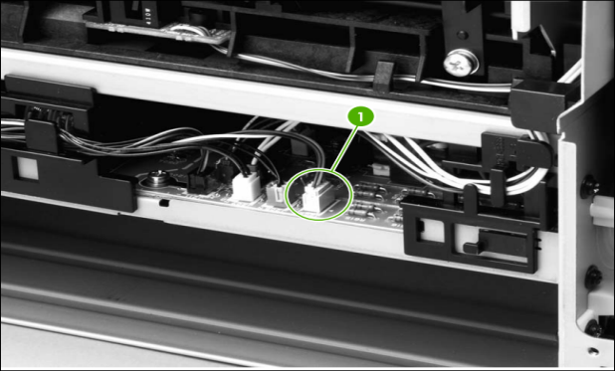
Figure 2.18 removing the fan (1 of 2)
3. Unthread the fan wires from the retaining clips.
4. Remove two screws (1).
5. Unhook the fan clip (2) and then lift the fan off the printer.
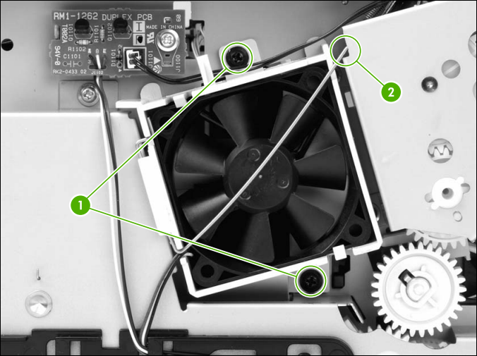
Figure 2.19 removing the fan (2 of 2)
Duplex-drive gears (HP LaserJet P2015d, P2015dn, and P2015x printers only)
1. Remove all covers.
2. Remove the fan.
3. Remove three screws (1).
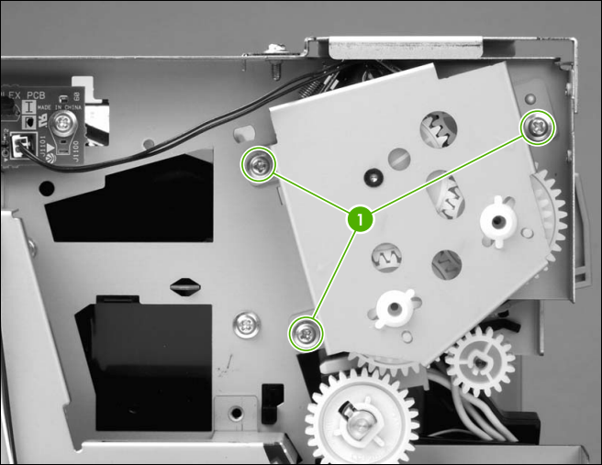
Figure 2.20 removing the duplex-drive gears (1 of 2)
4. Lift the assembly away from the printer.
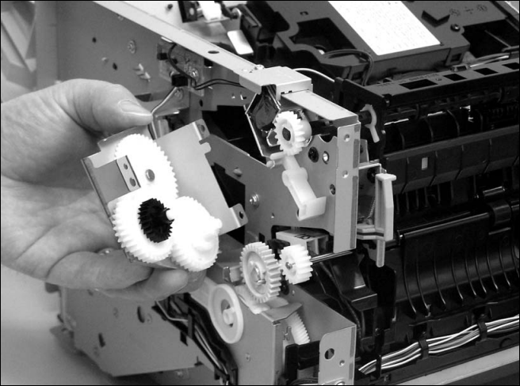
Figure 2.21 removing the duplex-drive gears (2 of 2)
NOTE the gears are not attached to the gear plate. Carefully remove the gear plate and the gears together to prevent them from falling out of the assembly.
Duplex solenoid (HP LaserJet P2015d, P2015dn, and P2015x printers only)
1. Remove all covers.
2. Remove the fan.
3. Remove the duplex-drive gears.
4. Disconnect one cable (1) at the duplex-drive PCA.
5. Remove one screw (2), and then lift the solenoid off the printer chassis.
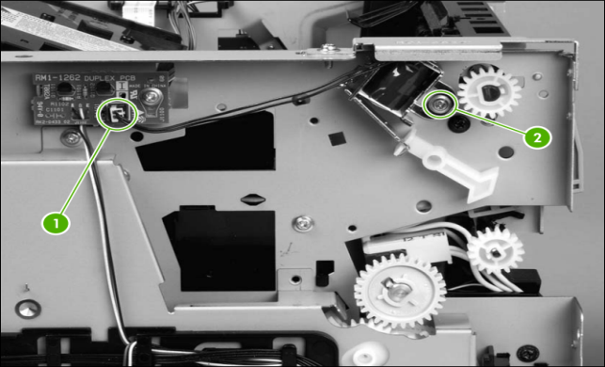
Figure 2.22 removing the duplex solenoid
Fuser
1. Remove all covers.
2. Remove the fan.
3. Remove the duplex-drive gears or face-down gears.
4. Remove the formatter.
5. On the right side of the printer, press the tabs on two gears (1) to release the gears, and then slide the gears off the shafts.
6. Disconnect one cable (2) on the right side of the printer.
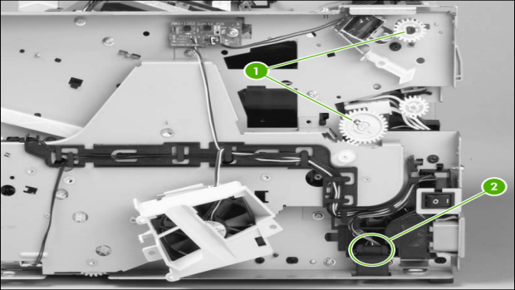
Figure 2.23 removing the fuser (1 of 10)
7. Disconnect four cables (1) from the ECU, and then disconnect two more cables (2) that were behind the first set.
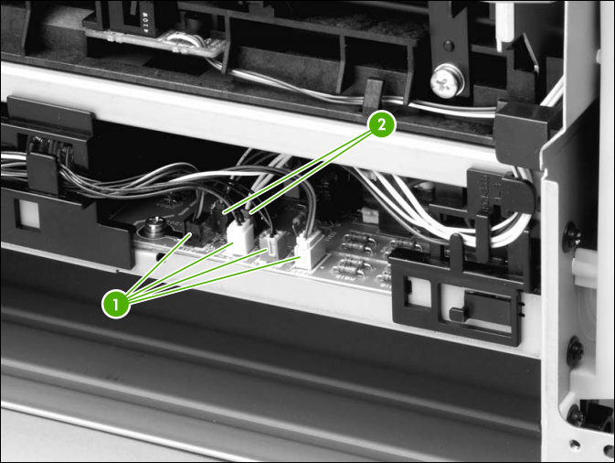
Figure 2.24 removing the fuser (2 of 10)
8. Pull the tab on the cable holder (1) at the left side of the printer and slide it toward the center to release it from the frame, and then unroute the cables.
9. Pull the tab on the cable holder (2) and slide it toward the center to release it from the frame, and then unroute the cables.
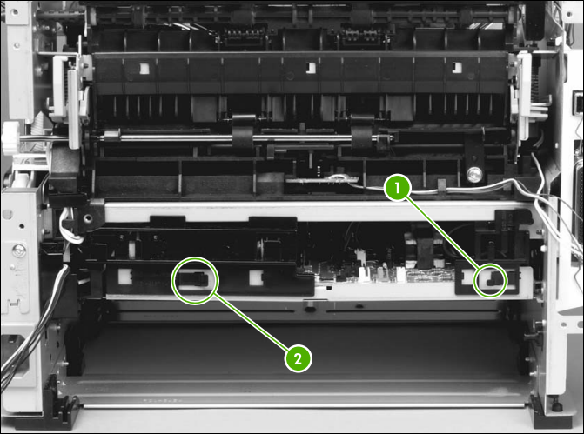
Figure 2.25 removing the fuser (3 of 10)
10. Remove one screw (1) from the fuser cover, and then slide the fuser cover to the right and remove it.
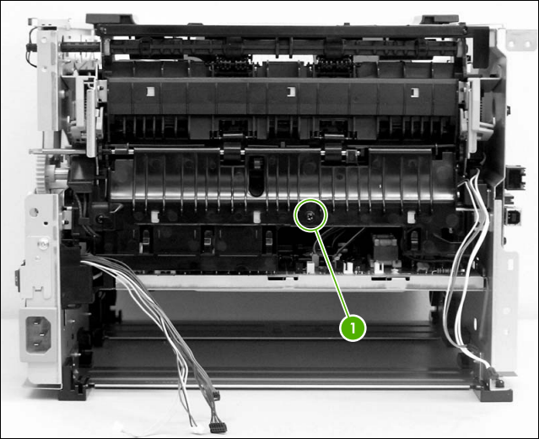
Figure 2.26 removing the fuser (4 of 10)
11. Disconnect three cables (1).
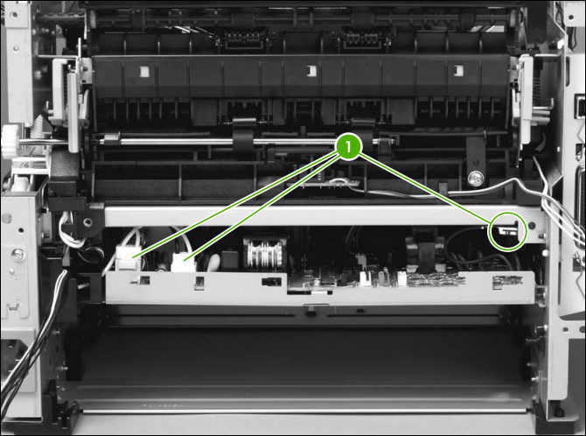
Figure 2.27 removing the fuser (5 of 10)
12. Disconnect one cable (1), and then unroute the cable from the cable guide.
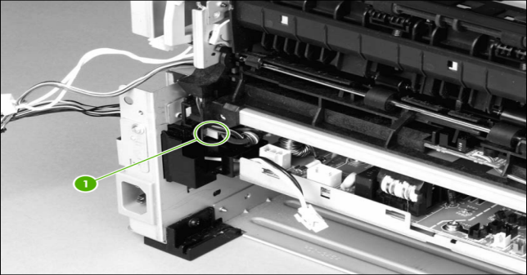
Figure 2.28 removing the fuser (6 of 10)
NOTE before you proceed to step 13, make sure that all cables disconnected in previous steps are free from any cable guides and cable holders.
13. Remove three screws (1) on the right side of the printer.
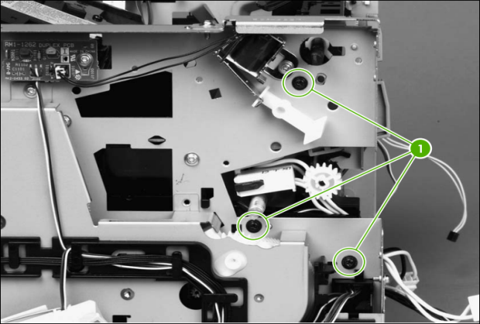
Figure 2.29 removing the fuser (7 of 10)
14. Remove three screws (1) from the left side of the printer.
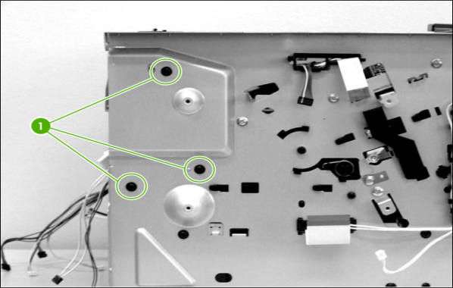
Figure 2.30 removing the fuser (8 of 10)
15. At the left side of the printer, pull the printer chassis from the top to spread the printer frame and release the fuser from the frame.

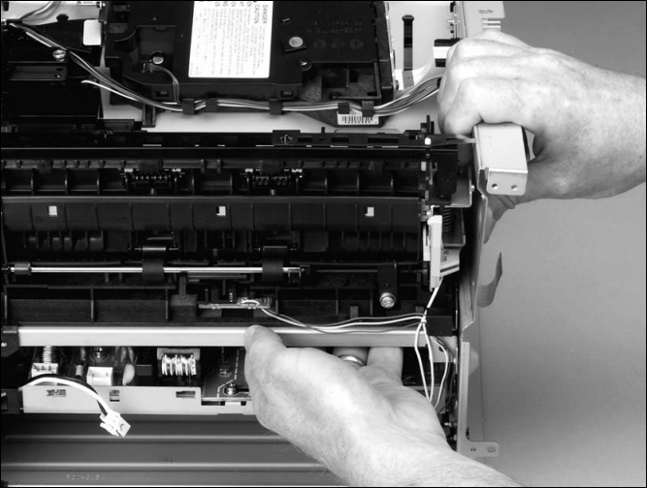
Figure 2.31 removing the fuser (9 of 10)
16. Pull the fuser out of the printer at an angle so that the delivery roller shaft clears the hole (1) in the chassis.
Interlock assembly
1. Remove all covers.
2. Open the print-cartridge door.
3. Remove two screws (1) that secure the interlock assembly to the left side of the printer chassis.
4. Remove two cables (2).
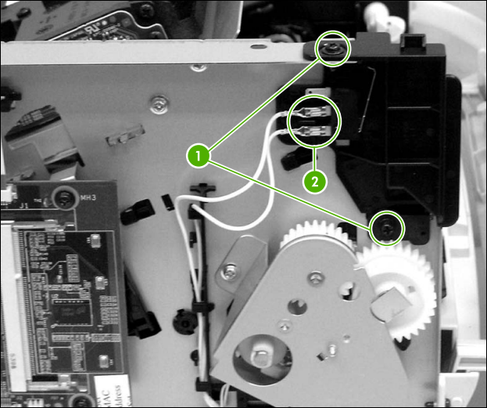

Figure 2.33 removing the interlock assembly (1 of 2)
ECU
1. Remove all covers.
2. Remove the fan.
3. Remove the duplex-drive gears.
4. Remove the formatter.
5. Remove the fuser.
6. Remove the interlock assembly.
7. Remove cables from the cable clip under the feed plate (1), and then remove the feed plate by lifting it and pulling it straight back.
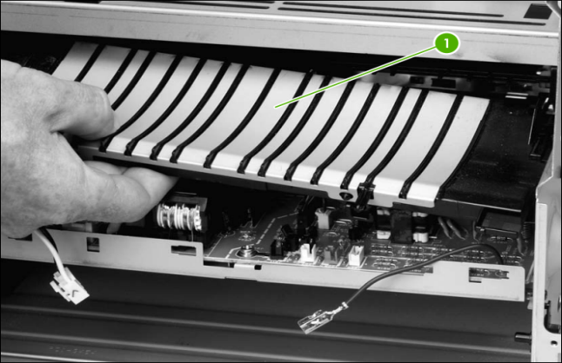
Figure 2.34 Removing the ECU (1 of 7)
8. Disconnect three cables (1).
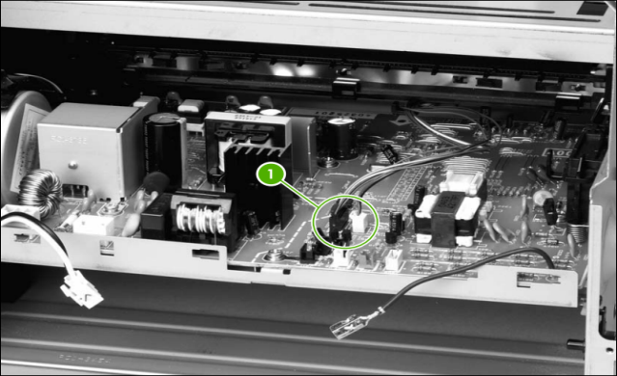
Figure 2.35 Removing the ECU (2 of 7)
9. Remove one screw (4) from the right side of the printer.
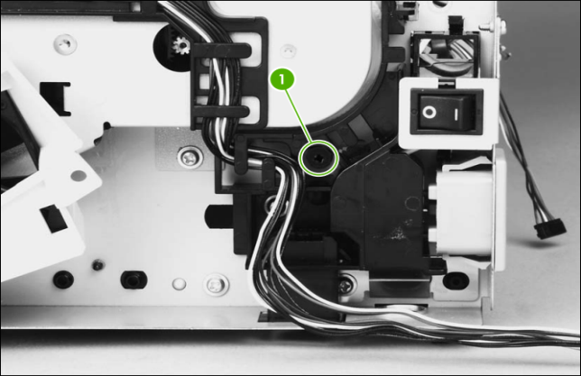
Figure 2.36 Removing the ECU (3 of 7)
10. Remove two screws (1) from the left side of the printer, and then push the interlock cables and the formatter cable (2) through the hole in the chassis.
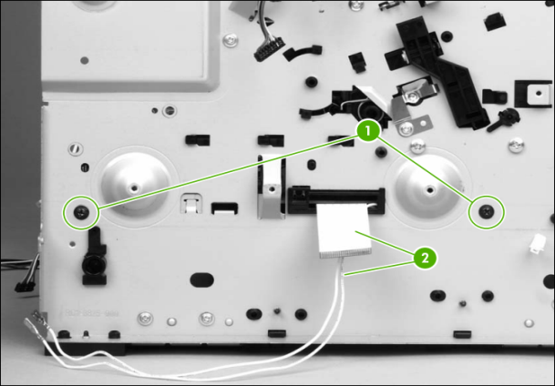
Figure 2.37 Removing the ECU (4 of 7)
11. Spread the printer frame at the right side of the printer to release the internal tabs that secure the ECU to the chassis.
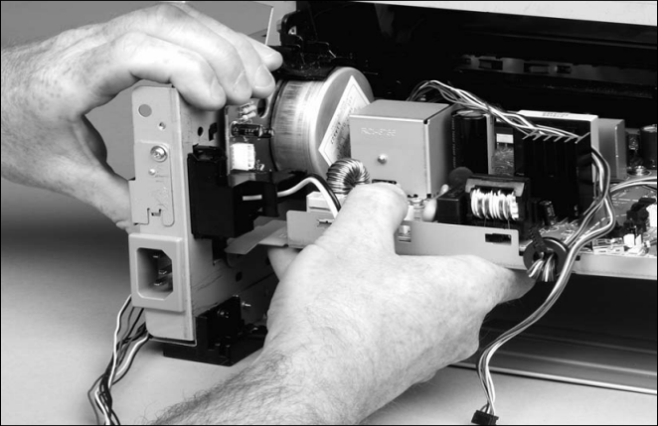
Figure 2.38 Removing the ECU (5 of 7)
12. Spread the printer frame at the left side of the printer to release the internal tabs, and then lower the ECU slightly and pull it straight back to remove it.
NOTE Make sure that cables do not become caught on the contact springs as you remove the ECU.
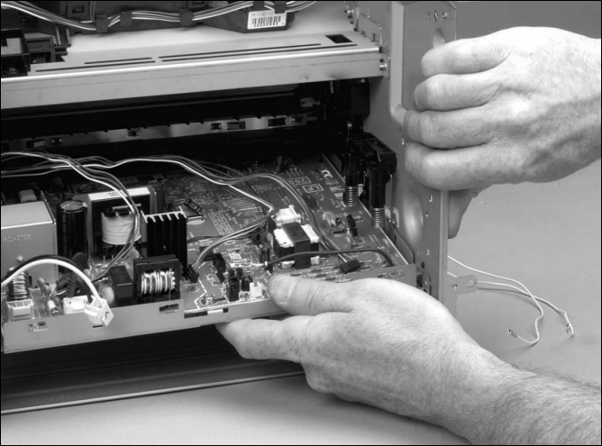
Figure 2.39 Removing the ECU (6 of 7)
Reinstallation tip When replacing the ECU, you might find it easier to find the correct placement of the ECU pan in the printer if you tip the printer so that it rests on its front.
13. Remove four screws (1) and then lift the ECU off the ECU plate.
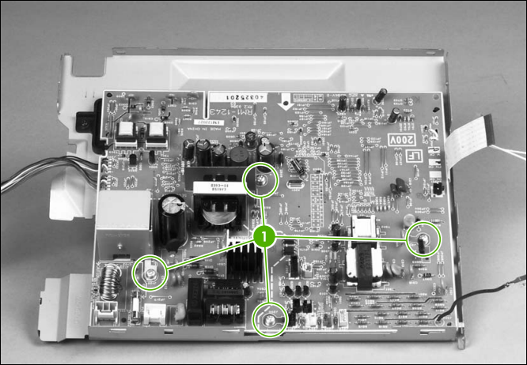
Figure 2.40 Removing the ECU (7 of 7)
Main motor
1. Remove all covers.
2. Remove the fan.
3. Remove the duplex-drive gears.
4. Remove the formatter.
5. Remove the fuser.
6. Remove the interlock assembly.
7. Remove the ECU.
8. Remove three screws (1).
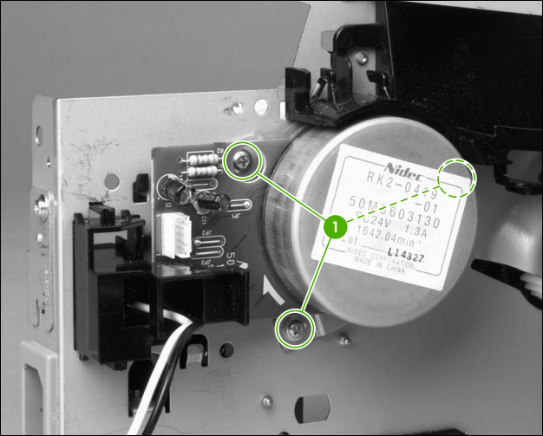
Figure 2.41 removing the main motor (1 of 2)
9. Hold the motor while releasing the tabs (1) on the cable guide, and then lift the motor and the cable guide out of the printer together.
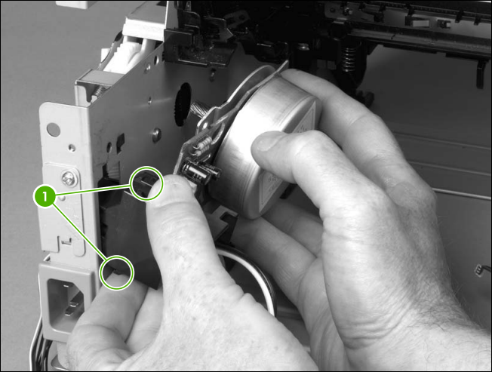
Figure 2.42 removing the main motor (2 of 2)
Pickup and feed assemblies
This section covers the major assemblies of the pickup and feed system: the transfer roller and the registration assembly.
Transfer roller
NOTE It is important to make sure that the transfer roller needs to be replaced before removing it. Excess handling can cause additional damage.
1. Open the print-cartridge door and remove the print cartridge.
2. Use needle-nose pliers to release the transfer roller tabs at the end of the roller, near the right side of the printer.
CAUTION Do not break the tabs, and do not touch the rollers.
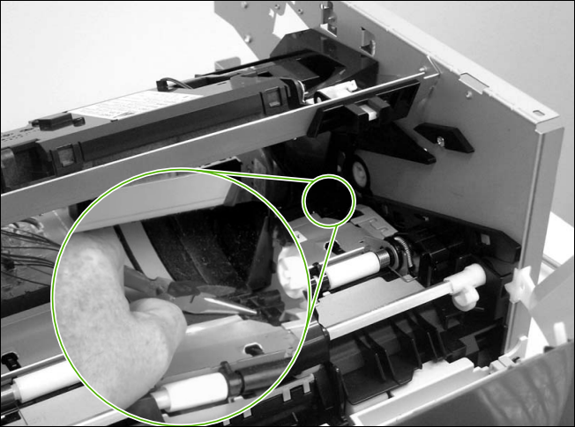
Figure 2.43 removing the transfer roller
3. Lift up the end of the roller near the right side of the printer, and then slide it toward the right side of the printer while pulling it out of the printer.
Registration assembly
1. Remove five screws (1).
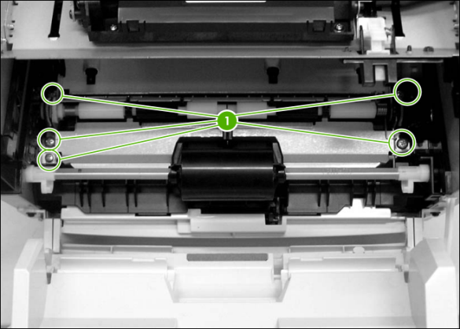
Figure 2.44 removing the registration assembly
2. Lift the entire assembly out of the printer.
Main gear assembly/tray 2 pickup solenoid
1. Remove all covers.
2. Remove the fan from the printer chassis.
3. Disconnect one cable (1) at the ECU.
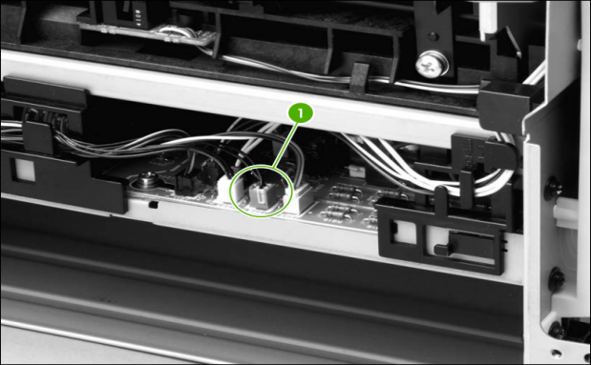
Figure 2.45 removing the main gear assembly (1 of 2)
4. Remove the duplex-drive PCA from the printer chassis.
5. Release the tab on the gear (1) and slide the gear off the shaft.
6. Remove the cables from the cable guide (2).
7. Remove four screws (3).
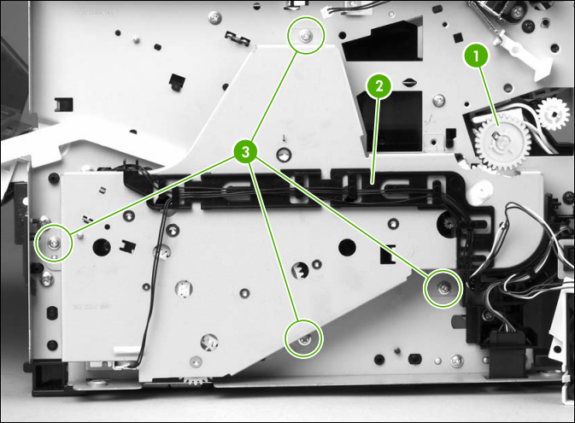
Figure 2.46 removing the main gear assembly (2 of 2)
8. Pull the main gear assembly straight away from the printer.
9. To remove the tray 2 pickup solenoid, disconnect one cable (1).
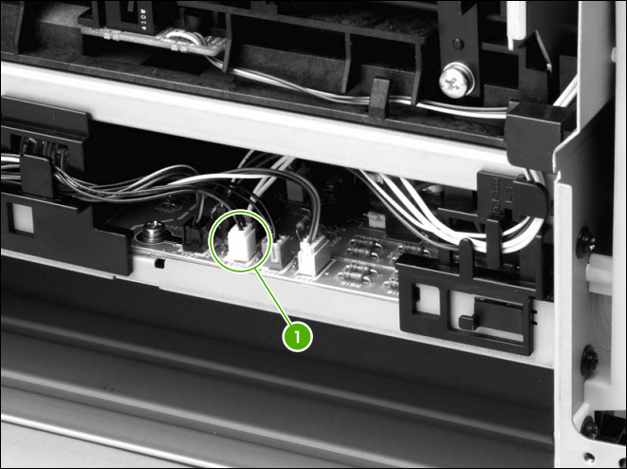
Figure 2.47 removing the tray 2 pickup solenoid (1 of 2)
10. Remove one screw (1), and then lift the solenoid off the printer.
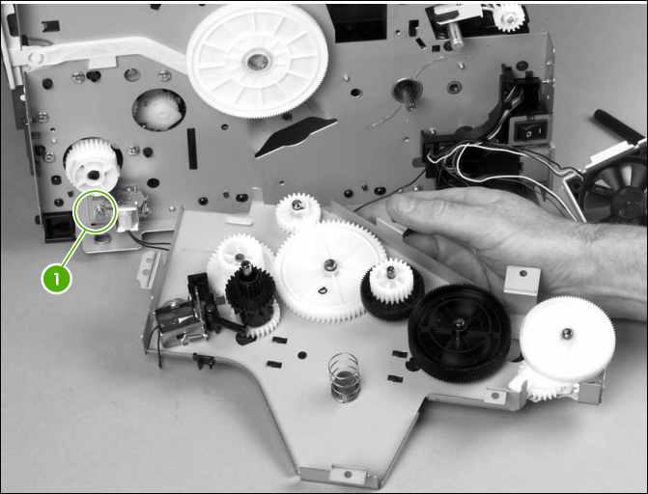
Figure 2.48 removing the tray 2 pickup solenoid (2 of 2)
Print-cartridge door
1. Use a flat-blade screwdriver to gently pry the cartridge-door arm (1) off the print-cartridge door.
CAUTION Be careful not to break the tabs.
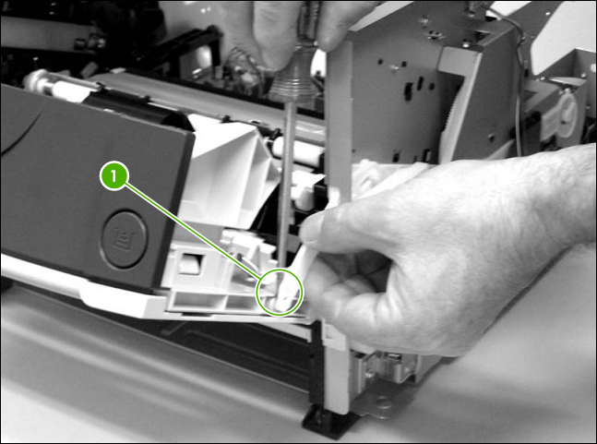
Figure 2.49 removing the print-cartridge door (1 of 2)
2. Remove two screws (2).
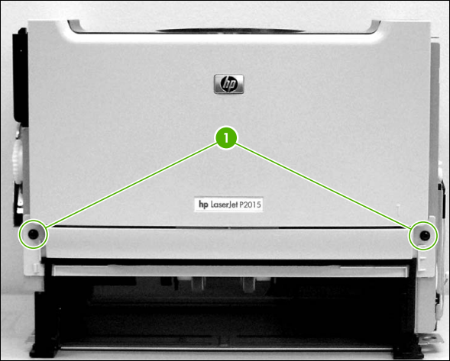
Figure 2.50 removing the print-cartridge door (2 of 2)
3. Lift the cartridge-door assembly straight away from the printer.

Checking and identifying defects and Faults
Faults/defects troubleshooting procedures.
The troubleshooting process is a systematic approach that addresses the major problems first and then other problems as you identify the causes for printer malfunctions and errors. If you know the cause of a problem in the printer system, go directly to that area. Otherwise, use the troubleshooting process diagrams starting on the next page. The diagrams illustrate the major steps for troubleshooting the printing system. In the diagrams each heading depicts a major troubleshooting step. A YES answer to the questions allows you to proceed to the next major step. A NO answer indicates that additional testing is needed. Proceed to the referenced location and follow the directions for that area. After completing the additional testing, proceed to the next major step.
The following lists symptoms and typical solutions to those problems.
Abnormal noises are evident, such as grinding or chattering when main motor energized. From the toner cartridge area:
- Replace the toner cartridge.
- Replace the Main Gear Assembly.
- Verify proper paper loading, acceptable media.
- Inspect the “fingers” on the paper trays to ensure proper paper size detection.
- Replace the Paper Input Unit.(PIU).
- Replace the Main Gear Assembly.
Common printer machine defects/faults
- When the product is connected to a correctly grounded power source, the LEDs on the control panel do not illuminate and the main motor does not rotate. The printer does not turn on.

Cause | Solution
No power to the printer | Verify that the power switch is turned on.
No power to the printer | Verify that the power cable is correctly plugged into the outlet and the printer.
No power to the printer | Verify that the power outlet has the correct voltage.
The power inlet/switch cable assembly is defective | Replace the power inlet/switch cable assembly.
The ECU is defective. | Replace the ECU

- When turned on, the LEDs on the control panel light up, but the main motor does not rotate. The printer turns on, but the motor does not rotate.
Cause | Solution
The print cartridge door is open. | Close the print cartridge door.
Media is jammed in the paper path. | Clear all media from the paper path and make sure that all sensors are working correctly.
The motor cable is not connected correctly. | Reconnect the motor cable.
The motor is not mounted correctly in the printer chassis. | Verify that the motor is connected correctly and that it rotates freely.
A gear is damaged or jammed. | Replace the gear assembly.
The ECU is defective. | Replace the ECU
The main motor is defective. | Replace the motor.
- The printer turns on and the motor rotates, but none of the control panel lights turn on, and pressing the control panel buttons has no effect. The printer is unresponsive.
Cause | Solution
The control panel cable is not connected correctly. | Reconnect the control panel cable.
The control panel is defective. | Replace the control panel.
The formatter is defective. | Replace the formatter.
- The printer is on, but the control panel lights indicate that the printer is not in the "ready" state. The printer is not "ready." The printer does not print.
Cause | Solution
A printer component is defective. | Perform an engine test to verify print-engine components.  1. Press the engine test switch to print an engine test.  2. If the engine test page does not print, check all of the connectors on the ECU and reconnect any cables that are connected incorrectly.  3. If, after checking the connectors, the error persists, replace the ECU.
The formatter is defective. | Press the Go button to print a Demo page. If the Demo page does not print, replace the formatter.
The printer prints the engine test and the Demo page, but does not print jobs sent from a computer. The printer does not print from a computer.
Cause | Solution
The cable is not connected correctly. | Reconnect the cable.
An incorrect printer driver is selected. | Select the correct printer driver.
The printer driver is not installed correctly. | Uninstall and then reinstall the printer software. Make sure that you use the correct procedure and port setting.
Other devices are connected to the printer (for example, through a switch or hub) that are interfering with the computer-printer communications. | Disconnect the other devices, switches, or hubs.
There is a computer-port communications problem. | Reset the computer port settings (see the computer user guide for more information).
The formatter is defective. | Replace the formatter

Status-light patterns andControl settings and adjustments
Status-light patterns
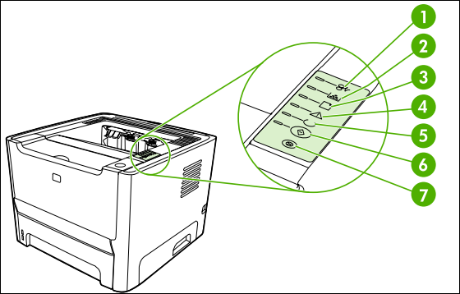
Figure 2.51Status-light patterns

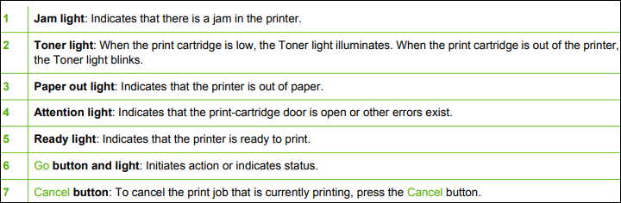
Table 7-2 Status-light legend
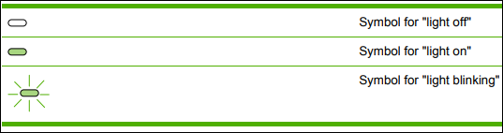
Table 7-3 Control-panel status light patterns
Error code | Pattern | Description | Action
10007 | 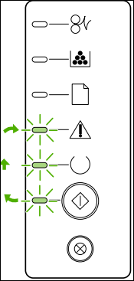 | Initialization/Startup While in the Startup state, the Go, Ready, and Attention lights cycle (at the rate of 500 ms) one after another.  Reconfiguration Initialization During the printer start up, you can request special initialization sequences that reconfigure the printer. When one of the sequences is requested, such as cold reset, the lights cycle as in the Initialization/Startup state.  Job Cancel After the cancellation process has been completed, the printer returns to the Ready state. | During the Initialization, Reconfiguration, and Job Cancel processes, pressing buttons has no effect.

Error code | Pattern | Description | Action
10001 | 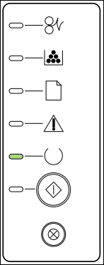 | Ready The printer is ready with no job activity. | To print a Configuration page, press and hold the Go button for 5 seconds. To print a Demo page, press and release the Go button.

Error code | Pattern | Description | Action
10023 | 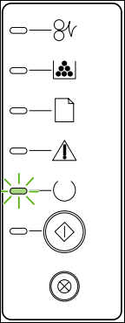 | Processing Data The printer is processing or receiving data. | To cancel the current job, press the Cancel button.

Error code | Pattern | Description | Action
41000 | 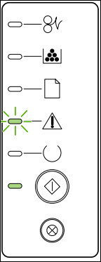 | Manual Feed or Continuable Error This state can be reached in the following circumstances: ● Manual feed ● General continuable error ● Memory configuration error ● Personality/Job-related error | To recover from the error and print whatever data is possible, press the Go button. If the recovery is successful, the printer goes to the Processing Data state and completes the job. If the recovery is unsuccessful, the printer returns to the Continuable Error state.

Error code | Pattern | Description | Action
40021 | 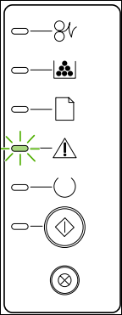 | Attention The print-cartridge door is open. | Close the print-cartridge door.

Error code | Pattern | Description | Action
50003  50005  50006  50007  5000X | 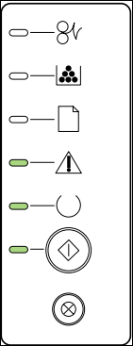  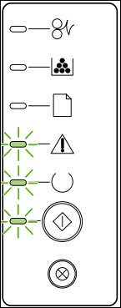 | Fatal Error | ● Turn off the printer, wait 10 seconds, and turn on the printer.  ● Unplug the printer for five minutes. Then plug it back in and turn the power on.  ● If you are unable to resolve the problem, contact HP.
 |  | Accessory Error | To display additional error information, press the Go button. The light pattern changes. When you release the Go button, the printer returns to the initial Accessory Error state.

Error code | Pattern |  | Description | Action
 | 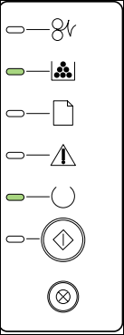 |  | Toner Low The Go, Ready, and Attention lights act independently of the Toner Low state. | Order a new print cartridge and have it ready.
 | 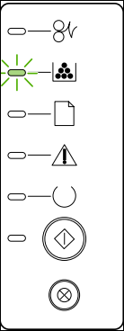 | Toner Missing The print cartridge has been removed from the printer |  | Reinsert the print cartridge in the printer.

Error code | Pattern | Description | Action
40022 | 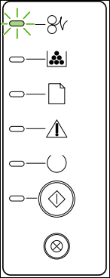 | Jam | Clear the jam.

Error code | Pattern | Description | Action
41900 | 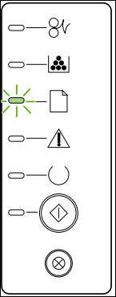 | Paper Out | Load paper or other media.
 | 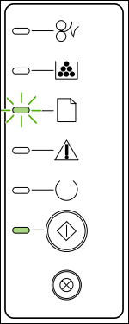 | Paper Mount The loaded paper or other media is not supported. | Load acceptable paper or other media. Press the Go button to override the condition.
Fatal error secondary messages
If the printer has a fatal error, press and hold the Go button to see a secondary error message.
Table 7-4 fatal error secondary messages
Error code | Pattern | Description | Action
55  50007 | 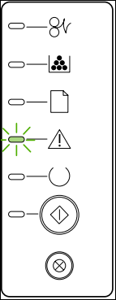 | Engine error. The formatter and engine are not communicating. | 1. Unplug the printer, and then plug it in again.  2. Reseat the formatter cable in the ECU.  3. If the error persists, replace the formatter.  4. If, after replacing the formatter, the error persists, replace the ECU.

Error code | Pattern | Description | Action
52  50005 | 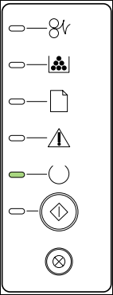 | Laser/scanner error. The laser/scanner has a malfunction. | 1. Check the laser/ scanner cable connections. 2. If the error persists, replace the laser/ scanner

Error code | Pattern | Description | Action
57 | 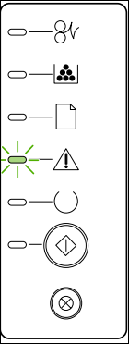 | Fan motor error | 1. Check the fan cable connections. 2. If the error persists, replace the fan.

Error code | Pattern | Description | Action
50XXX | 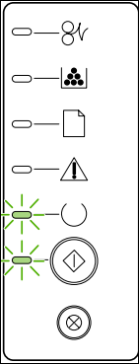 | Fuser error. The fuser has a malfunction. | 1. Unplug the printer for at least ten minutes, and then plug it in again.  2. Verify that the fuser connector and thermistor connector are both firmly seated in the ECU  3. Perform a heating element resistance check.  4. If the resistance readings are correct, but the error persists, replace the fuser.
Accessory error secondary messages
Table 7-5 Accessory error secondary messages
Error code | Pattern | Description | Action
 | 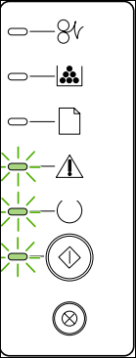 | Accessory error | If the printer has an accessory error, press and hold the Go button to see the secondary error message. Release the Go button to return to the initial accessory error state.
53XXXX  79XXX | 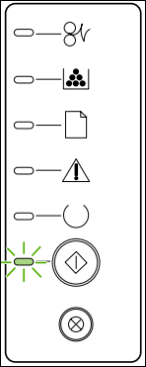 | DIMM slot error | 1. Verify that the DIMM is correctly seated.  2. If the error persists, replace the DIMM.

Problem | Cause | Solution
Poor print quality or toner adhesion | The paper is too moist, too rough, too heavy or too smooth, or it is embossed or from a faulty paper lot. | Try another kind of paper, between 100 and 250 Sheffield, with 4 to 6% moisture content.
Dropouts, jamming, or curl | The paper has been stored incorrectly. | Store paper flat in its moisture-proof wrapping.
Dropouts, jamming, or curl | The paper has variability from one side to the other. | Turn the paper over.
Excessive curl | The paper is too moist, has the wrong grain direction, or is of short-grain construction | Open the rear output bin, or use long grain paper.
Excessive curl | The paper varies from side-to-side. | Turn the paper over.
Jamming, damage to printer | The paper has cutouts or perforations. | Use paper that is free of cutouts or perforations.
Problems with feeding | The paper has ragged edges. | Use high-quality paper that is made for laser printers.
Problems with feeding | The paper varies from side-to-side. | Turn the paper over.
Problems with feeding | The paper is too moist, too rough, too heavy or too smooth, has the wrong grain direction, or is of short-grain construction or it is embossed or from a faulty paper lot. | Try another kind of paper, between 100 and 250 Sheffield, 4 to 6% moisture content.
Problems with feeding |  | Open the rear output bin, or use long grain paper.
Print is skewed (crooked). | The media guides might be incorrectly adjusted. | Remove all media from the input tray, straighten the stack, and then load the media in the input tray again. Adjust the media guides to the width and length of the media that you are using and try printing again.
More than one sheet feeds at one time | The media tray might be overloaded. | Remove some of the media from the tray.
More than one sheet feeds at one time | The media might be wrinkled, folded, or damaged. | Verify that the media is not wrinkled, folded, or damaged. Try printing on media from a new or different package
The printer does not pull media from the media input tray. | The printer might be in manual-feed mode. | Verify that the printer is not in manual feed mode and print your job again.
The printer does not pull media from the media input tray. | The pickup roller might be dirty or damaged | Contact HP Customer Care.
The printer does not pull media from the media input tray. | The paper-length adjustment control in tray 2 or optional tray 3 is set at a length that is greater than the media size | Adjust the paper-length adjustment control to the correct length.
The printer does not pull media from media input tray when using the automatic two-sided printing feature. | The automatic two-sided printing media-size selector is not set to the correct page size. | Push in the media selector for letter/ legal-size media. Pull out the mediasize selector for A4-size media.

Operating the unit to confirm defects
This section includes five functional checks for troubleshooting.
Engine test
The engine test is used to verify that the print engine is functioning correctly. The formatter is bypassed during an engine test, so the engine test is useful for isolating printer problems.
The engine test prints horizontal lines down the entire printable area of a page and is also useful for checking and adjusting registration.
NOTE The formatter must be connected to the ECU to perform an engine test.
Half self-test functional check
The print process can be subdivided into the following stages:
- Image formation stage (charges the drum and writes a latent image to the drum with the laser)
- Development stage (forms a toner image on the drum)
- Transfer stage (transfers the image to paper)
- cleaning stage (removes excess toner from the drum)
- fusing stage (applies heat and pressure to make the image on paper permanent)
To perform a half self-test check
The purpose of the half self-test check is to determine which process is malfunctioning.
- Print a configuration page.
- Open the print cartridge access door after the paper advances halfway through the printer (approximately five seconds after the motor begins rotating). The leading edge of the paper should have advanced past the print cartridge.
- Remove the print cartridge.
- Open the print cartridge drum shield to view the drum surface. If a dark and distinct toner image is present on the drum surface, assume that the first two functions of the electroph otographic process are functioning (image formation and development).
- Troubleshoot the failure as a transfer or fusing problem.
To perform other checks
- If there is no image on the photosensitive drum, perform these checks:
- Make sure you removed the entire length of the sealing tape from the print cartridge before you installed the cartridge.
- Perform a drum rotation functional check to ensure that the drum is rotating (see Drumrotation functional check).
- Perform a high-voltage power-supply check. (See below.)
Drum rotation functional check
The photosensitive drum, located in the print cartridge, must rotate for the print process to work. The photosensitive drum receives its drive from the main drive assembly.
This test is especially important if refilled print cartridges have been used.
1. Open the print-cartridge door.
2. Remove the print cartridge.
3. Mark the drive gear on the cartridge with a felt-tipped marker. Note the position of the mark.
4. Install the print cartridge and close the print-cartridge door. The startup sequence should rotate the drum enough to move the mark.
5. Open the print-cartridge door and inspect the gear that was marked in step 3. Verify that the mark moved.
If the mark did not move, inspect the main drive assembly to make sure that it is meshing with the print cartridge gears. If the drive gears appear functional and the drum does not move, replace the print cartridge.
Heating element check
Paper passes between the heating element and a soft pressure roller to fuse toner to the paper.
1. Unplug the printer for at least ten minutes.
2. Verify that the thermistor connector is seated into both the printer chassis and the ECU.
3. Remove the heating element connector from the ECU. To measure the continuity of the heating element, measure the resistance between the two pins at the end of the cable.
NOTENormal resistance is 25 ohms +/- 10 ohms for the 110 V printer and 80 ohms +/- 20 ohms forthe 220 V printer.
If no resistance is measured, replace the fuser.
- Remove the thermistor connector, and then measure the resistance between J206 pins one and two and between J206 pins three and four.
Normal resistance between both pairs of pins is 370K ohms +/- 50K ohms at 20° C (68° F).
5. If no resistance is measured, replace the fuser.
High-voltage contacts check
The high-voltage contacts in the printer must have a good connection with the contacts on the print cartridge to provide the necessary voltages for the electrophotographic processes.
To check the print cartridge contacts
Remove the print cartridge and visually inspect the three connection points on the ends of the print cartridge: drum ground (callout 1), charging (callout 2), and developing roller (callout 3). If they are dirty or corroded, clean the connection. If they are damaged, replace the print cartridge.
Use only isopropyl alcohol to clean the connections.
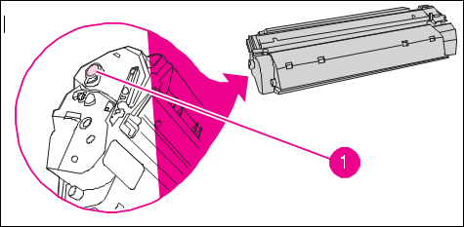
Figure 2.52.Print cartridge high-voltage connection points (right side)

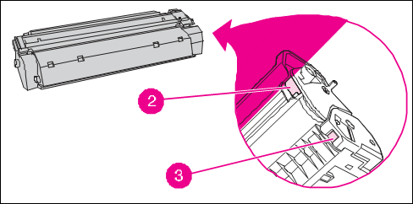
Figure 2.52Print cartridge high-voltage connection points (left side)

To check the high-voltage connector assembly
Visually inspect the cartridge connection points inside the printer to make sure that that they are not dirty or corroded. If the pins are dirty, clean them using isopropyl alcohol only.

Documenting diagnosis and test Results
Job Report Sheets
Job report sheets are essential documents that record all the necessary details about a specific repair or maintenance task.
- These sheets include information such as
- The customer's contact details,
- printer model,
- Problem description, and
- Any additional notes.
Job report sheets serve as a reference for technicians, enabling them to track the progress of each job and ensure that all necessary steps are taken to resolve the issue.
Job Order
A job order is a formal document that authorizes the initiation of a repair or maintenance task.
- the customer's request,
- the estimated time required for completion, and
- Any special instructions.
Job orders help technicians prioritize tasks, allocate resources effectively, and ensure that all customer requests are addressed promptly.
Bill of Materials
The bill of materials (BOM) is a comprehensive list of all the components and parts required for a specific repair or maintenance task.
- Part numbers,
- Descriptions,
- Quantities, and
- Sometimes even prices.
The BOM helps technicians ensure that they have all the necessary parts readily available, reducing the time spent searching for components and improving overall efficiency.
Customer Index
A customer index is a database or record that contains information about all the customers who have availed of the printer service or repair.
- Contact information,
- Service history, and
- Any specific preferences or requirements.
The customer index helps technicians provide personalized service, track customer interactions, and maintain a strong customer relationship.

Informing Customers about the status and serviceability of the unit
History of Verifying Repair/Maintenance
In the field of mobile phone service and repair, it is crucial to properly verify the repair and maintenance history of a unit before proceeding with any further work. This verification process ensures that technicians have a comprehensive understanding of the unit's previous issues, repairs, and maintenance, enabling them to make informed decisions and provide effective solutions.
Identification of the Unit
The first step in verifying the repair/maintenance history of printer unit is to accurately identify the unit.
This involves recording the unique identifiers such as
- Serial number, or
- Model number.
Gathering Information from the Customer
Once the unit is identified, technicians should engage in a detailed conversation with the customer to gather information about the unit's repair and maintenance history.
This information may include
- Previous issues,
- Repairs performed,
- Parts replaced, and
- Any recurring problems.
Reviewing Service Records:
Service centers often maintain detailed service records for each unit they have serviced.
These records include
- information about the repairs performed,
- parts replaced, and
- Any additional notes or recommendations from previous technicians.
Technicians should review these service records to gain a comprehensive understanding of the unit's repair/maintenance history. This step helps identify any recurring issues, patterns, or unresolved problems that may require special attention.
Checking Manufacturer's Database
- In addition to service records, technicians should also check
- The manufacturer's database for any available information about the unit.
- Manufacturers often maintain databases that store information about each unit's history, including repairs performed at authorized service centers.
Accessing this database can provide valuable insights into the unit's repair/maintenance history and any specific recommendations or updates from the manufacturer.

Self-check.2.1
True/False:
- Compliance with laser safety regulations is mandatory only for products marketed in the United States.
- Personal protective equipment (PPE) is not necessary for printer service and repair.
- The visual inspection of the printer is performed with the power turned on.
- It is recommended to remove all non-HP components from the printer before troubleshooting a problem.
- The top cover of the printer is removed before the left-side cover.
Part I. Multiple Choice:

1. Which of the following is not pre-service procedure you perform before service.
- Remove all media from the product.
- Place the product on an ESD mat.
- Remove the print cartridge.
- Plug the power cord and the interface cable.
2. In the process of printer disassembling which part of the printer is removed at the last stage
  - Left side cover b. Duplexer cover c. Control panel d. Main motor

3. Which of following part may not be removed before you can remove the fuser
        - Print cartridge b. Fan c. Duplex solenoid d. Fuser
4. Which of the following measures are taken when abnormal noises are evident, such as grinding or chattering during the main motorenergized.From the toner cartridge area
- Replace the toner cartridge.
- Replace the Main Gear Assembly.
- Verify proper paper loading, acceptable media.
- Replace the Main Gear Assembly.
- All of the above
5. When the product is connected to a correctly grounded power source, the LEDs on the control panel do not illuminate and the main motor does not rotate. The printer does not turn on. Which of the following alternatives could not be the Coase
- No power to the printer
- The power inlet/switch cable assembly is defective
- The ECU is defective
- Media is jammed in the paper path

6. Which government agency has implemented regulations for laser products?
a) Center for Devices and Radiological Health
b) U.S. Food and Drug Administration
c) U.S. Department of Health and Human Services
d) Radiation Control for Health and Safety Ac
7. What is the purpose of personal protective equipment (PPE) in printer service and repair?
a) Enhance printer performance
b) Improve print quality
c) Minimize the risk of injury or harm
d) Increase printer speed
8. Which personal protective equipment is used to protect the eyes from potential hazards?
a) Safety glasses or goggles
b) Gloves
c) Electrostatic discharge (ESD) protection
d) Respiratory protection
9. When troubleshooting a printer problem, what should you do first?
a) Conduct an interview with the customer
b) Remove all non-HP components from the printer
c) Perform a visual inspection of the printer with power off
d) Disassemble the unit
10. What tool is needed to remove the top cover of the printer?
a) #2 Phillips screwdriver with magnetic tip
b) Small flat-blade screwdriver
c) Small needle-nose pliers
d) ESD mat
11. How should parts be replaced during disassembly?
a) In random order
b) In the order of their removal
c) Start with the smallest parts and work your way up
d) Replace them all at once
12. What should you do before servicing the printer?
a) Remove all media from the product
b) Place the product on an ESD mat
c) Unplug the power cord and the interface cable
d) All of the above
13. Which cover is removed first during disassembly?
a) Left-side cover
b) Right-side cover
c) Back cover
d) Top cover
14. How should wire harnesses be replaced?
a) Use the provided wire loops, lance points, or wire harness guides
b) Cut and replace the wires individually
c) Use any available wires as long as they fit
d) Avoid replacing wire harnesses if possible
15. What is the purpose of an ESD wrist strap?
a) Protect the printer from static electricity
b) Prevent damage to sensitive electronic components
c) Improve print quality
d) Increase printer speed
Part II. March the items in B with the proper items in A

A | B
------1. Poor print quality or toner adhesion | - Clear the jam.
------2. Problems with feeding | - Turn off the printer, wait 10 seconds
------3. The formatter is defective. | - The paper has ragged edges.
------4. Fatal Error | - The paper is too moist
------5. Error code40022 | - Replace the formatter

Match the following personal protective equipment with its purpose:
- Safety Glasses or Goggles a) Protect against chemical splashes
- Gloves b) Prevent hearing damage
- Electrostatic Discharge (ESD) Protection c) Shield the hands from cuts and abrasions
- Respiratory Protection d) Prevent damage to electronic components
- Hearing Protection e) Protect the eyes from potential hazards
Part III Fill in the blank

1. The -----------------------test prints horizontal lines down the entire printable area of a page and is also useful for checking and adjusting registration

2. List the drum rotation functional check tests
----------------------------------------------------------.
----------------------------------------------------------.
----------------------------------------------------------.
----------------------------------------------------------.
----------------------------------------------------------.

3. List the Common issues to be looked during visual inspection
----------------------------------------------------------.
----------------------------------------------------------.
----------------------------------------------------------.
4. The laser printer is certified as a "Class 1" laser product under the __________ Radiation Performance Standard.
5. Personal protective equipment (PPE) should be selected based on the __________ assessment.
6. When troubleshooting a printer problem, it is important to conduct a __________ with the customer to gather information.
7. During disassembly, it is crucial to note the length, diameter, color, type, and location of each __________.
The __________ cover is removed first during the disassembly of the printer.

Operation Sheet 2.1
Operation Title: Printer Service and Repair
Instructions:
- Follow the recommended procedures and precautions outlined in this document.
- Use the appropriate personal protective equipment (PPE) to ensure safety.
- Refer to the provided tools list for required equipment during the service and repair.
Precautions:
- Ensure the printer is powered off and unplugged before beginning any service or repair.
- Be cautious of sharp edges and take necessary measures to avoid injury.
- Handle electrostatic discharge (ESD)-sensitive parts with care and use an ESD-protected workstation or mat.
Tools and Requirements:
- #2 Phillips screwdriver with magnetic tip
- Small flat-blade screwdriver
- Small needle-nose pliers
- ESD mat
- Penlight
Procedures:
- Perform preliminary operating checks to ensure the printer is maintained andin proper condition.
- Conduct a visual inspection of the printer with power off, looking for any physical damage or irregularities.
- Interview the customer to gather information about the printer's history and specific issues.
- Disassemble the unit following the recommended removal and replacement strategy.
- Replace parts in the reverse order of their removal, taking note of screw locations and using provided wire loops or harness guides.
- Reassemble the printer carefully, ensuring all components are properly secured.
- Conduct post-repair tests and checks to verify the printer's functionality.
Quality Criteria:
- The printer should power on and off without any issues.
- Print quality should be consistent and free from defects.
- All buttons, controls, and interfaces should function correctly.
- There should be no abnormal noises or vibrations during operation.
- The printer should successfully complete test print jobs without errors.

UNIT THREE: MAINTAIN AND REPAIR PRINTER
This learning guide is developed to provide you the necessary information regarding the following content coverage and topics:
- Electro-static discharge (ESD) protection procedure
- Replacing Defective parts/components
- soldering/mounting repaired or replaced parts/components
- Testing functionality of repaired part/components
- Cleaning and apply precaution in handling the unit
This guide will also assist you to attain the learning outcomes stated in the cover page. Specifically, upon completion of this learning guide, you will be able to:
- Follow Electro-static discharge (ESD) protection procedure
- Replace Defective parts/components
- Perform soldering/mounting repaired or replaced parts/components
- Perform Testing functionality of repaired part/components
- Perform Cleaning and apply precaution in handling the unit

Electro-static discharge (ESD) protection procedure
The product contains parts that are sensitive to electrostatic discharge (ESD).
- Always service the product at an ESD-protected workstation, or use an ESD mat.
- Watch for the ESD symbol to identify the parts that are sensitive to ESD.
- Protect these parts by using an ESD wrist strap and by placing ESD-sensitive parts into protective ESD pouches
- Electrostatic discharge (ESD) is a significant concern when performing service and repair tasks on printer. ESD can damage sensitive electronic components, leading to malfunctions or permanent failures. This chapter focuses on the ESD protection procedures necessary to prevent ESD-related damage. Here are key considerations for implementing an ESD protection procedure:
- ESD Awareness and Training:
- Provide comprehensive training to technicians on ESD risks, prevention measures, and the importance of following ESD protection procedures.
- Educate technicians about common ESD sources, such as clothing, work surfaces, and tools, and discuss the potential damage caused by ESD.
- ESD-Safe Workspace:
- Establish an ESD-safe workspace dedicated to printer service and repair.
- Ensure that the workspace has proper ESD control measures, including an ESD protective mat or workbench surface, grounded wrist straps, and grounding points.
- Grounding:
- Implement proper grounding procedures to prevent the buildup of static charges. This includes connecting the ESD protective mat, workbench, and grounding points to a reliable grounding system.
- Technicians should wear properly fitted and grounded wrist straps that are connected to the ESD protective mat or workbench.
- ESD-Safe Tools and Equipment:
- Use ESD-safe tools and equipment designed to minimize the risk of ESD. These may include ESD-safe screwdrivers, tweezers, and probes.
- Regularly inspect tools for damage, and replace any worn-out or damaged tools to maintain their ESD protection capabilities.
- ESD Protective Packaging:
- Store and transport sensitive electronic components and devices in ESD protective packaging, such as anti-static bags or containers.
- Use ESD-safe trays or containers to organize and store small electronic components during service and repair tasks.
- ESD Control Measures for Technicians:
- Ensure technicians are properly dressed for ESD protection. This may include wearing ESD-safe footwear, avoiding clothing made of static-generating materials (e.g., wool or synthetic materials), and using ESD-safe smocks or lab coats.
- Minimize movement and friction that can generate static charges, and avoid handling electronic components with bare hands.
- Workstation Maintenance:
- Regularly clean and maintain the ESD control measures in the workspace, including the ESD protective mat, grounding points, and ESD-safe tools.
- Inspect and replace worn-out or damaged ESD control items, such as wrist straps or grounding cords, as needed.
- ESD Audit and Compliance:
- Conduct periodic audits to ensure compliance with ESD protection procedures and identify areas for improvement.
- Implement an ESD monitoring system to regularly measure and verify the effectiveness of ESD control measures.
Maintaining the Printer
Service check points: Periodic replacement parts are the parts that should be inspected and if required, replaced at regular intervals. Failure of these parts can seriously affect the printer’s performance. These parts should be inspected during a regular service visit near the end of the part’s expected life and replaced if found to be worn or damaged.
Periodic inspection of parts
The following parts should be inspected and, if required, replaced after approximately 150,000 pages of use:
- Fuser assembly
- Transfer roller
- Separation pads (tray 1, tray 2, and tray 3)
- Pickup rollers (tray 1, tray 2, and tray 3)
- Output feed rollers (upper and lower)
- Transport belts and rollers
Toner cartridge information Toner cartridges contain components that are sensitive to light, temperature, and humidity. Make sure the user follows the recommendations in this section to ensure the highest quality and longest life of the toner cartridge.
Storage The toner cartridge (C4096A) should not be removed from its package until installation. The shelf life of a cartridge in an unopened package is approximately 2.5 years. The shelf life of a cartridge in an opened package is approximately 6 months. The expiration date of the toner cartridge is stamped on the cartridge box.
CAUTION never ship the printer with a toner cartridge installed. Excessive vibration during shipping can cause toner to leak, contaminating the printer. Never expose the toner cartridge to direct sunlight, or to room light. Bright light and direct sunlight can permanently damage a toner cartridge.
Handling instructions
Before installing a cartridge, evenly distribute the toner..
Do not touch the surface of the photosensitive drum in the cartridge. Protect the drum from light and contamination.
Do not expose the cartridge to unnecessary vibrations or shock.
Do not expose the photosensitive drum to strong light. Blurred areas on the page might indicate that the drum has been exposed to light for too long. This causes permanent damage to the photosensitive drum. Replace the cartridge.
Never manually rotate the drum, especially in the reverse direction; it can cause internal damage and toner spills.
Redistributing the toner when toner is low, faded or light areas might appear on a printed page. To temporarily improve print quality, redistribute the toner. The cartridge will need to be replaced soon. Use the following procedures to redistribute toner.
Step 1 Remove the toner cartridge from the printer.
Step 2 Rotate the toner cartridge and gently shake from side to side to redistribute the toner. (Do not tip the cartridge on end, or it might leak.) If toner gets on clothing, wipe it off with a dry cloth and wash clothing in cold water. (Hot water sets toner into fabric.)
The user-conducted preventive maintenance cycle for printer is every 350,000 images.
The part numbers for the preventive maintenance kits are C3914A for the 100V printers, and C3915A for the 220V printers. The kits contain the following replacement parts: one Fusing Assembly, one Transfer Roller Assembly, and eight Feed/ Separation Rollers [two each for Trays 2, 3, the 2000-sheet Input Tray (Tray 4), and the 2 x 500-sheet Input Tray (Trays 4 and 5)]. The control panel message, PERFORM PRINTER MAINTENANCE, indicates that the 350,000 image maintenance is due. After performing the maintenance procedures:
● Go to the control panel Configuration Menu and set the SERVICE MESSAGE to OFF.
● Reset PAGES SINCE LAST MAINTENANCE:
a. Turn the printer off.
b. Holding down the VALUE - and ITEM - keys, turn the printer back on.
Wait for Reset Maintain/Count to display before releasing the keys.
The default (350,000) maintenance message interval can be set to lesser values if needed (50K, 150K, 250K), for printers requiring more frequent maintenance.
This feature is provided for customers using heavy, rough, or generally out-of-specification media that prematurely wears out the maintenance parts.
Repair of the printer normally begins with a three-step process:
Step 1: Isolate the problem to the major system (the host computer, the network and/or server, or the printer system).
Step 2: Determine if the problem is located in the paper-handling devices or in the printer engine.
Step 3: Troubleshoot the problem.

Replacing Defective parts/components
Once a faulty part is located, repair is usually accomplished by assembly level replacement of Field Replaceable Units (FRUs).
Some mechanical assemblies may be repaired at the subassembly level.
Replacement of components on the printed circuit assemblies is not supported by Hewlett-Packard
Image problem solving
This section provides information about identifying and correcting print defects.
Light print or faded
 | ● The print cartridge is nearing end of life.  ● The media might not meet media specifications (for example, the media is too moist or too rough).  ● If the whole page is light, the print density adjustment is too light or EconoMode might be turned on. Adjust the print density, and disable EconoMode in the printer Properties.
Toner specks
 | The media might not meet Hewlett-Packard's media specifications (for example, the media is too moist or too rough).  ● The printer might need to be cleaned
Dropouts
 | ● A single sheet of media might be defective. Try reprinting the job.  ● The media's moisture content is uneven or the media has moist spots on its surface. Try printing with new media.  ● The media lot is bad. The manufacturing processes can cause some areas to reject toner. Try a different type or brand of media.  ● The print cartridge might be defective
Vertical lines
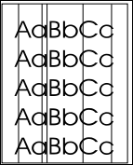 | The photosensitive drum inside the print cartridge has probably been scratched. Install a new HP print cartridge
Gray background
 | ● Make sure that tray 1 is in place. ● Decrease the print density setting through HP ToolboxFX or the embedded Web server. This decreases the amount of background shading. ● Change the media to a lighter basis weight. ● Check the printer's environment. Very dry (low humidity) conditions can increase the amount of background shading. ● Install a new HP print cartridge
Toner smear
 | ● If toner smears appear on the leading edge of the media, the media guides might be dirty. Wipe the media guides with a dry, lint-free cloth. ● Check the media type and quality. ● Try installing a new HP print cartridge. ● The fuser temperature might be too low. In your printer driver, make sure the appropriate media type is selected.
Loose toner
 | ● Clean the inside of the printer. ● Check the media type and quality. ● Try installing a new HP print cartridge. ● In your printer driver, make sure the appropriate media type is selected. ● Plug the printer directly into an AC outlet instead of into a power strip.
Vertical repetitive defects
 | ● The print cartridge might be damaged. If a repetitive mark occurs at the same spot on the page, install a new HP print cartridge. ● The internal parts might have toner on them. If the defects occur on the back of the page, the problem will probably correct itself after a few more printed pages. ● In your printer driver, make sure the appropriate media type is selected.
Misformed characters
 | ● If characters are improperly formed, producing hollow images, the media stock might be too slick. Try a different media. ● If characters are improperly formed, producing a wavy effect, the printer might need service. Print a configuration page. If the characters are improperly formed, contact an HP-authorized dealer or service representative.
Page skew
 | ● Make sure that the media is loaded correctly and the media guides are not too tight or too loose against the media stack. ● The input bin might be too full. ● Check the media type and quality.
Curl or wave
 | ● Check the media type and quality. Both high temperature and humidity cause media to curl.  ● The media might have been in the input tray too long. Turn over the stack of media in the tray. Also, try rotating the media 180° in the input tray.  ● Open the straight-through output door and try printing straight through.  ● The fuser temperature might be too high. In your printer driver, make sure the appropriate media type is selected. If the problem persists, select a media type that uses a lower fuser temperature, such as transparencies or light media.
Wrinkles or creases
 | ● Make sure that media is loaded properly.  ● Check the media type and quality.  ● Open the straight-through output door and try printing straight through.  ● Turn over the stack of media in the tray. Also, try rotating the media 180° in the input tray.  ● For envelopes, this can be caused by air pockets inside the envelope. Remove the envelope, flatten the envelope, and try printing again.
Toner scatter outline
 | ● If large amounts of toner have scattered around the characters, the media might be resisting the toner. (A small amount of toner scatter is normal for laser printing.) Try a different media type.  ● Turn over the stack of media in the tray.  ● Use media designed for laser printers.
Clear jams
Occasionally, media becomes jammed during a print job. You are notified of a media jam by an error in the software and the printer control-panel lights. The following are some of the causes of media jams:
- The input trays are loaded improperly or too full.
- The media does not meet HP specifications.
The printer might need to be cleaned to remove paper dust and other particles from the paper path. There might be loose toner in the printer after a media jam. This toner clears up after a few sheets print
NOTE when you add new media, always remove all of the media from the input tray and straighten the stack of new media. This helps prevent multiple sheets of media from feeding through the printer at one time, reducing media jams.
Print-cartridge area
To clear a jam in the print-cartridge area, perform the following steps
CAUTION
- Do not use sharp objects, such as tweezers or needle-nose pliers, to remove jams.
- Damage caused by sharp objects will not be covered by the warranty.

- Press the print-cartridge-door button, and then remove the print cartridge from the printer.
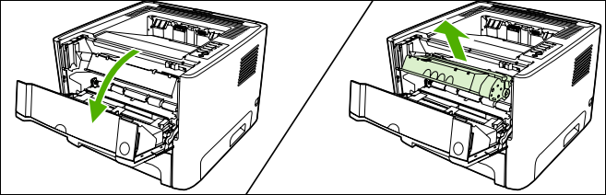
CAUTION To prevent damage to the print cartridge, minimize its exposure to direct light. CAUTION After removing the print cartridge, handle it only on the ends
- Open the straight-through output door.
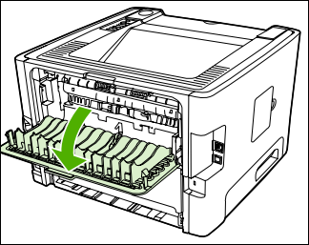
- Pull down the green pressure-release levers.
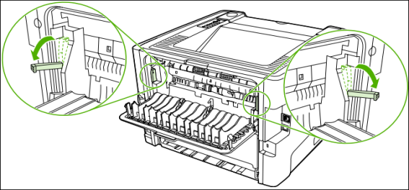
- With both hands, grasp the side of the media that is most visible (this includes the middle), and carefully pull it free from the printer.
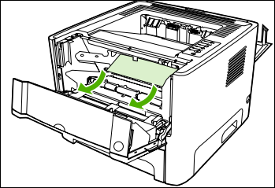
5. Replace the print cartridge, and close the print-cartridge door.
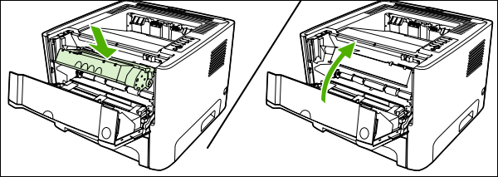
Input trays
To clear a jam in the input trays, perform the following steps:
CAUTION do not use sharp objects, such as tweezers or needle-nose pliers, to remove jams. Damage caused by sharp objects will not be covered by the warranty.
    - Open the straight-through output door.
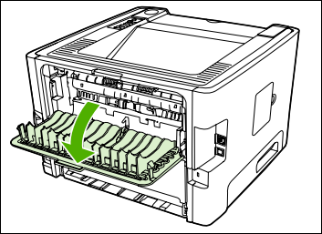
    - Pull down the green pressure-release levers.
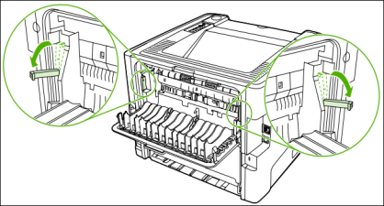
    - Press the print-cartridge-door button, and then remove the print cartridge from the printer.
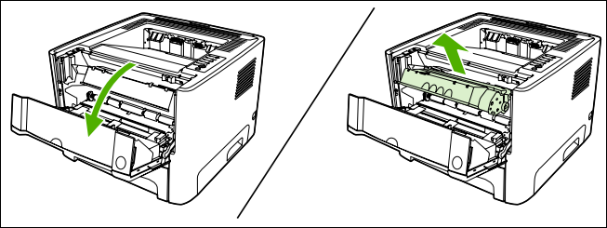
CAUTION After removing the print cartridge, handle it only on the ends.
    - With both hands, grasp the side of the media that is most visible (this includes the middle), and carefully pull it free from the printer.
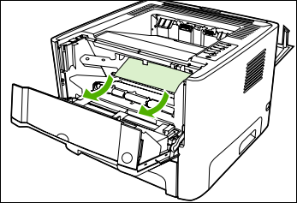
    - Insert the print cartridge in the printer and close the print-cartridge door.
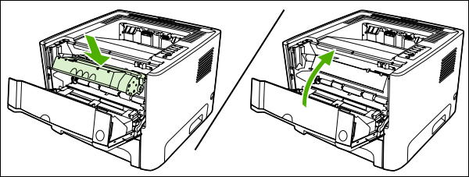
    - Open tray 2.
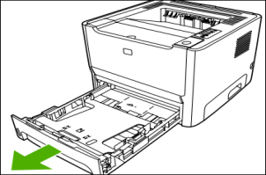
    - With both hands, grasp the side of the media that is most visible (this includes the middle), and carefully pull it free from the printer.
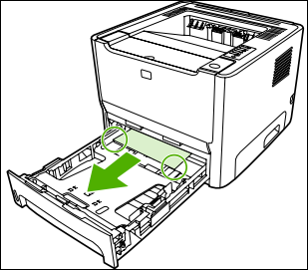
    - If no media is visible, open the print-cartridge door, remove the print cartridge, and pull down the upper media guide. Carefully pull the media up and out of the printer.
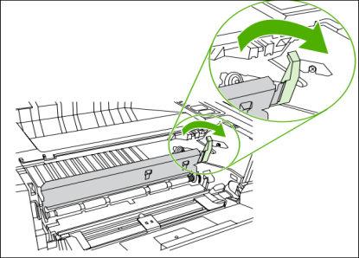
    - Close tray 2.

Output bin
With both hands, grasp the side of the media that is most visible (this includes the middle), and carefully pull it free from the printer.
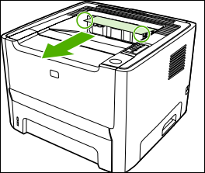
Straight-through output path
To clear a jam in the straight-through output path, perform the following steps:
- Open the straight-through output door.
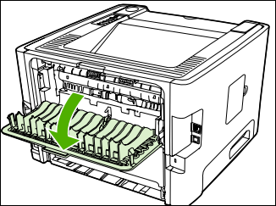
- Pull down the green pressure-release levers.
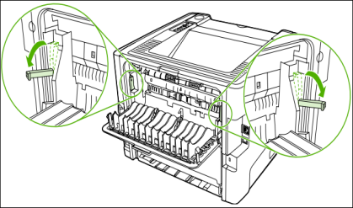
- With both hands, grasp the side of the media that is most visible (this includes the middle), and carefully pull it free from the printer.
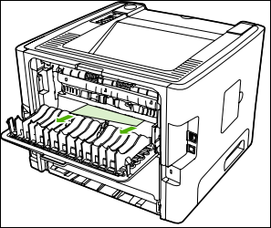
NOTE If you cannot grasp the media with your hands, perform the procedure in Print cartridge area
- Close the straight-through output door.
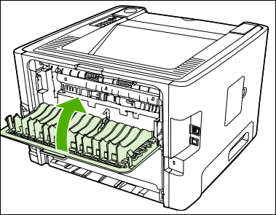
Automatic two-sided printing path
To clear a jam in the automatic two-sided printing path, perform the following steps:
- Open the straight-through output door.
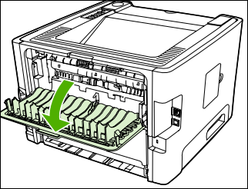
- Pull down the green pressure-release levers.
- Remove tray 2
- Push down on the green lever on the automatic two-sided printing path door on the front of the printer.
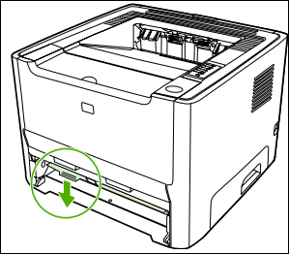
- With both hands, grasp the side of the media that is most visible (this includes the middle), and carefully pull it free from the printer.
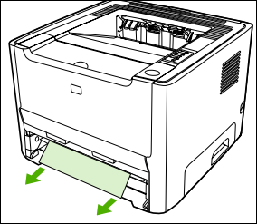
- Close the automatic two-sided printing path door by firmly pushing it up.
- Reinsert tray 2
- Open the automatic two-sided printing path door on the back of the printer.
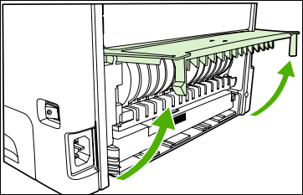
- With both hands, grasp the side of the media that is most visible (this includes the middle), and carefully pull it free from the printer.
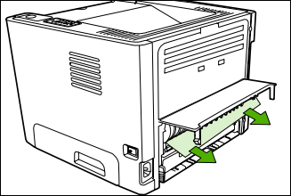
- Close the automatic two-sided printing path door.
Replace the print cartridge
- Press the print-cartridge-door button, and then remove the print cartridge from the printer. For recycling information, see the inside of the print-cartridge box.
- Remove the new print cartridge from the packaging.
- Bend the tab on the left side of the cartridge to break it loose.
- Pull the tab until all the tape is removed from the cartridge. Put the tab in the print-cartridge box to return for recycling
- Gently rock the toner cartridge from front to back to distribute the toner evenly inside the cartridge.
- Insert the print cartridge in the printer and close the print-cartridge door.

Redistribute toner
When toner is low, faded or light areas appear on the printed page. You might be able to temporarily improve print quality by redistributing the toner.
- Open the print-cartridge-door button, and then remove the print cartridge from the printer.
- 2. To redistribute the toner, gently rock the print cartridge from front to back.
- 3. Reinsert the print cartridge into the printer, and close the print cartridge door
- If the print is still light, install a new print cartridge

Clean the printer
During the printing process, paper, toner, and dust particles can accumulate inside the printer. Over time, this buildup can cause print quality problems, such as toner specks or smearing, and paper jams. To correct and prevent these types of problems, you can clean the print cartridge area and the printer media path
Clean the print-cartridge area you do not need to clean the print-cartridge area often. However, cleaning this area can improve the quality of your printed sheets.
- Press the print-cartridge-door button, and then remove the print cartridge from the printer.
- With a dry, lint-free cloth, wipe any residue from the media-path area and the print-cartridge cavity.
- Replace the print cartridge, and close the print-cartridge door.
- Plug the power cord into the printer. Clean the printer media path if you are seeing toner specks or dots on the printouts, clean the printer media path. This process uses a transparency to remove dust and toner from the media path. Do not use bond or rough paper.

Clean the pickup roller (tray 1)
1. Unplug the power cord from the printer, and allow the printer to cool.
2. Press the print-cartridge-door button to open the print-cartridge door.
3. Remove the print cartridge
4 Grasping the pickup-roller cover with thumb and forefinger, squeeze the left side of the pickup roller cover to release the left retaining tab, and then slide the cover to the left and up.
- Press the two black retaining tabs outward until the pickup roller is released from its seat.
- Remove the pickup roller from the printer.
- Dab a lint-free cloth in water, and scrub the roller.
- Using a dry, lint-free cloth, wipe the pickup roller to remove loosened dirt.
- Allow the pickup roller to dry completely.
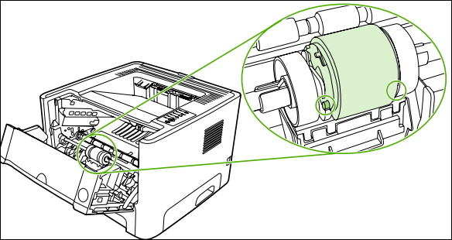
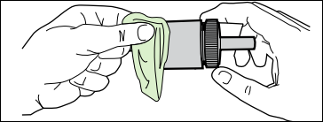
10. Line up the black retaining tabs in the printer with the grooves in the pickup roller, and then press the pickup roller into the pickup-roller seat until the retaining tabs click.
11. Grasping the pickup-roller cover with thumb and forefinger, insert the pickup-roller cover's right retaining tab into the retaining slot
12. Squeeze the left side of the pickup-roller cover and insert the left retaining tab in the retaining slot.
13. Close the print-cartridge door.
14. Plug the printer in.

Replace the pickup roller (tray 1)
- Unplug the power cord from the printer, and allow the printer to cool.
- Press the print-cartridge-door button to open the print-cartridge door. .
- Remove the print cartridge.
- Grasping the pickup-roller cover with thumb and forefinger, squeeze the left side of the pickup roller cover to release the left retaining tab, and then slide the cover to the lef
- 5. Press the two black retaining tabs outward until the pickup roller is released from its seat.
- Remove the old pickup roller from the printer. .
- Line up the black retaining tabs in the printer with the grooves in the new pickup roller, and then press the pickup roller into the pickup-roller seat until the retaining tabs click.
- Grasping the pickup-roller cover with thumb and forefinger, insert the pickup-roller cover's right retaining tab into the retaining slot.
- Squeeze the left side of the pickup-roller cover and insert the left retaining tab in the retaining slot.
- Close the print-cartridge door.
- Plug the printer in

Clean the pickup roller (tray 2)
- Unplug the power cord from the printer, and allow the printer to cool.
- Press the print-cartridge-door button, and then remove the print cartridge from the printer.
- Open the automatic two-sided path door on the front of the printer (HP LaserJet P2015d, HP LaserJet P2015dn, and HP LaserJet P2015x printers only).
- Place the printer on the work surface with the front of the printer facing up
- Pull the white tabs outward, and rotate the tabs up.
- Slide the right tab to the right, and leave the tab in this position throughout the procedure
- Slide the pickup roller assembly to the right, and remove the left end cap.
- Remove the pickup roller.
- Dab a lint-free cloth in water, and scrub the roller.
- Using a dry, lint-free cloth, wipe the pickup roller to remove loosened dirt.
- Allow the pickup roller to dry completely.
- Insert the left side of the pickup roller into the left slot (1), and insert the right side (the side that has the notches in the shaft) into the right slot (2)
- Place the end cap over the shaft on the left side, push the end cap to the right, and rotate the tab downward into position.
- Rotate the shaft until the notches engage and the shaft clicks into place.
- Push the right tab to the left, and rotate the tab downward into position.
- Place the printer on the work surface with the top of the printer facing up.
- Close the automatic two-sided path door

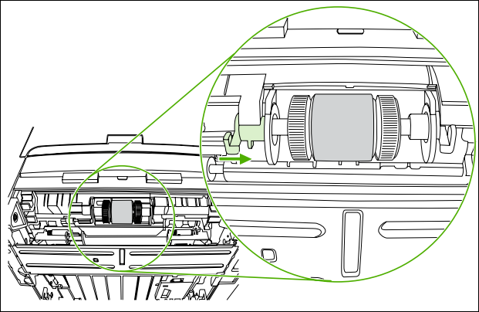
- Reinstall the print cartridge, and close the print-cartridge door. 20. Plug the printer in

Replace the pickup roller (tray 2)
- Unplug the power cord from the printer, and allow the printer to cool.
- Press the print-cartridge-door button, and then remove the print cartridge from the printer
- Remove tray 2
- Open the automatic two-sided path door on the front of the printer (HP LaserJet P2015d, HP LaserJet P2015dn, and HP LaserJet P2015x printers only).
- Place the printer on the work surface with the front of the printer facing up.
- Pull the white tabs outward, and rotate the tabs up.
- Slide the right tab to the right, and leave the tab in this position throughout the procedure
- Slide the pickup roller assembly to the right, and remove the left end cap.
- Remove the old pickup roller
- Insert the left side of the new pickup roller into the left slot (1), and insert the right side (the side that has the notches in the shaft) into the right slot (2).
- Place the end cap over the shaft on the left side, push the end cap to the right, and rotate the tab downward into position.
- Rotate the shaft until the notches engage and the shaft clicks into place.
- Push the right tab to the left, and rotate the tab downward into position.
- Place the printer on the work surface with the top of the printer facing up.
- Close the automatic two-sided path door.
- Reinstall the print cartridge, and close the print-cartridge door.
- Plug the printer in to turn it back on

Testing functionality of repaired part/components
Testing Methods
There are two methods that you can use to find out faulty or damaged componentsina printer.
- The coldtestingmethod
- Thehottestingmethod

TheColdTestingMethod:
Cold testing is when we use a multimeter to check the value of resistance at the timeof repairing a fault in a mobile phone.During cold testing do not power the phonefrom any equipment.Use the diode range and beep sound from the multimeter tofind fault in the printer.During cold testing, you should connect the REDprobe of the multimeter to the ground of the printer PCB, and use the BLACKprobe to touch the testing points of the printer.

HotTesting:
The hot testing method is adopted when the fault cannot be found or when the printer cannot be repaired using the cold testing method. In this method, theVOLTAGE of the damaged part or component is checked. The fault is found bypowering the printer.Once you powerthe printer,youshouldselecttherangeoftheMultimeter.
Then you should connect the BLACK probe of the Multimeter to the ground of the PCBandensurethe‘EDProbetouchestheTestingPoints.

Perform Cleaning and apply precaution in handling the unit
Cleaning the printer and accessories
To maintain superior print quality and performance, use the following procedures to clean the printer and the paper-handling accessories thoroughly every time you change the toner cartridge or whenever print-quality problems occur.
General cleaning
Before you begin these steps, turn the printer off and unplug all power cords to avoid shock hazard.
Do not use ammonia-based cleaners on or around the printer. While cleaning the printer, be careful not to touch the transfer roller (located underneath the toner cartridge). Skin oils on the roller can cause print-quality problems. To prevent damage, do not expose the toner cartridge to light. Place a piece of paper over the top of the toner cartridge to shield it while it is out of the printer.
Clean the outside of the printer with a water-dampened cloth.
Clean the inside of the printer with a dry, lint-free cloth:
• transfer roller
• Tray 1, tray 2, and tray 3 pickup roller
• Tray 1, tray 2, and tray 3 separation pad
• Registration shutter
• transfer guide unit
• feed belt/feed guide unit
• fusing assembly entrance guide
Cleaning spilled toner Defective toner cartridges can develop leaks. After a jam has occurred, some toner might remain on the rollers and guides inside the printer. The pages that print immediately after the jam can pick up this toner.
Do not vacuum the printer or any spilled toner using a conventional vacuum. Toner particles used in this product might be too fine for effective vacuuming and could result in damage to conventional vacuums. A vacuum specifically designed for cleaning toner can be used if it is capable of filtering fine particles (5 microns in diameter).
Internal cleaning during the printing process, paper, toner, and dust particles can accumulate inside the printer. Over time, this buildup can cause print quality problems such as toner specks or smearing. This printer has an internal cleaning mode that can correct and prevent these types of problems.
Before you begin these steps, turn the printer off and unplug all power cords to avoid shock hazard.
Step 1 Open the top cover.
Step 2 Remove the toner cartridge.
Step 3 with a dry, lint-free cloth, wipe any residue from the paper-path area and the toner cartridge cavity.
Step 4 Replace the toner cartridge and close the top cover. Plug in the power cable, and turn the printer on.
Engine cleaning
For best results, use a transparency during this process.
If a transparency is not available, use copier, grade paper; do not use bond or rough paper. This process uses a transparency from tray 1 to remove dust and toner from the paper path. Use this process if toner specks or dots appear on printouts. This process will produce a blank page which should be discarded.
During the engine cleaning process, the printer pulls the transparency into the printer and then stops. This is not a jam. The transparency will be slowly stepped through the printer to complete the engine cleaning.
To start engine cleaning
Step 1 Make sure the printer is turned on and in the ready state. Load a transparency in tray 1.
Step 2 Press and hold 10 seconds.
Step 3 Release GO, the lights will cycle from front to back until the cleaning process has completed.
Note If GO is not held long enough the device will print a demo page rather than performing the cleaning process.
Step 4 Discard the blank page produced from the engine cleaning process.

Toner cartridge information Toner cartridges contain components that are sensitive to light, temperature, and humidity. Make sure the user follows the recommendations in this section to ensure the highest quality and longest life of the toner cartridge.
Storage The toner cartridge (C4096A) should not be removed from its package until installation. The shelf life of a cartridge in an unopened package is approximately 2.5 years. The shelf life of a cartridge in an opened package is approximately 6 months. The expiration date of the toner cartridge is stamped on the cartridge box.
CAUTION never ship the printer with a toner cartridge installed. Excessive vibration during shipping can cause toner to leak, contaminating the printer. Never expose the toner cartridge to direct sunlight, or to room light. Bright light and direct sunlight can permanently damage a toner cartridge.
Handling instructions
Before installing a cartridge, evenly distribute the toner..
Do not touch the surface of the photosensitive drum in the cartridge. Protect the drum from light and contamination.
Do not expose the cartridge to unnecessary vibrations or shock.
Do not expose the photosensitive drum to strong light. Blurred areas on the page might indicate that the drum has been exposed to light for too long. This causes permanent damage to the photosensitive drum. Replace the cartridge.
Never manually rotate the drum, especially in the reverse direction; it can cause internal damage and toner spills.
Redistributing the toner when toner is low, faded or light areas might appear on a printed page. To temporarily improve print quality, redistribute the toner. The cartridge will need to be replaced soon.
Use the following procedures to redistribute toner.
Step 1 Remove the toner cartridge from the printer.
Step 2 Rotate the toner cartridge and gently shake from side to side to redistribute the toner. (Do not tip the cartridge on end, or it might leak.) If toner gets on clothing, wipe it off with a dry cloth and wash clothing in cold water. (Hot water sets toner into fabric.)
The user-conducted preventive maintenance cycle for printer is every 350,000 images.
The part numbers for the preventive maintenance kits are C3914A for the 100V printers, and C3915A for the 220V printers. The kits contain the following replacement parts: one Fusing Assembly, one Transfer Roller Assembly, and eight Feed/ Separation Rollers [two each for Trays 2, 3, the 2000-sheet Input Tray (Tray 4), and the 2 x 500-sheet Input Tray (Trays 4 and 5)]. The control panel message, PERFORM PRINTER MAINTENANCE, indicates that the 350,000 image maintenance is due. After performing the maintenance procedures:
● Go to the control panel Configuration Menu and set the SERVICE MESSAGE to OFF.
● Reset PAGES SINCE LAST MAINTENANCE:
a. Turn the printer off.
b. Holding down the VALUE - and ITEM - keys, turn the printer back on.
Wait for Reset Maintain/Count to display before releasing the keys.
The default (350,000) maintenance message interval can be set to lesser values if needed (50K, 150K, 250K), for printers requiring more frequent maintenance.
This feature is provided for customers using heavy, rough, or generally out-of-specification media that prematurely wears out the maintenance parts.
Repair of the printer normally begins with a three-step process:
Step 1: Isolate the problem to the major system (the host computer, the network and/or server, or the printer system).
Step 2: Determine if the problem is located in the paper-handling devices or in the printer engine.
Step 3: Troubleshoot the problem.

Self-check.3.1

Part ITrue or False:
1. ESD can damage sensitive electronic components in a printer. (True/False)
2. Ammonia-based cleaners can be used to clean the printer. (True/False)
3. The toner cartridge should be exposed to direct sunlight. (True/False)
4. The transfer roller should be inspected and replaced after 150,000 pages of use. (True/False)
5. Engine cleaning is performed to redistribute toner in the cartridge. (True/False)
Matching:
Part II. Choose the best answer
1. Which of the following is notincluded in handling instructions of a toner cartridge.
- Before installing a cartridge, do not distribute the toner..
- Do not touch the surface of the photosensitive drum in the cartridge
- Do not expose the cartridge to unnecessary vibrations or shock
- Do not expose the photosensitive drum to strong light
2. Which of the following is notconsideration for implementing an ESD protection procedure:
              - ESD Awareness b. Power c. Grounding d. ESD-Safe Tools and Equipment
3. Which of the following parts shouldbe inspected and, if required, replaced after approximately 150,000 pages of use:
- Fuser assembly
- Transfer roller
- Separation pads
- Pickup rollers
- All of the above
4. Which of the following parts of printer contain components that are sensitive to light, temperature, and humidity.
- Fuser assembly b. Toner cartridges c. Transfer roller d. Separation pads
5. During Which type of cleaning process, that the printer pulls the transparency into the printer and then stops.
- General cleaning b. Cleaning spilled toner c. internal cleaning d. Engine cleaning
6. Which of the following is a key consideration for implementing an ESD protection procedure?
a) Using ammonia-based cleaners for cleaning the printer
b) Wearing clothing made of static-generating materials
c) Educating technicians about ESD risks and prevention measures
d) Using conventional vacuums for cleaning spilled toner
7. What should be inspected and replaced after approximately 150,000 pages of use in a printer?
a) Toner cartridgeb) Transfer rollerc) Pickup rollersd) Fuser assembly
8. What is the recommended storage life of an unopened toner cartridge?
a) 6 monthsb) 1 yearc) 2.5 yearsd) 5 years
9. What should be used to clean the outside of the printer?
a) Dry, lint-free cloth b) Water-dampened clothc) Ammonia-based cleanerd) Vacuum cleaner
10. What is the purpose of engine cleaning in a printer?
a) To replace the toner cartridge
b) To remove dust and toner from the paper path
c) To clean spilled toner using a vacuum
d) To perform a periodic inspection of printer parts
Part III. March the items in B with the proper items in A

A | B
-----1. Vertical lines | - When toner is low
-----2.Toner smear | - The print cartridge might be damaged
-----3.Redistribute toner | - the media guides might be dirty
-----4.Curl or wave print | - scratched photosensitive drum
-----5.Vertical repetitive defects | - The fuser temperature might be too high
Match the following parts with their respective replacements in the preventive maintenance kits:
Fusing Assembly A. Two Feed/Separation Rollers each for Trays 2, 3, Tray 4
Transfer Roller B. One Fusing Assembly
Feed/Separation Rollers C. One Transfer Roller Assembly
Part IV Fill in the blank
1. List at least two causes of media jams:
----------------------------------------------------------.

----------------------------------------------------------.
2. The two methods that you can use to find out faulty or damaged components are
----------------------------------------------------------.

----------------------------------------------------------.
3. The printer should be cleaned with a __________ cloth.
4. __________ should be used to store and transport sensitive electronic components.
5. The toner cartridge should not be exposed to direct __________.
6. Engine cleaning is performed to remove dust and __________ from the paper path.
7. The shelf life of an unopened toner cartridge is approximately __________ years.

Operation Sheet 3.1
Operation Title: Printer Preventive Maintenance
Instructions:
- Follow the provided precautions and safety guidelines.
- Gather the required tools and materials.
- Perform the preventive maintenance procedures in the given sequence.
- Ensure compliance with quality criteria.
Precautions:
- Turn off the printer and unplug all power cords before performing maintenance.
- Avoid touching sensitive components, such as the transfer roller and photosensitive drum.
- Use caution while handling toner cartridges to prevent leaks and exposure to light.
Tools and Requirements:
- Dry, lint-free cloth
- Water-dampened cloth
- ESD-safe tools (screwdrivers, tweezers)
- ESD wrist strap
- ESD mat or workbench surface
- ESD pouches or protective packaging
- Transparency or copier-grade paper
- Preventive maintenance kit (part numbers: C3914A for 100V printers, C3915A for 220V printers)
Procedures:
- Clean the outside of the printer using a water-dampened cloth.
- Clean the inside of the printer, including the transfer roller, pickup rollers, separation pads, and registration shutter, using a dry, lint-free cloth.
- Perform engine cleaning to remove dust and toner from the paper path.
- Replace worn or damaged parts according to the recommended replacement intervals (e.g., fuser assembly, transfer roller, feed/separation rollers).
- Redistribute toner in low cartridges by gently shaking them from side to side.
- Follow specific instructions for storing, handling, and installing toner cartridges.
Quality Criteria:
- The printer should be free of dust and toner particles after cleaning.
- Replaced parts should be installed correctly and securely.
- Print quality should be improved after redistributing toner.
- The printer should be in proper working condition without any abnormal noises or malfunctions.
- Verify compliance with ESD protection procedures throughout the maintenance process.

UNIT FOUR: TESTING REPAIRED PRODUCT
This learning guide is developed to provide you the necessary information regarding the following content coverage and topics:
- reassembling Repaired units
- final testing and cleaning
- Service completion procedures and documentations
- disposing Waste materials
This guide will also assist you to attain the learning outcomes stated in the cover page.
Specifically, upon completion of this learning guide, you will be able to attain:
- perform reassembling repaired units
- perform final testing and cleaning
- performService completion procedures and documentations
- dispose Waste materials

Reassembling Repaired units
- After the defective part has been replaced, the printer is reassembled by reversing the disassembly steps. All screws, connectors, and cables should be properly secured to ensure the printer’s structural integrity. Once reassembled, the printer should undergo thorough testing to ensure that the replacement part has resolved the problem and that the printer is functioning correctly. This may involve checking various features and overall performance.
- Note the length, diameter, color, type, and location of each screw. Be sure to return each screw to its original location during reassembly. Incorrectly routed or loose wire harnesses can interfere with other internal components and can become damaged or broken. Frayed or pinched harness wires can be difficult to locate. When replacing wire harnesses, always use the provided wire loops, lance points, or wire harness guides
- The product contains parts that are sensitive to electrostatic discharge (ESD). Always service the product at an ESD-protected workstation, or use an ESD mat. Watch for the ESD symbol to identify the parts that are sensitive to ESD. Protect these parts by using an ESD wrist strap and by placing ESD-sensitive parts into protective ESD pouches
Quality Assurance
- After the repair is completed, a quality assurance check should be performed to ensure that the printer is functioning optimally. This includes verifying that all features and functions are working as expected, ensuring there are no loose connections or misaligned components, and conducting additional tests if necessary.
Required tools
The following tools are needed to service this product:
- #2 Phillips screwdriver with magnetic tip
- Small flat-blade screwdriver
- Small needle-nose pliers
- ESD mat
- Penlight

Final testing and cleaning
Cleaning the Printer and Paper Handling Accessories
To maintain print quality and paper performance, thoroughly clean the printer and the paper handling devices:
- Every time you change the toner cartridge.
- After printing approximately 20,000 images.
- Whenever print quality problems occur.
- If the edge-to-edge feature is used frequently (HP LaserJet 8150 series only). Clean the outside surfaces with a lightly dampened cloth.
- Clean the inside with only a dry, lint-free cloth.
Before you begin these steps, turn the printer off and unplug all power cords to avoid shock hazard. Be careful when cleaning around the Fusing Assembly area. It may be hot
To avoid permanent damage to the toner cartridge, do not use ammonia-based cleaners on or around the printer.
Do not touch the transfer roller with your fingers. This can cause print quality problems.
Cleaning the Printer
1 Before you begin these steps, turn the printer off and unplug all cords.
2 Open the top cover of the printer and remove the toner cartridge
WARNING! Avoid touching the adjacent fusing area. It may be HOT.
CAUTION do not touch the transfer roller
(A). Oils from your hands can contaminate the roller and reduce print quality. If toner gets on your clothes, wipe it off with a dry cloth and wash your clothes in cold water. Hot water sets toner into fabric. With a dry lint-free cloth, wipe any residue from the paper path area, the registration roller
(B), and the toner cartridge cavity. Use the brush supplied with the printer to remove residue from tight areas. 4 Replace the toner cartridge, close the printer, reconnect all cables, and turn the printer on.
1 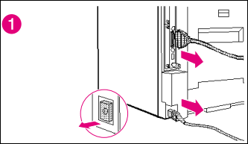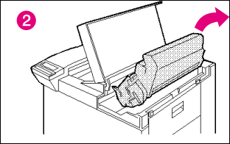
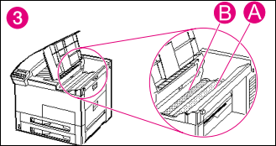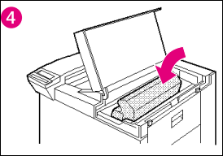
Table 4-1. Cleaning the Printer
Component | Cleaning Method/Notes
Outside Covers | Use a water-dampened cloth. Do not use solvents or ammonia-based cleaners.
Inside General | Use a dry, lint free cloth. Remove all dust, spilled toner, and paper particles.
Paper Pickup, Feed, and Separation Rollers | Use a water-dampened lint-free cloth.
Separation Pad | Use a dry lint-free cloth.
Registration Roller | Use a dry lint-free cloth.
Transfer Roller | Use a dry, lint-free cloth. DO NOT TOUCH the transfer roller with your fingers.
Fusing Assembly | Use a water-dampened lint-free cloth.
Cleaning Spilled Toner Defective toner cartridges can develop leaks. Also, after a paper jam has occurred, there may be some toner remaining on the rollers and guides inside the printer. The images that print immediately after the jam may pick up this toner. Clean spilled toner with a cloth slightly dampened in cold water. Do not touch the Transfer Roller with the damp cloth or with your fingers. Do not use a vacuum cleaner unless it is equipped with a micro-fine particle filter.

Service completion procedures and documentations
- Documenting Results of Diagnosis and Test
Accurate documentation of the results obtained from the diagnosis and testing process is crucial in the service and repair of printer. It helps in maintaining a record of the identified issues, their corresponding solutions, and any further actions taken.
Here are some key steps to effectively document the results of diagnosis and testing:
Comprehensive Notes: Keep detailed notes during the diagnosis and testing phase, capturing all relevant information, including
- Observed symptoms,
- Test results, and
- Any actions taken.
Document the specific tests performed, the test outcomes, and any abnormal or unexpected behavior observed during the testing process.
Clear and Organized Format: Use a clear and organized format to record the information, such as
- A digital or physical document,
- Spreadsheet, or dedicated software tool.
- Ensure that the documented information is easy to read, understand, and navigate.
Systematic Identification:Clearly identify the printer unit being diagnosed, including its make,
Model,and: Any unique identifiers, such as serial numbers. Assign a unique identifier or reference number to the diagnostic case to track and retrieve the information easily in the future.
Fault Description: Provide a detailed description of the identified faults or issues.
- Specific symptoms,
- Error messages,
- Abnormal behaviors observed during the diagnosis: Use clear and concise language to describe the problems, avoiding technical jargon whenever possible for better user comprehension.
Test Results:
- Document the results of each specific test conducted during the diagnosis process. Include both positive and negative outcomes.
- Record the specific tests performed, their expected outcomes, and the actual results obtained.
- Note any variations, discrepancies, or inconsistencies between the expected and actual results.
Identified Faults or Issues:
- Clearly list and describe the identified faults or issues based on the diagnosis and testing results.
- Include specific hardware or software components that have been identified as faulty or problematic.
- Provide a summary or overview of the root causes or underlying reasons for the identified faults.
Recommended Solutions:
- Document the recommended solutions or actions to address the identified faults or issues.
- Include detailed instructions, steps, or procedures for implementing the recommended solutions.
- Specify any required replacement parts, tools, or software updates necessary for the repairs.
- Follow-up Actions:
- Record any follow-up actions taken or planned, such as ordering replacement parts, scheduling repairs, or further consultations with experts.
Document any additional testing or diagnostic steps that may be required to confirm the effectiveness of the recommended solutions.

Disposing Waste materials
Environmental Compliance Introduction: In the printer repair and servicing industry, the proper disposal of waste materials is of utmost importance to ensure environmental sustainability. This essay will discuss the significance of disposing of waste materials in accordance with environmental requirements in the context of mobile phone repair and servicing.
1. Environmental Impact of Improper Waste Disposal:
Improper disposal of waste materials from mobile phone repair and servicing can have detrimental effects on the environment. Printer contain various hazardous substances, including heavy metals, toxic chemicals, and non-biodegradable materials (EPA, 2021). When these materials are not disposed of correctly, they can contaminate soil, water bodies, and air, posing risks to human health and ecosystems.
2. Compliance with Environmental Requirements:
To mitigate the environmental impact of waste materials, mobile phone repair and servicing businesses must comply with environmental requirements for proper disposal. This involves following established guidelines and regulations set by local authorities and environmental agencies.
a.Segregation of Waste: Technicians should segregate waste materials into different categories, such as electronic components, batteries, plastics, and metals. This segregation facilitates proper disposal and recycling of each waste type, minimizing environmental harm.
b.Recycling: Mobile phone repair and servicing businesses should partner with certified recycling facilities to ensure that waste materials are recycled appropriately. Recycling helps recover valuable resources from mobile phones and reduces the need for raw materials extraction, conserving natural resources and reducing energy consumption (EPA, 2021).
c.Hazardous Waste Disposal: Hazardous waste, such as batteries and certain electronic components, must be disposed of in accordance with specific regulations. Printer repair and servicing businesses should identify authorized hazardous waste disposal facilities and adhere to proper disposal protocols to prevent contamination and ensure compliance with environmental requirements.
d.Documentation: Maintaining proper documentation of waste disposal activities is essential for demonstrating compliance with environmental regulations. This includes recording the types and quantities of waste materials disposed of, the recycling facilities used, and any hazardous waste disposal certificates obtained.
3. Environmental Benefits and Corporate Responsibility:
Proper disposal of waste materials in mobile phone repair and servicing not only ensures compliance with environmental requirements but also offers several environmental benefits. These include:
a.Pollution Prevention: By disposing of waste materials correctly, the release of hazardous substances into the environment is minimized, reducing pollution and protecting ecosystems.
b.Resource Conservation: Recycling waste materials helps conserve valuable resources, such as metals and plastics, by reducing the need for new raw materials extraction.
c.Corporate Responsibility: Demonstrating a commitment to environmental sustainability through proper waste disposal enhances the reputation and credibility of mobile phone repair and servicing businesses. It showcases their corporate responsibility and contributes to a greener and more sustainable future.

Self-check.1.1
Part I. Choose the best answer

1. Which of the following is false in reassembling the printer part
- Reassembling is done by reversing the disassembly steps.
- All screws, connectors, and cables should be properly secured
- The printer should not undergo thorough testing
- Each screw is returned to its original location
2. After the repair is completed, a quality assurance check should be performed to ensure that
- The printer is functioning optimally
- To verifying that all features and functions are working as expected
- To ensure there are no loose connections or misaligned components
- To conduct additional tests if necessary.
- All of the above
3. Which of the following is not true about cleaning the printer and the paper handling devices
- Performed Every time you change the toner cartridge.
- Performed After printing approximately 2000 images.
- Whenever print quality problems occur.
- Clean the inside with only a dry, lint-free cloth.

Operation Sheet 4.1
Operation Title: Reassembling Repaired Printer
Instructions:
- Ensure the defective part has been replaced.
- Secure all screws, connectors, and cables properly.
- Perform thorough testing to verify the resolution of the problem and proper printer functioning.
Precautions:
- Watch for the ESD symbol and use an ESD-protected workstation.
- Avoid touching the transfer roller with your fingers.
- Turn off the printer and unplug all power cords before cleaning.
Tools and Requirements:
- #2 Phillips screwdriver with magnetic tip
- Small flat-blade screwdriver
- Small needle-nose pliers
- ESD mat
- Penlight
Procedures:
- Reverse the disassembly steps to reassemble the printer.
- Ensure each screw is returned to its original location.
- Secure all connectors and cables.
- Perform thorough testing to check various features and overall performance.
Quality Criteria:
- Verify that the replacement part has resolved the problem.
- Ensure all printer featuresand functions are working correctly.
- Check for any loose connections or misaligned components.
- Conduct additional tests if necessary.
- Ensure the printer is functioning optimally after repair.

References:
BOOKS
HP Color LaserJet 4500, 4500 N, 4500 DN Printer
HP LaserJet P2015 Series Service Manual
HP LaserJet 8150 and 8100 Series Print Systems and Paper Handling Devices
Health and Safety Executive. (2019). Personal Protective Equipment (PPE) at Work.
(PPE) at work what the law says and how to use personal protective equipment at work.
“The Importance of Gathering Customer Information." Repair Desk,
Environmental Protection Agency (EPA). (2021). Electronics Donation and Recycling.
WAVE PAGES
www.hse.gov.uk (http://www.hse.gov.uk/toolbox/ppe.htm) Personal protective equipment
Retrieved from https://www.hse.gov.uk/toolbox/ppe.htm
www.repairdesk.co/blog/ the-importance-of-gathering-customer-information.
Retrieved from https://www.epa.gov/recycle/electronics-donation-and-recycling
Environmental Laser: http://www.toners.com/welcome.html Laser Pros International: http://www.laserpros.com/ Laser Saver: http://rampages.onramp.net/~laser/ Laser Supplies: http://www.mind.net/laser/ Printer Drivers
http://www.primenet.com/~penguink/printers.html The Printer Works: http://www.printerworks.com/index.html

Developers Profile
The trainers who Develop these Learning modules
No | Name | Qualification | Educational background | Region | College | Mobile number | E-mail
 | TesfahunAyalewDenidine | MSc | Electronics and comm Eng. | BGRS | Assosa poly TVET | 012132308/09212121 | tesfugps4545@gmail.com
 | Shimeles DejenMekonenn | BSC | Electrical CommTechn | Ahama | W/Sein PTC. | 0910838814 | shimelesdejen@gmail.com
 | PetrosGelanaMegersa | BSC | Electrical comm.T | Oromia | Ambo poly TVET | 0921183975 | petrosgelana6@gimal.com
 | MezgebuAlemseged | BSC | Electrical &comm.T | A.A | M/G/M/B/ Poly TVET | 0943933255 | Alemsegedmezgebu994@gmail.com
 | ZekariasSisay G/egziabher | MSc | Electrical & Power Eng. | Harari | Harari poly TEVET Co | 0703747163 /o913344201 | szekarias07@gmail.com

