Electrical/Electronic Equipment Servicing Level III
Based on October, 2023, Curriculum Version I

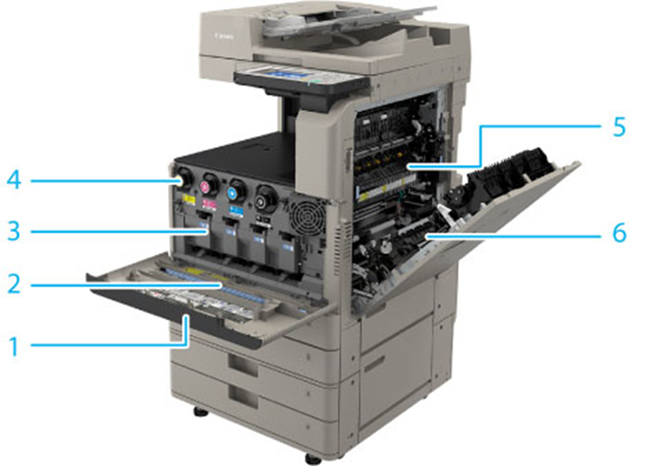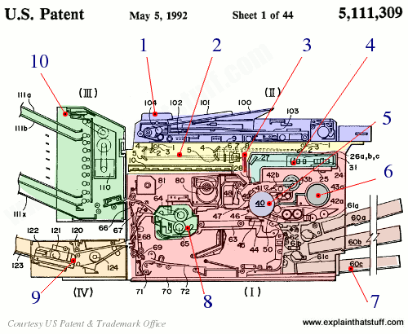
Module Title: - Digital Copier Machine Maintaining and Repairing
Module Code: EISE EEES3 M05 1023
Nominal Duration:-80- Hours
Prepared by: Ministry of Lab our and Skill
October, 2023
Addis Ababa, Ethiopia

Table Contents
Acknowledgment 4
Acronyms 4
Introduction to the Module 5
Unit one: Basic Concept of Digital Copy Machine 7
1.1 Over view ofDigital Copier machine 9
1.1.1. Image formation process. 9
1.1.1 Photoreceptor drum 10
1.1.2 Corona wires 11
1.1.3 Lamp and lenses. 12
1.1.4 Toner 12
1.1.5. Types of photocopiers 19
1.2. Principle operations of CCD 19
1.3 External view Copier machine 22
Personal protective equipment 30
1.5 Workstation and work specifications. 32
1.6 Tools, test instruments 33
Self cheek 1.1 36
Unit two: Diagnosis faults of Digital Copy Machine 37
2.1. Electro-static discharge (ESD) protection procedure 38
2.2 Pre-testing procedures of Digital Copier machine. 40
2.3 Disassembling copy-printer parts. 43
2.3. Identifying defects and faults symptoms. 56
2.5 Using test instruments with user manuals. 58
2.6 Checking and isolating Circuits 60
Self cheek 2.1 62
Operation sheet 2.1 62
Unit Three: Maintain/repair. 64
3.1Replacing Defective parts/components 65
3.2 Solderingparts/components. 67
3.2.Performing repair activity 69
3.5. Precaution in handlingof the unit. 71
Unit Four :Test repaired unit 76
4.1. Test and clean the final reassembled unit. 77
4.2. Compile final documentations. 78
4.3. Dispose waste materials. 80
Self-check 4.1 82
Operation sheet 2.1 82
Reference 84

Acknowledgment

Ministry of Labor and Skills wish to extend thanks and appreciation to the many representatives of TVET instructors and respective industry experts who donated their time and expertise to the development of this Teaching, Training and Learning Materials (TTLM).

Acronyms
AC..……………………………. Alternating current
DC……………………………… Direct current
OHS ………………………………Occupational health and safety
LAP ……………………………… learning assistance program
LED………………………………light emitting diode
PCB………………………………printed circuit boar
ESD………………………………electrostatic discharge
DMM………………………………digital multi-meter
VOM………………………………volt ohm meter
GFCI ……………………………. Ground Fault Circuit Interrupter
OPC……………………………….Organic Photoconductor

Introduction to the Module
In Electrical/Electronic Equipment Servicing filed; Maintain and Repair Digital CopyMachinehelps to know about operation and maintenance of Digital Copy it is a huge time saver when compared to hand Copying. You don't have to do anything except dump your clothes in the machine, turn on the power, and pick your cycle. There is virtually no labor required.
This module is designed to meet the industry requirement under the Electrical/Electronic Equipment Servicingoccupational standard, particularly for the unit of competency: Maintain and Repair Digital Copy Machine
This module covers the units:
- Basic Concept of Digital Copy Machine.
- Diagnose faults.
- Maintain and repair.
- Test repaired product
Learning Objective of the Module
- Identify Basic Concept of Digital Copy Machine.
- Able to Diagnose faults .
- Able to Maintain and repair
- Able to Test repaired product
Module Instruction
For effective use this modules trainees are expected to follow the following module instruction:
- Read the information written in each unit
- Accomplish the Self-checks at the end of each unit
- Perform Operation Sheets which were provided at the end of units
- Do the “LAP test” giver at the end of each unit and
- Read the identified reference book for Examples and exercise

Unit one: Basic Concept of Digital Copy Machine
This unit is developed to provide you the necessary information regarding the following content coverage and topics:
  - Introduction of digital Copier machine.
  - Principle operations of CCD
  - External and Internal view of digital Copier machine.
  - Personal protective equipment.
  - workstation and work specifications
  - Tools, test instruments
This unit will also assist you to attain the learning outcomes stated in the cover page. Specifically, upon completion of this learning guide, you will be able to:
  - Explain of digital Copier machine.
  - Discus Principle operations of CCD
  - Identify External view of digital Copier machine.
  - Use Personal protective equipment.
  - Prepare workstation and work specifications
  - Identify Tools, test instruments

1.1 Over view ofDigital Copier machine
A photocopier (also called copier or copy machine, and formerly Xerox machine, the generic trademark) is a machine that makes copies of documents and other visual images onto paper or plastic film quickly and cheaply. Most modern photocopiers use a technology called xerography, a dry process that uses electrostatic charges on a light-sensitive photoreceptor to first attract and then transfer toner particles (a powder) onto paper in the form of an image. The toner is then fused onto the paper using heat, pressure, or a combination of both. Copiers can also use other technologies, such as inkjet, but xerography is standard for office copying.
Commercial xerographic office photocopying [1] gradually replaced copies made by Verifax, Photostat, carbon paper, mimeograph machines, and other duplicating machines.
Photocopying is widely used in the business, education, and government sectors. While there rely less on distributing actual pieces of paper, as of 2015, photocopiers continue to be widely have been predictions that photocopiers will eventually become obsolete as information workers increase their use of digital document creation, storage, and distribution and used. During the 1980s, a convergence began in some high-end machines towards what came to be called a multi-function printer: a device that combined the roles of a photocopier, a fax machine, a scanner, and a computer network-connected printer. Low-end machines that can copy and print in color have increasingly dominated the home-office market as their prices fell steadily during the 1990s. High-end color photocopiers capable of heavy-duty handling cycles and large-format printing remain a costly option found primarily in print and design shops.
Basic copier

1.1.1. Image formation process.

When the copier illuminates the sheet of paper on the glass surface of a copier, a pattern of the image is projected onto the positively charged photoreceptive drum below. Light reflected from blank areas on the page hits the drum and causes the charged particles coating the drum's surface to be neutralized. This leaves positive charges only where there are dark areas on the paper that did not reflect light. These positive charges attract negatively charged toner. The toner is then transferred and fused to a positively charged sheet of paper.

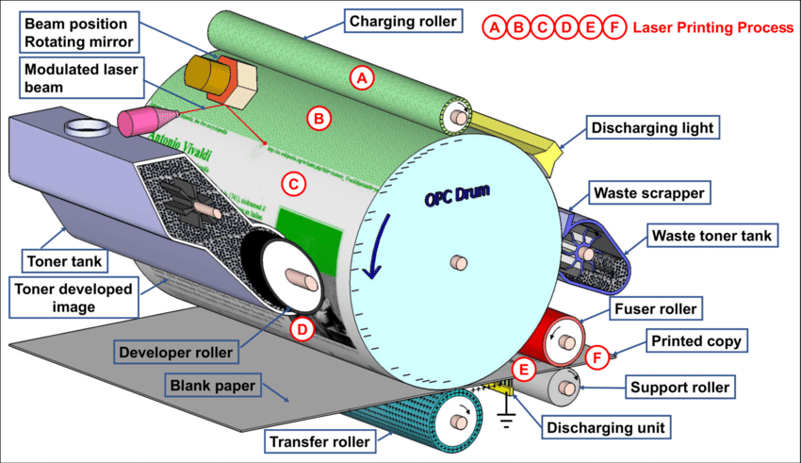

Figure 1.1.Imageprosscer

1.1.1 Photoreceptor drum

The photoreceptor drum (or, in some photocopiers, belt) is the heart of the system. A drum is basically a metal roller covered by a layer of photoconductive material. This layer is made out of a semiconductor such as selenium, germanium or silicon. What makes elements like selenium so cool is that they can conduct electricity in some cases, but not in others.

In the dark, the photoconductive layer on the drum acts as an insulator, resisting the flow of electrons from one atom to another. But when the layer is hit by light, the energy of the photons liberates electrons and allows current to pass through!

These newly freed electrons are what neutralizes the positive charge coating the drum to form the latent image.

Various photocopier drums It's easy to imagine how you might project a copy of an image on a photoreceptive belt that has roughly the same dimensions as the sheet of paper containing the image. A problem emerges when you think about doing the same thing on a thin, cylindrical drum. How can the surface area of the drum possibly match the real estate on a sheet of paper? The solution is to simply rotate the drum while you're making a copy. If you rotate the drum in lockstep with the movement of the light beam across the original document, you can build the image strip by strip. After one strip of light is focused onto a corresponding swath of the drum, the drum rotates to expose a fresh area of the photoconductor. Meanwhile, the previously exp

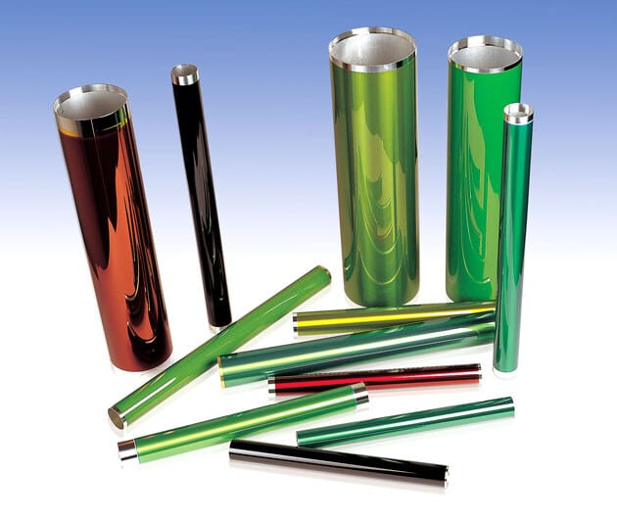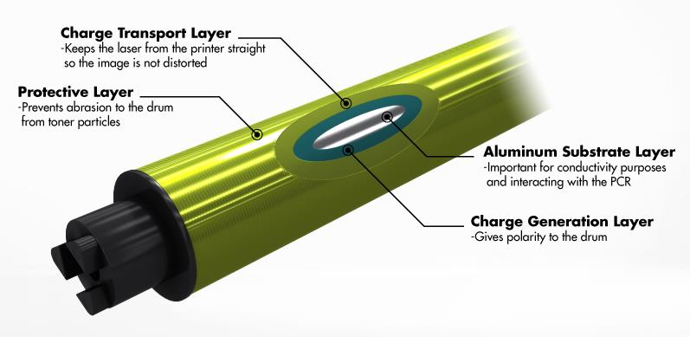

Fig. 1.2.opcduram

1.1.2 Corona wires

For a photocopier to work, a field of positive charges must be generated on the surface of both the drum and the copy paper.

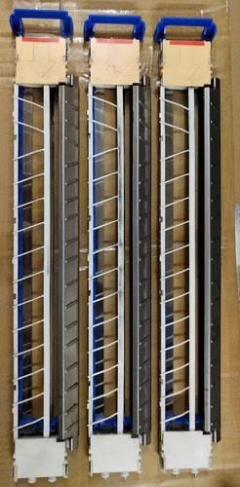
These tasks are accomplished by the corona wires. These wires are subjected to a high voltage, which they subsequently transfer to the drum and paper in the form of static electricity.

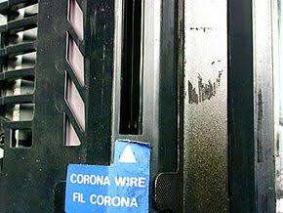

Fig. 1.3Corona wires

1.1.3 Lamp and lenses.

Making a photocopy requires a light source with enough energy to boot electrons out of the photoconductive atoms. What wavelengths of light can do this? It turns out that most of the visible spectrum of light contains enough energy to drive the process, especially the green and blue end of the spectrum.

Anything lower than the red portion of the visible spectrum doesn't have enough gusto to activate the photoconductor.and, although UV light has more than enough firepower to make a photocopy, it can be very damaging to our eyes and skin. This is why photocopiers use a plain old incandescent or Fluorescent bulb to flash light onto the original document.
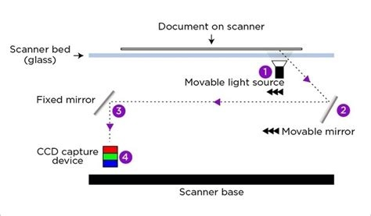
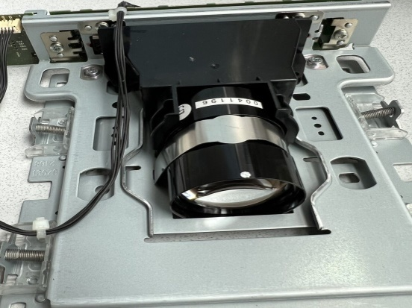

Fig. 1.4 Lamp and lenses

1.1.4 Toner

Toner is sometimes referred to as dry ink, but toner isn't actually ink at all! Ink is a pigmented liquid. Toner is a fine, negatively charged, plastic-based powder. The black color in photocopier toner comes from pigments blended into the plastic particles while they are being made. In your photocopier, toner is stuck on larger, positively charged beads and stored inside a toner cartridge. When toner-coated beads are rolled over the drum, the

toner particles find the positively charged ions on the unexposed areas on the

drum's surface much more attractive than the weakly charged bead. The same

particles are subsequently even more drawn to the electrostatically charged paper.

The plastic in the toner lets you keep it from jumping ship once you've finally got it

on the paper; all you have to do is apply heat to the toner, and the plastic particles

melt and fuse the pigment to the paper.

1.1.5 Fuser Unit

The fuser provides the finishing touches that make the toner image on a sheet of

paper permanent. The fuser has to do two things:

● Melt and press the toner image into the paper

● Prevent the melted toner and/or the paper from sticking to the fuser

All that's required to accomplish these tasks is quartz tube lamps and Teflon-coated rollers. The sheet of paper is sent between two of the rollers. Then, the rollers gently press down on the page to embed the toner in the paper fiber.
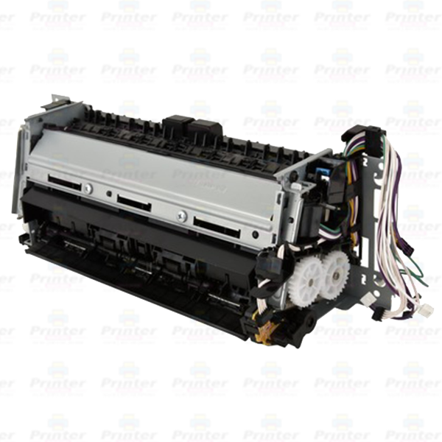
Fig. 1.5 Fuser unit

Basic Copy Process
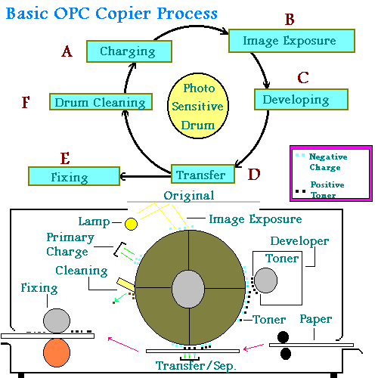

1.1.6 The Basic copy process is made up of seven steps:
- Primary Corona Charging
- Image Exposure
- Developing
- Transfer
- Fixing
- Cleaning
- Photosensitive Drum
The drum is a tubular aluminum cylinder whose surface is coated with a photoconductive layer. What this means is that if light is reflected onto the drum surface then the conductive layer will change resistance. If the drum is exposed to light, then the surface will be conductive and the resistance will be low. If no light is exposed to the drum, then the surface is not conductive and the resistance is high.
What is meant by "Charging"
A metallic wire called a corona wire is stretched parallel to the drum and subjected to a high voltage. This causes a corona discharge to occur from the wire. The discharge exposes the drum surface with positive and negative charges.
- Primary Corona Charging
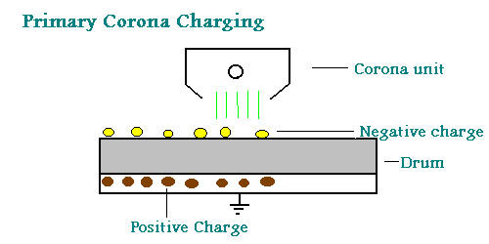
During the Primary Charging phase a corona unit exposes the drum surface with a uniform negative potential. This causes the surface of the drum to have a negative potential. Positive charges occur in the base of the drum to balance the negative charges on the surface.
- Image Exposure
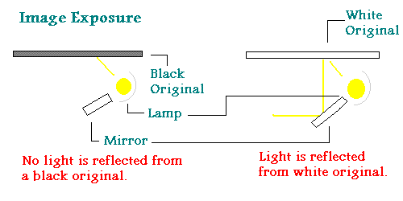
- Reflection:
The light from a lamp exposes an original and the light reflected from the original strikes the drum surface via a lens and mirrors. When light strikes a black color on the original the light is absorbed and not reflected back to the drum. When the light strikes a white area the light is reflected back to the drum. When light strikes other colors or grays the intensity of the light reflected back to the drum varies.
Photosensitive:
When light strikes the photosensitive drum the resistance of the drum surface is lowered and becomes conductive which allows the positive and negative charges in those lighted areas to cancel out. The area where the light did not hit the drum, negative charges remain on the surface. At this point in the process there is an electrostatic image on the drum.

- Developing
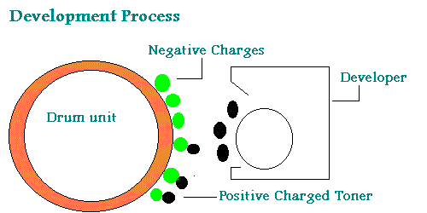
As the drum turns the electrostatic image passes the developer unit which contains positively charged toner particles. Where there is a negative charge on the drum the positive charged toner particle will attract to it. This now forms a visible image on the drum surface.

- Transfer
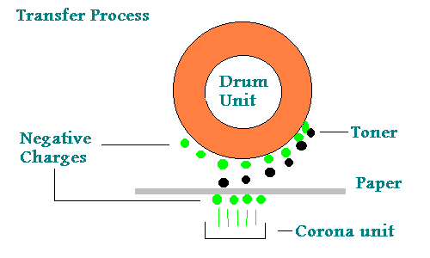
The transfer stage is performed by another negatively charged corona unit. The corona subjects the back side of the paper to a very strong negative charge which causes the positive toner to attract to the paper. At this point the image is now on the paper and is held there by static charges.
Fixing
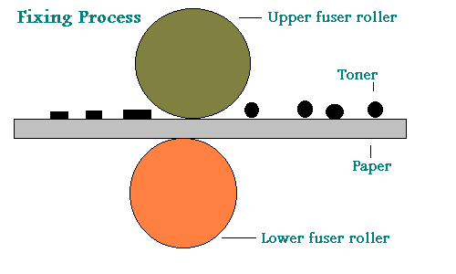
The fixing stage is typically done by running the paper threw to heated pressure rollers thereby melting the toner and pressing it into the paper fibers. The image is now permanent on the paper.
- Cleaning
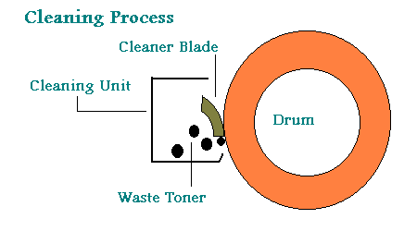
- Drum cleaning is done by a mylar blade that rest on the drum surface. As the drum rotates the excess toner that was left on the drum is cleaned off. The amount of excess toner is based on the design of the machine. Most copiers today have at least 90% toner transfer to the paper.

1.1.5. Types of photocopiers
.There are many types of photocopier available on the market today, all offering different features to the users. Mindshare is able to supply any photocopier that a company requires, from an A4 desktop black and white photocopier right up to A3 heavy-duty, full-color photocopiers with advanced finishing option.

Black and white (mono) photocopier.

Color photocopiers.

Desktop photocopiers.

Office photocopiers.

Multifunction.

A3 photocopiers.

Digital Photocopiers.

High volume photocopier

1.2. Principle operations of CCD
A charge-coupled device (CCD) is a light-sensitive integrated circuit that captures images by converting photons to electrons. A CCD sensor breaks the image elements into pixels. Each pixel is converted into an electrical charge whose intensity is related to the intensity of light captured by that pixel.

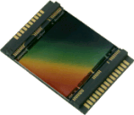
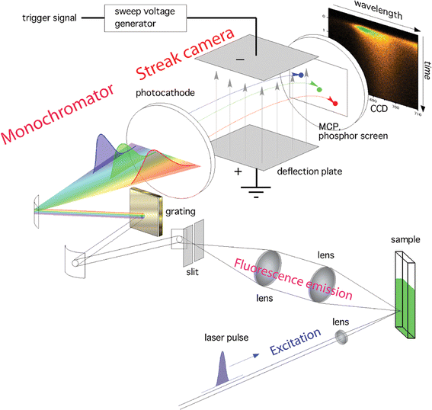
Figure 1.5charge-coupled device (CCD)
What does a charge-coupled device do?
Small, light-sensitive areas are etched into a silicon surface to create an array of pixels that collect the photons and generate electrons. The number of electrons in each pixel is directly proportional to the intensity of light captured by the pixel. After all the electrons have been generated, they undergo a shifting process that moves them toward an output node, where they're amplified and converted to voltage.
For many years, CCDs were the sensors of choice in a wide range of devices, but they're steadily being replaced by image sensors based on complementary metal-oxide-semiconductor (CMOS) technology.
CCDs vs. CMOS sensors
Despite the early successes of CCDs, CMOS sensors have been gaining favor across the industry, and they're now used extensively in consumer products for capturing images. CMOS sensors are easier and cheaper to manufacturer than CCD sensors. They also use less energy and produce less heat.
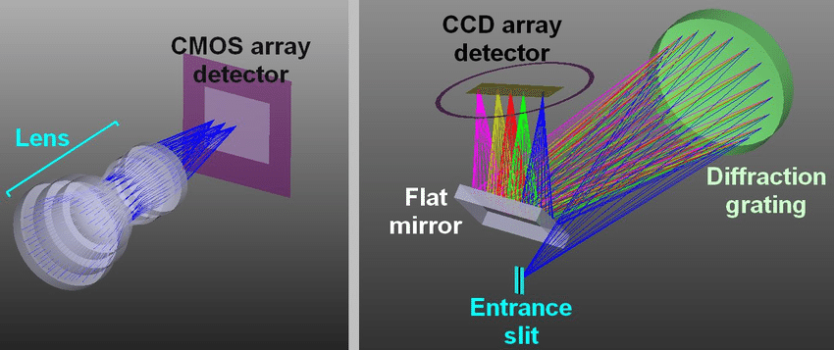


Figure 1.6CCDs vs. CMOS sensors

1.3 External view Copier machine

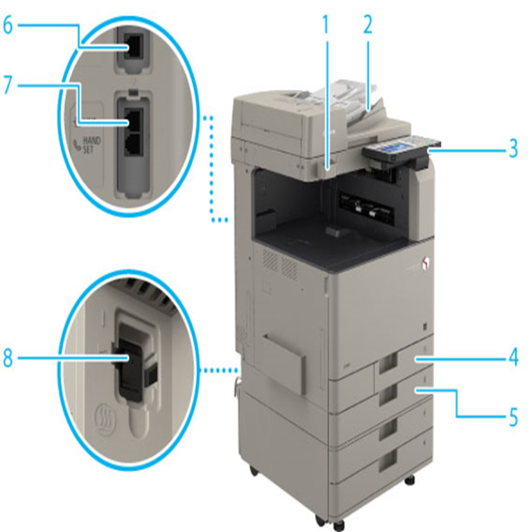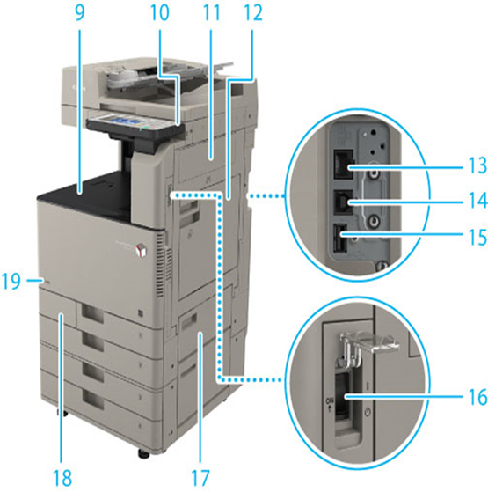
Figure 1.7 Copierinternal view
1. Glass Cleaning
Sheet Storage Box Use this box to store sheets for cleaning the platen glass.
2. Feeder
Originals placed in the feeder are automatically fed sheet by sheet to the scanning area. The feeder also automatically turns over two-sided originals to make one- or two-sided copies.
3.Control Panel
The control panel includes the keys, touch panel display, and indicators required for operating the machine. (See "Control Panel Parts and Functions.")
4.Paper Drawer 1
Holds up to 550 sheets of paper (80 g/m2).
5.Paper Drawer 2
Holds up to 550 sheets of paper (80 g/m2).
6. LINE 2
Use this port to connect the Super G3 2nd Line Fax Board to the machine.
7. LINE 1
Use this port to connect a fax line to the machine.
8. Dehumidification Switch
Use this switch when paper in a paper drawer is damp to dry the paper by warming it up, in order to prevent printing problems. Can be used when a heater is attached.
9. Output Tray
Prints are output to this tray.
10. USB Port (1)
Use the USB port to connect USB memory, external hard disks, and other devices to the machine.
11. Right Cover of the Main Unit
Open this cover when clearing a paper jam inside the main unit. (See "Clearing Paper Jams/Staple Jams.")
12. Multi-Purpose Tray
Use the multi-purpose tray to feed paper manually, and for loading nonstandard paper stock. (See "Loading Paper into the Multi-Purpose Tray.")
13. LAN Port
Use an Ethernet cable to connect the machine to a network.
14. USB Port (2)
Use the USB port to insert a USB cable for connecting to a computer.
15. USB Port (3)
Use the USB port to connect external hard disks and other devices to the machine.
16. Main Power Switch
Press to the "I" side to turn ON the machine. (See "Main Power and Energy Saver Key.")
17. Upper Right Cover of the Paper Drawer
Open this cover when clearing a paper jam. (See "Clearing Paper Jams/Staple Jams.")
18. Waste Toner Cover
Open this cover when replacing the waste toner container.
19. Toner Code
This code indicates the type of genuine toner that can be used with the machine. Use toner with a code that includes the same letters as the code on the front cover of the machine.

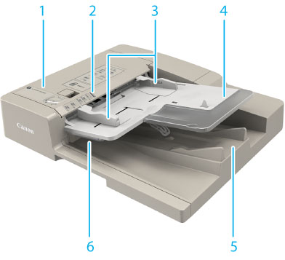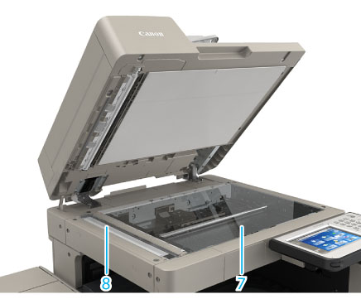
Figure 1.8 Copierinternal view
1. | Feeder Cover  Open this cover to remove jammed paper.
2. | Original Set Indicator  Lights when originals are placed in the original supply tray.
3. | Slide Guides  Adjust these guides to match the width of the original.
4. | Original Supply Tray  Originals placed here are automatically fed sheet by sheet into the feeder. Place originals into this tray with the surface that you want to scan face up.
5. | Original Output Area  Originals that have been scanned from the original supply tray are output into the original output area.
6. | Original Output Indicator  Lights up when originals are being output and flashes for a certain period after the originals have finished being output, to prevent the user from forgetting to take their originals.
7. | Platen Glass  Use the platen glass when scanning books, thick originals, thin originals, transparencies, etc.
8. | Document Feed Scanning Area  Scans documents sent from the feeder.

Internal View

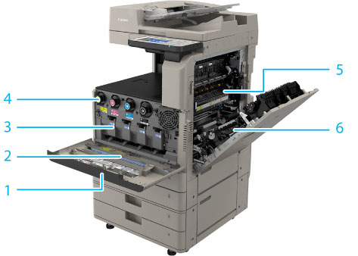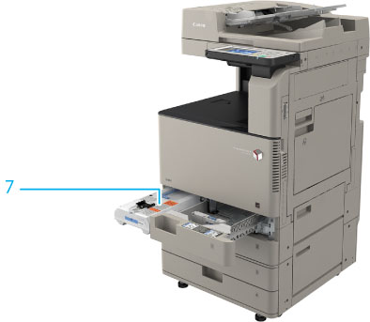
Figure 1.9 Copierinternal view

1. | Front Cover of the Main Unit  Open this cover to replace the toner cartridge and the drum unit.
2. | Dust Proof Glass Cleaner  Use this cleaner when cleaning the dust proof glass.
3. | Drum Unit  The unit that sets toner onto paper. For instructions on replacing the drum unit, see "Replacing the Drum Unit."
4. | Toner Cartridge  When toner runs out, pull out the toner cartridge and replace it with a new one. (See "Consumables.")
5. | Fixing Assembly  The unit that fixes toner onto paper.
6. | Duplexing Unit  If paper is jammed in the duplexing unit, remove the paper jam. (See "Clearing Paper Jams/Staple Jams.")
7. | Waste Toner Container  When the waste toner container becomes full, replace it with a new one.(See "Replacing the Waste Toner Container.")

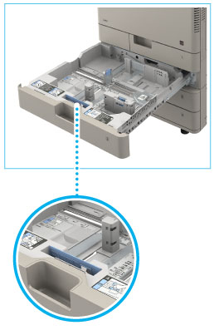
Envelope Feeder Attachment A
Used with Paper Drawer 2. Envelopes are loaded horizontally.
Control Panel Parts and Functions
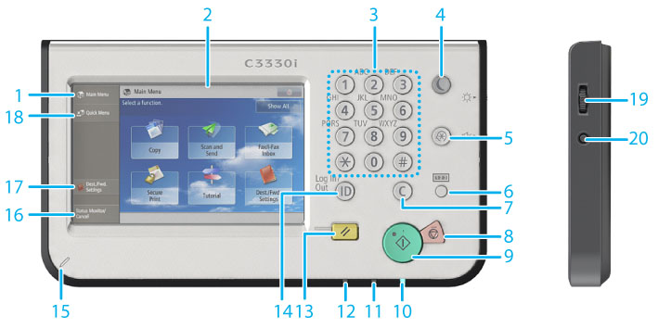
Figure 1.10Control Panel Parts and Functions

1. | [Main Menu]  Press to display the Main Menu screen. If the Main Menu screen is not displayed when using a function, it is necessary to press [Main Menu] before using the function.
2. | Touch Panel Display  The settings screen for each function is shown on this display. Six function keys are displayed by default.
3. | Numeric keys  Press to enter numerical values.
4. | Energy Saver key  Press to set or cancel the Sleep mode. Lights when the machine enters the Sleep mode. For more information on the Auto Sleep mode, see "Main Power and Energy Saver Key."
5. | Settings/Registration key  Press to specify settings/registration.
6. | Counter Check key  Press to display the copy and print count totals on the touch panel display.
7. | Clear key  Press to clear entered values or characters.
8. | Stop key  Press to stop a job in progress, such as a scan, copy, or fax (scanning only) job.
9. | Start key  Press to start an operation.
10. | Main Power Indicator  Lights when the main power is turned On.
11. | Error Indicator  Flashes or lights if there is an error in the machine. When the Error indicator flashes, follow the instructions that appear on the touch panel display. When the Error indicator maintains a steady red light, contact your local authorized Canon dealer.
12. | Processing/Data Indicator  Flashes or blinks green when the machine is performing operations, and maintains a steady green light when there is a job or received data waiting to be processed. However, if [Sleep Mode Energy Use] (Settings/Registration) is set to 'Low' and the machine is in the complete Sleep mode, the light will not turn on, even if the received data is stored in memory. (See "Energy Consumption in the Sleep Mode.")
13. | Reset key  Press to restore the standard settings of the machine.
14. | ID (Log In/Out) key  Press to log in/out when a login service such as User Authentication or DepartmentID Authentication has been set.
15. | Edit Pen  Use when operating the touch panel display, such as to enter characters.
16. | [Status Monitor/Cancel]  Press to check the status of jobs or to cancel print jobs. Also, you can check the status of the machine such as the amount of paper remaining in the paper source.
17. | [Dest./Fwd. Settings]  Press to register e-mail addresses and phone numbers, and set forwarding destinations for received documents.
18. | [Quick Menu]  Press to display functions registered in the Quick Menu.
19. | Brightness Adjustment Dial  Use to adjust the brightness of the touch panel display.
20. | Volume Settings key  Press to display the screen for adjusting settings, such as the transmission volume and fax sending/receiving alarm volume.

Internal component parts view
Figure 1.11 Internal component parts view.
- You place your document on the glass or, if it's a multi-page document, slip it into the document feeder (blue) on top.
- A computer-style optical scanner (yellow) systematically scans a bright light across the document.
- A digital image of the document is captured by an image-sensing chip (red) and the circuit it's wired into; in this case, the sensor is a charge-coupled device (CCD).
- The scanned image is used to drive a laser and rotating mirror (turquoise).
- The laser rescans an electrically charged version of the scanned image onto the surface of a photo-conducting drum (gray, with original numbering "40"), in a similar way to what happens in a laser printer.
- The drum picks up toner particles from one or more containers (gray) to create an inked version of the scanned image.
- Guided by various rollers, a sheet of paper feeds in from one or more hoppers on the right and picks up the inked image from the drum.
- The image is fused onto the drum by heated rollers (light green).
- If a two-sided copy is required, the reversal unit (orange) flips the printed paper over and returnsit to the mechanism for printing on the other side.
- The finished copy emerges in the sorter section (green), which can be used to collate multi-page documents.

Personal protective equipment
When maintaining a photocopy machine, it is important to follow proper safety protocols and wear appropriate personal protective equipment (PPE). While the specific PPE requirements may vary depending on the workplace and local regulations, here are some general recommendations:
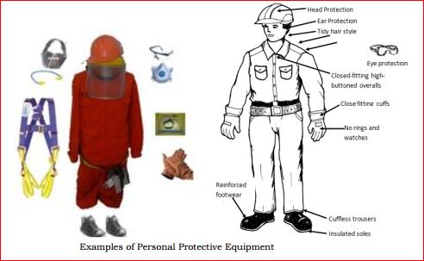
Figure 1.4 Proper Uses of PC and PPE
- Safety Glasses: Wear safety glasses or goggles to protect your eyes from any debris, chemicals, or flying particles that may be generated during maintenance tasks.
- Gloves: Wear gloves to protect your hands from potential cuts, burns, or exposure to chemicals. Nitrile or latex gloves are commonly used for general maintenance tasks. However, be aware of any latex allergies among the maintenance staff or individuals involved.
- Respiratory Protection: Depending on the maintenance activities being performed, respiratory protection may be necessary. If there is a risk of inhaling airborne particles, such as toner dust or cleaning chemicals, a respirator or dust mask should be worn. The specific type of respirator required will depend on the nature and concentration of the airborne contaminants. Refer to local regulations and consult with occupational health and safety professionals for guidance.
- Protective Clothing: Depending on the maintenance tasks, it may be necessary to wear protective clothing to prevent contact with hazardous substances or to protect against physical hazards. This could include coveralls, aprons, or other protective garments.
- Hearing Protection: In certain situations, such as when operating noisy equipment during maintenance, it may be necessary to wear hearing protection, such as earplugs or earmuffs, to prevent hearing damage.
- Closed-Toe Shoes: Wear closed-toe shoes or safety shoes to protect your feet from falling objects or potential hazards in the maintenance area.
- First Aid Kit: Ensure that a well-stocked first aid kit is readily available in the maintenance area to address any minor injuries that may occur.

1.5 Workstation and work specifications.
The specific requirements for a photocopier machine maintenance workstation may vary depending on the manufacturer and model of the machine, as well as the organization's preferences. However, here are some standard requirements and considerations for setting up a workstation for photocopier machine maintenance:
Poor housekeeping can be a cause of incidents, such as:
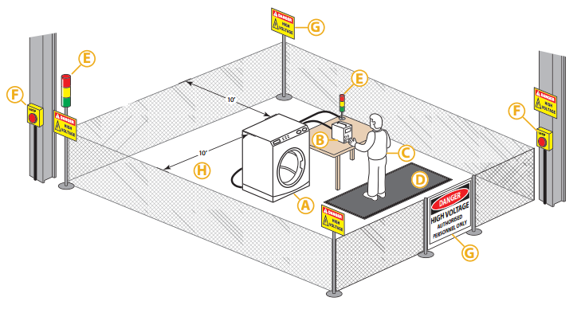

- Workspace: Ensure you have an adequate workspace that can accommodate the photocopier machine and allow you to move around freely. The area should be well-lit and well-ventilated.
- Power Supply: The workstation should have access to a reliable power supply to plug in the photocopier machine and any other equipment you may need, such as diagnostic tools or a computer.
- Tools and Equipment: Gather the necessary tools and equipment for maintenance and repairs, such as screwdrivers, pliers, multimeter, cleaning supplies, lubricants, and replacement parts. These tools may vary depending on the specific tasks you'll be performing and the photocopier model.
- Documentation and Manuals: Keep a collection of relevant documentation, user manuals, service manuals, and technical guides for the photocopier machines you'll be working on. These resources will assist you in troubleshooting and performing maintenance tasks correctly.
- Safety Equipment: Ensure you have the necessary safety equipment, such as gloves, safety glasses, and an antistatic wrist strap, to protect yourself and prevent damage to the photocopier machine during maintenance.
- Workbench or Table: Have a sturdy workbench or table where you can place the photocopier machine during maintenance tasks. This will provide a stable surface for disassembly and reassembly, as well as space to organize parts and tools.
- Storage and Organization: Maintain an organized storage system for tools, spare parts, and supplies. Use labeled drawers, shelves, or cabinets to keep everything easily accessible and prevent loss or damage.
- Connectivity: If your maintenance tasks involve connecting the photocopier machine to a computer or network for diagnostics or software updates, ensure you have the necessary cables and connectors available.
- Cleaning Area: Set up a designated area for cleaning photocopier components, such as the glass platen, rollers, or cartridges. This area should be equipped with appropriate cleaning supplies and waste disposal facilities.
- Training and Knowledge: It's important to have a good understanding of the photocopier machines you'll be maintaining. Stay updated with the manufacturer's training materials and attend relevant workshops or courses to enhance your knowledge and skills.

1.6 Tools, test instruments
Appliance repair involves a number of specialty tools.
• variable power supply  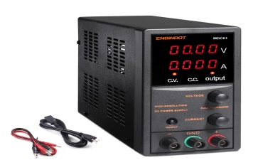 | •flashlight  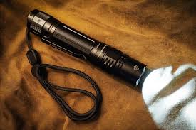
•electric blower  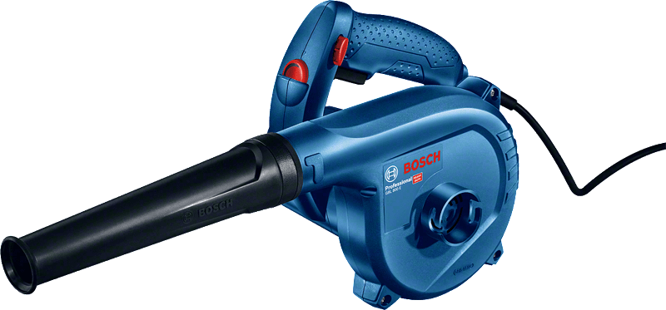 | •wrenches (assorted)  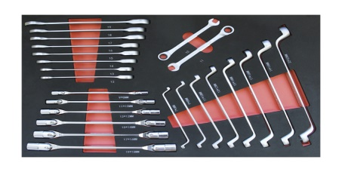
- soldering iron/gun  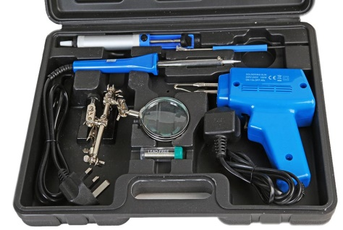 | - Hot Air gun  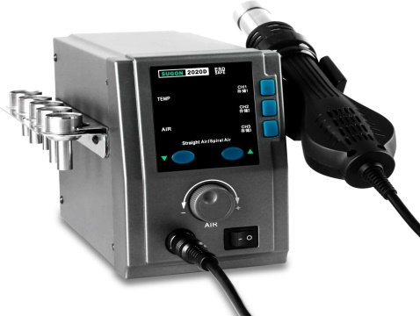

•cleaning brush  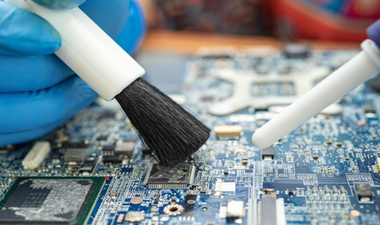 | - high-grade magnifying 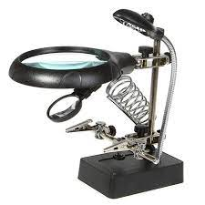

•Allen wrench/keying   | - ball peen hammer  
•de-soldering tools  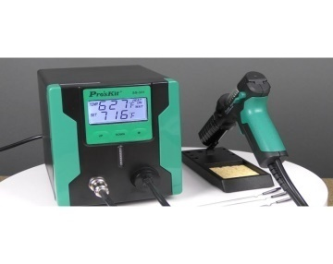 | - multi-testers (analogue /digital)  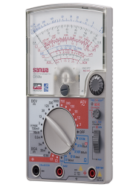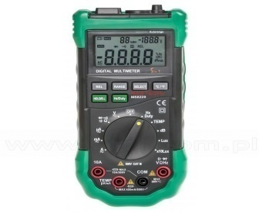
•glass with lamp   | - soldering lead  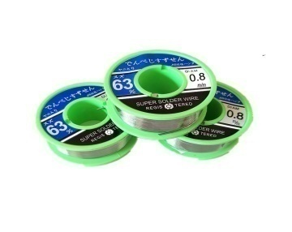
•screwdriver (assorted)   | 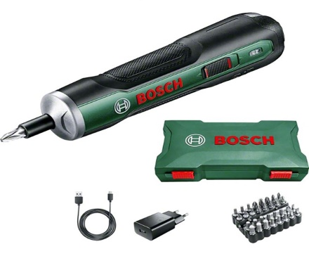

Self cheek 1.1
Test I: say ‘true’ if the statement is correct and ‘false’ if the statement is not correct
__________1.Digital photocopying uses a scanning mechanism to convert physical documents into digital images.
__________2.Digital photocopying allows for easy duplication and distribution of digital documents without the need for physical printing.
__________3.In the image formation process of a digital photocopy machine, a laser beam is used to create an electrostatic image on a photosensitive drum.
__________4.In the image formation process of a digital photocopy machine, toner particles are attracted to the areas of the photosensitive drum that have a higher electrostatic charge, resulting in the formation of a visible image.
Test III: Explain briefly
- List at least four image formation process.
- List and explain external and internal copy machine,

Unit two: Diagnosis faults of Digital Copy Machine
This unit is developed to provide you the necessary information regarding the following content coverage and topics:
  - Electro-static discharge (ESD) protection procedure
  - Pre-testing procedure
  - Disassembling copy-printer parts.
  - Identifying defects and faults symptoms.
  - Using test instruments with user manuals.
  - Checking and isolating Circuits.
  - Checking Control settings/adjustments.
This unit will also assist you to attain the learning outcomes stated in the cover page. Specifically, upon completion of this learning guide, you will be able to:
  - Use Electro-static discharge (ESD) protection procedure.
  - Follow Pre-testing procedure.
  - Disassemble copy-printer parts.
  - Identify defects and faults symptoms.
  - Using test instruments with user manuals.
  - Check and isolating Circuits.
  - Check Control settings/adjustments.

2.1. Electro-static discharge (ESD) protection procedure
Electrostatic discharge, or “ESD”, occurs when static electricity is suddenly transferred between two electrically charged objects. ESD is incredibly common, and although it isn’t always noticeable to humans, it can still be powerful enough to harm or ruin electronics.
Those extra electrons give the person a negative charge. When the negatively-charged person comes into contact with a nearby, positively-charged doorknob, electrons will “jump” from the person to the doorknob. That “jump” sometimes causes a shock, which is an electrostatic discharge event caused by the sudden flow of electricity between two electrically charged objects.
2.1.1Why is ESD harmful to electronics?
“Electrostatic sensitive devices” refers to those objects that could be damaged by electrostatic discharge. Electronics fit into this category because they contain integrated circuits, which can be easily damaged by the sudden flow of electricity that happens during an ESD event.
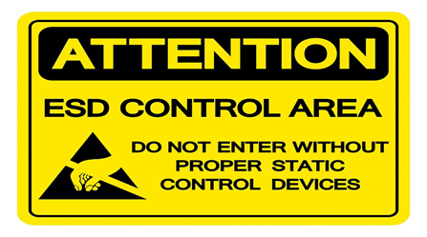
2.1Figure : ESD Sign tags
2.1.2 How to protect against ESD
Prevention is the key to protect electronic components against electrostatic discharge. Any protective measures taken to minimize the risk of ESD must provide a grounding method for static electricity, which will naturally accumulate in any environment. It’s important that employees have a safety protocol that details how to ground themselves prior to working with any type of electronics. Another option is to create an ESD protected area that can be used when working with sensitive equipment.
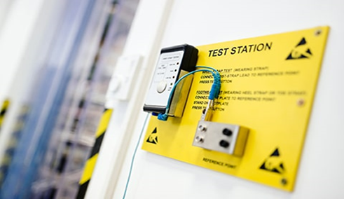
2.2 Figure :ESD workbenches
Here are some ways to create an ESD protected area:
- Apply ESD floor coatings.
- Use ESD mats.
- Install ESD workbenches.
- Remove anything that might generate static electricity from workspaces.
- Properly store electricity generating devices.
- Use antistatic packaging.
- Closely regulate temperature and humidity to minimize the possibility of static electricity build up.
- Wear grounded, antistatic wristbands when working with electronics.
- Install ESD countermeasures at every point where contact with a human or other object is possible, including ESD suppressors, protective filters, test stations etc.
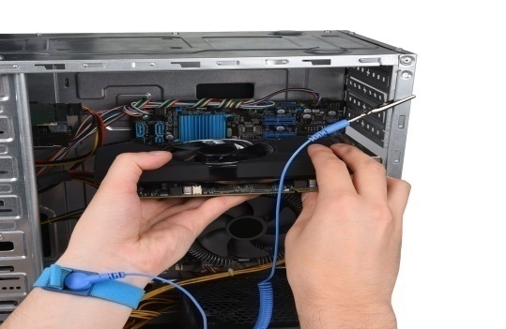
  - Figure : Antistatic Wristbands

ESD poses a serious threat to electronics. Without protective measures in place, employees could unknowingly cause thousands of dollars in damage by just touching a piece of equipment. The damage might not even be evident at first, but could cause a major problem later. Not to mention, a spark caused by ESD could cause an explosion. Creating an ESD protected area and training employees in proper grounding techniques are important safety measures that should be taken by any businesses dealing with electronics.

2.2Pre-testing procedures of Digital Copier machine.
The pre-testing procedure for a photocopy machine typically involves a series of steps to ensure that the machine is functioning properly and ready to produce high-quality copies. Here's a general outline of the pre-testing procedure:
A)Visual Inspection: The technician visually inspects the equipment for any visible signs of damage, loose connections, or burnt components. This may include checking cables, connectors, circuit boards, and external parts.
B) Machine Not Powering On:
Check the power cord and ensure it is securely connected to both the machine and the power source.
Check the power outlet by plugging in another device to verify if it is functioning.
If the machine has a power switch, ensure it is in the "On" position.
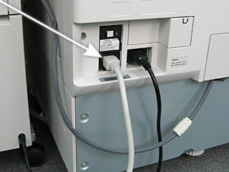
2.4Figure :power outlet
C) Warm-up:Allow the machine to warm up for a few minutes. This is necessary for the machine's internal components to reach the optimal operating temperature.
D) Paper loading: Check the paper tray and load it with the appropriate type and size of paper. Make sure the paper is loaded correctly and aligned properly.
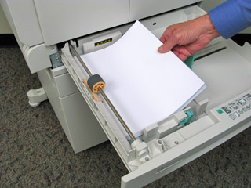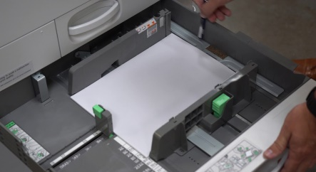
2.5 Figure :paper loading
E) Adjust settings: Set the desired copy settings such as the number of copies, paper size, paper type, and print quality. These settings may vary depending on the specific photocopy machine model.
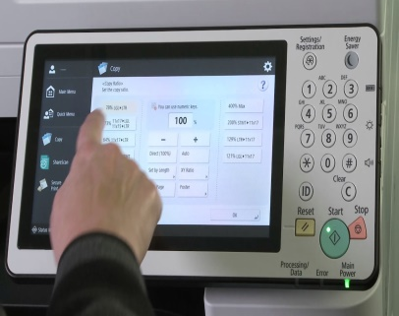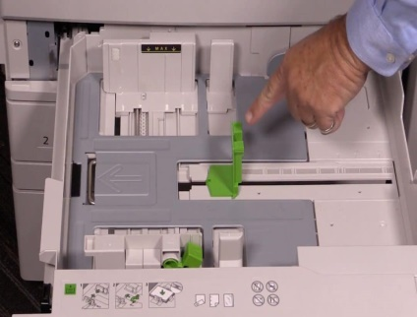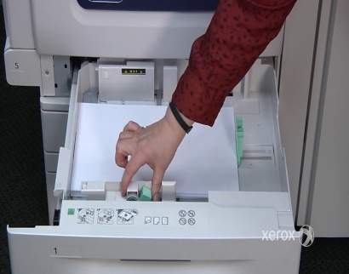
2.6 Figure :Adjust settings
F) Document placement: Place the document that you want to copy on the glass platen or in the document feeder, depending on the machine's configuration. Ensure that the document is properly aligned and free from any wrinkles or folds.
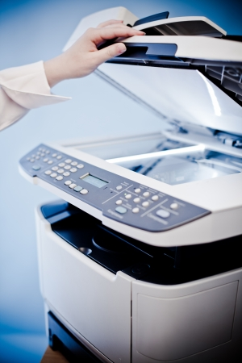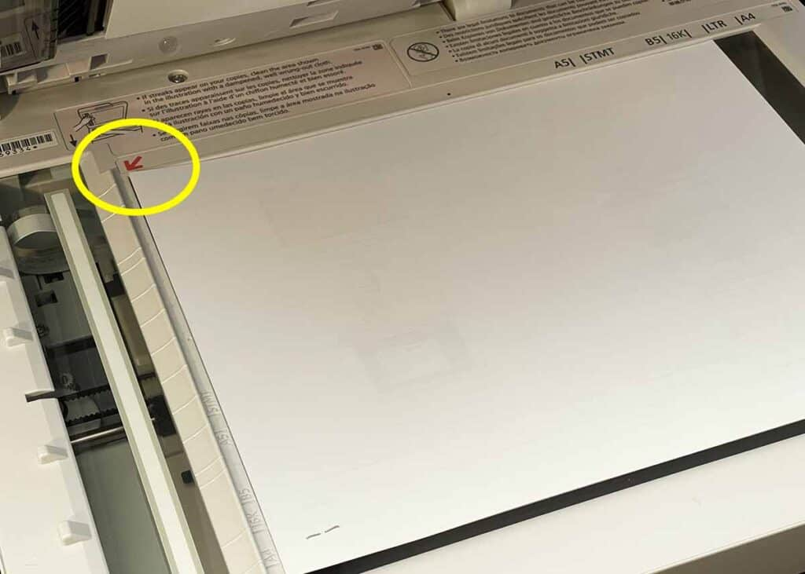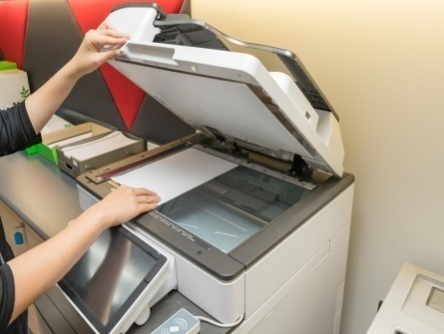
2.7 Figure: Document placement
G) Copy quality check: Make a test copy to check the quality of the output. Examine the copy for any issues such as smudging, streaks, or distortions. If the copy quality is poor, you may need to troubleshoot or adjust the machine settings.
H) Finish and reset: Once you have completed the pre-testing procedure and confirmed that the photocopy machine is functioning correctly, reset any settings or adjustments you made and prepare the machine for regular use.
Poor Copy Quality:Check the toner or ink levels. If they are low, replace or refill them.
Clean the scanner glass and the feeder rollers to remove any dirt, smudges, or debris that may be affecting the copy quality.
Adjust the copy settings to ensure the correct paper size, paper type, and print quality are selected.
If the issue persists, it might be necessary to perform a calibration or maintenance routine. Consult the user manual or contact the manufacturer for specific instructions.
Lines or Streaks on Copies:
Check the scanner glass for any dirt, smudges, or scratches. Clean it thoroughly using a soft, lint-free cloth.
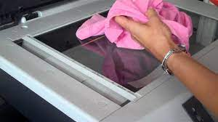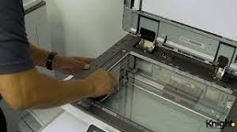
2.7 Figure: cleaning copy glass
Inspect the document feeder for any debris or marks. Clean the feeder rollers and remove any obstructions.
If the problem persists, it might be due to a malfunctioning drum or cleaning blade. In such cases, it is advisable to contact a service technician for further assistance.
Copying Problems with Document Feeder:
Ensure that the document feeder is loaded correctly and that the documents are properly aligned.
Clean the document feeder rollers and check for any obstructions or debris that may be hindering its operation.
If the issue continues, there might be a problem with the document feeder's sensors or its mechanical components. Contact the manufacturer or a service professional for assistance.
If the machine still does not power on, there may be an issue with the internal power supply or a fuse. In such cases, it is best to consult a qualified technician.
Remember, these are general troubleshooting steps, and specific procedures may vary depending on the model and manufacturer of the photocopy machine. Always refer to the user manual or contact the manufacturer's support for detailed troubleshooting instructions tailored to your particular machine.

2.3 Disassembling copy-printer parts.
Disassembling a copy-printer can be a complex task that requires technical knowledge and expertise. It is important to note that disassembling a copy-printer may void any warranties or support agreements you have with the manufacturer. Additionally, disassembling electronic devices can be hazardous and may pose risks such as electric shock or damage to the equipment
- External Covers Panels
Please refer the nameof each partslisted by number from below website:-
https://printcopy.info/?l=en&mod=pc&brand=Canon&model=iR3320&page=23
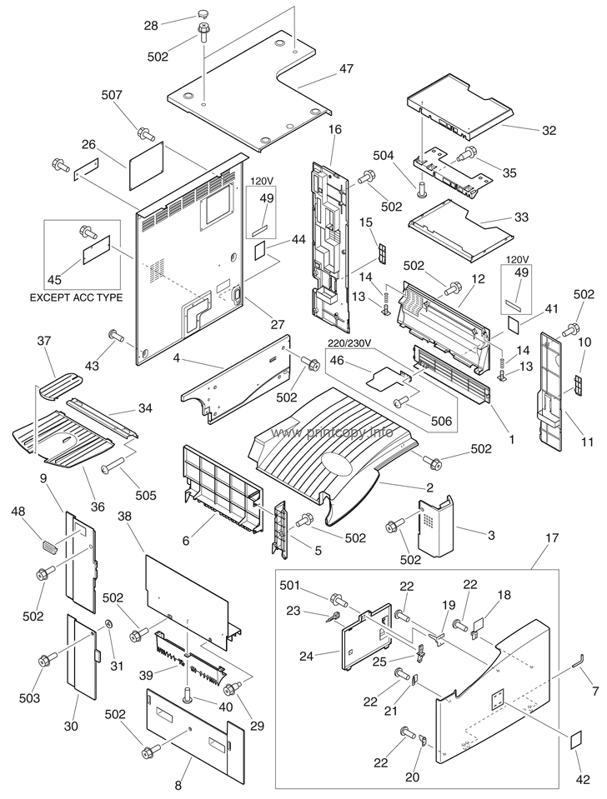

- Machine Front Panel
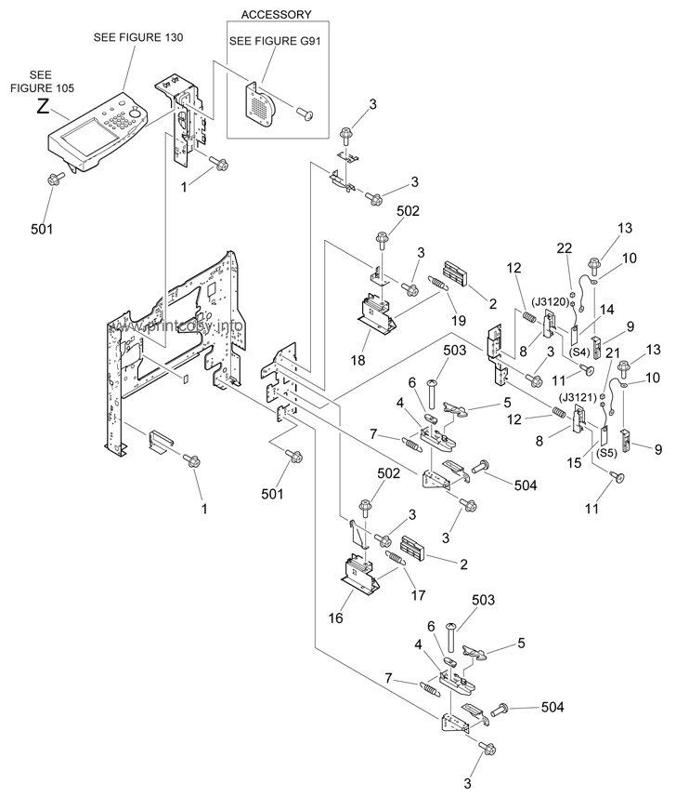

- Internal Component 1
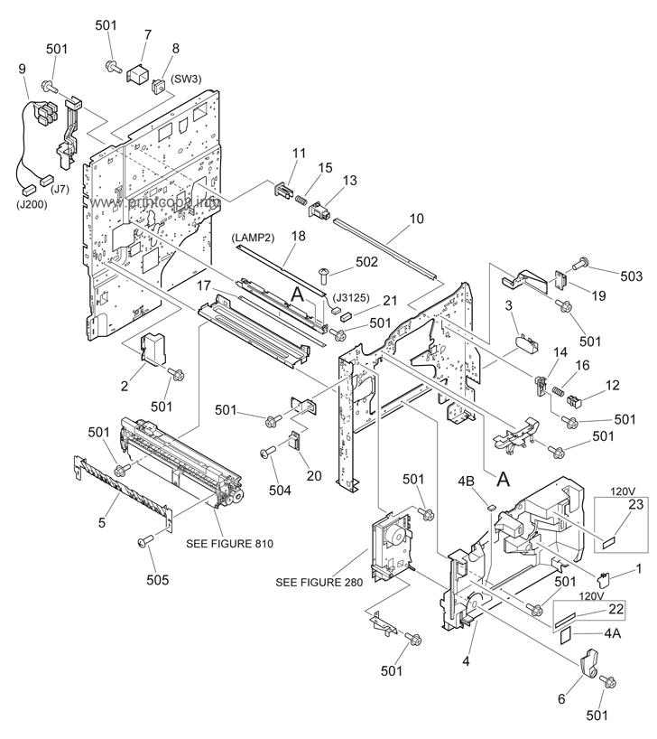

- Internal Component 2
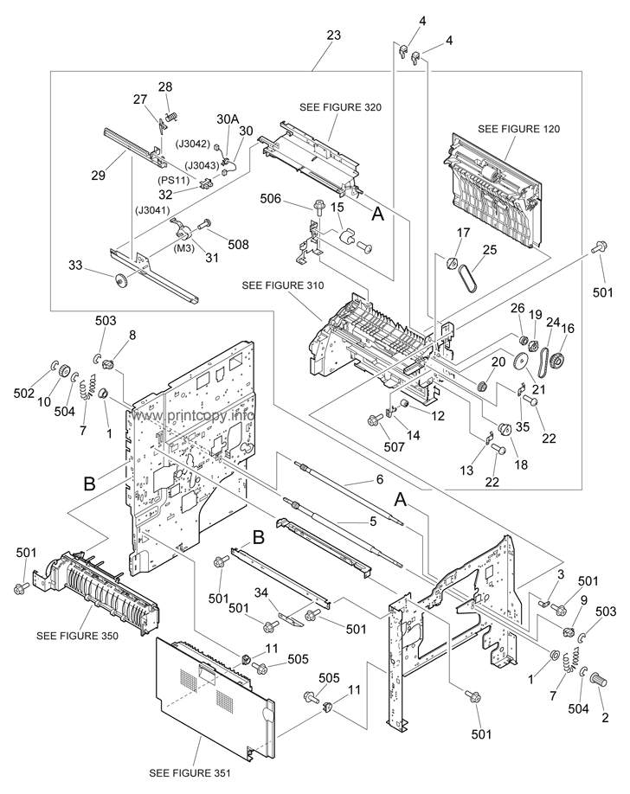

- Internal Component 3

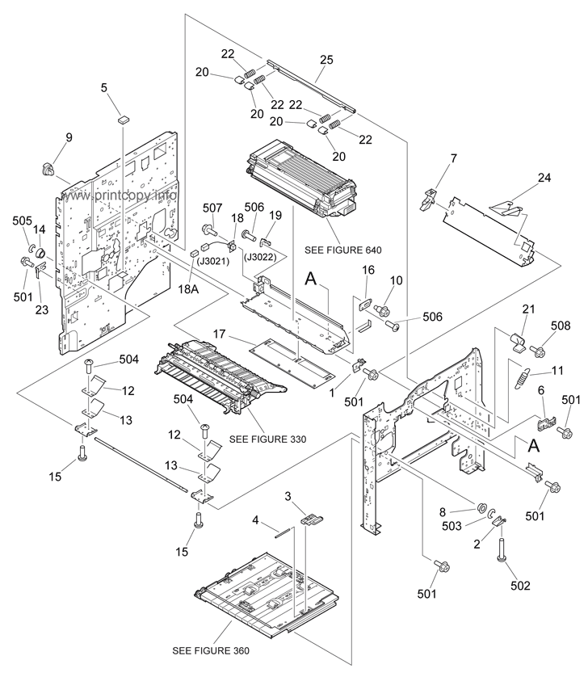

- Internal Component 4
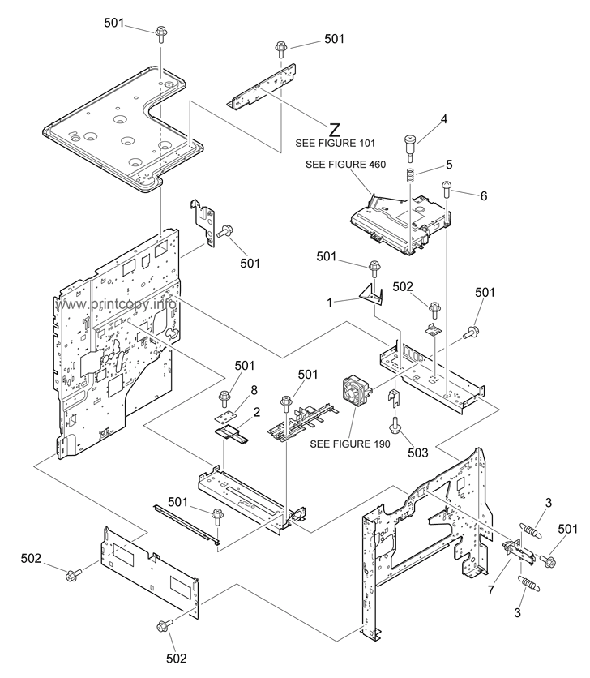

- Internal Component 5
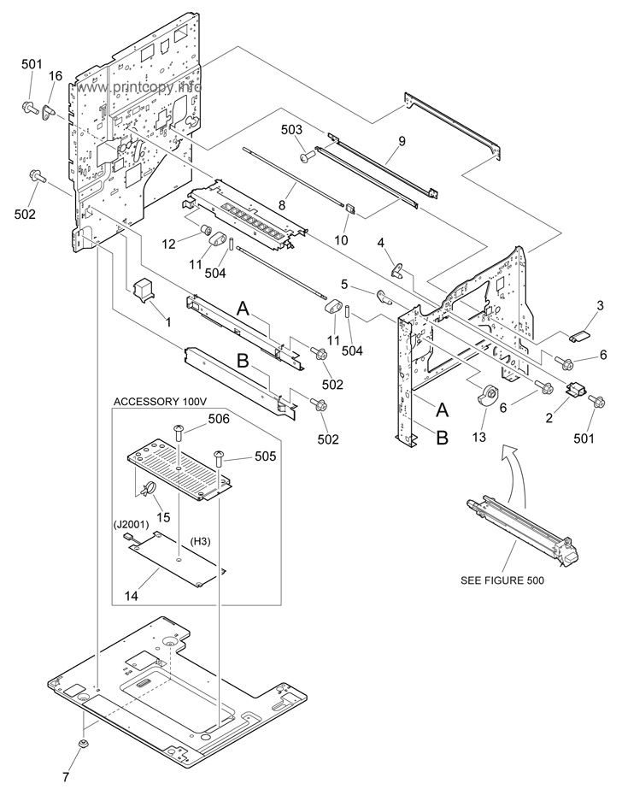

- Machine Rear Plate

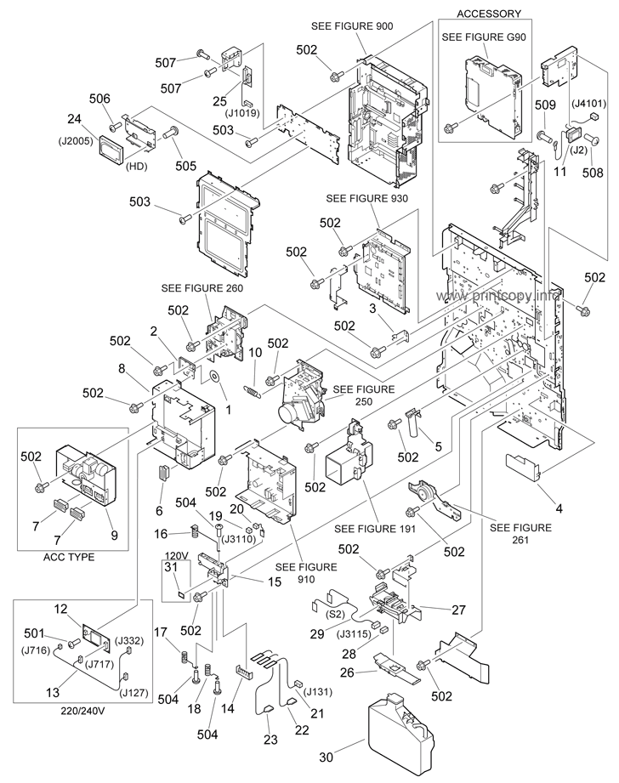

- Control Panel Assembly
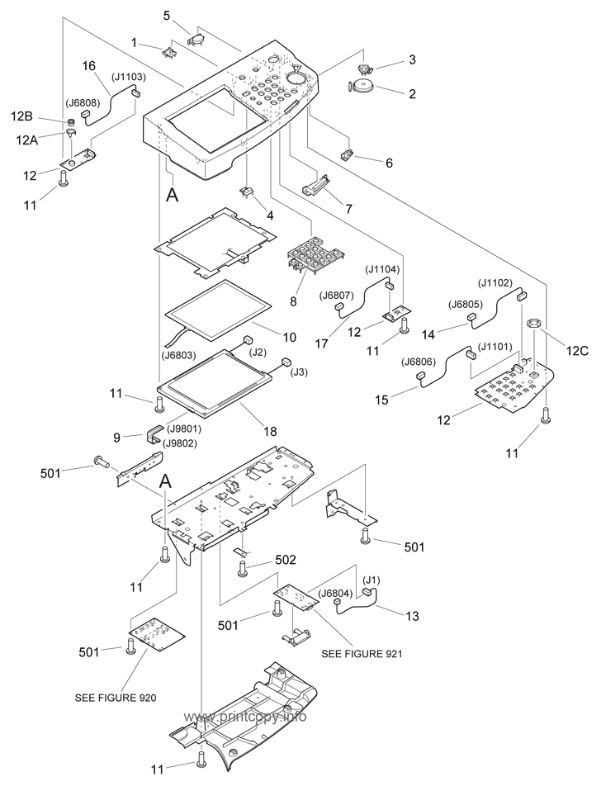

- Right Door Assembly
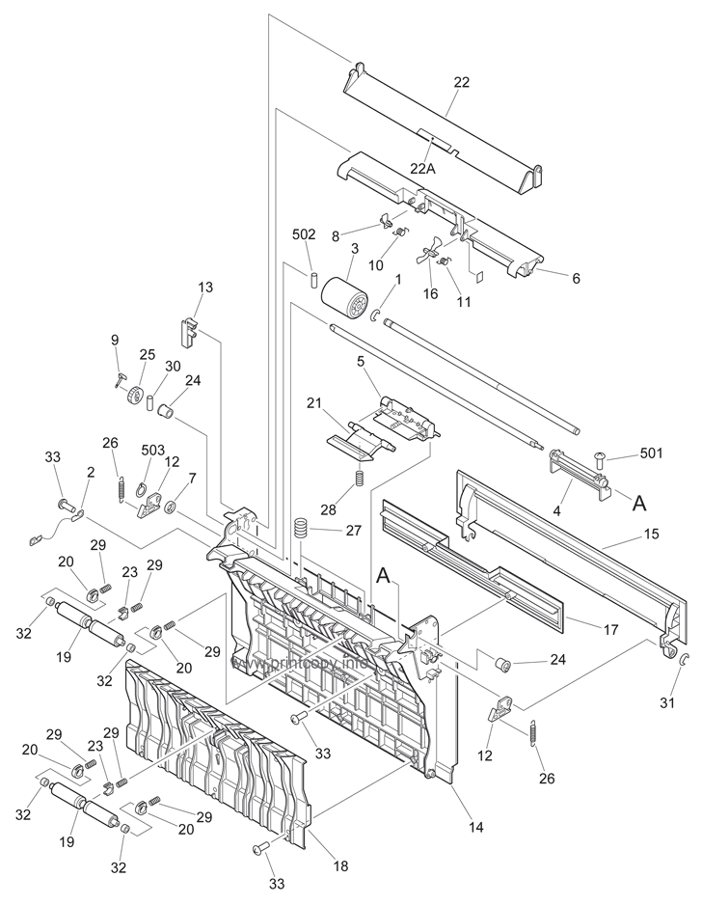

- Fixing Feeder Drive Assembly
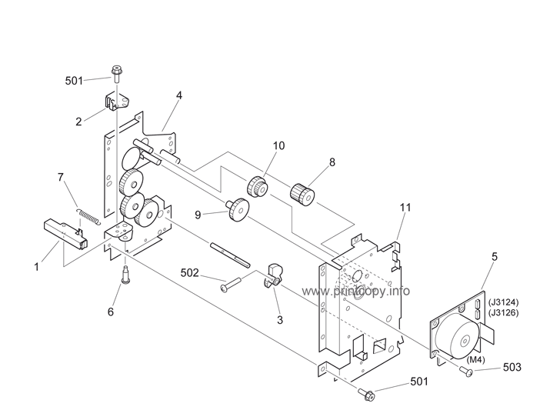
- Scanner Assembly
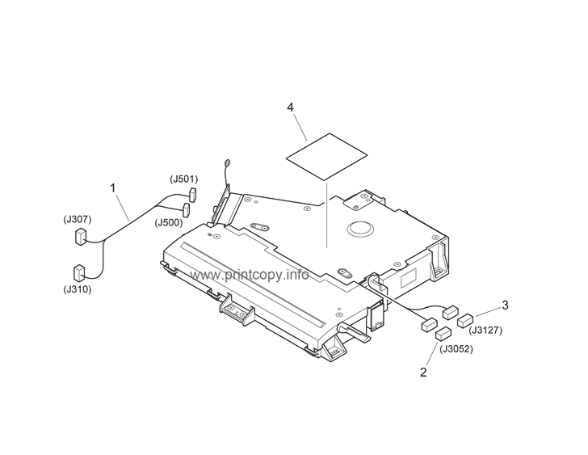
13) Drum Cartridge Assembly
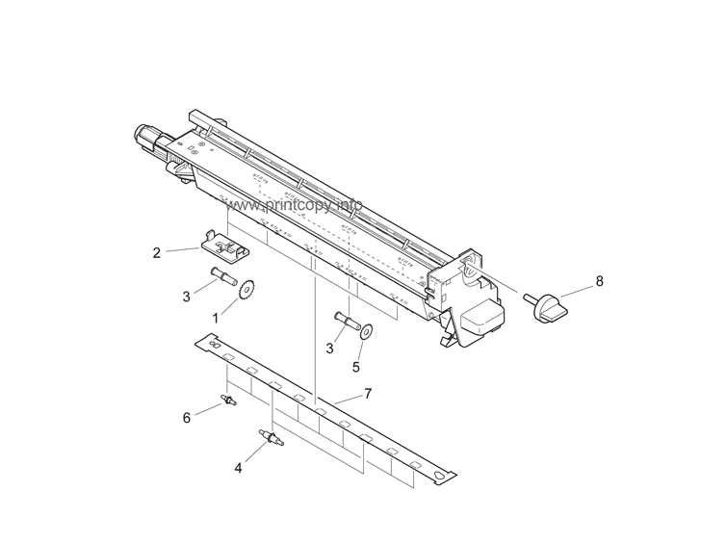

14) Develop Assemble
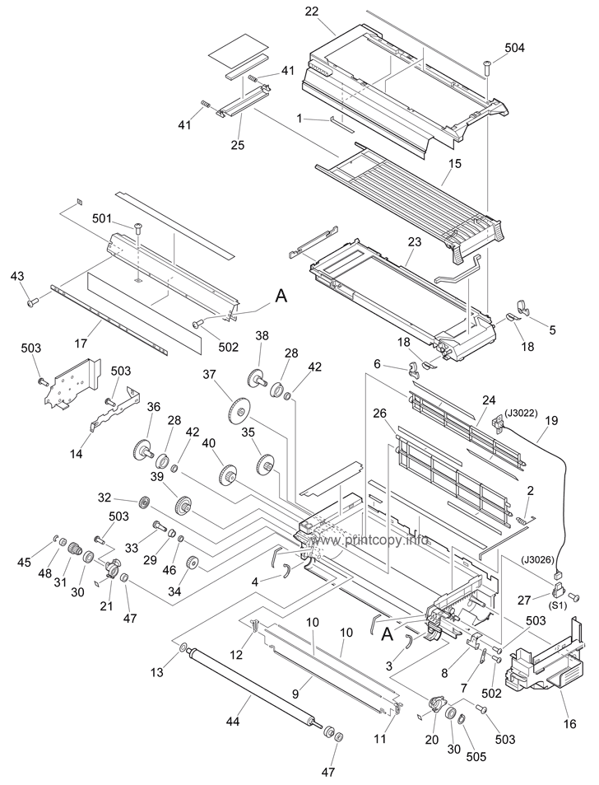

15) Fixing Assembly

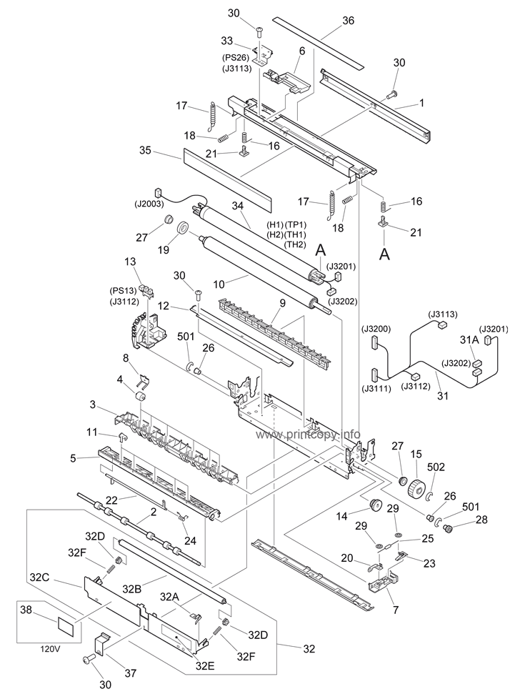

16) Controller Box Assembly
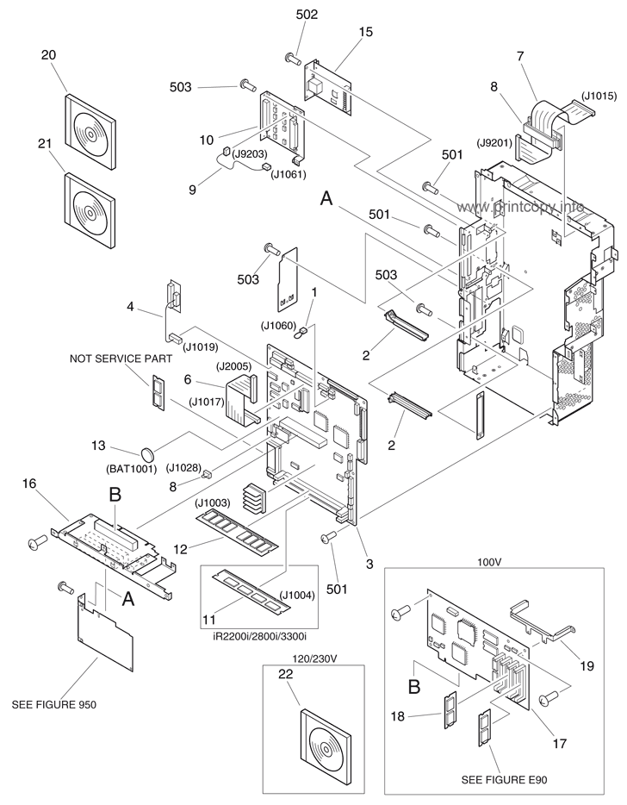

2.3. Identifying defects and faults symptoms.

Digital photocopiers, like any complex electronic devices, can experience various defects and faults. Here are some common issues and their symptoms, along with possible solutions:

- Paper Jams:

Symptoms: Frequent paper jams, error messages indicating a paper jam.
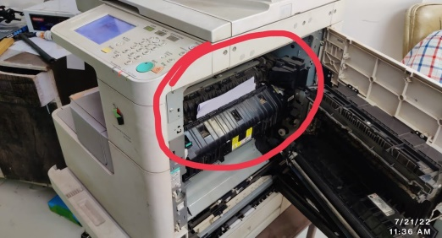

Solutions: Remove any jammed paper carefully. Clean the paper path and rollers.
Ensure the paper is properly loaded and aligned. If the problem persists, there may be a faulty sensor or a worn-out roller that requires professional repair.
- Poor Print Quality:
Symptoms: Faint or blurry prints, streaks or lines on the copies, uneven or faded colors.
Solutions: Check the toner or ink levels and replace if low. Clean the print heads, lenses, and glass. Calibrate the copier settings for optimal print quality. If the issue persists, the drum unit or toner cartridge may need replacement.
- Ghosting:
- Symptoms: Light or faded copies with faint duplicate images.
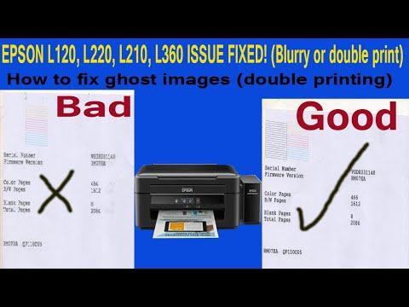
Solutions: Check and replace the imaging unit or drum cartridge if worn out. Clean the printer components thoroughly. Adjust the printer settings to reduce the fuser temperature or decrease the print density.
- No Power or Startup Failure:
Symptoms: The copier does not power on or fails to start.
Solutions: Check the power cord and ensure it is securely connected. Verify that the power outlet is functioning correctly. If necessary, replace the power cord or use a different outlet. If the problem persists, there may be an internal power supply issue that requires professional repair.
- Error Codes or Messages:
Symptoms: Error codes or messages displayed on the copier's control panel.
Solutions: Consult the user manual or the manufacturer's support documentation to identify the specific error code or message. Follow the recommended
troubleshooting steps provided. If the error persists, contact customer support or schedule a service visit.
- Scanning or Document Feeding Issues:
Symptoms: Difficulty in scanning documents, misfeeds, or multiple pages pulled through at once.
Solutions: Clean the scanner glass and the automatic document feeder (ADF). Ensure the documents are properly aligned and free from staples or other obstructions. Adjust the paper guides and the ADF separator pad if necessary. If the problem continues, there may be a mechanical issue that requires professional attention.

2.5 Using test instruments with user manuals.
o use test instruments for photocopier maintenance, follow these general steps:
Read the User Manual: Start by thoroughly reading the user manual of the photocopier. The manual provides essential information about the maintenance procedures, test points, and safety precautions specific to your model. It will also outline the recommended test instruments for maintenance purposes.
Gather Required Test Instruments: Based on the information provided in the user manual, gather the necessary test instruments. Common instruments used for photocopier maintenance include:
Multimeter: Used to measure voltage, current, and resistance. It helps diagnose electrical issues, check power supply, and identify faulty components.
Oscilloscope: Enables the analysis of electronic signals. It is useful for troubleshooting electrical problems, such as waveform distortions or signal irregularities.
Toner Density Meter: Measures the density of toner on printed pages. It helps ensure consistent print quality and toner distribution.
Reflectometer: Measures the reflectivity of photocopied images. It assists in evaluating the performance of the photoreceptor drum and other optical components.
Thermometer: Measures temperature variations, aiding in identifying overheating issues that may affect the copier's performance.
Static Electricity Meter: Measures static charge buildup, which can interfere with the copier's functionality. It helps diagnose and prevent static-related problems.

2.6 Checking and isolating Circuits
To perform electrical checking and isolating circuits in a digital photocopy machine, you need to follow proper safety procedures and have a basic understanding of electrical systems. Here is a general guide to help you get started:

- Safety first: Ensure that the photocopy machine is powered off and disconnected from the electrical supply before you begin any electrical work. Also, wear appropriate personal protective equipment (PPE), such as insulated gloves and safety glasses, to protect yourself from electrical hazards.

- Identify the power source: Locate the power cord of the photocopy machine and trace it back to the power supply. Depending on the setup, the machine may be plugged directly into a wall outlet or connected to a power distribution board.

- Use a multimeter: A multimeter is a versatile tool that allows you to measure voltage, current, and resistance. Set the multimeter to the appropriate function (voltage or resistance) and range.

- Check power supply voltage: With the machine still disconnected from the power supply, use the multimeter to measure the voltage between the live and neutral or ground wires. Ensure that the measured voltage matches the expected voltage (e.g., 110V or 220V) for your region. If the voltage is significantly different, there may be an issue with the power supply.

- Inspect power cables and connectors: Examine the power cord and connectors for any visible damage, such as cuts, fraying, or loose connections. If you find any issues, replace the faulty cables or connectors.

- Check fuses and circuit breakers: In digital photocopy machines, there are often internal fuses or circuit breakers that protect the electrical circuitry. Consult the machine's user manual or service documentation to locate these protective devices. Use a multimeter to check if the fuses are intact or the circuit breakers are in the closed position. Replace any blown fuses or reset any tripped circuit breakers as necessary.

- Isolate subsystems or components: If you suspect a specific subsystem or component is causing electrical issues, you can isolate it by disconnecting or bypassing it temporarily. For example, you can disconnect the power supply to the imaging unit or the control board and observe if the problem persists. This process helps narrow down the faulty part.

- Perform continuity tests: Continuity tests help identify breaks or shorts in electrical connections. With the machine powered off and disconnected from the power supply, use the multimeter's continuity function to check the continuity of wires, connectors, switches, and other electrical components. A continuous beep or low resistance reading indicates a good connection, while no beep or high resistance reading suggests a problem.

- Seek professional assistance if needed: If you are unable to identify or resolve the electrical issue on your own, it is advisable to contact a qualified technician or the manufacturer's support for further assistance.

Self cheek 2.1
Test I: for the following questions write ‘true’ if the statement is correct and ‘false’ if the statement is incorrect and explain the reason.
________1. A blank or streaky output is a common symptom of a defective copier machine..
________2. Random paper jams are not indicative of a defective copier machine.
________3.Unusual grinding or clicking noises during operation can be a sign of a defective copier machine.
________4.Slow or inconsistent copying speed is not a symptom of a defective copier machine..
Test III: Explain the following questions in brief
- Describe theCommon faults symptoms of Copier Machine.
- List ten main test pointof Copier machine during troubleshooting.
- List and explain two steps when we check and repair the lid switch.

Operation sheet 2.1
Operation sheet title:-To troubleshoot faults/defect scanner assembly and image
Purpose: - To troubleshoot faults/defect scanner assembly and image
Instruction: -Using the given equipments troubleshoot faults Copier machine makebla
You have given 60Minuts for the task and you are expected to write the answer on the given line.
Tools and requirement
- Drum OPC
- Charging roller
- Fuser film
- Scanner lamp.
- Scanner lamp cable
- Scanner
Steps in doing the task
Step 1 Check the druopc. If faulty, replace with a new opc.
Step 2.Check the wastage tanker full. If there is a wastage then remove wastage Tone.
Step 3. Check the sensor , toner ditector. Scanner cable connections or replace sensor;.
Step4. Check the scanner lamp.Source power Connections or replace scanner lamp.
Step 5.Check the Charging roller. Fix connections or replace .
Step6. Check the over head glass. Clean or replace.
Step 7.Check Resolution and Quality Settings. Fix connections or replacecomponents .
Step8.Check the mirror .fix lens position or replace.

Lab test 2.1
Task1: Check the OPC
Task2. Check the Wastage tank
Task3: Check the sensor
Task4: Check the scanner lamp
Task5: Check Charge roller
Task6: Check the glass
Task7: Check any plastic valve
Task8: Check the Resolution

Unit Three: Maintain/repair.
This unit is developed to provide you the necessary information regarding the following content coverage and topics:
  - Replacing Defective parts/components.
  - Soldering parts/components.
  - Performing repair activity .
  - Control settings/adjustments.
  - Precaution in handlingof the unit.
  - Cleaning of digital copier Machine.
Machine This unit will also assist you to attain the learning outcomes stated in the cover page. Specifically, upon completion of this learning guide, you will be able to:
  - . Replace Defective parts/components.
  - Solderparts/components.
  - Perform repair activity .
  - Control settings/adjustments.
  - Precaution in handlingof the unit.
  - Clean of digital copier Machine.

3.1Replacing Defective parts/components
When dealing with a defective part or component in a photocopy machine, there are several common replacements that may be necessary. Here are some of the most commonly replaced parts in a photocopy machine:

- Toner Cartridge: The toner cartridge contains the toner powder used to create the image on the paper. When the toner runs out or becomes faulty, it needs to be replaced.
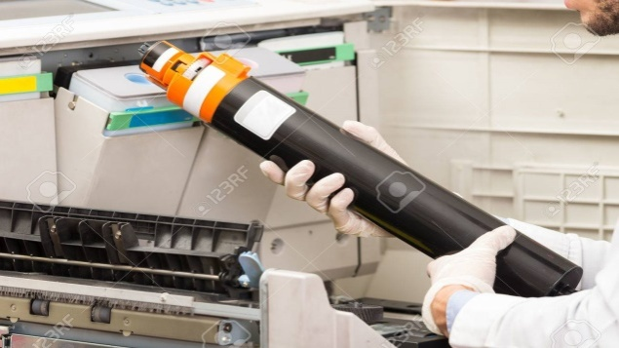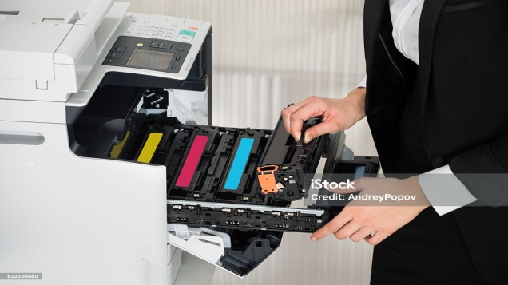

  - Drum Unit: The drum unit is responsible for transferring the toner onto the paper. Over time, the drum may wear out or become damaged, requiring replacement.

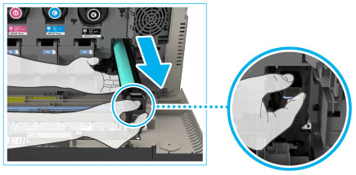

  - Fuser Assembly: The fuser assembly is responsible for melting and bonding the toner to the paper. If the fuser assembly is not functioning correctly, it may cause issues such as smudging or poor print quality.

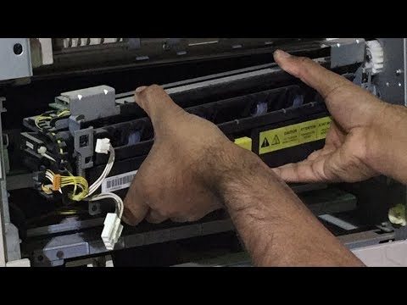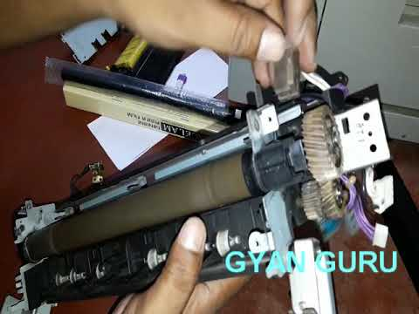
  - Paper Feed Rollers (paper pickup): These rollers help to feed the paper through the machine. If the rollers become worn or dirty, they may not grip the paper properly, resulting in paper jams or misfields
.
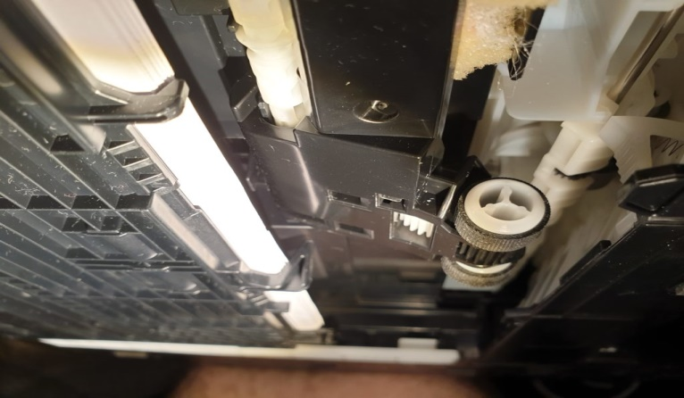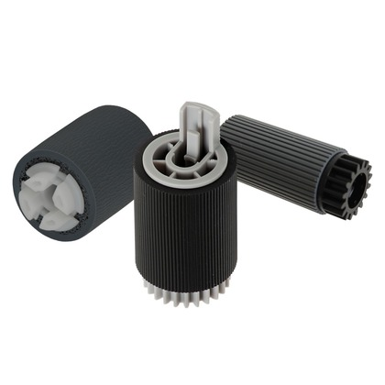
  - Imaging Unit: The imaging unit houses the various components responsible for creating the image, such as the laser, mirrors, and lenses. If any of these components fail, the imaging unit may need to be replaced.
  - Transfer Belt: The transfer belt assists in transferring the toner from the drum to the paper. If the transfer belt becomes damaged or worn, it can lead to print quality issues.
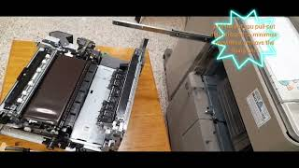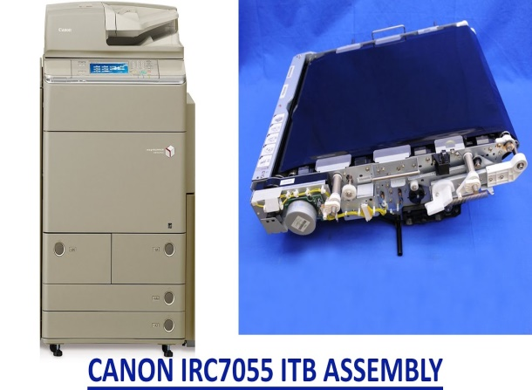
  - Developer Unit: The developer unit works with the drum to apply toner to the paper. If the developer unit malfunctions, it may need to be replaced.
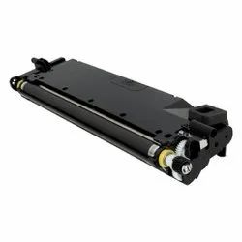
  - Power Supply: If the photocopy machine is not receiving adequate power or is experiencing electrical issues, the power supply unit may need to be replaced.
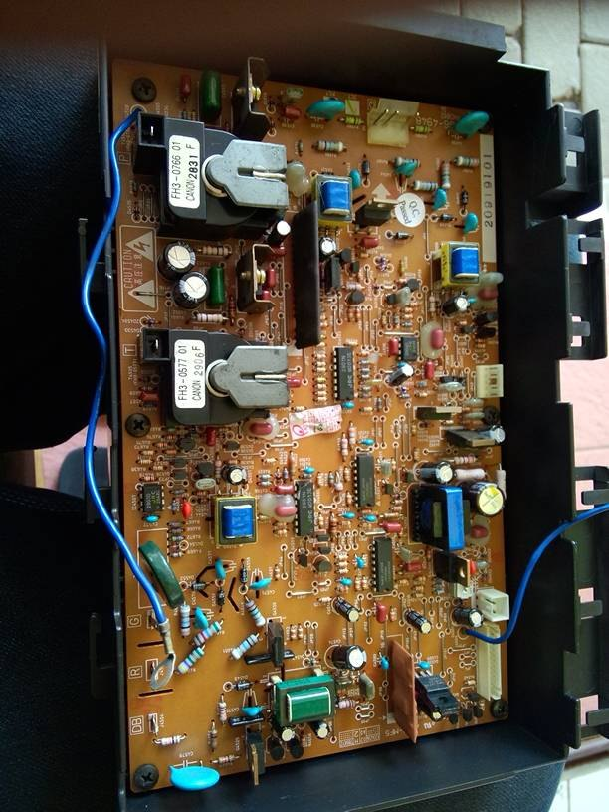

3.2 Solderingparts/components.
When it comes to soldering parts or components on a photocopy, it's important to note that the photocopying process involves the use of heat and pressure to transfer toner onto paper. Soldering involves applying heat to melt solder and join electronic components together.
- Integrated circuits (ICs): These are small electronic chips that perform specific functions in a circuit.
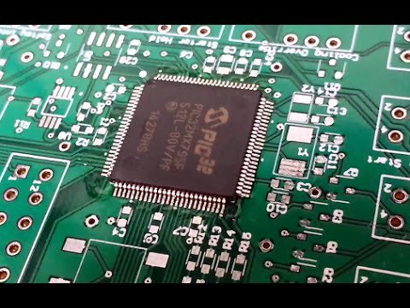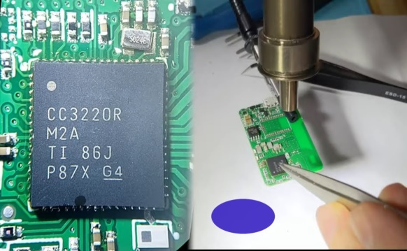

- Resistors: They are passive components that resist the flow of electric current.
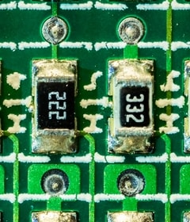

- Capacitors: These components store and release electrical energy. They are commonly used for filtering, decoupling, and timing purposes.
- Diodes: Diodes allow current to flow in one direction and block it in the opposite direction.
- Transistors: Transistors are active components that amplify or switch electronic signals.
- LEDs (Light Emitting Diodes): LEDs are specialized diodes that emit light when current passes through them.
- Connectors: These are used to establish electrical connections between different components or devices.
- Switches: Switches are used to control the flow of current in a circuit.
- Potentiometers: Also known as variable resistors, potentiometers allow you to adjust the resistance in a circuit.
- Inductors: Inductors store energy in a magnetic field and are commonly used in filters and power supply circuits.

3.2.Performing repair activity
To perform repair activities on a digital photocopy machine, you can follow these general steps:
- Identify the Issue: Start by identifying the problem with the digital photocopy machine. It could be a malfunctioning component, a software error, or any other issue affecting its performance.
- Consult the Manual: Refer to the user manual or technical documentation for the digital photocopy machine. It will provide you with specific troubleshooting steps and information about common issues.
- Basic Checks: Perform basic checks to ensure that the machine is properly connected to power, the network (if applicable), and all cables are securely attached. Check for any visible signs of damage or loose connections.
- Restart: Sometimes, a simple restart can resolve minor glitches. Turn off the machine, unplug it from the power source, wait for a few minutes, and then plug it back in and turn it on again.
- Error Codes: If the machine displays an error code or message, consult the user manual or the manufacturer's website for information about the specific error and possible solutions.
- Software Issues: If the problem seems to be software-related, check for any available firmware updates or patches from the manufacturer's website. Follow the instructions provided to update the software.
- Clean and Maintain: Regularly clean the machine, including the glass, rollers, and paper path. Use recommended cleaning materials and procedures provided in the user manual.
- Component Replacement: If a specific component is identified as faulty, such as a toner cartridge or a drum unit, follow the instructions in the user manual to replace the component. Ensure that you have the correct replacement part.
- Professional Assistance: If the problem persists or if you are uncomfortable performing the repairs yourself, contact the manufacturer's customer support or a certified technician for assistance. They will have the expertise and tools to diagnose and repair complex issues.
3.5 Control settings/adjustments
Digital photocopiers typically offer various control settings and adjustments to optimize copy quality and functionality. While specific features may vary depending on the make and model of the machine, here are some common control settings you may find on a digital photocopier:
- Image Density/Contrast:This setting allows you to adjust the overall darkness or lightness of the copied image. Increasing the density makes the image darker, while decreasing it makes the image lighter. It's useful for adjusting the copy to match the original document or to enhance readability.
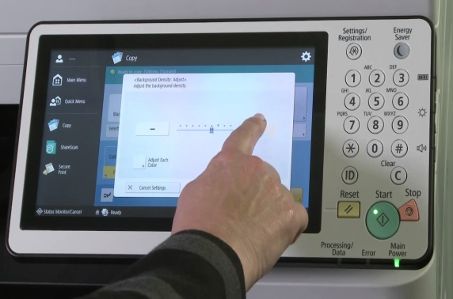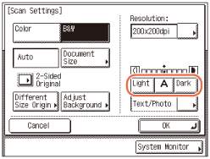
- Zoom: The zoom function allows you to enlarge or reduce the size of the copied image. You can specify a percentage increase or decrease to adjust the size according to your requirements.
- Paper Size/Type: You can select the paper size and type to match the original document or your desired output. Common options include letter, legal, A4, A3, and various envelope sizes. Additionally, you may have the option to choose between different paper types, such as plain paper, recycled paper, or glossy paper.
- Duplexing: If your photocopier supports duplexing, you can enable this feature to automatically copy both sides of a double-sided original document. It helps save paper and is useful for copying booklets or documents printed on both sides.
- Sorting/Collation: This feature allows you to specify whether you want the copies to be sorted or collated. Sorting arranges the copies in separate sets, with all the first pages together, followed by the second pages, and so on. Collation groups the copies into complete sets, so each set contains all the pages of the document.
- Resolution/Quality: You may have the option to adjust the resolution or quality of the copied image. Higher resolution settings generally result in better image detail but may take longer to produce. Lower resolution settings may sacrifice some image quality but can be quicker
- Color/B&W: If your photocopier supports color copying, you can choose to make copies in color or black and white. Color copying can be useful for preserving the original document's appearance, while black and white copying is often more economical.
- Image Editing: Some advanced photocopiers offer basic image editing capabilities, such as cropping, rotating, or adjusting skew. These features allow you to modify the copied image to align it correctly or remove unwanted portions.

3.5. Precaution in handlingof the unit.
When handling a photocopier, it's important to follow certain precautions to ensure your safety and the proper functioning of the machine. Here are some common precautions to keep in mind:
- Read the User Manual: Familiarize yourself with the operation and safety instructions provided in the user manual. Each photocopier may have specific guidelines, so it's crucial to understand them before use.
- Placement: Ensure that the photocopier is placed on a stable and level surface to prevent it from tipping over. Avoid placing it near any flammable materials or in areas with poor ventilation.

- Power Source: Connect the photocopier to a properly grounded electrical outlet. Avoid using extension cords or power strips unless they are specifically recommended by the manufacturer.
- Ventilation: Ensure that the photocopier has adequate ventilation to prevent overheating. Avoid blocking the air vents and allow some space around the machine for air circulation.
- Moving Parts: Be cautious of moving parts, such as the document feeder, paper feed trays, and output trays. Avoid placing your hands or any objects near these areas during operation to prevent injury.
- Cleaning: Follow the manufacturer's instructions for cleaning the photocopier. Use only recommended cleaning agents and avoid spraying liquids directly onto the machine. Disconnect the power supply before cleaning any internal parts.
- Toner and Cartridge Handling: When replacing toner cartridges or handling them for any reason, be careful not to spill toner powder. It can be messy and potentially hazardous if inhaled or ingested. Follow the manufacturer's guidelines for proper handling and disposal of toner cartridges.
- Paper Handling: Use the recommended paper type and size for the photocopier. Do not overload the paper trays beyond their capacity, as it can cause paper jams and other operational issues.
- Maintenance: Regularly schedule maintenance and servicing of the photocopier according to the manufacturer's recommendations. This will help keep the machine in optimal working condition and extend its lifespan.

- Authorized Personnel: Unless you are specifically trained and authorized, avoid attempting any repairs or modifications on the photocopier yourself. Contact the manufacturer's customer support or a qualified technician for assistance.
  - Cleaning of digital copier Machine.
To keep your digital copier machine in good working condition and ensure optimal performance, regular cleaning is necessary. Here are some common cleaning steps you can follow:
- Power off the copier: Before starting the cleaning process, make sure the copier is powered off and unplugged from the electrical outlet. This ensures your safety and prevents any accidental damage.
- Dusting: Use a soft, lint-free cloth or a microfiber cloth to gently wipe the exterior surfaces of the copier, including the control panel, document feeder, and paper trays. This helps remove any dust or loose dirt that may have accumulated.
- Glass platen: The glass platen is the flat surface where you place documents for scanning or copying. Clean it by spraying a small amount of glass cleaner onto a lint-free cloth and gently wipe the surface. Avoid spraying the cleaner directly onto the glass to prevent any liquid from seeping into the copier.
- Document feeder: If your copier has an automatic document feeder (ADF), open it and inspect for any debris or dirt. Use a can of compressed air or a soft brush to remove any particles that may be stuck in the feed rollers or the ADF mechanism.
Toner cartridge: If you notice any toner spills or smudges inside the copier, carefully remove the toner cartridge according to the manufacturer's instructions. Wipe away any excess toner with a clean, dry cloth. Be cautious when handling toner cartridges as they contain fine particles that can be messy if mishandled.
Paper path: Occasionally, paper dust or small paper shreds may accumulate inside the copier's paper path. To clean it, refer to the copier's user manual for specific instructions on accessing the paper path. Typically, you can use a lint-free cloth or a small vacuum cleaner to remove any debris.

- Ventilation areas: Check for any ventilation slots or openings on the copier's exterior. Ensure they are clear of dust or obstructions, as proper ventilation helps prevent overheating.
Regular maintenance: In addition to routine cleaning, consult the copier's user manual for recommended maintenance procedures. This may include replacing consumables such as toner cartridges, cleaning blades, or fuser units at specified intervals.

Steps in doing the task
Step 1: Disassemble the Machine and Test Components
Step 2: Inspect the Electronic Board
Step 3: Identify the Burned Component (transistor) and Testing
Step 4: Repairing the Electronic Board
Step 5: De-solder burned transistor
Step 6: place and solder new transistor with similar model number

Lab test 3.1
Task1: Disassemble Digital photocopy machine
Task 2: Troubleshoot the Electronic Board
Task 3: Identify the Burned Component and Testing
Task4: Repairing the Electronic Board
Task 5: De-solder burned transistor
Taskn6: place and solder new transistor

Unit Four :Test repaired unit
This unit is developed to provide you the necessary information regarding the following content coverage and topics:
- Repair and reassemble
- Tested and clean the final reassembled unit
- Compile final documentations
- Dispose waste materials
This unit will also assist you to attain the learning outcomes stated in the cover page. Specifically, upon completion of this learning guide, you will be able to:
- Repair and reassemble
- Test and clean
- Compile document
- Dispose west materials

4.1. Test and clean the final reassembled unit.
Testing and cleaning the final reassembled unit usually involves several steps to ensure its functionality and cleanliness. Here's a general procedure you can follow:
- Preparation:
Set up a clean and well-lit workspace with adequate ventilation.
Gather the necessary tools and equipment, such as testing instruments, cleaning supplies, safety gear, and any specific tools required for the unit.
Review the unit's documentation, including assembly instructions and testing guidelines.
- Visual Inspection:
Conduct a visual inspection of the reassembled unit to check for any visible defects, loose connections, or abnormalities.
Ensure that all components are correctly installed and aligned according to the assembly instructions.
Look for any signs of damage, such as cracks, dents, or corrosion.
- Functional Testing:
Connect the necessary power sources and ensure proper grounding.
Follow the unit's testing guidelines to perform functional tests. This may involve powering on the unit, running diagnostic software, or using specialized testing equipment.
Verify that all functions and features of the unit are working correctly.
Record the test results and any observed issues or malfunctions.
- Performance Testing (if applicable):
If the unit has specific performance metrics, conduct tests to verify its performance against those metrics.
Use appropriate measuring instruments and methodologies to assess the unit's performance.
Compare the test results with the specified performance criteria to determine if the unit meets the required standards.
- Cleaning:
Before cleaning, ensure that the unit is powered off and disconnected from any power sources.
Follow the manufacturer's guidelines for cleaning the unit. This may involve using specific cleaning agents, tools, or techniques.
Pay particular attention to sensitive components, connectors, and areas prone to dust or debris accumulation.
Use antistatic measures if required to prevent damage to electronic components.
Thoroughly remove any dirt, dust, or contaminants from the unit's surfaces.
Inspect the unit again after cleaning to ensure all residues are removed.
- Final Inspection:
Conduct a final visual inspection to verify that the unit is clean, free from contaminants, and meets the required quality standards.
- Check for any loose connections or components that may have been affected during the cleaning process.
Ensure that all protective covers, labels, and markings are intact and correctly positioned.

4.2. Compile final documentations.
To compile the final documentation for a digital photocopy machine, you can follow these steps:
- Gather all relevant information: Collect all the necessary documentation and materials related to the digital photocopy machine. This may include user manuals, technical specifications, design documents, test results, and any other relevant information.
- Organize the documentation: Create a folder or directory structure to organize the documentation. Use clear and logical categories or sections to make it easy to navigate and locate specific documents.

- Create an index or table of contents: Develop an index or table of contents that provides an overview of the documentation. This should include a list of documents, their titles, and brief descriptions. This helps users quickly find the information they need.
- Review and revise documents: Carefully review each document to ensure accuracy, clarity, and consistency. Check for any spelling or grammatical errors, and revise as necessary. Verify that the information presented is up-to-date and matches the features and functions of the digital photocopy machine.
- Standardize document formats: Maintain consistent formatting across all documents. Use a consistent font, font size, headers, and footers. Ensure that diagrams, images, and tables are properly labeled and referenced.
Include visual aids: Whenever applicable, include visual aids such as diagrams, illustrations, and screenshots to enhance understanding. Visuals can be particularly helpful in explaining complex concepts or procedures.
- Provide step-by-step instructions: Clearly outline the steps required to perform common tasks or operations on the digital photocopy machine. Write detailed instructions using simple language, and consider including both textual descriptions and accompanying visuals.
Add troubleshooting and maintenance information: Include troubleshooting guides and maintenance procedures to help users resolve common issues or perform routine maintenance tasks. Provide clear instructions, error codes, and troubleshooting tips.
- Incorporate safety information: Include a section dedicated to safety precautions and guidelines. Highlight any potential hazards and provide instructions on how to safely operate and maintain the digital photocopy machine.
- Review the final compilation: Once you have compiled all the documents, review the entire compilation to ensure that it is comprehensive, accurate, and well-organized. Double-check that all necessary documents are included and that there are no inconsistencies or missing information.
- Finalize the documentation: Make any necessary revisions based on the review and feedback process. Ensure that the documentation is formatted consistently, and that all content is accurate and up-to-date.

- Publish and distribute the documentation: Once the final documentation is ready, determine the appropriate format for distribution. This could include printed copies, electronic files (PDFs), or online documentation. Make the documentation easily accessible to the intended users, such as customers, service technicians, or internal staff.

4.3. Dispose waste materials.
To compile the final documentation for a digital photocopy machine, you can follow these general steps:
- Gather all the relevant documents: Collect all the documents related to the digital photocopy machine, including user manuals, technical specifications, service records, warranty information, and any other relevant materials.
- Organize the documents: Sort the documents in a logical order. You can arrange them chronologically or categorize them based on their purpose or topic.
- Review and edit the documents: Read through each document carefully and make any necessary edits or updates. Ensure that the information is accurate, up to date, and consistent across all documents.
- Standardize formatting: Maintain a consistent formatting style throughout the documentation. Use the same font, font size, headings, bullet points, and numbering conventions. Consider using templates or style guides to ensure consistency.
- Create a table of contents: Generate a table of contents that lists all the sections or documents included in the compilation. This will help readers navigate the documentation easily and find the information they need.
- Add introductory sections: Include an introduction that provides an overview of the digital photocopy machine, its features, and its intended use. You can also include a brief history of the machine or any other relevant background information.
- Include step-by-step instructions: If applicable, include detailed instructions on how to operate the digital photocopy machine. These instructions should be clear, concise, and easy to follow. Use diagrams or screenshots to illustrate the steps if necessary.

- Include troubleshooting and maintenance information: Provide troubleshooting guides to help users identify and resolve common issues they may encounter with the photocopy machine. Also, include maintenance instructions, such as how to clean or replace consumable parts.
- Add safety information: Include safety precautions and guidelines to ensure users understand how to operate the machine safely. Highlight any potential hazards or risks associated with the photocopy machine and provide instructions on how to mitigate them.
- Proofread and revise: Before finalizing the documentation, carefully proofread all the content to eliminate any spelling or grammatical errors. Ensure that the information is accurate, concise, and easy to understand.
- Compile the documentation: Once all the individual documents have been reviewed and edited, compile them into a single, cohesive document. You can use a word processing software like Microsoft Word or Google Docs to merge the files.
- Design and formatting: Pay attention to the overall design and formatting of the document to make it visually appealing and easy to read. Use headings, subheadings, bullet points, and other formatting elements to enhance readability.
- Include a cover page: Create a cover page that includes the title of the documentation, the version number, the date of compilation, and any other relevant information.
- Add a revision history: Include a revision history section that tracks any updates or changes made to the documentation over time. This helps users identify the most recent version and understand what changes have been made.
- Finalize and distribute: Once you are satisfied with the compiled documentation, save it in a suitable file format, such as PDF, and distribute it to the intended audience. You can share it electronically via email or make it available for download on a website or intranet.

Self-check 4.1

Operation sheet 2.1
Operation sheet title:-To troubleshoot faults/defect fixing assembly.
Purpose: - To troubleshoot faults/defect scanner assembly and image
Instruction: -Using the given equipments troubleshoot faults Copier machine make bla
You have given 80Minuts for the task and you are expected to write the answer on the given line.
Tools and requirement
- Fuser film
- Heat element
- thermostat
- pressure roller
- Fuser cram
Steps in doing the task
Step 1 Check the fuse film. If faulty, replace with a new fuse film.
Step 2.Check the heater element. If there is a wastage then remove heater element.
Step 3. Check the thermostat .sourcecable connections or replace thermostat;.
Step4. Check the heater broken .replace heater.
Step 5.Check the pressure roller . Fix connections or replace .
Step6. Check the gearsbroken.or replace.
Step 7.Check fixing assembly. Fix connections or replace.
Step8.Check fixing gear.position aliment or replace.

Lab test 2.1
Task1: Check the fuse film
Task2. Check the heater element
Task3: Check the thermostat
Task4: Check the heater broken
Task5: Check Charge roller
Task6: Check the gears broken.
Task7: Check fixing assembly.
Task8: Check fixing gear

Reference
- https://printcopy.info/?l=en&mod=pc&brand=Canon&model=iR3320&page=23
- https://printcopy.info/index.php?mod=pc&brand=Epson&model=Stylus+Photo+PX660&page=4
- https://printcopy.info/index.php?mod=pc&brand=Xerox&model=Phaser+3155&page=11
- https://printcopy.info/?mod=pc&brand=Ricoh&model=Aficio%20MP161LN&page=4
- If you can't find what you're looking for, you can search here.https://bestengineeringprojects.com/electronics-washing-machine-control-circuit-diagram/

The trainers who develop the leaning Guide
No | Name | Qualification | Educational background | Region | College | Mobile number | E-mail
 | Tesfahun Ayalew Denidine | MSc | Electronics and comm Eng. | BGRS | Assosa poly TVET | 012132308/09212121 | tesfugps4545@gmail.com
 | Shimeles Dejen Mekonenn | BSC | Electrical Comm Techn | Ahama | W/Sein PTC. | 0910838814 | shimelesdejen@gmail.com
 | Petros Gelana Megersa | BSC | Electrical comm.T | Oromia | Ambo poly TVET | 0921183975 | petrosgelana6@gimal.com
 | Mezgebu Alemseged | BSC | Electrical & comm.T | A.A | G/M/B/ Poly TVET | 0943933255
 | Zekarias Sisay G/egziabher | MSc | Electrical & Power Eng. | Harari | Harari poly TEVET Co | 0703747163 /o913344201 | szekarias07@gmail.com

