ELECTRICAL/ELECTRONIC EQUIPMENT SERVICING
LEVEL III
October 2023, TTLM Versions - I
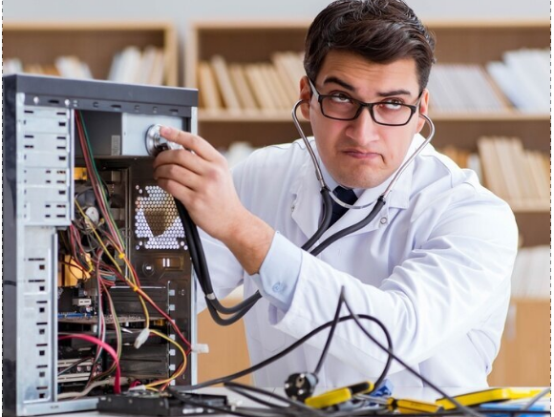
Module Title: Computer Maintenance and Repair
Module code: EIS EEES3 M06 1023
Nominal duration: 100 Hour
Prepared by: Ministry of Labor and Skills
October, 2023
Addis Ababa, Ethiopia
Contents
ACRONYM iii
ACKNOWLEDGMENT iv
- UNIT ONE OVERVIEW OF COMPUTER SYSTEMS 1
1.1 Introduction to Computer Systems: 1
1.2 Job Requirements and Work Planning 8
1.3. Tools, equipment, testing devices and necessary materials 13
1.4. Occupational Health and Safety and PPE 20
1.5. Safe handling of computer systems 28
Self-check 1.1 33
Operation Sheet:1.1 35
- UNIT TWO: FAULT DIAGNOSIS 36
2.1 Fault diagnosis procedures 37
2.2 Diagnosing faults or problems in the computer systems 40
2.2.1 Identify and Analyze Symptoms of faults 42
2.2.2 Troubleshoot and Fault localizing 44
2.2.3 Flowchart for Diagnosing Computer Maintenance 45
2.3 Managing and implementing contingency measures 78
2.4 Responding unexpected conditions. 79
2.4.1 Procedures in maintenance scheduling 81
2.4.2 Procedures in maintenance scheduling 82
Self-check 2.1. 85
Operation Sheet: 2.1 87
- UNIT THREE RECTIFYING DEFECTS IN COMPUTER SYSTEMS 89
3.1 Replacement and repair of defective components 90
3.2 Implementing Environmentally Friendly Practices in Computer Maintenance: 98
3.3 Implementing Effective Adjustment Procedures in Accordance with Established Guidelines 99
Self-check 3.1 102
Operation Sheet: 3.1 104
- UNIT FOUR: MAINTAIN COMPUTER SYSTEMS 105
4.1 Introduction to maintain computer systems 106
4.2 Preventive maintenance of computer system and network 107
4.3 Checking normal function of computer systems. 112
4.4 Maintain computer systems Scheduled/periodic maintenance tasks 114
4.5 Repairs and replacements as per established procedures 115
Self-check 4.1 118
Operation Sheet: 4.1 120
- UNIT FIVE : INSPECT AND TEST THE COMPUTER SYSTEMS 122
5.1 Introduction to Inspecting and testing computer systems 123
5.2 Final inspections to ensure compliance with manufacturer's instructions 124
5.3 Testing for safe operation 126
5.4 Adherence to OHS standards and 5S principles 128
5.5 Checking/testing maintain and repaired of computer. 130
5.6 Disposing excess components and materials. 132
5.7 Checking/testing maintain and repaired of computer. 134
5.8 Disposing excess components and materials. 135
5.9 Directives and waste management program. 137
Operation Sheet: 5.1 142
- UNIT SIX: DISPOSAL AND WASTE MANA.GEMENT 144
6.1 Introduction to Disposal and Waste Management 145
6.2 Compliance with Waste Electrical and Electronic Equipment directives 146
6.3 Reuse, recycle, and reduction practices 148
6.4 Proper disposal of excess components and materials 150
6.5 Proper disposal of excess components and materials 152
Self-check 6.1 154
Operation Sheet: 6.1 156
- UNIT SEVEN: DOCUMENTATION AND REPORTING 158
7.1 Introduction to Documentation and Reporting 159
7.2 Preparation of reports according to company requirements 160
7.3 Completion of job service order forms or checklists 162
Self-check 7.1 165
Operation Sheet: 7.1 167
References: 169

ACRONYM

ANSI | American national standards institute
ASTM | American Society for Testing and Materials
BR | Bridge rectifier
CAD | Computer-aided design
CPU | Central processing unit
CCNA | Cisco certified network
ESD | Electrostatic discharge
FMEC | Factory mutual engineering corporation
GPU | Graphics processing unit
HDD | Hard disk drive
IEEE | Institute of Electrical and Electronics
MCP | Microsoft certified professional
NFPA | National fire protection. Association
NEC | Negative temperature coefficient
NEMA | National electrical manufacturers association
NFPA | National fire protection association
NTC | Negative temperature coefficient
OHS | Occupational Health and Safety
OS | Operating system
PPE | Personal protective equipment
PCs | Personal computers
PSU | Power supply unit
RAM | Random access memory
SSD | Solid-state drive
SLAs | Associate service level agreements
SMPT | Switch mode power transformer
UL | Underwriters laboratory
WEEE | Waste Electrical and Electronic Equipment

ACKNOWLEDGMENT
The Ministry of Labor and skill, to Prosperity wish to thank MoLS experts, regional labor and skill bureaus, TVT trainers, university lecturers and industry experts who contribute their time and professional experience to the development of this Training module for ELECTRICAL / ELECTRONICS EQUIPMENT SERVICING LEVEL III
We would like to express our appreciation to the Ministry of Labor and skill to Prosperity Ethiopia for their technical and financial support and workshop facilitation of this training module development.

INTRODUCTION TO THE MODULE
Basic Concepts for Electrical and Electronics Equipment Servicing Computer maintenance refers to the regular upkeep and servicing of computer systems to ensure their optimal performance, reliability, and longevity. In the context of electrical and electronics equipment servicing, computer maintenance involves specific considerations related to the electrical components and circuits within the computer system. Computer maintenance in the context of electrical and electronics equipment servicing involves ensuring the proper functioning of electrical components, circuits, and associated hardware. Regular cleaning, inspection, and preventive measures for power supply, cooling system, circuit boards, data cables, and software are essential for maintaining optimal computer performance, reliability, and longevity.
Computer Maintenance and Repair
This module covers the units:
- Over view of mobile phone
- Diagnose faults of cellular phone unit
- Service/repair cellular phone unit
- Test repaired unit
- Install additional/ enhancement features
Learning Objective of the Module
- Prepare unit and workplace
- Diagnose faults of cellular phone unit
- Service/repair cellular phone unit
- Test repaired unit
- Install additional/ enhancement features
Module Learning Instructions:
- Read the specific objectives of this Learning Guide.
- Read the information written in the information Sheets
- Accomplish the Self-checks
- Perform Operation Sheets
- Do the “LAP test

UNIT ONE OVERVIEW OF COMPUTER SYSTEMS
This learning guide is developed to provide you the necessary information regarding the following content coverage and topics:
- Introduction to Computer Systems
- Job requirements and work planning
- tools, equipment, testing devices and necessary materials
- Occupational Health and Safety and PPE
- Safe handling of computer systems
This guide will also assist you to attain the learning outcomes stated in the cover page. Specifically, upon completion of this learning guide, you will be able to:
- Understand Introduction to Computer Systems
- Plan and prepare Job requirements and work planning
- Prepare and obtain tools, equipment, testing devices and necessary materials
- Follow Occupational Health and Safety and PPE
- Follow Safe handling of computer systems

Introduction to Computer Systems:
A computer system is a combination of hardware and software components that work together to process and store information. It consists of various interconnected parts that perform specific functions to enable the computer to carry out tasks and operations. Computer systems are used in a wide range of applications, from personal computers and laptops to large-scale servers and mainframes.
- Types of Computers:
There are several types of computers, each designed for specific purposes. The main types of computers include:
- Personal Computers (PCs): These are general-purpose computers designed for individual use. They are commonly used for tasks such as browsing the internet, word processing, multimedia, and gaming.

Figure 1-1Personal Computers (PCs):
- Laptops and Notebooks: These are portable computers that offer the same functionality as personal computers but in a compact and lightweight form. Laptops are suitable for users who need to work on the go.

Figure 1-2Laptops and Notebooks:
- Workstations: Workstations are high-performance computers designed for specialized tasks such as computer-aided design (CAD), video editing, and scientific simulations. They typically have more processing power, memory, and graphics capabilities than personal computers.
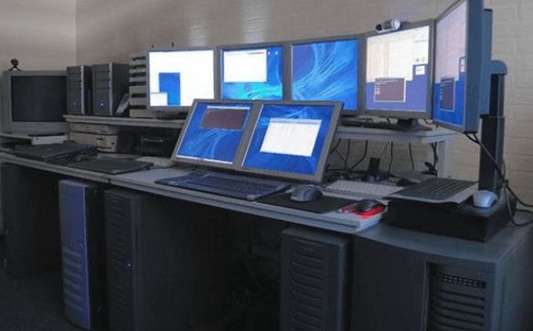
Figure 1-3 Workstations
- Servers: Servers are computers that provide resources and services to other computers, known as clients, over a network. They are used for tasks such as hosting websites, managing databases, and file sharing.
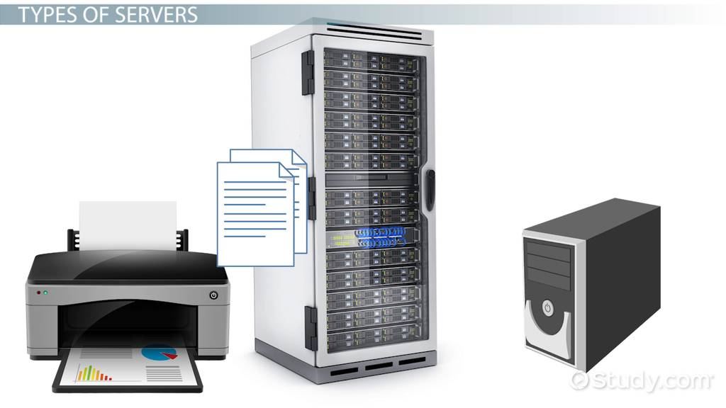
Figure 1-4Servers
- Mainframes: Mainframes are large-scale computers capable of handling massive volumes of data and supporting thousands of users concurrently. They are commonly used in organizations that require high-performance computing and data processing.
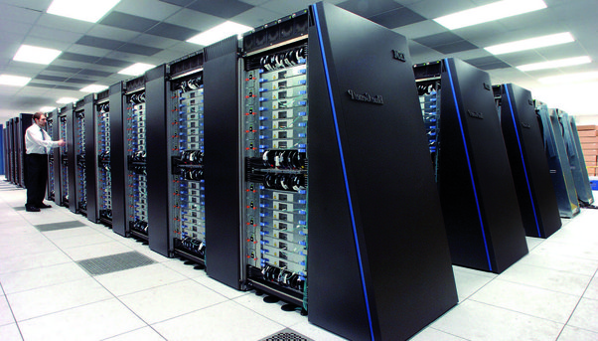
Figure 1-5Mainframes or large-scale computers
- Super computers: Supercomputers are the most powerful and fastest computers available. They are used for complex calculations and simulations in scientific research, weather forecasting, and cryptography.
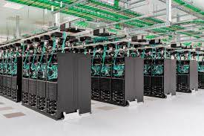
Figure 1-6Supercomputers:
- External and Internal Parts of a Computer
- External Parts:
- Monitor or Display: It is the output device that displays visual information.

Figure 1-7Monitor or Display
- Keyboard: It is an input device used for typing and entering commands.

Figure 1-8Keyboard:
- Mouse: It is an input device that allows the user to control the cursor on the screen.

Figure 1-9Mouse:
- Printer: It is an output device used to produce hard copies of documents or images.
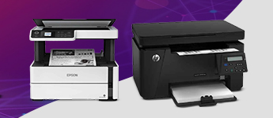
Figure 1-10Printer
- Speakers: They are output devices that provide audio output.
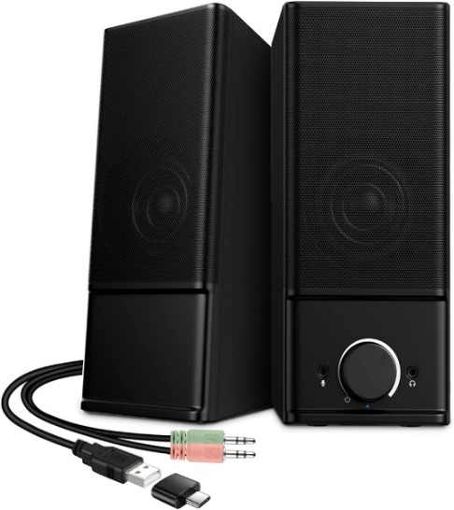

Figure 1-11Speakers:
- Internal Parts:
- Central Processing Unit (CPU): It is the brain of the computer responsible for executing instructions and performing calculations.
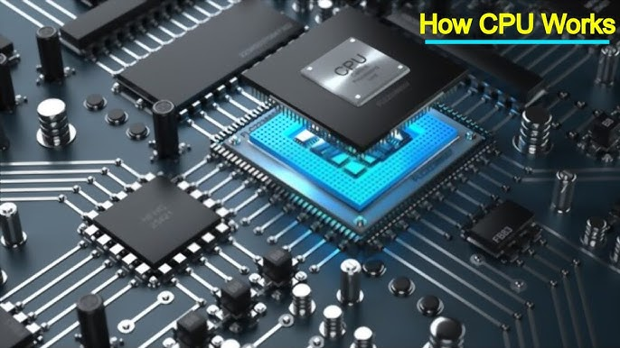
Figure 1-12Central Processing Unit (CPU):
- Motherboard: It is the main circuit board that connects and allows communication between various components of the computer.
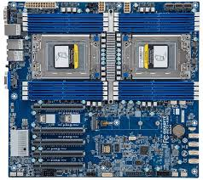
Figure 1-13Motherboard:
- Random Access Memory (RAM): It is the temporary memory where data and instructions are stored for quick access by the CPU.
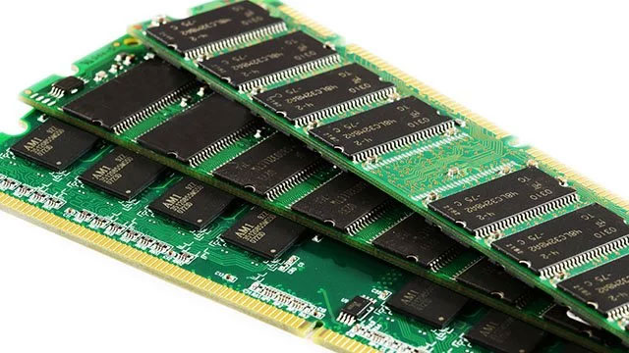
Figure 1-14Random Access Memory (RAM):
- Hard Disk Drive (HDD) or Solid-State Drive (SSD): They are storage devices used to store data and programs permanently.
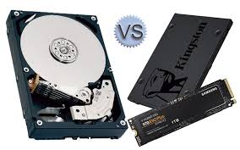
Figure 1-15Hard Disk Drive (HDD) or Solid-State Drive (SSD):
- Graphics Processing Unit (GPU): It is responsible for processing and rendering images, videos, and animations.
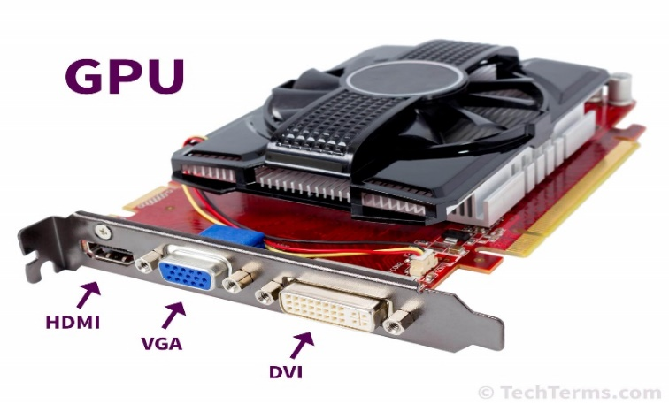
Figure 1-16Graphics Processing Unit (GPU):
- Power Supply Unit (PSU): It supplies electrical power to the computer components.
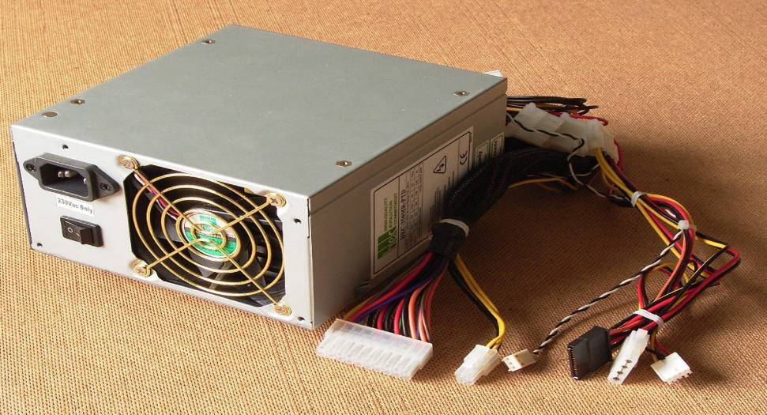
Figure 1-17Power Supply Unit (PSU):
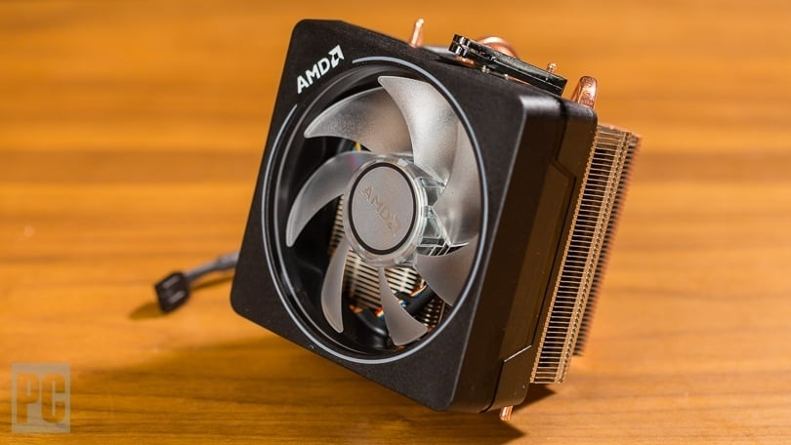
- Cooling System: It includes fans and heat sinks to prevent overheating of the computer.
Figure 1-18Cooling System:
These are just some of the basic external and internal parts of a computer. There are many other components and peripherals that can be added based on specific requirements and functionalities.
Computer maintenance and repair involve various tasks to ensure the smooth functioning of a computer system, such as software updates, hardware diagnostics, cleaning, and troubleshooting. Regular maintenance and proper care can extend the lifespan and performance of a computer

Job Requirements and Work Planning
Computer maintenance and repair technicians play a crucial role in ensuring the proper functioning of computer systems. They are responsible for diagnosing and resolving hardware and software issues, performing routine maintenance tasks, and providing technical support to users. Here are some job requirements and work planning considerations for computer maintenance preparation:
- Technical Knowledge and Skills:
Computer maintenance technicians should have a strong foundation in computer hardware and software. They should be familiar with various operating systems, networking concepts, hardware components, and troubleshooting techniques. Additionally, staying updated with the latest technological advancements and industry trends is essential.
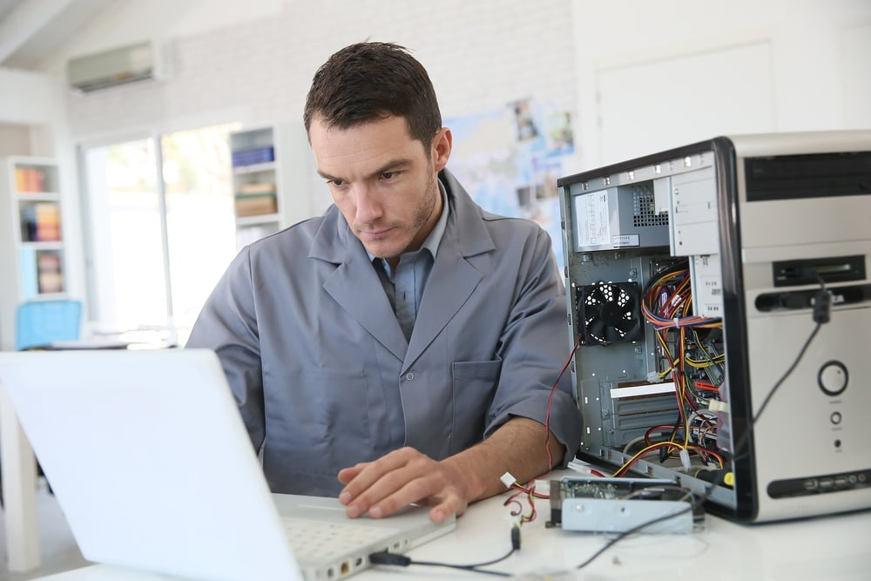
Figure 1-19Technical Knowledge and Skills:
- Certifications and Training: Obtaining relevant certifications, such as CompTIA A+, Microsoft Certified Professional (MCP), or Cisco Certified Network Associate (CCNA), can enhance a technician's credibility and job prospects. Additionally, attending workshops, seminars, and training programs can provide valuable insights into new technologies and repair techniques.

Figure 1-20Certifications and Training:
- Diagnostic and Problem-Solving Skills: Computer maintenance technicians should possess excellent diagnostic and problem-solving skills. They should be able to identify and resolve hardware and software issues efficiently. Strong analytical skills and attention to detail are necessary for diagnosing complex problems and implementing effective solutions.
Figure 1-21Diagnostic and Problem-Solving Skills
- Communication and Customer Service: Effective communication skills are essential when dealing with clients and end-users. Technicians should be able to listen to users' concerns, explain technical concepts in a clear and concise manner, and provide excellent customer service. Patience and empathy are crucial when assisting users who may have limited technical knowledge.

Figure 1-22Communication and Customer Service
- Work Planning and Time Management: Computer maintenance technicians need to plan their work effectively to maximize productivity and meet deadlines. They should prioritize tasks based on urgency and importance, create a schedule for routine maintenance activities, and allocate sufficient time for troubleshooting and repairs. Adhering to service level agreements (SLAs) and managing time efficiently can help ensure timely resolution of issues.

Figure 1-23Work Planning and Time Management:
- Documentation and Reporting: Maintaining accurate records of repairs, maintenance activities, and equipment inventory is essential. Technicians should document the problems encountered, the steps taken for resolution, and any parts or software used during the repair process. This documentation aids in future troubleshooting, warranty claims, and tracking maintenance history.
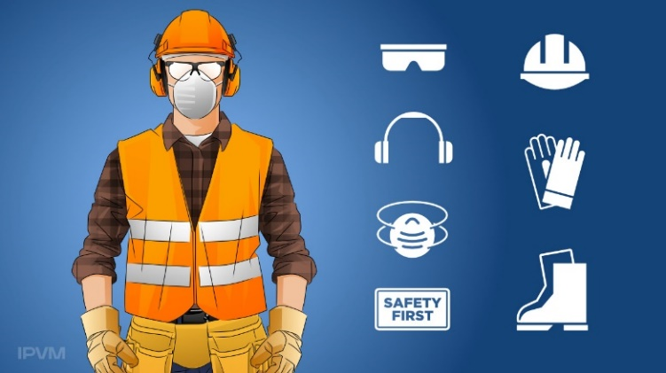
- Safety Precautions: Computer maintenance and repair involve working with electrical components and potentially hazardous equipment. Technicians should adhere to safety protocols, such as wearing appropriate protective gear, following electrical safety guidelines, and practicing safe handling of computer components.
Figure 1-24Safety Precautions
- Continuous Learning: The field of computer maintenance and repair is constantly evolving. Technicians should have a keen interest in staying updated with new technologies, software updates, and emerging trends. Engaging in continuous learning through self-study, online resources, and industry publications can help technicians stay ahead in their field.
- Maintenance and Diagnosis of Faults in Computer Maintenance and Repair
In the field of computer maintenance and repair, the process of maintaining and diagnosing faults is a crucial aspect of ensuring the optimal performance and reliability of computer systems. Maintenance and diagnosis activities are carefully planned and prepared in line with specific job requirements to effectively address system issues. This section will delve into the importance of planning and preparation in computer maintenance and repair, particularly in relation to maintenance and fault diagnosis.
- Maintenance Planning:
Maintenance planning involves the systematic approach of determining the necessary actions to keep computer systems in good working condition. It begins by assessing the job requirements and objectives, which may vary depending on the type of computer system, its intended use, and the organization's specific needs. Planning also considers factors such as the system's age, usage patterns, and environmental conditions.
During the planning phase, maintenance professionals analyze the system's components, including hardware, software, and peripherals, to identify potential areas of concern. They may refer to manufacturer's guidelines, technical documentation, or industry best practices to determine the recommended maintenance procedures. This includes tasks such as hardware cleaning, software updates, data backups, and performance optimizations.
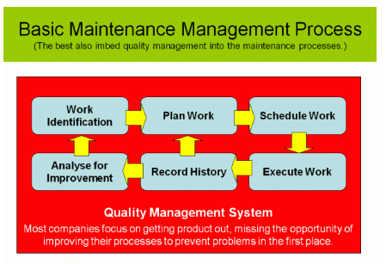
Figure 1-25Basic Maintenance management Process
- Diagnosis of Faults:
When computer systems encounter faults or issues, diagnosis becomes a crucial step in the maintenance and repair process. Diagnosis involves identifying the root cause of the problem, whether it's related to hardware malfunctions, software conflicts, or user errors. The accuracy and efficiency of fault diagnosis directly impact the effectiveness of subsequent repair actions.
To diagnose faults effectively, maintenance professionals employ various techniques and tools. They may utilize diagnostic software to run system tests, examine error logs, or conduct hardware inspections. Additionally, they may interview end-users or clients to gather information about the symptoms and circumstances surrounding the system issue. This comprehensive approach helps in narrowing down the potential causes and pinpointing the specific fault.
- Maintenance Preparation:
Once faults are diagnosed, maintenance professionals proceed with the necessary preparations for repair and resolution. This stage involves gathering the required resources, tools, and spare parts to address the identified issues. Adequate preparation ensures that the repair process can be conducted smoothly and minimizes any potential disruptions to the computer system's operation.
Maintenance preparation also entails coordinating with suppliers or vendors to procure necessary components or software licenses. It may involve scheduling downtime or coordinating with end-users to minimize the impact on their work. Additionally, professionals need to ensure that all necessary safety precautions are taken into account to protect both the technicians and the computer system during the repair process.
By planning and preparing maintenance and fault diagnosis activities in line with job requirements, computer maintenance and repair professionals can effectively address system issues. This proactive approach helps minimize downtime, increase system reliability, and optimize the overall performance of computer systems. It also ensures that the repair process is conducted efficiently, with the necessary resources and tools readily available, resulting in enhanced customer satisfaction and user experience.

Tools, equipment, testing devices and necessary materials
In the field of computer maintenance and repair, professionals rely on a range of tools, equipment, testing devices, and necessary materials to effectively diagnose and resolve issues. While the list of tools and materials can vary depending on the specific job requirements and the type of computer system being serviced, the following items are commonly included in a computer maintenance and repair toolkit:
- Pliers (assorted): Pliers are versatile tools used for gripping, bending, and cutting wires or small components. Different types of pliers, such as needle-nose pliers or wire cutters, may be included in the toolkit to handle various tasks.
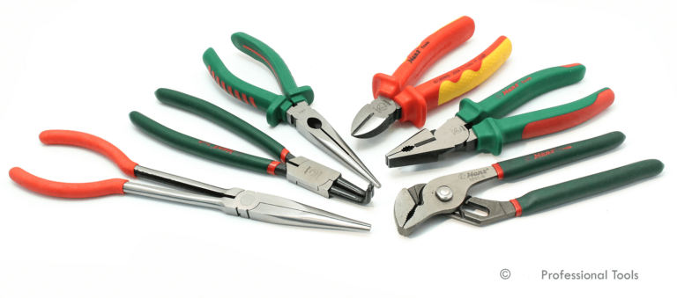
Figure 1-26Pliers (assorted):
- Screwdrivers (assorted): Screwdrivers of different sizes and types, including flathead and Phillips-head screwdrivers, are essential for removing screws and accessing internal components of computer systems.
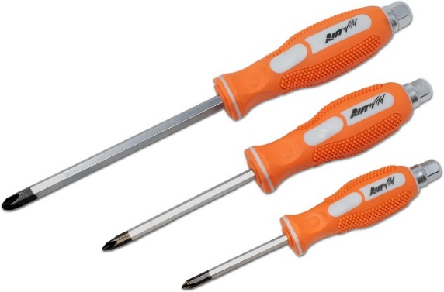
Figure 1-27Screwdrivers (assorted)
- Special tools: Specialized tools may be required for specific computer models or components. These tools could include specialized screwdrivers, pry tools, or spudgers designed to safely open and manipulate delicate components without causing damage.
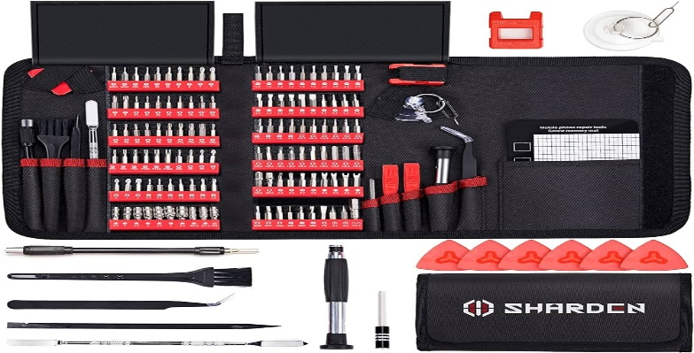
Figure 1-28Special tools:
- Soldering iron/gun: A soldering iron or gun is used for soldering or desoldering electronic components on circuit boards. This tool is necessary for repairing or replacing faulty components.
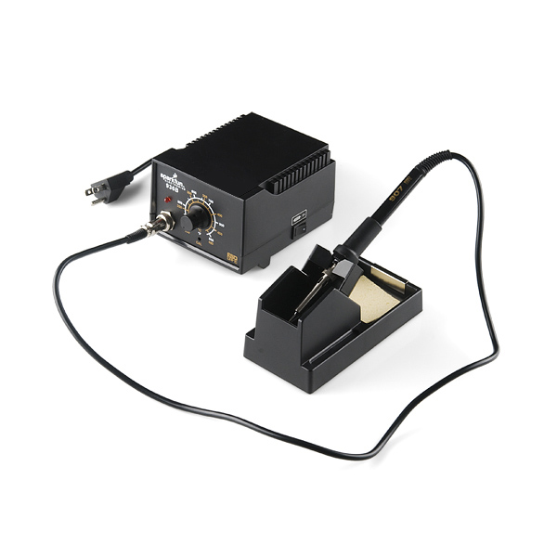
Figure 1-29Soldering iron/gun:
- Wrenches: Wrenches, such as adjustable wrenches or socket wrenches, may be needed to tighten or loosen bolts or screws on computer systems or peripherals.
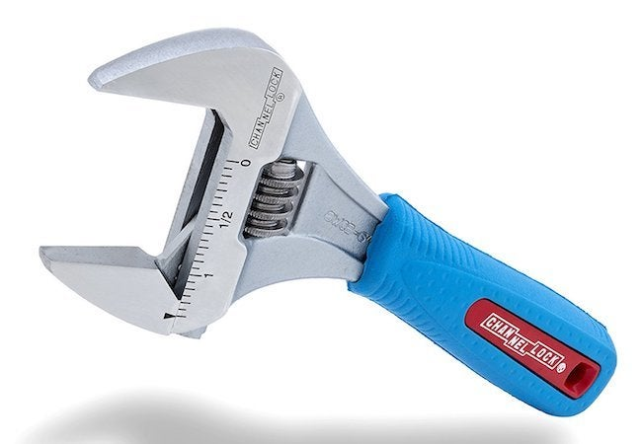
Figure 1-30Wrenches:
- Utility knife/stripper: A utility knife or wire stripper is used to cut or strip the insulation from wires, cables, or connectors during repair or maintenance tasks.

Figure 1-31Utility knife/stripper
- Hot air soldering station: A hot air soldering station is often used for more advanced repair tasks, such as reworking or replacing surface-mount components on circuit boards.
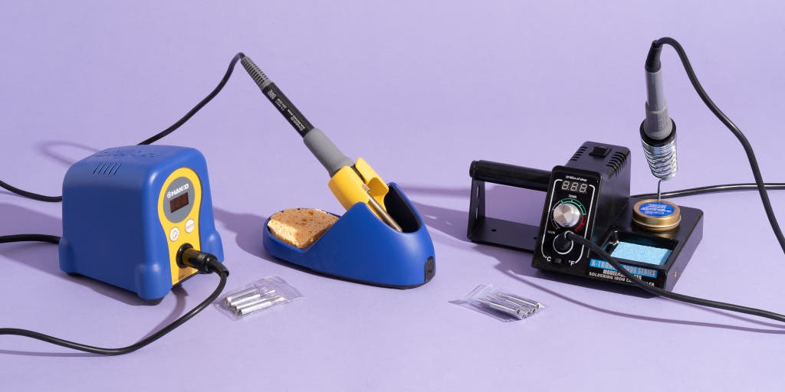
Figure 1-32Hot air soldering station:
- LAN tester: A LAN tester helps diagnose network connectivity issues by checking the integrity and performance of network cables, connectors, and connections.
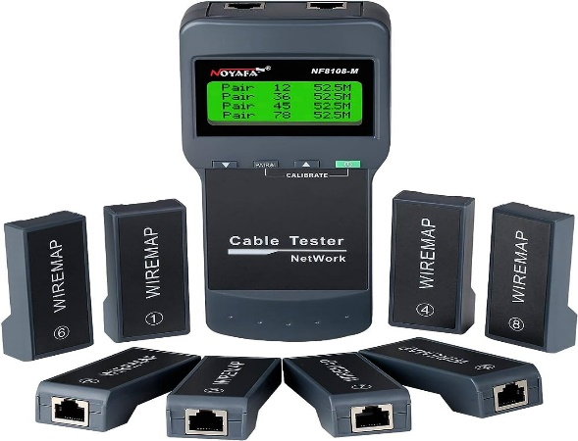
Figure 1-33LAN tester
- Crimping tools: Crimping tools are used to secure connectors onto the ends of cables, ensuring reliable and secure connections.
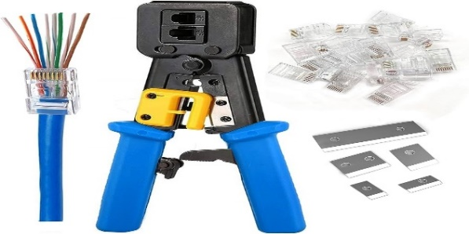
Figure 1-34Crimping tools:
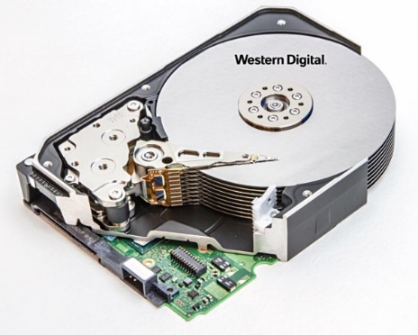
- Disks: Various disks, such as operating system installation disks or diagnostic disks, are essential for reinstalling software, performing system diagnostics, or troubleshooting issues.
Figure 1-35diagnostic Disks:
- Connectors: Assorted connectors, such as USB connectors, audio connectors, or network connectors, may be included to replace faulty or damaged connectors on computer systems or peripherals.
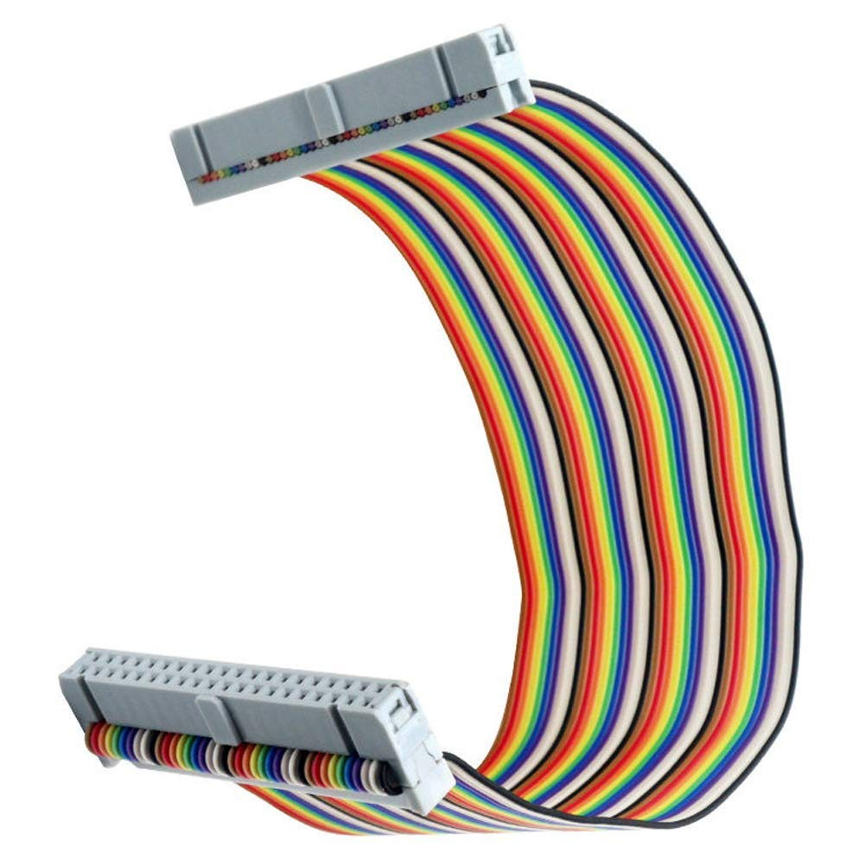
Figure 1-36Connectors:
- Adaptors: Adaptors are useful for converting between different types of connectors or interfaces to facilitate compatibility between devices.
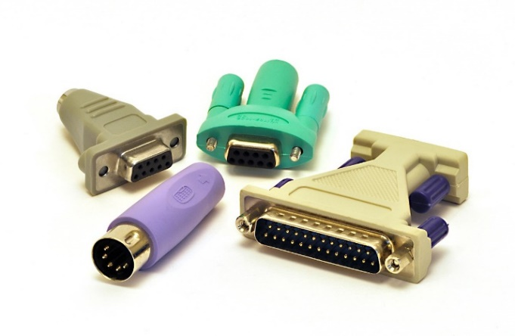
Figure 1-37Adaptors:
- Wires and cables: A selection of wires and cables, including data cables, power cables, or jumper wires, is necessary for replacing damaged cables or establishing connections during repair or maintenance tasks.
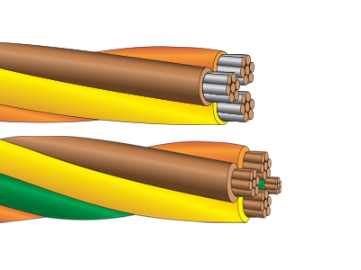
Figure 1-38Wires and cables:
- Appropriate software: Computer maintenance professionals require various software tools for diagnostic purposes, system monitoring, or firmware updates.
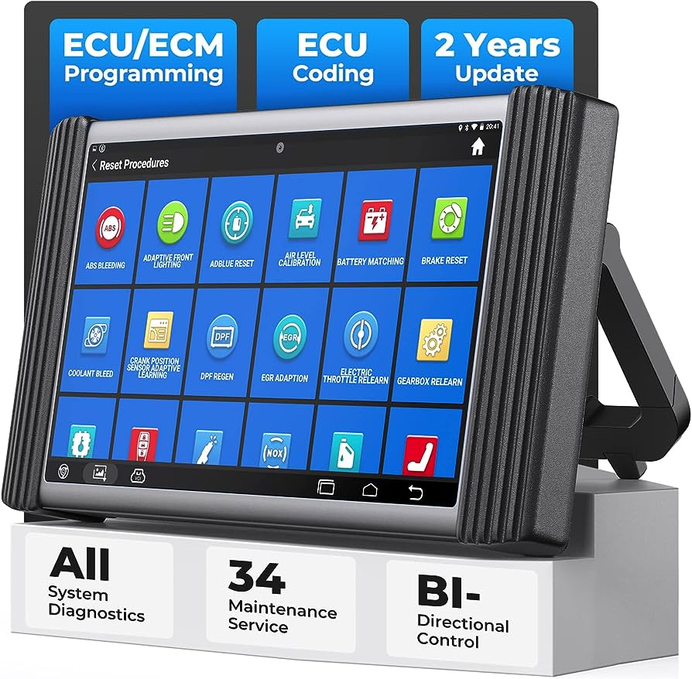
Figure 1-39Appropriate software:
Computer storage media: Storage media, such as USB drives or external hard drives, are essential for backing up data, transferring files, or performing system recovery tasks.
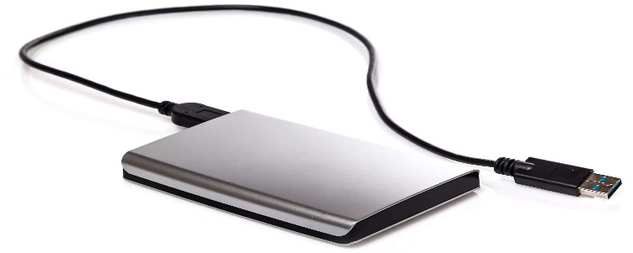
Figure 1-40Computer storage media:
It's important to note that the specific tools, equipment, and materials included in a computer maintenance and repair toolkit may vary depending on the technician's specialization, the type of computer systems being serviced, and the nature of the job requirements.
- The Functions of Hardware Components in a Computer System
Hardware components are essential elements of a computer system that work together to enable the execution of various tasks. Each hardware component has a specific function that contributes to the overall functioning and performance of the computer system.
  - Central Processing Unit (CPU):
The CPU is often referred to as the "brain" of the computer system. Its primary function is to execute instructions and perform calculations. It fetches instructions from memory, decodes them, and executes them by manipulating data stored in registers. The CPU's speed and processing power significantly impact the overall performance of the computer system (Patterson & Hennessy, 2013).
  - Random Access Memory (RAM):
RAM serves as temporary storage for data and instructions that the CPU needs to access quickly. Its function is to provide fast and temporary storage for data that is actively being used by the CPU. RAM allows for quick retrieval and modification of data, enabling efficient multitasking and faster program execution (Stallings, 2018).
  - Hard Disk Drive (HDD) and Solid-State Drive (SSD):
HDDs and SSDs are storage devices that store data even when the computer is turned off. Their primary function is to provide long-term storage for the operating system, software applications, and user files. HDDs use spinning magnetic disks to read and write data, while SSDs use flash memory technology, resulting in faster data access and improved system responsiveness (Tanenbaum & Bos, 2014).
  - Graphics Processing Unit (GPU):
The GPU is responsible for rendering and displaying graphics on the computer screen. Its primary function is to offload graphics-related tasks from the CPU, allowing for faster and more efficient processing of visual elements. GPUs are particularly important for tasks such as gaming, video editing, and graphic design (Shreiner et al., 2013).
  - Motherboard:
The motherboard serves as the main circuit board that connects and allows communication between various hardware components. It provides electrical connections, data pathways, and interfaces for components such as the CPU, RAM, storage devices, and expansion cards. The motherboard's function is to facilitate the smooth operation and coordination of all hardware components (Mueller, 2015). Conclusion:

Occupational Health and Safety and PPE
- Occupational Health and Safety
Computer maintenance and repair professionals need to prioritize occupational health and safety to ensure their well-being and the well-being of others in the workplace. This involves several key practices, including the use of proper tools and equipment, safe handling of computer systems, observing the workplace environment, and adhering to safety requirements. By following these practices, professionals can minimize the risk of accidents, injuries, and potential damage to computer systems.

Figure 1-41Occupational Health and Safety
- Importance of OHS Policies and Procedures:
- OHS policies and procedures are designed to protect workers from potential hazards and minimize the risk of accidents or injuries.
- They ensure compliance with legal requirements and industry standards, promoting a safe and healthy work environment.
- OHS policies and procedures help to create a culture of safety, where everyone is responsible for maintaining a safe workplace.
- We have to ensure in all business about the care of technicians and all the persons involved in business for good health all the time.
- It provides technicians lives and health.
- Occupational safety and health rules can decrease technician’s injury and illness. In general, Occupational health and safety (OHS) policies and procedures protect the safety, health and welfare of people at the work place.
- Risk Assessment:-
- Conduct a thorough risk assessment before starting any electrical/electronic system design or development project.
- Identify potential hazards, such as electrical shocks, fire risks, or exposure to hazardous substances.
- Assess the likelihood and severity of each hazard and implement appropriate control measures to mitigate the risks.
- Electrical Safety:
- Follow electrical safety standards and regulations, such as proper grounding, insulation, and circuit protection.
- Ensure that all electrical equipment and systems are installed, operated, and maintained by qualified personnel.
- Provide appropriate personal protective equipment (PPE), such as insulated gloves and safety glasses, when working with electrical systems.
- Equipment Safety:
- Regularly inspect and maintain electrical equipment to ensure it is in safe working condition.
- Follow manufacturer's guidelines for installation, operation, and maintenance of equipment.
- Implement lockout/tag out procedures to isolate and de-energize equipment before performing any maintenance or repairs.
- Emergency Preparedness:
- Develop and communicate emergency procedures, including evacuation plans and protocols for dealing with electrical emergencies.
- Provide training to employees on emergency response procedures and ensure they have access to emergency contact information
- Training and Education:
Provide comprehensive training to all personnel involved in the design and development of advanced electrical/electronic systems.
- Ensure employees are aware of potential hazards, safety procedures, and the proper use of equipment and tools.
- Regularly update training programs to keep up with new technologies and industry best practices.
- Reporting and Incident Investigation:
- Establish a system for reporting and documenting any incidents, near misses, or potential hazards.
- Investigate incidents to identify the root causes and implement corrective actions to prevent recurrence.
- Encourage a culture of reporting and learning from incidents to continuously improve safety practices.
- Codes, Standards, and Regulations
Workers, who perform electrical or electronic work, where applicable, shall comply with relevant DOE Orders and should comply with the current revision of the following codes and standards.
What equipment is covered by the Regulations?
Generally, any equipment which is used by an employee at work is covered, for example hammers, knives, drilling machines, power presses, and printers, photocopiers, lifting equipment (including lifts), and motor vehicles. Similarly, if you allow technicians to provide their own equipment and you will need to make sure it complies. Examples of uses of equipment which are covered by the Regulations include starting or stopping the equipment, repairing, modifying, maintaining, servicing, cleaning and transporting.
- Standards published by the National Fire Protection. Association (NFPA)
- National Electrical Code (NEC), NFPA 70
- Electrical Safety Requirements for Employee Workplaces, NFPA 70E.
- National Electrical Safety Code, ANSI C2.
- All relevant state and local requirements.
The standards and performance specifications from the following organizations are recommended and should be observed when applicable:
- Institute of Electrical and Electronics Engineers (IEEE)
- National Electrical Manufacturers Association (NEMA)
- American National Standards Institute (ANSI)
- American Society for Testing and Materials (ASTM)
- National Fire Protection Association (NFPA)
- Underwriters Laboratory, Inc. (UL)
- Factory Mutual Engineering Corporation (FMEC)
Other Nationally Recognized Testing Laboratories recognized by OSHA on a limited basis. Where no clear applicable code or standard provides adequate guidance or when questions regarding workmanship, judgment, or conflicting criteria arise, personnel safety protection shall be the primary.
- Safe Handling of Computer Systems:
Computer systems can be delicate and sensitive to mishandling. Professionals should be trained in safe handling techniques to prevent accidental damage or injury. This includes lifting and moving computer systems with care, using proper lifting techniques to avoid strain or back injuries. Additionally, professionals should be mindful of electrostatic discharge (ESD) precautions when handling sensitive components, such as wearing anti-static wrist straps or working on grounded surfaces to prevent static electricity from damaging the system.
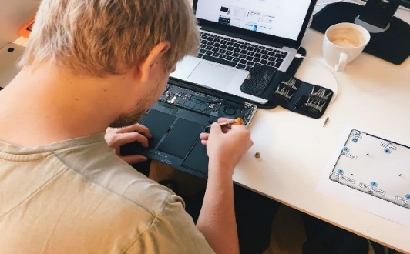
Figure 1-42Safe Handling of Computer Systems
- Use of Proper Tools and Equipment
Using appropriate tools and equipment is crucial for both the safety of the technician and the integrity of the computer system. Professionals should be equipped with the necessary tools and ensure they are in good working condition. This includes using insulated screwdrivers to prevent electrical shocks, employing anti-static mats or workbenches to prevent ESD, and using specialized tools designed for specific computer models or components. Using the right tools reduces the risk of accidents, damage, and injuries.
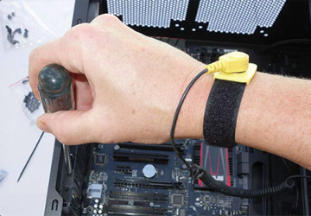
Figure 1-43Proper of Use Tools and Equipment
- Observing the Workplace Environment and Safety:
Computer maintenance and repair professionals should be aware of potential hazards in the workplace environment. This includes being mindful of tripping hazards, ensuring clear pathways, and maintaining a clean and organized workspace. Professionals should also be aware of emergency exits, fire extinguisher locations, and other safety equipment in case of emergencies. Regular inspections of the workspace can help identify and address any potential safety concerns promptly.
- Adherence to Safety Requirements:
Computer maintenance and repair professionals should adhere to safety requirements and guidelines specific to their organization or industry. This may include wearing appropriate personal protective equipment (PPE) such as safety goggles, gloves, or protective clothing. Professionals should also follow safety protocols related to electrical safety, such as properly disconnecting power sources before working on computer systems. Adhering to safety requirements ensures a safe working environment and reduces the risk of accidents or injuries.
Regular training and refresher courses on occupational health and safety are essential for computer maintenance and repair professionals. This helps them stay updated on best practices, new safety regulations, and emerging risks. By prioritizing occupational health and safety, professionals can create a safer work environment, reduce accidents, and ensure the well-being of themselves and others involved in computer maintenance and repair tasks

- Personal protective equipment
Personal protective equipment (PPE) is an essential component of occupational health and safety in computer maintenance and repair. While the specific PPE requirements may vary depending on the organization and the nature of the tasks being performed, the following items are commonly used:
- Goggles/Glasses: Safety goggles or glasses protect the eyes from potential hazards such as flying debris, dust, or chemical splashes. They are particularly important when working with tools that generate sparks, when handling chemicals, or when there is a risk of objects entering the eyes.
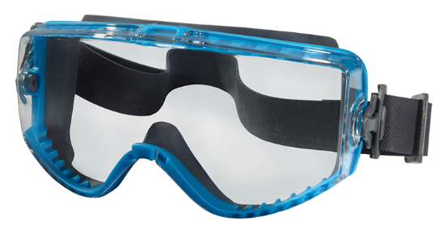
Figure 1-44Safety goggles or glasses
- Mask: Masks, including dust masks or respirators, are used to protect against airborne particles, dust, fumes, or harmful gases. They are especially important when working in environments with poor ventilation or when handling materials that may release harmful substances.
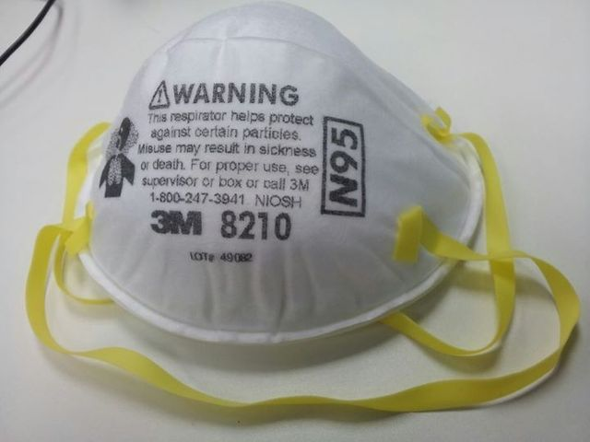
Figure 1-45dust masks or respirators
- Gloves: Protective gloves, such as latex, nitrile, or rubber gloves, are used to protect hands from cuts, abrasions, chemicals, or electrical hazards. They provide a barrier between the technician's hands and potentially hazardous substances or components.


Figure 1-46Protective gloves,
- Anti-static Wrist Wrap: An anti-static wrist wrap, also known as an anti-static wrist strap, is used to prevent electrostatic discharge (ESD) during computer maintenance and repair. It is a strap worn around the wrist that connects to a grounded surface, dissipating any built-up static electricity and protecting sensitive electronic components from damage.
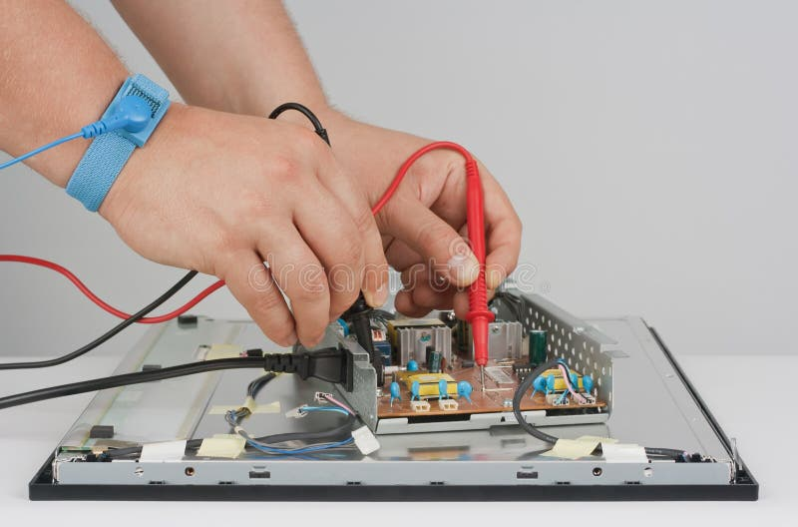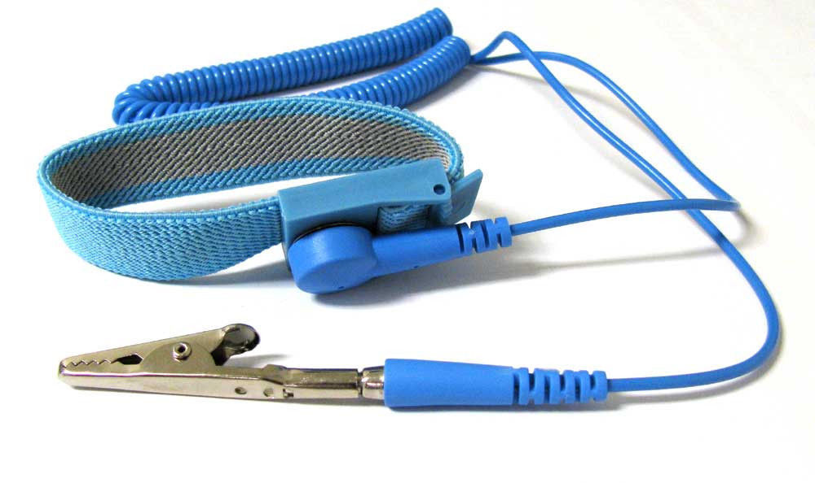
Figure 1-47anti-static wrist wrap
It is important to note that the selection and use of PPE should be based on a thorough assessment of the specific hazards present in the work environment. Employers should provide appropriate PPE to their employees and ensure that it fits correctly, is in good condition, and is properly used and maintained.
In addition to the items mentioned above, other types of PPE may be necessary depending on the specific tasks and risks involved. This could include hearing protection (earplugs or earmuffs) for working in noisy environments, protective clothing (such as coveralls) for protection against chemicals or physical hazards, or safety footwear to protect against slips, falls, or electrical hazards.
Ultimately, the use of personal protective equipment is essential to minimize the risk of injuries, occupational illnesses, and exposure to hazards in computer maintenance and repair. Compliance with PPE requirements helps ensure the safety and well-being of technicians in the workplace.

Safe handling of computer systems
Safe handling of computer systems is crucial in computer maintenance and repair to prevent accidents, damage to the equipment, and injuries to technicians. Adhering to best practices for safe handling ensures the longevity and optimal functioning of computer systems. Here are some key guidelines to follow:
- Power Off and Disconnect: Before handling any computer system, ensure it is powered off and disconnected from the electrical source. This minimizes the risk of electric shock and protects both the technician and the equipment.
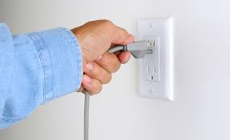
Figure 1-48Power Disconnect
- Proper Lifting Techniques: When moving or lifting computer systems, use proper lifting techniques to avoid strain or back injuries. Bend at the knees, keep the back straight, and lift with the leg muscles. If a system is too heavy or bulky, seek assistance or use appropriate lifting aids.

Figure 1-49Proper Lifting Techniques
- Secure Cables and Connections: Before moving a computer system, make sure all cables and connections are securely fastened. Loose cables can get tangled or damaged, leading to connectivity issues or potential tripping hazards.
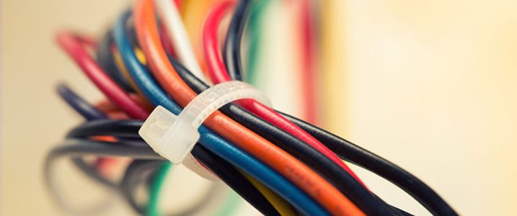
Figure 1-50Secure Cables and Connections
- Avoid Rough Handling: Handle computer systems with care and avoid rough or excessive force. Avoid shaking or dropping the equipment, as this can cause internal damage to delicate components.
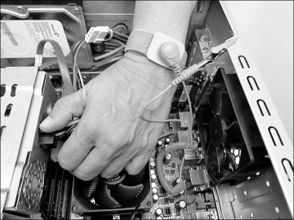
- ESD Precautions: Take precautions to prevent electrostatic discharge (ESD) when handling computer systems. Wear an anti-static wrist strap or use an anti-static mat on the work surface to ground any static electricity and prevent damage to sensitive electronic components.

Figure 1-51ESD Precautions
Protect Against Dust and Debris: Keep computer systems in a clean environment and protect them from dust and debris. Dust can accumulate inside the system and hinder its performance or cause overheating. Use compressed air or appropriate cleaning tools to remove dust and debris from the system.
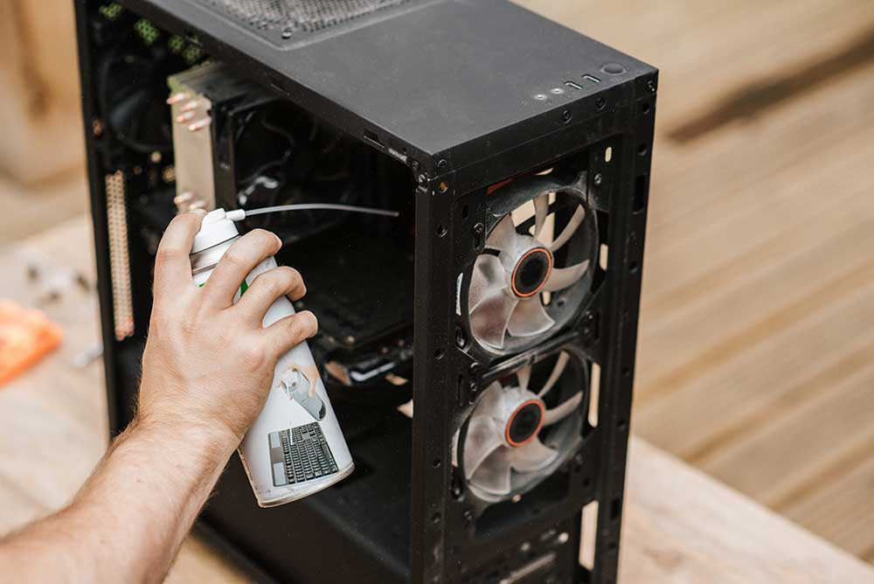
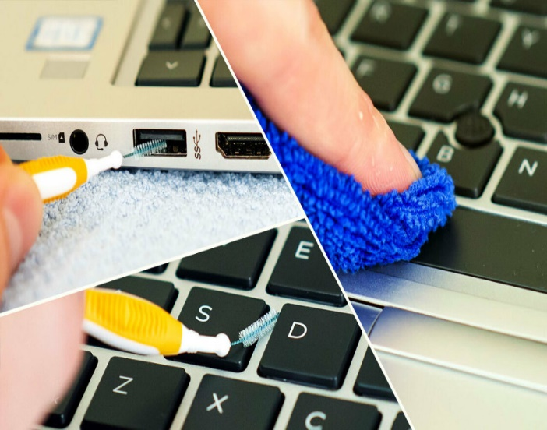
Figure 1-52Protect Against Dust and Debris:

- Avoid Liquid Exposure: Keep liquids away from computer systems to prevent accidental spills or exposure. Liquid spills can cause damage to internal components and can lead to electrical hazards. If a liquid spill occurs, power off the system immediately and seek professional assistance for proper cleaning and repairs.
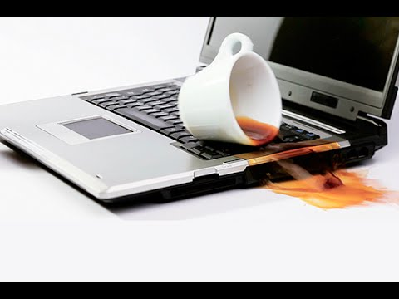
Figure 1-53Liquid Exposure:
- Follow Manufacturer Guidelines: Refer to the manufacturer's guidelines and instructions for handling specific computer systems. Manufacturers often provide specific recommendations for safe handling, maintenance, and repair procedures that should be followed to ensure proper care and prevent damage.
- Workspace Organization: Maintain a clean and organized workspace to minimize the risk of accidents. Clear away unnecessary tools, cables, and debris that could pose tripping hazards or interfere with your ability to handle computer systems safely.
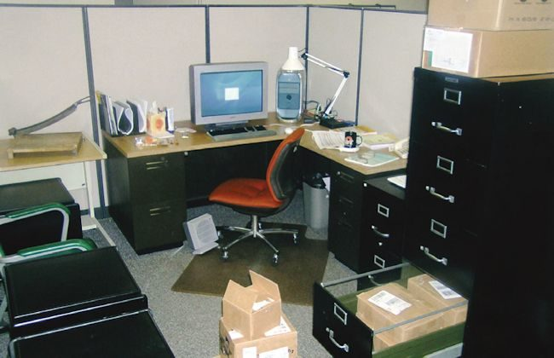
Figure 1-54Maintain a clean and organized workspace
- Ongoing Training: Stay updated with industry best practices and receive regular training on safe handling techniques and procedures. As technology evolves, new safety considerations may arise, and it is important to stay informed and adapt to changing requirements.
By following these guidelines for safe handling, technicians can minimize the risk of accidents, equipment damage, and injuries. Prioritizing safe handling practices ensures the well-being of both the technician and the computer systems being serviced.

Self-check 1.1
Part 1. True/False:
- Supercomputers are primarily used for browsing the internet and word processing.
- Laptops and notebooks are portable computers that offer the same functionality as personal computers.
- The motherboard is responsible for processing and rendering images, videos, and animations.
- The power supply unit (PSU) supplies electrical power to the computer components. Computer maintenance and repair involve tasks such as software updates, hardware diagnostics, and troubleshooting.
Part 2. Matching:
Match the computer part with its corresponding function:
Match A | Match B
_____1. GPU | a). Output device that produces hard copies
_____2. RAM | b). Temporary memory for quick access by the CPU
_____3. HDD/SSD | c). Responsible for processing and rendering images, and videos,
_____4. PSU | d). Storage devices for permanent data and programs
_____5. Printer | e). Supplies electrical power to the computer components
Part 3. Multiple Choice:
- Which type of computer is designed for specialized tasks such as computer-aided design (CAD) and video editing?
a) Personal Computers (PCs)
b) Laptops and Notebooks
c) Workstations
d) Servers

- Which component of a computer is responsible for executing instructions and performing calculations?
a) Graphics Processing Unit (GPU)
b) Random Access Memory (RAM)
c) Central Processing Unit (CPU)
d) Hard Disk Drive (HDD)
- What is the main function of a server in a computer system?
a) Hosting websites
b) Rendering images and videos
c) Providing audio output
d) Displaying visual information
- Which type of computer is capable of handling massive volumes of data and supporting thousands of users concurrently?
a) Laptops and Notebooks
b) Mainframes
c) Supercomputers
d) Workstations
- What is the purpose of a cooling system in a computer?
a) To produce hard copies of documents or images
b) To prevent overheating of the computer
c) To connect and allow communication between various components
d) To execute instructions and perform calculations
Part 4. Fill in the Blank:
- The brain of the computer responsible for executing instructions and performing calculations is the __________.
- Workstations are high-performance computers designed for specialized tasks such as __________.
- Servers are used to provide resources and services to other computers, known as __________.

Operation Sheet:1.1
Operation Title: Computer Maintenance and Repair
Instructions:
- Ensure the computer is powered off and unplugged before starting any maintenance or repair tasks.
- Use appropriate protective gear, such as anti-static wristbands and safety goggles.
- Refer to the equipment manufacturer's manuals and guidelines for specific instructions.
Precautions:
- Always handle computer components with care to avoid damage.
- Be cautious of electrical hazards and follow safety guidelines.
- Keep the work area clean and organized to prevent accidents.
Tools and Requirements:
- Screwdriver set
- Cleaning brush
- Compressed air canister
- Thermal paste
- Diagnostic software (e.g., hardware monitoring tools)
Procedures:
- Perform a visual inspection of the computer components for any signs of damage or loose connections.
- Clean the dust and debris from the internal parts using a cleaning brush and compressed air canister.
- Check the CPU temperature and apply new thermal paste if necessary.
- Run diagnostic software to identify any hardware or software issues.
- Replace faulty components, such as RAM modules or hard drives, if needed.
Quality Criteria:
- The computer should power on without any hardware or software errors.
- The internal parts should be free of dust and debris.
- The CPU temperature should be within the acceptable range.
- All replaced components should be functioning properly.

UNIT TWO: FAULT DIAGNOSIS
This learning guide is developed to provide you the necessary information regarding the following content coverage and topics:
- Fault diagnosis procedures
- Diagnosing faults or problems in the computer systems.
- Managing and implementing contingency measures.
- Responding unexpected conditions.
This guide will also assist you to attain the learning outcomes stated in the cover page. Specifically, upon completion of this learning guide, you will be able to:
- diagnose Fault procedures
- Diagnose faults or problems in the computer systems.
- Manage and implement contingency measures.
- Respone unexpected conditions.

Fault diagnosis procedures
Fault diagnosis procedures are systematic steps and techniques used to identify and analyze faults or problems in various systems, including computer systems. These procedures are essential for efficient troubleshooting and resolving issues, ensuring the optimal performance and functionality of the systems. Here are the key aspects of fault diagnosis procedures:
- Key Steps in Fault Diagnosis Procedures:
Fault diagnosis procedures are an essential part of computer maintenance. When a computer system or component is not functioning as expected, proper diagnosis is crucial to identify the underlying issue and determine the appropriate course of action. Here are the key steps involved in fault diagnosis procedures:
- Gather Information:
  - Start by collecting relevant information about the problem. This can include details about the symptoms, error messages, recent changes or updates, and any specific circumstances surrounding the issue.
  - Talk to the user or system owner to gain insights into the problem and gather additional information that may be useful for diagnosis.
- Reproduce the Issue:
  - Attempt to reproduce the problem to understand its behavior and identify any patterns or triggers.
  - Perform the necessary steps or actions that led to the issue or try to recreate the conditions under which the problem occurred.
- Analyze Symptoms:
  - Carefully analyze the symptoms exhibited by the computer system or component. This can include abnormal behavior, error messages, system crashes, slow performance, or any other indications of the problem.
  - Note down any specific details or patterns observed during the analysis.
- Troubleshooting:
  - Use systematic troubleshooting techniques to identify the root cause of the problem.
  - Start by checking the most common and easily verifiable causes, such as loose connections, power supply issues, or software settings.
  - Proceed with a step-by-step approach, ruling out potential causes one by one, and narrowing down the possibilities.
- Diagnostic Tools:
  - Utilize diagnostic tools and software to assist in the fault diagnosis process.
  - These tools can help identify hardware failures, software conflicts, driver issues, or other system-level problems.
  - Examples of diagnostic tools include system monitoring software, hardware testing utilities, and error logging tools.
- Documentation:
  - Document the entire fault diagnosis process, including the steps taken, observations made, and any changes or fixes attempted.
  - This documentation serves as a reference for future troubleshooting or for sharing information with other technicians or support personnel.
- Resolution and Repair:
  - Once the root cause of the problem has been identified, determine the appropriate solution or repair method.
  - Implement the necessary fixes, which can include hardware replacements, software updates or patches, driver installations, system reconfiguration, or other corrective measures.
- Testing and Verification:
  - After implementing the repairs or solutions, thoroughly test the system or component to ensure that the issue has been resolved.
  - Verify that the system functions as expected, without any recurring problems or symptoms.
By following these fault diagnosis procedures, computer maintenance technicians can effectively identify and resolve issues, minimizing downtime and ensuring the proper functioning of computer systems and components.
Share 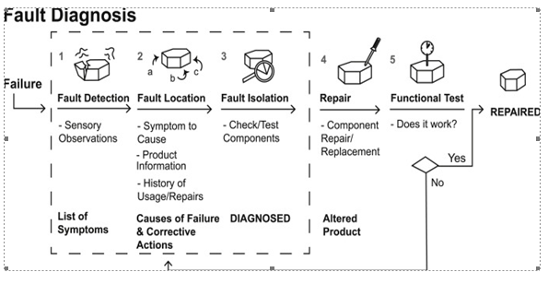
Figure 2-1Fault diagnosis procedures
- Importance of Fault Diagnosis Procedures:
Fault diagnosis procedures in computer maintenance are of utmost importance for several reasons:
- Efficient Problem Resolution: Fault diagnosis procedures help technicians efficiently identify the root cause of computer issues. By following a systematic approach, they can narrow down the possibilities and focus on the specific area or component causing the problem. This saves time and effort, leading to faster problem resolution.
- Minimize Downtime: Swift and accurate fault diagnosis minimizes the downtime of computer systems. By promptly identifying the cause of the problem, technicians can take appropriate action to resolve it quickly, reducing the impact on productivity and minimizing disruptions for users.
- Cost Savings: Effective fault diagnosis can lead to cost savings in computer maintenance. By accurately identifying the faulty component or software issue, technicians can avoid unnecessary replacements or repairs. This helps in optimizing the use of resources and reducing expenses associated with trial-and-error troubleshooting.
- Preventive Maintenance: Fault diagnosis procedures can also help in preventive maintenance. By identifying and addressing potential issues before they escalate into major problems, technicians can prevent system failures, data loss, or hardware damage. This proactive approach helps in maintaining the reliability and longevity of computer systems.
- User Satisfaction: Prompt and accurate fault diagnosis is crucial for user satisfaction. Users rely on their computers for work, communication, and other tasks. When issues arise, quick resolution through effective fault diagnosis ensures that users can resume their activities with minimal disruption, enhancing their overall satisfaction and productivity.
- Knowledge Base Development: Fault diagnosis procedures contribute to the development of a knowledge base within an organization or among technicians. By documenting the diagnosis process, including symptoms, causes, and resolutions, technicians can build a repository of information that can be referenced in future troubleshooting scenarios. This knowledge base facilitates faster and more consistent problem-solving in the future.
- System Performance Optimization: Fault diagnosis procedures can uncover underlying issues that affect the performance of computer systems. By resolving these issues, technicians can optimize system performance, ensuring that the computer operates at its full potential, providing a smooth and efficient user experience.
In summary, fault diagnosis procedures in computer maintenance are crucial for efficient problem resolution, minimizing downtime, cost savings, preventive maintenance, user satisfaction, knowledge base development, and system performance optimization. By following a systematic approach to diagnose and resolve issues, technicians can effectively maintain and support computer systems, ensuring their reliability and functionality

Diagnosing faults or problems in the computer systems
Diagnosing faults or problems in computer systems is a critical task performed by technicians and electronics professionals to identify and resolve issues that arise within hardware, software, or network components. In today's technology-driven world, where computers play a vital role in various industries and everyday life, the ability to diagnose and troubleshoot computer system faults efficiently is essential to ensure smooth operations and minimize disruptions.
Diagnosing faults involves a systematic approach that requires a combination of technical knowledge, analytical skills, and the utilization of diagnostic tools and techniques. It is a process of identifying the root cause of a problem, understanding its impact on system performance, and implementing appropriate solutions to restore normal functionality.
Computer systems encompass a wide range of components, including servers, desktop and laptop computers, peripherals, network devices, cables, and connections. Each of these components can experience faults or problems, ranging from hardware malfunctions to software conflicts or network connectivity issues. Diagnosing faults involves understanding the symptoms reported by users, gathering relevant information, analyzing system logs, performing tests, and employing troubleshooting methodologies to pinpoint the underlying cause.
The complexity of modern computer systems often requires technicians to have a broad understanding of various hardware and software technologies. They need to be familiar with operating systems, network protocols, device drivers, and other system components. Additionally, staying up-to-date with the latest advancements and troubleshooting techniques is crucial to effectively diagnose and resolve complex issues.
Effective fault diagnosis not only requires technical expertise but also relies on effective communication and collaboration. Technicians often work closely with end-users or IT support teams to gather information about the problem, understand its context, and gather insights that aid in the diagnosis. Collaboration platforms and knowledge-sharing practices foster a collective approach to problem-solving, ensuring a streamlined diagnostic process.
Furthermore, documentation plays a vital role in fault diagnosis. Technicians document the steps taken, tests performed, and solutions implemented throughout the diagnostic process. This documentation serves as a reference for future troubleshooting, knowledge sharing, and creating a comprehensive knowledge base that can benefit both technicians and end-users

Identify and Analyze Symptoms of faults
- Servers:
- Symptoms: Server crashes, unresponsive or slow performance, error messages, service disruptions, abnormal system behavior.
- Analysis: Check event logs, monitor server resource utilization, analyze network connectivity, review server configuration and settings.
- Peripherals:
- Symptoms: Printer not printing, scanner not scanning, malfunctioning keyboard or mouse, audio or video issues with speakers or headphones.
- Analysis: Verify power and cable connections, check device drivers, test peripherals on another computer, review software settings and configurations.
- Desktop and Laptop Computers:
- Symptoms: System freezes or crashes, blue screen errors, slow performance, software not launching or responding, hardware not recognized.
- Analysis: Check system resources (CPU, memory, disk usage), scan for malware or viruses, update device drivers, review software conflicts or compatibility issues.
- Network Devices:
- Symptoms: Network connection drops, slow or intermittent internet connectivity, inability to access network resources, network errors or warnings.
- Analysis: Verify physical connections, check network device configurations, test network connectivity with other devices, monitor network traffic and performance.
- Cables and Connections:
- Symptoms: Intermittent or no connectivity, data transfer errors, loose or damaged cables, distorted audio or video signals.
- Analysis: Inspect cable connections, replace or reseat cables, check for physical damage, test with known working cables or connections.
- Maintenance:
- Symptoms: Lack of system updates or patches, system slowdown, increased vulnerability to security threats.
- Analysis: Review maintenance logs, check for pending updates, schedule regular maintenance tasks, ensure proper system and software updates.
- Software Updates:
- Symptoms: Software crashes or errors, compatibility issues with other programs, security vulnerabilities.
- Analysis: Review software update notifications, check release notes for bug fixes or improvements, test updates in a controlled environment.
- Hard Disk Maintenance:
- Symptoms: Slow file access, disk errors, data corruption, system crashes.
- Analysis: Perform disk health checks, run disk cleanup and defragmentation, monitor disk SMART status, check for bad sectors.
- File Backup/Restoration:
- Symptoms: Data loss, accidental deletion, file corruption, inability to retrieve important files.
- Analysis: Review backup logs, test file restoration process, ensure backups are performed regularly, verify backup integrity.
- Faults and Problems:
- Network Connectivity:
- Symptoms: No internet access, limited connectivity, network timeouts, inability to connect to specific devices or servers.
- Analysis: Check network adapter settings, troubleshoot IP configuration, test network connectivity using ping or traceroute commands.
- Software Issues:
- Symptoms: Application crashes, error messages, software conflicts, compatibility issues.
- Analysis: Review software logs or error messages, update or reinstall software, check for known software issues or patches.
- Hardware Issues:
- Symptoms: Hardware not recognized, malfunctioning components, system instability, device driver errors.
- Analysis: Check device manager for hardware conflicts or driver issues, test hardware on another computer, update or reinstall device drivers.
By following a systematic approach to identify and analyze symptoms in each of these areas, technicians can effectively diagnose and resolve faults or problems in computer systems, peripherals, network devices, cables and connections, and address maintenance tasks and software/hardware issues as needed..

Troubleshoot and Fault localizing
Diagnosing Flowchart in Computer Maintenance
Diagnosing computer issues accurately is essential for effective maintenance. A flowchart can be a useful tool in guiding the troubleshooting process, helping to identify and resolve problems efficiently. This essay presents a step-by-step flowchart for diagnosing common computer maintenance issues. 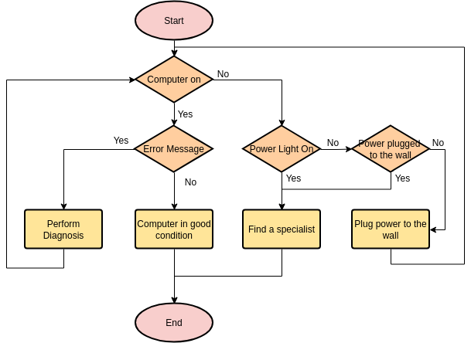
Diagnosing Flowchart in Computer Maintenance
Note: The following flowchart is a general guide and may need to be adapted based on specific computer models and troubleshooting scenarios.

Flowchart for Diagnosing Computer Maintenance
1. Start: - Begin by observing and documenting the symptoms or issues experienced by the computer user.
2. Power-related issues: - Is the computer not turning on or experiencing power-related problems? - If yes, proceed to the "Power-related issues" branch. - If no, proceed to the next step.
3. Check power connections: - Are all power cables securely connected to the computer and power outlet? - If yes, proceed to the next step. - If no, ensure all power connections are properly seated and try turning on the computer again.
4. Power supply unit (PSU): - Is the PSU functioning correctly? - If unsure, test the PSU using a PSU tester or replace it with a known working PSU. - If the PSU is faulty, replace it and retest the computer.
5. Motherboard issues: - Is the motherboard causing the problem? - Check for any visible signs of damage or bulging capacitors. - If there are no visible issues, test the motherboard using diagnostic tools or replace it if necessary.
6. Display-related issues: - Is the computer turning on, but there is no display? - If yes, proceed to the "Display-related issues" branch. - If no, proceed to the next step.
7. Check monitor connections: - Ensure the monitor cables are securely connected to both the computer and the monitor. - If necessary, try using a different monitor or cable to rule out any issues.
8. Graphics card issues: - Is the graphics card causing the display problem? - Test the graphics card in another computer or replace it with a known working card. - If the graphics card is faulty, replace it and retest the computer.
9. Operating system (OS) issues: - Is the computer turning on and displaying properly, but experiencing software-related issues? - If yes, proceed to the "OS-related issues" branch. - If no, proceed to the next step.
10. Check for software conflicts: - Perform a clean boot, disabling all startup programs and non-essential services. - If the issue is resolved, gradually enable programs and services to identify the conflicting software.
11. Update drivers and software: - Ensure all drivers and software are up to date. - Visit the manufacturer's website to download and install the latest updates.
12. Hardware component issues: - Is a specific hardware component causing the issue? - Test each hardware component individually (RAM, hard drive, etc.) using diagnostic tools or replace them if necessary.
13. End: - Once the issue is identified and resolved, the troubleshooting process is complete.
- Troubleshooting the failure
Time to narrow down the possible cause by using some strategy to check the different functional block of the supply. As I only do this kind of repair jobs in my spare time, mostly for fun, I don't really have a proven and tested troubleshooting strategy for SMPS, I would just use my everyday problem solving approach to try and track down the root of the problem.
Step 1 - Visual check
Before firing up the board and go poking around with probes, it was worth visually checking the components for any sign of stress/breakage which might hint to more serious problems. The first candidate was obviously the fuse, just in case it had blown. No sign of damage there.
Then a quick glance to the power transistor Q1, the transistor Q2, the dual diode DP1, the optocoupler PC1 and the precision reference IC1. All good there. A quick check at all the electrolytic capacitors, to look for any bulging or leaking, but no sign of damage there either.
All the 1/4W resistors (the smaller ones) seemed fine, with the exception of R9, which looked a bit dark and with a small crack, but it might mean nothing, as the only way to be sure is to desolder it from the board and check with the tester (noted down, for later). R4 and R5, both 3W resistors, looked a little "tired" as well, so they need checking too. All the diodes seemed fine, and so the rest of the capacitors. Last, but not least, the transformer looked OK too.
Step 2 - Check Protection, Filter and Rectifier circuits
Time to power up the SMPS, to check the problem was not due to a failure of the components placed between the power line feed and the rectifier output. The quickest check to perform was to read the voltage at the output of the diode bridge, as a good reading there means all the components upstream of the rectifier were working properly. Measuring the DC voltage I got a reading of 326V, which was the value I expected to read, so the problem must be further down the circuit.
Step 3 - Check Transformer
Typically, failure of the transformer is not really a common occurrence, as it tends to be quite a reliable component. With this in mind, I assumed the transformer was OK (beforehand, when I was still tracing the circuit, I did measure the resistance of the windings, to map them correctly, the result is shown in the photo), therefore, I thought it made sense now to measure the windings voltages. The idea was to understand if the problem was on the hot side or on the cold side of the transformer. Across the primary, I could read a DC voltage, and I got some AC voltage on the auxiliary too, while the secondary did not have any voltage across it. Not having tested anything on the secondary side
Step 4 - Check for shorts on the secondary side
To test for shorts, I set the multimeter on the resistance reading with beeper (so I didn't have to constantly look at the multimeter screen), and with one probe fixed on the cold ground, I moved the other probe, testing all the pads not directly connected to the ground. As expected, I heard a beep only when I touched the other end of the secondary winding, so looked like no shorts on the secondary side of the power supply. This left only one place to look for fault: the switching transistor with the PWM control circuit.

Step 5 - Remove components from PCB for testing
Testing the components in that switching and PWM control part of circuit couldn't be done without removing them from the board, so that is what I did next.
Step 6 - Replace components
Finally there was a hope that I could bring the power supply back to life. All I needed is to get a replacement for Q2. The marking on the transistor was "C1383", and after searching on the internet, I found the datasheet. Unfortunately none of the distributors I usually buy components from seemed to have such part in stock, so I had 2 alternatives: order from China (and wait for a month for the delivery), or find a suitable replacement part. I decided to go for the latter, and after comparing a few transistors, I finally found a decent substitute: KSC2383YTA. All the maximum ratings were met or exceeded, with the only exception of the power dissipation, where the original was 1W, while the replacement was 0.9W (something to keep in mind, especially if the collector current, with the power supply in full load condition, gets closer to the maximum rating).
Step 7 - Test the repair
Once the components arrived, I soldered the new Q1 and Q2 on the board, cleaned up and connected the power supply to the mains and placed the probes on the 12V and GND pads, switched on the supply and... it worked! Q2 was indeed what caused the power supply to shut down. Well, while testing, I also noticed the small LED indicator wasn't working, so another component to add to the list of things to replace...
  - Switch mode power supply failure symptoms
Simply put, the 12V DC output was dead, no power! Plugging in the power supply to the mains did not produce the expected 12V at the output, not even an unregulated voltage of any sort or a ripple...zero, nil! Unfortunately, the failure symptom didn't provide much insights, as there are plenty of possible causes for no output. Let's start troubleshooting then, to try and narrow down the culprit(s)
Linear Power Supply
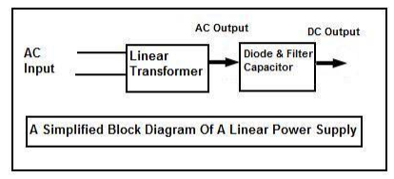
Figure 2-2A Simplified Block Diagram of a SMPS
Linear Power Supply is not covered in this book but anyway I will briefly explain how this power supply works. AC voltage enters to the primary side of linear transformer and then converts the AC into a lower or higher AC voltage depending on the secondary winding. The output AC voltage is then rectified and filtered by a diode and capacitors to produce a clean DC voltage.
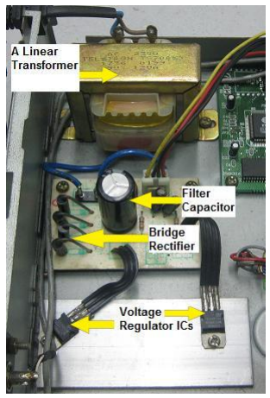
Figure 2-3A Linear Power Supply Circuit
The linear power supply could have more than one DC output. If there is a problem in the linear transformer circuit, I can say that it is very easy to locate the fault because it is quite direct. Simply use a multimeter to test on the output of the linear transformer (AC voltage) or the DC output (after the diode) to determine the fault fast. This is somehow different in the case of a switch mode power supply. Please read on as the information in the following chapters will eventually guide you to become a professional in repairing SMPS. If you want to be an expert in power supply repair, one has to practice, read and fully understand how basic electronic components and power supply work. With all these knowledge in your mind and hand, I believe there will be no power supply problems that are too difficult for you to repair.
- Electronic Components Found In PS and Possible Causes
There are many types of PS designs in the market but overall almost all of them use the same electronic components to function. The only difference between a PS with another PS is the location and the quantity of electronic components used
I will also explain the possible causes that these electronic components can cause.
- Fuse
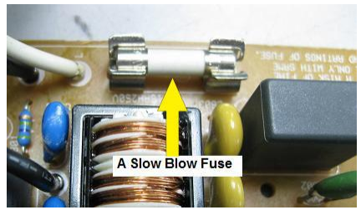

Figure 2-4A Slow Blow Fuse
Fuse (board location marked as “F”) – The purpose of a fuse is to open an electronic circuit when current flow exceeds a certain amount, determined by the fuse rating. Opening a circuit under a high current conditions can save electronic components from damaged and prevents overheating, which could cause fire. The fuse can breakdown on its own due to the life span or from a mild surge. Normally in this condition, replacing with a new fuse will solve the problem. In some cases, you could see that the glass type fuse was totally blown into black/dark colour. If this happen, replacing only the fuse would not solve the problem as the dark colour fuse indicated there was a major short circuit in the power supply. In this case, you have to spend a little bit more time to find out the fault before putting a new fuse and retest the power supply.
- Varistor
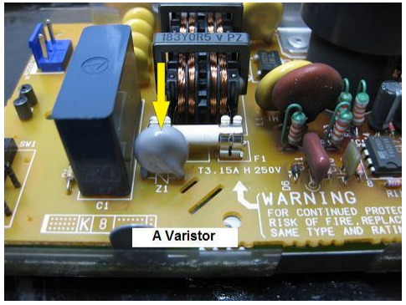
Figure 2-5Varistor
Varistor (board location marked as “Z”, “RV” or “ZNR”) - Metal Oxide Varistor (MOV) is voltage dependent symmetrical resistors intended to protect equipment from transient voltages resulting from lightning strikes and it has many colours. This component is located near the ac supply input and before the bridge rectifier. The use of MOV not only reduces the chance of electrical damage but also improves equipment reliability. Whenever the Varistor has problem, the top part always darkens in colour and splits open (blown)! In order to test MOV you can use an analogue meter set to X 10 K ohm and it should show no reading on both ways. If there are any readings, then it had developed a short circuit.
- Negative Temperature Coefficient Thermistor
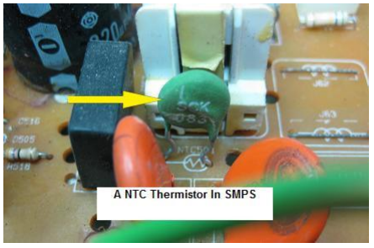
Figure 2-6Thermistor Negative temperature coefficient (NTC)
Thermistor (board location marked as “TH”, “R” or “NTC”) - The function is to limit the inrush current that can kill the components in the power section during start up. An NTC Thermistor has a relatively high resistance at room temperature, so at turn-on, it limits the current charging the load’s rail capacitors. As the Thermistor heats up, its resistance drops, so the power supply becomes relatively low impedance. You can test it using an analogue meter set to X 1 Ohm and it should show a low ohms reading. For your information not all SMPS use this component in their design. In some SMPS, the designer may add in a resistor in series (usually low ohm resistor with higher wattage) to the input to limit the initial peak inrush current whenever the power supply is switched on.
- Bridge Rectifier
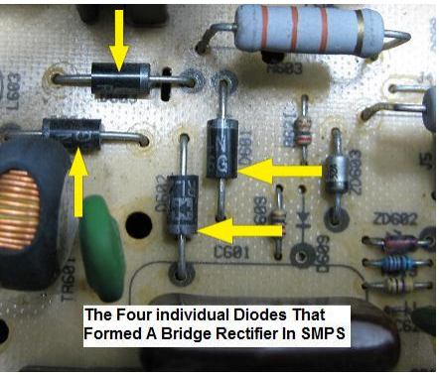
Figure 2-7Four Diodes That Forms the Bridge Rectifier
Bridge Rectifier (board location marked as “D” or “BR”) - Bridge rectifier can come in 4 individual diodes or in a single package. It depends on the design engineers as which type they want to use. In the four individual diodes bridge arrangement, if one diode is found to be shorted, you have to replace the other three. The reason for it is if you do not replace the other three, there could be a high chance one of the three diodes will go shorted again, I had come across this problem before and I don’t want you to follow my path of saving money and end up getting the same complaint again (no power) from the same customers.
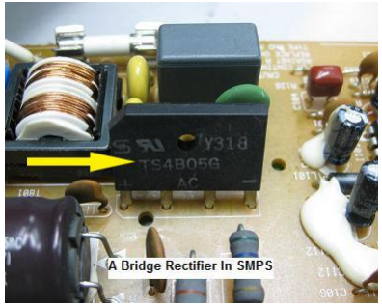
Figure 2-8Bridge Rectifier
As for the bridge rectifier in a single package, if one diode is found to be faulty, you have to replace the whole package. Assuming if you can’t get the spare part, you can always make yourself a bridge rectifier from four individual diodes. You may use four pieces of diode with the part number of 1N5408 to make a bridge rectifier. This part number is best use for most of the consumer electronics circuit. Whenever you come across a blown fuse, please test the bridge rectifier first before you replace it with a new fuse and retest the power supply
- Large Filter Capacitor
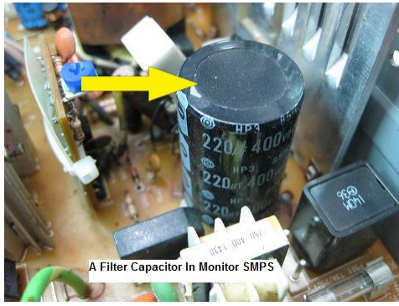
Figure 2-9Filter Capacitor in Primary Side of SMPS
Filter capacitor (board location marked as “C”) - This is the biggest electrolytic capacitor found in any SMPS. The function is to remove the ripple in the line and provide a clean DC to the circuitry. This capacitor has four common failures:
- Bulged- The top part aluminum cap opens up (or exploded) indicates an over voltage problem.
- Open circuited- The capacitance dropped to zero value indicating the internal part are already broken or the electrolyte has been dried up.
- High ESR- Some filter capacitors have a good capacitance value but the ESR value shoots up causing the power supply to stop working. The electrolytic capacitor ESR value can only be measured by using an ESR meter.
- Short circuited- A short circuited filter capacitor can be completely blown up the fuse. It is quite rare to have a short circuit filter capacitor but I have come across some cases. Set your analogue multimeter to X 1 Ohm and check across the two leads. It should not show any steady reading on both directions.
- Breakdown when under load- Although it does not happen that frequent, it does happen especially when you have tested all of the components in the power side area and still could not locate why the fuse keep on blowing upon power “On”. The filter capacitor can be tested okay with analogue, digital capacitance meter or even ESR meter but failed when the full voltage apply across it. This kind of problem can only be detected by using an insulation tester.
- Resistor
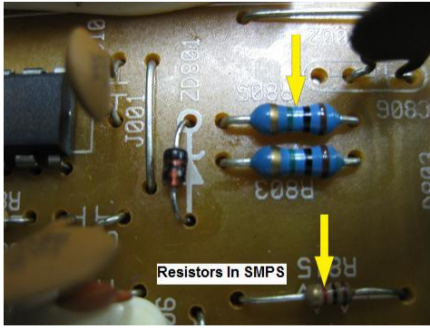
Figure 2-10Resistors
Resistors (board location marked as “R”) - The function of resistor is to limit current in electronic circuit. Resistor problems could be in the form of open circuit, turn into high ohms, and burnt, discolored, broken leads due to rust and even intermittent problem (quite rare). By using only the digital multimeter set to Ohms range, you will be able to detect most of the resistors faults in power supply circuit.
- Non Polarity Capacitors
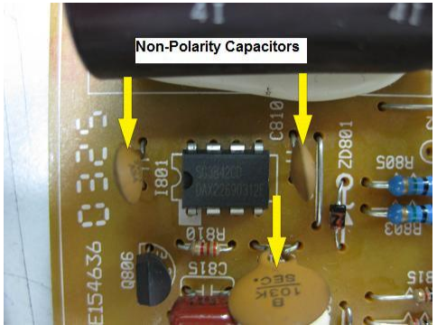
Figure 2-11Non Polarity Capacitors
Non polarity capacitors (board location marked as “C”) - These capacitors can be found in the RFI circuit and in primary side of power supply. Some of these capacitors are part of the oscillator circuitry. The problems that these capacitors can cause are open circuit, capacitance value out and short circuit. Sometimes under heavy short circuit in the power supply, these capacitors could crack and will have burnt mark and split open.
- Zener Diode
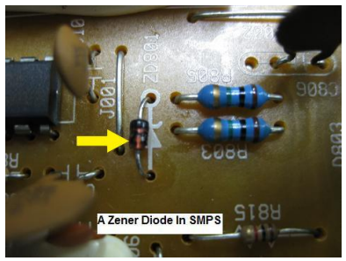
Figure 2-12Zener Diode
Zener diode (board location marked as “D” or “ZD”) - Not all SMPS use Zener diode in the circuit. For those SMPS that use the Zener diode, it is meant to protect the power IC and to shut down the power supply, in case if there is overvoltage (refer to page 43). Zener diodes can develop short circuit or open circuit or even leak when test with an analogue meter set to X 10 K Ohm.
- Diode
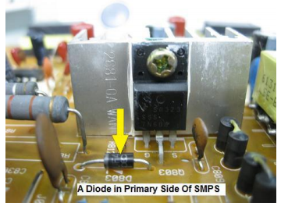
Figure 2-13Diode
Diodes (board location marked as “D”) - You could see some small signal diodes that have the marking of IN4148 and small ultra-fast recovery diodes (like BA159 and UF4004 and etc) in the power supply primary section. The signal diodes could be part of the oscillator circuit and the ultra-fast recovery diode is to convert the AC voltage into DC to supply to the power IC. For your information the diode in the RUN DC circuit is an ultra-fast recovery diode (refer to page 29). This diode can be shorted, open circuited, leaked and even breakdown when under load.
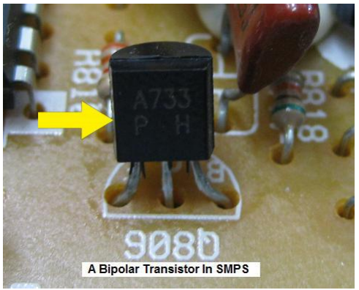
- Bipolar Transistor

Figure 2-14Bipolar Transistor
Bipolar Transistors (board location marked as “Q”) - For older model of SMPS you could see more transistors compare to a newer model of SMPS. The transistors are part of the oscillator circuit and it could develop short circuit, open circuit and leaking that caused the power supply to totally stop working. It could also like diode, breakdown when under full operating voltage.
- IGBT Transistor
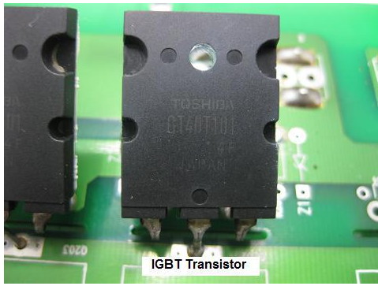
Figure 2-15IGBT Transistor
IGBT is a short term for the Insulated Gate Bipolar Transistor (board location marked as “Q”) – This device is a combination of bipolar transistor and Mosfet. The emitter and collector of the IGBT device is the same as they are in a bipolar transistor. In place of the base of the bipolar transistor, the IGBT has insulated gate, as it is found in Mosfet device as seen in the diagram below. This transistor can be found in SMPS, Induction heating, Traction Motor, Uninterruptible Power Supply (UPS) and etc.
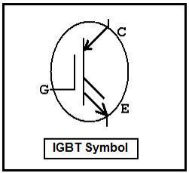
Figure 2-16IGBT Symbol
Like the bipolar transistor the IGBT could develop short circuit, open circuit and leaking that caused the power supply to totally stop working.
- Silicon Controlled Rectifier (SCR)
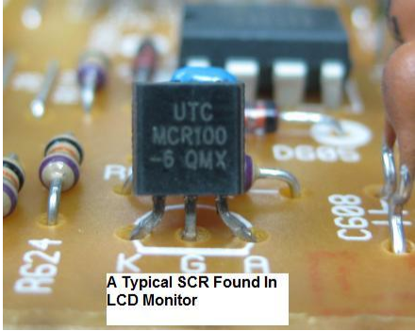
Figure 2-17Silicon Controlled Rectifier
SCR (board location marked as “Q”) can be found in many electronic circuits. Part numbers such as the FOR3G and MCR 100-6 are commonly used in Computer Monitor especially in the primary power side. The SCR can also be found in overvoltage protection circuit in secondary side of some SMPS. SCR consists of three pin of Gate (G), Anode (A) and Cathode (C). In order to identify the pin out, one must find it from semiconductor data book. The data book will list out the general specification of the SCR such as the volt and ampere. If you want to know more details about a particular SCR, you can always try to search from the Internet. You can usually download the full datasheet from the SCR manufacturers. When this component encounters a problem, it could cause no power, power blink and even power shutdown in power supply.
- Power IC
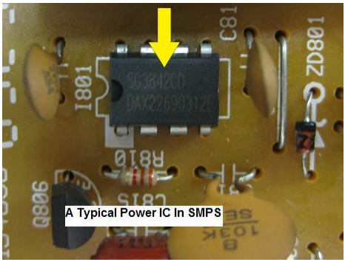
Figure 2-18 Typical Power IC
Power IC (board location marked as “IC”, “I” or “U”) - The power IC is used to generate waveform to switch the power FET/transistor in the power supply circuit and to detect currents drawn from the secondary side. If too much current were being drawn from the secondary side (like a shorted secondary output diode) the power IC would shut itself down. The most common part number for power IC is UC3842 and it has 8 pins. Power IC can come in many different types and no matter what part number it is, the main function is to generate an output waveform to drive transistor.
- Power FET
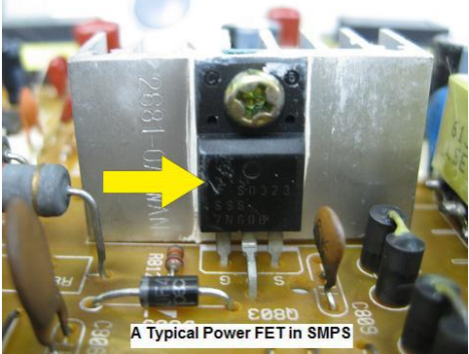
Figure 2-19Typical Power FET Field effect transistor (FET)
This FET transistor is used to switch the SMPS transformer when it gets the signal waveform from the power IC. It is usually the N-channel FET transistor and can be easily become defective whenever there is a surge in the power supply or some components have shorted in the corresponding circuit or in the secondary side. The common faults for this type of transistor are almost the same as power IC like short circuit, open circuit, cracked and even the outer layer coming off from its casing.
Note: Newer power supply may not use the power FET anymore because the FET has already integrated into the power IC as one single package. So do not waste your time searching for this FET in the newer power supply circuit. Please refer to figure 5.19 and 5.20
- Switch Mode Power Transformer
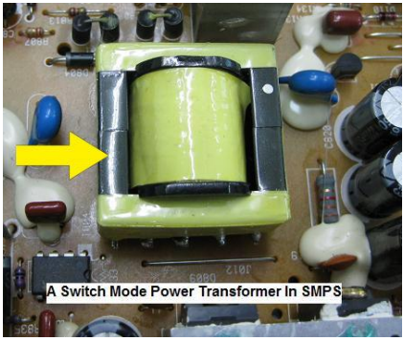
Figure 2-20Switch Mode Power Transformer
Switch mode power transformer (SMPT) (board location marked as “T” an sometimes “TR”) – The transformer function is to convert the AC input into another AC output of different voltages. SMPT rarely has problems but when it encounters problems, the main fuse will usually blow and the components in the primary side may be affected as well. A shorted turn in the primary winding is the main problem for SMPT. You have to use a coil tester (Blue Ring Tester) to test the primary winding. Secondary winding seldom gives problem and when it has problem, one or few of the output voltages will drop to half.
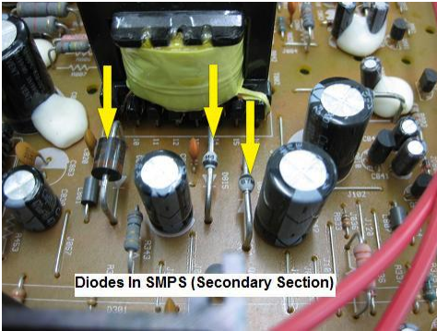
- Secondary Output Diodes

Figure 2-21Typical Output Diodes in The Secondary Side Of SMPS
Secondary output diodes (board location marked as “D”) – These are ultra-fast recovery diodes (high speed) and not ordinary diode and their job is to convert the high pulse AC signal voltage into DC output voltage. High speed diodes are used to handle the very fast switching action of the power supply. SMPS usually have two or more output DC voltages. Some design uses a Schottky diode or Dual Schottky diodes or even few Schottky diodes in a single package and can be found in power supply. Refer to figure 5.24 and 5.25 in the next page.
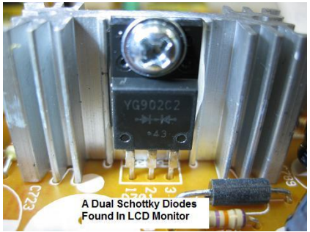
Figure 2-22Typical Dual Schottky Diode
The common faults for the diodes are short circuit, open circuit, leaking and cracked! You can test the ultra-fast recovery diode using analogue meter set to X10 K ohm and it should have only one reading.

- Secondary Filter Capacitors
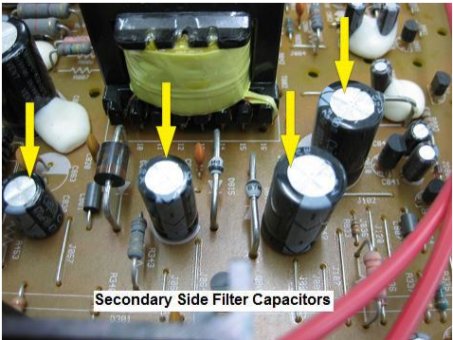
Figure 2-23Filter Capacitors in Secondary Side of SMPS
Secondary output filter capacitors (board location marked as “C”) – Same explanation as in page except that it is not as big as the big filter capacitor in the primary side.
- Secondary Output Inductors/Coils
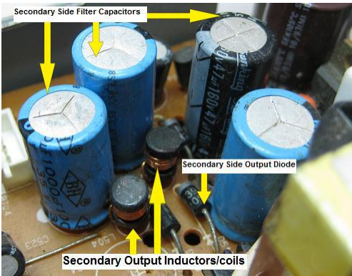
Figure 2-24Inductors/Coils
In Secondary Side of SMPS Secondary output inductors/coils (board location marked as “L”) – The function is to filter any unwanted AC and let DC to pass through. These coils rarely have problem and if there were any problem, it would be the decayed glue that had eaten up the leads. Sometimes you can also find dry joints in these coils. If the coil was opened circuit, the DC voltage couldn’t get through and the circuit area will be affected because no DC supply had entered the respective ICs and circuits. You can test these small coils using ohm meter and it should have low ohm reading.
- Adjustable Precision Shunt Regulator IC
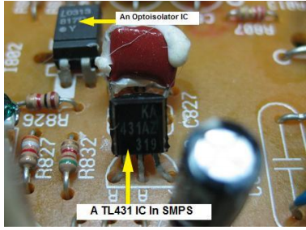
Figure 2-25TL431 IC in SMPS
Adjustable Precision Shunt Regulator IC (board location marked as “IC”) If you repair the SMPS that have the Opt isolator IC connected between the primary and the secondary section, you would usually see a transistor like component. It is actually the adjustable precision shunt regulator with the part number of TL431 and it just like the shape of a C945 transistor. This component is quite cheap and can be easily obtained from those used/junk electronic boards especially boards that have the Opt isolator IC in it. What happens to the power supply if this component is shorted or leaked? It would cause power blinking/cycling, low power or even intermittent no power problem.
- Voltage Regulator
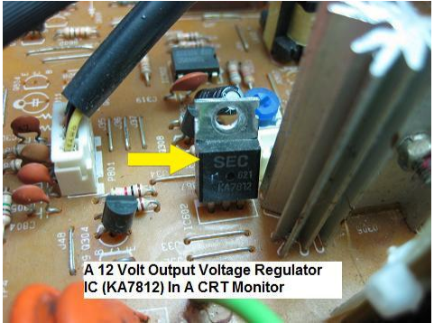
Figure 2-26 Voltage Regulator IC
  - Monitor problems and Troubleshooting
If you've tried the basic troubleshooting steps and your LCD still doesn't work properly, you may have one or more of the following problems:
- Check the Power
- Check Loose or Damaged Cables
- Inspect the video cable and connectors for any damage
- Change the computer's display resolution to resolve monitor issues
- Check BIOS and Recovery Options
- Check System Failure
- Monitor problems and trouble shootings:
- General display problem
- Incorrect configuration. [Check the brightness and contrast control]
- Adapter might not be seated properly in expansion slot.
- Cable between the CPU and monitor may loose or fail.
- Software related problems.
- Failure in monitor s display electronics and in monitor's power supply.
- Incompatibility between software and display adapter.
- Common symptom:
- No image
- Screen flickers
- Poor image
- "Signal out of range" message
- Text or lines are shadowed, jaggy, or blocky
- Some pixels are always on or always off
- A persistent after-image exists
- Moving images blur, smear, or ghost
- Dim image
- Troubleshooting
- Check the power to monitor.
- Check the brightness control on the monitor.
- Check the data cable between the monitor and the video port on the system unit.
- Problem
- When the system turns on, it sounds a single beep and shows the disk activity (light flashes) but the display is blank.
- Solution
- The computer is starting normally but the monitor doesn't display anything. Just use the following simple method.
- Methods
- Shutdown the PC [unplug the power cable] and press down the video card firmly, restart the PC.
- Is the monitor turned on? If not, check the monitor power connector.
- If the problem is on the monitor, use the replacement method.
- Also check the connection (data cable) between the video card and the monitor.
- Your adapter hardware may not work, so use the replacement method.
- Problem
- The Monitor shows only one bright vertical line in the center of the screen
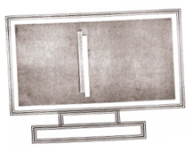
Figure 2-27Monitor shows only one bright vertical line
- Solution
- The monitor is una\Jle to drag the ray (beam) to the horizontal side.
- There is a -problem on the horizontal section of the monitor circuit board.
- This symptom may also be the horizontal deflection' coil or its connection opened. However, unsolder the horizontal transistor from its board and measure it by using a multi-meter. [Usually Done by an electronics expert]
- Problem
- The Monitor shows only one bright borizontalline in the center of the screen
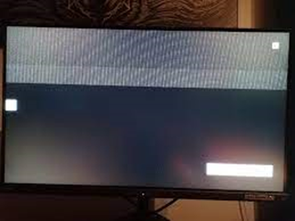
Figure 2-28Monitor shows only one bright borizontalline
- Solution
- The monitor is unable to pull the beam to the vertical the vertical side
- There is a problem in the vertical section [vertical IC].
- Cable between the CPU and monitor might fail or disconnected.
- Display adapter fault.
- Supply to vertical section is missing.
- Vertical deflection coil or its connection IS opened.
- Problem
- The Monitor shows only one bright point in the center of the screen


Figure 2-29bright point in the center of the screen
- Solution
- The monitor is unable to pull the beam to horizontal and vertical side of the monitor .
- Check the horizontal transistor and vertical IC.
- Problem
- No Power light appears on the Computer (Monitor &. System Unit) and
there is no display on the screen.
- Solution
- Check the power line from the wall outlet.
- Check the adapter sockets.
- Check the power cables.
- Check that the system unit's power supply is plugged into the wall outlet (adapter socket)
- Check that the monitor is plugged into the wall outlet (adapter socket).
- Check the system unit's ON\ OFF switch.
- Check the monitor's ON\OFF switch.
- Problem
- Still black screen, no power light and no fan sounds.
- Solution
- Both the system unit and the monitor not getting power properly.
- Is it plugged in?
- Is the wall outlet power working?
- Or Computer's power supply has gone bad
- Problem
- System unit's power lights, fan sound and no power light on the monitor.
- Solution
- Check the monitor power connection.
- Use the replacement method.
- Problem
- Both the monitor's and the system unit's power lights but no picture on the screen.
- Solution
Note: The red power light on the monitor indicates 'no signal’ has been sent to the monitor through the monitor's data cable, and the green light indicates: that the monitor has received a signal from the CPU.
- Check if the monitor brightness and contrast is on accurate setting.
- Re-attach the data cable. The data (video) cable that connects the monitor to the video card may be unplugged.
- Problem
- Still the monitor and computer system Power lights came on but there is no picture on the screen.
- Solution
- Reseat the video card firmly. [Don't forget ESD]
- The video cable (pins) might fail. [So check it]
- The video card might fail. [Replace it]
- The monitor might fail.
- Use the replacement method.
- Problem
- The computer shows "keyboard error" message on black screen or you couldn’t' type anything.
- Solution
- Check the keyboard connection (Identify t.: keyboard and the mouse connector (PS /2 types) at the back of your PC].
- Unplug and re-plug the keyboard cable to make sure it is plugged in firmly.
- Make sure that nothing is holding any key down on the keyboard.
- Or the keyboard might fail. Use the replacement method.
- Problem
- A PC shuts down and reboots without warning.
- Solution
- Fluctuation in voltage would cause sudden restart or shutdown.
- Heat problem could cause restart after a few minutes of operation.
- Check the power supply fan.
- Check the CPU cooling fan.
- Check also the thermal compound [grease] between the CPU chipset and heat sink.
  - Motherboard problems and trouble shootings:
- Problem
- The PC shows 100 series error (any error from 100- 199) code and freezes the system.
- Solution
- Any number starting with 1 usually indicates system board problem.
- Check the system board (motherboard)
- Use a replacement method.
- Problem
- The power supply works properly' but no movement of the CPU fan and the display shows black screen.
- Solution
- The system board power connector is plugged correctly or the motherboard failure might cause this problem.
- Symptom: - hard disk failure message on black screen
- Troubleshooting
- Your hard drive is not hooked up right.
- Check the power cable for hard drive.
- Check the data (IDE) cable.
- Check the BIOS setting for hard drive and CD¬ROM drive. [usually configured AUTO]
- Check the jumper (MASTER \SLA VE) setting.
- Else-the hard drive has failed. If you can get another hard drive that works, plug it in and see if it corrects the problem (replacement method).
- Symptom: - boot failure message troubleshooting
- Your hard disk can't start windows. It might have gone bad, or you might have a computer virus. Re-installation of the operating system may solve the problem.
- Problem
- The PC's hard disk is busy
- Solution
- Check the viruses.
- Run the system maintenance·· tasks [disk defragmenter, disk cleanup, scandisk.]
- Is the hard disk's Light indicator [on the PC's front case] blinking constantly? If so, your PC doesn't have enough memory. So, add more RAM
- Problem
- On POST (power on self-test) routine, the system freezes and shows "no boot device available" message on the screen
- Solution
- Remove any floppy disk from the floppy drive so that the boot process can continue.
- Check the IDE cables connectors.
- Check the jumper of the hard disk\CD drive.
- You have a bootable Hard disk partition but forget to set it active. [Reconfigure the hard disk setting]
- Problem
- Some systems show 1700-1799 error code on the screen during the POST routine.
- Solution
- Hard disk problems. The hard disk geometry might not be set correctly, or the hard disk contains a bad controller.
- Use the replacement method.
- Problem
- The system shows "drive not found" or not boot device available" at boot time.
- Solution
- Check the connectivity first.
- Check the jumper setting for the HDD\ CD¬ROM.
- Check the cable connection.
- Adjust the CMOS setting to 'Auto' detection.
- Problem
- The system shows "no operating system" or "missing operating system" error message during boot process.
- Solution
- Make sure the CMOS setting detects the hard disk properly.
- The hard disk might have a corrupted or missing, file.
- Backup the data and reinstall the operating!" system.
  - Sound card
- Usually built-in the motherboard and is used to give sound through the speakers.
- Problem
- No sound from the Computer
- Possible cause:
- Software related problem.
- Speaker connection failure.
- Solution
- Check your speaker and its connection.
- Check the volume control in the windows system
- Check the driver software for the sound card.
- Problem
- No sound from the CD drive
- Solution
- Check the disc into another system.
- The audio cable connecting the CD drive to Sound card is detached. Therefore, unplug off] the PC and reattach the audio cable to sound card.
- Run any sound card diagnostic software.
- Use the replacement method.
  - Modem card
In order to connect· the computer ·to the Internet connection, you must have a modem card between the motherboard and Telephone line.
- Problem
- Modem cannot dial and "no Dial tone" message appears on the monitor
- Solution
- Check the phone card connection.
- Make sure the jack on the modem labeled "line" is connected to phone line wall jack.
Testing and checking
Testing is an essential step in computer repair to ensure that the issue has been successfully resolved and that the system is functioning properly. It helps to verify that the repairs or maintenance performed have effectively addressed the problem and that the computer is ready to be returned to the user.
When testing computer repairs, professionals should consider the following steps:
1. Functional Testing: This involves testing the basic functions of the computer to ensure that they are working correctly. This includes checking the operating system, hardware components, and peripherals. For example, testing the keyboard, mouse, display, and audio output to ensure they are functioning as expected.
2. Software Testing: It is important to test the software applications installed on the computer to ensure they are working properly. This includes launching and using different software programs to verify their functionality. Additionally, running system diagnostics or software tools to check for any errors or conflicts.
3. Connectivity Testing: If the computer is connected to a network or the internet, it is crucial to test the connectivity. This involves checking the network settings, verifying internet access, and testing network connectivity to ensure that the computer can communicate with other devices or access online resources.
4. Performance Testing: Testing the performance of the computer is important to ensure that it is operating at an optimal level. This can involve running benchmark tests or stress tests to evaluate the speed, responsiveness, and overall performance of the system. It helps to identify any bottlenecks or performance issues that may need to be addressed.
  - Test Procedure in Computer System
- Test Hardware part :
- Power Supply:
Before conducting any hardware tests, ensure that the computer is properly connected to a reliable power source. Check if the power supply unit (PSU) is functioning correctly by verifying that the power cables are securely connected and that the PSU fan is spinning.
- Visual Inspection:
Perform a visual inspection of the computer system to identify any physical damage or loose connections. Look for signs of overheating, such as dust accumulation or damaged fans.
- RAM: Test the Random Access Memory (RAM) using a diagnostic tool like Memtest86+. Create a bootable USB or CD with Memtest86+ and run the test to check for any errors or faults in the RAM modules.
- Hard Drive: Use a software program like Crystal Disk Info to monitor the health of the hard drive. Check for any warning signs, such as high temperature, bad sectors, or imminent failure.
- CPU: Evaluate the stability and performance of the CPU by stress testing it with tools like Prime95. Run the stress test for a significant period to ensure the CPU can handle heavy workloads without overheating or crashing.
  - Test Procedure in Computer System Software:
- Operating System: Ensure that the computer's operating system is up to date with the latest patches and security updates. Check for any system errors or conflicts that may affect the overall performance.
- Drivers: Verify that all hardware drivers are installed correctly and up to date. Outdated or incompatible drivers can cause various issues, including system crashes and hardware malfunctions.
- Software Updates: Update all installed software applications to the latest versions. This helps ensure compatibility, security, and optimal performance.
- Virus and Malware Scan: Perform a thorough scan of the system using reputable antivirus software to detect and remove any malicious programs that may compromise the system's security or performance.
- System Configuration: Review the system configuration settings, including power management, network settings, and startup programs. Optimize these settings to enhance system performance and stability. It is important to note that the pre-test procedures may vary depending on the specific hardware and software configurations of the computer system. Always refer to the official documentation and guidelines provided by the hardware and software manufacturers for the most accurate and up-to-date pre-test procedures.
  - Testing for a Blown Fuse with a multimeter
Whilst it is easy to visually inspect the element in a glass fuse to see if it has blown, the majority of fuses have solid, non-transparent bodies that hide the element from view. To test if the fuse is blown, we require a multimeter. Once configured, a multimeter can measure the resistance of the fuse element. Resistance is measured in Ohms 'Ω'. The following tutorial uses a digital multimeter, however the same principles apply when using an analogue multimeter (ie. one with a needle display). If you are using an analogue meter, firstly read the tutorial and then refer to the additional notes at the end.
Step 1: Connecting the Test Leads.
The black lead should be connected to the Common socket.
The red lead should be connected to the Ω or Ohms socket.
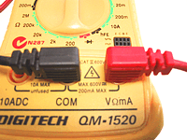
Figure 2-30 Connected the Test Leads.
- Step 2: set the ohms on a multimeter.
Move the dial to the lowest range of the Ohms scale (200 ohms is the lowest setting on this mulitmeter). This should also power the meter ON. If there is a separate ON switch, please turn the meter ON. You can see in the picture that the Ohms range is illustrated by a light green band in lower left area.
The 5 different Ohms range settings on this multimeter are;
- 2M = 2,000,000 ohms or 2 Mega ohms (highest resistance setting
- 200k = 200,000 ohms
- 20k = 20,000 ohms
- 2k = 2,000 ohms
- 200 = 200 ohms (lowest resistance setting)
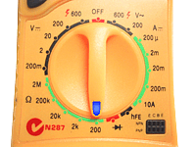

Figure 2-31Different Ohms range settings on this multimeter
Step 3: test if your multimeter is working.
Touch the metal tips of the 2 testing leads and whilst holding them together, the meter display should change to show that little or no resistance is present. Power will simply flow from one lead back through the other. When you separate the two tips, the meter display will return to a 100% resistance state.
Step 4: Measure Resistance of the Fuse.
Important! Place the fuse on a non-conducting surface such as wood, laminate or plastic. Touch the metal caps at each end of the fuse with the metal tips of the testing leads. There is no polarity so you can use any lead for either fuse cap. Ensure to make good contact by touching a clean metal surface on each cap. Whilst the leads are firmly connected to the fuse, look at the reading displayed on the multimeter.
Note: If you wish to test a fuse still located in a circuit. Please ensure that you have turned off power and disconnected the power source to avoid possibility of electric shock.
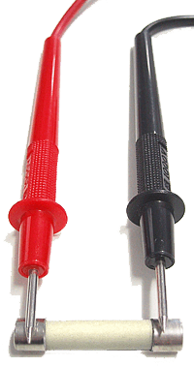
Figure 2-32Measure Resistance of the Fuse
Step 5: Understanding a Digital Multimeter Reading.
Fuse is OK: If the multimeter reading changes to a low resistance value (similar to the result of touching the 2 leads together).
Fuse is Blown: If the meter reading does not change and display still shows the original 100% resistance state.
Don't forget to turn the multimeter OFF when you have finished testing.
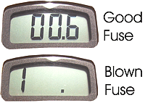
Figure 2-33Indicate connectivity of fuse
  - Test a Power Supply Unit
The PSU's fan should start spinning, the moment it powers on. This is an elementary and yet essential test, because if the PSU doesn't even turn on, then what's the point of testing it with a multimeter?
There's a twist to this test: a PSU won't turn on without a motherboard. This is because the PSU has a power-on pin that connects to the motherboard. So, if you flipped the power switch on your brand new PSU and the fan didn't spin, don't panic. That's how it's supposed to be.
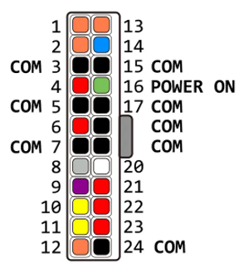
Figure 2-34 Man power connector (pin view)
To conduct this test without risking a motherboard, you can use a paper clip to connect the power on pin to a ground pin. If your PSU's main connector has colored wires, then the green wire goes to the power-on pin and the black ones go to ground pins. If the wires aren't color-coded, you can use the diagram above to locate the pins on your connector. Pay attention to the clip's position.
With the connector's clip facing the ground, the power-on pin is the fourth pin from right on the bottom row. Once you've located the pins, here's how you can turn on the PSU:
- Make sure the PSU is unplugged and the power switch is set to off. Off is marked with a circle (O) on the switch.
- Grab a metal paper clip and straighten it. You can also use a jumper wire, or any flexible conductor.
- Connect one end of the clip to a ground pin. These are marked with COM in the diagram.
- Connect the other end of the clip to the power-on pin
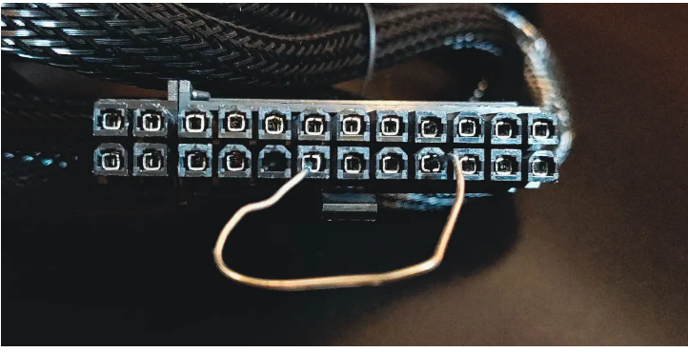
Figure 2-35connect the power on pin to a ground pin.
- Plug in your PSU.
- Switch the power switch to on.
Now for the moment of truth. If the fan is starts spinning, then congratulations! You've passed the first test! Some PSUs have a zero rpm feature, and the fan will stop spinning after a while. So don't worry if the fan stops spinning.
Voltage Test: Testing the PSU with a Multimeter
Now it's time to check whether the PSU is supplying adequate power to each pin. You'll need to measure the voltage on 13 pins that fall into three categories: 3.3V, 5V, and 12V.
Your PSU should stay on for this test, so don't turn it off; let the power on bridge stay as it is. If you haven't used a multimeter before, read on how to use a multimeter to get started.
- Plug the black test lead into the COM jack.
- Plug the red test lead into the VΩmA/μA jack (it may be labeled slightly differently on your multimeter).
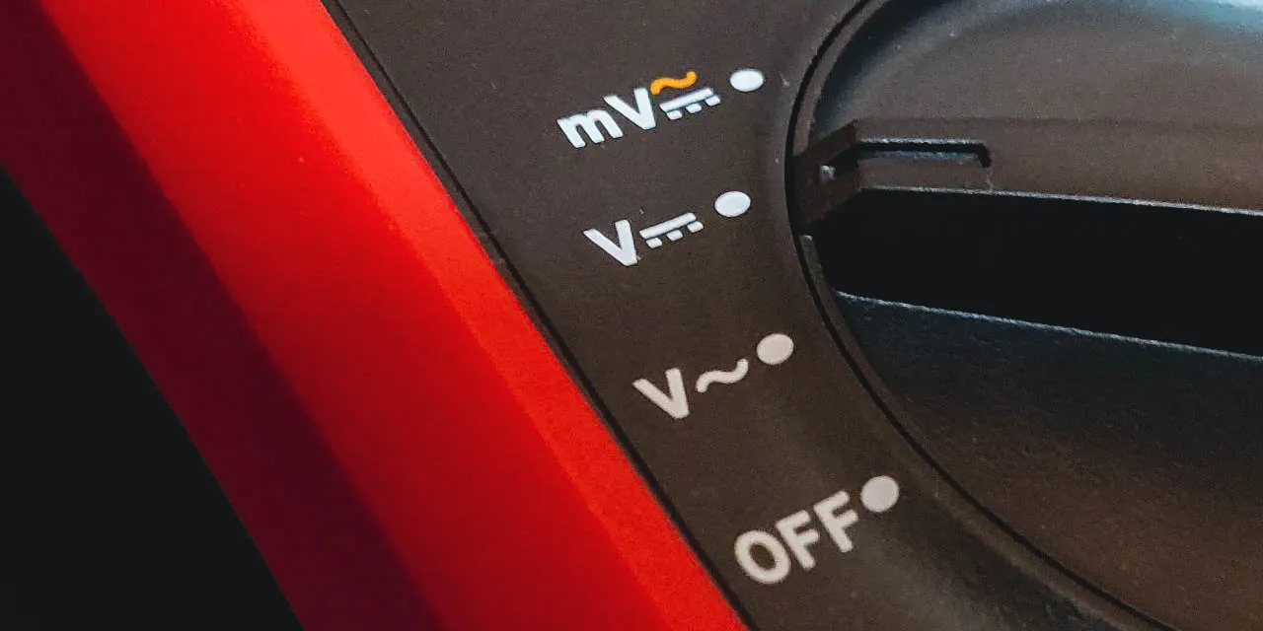
Figure 2-36Select parameter
- Connect the black test lead to a COM pin on your PSU's connector.
- Connect the red test lead to the PSU pin you want to test.
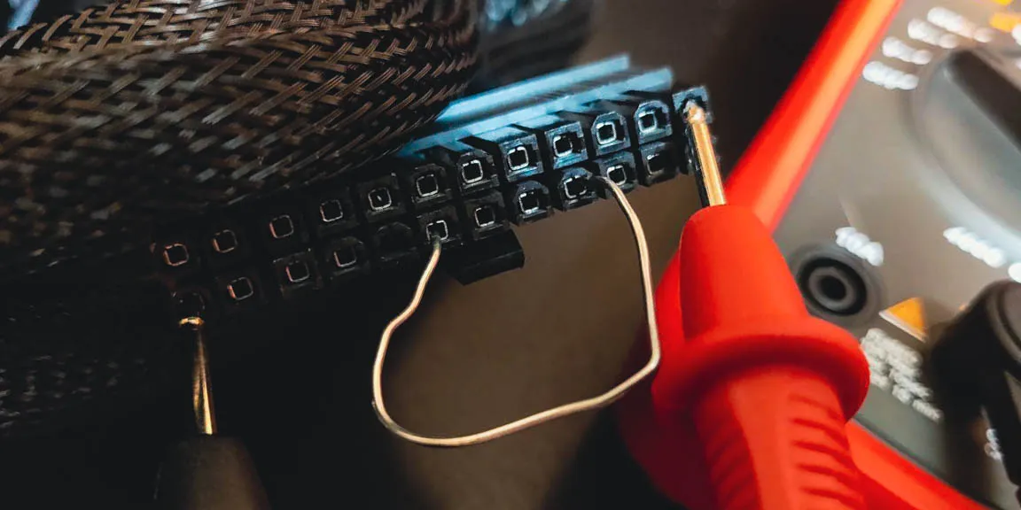
Figure 2-37Connect the test lead to the PSU pin
Observe the voltage reading on your multimeter
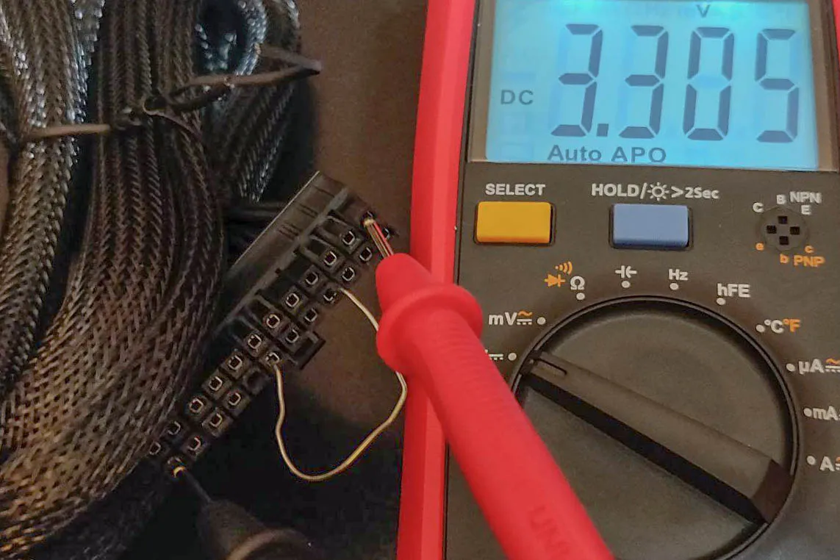
Figure 2-38Observe the voltage reading
Repeat this for the remaining pins to ensure they're providing the voltage they should. The pins have a voltage tolerance, so it's OK if the voltage is a little bit above or below what it should be. Compare the voltage reading from your PSU with the table below
Pin | Tolerance | Voltage Range
1 | +3.3V ± 5% | +3.135 to +3.465V
2 | +3.3V ± 5% | +3.135 to +3.465V
4 | +5V ± 5% | +4.75 to +5.25V
6 | +5V ± 5% | +4.75 to +5.25V
9 | +5V ± 5% | +4.75 to +5.25V
10 | +12V ± 5% | +11.40 to +12.60V
11 | +12V ± 5% | +11.40 to +12.60V
12 | +3.3V ± 5% | +3.135 to +3.465V
13 | +3.3V ± 5% | +3.135 to +3.465V
14 | -12V ± 10% | -10.80 to -13.20V
21 | +5V ± 5% | +4.75 to +5.25V
22 | +5V ± 5% | +4.75 to +5.25V
If the pin's voltage falls within the voltage reading in the table above, then it's functioning properly. Once you've tested all the pins, you'll know if your PSU is healthy or not.
Alternatively, if you want to be extra cautious, you can connect a testing component like a lamp to the PSU connector and then check if the voltage reading drops or not. Each pin's voltage should stay within its range regardless of the components attached to it.

Managing and implementing contingency measures
Managing and implementing contingency measures in computer maintenance is crucial for maintaining the smooth operation of computer systems and minimizing the impact of potential failures or disruptions. Contingency measures involve proactive steps taken to prepare for and respond to unexpected events or failures within a computer system. One key aspect of managing contingency measures is the development of a comprehensive contingency plan. This plan should outline specific actions to be taken in the event of various types of failures, such as hardware malfunctions, software crashes, or network outages. It should include detailed procedures for identifying and diagnosing the issue, as well as steps for resolving it efficiently. To effectively implement contingency measures in computer maintenance, professionals should consider the following strategies:
1. Regular backups: Regularly backing up critical data and system configurations is essential for minimizing data loss and facilitating quick system recovery in the event of a failure. This can be accomplished using various backup methods, such as cloud-based solutions or external storage devices.
2. Redundancy and failover systems: Implementing redundant components or failover systems can help ensure continuous operation even if a primary component fails. For example, using redundant power supplies or RAID configurations for storage devices can prevent system downtime in case of a hardware failure.
3. Monitoring and alert systems: Utilizing monitoring tools and alert systems can help detect potential issues or anomalies in real-time. These tools can track system performance, network connectivity, and hardware health, providing early warnings of potential failures. This allows for proactive troubleshooting and resolution before the issue escalates.
4. Disaster recovery planning: In the event of a major system failure or disaster, having a well-defined disaster recovery plan is crucial. This plan outlines the steps to be taken to restore the system to its normal state, including procedures for data recovery, system reconfiguration, and testing. By effectively managing and implementing contingency measures, computer maintenance professionals can minimize the impact of failures, reduce downtime, and ensure the continuity of critical operations. It is important to regularly review and update contingency plans to account for changes in technology, system configurations, and potential risks.

Responding unexpected conditions.
Computer maintenance and repair professionals often encounter unexpected conditions while working on computer systems. These conditions can range from hardware failures to software glitches, and it is crucial for technicians to respond effectively to ensure the smooth operation of the computer. In this essay, we will discuss the best practices for responding to unexpected conditions in computer maintenance and repair.
1. Assess the Situation: When faced with an unexpected condition, the first step is to assess the situation thoroughly. This involves gathering information about the symptoms, error messages, or any other indications of the problem. By understanding the nature of the issue, technicians can determine the appropriate course of action.
2. Troubleshooting: Troubleshooting is a systematic approach to identify and resolve computer problems. It involves using diagnostic tools, techniques, and knowledge to isolate the root cause of the issue. Technicians should follow a step-by-step process to eliminate potential causes and narrow down the problem. This may include checking hardware connections, running diagnostic tests, or analyzing software configurations.
3. Documentation: It is essential to document the unexpected condition and the steps taken to address it. This documentation serves multiple purposes. Firstly, it helps in tracking the history of the computer system, which can be valuable for future reference or troubleshooting. Secondly, it provides a record of the actions taken, which can be useful for accountability and quality assurance purposes.
4. Communication: Effective communication is crucial when responding to unexpected conditions. Technicians should maintain clear and open communication with the user or client, explaining the situation, the steps being taken, and the expected resolution time. Regular updates and transparency help to manage expectations and build trust with the user.
5. Flexibility and Adaptability: Unexpected conditions often require technicians to be flexible and adaptable in their approach. They may need to think creatively, explore alternative solutions, or adapt their troubleshooting methods based on the specific situation. Being open to new ideas and approaches can lead to quicker and more effective resolutions.
6. Continuous Learning: Computer maintenance and repair professionals should continuously update their knowledge and skills to stay abreast of new technologies and emerging issues. Unexpected conditions can sometimes be caused by unfamiliar or rare problems, and having a broad knowledge base can help technicians respond more effectively. Engaging in professional development activities, attending training sessions, and staying connected with industry forums can contribute to ongoing learning.

Procedures in maintenance scheduling
Problem solving in emergency situations is a critical skill for computer maintenance and repair professionals. When faced with urgent issues that require immediate attention, technicians must be able to quickly diagnose faults and implement effective solutions to minimize downtime and restore the functionality of computer systems. In this essay, we will discuss the best practices for problem solving in emergency situations in computer maintenance and repair.
1. Stay Calm and Focused: In emergency situations, it is essential for technicians to remain calm and focused. Panicking or becoming overwhelmed can hinder the problem-solving process and lead to errors. Taking a deep breath, maintaining composure, and focusing on the task at hand will help technicians approach the situation with a clear mind.
2. Gather Information: Before attempting to solve the problem, technicians should gather as much information as possible about the issue. This may include understanding the symptoms, error messages, recent changes to the system, or any other relevant details. Gathering information helps in narrowing down the possible causes and identifying the most appropriate solution.
3. Prioritize and Triage: In emergency situations, it is crucial to prioritize tasks based on their impact on system functionality. Technicians should identify the most critical issues that need immediate attention and address them first. This triage approach ensures that the most pressing problems are resolved promptly, minimizing the impact on the user or organization.
4. Use Diagnostic Tools and Techniques: Diagnostic tools and techniques are invaluable in emergency problem-solving situations. Technicians should utilize hardware and software diagnostic tools to identify the root cause of the problem. This may involve running system diagnostics, checking hardware components, or analyzing software logs. Diagnostic tools provide valuable insights and help in making informed decisions about the appropriate course of action.
5. Implement Temporary Workarounds: In emergency situations, technicians may need to implement temporary workarounds to restore system functionality quickly. These workarounds may not be permanent solutions but can provide temporary relief until a more comprehensive fix can be implemented. Technicians should communicate with the user or client about the temporary measures and provide clear instructions on how to proceed.
6. Collaborate and Seek Help: In complex emergency situations, it is beneficial to collaborate with other technicians or seek help from experts in the field. Discussing the problem with colleagues or reaching out to online forums or support communities can provide fresh perspectives and alternative solutions. Collaboration and seeking help can expedite the problem-solving process and lead to more effective resolutions.
7. Document and Learn: After resolving the emergency situation, it is crucial to document the problem, the steps taken to resolve it, and the outcome. Documentation serves as a reference for future troubleshooting and helps in identifying patterns or recurring issues. Additionally, technicians should reflect on the emergency situation and identify any lessons learned. This continuous learning process contributes to professional growth and enhances problem-solving skills for future emergencies.

Procedures in maintenance scheduling
Maintenance scheduling is a crucial aspect of computer system maintenance and repair. It involves planning and organizing routine maintenance tasks to ensure the optimal performance and longevity of computer systems. In this essay, we will discuss the procedures involved in maintenance scheduling for maintaining and repairing computer systems.
1. Establish Maintenance Objectives: The first step in maintenance scheduling is to establish clear objectives. These objectives may include maximizing system uptime, preventing hardware failures, optimizing system performance, or ensuring data security. By defining the maintenance goals, technicians can align their efforts and resources accordingly
2. Identify Maintenance Tasks: Once the objectives are established, the next step is to identify the specific maintenance tasks that need to be performed. These tasks can include hardware inspections, software updates, virus scans, disk cleanup, data backups, and system optimizations. Technicians should create a comprehensive list of maintenance tasks based on the system requirements and industry best practices.
3. Determine Maintenance Frequency: After identifying the maintenance tasks, technicians need to determine the appropriate frequency for performing each task. This can vary depending on factors such as the criticality of the system, the workload it handles, and the manufacturer's recommendations. Some tasks, like data backups, may need to be performed daily or weekly, while others, like hardware inspections, may be scheduled monthly or quarterly.
4. Create a Maintenance Schedule: With the maintenance tasks and frequencies determined, technicians can create a maintenance schedule. This schedule should outline the specific tasks to be performed, the frequency of each task, and the timeframe for executing them. It is essential to consider factors such as system usage patterns, user availability, and any potential impact on system operations when creating the schedule.
5. Prioritize and Allocate Resources: In maintenance scheduling, it is crucial to prioritize tasks based on their importance and allocate the necessary resources accordingly. Technicians should identify critical tasks that require immediate attention and allocate sufficient time, manpower, and tools to complete them effectively. By prioritizing and allocating resources, technicians can ensure that maintenance tasks are performed efficiently and that system downtime is minimized.
6. Communicate and Coordinate: Maintenance scheduling involves effective communication and coordination with system users or stakeholders. Technicians should inform users about scheduled maintenance activities, their impact on system availability, and any necessary precautions or preparations. Additionally, coordination with other departments or teams may be required to ensure smooth execution of maintenance tasks without disrupting other business operations.
7. Monitor and Evaluate: Once the maintenance schedule is implemented, technicians should monitor the progress and evaluate the effectiveness of the maintenance tasks. This involves tracking the completion of scheduled tasks, assessing their impact on system performance, and identifying any areas for improvement. Regular monitoring and evaluation help in refining the maintenance schedule and adapting it to changing system requirements.
8. Document and Maintain Records: Documentation is a crucial aspect of maintenance scheduling. Technicians should maintain detailed records of all maintenance activities, including the tasks performed, dates, and any observations or findings. These records serve as a reference for future maintenance activities, aid in troubleshooting, and provide insights into system performance trends over time.

Self-check 2.1.
Part 1: True or False:
- Fault diagnosis procedures are systematic steps used to identify and analyze faults in computer systems.
- Reproducing the issue is not necessary in fault diagnosis procedures.
- Diagnostic tools are not useful in the fault diagnosis process.
- Documenting the fault diagnosis process is not important for future troubleshooting.
- Fault diagnosis procedures do not contribute to system performance optimization.
Part 2: Match the following symptoms with the corresponding components:
Match A | Match B
______1. Server crashes | a). Servers
______2. Printer not printing | b). Peripherals
______3. System freezes or crashes | c). Desktop and Laptop Computers
______4. Network connection drops - | d). Network Devices
______5. Intermittent or no connectivity | e). Cables and Connections
Part 3: Multiple Choice:
- What is the purpose of fault diagnosis procedures?
a) To create system backups
b) To prevent system failures
c) To install software updates
d) To optimize network performance
- What is the role of documentation in fault diagnosis?
a) To increase system vulnerabilities
b) To share information with other technicians
c) To ignore the symptoms of the problem
d) To disregard user satisfaction

- What should technicians do after implementing the necessary fixes?
a) Ignore testing and verification
b) Proceed with more troubleshooting steps
c) Document the entire fault diagnosis process
d) Repeat the fault diagnosis process from the beginning
- What is a potential benefit of fault diagnosis procedures?
a) Increased system downtime
b) More expensive computer maintenance
c) Preventive maintenance and system reliability
d) Decreased user satisfaction
- What can diagnostic tools help identify?
a) Hardware failures and software conflicts
b) User activities and preferences
c) System backups and restoration processes
d) Network connectivity and data transmission speed
Part 5: Fill in the Blank:
- The first step in fault diagnosis procedures is to gather __________ about the problem
- Fault diagnosis procedures help technicians efficiently identify the _________ cause of computer issues.
- Effective fault diagnosis can lead to cost savings in computer ____________.
- Fault diagnosis procedures contribute to the development of a ___________ base within an organization.
- Fault diagnosis procedures are crucial for efficient problem resolution, minimizing ___________, and user satisfaction.

Operation Sheet: 2.1
Operation Title: Computer System Fault Diagnosis
Instructions:
- Gather relevant information about the problem, including symptoms, error messages, recent changes or updates, and specific circumstances.
- Attempt to reproduce the issue to understand its behavior and identify patterns or triggers.
- Carefully analyze the symptoms exhibited by the computer system or component.
- Use systematic troubleshooting techniques to identify the root cause of the problem.
- Utilize diagnostic tools and software to assist in the fault diagnosis process.
- Document the entire fault diagnosis process, including steps taken, observations made, and any changes or fixes attempted.
- Determine the appropriate solution or repair method based on the identified root cause.
- Thoroughly test the system or component after implementing the repairs or solutions to ensure resolution.
Precautions:
- Ensure the safety of personnel and equipment during the fault diagnosis process.
- Follow proper electrostatic discharge (ESD) precautions when handling computer components.
- Disconnect power sources and remove batteries before performing any hardware-related diagnostics.
- Create backups of important data before making any changes or modifications.
- Refer to manufacturer documentation and guidelines for specific precautions related to the computer system or components.
Tools and Requirements:
- Diagnostic tools (e.g., system monitoring software, hardware testing utilities).
- Screwdrivers and other necessary tools for opening computer cases.
- Diagnostic software and utilities.
- Test equipment for network connectivity (if applicable).
- Paper and writing instruments for documentation.

Procedures:
- Gather information from the user or system owner about the problem.
- Attempt to reproduce the issue and note any observed patterns or triggers.
- Analyze the symptoms exhibited by the computer system or component.
- Start troubleshooting by checking common and easily verifiable causes.
- Use diagnostic tools and software to assist in identifying hardware or software-related issues.
- Document each step taken, observations made, and any changes or fixes attempted.
- Determine the root cause of the problem and implement the appropriate solution or repair method.
- Thoroughly test the system or component after implementing the repairs or solutions.
- Verify that the issue has been resolved and that the system functions as expected.
Quality Criteria:
- The fault diagnosis process should be thorough and systematic.
- Documentation should be clear, complete, and organized.
- The Quality Criteria (continued):
- The root cause of the problem should be accurately identified.
- The implemented solution or repair method should effectively resolve the issue.
- The system or component should pass the testing and verification phase without any recurring problems or symptoms.
- The fault diagnosis process should adhere to safety precautions and guidelines.
- The documentation should serve as a comprehensive reference for future troubleshooting or sharing information with other technicians or support personnel.
- The overall system performance and user satisfaction should be improved after completing the fault diagnosis procedures.

UNIT THREE RECTIFYING DEFECTS IN COMPUTER SYSTEMS
This learning guide is developed to provide you the necessary information regarding the following content coverage and topics:
- Replacement and repair of defective components
- Implementing Environmentally Friendly Practices in Computer Maintenance:
- Implementing Effective Adjustment Procedures in Accordance with Established Guidelines
This guide will also assist you to attain the learning outcomes stated in the cover page. Specifically, upon completion of this learning guide, you will be able to:
- Replace and repair of defective components
- Implementing Environmentally Friendly Practices in Computer Maintenance:
- Implement Effective Adjustment Procedures in Accordance with Established Guidelines

Replacement and repair of defective components
Basic Hardware Repairs
Below are descriptions of some of the most common hardware repairs, including key steps in the process. In all cases, however, the lab manager who is just beginning to work on computer repair would be encouraged to complete these repairs alongside a more experienced technician as they gain skill and confidence. If the lab manager has an opportunity (through this course or any other) to attend a hardware repair training session, he or she should insist on being involved in as much hands-on training as is possible.
- Replacing a Power Supply:
For desktop computers in developing countries, power supply failure is a common problem. This is due to an uneven or “dirty” voltage and power surges. Before replacing a power supply, a lab manager should make sure that it truly is dead by following the tip box in section 5.2.2. Then follow the steps below:
- Unplug the power cord from the back of the computer case.
- Open up the computer case. The method varies with the brand and model of computer, but often involves laying the case on its side and opening up the side panel. Some computer cases use screws and others have buttons to press that release one side panel.
- Find and unscrew all of the screws attaching the power supply to the back of the case. Usually there will be four screws, located just outside the cut out in the case (or along the mesh grid) where the power supply is found. Do not disconnect the various cables yet. Move the dead power supply as far out of the way as the cables will allow.

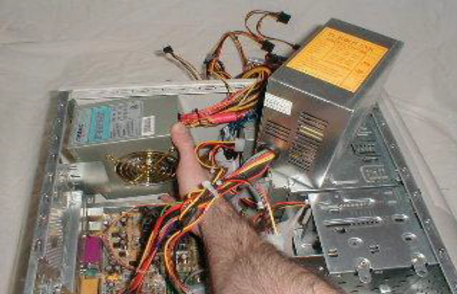
Figure 3-1Replacing a Power Supply
For the complete procedure see http://www.fonerbooks.com/r_power.htm
4. Install the new power supply and screw in all screws.
5. One by one, detach the cables from the old power supply to the various computer components, and replace them with the cables from the new power supply. Doing this one by one will help make sure that no components are missed. There will be power supply connectors for the motherboard and all drives. When removing the cables, keep an eye out for latches that need to be depressed to release the connector. All of the connectors should only fit in one direction, and with little force. If a connector does not attach easily, make sure that it is properly aligned before pushing harder.
- Replacing a Hard Drive:
Replacing a faulty hard drive is not a difficult task, but a lab manager should have done some investigative work first to determine if the hard drive is faulty. The computer may also present error codes during start up that indicate a problem with the hard drive. Before replacing a hard drive, it is worth trying to reset the BIOS to the default settings to see if this fixes the problem. To do this, enter the BIOS during computer start up. Then save the new settings and exit. The onscreen instructions in the BIOS program will guide the computer lab manager through these steps.
Once it has been determined that a hard drive problem is likely, the computer lab manager should follow the steps below to replace the hard drive with a known working hard drive.
1. Disconnect the computer case from electricity and then open the computer case (as described above).
2. Locate the hard drive. It will likely be found in a metal case or cage near the front of the computer case, below the other drives. It could be mounted directly on the cage or it could be mounted on rails that will slide out of the case (see photo).
3. Unscrew the hard drive from the cage or slide the rails out and unscrew the hard drive from the rails.
4. Remove the long ribbon cable from hard drive. There may have been a small amount of glue used to hold the ribbon in place that will also need to be removed.
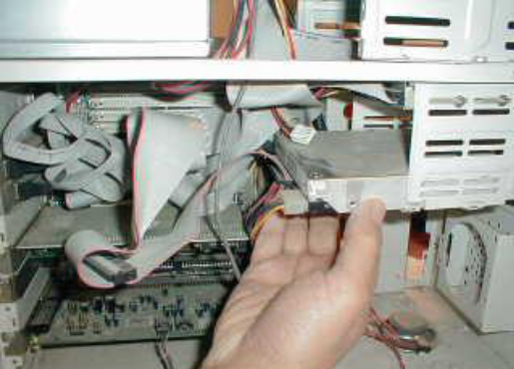
Figure 3-2 Removing a Hard Drive
For the complete procedure see http://www.fonerbooks.com/r_hard.htm
Then remove the smaller power cable. If it is difficult to remove, gently wiggle the connector back and forth along its long axis as you pull. Note the orientation of the connector (which end is the red wire on?) to make sure that the new hard drive is connected in the same manner.
5. If there are two hard drives in a computer, one is called the master and the other the slave. On older hard drives, an electrical connection needs to be changed to indicate whether the hard drive is a master or a slave. If the hard drive being installed has not been used before, it will be correctly set as a master (or also on the acceptable “Cable Select” setting, used when the ribbon cable has two connectors – one for a master and one for a slave). If the hard drive has been previously used as a slave, however, it will need to be changed to a master. To do this, look for a diagram on the hard drive that shows the pattern for connecting (jumping) two of the eight pins located between the two cable connectors on the front end of the hard drive. Then using needle nose pliers, pull off the jumper that is connecting two of the pins and replace it to connect the proper pair.
6. Connect the cables to the new hard drive. Then screw the hard drive back on to the rails and slide the rails into position (or screw the hard drive directly to the cage if there are no rails).
Make sure that all of the other ribbons and cables are as they were found. Close the case and the repair is complete. Note that if any new noises or problems appear after the installation, it is possible that another device or cable was disrupted during the repair and needs to be reattached or reseated.
- Replacing a Hard Drive for a Laptop Computer.
Hard drives for many laptop computers can be replaced quite easily because the manufacturers have made the hard drives accessible from hatches on the underside of the computer. To replace the hard drive on a laptop with an accessible hard drive follow the steps below:
- Remove the laptop battery before making this (or any other) laptop repair. This is important in order to avoid electricity from the battery flowing through the computer during repair, which could be damaging to computer components. The technique for removing the battery depends on the make and model of the laptop, but often involves unlocking the battery at one or two points (on the underside of the computer) and then sliding it out.
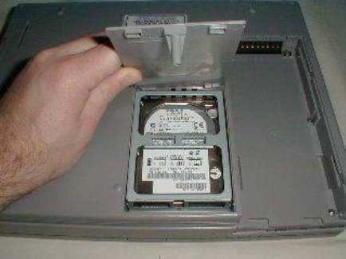
- With the laptop resting upside down on a table, find the hard drive compartment and unscrew the screw or screws holding the lid in place. Remove the lid and examine how the hard drive is attached to the computer.

Figure 3-3A Laptop Hard Drive in its "Cage"
For the complete procedure see http://www.fonerbooks.com/laptop_1.htm
- Slide out the assembly containing the hard drive in its cage or brackets. You may have to push the assembly in or lift it up first in order to clear anything else used to hold the assembly in place.
- Remove any screws attaching the laptop to its cage/brackets, remove the damaged hard drive, replace it with a functioning laptop hard drive and then retighten all screws.
- Slide the assembly back into the laptop and secure it as it was previously. Make sure that you push hard enough to reattach the hard drive to the power and data connectors. Push horizontally (or as close as possible to horizontally) when reconnecting.
- Close the hard drive compartment and replace all screws. Then replace the laptop battery, turn the computer over and restart it.
- Replacing RAM.
A lab manager may want to add RAM to speed up a slow computer. RAM also can fail or come loose from its housing and need to be reseated. If a lab manager has decided that a computer needs new or additional RAM, it is important to make sure that the RAM used is compatible with the computer system. There are several online RAM sales companies that will identify the appropriate RAM if a user inputs the computer make and model. Two example companies are Corsair (www.corsairmemory.com) and Crucial (www.crucial.com). Once the RAM has been obtained, the lab manager should follow the steps below to replace the RAM. Please Note: RAM is very easily damaged by electrostatic charges, so it is very important for the user to be grounded before picking up RAM. Also RAM should only be handled by the edges.
1. Open the computer case as previously described. Find the RAM slots (long parallel connectors). Note which slots are occupied and if the slots are numbered (at the ends). If the slots are not numbered, the slots closest to the processor are probably the lower numbered slots and should be filled first.
2. Simultaneously push down and out on both retaining clips (on each end) of a RAM slot to remove the old RAM. Note the orientation of the RAM so that the replacement RAM can be put in facing the same direction. There should be some notches on the bottom edge of the RAM that can be used as a guide.
3. Gently place the new RAM in the socket and press down firmly on the top of the RAM at both ends (see photo). When the RAM module is correctly seated, the retaining clips will automatically close.
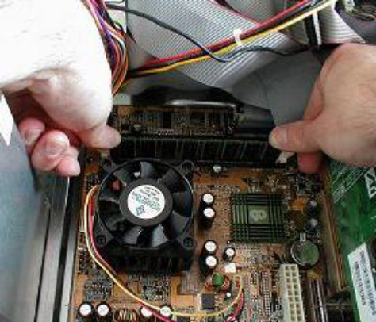
Figure 3-4Installing RAM
For the complete procedure see http://www.fonerbooks.com/r_ram.htm
4. Close the computer case as previously described.
- Software Maintenance
Think of a computer as being like a human body. We are advised to perform certain tasks to keep our body in good shape. These maintenance tasks such as eating well, avoiding some harmful activities and getting exercise keep our body in good condition. If we don’t maintain our bodies, we might end up in the hospital with problems that result from the abuse such as high blood pressure from eating too much salt, obesity from not exercising or lung problems from smoking. Similarly, if we allow our computers to intake harmful materials (such as dust) and programs (such as viruses) and we don’t keep our software in good condition (updated) then the computer may also end up with significant problems that are then harder to deal with. Proper maintenance of a computer, on the other hand, can keep it running smoothly for years and years.
- Updating Software
Software programmers gradually develop updates for their software packages as they discover problems with the software and design tools to address or fix these problems. This can be true for any of the types of software but is typically most common and important for operating systems. It is important for a computer user to find and install software updates in order to have well performing computers. Updating software can be done in a variety of ways.
- Automatic Updates. If a computer is on a reasonably fast Internet connection, the easiest way to keep it up to date is to allow the programs to automatically check for updates and download and install them as needed. When setting up a new computer with Microsoft Windows, this is the choice that the software recommends. It does not require any action on the part of the user, and results in a computer system that is current. To turn on automatic updates for a Windows operating system, find the Systems and Maintenance options in the Control Panel.
- Automatic Alerts for Updates. If a computer is connected to the Internet, but the connection is slow at some times of the day, another option is to have the computer automatically check for updates but not download or install them until the user elects to do so. For Microsoft Windows computers, if this option is selected, an alert appears in the computer’s system tray stating that there are updates waiting, and then the user can wait until the Internet is faster to install these updates.
- Manual Updating. A computer user can also turn off all automatic update checking and choose to manually check for updates. For a computer that is rarely connected to the Internet, this would be a good option as long as the user remembered to check when connecting to the Internet. Also some programs do not have automatic update options, and can only be updated in this manner. A program usually has a menu item titled “check for updates” that a user can click on when connected to the Internet.
- Offline Updating. If a computer is in a location that never has access to the Internet, need to download updates from a computer that is connected to the Internet and then transfer them (via a disk or flash drive) to the computer in question to be installed. This option is also useful if a computer lab has several computers that all need the same update. Instead of having each computer download the update separately, one computer could download the update and then it could be shared amongst all of the computers. Offline updates for operating systems can easily be found through Internet searches.
- Virus and Malware Prevention and Removal
Viruses, spyware and other malicious programs can all be referred to together as malware. Malware prevention is a significant maintenance task for a computer lab manager. Without vigilance, a computer lab will quickly become prey to malware. It will spread from machine to machine causing the computers to slow down, work improperly or possibly even stop working altogether. Also make sure that all of the computers have anti-virus software installed, and that this software is set up so that it regularly updates its virus databases and scans the computers.
Also it needs to have strict policies in place to prevent virus infection. Since viruses are easily spread by the use of flash drives, the policy could prohibit the use of flash drives, or require them to be scanned before use. Another policy to consider is the prohibition of downloading, since unsuspecting users can accidentally download malware. A firewall that blocks dangerous download can also be useful
Tips for Using Anti-Virus Software
- You can get very good antivirus protection using the free edition of AVG, available online at http://free.avg.com. No anti-virus software is perfect, however, so you might choose to have a back-up antivirus program as well. Avast antivirus, available at www.avast.com will work well and will not conflict with AVG if it is not set up to scan automatically. Another good back-up program is Malwarebytes’ Anti-Malware program, available at www.malwarebytes.org.
- After installing antivirus software, make sure that you have selected the settings needed for the software to automatically download and install updates from the Internet. This allows the software to protect against newer viruses. To change the settings for AVG choose Update Manager from the Overview screen.
- When setting up antivirus software, make sure that you choose the proper settings so that the computer is automatically scanned for viruses on a regular basis (such as every day at 12:00). Also make sure that you have selected for the scheduled scans to “run on computer startup if task has been missed”. In other words, if you have chosen to have scans run at 8:00, but the computer isn’t turned on until 10:00, it will still run a scan. In AVG these options are chosen by choosing Manage Scheduled Scans from the Computer Scanner screen.
Make sure that your computer has the proper date and time set. If it is not set properly, the update manager and schedule scans may not run at the time you desire. If your computer does not keep proper time, this is a sign that the small (watch style) battery on the motherboard needs to be replaced

Implementing Environmentally Friendly Practices in Computer Maintenance:
A Sustainable Approach to Corrective Action Introduction: In today's digital age, computer maintenance plays a crucial role in ensuring the smooth functioning of our technological infrastructure. However, it is equally important to address the environmental impact associated with these activities. This essay aims to explore the concept of replacing corrective action in computer maintenance with environmentally friendly practices, highlighting the significance of sustainable approaches in preserving the environment.
- Understanding Corrective Action in Computer Maintenance: Corrective action refers to the process of identifying and rectifying issues or problems that arise in computer systems. This typically involves troubleshooting, repairing or replacing faulty hardware components, and resolving software-related issues. While corrective action is essential for maintaining the performance and reliability of computer systems, it often generates electronic waste and contributes to environmental degradation.
- The Environmental Impact of Traditional Corrective Action:
a. Electronic Waste: Traditional corrective action in computer maintenance often leads to the disposal of electronic waste, which contains hazardous materials such as lead, mercury, and cadmium. These substances can leach into soil and water, posing significant risks to human health and the environment.
b. Energy Consumption: Repairing or replacing hardware components requires energy-intensive processes, contributing to greenhouse gas emissions and climate change.
c. Resource Depletion: The extraction and manufacturing of new computer components require the consumption of valuable resources, including rare earth metals, which are often obtained through environmentally damaging mining practices.

Implementing Effective Adjustment Procedures in Accordance with Established Guidelines
Repair and Refurbishment: Instead of immediately replacing faulty components, computer maintenance technicians can explore repair and refurbishment options. This approach not only reduces electronic waste but also extends the lifespan of existing hardware, minimizing
Implementing Effective Adjustment Procedures in Accordance with Established Guidelines
In various industries, adjustment procedures are crucial for ensuring the proper functioning and performance of equipment, systems, or processes. Adhering to established guidelines is essential to maintain consistency, accuracy, and safety. This essay aims to explore the importance of implementing effective adjustment procedures in accordance with established guidelines, highlighting the benefits of following standardized practices.
- Understanding the Significance of Adjustment Procedures: Adjustment procedures refer to a set of steps or actions taken to modify, calibrate, or fine-tune equipment or systems to achieve desired performance levels. These procedures are essential for maintaining accuracy, reliability, and efficiency, while also ensuring compliance with industry standards and regulations.
- Benefits of Following Established Guidelines:
- Consistency: Established guidelines provide a standardized framework that ensures consistency in adjustment procedures across different contexts. This consistency helps to minimize errors, reduce variability, and improve overall quality.
- Accuracy: Guidelines are developed based on industry best practices and extensive research, ensuring that adjustment procedures are performed accurately. Following these guidelines helps to achieve precise and reliable results.
- Safety: Many adjustment procedures involve potentially hazardous equipment or processes. Adhering to established guidelines helps to mitigate risks and ensure the safety of personnel and the surrounding environment.
- Implementing Effective Adjustment Procedures:
- Familiarize with Guidelines: Before conducting any adjustment procedure, it is crucial to thoroughly review and understand the established guidelines. This includes studying technical manuals, standard operating procedures, and any relevant industry regulations.
- Pre-Adjustment Preparation: Proper preparation is essential to ensure the adjustment procedure is conducted smoothly. This may involve gathering necessary tools and equipment, ensuring proper safety measures are in place, and verifying the availability of required resources.
- Step-by-Step Execution: Following the established guidelines, perform the adjustment procedure step-by-step, paying close attention to details and any specific instructions provided. Take accurate measurements, record data, and document any deviations or unexpected observations.
- Verification and Testing: After completing the adjustment procedure, it is crucial to verify the effectiveness of the adjustment. This may involve conducting tests, comparing results against predetermined standards, or seeking validation from relevant authorities or experts.
- Documentation and Reporting: Accurate documentation of the adjustment procedure is essential for future reference, quality control, and compliance purposes. Record all relevant details, including the date, time, personnel involved, measurements, observations, and any deviations encountered during the process.
- Continuous Improvement and Training: To ensure the effectiveness of adjustment procedures, organizations should prioritize continuous improvement and provide regular training to personnel involved. This includes staying updated with the latest industry guidelines, incorporating feedback from previous adjustments, and fostering a culture of learning and knowledge sharing.
Implementing effective adjustment procedures in accordance with established guidelines is crucial for maintaining consistency, accuracy, and safety in various industries. By following standardized practices, organizations can achieve reliable results, minimize errors, and ensure compliance with industry standards. Thoroughly understanding the guidelines, proper preparation, step-by-step execution, verification, and documentation are key elements of successful adjustment procedures. Continuous improvement and training further enhance the effectiveness of these procedures, ensuring ongoing excellence and adherence to evolving industry requirements.

Self-check 3.1
Part 1: True/False:
- Power supply failure is a common problem in desktop computers in developing countries.
- The orientation of the connector when replacing a hard drive should not be taken into consideration.
- Laptop hard drives are usually accessible from hatches on the underside of the computer.
- RAM should be handled with gloves to prevent static electricity damage.
- Proper software maintenance can extend the lifespan of a computer.
Part 1: Matching:
Match the following components with their corresponding description:
Match A | Match B
____1. Power Supply | (a). Responsible for temporary data storage
- ____2. Hard Drive | (b). Converts AC power to DC power for the computer
____3. RAM | (c). Stores data and programs even when the computer is turned off
____4. BIOS | (d). Provides instructions for the computer to start up
____5. Motherboard | (e). Connects and allows communication between all computer components
Part 1: Multiple Choice:
- When replacing a power supply in a desktop computer, what should be done first?
a) Unplug the power cord from the back of the computer case.
b) Open up the computer case.
c) Find and unscrew all the screws attaching the power supply.
d) Disconnect the cables from the old power supply.
- How can a hard drive be connected as a master or slave?
a) By changing the BIOS settings.
b) By using needle nose pliers to adjust the pins.
c) By connecting the appropriate power cable.
d) By installing a specific software driver.
- What is the purpose of removing the laptop battery before replacing a hard drive?
a) To avoid electrical damage to computer components.
b) To reset the BIOS settings.
c) To install the new hard drive more easily.
d) To prevent data loss on the old hard drive.
- How should RAM be handled to avoid damage?
a) By wearing gloves to protect it from static electricity.
b) By holding it by the edges.
c) By placing it on an anti-static mat.
d) By cleaning it with a soft cloth before installation.
- What is the importance of software maintenance for a computer?
a) To keep the computer running smoothly.
b) To prevent hardware failures.
c) To improve the computer's physical condition.
d) To increase the computer's storage capacity.
Part 1: Fill in the Blank:
- Before replacing a power supply, it is important to __________ that it truly is dead.
- When removing the cables from an old power supply, it is important to keep an eye out for __________ that need to be depressed.
- The hard drive in a laptop computer is usually accessed through hatches on the __________ of the computer.
- RAM should be handled with care and only touched by the __________ to avoid damage.
- Regular software maintenance can help prevent __________ and keep the computer running smoothly.

Operation Sheet: 3.1
Operation Title: Replacing a Power Supply
Instructions:
- Unplug the power cord from the back of the computer case.
- Open up the computer case.
- Find and unscrew all the screws attaching the power supply.
- Install the new power supply and screw in all screws.
- Detach the cables from the old power supply and replace them with the cables from the new power supply.
Precautions:
- Ensure the computer is turned off and unplugged before starting the replacement.
- Handle the power supply with care to avoid any damage.
- Follow proper electrostatic discharge precautions to prevent static electricity damage.
Tools and Requirements:
- Screwdriver
- Replacement power supply
- Anti-static wrist strap (recommended)
Procedures:
- Unplug the power cord from the back of the computer case.
- Use a screwdriver to open up the computer case.
- Locate the power supply and unscrew all the screws attaching it to the back of the case.
- Carefully remove the old power supply and set it aside.
- Install the new power supply in the same position and screw in all the screws.
- One by one, detach the cables from the old power supply and connect them to the corresponding connectors on the new power supply.
- Ensure all connections are secure and properly aligned.
- Close the computer case and screw it back together.
Quality Criteria:
- The computer should power on without any issues.
- All components should receive proper power supply.
- The cables should be connected securely without any loose connections.

UNIT FOUR: MAINTAIN COMPUTER SYSTEMS
This learning guide is developed to provide you the necessary information regarding the following content coverage and topics:
- Introduction to maintain computer systems
- Preventive maintenance of computer system and network
- Checking normal function of computer systems.
- Scheduled/periodic maintenance tasks
- Repairs and replacements as per established procedures
This guide will also assist you to attain the learning outcomes stated in the cover page. Specifically, upon completion of this learning guide, you will be able to:
- Understand Introduction to Computer Systems
- Perform Preventive maintenance of computer system
- Check normal function of computer systems.
- Perform Scheduled/periodic maintenance tasks
- Repair and replace as per established procedures

Introduction to maintain computer systems
Maintaining computer systems is a critical responsibility for organizations and individuals that rely on technology to support their operations. Proper maintenance ensures the smooth operation, reliability, and security of computer systems, minimizing downtime and maximizing productivity. This introduction provides an overview of the importance and key aspects of maintaining computer systems.
Maintaining computer systems involves a range of activities aimed at preserving the optimal performance and longevity of hardware and software components. It includes regular inspections, testing, updates, troubleshooting, and preventive measures to address potential issues before they escalate into major problems.
One of the primary goals of computer system maintenance is to ensure the hardware components are in good working condition. This involves inspecting physical elements such as the central processing unit (CPU), memory (RAM), hard drives or solid-state drives (SSDs), power supply, cooling systems, and other internal and external components. Regular cleaning, monitoring temperature levels, and addressing any signs of wear or damage are essential to prevent hardware failures and extend the lifespan of computer systems.
Software maintenance is equally important in maintaining computer systems. This includes keeping the operating system, applications, and drivers up to date with the latest patches, security updates, and bug fixes. Regular software updates not only enhance system performance but also address vulnerabilities that could be exploited by malicious actors. Additionally, software maintenance involves optimizing system configurations, managing user accounts, and implementing security measures to protect against cyber threats.
The role of monitoring and proactive maintenance cannot be overstated. Continuous monitoring allows for the early detection of performance issues, security breaches, or potential hardware failures. By utilizing monitoring tools and implementing proactive maintenance practices, technicians can identify and resolve issues before they impact system availability or cause data loss.
Documentation and reporting are integral to computer system maintenance. Keeping accurate records of maintenance activities, including repairs, upgrades, and configuration changes, helps in tracking the history of the system and provides valuable insights for future troubleshooting or decision-making. Regular reporting enables the analysis of system performance, identification of trends, and assessment of maintenance effectiveness

Preventive maintenance of computer system and network
- Is a schedule of planned maintenance actions aimed at the prevention of break downs and failures
- Often abbreviated as PM which refers to performing proactive maintenance in order to prevent to system problems.
- Is a service given for the purpose of maintaining equipment’s and facilities in satisfactory operating conditions by providing systematic inspection detection and correction of failures either before they occur or before they develop into major defects.
- Goals of preventive maintenance
- Is conducted to keep working and /or extending the life of the equipment
- Conducted to get equipment working again sometimes called repairing
- To prevent the failure of equipment before it occurs.
- Preserve and enhance equipment reliability by replacing worm components before they actually fail.
- Advantage of preventive maintenance
- Preventive maintenance has the following long term benefits:
- Improves system reliability
- Decreases cost of replacement
- Decreases system downtime
- Cleaning of personal computer components:
- It is important that you clean your computer periodically to ensure that it will function properly and have a long life.
- When you clean your computer you not only improve the physical appearance, but you prolong the life of the computer.
- How often
- Generally you should try to clean your computer every 3-6 months.
- If you use your computer often and if it's in a very dusty environment then you should clean it sooner (every 3-4 months)If you use your computer sparingly in a fairly dust free environment you don't need to clean it as often (every 5-6 months
- Cleaning the Computer Case
- Benefits: Improves the overall appearance of your computer.
Steps:
- Turn off the system.
- Unplug the system unit power connector from the wall outlet (power supply).
- Spray a Gentle cleaner (Alcohol) on hair free cloth.
- Then clean it slowly.
- Note: Don't put too much liquid on the cloth where it might drip/drop through any openings and into the inside of the computer
- Clean the mouse [mechanical mouse]:
- Benefits:
- For a mechanical mouse cleaning it will make the mouse run smoother and for all mousses in general cleaning it will improve its appearance and give it a feeling of cleanliness.
- The mouse may hang up or may not move in the correct way due to dust. It may not work properly.
- Steps:
- Shutdown the PC.
- Remove the mouse cable from its connection at the back of your PC.
- Turn the mouse upside-down and remove the securing screws from the mouse case.
- Remove the mouse ball from the cavity.
- Clean the cavity and the mouse ball with proper available materials. [ use dry cloth]
- Replace the ball carefully into the cavity.
- Twist the plate to tighten it into position.
- Reconnect the cable to the computer.
- Turn ON the PC and see that if it is activated.
- Cleaning the keyboard
Benefits: Cleaning your computer keyboard will not only result in sticky-free keys but also ensure that your keyboard will continue to function properly by removing dirt, dust and other particles that can damage the keyboard's circuits.
- Steps: While working on my PC, something (liquid) Spilled into the keyboard.
- Remove the keyboard cable from its connection at the back of the PC. Do not wait!! You need to cut power to the device in order to avoid a possible short circuit.
- Shutdown the PC using the mouse [start>turn off computer ...].
- Tip the keyboard upside down and drain out as much of the liquid as you can.
- Try to dry the inside part of the keyboard properly by using blow dryer or direct sunlight.
- Reconnect the keyboard cable to the computer.
- Power up the computer and manipulate the keyboard to assure proper functioning.
Note: Purchasing a keyboard cover or protector will protect your keyboard from dust and any unexpected spills that may occur.
- Cleaning a DVD or CD-ROM Drive
- Steps:
- Take a clean cotton cloth and dampen it with warm water.
- Wipe the disc from the center towards the edge of the CD (wiping along the track of the disc can cause scratches).
- Prepare the CD cleaner kit.
- The CD cleaning DISC has two soft brushes: dry and wet.
- Turn over the disc and drop one of the cleaning fluids on the brush.
- Insert the cleaning DISC into CD-drive like you would insert an ordinary disc.
- Try to open the CD Drive from "My Compute: and allow the CD to operate.
- The cleaning Disc will automatically clean the CD heads with the picture displaying.
- Cleaning the Floppy drive head
- step
- Prepare the diskette cleaner and fluid.
- Drop one of the cleaning fluids on the brush surface of the diskette.
- While the Windows is working, place the cleaning diskette in your floppy drive.
- Try to open the floppy Drive from "My Computer" and the cleaning diskette will automatically clean the read \ write heads.
- After cleaning, put the cleaning diskette back to its special box.
- Hard Drive Cleaning
Benefits: It takes a skilled technician to physically open up and clean a hard drive, but your computer's performance can be optimized by doing such things as clearing out unnecessary files on your hard drive.
- Steps
- Uninstall any programs that are outdated or unnecessary (if you aren't sure if you need the program for your computer to run it's best to just leave the program as is) and go through your folders and delete any files (pictures, mp3's, text documents...) that you don't have a need for.
- Empty you’re "Recycle Bin".
- Run Scandisk which checks and repairs disk errors.
- Run Disk Cleanup which automatically deletes temporary files stored on your computer.
- Run Disk Defragmenter which optimizes your hard drive by rearranging programs, files, and unused space which results in files opening quicker and programs running faster.
- Cleaning Monitor-Screen (LCD, flat panel)
Benefits: A clean screen on your monitor gives you a clearer view of the items displayed on your computer.
- Cleaning the Screen Steps:
- Turn off the monitor
- Dampen a clean soft cotton cloth with water and gently wipe the screen starting from the top of the screen to bottom wiping in a downward motion.
- For LCD (laptop and flat panel) screens be careful not to press too hard or else you may damage the screen.
- Using a paper towel or dirty cloth can scratch the screen.
- using methyl chloride, acetone, ethyl acid, ethyl alcohol or ammonia-based cleaners can damage the screen,
- LCD monitors are especially sensitive to these agents.)
- Cleaning the Monitor Casing:
Benefits: Improves the overall appearance of your computer.
Steps:
- Turn off the monitor
- Dampen a cloth or paper towel with a mild cleaning agent and wipe down the casing, especially the top as this is where most of the dust tends to be. Don't put too much liquid on the cloth where it might drip through the holes and into the computer monitor.
- Use a can of air and blow in the holes to get the any dust that may be in there out (Alternatively you can use a vacuum cleaner and suck the dust out).
- Clean Computer Inside:
Benefits: The inside of the computer is the most important part of the computer that needs to be cleaned. Removing dust from the computer vents increases the internal air circulation. If you don't remove the dust the circuit boards it can slow down or interfere with the connections running through the circuit boards. Dusting the inside of your computer also prevents it from overheating.
Steps:
- Turn off and unplug the computer.
- Remove the casing of the computer (directions should be in your computer manual). It is recommended that you bring the computer outside at this point because in the next step there'll be a lot of dust coming out of your computer.
- Use the can of air to clean out the dust from the vents and the fan in the back of the computer.
- Use a can of air to blow the dust out of the computer going in one direction while using short bursts of air (you want to clean all the circuit boards, underneath the motherboard, the bottom of the case, get rid of dust on any of your drives and blow air into the power supply box). You want to try to get as much dust out of the computer as you can, if there is dust on the inside of the case you should try to get that out of there as well. Try to avoid any direct physical contact with any circuits in the computer.
- Put the case back on.

Checking normal function of computer systems.
To check the normal function of computer systems as part of maintaining them, you can perform the following tasks:
- Boot-up Process:
  - Power on the computer system and observe the boot-up process.
  - Ensure that the system BIOS or UEFI screen appears and completes successfully.
  - Check for any error messages or abnormal behavior during the boot-up process.
- Operating System Start-up:
  - Once the boot-up process is complete, monitor the start-up of the operating system.
  - Verify that the operating system loads properly without any errors or delays.
  - Check for any error messages or unusual behavior during the start-up process.

- System Performance:
  - Observe the overall performance of the computer system.
  - Check for any signs of sluggishness, slow response times, or unexpected freezes.
  - Monitor the CPU, memory, and disk usage to ensure they are within normal limits.
- Connectivity and Network:
  - Test the connectivity of the computer system to the network.
  - Ensure that the system can connect to the local network and access the internet if required.
  - Verify that network services, such as file sharing, printing, or remote access, are functioning correctly.
- Hardware Functionality:
  - Test the various hardware components of the computer system.
  - Check the functionality of the keyboard, mouse, display, and audio devices.
  - Test any additional peripherals, such as printers, scanners, or external storage devices.
- Software Applications:
  - Launch and test common software applications used on the computer system.
  - Verify that the applications open without errors and perform their intended functions.
  - Pay attention to any specific software that is critical for the system's operation or user productivity.
- Security and Updates:
  - Ensure that the computer system has up-to-date security software, such as antivirus and anti-malware.
  - Verify that the security software is running and performing regular scans.
  - Check for the latest operating system updates and install them if necessary.
- User Accounts and Permissions:
  - Verify that user accounts are functioning correctly.
  - Test user login and ensure that users can access their files and applications.
  - Check user permissions and make sure they have appropriate access levels.
- Error Logs and Event Viewer:
  - Review system logs, error messages, and event logs for any indications of errors.
  - Investigate and resolve any recurring or critical errors found in the logs.
Remember to document any observations or issues encountered during the process. If you encounter any abnormalities or problems, follow the established troubleshooting procedures to resolve them.

Maintain computer systems Scheduled/periodic maintenance tasks
To maintain computer systems and perform repairs and replacements as per established procedures, follow these general guidelines:
- Regular Maintenance:
  - Keep the computer systems clean and free from dust and debris.
  - Ensure proper ventilation and cooling for desktop computers and servers.
  - Update software and operating systems to the latest versions.
  - Run regular antivirus scans and keep the antivirus software up to date.
  - Perform regular backups of important data.
- Troubleshooting:
  - When a computer system encounters an issue, start by identifying the problem. Gather information about the symptoms, error messages, and any recent changes.
  - Consult the system documentation, user manuals, and online resources to troubleshoot common problems.
  - Use diagnostic tools to identify hardware or software issues.
  - Follow established procedures or guidelines provided by the manufacturer or IT department for specific troubleshooting steps.
  - Document the troubleshooting process and any steps taken to resolve the issue.
- Repairs and Replacements:
  - For hardware repairs, follow proper safety procedures, such as turning off the power and unplugging the device before working on it.
  - Consult hardware manuals or contact technical support for guidance on repairing or replacing specific components.
  - If a component needs replacement, ensure compatibility with the existing system and follow proper installation procedures.
  - Keep track of any replaced components and update the inventory or documentation accordingly.
- Establish Procedures:
  - Create and maintain a standard operating procedure (SOP) document that outlines the step-by-step process for maintaining, repairing, and replacing computer systems.
  - Include guidelines for handling common issues, troubleshooting steps, safety precautions, and documentation procedures.
  - Regularly review and update the procedures to reflect any changes in technology or best practices.
- Documentation:
  - Maintain accurate records of all maintenance, repairs, and replacements performed on computer systems.
  - Document the date of the activity, the problem or issue encountered, steps taken to address it, and the outcome.
  - Keep a record of any replaced components, including their serial numbers, models, and warranty information.
  - Track any costs associated with repairs or replacements for budgeting and reporting purposes.
Remember, it is important to consult and adhere to any specific procedures or guidelines set by your organization or IT department. These general guidelines should provide a good starting point for maintaining and repairing computer systems.

Repairs and replacements as per established procedures
When it comes to repairs and replacements of computer systems, it's important to follow established procedures to ensure efficient and effective maintenance. Here's a step-by-step guide:
- Identify the Issue:
  - Determine the problem with the computer system by gathering information, such as error messages, system behavior, or user reports.
  - Consult documentation, user manuals, or online resources to diagnose the issue accurately.
- Follow Established Procedures:
  - Check if your organization or IT department has established procedures for repairs and replacements.
  - Follow those procedures closely to ensure consistency and adherence to best practices.
- Safety Precautions:
  - Before performing any repairs or replacements, ensure your safety and the safety of the equipment.
  - Power off the system and unplug it from the power source.
  - If necessary, wear protective gear, such as anti-static wristbands, to prevent electrostatic discharge.
- Troubleshooting and Repairs:
  - If the issue is software-related, follow troubleshooting steps specific to the problem.
  - Use diagnostic tools or software provided by the manufacturer or IT department to identify and resolve software issues.
  - Document the troubleshooting process, including the steps taken and their outcomes.
- Replacement of Components:
  - If a hardware component needs to be replaced, ensure compatibility with the existing system.
  - Consult hardware manuals or contact technical support for guidance on replacing specific components.
  - Follow proper installation procedures, including handling and securing cables, connectors, and screws.
- Testing and Verification:
  - After repairs or replacements, test the computer system to ensure the issue has been resolved.
  - Power on the system and verify that it boots up correctly without any errors.
  - Test the functionality of the repaired or replaced component to ensure it is working as expected.
- Documentation:
  - Maintain accurate records of all repairs and replacements performed on computer systems.
  - Document the date, details of the issue, steps taken for resolution, and the outcome.
  - Keep a record of any replaced components, including their serial numbers, models, and warranty information.
  - Update inventory or documentation systems to reflect any changes made.
- Follow-Up and Quality Assurance:
  - Conduct follow-up checks to ensure that the repaired or replaced component is functioning correctly and the issue has been fully resolved.
  - Monitor the system's performance over time to identify any recurring issues.
  - Implement quality assurance measures to prevent similar issues from occurring in the future.
Remember to consult and adhere to any specific procedures or guidelines provided by your organization or IT department. These general steps should provide a framework for performing repairs and replacements on computer systems while maintaining consistency and adherence to best practices.

Self-check 4.1
Part 1: True/False:
- Documentation and reporting are essential for effective computer maintenance.
- Visual aids such as charts and graphs can help present data in a more understandable format in reports.
- Completion of job service order forms or checklists is not necessary for computer maintenance documentation.
- Timeliness and frequency of reporting should be considered based on the company's needs.
- Reports in computer maintenance cannot be used to identify trends or areas for improvement.
Part 2: Matching:
Match the following terms related to computer maintenance documentation and reporting with their corresponding descriptions.
Match A | Match B
_____1. Data Collection and Analysis | A. Utilizing visual aids to present data
_____2. Report Format and Content | B. Analyzing collected information for insights
_____3. Compliance and Security | C. Determining the purpose and objectives of the report
_____4. Visual Representation | D. Adhering to legal and regulatory requirements
_____5. Report Objectives | E. Structuring the report based on company requirements
Part 3: Multiple Choice:
- Which of the following is NOT a purpose of documentation and reporting in computer maintenance?
A. Tracking system performance
B. Identifying trends and areas for improvement
C. Complying with regulatory requirements
D. Installing software updates

- What should be included in a job service order form or checklist in computer maintenance?
A. Detailed description of the maintenance task
B. Customer's favorite color C. Employee's favorite movie
D. Recipe for a chocolate cake
- Which of the following is NOT a consideration when preparing reports according to company requirements?
A. Timeliness and frequency of reporting
B. Utilizing visual representations of data
C. Collecting and analyzing relevant data
D. Ignoring company policies
- Why is it important to include employee identification in job service order forms or checklists?
A. To track the progress of the work
B. To establish a timeline of maintenance activities
C. To provide a point of contact for inquiries or follow-up
D. To identify the employee's favorite color
- What does documentation and reporting in computer maintenance facilitate?
A. Efficient communication among stakeholders
B. Hiding recurring issues in the computer systems
C. Ignoring customer concerns or issues
D. Avoiding the need for resource allocation
Part 4: Fill in the Blank:
- Effective documentation and reporting in computer maintenance require attention to detail, standardized formats, and ___________ completion.
- Job service order forms or checklists serve as valuable tools for capturing information about __________ tasks.
- __________ Analysis of collected information can help identify patterns and trends.
- Reports in computer maintenance help in evaluating the effectiveness of maintenance activities and tracking key __________ indicators.

Operation Sheet: 4.1
Operation Title: Computer System Maintenance
Instructions:
- Start by powering off the computer system.
- Use a can of compressed air to clean the dust from the computer's internal components.
- Check all cables and connections for any signs of damage or looseness.
- Update the system's antivirus software and perform a full system scan.
- Remove any unnecessary files or programs to free up disk space.
- Run a disk cleanup utility to remove temporary and unnecessary files.
- Check and install any available software updates for the operating system and applications.
- Perform a system optimization by defragmenting the hard drive and adjusting startup programs.
- Conduct a thorough security check to ensure firewall and security settings are properly configured.
- Power on the computer system and test its performance.
Precautions:
- Ensure the computer system is powered off before performing any maintenance tasks.
- Use caution when handling compressed air to avoid blowing dust towards sensitive components.
- Disconnect the computer system from the power source before checking cables and connections.
- Be careful when deleting files or programs to avoid removing essential system files.
- Follow proper safety procedures when working with electrical equipment.
Tools and Requirements:
- Can of compressed air
- Antivirus software
- Disk cleanup utility
- Internet connection for software updates
- Defragmentation tool
- System documentation and manuals
Procedures:
- Power off the computer system.
- Clean internal components with compressed air.
- Check cables and connections.
- Update antivirus software and perform a full system scan.
- Remove unnecessary files and programs.
- Run disk cleanup utility.
- Install software updates.
- Perform system optimization.
- Conduct security check.
- Power on and test the computer system.
Quality Criteria:
- All maintenance tasks completed accurately and thoroughly.
- System performance improved or maintained.
- No errors or issues encountered during the maintenance process.
- Proper documentation and reporting of maintenance activities.

UNIT FIVE : INSPECT AND TEST THE COMPUTER SYSTEMS
This learning guide is developed to provide you the necessary information regarding the following content coverage and topics:
- Final inspections to ensure compliance with manufacturer's instructions
- Testing for safe operation
- Adherence to OHS standards and 5S principles
- Cleaning and clearing of work site
- Checking/testing maintain and repaired of computer.
- Disposing excess components and materials.
- Waste Electrical and Electronic Equipment (WEEE)
- Directives and Rs Waste management program.
This guide will also assist you to attain the learning outcomes stated in the cover page. Specifically, upon completion of this learning guide, you will be able to:
- Undertake Final inspections to ensure compliance with manufacturer's instructions
- Test for safe operation
- Adherence to OHS standards and 5S principles
- Clean and clear of work site
- Check / test maintain and repaired of computer.
- Dispose excess components and materials.
- Dispose Waste Electrical and Electronic Equipment (WEEE)
- Dispose Directives and Rs Waste management program.

Introduction to Inspecting and testing computer systems
Inspecting and testing computer systems is a fundamental aspect of computer maintenance, ensuring their optimal functionality, performance, and reliability. Through systematic examination and rigorous testing, technicians can identify potential issues, diagnose problems, and implement appropriate solutions. This process plays a crucial role in preventing system failures, improving efficiency, and prolonging the lifespan of computer systems.
Inspecting computer systems involves a comprehensive assessment of both hardware and software components. Technicians examine physical elements, such as the computer's internal and external parts, cables, connectors, and peripherals, to identify any signs of damage, wear, or improper installation. They also evaluate the overall cleanliness and ventilation of the system, as dust accumulation or inadequate airflow can lead to overheating and performance degradation.
In addition to the physical inspection, testing computer systems is critical for identifying functional or operational problems. This involves executing various diagnostic procedures and running specialized software tools to assess the system's performance, stability, and compatibility. By conducting thorough tests, technicians can detect issues related to hardware malfunctions, software conflicts, driver errors, or security vulnerabilities.
The testing process often includes evaluating key system components such as the central processing unit (CPU), memory (RAM), storage devices (hard drives or solid-state drives), graphics cards, and network connectivity. Technicians also verify the functionality of input and output devices, such as keyboards, mice, displays, and printers. Additionally, software testing involves assessing the operating system, applications, and drivers for potential errors or compatibility issues.
The importance of inspecting and testing computer systems extends beyond routine maintenance. These activities are crucial during system upgrades or when introducing new software or hardware components. By conducting thorough inspections and tests, technicians can ensure the compatibility of new elements with the existing system, identify potential conflicts or performance issues, and take necessary precautions to avoid system instability or data loss.

Final inspections to ensure compliance with manufacturer's instructions
When conducting final inspections of computer systems to ensure compliance with manufacturer's instructions, follow these steps:
- Review Manufacturer's Instructions:
  - Familiarize yourself with the manufacturer's instructions and guidelines for the specific computer systems or components that you are inspecting.
  - Pay close attention to any specific requirements or recommendations outlined by the manufacturer.
- Visual Inspection:
  - Perform a visual inspection of the computer systems, both internally and externally.
  - Check for any visible damage, loose connections, or signs of wear and tear.
  - Ensure that all components are properly installed and secured according to the manufacturer's instructions.
- Cable and Connectivity Check:
  - Inspect all cables and connections to ensure they are properly connected and secured.
  - Verify that cables are not frayed, damaged, or tangled.
  - Ensure that connectors are in good condition and properly seated.
- Power Supply and Electrical Safety:
  - Verify that the power supply unit (PSU) is appropriate for the computer system and meets the manufacturer's specifications.
  - Check for any signs of damage or overheating in the power supply unit.
  - Ensure that power cables and outlets are in compliance with electrical safety standards.
- Functionality Testing:
  - Power on the computer systems and test their functionality.
  - Verify that all the essential components, such as the CPU, RAM, storage devices, and peripherals, are functioning correctly.
  - Test the performance of the computer systems under typical usage scenarios, such as running software applications or accessing network resources.
- Operating System and Software:
  - Check that the operating system is installed properly and is compatible with the computer system.
  - Test the functionality of the operating system and any pre-installed software according to the manufacturer's instructions.
  - Ensure that all necessary drivers, updates, and patches are installed and functioning correctly.
- Performance and Stress Testing:
  - Conduct performance and stress tests to evaluate the computer system's performance under demanding conditions.
  - Use benchmarking software or specific stress testing tools to assess the system's stability, cooling efficiency, and performance capabilities.
  - Monitor the system's temperature, CPU usage, and other performance metrics during the stress testing process.
- Compliance Documentation:
  - Document the results of the final inspection, including any issues identified and their resolution.
  - Keep a record of the inspection date, the person conducting the inspection, and any relevant details or observations.
  - Ensure that the computer systems meet the compliance requirements set forth by the manufacturer.
By following these steps, you can perform final inspections of computer systems to ensure compliance with the manufacturer's instructions. It is important to document the inspection process and address any identified issues promptly to maintain the systems in optimal working condition and adhere to the manufacturer's guidelines.

Testing for safe operation
When inspecting and testing computer systems for safe operation, it is crucial to ensure that all components and functionalities are working correctly and meet safety standards. Here are some considerations for testing computer systems for safe operation:
- Electrical Safety:
  - Verify that the power supply and electrical connections are in compliance with safety standards.
  - Check that power cables, outlets, and extension cords are in good condition and properly grounded.
  - Test the functionality of surge protectors or uninterruptible power supply (UPS) systems, if present.
- Cooling System:
  - Inspect the cooling system, including fans, heat sinks, and airflow pathways.
  - Ensure that the cooling system is clean and free from obstructions that could lead to overheating.
  - Test the functionality of fans and temperature sensors to prevent excessive heat buildup.
- Power On/Off:
  - Test the power button and ensure that the computer system powers on and off smoothly.
  - Check the behavior of the system during power cycling and ensure that it shuts down properly.
- Emergency Shutdown:
  - Test the emergency shutdown procedures to ensure that the system can be powered off quickly in case of a safety hazard or critical failure.
  - Verify that the emergency shutdown mechanisms, such as power switches or buttons, are easily accessible and functioning correctly.

- Peripheral Safety:
  - Inspect and test peripherals, such as keyboards, mice, and monitors, for any safety-related issues.
  - Check for exposed wires, damaged cables, or sharp edges that could pose a risk to users.
  - Test the functionality of peripherals to ensure they operate safely and as intended.
- Ergonomics:
  - Evaluate the ergonomics of the computer system setup, including the positioning of monitors, keyboards, and chairs.
  - Ensure that the workstation is set up in a way that promotes good posture and minimizes the risk of musculoskeletal injuries.
  - Provide guidelines or recommendations for users regarding ergonomic practices.
- Software Safety:
  - Test the computer system's software for any security vulnerabilities or safety risks.
  - Ensure that the operating system and software applications have the latest security patches and updates installed.
  - Check that antivirus and firewall software are active and properly configured.
- User Training and Awareness:
  - Assess the users' knowledge and understanding of safe computer system operation.
  - Provide training or educational materials on safe computing practices, such as avoiding phishing scams, using strong passwords, and handling sensitive information securely.
- Documentation:
  - Document the results of the safety testing, including any issues identified and their resolution.
  - Keep a record of the testing date, the person conducting the testing, and any relevant details or observations.
  - Maintain a log of periodic safety inspections and any follow-up actions taken.
By conducting thorough testing for safe operation, you can identify and address any potential safety hazards or risks associated with the computer systems. Regular inspections and testing help ensure that the systems are operating safely and minimize the chances of accidents or injuries

Adherence to OHS standards and 5S principles
Adhere to Occupational Health and Safety (OHS) standards and incorporate 5S principles for a safe and efficient work environment. Here's how these concepts can be applied:
Adherence to OHS Standards:
- Risk Assessment:
  - Conduct a risk assessment to identify potential hazards associated with computer systems, such as electrical risks, ergonomic issues, or exposure to harmful substances.
  - Implement control measures to mitigate identified risks, such as proper grounding, ergonomic workstation setup, and handling of hazardous materials.
- Safety Equipment:
  - Ensure the availability and proper use of personal protective equipment (PPE) when inspecting and testing computer systems.
  - Examples of PPE may include anti-static wrist straps, safety goggles, and gloves when working with sensitive components or hazardous substances.
- Electrical Safety:
  - Follow electrical safety guidelines, including proper grounding, use of surge protectors, and safe handling of power cables.
  - Regularly inspect power cords and outlets for damage, and replace any faulty components to prevent electrical hazards.
- Ergonomics:
  - Promote ergonomic principles in the workstation setup, including proper seating position, adjustable chairs, and ergonomic keyboard and mouse.
  - Encourage users to take regular breaks and stretch to minimize the risk of musculoskeletal injuries.
- Fire Safety:
  - Ensure the availability and proper functioning of fire detection and suppression systems in the vicinity of computer systems.
  - Regularly inspect fire extinguishers, smoke detectors, and other fire safety equipment as per OHS standards.
- 5S Principles:
The 5S principles focus on organizing and maintaining a clean and efficient workspace. Apply these principles to computer system inspections and testing:
- Sort:
  - Remove any unnecessary items or equipment from the workspace to minimize clutter and potential hazards.
  - Properly dispose of or store obsolete or non-functional computer components.
- Set in Order:
  - Organize computer systems, peripherals, and tools in a logical and easily accessible manner.
  - Use labeling or color-coding to identify cables, connectors, or components for efficient troubleshooting and maintenance.
- Shine:
  - Regularly clean and maintain computer systems and their surroundings.
  - Remove dust, debris, or other contaminants that can affect the performance or safety of the equipment.
- Standardize:
  - Establish standardized procedures for inspecting and testing computer systems.
  - Document and communicate these procedures to ensure consistency and adherence to best practices.
- Sustain:
  - Foster a culture of continuous improvement and regularly review and update inspection and testing processes.
  - Encourage employees to take ownership of their workspaces and adhere to OHS standards and 5S principles.
By adhering to OHS standards and incorporating 5S principles, you can create a safe work environment, minimize risks, and improve the efficiency and effectiveness of computer system inspections and testing. These practices contribute to the well-being of employees while maintaining the integrity and functionality of the computer systems.

Checking/testing maintain and repaired of computer.
When checking and testing the maintenance and repair of computer systems, there are several important steps to follow to ensure that the systems are functioning properly and have been effectively serviced. Here's a guide to checking and testing the maintenance and repair of computer systems:
- Review Maintenance and Repair Documentation:
  - Begin by reviewing the maintenance and repair documentation provided by the service provider or technician.
  - Check for details such as the date of service, specific repairs conducted, and any replacement parts used.
- Visual Inspection:
  - Perform a visual inspection of the computer system, both internally and externally.
  - Look for any signs of damage, loose connections, or improper reassembly after repair.
  - Ensure that all components are properly installed and secured.
- Power On and Boot-Up:
  - Power on the computer system and observe the boot-up process.
  - Check for any error messages, abnormal sounds, or unusual behavior during startup.
  - Ensure that the system boots up without any issues and reaches the operating system successfully.
- Hardware Functionality Testing:
  - Test the functionality of various hardware components, such as the CPU, RAM, storage devices, and peripherals.
  - Use diagnostic tools or software to assess the performance and health of these components.
  - Verify that all hardware components are functioning correctly and are detected by the system.
- Software Functionality Testing:
  - Test the functionality of the operating system and any software applications installed on the computer system.
  - Ensure that all software features are working as expected and that there are no compatibility issues or errors.
  - Test the performance of the system by running software applications or performing specific tasks.
- Connectivity and Network Testing:
  - Verify that the computer system can connect to networks, both wired and wireless, if applicable.
  - Test internet connectivity, file sharing, and any other network-related functionality.
  - Check that all network adapters and settings are properly configured.
- Peripheral Testing:
  - Test the functionality of peripherals such as keyboards, mice, monitors, printers, and scanners.
  - Ensure that all peripherals are properly connected and recognized by the system.
  - Verify that peripherals can perform their intended functions without any issues.
- User Acceptance Testing:
  - Involve the end-users or stakeholders in the testing process, if applicable.
  - Allow them to use the computer system and provide feedback on its performance and usability.
  - Address any concerns or issues raised during user acceptance testing.
- Documentation and Reporting:
  - Document the results of the checking and testing process, including any identified issues and their resolution.
  - Maintain a record of the date, details of the maintenance or repair, and any relevant observations.
  - Report any recurring or unresolved issues to the service provider or technician for further action.
By following these steps, you can effectively check and test the maintenance and repair of computer systems. This process helps ensure that the systems are functioning properly, all repairs have been properly addressed, and the systems are ready for use by end-users.

Disposing excess components and materials.
When disposing of excess components and materials from computer systems, it is crucial to follow proper procedures to ensure environmental sustainability and prevent any data breaches or security risks. Here's a guide to disposing of excess components and materials from computer systems:
- Identify Excess Components and Materials:
  - Conduct an inventory of the computer systems and identify any components or materials that are no longer needed or functional.
  - This may include outdated or broken hardware components, obsolete peripherals, or electronic waste (e-waste) such as cables, batteries, or circuit boards.
- Data Sanitization:
  - Before disposing of any storage devices, ensure that all data is securely erased to prevent unauthorized access.
  - Use data sanitization methods such as secure formatting, disk wiping, or data destruction techniques that comply with industry standards and regulations.
- Reuse or Repurpose:
  - Consider whether any excess components or materials can be reused or repurposed within the organization.
  - Functional components can be utilized for spare parts or in other systems, reducing waste and saving costs.
  - Work with IT or procurement departments to determine if any components can be repurposed or donated to other organizations or individuals.
- Recycling and Disposal:
  - For components and materials that cannot be reused or repurposed, follow proper recycling and disposal practices.
  - Identify local recycling facilities or electronic waste recycling programs that accept computer components and materials.
  - Ensure that the recycling facilities comply with environmental regulations and responsibly handle electronic waste.
- Secure Data Destruction:
  - If outsourcing the disposal or recycling process, choose a reputable service provider that offers secure data destruction services.
  - Request documentation or certificates of destruction to verify that sensitive data has been properly erased or destroyed.
- Environmental Considerations:
  - Dispose of electronic waste in an environmentally responsible manner.
  - Follow local regulations or guidelines for electronic waste disposal, as improper handling can lead to environmental pollution.
  - Separate hazardous materials, such as batteries or chemicals, and dispose of them according to local regulations.
- Documentation and Records:
  - Maintain proper documentation of the disposal process, including a record of the components and materials disposed of, the date of disposal, and the method used (recycling, donation, etc.).
  - Keep a record of any certificates of destruction or recycling provided by the service provider.
By following these steps, you can ensure the proper disposal of excess components and materials from computer systems. This approach promotes environmental sustainability, protects sensitive data, and adheres to legal and regulatory requirements for electronic waste management.

Checking/testing maintain and repaired of computer.
Certainly! I can help you with checking and testing the maintenance and repair of a computer. Here are some steps you can follow:
- Physical Inspection:
  - Check for any visible physical damage to the computer, such as dents, broken parts, or loose connections.
  - Ensure that all cables, including power cables and data cables, are properly connected.
- Power Supply:
  - Verify that the power supply is working correctly. You can do this by checking if the computer powers on and if the fans spin.
  - If there are any signs of power issues, such as the computer not turning on or unusual noises from the power supply, it may need to be replaced or repaired.
- Operating System:
  - Check the operating system for any error messages or unusual behavior.
  - Run system diagnostic tools or built-in utilities to identify and fix any software-related issues.
- Hardware Components:
  - Test the functionality of individual hardware components, such as the CPU, RAM, hard drive, and graphics card.
  - Use software tools like memtest86+ for RAM testing, CrystalDiskInfo for hard drive health, and benchmarking software for CPU and graphics card stress testing.
- Software Updates:
  - Ensure that the operating system and all software installed on the computer are up to date.
  - Install the latest drivers for hardware components to ensure optimal performance and compatibility.

- Malware and Virus Scan:
  - Perform a thorough scan of the computer using reliable antivirus or anti-malware software.
  - Remove any detected threats and ensure the computer is protected with up-to-date security software.
- Cleanliness:
  - Clean the computer's exterior and interior, removing dust and debris using compressed air or a soft brush.
  - Ensure that cooling fans and vents are clear of obstructions to prevent overheating.
- Backup and Recovery:
  - Regularly back up important data to an external storage device or cloud service to prevent data loss.
  - Familiarize yourself with data recovery methods in case of system failure or accidental deletion.
If you encounter any specific issues during the process or need further assistance, feel free to provide more details, and I'll be happy to help you troubleshoot.

Disposing excess components and materials.
Waste Electrical and Electronic Equipment (WEEE) When disposing of excess components and materials from computer systems, it is important to follow proper procedures to ensure environmental responsibility, data security, and compliance with regulations. Here's a guide on how to effectively dispose of excess components and materials:
- Inventory and Identification:
  - Conduct a thorough inventory of the computer systems and identify any excess components and materials that are no longer needed or functional.
  - This may include outdated or broken hardware components, peripheral devices, cables, batteries, or other electronic waste (e-waste).

- Data Backup and Erasure:
  - Before disposing of any storage devices, ensure that all data is backed up and securely erased to prevent unauthorized access.
  - Use data sanitization methods such as secure formatting, disk wiping, or data destruction techniques that comply with industry standards and regulations.
  - Consider using specialized software or engaging professional data destruction services for complete data erasure.
- Reuse or Repurpose:
  - Assess whether any excess components or materials can be reused or repurposed within the organization or donated to others.
  - Functional components can be utilized as spare parts or in other systems, reducing waste and promoting cost-effectiveness.
  - Coordinate with relevant departments, such as IT or procurement, to determine if there are any suitable reuse opportunities.
- Recycling and Disposal:
  - For components and materials that cannot be reused or repurposed, follow proper recycling and disposal practices.
  - Research and identify local recycling facilities or e-waste recycling programs that accept computer components and materials.
  - Ensure that the recycling facilities adhere to environmental regulations and responsibly handle e-waste.
- Environmental Considerations:
  - Dispose of electronic waste in an environmentally responsible manner, adhering to local regulations and guidelines.
  - Separate hazardous materials, such as batteries or chemicals, and dispose of them according to appropriate procedures.
  - Consider recycling or disposing of e-waste through certified recycling programs to minimize environmental impact.

- Documentation and Records:
  - Maintain proper documentation of the disposal process, including a record of the components and materials disposed of, the date of disposal, and the method used (recycling, donation, etc.).
  - Keep a record of any certificates or documentation provided by recycling facilities or service providers.
- Compliance with Regulations:
  - Stay informed about relevant regulations and laws regarding the disposal of e-waste.
  - Ensure compliance with data protection and privacy regulations to safeguard sensitive information during the disposal process.
  - Consult with legal or compliance departments to ensure adherence to applicable regulations.
By following these steps, you can ensure the proper disposal of excess components and materials from computer systems while prioritizing environmental sustainability and data security. Responsible disposal practices contribute to reducing electronic waste, protecting sensitive information, and promoting a cleaner and safer environment.

Directives and waste management program.
Directives and waste management programs are initiatives or guidelines aimed at promoting proper handling, disposal, and recycling of waste, including electronic waste (e-waste) generated by computer systems. Let's explore these topics in more detail:
- Directives:
Directives, in the context of waste management, typically refer to specific guidelines, regulations, or policies established by governing bodies or organizations to regulate waste management practices. These directives are designed to ensure the proper handling, treatment, and disposal of different types of waste, including electronic waste.
Directives may include provisions for waste segregation, recycling, hazardous waste management, and the promotion of sustainable waste management practices. They often outline legal requirements, compliance standards, and reporting obligations for organizations and individuals involved in waste management activities.
- Waste Management Programs:
Waste management programs are comprehensive strategies implemented by organizations or governing bodies to address waste-related issues effectively. These programs aim to minimize waste generation, promote recycling and reuse, ensure proper waste disposal, and reduce the environmental impact of waste.
In the context of computer systems, waste management programs may specifically focus on e-waste management. These programs typically include the following components:
- Waste Segregation: Promoting the separation of different types of waste, including e-waste, at the source to facilitate proper recycling and disposal.
- Collection and Transportation: Establishing processes for the collection and transportation of e-waste from various sources, such as offices, data centers, or households, to designated recycling or disposal facilities.
- Recycling and Recovery: Collaborating with certified recycling facilities to ensure the proper recycling and recovery of valuable materials from e-waste components, such as metals, plastic, and precious metals.
- Disposal of Hazardous Components: Implementing procedures for the safe disposal of hazardous components found in e-waste, such as batteries or chemical substances, in compliance with environmental regulations.
- Public Awareness and Education: Conducting awareness campaigns and educational programs to inform individuals and organizations about the importance of responsible e-waste management and the available options for recycling or disposing of e-waste.
- Compliance and Reporting: Establishing mechanisms to monitor compliance with waste management regulations, track waste generation and disposal, and report on progress and achievements in waste reduction and recycling.
By implementing directives and waste management programs, organizations and governing bodies can create a framework for responsible waste management, including the proper disposal and recycling of e-waste generated by computer systems. These initiatives contribute to environmental sustainability, resource conservation, and the reduction of harmful impacts associated with improper waste management practices.

Self-check 5.1
Part 1: True/False:
- Inspecting and testing computer systems helps prevent system failures and improve efficiency
- Inspecting computer systems only involves assessing the software components
- Final inspections of computer systems ensure compliance with safety standards
- Testing for safe operation includes evaluating the functionality of peripherals.
- Adhering to OHS standards and 5S principles helps create a safe and efficient work environment.
Part 2: Matching:
Match the following components with their respective evaluation in computer system testing:
Match A | Match B
_____1. Central Processing Unit (CPU) | A. Software compatibility
_____2. Memory (RAM) | B. Cooling efficiency
_____3. Storage devices | C. Power supply evaluation
_____4.Graphics cards | D. Functional testing
Part 3: Multiple Choice:
- Which of the following is NOT a step in the final inspection process of computer systems?
A. Visual Inspection
B. Cable and Connectivity Check
C. Functionality Testing
D. Compliance Documentation
- When testing for safe operation, which of the following should be evaluated?
A. Ergonomics
B. Software Safety
C. Compliance Documentation
D. All of the above
- Adhering to OHS standards helps mitigate risks related to:
A. Electrical hazards
B. Ergonomic issues
C. Exposure to harmful substances
D. All of the above
- Which of the following is a key consideration for testing computer systems for safe operation?
A. Peripheral Safety
B. Compliance Documentation
C. User Training and Awareness
D. Cooling System Evaluation
- The 5S principles focus on:
A. Organizing and maintaining a clean workspace
B. Evaluating software compatibility
C. Testing the functionality of peripherals
D. Conducting risk assessments
Part 4: Fill in the Blank:
One of the considerations for testing computer systems for safe operation is ensuring that the ____________ is clean and free from obstructions.
Adherence to OHS standards helps create a safe and ____________ work environment.
The final inspection process of computer systems should be documented to maintain ____________.
The 5S principles involve organizing and maintaining a ____________ workspace.
Risk assessments should be conducted to identify potential ____________ associated with computer systems.

Operation Sheet: 5.1
Operation Title: Inspecting and Testing Computer Systems
Instructions:
- Familiarize yourself with the manufacturer's instructions and guidelines.
- Perform visual inspection of the computer systems.
- Inspect cables and ensure proper connectivity.
- Verify power supply and electrical safety.
- Power on and test the functionality of computer systems.
- Check the operating system and software for compatibility.
- Conduct performance and stress testing.
- Document the results of the inspection and testing process.
Precautions:
- Handle computer systems and components with care to avoid damage.
- Follow electrical safety guidelines to prevent electrical hazards.
- Use personal protective equipment (PPE) when necessary.
- Ensure proper grounding and safe handling of power cables.
Tools and Requirements:
- Manufacturer's instructions and guidelines.
- Visual inspection tools (flashlight, magnifying glass).
- Testing software and diagnostic tools.
- Power supply unit (PSU) specifications.
Procedures:
- Review the manufacturer's instructions and guidelines.
- Perform a visual inspection of the computer systems, checking for any damage or wear.
- Inspect cables and connectors to ensure proper connectivity.
- Verify the power supply unit (PSU) and check for any signs of damage or overheating.
- Power on the computer systems and test their functionality.
- Check the compatibility of the operating system and software.
- Conduct performance and stress tests to evaluate the system's capabilities.
- Document the results of the inspection and testing process.
Quality Criteria:

- All components are properly installed and secured.
- Cables and connectors are in good condition and properly connected.
- Power supply unit meets the manufacturer's specifications.
- Computer systems power on and off smoothly.
- Operating system and software function correctly without errors

UNIT SIX: DISPOSAL AND WASTE MANAGEMENT
This learning guide is developed to provide you the necessary information regarding the following content coverage and topics:
- Introduction to Disposal and Waste Management
- Compliance with Waste Electrical and Electronic Equipment (WEEE) directives
- Reuse, recycle, and reduction practices
- Proper disposal of excess components and materials
This guide will also assist you to attain the learning outcomes stated in the cover page. Specifically, upon completion of this learning guide, you will be able to:
- Understand Disposal and Waste Management
- Compliance with Waste Electrical and Electronic Equipment (WEEE) directives
- Engage in practicing Reuse, recycle, and reduction practices
  - Proper disposing of excess components and materials

Introduction to Disposal and Waste Management
Disposal and waste management are critical aspects of ensuring environmental sustainability and responsible handling of various materials, including electronic waste. Proper disposal and waste management practices involve the safe and efficient handling, recycling, and disposal of different types of waste to minimize environmental impact. By implementing effective waste management strategies, we can reduce pollution, conserve resources, and promote a cleaner and healthier environment for current and future generations.
Certainly! Here is some additional information about disposal and waste management:
- Types of Waste:
  - Solid Waste: This includes non-hazardous waste such as household trash, packaging materials, and discarded items.
  - Hazardous Waste: This category includes substances that can be harmful to human health or the environment, such as chemicals, batteries, electronic waste, and certain medical or industrial waste.
- Importance of Disposal and Waste Management:
  - Environmental Protection: Proper disposal and waste management help prevent pollution of land, water, and air. It reduces the release of harmful substances, greenhouse gases, and toxins that can have adverse effects on ecosystems and human health.
  - Resource Conservation: Effective waste management practices promote resource conservation by recovering materials from waste streams. Recycling and reusing materials reduce the need for extracting and processing virgin resources, conserving energy and reducing greenhouse gas emissions.
  - Public Health and Safety: Proper waste management prevents the spread of diseases, pests, and contamination. It minimizes risks to public health and ensures the safety of communities, workers, and the environment.
- Recycling:
  - Recycling is a key component of waste management. It involves collecting and processing waste materials to create new products or materials.
  - Recycling reduces the consumption of raw materials, saves energy, and decreases greenhouse gas emissions associated with manufacturing processes.
  - Common recyclable materials include paper, cardboard, plastics, glass, metals, and electronic waste.
- Waste Reduction Strategies:
  - Waste reduction focuses on minimizing waste generation at the source. This can include practices such as reducing packaging, promoting reusable products, and implementing composting programs.
  - Adopting sustainable consumption habits and making conscious choices about the products we use can help minimize waste generation.
- Regulations and Policies:
  - Governments and regulatory bodies often establish laws and regulations to govern waste management practices and promote responsible disposal.
  - These regulations may include waste classification, proper handling and storage requirements, licensing for waste management facilities, and penalties for non-compliance.
- Individual and Community Responsibility:
  - Disposal and waste management are not solely the responsibility of governments and organizations. Individuals and communities play a crucial role in adopting sustainable waste management practices.
  - This can involve separating waste for recycling, participating in local recycling programs, and educating oneself and others about proper waste disposal methods.
By embracing responsible disposal and waste management practices, we can contribute to a healthier environment, conserve resources, and create a more sustainable future for generations to come.

Compliance with Waste Electrical and Electronic Equipment directives
Compliance with Waste Electrical and Electronic Equipment (WEEE) directives is crucial for effective disposal and waste management of electrical and electronic equipment. The WEEE directives are a set of regulations established by the European Union (EU) to regulate the collection, treatment, recycling, and recovery of e-waste. Here's an overview of compliance with WEEE directives in the context of disposal and waste management:
- Understanding WEEE Directives:
  - The WEEE directives aim to reduce the environmental impact of e-waste by promoting its proper management and encouraging the recycling and recovery of valuable materials.
  - The directives cover a wide range of electrical and electronic equipment, including computers, laptops, monitors, printers, televisions, and consumer electronics.
  - They require manufacturers, distributors, and end-users to take responsibility for the proper disposal and recycling of e-waste.
- Producer Responsibility:
  - WEEE directives establish the principle of producer responsibility, which means that manufacturers and importers are responsible for the management and financing of e-waste collection, treatment, and recycling.
  - Manufacturers must comply with specific obligations, such as labeling products with the "crossed-out wheeled bin" symbol, providing information on proper disposal, and establishing systems for collecting and recycling e-waste.
- Collection and Recycling:
  - EU member states are required to establish collection systems for e-waste to ensure its proper disposal and recycling.
  - Collection points, such as recycling centers or designated facilities, should be available to consumers, businesses, and public institutions for the convenient return of e-waste.
  - E-waste collected through these systems should be sent to authorized treatment facilities for proper recycling, recovery of valuable materials, and safe disposal of hazardous components.
- Reporting and Documentation:
  - Producers and recyclers are obligated to keep records and provide reports on the quantities of e-waste collected, treated, and recycled.
  - Compliance with WEEE directives may require submitting periodic reports to regulatory authorities detailing the activities and outcomes of e-waste management.
- Compliance Monitoring and Enforcement:
  - Regulatory authorities in each EU member state are responsible for monitoring compliance with WEEE directives.
  - They may conduct inspections, audits, and assessments to ensure that producers, distributors, and recyclers comply with the regulations.
  - Non-compliance with WEEE directives can lead to penalties and legal consequences.
- International Implications:
  - While WEEE directives are specific to the EU, they have influenced e-waste regulations in other regions and countries worldwide.
  - Many countries outside the EU have adopted similar principles and regulations to address the challenges associated with e-waste management.
Compliance with WEEE directives is essential for sustainable waste management and the responsible disposal of electrical and electronic equipment. By adhering to these regulations, manufacturers, distributors, and end-users contribute to the reduction of e-waste, the conservation of resources, and the protection of the environment and human health.

Reuse, recycle, and reduction practices
Reuse, recycle, and reduction practices are fundamental principles in effective disposal and waste management strategies. These practices aim to minimize waste generation, promote resource conservation, and reduce the environmental impact of waste. Here's an overview of each practice:
- Reuse:
  - Reuse involves finding alternative uses for products or materials to extend their lifespan and avoid disposal.
  - Examples of reuse include repairing or refurbishing electronic devices, repurposing items for different functions, or donating unwanted but functional items to others.
  - Reuse not only reduces waste but also conserves resources and saves energy that would otherwise be required in the production of new items.
- Recycle:
  - Recycling involves converting waste materials into new products or raw materials through specific processes.
  - Recycling reduces the need for extracting and processing virgin resources and helps conserve energy.
  - In the context of waste management, electronic waste (e-waste) recycling is particularly important. It involves recovering valuable materials, such as metals, plastics, and precious metals, from discarded electronic devices.
  - Recycling e-waste prevents environmental pollution and reduces the demand for new raw materials.
- Reduction:
  - Reduction focuses on minimizing waste generation at the source, aiming to prevent or decrease the amount of waste produced.
  - Reduction practices include:
    - Source reduction: Optimizing product design and manufacturing processes to minimize waste generation during production.
    - Waste reduction: Implementing strategies like waste segregation, composting organic waste, and utilizing efficient packaging techniques to minimize waste.
    - Consumption reduction: Promoting responsible consumption patterns, such as buying only what is needed, avoiding single-use items, and opting for durable and long-lasting products.
  - Reduction practices not only minimize waste but also save resources, reduce pollution, and lower overall environmental impact.
To effectively implement these practices in disposal and waste management, consider the following steps:
- Awareness and Education:
  - Raise awareness among individuals, businesses, and communities about the importance of reuse, recycle, and reduction practices.
  - Educate people about proper waste management techniques, available recycling programs, and the benefits of minimizing waste generation.
- Infrastructure and Facilities:
  - Establish collection systems and recycling facilities for different types of waste, including e-waste, to enable proper recycling and processing.
  - Ensure that recycling facilities comply with environmental regulations and follow best practices for safe and responsible recycling.
- Policy and Regulation:
  - Implement waste management policies and regulations that incentivize and support reuse, recycle, and reduction practices.
  - Encourage businesses to adopt sustainable practices, such as eco-design, extended producer responsibility, and waste reduction targets.
- Collaboration and Partnerships:
  - Foster collaboration between government entities, businesses, non-profit organizations, and communities to promote reuse, recycle, and reduction practices.
  - Establish partnerships with recycling organizations, charities, and community groups to facilitate the reuse and recycling of products and materials.
- Evaluation and Continuous Improvement:
  - Regularly assess the effectiveness of reuse, recycle, and reduction initiatives by tracking waste generation, recycling rates, and resource savings.
  - Identify areas for improvement and adjust strategies accordingly to achieve greater waste reduction and resource conservation.
By integrating reuse, recycle, and reduction practices into waste management systems, societies can minimize waste generation, conserve resources, and mitigate the environmental impact of waste disposal. These practices contribute to a more sustainable and circular economy, promoting long-term environmental stewardship

Proper disposal of excess components and materials
Proper disposal of excess components and materials is a critical aspect of disposal and waste management to ensure environmental sustainability and compliance with regulations. Here are some guidelines for the proper disposal of excess components and materials:
- Inventory and Assessment:
  - Conduct an inventory and assessment of the excess components and materials to identify their nature, composition, and potential environmental impacts.
  - Categorize the items based on their characteristics, such as hazardous or non-hazardous, recyclable, or non-recyclable.
- Hazardous Waste Identification:
  - Determine if any of the excess components or materials are classified as hazardous waste according to local regulations.
  - Hazardous waste may include items containing toxic substances, such as batteries, certain chemicals, or electronic components with hazardous components (e.g., mercury, lead).
  - Separate hazardous waste from non-hazardous waste to ensure appropriate handling and disposal.
- Recycling and Reuse:
  - Explore recycling and reuse options for excess components and materials whenever possible.
  - Contact specialized recycling facilities or organizations that accept and process specific materials, such as electronic components, metals, plastics, or batteries.
  - Consider donating functional items or components to organizations, schools, or individuals who can reuse them.
- Waste Segregation and Packaging:
  - Practice waste segregation by separating different types of excess components and materials to facilitate proper disposal.
  - Use appropriate packaging materials to ensure the safe handling and containment of hazardous waste, preventing leaks or spills during transportation.
- Disposal Methods:
  - Consult local waste management regulations and guidelines to determine approved disposal methods for excess components and materials.
  - Follow the recommended methods, such as utilizing authorized waste collection services or facilities.
  - Some options for proper disposal may include landfill disposal for non-hazardous waste or specialized treatment facilities for hazardous waste.
- Compliance and Documentation:
  - Keep records of the disposal process, including the quantities and types of excess components and materials disposed of, and the methods used.
  - Adhere to any reporting requirements or documentation necessary to demonstrate compliance with waste management regulations.
- Training and Awareness:
  - Provide training and awareness programs to employees and stakeholders involved in the disposal process.
  - Educate them about the importance of proper disposal methods, potential environmental impacts, and compliance obligations.
It is essential to ensure that excess components and materials are disposed of responsibly to prevent environmental pollution, protect human health, and comply with waste management regulations. By following proper disposal practices, organizations can contribute to sustainable waste management and the transition toward a circular economy, where materials are reused, recycled, or properly disposed of to minimize environmental impact.

Proper disposal of excess components and materials
Proper disposal of excess components and materials is crucial for environmental sustainability and responsible waste management. Here are some steps to follow:
- Assess and Identify:
  - Evaluate your excess components and materials to determine which ones need to be disposed of.
  - Separate items that are no longer functional, outdated, or no longer needed.
- Recycling:
  - Check if the components and materials can be recycled. Common recyclable items include metals, plastics, glass, and certain electronic components.
  - Research local recycling facilities or programs that accept the specific materials you want to dispose of.
  - Ensure that the recycling facility follows proper environmental and safety protocols.
- Data Security:
  - If the components or materials contain sensitive data, ensure that all data is securely erased or destroyed.
  - Use data wiping or disk sanitization software to remove all traces of data from storage devices.
  - Alternatively, physically destroy the storage devices to ensure data cannot be recovered.
- Donation or Reuse:
  - Consider donating functional components or materials to organizations, schools, or individuals who can make use of them.
  - Reusing components or materials helps extend their lifespan and reduces the demand for new resources.
- Hazardous Materials:
  - If you have components or materials that contain hazardous substances, such as batteries or certain electronic waste, follow proper disposal guidelines.
  - Check with local authorities or waste management facilities for specific instructions on how to handle and dispose of hazardous materials safely.
- Local Regulations:
  - Familiarize yourself with local regulations and guidelines regarding the disposal of electronic waste or specific materials.
  - Some areas have specific collection programs or designated drop-off locations for certain types of waste.
- E-Waste Recycling Events:
  - Keep an eye out for e-waste recycling events or collection drives in your community.
  - These events provide an opportunity to dispose of electronic components and materials in an environmentally friendly manner.
Remember, proper disposal of excess components and materials involves recycling, data security, donation or reuse, handling hazardous materials appropriately, following local regulations, and taking advantage of e-waste recycling events. By practicing responsible disposal, you contribute to waste reduction, resource conservation, and a healthier environment

Self-check 6.1
Part 1: True/False:
- Hazardous waste includes substances that can be harmful to human health or the environment.
- Recycling reduces the consumption of raw materials and saves energy.
- Waste reduction focuses on minimizing waste generation at the source.
- WEEE directives are regulations established by the European Union to regulate the collection and recycling of e-waste.
- Reuse involves finding alternative uses for products or materials to extend their lifespan.
Part 2. Multiple Choice:
- Which of the following is NOT a benefit of proper waste management practices?
- Reducing pollution
- Conserving resources
- Promoting sustainable consumption
- Increasing greenhouse gas emissions
- What is the purpose of WEEE directives?
- To regulate the collection and recycling of e-waste
- To promote single-use items
- To encourage waste generation
- To increase pollution
- What does the principle of producer responsibility mean in the context of WEEE directives?
- Manufacturers and importers are responsible for managing and financing e-waste collection and recycling.
- Consumers are responsible for managing and financing e-waste collection and recycling.
- Governments are responsible for managing and financing e-waste collection and recycling.
- Recycling facilities are responsible for managing and financing e-waste collection and recycling.

- Which practice aims to minimize waste generation at the source?
- Reuse
- Recycling
- Reduction
- Recovery
- What is the purpose of raising awareness and educating people about waste management practices?
- To increase waste generation
- To promote responsible disposal
- To discourage recycling
- To deplete resources
Part 3: Fill in the Blank:
- The WEEE directives require manufacturers, distributors, and end-users to take responsibility for the proper _______ and recycling of e-waste
- Reuse involves finding alternative _______ for products or materials to extend their lifespan and avoid disposal
- _______ involves converting waste materials into new products or raw materials through specific processes
- Reduction practices focus on minimizing waste generation at the _______.
- Regularly assessing the effectiveness of waste management initiatives helps identify areas for _______ and improvement.

Operation Sheet: 6.1
Operation Title: Disposal of Excess Components and Materials
Instructions:
- Gather all excess components and materials that need to be disposed of.
- Ensure proper identification and labeling of each component or material.
- Separate hazardous and non-hazardous components/materials.
- Follow regulations and guidelines for the disposal of hazardous waste.
- Determine appropriate disposal methods for non-hazardous components/materials.
- Prepare necessary documentation and records for disposal.
Precautions:
- Use appropriate personal protective equipment when handling hazardous components/materials.
- Follow safety protocols to prevent accidents or injuries during the disposal process.
- Avoid mixing different types of waste to prevent contamination.
Tools and Requirements:
- Personal protective equipment (e.g., gloves, goggles, masks)
- Labels and markers for proper identification
- Waste disposal containers or bags
- Documentation forms for recording disposal activities
Procedures:
- Conduct an inventory and assessment of the excess components and materials.
- Separate hazardous and non-hazardous components/materials.
- Follow applicable regulations and guidelines for the disposal of hazardous waste.
- Dispose of hazardous components/materials in accordance with approved methods (e.g., through licensed waste management facilities).
- Determine appropriate disposal methods for non-hazardous components/materials (e.g., recycling, donation, proper waste containers).
- Label the disposal containers or bags accordingly.
- Complete necessary documentation and record the disposal activities.
Quality Criteria:
- Compliance with applicable regulations and guidelines for hazardous waste disposal.
- Proper separation and labeling of hazardous and non-hazardous components/materials.
- Documentation of disposal activities, including quantities and methods used.
- Adherence to safety protocols and precautions during the disposal process.
- Note: The above Operation Sheet is a general outline and may need to be customized based on specific requirements and regulations in your location.

UNIT SEVEN: DOCUMENTATION AND REPORTING
This learning guide is developed to provide you the necessary information regarding the following content coverage and topics:
- Introduction to maintain computer systems
- Preparation of reports according to company requirements
- Completion of job service order forms or checklists
This guide will also assist you to attain the learning outcomes stated in the cover page. Specifically, upon completion of this learning guide, you will be able to:
- Understand maintain computer systems
- Prepare the reports according to the company’s requirements
- Complete job service order forms or checklists

Introduction to Documentation and Reporting
Computer maintenance is a vital aspect of ensuring the optimal performance and longevity of computer systems. It involves a range of activities, including hardware diagnostics, software updates, system optimization, and security checks. Alongside the actual maintenance tasks, proper documentation and reporting play a crucial role in computer maintenance. Documentation provides a systematic record of maintenance activities, while reporting enables the analysis of data and the identification of trends or areas for improvement.
Documentation and reporting in computer maintenance serve several important purposes. Firstly, they facilitate accurate record-keeping, allowing organizations to track the history of maintenance activities, monitor system performance, and comply with regulatory requirements. Additionally, documentation provides a valuable resource for future reference, enabling technicians to identify recurring issues, document repairs or modifications, and maintain a comprehensive overview of the computer systems under their care.
Moreover, reporting in computer maintenance transforms raw data into actionable insights. By analyzing the collected information, organizations can identify patterns, trends, and potential areas for improvement. Reports help in evaluating the effectiveness of maintenance activities, tracking key performance indicators, and making informed decisions regarding resource allocation, training needs, or equipment upgrades.
Effective documentation and reporting in computer maintenance require attention to detail, standardized formats, and timely completion. Job service order forms or checklists serve as valuable tools for capturing information about maintenance tasks, ensuring that all necessary steps are completed, and providing a record of work performed. They enable technicians to track their progress, communicate with customers or users, and maintain accountability throughout the maintenance process.
Furthermore, documentation and reporting facilitate communication and collaboration among different stakeholders involved in computer maintenance, including technicians, managers, and customers. Clear and concise reports provide a common language for discussing maintenance activities, sharing findings, and addressing any concerns or issues that may arise.

Preparation of reports according to company requirements
Documentation and reporting play a crucial role in computer maintenance to ensure proper record-keeping, track system performance, identify trends, and meet company requirements. Here are some key aspects to consider when preparing reports according to company requirements in computer maintenance:
- Report Objectives:
  - Understand the specific objectives and requirements of the company regarding documentation and reporting in computer maintenance.
  - Determine the purpose of the report, such as tracking system performance, identifying maintenance needs, or evaluating the effectiveness of maintenance activities.
- Data Collection and Analysis:
  - Collect relevant data related to computer maintenance activities. This may include information on system configurations, maintenance tasks performed, hardware and software changes, and any issues or incidents encountered.
  - Analyze the collected data to identify patterns, trends, and areas that require attention or improvement.
  - Utilize data analysis tools or techniques to derive meaningful insights from the collected information.
- Report Format and Content:
  - Determine the format and structure of the report based on company requirements and the intended audience.
  - Include a clear and concise summary of the findings and key metrics related to computer maintenance activities.
  - Provide detailed information on any significant incidents, system performance indicators, maintenance tasks completed, and recommendations for improvements or future actions.

- Timeliness and Frequency:
  - Determine the appropriate frequency of reporting based on the company's needs and the nature of computer maintenance activities.
  - Ensure that reports are prepared and delivered in a timely manner to allow for prompt decision-making and action.
  - Consider providing regular updates on ongoing maintenance activities, as well as periodic comprehensive reports to review long-term trends and performance.
- Visual Representation:
  - Utilize visual aids such as charts, graphs, and tables to present data in a visually appealing and easily understandable format.
  - Visual representations can help convey complex information more effectively and facilitate quick comprehension of key trends or issues.
- Documentation Standards:
  - Adhere to documentation standards set by the company, which may include specific templates, formatting guidelines, or data fields to be included in the reports.
  - Ensure consistency and accuracy in documenting computer maintenance activities, including dates, descriptions of tasks performed, and any relevant supporting documentation.
- Compliance and Security:
  - Consider any legal or regulatory requirements related to data privacy and security when preparing reports.
  - Ensure that sensitive or confidential information is handled and shared according to company policies and applicable regulations.
- Communication and Presentation:
  - Present the report findings in a clear and concise manner.
  - Highlight key takeaways, recommendations, and any notable observations or trends.
  - Prepare the report with the intended audience in mind, using language and terminology that is easily understood by stakeholders.

- Continuous Improvement:
  - Use the reports as a tool for continuous improvement by analyzing the findings and identifying areas for enhancement in computer maintenance processes, resource allocation, or training needs.
  - Incorporate feedback from stakeholders to refine and improve future reports.
By effectively documenting computer maintenance activities and preparing reports that align with company requirements, organizations can monitor system performance, identify maintenance needs, and make informed decisions to ensure the reliability and efficiency of their computer systems.

Completion of job service order forms or checklists
Completion of job service order forms or checklists is an essential component of computer maintenance documentation and reporting. These forms or checklists serve as a standardized method for capturing information about the work performed, tracking the status of maintenance tasks, and ensuring that all necessary steps are completed. Here are some key points to consider when completing job service order forms or checklists in computer maintenance:
- Standardized Forms or Checklists:
  - Develop or utilize standardized job service order forms or checklists that cover the required maintenance tasks and activities.
  - Ensure that the forms or checklists are comprehensive and cover all relevant aspects of computer maintenance, such as hardware diagnostics, software updates, system optimization, and security checks.
- Detailed Description and Identification:
  - Provide a detailed description of the maintenance task or service requested or performed.
  - Include relevant identification information, such as the computer or equipment name, serial number, or location, to accurately associate the task with the specific system.
- Task Breakdown:
  - Break down the maintenance task into specific steps or actions to be completed.
  - Use a checklist format to track the completion of each step, ensuring that no critical tasks are missed.
- Time and Date Stamp:
  - Record the date and time of each task completion to establish a timeline of maintenance activities.
  - This information helps in tracking the progress of the work and provides a historical record for reference.
- Employee Identification:
  - Include the name or identification of the technician or employee responsible for performing the maintenance task.
  - This information allows for accountability and provides a point of contact for further inquiries or follow-up.
- Observations and Findings:
  - Provide a section to document any observations, findings, or notes related to the maintenance task.
  - Include details about any issues encountered, repairs made, or recommendations for future actions.
- Material and Resource Tracking:
  - Document the materials, tools, or resources used during the maintenance task.
  - This information helps in tracking inventory, identifying resource needs, and assessing the overall cost of maintenance.
- Customer or User Signature:
  - Include a section for the customer or user to sign, acknowledging the completion of the maintenance task.
  - This signature serves as confirmation that the requested work has been performed satisfactorily.
- Documentation Retention:
  - Establish a system for securely storing and retaining completed job service order forms or checklists.
  - Retain the documentation for an appropriate period based on company policies, industry standards, or legal requirements.

- Integration with Reporting:
- Ensure that the information captured in the job service order forms or checklists can be easily integrated into reporting processes.
- Use the completed forms or checklists as a source of data for generating reports on maintenance activities, performance metrics, or customer service evaluations.
By completing job service order forms or checklists in computer maintenance, organizations can maintain a structured record of maintenance tasks, track the status of work performed, and generate accurate reports for analysis and decision-making. These forms or checklists contribute to effective documentation and reporting, facilitating efficient maintenance processes and ensuring the reliability of computer systems.

Self-check 7.1
Part 1: True or False:
- Hazardous waste includes substances that can be harmful to human health or the environment.
- Recycling reduces the consumption of raw materials and saves energy.
- Waste reduction focuses on minimizing waste generation at the source.
- WEEE directives are regulations established by the European Union to regulate the collection and recycling of e-waste.
- Reuse involves finding alternative uses for products or materials to extend their lifespan.
Part 2: Multiple Choice:
- Which of the following is NOT a benefit of proper waste management practices?
a. Reducing pollution
b. Conserving resources
c. Promoting sustainable consumption
d. Increasing greenhouse gas emissions
- What is the purpose of WEEE directives?
a. To regulate the collection and recycling of e-waste
b. To promote single-use items
c. To encourage waste generation
d. To increase pollution
- Which practice aims to minimize waste generation at the source?
a. Reuse
b. Recycling
c. Reduction
d. Recovery

- What is the purpose of raising awareness and educating people about waste management practices?
a. To increase waste generation
b. To promote responsible disposal
c. To discourage recycling
d. To deplete resources
Part 4: Fill in the Blank:
- The WEEE directives require manufacturers, distributors, and end-users to take responsibility for the proper _______ and recycling of e-waste.
- Reuse involves finding alternative _______ for products or materials to extend their lifespan and avoid disposal.
- _______ involves converting waste materials into new products or raw materials through specific processes.
- Reduction practices focus on minimizing waste generation at the _______.
- Regularly assessing the effectiveness of waste management initiatives helps identify areas for _______ and improvement.

Operation Sheet: 7.1
Operation Title: Disposal of Excess Components and Materials
Instructions:
- Gather all excess components and materials that need to be disposed of.
- Ensure proper identification and labeling of each component or material.
- Separate hazardous and non-hazardous components/materials.
- Follow regulations and guidelines for the disposal of hazardous waste.
- Determine appropriate disposal methods for non-hazardous components/materials.
- Prepare necessary documentation and records for disposal.
Precautions:
- Use appropriate personal protective equipment when handling hazardous components/materials.
- Follow safety protocols to prevent accidents or injuries during the disposal process.
- Avoid mixing different types of waste to prevent contamination.
Tools and Requirements:
- Personal protective equipment (e.g., gloves, goggles, masks)
- Labels and markers for proper identification
- Waste disposal containers or bags
- Documentation forms for recording disposal activities
Procedures:
- Conduct an inventory and assessment of the excess components and materials.
- Separate hazardous and non-hazardous components/materials.
- Follow applicable regulations and guidelines for the disposal of hazardous waste.
- Dispose of hazardous components/materials in accordance with approved methods (e.g., through licensed waste management facilities).
- Determine appropriate disposal methods for non-hazardous components/materials (e.g., recycling, donation, proper waste containers).
- Label the disposal containers or bags accordingly.
- Complete necessary documentation and record the disposal activities.

Quality Criteria:
- Compliance with applicable regulations and guidelines for hazardous waste disposal.
- Proper separation and labeling of hazardous and non-hazardous components/materials.
- Documentation of disposal activities, including quantities and methods used.
- Adherence to safety protocols and precautions during the disposal process.
Note: The above Operation Sheet is a general outline and may need to be customized based on specific requirements and regulations in your location

References:
- Rausand, M., & Høyland, A. (2004). System reliability theory: models, statistical methods, and applications. John Wiley & Sons.
- Vachtsevanos, G., Lewis, F. L., Roemer, M. J., Hess, A. J., & Wu, B. (2006). Intelligent fault diagnosis and prognosis for engineering systems. John Wiley & Sons.
- Smith, John. "Common Faults of Hardware Parts in Computers." Tech Support Magazine, vol. 25, no. 3, 2021, pp. 45-52.
- Brown, J. (2020). Performance Optimization Techniques for Software. Retrieved from https://www.techopedia.com/definition/28272/performance-optimization - Johnson, M. (2018).
- Software Compatibility Issues and How to Solve Them. Retrieved from https://www.softwaretestinghelp.com/software-compatibility-issues/ - Jones, R. (2017)
- Mueller, S. (2015). Upgrading and Repairing PCs. Que Publishing. - Patterson, D. A., & Hennessy, J. L. (2013).
- Computer Organization and Design: The Hardware/Software Interface. Morgan Kaufmann. - Shreiner, D., et al. (2013). OpenGL Programming Guide: The Official Guide to Learning OpenGL.
- Addison-Wesley Professional. - Stallings, W. (2018). Operating Systems: Internals and Design Principles. Pearson. - Tanenbaum, A. S., & Bos, H. (2014). Modern Operating Systems. Pearson.
- Mueller, S. (2015). Upgrading and Repairing PCs. Que Publishing. - Morris, J. (2019). CompTIA A+ Certification All-in-One Exam Guide, Tenth Edition (Exams 220-1001 & 220-1002).
- McGraw-Hill Education. - Meyers, M. (2019). CompTIA A+ Certification Passport (Core 1 Exam 220-1001 and Core 2 Exam 220-1002). McGraw-Hill Education.
- Meyers, M. (2012). CompTIA A+ Certification All-in-One Exam Guide, 8th Edition (Exams 220-801 & 220-802). McGraw-Hill Education.
- Andrews, J., & West, J. (2014). A+ Guide to IT Technical Support (Hardware and Software). Cengage Learning.
- Kizza, J. M. (2013). Guide to Computer Network Security. Springer Science & Business Media.
- White, G. (2017). Computer Systems: A Programmer's Perspective. Pearson.
- Meyers, M. (2012). CompTIA A+ Certification All-in-One Exam Guide, 8th Edition (Exams 220-801 & 220-802). McGraw-Hill Education.
- Andrews, J., & West, J. (2014). A+ Guide to IT Technical Support (Hardware and Software). Cengage Learning.
- United Nations University. (2017). The Global E-waste Monitor 2017. Retrieved from https://collections.unu.edu/eserv/UNU:6343/Global-E-waste_Monitor_2017__2017_.pdf
- United States Environmental Protection Agency. (2020). Sustainable Materials Management: Electronics. Retrieved from https://www.epa.gov/smm-electronics
- United Nations Environment Programme. (2019). E-waste: A Story of Trashing, Trading, and Valuable Resources. Retrieved from https://www.unenvironment.org/news-and-stories/story/e-waste-story-trashing-trading-and-valuable-resources
- International Organization for Standardization. (2015). ISO 9001:2015 - Quality management systems - Requirements. Retrieved from https://www.iso.org/standard/62085.html
- Occupational Safety and Health Administration. (n.d.). Safety and Health Topics: Calibration. Retrieved from https://www.osha.gov/calibration
- National Institute of Standards and Technology. (2018). Calibration Procedures and Methods. Retrieved from https://www.nist.gov/pml/calibration-procedures-and-methods

