ELECTRICAL/ELECTRONICS EQUIPMENT SERVICING
Level – lV
October 2023, TTLM Versions - l
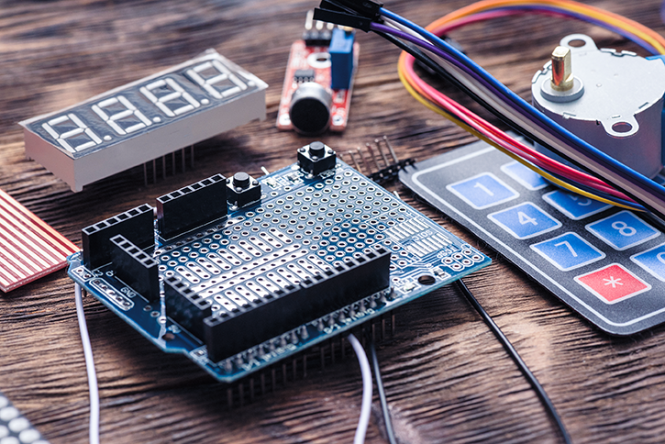

Module Title: Designing and Developing Advanced Electrical/Electronic System
Module code: EEL EES4 M01 0123
Nominal duration: 150 Hour

Prepared by: Ministry of Labor and Skill
October , 2023
Addis Ababa, Ethiopia
Contents
ACROMYM 3
ACKNOWLEDGMENT 4
Introduction 5
UNIT ONE: OVER VIEW OF ADVANCED ELECTRICAL/ELECTRONIC SYSTEMS 7
1.1 Concepts of Advanced Electrical/Electronic Systems 8
1.2 OHS policies and procedures and PPE 10
1.3 Risk control measures and procedures 16
1.4 Determining advanced electrical/electronic system 23
1.5 Development digital system 26
1.6 Design development work 28
1.7 Design development work 29
1.8 Tools Materials and devices/components 33
Self-check 1.1 43
Operation Sheet:1.1 45
2 UNIT TWO: ADVANCED DIGITAL SYSTEMS 47
2.1 Concepts of advanced electrical/electronic systems. 48
2.2 Knowledge of advanced electrical/electronic devices and systems 50
2.3 Alternative arrangements for the design. 52
2.4 Incorporating safety, functional and budget considerations in the design. 55
2.3. Prototype devices and circuits 55
2.4.1 Design and Simulation of Multiplexers and Demultiplexers 57
2.4.2 Automatic Street Light Circuit Using IC 741 70
2.4.3 Clap Switch Circuit with Relay 72
2.4.4 Light Detector With Sensitivity Control Circuit 74
2.4.5 Temperature Controlled DC Fan 76
2.4.6 Circuit Description Clap Switch Cum Touch Switch 78
2.4.7 Low Voltage Audio Power Amplifier Circuit 80
2.5 Rectification and Retesting of Prototype Malfunctions 82
2.6 Documenting electrical/electronic system design 84
2.7 Consistent solutions to unplanned situation. 86
Self-check 2.1 88
Operation Sheet:2.1 91
3 UNIT THREE: OBTAIN APPROVAL FOR THE DESIGN 93
3.1 Concept of Obtain approval for the design 94
3.2 Presenting and explaining the design 95
3.3 Requests for Design Modifications 97
3.4 Documenting and approval final design 98
3.5 Quality of work 100
3.2.1. Importance of Quality Monitoring: 101
3.2.2. Monitoring against Personal Performance Agreements: 101
3.2.3. Monitoring against Established Organizational Standards: 101
3.5.1 Monitoring against Professional Standards 101
Self check 3.1. 103
Operation Sheet: 3.1 105
References: 107

ACROMYM
ANSI | American National Standards Institute
ASTM | American Society for Testing and Materials
AF | Audio Frequency
DIAC | diodes for alternating current
AI | Artificial Intelligence
ESD | electrostatic discharge
FME | Factory Mutual Engineering Corporation
ICE | In-Circuit Emulator
IC | Integrated Circuit
IoT | Internet of Things
LEDs | liquid emitting displays
LDR | Light Dependent Resistor
LCDs | liquid crystal displays
ML | Machine Learning
NEC | National Electrical Code
IEEE | Institute of Electrical and Electronics Engineers
NEMA | National Electrical Manufacturers Association
NFPA | National Fire Protection Association
OHS | Occupational Health and Safety
OLED | organic light-emitting diodes
PCB | Circuit Board
PLC | programmable logic controller
PPE) | personal protective equipment
RF | Radio Frequency
TRIAC | triode for alternating current
UL | Underwriters Laboratory,

ACKNOWLEDGMENT
The Ministry of Labor and skill, to Prosperity wish to thank MoLS experts, regional labor and skill bureaus, TVT trainers, university lecturers and industry experts who contribute their time and professional experience to the development of this Training module for ELECTRICAL / ELECTRONICS EQUIPMENT SERVICING
We would like to express our appreciation to the Ministry of Labor and skill to Prosperity Ethiopia for their technical and financial support and workshop facilitation of this training module development.

Introduction
Advanced Electrical/Electronic System Development refers to the process of designing and developing complex electrical and electronic systems that incorporate cutting-edge technologies and functionalities. This field encompasses various domains, including power systems, control systems, communication systems, and embedded systems. The design and development of advanced electrical/electronic systems require a multidisciplinary approach, combining knowledge from electrical engineering, electronics, computer science, and other related fields. This module will explore the key aspects and challenges involved in the design and development of advanced electrical/electronic systems, highlighting the importance of innovation, efficiency, and reliability in this rapidly evolving field.
Designing and Developing Advanced Electrical/Electronic System
This module covers the units:
- Advanced Electrical/Electronic systems
- advanced digital systems
- Obtain approval for the design
Learning Objective of the Module
- Design and develop Advanced Electrical/Electronic systems
- Design and develop advanced digital systems
- Obtain approval for the design.
Module Learning Instructions:
- Read the specific objectives of this Learning Guide.
- Read the information written in the information Sheets
- Accomplish the Self-checks
- Perform Operation Sheets
- Do the “LAP test

UNIT ONE: OVER VIEW OF ADVANCED ELECTRICAL/ELECTRONIC SYSTEMS
This learning guide is developed to provide you the necessary information regarding the following content coverage and topics:
  - Concepts of advanced electrical/electronic systems.
  - OHS policies and procedures and PPE
  - Risk controlling measures and procedures
  - Determining advanced electrical/electronic system
  - Develop digital system
  - Design development work
  - Equipment Materials and testing devices
This guide will also assist you to attain the learning outcomes stated in the cover page. Specifically, upon completion of this learning guide, you will be able to:
  - Understand and define Concepts of advanced electrical/electronic systems.
  - Identify, obtain and Prepare OHS policies and procedures and PPE
  - follow Risk controlling measures and procedures
  - determine advanced electrical/electronic system
  - plan Development digital system
  - plan Design development work
  - select , Obtain and check Tools, equipment Materials and testing devices

Concepts of Advanced Electrical/Electronic Systems
In today's rapidly evolving technological landscape, the field of electrical and electronic systems is advancing at an unprecedented pace. As a result, professionals in this domain need to stay updated with the latest concepts and techniques to design and develop advanced electrical/electronic systems. This article aims to provide an overview of the key concepts involved in designing and developing advanced electrical/electronic systems.
- Basic terminology in Advanced Electrical/Electronic Systems
Designing and developing advanced electrical/electronic systems requires a solid understanding of the terminology used in this field. Whether you are a professional engineer or an enthusiast looking to expand your knowledge, it is essential to familiarize yourself with the basic terminology. In this article, we will explore some of the key terms used in the design and development of advanced electrical/electronic systems.
- Circuit: A circuit refers to a closed loop through which electric current can flow. It consists of various components such as resistors, capacitors, inductors, and integrated circuits that work together to perform a specific function.
- Integrated Circuit (IC): An integrated circuit, also known as a microchip or chip, is a miniaturized electronic circuit that contains multiple electronic components such as transistors, resistors, and capacitors on a single semiconductor substrate.
- Microcontroller: A microcontroller is a small computer on a single integrated circuit. It consists of a central processing unit (CPU), memory, and input/output peripherals. Microcontrollers are commonly used in embedded systems and control applications.
- Printed Circuit Board (PCB): A printed circuit board is a flat board made of non-conductive material, such as fiberglass, with conductive pathways etched or printed on it. It provides mechanical support and electrical connections for electronic components.
- Firmware: Firmware refers to the software that is embedded in a hardware device, such as a microcontroller or programmable logic controller (PLC). It provides low-level control and functionality to the hardware.
- Prototyping: Prototyping is the process of building a working model or a scaled-down version of a product to test its functionality and design. In the context of electrical/electronic systems, prototyping involves creating a physical representation of a circuit or system to validate its performance..
- Simulation: Simulation involves using software tools to model and analyze the behavior of electrical/electronic systems. It allows engineers to predict and optimize the performance of a design before building a physical prototype.
- Integration of Advanced Components: Advanced electrical/electronic systems involve the integration of cutting-edge components that enhance performance, efficiency, and functionality. These components may include advanced sensors, microcontrollers, programmable logic controllers (PLCs), and communication modules.
- Signal Processing and Analysis: Signal processing plays a vital role in advanced electrical/electronic systems. It involves the manipulation and analysis of electrical signals to extract meaningful information. Techniques such as filtering, modulation, demodulation, and Fourier analysis are commonly employed.
- Control Systems and Automation: Advanced electrical/electronic systems often incorporate sophisticated control systems and automation techniques. These systems enable precise regulation and monitoring of various parameters, enhancing efficiency and safety.
- 4. Power Electronics and Energy Management: Efficient energy management is a critical aspect of advanced electrical/electronic systems. Power electronics, which deals with the conversion and control of electrical power, plays a pivotal role in optimizing energy usage.
- Embedded Systems and IoT Integration: The integration of embedded systems and Internet of Things (IoT) technologies has revolutionized the field of electrical/electronic systems. Embedded systems, consisting of microcontrollers and software, enable intelligent control and communication within the system. IoT integration allows for remote monitoring, data analysis, and system optimization.
Designing and developing advanced electrical/electronic systems requires a comprehensive understanding of various concepts. This article has provided an overview of some key areas, including the integration of advanced components, signal processing, control systems, power electronics, and IoT integration. By staying updated with these concepts, professionals can unlock the potential of advanced electrical/electronic systems and contribute to technological advancements in various industries.

OHS policies and procedures and PPE
- OHS policies and procedures
When it comes to designing and developing advanced electrical/electronic systems, it is crucial to prioritize the safety and well-being of those involved in the process. Occupational health and safety is an aspect of public health program. Creating a healthy workplace and a healthy work force in any occupational environment is the best way to position that occupation to better delivery of service. Concern for your own safety as well as the safety of others should always be on your mind. Most safety procedures are common sense but, because some hazards are not obvious, there are regulations born out of experience which are designed to make the workplace safer. The need to use safe working practices and safety equipment is to avoid the risk of injury to yourself and to others in the course of your work.

Figure 0-1Occupational health and safety
- Importance of OHS Policies and Procedures:
- OHS policies and procedures are designed to protect workers from potential hazards and minimize the risk of accidents or injuries.
- They ensure compliance with legal requirements and industry standards, promoting a safe and healthy work environment.
- OHS policies and procedures help to create a culture of safety, where everyone is responsible for maintaining a safe workplace.
- We have to ensure in all business about the care of technicians and all the persons involved in business for good health all the time.
- It provides technicians lives and health.
- Occupational safety and health rules can decrease technician’s injury and illness. In general, Occupational health and safety (OHS) policies and procedures protect the safety, health and welfare of people at the work place.
- Risk Assessment:-
- Conduct a thorough risk assessment before starting any electrical/electronic system design or development project.
- Identify potential hazards, such as electrical shocks, fire risks, or exposure to hazardous substances.
- Assess the likelihood and severity of each hazard and implement appropriate control measures to mitigate the risks.
- Electrical Safety:
- Follow electrical safety standards and regulations, such as proper grounding, insulation, and circuit protection.
- Ensure that all electrical equipment and systems are installed, operated, and maintained by qualified personnel.
- Provide appropriate personal protective equipment (PPE), such as insulated gloves and safety glasses, when working with electrical systems.
- Equipment Safety:
- Regularly inspect and maintain electrical equipment to ensure it is in safe working condition.
- Follow manufacturer's guidelines for installation, operation, and maintenance of equipment.
- Implement lockout/tagout procedures to isolate and de-energize equipment before performing any maintenance or repairs.
- Emergency Preparedness:
- Develop and communicate emergency procedures, including evacuation plans and protocols for dealing with electrical emergencies.
- Provide training to employees on emergency response procedures and ensure they have access to emergency contact informatioon
- Training and Education:
Provide comprehensive training to all personnel involved in the design and development of advanced electrical/electronic systems.
- Ensure employees are aware of potential hazards, safety procedures, and the proper use of equipment and tools.
- Regularly update training programs to keep up with new technologies and industry best practices.
- Reporting and Incident Investigation:
- Establish a system for reporting and documenting any incidents, near misses, or potential hazards.
- Investigate incidents to identify the root causes and implement corrective actions to prevent recurrence.
- Encourage a culture of reporting and learning from incidents to continuously improve safety practices.
- Codes, Standards, and Regulations
Workers, who perform electrical or electronic work, where applicable, shall comply with relevant DOE Orders and should comply with the current revision of the following codes and standards.
What equipment is covered by the Regulations?
Generally, any equipment which is used by an employee at work is covered, for example hammers, knives, drilling machines, power presses, and printers, photocopiers, lifting equipment (including lifts), and motor vehicles. Similarly, if you allow technicians to provide their own equipment and you will need to make sure it complies. Examples of uses of equipment which are covered by the Regulations include starting or stopping the equipment, repairing, modifying, maintaining, servicing, cleaning and transporting.
- Standards published by the National Fire Protection. Association (NFPA)
- National Electrical Code (NEC), NFPA 70
- Electrical Safety Requirements for Employee Workplaces, NFPA 70E.
- National Electrical Safety Code, ANSI C2.
- All relevant state and local requirements.
The standards and performance specifications from the following organizations are recommended and should be observed when applicable:
- Institute of Electrical and Electronics Engineers (IEEE)
- National Electrical Manufacturers Association (NEMA)
- American National Standards Institute (ANSI)
- American Society for Testing and Materials (ASTM)
- National Fire Protection Association (NFPA)
- Underwriters Laboratory, Inc. (UL)
- Factory Mutual Engineering Corporation (FMEC)
Other Nationally Recognized Testing Laboratories recognized by OSHA on a limited basis. Where no clear applicable code or standard provides adequate guidance or when questions regarding workmanship, judgment, or conflicting criteria arise, personnel safety protection shall be the primary.
- Personal Protective Equipment (PPE) and Clothing
Designing and developing advanced electrical/electronic systems involves working with potentially hazardous equipment and processes. To ensure the safety of personnel involved in these activities, it is crucial to implement personal protective equipment (PPE) and risk controlling measures and procedures.
Personal protective equipment and clothing must be used at all times. However, Personal protective equipment is much less effective and it is not a substitute for other controls since it does not eliminate the hazard. PPE is usually seen as the last line of defense and is usually used in conjunction with one or more of the other control measures. Note: The Company requires workers to use personal protective equipment wherever its use is prescribed by regulations or internal work procedures. Workers must be trained to use, store, and maintain their equipment properly. Management, supervisors, and workers must understand the limitations of their personal protective equipment.
- Personal Protective Equipment (PPE):
PPE refers to specialized equipment worn by individuals to protect themselves from potential hazards in the workplace. In the context of designing and developing advanced electrical/electronic systems, some common PPE includes:
- Safety goggles or face shields: These protect the eyes and face from flying debris, sparks, or chemicals.
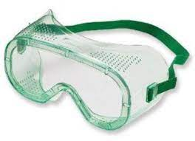
Figure 0-2Safety goggles or face shields:
- Insulated gloves: Insulated gloves are essential when working with live electrical components to prevent electric shock.

Figure 0-3Electrican Insulated gloves:
- Safety footwear: Safety shoes or boots with reinforced toes protect against falling objects or electrical hazards.

Figure 0-4Safety shoes or boots
- Protective clothing: This may include flame-resistant clothing, lab coats, or coveralls to protect against burns, chemical splashes, or other physical hazards.

Figure 0-5Protective clothing
- Ear protection: Earplugs or earmuffs are necessary in environments with high noise levels to prevent hearing damage.

Figure 0-6Earplugs or earmuffs

Risk control measures and procedures
Occupational Health and Safety (OHS) policies and procedures are a set of guidelines and practices implemented in workplaces to ensure the health, safety, and well-being of employees and visitors. These policies and procedures are crucial, especially in industries like designing and developing advanced electrical/electronic systems, where there may be potential hazards and risks involved.
- OHS policies and procedures serve several important purposes:
- Risk Management: OHS policies and procedures help identify and assess potential hazards and risks in the workplace. This includes evaluating the risks associated with electrical systems, equipment, and processes. By conducting thorough risk assessments, organizations can implement appropriate control measures to minimize or eliminate these risks.
- Legal Compliance: OHS policies and procedures ensure compliance with local, regional, and national laws and regulations related to workplace safety. It is essential for organizations to stay up-to-date with the latest OHS legislation and standards to avoid legal penalties and protect the well-being of their employees.
- Employee Safety: The primary objective of OHS policies and procedures is to protect employees from harm and provide a safe working environment. This includes implementing safety measures such as proper equipment maintenance, training on safe work practices, and the provision of personal protective equipment (PPE) when necessary.
- Training and Education: OHS policies and procedures often include training programs to educate employees about potential hazards, safe work practices, and emergency procedures. By providing comprehensive training, organizations can ensure that employees are aware of the risks associated with their work and equipped with the knowledge to mitigate those risks effectively.
- Incident Reporting and Investigation: OHS policies and procedures establish protocols for reporting and investigating workplace incidents, accidents, and near misses. This allows organizations to identify the root causes of incidents and implement corrective actions to prevent similar incidents from occurring in the future. Incident reporting also helps in maintaining accurate records and statistics for continuous improvement.
- Emergency Preparedness: OHS policies and procedures include plans and procedures for responding to emergencies, such as fires, electrical failures, or other hazardous situations. These plans outline evacuation procedures, emergency contacts, and the roles and responsibilities of employees during emergencies. By being prepared, organizations can minimize the impact of emergencies and ensure the safety of their employees.
- Continuous Improvement: OHS policies and procedures are not static; they should be regularly reviewed, updated, and improved to reflect changes in technology, regulations, and best practices. Organizations should encourage feedback from employees and actively seek ways to enhance safety measures and promote a culture of safety.
- Hazards/risks
A hazard is something with the potential to cause harm, for example chemicals, electricity or working above ground. Hazard is something that might cause harm. A risk is the likelihood of harm actually being done. A risk is the chance that harm will be done. A competent person is anyone who has the necessary technical skills, training and expertise to safely carry out the particular activities.
- Hazard assessment
The purpose of hazard assessment is to assist the Executive Safety Steering Committee, the Safety Committee, the Safety Manager and supervisors in making decisions about how to address and control workplace hazards (Attachment (H) “Hazard Assessment Form”). Full and accurate information, including all possible alternatives, should be provided to the Committees they can make intelligent, informed decisions concerning hazard control. Additionally the level of risk associated with the hazard shall be established in order to prioritize the corrective action. Hazards should be addressed in accordance with the principle of - “correct the hazards with the highest risk first”, or “worst first”. Another possible reason estimating the risk associated with a hazard would be when one or more members of the workplace begin to overreact because of the presence of a hazard, expressing a level of fear or agitation which is disproportionate to actual risk of harm. In this situation, a careful and reasoned evaluation of the risk may help to restore a more rational outlook and attitude about the hazard. Risk analysis, involves a careful prediction of the consequences of an accident caused by the hazard. The level of risk associated with a hazard is estimated by considering a combination of two factors
- The likelihood of the hazard causing an accident and,
- The consequences if it did happen, in terms of harm to people and/or damage to property.

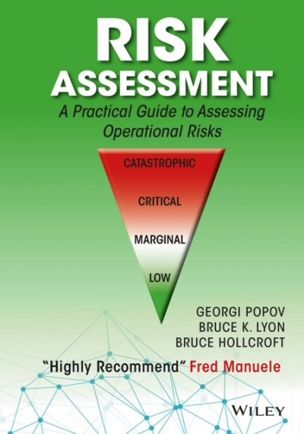
Figure 0-7Hazard risk assessment
- Hazard Likelihood Category
Probability estimates based on frequencies or actual occurrences shown in past experience are desirable. If that data is not available, the following definitions may be used: Almost certain: likely to occur immediately or within a short period of time when exposed to the hazard
Likely: will occur in time, eventually
Possible: possible to occur in time; could occur at some point
Unlikely: unlikely to occur
Rare: very unlikely
- Hazard Severity Category
A severity estimate is based on the potential destructive consequences; the following definitions may be used:
- Catastrophic - may cause death or loss of a facility
Major - may cause serious injury, severe occupational illness or major property damage
Moderate - may cause minor injury, or illness resulting in lost work days, or minor property damage Minor/Insignificant - probably would not affect personal safety or health and thus, less than a lost work day, but nevertheless is in violation of specific criteria
- Ranking Hazards
Once hazards have been identified or anticipated, they must be ranked to set corrective action priorities based on the case with the highest risk. Corrective action is to develop or improve controls and reinforce safe work practices. Attachment (H) contains a “Hazard Assessment Form” that shall be used when doing a risk evaluation.
- Hazard control
Assessing and controlling hazards are interrelated. Often the assessment process will reveal workplace hazards that need to be corrected. After serious hazards have been identified and analyzed, the Company needs to control them. In workplaces where the hazard assessment indicates that quite a few serious hazards are present and may take time to correct, the Executive Safety Steering Committee will set priorities for controlling the most serious hazards first. In such cases, the Executive Safety Steering Committee will set timetables for correcting these hazards and carefully track progress in achieving these fixes.
Where hazards are present in the workplace, the Executive Safety Steering Committee, the Safety Committee, and supervisor needs to implement feasible controls to eliminate or reduce them. To control hazards, McCabe, Hamilton, and Renny will use the following hierarchy of hazard control to minimize or eliminate exposure to hazards:
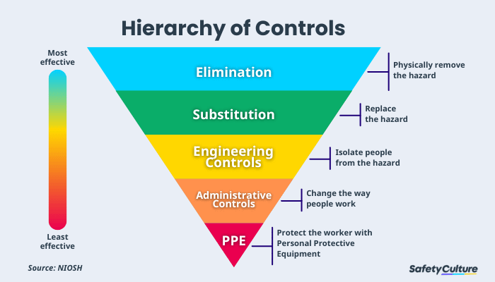
Figure 0-8Hazards control
- Control of the Hazards through:
- Elimination the hazard - The very best method of controlling a hazard is to eliminate it completely, if possible. Elimination of the hazard is not always achievable though it does totally remove the hazard and thereby eliminates the risk of injury. This is the best a way to protect workers.
- Engineering Controls - Engineering Controls involve redesigning a process to place a barrier between the person and the hazard or remove the hazard from the person, such as machinery guarding, proximity guarding, extraction systems or removing the operator to a remote location away from the hazard.
- Administrative Controls - Administrative controls include adopting standard operating procedures, safe work practices and providing appropriate training, instruction and/or information to reduce the potential for harm and/or adverse health effects to person(s).
- Work Procedures, Training, and Supervision - Supervisors will be trained to apply modern safety management and supervisory practices. The Safety Committee and Safety Manger shall help the other departments periodically review and update operating procedures and worker training.
- Emergency Planning
Written plans should be in place to handle fires, chemical spills, and other emergencies. Workers should be trained to follow these procedures and use appropriate equipment. Refresher training should be provided regularly.
- Risk Controlling Measures and Procedures:
To mitigate risks associated with designing and developing advanced electrical/electronic systems, it is important to implement effective risk controlling measures and procedures. Some key considerations include:
- Risk assessment: Conducting a thorough risk assessment is crucial to identify potential hazards and evaluate the associated risks. This involves analyzing the equipment, processes, and work environment to determine the likelihood and severity of potential incidents.
- Engineering controls: Implementing engineering controls involves designing and modifying systems or equipment to eliminate or minimize risks. For example, using circuit breakers or safety interlocks to prevent electrical overloads or implementing ventilation systems to control exposure to hazardous fumes.
- Administrative controls: These measures involve implementing policies, procedures, and training programs to ensure safe work practices. This includes providing clear instructions on equipment operation, maintenance procedures, and emergency response protocols.
- Regular maintenance and inspections: Regular maintenance and inspections of electrical/electronic systems are essential to identify and address potential issues before they become hazards. This includes checking for loose connections, frayed wires, or signs of wear and tear.
- Emergency response procedures: Establishing well-defined emergency response procedures is crucial to handle potential incidents effectively. This includes protocols for evacuations, first aid, fire suppression, and contacting emergency services.
- Use of Proper Tools and Equipment:
One of the fundamental OHS risk control measures is the use of proper tools and equipment. Designers and developers should ensure that they have access to appropriate tools and equipment that are in good working condition and suitable for the task at hand. Using incorrect or faulty tools can increase the risk of accidents or injuries.
For example,
- When soldering electronic components,
- The use of a temperature-controlled soldering iron with a grounded tip is crucial to prevent burns and
- Electrical shocks (work safe Victoria, 2018).
- Observation of Workplace Environment and Safety:
Designers and developers must observe the workplace environment and safety conditions to identify potential hazards and take necessary precautions. This includes maintaining a clean and organized workspace, ensuring proper ventilation, and identifying and addressing any electrical or fire hazards. Regular inspections and risk assessments should be conducted to identify and mitigate potential risks. For instance, the presence of flammable materials should be minimized, and fire extinguishers should be readily available (Safe Work Australia, 2018).

- Adherence to Safety Requirements in Handling the Unit:
When handling advanced electrical/electronic units, strict adherence to safety requirements is essential. This involves following manufacturer guidelines and instructions for handling and operating the equipment.
For example, when working with high-voltage systems, designers and developers should be
- Trained on proper isolation procedures,
- Wearing appropriate personal protective equipment (PPE), and
- Following lockout/tag out procedures to prevent electrical shocks (electrical safety foundation international, 2021).
- Use of Protective Devices/Shields:
The use of protective devices and shields is another critical OHS risk control measure. These devices are designed to protect individuals from potential hazards and reduce the severity of injuries.
For instance, when working with high-intensity light sources,
Such as
- Lasers,
- Safety
- Goggles with the appropriate optical density should be worn to protect the eyes from potential damage (occupational safety and health administration, 2021).
Additionally, the use of shields or barriers can help prevent accidental contact with live electrical components or moving parts of machinery
By implementing appropriate personal protective equipment (PPE) and risk controlling measures and procedures, organizations can significantly reduce the likelihood and severity of accidents or injuries in the designing and developing advanced electrical/electronic systems field. It is important to regularly review and update these measures to ensure they remain effective and aligned with industry best practices.

Determining advanced electrical/electronic system
Determining advanced electrical/electronic systems involves the process of designing and developing complex and sophisticated electrical or electronic systems that go beyond basic functionalities. These systems are typically used in various industries such as automotive, aerospace, telecommunications, robotics, and renewable energy, among others. They often require advanced features, high performance, and integration with other technologies. The process of determining such systems involves several key steps and considerations.
- System Requirements Analysis: The first step in determining an advanced electrical/electronic system is to conduct a thorough analysis of the system requirements. This involves understanding the needs and objectives of the system, considering factors such as performance, reliability, safety, scalability, and compatibility with existing infrastructure. It is important to engage stakeholders, including end-users, engineers, and product managers, to gather their inputs and ensure that the system requirements align with their expectations.
- Conceptual Design: Once the system requirements are defined, the next step is to develop a conceptual design of the advanced electrical/electronic system. This involves creating a high-level architectural framework that outlines the major components, subsystems, and their interconnections. The conceptual design takes into account factors such as functionality, modularity, flexibility, and future scalability. It may also involve evaluating different design alternatives and selecting the most suitable approach based on technical feasibility and cost considerations.
- Detailed Design: After the conceptual design, the detailed design phase begins. This involves transforming the high-level architecture into a detailed design specification. The detailed design includes specifying the components, subsystems, interfaces, and their respective functionalities. It also involves selecting appropriate technologies, components, and materials based on performance requirements, cost-effectiveness, and availability. The detailed design phase may also include simulations, prototype development, and testing to validate the design and ensure its feasibility.
- Integration and Interoperability: Advanced electrical/electronic systems often need to integrate with other systems or technologies. Determining the integration requirements and ensuring interoperability is a critical aspect of the design process. This may involve defining communication protocols, data exchange formats, and interface standards to enable seamless interaction between different subsystems or external systems. Compatibility with existing infrastructure and legacy systems should also be considered during the integration process.
- Safety and Compliance: Advanced electrical/electronic systems must comply with industry standards, regulations, and safety requirements. Determining the necessary safety measures and ensuring compliance with applicable standards is essential to protect users, prevent hazards, and meet legal and regulatory obligations. This may involve conducting risk assessments, implementing fail-safe mechanisms, and incorporating safety features into the system design.
- Testing and Validation: Once the advanced electrical/electronic system is designed, it needs to undergo rigorous testing and validation to ensure its performance, reliability, and functionality. This includes conducting various tests, such as functional testing, performance testing, environmental testing, and reliability testing. The testing phase helps identify any design flaws, performance bottlenecks, or compatibility issues that need to be addressed before the system is deployed.
- Documentation and Maintenance: Documenting the design specifications, test results, and maintenance procedures is essential for future reference, troubleshooting, and maintenance purposes. Proper documentation ensures that the system can be effectively maintained, upgraded, or repaired throughout its lifecycle. It also facilitates knowledge transfer and enables efficient collaboration among engineers and technicians involved in the system development and maintenance.
Certainly! Here are some additional details regarding the process of determining advanced electrical/electronic systems:
- Design Trade-offs: Determining advanced electrical/electronic systems often involves making design trade-offs. Engineers must balance various factors such as cost, performance, power consumption, size, weight, and manufacturability. For example, achieving higher performance may come at the expense of increased complexity or cost. Engineers must carefully evaluate these trade-offs to find the optimal solution that meets the desired system requirements.
- System Modeling and Simulation: Modeling and simulation tools play a crucial role in determining advanced electrical/electronic systems. Engineers use specialized software to create virtual models of the system and simulate its behavior under different conditions. This allows them to evaluate the system's performance, analyze its response to various inputs, and optimize the design before physical implementation. Simulation helps identify potential issues early in the design process, reducing costs and time associated with physical prototypes.
- Power Management: Advanced electrical/electronic systems often require efficient power management strategies. Engineers must consider power supply requirements, energy consumption, battery life, and heat dissipation. They may incorporate power management techniques such as power gating, dynamic voltage and frequency scaling, and sleep modes to optimize power usage and extend battery life. Power management is particularly critical in portable devices, IoT applications, and energy-efficient systems.
- Human-Machine Interaction: Advanced electrical/electronic systems frequently involve human-machine interaction. Designers must consider user interfaces, ergonomics, accessibility, and usability factors. They may incorporate touchscreens, haptic feedback, voice recognition, or gesture control to enhance user experience. Human factors engineering principles are applied to ensure that the system design aligns with the cognitive and physical capabilities of the intended users.
- Communication and Networking: Many advanced electrical/electronic systems rely on communication protocols and networking capabilities. Engineers must determine the most suitable communication technologies and protocols, such as wired or wireless networks, Ethernet, Bluetooth, Wi-Fi, or cellular connectivity. They need to consider factors like data transmission speed, range, reliability, security, and compatibility with existing infrastructure.
- Reliability and Fault Tolerance: Advanced electrical/electronic systems often operate in mission-critical or safety-critical environments. Ensuring reliability and fault tolerance is crucial to prevent system failures and minimize downtime. Engineers employ redundancy techniques, fault detection and recovery mechanisms, and error correction codes to enhance system reliability and mitigate the impact of failures. They may also incorporate diagnostic capabilities and remote monitoring to facilitate proactive maintenance and fault diagnosis.
- Compliance with Standards and Regulations: Advanced electrical/electronic systems must adhere to relevant industry standards and regulations. Engineers need to be aware of regulations related to electromagnetic compatibility (EMC), safety, environmental impact, and privacy. Compliance with these standards ensures that the system meets quality and safety requirements and avoids legal and regulatory issues.
- Lifecycle Considerations: Determining advanced electrical/electronic systems involves considering their entire lifecycle, from design to disposal. Engineers must assess factors such as system upgradability, scalability, maintainability, and end-of-life disposal. They may design modular systems that can be easily upgraded or replaced, or consider environmental impact by using recyclable materials and minimizing energy consumption during the system's operational phase.
Determining advanced electrical/electronic systems requires a multidisciplinary approach, combining engineering expertise, domain knowledge, and a deep understanding of the specific industry or application. It involves a systematic and iterative design process that takes into account the system requirements, conceptual design, detailed design, integration, safety, testing, and documentation. Through careful determination, these advanced systems can provide innovative solutions, enhance performance, and drive technological advancements in various fields.

Development digital system
Electronics - The branch of physics concerned with the behavior and application of electric charge carriers in components, devices and systems that accomplish amplification, oscillation, signal processing, and/or switching.
- System
- An integrated assemblage of hardware and/or software elements operating together to accomplish a prescribed end purpose (e.g., servo system, operating system, and communications system).
- Methodology incorporations fixed and ordered procedures for accomplishing an end purpose.
- Design
- A unique planned arrangement of electronic components in a circuit, in accordance with good engineering practice, to achieve a de- sired end result.
- A unique layout of components or controls, in accordance with good engineering practice, esthetics, and (often) ergonomic every research and development engineer needs to be familiar with the design activities and with the requisite technical documentation (technical drawings, circuit diagrams, CAD models) in order to produce successful electronic products.
- Life Cycle of Electronic Product
The different stages in a product’s life, also known as the product life cycle, typically consist of:
- Development (development stage)
- use (marketing stage) and disposal
- The development stage consists of the following steps:
- Product planning,
- Design and development, and
- First production runs with prototype build and pilot series.
The development process for an electronic system begins with the product planning stage. During this initial planning period, ideas for products are generated and assessed, and project tasks are formulated. The subsequent design and development stage uses as input the functional specification developed with the product proposal. At the end of the design and development stage, the complete product documentation containing all instructions for product fabrication, use, maintenance, and disposal (including recycling) is produced.
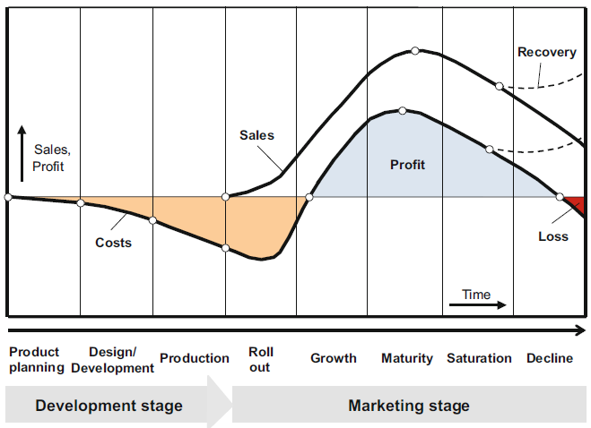
Figure 0-9Development process

Design development work
The design and development of an electronic system or device is a key element of the preparations for manufacture in essence, function, quality, and costs are defined at this stage.
The design process encompasses all creative, manual, and technical activities necessary to define the product and which need to be carried out to convert a system definition to a sufficiently detailed system design specification for product manufacture and deployment.
The term “design” typically covers the first prototype for a system or a device, while the term “development” generally includes the production of the documentation (e.g., circuit diagrams for electronic modules, drawings for mechanical components) necessary for fabrication.
Design and development can be divided into four stages, each with different definitions: – Task definition (informative definition),
- Conceptual stage (cardinal definition),
- design stage (formative definition), and
- Implementation stage (manufacturing definition).
Information is gathered on the requirements for the product to be developed during task definition in the form of a requirements specification. These requirements are then transformed into an optimal technical principle at the conceptual stage. The cardinal definition of a solution is thus formulated here along with proof of functionality.
A system design based on the conceptual solution is presented at the design stage. The objective is to determine the best overall design for the product taking technological and economic constraints into consideration. Finally, fabrication and usage details are set out at the implementation stage to facilitate manufacturing and deployment
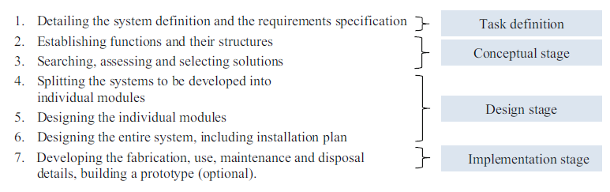
Product Planning:
Phase 1: Concept Development
Phase 2: System-Level Design
Phase 3: Detail Design
Phase 4: Testing and Refinement
Phase 5: Production Ramp-Up
Scheduling
Scheduling the design process can be a major challenge. A number of requirements must be fulfilled to create a useful planning system. The activities in product development must be coordinated and scheduled. A network plan is particularly useful in this regard for large projects. This type of time schedule shows all project activities and their mutual dependencies in graphic form.
Table 1Planning Scheduling system 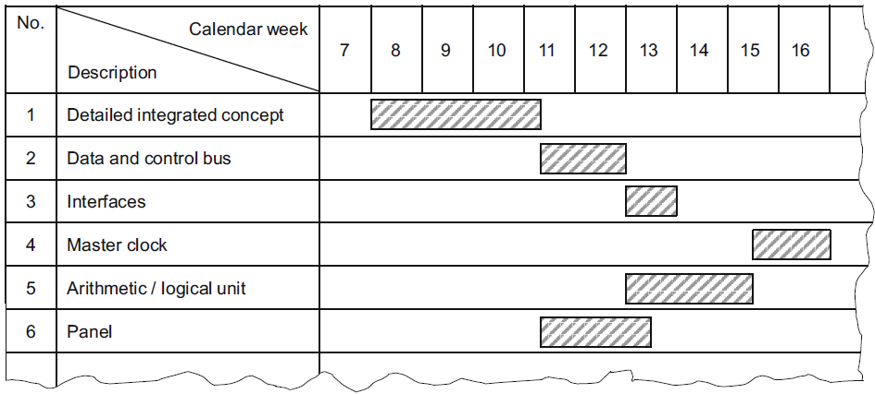

Design development work
In the field of electrical and electronic engineering, the design and development of advanced digital systems play a crucial role in various applications. This essay aims to document the design process of several key components, including sequential circuits, combinatorial functions, electronic switching and control circuits, sound-operated systems, and touch-operated systems. The documentation will be prepared for submission to the appropriate person(s) for approval.
Sequential Circuits:
Sequential circuits are essential components in digital systems that store and process information in a sequential manner. Some commonly used sequential circuits include:
- Seven-Segment Display: A seven-segment display is a digital indicator that can display numbers and some alphabetic characters. It consists of seven LEDs arranged in a specific pattern to form the desired character.
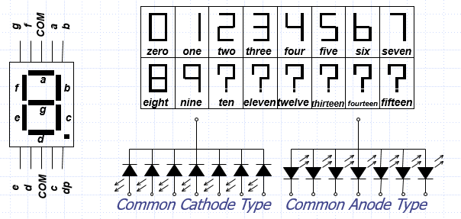
Figure 0-10seven-segment display
- Register: A register is a group of flip-flops used to store and manipulate binary data. It can be used for various purposes, such as data storage, data transfer, and arithmetic operations
. 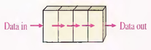
Figure 0-11register
- Flip-Flops: Flip-flops are fundamental building blocks of sequential circuits. They are used to store a single bit of information and can be triggered by clock signals to change their state.
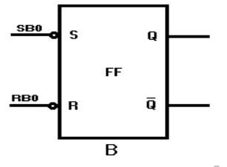
Figure 0-12Flip-Flops
- Counters: Counters are sequential circuits that generate a sequence of binary numbers. They are widely used in applications such as frequency division, timekeeping, and digital signal processing.
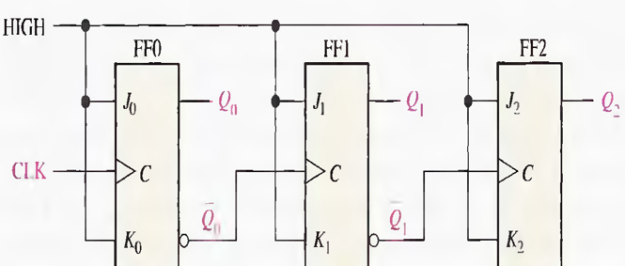
Figure 0-13Counters
- Timers: Timers are circuits used to measure or generate time intervals. They find applications in various fields, including automation, control systems, and communication.
Combinatorial Functions:
Combinatorial functions, also known as combinational logic, are circuits that generate outputs solely based on the current input values. Some commonly used combinatorial functions include:
- Encoders: Encoders are circuits that convert multiple input signals into a coded output. They are often used in data transmission and address decoding. 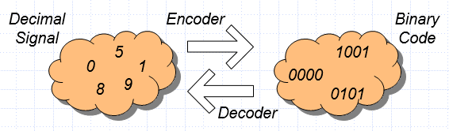
Figure 0-14Encoders
- Decoders: Decoders are circuits that convert coded inputs into multiple output signals. They are commonly used in memory systems, address decoding, and data demultiplexing.
Figure 0-15Decoders:
- Multiplexers: Multiplexers are circuits that select one of several input signals and route it to a single output. They are widely used in data routing, signal switching, and data compression.
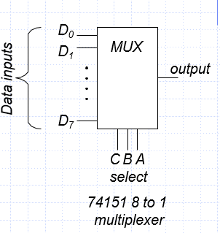
Figure 0-16Multiplexers
- Demultiplexers: Demultiplexers perform the opposite function of multiplexers. They take a single input and route it to one of several possible outputs. Demultiplexers are commonly used in data demultiplexing and address decoding.
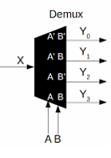
Figure 0-17Demultiplexers
- Electronic Switching and Control Circuits:
Electronic switching and control circuits are crucial for automating various electrical systems. Some examples of electronic switching and control circuits include:
- Automatic Light Operated Switch Using LDR and IC741: This circuit uses a Light Dependent Resistor (LDR) and an operational amplifier (IC741) to automatically switch on or off a light source based on the ambient light level.
- Clap Operated Electronic Switch Circuit: This circuit detects clapping sounds using a microphone and triggers a relay to switch on or off an electrical load.
- DC Motor Control Circuit Using NE555: This circuit uses the NE555 timer IC to control the speed and direction of a DC motor.
- Dome Lamp Dimmer: This circuit allows for the dimming of a dome lamp using a triac and a potentiometer.
- Electronic Washing Machine Control Circuit Diagram: This circuit controls the various functions of a washing machine, such as water level, temperature, and motor control.
- Sound Operated Light and Alarm:
Sound-operated systems are designed to respond to specific sound patterns or frequencies. One example is the Sound Operated Light and Alarm circuit, which triggers a light or alarm when a specific sound threshold is reached.
- Clap Switch Cum Touch Switch:
The Clap Switch Cum Touch Switch circuit combines the functionality of both clap-operated and touch-operated switches. It allows users to control electrical devices by either clapping their hands or touching a specific part of the circuit.

Tools Materials and devices/components
Designing and developing advanced electrical/electronic systems involves the selection and utilization of various materials, devices, and components. In this article, we will identify and discuss some of the key materials and devices/components commonly used in advanced electrical/electronic systems.
Testing and test instruments are key to any electronics design, development, production and maintenance activity. Learn about test instruments from digital millimeters and logic analyzers to oscilloscopes, spectrum analyzers and many more with our online tutorials.
Electronics test and test equipment are essential elements of electronics and radio. Electronic equipment can develop failures, or it may not work properly when it is built. In order to discover whether a circuit is working, and then where the problem is located, it is necessary to use various forms of test equipment.
The items of test equipment that are commonly found are multimeters, analogue and digital (DMM - digital multimeter), oscilloscopes, and under some circumstances more specialized test equipment including spectrum analyzers may be used.
- Materials:
- Printed Circuit Boards (PCBs): PCBs are the foundation of most electronic systems. They provide a platform for mounting and interconnecting electronic components. PCBs are typically made of fiberglass-reinforced epoxy laminates, with copper traces and pads to facilitate electrical connections.
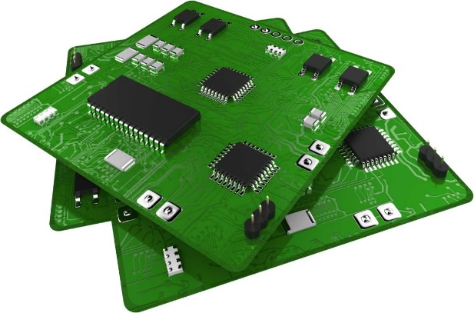
Figure 0-18Printed Circuit Boards (PCBs)
- Semiconductors: Semiconductors are essential components in advanced electrical/electronic systems. They include materials such as silicon, gallium arsenide, and germanium, which have unique electrical properties. Semiconductors are used in various devices like transistors, diodes, and integrated circuits (ICs).
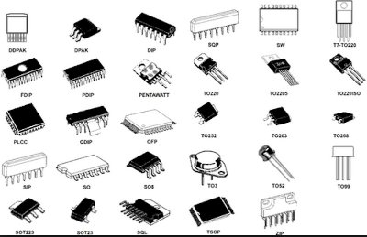
Figure 0-19Semiconductors
- Conductors: Conductive materials, such as copper and aluminum, are used for wiring and interconnecting components in electrical systems. These materials offer low resistance to the flow of electrical current and are widely used for their excellent conductivity.

Figure 0-20Conductive materials
- Insulators: Insulating materials, such as plastics, ceramics, and glass, are used to prevent the flow of electrical current and provide electrical isolation between conductive components. Insulators are crucial for ensuring the safety and proper functioning of electrical systems.

Figure 0-21Insulating materials
- Logic Analyzer: A logic analyzer is a powerful tool used to capture and analyze digital signals in a system. It helps in debugging and troubleshooting complex digital circuits by providing detailed insights into the logic states and timing of signals.
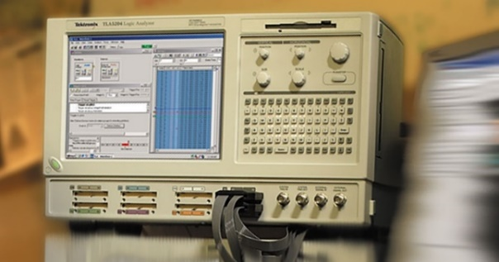
Figure 0-22logic analyzer
- Logic Clip: A logic clip is a small device that attaches to individual pins of integrated circuits (ICs) to monitor and analyze the digital signals. It allows for non-intrusive testing and debugging of digital circuits without the need for soldering or permanent connections.
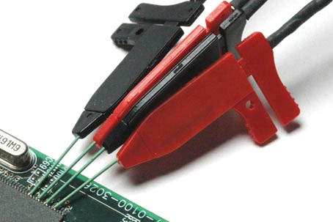
Figure 0-23logic clip
- Logic Probe: A logic probe is a handheld tool used to test and troubleshoot digital circuits. It indicates the logic state (high or low) of a signal by lighting up LEDs or displaying the state on a built-in display. Logic probes are commonly used to verify the functionality of digital circuits and identify signal integrity issues.
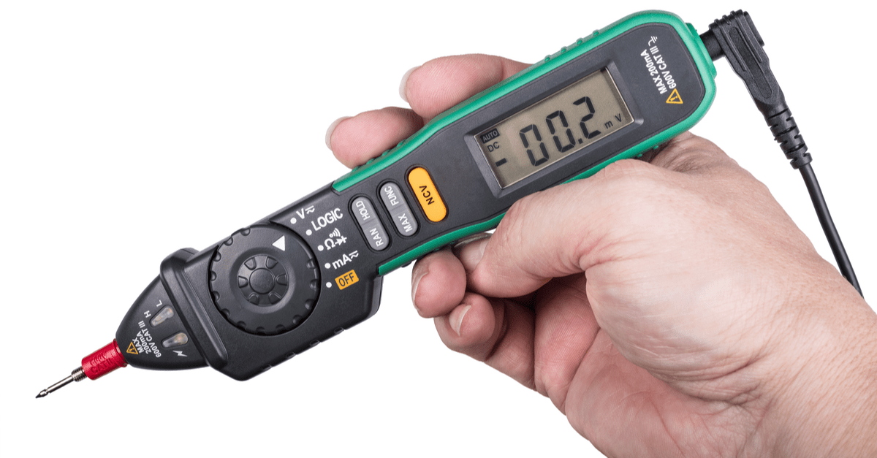
Figure 0-24logic probe
- Logic Current Tracer: A logic current tracer is a specialized tool used to measure and trace the flow of current in digital circuits. It helps in identifying current paths, detecting excessive current draw, and locating potential short circuits or faulty components.

Figure 0-25logic current tracer
- Devices/Components:
  - Microcontrollers: Microcontrollers are integrated circuits that contain a processor core, memory, and input/output peripherals. They are widely used in advanced electrical/electronic systems for controlling and monitoring various functions. Microcontrollers provide the intelligence and decision-making capabilities in many applications.
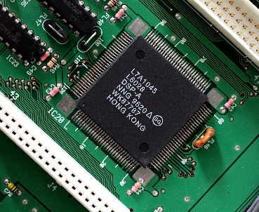
Figure 0-26Microcontrollers
- Sensors: Sensors are devices that detect and measure physical quantities, such as temperature, pressure, light, and motion. They play a vital role in advanced electrical/electronic systems by providing input data for control and monitoring purposes. Common types of sensors include temperature sensors, pressure sensors, proximity sensors, and accelerometers.
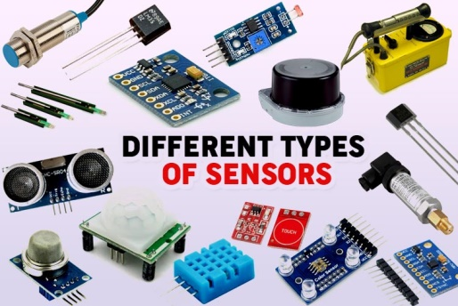
Figure 0-27Sensors
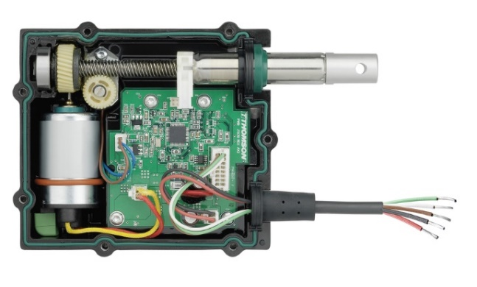
- Actuators: Actuators are devices that convert electrical signals into physical motion or force. They are used to control and manipulate various mechanisms in advanced electrical/electronics systems. Examples of actuators include motors, solenoids, relays, and valves.
Figure 0-28Actuators
- Displays: Displays are used to present information and visual feedback in electrical/electronic systems. Technologies like liquid crystal displays (LCDs), organic light-emitting diodes (OLEDs), and light-emitting diodes (LEDs) are commonly employed for this purpose. Displays can range from simple alphanumeric displays to high-resolution graphical interfaces.

Figure 0-29Monitor LCD and LED
- Power Supplies: Power supplies provide the necessary electrical energy to operate advanced electrical/electronic systems. They convert input power from sources such as batteries or the electrical grid into the appropriate voltage and current levels required by the system. Power supplies can be linear or switching, depending on the application and efficiency requirements
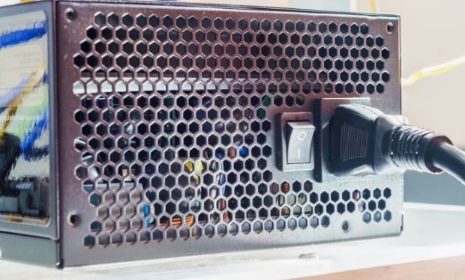
Figure 0-30Power supplies
- Logic Plus: Logic Plus is a type of integrated circuit (IC) used in advanced digital systems. It combines multiple logic gates, such as AND, OR, and XOR gates, into a single package. Logic plus ICs offer higher integration and improved performance compared to discrete logic gates.
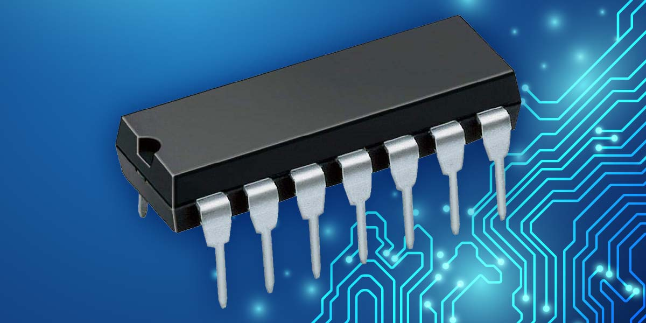
Figure 0-31integrated circuit (IC)
- ICE Remover: ICE (In-Circuit Emulator) remover is a device used to remove or disable the In-Circuit Emulator connections from a target system. In-Circuit Emulators are used for real-time debugging and testing of microcontrollers or other embedded systems. The ICE remover allows the system to operate independently without the emulator connected.
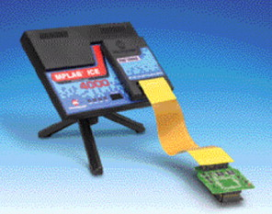
Figure 0-32ICE (In-Circuit Emulator) remover
- ICE Extraction: ICE extraction refers to the process of removing the In-Circuit Emulator connections from a target system. This is done to disconnect the emulator and allow the system to function normally without any debugging or testing interference.
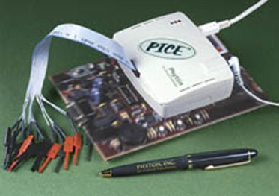
Figure 0-33 ICE extraction
- Anti-static Wrist Strap: An anti-static wrist strap is an essential tool used to prevent electrostatic discharge (ESD) when working with sensitive electronic components. It is worn on the wrist and connected to a grounding point to safely dissipate any static charges that could potentially damage electronic devices.

Figure 0-34Anti-static Wrist Strap
- Soldering and Desoldering Tools: Soldering and desoldering tools are used for assembling and disassembling electronic components on printed circuit boards (PCBs). These tools include soldering irons, soldering stations, solder wire, desoldering pumps, and soldering flux. They are crucial for creating reliable electrical connections and repairing faulty components.
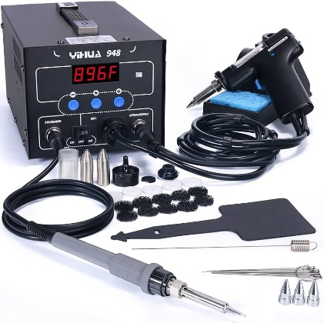
Figure 0-35 Soldering and Desoldering Tools
- Test Instruments:
- Multi-testers:- Various test instruments, such as multi-testers (analog/digital), signal generators, and oscilloscopes, are used to diagnose and troubleshoot mobile phone issues. These instruments help technician’s measure voltage, current, resistance, and other electrical parameters, allowing them to identify faulty components and circuits accurately.
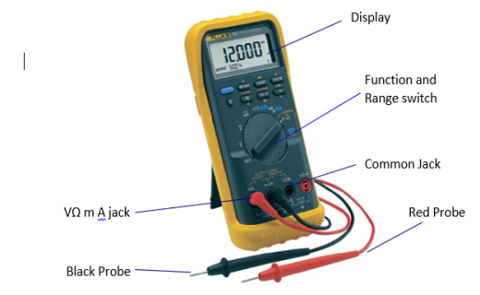
Figure 0-36multi-testers
- Signal Generator - AF/RF: A signal generator is an essential test instrument used for troubleshooting and diagnosing mobile phone signal-related issues. It generates specific frequencies and signals that help technicians identify problems with the phone's antenna, receiver, or transmitter. The AF (Audio Frequency) and RF (Radio Frequency) capabilities of the signal generator allow technicians to test both audio and wireless signal functionalities (Mobile Phone Repairing, n.d.).
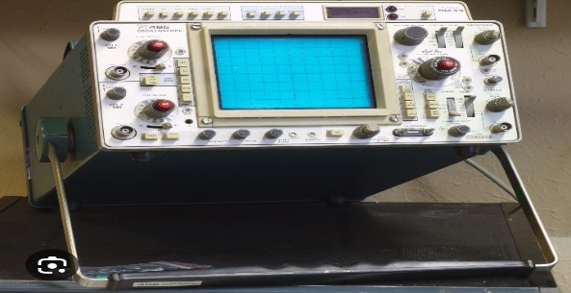
Figure 0-37Signal Generator - AF/RF
- Oscilloscope: An oscilloscope is an advanced test instrument used for analyzing and measuring electronic signals in mobile phone circuits. It displays waveforms, voltages, and frequencies, allowing technicians to identify abnormalities or malfunctions in the phone's electrical system.
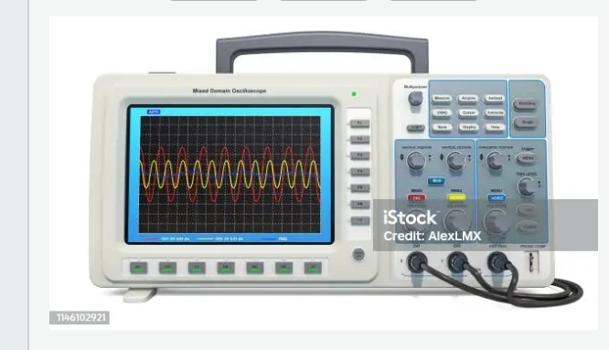
Figure 0-38 Oscilloscope
By utilizing these materials and devices/components, engineers can effectively design, develop, and troubleshoot advanced electrical/electronic systems. Each tool serves a specific purpose and contributes to the overall functionality and reliability of the system. It is important to have a good understanding of these tools and their proper usage to ensure successful implementation of advanced electrical/electronic systems.

Self-check 1.1
Part one: Say True/False:
- OHS policies and procedures help to create a culture of safety.
- Prototyping involves creating a physical representation of a circuit or system.
- Power electronics deals with the conversion and control of electrical power.
- Embedded systems and IoT integration allow for remote monitoring and data analysis.
- Personal protective equipment (PPE) is a substitute for other control measures.
Part Two: Match the following terms with their definitions:
Match A | Match B
_____1. Circuit | a. Miniaturized electronic circuit on a single substrate.
_____2. Microcontroller | b. Flat board with conductive pathways for electronic components.
_____3. Firmware | c. Software embedded in a hardware device.
_____4. Printed Circuit Board | d. Closed loop for electric current flow.
_____5. Integrated Circuit | e. Small computer with CPU and memory.
Part Three: Multiple Choice:
- What is an integrated circuit (IC)?
- A closed loop through which electric current can flow.
- A small computer on a single integrated circuit.
- A flat board made of non-conductive material.
- The software embedded in a hardware device.
- Which component is commonly used in embedded systems and control applications
- Microcontroller
- Printed Circuit Board (PCB)
- Firmware
- Integrated Circuit (IC)
- What does prototyping involve in the context of electrical/electronic systems?
- Building a working model to test functionality and design.
- Modeling and analyzing the behavior of systems using software tools.
- Integrating advanced components for enhanced performance.
- Manipulating and analyzing electrical signals.

- Signal processing in advanced electrical/electronic systems involves:
- The conversion and control of electrical power.
- The manipulation and analysis of electrical signals.
- Building a physical representation of a circuit or system.
- The integration of embedded systems and IoT technologies.
- Power electronics is concerned with:
- The conversion and control of electrical power.
- The manipulation and analysis of electrical signals.
- Building a physical representation of a circuit or system.
- The integration of embedded systems and IoT technologies.
- Which organization publishes the National Electrical Code (NEC)?
- National Fire Protection Association (NFPA)
- Institute of Electrical and Electronics Engineers (IEEE)
- American National Standards Institute (ANSI)
- National Electrical Manufacturers Association (NEMA)
- What should be done before starting any electrical/electronic system design or development project?
- Conduct a risk assessment.
- Follow electrical safety standards and regulations.
- Regularly inspect and maintain electrical equipment.
- Develop and communicate emergency procedures.
- Personal Protective Equipment (PPE) is:
- The software embedded in a hardware device.
- The manipulation and analysis of electrical signals.
- Specialized equipment worn to protect individuals.
- The integration of cutting-edge components.
- What is the purpose of conducting a risk assessment in electrical/electronic system projects?
- To identify potential hazards and mitigate risks.
- To follow electrical safety standards and regulations.
- To ensure compliance with legal requirements.
- To develop and communicate emergency procedures.
- What is the role of embedded systems in advanced electrical/electronic systems?
- To manipulate and analyze electrical signals.
- To provide mechanical support and electrical connections.
- To enable intelligent control and communication within the system.
d. To integrate advanced components for enhanced performance

Operation Sheet:1.1
Operation Sheet: Installation of Advanced Electrical/Electronic System
Operation Title: Installation of Advanced Electrical/Electronic System
Instructions:
- Read and understand the installation manual and documentation provided by the manufacturer.
- Ensure that all necessary safety precautions are followed throughout the installation process.
- Familiarize yourself with the layout and components of the advanced electrical/electronic system before proceeding with the installation.
Precautions:
- Ensure that the power source is disconnected and the system is powered off before starting the installation.
- Use appropriate personal protective equipment (PPE), including insulated gloves and safety glasses, to protect against electrical hazards.
- Avoid touching exposed electrical connections or components with bare hands to prevent electric shock.
- Handle electronic components with care to avoid damage.
- Double-check the compatibility of the system components and ensure they are suitable for the intended installation.
Tools and Requirements:
- Installation manual and documentation provided by the manufacturer.
- Screwdrivers, pliers, wire cutters, and other basic hand tools.
- Insulated gloves and safety glasses.
- Multimeter for testing electrical connections and voltages.
- Mounting brackets or hardware, if required.
- Wiring and cabling suitable for the system.

Procedures:
- Identify the appropriate location for the installation, considering factors such as accessibility, ventilation, and proximity to power sources.
- Mount the printed circuit board (PCB) or control panel securely using the provided brackets or hardware.
- Connect the necessary wiring and cables according to the manufacturer's instructions, ensuring proper insulation and secure connections.
- Install any additional components, such as sensors or communication modules, as per the system design.
- Double-check all connections and ensure they are secure and properly routed to avoid interference or short circuits.
- Perform a visual inspection of the installed system to ensure that all components are properly aligned and mounted.
- Power on the system and conduct functional tests to verify its operation.
- Check for any abnormal behavior or malfunctions and troubleshoot as necessary.
- Document the installation process, including any deviations or modifications made during the installation.
Quality Criteria:
- All connections should be properly secured and insulated to prevent loose connections or electrical hazards.
- The system should power on and operate as intended, without any abnormal behavior or malfunctions.
- Visual inspection should confirm that all components are properly mounted and aligned.
- Functional tests should demonstrate the system's ability to perform its intended functions effectively and reliably.
- Documentation should be accurate and comprehensive, including any modifications or deviations made during the installation process.

UNIT TWO: ADVANCED DIGITAL SYSTEMS
This learning guide is developed to provide you the necessary information regarding the following content coverage and topics:
- Concepts of advanced electrical/electronic systems.
- knowledge of advanced electrical/electronic devices and systems
- Alternative arrangements for the design.
- Incorporating safety, functional and budget considerations in the design.
- prototype devices and circuits
- Rectifying and retesting prototype malfunctions.
- Documenting electrical/electronic system design
- Consistent solutions to unplanned situation.
This guide will also assist you to attain the learning outcomes stated in the cover page. Specifically, upon completion of this learning guide, you will be able to:
- Define Concepts of advanced electrical/electronic systems.
- Apply of knowledge of advanced electrical/electronic devices and systems
- Consider alternative arrangements for the design
- Incorporate safety, functional and budget considerations in the design.
- Construct and test prototype devices and circuits
- Rectify and Retest of Prototype Malfunctions
- Document electrical/electronic system design for submission
- Provide consistent solutions to unplanned situation

Concepts of advanced electrical/electronic systems.
Concepts of advanced electrical/electronic systems encompass a range of principles and technologies that go beyond basic electrical and electronic functionalities. These concepts involve innovative approaches, advanced components, and sophisticated integration techniques to achieve enhanced performance, efficiency, reliability, and functionality. Here are some key concepts in the realm of advanced electrical/electronic systems:
- System Integration: Advanced electrical/electronic systems often involve the integration of multiple subsystems, components, and technologies. System integration aims to create a cohesive and seamless operation by connecting various elements and enabling communication and data exchange between them. Integration can be achieved through standardized interfaces, protocols, and communication networks, allowing different subsystems to work together as a unified system.
- Embedded Systems: Embedded systems refer to specialized computer systems designed to perform specific functions within larger systems or products. These systems are often dedicated, real-time, and resource-constrained, and they can be found in a wide range of applications, such as automotive electronics, industrial automation, medical devices, and consumer electronics. Embedded systems typically consist of microcontrollers or microprocessors, memory, input/output interfaces, and software tailored to the specific application requirements.
- Internet of Things (IoT): The Internet of Things is a concept that involves connecting everyday objects and devices to the internet, allowing them to communicate and exchange data. Advanced electrical/electronic systems leverage IoT to enable smart and interconnected functionalities. IoT systems typically comprise sensors, actuators, connectivity modules, and cloud-based platforms. They enable intelligent monitoring, control, and automation of various processes and applications, leading to increased efficiency, improved decision-making, and enhanced user experiences.
- Robotics and Automation: Advanced electrical/electronic systems play a vital role in robotics and automation. Robotic systems involve the integration of electrical/electronic components, sensors, actuators, and control systems to enable autonomous or semi-autonomous operation. These systems are utilized in industrial automation, medical robotics, autonomous vehicles, and other fields. Advanced techniques, such as machine learning, computer vision, and motion control algorithms, are employed to enhance the capabilities and intelligence of robotic systems.
- Power Electronics: Power electronics deals with the conversion, control, and management of electrical power. Advanced power electronic systems play a crucial role in various applications, including renewable energy systems, electric vehicles, high-power industrial systems, and grid infrastructure. These systems involve the use of advanced semiconductor devices, such as power transistors and thyristors, along with sophisticated control techniques to optimize power conversion efficiency, improve power quality, and enable energy storage and management.
- Sensor Technologies: Sensors are fundamental components of advanced electrical/electronic systems. Sensors detect and measure physical, chemical, or environmental parameters and convert them into electrical signals. Advanced sensor technologies include various types such as temperature sensors, pressure sensors, accelerometers, gyroscopes, proximity sensors, and many others. These sensors enable precise measurement, feedback control, and intelligent decision-making within the system.
- Artificial Intelligence (AI) and Machine Learning (ML): AI and ML techniques are increasingly integrated into advanced electrical/electronic systems to enhance their capabilities. AI enables systems to exhibit intelligent behavior, learn from data, and make decisions or predictions. ML algorithms enable systems to analyze large datasets, recognize patterns, and adapt their behavior based on experience. These concepts find applications in various areas, including image and speech recognition, natural language processing, predictive maintenance, and autonomous systems.
- Cybersecurity: With the growing interconnectivity of advanced electrical/electronic systems, cybersecurity becomes a critical aspect. Protecting these systems from unauthorized access, data breaches, and cyber threats is essential. Concepts such as secure communication protocols, encryption algorithms, access control mechanisms, and intrusion detection systems are integrated into the design and operation of advanced electrical/electronic systems to ensure data integrity, confidentiality, and system security.
These concepts represent the evolving landscape of advanced electrical/electronic systems. They encompass interdisciplinary knowledge, cutting-edge technologies, and innovative approaches that drive advancements in various industries, enabling smarter, more efficient, and interconnected systems.

Knowledge of advanced electrical/electronic devices and systems
In the field of electrical and electronic engineering, the design and development of advanced digital systems requires a deep understanding of advanced electrical/electronic devices and compliance standards. This module will discuss the application of knowledge in advanced electrical/electronic devices and compliance standards in the design and development of digital systems. Specifically, we will explore the use of sequential circuits, combinatorial functions, electronic switching and control circuits, sound-operated light and alarm systems, and clap switch cum touch switch circuits.
- Sequential Circuits:
Sequential circuits are essential components in digital systems, enabling the storage and manipulation of data. In the design and development of advanced digital systems, various sequential circuits are utilized. These include
- Seven-segment displays for visual output,
- Registers for temporary data storage,
- Flip-flops for memory elements,
- Counters for counting and sequencing operations, and
- Timers for time-based functions (Harris & Harris, 2011).
- Combinatorial Functions:
Combinatorial functions play a crucial role in digital system design by implementing logical operations.
- Encoders are used to convert multiple inputs into a coded output,
- Decoders perform the reverse operation,
- Multiplexers select one of many inputs to be routed to a single output, and
- Demultiplexers distribute a single input to multiple outputs (Katz & Borriello, 2012).
These functions are vital for data manipulation and control in advanced digital systems.

- Electronic Switching and Control Circuits:
Electronic switching and control circuits are employed to automate various tasks and improve system efficiency.
Examples of such circuits include
- The automatic light-operated switch using LDR and IC741,
- Clap-operated electronic switch circuit,
- DC motor control circuit using NE555,
- Dome lamp dimmer,
- Electronic washing machine control circuit diagram,
- Light dimmer circuit,
- Light-operated lamp switch using DIAC and TRIAC,
- Photoelectric switch using NE555,
- Priority lamp switch, and
- Light switch circuit (Singh, 2018).
These circuits enable intelligent control and automation in digital systems.
Sound-Operated Light and Alarm Systems:
Sound-operated light and alarm systems utilize sound input to trigger specific actions. These systems are commonly used in security and automation applications.
- By integrating sound sensors,
- Amplifiers, and
- Control circuits,
Digital systems can respond to specific sound patterns and activate corresponding outputs, such as lights or alarms (Gupta, 2016).
- Clap Switch Cum Touch Switch:
Clap switch cum touch switch circuits provide a convenient and hands-free way to control electrical devices. By detecting sound patterns or touch inputs, these circuits can toggle power to connected devices. This technology is widely used in home automation systems and can enhance user experience and energy efficiency (Gupta, 2016).
Alternative arrangements for clap switch cum touch switch circuits can involve different sensing mechanisms and control circuit designs. Designers can explore the use of different types of sensors, Such as
- Sound sensors or
- Touch sensors, and
- Choose appropriate control circuitry to detect and respond to the desired inputs.
Additionally, alternative arrangements can involve incorporating additional features, such as adjustable sensitivity or multiple modes of operation, to enhance the usability of the system.
- Compliance Standards:
In the design and development of advanced electrical/electronic digital systems, compliance with relevant standards is crucial to ensure safety, reliability, and interoperability.
Standards such as
- ISO 9001 for quality management,
- ISO 14001 for environmental management, and
- ISO 27001 for information security management should be applied throughout the design process (International Organization for Standardization, n.d.).
Additionally, adherence to specific industry standards, such as IEC 60601 for medical electrical equipment or IEC 61508 for functional safety, is essential to meet regulatory requirements and ensure the safe operation of digital systems in specific domains.

Alternative arrangements for the design.
In the design and development of advanced electrical/electronic systems, it is essential to consider alternative arrangements based on the requirements outlined in the design brief. This essay will discuss alternative design arrangements for sequential circuits, combinatorial functions, electronic switching and control circuits, sound-operated light and alarm systems, and clap switch cum touch switch circuits.
  - Sequential Circuits:
Sequential circuits are fundamental building blocks in digital systems, enabling the storage and manipulation of data. When considering alternative arrangements for sequential circuits, designers must evaluate factors such as speed, power consumption, and complexity.
For example, different types of flip-flops, such as
- D flip-flops,
- JK flip-flops, or
- T flip-flops,
Can be used based on the specific requirements of the system (Harris & Harris, 2011). Additionally, designers can explore the use of different types of counters, such as synchronous or asynchronous counters, to achieve specific functionality (Katz & Borriello, 2012).
  - Combinatorial Functions:
Combinatorial functions play a crucial role in digital system design by implementing logical operations. When considering alternative arrangements for combinatorial functions, designers must evaluate factors such as speed, area utilization, and power consumption.
Different types of
- Encoders,
- Decoders,
- Multiplexers, and
- Demultiplexers can be chosen based on the specific requirements of the system.
For example, priority encoders can be used when prioritizing multiple inputs, while multiplexers with different numbers of inputs can be selected based on the complexity of the system (Katz & Borriello, 2012).
- Electronic Switching and Control Circuits:
Alternative arrangements for electronic switching and control circuits can provide flexibility and customization options based on the design requirements. Designers can explore different circuit configurations and components to achieve specific functionalities.
For example,
- When designing an automatic light-operated switch,
- Alternative arrangements can involve using different types of sensors, such as pir (passive infrared) sensors or ultrasonic sensors,
- In combination with appropriate control circuitry (singh, 2018).
Similarly, alternative arrangements for clap-operated or touch-operated switches can involve different sensing mechanisms and control circuit designs.
    - Sound-Operated Light and Alarm Systems:
Alternative arrangements for sound-operated light and alarm systems can involve different sensing techniques and control circuit designs.
Designers can explore the use of different sound sensors,
Such as
- Microphones or sound detection modules,
- Choose appropriate amplifiers and
- Control circuitry to achieve the desired functionality.
Additionally, alternative arrangements can involve integrating different types of alarms or light sources based on the specific requirements of the system (Gupta, 2016).
- Clap Switch Cum Touch Switch:
Alternative arrangements for clap switch cum touch switch circuits can involve different sensing mechanisms and control circuit designs. Designers can explore the use of different types of sensors, such as sound sensors or touch sensors, and choose appropriate control circuitry to detect and respond to the desired inputs. Additionally, alternative arrangements can involve incorporating additional features, such as adjustable sensitivity or multiple modes of operation, to enhance the usability of the system.

Incorporating safety, functional and budget considerations in the design.

Prototype devices and circuits
In the field of electrical and electronic engineering, the design and development of advanced digital systems are crucial for various applications. This essay aims to discuss the process of designing, developing, and testing prototype devices and circuits for compliance with the design brief and regulatory requirements. The design includes sequential circuits, combinatorial functions, electronic switching and control circuits, sound-operated systems, and touch-operated systems.
Figure 39Prototype devices and circuits
- Design and Development Process:
- Sequential Circuits:
Sequential circuits are essential components in digital systems that store and process information in a sequential manner. The design and development process for sequential circuits involves the following steps: -
- Seven-Segment Display: Design and construct a circuit that can display numbers and characters using a seven-segment display. Test the circuit to ensure proper functionality and compliance with the design brief and regulatory requirements. –
- Register: Design and develop a register circuit using flip-flops to store and manipulate binary data. Test the circuit to verify its performance and compliance with the design specifications. –
- Flip-Flops: Design and construct flip-flop circuits that can store a single bit of information and change their state based on clock signals. Test the flip-flops to ensure proper functioning and adherence to design requirements. –
- Counters: Design and develop counters that generate a sequence of binary numbers. Test the counters to verify their accuracy and compliance with the design brief and regulatory requirements. –
- Timers: Design and construct timer circuits that accurately measure or generate time intervals. Test the timers to ensure their reliability and adherence to design specifications.

- Combinatorial Functions:
Combinatorial functions, also known as combinational logic, generate outputs solely based on the current input values. The design and development process for combinatorial functions involves the following steps: -
- Encoders: Design and develop encoders that convert multiple input signals into a coded output. Test the encoders to ensure accurate conversion and compliance with design requirements. –
- Decoders: Design and construct decoders that convert coded inputs into multiple output signals. Test the decoders to verify their functionality and adherence to design specifications. - Multiplexers: Design and develop multiplexers that select one of several input signals and route it to a single output. Test the multiplexers to ensure proper signal routing and compliance with design requirements. –
- Demultiplexers: Design and construct demultiplexers that route a single input to one of several possible outputs. Test the demultiplexers to verify their functionality and adherence to design specifications.
- Electronic Switching and Control Circuits:
Electronic switching and control circuits are crucial for automating various electrical systems. The design and development process for electronic switching and control circuits involves the following steps: -
- Automatic Light Operated Switch Using LDR and IC741: Design and develop a circuit that automatically switches on or off a light source based on the ambient light level. Test the circuit to ensure reliable operation and compliance with design specifications and regulatory requirements. –
- Clap Operated Electronic Switch Circuit: Design and construct a circuit that detects clapping sounds and triggers a relay to switch on or off an electrical load. Test the circuit to verify its responsiveness and compliance with design requirements. –
- DC Motor Control Circuit Using NE555: Design and develop a circuit that controls the speed and direction of a DC motor using the NE555 timer IC. Test the circuit to ensure accurate motor control and compliance with design specifications. –
- Dome Lamp Dimmer: Design and construct a circuit that allows for the dimming of a dome lamp using a triac and a potentiometer.Test the circuit to verify its dimming functionality and compliance with design requirements. –
- Electronic Washing Machine Control Circuit Diagram: Design and develop a circuit that controls various functions of a washing machine, such as water level, temperature, and motor control. Test the circuit to ensure proper operation and compliance with design specifications and regulatory requirements.
- Sound Operated Light and Alarm:
Sound-operated systems respond to specific sound patterns or frequencies. The design and development process for sound-operated systems involves the following steps: -
- Sound Operated Light and Alarm: Design and develop a circuit that triggers a light or alarm when a specific sound threshold is reached. Test the circuit to verify its responsiveness and compliance with design requirements and regulatory standards.
- Clap Switch Cum Touch Switch:
The Clap Switch Cum Touch Switch combines the functionality of both clap-operated and touch-operated switches. The design and development process for this circuit involves the following steps: -
- Clap Switch Cum Touch Switch: Design and construct a circuit that allows users to control electrical devices by either clapping their hands or touching a specific part of the circuit. Test the circuit to ensure reliable switching and compliance with design specifications and regulatory requirements.

Design and Simulation of Multiplexers and Demultiplexers
Data Transmission in Communication Systems and Boolean Logic Implementation
A multiplexer (abbreviated as MUX) is a combinational circuit that selects binary information from one of many input lines and directs it to a single output line. The selection of a particular input line is controlled by a set of selection lines.
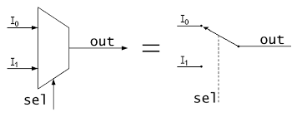
Figure 2-2 Block Diagram of a 2:1 MUX
Normally. there are 2^n input lines and n selection lines whose bit combinations determine which input is selected.
A multiplexer can be visualized as a data router which routes data from one of multiple input lines (determined by select lines) to a single output line. This can be used in communication systems to transmit multiple signals using a single channel (transmission link).
MUX can be implemented using Logic gates such as AND, OR, NAND etc. or Transmission gates (Tristate Buffers).
A demultiplexer (abbreviated as DEMUX) performs the reverse operation of a multiplexer. It routes data from a single input line to one of multiple output lines (determined again by select lines).
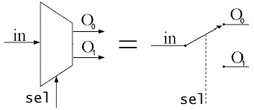
Figure 2-3 Block Diagram of a 1:2 DEMUX
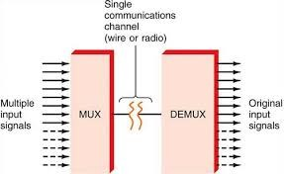
Figure 2-4 Communication System making use of MUX and DEMUX
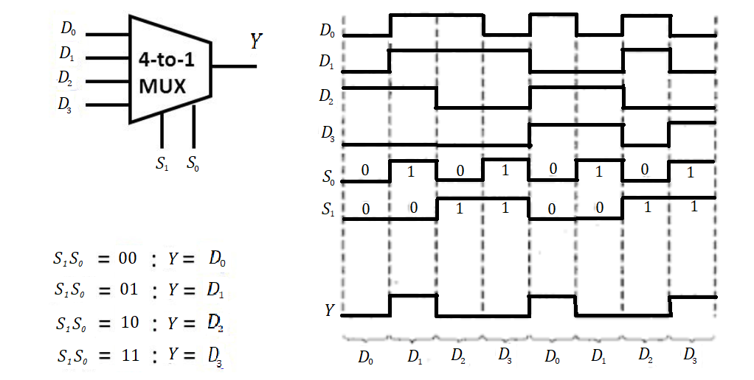
Figure 2-5Timing Diagram of a 4:1 MUX
- When S1S0 = 00, D0 is selected (00 is the binary representation of 0)
- When S1S0 = 01, D1 is selected (01 is the binary representation of 1)
- When S1S0 = 10, D2 is selected (10 is the binary representation of 2)
- When S1S0 = 11, D3 is selected (11 is the binary representation of 3)
- Design of 2:1 MUX:
A 2:1 MUX has two input lines (I0 and I1), one output line (Y) and one select line (S).
If S=0, Y=I0 and if S=1, Y=I1
Table 2 Truth Table of 2:1 MUX
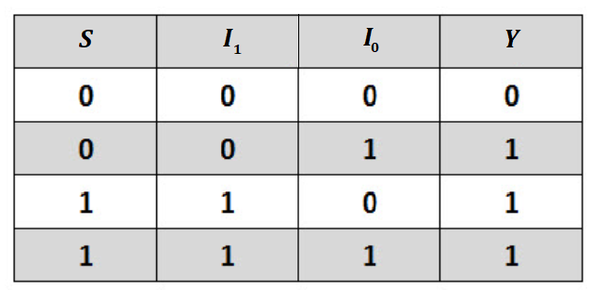
From the truth table, the Boolean expression for the output of 2:1 MUX can be obtained as:
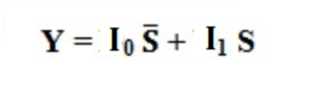
A 2:1 MUX can be implemented using two 2-input AND gates (1 7408 IC), one 2-input OR gate (1 7432 IC) and one inverter (1 7404 IC)
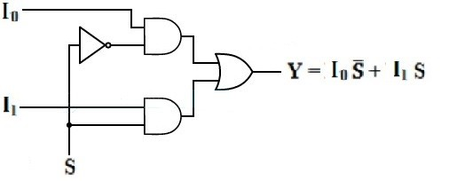
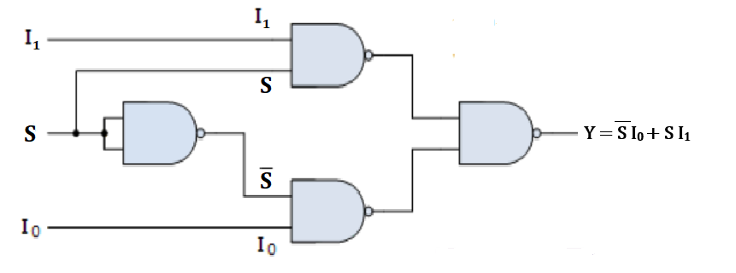
Figure 2-6NAND Logic Implementation
Tristate buffers have a normal input, an output, and a control input that determines the state of the output. When the control input is equal to 1, the output is enabled and the gate behaves like a conventional buffer with the output equal to the normal input. When the control input is 0, the output is disabled and the gate goes to a high-impedance state (the tristate buffer becomes an open circuit), regardless of the value in the normal input. Due to the presence of the high impedance state, the output of several tristate buffers can be tied together to form a common line without any loading effects.
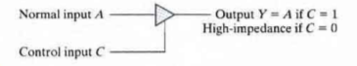
Figure 2-7Behavior of a Tristate Buffer
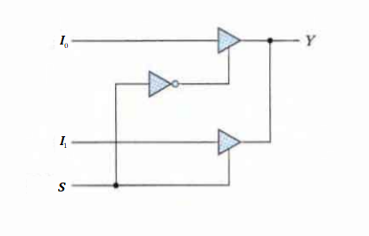
Figure 2-8Implementation of 2:1 MUX using Tristate Buffers
- Code for Verilog HDL Simulation:
- module mux_2x1_case(i0,i1,s0,out);
- input i0,i1,s0;
- output reg out;
- always @(*)
- begin
- case(s0)
- 1'b0:out=i0;
- 1'b1:out=i1;
- endcase;
- end
- endmodule
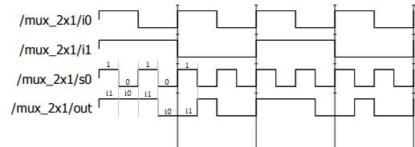
Figure 2-9Simulated waveforms for a 2:1 MUX

- Design of 4:1 MUX:
A 4:1 MUX has four input lines (I0,I1,I2 and I3), one output line (Y) and two select lines (S1 and S0).
Table 3 Truth Table of 4:1 MUX
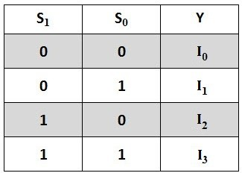
From the truth table, the Boolean expression for the output of 4:1 MUX can be obtained as:
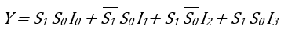
A 4:1 MUX can be implemented using four 3-input AND gates (2 7411 IC), three 2-input OR gates (1 7432 IC) and two inverters (1 7404 IC).
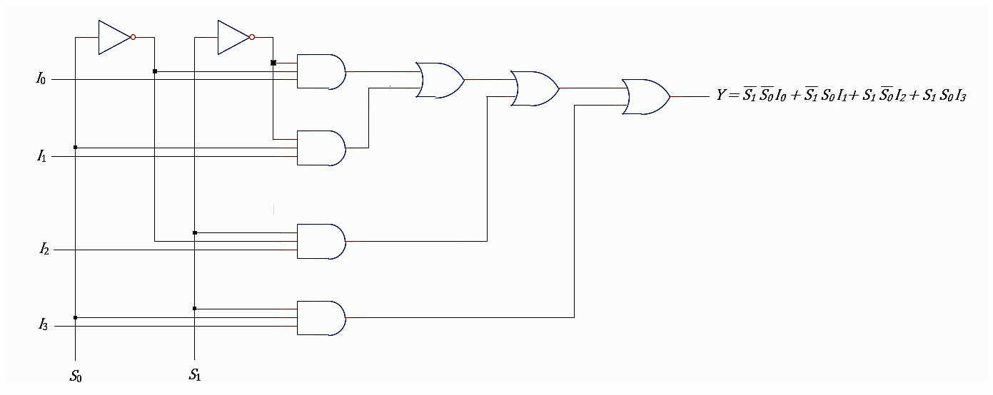
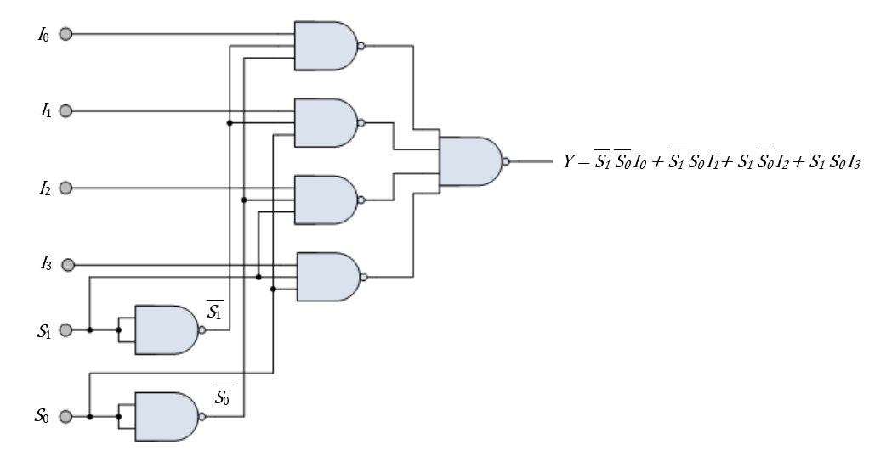
Figure 2-10NAND Logic Implementation
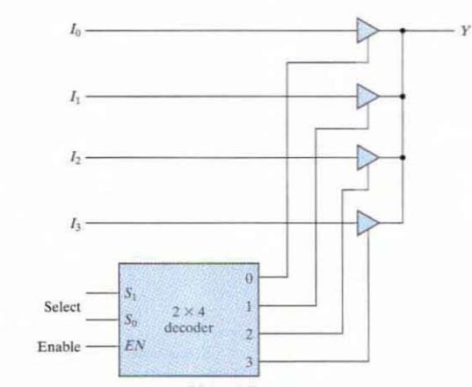
Figure 2-11 Tristate Buffer Implementation
The 2 by 4 decoder gives the outputs S1'S0' , S1'S0 , S1S0' , S1S0 which are then given as the control signals to the tristate buffers to select the desired input.
A 4:1 MUX can also be implemented using three 2:1 MUXes. Here s1 and s0 are select lines and w0, w1, w2 and w3 are the input lines.
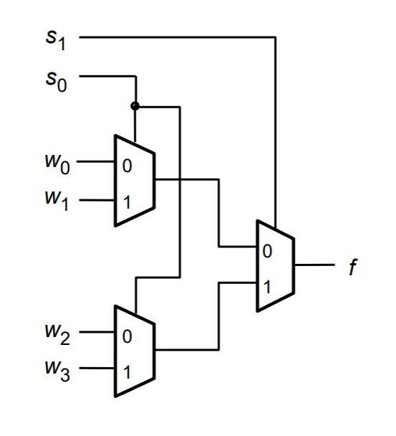
Figure 2-124:1 MUX can also be implemented 2:1 MUXes.
- Code for Verilog HDL Simulation:
Module mux_4x1_case(i0,i1,i2,i3,s,out);
input i0,i1,i2,i3;
input [1:0]s;
output reg out;
always @(*)
begin
case(s)
2'b00:out=i0;
2'b01:out=i1;
2'b10:out=i2;
2'b11:out=i3;
endcase
end
endmodule
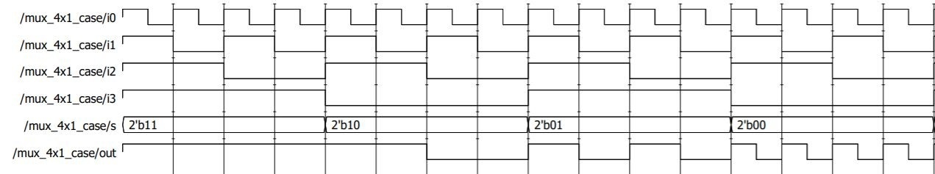
Figure 2-13Simulated waveforms for a 4:1 MUX
- Implementation of Boolean Functions using MUX:
A n-variable Boolean Function can be implemented easily using a 2^n : 1 MUX
For example, consider the following
Table 4truth table of 2^n : 1 MUX
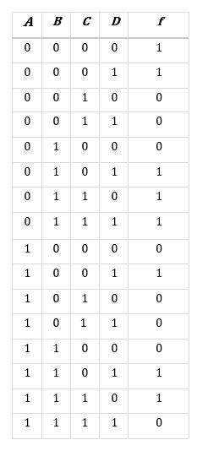
This function can be easily implemented using a 16:1 MUX. The 4 inputs A, B, C and D should be given as the 4 select lines of the MUX.
For the input combination ABCD = 0, the input selected by the MUX is I0. From the truth table we can deduce that I0 = 1. Similarly, the other inputs are given to the MUX.
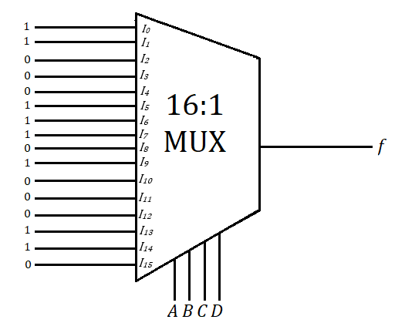
Figure 2-14 Implementation of the given 4 variable Boolean Function using 16:1 MUX
However, this is inefficient as the MUX logic complexity increases as number of select lines increases (compare the implementation of 2:1 MUX and 4:1 MUX). So we try to reduce the number of select lines.
A n variable boolean function can be implemented with a 2^(n-1):1 MUX and one inverter.
Consider the 4 variable function specified before, it can be implemented using an 8:1 MUX and an inverter. Three of the inputs, A,B and C in that order are given as the select lines. The input values are determined from the truth table, as a function of the fourth input D.
For a particular combination of input values ABC, D can take two values D=0 and D=1. The Boolean function can also take two values f=0 and f=1. 4 different situations arise for a particular combination of ABC values.
XXX - indicates a particular combination of ABC values (ranging from 000 to 111)
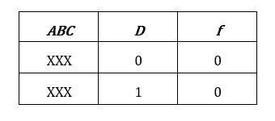
Table 5combination of ABC

Here f is zero irrespective of the value of D.
Hence for the particular combination of ABC, f = 0
Table 6 combination of ABC
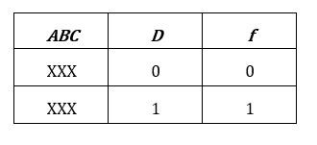
Here f has the same value as D.
Hence for the particular combination of ABC, f = D
Table 7 combination of ABC
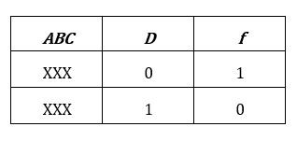
Here f is the complement of D.
Hence for the particular combination of ABC, f = D'
Table 8combination of ABC, f = D'
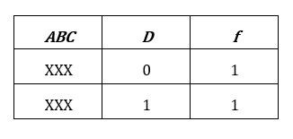
Here f is one irrespective of the value of D.
Hence for the particular combination of ABC, f = 1
The Truth table for the 4 variable Boolean function specified above, could be redrawn as:
Table 9 : 4 variable Boolean function
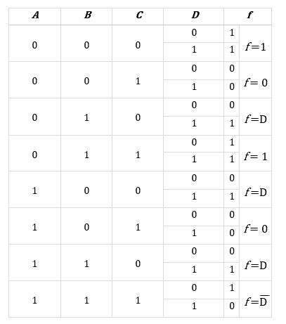
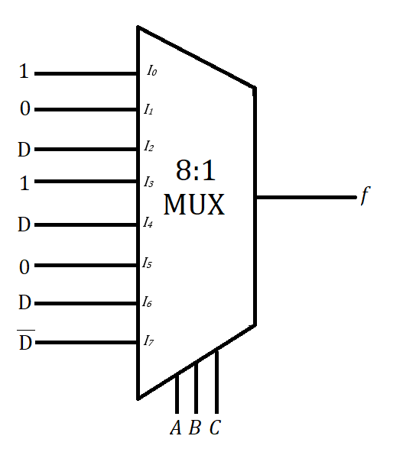
Figure 2-15Implementation of a 4 variable Boolean Function using a 3:1
If we try to reduce the selection lines further, some extra logic gates might be introduced.
An efficient implementation of a n variable Boolean function can be done using a 2^(n-1) : 1 MUX and an inverter.
- Design of 1:2 DEMUX:
A 1:2 DEMUX has one input line (I), two output lines (Y1 and Y2) and one select line (S).
If S=0, Y0=I and Y1=0; if S=1, Y0=0 and Y1=I
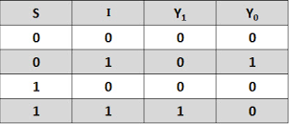
Table 10 Truth Table of a 1:2 DEMUX

The Boolean expressions for the outputs Yo and Y1 can be given as
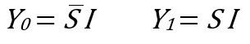
A 1:2 DEMUX can be implemented using two 2-input AND gates (1 7408 IC), and one inverter (1 7404 IC)
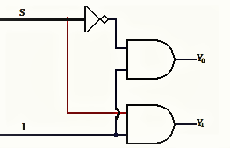
Figure 2-161:2 DEMUX can be implemented using two 2-input AND gates (1 7408 IC
- Code for Verilog HDL Simulation:
module demux_1x2_cond(I,s0,out);
input I,s0;
output [1:0]out;
assign out[0]=s0?1'b0:I
assign out[1]=s0?I:1'b0
endmodule
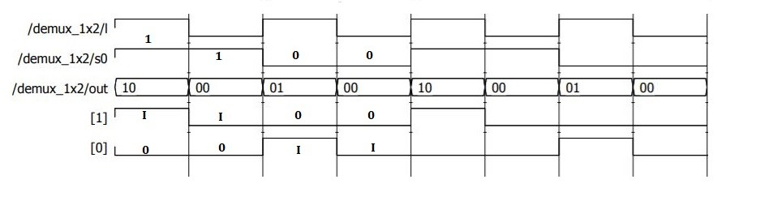
Figure 2-17Simulated waveforms for a 1:2 DEMUX
- Design of 1:4 DEMUX:
A 1:4 DEMUX has one input line (I), four output lines (Y0,Y1,Y2 and Y3) and two select lines (S1 and S0).
Table 11Truth table of 1:4 DEMUX
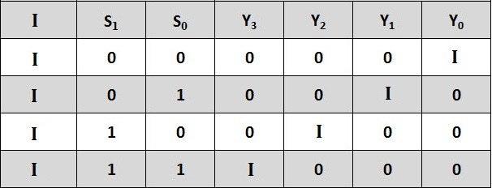
Figure 2-18Boolean expressions for the outputs Y0, Y1, Y2 and Y3 can be given as
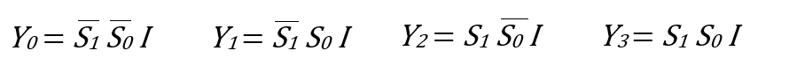

A 1:4 DEMUX can be implemented using four 3-input AND gates (2 7411 ICs), and two inverters (1 7404 IC)
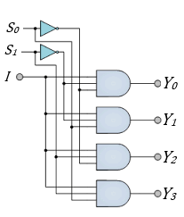
Figure 2-19four 3-input AND gates (2 7411 ICs), and two inverters (1 7404 IC)
- Code for Verilog HDL Simulation:
module demux_1x4_cond(I,s,out);
input I;
input [1:0]s;
output [3:0]out;
assign out[0]=s[0]?1'b0:(s[1]?1'b0:I);
assign out[1]=s[0]?(s[1]?1'b0:I):1'b0;
assign out[2]=s[0]?1'b0:(s[1]?I:1'b0);
assign out[3]=s[0]?(s[1]?I:1'b0):1'b0;
endmodule
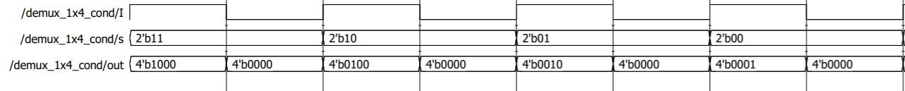
Figure 2-20 Simulated waveforms for a 1:4 DEMUX

Automatic Street Light Circuit Using IC 741
Simple Automatic Street Light Circuit Using IC 741 is easy to construct with few easily available components. In this circuit LDR (light depended Resistor) is used as a light-dark Sensor. Operational amplifier IC 741 drives Relay through BC547 Transistor as inverting amplifier.
You can connect any Light Source to the Relay. (How to use Relay?). We know IC 741 is a general purpose operational Amplifier, Here 8 Pin dual in line package operational amplifier used and configured as inverting amplifier.
Circuit Diagram
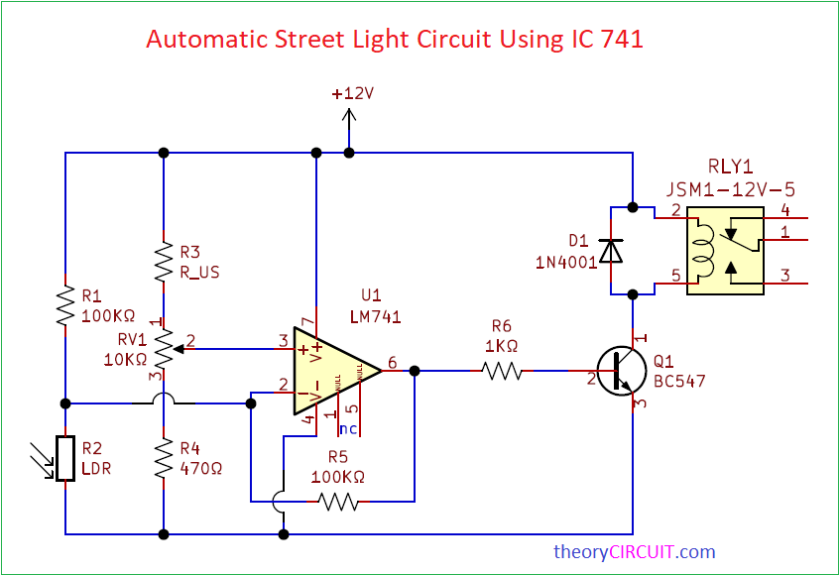
Figure 2-21Automatic Street Light Circuit Using IC 741 Circuit Diagram
- Components Required
- Operational Amplifier IC 741
- 12V SPDT Relay
- LDR
- Transistor BC547 NPN
- Diode 1N4001
- Variable Resistor 10KΩ
- Resistor (R3, R6) 1KΩ = 2
- Resistor 100KΩ = 2
- Resistor 470Ω
- IC 741 Pin Details
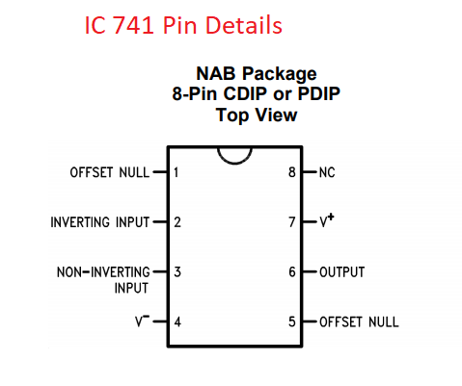
Figure 2-22 IC 741 8 Pin CDIP
- IC 741 Pin Details
Figure 2-23IC 741 8 Pin CDIP
When there is natural light then the LDR Resistance level goes down so that voltage and current flow through R1 easily goes to the ground or negative. Hence the inverting input receives low range voltage and current due to that Output voltage decrease and turns OFF the transistor. So the Relay coil gets disconnected from bias and turns OFF the light source connected with the common and N/O pins.
LDR Resistance level increase due to darkness after sunset. Hence the maximum voltage and current flow through R1 Reaches inverting input of Op-Amp, So the output voltage also gets increase and turns ON the transistor Q1 by the way Relay coil gets bias and turns ON the light Source connected with the common and N/O pins.

Clap Switch Circuit with Relay
If you want to design a Switch circuit to turn ON and turn OFF without reach a physical switch then try this simple Clap Switch Circuit with Relay, this circuit is designed with timer IC 555, dual D flip flop IC 7474 and a electromagnetic Relay.
This circuit will turn ON or turn OFF the load connected with Relay when you clap or make louder sound trigger to this circuit, a simple condenser mic is act as a sensor in this circuit.
Circuit Diagram
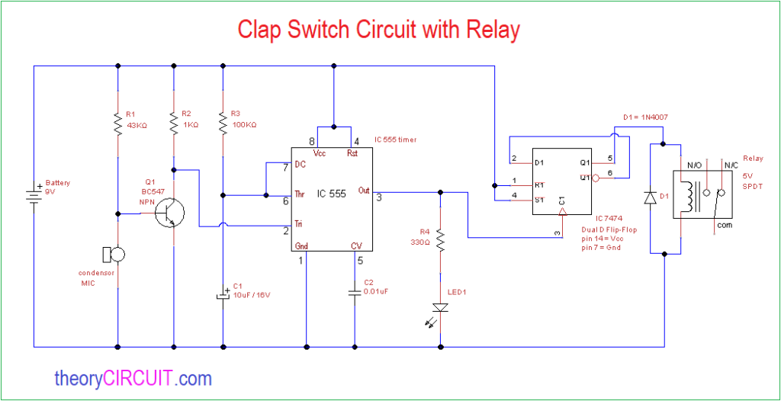
Figure 2-24 Clap Switch Circuit with Relay
Components Required
- IC 555 timer
- IC 7474 dual D flip flop
- 5V Relay (SPDT)
- Condenser Mic
- Transistor BC 547 NPN
- LED
- Diode 1N4007
- Resistor 43KΩ, 1KΩ, 100KΩ, 330Ω each one
- Capacitor 10μF, 0.01μF
- Battery 9V
Construction & Working
This circuit has three stage one is sound detector stage this is constructed by Condenser mic and transistor BC 547 as a level shifter, then second stage is timer IC 555 and this IC employed as a monostable multivibrator which will produce one timing pulse depends on timing Resistor R3 and timing Capacitor C1, when it receives trigger input from sound detector stage.
Output pulse from timer IC is directly fed into third stage that is D flip flop, here the Input pulse is makes the D flip flop into either SET or RESET position, the Relay is connected at the Q output of D flip flop, this Relay gets energized and turn ON load during set condition and turn OFF load during Reset condition
This circuit constructed without any load connection at Relay. How to use Relay?
Condenser Mic
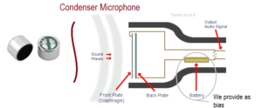
Figure 2-25 Condenser microphone
available in different size and all are working in the same way, A condenser mic will have Fixed back plate and Movable front plate (Diaphragm), and separated by air (insulator), when the sound wave hits the front plate then it moves according to the sound wave and makes the different capacitance level and this signal can be used as electric audio signal, condenser mic requires bias and amplifier for to produce electric audio signal.

Light Detector With Sensitivity Control Circuit
Simple Light Detector With Sensitivity Control Circuit is designed by using LDR (Light Dependent Resistor) and operational amplifier. Here LDR acts as Light detecting sensor and it is placed in a balanced Wheatstone bridge, A 10KΩ Variable Resistor connected with LDR can control the sensitivity of LDR.
This light detector circuit is designed to indicate the presence of light through LED, you can connect Relay switch or any output actuator depends on your requirement.
Circuit Diagram
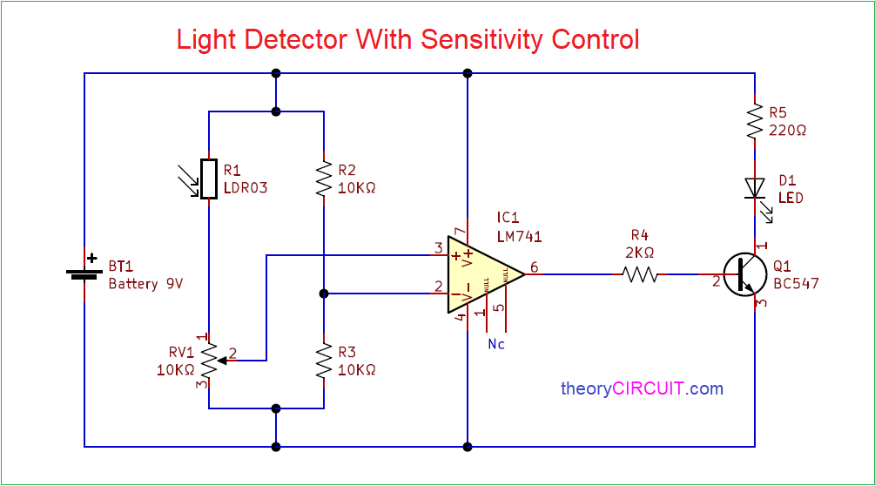
Figure 2-26Simple Light Detector With Sensitivity Control Circuit
- Components Required
- LDR (Light Dependent Resistor)
- Operational amplifier IC 741
- Transistor BC547 (NPN)
- LED
- Variable Resistor 10KΩ
- Resistor 220Ω, 2KΩ each one
- Resistor 10KΩ = 2
- Battery 9V
- Circuit Construction & Working
We know Wheatstone bridge helps us to find unknown Resistance value from a quadrilateral with three known resistances and applying a voltage between a pair of opposite corners. The voltage difference from Wheatstone bridge is applied to the operational amplifier inputs and the difference between inverting pin and non-inverting pin is amplified by the op-amp and gives output through pin 6. This output is fed into transistor switch Q1 and the LED glows depends on the Q1 ON and OFF conditions.
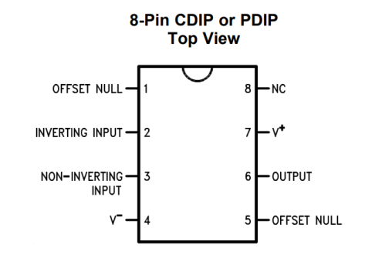
Figure 2-27 IC 741 (Operational Amplifier)
This Operational Amplifier IC LM741 has 8 Pins, and we don’t use pin 1 and 5 in this circuit they are called offset null. Bias for this IC applied through pin 7 and pin 4. Inverting input pin 2 and Non inverting input pin 3 are considered as input terminals and pin 6 acts as output terminal.
- Transistor BC547 (NPN)
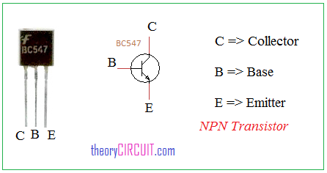
Figure 2-28Transistor BC547 (NPN)
Transistor BC547 is a NPN transistor and have three terminals called collector, Base and Emitter. This transistor can acts as Switch and low power general purpose amplifier.
Light Dependent Resistor (LDR)
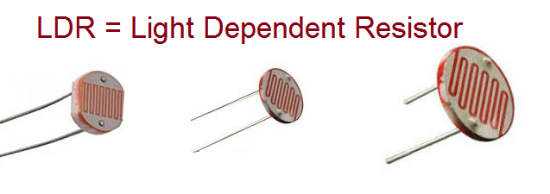
Figure 2-29Light Dependent Resistor (LDR)
LDR is a component that changes its Resistance depends on light intensity, it has two terminals and don’t have any polarity, it is made by cadmium sulfide Material, Resistance between two terminal will be very high when there is no light and Resistance between two terminal will be very low when there is near light source.

Temperature Controlled DC Fan
Simple Temperature Controlled DC Fan Circuit is designed with Negative temperature co-efficient Thermistor and an operational amplifier. This Thermistor variable Resistance value based on the temperature, when the temperature rises then Thermistor Resistance gets decrease and for temperature decrease then Thermistor Resistance gets Increase. We can choose threshold point of temperature by using variable resistor.
We can implement this Temperature Controlled DC Fan circuit in a common PCB and place the Thermistor sensor near the place where temperature controlling is need.
Circuit Diagram
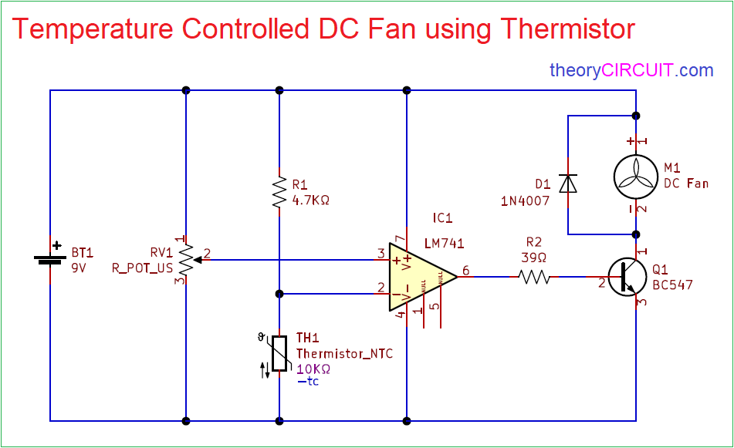
Figure 2-30 Temperature Controlled DC Fan using Thermistor
Components Required
- Thermistor NTC 10KΩ
- Operational Amplifier IC LM741
- DC Fan 9V
- Transistor BC547 NPN
- Resistors 4.7KΩ, 39Ω each one
- Variable Resistor 10KΩ
- Diode 1N4007
- Battery 9V
- Construction & Working
Here Operational Amplifier compares Reference voltage at non inverting input and inverting input and controls output voltage by using op-amp output transistor BC547 acts as switch to connect or disconnect DC fan from power supply.
Variable Resistor VR1 is connected across power supply and variable pin is connected to the Non inverting input of IC 741 and then NTC thermistor is connected between the power supply through R1 Resistor and also connected with Inverting Input of IC 741. Operational amplifier also uses the same power supply source and output is connected to the Q1 transistor base through R2 Resistor. 9V DC fan is conned with positive supply and Q1 transistor collector terminal, here the Q1 transistor acts as switch. When the temperature increase and reaches the threshold then op-amp gives differential voltage and makes Q1 transistor turn ON then DC fan gets ground supply and starts to run. If the temperature level below the threshold then op-amp gives zero output then Q1 transistor stays in turn OFF condition and DC fan don’t get bias to run and so it remains in off condition.
- Thermistor
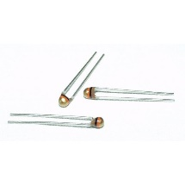
Figure 2-31Thermistor
This Thermistor element don’t have polarities and we can connect the terminals in any direction.
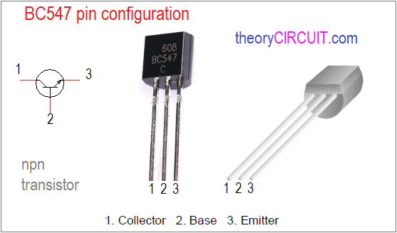
Transistor BC547
Transistor BC547 is a Three terminal two junction active device (NPN), we can configure BC547 pin as facing the flat surface and pin 1 is called as Collector terminal and 2 is Base and Pin 3 is called as Emitter terminal. It can be used in general purpose, amplification and switching applications.

Circuit Description Clap Switch Cum Touch Switch
This circuit uses a timer IC NE555 (IC₂) and audio amplifier IC TBA810 (IC₁). TBA810 is a 7-watt audio amplifier IC which is used to amplify the audio signal coupled from audio transformer X₁. Here we used a loudspeaker as a sound sensor. The audio transformer of 3 volts is connected to the loudspeaker as a coupling transformer. The central terminal of the transformer is kept open as shown in the circuit diagram of the clap switch cum touch switch.
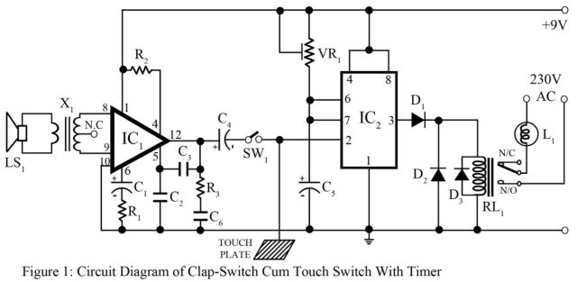
Clap Switch Cum Touch Switch
The loudspeaker LS₁ is used to change audio signal to voltage signal which is further coupled with audio transformer and is given to the input of audio amplifier IC (IC₁). The amplified output from pin 12 of IC₁ is connected to pin 2 of IC₂.
When the power supply of 9-volt is applied with switch SW₁ closed, the relay RL₁ operates. It remains in an ON state for a certain interval of time due to the timer circuit.
The purpose of switch SW1 is to select between the touch switch and the clap switch. With the Close position of switch SW1, this circuit works as a Clap switch. With the Open position of switch SW1, this circuit works as a touch switch.
- Electronics Component Required
Resistor (all ¼-watt, ± 5% Carbon)
R1 = 150 Ω
R2 = 100 Ω
R3 = 1 Ω
VR1 = 1M Ω
Capacitors
C1, C5 = 100 µF, 10V (Electrolytic capacitor)
C2 = 6.8 KpF (Ceramic Disc)
C3 = 1.5 KpF (Ceramic Disc)
C4 = 1000 µF, 10V (Electrolytic capacitor)
C6 = 0.1 µF (Ceramic Disc)
Semiconductors
IC1 = TBA810 (Audio Amplifier IC)
IC2 = NE555 (Timer IC)
D1 – D3 = 1N4001 (Rectifier Diode)
Miscellaneous
RL1 = 6V, 100Ω Relay
SW1 = Selector Switch
L1 = Light bulb or Load
LS1 = 8Ω Speaker (Used as microphone)
X1 = Audio Output Transformer (3 or 4.5 V)
Touch Plate

Low Voltage Audio Power Amplifier Circuit
Simple Low Voltage Audio Power Amplifier Circuit designed by using IC LM386. IC LM386 from Texas Instruments is a power amplifier designed for use in low voltage consumer applications. This IC Provides gain value 20 with low external components. By adding addition of external Resistor and capacitor between Pins 1 and 8 will increase the gain to any value from 20 to 200.
IC LM386 Can operate with 4V to 12V and has low quiescent current Drain 4mA. This IC can give Voltage gain from 20 to 200. It can operate with Battery power also. This IC comes in different package size.
- Components Required (BOM)
1 | C2, C4 | 10µF | CP_Elec_3x5.4 | 2
2 | C1 | 2.2µF | CP_Elec_3x5.4 | 1
3 | C7 | 220µF | CP_Elec_3x5.4 | 1
4 | C3, C5 | 0.1µF | C_0805_2012Metric | 2
5 | C6 | 0,22µF | C_0805_2012Metric | 1
6 | R1 | 1kΩ | R_0805_2012Metric | 1
7 | R2 | 2.2kΩ | R_0805_2012Metric | 1
8 | R3 | 22Ω | R_0805_2012Metric | 1
9 | D1 | LED | LED_0805_2012Metric | 1
10 | U1 | LM386 | VSSOP-8_3.0x3.0mm_P0.65mm | 1
11 | RV1 | 10kΩ | Potentiometer_Bourns_3214G_Horizontal | 1
12 | J1, J2, J3 | Screw_Terminal_01x02 | JWT_A3963_1x02_P3.96mm_Vertical | 3

- Circuit Diagram
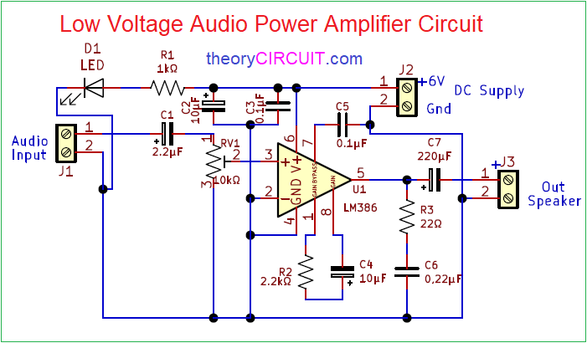
Figure 2-32Low Voltage Audio Power Amplifier Circuit Using LM386 PCB Gerber files.
- Construction & Working
This Low Voltage Audio Power Amplifier Circuit can drive 4Ω, 8Ω and 16Ω loud speakers. 6V DC supply used as bias to this circuit, Audio input is applied to the Non Inverting pin through Capacitor C1, Variable Resistor RV1, by changing the RV1 value we can adjust the output volume. Inverting pin of this IC grounded, Gain bypass and gain pins are connected through C4 and R2 components.
Output from Pin 5 is connected to the screw terminal through C7 Capacitor, Here LED indicates the ON condition of this amplifier circuit.
- Printed Circuit Board
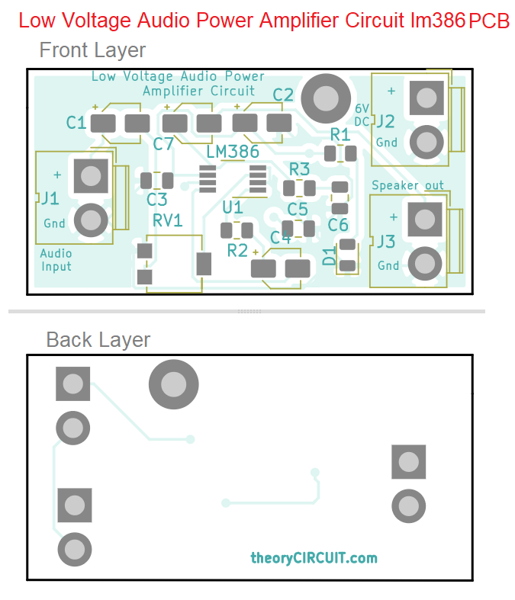
Figure 2-33 Interactive Board Viewer

Rectification and Retesting of Prototype Malfunctions
In the design and development of advanced digital systems, it is crucial to rectify and retest any malfunctions that may occur in the prototype devices and circuits. This essay aims to discuss the process of identifying and rectifying prototype malfunctions, followed by retesting to ensure effective operation of the design. The design includes sequential circuits, combinatorial functions, electronic switching and control circuits, sound-operated systems, and touch-operated systems.
- Identifying and Rectifying Prototype Malfunctions:
Sequential Circuits: Sequential circuits are prone to malfunctions such as incorrect data storage, timing issues, or improper state transitions. To identify and rectify these malfunctions, the following steps can be taken: -
- Seven-Segment Display: Check for any incorrect or missing segments in the display. Verify the connections and ensure that the correct signals are being applied. Rectify any faulty connections or components. –

- Register: Verify that the register is storing and manipulating data correctly. Check for any data corruption or incorrect outputs. Rectify any issues with the flip-flops or data paths. –
- Flip-Flops: Test the flip-flops individually to ensure proper functioning. Check for any issues with clock signals, input/output connections, or timing violations. Rectify any faulty flip-flops or connections. –
- Counters: Verify that the counters are generating the expected sequence of numbers. Check for any issues with clock signals, reset signals, or incorrect outputs. Rectify any faulty components or connections. –
- Timers: Test the timers to ensure accurate time measurement or generation. Check for any timing inaccuracies or incorrect outputs. Rectify any faulty components or connections.

    - Combinatorial Functions:
Combinatorial functions can suffer from malfunctions such as incorrect logic operations, signal propagation delays, or faulty inputs/outputs. To identify and rectify these malfunctions, the following steps can be taken: -
- Encoders: Verify that the encoders are correctly converting input signals into coded outputs. Check for any incorrect or missing outputs. Rectify any faulty components or connections. –
- Decoders: Test the decoders to ensure proper conversion of coded inputs into multiple outputs. Check for any incorrect or missing outputs. Rectify any faulty components or connections. –
- Multiplexers: Verify that the multiplexers are correctly selecting and routing input signals to the desired output. Check for any signal distortion or incorrect routing. Rectify any faulty components or connections. –
- Demultiplexers: Test the demultiplexers to ensure proper routing of a single input to the desired output. Check for any signal distortion or incorrect routing. Rectify any faulty components or connections.
    - Electronic Switching and Control Circuits:
Electronic switching and control circuits can experience malfunctions such as improper switching, incorrect sensor readings, or faulty control signals. To identify and rectify these malfunctions, the following steps can be taken: -
- Automatic Light Operated Switch Using LDR and IC741: Verify that the circuit is correctly responding to the ambient light level and switching the light source accordingly. Check for any incorrect switching or sensor readings. Rectify any faulty components or connections. –
- Clap Operated Electronic Switch Circuit: Test the circuit to ensure it accurately detects clapping sounds and triggers the desired switching action. Check for any false triggers or incorrect switching. Rectify any faulty components or connections. –
- DC Motor Control Circuit Using NE555: Verify that the circuit is correctly controlling the speed and direction of the DC motor. Check for any incorrect motor behavior or faulty control signals. Rectify any faulty components or connections.
- Dome Lamp Dimmer: Test the circuit to ensure smooth and accurate dimming of the dome lamp.Check for any flickering or incorrect dimming levels. Rectify any faulty components or connections. –
- Electronic Washing Machine Control Circuit Diagram: Verify that the circuit is correctly controlling various functions of the washing machine, such as water level, temperature, and motor control. Check for any incorrect operation or faulty control signals.
- Rectify any faulty components or connections. Retesting for Effective Operation: After rectifying the identified malfunctions, it is essential to retest the prototype devices and circuits to ensure their effective operation.
- The retesting process involves:
- Verification of Functionality: Verify that the prototype devices and circuits perform their intended functions accurately and reliably. Check for any remaining malfunctions or unexpected behavior.
- Compliance with Design Specifications: Ensure that the prototype devices and circuits comply with the design brief and regulatory requirements. Verify that all design specifications, such as performance, safety, and efficiency, are met.
- Performance Evaluation: Evaluate the performance of the prototype devices and circuits under different operating conditions. Check for any performance deviations or limitations.
- Reliability and Durability Testing: Test the prototype devices and circuits for their reliability and durability over an extended period. Check for any potential issues that may arise during long-term operation.

Documenting electrical/electronic system design
- Documentation for Approval
In the field of electrical/electronic engineering, the design and development of advanced digital systems play a crucial role in various industries. These systems are responsible for the efficient and reliable operation of complex electrical/electronic devices and equipment. To ensure the successful implementation of such systems, it is essential to document the design process thoroughly. This essay aims to provide a comprehensive overview of the documentation required for the approval of electrical/electronic system designs.
- System Requirements: Before initiating the design process, it is imperative to clearly define the system requirements. This includes identifying the purpose, functionality, and performance criteria of the proposed system. The documentation should outline the specific objectives, constraints, and specifications to be met during the design and development stages.
- System Architecture: The system architecture serves as the foundation for the design process. It involves the identification and organization of various components, interfaces, and subsystems within the system. The documentation should provide a detailed description of the system architecture, including block diagrams, flowcharts, and any other relevant graphical representations. This allows stakeholders to understand the overall structure and functionality of the proposed system.
- Design Methodology: The design methodology outlines the step-by-step process followed to develop the advanced electrical/electronic system. It should include a comprehensive description of the design approach, tools, and techniques employed. This documentation ensures that the design process is systematic, efficient, and adheres to industry standards and best practices.
- Component Selection and Integration: The selection and integration of components are critical aspects of system design. The documentation should include a detailed analysis of the chosen components, such as microcontrollers, sensors, actuators, and communication modules. It should outline the rationale behind the selection, considering factors such as cost, performance, reliability, and compatibility. Additionally, the documentation should describe the integration process, including circuit diagrams, wiring schematics, and any other relevant technical details.
- Testing and Validation: To ensure the functionality and reliability of the advanced electrical/electronic system, thorough testing and validation are essential. The documentation should outline the test procedures, test cases, and expected outcomes. It should also include the results of the tests conducted, highlighting any issues encountered and the corresponding resolutions. This documentation provides evidence of the system's performance and compliance with the defined requirements.
- Safety and Compliance: Electrical/electronic systems must adhere to safety regulations and industry standards. The documentation should include a comprehensive assessment of safety considerations, risk analysis, and compliance with relevant standards (e.g., IEC 61508, ISO 26262). It should also outline any necessary safety measures implemented during the design process to mitigate potential hazards and ensure the system's safe operation.

Consistent solutions to unplanned situation.
In the realm of advanced electrical/electronic design, it is crucial to anticipate and address unplanned situations that may arise during the development and implementation of digital systems. This essay aims to provide solutions consistent with organizational policies for such situations in the context of sequential circuits, combinatorial functions, and electronic switching and control circuits.
- Sequential Circuits:
Sequential circuits are essential components in digital systems, allowing for the storage and manipulation of data. In the event of an unplanned situation, such as a malfunctioning seven-segment display, register, flip-flop, counter, or timer, it is important to follow the organization's policies for troubleshooting and rectification. This may involve conducting a thorough analysis of the circuit, checking for loose connections, faulty components, or incorrect programming. If necessary, replacement of defective components or reprogramming of the circuit may be required to restore proper functionality.
- Combinatorial Functions
Combinatorial functions, including encoders, decoders, multiplexers, and demultiplexers, play a vital role in digital systems by enabling data manipulation and routing. If an unplanned situation arises, such as incorrect output from an encoder or decoder, it is important to adhere to the organization's policies for resolution. This may involve verifying the input signals, checking for incorrect wiring or faulty components, and ensuring proper programming or configuration. If necessary, recalibration or replacement of components may be required to rectify the issue and restore the desired functionality.

- Electronic Switching and Control Circuits
Electronic switching and control circuits are responsible for automating various functions, such as light operation, motor control, and appliance switching. In the event of an unplanned situation, such as a malfunctioning light-operated switch or a faulty motor control circuit, it is essential to follow the organization's policies for resolution. This may involve checking the circuit connections, verifying the input/output signals, and ensuring proper functioning of integrated circuits or microcontrollers. Troubleshooting techniques, such as signal tracing, component testing, and circuit simulation, may be employed to identify and rectify the issue. If necessary, replacement of faulty components or reprogramming of the control circuit may be required to restore normal operation.

Self-check 2.1
Part one: Say True/False:
- System integration aims to create a cohesive and seamless operation by connecting various elements.
- Embedded systems are specialized computer systems designed to perform specific functions within larger systems or products.
- The Internet of Things (IoT) enables intelligent monitoring, control, and automation of various processes and applications.
- Robotics and automation do not play a vital role in advanced electrical/electronic systems.
- Power electronics involves the conversion, control, and management of electrical power.
Part Two: Multiple Choice:
- Which concept involves connecting everyday objects and devices to the internet?
- System Integration
- Embedded Systems
- Internet of Things (IoT)
- Robotics and Automation
- What does power electronics deal with?
- Conversion, control, and management of electrical power
- Integration of multiple subsystems and technologies
- Design and development of advanced digital systems
- Detection and measurement of physical parameters
- Which component is a fundamental part of advanced electrical/electronic systems?
- Encoders
- Sensors
- Microcontrollers
- Power transistors
- What do AI and ML techniques enable in advanced electrical/electronic systems?
- Energy storage and management
- Intelligent monitoring and control
- Secure communication protocols
- Conversion and manipulation of data
- Why is cybersecurity important in advanced electrical/electronic systems?
- To optimize power conversion efficiency
- To protect against unauthorized access and data breaches
- To enable intelligent decision-making
- To enhance the capabilities of robotic systems
- Which type of circuit enables the storage and manipulation of data in digital systems?
- Sequential circuit
- Combinatorial function
- Power electronic circuit
- Sensor circuit
- What do encoders and decoders do in digital system design?
- Perform logical operations
- Convert multiple inputs into a coded output
- Select inputs to be routed to a single output
- Store and manipulate data temporarily
- What do sound-operated light and alarm systems use to trigger specific actions?
- Temperature sensors
- Light dimmer circuits
- Sound sensors
- Proximity sensors
- What do clap switch cum touch switch circuits provide a convenient way to control?
- Sequential circuits
- Power electronics
- Electrical devices
- Combinatorial functions
- Which standards are crucial for ensuring safety, reliability, and interoperability in digital systems?
- ISO 9001 and ISO 14001
- ISO 27001 and IEC 60601
- IEC 61508 and ISO 14001
- ISO 9001 and IEC 61508
Part Two: Match the following concepts with their corresponding descriptions:
Match A | Match B
AI and ML | a. Control and management of electrical power
System Integration | b. Connecting objects and devices to the internet
Power Electronics | c. Enhancing system capabilities with intelligent behavior and learning from data
IoT | d. Integration of multiple subsystems and technologies
Robotics and Automation | e. Utilizing electrical/electronic components for autonomous
Part Four: Fill in the Blank:
- Advanced electrical/electronic systems often involve the __________ of multiple subsystems, components, and technologies.
- Embedded systems are often dedicated, real-time, and __________ constrained.
- Sensors detect and measure physical, chemical, or environmental __________ and convert them into electrical signals.
- __________ and ML algorithms enable systems to analyze large datasets and recognize patterns.
- Cybersecurity concepts, such as secure communication protocols and __________ algorithms, are essential for protecting advanced electrical/electronic systems.

Operation Sheet:2.1
Operation Title: Assembling an Embedded System
Instructions:
- Gather all the necessary components and tools.
- Ensure a clean and well-lit workspace.
- Follow the assembly steps carefully.
- Double-check the connections and alignments before proceeding.
Precautions:
- Handle electronic components with care to avoid damage.
- Disconnect power sources before making any connections.
- Avoid static electricity by grounding yourself and using an anti-static mat.
Tools and Requirements:
Microcontroller board
- Sensors and actuators
- Connecting wires
- Soldering iron
- Screwdriver
- Multimeter
- Power supply
Procedures:
- Identify the specific functions and requirements of the embedded system.
- Mount the microcontroller board on a suitable platform.
- Connect the required sensors and actuators to the microcontroller board following the datasheets and pin diagrams.
Quality Criteria:
- All connections are secure and properly soldered.
- The microcontroller board is powered up and functioning correctly.
- Sensors and actuators respond accurately to inputs.
- There are no loose or tangled wires.
- The assembled embedded system passes functional testing and performs the desired tasks successfully.
- Please note that the operation sheet is truncated, and the remaining steps and quality criteria are missing
.

UNIT THREE: OBTAIN APPROVAL FOR THE DESIGN
This learning guide is developed to provide you the necessary information regarding the following content coverage and topics:
  - concept of Obtain approval for the design
  - Presenting and explaining the design
  - Requests for Design Modifications
  - Documenting and approval final design
  - Quality of work
This guide will also assist you to attain the learning outcomes stated in the cover page. Specifically, upon completion of this learning guide, you will be able to:
  - Define concept of Obtain approval for the design
  - Present and explain the design
  - Negotiate Requests for Design Modifications
  - Document and approval final design
  - Monitor Quality of work

Concept of Obtain approval for the design
In the field of electrical and electronic engineering, designing and developing advanced systems requires a meticulous approach to ensure optimal performance, reliability, and safety. One crucial step in this process is obtaining approval for the design from client representatives or other relevant individuals. This essay aims to outline the key considerations and steps involved in presenting and explaining the design to the client representative and/or other relevant person(s) to secure their approval.
1. Understand the Client's Requirements: Before presenting the design, it is essential to thoroughly understand the client's requirements, expectations, and constraints. This understanding will enable the design team to tailor the presentation to address specific concerns and align the design with the client's objectives.
2. Prepare a Comprehensive Design Documentation: To effectively present and explain the design, it is crucial to prepare a comprehensive design documentation package. This package should include detailed technical drawings, specifications, calculations, and any relevant supporting documentation. The documentation should be organized, clear, and concise, enabling the client representative to easily comprehend the design and its features.
3. Highlight the Design Rationale: During the presentation, it is important to articulate the design rationale, explaining the choices made and the reasons behind them. This helps the client representative understand the design's purpose, functionality, and benefits. By providing a clear rationale, the design team can instill confidence in the client representative regarding the design's effectiveness and suitability for the intended application.
4. Address Safety and Regulatory Compliance: Safety is a critical aspect of any electrical/electronic design. It is imperative to demonstrate that the design adheres to relevant safety standards and regulatory requirements. This can be achieved by highlighting safety features, such as fail-safe mechanisms, protective measures, and compliance with industry standards. Providing evidence of compliance, such as certifications or test reports, can further reinforce the design's reliability and safety.
5. Discuss Performance and Efficiency: The presentation should emphasize the design's performance capabilities and efficiency. This includes discussing factors such as power consumption, speed, accuracy, and reliability. Utilizing simulation results, prototypes, or past performance data can help substantiate claims regarding the design's performance. Demonstrating how the design meets or exceeds the client's performance expectations is crucial for obtaining approval.
6. Address Cost and Feasibility: Cost-effectiveness and feasibility are key considerations for any design project. During the presentation, it is essential to address these aspects by discussing the design's cost implications, potential savings, and feasibility in terms of resources, materials, and manufacturing processes. Providing a cost-benefit analysis or return on investment (ROI) assessment can help the client representative evaluate the design's economic viability.
7. Encourage Feedback and Address Concerns: Throughout the presentation, it is important to encourage the client representative to provide feedback, ask questions, and express any concerns they may have. Actively listening to their input and addressing their concerns demonstrates a commitment to client satisfaction and fosters a collaborative relationship. By incorporating their feedback, if feasible, the design team can further enhance the design's suitability and acceptance.

Presenting and explaining the design
Presenting and explaining the design of advanced electrical and electronic systems requires clear communication and effective demonstration of the design concept, features, and benefits. Here are some key points to consider when presenting and explaining the design:
- Understand the Target Audience: Tailor your presentation to the specific audience you are addressing. Consider their technical background, level of expertise, and familiarity with advanced electrical and electronic systems. Adapt your language and presentation style accordingly to ensure effective communication.
- Start with an Overview: Begin by providing an overview of the design project, including its purpose, objectives, and scope. Explain the problem or need that the design aims to address and highlight the significance of the advanced electrical and electronic system in meeting those requirements.
- Visual Aids and Prototypes: Utilize visual aids such as diagrams, schematics, 3D models, or prototypes to illustrate the design concept. Visual representations help the audience grasp the system architecture, component connections, and overall functionality. Use labels, callouts, and animations if necessary to explain complex or dynamic aspects of the design.
- Break down the Design: Break down the design into its main components, subsystems, or modules. Explain the function and purpose of each element and how they interconnect and work together to achieve the desired system operation. Highlight any innovative or unique features of the design that differentiate it from conventional solutions.
- Emphasize Benefits and Advantages: Clearly articulate the benefits and advantages of the advanced electrical and electronic system. Explain how the design enhances performance, efficiency, reliability, safety, or user experience compared to existing systems or alternative solutions. Use quantitative data or case studies if available to support your claims.
- Address Design Considerations: Discuss the considerations that were taken into account during the design process, such as safety, functionality, budget, and scalability. Explain the trade-offs made and the reasoning behind design decisions. Highlight any design features or strategies that were implemented specifically to address these considerations.
- Demonstrate Performance and Functionality: If possible, demonstrate the performance and functionality of the advanced electrical and electronic system. Conduct live demonstrations or use pre-recorded videos to showcase key features, operation modes, or real-world applications. This provides a tangible experience for the audience and helps them visualize the system in action.
- Address Potential Challenges and Limitations: Acknowledge any potential challenges, limitations, or areas for improvement in the design. Be transparent about the design's constraints and discuss any ongoing research or future developments that may address these challenges. This shows a realistic approach and encourages feedback and collaboration.
- Encourage Questions and Discussion: Create an interactive environment by encouraging the audience to ask questions, provide feedback, or share their insights. This promotes engagement and allows for a deeper understanding of the design concept. Be prepared to address inquiries and provide further explanation or clarification as needed.
- Conclusion and Next Steps: Conclude the presentation by summarizing the key points discussed and reiterating the value and significance of the design. Clearly communicate the next steps, such as further development, testing, or implementation, and invite collaboration or partnership opportunities if applicable.
Remember to adapt your presentation style and level of technical detail based on the audience's level of understanding and interest. Use language that is accessible and avoid jargon or excessive technical terms unless the audience is familiar with them. Clear and concise communication is key to effectively present and explain the design of advanced electrical and electronic systems

Requests for Design Modifications
In the process of designing and developing advanced electrical/electronic systems, it is not uncommon for requests for modifications to arise. These modifications may be suggested by relevant individuals within the organization, such as project managers, engineers, or stakeholders. Negotiating these requests while adhering to organizational policies and constraints is crucial to ensure the design remains efficient, feasible, and aligned with the project objectives. This essay aims to outline the key considerations and steps involved in negotiating requests for modifications to the design within the constraints of organization policy.
1. Evaluate the Requested Modification: When a request for a design modification is received, it is essential to thoroughly evaluate its feasibility, impact, and alignment with the project objectives. This evaluation should consider factors such as technical feasibility, cost implications, time constraints, and potential effects on performance, safety, and regulatory compliance. A detailed analysis will enable the design team to make informed decisions during the negotiation process.
2. Review Organizational Policies and Constraints: Before entering into negotiations, it is crucial to review the organization's policies, design guidelines, and constraints. These policies may include factors such as budget limitations, resource availability, quality standards, and project timelines. By understanding these constraints, the design team can negotiate within the boundaries set by the organization, ensuring that any modifications align with the overall project goals and objectives.
3. Communicate with Relevant Stakeholders: Effective communication with relevant stakeholders is vital during the negotiation process. This includes engaging with the individuals who have requested the modification, project managers, engineers, and other key decision-makers. By actively listening to their concerns, understanding their perspectives, and explaining the potential implications of the requested modification, the design team can foster a collaborative environment and work towards finding mutually agreeable solutions.
4. Assess the Impact of the Modification: During the negotiation process, it is crucial to assess the impact of the requested modification on various aspects of the design. This includes evaluating its effects on performance, functionality, safety, regulatory compliance, cost, and feasibility. By conducting a thorough impact assessment, the design team can determine the viability of the modification and propose alternative solutions if necessary. It is important to balance the benefits of the modification with any potential drawbacks or compromises.
5. Propose Alternative Solutions: If the requested modification is not feasible or aligns poorly with the project objectives, it is essential to propose alternative solutions. These alternatives should address the underlying concerns or requirements while considering the organizational policies and constraints. By presenting well-reasoned alternatives, the design team can demonstrate their commitment to finding suitable solutions that meet the needs of the stakeholders while maintaining the integrity of the design.
6. Document and Communicate the Negotiated Changes: Once an agreement is reached, it is crucial to document and communicate the negotiated changes to all relevant parties. This includes updating the design documentation, specifications, and any other relevant documentation to reflect the approved modifications. Clear and concise communication ensures that all stakeholders are aware of the changes and can proceed with the project accordingly.

Documenting and approval final design
Documenting and obtaining approval for the final design of advanced electrical and electronic systems is crucial to ensure proper communication, traceability, and compliance with project requirements. Here are some key considerations for documenting and obtaining approval for the final design:
- Design Documentation:
a. Design Specifications: Document the detailed specifications of the system, including functional requirements, performance targets, safety standards, and any specific industry regulations or guidelines that need to be followed.
b. System Architecture: Provide a comprehensive overview of the system's architecture, including block diagrams, schematics, and interconnections. Clearly document the functions and relationships between different components, subsystems, and interfaces.
c. Component Documentation: Document the specifications, datasheets, and characteristics of the selected components, including electrical ratings, tolerances, and compatibility requirements.
d. Design Calculations: Include relevant design calculations, such as power budgets, voltage drop calculations, thermal analysis, and electromagnetic compatibility (EMC) considerations. Document any assumptions or simplifications made during the design process.
e. Safety Analysis: Document the results of safety analyses, risk assessments, and any mitigation measures implemented to ensure compliance with safety standards and regulations.
f. Test and Validation Plans: Outline the plans for testing and validation of the design, including test procedures, acceptance criteria, and performance metrics. Specify any specialized test equipment or facilities required for verification and validation.
- Approval Process:
a. Internal Review: Conduct an internal review of the design documentation by cross-functional teams or subject matter experts. This ensures that the design meets the required specifications, aligns with company standards, and addresses any potential issues or risks.
b. Design Review Meetings: Schedule formal design review meetings with stakeholders, including project managers, engineers, and representatives from relevant departments (e.g., quality control, manufacturing, and procurement). Present the design documentation, explain the design concept, and address any questions or concerns raised by the reviewers.
c. Design Changes and Iterations: Consider feedback received during the design review process and incorporate necessary revisions or improvements. Clearly document design changes, including the reasons, impact analysis, and approval status for each change.
d. Compliance Verification: Ensure that the design documentation complies with applicable regulations, standards, and industry guidelines. This may involve collaborating with regulatory bodies or seeking certifications for compliance.
e. Approval Signatures: Obtain formal approval signatures from key stakeholders or decision-makers to signify their agreement and acceptance of the final design. This includes obtaining sign-offs from project managers, engineering leads, and other relevant authorities within the organization.
f. Document Control: Establish a document control system to manage versions, revisions, and access to the design documentation. This ensures that the approved final design is securely stored, easily accessible, and protected against unauthorized modifications.
- Change Management:
a. Change Request Process: Establish a formal change request process to handle any design modifications or deviations from the approved final design. This includes documenting change requests, assessing their impact on the design, and obtaining appropriate approvals before implementing the changes.
b. Document Revisions: Update the design documentation to reflect approved design changes. Clearly indicate the revision history, including the date, description of changes, and the person responsible for the revision.
c. Communication: Communicate design changes and revisions to all relevant stakeholders, ensuring that they are aware of the modifications and any potential impact on downstream processes, such as manufacturing, procurement, or testing.
By following a systematic approach to documenting and obtaining approval for the final design, you ensure proper documentation, traceability, and compliance with project requirements. This facilitates effective communication, reduces the likelihood of errors or misunderstandings, and supports the successful development and implementation of advanced electrical and electronic systems.

Quality of work
In the field of advanced electrical/electronic design and development, ensuring the quality of work is of utmost importance. Quality monitoring involves the systematic evaluation of work against personal performance agreements and established organizational or professional standards. This essay will explore the significance of quality monitoring in this domain and discuss various methods and tools used to monitor and maintain high-quality work.

Importance of Quality Monitoring:
Quality monitoring plays a crucial role in advanced electrical/electronic design and development for several reasons.
- It ensures that the work meets the agreed-upon standards and specifications, thereby minimizing errors and defects.
- It helps identify areas for improvement and enables continuous learning and development.
- Quality monitoring enhances customer satisfaction by delivering products and services that meet or exceed their expectations.

Monitoring against Personal Performance Agreements:
Personal performance agreements are individual goals and targets set by employees in alignment with organizational objectives. Monitoring work against these agreements helps individuals assess their performance and identify areas for improvement. It also provides a framework for evaluating the quality of work based on personal benchmarks. Regular self-assessment and reflection are essential components of this monitoring process.

Monitoring against Established Organizational Standards:
Organizations often establish specific quality standards and guidelines to ensure consistency and excellence in their work. Monitoring against these standards involves evaluating the work against predefined criteria, such as design specifications, safety regulations, and industry best practices. This monitoring process ensures that the work aligns with the organization's quality objectives and helps maintain a high level of professionalism.

Monitoring against Professional Standards
In addition to organizational standards, professionals in the field of advanced electrical/electronic design and development are expected to adhere to industry-wide professional standards. These standards are defined by recognized bodies, such as the Institute of Electrical and Electronics Engineers (IEEE) or the International Electro technical Commission (IEC).
Monitoring work against these professional standards ensures compliance with ethical guidelines, technical accuracy, and best practices within the industry.
- Methods and Tools for Quality Monitoring:
Several methods and tools are available to monitor the quality of work in advanced electrical/electronic design and development. These include:
- Peer Reviews: Involving colleagues or subject matter experts to review and provide feedback on the work. Peer reviews help identify potential errors, offer alternative perspectives, and ensure adherence to standards.
- Testing and Validation: Conducting rigorous testing and validation procedures to verify the functionality, performance, and reliability of the design. This may involve simulation tools, prototyping, and real-world testing.
- Quality Assurance Processes: Implementing quality assurance processes, such as ISO 9001, to ensure that the design and development activities follow standardized procedures and meet quality objectives.
- Documentation and Documentation Reviews: Maintaining comprehensive documentation throughout the design and development process and conducting regular reviews to ensure accuracy, completeness, and compliance with standards.

Self check 3.1.
Part one: True or False:
- Visual aids such as diagrams and prototypes can help illustrate the design concept.
- The design presentation should emphasize the design's performance capabilities.
- Addressing safety and regulatory compliance is not necessary when obtaining approval for a design
- Encouraging questions and discussion during the presentation can promote engagement.
- The presentation style should be adapted to the audience's level of understanding.
Part Two: Match the design consideration with its description
Match A | Match B
- Safety and regulatory compliance | a. Discussing the design's cost implications
- Performance and efficiency | b. Explaining the choices made in the design
- Cost and feasibility | c. Highlighting fail-safe mechanisms
- Design rationale | d. Demonstrating power consumption
- Addressing concerns | e. Encouraging the client representative's feedback

Part Three: Multiple Choice:
- When obtaining approval for a design, it is important to:
- Ignore the client's requirements
- Present incomplete design documentation
- Highlight safety and regulatory compliance
- Discourage feedback and concerns
- The design rationale helps the client representative understand:
- The purpose and functionality of the design
- The benefits of the design
- The cost and feasibility of the design
- The performance and efficiency of the design

- Addressing cost and feasibility during the presentation involves discussing:
- Safety features of the design
- The design's compliance with industry standards
- The design's potential savings and economic viability
- The design's performance capabilities
- Encouraging feedback and addressing concerns during the presentation demonstrates:
- A commitment to client satisfaction
- A disregard for client input
- A focus on jargon and technical terms
- A lack of interest in collaboration
- When presenting and explaining the design, it is important to:
- Use excessive technical terms
- Avoid visual aids and prototypes
- Break down the design into its main components
- Disregard potential challenges and limitations
Part Three: Fill in the Blank:
- During the presentation, it is important to __________ the design's purpose, functionality, and benefits.
- One way to demonstrate the design's reliability and safety is by providing evidence of __________ or test reports.
- The presentation should emphasize the design's __________ capabilities, such as power consumption and speed.
- During the negotiation process, it is crucial to assess the impact of the requested modification on various aspects of the __________.
- Effective communication with relevant stakeholders is vital during the negotiation process to foster a collaborative __________.

Operation Sheet: 3.1
Operation Title: Assembling a Wooden Shelf
Instructions:
- Gather all the necessary materials, including wooden panels, screws, a screwdriver, and a level.
- Lay out the wooden panels on a flat surface and ensure they are aligned properly.
- Using the screwdriver, attach the wooden panels together by inserting screws through the pre-drilled holes.
- Tighten the screws securely but be careful not to overtighten and damage the wood.
- Use the level to check the shelf's horizontal and vertical alignment. Make adjustments if necessary.
- Once the shelf is properly assembled, double-check the tightness of all screws to ensure stability.
Precautions:
- Handle the wooden panels with care to avoid splinters or injuries.
- Use appropriate safety equipment, such as safety goggles and gloves, when handling tools and materials.
- Avoid overtightening the screws, as it may cause the wood to split or crack.
Tools and Requirements:
- Wooden panels
- Screws
- Screwdriver
- Level
Procedures:
- Gather materials
- Lay out wooden panels
- Attach panels with screws
- Tighten screws securely
- Check alignment with the level
- Adjust if necessary
- Double-check screw tightness
Quality Criteria:
- The wooden panels are securely attached without any wobbling.
- The shelf is level and properly aligned.
- All screws are tightened securely without damaging the wood.

References:
- Work Safe Victoria. (2018). Soldering - Health and Safety. Retrieved from https://www.worksafe.vic.gov.au/soldering-health-and-safety
- Safe Work Australia. (2018). Electrical Safety. Retrieved from https://www.safeworkaustralia.gov.au/electrical-safety 3. Electrical Safety Foundation International. (2021).
- Electrical Safety Tips. Retrieved from https://www.esfi.org/resource/electrical-safety-tips-478 Occupational Safety and Health Administration. (2021).
- Laser Hazards. Retrieved from https://www.osha.gov/laser-hazards
- Gupta, D. (2016). Electronics for you: Projects and ideas. EFY Enterprises Pvt Ltd. Harris, D., & Harris, S. (2011). Digital design and computer architecture.
- Morgan Kaufmann. International Organization for Standardization. (n.d.). ISO standards. Retrieved from https://www.iso.org/standards.html Katz, R. H., & Borriello, G. (2012).
- Contemporary logic design. Pearson. Singh, R. (2018). Electronics projects for beginners. BPB Publications.
- Morgan Kaufmann. Katz, R. H., & Borriello, G. (2012). Contemporary logic design. Pearson. Singh, R. (2018). Electronics projects for beginners. BPB Publications.
- M. Morris Mano and Michael Ciletti, "Digital Design: With an Introduction to the Verilog HDL," Pearson, 2012.
- M. Morris Mano, "Digital Logic and Computer Design," Pearson, 2019.
- John F. Wakerly, "Digital Design: Principles and Practices," Pearson, 2017.
- Muhammad H. Rashid, "Power Electronics: Circuits, Devices, and Applications," Pearson, 2018.
- Donald G. Fink and H. Wayne Beaty, "Standard Handbook for Electrical Engineers," McGraw-Hill Education, 2017.
- IEC 61508: Functional safety of electrical/electronic/programmable electronic safety-related systems. International Electro technical Commission.
- ISO 26262: Road vehicles - Functional safety. International Organization for Standardization.
- Mano, M. M., & Kime, C. R. (2007). Logic and Computer Design Fundamentals. Pearson Education.
- Bhasker, J. (2010). A VHDL Primer. Prentice Hall.
- Malvino, A. P., & Leach, D. P. (2006). Digital Principles and Applications. Tata McGraw-Hill Education.
- IEC 60601-1: Medical electrical equipment - Part 1: General requirements for basic safety and essential performance.
- IEEE 802.11-2016: IEEE Standard for Information technology - Telecommunications and information exchange between systems - Local and metropolitan area networks - Specific requirements - Part 11: Wireless LAN Medium Access Control (MAC) and Physical Layer (PHY) Specifications.
- ISO 9001:2015: Quality management systems - Requirements.
- ISO 14001:2015: Environmental management systems - Requirements with guidance for use.
- IEEE 1220-2005: IEEE Standard for Application and Management of the Systems Engineering Process.
- IEC 61508: Functional safety of electrical/electronic/programmable electronic safety-related systems.
- Institute of Electrical and Electronics Engineers (IEEE). (n.d.). Retrieved from https://www.ieee.org/
- International Electro technical Commission (IEC). (n.d.). Retrieved from https://www.iec.ch/
- ISO 9001:2015 - Quality management systems. (n.d.). Retrieved from https://www.iso.org/ standard/62085.html

