Electrical/Electronic Equipment Servicing Level IV
October 2023, Curriculum Versions – II
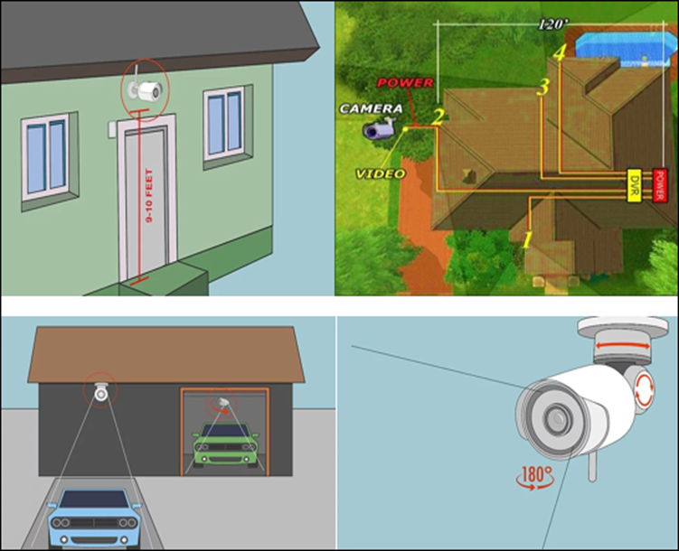
Module Title: Develop Basic Integrated Security System
Module code: EIS EEES3 M01 0322
Nominal duration: 120 Hour
Prepared by: Ministry of Labor and Skill

October, 2023
Addis Ababa, Ethiopia

Table of Contents
ACKNOWLEDGMENT 4
Acronym 5
Introduction to the Module 6
1 Unit One: Basic concepts of CCTV surveillance systems 7
1.1 Basic concept of surveillance system 8
1.2 Classification of surveillance systems 11
1.3 Components of CCTV Camera system 17
Self-check 1 39
2 Unit Two: Understanding Customer Requirement 41
2.1 Plan Work and system arrangements 42
2.2 Check and document plan 52
2.3 Understand Requirements 54
2.4 Apply Simple cost analysis 56
2.5 Total Cost Approach: 57
Self-Check 59
Operation sheet #1 60
LAP Test # 1 60
3 Unit Three: Preparation Of Cable Terminal 61
3.1 Network and data Cable Specifications 62
3.2 Preparing Cable ends 65
3.3 Cable Crimping and Testing Tools 66
3.4 Crimping Twisted-Pair Cable 67
3.5 Preparation of electric power source 71
Materials needed power source CCTV surveillance 71
Self-Check-1 75
Operation sheet #1 76
LAP Test # 78
4 Unit Four: Assemble and Install Wired and Wireless CCTV Camera System 79
4.1 Interpreting wiring diagram 80
4.2 Types of Drawings 80
4.3 Positioning CCTV surveillance devices 82
4.4 Dome Setups and Cable Connection 88
4.5 CCTV Installation 97
Self-check 100
Operation sheet #1 101
LAP Test # 15 102
Operation sheet #2 102
LAP Test # 2 104
UNIT FIVE: Setup, Configure and Basic Maintentenace of CCTV System 105
TRAINING OUTCOME 105
5.1 Setting and configuring CCTV surveillance system 106
5.2 Types of computers based on their uses 106
5.3 Setting up CCTV camera 110
5.4 Controls of different options in camera 118
5.5 Accessing from Back-end Software 119
5.6 Basic maintenance of CCTV camera: 123
5.7 CCTV Preventative Maintenance procedures 126
Self-check1 127
Operation sheet #1 128
LAP Test # 1 129
Operation sheet #2 130
LAP Test # 2 130
Reference 131
Developers Profile 132

ACKNOWLEDGMENT
The Ministry of Labor and skill, to Prosperity wish to thank MoLS experts, regional labor and skill bureaus, TVT trainers, university lecturers and industry experts who contribute their time and professional experience to the development of this Training module for Develop Basic Integrated Security System lV
We would like to express our appreciation to the Ministry of Labor and skill to Prosperity Ethiopia for their technical and financial support and workshop facilitation of this training module development.

Acronym
CCTV | Closed Circuit Television
RVRC | Remote Video Response Centre
PC | Personal Computer
HDMI | High-Definition Multimedia Interface
CRT | Cathode Ray Tube
HD | High definition
IP | Internet protocol
IR | Infrared
LED | Light emitting Diode
DVR | Digital Video Recorder
VCR | Video Cassette Recorders
LCD | Liquid crystal display
OLED | Organic Light-Emitting Diode
TB | Terabyte.
DVD - | Digital optical disc
DVD-RW | Read and Write Digital optical disc
RAID | Redundant Array of Independent Disks
NVR | Network Video Recorder
DVD-R | Read only Digital optical disc
TV | Television
EMI | Electromagnetic Interference

Introduction to the Module
The knowledge of Basic CCTV system may act as a general deterrent to crime, unless it is being observed continuously, it is only able to provide recorded evidence of events discovered or suspected after they have actually occurred. If a CCTV system is to play an effective role in security, it is usually necessary for the system to be activated by some form of alarm detector, which then initiates the live transmission of images to an occupied monitoring post, e.g. a security lodge/gatehouse or a Remote Video Response Centre (RVRC). Such monitoring allows security operatives to view events as they unfold and actively arrange an appropriate response. We will explore the importance of this specialized area, the skills required, and the significance of installing, maintaining and repairing Basic Integrated Security System to ensure their optimal performance.
Develop Basic Integrated Security System.
This module covers the units:
- Basic concepts of CCTV surveillance systems
- Customer Requirement
- Preparation of cable terminal
- Assemble and Install wired and wireless CCTV Camera system
- Setup, configure and basic maintenance of CCTV System
Learning Objective of the Module
- Understand Basic concepts of surveillance system
- Understand Customer Requirement
- Prepare cable terminal
- Assemble and Install CCTV Camera system
- Setup, configure and maintain CCTV System
Module Learning Instructions:
- Read the specific objectives of this Learning Guide.
- Read the information written in the information Sheets
- Accomplish the Self-checks
- Perform Operation Sheets
- Do the “LAP test”

Unit One: Basic concepts of CCTV surveillance systems
This learning guide is developed to provide you the necessary information regarding the following content coverage and topics.
  - Basic concepts of surveillance system
  - Classification of surveillance systems
  - Components of CCTV Camera system
  - OHS procedures and WHS risk control measures
  - Tools, equipment and testing devices
This guide will also assist you to attain the learning outcomes stated in the cover page. Specifically, upon completion of this learning guide, you will be able to:
  - Understand Basic concepts of surveillance system
  - Identify Classification of surveillance systems
  - Understand Components of CCTV Camera system
  - Follow OHS procedures and WHS risk control measures
  - Use Tools, equipment and testing devices

Basic concept of surveillance system
Introduction
As part of a consolidated approach to security, CCTV can support other forms of protection such as intruder alarm systems. It can be an effective and versatile tool to help combat criminal activity and anti-social behavior, achieving this by a combination of:
• Deterrence
• Detection/response
• Provision of evidence
The first CCTV systems were relatively expensive to install and maintain and, as a result, they were restricted in use, such as in town centers, shopping malls and large industrial or military sites. However, technological developments and reducing costs, coupled with greater versatility and reliability have led to such systems now becoming commonly used in all types of premises.
CCTV SYSTEM: Closed-circuit television (CCTV) system is the use of video cameras to transmit a signal to specific, limited set of monitors. It differs from broadcast television in that the signal is not openly transmitted, though it may employ point to point wireless links. CCTV is often used for surveillance in area which need security, such as banks, casinos, and airports or military installations.
In simple terms a CCTV system is an electronic system for the capture of images and their transmission to another location for viewing and/or recording. The most basic CCTV system will consist of cameras and a television monitor(s), but now most will also include a recording device, typically a digital recorder, with these devices having largely replaced older, less flexible, video recorders.
Basic CCTV system may act as a general deterrent to crime, unless it is being observed continuously, it is only able to provide recorded evidence of events discovered or suspected after they have actually occurred. If a CCTV system is to play an effective role in security, it is usually necessary for the system to be activated by some form of alarm detector, which then initiates the live transmission of images to an occupied monitoring post, e.g. a security lodge/gatehouse or a Remote Video Response Centre (RVRC). Such monitoring allows security operatives to view events as they unfold and actively arrange an appropriate response.
CCTV CAMERA: A security camera is used in surveillance to monitor public or private areas that need to be monitored for security reasons. Modern security cameras use closed-circuit television (CCTV) technology, which employs video cameras that transmit signals to a specific limited set of monitors.
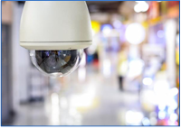
Figure1.1 Security camera
CCTV systems can be -analog or digital, wired or wireless-and their modes of operation vary; however, the basic components are more or less the same: a camera, a lens, a monitor, and (for wired systems) cables that carry the signal from one place to another. Many systems also use video recorders to record the video footage. The camera picks up the signal from the area being monitored via the lens (which determines how far and how much the camera can see, and which is often bought separately) and can be either wired or wireless.
In a wired system, the camera sends the signals through a coaxial cable to the monitor; in wireless systems, no cable is needed, and the camera simply broadcasts the signal straight to the monitor itself. The monitor can be either a simple television set (without tuning capacity) or your PC or laptop. Most wired analog systems use television monitors, while digital and wireless systems tend to use computers as monitors (so you can view the images from anywhere, often via the internet).
For recording purposes, the monitor is accompanied by a video recorder-a VCR for analog systems, or a DVR (digital video recorder) for digital systems. A DVR can actually replace the monitor as the receiving device, since many DVRs are stand-alone units that do everything, a computer would do: receive, record, and store the information for later viewing.
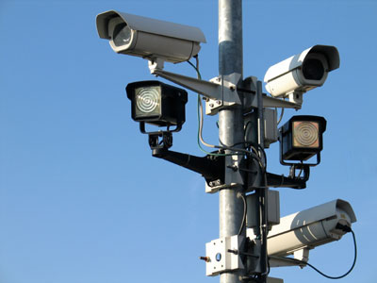
Figure1.2 Security cameras
If you have made the decision to secure your home or business by installing a surveillance system with security cameras, you are making a good decision. However, you might be a bit confused when it comes to purchasing your surveillance system and the accompanying cameras. Many people have a difficult time choosing the right type of cameras for their home or business, and the task can be a bit daunting for those who have never purchased security cameras before. There are several types of security cameras out there for you to choose from, and it is important to choose the right type for your needs. By doing a bit of research and choosing the right security camera, you can save money by purchasing only what you need, and you can also feel assured that you are getting the maximum security and protection out of your surveillance system.
Wired vs. Wireless: Security cameras come in either wired or wireless models. Wired cameras are the most cost effective and also offer the best, most reliable video quality, because there is never a problem with signal interference. Wireless cameras are easier to install, making them ideal for residential use, but they're more expensive and require some form of local power supply at the camera location.
Among the many different security cameras that are out there, you should have the option between wireless and wired options. Just because you choose a wireless or wired camera does not mean that you are restricting your other options: Security cameras of all types should come with the option between the two.
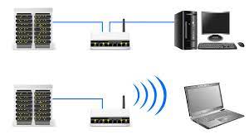
Figure1.3 Wired and Wireless cameras
Many people feel comfortable with wired security cameras because they are what most people the most familiar are with. In the past, there was no option to purchase wireless security cameras. There are plenty of top-of-the-line wired security cameras out there that offer plenty of features and a high picture quality, but there are some disadvantages that go along with choosing these cameras.

Classification of surveillance systems
CCTV security cameras, otherwise known as closed-circuit television, are a system ofvideofeedswithinaclosedsystemavailableonlytoauthorizedusers.Sincetheirorigininthemid-20thcentury,CCTVcamerashaveevolvedtoofferhighframerates,allowinga user to follow the movement of someone on camera. Additionally, high resolutionallows for full-color feeds and incredibly detailed pictures as well as night visioncapabilities.
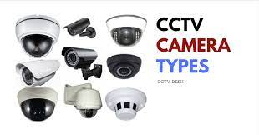
Figure1.4 classification of surveillance systems

Types of CCTV cameras
CCTV cameras are being installed everywhere for purpose security and crime prevention and detection. There are many types of CCTV cameras are available for this purpose. These are:
- Indoor camera
- Outdoor camera
- Bullet camera
- IR day/Night Camera
- Hidden camera
- Dome camera
- Pan/Tilt Zoom camera
There is a wide variety of security cameras, and each one serves a different purpose. From fixed cameras to pan and tilt cameras, night vision cameras to motion detection cameras, there are security cameras for nearly every scenario. Many security cameras will have compound features, for example: “outdoor, night vision, pan and tilt cameras” or “fixed, dome IP cameras.”
Indoor camera
Indoor camera as its name suggests used for indoor security mechanism. These are suitable for security in home, schools, offices, hotels, etc.
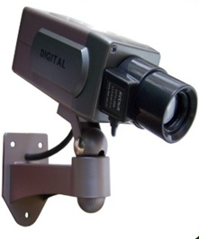
Figure1.5 Indoor camera
Outdoor camera
Outdoor camera is used for outdoor places. They are mostly used for entry and exit points with limited night lighting. These cameras have hard shell vandal-proof casings.
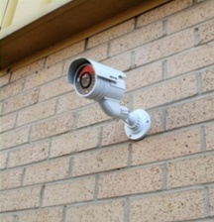
Figure1.7 Outdoor camera
IR Day/Night cameras
IR Day/Night cameras are used for high alert security areas where surveillance needs to happen day and Night. These cameras are used by military personals, in parking lots and high security zones. One exciting type of technology that has hit the security camera market in recent years is a camera that can capture footage both during the daytime and at night. These cameras capture clear footage during the day, just as a regular daytime camera would, but they have technology that allows them to switch over to using infrared technology when lighting conditions become too dark.
Benefits of day/night cameras include:
- Recording both color and black & white.
- Wide variety of sizes available
- Infrared capability
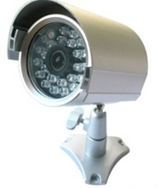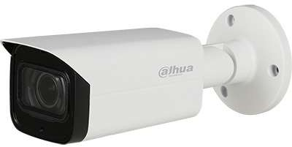
Figure 1 Night cameras

Dome cameras: are great for those who are looking to secure a large area, such as a large retail store or other business. Because people cannot see inside the dome that houses the camera, it is difficult for them to realize which direction the camera is pointing and filming at. Therefore, those who use dome cameras can sometimes deter crime without having to purchase enough cameras to adequately record everything that happens in their business. For those who utilize security cameras for home use, however, dome cameras might not be the best solution.
Dome cameras are installed inside a dark dome and are designed in a way that they go unnoticed by visitors. These cameras can be rotated and tilted manually. Dome cameras are used in public places like railway stations, bus terminals, and others areas where there is a huge gathering of people.
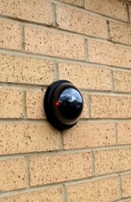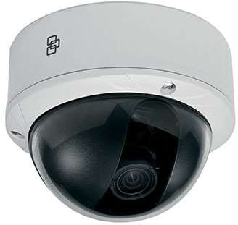
Figure1.8 Dome cameras
Bullet cameras: are the more traditional style of camera that you probably think of when you think about security cameras. These cameras look like cameras and mount on the wall or ceiling, and it is easy to tell where the camera is pointing and what it is recording. Dome cameras are typically general-purpose cameras, and they can be used for indoor or outdoor use in both homes and businesses.
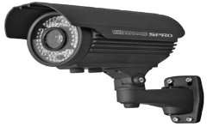
Figure1.9 Bullet cameras

Built cameras are placed inside bullet shaped housing, and they are used in residential places as well as commercial places. They are small in size, have an integrated design

Hidden camera: are compact in size and are used for secret monitoring. They are usually installed in public places like department stores, theatres, clubs, etc. Hidden cameras have a built-in recorder that records and broadcast simultaneously.
Hidden cameras are great for those who are looking for a reliable nanny cam. With a hidden nanny cam, you can keep an eye on your babysitter or nanny to make sure that he or she is doing his or her job, and you can watch out for any suspicious behavior.
Although most traditional hidden cameras look like cameras but are simply smaller and easier to hide, there are plenty of even more discreet cameras out there for you to choose from. You can even purchase alarm clocks, ink pens and other items that are fully functional yet that work as hidden security cameras.

Figure1.10 Hidden camera
Pan-tilt-zoom camera: offers the ability to view and zoom in all directions. We can even set the camera to automatically rotate to different field of vision.
Benefits ofPTZ camerasinclude:
      - 200m IRnightvision
      - X36optical zoom
      - High-qualityimage resolution
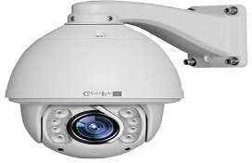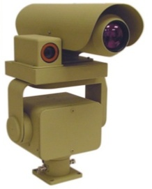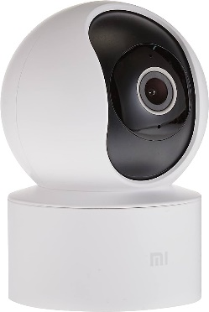
Figure1.11PTZ Cameras
Infrared Cameras: Oneofthebest24-hoursurveillancecamerasaroundprovidingairports,seaports,boardsand many other critical infrastructures with quality images, no matter what time of dayit is. Infrared cameras have small LEDs surrounding the lens to help pick up movingfigures in pitch black. Thermal image cameras can see over long distances, up to 300metersaway.
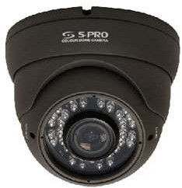
Figure1.12 Infrared Cameras
Benefitsofinfrared cameras include:
      - Detect intruders up250-300 meters away
      - Good in low-light
      - Thermal radiation passes through visual barriers
Thermal cameras: also known as infrared or night vision cameras, use heat signatures to detect objects in their field of view. They are capable of capturing images in complete darkness or adverse weather conditions, making them suitable for night surveillance, perimeter security, and search and rescue operations. Thermal cameras operate without relying on visible light, detecting heat patterns emitted by living beings, objects, or heat sources.
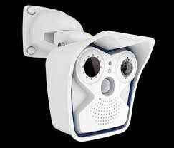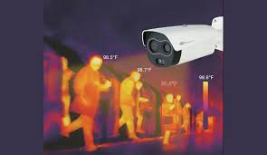
Figure1.13Thermal cameras
IP/Network Security Camera
IP or network security cameras can come in many different forms, and they allow you to view your surveillance footage from your personal computer or other device from anywhere around the world. You have to be careful with security on your network if you use this type of camera, however, because an experienced hacker could figure out how to stream your surveillance footage if you aren’t careful. By taking precautions and protecting your network with a strong password, you can help to eliminate this concern.
There are several reasons why you might want to consider an IP or network security camera. If you do not want to purchase a standalone digital video recorder in order to record, store and watch your surveillance footage, you can instead choose to purchase IP or network security cameras that will allow you to watch your footage from your personal computer. This can save you a bit of money in some cases, and it will still allow you to keep your home or business under surveillance.
You do want to make sure that your computer has plenty of hard drive space, however, and you will also want to make sure that your components are strong enough that you can use your computer as a part of your security system.
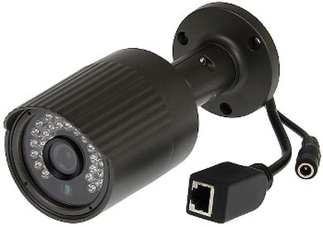
Figure1.14 IP or network security cameras
Many people also like to use IP or network cameras because it allows them to feel peace of mind. For instance, a parent who leaves his or her child at home alone in the afternoons might be a bit concerned about doing so. By using indoor security cameras and having the ability to stream the footage onto their office computers, however, these parents can feel more comfortable about the safety of their children.
If you travel or stay away from home often, you may also like the idea of being able to keep an eye on your home when you are away. If you have IP or network cameras installed, you can check on your home any time that you want to, as long as you have a laptop or device and an Internet connection around.
Business owners may also want to consider installing IP or network cameras instead of more traditional cameras. Many business owners have a difficult time relaxing when they go home, especially if their businesses are still open, but you can check on how things are going at your business any time that you want to if you use IP or network cameras. You can also check on things while you are away on business or when you cannot physically get to your business for one reason or another.

Components of CCTV Camera system
Types of CCTV cameras in the market
CCTV systems use various camera types, including bullet, pan-tilt-zoom, dome, and professional models, with lens and sensor components determining capabilities, positioning, and image transmission. There are different variables to justify local CCTV Cameras for Example:-

Based on Lens / aperture
Lens and camera sensor are essential components for focusing images, determining field of view and aperture, which control light entry. Aperture sensitivity and depth of field can be adjusted.
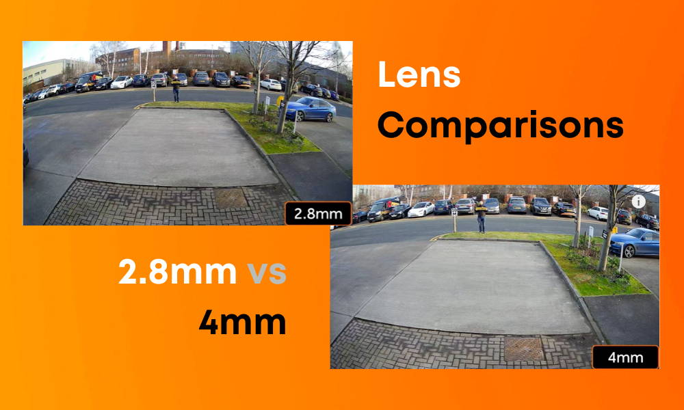
Figure1.15 Lens / aperture
Based on Shutter
The lens and camera sensor are essential components in a camera system. The lens and sensor determine the field of view, which ranges from wide angle to telephoto. The aperture controls light entering the sensor, and as the aperture widens, the depth of field decreases. Electronic shutters limit sensor charge build-up, while limiting shutter speeds based on frame rate and available light. Adjusting ambient light levels is necessary if the required combination is not achievable.
Based on Sensor
The sensor is the device that actually ‘records’ the scene view, with current cameras having either CCD (charge coupled device) or CMOS (complementary metal-oxide-semiconductor) sensors. Sensors have both different sizes, which can change the field of view, and different pixel densities which affect the resolution.
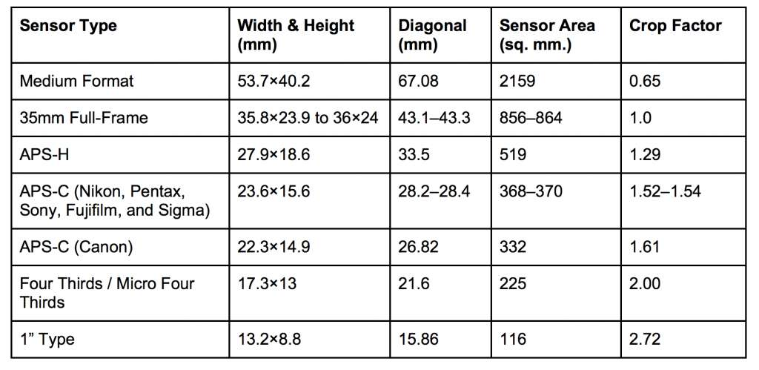
Figure1.16 Camera sensors
Based on Field of View (FOV)
FOV refers to camera's angle of view, influenced by lens, sensor, and position, resulting in smaller target objects.
Acamerawithalargesensorelementof2/3”andawide-anglelensof5mm positioned6metershighonthesideofabuildingwillprovidea largefield ofview. By contrast acamerawith asmall sensor element of1/3”andatelephotolensof50mmpositioned2metershighonaninteriorwallwouldprovideaverysmallfieldofview.
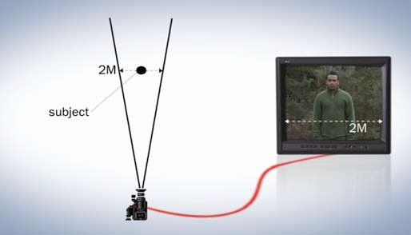
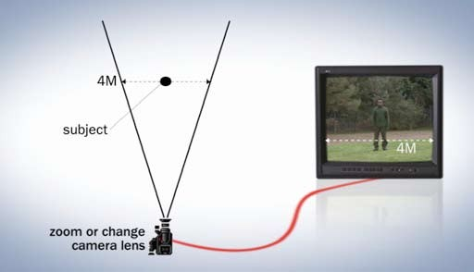
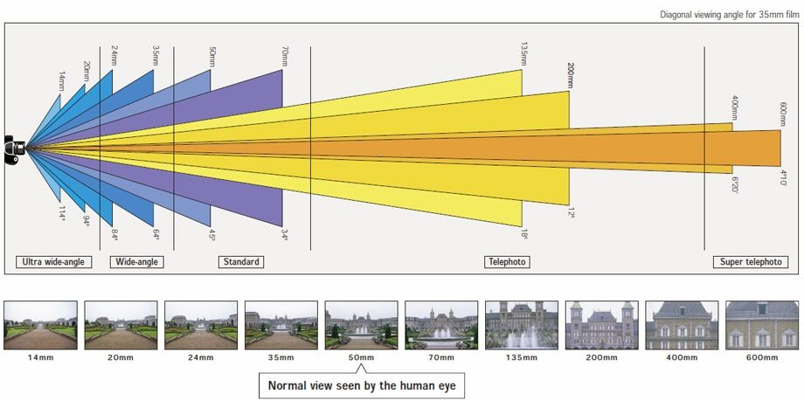
Figure1.17 Effect on FoV of varying lenses with a constant distance
Determine area of interest, activity, observation criteria, target speed, and FoV; estimate using CCTV Lens Calculator for accuracy.Subject size, distance from camera determine sensor element and lens combination, affecting image width and vertical percentage.
For example: -
Subject Height |  | 100% | 50% | 25% | 10%
Image Width |  | 2.2m | 4.5m | 9m | 22m
Sensor element | Lens (mm) | Subject Distance (m)
1/3" | 50 | 26 | 50 | 105 | 250
1/3" | 25 | 13 | 26 | 52 | 120
1/3" | 12.5 | 6.5 | 13 | 26 | 60
1/3" | 8.5 | 4.4 | 8.6 | 17.5 | 41
1/3" | 3.5 | 1.8 | 3.6 | 7.2 | 17
1/2" | 50 | 18 | 36 | 72 | 175
1/2" | 25 | 9 | 18 | 36 | 85
1/2" | 12.5 | 4.6 | 9 | 18 | 43
1/2" | 8.5 | 3.2 | 6.2 | 14 | 29
1/2" | 3.5 | 1.3 | 2.6 | 5 | 12
2/3" | 50 | 13 | 26 | 51 | 120
2/3" | 25 | 6.5 | 13 | 26 | 60
2/3" | 12.5 | 3.2 | 6.5 | 13 | 30
2/3" | 8.5 | 2.2 | 4.4 | 8.6 | 20
2/3" | 3.5 | 0.85 | 1.8 | 3.6 | 8.5
Table: The subject distance required to achieve specified subject heights for different combinations of sensor size and lens focal length
Based on Pan-Tilt-Zoom Cameras
As an alternative (or as a supplement) to using fixed-view cameras it may be beneficial to use a camera with a pan-tilt-zoom (PTZ) capability. This gives the operator the ability to cover a wide area but also zoom in to focus on an incident wherever it occurs within the original field of view, providing greater detail and assisting with identification of the subject. It can also be used to pan across a scene to track a target. PTZ cameras are often used as a backup or in addition to cameras with fixed Fo Vs. However, PTZs can be deployed unmanned with fixed ‘security patrols’ or with preset triggered sequences, for example being programmed to zoom into a car number plate and person operating a petrol pump, triggered when the nozzle is removed from its stand. Disadvantages of PTZ cameras are their cost compared with a fixed camera, plus the additional work usually placed on the control room operator. It should also be remembered that they usually only cover a small area at a time.
Based on Infra-Red Sensitivity
In low light conditions, an infrared sensitivity camera may be necessary for nighttime or poorly lit areas. It produces black and white images, but may have poor color rendition. Increase ambient light levels for better results.

Figure1.18The effect of infra-red illumination on the reproduction of skin tone and scaring
Based on On-board Image Processing
A camera often has a variety of automated features built in that are intended to enhance the output picture quality. These often have a beneficial impact, but occasionally the placement or configuration of the camera may be such that the automated camera processing is harmful, lowering the camera's efficacy.
Based on Automatic gain control (AGC)
Automatic gain control is an electronic modifier that adjusts imaging chip sensitivity for good exposure across ambient light levels, allowing scene brightness adjustment without changing iris aperture. However, it can be slow and introduce noise, making it difficult to discern fine detail.
Based on White balance and color
Humans automatically color correct objects, causing cameras to mimic whiteness by assuming brightest part is white and setting preset white balances.
Based on Image resolution at the camera
Cameras have various TVL resolutions, with current ranges between 300-700, with higher resolutions available.
There are several points to be borne in mind when considering the necessary camera resolution:
- If the camera hasn’t captured the data or the compression scheme has discarded it, it cannot be replaced.
- There is no point in capturing data at a significantly higher resolution than your recording and display system can cope with.
- Factors such as sensor array type and size, presence and type of anti- aliasing filter, etc. may have a serious impact on perceived sharpness regardless of actual pixel count.
- High resolution cameras can require proportionally brighter light sources.
IP cameras in Local market
Cameras come in various resolutions, typically measured in TVLs. Digital cameras, often rated by tIP, collect image information and encode and transmit pictures digitally across networks. They offer advantages over analogue cameras, such as remote viewing and higher quality images. IP cameras can generate large volumes of data, allowing for compression adjustments before transmission. However, this function should be used with care and optimized for the available transmission bandwidth.
There is a limit to the maximum data output rate due to processing required within the camera. As the camera's resolution increases, the maximum frame rate decreases. Additionally, the IP transmission network has a finite bandwidth available, constrained by factors like frame resolution, frame rate, and compression level. Adjusting data compression on the camera is necessary to stay within the available bandwidth while maintaining video quality. Currently, cameras have a TVL rating between 300 and 700, with higher resolution cameras becoming more available.
Based on Transmission
The technology used for transmitting video signals in CCTV systems has evolved from traditional analogue coaxial cables to IP-based transmissions. This robust and manageable method is growing in use and often leads to new solutions. The specifier must consider the physical and financial constraints of the system, such as greenfield build or retrofit, and the level of link security demanded by the application or surveillance object. Analogue and digital video signals are introduced, along with wired and wireless transmission options.
Based on Video signal type
The technology used for transmitting video signals in CCTV systems has evolved significantly, with the development of IP cameras. Analogue transmission offers a simple, mono-directional, broadcasted approach, while digital video streams can be digitized and transmitted over a digital link. The focus should be on timely and accurate delivery of information, using networking processes like QoS parameters and compression techniques. Digital video can also be treated as a data file, with inbuilt mechanisms to detect errors and request damaged or missing packets to be re-sent. Transmission options include IP cameras, aed transmission, and wired and wireless transmission options. It is crucial for specifiers to consider both physical and financial constraints when choosing a transmission method.
Wired transmission: An analogue wired connection is typically coaxial, with RG59 being the standard for up to 200 meters. Twisted pair cables, like Cat-5 and Cat-6, are used for both analogue and digital transmission. Wired digital systems have various standard speeds, including 10BASE-T, 100BASE-T, and Gigabit Ethernet. The actual speed achieved depends on factors like transmitting device output rate and network infrastructure.
Wireless transmission: This has been a significant growth area, and most CCTV system suppliers offer some form of wireless transmission link, either analogue or digital. On a small scale, wireless links that are designed to link a single video channel to the CCTV system are becoming more common in the marketplace. These range in complexity from an insecure short hop analogue radio frequency link to remote access over the mobile phone transmission network.
Link Type | Transmission  Distance | Transmission  Frequencies | Link  Bandwidth | Comments
Analogue RF | ~30 m indoors  ~100 m +  Outdoors  (Non Line of Sight. Line of Sight can be  significantly greater) | 2.4 GHz / 5 GHz (Unlicensed bands) Other frequencies can be used depending on spectral allocation and  licensing details. | Dependent on installation specifics | Simple operation described here. More complex solutions can be offered.
‘Wifi’  (IEEE 802.11) | ~30 m indoors  ~100 m Outdoors (Non Line of Sight) | 2.4 GHz / 5 GHz (Unlicensed bands) | Up to  74 MBits/s (802.11n)  Up to  19 MBits/s (802.11g) | Generally not suitable for long range transmission. Range and throughput is heavily dependant on signal power at  receiver.
Mobile WiMax (IEEE 802.16e) | Up to 50 km (Line of sight) | Depends on installation. Configurable to both open and licensed frequencies | Up to  70 MBit/s | System either delivers long transmission distance or high transfer rate, not both. Developing technology
2G GSM  (Global System for Mobile Communications) | National/International assuming system is within cell coverage (Inner City ~1/2 mile from cell site  Rural ~ 5 miles from cell site) | ~800-950 MHz or  ~1.9 to ~2.2 GHz (Limited to cellular phone licensed bands) | 14.4 kBit/s | More suited to speech and very low bit rate video or stills transmission. Requires a cellular service provider. Performance is dependant on carrier load, atmospherics and  infrastructure provision.
3G HSDPA  (High speed downlink packet access) | National/International assuming system is within cell coverage (Inner City ~1/2 mile from cell site  Rural ~ 5 miles from  cell site) | ~1.9 to ~2.2 GHz (Limited to cellular phone licensed bands) | Currently up to  14.4 MBit/s  Developments in technology will increase  throughput | Requires a cellular service provider. Performance is dependant on carrier load and atmospherics and infrastructure  provision.

Table: Wireless transmission options
Based on Display type: Displays come in two forms: CRT (Cathode Ray Tube) and modern flat panel displays, which can be LCD or plasma. CRTs offer superior image quality but have bulk, weight, and heat generation. New flat panel technologies improve viewing angle and size.

Type | Pros | Cons
CRT | Best attainable picture quality Robust technology  Much equipment was designed for reproduction on a CRT  Low cost | High power consumption High heat generation High space requirements  Manufacture largely discontinued
LCD | Compact and light  Low power consumption  Wide range of screen sizes available  High resolution Low black level  Low cost | Poor movement reproduction Possibly restricted viewing angle Lower image contrast
Plasma | Slim design, wall mountable High resolution  Larger maximum size than LCD Wider viewing angles than LCD | Fragile  High power consumption High heat generation High black level  Expensive
Table : Summary of display technologies
Size: Large size and high resolution flat panel displays can be effective as matrix displays for multiple cameras. High screen resolution will not improve the capture resolution.
Heat: The amount of heat a unit generates becomes significant as the size of the facility increases and can affect not only operator comfort but also machine efficiency.
Color: Modern displays of all types have similar quality colour reproduction.
Black level: The ‘black level’ of a screen refers to how well the screen performs in a well it environment. The lower the black level the better the screen works in higher brightness environments.
Burn in: Most screens can suffer from ‘burn in’ or image burn, where, if the same background is displayed continuously for a long period, this can leave a permanent mark on the screen. Plasma and CRT screens are particularly susceptible to this.

Based on mage Quality: To optimize image quality for monitoring activities, consider four areas: clarity, detail, color, and artefacts. Ensure lens quality, detail, lighting, and obtrusive elements are present, and adjust compression or camera placement accordingly.
Based on Recording: monitoring, with image quality being a secondary consideration. Correct configuration can be costly, especially if images are required as evidence in court. Analog systems use standard VHS recorders, with tapes changing daily. Digital recorders store video on hard drives, but may not store images as high as live view.
Consider the following when deciding on how best to record and save your video:
    - How many days’ worth of video do you need to retain?
    - What image quality do you require from your recorded video?
    - How many frames per second do you require?
Increase retention time in CCTV recorders may reduce image quality due to compression, but lower-priced hard drives improve system performance.
Based on storage Capacity: Estimate digital CCTV storage requirement before installation to ensure adequate capacity, ensuring image quality and retention time.

Variable | Frame Size | Frames Per Second | Number of Cameras | Operational Hours | Retention Period
Typical Range | 5kB – 50kB | 1 – 25 | 1 – 16+ | 1 – 24 | 24 Hours –  31 Days
Table: Factors affecting the storage capacity required for a CCTV recorder
Components of CCTV System
CCTV uses components that are directly connected to generate, transmit, display, and store video data. A CCTV system can be as simple as a camera purchased from a retail electronics store connected to a video monitor. However, larger systems operated by professional security personnel are comprised of a number of components falling into several basic categories:
- Cameras
- Lenses
- Housings and mounts
- Monitors
- Switchers and multiplexers and
- Video recorders
Many features exist within each of these categories that can satisfy an agency’s operational requirements in the most challenging environments. The most complex CCTV systems may incorporate hundreds of cameras and sensors integrated into one overall security network.
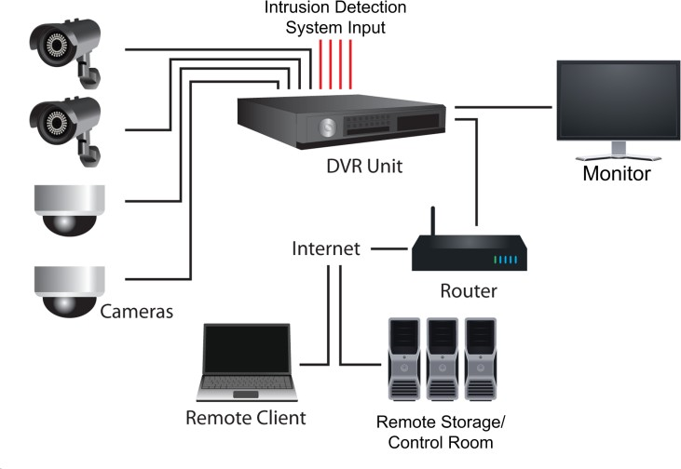
Figure1.19 CCTV Components
Most new CCTV systems maximize the advantages of digital technologies by utilizing electronic databases, compact components, and wireless transmission techniques. With larger quantities of data being collected, it is essential that the system be capable of retaining data in accordance with the organization’s policies and procedures.
- Cameras
Cameras are an essential component of any CCTV system. Matching the right CCTV camera to a particular application is increasingly complex due to rapid technological developments and a greater range of applications. A system’s performance is affected by many factors beyond those listed in the vendor data sheets. Effective camera selection requires detailed knowledge of the camera, application, supporting architecture, and host environment.
All CCTV cameras include three basic elements:
- Image sensor–Converts light (photons) into electronic signals;
- Lens–Gathers light reflected from a subject and focuses the light on the image sensor; and
- Image processing circuitry–Organizes, optimizes, and transmits video signals.
Image Sensors: CCTV cameras commonly use charge-coupled device (CCD) or complementary metal oxide semiconductor (CMOS) image sensor technology. The smallest part of an image produced on a solid-state chip is the picture element, or pixel. Regardless of the sensor type, pixels are engineered in number, size, and filtration to provide different resolutions, light sensitivity, and spectral responses.
Lenses: The lens on a CCTV camera is the first element in the imaging chain, which consists of the lens, camera, transmission system, image management and analysis software, and monitor. The lens focuses light or IR energy onto the imaging sensor. A lens’s role is to deliver an undistorted, evenly focused, accurate image to the imaging sensor. Systems that require superior quality images start with lenses engineered to produce a high-quality image for the imaging sensor. Other components of the imaging chain cannot compensate for an inferior lens.

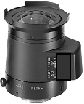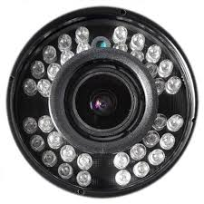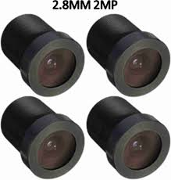
Figure1.20CCTV lens
Types of Lenses
- Fixed Focal Length Lenses
- Varifocal Lenses
- Zoom Lenses
- Housing and Mounts
Part of designing and installing an effective CCTV system includes selection of the camera housings and mounts. Selecting CCTV housing and mounting hardware is directly related to the operational system requirements, which are developed during the design and procurement phases of a CCTV installation project. In any application, the housing and mounting hardware is selected on the basis of several criteria:
- Environmental conditions, which include operating temperatures and weather conditions, such as humidity and corrosion;
- Architectural considerations, which are important to the aesthetics of the hardware and can affect the architectural design or change the value of the property; and
- Installation and other special considerations that match the installed materials to the system’s intended use and planned maintenance.
The following hardware and mounting options are briefly described for comparison with system requirements.
- Camera Housing
Fixed or PTZ cameras may require special housings or enclosures to ensure cameras are protected from elements such as extreme weather conditions and vandalism. Camera housings must be well-suited to the type of equipment installed. The housing will need to complement the CCTV system design and must not interfere with the desired FOV.
Dome Enclosures: Indoor and outdoor domes are enclosures that protect CCTV equipment, often PTZ cameras, from the elements and provide discrete video surveillance by helping to conceal the direction the camera is facing.
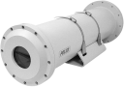
Sealed Housings: Special housings are available for cameras that must be placed in a hostile environment, or in areas where electrical components must be sealed to prevent a possible explosion.

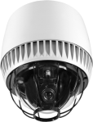
Impact-Resistant Housings–Impact-resistant, or anti-vandal, housings are often used in high crime areas or as components of military sensor systems.
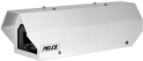
Tamper-Resistant Housings–Tamper-resistant housings are hardened protective housings similar to impact-resistant housings. It is lockable and designed to withstand cutting, hammering, or prying
Housing Features
- Sun Shields
- Wipers
- Heaters and Ventilators
- Indoor Camera Mounts
Indoor Dome Camera Mounts–Dome mounts are sometimes mounted in highly visible areas. Domes can be partially recessed into a ceiling or mounted flush to a surface.
Wall Mounts–Wall mounts use a bracket to support the camera similar to a shelf’s bracket. This mount often provides a method for adjusting the camera’s view or aim.
Pendant Mounts–Pendant mounts can be used to suspend the camera or equipment from a ceiling.
Corner Mounts–are used to attach a camera at a location where two walls meet at a right angle.
- Video Monitors
The function of monitors is to display video images for viewing. The selection of monitors is as important to the quality of the image as the selection of cameras, lenses, and other components in the imaging chain.
Televisions–HDTVs can be used to view video in certain circumstances such as viewing video for investigation purposes from a secured office. Televisions can also offer a cost-effective alternative for dual purpose monitoring of both internal CCTV feeds and network broadcasts. However, televisions do not have the same durability as monitors; therefore, it is not an advisable choice for 24-hour monitoring requirements.
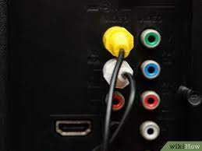
Figure1.21 High-definition television
PC Monitors–DVRs can be connected to a PC monitor. Inputs and outputs between these devices need to be matched using standard connectors, adapters, or converters.
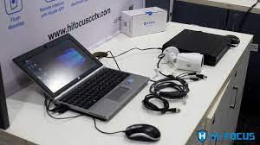
Figure1.22 PC Monitors
Monochrome Monitors–Due to the differences in technologies, monochrome monitors have a greater potential to display detail than color monitors. Although the difference in resolution of color and monochrome monitors is narrowing, the potential loss of visual detail with a color monitor must be weighed against the cost and benefits of its display. Either type of monitor can display both monochrome and color video signals.
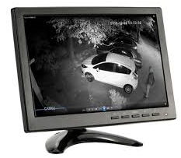
Figure1.23 Monochrome Monitors
CCTV Monitors–Monitors designed for CCTV systems are preferred if the system will include multiple monitors and cameras, or if the monitor is always on. Monitor technologies include cathode ray tube (CRT), LCD, organic light-emitting diode (OLED), and plasma
CRT Monitors–The CRT analog monitor is a legacy CCTV monitoring technology. CRT monitors are available in a variety of sizes. CRT monitors should include electromagnetic interference (EMI) protection. EMI can distort the path of the electron beams and reduce the quality of the image. Since CRT monitors are bulky, they are no longer used in handheld viewing devices and are seldom used in other configurations of portable equipment.
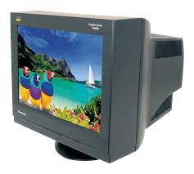
Figure1.24 CRT Monitors
LCD Monitors–LCD monitors are available in many shapes, sizes, and CRT Monitor resolutions. They provide a sharper, brighter picture than CRT monitors because they can process CCTV signals at a higher resolution.
LCD monitors are much thinner front-to-back than CRT monitors of similar screen size so they take up less space and they generate less heat. Many are small and compact enough to be portable. They are also available in large sizes for multiple camera viewing.
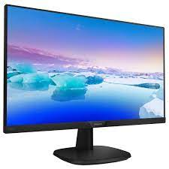
Figure1.25 LCD Monitors
OLED Monitors–LED/OLED monitors use OLEDs, which emit light directly without the need for a backlight. This means that each diode can be turned on and off depending on what needs to be displayed on the monitor screen, unlike LCD displays, which require the backlight source.

Type | Pros | Cons*
CRT | - Good overall picture quality  - Robust technology  - Low-cost option that is compatible with most existing CCTV equipment | - High power consumption  - High heat generation  - High space requirements  - Manufacturers have largely discontinued  - Burn-in tendency (when consistent image is permanently etched onto screen)
LCD | - Compact and relatively light  - Low power consumption and electromagnetic radiation  - Wide range of screen sizes available  - No flicker  - Less burn-in. Long life expectancy (up to 50,000 hrs.’) | - Limitations reproducing true black colors  - Restricted viewing angle  - Low image contrast  - Time lag of pixels can lead to “smearing” effect
OLED | - Thinner, lightweight, low-power consumption, and better dynamic contrast ratio  - Brighter display and wide color range | - More expensive than other monitor technologies  - Shorter lifespan
Plasma | - Wider viewing angles than LCD  - Higher black levels  - Higher contrast ratio (the difference between the brightest and the darkest part of the image) | - Fragile  - High power consumption  - High heat generation  - Susceptible to burn-in

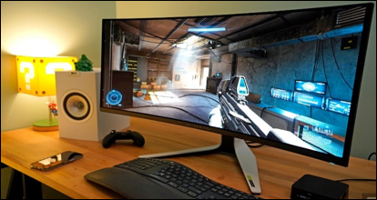
Figure1.26 OLED monitor
Plasma Monitors–Plasma monitors are much like LCD monitors in that they are flat panels and individually control every pixel. A plasma display has a specific gas inside every pixel. The pixel elements illuminate in response to received electrical signals. Plasma monitors are available in many different sizes, although most are manufactured in a wide-screen 16:9 aspect ratio. The main advantage of plasma over LCD monitors is the greater viewing capability from an off-axis angle. Plasma displays are rapidly becoming less popular in CCTV applications due to improvements in LCD display capabilities.
- Pixels
The display resolution of a monitor is expressed by the number of pixels that can be displayed. To ensure the highest quality image, a monitor should be able to show at least as many pixels of information as the cameras are capable of imaging. Image quality depends on specifications and adjustments, usually described as width by height using the number of pixels. For example, an 800 x 600 pixel setting on a 17- to 19-inch monitor will provide a mid-range level of video quality.
A 16:9 aspect ratio (width of 16 units and height of 9) has become a standard high-definition television (HDTV) format for displaying wide screen images on televisions and computer monitors. CCTV systems using digital or IP network components exclusively may benefit from 16:9 monitors.
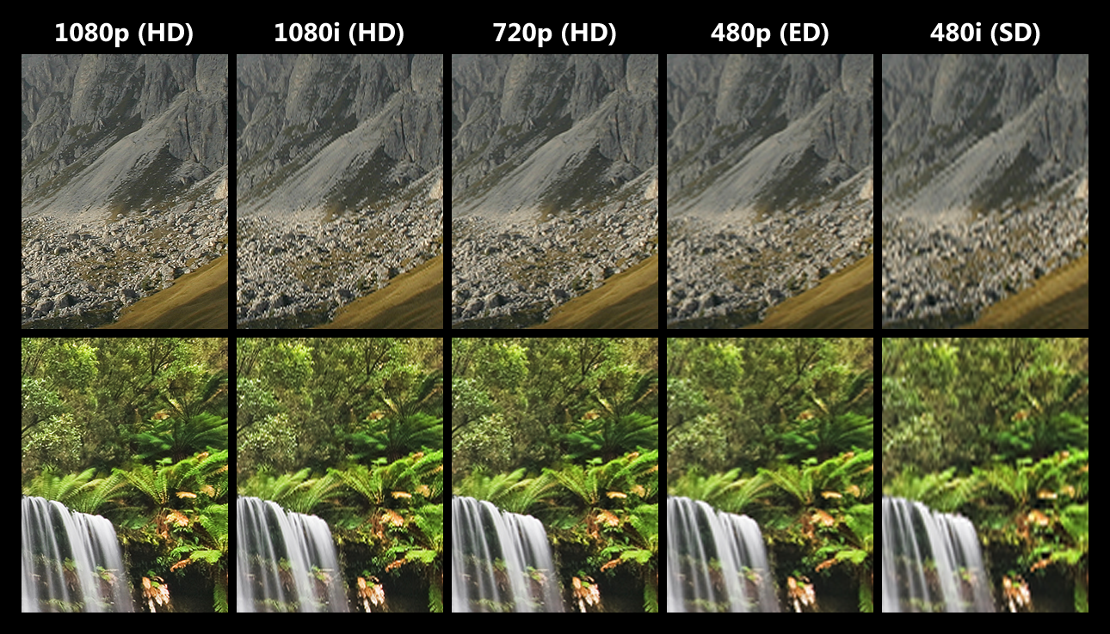
Figure1.27 Pixel per inch comparison
- Multiplexer
Multiplexing began the transition from analog to digital video; these devices receive an analog video signal and then digitize it. Unlike switchers, which do not digitize the video signal, multiplexers often have imbedded software that can perform analytical tasks on the video signal, such as video motion detection. Before transmitting video data to other components, a multiplexer may convert the signal back to analog for display or recording.
A number of multiplexers can be used in networks controlled by computers and servers. This flexibility, when combined with digital storage media, blurs the distinction between multiplexers and DVRs. DVRs not only perform the functions of multiplexers, but also include integral hard drive storage so that prioritized video is recorded as compressed digital data.
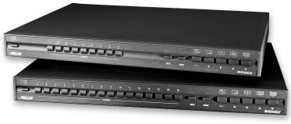

Figure1.28 Multiplexer

- Video Recorders
Recording capability is essential for assessment, investigation, and evidence collection. Video recording has transformed from tape-based systems to digital hard drive systems. While some systems still use tape, the popularity of digital video has driven the demand for recorders with hard drive storage. Traditional analog CCTV systems in which video is recorded to video cassette recorders (VCR) are rare in today’s environment and have rapidly been taken over by DVRs and NVRs on IP networks. Many types of recorders are being used today, but this section will focus on digital recording equipment as well as removable media and some emerging technologies.
Recording units
- DVR (Digital Video Recorder)
- NVR (Network Video Recorder)
- Servers, Cloud Storage
Digital Video Recorders/DVR/
A CCTV system may send digital or analog video to the recording system. A DVR receiving analog video takes two fields of the analog signal and builds one image, which is then digitized and compressed. If the video going to the DVR is digital, it is normally compressed to save storage space. Various data compression methods can be used that offer varying degrees of performance, quality, and storage economy.
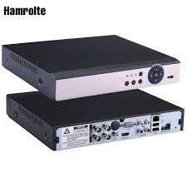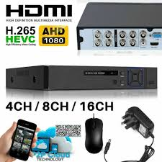
Figure1.29Digital Video Recorders
DVRs can include a variety of features and capabilities such as:
- On-board software, such as video analytics;
- Image protection/authentication techniques;
- Ports for additional recording capabilities;
- Internal hard drive for video storage;
- Ability to easily search for and locate events;
- Ability to record one or more camera inputs while performing video analytics;
- Removable hard drive for archiving purposes; and
- Ability to transfer data to expandable storage systems called Redundant Array of Independent Disks (RAID) to free up recording space.
Other Recording Options
Network Video Recorder–NVRs record digital video data transmitted over an IP network from multiple CCTV digital cameras. NVRs can be configured to record video in a digital format to a disk drive, portable storage device or a mass storage device. NVRs differ from DVRs as video input is delivered from an IP network. With an NVR configuration, video is encoded and processed at the camera and streamed to the NVR for storage or remote viewing. With a DVR configuration, video is encoded and processed at the DVR.
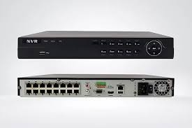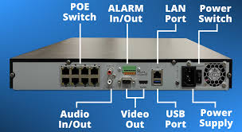
Figure1.30 Network Video Recorder
Hybrid DVR–Hybrid DVRs incorporate functions of both NVRs and DVRs by accepting and converting video images from analog cameras as well as IP video inputs. Hybrid DVRs often have IP connectivity supporting remote viewing capabilities to play back recorded video from across the network. They also allow viewing of live video.
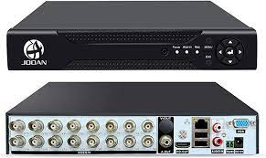
Figure1.31 Hybrid Digital video recorders
Mobile Recorders–Mobile recorders are replacing mobile VCRs in patrol cars and on motorcycles. Mobile recorders have all the features available in a conventional DVR and are less susceptible to dirt. These recorders have become reliable recording platforms due to the advancements in immunity to vibration and motion. Many mobile recorders provide the ability to download recorded data to a memory card.
Some mobile recorders have a removable hard drive for data backup. Some also have wireless inputs and outputs for transmitting the data to a server. Mobile recorders are often coupled with other devices, such as radar guns, where the radar information is overlaid on the video itself.
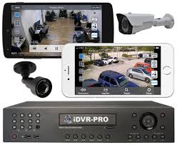
Figure1.32 Mobile Recorders
Portable Storage Devices
DVR’s Can Accommodate Several Types Of Portable Storage Media. Universal Serial Bus (USB) Flash Drives, Memory Sticks, And DVD+R Dual Layer (DL) Are Detailed Below.
USB Flash Drives–USB flash drives allow video to be recorded or transferred. USB flash drives are available in capacities in excess of 128 GB, have a fast transfer speed, and can be programmed with password protection.
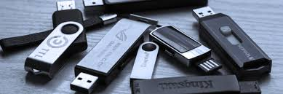
Figure1.33 USB Flash Drives
Memory Sticks–Memory sticks come in a variety of capacities up to 1 terabyte (TB). They have a fast transfer rate allowing video to be transferred to them quickly.
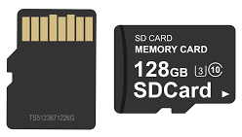
Figure1.34 micro–Solid-state Drive
DVD+R DL–DVD+R DL discs have two storage layers and can hold about 17 GB of data. There are also other DVD media available, including DVD-R, DVD-RW, DVD+R, DVD+RW, and DVD-RAM. These are lower in cost but hold less data (approximately 4.9GBs).
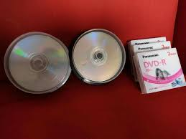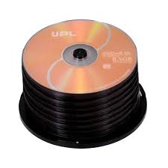
Figure1.35digital optical disc
Cloud data storage
Cloud data storage has become a popular choice for security cameras due to its enhanced security features. By saving surveillance footage directly to the cloud, businesses and homeowners can ensure that their valuable recordings are protected from physical damage or theft. Additionally, cloud storage offers the convenience of remote access, allowing users to view and download footage from anywhere with an internet connection. With the increasing prevalence of security breaches, opting for cloud data saving for security cameras is a smart and secure choice.
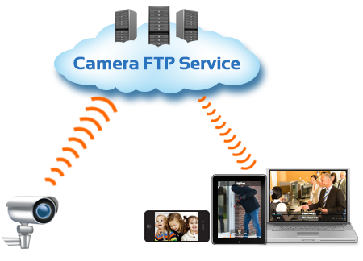
Figure1.36 Cloud data
One of the key advantages of cloud data saving for security cameras is the enhanced security it provides. Unlike local storage options, such as on-site servers or physical hard drives, cloud storage offers advanced encryption and authentication protocols. This ensures that the recorded footage remains secure and protected from unauthorized access. Additionally, reputable cloud storage providers often have multiple data centers located in different geographic regions, further safeguarding against data loss in the event of a natural disaster or physical damage.
Cloud storage also offers the convenience of remote access to surveillance footage. With cloud-based solutions, users can easily access their camera feeds and recorded videos from any device with an internet connection. This allows for real-time monitoring and the ability to quickly review footage in the event of an incident. Furthermore, cloud storage eliminates the need for physical storage devices, reducing the risk of data loss due to hardware failure or damage.
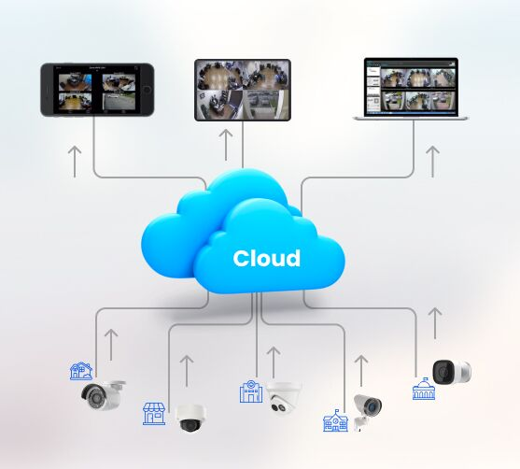
Figure1.37 Cloud Data storage
data saving in clouds for security cameras provides enhanced security and convenience. By storing surveillance footage in the cloud, businesses and homeowners can ensure the protection of their valuable recordings. With advanced encryption and authentication protocols, along with the ability to access footage remotely, cloud storage is a reliable and secure option for safeguarding security camera data.

Self-check 1
- Choose the best answer for the following question
1. Which of the following components is responsible for capturing and converting light into an electrical signal in a CCTV camera system?
- Lens B. Image sensor C. Digital video recorder (DVR) D. Monitor
2. In a CCTV camera system, what does PTZ stand for?
- Pixel Transmission Zone C. Power and Timing Zone
- Pan-Tilt-Zoom D. Public Telecommunications Zone
- Which component is responsible for controlling the movement and positioning of CCTV cameras in a PTZ system?
- Lens B. Image sensor C. DVR D. Joystick controller
- What is the purpose of an infrared cut filter in a CCTV camera system?
- To enhance image resolution
- To filter out infrared light during the day for accurate color reproduction
- To protect the camera from harsh weather conditions
- To provide night vision capabilities
- Which function does a multiplexer serve in a CCTV camera system?
- To compress video footage for efficient storage
- To split the video signal into multiple outputs for simultaneous viewing
- To control the PTZ movements of the cameras
- To transmit video signals wirelessly
- Which of the following is NOT a type of CCTV camera?
- Dome camera B. Bullet camera C. Thermal camera D. Wireless camera
- Which component is responsible for storing video footage in a CCTV camera system?
- Image sensor B. Lens C. DVR D. Monitor
- Matching Questions
Match the following components with their respective functions in a CCTV camera system:
A B
- Lens A. Converts light into electrical signals
- Image sensor B. Controls the movement and positioning of cameras
- DVR C. Stores recorded video footage
- Monitor D. Displays live video feeds
- Cables E. Transmit video signals
- True or False Questions:
- In a PTZ camera system, the camera movement is controlled by a joystick controller.
- A DVR records and stores video footage in a digital format.
- The image sensor in a CCTV camera determines its maximum zoom capabilities.
- Answer all the questions listed below
- Explain the procedures to install UTP cables
- Explain the procedures to install Coaxial cable
- What are the requirements for cabling free to air TV
- Define CCTV system
- List and explain types and uses of different CCTV cameras
- Write some of the applications of CCTV system

UNIT TWO: UNDERSTANDING CUSTOMER REQUIREMENT
This learning unit is developed to provide the trainees the necessary information regarding the following content coverage and topics:
- Work and system arrangements
- Checking and documenting plan
- Dealing with unexpected situations
- Monitoring Quality of work
- Understanding Requirements
- Simple cost analysis
- following Cost Approach
This guide will also assist you to attain the learning outcomes stated in the cover page. Specifically, upon completion of this learning guide, you will be able to attain :
- Plan Work and system arrangements
- Check and document plan
- Deal with unexpected situations
- Monitor Quality of work
- Understand Requirements
- apply Simple cost analysis
follow Cost Approach

Plan Work and system arrangements
Determining the extent of the proposed CCTV camera system
Determine the most effective solution: The most suitable remedies may be evaluated after the problem areas and possible dangers have been highlighted on the plan. CCTV is likely only one of many potential solutions, thus it should be taken into account with other safety and security measures as part of a larger security assessment such as:
    - Lighting
    - Physical protection / barriers
    - Proximity alarms / intruder detection systems
    - Improved site design / threat removal
There are, however, several scenarios where a correctly designed CCTV system may be of benefit. These usually fall into one of three broad categories:
    - Safety / security
    - Deterrence
    - Crime investigate
Operational Requirement
The commissioning of an efficient system comes after the "I need CCTV" decision. With any CCTV system, the first and most crucial question to answer is, "What do I need to see?" "Why do I need to see it?" came next.
The majority of camera systems are made to record human behavior. However, there are a variety of applications for this technology, including access control and crowd management (when the movement of huge numbers of people has to be watched over a big area). The kind of activity that has to be recorded will choose the precise CCTV camera to use.
Monitor and Control: A figure occupies at least 5% of the screen height and the scene portrayed is not unduly cluttered. From this level of detail an observer should be able to monitor the number, direction and speed of movement of people across a wide area, providing their presence is known to him; i.e. they do not have to be searched for.
Detect: The figure now occupies at least 10% of the available screen height. After an alert an observer would be able to search the display screens and ascertain with a high degree of certainty whether or not a person is present.
Observe: A figure should occupy between 25% and 30% of the screen height. At this scale, some characteristic details of the individual, such as distinctive clothing, can be seen, whilst the view remains sufficiently wide to allow some activity surrounding an incident to be monitored.
Recognize: When the figure occupies at least 50% of screen height viewers can say with a high degree of certainty whether or not an individual shown is the same as someone they have seen before.
Identify: With the figure now occupying at least 100% of the screen height, picture quality and detail should be sufficient to enable the identity of an individual to be established beyond reasonable doubt.

Detect | Observe
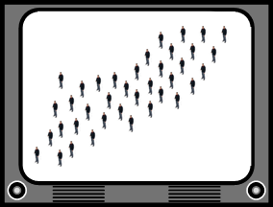 | 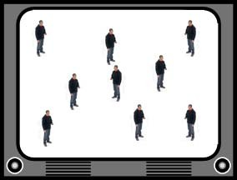
10% | 25%

Recognize | Identify
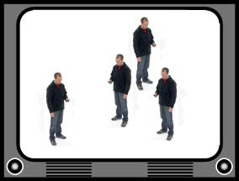 | 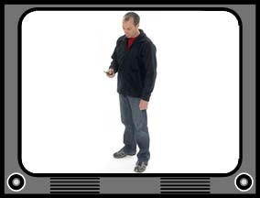
50% | 100%
Figure2.1Height based ‘levels of detail’ for the more commonly used screen heights
This table shows the equivalent screen heights needed to maintain the required resolution.
 | PAL | 1080p | 720p | WSVGA | SVGA | VGA | 2CIF | CIF | QCIF
Height | 400¹ | 1080 | 720 | 600 | 600 | 480 | 288 | 288 | 144
Width | 720 | 1920 | 1280 | 1024 | 800 | 640 | 704 | 352 | 176
Table : Commonly encountered resolutions
Checklist for CCTV
The checklist outlines the issues to consider when specifying a CCTV system, with numbered boxes containing explanatory notes. The first set of issues requires referring to the site plan and addressing each marked threat/vulnerability separately. This checklist forms a comprehensive Operational Requirement for contractors and suppliers, aiding in designing a suitable CCTV system and establishing an operational code of practice for the facility.
Define the Problem
The purpose is that to gather information for the system provider to select suitable cameras and position them for accurate scene capture. General threats should be considered location-by-location, working separately for each location.
Location
To monitor specific zones or locations on your premises, divide the site plan into zones or locations where high-quality images of the offender can be obtained. Consider whether monitoring is needed throughout the site or in a single area for separate activities. Treat each scenario separately when determining operational requirements.
For Example, Ina car parkfor instance you may have two locations; one where vehiclesare monitored as they enter and leave, to control access and obtain vehicleregistrationinformation,andanotherwheretheyareintheparkingbays.

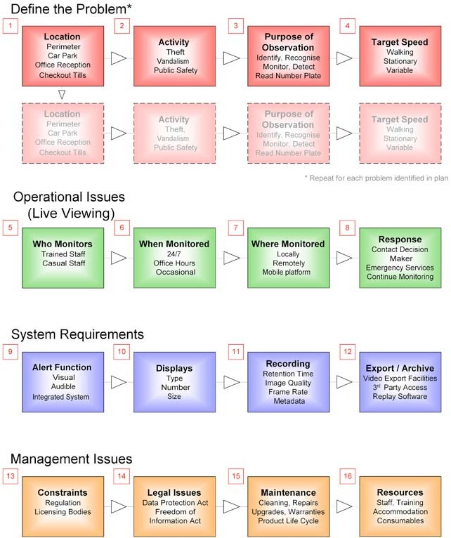

Figure2.2checklist for CCTV
Activity
Types of activity that are commonly monitored are:
- Theft / shoplifting
- Public safety
- Flow of customers / crowds
- Unauthorized entry
- Anti-social behavior / vandalism
Purpose of the observation
Consider which of the five ‘levels of detail’ described in section 3.1 is most appropriate to your requirement.
You may wish to:
- Monitor a large area
- Detect individuals approaching a building
- Observe the actions of a group
- Recognize known individuals at an entrance
- Obtain images that would enable you (or the police) to identify an unfamiliar individual
A fixed camera can cover a narrow field of view with high detail for recognition or a wide field of view with lower detail for monitoring or detection, but not both. It's crucial to choose the appropriate requirement for each location.

Theremaybemorethanonepurposetotheobservation.Forexample,theremaybearequirementtodetecttheftsfromvehiclesinacarpark,butalsotoidentifytheoffendersastheyleave.Howevertheimageclarityrequiredforidentifyingthosepeoplewouldneedtobegreaterthanthatrequiredtodetectanactionsuchasbreakingintoavehicle.Sothecamerascoveringthe car parkwouldbeset at the Detect (10%) level, but those at theentrance/exitwouldbesetattheIdentify(100%)level.
Target speed: Determine the appropriate frame-rate for recording an event in CCTV systems, focusing on low or high frames per second for exit less corridors and busy areas.
Operational Issues: This concerns the daily operation of a CCTV system, including monitoring personnel, location, and response in case of incidents. It may not apply to all systems, but should be considered during development.
Who monitors: The most common options are:
Dedicated personnel whose sole responsibility is to operate the system and respond to events.
Casual operation by personnel, as a secondary function to their main role, such as a receptionist.
Some systems are designed only for recording and post event investigation in which case no body would be required to monitor the activities live.
Additionally consider whether personnel should receive training and if so to what level. Most public space CCTV operators must now be licensed by the Regional police offices, and to obtain a license must show they have been appropriately trained
When monitored: It may be the case that the control room is staffed during the site’s opening hours but not at other times, or there may be a requirement for 24-hour monitoring.
Similarly, the same regime may be required every day, or a different regime may be appropriate at weekends, or at times of higher than normal risk such as after a football match or during a protest.
Monitored: Decide on off-site monitoring or on-site monitoring, identify suitable location, and design control room for system effectiveness.
The following points are worth considering:
- Size and shape of room
- Light and ventilation
- Security
- Proximity to the locations being monitored
- Ergonomics (Is the layout comfortable for the operators and does it allow them to maintain appropriate levels of alertness?)
Response: Consider who decides when a response is necessary and what that response should be. For example, it might be appropriate for the operator to contact:
- a guard on patrol
- the site manager
- the community police services
- the control room of a neighboring CCTV facility
System Requirements: Having developed an operating procedure and decided on the observation requirements for each area of interest attention should be focused on the features of the CCTV recording / display system itself.
Alert function: Many systems have some configurable automatic alert function, which will be activated when a particular event occurs. It may be desirable to integrate the CCTV with other protective security equipment such asan intruder detection system, which will detect an event such as the opening of a door and then activate the CCTV.
A decision should be made regarding what type of activity should trigger an alert, and then what form that alert should take, for example:
      - a simple audible alarm such as a beep
      - visual alarms such as a flashing light that pinpoints the location of the event on a plan of the facility on a screen in front of the operator
      - a text message or an image sent to a key holder
      - an emergency relay sent to the local police station
      - Record event data.
Alarm-activated recording can start seconds before events, using a record buffer for overwriting or high frame rate for retaining relevant sections.
      - display the view from the camera on a monitor screen in front of the operator
      - create a record of the event in an audit log

      - There may be a requirement to prove that the system is functioning correctly and that nothing of interest occurred during the times it was not recording.
Display: If live monitoring is required, the following points need to be considered:
- The number of screens required:A single operator should monitor no more than 16 screens simultaneously, depending on circumstances, and consider using dedicated screens for constant monitoring or separate viewing areas for video review.
The number of cameras per display screen Detection activities and display size determine the optimal size for a display. Splitting a display for multiple cameras may reduce resolution and screen height, but larger screens are more cost-effective.
The type of display is an option between more contemporary LCD or plasma displays and classic CRT panels. Many IP-based CCTV systems provide remote live monitoring capabilities via any internet-capable device, such a PDA, smartphone, or desktop computer. However, as this often functions inside a bandwidth-constrained environment, the transmitted live view frequently features severe data compression, a decreased frame rate, and a lower resolution, all of which lead to a noticeable decline in quality.
Recording: New CCTV systems use digital recording technology, storing video on hard drives for set periods.
Retention time of 31 days has traditionally been used for most CCTV applications and is still recommended by police. In practice, however, it may be appropriate to select from a sliding scale of retention times, which varies according to the likely severity of the incident that requires monitoring. For example, a town center or other large scheme that may capture details of a serious crime or major incident should retain all footage for 31 days. This is because in a major incident it may be valuable for the police to be able to review the video of the days prior to the event as well as of the event itself. However, it may not always be necessary for the owners of small premises to retain all data for 31 days, as the events captured are likely to be less serious in nature, or are ‘one-off’ incidents.
In these cases a minimum retention time of 14 days could be recommended, as this provides sufficient time for the authorities to attend the scene and retrieve the video in the event of an incident, but respects the advice of the Information Commissioner that data should not be retained for longer than necessary.
When a digital video recorder saves images it compresses them so that more data can be saved on the hard drives. This compression will almost invariably reduce the quality of the video.
When purchasing and commissioning a CCTV recorder it is therefore vital to inspect the quality of the recorded images as well as the live view as there could be a substantial difference between the two.
Adjusting the recorder settings to increase the retention time will result in a reduction in the stored image quality (i.e. “Best Storage” settings give you the lowest quality recorded video). It is extremely important to be aware of this trade-off between retention timeand recorded imagequality when setting up the system.Choose an appropriate frame rate for each camera to record, based on speed of Different frame rates may be required at different locations.
It should specify the required retention time, recorded image quality and frame rate for each camera. The CCTV supplier will use this information to determine the appropriate storage capacity (hard drive size).
Export / Archive: A CCTV recorder should create a permanent record of an incident for evidence in investigations. Analog recorders can be easily removed and retained, while digital recorders require copying to a permanent storage medium like CD/DVD before overwriting. A suitable export facility is essential for single images and short video clips.
For exporting longer video clips and for large scale archiving, the system should provide one of the following:
- the ability to export video to an external ‘plug and play’ hard drive via a USB or Firewire connection
- Network port
- Removable hard drive
Note that network and USB ports can operate at a range of speeds, the slower of which may not be suitable for transferring large volumes of data. The latest (and fastest) standard should be specified for a new system.
There may be a requirement for a system to be permanently connected to a network, to provide remote access either for data download or for live viewing, and possibly to provide a link to other CCTV systems as part of a larger CCTV network.
The exported video sequence may be in a non-standard format. If this is the case, it is important to ensure that the manufacturers provide additional software so that the video can be replayed and viewed on a standard computer. Many systems enable the replay software to be downloaded from the system at the same time as the data. If a removable hard drive is provided, then this should either be in a format that can be read on a standard computer (e.g. Windows based) or a separate replay machine should be provided to which the drive can be attach
Technical Guidance
Guidance for developing detailed technical specifications for CCTV systems, including camera placement and recording requirements, helps discuss with contractor, ensuring system design and installation.
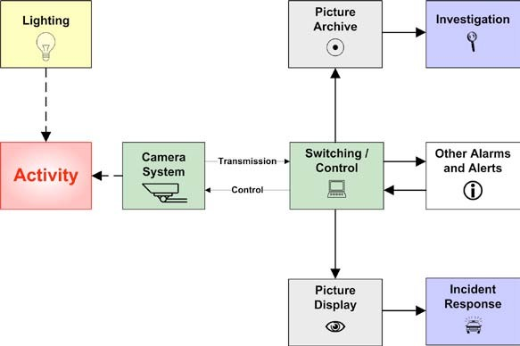
Figure2.3Constituent parts of a typical CCTV system
- Lighting
- Scene Contrast
To ensure accurate lighting, no part of the scene should be more than 3 times brighter than the darkest area, and the contrast ratio must match dynamic range. Diffusers or increased light sources can help combat this issue in dense pedestrian areas.

Figure2.3 (a) effect of flare and (b) silhouette effect

Check and document plan
Site plan
Drawing a site plan and marking the trouble spots on it is the first step in every construction project. The more specific the design may be, the better, since this will help with the placement of lighting and cameras, especially with regard to fields of vision and any environmental issues like low sun or vegetation.
Example
Site plan is shown in the next figure, for large commercial premises with an attached car park.

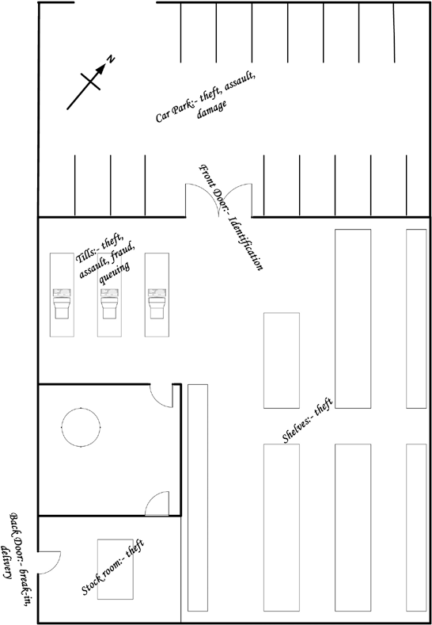

Figure2.4Example site plan with threats mark Statement of problem
The next step is to identify the issues that the site is experiencing. Some of them can be risks that apply across the board, while others might be regional in nature. Common dangers or threats that may be recognized include:
- Crowd control
- Theft
- Unauthorized entry
- Public safety
These potential problems and/or threats can be marked on the site plan. This can then be used to visualize the scale of the problem and the level of cover required. Some areas such as checkouts and entrances/exits may need cover for different activities i.e., to monitor flow of people and to identify people in the event of a theft or similar.
There are four key stages when planning the installation of a CCTV system,
Determining the issue, whether it be a security danger, a problem with public safety, or another weakness, is the first step. Operational requirement. At this stage, we consider about if installing a CCTV system is the best course of action to address these worries or whether there are other possibilities. Having developed a clear picture of the concerns that need to be addressed, attention can be turned to the specific issues relating to the CCTV system itself.
This helps the CCTV user/manager to:
- Further define the areas of concern
- Understand operational issues and responses
- Decide on the most suitable system requirements
- Identify any managerial implications
The third step is where a more detailed technical required specification for the CCTV system is developed. And considered camera selection, the effects of compression on image quality, and guidance on how to estimate the storage capacity that should be included with the system.
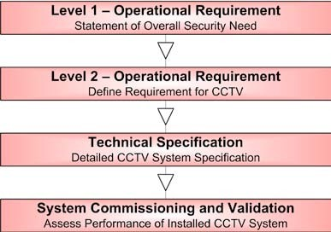
The final stage in the process occurs when the system is installed and commissioned. At this point it is important to check that it meets the operational requirements and that the performance is fit for purpose.

Figure2.5Key stages in specifying a CCTV system

Understand Requirements
Requirements: There are four key stages when planning the installation of a CCTV system,
Determining the issue, whether it be a security danger, a problem with public safety, or another weakness, is the first step. Operational requirement. At this stage, we consider about if installing a CCTV system is the best course of action to address these worries or whether there are other possibilities. Having developed a clear picture of the concerns that need to be addressed, attention can be turned to the specific issues relating to the CCTV system itself.
This helps the CCTV user/manager to:
- Further define the areas of concern
- Understand operational issues and responses
- Decide on the most suitable system requirements
- Identify any managerial implications
The third step is where a more detailed technical required specification for the CCTV system is developed. And considered camera selection, the effects of compression on image quality, and guidance on how to estimate the storage capacity that should be included with the system.
The final stage in the process occurs when the system is installed and commissioned. At this point it is important to check that it meets the operational requirements and that the performance is fit for purpose.
Operational Requirement: Consideration should be given to the nature of the issue or danger that needs to be handled before focusing on the demand for the CCTV system itself. The Level 1 Operational need is this high-level description of the entire security need. The image below displays a straightforward Level 1 checklist.
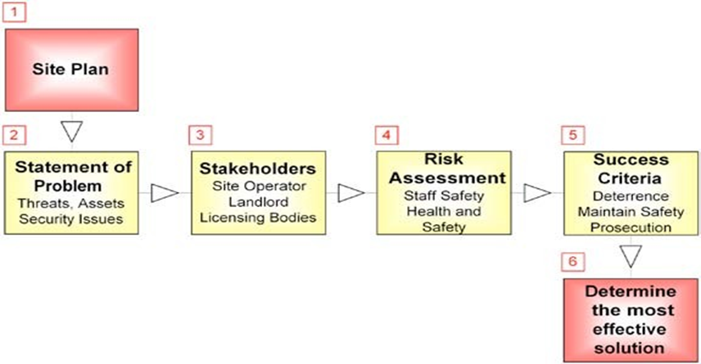
Stakeholders
If the installation is likely to be complex and involve several different stakeholders, then they should all be consulted at this stage in the process and asked to identify their requirements on the site plan.

Apply Simple cost analysis
Cost estimation: Cost estimation is an essential aspect of project management as it allows stakeholders to budget and allocate resources effectively. There are several methods that project managers use to estimate costs. Here are some of the most common ones:
- Analogous Estimation: This method involves using historical data from similar projects and applying it to the current project. The project manager looks for similarities in the scope, size, and complexity of the projects to draw comparisons. It's a less precise method as it relies on the manager's experience and judgment.
- Bottom-up Estimation: This method involves breaking down a project into smaller, more specific tasks and estimating the costs for each task. The project manager then adds up all the costs to get a total cost estimate. This method is more time-consuming but more precise and accurate compared to other estimation methods.
- Parametric Estimation: This approach involves estimating the cost based on parameters, such as square footage, number of employees, or length of time. The project manager multiplies the parameter value by an average cost per unit to arrive at a total cost estimate. This method is useful for projects that have similar patterns.
- Three-Point Estimation: This approach takes into account three factors to determine the cost estimate: the most likely cost, the best-case scenario, and the worst-case scenario. The project manager averages the three estimates to arrive at a more realistic cost estimate.
- Reserve Analysis: This method considers unforeseen expenses that might arise during the project. The project manager sets aside a reserve amount, usually a percentage of the total project, to cover unexpected expenses that may arise during the project.
Simple cost analysis: Simple cost analysis is a method used to calculate the total cost of a project or decision. It involves tallying up the cost of all the resources used for a project, including direct costs such as materials, labor, and equipment, as well as indirect costs such as overhead and administrative expenses. The resulting total cost is then compared to the project's total benefits to determine its profitability. Simple cost analysis is often used for small or non-critical financial decisions, where a more in-depth analysis is not necessary.
Several methods can be used to conduct simple cost analysis, including:
- The Total Cost Approach: This method involves calculating the cost of each resource used to complete the project and adding them up to determine the project's total cost.
- The Fixed Cost Approach: This method involves identifying the fixed costs associated with the project, such as rent or equipment leases, and including them in the total cost estimate.
- The Variable Cost Approach: This method involves identifying the variable costs associated with the project, such as labor or material costs, and including them in the total cost estimate.

Total Cost Approach:
The Total Cost Approach is a method of calculating the total cost of a project by adding up the cost of each resource used to complete the project. Here is an example of the total cost analysis approach for the construction of a new building:
- Direct costs the: direct costs of constructing the building would include materials, such as wood, concrete, steel, and fixtures.
- Labor costs: the labor costs of building the new facility would include paying construction workers and supporting staff.
- Equipment costs: Equipment costs would include leasing or purchasing specialized heavy equipment, tools, and machinery needed to complete the construction.
- Indirect costs:indirect project costs would include rent, utilities, insurance, taxes, and other administrative expenses.
By adding up all these costs, one can compute the total cost of the new building. This cost can then be compared to the revenue that could be generated by renting or selling the building to determine whether the project is financially feasible. The Total Cost Approach is a simple and effective way to perform cost analysis for projects or investment decisions for small or non-critical financial decisions.Equipment Cost
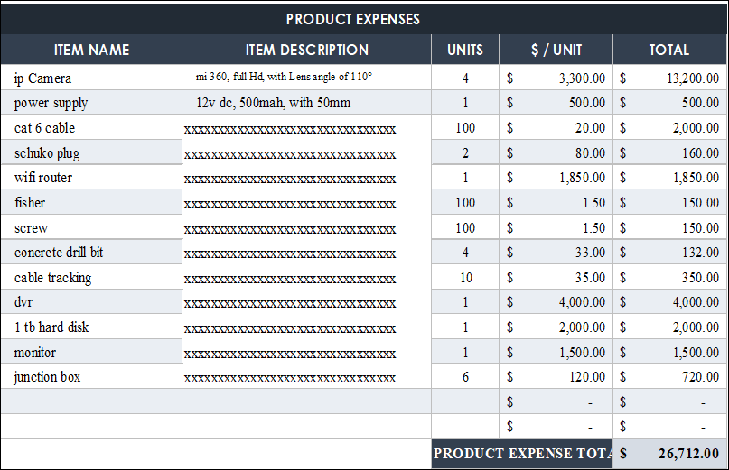
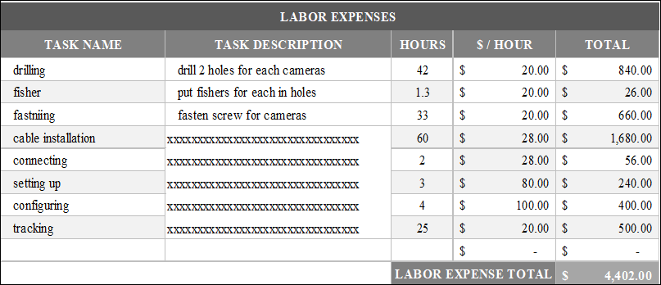
Note: by double clicking the above table, you can use this Excel sheet for your own project
Product cost calculation involves determining the cost of producing a particular product, and is typically calculated by adding up the costs of all the resources that are used in the production process. This includes direct costs such as materials and labor, as well as indirect costs like overhead and administrative expenses. The formula for calculating product cost is typically
Let’s assume your profit margin is 10%
Direct Material + Direct Labor + Value-Added Tax (VAT) + Profit = Price of service
$26,712.00 +$4,402.00 + $ 4,006.8 + $ 3,111.4 = $38,232.2

Self-Check 2.1.
Choice Questions
1. Which type of CCTV camera is best suited for outdoor surveillance?
a) Dome camera c) PTZ camera
b) Bullet camera d) Box camera
2. What is the recommended minimum resolution for capturing clear facial details in CCTV footage?
a) 480p c) 1080p
b) 720p d) 4K
3. Which type of CCTV camera offers a wider field of view?
a) Fixed lens camera c) Zoom lens camera
b) Varifocal lens camera d) Pinhole lens camera
4. Which of the following factors should be considered during cost estimation?
Labor costs c) Overhead costs
Material costs d) All
5. What is the purpose of cost estimation?
To ensure that a project is completed within the allocated budget.
To determine the profitability of a project.
Both a and b.
True/False Questions:
1. IP cameras can be accessed and controlled remotely via the internet.
2. Wireless CCTV cameras are generally more reliable than wired ones.
3. The placement of CCTV cameras should comply with privacy laws and regulations.
4. Cost estimation is only necessary for large-scale projects.
Write short and precise answer
- List different variables to classify types of CCTV cameras in the market
- Write consideration points to specify the camera placement
- List consideration for the necessary camera resolution

Operation sheet 2.1.
Operation Title: Visit site and decide CCTV camera
Instruction: Visit site and decide CCTV camera installation requirement
Purpose: to install a CCTV camera
Required tools and equipment: CCTV cameras, DVR/NVR (Digital Video Recorder/Network Video Recorder), Coaxial cables or Ethernet cables, Power supply
Precautions:
- use safety precaution while confirm electric supply
- Properly handle the tools
Procedures:
- Visit Site and understand the basics
- Decide how you'll be monitoring the system
- Determine the number of Closed-Circuit Television Cameras required
- Position the CCTV cameras
- Place of the DVR/NVR
- Decide on power backup of CCTV Camera
- Analyze budget

LAP Test 2.1.
Name: __________________________ Date: ____________
Time started: ____________________ Time finished: _______________
Instructions: Given necessary templates, tools and materials you are required to perform the following tasks within.
Task 1: Visit site and decide CCTV camera

UNIT THREE: UNIT THREE: PREPARATION OF CABLE TERMINAL
This learning unit is developed to provide the trainees the necessary information regarding the following content coverage and topics:
  - Network and data Cable Specifications
  - Network Cable Types and Specifications
  - Preparing Cable ends
  - cable Crimping and Testing Tools
  - Crimping Twisted-Pair Cable
  - Preparation of electric power source
  - Materials needed for CCTV surveillance Camera
This unit will also assist you to attain the learning outcomes stated in the cover page. Specifically, upon completion of this learning guide, you will be able to:
  - Identify Network and data Cable Specifications
  - Identify Network Cable Types and Specifications
  - Prepare Cable ends
  - Identify cable Crimping and Testing Tools
  - Crimp Twisted-Pair Cable
  - Prepare electric power source
  - Prepare Materials needed for CCTV surveillance Camera

Network and data Cable Specifications
Network Cable Types and Specifications: This unit explains the types of network cables used in computer networks in detail. Learn the specifications, standards, and features of the coaxial cable, twisted-pair cable, and the fiber-optical cable.
To connect two or more computers or networking devices in a network, network cables are used. There are three types of network cables; coaxial, twisted-pair, and fiber-optic.
Specifications of coaxial cables
Coaxial cables have been in use for the last four decades. During these years, based on several factors such as the thickness of the sheath, the metal of the conductor, and the material used in insulation, hundreds of specifications have been created to specify the characteristics of coaxial cables.
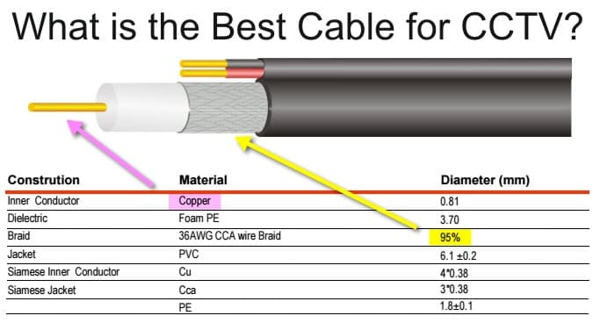
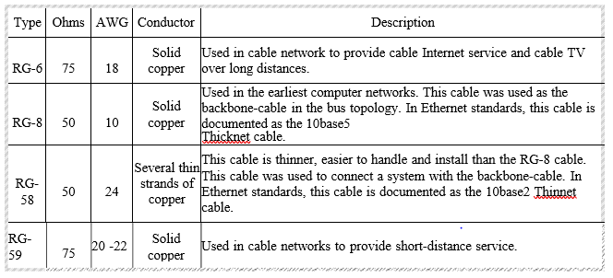
Twisted-Pair Cable specification
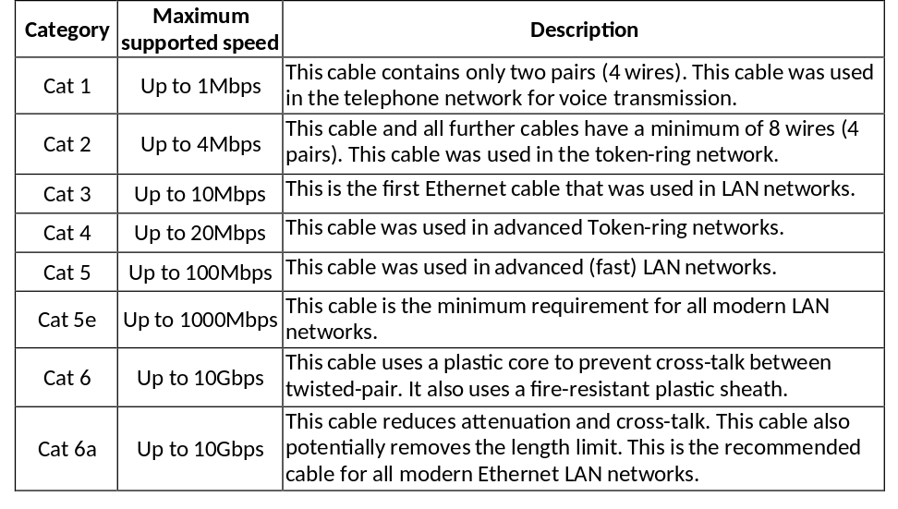
Data Cabling Specifications – Enhanced Category 5 UTP Cable
- 24 AWG, solid conductors
- 4-Pair cable:
- Meets or exceeds TIA/EIA-568-B Enhanced Category 5 ISO 11801:2002 class D specifications Independently verified by Intertek ETL SEMKO testing services
- Performance characterized to 200 MHz(minimum)
- 2dB NEXT performance above Category 5e
- UL & cUL Listed (CMR/CMP)
- Meets or exceeds all requirements for Gigabit Ethernet
- Lead-free jacketing
Data Cabling Specifications – Enhanced Category 5 UTP Jack with Face Plates and Mounting Box
- Thin profile improvers outlet density
- Modular jacks available with integral dust covers
- 1800 or 900 cable dress for easy termination
- Universal wiring label permits wiring to T568A or T568B
- Meet or exceed all TIA and ISO component performance requirements
- Bend-limiting stain relief included with unshielded jacks
- UL Listed: E81956
- 8-Position RJ45 modular jacks for 1-,2-, 3- and 4-pair applications
Data Cabling Specifications – Enhanced Category 5 Patch Leeds
- Meet or exceed Category 5e Performance Standards
- 4-Pair stranded unshielded, 24 AWG conductors
- Booted cable assemblies include color-matched snaggles boots
- Universal wiring (works with both T568A and T568B)
- Minimum length should be 3m
A data cable is a type of cable used for transmitting data from one device to another. It is usually made up of a bundle of wires encased in an insulating material, which provides protection and insulation to the wires.
Here are some key specifications to consider when selecting a data cable:
- Cable length: The length of the cable is an important consideration because it determines the maximum distance over which data can be transmitted without losing quality.
- Cable type: There are different types of data cables available, including coaxial, twisted pair, and fiber optic cables. Each type of cable has its own unique specifications and is suited for different types of data transmission.
- Connector type: The connector type is an important consideration because it determines the compatibility of the cable with different devices. Common connector types include USB, HDMI, and Ethernet.
- Cable shielding: Data cables may have shielding to reduce electromagnetic interference. Shielding can improve overall signal quality and reduce data corruption.
- Bandwidth: The bandwidth of a data cable refers to the amount of data that can be transmitted over a given period of time. Cables with higher bandwidth can transmit more data, faster.
- Data transfer rate: The data transfer rate refers to the speed at which data can be transmitted over the cable. This is measured in bits per second (bps) and is an important consideration when selecting a cable for high-speed data transfer applications.
- Durability: A data cable should be designed to withstand frequent use without breaking down. Factors that influence cable durability include construction materials, connector quality, and flexibility.
Data cable specification
- Ethernet cables: Ethernet cables, such as Cat5, Cat6, and Cat7, are multi-pair cables used mainly for data transmission. Each category of cable has its own bandwidth and data transfer rate specifications.
- USB cables: USB cables come in different versions, including USB 2.0, USB 3.0, and USB Type-C. Each version has its own data transfer rate and capabilities, and may have different
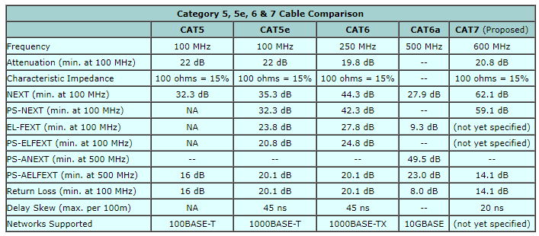

Preparing Cable ends
Network cable Crimping and Testing Tools
In This part of experiment explains the most common twisted-pair network cable testing and crimping tools in detail. Learn the tools that you can use to crimp and test twisted-pair network cables. Cables are the backbone of a wired network. The stability, reliability, and performance of a wired network depend on cables. Installing and maintaining cables in a wired network is a difficult task. To make this task easier, a variety of network cable crimping and testing tools are available. In this tutorial, we will not only discuss some of the most common network cable crimping and testing tools but also understand their features and functions.
Twisted-pair (STP and UTP) network cable crimping tools
Crimping tools are used for the following purposes.
- To cut the network cable of the required length from the bundle.
- To remove the outer and inner jackets of the network cable.
- To attach the connectors on both ends of the cable.
Some crimping tools provide all the functionality while others provide one or two functionalities. The most common twisted-pair network cable crimping tools are described below.

Cable Crimping and Testing Tools
Wire Cutter:- To cut the network cable of the required length from the bundle, you can use any standard wire cutter tool or can use a wire cutter tool that is specially designed for the twisted-pair cable. A twisted-pair wire cutter usually includes additional blades for stripping the wire.
Wire Stripper: - This tool is used to remove the outer and inner jackets of the network cable. Typically, you do not need to purchase this tool separately as all standard twisted-pair wire cutters are equipped with wire-strippers.
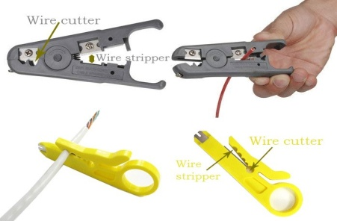
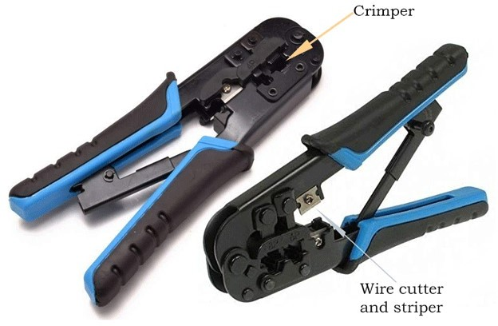
Crimp tool: -This tool is used to attach the connectors to the cable. Typically, this tool also includes a wire-cutter and wire-stripper. So if you buy a crimp tool, you don't have to buy a wire-cutter and wire-striper separately.
Figure3.1crimping tools

The standard connector for twisted-pair cabling is an RJ-45 connector
  - RJ stands for Registered Jack
  - An 8-pin connection used for Ethernet network
  - A plastic connecter that looks like ordinary phone jacks (RJ-11)
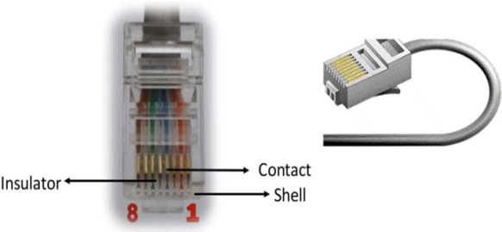
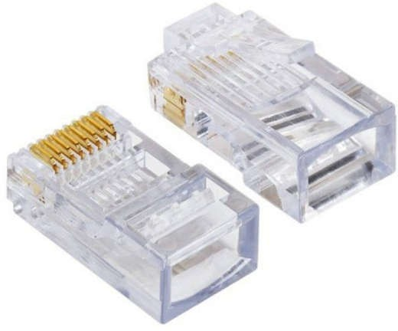
  - The RJ-45 is a keyed connector, meaning the connector can be inserted in only one way.
Figure3.22 RJ 45

Crimping Twisted-Pair Cable
Two types of Ethernet network cable are straight through andcrossover cable.
- Straight through and Crossover cable have different wire arrangement for serving different purposes.
- Cat 5, Cat 5e or Cat 6 UTP cable
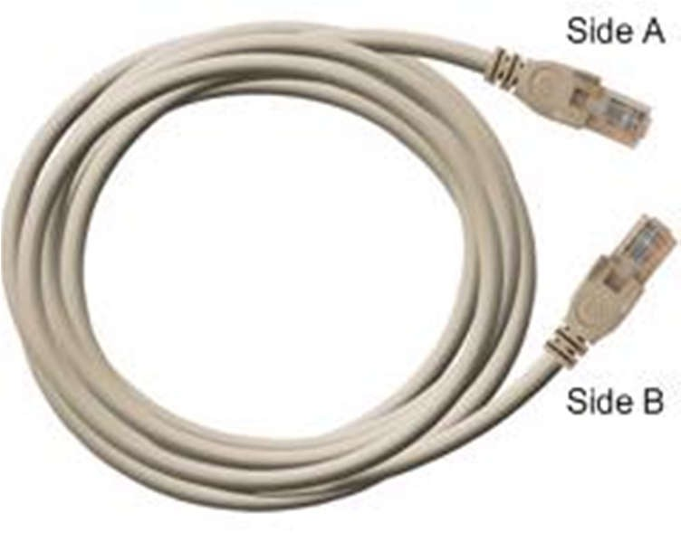
- Made of 4 pair high performance cable that consists twisted pair conductors that used for data transmission.
- Both end of cable is called RJ-45 connector

Straight Through Cable
Used to connect different type of devices and used most of the time
- Connect a computer to a switch/hub's normal port.
- Connect a computer to a cable/DSL modem's LAN port.
- Connect a router's WAN port to a cable/DSL modem's LAN port.
- Connect a router's LAN port to a switch/hub's uplink port. (Normally used for expanding network)
- Connect 2 switches/hubs with one of the switch/hubs using an uplink port and the other one using normal port. plink port special port that eliminates the need of crossover cable
Straight Through Cabling Standard
- Both side (side A and side B) of cable have wire arrangement with same color.
- Clip is pointed away from you
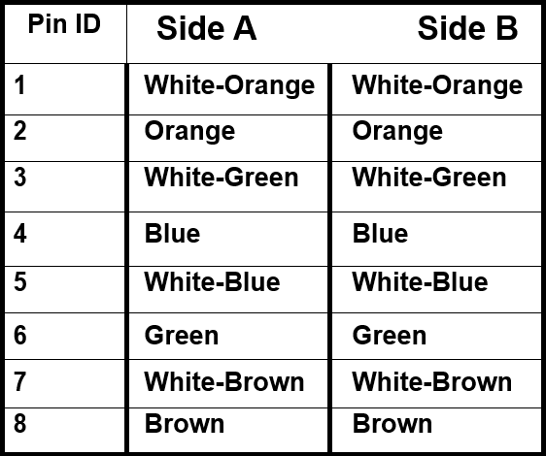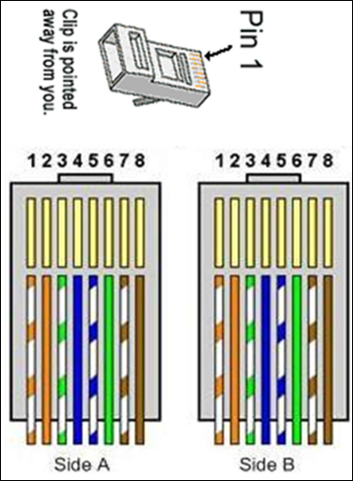

Crossover cable: Used to connect same type of devices without a switch or hub.
    - Connect 2 computers directly
    - Connect a router's LAN port to a switch/hub's normal port
    - (normally used for expanding network)
    - Connect 2 switches/hubs by using normal port in both switches/hubs
Crossover Cabling Standard
- Crossover cables have different ends
- Both side (side A and side B) of cable have wire arrangement with following different color
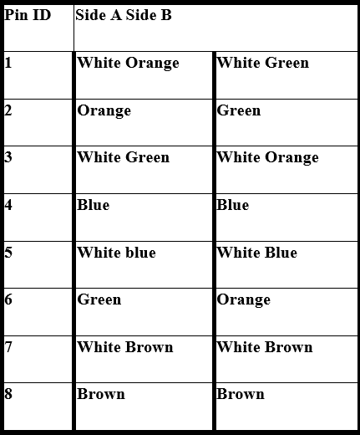
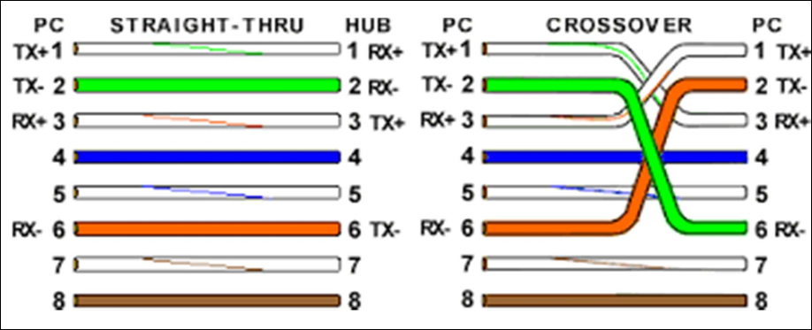

Straight throughcables have identical ends and are used for connecting computers through a hub/switch
Crossover cableshave different ends and are used for connecting devices directly with each other (e.g. PC to PC)
Coaxial Cable Connectors
The most common type of connector used with coaxial cables is the Bayonet Neill–Councilman (BNC) connector.
- Different types are available for BNC connectors, including a T-connector, barrel connector, e.t.c.
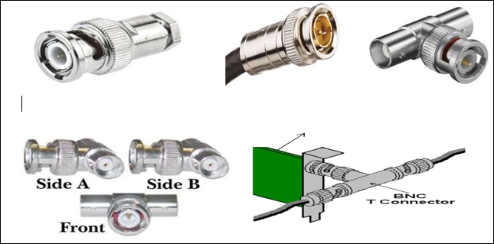
Figure3.3 Coaxial Cable Connectors
Fiber Optic Connector: There are many connectors used with fiber optic cable such as anST and SC connector:
- The ST is barrel shaped, similar to a BNC connector.
- The SC has a squared face and is easier to connect in a confined space.
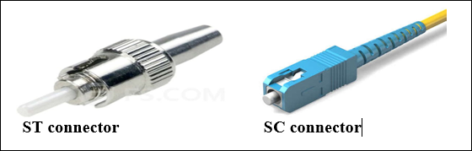
Figure3.4 Fiber Optic Connec

Preparation of electric power source
CCTV Camera Power Supply:CCTV Camera Pros offers the best selection of individual CCTV camera power supplies, also known as power adapters. We carry 24VAC and 12V DC individual adapters, like the ones seen on the page you are on, as well as power supply boxes that can distribute power to surveillance systems with 4, 8, and 16 cameras. Installers should check the manual of the security cameras that will be installed to confirm whether the camera needs 12V DC or 24VAC power. Most CCTV cameras are either 12V DC or dual voltage, which means that they can use either. Please note that connecting a 12v security camera to a 24v power source will almost always burn the camera's circuit board and render the camera useless. If you have any questions about which power supply is required for any of the cameras that we supply, please contact us.
The power consumption of a typical CCTV camera ranges from 4 to 15 watts, depending on the type. While the DVR device that is connected to the CCTV camera uses between 10 and 40 watts.
Materials needed power source CCTV surveillance Camera
Power adapter appropriate for the camera : Most CCTV cameras are either 12V DC or dual voltage, which means that they can use either. Please note that connecting a 12v security camera to a 24v power source will almost always burn the camera's circuit board and render the camera useless.
Power cables : Wire is a single conductor whereas cable is a group of two or more insulated conductors. Even if there are multiple strands or a single strand and only one conductor, then we call it wire. Also, if there are multiple conductors but no insulation, it is deemed to be wire.
It can also be said that wires are located inside cables. Wire is usually measured by looking at the diameter. They are grouped as per the gauge number. If the number is smaller, then the wire will be thicker. Wires are also grouped according to their insulation type electrical capacity. Generally, two types of wires are found – stranded wire and solid wire.
Cable: consists of two or more conductors or wires enveloped together in one sheath. Cables have positive or hot lines in them that carry current and a neutral line that completes the loop. There may be also a third wire that act as a ground wire.
The cables are normally classified as per the number of wires it has and also according to the gauge.
Types of electric cable by their use
- Cables for electric panels. Flexible cables for wiring electric cabinets. ...
- Power cables. Energy cables for industrial facilities and public places. ...
- Armoured cables. ...
- Rubber cables. ...
- Halogen-free cables. ...
- Fire resistant cables. ...
- Control cables. ...
- Instrumentation cables
Equipment’s needed
Socket outlet :Socket outlet means a device with protected current-carrying contacts intended to be mounted in a fixed position and permanently connected to the fixed wiring of the installation to enable the connection to it of a flexible cord or cable by means of a plug;
A socket outlet is a female socket connected to the power wiring in the building and will accept the male plug attached at the end of the flexible cord of an appliance such as a vacuum cleaner, electric fire or electronic equipment. The general arrangement of socket outlets is similar to that of switches
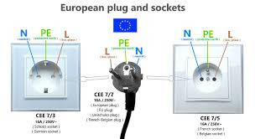
Figure3.5 Electrical Socket outlet
Circuit breaker
A circuit breaker is an electrical switch designed to protect an electrical circuit from damage caused by overcurrent/overload or short circuit. Its basic function is to interrupt current flow after protective relays detect a fault. Rating of circuit breaker for CCTV installation is same as a normal house hold appliance 16A.
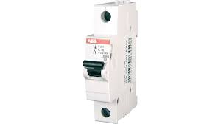
Figure3.6 Circuit breaker
Runningyourcables: Torun the cable. Thefollowingwill cover two popularscenarios.
Scenario1:It is a common installation option that the cable is run through the attic and mountingcameras to the soffit provided there is access to the attic and soffits. To do this, firstchoosethe placement oftherecorderand power supply. Somepeoplesimplyhavelocatedtheminanofficeoraroomwithintheirhome.Otherspreferhavingt eminamoresecurelocationsuchasinalockbox,hiddeninacloset,oreven in the attic itself. Power and video wires run up the wall into the atticto the location where the camera will be located and out a small hole in the soffit werethecamerawill bemounted.
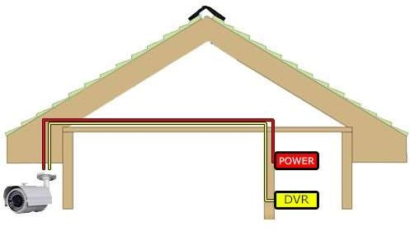
Scenario2: Another option is to run the cable through an exterior wall and then use conduit on theexterior of the structure to run the cables from one camera to another. This is a greatoptionfor thosewho donot havean attic orlimited access to one.
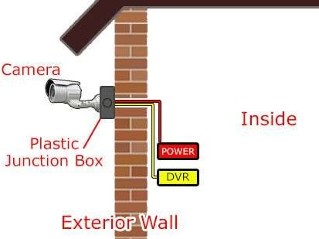
Figure3.7 Running cables externally
MountingYourCameras
Oncethewireshasbeenruntothedesiredlocation,thecameracanbeconnectedeasily.In some cases where the cables are coming out of the soffit it is possible to connect thewirestogetherandtucktheconnectionsupintothehollowareaofthesoffit,thencameraismounted directlyto thesoffit.
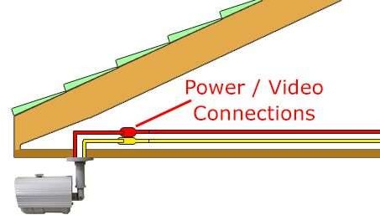
Figure3.8 Mounting camera
JunctionBoxesandConduit: Junction boxes are particularly useful when running cables through conduit on theexterior of the structure as they serve as a weather proof container to protect the powerand video connections from the elements and also provide a flat surface to mount thecamerason it.
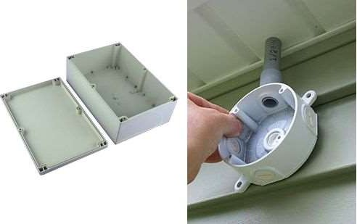
Figure3.9 Junction boxes and conduit
firstpullthewiresthroughtheaccessholeonthebackofthejunctionbox.Then,mountthejunctionboxtothewallanddrillaholeinthejunctionboxcoverbigenoughtofeedthecameraconnections.Next,connectthecameratothepowerandvideoconnection(s).Then,screwthecoverontothejunctionboxand mountthecameratothejunctionbox.
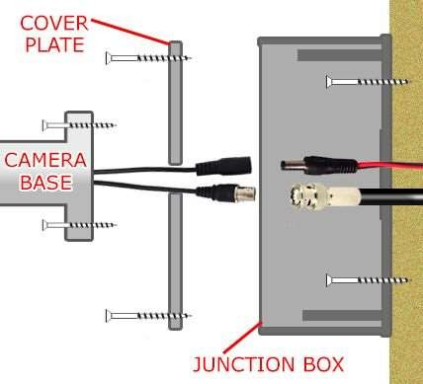
Figure3.10installing accessories
When used on a soffit, a junction box will sometimes be helpful in order to lower anddrop the cameras below obstructions such as deep fascia boards as shown figure 4.21below
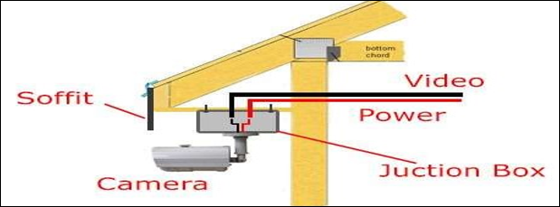
Figure3.11 Using junction box on soffit
General instructions for installing an electric power supply for a CCTV surveillance camera:
- Determine the ideal location for your CCTV surveillance camera. Consider factors such as the desired field of view, surveillance coverage, and accessibility to power source.
- Identify and locate a nearby power source that can provide the required voltage and current for your CCTV camera. It can be an existing electrical outlet or you may need to install a separate power supply unit for your camera.
- Ensure the power source is switched off before proceeding with any installation work for safety purposes.
- Connect the power adapter to the CCTV camera. Most cameras have a DC power input port. Match the voltage and current requirements of the camera to the power adapter specifications.
- Measure and cut the power cable to the desired length, ensuring it is long enough to reach the power source.
- Run the power cable from the CCTV camera to the power source location. Conceal or secure the cable along the desired path using cable clips or wire connectors.
- If necessary, use a screwdriver or appropriate tools to open the power supply or electrical outlet where you are connecting the camera. Ensure all wires are connected securely and follow the color-coded labels on the power supply unit or outlet (e.g., positive and negative terminals).
- Connect the power cable from the CCTV camera to the power source. Match the polarity correctly (positive to positive, negative to negative) to prevent damage to the camera.

- Once the power connection is secure, turn on the power source and verify that the CCTV camera receives power. Check if the camera's power indicator lights up or if there are any error messages indicating a power issue.
- Adjust the position and angle of the CCTV surveillance camera as needed for optimal surveillance coverage.
- Test the camera's functionality by connecting it to a monitor or recording device. Verify that the camera captures video and works as expected.

Self-Check-3.1.
- Choose the best answer
1. Which tool is commonly used to strip the outer jacket of a cable?
A. Wire cutter b. Wire tester c. Wire stripper d. Wire crimping tool
2. Which type of connector is commonly used for terminating Ethernet cables?
A. BNC connector b. USB connector c. RCA connector d. RJ45 connector
3. What is the purpose of applying a cable gland on a cable end?
A. To provide strain relief and protect the cable from pulling or twisting forces
B. To improve signal transmission quality
C. To prevent electromagnetic interference
D. To enhance cable flexibility
4. Which method is commonly used to secure a cable to a connector?
A. Soldering b. Crimping c. Twisting d. Taping
- True/False Questions:
- When preparing a cable end, it is important to remove the appropriate length of the outer jacket to expose the required wires.
- Applying a cable gland is only necessary for outdoor cable installations.
- Stripping too much insulation from the wires can lead to short circuits or signal loss.
- Crimping is the most common method used to terminate cables for electrical connections.
- Short Answer Questions:
- What is the purpose of using a cable stripping tool instead of a knife or scissors to strip the outer jacket?
- Name two common types of connectors used for terminating coaxial cables
- Explain the purpose of crimping when preparing cable ends.

Operation sheet 3.1.
Operation Title: Crimping CAT 6 Data cable
Instruction: Crimping a CAT 6 data cable step-by-step
Purpose: to perform crimping CAT6 Data cable
Required tools and equipment: unit one of this module, tools from workshops like Crimpers, Knifes, measuring tools, LAN Tester
Precautions:
- use safety precaution while confirm electric supply
- Properly handle the tools
Procedures:
Step 1: Separate the wire pairs by untwisting each pair individually trying to keep the pairs together to make it easier to find them.
Step 2: Place the wires in the order specified below.
The ends will be trimmed before crimping.

• Orange-white
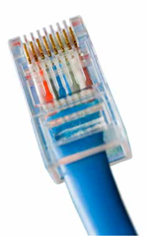
• Orange
• Green-white
• Blue
• Blue-white and Green
• Brown-white and Brown
Step 3: Grab the wires at the jacket keeping all of the wires in the same configuration sliding your fingers up the wires flattening them out into a straight line.
Step 4: Use the wire cutters to trim the tips of the wires to make them even.
Step 5: Ensuring the wires are in the same order as in the last section, push the wires into the RJ45 data plug until the ends go all the way up into the top of the plug.
Step 6: Pinch the jacket of the wires sliding it up into the back end of the data plug by pinching two inches below the cut end of the jacket with one hand and holding the data plug with the other.
Step 7: Insert the RJ45 data plug into the crimper then, using constant pressure until the crimper clicks, release the crimper.
Step 8: Testing your cable after crimping is important to make sure that the communications between the end device and the network are correct.

LAP Test: 3.1: Crimping CAT 6 Data cable
Name: __________________________ Date: ____________
Time started: ____________________ Time finished: _______________
Instructions: Given necessary templates, tools and materials you are required to perform the following tasks within.
Task 1: Preparing the wire for crimping. (2hrs)
Task 2: Crimping the wires into the RJ45 plug. (1hrs)

Unit Four: Assemble and Install Wired and Wireless CCTV Camera System
This learning guide is developed to provide you the necessary information regarding the following content coverage and topics:
  - Interpreting wiring diagram
  - Types of Drawings
  - Positioning CCTV surveillance devices
  - Wireless Camera
  - Dome Setups and Cable Connection
  - CCTV Installation
  - Cleaning worksiteand equipment
  - Documenting Security system installation
This guide will also assist you to attain the learning outcomes stated in the cover page.
Specifically, upon completion of this learning guide, you will be able to attain:
  - Interpret wiring diagram
  - Identify Types of Drawings
  - Position CCTV surveillance devices
  - Understand Wireless Camera
  - UnderstandDome Setups and Cable Connection
  - Install CCTV
  - Clean worksiteand equipment
  - DocumentSecurity system installation

4.1. Interpreting wiring diagram
Introduction
Successfulelectricalworkperformancerequirestheabilitytoreadandinterpretdifferenttypesofdrawingsanddiagrams.Understandingcircuitsymbolsandcomponents is the other basic building blocks needed to become an electrician. If anelectrician misinterprets a drawing or diagrams when wiring a house, devices could beincorrectlyinstalledorevenmissedtotally.So,knowinghowtoproperlytakeinformation from an electrical drawing or diagram and applying it to the real world isessentialprerequisite forthe electrician’swork

4.2. 1. Types of Drawings
    - BlockDiagram.
    - SchematicsCircuitDiagram.
    - SingleLineDiagramor One-lineDiagram.
    - WiringDiagram
BlockDiagram: Ablockdiagramshowsthemajorcomponentsofelectricalormechanicalinterrelationsin block, or square or rectangular, form. The lines between the blocks represent theconnectionsbetween thesystems or components.
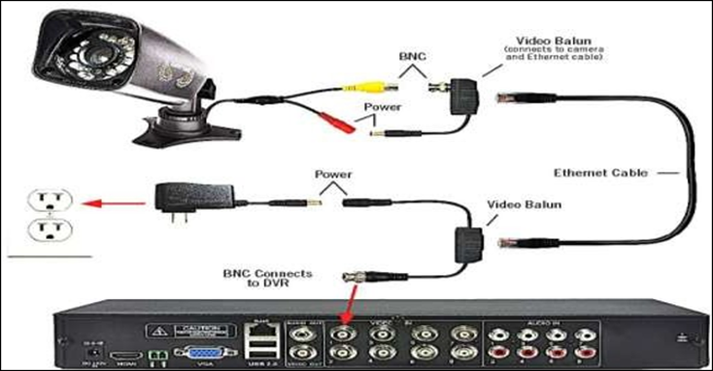
Figure4.1 Block Diagram
SchematicsorCircuit Diagram: Schematic diagram of an electrical circuit shows the complete electrical connectionsbetween components using their symbols and lines. Unlike wiring diagram, it does notspecify the real location of the components, the line between the components does notrepresentreal distancebetween them.

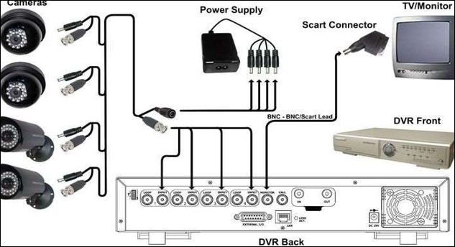

Figure4.2Schematics or Circuit Diagram

3SingleLineDiagramorOne-line Diagram: A single-line diagram (SLD) is a high-level schematic diagram showing how incomingpower is distributed to equipment. It shows a correct power distribution path from theincoming power source to each downstream load including the ratings and sizes of eachpiece of electrical equipment, their circuit conductors, and their protective devices asdepictedin Figurebelow

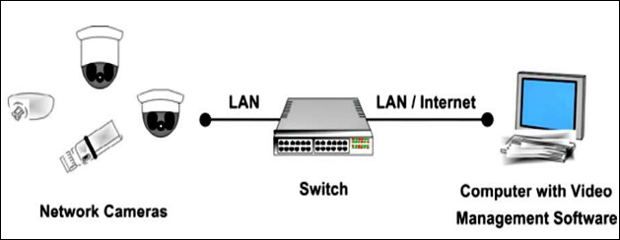
Figure4.3 Single Line Diagram or One-line Diagram.
WiringDiagram: A wiring diagram is a simple visual representation of the physical connections andphysical layout of an electrical system or circuit.
The wiring diagram also gives detailed information about wiring such that one can getaneasyideaofmakingconnectionbetweenthedevices.Italsoincludesrelativeposition,arrangementand terminals on the devices in thecircuits. It shows how the electrical wires areinterconnected and where fixtures and components are connected to the system as seeninfigurebelow.

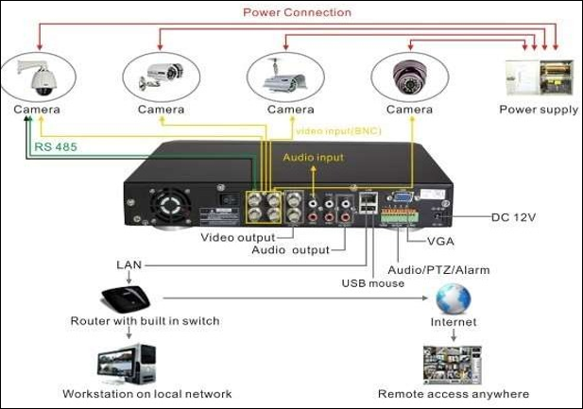
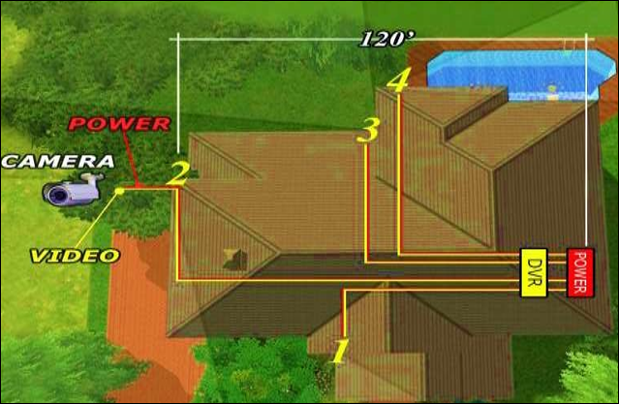
Figure4.4 Wiring Diagram

4.3. Positioning CCTV surveillance devices
Positioning the cameras above the door and pointing away from light sources and windows will ensure they pick up a clear view of people's faces. The cameras placed at entrances to the building should be fully visible.
Position of CCTV
Keep cameras up high
- All cameras should be out of reach so they can't be easily knocked down or destroyed.
- Place exterior cameras at a second-story level—at least nine feet above the ground—and keep interior cameras near the ceiling.
- Make sure the cameras are installed securely as well.

Part 1 Selecting the Right Equipment: Go with wireless cameras for an easy installation process. Battery-powered cameras that use Wi-Fi to transmit their footage are the easiest to install, since there’s much less equipment and wiring to deal with. This is also the best option if you only need 1 or 2 cameras instead of a larger system
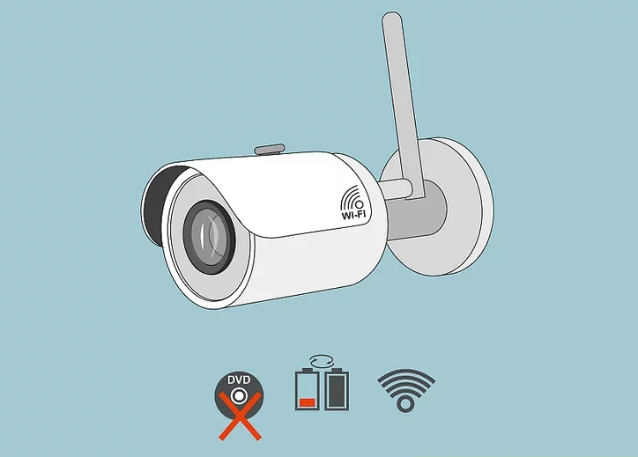
Be sure to go with night-vision cameras if they’ll be used in the dark. Otherwise, if the camera is pointed toward a location without any lighting, it won’t be able to pick up any activity that goes on there. This is especially important if you plan to install your security cameras outdoors
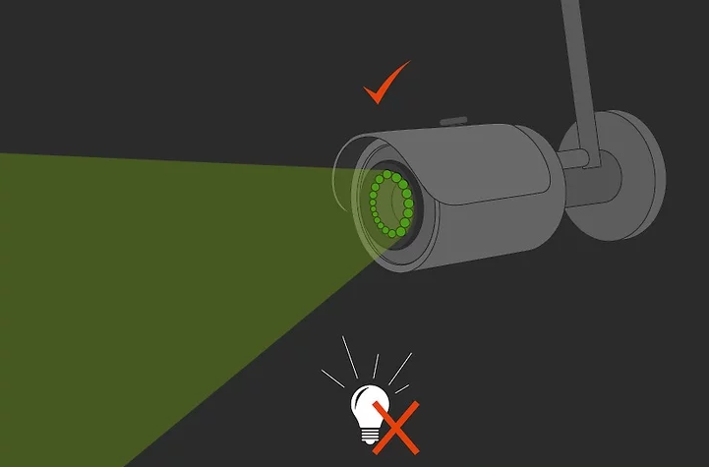
Choose cameras with wide fields of view for greater security. The larger the field of view, the more your camera will be able to pick up. For best results, go with a camera with either a 180-degree lens or with pan and tilt functionality.
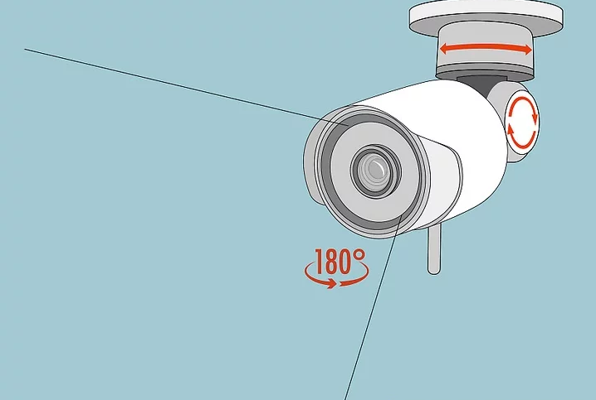

Avoiding opting for the cheapest camera just to save money. Usually, the quality of a security camera is reflected in its price. If it’s a relatively inexpensive model, this most likely means that it’s not as high-quality or as effective as other security cameras.
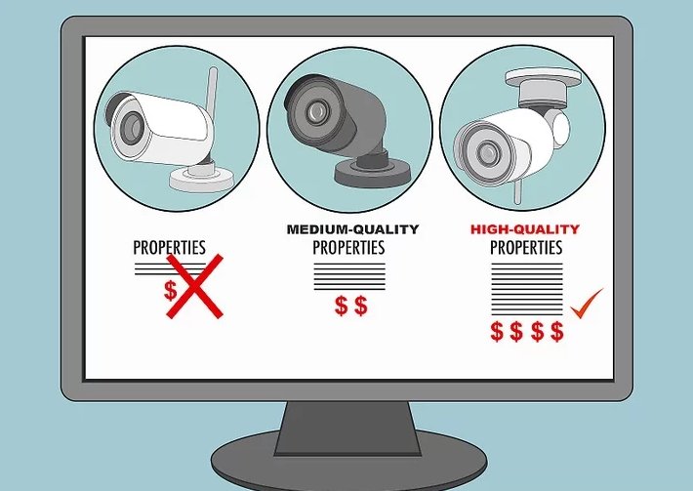
Part 2 Choosing Where to Install Your Cameras
- Place cameras by doors to your house if your main concern is security. Most burglars attempt to enter houses through either the front door or a side entrance, so these are the best spots to place cameras to catch or deter potential home invaders. Place the cameras so that they are high above the doors facing outwards in order to see would-be burglars’ faces.
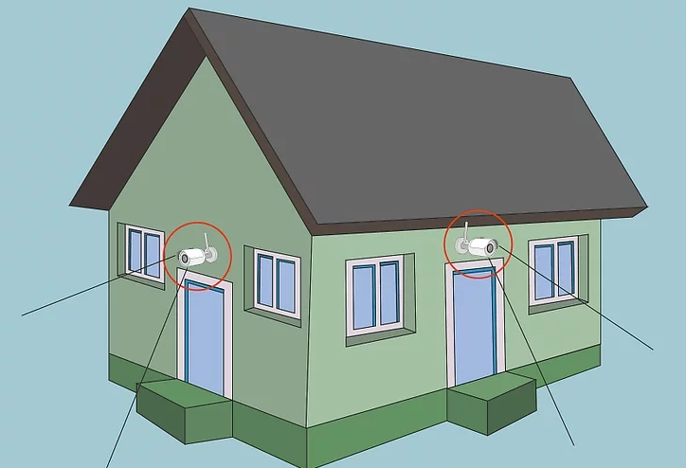

- Position cameras above the garage or driveway to watch your car. Have the camera face your car, whether you keep it in the garage or in the driveway. Placing a camera in your garage will also cover another potential entrance to the inside of your house, giving you even greater security
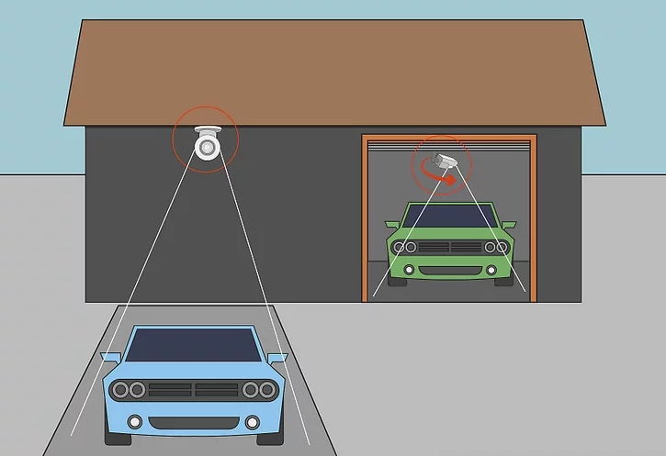
- Put cameras in common gathering areas to monitor people in your home. Place cameras over the living room, kitchen, dining room, and anywhere else that people tend to congregate when inside the house. This is especially useful for keeping an eye on children, babysitters, or guests in your home while you’re away
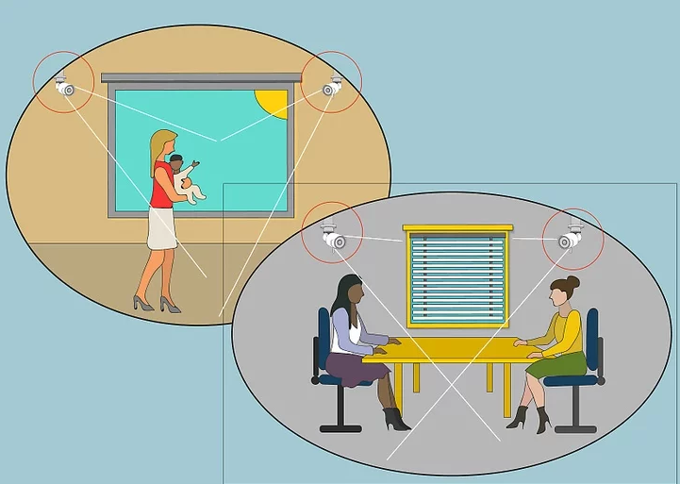
- Avoid putting cameras in bedrooms or bathrooms. Although you may feel the best way to keep your children safe is to be able to watch them in their rooms, areas like bedrooms and bathrooms have a warranted expectation of privacy that security cameras would undermine.
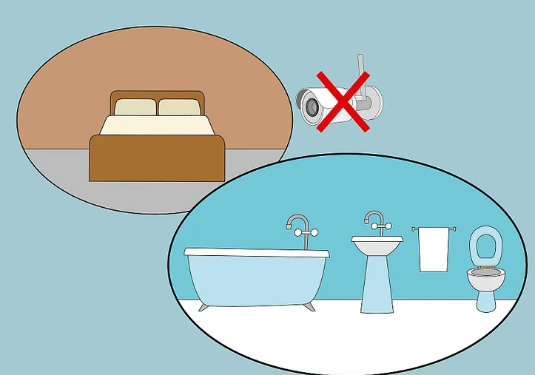
Part 3 Mounting and Wiring Your Camera
- For a high vantage point wherever possible to protect the camera. Place the camera about 9 to 10 feet (2.7 to 3.0 m) off the ground in order to prevent people from being able to tamper with it. However, don’t put the camera too high or else you may not be able to adequately see people with it.
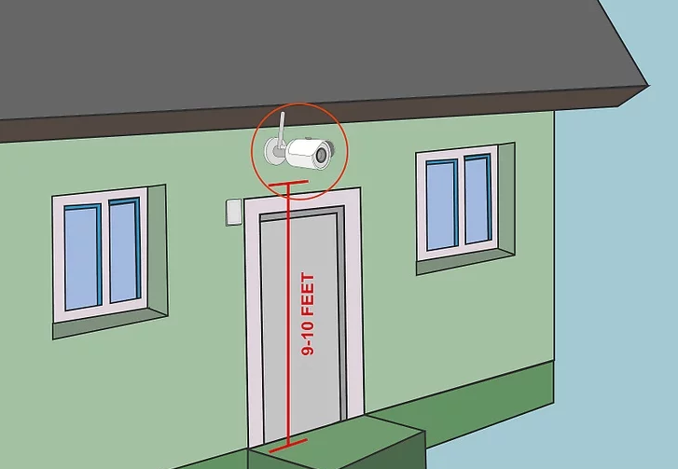
- Use screws or an adhesive pad to mount your camera to the wall. Use a screwdriver or drill to attach the camera mount to the wall with the screws that came with it. If the camera came with an adhesive pad instead of screws, simply remove the plastic covering from the adhesive pad and place it on the wall. Hold it there for at least 30 seconds before removing your hand.
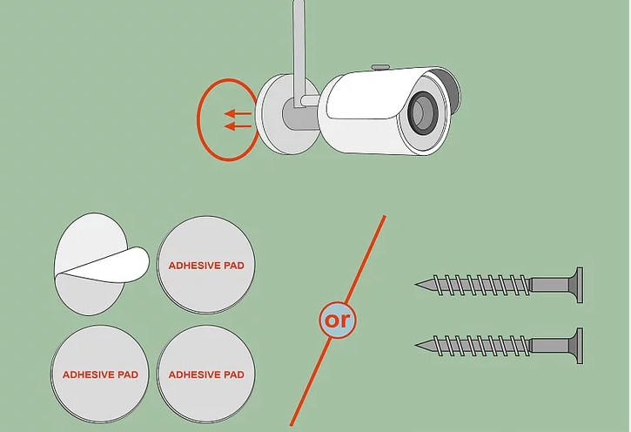
- Run video cables from your camera to the storage device, if applicable. If you bought a wired camera, it should have come with cables that are labeled “To Camera” and “To DVR” on either side. Plug these cables into your camera and DVR device by inserting the opposite ends of the cables into the devices indicated by their respective labels.
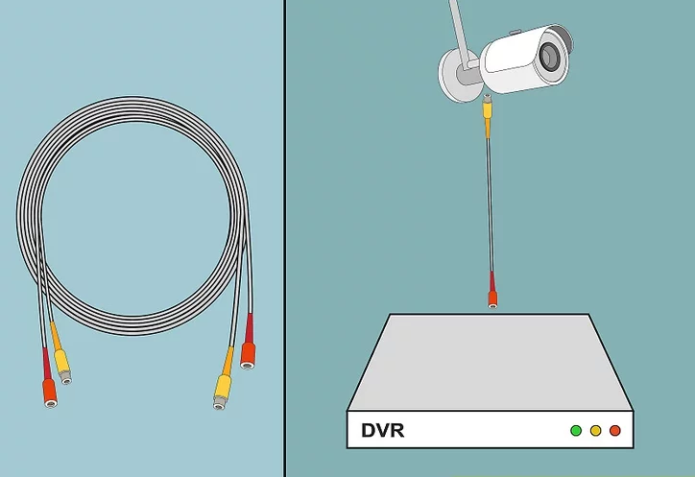
- Repeat this process for any other cameras you plan to install. If you’re installing multiple cameras, be sure to angle them so that they all cover different areas of your home or business. This will minimize the amount of overlap between different camera feeds and make your home or business as safe as possible.
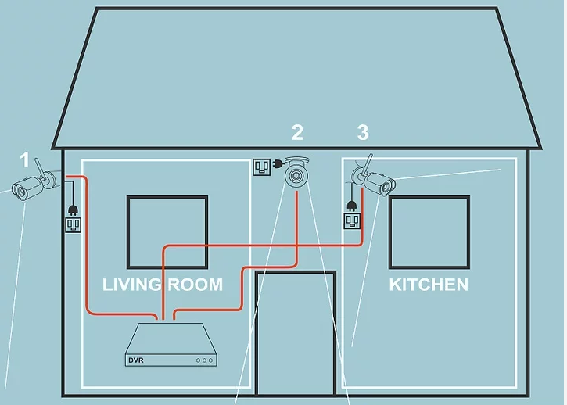
Wireless Camera
The Mi Home Security Camera 360° 1080p can be placed on a number of horizontal surfaces, such as a writing desk, dining table, and coffee table. It can also be mounted on the wall.
Mounting the Security Camera on a Wall
- Drill two holes on the wall by using the base of the security camera as a template. It is recommended that you mark the locations of the holes with a pencil before drilling. The diameter of each hole is approximately 6 mm and the depth is approximately 30 mm.
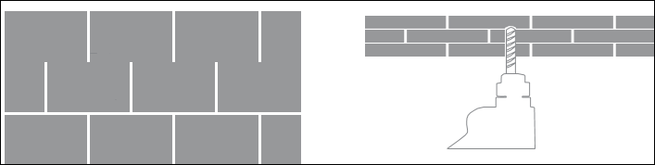
- Insert the two plastic anchors into the holes on the wall.
- Place the side of the base with arrows facing forward, and then align the holes. Insert the screws and then tighten them into the wall plugs with a Phillips head screwdriver.
Match the grooves on the bottom of the camera unit with the raised area on the base unit. Press down until the two surfaces are flush, then turn the camera unit in either direction to lock it in position.
Warning: To avoid any damages or injuries, the device must be securely fastened to the floor/wall as specified in the installation instructions.
When mounting the security camera on a wall: please note that the wall must be able to support at least triple the product’s total weight.
Match the grooves on the bottom of the camera unit with the raised area on the base unit. Press down until the two surfaces are flush, then turn the camera unit in either direction to lock it in position.
Warning: To avoid any damages or injuries, the device must be securely fastened to the floor/wall as specified in the installation instructions.
When mounting the security camera on a wall: please note that the wall must be able to support at least triple the product’s total weight.
Product Instructions
- Turning the Device On
The Mi Home Security Camera will automatically activate once the power cable is inserted into the Micro-USB charging port.
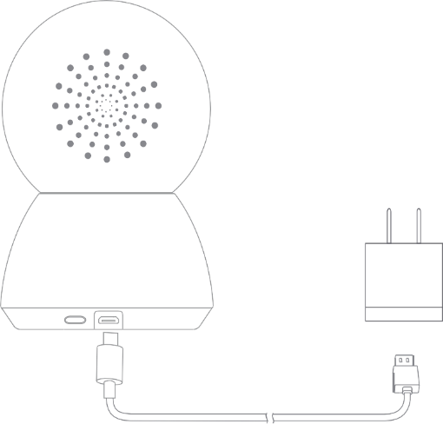
If the indicator light is flashing orange, that means the device is activated successfully. If you do not see a flashing orange light, please press and hold the Reset button to restart the device to enter pairing mode. Once the Mi Home Security Camera is turned on, please do not attempt to rotate its head by force. If the camera position is incorrect, adjustments can be made through the app.
reset
- Indicator Light
Steady blue on: connected/device status is normal flashing blue: network error
Flashing orange rapidly: waiting for connection flashing orange slowly: system upgrade in progress
- Installing a MicroSD Card
Make sure that the power to the security camera is already disconnected. Adjust the camera lens upward until the MicroSD slot is revealed, then insert the MicroSD card into the card slot with its contact points facing downward.
- Note: Please unplug the security camera before inserting or removing the MicroSD card. Please use a genuine MicroSD card manufactured by a qualified supplier, with a reading/writing speed of no less than U1/Class 10. (Maximum support capacity is 64 GB)
- Restore Factory Settings
Press and hold the Reset button to restore your device to factory settings. Data stored on the MicroSD card is not deleted.

Dome Setups and Cable Connection
Before installing or connecting the dome camera, please refer to this section and complete preparation, switch setting and communication switch settings.
Preparations for Indoor Dome Camera Setups
Follow the steps below to remove the PE cushion inside the dome cover and take off the lens cap to prepare for subsequent switch setting.
Step 1: Unpack the dome package and take out the dome body. | 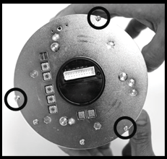
Step 2: Unscrew the three screws on the dome back, as marked in the figure, and remove the dome housing with the dome cover. | 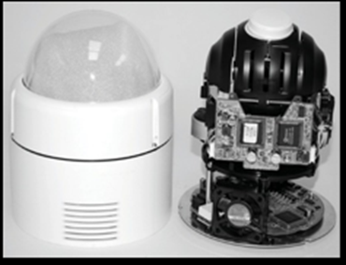
Step 3: Remove the PE cloth sheet and take off the lens cap. | 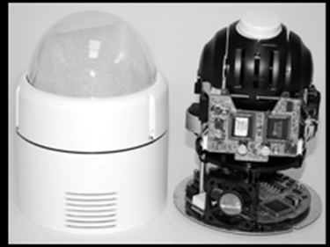
Step 4: Replace the dome housing with the cover back. Then screw it and the dome back together. | 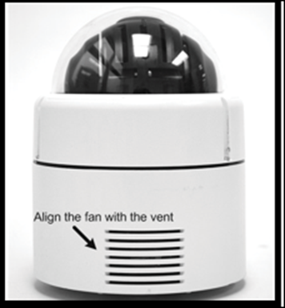

Note: When replacing the dome housing back, please align the cooling fan with the vent on the dome housing.
Pre
STEP 1Unpack the dome package and take out the dome body. | 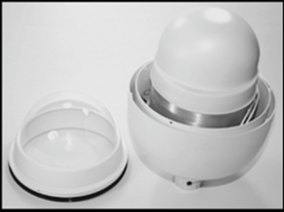
STEP 2Rotate the top holder and take it off from the dome body. | 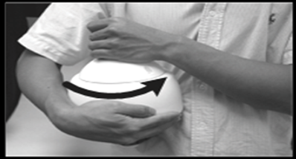
STEP 3Remove the protective cover and PE sheet. | 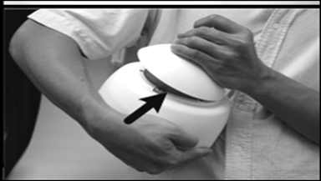
STEP 4Attach the dome cover to the dome body. Before doing that, apply some lubricant on the cover’s water-proof rubber to make the installation process smoother. | 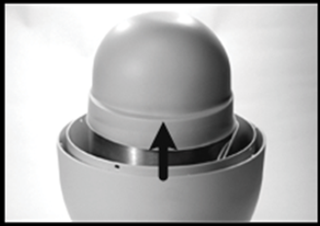
STEP 5Gently pressure the dome cover downward with two hands on the side of it. | 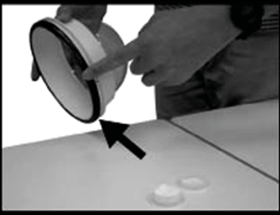
STEP 6Screw the dome cover and body together | 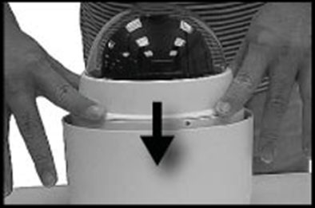
STEP 7Set the switches located on the bottom of the dome body. | 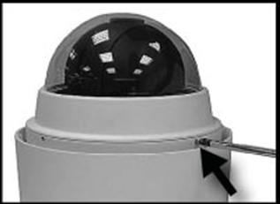
parations for Outdoor Dome Setups
This installation procedure is for the outdoor dome equipped with sunshield housing. Please follow the steps below to complete dome housing installation.
Dome Setups
Before connecting the dome camera to other devices of CCTV system, please complete the dome ID and communication switch setting. These switches are located on the bottom of the dome camera.
- Switch Definition
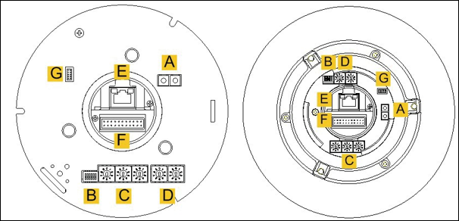
Indoor Dome Outdoor Dome
A | Reserved
B | Communication Switch
C | Dome ID Switch
D | Dome Control Protocol Switch
E | RJ-45 Connector (for IP Dome only)
F | 22-Pin Connector
G | ISP Connector (for FW upgrade)
Communication Switch Setting
The table below shows the function of each pin within the Communication Switch.
Communication Switch | SW 1 | RS-485 Setting
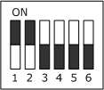 | SW 2 | RS-485 Setting
 | SW 3 | Termination
 | SW 4 | Line Lock
 | SW 5 | System Initialization
 | SW 6 | Reserved

RS-485 is the interface that communicates the dome camera and its control device; for this reason, the RS-485 setup of the dome and the control device must be the same. The RS-485 default setting is half-duplex (see the diagram follows). Please do not change the default setting without qualified specialist or supplier’s notice. As for the SW 3 and SW 4, they are used for termination and Line Lock adjustment respectively. The SW 5 is mainly used when users want to restore the camera to the factory default status; moreover, once firmware upgrade is carried out, users need to reset the SW 6 afterward.
RS-485 Setting
Half-duplex  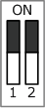 | Full-duplex  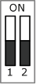
Dome ID Setting
Please change the dome ID if there is more than one dome on the same installation site. Before installing the dome camera, use the switch to change your speed dome ID by turning the arrow to the desired number respectively. For instance, if the dome ID is 123, the ID switch should be set as shown below.
Dome Cable Definition and Requirements
For operation, the integrated dome camera requires the video cable to carry the video signals to the remote viewing site, power cable to power the dome and RS485 data cable to carry commands from the control device.
- Cable Requirements
For operation, the integrated high speed dome cameras require video and data cables as described below:
      - The video cable sends video signals to a remote viewing site. Using a coaxial cable to send video signals is recommended.
      - RS-485 cable carries commands from a control device to the dome cameras. A CAT 5, 24-gauge cable is recommended.
      - The power cable provides either AC 24V or DC 12V power supply to the dome.
NOTE: Ensure power supply corresponds with the dome’s power requirement, or product impairment will occur. If any mistake happens,

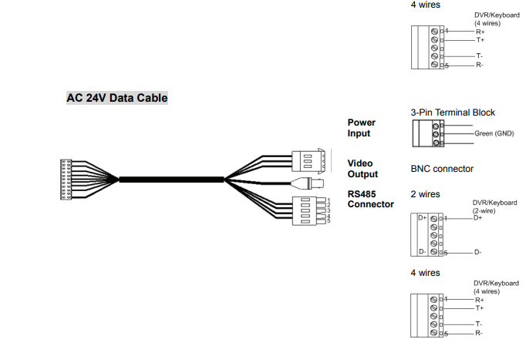.
Additionally, it is suggested to fasten the cables after cable connection is completed. Furthermore, when wiring the power cable, make sure the G/Y wire (Ground) inserted into the mid-pin of the terminal block.
Cable Wiring and Connection

 | 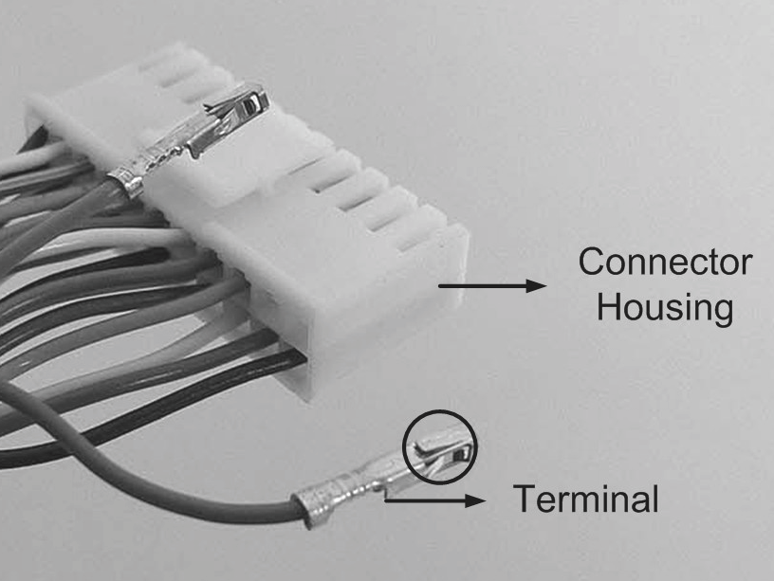
Insert the terminal into the pin holes on the connector housing, with the hook outward, as indicated in the figure. | 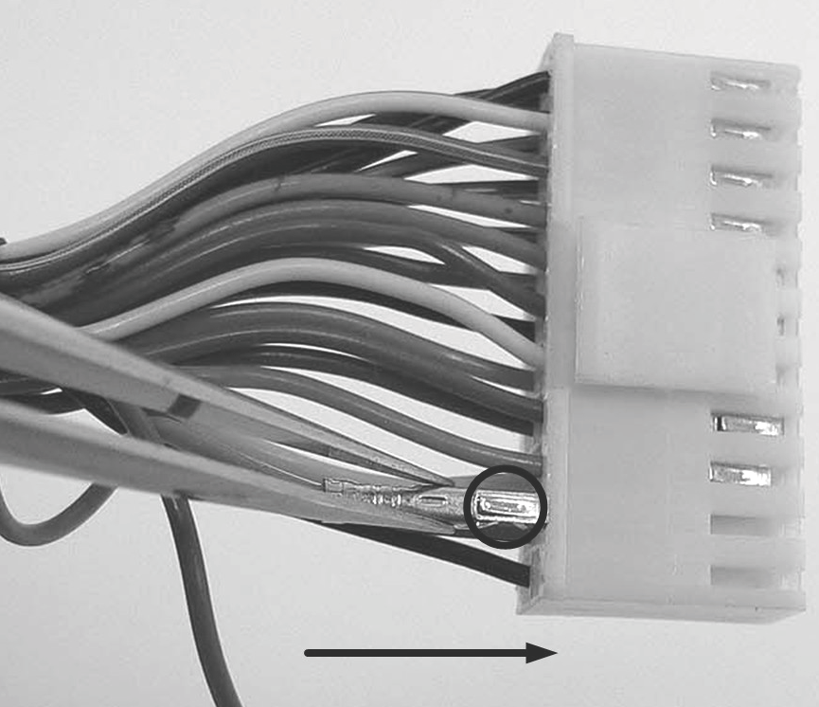

To unlock the terminal, press the hook, as indicated in the figure, with a proper tool and pull it out gently. | 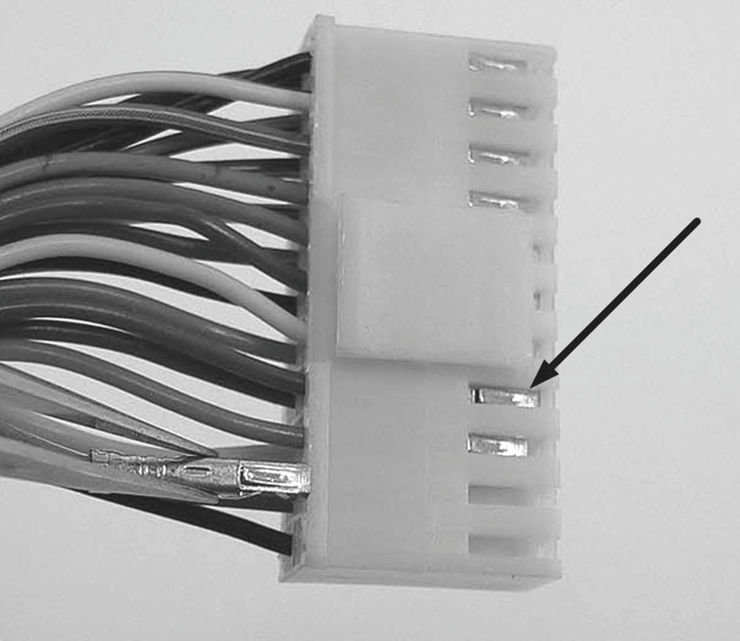
Connect the 22-pin connector to the dome camera. | 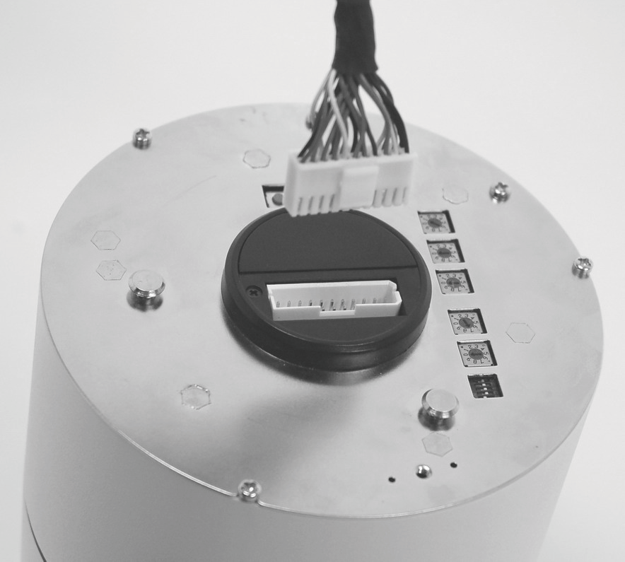
Dome Installation
Basing on user’s installation environments, the dome can be installed on ceiling, on wall or on pole. In the following sections, various indoor dome installation accessories, installation methods and installation procedures will be described in detail.
Ceiling Mount
Generally, there are three kinds of dome camera ceiling mounting methods: hard-ceiling, in-ceiling and mounting with straight tube. Refer to the following sections for more details.
Hard Ceiling Mounting (Indoor)
Hard Ceiling Mounting is a standard installation for an indoor dome, and general Mounting accessories are equipped in the standard indoor dome camera package. Here lists the items and tools needed to mount the dome camera onto the ceilings. The supplied items are all in the dome camera package.
Items Needed:
      - Dome Camera
      - Hard Ceiling Mount and Decoration Ring (Supplied)
      - Fixing Plate (Supplied)
Tools Needed:
      - Tool for drilling
      - (+,– ) Philips and flat Screw Drive
high speed dome camera for hard ceilings.
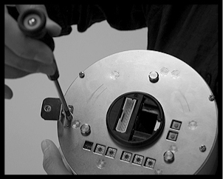
STEP 1
Screw the Fixing Plate to your dome body.

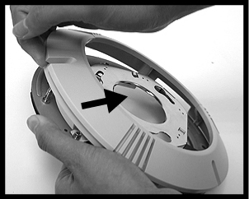
STEP 2
Remove the Hard Ceiling Mount from the
Decoration Cover.

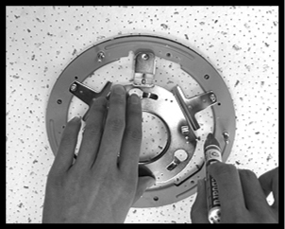
STEP 3
Attach the Mount to the ceiling. Mark the locations
where all three ceiling holes should go.
STEP 4
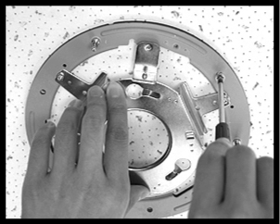
Drill these holes on the hard ceiling. Fix the Mount
With three screws.
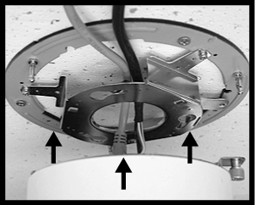
STEP 6
Connect the data cable through the center hole of the
Mount to the dome body.

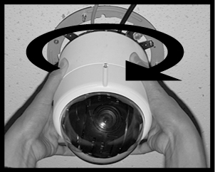
STEP 7
Attach the dome body to the Mount and rotate the dome
body clockwise. Tighten the fixing screw on the fixing
plate.
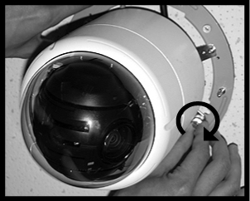
STEP 8
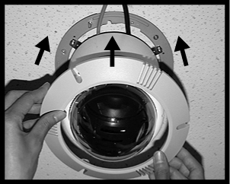
Assemble the Decoration Ring to the Mount.

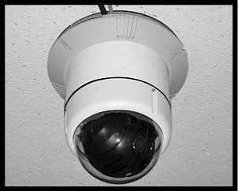
Completion

CCTV Installation
CCTV Installation can sometimes be difficult and complicated though you can either hire a professional to help you or just do it by yourself.
It’s essential to note that, if your IP address has POE (power over Ethernet) then there is no need to supply power to your cameras. However, for those having analogue and HD-SDO system, it’s necessary to have a power supply for all your cameras
Here are the basic 6 easy step to follow when installing a CCTV;
Step 1: Choose camera location
First, consider the required field of view but avoid pointing your CCTV cameras directly to sources of light such as bright doorways, lightings and windows. Too much light affects the quality of image though sufficient lighting is essential.
Things to consider;
- For indoors CCTV installation, the most suitable place is a corner in the room in which most entry points into your rooms are visible.
- For outdoors, a higher spot that’s covering the door and windows approaches are the most suitable location.
- Power sockets should be in close proximity.
- Each chosen spots should be above 10ft to avoid being knocked down easily.
Step 2: Run Cables
Make sure that in each camera location, you have run one of the supplied pre-terminated cables that is, between the location of the camera and the control equipment (DVR) location.
Things to consider;
- The male power plug should be located at the camera side.
- The power-socket should be located at the control equipment side.
- Thereafter, for each camera’s video-out socket, connect them to a video-input socket that is on the DVR through the black BNC lead on the supplied cables.
Step 3: Power Cameras
It is essential to know that both the DVR as well as the cameras are all powered by a single power supply. Therefore, for each CCTV camera’s power-input, connect them to the 4/5/8 way power supply-splitter lead on your power supply using the same cable.
Things to consider;
- A camera unit should be placed at the desired place.
- For the camera to work, you’ll have to insert the camera’s power cable in a socket.
Step 4: Power DVR
Just connect your DVR to the power supply-input which is on the DVR. After it’s done, you can then connect the power supply for DVR, monitor and camera to the main power supply.
Things to consider;
- All CCTV recording are stored inside a DVR thus it’s vital to keep your DVR inside a safe and locked compartment
- This is the most crucial step when it comes to CCTV installation, it ensure a secured security system for your office or home.
- It’s important to safe-guard your CCTV’s DVR since it’s the place where your surveillance hard disk is stored.
Step 5: Connect your Monitor to the DVR
you can use a BNC-BNC, Scart lead or even a VGA led to connect your monitor to the DVR. However, for those using a TFT monitor, it’s important to refer to your manufacturers’ connection instructions.
Things to consider;
To connect your monitor to the DVR, you’ll have to use a video cable to connect through a BNC port. However, when connecting your BNC port, There are certain things you should consider. First, you’ll have to;
- Remove an outer covering of your video cable of about 1.5 cm to expose the braids.
- Slide the crimping barrel towards the cable as its wider diameter facing the cable’s end. Thereafter, you should remove the
white insulator that’s covering the innermost cable.
- Insert the exposed cables into your BNC port as you screw the crimping barrel to ensure a secure connection.
- You can then connect your DVR-output port to the screen or monitor to video feed.
Step 6: Program your DVR
This is the final stage when installing a CCTV. Based on the instruction manual, continue with programming your DVR.
Things to consider;
- Before you start programming your DVR, you have to first, power on your cameras which will then be followed by the display and lastly the DVR.
- Setup your DVR based on the provided user manual with the DVR.
- To confirm if each camera is properly working and it’s providing the required viewing angle, it’s important to go over on each and every camera’s feed.

Self-check 4.1.
- Write clear short and precise answer
- Drawlayoutand wiringdiagramof twolampscontrolled fromoneposition.

- Writethe different between layout and wiringdiagram.

- Discussthemaintypesofelectricaldrawings.

- Whatdoes itmean byelectrical codeandregulations?

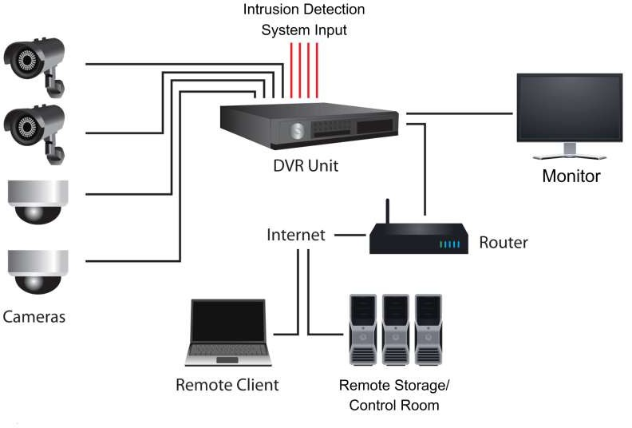
- Convertthesinglelinediagramgiveninfigurebelow into wiringdiagram.

Operation sheet 4.1.
Operation Title: installing aDome type camera:
Instruction: install a Dome type CCTV camera system step-by-step
Purpose: to install a CCTV camera
Required tools and equipment: Dome Camera, T-Bar (Optional Accessory), Supplied Screw (Equipped with T-Bar), Red Sticker (Equipped with T-Bar), Decoration Ring (Supplied), Tool for cutting a circle on the ceiling, (+,–) flat and Philips Screw Drivers
Precautions:
- use safety precaution while connecting electric supply
- Properly handle the tools
Procedures:
STEP 1 Screw the T-Bar Body Holder, which is equipped with the T-Bar, onto the dome back
STEP 2 Place the Red Sticker on the ceiling plate, and cut the circle part out of the ceiling
STEP 3 Put up the T-Bar into the ceiling hole.
STEP 4 Rotate the T-Bar’s wings to fix the T-Bar at the edge of the ceiling opening.
STEP 5 Tighten the screws on the wings.
STEP 6 Connect the data cable to the dome body through the center hole of the bracket.
STEP 7 Mount the dome body onto the bracket and rotate it clockwise. Then ensure the dome body fastened firmly and screw the T-Bar Body Holder.
STEP 8 Assemble the Decoration Ring to the T-Bar.

LAP Test 4.1.
Name: __________________________ Date: ____________
Time started: ____________________ Time finished: _______________
Instructions: Given necessary templates, tools and materials you are required to perform the following tasks within.
Task 1:Assemble and Mount Dome type CCTV Camera

Operation sheet 4.2.
Operation Title: installing a CCTV camera system:
Instruction: install a CCTV camera system step-by-step
Purpose: to install a CCTV camera
Required tools and equipment: CCTV cameras, DVR/NVR (Digital Video Recorder/Network Video Recorder), Coaxial cables or Ethernet cables, Power supply (for the cameras and DVR/NVR), Monitor or TV (for viewing the camera footage), Mounting brackets or stands for the cameras, Screwdriver and appropriate tools for installation, Cable clips and wire connectors,
Precautions:
- use safety precaution while confirm electric supply
- Properly handle the tools
Procedures:
- Plan the camera placement: Identify the areas you want to monitor and determine the optimal locations for installing the cameras. Consider factors like line-of-sight, coverage area, and security requirements.
- Install the cameras: Use the mounting brackets or stands to securely mount each camera to the chosen locations. Ensure they are positioned at the right angle and securely fastened to minimize vibrations.
- Connect the cameras: Depending on the camera type, connect them using either coaxial cables or Ethernet cables. For analog cameras, attach the coaxial cables to both the camera and DVR, ensuring a tight connection. If using IP cameras, connect them to the same network as the NVR using Ethernet cables.
- Run the cables: Conceal or secure the cables along the desired path. Use cable clips or wire connectors to keep them organized and prevent damage. Ensure the cables are long enough to reach the DVR/NVR location.
- Connect the cables to the DVR/NVR: Attach the other ends of the coaxial cables (for analog cameras) or Ethernet cables (for IP cameras) to the appropriate ports on the DVR/NVR. Ensure a secure and proper connection for each camera.
- Connect the DVR/NVR to the power supply: Plug in the power supply for the DVR/NVR to an electrical outlet. Make sure it has adequate power to support all the connected cameras.
- Connect the cameras to the power supply: Use separate power cables to connect each camera to the power supply. Ensure the voltage and current requirements of the cameras are compatible with the power supply. Plug the power supply into an electrical outlet.
- Connect a monitor or TV: Connect a monitor or TV to the DVR/NVR using HDMI or VGA cables. This allows you to view the camera footage.
- Configure the system: Follow the manufacturer's instructions to set up and configure the DVR/NVR. This may involve adjusting settings like date and time, network settings, motion detection, and remote access.
- Test the system: Ensure all cameras are functioning properly and the footage is being recorded. Adjust the camera angles if necessary. Verify that the monitor or TV displays the camera footage correctly.
- Optional: Set up remote access: If you wish to view the camera footage remotely, follow the instructions to enable and configure remote access. This may involve setting up port forwarding or using a mobile app.

LAP Test 4.2. : Install CCTV Camera
Name: __________________________ Date: ____________
Time started: ____________________ Time finished: _______________
Instructions: Given necessary templates, tools and materials you are required to perform the following tasks within.
Task 1: Install CCTV Camera

Unit Five: Setup, Configure and Basic Maintenance of CCTV System
This learning guide is developed to provide you the necessary information regarding the following content coverage and topics:

TRAINING OUTCOME
  - Setting and configuring CCTV surveillance system
  - Introduction to Computer Systems
  - Types of computers based on their uses
  - Setting up CCTV camera
  - Controls of different options in camera
  - Accessing from Back-end Software
  - Basic maintenance of CCTV camera
  - CCTV Preventative Maintenance procedures
This guide will also assist you to attain the learning outcomes stated in the cover page. Specifically, upon completion of this learning guide, you will be able to attain :
  - Set and configure CCTV surveillance system
  - Introduction to Computer Systems
  - Identify types of computers based on their uses
  - Set up CCTV camera
  - Understand controls of different options in camera
  - Access from Back-end Software
  - maintain CCTV camera
  - apply CCTV Preventative Maintenance procedures

5.1. Setting and configuring CCTV surveillance system

Introducing Computer Systems
It is a machine that takes in raw data and performs some calculations on it and gives us the formed output in the desired format. Computer is also a device that stores as well as processes information electronically. Computers usually come in different sizes and grades of functionalities.

5.2. Types of computers based on their uses
Information processing of computers
Information processing is a fundamental function of computers. It involves the input, storage, processing, and output of data. When data is entered into a computer, it is converted into a digital format and stored in memory. The computer then processes the data using algorithms and instructions to perform calculations, make decisions, and generate results. Finally, the processed information is displayed or transmitted as output. This process is repeated continuously, allowing computers to perform complex tasks and solve problems efficiently. Overall, information processing is a crucial aspect of computer functionality and is essential for the operation of modern technology.
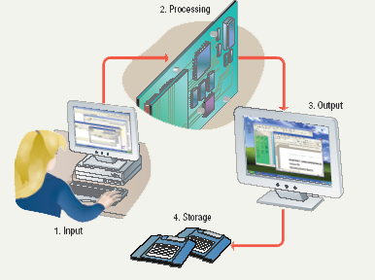
Processing - manipulation of data.
  - Data are symbols that represent raw facts, objects, and ideas about people, places, events, and things that are of importance in an organization.
  - A computer program or software is a series of instructions that tell a computer how to carry out a processing task.
Memory and Storage
- Memory - the area of a computer that temporarily holds data that is being processed or waiting to be processed, stored, or output.
- Storage - The area where data can be left on a permanent basis while it is not needed for processing.
- Examples of Storage
  - magnetic disks
  - CD-ROM (Compact Disk Read-Only Memory)
  - magnetic tapes
  - Flash disk
  - Memory card
  - Floppy disk
Types of computers based on their uses
There are several types of computers based on their uses. The first type is
Personal computers it is commonly known as PCs. PCs are designed for individual use and are typically used for tasks such as word processing, web browsing, and multimedia consumption. They are versatile and can be customized to suit the user's needs.
Laptops are portable computers that can be easily carried around. Laptops are designed for users who need to work on the go. They are lightweight and compact, making them ideal for travelers and students. Laptops offer similar functionality to PCs but with the added convenience of mobility.
Servers they are powerful computers that are used to store and manage data for multiple users or devices. Servers are commonly used in businesses and organizations to host websites, manage databases, and provide network services. They are designed to handle heavy workloads and ensure reliable performance.
There are three main types of computers based on their uses: personal computers, laptops, and servers. Each type serves a specific purpose and offers unique features and capabilities. Understanding the different types of computers can help users choose the right device for their needs.
Basic Computer Hardware Components

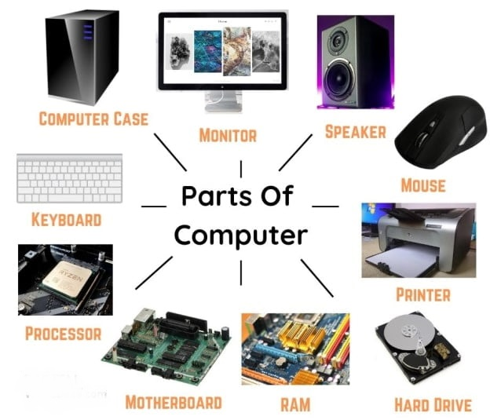
A computer is composed of several essential parts. These include the central processing unit (CPU), which is responsible for executing instructions and performing calculations. The motherboard acts as a central hub, connecting all the components together. Random access memory (RAM) provides temporary storage for data that the CPU needs to access quickly. The hard drive stores long-term data, such as the operating system and files. The graphics card handles the processing of visual information and is crucial for gaming and video editing. The power supply unit (PSU) provides power to all the components. Finally, the computer case houses and protects all the internal components.
Computer Software
System software: Is any program that controls the computer’s hardware or that can be used to maintain the computer in some way so that it runs more efficiently.
System Software provides a platform for running application software.
There are three basic types of system software:
- An operating system tells the computer how to use its own components. All computers require an operating system.
- The OS tells the computer how to interact with the user and its own devices.
- Examples of operating systems include Windows, Macintosh operating system and Linux.
- A network operating system allows computers to communicate and share data across a network while controlling network operations and overseeing the network’s security. Example is Windows server 2003.
- A utility is a program that makes the computer system easier to use or performs highly specialized functions.
  - Utilities are used to manage disks, troubleshoot hardware problems, and perform other tasks that the operating system itself may not be able to do. For example a Symantec antivirus, Partition Magic etc.
Application Software: Tells the computer how to accomplish specific tasks, such as word processing or drawing, for the user.
- Some of the major categories of these applications include:
- Word processing software for creating text-based documents
- Spreadsheets for creating numeric-based documents such as budgets.
- Presentation programs for creating and presenting electronic slide shows.
- Graphics programs for designing illustrations or manipulating photographs, movies etc.
- Database management software for building and manipulating large sets of data such as names, addresses etc.
- CCTV surveillance software
Data and Information
- Data are the words, numbers, symbols and graphics that describe people, events, things, and ideas.
- Data becomes information when it is used as the basis for initiating some action or for making a decision.
- Information are the words, numbers, and graphics used as the basis for human actions and decisions.
- A set of data that has been given a name is called a file.
- A file that a user can open and use is called document.
- A folder is a place where groups of computer files and other folders can be kept and organized.
Files
- A file is a named collection of data, stored on a storage medium such as a hard disk.
- There are two types of files
- Data files contains text, images, or other data that can be used by a program.
- Executable files contains programs or instructions that tell the computer how to perform a task.
- Filename extensions describe a file’s contents. For example Executable files usually end in .exe, word files end in .doc, adobe acrobat documents end in .pdf, Security video footages as different video formats etc.
Extensions and Formats
- A filename might be followed by a filename extension that further describes the file contents.
- Word files end in .doc
- Excel files end in .xls
- The file format is the arrangement of data in a file and the coding scheme that is used to represent the data.
- The native file format is the format that is saved by the application that created it.

5.3. Setting up CCTV camera

Accessing Network Camera
Assigning an IP Address: The Network Camera must be assigned an IP address to be accessible. The default IP address of most Network Camera’s looks like this 192.168.xx.xx. But, it is recommended to look up on their installation manuals to get the correct Ip address or we could get their address using their on configuration software and apps just by scanning the QR code
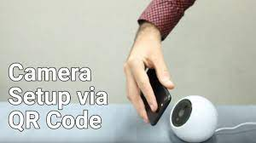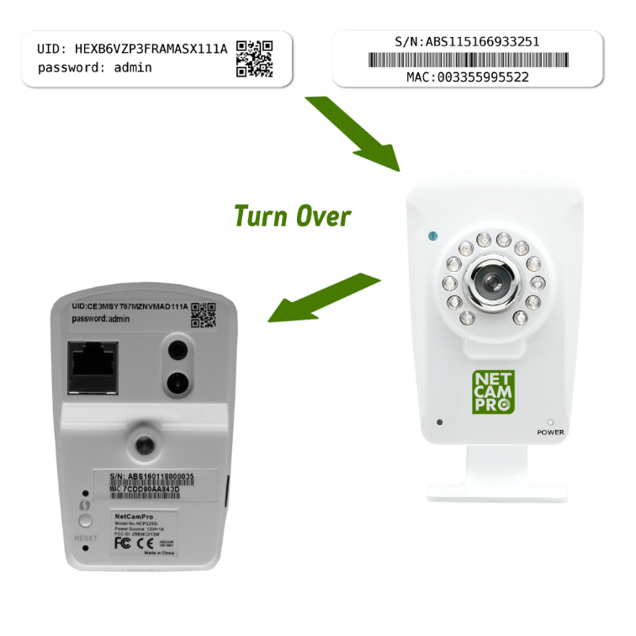
Figure5.1 Cameras QR code
You can either change the IP address of the camera via Smart Tools or browser. But it is mandatory not to forget to connect the camera in the same LAN of your computer before starting.
Assigning an IP Address by Using Smart Tools
Smart Tools is a software tool which can automatically detect multiple online network cameras in the LAN, set IP addresses, and manage firmware upgrades. It’s recommended to use when assigning IP addresses for multiple cameras.
Step1: Install Smart Tools (The software could be downloaded from the manufacturers website for example xiaomi mi app and pc monitor, Hikvision cctv manager and some of cameras may be accessible using third party apps and software);
Step2: Start Smart Tools, click the IPC Tools page, then enter the device information, such as IP address, MAC address, Status, Port number, Netmask, and Gateway, then all related network cameras in the same network that will be displayed.
If you couldn’t find the ip address there you could always use “ip cam finder software” to find a camera’s Ip and mac address in your camera
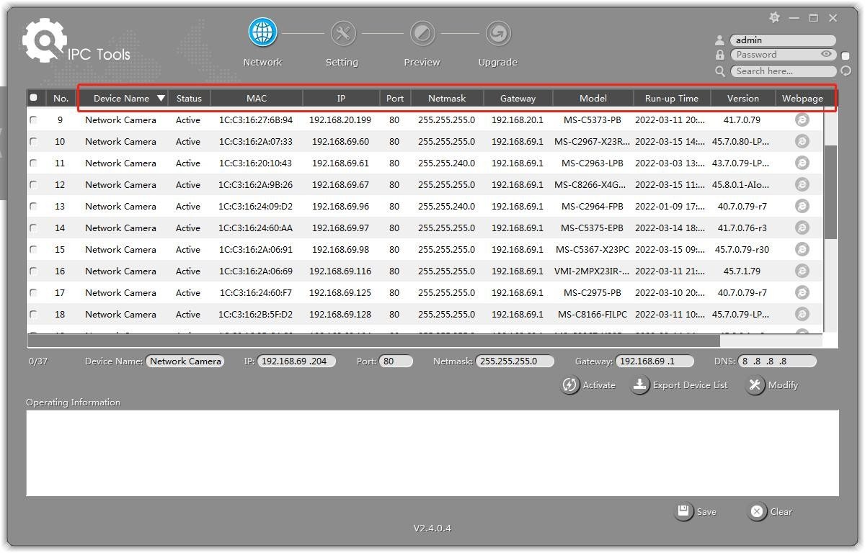
Figure5.2 Ip address finder software
Step3: Select a camera or multiple cameras according to the MAC addresses

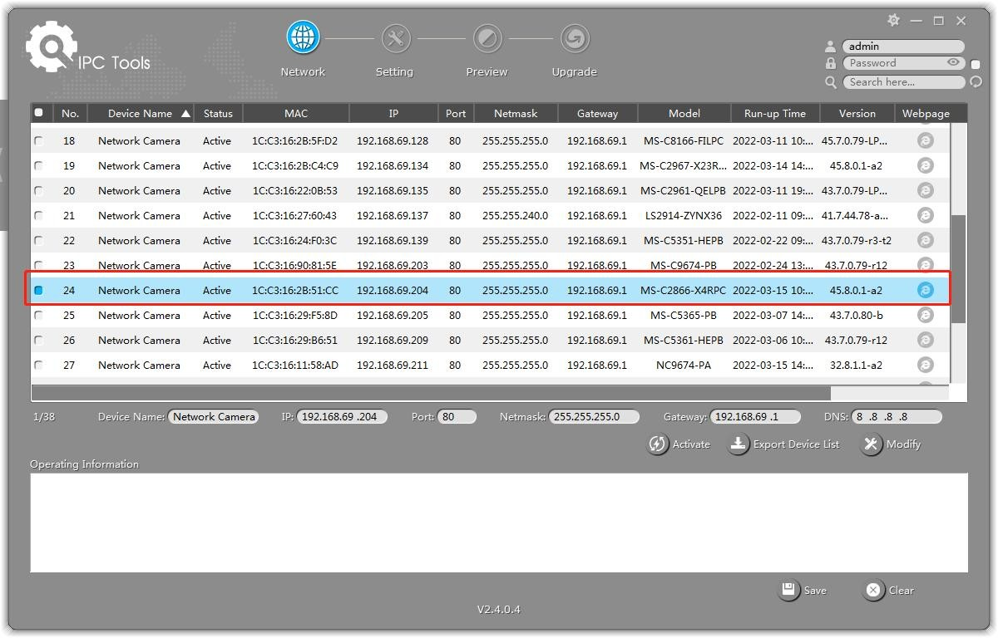
Figure5.3 Select a camera ip address
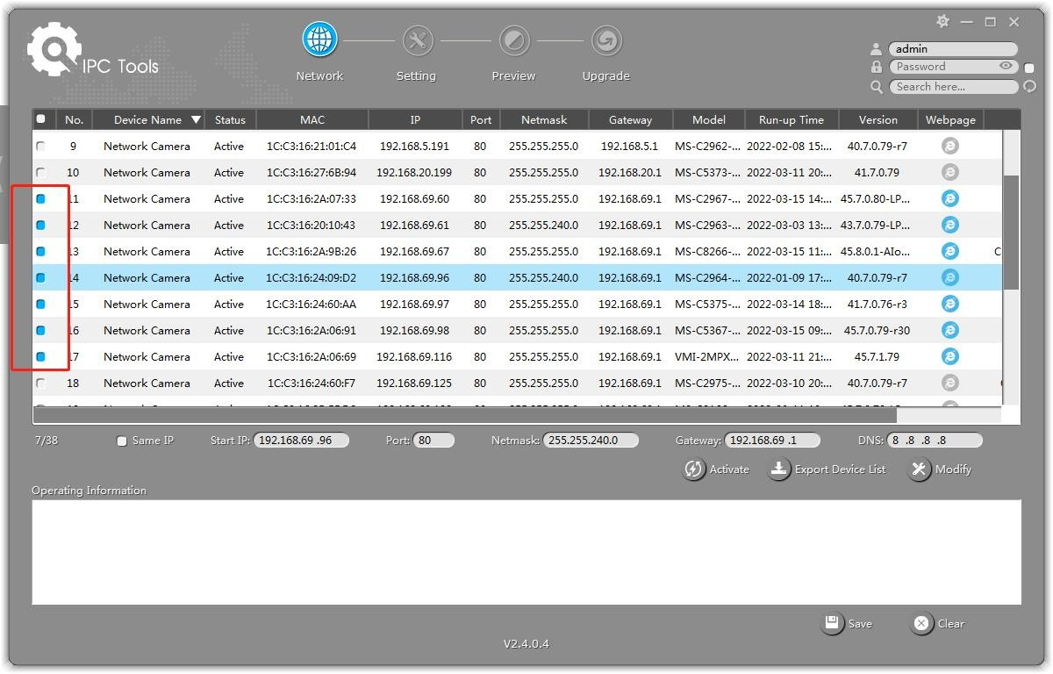
Figure 3 Selecting multiple cameras
Step4: If the selected camera shows "Inactive" in the status bar, click "Activate" to set the password when using it for the first time After activation, you can change the IP address or other network values, and then click “Modify” button.
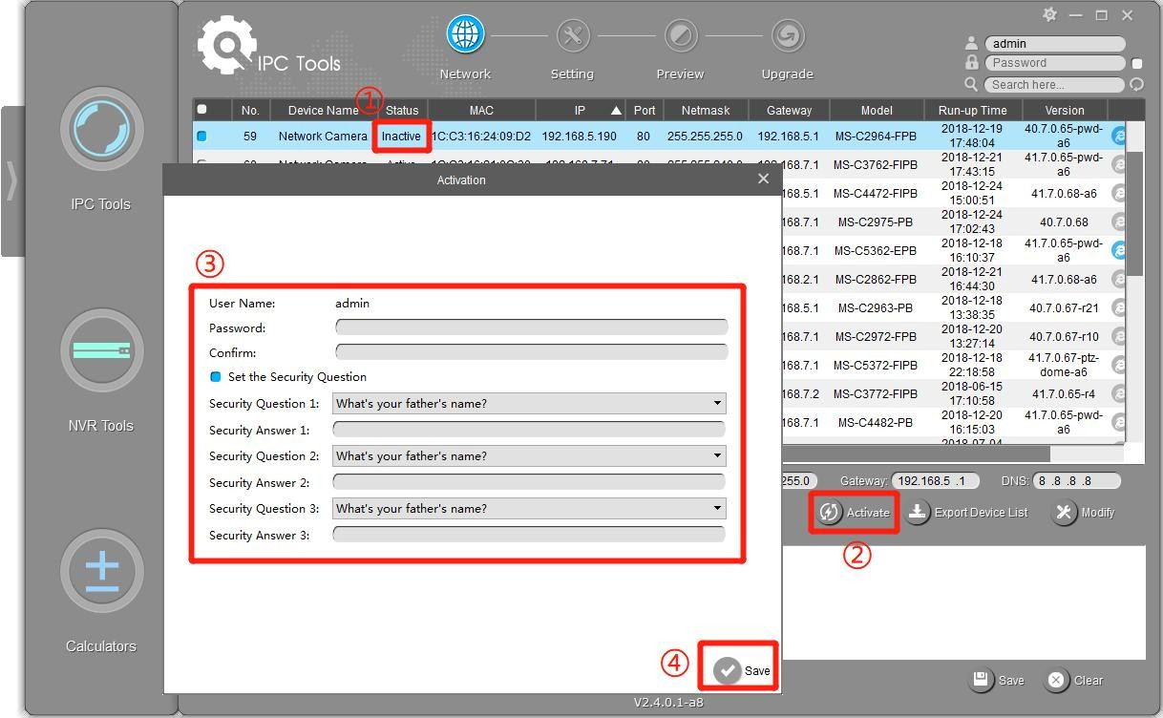
Step5: Change the IP address successfully

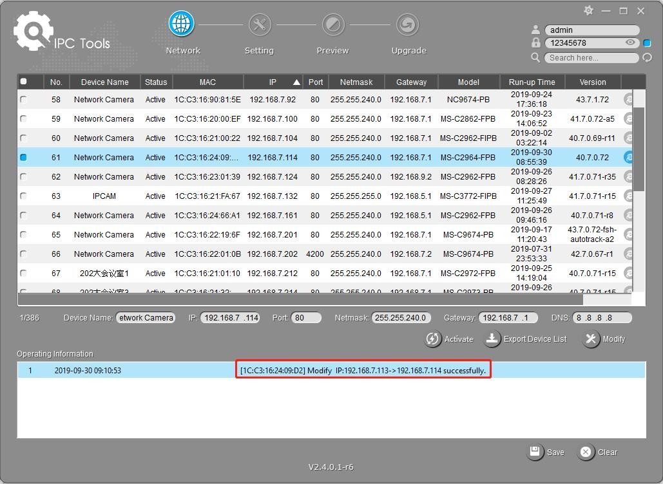
Step6: By double clicking the selected camera or the browser of interested camera, you can access the camera via web browser directly. The Internet Explorer window will pop up.

More usage of Smart Tools, please refer to the Smart Tools User Manuel:

Assign an IP Address via Browser
Ifthenetworksegmentofthecomputerandthatofthecameraaredifferent,pleasefollowthestepstochangetheIPaddress:
Step1:ChangetheIPaddressofcomputerto192.168.5.0segment,herearetwowaysasbelow:
StartControlPanelNetworkandInternetConnectionNetworkConnectionLocalAreaConnection,anddoubleclickit.
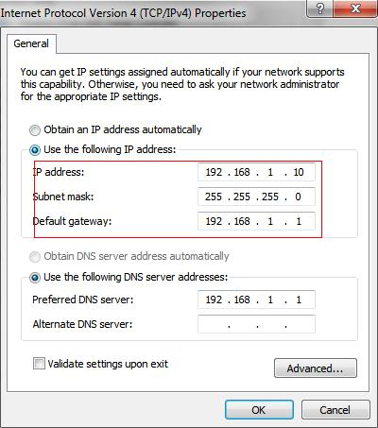

Click “Advanced”, and then click “IP settings” “IP address” “Add”. In the pop-up window, enter an IP address that in the same segment with network camera ( e.g. 192.168.5.61, but please note that this IP address shall not conflict with the IP address on the existing work);

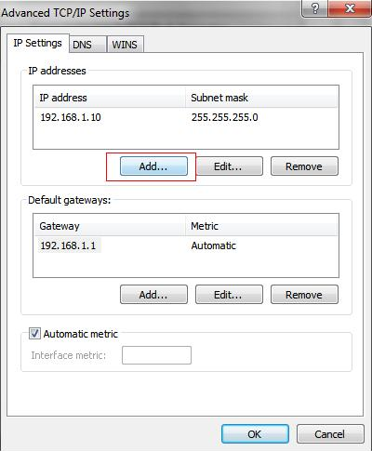
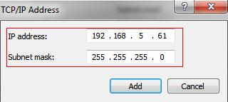
Step2: Start the browser. In the address bar, enter the default IP address of the camera: http://192.168.5.190.
Step3: You need to set the password first when using it for the first time. And you can also set three security questions for your device after activation. Then you can log in to the camera with the user name (admin) and a custom password.
Step4: After login, please select “Settings” → “Network” → “Basic” → “TCP/IP”. The
Network Settings page appears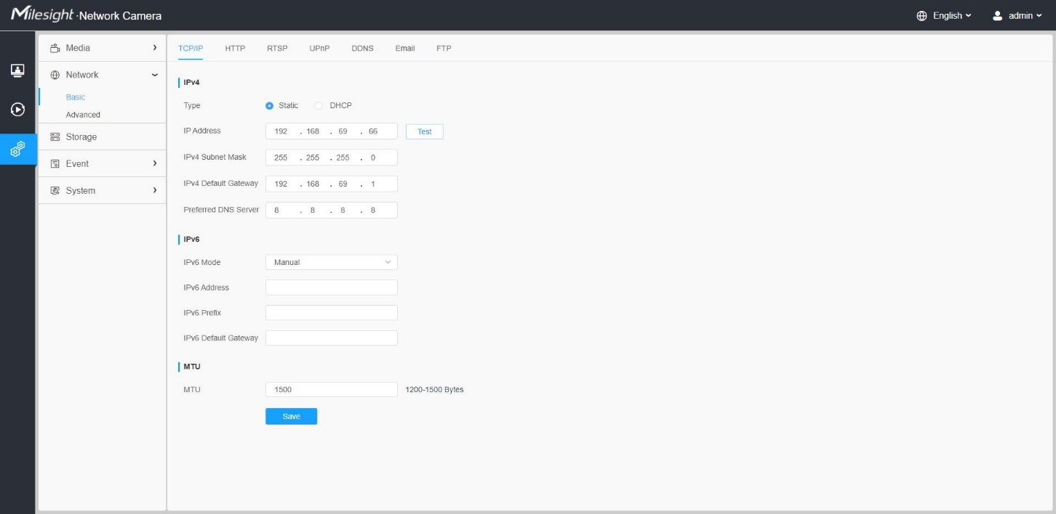
Step5: Change the IP address or other network values. Then click “Save” button; Step6: The change of default IP address is completed.

5.4. Controls of different options in camera
Accessing from the Web Browser
The camera can be used with the most standard operating systems and browsers. And the camera was upgraded to support Plugin-Free Mode. In Plugin-Free Mode in most of camera’s, you can preview the video on the browser without plugin. Currently Plugin-Free Mode is supported in Firefox & Google Chrome & Safari & Edge browser for Windows system, MAC system, iOS system and Android system. Both H.265&H.264 video codec is supported in Plugin-Free Mode for camera, and it will play the secondary stream by default.
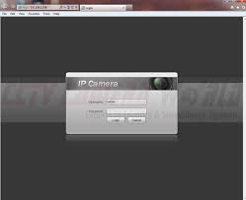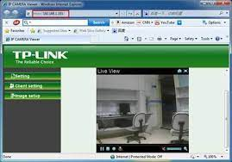
Figure5.4 Accessing from the Web Browser

5.5. Accessing from Back-end Software

5.5.1. Accessing from NVR (Network Video Recorder
NVR manages and stores HD video data. It owns multi-disk management systems, front end HD device management system, HD video analysis system and high-capacity system for video. Also, they adopts the technology of high flow capacity data network transmitting transmission, with multi-channel video decoding, to achieve functions like intelligent management, safe storage, HD decoding, etc.

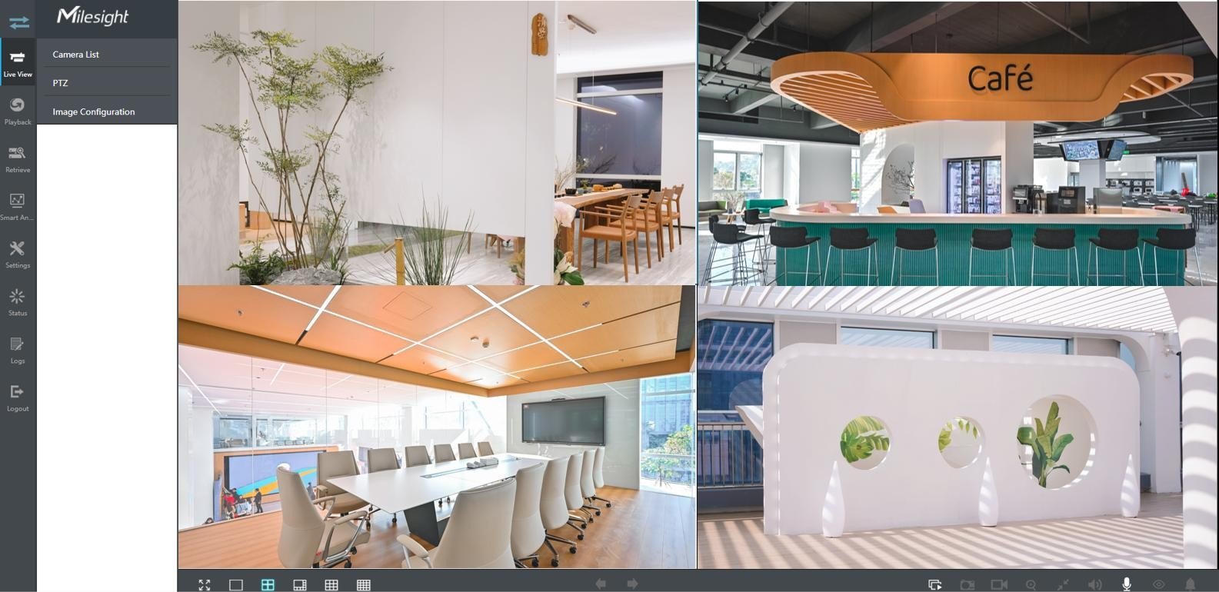

Figure5.5 Accessing NVR
Connecting with commonly used Mi Home/Xiaomi Home App
This product works with Mi Home/Xiaomi Home app*. Control your device with Mi Home/ Xiaomi Home app.
Scan the QR code to download and install the app. You will be directed to the connection setup page if the app is installed already. Or search
"Mi Home/Xiaomi Home" in the app store to download and install it. Open Mi Home/Xiaomi Home app, tap "+" on the upper right, and then follow prompts to add your device.
* The app is referred to as Xiaomi Home app in Europe (except for Russia). The name of the app displayed on your device should be taken as the default.
Real-time Surveillance
Launch the Mi Home app and select a Mi Home Security Camera 360° 1080p that is already connected to monitor the surroundings in real-time. The camera’s control interface allows you to adjust the sharpness of the image, as well as to change the device’s vertical and horizontal viewing angles. Additional features such as screen capture or record and remote communications can also be performed.

HD
Figure5.6 Real-time Surveillance
Launch the Mi Home app and select a Mi Home Security Camera 360° 1080p that is already connected to monitor the surroundings in real-time. The camera’s control interface allows you to adjust the sharpness of the image, as well as to change the device’s vertical and horizontal viewing angles. Additional features such as screen capture or record and remote communications can also be performed. The camera could automatically switch to night-vision mode based on changing light conditions. The 6 built-in infrared night vision lights increase the night vision distance up to 9 meters, so the camera can clearly capture video in the dark.
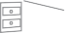
Figure5.7 Infrared night vision mode sample
Playback
Mi Home Security Camera’s playback feature is only available after installing a compatibleMicroSD card. Once a MicroSD card has been installed and the security camera is turned on,videoswillberecordedautomatically.AfterenteringtheuserinterfaceofthePlaybackfeature,simplyslidethebaronthetimelinetoselectthetimeperiodyouwishtoview.
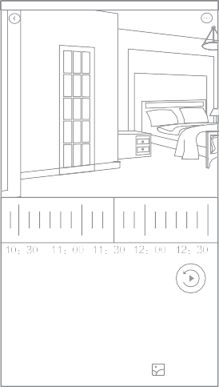
HD
Figure5.8 playback feature
Automatic Surveillance
- Home surveillance can be enabled or disabled in the Mi Home app.
- Available options include 24-hour, daytime, and nighttime monitoring. You can also create your own schedule and set the desired camera angle.
- This product is able to detect movements within its field of view. Once movements are detected, a video is recorded and you will receive a notification.




Figure5.9 Home surveillance can be enabled or disabled in the Mi Home app.
Shared Remote Viewing


Through the Mi Home Security Camera 360° 1080p control interface in the Mi Home app, you can set your security camera as a shared device under the general settings menu, and invite your friends to view the camera remotely. Your friends will be required to download the Mi Home app and log
10:19 4G

Share...
SharewithMiAccount
Share withfriends
Sharewithfamily

Help
Device sharing
Automation
Managestorage
Homesurveillance
GeneralseGings
4G
10:15

5.6. Basic maintenance of CCTV camera:
Like any technology, CCTV cameras can occasionally encounter issues that may affect their performance. Being familiar with some basic troubleshooting techniques can save time and effort in resolving these problems.
Here are some troubleshooting tips to help CCTV cameras back on track.
- Check Power Supply: One of the most common issues with CCTV cameras is a power-related problem. If your camera is not turning on or displaying a blank screen, ensure that it is properly connected to a power outlet and that the power supply is functioning correctly. Check the camera's power cable and connection points for any signs of damage. Additionally, verify that the power outlet is working by plugging in another device. If necessary, try using a different power adapter to rule out a faulty adapter.
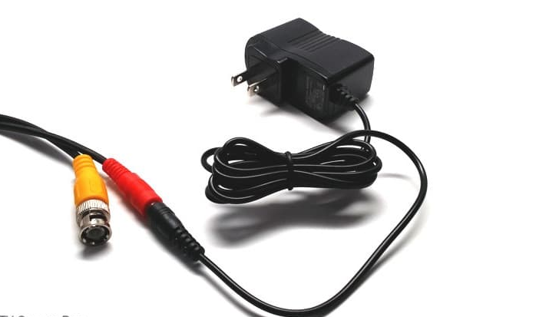
Or if it is on a big infrastructure, it more likely to have a common bower supply so Check Power Supply Box Fuses on distributor for all cameras make sure to look at your existing power supply to confirm whether it is 12V DC or 24VAC. Most are 12V DC.
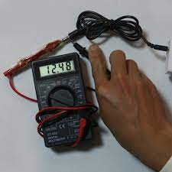
To do that, disconnect your existing power supply from the cable and attach your spare. Plug it in and test to see if your camera now displays video
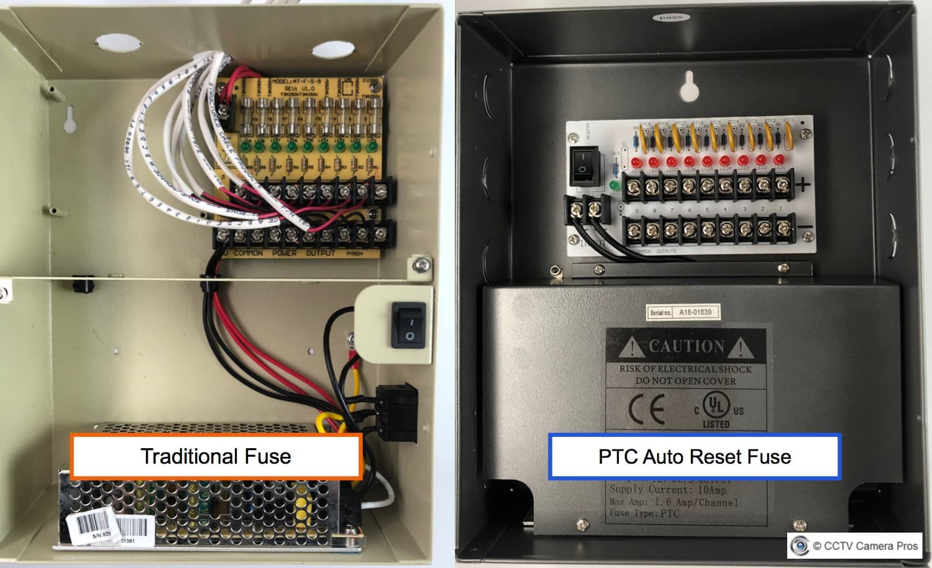

- Test Camera on a Different DVR Port
This is uncommon, but it is possible that one of the BNC video input ports on your security camera DVR went bad. It is a simple thing to test, so you may as well give it a try before you spend time on the other troubleshooting steps.
Simply disconnect the BNC video connector of the troubled surveillance camera from the back of your digital video recorder and plug it into one of the ports where a working camera is plugged in. Plug the BNC connector of the camera that is working into the port of the camera that is not working. Does the working camera show video on the other BNC port? Does the troubled camera display video on the other port?
If the troubled camera works and the camera that was working does not work, then you have a bad input port on your DVR.
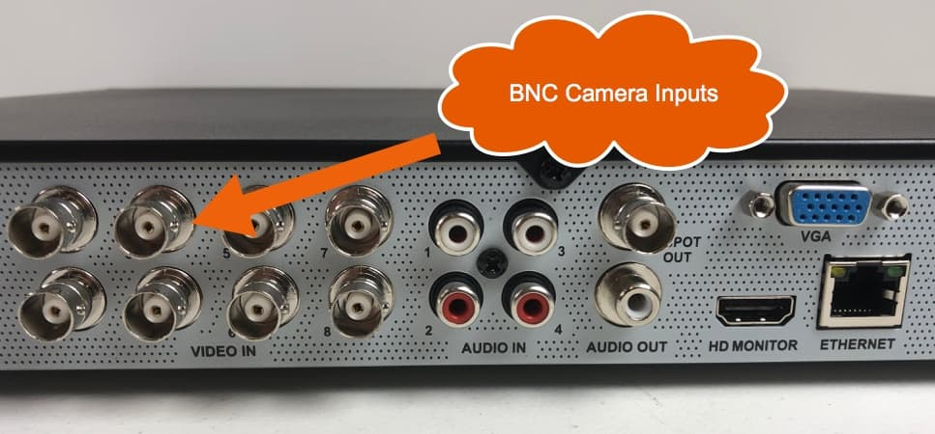
Examine Cable Connections: Sometimes, a faulty or loose cable connection can disrupt the camera's signal transmission, resulting in the loss of video feed or poor quality footage. Inspect the cables connecting the camera to the DVR/NVR or monitor. Ensure they are securely plugged into their respective ports and that there are no signs of wear or damage. Consider testing the camera with a different cable to rule out a faulty cable as the cause of the issue.
3. Check Network Connectivity (for IP Cameras): For IP cameras that rely on network connectivity, ensure that the camera is properly connected to the network. Check the Ethernet cable for any damage or loose connections. Verify that the camera's IP address is correctly configured, and make sure it is within the range of the router's DHCP pool. Try restarting both the camera and the router to establish a fresh connection. In some cases, a firewall or security settings on the router may be blocking the camera's access. Ensure that the necessary ports are open for remote viewing and recording.
4.Reboot DVR/NVR: If multiple cameras connected to a DVR/NVR are experiencing issues, it's worth restarting the device. Power cycling the DVR/NVR can resolve common software or firmware glitches that may be causing the problems. Simply unplug the power cable from the device, wait for a few seconds, and then plug it back in. Allow the device to reboot completely before checking if the cameras are functioning properly.
5.Adjust Camera Settings: Sometimes, incorrect camera settings can result in undesirable footage quality or operational issues. Check the camera's settings, including resolution, exposure, white balance, and motion detection. Ensure that these settings are appropriately adjusted according to your specific requirements. If required, consult the camera's user manual or manufacturer's website for detailed instructions on adjusting these settings.
6. Perform a Camera Reset: If all else fails and the issues persist, you can try resetting the camera to its factory default settings. This process can vary depending on the camera model, so consult the user manual or manufacturer's support resources for specific instructions. Keep in mind that a factory reset will erase any customized settings, so you will need to reconfigure the camera after the reset. Remember, if you are unsure about any troubleshooting steps or encounter hardware-specific issues, it is always best to consult the camera's user manual or reach out to the manufacturer's technical support for assistance. With these basic troubleshooting tips, you can overcome common issues and ensure the optimal performance of your CCTV camera system, providing peace of mind and enhanced security for your premises.
“Preventionisbetterthancure”
When CCTV Camera in use for many years, there is a possibility to face some technical problems. When CCTV Camera frequently maintained, the problem can easily be figured out at premature stage to be solved. This also helps in lowering the cost of maintenance and reduction of complication.

5.7. CCTV Preventative Maintenance procedures
      - Testing and r e-adjustment of focus and video levels on all cameras
      - Testing of external camera housings
      - Checkingofallmechanicalfixtures,brackets,towersandcamerafunctions
      - Cleaning fall camera lenses and housings where appropriate
      - Removal of any temporary obstructions; e.g. growing trees and bushes
      - Test all photo cells and infrared lamps for correct operation
      - Clean all video display monitors with anti-static solution
      - Adjust video time and date displays required, and check equipment settings
      - Carry out test reviewing of recordings and advise on best practice
      - Checkvideodataconnectionsbetweenallcontrolequipmentre-terminateandcrimp
      - Testallremotevideotransmissionequipment,ensuringcorrectoperation
      - Provide an engineer’s report on the condition of the installation if so required
      - Provide any necessary basic instruction and training
      - Advise on latest data protection and security legislation
      - Adviseonthelatestequipmentavailabletoimprovethefunctionalityoftheinstallation
      - Check installation, location and mounting of all equipment and devices against specification.
      - Check operation of all detection devices
      - Inspect all flexible connections
      - Checkpowermainsandstand-bybatterypowersupplies,includingchargingrates
      - Check control unit for correct operation
      - Check remote sign aligned equipment physical connections
      - Test remote sign align equipment communications to the Alarm Receiving Centre

Self-check-5.1.
- Write the steps for installing of CCTV camera
- What is CCTV Camera Maintenance?
- What are some important factors to consider when setting up CCTV cameras?
- How can you ensure proper placement and positioning of CCTV cameras?
- What are some common challenges or obstacles in setting up a CCTV camera system?
- What are the main components required for a basic CCTV camera setup?

Operation sheet 5.1.
Operation Title: Installing Wireless CCTV camera
Instruction: install a Wireless camera system using below steps
Purpose: to Install Wireless CCTV camera
Required tools and equipment: Wireless CCTV camera, Wi-Fi router, Smartphone, Screwdriver and appropriate tools for installation
Precautions:
- use safety precaution while confirm electric supply
- Properly handle the tools
Procedures:
- Plan the camera placement: Identify the areas you want to monitor and determine the optimal locations for installing the camera. Consider factors like line-of-sight, coverage area, and security requirements.
- Install the camera: Use the mounting brackets or stands to securely mount the camera to the chosen location. Ensure it is positioned at the right angle and securely fastened to minimize vibrations.
- Power on the camera: If your wireless CCTV camera requires a power supply, connect it to an electrical outlet using the provided power adapter. Ensure the camera is receiving power.
- Connect the camera to your Wi-Fi network:
- In most cases, you will need to connect your smartphone or computer to the camera's Wi-Fi network
- Launch the camera's app or access the web interface and follow the on-screen instructions to connect the camera to your home Wi-Fi network. You will typically need to provide the Wi-Fi network name (SSID) and password.
- Adjust camera settings:
- Change default password
- Test the camera: Once the camera is connected to your Wi-Fi network and any necessary settings are configured, test the camera's functionality. Use the smartphone app or web interface to view the camera's live footage.

LAP Test 5.1. Configure IP Camera
Name: __________________________ Date: ____________
Time started: ____________________ Time finished: _______________
Instructions: Given necessary templates, tools and materials you are required to perform the following tasks within.
Task 1: Configure IP Camera

Operation sheet #2
Operation Title: CCTV Maintenance
Instruction: follow instruction to maintain CCTV Camera
Purpose: To Troubleshoot CCTV camera maintenance
Required tools and equipment: IP camera, Wi-Fi router, Smartphone, Screwdriver and network tester
Precautions:
- use safety precaution while confirm electric supply
- Properly handle the tools
- Give appropriate electric power
Procedures:
- Clean Camera Lenses
- Inspect Cables and Connections
- Test power source
- Keep Your Software Up-To-Date
- Check the Lighting Conditions
- Test the camera:

LAP Test - 5.2.

Name: __________________________ Date: ____________
Time started: ____________________ Time finished: _______________
Instructions: Given necessary templates, tools and materials you are required to perform the following tasks within.
Task 1: Troubleshoot CCTV Camera system

REFERENCE
- CCTV Technology Handbook.
- Anonymous authenticated access to MJPEG stream. http://goo.gl/sYkUAF.
- BabyMonitorHack’CouldHappenTo40,000O the Foscam Users. http://goo.gl/2cdYy0
- Bugged Planet Surveillance Industry and Country’s Acting. http://buggedplanet.info/.
- CVE-2013-1391–Filed is closure in Hunt DVR and generic brands, discloses authentication in formation.
- YouTube.Thefastestrobbery1mininbank.http://youtu.be/LFArxqcP4MI
- ABUSTVIP11550/21550Multiplevulnerabilities.http://www.securityfocus.com/archive/1/520045.

Developers Profile
The trainers who Develop these Learning modules
No | Name | Qualification | Educational background | Region | College | Mobile number | E-mail
 | Tesfahun Ayalew Denidine | MSc | Electronics and comm Eng. | BGRS | Assosa poly TVET | 012132308/09212121 | tesfugps4545@gmail.com
 | Shimeles Dejen Mekonenn | BSC | Electrical Comm Techn | Ahama | W/Sein PTC. | 0910838814 | shimelesdejen@gmail.com
 | Petros Gelana Megersa | BSC | Electrical comm.T | Oromia | Ambo poly TVET | 0921183975 | petrosgelana6@gimal.com
 | Mezgebu Alemseged | BSC | Electrical & comm.T | A.A | M/G/M/B/ Poly TVET | 0943933255 | Alemsegedmezgebu994@gmail.com
 | Zekarias Sisay G/egziabher | MSc | Electrical & Power Eng. | Harari | Harari poly TEVET Co | 0703747163 /o913344201 | szekarias07@gmail.com

