Industrial Electrical/Electronic
Control Technology
Level – II
Based on March ,2022Curriculum Version
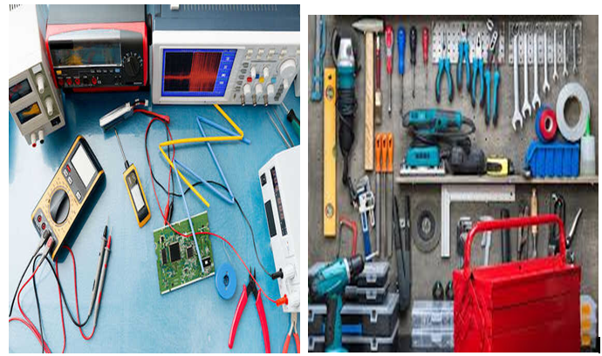
Module Title: - Perform Electrical Measurement and Calculation
Module code: EIS IEC 01 0322
Nominal duration: 80Hour

Prepared by: Ministry of Labor and Skill
August, 2022
Addis Ababa, Ethiopia

Contents
Acknowledgment 4
Acronym 5
Unit one: Plan and prepare tasks 7
1.1. Personal protective equipment 8
1.2. Hand tools and measuring instrument 10
1.3. Work stations safety 27
1.4. Component measurement 28
1.5. Hand tools and measuring instrument specification 29
Self check-1 .
Operation sheet-1:1 31
Unit Two: Selection of measuring instruments 33
2.1. Methods of checking hand tools and measuring instruments 34
2.2. Isolation of faulty tools 41
2.3 Selection of measuring instruments 43
2.4. Accurate measurements 43
2.5 Numerical computation 46
Self-check 2 47
Unit Three: Hand tools and measurement instrument 49
3.1. Standard operating procedures Methods of cleaning measuring instrument Standards and code of practice 50
3.2. Standard operating procedures 50
3.3. Ways of reporting malfunctions, unplanned or unusual events 51
3.4. Secondary instrument, absolute instrument and store in proper manner 53
Self –check 3 59
4.1. Numerical Calculation of fraction, percentage and mixed numbers Standards , code, Tolerances and Accuracy. 61
Self-check 4 71
Unit Five : Maintain measuring instruments 72
5.1 Methods of Handle measuring instruments 73
5.2 Preventive maintenance 75
5.3 Selection of objects to be measured 76
Self-check 5 78

Acknowledgment

Ministry of Labor and Skills wish to extend thanks and appreciation to the many representatives of TVT instructors and respective industry experts who donated their time and expertise to the development of this Teaching, Training and Learning Materials (TTLM).

Acronym

QA quality assurance
QC quality control
Sc specific conductivity
DMM Digital multicenter
LCR inductance capacitance resistance
PPE Personal protective equipment
DC Direct current
AC Alternative current
CIP Cleaning in place
COP Clean on of place

Introduction of this module
In performing measurement and calculation ; the measurement and quantity estimation of electrical power and control circuit helps to know the quantity of work; to estimate the quantity of material required; to determine the cost of the work; to estimate the expect project completion time. This module is designed to meet the industry requirement under the performing measurement and calculation occupational standard, particularly for the unit of competency: Carry out measurements and calculations.

Unit one: Plan and prepare tasks
This unit is developed to provide you the necessary information regarding the following content coverage and topics:
- Personal protective equipment
- hand tools and measuring instrument
- work stations safety
- component measurement .
- hand tools and measuring instrument specification
This unit will also assist you to attain the learning outcomes stated in the cover page. Specifically, upon completion of this learning guide, you will be able to:
  - Apply PPE
  - Identify hand tools and measuring instrument
  - Confirm and apply work station safety
  - Identify object or component to be measured
  - Obtain correct specification

Personal protective equipment
PPE Definition and Meaning
A Personal Protective Equipment (PPE) is clothing or equipment designed to reduce employee exposure to chemical, biological, and physical hazards when on a worksite. It is used to protect employees when engineering and administrative controls are not feasible to reduce the risks to acceptable levels.
Types of PPE
Various types of PPE are available for use in the workplace. The Health and Safety Executive provides guidance and general information about types of PPE used in industry, but it doesn’t cover specialized and less-used items
The different types of PPE include:
- Head and scalp protection;
- Respiratory protection;
- Eye protection;
- Hearing protection;
- Hand and arm protection;
- Foot and leg protection
- Body protection

Figure1. 1.Face and Eye Protection

Face and Eye Protection
PPE includes safety goggles and face shields and should be used for tasks that can cause eye damage or loss of vision, sprays of toxic liquids, splashes, and burns.

Figure1. 1 Face and Eye Protection
Respiratory Protection
PPE includes full-face respirators, self-contained breathing apparatus, gas masks, N95 respirators, and surgical masks are used for a task that can cause inhalation of harmful materials to enter the body. This includes harmful gas, chemicals, large-particle droplets, sprays, splashes, or splatter that may contain viruses and bacteria such as COVID-19, viral infections, and more.

Figure1. 3. Respiratory Protection

Skin and Body Protection
Hearing Protection
PPE includes ear muffs and plugs and should be used for tasks that can cause hearing problems and loss of hearing.
Safety Tips:
Ensure the equipment fit the ear canal perfectly.
It is recommended to use formable earplugs to fit on different sizes of ear canals.
Use protectors that reduce noise to an acceptable level to have a room for communication.
Ensure earplugs are clean and in good condition.

Hand tools and measuring instrument

Hand tools
A hand tool is a device for doing a particular job that does not use a motor, but is powered solely by the person using it.
Types of hand tools
- Striking Tools
- Measurement and Level Tools
- Long tapes, tape rules etc…
Striking Tools
- Ball-Peen Hammer
The head is made of heat treated forged high carbon steel that is harder than a claw hammer. The round “peening” end is used less in metalworking than it used to be, but it is meant to work and shape malleable metals.
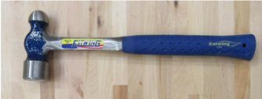
Figure1. 4. Ball-Peen Hammer
- Dead Blow
Dead blow hammers are specialized striking tools used to minimize damage to a part’s surface. The head of a dead blow is polyurethane and is with sand or lead shot to absorb the impact of the strike.
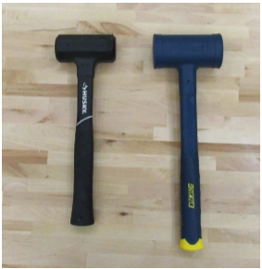
Figure1. 5. Dead Blow

Dead blow hammers are specialized striking tools used to minimize damage to a part’s surface. The head of a dead blow is polyurethane and is with sand or lead shot to absorb the impact of the strike.
- Rubber Mallet
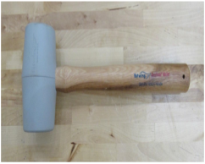
Figure1. 6.Rubber Mallet
The rubber Mallet is used in woodworking or when a softer impact is required. The rubber head ensures that the face of the surface you are striking will not be damaged.
- Claw Hammer
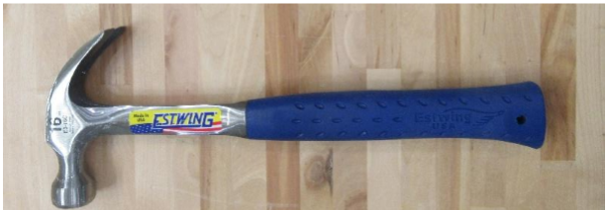
Figure1. 7.Claw Hammer

The claw hammer is the tool most people think of when they think of hammers. The head of this tool is used for driving nails into wood and the claw on the back is used to pry nails out of wood.

- Files Flat
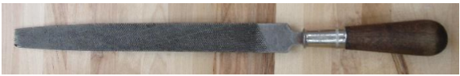
Figure1. 8. Flail Flat
A flat file is a fine cutting tool with two wide flat faces and two skinny flat faces that can remove small amounts of material from wood, plastic, or metal. It is used to break sharp corners, remove burrs from a work piece, or smooth out the surface of a work piece.
- Round
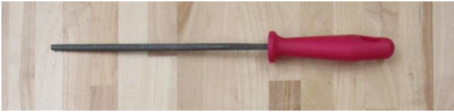
Figure1. 9. Round
A round file is a fine cutting tool with a cylindrical shape that can remove small amounts of material from wood, plastic, or metal. It is used to break sharp corners, remove burrs from a work piece, or smooth out the surface of a work piece. A round file is primarily used to file the insides of small holes and small inner radii.
Use backward strokes. The teeth are angled forward and will not remove any material on backward strokes
- Knives
X-Acto Knife
X-Acto is a brand name for a variety of cutting tools and office products. Cutting tools include hobby and utility knives, saws, carving tools and many small-scale precision knives used for crafts and other applications.

- Magazine Knife
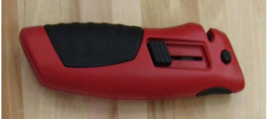
Figure1. 10. Magazine Knife
A magazine knife is a knife used for general or utility purposes with snap-off blades for quick blade replacement.
Measurement and Level Tools ( A layout tool)
Is a tool used to measure or mark wood, metal, and other materials.A. Measuring is normally done using rulers, wooden folding rules, measuring tapes, or 100 foot wind up tapes. Rulers can be one foot, yardsticks, and meter sticks. Wooden folding rules are generally 6 foot long and their rigidness makes them useful in making vertical measurements. Locking tape measures come in lengths ranging from 6 foot to 30 foot, a width of ½ to 1 inch, they lock open, and use a spring to retract the tape with the push of a button. The 100 foot wind up tape is useful in building layout work where distances over 30 feet must be measured. Most construction in this country is done using standard English measurement units of inches, feet, and yards. Metric measurements using millimeters, centimeters, and meters is used in many other countries
Tape Measure
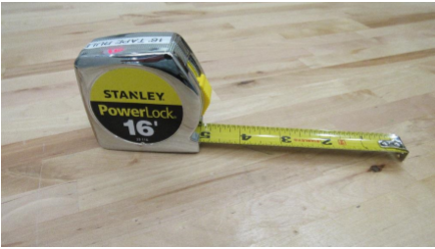
Figure1. 11. Tape Measure
A tape measure is a portable, easy to use, measurement tool that is typically accurate to the nearest 1/16”.

T Square
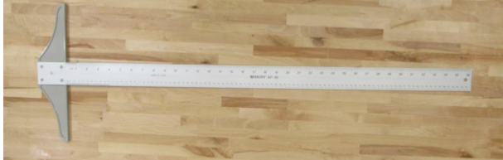
Figure1. 2T Square
In the picture above, the grey plastic part of the T-square is called the head and the metal part with the scale is called the blade. The head and the blade of a T square are perpendicular to each other. T-squares are used to draw horizontal lines in manual drafting. They can also be used to layout cut lines on drywall and plywood.
vernier caliper
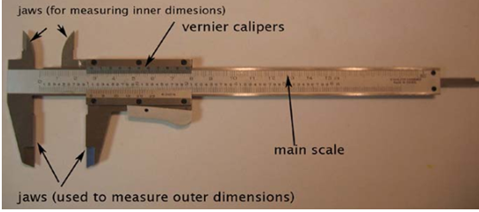
Figure1. 3 vernier caliper
A vernier calliper
A measuring device that is used for the measurement of linear dimensions. It is also used for the measurement of diameters of round objects with the help of the measuring jaws.
Types of vernier calipers:
Manual readout, which is the original vernier calliper
Dial readout
Digital readout
How to Read Vernier Calliper
The first step is to measure nothing through which we can check if the main and the vernier scales are aligned.
When the main scale reading and the vernier scale reading are at zero, it means there is no zero error.
Now, place a ball between the two jaws of the vernier scale.
Look at the 0 mark on the vernier scale lining with the main scale.
That gives the main scale reading.
Next, look for the point on the vernier scale, which is aligned with the main scale, which gives the vernier scale reading.
It is important to note that the readings will most of the time be in decimals.
The number before the decimal point is the main scale reading, while the number after the decimal point is the vernier scale reading.
Applications of Vernier Calipers
- Medical usages
- Science labs
- Industries such as steel and aerospace
- Educational sectors
- Micrometer (device)
A micrometer is a widely used device in mechanical engineering for precisely measuring thickness of blocks, outer and inner diameters of shafts and depths of slots. Appearing frequently in metrology, the study of measurement, micrometers have several advantages over other types of measuring instruments like the Verniercaliper.
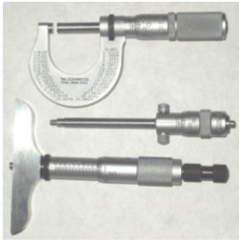
Figure1. 4N Outside, inside, and depth micrometers

Types of Micrometer
There are various types of micrometers available, each suited to varying uses and applications. Outside micrometers are one of the most widely used varieties, but inside and depth micrometers are alternatives that may be more appropriate for use in certain scenarios. Below are some of the most common types of micrometers:
- Outside Micrometer: The outside micrometer is the most commonly used type of micrometer. It is used to measure external dimensions such as the outside diameter of an object.
- Inside Micrometer: Inside micrometers are used to measure inside dimensions like the inside diameter of a hole or tube. There are two types of inside micrometers: caliper-type inside micrometers and tubular and rod inside micrometers.
Caliper-Type Micrometer
Caliper-type inside micrometers have measuring jaws similar to those found on a dial caliper or Vernier caliper.
The jaws are inserted into the space to be measured and are adjusted by turning the thimble or ratchet speeder.
Tubular Micrometers and Rod Micrometers
Both tubular micrometers and rod micrometers are placed within the space to be measured and extended until the measuring faces contact the edges of the space to be measured.
Rod micrometers come with a selection of measuring rods which, when attached to the tool, extend the measuring capabilities of the micrometer. Some rod micrometers have a handle that connects to the instrument and helps the user to measure inaccessible or difficult-to-reach spaces.
Depth Micrometer
Depth micrometers are used to measure the depths of holes, slots, and steps.
They come with a variety of interchangeable rods of different lengths so that they can be used to measure a range of depths.
How to use micrometer
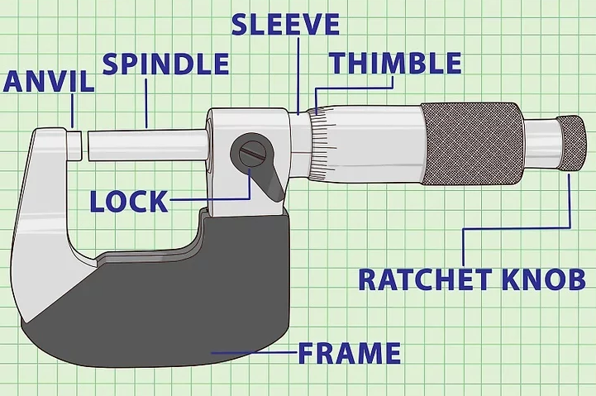
Figure1. 5 micrometer
Familiarize yourself with the anatomy of a micrometer.
- Some parts are stationary while others are movable.
- Ratchet stop
- Thimble
- Frame
- Thimble lock
- Spindle
- Anvil
- Sleeve
- Clean the anvil and spindle before beginning. Use either a clean sheet of paper or soft cloth, and hold it between the anvil and the spindle. Gently twist and close on the sheet or cloth. Slowly, pull out the sheet or the cloth.
This practice isn't a necessary step for measuring, but keeping the surfaces of the anvil and spindle clean ensures precise measurements.
- Hold the object in your left hand and place it against the anvil. The anvil is stationary and can withstand more pressure than the spindle. Make sure the object doesn't move or scratch the surface of the anvil.
Hold the micrometer with your right hand. The frame will rest gently on your palm. You can also fasten the frame on a stationary vise; this helps free up both hands for the measuring process.
4. Spin the ratchet counter clockwise. Be sure the 0 on the thimble is lined up with the scale on the sleeve
5. Twist until the spindle is against the object. Apply enough force. The thimble often clicks. Three clicks is a good stopping point.
6. Set the thimble lock while the micrometer is still on the object. Even though it is on lock, the spindle can still be moved.
7 . Slide out the object carefully. Be sure to avoid scratching either surfaces of the anvil or spindle; the slightest scratch can ruin the micrometers measuring accuracy.
8. Write down the measurements before unlocking the spindle. If the spindle loosens, be sure to remeasure
Method 2
Reading an Inch Micrometer
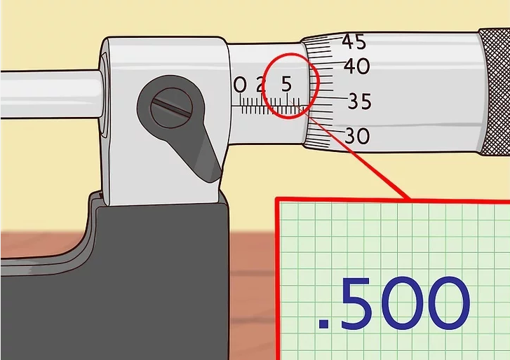
Figure1. 6.Reading an Inch Micrometer
- Learn the different number scales on the thimbles.
On the sleeve is a scale that measures by the one-hundred thousands or 1/10 of an inch; in decimal form it would be .100.
In between those whole numbers are three lines that represent twenty-five thousandths of an inch; in decimal form, it would look like .025.
The thimble has evenly spaced lines that represent one-thousandth of an inch; in decimal form it would be .001.
Above the whole number scale on the sleeve are lines that measure to ten-thousandths of a inch; in decimal form it looks like .0001.
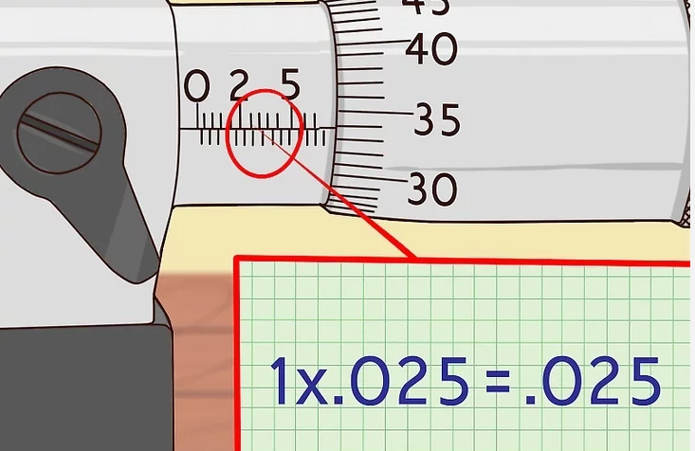
Figure1. 70.225 scale

- Read the whole number on the sleeve first. The last visible number will read as the thousandths. For example, if the last number you can see on the sleeve is 5, then it would read 500 thousandths, or .00005.
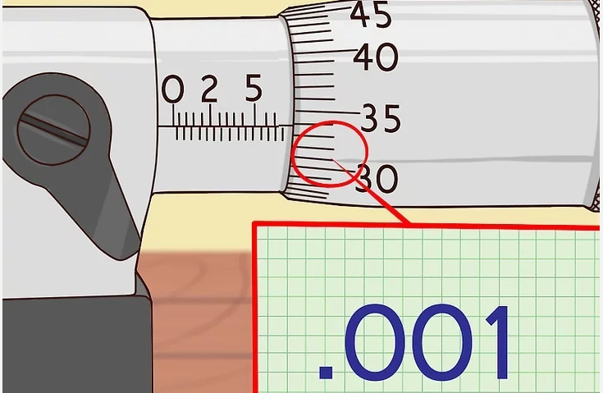
Figure1. 80.001 scale

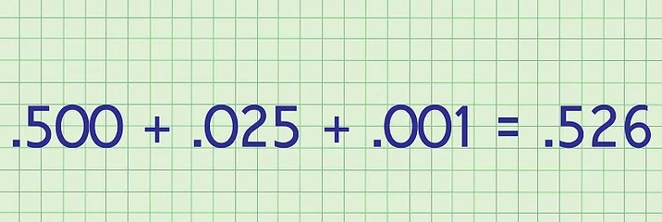

- Read how many lines come after the whole number. Look at the individual markings exposed4.Find the number and corresponding marking on the thimble scale closest to but underneath the measurement line on the stock. If it's closest to 1, then it would be .001.
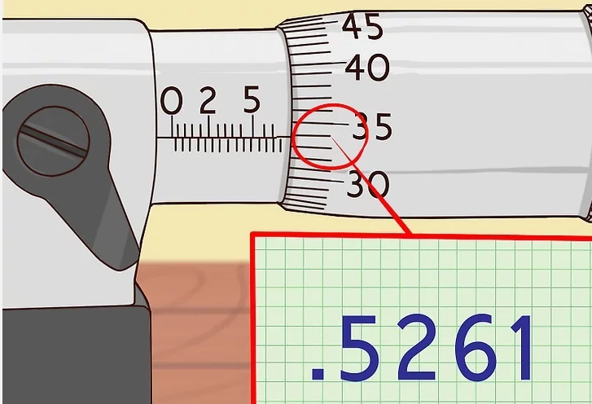
Figure1. 9 0.5261 scale
- Hold the micrometer with your right hand. The frame will rest gently on your palm.
You can also fasten the frame on a stationary vise; this helps free up both hands for the measuring process
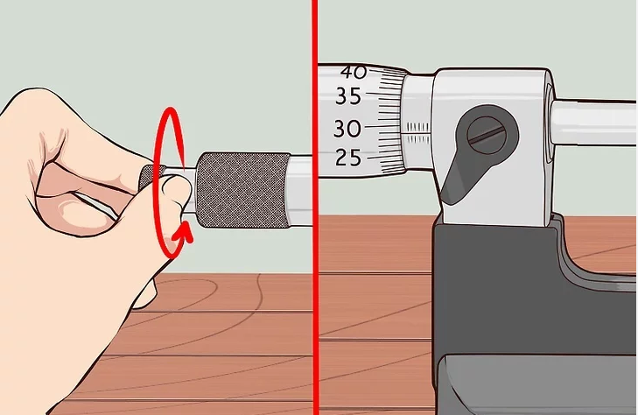
Figure1. 10 hold micrometer
- Add those three numbers together. In this case it would be .500 + .025 + .001 = .526.
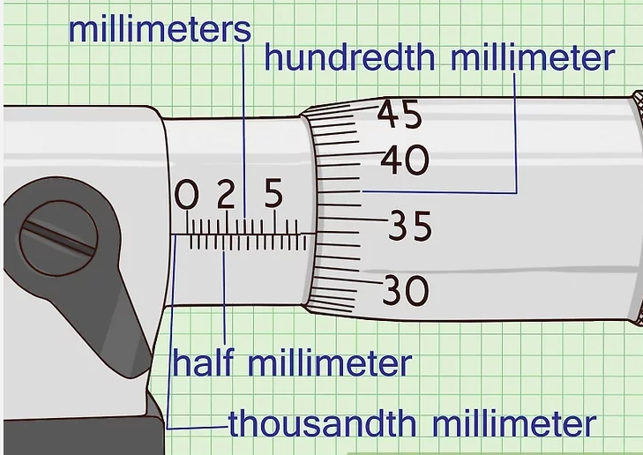
Figure1. 11 reading
- Flip the micrometer over to read to the 10 thousandths marking. Read that line that lines closest with the sleeve. If, for example, it lines with 1, then the measurement will will read .5261
Method 3
Reading a Metric Micrometer
The horizontal lines above the scale on the sleeve will measure to the thousandth of a millimeter, or .001 mm.
- Learn the different number scales on the thimbles.
The line on the sleeve usually has top line showing millimeters, and below that line the marks represent half millimeters.
The marks on the thimble usually go to 50, and each line represents a hundredth of a millimeter or .01 mm.
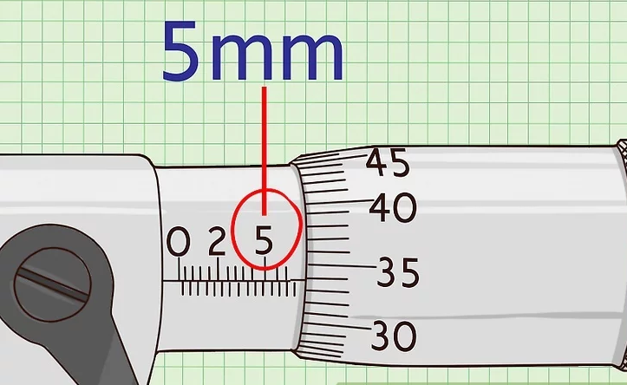
Figure1. 12reading
- Read the number of millimeters first. If the last line you saw were a 5, then you would have 5mm thus far.
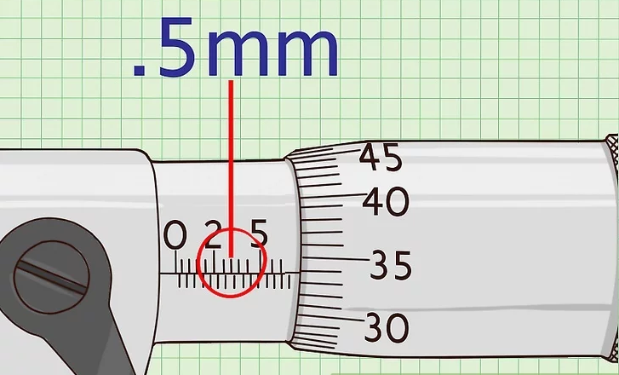
Figure1. 13reading number
- Find the number of .01 millimeters. If the line on the thimble reads 33, then you'd have .33 mm.
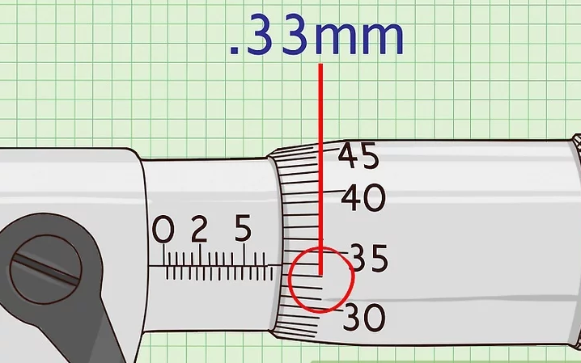
Figure1. 14Reading number

- Add up all three lines. In this example, add 5 + .5 + .33. The measurement is 5.83 mm.
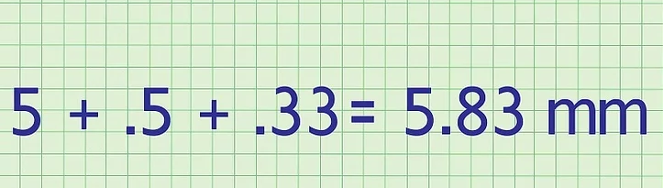
the thousandths. If the thousandths read a 6, then at .006 to the measurement. In this example, it would be 5.836
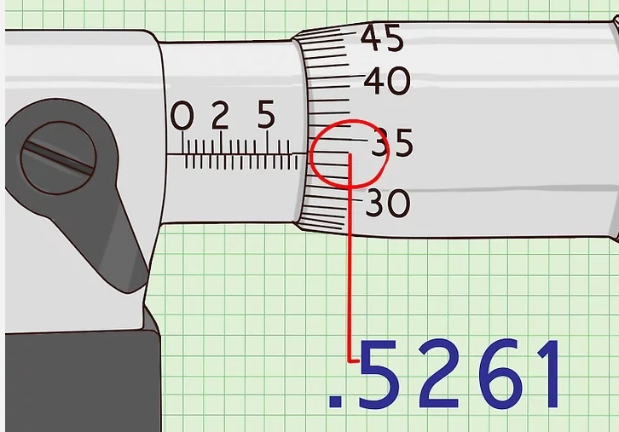
Figure1. 15 reading output
Screw Drivers
- Flat Head
A screwdriver is a hand-tool for turning (driving) screws (and sometimes bolts or other machine elements with a mating drive system. A screwdriver is identified by its tip, which is shaped to fit, or mate with, a screw the head of which has a particular contour, or surface shape. A screwdriver is, thus, a mechanism to apply torque to a screw
- Philips Head
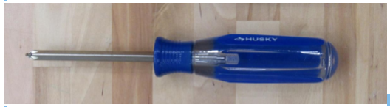
Figure1. 16 Philips Head
A screwdriver is a hand-tool for turning (driving) screws (and sometimes bolts or other machine elements with a mating drive system). A screwdriver will be easy to identify by its tip, which is shaped to fit, or mate with, a screw the head of which has a particular contour, or surface shape. A screwdriver is, thus, a mechanism to apply torque to a screw.
- Allen Wrenches
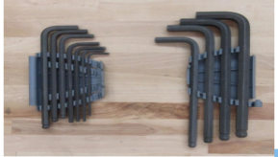
Figure1. 17 Allen Wrenches
A Hex Key or Allen Key or wrench (also known by various other synonyms) is a tool of hexagonal cross-section used to drive bolts and screws that have a hexagonal socket in the head (internal-wrenching hexagon drive).
Pliers
Slip Joint Pliers
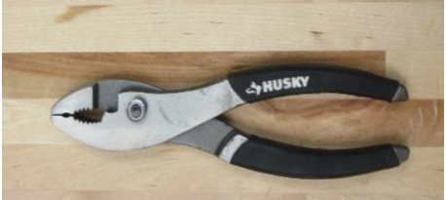
Figure1. 18 Slip Joint Pliers
Straight slip joint pliers are configured similarly to common or lineman's pliers in that their jaws are in line with their handles. One side of the pliers usually has two holes that connect by a slot for the pivot. The pivot is fastened to the other side and shaped such that it can slide through the slot when the pliers are opened.
Tongue and Groove Pliers
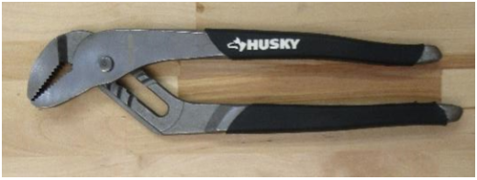
Figure1. 19 Tongue and Groove Pliers
Tongue-and-groove pliers, also known as water pump pliers, adjustable pliers, groove joint pliers, Multi-Grips, and Channel locks, are a type of slip-joint pliers. They have serrated jaws generally set 45° to 60° from the handles. The lower jaw can be moved to a number of positions by sliding along a tracking section under the upper jaw. An advantage of this design is that the pliers can adjust to a number of sizes without the distance in the handle growing wider. These pliers often have long handles—commonly 9.5 to 12 inches long—for increased leverage.
Tongue-and-groove pliers are commonly used for turning and holding nuts and bolts, gripping irregularly shaped objects, and clamping materials.

- Needle Nose Pliers

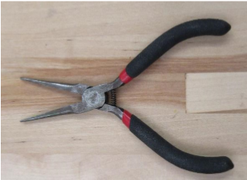
Figure1. 20 Needle Nose Pliers
Needle-nose pliers are both cutting and holding pliers. They are often used by electricians and other tradespersons to bend, re-position and cut wire. Their namesake long gripping nose provides excellent control and reach for fine work in small or crowded electrical, while cutting edges nearer the pliers' joint provide "one-tool" convenience. Given their long shape, they are useful for reaching into cavities where cables (or other materials) have become stuck or unreachable to fingers or other means.
- Diagonal Cutter (Soft Jaws)

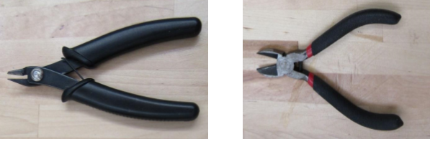
Figure1. 21 Diagonal Cutter (Soft Jaws)
Diagonal pliers or wire cutters are pliers intended for the cutting of wire. The plane defined by the cutting edges of the jaws intersects the joint rivet at an angle or "on a diagonal", hence the name. Instead of using a shearing action as with scissors, they cut by indenting and wedging the wire apart.
- Bolt Cutters
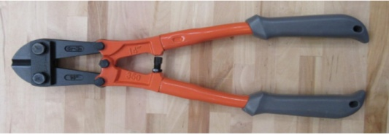
Figure1. 22 Bolt Cutters
A bolt cutter is a tool used for cutting steel wire, small diameter bolts, and wire mesh. This device has compound hinges to maximize leverage and cutting force.
- Retaining Ring Pliers
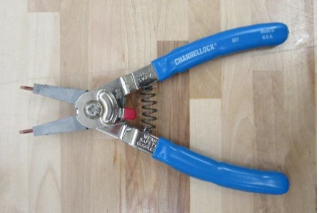
Figure1. 23 Retaining Ring Pliers
A retaining ring is a fastener that holds components or assemblies onto a shaft or in a housing/bore when installed in a groove. Once installed, the exposed portion acts as a shoulder that retains the specific component or assembly. The retaining ring plier is a tool for installing retaining rings. Two settings, selectable by the toggle lever on the tool, allow for installation of internal or external retaining rings.
Wrenches
- Box Wrench
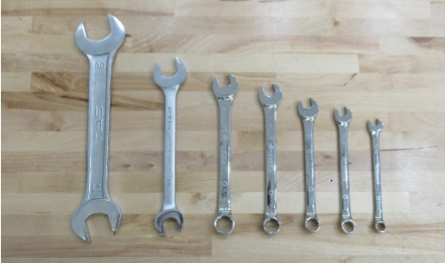

Figure1. 24Box Wrench
- A wrench (or spanner) is a tool used to provide grip and mechanical advantage in applying torque to turn objects—usually rotary fasteners, such as nuts and bolts—or keep them from turning.
- Spud Wrench
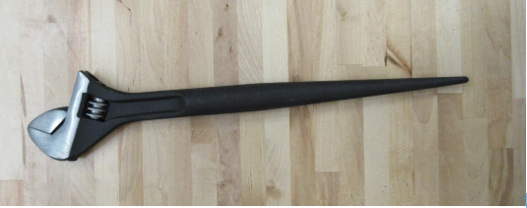
Figure1. 25.Spud Wrench
A steel erecting tool which consists of a normal wrench at one end and a spike (drift pin) at the other, used for lining up bolt holes (typically when mating two pipe flanges).
- Adjustable Wrench
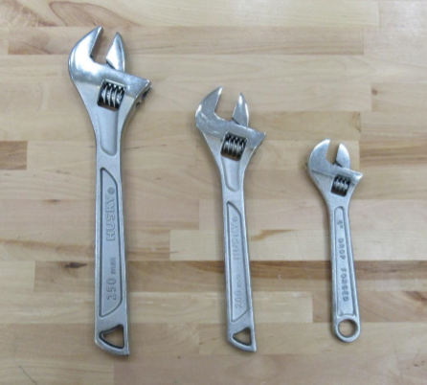
Figure1. 26.Adjustable Wrench
The most common type of adjustable wrench in use today. The adjustable end wrench differs from the monkey wrench in that the gripping faces of the jaws are displaced to a (typically) 15° angle relative to the tool's handle, a design feature that facilitates the wrench's use in close quarters.
A hollow cylinder that fits over one end of a nut or bolt head, and is attached to a ratchet handle for leverage. It generally has a six-point, eight-point or twelve-point recess, may be shallow or deep, and may have a built-in universal joint.
Electrical (Small Gauge)
- Double Crimper
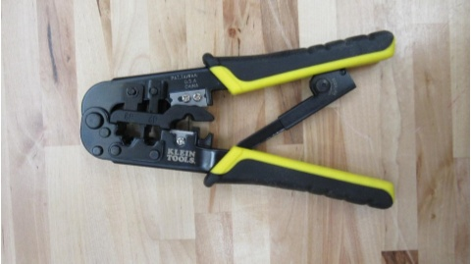
Figure1. 27.Double Crimper
The ratcheting double crimp tool has three nests with two crimp stations each designed for insulated terminals. ..Designed for strong mechanical and consistent crimps for both standard and reinforced (double crimp) terminals in one easy crimp.
- Crimper/Stripper
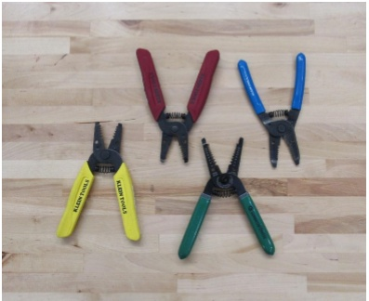
Figure1. 28. Crimper/Stripper
A combination tool used to strip and crimp typical gauge wires
- Cable Cutter
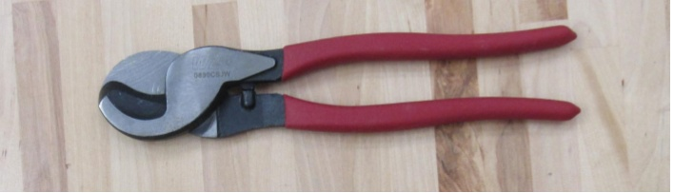
Figure1. 29 . Cable Cutter
A single-purpose tool meant only for cutting typical gauge wires made of soft metals such as copper or aluminum wires.
- Wire Crimper
Used to crimp ring lugs, quick disconnects, and other terminals onto wire.
A cordless drill is an electric drill that uses rechargeable batteries. These drills are available with similar features to an AC mains-powered drill. This driver drill has a clutch, also called a torque limiter, which aids in driving screws into various work pieces without damaging them. Read more about how to safely use this tool in the manual.

1.3. Work stations safety
Safe work practice
A safe work environment is not enough to control all electric hazards. You must also work safely. Safe work practices help you control your risk of death from workplace hazards. If you are working on electrical circuits or with electrical tools and equipment, you need to use safe work practices.
- Before you begin a task, ask yourself:
- What could go wrong?
- Do I have the knowledge, tools, and experience to do this work safely? All workers should be very familiar with the safety procedures for their jobs. You must know how to use specific controls that help keep you safe. You must also use good judgment and common sense.
Electrical Work station
Electrical workstations include electrical outlets that are designed to provide a source of power for the use of tools and equipment. How this type of workstation is designed plays an important role in how organized and efficient that workspace proves to be for your employees.
Electrical needs go beyond how many outlets you should have to accommodate the tools most frequently used in a workstation.

Component measurement

Steps to Ensuring Your Measured Results Are In Spec
A device is calibrated in order to:
- Ensure that readings are consistent with other measurements that is, the device’s measurements are compared with and traceable to a known and accepted standard
- Determine the accuracy of the device’s readings
- Establish the reliability of the device
But just because we all use calibrated tools does not guarantee that everyone measuring the same part will get the same results.
How can this be? For starters, even when you are using NIST traceable, calibrated measuring devices, within each device there is a tolerance, indicating accuracy within plus or minus X amount. What’s more, the tool used to calibrate that device — for example, a pin — also has its own tolerance. Add to that the tolerance of the tool used to calibrate the pin … You get the idea.
Measuring and whether the end results meet your specs.
Success is in the details.
There are some simple “rules” that can help to ensure that calibrated measuring yields accurate and consistent results
- Make sure you and your supplier or manufacturer are using the same type of device to do the measuring. For example, if a manufacturer verifies a specified ID using optical measurement but you inspect the finished parts using a pin gage, there may be discrepancies in the results. If you are measuring length, will you be using a caliper, a micrometer, or a ruler?
- Make sure that you and your supplier/manufacturer are using measuring devices that are correctly cross-calibrated. Otherwise, the two devices may measure a part differently. A Z pin gage versus a ZZ pin gage will not yield the same results. If you are using a digital micrometer, be sure you are using the same device calibrated in the same units to the same standard, and rounded to the same number of decimal places
- If possible, provide your manufacturer with the measuring gage or other device you plan to use to verify the dimensions of your parts. For example, for functional test requiring a go/no go gage, you can send a copy of your calibrated pin or screw gage to your vendor. Where more complex testing is required for a high volume of work, your vendor may be willing to purchase the same calibrated measuring device to have on-site for use with your production runs.
- The method of measurement, not just the device to be used, should also be specified. Have a pre-production discussion with your vendor and provide detailed instructions on how measurements should be done. For instance:
- Make sure all your measurement requirements are included in your drawing — and that the details of your drawing don’t conflict with your measurement method. For example, if you provide a go/no go gage but your drawing calls for a certain pitch in a screw part, your manufacturer may have to reconcile parts that pass the go/no go test but if done to the drawing specifications, don’t pass the pitch test — or may pass the test if measured from one point but not another.
- Carefully consider what you really need to measure. Avoid the risks of over-engineering — such as more rejected parts, increased waste, and higher cost — by distinguishing between critical and non-critical dimensions. Ask yourself, do you really need a very tight tolerance on dimension X? Or will any . 7.Where practical for your inspection needs, use a functional test. A simple go/no go test with a pin or screw gage may be a perfectly acceptable measure of quality and consistency, and be more cost-effective than specifying a particular tolerance.
- Where practical for your inspection needs, use a functional test. A simple go/no go test with a pin or screw gage may be a perfectly acceptable measure of quality and consistency, and be more cost-effective than specifying a particular tolerance.

1.5. Hand tools and measuring instrument specification
.

Specifications” is a general term applying to all directions, provisions, and requirement pertaining to the performance of the work and payment for the work. Technician metrology is defined as the measurement of dimensions: length, thickness, diameter, taper, angle, flatness, profiles and others. An important aspect of metrology in manufacturing processes is dimensional tolerances. That is, the permissible variation in the dimensions of a part. Tolerances are important not only for proper functioning’s of products, they also have a major economic impact on manufacturing costs. A specification often refers to a set of documented requirements to be satisfied by a material, design, product, or service. A specification is often a type of technical standard.
A specification may refer to a standard which is often referenced by a contract or procurement document, or an otherwise agreed upon set of requirements (though still often used in the singular). In any case, it provides the necessary details about the specific requirements.
Self check .1.
Test-I
Instruction: Choose the correct answer .You have given 1 Minute for each question. Each question carries 2 Point.
- Skin & body PPE- should be worn by workers to be avoid injuries accidents caused by
A. Radiation B. Toxic chemicals C. falling objects D. all are answers
- Example of Striking Tools
A. screw drivers B. cutter C. hammer D. none
- A -------- is a portable, easy to use, measurement tool that is typically accurate to the nearest 1/16”.
A.T square B. Tape Measure C. hammer D. all are answers
Part III: say True or false
- Various types of PPE are available for use only in the school.
- Dead blow hammers are specialized striking tools used to maximize damage to a part’s surface.
- Varner cliper is measuring device that is used for the measurement of linear dimensions.
Test-III Matching
Instruction: select the correct answer for the give choice. You have given 1 Minute for each question. Each question carries 2 Point.
“A” “B”
----1. Striking Tools A. Varner cliper
---2. Measurement and Level Tools B. Rubber Mallet
----3. Applications of Vernier Callipers C. Industries such as steel and aerospace
D. to protect electrical hazards

Operation sheet-1:1 Plan and prepare tasks

Operation title: Procedures of micrometer measurement
Purpose: To measure the dimension of an object
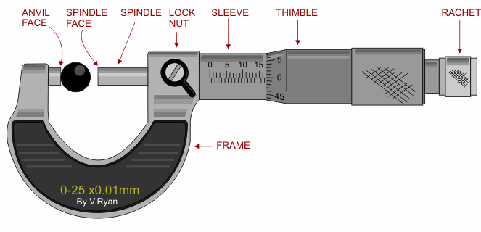

Instruction: Use the given figure Read the scale on the sleeve. For this operation you have given 3 Hour and you are expected to provide the answer on the given table.
Tools and requirement:
1. Micrometer
2. Paper
3.Pencil
Steps in doing the task
1. Use the given figure
2. Measure the thickness of the given component
Quality Criteria: the given object is measured with 1mm accuracy
Precautions: Measure at least three times before recording the result on the given format

Lap Test-
- Task-1: Perform liner measurement using micrometer
- Task-2: Measure thickness of the component

Unit Two: Selection of measuring instruments
This unit is developed to provide you the necessary information regarding the following content coverage and topics:
- methods of checking hand tools and measuring instruments
- Isolation of faulty tools
- Selection of measuring instruments
- accurate measurements
- numerical computation
This unit will also assist you to attain the learning outcomes stated in the cover page. Specifically, upon completion of this learning guide, you will be able to:
- Check hand tools and measuring instruments
- Identify and marking unsafe or faulty tools
- Select measuring instruments
- Obtain accurate measurements
- Check and correcting numerical computation

2.1. Methods of checking hand tools and measuring instruments
Measurement the process of associating numbers with physical quantities and phenomena. Measurement is fundamental to the sciences; to engineering, construction, and other technical fields; and to almost all everyday activities. For that reason the elements, conditions, limitations, and theoretical foundations of measurement have been much studied. See also measurement system for a comparison of different systems and the history of their development.
Measurement may be may be made by unaided human senses, in which case they are often called estimates, or, more commonly, by the use of instruments, which may range in complexity from simple rules for measuring lengths to highly sophisticated systems designed to detect and measure quantities entirely beyond the capabilities of the senses, such as radio waves from a distant star or the magnetic moment of a subatomic particle.
Measuring instrument is a device to measure a physical quantity. In the physical sciences, quality assurance, and engineering, measurement is the activity of obtaining and comparing physical quantities of real-world objects and events
Concepts and measurement principles
A process:
is an integrated set of activities that uses resources to transform inputs into outputs. In the case of measurement, the requirement or the objective of measurement is the input, while the method employed is the activity that uses the measuring instrument and operator as the resources, to give the output. The value assigned is defined as the “measurement value”. It is also known as the measure and or the result of a measurement value attributed to a measure and, obtained by measurement.
Standard
is a material measure or physical property that defines or reproduces the unit of measurement of a base or derived quantity.
Accuracy
The closeness of the agreement between the result of a measurement and a true value of the measure and.

Precision
The closeness of the agreement between the results of successive measurements of the same measure and carried out under the same conditions of measurement. Precision is also called repeatability.
Reproducibility
The closeness of the agreement between the results of measurements of the same measure and carried out under changed conditions of measurement. The changed conditions of measurement may include: Units of measurements.
The solution to any practical mathematics problem entails a two-part answer. The first part represents the how many, or the amount, and is always a number. This amount or magnitude is physically meaningless without the second part, which is the what, or unit of the solution. In general, a unit is fixed by definition and is independent of physical conditions. Some examples of units are the foot, pound, degree, ohm, meter, and so on. Each of these is physical unit, which means that it is a subject of observation and measurement.
The early establishment of standards for the measurement of physical quantities proceeded in several countries at broadly parallel times, and in consequence, several sets of units emerged for measuring the same physical variable. For instance, length can be measured in yards, meters, or several other units. Apart from the major units of length,
Subdivisions of standard units exist such as feet, inches, centimeters and millimeters, with a fixed relationship between each fundamental unit and its subdivisions.
Fundamental and derived units and their definition
At the time of measuring a physical quantity, we must express the magnitude of that quantity in terms of a unit and a numerical multiplier,
i.e., Magnitude of a physical quantity = (Numerical ratio) × (Unit)
The numerical ratio is the number of times the unit occurs in any given amount of the same quantity and, therefore, is called the number of measures. The numerical ratio may be called numerical multiplier. However, in measurements, we are concerned with a large number of quantities which are related to each other, through established physical equations, and therefore the choice of size of units of these quantities cannot be done arbitrarily and independently. In this way, we can avoid the use of awkward numerical constants when we express a quantity of one kind which has been derived from measurement of another quantity. In science and engineering, two kinds of units are used:
Fundamental Units are the units of the fundamental quantities, as defined by the International System of Units. They are not dependent upon any other units, and all other units are derived from them. In the International System of Units, the fundamental

Table2.1 table of fundamental units
Physical quantity | SI unit |  | Symbol |  | Deﬁnition
Length | Meter |  | M |  | The length of path travelled by light in an interval of  1/299 792 458 seconds
Mass | Kilogram |  | Kg |  | The mass of a platinum– iridium cylinder kept in the International Bureau of Weights and Measures.
Time | Second |  | Sec |  | 9.192631770 x 10⁹cycles of radiation from vaporized caesium-133 (an accuracy of 1 in 10¹²or1 second in 36 000 years)
Temperature | Kelvin |  | K |  | The temperature difference between absolute zero and the triple point of water is defined as 273.16kelvin
Temperature |  | Kelvin |  | K |  | The temperature difference between absolute zero and the triple point of water is defined as 273.16kelvin
Current |  | Ampere |  | A |  | One ampere is the current following through two inﬁnitely long parallel conductors of negligible cross-section placed 1 meter apart in a vacuum and producing a force of 2 x 10⁻⁷newtons per meter length of conductor
Luminous intensity |  | Candela |  | Cd |  | One candela is the luminous intensity in a given direction from a source emitting mono chromatic radiation at a frequency of 540 tera-hertz (Hz X10¹²)and with a radiant density in that direction of 1.4641mW/ steradian. (1 steradian is the solid angle which, having its vertex at the centre of a sphere, cuts off an area of the sphere surface equal to that of a square with sides of length equal to the sphere radius)
Matter |  | Mole |  | Mol |  | The number of atoms in a 0.012 kg mass of carbon-12

Derived Units
Other quantities, called derived quantities, are defined in terms of the seven base quantities via a system of quantity equations. The SI derived units for these derived quantities are obtained from these equations and the seven SI base units. Examples of such SI derived units are given in Table
Table 2.2 Examples of SI derived units

 | SI derived unit
Derived quantity | Name | Symbol
Area | square meter | m²
Volume | cubic meter | m³
speed, velocity | meter per second | m/s
Acceleration | meter per second squared | m/s²
wave number | reciprocal meter | m⁻¹
mass density | kilogram per cubic meter | kg/m³
specific volume | cubic meter per kilogram | m³/kg
current density | ampere per square meter | A/m²
magnetic field strength | ampere per meter | A/m
amount-of-substance concentration | mole per cubic meter | mol/m³
Luminance | candela per square meter | cd/m²
mass fraction | kilogram per kilogram, which may be represented by the number 1 | kg/kg = 1

Electrical quantities /electronic units
Units that can be measured in Electrical /electronic include, current, voltage, power, resistance, conductance, charge, and frequency.
Voltage
Voltage, okay, defining voltage, when some distance separates two bodies with unequal charges they risk the potential for doing work. Its unit is volt .A devise measure voltage is known as voltmeter .
Resistance
Resistance is current flowing through a circuit encounters opposition. This opposition is referred to as resistance. Its unit is ohm. A devise measure voltage is known as ohmmeter.
Current
Current is the movement of charges in a conductor. It is the measure of the number of electrons that flow past a given point notice per second. One AMP is the amount of current that flows when one coulomb flows past the point in one second .A devise measure voltage is known as ohmmeter.
Ampere
Alternating Current (AC)
Alternating current describes the flow of charge that changes direction periodically. As a result, the voltage level also reverses along with the current. AC is used to deliver power to houses, office buildings, etc.
Direct Current (DC)
Direct current is a bit easier to understand than alternating current. Rather than oscillating back and forth, DC provides a constant voltage or current.
Ampere (amp or A) is the name given to the transfer of certain number of electrons through a material over a certain elapse time as a result of an electrical pressure. A movement of 6.25 X 10 18 electrons (one coulomb) past a point in 1 second is defined to be 1 ampere of current
Electron Volt
Electron volt is used to state the energy of charged particles, such as electrons, and must not be confused with the volt unit. An electron which is accelerated through a potential difference of one volt gains one electron volt (v) of energy.
Ohm
Ohm (Ω) is the physical unit of resistance of a material. One ohm is the amount of electrical opposition that forces an electron movement through a material. One volt across one ohm will result in a current of one ampere.
Siemens
Conductivity of a material is the ease with which it passes electrons. Conductivity and resistivity of a material are inversely related by the formula (G=1/R). The unit of conductance is the Siemens. The symbol used for the Siemens is (S).
Watt
Watt is the unit of power or the rate of doing work in an electrical circuit. The power converted in an electrical circuit is 1 watt when energy is converted at the rate of 1 joule-per-second.
Coulomb
Coulomb (Q) is the unit of electrical charge. One coulomb is a charge of 6.25 X 1018 electrons. A flow of one coulomb past a point in one second is one ampere.
Hertz
Frequency is the number of times an event occurs in a given period. In electrical circuits, frequency is usually given in cycle-per-second. By international agreement, the term Hertz (Hz)has been adopted to mean cycle-per-second.
Second
The standard unit of time is second.
In electronics, measurements may be specified in either the English system or the metric system, and for this reason we must convert from one system to the other system of measurement. However, the metric system is preferred and should be used in all scientific writing. However, since both systems are in current usage we must learn to convert from one to the other.
Ranges of Electrical Units
As we noted earlier, electronics is a science which uses very large and very small units, such as a thousand-ohm resistor, a millionth-farad capacitor, a thousand million-cycles-per- second and soon. To save time in writing and speaking these terms, symbols have been universally adopted to replace those most commonly used terms.
2.3 Table of the most Common prefixes used in Electronics
Prefix | Symbol | Value
Pico | P | 10⁻¹²
Nano | N | 10⁻⁹
Micro | µ | 10⁻⁶
Milli | M | 10⁻³
Kilo | K | 10³
Mega | M | 10⁶
Giga | G | 10⁹
Tera | T | 10¹²

2.2. Isolation of faulty tools

Hand Tool Inspections inspection
There are many injuries while using hand tools on the job. Many of these injuries occur from improper use, but there are also injuries that involve a tool that was broken or in need of repair. What tool is being used will decide what needs to be inspected on it. In this safety talk, we will discuss basic handheld tools that are not electric or pneumatic.
Common hand tools found on almost every job site and at home across the country are screwdrivers, hammers, chisels, and wrenches. This is not an all-inclusive list, but these are some of the most commonly used hand tools.
Common Hand Tool Inspection Items
Hammer
Ensure that the handle is not broken or chipped. If a handle is taped, more than likely it is broken and needs replaced. On any tool, tape is not a manufacturer’s approved fix for a needed repair. Ensure the head of the hammer is tight on the handle. Throw the hammer away if part of the claw is broken off.
Screwdrivers
Ensure the handle is not chipped or broken. Many people will use the screwdriver as a chisel and hit the back end of it with a hammer. This causes damage to the screwdriver and will damage the handle. If the head of the screwdriver is chipped or worn down, replace the screwdriver.
Chisels
Chisels are strong tools, but just like any other tool they will begin to break down over time. Check the back of the chisel. Often times, the back will begin to mushroom. When mushrooming occurs the chisel either needs to be repaired properly or replaced.
Wrenches
Check that the wrench is not bent. Replace any wrench that is chipped or excessively worn. Losing the grip on a bolt due to a worn or broken wrench can easily cause hand injuries to the user.
Pliers
Pivot points and/or joints are firm.
If a plier is electrically insulated, check that the insulation has not been compromised, exposing the underlying conductive material.
Pliers are not being abused. e.g.: hammering the jaws to cut a wire or bolt.
Checking power tools
When not in use they should be disconnected from the energy source and properly stored.
They do not show signs of being operated outside their designed specifications.
The tools, besides being visually inspected, should also be briefly turned on in order to check for abnormal noises, mal function of switches.
General Hand Tools Best Practices
Keep tools clean. Dirty tools are harder to use safely and properly.
Do not modify hand tools. Keep the manufacturer’s design intact.
Secure all hand tools and store them away properly. Tools left out are much more likely to get lost, stolen, or damaged.
Use tools how they are designed to be used. This will keep the tool in good condition longer and you safe when using it.
2.3 Selection of measuring instruments
Selecting the right instrument for a given measuring application can be a challenge. By considering the answers to six core questions, industrial research and engineering professionals can find the ideal tool to provide cost-effective, accurate measurement data to support their research, engineering, and production goals. These questions address the samples to be measured along with the goals and purpose of the measurement process. After considering sample and feature size, measuring challenges, contact, application standards, output, and overall throughput, you can help narrow down the instruments that best match your application. Then you can compare the features and benefits of your top-choice instruments, reviewing what they deliver against your budget to come up with the best instrument for your needs.
Selecting the right instrument for your application involves considering the sample size, feature size, any special measuring challenges; whether your process can involve actual contact with the sample; what precision and accuracy specifications your application requires; what output you must produce; and how high your level of throughput will be. Once you have these answers, consider the variety of measuring instruments, from gauges to microscopes to automated measuring systems, with your budget and requirements in mind. Measurement and inspection requirements are as varied as the applications they are designed for, and technology is advancing rapidly. Take the time to do a thorough analysis to determine the best system for your needs.

2.4. Accurate measurements
Measurement accuracy is defined as the closeness of agreement between a measured quantity value and a true quantity value of a measurand (i.e., the quantity intended to be measured
How to measure accuracy and precision
Here are some steps you can take when measuring the accuracy and precision of your data:

1. Collect data
Begin by recording all the data you have for the project or experiment. It's important to collect as much data as possible to ensure a comprehensive measure of accuracy. If you're working with large amounts of data, it's helpful to record the measurements electronically using tools such as spreadsheet software programs. Sort the data values in order from least to greatest to help you determine the range of data you've collected.
2. Determine the average value
Once you've collected and sorted your data, you can determine the average value of your data, which can give you a measurement of accuracy. To determine the average value, add all of your data together and divide by the total number of measurements. If you're using a spreadsheet program, you can create a formula that can find this value for you. When working with small amounts of data, you may choose to
Average value = sum of data / number of measurements
For example, if you're measuring the weight of a substance and calculate separate measurements of 10 pounds, 10.2 pounds, 9.8 pounds and 10.1 pounds, the average value of this data is 10.02. If the actual standard for this value is 10 pounds, you've produced a highly accurate result. Here's what the example looks like using the formula
Average value = (10 + 10.2 + 9.8 + 10.1) / 4 = 10.02
3. Find the percent error
calculate the metric manually using this formula:
You can also calculate the accuracy of your measurements in percentages by finding the percent error
This can be a helpful tool for explaining your results to people who may be unaware of the standard measurement for the data. For example, you can convey the accuracy of your measurements by stating that they're within 1% of the accepted standard. To find the percent error, subtract the results of your measurement from the accepted value and divide by the accepted value. Then, multiply that figure by 100. The formula looks like this:
Percent error = [(accepted value - measured value) / accepted value] x 100
For example, if you collect data to measure the temperature of a climate and find the average to be 95.3 degrees, while the accepted value is 96.8 degrees, the percent error of your data would be 1.5%. This means you've produced results within 1.5% accuracy of the accepted value. Here's what the formula looks like for this example:
Percent error = [(96.8 - 95.3) / 96.8] x 100 = 1.5%
4. Record the absolute deviations
After calculating the accuracy of your data, you may also want to know the precision, which can help you evaluate your measurements. When determining the precision, you begin by finding the average value of your data. Once you have the average value, you can subtract each individual measurement from the average value to give you a set of absolute deviations. The absolute deviation of each measurement shows how close the value is to the average value. Here's the formula for finding the absolute deviation:
Absolute deviation = measured value - average value
For example, if you're measuring the length of an item and produce data of 5 feet, 5.2 feet, 4.6 feet and 5.4 feet, the average value for this data is 5.05 feet. Here's the calculation for the average value:
Average value = (5 + 5.2 + 4.6 + 5.4) / 4 = 5.05
Then, you can find the absolute deviation for each measurement by subtracting the average value from the measured value. Here's the absolute deviation for each measurement in this data set:
5- 5.05 = 0.05
5.2 - 5.05 = 0.15
4.6 - 5.05 = 0.45
5.4 - 5.05 = 0.35
5. Calculate the average deviation
After calculating the absolute deviation for each measurement, you can determine the average deviation for the data, which shows you the precision. To calculate the average deviation, add the absolute deviations for each measurement together and divide by the total number of measurements.
Record the precision result as the average value plus or minus the average deviation. Here's the formula for average deviation:
Average deviation = sum of absolute deviations / number of measurements
For example, using the absolute deviations from the last step, you can find the average deviation by adding them together and dividing by four. The average deviation for this data is 5.05±0.25, which means the data is precise within a range of ±0.25. Here's what the formula looks like for this example:
Average deviation = (0.05 + 0.15 + 0.45 + 0.35) / 4 = ±0.25

2.5 Numerical computation

Numerical Computation is an advanced undergraduate-level introduction to the mathematics and use of algorithms for the fundamental problems of numerical computation: linear algebra, finding roots, approximating data and functions, and solving differential equations. “If mathematical modeling is the process of turning real phenomena into mathematical abstractions, then numerical computation is largely about the transformation from abstract mathematics to concrete reality. Many science and engineering disciplines have long benefited from the tremendous value of the correspondence between quantitative information and mathematical manipulation.”

Self-check 2
Test I:
Instruction: Choose the correct answer from the question below
1. _______________ is used to state the energy of charged particles, such as electrons, and must not be confused with the volt unit
A.Current C. Ohm’s
B.Electric volt D. Power
2. ______________is a material measure or physical property that defines or reproduces the unit of measurement of a base or derived quantity.
A.Accuracy C. Standard
B.Precision D. All
3. _______________is an integrated set of activities that uses resources to transform inputs into outputs.
Process C. Calibration
Measurement D. none
Test II Matching
Instruction: select the correct answer for the give choice. You have given 1 Minute for each question. Each question carries 2 Point.
Column A Column B
_______1. Resistor A. Area
_______2. Current B. Ampere
_______3. Siemens C. Length
_______4. Derived unit D. Ohms
_______5. Fundamental unit E. Conductivity

Part III:
Direction: Say true and false for the following question below
_______ 1. Accuracy is not the closeness of the agreement between the result of a
Measurement.
_________ 2. The right measuring tool should be used to perform accurate
measurement.
_________ 3. The measurement process is the set of operations to determine the value
of a quantity.

Unit Three: Hand tools and measurement instrument
This unit is developed to provide you the necessary information regarding the following content coverage and topics:
  - methods of cleaning measuring instruments Standards and code of practice
  - Standard operating procedures
  - Ways of reporting malfunctions, unplanned or unusual events
  - Secondary instrument , absolute instrument and store in proper manner

This unit will also assist you to attain the learning outcomes stated in the cover page. Specifically, upon completion of this learning guide, you will be able to:
Cleaning measuring instruments
- Undertake instruments store in proper manner
- Use standard operating procedures
- Report malfunctions, unplanned or unusual events
- Identify secondary instrument and absolute instrument

3.1. Standard operating procedures Methods of cleaning measuring instrument Standards and code of practice
Cleaning
Cleaning is the complete removal of food soil using appropriate detergent chemicals under recommended conditions. It is important that personnel involved have a working understanding of the nature of the different types of food soil and the chemistry of its removal.
Cleaning Methods
- Mechanical Cleaning. Often referred to as clean-in-place (CIP). Requires no disassembly or partial disassembly.
- Clean-out-of-Place (COP). Can be partially disassembled and cleaned in specialized COP pressure tanks.
- Manual Cleaning. Requires total disassembly for cleaning and inspection.
Scheduled Cleaning
- The environment in which you use it: Some situations may cause measuring tools to require cleaning more often. If you use your tools in a dusty manufacturing environment, for example, you may need to clean them more often than if you work in a relatively controlled lab environment
- The task for which you use it: The job you use the tool for can also impact how often it requires cleaning. For example, pressure gage maintenance may involve cleaning it more often if you use it with liquids, as opposed to solid items. Also, if the measurements are so precise that small amounts of dirt or residue could throw them off, you’ll need to clean your instruments more frequently devices. Various factors influence how often you should plan to clean your instruments.
Legal requirements: In certain industries, rules and regulations may require you to clean tools more often. For example, food-related businesses must adhere to higher cleanliness standards than many other industries.

3.2. Standard operating procedures

Instruments store in proper manner
This standard operating procedure (SOP) describes procedures that will be used to obtain field
Parameter measurements for surface water and groundwater parameter samples. These
parameters are pH, temperature, and specific conductivity (S.C.). This SOP describes field
measurement procedures, personnel responsibilities and qualifications, and quality
assurance/quality control (QA/QC) procedure

3.3. Ways of reporting malfunctions, unplanned or unusual events
Unplanned or unusual events
Common Malfunction In Hand Tools, Equipment and Paraphernalia
The proper use of tools, equipment and paraphernalia will greatly increase efficiency and occupational safety in a workplace. Having the proper knowledge and skills in using such tools is needed in order to operate and use them effectively. But more often than not, problems and malfunctions may arise while using these tools. These malfunctions can be minimized by exercising careful usage of the tools.
Malfunctions and other unplanned and unusual event may not be totally eliminated, but it can surely be minimized.
Listed below are some of the malfunctions and unplanned events when using the different tools in completing a job requirement:
When using a driving tool, screws may slip the tip of the screw driver. This happens when the screw driver is not properly aligned with drive of the screw’s head. This can be minimized by making sure that the tip of the screw driver is well secured in the drive of the screw’s head. Using a screw driver with a magnetized tip can also help minimize this type of malfunction.
Small objects tend to fall down when being held by a gripping tool like pliers. This usually happens when the jaws of the pliers are blunt, thus making it hard to hold on things. This can be prevented by making sure that gripping tools have well maintained jaws that can grasp objects properly
Listed below are some of the malfunctions and unplanned events when using the different tools in completing a job requirement (continued):
The use of striking tools also imposes a great threat if there will be a malfunction. Common hazards are heads separating away from the handle. This could cause severe injuries to anyone. To avoid this type of accident, the handle of a striking tool must be tightly attached to its head.
Mishaps in using cutting tools is also dangerous. Malfunctions may arise from slippage of the material to be cut. This may also happen if a cutting tool is not sharp enough. These unplanned events will cause laceration and wounds to the user. To avoid this, cutting tools must always be kept sharp.
Power tools also impose danger during mishaps. Common problems are electrical short circuiting or mechanical problems. Malfunctioning power tools may cause electrocution and even decapitation of the limbs. These accidents can be avoided by making sure that all power tools are well maintained and are in fit operating condition.
Diagnostic tools may not impose a threat to the well-being of a worker but inaccurate reading may compromise the completion of a job requirement. Inaccurate reading may occur if a diagnostic tool is not properly calibrated. To avoid this, a regular calibration to all diagnostic tools must be done.
REMEMBER:
- There is certainly no absolute way to avoid any unforeseen malfunctions.
- The only way to minimize them is to have the appropriate knowledge in using the different tools.
- Proper inspection and assessment of tools must also be practiced to ensure the safety of the worker and the accurate completion of a job requirement.
- Having a first aid kit in the work area is also necessary so that quick response and cure can be applied in case of any injuries.

Five common causes of equipment failure
- Improper operation
- Failure to perform preventive maintenance
- Too much preventive maintenance
- Failure to continuously monitor equipment
- Bad (or no) reliability culture

3.4. Secondary instrument, absolute instrument and store in proper manner

As per the Electrical Quantities, instruments are broadly classified into two parts. Classification of electrical measuring instruments.
Classification according to the Electrical Quantity
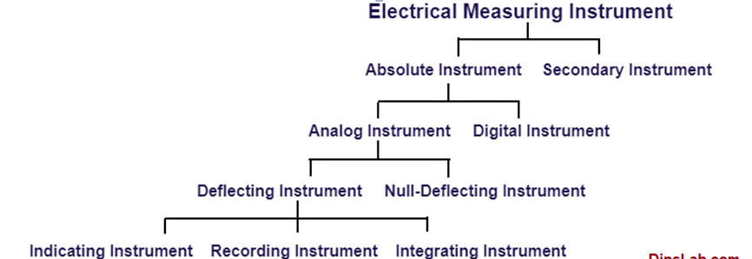
Figure3.1.Classification according to the Electrical Quantity
1. Absolute Instrument
This instrument gives the value of the electrical quantity to measure in terms of the constant and its deflection. This instrument is known as ‘Absolute Instrument’.
It is also called a Primary Instrument or Indirect Instrument. These instruments are not required to compare with the standard values.
Example: Tangent Galvanometer is the best example of an absolute instrument. It is used for detecting and displaying an electric current unit.
These types of instruments are rarely used for commercial purposes.
2. Secondary Instrument
The instrument gives the value of the quantity to be measured directly into the deflection. This instrument is known as ‘Secondary Instrument’.
It is also called as Direct Instruments.
These instrument values are required to compare with absolute instruments or the standard values of the instruments.
The secondary instrument is classified into two-part,
- Deflection Instrument
- Deflection Instrument
Example: Ammeter, Voltammeter, Wattmeter, etc are examples of secondary instruments.
Classification according to the Nature of the Operation
The instrument can also be classified based on the nature of the operation. They majorly fall into the secondary instrument.
This instrument is divided into four major parts.
- Indicating Instrument
- Recording Instrument
- Integrating Instrument
- Null Deflection instrument
- Shortly describe as,
1. Indicating Instrument
The Indicating Instrument displays only the value of the electrical quantities per time of measurement.
This instrument gives the reading only when connected to the electrical supply. Otherwise, it goes to zero position.
Example: Ammeters, Voltmeters, Wattmeters, etc are example of the indicating instrument.
2. Recording Instrument
The Recording Instrument displays and records the reading of the electrical quantities at per time of measurement.
This instrument is generally used in the Generating Station and Substation.
Example: ECG, and X-Rays are examples of recording instruments
3. Integreting instrument
The Integrating Instrument displays, record, and add the numerical value of the reading of the electrical quantities per time of measurement
Example :- Energy meter, and Ampere-hour meter are examples of the integrating instrument
4. Null Deflection Instrument
The Null Deflection Instrument shows the reading of the electrical quantities without the deflection angle at per time of measurement.
1. AC Instrument
The AC Instrument is connected with the AC supply. Further, they are classified into two parts
Example:-The potentiometer is an example of a null deflection instrument
- AC Instrument
- DC Instrument
Single Phase AC Instrument Classification according to the Electrical Supply
This classification is based on the alternating current (AC) and direct current (DC)types of an electrical source.
Example: Moving Instrument [M.I.], Induction Instrument, Electrostatic Instrument, dynamometer Instrument, and Electrostatic Instrument are examples of the AC Instrument.
2. DC Instrument
The instrument is connected with the DC supply.
Example: ‘Permanent Magnet Moving Coil Instruments’ is the best example of the DC instrument.
Classification according to the Effect
Due to the various magnetic effects, electromagnetic induction effects, electrostatic effects, thermal effects, chemical effects, etc., there are more chances to get the application or system damage.
So, multiple types of instruments are used to measure and compare the unknown quantities with the standard value. These instruments protect the device.
The classification is as follows.
- Moving Coil Instruments
- Moving Iron Instruments
- Induction Instruments
- Electrostatic Instruments
- Electrolytic Instruments
- Hot Wire Instruments
Classification according to Moving Coil [M.C.] Instrument
- The Moving Coil Instrument is classified into two parts.
- Permanent Magnet Moving Coil [PMMC] instrument
- Electrodynamic or Dynamometer types instrument
Classification according to Moving Iron [M.I.] Instrument
The Moving Iron Instrument is classified into two parts.
- Attraction type M.I. instrument
- Repulsion type M.I. instrument
Classification according to an Electrical Application
In daily routine, multiple instruments are used for multiple purposes. Instruments work on AC or DC electrical sources as per the appliances use.
Here is the list of the most popular and widely used instruments.

Ammeter
Ammeter is an instrument used to measure the amount of electrical current intensity in a circuit. The unit of measure is ampere (a). It is connected along or series to the circuit.
Voltmeter is an instrument used to measure electrical pressure or voltage of a circuit. The unit of measure is volt (v). This is connected across or parallel to the circuit.
Clamp Ammeter is also called tong-tester. It is used to measure current flowing in a conductor. It is clamped or hanged in a conductor
Multimeter
A multimeter is a popular type of electrical measuring instrument. Like its name, it works like an ammeter, voltmeter, and ohmmeter to measure current, voltage, and resistance respectively.
The multimeter is available into two different forms, like-Analog and digital
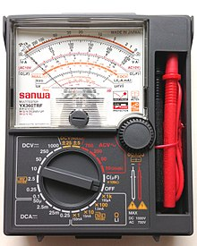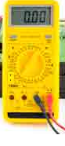
Figure3. 2 Analog mutineer Figure3. 3. Digital mutineer
In this advanced technology, both types of meters are needful as per requirement.
Advantages of a digital multimeter over an analog multimeter
The analog type of multimeter shows the continuous signal. It detects and displays the electrical reading by using the moving pointer.
Whereas, the digital type of multimeter shows the discrete signal. And it measures and displays the numeric measuring unit or value.
So, a digital multimeter (DMM) gives a more accurate, fast response and readable digital output over an analog multimeter.
Digital meter is also called as ‘Smart Meters‘ or ‘Advance Meters’.
With this single smart meter, you can measure multiple units. Instead of buying separate meters to measure current, voltage, resistance, and so on, you buy digital a millimeter.
Similarly, the LCR meter is a type of millimeter which measures the inductance (L), capacitance (C), and resistance (R).
From this study, we conclude that measurements and instruments are the most essential term in electrical, electronics, mechanical, and other related fields.
Table 3.1 Secondary instrument Vs absolute instrument
No | Secondary instrument |  | Absolute instrument
1 | Calculated in terms of physical  constants and their deflection are given by Absolute Instruments | It is not necessary to calibrate them and there is no need to compare them with the other standard instruments
2 | It is not necessary to calibrate them and there is no need to compare them with the other standard instruments | The quantity to be evaluated should be measured by the amount of the deflection of these devices.
3 | Absolute instruments are being used as standardization methods in laboratories. | It is important to calibrate these tools against an absolute instrument. Secondary instruments are utilized in day to day life.
4 | Examples – Absolute electrometer, tangent Galvanometer etc | Examples – Voltmeter, ammeter etc

Self –check 3
Part I. Choose the correct answer
1. The use of _____ instruments is merely confined within laboratories as stand¬ardizing instruments.
(a) absolute (b) indicating (c) recording (d) integrating (e) none of the above .
2. Which of the following instruments indicate the instantaneous value of the electrical quantity being measured at the time at which it is being measured ?
(a) Absolute instruments (b) Indicating instruments (c) Recording instruments (d) Integrating instruments
3. _____ instruments are those which measure the total quantity of electricity delivered in a particular time.
(a) Absolute (b) Indicating (c) Recording (d) Integrating
4. Which of the following are integrating instruments ?
(a) Ammeters (b) Voltmeters (c) Wattmeters (d) Ampere-hour and watt-hour meters
5. Resistances can be measured with the help of
(a) wattmeters (b) voltmeters (c) ammeters (d) ohmmeters and resistance bridges (e) all of the above
11. A moving-coil permanent-magnet instrument can be used as _____ by using a low resistance shunt.
(a) ammeter (b) voltmeter (c) flux-meter (d) ballistic galvanometer
Part II True false questions
1. Standard operating procedure (SOP) describes procedures that will be used to obtain field
2. Malfunctions and other unplanned and unusual event may not be totally eliminated, but it can surely be minimized.
3. Ammeter is an instrument used to measure the amount of electrical current intensity in a circuit.

Part III Matching
“A” “B”
1, Absolute Instrument A, voltmeter
2. Secondary instrument B. Tangent Galvanometer
3. Integrating instrument C. ECG
D. Energy meter

4.1. Numerical Calculation of fraction, percentage and mixed numbers Standards, code, Tolerances and Accuracy.
Calculate fraction, percentage and mixed numbers
Fractions in which the numerator is 1 are known as unit fractions. For example, 1/4, 1/7, 1/9, and so on.
Types of Fractions
Based on the numerator and denominator, which are parts of a fraction, there are different types of fractions as listed below
Proper Fraction
Proper fractions are the fractions in which the numerator is less than its denominator. For example, 5/7, 3/8, 2/5, and so on are proper fractions
Improper Fraction
An improper fraction is the type of fraction in which the numerator is more than or equal to its denominator. It is always the same or greater than the whole. For example, 4/3, 5/2, 8/5, and so on.
Unit Fraction
Fractions in which the numerator is 1 are known as unit fractions. For example, 1/4, 1/7, 1/9, and so on.
Mixed Fraction
A mixed fraction is a mixture of a whole number and a proper fraction. For example, 513 where 5 is the whole number and 1/3 is the proper fraction, or, 225, 7911 and so on.
Equivalent Fraction
Equivalent fractions are the fractions that represent the same value after they are simplified. To get equivalent fractions of any given fraction:
We can multiply both the numerator and the denominator of the given fraction by the same number.
We can divide both the numerator and the denominator of the given fraction by the same number.
Example :-Find the two fractions that are equivalent to 5/7.
Solution:
Equivalent Fraction 1: Let us multiply the numerator and the denominator with the same number 2. This means, 5/7= (5 × 2)/(7 × 2) = 10/14
Equivalent Fraction 2: Let us multiply the numerator and the denominator with the same number 3. This means, 5/7 = (5 × 3)/(7 × 3) = 15/21
Therefore, 10/14, 15/21, and 5/7 are equivalent fractions.
Like and Unlike Fractions
Like fractions are the fractions that have the same denominators. For example, 5/15, 3/15, 17/15, and 31/15 are like fractions.
Unlike fractions are the fractions which have different denominators. For example, 2/7, 9/11, 3/13, and 39/46 are unlike fractions.
Example 1: Write two equivalent fractions for 5/15
Solution
Let us write the equivalent fractions for 5/15 using multiplication and division.
a.) Let us multiply the numerator and the denominator with the same number 2. This means, (5 × 2)/(15 × 2) = 10/30
b.) Let us divide the numerator and the denominator with the same number 5. This means, (5 ÷ 5)/(15 ÷ 5) = 1/3
Therefore, 10/30 and 1/3 are equivalent to 5/15. In other words, 10/30, 1/3, and 5/15 are equivalent
Fractions.
Example 2: In a class of 48 students, 1/4th of them watch cartoons. How many students do not watch cartoons?
Solution:
Total number of students = 48, the fraction of students who watch cartoons = 1/4
Number of students who watch cartoons = 1/4 × 48 = 12
Thus, the number of students who do not watch cartoons = 48 - 12 = 36
Therefore, the number of students who do not watch cartoons is 36.
Example 3: State true or false.
.) Proper fractions are the fractions in which the numerator is less than its denominator.
b.) 9/2 is a proper fraction.
c.) 3/4 and 2/4 are like fractions.
Solution:
a.) True, proper fractions are the fractions in which the numerator is less than its denominator.
b.) False, 9/2 is an improper fraction because the numerator is larger than the denominator.
c.) True, 3/4 and 2/4 are like fractions because their denominators are the same.
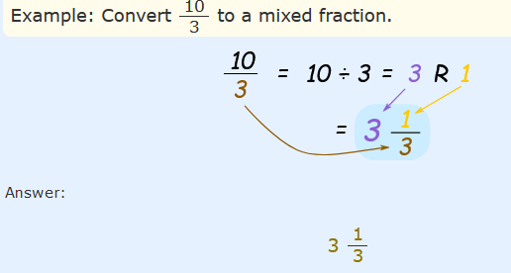
Converting Mixed Fractions to Improper Fractions
To convert a mixed fraction to an improper fraction, follow these steps:
Multiply the whole number part by the fraction's denominator.
Add that to the numerator
Then write the result on top of the denominator

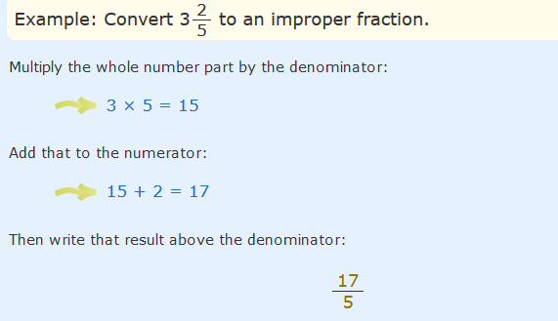
There are 3 simple steps to subtract fractions
Step 1. Make sure the bottom numbers (the denominators) are the same
Step 2. Subtract the top numbers (the numerators). Put the answer over the same denominator.
Step 3. Simplify the fraction (if needed).
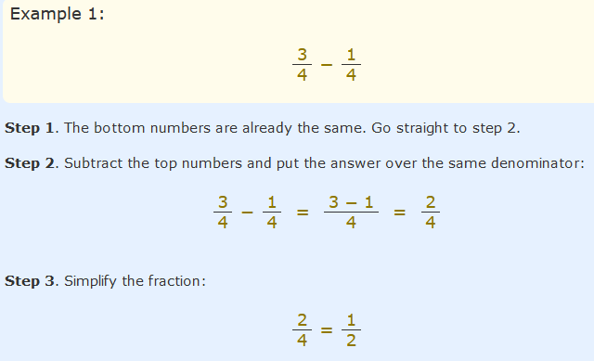
Here are 3 Simple Steps to Divide Fractions:
Step 1. Turn the second fraction (the one you want to divide by) upside down
(this is now a reciprocal).
Step 2. Multiply the first fraction by that reciprocal
Step 3. Simplify the fraction (if needed)
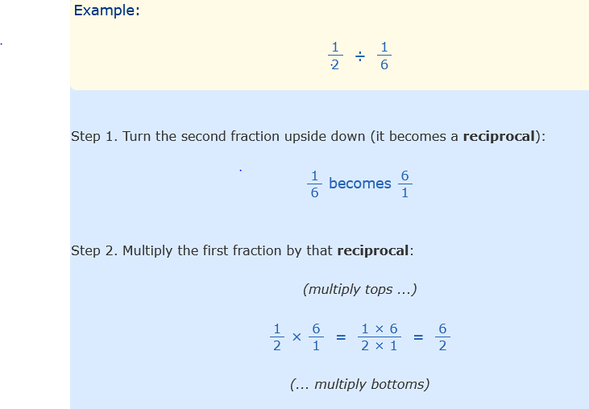
Numbers
A mixed number is a combination of a whole number and a proper fraction. Mixed numbers are also known as mixed fractions and they help us to understand a quantity in a simpler way. Let us learn more about mixed numbers, adding mixed numbers, and conversion of mixed numbers in this article.
Parts of a Mixed Number
A mixed number is formed by combining three parts: a whole number, a numerator, and a denominator. The numerator and denominator are part of the proper fraction that makes the mixed number.

Mixed Numbers
- It is partly a whole number.
- It is partly a fraction.
Converting improper fractions to mixed fractions.
Step 1: Divide the numerator by the denominator.
Step 2: Write down the quotient as the whole number.
Step 3: Write down the remainder as the numerator and the divisor as the denominator.
For example, we follow the given steps to convert 7/3 into a mixed number form.
Step 1: Divide 7 by 3
Step 2: Write quotient, divisor and remainder in form as in step 2 and step 3 above.
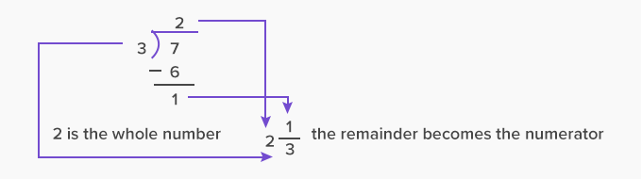
Adding Mixed Numbers
One can add mixed numbers by rearranging the whole numbers, adding them separately and adding the leftover fractions individually and in the end combing them all.
1 ¹⁄₂ + 3 ³⁄₄
Adding the whole numbers separately and the fractions separately.
whole numbers:
1+3 = 4
For fractions: Find the LCM and then add
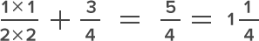
In the end, adding both the parts together.
4+1 ¹⁄₄ =5 ¹⁄₄
Multiplying Mixed Numbers
A mixed number has a whole number and a fractional part. The fractional part consists of a numerator and a denominator.

Pictorially this can be shown as:

Here, we divide each whole into 2 equal parts. So, the denominator of the fraction is 2. There are 7 shaded parts and the fraction represented is 7 2 .
There are 3 whole parts and one-half part. Thus, the fraction represented is 312.
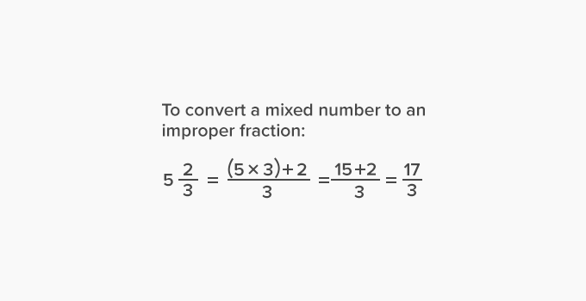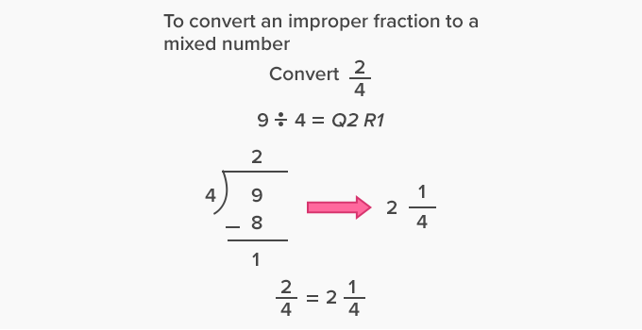 Multiplying a mixed number by a whole number:
Step 1: Convert the mixed number into an improper fraction.
Step 2: Rewrite the whole number as a fraction with denominator 1.
Step 3: Multiply two fractions by multiplying the numerators and denominators separately.
Example 1: 212 x 2
First, convert 212 into an improper fraction.
212=(2×2) + 12 = 52
Now, the whole number 2 can be written as a fraction with denominator 1.
212 x 2= 52 x 21 = 5 x 1 1 x 1 = 51= 5
Example 2: 435 x 6
First, convert 435into an improper fraction.
435=(4 x 5)+ 35 = 235
Now, the whole number 6 can be written as a fraction with denominator 1.
435x 6 = 235 x 61= 23 x 65 x 1 = 1381
Now, convert the improper fraction into a mixed number.
1385 = 2735
Thus, 4 3 5 x 6= 2735.
Multiplying two mixed numbers:
Step 1: Convert the mixed numbers into improper fractions.
Step 2: Multiply the two fractions by multiplying the numerators and denominators separately.
Example 3: 112 x213.
First, convert 112 and213into improper fractions.
112 = (1 x 2) + 12 = 32
213 = (2 x 3) + 13 =73
Now, multiply the two improper fractions.
112 = 213 =32x 73
Cancel the common factors and multiply the numerators and denominators separately.
3 2 x 7 3 = 1×72×1 = 72
Now, convert the improper fraction into a mixed number.
7 ÷ 2 = Q3 R1
72 = 312
Thus, 112 = 213= 312
Example 4: 323= 525
First, convert 323and 525into improper fractions.
323=(3 x 3) + 23 = 113
525=(5 x 5) + 25 = 275
Now, multiply the two improper fractions.
323 = 5 25 = 11 3 x 27
5
Cancel the common factors and multiply the numerators and denominators separately.
11 3 x 27 5 = 11
1 x 9 5 = 11x 9 5 = 995
Now, convert the improper fraction into a mixed number.
99 ÷ 5 = Q19 R4
995 = 1945
Thus,
3 23 x 5 25 = 194 5
Facts
Multiplying a mixed number by a whole number is performing the repeated addition of the mixed number as many times as the whole number. For example, 11
2× 3, is adding 11 2 three times as:
112x 3 =112 + 112 + 112 = 1 + 1 + 1 +12 + 12 + 12 = 3 + 32 = 62 + 32 = 92= 412

Self-check 4
Part I. Choose the correct answer
1. How many 2/3 kg pieces can be cut from a cake of weight 4 kg?
A. 6 B.7 C.10 . D. 1
2. What is the product of 5/129 and its reciprocal?
A. 1 B. 129 C 5 D, none
Part II True or False
1 Improper fractions are the fractions in which the numerator is less than its denominator
2. Proper fraction is the type of fraction in which the numerator is more than or equal to its denominator
3. A mixed fraction is a mixture of a whole number and a proper fraction.
Part III Matching
“A” “B”
1. Parts of a Mixed Number A. numerator
2. 4+1 ¹⁄₄ B. 5 ¹⁄₄
3.1x1/2x2 +3/4 C.5/4
D.2 1/4
Part III Give short answer
1.Mmixed fraction is a mixture of a whole number and a proper fraction
2.Write types of Fractions and give examples
3.Find the two fractions that are equivalent to 5/7

Unit Five : Maintain measuring instruments
This unit is developed to provide you the necessary information 72regarding the following content coverage and topics:
- Methods of Handle measuring instruments
- Preventive maintenance
- Selection of objects to be measured
- correct specification
This unit will also assist you to attain the learning outcomes stated in the cover page. Specifically, upon completion of this learning guide, you will be able to:
- Handle tools without damage
- Perform preventive maintenance
- Identify object to be measured
- Obtain correct specification

5.1 Methods of Handle measuring instruments
The world's best measuring instruments are all but worthless if they can't be relied on to provide accurate, reliable results. One key to ensuring that measuring instruments, such as micrometers, calipers and dial gauges, maintain a high level of reliability and accuracy is by taking proper care of them. Below is what you should know about the care and maintenance of these special precision tools.
Lubricate Instruments Appropriately to Prevent Corrosion
Proper lubrication of measuring instruments will prevent damage due to corrosion and oxidation. Precision measuring instruments should be lightly oiled after each use, and any excess oil should be removed from metal surfaces with a clean, dry cloth. A visibly "wet" instrument can attract and hold minute particles that can cause internal wear of precisely fabricated parts, especially those that move against one another.
In addition, do not use penetrating oils or other compounds designed for purposes other than light lubrication. For example, avoid spraying your instruments with WD-40, as it may leave a film that can alter the calibration of the instrument. Even the thinnest layer of a foreign substance can throw off the accuracy of some measuring instruments, such as calipers and micrometers.
Store Instruments in an Appropriate Environment
Whenever you place an instrument in its storage location, be sure the location is well-protected from destructive elements. Do not store precision instruments where they can jostle against one another in a drawer; instead, separate instruments from one another using dividers or place them in padded cases. Avoid stacking instruments on top of each other, unless they are well-protected in cases.
If your work is in an environment where vibration is a problem, keep measuring instruments stored in an area as far away as possible from vibration and movement. Over time, these forces can slowly cause your instruments to fall out of calibration.
In addition, if the storage location is subject to dampness, be sure to use moisture-removal methods that can help lower the humidity. Silica gel packets placed in drawers or keeping a storage room air conditioned can also greatly lessen ambient moisture. If air conditioning isn't possible, then consider investing in a dehumidifier that can dry the air to appropriate levels.
Properly Handling of Instruments During Use
Once you have a precise measuring instrument in your hand, it becomes that much more important to protect that tool from harm or providing false readings. There are a few things you should do that will help prevent damage or miscalibration during use, including avoiding sudden shocks or rough treatment. Do not drop, throw, or bang measuring instruments against hard surfaces.
If you use precision instruments often at a workbench, then consider investing in a rubber mat that can rest on the floor beneath the edge of the bench. This will help protect your instruments from damage should they be dropped. In addition, it should go without saying to never use a measuring instrument to pry or hammer another object.
In addition, keep instruments from experiencing temperature extremes. If you are handling a measuring instrument, it is important to avoid permitting it to either heat up or cool down.
Expansion and contraction can alter the calibration of the instrument, and that is why you should endeavor to keep it within a normal room temperature range. Avoid holding instruments in your hands for an extended period of time, for example, and don't rest them on surfaces that are either too hot or cold.
Professional Recalibration Assistance
Some measuring instruments require occasional recalibration to ensure they continue to function as designed, and that is why it is important to have a professional relationship with a precision instrument manufacturer or supplier. They can keep your instruments in top-notch condition so they'll provide years of reliable service.

5.2 Preventive maintenance
Preventive maintenance (also called “preventative” maintenance) is a systematic approach to building operations that aims to predict and prevent catastrophic equipment failures before they occur
ways of facilities teams can stay on top of preventive maintenance:
- Schedule and perform regular inspections of equipment
- Conduct regular cleaning of instruments
- Lubricate moving parts to reduce wear-and-tear
- Adjust controls for optimal performance and energy efficiency
- Repair and replace any defective equipment parts
The four key action items of preventive maintenance
Inspection
Inspections are a necessary part of preventive maintenance and aid organizations in two ways. First, facility inspections ensure that equipment is safe to use. Regular inspections help prevent workplace injuries and provide a business with increased liability protection. Second, regular inspections protect property. Inspections ensure that equipment is functioning as the manufacturer intended.
Detection
Operating on a run-to-failure approach can end up costing a facility department
significant money, which is why many facility managers choose to utilize a preventive approach to maintenance. Preventive maintenance helps facility managers detect problems early, when issues are still relatively easy and inexpensive to fix.
Correction
Preventive maintenance encourages facility managers to take a proactive approach towards equipment care and correct issues before they occur. If an issue (or potential issue) is detected, facility managers take steps to promptly address the problem before it worsens or shuts down operations.
Prevention
Facility managers can combine inspection records and maintenance notes to learn from past mistakes and correct repeated issues with equipment. Prevention of asset failure reduces stress and increases productivity for facilities teams. When equipment works as inspected, staff can focus on proactive (rather than reactive) maintenance tasks.
Benefits of preventive maintenance
Preventive maintenance has two overarching goals: to increase asset longevity and productivity and to keep people and assets safe from harm.
The principles of preventive maintenance to achieve various benefits, including the following:
- Diminish excess depreciation of equipment
- Prevent untimely breakdowns of critical equipment
- Eliminate unnecessary inspections and maintenance tasks
- Save money by extending the useful life of assets
- Prepare for and prevent future issues from occurring

5.3 Selection of objects to be measured

The step taken before measure:
- Procedure of measurement: Identified the parameter or variable to be measured, how to record the result
- Characteristic of parameter: Should know the parameter that to be measured; ac, dc, frequency or etc.
- Quality: Time and cost of equipment, the instrument ability, the measurement knowledge and suitable result.
Instrument: Choose a suitable equipment; multimeter, voltmeter, oscilloscope or etc.
During measurement:
- Quality: Make sure the chosen, instrument is the best, the right position when taken result, the frequent of measurement.
- Safety first: Electric shock, overload effect, limitation of instrument.
- Sampling: See the changing of parameter during measurement, which value should be taken when the parameter keep changing. Take enough samples and it is accepted.

Self-check 5
Part I: Choose the correct answer
1.Which one of the following is not benefits of preventive maintenance
A. Eliminate unnecessary inspections and maintenance tasks
B, Diminish excess depreciation of equipment
C .Prevent untimely breakdowns of critical equipment
D. No answer
2.Whenever you place an instrument in its storage location, be sure the location is well-protected from destructive elements
A. True B, False
3. Inspections are a necessary part of preventive maintenance and aid organizations because of
A. Regular inspections help prevent workplace injuries and provide a business with increased
B. Inspections ensure that equipment is functioning as the manufacturer intended.
C A&B D. no answer
Part II fill in the blank space
- ……………….. Electric shock, overload effect, limitation of instrument.
- …………………… measuring instruments will prevent damage due to corrosion and oxidation.
- …………………make sure the chosen, instrument is the best, the right position when taken result, the frequent of measurement
Part III .give short answer
1. List ways of Ways of facilities teams can stay on top of preventive maintenance.
2. Mention four key action items of preventive maintenance

Reference
1. Electronic Devices and Circuit Applications Thomas F. Schubert, Jr. and Ernest M. Kim, 2015
2. Introductory to circuit analysis10th edition, Boylestad,
3. Fundamental Electrical and Electronic Principles Third Edition, Christopher R Robertson

Participants of this Module (training material) preparation

No | Name | Qualification (Level) | Field of Study | Organization/ Institution | Mobile number | E-mail
1 | Roman Ayalew | A | Industrial Automation & Control | Wonji PTC | 911837475 | nimonaroman@gmail.com
2 | Sirgut Wandimagegn | A | Electrical Automation & Control Tech | Entoto PTC | 911966234 | sirgut10@gmail.com
3 | Esubalew Amsalu | A | Electrical Automation & Control Tech | Harar PTC | 910644790 | balewesu@gmail.com
4 | Adamu Asfaw | B | Electrical/Electronic Technology | M/G/Mulugeta Buli PTC | 922839529 | adamuasfaw95@gmail.com
5 | Tenagnwork W/Hana | A | Electrical Automation & Control Tech | Kombolcha PTC | 913659902 | tenagneworkwoldehana@gmail.com
6 | Biruk Aniley | A | Electrical Automation & Control Tech | Ethio-Italy PTC | 920131850 | birukanu@gmail.com

