Industrial Electrical/Electronic
Control Technology
Level-II
Based on March 2022, Curriculum Version 1
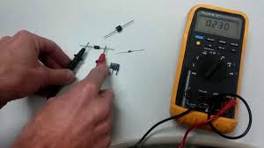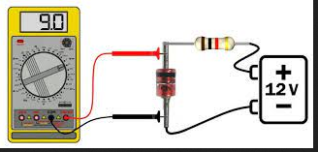

Module Title: - Testing Electrical and Electronics Components/Parts
Module code: EIS IEC2 M03 0322
Nominal duration: 80Hour
Prepared by: Ministry of Labor and Skill

April, 2022
Addis Ababa, Ethiopia

Acknowledgment 3
Acronym 4
Introduction to the Module 5
Unit one: Electrical/electronic component/ parts 6
1.1. OHS guidelines and procedures 7
1.2 Component testing instruments 8
1.2.1. Specification of Resistors 9
Self-check 1 100
Unit Two: Test Electrical/electronic component/ parts 101
2.1 Preparation of testing electrical/electronics components 102
2.2 Proper methods of testing electrical/electronics components 104
2.3 Correct use of test/measuring instrument 106
2.4 Confirmation of electrical/electronic part data and value 107
Self-check 2 109
Unit Three: Methods of testing construction of electrical /electronic circuit 110
3.1 Continuity and accurate operation test of Complete construction circuit 111
Self-check 3 126
Operation sheet 1 127
Lap Test 3 128
Reference 129

Acknowledgment

Ministry of Labor and Skills wish to extend thanks and appreciation to the many representatives of TVET instructors and respective industry experts who donated their time and expertise to the development of this Teaching, Training and Learning Materials (TTLM).

Acronym

QA quality assurance
QC quality control
DMM digital multicenter
LCR inductance capacitance
OHS Occupational health and safety
DC direct current
AC alternative current
SC Specific conductivity
SOP Standard operation standard
LDR Light depenat resistor
VDR Varistors
LED Light emitted diode
EIA Electrical industries association
MOSFET Metal-Oxide semiconductor Feid Effect Transistor
JFE Junction Felid Effect Transistor
FET Felid Effect Transistor
AF Audio Frequency
RF Radio Frequency
ICs Integrated circuit

Introduction to the Module

In Electrical field; the industrial electrical machine helps to know the quantity of work; to estimate the quantity of material required; to determine the cost of the work; to estimate the expect project completion time and to know the amount of water supplied for irrigation filed.
This module is designed to meet the industry requirement under the irrigation and drainage occupational standard, particularly for the unit of competency: Carry out measurements and calculations.
This module covers the units:
- Electrical/electronic component/ parts
- Identify and test Electrical/electronic component/ parts
- construction of electrical/ electronic circuits
Module Instruction
For effective use this modules trainees are expected to follow the following module instruction:
- Read the information written in each unit
- Accomplish the Self-checks at the end of each unit
- Perform Operation Sheets which were provided at the end of units
- Do the “LAP test” giver at the end of each unit and
- Read the identified reference book for Examples and exercise

Unit one: Electrical/electronic component/ parts
This unit is developed to provide you the necessary information regarding the following content coverage and topics:
- OHS guidelines and procedures
- component testing instruments
This unit will also assist you to attain the learning outcomes stated in the cover page. Specifically, upon completion of this learning guide, you will be able to:
- Plan and follow(OHS) guidelines and procedures
- Select test instrument

OHS guidelines and procedures
Occupational health and safety (OHS) is a branch of public health aimed at improving workplace health and safety standards.
Every occupation has health or safety risks associated with it, and it is every employer’s responsibility to ensure that their employees can carry out their work as safely as possible.

General Safety
Before working on any electronics, consider following these basic safety precautions to help reduce any hazards.
- Remove any electronic equipment you’re testing or working on from the power source.
- Never assume the power circuit is off. Test and test again with a voltmeter to confirm.
- Remove fuses and replace them only after the power to the circuit is disconnected.
- Don’t connect power to a circuit until you’re done working on it and rechecked the work.
- Always ensure that all electronics equipment is properly grounded
- If it’s damaged, replace it. For instance, replace cables instead of repairing with insulating tape.
- Always use the right electronics repair and maintenance tools.
- Always return covers after removing them to reduce the risk of electric shock.
- Make sure your circuit is not overloaded.
Always have safety equipment like a fire extinguisher, a basic first aid kit and a mobile phone nearby.

Personal Safety

It’s important to ensure that you’re safe when working on electronic circuits. Here are some personal safety precautions to keep in mind:
- Always keep your work area dry.
- Always work in a well-ventilated area.
- Don’t wear flapping or loose clothing when working.
- Don’t work with metallic jewelry on your hands like watches, rings and bracelets.
- Don’t use bare hands to remove hot parts.
- Always wear non-conductive shoes.
- Always wear insulator gloves in your hands when carrying out repairs.
- When removing high-voltage charges on capacitors, always use a shorting stick.
- Don’t hold the test prods when measuring voltage over 300V.
- Always remove power to a circuit before connecting alligator clips.
- Always wear safety goggles.
- Be careful when handling large capacitors as they can still hold high voltage even after you’ve disconnected the circuit from power.

1.2 Component testing instruments

Electronics components
Electronic components are categorized as active or passive depending on the functions they are able to perform. In a nutshell, active components can, generally speaking, inject power into a circuit and are capable of electrically controlling and amplifying the flow of electrical current, whereas passive components cannot.
Unlike active components, passive components either consume or store energy. A simple way to test whether a component is active or not is to measure the difference between its input and output signals. If there is a decline in power, the component is passive. If the signal is amplified, it is active.
All electronic circuits must contain at least one active component, and most electronic devices contain both active and passive components.
Active and passive components. Passive component
• A passive component cannot deliver power or cannot process the electrical signal are known as
the passive component. E.g. resistor, inductor, capacitor
• An Active component is that which is capable of delivering power to some external device.
E.g. voltage source or current source
Types of passive components
The passive components are used to limit the circuit current, vary the current or voltage in an electrical circuit. Depending upon their construction and working principle the applications of these components vary.
Resistors
A resistor is an electrical/electronic passive component used to limit the flow of current. The figure represents the various types of resistors.

1.2.1. Specification of Resistors

The specification of resistors are :
- Resistance value
- Tolerance
- Power rating
- Thermal stability
1) Resistance value (Ohmic value):
The magnitude of the resistor is been expressed in terms of its resistance value. The resistance value decides the quantity of current flow to be opposed. Thus the resistance value is expressed in ohms (Ω) or kilo-ohms (KΩ) or mega-ohms (MΩ). The resistance value is either printed on the surface of a resistor or by color bands.

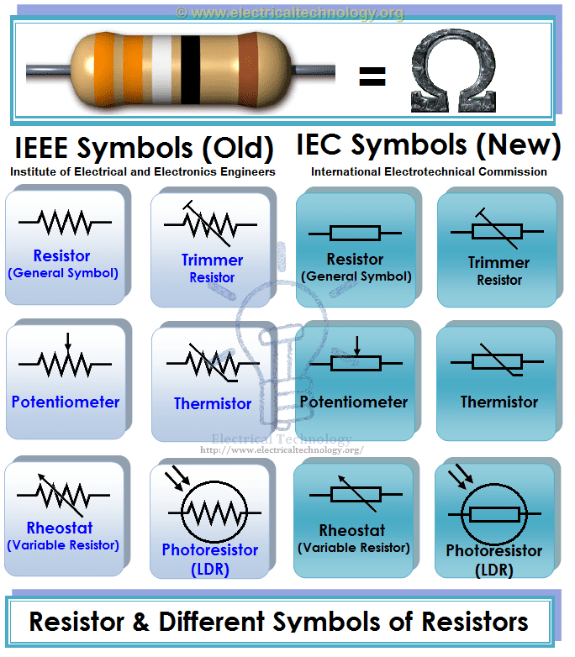

Figure1. 1Resistance value (Ohmic value):
2) Tolerance:
Tolerance represents the maximum and minimum values of a resistance value. It is specified in terms of percentage. It is been expressed as either ±% on the surface of the resistor or with the help of a fourth color band.
3) Power Rating (Wattage rating):
Power rating specifies the maximum power in watts that the resistor can handle without being destroyed or damaged. It also represents the power dissipation in the resistor in terms of I2R loss (or heat).
4) Thermal Stability:
Thermal stability indicates the stability in the resistance value to a maximum specified temperature. or It is the ability of a resistor to maintain the same resistance value with variation in temperature.
Types of Resistor and their Symbols:
Based on their operation following are the types of resistor:
- Fixed resistor
  - Wire Wound Resistors
    - Power type wire wound resistor
    - Precision type wire-wound resistor
  - Carbon Composition Resistors
  - Cracked Carbon Resistors or Carbon Film Resistors
  - Metal Oxide Resistors
  - Metal Film Resistors
- Variable resistor
  - Continuously variable resistors
    - Potentiometers
    - Rheostats
  - Adjustable or pre-set resistors
    - Decade resistance boxes
    - Thermistors
    - Varistors.
- Tapped resistors

1) Fixed Resistors
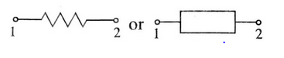
In these types of resistor, whose resistance value cannot be changed are called fixed resistors. Generally, they are very cheap and small in size, hence, occupy less space. They are reliable and available in different ohmic and power ratings. Also, fixed resistor can be easily connected to the circuit and withstand for more voltage.Based on the construction and material used, fixed resistors are further classified into:
- Wire Wound Resistors
- Carbon Composition Resistors
- Cracked Carbon Resistors or Carbon Film Resistors
- Metal Oxide Resistors
- Metal Film Resistors
a) Wire Wound Resistors:
As the name itself indicates that these types of resistor are manufactured by winding resistance wire over a rod or tube. There are two types such as power type and precision type. The resistance wire is generally Tungsten, manganin, Nichrome or nickel or nickel chromium alloy and the insulating core is made of porcelain, Bakelite, press bond paper or ceramic clay material
i) Power Type Wire Wound Resistor:
Power type wire wound resistor is manufactured by winding resistance wire made of nichrome or mangan in or constantan and annealed at high temperature to limit the mechanical strain over a ceramic rod as shown in the figure.
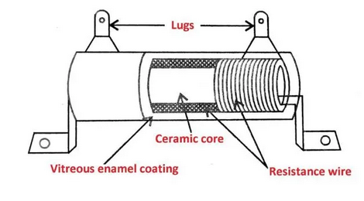
Figure1. 2Power Type Wire Wound Resistor
To avoid short-circuiting between the turns the wire is coated with a thin insulation coating. The two ends of the wire are soldered to tinned alloy terminals for external connection. The whole assembly is coated with enamel.
The drawback of a power type resistor is, it is not applicable above 200 kHz frequency because inductance and capacitance effect will exist at high frequencies. So for high-frequency applications precision type wire wound resistors are used.
ii) Precision type wire-wound resistor:
These types of resistors are used above 200 kHz and are manufactured using two techniques such as ‘π’ technique and the Bi-fular technique.
Pi-technique (π Technique):

In this technique, even sections are made in a ceramic tube and the resistance wire made of manganin is wound in the clockwise direction (1, 3 sections) as well as in anticlockwise direction (2, 4 sections) alternately to avoid the inductive effect. The entire unit is coated with vitreous enamel.
Bi-fular technique:
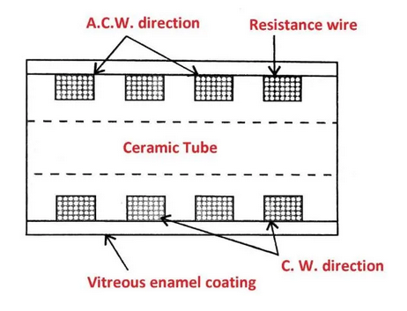
Figure1. 3Bi-fular technique
In this technique, the whole length of manganin wire is folded to half, and the folded end is fixed to one end of a ceramic tube. The wire is wound in one direction. This wire is provided with insulation coating to avoid short circuits.
Applications:
Power type resistors are used in power supplies and control circuits.
Precision type resistors are used in T.V. receivers, voltmeters, multimeters etc.
b) Carbon composition resistors:
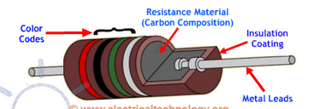
Figure1. 4Carbon composition resistors:

The mixture of fine powder of graphite lac and resin as a binder is moulded into rods.
These rods are baked in hydrogen 1400°C and copper leads are attached.
The whole assembly is provided with a varnish coating and colour bands.
Applications: These are used in electronic circuits and in low-power amplifiers.
c) Cracked carbon or carbon film resistors:
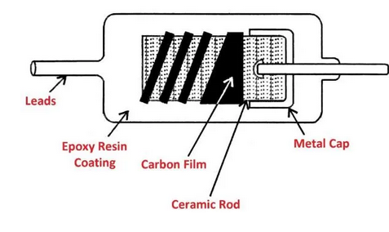
Figure1. 5Cracked carbon or carbon film resistors
- These are high stability carbon resistor.
- Make the paste of calcinated ceramic powder with water. Make rods from this paste.
- Bake them at 1100° C and pass hydrocarbon gas with some percentage of nitrogen gas to form carbon film on rods.
- Fix metal caps to the ends of rods and connect copper leads. Provide spiralling on the surface and coat the resin.
Applications: These are used in,
- Computers
- Amplifiers
- Telephone
- T.V. circuits

d) Metal oxide:

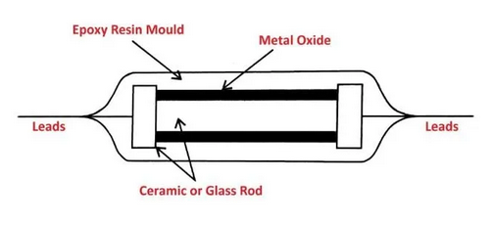
Figure1. 6Metal oxide
- Oxides of tin and antimony are sprayed over the ceramic rod at 1200° C.
- Metal caps are attached to the ends and copper leads are connected to it.
- Resin coating is provided on the surface with colour bands.

e) Metal film resistors:

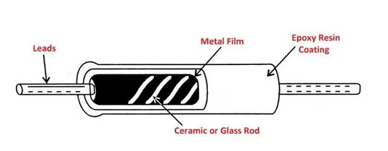
Figure1. 7Metal film resistors
- The rods of ceramic maintained at 300°C are kept in an evacuated chamber that contains an alloy of nickel-chromium.
- Pass current through this alloy, so the vapours of nichrome are deposited on the surface of the rod, which gives a thin coating of nichrome.
- Connect the copper leads and coat the resin with colour bands.
Applications:
- These are used in high-frequency test and measuring instruments.
- Used in high-frequency amplifiers.

2) Variable resistors:
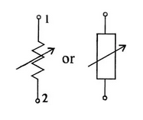
These are types of resistor, whose value can be varied either continuously or in steps are called a variable resistor.
Based on the operation, these are classified into :
- Continuously variable resistors :
  - Potentiometers
  - Rheostats
- Adjustable or pre-set resistors
  - Decade resistance boxes
  - Thermistors
  - Varistors.
a) Continuously variable resistors:
i) Potentiometers (Pot):
These are continuously variable resistors used as voltage dividers in electrical and electronic circuits. Potentiometers are of carbon film and wire-wound types.
Carbon Film Potentiometers:
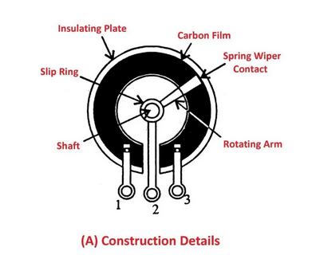
Figure1. 8Carbon Film Potentiometers
- This is used in low power circuits.
- The constructional details are shown in the figure.
- The mixture of carbon powder and resin is coated on a circular ring plate of insulating material. Two leads are connected to the ends of the ring called as fixed terminals (1&3).
- The variable terminal (2) is fixed to the moving arm (rotating arm) which is connected to the shaft at one end and wiper made of brass at other ends.
- The whole unit is enclosed in a metal casing.
Applications: These are used :
- In radios, Amplifiers and T.V. sets.
- To control volume and tone, in radio and T.V. etc.
- To control brightness and contrast in T.V. sets.
- Carbon film potentiometers are further classified into linear and logarithmic potentiometers.
Linear potentiometer: In these potentiometers, the resistance value is varied linear i.e. its value remains the same throughout.
Logarithmic potentiometer: In these potentiometers, the resistance value is not linear i.e. at one end it changes gradually, and at other ends, it changes drastically.
Wire Wound Potentiometers:
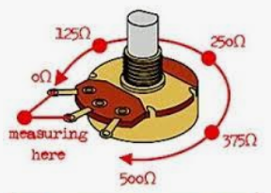
Figure1. 9Wire Wound Potentiometers
- Constructional details of wire wound potentiometer are shown in the figure.
- The nichrome wire is wound on asbesta cement or ceramic ring. The two ends of the ring are connected to fixed terminal 1 & 3.
- The variable terminal (2) is connected to moving arm and the rotating shaft, through a slip ring to wiper over the wire from one end to the other. Applications remain the same as the carbon film potentiometers.

ii) Rheostats:
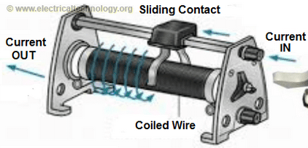
Figure1. 10Rheostats
- A rheostat is a variable wire wound resistor, connected in series with the load to limit the flow of current.
- The constructional details are as shown in the figure.
- The nichrome wire is wound firmly over a ceramic or cement tube. The two ends of the wire are connected to 2 connecting terminals. (1 and 2).
- The resistance value can be varied by sliding contact that moves on the wire.
Applications: These are used:
- In electrical and electronic circuits to limit the current.
- Used as a resistive load.
- In laboratories, because of their small ranges of resistance values (10Ω-100Ω)

b) Adjustable or Preset resistors:

i) Decade Resistance Box (DRB):
- Decade resistance box is an adjustable resistor, whose resistance value can be varied in steps.
- The constructional details are shown in the figure which consists of 3 to 6 sections made of carbon resistors.
- The resistance of each section is varied in steps by selector switches fixed to dials.

Applications:
- It is used as test equipment and calibration equipment for multimeter carlibration.
- It is also used in laboratories for conduction of experiments.

ii) Thermostats:
- Thermostats are thermally sensitive resistors, i.e. the resistance value varies with increasing temperature.
- If resistance value decreases with an increase in temperature, then such thermistors are known as negative temperature coefficient (NTC) thermistors.
- In positive temperature coefficient (PTC) thermistors, the resistance value increases with increase in temperature.
- The oxides of nickel manganese copper are mixed with binder and rods or discs are formed. e) These rods or discs are heated at 1200° C. The silver is sprayed over the surface, leads are soldered to silver contacts and resin, the coating is provided for external protection.

Applications:
These are used,
- For measurement of temperature, thermal conductivity, wind velocity etc.
- Switching devices that are temperature-activated.
- In time delay relays and thermal relays.
- In voltage regulators.

c) Varistors (VDR):
- A varistor is a voltage-sensitive resistor, i.e. its resistance value varies with change in applied voltage. It is also called a voltage-dependent resistor.

- These are manufactured by mixing silicon or carbide, metal oxide (zinc oxide + bismuth) with a ceramic binder. Then it is pressed into discs or rods and heat-treated at 1200°C in a controlled atmosphere.
- The leads are connected to the ends and the entire unit is placed in a ceramic body.

Applications:
These are used,
- As sensing element, in voltage stabilizer of T.V. and motor control circuits etc.
- In switch circuits, relays etc.
- To protect the components from inductive surge voltages

3) Tapped resistors:
- The resistor in which the resistance value can be tapped at fixed length is called as a tapped resistor.
- this types of resistor consist of firmly wound resistance wire on a ceramic rod. The tappings are provided on the wire at a fixed length.
Applications: Used in fan regulators to get variable speed.
Light Dependent Resistor (LDR):
Length dependent resistor is a bipolar semiconductor resistor, whose resistance value depends on the intensity of incident light. i.e. when LDR is exposed to light its resistance value decreases and when it is not illuminated its resistance value is very high (100 kΩ or more). This higher value of resistance of LDR has known a dark resistance.
LDR is manufactured by depositing a thin film of cadmium sulphide or cadmium selenide on a ceramic substrate. The leads of tin or indium are soldered to the ends of the deposited layer. The thin layer is formed in a zig-zag fashion to increase the length and hence the resistance value. The window is fixed on the layer to allow light to fall on a thin layer of cadmium sulphide.
Resistance Color Coding:
Resistors are manufactured in different sizes and shapes. If they are of big size then it is possible to print their values on the surface of resistors themselves. But if they are of small size then, it is difficult to print the values. So the Electronic Industries Association (EIA) has adopted the Standard Color Coding method to indicate the resistance value.
- In this method, the different color bands are printed on the left end of the body of the resistor to indicate the numerical values. The color code chart is given in table (A). To identify the resistance value the following steps are adopted.
- Hold the resistor so that colour bands should start from the left-hand side
- Read the colour bands from left to right.
- The first band shows the first digit of the resistance value.
- The second hand indicates the second digit, the third band indicates the multiplier or number of zeroes to be added after the second digit.
- The fourth band indicates the tolerance in percentage.
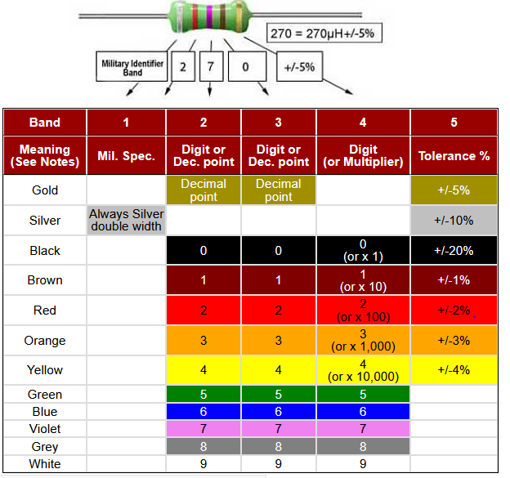
Ex: Write color code for the following resistors:
Ans: i) 1KΩ 10% tolerance: Brown Black Red Silver
ii) 3.3KΩ 5%: Orange Red Gold
Resistance Letter Code (BS 1852 Code) Method:
Generally, on larger power resistors, the resistance value, tolerance, and even the power rating are written on the body of the resistor rather than color code. But when the component is dirty, it is difficult to read the position of a decimal point or comma, so to overcome this misread British Standard BS 1852 Standard coding system is used.
This method decimal point position is replaced by the suffix letters “K” for thousands or kilo ohms, the letter “M” for millions of megaohms, and for both multiplier is denoted by letter “R” when the multiplier is equal to or less than 1. Any number coming after R is equivalent to a decimal point.
Sometimes after the resistance value, an additional letter is used, which represents the tolerance of the resistor. The BS 1852 letter code and tolerance letter coding for resistors are shown below:

Applications of Resistor
Resistors are used as:
- Electrical load
- Current limiter
- Voltage divider
- Biasing element
- Filter with capacitor
- Relay coil in thermal relays than
Inductors and TypesInductors are an electrical/electronic component that opposes a change in current due to its self-inductance. It consists of a number of turns of fine wire of copper wound on a core of some material (air, iron, powdered iron, or ferrite material) in spiral form.
When the current flows through a coil of inductor it induces EMF due to the effect of electromagnetic induction which opposes the change in the cause for it (applied current).
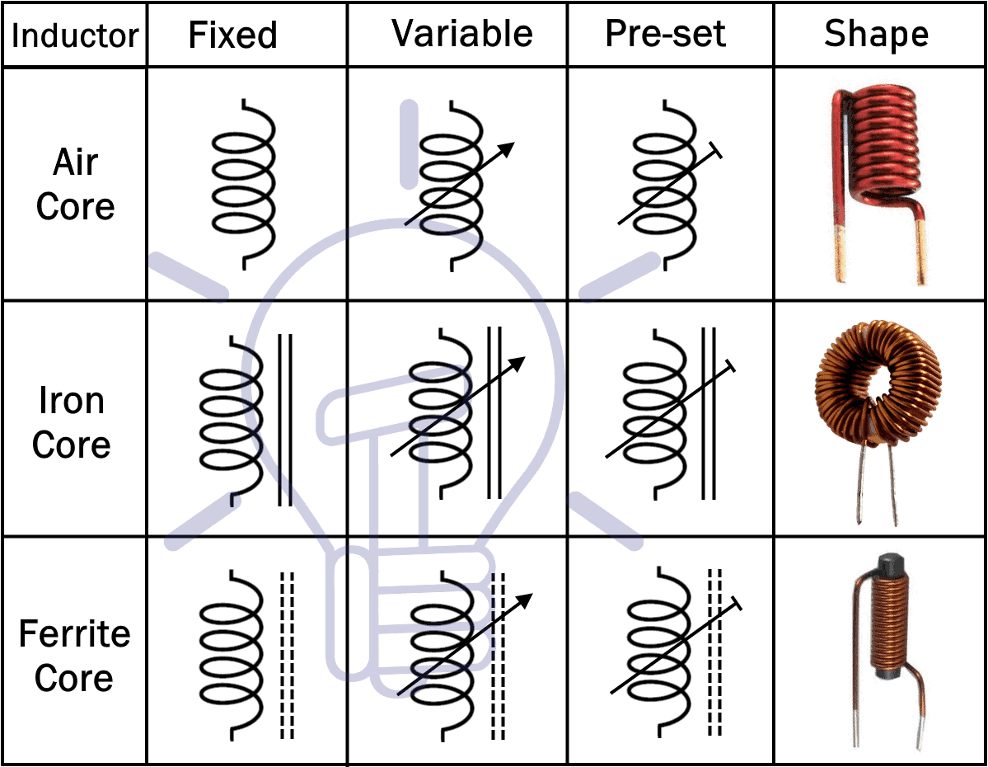.
Figure1. 11Types of Inductors
Following are the types of inductors:
- Iron Cored Inductors
- Air Cored Inductors
- Powdered Iron Cored Inductors
- Ferrite Cored Inductors
- Variable Inductors
- Audio Frequency Inductors
- Radio Frequency Inductors
1. Iron Cored Induct
The figure represents the constructional details and symbol of an iron-cored inductor which consists of a coil wound on laminated iron core or cobalt or nickel alloys.
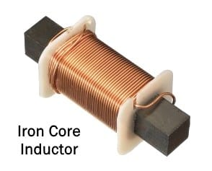
Figure1. 12Iron Cored Induct
Two lead are connected to two ends of the coil and is also center-tapped to the half of the length of the coil.
It is also known as a transformer that consists of primary and secondary windings in which two leads are soldered to primary and three
Applications: These are used:
- At low power frequency (50Hz) for building surge voltages.
- At audio frequency (20Hz – 20kHz) as AF chokes for tone control.
- As filter chokes with the capacitor in power supplies.
2 Air Cored Inductors
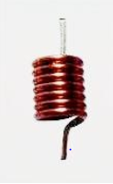
Figure1. 13Air Cored Inductors
The figure represents the constructional details of air-cored inductors which consist of air as core material, i.e. coil is wound on an insulating Bobin that contains air.
These can be operated at radio frequencies.
Applications: These are used:
- As RF chokes, RF transformers andIF transformers

3 Powdered Iron Cored Inductors

Constructional details of the powdered iron cored inductor are shown in the figure, in which powdered iron rods are used as cores.
These are used at higher frequencies.
Applications: These are used:
- RF chokes, RF transformers in radio receivers.
- As IF transformers and IF chokes in radio receivers.
- As an arial coil in tuned circuits of radio receivers.
- For tuning radio connected with gang condensers.
4 Ferrite Cored Inductors
Ferrite cored inductors contain coils wound on a solid core made of ferrite material. These are pot core and toroidal core type inductors as shown in the figure.
Applications: These are used at higher frequency ranges.
- For radio interference suppression.
- As filter chokes.
- For colour T.V. raster generation.
5. Variable Inductors
The inductors whose inductance value can be varied continuously are known as variable inductors. The constructional details are shown in the figure.
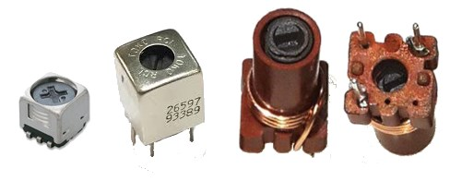
Figure1. 14Variable Inductors
Threaded screw is used as a screw, which can be rotated in or out of the coil to vary the inductance value.
Applications: These are used,
- Tuning circuits
- Coupling circuits
- Oscillator circuits
- Timing circuits
6 .Audio Frequency (A.F.) Inductors (AF Chokes)
Choke is an inductor that opposes a change in current. If choke operates at audio frequency range then it is called an A.F. choke or A.F. inductor.
It contains a number of turns of thin wire wound on a laminated iron core as shown in the figure.
The wire is made up of insulated copper and the unit is placed in a metal casing.
Applications: AF chokes are used,
- As filter chokes in radio and T.V. receivers.
- For generating voltage surges in fluorescent lamp sets.
- In tube light sets.
7 Radio Frequency (R.F.) Inductors (R.F. Chokes)
These are designed to operate at the radio frequency range (>20 kHz), shown in the figure.
They consist of a number of turns of thin wire wounds on an insulator tube or powdered iron core. For higher permeability, powdered iron cored is used.
Applications: These are used:
- Inductors are used.
- In radio transmitters.

Specification of Inductors
The specifications of inductors are:
- Inductance value
- Resistance
- Capacitance
- Frequency range
- Quality factor
- Power loss
- Current rating
- Temperature coefficient
- Inductance value:
- The value of inductance is measured in terms of its inductance value and is expressed in henries, mille henries, and micro henries.
- Resistance:
- Resistance is the ohm value of an inductor wire, which is expressed in ohms.
- Capacitance:
Stray capacitance effect exists in an inductor, i.e. a coil has some capacitance between windings which is called a stray capacitance. It lies between 1 to 10pF.
6) Frequency range:
The frequency range is the maximum frequency up to which the inductor can work safely.
7) Quality factor:
The reciprocal of the power factor is the quality factor. It is the ratio of inductive reactance (XL) to the resistance (R) of the coil. It is merely a number. For a good coil, Q must be high and R must be below.
i.e. Q-factor=XL/R
5) Power loss:
The loss in the coil is due to the copper wire, stray capacitance, and resistance of the coil. Less the power loss greater will be the quality of the coil.

9) Current rating:
The current rating is the operating current of an inductor and it is measured in Amps.

10) Temperature coefficient:
The temperature coefficient represents the stability in inductance value with a change in temperature. It is expressed in ppm/°c.

Factor Influencing the Inductance of an Inductor
The inductance of an inductor is,
- Is directly proportional to the square of the number of turns (N2) of the coil.
- Directly proportional the area (A) enclosed by each turn.
- Directly proportional to the permeability of the core (µa).
- Inversely proportional to the length (l) of the coil.
Where,
- µa = Absolute Permeability of the core material
- µo = Absolute Permeability of air
  - = 4π(Pi)x10^-7 H/m
- µr = Relative permeability of the core material

Applications of Inductors
Inductors are used in:
- Communication circuits
- Filter circuits
- Tuning circuits
- Magnetic amplifiers
- Fluorescent lamps
- Telemetric equipment
- Modulating and demodulation circuits
- Radar sets.
Capacitor:
A capacitor is a two-terminal passive electronic component that stores charge in an electric field between its metal plates. it is made up of two metal plates (electrodes) separated by an insulator known as the dielectric.
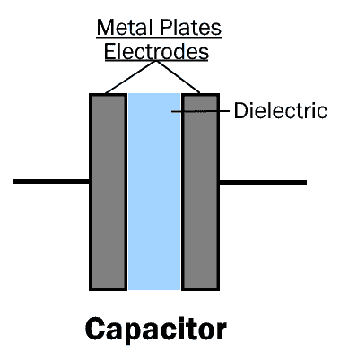
Figure1. 15.Capacitance
The capacitance is the ability of a capacitor to store charge in its metal plates (Electrodes). Its unit is Farad F.
One Farad is the amount of capacitance when a charge of one-coulomb causes the potential difference of one volt across its terminals. The capacitance is always positive, it cannot be negative.
Symbols Of Different Types Of Capacitors
Symbols of different Types of capacitors & its alternative symbols are given below.
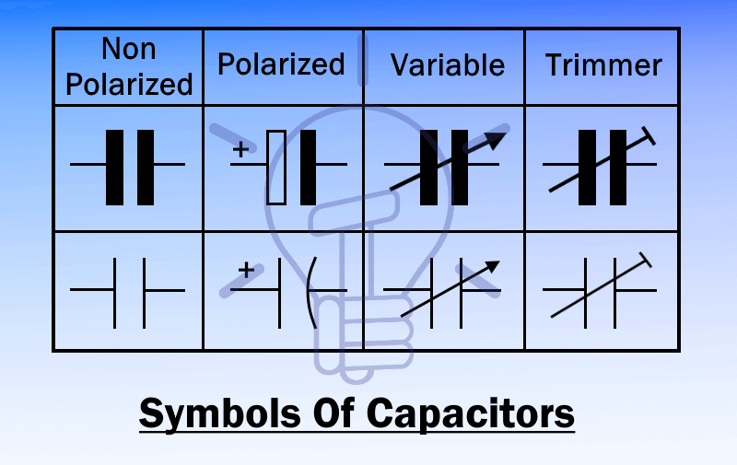
Figure1. 16Symbols Of Different Types Of Capacitors
Types of Capacitors: Polar and Non Polar Capacitors with Symbols
Types of Capacitors
There are different types of Capacitors classified on the basis of their sizes, shapes & materials. Different types of capacitors are given below with details.
The two main types of capacitors are fixed capacitors and variable capacitors.
1) Fixed Capacitors:
As the name suggests, the fixed capacitor has a fixed capacitance value. It cannot be changed. Fixed capacitors are further divided into two types i.e.
- Polar Capacitors
- Non-polar Capacitors
Polar Capacitors:
Polar capacitors or polarized capacitors are such type of a capacitor whose terminals (electrodes) have polarity; positive and negative.
The positive terminal should be connected to positive of supply and negative to negative. Reversing the polarity will destroy the capacitor. These type of capacitors are only used in DC applications.
Polar capacitors are further classified into two types:

- .Electrolytic Capacitors
- Super capacitors
Electrolytic Capacitors:
An electrolytic capacitor is a type of polar capacitor that uses an electrolyte as one of its electrodes to maintain heavy charge storage. It is made up of two metal plates whose positive (anode) plate is covered with an insulating oxide layer through anodization. This insulating layer acts as the dielectric. The electrolyte is used as the second terminal cathode. The electrolytes can be solid, liquid or gas type material.
Such Types of capacitors have a high capacitance value ranging from 1 μF to 47000 μF. They are only used in DC circuits.
The electrolytic capacitors are classified into three families
- Aluminum Electrolytic Capacitors
- Tantalum Electrolytic Capacitors
- Niobium Electrolytic Capacitors
Aluminum Electrolytic Capacitors
In the aluminum Electrolytic capacitor, the electrodes used are made of pure aluminum. However, the anode (positive) electrode is made by forming an insulating layer of aluminum oxide (Al₂O₃) through anodization. The electrolyte (solid or non-solid) is placed on the insulating surface of the anode. This electrolyte technically acts as the cathode. The second aluminum electrode is placed on top of electrolyte which acts as its electrical connection to the negative terminal of the capacitor.
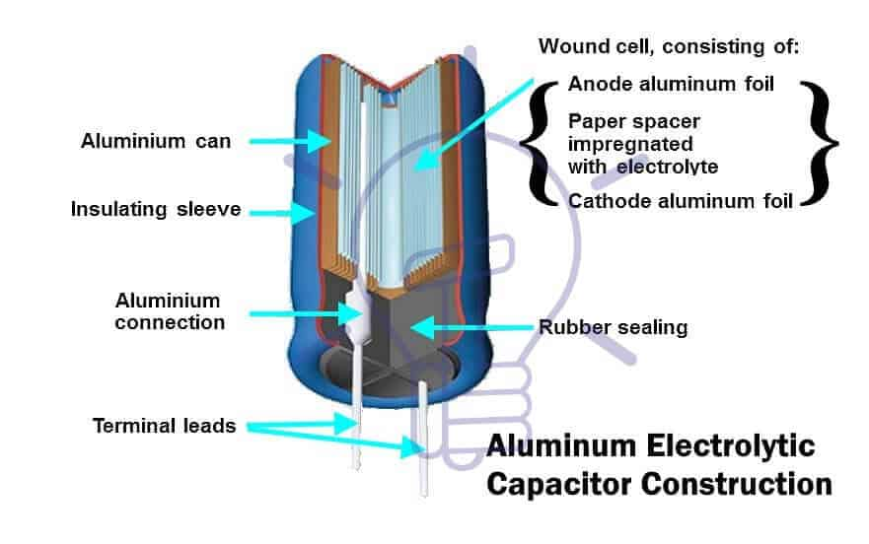
Figure1. 17Aluminum Electrolytic Capacitors
Depending on its electrolyte, they are divided into two sub-types
- Non-Solid or Wet
- Aluminum Electrolytic Capacitors
- Solid Aluminum Electrolytic Capacitors (SAL’s)
1) Non-Solid Aluminum Electrolytic Capacitors
Non-solid aluminum electrolytic capacitors use liquid or gel electrolyte. They are made of two foils of aluminum with a paper in between which are impregnated with a liquid or gel-like electrolyte. The anode aluminum foil is oxidized to form (AL₂O₃) dielectric. The cathode foil serves the purpose of electrical contact for the electrolyte. Although, the cathode foil hanatural oxide layer formed by air which increases its capacitance.
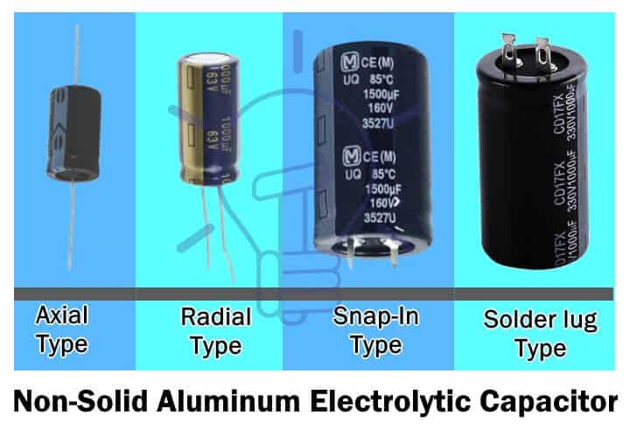
Figure1. 18.Non-Solid Aluminum Electrolytic Capacitors
The non-solid electrolytes normally used are
- Borax (ethylene glycol and boric acid) they have a max voltage rating of 600 v at a max temperature of 85° C to 105° C.
- Organic solvents such as dimethylformamide (DFM), dimethylacetamide (DMA) or gamma-butyrolactone. They have a relatively high-temperature rating (GBL) and leakage current.
- Water containing solvents with water up to 70% is famous for its low ESR (effective series resistance) and low cost.
The aluminum foils with paper in-between are wound together. They are impregnated in the electrolyte and then covered in a casing of aluminum.
Advantages and Disadvantages
Advantages
- Inexpensive
- Self-healing mechanism, it forms a new oxide form after applying voltage.
Disadvantages
- Due to evaporation, dry out over time reducing health.
- ESR increases with time.
- Only used in DC circuits.
- They are sensitive to mechanical stress.
Application
- Power factor correction.
- Flash capacitor for a camera.
- I/O filters in AC power supplies
- Coupling, decoupling.
2) Solid Aluminum Electrolytic Capacitors (SAL’s)
SAL has the same construction design as wet electrolytic capacitor except they use solid electrolytes like;
- Manganese dioxide (MnO₂)
- Polymer electrolyte
- Hybrid electrolytes (solid polymer with liquid)

The electrolyte is sandwiched between two foils of aluminum after anodization of anode foil. They are then folded together for pearl style or wound for the radial style.
Advantages and Disadvantages
Advantages
- Due to its dry nature of electrolyte, there is no evaporation
- They have longer life-span
- They have low ESR
Disadvantages
- They are expensive
- No self-healing mechanism except hybrid polymer capacitor
Applications
Their application uses are similar to a non-solid electrolytic capacitor.

Tantalum Electrolytic Capacitors
Such type of electrolytic capacitor uses tantalum metal as an anode electrode. Tantalum pallet is oxidized to form an insulating layer of oxide that acts as the dielectric. This pallet is dipped into an electrolyte (solid or liquid). The electrolyte acts as a cathode. However, a layer of graphite and silver is coated on top of the electrolyte for cathode electrical connection.
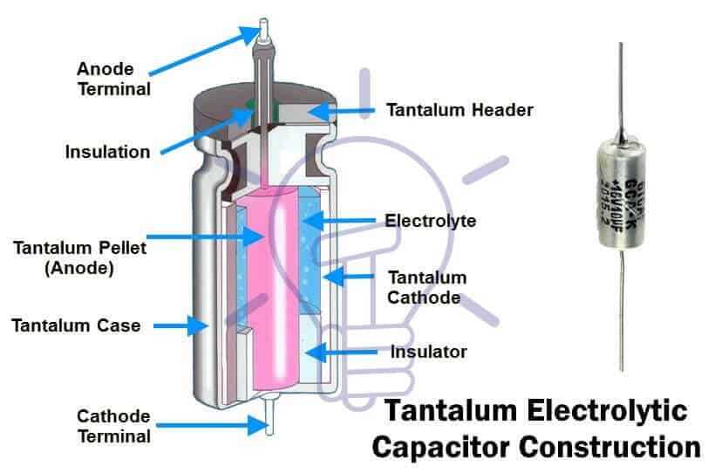
Figure1. 19Tantalum Electrolytic Capacitors

Due to its thin oxide layer, tantalum capacitors have a high capacitance per volume as compared to other electrolytic capacitors. They are smaller in size.
Depending on the state of its electrolyte, they are classified into two subfamilies
- Wet or Non-Solid
- Tantalum
- Electrolytic
- Capacitors
2. Solid Electrolytic Capacitors
1) Wet or Non-Solid Tantalum Electrolytic Capacitors
Wet tantalum capacitor uses liquid electrolyte such as sulphuric acid because the tantalum oxide layer is inert and stable. These capacitors operate on relatively high voltages up to 630 v with lowest leakage current compared to other electrolytic capacitors.
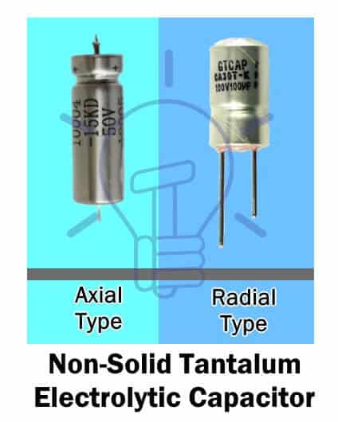
Figure1. 20 Solid Electrolytic Capacitors

2) Solid Tantalum Electrolytic Capacitors
Solid tantalum capacitor uses solid electrolytes such as manganese dioxide (MnO₂) or polymer.
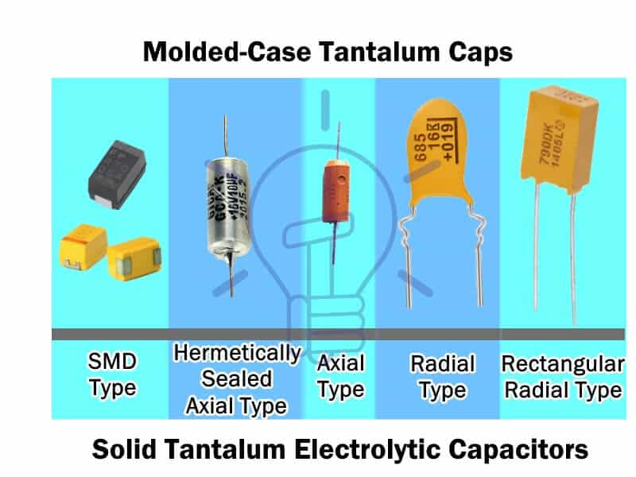
Figure1. 21Solid Tantalum Electrolytic Capacitors
MnO₂ electrolytes have high stability whereas polymer electrolytes conductivity deteriorates with time.
- Related Post: Types of ICs. Classification of Integrated Circuits and Their Limitation
Applications of Tantalum Capacitor
- Due to high capacitance per volume, it can replace aluminum electrolytic capacitor where temperature increases due to the dense packing of components.
- They are used in medical electronics for its high-quality results.
- Due to its low leakage current, they are used in sample & hold circuits.
- Most common application is filtering in computer power supplies due to its small size and reliability.
Advantages And Disadvantages
- They are available in small size and high capacitance.
- It is very stable and reliable, thus having longer life-span.
- It can operate on a wide range of temperature from -55° C to +125° C.
- They are expensive.
- They cannot tolerate reverse voltages.

3) Niobium Electrolytic Capacitors
In niobium electrolytic capacitor the anode is made of niobium metal (Niobium monoxide). It is oxidized through anodization to form an insulating layer of niobium pentoxide. This layer acts as the dielectric.
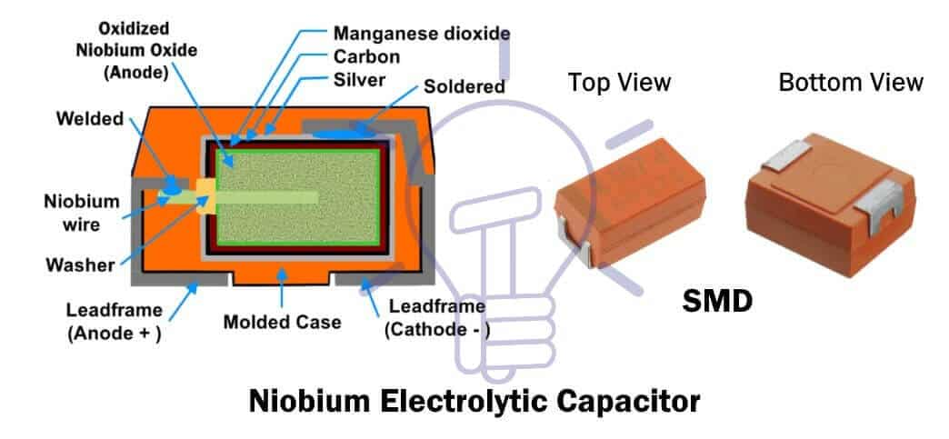
Figure1. 22Niobium Electrolytic Capacitors
The electrolyte used in niobium electrolytic capacitor is solid i.e. either manganese dioxide or polymer electrolyte. This electrolyte covers the surface of the anode. The electrolyte acts as the cathode.
A graphite and silver layer is placed on top of the electrolyte for electrical contact of cathode terminal.
Related post: Types of Solar Panel and Which one is the best PV Panel?
Super capacitors:
A super capacitor is also known as ultra-capacitor or Super cap. A supercapacitor is a type of polar capacitor that has very high capacitance but low voltage ratings.
These types of capacitors can deliver charge much faster than a battery and store charge more than an electrolytic capacitor per volume unit. That is why it is considered between a battery and an electrolytic capacitor.
Super capacitor capacitance ranges from 100 F to 12000 F with low voltage ratings approximately 2.5 v to 2.7 v.
Super capacitors construction is somewhat similar to electrolytic capacitors. They are made of metal foil (electrodes), each layered with activated carbon. These foils sandwich the separator in between. The separator is an ion-permeable membrane such as graphene (used in modern supercapacitor) which provides the insulation and exchange of ions of the electrolyte between the electrodes.
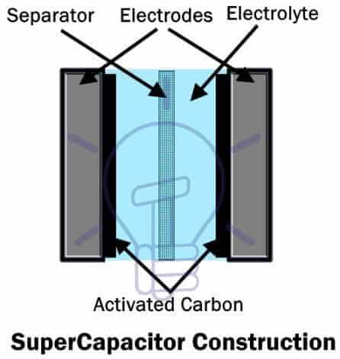
Figure1. 23Super capacitor construction
Subsequently, these foils are folded for rectangular or rolled for cylindrical shape and placed in an aluminum casing. It is then impregnated with an electrolyte; the electrolyte is rich in ions and conducts ions between electrodes. The casing is then sealed hermetically.
The super capacitor store charge either using electrostatic double-layer capacitance (EDLC) or electrochemical pseudo capacitance or both known as hybrid capacitance. Thus, super capacitors are classified into these types given above.
Related Post: Difference Between Capacitor and Super capacitor
Electrostatic Double-Layer Capacitors (EDLC’s)
It is a type of super cap that store charge electrostatic ally in double-layer. The electrodes are made of activated carbon. When the voltage is applied to its electrodes, two layers of charge are formed. One layer appears on the surface of electrodes, which causes another layer of opposite polarity ions in the electrolyte. These two layers are separated by a polarized monolayer of solvent molecules. It is known as the Helmholtz plane.
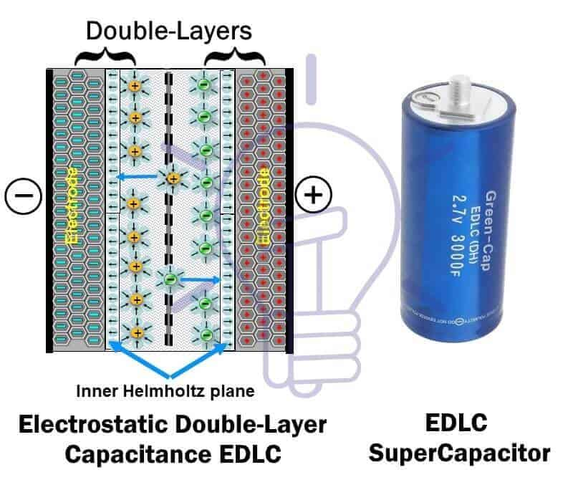
Figure1. 24Electrostatic Double-Layer Capacitors (EDLC’s)
There is no charge transfer between electrodes and electrolyte which can cause a chemical change. So the charge is not stored in the chemical bond (electrochemically). Instead, there is an electrostatic force between the ions, so EDLC stores charge electro statically.
Electrochemical Pseudo Capacitors
This a type of super capacitor which stores energy by transfer of charge between electrolyte and electrode, also known as faradic-electron-charge-transfer. So they store charge electrochemically.
It is a very fast reversible redox reaction where reduction occurs at one electrode and oxidation at other during charging and vice versa during discharging.
The faradic-electron-charge-transfer occurs with double-layer capacitance. The ions flow through the inner Helmholtz layer to reach electrode. The charge transfer between the ion and electrode cause capacitance known as Pseudo capacitance. Its capacitance exceeds the double-layer capacitance by 100 times.
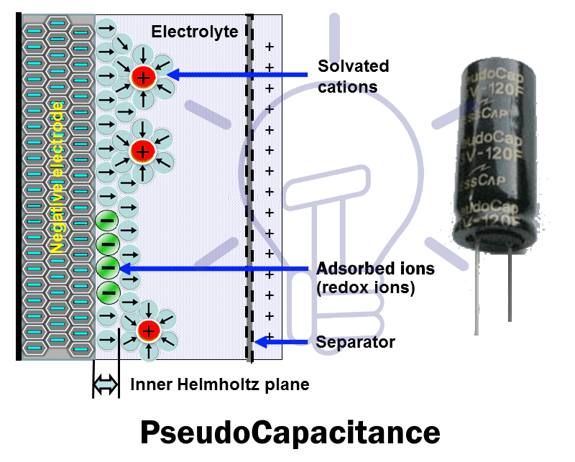
Figure1. 25Pseudo capacitance
When the ions transfer the charge to an electrode they become fused (adsorbed) on the surface of the electrode. There is no chemical reaction between the ions and electron since only charge-transfer occurs.
The electrodes of Pseudo capacitor are made of transition metal-oxide (MnO₂, IrO₂) with doping of active carbon and a conductive polymer, which provides a porous and spongy structure. Its structural design resembles the EDLC.
Hybrid Super Capacitors
Hybrid super capacitor uses the technology of both the EDLC & Pseudo capacitor by using two types of electrodes. One type of electrode is used for double-layer capacitance such as activated carbon (usually used as a cathode). The other electrode is used for pseudo capacitance.
The example of a hybrid supercapacitor is a Lithium-ion capacitor. Its anode terminal is made from graphite with doping of lithium ions during production which increases its output voltage compared to other super capacitors. Its max voltage reaches up to 3.8 v.
The cathode forms electric double-layer capacitance on its side and the anode forms a Pseudocapacitance. A separator is used in between cathode and anode to prevent electrical contact between them.
Hybrid capacitors provide high energy density, high power density with high reliability.
Application Of Super Capacitors
Modern technology has so many applications of supercapacitors. Some of them are given below
- Cordless electric screwdriver, which can be charged in a few minutes.
- LED flashlights in digital cameras.
- For stabilizing power supply in laptops and handheld devices etc.
- Uninterrupted power supply (UPS) where it replaces electrolytic capacitor banks.
Related Post: Capacitor Code: How to Find the value of Ceramic Capacitors?
Non-Polar capacitors:
Non-polar or non-polarized capacitors are such types of capacitors whose terminals have no fixed polarity. They can be used either way in a circuit. Due to its non-polarized terminals, they are used in DC circuits as well as AC circuits.
They are cheaper than Polar capacitor but they have low capacitance and high range of voltage ratings from a few volts to thousands of volts.
Non-polar capacitor are classified into three types
Film Capacitor
Ceramic Capacitors:
As the name suggests the ceramic capacitor is a type of non-polar capacitor in which the dielectric used is a ceramic material.
It is made of two layers of metal (usually nickel and copper) with ceramic (Para electric or Ferroelectric) as the dielectric. These alternating layers are stacked together to provide high capacitance value.
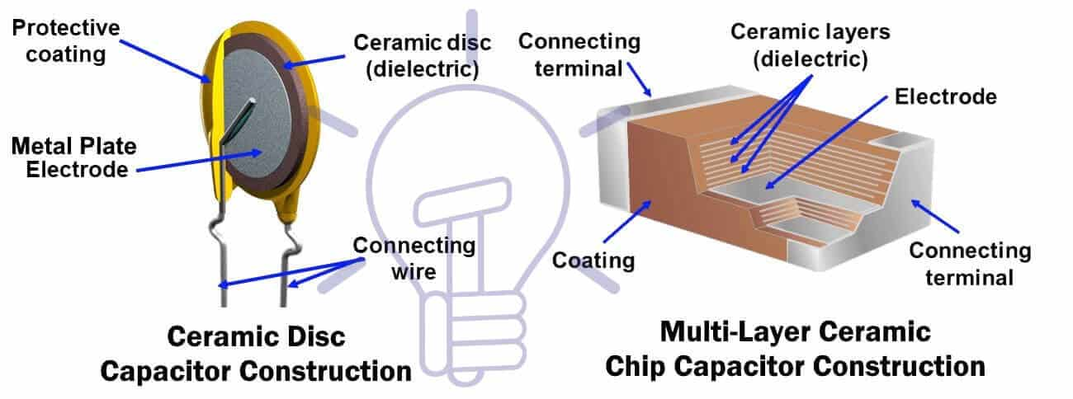
Figure1. 26Ceramic Capacitors
The minimum thickness of the ceramic dielectric layer is about 0.5 μm. The voltage rating of the capacitor depends on its dielectric strength. Furthermore, the terminals are attached to electrodes & the capacitor is covered in ceramic protective layer against moisture.
Related Post: What is the difference between a battery and a capacitor?
Ceramic capacitors are available in different shapes and styles.
- Ceramic disc shape: most commonly used type of ceramic capacitor having one layer of ceramic disc sandwiched between electrodes with through-hole terminals.
- MLCC: multi-layer ceramic chip is rectangular shaped with multiple alternating layers of metal and ceramic material with surface mounting terminals
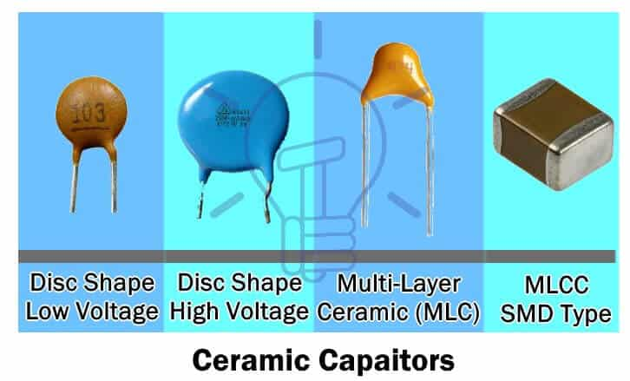
Figure1. 27Ceramic capacitors
The parameters of the ceramic capacitor depend on the different compositions of the ceramic dielectric. Due to which, they are classified into four classes.
Class 1
Class 1 ceramic capacitor uses Para electric material such as Titanium dioxide (TiO₂). They are most accurate with most stable voltage and temperature. They have the lowest losses. Its capacitance value does not depend on the applied voltage. They do not age.
Class 1 ceramic capacitor has a very low volumetric efficiency (low capacitance over large space) thus they have low capacitance value. This is because of the fact that Para electric material has low permeability.
They are used in the applications where capacitance stability and low losses are the utmost requirements such as resonant circuits.
Class 2
Class 2 ceramic capacitors use a Ferroelectric material with other additives as the dielectric. It has high permeability, which provides a relatively higher volumetric efficiency than a class1 ceramic capacitor. They are very smaller than class1.
They have low accuracy and stability with a non-linear change of capacitance with temperature. Also, its capacitance value varies with applied voltage and they age over time.
These types of capacitors are used for coupling, decoupling and by-pass applications where capacitance stability is not required.
Class 3 and 4
Class 3 also known as barrier-layer ceramic capacitors uses the dielectric with higher permeability than class 2. That is the reason they have better volumetric efficiency but with worst electrical parameters.
Its capacitance changes non-linearly with temperature with a very high margin. Also, it depends on the applied voltage. It has the worst stability and accuracy with very high losses. They age over time.
In modern electronic technology, they are considered obsolete, instead, class 2 ceramic capacitors are preferred. Class 4 has even worse parameters than class 3 & they are also obsolete as of today.
Related Post: How to Calculate the Suitable Capacitor Size in Farads &#038; kVAR for Power factor Improvement?
Mica Capacitors:
Mica capacitor as its name suggests is a non-polar capacitor that uses mica (chemically inert and stable material) as the dielectric.
There are two type of mica capacitor
- Clamped Mica
- Capacitor
- Silver Mica Capacitor
Clamped Mica Capacitors
These types of capacitors were used in the early 20th century. They were constructed from thin sheets of mica and metal (usually copper) foil. These sheets and foils are stacked together and clamped. They were then encapsulated in insulating material.
The tolerance and stability of clamped mica capacitor are worse than other capacitors because the surface of mica is not flat and smooth.
Nowadays, There are obsolete and are replaced by silver mica capacitor discussed below.
Silver mica capacitors:
Unlike clamped mica capacitor where sheets of mica are clamped with metal foils, the silver mica capacitor is made of sheets of mica with metal (silver electrode) being coated on its both sides. Multiple layers are added together to increase its capacitance. It is then dipped in an insulator Epoxy for protection against humidity and air etc.
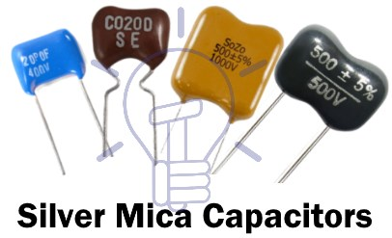
Figure1. 28 Silver mica capacitors
They are very stable and have low losses. They have a low tolerance of about +/- 1%. Its capacitance depends very little on the applied voltage. The encapsulation protects the electrodes from corrosion. Thus, they maintain a longer lifespan.
They are costly and have a larger volume as compared to ceramic capacitors. It can operate on heavy voltage ranging from 100 v to 10 Kv with capacitance ranging from 47 pF to 3000 pF.
They are still used in modern electronic circuits because of its high voltage and power handling capabilities such as RF broadcast transmitter, amplifiers, high voltage inverters, and resonance circuits etc.
Film Capacitors:
Film capacitor, also known as Polymer film capacitor or plastic film capacitor is a type of non-polar capacitor which uses a film of usually plastic and sometimes paper as a dielectric.
Its construction has two types or formats of configuration
Metalized Capacitor
Film/Foil Capacitor
Related Post: High Inrush Current in Capacitor Switching and Ways to Prevent It. Metalized Capacitors
Metalized capacitors are those types of capacitors that use a metalized dielectric film, which is made by depositing a metal layer over the dielectric film. The metal used can be Aluminum or Zinc.
Such configuration provides self-healing property and the film can be wound together to achieve capacitance up to 100uF
Film/Foil Capacitors
Such types of capacitors are constructed by sandwiching a dielectric film with metal foils. The metal is usually Aluminum which acts as the electrodes.
Such type of configuration enables the capacitor to handle high surge currents.
The film capacitors are divided into different types of capacitors based on the type of dielectric film.

Paper Capacitors
It is the first film capacitor where an oil-impregnated paper was used as a dielectric between Aluminum foils.
The main drawback of paper film/foil capacitor was that it soaks moisture, which degrades its performance over time. They were fairly bulky.
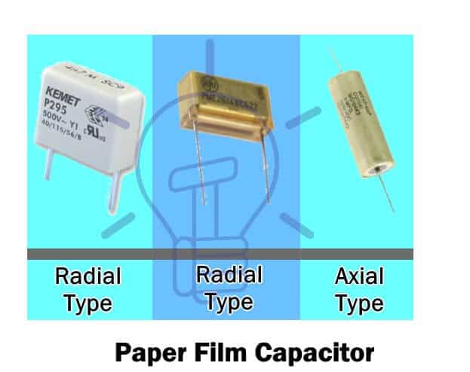
Figure1. 29Paper Capacitors
Nowadays, Metallized paper films are used as a dielectric with a self-healing property. The paper is combined with polypropylene film to increase its voltage rating and improve its performance.
Power capacitor that uses paper as a dielectric, is filled with oil to fill the air gaps increasing its breakdown voltage.
Related Post: How to Convert Capacitor Farads into kVAR &#038; Vice Versa (For Power factor improvement)?
Polyester (PET) Film or Mylar Capacitors
Polyester film capacitor, also known by its trademark name Mylar capacitor uses a dielectric made of polyethylene terephthalate (PET), which is a thermoplastic polar polymer. They are constructed in both metalized film and Film/Foil structure as well.
Its ability to resist moisture makes the capacitor to be used without coating. Its high permeability and dielectric strength offer high volumetric efficiency. However, its capacitance temperature coefficient is a little higher than other film capacitors. It can operate in temperature up to 125° C. This also allows it to be used as an SMD capacitor. They operate on a maximum voltage of about 60 Kv. They have a tolerance of 5% to 10%.
Poly Propylene (PP) Film Capacitors
Polypropylene is a non-polar organic polymer material that is used as a dielectric in this capacitor.
They are manufactured in both configurations i.e. metalized film and film/foil.
They are even more resistant to moisture than polyester film capacitor, thus they don’t need any protective coating. Their capacitance is less dependent on temperature and frequency as compared to polyester but its operating frequency is lower with a max limit of 100 KHz. Its max operating temperature is 105° C. They have high operating voltage with a maximum voltage rating of 400 Kv.
They are used in high-power induction heating and low-power application such as sample & hold and VCO etc. they are also used as AC motor run capacitor and power factor correction capacitor.
Polyethylene Naphthalate (PEN) Film Capacitors
The dielectric material used in such type of film capacitors is Polyethylene Naphthalate (PEN) which belongs to the polyester family. These capacitors are only available in metalized dielectric structure.
The main advantage of PEN capacitors is its high-temperature stability of about 175° C. Due to high-temperature stability; they are manufactured in SMD packaging.
It has low volumetric efficiency because the PEN dielectric has lower permeability & strength compared to PET. However, its capacitance dependence on its temperature and frequency is similar to PET capacitors, which is why they are used in applications where temperature dependencies are not required.
There are used for coupling, decoupling & filtering purposes.
Polyphenylene Sulfide (PPS) Film Capacitors
These film capacitors are available in only metalized film form. Their capacitance depends very little on the temperature & frequency compared to other film capacitors.
It offers a very stable response for the temperature below 100° C. Its dielectric can withstand temperature up to 270° C. Therefore, they are also made in SMD packaging. However, they are costly compared to other film capacitors.
They are used in applications where high operating temperatures exist.
Polytetrafluoroethylene (PTFE) Film Capacitors
Also known by its trademark name Teflon, uses a synthetic polymer Poly tetra fluoro ethylene (PTFE) as the dielectric. They are manufactured in both metalized & Film/foil types.

They are fairly bulky & expensive. The temperature dependence for its capacitance is a little higher than the Polypropylene (PP) film capacitor. But they are very resistant to a temperature of about 200° C with very low losses.
They are used in high-quality applications for aerospace & military equipment.
Polystyrene (PS) Film Capacitors
The main advantage of these capacitors is that they offer almost zero change in its capacitance when operating in its temperature range. But they have a very low-temperature rating with the maximum limit of 85° C.
These film capacitors are cheap capacitors with very low losses & high stability. They are manufactured in tubular shape & are now replaced by polyester film capacitor.
Polycarbonate (PC) Film Capacitors
These film capacitors use polycarbonate dielectric which is manufactured in both metalized and film/foil structure as well.
They offer very high stability & very low loss. It is almost independent of the temperature in the range of -55° to +125° C. The Polycarbonate film provides high tolerance which increases its reliability.
They are used in the applications where low-loss & temperature stability is required such as filtering & timing circuits in a harsh environment.
1.Power Film Capacitors
They have the similar construction as film capacitor. The layers are wound together to attain a larger size and capable of handling high power. They are used in high power AC & DC applications.
2.Variable Capacitors:
Such types of capacitors whose capacitance can be changed either mechanically or electrically is known as the variable capacitors. They don’t have fixed capacitance value instead they provide a range of values. They are used in tuning LC circuits for a radio receiver, impedance matching in antennas.
These variable capacitors are divided into two main types based on its operating mechanism
- Mechanically
- Controlled
- Electrically Controlled
Mechanically Controlled Variable Capacitors
These variable capacitors capacitance value can be changed mechanically through a knob or a screwdriver. They are made of semi-circular metal plates with a dielectric in between them.
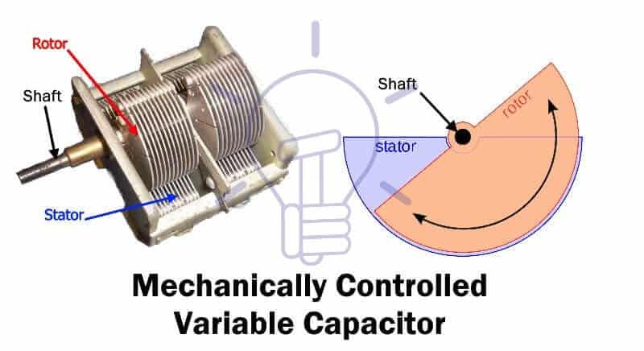
Figure1. 30Mechanically Controlled Variable Capacitors
One set of plates which is movable is known as rotor & the other set of plates which is stationary is known as the stator. The rotor rotates around a shaft that increases or decrease the distance between the plates which changes the capacitance of the capacitor.
Mechanical controlled types of capacitors are further divided into two sub-types.
- Tuning
- Capacitors
- Trimmer Capacitors
Tuning Capacitors
This type of variable capacitor is used for tuning & is commonly used in LC circuits for radio tuning. Its capacitance can be varied by rotating a knob which rotates the rotor across the stator with a dielectric between them. The dielectric used is either air or mica.
They are a more robust type of variable capacitor. It is used in such circuits where the capacitance needs to be changed more than once in order to achieve the desired output.
Trimmer Capacitors
This type of variable capacitor’s capacitance is varied by using a screwdriver. They are not very tolerant to continuous changing in capacitance. They can only withstand a few adjustments.
It has the same construction design as a tuning capacitor. The dielectric used in the trimmer capacitor is either air or ceramic.

They are used in such circuits where the capacitance does not need to be changed more than a few times. They are used in calibration circuits of equipment. Their small size allows it to be used on PCB (Printed Circuit Board).
Electrically Controlled Variable Capacitors
Such type of variable capacitor is made of P-N junction semiconductor device whose junction capacitance is controlled using the reverse voltage.
Varactor diode or more commonly known as Vericap is a special type of diode that uses the reverse bias voltage to vary its junction capacitance.
They are used in PLL (Phase locked loop) as VCO (voltage controlled oscillator) & as frequency synthesizers
Applications of Capacitors
There are some of the general application for all types of capacitors.
- Smoothing power supply’s output.
- Power factor correction
- Frequency filters, high pass, low
- pass filters.
- Coupling & Decoupling of signals.
- Motor Starter.
- Snubber (Surge absorber & Noise filter)
- Oscillators
Active components

- Diode
- Transistor
- Thyristor
Diode is known as a semiconductor component because it is made from semiconductor materials such as silicon or germanium (both give different results of the diodes).
Diodes can pass a current in our desired direction and block the current if it flows in the opposite direction. Just imagine it as a one way street. This is why we can convert AC voltage into DC voltage because it blocks the current when its value is in the negative area.
What is Diode Symbol
Diode symbol illustrates its function in a smart way. It contains an arrow with a “wall” at its end
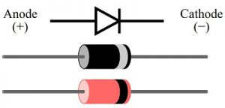
Figure1. 31just as drawn below.
Diode Symbol
Diode is a two terminal component and its terminals named with:
Anode
Cathode
Anode represents the direction we desire to flow or also known as forward biased. Cathode represents the direction we desire to block or also known as reverse biased.
What is Diode Structure
After looking at the explanation above, we need to know how diodes can behave like that. Its unique work principle comes from its semiconductor materials such as silicon or germanium.
As long as the anode voltage is higher than cathode voltage, the current is forward biased, current is flowing through in the circuit without any problem.
As long as the cathode voltage is higher than anode voltage, the current is reverse biased, current is not able to flow past the diode and no current flows in the circuit.
Types of Diodes
This is where we will spend most of our time, learning what are the types of diodes used in every circuit application. The types of diodes are:

No |  | No.
1 | Light Emitting Diode (LED) | 14 | Tunnel Diode
2 | Laser diode | 15 | Varactor Diode
3 | Avalanche diode | 16 | Transient Voltage Suppression Diod
4 | Zener diode | 17 | Transient Voltage Suppression Diode
5 | Schottky diode | 18 | Point Contact Devices
6 | Transient Voltage Suppression Diode | 19 | Gunn Diode
7 | Photodiode | 20 | Gold Doped Diodes
8 | PN junction diode | 21 | Super Barrier Diodes
9 | Small Signal Diode | 22 | Super Barrier Diodes
10 | Large Signal Diode | 23 | Pettier Diode
11 | Constant Current Diodes | 24 | Diode
12 | Shockley Diode | 25 | Silicon Controlled Rectifier
13 | Step Recovery Diodes | 26 | PIN Diode
P-N J1unction Diode
The P-N junction diode is made up of semiconductor material. It consists of two layers of semiconductors. One layer is doped with P-type material and the other layer with N-type material. The combination of these both P and N-type layers form a junction known as the P-N junction. Hence the name P-N junction diode.
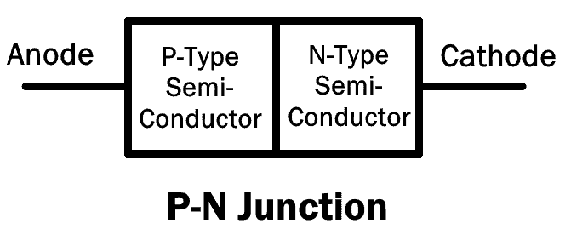
Figure1. 32 P-N junction
It allows the flow of current in the forward direction and blocks it in reverse direction. They are also known as rectifier diode used for rectification.
There are different types of diodes that use the P-N junction with variation in doping concentration. They are discussed below.
Small Signal Diode
It is a type of P-N junction diode which operates on low voltage signals. Its junction area is very small. Due to which, the junction has less capacitance & low charge storing capacity. It enables the small signal diode to have high switching speed with very fast recovery time. However, its limitations are low voltage and current parameters.
Due to its high switching speed, these types of diodes are used in circuits with high frequencies.
Related post: Different Types Of Relays, Its Operation & Applications
Rectifier Diode
A rectifier diode is a type of P-N junction diode, whose P-N junction area is very large. This results in high capacitance in reverse direction. It has low switching speed.
This is the most common and most used type of a diode. These types of diodes can handle heavy current and are used in converting AC into DC (Rectification).
Schottky Diode The Schottky diode, named after a German physicist Walter H. Schottky, is a type of diode which consists of a small junction between an N-type semiconductor and a metal. It has no P-N junction. The plus point of the Schottky diode is that it has very low forward voltage drop and fast switching. As there is no capacitive junction (P-N junction), the Schottky diode switching speed is very fast.
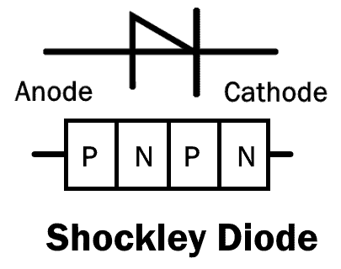
Figure1. 33 Schottky Diode
The limitation of Schottky diode is that it has low reverse breakdown voltage and high reverse leakage current.
Super Barrier Diodes
Super barrier diodes (SBR) are also rectifier diodes but they have a low forward voltage drop just like a Schottky diode. They have low reverse leakage current just like a normal P-N junction diode.
SBR uses MOSFET by making short contact between its gate and source.
SBR has a low forward voltage drop, less reverse leakage current and fast switching capability.
Related Post: Types of Switches. Its Construction, Working & Applications
Light Emitting Diode (LED) The light emitting diode is also a type of P-N junction diode that emits light in the forward bias configuration.LED is made up of a direct-band semiconductor. When the charge carriers (electrons) cross the barrier and recombine with electron holes on the other side, they emit photon particles (light). While the color of the light depends on the energy gap of the semiconductor.
LED converts electrical energy into light energy.
Photodiode
The photodiode is a type of P-N junction diode that converts the light energy into electrical current. Its operation is opposite to that of an LED.
Every semiconductor diode is affected by optical charge carriers. It is why they are packaged in a light blocking material.
In the photodiode, there is a special opening that allows the light to enter its sensitive part.
When the light (Photon particles) strikes the PN junction, it creates an electron-hole pair. These electron and hole flow out as electrical current. To increase its efficiency, a PIN junction diode is used.
A photodiode is used in reverse bias and they can be used in solar cells.
- Related Post: Types of Fuses – Its Construction, Operation & Applications
Laser Diode
A laser diode is similar to LED because it converts electrical energy into light energy. But unlike LED, Laser diode produces coherent light.
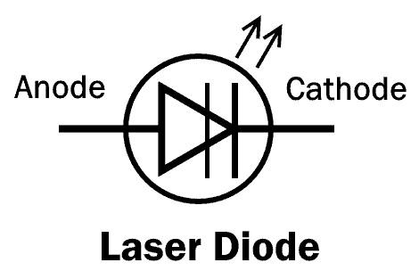
Figure1. 34Laser Diode
The laser diode consists of a PIN junction, where electron and holes combine together in the intrinsic (I) region. when they combine, it generates a laser beam.
Laser diodes are used in optical communication, laser pointer, CD drives and laser printer etc.
Tunnel Diode
Tunnel diode was invented by Leo Esaki in 1958 for which he received Nobel prize in 1973, which is why it is also known as Esaki diode.
A tunnel diode is a heavily doped P-N junction diode. It works on the principle of the tunneling effect. Due to heavy doping concentration, the junction barrier becomes very thin. This allows the electron to easily escape through the barrier. This phenomenon is known as tunneling effect.
The Tunnel diode has a region in its VI curve where the current decreases as the voltage increases. This region is known as the negative resistance region. The tunnel diode operates in this region in different applications such as an oscillator and a microwave amplifier.
The symbol with VI characteristic curve of tunnel diode is given below:
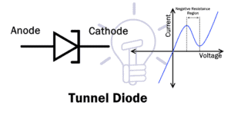
Figure1. 35Tunnel Diode
The tunnel diode also conducts current in reverse direction & it is a fast switching device.
- Related Post: Types of Resistors | Fixed, Variable, Linear & Non-Linear
Zener Diode
Zener diode is named after Clarence Malvin Zener who discovered the zener effect.
It is a type of diode, which not only allows the flow of current in the forward direction but also in reverse direction. when the reverse voltage reaches the breakdown voltage known as Zener voltage it allows the current flow.
The Zener diode has heavier doping concentration than a normal P-N junction diode. Hence, it has a very thin depletion region.
In forward bias, it operates as a simple P-N junction diode (Rectifier).
In reverse bias, it blocks until the reverse voltage reaches breakdown. After that, it allows the current flow with a constant voltage drop.
Zener reverse breakdown is caused due to two reason i.e. electron quantum tunneling and Avalanche breakdown.
A Zener diode is mainly used in reverse bias configuration. It provides a stabilized voltage for protection of circuits from overvoltage.
Backward Diode
The backward diode or the back diode is a P-N junction diode, whose operation is similar to that of tunnel diode and Zener diode. But the operating voltages are much lower.
A backward diode is essentially a tunnel diode, whose one side of the junction has relatively less doping concentration compared to the other side.
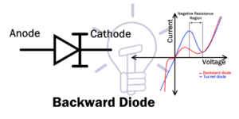
Figure1. 36Backward Diode
In the forward bias, it operates as a tunnel diode but its tunneling effect is much reduced as compared to tunnel diode. Otherwise, it operates as a normal P-N junction diode.
In reverse bias, it operates as a Zener diode but the breakdown voltages are much lower.
It is not widely used but it can be used for rectification of a small voltage signal (0.1 to 0.6v). Due to its fast switching speed, it can be used as a switch in RF mixer and multiplier.
- Related Post: Types Of Capacitors | Fixed, Variable, Polar & Non-Polar
Avalanche Diode
The Avalanche diode is a P-N junction diode that is specifically designed to operate in the avalanche breakdown region.
Avalanche breakdown is a phenomenon where sufficient reverse voltage is applied to the P-N junction. Due to which, the minority carrier ionizes & starts a heavy current flow in reverse direction.
Avalanche diode works electrically similar to the Zener diode. However, the doping concentration of a Zener diode is relatively higher as compared to an avalanche diode.
The heavy doping inside the Zener diode creates a small junction & low voltages can easily break it. However, the avalanche diode has a wide junction because of light doping concentration. Thus, it requires a high voltage for its breakdown. This wide junction makes it a better surge protector compare to a simple Zenger diode.
Transient Voltage Suppression (TVS) Diode
Transient voltage suppression diode or TVS diode is a type of avalanche diode that protects the circuit form high voltage surges.
TVS diode has the capability of handling high voltages as compared to avalanche diode.
Unidirectional TVS diode operates similar to avalanche diode. it acts as a rectifier in forward bias & surge protector in reverse bias.
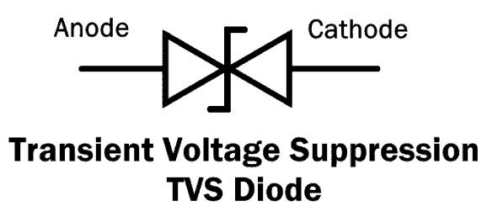
Figure1. 37Transient Voltage Suppression (TVS) Diode

Bidirectional TVS diode acts as two avalanche diodes opposing each other in series. It is manufactured as a single component. It operates both ways and provides surge protection when used in parallel with a circuit.
Related post: Types of Latches – SR & D Latches
Gold Doped Diode
In such type of diode, Gold or platinum is used as the dopant (doping material). It enables the diode to operate at fast switching speed but at the expense of increasing the forward voltage drop. Also, its reverse leakage current is higher than a normal P-N junction diode.
Constant Current Diode
The constant current diode AKA the current-limiting diode (CLD) is a two terminal diode made from JFET. It regulates the current flow through it up to a fixed level.
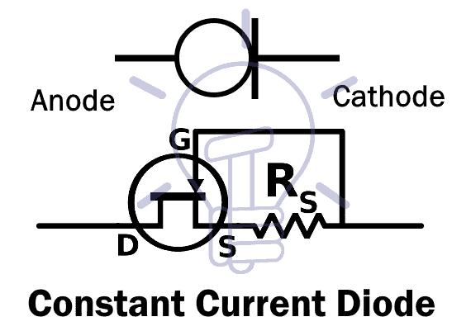
Figure1. 38Constant Current Diode
CLD is made by making short contact between the gate and the source of JFET. It limits the current just like Zener diode limits voltage.
Step Recovery Diode
Step recovery diode or snap-off diode is a P-N junction diode which abruptly ceases the flow of current when its direction is reversed.
The SRD (Step Recovery Diode) is made of a P-N junction with very low doping concentration near the junction. Due to which, the charge carriers (electron and holes) near the junction also decrease in number. Hence, the charge storing capacity near the junction becomes negligible. This enables the SRD to switch from ON to OFF very fast.
In a normal diode, when it is switched from forward conduction to reverse cutoff, the current flows briefly because of the stored charge. Due to which, the normal diode takes some time in switching. The SRD does not store charge, So it can cease the current flow instantaneously.
- Related Post: Various Types of Electronic Counters
Peltier Or Thermal Diode
Peltier or thermal diode is a type of diode whose thermal resistance is different in one direction than the other direction. So the heat generated flows in one direction to one side (terminal) and leaving the other side cooler.
This diode is used in the application of heat monitoring in microprocessor and in refrigerators for cooling effect.
Vacuum Diode
It is the simplest form of a diode made from a vacuum tube and two electrodes (cathode and anode). The Anode and Cathode are enclosed inside the vacuum tube (empty glass).
When the cathode heats up it emits electrons, the anode picks up the electrons and the flow continues.
The cathode can be heated directly or indirectly.
In forward bias, the free electron on cathode release into the vacuum after getting heat up. The anode collects these electrons and the current flows.
In reverse bias, the free electron in the vacuum gets repelled by the anode as it is connected to the negative terminal, therefore the current does not flow.
Thus, the current flows in only one direction.
Varactor Diode
Varactor diode also known as Vericap diode are voltage controlled capacitors. They have a P-N junction with variable junction capacitance.
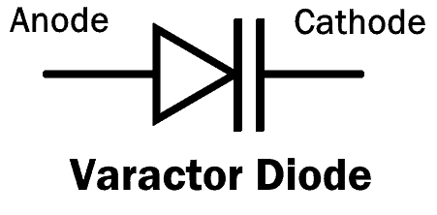
Figure1. 39Varactor Diode
The varactor diode operates under reverse bias conditions. The depletion layer between the P and N-type material is varied by changing the reverse voltage.
All diode’s junction capacitance varies with reverse voltage but Varactor diode is able to use this effect with a high range of capacitance.
The applications of Varactor diodes are as a voltage controlled oscillator in the phase-lock loop, in RF tuning filters and frequency multipliers.
Gunn Diode
Gunn diode AKA “Transferred Electron Device” (TED) is a type of diode having negative resistance like tunnel diode. It is named after a British physicist J.B Gunn who discovered the “Gunn Effect” in 1962.The Gunn diode does not have P-N junction. In fact, it consists of only N-type material, which is why it does not rectify AC or work like a normal diode. It is also the reason many people call it “Transferred Electron Device” (TED) instead of a diode.
It consists of three N-type layers; two of them which are on the terminal’s side have a higher doping concentration whereas the middle thin layer has a lighter doping concentration.
When the voltage is applied to Gunn diode, initially its current increases with increase in voltage.
At higher voltage, the resistance of the middle layer starts increasing with voltage. It results in the fall of the current flow. This is the negative resistance region & Gunn diode operates in this region.
The Gunn diode is used in an oscillator for generating microwaves of high frequency.
- Related post: Types of Circuits, Network & Parts Of Circuit
PIN Diode
PIN diode is a three-layer diode i.e. P-layer, I-layer & N-layer. The ‘I‘ intrinsic semiconductor layer is placed between heavily doped P and an N-type semiconductor.
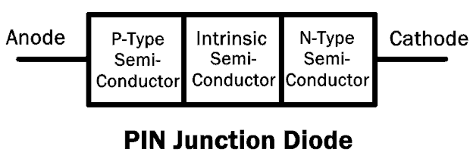
Figure1. 40PIN Diode
The electron and holes from N and P-type region respectively flow to the intrinsic region (I). Once the “I” region fills completely with electron-holes, the diode starts conduction.
In reverse bias, the wide intrinsic layer in the diode can block and tolerate high reverse voltages.
At higher frequency, the PIN diode will act as a linear resistor. It is because of the fact that the PIN diode has poor reverse recovery time. The reason is that the heavily charged “I” region does not get enough time to discharge during fast cycles.
While at low frequency, it acts as a rectifier diode. Because it gets enough time to discharge & turn off during the cycle.
If a photon enters the “I” region of a reversed bias PIN diode, it produces an electron-hole pair. This electron-hole pair flows out as current. So it is also used in photodetectors and photovoltaic cells.
PIN diodes are used in high voltage rectification, in RF application as attenuator & switching element.
Silicon Controlled Rectifier (SCR)
SCR is a four-layer P-N-P-N semiconductor switching device. It has three terminals Anode, Cathode, and Gate.
SCR is essentially a diode with an external control input known as the gate input. It allows current flow in one direction.
When SCR is connected in the forward bias, it won’t yet allow the flow of current. This is known as the forward blocking mode.
To make SCR conduct in the forward mode, it either needs the necessary voltage to cross its breakover limit or by applying a positive pulse to its gate input.
To turn off SCR, either decrease the current below the holding current point or turn off the gate input and short circuit the anode-cathode momentarily.
In reverse bias, the SCR does not allow current even after applying gate input. But if the reverse voltage reaches reverse breakdown voltage, the SCR starts conduction due to avalanche phenomena.
SCR is used for controlling high power circuits, rectification of high power AC
Shockley Diode
Shockley diode is a four layer PNPN diode. It resembles SCR but it has no control or gate input.
Shockley diode tends to stay ‘ON’ once it is turned ‘ON’ & tends to stay ‘OFF’ when it is turned ‘OFF’.
As we know that the Shockley diode has no gate input so the only way to switch it ‘ON’ is by applying Forward voltage greater than its breakdown voltage.
After applying the voltage greater than its breakdown voltage, it will allow the current flow.
During conduction state, it won’t turn off even if the voltage decreases from its breakdown voltage. To make it switch ‘OFF’, the voltage needs to be sufficiently lower than its breakdown voltage.
- Related Post: Different Types of Solar Panels
Point Contact Diode
It is also known as Cat Whisker diode or crystal diode.
It is a type of diode in which a small point junction is formed between a metal wire & N-types semiconductor crystal.
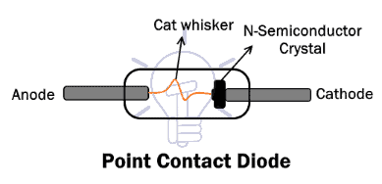
Figure1. 41Point Contact Diode
“cat whisker” is a thin springy wire made of Phosphorus bronze or tungsten. It makes a point contact junction with an N-type semiconductor, Hence the name point-contact diode.
As the junction formed is very small so the junction capacitance of point contact diode is very low. Thus, there is very low charge storage capacity, which makes it a fast switching device.
During manufacturing, passing a relatively large current through the cat whisker wire results in the formation of small a P-region upon the N-type semiconductor. This small junction acts as a P-N junction.
Point contact diodes are used for low voltage signal & in microwave mixer & detectors.
These are some of the most common types of diodes used in designing and operation of electronic circuits. If you want to add more kinds of diodes, let us know in the comment box below.
Transistor
Transistor is an active component and that is establishing all over electronic circuits. They are used as amplifiers and switching apparatus. As the amplifiers, they are used in high and low level, frequency stages, oscillators, modulators, detectors, and in any circuit need to perform a function. In digital circuits, they are used as switches.
The transistor is electronic equipment. It is made through a p and n-type semiconductor. When a semiconductor is placed in the center between the same type of semiconductors the arrangement is called transistors. We can say that a transistor is the combination of two diodes it is a connection back to back. A transistor is a device that regulates current or voltage flow and acts as a button or gate for electronic signals.
Types of Transistors
Transistors consist of three layers of a semiconductor device, each capable of moving a current. A semiconductor is a material such as germanium and silicon that conducts electricity in a “semi-enthusiastic” way. It’s anywhere between a genuine conductor such as a copper and an insulator (similar to the plastic-wrapped roughly wires).
Transistor Symbol
A diagrammatic form of n-p-n and p-n-p transistor is exposed. In-circuit is a connection drawn form is used. The arrow symbol defined the emitter current. In the n-p-n connection, we identify electrons flow into the emitter. This means that the conservative current flows out of the emitter as indicated by the outgoing arrow. Equally, it can be seen that for the p-n-p connection, the conservative current flows into the emitter as exposed by the inward arrow in the figure.
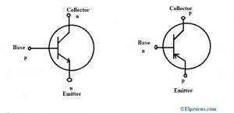
Figure1. 42PNP and NPN Transistors
There are so many types of transistors and they each vary in their characteristics and each has its possess advantages and disadvantages. Some types of transistors are used mostly for switching applications. Others can be used for both switching and amplification. Still, other transistors are in a specialty group all of their own, such as phototransistors, which react to the amount of light shining on it to produce current flow through it. Below is a list of the different types of transistors; we will go over the characteristics that create them each up
What are the Two Main Types of Transistors?
Transistors are classified into two types like BJTs and FETs.
Bipolar Junction Transistor (BJT)
Bipolar Junction Transistors are transistors that are built up of 3 regions, the base, the collector, and the emitter. Bipolar Junction transistors, different FET transistors, are current-controlled devices. A small current entering the base region of the transistor causes a much larger current flow from the emitter to the collector region. Bipolar junction transistors come in two major types, NPN and PNP. An NPN transistor is one in which the majority of the current carriers are electrons.
Electron flowing from the emitter to the collector forms the base of the majority of current flow through the transistor. The further types of charge, holes, are a minority. PNP transistors are the opposite. In PNP transistors, the majority of current carrier holes. BJT transistors are available in two types namely PNP and NPN
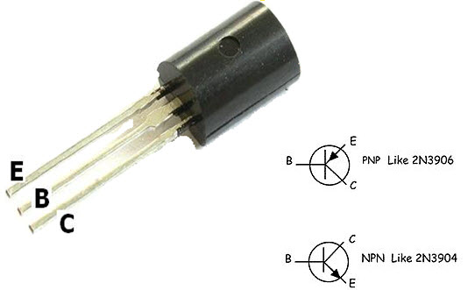
Figure1. 43Bipolar Junction Transistor pins
PNP Transistor
This transistor is another kind of BJT – Bipolar Junction Transistors and it contains two p-type semiconductor materials. These materials are divided through a thin n-type semiconductor layer. In these transistors, the majority charge carriers are holes whereas the minority charge carriers are electrons.
In this transistor, the arrow symbol indicates the conventional current flow. The direction of current flow in this transistor is from the emitter terminal to the collector terminal. This transistor will be turned ON once the base terminal is dragged to LOW as compared with the emitter terminal. The PNP transistor with a symbol is shown below.
NPN Transistor
NPN is also one kind of BJT (Bipolar Junction Transistors) and it includes two n-type semiconductor materials which are divided through a thin p-type semiconductor layer. IN the NPN transistor, the majority charge carriers are electrons whereas the minority charge carriers are holes. The electrons flow from the emitter terminal to the collector terminal will form the current flow within the base terminal of the transistor.
In the transistor, the less amount of current supply at the base terminal can cause supply huge amount of current from the emitter terminal to the collector. At present, the commonly used BJTs are NPN transistors, as the electrons mobility is higher as compared with the mobility of holes. The NPN transistor with a symbol is shown below.
Field Effect Transistor
Field Effect Transistors are made up of 3 regions, a gate, a source, and a drain. Different bipolar transistors, FETs are voltage-controlled devices. A voltage placed at the gate controls current flow from the source to the drain of the transistor. Field Effect transistors have a very high input impedance, from several mega ohms (MΩ) of resistance to much, much larger values.
This high input impedance causes them to have very little current run through them. (According to ohm’s law, the current is inversely affected by the value of the impedance of the circuit. If the impedance is high, the current is very low.) So FETs both draw very little current from a circuit’s power source.
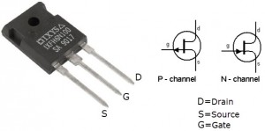
Figure1. 44Field Effect Transistors
Thus, this is ideal because they don’t disturb the original circuit power elements to which they are connected to. They won’t cause the power source to be loaded down. The drawback of FETs is that they won’t provide the same amplification that could be gotten from bipolar transistors.
Bipolar transistors are superior in the fact that they provide greater amplification, even though FETs are better in that they cause less loading, are cheaper, and easier to manufacture. Field Effect Transistors come in 2 main types: JFETs and MOSFETs. JFETs and MOSFETs are very similar but MOSFETs have even higher input impedance values than JFETs. This causes even less loading in a circuit. FET transistors are classified into two types namely JFET and MOSFET.
JFET
The JFET stands for Junction-Field-Effect transistor. This is simple as well as an initial type of FET transistors which are utilized like resistors, amplifiers, switches, etc. This is a voltage-controlled device and it doesn’t use any biasing current. Once the voltage is applied among gate & source terminals then it controls the current flow among the source & drain of the JFET transistor.
The Junction Field Effect Transistor (JUGFET or JFET) has no PN-junctions but in its place has a narrow part of high resistivity semiconductor material forming a “Channel” of either N-type or P-type silicon for the majority carriers to flow through with two ohmic electrical connections at either end normally called the Drain and the Source respectively.
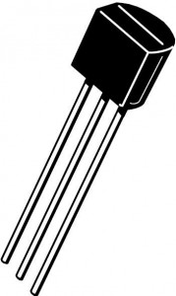
Figure1. 45Junction Field Effect Transistors
There are two basic configurations of a junction field-effect transistor, the N-channel JFET and the P-channel JFET. The N-channel JFET’s channel is doped with donor impurities meaning that the flow of current through the channel is negative (hence the term N-channel) in the form of electrons. These transistors are accessible in both P-channel and N-channel types.
MOSFET
MOSFET or Metal-Oxide-Semiconductor Field-Effect Transistor is most frequently used among all kinds of transistors. As the name suggests, it includes the terminal of the metal gate. This transistor includes four terminals like source, drain, gate & substrate, or body.
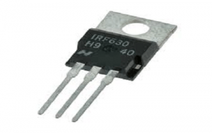
Figure1. 46MOSFET
As compared with BJT and JFET, MOSFETs has several benefits as it provides high i/p impedance as well as low o/p impedance. MOSFETs are mainly used in low power circuits especially while designing chips. These transistors are available in two types like depletion & enhancement. Further, these types are categorized into P-channel & N-channel types.
The main features of FET include the following.
- It is unipolar because the charge carriers like either electrons or holes are accountable for transmission.
- In FET, the input current will flow because of the reverse bias. Therefore the input impedance of this transistor is high.
- When the o/p voltage of the field-effect transistor is controlled through the input voltage of the gate, then this transistor is named the voltage-controlled device.
- In the conduction lane, there are no junctions present. So FETs have less noise as compared with BJTs.
- The characterization of gain can be done with transconductance because it is the ratio of o/p change current and input voltage change
- The o/p impedance of the FET is low.

Advantages of FET
The advantages of FET as compared with BJT include the following.
- FET is a unipolar device whereas the BJT is a bipolar device
- FET is a voltage-driven device whereas the BJT is a current-driven device
- The i/p impedance of the FET is high whereas BJT has low
- The noise level of FET is low as compared with BJT
- In FET, thermal stability is high whereas BJT has low.
- The gain characterization of FET can be done through transconductance whereas in BJT with a voltage gain

Applications of FET
The applications of FET include the following.
- These transistors are used within different circuits to decrease the loading effect.
- These are used in several circuits like Phase shift Oscillators, Voltmeters & Buffer amplifiers.

FET Terminals
FET has three terminals like source, gate, and drain which are not similar to the terminals of BJT. In FET, the Source terminal is similar to the Emitter terminal of BJT, whereas the Gate terminal is similar to the Base terminal & Drain terminal to the Collector terminal.

Source Terminal
In FET, the source terminal is the one through which the charge carriers enter the channel.
This is similar to the emitter terminal of BJT
The source terminal can be represented with ‘S’.
The flow of current through the channel on the source terminal can be specified like IS.
Gate Terminal
In a FET, the Gate terminal plays an essential role to control the flow of current throughout the channel.
The flow of current can be controlled through the gate terminal by providing an external voltage to it.
Gate terminal is a blend of two terminals which are internally connected and are doped heavily. The conductivity of the channel can be modulated through the Gate terminal.
This is similar to the base terminal of BJT
The gate terminal can be represented with ‘G’.
The flow of current through the channel at the Gate terminal can be specified as IG.

Drain Terminal
- In FET, the drain terminal is the one through which the carriers leave the channel.
- This is analogous to the collector terminal in a Bipolar Junction Transistor.
- The Drain to Source voltage is designated as VDS.
- The Drain terminal can be designated as D.
- The flow of current moving away from the channel at the Drain terminal can be specified as ID.

Different Types of Transistors
There are different types of transistors available based on the function like the small-signal, small switching, power, high frequency, phototransistor, UJT. Some kinds of transistors are mainly used for amplification otherwise switching purposes.

Small Signal Types of Transistors
Small signal transistors are used mainly used to amplify low-level signals but can also function well as switches. These transistors available through an hFE value, that specifies how a transistor amplifies input signals. The range of typical hFE values is from 10 to 500 including the highest collector current (Ic) rating ranges from 80 mA to 600mA.
These transistors are available in two forms like PNP and NPN. The highest operating frequencies of this transistor have from 1 to 300 MHz. These transistors are used when amplifying small signals like a few volts & simply when a mill ampere of current is used. A power transistor is applicable once a huge voltage, as well as current, is used.

Small Switching Types of Transistors
Small Switching Transistors are used like switches as well as amplifiers. The typical hFE values for these transistors range from 10 to 200 including least collector current ratings which range from 10 mA to 1000mA. These transistors are available in two forms like PNP and NPN
These transistors are not capable of the small-signal amplification of transistors, which can include up to 500 amplification. So this will make the transistors more helpful for switching, although they may be used as amplifiers for providing gain. Once you require additional gain, then these transistors would function better like amplifiers.

Power Transistors
These transistors are applicable where a lot of power is used. The collector terminal of this transistor is allied to the base terminal of metal so that it works like a heat sink to dissolve surplus power. The range of typical power ratings mainly ranges from approximately 10 W to 300 W including frequency ratings which range from 1 MHz – 100 MHz.
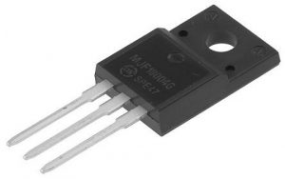
Figure1. 47Power Transistor
The values of the highest collector current will range between 1A – 100 A. Power transistors are available in PNP & NPN forms whereas the Darlington transistor comes in either PNP or NPN forms.
High-Frequency Types of Transistors
High-Frequency Transistors are used especially for small signals that work at high frequencies and used in high-speed based switching applications. These transistors are applicable in high-frequency signals & should be capable of turning ON/OFF at extremely high speeds.
The applications of high-frequency transistors mainly include HF, UHF, VHF, MATV, and CATV amplifier as well as oscillator applications. The range of maximum frequency rating is about 2000 MHz & the highest collector currents range from 10 mA – 600mA. These are obtainable in both PNP & NPN forms.
Phototransistor
These transistors are light-sensitive and a common type of this transistor looks like a bipolar transistor where the base lead of this transistor is removed as well as changed through a light-sensitive region. So this is the reason that a phototransistor includes simply two terminals in place of the three terminals. Once the outside region is kept shady, then the device will be turned off.
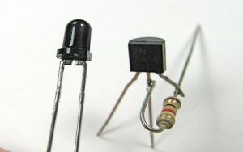
Figure1. 48Phototransistor
Basically, there is no flow of current from the regions of the collector to the emitter. But, whenever the region of light-sensitive is exposed toward daylight, then a small amount of base current can be produced to control a much high collector to emitter current.
Similar to normal transistors, these can be both FETs and BJTs. FETs are light-sensitive transistors, not like photo bipolar transistors, photo FETs utilize light to produce a gate voltage that is mainly used for controlling a drain-source current. These are very responsive to changes within light as well as more delicate as compared with bipolar phototransistors.
- Unijunction Types of Transistors
Unijunction transistors (UJTs) include three-leads that work completely like electrical switches so they are not utilized like amplifiers. Generally, transistors work like a switch as well as an amplifier. However, a UJT does not give any kind of amplification due to its design. So it is not designed for providing enough voltage otherwise current.
The leads of these transistors are B1, B2 & an emitter lead. The operation of this transistor is simple. When voltage exists between its emitter or base terminal then there will be a small flow of current from B2 to B1.
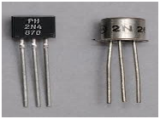
Figure1. 49Unijunction Transistor
The control leads in other types of transistors will provide a small additional current whereas, in UJT, it is quite opposite. The primary source of the transistor is its emitter current. The flow of current from B2 to B1 is simply a small amount of the whole combined current, which means that UJTs are not appropriate for amplification but they are suitable for switching.
Heterojunction Bipolar Transistor (HBT)
AlgaAs/GaAs heterojunction bipolar transistors (HBTs) are used for digital and analog microwave applications with frequencies as high as the Ku band. HBTs can supply faster-switching speeds than silicon bipolar transistors mostly because of reduced base resistance and collector-to-substrate capacitance. HBT processing requires less demanding lithography than GaAs FETs, therefore, HBTs can priceless to fabricate and can provide better lithographic yield.
This technology can also provide higher breakdown voltages and easier broadband impedance matching than GaAs FETs. In assessment with Si bipolar junction transistors (BJTs), HBTs show better presentation in terms of emitter injection efficiency, base resistance, the base-emitter capacitance, and cutoff frequency. They also present good linearity, low phase noise and high power-added efficiency. HBTs are used in both profitable and high-reliability applications, such as power amplifiers in mobile telephones and laser drivers.
Darlington Transistor
A Darlington transistor sometimes called a “Darlington pair” is a transistor circuit that is made from two transistors. Sidney Darlington invented it. It is like a transistor, but it has a much higher ability to gain current. The circuit can be made from two discrete transistors or it can be inside an integrated circuit.
The hfe parameter with a Darlington transistor is every transistor hfe multiplied mutually. The circuit is helpful in audio amplifiers or in a probe that measures a very small current that goes through the water. It is so sensitive that it can pick up the current in the skin. If you connect it to a piece of metal, you can build a touch-sensitive button.
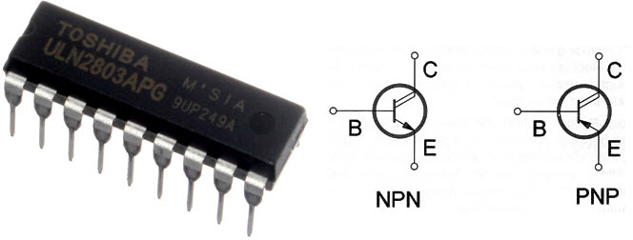
Figure1. 50Darlington Transistor
Schottky Transistor
A Schottky transistor is a combination of a transistor and a Schottky diode that prevents the transistor from saturating by diverting the extreme input current. It is also called a Schottky-clamped transistor.
Multiple-Emitter Transistor
A multiple-emitter transistor is a specialized bipolar transistor frequently used as the inputs of transistor logic (TTL) NAND logic gates. Input signals are applied to the emitters. Collector current stops flowing simply, if all emitters are driven by the logical high voltage, thus performing a NAND logical process using a single transistor. Multiple-emitter transistors replace diodes of DTL and agree to a reduction of switching time and power dissipation.
- Dual Gate MOSFET
One form of MOSFET that is particularly popular in several RF applications is the dual-gate MOSFET. The dual-gate MOSFET is used in many RF and other applications where two control gates are required in series. The dual-gate MOSFET is fundamentally a form of MOSFET where two gates are made-up along the length of the channel one after the other.
In this way, both gates influence the level of current flowing between the source and drain. In effect, the dual-gate MOSFET operation can be considered the same as two MOSFET devices in series. Both gates affect the general MOSFET operation and therefore the output. The dual-gate MOSFET can be used in a lot of applications including RF mixers /multipliers, RF amplifiers, amplifiers with gain control, and the like.
- Avalanche Transistor
An avalanche transistor is a bipolar junction transistor designed for process in the region of its collector-current/collector-to-emitter voltage characteristics beyond the collector-to-emitter breakdown voltage, called the avalanche breakdown region. This region is characterized by the avalanche breakdown, an occurrence similar to Townsend discharge for gases, and negative differential resistance. Operation in the avalanche breakdown region is called avalanche-mode operation: it gives avalanche transistors the capability to switch very high currents with less than a nanosecond rise and fall times (transition times).
Transistors not particularly designed for the purpose can have reasonably consistent avalanche properties; for example, 82% of samples of the 15V high-speed switch 2N2369, manufactured over a 12-year period, were capable of generating avalanche breakdown pulses with a rising time of 350 ps or less, using a 90V power supply as Jim Williams writes.
- Diffusion Transistor
A diffusion transistor is a bipolar junction transistor (BJT) formed by diffusing dopants into a semiconductor substrate. The diffusion process was implemented later than the alloy junction and grown junction processes for making BJTs. Bell Labs developed the first prototype diffusion transistors in 1954. The original diffusion transistors were diffused-base transistors.
These transistors still had alloy emitters and sometimes alloy collectors like the earlier alloy-junction transistors. Only the base was diffused into the substrate. Sometimes the substrate produced the collector, but in transistors like Philco’s micro-alloy diffused transistors, the substrate was the bulk of the base.
- Applications of Types of Transistors
The appropriate application of power semiconductors requires an understanding of their maximum ratings and electrical characteristics, information that is presented within the device datasheet. Good design practice employs datasheet limits and not information obtained from small sample lots. A rating is a maximum or minimum value that sets a limit on the device’s ability. Act in excess of a rating can result in irreversible degradation or device failure. Maximum ratings signify the extreme capabilities of a device. They are not to be used as design circumstances.
A characteristic is a measure of device performance under individual operating conditions expressed by minimum, characteristic, and/or maximum values, or revealed graphically.
Thus, this is all about what is a transistor and the different types of transistors and their applications. We hope that you have got a better understanding of this concept or to implement electrical and electronics projects, please give your valuable suggestions by commenting in the comment section below. Here is a question for you, what is the main function of a transistor?
Logic gates are the basic building blocks of any digital system. It is an electronic circuit having one or more than one input and only one output. The relationship between the input and the output is based on a certain logic. Based on this, logic gates are named as AND gate, OR gate, NOT gate etc.
AND Gate
A circuit which performs an AND operation is shown in figure. It has n input (n >= 2) and one output.
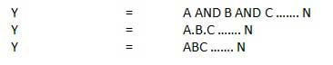
Logic diagram
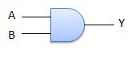

Truth Table
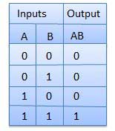
OR Gate
A circuit which performs an OR operation is shown in figure. It has n input (n >= 2) and one output.
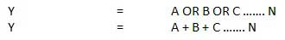
Logic diagram
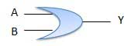
Truth Table
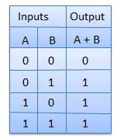
NOT Gate
NOT gate is also known as Inverter. It has one input A and one output Y.
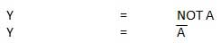
Logic diagram
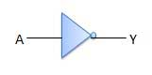
Truth Table
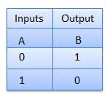
NAND Gate
A NOT-AND operation is known as NAND operation. It has n input (n >= 2) and one output.
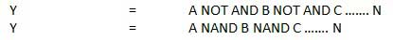
Logic diagram
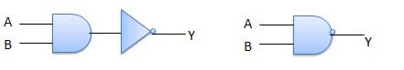
Truth Table
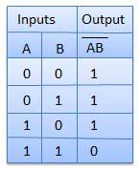
NOR Gate
A NOT-OR operation is known as NOR operation. It has n input (n >= 2) and one output.
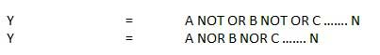
Logic diagram
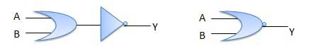
Truth Table
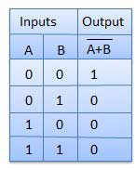
XOR Gate
XOR or Ex-OR gate is a special type of gate. It can be used in the half adder, full adder and subtractor. The exclusive-OR gate is abbreviated as EX-OR gate or sometime as X-OR gate. It has n input (n >= 2) and one output.
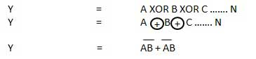
Logic diagram
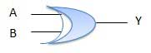
Truth Table
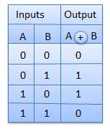
XNOR Gate
XNOR gate is a special type of gate. It can be used in the half adder, full adder and subtractor. The exclusive-NOR gate is abbreviated as EX-NOR gate or sometime as X-NOR gate. It has n input (n >= 2) and one output.
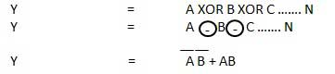
Logic diagram
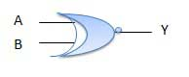
Truth Table
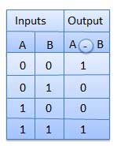

What is an Integrated Circuit (IC)
Normally bipolar junction transistors, diodes and field effect transistors are commonly used electronics component in electronic circuit. These components are interconnected along with required resistors and capacitors to form an electronic circuit. This type of circuit is known as discrete circuit as each of the components can be separated from the circuit as when required. Nowadays there is a new trend of producing electronic circuit where on a semiconductor wafer numbers of diodes, transistors, and capacitors are permanently fabricated.
As the components in this type of electronic circuit are not separable that is integrated on the semiconductor wafer, this circuit is commonly referred to as an Integrated Circuit. IC is also popularly known as chip or microchip.
The number of transistors that we have been able to fit into an IC has rapidly increased since their creation, doubling approximately every 2 years. This phenomenon is known as Moore’s Law, and is often cited as an explanation for the exponential growth of technology over the last 50 years.
History of Integrated Circuits
This technology was invented in the year of 1950 the by Jack Kilby of Texas Instruments USA and Robert Noyce of Fairchild Semiconductor USA. The first costumer to this new invention was the US Air Force. In the year 2000 Jack Kilby won the Nobel Prize in Physics for miniaturized electroniccircuits.
One and a half years after Kilby demonstrated his IC design, Robert Noyce of Fairchild Semiconductor Limited came up with his own integrated circuit. His model solved many practical problems which Kilby’s device had. It was made up of silicon where as Kilby’s was made up of germanium. Jack Kilby and Robert Noyce both received US patents for their part of work on integrated circuits. After several years of legal issues both companies wisely decided to cross license their technology and created a huge global market.
Types of Integrated Circuits (ICs)
There are two main types of integrated circuits: digital ICs or analog ICs. These types of ICs are discussed in detail below.

Analog IC
In this type of ICs, the input and output both signals are continuous. The output signal level depends upon the input signal level and the output signal level is a linear function of input signal level. Linear ICs or analog ICs are most commonly used as audio frequency amplifier and radio frequency amplifier. Op amps, voltage regulators, comparators and timers are also well-known examples of linear ICs or analog ICs.

Digital IC
The logic Gates, such as AND gate, OR gate, NAND gate, XOR gate, flip flops, counters; microprocessors are some well-known examples of digital ICs. These ICs operate with binary data such as either 0 or 1. Normally in digital circuit, 0 indicates 0 V and one indicate +5 V. Digital ICs are commonly used in many electronics projects, and are often available as added components to the top Arduino starter kits.
The main components of an IC are transistors. These transistors may be bipolar or field effect depending upon the applications of ICs.
As the technology is improving day by day, the number of transistors incorporated in a single IC chip is also increasing. Depending upon the number of transistors incorporated in a single chip, the ICs are categorized in five groups. Namely,
i) | Small Scale Integration (SSI) where the number of transistors incorporated in a single IC chip is up to 100.
ii) | Medium Scale Integration (MSI) where the number of transistors incorporated in a single IC chip is from 100 to 1000.
iii) | Large Scale Integration (LSI) where the number of transistors incorporated in a single IC chip is from 1000 to 20,000.
iv) | Very Large Scale Integration (VLSI) where the number of transistors incorporated in a single IC chip is from 20,000 to 10,00,000.
v) | Ultra Large Scale Integration (ULSI) where the number of transistors incorporated in a single IC chip is from 10,00,000 to 1,00,00,000.
Depending upon the active devices used in ICs, it can be further classified as bipolar ICs and unipolar ICs. In bipolar ICs the main components are bipolar junction transistors, whereas in unipolar ICs the main components are field effect transistors or MOSFETs.
IC Manufacturing Process
There are two types of IC manufacturing technologies one is monolithic technology and other is hybrid technology. In monolithic technique, all electronic component and their interconnections are manufactured together into a single chip of silicon. This technology is applied when identical ICs to be produced in large scale. Monolithic ICs are cheap but reliable.
In hybrid ICs, separate components are attached on a ceramic substance and interconnected by wire or metallization pattern.
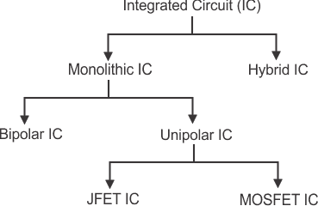
Advantages of Integrate Circuit or IC
The advantages of integrated circuits (ICs) include:
- It is quite small in size practically around 20,000 electronic components can be incorporated in a single square inch of IC chip.
- Many complex circuits are fabricated in a single chip and hence this simplifies the designing of a complex electronic circuit. Also it improves the performance.
- Reliability of ICs is high
- These are available at low cost due to bulk production.
- ICs consume very tiny power.
- Higher operating speed due to absence of parasitic capacitance effect.
- Very easily replaceable from the mother circuit.

Disadvantages of Integrate Circuit or IC

The disadvantages of integrated circuits (ICs) include:
- Because of its small size, IC is unable to dissipate heat in required rate when current in it increased. That is why ICs are often damaged due to over current flowing through them.
- Inductors and Transformers cannot be incorporated in ICs.
Amplifiers
Amplifiers can be defined simply as an electronic device that increases the power of a signal. In other words, it increases the amplitude of a signal, and makes it stronger than the given input.
Although this sounds simple in theory, amplifiers have a lot of parameters and conditions in the real world. Amplification is never perfectly efficient, there are always losses, distortion and noise to deal with.
Thus, there are a whole load of amplifiers created, that work best in different situations. Not all amplifiers provide optimal output in all situations, and there’s always cost factors to consider. So here’s all the types of amplifiers and all you need to know about them!
Important Characteristics of an Amplifier
The quality of an amplifier is measured by a series of specifications called figures of merit. They are as follows:

Bandwidth: The frequency range at which the amplifier can operate.
Noise: The amount of unwanted extra information included in the output.
Skew Rate: The maximum rate of change of output.
Gain: Perhaps the most important, the ratio between the magnitudes of input and output signals.
- Stability: The ability to provide constant and reliable output.
- Linearity: The degree of proportionality between input and output signals.
- Efficiency: Another very important characteristic, it is the ratio between the output power and power consumed.
- Output Dynamic Range: Ratio between the largest and smallest useful output levels.
Types of Amplifiers
Although amplifiers are sometimes classified according to input and output parameters (we’ll get to that), there are 4 basic types, which are:
Current Amplifier: As the name suggests, an amplifier that makes the given input current higher. It is characterized by a low input impedance and high output impedance.
Voltage Amplifier: An amplifier that amplifies given voltage for a larger voltage output. It is characterized by a high input impedance and low output impedance.
Transconductance Amplifier: An amplifier that changes output current according to changing input voltage.
Tran’s resistance Amplifier: An amplifier that changes output voltage according to changing input current. It is also known as a current-to-voltage converter.
Rectifier is an electric circuit that transforms AC current into DC the process of AC to DC conversion is known as rectification.
- There are numerous categories of diodes some were used in the previous year such as Vaccum tube diode, mercury arc valves, etc.
- Currently, semiconductor diodes are used as rectifier circuits.
- There are numerous applications of rectifies but most commonly used is in DC power supply and transmission system that transmit high voltage DC.
- There are 2 main types of rectifier first one is the half-wave rectifier and the second one full-wave rectifier.
- Half wave rectifier converts positive cycle of AC into DC and its circuit consists of a single diode.
- A full-wave rectifier converts a complete cycle of alternating current into the direct current and its circuit uses 2 or 4 diodes for rectification.
- The output obtained by these filter circuit is not pure dc and have some ripples to make it pure dc and smooth different filter circuits are used.

1.2. component testing instruments

Electrical tester tools are used for measuring various electrical parameters. These parameters include current, voltage, resistance, continuity, etc. It is commonly used by professional electricians and electrical contractors to test live wires, circuit breakers, electrical panels or power transformers. They are both multi-function and single-function devices that can conduct typical electrical testing duties. The various types of an electrical tester include clamp meters, insulation testers, multimeters, ohmmeters, voltage detectors, etc. The purpose of writing this article is to discuss and guide you with the functionality and uses of all electrical testers. It will help you in selecting the right tester for your project.
The testing equipment used to detect faults in the operation of electronic devices by creating stimulus signals and capture responses from electronic devices under test is known as electronic test equipment. If any faults are detected, then identified faults can be traced an rectified using electronic testing equipment. Most often all electrical and electronic circuits are tested and troubleshooted to detect faults or abnormal functioning if any.
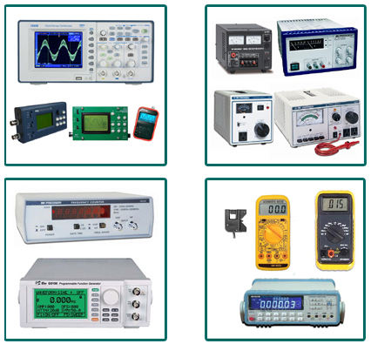
Figure1. 51Basic Electronic Testing Equipments
Therefore, testing equipment is necessary to find and analyze the circuit conditions, for checking electronic test equipment and maintenance in various industries. Many industries utilize different types of electronic test equipment ranging from the very simple and inexpensive to complex and sophisticated ones.

Types of Electrical Electronic Testing Equipments
The Basic Electronics Testing Equipments Under this Category Include the Following
Voltmeter
A basic electronics device or instrument used to measure voltage or electrical potential difference between two points in electrical circuits is known as voltmeter. There are two types of voltmeters: analog and digital. An analog voltmeter moves a pointer across a scale in proportional to the voltage of the electrical circuit. A digital voltmeter measures an unknown input voltage by converting the voltage to a digital value by using a converter and then displays the voltage in numeric form.

Ohmmeter
An electrical instrument that measures electrical resistance is known as an ohmmeter. The instrument used to measure small value of resistance are micro-ohmmeters. Similarly meg-ohmmeters is used to make large resistance measurements. Resistance values are measured in ohms (Ω). Originally, ohmmeter is designed with a small battery to apply a voltage to a resistance.
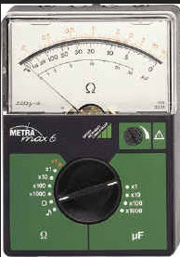
Figure1. 52Ohmmeter
It uses a galvanometer to measure the electric current through the resistance. The scale of the galvanometer was marked in ohms (Ω), because the fixed voltage from the battery assures that the resistance decreases and the current through the meter increases.

Ammeter
A measuring instrument which is used to measure the electric current in a circuit is known as an ammeter. The units of measurement for electric current is amperes (A) Earlier ammeters were laboratory instruments which depend on the earth’s magnetic field for operation. In an era of the 19th century, improved instruments were designed which could be placed in any position and allows accurate measurements in electric power systems.
Ammeter
The smaller currents can be measured by using milliammeters or micro ammeters, units of measuring the smaller current are in the milliampere or micro-ampere range. There are different types of ammeters such as moving-coil, moving magnet and moving-iron, etc.

Multimeter
A multimeter is an electronic instrument used to measure the three basic electrical characteristics: voltage, current and resistance. It has multiple functions and acts like ohmmeter, voltmeter and ammeter and also used for household wiring, electric motors, testing batteries and power supplies. The multimeter is a handheld device with a needle over a numeric LCD digital display for indication purpose. It is also used to test continuity between two points in an electrical circuit. There are three types of multimeters made available in the market such as: digital multimeter, analog multimeter and fluke multimeter.
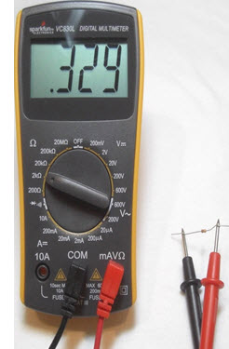
Figure1. 53 Multimeter
The Following are used for Testing Stimulus Signals of the Circuit under Test
Power Supplies
A power supply is an electronic instrument that supplies electric energy to an electric load. Regulated power supplies refers to a power supply which supplies a variety of output voltages used for bench testing of electronic circuits, with the variation of output voltages or some preset voltages. Almost all the electronic circuits make use of a DC source of power for operation. A regulated power supply consists of various blocks such as an ordinary power supply and a voltage regulating device. The output generated from ordinary power supply is fed to the voltage regulating device that provides the final output. The main function of a power supply is to convert one form of electrical energy into another.
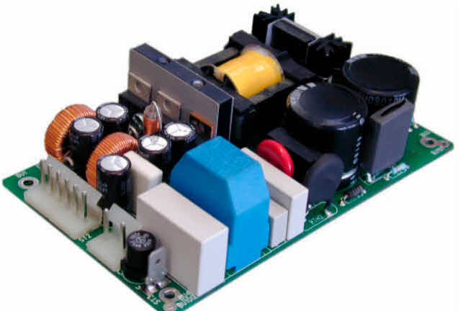
Figure1. 54Power Supplies

Signal Generator
A signal generator is also named as pitch generator, function generator or frequency generator is an electronic device used for generating electronic signals either in the analog or digital domains (repeating or non-repeating signals). Signal generators are used in testing, designing and repairing electro acoustic or electronic devices.
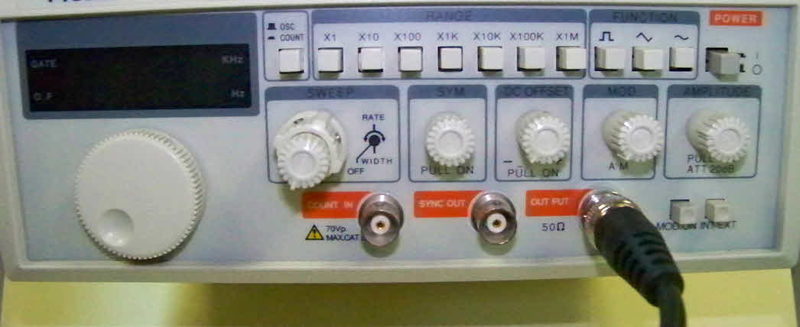
Figure1. 55Signal Generator
In general no electronic device is suitable for all applications. There are various types of signal generators with different applications and purposes. During the development in technology, compared to signal generators there are flexible and programmable software tone generators with embedded hardware units are made available in the market.
Pulse Generator
A pulse generator is either an electronic circuit or a piece of electronic test equipment used to generate electrical pulses in different shapes: mostly used for tests at analog or electrical level. Pulse generators are used to control the width, frequency,delay based on the low and high voltage levels of the pulses and with respect to an internal and external triggering. There are three types of pulse generators namely optical pulse generator, bench pulse generators and microwave pulsers.
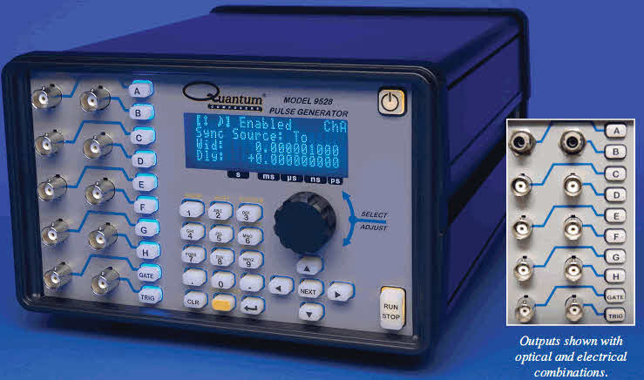
Figure1. 56Pulse Generator
Digital Pattern Generator
A digital generator is an electronic testing equipment or software used to generate digital electronics stimuli. Digital electronics stimuli are a specific type of electrical waveform varying between two conventional voltages corresponding to two logic gates (either 1 or 0, low or high). The function of the digital pattern generator is to stimulate the inputs of a electronic device. For that purpose, the voltage levels are generated by a digital pattern generator are compared to I/O standards of digital electronics: TTL, LVTTL and LVDS. It is also known as a logic source because it is a source of synchronous digital stimulus.
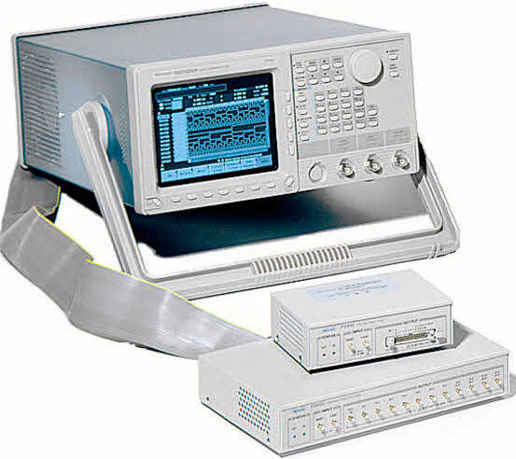
Figure1. 57 Digital Pattern Generator
It generates a signal for testing digital electronics at logic level. This generator also produces a single shot or repetitive signals in which some sort of triggering source takes place ( internally or externally)
The Following Equipments Analyze the Response of the Circuit Under Test
Oscilloscope
The oscilloscope is an electronic test instrument that constantly obverses varying voltage signals as a two dimensional plot of one or more signals as a function of time. The other names for oscilloscope are oscillograph, cathode ray oscilloscope or digital storage oscilloscope. It is also used for converting non electrical signals such as vibration or sound into voltages and then displays the result.
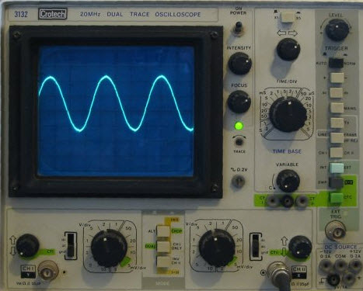
Figure1. 58Cathode Ray Oscilloscope
Oscilloscopes are used to observe the change of an electrical signal based on time such that voltage and time describe a shape of the signals and graphed continuously compared with a calibrated scale.The obtained waveforms can be considered for following properties such as frequency, amplitude, time interval, rise time and others. Modern digital instruments may calculate these properties directly and displays them.
Frequency counter
Digital frequency counter is an electrical test equipment used for measuring the frequency of repetitive signals and elapsed time between events. Digital frequency counters are also used to measure the radio frequency where it is important to measure the precise frequency of a particular signal.
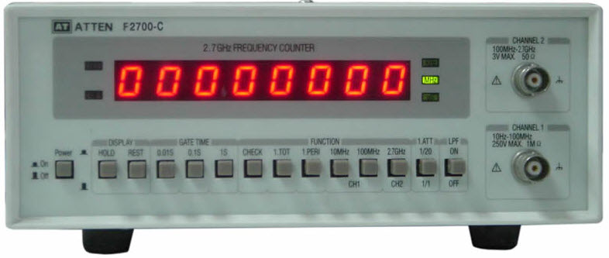
Figure1. 59Frequency Counter
There is a slight difference between the timers and frequency counters in the electronic industry. It is often possible to use both timers and frequency counters to perform the both functions: to measure the time and frequency. Frequency counters are mostly used as general purpose laboratory test equipment to measure higher frequencies.
Advanced or Less Commonly used Testing Equipment
LCR Meter
LCR Meter name itself indicates that it is used to measure the inductance, capacitance and resistance of electronics components. The inductance, capacitance and resistance are denoted by the letters L, C, and R so it is named as LCR Meter. A variety of meters are made available in the market, but simple versions of LCR meters indicates impedance only for converting the values to capacitance or inductance.
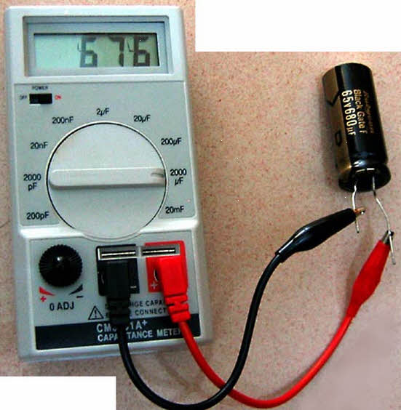
Figure1. 60LCR Meter
More designs are available and used to measure the capacitance or inductance, and also the equivalent series resistance of capacitors and the Q factor of inductive components. These conditions make the LCR meters valuable for measuring the quality and overall performance of the component.
There are many advanced testing equipments developed using most innovative technologies and are being used almost all types of electrical and electronic industries for checking estimated results and operation of electronics projects or devices. For more information regarding the testing equipments and their working you can contact us by posting your queries in the comments section below.
Clamp Meters - It is an electrical testing tool as a combination of a digital multimeter with a current sensor. It is preferred for measuring the high level of current in the circuit without disconnecting it. The advanced versions can measure voltage, continuity and resistance as well along with the current. They are preferred for both safety and convenience. The clamp meters are basically used for service, installation and maintenance. It is applicable to use on industrial equipment, industrial controls, residential and commercial systems, and HVAC. Its 3 types include
- Current transformer - It can measure alternating current
- Hall effect - It can measure both alternating and direct current.
- Flexible type - It has a Rogowski coil that can measure only ac. It is suitable for use in confined space or congested areas.
Cord Flexing Testers - It is used for testing and measuring the quality of power cords. It determines whether the material in the flexible cable can withstand constant flexing under an electrical load.
Insulation Testers - It is used to prevent the users from hazards like an electric shock, short circuits that occurs when the insulation in electrical parts are used in industrial plants, buildings, etc. The portable type of tester is used for testing insulation resistance, continuous current, alternating current, etc. Also, it is used for testing supply lines to protect the user and ensure the proper functioning of the system.
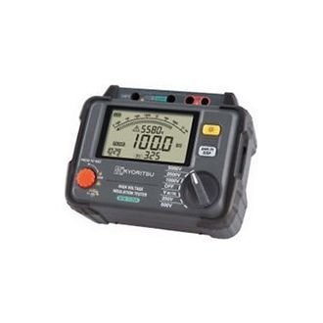
Figure1. 61 Insulation Testers
Voltage Detector
The standard electrical test kits consist of a multimeter, voltage tester and a receptacle tester. The voltage tester is used to identify voltage in circuit breakers, wires or outlets. At the same time, the receptacle tester is used to identify a common wiring problem. The kits include batteries as well.
Electrical testing equipment is used for creating signals and capturing responses from electrical devices that are under testing phase. It is used to ensure the proper functioning of system and identifying the existing faults. These equipment are majorly used in engineering and assembly tasks and while performing the production testing or troubleshooting units in the field. You can find all types of electrical testing equipment online of high-quality brands and at budget price rates.
How To Test Electrical & Electronics Components using Multimeter?
Testing Electrical and Electronics Components and Devices using Digital and Analog Multimeter
Troubleshooting with Multimeter
We all know the role and importance of “Troubleshooting” in Electrical and Electronics Engineering. Most EE components and elements used in Electrical and Electronics equipment, devices and instruments are common in their functions and operations. In this article, we will show how to check different components and devices using multimeter (DMM and AMM).
To be a good analyzer and troubleshooter, you must know the following basic techniques and have good skills in Electrical and Electronics troubleshooting, design and analyzing electric / electronic circuits. For this purpose, we have started a multimeter tutorial where we will use DMM (Digital Multimeter) and AVO Meter (Ampere-Voltage-Resistance Meter) or Multimeter (Digital/Analog) to test different electrical / electronics devices, instruments and components to find their terminals and condition such as are are they short, open, good or faulty.
In this basic multimeter tutorial, We will use digital and analog multimeter to check the following electrical and electronic components, devices, tools and instruments:
- Cable and Wires
- Switch/Push Buttons
- Fuse
- Capacitors & Inductors
- Resistors & Burnt resistors
- Diodes and LED
- Battery
- Transistors
- Relays

In troubleshooting, we use different kinds of basic Electrical and Electronics Engineering Tools but the main and important tool is Multimeter. Let’s see how to test different electrical and electronic components and devices using digital and analog multimeters.
Cable and Wires
To check if the cable and wires are in good condition or broken before sizing the proper cable & wire for Electrical Wiring installation, we perform the continuity test. For this purpose, take AVO meter (or Digital Multimeter) and select “Resistance” (in AVO meter…Rotate the knob to the “Ω” or Resistance).
Now connect both terminals, i.e. both naked ends of the cable/wire with the AVO or Digital Multimeter Terminals. If the meter reading shown “0 Ω”, it means Cable/Wire is in “Good Condition”. On the other hand, if meter reading is “Infinite”, it shows the cable/wire may be defective or broken. So you need to replace it with a new one.
Switch/Push Buttons
Use the same method (mentioned above for checking the cable and wires)…to perform this method correctly, you will need to apply this method in both cases (ON & OFF positions) on switches and push buttons…In other words, first apply this method on switches/push buttons and then “Push” the push button and perform the same method again.
In the first attempt, if the meter reading is “Zero” and in the second attempt, the meter reading is infinite, it means the Switch/Push button is in good condition. If Multimeter reading is “Zero” or “infinite” in both attempts, it means the switch is in short circuit or continuity connection is broken and you should replace it with a new one.
Fuse
To verify Fuse condition, i.e. is “Fuse” in good condition or damaged? … We perform the same method I.e. continuity test as mentioned above. In short, if the meter reading is “Zero” it means Fuse is in good condition. If Multimeter reading is infinite, it means Fuse continuity may be broken or blown. So you should replace it with a new one immediately.

Capacitor
We have already discussed the topic “How to Check a Capacitor with Digital (Multimeter) and Analog (AVO Meter), By Eight (8) Methods with pictorial views.
In this tutorial, you can check and test using a Digital Multimeter or AVO meter if the Capacitor is Good, Short or Open?
Diode & LED
We have updated a detailed post about “How to Test a Diode using Digital & Analog Multimeter” by four methods. In this multimeter tutorial, we have shown different things about diodes such as using diode mode in DMM and resistance mode in DMM and AMM to identify the terminals of Diode, LED and Zener diode. In addition, you may also check if the diode is good, bad, short or open.
Transistor
In another detailed multimeter tutorial about “How to Check a Transistor by Multimeter (DMM+AVO)” you may find the Base, Collector and Emitter of a transistor by using Digital and analog multimeter. Also, There is an easy method to remember the direction of NPN and PNP transistors. In short, in this tutorial, You will be able to use the multimeter in resistance mode (Digital + Analog multimeter) or hFE / Beta mode (Only DMM) to test a transistor if it is good, faulty, short or open.
Battery
In the basic test meter tutorial about “How to test a battery with Test meter?” you will be able to find if the battery is in good condition, charged, needs to be charged, low charge / current, high charge / current or is it faulty and needs to be replaced with a new one.
Resistor & Burnt Resistors
To check if the Resistor is in good condition or broken, we use a multimeter. For this purpose, take AVO meter (or Digital Multimeter) and select “Resistance” (in AVO meter…Rotate the knob to the “Ω” or Resistance). Now connect both ends of the resistor with the AVO or Digital Multimeter Terminals. If the meter reading shows the exact value of resistance or with a percentage tolerance, it means Resistor in “Good Condition”.
For Example, 1kΩ = 1000Ω with a 5% tolerance will show the reading near about 950Ω to 1050Ω. On the other hand, if meter reading is “Infinite”, it shows the Resistor may be defective or broken and open. So you need to replace it with a new one (exact value).
Good to know:
You can also check the value of a burnt resistor using a digital or analog multimeter by the following three handy methods.
Related Post: How to find The value of Burnt Resistor ( By three handy Methods )
Relay Coils & SSR Relay
To test an SSR (Solid state relay) and electromechanical relay coils by using a multimeter, You will have to follow the detailed and step by step guide about “How to Test a Relay? Checking SSR & Coil Relays“.
Measuring Electrical Quantities Using Multimeter
Voltage
In the very first measuring tutorial posted as “How to Measure Voltage using Digital and Analog Multimeter?“, you will know how to know the value of eclectic potential or voltage using analog or digital multimeter.
Current
In the second measuring tutorial named as “How to Measure Current using Digital and Analog Multimeter?” you will learn how to measure the amount of electric current using a digital or analog multimeter.
Power
In the detailed post about How to Measure Power using Digital and Analog Multimeter? You can find and measure the amount of electric power using DMM and AMM. The basic procedure is to measure both voltage and current and multiply to get the value of power.
Resistance
Measuring resistance via multimeter has been step by step described in the post of How to Measure Resistance using Digital & Analog Multimeter?
Frequency
You may check the detailed post about How to Measure Frequency using a Multimeter? In this post, you will be able to measure the frequency of a circuit using digital and analog multimeters.
Capacitance
In our previous tutorial under the title of “How to Measure Capacitance using a Multimeter?” you can find the value of capacitance of a capacitor using a multimeter in both the basic and capacitance mode.
.

Self-check 1

Part I. Choose the correct answer
1. --------- meter measures electric current.
A. ammeter B. ohmmeter C. voltmeter D. no answer
2. ------- used to prevent the users from hazards like an electric shock,
A. ammeter B. Insulation Testers C. voltmeter D. no answer
3. -------- Meter name itself indicates that it is used to measure the inductance, capacitance
and resistance of electronics components
A. ammeter B. Insulation Testers C. LCR D. no answer
Part II Matching
“A” “B”
------1. Capacitor A. active component
------2.Resistor B .store electrical charge
-------3.Dide C. passive component
D. Volt
Part III fill in the blank space
1. -------- is a branch of public health aimed at improving workplace health and safety standards.
2. -------- is that which is capable of delivering power to some external device.
3. -------- is an electrical/electronic passive component used to limit the flow of current.

Unit Two: Test Electrical/electronic component/ parts
This unit is developed to provide you the necessary information regarding the following content coverage and topics:
  - Preparation of testing electrical/electronics components
  - Proper methods of testing electrical/electronics components
  - Correct use of test/measuring instrument
  - Confirmation of electrical/electronic part data and value
This unit will also assist you to attain the learning outcomes stated in the cover page. Specifically, upon completion of this learning guide, you will be able to:
- Prepare and test Electrical/electronic components and parts for de-soldering
- Use appropriate methods in testing electrical /electronic circuits
- Follow Correct use of test/measuring instrument
- Confirm the electrical/electronic parts data, function and value

2.1 Preparation of testing electrical/electronics components

Before getting into any specific electronic component testing process. It is important that we understand the testing process in general.
This general process will help us in the long run. As it will make us prepare for the unseen or uncertain situations throughout our career and working with electronics.
So, there are two types of electronics components. One group is called the Active Components while the other is called the passive Components.
Active components are those that need external power for their operations. They provide some type of gain to the circuit. Example are: diode ,bipolar transistor
While on the other side there are passive components. They don’t need any external power for their proper operations. And don’t provide gain, in fact they dissipate power example resistor ,capacitor
So, there are two different groups of components. This means that there should be two separate sets of testing procedures as well. And you are absolutely right. We will discuss them soon.
Now, besides active and passive. There are two very important categories of electronics components.
They are:
- Through holes components
- Surface mount devices (SMDs)
Through holes components are those which have thick terminals you may say legs that go through the holes of PCBs.
While on the other hand SMDs are soldered on the surface of the PCBs. Both components have their own uses and advantages. It is not like which is better – it totally depends on what you are designing.
So until now, we know there are active and passive components, and there are through holes and SMDs components. It should be understood now that to handle each type and category we should have to follow their own specific testing procedure in order to get satisfactory results.
Purpose of testing equipment
Testing equipment is one of the key pieces of equipment that is available to an engineer. They provide you with the ability to test circuitry or components with known units (such as volts, amps, etc) to prove whether there is a fault or issue.
Some of the most common applications where testing equipment is used are:
- Fault-finding in electrical circuits
- Testing for the presence of voltage
- Testing motors
- Circuit design
- Planned preventative maintenance checks
- Testing electrical components
- Testing electrical components
When fault finding they can help you quickly identify where an issue is within a circuit or highlight if a component is faulty.
What job roles require the use of electrical testing equipment ?
There are a number of different job roles and industries that require the use of electrical testing equipment. We will take a look at some of the most common ones below:
Electrical engineers – electrical engineers require testing equipment when testing equipment, fault finding and performing checks like testing for dead. They are extremely useful and can be found in almost every engineer’s workshop.
Electricians – electricians require testing equipment when they are installing new components, fault finding within a circuit and performing safety checks.
Design engineers – the use of electrical testing equipment is extremely important to design engineers. When they build circuits or are testing their prototypes they may need to test certain levels of voltage, current or resistance. They can also come in handy if a fault occurs as they can diagnose the issue with a meter of some sort.
Automotive engineers/mechanics – if an electrical fault occurs within a motor vehicle an automotive engineer will use this to test out the circuit.
Testing engineers – engineers that perform tests such as PAT testing, voltage level testing, etc require the use of testing equipment. They help gather readings and identify any faults with large-scale electrical circuits and systems. Without electrical testing equipment, their jobs would be extremely tough.
Like any testing equipment in any industry, you will need a basic level of electrical skills to be able to use the testing equipment correctly. Electrical knowledge may also be required when selecting the correct test to perform on a device such as a multimeter which can perform multiple test

2.2 Proper methods of testing electrical/electronics components

General Methods for electronic components testing
Ok with that said let’s look at two known and proven methods to test any electronic component in general.
Once we understand them generally then it would be easy to apply them and change them according to a specific component under test. Let’s explore them one by one.
Method 1: The Visual Inspection
Method 2: Using the test equipment
Visual Inspection
As you can guess from the name, it is the method of generally seeing a component with our eyes. Visual inspection is so important. Because sometimes you don’t need to test a bad component. As it is sometimes so obvious by eyes that the component is busted open and there is no need to test it. So, before going for any further testing process the first step to electronic components testing is to visually see the component. f it is busted open, there is leakage, broken, cracked, color has changed, – then it is time to directly replace that component if it is inside a circuit board. Or don’t even think to use that component if it is off the circuit.
Using the test equipment Test equipment is the essential tool and device used for testing electronic circuits and components.
There are many testing tools available on the market. Each tool has a specific job to perform. And to be honest, the need for these tools totally depends on what project you work on.
General Precaution
- Disconnect the power source before checking, servicing, repairing or installing electrical equipment and devices.
- Always, Select the higher value in Digital or analog Multimeter, and then, gradually reduce it to the proper valve.
- Never try to work on electricity without proper guidance and care
- Read all the instructions and cautions and follow them strictly.
- The author will not be liable for any losses, injuries, or damages from the display or use of this information or try any circuit in the wrong format so please! Be careful because it’s all about electricity and electricity is too dangerous
The Most Common Electronic Components That Fail?
Instead of relying on individual component failure rates, it may be more useful to classify components according to failure modes or source of failure. Generating a list of component failure types that can be practically utilized would improve quality control methods for electronics manufacturing. Such a list of the most common types of electronic components that fail is presented below.
How Can Electronic Component Failures Be Avoided?
As explained above, component failures are possible and in some cases even probable. By committing to habits that focus on mitigating the potential causes of electronic component failure, you can increase the likelihood that your boards and components will perform as intended over their operational lifetimes.
Habits for Avoiding Electronic Component Failures
- Utilize conformal coating.
- Information on conformal coating standards.
- Apply moisture protection methods.
- Information on the best PCBA moisture protection methods.
- Follow good handling and storage guidelines.
- Information on the best storage guidelines to follow.
- Understand and apply good thermal dissipation and distribution techniques.
- Information on thermal dissipation versus thermal distribution.
- Utilize protection circuitry.
- Information on protecting against high currents.
- Apply radiation hardening techniques, if necessary.
- Information on radiation hardening for electronics.
- Ensure the structural integrity of board construction.
- Information on ensuring PCBA structural integrity.
- Ensure your component procurement process is secure.
Information on de-risking your component procurement process.
Avoiding component failure is not limited to selection during design. Instead, it requires a partnership with your CM to effectively institute the guidelines listed. At Tempo Automation, the PCB industry leader for high-quality fast circuit board prototyping and low volume production, quality control is woven into all aspects of our operations

2.3 Correct use of test/measuring instrument

Correct measuring AC current using Digital Multimeter:
- Turn off the power supply to the circuit.
- Switch ON the multimeter.

- Turn the knob to AC current “Ã” (denote by letter A with wavy “~” sign on top of it).

- Set the current range of the meter by turning the dial. The range should be selected to the largest expected value. Use maximum range for unknown current
- Insert the black probe into the COM (common) socket of the meter.
- Insert the red probe into the current socket having the letter “A” or “mA” on it.
- Most DMM has separate sockets for low current (fused) and high current (unfused). The low current socket is usually identified by having mA written on it. Use the socket according to the expected current range. Otherwise, you may damage the meter.
- Break the circuit at the point of measurement.
- Connect the black probe to one of the two points at the point of measurement
- Connect the red probe to the other point at the point of measurement.
- Turn ON power supply to the circuit.
- Note the reading from the meter. DMM provides simple and easy to read numbers on its screen.
- If the range is set at maximum, reduce it using the selector knob to increase the accuracy.
- Once the measurement is complete, switch off the power supply to the circuit.
- Remove the red probe first and then the black probe.
Rotate the knob back to voltage or resistance position and switch off the multimeter. If you want to keep the probes inserted in the meter, try to place the probes in the voltage socket.
Note: Do not touch the tips of the lead even if one of them is connected. Do not touch the wires with bare hands. Do not allow the tips of the lead to connect with one another. Be very careful when working on AC current of the mains as it can shock or electrocute a person if necessary precautions are not taken.

2.4 Confirmation of electrical/electronic part data and value

A data sheet , data-sheet , or spec sheet is a document that summarizes the performance and other characteristics of a product, machine, component (e.g., an electronic component ), material, a subsystem (e.g., a power supply) or software in sufficient detail that allows a buyer to understand what the product and a design engineer to understand the role of the component in the overall system. Typically, a datasheet is created by the manufacturer and begins with an introductory page describing the rest of the document, followed by listings of specific characteristics, with further information on the connectivity of the devices. In cases where there is relevant source code to include, it is usually attached near the end of the document or separated into another file. Data-sheets are created, stored and distributed via Product information management or Product data management systems.
Depending on the specific purpose, a datasheet may offer an average value, a typical value, a typical range, engineering tolerances, or a nominal value. The type and source of data are usually stated on the datasheet.
A datasheet is usually used for the commercial or technical communication to describe the characteristics of an item or product. It can be published by the manufacturer to help people choose products or to help use the products. By contrast, a technical specification is an explicit set of requirements to be satisfied by a material, product, or service.

Self-check 2

Part I choose the correct answer
1.--------- a type of voltage tester
A. ammeter B. ohmmeter C. voltmeter D. no answer
2. ------- used to prevent the users from hazards like an electric shock,
A. ammeter B. Insulation Testers C. voltmeter D. no answer
3. -------- Meter name itself indicates that it is used to measure the inductance, capacitance
and resistance of electronics components
A. ammeter B. Insulation Testers C. LCR D. no answer
Part II Matching
“A” “B”
------1. LCR A. Megger
------2.volt B .unit of voltage
-------3.insulation tester C. inductor ,capacitance
,resistance meter
D. iron core
Part III fills in the blank space
1. -------- is a branch of public health aimed at improving workplace health and safety standards.
2. -------- is that which is capable of delivering power to some external device.
3. -------- is an electrical/electronic passive component used to limit the flow of current.

Unit Three: Methods of testing construction of electrical /electronic circuit
This unit to provide you the necessary information regarding the following content coverage and topics:
  - Continuity and accurate operation test of Complete construction circuit
  - Unplanned events or conditions
This guide will also assist you to attain the learning outcomes stated in the cover page. Specifically, upon completion of this learning guide, you will be able to:
- Test continuity for Electrical/electronic components and parts for de-soldering
- Respond to unplanned events or conditions

3.1 Continuity and accurate operation test of Complete construction circuit
Electric Circuit is a complete circular path that electricity flows through. A simple circuit consists of a current source, conductors and a load. The term circuit can be used in a general sense to refer to any fixed path that electricity, data or a signal can travel through.
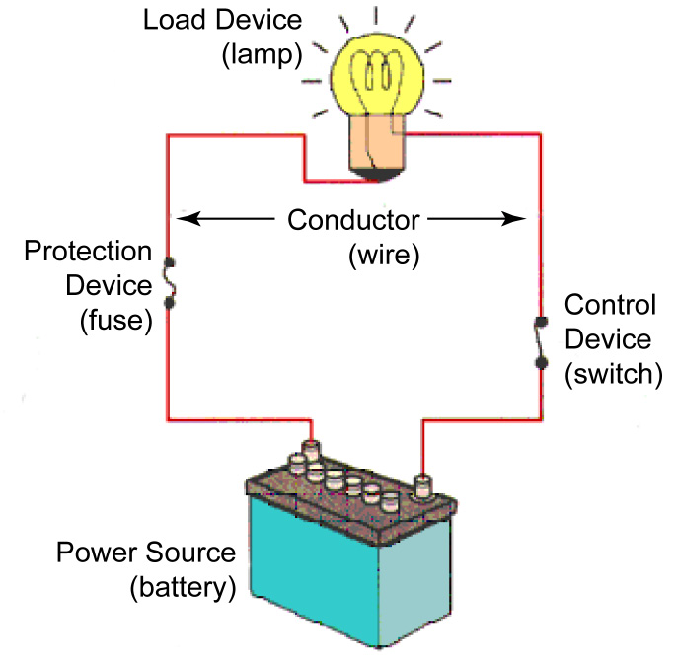
Figure 3.1 Parts of simple electric Circuit
- Power Source (Battery, Alternator, Generator, etc.) is needed to supply the flow of electrons (electricity).
- Protection Device (Fuse, Fusible Link, or Circuit Breaker) prevents damage to the circuit in the event of a short.
- Control Device (Switch, Relay, or Transistor) allows the user control to turn the circuit on or off
- Load Device (Lamp, Motor, Winding, Resistor, etc) .converts the electricity into work.
- Conductor (a return path, wiring to Ground) provide an electrical path to and from the power source.
Alternating Current & Direct Current
Direct current
Direct current (DC) is the unidirectional flow of electric charge. Direct current is produced by sources such as batteries, power supplies, thermocouples, solar cells, or dynamos. Direct current may be obtained from an alternating current supply by use of a rectifier, which contains electronic elements (usually) or electromechanical elements (historically) that allow current to flow only in one direction. Direct current may be converted into alternating current with an inverter or a motor-generator set.
Direct current is used to charge batteries and as power supply for electronic systems. Very large quantities of direct-current power are used in production of aluminum and other electrochemical processes. It is also used for some railways, especially in urban areas. High-voltage direct current is used to transmit large amounts of power from remote generation sites or to interconnect alternating current power grids.
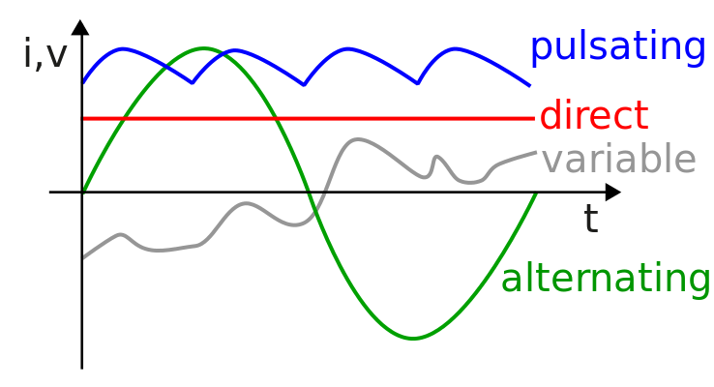
Figure3.2 Dc current
The supply of current for electrical devices may come from a direct current (DC) source or an alternating current (AC) source. In a direct current circuit, electrons flow continuously in one direction from the source of power through a conductor to a load and back to the source of power. Voltage polarity for a direct current source remains constant. DC power sources include batteries and DC generators.
Alternating current
By contrast, an AC generator makes electrons flow first in one direction then in another. In fact, an AC generator reverses its terminal polarities many times a second, causing current to change direction with each reversal.
Electrical power
Electrical power is the rate of energy consumption in an electrical circuit. Power P in an electrical circuit is given by the product of potential difference V and current I, The unit of power is the watt, W
Types of electrical circuits
Depending upon the condition of the circuit A.C. or D.C. circuits are classified into three circuits they are:
- Closed-circuit
- Open circuit
- Short circuit
Open Circuit
A circuit which has no return path for current to flow in it (i.e. which is not completed) is known as an open circuit. In other words, a circuit where voltage tends to the EMF (of generating source) and no current is flowing at all is called an open circuit.
Example of an open circuit: A circuit with an open switch or blown fuse where the light bulb connected to the battery. So the bulb won’t glow as the circuit is not completed i.e. it is an open circuit and there is no flowing current in it.
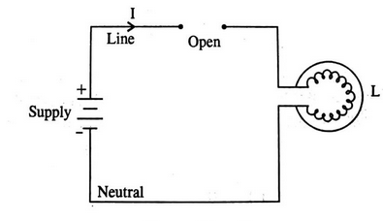
Figure3.3.open circuit
2. Closed-Circuit
In the closed-circuit the current path is closed i.e. current starts from the positive terminal of the supply, through the line, load, neutral and ends in the negative terminal of the supply. The closed-circuit is shown in the figure.
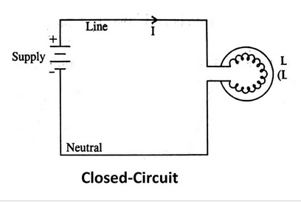
Figure3.4.Continuity test
A continuity test is an important test in determining the damaged components or broken conductors in a circuit. It can also help in determining if the soldering is good, if the resistance is too high for flow of current or if the electrical wire is broken between two points.
This is a quick audible alarm test using a digital multimeter to determine whether an electrical circuit or wire is complete or broken.
This test can be applied to a circuit as a whole or in sections—on individual components or sections of wiring. A break in continuity can be caused by mechanical damage, corrosion of components, or simply a switch being left open.
Why Do We Use Continuity Test?
Continuity test very important test in troubleshooting of any circuit. Various uses of continuity tests are:
- To check the wire connection inside the circuit. These wires may be broken.
- It is used for Identifying damaged component.
- It is also used for checking the quality of soldering.
- It is used for identifying a specific wire or electrical connection.
There are mainly two methods for checking the continuity of a circuit using a multimeter.
- The first method is to use the continuity mode in the multimeter, which is specially made for this purpose.
- The second method is to use the Ohmmeter.

Using Continuity Mode
The steps for continuity test using continuity mode is given below:
- De-energize the circuit, if it has any power input.
- Set the dial of the multimeter in continuity mode (continuity mode is shown by the symbol of sound)
- Insert the black probe into the COM port.
- Insert the red probe into the V, Ω port.
- Now touch the probes with each other. If the meter beeps or gives reading 0 that means the meter works fine.
- Now connect the probes to both ends of the component or wire that you want to test.
- If the meter shows 0 and beeps, it means the path is complete (close) or the component allows the flow of current.
- If the meter does not beep & show 1 or OL, it means the path is broken (open) or the component does not allow the flow of current.
The continuity in non-directional, it does not matter which probe should be connected to which side. The result is always the same except some cases like diodes which allow the flow in only one direction.

Using Ohm-Meter
An Ohmmeter can also be used to determine the circuit whether it is a closed or open circuit, which is the main purpose of a continuity test.
Steps for continuity test using an ohmmeter
- First de-energize the circuit, if it has any power source.
- Set the dial of the multimeter to resistance mode Ω. If it has many ranges, set the dial to the minimum range.
1. Before conducting an electrical continuity test, contact the hose manufacturer for instructions on the proper method and criteria.
2. Use a multimeter to perform the test. A multimeter registers electrical resistance in ohms.
3. Compare the multimeter reading to the one provided by the hose manufacturer. If the multimeter does not register or the reading is not what the hose manufacturer specified, reinstall the couplings to ensure that the grounding wire is contacting the couplings.
4. Retest the assembly.
5. Record the results, and tag or mark the assembly.
Follow these steps to complete the continuity test procedure with an auto range digital meter:
- Make sure all power is off in the circuit you are testing.
- Set the selector dial to Ω (audible alarm symbol).
- Connect the test lead and probes on the load terminals as shown (Figure 5). The audible alarm will indicate continuity without a need for taking your eyes off the work.
- Touch the probes together to check the leads, connections, and battery life. The audible alarm should sound. With the leads apart the meter should display OL or I, depending on the manufacturer.
- If this is the last test you are doing, turn the meter to “off” and store it in a safe place.

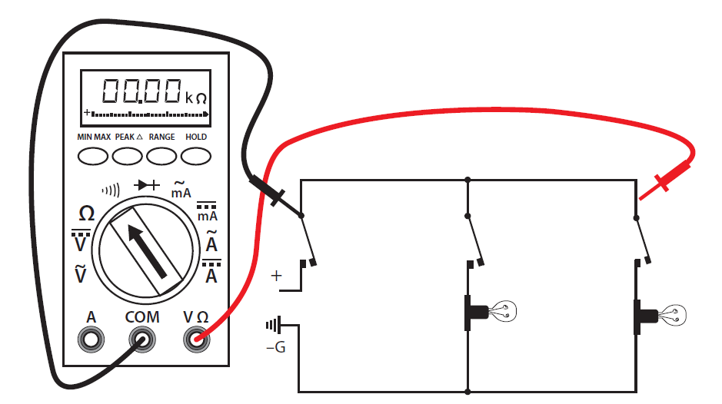

Figure.3.5.Wiring for a Continuity Test

Continuity Test For Capacitor
You can test a capacitor using the continuity test.
- Remove the capacitor if it is in a circuit.
- Discharge it carefully if charged.

Using Continuity Mode
- Set the Multi-meter in continuity mode & insert the black & red probe as described above.
- Place the red and black probes of multi-meter across positive & negative terminals of the capacitor respectively.
- If the capacitor is good, the reading should start from ‘0’ as the capacitor is charging from the multi-meter. The reading will increase & eventually becomes infinity or OL, which means that the capacitor became fully charged & open.
- If a capacitor is damaged, multi-meter will either show very low value (short) or infinity OL (open).

Using Resistance Mode
- Set the dial of the multimeter in resistance mode.
- Place the red probe on the positive terminal and black probe on the negative terminal of the capacitor
- If the resistance starts increasing from 0 Ohm to infinity, the capacitor is good. Because it was charging at the beginning.

- If the meter reads very high resistance initially even when it was discharged, the capacitor is damaged (open).
- If the readings show very low resistance, the capacitor is short.
Continuity Test For Inductor:
You can also test an inductor using the continuity test.
An inductor is a coil & both terminals of the coil are electrically short.
- First, you need to remove the inductor from its circuit. It can be tested while connected in a circuit but it depends on the circuit itself. Best way to test it is to remove it.

Using Continuity Mode
- Turn the knob of Multi-meter in continuity mode.
- Insert the black & red probe in COM & V-ohm jack respectively.
- Place the probes of multi-meter across both terminals of the Inductor respectively.
- If the Inductor is good, the multimeter will beep and the reading will show very low values. But it will not Identify any damaged or short turns.
- If the inductor is damaged, multi-meter will not beep and the reading will be 1 or OL (open).

Using Resistance Mode
- Set the dial of the multimeter in resistance mode & set it to the lowest possible settings.
- Place the probes on both terminals of the inductor.
- If the ohm-meter shows a resistance of few Ohm, the inductor is good
- If the resistance is very low (close to 0), then the inductor has probably short turns.

Test a Diode by Analog & Digital Multimeter

Troubleshooting Electronic Devices & Components
Troubleshooting in electronic and electrical engineering is an important part and one must know the basic skills and knowledge about the components to design and troubleshoot a circuit. It is advisable to test component before assembling and placing in a circuit.
Sometimes, we get unexpected results and we must perform some tests to find whether the component and device is working properly or we should replaced with a new one. For this purpose, we have started some Digital and Analog multimeters tutorials where we will discus how to test different electrical and electronics components. Today, we will have to discuss how to test a diode using DMM and AMM by 4 methods.

How to Test a Diode
Diode is a simple PN Junction and two terminal device which allow to flow current though it in one direction (Forward Bias). It is the most used component in different electronic designs and systems like rectifiers, LED lights related circuits, voltage multiplying circuits, solar panels, logic gates etc.
Diode Terminal Identification (Anode + Cathode)
When the cathode terminal of diode is connected to the neutral and anode to positive, It is called in forward bias position and it acts like a short switch where current starts to flow through it. Cathode to positive and anode to neutral is called reverse bias and diode is acts as open switch which is know as reverse bias (This case is reverse in case of zener diode).
Before testing a diode, We must know the diode terminals like Anode (+) and Cathode (-). In most cases, there is a white band color coating on normal PN junctions diodes which indicates as cathode terminal and the rest is anode. In other cases, there are different colors are used and the color coated sides are cathode as shown in fig below. Below is a tutorial that shows how to test a normal PN Diode, LED, and Zener Diode by different methods..
Diode can be check and tested by 4 methods using digital or analog multimeters.
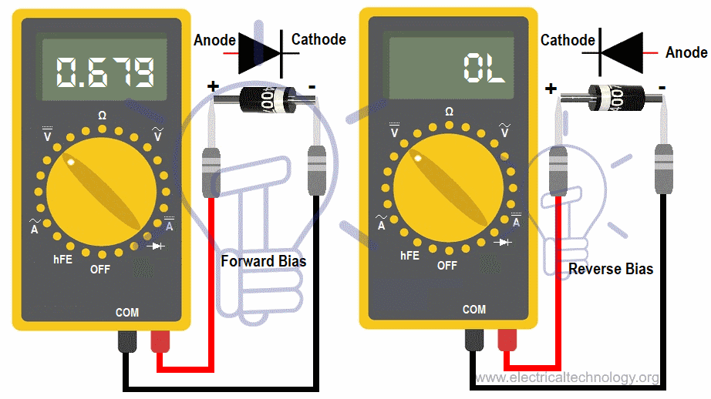
Figure.3.6.. Diode Terminal Identification (Anode + Cathode)
Testing Diode using DMM (Diode Test Mode + Resistance Mode)
The best practice to test a diode in “Diode test” mode by measuring the voltage drop across the diode in case of forward biased. Keep in mind that diode in forward-biased acts as closed switch which let to flow current in it like conductors. In reverse-biased diode, it acts like an open switch and doesn’t permit current to flow in it as it acts like a resistor.
Forward Biased: When the Positive (Red) test lead is connected to the anode (+) and negative (Black) test lead is connected to the cathode (-) of diode. In Forward-biased, the diode acts like close switch and will pass the current through it like conductors.
Reverse Biased: If we do the reverse as mention above i.e. RED Test lead to cathode (-) and BLACK test lead to the Anode (+) of the diode. In revere-biased, the diode acts like open switch and will not let pass the current through it like resistor.
Steps:
- Remove the diode from the circuit i.e. disconnect the power supply across the diode which has to be tested. Discharge all the capacitor (by shorting the capacitor leads) in the circuit (If any).
- Set the meter on “Diode Test” Mode by turning the rotary switch of multimeter.
- Connect the diode leads to the multimeter test leads and note the reading.
- Now, Connect the diode lead to the multimeter test leads in reverse direction (i.e. Reverse the test leads) and note the measurement.
- If the multimeter shows 0.5V – 0.8V for common silicon diodes and 0.2V- 0.3V in case of germanium diodes in the first attempt, its mean the diode is in good condition (forward-biased).
- If multimeter display “OL” in reverse biased, It is good as well.
- If multimeter does not show measurements I.e. if multimeter display “OL” reading in both direction (Forward-biased and reverse-biased), its mean diode is dead and acting as an open switch which doesn’t allow current to flow in it. In case of shorted diode, there will be zero voltage drop across the diode as current will flow through it and it acts like a short path for current. The diode needs to be changed then.
- If the multimeter displays approximately 0.4V in both directions, its mean the diode is short and need to be replaced with new one.
If “diode test is not available in case of digital multimeter or you have to test the diode with analog multimeter, Resistance mode (Ω) can be used to test the diode as alternative.
- Testing Diode by Multimeter (DMM & AMM in Resistance Mode)
Steps:
- Remove the diode from the circuit and make sure that power supply is disconnected from the circuit and there is no voltage across the diode which has to be tested. Also, discharge all the capacitors by shorting their leads in the circuits if any.
- Set the meter on “Resistance mode (Ω)” Mode by turning the rotary switch of multimeter. For better result, set the Ω range on 1kΩ for forward bias and 100kΩ for reverse bias as shown in fig below.
- Connect the RED test lead to the anode of the diode and BLACK test lead to the cathode of diode (Forward Bias) as shown in fig. Note the measurement and reading.
- Now reverse the test leads i.e. RED test lead to cathode and BLACK to anode (Reverse Bias) and note the reading and measurement displayed by multimeter.
- If multimeter shows 1k Ω to 10 MΩ (not OL or infinite ∞), its mean the diode is in good condition (forward-biased). Mostly, the best value is below 1kΩ i.e. for good diode, the forward bias resistance should be low.
- If multimeter shows “OL” in reverse biased. The diode is good as well.
- If the multimeter displays same reading and measurement in both directions (i.e. forward biased and reverse bias), its mean diode is bad and need to be replaced accordingly.
- If multimeter shows the same results i.e. low resistance or high resistance (OL) in both direction (forward and reverse bias), the diode is short and open respectively. In other words, if the multimeter shows 0Ω resistance in both reverse and forward bias, the diode is short, if ohmmeter shows ∞, OL or very high resistance in both forward and reverse bias, the diode is open and need to be replaced with new one.
- To make sure the result is accurate, the best practice is that test and compare the result of good diodes in Resistance Mode.

How to test LED (Light Emitting Diode)
Before testing a diode, we must identify the diode terminal i.e. anode and cathode. For LED, the longer terminal of diode is anode (+) and the shorter terminal is cathode (-). In other cases, the flat terminal of diode is cathode and the other side is anode as shown in below fig.
Related Post: How to Calculate the Battery Charging Time & Battery Charging Current – Example
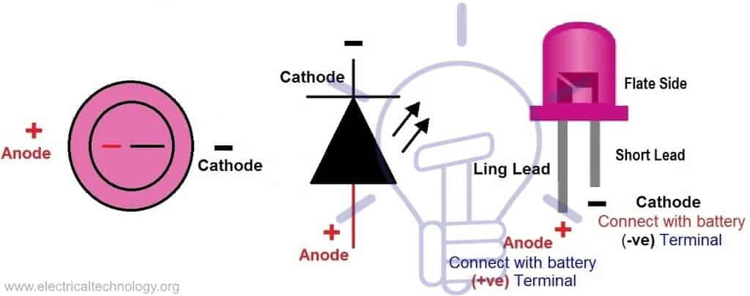
Figure.3.7. Terminals Identification (Anode & Cathode)
To test an LED with digital or analog multimeter, follow the instructions given below.
- Disconnect the LED from the circuit and power supply if it is already connected in a circuit.
- Find the LED terminal i.e. anode and cathode (as shown in above fig)
- In case of digital multimeter, set the meter on “Diode Test” Mode (in case of analog multimeter, set the multimeter on Resistance or continuity mode) by turning the rotary switch of multimeter.
- Connect the LED in forward biased with multimeter test leads i.e. cathode to black (-ve) and anode to Red (+ve) test leads.
- If the LED glows, it doesn’t need to say it is in good condition and working properly, otherwise LED is defective and it should be changed.
- In reverse biased (LED anode to Black (-ve) and cathode to Red (+ve) test leads), it won’t work and multimeter wont show any reading as LED will not flow current through it i.e. it acts like an open switch same as diode.
How to test Zener Diode
Zener diode is something else as compared to normal diodes as simple PN junctions diodes operated in forward biased and not in reverse bias. The case is reverse in case of zener diode as it only operates in reverse based when the applied reverse voltage is greater than the zener breakdown voltage. This way, we need additional simple circuit to check whether the zener diode is good or bad.
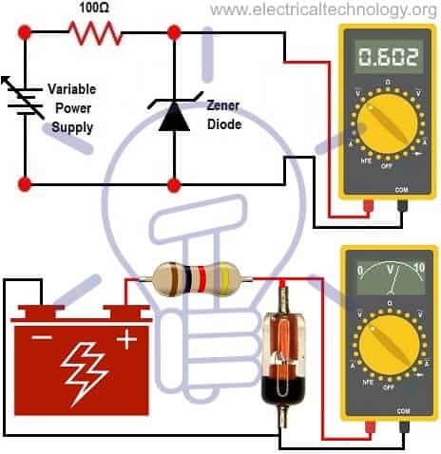
Figure. 3.7.Testing a Zener Diode by DMM & AMM
To check a zener diode with digital or analog multimeter, follow the instructions below.
Disconnect the zener diode from the circuit and power supply if it is already connected in a circuit.
Find the zener diode terminals i.e. anode and cathode as it is same as normal LED and PN junction diodes (as shown in above fig)
Connect the zener diode across a variable or known (such as 12V DC) supply voltage source in series of 100Ω resistance and then connect the zener diode reverse bias (cathode to Red (+ve) and anode to Black (-ve) test leads of multimeter as shown in fig.
In both of digital or analog multimeter, set the meter on “DC Voltage” test mode by turning the rotary switch of multimeter.
Increase the supply voltage gradually to the zener diode and note the meter reading displayed on screen. The meter reading should increase until the breakdown voltage of zener diode (in case of 12VDC supply voltage, the breakdown voltage is 6V) when you increase the supply voltage step by step from low to high. After this, meter should not show additional value i.e. it must shows a constant value (Such as 6V in case of 12VDC supply voltage). When meter stop at specific value and not showing another value when you still increasing the supply voltage, you should not continue to increase the supply voltage otherwise, diode may destroy.
- If it is the case, the zener diode is in good condition otherwise, the zener diode is faulty and need to be changed.
De-soldering/soldering of electronic parts
- Solder
Solder is a low-melting alloy, especially one based on lead and tin, used for joining less fusible metal. 5.3.
- Soldering
Soldering is joining with this alloy. Prior to soldering it is a good idea to have all components organized as it will make populating the PCB more efficient.
Soldering quality and performance vary depending on tip geometry, board thickness, temperature, flux type, solder type, technique, etc
Soldering Iron:
Soldering iron is an essential tool for soldering. A soldering iron should give sufficient heat to melt solder by heat transfer when the iron tip is applied to be soldered. The selection of the soldering iron can be made as regard to its tip size, shape and wattage. The tips are made in shape of pencil, flat and rectangular. Soldering irons have different wattages depending on the types of work required. Example 25W, 40W, 60W, 100W etc.
- Soldering Techniques
Soldering is the act of heating two metals (a pad and a lead) and a solder alloy to form a solder joint. As the joint cools, a strong electrical and mechanical connection is formed.
- Select the correct tip and tip temperature (see previous sections).
- Turn on the system; wait for the tip to heat up (5-10 seconds).
- Clean the tip on a sponge with the following qualities:
- Damp, not dry—use de-ionized water.
- Clean, not dirty.
- Sulfur-free (do not use household sponges).
- Contact the terminal and the pad simultaneously, and feed wire core solder into the joint.
- Do not feed solder into the tip while you solder. Feeding solder into one part of the tip may cause the flux to activate in only one spot. This feeding may cause a hole in the iron plating of the tip
- Hold the tip steady until the joint is filled evenly with solder.
- Do not rub the tip against the lead.
- Do not apply too much pressure to the joint.
- Good contact with a wet surface is sufficient to pass heat efficiently into the solder joint.
- After soldering, clean the tip on the sponge, tin the tip with RMA solder, and turn the system off.
- Flux
Flux is a cleaning agent to remove oxidation during soldering. Heating a metal uses rapid oxidation. Oxidation prevents solder from reacting chemically with a metal. Flux cleans the metal by removing the oxide layer.

3.3 Unplanned events

Actions to reduce Unplanned events
Accidents, malfunctions, and unplanned events are accidents or upset events or conditions that are not planned. Many accidents, malfunctions, and unplanned events are preventable and can be readily addressed or prevented by good planning, design, equipment selection, hazards analysis and corrective action, emergency response planning, and mitigation.
Occupational health and safety (OH&S) impacts associated with unplanned events are considered in Section 8.16. To ensure OH&S readiness of the workforce for unplanned events, the project will:
- use national and international standards
- use equipment that can accommodate unplanned events
- provide readiness training • establish a corporate OHS management system
How to minimize work place unplanned events
- Undertaking planned maintenance to maintain optimal operating performance.
- regularly inspecting facilities and safety critical activities to ensure they are within the intended design conditions
- monitoring of areas of geotechnical instability

Self-check 3

Part I choose the best answer
1. -- is a complete circular path that electricity flows through
A resistor B. alternator C, electric circuit D. all
2. protection device
A resistor B. fuse C, electric circuit D. all
3. ---------is the unidirectional flow of electric charge.
A AC B. fuse C, DC D. all
4. ------ is the rate of energy consumption in an electrical circuit
A voltage B. current C, power D. all
5. --------- circuit which has no return path for current to flow in it
A. open B. closed C. short D. no answer

Part II. Fill in the blank space
1. ------- is a cleaning agent to remove oxidation during soldering.
2.
Part III Explain the following question briefly
1. Why Do We Use Continuity Test?
2. How to minimize work place unplanned events
3. Define soldering

Operation sheet 1 Test electrical/electronics components
Operation title: Continuity test For Inductor:
Purpose: it is used for checking an inductor coil & both terminals of the coil
Instruction: covering that is wrapped over the splice by soldering technique
Write your observation and conclusion in this activity
Equipment, tools and materials:
- Multi-tester 5 pc .Long noise plier
- Digital multi meter
- Soldering gun
- Soldering lead
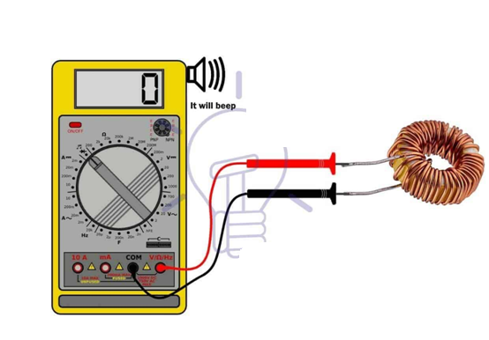
Steps in doing the task
- Continuity Test For Inductor
- First remove the inductor from its circuit.
- Turn the knob of Multi-meter in continuity mode.
- Insert the black & red probe in COM & V-ohm jack respectively
- Place the probes of multi-meter across both terminals of the Inductor respectively. If the Inductor is good, the multimeter will beep and the reading will show very low values. But it will not identify any damaged or short turns.
Precaution: Be careful of using the knife to remove the insulation from the conductor (Use extreme care when cutting the insulation may be cut your finger)
Quality criteria: All these tasks should be performed using correctly according to the given procedure; we should have a good experience for testing electrical circuit.

Lap Test 3
Instructions: Given necessary templates, workshop, tools and materials you are required to perform the following tasks within 3 hours.
Task 1: Identify the required material and equipment for electrical tests.
Task2: Disconnect /remove the inductor from its circuit.
Task3: Test continuity

Reference

- Journals/Publication/Magazines
- Starting Electronics (Fourth Edition) Author: Keith Brindley
- The Industrial Electronics Handbook By: Bogdan M. Wilamowski, J. David Irwin

No | Name | Qualification (Level) | Field of Study | Organization/ Institution | Mobile number | E-mail
1 | Roman Ayalew | A | Industrial Automation & Control | Wonji PTC | 911837475 | nimonaroman@gmail.com
2 | Sirgut Wandimagegn | A | Electrical Automation & Control Tech | Entoto PTC | 911966234 | sirgut10@gmail.com
3 | Esubalew Amsalu | A | Electrical Automation & Control Tech | Harar PTC | 910644790 | balewesu@gmail.com
4 | Adamu Asfaw | B | Electrical/Electronic Technology | M/G/Mulugeta Buli PTC | 922839529 | adamuasfaw95@gmail.com
5 | Tenagnwork W/Hana | A | Electrical Automation & Control Tech | Kombolcha PTC | 913659902 | tenagneworkwoldehana@gmail.com
6 | Biruk Aniley | A | Electrical Automation & Control Tech | Ethio-Italy PTC | 920131850 | birukanu@gmail.com
Participants of this Module (training material) preparation

