Industrial Electrical/Electronic Control Technology
Level – IiI
Based on October, 2023 Curriculum Version 2
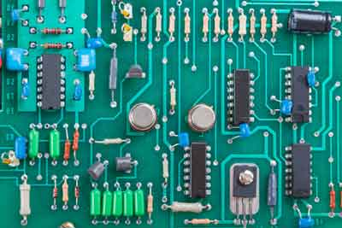

Module Title: -Designing and Developing Digital Electronics System

Module code: EIS IEC3 M01 1023
Nominal duration: 100Hour

Prepared by: Ministry of Labour and Skill

October, 2023
Addis Ababa, Ethiopia

Table of contents
Acknowledgments Error! Bookmark not defined.
Acronyms 5
Introduction to the Module 6
Unit-One: Digital Electronics System 7
1.1 Introduction to digital electronics systems 8
1.2 OHS Policies, risk control measures and procedure 25
1.3 Materials, tools, and devices/components 33
Self-Check -1.1 444
Operation Sheet -1. 1 46
Unit-Two: Digital electronic circuit control system 48
2.1 Digital electronic logic gates and circuits 49
2.1.1 Logic gates 49
2.1.2 Logic Gates Symbols and Operations 49
2.1.3 Logic Gate Circuits 63
2.2 Digital components/materials 65
2.3 Application of digital electronics 67
Self-Check -2.1 69
Operation Sheet-2. 1 71
Unit-Three: Design and develop basic digital electronic control system 73
3.1 Digital electronic control components 74
3.2 Digital electronic control components measurement 75
3.3 Schematic diagram preparation 76
3.5 Schematic diagram to PCB board Conversion 78
3.6 Assemble digital electronic control components 79
Self-Check -3.1 69
Unit-Four: Test developed design 83
4.1 Check lines and component on a PCB board 84
4.2 Electronic and measuring devices testing techniques 85
4.3 Functional Test 87
4.4 Compile report 88
Self-Check -4.1 69
List of Reference Materials Error! Bookmark not defined.

Acknolwgement

The Ministry of Labor and skills wishes to thank and appreciation to MoLS leaders and experts, Regional Labor and skill/training Bureaus leader, experts, TVT College Deans, Instructors and industry experts who contribute their time and professional experience to the development of this Curriculum for Packing and Labeling Service.

Acronyms

ADC | Analog-to-Digital Converter
ALU | Arithmetic and Logic Unit
CD | Compact Disk
DAC | Digital to Analog Converter
DRC | Design Rule Checking
DSP | Digital Signal Processing
FPGA | Field-Programmable Gate Arrays
IC | Integrated Circuit
LEDS | Light-Emitting Diodes
MCU | Microcontrollers
OHS | Occupational Health And Safety
PAL | Programmable Array Logic
PCB | Printed Circuit Board
PLD | Programmable Logic Device
POST | Power-On Self-Test
PPE | Personal Protective Equipment
PWM | Involve Pulse-Width Modulation
SMT | Surface-Mount
SWG | Standard Wire Gauge
TTL | Transistor-Transistor Logic
UN | United Nation

Introduction to the Module

In the field of Industrial Electrical Engineering; design and develop digital electronics system modules is designed to meet the industry requirements under the industrial machine to performing maintenance, troubleshooting and repair works on Maintain and Repair Industrial Electrical Machines and Drives including diagnose and rectify fault in motor drive system: Carry out Design and Develop digital electronics system
This module covers the units:
- Prepare to design and develop digital electronics systems
- Identify digital electronic circuit control system
- Design and develop basic digital electronic control system
- Test digital electronic
Learning Objective of the Module
- Follow OHS policies and procedures
- Identify digital electronic circuit
- Test requirement electronic circuit
Module Instruction
For effective use this modules trainees are expected to follow the following module instruction:
- Read the information written in each unit
- Accomplish the Self-checks at the end of each unit
- Perform Operation Sheets which were provided at the end of units
- Do the “LAP test” giver at the end of each unit and

Unit-One: Digital Electronics System
This unit is developed to provide you the necessary information regarding the following content coverage and topics:
- Introduction to digital electronics systems
- OHS Policies, risk control measures and procedures
- Materials ,tools, equipment’s and devices/components
This unit will also assist you to attain the learning outcomes stated in the cover page. Specifically, upon completion of this learning guide, you will be able to:
- Explain digital electronics systems
- Identify and follow OHS Policies, risk control measures and procedures
- Obtain Materials ,tools, equipment’s and devices/components

1.1 Introduction to digital electronics systems
Digital electronics is a branch of electronics that deals with the use of digital signals and logic circuits to process and transmit information. It involves the manipulation and control of electronic circuits and devices that operate on binary (0 and 1) signals, representing discrete digital values.
Components in digital electronics include:
- Binary System is a digital electronics is based on the binary number system, which uses two digits, 0 and 1, to represent information. Binary digits, also called bits, form the foundation of digital data representation and processing.
- Logic Gates are fundamental building blocks of digital circuits. Common logic gates include AND gates, OR gates, NOT gates, and XOR gates.
- Flip-Flops are sequential logic circuits that store and manipulate binary information. They can store one bit of data and are used as memory elements or building blocks for constructing digital registers, counters, and other sequential circuits.
- Combinational Logic Circuits combine multiple logic gates to produce specific output logic based on the current input logic levels.
- Multiplexers and Demultiplexers are digital circuits used to combine or separate multiple digital signals onto a single transmission line. Multiplexers select one input from multiple inputs and route it to a single output, while demultiplexers route the input to one of several outputs.
- Arithmetic and Logic Units (ALUs) are digital circuits capable of performing arithmetic operations (such as addition, subtraction) and logical operations (such as AND, OR) on binary inputs.
- Programmable Logic Devices (PLDs) are integrated circuits that can be programmed to implement specific digital logic functions. They provide flexibility in designing custom digital circuits without the need for custom IC fabrication.
Digital electronics finds wide applications in various fields, including computer systems, telecommunications, consumer electronics, control systems, and more. It forms the basis for digital computing and the processing of digital information.

Digital electronic logic gates and circuits
- Digital and Analog
- Digital and analog quantities
Introduction: In science, technology and business, we are dealing with quantities.
Quantities are defined as something which can be measured, recorded and manipulated arithmetically. Representation of quantities can be analog and digital representation.
- Analog Quantity: is one having continuous range of values. Most things that can be measured quantitatively appear in nature in analog form.
E.g. Voice signal, temperature variation of the Environment, Pressure of the environment, speed of automobile, time, distance, etc.
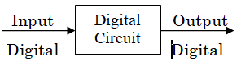
Figure 1.1: Analog system
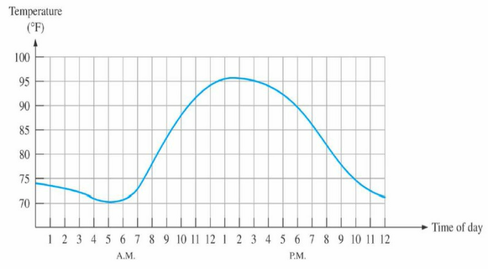
Figure 1.1: Sampled value representation (Quantization) of the analog quantity.
- It is important to realize that this fig.2.1 itself is not digital representation of analog quantities. In the digital representation each dot will be represented by a series of 1s and 0s.
E.g. of an application of analog electronics
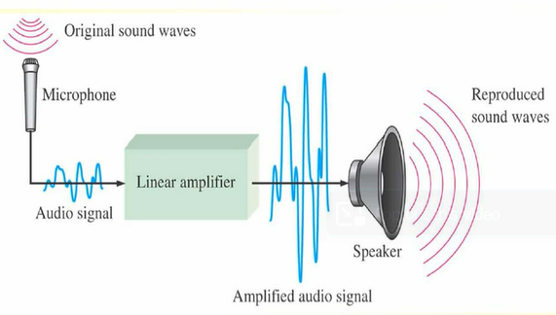
Figure 1.2; a basic audio public address system
The basic diagram in fig 1.2 illustrates that sound wave, which are analog in nature, are picked up by microphone and converted to a small analog voltage called the audio signal. This voltage varies continuously as the volume and frequency of the sound changes and is applied to the input of a linear amplifier. The output of amplifier, which is an increased reproduction of input voltage, goes to the speaker(s). The speaker changes the amplified audio signal back to sound waves that have a much greater volume than the original sound waves picked up by the microphone.
- Digital Quantity: is one having a discrete set of values or quantities which has two operating states.
E.g. Switch, on or off state of bulb, conducting and non-conduct of diode etc.
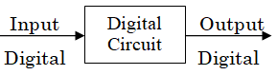
Figure .1.3: Digital quantity
E.g. Digital voltmeter, calculator, computer, micro processor etc.
Advantage of digital representation over analog representation
- Digital technique is easy to understand.
- Digital systems have high speed of operation.
- Allow to detect (identity) and correct errors easily.
- Digital technique provides greater precision.
- Digital data can be processed and transmitted more efficiently and reliable.
- Noise (unwanted voltage fluctuations) does not affect digital data.
To take the above advantage of digital techniques, when dealing with analog inputs, the following steps has to be followed.
- Convert the real world analog inputs to digital form.
- Process the digital information.
- Convert the digital output back to analog form.
Example: of a system in which both digital and analog circuits are used.
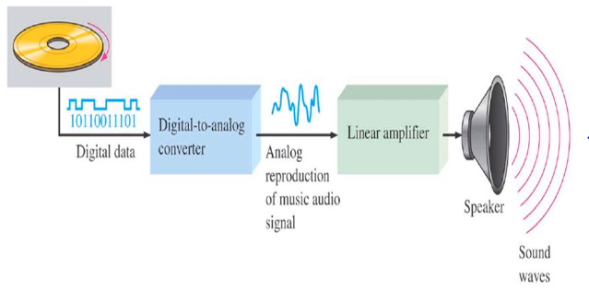
Figure 1.4: illustrates the basic principle of a CD player
The compact disk (CD) player is an example of a system in which both digital and analog circuits are used.
Music in digital form is stored on the compact disk (CD). A laser diode optical system picks up the digital data from the rotating disk and transfers it to the Digital to Analog converter (DAC). The DAC changes the digital data in to an analog signal that is an electrical reproduction of the original music. This signal is amplified and sent to the speaker for you to enjoy. When the music was originally recorded on the CD, a process, essentially the reverse of the one described here, using analog-to-digital converter (ADC) was used.
- Binary Digits
The two digits in the binary system, 1 and 0, are called bits. In digital circuits, two different voltage levels are used to represent the two bits. Generally, 1 is represented by high voltage, which we will refer to as a High, and 0 is represented by lower voltage level which we will refer to as a low.
This is called positive logic.
High = 1, Low = 0,
Another system in which a 1 is represented by a low and 0 is represented by High is called negative logic.
High = 0 Low = 1
Groups of bits (combination of 1s and 0s), called codes, are used to represent numbers, letters, symbols, instructions, and anything else required in a given application.

Logic level and pulse wave forms
- Logic Level
The voltage used to represent a 1 and a 0 are called logic level. Ideally, one voltage level represents a High and another voltage level represents a Low. In practical digital circuit, however, a High can be any voltage between a specified minimum and maximum value. Likewise, a low can be any voltage between a specified minimum and maximum value. There can be no overlap between the accepted High levels and the accepted Low levels.
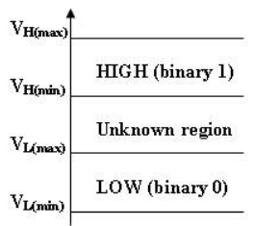
Figure.1.5: Logic level ranges of voltage for a digital circuit
- The voltage values between V_{L} (max) and V_{H} (min) are unacceptable for proper operation.
- The voltage in the unacceptable range can appear as either a high or a low to a given circuit. Therefore, these unacceptable values are never used.
For example, the high values for a certain type of digital circuit called TTL may range from 2V to 5V and the low values may range from 0V to 0.8V, so, for example, if a voltage of 3.5V is applied, the circuit will accept it as a High or binary 1. If a voltage of 0.5V is applied, the circuit will accept it as a Low or binary 0. For this types of circuit, voltage between 0.8V and 2V are UN acceptable and are never used.

Pulse wave form
Digital wave forms consist of voltage levels that are changing back and forth between the HIGH and LOW levels or states.
There are two types of pulses:
    - Ideal pulse
The time take to rise from low level to high level is zero (the rising and falling edges are assumed to change in zero time). It can be positive or negative going pulse.
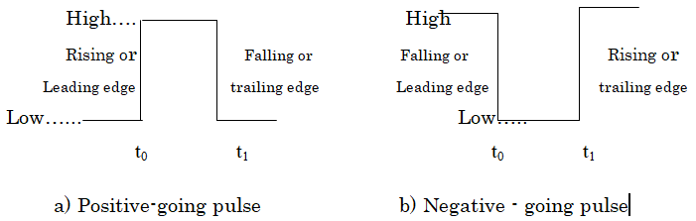
Figure.1.6. Ideal pulse
The pulse: As indicated in fig. 1.6:The pulse has two edges a leading edge that occurs first at time t_{o} and trailing edge that occurs last at time t_{1.}
For a positive - gong pulse, the leading edge is a rising edge, and the trailing edge is a falling edge.
- Actual pulse (non ideal pulse)
The time required for the pulse to go from Low level to High level is called the rise time (t_{r}), and the time required for the transition from the high level to Low level is called the fall time ( t_{f} ). In practice, it is common to measure the time form 10% of the pulse amplitude to 90% of the pulse amplitude, as indicated in fig 2.7.
The bottom 10% and the top 10% of the pulse are not included in the rise and fall time because of the non-linarite in the wave form in these areas. The pulse width (t_{w}) is a measure of the duration of the pulse and is often defined as the time interval between the 50% points on the rising and falling edges, as indicated in fig.2.7.

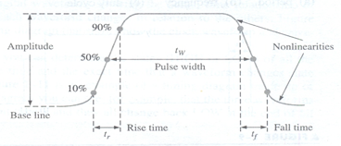
Figure.1.7: None ideal pulse characteristics
Raise time (tr): The time taken the signal to raise from its 10% to 90% of the pulse amplitude.
Falling time (t_{f )}: The time taken the signal to fall from its 90% to 10% of the pulse amplitude.
Pulse width (tw): Is the time taken of pulse from its 50% high transition to its 50% Low transition of the pulse amplitude.
- Wave form characteristics:
Most wave forms encountered in digital systems are composed of series of pulses, sometime called pulse trains, can be classified as either periodic or non-periodic.
- A periodic pulse: wave form is one that repeats itself at a fixed interval, called period (T).

- A non-periodic pulse wave form, of course, does not repeat itself at fixed intervals and may be composed of pulses of randomly differing pulse widths and/ or randomly differing time intervals between the pulses.

Number Systems
- Decimal number system
The familiar decimal number system has base or radix 10. It referred to as base 10 because it uses ten digits 0, 1, 2, 3, 4, 5, 6, 7, 8, and 9. These digits are referred to as the coefficients of the decimal system. Thus, in the decimal system the coefficients are multiplied by the appropriate powers of 10 to form a number.

- For example, the decimal number 58, 392.46 is interpreted as:
58, 392.46 = 50, 000 + 8, 000+300+90+2+0.4+0.06
5* 10 ⁴ +8 *10 ³ +3 *10 ² +9 *10 ¹ +2* 10 ⁰ +4* 10 ⁻¹+6 *10 ⁻²
In general, any number may be represented by a series of coefficients as:
A_{n} A_{n-1} A_{n-2}.....................A₂ A₁ A₀.A₋₁ A₋₂……………..A_{-n}
In the decimal system, the A_{k} coefficients are the ten coefficients (zero through nine), and the subscript value denotes the power of ten by which the coefficient must be multiplied. Thus, the last expression above can also be written as
A_{n}*10^{n}+A_{n-1}*10^{n-1}+A_{n-2}*10^{n-2}…+A₂*10²+A₁*10¹ +A₀*10⁰+A₋₁*10⁻¹+A₋₂*10⁻²……+A_{-n}*10^{-n}
Digital computers use the binary (base 2) system which has only two coefficients, 0 and 1. In the binary system each coefficient A_{k is} multiplied by 2^{k}. In general, a number of base or radix r with coefficients A_{k} is expressed as
A_{n}.r^{n}+A_{n-1}.r^{n-1}+A_{n-2}.r^{n-2}+…..+A₂.r²+A₁.r¹+A₀.r⁰+A₋₁.r⁻¹ +…A_{-n}.r^{-n} (1)
The number 110010.01 could be interpreted as a binary or decimal or any other base number since the coefficients 0 and 1 are valid in any number with base 2 or above. Therefore, it is a recommended practice to enclose the number in parenthesis and write a subscript representing the base of the number. Thus, if the number 110010.01 is binary, it is denoted as (110010.01)₂
But if it is a decimal number, it should be denoted as (110010.01)₁₀
Two other numbers of interests are the octal (base 8) and hexadecimal (base 16).
The octal system uses the coefficients 0 through 7. Thus, the number5467.42 can be either an octal number or a decimal number. Accordingly, if it is an octal number, it must be denoted as (5467.42)₈. But if it is a decimal number, it must be denoted as (5467.42)₁₀. The hexadecimal number system uses the numbers 0,1, 2,3, 4,5,6, 7, 8, and 9 and for the remaining six numbers uses the letters A, B, C, D, E, and F corresponding to the decimal numbers 10, 11, 12, 13, 14, and 15 respectively.
- Binary Number System
Binary is a number system used by digital devices like computers, cd players, etc. Binary is Base 2 unlike our counting system decimal which is Base 10 (denary). In other words, Binary has only 2 different numerals (0 and 1), unlike Decimal which has 10 numerals (0, 1, 2,3,4,5,6,7,8 and 9). Here is an example of a binary number: 10011100.

The bit on the far right (in this case a zero) is known as the Least significant bit (LSB), and the bit on the far left (in this case a 1) is known as the Most significant bit (MSB).
For example: 1012 is a binary number and 10110 is a decimal (denary) value.

- Octal Number System
Although this was once a popular number base, especially in the Digital Equipment Corporation PDP/8 and other old computer systems, it is rarely used today. The Octal system is based on the binary system with a 3-bit boundary.
The Octal Number System:
Uses base 8 Includes only the digits 0 through 7 (any other digit would make the number an invalid octal number).
- Hexadecimal Number System
Binary is an effective number system for computers because it is easy to implement with digital electronics. It is inefficient for humans to use binary, however, because it requires so many digits to represent a number. The number 76, for example, takes only two digits to write in decimal, yet takes seven digits to write in binary (1001100). To overcome this limitation, the hexadecimal number system was developed. Hexadecimal is more compact than binary but is still based on the digital nature of computers.
Hexadecimal works in the same way as binary and decimal, but it uses sixteen digits instead of two or ten. Since the western alphabet contains only ten digits, hexadecimal uses the letters A-F to represent the digits ten through fifteen.

TABLE 1.1; The first 16 decimal, binary, octal, and hexadecimal numbers
Decimal  (Base 10) | Binary  (Base 2) | Octal  (Base 8) | Hexadecimal  (Base 16)
0 | 0 | 0 | 0
1 | 1 | 1 | 1
2 | 10 | 2 | 2
3 | 11 | 3 | 3
4 | 100 | 4 | 4
5 | 101 | 5 | 5
6 | 110 | 6 | 6
7 | 111 | 7 | 7
8 | 1000 | 10 | 8
9 | 1001 | 11 | 9
10 | 1010 | 12 | A
11 | 1011 | 13 | B
12 | 1100 | 14 | C
13 | 1101 | 15 | D
14 | 1110 | 16 | E
15 | 1111 | 17 | F

Number Conversions
- Binary, Octal, and Hexadecimal to Decimal Conversions
A number in base other than base 10 can be converted to its decimal equivalent using the following steps:
Express the given number in the form of A_{n}.r^{n}+A_{n-1}.r^{n-1}+A_{n-2}.r^{n- 2}+…..+A₂.r²+A₁.r¹+A₀.r⁰+A₋₁.r⁻¹ +…A_{-n}.r^{-n} (or refer (1))
Add the terms following the rules of decimal addition.
Example 2.1
Convert the binary number (1101.101)₂ to its decimal equivalent.
Solution: (1101.101)2 = 1×2³ +1×2² +0×2¹ +1×2⁰ +1×2^{–1} +0 ×2^{–2}+ 1× 2^{–3}
=8+4+0+1+0.5+0+0.125= (13.625)₁₀
Example 2.2
Convert the octal number (540.6)₈ to its decimal equivalent.
Solution: (540.6)8 = 5×8² +4×8¹ +0×8⁰ +6 ×8^{–1}
=5×64 + 4×8+ 0×1+ 6 ×8^{–1} = (352.75)₁₀
Example 2.3
Convert the hexadecimal number (DB0.A)₁₆ to its decimal equivalent.
Solution: (DB0.A)₁₆ = D× 16 ² +B× 16 ¹ +0 × 16 ⁰ + A 16 ⁻¹
= 13 × 256 +11 × 16+ 0×1+ 10 ×16 ^{–1} = (3, 504.625)₁₀
- Decimal to Binary, Octal, and Hexadecimal Conversions
We have learned how to convert any number of any bases other than base 10 to its equivalent decimal. Now we will learn how to convert a decimal number to another base number.
The procedure is as follows:
An integer decimal number can be converted to any other base, say r, by repeatedly dividing the given decimal number by r until the quotient becomes zero. The first remainder obtained becomes the least significant digit, and the last remainder becomes the most significant digit of the base r number.
A fractional decimal number can be converted to any other base, say r, by repeatedly multiplying the given decimal number by r until a number with zero fractional part is obtained. This, however, may not be always possible, i.e., the conversion may be endless as some examples to follow will show.
A mixed (integer and fractional) decimal number can be converted to any other base number, say r, by first converting the integer part, then converting the fractional part, and finally combining these two parts.
Example 2.4
Convert the decimal number (39)₁₀ to its binary equivalent.
Solution: 39/2 = Quotient 19 + Remainder 1 (lsb)
19/2 = Quotient 9 + Remainder 1
9/2 = Quotient 4 + Remainder 1
4/2 = Quotient 2 + Remainder 0
2/2 = Quotient 1 + Remainder 0
1/2 = Quotient 0 + Remainder 1 (msb)
In the last step above, the quotient is 0; therefore, the conversion is completed and thus we have: (39)₁₀ = (100111)₂
Example 2.5
Convert the decimal number (0.39654₎₁₀ to its binary equivalent.
Solution: 0.39654 × 2=0.79308=0 (msb of binary number)+ 0.79308
0.79308 × 2=1.58616=1 (next binary digit)+ 0.58616
0.58616 × 2=1.17232=1 + 0.17232
0.17232 × 2=0.34464=0 + 0.34464 and so on
We observe that, for this example, the conversion is endless; this is because the given fractional decimal number is not an exact sum of negative powers of 2. Therefore, for this example, (0.39654)₁₀ = (0.0110...)₂
Example 2.6
Convert the decimal number (0.84375)₁₀to its binary equivalent.
Solution: 0.84375 × 2=1.6875=1 (msb of binary number)+ 0.6875
0.6875 × 2=1.375=1 (next binary digit)+ 0.375
0.375 × 2=0.75=0 + 0.75
0.75 × 2=1.5=1 + 0.5
0.5 × 2=1.0=1 (lsb) + 0.0
Since the fractional part of the last step above is, the conversion is complete and thus: (0.84375)₁₀ = (0.11011)₂
For this example, the conversion is exact; this is because
(0.84375)₁₀ = (0.11011)₂ = 1 × 2^{–1} ×+1× 2^{–2} +0× 2^{–3} +1× 2^{–4} +1× 2^{–5}
Example 2.7
Convert the decimal number (39.84375)₁₀to its binary equivalent.
Solution: Here, we first convert the integer part, i.e., 39 to its equivalent binary, then we convert the fractional part to its equivalent binary, and finally we combine the two parts to form the entire binary number. Thus, From Example 2.4, (39)₁₀ = (100111)₂
And from Example 1.6, (0.84375)₁₀ = (0.11011₎₂
Therefore, (39.84375)₁₀ = (100111.11011)₂
Conversion from decimal- to- octal is accomplished by repeated division by 8 for the integer part, and by repeated multiplication by 8 for the fractional part.
Example 2.8
Convert the decimal number (345.158)₁₀ to its octal equivalent.
Solution:
We first convert the integer part, next the fractional part, and then we combine these.
Integer part conversion: 345/8 = Quotient 43 + Remainder 1 (lsb)
43/8 = Quotient 5 + Remainder 3
5/8 = Quotient 0 + Remainder 5 (msb)
Fractional part conversion: 0.158 × 8=1.264=1 (msb of fractional part) + 0.264
0.264 × 8=2.112=2 (next octal digit)+ 0.112 and so on
We observe that the fractional part conversion is endless; therefore,
(345.158)₁₀ = (531.12...)₈
Conversion from decimal to hexadecimal is accomplished by repeated division by 16 for the integer part, and by repeated multiplication by 16 for the fractional part.
Example 2.9
Convert the decimal number (389.125)₁₀to its hexadecimal equivalent.
Solution:
As before, we first convert the integer part, next the fractional part, and then we combine these.
Integer part conversion: 389 / 16 = Quotient 24 + Remainder 5 (lsb)
24 / 16 = Quotient 1 + Remainder 8
1 / 16 = Quotient 0 + Remainder 1 (msb)
Fractional part conversion: 0.125 × 16=2.0=2 (msb of fractional part)+ 0.0
We observe that the conversion of this example is exact; therefore,
= (185.2)₁₆
- Binary, Octal, Hexadecimal Conversions
Since 2³ = 8 and 2⁴ =16, it follows that each octal digit corresponds to three binary digits and each hexadecimal digit corresponds to four binary digits. Accordingly, to perform binary-to-octal conversion, we partition the binary number into groups of three digits each starting from the binary point and proceeding to the left for the integer part and to the right of the binary point for the fractional part.
Example 2.10
Convert the binary number (10110001101011.1111)₂ to its octal equivalent.
Solution:
Since leading zeros (zeros to the left of the integer part of the number) and zeros added to the right of the last digit of the fractional part of the number do not alter the value of the number, we partition the number in groups of three digits by inserting a zero to the left of the number (i.e. a leading zero), and two zeros to the right of the given number, and then we assign the equivalent octal value to each group as shown below.
010 110 001 101 011. 111 100
2 6 1 5 3 7 4
Therefore, (10110001101011.1111)₂ = (26153.74)₈
Conversion from octal−to−binary is accomplished in the reverse procedure, i.e. each octal digit is converted to its binary equivalent as it is shown in the following example.
Example 2.11
Convert the octal number (673.124)₈to its binary equivalent.
Solution:
Here, we replace each octal digit by its binary equivalent, i.e.,
(673.124)₈ = 110 111 011 . 001 010 100
6 7 3 . 1 2 4
Therefore, (673.124)₈ = (110111011.001010100)₂
Conversion from binary-to-hexadecimal or hexadecimal-to-binary is performed similarly except that the binary number is divided into groups of four digits for the binary-to-hexadecimal conversion, or replacing each hexadecimal digit to its four digit binary equivalent in the hexadecimal- to-binary conversion.
Example 2.12
Convert the binary number (10110001101011.111101)₂to its hexadecimal equivalent.
Solution:
For this example, we insert two leading zeros to the left of the integer part and two zeros to the right of the decimal part, we partition the given binary number in groups of four digits, and we assign the equivalent hexadecimal digit to each binary group, that is,
0010 1100 0110 1011 . 1111 0100
2 C 6 B . F 4
Therefore, (10110001101011.111101)₂ = (2C6B.F4)₁₆
Example 1.13
Convert the hexadecimal number (306.D)16 to its binary equivalent.
Solution:
3 0 6 . D
0011 0000 0110 . 1101
Therefore, (306.D) ₁₆ = (1100000110.1101)2
Conversion from Octal to hexadecimal and Vice versa
To convert from Octal to hexadecimal, first we have to convert to binary and the binary to hexadecimal. To convert from hexadecimal to Octal, first we have to convert to binary and then the binary to Octal.
- Binary Arithmetic
- Binary Addition
The addition of numbers in any numbering system is accomplished much the same manner as decimal addition, that is, the addition starts in the least significant position (right most position), and any carries are added in other positions to the left as it is done with the decimal system. The binary number system employs the numbers 0 and 1 only; therefore, the possible combinations of binary addition are: 0+0=0 0+1=1 1+0=1 1+1=0 with carry of 1We observe that in a binary addition the largest digit in any position is 1, just as in the decimal addition the largest digit is 9. Furthermore, the above combinations indicate that if the number of ones to be added in any column is odd, the sum digit for that column will be 1, and if the number of ones to be added in any column is even, then the sum digit for that column will be zero. Also, a carry occurs whenever there are two or more ones to be added in any column.
Example 2.1
Add the numbers (101101101)2 and (1110011)2
Solution: 101101101
+1110011 1111111 carries
111100000

Check:
(101101101)2 = (365)10
(1110011)2 = (115)
Then, (111100000)2 = (365 + 115)10 = (480)10
Example 2.2
Add the number 6+7=13, 19+31+10=60
110+111=1101 10011+11111+1010=111100
Example 2.3
Add the numbers, (110110)2 (101001)2 (111000)2 (10101)2 and (100010)2
Solution:
11
11
111111 Carries

110110
101001
111000
+ 10101
100010
11001110
Check:
(110110)2 = (54)10
(101001)2 = (41)10
(111000)2 = (56)10
(10101)2 = (21)10
(100010)2 = (34)10
(11001110)2= (54+41+56+21+34)10= (206)10
Binary Subtraction
It operates by the same rule as decimal subtraction. The rule is as follows;
0-0=0, 1-0=1, 1-1=0, 10-1=1
Example:
11100 28 101101 45 11001.011
- 11010-26 -111-7 111.110
=2 101100 =38 10001.101
- Binary Multiplication:
It is very simple process that operates by the following obvious rulers:
(a) Multiplying any number by 1 rules the multiplicand unchanged
0x1=0, 1x1=1
(b) Multiplying any number by 0 produces 0
0x0=0 1x0=0
- Binary division
That is, the process for dividing one binary number (the dividend) by another (the divisor) is based on the rules for binary subtraction and multiplication and Similar to decimal division.
Ex 1111101÷ 11001
11001 101
11001
11001
00000
There for: 1111101 ÷ 11001 = 101
- Representation of Negative numbers
There are different ways of representing negative numbers in a computer.
Sign- magnitude representation
In signed binary representation, the left-most bit is used to indicate the sign of the number. Traditionally, 0 is used to denote a positive number and 1 is used to denote a negative number. But the magnitude part will be the same for the negative and positive values. For example 11111111 represents -127 while, 01111111 represents + 127. We can now represent positive and negative numbers, but we have reduced the maximum magnitude of these numbers to 127.
In a 5- bit representation we use the first bit for sign and the remaining 4- bits for the magnitude. So using this 5 bit representation the range of number that can be represented is from -15 (11111) to 15(01111)
Ex1 represent-12 using 5-bi sign magnitude representation
- first we convert 12 to binary i. e 1100
Now -12 = 11100
Ex2 Represent –24 using 8-bits
24=00011000
-24 = 1001100
In general for n-bit sign –magnitude representation the range of values that can be represented are –(2 ^{n-1}-1 ) to (2 ^{n-1}-1).
i.e. 2 ^{n-1} + 1 to 2 ^{n-1} –1
Note:
In sign magnitude representation zero can be represented as 0 or -0 .This representation has two problems one is it reduces the maximum size of magnitude, and the second one is speed efficiency to perform arithmetic and other operations.
For sign magnitude representation, correct addition and subtraction are relatively complex, involving the comparison of signs and relative magnitude of the two numbers.
The solution to this problem is called the two’s complement representation.

1.2 OHS Policies, risk control measures and procedure

Occupational health and safety
Occupational safety and health (OSH), also commonly referred to as occupational health and safety (OHS), occupational health, or workplace health and safety (WHS), is a multidisciplinary field concerned with the safety, health, and welfare of people at work.
OSH may also protect co-workers, family members, employers, customers, and many others who might be affected by the workplace environment. In the United States, the term occupational health and safety is referred to as occupational health and occupational and non-occupational safety and includes safety for activities outside of work.
In common-law jurisdictions, employers have a common law duty to take reasonable care of the safety of their employees. Statute law may in addition impose other general duties, introduce specific duties, and create government bodies with powers to regulate workplace safety issues: details of this vary from jurisdiction to jurisdiction.
All organizations have the duty to ensure that employees and any other person who may be affected by the organization's activities remain safe at all times.
As defined by the World Health Organization (WHO) "occupational health deals with all aspects of health and safety in the workplace and has a strong focus on primary prevention of hazards."
The main focus in occupational health is on three different objectives:
- the maintenance and promotion of workers’ health and working capacity;
- the improvement of working environment and work to become conducive to safety and health and
- Development of work organizations and working cultures in a direction which supports health and safety at work and in doing so also promotes a positive social climate and smooth operation and may enhance productivity of the undertakings.
The concept of working culture is intended in this context to mean a reflection of the essential value systems adopted by the undertaking concerned. Such a culture is reflected in practice in the managerial systems, personnel policy, principles for participation, training policies and quality management of the undertaking.
Occupational health should aim at:
- The promotion and maintenance of the highest degree of physical, mental and social well-being of workers in all occupations;
- The prevention amongst workers of departures from health caused by their working conditions;
- The protection of workers in their employment from risks resulting from factors adverse to health;
- The placing and maintenance of the worker in an occupational environment adapted to his physiological and psychological capabilities; and, to summarize,

Hazards, risks, outcomes
The terminology used in OSH varies between countries, but generally speaking:
- A hazard is something that can cause harm if not controlled.
- The outcome is the harm that results from an uncontrolled hazard.
- A risk is a combination of the probability that a particular outcome will occur and the severity of the harm involved.
“Hazard”, “risk”, and “outcome” are used in other fields to describe e.g. environmental damage, or damage to equipment. However, in the context of OSH, “harm” generally describes the direct or indirect degradation, temporary or permanent, of the physical, mental, or social well-being of workers. For example, repetitively carrying out manual handling of heavy objects is a hazard.

Hazard identification
Hazard identification or assessment is an important step in the overall risk assessment and risk management process. It is where individual work hazards are identified, assessed and controlled/eliminated as close to source (location of the hazard) as reasonably as possible. As technology, resources, social expectation or regulatory requirements change, hazard analysis focuses controls more closely toward the source of the hazard. Thus hazard control is a dynamic program of prevention. Hazard-based programs also have the advantage of not assigning or implying there are "acceptable risks" in the workplace. A hazard-based program may not be able to eliminate all risks, but neither does it accept "satisfactory" – but still risky – outcomes. And as those who calculate and manage the risk are usually managers while those exposed to the risks are a different group, workers, a hazard-based approach can by-pass conflict inherent in a risk-based approach.

Risk Assessment
Modern occupational safety and health legislation usually demands that a risk assessment be carried out prior to making an intervention. It should be kept in mind that risk management requires risk to be managed to a level which is as low as is reasonably practical.

This assessment should:
- Identify the hazards
- Identify all affected by the hazard and how
- Evaluate the risk
- Identify and prioritize appropriate control measures
The calculation of risk is based on the likelihood or probability of the harm being realized and the severity of the consequences. This can be expressed mathematically as a quantitative assessment (by assigning low, medium and high likelihood and severity with integers and multiplying them to obtain a risk factor), or qualitatively as a description of the circumstances by which the harm could arise.

Safety procedures and Sequence
Safety: Relative freedom from danger, risk, or threat of harm, injury, or loss to personnel and/or property, whether caused deliberately or by accident.
Hazards may occur due to improper handling of tools and equipment’s, unsafe work areas, operating machines without knowing how to operate and using materials out of their intended purpose etc…
- Safe work practices
A safe work environment is not enough to control all electric hazards. You must also work safely. Safe work practices help you control your risk of death from workplace hazards. If you are working on electrical circuits or with electrical tools and equipment, you need to use safe work practices.
Before you begin a task, ask yourself:
- What could go wrong?
- Do I have the knowledge, tools, and experience to do this work safely?
- All workers should be very familiar with the safety procedures for their jobs. You must know how to use specific controls that help keep you safe. You must also use good judgment and common sense.

Safety Procedures in Using Hand Tools and Equipment
We are already familiar with the different hand tools and their proper use. Know we need to know how to be safe in using these. What are the safety precautions in using hand tools and equipment? What are its do’s and don’ts’s?
- Safety Precautions in Using Hand Tools and Equipment
- All tools must be kept in good condition with regular maintenance.
- Right tool must be used for job.
- Each tool must be examined before use and damaged or defective tools not to be used.
- Tools must be operated according to manufacturer’s instruction.
- The right protective equipment for the tool and activity must be used.
Procedures in Cleaning, Tightening and Simple Repair for Hand tools and Equipment
- Cleaning the tools after use is highly recommended.
- All tools and equipment must be placed in a clean and dry place.
- The work area must always be kept neat and tidy.
- Lubricants must also be applied after tightening to reduce the friction.
Before cleaning any tool, be sure to wear the proper personal protective equipment (PPE). Gloves, masks and goggles are usually worn when cleaning tools since most cleaning agents and solutions are harmful to the human body.
Only use cleaning agents as prescribed by the tool or equipment’s manufacturer. Follow the cleaning procedures as well to make sure that no damage will be inflicted on the tools.

Use personal protective equipment
Personal Protective Equipment (PPE) is anything used or worn by a person to minimize risk to the person’s health or safety and includes a wide range of clothing and safety equipment. PPE includes boots (safety shoes, face masks, hard hats (helmet), ear plugs, respirators, gloves, safety harnesses and high visibility clothing.
- Safety for the head
Wearing a helmet offers protection and can prevent head injuries. Select a sturdy helmet that is adapted to the working conditions. These days you can find many elegant designs and you can choose extra options such as an adjustable interior harness and comfortable sweatbands.

Figure 1.8: Helmet

- Protect your eyes
The eyes are the most complex and fragile parts of our body. Each day, more than 600 people worldwide sustain eye injuries during their work. Thanks to a good pair of safety glasses, these injuries could be prevented. Do you come into contact with bright light or infrared radiation? Then welding goggles or a shield offer the ideal protection!

Figure 1.9: Goggles

- Hearing protection
Do you work in an environment with high sound levels? In that case it is very important to consider hearing protection. Earplugs are very comfortable, but earmuffs are convenient on the work floor as you can quickly put these on or take them off.


Figure 1.10: Earmuffs

- Maintain a good Respiration
Wearing a mask at work is no luxury, definitely not when coming into contact with hazardous materials. 15% of the employees within the EU inhale vapours, smoke, powder or dusk while performing their job. Dust masks offer protection against fine dust and other dangerous particles. If the materials are truly toxic, use a full-face mask. This adheres tightly to the face, to protect the nose and mouth against harmful pollution.

Figure 1.11: Full-face mask
- Protect your hands with the right gloves
Hands and fingers are often injured, so it is vital to protect them properly. Depending on the sector you work in, you can choose from gloves for different applications:

Figure 1.12: Gloves
- Protection against cuts by sharp materials
- Protection against cold or heat
- Protection against bacteriological risks
- Protection against splashes from diluted chemicals.
- Protection against vibrations

- Protection for the feet
Even your feet need solid protection. Safety shoes (type Sb, S1, S2 or S3) and boots (type S4 or S5) are the ideal solution to protect the feet against heavy weights. An antiskid sole is useful when working in a damp environment, definitely if you know that 16,2% of all industrial accidents are caused by tripping or sliding. On slippery surfaces, such as snow and ice, shoe claws are recommended. Special socks can provide extra comfort.

Figure 1.13: Safety shoes

- Wear the correct work clothing
Preventing accidents is crucial in a crowded workshop. That is why a good visibility at work is a must: a high-visibility jacket and pants made of a strong fabric can help prevent accidents. Just like the hand protection, there are versions for different applications.

Figure 1.14: High-Visibility Jacket
- Benefits of PPE
PPE is one of the least effective ways of controlling risks to work health and safety and should only be used:
when there are no other practical control measures available (as a last resort)
As an interim measure until a more effective way of controlling the risk can be used, or
To supplement higher level control measures (as a back-up).
- Standard of PPE
PPE used at a workplace must be:
- selected to minimize risk to work health and safety
- suitable for the nature of the work and any hazard associated with the work
- a suitable size and fit and reasonably comfortable for the person wearing it
- maintained, repaired or replaced so it continues to minimize the worker’s health and safety risk, and
- Used or worn by the worker, so far as is reasonably practicable.

The right PPE for the job:
Selection processes for choosing the right PPE must involve consultation with workers and their representatives and should include:
- a detailed evaluation of the risk and performance requirements for the PPE
- compatibility of PPE items where more than one type of PPE is required (for example ear muffs with a hard hat)
- Consultation with the supplier to ensure PPE is suitable for the work and workplace conditions, and
- Preference for PPE that complies with the relevant Australian Standard or equivalent standard. Always remember to use PPE and apply safety rules while working any electrical works.

1.3 Materials, tools, and devices/components
Materials, tools, and devices/components are essential elements in various fields, including manufacturing, construction, electronics, and more. Here's an overview of each category:

Appropriate tools and equipment’s
It is hard to do a good job of electronics construction unless proper electronic tools and knowledge of using them are adequate.
- Drivers
Screw driver. It is a device specifically designed to insert and tighten or to loosen and remove screws. A screwdriver comprises a head or tip which engages with a screw, a mechanism to apply torque by rotating the tip and some way to position and support the screwdriver. A typical hand screwdriver comprises an approximately cylindrical handle of a size and shape to be held by a human hand and an axial shaft fixed to the handle, the tip of which is shaped to fit a particular type of screw. The handle and shaft allow the screwdriver to be positioned and supported when rotated to apply torque.
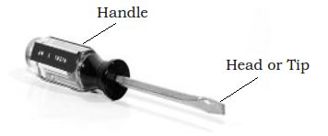
Figure 1.15: Driver
Flat Screwdriver: It is used to drive or fasten negative slotted screws.

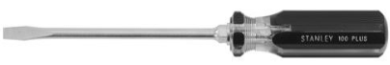
Figure 1.16: Flat
Phillips Screwdriver: It is used to drive or fasten positive slotted screws. It is a screwdriver that could take greater torque and can provide tighter fastenings.

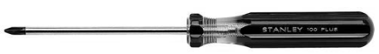
Figure 1.17: Philips

- Soldering Tools
- Soldering Iron
It is a device used for applying heat to melt solder in attaching two metal parts. A soldering iron is composed of a heated metal tip and an insulated handle.
Heating is often achieved electrically, by passing a current, supplied through an electrical cord, through a heating element.
For electrical work, wires are usually soldered to printed circuit boards, other wires, or small terminals. A low-power iron (1530 Watts) is suitable for this works

Figure 1.18: Soldering Iron
Some soldering irons have interchangeable tips for different types of work. Fine round or chisel tips are typically used for electronics work. A new tip needs to be coated, heated, and then covered with solder before its first use. This procedure is called "tinning". The tinning forms a liquid layer, which facilitates the transfer of heat to the work piece. A dirty tip does not transfer heat well. The tip needs to be kept coated with a shiny layer of solder by occasional wiping and applying solder directly to the tip.
- Soldering station
Working with surface-mount parts requires soldering tools that are capable of working with small parts and closely spaced leads. Soldering stations for surface-mount work can be rather pricey, particularly for the stations that also include a hot-air attachment. The good news is that a soldering station like the one shown in Figure below will handle a lot of SMT tasks if used with a fine tip and the appropriate temperature.
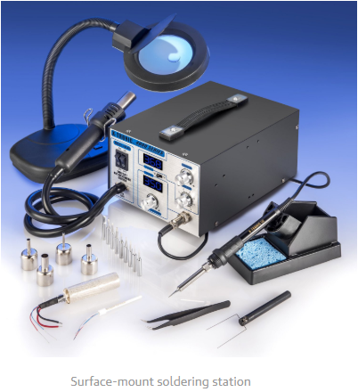
Figure 1.19: Soldering Station
- Soldering Tool Stand
It is a place of the soldering iron to keep them away from flammable materials. The stand often also comes with a sponge and flux pot for cleaning the tip.

Figure 1.20: Soldering iron stand

- Disordering tool
It is used for the removal of solder and components from a circuit when troubleshooting, repair purposes and to save components. Electronic components are often mounted on a circuit board and it is usually desirable to avoid damaging the circuit board, surrounding components, and the component being removed.

Figure 1.21: Sucker

- Splicing Tools
- Long Nose
It is used for holding, bending and stretching the lead of electronic component or connecting wire.

Figure 1.22: Long nose
- Side Cutter.
It is a wire-cutting plier, though they are not used to grab or turn anything, but are used to cut wire.
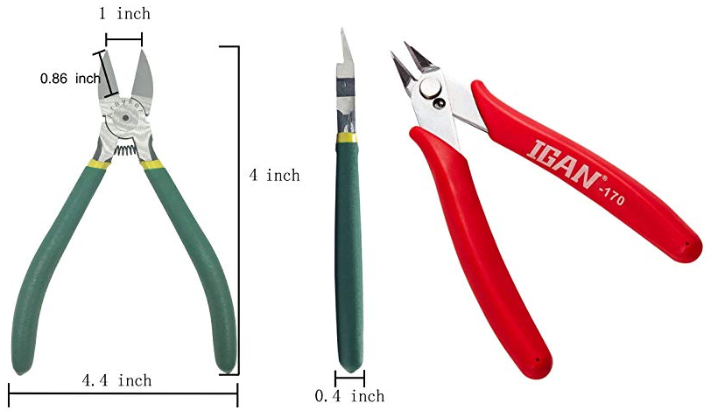
Figure 1.23: Side cutter
- Wire Stripper
It is a pair of opposing blades much like scissors or wire cutters. The addition of a center notch makes it easier to cut the insulation without cutting the wire. This type of wire stripper is used by rotating it around the insulation while applying pressure in order to make a cut around the insulation. Since the insulation is not bonded with the wire, it will be pulled easily at the end.
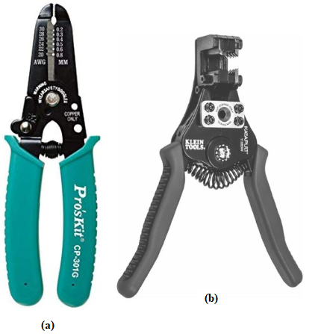
Figure 1.24: Wire striper (a) manual (b) automatic
- Designing tools
- Electronic circuit design and simulation software
Uses mathematical models to replicate the behavior of an actual electronic device or circuit. Simulation software allows for modeling of circuit operation and is an invaluable analysis tool. Due to its highly accurate modeling capability, many colleges and universities use this type of software for the teaching of electronics technician and electronics engineering programs. Electronics simulation software engages its users by integrating them into the learning experience. These kinds of interactions actively engage learners to analyze, synthesize, organize, and evaluate content and result in learners constructing their own knowledge.
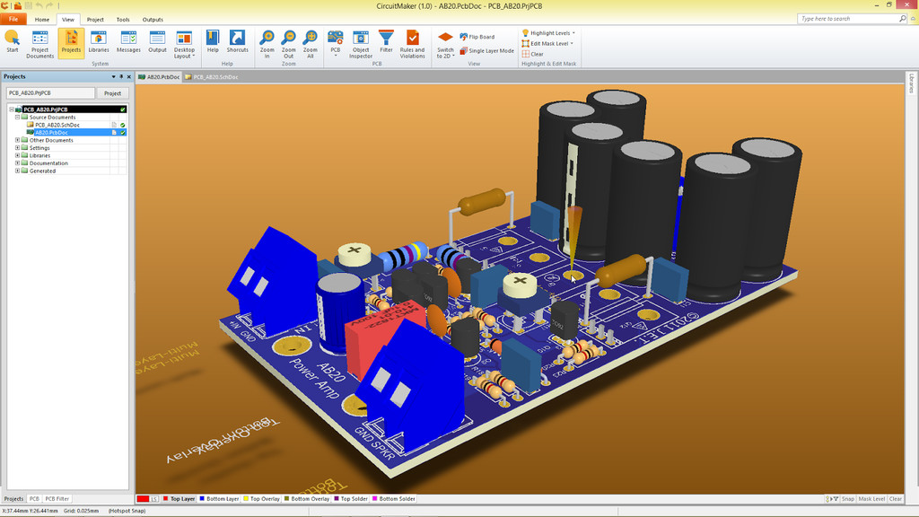
Figure 1.25: circuit simulation on circuit-maker CAD software
Simulating a circuit’s behavior before actually building it can greatly improve design efficiency by making faulty designs known as such, and providing insight into the behavior of electronics circuit designs.
Examples of Electronic circuit design and simulation software:
- Circuit Maker
- Open Circuit Design Software
- KiCad EDA
- ADS Circuit Design Software
- SuperSim Circuit Design Software
- Portus

- Computers
Is a device that accepts information (in the form of digitalized data) and manipulates it for some result based on a program, software, or sequence of instructions on how the data is to be processed?
By installing Electronic circuit design and simulation software, we can use them to design and construct electrical/electronics circuit.
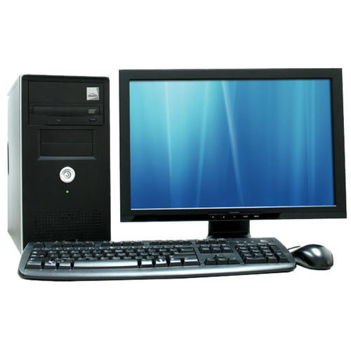
Figure 1.26: Computer (desktop and laptop)
- Printed circuit board (PCB)
Printed circuit boards (PCBs) are by far the most common method of assembling modern electronic circuits. Comprised of a sandwich of one or more insulating layers and one or more copper layers which contain the signal traces and the powers and grounds, the design of the layout of printed circuit boards can be as demanding as the design of the electrical circuit.
Most modern systems consist of multilayer boards of anywhere up to eight layers (or sometimes even more). Traditionally, components were mounted on the top layer in holes which extended through all layers. These are referred as through hole components. More recently, with the near universal adoption of surface mount components, you commonly find components mounted on both the top and the bottom layers.
The design of the printed circuit board can be as important as the circuit design to the overall performance of the final system. We shall discuss in this chapter the partitioning of the circuitry, the problem of interconnecting traces, parasitic components, grounding schemes, and decoupling. All of these are important in the success of a total design.
Figure 2.27: Printed circuit board wire wrapping
PCB effects that are harmful to precision circuit performance include leakage resistances, IR voltage drops in trace foils, vias, and ground planes, the influence of stray capacitance, and dielectric absorption (DA). In addition, the tendency of PCBs to absorb atmospheric moisture (hygroscopicity) means that changes in humidity often cause the contributions of some parasitic effects to vary from day to day.
- Hand tools
Hand tools are simple tools which you use with your hands , and which are usually not powered also Hand tools is any tool that is powered by hand rather than a motor examples are chopping, chiseling, , cutters, files, striking tools, struck or hammered tools, screwdrivers, vises, clamps, snips, saws, and drills.
- Copper
The next layer is a thin copper foil, which is laminated to the board with heat and adhesive. On common, double sided PCBs, copper is applied to both sides of the substrate. In lower cost electronic gadgets the PCB may have copper on only one side. When we refer to a double sided or 2-layer board we are referring to the number of copper layers (2) in our lasagna. This can be as few as 1 layer or as many as 16 layers or more
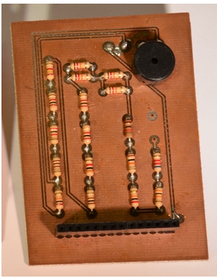
Figure 2.28: PCB with copper exposed, no solder mask or silkscreen.
The copper thickness can vary and is specified by weight, in ounces per square foot. The vast majority of PCBs have 1 ounce of copper per square foot but some PCBs that handle very high power may use 2 or 3 ounce copper. Each ounce per square translates to about 35 micrometers or 1.4 thousandths of an inch of thickness of copper.

- Soldering lead
Solder is a metallic compound that has a low melting point, usually around 200°C. The composition of solder varies depending on the type, but usually contains lead or tin or both. The most common types are given below. It is available in wire, stick or pellet form. Sticks and pellets are for solder-pots; for normal soldering, you will need solder wire.
Solder wire is available in widths given in "standard wire gauge" (SWG). The larger the SWG number, the thinner the wire. Common gauges are 18 and 22, although others are available. 18-gauge solder is suitable for soldering large components and thick wire, as a large quantity of solder can be delivered quickly. 22 gauge solder is thinner than 18 gauge, and should be used for most electronics work, as it allows much greater control over the quantity of solder delivered, and the chances of accidentally bridging a gap due to over-application or the wire's width are greatly reduced. Finer gauges such as 26 are available for very fine work with SMT (surface-mount) components.
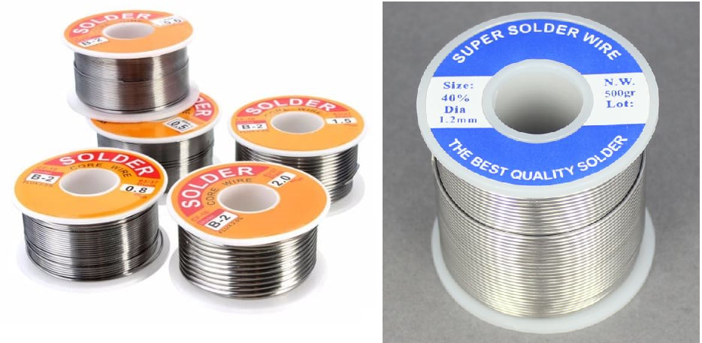
Figure 2.29: soldering lead (solder)
60/40 solder is made of 60% tin and 40% lead. It has a melting point of around 190°C, depending on the exact composition. Iron tip temperatures of at least 300°C are recommended. It is also very soft, meaning that cracks do not form so readily if the joint moves during cooling.
63/37 solder is made of 63% tin and 37% lead. It has a melting point of 183°C, slightly lower than the more common 60/40 blend. The primary advantage of this solder is not the lower melting point, but its eutectic property.
50/50 is made of a half and half mix of tin and lead. Never use 50/50 solder for electronics — it is meant for plumbing. Otherwise, you may end up with failed joints.
- Flux
Flux is a compound that is used to improve the quality of the soldered joint. It does this in three ways:
- It chemically removes oxidation from the surfaces being soldered.
- It prevents air from oxidizing the surfaces once they have been cleaned.
- It increases the "wetting" of the surfaces when the solder is applied
Wetting is the degree to which the solder flows across the surfaces being joined. Without flux, a dry joint may be formed, making a poor connection.

Figure 1.30: Flux
- Jumper wire
In order to make quick, temporary connections between some electronic components, you need jumper wires with small "alligator-jaw" clips at each end. These may be purchased complete, or assembled from clips and wires.
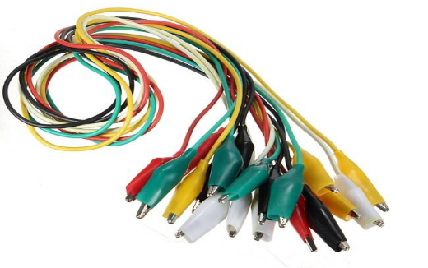
Figure 1.31: Jumper wire
- Permanent marker (ink)
To transfer your design to the copper or for correction, use a permanent marker (solvent-based permanent-marker pen) and draw your traces directly on the copper which is capable of resist the etchant Ferric Chloride solution. One layer of ink is not enough, let it dry for 10 minutes and redraw it again on top to make the layer thicker.

Figure 1.32: Permanent marker (ink)
- Strip board (uninsulated breadboard)
Strip board is one of the commonly-used types of prototyping board. These boards are intended for permanently assembling one-off circuits, especially prototypes. The board is made from insulating material, usually a resin-bonded plastic or fiberglass. One side has parallel copper strips on it, spaced 2.54 mm apart. There are holes bored in these strips, also 2.54 mm apart. Components are placed on the other side of the board with their wires bent to pass through the holes. The wires are soldered to the copper strips, the projecting ends being cut off to make the assembly neater.
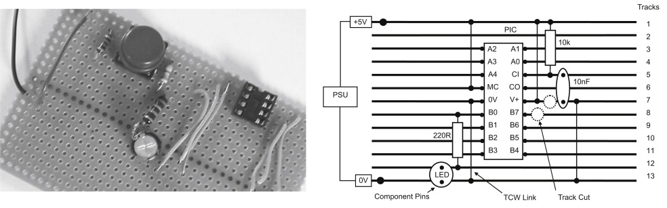
Figure 1.33: Strip board (uninsulated breadboard)

Self-Check -1.1

Part- I: say True or False
- Disordering tool is not used for the removal of solder and components from a circuit when troubleshooting, repair purposes and to save components.
- Strip board is one of the commonly-used types of prototyping board.
- Wearing a mask at work is n luxury.
- Wave form is one that repeats itself at a fixed interval, called period.

Part-II: Multiple Choose
- Which of the following is an example of a digital Electronic?
- Computers
- Information appliances
- Digital cameras
- All of the mentioned
- ____________are fundamental building blocks of digital circuits.
- Combinational logic
- Logic gate
- Binary Digits
- Bits
- ____________The time taken the signal to fall from its 90% to 10% of the pulse amplitude.
- Raise time
- Falling time
- Pulse width
- periodic pulse

Part-III: Matching
Column “A” | Column “B”
- PCB board | - Refers to the state of being protected from harm, danger, or risk.
- Hazard | - 10001
- 101111 | - The most common method of assembling modern electronic circuits.
- 17 | - 95
- Safety | - Represents a potential source of harm.

Part-III: write short answer
Instruction: write short answer for the given question. You are provided 4 minute for each question and each point has 5 Points.
- ____________ is a branch of electronics that deals with the use of digital signals and logic circuits to process and transmit information.
- Define analog quantity and list three examples.
- ____________The time taken the signal to raise from its 10% to 90% of the pulse amplitude.
- ____________is a place of the soldering iron to keep them away from flammable materials.

Operation Sheet -1. 1

Module Title: Designing and Developing Digital Electronics System
Objective-: design and simulation of digital circuits
Techniques to select appropriate tools and equipment have to construct electrical/electronic circuit.
Instruction:
Step 1: prepare clean and safe work station
Step 2: analyze and understand the given task
Step 3: list out tools, materials and equipment’s necessary for the specific task
Step 4: calibrate/adjust the equipment to be used for the task if necessary
Step 5: make the workstation ready for the task to be start

Q1. Construct and simulate the following circuits using protues software.
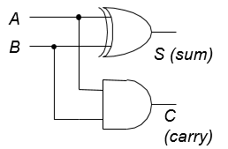

LAP Test – 1.1
Instructions: Given necessary templates, tools, materials and equipment you are required to perform the following tasks within 5 hour.

Task-1: Construct and simulate the fundamental logic gates, test the functionality with the truth table values. Repeat with three and four input logic gates also.

Task-2: construct and simulate BCD to seven segment display decoder circuit:
Q1. Using 7447 decoder IC (common anode).

Unit-Two: Digital electronic circuit control system
This unit to provide you the necessary information regarding the following content coverage and topics:
- Digital electronic logic gates and circuits
- Digital components/materials
- Application of digital electronics
This guide will also assist you to attain the learning outcomes stated in the cover page. Specifically, upon completion of this learning guide, you will be able to:
  - Identify Digital electronic logic gates and circuit
  - Components /material collected for selected project
  - Application of digital electronics is understood

  - 2.1 Digital electronic logic gates and circuits

2.1.1 Logic gates
Logic gates perform basic logical functions and are the fundamental building blocks of digital integrated circuits. Most logic gates take an input of two binary values, and output a single value of a 1 or 0. Some circuits may have only a few logic gates, while others, such as microprocessors, may have millions of them. There are seven different types of logic gates, which are outlined below. In the following examples, each logic gate except the NOT gate has two inputs, A and B, which can either be 1 (True) or 0 (False). The resulting output is a single value of 1 if the result is true or 0 if the result is false.
- Basic logic gates
There are seven basic logic gates: AND, OR, XOR, NOT, NAND, NOR, and XNOR.
AND - True if A and B are both True
OR - True if either A or B is True
NOT - Inverts value: True if input is False; False if input is True
XOR - True if either A or B are True, but False if both are True
NAND - AND followed by NOT: False only if A and B are both True
NOR - OR followed by NOT: True only if A and B are both False
XNOR - XOR followed by NOT: True if A and B are both True and both False

2.1.2 Logic Gates Symbols and Operations
All digital electronic circuits and microprocessor based systems contain hardware elements called: Digital Logic Gates that performs the logical operations of AND, OR and NOT on binary numbers. In digital logic only two voltage levels or states are allowed and these states are generally referred to as logic “1” or logic “0”, high or Low, true or false and which are represented in Boolean algebra and truth tables by the numbers 1 and 0 respectively.
- THE AND GATE
The AND gate is a logic circuit that requires all inputs to be TRUE at the same time in order for the output to be TRUE.
- Logic Symbol
The standard symbol for the AND gate is shown in figure 2.1. Variations of this standard symbol may be encountered. These variations become necessary to illustrate that an AND gate may have more than one input.
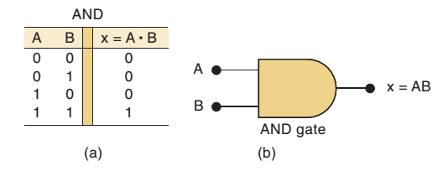

Figure 2.1: AND gate
If we apply two variables, A and B, to the inputs of the AND gate, then both A and B would have to be TRUE at the same time to produce the desired TRUE output. . The symbol f designates the output function. The Boolean expression for this operation is f = A·B or f = AB. The expression is spoken, "f = A AND B." The dot, or lack of, indicates the AND function.
- AND gate operation
We can demonstrate the operation of the AND gate with a simple circuit that has two switches in series as shown in figure 4.2. You can see that both switches would have to be closed at the same time to light the lamp (view A). Any other combination of switch positions (view B) would result in an open circuit and the lamp would not light (logic 0).
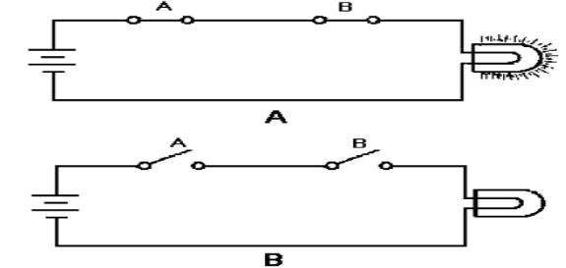

Figure 2.2: AND gate equivalent circuit: A. Logic 1 state; B. Logic 0 state.

Now look at figure 4.3. Signal A is applied to one input of the AND gate and signal B to the other. At time T0, both inputs are LOW (logic 0) and f is LOW. At T1, A goes HIGH (logic 1); B remains LOW; and as a result, f remains LOW. At T2, A goes LOW and B goes HIGH; f, however, is still LOW, because the proper input conditions have not been satisfied (A and B both HIGH at the same time). At T4, both A and B are HIGH. As a result, f is HIGH. The input requirements have been satisfied, so the output is HIGH (logic 1).

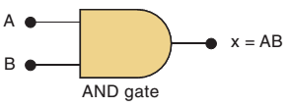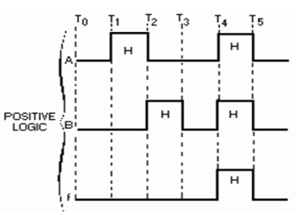

Figure 2.3: AND gate input and output signals.

- Truth Table
Now let’s refer to figure 2.4. As you can see, a Truth Table and a Table of Combinations are shown. The latter is a deviation of the Truth Table. It uses the HIGH and LOW logic levels to depict the gate’s inputs and resultant output combinations rather than the 1 and 0 logic states. By comparing the inputs and outputs of the two tables, you see how one can easily be converted to the other (remember, 1 = HIGH and 0 = LOW). The Table of Combinations is shown here only to familiarize you with its existence; it will not be seen again in this book. As we mentioned earlier, the Truth Table is a chart that shows all possible combinations of inputs and the resulting outputs.
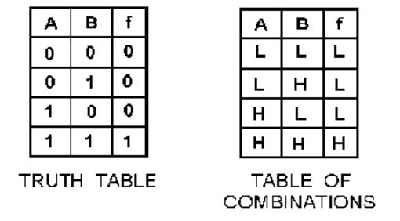
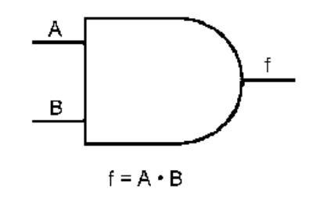

Figure 2.4: AND gate logic symbol, Truth Table, and Table of Combinations
The first combination (A = 0, B = 0) corresponds to T0 in figure 4.3; the second to T1; the third to T2; and the last to T4. When constructing a Truth Table, you must include all possible combinations of the inputs, including the all 0s combination. A Truth Table representing an AND gate with three inputs (X, Y, and Z) is shown below. Remember that the two-input AND gate has four possible combinations, with only one of those combinations providing a HIGH output. An AND gate with three inputs has eight possible combinations, again with only one combination providing a HIGH output. Make sure you include all possible combinations. To check if you have all combinations, raise 2 to the power equal to the number of input variables. This will give you the total number of possible combinations.

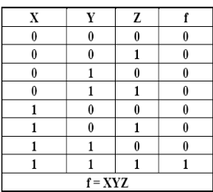
EXAMPLE 1-AB = 2² = 4 combinations
EXAMPLE 2-XYZ = 2³ = 8 combinations
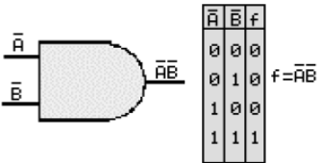
As with all AND gates, all the inputs must be HIGH at the same time to produce a HIGH output. Don’t be confused if the complement of a variable is used as an input. When a complement is indicated as an input to an AND gate, it must also be HIGH to satisfy the input requirements of the gate. The Boolean expression for the output is formulated based on the TRUE inputs that give a TRUE output. Here is an adage that might help you better understand the AND gate: In order to produce a 1 output, all the inputs must be 1. If any or all of the inputs is/are 0, then the output will be 0. Referring to the following examples should help you cement this concept in your mind. Remember, the inputs, whether the original variable or the complement must be high in order for the output to be high. The three examples given are all AND gates with two inputs. Keep in mind the Boolean expression for the output is the result of all the inputs being HIGH.
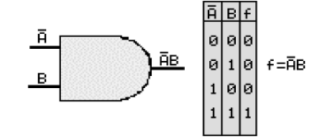
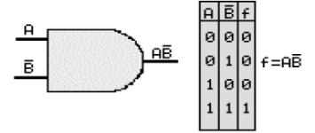

Figure 2.5: AND gate logic with two inputs, Truth Table

- The OR gate
The OR gate differs from the AND gate in that only ONE input has to be HIGH to produce a HIGH output. An easy way to remember the OR gate is that any HIGH input will yield a HIGH output.
- Logic Symbol
Figure 2.6.Shows the standard symbol for the OR gate. The number of inputs will vary according to the needs of the designer.
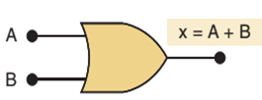
Figure 2.6; OR gate
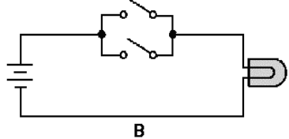
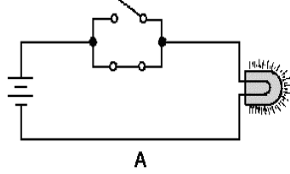
The OR gate may also be represented by a simple circuit as shown in figure 4.7. In the OR gate, two switches are placed in parallel. If either or both of the switches are closed (view A), the lamp will light. The only time the lamp will not be lit is when both switches are open (view B).

Figure 2.7; OR gate equivalent circuit: A. Logic 1 state; B. Logic 0 state.
Let’s assume we are applying two variables, X and Y, to the inputs of an OR gate. For the circuit to produce a HIGH output, either variable X, variable Y, or both must be HIGH. The Boolean expression for this operation is f = X+Y and is spoken "f equals X OR Y." The plus sign indicates the OR functions and should not be confused with addition.
- OR gate operation
Look at figure 4.8. At time T0, both X and Y are LOW and f is LOW. At T1, X goes HIGH producing a HIGH output. At T2 when both inputs go LOW, f goes LOW. When Y goes HIGH at T3, f also goes HIGH and remains HIGH until both inputs are again LOW. At T5, both X and Y go HIGH causing f to go HIGH.

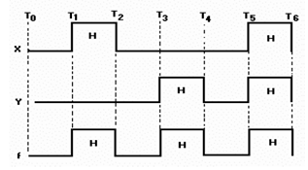

Figure 2.8: OR gate input and output signals.
- Truth Table
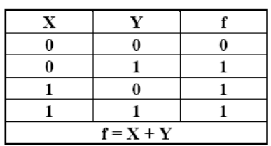
Using the inputs X and Y, let’s construct a Truth Table for the OR gate. You can see from the discussion of figure 4.8 that there are four combinations of inputs. List each of these combinations of inputs and the respective outputs and you have the Truth Table for the OR gate.
When writing or stating the Boolean expression for an OR gate with more than two inputs, simply place the OR sign (+) between each input and read or state the sign as OR. For example, the Boolean expression for an OR gate with the inputs of A, B, C, and D would be: f = A+B+C+D
This expression is spoken "f equals A OR B OR C OR D."
You can substitute the complements for the original statements as we did with the AND gate or use negative logic; but for an output from an OR gate, at least one of the inputs must be TRUE.
- The Inverter
The inverter, often referred to as a NOT gate, is a logic device that has an output opposite of the input. It is sometimes called a NEGATOR. It may be used alone or in combination with other logic devices to fulfill equipment requirements.
When an inverter is used alone, it is represented by the symbol shown in figure 4-9 (view A). It will more often be seen in conjunction with the symbol for an amplifier (view B). Symbols for inverters used in combination with other devices will be shown later in the chapter.

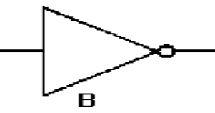
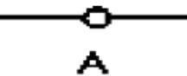

Figure 2.9: Inverter: A. Symbol for inverter used alone; B. Symbol for an amplifier/inverter.
Let’s go back to the statement "Today is payday." We stated that P represents the TRUE state. If we apply P to the input of the inverter as shown in figure 2.10, then the output will be the opposite of the input. The output, in this case, is P. At times T0 through T2, P is LOW. Consequently, the output (P) is HIGH. At T2, P goes HIGH and as a result P goes LOW. P remains LOW as long as P is HIGH and vice versa. The Boolean expression for the output of this gate is f = P
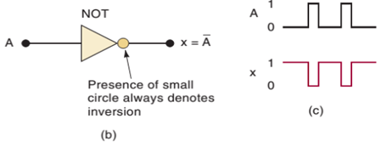

Figure 2.10; —Inverter input and resultant output.

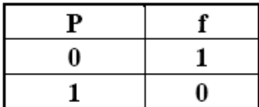
You will recall that P is the complement of P.
The Truth Table for an inverter is shown below.
The output of an inverter will be the complement of the input.
The vinculum, or NOT sign, is placed over the entire output or removed from the output, depending on the input. If we applied ABC to an inverter, the output would be ABC. And if we ran that output through another inverter, the output would be ABC

- The NAND gate
The NAND gate is another logic device commonly found in digital equipment. This gate is simply an AND gate with an inverter (NOT gate) at the output
- Logic Symbol

The logic symbol for the NAND gate is shown in figure 2.11.
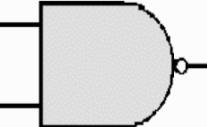

Figure 2.11: NAND gate.
The NAND gate can have two or more inputs. The output will be LOW only when all the inputs are HIGH. Conversely, the output will be HIGH when any or all of the inputs are LOW. The NAND gate performs two functions, AND and NOT. Separating the NAND symbol to show these two functions would reveal the equivalent circuits depicted in figure 4-12. This should help you better understand how the NAND gate functions.
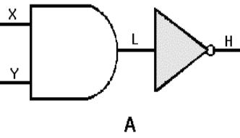
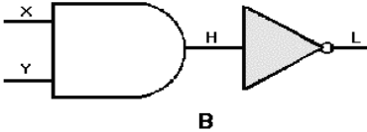

Figure 2.12: NAND gate equivalent circuit: A. Either X or Y or both are LOW; B. Both X and Y are HIGH.
Inputs X and Y are applied to the AND gate. If either X or Y or both are LOW (view A), then the output of the AND gate is LOW. A LOW (logic 0) on the input of the inverter results in a HIGH (logic 1) output. When both X and Y are HIGH (view B), the output of the AND gate is HIGH; thus the output of the inverter is LOW. The Boolean expression for the output of a NAND gate with these inputs is f = XY.
The expression is spoken "X AND Y quantity NOT." The output of any NAND gate is the negation of the input. For example, if our inputs are X and Y, the output will be XY.

- NAND gate operation
Now, let’s observe the logic level inputs and corresponding outputs as shown in figure 2.13. At time T0, X and Y are both LOW. The output is HIGH; the opposite of an AND gate with the same inputs. At T1, X goes HIGH and Y remains LOW.

As a result, the output remains HIGH. At T2, X goes LOW and Y goes HIGH. Again, the output remains HIGH. When both X and Y are HIGH at T4, the output goes LOW. The output will remain LOW only as long as both X and Y are HIGH.
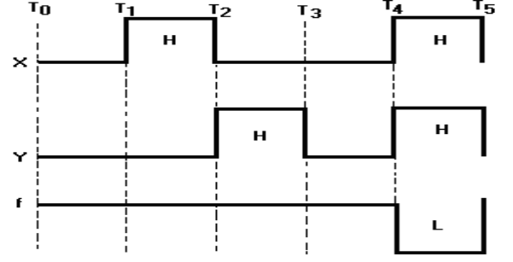

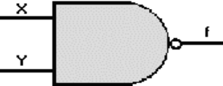

Figure 2.13: NAND gate input and output signals.

- Truth Table

The Truth Table for a NAND gate with X and Y as inputs is shown below.
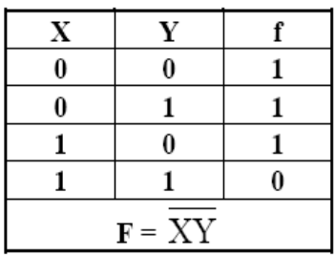

.

- The NOR gate
As you might expect, the NOR gate is an OR gate with an inverter on the output.
- Logic Symbol
The standard logic symbol for this gate is shown in figure 4-14. More than just the two inputs may be shown.

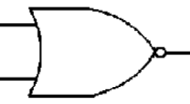

Figure 2.14: NOR gate
The NOR gate will have a HIGH output only when all the inputs are LOW.
When broken down, the two functions performed by the NOR gate can be represented by the equivalent circuit depicted in figure 4-15. When both inputs to the OR gate are LOW, the output is LOW. A LOW applied to an inverter gives a HIGH output. If either or both of the inputs to the OR gate are HIGH, the output will be HIGH. When this HIGH output is applied to the inverter, the resulting output is LOW. The Boolean expression for the output of this NOR gate is f = K+L. The expression is spoken, "K OR L quantity NOT."
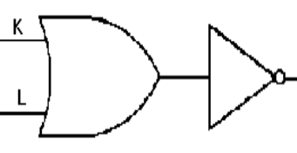

Figure 2.15: NOR gate equivalent circuit
- Nor Gate Operation
The logic level inputs and corresponding outputs for a NOR gate are shown in figure 4-16. At time T0, both K and L are LOW; as a result, f is HIGH. At T1, K goes HIGH, L remains LOW, and f goes LOW. At T2, K goes LOW, L goes HIGH, and the output remains LOW. The output goes HIGH again at T3 when both inputs are LOW. At T4 when both inputs are HIGH, the output goes LOW and remains LOW until T5 when both inputs go LOW. Remember the output is just opposite of what it would be for an OR gate.
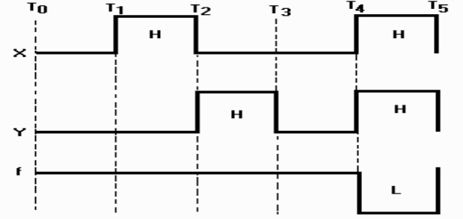
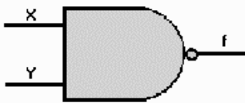

Figure 2.16: NOR gate input and output signals

- Truth Table

The Truth Table for a NOR gate with K and L as inputs is shown below.
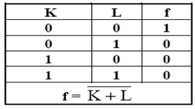
- Variations Of Fundamental Gates
Now that you are familiar with fundamental logic gates, let’s look at some variations of these gates that you may encounter. Up to now you have seen inverters used alone or on the output of AND and OR gates. Inverters may also be used on one or more of the inputs to the logic gates. Take a look at the examples as discussed in the following paragraphs.
- AND/NAND Gate Variations
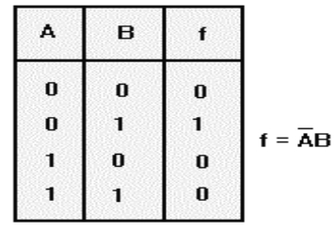
If we place an inverter on one input of a two-input AND gate, the output will be quite different from that of the standard AND gate. In figure 2-17, we have placed an inverter on the A input. When A is HIGH, the inverter makes it a LOW going into the AND gate. In order for the output to be HIGH, A would have to be LOW while B is HIGH, as shown in the Truth Table. If the inverter were on the B input, the output expression would then be f = AB.
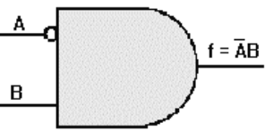

Figure 2.17: NAND gate input and output signals
Now let’s compare a NAND gate to an AND gate with an inverter on each input. Figure 2.18 shows these gates and the associated Truth Tables. With the NAND gate (view A), the output is HIGH when either or both inputs is/are LOW. The AND gate with inverters on each input (view B), produces a HIGH output only when both inputs are LOW. This comparison also points out the differences between the expressions f = AB (A AND B quantity NOT) and f = ¾¾® A B (NOT A AND NOT B).
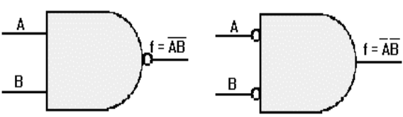
Now, look over the Truth Tables for figures 2.17, 2.18, and 2.19; look at how the outputs vary with inverters in different positions.
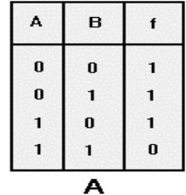
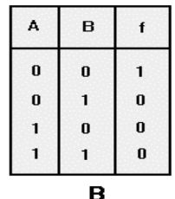

Figure 2-18: Comparison of NAND gate & AND gate with inverted inputs: A. NAND gate; B. AND gate with inverters on each input
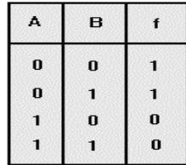
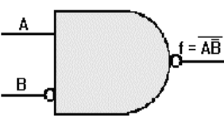

Figure 2-19; NAND gate with one inverted input
- OR/NOR Gate Variations
The outputs of OR and NOR gates may also be changed with the use of inverters. An OR gate with one input inverted is shown in figure 2-20. The output of this OR gate requires that A be LOW, B be HIGH, or both of these conditions existing at the same time in order to have a HIGH output. Since the A input is inverted, it must be LOW if B is LOW in order to produce a HIGH output.
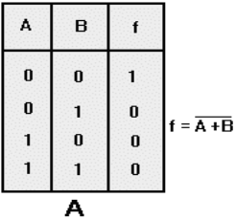
Therefore the output is f = A +B
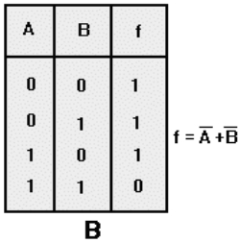
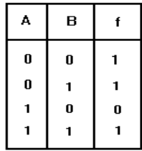
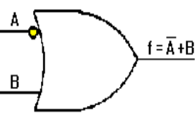

Figure 2.20: OR gate with one inverted input.
Figure 2-21compares a NOR gate (view A), to an OR gate with inverters on both inputs (view B), and shows the respective Truth Tables. The NOR gate will produce a HIGH output only when both inputs are LOW. The OR gate with inverted inputs produces a HIGH output with all input combinations EXCEPT when both inputs are HIGH. This figure also illustrates the differences between the expressions f = A+B (A OR B quantity NOT) and f = A + B (NOT A OR NOT B).
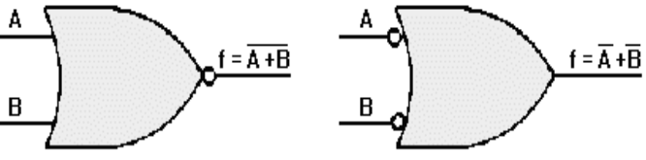

Figure 2.21: Comparison of NOR gate and OR gate with inverted inputs: A. NOR gate; B.
- OR gate with inverters on both inputs
As with the NAND gate, one or more inputs to NOR gates may be inverted. Figure 2-22 shows the result of inverting a NOR gate input. In this case, because of the inversion of the B input and the inversion of the output, the only time this gate will produce a HIGH output is when A is LOW and B is HIGH. The output Boolean expression for this gate is f = A + B, spoken “A OR NOT B quantity NOT.”
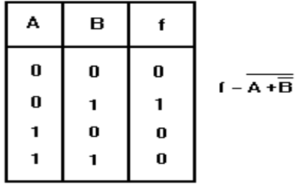
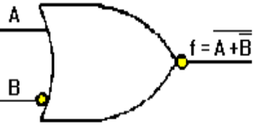

Figure 2.22: NOR gate with one inverted input.
Table 2-4 illustrates AND, NOR, NAND, and OR gate combinations that produce the same output. You can see by the table that there is more than one way to achieve a desired output. Although the gates have only two inputs, the table can be extended to more than two inputs.
- The Exclusive OR gate
The exclusive OR gate is a modified OR gate that produces a HIGH output when only one of the inputs is HIGH. You will often see the abbreviation X-OR used to identify this gate. When both inputs are HIGH or when both inputs are LOW, the output is LOW. The standard symbol for an exclusive OR gate is shown in figure 3-2 along with the associated Truth Table. The operation function signs for the exclusive OR gate is Å.
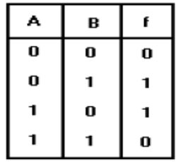
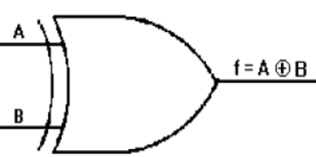

Figure 2.23: Exclusive OR gate and Truth Table.
If you were to observe the input and output signals of an X-OR gate, the results would be similar to those shown in figure 2.24. At T0, both inputs are LOW and the output is LOW. At T1, A goes to HIGH and remains HIGH until T2. During this time the output is HIGH. At T3, B goes HIGH and remains HIGH through T5. At T4, A again goes HIGH and remains HIGH through T5. Between T3 and T4, the output is HIGH. At T4, when both A and B are HIGH, the output goes LOW.
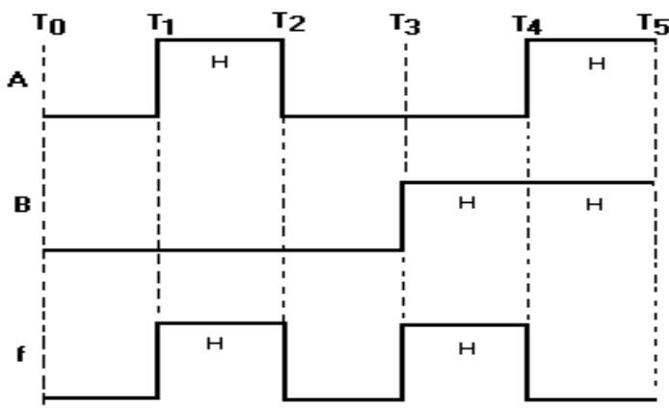

Figure 2.24: Exclusive OR gate timing diagram
- The Exclusive NOR gate
The exclusive NOR (X-NOR) gate is nothing more than an X-OR gate with an inverted output. It produces a HIGH output when the inputs are either all HIGH or all LOW. The standard symbol and the Truth Table is shown in figure 3-4.The operation function sign is Å with a vinculum over the entire expression.
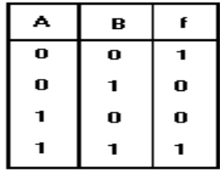
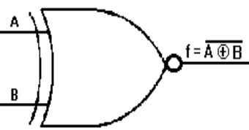

Figure 2.25: Exclusive NOR gate and Truth Table

Exercise:
Q1. What is the sign of operation for the X-OR gate?
Q2. What will be the output of an X-OR gate when both inputs are HIGH?
Q3. A two-input X-OR gate will produce a HIGH output when the inputs are at what logic levels?
Q4. What will be the output of an X-NOR gate when both inputs are LOW?

2.1.3 Logic Gate Circuits
- Logic Gates

When you look at logic circuit diagrams for digital equipment, you are not going to see just a single gate, but many combinations of gates. At first it may seem confusing and complex. If you interpret one gate at a time, you can work your way through any network. in Combination In this section, we will analyze several combinations of gates and then provide you with some practice problems. Figure 2-23 (view A) shows a simple combination of AND gates. The outputs of gates 1 and 2 are the inputs to gate 3. You already know that both inputs to an AND gate must be HIGH at the same time in order to produce a HIGH output.
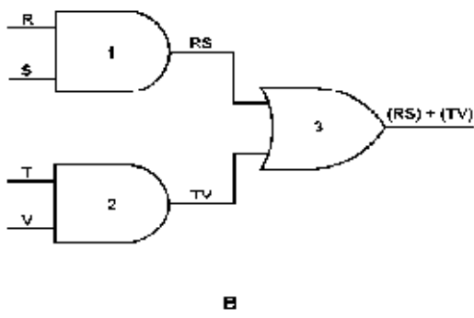
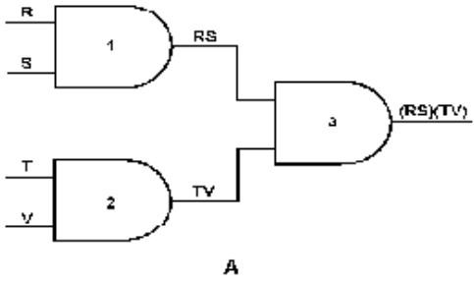

Figure 2.26; Logic gate combinations: A. Simple combination of AND gates; B. Simple combination of AND gates and OR gate.
The output Boolean expression of gate 1 is RS, and the output expression of gate 2 is TV. These two output expressions become the inputs to gate 3. Remember, the output Boolean expression is the result of the inputs, in this case (RS) (TV); spoken "quantity R AND S AND quantity T AND V." In view B we have changed gate 3 to an OR gate. The outputs of gates 1 and 2 remain the same but the output of gate 3 changes as you would expect. The output of gate 3 is now (RS)+(TV); spoken "quantity R AND S OR quantity T AND V." In figure 2-24 (view A), the outputs of two OR gates are being applied as the input to third OR gate. The output for gate 1 is R+S, and the output for gate 2 is T+V. With these inputs, the output expression of gate 3 is (R+S) + (T+V).

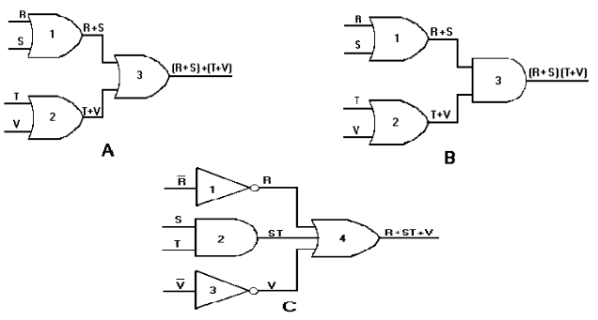

Figure 2.27: Logic gate combinations: A. Simple combination of OR gates; B. Simple combination of OR gates and AND gate; C. Output expression without the parentheses.
In view B, gate 3 has been changed to an AND gate. The outputs of gates 1 and 2 do not change, but the output expression of gate 3 does. In this case, the gate 3 output expression is (R+S)(T+V). This expression is spoken, "quantity R OR S AND quantity T OR V." The parentheses are used to separate the input terms and to indicate the AND function. Without the parentheses the output expression would read
R+ST+V, which is representative of the circuit in view C. As you can see, this is not the same circuit as the one depicted in view B. It is very important that the Boolean expressions be written and spoken correctly. The Truth Table for the output expression of gate 3 (view B) will help you better understand the output. When studying this Truth Table, notice that the only time f is HIGH (logic 1) is when either or both R and S AND either or both T and V are HIGH (logic 1).

2.2 Digital components/materials
- A logic analyzer is a test and measurement instrument used in digital electronics to capture, analyze, and display digital signals. It is commonly used for debugging, troubleshooting, and verifying the functionality of digital circuits and systems.
- A logic clip, also known as a logic probe or a clip-on logic analyzer probe, is a tool used in digital electronics for probing and analyzing digital signals in a circuit.
- A logic probe is a handheld tool used in digital electronics for testing and troubleshooting digital circuits.
- An electronics tool kit is a collection of tools and equipment specifically designed for working with electronic components, circuits, and devices.
- Measuring instruments are tools used to accurately measure various physical quantities and parameters in different fields, including electronics. These instruments provide quantitative data for analysis, evaluation, and troubleshooting purposes.
- A soldering iron is a handheld tool used for joining electronic components together by melting solder. It consists of a heated metal tip, usually made of copper or iron that is heated electrically.
- Electrical workshop machines are specialized tools and equipment used in electrical workshops and manufacturing facilities for various purposes, such as fabrication, assembly, testing, and repair of electrical components and systems. These machines help increase efficiency, accuracy, and productivity in electrical work.
- Transistor-transistor logic (TTL) is a logic family that is built from bipolar junction transistors. It is named as such because transistors perform both the logic function and the amplifying function.
- Decoder and encoder integrated circuits (ICs) are essential components in digital systems that are used for encoding and decoding binary information. These ICs play a crucial role in various applications, including data transmission, remote control systems, and communication protocols.
- Flip-flops are essential components in digital circuits that can store binary data in two stable states. They are widely used in various applications, including computers, communication systems, and other digital electronics systems. Flip-flops are bistable multivibrators, meaning they have two stable states that can store state information.
- Seven-segment LED displays are commonly used to represent numerical digits or certain characters in electronic systems. These displays consist of seven individual light-emitting diodes (LEDs) arranged in a specific pattern, each corresponding to a segment of the digit or character being displayed. Here is the symbol commonly used to represent a Seven-Segment LED Display:
- The seven segments of the display are labeled with letters A to G, as shown in the symbol above. Each segment can be independently controlled to form different digits or characters. By selectively turning on or off the appropriate segments, the display can show numbers from 0 to 9 and certain letters or symbols.
- To represent a specific number or character using a seven-segment LED display, different combinations of segments are illuminated. For example, to display the number "0," segments A, B, C, D, E, and F are typically turned on, while segment G remains off
- It's important to note that there are variations in the exact segment labeling and arrangement of seven-segment LED displays, depending on the manufacturer or specific display model. However, the general concept of using seven segments to represent digits or characters remains consistent.
- Programmable Logic Devices (PLDs) are integrated circuits (ICs) that can be programmed to implement digital logic functions or custom digital circuitry. These devices offer flexibility and versatility in designing digital systems by allowing users to configure the internal logic connections and functionality of the device according to their specific requirements.
- Programmable Array Logic (PAL) is a type of programmable logic device (PLD) that was popular in the early days of digital design. PALs are programmable integrated circuits that can implement combinational logic functions. They provide a fixed number of inputs and outputs and are programmed to generate specific logic functions or equations.

2.3 Application of digital electronics
Digital electronics has a wide range of applications in various fields due to its ability to process and manipulate digital signals with high accuracy and speed. Here are some common applications of digital electronics:
- Computers and Microprocessors: Digital electronics forms the foundation of modern computers and microprocessors. These devices rely on digital circuits to perform complex calculations, store and process data, and execute instructions.
- Communication Systems: Digital electronics plays a crucial role in communication systems such as telecommunication networks, wireless communication, and data transmission. Digital signals are used for encoding, decoding, modulation, and demodulation of information.
- Consumer Electronics: Many consumer electronic devices, such as smartphones, tablets, digital cameras, televisions, and audio players, heavily rely on digital electronics for signal processing, data storage, and user interface interactions.
- Industrial Automation: Digital electronics is extensively used in industrial automation systems. Programmable Logic Controllers (PLCs) and other digital control systems are employed to monitor and control processes, machinery, and production lines in industries such as manufacturing, power generation, and chemical processing.
- Digital Signal Processing (DSP): Digital electronics plays a vital role in DSP applications, where signals such as audio, video, and images are processed and manipulated digitally. DSP techniques are used in fields like audio/video compression, image and speech recognition, medical imaging, and radar systems.
- Control Systems: Digital electronics is widely used in control systems for automation and regulation of various processes. It enables precise control and feedback mechanisms in applications such as robotics, industrial control, home automation, and automotive control systems.
- Data Storage: Digital electronics has revolutionized data storage technologies. Hard disk drives, solid-state drives, memory cards, and USB drives use digital circuitry to store and retrieve data with high speed and reliability.
- Security Systems: Digital electronics plays a crucial role in security systems such as surveillance cameras, access control systems, and alarm systems. It enables the processing and analysis of video and audio signals for detection and identification purposes.
- Scientific Research: Digital electronics is extensively used in scientific research for data acquisition, measurement, and analysis. Instruments such as oscilloscopes, spectrometers, and data loggers employ digital circuitry for accurate and high-speed data processing.
These are just a few examples of the application areas where digital electronics is widely used. The field continues to evolve, and new applications are being developed as technology advances.

Self-Check -2.1
Part-II. True or False
- The output of an exclusive-OR (XOR) gate is 1 only when the inputs are different.
- Logic gate circuits contain predictable gate functions that open their outputs.

Part-II: Multiple Choose
- Which logic gate outputs a high (1) signal only when all of its inputs are high (1)?
- AND gate
- OR gate
- NOT gate
- XOR gate
- What is the binary subtraction of 101001 - 010110 =?
- 010011
- 100110
- 011001
- 010010
- What is the binary multiplication of 10100 * 01011 =?
- 011011000
- 011001100
- 011011100
- 011100011

- The output of the two-input OR gate is high
- Only if both inputs are high
- Only if both inputs are low
- Only if one input is high and the other is low
- If at least one of the inputs is high

- Digital circuit can be made by the repeated use of ………………
- OR gates
- NOT gates
- NAND gates
- None of the above
Part-III: short Answer writing
Instruction: write short answer for the given question. You are provided 4 minute for each question and each point has 5 Points.
- Draw the correct symbol and truth table for each of the following logic gates.

  - AND gate
  - OR gate
  - NAND gate
  - NOR gate
- The figure below shows a logic circuit and its incomplete truth table. Complete the below truth table.
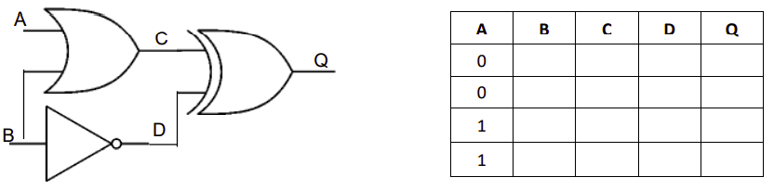

- Find the output of the given circuit:

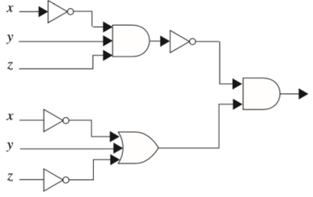

Operation Sheet-2. 1
Design and construct printed circuit board (PCB)
- Operation title: Procedures of design and construct printed circuit board (PCB)
- Purpose: To practice and demonstrate the knowledge and skill required design and construct printed circuit board (PCB) to construct electrical/electronic Components.

Instruction: Use the given select tools and equipment so that design is usually done by converting your circuit’s schematic diagram into a PCB layout using PCB layout software. For this operation you have given 3Hour and you are expected to provide the answer on the given steps.

STEP 1: Take printout of circuit board layout

STEP 2: Cutting the copper plate for the circuit board

STEP 3: Transferring the PCB print onto the copper plate
STEP 4: Circuit by hand on PCB (for simple and small circuits)

STEP 5: Ironing the circuit from the paper onto the PCB plate

LAP Test -2.1
Instructions: Given necessary templates, tools, materials and equipment you are required to perform the PCB design for the following tasks within 3 hour.
  - The circuit of the given figure realizes the function-------------

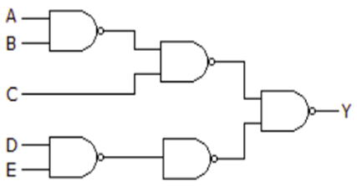

Unit-Three: Design and develop basic digital electronic control system
This unit to provide you the necessary information regarding the following content coverage and topics:
- Digital electronic control components
- Digital electronic control components measurement
- Schematic diagram preparation
- Schematic diagram using computer software
- Schematic diagram to PCB board Conversion
- Assemble digital electronic control components
This guide will also assist you to attain the learning outcomes stated in the cover page. Specifically, upon completion of this learning guide, you will be able to:
  - Digital electronic control components are sized(measured)
  - Schematic diagram is prepared to meet control system
  - Schematic diagram implemented using computer software
  - Implement schematic is copied to a PCB board
  - Digital electronic control components are assembled to maintain schematic.

3.1 Digital electronic control components
Digital electronic control components are electronic devices that are used to control and manipulate digital signals in various applications. These components are specifically designed to process and regulate digital signals, enabling precise control and automation in electronic systems. Here are some commonly used digital electronic control components:
    - Microcontrollers (MCUs) are integrated circuits that combine a microprocessor core with memory, input/output peripherals, and other functional blocks on a single chip. They are widely used in embedded systems and provide control and processing capabilities for various applications. Microcontrollers are programmable and can execute specific instructions to control external devices based on inputs and conditions.
    - Programmable Logic Controllers (PLCs) are industrial control systems that utilize digital electronic components to automate and control machinery and processes. They consist of a microprocessor, input/output modules, and programming software. PLCs are widely used in manufacturing and industrial automation for tasks such as monitoring inputs, executing control algorithms, and driving outputs.
    - Digital Signal Processors (DSPs) are specialized microprocessors designed for high-speed digital signal processing tasks. They are commonly used in applications that require real-time signal processing, such as audio and video processing, telecommunications, and control systems. DSPs are optimized for performing mathematical computations on digital signals, enabling precise control and manipulation of signals in real-time.
    - Field-Programmable Gate Arrays (FPGAs) are programmable logic devices that consist of an array of configurable logic blocks and programmable interconnects. They provide a high level of flexibility and can be programmed to implement digital logic functions and control algorithms. FPGAs are commonly used in applications where custom digital logic implementation and high-performance control are required.
    - Digital Timers and Counters are components used to measure and control time intervals or count events in digital systems. They can be used for tasks such as generating accurate timing signals, event sequencing, or frequency measurement.
    - Digital-to-Analog Converters (DACs) and Analog-to-Digital Converters (ADCs are components used to convert digital signals to analog and analog signals to digital, respectively. They enable the interface between digital control systems and analog devices or signals. DACs are used to generate analog control signals, while ADCs are used to digitize analog signals for processing in digital systems.
These are just a few examples of digital electronic control components. There are many more specialized components available for specific control and automation applications, such as digital encoders, decoders, multiplexers, and shift registers. The choice of components depends on the specific requirements of the control system and the desired functionality.

Digital electronic control components measurement
When working with digital electronic control components, it is important to measure and verify certain parameters to ensure proper operation and performance. Here are some common measurements and tests for digital electronic control components:
Voltage Measurements: Use a multimeter or voltage probe to measure voltage levels at various points in your digital circuit. This includes power supply voltages, logic signal levels, and voltage drops across specific components such as resistors or diodes.
Current Measurements: Measure current flow at different points in the circuit to determine power consumption and identify any abnormal or excessive current draws. Use a multimeter in series with the circuit or a current probe for non-invasive measurements.
Frequency Measurements: For time-dependent digital signals, use an oscilloscope or frequency counter to measure the frequency of clock signals or other digital waveforms.
Pulse Width and Duty Cycle Measurements: A digital circuit may involve pulse-width modulation (PWM) signals or other waveforms with varying duty cycles.
Signal Integrity Analysis: When working with high-speed or complex digital signals, it is important to analyze their integrity. Use an oscilloscope to observe the signal waveforms and check for distortions, ringing, noise, or other anomalies. Measure parameters such as rise time, fall time, and signal levels to ensure they meet the required specifications.
Timing Measurements: Digital circuits often rely on precise timing for proper operation. Use an oscilloscope or logic analyzer to measure and verify signal delays, propagation times, setup and hold times, and other timing parameters.
Remember to refer to the component datasheets, design specifications, and any relevant test procedures or guidelines specific to your digital electronic control components. Carefully interpret the measurement results and compare them against the expected values to identify and troubleshoot any issues or discrepancies.

Schematic diagram preparation
A digital electronics schematic diagram is a graphical representation of a digital circuit or system. It uses symbols to represent different electronic components and their interconnections. Here is a basic example of a digital electronics schematic diagram:
In this example, there are two components: an input and an output. The input is connected to the output through a wire or connection line. The symbols used for the input and output can vary depending on the specific component being represented. Common symbols include rectangles for logic gates, circles for flip-flops, and lines for connections.
Digital electronics schematic diagrams can become much more complex and include various types of components such as logic gates, flip-flops, multiplexers, decoders, and more. These diagrams are used to design, analyze, and understand digital circuits and systems.
Keep in mind that the specific symbols and conventions used in digital electronics schematic diagrams may vary depending on the design standards or the software tools being used.
Examples of schematic diagrams for different electronic components and circuits:
- Logic Gate Circuit
- 555 Timer Circuit
- Power Supply Circuit
This schematic diagram illustrates a basic logic gate circuit. It shows the symbols for different logic gates (AND, OR, NOT) and how they are interconnected to perform a specific logic function.2. 555 Timer Circuit.
  - Schematic diagram using computer software
Digital electronic control components are electronic devices that are used to control and manipulate digital signals in various applications. These components are specifically designed to process and regulate digital signals, enabling precise control and automation in electronic systems. Here are some commonly used digital electronic control components:
- Microcontrollers (MCUs) are integrated circuits that combine a microprocessor core with memory, input/output peripherals, and other functional blocks on a single chip. They are widely used in embedded systems and provide control and processing capabilities for various applications. Microcontrollers are programmable and can execute specific instructions to control external devices based on inputs and conditions.
- Programmable Logic Controllers PLCs are industrial control systems that utilize digital electronic components to automate and control machinery and processes. They consist of a microprocessor, input/output modules, and programming software. PLCs are widely used in manufacturing and industrial automation for tasks such as monitoring inputs, executing control algorithms, and driving outputs.
- Digital Signal Processors (DSPs) are specialized microprocessors designed for high-speed digital signal processing tasks. They are commonly used in applications that require real-time signal processing, such as audio and video processing, telecommunications, and control systems. DSPs are optimized for performing mathematical computations on digital signals, enabling precise control and manipulation of signals in real-time.
- Field-Programmable Gate Arrays (FPGAs) are programmable logic devices that consist of an array of configurable logic blocks and programmable interconnects. They provide a high level of flexibility and can be programmed to implement digital logic functions and control algorithms. FPGAs are commonly used in applications where custom digital logic implementation and high-performance control are required.
- Digital timers and counters are components used to measure and control time intervals or count events in digital systems. They can be used for tasks such as generating accurate timing signals, event sequencing, or frequency measurement.
- Digital-to-Analog Converters (DACs) and Analog-to-Digital Converters (ADCs):are components used to convert digital signals to analog and analog signals to digital, respectively. They enable the interface between digital control systems and analog devices or signals. DACs are used to generate analog control signals, while ADCs are used to digitize analog signals for processing in digital systems.
These are just a few examples of digital electronic control components. There are many more specialized components available for specific control and automation applications, such as digital encoders, decoders, multiplexers, and shift registers. The choice of components depends on the specific requirements of the control system and the desired functionality.

Schematic diagram to PCB board Conversion
The process of converting a schematic diagram to a PCB (Printed Circuit Board) layout involves translating the components, connections, and design constraints from the schematic into a physical representation on the PCB. Here's a general overview of the steps involved in the schematic to PCB conversion process:
- Import the Schematic: The first step is to import the schematic diagram into a PCB design software tool. Most PCB design software tools have the capability to import schematic files from various formats like EAGLE, Altium, KiCad, etc.
- Component Footprint Assignment: Each component in the schematic needs to be associated with a corresponding physical footprint or package. In the PCB design software, you'll need to assign the appropriate footprint to each component. The footprints define the physical dimensions, pad layout, and pin connections of the components on the PCB.
- Component Placement: Once the footprints have been assigned, the next step is to place the components on the PCB layout. The PCB design software typically provides tools for manually placing the components or using automated placement algorithms. During component placement, considerations such as signal integrity, power distribution, thermal management, and mechanical constraints need to be taken into account.
- Routing: After the components are placed, the next step is to establish the electrical connections or traces between the component pins. The routing process involves drawing traces on different PCB layers to connect the required nets according to the schematic.
- Power and Ground Planes: To ensure proper power distribution and grounding, dedicated power and ground planes are often used in PCB designs. These planes provide low impedance paths for power supply and return currents and help in minimizing noise and interference. PCB design software allows for the creation of power and ground planes, and they can be connected to the corresponding power and ground nets on the schematic.
- Design Rule Checking (DRC): Once the routing is complete, it's essential to perform a Design Rule Check (DRC) to ensure that the PCB design meets specific electrical and manufacturing constraints. The PCB design software will provide tools for running DRC checks and identifying and resolving any violations.
- Output Generation: Once the PCB layout is complete and passes the DRC, it is ready for manufacturing. The PCB design software allows for the generation of output files that include Gerber files, drill files, and assembly drawings.
It's important to note that the conversion process may vary slightly depending on the specific PCB design software being used. Additionally, the expertise and experience of the PCB designer play a significant role in achieving an optimal and manufacturable PCB layout from the schematic diagram.

Assemble digital electronic control components
To assemble digital electronic control components, you'll need to follow a systematic approach to ensure proper connections and functionality. Here are the general steps involved in assembling digital electronic control components:
- Gather Components: Collect all the necessary digital control components required for your project. This may include microcontrollers, digital logic ICs, resistors, capacitors, LEDs, switches, connectors, and other components specific to your design.
- Prepare the Work Area: Set up a clean and well-lit workspace with the necessary tools and equipment. Ensure that you have a suitable soldering iron, solder, wire cutters/strippers, tweezers, and a multimeter for testing.
- Read Component Datasheets: Familiarize yourself with the datasheets of the components you're using. The datasheets provide important information such as pin configurations, recommended operating conditions, and electrical characteristics.
- Identify Component Orientation: Examine each component to determine its correct orientation. Components like integrated circuits (ICs) and polarized capacitors have specific pin configurations that must align correctly with the circuit board.
- Place Components on the Circuit Board: Begin by placing the components on the circuit board according to the schematic diagram. If using a PCB, components can be inserted into their designated footprints. If working on a breadboard or per board, arrange the components in the desired layout.
- Make Electrical Connections: Use appropriate methods to make electrical connections between the components. This typically involves soldering the component leads to the appropriate pads or soldering points on the circuit board. Ensure that the connections are clean, secure, and free from solder bridges or cold joints. Double-check the connections against the schematic diagram to verify accuracy.
- Test and Troubleshoot: After assembling the digital control components, it's crucial to test the circuit for functionality. Connect power to the circuit and use a multimeter or an oscilloscope to measure voltages, currents, and signal waveforms at critical points. Verify that the circuit behaves as expected and troubleshoot any issues or errors that arise.
- Enclosure and Wiring (if applicable): If your digital control components require an enclosure or additional wiring, follow best practices for enclosure design and wiring techniques. Ensure proper insulation, strain relief, and grounding where necessary.
Remember to exercise caution while handling electronic components, follow safety guidelines, and avoid static electricity discharge that can damage sensitive components. If you're new to electronics assembly, it's advisable to seek guidance from experienced individuals or consult relevant resources to ensure proper assembly techniques and practices.

Self-Test -3.1
Part-I: Say True Or False
    - Component Placement is once the footprints have been assigned, the next step is to place the components on the PCB layout.
    - FPGAs are programmable logic devices that consist of an array of configurable logic blocks and programmable interconnects.
    - A digital electronics schematic diagram is a graphical representation of a digital circuit or system.

Part-II: Fill in the blanks
    - ------------------- are components used to convert digital signals to analog and analog signals to digital, respectively.
    - --------------------are industrial control systems that utilize digital electronic components to automate and control machinery and processes.
- Connect power to the circuit and use a ------------------------.

Unit-Four: Test developed design
This unit to provide you the necessary information regarding the following content coverage and topics:
- Check lines and component on a PCB board
- Electronic and measuring devices testing techniques
- Functional test
- Compile report Compile report
This guide will also assist you to attain the learning outcomes stated in the cover page. Specifically, upon completion of this learning guide, you will be able to:
  - Digital electronic control components are sized(measured)
  - Schematic diagram is prepared to meet control system
  - Schematic diagram implemented using computer software
  - Implement schematic is copied to a PCB board
  - Digital electronic control components are assembled to maintain schematic.

4.1 Check lines and component on a PCB board
When checking the lines and components on a PCB (Printed Circuit Board), there are several aspects to consider ensuring the board's integrity and proper functioning. Here are some key steps to follow:
- Visual Inspection: Begin by visually inspecting the PCB board and components. Look for any obvious defects, such as physical damage, soldering issues (e.g., cold joints, solder bridges, or insufficient solder), misaligned or missing components, or visible traces of contamination or debris.
- Component Placement: Verify that all components are correctly placed on the PCB board according to the schematic diagram or component placement guidelines. Check for proper orientation, correct pin alignment, and ensure that components are securely soldered to their designated pads.
- Trace Continuity: Use a multimeter or continuity tester to check the continuity of the traces on the PCB board. Test the connectivity between different points, ensuring that the traces are not broken, disconnected, or shorted. Continuity testing helps identify any open circuits or unintended connections.
- Trace Clearance and Spacing: Examine the PCB board to ensure that there is adequate clearance and spacing between adjacent traces, pads, and components. Verify that the design adheres to the specified design rules, including minimum trace-to-trace spacing, pad-to-pad spacing, and other clearance requirements.
- Power and Ground Connections: Check the power and ground connections on the PCB board. Ensure that power and ground traces are properly routed and connected to the respective power and ground planes or designated power sources. Verify that there are no unintended breaks, shorts, or weak connections in the power and ground network.
- Signal Integrity: Inspect the signal traces for any signs of signal integrity issues, such as discontinuities, reflections, noise coupling, or excessive crosstalk. Visually check for any signal traces that may run too close to noisy components or high-power traces, potentially causing interference or coupling problems.
- Test Points: Identify and verify the presence of test points or probe pads on the PCB board. These points allow for easy access to specific signals or nodes during testing or troubleshooting. Ensure that the test points are appropriately labeled and conveniently located for easy measurement.
- Silkscreen and Labeling: Examine the silkscreen markings and labels on the PCB board. Check that component designators, reference designators, and other important labels are accurate and clearly visible. Confirm that silkscreen markings do not overlap with traces or pads, preventing confusion during assembly or maintenance.
- Overall Mechanical Integrity: Assess the overall mechanical integrity of the PCB board. Check for any physical stress on the board, such as bending or warping. Ensure that the board fits properly in its designated enclosure or mounting mechanism without any interference or misalignment issues.
- It is important to perform these checks before powering up the PCB board to minimize the risk of electrical failures or damage. If any issues or discrepancies are found during the inspection, they should be addressed and corrected before proceeding with further testing or deployment.

Electronic and measuring devices testing techniques
Testing electronic and measuring devices is crucial to ensure their proper functionality and accuracy. Here are some common testing techniques used for electronic and measuring devices:
- Visual Inspection: Perform a visual inspection of the device, checking for any physical damage, loose connections, broken components, or abnormalities. Ensure that all connectors, switches, knobs, and indicators are intact and functioning correctly.
- Power-On Self-Test (POST): Many electronic devices, especially complex ones, have built-in self-test routines that run when the device is powered on. These tests check various internal components, interfaces, and subsystems to verify their functionality. Pay attention to any error codes or self-diagnostic messages generated during the POST.
- Functional Testing: Conduct functional tests to verify that the device performs its intended functions accurately. Follow test procedures or use appropriate test cases to check the device's response to different inputs or stimuli. Ensure that the device operates as expected and produces the correct outputs or measurements.
- Signal Verification: Use an oscilloscope, logic analyzer, or multimeter to measure and verify the signals produced or processed by the device. Compare the measured signals against the expected values to ensure accurate signal generation, amplification, filtering, or modulation/demodulation.
- Accuracy and Calibration: For measuring devices, calibration is crucial to ensure accurate measurements. Calibrate the device according to the manufacturer's guidelines or industry standards using reference standards or certified calibration equipment. Perform accuracy tests by comparing the device's measurements against known or traceable standards.
- Performance Testing: Evaluate the performance of the device under different operating conditions or stress levels. This may include testing the device's response time, sensitivity, dynamic range, resolution, linearity, or noise levels. Use appropriate test procedures and equipment to assess the device's performance characteristics.
- Environmental Testing: Some electronic devices may need to undergo environmental testing to ensure their reliability and durability. This may involve subjecting the device to temperature variations, humidity, vibration, shock, or electromagnetic interference (EMI). Verify that the device can withstand and operate correctly within specified environmental conditions.
- Interface Testing: If the device interfaces with other devices or systems, test the compatibility and proper functioning of the interfaces. Ensure that communication protocols, data transfer rates, and signal levels are within the specified ranges and meet the requirements of the connected systems.
- Safety Testing: For devices that involve user interaction or expose users to electrical or other hazards, perform safety testing. Verify compliance with relevant safety standards and regulations, including insulation resistance, grounding, leakage current, and protection against electric shock or fire hazards.
- User Acceptance Testing: Involve end-users or stakeholders in the testing process to gather feedback on the device's usability, user interface, and overall satisfaction. Consider user feedback to identify any usability issues, improvements, or additional features that may enhance the device's performance or user experience.
It's important to consult the device's documentation, user manuals, and relevant industry standards for specific testing guidelines and procedures. Follow safety precautions during testing and ensure that appropriate test equipment and measurement instruments are used for accurate and reliable results.

Functional Test
Functional testing is a crucial aspect of evaluating the performance and functionality of electronic devices. It involves testing the device's functions and features to ensure that they operate as intended. Here are some key points to consider when conducting functional tests:
- Test Plan: Develop a comprehensive test plan that outlines the specific functions and features to be tested. Identify the expected behavior, inputs, and outputs for each test case.
- Input Testing: Provide different inputs to the device to simulate real-world scenarios. This includes testing various control settings, buttons, switches, or data inputs to ensure the device responds appropriately.
- Output Verification: Verify the device's outputs against the expected results. This may involve checking displayed information, generated signals, data transmission, or any other output produced by the device.
- Boundary Testing: Test the device's performance at the boundaries of its operating range. This includes testing the minimum and maximum values for parameters such as voltage, frequency, temperature, or input range to ensure the device functions correctly under extreme conditions.
- Error Handling: Intentionally introduce errors or invalid inputs to test how the device handles them. Verify that the device provides appropriate error messages, warnings, or takes corrective actions when faced with invalid or unexpected conditions.
- Performance Testing: Evaluate the device's performance under normal operating conditions. This may include measuring response times, processing speed, accuracy, throughput, or any other performance metrics specified for the device.
- Compatibility Testing: If the device interacts with other systems or devices, perform compatibility testing. Test the device's compatibility with different operating systems, software versions, communication protocols, or hardware configurations to ensure seamless integration and interoperability.
- Stress Testing: Subject the device to stress conditions beyond normal operating parameters to assess its robustness and reliability. This may involve testing the device under high loads, extended operation, or extreme environmental conditions to identify any performance degradation or failures.
- User Interface Testing: Evaluate the device's user interface, including menus, screens, buttons, and controls. Verify that the user interface is intuitive, responsive, and user-friendly. Test the device's usability by involving end-users or representative users to gather feedback.
- Documentation Verification: Review the device's documentation, including user manuals, technical specifications, and operating instructions. Ensure that the documentation accurately reflects the device's functionality and features. Cross-reference the documentation with the actual device behavior to identify any inconsistencies or discrepancies.
- Regression Testing: After making any changes or updates to the device, perform regression testing to ensure that previously tested functions and features continue to operate correctly. This helps identify any unintended side effects or regressions introduced during development or modification.
- Record and Analyze Results: Maintain detailed records of test cases, inputs, expected results, and actual outcomes. Analyze the test results to identify any failures, deviations, or areas that require improvement. Document any issues or bugs found during testing for further investigation and resolution.
Remember to use appropriate test equipment, measurement instruments, and simulation tools to conduct functional tests accurately. Follow safety precautions and guidelines, especially when dealing with high voltages, hazardous materials, or complex systems.

Compile report
Compiling a report is an essential step in documenting the findings, results, and recommendations from various tests and evaluations. When creating a report for electronic devices or PCB testing, consider including the following sections:
- Introduction: Provide an overview of the report, including the purpose, scope, and objectives of the testing. Briefly describe the device or PCB under evaluation and any relevant background information.
- Test Methodology: Explain the testing procedures, techniques, and equipment used during the evaluation. Describe the test setup, test cases, and any specific parameters or conditions applied during the testing process.
- Test Results: Present the results obtained from the various tests conducted on the device or PCB. Include both quantitative and qualitative data, such as measurements, observations, or performance metrics. Clearly present the findings, highlighting any issues, failures, or deviations from expected behavior.
- Analysis and Discussion: Analyze the test results and provide an in-depth discussion of the findings. Explain the significance of the results, identify any patterns or trends, and discuss the implications for the device's performance, reliability, or functionality. Compare the results against specifications, standards, or industry benchmarks, as applicable.
- Defects and Issues: Document any defects, failures, or issues encountered during the testing process. Provide a detailed description of each problem, including its impact on the device's functionality or performance. Include relevant photographs, diagrams, or screenshots to support the descriptions.
- Recommendations: Based on the test results and analysis, provide recommendations for improving the device or PCB. Suggest corrective actions or measures to address the identified defects or issues. Recommend enhancements or modifications to enhance the device's performance, reliability, or usability.
- Conclusion: Summarize the key findings, conclusions, and overall assessment of the device or PCB. Provide a concise summary of the report, emphasizing the main points discussed throughout the document.
- Appendices: Include any additional information, raw data, test logs, or supporting documentation as appendices. This may include detailed test procedures, calibration certificates, reference documents, or additional test results that provide further context or evidence.
- References: List any references, standards, or sources used during the testing or analysis process. Include proper citations for external sources or documents referenced in the report.
- Acknowledgments: Acknowledge individuals or organizations that contributed to the testing or provided support during the evaluation. This may include the names of team members, technicians, or subject matter experts involved in the testing process.
- Ensure that the report is well-organized, clear, and concise. Use headings, subheadings, and bullet points to enhance readability. Include appropriate visual aids, such as tables, graphs, or diagrams, to illustrate the data and findings effectively.
- Proofread the report carefully to eliminate any grammatical or typographical errors. Finally, distribute the report to the relevant stakeholders, such as project managers, engineers, or quality assurance personnel, as necessary.

Self-Check-4.1
Part-I: Say True or False
    - Begin by visually inspecting the PCB board and components.
    - Document any defects, failures, or issues encountered during the testing process.
    - Analyze the test results and provide an in-depth discussion of the findings.
    - Verify the device's inputs against the expected results.

Part-II: FILL The Blanks With The Necessary Answer
    - ---------------individuals or organizations that contributed to the testing or provided support during the evaluation.
    - ---------------------is an essential step in documenting the findings, results, and recommendations from various tests and evaluations.
    - Ensure that the report is -----------------, ----------------------, and ---------------------.

List of Reference Materials

- Tomal, D. and Widmer, N. S. (2004) Electronic Troubleshooting, McGraw-Hill, USA.
- Coombs Jr, C. F. (1999) Electronics Instrument handbook, McGraw-Hill Inc., USA.
- Webster, J. G. (1999) The Measurement, Instrumentation and Sensors Handbook, CRC Press (in cooperation with IEEE Press), FL, USA.
- Whitaker, J. C. (1996) The Electronics Handbook, CRC Press (in cooperation with IEEE Press), FL, USA.
- E. Allender, “Circuit Complexity before the Dawn of the New Millennium,” in Conf. Foundations of Software Technology and Theoretical Computer Science, published as Springer Lecture Notes in Computer Science, Vol. 1180, pp. 1–18, 1996.
- . John M Yarbrough - Digital Logic Applications and Design, Thomson Learning, 2001. ISBN 981-240-062-1.
- Donald D. Givone, ―Digital Principles and Design‖, McGraw Hill, 2002. ISBN 978-0-07- 052906-9.
- Nazeih M.Botros-John Weily India Pvt. Ltd. 2008. HDL Programming (VHDL and Verilog)
- D. P. Kothari and J. S Dhillon, ―Digital Circuits and Design‖, Pearson, 2016, ISBN: 9789332543539.
- Charles H Roth, Jr., ―Fundamentals of Logic Design, Cengage Learning.
- K. A. Navas, ―Electronics Lab Manual‖, Volume I, PHI, 5th Edition, 2015 ISBN: 9788120351424.
- Scott P. Schneider (1998). "Tools". In Jeanne Mager Stellman (ed.). Chemical, industries and occupations. Encyclopaedia of Occupational Health and Safety. 3 (4th ed.). International Labour Organization. pp. 93.33–93.34. ISBN 978-92-2-109816-4.
- Cacha, Charles A. (1999). Ergonomics and Safety in Hand Tool Design. CRC. ISBN 1566703085.
- https://www.google.com

Participants of this Module (training material) preparation
No | Name | Qualification (Level) | Field of Study | Organization/ Institution | Mobile number | E-mail
1 | Hassen Hussein Hamid | A(MSC) | Electrical Engineering | M/G/M/B/P/T/C | 0943402001 | hassenhussen0211@gmail.com

