Industrial Electrical/Electronic Control Technology
LEVEL – III
Based on October, 2023 Curriculum Version 2
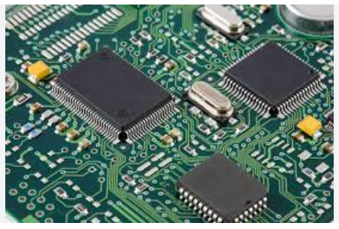

Module Title: -Designing and Developing power Electronics System

Module code: EIS IEC M02 1023
Nominal duration: 80Hour

Prepared by: Ministry of Labour and Skill

October, 2023
Addis Ababa, Ethiopia

Table of contents
Acknolwgement 3
Acronyms 4
Introduction to the Module 6
Unit-One: Power Electronics System 7
1.1 Introduction to Power Electronics 8
1.1.1 Uncontrolled devices 9
1.1.2 Semi-controllable devices 12
1.1.3 Fully-Controlled Devices: 16
1.2 OHS Policies, risk control measures and procedures 25
1.3 Materials, tools, and devices/components 31
Self-check-1 36
Operation sheet-1 38
Unit-Two: Power Electronics System 40
2.1 Power electronic control circuit 41
2.2 Selection of Power electronics components/materials 49
2.3 Power electronics software 50
Self-Check -2 52
Operation sheet-2 55
Lap Test-2 56
Unit-Three: Power Electronics System 57
3.1 Power electronic control components size and measurement 58
3.2 Schematic diagram preparation 59
Self Chech-3 61
Unit-Four: Test developed design 63
4.1 Check lines and component on a PCB board 64
4.2 Electronic and measuring devices testing techniques 65
4.3 Functional Test 67
4.4 Compile report 68
Self-Check-4 70
List of Reference Materials 73

Acknolwgement

The Ministry of Labor and skills wishes to thank and appreciation to MoLS leaders and experts, Regional Labor and skill/training Bureaus leader, experts, TVT College Deans, Instructors and industry experts who contribute their time and professional experience to the development of this Curriculum for Packing and Labeling Service.

Acronyms

A/D | Analog-To-Digital
AC | Alternating Current
AM | Amplitude Modulation
BJT's | Power Transistors
D/A | Digital-To-Analog
DC | Direct Current
DIAC | Diode for Alternating Current
DIP | Dual Inline Package
DSPs | Digital Signal Processors
FM | Frequency Modulation
GTO | Gate Turn-Off Thyristor
HVDC) | High Voltage Direct Current
ICs | Integrated Circuits
IGFET | Insulated Gate Field Effect Transistor
MOSFET | Power Metal-Oxide Semiconductor Field-Effect Transistor
OSH | Occupational Safety And Health
PCB | Printed Circuit Board
PIV | Peak Inverse. Voltage
PM) | Phase Modulation
POST | Power-On Self-Test
PPE | Personal Protective Equipment
PUT) | Programmable Unijunction Transistor
PWM | Pulse Width Modulation
QFN | Quad Flat No-Lead
SCR | Silicon-Controlled Rectifiers
SOIC | Small Outline Integrated Circuit
TRIAC | Triode Alternating Current
TSOP | Thin Small Outline Package
TTL | Transistor-Transistor Logic
WHO | World Health Organization
WHS | Workplace Health And Safety
𝐼𝑎 | Anode Current
𝐼𝑔 | Gate Current
𝑉𝐵𝑂 | Forward Break Over Voltage
𝑉𝐵𝑅 | Reverse Break Over Voltage
𝑉𝑎 | Anode Voltage Across The Thyristor Terminal A, K.

Introduction to the Module
In the field of Industrial Electrical Engineering; design and develop digital electronics system modules is designed to meet the industry requirements under the industrial machine to performing maintenance, troubleshooting and repair works on Maintain and Repair Industrial Electrical Machines and Drives including diagnose and rectify fault in motor drive system: Carry out Design and Develop digital electronics system
This module covers the units:
- Prepare to design and develop digital electronics systems
- Identify digital electronic circuit control system
- Design and develop basic digital electronic control system
- Test digital electronic

Learning Objective of the Module
- Follow OHS policies and procedures
- Identify digital electronic circuit
- Test requirement electronic circuit

Module Instruction
For effective use this modules trainees are expected to follow the following module instruction:
- Read the information written in each unit
- Accomplish the Self-checks at the end of each unit
- Perform Operation Sheets which were provided at the end of units
- Do the ―LAP test‖ giver at the end of each unit and

Unit-One: Power Electronics System
This unit is developed to provide you the necessary information regarding the following content coverage and topics:
  - Introduction to power electronics systems
  - OHS Policies, risk control measures and procedures
  - Materials ,tools, equipment’s and devices/components
This unit will also assist you to attain the learning outcomes stated in the cover page. Specifically, upon completion of this learning guide, you will be able to:
  - Explain power electronics systems
  - Identify and follow OHS Policies, risk control measures and procedures
  - Obtain Materials ,tools, equipment’s and devices/components

Introduction to Power Electronics
Power Electronics is a field which combines Power (electric power), Electronics and Control systems. Power engineering deals with the static and rotating power equipment for the generation, transmission and distribution of electric power. Electronics deals with the study of solid state semiconductor power devices and circuits for Power conversion to meet the desired control objectives (to control the output voltage and output power).
Power electronics may be defined as the subject of applications of solid state power semiconductor devices (Thyristor) for the control and conversion of electric power. Power electronics deals with the study and design of Thyristorised power controllers for variety of application like Heat control, Light/Illumination control, and Motor control - AC/DC motor drives used in industries, High voltage power supplies, Vehicle propulsion systems, High voltage direct current (HVDC) transmission.
Power Electronics refers to the process of controlling the flow of current and voltage and converting it to a form that is suitable for user loads. The most desirable power electronic system is one whose efficiency and reliability is 100%.Take a look at the following block diagram. It shows the components of a Power Electronic system and how they are interlinked.
Power electronics is a branch of electrical engineering that deals with the conversion, control, and management of electrical power. It involves the design, analysis, and implementation of circuits and systems that manipulate electrical energy to meet specific requirements.
A power electronic system converts electrical energy from one form to another and ensures the following is achieved
- Maximum efficiency
- Maximum reliability
- Maximum availability
- Minimum cost
- Least weight
- Small size

- Power Semiconductors Devices
The concept of the ideal switch is important when evaluating circuit topologies. Assumptions of zero-voltage drop, zero-leakage current, and instantaneous transitions make it easier to simulate and model the behavior of various electrical designs.
Power Semiconductor Devices
- Power Diodes.
- Power transistors (BJT's).
- Power MOSFETS. iv. IGBT's.
- Thyristor
All of these semiconductor devices can be classified as the following three types:

Uncontrolled devices
Uncontrolled devices that do not need any trigger signals to control their on/off action, such as a rectifying diode.
The switch has no control terminal. The state of the switch is determined by the external voltage or current conditions of the circuit in which the switch is connected. A diode is an example of such switch.
- Power diode (Uncontrolled switch) Power diodes play an important role in power electronics circuits. They are used mainly in uncontrolled rectifiers to convert AC to fixed DC voltages and as freewheeling diodes to provide a path for the current flow in inductive loads. Power diodes are similar in function to ordinary PN junction diodes; however, power diodes have larger power-, voltage-, and current-handling capabilities. The switch has no control terminal. The state of the switch is determined by the external voltage or current conditions of the circuit in which the switch is connected. A diode is an example of such switch.
Power diodes play an important role in power electronics circuits. They are used mainly in uncontrolled rectifiers to convert AC to fixed DC voltages and as freewheeling diodes to provide a path for the current flow in inductive loads. Power diodes are similar in function to ordinary PN junction diodes; however, power diodes have larger power-, voltage-, and current-handling capabilities.

Some examples of power diodes commonly used in power electronics:
- Rectifier Diodes
- Schottky Diodes
- Fast Recovery Diodes
- Zener Diodes
- Avalanche Diodes
- PIN Diodes
    - The PN Junction Diode:
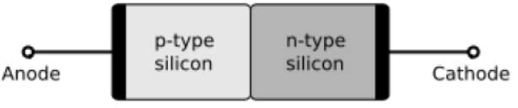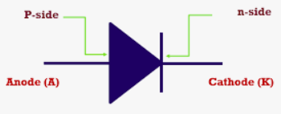
Figure 1.1:power diode PN-juction and symbols
Diode has two terminals an anode a terminal (P junction) and a cathode K terminal (N junction). When the anode voltage is more positive than the cathode, the diode is said to be forward-biased, and it conducts current readily with a relatively low voltage drop. When the cathode voltage is more positive than the anode, the diode is said to be reverse-biased, and it blocks the current flow. The arrow on the diode symbol shows the direction of conventional current flow when the diode conducts.
(b) The Voltage-Current Characteristic of a Diode:
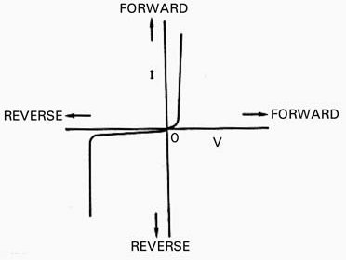
Figure 1.2: V-I Characteristics of Power Diode
When forward-biased, the diode begins to conduct current as the voltage across its anode (with respect to its cathode) is increased. When the voltage approaches the so-called knee voltage, about 1 V for silicon diodes, a slight increase in voltage causes the current to increase rapidly. This increase in current can be limited only by resistance connected in series with the diode.
When the diode is reverse-biased, a small amount of current called the reverse leakage current flows as the voltage from anode to cathode is increased; this simply indicates that a diode has a very high resistance in the reverse direction. This large resistance characteristic is maintained with increasing reverse voltage until the reverse breakdown voltage is reached. At breakdown, a diode allows a large current flow for a small increase in voltage. Again, a current-limiting resistor must be used in series to prevent destruction of the diode.
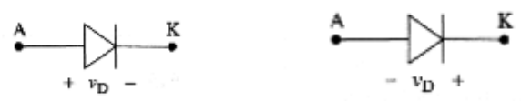
Figure 1.3: (a) Forward-biased diode and (b) Reverse-biased
Power diodes can be classified as:
  - General purpose diodes.
  - Fast recovery diodes.
  - Schottky Diodes.
Principal Ratings for Diodes:
- Peak Inverse. Voltage (PIV)
- Maximum Average Forward Current
- Reverse Recovery Time (trr)
Function of power diodes
Power diodes serve several important functions in power electronics applications. Here are the main functions of power diodes:
- Rectification
- Current Switching
- Voltage Clamping
- Overvoltage Protection
- Snubber Circuits

Semi-controllable devices
Semi-controllable devices, also known as semi-controlled devices, are electronic components that possess limited control over the flow of power or current. These devices exhibit some level of controllability but do not provide full control or regulation like active power electronic devices. They are typically used in applications where partial control is sufficient or where cost considerations are important.
  - The Silicon Controlled Rectifier SCR or Thyristor
It has three terminals: the anode (A) is the positive power terminal, the cathode (K) is the negative power terminals and the gate (G) is the control terminal.
Silicon-Controlled Rectifiers (SCRs) also known as Thyristor, are four-layer semiconductor devices that can handle high power levels. They are mainly used for rectification and switching applications in AC power systems. SCRs can be turned on by applying a gate trigger pulse, and once triggered, they remain conducting until the current through them decreases below a certain threshold or the supply voltage is removed.
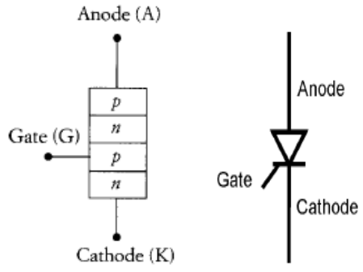
Figure 1.4: Thyristor (a) PNPN structure, (b) Symbol
When the SCR is forward-biased, that is, when the anode is made positive with respect to the cathode, a positive voltage on the gate with respect to the cathode turns on (triggers) the SCR. However, the current through the SCR cannot be turned off using the gate. It is turned off by interrupting the anode current. In a manner similar to that of a diode, the SCR blocks current in the reverse direction.
  - Two-Transistor Model of the SCR:
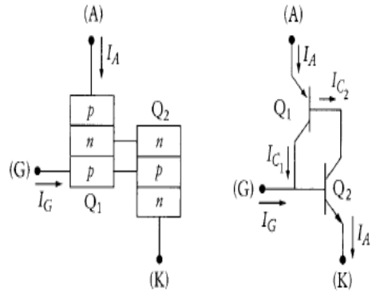
Figure 1.5: The SCR two-Thyristor mode (a) PNP-NPN transistor analogy, (b) SCR transistor analogy
The most common explanation of the positive feedback action that results when an SCR switches can be illustrated using the two-transistor model shown in Figure the SCR two-Thyristor mode (a) PNP-NPN transistor analogy, (b) SCR transistor analogy.
It is important to note that to turn the Thyristor on, the gate requires a small magnitude positive pulse for only a short period of time. Once the device is on, the gate signal serves no useful purpose and can be removed.
Electric's trade name for a type of Thyristor. SCRs are mainly used in electronic devices that require control of high voltage and power. This makes them applicable in medium and high AC power operations such as motor control function.
An SCR conducts when a gate pulse is applied to it, just like a diode. It has four layers of semiconductors that form two structures namely; NPNP or PNPN. In addition, it has three junctions labeled as J1, J2 and 18 J3 and three terminals (anode, cathode and a gate). An SCR is diagrammatically represented as shown below.
The anode connects to the P-type, cathode to the N-type and the gate to the P-type as shown below.
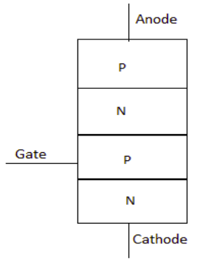
Figure 1.6: structure of Thyristor
SCR is made up of silicon, it act as a rectifier; it has very low resistance in the forward direction and high resistance in the reverse direction. It is a unidirectional device.
A typical SCR V-I characteristic is as shown below:
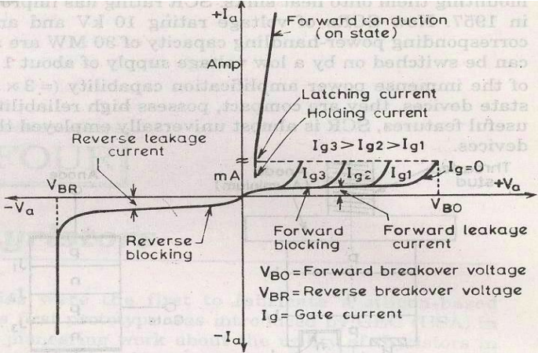
Figure 1.7: V-I characteristics of Thyristor
Where:
𝑉𝐵𝑂=Forward break over voltage
𝑉𝐵𝑅=Reverse break over voltage
𝐼𝑔=Gate current
𝑉𝑎=Anode voltage across the Thyristor terminal A, K.
𝐼𝑎=Anode current
It can be inferred from the static V-I characteristic of SCR.
SCR have 3 modes of operation:
- Reverse blocking mode
- Forward blocking mode (off state)
- Forward conduction mode (on state)
  - Reverse Blocking Mode when cathode of the Thyristor is made positive with respect to anode with switch open Thyristor is reverse biased. Junction’s 𝐽1 and 𝐽2 are reverse biased where junction 𝐽2 is forward biased. The device behaves as if two diodes are connected in series with reverse voltage applied across them.
- A small leakage current of the order of few mA only flows. As the Thyristor is reverse biased and in blocking mode. It is called as acting in reverse blocking mode of operation.
- Now if the reverse voltage is increased, at a critical breakdown level called reverse breakdown voltage 𝑉𝐵𝑅, an avalanche occurs at 𝐽1 and 𝐽3 and the reverse current increases rapidly. As a large current associated with 𝑉𝐵𝑅 and hence more losses to the SCR. This results in Thyristor damage as junction temperature may exceed its maximum temperature rise.
  - Forward Blocking Mode when anode is positive with respect to cathode, with gate circuit open, Thyristor is said to be forward biased. Thus junction 𝐽1 and 𝐽3 are forward biased and 𝐽2 is reverse biased. As the forward voltage is increases junction 𝐽2 will have an avalanche breakdown at a voltage called forward breakover voltage𝑉𝐵𝑂. When forward voltage is less than 𝑉𝐵𝑂Thyristor offers high impedance. Thus a Thyristor acts as an open switch in forward blocking mode.
  - Forward Conduction Mode here Thyristor conducts current from anode to cathode with a very small voltage drop across it. So a Thyristor can be brought from forward blocking mode to forward conducting mode:
- By exceeding the forward breakover voltage.
- By applying a gate pulse between gate and cathode.
During forward conduction mode of operation Thyristor is in on state and behave like a close switch. Voltage drop is of the order of 1 to 2mV. This small voltage drop is due to ohmic drop across the four layers of the device.

Fully-Controlled Devices:
    - Gate Turn-Off Thyristor (GTO)
The GTO is a type of Thyristor that can be turned on and off with a gate pulse. It offers better control compared to the standard Thyristor, but turn-off gate voltages are usually larger and require more current than turn-on levels. A snubber circuit is often required for proper switching characteristics.
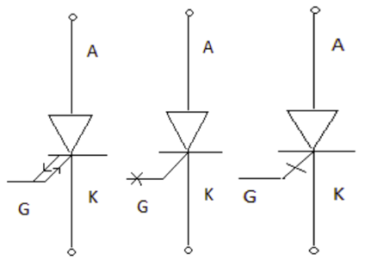
Figure 1.8: symbol of GTO
Conventional SCR are turned on by a positive gate signal but once the SCR is turned on gate loses control over it. So to turn it off we require external commutation circuit. These commutation circuits are bulky and costly. So due to these drawbacks GTO comes into existence.
The salient features of GTO are:
- GTO turned on like conventional SCR and is turned off by a negative gate signal of sufficient magnitude.
- It is a non latching device.
- GTO reduces acoustic and electromagnetic noise.
It has high switching frequency and efficiency. A gate turn off Thyristor can turn on like an ordinary Thyristor but it is turn off by negative gate pulse of appropriate magnitude. Disadvantage
- The negative gate current required to turn off a GTO is quite large that is 20% to 30 % of anode current
Advantage
- It is compact and cost less
Gate turn-on characteristics
- The gate turn on characteristics is similar to a Thyristor. Total turn on time consists of delay time, rise time, spread time.
- The turn on time can be reduced by increasing its forward gate current.
    - TRIAC :
The Triac is a member of the Thyristor family. But unlike a Thyristor which conducts only in one direction (from anode to cathode) a triac can conduct in both directions. Thus a triac is similar to two back to back (anti parallel) connected Thyristor but with only three terminals.
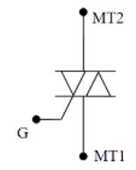
Figure 1.9: symbol of TRIAC
V-I characteristics OF TRIAC
From a functional point of view a triac is similar to two Thyristor connected in anti-parallel. Therefore, it is expected that the V-I characteristics of Triac in the 1st and 3rd quadrant of the V-I plane will be similar to the forward characteristics of a Thyristor. As shown in Fig. 6, with no signal to the gate the triac will block both half cycle of the applied ac voltage provided its peak value is lower than the break over voltage (V_{BO} ) of the device. However, the turning on of the triac can be controlled by applying the gate trigger pulse at the desired 19 instance. Mode-1 triggering is used in the first quadrant whereas Mode-3 triggering is used in the third quadrant.
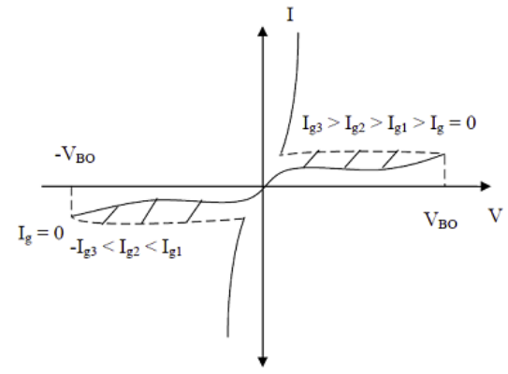
Figure 1.10: V-I characteristics of TRIAC
As such, most of the Thyristor characteristics apply to the triac (i.e., latching and holding current). However, in a triac the two conducting paths (from MT 1 to MT 2 or from MT 1 to MT 1) interact with each other in the structure of the triac. Therefore, the voltage, current and frequency ratings of triacs are considerably lower than Thyristor. At present triacs with voltage and current ratings of 1200V and 300A (rms) are available. Triacs also have a larger on state voltage drop compared to a Thyristor.
Modes of operation of TRIAC and mention the preferred modes Since a Triac is a bidirectional device and can have its terminals at various combinations of positive and negative voltages, there are four possible electrode potential combinations as given below
MT 2 positive with respect to MT 1, G positive with respect to MT 1
MT 2 positive with respect to MT 1, G negative with respect to MT 1
MT 2 negative with respect to MT 1 , G negative with respect to MT 1
MT 2 negative with respect to MT 1, G positive with respect to MT 1 The triggering sensitivity is highest with the combinations 1 and 3 and are generally used. However, for bidirectional control and uniforms gate trigger mode sometimes trigger.
In trigger mode-1 the gate current flows mainly through the P 2 N 2 junction like an ordinary Thyristor. When the gate current has injected sufficient charge into P 2 layer the triac starts conducting through the P 1 N 1 P 2 N 2 layers like an ordinary Thyristor.
In the trigger mode-3 the gate current I g forward biases the P 2 P 3 junction and a large number of electrons are introduced in the P 2 region by N3. Finally the structure P 2 N 1 P 1 N 4 turns on completely.
Applications of TRIAC (Phase control using TRIAC)
A triac is functionally equivalent to two anti-parallel connected Thyristor. It can block voltages in both directions and conduct current in both directions.
A triac has three terminals like a Thyristor. It can be turned on in either half cycle by either a positive on a negative current pulse at the gate terminal.
Triacs are extensively used at power frequency ac load (e.g. heater, light, motors) control applications.
Power Transistors:
Power transistors are three terminal devices which are composed of semiconductor materials. They feature emitter, base and collector terminals. These devices are particularly designed to control high current – voltage rating.
- Power Bipolar Junction Transistor (BJT)
Power BJT is used traditionally for many applications. However, IGBT (Insulated-Gate Bipolar Transistor) and MOSFET (Metal-Oxide-Semiconductor Field-Effect Transistor) have replaced it for most of the applications but still they are used in some areas due to its lower saturation voltage over the operating temperature range. IGBT and MOSFET have higher input capacitance as compared to BJT. Thus, in case of IGBT and MOSFET, drive circuit must be capable to charge and discharge the internal capacitances.
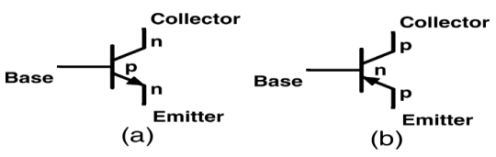
Figure 1.11: Symbol of BJT transistor
The BJT is a three-layer and two-junction NPN or PNP semiconductor device. Although BJTs have lower input capacitance as compared to MOSFET or IGBT, BJTs are considerably slower in response due to low input impedance. BJTs use more silicon for the same drive performance. In the case of MOSFET studied earlier, power BJT is different in configuration as compared to simple planar BJT. In planar BJT, collector and emitter is on the same side of the wafer while in power BJT it is on the opposite edges as shown in Fig. 33. This is done to increase the power-handling capability of BJT.
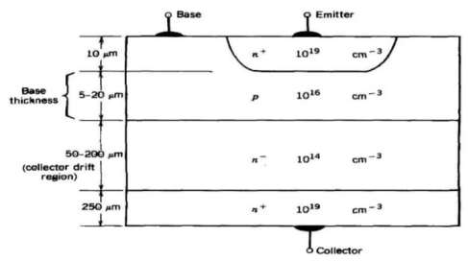
Figure: 1.12. Construction of Power BJT
Power n-p-n transistors are widely used in high-voltage and high-current applications which will be discussed later. Input and output characteristics of planar BJT for common-emitter configuration are shown in fig. These are current-voltage characteristics curves.
V – I Characteristics of BJT
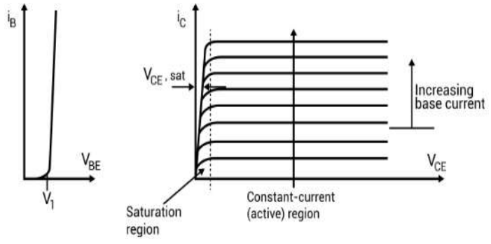
Figure: 1.13. Input and Output Characteristics of Power BJT

Advantages of BJT’S
BJT’s have high switching frequencies since their turn-on and turn-off time are low.
- The turn-on losses of a BJT are small.
- BJT has controlled turn-on and turn-off characteristics since base drive control is possible.
- BJT does not require commutation circuits
Demerits of BJT
- Drive circuit of BJT is complex.
- It has the problem of charge storage which sets a limit on switching frequencies.
- It cannot be used in parallel operation due to problems of negative temperature coefficient.
- Power Metal-Oxide Semiconductor Field-Effect Transistor (MOSFET)
Power MOSFET is a Metal Oxide Semiconductor Field Effect Transistor. It has three terminals Gate, Source, Drain. The gate is insulated from the channel by a layer of SiO2. It is also called as Insulated Gate Field Effect Transistor (IGFET). It is a unipolar device. The gate terminal has the complete control over the operation of MOSFET. The operation of Power MOSFET depends on flow of majority charge carriers, it is called as Voltage Controlled Device. It operates in two modes: Depletion Mode and Enhancement Mode. In depletion Mode, a negative voltage is applied to decrease the width of the channel. In Enhancement Mode, a positive voltage is applied to increase the width of the channel. Both depletion and enhancement mode have N-Channel and P-Channel MOSFET. Power MOSFETs which are most widely used are N-channel Enhancement Mode. These exhibit high switching speed and can work much better in comparison with other normal MOSFETs.
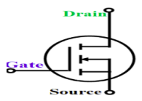
Figure: 1.14. Symbol of Power MOSFE

Construction of MOSFET:
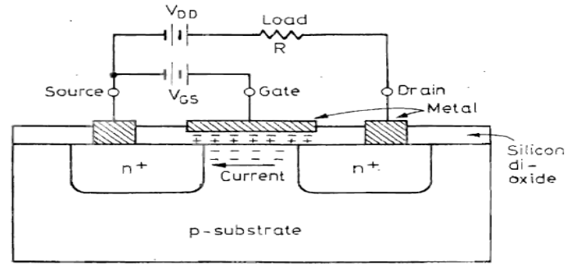
Figure: 1.14. Basic Structure of N Channel Enhancement MOSFET
V – I Characteristics of Power MOSFET
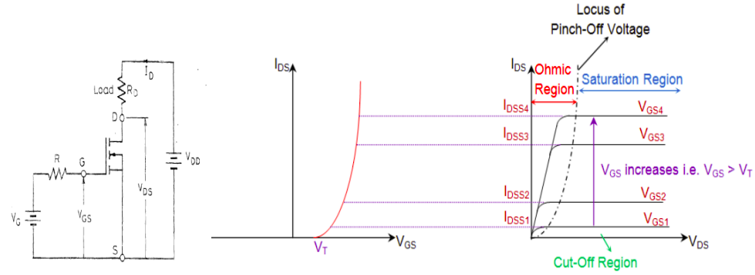
Figure: 1.15. Circuit diagram and V-I Characteristics of Power MOSFET
For lower value of VDS, MOSFET works in a linear region where it has a constant resistance equal to VDS / ID. For a fixed value of VGS and greater than threshold voltage VTH, MOSFET enters a saturation region where the value of the drain current has a fixed value. Besides the output characteristics curves, transfer characteristics of power MOSFET is also shown in Fig.

Table 1.1: Comparison of Power BJT and Power MOSFET
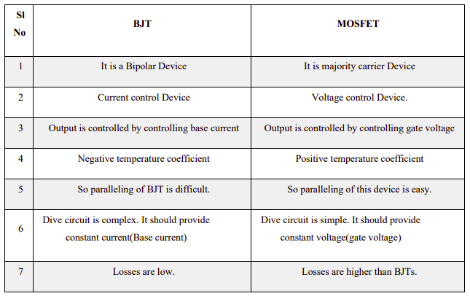
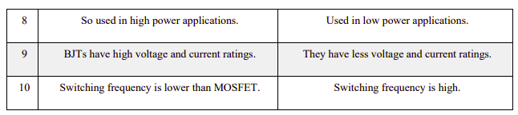
- Insulated-Gate Bipolar Transistor (IGBT)
IGBT combines the physics of both BJT and power MOSFET to gain the advantages of both worlds. It is controlled by the gate voltage. It has the high input impedance like a power MOSFET and has low on-state power loss as in case of BJT. There is no even secondary breakdown and not have long switching time as in case of BJT. It has better conduction characteristics as compared to MOSFET due to bipolar nature. It has no body diode as in case of MOSFET but this can be seen as an advantage to use external fast recovery diode for specific applications. They are replacing the MOSFET for most of the high voltage applications with less conduction losses. Its physical cross-sectional structural diagram and equivalent circuit diagram is presented in Fig. It has three terminals called collector, emitter and gate.
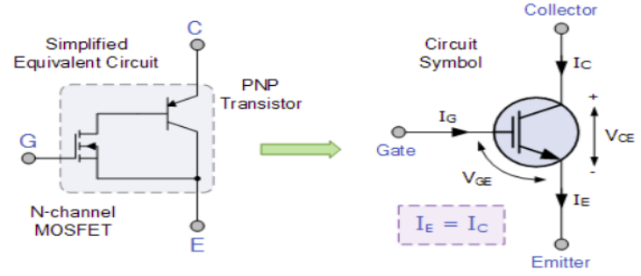
Figure: 1.16. Equivalent diagram and Symbol of MOSFET
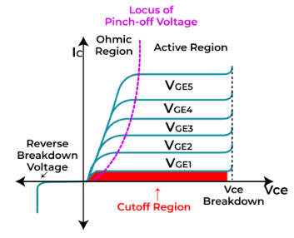
Figure: 1.17. V-I Characteristics of IGBT
Merits of IGBT:
- Voltage controlled Device
- Less On state loss
- High switching frequency
- No commutation circuit
- Gate has full control over operation.
- Flat temperature coefficient

Demerits of IGBT:
- Static charge problem
- Costlier than BJT and MOSFET
Applications of IGBT:
- IGBTs are used in high power applications such as:
- Appliance motor drives
- Electric vehicle motor drives
- Power factor correction converters
- Uninterruptible power supplies
- Solar inverters
- High frequency welders
- Inductive heating cookers
- programmable unijunction transistor(PUT)
A programmable unijunction transistor (PUT) is a three-lead electronic semiconductor device which is similar in its characteristics to a unijunction transistor, except that its behavior can be controlled using external components.
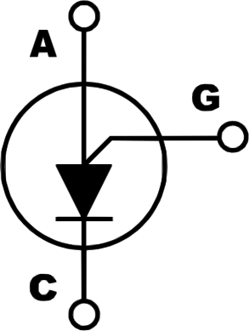
Figure 1.18: symbol of PUT

OHS Policies, risk control measures and procedures

Occupational health and safety
Occupational safety and health (OSH), also commonly referred to as occupational health and safety (OHS), occupational health, or workplace health and safety (WHS), is a multidisciplinary field concerned with the safety, health, and welfare of people at work. OSH may also protect co-workers, family members, employers, customers, and many others who might be affected by the workplace environment. In the United States, the term occupational health and safety is referred to as occupational health and occupational and non-occupational safety and includes safety for activities outside of work.
In common-law jurisdictions, employers have a common law duty to take reasonable care of the safety of their employees. Statute law may in addition impose other general duties, introduce specific duties, and create government bodies with powers to regulate workplace safety issues: details of this vary from jurisdiction to jurisdiction. All organizations have the duty to ensure that employees and any other person who may be affected by the organization's activities remain safe at all times. As defined by the World Health Organization (WHO) "occupational health deals with all aspects of health and safety in the workplace and has a strong focus on primary prevention of hazards."
The main focus in occupational health is on three different objectives:
- The maintenance and promotion of workers’ health and working capacity;
- The improvement of working environment and work to become conducive to safety and health and
- Development of work organizations and working cultures in a direction which supports health and safety at work and in doing so also promotes a positive social climate and smooth operation and may enhance productivity of the undertakings.
The concept of working culture is intended in this context to mean a reflection of the essential value systems adopted by the undertaking concerned. Such a culture is reflected in practice in the managerial systems, personnel policy, principles for participation, training policies and quality management of the undertaking.
Occupational health should aim at:
- The promotion and maintenance of the highest degree of physical, mental and social well-being of workers in all occupations;
- The prevention amongst workers of departures from health caused by their working conditions;
- The protection of workers in their employment from risks resulting from factors adverse to health;
- The placing and maintenance of the worker in an occupational environment adapted to his physiological and psychological capabilities; and, to summarize,
- Hazards, risks, outcomes
The terminology used in OSH varies between countries, but generally speaking:
- A hazard is something that can cause harm if not controlled.
- The outcome is the harm that results from an uncontrolled hazard.
- A risk is a combination of the probability that a particular outcome will occur and the severity of the harm involved.
‘Hazard‖’, ‘risk‖’, and ‘outcome‖’ are used in other fields to describe e.g. environmental damage, or damage to equipment. However, in the context of OSH, ―harm‖ generally describes the direct or indirect degradation, temporary or permanent, of the physical, mental, or social well-being of workers. For example, repetitively carrying out manual handling of heavy objects is a hazard.
- Hazard identification
Hazard identification or assessment is an important step in the overall risk assessment and risk management process. It is where individual work hazards are identified, assessed and controlled/eliminated as close to source (location of the hazard) as reasonably as possible. As technology, resources, social expectation or regulatory requirements change, hazard analysis focuses controls more closely toward the source of the hazard. Thus hazard control is a dynamic program of prevention. Hazard-based programs also have the advantage of not assigning or implying there are "acceptable risks" in the workplace. A hazard-based program may not be able to eliminate all risks, but neither does it accept "satisfactory" – but still risky – outcomes. And as those who calculate and manage the risk are usually managers while those exposed to the risks are a different group, workers, a hazard-based approach can by-pass conflict inherent in a risk-based approach.
- Risk Assessment
Modern occupational safety and health legislation usually demands that a risk assessment be carried out prior to making an intervention. It should be kept in mind that risk management requires risk to be managed to a level which is as low as is reasonably practical.
This assessment should:
- Identify the hazards
- Identify all affected by the hazard and how
- Evaluate the risk
- Identify and prioritize appropriate control measures
The calculation of risk is based on the likelihood or probability of the harm being realized and the severity of the consequences. This can be expressed mathematically as a quantitative assessment (by assigning low, medium and high likelihood and severity with integers and multiplying them to obtain a risk factor), or qualitatively as a description of the circumstances by which the harm could arise.
- Safety procedures and Sequence Safety:
Relative freedom from danger, risk, or threat of harm, injury, or loss to personnel and/or property, whether caused deliberately or by accident. Hazards may occur due to improper handling of tools and equipment’s, unsafe work areas, operating machines without knowing how to operate and using materials out of their intended purpose etc…
- Safe work practices
A safe work environment is not enough to control all electric hazards. You must also work safely. Safe work practices help you control your risk of death from workplace hazards. If you are working on electrical circuits or with electrical tools and equipment, you need to use safe work practices.
Before you begin a task, ask yourself:
- What could go wrong?
- Do I have the knowledge, tools, and experience to do this work safely?
- All workers should be very familiar with the safety procedures for their jobs. You must know how to use specific controls that help keep you safe. You must also use good judgment and common sense.
Safety Procedures in Using Hand Tools and Equipment
We are already familiar with the different hand tools and their proper use. Know we need to know how to be safe in using these. What are the safety precautions in using hand tools and equipment? What are its do’s and don’ts’s?
Safety Precautions
All tools must be kept in good condition with regular maintenance.
- Right tool must be used for job.
- Each tool must be examined before use and damaged or defective tools not to be used.
- Tools must be operated according to manufacturer’s instruction.
- The right protective equipment for the tool and activity must be used.
Procedures in Cleaning, Tightening and Simple Repair for Hand tools and Equipment
- Cleaning the tools after use is highly recommended.
- All tools and equipment must be placed in a clean and dry place.
- The work area must always be kept neat and tidy.
- Lubricants must also be applied after tightening to reduce the friction.
Before cleaning any tool, be sure to wear the proper personal protective equipment (PPE). Gloves, masks and goggles are usually worn when cleaning tools since most cleaning agents and solutions are harmful to the human body. Only use cleaning agents as prescribed by the tool or equipment’s manufacturer. Follow the cleaning procedures as well to make sure that no damage will be inflicted on the tools.
Use personal protective equipment
Personal Protective Equipment (PPE) is anything used or worn by a person to minimize risk to the person’s health or safety and includes a wide range of clothing and safety equipment. PPE includes boots (safety shoes, face masks, hard hats (helmet), ear plugs, respirators, gloves, safety harnesses and high visibility clothing.
- Safety for the head
Wearing a helmet offers protection and can prevent head injuries. Select a sturdy helmet that is adapted to the working conditions. These days you can find many elegant designs and you can choose extra options such as an adjustable interior harness and comfortable sweatbands.

Figure 1.19: Helmet
- Protect your eyes
The eyes are the most complex and fragile parts of our body. Each day, more than 600 people worldwide sustain eye injuries during their work. Thanks to a good pair of safety glasses, these injuries could be prevented. Do you come into contact with bright light or infrared radiation? Then welding goggles or a shield offer the ideal protection!

Figure 1.20: Goggles
- Maintain a good Respiration
Wearing a mask at work is no luxury, definitely not when coming into contact with hazardous materials. 15% of the employees within the EU inhale vapours, smoke, powder or dusk while performing their job. Dust masks offer protection against fine dust and other dangerous particles. If the materials are truly toxic, use a full-face mask. This adheres tightly to the face, to protect the nose and mouth against harmful pollution.

Figure 1.21: Full-face mask

- Protect your hands with the right gloves
Hands and fingers are often injured, so it is vital to protect them properly. Depending on the sector you work in, you can choose from gloves for different applications:

Figure 1.22: Gloves
Benefits of PPE
PPE is one of the least effective ways of controlling risks to work health and safety and should only be used: when there are no other practical control measures available (as a last resort) As an interim measure until a more effective way of controlling the risk can be used, or To supplement higher level control measures (as a back-up).
The right PPE for the job:
Selection processes for choosing the right PPE must involve consultation with workers and their representatives and should include:
- A detailed evaluation of the risk and performance requirements for the PPE
- compatibility of PPE items where more than one type of PPE is required (for example ear muffs with a hard hat)
- Consultation with the supplier to ensure PPE is suitable for the work and workplace conditions, and
- Preference for PPE that complies with the relevant Australian Standard or equivalent standard. Always remember to use PPE and apply safety rules while working any electrical works.

Materials, tools, and devices/components
Materials, tools, and devices/components are essential elements in various fields, including manufacturing, construction, electronics, and more. Here's an overview of each category:
Appropriate tools and equipment’s
It is hard to do a good job of electronics construction unless proper electronic tools and knowledge of using them are adequate.
- Drivers Screw driver
It is a device specifically designed to insert and tighten or to loosen and remove screws. A screwdriver comprises a head or tip which engages with a screw, a mechanism to apply torque by rotating the tip and some way to position and support the screwdriver. A typical hand screwdriver comprises an approximately cylindrical handle of a size and shape to be held by a human hand and an axial shaft fixed to the handle, the tip of which is shaped to fit a particular type of screw. The handle and shaft allow the screwdriver to be positioned and supported when rotated to apply torque.
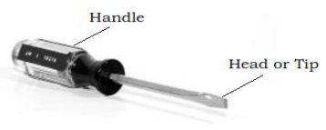
Figure 1.23: Driver
- Phillips Screwdriver:
It is used to drive or fasten positive slotted screws. It is a screwdriver that could take greater torque and can provide tighter fastenings.
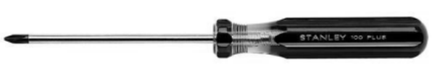
Figure 1.24: Philips
- Soldering Iron
It is a device used for applying heat to melt solder in attaching two metal parts. A soldering iron is composed of a heated metal tip and an insulated handle. Heating is often achieved electrically, by passing a current, supplied through an electrical cord, through a heating element. For electrical work, wires are usually soldered to printed circuit boards, other wires, or small terminals. A low-power iron (1530 Watts) is suitable for this works
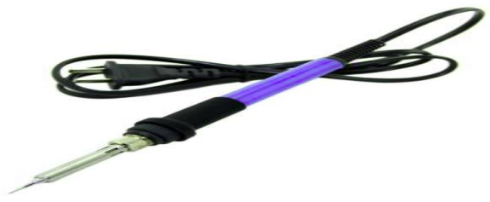
Figure 1.25: Soldering Iron
- Designing tools
Electronic circuit design and simulation software
Uses mathematical models to replicate the behavior of an actual electronic device or circuit. Simulation software allows for modeling of circuit operation and is an invaluable analysis tool. Due to its highly accurate modeling capability, many colleges and universities use this type of software for the teaching of electronics technician and electronics engineering programs. Electronics simulation software engages its users by integrating them into the learning experience. These kinds of interactions actively engage learners to analyze, synthesize, organize, and evaluate content and result in learners constructing their own knowledge.
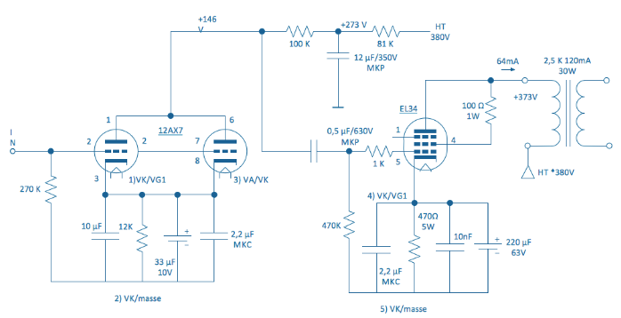
Figure 1.26: electrical circuit diagram
Simulating a circuit’s behavior before actually building it can greatly improve design efficiency by making faulty designs known as such, and providing insight into the behavior of electronics circuit designs. Examples of Electronic circuit design and simulation software:
- Circuit Maker
- Open Circuit Design Software
- KiCad EDA
- ADS Circuit Design Software
- SuperSim Circuit Design Software
- Portus
Computers
Is a device that accepts information (in the form of digitalized data) and manipulates it for some result based on a program, software, or sequence of instructions on how the data is to be processed? By installing Electronic circuit design and simulation software, we can use them to design and construct electrical/electronics circuit.

Figure 1.27: Computer (desktop and laptop)
- Printed circuit board (PCB)
Printed circuit boards (PCBs) are by far the most common method of assembling modern electronic circuits. Comprised of a sandwich of one or more insulating layers and one or more copper layers which contain the signal traces and the powers and grounds, the design of the layout of printed circuit boards can be as demanding as the design of the electrical circuit. Most modern systems consist of multilayer boards of anywhere up to eight layers (or sometimes even more). Traditionally, components were mounted on the top layer in holes which extended through all layers. These are referred as through hole components. More recently, with the near universal adoption of surface mount components, you commonly find components mounted on both the top and the bottom layers. The design of the printed circuit board can be as important as the circuit design to the overall performance of the final system. We shall discuss in this chapter the partitioning of the circuitry, the problem of interconnecting traces, parasitic components, grounding schemes, and decoupling. All of these are important in the success of a total design.
Figure 1.28: PCB
- Hand tools
Hand tools are simple tools which you use with your hands , and which are usually not powered also Hand tools is any tool that is powered by hand rather than a motor examples are chopping, chiseling, , cutters, files, striking tools, struck or hammered tools, screwdrivers, vises, clamps, snips, saws, and drills.
- Strip board (uninsulated breadboard)
Strip board is one of the commonly-used types of prototyping board. These boards are intended for permanently assembling one-off circuits, especially prototypes. The board is made from insulating material, usually a resin-bonded plastic or fiberglass. One side has parallel copper strips on it, spaced 2.54 mm apart. There are holes bored in these strips, also 2.54 mm apart. Components are placed on the other side of the board with their wires bent to pass through the holes. The wires are soldered to the copper strips, the projecting ends being cut off to make the assembly neater.
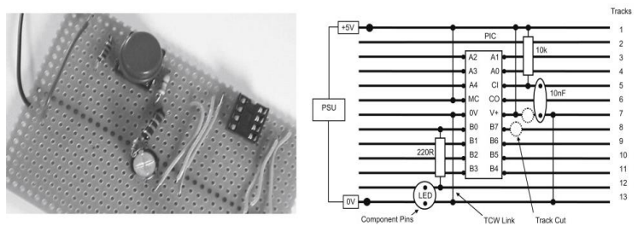
Figure 1. 29: Strip board (uninsulated breadboard)

Self-check-1

Part-I: Say True or False
- Power electronics is the study of electronic devices and circuits used to control and convert electrical power.
- Power electronics primarily focuses on AC (alternating current) systems.
- New workers are less likely to get hurt on the job than people who have been on the job longer.
- The Occupational Health and Safety Act and Regulations tell everyone from the employer to the newest worker how to make the workplace safer.

Part-II: Multiple Choose
- What is the main goal of a power electronic system?
a) Maximum efficiency
b) Maximum reliability
c) Maximum availability
d) All of the above
- Which type of power electronic application utilizes moving and/or rotating mechanical parts?
a) Static applications
b) Drive applications
c) Both static and drive applications
d) None of the above
- What is the purpose of a multimeter?
a) To measure temperature
b) To measure voltage
c) To cut wires
d) To tighten screws
- Which tool is used to cut through metal?
a) Screwdriver
b) Hammer
c) Pliers
d) Hacksaw

Part-III: Write the Short Answer
- What is power electronics, and what are its main applications?
- Explain the concept of power semiconductor devices and their role in power electronics.
- What are the key elements of an OHS management system?
- Power semiconductors can be classified into-----------, and list each.
- Soldering irons may be externally heated.

Part-IV: Matching

Column “A” | Column “B”
- PCB | - Power diode
- Thyristor | - Goggles
- Un-controlled devices | - a non-conductive material
- Protect your eyes | - acting as a switch

Operation sheet-1

Module Title: Designing and Developing Digital Electronics System

Operation title: To Design the Silicon Controlled Rectifier (SCR)
Purpose: To practice and demonstrate the knowledge and skill required in measuring the voltage and currents.

Instruction: Use the given circuit diagram (Figure-1), Read the manual. For this operation you have given 3 Hour and you are expected to provide the answer on the given table.

Precautions: Measure at least two times the result on the given format
Steps in doing the task;
Step-1: Use the given figure
Step-2: Measure the output of the given component.

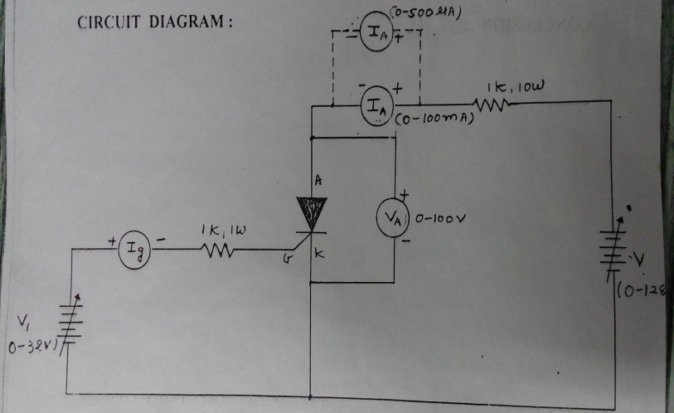
Figure -1

Lab Test-1:

Task-1: Perform liner measurement using mulitimeter
Task-2: Measure the gate voltage and current of the SCR circuit.
Task-3: Record measurements using standard procedure

Unit-Two: Power Electronics System
This unit is developed to provide you the necessary information regarding the following content coverage and topics:
- Power electronic control circuit
- Selection of Power components/materials
- Application of power electronics Software
This unit will also assist you to attain the learning outcomes stated in the cover page. Specifically, upon completion of this learning guide, you will be able to:
  - Identify Digital electronic logic gates and circuit
  - Components /material collected for selected project
  - Application of digital electronics is understood

Power electronic control circuit
A power electronic control circuit is a circuit that is used to control and regulate the operation of power electronic devices or converters. These circuits play a crucial role in ensuring the efficient and reliable operation of power electronic systems. They are responsible for controlling the switching of power electronic devices, managing power flow, and maintaining desired output characteristics.
Key Components of a Power Electronic Control Circuit:
- Controller: The controller is the brain of the control circuit. It receives input signals, processes them, and generates control signals to regulate the operation of power electronic devices. The controller can be implemented using various technologies such as microcontrollers, digital signal processors (DSPs), or programmable logic controllers (PLCs).
- Sensors: Sensors are used to measure various parameters such as voltage, current, temperature, and speed. These measurements provide feedback to the controller, enabling it to make informed decisions and adjustments in real-time.
- Gate Drivers: Gate drivers are responsible for providing the necessary voltage and current signals to control the switching of power electronic devices such as transistors or Thyristor. They ensure proper timing and control of the switching process.
- Protection Circuits: Power electronic control circuits often include protection mechanisms to safeguard the system and its components from faults, overloads, and short circuits. These protection circuits can include overcurrent protection, overvoltage protection, and temperature monitoring.
Applications of Power Electronic Control Circuits:
- Motor Drives: Power electronic control circuits are widely used in motor drives for precise control of motor speed, torque, and direction. They enable efficient and variable speed control of motors in applications such as industrial machinery, electric vehicles, and robotics.
- Power Supplies: Power electronic control circuits are used in power supplies to convert and regulate electrical power. They ensure stable and reliable power delivery to various electronic devices, ranging from small electronic gadgets to large-scale industrial systems.
- Renewable Energy Systems: Power electronic control circuits are essential in renewable energy systems such as solar and wind power. They enable the efficient conversion of renewable energy sources into usable electrical power and facilitate grid integration.
- Electric Grid Systems: Power electronic control circuits play a vital role in grid systems for power transmission, distribution, and voltage regulation. They enable efficient power flow control, reactive power compensation, and grid stability enhancement.
A power electronic control circuit refers to the circuitry and components used to control and regulate the operation of power electronic devices in various applications. These control circuits play a crucial role in ensuring proper functionality, efficiency, and protection of power electronic systems. Here are some key aspects and components of a power electronic control circuit:
Control Signals: Power electronic control circuits receive control signals from external sources or microcontrollers to regulate the operation of power electronic devices.
Gate Drive Circuit: Gate drive circuits are used to control the switching behavior of power electronic devices such as transistors (MOSFETs, IGBTs) and thyristors (SCRs, TRIACs). They generate the appropriate voltage and current levels to turn the devices on and off at the desired timing and duration.
PWM signals are used in applications such as motor speed control, power inverters, and DC-DC converters.
Feedback and Control Loops: Power electronic control circuits often incorporate feedback and control loops to regulate and stabilize the output parameters. These loops compare the desired output values with the actual measured values and adjust the control signals accordingly. Examples include voltage feedback loops, current feedback loops, and closed-loop control algorithms.
Protection and Fault Detection: Power electronic control circuits include protection mechanisms to safeguard the system and components from overcurrent, overvoltage, over temperature, and other faults. These protection features may involve current sensing, voltage sensing, temperature sensing, and fault detection circuitry.
Analog and Digital Signal Processing: Power electronic control circuits can involve both analog and digital signal processing techniques. Analog circuits are used for signal conditioning, amplification, filtering, and analog-to-digital (A/D) or digital-to-analog (D/A) conversion. Digital signal processing (DSP) techniques are employed for advanced control algorithms, digital signal filtering, and communication interfaces.
Microcontrollers and Digital Signal Processors (DSPs): Microcontrollers and DSPs are often used in power electronic control circuits for advanced control algorithms, signal processing, and communication interfaces. They provide the intelligence and computational power required for complex control tasks and system monitoring.
Communication Interfaces: Power electronic control circuits may incorporate communication interfaces such as serial communication (UART, SPI, and I2C), Ethernet, or fieldbus protocols (CAN, Modbus) for remote monitoring, control, and integration with other systems.
User Interface: In some applications, power electronic control circuits include a user interface for monitoring and controlling the system parameters. This may involve displays, buttons, touchscreens, or human-machine interfaces (HMIs) to provide real-time information and user interaction.

Power Supply and Conditioning: Power electronic control circuits require reliable and stable power sources. Power conditioning circuits, such as voltage regulators and filters, are used to provide clean and stable power to the control circuitry.
The specific design and components of a power electronic control circuit depend on the application requirements, system complexity, and desired functionality. It is important to carefully design and implement these control circuits to ensure proper operation, efficiency, and protection of the power electronic system.
Control mechanizing of Thyristor
To control the triggering and operation of a Thyristor, you can use various techniques. One common method is to use pulse-width modulation (PWM) control, which allows precise control of the thyristor's conduction angle and power output. Here's a general overview of how you can control the mechanizing of a Thyristor:

Triggering Circuit: The triggering circuit provides the necessary gate current to turn on the thyristor. It typically consists of a control signal source and a pulse transformer or optocoupler to isolate the control circuit from the power circuit.

Gate Signal Generation: The gate signal is generated by a control circuit, which can be implemented using various techniques such as microcontrollers, digital signal processors (DSPs), or dedicated gate driver ICs. The control circuit processes the desired control input (e.g., voltage, current, or frequency) and generates an appropriate gate signal to trigger the thyristor.
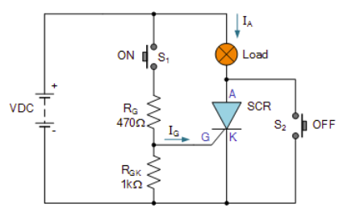
Figure 2.1: Thyristor circuit

To control the triggering and operation of a Silicon-Controlled Rectifier (SCR), you can use various techniques. Here's a general overview of how you can control the mechanizing of an SCR:
Triggering Circuit: The triggering circuit provides the necessary gate current to turn on the SCR. The gate current can be derived from various sources such as a control signal source, a pulse transformer, or an optocoupler.
Gate Signal Generation: The gate signal is generated by a control circuit that processes the desired control input. The control input can be a voltage, current, or frequency signal. The control circuit generates an appropriate gate signal to trigger the SCR based on the control input.
Triggering Methods: There are several methods to trigger an SCR:
- Forward Voltage Triggering: Applying a sufficient forward voltage across the anode and cathode terminals of the SCR can trigger it. This method is commonly used for low-power applications.
- Gate Current Triggering: Applying a sufficient gate current to the gate terminal of the SCR can trigger it. This method provides more precise control and is commonly used for both low-power and high-power applications.
- DIAC
The Diac is a two-junction bidirectional semiconductor device designed to break down when the AC voltage across it exceeds a certain level passing current in either direction
The Diode AC switch, or Diac for short, is another solid state, three-layer, two-junction semiconductor device but unlike the transistor the Diac has no base connection making it a two terminal device, labelled A₁ and A₂.
Diac’s are an electronic component which offer no control or amplification but act much like a bidirectional switching diode as they can conduct current from either polarity of a suitable AC voltage supply.

Diac AC Phase Control

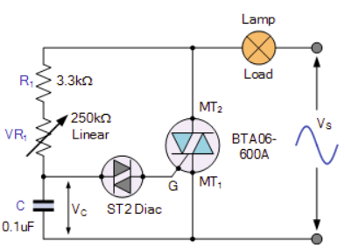

Figure 2.2: DIAC control circuit

As the AC supply voltage increases at the beginning of the cycle, capacitor, C is charged through the series combination of the fixed resistor, R1 and the potentiometer, VR₁ and the voltage across its plate’s increases. When the charging voltage reaches the break over voltage of the diac (about 30 V for the ST2), the diac breaks down and the capacitor discharges through the diac.

The Quadrant
The Quadrant is basically a Diac and Triac fabricated together within a single semiconductor package and as such are also known as “internally triggered triacs”. This all in one bi-directional device is gate controlled using either polarity of the main terminal voltage which means it can be used in full-wave phase-control applications such as heater controls, lamp dimmers, and AC motor speed control, etc.
- IGBT

The equivalent circuit of an IGBT is shown below. When both the gate-emitter (G-E) and collector-emitter (C-E) paths are positively biased, the N-channel MOSFET conducts, causing drain current to flow. This drain current also flows to the base of Q_{PNP} and causes the IGBT to turn on.

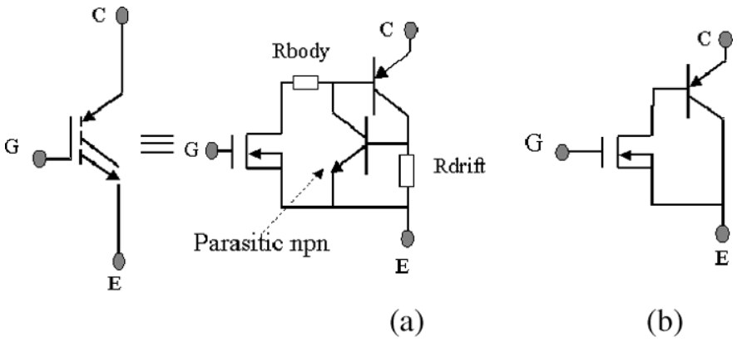

Figure 2.3: IGBT equivalent circuit
- Half-Wave Rectifier
A half-wave rectifier is a type of rectifier circuit that converts an alternating current (AC) input signal into a pulsating direct current (DC) output signal. It is called a half-wave rectifier because it rectifies only one-half of the input waveform.
The basic configuration of a half-wave rectifier consists of a diode, which is a semiconductor device that allows current to flow in only one direction. The AC input signal is applied across the diode, and the output is taken across a load resistor connected in series with the diode.
Here's how a half-wave rectifier works:
Positive Half-Cycle: During the positive half-cycle of the input AC signal, the diode is forward-biased, allowing current to flow through it. The current flows through the load resistor, and a positive half-cycle is obtained at the output.
Negative Half-Cycle: During the negative half-cycle of the input AC signal, the diode is reverse-biased, blocking the current flow through it. As a result, no current passes through the load resistor, and the output voltage is zero.
The output waveform of a half-wave rectifier is a pulsating DC waveform, consisting of only the positive half-cycles of the input waveform. It has a DC component equal to the peak value of the input AC waveform but contains significant ripple due to the absence of the negative half-cycles.
The main disadvantage of a half-wave rectifier is its low efficiency and high ripple content. It is typically used in applications where a lower output voltage and less smoothness are acceptable, or where the cost and complexity of a full-wave rectifier circuit need to be avoided.
It's worth noting that there are more sophisticated rectifier circuits available, such as full-wave rectifiers and bridge rectifiers, which provide higher efficiency and smoother output waveforms by utilizing multiple diodes and additional circuitry.
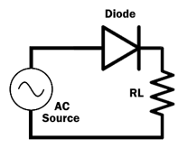
Figure 2.4: Half-Wave Rectifier
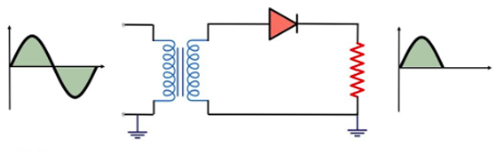
Figure 2.5: wave form of half wave rectifier
The key function of a half-wave rectifier can be summarized as follows:
Rectification: The half-wave rectifier allows only the positive half-cycles of the input AC signal to pass through. It achieves this by utilizing a diode, which acts as a one-way valve for current flow. The diode conducts current during the positive half-cycles and blocks current during the negative half-cycles.
- Full wave rectifier:
A full wave rectifier is defined as a rectifier that converts the complete cycle of alternating current into pulsating DC. Unlike half wave rectifiers that utilize only the half wave of the input AC cycle, full wave rectifiers utilize the full cycle.
Unlike half wave rectifiers that utilize only the half wave of the input AC cycle, full wave rectifiers utilize the full cycle. The lower efficiency of the half wave rectifier can be overcome by the full wave rectifier.

Full Wave Rectifier Circuit
The circuit of the full wave rectifier can be constructed in two ways. The first method uses a center tapped transformer and two diodes. This arrangement is known as a center tapped full wave rectifier. The second method uses a standard transformer with four diodes arranged as a bridge. This is known as a bridge rectifier.
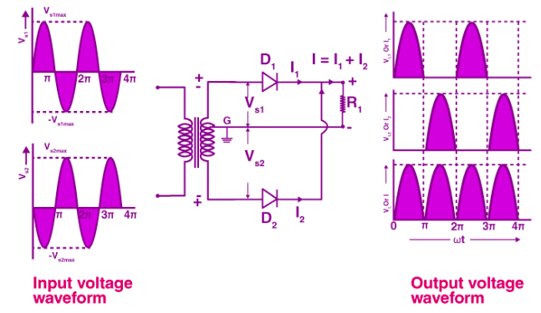
Figure 2.6: Full Wave Rectifier

The circuit of the full wave rectifier consists of a step-down transformer and two diodes that are connected and center tapped. The output voltage is obtained across the connected load resistor.

Working of Full Wave Rectifier
The input AC supplied to the full wave rectifier is very high. The step-down transformer in the rectifier circuit converts the high voltage AC into low voltage AC. The anode of the centre tapped diodes is connected to the transformer’s secondary winding and connected to the load resistor. During the positive half cycle of the alternating current, the top half of the secondary winding becomes positive while the second half of the secondary winding becomes negative.
During the positive half cycle, diode D₁ is forward biased as it is connected to the top of the secondary winding while diode D₂ is reverse biased as it is connected to the bottom of the secondary winding. Due to this, diode D₁ will conduct acting as a short circuit and D₂ will not conduct acting as an open circuit
During the negative half cycle, the diode D₁ is reverse biased and the diode D₂ is forward biased because the top half of the secondary circuit becomes negative and the bottom half of the circuit becomes positive. Thus in a full wave rectifiers, DC voltage is obtained for both positive and negative half cycle.

Selection of Power electronics components/materials
Selection of power electronic components and materials is crucial for designing efficient and reliable power electronic circuits. Here are some key factors to consider when choosing power electronic components and materials:
- Component Specifications: Consider the specific requirements of your circuit, such as voltage, current, power rating, switching frequency, and temperature range. Ensure that the selected components can handle these specifications without exceeding their limits.
- Switching Devices: Select the appropriate switches, such as power MOSFETs, IGBTs, or thyristors, based on factors like voltage rating, current handling capability, switching speed, and conduction losses. Consider the trade-off between conduction and switching losses to optimize efficiency.
- Diodes: Choose diodes with low forward voltage drop and fast recovery time to minimize power losses and improve circuit efficiency. Consider the diode's current rating, reverse voltage rating, and temperature characteristics.
- Capacitors: Select capacitors with suitable capacitance, voltage rating, and temperature rating. Consider the type of capacitor (electrolytic, ceramic, film, etc.) based on the application requirements, such as energy storage, filtering, or decoupling.
- Inductors: Choose inductors with appropriate inductance, current rating, and saturation current. Consider the core material (ferrite, iron powder, etc.) and its characteristics, such as permeability and saturation flux density.
- Heat Sink and Thermal Management: Ensure proper heat dissipation by selecting suitable heat sinks and thermal management techniques. Consider the thermal resistance of the components and the overall system to prevent overheating and ensure long-term reliability.
- Protection and Control Components: Include protective devices like fuses, circuit breakers, and overvoltage/overcurrent protection circuits to safeguard the power electronic system. Use control components like gate drivers, controllers, and sensors to ensure proper operation and control of the circuit.
- Reliability and Quality: Choose components from reputable manufacturers and suppliers to ensure reliability and quality. Consider factors like component lifespan, failure rates, and availability.

Power electronics software
Power electronics software plays a crucial role in the design, analysis, and simulation of power electronic systems. It enables engineers to model and optimize the performance of power electronic circuits, control algorithms, and power semiconductor devices. Here are some key applications of power electronics software:
- Circuit Design and Simulation: Power electronics software allows engineers to design and simulate various power electronic circuits, such as converters, inverters, and motor drives. It provides a virtual platform to test different circuit topologies, component values, and control strategies before implementing them in hardware.
- Component Selection and Sizing: Power electronics software helps in selecting and sizing the appropriate components for a given application. It considers factors like voltage and current ratings, power losses, thermal characteristics, and efficiency. This ensures that the chosen components can handle the desired power levels and meet the system requirements.
- Control System Design: Power electronics software enables engineers to design and optimize control algorithms for power electronic systems. It allows for the implementation of various control techniques, such as pulse width modulation (PWM), current control, voltage control, and feedback loops. The software provides tools to analyze the stability, transient response, and overall performance of the control system.
- Efficiency Analysis: Power electronics software helps in evaluating the efficiency of power electronic systems. It allows engineers to analyze power losses in different components, such as switches, diodes, and inductors. By optimizing component values and control strategies, engineers can improve the overall efficiency of the system.
- Transient and Harmonic Analysis: Power electronics software enables engineers to analyze the transient response and harmonic content of power electronic circuits. It helps in identifying and mitigating issues like voltage spikes, current overshoots, and harmonic distortion. This ensures the system's stability, reliability, and compliance with standards.
- Fault Analysis and Protection: Power electronics software allows engineers to simulate and analyze fault conditions in power electronic systems. It helps in understanding the behavior of the system during faults and designing appropriate protection mechanisms, such as overcurrent protection, overvoltage protection, and fault detection algorithms.
- System Integration and Optimization: Power electronics software facilitates the integration and optimization of power electronic systems with other components and subsystems. It enables engineers to analyze the interactions between power electronics, energy storage systems, renewable energy sources, electric machines, and grid interfaces. This helps in optimizing the overall system performance and achieving seamless integration.

Self-Check -2

Part-1: Say True or False
- Power electronic control circuits are responsible for regulating and controlling the flow of electrical power.
- Control circuits in power electronics utilize various control algorithms and techniques to achieve desired system performance.
- The selection of cooling methods and heat sinks is not important for power electronic components.
- Power electronic control circuits are only used in static power conversion applications.
- The control algorithms implemented in power electronic control circuits aim to reduce harmonics and improve efficiency.
- Power electronic control circuits are not necessary for achieving precise control and regulation of electrical power.
- The selection of power electronics components/materials is not important for the overall performance and reliability of a power electronic system.
- Power electronic converters can convert DC power to AC power and vice versa.

Part-2: Multiple Choose
- Which of the following is a commonly used control circuit in power electronics?
a) Pulse Width Modulation (PWM)
b) Frequency Modulation (FM)
c) Amplitude Modulation (AM)
d) Phase Modulation (PM)
- The selection of power components/materials in power electronics is based on:
a) Voltage rating
b) Current rating
c) Power rating
d) All of the above
- Which of the following is an application of power electronics software?
a) Simulation of power electronic circuits
b) Design optimization of power electronic systems
c) Control algorithm development for power converters
d) All of the above
- In a power electronic control circuit, the main function of a gate driver is to:
a) Control the switching of power devices
b) Measure the voltage and current in the circuit
c) Provide isolation between the control circuit and power circuit
d) None of the above
- The selection of power components/materials in power electronics is influenced by:
a) Efficiency requirements
b) Thermal considerations
c) Cost constraints
d) All of the above
- Which of the following is a commonly used power semiconductor device in power electronics?
a) Diode
b) Transistor
c) Thyristor
d) All of the above
- The application of power electronics software can help in:
a) Designing efficient power converters
b) Analyzing the behavior of power electronic circuits
c) Optimizing control strategies for power systems
d) All of the above
- The selection of power components/materials in power electronics is also influenced by:
a) Voltage/current rating derating factors
b) Reliability requirements
c) Size and weight constraints
d) All of the above
- Which of the following is a commonly used software tool for power electronics simulation?
a) MATLAB/Simulink
b) PSpice
c) LTspice
d) All of the above
- The application of power electronics software can help in:
a) Analyzing the impact of component tolerances on system performance
b) Evaluating the transient response of power converters
c) Assessing the stability of control loops
d) All of the above

Part-3: Write the Short Answers
- What is the main function of a control circuit in power electronics?
- What factors influence the selection of power components/materials in power electronics?
- How does voltage rating affect the choice of power components?
- What considerations are important when selecting power components for high-power applications?
- What are some common applications of power electronics software?
- How can power electronics software aid in the design and optimization of power electronic systems?
- Which software tools are commonly used for power electronics simulation?

Operation sheet-2

Module title: designing and developing power electronic systems

Operation title: Procedures of TRIAC transistor
Purpose: To practice and demonstrate the knowledge and skill required in measuring the voltage and currents at anode.

Instruction: Use the given figure above (Figure.), Read the manual. For this operation you have given 3Hour and you are expected to provide the answer on the given table.
- Tools and requirement:
- mulitimeter
- Paper
- Pencil
Precautions: Measure at least three times before recording the result on the given format
Steps in doing the task
Step-1: Use the given figure
Step-2: Measure the Va ,Vg and Ia of the given diagram.

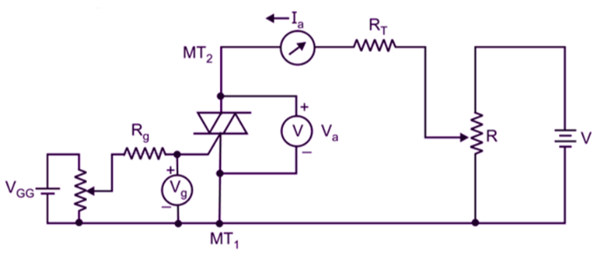
Figure

Lap Test-2

Task-1: Draw the half wave rectifier circuit.
Task-2: Measure the load current of the circuit.
Task-3: Draw the output wave forms.

Unit-Three: Power Electronics System
This unit is developed to provide you the necessary information regarding the following content coverage and topics:
- power electronic control components size and measurement
- Schematic diagram preparation
- Schematic diagram using computer software
- Schematic diagram to PCB board Conversion
- power electronic control components assemble
This unit will also assist you to attain the learning outcomes stated in the cover page. Specifically, upon completion of this learning guide, you will be able to:
- power electronic control components are sized(measured)
- Schematic diagram is prepared to meet control system
- Schematic diagram implemented using computer software
- Implement schematic is copied to a PCB board
- Digital electronic control components are assembled to maintain schematic.

Power electronic control components size and measurement
Power electronic control components come in various sizes, and their measurements depend on the specific component and its intended application. Here are some commonly used power electronic control components and their typical size ranges:
Integrated Circuits (ICs): Power electronic control ICs are available in different package sizes, such as Dual Inline Package (DIP), Small Outline Integrated Circuit (SOIC), Thin Small Outline Package (TSOP), and Quad Flat No-Lead (QFN). The dimensions of these packages can vary, but they typically range from a few millimeters to a few centimeters in length and width.
Transistors: Power transistors are used for switching and amplifying electrical signals. They are available in various packages, including TO-220, TO-247, and SOT-23. The dimensions of power transistors depend on the package type, but they generally range from a few millimeters to a few centimeters in length.
Diodes: Power diodes are commonly used for rectification and switching applications. They are available in packages such as DO-41, DO-15, and SOD-123. The dimensions of power diodes can vary, but they typically range from a few millimeters to a few centimeters in length.
Capacitors: Power electronic circuits often require capacitors for energy storage and filtering. Capacitors come in different types, including ceramic, electrolytic, and film capacitors. Their sizes can vary significantly depending on the capacitance and voltage rating. For example, ceramic capacitors can range from a few millimeters to several centimeters in length.
Inductors: Inductors are used in power electronic circuits for energy storage and filtering. They are available in various forms, such as axial leaded, radial leaded, and surface mount. The dimensions of inductors depend on the inductance value and package type. Axial leaded inductors can range from a few millimeters to several centimeters in length.
Transformers: Power transformers are used for voltage transformation and isolation in power electronic systems. The size of power transformers varies significantly depending on the power rating and application. They can range from small, compact transformers used in electronic devices to large, heavy transformers used in power distribution systems.
It's important to note that the dimensions mentioned above are general guidelines, and actual sizes may vary depending on the manufacturer and specific requirements of the application. When selecting power electronic control components, it's important to consider factors such as power rating, voltage rating, current handling capacity, and thermal considerations in addition to size.

Schematic diagram preparation

To prepare a schematic diagram for power electronics, follow these steps:
Identify the Components: Determine the power electronic components you will be using in your circuit, such as transistors, diodes, capacitors, inductors, and integrated circuits. Make a list of these components.
Determine the Connections: Determine how the components will be connected to each other. Consider the power flow, signal flow, and control signals. Identify the input and output connections, as well as the control signals required for the operation of the circuit.
Start Drawing: Use a schematic capture software or a drawing tool to create the schematic diagram. Begin by placing the components on the drawing area. Use the appropriate symbols for each component, adhering to recognized standards such as IEEE or IEC.
Connect the Components: Draw lines or wires to represent the connections between the components. Use appropriate symbols for wires, such as straight lines or curves. Ensure that the connections accurately represent the electrical connections in the circuit.
Label the Components: Add labels or designators to each component to identify them uniquely. Commonly used designators include letters (e.g., R for resistors, C for capacitors) followed by a number (e.g., R1, C2). Label the input and output terminals as well.
Add Reference Designators: Assign reference designators to components, which are typically alphanumeric codes that uniquely identify each component. For example, a resistor might be labeled as R1, a diode as D1, and so on.
Include Control Signals: If your power electronics circuit requires control signals, include them in the schematic diagram. Use appropriate symbols to represent control signals, such as arrows or dashed lines.
Verify the Schematic: Review the schematic diagram to ensure that it accurately represents the intended circuit. Check for errors, such as missing connections, incorrect component symbols, or labeling mistakes.
Add Notes and Annotations: Include any necessary notes or annotations to provide additional information about the circuit, component values, or specific design considerations.
Finalize the Schematic: Once you are satisfied with the schematic diagram, save it in an appropriate file format and consider printing a hard copy for reference during the circuit construction.
Remember, it's essential to adhere to standard symbol conventions and follow clear and logical wiring practices to ensure that your schematic diagram is easily understandable by others who may need to work with or review your circuit design.
Examples of Electronic Schematic Diagrams
Electronic schematics use symbols for each component found in an electrical circuit, no matter how small. The schematics do not show placement or scale, merely function and flow. From this, the actual workings of a piece of electronic equipment can be determined. Figure 3 is an example of an electronic schematic diagram.
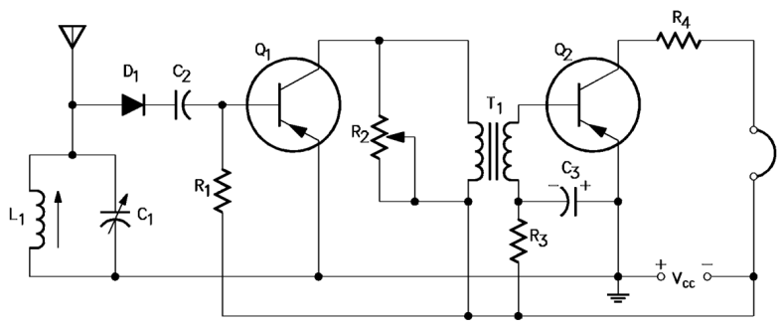
Figure 3.1: schematic diagram

Self Chech-3

Test-1: Say True or False
- Power electronic control components come in standardized sizes and measurements.
- Schematic diagram preparation involves identifying components and determining their connections.
- Schematic diagrams can be created using computer software.
- Schematic diagram to PCB board conversion involves transferring the circuit layout from the schematic to a physical printed circuit board.
- Power electronic control components assembly involves physically mounting and connecting the components on a PCB or other substrate.

Part-2: Multiple Choose
- Which of the following factors determine the size and measurement of power electronic control components?
a) Power rating
b) Voltage rating
c) Current handling capacity
d) All of the above
e) None of the above

- What is the purpose of schematic diagram preparation?
a) To identify power electronic control components
b) To determine connections between components
c) To plan the layout of a PCB
d) All of the above
e) None of the above

- What does schematic diagram to PCB board conversion involve?
a) Transferring the circuit layout from the schematic to a physical PCB
b) Creating a bill of materials (BOM) for the circuit
c) Testing the circuit for functionality
d) All of the above
e) None of the above

- What does power electronic control components assembly involve?
a) Mounting and connecting the components on a PCB or substrate
b) Designing the schematic diagram
c) Programming the microcontroller
d) All of the above
e) None of the above

Part-3: Writing Short Answer
- What factors should be considered when determining the size and measurement of power electronic control components?
- How does schematic diagram preparation contribute to the successful implementation of a power electronics circuit?
- What are the advantages of using computer software for creating schematic diagrams?
- What are the key steps involved in converting a schematic diagram to a PCB board layout?
- What are the main tasks involved in the assembly of power electronic control components?
- What are the main components typically included in a power electronics schematic diagram?

Unit-Four: Test developed design
This unit is developed to provide you the necessary information regarding the following content coverage and topics:
- Lines and component on a PCB board inspection
- Lines and component on a PCB board testing
- Functional test
- Compile report
This unit will also assist you to attain the learning outcomes stated in the cover page. Specifically, upon completion of this learning guide, you will be able to:
- Check lines and component on a PCB board is visually
- Test lines on a board is to meet electric/electronic value
- Perform functional test
- Approve result and compile report.

Check lines and component on a PCB board
When checking the lines and components on a PCB (Printed Circuit Board), there are several aspects to consider ensuring the board's integrity and proper functioning. Here are some key steps to follow:
- Visual Inspection: Begin by visually inspecting the PCB board and components. Look for any obvious defects, such as physical damage, soldering issues (e.g., cold joints, solder bridges, or insufficient solder), misaligned or missing components, or visible traces of contamination or debris.
- Component Placement: Verify that all components are correctly placed on the PCB board according to the schematic diagram or component placement guidelines. Check for proper orientation, correct pin alignment, and ensure that components are securely soldered to their designated pads.
- Trace Continuity: Use a multimeter or continuity tester to check the continuity of the traces on the PCB board. Test the connectivity between different points, ensuring that the traces are not broken, disconnected, or shorted. Continuity testing helps identify any open circuits or unintended connections.
- Trace Clearance and Spacing: Examine the PCB board to ensure that there is adequate clearance and spacing between adjacent traces, pads, and components. Verify that the design adheres to the specified design rules, including minimum trace-to-trace spacing, pad-to-pad spacing, and other clearance requirements.
- Power and Ground Connections: Check the power and ground connections on the PCB board. Ensure that power and ground traces are properly routed and connected to the respective power and ground planes or designated power sources. Verify that there are no unintended breaks, shorts, or weak connections in the power and ground network.
- Signal Integrity: Inspect the signal traces for any signs of signal integrity issues, such as discontinuities, reflections, noise coupling, or excessive crosstalk. Visually check for any signal traces that may run too close to noisy components or high-power traces, potentially causing interference or coupling problems
- Test Points: Identify and verify the presence of test points or probe pads on the PCB board. These points allow for easy access to specific signals or nodes duringtesting or troubleshooting. Ensure that the test points are appropriately labeled and conveniently located for easy measurement.
- Silkscreen and Labeling: Examine the silkscreen markings and labels on the PCB board. Check that component designators, reference designators, and other important labels are accurate and clearly visible. Confirm that silkscreen markings do not overlap with traces or pads, preventing confusion during assembly or maintenance.
- Overall Mechanical Integrity: Assess the overall mechanical integrity of the PCB board. Check for any physical stress on the board, such as bending or warping. Ensure that the board fits properly in its designated enclosure or mounting mechanism without any interference or misalignment issues.
- It is important to perform these checks before powering up the PCB board to minimize the risk of electrical failures or damage. If any issues or discrepancies are found during the inspection, they should be addressed and corrected before proceeding with further testing or deployment.

Electronic and measuring devices testing techniques
Testing electronic and measuring devices is crucial to ensure their proper functionality and accuracy. Here are some common testing techniques used for electronic and measuring devices:
- Visual Inspection: Perform a visual inspection of the device, checking for any physical damage, loose connections, broken components, or abnormalities. Ensure that all connectors, switches, knobs, and indicators are intact and functioning correctly.
- Power-On Self-Test (POST): Many electronic devices, especially complex ones, have built-in self-test routines that run when the device is powered on. These tests check various internal components, interfaces, and subsystems to verify their functionality. Pay attention to any error codes or self-diagnostic messages generated during the POST.
- Functional Testing: Conduct functional tests to verify that the device performs its intended functions accurately. Follow test procedures or use appropriate test cases to check the device's response to different inputs or stimuli. Ensure that the device operates as expected and produces the correct outputs or measurements.
- Signal Verification: Use an oscilloscope, logic analyzer, or multimeter to measure and verify the signals produced or processed by the device. Compare the measured signals against the expected values to ensure accurate signal generation, amplification, filtering, or modulation/demodulation.
- Accuracy and Calibration: For measuring devices, calibration is crucial to ensure accurate measurements. Calibrate the device according to the manufacturer's guidelines or industry standards using reference standards or certified calibration equipment. Perform accuracy tests by comparing the device's measurements against known or traceable standards.
- Performance Testing: Evaluate the performance of the device under different operating conditions or stress levels. This may include testing the device's response time, sensitivity, dynamic range, and resolution, linearity, or noise levels. Use appropriate test procedures and equipment to assess the device's performance characteristics.
- Environmental Testing: Some electronic devices may need to undergo environmental testing to ensure their reliability and durability. This may involve subjecting the device to temperature variations, humidity, vibration, shock, or electromagnetic interference (EMI). Verify that the device can withstand and operate correctly within specified environmental conditions.
- Interface Testing: If the device interfaces with other devices or systems, test the compatibility and proper functioning of the interfaces. Ensure that communication protocols, data transfer rates, and signal levels are within the specified ranges and meet the requirements of the connected systems.
- Safety Testing: For devices that involve user interaction or expose users to electrical or other hazards, perform safety testing. Verify compliance with relevant safety standards and regulations, including insulation resistance, grounding, leakage current, and protection against electric shock or fire hazards.
- User Acceptance Testing: Involve end-users or stakeholders in the testing process to gather feedback on the device's usability, user interface, and overall satisfaction. Consider user feedback to identify any usability issues, improvements, or additional features that may enhance the device's performance or user experience.
- It's important to consult the device's documentation, user manuals, and relevant industry standards for specific testing guidelines and procedures. Follow safety precautions during testing and ensure that appropriate test equipment and measurement instruments are used for accurate and reliable results.

Functional Test
- Functional testing is a crucial aspect of evaluating the performance and functionality of electronic devices. It involves testing the device's functions and features to ensure that they operate as intended. Here are some key points to consider when conducting functional tests:
- Test Plan: Develop a comprehensive test plan that outlines the specific functions and features to be tested. Identify the expected behavior, inputs, and outputs for each test case.
- Input Testing: Provide different inputs to the device to simulate real-world scenarios. This includes testing various control settings, buttons, switches, or data inputs to ensure the device responds appropriately.
- Output Verification: Verify the device's outputs against the expected results. This may involve checking displayed information, generated signals, data transmission, or any other output produced by the device.
- Boundary Testing: Test the device's performance at the boundaries of its operating range. This includes testing the minimum and maximum values for parameters such as voltage, frequency, temperature, or input range to ensure the device functions correctly under extreme conditions.
- Error Handling: Intentionally introduce errors or invalid inputs to test how the device handles them. Verify that the device provides appropriate error messages, warnings, or takes corrective actions when faced with invalid or unexpected conditions.
- Performance Testing: Evaluate the device's performance under normal operating conditions. This may include measuring response times, processing speed, accuracy, throughput, or any other performance metrics specified for the device.
- Compatibility Testing: If the device interacts with other systems or devices, perform compatibility testing. Test the device's compatibility with different operating systems, software versions, communication protocols, or hardware configurations to ensure seamless integration and interoperability.
- Stress Testing: Subject the device to stress conditions beyond normal operating parameters to assess its robustness and reliability. This may involve testing the device under high loads, extended operation, or extreme environmental conditions to identify any performance degradation or failures.
- User Interface Testing: Evaluate the device's user interface, including menus, screens, buttons, and controls. Verify that the user interface is intuitive, responsive, and user-friendly. Test the device's usability by involving end-users or representative users to gather feedback.
- Documentation Verification: Review the device's documentation, including user manuals, technical specifications, and operating instructions. Ensure that the documentation accurately reflects the device's functionality and features. Crossreference the documentation with the actual device behavior to identify any inconsistencies or discrepancies.
- Regression Testing: After making any changes or updates to the device, perform regression testing to ensure that previously tested functions and features continue to operate correctly. This helps identify any unintended side effects or regressions introduced during development or modification.
- Record and Analyze Results: Maintain detailed records of test cases, inputs, expected results, and actual outcomes. Analyze the test results to identify any failures, deviations, or areas that require improvement. Document any issues or bugs found during testing for further investigation and resolution.
Remember to use appropriate test equipment, measurement instruments, and simulation tools to conduct functional tests accurately. Follow safety precautions and guidelines, especially when dealing with high voltages, hazardous materials, or complex systems.

Compile report
- Compiling a report is an essential step in documenting the findings, results, and recommendations from various tests and evaluations. When creating a report for electronic devices or PCB testing, consider including the following sections:
- Introduction: Provide an overview of the report, including the purpose, scope, and objectives of the testing. Briefly describe the device or PCB under evaluation and any relevant background information.
- Test Methodology: Explain the testing procedures, techniques, and equipment used during the evaluation. Describe the test setup, test cases, and any specific parameters or conditions applied during the testing process.
- Test Results: Present the results obtained from the various tests conducted on the device or PCB. Include both quantitative and qualitative data, such as measurements, observations, or performance metrics. Clearly present the findings, highlighting any issues, failures, or deviations from expected behavior.
- Analysis and Discussion: Analyze the test results and provide an in-depth discussion of the findings. Explain the significance of the results, identify any patterns or trends, and discuss the implications for the device's performance, reliability, or functionality. Compare the results against specifications, standards, or industry benchmarks, as applicable.
- Defects and Issues: Document any defects, failures, or issues encountered during the testing process. Provide a detailed description of each problem, including its impact on the device's functionality or performance. Include relevant photographs, diagrams, or screenshots to support the descriptions
- Recommendations: Based on the test results and analysis, provide recommendations for improving the device or PCB. Suggest corrective actions or measures to address the identified defects or issues. Recommend enhancements or modifications to enhance the device's performance, reliability, or usability.
- Conclusion: Summarize the key findings, conclusions, and overall assessment of the device or PCB. Provide a concise summary of the report, emphasizing the main points discussed throughout the document.
- Appendices: Include any additional information, raw data, test logs, or supporting documentation as appendices. This may include detailed test procedures, calibration certificates, reference documents, or additional test results that provide further context or evidence.
- References: List any references
- Acknowledgments: Acknowledge individuals or organizations that contributed to the testing or provided support during the evaluation. This may include the names of team members, technicians, or subject matter experts involved in the testing process.
- Ensure that the report is well-organized, clear, and concise. Use headings, subheadings, and bullet points to enhance readability. Include appropriate visual aids, such as tables, graphs, or diagrams, to illustrate the data and findings effectively.
- Proofread the report carefully to eliminate any grammatical or typographical errors. Finally, distribute the report to the relevant stakeholders, such as project managers, engineers, or quality assurance personnel, as necessary.

Self-Check-4

Part-I: Say True or False
- Lines on a PCB board refer to the conductive traces that connect various components.
- Component inspection on a PCB board involves checking for proper placement, alignment, and soldering of the components.
- Inspection of lines and components on a PCB board is typically done visually.
- Testing of lines on a PCB board involves checking for continuity and proper electrical connections between components.
- Functional testing of a PCB board involves verifying its overall performance and functionality as a complete circuit.
- Functional testing typically includes inputting specific signals or stimuli to the PCB board and monitoring the expected outputs or responses.
- Functional testing is usually performed to ensure that the PCB board meets the desired design specifications and requirements.
- Compiling a report after PCB board inspection and testing involves documenting the findings, observations, and any issues or defects identified during the process.
- The report may include details such as the date of inspection/testing, the specific PCB board under evaluation, and the names of the individuals involved in the process.
- Compiling a report is an important step in the quality control and documentation of the PCB board manufacturing or assembly process.

Part-II: Multiple Choose
- What does the term "lines" refer to in the context of a PCB board?
a) Conductive traces
b) Passive components
c) Integrated circuits
d) Solder joints

- What is the purpose of component inspection on a PCB board?
a) Checking for proper placement and alignment of components
b) Verifying the functionality of the components
c) Testing the electrical connections between components
d) All of the above

- What is the main objective of testing lines on a PCB board?
a) Ensuring continuity and proper electrical connections
b) Verifying the functionality of individual components
c) Checking for proper placement and alignment of components
d) Testing the solder joints

- What does component testing on a PCB board involve?
a) Checking for proper placement and alignment of components
b) Verifying the functionality and performance of individual components
c) Testing the electrical connections between components
d) All of the above

- What is the purpose of functional testing of a PCB board?
a) Verifying its overall performance and functionality as a complete circuit
b) Checking for proper placement and alignment of components
c) Testing the solder joints
d) Ensuring continuity and proper electrical connections

- What does functional testing typically involve?
a) Inputting specific signals or stimuli and monitoring expected outputs or responses
b) Checking for proper placement and alignment of components
c) Testing the electrical connections between components
d) Verifying the functionality of individual components

- What is the purpose of compiling a report after PCB board inspection and testing?
a) Documenting the findings, observations, and any issues or defects identified during the process
b) Checking for proper placement and alignment of components
c) Testing the solder joints
d) Verifying the functionality of individual components

- What kind of information is typically included in the report?
a) Date of inspection/testing, specific PCB board details, and names of individuals involved
b) Continuity and electrical connection details of the lines
c) Performance and functionality of individual components
d) All of the above

Part-3: Fill In the Blanks the Correct Answer
Match the following activities with their corresponding steps or descriptions:
A. Lines and Component on a PCB Board Inspection
B. Lines and Component on a PCB Board Testing
C. Functional Test
D. Compile Report
- _____ Checking for proper placement, alignment, and soldering of components.
- _____ Verifying the overall performance and functionality of the PCB board.
- _____ Identifying and documenting any issues, defects, or observations during the inspection and testing processes.
- _____ Testing the continuity and electrical connections between components.
- _____ Documenting the findings, observations, and details of the inspection and testing processes.
- _____ ensuring that the PCB board meets the desired design specifications and requirements.
- _____ inspecting the conductive traces on the PCB board.
- _____ Testing the functionality and performance of individual components.
- _____ Compiling information such as the date, specific PCB board details, and the names of individuals involved.

List of Reference Materials
- B. Jayant Baliga,” Fundamentals of Power Semiconductor Devices” Springer International Publishing, 2nd edition 2019.
- Josef Lutz, Heinrich Schlangenotto, Uwe Scheuermann, Rik De Doncker,” Semiconductor Power Devices” Springer International Publishing, 2nd edition 2011.
- S. M. SZE,” High-Speed Semiconductor Devices” Wiley-Interscience First edition, 1990.
- Rashid M.H., “Power Electronics circuits Devices and Applications”, Prentice Hall, 3rd Edition, New Delhi, 2013
- Frede Blaabjerg, Tomislav Dragičević and Pooya Davari,”Application of Power Electronics” Special issue published online electronics 2019.
- Muhammad H Rashid,”Power Electronics Handbook” Academic Press, 2007.
- Sajib Chakraborty,”DC-DC converter topologies for Electric Vehicle” MDPI, 2019.
- B.K. Bose, Power Electronics and Variable Frequency Drives (IEEE, New York, 1997)
- B.J. Baliga, Power semiconductor devices for variable-frequency drives, Proceedings of the IEEE, 82, 1112–1122, 1994
- B.J. Baliga and J.P. Walden, Improving the reverse recovery of power MOSFET integral diodes by electron irradiation, Solid-State Electronics, 26, 1133–1141, 1983
- B.J. Baliga and D.A. Girdhar, Paradigm shift in power MOSFET technology, Power Electronics Technology Magazine, 24–32, 2003
- M. Bhatnagar, P.K. McLarty, and B.J. Baliga, Silicon carbide high voltage (400 V) Schottky barrier diodes, IEEE Electron Device Letters, 13, 501–503, 1992
- R. Hotz, F. Bauer, and W. Fichtner, On-state and short circuit behavior of high voltage trench gate IGBTs in comparison with planar IGBTs, IEEE International Symposium on Power Semiconductor Devices and ICs, 224–229, 1995
- F. Bauer et al., 6.5 kV Modules using IGBTs with field stop technology, IEEE International Symposium on Power Semiconductor Devices and ICs, 121–124, 2001

Participants of this Module (training material) preparation
No | Name | Qualification (Level) | Field of Study | Organization/ Institution | Mobile number | E-mail
1 | Hassen Hussein | A(MSC) | Electrical Engineering | M/G/M/B/P/T/C | 0943402001 | hassenhussen0211@gmail.com

