Industrial Electrical/Electronic Control Technology Level-III
Based on October, 2023 Curriculum
Version 2

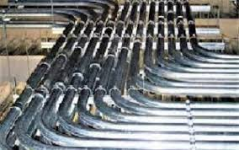

MODULE TITLE : Installing instrumentation of control cabling and tubing
MODULE CODE : EIS IEC3 M03 1023
NOMINAL DURATION : 40 Hours

October,2023
Addis Ababa, Ethiopia

Table of contents

Acknowledgment

Ministry of Labor and Skills wish to extend thanks and appreciation to the many representatives of TVT instructors and respective industry experts who donated their time and expertise to the development of this Teaching, Training and Learning Materials (TTLM).

Acronym
1.OHS-----------------Occupational Health and Safety
2.VIR------------------ Valcanized rubber
3.PVC------------------Poly vinyl chloride
4.NEC--------------- National Electric Code’s

Introduction to the Module
Installing instrumentation of control cabling and tubing, This Module covers the installation and termination of instrument and control apparatus cabling and tubing for chemical industry or food processing systems or any other Industry. It encompasses working safely and to standards, routing cables and tubing to specified locations, terminating cables and tubing and connecting wiring at accessories and at instruments and control apparatus and completing the necessary installation documentation, Carry out Installing instrumentation of control cabling and tubing
This module covers the units:
- Erect cabling and tubing
- Conduit erection and tubing
- Inspect the system
Learning Objective of the Module
- Prepare to erect cabling and tubing
- Perform conduit erection and tubing
- Inspect the system
Module Instruction
For effective use this modules trainees are expected to follow the following module instruction:
- Read the information written in each unit
- Accomplish the Self-checks at the end of each unit
- Perform Operation Sheets which were provided at the end of units
- Do the “LAP test” giver at the end of each unit and
- Read the identified reference book for Examples and exercise

Unit one:- Erect cable and tube
This unit is developed to provide you the necessary information regarding the following content coverage and topics.
  - Work health and safety (WHS)/OHS procedures
  - Cable and tube layout
  - Control, valves and devices
  - cables and tube size selection
This unit will also assist to attain the learning outcomes stated in the cover page .Specifically ,upon completion of this learning guide, you will be able to:-
  - Identify Work health and safety (WHS)/OHS procedures
  - Read and interpret drawings related to cable and tube layout
  - Identify correct location of system control, valves and devices
  - Select cables and tube of different size

  - Work health and safety (WHS)/OHS procedures

OHS policies /Occupational Health and Safety
Occupational health and safety (OHS) is crucial in any workplace, including environments where cabling and tubing are involved. Here are some considerations for OHS in cabling and tubing installations:
1. Risk Assessment: Conduct a thorough risk assessment before starting any cabling and tubing work. Identify potential hazards such as electrical shocks, falls from heights, exposure to hazardous substances, and ergonomic issues.
2. Compliance with Regulations: Ensure compliance with relevant OHS regulations, codes, and standards specific to your region or industry. These may include electrical safety standards, working at heights regulations, and hazardous material handling guidelines.
3. Training and Competence: Provide adequate training to workers involved in cabling and tubing installations. Ensure they have the necessary knowledge and skills to perform their tasks safely. Training should cover topics such as electrical safety, proper lifting techniques, working at heights, and personal protective equipment (PPE) usage.
4. Personal Protective Equipment (PPE): Identify the required PPE for cabling and tubing work. This may include safety glasses, gloves, helmets, hearing protection, and non-slip footwear. Encourage workers to use the appropriate PPE and ensure that it is readily available.
5. Electrical Safety: When working with cabling, there is a risk of electrical shocks. Ensure that workers are trained in electrical safety practices, such as de-energizing circuits before working on them, using insulated tools, and following proper lockout/tagout procedures.
6. Working at Heights: If cabling or tubing installations involve working at heights, take necessary precautions. Provide fall protection equipment like harnesses, lanyards, and guardrails. Ensure workers are trained in fall prevention and rescue procedures.
7. Manual Handling: Cabling and tubing installations may require lifting and carrying heavy objects. Train workers on proper manual handling techniques to prevent musculoskeletal injuries. Provide mechanical lifting aids or equipment when necessary.
8. Hazardous Substances: Some cabling and tubing materials may involve the use of hazardous substances, such as chemicals or solvents. Ensure workers are trained in the safe handling, storage, and disposal of these substances. Provide appropriate ventilation and personal protective equipment for working with hazardous materials.
9. Emergency Preparedness: Develop and communicate emergency procedures specific to cabling and tubing installations. Workers should know how to respond in case of accidents, electrical incidents, fires, or other emergencies. Maintain well-marked emergency exits and first aid kits.
10. Regular Inspections and Maintenance: Regularly inspect cabling and tubing installations to identify potential hazards or wear and tear. Maintain a schedule for equipment maintenance and ensure that damaged or faulty components are repaired or replaced promptly.
  - Cable and tube lay out
- Wire and Cables
Wire and cable are essential components used for the transmission of electrical signals and power in various applications. Here is some information about wire and cable:
1. Wire: Wire refers to a single strand or conductor that carries electrical current. It is typically made of a conductive material, such as copper or aluminum, which offers low resistance to the flow of electricity. Wire is available in different gauges or thicknesses, with smaller gauge numbers indicating thicker wires. Thicker wires can carry higher currents without significant voltage drop.
2. Cable: Cable consists of multiple wires or conductors bundled together and covered by a protective outer sheath. Cables are used to transmit power or signals over longer distances or in more complex electrical systems. They are available in various types, including:
a. Power Cables: These cables are used to transmit electrical power from a power source to electrical devices or systems. Power cables typically have multiple conductors and are designed to handle higher voltages and currents.
b. Communication Cables: Communication cables are used for transmitting signals, such as audio, video, data, or telecommunications signals. Examples include coaxial cables for television and data networks, Ethernet cables for computer networks, and fiber optic cables for high-speed data transmission.
c. Control Cables: Control cables are used to transmit low-voltage signals for controlling and operating electrical equipment. They are commonly used in industrial automation, HVAC systems, and machinery.
d. Specialty Cables: There are various specialty cables designed for specific applications. These include fire-resistant cables, thermocouple cables for temperature measurement, and shielded cables for environments with electromagnetic interference (EMI).
3. Insulation and Jacketing: Both wires and cables are insulated with materials to provide electrical insulation and protect against electrical shocks. Common insulation materials include PVC (polyvinyl chloride), XLPE (cross-linked polyethylene), and rubber. The outer sheath or jacket provides additional protection against environmental factors, such as moisture, chemicals, and abrasion.
4. Standards and Ratings: Wire and cable products are manufactured to meet specific standards and ratings. These standards define characteristics such as voltage ratings, current-carrying capacity, temperature limits, and flame resistance. Compliance with standards ensures the safe and reliable operation of electrical systems.
5. Installation Considerations: Proper installation practices are crucial for wire and cable systems. Factors such as correct sizing, proper routing, appropriate termination methods, and compliance with installation codes and regulations are essential for safety and optimal performance.It's important to consult industry-specific guidelines, local electrical codes, and professional advice when selecting and installing wire and cable to ensure they meet the requirements of your specific application and comply with safety standards.
The term wire and cable are used more nor less synonymously in house wiring. Strictly speaking, single wire, may be bare or covered with insulation is known as a wire and
several wires stranded together is known as a cable. But in practice bare conductors,whether single or stranded together are termed as wire and conductors covered with insulation are termed as cables. The necessary requirements of a cable are that it should conduct electricity efficiently, cheaply, and safely. This should neither be so small so as to have a large internal voltage drop nor be too large so as to cost too much. Its insulation should be such as to prevent leakage of current in unwanted direction and to minimize risk of fire and shock.
A cable consists of three parts:
A. the conductor or core- the metal wire or strand of wires caring current.
B. the insulation or dielectric- a covering of insulation material to avoid leakage
current from the conductor.
C. the protective covering- for protection of insulation from mechanical damage

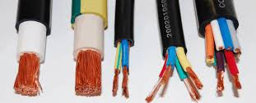
Fig 1.1Different size of Cable
- Tube
A tube is a cylindrical hollow structure typically made of materials such as metal, plastic, or glass. Tubes are used for various purposes, including fluid or gas transport, structural support, protection, and containment. Here are some key aspects of tubes:
1. Composition: Tubes can be made from a wide range of materials to suit different applications. Common materials include metals like steel, aluminum, copper, and stainless steel, as well as plastics such as PVC (polyvinyl chloride), polyethylene, and acrylic. Glass tubes are also used in certain specialized applications.

2. Shape and Size: Tubes come in various shapes, including round, square, rectangular, oval, or other custom profiles. The size of a tube is typically specified by its outside diameter (OD), inside diameter (ID), and wall thickness. These dimensions determine the tube's strength, capacity, and compatibility with fittings or connections.
3. Manufacturing Methods: Tubes can be produced through various manufacturing methods. Common techniques include extrusion, where a material is forced through a die to form a continuous profile, and welding, where two separate pieces are joined together using heat or pressure. Other methods include rolling, bending, and drawing.
4. Applications: Tubes have a wide range of applications across industries. They are commonly used in plumbing systems, HVAC (Heating, Ventilation, and Air Conditioning) systems, automotive components, structural frameworks, electrical conduits, and fluid transport systems. Tubes are also utilized in laboratory equipment, scientific experiments, and industrial processes.
5. Customization: Tubes can be customized to meet specific requirements. They can be cut to desired lengths, bent or shaped into specific configurations, and surface-treated for enhanced corrosion resistance, insulation, or aesthetic purposes. Different types of coatings or linings can also be applied to the inner or outer surface of tubes to enhance their performance or functionality.
6. Standardization: Tubes may adhere to industry standards and specifications to ensure compatibility, quality, and safety. These standards define parameters such as dimensions, tolerances, material properties, and testing procedures to ensure consistent performance and interchangeability.
It's important to select the appropriate tube material, size, and configuration based on the specific application requirements, including factors such as pressure, temperature, chemical compatibility, and structural considerations. Consulting industry standards, guidelines, and experts can help in choosing the right tube for a given application.

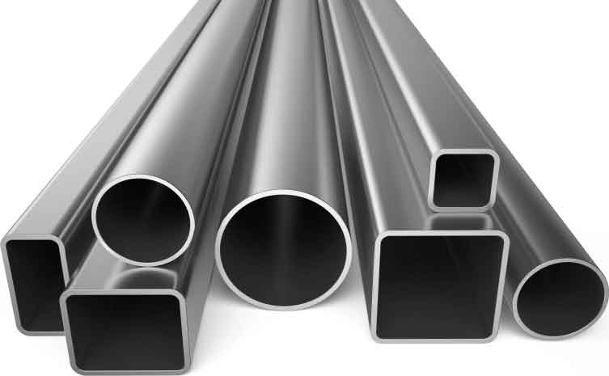

Fig 1.2 Different shape of Tube
  - Control valve
One of the most common final control elements in industrial control systems is the control valve. Some control valve designs are intended for discrete (on/off) control of fluid flow, while others are designed to throttle. Fluid flow somewhere between fully open and fully closed (shut), inclusive. The electrical equivalent of an on/off valve is a switch, while the electrical equivalent of a throttling valve is a variable resistor.
Control valves are comprised of two major parts:
The valve body, which contains all the mechanical components necessary to influence fluid flow. And The valve actuator, which provides the mechanical power necessary to move the components within the valve body.
Within a control valve body, the specific components performing the work of throttling (or completely shutting off) of fluid flow are collectively referred to as the valve trim. For each major type of control valve, there are usually many variations of trim design.
The major difference between an on/off control valve and a throttling control valve is the type of actuator applied to the valve: On/off actuators need only position a valve mechanism to one of two extreme positions (fully open or fully closed). Throttling actuators must be able to accurately position a valve mechanism anywhere between those extremes.Types of valves
The choice of valve type, and of specific trim for any type of valve, is a decision dictated by the type of fluid being controlled, the nature of the control action (on/off versus throttling), the process conditions (expected flow rate, temperature, pressures, etc.), and economics.

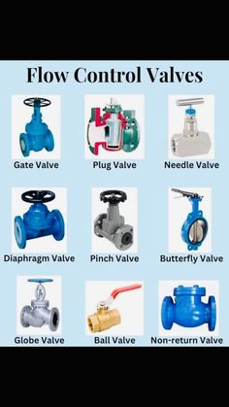

Fig 1.1 Different Flow control Valve
A.Globe valves
Globe valves restrict the flow of fluid by altering the distance between a movable plug and a stationary seat (in some cases, a pair of plugs and matching seats). Fluid flows through a hole in the center of the seat, and is more or less restricted by how close the plug is to that hole. The globe valve design is one of the most popular sliding-stem valve designs used in throttling service. A photograph of a small (2inch) globe valve body appears below: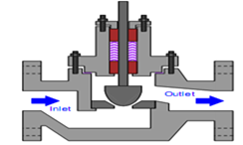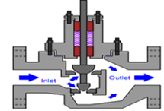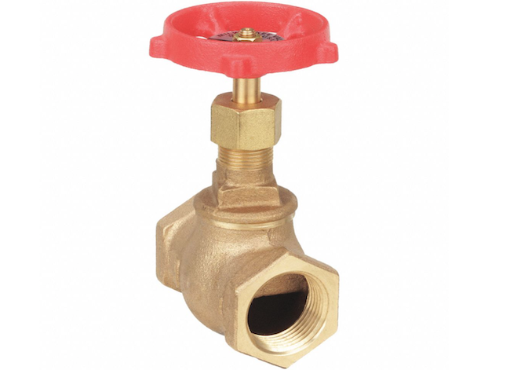
Fig1.3 Single-ported globe valve Fig 1.2.Globe Valve
B.Gate valves
Gate valves work by inserting a dam (gate) into the path of the flow to restrict it, in a manner similar to the action of a sliding door. Gate valves are more often used for on/off control than for throttling.
The following set of photographs shows a hand-operated gate valve (cut away and painted for use as an instructional tool) in three different positions, from full closed to full open (left to right):
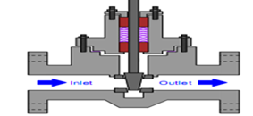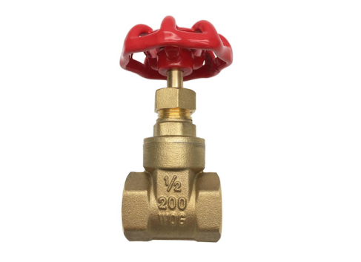
Fig 1.5 Gate valves
- Diaphragm valves
Diaphragm valves use a flexible sheet pressed close to the edge of a solid dam to narrow the flow path for fluid. These valves are well suited for flows containing solid particulate matter such as slurries, although precise throttling may be difficult to achieve due to the elasticity of the diaphragm.
The next photograph shows a diaphragm valve actuated by an electric motor, used to control the flow of treated sewage
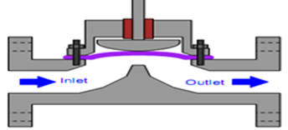
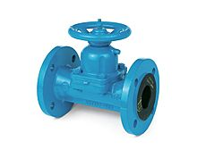
Fig 1.6Diaphragm valves

- Rotary-stem valves
A different strategy for controlling the flow of fluid is to insert a rotary element into the flow path. Instead of sliding a stem into and out of the valve body to actuate a throttling mechanism, rotary valves rely on the rotation of a shaft to actuate the trim. An important advantage of rotary control valves-stem designs such as the globe valve and diaphragm valve is a virtually obstruction less path for fluid when the valve is wide-open.
D. Ball valves
In the ball valve design, a spherical ball with a passage way cut through the center rotates to allow fluid more or less access to the passage way. When the passage way is parallel to the direction of fluid motion, the valve is wide open; when the passage way is aligned perpendicular to the direction of fluid motion, the valve is fully shut (closed). When used in throttling service, a more common variation of the simple ball valve is the characterized ball valve which uses a partial sphere rather than a metal sphere to throttle flow, with the throttling edge of the partial sphere notch-shaped to provide the desired characteristic for smooth throttling.
The following set of photographs shows a hand-operated ball valve in three different positions, from nearly full closed to nearly full open (left or right):
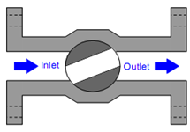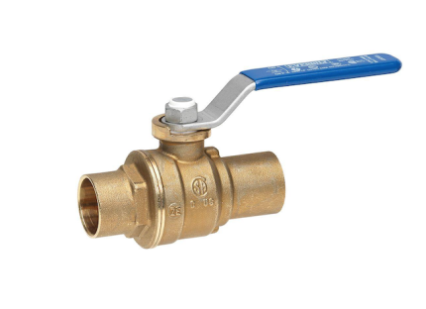
Fig 1.7 Ball valves
E.Butter fly valves
Butter fly valves are quite simple to understand: the butter fly element is a disk that rotates in the path of fluid flow. When parallel to the axis of flow, the disk presents minimal obstruction; when perpendicular to the axis, the disk completely blocks any flow. Fluid-tight shut-off is difficult to obtain in the classic butter fly design unless the seating area is lined with a soft (elastic) material
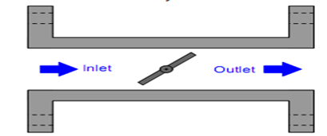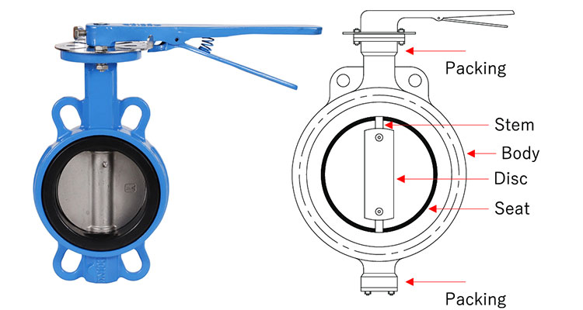

Fig 1.8 Butter fly valves
F.Disk valves
Disk valves (often referred to as eccentric disk valves, or as high-performance butter fly valves) area variation on the butter fly design intended to improve seat shut-off. The disks center is offset from the shaft center line, causing it to approach these at with a cam action that results in high seating pressure. Thus, tight shut-off flow is possible even when using metal seats and disks. The following photograph shows the body of a Fisher E-plug control valve, with the disk in a partially-open position

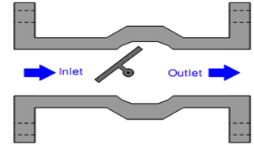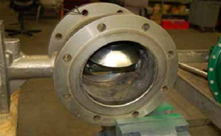

Fig 1.9 Disk valves
G.Valve packing
Regardless of valve type, all stem-actuated control valves require some form of seal allowing motion of the stem from some external device (an actuator) while sealing process fluid so no leaks occur between the moving stem and the body of the valve. The general term for this sealing mechanism is packing.
Packing in a sliding-stem valve fits in a section of the valve body called the bonnet, shown in this simplified diagram of a single-ported, stem-guided globe valve:
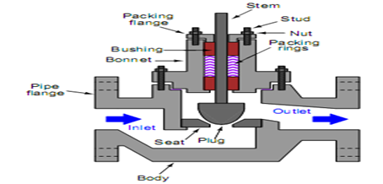
Fig 1.10 Valve packing

1.3 Cables and tube size Selection
1.3.1 cable selection
Types Of Cables Used In Internal Wiring
The wires divided in to different groups according to:
- The type of conductor
- The number of cores
- The voltage grading
- The type of insulation used.
According to the number of cores, the cables may be divided in to classes known as single core, twin core, twin core with ECC (earth continuity conductor).According to voltage grading the cables may be divided in to two classes:250/440 volt and 650/1100-volt cable
According to type of insulation cables can be classified in to:
1. Vulcanized Indian Rubber (VIR) cables:
-VIR cables are available in 250/440volt as well as 650/1100 volt grades and are
used for general conduit wiring.
2. Lead sheathed cables:
• available in 250/440 volt grade
• are used for internal wiring where climatic condition has moisture.
• Is a vulcanized rubber insulated conductor covered with a continuous
sheath of lead .The sheath provides very good protection against the
absorption of moisture and sufficient protection against mechanical injury
and can be used with out casing or conduit system.
• It is available as single core, flat twin core, flat three core and flat twin
core with ECC.
3. PVC cables:
• Are available in 250/440 volt and 650/1100 volt grades
• Used in concealed type of wiring system.
• Since PVC cables are harder than rubber, they do not require cotton taping
and braiding over it for mechanical and moisture protection.
4. Weather proof cables:
•Are used for out door wiring and for power supply
• are not affected by heat or sun or rain.
• Are either PVC insulated or vulcanized rubber-insulated conductors being
suitably taped (only incase of vulcanized rubber insulated cable) braided and
then compounded with weather resisting material.
•Are available in 250/440 and 650/1100 volt grades.
5. Flexible cords and cables:
- It consists of wires either silk or cotton or plastic covered, plastic cover is more popular as it is available various pleasing colors. Flexibility and strength is by using conductors having large number of strands.Wiring accessories & installation materials
- Most stranded conductors are built upon a single central conductor,
surrounding this conductor are layers of wires in a numerical progression of
6 in the first layer, 12 in the second layer, 18 in the third layer and so on.
►Colors of conductors:
Color identification of bare conductors and cable cores are given by EELPA’S regulation
Earthing --------------------------------------------- white
Live of a.c single-phase circuit ------------------- Green
Neutral of ac single or three phase ac circuit ----black
Phase R of three-phase ac circuit ------------------Green
Phase S of three-phase ac circuit ------------------ Yellow
Phase T of three-phase ac circuit ------------------ Red
►General specification of cables:
The complete specification of a cable will give the following information:
i. The size of the cable
ii. The type of conductor used in cables (copper or aluminum)
iii. Number of cores that the cable consists of (single core, twin core,
twin core with ECC etc,)
iv. Voltage grade
v. Type of insulation (taping, braiding & compounding
1.3.2. Tube selection

Tube, Hose, and Pipe
A hose, tube, and pipe can almost be used interchangeably, but they do have characteristics that differ.
- Tube: A hollow cylinder typically made out of plastic or metal that is used to transport liquids or gases.
- Hose: A flexible tube that is typically made out of plastic or metal that is used to transport liquids or gases. However, it can also be rigid. A hose is also typically made out of numerous materials.
- Pipe: Typically, a rigid tube that is made out of plastic or metal that is used to transport liquids or gases. However, it can also be flexible.
As you can tell, all three definitions are very similar. Here at Tameson, we typically refer to “rigid tubes as pipes and “flexible tubes as hoses. The terms hoses and tubes are also used interchangeably
- Pneumatic tube
A pneumatic tube or hose is a flexible conduit used to transport compressed air or other gases from one location to another. It is commonly used in various industrial applications, such as pneumatic power tools, automated machinery, and pneumatic control systems.

Pneumatic tubes or hoses are typically made of durable materials like rubber, PVC (polyvinyl chloride), or polyurethane. They are designed to withstand the pressure exerted by the compressed air while remaining flexible enough to allow for easy maneuverability and routing.
Here are some key features and considerations regarding pneumatic tubes or hoses:
1. Size and Diameter: Pneumatic tubes or hoses come in various sizes and diameters to accommodate different airflow requirements. The size and diameter selection depend on factors such as the volume of air needed, the length of the hose, and the pressure drop that can be tolerated.
2. Pressure Rating: Pneumatic tubes or hoses are designed to withstand specific pressure levels. It's crucial to choose a hose with a pressure rating that exceeds the maximum pressure expected in the pneumatic system to ensure safe and reliable operation.
3. Flexibility: Pneumatic tubes or hoses should possess sufficient flexibility to allow for easy routing and maneuverability. The flexibility of the hose depends on its material and construction. Some hoses have reinforced layers or wire braids to enhance their flexibility while maintaining structural integrity.
4. Fittings and Connectors: Pneumatic tubes or hoses typically require fittings and connectors to connect them to pneumatic devices or other components of the system. These fittings and connectors ensure a secure and airtight connection, preventing air leaks.
5. Durability and Resistance: Pneumatic tubes or hoses should be resistant to wear, abrasion, chemicals, and UV rays, depending on the specific application. This ensures a longer service life and reduces the risk of leaks or failures.
6. Maintenance: Regular inspection and maintenance are necessary to ensure the integrity and performance of pneumatic tubes or hoses. Checking for signs of wear, damage, or leaks and replacing worn-out components are essential for safe and reliable operation.
Pneumatic tubes or hoses play a crucial role in pneumatic systems by delivering compressed air to power various devices and equipment. They provide a flexible and efficient means of transporting compressed air, making them a vital component in many industrial and commercial applications.
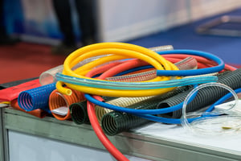
Fig1.11 Pneumatic Hose
- Hydraulic hose
A hydraulic hose is a flexible tube that is used to transport hydraulic fluid under high pressure. Hydraulic hoses are used in a wide variety of applications, including construction equipment, agricultural machinery, industrial equipment, and transportation vehicles.

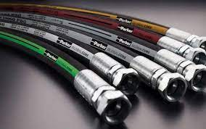

Fig 1.12Hydraulic hose (Tube)
Hydraulic hoses are typically made of a synthetic rubber inner tube, one or more layers of wire or fiber reinforcement, and a protective outer cover. The inner tube is made of a material that is resistant to hydraulic fluid and other chemicals. The wire or fiber reinforcement provides strength and durability to the hose, and the outer cover protects the hose from abrasion, weather, and other environmental hazards.
Hydraulic hoses are available in a variety of sizes, pressure ratings, and construction materials. The type of hydraulic hose that is best for a particular application depends on a number of factors, including the type of hydraulic fluid being used, the operating pressure, the temperature range, and the environmental conditions.

Self-Check 1 | Written Test
I.Say True or False
1. Several wires stranded together is known as a cable
2. Insulation should be such as to prevent leakage of current in unwanted direction and to minimize risk of fire and shock.
3. A pipe is a closed structure designed to provide an enclosed pathway for fluids or gas to flow
4. Control valve designs are intended for discrete (on/off) control of fluid flow
5. Color identification of bare conductors and cable cores of EELPA’S regulation colour of Live of a.c single-phase wire is black.
II.Choose the best answer
1. Which is one is true a part of cable
A. the conductor or core- the metal wire or strand of wires is used to caring current.
B. the insulation or dielectric- a covering of insulation material to avoid leakage
current from the conductor.
C. the protective covering- for protection of insulation from mechanical damage
D.All
2.________is a path way for fluid to flow
A. Pipe B. Cable C. Conduit D. None
3. According to Color identification of bare conductors and cable cores of EELPA’S regulation colour of earth wire is ______
A. white B. Yellow C. Green D. Red
4. According to Color identification of bare conductors and cable cores of EELPA’S regulation colour of Live of a.c single-phase ______
A. white B. Yellow C. Green D. Red
5.According to Color identification of bare conductors and cable cores of EELPA’S regulation colour of Phase R of three-phase ______
A. white B. Yellow C. Green D. Red
III.Matching
Column A Column B
1. Earthing A. Red
2. Neutral of ac single or three phase ac circuit black B. white
3. Phase R of three-phase ac circuit C. Yellow
4. Phase S of three-phase ac circuit D.Green
5. Phase T of three-phase ac circuit E. white
F. Black

Unit Two:- Conduit and tube Erection
This unit is developed to provide you the necessary information regarding the following content coverage and topics
- work procedure conduit and Tube erection
- Conduit erection with proper cable size
- Tube maintenance and termination
This unit will also assist to attain the learning outcomes stated in the cover page .Specifically ,upon completion of this learning guide, you will be able to:-
- Follow work procedure to conduit and Tube erection
- Erect conduit with proper cable size
- Maintain and terminate tube

  - work procedure conduit and Tube erection
    - prepare proper Cable and Pipe
Cable Installation Guidelines
- Cable should be pre-cut and hung suspended for 48 hours to develop its most natural set and lay prior to installation.
- Cable should be installed with, not against, its natural set. ...
- Strain relief on either end will reduce conductor breakage at the flex points.
Tube is measured by an exact outside diameter (OD) and wall thickness. Pipe is measured by a nominal outside diameter (also known as NPS or Nominal Pipe Size) and wall thickness. The dimensions provided for tubing refer to the actual outside diameter
  - Conduit erection with proper cable size
Conduits — any tube or trough that encases wires — protect against strain and wear from the elements. Electricians may want to stuff conduits, but overfilling can lead to unsafe installation. When running electrical cables and wires, it is essential to calculate the appropriate conduit fill to prevent conductor damage and meet national safety standards.
Requirements for conduit fill can be complicated, yet following them is essential for preventing costly rewiring and unsafe conditions. Learn how to calculate conduit fill and why it is important in this guide
Defining Conduit Fill
Conduit fill is the amount of a conduit’s cross-section that is filled with cables. This is calculated as a percentage of the conduit’s inside area. The allowable conduit fill based on the National Electric Code’s (NEC) guidelines is determined by the cable or wire’s outside diameter and the conduit’s inside diameter. Once you know these numbers, you can use the conduit fill calculation to determine if your installation meets safety requirements. If you use a conduit fill calculator, you will need to consider several factors, including:
- Conduit type
- Conduit size, in diameter
- Wire or cable type
- Wire or cable size, in diameter
- The number of wires or cables
All conductors count in conduit fill. This means you must include the measurements of the grounding and bonding conductors when calculating conduit fill.

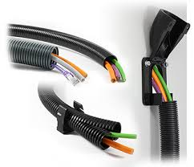

Fig 2.1 Conduit Erection

2.3 Tube maintenance and termination
2.3.1 Tube maintenance
Tube maintenance is the process of inspecting, cleaning, and repairing tubes to ensure that they are in good working order. This is important for both safety and performance.The specific steps involved in tube maintenance will vary depending on the type of tube and its application. However, some general guidelines include:
- Inspection: Tubes should be inspected regularly for signs of damage, such as cracks, leaks, or corrosion. This can be done visually, or using specialized tools such as ultrasonic testing.
- Cleaning: Tubes should be cleaned regularly to remove dirt, debris, and other contaminants. This can be done using a variety of methods, such as chemical cleaning, mechanical cleaning, or flushing.
- Repair: If any damage is found during inspection, the tube should be repaired or replaced. This should only be done by a qualified technician.
In addition to these general guidelines, there are some specific considerations for different types of tubes. For example, heat exchanger tubes need to be cleaned regularly to prevent fouling and maintain heat transfer efficiency. Boiler tubes need to be inspected for corrosion and thinning, which can lead to failure. And medical feeding tubes need to be kept clean and free of bacteria to prevent infection.
Here are some additional tips for tube maintenance:
- Follow the manufacturer's instructions for cleaning and maintenance.
- Use the correct cleaning agents and tools.
- Avoid damaging the tubes during cleaning or maintenance.
- Inspect the tubes regularly for signs of damage.
- Repair or replace damaged tubes immediately.
2.3.2 Pipe and pipe fittings
Various types of pipe fittings are available in plumbing systems for different purposes and functions. A pipe fitting is used in plumbing system to join multiple pipes of same size or different sizes, to regulate the flow or to measure the flow. They are made up of different materials like copper, iron, brass, PVC etc.
- Types of Pipe Fittings in Plumbing System
Different pipe fittings and their functions are explained below.
A. Elbows are used to change the direction of flow between two pipes. Elbows are generally available with an angle of 22.5º, 45º and 90º. If pipes are of same diameter then normal elbows are used otherwise Reducer elbows are used. Elbows are made of different materials. These are generally coming with female threads and we can fix them by butt or socket welding also. 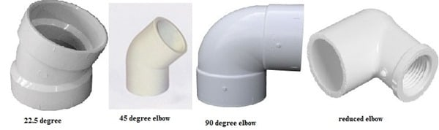
Fig 2.2 Elbow
- Reducer Pipe Fittings
Reducer is a pipe fitting component which reduces the flow size from larger to smaller by reducing size of pipe. Usually there are two types of reducers are available. One is concentric reducer which is like cone shaped with gradual decreasing around the pipe but in this case accumulation of air may possible and it results in cavitation. Other one is eccentric reducer which is having one edge parallel to connecting pipe due to which air accumulation is not possible

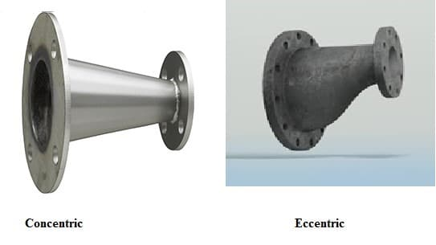
Fig 2.3 Reducer Pipe Fittings
C. Tee type Pipe Fitting
Tee type fitting is a component of plumbing system which is in T-shape. It is having one inlet and two outlets, outlets are arranged at 90º to the main line connection (inlet). It can also be used to combine the flow from two inlets to one outlet. They are also available in different materials and different sizes. If the 3 sides of T-fitting are similar in size then it is called as Equal tee otherwise it is called as Unequal tee.
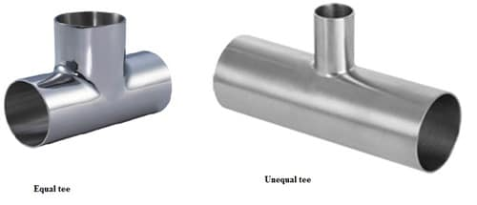
Fig 2.4 Tee type Pipe Fitting
- Cross type
Cross type fittings contains 4 opening in 4 directions. These are connected when there are 4 pipes are meeting at a point. These fittings generate more amount of stress on pipe as the temperature changes, because they are located at the center of four connection points. Cross fittings are generally used for fire sprinkler systems.
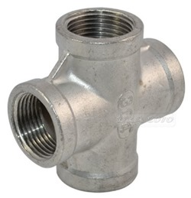
Fig 2.5 Cross type
- Coupling
A coupling is used to connect the pipes of same diameter. Coupling are also useful if the pipe is broken or leakage occurs. Generally there are two types of couplings are available. Compression coupling and slip coupling. Compression coupling is regular coupling which is connected between two pipes and it prevents leakage by the arrangement of gaskets or rubber seals on both sides, otherwise glue is provided. Slip coupling is easier to install and it contains two pipes which are arranged as one into other, inner pipe can slide up to some length. So, we can fix long length 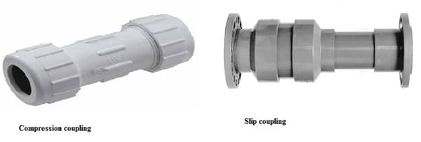.
Fig 2.6 Coupling
- Unions
Union is a type of fitting, which functions as similar to coupling. But coupling cannot be removed after fixing but in this case we can remove the union whenever we needed. Unions consists nut, male and female ended threads. So, this is also useful for maintaining purpose of pipe.
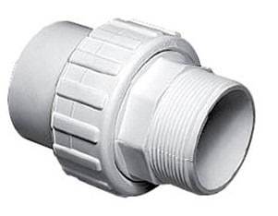
Fig 2.67Unions
- Adaptors
If the pipes are not having special ends or plain ends then adaptors make them threaded either male or female whichever is needed. Adopters are generally used for copper and PVC pipes. Male adapters contain male threads and female adapters contains female threads. One end of adapter is plain which is glued or welded or soldered to the plain pipe end. 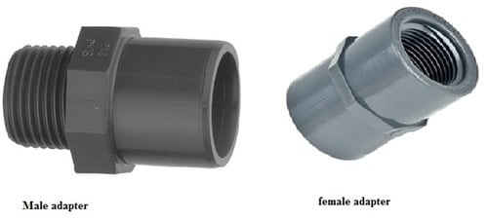

Fig 2.8 Adaptors
H .Plug
Plug is a component of plumbing component which is generally used to close pipe opening during inspections and repairs. Plug are generally contains male threads

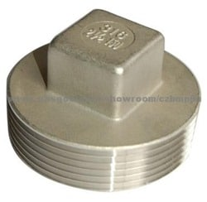

Fig 2.9 Plug

- Cap
Cap is a type of pipe fitting which function is same as plug but the only difference is plug contain male threads and cap contain female threads which is screws on the male thread of pipe. These are available in different materials like rubber, copper, steel, plastic
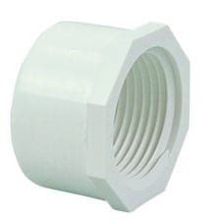
Fig 2.10Cap

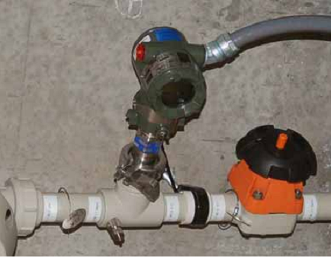
Fig 2.11 photograph Sanitary pipe fittings
Sanitary pipe fittings are not limited to instrument connections, either. Here are two photographs of process equipment (a ball valve on the left and a pump on the right) connected to process pipes using sanitary fittings:
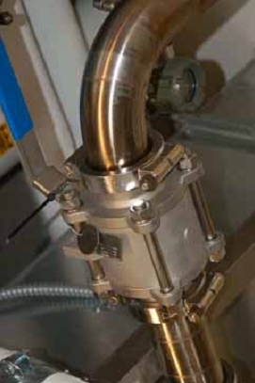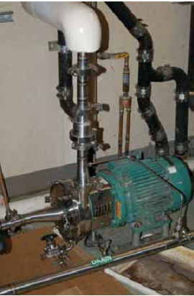
Fig 2.12 photograph Sanitary pipe fittings
- Tube and tube fittings
Tube, like pipe, is a hollow structure designed to provide an enclosed path way for fluids to flow .In the case of tubing, it is usually manufactured from rolled or extruded metal (although plastic is a common tube material from any industrial applications). This section discusses some of the more common methods for joining tubes together (and joining tube ends to equipment such as pressure instruments).
One of the fundamental differences between tube and pipe is that tube is never threaded at the end to form a connection. Instead, a device called a tube fitting must be used to couple a section of tube to another tube, or to a section of pipe, or to a piece of equipment (such as an instrument). Unlike pipes which are thick-walled by nature, tubes are thin-walled structures. The wall thickness of a typical tube is simply tooth into support threads.
Tubes are generally favored over pipe for small-diameter applications. The ability for skilled workers to readily cut and bend tube with simple hand tools make sit the preferred choice for connecting instruments to process piping. When used as the connecting units between an instrument and a process pipe or vessel, the tube is commonly referred to as an impulse tube or impulse line.
- Compression tube fittings
By far the most common type of tube fitting for instrument impulse lines is the compression-style fitting, which uses a compressible ferrule toper form the task of sealing fluid pressure. The essential components of a compression tube fitting are the body, the ferrule, and the nut. The ferrule and body parts have matching conical profiles designed to tightly together, forming a pressure-tight metal-to metal seal. Some compression fitting designs use a two-piece ferrule assembly, such as this tube fitting shown here (prior to full assembly):
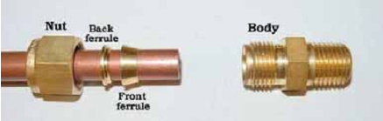
Fig 2.13 Compression tube fittings
Just prior to assembly, we see how the nut will cover the ferrule components and push them in to the conical entrance of the fitting body:
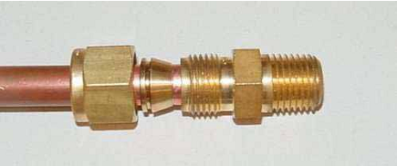
After properly tightening the nut, the ferrule(s) will compress on to the outside circumference of the tube, slightly crimping the tube in the process and there by locking the ferrules in place
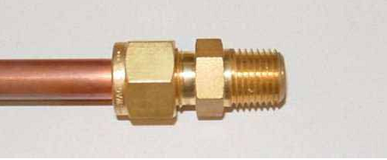
When assembling compression-style tube fittings, you should always precisely follow the manufacturer’s instructions to ensure correct compression.
2.3.3 Tubing elbows
Tubing elbows are tube connectors with a bend. These are useful for making turns in tube runs without having to bend the tubing itself. Like standard connectors, they may terminate in male pipe thread, female pipe threads, or in another tube end:
Male elbow Female elbow Union elbow
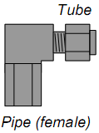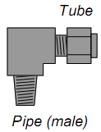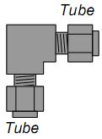
Fig2.13 Tubing elbow

These elbows shown in the above illustration are all 90º, but this is not the only angle available. 45ºelbows are also common.
Tee fittings join three fluid lines together. Tees may have one pipe end and two tube ends (branch tees and run tees), or three tube ends (union tees). The only difference between a branch tee and a run tee is the orientation of the pipe end with regard to the two tube ends:
Male branch tee Male run tee Union tee
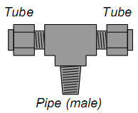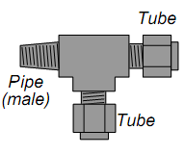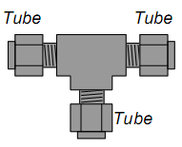
Fig 2.14 Tee fitting
2.3.4 Bending instrument tubing
Tube bending is something of an art, especially when done with stainless steel tubing. It is truly magnify cent to see a professionally-crafted array of stainless steel instrument tubes, all bends perfectly made, all terminations square, all tubes parallel when laid side by side and perfectly perpendicular when crossing.
If possible, a goal in tube bending is to eliminate as many connections as possible. Connections invite leaks, and leaks are problematic. Long runs of instrument tubing made from standard 20 foot tube sections, however, require junctions be made somewhere, usually in the form of tube unions. When multiple tube unions must be placed in parallel tube runs, it is advisable to set the unions so it is easier to get a wrench around the tube nuts to turn them. The philosophy here, as always, is to build the tubing system with future work in mind. A photograph of several tube junctions shows one way to do this:
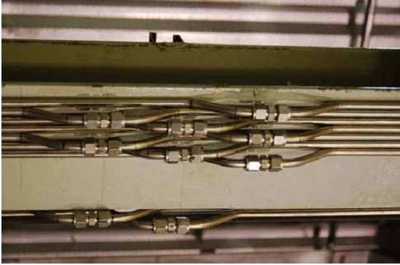
Fig 2.15 Bending instrument tubing
2.3.4 Termination
What Is Cable Termination Procedure? Understanding the cable termination procedure is essential for anyone involved in electrical installations or maintenance. By following the correct steps, using appropriate connectors, and employing cable glands for strain relief and protection, you can ensure a secure and reliable connection. Prioritizing proper cable termination practices contributes to improved safety, system reliability, and signal integrity. Remember to consistently follow best practices and consult manufacturer guidelines to achieve the best possible results
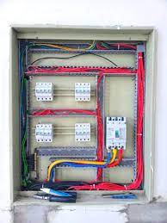
Fig2.16 Cable Termination
Self Check-2
I. Say True or False
1. Pipe is measured by an exact outside diameter (OD) and wall thickness.
2. Tube is measured by a nominal outside diameter (also known as NPS or Nominal Pipe Size) and wall thickness.
3. Conduits any tube or trough that encases wires protect against strain and wear from the elements
4. When running electrical cables and wires, it is essential to calculate the appropriate conduit fill to prevent conductor damage and meet national safety standards.
5. proper cable termination practices contributes to improved safety, system reliability, and signal integrity
II. Choose the best answer
- which one is true for conduit fill calculation to determine if your installation meets safety requirements.
A. Conduit type B Conduit size, in diameter C. Wire or cable type
D. Wire or cable size, in diameter E. All
2. From the following one is not Care for Plumbing System
A.Allow Chemical Drain B. Prevent Future Clogging. ... C. Reduce the Pressure.
D. Soften the Water. ...
3. which one is true for a Tube
A. hollow structure B .manufactured from cast metal C. manufactured from Plastic
D. All

Operation sheet 2: perform conduit work
Title: - Standard 90 degree bending
Purpose: - To Apply 90 degree bending
Tools ,Equipment and Materials: - Steel Conduit 16mm² , Hieky bender
Conditions: - A Spanner may detach the edge of screw
Procedures
- Prepare and measure steel conduit
- Check the hiaky bender
- Put the hikey bender on the marking conduit
- Apply force until to touch the 90 degree

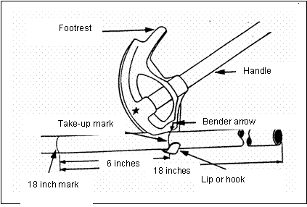

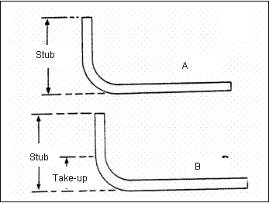

Precautions
- Consider safety rule
Criteria
- Applying the bending process according to the standard
Checkpoint
- what is the purpose 90 degree bending?

Lap Test-2
Task-1: Prepare and measure steel conduit
Task-2: Check the hiaky bender
Task-3: Put the hikey bender on the marking conduit
Task-4: make 90 degree bend

Unit Three:- Inspection System
This unit is developed to provide you the necessary information regarding the following content coverage and topics
- Cable and tube testing and measuring
- Conduit and tube inspection
- Tools, equipment and testing devices
- This unit will also assist to attain the learning outcomes stated in the cover page .Specifically ,upon completion of this learning guide, you will be able to:-
- Inspect, test and measure cabling and tubing
- Inspect performance of conduit and tubing
- Obtain tools, equipment and testing devices

  - Cable and tube testing and measuring
- Inspect exposed sections of cables for physical damage and evidence of overheating.
- Inspect bolted electrical connections for high resistance using one of the following methods:
- Use of low-resistance ohmmeter ,Verify tightness of accessible bolted electrical connections by calibrated torque-wrench method in accordance with manufacturer's published data. Inspect compression-applied connectors for correct cable match and indentation.
- Electrical Tests
- . Perform resistance measurements through bolted connections with low-resistance ohmmeter, if applicable, Perform insulation-resistance test on each conductor with respect to ground and adjacent conductors. Applied potential shall be 500 volts dc for 300 volt rated cable and 1000 volts dc for 600 volt rated cable. Test duration shall be one minute.
- Test Values
- . Compare bolted connection resistances to values of similar connections.
- Microhm or millivolt drop values shall not exceed the high levels of the normal range as indicated in the manufacturer's published data. If manufacturer's data is not available, investigate any values which deviate from similar connections by more than 50 percent of the lowest value.
- Minimum insulation-resistance values should be comparable to previously obtained results but not less than two megohm

  - Conduit and tube inspection
3.2.1 Tube inspection

What are the Important Items in the Piping or tube Inspection?
Pipe is a pressure-tight cylinder used to convey a fluid or to transmit a fluid pressure. These are only important points or a summary of points for the process piping in-service inspection and should not be assumed as the entire piping inspection procedure.
A piping inspection procedure is a comprehensive document, which need to cover inspection methods to be employed, equipment and material to be used, qualification of inspection personnel involved and the sequence of the inspection activities at the minimum.
You may use the following content as a summary of points for the in-service inspection of the piping system.
- Creating a piping inventory list indicating the line number, pipe specification class, rating, schedule, pipe origin location (from) and pipe destination location (to)
- Creating piping isometric sketches to facilitate inspection and the recording of corrosion monitoring locations (CMLs)
- Dividing whole unit piping into piping circuits based on process condition and potential degradation mechanism
- Selecting appropriate NDE techniques for each piping circuit based on the circuit damage mechanism
- Determination of CMLs points in piping isometric sketches based on the potential for general or localized corrosion and service specific damage mechanisms
- Determination of piping service class based consequence of failure and instruction stated in API 570 or based on the Risk Based Inspection method.
- Carry out external inspection for corrosion, leaks, previous temporary repairs, clamps, coating breakdown, insulation damage, vibration, misalignment, pipe support deterioration specifically in touch points and to air to soil interface, pipe hanger distortion or breakage and frizz damage
- External thickness measurement on CMLs on each piping circuit
- Corrosion rate calculation based on metal loss in a specific time interval
- Retirement thickness calculation based on the minmium required thickness and minimum required structural thickness
- Remaining life calculation based on the available thickness for corrosion and the corrosion rate value
- Determination of piping circuit inspection interval based remaining life calculation and piping service class
- Determination of piping inspection interval for non-thinning damage mechanism
- Making supplementary inspection with the proper NDE method for piping circuits susceptible to creep cracking
- Making supplementary inspection with the proper NDE method for piping circuits susceptible to the creep cracking
- Making supplementary inspection with the proper NDE method for piping circuits susceptible to environmental cracking from Chloride SCC, Polythionic acid SCC, Caustic SCC, Amine SCC, Carbonate SCC, Hydrogen blistering and hydrogen induced cracking (HIC), etc.
- Internal inspection in opened flanges for deposition, corrosion, localized corrosion, erosion, etc.
- Internal inspection of clad or lined piping for disbanding, bulging and cracking
- Internal inspection of refractory lined piping for erosion, deterioration of anchors, undercutting of refractory and coke build up behind refractory
- Flange joint inspection for distortion and leakage and flange face inspection, ring groove and gasket for corrosion, erosion , cracking and mechanical damage
- Internal inspection of dismantled valve for corrosion, erosion, mechanical damage and cracking
- Specific attention and internal inspection of critical check valves
- Inspection of injection points for localized corrosion
- Inspection of dead legs for corrosion
- Corrosion under insulation inspection of piping in susceptible temperature (-12˚ to 175˚ C) either by advance NDT or by removal of insulation and making visual inspection
- Making appropriate reporting and report keeping and implement proper system for quick access to the records
3.2.2 Conduit inspection
- Conduit Introduction
The purpose of conduit is to provide a protected pathway, or raceway, for electrical conductors and communications cables. Additionally, conduit provides a means of removing and replacing the product inside of the conduit, without the need to re-trench. There are numerous types of conduits, coming in a variety of materials, shapes, and sizes,
used for different purposes in CFX’s ITS infrastructure. All conduit installations on CFX’s system must meet National
Electric Code (NEC), CFX Technical Specification, and CFX ITS Design Standard requirements. These requirements will vary depending on the conduit type, application, and installation method. This chapter will provide an overview of conduit systems commonly utilized in CFX’s ITS infrastructure. Specifically, we will cover the following topics: conduit size, conduit accessories, types of conduit, methods of conduit installation, and conduit installation details.
- Conduit Size
Conduits come in a variety of sizes and the construction plans will designate a trade size for each conduit run. Conduit size is commonly specified by two designations: a nominal pipe size (NPS) for diameter based on inches and a Pipe Schedule or Size Dimension Ratio (SDR) for wall thickness. Figure 2.1 below illustrates three key concepts relating to
conduit size: inner diameter, outer diameter, and wall thickness.
Inner Diameter (I.D.) - The I.D. is the width of the conduit opening or inside wall to inside wall. Outer Diameter (O.D) - The O.D. is the width of the conduit from the outer wall to the outer wall. Wall Thickness - The wall thickness is the width between the outer wall and inner wall or is given by the
example conduit diameter sizes are 20mm, 25mm and even 32mm. These sizes are well stocked and readily available from stock at Centaur. However, in addition we also offer large sizes also from stock in 38mm and 50mm, all complimented by an extensive range of accessories

  - :- Tools ,equipment and testing devices
- Hand tools and equipment
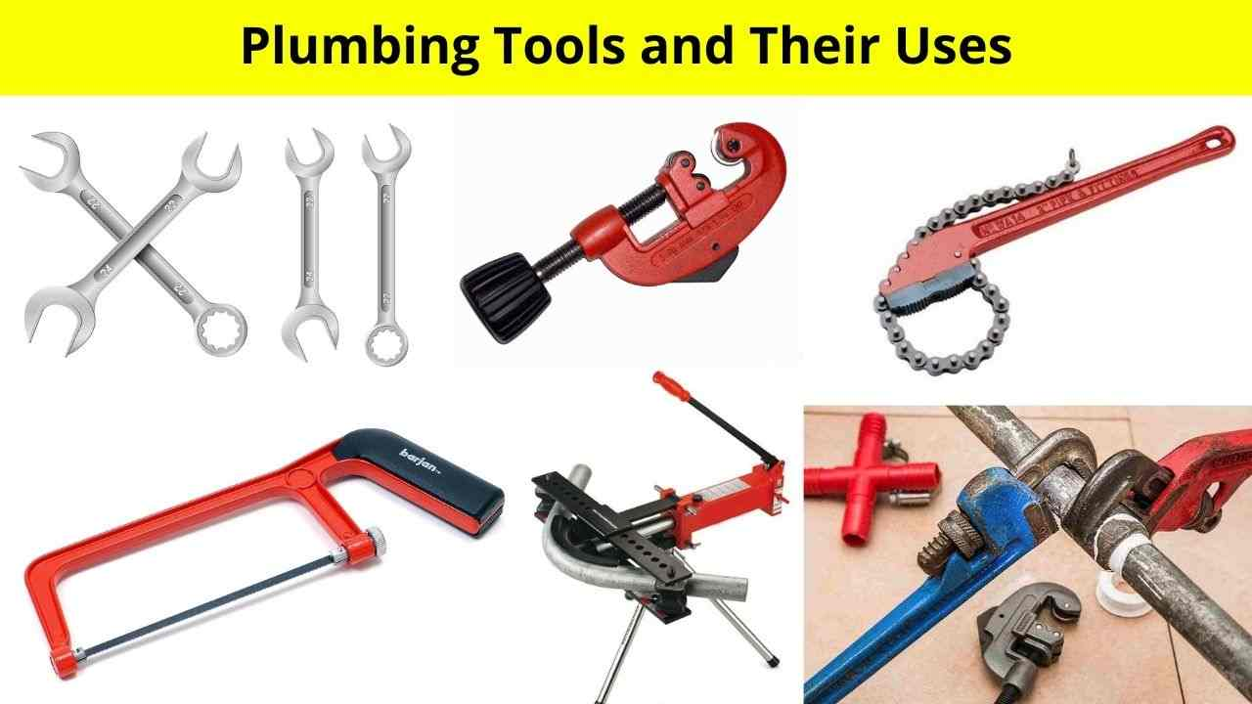
Fig 3.1 Plumbing Hand tools
- Different Types of Plumbing Tools and Their Uses
In this article, we are going to explain the different types of plumbing tools that are used to fix house drainage system problems. These plumbing tools are mostly used everywhere for all types of house plumbing problems.
- Plumbing Tools and Their Uses
The tool which is used to fix the house drainage, sanitary, water distribution problems is known as plumbing tools.
In recent times, lots of plumbing tools are available in the market as per their purpose and uniqueness. But here we listed some very common and most useful plumbing tools that are mostly used for plumbing works.
Different types of plumbing tools are listed below.
1.Pipe cutter 2. Pipe Wrench 3. Pipe Vice 4. Hacksaw
5.Pipe Bending Machine 5. Water Pump Pliers 6. Threading Dies
7.Chain Wrench 8. Set of common ring 8.Spanners 9 .Plumb Bob
10. Pipe Cutter
Fig 3.2 Pipe Cutter 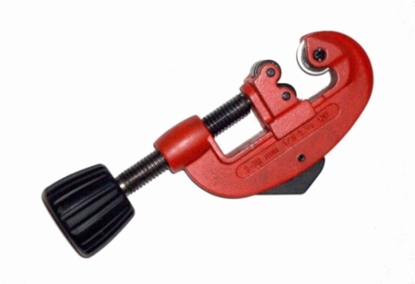
Pipe cutter is one of the most common type of plumbing tool that is used to cut water, sanitary, or sewer pipes. Generally, Solid type, Hook Type, and chain type pipe cutters are mostly used.
Pipe cutter includes the cutting reels, moving reels base, screw, and adjusting handles. Moving reels base is adjusted as per pipe size with the help of adjusting screwed handle. The pipe was cut by a rotating cutter surrounding it.
2. Pipe Vice
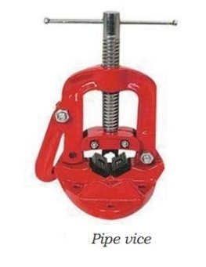
Fig 3.3 Pipe Vice
- Open Side Pipe Vice
- Fixed Side Pipe Vice
Pipe vice includes the set of the jaw, one is fixed while another is moveable to adjust as per the size of pipe.
- Pipe Wrench

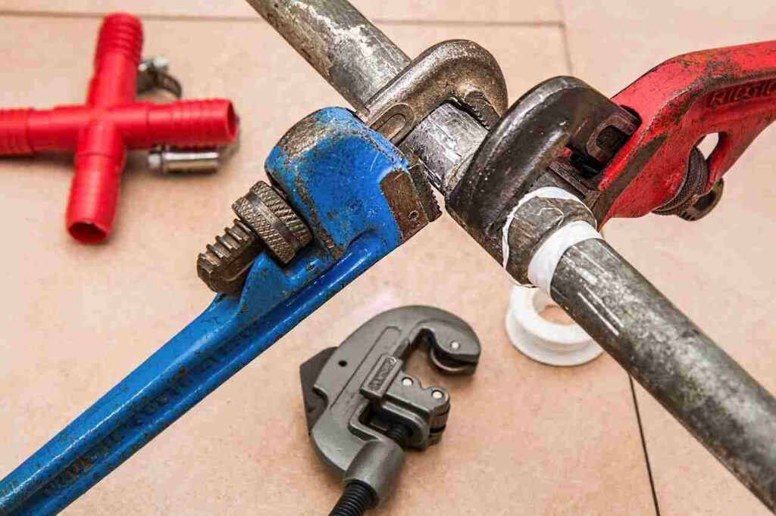

Fig 3.4 Pipe Wrench

Pipe wrench is a fitting plumbing tool that is used to loosening or tightening the connections of pipes, joints, nuts, etc. It is also used to hold the pipe and turn around it for tightening or loosening purposes.
Pipe wrenches were available in two types, adjustable and non-adjustable wrenches. These wrenches are used to screw and unscrew the pipe upto 75 mm dia.
Non-adjustable wrenches are available in fixed size while the adjustable wrenches are adjusted as per pipe diameter.
Adjustable wrenches include the Fixed flat jaw, moveable flat jaw, handle and square toothed screw. The moveable flat jaw slide in the body with the help of a screw. The gap between fixed flat jaw and moveable flat jaw is used to hold the pipes, nuts, joints, etc.

4. Hacksaw
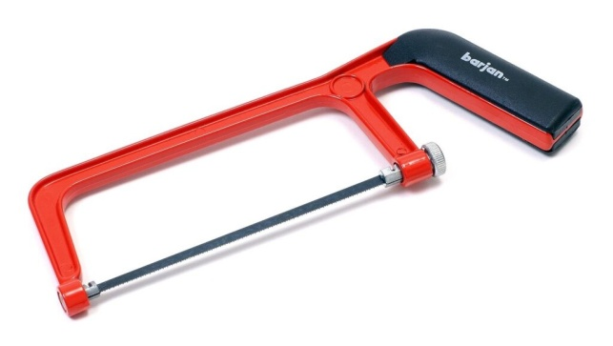
Fig 3.5 Hacksaw
Hacksaw is a cutting plumbing tool that is used to cut the plastic pipes, steel hollow roads, steel thin sheets, angles, etc. Hacksaw includes the handle, frame, blade and adjustable wing screw.
Cutting operation using manually operated hacksaw includes the forward stroke and reverse stroke, where the forward stroke is known as cutting stroke while reverse stroke is known as idle stroke.
Hand-operated hacksaw is used in site work while power hacksaw is used in workshop works.

5.Pipe Bending Machine
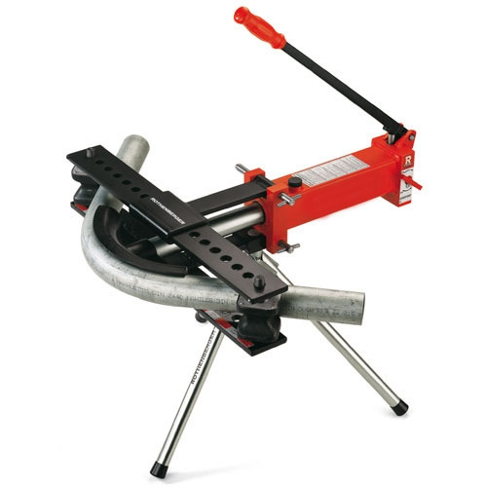

Fig 3.6 Pipe Bending Machine
Pipe bending machine is used to turn or bend the pipes at various angles as per requirement. The hand-operated pipe bending machine is used to bend small sizes pipes while the hydraulic pipe bending machine was used to bend large size pipes.

6. Water Pump Pliers

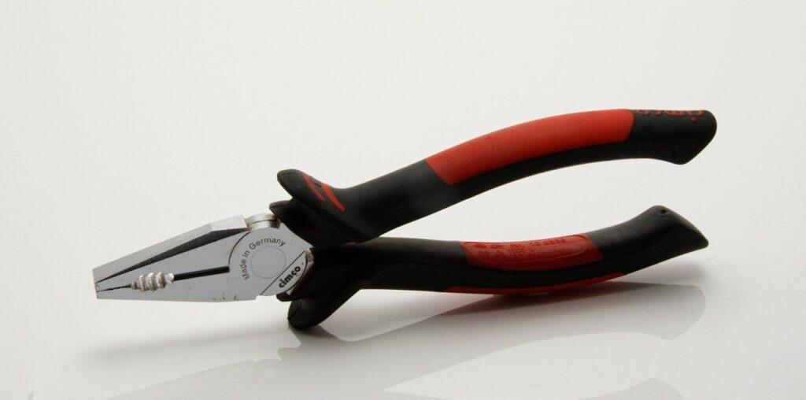

Fig 3.7 Water Pump Pliers

Water pump pliers or pipe pliers is one of the most essential home plumbing tools that is used to cut pipes, wires, tightening or loosening the various parts, etc. Different shape and sizes pliers are available in market.

7.Threading Dies
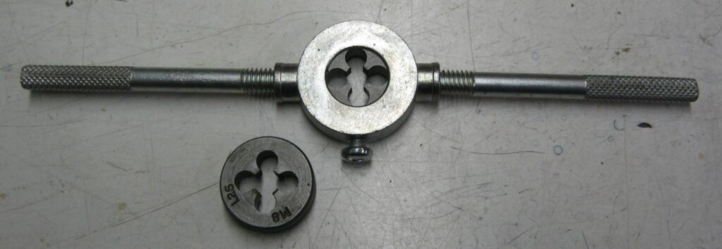

Fig 3.8 Threading Dies
Threading dies are used to create threads on pipes to join them with another one to make a strong joint connection. It was used to make threads on plastic pipes as well as steel pipes.

8. Chain Wrench
Chain wrench is holding plumbing tools that are used to hold and open or close the large dia pipes. Chain wrench includes the chain and toott which helps to hold and rotate the pipes.
The chain wrench is available in 3″, 4″, 6″, 8″ and 12″, with the length 475 mm, 585 mm, 834 mm, 1100 mm, and 1360 mm respectively.

9. Set of Common Ring Spanners
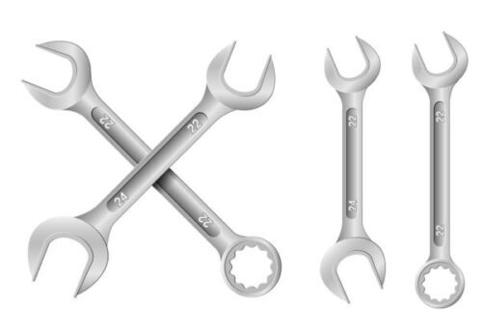
Fig 3.9 Ring Spanners
The spanners are the fitting plumbing tool that is used to loosening or tightening the standard size nuts and bolts. The various types of spanners are available in market mentioned as below.
Ring Spanners
Ring spanners are included circular closed rings at both ends. Uses of ring spanners sometimes cause damage due to slips.
Open-Ended Spanners
Open-ended spanners include the open jaw at both ends of spanners that is mostly used to open or close the nut and bolts.
Combination Spanners
Combination spanners include the combination of Ring and Open-ended spanners. It is one end with a circular ring while other ends consist open-ended jaw.
Bi-Hexagonal Ring Spanners
Bi-hexagonal spanners include the hexagonal rings at both ends to hold and open nuts and bolts. It is available in the market in various sizes.

Fig 3.10Ring Spanners 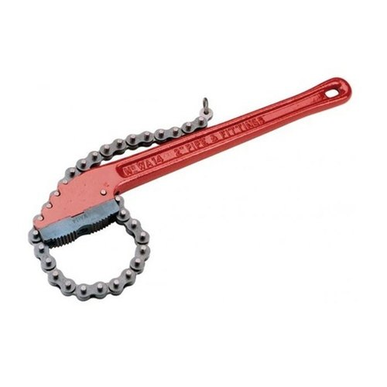

Different types of pipe testing methods
- Hydrostatic Testing
- Magnetic Particle Inspection
- Charpy Impact Test
- Ultrasonic Testing
Steel pipes are used everywhere, from plumbing systems to a wide variety of structural applications. To ensure that these pipes can perform under different levels of environmental stresses, they have to undergo a series of pipe testing methods. The types of testing can be classified under destructive and non-destructive testing. Since almost all pipes will inevitably be subject to wear and tear, corrosion, cracking, and other manufacturing defects, testing methods are crucial in predicting their behavior.
As the name suggests, non-destructive testing or NDT involves the implementation of techniques that do not lead to any physical damage to the specimen. Some examples of NDT include ultrasonic testing and magnetic particle inspection. Meanwhile, destructive pipe testing can include hydrostatic, Charpy impact, or pipe notch testing methods — all of which are designed to measure the pipe’s performance and failure.
Understand that whenever you’re purchasing steel or any kind of pipe, pipe testing is crucial. This is conducted by your manufacturer or supplier to guarantee that the pipe is fit for its intended use. Read on to learn more.
1.Hydrostatic Testing
For pipes that need to be used for transmitting fluids at a certain pressure, hydrostatic or hydro testing is applied to determine the pipe’s risk assessment for breakage and leaks. Hydro tests are usually conducted after pipelines have been shut down and repairs have been made in order to confirm that the piping equipment will still be fit for operational use under certain conditions.
Hydro testing starts by fully filling the material with water, vacuuming the air present, and then pressurizing the entire system up to 1.5 times its pressure limit. The unit is maintained in this condition for several hours or minutes, as determined by the inspector. During this time, they will conduct visual examinations on the pipe and check if there are any potential signs of leaks and cracks. For improved visibility, testing engineers will oftentimes include additives to the fluid — either a fluorescent dye or a tracer to accurately trace the source of the leak.
By pressurizing the pipe almost twice the recommended pressure load, hydrostatic testing provides proof of the pipe’s strength under extreme environmental conditions. With this information, petrochemical industries or plumbing companies can set safety margins for the usage of the pipe

2.Magnetic Particle Inspection
As previously discussed, magnetic particle inspection is a form of non-destructive testing, unlike the hydrostatic method. The aim of this method is to identify if there are any linear flaws present near or on the surface of the pipe, especially when it is a ferromagnetic stainless steel grade — 403, 430, and 439 are some examples.
Since only surface identification is involved in magnetic particle inspection, it does not destroy parts or the entire pipe itself. Likewise, it is capable of identifying locations prone to surface breakage, cracking, poorly-welded joints, pores, cold laps, and the like.
For this technique, the most popular and versatile method involves a yoke magnet, strippable white paint, and magnetic “ink” that contains powderized iron particles in a liquid base. A certain area of the pipe will be magnetized, and if there are any surface defects present, the iron-liquid compound will deform around them.

3.Charpy Impact Test
Another destructive pipe testing technique, the Charpy impact design is designed to measure the toughness of the pipes. This is most commonly performed on notched pipes or pipes that have been joined together on the side to create a bend or a joint.
In this test, a weighted pendulum is placed in a controlled environment, where it is swung from a height. The impact on the material is the measurement of how much energy the pipe absorbed upon impact or fracturing.
Some advantages of the Charpy impact test are that it’s easy to perform, cost-effective, and allows piping manufacturers to determine the quality and strength of their product. However, the results are often qualitative in nature, which means they have to be compared with one another for improved accuracy.
4. Ultrasonic Testing
Ultrasonic is defined as the vibration of frequencies that measure above the upper limit of the human audible range, greater than 20 kilohertz. Unlike previous testing methods which are suited for identifying strength, toughness, or ductility, ultrasonic testing is done to determine the pipe’s wall thickness or its internal structuring.
Through the pipe’s surface, an ultrasonic sound wave is transmitted and allowed to bounce off inside its walls when it encounters another medium, such as air. At this point, the sound waves reflect back to the source, where the rate of travel is measured. All of these are made possible by electronic transducers that can produce visualizations of the pipe’s properties. Aside from wall thickness, it can also determine weld indentations, fractures, and moving components, if any
Ultrasonic testing has also been reliable because once wall thickness is properly identified, it can provide useful information for the inspector regarding corrosion and other potential imperfections. Post-processing techniques are thus implemented as a result

Self check
  - Say Trur or False
1.Pipe is a pressure-tight cylinder used to convey a fluid or to transmit a fluid pressure
2. The purpose of conduit is to provide a protected pathway, or raceway, for electrical conductors and communications cables.
3. Conduit size is commonly specified by two designations: a nominal pipe size (NPS) for diameter based on meter
4. Charpy Impact test is applied to determine the pipe’s risk assessment for breakage and leaks
5. The Charpy impact design is designed to measure the toughness of the pipes

  - Choose the best answer
1.In-service inspection of the piping system. Which one is true for the line number.
A. pipe specification class B. rating C. schedule
D. pipe origin location (from) and pipe destination location E.All
2.Which is true about Conduit
A .Inner Diameter (I.D.) - The I.D. is the width of the conduit opening or inside wall to inside wall.
B. Outer Diameter (O.D) - The O.D. is the width of the conduit from the outer wall to the outer wall.
C. Wall Thickness - The wall thickness is the width between the outer wall and inner wall or is given by the D. All

3. Which one is not a types of pipe testing methods
A. Hydrostatic Testing B. Magnetic Particle Inspection
C. Charpy Impact Test D. Ultrasonic Testing E.All

Operation sheet 3 :-Inspection system
Operation title:- Pipes/tubes & fittings
Purpose: Connect pipe with a motor pump
Instruction:- Follow the the given step and instruction install the water pump . You have given 1 hours for the task and you are expected to write the answer on the given paper
Steps in doing the task
Step 1.Prepare the required hand tools for pipe installation.
Step 2.Prepare the pipe for water pump motor
Step 3.Make a trade with a pipe and connect the pipe
Step 4. connect the pipe with motor
Step 5. Between the two pipe insert or a valve in order to flow the water from tanker to water reservoir

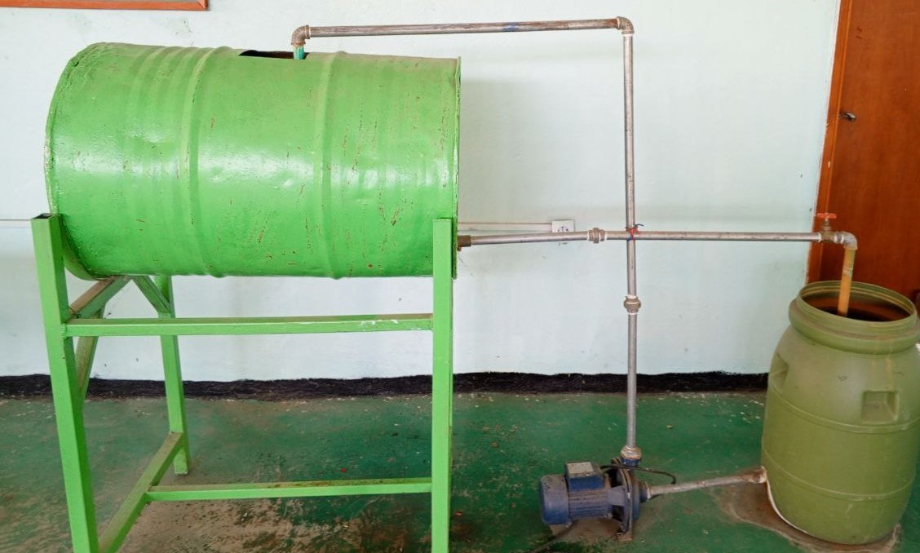

Lap Test -3
Instruction :-Given the necessary tools and materials you are expected to perform the following tasks within 1:30 hour.
Task 1:- Install a motor pump

Reference

    - Buildingelectricalinstallationhttps://dps.mn.gov/divisions/ojp/forms-documents/Documents/Wilder_Program_Evaluation_8.pdf
    - Identifying Wire Splices and Joining http://www.team reporterapp.com/information-gathering/
    - Gathering information: Available on: Information Gathering. Available on: http://www.teamreporterapp.com/information-gathering/
    - Medical Advice Disclaimer (2005-2019). The Importance of Using Community Resources in Treatment. Available on
    - Ethiopian building code standard edition -10
    - Salaman, R. A. (1997 edition revised by Philip Walker; first published in 1975 by George Allen & Unwin [Publishers] Ltd). Dictionary of Woodworking Tools, c. 1700–1970 Mendham, NJ: Astragal Press ISBN 978-1-879335-79-0.
    - Salaman, R. A. (1996). Dictionary of Leather- working Tools, c.1700–1950, and the Tools of Allied Trades Mendham, NJ: Astragal Press ISBN 978-1-879335-72-1.
    - Russell, David R., with Robert Lesage and photographs by James Austin, cataloguing assisted by Peter Hackett (2010). Antique Woodworking Tools: Their Craftsmanship from the Earliest Times to the Twentieth Century Cambridge: John Adamson
    - R.K. Clidero Applications of Electrical Construction, General Publishing Co., Don Mills Ontario Canada, 1975, ISBN 0-7736-5011-3
    - ^ R. S. Means Electrical Cost Data 22nd Edition, ISBN 0-87629-504-9, pages 106-107 table 16 200 Conduits
    - ^ Jump up to:ª ^{b} "Benefits of Fiberglass Conduit" (PDF). Outsideplant.colonialteltek.com. Retrieved 2 October 2017.
    - ^ "Five advantages of PVC coated conduit". FlexGlory.
    - ^ "Reinforced Thermosetting Resin Conduit: Type RTRC" (PDF). Ul.com. Retrieved 2 October 2017.

The trainers who developed the TTLM
No | Name | Qualification level | Educational background | Region | College | Mobile number | E-mail
1 | Melaku Bekele Ofgaha | A | Electri/Automation Control Technology | Oromia | Amboo poly TVET college | O921051772 | kakumalaku430@gmail.com
2 | Bahiru Demeke Beshah | A | Electri/Elec Control  Technology | Oromia | Bishoftu Poly TVET College | O911394408 | bahirudemeke20@gmail.com
3 | Worku Biru Mekonnen | A | Electri/Automation Control Technology | Oromia | Sebeta Poly TVET College | O912106303 | workubiru3@gmail.com
4 | Sisay H/Mariam Toga | A | Electrical Power Enginering | Southern | Arbaminch poly &satelite College | O945234339 | sisayhailemariam971@gmail.com
5 | Hassen Husen Hamid | A | Electrical Eng | Oromia | M/G/M/B Poly TVET College | O943402001
Participants of this Module (training material) preparation

