
Industrial Electrical/ Electronic Control Technology
Level III
Based on October, 2023 (Version-II) Curriculum

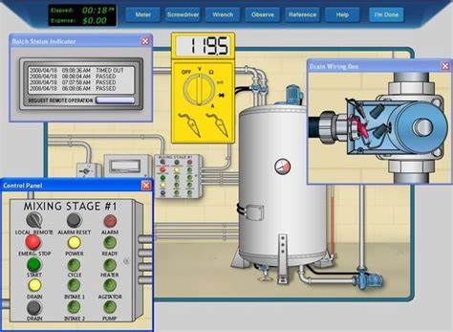
Module Title: Set-up industrial field control devices
TTLM Code: EIS IEC3 TTLM 2023 V-1
Nominal duration: 75 Hour
Prepared by:

September 2023
Addis Abeba
Table of Contents
Acknowledgment 2
List of Acronym 3
Introduction to the Module 4
This module covers the units: 4
Learning Objective of the Module 4
Module Instruction 4
UNIT 1. Formulate process control loops 5
1.1. WHS/OHS processes and workplace procedures 6
1.2. Tools, equipment and testing devices 11
1.3. Process controller material, equipment and device 22
Self-check (1.1) 26
UNIT 2. Set up process control 29
2.1. Introduction Process control 30
2.2. Control loop 33
2.3. Control loop set up standard 46
2.4. Field Control device set up 50
2.5. Field control devices arrangement 56
2.6. Final set up system of process control 61
Self-check (2.1) 67
Operation sheet (2.1) 69
UNIT 3. Test for correct functionality 72
3.1. Conduct calibration and instrumentation standard 73
3.2. Install specific complete loop system 83
3.3. Follow functionality tests 94
3.4. Complete status report/s and notify work supervision 102
Self-check (3.1) 104
Operation sheet (3.1): Control valve pressure test and setup 105
Expert Profile 111
Reference 112

Acknowledgment
The Ministry of Labor and skill would like to extend its gratitude to Regional Labor, and skill/training Bureaus, TVT College Deans, Instructors, and industry experts for their financial and technical support Set-up industrial field control devices training module. Finally, MOLS extends its gratitude to the following instructors and experts who contributed to the development of this TTLM until its finalization.

List of Acronym
ANSI | American National Standards Institute
DAC | Digital Analog Converter
EDS | Electrical Data Sheet
ESIA | Environmental Impact Assessment
DDC | Direct Digital Control
PV | Process Variable
HMI | Human Machine Interface
ILO | International Labor Organization
ISA | Instrumentation, Systems and Automation Society
MSD | Musculoskeletal Disorder
OHS | Occupational Health and Safety
PID | Proportional Integral Derivative
P&ID | Pipe And Instrument Diagram
PH | Pound Hydrogen
PLC | Programmable Logic Controller
HVAC | Heating, ventilation, and air conditioning
TUR | Test Uncertainty Ratio
PSI | Pound Ser Square
SCADA | Supervisory Control and Data Acquisition
DDM | Digital Multi meter
RTU | Remote Terminal Unit
WHS | Workplace Safety and Healthy

Introduction to the Module
This Learning material covers setting up industrial field control devices such as transducers, sensors, and actuators. It encompasses working safely, following design brief, applying knowledge of device operating principles, interpreting device specifications, following manufacturer’s set up specifications, testing device operation and documenting set up parameters.

This module covers the units:
- Prepare to work on process control loops
- Set up process control
- Test for correct functionality

Learning Objective of the Module
- Determine Plan and prepare for work on process control loops
- Set up process control
- Apply Test for correct functionality

Module Instruction
For effective use these modules trainees are expected to follow the following module instruction:
- Read the information written in each unit
- Accomplish the Self-checks at the end of each unit
- Perform Operation Sheets which were provided at the end of units
- Do the “LAP test” giver at the end of each unit and
- Read the identified reference book for Examples and exercise

UNIT 1. Formulate process control loops

This learning guide is developed to provide you the necessary information regarding the following content coverage and topics:
- WHS/OHS processes and workplace procedures
- Tools, equipment and testing devices for setup control loop
- Process controller/ material, equipment and device.

This guide will also assist you to attain the learning outcome stated in the cover page. Specifically, upon completion of this Learning Guide, you will be able to:
- Identify and apply WHS/OHS processes and workplace procedures
- Obtain Tools, equipment and testing devices for setup control loop
- Collect and organize process controller/ material, equipment and device

WHS/OHS processes and workplace procedures
    - The general approach
A safe and healthy workplace only occurs when there is a planned and systematic approach to managing risks. We firstly need to understand our exposures to safety risks in our workplaces and what the harmful consequences could be. Then we must do whatever is reasonably practicable to either eliminate or minimize the work health and safety risks following the hierarchy of controls. A proactive approach to managing risks is encouraged, that is: anticipating hazards/risks, planning ahead and implementing control measures before work starts or any significant exposure to risk occurs. We also need processes in place to fix hazards as they are found, for example, from workplace inspections or hazard/near miss reports.
The four-step cycle of risk management
The risk management process follows a four-step process as shown in this diagram taken from How to Manage Work Health and Safety Risks.
These four steps are:
- Identify hazards – what could cause harm?
- Assess risks if necessary – how serious could the harm be and how likely?
- Control risks – what are the most effective control measures that are reasonably practicable in the circumstances?
- Review control measures – Are controls working as planned?

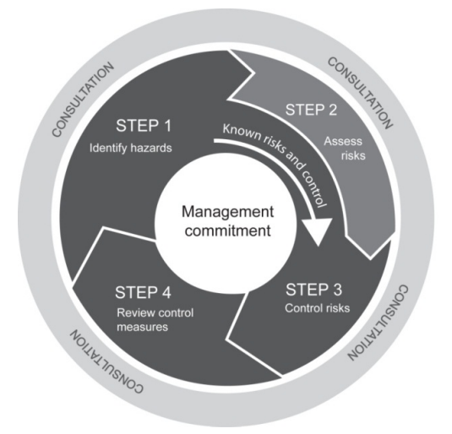
Figure 1. 1 Step cycle of risk management
For managing workplace health and safety risks, As shown in the diagram, the central core of risk management is management commitment. Managers need to lead and support the risk management process in their area of responsibility and provide adequate resources for implementation of the necessary control measures.
Consultation with university personnel performing work must occur during all four steps. This participation is critical as it provides an opportunity to draw upon individual experience, skills, knowledge and ideas with a view to finding practical control measures.
Many work-related hazards and their associated risks are well known and have well established and accepted risk control measures. In these situations, it is not essential to formally assess the risks. It may be sufficient to simply implement the controls in accordance with the relevant legislation, code of practice, standard or industry practice as applicable in the university context.
Controlling risks is to be carried out in accordance with the hierarchy of controls (see below). An explanation of the hierarchy of controls and guidance on its application is provided in How to Manage Work Health and Safety Risks. Our first aim is to eliminate a hazard, which is the most effective control. If this is not reasonably practicable, we must minimize the risk by working through the other alternatives in the hierarchy.
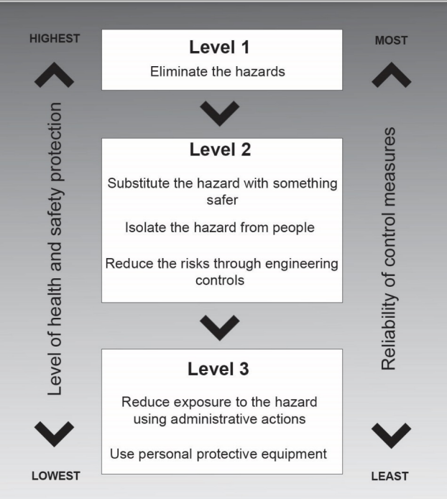
Figure 1. 2 The Hierarchy of Controls diagram
    - Work Health and Safety

WHS, or Work Health and Safety, is the regulatory approach to promoting safe and healthy in workplaces. It involves establishing standards and processes that ensure everyone knows their rights and responsibilities regarding workplace health and safety.
The scope of Work Health and Safety (WHS) is comprehensive. It encompasses all aspects of a business, from the physical work environment to employees' mental and emotional well-being. It includes identifying, assessing, and managing safety risks associated with work activities and taking steps to prevent or control hazards that may cause injury or illness.
WHS laws apply to all organizations, including small businesses, large corporations, and government agencies. These laws and regulations are in place to protect workers and the public from harm. Organizations must comply with these regulations to ensure the safety and health of their employees and others who may be affected by their activities.
WHS Policies and Procedures
When faced with managing the health and safety of their workplace, employers must handle this responsibility seriously. They are ultimately accountable for the well-being of their employees while they are on the job. That is why you must familiarize yourself with your organizations health and safety policies and procedures, and follow them thoroughly.
Let's take a closer look:
WHS Policies and Procedures are written documents that provide guidelines for how a business should handle all safety matters in the workplace. They can be as broad or specific as necessary to ensure everyone is on the same page regarding staying safe while working.
These policies are:
- Risk assessments and management
- Workplace safety standards
- Reporting of accidents and injuries
- Employee training and education
- Emergency preparedness and response
- Investigation of incidents
- Personal protective equipment (PPE)

    - The scope of occupational health and safety include:
- Recognition and anticipation of workers health problems in an industrial atmosphere;
- Evaluation of the recognized problem which encompasses mainly data collection, analysis, interpretation, and recognition;
- Development of corrective actions to eliminate or limit the problem.
- Generally, the work frame of industrial hygiene is wide and needs multidisciplinary approach. It requires the knowledge of physics, biology, chemistry, ergonomics, medicine, engineering and related science. It also requires public health management skills for proper communication and decision making.
Some common hazards that may be encountered in the workplace include:
Chemical Hazards
These include asbestos, coal dust, multitude of acids and alkalis, gases such as SO₂, CO₂, CO, NO_{x}, heavy metal poisonings such as lead and mercury and a long list of toxic substances such as pesticides, solvents and preservatives. These harmful chemical compounds in the form of solids, liquids, gases, mists, dusts, fumes, and vapor exert toxic effects after they get entrance by inhalation, absorption through direct contact with skin or ingestion. The most important of these is inhalation due to the speed with which toxic substances are absorbed and enter the blood stream. Please note that the degree of worker risk from exposure to any given substances depends on the nature and potency of the toxic effects and the magnitude and duration of exposure.
Biological Hazards
These include bacteria, virus, fungi, and other living organisms that can cause acute and chronic infections.
Physical Hazards
- Non-ionizing radiation e.g. microwaves, infra red, visible and ultra-violet light
- Ionizing radiation e.g. X-rays, gamma rays, beta particles, alpha particles from radon daughters
- Noise (usually measured in decibels dB) and vibration;
- Temperature, humidity etc

Ergonomic Hazards
The term is originated from two Greek words, ergon- meaning work and nomos meaning law. Ergonomics is, therefore, the study of law(s) governing work and its environment. Ergonomics includes human factors in engineering and it deals with the consideration of human characteristics, expectations and behaviors in the design of tools, equipment etc that people use in their work and everyday lives and the environment in which they work and live. Ergonomics related injuries and illness are ranging from eyestrain and headaches, musculoskeletal ailments such as chronic backache, neck and shoulder pain, etc. These and other related problems are avoided primarily by the effective design of a job or jobsite and by better- designed tools or equipment that meet workers needs in terms of physical environment and job tasks
Psychosocial Hazards
The term “stress” means the strain imposed on the worker by psychosocial influences associated with urbanization and works. Within the work environment itself, emotional stress may arise from a variety of psychosocial factors, which the worker finds unsatisfactory, frustrating or demoralizing, for example: Workers may be working in shifts that will expose them to unusual hours. They may upset their family’s life as a result of their work conditions.
Workers may be working with a person who is paid more but who is incapable of working. Financial incentives are too low, work overload, work under load, poor job management, career development, and lack of job security, etc.

Tools, equipment and testing devices
    - Selecting Healthy Hand Tools
Choosing the right-hand tool for a job can protect workers from painful injuries and improve productivity at the same time. Everyone has heard the saying; “the right tool for the right job”, and “you are only as good as your tools.” These sayings are very true when it comes to the choice and use of tools in the in electrical/electronic or engineering field. The proper selection of tools, devices, equipment, mechanisms, resources and utilization for proper activity will justify the job quality and completion of your task at proper time.
- Ergonomics advantage:
Ergonomics often is described as matching human capabilities (physical, psychological, physiological and biomechanical) to the demands of a specific task. The risk-injury relationship often is described as an exponential relationship. Using ergonomics principles to reduce job risk factors not only decreases the injury risk but often increases the efficiency and quality of a job and improves the overall productivity.
Workers should be trained on safe procedures for working with tools. However, safe practices when carrying or storing those tools may not be thoroughly covered. Tools can pose a safety risk when they are misplaced or improperly handled by workers. The National Safety Council offers the following tips for safe handling of tools when they are not in use
When there is a mismatch in some of these requirements, one of the consequences may be the development of musculoskeletal injuries. The common occupational risk factors for the development of a Musculoskeletal disorders (MSD) are the application of excessive force, high repetition, awkward postures, long task durations and static loading of the muscles. The level of injury risk depends on both the frequency and severity of risk factors present in a task.
Importance of using the right tool for the job – Each tool is precisely designed for a specific purpose, so choosing the correct tool will also decrease the amount of effort required to get a job done right without causing damage to either the equipment or the surface being worked on.
Never adapt if you are missing a tool or piece of equipment. Remember tools are designed for specific needs and purposes. Using any tool inappropriately is wrong and just plain dangerous. To avoid personal injury and tool damage, select the proper tool to do the job well and safely.
The Tools can be classified into two types
- The first type of tool is the physical device that employees directly use to complete a task correctly.
- The second type of tool expedites processes at work. These might not be necessary to complete a task but are just as important to the project
- Time saving & Efficiency:
With the right tools and equipment, maximum efficiency can be achieved. Tools are designed to help us accomplish specific tasks easier and safely. Using the incorrect tool for a task not only can take longer to accomplish, but it could also result in injuries, mistakes, and shoddy workmanship. All of these will end up costing you more time and money than if the right tool had been used the right way from the start.
- Quality of Work:
When employees are using the wrong equipment, mistakes are bound to happen. Incorrect installation techniques can lead to leaks, damage to the equipment or to the surface being worked on. As a result of these issues, your reputation with your customer and your employees’ sense of pride in their work can be damaged. To be successful, you need your customers to trust you to complete the work at a high-quality standard. In addition, your employees will feel proud of the work they do if they know it’s important to do it the right way, with the right tools.
- Safety:
On job sites, it’s crucial to have the proper PPE to protect employees from injury. It’s equally as important to equip workers with the right tools to complete jobs safely. You don’t want your employees to have to get creative with what ladders or power tools to use.
To conclude, tools are the backbone of business processes. The tools and equipment should be well maintained and serviced to make certain that it stays in good working order and lasts as long as possible. Whether you are attempting to save time or are just negligent, using the wrong tool for the job is a mistake. The best workmen always equip themselves always with the right tools for their work. Foremen and their crews appreciate having the tools they need to do their jobs. Provided with the right tools and equipment, they will not only be happier, more engaged employees, they will also be motivated to do their best work.
- Important electrician hand tools
- Cutter
Cutter is general name that stands for different types of cutting devices, which include, scissors, diagonal cutting pliers, axle…etc. However, it is better idea to consider only hand tools that are used in this competency/ learning module as cutting tools.
- Hack saw: - Hack saw can be manufactured in different size and types. It is used to cut PVC or metal pipes and metal frames. Tube frame of hack saw is made up of Iron and the handle is made up of metal or wood. A clip is fixed in its other end to adjust the length.
- File: - Sharper is different type of device or tools that are used to make sharpen tip of object sharpen blade. So, File is a sharper device used to correct the size and smooths the upper part of metals. It is named according to the size and the rough surface for smoothing other surface.
- Grinder: - grinders are different types and they are also used for different purposes. So it is one of the sharpening tools that are use for cutting, grinding and sharpening purpose.
- Drill: Portable electrical hand drill is used (some of new products has two-mode selection switch) for hammer-drilling in concrete or drill-only mode for wood, steel and
- Threading tool and tappers: A tap is used to cut threads on the inside of a hole, while a die is for cutting external threads on round stock. They are made of hard tempered steel and ground to an exact size. There are four types of threads that can be cut with standard taps and dies. They are: National Coarse, National Fine, National Extra Fine, and National Pipe.
- Plier sorted: In electrical works the most useful hand tools are different types of pliers these are combination pliers and cutting plier. Combination pliers are used for holding, griping, twisting and bending, while cutting pliers are used to cut the cables and to tighten them. The handles of the plier is, wrapped by rubber even to be used in current supply. Even if it is unadvisable at emergency situation it can be also used to fix or remove screws.
- Screw Drivers (Assorted): The screwdriver can be classified by its shape, type of blade, and blade length. It is made for only one purpose, i.e., for loosening or tightening screws or screw head bolts. There are several different types of screwdrivers. When using the common screwdriver, select the largest screwdriver whose blade will make a good fit in the screw that is to be turned. The two types of recessed head screws in common use are the Phillips and the Reed & Prince. Both the Phillips and Reed & Prince recessed heads are optional on several types of screws.
- Soldering iron/gun
- Soldering Irons: soldering irons are device that convert electrical energy to heat energy through systematical designed high resistive wire as heating elements. They are used to solder electronic circuits or connecting wires and other materials using soldering leads as well as using other catalysts that aids either to increase strength of connection or to clean contacts.
- Soldering Gun: It is especially well adapted to maintenance and troubleshooting work where only a small part of the technician's time is spent actually soldering.
- Wrenches, hexagonal wrenches or allen keys: The wrenches most often used in maintenance are classified as open-end, box-end, socket, adjustable, ratcheting and special wrenches. The Allen wrench, although seldom used, is required on one special type of recessed screw. Solid, nonadjustable wrenches with open parallel jaws on one or both ends are known as open-end wrenches. Box-end wrenches are popular tools because of their usefulness in close quarters. They are called box wrenches since they box, or completely surround the nut or bolt head.
- Water level, tri-square
- Water sprit level: - is a device used for measuring or machining surface elevation of locations is too far apart for a sprit level to span. Alcohol such as ethanol is often used rather than water because alcohols have low viscosity and surface tension.
- Tri-Square: MEASURING ANGLES frequently you will have to determine angles between parts or units of aircraft. In layout work, it is also sometimes necessary to measure angles. The tools most frequently used for measuring angles are Tri-squares, the combination set, angle gages, and levels. It is used for measuring angles of90: (Right angle) Measurements in mile meter are marked in its scale. it is used to measure 90 right angle accurately.
- Measuring tapes: They are extended easily or coiled in their cases for stowage, and you can conveniently carry one of these in your pocket.
- Calipers and gauges: Layout and measuring devices are precision tools. They are carefully machined, accurately marked and, in many cases, are made up of very delicate parts. When using these tools, be careful not to drop, bend, or scratch them. The finished product will be no more accurate than the measurements or the layout; therefore, it is very important to understand how to read, use, and care for these tools.
- Micrometer: A micrometer can be used to measure small and large sizes of wires, it is also used to remove the diameter of circular wires. A micrometer can measure the diameter of thin wire accurately or thickness of sheet metal.
    - Measuring/testing instruments
The classification of an electrical measuring instrument is based on the nature of the operation, function, purpose, uses and many other terms.
Generally, it is classified into two categories.
- Direct Measuring Instrument
- Comparison Measuring Instrument
A direct measuring instrument measures the electrical unit by reading and deflection. Ammeter, voltmeter, wattmeter are types of direct measuring instruments.
It is mostly used in engineering practical study especially electrical and electronics stream. It is simple and inexpensive as compared to the comparison instrument.
It is also classified into two different parts like,
- Absolute Instrument
- Secondary Instrument
You can easily understand the classification of an instrument through the block chart.
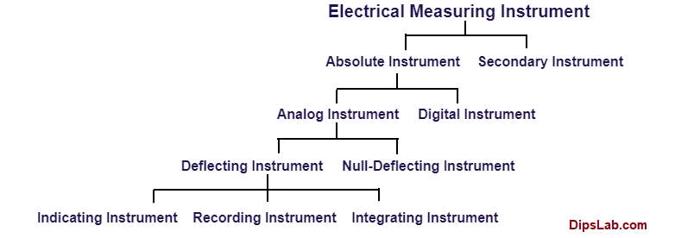
For further classification details, I have explained each type of electrical measuring instruments in another article.
Multimeters are a popular type of electrical measuring instrument. Like its name, it works like an ammeter, voltmeter, and ohmmeter to measure current, voltage, and resistance, respectively.
The multimeter is available into two different forms, like-
- Analog type Multimeter
- Digital type Multimeter
In this advanced technology, both types of meter are needed as per requirement.
A signal multimeter performs all standard analog and digital meters measurement units or functions for AC and DC.
Digital Multi-meters
Multi-meters are Electronic measuring instruments that help to measure different quantities, they have advantages over instruments such as the moving-iron or moving-coil meters, in that they have a much higher input resistance (some as high as 1000M) and can handle a much wider range of frequency (from D.C. up to MHz). They can be categorized as digital and analog multi-meter their difference is how they display measured quantities. Even digital multi-meters have different quality, different size, testing methods. Look the following figures.
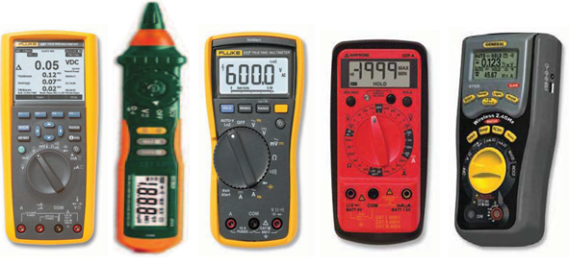
Figure 1. 3 different types of multi meters
Analog multimeters
Analog multimeters are instruments that are used to measure electrical quantities such as voltage, current, resistance, frequency and signal power. Basic functionality includes measurement of potential in volts, resistance in ohms, and current in amps. Analog multimeters are used to find electronic and electrical problems. Advanced units come with more features such as capacitor, diode and IC testing modes.
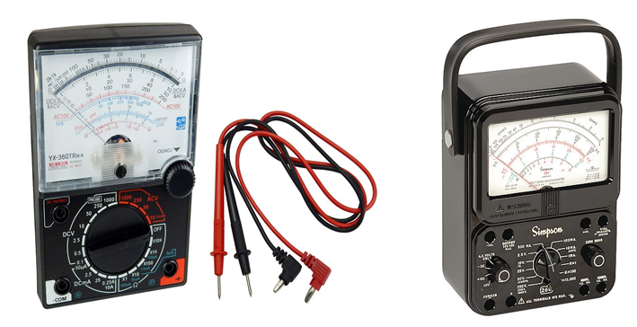
Figure 1. 4 Analogue multi meter

Like any item of test equipment an analogue multimeter or test meter has its limitations. Knowing what they are and how to overcome them is a key stage in understanding how to use an analogue multimeter to its best.
Advantages:
- Analogue movement: The meter needle gives a continuous movement from which it is very easy to gain a fast idea of the order of magnitude, or of trends for slowly moving changes. This is not always so easy using a digital multimeter.
- Low cost: Analogue multimeters can be bought very cheaply these days.
- Availability: These pieces of test equipment are still widely available from many sources despite the fact that digital multimeters tend to be more widely used.
- Preference: Some people prefer to use an analogue meter - it is very easy to glance at it and gain a very good indication of the approximate value of the reading.
Disadvantages:
- Multiple scales: Any multimeter will have a number of different scales and these can cause confusion. They were often a cause of error.
- Lower input resistance: Using analogue technology, analogue multimeters did not provide such a high input impedance as a digital one. Understanding when this may be an issue is a key element of knowing how to use an analogue multimeter.
- Polarities of test leads: Analogue multimeters do not have an auto-polarity function. Therefore, it is necessary to correctly connect the test leads, otherwise the meter could deflect in a negative direction and quickly hit an end stop.
- Less accurate than a digital multimeter: Analogue multimeters are typically less accurate than digital test instruments. That said the measurements are sufficiently accurate for most of the measurements that need to be made.
Analogue multimeters or test meters formed the main form of test equipment used in many areas for many years. Although now mainly superseded by digital multimeters, analogue test meters are still found in many places, where they can still provide the measurement capabilities needed for most tests. These analogue multimeters can also still be bought new as well for those who prefer an analogue meter to read rather than a digital display.
Insulation resistance
However, insulation resistance is different from the above-mentioned tests. It conducted using an Insulation Resistance Tester, not a multi-meter, which is incapable of delivering the test voltages. Test between live conductors, individually or collectively, to earth and between each live conductor.
The minimum values and the test voltages for insulation resistance test are:

Table 1.1 Minimum value of insulation resistance – normal circuits.
Circuit nominal voltage (V) | Test voltage d.c. (V) | Minimum insulation resistance (MW)
Normal LV circuits up to 500 V | 500V | ≥ 1.0
Normal LV circuits up to 500 V  where it is difficult to disconnect  sensitive equipment | 250V | ≥ 1.0

Table 1.2 Minimum value of insulation resistance SELV, PELV and circuits above 500 V.
Circuit nominal voltage (V) | Test voltage d.c. (V) | Minimum insulation resistance (MW)
SELV and PELV | 250 | 0.5
Above 500 V | 1000 | 1.0
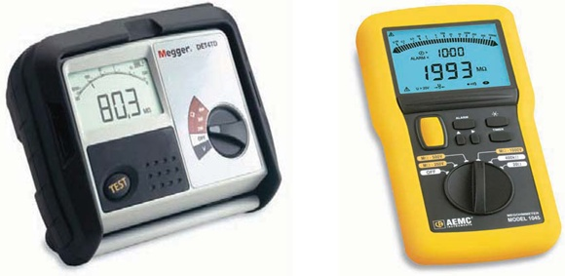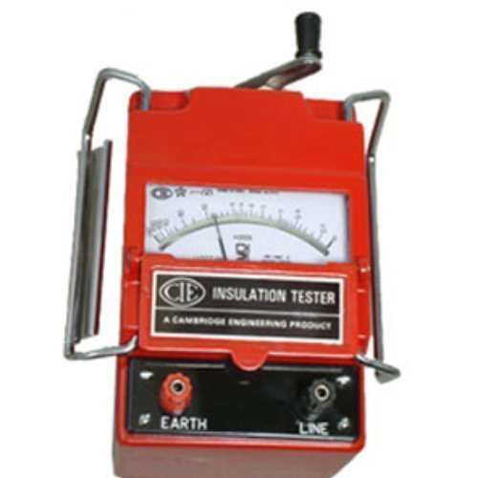
Figure 1. 5 Digital and insulation tester/megger
Oscilloscope
An oscilloscope is a laboratory instrument commonly used to test and display and analyze the waveform of electronic signals. In effect, the device draws a graph of the instantaneous signal voltage as a function of time.
An oscilloscope's primary function is to provide a graph of a signal's voltage over time. Usually the Y axis represents the voltage and the X axis time. This is useful for measuring such things as clock frequencies, duty cycles of pulse-width-modulated signals, propagation delay, or signal rise and fall times based on the input to its probes.
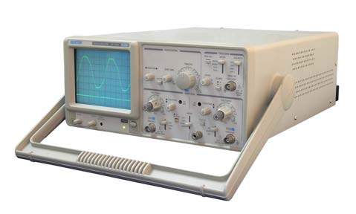
Figure 1. 6 Analog oscilloscope
The intent of this standard is to provide the minimum requirements for initial inspection, loop check, and commissioning of a control system.
The objectives checking follows:
- Verify the proper physical installation (wiring, grounding, labels, tags, pressure ratings, area classification) of instruments.
- Ensure wiring is landed on the proper termination and verify overall wiring loop integrity.
- Verify proper calibration range, engineering units, tag name, and diagnostics.
- Verify PES input range.
- Verify all logic including the interlock system
- Verify pre-alarms, bad quality, maintenance bypass switches, and proper configuration of HMI displays.
- Verify and confirm proper operation of the instrument and sensor according to supplier and Air Products specifications.
- Verify proper installation, power and grounding, backup power, network communications, system diagnostics, and operational functionality of the PES.
- Verify auxiliary systems (Foreign Device Interfaces, Historians, and Billing Systems).
- Verify remote access and remote control if applicable.
- The following documents shall be available on site and shall be the latest revision:
- PES Procurement Specification.
- Supplier Control System Manufacturing Drawings (if applicable).
- Control System Design Objectives and Control and Optimization Strategy Document (if applicable).
- HMI Console Configuration Guidelines/Control System Design Basis Paper (if applicable).
- Instrument Specifications.
- Alarm and Trip Summary.
- Electrical Schematics (both Air Products- and supplier-furnished).
- Hazardous area classification drawings.
- Relevant calculations and process data (for example, heat and material balance, sequence data, compressor curves, compressor surge lines, motor data sheets, and flow element calculations).
- Any relevant data needed for interface to supplier skids and equipment.
- Applicable configuration standards.
- P&ID.
- FAT report and punch list.

Process controller material, equipment and device
Process controllers are used to monitor and control various process variables, such as temperature, pressure, flow, and other values. They receive sensor inputs, provide control functions, and output control signals.
The material, equipment, and devices used in process controllers depend on the specific application. Here are some examples of materials and equipment that may be used in process controllers:
- Sensors: Sensors are devices that detect changes in a physical quantity and convert them into an electrical signal. They are used to measure process variables such as temperature, pressure, flow rate, and level.
- Actuators: Actuators are devices that convert electrical signals into mechanical motion. They are used to control valves, dampers, and other mechanical components in a process.
- Controllers: Controllers are devices that receive sensor inputs and provide control functions. They use feedback from the sensors to adjust the output signal to maintain a desired set point.
There are many different types of controllers, each with its own specific purpose and application. Some of the most common types of controllers include:
- PID controllers: PID controllers are the most common type of controller used in industry. They are used to control a wide variety of systems, including temperature, pressure, flow, and motion. PID controllers work by calculating the error between the desired value (setpoint) and the current value of the system. The controller then outputs a signal to the system that is proportional to the error, the integral of the error over time, and the derivative of the error. PID controllers are very versatile and can be used to control a wide variety of systems with high accuracy.
- Programmable logic controllers (PLCs): PLCs are digital computers that are used to control manufacturing processes and other industrial applications. PLCs are programmed to perform a specific set of tasks, such as turning on and off motors, valves, and other devices. PLCs are very reliable and can be used to control complex systems with ease.
- Motion controllers: Motion controllers are used to control the movement of motors and other actuators. Motion controllers can be used to control the speed, position, and torque of motors. Motion controllers are commonly used in robotics and other applications where precise control of movement is required.
- Game controllers: Game controllers are used to control the movement of characters and objects in video games. Game controllers typically have a variety of buttons and joysticks that allow players to perform different actions. Game controllers are available in a wide variety of shapes and sizes, and can be wired or wireless.
- Remote controls: Remote controls are used to control devices from a distance. Remote controls typically have a variety of buttons that allow users to perform different functions, such as turning on and off a TV, changing channels, and adjusting the volume. Remote controls can be used to control a wide variety of devices, including TVs, radios, DVD players, and sound systems.
- Human-Machine Interfaces (HMIs): HMIs are devices that allow operators to interact with a process controller. They provide a graphical interface for monitoring process variables and adjusting set points
- Other Equipment with their Specific Purpose
For temperature: Thermocouple, radiation pyrometer, optical pyrometers, resistance thermometer, all glass thermometers, electronic potentiometer, multi-point potentiometer, automatic electronic balanced bridge, ratio meter, automatic millimeters, Liquid type manometric temperature measuring instrument and direct acting temperature controller.
For pressure: Strain gauges, pressure transducer, pressure gauge, vacuum gauge, compound pressure and vacuum gauge, pressure head gauge, draft gauge, compound pressure and draft gauge, automatic pressure regulator, gas pressure regulator, fuel oil pressure regulator, direct acting recorders, diaphragm type breathing valve. High Vacuum measurement: Bodurn gauge, bellos gauge, diaphragm gauge, mcleod gauge, Knudsen gauge, thermal conductivity gauge, rotating viscometer gauge, heat filament isolation gauge, Philips cold cathode ionization gauge.
For Level: Liquid level detector, float gauge, mercury manometer, aneroid manometer, liquid level measuring instrument, remote liquid level indicator with continuous type, fixed point indicating device, fluidized, soiled level indicator.
For Flow: Liquid filled manometer, float type manometer, head flow meter, belt type meter, weight balance type meter, bellows meter, force balance meter, integrators, area flow meter, rota meters, position type area meter, positive displacement meter, mass and magnetic flow meter, densitometer, turbine velocity meter, volumetric flow meter, gasoline flow meter, gas flow controller, air flow controller, different pressure gauge for measuring flow rates.
Quality Analyzer: Commercial automatic analyzer installed on process plant, chromatography apparatus, photoelectric calorimetric gas analyzer, gas/vapour monitor alarm devices and viscosimeter.
For centralize process control computers: Digital computer, automatic petroleum processing control system, automatic air operated centralizes monitoring and control system, electronic instrumentation system.
Revolution Meters: Tacho meter, Govemor, air velocity meter, acidometer.
Density & specific gravity meters: Psychomotor, hygrometer, dew point meters, viscometers, velocity measuring devices, consistent measuring devices, densitometer.
Process & control equipment characteristic: Chemical process and operation need efficient process and control system & a variety of instruments for them. Instrumentation and control has developed as a special branch of engineering.
Exclusive instrument control department and instrument control engineers are employed for this specific purpose.

Types of Instruments:
Manual control system includes instruments for whole range of chemical and physical properties and a wide range of display such as panel board displays, computer graphic and displays of flow, current measurement, alarms, sequential control, maloperations, commands etc.
Analogue control equipment’s are used for measurement, information and reduction and sequential control. They include data loggers, alarm sensors and trip systems. Trip system may be used for safety shut down function also. Computer control includes direct digital control (DDC), programmable logic control, PLC, distribution control system (DCS) and supervisory control. Present tend in control system is to increase degree of automation and change in operator’s role from process control to monitoring.

Self-check (1.1)

Instruction1: Say true for the statement true and false if the statement not correct
- Process controllers are used to monitor and control various process variables.
- PLCs are digital computers that are used to control manufacturing processes.
- Actuators are devices that detect changes in a physical quantity and convert them into an electrical signal.
Instruction 2: Choose the correct answer for the following question
- Which types of risk management steps rises ‘how serious could the harm be and how likely?’
- Control risks
- Review control measures
- Identify hazards
- Assess risks if necessary
- What is the responsibility of workers during activity?
- Protecting himself from hazard
- Protecting coworkers from hazard
- During protecting properties work from hazard
- Asking and understanding cause of hazard
- All of them are correct
- _____________is administrative regulations or civil law rules implemented for the treatment and maintenance of the environment.
  - Occupational health & Safety
  - Environmental standard
  - air, water, and soil
  - all
- Someone who has the necessary technical skills training and experience to safely carry out a particular activity is said to be a_____.
  - legal contract
  - risk
  - hazard
  - competent person
- What is a devices that convert electrical signals into mechanical motion.
  - Sensors
  - Actuators
  - Controllers
  - All are correct answer
- Wich types type of controllers allow operators to interact with a process controller.?
- Motion controllers
- Programmable logic controllers (PLCs)
- PID controllers

Instruction 3: match the correct answer under column B to column A
 | A |  | B
1 | Actuators | A | the most common type of controller used in industry
2 | Controllers | B | A device that detect changes in a physical quantity and convert them into an electrical signal
3 | Human-Machine Interfaces (HMIs) | C | devices that allow operators to interact with a process controller.
4 | PID controllers | D | devices that receive sensor inputs and provide control functions.
5 | Sensor | E | Devices that convert electrical signals into mechanical motion.

Instruction 4: Write short answer for the given question below

- Write four-step of risk management process.
- What are common hazards that may be encountered in the workplace?
- Write any types of equipment or device used to measure pressure

UNIT 2. Set up process control
This learning guide is developed to provide you the necessary information regarding the following content coverage and topics:
- Introduction to process control
- Control loop
- Control loop set up standard
- Field control device set up control process loop Arrangement
- Performing final set up system
This guide will also assist you to attain the learning outcome stated in the cover page. Specifically, upon completion of this Learning Guide, you will be able to:
- Introduce process control
- Identify control loop to set up
- Maintain specific standard for specific control loop to set up
- Use measured and calculated values for solving and set up control process loop
- Arrange field control devices
- Perform final set up system

Introduction to Process control
A control system is a device or set of devices used to manage the behavior of other devices or systems in an industrial process facility. Process control is a way to monitor and manage the conditions in which businesses make and transport products to ensure conformity and quality, limit waste and increase efficiency. Process control is common in manufacturing and continuous production environments. Many examples of process control involve some form of automation to limit the possibility of human error, allow for more detailed analysis of conformity, quality and efficiency and provide for programmed uniform changes to production and manufacturing processes.
Here is a list of common benefits you can realize when you use process control effectively:
- Decreased overhead costs: Organizations that use process control can decrease their overhead costs in many ways, such as through more efficient use of raw materials, decreased depreciation of production materials and lower insurance costs.
- More safety: Process control and the automation process may increase the safety of work environments by decreasing employee exposure to potentially dangerous or accident-prone situations.
- Higher production capabilities: Many businesses have limitations to their ability to produce goods due to the size and physical capabilities of their facilities and the limited availability of some raw materials, which can cause some products to sell out or become unavailable, limiting the revenue of that business. Process control allows businesses to maintain constant production, increasing their ability to meet consumer demands for their products.
The variables can vary from temperature, flow, level, and pressure, to time and distance, all of which can be interdependent variables in a single process requiring complex microprocessor systems for total control. The advancement changes are being driven by the need for higher accuracy, quality, precision, and performance.
Process control can take two forms: (1) sequential control, which is an event-based process in which one event follows another until a process sequence is complete; or (2) continuous control, which requires continuous monitoring and adjustment of the process variables.
- Sequential Process Control
Control systems can be sequential in nature, or can use continuous measurement; both systems normally use a form of feedback for control. Sequential control is an event-based process, in which the completion of one event follows the completion of another, until a process is complete, as by the sensing devices. Figure 2.1 shows an example of a process using a sequencer for mixing liquids in a set ratio. The sequence of events is as follows:
    - Open valve A to fill tank A.
    - When tank A is full, a feedback signal from the level sensor tells the sequencer to turn valve A Off.
    - Open valve B to fill tank B.
    - When tank B is full, a feedback signal from the level sensor tells the sequencer to turn valve B Off.
    - When valves A and B are closed, valves C and D are opened to let measured quantities of liquids A and B into mixing tank C.
    - When tanks A and B are empty, valves C and D are turned Off.
    - After C and D are closed, start mixing motor, run for set period.
    - Turn Off mixing motor.
    - Open valve F to use mixture.
    - The sequence can then be repeated after tank C is empty and Valve F is turned Off.

- Continuous Process Control
Continuous process control falls into two categories: (1) elementary On /Off action, and (2) continuous control action.
On/Off action
This action is used in applications where the system has high inertia, which prevents the system from rapid cycling. This type of control only has only two states, On and Off; hence, its name. This type of control has been in use for many decades, long before the introduction of the computer. HVAC is a prime example of this type of application. Such applications do not require accurate instrumentation. In HVAC, the temperature (measured variable) is continuously monitored, typically using a bimetallic strip in older systems and semiconductor elements in newer systems, as the sensor turns the power (manipulated variable) On and Off at preset temperature levels to the heating/cooling section.
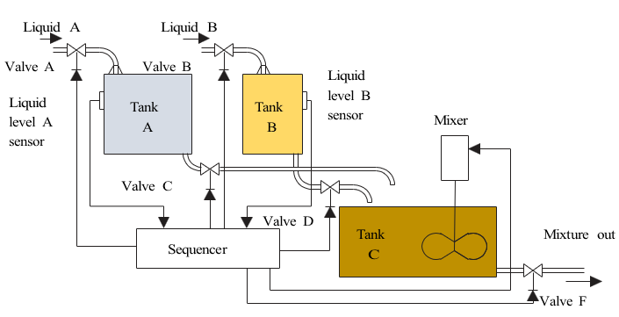
Figure 2. 1 Sequencer used for liquid mixing.

Continuous process
A continuous process action is used to continuously control a physical output parameter of a material. The parameter is measured with the instrumentation or sensor, and compared to a set value. Any deviation between the two causes an error signal to be generated, which is used to adjust an input parameter to the process to correct for the output change. An example of an unsophisticated automated control process is shown in Figure 2.2. A float in a swimming pool is used to continuously monitor the level of the water, and to bring the water level up to a set reference point when the water level is low. The float senses the level, and feedback to the control valve is via the float arm and pivot. The valve then controls the flow of water (manipulated variable) into the swimming pool, as the float moves up and down.
A more complex continuous process control system is shown in Figure 2.1, where a mixture of two liquids is required. The flow rate of liquid A is measured with a differential pressure (DP) sensor, and the amplitude of the signal from the DP measuring the flow rate of the liquid is used by the controller as a reference signal (set point) to control the flow rate of liquid B. The controller uses a DP to measure the flow rate of liquid B, and compares its amplitude to the signal from the DP monitoring the flow of liquid A. The difference between the two signals (error signal) is used to control the valve, so that the flow rate of liquid B (manipulated variable) is directly proportional to that of liquid A, and then the two liquids are combined.
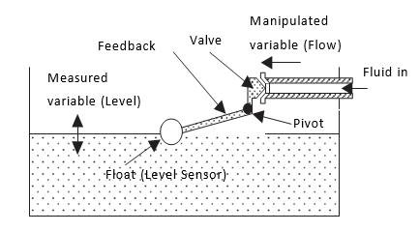
Figure 2. 2 unsophisticated automated control process

Control loop

Introduction to Control loop
A control loop is the fundamental building block of control systems in general and industrial control systems in particular. It consists of the process sensor, the controller function, and the final control element (FCE) which controls the process necessary to automatically adjust the value of a measured process variable (PV) to equal the value of a desired set-point (SP).
In various industrial applications they Control loops are used to maintain process variables (PVs) at a desired value or set point (SP). Control loops are important for maintaining the stability of a system, and for consistently producing the desired outcome of a process.
- The role of sensors, controllers, and actuators in process control, and the importance of effective control loop tuning.
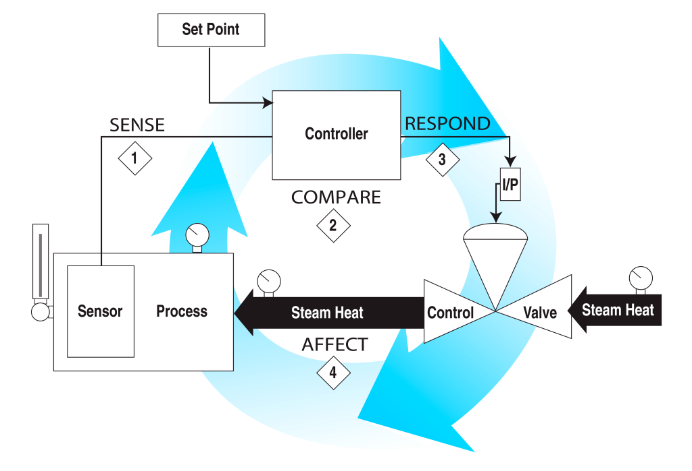
Figure 2. 3 Role of control loop element in system
The primary components of a control loop include a measurement device (sensor or transmitter), a controller, and a final control element (actuator or control valve). The measurement device senses the process variable, such as temperature, pressure, level, or flow rate. The controller receives this measurement and compares it to a desired setpoint, determining the necessary corrective action. The final control element adjusts the process to bring the output back to the desired setpoint.
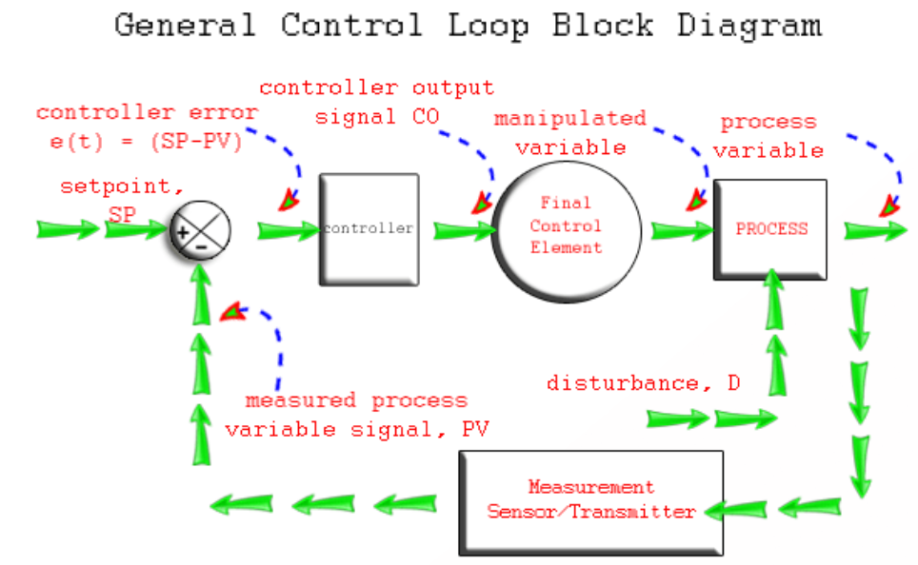
Figure 2. 4 General control loop block diagram

Types of Control Loop
There are two common classes of control loop:
  - Open loop:
- The control action from the controller is independent of the process variable. An example of this is a central heating boiler controlled only by a timer.
- The control action is the switching on or off of the boiler
- The process variable is the building temperature.
- The controller operates the heating system for a constant time regardless of the temperature of the building
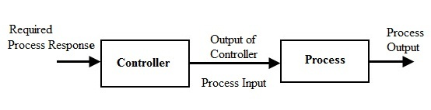
Figure 2. 5 Open loop system block diagram
  - Closed loop:
- The control action from the controller is dependent on the desired and actual process variable.
- In the case of the boiler analogy, this would utilize a thermostat to monitor the building temperature, and feedback a signal to ensure the controller output maintains the building temperature close to that set on the thermostat.
- A closed-loop controller has a feedback loop which ensures the controller exerts a control action to control a process variable at the same value as the setpoint.
- For this reason, closed-loop controllers are also called feedback controllers.
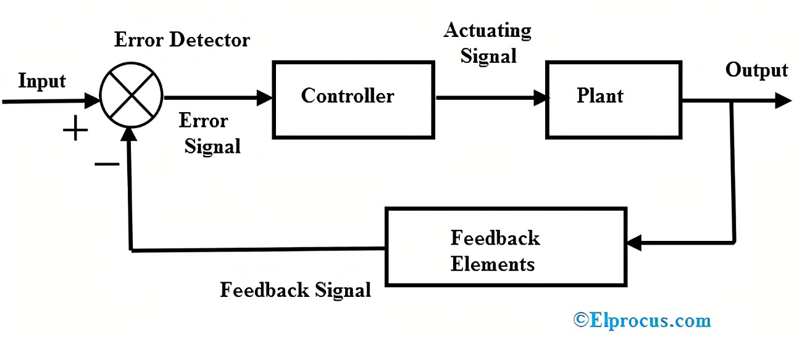
Figure 2. 6 Closed loop system block diagram
Example 1: Home heating control system
A temperature control loop is one of the most common examples of a control loop. Control loops work to maintain the temperatures in our homes and offices. They are used for a range of immersion and industrial heating systems as well.
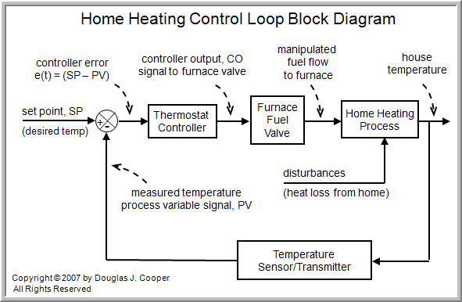
Figure 2. 7 Room heating control loop block diagram
Temperature control loops are set up as follows:
- The process to be controlled is established. In the case of a temperature control loop, this refers to the temperature of a substance that is being heated, such as water temperature.
- Sensors measure the process value (PV), or in this case, the current value of the temperature. Sensors come in the form of thermostats in domestic heating systems, while industrial applications usually apply the use of thermocouples, RTDs and thermistors.
- Sensors feed the measured value of the process value to the temperature controller. This initiates the control process required to achieve the set point (desired temperature).
- The final control element receives the manipulated values from the controller and physically reduces or increases the temperature.
All control loop systems contain a coordinated series of elements required in achieving a control objective. Control loop systems are available in various configurations, depending on the type of industry and specification of use. However, they all follow a similar design principle.
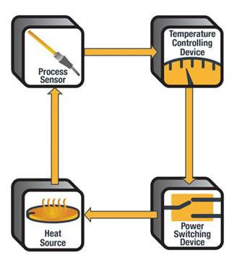
Figure 2. 8 Control loop system element
Examples 2: An example of a control system is a car's cruise control.
- Objective maintain vehicle speed at a constant desired or reference speed provided by the driver.
- The controller is the cruise control,
- The plant is the car, and the system is the car and the cruise control.
- The system output is the car's speed
- The control itself is the engine's throttle position which determines how much power the engine delivers.

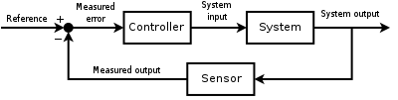
Figure 2. 9 Feedback loop to control diagram example
A block diagram of a negative feedback control system using a feedback loop to control the process variable by comparing it with a desired value, and applying the difference as an error signal to generate a control output to reduce or eliminate the error.
In a closed-loop control system, data from a sensor monitoring the car's speed (the system output) enters a controller which continuously compares the quantity representing the speed with the reference quantity representing the desired speed. The difference, called the error, determines the throttle position (the control). The result is to match the car's speed to the reference speed (maintain the desired system output). Now, when the car goes uphill, the difference between the input (the sensed speed) and the reference continuously determines the throttle position. As the sensed speed drops below the reference, the difference increases, the throttle opens, and engine power increases, speeding up the vehicle. In this way, the controller dynamically counteracts changes to the car's speed. The central idea of these control systems is the feedback loop, the controller affects the system output, which in turn is measured and fed back to the controller.

Components of control loop
Control loops are essentially feedback loops as they involve error detection and the implementation of a feedback correction. The process is achieved by linking various hardware components in a circuit. This involves a manufacturing sequence or system that involves a single variable or multiple variables to be controlled.
The components in a closed control loop are set up accordingly. It is important to ensure that all components are linked in the right order at all times. Any disruption within the system leads to a discontinuation of the automated process. For instance, switching to a manual controller.
- Primary element/Sensors:
Sensors are the first element in the control loop which measures the change in the process and reporting the process variable so they are also called as the primary element. They convert the process variable into corresponding analog or digital signals which are read by the controller and then compared to the desired set point. Measurements are usually represented in electrical charge, voltage or pneumatic pressure. If the reading from the sensor is outside of the set point’s control band, the controller then opens or closes the power switch turning the heater on or off until the desired temperature is achieved.
A wide variety of sensors are available in the market. These are applied according to the type of variable to be measured. Watlow provides temperature sensors such as thermocouples or RTDs. These provide high-temperature dielectric strength that ensures signals are carried faithfully to the instrumentation or controls.
Sensors are devices which cause change when affected by a change in the process variable. There are different types of sensors for measuring variables like Pressure, Temperature, Flow, Level, pH, Vibration etc.,
There are different types of sensors available for various process variable:
- Thermocouples, RTD for Temperature measurement
- Strain gauge, Pressure sensing diaphragm, capacitive cells for pressure measurement
- Orifice plate, Pitot tube, Magnetic flow tube etc., for flow measurement
There are so many other sensors used to measure different variables like vibration, pH, force, weight etc..,
- Transducers:
Transducers are advanced sensors that further transform given values through signal conditioning. For instance, in electrical instrumentation, current may be converted into voltage measurements. These conversion devices are also available in various forms according to their working principles, such as capacitance and self-generating properties.
A transducer converts any form of energy into another form. In electrical instrumentation field Transducers are devices which converts a physical variable into electrical signals. Another name transducers are Pick-ups.
In process control, a converter used to convert a 4–20 mA current signal into a 3–15 psi pneumatic signal is called a current-to-pressure converter. There are different types of transducers classified based on their working principle.
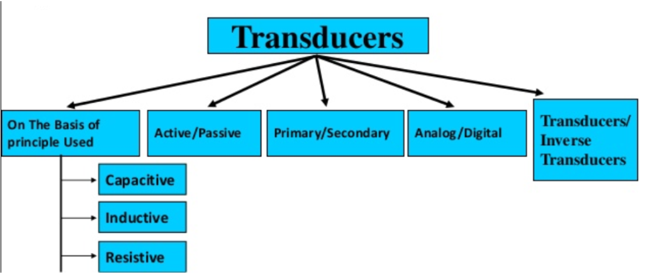
Figure 2. 10 Classification of transducer
The principles of working of these transducers are different and depend on the type of transducer.
For example, the working principle of a photoelectric transducer can be classified as photo emissive, photovoltaic or photoconductive

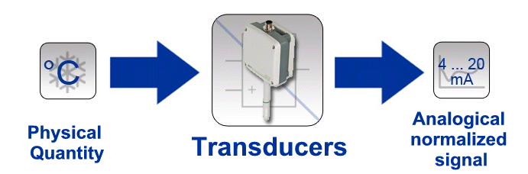
Figure 2. 11 Transducer working principle
Referred to the above diagram transducer is converting of physical quantities to electrical ones. Means, it converts the physical quantity to voltage or electric current. In general words, it changes the quantities to the form, which is measurable in the form of electrical signals.
It is remarkable to say that any device that can convert one form of energy into another is a transducer. As example,
- A speaker converts an electrical signal to pressure waves, so it is called a transducer.
- A microphone converts sound vibration to electrical vibrations. Besides, a loudspeaker converts electrical pulses into sound.
- A solar cell converts brightness into electricity, and a thermocouple transforms thermal energy into electrical energy.
- An incandescent light bulb creates light. It passes a current through a filament. Therefore, a light bulb is a transducer for the conversion of electrical energy to optical energy.
- An electric motor is a transducer for the conversion of electricity into mechanical energy or motion.
Each transducer consists of two essential parts: The sensing element and the traducing element.
- Transmitters:
Transmitters are devices that convert the signal into a standard signal that can be transmittable through the control loop and the parameters can be monitored remotely. Transmitters may be applied to standardize the signals that are circulated throughout the control loop, where parameters are remotely monitored and managed. These devices that function closely with sensors are able to deal with various signals, such as:
- Pressure transmitters
- Flow transmitters
- Temperature transmitters
- Level transmitters
- Analytic transmitters
- Controllers
Controllers are the Centre of process control, which receives process variable then compare with setpoint stored in the controller and sends feedback as the controller output to control the final control element.
This means controller requires an input of measured readings. These are of controlled variables and a representation of the SP (set point) expressed as a measured value. PID (proportional integral derivative) controllers are considered by professionals as being the most effective and stable controllers available in the market.
Controllers begin by processing the measured values via a component known as the error detector. The error detector will determine if the measured PV is aligned with the SP or reference value.
Controllers utilize error signals to execute subsequent control actions that are executed to reach the SP. Therefore, it is necessary for error detectors to generate error signals before control actions are conveyed. Control actions are traditionally evaluated by pneumatic or electronic signal processing.
There are pneumatic and electronic or programmable such as PID (proportional integral derivative), DCS, PLC uses a complex mathematical algorithm to perform the control action.
PID (proportional integral derivative): The basic idea behind a PID controller is to read a sensor, then compute the desired actuator output by calculating proportional, integral, and derivative responses and summing those three components to compute the output.
PLC (Programmable Logic Controller): PLCs are usually computers connected to a set of input/output (I/O) devices. The computers are programmed to respond to inputs by sending outputs to maintain all processes at setpoint.
DCS (Distributed Control Signal): DCSs are controllers that, in addition to performing control functions, provide readings of the status of the process, maintain databases and advanced man-machine-interface.
The controller is the device within the control loop that interprets the measurements fed by the sensor and determines the control action to take based on a comparison of that value to the set point. There are various versions of the device, including Watlow's temperature, power and process controllers.
- Final control elements and actuators
The final control elements are those that receive control action signals from the controller. They adjust the process variable at the desired parameter. Response time is integral in the design of an effective thermal loop. This greatly improves crisis management in the event that a PV is outside of the desired SP. In any control loop, the speed with which a final control element reacts to correct a variable that is out of setpoint is very important. Many of the technological improvements in final control elements are related to improving their response time.
Actuators are the most crucial component within final control elements, which has a direct influence on the control process. The component initiates change by processing evaluated control actions, which regulates the transition from PV to SP.
These devices are commonly represented by a valve stem or heating coil in most industrial settings. Additional devices such as valve positioners may be installed to improve the response rate of actuators such as control valves. Re positioners help to establish the exact position of the valve (actuator) according to the controller output signal.
For example:
Pumps and Control valves – Final control devices of Flow control system
Heaters and Boilers – Final control devices of temperature control system
Compressor and Valves: Final control devices of pressure control system
- Signals:
Signals are used to transmit process variable from transmitter to the controller and sent back the feedback signal from the controller to the final control elements. There are three types of signal in industrial automation:
- Pneumatic signal: Air pressure in the pneumatic pipeline change according to the change in the process variable. The standard pneumatic pressure in the signal pipe in industries are in a range of 3-15psi.
- Analog signal: Analog signals are mostly used control signals, the transmitter sends the signal through a set of electrical wire. The standard signal range is within 4-20mA, for LRV valve a 4mA signal is produced and for URV it is 20mA.Other common standard electrical signals include the 1–5 V (volts) signal and the pulse output.
- Digital signal: Digital signals are special protocols used for communication in industries. All protocol are owned by specific companies, they include Fieldbus foundation, Modbus from Modicon, Profibus, DeviceNet from Rockwell automation.
- Indicators:
An indicator is human readable devices that display the process variable. There are analog indicators such as used in pressure, temperature gauges and there are digital indicators that display process variables as the digits. Even though the process variable is connected to the controller, the indicators are used industries for different purposes.
- Recorder:
Recorders are used in industries to provide history on the process and to be submitted to regulatory agencies for verification. By recording the readings of critical measurement points and comparing those readings over time with the results of the process, the process can be improved.

- Actuators:
An actuator is the most important part of the final control element, a device that causes physical change in the final control element. For a valve actuator is the valve stem actuator and for a heater, it is the heating coil. An actuator can be controlled by pneumatically, Hydraulically, electrically.

Control loop set up standard
A control loop is the fundamental building block of control systems in general and industrial control systems in particular. It consists of the process sensor, the controller function, and the final control element (FCE) which controls the process necessary to automatically adjust the value of a measured process variable (PV) to equal the value of a desired set-point (SP).
Every engineering discipline uses codes and standards. Some codes and standards are specific to an engineering discipline while some cross multiple disciplines. To identify instrumentation standard read the following please!
    - Outline of the identification system
- General
Each instrument or function to be identified is designated by an alphanumeric code or tag number as shown in Figure 2.12 The loop identification part of the tag number generally is common 14 ANSI/ISA-S5.1-1984 (R 1992) to all instruments or functions of the loop. A suffix or prefix may be added to complete the identification. Typical identification is shown in Figure 2.12.
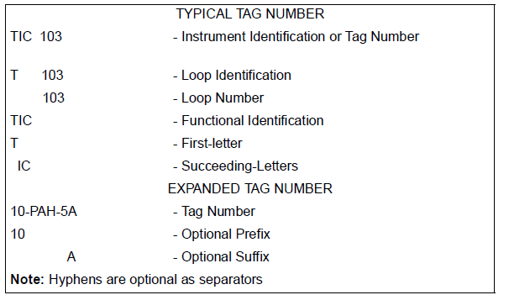
Figure 2. 12 Tag numbers
The instrument loop number may include coded information, such as plant area designation. It is also possible to set aside specific series of numbers to designate special functions; for instance, the series 900 to 999 could be used for loops whose primary function is safety-related. Each instrument may be represented on diagrams by a symbol. The symbol may be accompanied by a tag number.
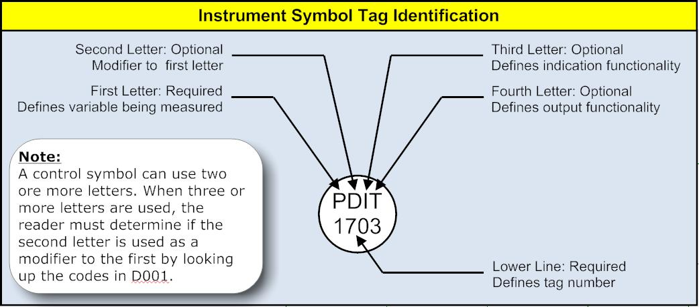
Figure 2. 13 Instrument symbol tag identification
- Functional identification
- The functional identification of an instrument or its functional equivalent consists of letters from Table 1 and includes one first-letter (designating the measured or initiating variable) and one or more succeeding-letters (identifying the functions performed).
- The functional identification of an instrument is made according to the function and not according to the construction. Thus, a differential-pressure recorder used for flow measurement is identified by FR; a pressure indicator and a pressure-actuated switch connected to the output of a pneumatic level transmitter are identified by LI and LS, respectively.
- In an instrument loop, the first-letter of the functional identification is selected according to the measured or initiating variable, and not according to the manipulated variable. Thus, a control valve varying flow according to the dictates of a level controller is an LV, not an FV.
- he succeeding-letters of the functional identification designate one or more readout or passive functions and/or output functions. A modifying-letter may be used, if required, in addition to one or more other succeeding-letters. Modifying-letters may modify either a first-letter or succeeding- letters, as applicable. Thus, TDAL contains two modifiers. The letter D changes the measured variable T into a new variable, "differential temperature." The letter L restricts the readout function A, alarm, to represent a low alarm only.
- The sequence of identification letters begins with a first-letter selected according to figure above.
- Readout or passive functional letters follow in any order, and output functional letters follow these in any sequence, except that output letter C (control) precedes output letter V (valve), e.g., PCV, a self-actuated control valve. However, modifying-letters, if used, are interposed so that they are placed immediately following the letters they modify.
- A multiple function device may be symbolized on a diagram by as many bubbles as there are measured variables, outputs, and/or functions. Thus, a temperature controller with a switch may be identified by two tangent bubbles — one inscribed TIC-3 and one inscribed TSH-3. The instrument would be designated TIC/TSH-3 for all uses in writing or reference. If desired, however, the abbreviation TIC-3 may serve for general identification or for purchasing, while TSH-3 may be used for electric circuit diagrams.
- The number of functional letters grouped for one instrument should be kept to a minimum according to the judgment of the user. The total number of letters within one group should not exceed four.
The number within a group may be kept to a minimum by:
    - Arranging the functional letters into subgroups. For instruments having more than one measured variable or input, but it may also be used for other instruments.
    - Omitting the I (indicate) if an instrument both indicates and records the same measured variable.
All letters of the functional identification are uppercase.
    - Loop identification
- The loop identification consists of a first-letter and a number. Each instrument within a loop has assigned to it the same loop number and, in the case of parallel numbering, the same first letter. Each instrument loop has unique loop identification. An instrument common to two or more loops should carry the identification of the loop which is considered predominant.
- Loop numbering may be parallel or serial. Parallel numbering involves starting a numerical sequence for each new first-letter, e.g., TIC-100, FRC-100, LIC-100, AI-100, etc. Serial numbering involves using a single sequence of numbers for a project or for large sections of a project, regardless of the first-letter of the loop identification, e.g., TIC-100, FRC-101, LIC-102, Al-103, etc. A loop numbering sequence may begin with 1 or any other convenient number, such as 001, 301 or 1201. The number may incorporate coded information; however, simplicity is recommended.
- If a given loop has more than one instrument with the same functional identification, a suffix may be appended to the loop number, e.g., FV-2A, FV-2B, FV-2C, etc., or TE-25-1, TE-25-2, etc. However, it may be more convenient or logical in a given instance to designate a pair of flow transmitters, for example, as FT-2 and FT-3 instead of FT-2A and FT-2B.
The suffixes may be applied according to the following guidelines:
- An uppercase suffix letter should be used, i.e., A, B, C, etc.
- For an instrument such as a multipoint temperature recorder that prints numbers for point identification, the primary elements may be numbered TE-25-1, TE-25-2, TE- 25-3, etc., corresponding to the point identification number.
- Further subdivisions of a loop may be designated by serially alternating suffix letters and numbers.

Field Control device set up
Control System is a system in which deliberate guidance or manipulation is used to achieve a prescribed value for a variable. Control systems include SCADA, DCS, PLCs and other types of industrial control systems.
Control Loop (automation view) is combination of field devices and control functions arranged, so that a control variable is compared to a set point and returns to the process in the form of a manipulated variable through (sensor controller actuator feedback)
The field device equipment connected to the field side of an industrial control system serve to monitor and control physical processes in the industrial infrastructures such as monitoring flow, level, pressure, temperature and analyze liquids.
They may be installed inside cabinets or mounted directly onto the infrastructure. Types of field devices include:
• RTUs,
• PLCs,
• Actuators & sensors,
• HMIs, • Communication devices,

General Requirements of a Control System
Solving and set up of field control device in control process loop can be performed through measured values and calculated values achieved from the system. The primary requirement of a control system is that it be reasonably stable or control system must also be able to reduce the system error to zero or to a value near zero.
Any dynamic changes cause deviations from the desired setpoint in the processes. In some cases, the extent and duration of these deviations may result in an unacceptable end product. For this reason, process control loops are sometimes designed to minimize both the excursion of deviations from the operating setpoint and the time span during which such deviations occur.
  - System Error
The system error is the difference between the value of the controlled variable set point and the value of the process variable maintained by the system. The system error is expressed in equation form by the following:
e(t) = PV(t) – SP(t)
where:
e(t) = system error as a function of time
PV(t) = process variable as a function of time
SP(t) = set point as a function of time
  - System Response
The main purpose of a control loop is to maintain some dynamic process variable (pressure, flow, temperature, level, etc.) at a prescribed operating point or set point. System response is the ability of a control loop to recover from a disturbance that causes a change in the controlled process variable.
There are two general types of good response:
    - Underdamped (cyclic response): process variable oscillates around the set point after a process disturbance.
    - Damped: control system is able to bring the process variable back to the operating point with no oscillations.
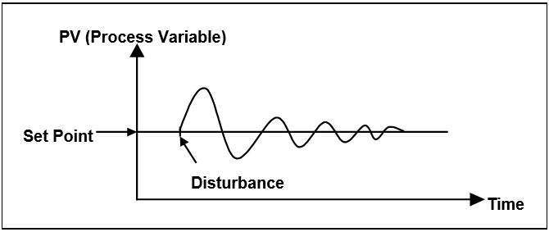
Figure 2. 14 Cyclic response to process disturbance
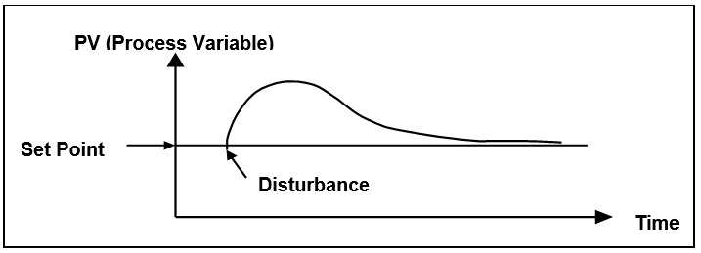
Figure 2. 15 Damped response to process disturbance

Control Loop Design Criteria
The most common of these include settling time, maximum error, offset error, and error area
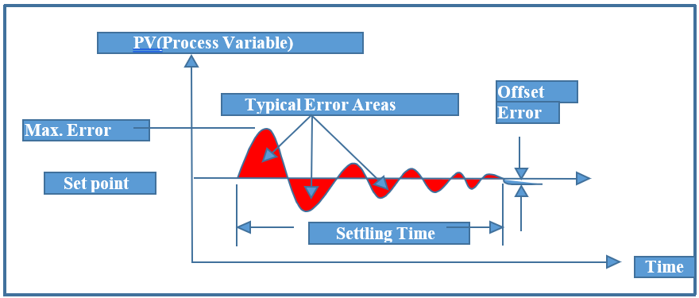
Figure 2. 16 Evaluation of control loop response
When there is a process disturbance or a change in set point, the settling time is defined as the time the process control loop needs to bring the process variable back to within an allowable error. The maximum error is simply the maximum allowable deviation of the dynamic variable. Most control loops have certain inherent linear and nonlinear qualities that prevent the system from returning the process variable to the set point after a system change. This condition is generally called offset error. The error area is defined as the area between the response curve and the set point line as shown by the shaded area in Figure 1-15.
These four evaluation criteria are general measures of control loop behavior that are used to determine the adequacy of the loop’s ability to perform some desired function.

Intuitive Approach to Process Control Concepts
The practice of process control arose long before the theory or analytical methods underlying it were developed. Processes and controllers were designed using empirical methods that were based on intuition (“feel”) and extensive process experience. Most of the reasoning involved was nonmathematical. This approach was unscientific trial and error, but it was a successful control method.
In this section, we will approach the study of control fundamentals in much the same way that control knowledge developed—that is, through a step-by-step procedure starting from manual control and moving to ever increasing automatic control.
Example 1: Manual control process
Suppose we have a process like that shown in below. A source of feed liquid flows into a tank at a varying rate from somewhere else in a process plant. This liquid must be heated so that it emerges at a desired temperature, T_{d}, as a hot liquid. To accomplish this, hot water flows through heat exchanger coils in the tank. By controlling the flow of hot water, we can obtain the desired temperature, T_{d}. A further process requirement is that the level of the tank must neither overflow nor fall so low that it exposes the heater coils.
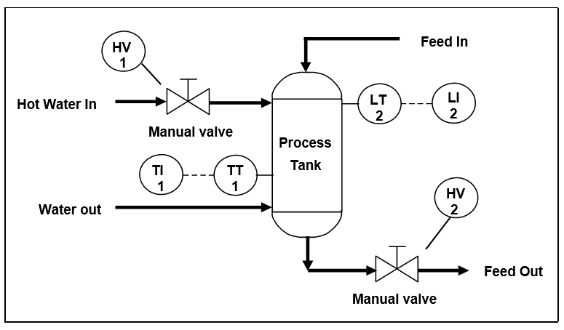
Figure 2. 17 Example process – using manual valves
The temperature is measured in the tank, and a temperature transmitter (TT-1) converts the signal into a 4-20 mA direct current (DC) signal to drive a temperature indicator (TI-1) mounted near the hot water inlet valve. Similarly, a level indicator (LI-2) is mounted within the operator’s view of the hot feed outlet valve (HV-2).
Suppose a process operator has the task of holding the temperature, T, near the desired temperature, T_{d}, while making sure the tank doesn’t overflow or the level get too low. The question is how the operator would cope with this task over a period of time. He or she would manually adjust the hot water inlet valve (HV-1) to maintain the temperature and occasionally adjust the outlet valve (HV-2) to maintain the correct level in the tank.
The operator would face several problems, however. Both indicators would have to be within the operator’s view, and the manual valves would have to be close to the operator and easy to adjust.
Example 2: On/Off Control
To make the operator’s work easier, suppose we install electrically operated solenoid valves in place of the manual valves, as shown in Figure 2.17. We can also install two hand switches (HS-1 and HS-2) so the solenoid valves can be operated from a common location. The valves can assume two states, either fully open (on) or fully closed (off). This type of control is called two-position or on/off control.
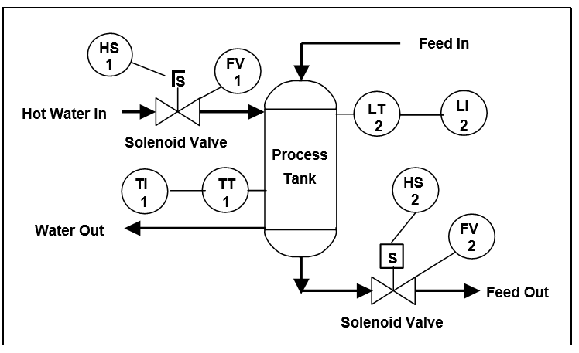
Figure 2. 18 Sample process – solenoid valves
Assume for the moment that the level is holding steady and that the main concern is controlling temperature. The operator has been told to keep the temperature of the fluid in the tank at 100°F. He or she compares the reading of the temperature indicator with the selected set point of 100°F. The operator closes the hot water valve when the temperature of the fluid in the tank rises above the set point (Figure 2-17). Because of process dead time and lags, the temperature will continue to rise before reversing and moving toward the set point. When the temperature falls below 100°F, the operator opens the hot water valve. Again, dead time and lags in the process create a delay before the temperature begins to rise. As the temperature crosses the set point, the operator again shuts off the hot water, and the cycle repeats.
This cycling is normal for a control system that uses on/off control. This limitation exists because it’s difficult for the operator to control the process exactly with only two options.
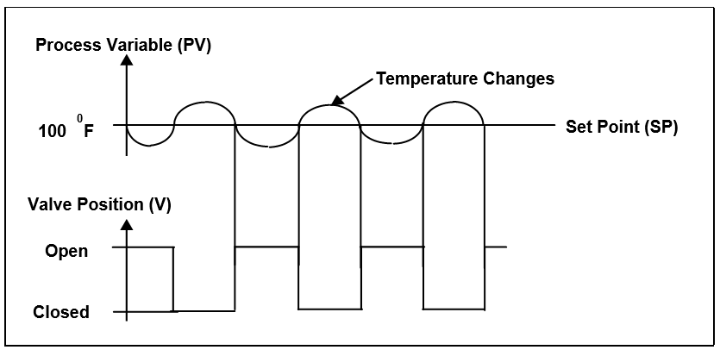
Figure 2. 19 On/Off temperature control
This type of on/off control can be expressed mathematically as follows:
e = PV – SP (1-2)
where:
e = error
SP = set point
PV = process variable
In the on/off control mode, the valve is opened when the error (e) is positive (+), and the valve is closed when e is negative (–).

Field control devices arrangement
The invention relates to a field device arrangement containing at least one field device, a control unit and a field bus via which the field device and the control unit communicate with one another. The field device arrangement additionally has at least one energy converter arrangement and at least one primary battery for supplying the field device with electrical energy, and a power control unit which depends on the amount of electrical energy provided by the energy converter arrangement controls the proportion of the primary battery to the electrical energy provided to the field device.
Typically, industrial field control device in control system composed of:
Access Control Systems
Access Control Systems are electronic or electro-mechanical devices or systems composed of remote stations and centralized controlling stations which are used for security monitoring and to manage the movement of personnel, vehicles, materials, etc. through entrances and exits. Key specifications include the intended application, type, and method of identification. An access control system uses identifying methods such as facial recognition, fingerprints, metal detection, bar coding, and swipe cards, to permit entrance and exit from various secured areas. They can be used as well for tracking the movements of bulk materials, for allowing the use of certain machines such as x-ray equipment, or for vending various tools. Typical applications include high security operations in military facilities.
Flow Controllers
Flow Controllers are mechanical or electro-mechanical devices composed of measuring sensors or controlling elements that are used to ensure media flow in manufacturing processes. Key specifications include the intended application, type, media, flow rate, connection style, pressure rating, as well as mounting style. Flow controllers are used primarily in process control applications. They are made for gases as well as liquids of many types, and are available in many sizes and configurations depending on the application. Some flow controllers consist of mechanical valves, while others are electronically operated and controlled. Flow controllers are sometime called batch controllers for their ability accurately control different ingredients in a chemical batching process, for instance.
Level Controllers
Level Controllers are mechanical or electro-mechanical devices used for controlling the levels of tanks, vats, etc. usually by means of pumps, and they are sometimes called pump controllers. Some level controllers incorporate sensors or other means of detecting the level of products in containers, etc. while others require inputs from remote switches or sensors. Key specifications include the intended application, medium type, and the control method. Level controllers rely on a variety of sensor styles including conductive, capacitance, optical, and ultrasonic, in addition to mechanical arms, floats, and levers. They can be used for liquids or bulk dry goods such as grain or powders. Many industries use level controllers in various processes. A level controller receives an input signal, compares it to a set point and via an output signal adjusts the level as the process requires.
Pressure Controllers
Pressure Controllers are electro-mechanical devices used for controlling process/system pressure in various industrial processes. Key specifications include the intended application, type, control method, sensing element, and the pressure range. Pressure controller types include differential gap, proportional, on/off types, among others. They rely on a variety of sensing elements such as a bellows, diaphragms, capsules, bourdon tubes, etc. In operation, the controller receives a process/system pressure input, compares it to the desired set point in the pressure controller, then outputs a signal (usually to a control valve) which adjusts the process/system pressure (if necessary) back to the set point.
Programmable Logic Controllers
Programmable Logic Controllers are electronic devices used for controlling automatic machinery, processes, etc. Key specifications include the intended application, type, function, mounting style, as well as power requirements. Programmable logic controllers are configurable with a range of input and output modules. They control various operating parameters and functions by receiving input signals from various sources and adjusting machine functions as required by the processes through sets of programmed instructions.

Universal Process/Temperature Controllers
Universal Process/Temperature Controllers are electronic devices used to control various process parameters, including temperature. Key specifications include the intended application, control method, input and output types, features, connections type and mounting style, number of inputs, communication interface, as well as the power specifications for the input and output process. Universal process/temperature controllers are used mainly in manufacturing applications for ensuring various process values are within their operational ranges.
Example of Control Loop arrangement and steps:
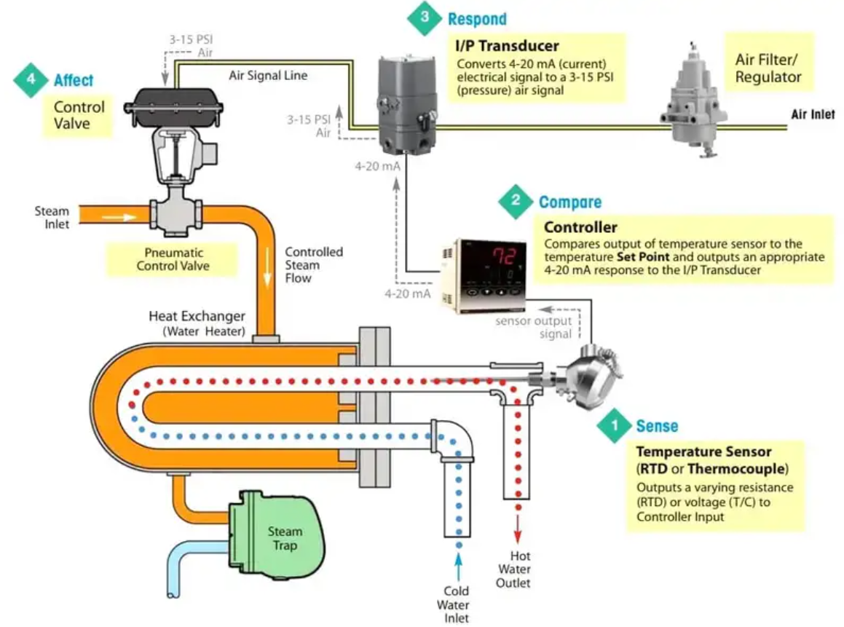
Figure 2. 20 Full control loop that control valve in system to maintain temperature output
The Control Loop Steps:

Sense:
Measure the current condition of the process using a sensor, which can be a thermocouple or RTD transmitter.

Compare:
Evaluate the measurement of the current condition against the set point using an electronic PID controller.

Respond:
Reacts to any error that may exist between the measured temperature value and the temperature set point by generating a corrective pneumatic signal.

Affect:
Actuate the control valve that will produce a change in the process variable.
The loop continually cycles through the steps, affecting the process variable (water temperature) in order to maintain the desired temperature, set point.

Principle:
An electronic sensor (thermocouple, RTD or transmitter) installed at the measurement location continuously sends an input signal to the controller.
At set intervals, the controller compares this signal to a predefined set point. If the input signal deviates from the set point, the controller sends a corrective electric output signal to the control element.
This electric signal must be converted to a pneumatic signal when used with an air operated valve.
Using a I/P Transducer, which converts a 4 to 20 mA electric signal to a 3 to 15 PSI air signal and sends the respective air supply to the Control Valve Positioner.
The valve positioner adjusts the control valve stem position and regulates the flow through the control valve, accordingly the temperature controls. This loop repeats until controller achieves setpoint.

Final set up system of process control
The process of setting up and operating industrial field control devices involves identifying, positioning, and adjusting the devices in accordance with the manufacturer’s operating instructions and system requirements. It also includes testing and documenting the setup of industrial field control devices.
The specific steps for setting up an industrial field control device may vary depending on the device type and manufacturer. However, some general steps include:
- Identifying the device: This involves selecting the appropriate device for the application and ensuring that it meets the system requirements.
- Positioning and adjusting the device: This involves installing the device in the correct location and adjusting it to meet the system requirements.
- Preparing and setting up the device: This involves configuring the device settings, wiring it to the system, and testing its operation.
- Testing and documenting: This involve verifying that the device is functioning correctly and documenting its setup.
Operating an industrial field control device typically involves monitoring its performance, making adjustments as necessary, and troubleshooting any issues that arise. Industrial field control devices are mechanical, electro-mechanical, or electronic devices that use input signals to change conditions or values in processes or oversee access to buildings, gated areas, etc. Some of the most common types of industrial field control devices include:
- Flow controllers: Mechanical or electro-mechanical devices composed of measuring sensors or controlling elements that are used to ensure media flow in manufacturing processes.
- Level controllers: Mechanical or electro-mechanical devices used for controlling the levels of tanks, vats, etc. usually by means of pumps.
- Access control systems: Electronic or electro-mechanical devices or systems composed of remote stations and centralized controlling stations which are used for security monitoring and to manage the movement of personnel, vehicles, materials, etc. through entrances and exits.
Access control systems are used in various industries to regulate and monitor access to restricted areas or information. For instance, in the healthcare industry, access control systems are used to restrict access to sensitive patient information, medical supplies, and equipment. In the banking industry, access control systems are used to secure bank vaults, ATMs, and other restricted areas. In the manufacturing industry, access control systems are used to regulate access to production lines, warehouses, and other sensitive areas.
In general, access control systems can be used to:
- Restrict access to sensitive information or areas
- Monitor and record access activity
- Enhance security by preventing unauthorized entry
- Controllers: Mechanical, electro-mechanical, or electronic devices which use input signals to change conditions or values in processes.
These devices are used primarily in process control applications such as boilers, lasers, tanks, molding machines, pumps, furnaces, etc
- Liquid level control loop system setup
  - Liquid Level Control System
Liquid Level Control System is a system specifically designed to control the level of fluid in tanks. The main aim possessed by these systems is to control the rate with which the pump delivers fluid to the tank and so it can reach the desired level inside the tank.
The purpose of the liquid level system is to maintain a specific level of fluid inside the tank. The liquid level control systems find major applications in industrial processes.
- Introduction
In our previous article, we have discussed control systems that are designed with the base that these systems would be able to perform controlled action. The controller present in the system generates the control signal that is converted into the desired signal by the actuator and is fed to the plant in order to perform the desired action.
The closed-loop operation of the control system allows the feedback signal to get compared with the reference input thereby providing controlled action. This principle of operation is utilized by the liquid level system.
- Working of Liquid Level Systems
The crucial components of the water level control system are as follows:
Fluid tank: Also known as a storage tank, used to hold the desired amount of fluid.
Measurement system: Senses the level of the fluid inside the tank.
Controller: The controller is used to maintain the desired level by starting and stopping the pump when gets information by the measurement system.
Pump: The water from the source is fed to the tank through the pump when actuated by the controller.
The figure below represents the liquid level system:
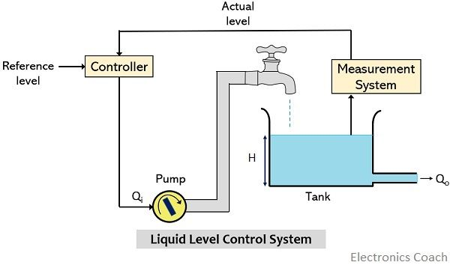
Figure 2. 21 Liquid level control system
In such systems, fluid from the pump is allowed to enter the tank when the control signal is generated by the controller.
Suppose, the controller actuates the pump and the pump starts filling the tank with an inflow rate of Q_{i} m³/s. Here H denotes the fluid level inside the tank in m and Q_{o} be the outflow rate of the fluid from the tank.
  - Non-adjustable on/off level control
Description
Non-adjustable on/off level control uses a conductivity probe connected to an electronic controller. The probe typically has three or four tips, each of which is cut to length during installation to achieve the required switching or alarm level (see Figure 2.22).
- When the tip of the probe is immersed in liquid it uses the relatively high conductivity of the water to complete an electrical circuit via the tank metalwork and the controller.
- When the water level drops below the tip, the circuit resistance increases considerably, indicating to the controller that the tip is not immersed in the liquid.
- In the case of a simple ‘pumping in’ system with on/off level control:
- The valve is opened when the tank water level falls below the end of a tip.
- The valve is closed when the water level rises to contact another tip.
- Other tips may be used to activate low or high alarms.
Advantage: A simple but accurate and relatively inexpensive method of level control.
Applications: The system can be used for liquids with conductivities of 1 μS/cm or more, and is suitable for condensate tanks, feedwater tanks and process vats or vessels. Where the conductivity falls below this level it is recommended that capacitance-based level controls are used.
Point to note:
If the tank is constructed from a non-conductive material, the electrical circuit may be achieved via another probe tip.
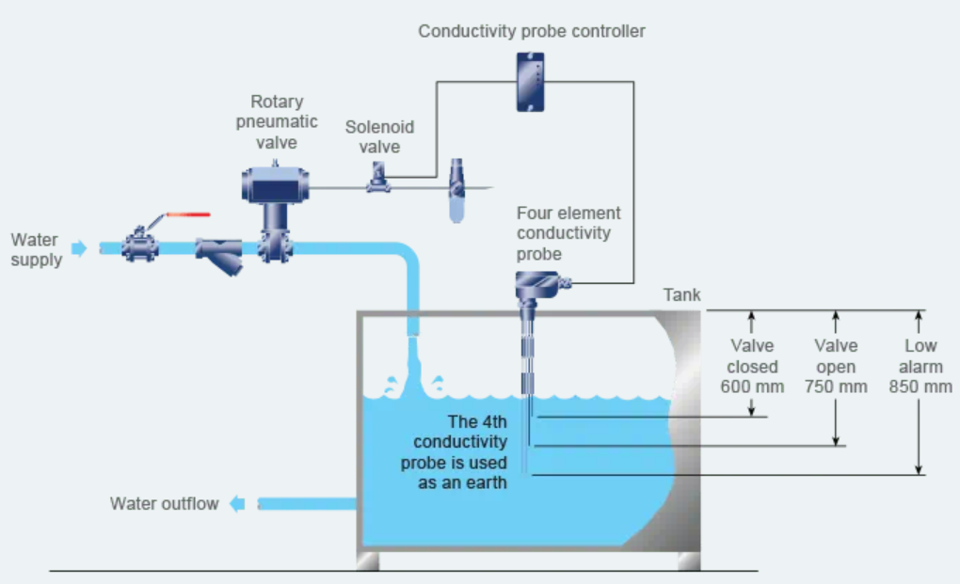
Figure 2. 22 General arrangement of a non-adjustable on/off level control system for a tank
  - Adjustable on/off level control
Description
An adjustable on/off level control system consists of a controller and a capacitance probe (see Figure 2.20), and provides:
- Valve open/closed control plus one alarm point.
- Alternatively, two alarms - high and low.
The levels at which the valve operates can be adjusted through the controller functions.
Advantage: Adjustable on/off level control allows the level settings to be altered without shutting down the process.
Disadvantage: More expensive than non-adjustable on/off control.
Applications: Can be used for most liquids, including those with low conductivities.
Point to note: Can be used in situations where the liquid surface is turbulent, and the in-built electronics can be adjusted to prevent rapid on/off cycling of the pump (or valve).

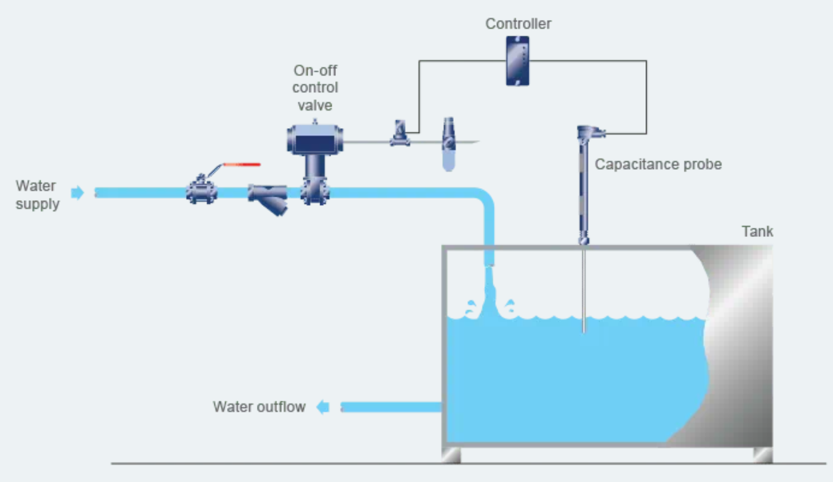
Figure 2. 23 General arrangement of an adjustable on/off level control system for a tank

Self-check (2.1)

Instruction 1: Choose the correct answer for the following question
- Why we use process control?
- To ensure More safety
- For Higher production capabilities
- Decreased overhead costs
- All are correct answer
- Which control action is used in applications where the system has high inertia?
- Continuous control action
- On/Off action
- Automatic control
- None of the above
- When the control action from the controller is independent of the process variable, the control loop is
- Closed loop
- Open loop
- Transitional loop
- All are correct answer
- If Compressor and Valves are final control device of pressure control system what would be Heater and boiler?
- Final control devices of Flow control system
- Final control devices of level control system
- Final control devices of temperature control system
- Final control devices of speed control system

Instruction 2: match the correct answer under column B to column A
 | A |  | B
1 | System Error | A | Convert the signal into a standard signal that can be transmittable through the control loop
2 | Transducers | B | Human readable devices that display the process variable
3 | Open loop | C | PV(t) – SP(t)
4 | Transmitters | D | Converts any form of energy into another form
5 | Indicators | E | The control action from the controller is independent of the process variable
 |  | F | The control action from the controller is dependent on the desired and actual process variable
Instruction 3: write short answer for the give question below
- Write any types of Components of control loop
- list common benefits you can realize when you use process control effectively
- What is the use of access control systems?
- List any types of field devices

Operation sheet (2.1)
Instruction: read carefully all standard operation Procedure (SOP) for implementation
Title: Room Temperature control setup and standard operation procedure in Hospital (Clinic)
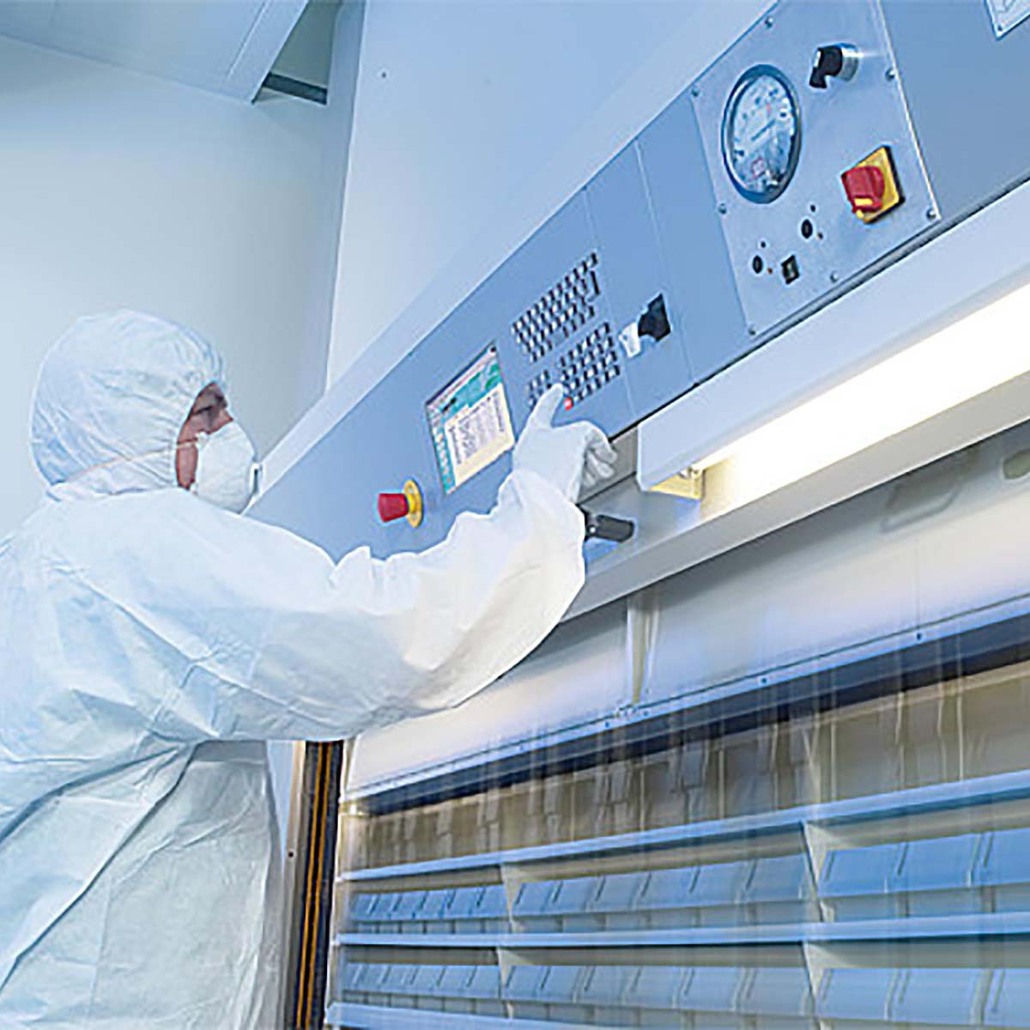
- Introduction to title:
Medicines or drug must be stored under conditions which ensure that their quality is not adversely affected by the environment. Extreme hot and cold temperatures can damage medicines or drug and therefore they must be stored according to manufacturers’ recommendations i.e. within 15ºC-25ºC for ambient storage or within 2ºC-8ºC for fridge storage. In order to ensure the quality of medicines used within the trust, the temperature of all areas where medicines are stored must be monitored regularly. Monitoring records may be requested in the event of an inspection.
- Purpose:
The aim of this Standard Operating Procedure (SOP) is to describe the correct procedure for monitoring the temperature of any clinic room within the trust, when medicines are being stored there.
- Scope:
This SOP applies to all clinical staff working in areas where there is a clinic room on site that is used to store medicines.
- Roles and Responsibilities:
It is the responsibility of individuals carrying out this procedure to:
- Have read and understood this SOP and the instructions for the temperature monitor provided.
- Undertake the procedure as outlined below.
- Only use approved min/max temperature monitors which have a valid, up-to date calibration certificate – for advice on suitable equipment speak to the pharmacy department.
- Store the temperature monitoring records where they can be retrieved for inspection.
- Inform pharmacy staff where appropriate

- Environmental Monitoring Procedure
A calibrated max / min thermometer must be kept in all clinic rooms where medication is to be stored. This is used to monitor ambient room temperature. The thermometer must be kept next to the medication. If medication is also stored in a fridge there must be a separate fridge thermometer used to monitor that storage temperature.
This procedure refers to a temperature recording chart found in the Appendix below. Staff may use this chart or an alternative chart, so long as it records the same information. If a digital temperature recording system is in place and working well, this can continue to be used instead of the procedure below, provided staff have written procedures for downloading and storing the temperature information and for responding to a temperature deviation.
  - Temperature monitoring
- At the beginning of each month start a new recording chart (see Appendix below for example). Write the month and year in the appropriate space.
- Check the temperature shown on the thermometer(s) daily and record max and min temperatures onto the chart. Sign in the appropriate space.
- Reset the thermometer according to the operational instructions.
- If daily recording isn’t possible, enter the details as frequently as possible. Min/max thermometers will keep a record of the minimum and maximum temperature reached until it is reset.
- During extreme (hot/cold) weather conditions the temperature should be monitored more frequently.
- At the end of each month the completed monitoring record form must be signed by a senior team member who must first check that no unreported deviation has occurred.
- All records must be kept in a folder along with the thermometers calibration certificate. These records will be requested during an inspection.

  - Responding to an alarm or a temperature deviation:
- The alarms on the thermometer must be set to go off if the temperature reaches the boundaries of the desired range i.e. 15°C-25°C or 2 oC-8ºC.
- If the alarms go off, action must be taken to try to ensure that the room or fridge remains within the desired range – open / close windows, install portable fan / heater to cool / heat the room, close fridge door, contact engineer to service fridge.
- Once these measures have been taken, ensure that the temperature record has been recorded, then reset the thermometer to silence the alarm
- If the temperature has varied outside of the required range, inform a member of pharmacy staff or the medicines information department. They will need to know the temperature reached, an estimate of how long the temperature has been out of range and the details of any medication stored there.
- Definitions
Ambient room temperature:
The minimum and maximum temperatures are within range of 15oC and 25oC
Fridge temperature:
The minimum and maximum temperatures are within range of 2ºC and 8ºC
- Revision History
This is a new Standard Operating Procedure that has not undergone any revisions since first approved
- Appendix
Temperature Monitoring Record

UNIT 3. Test for correct functionality
This learning guide is developed to provide you the necessary information regarding the following content coverage and topics:
- Calibration, instrumentation standard.
- loop system Installation
- Functionality tests
- Status report/s and work supervision
This guide will also assist you to attain the learning outcome stated in the cover page. Specifically, upon completion of this Learning Guide, you will be able to:
- Conduct calibration and instrumentation standard.
- Install specific complete loop system
- Follow functionality tests
- Complete status report/s and notify work supervision

Calibration and instrumentation standard
    - Calibration Standards to Produce and Measure Physical Quantities
Calibration refers to the checking and adjustment of an instrument so that its output faithfully corresponds to its input throughout a specified range. In order to calibrate an instrument, we must have some means of knowing the input and/or output quantities associated with the instrument under test. A substance or device used as a reference to compare against an instrument’s response is called a calibration standard. Simply put, a calibration standard is something we may compare the calibrated instrument to. Thus, any calibration can only be as good as the standard used.
Standards Used for Calibration
Calibration standards fall into two broad categories: standards used to produce accurate physical quantities (e.g. pressure, temperature, voltage, current, etc.), and standards used to simply measure physical quantities to a high degree of accuracy. An example of the former would be the use of boiling water (at sea level) to produce a temperature of 100 degrees Celsius (212 degrees Fahrenheit) in order to calibrate a temperature gauge, whereas an example of the latter would be the use of a laboratory-quality precision thermometer to measure some arbitrary source of temperature in comparison to the temperature gauge being calibrated.
In metrology labs, the ultimate standards are based on fundamental constants of nature, and are called intrinsic standards. A modern example of an intrinsic standard for time is the so-called atomic clock, using isolated atoms of Cesium to produce frequencies which are inherently fixed and reproduceable world-wide. Instrument shops located in industrial facilities cannot afford the capital and consumable costs associated with intrinsic standards, and so must rely on other devices for their calibration purposes. Ideally, there should be a “chain” of calibration from any device used as a shop standard traceable all the way back to some intrinsic standard in a national-level or primary metrology lab.
Calibration standards used in instrument shops for industrial calibration work should therefore be periodically sent to a local metrology lab for re-standardization, where their accuracy may be checked against other (higher-level) standards which themselves are checked against even higher-level calibration standards, ultimately traceable all the way to intrinsic standards. In each step of the calibration “chain,” there is a progressive degree of measurement uncertainty. Intrinsic standards possess the least amount of uncertainty, while field instruments (e.g. pressure transmitters, temperature gauges, etc.) exhibit the greatest uncertainties.
    - Some examples of calibration and instrumentation standard
  - Test Uncertainty Ratio (TUR)
It is important that the degree of uncertainty in the accuracy of a test instrument is significantly less than the degree of uncertainty we hope to achieve in the instruments we calibrate. Otherwise, calibration becomes a pointless exercise. This ratio of uncertainties is called the Test Uncertainty Ratio, or TUR. A good rule-of-thumb is to maintain a TUR of at least 4:1 (ideally 10:1 or better), the test equipment being many times more accurate (less uncertain) than the field instruments we calibrate with them.
The lesson to be learned here is to always ensure the standards used to calibrate industrial instruments are reliably accurate (enough). No calibration standard is perfect, but perfection is not what we need. Our goal is to be accurate enough that the final calibration will be reliable within specified boundaries.
The next few subsections describe various standards used in instrument shops to calibrate industrial instruments.
  - Electrical Calibration Standards
Electrical calibration equipment is used to calibrate instruments measuring voltage, current, and resistance must be periodically calibrated against higher-tier standards maintained by outside laboratories. In years past, instrument shops would often maintain their own standard cell batteries (often called Weston cells) as a primary voltage reference. These special-purpose batteries produced 1.0183 volts DC at room temperature with low uncertainty and drift, but were sensitive to vibration and non-trivial to actually use. Now, electronic voltage references have all but displaced standard cells in calibration shops and laboratories, but these references must be checked and adjusted for drift in order to maintain their NIST traceability.
The following illustration shows how a high-accuracy voltmeter could be used to calibrate a handheld voltmeter in this fashion:
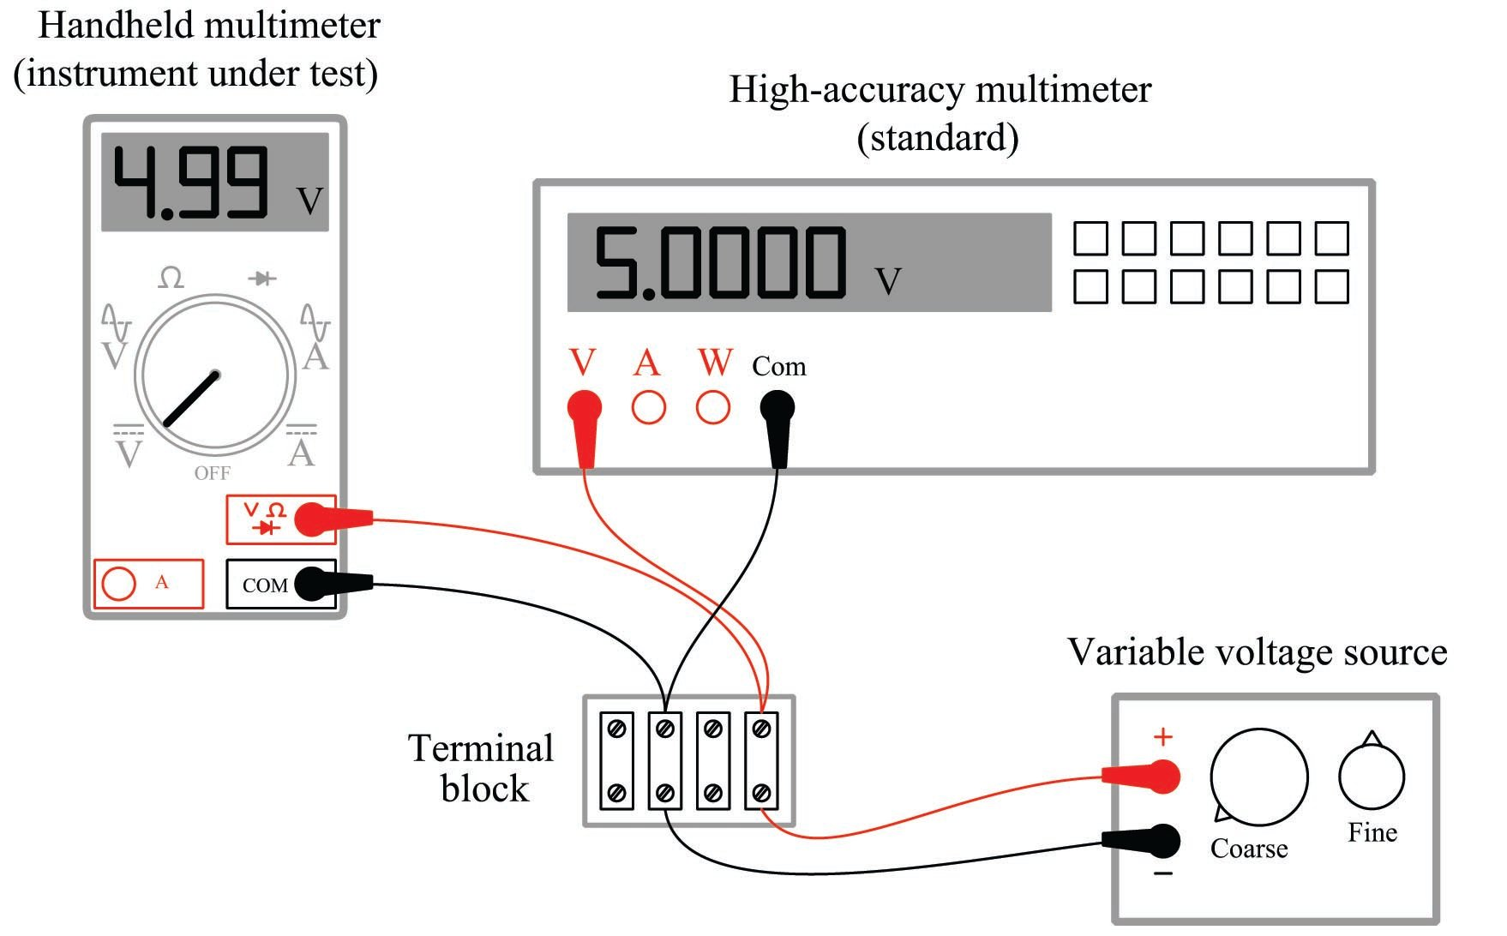
Figure 3. 1 A high-accuracy voltmeter used to calibrate a handheld voltmeter
It should be noted that the variable voltage source shown in this test arrangement need not be sophisticated. It simply needs to be variable (to allow precise adjustment until the high-accuracy voltmeter registers the desired voltage value) and stable (so the adjustment will not drift appreciably over time). The accuracy of your calibration in the previous circuit originates not from the variable voltage source, but rather from the high-accuracy multimeter used as the calibration standard. It is the high-accuracy multimeter that serves as the calibration reference here, not the voltage source – it is the high-accuracy multimeter that functions as the standard.
  - Temperature Calibration Standards
The most common technologies for industrial temperature measurement are electrical in nature: RTDs and thermocouples. As such, the standards used to calibrate such devices are the same standards used to calibrate electrical instruments such as digital multimeters (DMMs). For RTDs, this means a precision resistance standard such as a decade box used to precisely set known quantities of electrical resistance.
Modern, electronic calibrators are also available now for RTD and thermocouple instrument calibration, capable of sourcing accurate quantities of electrical resistance and DC millivoltage for the simulation of RTD and thermocouple elements, respectively. A photograph of a Fluke model 525A laboratory standard is shown here:
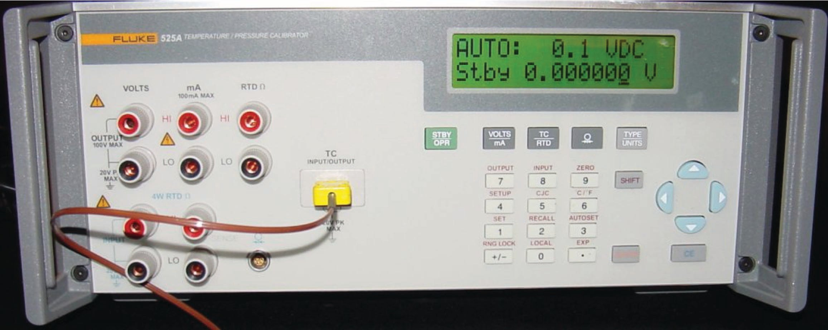
Figure 3. 2 Fluke 525A modern laboratory calibrator
Modern laboratory calibrator such as the Fluke 525A are self-contained sources useful for simulating the electrical outputs of temperature sensors.
Given an accurate enough voltmeter, it is possible to construct your own calibration potentiometer for simulating the millivoltage output of a thermocouple. A simple voltage divider set up to reduce the DC voltage of an ordinary variable-voltage power supply will suffice, so long as it provides fine enough adjustment:
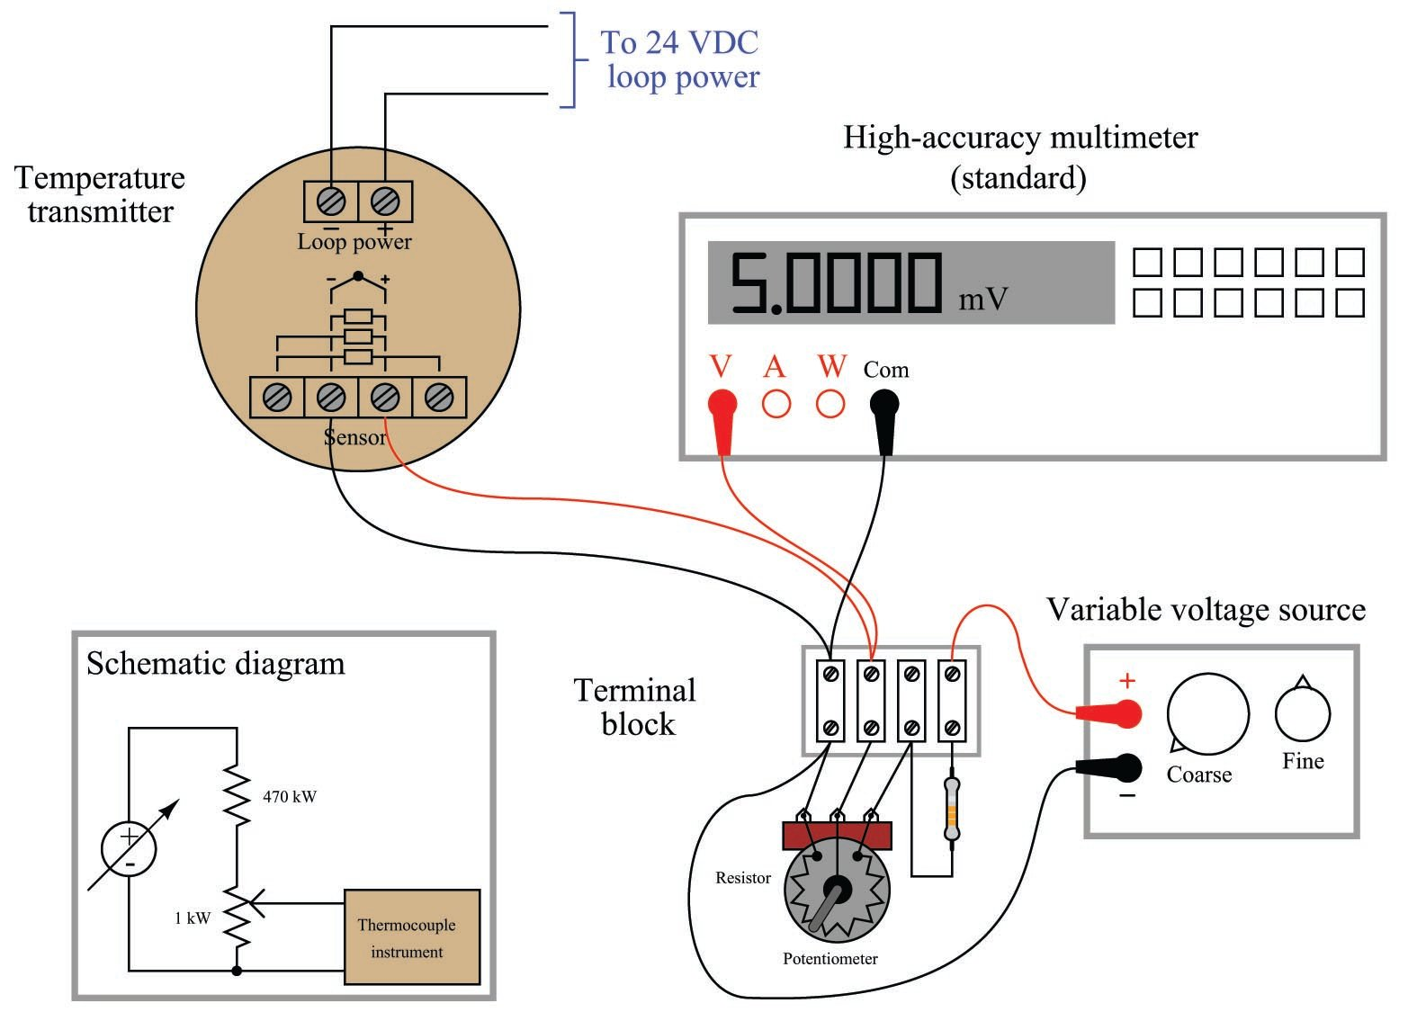
Figure 3. 3 high-accuracy multimeter diagram

This means the high-accuracy multimeter functions as the calibration standard in this set-up, permitting the use of non-precision components in the rest of the circuit. Since the multimeter’s indication is the only variable being trusted as accurate when calibrating the thermocouple-input temperature transmitter, the multimeter is the only component in the circuit affecting the uncertainty of our calibration.
Electrically simulating the output of a thermocouple or RTD may suffice when the instrument we wish to calibrate uses a thermocouple or an RTD as its sensing element. However, there are some temperature-measuring instruments that are not electrical in nature: this category includes bimetallic thermometers, filled-bulb temperature systems, and optical pyrometers. In order to calibrate these types of instruments, we must accurately create the calibration temperatures in the instrument shop. In other words, the instrument to be calibrated must be subjected to an actual temperature of accurately known value.
  - Pressure setup Standards
In order to accurately calibrate a pressure instrument in a shop environment, we must create fluid pressures of known magnitude against which we compare the instrument being calibrated. As with other types of physical calibrations, our choice of standards falls into two broad categories: devices that inherently produce known pressures versus devices that accurately measure pressures created by some (other) adjustable source.
- Deadweight Tester
A deadweight tester (sometimes referred to as a dead-test calibrator) is an example in the former category. These devices create accurately known pressures by means of precise masses and pistons of precise area:
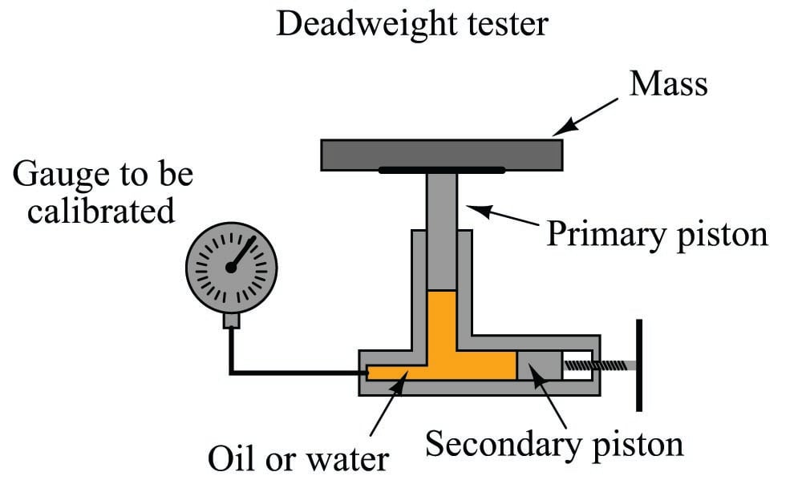
Figure 3. 4 A deadweight tester
After connecting the gauge (or other pressure instrument) to be calibrated, the technician adjusts the secondary piston to cause the primary piston to lift off its resting position and be suspended by oil pressure alone. So long as the mass placed on the primary piston is precisely known, Earth’s gravitational field is constant, and the piston is perfectly vertical, the fluid pressure applied to the instrument under test must be equal to the value described by the following equation:
$$P=\frac{F}{A}$$
Where,
FP = Fluid pressure
F = Force exerted by the action of gravity on the mass (F_{weight} =mg)
A = Area of piston
The primary piston area, of course, is precisely set at the time of the deadweight tester’s manufacture and does not change appreciably throughout the life of the device.
Most modern deadweight testers include extra features such as hand pumps and bleed valves in addition to secondary pistons, to facilitate both rapid and precise operation. The next photograph shows a newer deadweight tester, with these extra features:
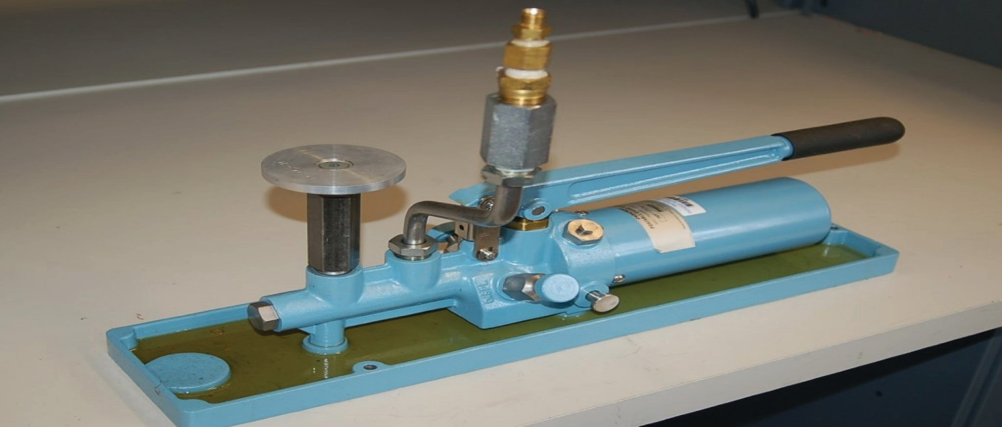
Figure 3. 5 A newer deadweight tester

- Pneumatic Deadweight Tester
There is also such a thing as a pneumatic deadweight tester. In these devices, a constant flow of gas such as compressed air or bottled nitrogen vents through a bleed port operated by the primary piston. The piston moves as necessary to maintain just enough gas pressure inside the unit to suspend the mass(es) against gravity. This gas pressure passes on to the instrument under test, just as liquid pressure in a hydraulic deadweight tester passes to the test instrument for comparison:
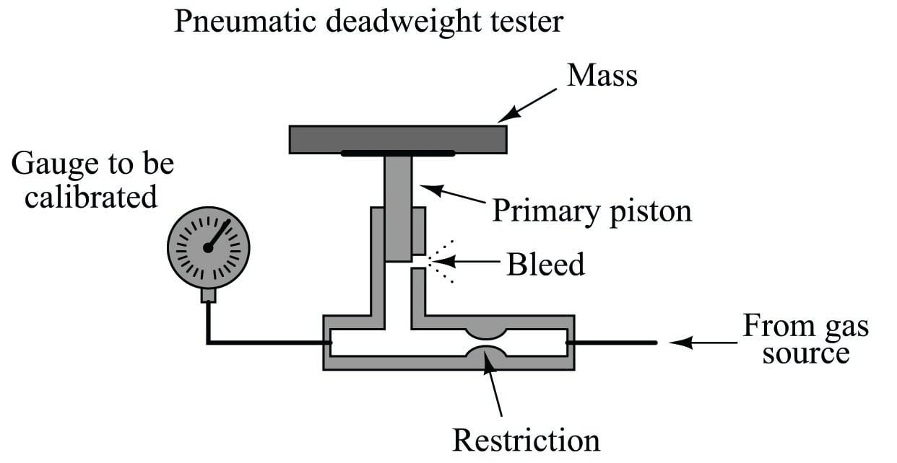
Figure 3. 6 Pneumatic Deadweight Tester
In fact, the construction and operation of a pneumatic deadweight tester is quite similar to a self-balancing (force-balance) pneumatic instrument mechanism with a baffle/nozzle assembly. A moving element opens or closes a variable restriction downstream of a fixed restriction to generate a varying pressure. In this case, that pressure directly operates the bleed vent to self-regulate gas pressure at whatever value is necessary to suspend the mass against gravity.
Deadweight testers (both hydraulic and pneumatic) lend themselves well to relatively high pressures, owing to the practical limitations of mass and piston area. You could use a deadweight tester to calibrate a 100 PSI pressure gauge used for measuring water mains pressure, for example, but you could not use a deadweight tester to calibrate a 0 to 1 "W.C. (zero to one inch water column) pressure gauge used to measure draft pressure in a furnace flue.
- Manometer
For low-pressure calibrations, the simple manometer is a much more practical standard. Manometers, of course, do not generate pressure on their own. In order to use a manometer to calibrate a pressure instrument, you must connect both devices to a source of variable fluid pressure, typically instrument air through a precision pressure regulator:
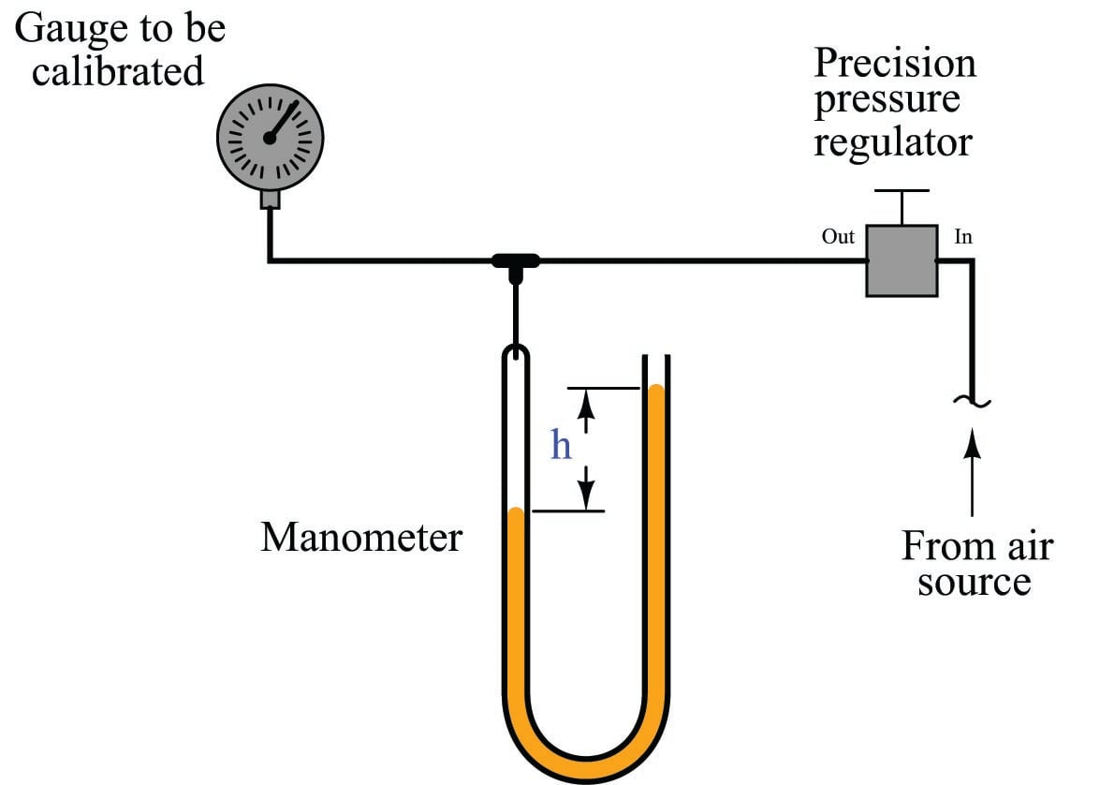
Figure 3. 7 Manometer for low pressure calibration
The difference in liquid column heights (ℎ) within the manometer shows the pressure applied to the gauge. As with the deadweight tester, the accuracy of this pressure measurement is bound by just a few physical constants, none of which are liable to sudden change. So long as the manometer’s liquid density is precisely known, Earth’s gravitational field is constant, and the manometer tubes are perfectly vertical, the fluid pressure indicated by the manometer must be equal to the value described.
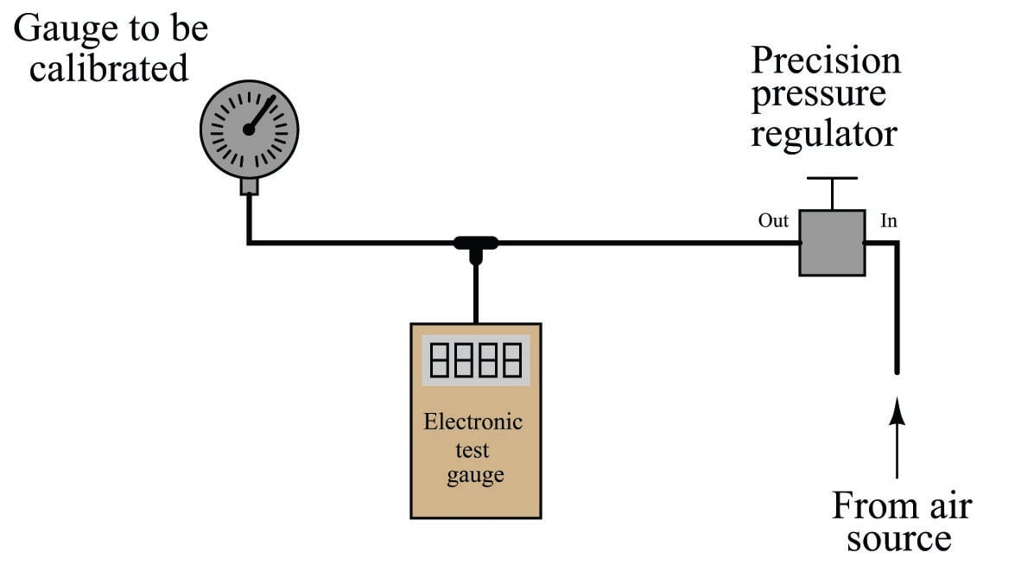
Figure 3. 8 An electric manometer
When the electronic test gauge is designed for very low pressures (inches of water column), they are sometimes referred to as electronic manometers.
  - Analytical Calibration Standards
An analyzer measures intrinsic properties of a substance sample such as its density, chemical content, or purity. Whereas the other types of instruments discussed in this chapter measure quantities incidental to the composition of a substance (pressure, level, temperature, and flow rate), an analyzer measures something related to the nature of substance being processed.
As previously defined, to calibrate an instrument means to check and adjust (if necessary) its response so the output accurately corresponds to its input throughout a specified range. In order to do this, one must expose the instrument to an actual input stimulus of precisely known quantity. This is no different for an analytical instrument. In order to calibrate an analyzer, we must exposed it to known quantities of substances with the desired physical and/or chemical properties (density, chemical composition, etc.). In other words, we need to use chemical standards.
A classic example of this is the calibration of a pH analyzer. pH is the measurement of hydrogen ion activity in an aqueous solution. The standard range of measurement is 0 pH to 14 pH, the number representing a negative power of 10 approximately describing the hydrogen ion molarity of the solution (how many moles of active hydrogen ions per liter of solution).
  - Gas Analyzers
Analyzers designed to measure the concentration of certain gases in air must be calibrated in a similar manner. Oxygen analyzers, for example, used to measure the concentration of free oxygen in the exhaust gases of furnaces, engines, and other combustion processes must be calibrated against known standards of oxygen concentration. An oxygen analyzer designed to measure oxygen concentration over a range of ambient (20.9% oxygen) to 0% oxygen may be calibrated with ambient air as one of the standard values, and a sample of pure nitrogen gas (containing 0% oxygen) as the other standard value. An oxygen analyzer intended for the measurement of oxygen concentrations in excess of ambient air would require a different standard, most likely a sample of 100% pure oxygen, as a calibration reference.
A typical self-calibration system for a gas analyzer might look like this:
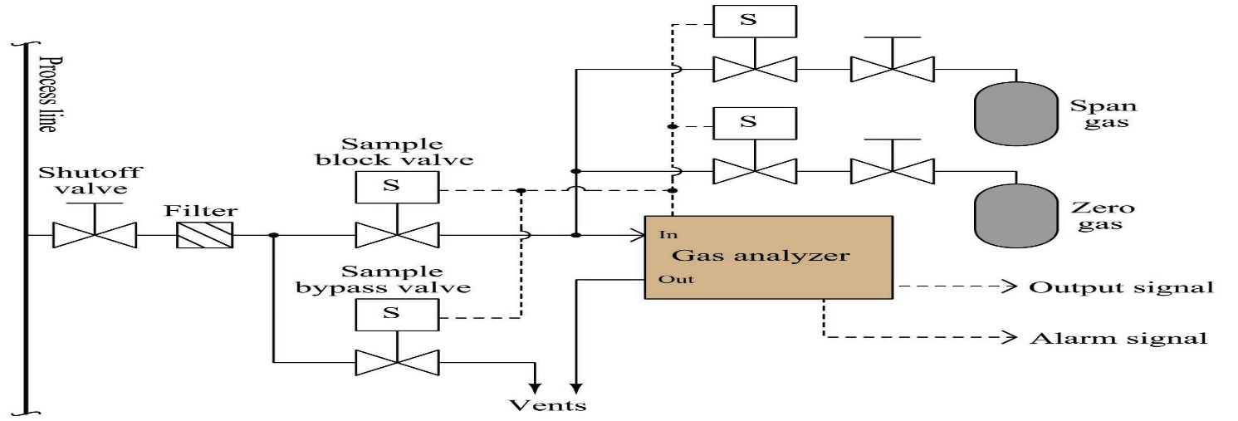
Figure 3. 9 Automatic self-calibration gas analyzer diagram
The gas analyzer is equipped with its own auto-calibration controls and programming, allowing it to periodically shut off the process sample and switch to known reference gases for “zero” and “span” calibration checks. If these checks indicate excessive drift or any other questionable results, the analyzer has the ability to flag a maintenance alarm to alert an instrument technician to a potential problem that may require servicing. This sort of self-calibration and self-diagnostic capability saves the instrument technician from having to spend substantial time running manual calibration checks, yet alerts the technician if anything is in need of actual repair. Barring any component failures within this system, the only maintenance this system will need is periodic replacement of the calibration gas bottles.

Loop system Iistallation
    - Understanding of process control and definition of term
A simple to understand example of process control is the supply of water to a number of cleaning stations, where the water temperature needs to be kept constant in spite of the demand. A simple control block is shown in Fig 10a, steam and cold water are fed into a heat exchanger, where heat from the steam is used to bring the cold water to the required working temperature. A thermometer is used to measure the temperature of the water (the measured variable) from the process or exchanger. The temperature is observed by an operator who adjusts the flow of steam (the manipulated variable) into the heat exchanger to keep the water flowing from the heat exchanger at the constant set temperature. This operation is referred to as process control, and in practice can be automated as shown in Fig 3.10 b.
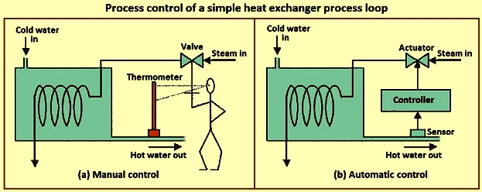
Figure 3. 10 Process control of a simple heat exchanger process loop
Process control is the automatic control of an output variable by sensing the amplitude of the output parameter from the process and comparing it to the desired or set level and feeding an error signal back to control an input variable. In Fig 3.10b, a temperature sensor attached to the outlet pipe senses the temperature of the water flowing. As the demand for hot water increases or decreases, a change in the water temperature is sensed and converted to an electrical signal, amplified, and sent to a controller which evaluates the signal and sends a correction signal to an actuator. The actuator adjusts the flow of steam to the heat exchanger to keep the temperature of the water at its pre-determined value.
Industrial processes are normally dynamic in nature and hence a process control system normally has dual tasks. Through process control system an operator
  - monitors certain process condition indicators and
  - induces changes in appropriate variables in order to improve process conditions.
Control is exercised to maintain desired conditions in the process system by adjusting selected variables in the process system. A specific value or range is used as the desired value for the variable to be controlled. It is always better to utilize the simplest control system which can achieve the desired objectives. The design of a process determines how it is going to respond dynamically and how it can be controlled.
A process has normally got four types of variables namely
  - input variables,
  - output variables,
  - control variables, and
  - state variables.
Input variables are those variables which independently stimulate the process system and hence induce change in the internal conditions of the process. Input variable shows the effect of the environment on the process.
Control systems are used to maintain process conditions at their desired values by manipulating certain process variables to adjust the variables of interest.
There are three types of process variables. These are
  - controlled variable,
  - manipulated variable, and
  - load variable.
Controlled variable is that variable which directly or indirectly indicate the form or state of the product such as temperature in a process reactor, outlet temperature of the product or exit gas. Manipulated variable is that variable which is selected for adjustment by the controller so as to maintain the controlled variable at the desired value. All other independent variables except controlled and manipulated variables are called load variable.
The process needs to be monitored by the operator so as to ensure that the process operates in the stable condition and gives the desired output. For monitoring, the conditions (process parameters) of the process system are measured. For this operator is to depend on instruments. Further each system has a control calculation which is also called algorithm. The results of calculation are implemented for process to function correctly. The instruments used for controlling a process can be sensors, transmitters, controllers, and final control element.
There are several common attributes of control systems which include
  - the ability to maintain the process variable at its desired value in spite of disturbances which can be experienced, and
  - the ability to move the process variable from one setting to a new desired setting which is also known as set point tracking.
In the control system, the controller compares the measurement signal of the controlled variable to the set point (the desired value of the controlled variable). The difference between the two values is called the error. Error set (point value) is the measurement signal of the controlled variable. Depending upon the magnitude and sign of the error, the controller takes suitable action by sending a signal to the final control element, which provides an input to the process to return the controlled variable to the set point.
The concept of using information about the deviation of the system from its desired state to control the system is called feed-back control. Information about the state of the system is ‘fed back’ to a controller, which utilizes this information to change the system in some way.
The type of control system shown in Fig 3.11 is termed a closed loop feed-back control system. Closed loop refers to the fact that the controller automatically acts to return the controlled variable to its desired value. Negative refers to the fact that the error signal is computed from the difference between the set point and the measured signal. The negative value of the measured signal is ‘fed back’ to the controller and added to the set point to compute the error.
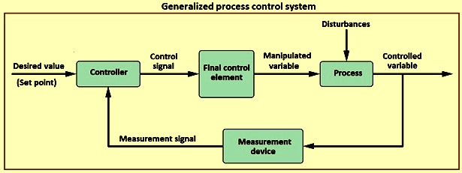
Figure 3. 11 Generalized process control system
Process control refers to the methods which are employed for controlling the variables of the process or processes used in the manufacturing of a product. It is the act of controlling a final control element to change manipulated variable to maintain the process variable at a desired set point. These variables can be in process inputs, in process parameters, and in process output. Control of the process is done to reduce its variability for getting aimed product quality, improving the production rates, increasing the efficiency of the process, facilitating protection of the environment and ensuring safety of the men and equipment employed for the process.
Summary of terms used in process control
Cascade control – It is a control system with two or more controllers, with a ‘master’ and a ‘slave’ loop. The output of the ‘master’ controller is the set point for the ‘slave’ controller.
Controllers – Controllers carry out the function of brain. Controllers can be pneumatic, electronic, or digital computers.
Dead time – It is the quantity of time which is taken by the process to start changing after a disturbance in the system.
Derivative control – It is the ‘D’ part of a PID (proportional integral derivative) controller. With derivative action, the controller output is proportional to the rate of change of the process variable or error.
Error – In the process control systems, error is defined as the difference between set point and process variable and is given by the equation ‘Error = set point – process variable’.
Final control elements – Final control elements carry out the function of muscles. These are control valves, pumps, compressors, conveyors, and relay switches etc.
Integral control – It is the ‘I’ part of a PID controller. With integral action the controller output is proportional to the quantity and duration of the error signal.
PID controller – PID controllers are designed to eliminate the need for continuous operator attention. They are used to automatically adjust system variables to hold a process variable at a set point.
Proportional control – It is the ‘P’ part of a PID controller. With proportional action the controller output is proportional to the quantity of the error signal.
Sensors – Sensors are those instruments which carry out the functions of vision, hearing etc. These instruments measures temperature, level, flow, composition etc. These are thermocouples, differential pressure meters, gas analyzers etc.
Set point – The set point is where the operator likes a controlled process variable to be set.
Transmitters – Transmitters are like neurons. They transmit signals like air signals or electric signal etc.
A block diagram showing some control elements is at Fig 3.
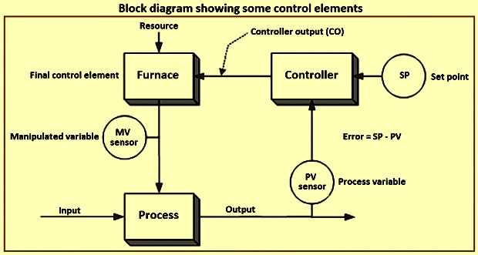
Figure 3. 12 Block diagram showing some control elements
    - Design methodology for Installation of process control
The design methodology of the process is described below.
- Understand the process – Before attempting to control a process, it is necessary to understand how the process works and what it does.
- Identify the operating parameters – Once the process is well understood, operating parameters such as temperatures, pressures, flow rates, and other variables specific to the process are to be identified for its control.
- Identify the hazardous conditions – In order to maintain a safe and hazard free facility, variables which can cause safety concerns are to be identified and can need additional control.
- Identify the measurable – It is important to identify the measurables which correspond with the operating parameters in order to control the process. Measurables for process systems include (i) temperature, (ii) pressure, (iii) flow rate, (iv) pH, (v) humidity, (vi) level, (vii) concentration, (viii) viscosity, (ix) conductivity, (x) turbidity, (xi) redox potential, (xii) electrical behaviour, and (xiii) flammability.
- Identify the points of measurement – Once the measurables are identified, it is important to locate the place where they are to be measured so that the system can be accurately controlled.
- Select measurement methods – Selecting the proper type of measurement device specific to the process ensures that the most accurate, stable, and cost effective method is chosen. There are several different signal types which can detect different things. These signal types include (i) electric, (ii) light, (iii) pneumatic, (iv) radio waves, (v) infrared (IR), and (vi) nuclear.
- Select control method – In order to control the operating parameters, the proper control method is important to control the process effectively. On / off is one control method and the other is continuous control. Continuous control involves proportional (P), integral (I), and derivative (D) methods or some combination of these three.
- Select control system – Choosing between a local or distributed control systems which fits well with respect to the process effects both the cost and efficacy of the overall control.
- Set control limits – Understanding the operating parameters allows the ability to define the limits of the measurable parameters in the control system.
- Define control logic – Choosing between feed-forward, feed-backward, cascade, ratio, or other control logic is a necessary decision based on the specific design and safety parameters of the system.
- Create a redundancy system – Even the best control system has failure points. Hence, it is important to design a redundancy system to avoid catastrophic failures by having back-up controls in place.
- Define a fail-safe – Fail-safes allow a system to return to a safe state after a breakdown of the control. This fail-safe allows the process to avoid hazardous conditions which can otherwise occur.
- Set lead / lag criteria – Depending on the control logic used in the process, there can be lag times associated with the measurement of the operating parameters. Setting lead / lag times compensates for this effect and allow for accurate control.
- Investigate effects of changes before / after – By investigating changes made by implementing the control system, unforeseen problems can be identified and corrected before they create hazardous conditions in the facility.
- Integrate and test with other systems – The proper integration of a new control system with existing process systems avoids conflicts between multiple systems.
    - Block diagram Design
A typical block diagram of a process with a single manipulated variable and a single controlled variable is shown in Fig 3.13. This diagram includes feed forward, feed-back, and supervisory control. The main aim of the feed-back controller of this process is to keep the controlled variable Y which is measured by some instrument as close as possible to the desired set point Ysp. The controlled variable can be the quality of the final product, which can be pressure, temperature, liquid level, composition, or any other inventory, environmental, or quality variable.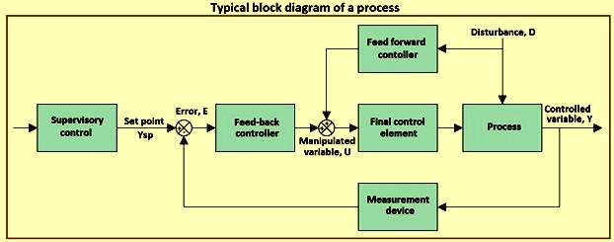
Figure 3. 13 Typical block diagram of a process
Feed-back control – The purpose of feed-back control is to keep the controlled variable close to its set point.
Feed forward control – A feed-back controller can only take action after the controlled variable deviates from its desired set point and generates a non-zero error.
Regulation and set point changes – The purpose of feed-back control is to keep the controlled variable close to its set point.
Safety and shut down systems – Plant safety is an important consideration in operating a plant. Also, increasingly stringent statutory regulations need special attention to process safety during the design process.
A protective system is to be provided for processes where hazardous conditions can develop. One possible solution to this is to provide logic for the specific purpose of taking the process to a state where this condition cannot exist, called a safety interlock system.
Alarms – The purpose of an alarm is to alert the process operator to a process condition which needs immediate attention. An alarm is activated whenever the abnormal condition is detected and the alert is issued.
Facility control hierarchy – There are five levels in the manufacturing process where various optimization, control, monitoring, and data acquisition activities are used below. Data from the plant (flows, temperatures, pressures, compositions, etc.) as well as so called enterprise data, consisting of commercial and financial information, are used with the methodologies shown in order to make decisions in a timely fashion.
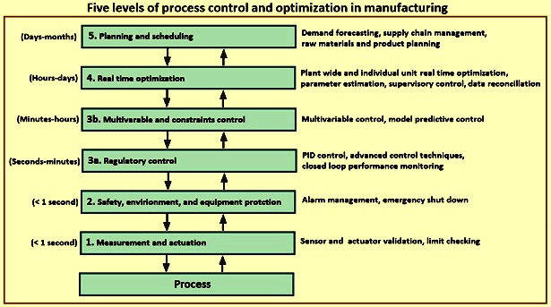
Figure 3. 14 Five levels of process control and optimization in manufacturing
Normally, the various levels of control applications are aimed at one or more of the objectives namely
  - determining and maintaining the plant at a practical optimal operating point given the current conditions and economics,
  - maintaining safe operation for the protection of personnel and equipment,
  - minimizing the need for operator attention and intervention, and
  - minimizing the number, extent, and propagation of upsets and disturbances.

Functionality tests
  - Checking normal functioning systems and components
It’s extremely difficult to generate the best possible solution to a problem when you don’t know what the problem is. The first thing you need to do in any design is to understand the requirements of the design and its functioning system. Once you understand the requirements, stake out the limits on the specifications and communicate those, so that the whole team is clear on what the system will and will not do. Then focus your design on delivering the all performance you’ve committed to deliver but nothing more. Adding margin will add cost.
In Mechatronics systems, the key requirements typically boil down to understanding the motion required, and the loads that must be moved. Make sure you understand all facets of the motion such as move time requirements, masses and inertias, friction loads, external loads and any constraints on the drive train. There’s often opportunities to reduce the size (and cost) of the components required by reducing the peak loads. The closer the peak load is to the average, the better utilization of the parts in the system.
- Check normal functioning of your machines or devices before allow to use for any purpose
- Check power supply, you have to use before connected devices
- Check voltage level and machines, or devices normal operation
- Read manual/instruction before connect it or use it.

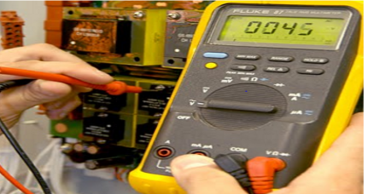
Figure 3. 15 checking of normal functionality

Fundamentals of Testing
- Organize your code for testing
- Create and test code iteratively
- View your system as a series of modules
- Configure your test environment
- Organize test directories based on execution environment
    - Normal functioning of Protection Relay Checking
The testing and verification of protection devices and arrangements introduces a number of issues. This happens because the main function of protection devices is related to operation under fault conditions so these devices cannot be tested under normal operating conditions. This problem is worsened by the growing complexity of protection arrangements, application of protection relays with extensive software functionalities, and frequently used Ethernet peer-to-peer logic. The testing and verification of sensor devices can be divided into four groups:
  - Routine factory production tests
  - Type tests
  - Commissioning tests
  - Occasional maintenance tests
Type Tests
Type tests are needed to prove that a protection relay meets the claimed specification and follows all relevant standards. Since the basic function of a protection relay is to correctly function under abnormal power conditions, it is crucial that the operation is evaluated under such conditions. Therefore, complex type tests simulating the working conditions are completed at the manufacturer's facilities during equipment development and certification. The standards that cover majority of relay performance aspects are IEC 60255 and IEEE C37.90.
Directives; Since type testing of a digital or numerical protection relay includes software and hardware testing, the type testing procedure is very complex and more challenging than a static or electromechanical relay.
    - Electrical Type Tests
In electrical machines or systems functionality testing, different electrical type tests must be completed, as follows:
- Functional Tests
A sample for the functional tests consists of using the adequate inputs to the protection relay under test and measuring the performance to discover if it meets the specification are analysed here. They are typically completed under controlled environmental conditions. The testing may complex, even where only a simple relay function is being assessed.
When a modern numerical protection relay with many functions is assessed, each of which has to be type-tested, the functional type-testing involved is significant issue. In the case of a recent relay development project, it was found that if one person had to complete all the work
- Rating Tests
Rating type tests are completed to make sure that components are used within their defined ratings and that there is no fire or electric shock hazards under a normal load or fault conditions. Also, this is done along with verification that the product follows its technical specification.
- Thermal Withstand Tests
The thermal withstands of VTs, CTs and output contact circuits are done to ensure compliance with the defined continuous and short-term overload conditions. In addition to functional check, the pass criterion is that there is no damaging effect on the relay assembly, or circuit elements, when the product is exposed to overload conditions that may be expected. Thermal withstand is evaluated over a time period of 1s for CTs and10s for VTs.

- Relay Burden Test
The auxiliary supply burdens, optically isolated inputs, VTs and CTs are measured to determine that the product complies with its specification. The burden of products with a big number of input/output circuits is application specific i.e. it increases according to the number of optically isolated input and output contact ports which are energized under normal power system load conditions.
- Relay Inputs
Relay inputs are verified over the specified ranges. Inputs include those for auxiliary voltage, VT, CT, frequency, optically isolated digital inputs and communication elements.
- Relay Output Contacts
Protection relay output contacts are type tested to make sure that they follow product specification. Special withstand and endurance type tests have to be completed using
DC, since the normal supply is via a station battery.
- Insulation Resistance Test
The insulation resistance test is completed in line with IEC 60255-27, i.e. 500V DC. - 10%, for a minimum of 5 seconds. This is completed between all circuits and case ground, between all independent circuits and across normally open contacts.
- Auxiliary Supplies
Digital and numerical protection relays typically need an auxiliary supply to give power to the on board microprocessor circuitry and the interfacing opto-isolated input circuits and output protection relays. The auxiliary supply can be either AC. or DC, powered from a number of sources or safe supplies.
Tests are completed for both AC. and DC. Auxiliary supplies and include mains change both above and below the nominal rating, supply interruptions derived by open circuit and short circuit, power dips as a percentage of the nominal supply, repetitive starts. The interruption duration and supply dips range from 2ms to 60s intervals.

- Electromagnetic Compatibility Tests
There are different tests that are completed to check the ability of protection relays to withstand the electrical environment in which they are put. The substation environment is a very severe environment in terms of the electrical and electromagnetic interference that can happen. There are many sources of interference within a substation, some developing internally, others being conducted along the transmission lines or cables into the substation from external disturbances. The most typical sources are:
  - system faults
  - switching operations
  - conductor flash over
  - lightning strikes
  - telecommunication operations e.g. mobile phones
A whole suite of tests are completed to simulate these types of interference, and they fall under the broad umbrella of what is known as EMC or Electromagnetic Compatibility tests.
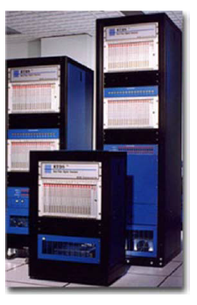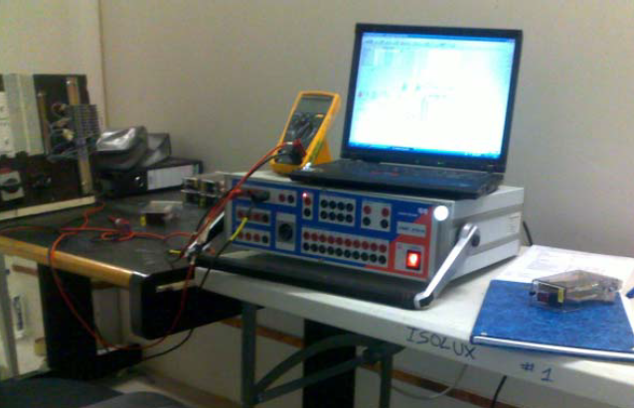
Figure 3. 16 Modern computer-controlled test bench
    - Test Equipment
Other than for purposes of rectification, repair, or replacement, no test equipment shall be moved from the job site for the duration of the contract. All calibration test equipment supplied by a contractor shall be certified for accuracy by an independent testing laboratory before use.
Each item of calibration test equipment supplied by a contractor shall exhibit a permanently fixed validation label indicating the serial number, name of certifier, and the date and duration of certification. Copies of relevant test certificates will be kept on file by the supplier of the test equipment and shall be made available for inspection by Air Products at any time.
Equipment that shall be considered calibration test equipment shall comprise, but not be limited to, the following: Hart Communicators, hand pumps, precision test gauges, portable potentiometers, deadweight tester (pneumatic only), manometers, constant temperature generator, thermocouple calibrator, RTD calibrator, transmitter simulators, pneumatic calibrators, signal generator and counter, portable oscilloscope, leak detection unit, and instrument manufacturer’s specially designed portable test sets.
Visual inspection of devices
Typically, physical inspection is the first task to be performed once an instrument is turned over from construction. Physical inspections do not have to be done in conjunction with loop checking but depending on manpower and instrument location, physical inspections and loop checking may be done at the same time. At a minimum, physical inspections must be documented to provide evidence of what was checked and whether the device passed or failed. It is recommended that field inspection reports be filled out for every piece of instrumentation. Failed devices shall be corrected before proceeding to loop check.
General Inspection Checks:
- Transmitter support stands installed
- Proper wiring, glanding, and conduit connection such as low point drains, grounding, shielding and terminations, and bottom cabinet entry
- Verify proper labeling of all tags, warning signs, pressure ratings, etc…
- Confirm all covers, screws, fittings, etc. are installed and properly tightened
- Look for signs of moisture and/or corrosion in electrical conduit and process impulse line
- Wire terminations are tightened
Pressure Transmitters Checking:
- Verify sensing line size, material, slope, tap orientation, adequate supports, etc.
- Proper installation of all compression fitting.
- Root valves installation and location.
- Manifold valve selection and proper installation.
- Verify sufficient impulse line length for heat transfer.
- Verify loop seals where required.
- Verify configuration according to specification sheet.
- Instrument accessible for routine maintenance and correctly supported
- Environment acceptable, vibration, heat, splash, etc.
- Heat traced if necessary.
- Verify proper electrical connections.
DP (level and flow) Transmitters and orifice plate Checking:
- Verify beta ratio and flow direction for orifice plates directly from the handle or nameplate.
- Verify sensing line size, material, slope, tap location, adequate supports, etc.
- Verify HI/LO pressure tap location relative to gas or liquid measurement.
- Proper installation of all compression fitting.
- Root valves installation and location.
- Manifold valve selection and proper installation.
- Inspect and confirm all sealed capillary sensing systems used for level measurement against instrument specification.
- Verify sufficient impulse line length for heat transfer.
- Verify loop seals where required.
- Verify configuration according to specification sheet.
- Instrument accessible for routine maintenance.
- Instrument correctly supported.
- Environment acceptable, vibration, heat, splash, etc.
- Heat traced if necessary.
- Verify proper electrical connections.
Temperature Element/ Transmitters Checking:
- Verify insertion length within process pipe and ensure firm contact with bottom of well.
- Verify that either RTD or T/C elements are connected and properly terminated to the transmitter
- Verify T/C element type and extension wire type according to specification
- Verify proper grounding and shielding according to specification and electrical installation drawings
- Confirm that all threaded connections are tight (for example, nipple-union-nipple, head cover and gasket)
- Verify transmitter configuration according to specification sheet
- Instrument accessible for routine maintenance
- Instrument correctly supported
- Environment acceptable, vibration, heat, splash, etc.
- Heat traced if necessary
- Verify proper electrical connections
Control Valves Checking:
- Verify control valve flow direction.
- Ensure proper installation of all tubing, fittings, and solenoid valves.
- Verify positioner and solenoid wiring for proper connections and tagging.
- Inspect overall installation of valve body and actuator. Look for signs of overstressed piping or improper actuator installation causing unnecessary stress.
- For rotary valves, ensure actuator rotation is indexed correctly with valve rotation.
- Verify installation of bug screens or other means of preventing water ingress for all vented openings.
- Check fail action.
- Verify start-up flush kit has been removed where applicable.
- Verify all other ancillary valve equipment functions properly.
- Verify configuration according to specification sheet.
- Instrument accessible for routine maintenance, actuator removal, bonnet and plug removal, hand wheel operation, positioner maintenance, and solenoid maintenance.
- Valve stroke is within specified time
- Proper support.
- Correct packing for application.
- Packing gland properly tightened.
- Verify all covers, screws, fittings, etc., are installed and properly tightened.
Field Switches Checking:
- Verify installation location, confirm against P&ID
- Verify wiring: NO/ NC contacts
- Verify wiring labeling
- Instrument accessible for routine maintenance
- Verify all covers, screws, fittings, etc., are installed and properly tightened
- Note: Field Inspection Reports (Appendix A) are included to provide guidance. There is a unique report template for each type of instrument and a generic form for special devices.

Status report/s and work supervision
  - Reporting and documenting the tasks undertaken
In reporting and documenting, the appearance of a report is no less important than its content. An attractive, clearly organised report stands a better chance of being read.
Documentation is any communicable material that is used to describe, explain or instruct regarding some attributes of an object, system or procedure, such as its parts, assembly, installation, maintenance and use.
It can be provided on paper, online, or on digital or analogue media, such as audio tape or CDs. Examples are user guides, white papers, online help, and quick-reference guides.
It is often distributed via websites, software products, and other online applications.
Fault Condition Reporting
While repairs are under way it is sometimes necessary to hand over the work or the equipment to someone else. If this is to work efficiently you must be able to pass on all relevant information. This is also important to ensure the safety of all personnel while the system is not in its usual operating condition. The steps involved are:
- Document all change to normal operational line-up either in the log or, if the system is in use, on forms supplied for this purpose. You should also make notes in your personal journal.
- Set out work schedules in accordance with safe practices and nominated company procedures. This may require you to document all notifications given to relevant persons together with Authority to Carry out Running Repairs, Work Permits, Clearance Certificates, Tags(Danger and Out of Service, etc.) Locks and Sentinels in operation or other applicable special precautions.
- Highlight any special precautions or fallback procedures relating to operation of running equipment.

- Prepare a concise report on the current status of the repair being undertaken including personnel involved, equipment or tooling obtained, equipment or tooling ordered or required, parts availability, strip-down status of the machine and estimated completion time. Pass on findings in regard to component condition or potential weaknesses found during dismantling and other information necessary for the person taking over to make informed decisions.
- Where practical, carry out a tour of inspection with the new person of the affected plant, pointing out areas of concern and activities under way.
- Ensure they have understood you and have a clear picture of the situation and its implications.

Self-check (3.1)

Instruction: Write short answer for provided question below
- What does calibration refer?
- Write example of calibration standards and discuss them one by one
- List Pressure Calibration Standards
- Write four types of variables and three types of process variable
- Write common attributes of control systems

Operation sheet (3.1): Control valve pressure test and setup
How to,
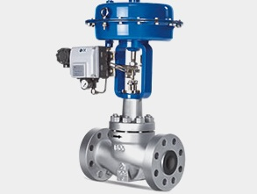

Introduction operation
For proper working of control valves there are some tests. they are commonly called as control valve pressure test. There are 3 types of Control valve pressure tests
- Body test
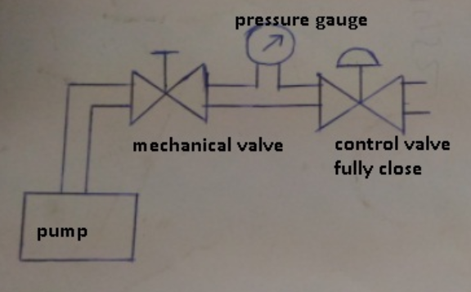
- For body test blind the output of control valve using blind flange
- Valve should be fully opened position either control valve is NO or NC. It should be open at the time of test.
- The other important parameter to check is body rating of control valve.
Body rating is the amount of total pressure which the body and stem seal can withstand without leaking.
- If the body rating is 300 psi
- The pressure of water that should give through inlet of control valve is 300 * 1.5 = 450 psi
- With the help of pump produce 450 psi in the control valve and with the help of master gauge we can make sure that pressure is 450 psi
- Then close the mechanical valve.
- Check whether any leakage of water through outlet of control valve.
- If there is no leakage the body test is passed.

- Seat leakage test (flow test)

Control Valves - Leakage Classification
Control valves are designed to throttle flows and they are not necessarily able to close 100% with no leakage.
The shut off ability has to do with type of valve. Double seated control valves have very poor shut off capabilities. In addition - the guiding, the seat material, the actuator thrust, the pressure drop and the type of fluid all play part in how well particular control valves shuts off.
Seat Leakage Classifications
There are actually six different seat leakage classifications and the most commonly used are:
- CLASS IV
- CLASS Vl
CLASS IV is also known as metal to metal. It is the kind of leakage rate you can expect from a valve with a metal plug and a metal seat.
CLASS Vl is known as soft seat classification. Soft Seat Valves are those where either the plug or seat or both are made from some kind of composition material such as Polytetrafluoroethylene (PTFE) or similar.

Valve Leakage Classifications details

Class I - Valve Leakage Classifications
Identical to Class II, III, and IV in construction and design intent, but no actual shop test is made. Cass I is also known as dust tight and can refer to metal or resilient seated valves.

Class II - Valve Leakage Classifications
Intended for double port or balanced singe port valves with a metal piston ring seal and metal to metal seats.
- 0.5% leakage of full open valve capacity
- Service dP or 50 psid (3.4 bar differential), whichever is lower at 50 to 125 ºF
- Test medium air at 45 to 60 psig is the test fluid
Typical constructions:
- Balanced, single port, single graphite piston ring, metal seat, low seat load
- Balanced, double port, metal seats, high seat load

Class III - Valve Leakage Classifications
Intended for the same types of valves as in Class II.
- 0.1% leakage of full open valve capacity
- Service dP or 50 psid (3.4 bar differential), whichever is lower at 50 to 125 ºF
- Test medium air at 45 to 60 psig is the test fluid
Typical constructions:
- Balanced, double port, soft seats, low seat load
- Balanced, single port, single graphite piston ring, lapped metal seats, medium seat load

Class IV - Valve Leakage Classifications
Intended for single port and balanced single port valves with extra tight piston seals and metal to-metal seats.
- 0.01% leakage of full open valve capacity
- Service dP or 50 psid (3.4 bar differential), whichever is lower at 50 to 125 ºF
- Test medium air at 45 to 60 psig is the test fluid
Typical constructions:
- Balanced, single port, Polytetrafluoroethylene (PTFE) piston ring, lapped metal seats, medium seat load
- Balanced, single port, multiple graphite piston rings, lapped metal seats
- Unbalanced, single port, lapped metal seats, medium seat load
- Class IV is also known as metal to metal

Class V - Valve Leakage Classifications
Intended for the same types of valves as Class IV
- The test fluid is water at 100 psig or operating pressure
- Leakage allowed is limited to 5 x 10⁻⁴ ml per minute per inch of orifice diameter per psi differential
- Service dP at 50 to 125 ºF
Typical constructions:
- Unbalanced, single port, lapped metal seats, high seat load
- Balanced, single port, Polytetrafluoroethylene (PTFE) piston rings, soft seats, low seat load
- Unbalanced, single port, soft metal seats, high seat load

Class VI - Valve Leakage Classifications
Class VI is known as a soft seat classification. Soft Seat Valves are those where the seat or shut-off disc or both
are made from some kind of resilient material such as Polytetrafluoroethylene (PTFE). Intended for resilient seating valves.
- The test fluid is air or nitrogen
- Pressure is the lesser of 50 psig or operating pressure
- The leakage limit depends on valve size and ranges from 0.15 to 6.75 ml per minute for valve sizes 1 through 8 inches

Control Valves - Class VI Leakage
Port Diameter |  | Bubbles per minute | ml per minute
inches | mm | Bubbles per minute | ml per minute
1 | 25 | 1 | 0.15
1 1/2 | 38 | 2 | 0.30
2 | 51 | 3 | 0.45
2 1/2 | 64 | 4 | 0.60
3 | 76 | 6 | 0.90
4 | 102 | 11 | 1.70
6 | 152 | 27 | 4.00
8 | 203 | 45 | 6.75
10 | 254 | 63 | 9
12 | 305 | 81 | 11.5
Typical constructions:
- Unbalanced, single port, soft seats, low load

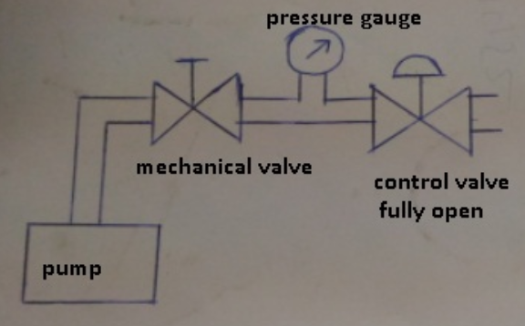
- For flow test outlet of the control valve should be open
- The valve should be fully closed
- The procedure is same as body test
- Apply 450 psi to the valve and check for any leakage.
- If there is leakage i.e. due to trim damage, seat ring damage, actuator and valve stem are not properly connected and aligned.

Control Valve Leakage Classification - Overview
Leakage Class Designation | Maximum Leakage Allowable | Test Medium | Test Pressure | Testing Procedures Required for Establishing Rating
I | x | x | x | No test required
II | 0.5% of rated capacity | Air or water at 50 - 125º F  (10 - 52ºC) | 45 - 60 psig or maximum operating differential whichever is lower | 45 - 60 psig or maximum operating differential whichever is lower
III | 0.1% of rated capacity | As above | As above | As above
IV | 0.01% of rated capacity | As above | As above | As above
V | 0.0005 ml per minute of water per inch of port diameter per psi differential | Water at 50 to125ºF (10 to 52ºC) | Maximum service pressure drop across valve plug not to exceed ANSI body rating | Maximum service pressure drop across valve plug not to exceed ANSI body rating
VI | Not to exceed amounts shown in the table above | Air or nitrogen at 50 to 125º F (10 to 52ºC) | 50 psig or max rated differential pressure across valve plug whichever is lower | Actuator should be adjusted to operating conditions specified with full normal closing thrust applied to valve plug seat

- Function test
- Check whether the valve is properly assembled.
- The valve, i/p converter, current generator, and instrument air supply are set up.
- Instrument air supply Is checked. It is set according to the i/p converter requirements
- 4 ma current signal is applied to the i/p converter the valve stem shall be in 0% travel
- When 20 ma is applied 100% travel should be done
- If the valve stem travel indication didn’t show correctly then calibration is to done.

The trainers who developed the curriculum
No | Name | Qualification level | Educational background | Region | College | Mobile number | E-mail
1 | Melaku Bekele Ofgaha | A | Electri/Automation Control Technology | Oromia | Amboo poly TVET college | O921051772 | kakumalaku430@gmail.com
2 | Bahiru Demeke | A | Electri/Elec Contr | Oromia | Bishoftu Poly TVET College | O911394408 | bahirudemeke20@gmail.com
3 | Worku Biru Mekonnen | A | Electri/Automation Control Technology | Oromia | Sebeta Poly TVET College | O912106303 | workubiru3@gmail.com
4 | Sisay H/Mariam Toga | A | Electrical Power Enginering |  | Arbaminch poly & satelite College | O945234339 | sisayhailemariam971@gmail.com
5 | Hassen Husen Hamid | A | Electrical Eng | Oromia | M/G/M/B Poly TVET College | O943402001

Expert Profile

Reference
      - Fundamental principles of occupational health and safety, Second edition, Benjamin O. Alli; 2008 1 v
      - UEENEEI119A Set up industrial field control devices (training.gov.au)
      - https://documents.uow.edu.au/content/groups/public/@web/@ohs/documents/doc/uow017046.pdf
      - http://online.anyflip.com/nclgi/xptp/mobile/index.html
      - https://paktechpoint.com/loop-checking-procedures-of-instruments/
      - R. W. Daniel and J. R. Hewit, “Editorial,” Mechatronics, vol. 1, no. 1, pp. i–ii, 1991.
      - R. Guserle and M. Zaeh, “Application of multidisciplinary simulation and optimization of mechatronic systems in the design process,” Proceedings, 2005 IEEE/ASME International Conference on Advanced Intelligent Mechatronics., pp. 922–927, 2005.
      - R. W. Daniel and J. R. Hewit, “Editorial,” Mechatronics, vol. 1, no. 1, pp. i–ii, 1991.
      - IFAC Technical Committees. (2005, september). [Online]. Available: http://tc.ifac-control.org/4/2/scope
      - AFNOR, “NF E01-010,” 2008.
      - https://www.vssut.ac.in/lecture_notes/lecture1423904331.pdf
      - ISA-99 Committee, ISA-62443 series of standard: Security for Industrial Automation and Control Systems, International Electrotechnical Commission (IEC) (2010).
      - Guidelines for SMEs on the security of personal data processing, https://www. enisa.europa.eu/publications/guidelines-for-smes-on-the-security-of-personal-dataprocessing
      - https://www.isa.org/getmedia/946ebd14-8930-42bc-9d7e-5693e3aaf752/LoopChecking_ATechniciansGuide_Jeffery_Chapter1.pdf
      - Sell, Nancy J. Process Control Fundamentals (TAPPI Press, 1995).

