
Industrial Electrical/Electronic
Control Technology
Level III
Based on October, 2023 Curriculum (Version-II)
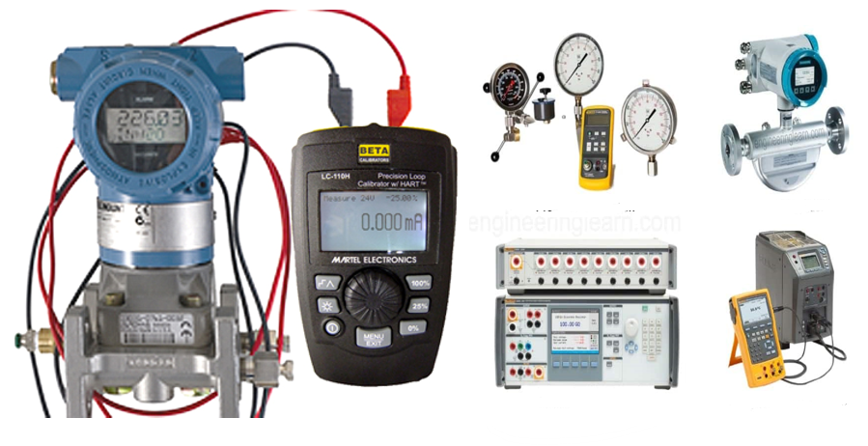
Module Title: Calibrating and Configuring Instrumentation and Control Devices
TTLM Code: EIS IEC3 M07 1023
Nominal duration: 60Hour
Prepared by:

September 2023
Addis Abeba
Table of Contents
List of Figure 2
Acknowledgment 5
List of Acronym 6
Introduction to the Module 7
This module covers the units: 7
Learning Objective of the Module 7
Module Instruction 7
UNIT 1: Instrumentation and control device configuration 8
1.1. OH&S policies and procedures and use PPE 9
1.2. Configuration Work plan 13
1.3. Instrumentation and control devices and their standard 23
1.4. Instrumentation and control devices Configuration 46
1.5. Material, Tools, equipment and testing devices 51
Self-Check -1.1 65
Operation sheet (1.1) - Analog Oscilloscope Procedures: 66
Operatiion sheet (1.2) Digital Oscilloscope Procedures: 70
Operatiion sheet (1.3) Digital Oscilloscope Procedures: 73
UNIT 2. Calibrate Instrumentation and Control Devices 75
2.1. Devices normal functions 76
2.2. Condition instrumentation and control devices 77
2.3. Calibrate or adjust instrumentation and control devices 79
2.4. Maintain configured and calibrated devices 128
2.5. Unplanned events or conditions 134
Self-check (2.2) 135
Self-check (2.2) 136
Operation sheet (2.1) 137
Operation sheet (2.2) ------------- Calibration of P/I converter. 139
UNIT 3. Inspect, test and calibrate instruments and control devices 141
3.1. Calibration work inspection 142
3.2. Examine instrumentation and control devices 144
3.3. Report result 149
Self-Check 3 152
Expert Profile 154
Reference 155

List of Figure
Figure 1. 1 Valve actuators 14
Figure 1. 2 Fully open and closed valve 14
Figure 1.3 Valve not fully close cannot fully open 15
Figure 1. 4 Valve not fully open cannot fully close 16
Figure 1. 5 Complementary valve sequence 17
Figure 1. 6 Opening and closing operation graphs for valve 18
Figure 1. 7 Exclusive valve sequencing 19
Figure 1. 8 Relation of valve opening and controller’s output graph 20
Figure 1. 9 pH control process 22
Figure 1. 10 Output of two control valves graphs 22
Figure 1. 11 Configuration process interface 26
Figure 1. 12 Pressure sensors a 4-20mA output signal and pressure transducers 27
Figure 1. 13 Pressure sensor unit 28
Figure 1. 14 Pressure transducer 29
Figure 1. 15 Pressure transducer 29
Figure 1. 16 Analogue indicator 30
Figure 1. 17 Digital indicator 30
Figure 1. 18 Control valve 32
Figure 1. 19 Electric valve actuator controlling ½ needle valves 32
Figure 1. 20 Annunciators vs. SCADA alarm systems 34
Figure 1. 21 P&ID of a compressed air control system 35
Figure 1. 22 chlorine wastewater disinfection systems 36
Figure 1. 23 Calibration hierarchy described by the example of Germany 37
Figure 1. 24 Calibration sticker on a mechanical pressure gauge 39
Figure 1. 25 Housing rotating Set Screw 46
Figure 1. 26 wiring block 47
Figure 1. 27 Conduit installation diagram 47
Figure 1. 28 sensor positions 48
Figure 1. 29 wiring diagram for the LD301 working as a transmitter 49
Figure 1. 30 wiring diagram for the LD301 working as a controller (optional) 49
Figure 1. 31 wiring diagram for the LD301 in multidrop configuration 50
Figure 1. 32 Load curve 50
Figure 1. 33 Different types of pliers 50
Figure 1. 34 different types screw driver 51
Figure 1. 35 different types of soldering iron 51
Figure 1. 36 Different types wrenches 52
Figure 1. 37 Different types of water level 52
Figure 1. 38 Tri-square 52
Figure 1. 39 measuring tape 53
Figure 1. 40 vernier scale 54
Figure 1. 41 wire gauge 54
Figure 1. 42 Calibration Bench 56
Figure 1. 43 Digital DC PS, analog DC PS, Digital dual PS 58
Figure 1. 44 PSG Analog Signal Generator, Function-generator, Tone-generator-and-wire-tracker 60
Figure 1. 45 Analog Oscilloscope 60
Figure 1. 46 Oscilloscope 62
Figure 1. 47 pressure gauge 62
Figure 1. 48 Sample level control loop 73

Figure 2. 1 The Seaward PV150 handheld meter provides multiple PV array testing functions. 77
Figure 2. 2 A block diagram of a typical instrumentation system with several different output devices 79
Figure 2. 3 Zero shift calibration error graph 85
Figure 2. 4 Span shift calibration error 85
Figure 2. 5 linearity calibration error 86
Figure 2. 6 Hysteresis calibration error 86
Figure 2. 7 Electrical Calibration 87
Figure 2. 8 Mechanical Calibration (micrometer and varnier caliper) 88
Figure 2. 9 Flow Calibration 89
Figure 2. 10 Pipette Calibration 90
Figure 2. 11 Pressure Calibration 90
Figure 2. 12 Temperature Calibration 91
Figure 2. 13 Calibration of pressure transmitters 93
Figure 2. 14 Calibration of temperature transmitters 93
Figure 2. 15 Illustration of five-point calibration 98
Figure 2. 16 Calibration Procedure of the Pressure Switch 99
Figure 2. 17 RTD Transmitter Calibration diagram 101
Figure 2. 18 Thermocouple transmitter equipment setup 102
Figure 2. 19 Performing a Sensor Trim on a Smart Transmitter 105
Figure 2. 20 Performing a 4 - 20mA Trim on a Smart Transmitter 106
Figure 2. 21 zero and span screws adjustment 108
Figure 2. 22 Current to Pressure (I/P) Converter Calibration setup 109
Figure 2. 23 Temperature sensor with indicator 110
Figure 2. 24 block diagram of a smart pressure transmitter 112
Figure 2. 25 block diagram of analog pressure transmitter 113
Figure 2. 26 block diagram of a smart pressure transmitter with signal reading 114
Figure 2. 27 High-accuracy voltmeter for calibration 116
Figure 2. 28 Dead- test calibrator 120
Figure 2. 29 Pneumatic dead weight tester 121
Figure 2. 30 Manometer 121
Figure 2. 31 Electronic manometers 122
Figure 2. 32 Typical self-calibration gas analyzer 127

Acknowledgment
The Ministry of Labor and skill would like to extend its gratitude to Regional Labor, and skill/training Bureaus, TVT College Deans, Instructors, and industry experts for their financial and technical support Calibrating and Configuring Instrumentation and Control Devices training module. Finally, MOLS extends its gratitude to the following instructors and experts who contributed to the development of this TTLM until its finalization.

List of Acronym
ANSI | American National Standards Institute
DAC | Digital Analog Converter
EDS | Electrical Data Sheet
ESIA | Environmental Impact Assessment
ESMF | Ethiopia Environmental and Social Management Framework
FAT | Field Acceptance Test
HMI | Human Machine Interface
ILO | International Labor Organization
ISA | Instrumentation, Systems and Automation Society
LRV | Lower Range Value
OHS | Occupational Health and Safety
OHSR | Occupational Health and Safety
P&ID | Pipe And Instrument Diagram
PH | Pound Hydrogen
PLC | Programmable Logic Controller
PPE | Personal Protective Equipment
PS | Power Supply
PSI | Pound Ser Square
SCADA | Supervisory Control and Data Acquisition
URV | Upper Range Value
VDU | Visual Display Units
WHS | Workplace Safety and Healthy

Introduction to the Module
Instrument calibration and configuration is one of the primary processes used to maintain instrument accuracy. Calibration is the process of configuring an instrument to provide a result for a sample within an acceptable range and eliminating or minimizing factors that cause inaccurate measurements is a fundamental aspect of instrumentation design.
Module also involves planning and preparation for configuration, demonstrate calibration work and inspection, test and documentation for task.

This module covers the units:
- Plan and prepare for configuration
- Calibrate instrumentation and control devices
- Inspect, test and calibrate instruments and control devices

Learning Objective of the Module
- Determine Plan and prepare for configuration
- Apply calibration on instrumentation and control devices
- Inspect, test and calibrate instruments and control devices

Module Instruction
For effective use these modules trainees are expected to follow the following module instruction:
- Read the information written in each unit
- Accomplish the Self-checks at the end of each unit
- Perform Operation Sheets which were provided at the end of units
- Do the “LAP test” giver at the end of each unit and
- Read the identified reference book for Examples and exercise

UNIT 1: Instrumentation and control device configuration

This learning guide is developed to provide you the necessary information regarding the following content coverage and topics:
- OH&S policies and procedures and PPE
- Configuration work plan
- Instrumentation and control devices and their standards
- Instrumentation and control devices configuration
- Materials, tools, equipment and testing devices

This guide will also assist you to attain the learning outcome stated in the cover page. Specifically, upon completion of this Learning Guide, you will be able to:

- Follow OH&S policies and procedures and use PPE
- Plan and prepare configuration
- Identify instrumentation and control devices
- Adopt instrumentation and Control standards
- Check instrumentation and control devices for configuration
- Obtain and Check materials, tools, equipment and testing devices for configuration

OH&S policies and procedures and use PPE

Safety Guidelines and Policies
The best way to provide a safe operating environment is to make personnel and equipment safety part of the planning process. You should examine every aspect of the system to determine which areas are critical to operator or machine safety. If you are not familiar with PLC system installation practices, or your company does not have established installation guidelines, you should obtain additional information from NEMA, NEC and Local and State Agencies
- Health and Safety Policy
Your Company Name is committed to the goal of providing and maintaining a healthy and safe working environment, with a view to continuous improvement. This goal is only achievable by adherence to established objectives striving to exceed all obligations under applicable legislation, and by fostering an enthusiastic commitment to health, safety and the environment within Your Company Name personnel, contractors and visitors.
Health, safety, the environment and loss control in the workplace are everyone’s responsibility. Your Company Name expects that everyone will join in our efforts to provide a healthy and safe working environment on a continuous day to day basis. Only through the dedication and efforts of all individuals can Your Company Name succeeds in providing a healthy safe working environment.

- Occupational Health and Safety in Workplaces
Duties of Workers
One of your most important responsibilities is to protect your Health and Safety as well as that of your co-workers. This booklet will discuss some of your duties under the occupational Health and Safety legislation and help you to make your workplace safer and healthier.
The law requires
Workplaces under the jurisdiction are governed by your provincial legislation.
The legislation places duties on owners, employers, workers, suppliers, the self-employed and contractors, to establish and maintain safe and healthy working conditions. The legislation is administered by your provincial legislation. Your officials are responsible for monitoring compliance.
Duties of Your Employer
Your employer is responsible for providing you with safe and healthy working conditions. This includes a duty to protect you from violence, discrimination and harassment. You must cooperate with your employer in making your workplace safe and healthy.
You’re Responsibilities
- You must also comply with the legislation. You have responsibilities to:
- protect your own Health and Safety and that of your co-workers;
- not initiate or participate in the harassment of another worker; and
- Co-operate with your supervisor and anyone else with duties under the legislation.
You’re Rights
The legislation gives your three rights:
- The right to know the hazards at work and how to control them;
- The right to participate in occupational health and safety; and
- The right to refuse work which you believe to be unusually dangerous.
You may not be punished for using these rights. An employer can be required to legally justify any action taken against a worker who is active in Health and Safety.
You’re Right to Know
The Act requires your employer to provide you with all the information you need to control the hazards you face at work. For example, chemicals at the workplace must be listed. You are entitled to review this list. Your employer must train you to safely handle the chemicals you will work with. If you are inexperienced, you must receive an orientation which includes;
- What to do in a fire or other emergency;
- First aid facilities;
- Prohibited or restricted areas;
- Workplace hazards; and
- Any other information you should know.
You must also be supervised closely by a competent supervisor.
You’re Right to Participate
You have the right to become involved in occupational Health and Safety.
Committees have duties to:
- Regularly inspect the workplace;
- Conduct accident investigations;
- Deal with the health and safety concerns of employees;
- Investigate refusals to work;
- Meet at least (four times a year – consult your provincial act); and return minutes of each meeting to the division.

You’re Right to Refuse
You have the right to refuse to do work which you believe is unusually dangerous. The unusual danger may be to you or to anyone else. An unusual danger could include such things as:
- A danger which is not normal for your occupation or the job;
- A danger under which you would not normally carry out your job; and/or
- A situation, for which you are not properly trained, equipped or experienced.
To exercise this right, use the following guidelines.
- Once you believe that the work you have been asked to do is unusually dangerous, you should inform your supervisor. Make sure that the supervisor understands that you are refusing to do the disputed job for health and safety reasons. Work with the supervisor to attempt to resolve the problem.
- If the problem cannot be resolved by the supervisor to your satisfaction, and no worker health and safety representative or occupational health committee exists at the workplace, your supervisor should phone the Division and ask for advice. You also have the right to contact the Division at any time.
- The supervisor has the right to assign you to other work (at no loss in pay or benefits) until the matter is resolved.

Safe Work Procedure and Practice
Safe Work Procedure
A Safe Work Procedure is a written step-by-step description of how a particular task is to be performed that is used during performance of the work by the person performing the work (or by two people doing the work – one reading and one doing). Examples of procedures include: equipment start-up or shut-down procedures; normal operating procedures; written operating instructions; abnormal operating procedures, emergency procedures, special test procedures, maintenance procedures, construction installation procedures, calibration procedures, hydrostatic test procedures, and inspection procedures.
Safe Work Practice
Safe Work Practices are written descriptions of how work is generally carried out and allow flexibility in how the work is accomplished. Due to the diversity of circumstances and situations within JACOS, the information contained in Safe Work Practices cannot be considered complete or applicable in every situation.
Supervisors and employees must refer to federal and provincial health and safety legislation, and industry practices to ensure that the work is accomplished safely.
Development
Procedures should be developed for high-hazard work or where historical information, legislation, a Hazard Assessment dictates.
Practices should be developed for commonly used equipment or process that does not necessarily follow a step-by-step order.
Employees, Supervisors, and Management will be involved in the development and/or review of these Safe Work Procedures and Practices.
All Safe Work Procedures and Practices will be developed using the standard JACOS Safe Work
Procedure and Practice format and are based on a job hazard assessment.
Review
Employees, Supervisors, and technical experts will periodically review Safe Work Procedures and Practices to ensure that they are complete, accurate and applicable on a minimum 3 year bases or when warranted.
Availability
Safe Work Procedures and Practices applicable to the work being performed will be available to all employees at the work site.
Action Guidelines
IHI Aerospace has established the following action guidelines to put its basic policies into practice, based on its five fundamental safety rules.
- Specify OH & S targets to achieve this policy; establish and implement action schedules.
- Strive to reduce risks and to identify factors that lead to hazards by applying OH & S risk assessment activities to all business activities.
- Establish and adhere to voluntary guidelines to ensure compliance with OH & S regulations and customer agreements.
- Improve health and safety awareness through health and safety training and in-house information activities.
- Periodically review the OH & S management system to ensure constant improvements.
- Pay particular attention to the following points, based on the specific characteristics of IHI Aerospace’s operations.
- Prevent accidents and disasters involving the handling of explosives and pressurized gas.
- Prevent falls or accidents caused by hazardous operations.
- Prevent accidents and disasters involving the handling of hazardous substances and chemicals.
- Provide inexperienced employees with safety training and comprehensive instruction in work procedures.
- Institute improvements to create a safe, comfortable workplace.
- Eliminate accidents in commutes to and from the workplace.

Configuration Work plan
          - Configure instrumentation and control devices
System configuration is the process of setting up your hardware devices and assigning resources to them so that they work together without problems. The way a system is set up, or the assortment of components that make up the system.
- A properly-configured system will allow you to avoid nasty resource conflict problems, and make it easier for you to upgrade your system with new equipment in the future.
- An improperly-configured system will lead to strange errors and problems, and make upgrading a night mare.
- Types of Configurations
Configuration can refer to either hardware or software, or the combination of both. For instance, a typical configuration for a PC consists of 32MB (megabytes) main memory, a floppy drive, a hard disk, a modem, a CD-ROM drive, a VGA monitor, and the Windows operating system.
Many software products require that the computer have a certain minimum configuration. For example, the software might require a graphics display monitor and a video adapter, a particular microprocessor, and a minimum amount of main memory.
When you install a new device or program, you sometimes need to configure it, which means to set various switches and jumpers (for hardware) and to define values of parameters (for software). For example, the device or program may need to know what type of video adapter you have and what type of printer is connected to the computer. Thanks to new technologies, such as plug-and-play, much of this configuration is performed automatically.
- Hardware/Device Configuration
- Actuator bench-set
Valve actuators provide force to move control valve trim. For precise positioning of a control valve, there must be a calibrated relationship between applied force and valve position. Most pneumatic actuators exploit Hooke’s Law to translate applied air pressure to valve stem position.
F = k x
Where,
F=Force applied to spring in Newton’s (metric) or pounds (English)
k=Constant of elasticity, or spring constant in Newton’s per meter (metric) or pounds per foot (English)
x=Displacement of spring in meters (metric) or feet (English)
Hooke’s Law is a linear function, which means that spring motion will be linearly related to applied force from the actuator element (piston or diaphragm). Since the working area of a piston or diaphragm is constant, the relationship between actuating fluid pressure and force will be a simple proportion (F=PA). By algebraic substitution, we may alter Hooke’s Law to include pressure and area:
F= k x PA= k x
Solving for spring compression as a function of pressure, area, and spring constant:
x=PA/k
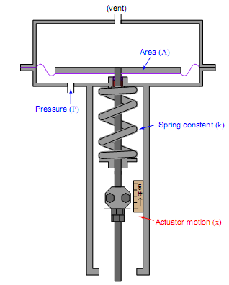
Figure 1. 1 Valve actuators

When a control valve is assembled from an actuator and a valve body, the two mechanisms must be coupled together in such a way that the valve moves between its fully closed and fully open positions with an expected range of air pressures. A common standard for pneumatic control valve actuators is 3 to 15PSI.
There are really only two mechanical adjustments that need to be made when coupling a pneumatic diaphragm actuator to a sliding – stem valve: the stem connector and the spring adjuster.
- The stem connector mechanically joins the sliding stems of both actuator and valve body so they move together as one stem. This connector must be adjusted so neither the actuator nor the valve trim prevents full travel of the valve trim:
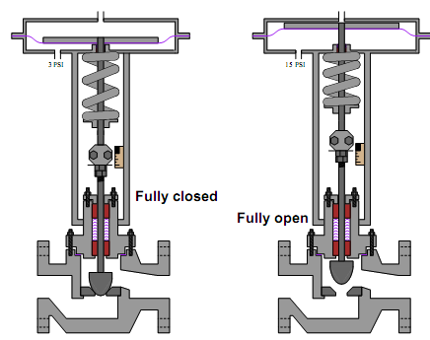
Figure 1. 2 Fully open and closed valve

Note how the plug is fully against the seat when the valve is closed, and how the travel indicator indicates fully open at the point where the actuator diaphragm nears its fully up ward travel limit. This is how things should be when the stem connector is properly adjusted. If the stem connector is set with the actuator and valve stems spaced too far apart (i.e. the total stem length is too long), the actuator diaphragm will bind travel at the upper end and the valve plug will bind travel at the lower end. The result is a valve that cannot every fully open:
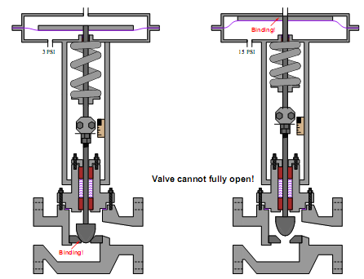
Figure 1.3 Valve not fully close cannot fully open
A control valve improperly adjusted in this manner will never achieve full-flow capacity, which may have an adverse impact on control system performance. If the stem connector is set with the actuator and valve stems too closely coupled (i.e. the total stem length is too short), the actuator diaphragm will bind travel at the lower end and the valve plug will bind travel at the upper end. The result is a valve that cannot ever fully close:
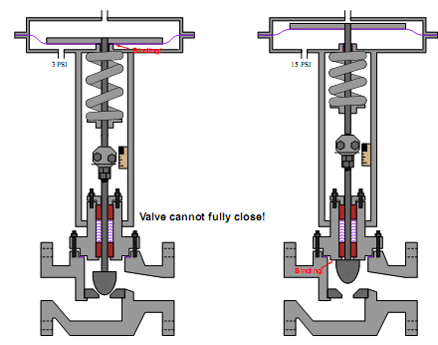
Figure 1. 4 Valve not fully open cannot fully close
This is a very dangerous condition: a control valve that lacks the ability to fully shut off. The process in which this valve is installed may be placed in jeopardy if the valve lacks the ability to stop the flow of fluid through it!
Once the stem length has been properly set by adjusting the stem connector, the spring adjuster must be set for the proper bench set pressure. This is the pneumatic signal pressure required to lift the plug of the seat. For an air-to-open control valve with a 3 to15PSI signal range, the bench set pressure would be 3PSI.
Bench set is a very important parameter for a control valve because it establishes the seating pressure of the plug when the valve is fully closed. Proper seating pressure is critical for tight shut-off, which carries safety implications in some process services.
Consult the manufacturer’s instructions when adjusting the bench set pressure for any sliding-stem control valve. These instructions will typically guide you through both the stem connector and the spring adjuster procedures, to ensure both parameters are correctly set.
- Split-ranging
There are many process control applications in industry where it is desirable to have multiple control valves respond to the output of a common controller. Control valves configured to follow the command of the same controller are said to be split-ranged, or sequenced.
Split-ranged control valves may take different forms of sequencing. A few different modes of control valve sequencing are commonly seen in industry: complementary, exclusive, and progressive.
- Complementary valve sequencing
The first is a mode where two valves serve to proportion a mixture of two fluid streams, such as this example where base and pigment liquids are mixed together to form colored paint:
Both base and pigment valves operate from the same 3to15PSI pneumatic signal output by the I/P transducer (AY), but one of the valves is Air-To-Open while the other is Air-To-Close.
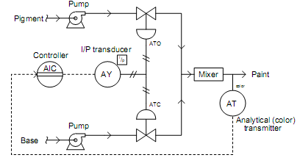
Figure 1. 5 Complementary valve sequence
The following table shows the relationship between valve opening for each control valve and the controller’s output:
Table 1. 1 The relationship between valve opening and controller’s output
Controller  output (%) | I/P output  (PSI) | Pigment valve  (Stem position) | Base valve  (Stem position)
0% | 3PSI | fully shut | fully opens
25% | 6PSI | 25%open | 75%open
50% | 9PSI | half-open | half-open
75% | 12PSI | 75%open | 25%open
100% | 15PSI | fully open | fully shut

An alternative expression for this split-range valve behavior is a graph showing each valve opening as a colored stripe of varying width (wider representing further open). For this particular mode of split-ranging, the graph would look like this:
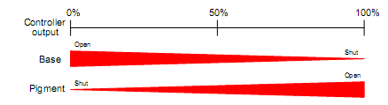
Figure 1. 6 Opening and closing operation graphs for valve
With this form of split-ranging, there is never a condition in the controller’s output range where both valves are fully open or fully shut. Rather, each valve complements the others position.
- Exclusive valve sequencing
Other applications for split-ranged control valves call for a form of valve sequencing where both valves are fully closed at a 50% controller output signal, with one valve opening fully as the controller output drives toward 100% and the other valve opening fully as the controller output goes to 0%. The nature of this valve sequencing is to have an “either-or” throttled path for process fluid. That is, either process fluid flows through one valve or through the other, but never through both at the same time.
A practical example of this form of split-ranging is in reagent feed to a pH neutralization process, where the PH value of process liquid is brought closer to neutral by the addition of either acid or caustic:
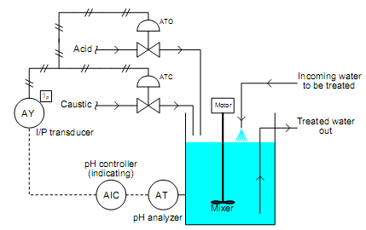
Figure 1. 7 Exclusive valve sequencing
Here, a pH analyzer monitors the pH value of the mixture and a single pH controller commands two reagent valves to open when needed. If the process pH begins to increase, the controller output signal increases as well (direct action) to open up the acid valve. The addition of acid to the mixture will have the effect of lowering the mixtures pH value. Conversely, if the process pH begins to decrease, the controller output signal will decrease as well, closing the acid valve and opening the caustic valve. The addition of caustic to the mixture will have the effect of raising the mixtures pH value.
Both reagent control valves operate from the same 3 to 15PSI pneumatic signal output by I/P transducer (AY), but the two valves calibrated ranges are not the same. The Air-To-Open acid valve has an operating range of 9 to 15PSI, while the Air-To-Close caustic valve has an operating range of 9 to 3PSI.
The following table shows the relationship between valve opening for each control valve and the controller’s output:
Table 1. 2 Relationship between valve opening and controller’s output
Controller  Output (%) | I/P output  (PSI) | Acid valve  (Stem position) | Caustic valve  (Stem position)
0% | 3PSI | fully shut | fully open
25% | 6PSI | fully shut | half-open
50% | 9PSI | fully shut | fully shut
75% | 12PSI | half-open | fully shut
100% | 15PSI | fully open | fully shut

Again, we may express the two valves exclusive relationship in the form of a graph, with colored stripes representing valve opening:
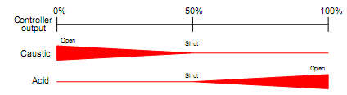
Figure 1. 8 Relation of valve opening and controller’s output graph
Exclusive-sequenced control valves are used in applications where it would be un desirable to have both valves open simultaneously. In the example given of a pH neutralization process, the goal here is for the controller to be able to call for it her acid reagent or caustic reagent to push the pH value either direction as needed. However, simultaneously adding both acid and caustic to the process would be wasteful, as one reagent would simply neutralize the other with no benﬁt to the process liquid itself.

- Progressive valve sequencing
A third form of control valve sequencing is used to expand the operating range of flow control for some fluid beyond that which a single control valve could muster. Once again pH control provides a suitable example to illustrate an application of this form of sequencing.
PH is an especially challenging application of process control because the dynamic range of the process is enormous. Each unit of pH value change represents a ten-fold change in hydrogen ion concentration within the process liquid. This means the difference in ion concentration between a process liquid having a value of 10pH and a process liquid having a value of 7pH is a factor of one thousand! Consequently, the flow rate of reagent necessary to neutralize a process liquid stream may vary widely.
It is quite possible that a control valve sized to handle minimum flow will simply be too small to meet the demands of high flow when needed.
Yet, a control valve sized large enough to meet the maximum flow rate may be too large to precisely turn down when just a trickle of reagent is needed.
This general control problem was encountered by automotive engineers in the days when carburetors were used to mix gasoline with air prior to combustion in an engine.
A carburetor sized to idle well and respond to the needs of in-town driving would not flow enough air to provide high-end performance. Conversely, a large carburetor suitable for performance driving would be almost uncontrollable for low-speed and idling operation.
Their solution to this problem was the progressive carburetor, having two butter fly valves to throttle the flow of air into the engine.
One butter fly valve handled low amounts of air flow only, while a larger butter fly valve opened up only when the accelerator pedal was nearly at its maximum position. The combination of two differently- sized butter fly valves progressively opened gave drivers the best of both worlds. Now, an automobile engine could perform well both at low power levels and at high power levels.
On a fundamental level, the problem faced in pH control as well as by early automotive engineers is the same thing: insufficient range ability.
Some processes demand a greater range of control than any single valve can deliver, and it is within these processes that a pair of progressively-sequenced control valves is a valid solution.
Applying this solution to a pH control process where the incoming liquid always has a high pH value, and must be neutralized with acid:
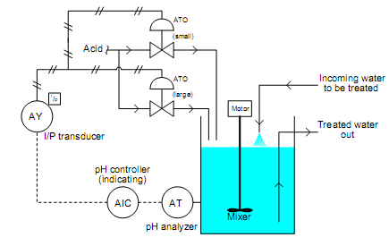
Figure 1. 9 pH control process
Proper sequencing of the small and large acid control valves is shown in the table and the graph:
Table 1. 3 sequencing of the small and large acid control valves
Controller  output(%) | I/P output  (PSI) | Small acid valve  (stem position) | large acid valve  (stem position)
0% | 3PSI | fully shut | fully shut
25% | 6PSI | half-open | fully shut
50% | 9PSI | fully open | fully shut
75% | 12PSI | fully open | half-open
100% | 15PSI | fully open | fully open
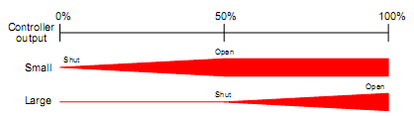
Figure 1. 10 Output of two control valves graphs
With the two acid control valves sequenced progressively, the control system will have sufficient range ability to handle widely varying process conditions.

Instrumentation and control devices and their standard
Instrumentation and control devices are used to measure and control process variables in various industries. These variables include pressure, temperature, humidity, flow, pH, force, and speed. The field of instrumentation and control engineering is interdisciplinary and requires knowledge of chemistry, mechanics, electricity and magnetism, electronics, microcontrollers and microprocessors, software languages, process control, pneumatics and hydraulics principles, and communications.
The primary objective of instrumentation is to measure the process variables accurately. Control devices are used to maintain the process variables at a desired set point.
Instruments are devices that measure or manipulate variables such as flow, temperature, level, or pressure. They can be classified into different types based on various criteria, such as location (in-field or panel), power source (pneumatic or electronic), output signal (analog or digital), or measurement parameter (pressure, temperature, flow, level, etc.) .
Control devices are mechanical, electro-mechanical, or electronic devices that use input signals to change conditions or values in processes or oversee access to buildings, gated areas, etc. Controllers generally receive voltage inputs from sources, analyze the inputs, and then oversee condition changes via signal outputs.
Instrumentation and control engineering (ICE) is a branch of engineering that studies the measurement and control of process variables using instruments and software tools. ICE involves the design and implementation of systems that incorporate sensors, transmitters, controllers, actuators, and displays 4

Types of instrumentation and control device to be configured
Configuration is the process of arranging parts or elements in a particular form, figure, or combination. In the context of Instrumentation and Control (I&C) Design, configuration refers to the planning, preparation, and arrangement of instrumentation and control devices in line with job requirements.
The purpose of I&C design is to cover the project-specific technical requirements that are to be followed throughout the Feed or Detailed Engineering Phase while preparing engineering deliverables.
Control System Philosophy
- Package Control System Philosophy
- Power Supply & Instrument Air Supply Philosophy
- Hazardous Area Classification Requirements
- Basic Requirements Related to Field Instruments and Cables
- Basic Requirements Related to Installation & Related Items
- Spare Philosophy
The design basis is considered as a mother document for all the engineering activities or deliverables to be carried out in a particular project.
In summary, configuration is important in I&C design because it ensures that instrumentation and control devices are arranged in a way that meets job requirements and technical specifications

Access Control Systems
Access Control Systems are electronic or electro-mechanical devices or systems composed of remote stations and centralized controlling stations which are used for security monitoring and to manage the movement of personnel, vehicles, materials, etc. through entrances and exits. Key specifications include the intended application, type, and method of identification. An access control system uses identifying methods such as facial recognition, fingerprints, metal detection, bar coding, and swipe cards, to permit entrance and exit from various secured areas. They can be used as well for tracking the movements of bulk materials, for allowing the use of certain machines such as x-ray equipment, or for vending various tools. Typical applications include high security operations in military facilities.

Flow Controllers
Flow Controllers are mechanical or electro-mechanical devices composed of measuring sensors or controlling elements that are used to ensure media flow in manufacturing processes. Key specifications include the intended application, type, media, flow rate, connection style, pressure rating, as well as mounting style. Flow controllers are used primarily in process control applications. They are made for gases as well as liquids of many types, and are available in many sizes and configurations depending on the application. Some flow controllers consist of mechanical valves, while others are electronically operated and controlled. Flow controllers are sometime called batch controllers for their ability accurately control different ingredients in a chemical batching process, for instance.

Level Controllers
Level Controllers are mechanical or electro-mechanical devices used for controlling the levels of tanks, vats, etc. usually by means of pumps, and they are sometimes called pump controllers. Some level controllers incorporate sensors or other means of detecting the level of products in containers, etc. while others require inputs from remote switches or sensors. Key specifications include the intended application, medium type, and the control method. Level controllers rely on a variety of sensor styles including conductive, capacitance, optical, and ultrasonic, in addition to mechanical arms, floats, and levers. They can be used for liquids or bulk dry goods such as grain or powders. Many industries use level controllers in various processes. A level controller receives an input signal, compares it to a set point and via an output signal adjusts the level as the process requires.

Pressure Controllers
Pressure Controllers are electro-mechanical devices used for controlling process/system pressure in various industrial processes. Key specifications include the intended application, type, control method, sensing element, and the pressure range. Pressure controller types include differential gap, proportional, on/off types, among others. They rely on a variety of sensing elements such as a bellows, diaphragms, capsules, bourdon tubes, etc. In operation, the controller receives a process/system pressure input, compares it to the desired set point in the pressure controller, then outputs a signal (usually to a control valve) which adjusts the process/system pressure (if necessary) back to the set point.

Programmable Logic Controllers
Programmable Logic Controllers are electronic devices used for controlling automatic machinery, processes, etc. Key specifications include the intended application, type, function, mounting style, as well as power requirements. Programmable logic controllers are configurable with a range of input and output modules. They control various operating parameters and functions by receiving input signals from various sources and adjusting machine functions as required by the processes through sets of programmed instructions. Some PLC makers have begun marketing programmable automation controllers, or PACs, which are have features beyond those of ordinary PLCs but perform similar tasks. PLCs are modular in construction and can be fitted with various modules for inputs, outputs, etc.

Data Acquisition System
DAS involves the process of sampling real world physical conditions and conversion of the resulting samples into digital numeric values that can be manipulated by a computer. Physical conditions relate to process variable or process conditions, e.g. pressure, temperature, level, flow, alarm conditions, events, etc.
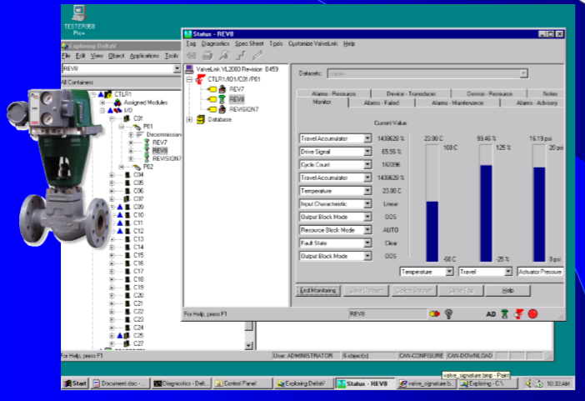
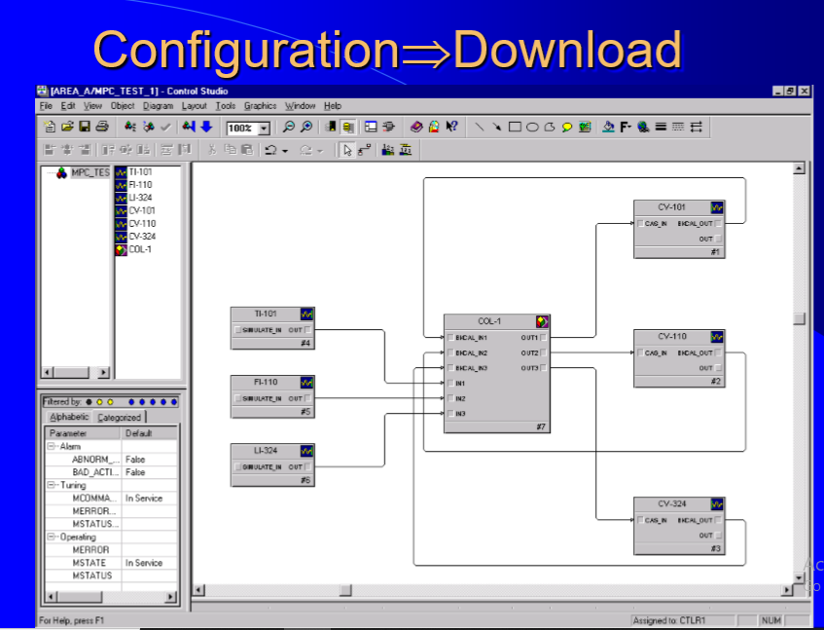
Figure 1. 11 Configuration process interface

Universal Process/Temperature Controllers
Universal Process/Temperature Controllers are electronic devices used to control various process parameters, including temperature. Key specifications include the intended application, control method, input and output types, features, connections type and mounting style, number of inputs, communication interface, as well as the power specifications for the input and output process. Universal process/temperature controllers are used mainly in manufacturing applications for ensuring various process values are within their operational ranges. Several types of control methods include set point, proportional, etc. as well as input types such as thermocouples, voltage, etc. that are used to sense and control process parameters. Controllers can be mounted in panels, walls, DIN rails, etc. Typical applications include boilers, lasers, tanks, molding machines, pumps, furnaces, etc.

Sensors/Transmitters/Transducers
Some of the main differences between the terms pressure sensor, transducer, and transmitter. The terms pressure sensor, pressure transducer and pressure transmitter are somewhat interchangeable in the industrial world. Pressure sensors can be described with a 4-20mA output signal and pressure transducers with a millivolt signal. Once the details are described to define the output signal and application, the proper term can be set. Here is a quick guideline on the terms and some benefits and limitations for each.
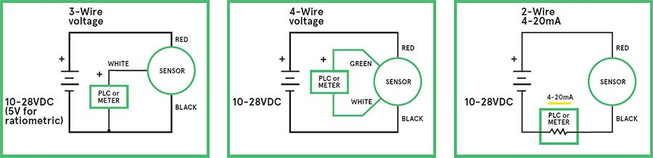
Figure 1. 12 Pressure sensors a 4-20mA output signal and pressure transducers

Pressure sensor
A pressure sensor simply monitors this pressure and can display it in one of the several units known around the world. This is commonly the “Pascal”, “Bar”, and “PSI” (Pounds per Square Inch) in the United States.

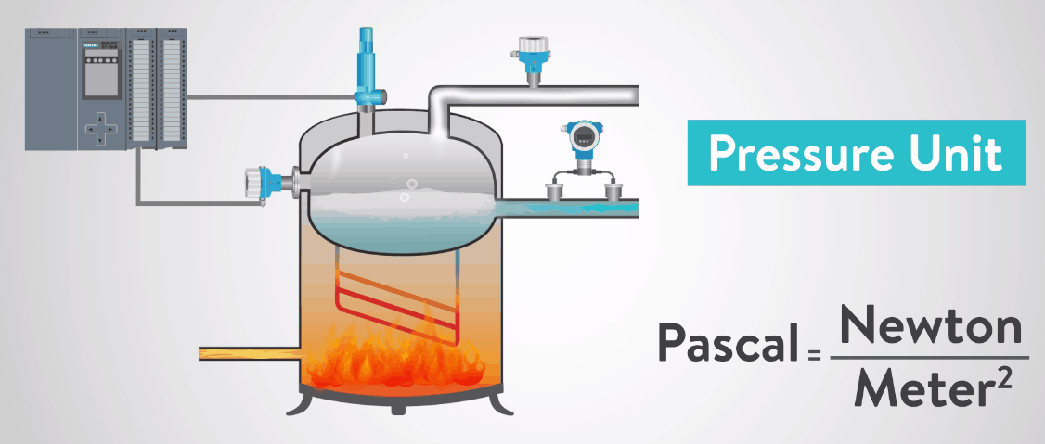
Figure 1. 13 Pressure sensor unit
In a nutshell, a pressure sensor converts the pressure to a small electrical signal that is transmitted and displayed. These are also commonly called pressure transmitters because of this. Two common signals that are used is a 4 to 20 milliamps signal and a 0 to 5 Volts signal.

Pressure transducer
High level voltage or frequency output signal including 0.5 to 4.5V ratio metric (output signal is proportional to the supply), 1-5V and 1-6 kHz. These output signals should be used within twenty (20) feet of the electronics. Supply voltages are typically from 8-28VDC, except for the 0.5-4.5V output, which requires a 5VDC regulated supply. Older voltage output signals, such as 0-5V, do not have a "live zero" where there is signal when the sensor is at zero pressure. The risk is that the system does not know the difference between a failed sensor with no output and zero pressure.
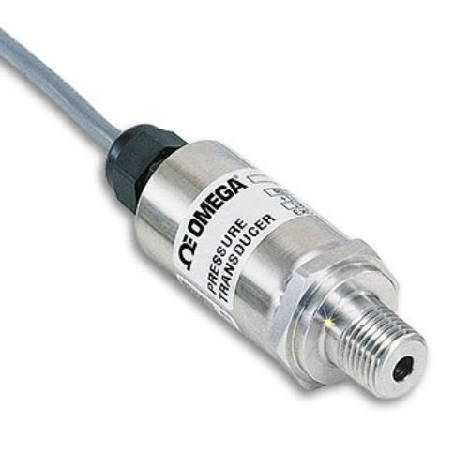
Figure 1. 14 Pressure transducer

Pressure transmitter
Current output signal, i.e. 4-20mA (4 to 20mA), the current, rather than the voltage, is measured on the device, rather than the voltage; TE pressure transmitters are two wire devices (red for supply, black for the ground). 4-20mA pressure transmitters offer good electrical noise immunity (EMI/RFI), and will need a power supply of 8-28VDC. Because the signal is producing current, it can consume more battery life if operating at full pressure.

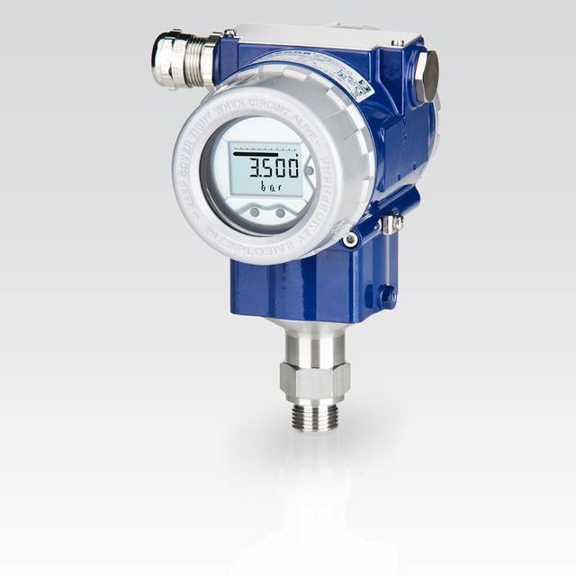
Figure 1. 15 Pressure transducer
Indicators both analogue and digital
- Analogue Indicator
An indicator on which the value of the physical quantity measured is indicated by an index and graduated scale, one of which is fixed and the position of the other is a continuous function of the magnitude of the physical quantity being measured. On analogue indicators the indication after resetting shall be within 0.2 scale interval of zero
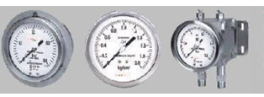
Figure 1. 16 Analogue indicator
- Digital Indicator
An indicator on which the value of the physical quantity measured is represented by a series of aligned digits which change abruptly such that no indication can be obtained between digits; a digital indicator does not have graduation lines.
On digital indicators, the indication after resetting shall be zero.
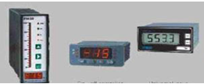
Figure 1. 17 Digital indicator

Controllers including PLC controlled devices
Type of control systems in which the system elements are dispersed but operated in coupled manners: -
Fault Tolerant System: - A system which is designed to carry out its assigned function even in the presence of one or more faults in the hardware or software.
Final Control Element: - The final control element is often an on/off valve or a control valve but may be another device such as a pump. Mean Time between Failures: - This is the average time between failures of the different components that make up a system including the time to repair the fault.
Mean Time to Repair: - This is the average time taken to identify and repair a fault.
Control valves
Control valves are industrial valves specifically designed to control liquid media and gases transmitted through a pipeline.
The operation principle of control valves is based on the need for a permanent change of flow path by way of changing the size of the orifice of the valve. Control valves can be operated manually, by means of a pneumatic single-piston actuator, electrically, by a solenoid or a diaphragm actuator.
In most cases, control valves tend to leak even when fully closed. This occurs due to the peculiar design features of these valves. Manufacturing methods and techniques help to minimize the leakage to acceptable levels. In this case, the valve is referred to as a “shutoff” control valve.
Control valves are applied in a variety of environments: water and heat supply systems, oil and gas pipelines, the chemical industry, combined heat and power stations, hydroelectric power stations and nuclear power stations, etc.
The main structural components of a control valve are
- Body,
- Trim and
- Actuator.
- The trim controls fluid flow.
Trims have different designs and they are selected according to control process requirements and operating medium characteristics.
Taking into account that control valves are often installed in pipelines with aggressive and abrasive media, high pressure and high temperature conditions and under conditions of cavitation, the trim sees heavy use and wears out relatively quickly. Many manufacturers produce control valves with trims constructed as separate units. This design strategy has a number of advantages:
- The capability to repair or replace the trim without valve removal makes trim assembly, fitting and finishing in the course of control valve installation or repair less labor-intensive;
- The trim can be made of different materials than other body parts, thus providing better corrosion and erosion resistance;
- For various operating media and working conditions, different trims can be installed into a typical control valve body.
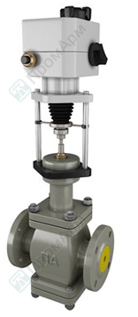
Figure 1. 18 Control valve

Actuators
An actuator is a component of a machine that is responsible for moving and controlling a mechanism or system, for example by opening a valve. In simple terms, it is a "mover".
An actuator requires a control signal and a source of energy. The control signal is relatively low energy and may be electric voltage or current, pneumatic, or hydraulic fluid pressure, or even human power. Its main energy source may be an electric current, hydraulic pressure, or pneumatic pressure. When it receives a control signal, an actuator responds by converting the source's energy into mechanical motion. In the electric, hydraulic, and pneumatic sense, it is a form of automation or automatic control.
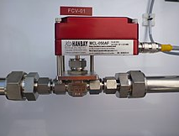
Figure 1. 19 Electric valve actuator controlling ½ needle valves

Recorders
Recording precipitation automatically has the advantage that it can provide better time resolution than manual measurements, and it is possible to reduce the evaporation and wetting losses. Three types of automatic precipitation recorders are in general use, namely
- The weighing recording type,
- The tilting or tipping-bucket type and
- The float types.
Only the weighing type is satisfactory for measuring all kinds of precipitation, the use of the other two types being for the most part limited to the measurement of rainfall. Some new automatic gauges that measure precipitation without using moving parts are available. These gauges use devices such as capacitance probes, pressure transducers, and optical or small radar devices to provide an electronic signal that is proportional to the precipitation equivalent. The clock device that times intervals and dates the time record is a very important component of the recorder. Because of the high variability of precipitation intensity over a 1 min timescale, a single 1 min rainfall intensity value is not representative of a longer time period. Therefore, 1 min rainfall intensity should not be used in a temporal sampling scheme, such as one synoptic measurement every one or three hours. Very good time synchronization, better than 10 s, is required between the reference time and the different instruments of the observing station.

Annunciator associated with the installed devices
In industrial process control, an annunciator panel is a system to alert operators of alarm conditions in the plant. Multiple back-lit windows are provided, each engraved with the name of a process alarm.
Lamps in each window are controlled by hard-wired switches in the plant, arranged to operate when a process condition enters an abnormal state (such as high temperature, low pressure, loss of cooling water flow, or many others).
Single point or multipoint alarm logic modules operate the window lights based on a preselected is an 18.1 or custom sequence. In one common alarm sequence, the light in a window will flash and a bell or horn will sound to attract the operator’s attention when the alarm condition is detected.
The operator can silence the alarm with a button, and the window will remain lit as long as the process is in the alarm state. When the alarm clears (process condition returns to normal), the lamps in the window go out.
Annunciator panels were relatively costly to install in a plant because they had dedicated wiring to the alarm initiating devices in the process plant.
Since incandescent lamps were used, a lamp test button was always provided to allow early detection of failed lamps. Modern electronic distributed control systems usually require less wiring since the process signals can be monitored within the control system, and the engraved windows are replaced by alphanumeric displays on a computer monitor.
Behavior of alarm systems, and colors used to indicate alarms, are standardized. Standards such as is an 18.1 or en 60073 simplify purchase of systems and training of operators by giving standard alarm sequences.
Principle
Whenever there is a change of input contacts from normally open to close or from normally close to open position, annunciator changes from rest condition to alarm condition. Hence there is an immediate recognition of fault input which will have a corresponding visual and audio alarm as per the particular selected program sequence.
The base unit of alarm annunciator has four programmable keys for mute, acknowledge, reset & test function.
- On pressing the Mute key, the internal buzzer can be deactivated.
- Acknowledge key is used to accept the fault condition,
- Reset key enables to reset the alarm annunciator to its default state and
- Test key helps to perform the complete test of the system
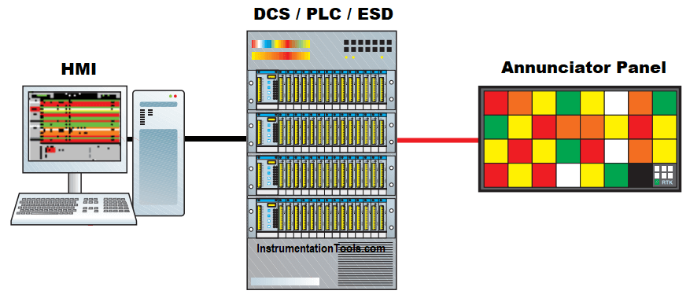
Figure 1. 20 Annunciators vs. SCADA alarm systems
SCADA systems were formerly considered the preferred alternative to discrete annunciators. A software-based solution, with almost endless ability to analyze, present and process alarms, has the potential for replacing discrete alarms switches altogether. However, software carries its own reliability risks.
New annunciator panels are utilizing long lasting and bright LEDs that significantly reduce the cost and maintenance of the panels. These new versions of the traditional system are still preferred over computer-based systems especially in critical plants like nuclear power generation, oil and gas.
In addition to the above, latest annunciator designs now feature clever electronics to give them very high immunity to noise, and can therefore reduce the amount of false alarms due to noise.

Process switches
Another type of instrument commonly seen in measurement and control systems is the process switches. The purpose of a switch is to turn on and oﬀ a device like heaters, motors, valves etc… with varying process conditions.
Usually, switches are used to activate alarms to alert human operators to take special action or can be used to trip or initiate interlocks.
In other situations, switches are directly used as control devices like there is level switch installed in a tank to prevent damage of a pump, pump will be automatically stopped/tripped when level reaches low in the tank.
Process Switch with Alarms
The following P&ID of a compressed air control system shows both uses of process switches:
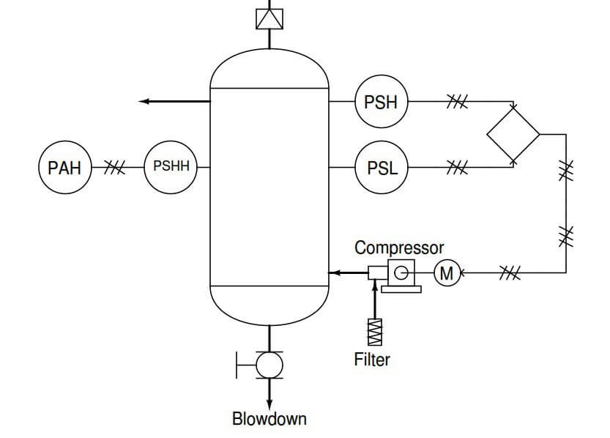
Figure 1. 21 P&ID of a compressed air control system

The “PSH” (pressure switch, high) activates when the air pressure inside the vessel reaches its high control point. The “PSL” (pressure switch, low) activates when the air pressure inside the vessel drops down to its low control point.
Both switches feed discrete (on/oﬀ) electrical signals to a logic control device (symbolized by the diamond) which then controls the starting and stopping of the electric motor-driven air compressor.
Another switch in this system labeled “PSHH” (pressure switch, high-high) activates only if the air pressure inside the vessel exceeds a level beyond the high shut-oﬀ point of the high-pressure control switch (PSH).
If this switch activates, something has gone wrong with the compressor control system, and the high-pressure alarm (PAH, or pressure alarm, high) activates to notify a human operator.
All three switches in this air compressor control system are directly actuated by the air pressure in the vessel: in other words, these are direct process-sensing switches allowing us to build on/oﬀ control systems and alarms for any type of process.
Example of Process Alarms and Switches
For example, the chlorine wastewater disinfection system shown earlier may be equipped with a couple of electronic alarm switches to alert an operator if the chlorine concentration ever exceeds pre-determined high or low limits:
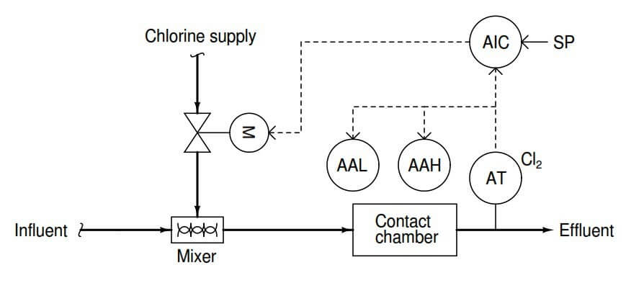
Figure 1. 22 chlorine wastewater disinfection systems

Adopt instrumentation and Control standards
- Traceability and calibration hierarchy
- Hierarchy of the standards and calibration services
To be able to compare measuring results, they must be “traceable” to a national or international standard via a chain of comparative measurements. To this end, the displayed values of the measuring instrument used or a measurement standard are compared over one or several stages to this standard. At each of these stages, calibration with a standard previously calibrated with a higher-ranking standard is carried out. In accordance with the ranking order of the standards from the working standard or factory standard and the reference standard to the national standard the calibration bodies have a calibration hierarchy. This ranges from the in-house calibration laboratory to the accredited calibration laboratory and to the national metrological institute (Fig 2.23).
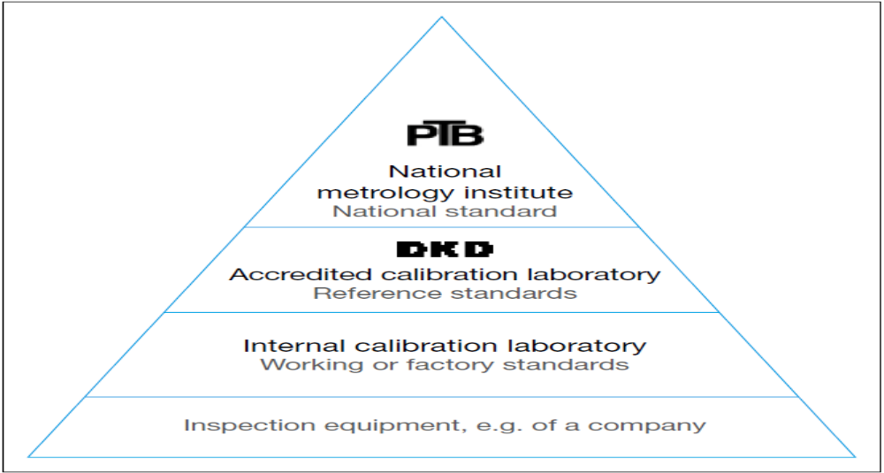
Figure 1. 23 Calibration hierarchy described by the example of Germany

- Traceability in practice
The German Calibration Service DKD (Deutscher Kalibrier dienst) designates the following as essential elements of traceability:
    - The chain of comparison must not be interrupted.
    - In each stage of the calibration chain, the measurement uncertainty must be known so that the total measurement uncertainty can be calculated. As a rule, a higher-ranking measuring instrument should have a measuring accuracy three to four times higher than the instrument calibrated by it.
    - Each stage of the calibration chain must be documented as must the result.
    - All bodies carrying out a stage in this chain must prove their competence by means of accreditation.
    - Depending on the required measuring accuracy and technical requirements, calibrations must be repeated at appropriate intervals
- Calibration on an international level
- BIPM
On an international level, the BIPM (International Bureau of Weights and Measures, abbreviation of French: Bureau International des Poised Measures) coordinates the development and maintenance of primary standards and the organization of international comparative measurements. Decisions about the representation of the primary standards are made by the CGPM (General Conference for Weights and Measures, abbreviation of French: Conference General Des Poised Measures). The participants of the conferences, which take place every four to six years, are the representatives of the 51 signatory states of the international Meter Convention and the representatives of those 26 associated member states without full voting rights.
- National metrological institutes
On a national level, institutes are responsible in most cases for metrology. They maintain the national standards to which all calibrated measuring instruments can be traced and ensure that these primary standards are comparable on an international level.
- Accredited calibration laboratories
Accredited calibration laboratories often take on calibration as external service providers for those companies that do not have the required equipment themselves. However, they themselves can also be part of a company and calibrate all measuring instruments within it.
To this end, they are equipped with their own working or factory standards which are calibrated at the proper time intervals with the smallest possible measurement uncertainty using the reference standard of the appropriate national metrological institute or other accredited calibration laboratories.
- Professional calibration
The professional execution of calibrations is governed by various standards, regulations and directives. For a measuring instrument to be calibrated in the first place, it must fulfill certain basic requirements. The physical conditions under which calibration can be carried out must also be known and taken into account.
Under these conditions, it is possible to select a calibration procedure suitable for the requirements.
- Standards, regulations and calibration directives
In essence, regulations for the calibration of measuring instruments take effect whenever a company decides to observe a standard or directive for its calibration or when it manufactures products whose production is subject to legal regulations.
- Quality assurance standards
Of great importance for quality assurance are standards and directives such as the ISO 9000 series of standards, which is being implemented more and more frequently in all industrialized nations. In Clause 7.6 “Control of monitoring and measuring equipment” of the ISO 9001:2008 standard “Quality management systems – Requirements”, there is a specific requirement that any inspection equipment that directly or indirectly affects the quality of the products must be calibrated. This includes, for example, test equipment used as a reference in measurement rooms or directly in the production process.
The ISO 9000 standards do not stipulate a validity period for calibrations – which would not make a lot of sense given the different technologies of measuring devices – but they do specify that any inspection equipment must be registered and then a distinction must be made as to whether or not it must be regularly calibrated. Inspection plans must be drawn up in which the scope, frequency, method and acceptance criteria are defined. Individual calibrations are to be documented in detail. Labels on the measuring instruments (Fig. 1.24) or appropriate lists must show when each piece of inspection equipment needs to be recalibrated.
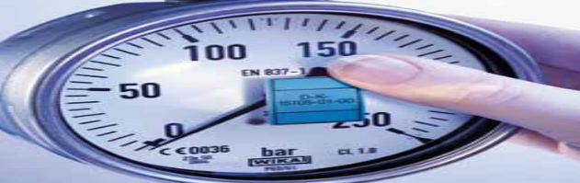
Figure 1. 24 Calibration sticker on a mechanical pressure gauge

It is essential to recalibrate when a measuring instrument has been altered or damaged during handling, maintenance or storage.
- Requirements for measurement management systems
Closely related to the ISO 9000 series of standards in terms of its structure is the ISO 10012:2004 standard “Measurement management systems – Requirements for measurement processes and measuring equipment”. It defines the requirements of the quality management system that can be used by companies in order to establish confidence in the measurement results obtained. In measurement management systems, it is not only the measuring device but the entire measuring process that is considered. This means that those responsible not only have to determine the measurement uncertainty during calibration, but also have to verify and evaluate the measurement uncertainty in use. To this end, statistical methods are also used.
- Industry-specific directives
In addition to such universal standards, individual sectors of industry have their own directives for the quality assurance of measuring devices, for example the automotive industry. American automobile manufacturers have developed the QS 9000 directive in which the ISO 9000 standards have been substantially supplemented by industry and manufacturer specific requirements, and in part tightened.
In the meantime, the American QS 9000, the German VDA 6.1 and other country-specific regulations have been combined to some extent in the international ISO/TS 16969 standard. This saves many suppliers multiple certifications.
- Legal provisions
Quality assurance standards and directives must only be observed by companies that want to be certified. The situation is completely different when, for example, drugs, cosmetics or foodstuffs are being manufactured. Here legal regulations, whose compliance is controlled by state agencies, often apply. Due to international trade relations, the regulations of the American Food and Drug Administration (FDA) are important. Thus, the Code of Federal Regulation (CFR) requires the “calibration of instruments, apparatus, gauges, and recording devices at suitable intervals in accordance with an established written program containing specific directions, schedules, limits for accuracy and precision, and provisions for remedial action in the event accuracy and/or precision limits are not met”. European laws have similar stipulations.

- Here are some examples of conditioning instrumentation and control standards:
- ISA (Instrumentation, Systems and Automation) Society (formerly Instrument Society of America)
The International Society of Automation (ISA), formerly known as The Instrumentation, Systems, and Automation Society
The Society includes the following: -

- Engineers
- Technicians
- Businesspeople
- Educators and
- Students
The society is more commonly known by its acronym, ISA, and the society's scope now includes many technical and engineering disciplines. ISA is one of the foremost professional organizations in the world for setting standards and educating industry professionals in automation. Instrumentation and automation are some of the key technologies involved in nearly all industrialized manufacturing. Modern industrial manufacturing is a complex interaction of numerous systems. Instrumentation provides regulation for these complex systems using many different measurement and control devices. Automation provides the programmable devices that permit greater flexibility in the operation of these complex manufacturing systems.
In addition to the member-driven aspects of the ISA, major ISA interests and products are divided into departments headed by a department vice president.
These departments are:

  - Automation & Technology
  - Industries & Sciences
  - Image & Membership
  - Professional Development
  - Publications
  - Standards & Practices
  - Strategic Planning
  - Web

Technical divisions
ISA’s technical divisions, established for the purpose of increased information exchange within tightly focused segments of the fields of instrumentation, systems, and automation are organized under the Automation & Technology or Industries & Sciences Departments, depending upon the nature of the division.
The divisions in the Automation & Technology Department are:

- Analysis
- Automatic Control Systems
- Computer Technology
- Management
- Process Measurement &Control
- Robotics & Expert Systems
- Safety
- Telemetry & Communications
- Test Measurement

Industries & Sciences Divisions are:

  - Aerospace Industries
  - Chemical & Petroleum Industries
  - Construction & Design
  - Food & Pharmaceuticals Industries
  - Mining & Metals Industries
  - Power Industry
  - Pulp & Paper Industries
  - Water & Wastewater Industries

- ANSI (American National Standards Institute)
The American National Standards Institute (ANSI) is a private non-profit organization that oversees the development of voluntary consensus standards for products, services, processes, systems, and personnel in the United States. The organization also coordinates U.S. standards with international standards so that American products can be used worldwide.
ANSI accredits standards that are developed by representatives of other standards organizations, government agencies, consumer groups, companies, and others. These standards ensure that the characteristics and performance of products are consistent, that people use the same definitions and terms, and that products are tested the same way. ANSI also accredits organizations that carry out product or personnel certification in accordance with requirements defined in international standards. ANSI's members are government agencies, organizations, corporations, academic and international bodies, and individuals. In total, the Institute represents the interests of more than 125,000 companies and 3.5 million professionals.
Process
Though ANSI itself does not develop standards, the Institute oversees the development and use of standards by accrediting the procedures of standards developing organizations. ANSI accreditation signifies that the procedures used by standards developing organizations meet the Institute's requirements for openness, balance, consensus, and due process.
ANSI also designates specific standards as American National Standards, or ANS, when the Institute determines that the standards were developed in an environment that is equitable, accessible and responsive to the requirements of various stakeholders.
Voluntary consensus standards quicken the market acceptance of products while making clear how to improve the safety of those products for the protection of consumers. There are approximately 9,500 American National Standards that carry the ANSI designation.
- The American National Standards process involves: consensus by a group that is open to representatives from all interested parties
- Broad-based public review and comment on draft standards
- Consideration of and response to comments
- Incorporation of submitted changes that meet the same consensus requirements into a draft standard
- Availability of an appeal by any participant alleging that these principles were not respected during the standards development process.
- ASME (American Society of Mechanical Engineers)
The American Society of Mechanical Engineers (ASME) is a professional association that, in its own words, "promotes the art, science, and practice of multidisciplinary engineering and allied sciences around the globe" via "continuing education, training and professional development, codes and standards, research, conferences and publications, government relations, and other forms of outreach.” ASME is thus an engineering society, a standards organization, a research and development organization, a lobbying organization, a provider of training and education, and a nonprofit organization. Founded as an engineering society focused on mechanical engineering in North America, ASME is today multidisciplinary and global.
ASME has over 130,000 members in 158 countries worldwide.
ASME is one of the oldest standards-developing organizations in America. It produces approximately 600 codes and standards covering many technical areas, such as fasteners, plumbing fixtures, elevators, pipelines, and power plant systems and components. ASME's standards are developed by committees of subject matter experts using an open, consensus-based process. Many ASME standards are cited by government agencies as tools to meet their regulatory objectives. ASME standards are therefore voluntary, unless the standards have been incorporated into a legally binding business contract or incorporated into regulations enforced by an authority having jurisdiction, such as a federal, state, or local government agency. ASME's standards are used in more than 100 countries and have been translated into numerous languages.
The largest ASME standard, both in size and in the number of volunteers involved in its preparation, is the ASME Boiler and Pressure Vessel Code (BPVC). The BPVC provides rules for the design, fabrication, installation, inspection, care, and use of boilers, pressure vessels, and nuclear components. The code also includes standards on materials, welding and brazing procedures and qualifications, nondestructive examination, and nuclear in-service inspection.
- NEC (National Electric Code)
The National Electrical Code (NEC), or NFPA 70, is a regionally adoptable standard for the safe installation of electrical wiring and equipment in the United States. It is part of the National Fire Codes series published by the National Fire Protection Association (NFPA), a private trade association. Despite the use of the term "national", it is not a federal law. It is typically adopted by states and municipalities in an effort to standardize their enforcement of safe electrical practices. In some cases, the NEC is amended, altered and may even be rejected in lieu of regional regulations as voted on by local governing bodies.
The "authority having jurisdiction" inspects for compliance with these minimum standards.
- IEC (International Electro-technical Commission)
The International Electro Technical Commission (IEC) is the leading global organization that prepares and publishes International Standards for all electrical, electronic and related technologies.
The International Electro Technical Commission is an organization which was formed as a result of the Resolution of the Chamber of Government Delegates at the International Electrical Congress of St. Louis (U.S.A.), in September 1904.
The name of the organization is the International Electro technical Commission. The abbreviated title is "the IEC". The organization is constituted as a corporate association with legal entity in accordance with Articles 60 et seq. of the Swiss Civil Code.
The work of the IEC is conducted under the IEC Statutes and Rules. These IECEx Conformity Mark Licensing Regulations are subordinate to the IEC Statutes and Rules with the IEC Statutes and Rules taking precedence over any requirement contained within these IECEx Conformity Mark Licensing Regulations, should a conflict arise.
The IECEx Scheme is the Scheme of the IEC for Conformity Assessment to Standards relating to Equipment for Use in Explosive Atmospheres, as provided for in accordance with Article 2 of the IEC Statutes and Rules, 2001 edition, (incorporating amendments approved by Council in 2004 and 2005).
The standard is suitable for use whenever any reference to an instrument is required in the chemical, petroleum, power generation, air conditioning, metal refining, and numerous other industries.
The standard is intended to provide sufficient information to enable anyone reading a flow diagram and having a reasonable amount of plant knowledge to understand the means of measurement and control of the process without having to go into the details of the instrumentation that require the knowledge of an instrument specialist.

Instrumentation and control devices Configuration
Configuration refers to the arrangement of elements in a system to achieve a specific purpose. It can be divided into two types: hardware configuration and software configuration.
Hardware configuration refers to the physical arrangement of hardware components in a system. It includes the selection of hardware components, their compatibility, and their placement in the system.
Software configuration refers to the arrangement of software components in a system. It includes the selection of software components, their compatibility, and their placement in the system.
Calibration is the comparison of measurement results provided by a device under test with those of a calibration standard of established accuracy in measurement technology and metrology. The calibration is just a comparison of measurement between the test equipment to the standard equipment. Calibration can be done on a variety of instruments in a variety of industries. Let’s have a look at some of the most common calibration procedures:
- Electrical Calibration: Electrical calibration is the process of ensuring that any instrument that measures or tests electrical properties such as voltage, current, resistance, inductance, capacitance, time, and frequency is operating properly. The following instruments are frequently submitted for electrical calibration: Data loggers Electric meters Multi-meters Oscilloscopes Frequency counters Insulation Testers Loop testers etc.
- Mechanical Calibration: Mechanical instruments are prone to drift as a result of repeated use, mechanical stress, and exposure to fluctuating air conditions etc., and because of such condition the mechanical calibration is the much-needed remedy to overcome the error induced in the equipment’s. Mass, volume, density, force, torque, dimension, angle, flatness, and vibration are the major properties that are calibrated during mechanical calibration in a temperature-controlled atmosphere. The following are some of the most commonly tested mechanical calibration instruments: Accelerometers Scales/Balances Force Gauges & Load Cells Micrometers, Vernier, and height gauges Screwdrivers & Torque Wrenches Sets of Weight and Mass
- Flow Calibration: A flow meter (also known as a flow sensor) is a device that measures the linear or non-linear, mass or volumetric flow rate of a liquid or gas. The flow rate is the rate at which a process fluid moves through pipelines, orifices, or vessels at a given time, and it is measured by instruments through a controlled manner to monitor and regulate the speed and efficiency of industrial flow processes and devices.
The configuration process is based on electronic data sheets (EDS-Files) provided by the device manufacturers, and contain relevant communication parameters, both commonly described as:
- Device Net is a digital, multi-drop network, used in Ethernet I/P layer, serving as a communication network between industrial controllers offering a single point of connection for configuration by supporting both I/O and explicit messaging.
- Control Net offers good real-time capabilities, also used in Ethernet I/P layer, providing high speed deterministic transmission for time-critical I/O data and messaging data.
The first step in operating a smart differential pressure transmitter is to set-up properly. This involves correct electrical wiring and positioning.
ELECTRIC WIRING
Reach the wiring block by removing the Electrical cover this cover can be locked closed by the cover locking screw (figure 6.1). To release the cover, rotate the locking screw clockwise
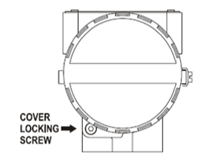
Figure 1. 25 Housing rotating Set Screw
Test and communication terminal allow, respectively, to measure the current in the 4-20mA loop, without opening it, and to communicate with transmitter. To measure it, connect a multimeter in the mA scale in the”-“and “+” terminals, use a HART configurator in “COMM” and “-“terminals.
The wiring block has screws on which fork or ring-type terminals can be fastened. See figure 6.2
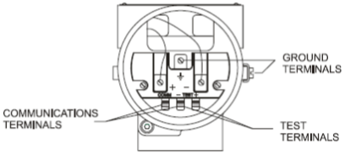
Figure 1. 26 wiring block
For convenience there are two ground terminals: one inside the cover and one external located close the conduit entries.
Use of twisted pair (22 AWG or greater then) cables is recommended.
Avoid routing signal wiring close to power cables or switching equipment.
Unused outlet connection should be plugged and sealed accordingly.
The LD301 is protected against reverse polarity.
The Figure 6.3 –conduit installation diagram shows the correct installation of the conduit, in order to avoid penetration of water, or other substance, which may cause malfunctioning of equipment.
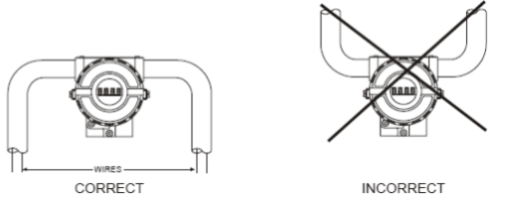
Figure 1. 27 Conduit installation diagram
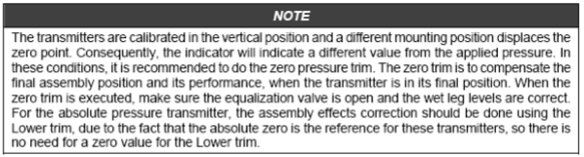
Hhen the sensor is in the horizontal position, the weight of the fluid pushes the diaphragm down, making it necessary a lower pressure trim, see Figure 6.5
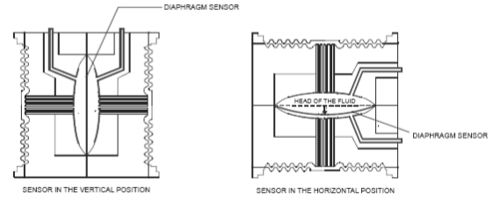
Figure 1. 28 sensor positions
Connection of LD301 working as transmitter should be done as in Figure 1.29.
Connection of LD301 working as a controller should be as indicated as in Figure 1.30
Connection of LD301 in multi-drop configuration should be done as in Figure 1.31. Note that a maximum of 15 transmitters can be connected on the same line and that they should be connected in parallel.
Take care to power supply as well, when many transmitters are connected on the same line.
The current through the 250-ohm resistor will be high causing a high voltage drop. Therefore, make sure that the power supply voltage is sufficient.
The Hand-Held terminal can be connected to the communication terminals of the transmitter or at any point of the signal line by using the alligator clips. It is also recommended to ground the shield of shielded cables at only one end. The unground end must be carefully isolated.
Note: Make sure that the transmitter is operating within the operating area as shown on the load curve (Figure 1.32). communication requires a minimum load of 250 ohm.

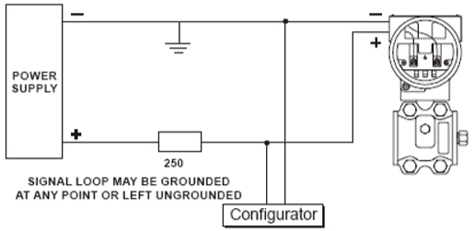
Figure 1. 29 wiring diagram for the LD301 working as a transmitter
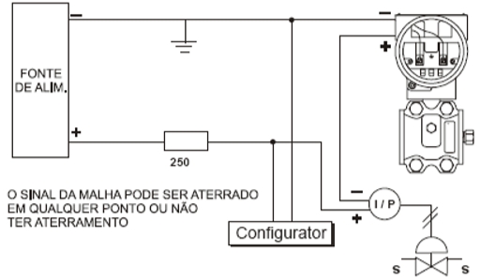
Figure 1. 30 wiring diagram for the LD301 working as a controller (optional)

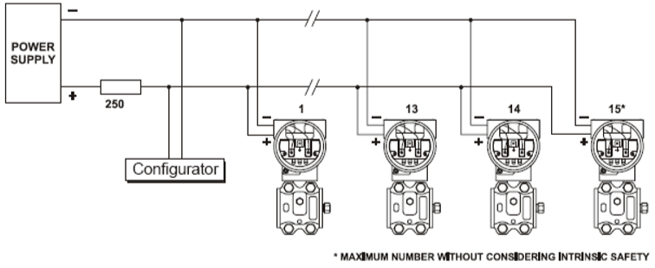
Figure 1. 31 wiring diagram for the LD301 in multidrop configuration
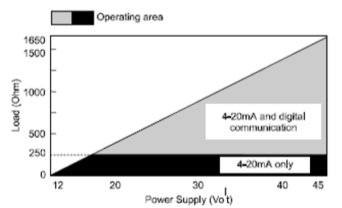
Figure 1. 32 Load curve
When using the instrument as a transmitter or a controller, the connection diagram is pretty much the same. Their responses to the input though are different.

Material, Tools, equipment and testing devices

    - Materials and Tools
- Pliers (assorted)
These made from metal with insulators in the handle and are used for cutting, twisting, bending, holding, and gripping wires and cables.
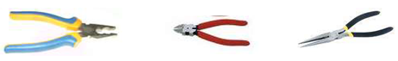
Figure 1. 33 Different types of pliers

- Screw drivers (assorted)
These tools are made of steel hardened and tempered at the tip used to loosen or tighten screws with slotted heads. They come in various sizes and shapes.
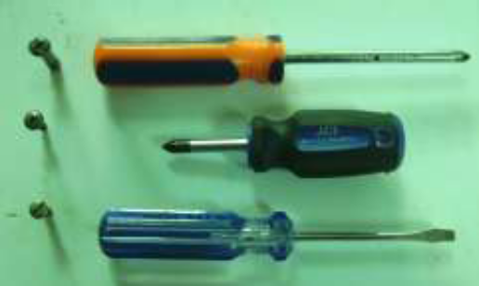
Figure 1. 34 different types screw driver

- Soldering iron/gun
Soldering irons are device that convert electrical energy to heat energy through systematical designed high resistive wire as heating elements. They are used to solder electronic circuits or connecting wires and other materials using soldering leads as well as using other catalysts that aids either to increase strength of connection or to clean contacts.
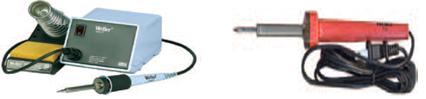
Figure 1. 35 different types of soldering iron
- Wrenches (assorted)
The wrenches most often used in maintenance are classified as open-end, box-end, socket, adjustable, ratcheting and special wrenches. The Allen wrench, although seldom used, is required on one special type of recessed screw. Solid, nonadjustable wrenches with open parallel jaws on one or both ends are known as open-end wrenches. Box-end wrenches are popular tools because of their usefulness in close quarters. They are called box wrenches since they box, or completely surround the nut or bolt head.
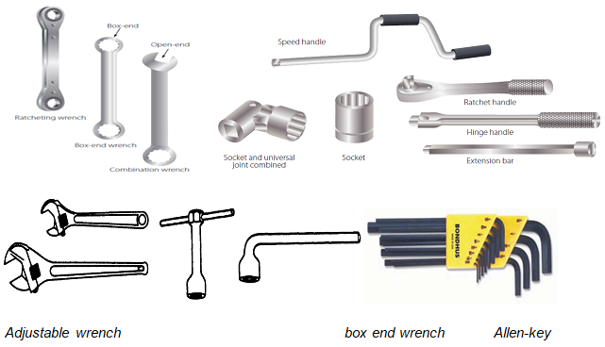
Figure 1. 36 Different types wrenches

    - Device, instrument and Equipment
          - Water level
It is a device used for measuring or machining surface elevation of locations is too far apart for a sprit level to span. Alcohol such as ethanol is often used rather than water because alcohols have low viscosity and surface tension.
It is used for measuring angles of 90: (Right angle) Measurements in mile meter are marked in its scale. it is used to measure 90 right angle accurately.
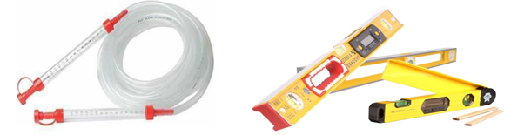
Figure 1. 37 Different types of water level

          - Tri-square
Measuring angles frequently you will have to determine angles between parts or units of aircraft. In layout work, it is also sometimes necessary to measure angles. The tools most frequently used for measuring angles are Tri-squares, the combination set, angle gages, and levels.

Figure 1. 38 Tri-square
          - Measuring tape
They are extended easily or coiled in their cases for stowage, and you can conveniently carry one of these in your pocket. Another thing, they are not as bulky to handle as the large steel tapes. You have to pull the FLEXIBLE STEEL TAPE, shown in figure 85, from its case by hand. When you want it back in the case, wind it with a crank. Tapes of this type are long, flexible steel rules, usually furnished in 3m, 8m, and 15m- lengths.
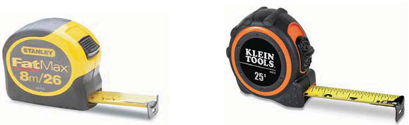
Figure 1. 39 measuring tape
          - Calipers
Layout and measuring devices are precision tools. They are carefully machined, accurately marked and, in many cases, are made up of very delicate parts. When using these tools, be careful not to drop, bend, or scratch them. The finished product will be no more accurate than the measurements or the layout; therefore, it is very important to understand how to read, use, and care for these tools.
A vernier scale is a device that lets the user measure more precisely than could be done unaided when reading a uniformly divided straight or circular measurement scale. It is a scale that indicates where the measurement lies in between two of the marks on the main scale. Verniers are common on sextants used in navigation, scientific instruments used to conduct experiments, machinists' measuring tools (all sorts, but especially calipers and micrometers) used to work materials to fine tolerances. An ordinary vernier caliper has jaws you can place around an object, and on the other side jaws made to fit inside an object. These secondary jaws are for measuring the inside diameter of an object. Also, a stiff bar extends from the caliper as you open it that can be used to measure depth. Gauges are several type, they may include stain gage, dial gauge and combination gauge…etc.
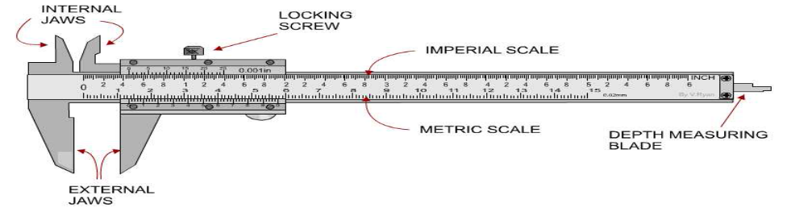
Figure 1. 40 vernier scale

          - Gauges
Used in determining the size of wires/conductors, the gauge ranges from 0 to 60 awg (American wire gauge).
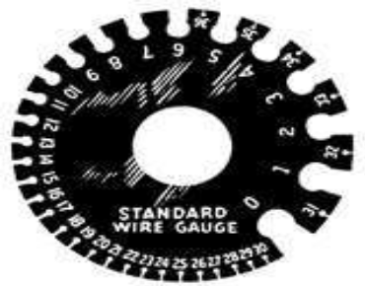
Figure 1. 41 wire gauge

    - Equipment/testing devices
- Signal sources & generators
GS610 - Source measure unit The GS610 is a high accuracy, high speed programmable voltage and current source that incorporate both generation and measurement functions as well as USB storage and an Ethernet interface. As the GS610 can operate as a current source or a current sink, a wide range of electrical characteristics can be evaluated.
- Wide range sink and source operation (3.2 A, 110 V, 60 W)
- Precise pulse generation (down to 100 µs width with 1 µs resolution)
- Battery simulator version available
GS820 - Multi channel source measure unit The GS820 is a highly accurate multi-channel voltage/current source measure unit that incorporates voltage generation/current generation as well as USB storage and an Ethernet interface. Since the two source channels and two measuring channels can be operated arbitrarily, almost all electrical characteristics can be evaluated.
- Dual sink and source operation: 7 V and 3.2 A or 18 V and 1.2 A
- Precise pulse generation (down to 100 μsec width with 0.1 μsec res.)
- 50 V version available, 50 V and 0.6 A or 20 V and 1.2 A
FG400 – Arbitrary/function generators The FG400 provides basic and 25 types of application specific waveforms as standard and generates signals quickly and easily. Acquire signals using a Yokogawa Oscilloscope or Scope Corded and use the 16 bit arbitrary waveform capabilities to reproduce them or add them to other signals.
- 1 or 2 independent or synchronised channels
- 0.01 μHz to 30 MHz
- Precise phase and frequency control between channels
- 20 V peak to peak and 42 V isolation between outputs
Refer others tools and equipment form your UC of calibration instrumentation and controlling device and also Level I from UC use hand tools and testing equipment
- Calibration bench
Calibration Bench is the ultimate multifunction calibration station from Time Electronics. Each calibration bench is custom-made to meet specific user requirements. Offering versatility and precision it is ideal for laboratories and workshops in need of multi-product testing and instrument calibration that meets the highest industry standards.
A wide range of modules can be fitted to the primary console creating a highly flexible system that is both functional and easy to use. Further expansion can be achieved by adding the secondary console, mounted under the primary.
Calibration modules cover

  - Electronic signal
  - Temperature
  - Loop and pressure applications.
  - Power supplies
  - DMMs
  - Oscilloscopes and
  - Signal generator

Functions are clearly defined on each module and a competent technician will quickly master the operation of the system without training or constant reference to manuals. Various fittings, functions, and additional devices can be added to Calibration Bench to create a comprehensive work environment.
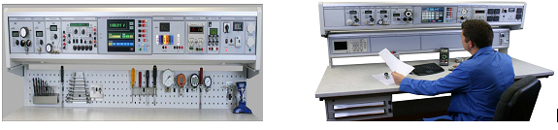
Figure 1. 42 Calibration Bench

Pressure: Ranges from vacuum to 600bar. Also available is an Automatic Pressure Calibrator that allows 4 preset points to be selected at the push of a button, or by Easy Cal remote control.
Power: Variable AC mains, variable DC and fixed quad or dual DC supplies can be fitted.
Loop and Temperature: High accuracy loop calibrator modules with source measure and sink functions. Temperature calibrators capable of measuring and simulating RTDs/thermocouples
External Options: Pneumatic and hydraulic handheld calibration pumps, dry block calibrators, solder stations, vices, laboratory furniture, and more.
- Air condition Equipped room
For calibration purpose calibration bench and equipment’s are not sufficient by themselves, depending on the requirement or types of calibration and essentiality to perform correct and standardized calibration there are also additional requirements. Air condition equipped room is a room which installed with device that help to maintain internal temperature of the room to optimum level as required for specific/ desired purpose. This is very necessary particularly in laboratory during calibration and test to control or avoid undesired intervention of environmental phenomenon.
In addition there are several areas that require air conditioning situation. Typical applications that benefit from precision air conditioning include:
- Medical equipment suites (MRI, CAT scan)
- Hospital facilities (operating, isolation rooms)
Requirements during calibration:
- Clean rooms
- Laboratories
- Data centers
- Server and computer rooms
- Telecommunications (wiring closets, switch gear rooms, cell sites)
- Printer/copier/CAD centers
- Air supply equipment or instrument
Compressor: Compressors used for instrument air delivery are available in various types and sizes, from rotary screw (centrifugal) compressors to positive displacement (reciprocating piston) types. The size of the compressor depends on the size of the facility, the number of control devices operated by the system, and the typical bleed rates of these devices. The compressor is usually driven by an electric motor that turns on and off, depending on the pressure in the volume tank. For reliability, a full spare compressor is normally installed.
Power Source: A critical component of the instrument air control system is the power source required to operate the compressor. Because high-pressure natural gas is abundant and readily available, gas pneumatic systems can run uninterrupted on a 24-hour, 7-day per week schedule. The reliability of an instrument air system, however, depends on the reliability of the compressor and electric power supply. Most large natural gas plants have either an existing electric power supply or have their own power generation system. For smaller facilities and remote locations, however, a reliable source of electric power can be difficult to assure. In some instances, solar-powered battery-operated air compressors can be cost effective for remote locations, which reduce both methane emissions and energy consumption. Small natural gas-powered fuel cells are also being developed.
Dehydrators: Dehydrators, or air dryers, are an integral part of the instrument air compressor system. Water vapor present in atmospheric air condenses when the air is pressurized and cooled, and can cause a number of problems to these systems, including corrosion of the instrument parts and blockage of instrument air piping and controller orifices. For smaller systems, membrane dryers have become economic. These are molecular filters that allow oxygen and nitrogen molecules to pass through the membrane, and hold back water molecules. They are very reliable, with no moving parts, and the filter element can be easily replaced. For larger applications, desiccant (alumina) dryers are more cost effective.
Volume Tank: The volume tank holds enough air to allow the pneumatic control system to have an uninterrupted supply of high-pressure air without having to run the air compressor continuously. The volume tank allows a large withdrawal of compressed air for a short time, such as for a motor starter, pneumatic pump, or pneumatic tools, without affecting the process control functions.
- Power supply equipment
A power supply is an electronic device that supplies electric energy to an electrical load.
The primary function of a power supply is to convert one form of electrical energy to another. As a result, power supplies are sometimes referred to as electric power converters.
Some power supplies are discrete, stand-alone devices, whereas others are built into larger devices along with their loads. Examples of the latter include power supplies found in desktop computers and consumer electronics devices.
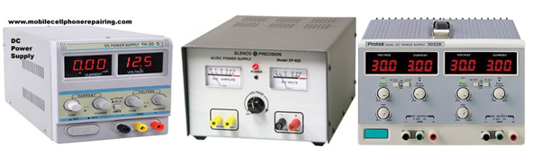
Figure 1. 43 Digital DC PS, analog DC PS, Digital dual PS

Power supplies are categorized in various ways, including by functional features.
Example:
Regulated power supply is one that maintains constant output voltage or current despite variations in load current or input voltage.
Unregulated power supply can change significantly when its input voltage or load current changes.
Adjustable power supplies allow the output voltage or current to be programmed by mechanical controls (e.g., knobs on the power supply front panel), or by means of a control input, or both.
Generally depending on the voltage Types of Power Supplies:
DC power supply: A DC power supply is one that supplies a constant DC voltage to its load. Depending on its design, a DC power supply may be powered from a DC source or from an AC source such as the power mains.
AC-to-DC supply: Some DC power supplies use AC mains electricity as an energy source. Such power supplies will sometimes employ a transformer to convert the input voltage to a higher or lower AC voltage. A rectifier is used to convert the transformer output voltage to a varying DC voltage, which in turn is passed through an electronic filter to convert it to an unregulated DC voltage.
An instrument to be calibrated:
The manufacturer usually does the initial calibration on its equipment. Subsequent calibrations may be done in-house, by a third-party lab, or by the manufacturer. The frequency of recalibration will vary with the type of equipment. Deciding when to recalibrate a flow meter, for example, depends mainly on how well the meter performs in the application. If liquids passing through the flow meter are abrasive or corrosive, parts of the meter may deteriorate in a very short time. Under favorable conditions, the same flow meter might last for years without requiring recalibration. As a rule, however, recalibration should be performed at least once a year. Of course, in critical applications frequency will be much greater.
Signal generator:
A signal generator is an electronic device that generates repeating or non-repeating electronic signals in either the analog or the digital domain. It is generally used in designing, testing, troubleshooting, and repairing electronic or electro acoustic devices, though it often has artistic uses as well.
There are many different types of signal generators with different purposes and applications and at varying levels of expense. These types include function generators, RF and microwave signal generators, pitch generators, arbitrary waveform generators, digital pattern generators and frequency generators. In general, no device is suitable for all possible applications.
Traditionally, signal generators have been embedded hardware units, but since the age of multimedia PCs, flexible, programmable software tone generators have also been available.
A function generator is a device which produces simple repetitive waveforms. Such devices contain an electronic oscillator, a circuit that is capable of creating a repetitive waveform. (Modern devices may use digital signal processing to synthesize waveforms, followed by a digital to analog converter, or DAC, to produce an analog output). The most common wave form is a sine wave, but saw tooth, step (pulse), square, and triangular waveform oscillators are commonly available as are arbitrary waveform generators (AWGs). If the oscillator operates above the audio frequency range (>20 kHz), the generator will often include some sort of modulation function such as amplitude modulation (AM), frequency modulation (FM), or phase modulation (PM) as well as a second oscillator that provides an audio frequency modulation waveform.
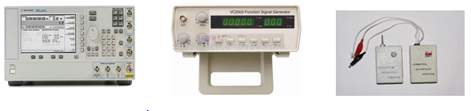
Figure 1. 44 PSG Analog Signal Generator, Function-generator, Tone-generator-and-wire-tracker
    - Oscilloscope
An oscilloscope is a laboratory instrument commonly used to display and analyze the waveform of electronic signals. In effect, the device draws a graph of the instantaneous signal voltage as a function of time.
An oscilloscope's primary function is to provide a graph of a signal's voltage over time. Usually the Y axis represents the voltage and the X axis time. This is useful for measuring such things as clock frequencies, duty cycles of pulse-width-modulated signals, propagation delay, or signal rise and fall times based on the input to its probes.
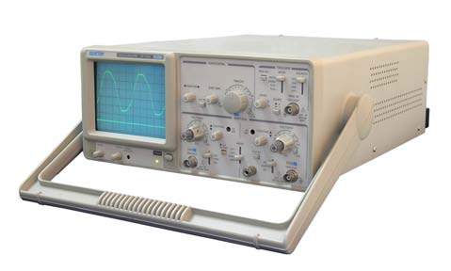
Figure 1. 45 Analog Oscilloscope

A typical oscilloscope can display alternating current (AC) or pulsating direct current (DC) waveforms having a frequency as low as approximately 1 hertz (Hz) or as high as several megahertz (MHz). High-end oscilloscopes can display signals having frequencies up to several hundred Gigahertz (GHz). The display is broken up into so-called horizontal divisions (hor div) and vertical divisions (vert div). Time is displayed from left to right on the horizontal scale. Instantaneous voltage appears on the vertical scale, with positive values going upward and negative values going downward.
The oldest form of oscilloscope, still used in some labs today, is known as the cathode-ray oscilloscope. It produces an image by causing a focused electron beam to travel, or sweep, in patterns across the face of a cathode ray tube (CRT). More modern oscilloscopes electronically replicate the action of the CRT using a liquid crystal display (liquid crystal display) similar to those found on notebook computers. The most sophisticated oscilloscopes employ computers to process and display waveforms. These computers can use any type of display, including CRT, LCD, and gas plasma.
In any oscilloscope, the horizontal sweep is measured in seconds per division (s/div), milliseconds per division (ms/div), microseconds per division (s/div), or nanoseconds per division (ns/div). The vertical deflection is measured in volts per division (V/div), milli-volts per division (mV/div), or micro-volts per division (μV/div). Virtually all oscilloscopes have adjustable horizontal sweep and vertical deflection settings. In the design and construction of circuits, the oscilloscope is a very handy equipment, electronic labs cannot do without it. Its functions are:
- Show and calculate the frequency and amplitude of an oscillating signal.
- Shows the voltage and time of a particular signal. This function is the most used in all labs.
- Helps to troubleshoot any malfunction components of a project by looking at the expected output after a particular component.
- Shows the content of the AC voltage or DC voltage in a signal.
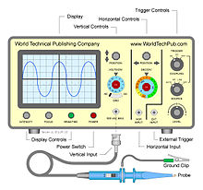
Figure 1. 46 Oscilloscope

Standard gauges
The standard gauge is a widely used railway track gauge. Approximately 55% of the lines in the world are used this gauge.
Pressure gauges are manufactured in many configurations and sizes from 50mm up to 300 mm dial size in ranges of 2.5 kPa up to 100,000kPa with brass or stainless-steel wetted parts. Scales can be offered in different units.
Regarding application several types of standard gauges are there.
General Purpose Pressure Gauges: - The ASG Series of General Purpose pressure gauges guarantees long life & durability for indoor, outdoor and harsh environmental conditions.
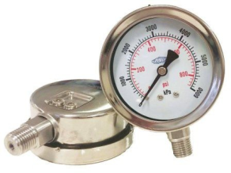
Figure 1. 47 pressure gauge
Low Pressure Gauges: - Low pressure gauges operated by a capsule system and only suitable for use on air and some gases. Pressure ranges from -2.5-0 kPa up to 0-60 kpa pressure or vacuum. Offered with stainless steel casing and brass connections for the use on non-corrosive applications, but can be offered with stainless steel wetted parts on request. Dial sizes available are 63mm, 100mm and 150mm
Test Gauge: - Precision test gauges manufactured to the highest standard in quality. Used for the testing of industrial gauges or equipment of the same standard. For quality control testing requirements, it is not always necessary to use a primary standard such as a dead weight tester, therefore a secondary standard such as a test gauge can be used, being a more convenient and economical method of testing.
Safety Pattern Pressure Gauges: - These gauges are generally used within the gas industry are designed with operator safety in mind in case of a bourdon tube rupture and that no projectiles will blow out from the front of the gauge. Safety pattern construction consists of a front baffle wall, Perspex window and a blowout disc in the rear of the case. Dial sizes available are 100mm and 150mm with pressure ranges up to 100,000 kPa.

Self-Check -1.1 | Written Test
Directions: Answer all the questions listed below. Write down the correct answer in sheet provided.
I. Choose the best answer (each 2point)
- ________the ratio of the error to the full scale output.
- Accuracy B. Tolerance C. A & B D) None
- ____________re-ranging could (usually) only be accomplished by re-calibration, since the same adjustments.
- In analog instruments B. In digital instruments C. A&B D. None
- ___________is defined as “the region between the limits within which a quantity is measured, received or transmitted, expressed by stating the lower and upper range values.”
- Accuracy B. Calibration tolerances C. The calibration range
- ________ for quality control testing requirements, it is not always necessary to use a primary standard such as a dead weight tester.
A. Test Gauge B. Low Pressure Gauges C. Standard gauges D. All
- ______ is an electronic device that supplies electric energy to an electrical load.
A. AC-to-DC supply B. power supply C. Volume tank D) none
- ______ is device that converts electrical energy to heat energy.
A. compressor B. soldering iron/gun C. pressure switch D) all
- _____________ high accuracy loop calibrator modules with source measure and sink functions.
A. Loop and Temperature B. Recorders C. Control valves D. All
- ____________ is indicated by an index and graduated scale
A. Analogue indicators B. digital indicators C. A & B D. none
- Part II fill the blank space
- List down why needed calibration? (5%) ____________________________________,___________________________________________________________________,_____________________________
- What is some advanced calibrators can: (Have 4 point)
  - ______________________________
  - _______________________________
  - _________________________________

Operation sheet (1.1) - Analog Oscilloscope Procedures:
The purpose of this operation is to introduce students to the basic tools used by engineers and technicians in analyzing electronic equipment: the function generator, the analog oscilloscope, and the digital oscilloscope.
During this operation, the student will use the function generator to generate a number of signals and to analyze those signals using either of the ‘oscilloscopes. The student will become familiar with the basic waveforms -- sine, square, and triangle waves -- and the components of the waveforms -amplitude, period, and frequency.
Equipment:
Qty | Equipment
1 | Leader LFG-1300S Function Generator
1 | BNC to 2 alligator clips cable
1 | Tektronix 2225 Analog Oscilloscope
1 | Tektronix P6103 10X probe
1 | Hewlett-Packard 54502A Digital Oscilloscope
1 | HP 10430A 10X probe

Overview:
In this part of the lab, you will use the function generator to generate a signal and then use the analog oscilloscope to make some measurements of the data. If you need any assistance in identifying or configuring the equipment, please see the on-duty GSA.
Function Generator Setup:
- Turn on the function generator.
- Make sure that the Sweep, Amplitude Modulation, and DC offset groups are turned OFF.
Note: The Sweep and Amplitude Modulation buttons should be in the OUT position, and the DC offset knob should be pushed IN.
- Select a TRIANGLE wave.
- Set frequency to 1.0 kHz.
- Set the amplitude knob to 12 o'clock.
- Make sure all the attenuation buttons are OUT.
- Attach the BNC end of the cable to the BNC socket in the function generator's Output Group.
- Tie back the black lead alligator clip by clipping the black alligator clip to the insulated wire to avoid short circuits and blown fuses.
Analog Oscilloscope Setup:
- Turn on the power to the oscilloscope.
- Connect the Tektronix 10X probe to the Channel 1 input on the oscilloscope.
- Tie back the black lead on the probe, then expose the hook and clip it to the red alligator clip on the function generator cable.
- Set CH1/BOTH/CH2 switch to CH1.
- In the Vertical Control Group, set the Channel 1 AC/GND/DC switch to GND.
- Use the CH1 vertical position knob to move the ground (0V) reference (horizontal line) to the center line on the screen.
- After referencing the signal to ground, set the AC/GND/DC switch to AC.
- Intensity knob: adjust the signal intensity and focus to a comfortable level, by using the intensity and focus knobs, respectively.
Note: Keep the signal intensity to within a reasonable range to minimize the chances of burning the phosphor and damaging the display screen.
- Set the Volts-per-Division knob to 2 V/div.
Note: you are using a 10X probe, so be sure to take all readings from the 10X position.
- Set the NORMAL/INVERT switch to NORMAL.
- Set the ADD/ALT/CHOP switch to ALT.
- Set X1/ALT/MAG to X1.
- Set the seconds-per-division knob to 0.1 ms/div.
- Set the rising/falling-edge switch to positive.
- Set the trigger-mode switch to AUTO.
- Set the trigger-source switch to VERT MODE.
- Set the trigger-coupling switch to AC.
Note: If the signal is still running, try adjusting the trigger level or holdoff knobs.
- Make sure that the 'cal' knobs on the V/div and S/div knobs are both pushed in and turned all the way to the right. They will click into position. This is so the scope will be calibrated properly.
Procedures:
Step1. Using the settings completed above, answer the following questions.
    - What is the setting on the Volts/Div control knob? _______ volts/div
    - How many vertical divisions from peak-to-peak? _______ div
    - What is the peak to peak voltage (Vpp)?
Vpp = _______ volts/div * _______ div = _______ volts
    - What is the setting on the Sec/Div control knob? _______ ___ seconds/div
    - How many horizontal divisions from positive going crossing to positive going crossing? _______ div
    - What is the period of the signal (T)?
T = _______ seconds/div * _______ div = _______ ___ seconds
    - What is the frequency of the signal (f)? _______ ___ hertz
    - Draw the displayed signal on Graph 4.1.
Be neat, to scale, and concise. Be sure to note the (scale) V/div and Sec/div settings.
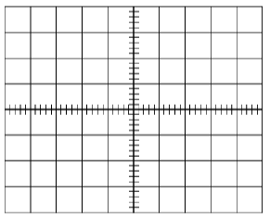
Graph 4.1
Step2. Next you will adjust the function generator to output another signal and repeat the measurements in Step 1.
    - Generate a square wave between 5 and 10 kHz with an amplitude setting of 3 o'clock.
    - Adjust the V/div and Sec/div settings to maximize the display of the signal on the CRT. Make sure you show the signal from peak-to-peak and at least one full cycle (period) of the signal.
    - What is the setting on the Volts/Div control knob? _______ volts/div
    - How many vertical divisions from peak-to-peak? _______ div
    - What is the peak to peak voltage (Vpp)?
Vpp = _______ volts/div * _______ div = _______ volts
    - What is the setting on the Sec/Div control knob? _______ ___ seconds/div
    - How many horizontal divisions from positive going crossing to positive going crossing? _______ div
    - What is the period of the signal (T)?
T = _______ sec/div * _______ div = _______ ___ seconds
    - What is the frequency of the signal (f)? _______ ___ hertz.
    - Draw the displayed signal on Graph 4.2.
Be neat, to scale, and concise. Be sure to note the (scale) V/div and Sec/div settings.
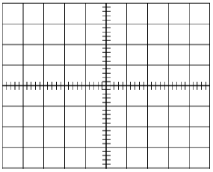
Graph 4.2
step3. In this part of the lab, you will experiment with the triggering of the analog oscilloscope. You will need to make some changes to the controls of the analog oscilloscope and the function generator, and you will then have to answer a few questions.
- Set TRIGGER MODE to NORM.
Set TRIGGER SOURCE to CH1.
- Turn the TRIGGER LEVEL knob all the way to the right.
Turn the TRIGGER HOLDOFF knob all the way to the right.
- Generate a 1.4 kHz sine wave with the function generator; setting the amplitude knob all the way to the left. Then display the signal on the oscilloscope.
- On the oscilloscope, turn the horizontal position (coarse) knob until the left edge of the trace is shown.
- While watching the display, turn the TRIGGER LEVEL knob to the left until you get a steady display.
- Keep turning the TRIGGER LEVEL knob to the left, and watch the trigger level go down. Note that the oscilloscope ceases to trigger when the level moves below the signal.
- Set the TRIGGER LEVEL as close to the top of the signal as possible while still retaining a steady picture.
- What is the peak-to-peak voltage (Vpp)? _______ volts
- On the function generator, depress the 10 dB attenuation button.
- Use the TRIGGER LEVEL knob to steady the display. It's a delicate adjustment, so watch the screen carefully while you turn the knob to the left.
- (Why did the signal run or disappear? (not steady or not locked)
- Without changing the V/div setting, what is the new Vpp? _______ volts
- Using the formula on page 3, calculate the attenuation in dB? _______dB (note sign!)
- Disconnect the analog oscilloscope, and turn off the power.

Operatiion sheet (1.2) Digital Oscilloscope Procedures:
Overview:
In this part of the operation, you will use the function generator to generate a signal and then use the digital oscilloscope to make some measurements of the data. If you need any assistance in identifying or configuring the equipment, please see the on-duty GSA.
Digital Oscilloscope Setup:
    - Generate a 6kHz triangle wave with the amplitude turned fully to the right using the function generator.
    - Connect the HP probe to the Channel 1 input on the oscilloscope, then connect the probe to the red lead from the function generator.
    - Press the AUTOSCALE button to make the oscilloscope automatically adjust its settings.
    - Select the Channel menu by pressing the CHAN button.
- Select Channel 1.
- Set v/div to 5.0 v/div, if it is not already set.
- Set offset to 0 volts, if not already set.
- Select AC. Select 1MΩ Ω, if not already set.
- Select More by pressing the button to the right of the more label.
- Make sure that 10:1 is selected. If not, use the wheel to set it.
- Press the More button.
    - Select the Time base menu by pressing the TIME BASE button.
- Set the time base to 50 µ µs/div, if not already set.
- Set delay to 0 seconds.
- Select reference: center, if not already set.
- Set window: off, if it is on.
- Select realtime.
    - Select the Trigger menu by pressing the TRIG button.
- Select AUTO.
- Select EDGE.
- Select source: channel 1.
    - Select the Display menu by pressing the DISPLAY button.
- Select NORM.
- Set persistence: 'minimum' or 'single'.
- Set No. of screens: 1. Select GRID.
- Set connect dots: ON.
PROCEDURES:
Step1. Using the settings completed above, answer the following questions.
- Select the ∆t/∆v menu by pressing the ∆ ∆t/∆ ∆v button.
- Select Vmarkers and Tmarkers.
- Select Vmarker 1, then use the data entry wheel to set the marker at the bottom of the signal.
Be sure to adjust the voltage level not the channel number.
- Similarly, set Vmarker 2 to the top of the signal.
- Read ∆V at the bottom of the screen.
- Vmarker 1: _______ ___ volts
- Vmarker 2: _______ ___ volts
- ∆V: _______ ___ volts
- Using the same procedure as for the Vmarkers, set the ∆T start marker to either a positive or negative peak.
- Similarly, set the ∆T stop marker to the next positive or negative peak. (Choose the same polarity as you did in Step 1.2.)
- Read ∆T and 1/∆T (period and frequency) at the bottom of the screen.
- Start Marker: _______ ___ seconds
- Stop Marker: _______ ___ seconds
- ∆T (period): _______ ___ seconds
- 1/∆T (frequency): _______ ___hertz
- Turn the markers off.
Step2. Using the automatic measurement capability of the digital oscilloscope, you will repeat the measurements you made in Step 1.
    - Press the blue shift button, press button 1 (Vpp), and then press button 1 for channel 1 when 'c#' appears at the bottom of the screen in reverse text.
    - Measure Vpp: _______ ___ volts
Note: If 'm#' or 'f#' appears in reverse text at the bottom of the screen, use the entry wheel to change this to 'c#'. If this fails, try hitting RECALL and CLEAR simultaneously to reset the oscilloscope. You would then need to restart with the pressing the AUTOSCALE in the digital oscilloscope setup section.
    - Press the blue shift button, press button 9 (Freq.), and then press button 1 for channel 1 when 'c#' appears at the bottom of the screen in reverse text.
Measure Frequency (f): _______ ___ hertz
    - Press the blue shift button, press button s-V (period) to the right of button 9, and then press button 1 for channel 1 when 'c#' appears at the bottom of the screen in reverse text.
Measure Period (T): _______ ___ seconds
    - Draw the displayed signal on Graph 4.3.
Be neat, to scale, and concise. Be sure to note the (scale) V/div and Sec/div settings.
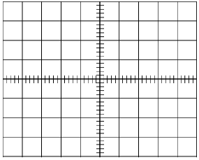
Graph 4.3
- To clear the measurements from the screen, press the blue shift button and then press the clear button.
- Disconnect the digital oscilloscope from the function generator and turn it off.
- Make sure all probes and connectors are disconnected from the equipment and neatly placed on the shelf above the work area.
Be sure to turn off both oscilloscopes and the function generator.

Operatiion sheet (1.3) Digital Oscilloscope Procedures:

Operation sheet
- Plan and prepare for configuration.
Learning Activity:
- Identify instrumentation and control devices for configuration.
- Specify minimum specification required to configure instrumentation and control devices.
Refer to the diagram below. Analyze the process flow and identify the important elements involve that is part of the instrumentation. Answer the questions that follow.
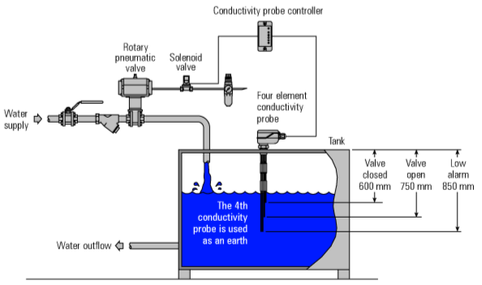
Figure 1. 48 Sample level control loop

- Describe the process as you understand it.
- Identify the elements of the level control loop? Describe their function in the above process control application.
- What are the important specifications required of each device that are involve in the level control loop? Define those specifications.

UNIT 2. Calibrate Instrumentation and Control Devices
This learning guide is developed to provide you the necessary information regarding the following content coverage and topics:
- Devices normal functions
- Condition instrumentation and control devices
- Calibrate or adjusting instrumentation and control devices
- Maintain configured and calibrated devices
- unplanned events or conditions
This guide will also assist you to attain the learning outcome stated in the cover page. Specifically, upon completion of this Learning Guide, you will be able to:
- Check normal functions of devices
- Condition instrumentation and control devices to be calibrated
- Calibrate or adjust instrumentation and control devices
- Maintain configured and calibrated devices with standard
- Respond to unplanned events or conditions

Devices normal functions
Introduction
Checking is commonly used to verify grounding and bonding connections in electrical systems. These tests also verify the proper operation of disconnecting means and the function of overcurrent protection devices like fuses and circuit breakers.
Checking normal functions of devices
PV systems should be thoroughly tested at the time of calibrating and periodically over their lifetime to ensure proper performance and safe operation. Baseline measurements at the time of system commissioning are compared to the system ratings and expectations for acceptance, and serve as a baseline for comparison with future measurements. Changes in test results over time are used to track system degradation, and identify problems that require attention or service for safety or performance reasons. Circuits or components that are modified or replaced should be retested accordingly.
There are several types of electrical tests conducted on PV systems that are used to verify NEC requirements and system performance.
Many of these tests can be conducted with common electrical test equipment, while some measurements require special meters and instruments. In many cases, system performance information is measured, recorded and displayed by PV system inverters or charge controllers, and can be used to verify system functions and proper operation.
The following summarizes common types of testing conducted on PV systems what information it provides:
- Continuity and resistance testing verifies the integrity of grounding and bonding systems, conductors, connections and other terminations.
- Polarity testing verifies the correct polarity for PV dc circuits, and proper terminations for dc utilization equipment
- Voltage and current testing verify that PV array and system operating parameters are within specifications.
- Insulation resistance testing verifies the integrity of wiring and equipment, and used to detect degradation and faults to wiring insulation.
- Performance testing verifies the system power and energy output are consistent with expectations. These tests also require measurements of array temperature and solar irradiance. For stand-alone or hybrid PV systems incorporating energy storage and additional energy sources, the following additional tests may be conducted:
- Measurements of battery voltage, capacity and specific gravity.
- Verification of charge controller set points and temperature compensation.
- Verification of charging current and load control functions.
- Verification of performance and wiring integrity for other sources, such as generators.
Multi-function PV system testers are now available, such as the Seaward PV150, that conduct many of the recommended tests, including continuity and resistance, polarity, voltage and current tests, and insulation resistance tests. By combining these test functions into single instruments, testing personnel avoid having to purchase, carry and maintain multiple meters. Multi-functional PV system testers simplify and speed up testing.
These instruments can also store data for later retrieval and processing into commissioning test reports that become part of the system documentation record. See Figure 2.1.
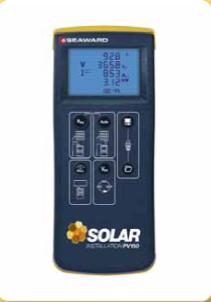
Figure 2. 1 The Seaward PV150 handheld meter provides multiple PV array testing functions.

Condition instrumentation and control devices
Conditioning instrumentation and control devices is a process of adjusting, calibrating, or modifying the devices to ensure their accuracy, reliability, and performance. Conditioning can involve various types of control devices and controllers, such as:
- Access control systems: These are devices or systems that use identification methods to manage the movement of personnel, vehicles, materials, etc. through entrances and exits. They can also be used for security monitoring and tracking purposes.
- Flow controllers: These are devices that measure and regulate the flow of media in manufacturing processes. They can use mechanical valves or electronic sensors to control the flow rate, pressure, temperature, etc. of gases or liquids.
- Level controllers: These are devices that monitor and control the levels of tanks, vats, etc. by means of pumps or valves. They can use various types of sensors, such as conductive, capacitance, optical, or ultrasonic, to detect the level of products in containers.
- Electrical calibration: This is a type of calibration that tests and adjusts the accuracy of instruments that measure electrical parameters, such as voltage, current, resistance, frequency, etc. Electrical calibration can use standard instruments or sources to compare the output of the device under test with the input signal
Any instrumentation system must include an input transducer (sensor), such as a strain gauge, whose response to a particular stimulus can be measured electrically. The other component that is generally present in modern instrumentation systems is a digital processor, such as a computer or a micro-controller. These programmable components have the flexibility to be used for a variety of functions. The most important function that they perform is to convert data into information. In the simplest situation the processing required to extract information may only involve converting an input signal by a scale factor so that the final result is in conventional units. For example, the output voltage signal from a strain gauge may be converted to the corresponding actual strain. Alternatively, within a more sophisticated system the signal from a strain gauge placed on an engine mounting might be processed to extract the vibrational spectrum of an engine, which is then used to detect any unusual frequency that might be indicative of wear. This information can then be displayed to a 2 user, stored for later analysis, transmitted to a remote location or used by a controller. The signal from a transducer is usually analogue in nature, ie. it is continuously varying and can take any value (within an allowed range). This continuous analogue data has to be converted to a digital format prior to being transferred to the digital processor. Any instrumentation system must therefore include an analogue-to-digital (A/D) converter (ADC for short) to convert an analogue signal into a digital format. A typical ADC will be an existing component that has been designed to convert an analogue input voltage, typically with a range of a few volts, into a digital word, which usually contains 8 or more bits. However, the output from a typical transducer, such as a strain-gauge, might have an amplitude of less than 10 mV. This transducer output signal must therefore be amplified in an analogue signal conditioning circuit before it can be converted into a digital word. Another aspect of the performance of the ADC that must also be taken into consideration when designing the signal conditioning circuit is that the ADC samples the transducer output at specific time intervals. An unfortunate consequence of this is that several frequencies will become indistinguishable at the ADC output. This is referred to as aliasing, and the effect can only be avoided by using a low-pass, anti-alias filter to ensure that only the low frequencies that can be represented accurately are present in the signal applied to the ADC input. Since the 3 requirements for the anti-alias filter arises from a fundamental property of the ADC, this type of filter should always be present.
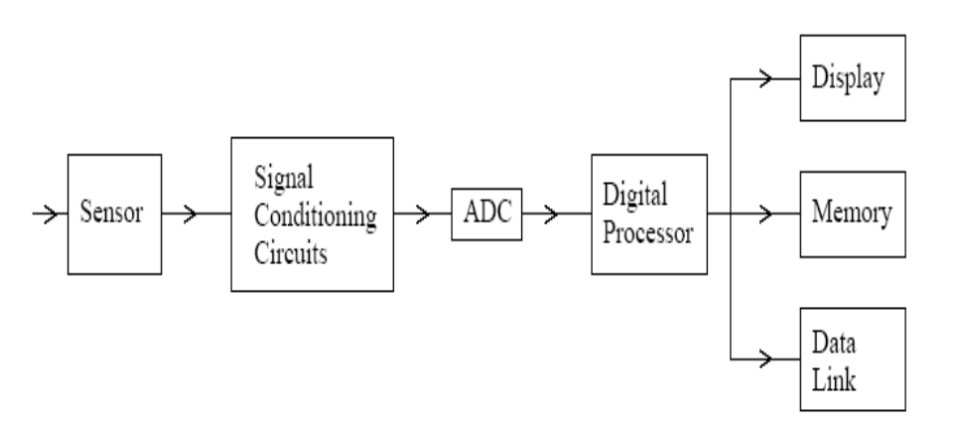
Figure 2. 2 A block diagram of a typical instrumentation system with several different output devices
As shown in Figure 1 the characteristics of typical sensors and ADCs mean that the data collection (or acquisition) part of a typical modern instrumentation system can be split into the three functional blocks, a sensor, signal conditioning circuits and an ADC. The digital output from the ADC can then be processed in a programmable digital processor to extract information that can be displayed to an operator, stored in a memory or transmitted via a data link or used in feedback control.

Calibrate or adjust instrumentation and control devices

Basic introduction to calibration
There are as many definitions of calibration as there are methods. According to ISA’s The Automation Systems and Instrumentation Dictionary, the word calibration is defined as “a test during which known values of measurand are applied to the transducer and corresponding output readings are recorded under specified conditions.” Therefore, it makes sense that calibration is required for a new instrument. We want to make sure the instrument is providing accurate indication or output signal when it is installed.
The definition includes the capability to adjust the instrument to zero and to set the desired span.
An interpretation of the definition would say that a calibration is a comparison of measuring equipment against a standard instrument of higher accuracy to detect, correlate, adjust, rectify and document the accuracy of the instrument being compared.
Purpose of Calibration:
- The calibration of any measuring system is very important to get meaningful results.
- In the case where the sensing system and measuring system are different, then it is imperative to calibrate the system as an integrated whole in order to take into account the error producing properties of each component.
- Calibration is usually carried out by making adjustments such that the readout device produces zero output for zero-measured input, and similarly, it should display an output equivalent to the known measured input near the full-scale input value.
- It is important that any measuring system calibration should be performed under environmental conditions that are as close as possible to those conditions under which actual measurements are to be made.
- It is also important that the reference measured input should be known to an as much greater degree of accuracy – usually, the calibration standard for the system should be at least one order of magnitude more accurate than the desired measurement system accuracy.

Typically, calibration of an instrument is checked at several points throughout the calibration range of the instrument.
- The calibration range is defined as “the region between the limits within which a quantity is measured, received or transmitted, expressed by stating the lower and upper range values.” The limits are defined by the zero and span values.
- Calibration and ranging are two tasks associated with establishing an accurate correspondence between any instrument’s input signal and its output signal.
To calibrate an instrument means to check and adjust (if necessary) its response so the output accurately corresponds to its input throughout a specified range. In order to do this, one must expose the instrument to an actual input stimulus of precisely known quantity. For a pressure gauge, indicator, or transmitter, this would mean subjecting the pressure instrument to known fluid pressures and comparing the instrument response against those known pressure quantities.
To range an instrument means to set the lower and upper range values so it responds with the desired sensitivity to changes in input.
For example, a pressure transmitter set to a range of 0 to 200 PSI (0 PSI = 4 mA output;
200 PSI = 20 mA output) could be re-ranged to respond on a scale of 0 to 150 PSI (0 PSI = 4 mA ; 150 PSI = 20 mA).
- The zero value is the lower end of the range.
- Span is defined as the algebraic difference between the upper and lower range values.
The calibration range may differ from the instrument range, which refers to the capability of the instrument.
For example, an electronic pressure transmitter may have a nameplate instrument range of 0–750 pounds per square inch, gauge (psig) and output of 4-to-20 milliamps (mA). However, the engineer has determined the instrument will be calibrated for 0-to-300 psig = 4-to-20 mA. Therefore, the calibration range would be specified as 0-to-300 psig = 4-to-20 mA.
In this example, the zero-input value is 0 psig and zero output value is 4 mA. The input span is 300 psig and the output span is 16 mA. Different terms may be used at your facility. Just be careful not to confuse the range the instrument is capable of with the range for which the instrument has been calibrated.
- In analog instruments, re-ranging could (usually) only be accomplished by re-calibration, since the same adjustments were used to achieve both purposes.
- In digital instruments, calibration and ranging are typically separate adjustments (i.e. it is possible to re-range a digital transmitter without having to perform a complete recalibration), so it is important to understand the difference.

Characteristics of Calibration
Every calibration should be performed to a specified tolerance. The terms tolerance and accuracy are often used incorrectly. In ISA’s The Automation, Systems, and Instrumentation Dictionary, the definitions for each are as follows:
Accuracy: The ratio of the error to the full-scale output or the ratio of the error to the output, expressed in percent span or percent reading, respectively.
Tolerance: Permissible deviation from a specified value; may be expressed in measurement units, percent of span, or percent of reading.
As you can see from the definitions, there are subtle differences between the terms. It is recommended that the tolerance, specified in measurement units, is used for the calibration requirements performed at your facility. By specifying an actual value, mistakes caused by calculating percentages of span or reading are eliminated. Also, tolerances should be specified in the units measured for the calibration.
For example, you are assigned to perform the calibration of the previously mentioned 0-to-300 psig pressure transmitter with a specified calibration tolerance of ±2 psig. The output tolerance would be:
(2 psig/300 psig)*16 mA = 0.1067 mA
The calculated tolerance is rounded down to 0.10 mA, because rounding to 0.11 mA would exceed the calculated tolerance. It is recommended that both ±2 psig and ±0.10 mA tolerances appear on the calibration data sheet if the remote indications and output milliamp signal are recorded.
Note the manufacturer’s specified accuracy for this instrument may be 0.25% full scale (FS). Calibration tolerances should not be assigned based on the manufacturer’s specification only.
Calibration tolerances should be determined from a combination of factors. These factors include:
    - Requirements of the process
    - Capability of available test equipment
    - Consistency with similar instruments at your facility
    - Manufacturer’s specified tolerance

Typical instrument error and calibration error
The instrument error can occur due to a variety of factors: drift, environment, electrical supply, addition of components to the output loop, process changes, etc. Since a calibration is performed by comparing or applying a known signal to the instrument under test, errors are detected by performing a calibration.
Typical errors that occur include:

Instrument errors
Any given instrument is prone to errors either due to aging or due to manufacturing tolerances. Here are some of the common terms used when describing the performance of an instrument.
- Range
The range of an instrument is usually regarded as the difference between the maximum and minimum reading.
For example: a thermometer that has a scale from 20 to 100ºC has a range of 80ºC. This is also called the full-scale deflection (f.s.d.).
- Accuracy
The accuracy of an instrument is often stated as a % of the range or full-scale deflection.
For example: a pressure gauge with a range 0 to 500 kPa and an accuracy of plus or minus 2% f.s.d. could have an error of plus or minus 10 kPa. When the gauge is indicating 10 kPa the correct reading could be anywhere between 0 and 20 kPa and the actual error in the reading could be 100%. When the gauge indicates 500 kPa the error could be 2% of the indicated reading.
- Repeatability
If an accurate signal is applied and removed repeatedly to the system and it is found that the indicated reading is different each time, the instrument has poor repeatability. This is often caused by friction or some other erratic fault in the system.
- Stability
Instability is most likely to occur in instruments involving electronic processing with a high degree of amplification. A common cause of this is unfavorable environment factors such as temperature and vibration.
For example, a rise in temperature may cause a transistor to increase the flow of current which in turn makes it hotter and so the effect grows and the displayed reading DRIFTS. In extreme cases the displayed value may jump about. This, for example, may be caused by a poor electrical connection affected by vibration
- Time lag error
In any instrument system, it must take time for a change in the input to show up on the indicated output. This time may be very small or very large depending upon the system. This is known as the response time of the system. If the indicated output is incorrect because it has not yet responded to the change, then we have time lag error.
A good example of time lag error is an ordinary glass thermometer. If you plunge it into hot water, it will take some time before the mercury reaches the correct level. If you read the thermometer before it settled down, then you would have time lag error.
A thermocouple can respond much more quickly than a glass thermometer but even this may be too slow for some applications. When a signal changes a lot and quite quickly, (speedometer for example), the person reading the dial would have great difficulty determining the correct value as the dial may be still going up when in reality the signal is going down again.
- Reliability
Most forms of equipment have a predicted life span. The more reliable it is, the less chance it has of going wrong during its expected life span. The reliability is hence a probability ranging from zero (it will definitely fail) to 1.0 (it will definitely not fail).
- Drift
This occurs when the input to the system is constant but the output tends to change slowly. For example, when switched on, the system may drift due to the temperature change as it warms up.
- NIST traceability
As defined previously, calibration means the comparison and adjustment (if necessary) of an instrument’s response to a stimulus of precisely known quantity, to ensure operational accuracy.
In order to perform a calibration, one must be reasonably sure that the physical quantity used to stimulate the instrument is accurate in itself.
For example, if I try calibrating a pressure gauge to read accurately at an applied pressure of 200PSI, I must be reasonably sure that the pressure I am using to stimulate the gauge is actually 200PSI. If it is not 200PSI, then all I am doing is adjusting the pressure gauge to register 200PSI when in fact it is sensing something different.

Calibration errors in instrumentation
A zero-shift calibration error shifts the function vertically on the graph. This error affects all calibration points equally, creating the same percentage of error across the entire range.
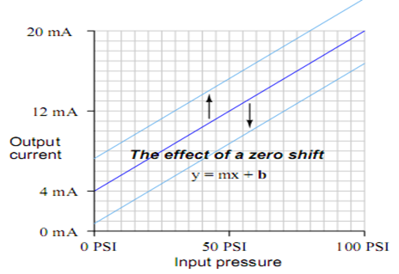
Figure 2. 3 Zero shift calibration error graph

A span shift calibration error shifts the slope of the function. This errors effect is unequal at different points throughout the range:
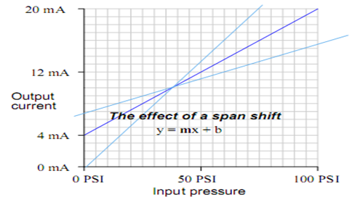
Figure 2. 4 Span shift calibration error

A linearity calibration error causes the function to differ from a straight line. This type of error does not directly relate to a shift in either zero (b) or span (m) because the slope - intercept equation only describes straight lines.
If an instrument does not provide a linearity adjustment, the best you can do for this type of error is split the error between high and low extremes, so the maximum absolute error at any point in the range is minimized:
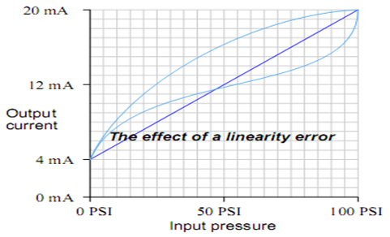
Figure 2. 5 linearity calibration error
A hysteresis calibration error occurs when the instrument responds differently to an increasing input compared to a decreasing input.
The only way to detect this type of error is to do an up-down calibration test, checking for instrument response at the same calibration points going down as going up:
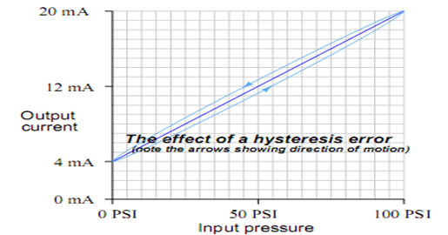
Figure 2. 6 Hysteresis calibration error
Hysteresis errors are almost always caused by mechanical friction on some moving element (and/or a loose coupling between mechanical elements) such as bourdon tubes, bellows, diaphragms, pivots, levers, or gear sets.
Flexible metal strips called flexures which are designed to serve as frictionless pivot points in mechanical instruments may also cause hysteresis errors if cracked or bent.
In practice, most calibration errors are some combination of zero, span, linearity, and hysteresis problems. It occurs widely with things involving magnetization and demagnetization.
The calibration may be correct at the maximum and minimum values of the range but the graph joining them may not be a straight line (when it ought to be). This is a non linear error. The instrument may have some adjustments for this and it may be possible to make it correct at mid-range as shown.

Calibration of instrument and control device procedures
The purpose of this section to describe procedures for efficiently calibrating different types of instruments. Calibration of measurement equipment can be done on a variety of instruments in a variety of industries.
          - Typical calibration
- Electrical Calibration:
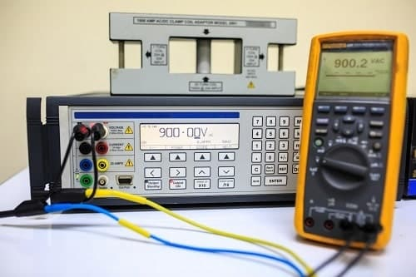
Figure 2. 7 Electrical Calibration
Electrical calibration is the process of ensuring that any instrument that measures or tests electrical properties such as voltage, current, resistance, inductance, capacitance, time, and frequency is operating properly. Electrical calibration is a high-end process which needs the use of precise instruments or calibrators to assess the performance of important criteria in other devices referred to as units under test.
The following instruments are frequently submitted for electrical calibration:

- Data loggers
- Electric meters
- Multi-meters
- Oscilloscopes
- Frequency counters
- Insulation Testers
- Loop testers etc.

- Mechanical Calibration:
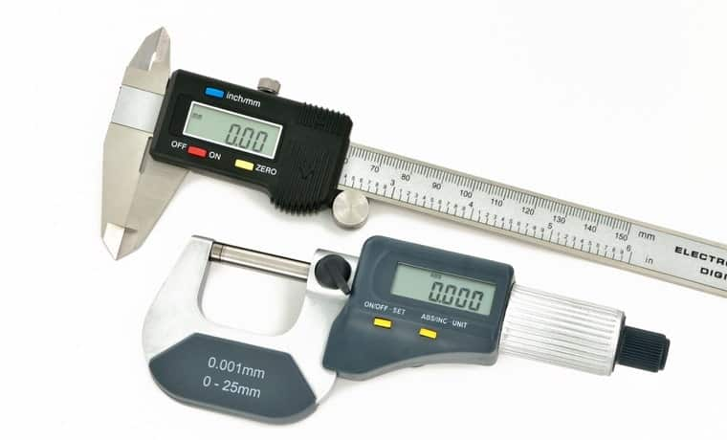
Figure 2. 8 Mechanical Calibration (micrometer and varnier caliper)
Mechanical instruments are prone to drift as a result of repeated use, mechanical stress, and exposure to fluctuating air conditions etc., and because of such condition the mechanical calibration is the much-needed remedy to overcome the error induced in the equipment’s. Mass, volume, density, force, torque, dimension, angle, flatness, and vibration are the major properties that are calibrated during mechanical calibration in a temperature-controlled atmosphere.
The following are some of the most commonly tested mechanical calibration instruments:
- Accelerometers
- Scales/Balances
- Force Gauges & Load Cells
- Micrometers, Vernier, and height gauges
- Screwdrivers & Torque Wrenches
- Sets of Weight and Mass

- Flow Calibration:
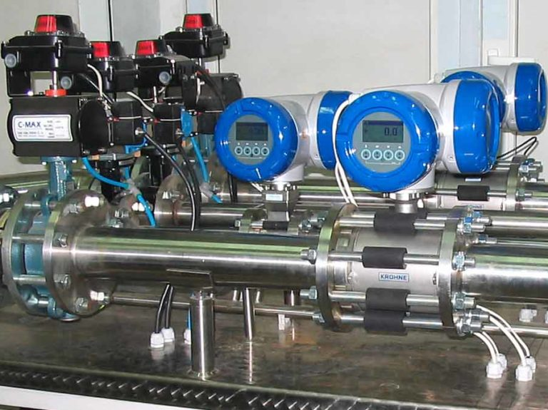
Figure 2. 9 Flow Calibration
A flow meter (also known as a flow sensor) is a device that measures the linear or non-linear, mass or volumetric flow rate of a liquid or gas. The flow rate is the rate at which a process fluid moves through pipelines, orifices, or vessels at a given time, and it is measured by instruments through a controlled manner to monitor and regulate the speed and efficiency of industrial flow processes and devices.
Calibration is required for flow equipment that helps maximize production, profitability, and compliance with regulatory standards. These flow meters that verify product or feedstock quality and quantity, fuel/energy quantity, or function in a vital process require flow calibration services on a regular basis to guarantee that measurements are accurate, allowing operations to proceed safely and on time.
The four most common types of flow meters that need calibration are:
- Thermal Mass Flowmeters
- Laminar flowmeters
- Gas and Air Rotameters
- Turbine meters

- Pipette Calibration: (Types of Calibration)
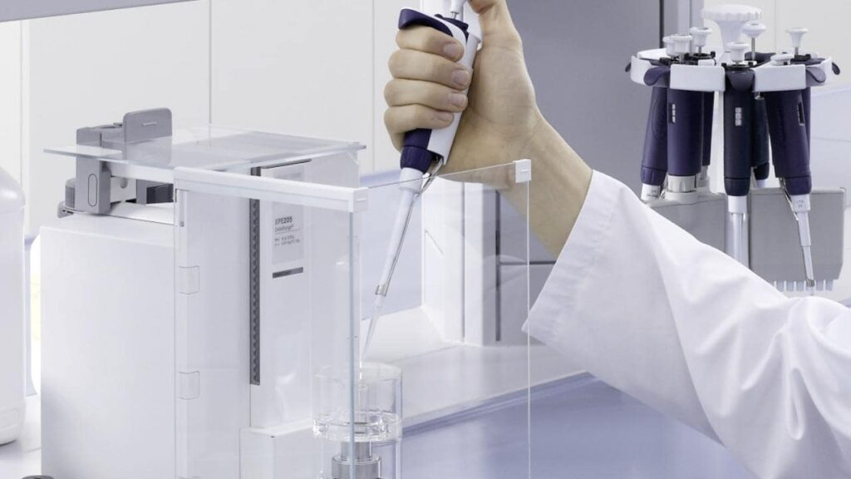
Figure 2. 10 Pipette Calibration

Pipette calibration is necessary for accurate and precise pipetting results in laboratories that uses this measurement device often. The calibration process and methods must be followed for all types of pipettes used in laboratories, including single-channel, multi-channel manual pipettes, and electronic pipettes. The primary goal of pipette calibration is to guarantee that dispensing is done with the desired precision.
- Pressure Calibration:
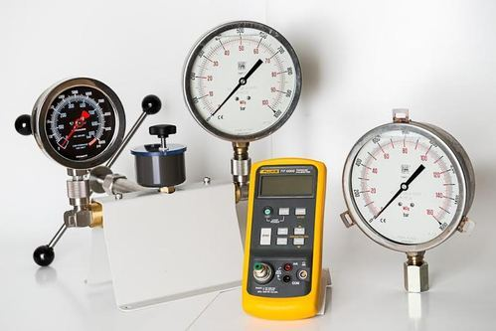
Figure 2. 11 Pressure Calibration
Pressure calibration is a critical operation performed in a variety of industries where measurement equipment is required to monitor process performance and safety, with gas and hydraulic pressure being the most common measurements. Many businesses are now certified to quality standards such as ISO9000. There is a different procedure that must be followed in order to maintain quality standards, and because many industrial processes depend upon pressure measurement, pressure calibration is a crucial aspect of a company’s quality assurance.
Pressure calibration is carried out using a different pressure balances and calibrators, as well as high-accuracy pressure sensors and pressure gauges.
The following are some examples of pressure devices that are calibrated on a regular basis:
- Digital Pressure Gauges
- Digital Indicators
- Transducers
- Transmitters
- Analogue Pressure Gauges
- Barometers
- Test Gauges
- Temperature Calibration:
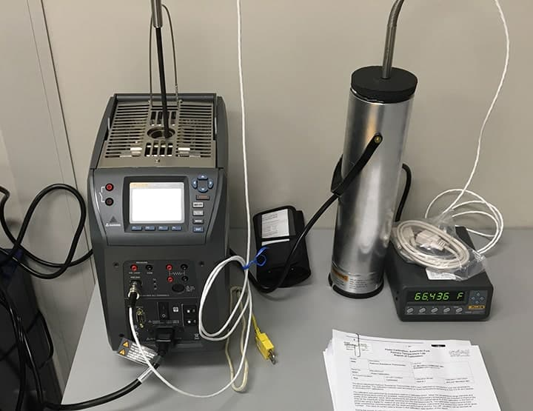
Figure 2. 12 Temperature Calibration
Temperature calibration is undertaken and carried out in a controlled environment in all processes where temperature readings play an important role for the equipment’s to run without interruption. Thermistors, thermocouples, or Platinum resistance thermometers (PRTs), sometimes known as resistance temperature devices (RTDs), are commonly employed in temperature calibration.
It’s important to remember that measuring the temperature from a temperature sensor using an RTD or thermocouple indicator and then comparing the readings to the in-line field indicator is not a temperature calibration. A temperature calibration can only be done by comparing the probe being tested to a recognized reference in a stable temperature environment.
The following are some examples of equipment that need temperature calibration on a regular basis:
- Data Acquisition Systems
- Thermometers/Thermocouples
- Dial Thermometers
- Chambers/Furnaces
- Infrared Meters
- PRTs and Thermistors
- Thermal Cameras
Steps or precautions to be observed during calibration of a measurement system:
- Specified environmental conditions are to be maintained so that similar conditions prevail when the system is calibrated and when the actual measurements are made.
- The device to be calibrated is checked for any physical defects.
- The standard measurement system used for calibration should be at least ten times more accurate than the desired measurement system accuracy i.e accuracy ratio of 10:1
          - Calibration Procedures in Linear, Non-Linear and Discrete Instruments
Calibration refers to the adjustment of an instrument so its output accurately corresponds to its input throughout a specified range. The only way we can know that an instrument’s output accurately corresponds to its input over a continuous range is to subject that instrument to known input values while measuring the corresponding output signal values. This means we must use trusted standards to establish known input conditions and to measure output signals. The following examples show both input and output standards used in the calibration of pressure and temperature transmitters:
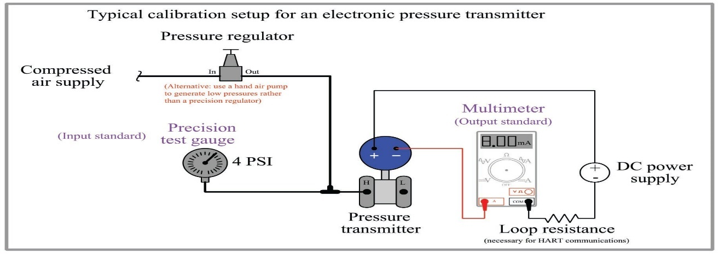
Figure 2. 13 Calibration of pressure transmitters

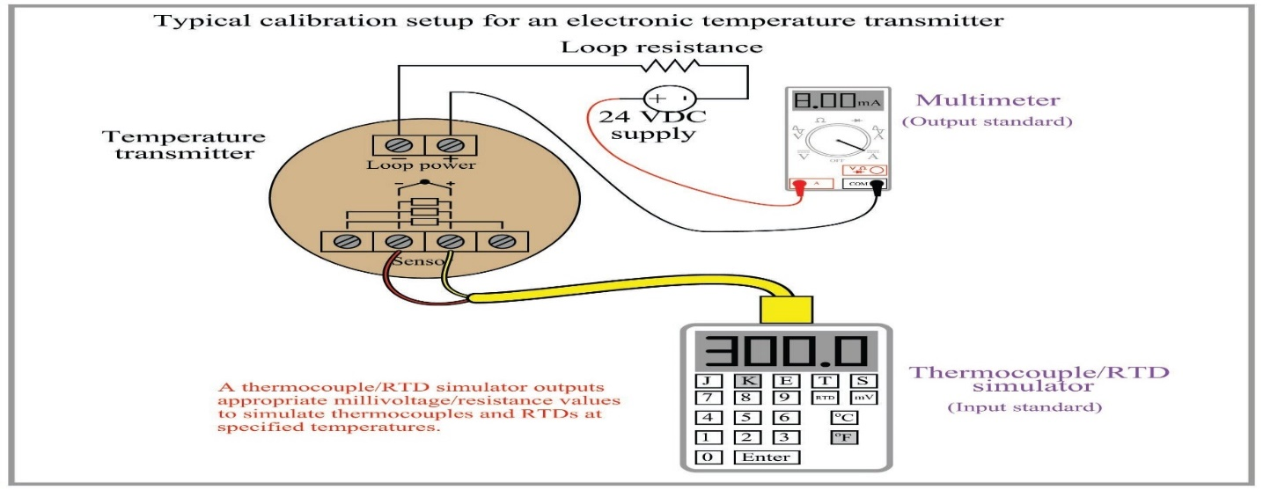
Figure 2. 14 Calibration of temperature transmitters
- Procedures for efficiently calibrating different types of instruments
- Linear instruments
The simplest calibration procedure for an analog, linear instrument is the so-called zero-and-span method. The method is as follows:
- Apply the lower-range value stimulus to the instrument, wait for it to stabilize
- Move the “zero” adjustment until the instrument registers accurately at this point
- Apply the upper-range value stimulus to the instrument, wait for it to stabilize
- Move the “span” adjustment until the instrument registers accurately at this point
- Repeat steps 1 through 4 as necessary to achieve good accuracy at both ends of the range
An improvement over this crude procedure is to check the instrument’s response at several points between the lower- and upper-range values. A common example of this is the so-called five-point calibration where the instrument is checked at 0% (LRV), 25%, 50%, 75%, and 100% (URV) of range. A variation on this theme is to check at the five points of 10%, 25%, 50%, 75%, and 90%, while still making zero and span adjustments at 0% and 100%. Regardless of the specific percentage points chosen for checking, the goal is to ensure that we achieve (at least) the minimum necessary accuracy at all points along the scale, so the instrument’s response may be trusted when placed into service.
Yet another improvement over the basic five-point test is to check the instrument’s response at five calibration points decreasing as well as increasing. Such tests are often referred to as Up-down calibrations. The purpose of such a test is to determine if the instrument has any significant hysteresis: a lack of responsiveness to a change in direction.
Some analog instruments provide a means to adjust linearity. This adjustment should be moved only if absolutely necessary! Quite often, these linearity adjustments are very sensitive, and prone to over-adjustment by zealous fingers. The linearity adjustment of an instrument should be changed only if the required accuracy cannot be achieved across the full range of the instrument. Otherwise, it is advisable to adjust the zero and span controls to “split” the error between the highest and lowest points on the scale, and leave linearity alone.
The procedure for calibrating a “smart” digital transmitter – also known as trimming – is a bit different. Unlike the zero and span adjustments of an analog instrument, the “low” and “high” trim functions of a digital instrument are typically non-interactive. This means you should only have to apply the low- and high-level stimuli once during a calibration procedure. Trimming the sensor of a “smart” instrument consists of these four general steps:
- Apply the lower-range value stimulus to the instrument, wait for it to stabilize
- Execute the “low” sensor trim function
- Apply the upper-range value stimulus to the instrument, wait for it to stabilize
- Execute the “high” sensor trim function
Likewise, trimming the output (Digital-to-Analog Converter, or DAC) of a “smart” instrument consists of these six general steps:

- Execute the “low” output trim test function
- Measure the output signal with a precision milliammeter, noting the value after it stabilizes
- Enter this measured current value when prompted by the instrument
- Execute the “high” output trim test function
- Measure the output signal with a precision milliammeter, noting the value after it stabilizes
- Enter this measured current value when prompted by the instrument
After both the input and output (ADC and DAC) of a smart transmitter have been trimmed (i.e. calibrated against standard references known to be accurate), the lower- and upper-range values may be set. In fact, once the trim procedures are complete, the transmitter may be ranged and ranged again as many times as desired. The only reason for re-trimming a smart transmitter is to ensure accuracy over long periods of time where the sensor and/or the converter circuitry may have drifted out of acceptable limits. This stands in stark contrast to analog transmitter technology, where re-ranging necessitates re-calibration every time.
- Nonlinear instruments
The calibration of inherently nonlinear instruments is much more challenging than for linear instruments. No longer are two adjustments (zero and span) sufficient, because more than two points are necessary to define a curve.
Examples of nonlinear instruments include expanded-scale electrical meters, square root characterizers, and position-characterized control valves.
Every nonlinear instrument will have its own recommended calibration procedure, so I will defer you to the manufacturer’s literature for your specific instrument. I will, however, offer one piece of advice: when calibrating a nonlinear instrument, document all the adjustments you make (e.g. how many turns on each calibration screw) just in case you find the need to “re-set” the instrument back to its original condition. More than once I have struggled to calibrate a nonlinear instrument only to find myself further away from good calibration than where I originally started. In times like these, it is good to know you can always reverse your steps and start over!

- Discrete instruments
The word “discrete” means individual or distinct. In engineering, a “discrete” variable or measurement refers to a true-or-false condition. Thus, a discrete sensor is one that is only able to indicate whether the measured variable is above or below a specified setpoint.
Examples of discrete instruments are process switches designed to turn on and off at certain values. A pressure switch, for example, used to turn an air compressor on if the air pressure ever falls below 85 PSI, is an example of a discrete instrument.
Discrete instruments require periodic calibration just like continuous instruments. Most discrete instruments have just one calibration adjustment: the set-point or trip-point. Some process switches have two adjustments: the set-point as well as a dead band adjustment. The purpose of a dead band adjustment is to provide an adjustable buffer range that must be traversed before the switch changes state. To use our 85 PSI low air pressure switch as an example, the set-point would be 85 PSI, but if the dead band were 5 PSI it would mean the switch would not change state until the pressure rose above 90 PSI (85 PSI + 5 PSI).
When calibrating a discrete instrument, you must be sure to check the accuracy of the set-point in the proper direction of stimulus change. For our air pressure switch example, this would mean checking to see that the switch changes states at 85 PSI falling, not 85 PSI rising. If it were not for the existence of dead band, it would not matter which way the applied pressure changed during the calibration test. However, dead band will always be present in a discrete instrument, whether that dead band is adjustable or not.

Calibration of instrument with their procedure
Owing to the physical limitations of measuring devices and the system under study, every practical measurement will always have some errors. Several types of errors occur in a measurement system. These include;
Static Errors:
They are caused by limitations of the measuring device or the physical laws governing its behavior.
Dynamic Errors:
They are caused by the instrument not responding fast enough to follow the changes in measured variable. A practical example can be seen in a situation where the room thermometer does not show the correct temperature until several minutes after the temperature has reached a steady value.
Random Errors:
These may be due to causes which cannot be readily established; could also be caused by random variations in the system under study.
Basic Steps in Instrument Calibration
Calibration is a process whereby we ascertain the output of an instrument after being used over a definite period, by measuring and comparing against a standard reference and to carry out the necessary adjustments required to confirm whether its present accuracy conforms to that specified by its manufacturer. There are three basic steps involved in the calibration of an instrument. These include:
- To collect measured values (Output values) of standard values (input values) provided by a standard input reference.
- To complete verification/calibration tables for upscale and down scale values (5 or 3 points)
- To calculate the error on the output signal and to compare the result with the expected accuracy.
If ERROR = EXPECTED ACCURACY, no adjustment is required. In other words we are verifying the accuracy of the instrument.
If ERROR is greater than the EXPECTED ACCURACY, we carry out necessary adjustments to reduce this error within the expected accuracy (calibration process)
Five Point Calibration Basics
In a five point calibration for an instrument, the output is measured at 0%, 25%, 50%, 75% & 100% of the calibration range of the instrument. In the five-point calibration process, output readings are taken for upscale and down scale values of the calibration range to determine the repeatability and hysteresis of the instrument. In a five-point calibration, LRV = 0% Input; URV = 100%
Steps Involved in a Five Point Calibration
In a five-point calibration exercise, three basic steps are involved. They include:
- Zero Adjustments (at LRV)
- Span Adjustments (at IJRV)
- Linearity Adjustments - at 25%, 50% & 75%
These basic step above are illustrated in the flow chart for a five-point calibration below:
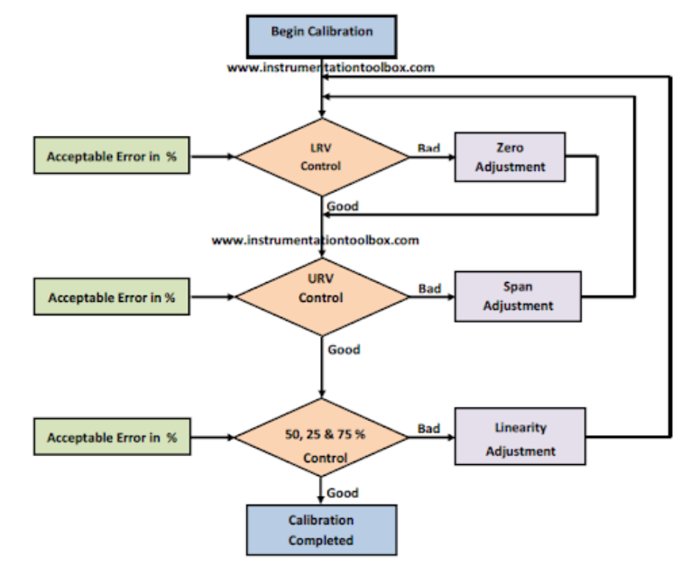
Figure 2. 15 Illustration of five-point calibration

Example of instrumentation and Control device with their procedure

Pressure Switch Calibration and Adjustment
Before we get down to the nitty-gritty of how to calibrate and adjust a pressure switch, let us get to understand some basic concepts with pressure switch calibration:
Setpoint:
This is the pressure at which the pressure switch is required to operate. A pressure switch may be set to operate on either a rising pressure (high level alarm) or a falling pressure (low level alarm). Most switches are designed to operate at a 'gauge' pressure setpoint i.e. relative to atmospheric pressure. Some applications require an 'absolute' pressure setpoint i.e. relative to absolute zero pressure, and an absolute pressure switch is required for these. Ideally the range of the switch should be chosen such that the setpoint is between 25% to 75% of this range.
Dead-band or Reset:
This is a setting that determines the amount of pressure change required to re-set the switch to its normal state after it has tripped. The dead-band or reset or switching differential is the difference in the rising and falling pressures at which, the pressure switch operates. For a fixed differential output switch this is typically about 1% to 3% of the switch range. For an adjustable differential output switch it may be adjusted from about 5% to 12% of the switch range.
The pressure switch is a ubiquitous device. It is practically everywhere in your plant. But how do you calibrate this simple device? The answer is here. Just follow the simple steps that I have outlined below.
Before you calibrate your pressure switch, confirm the following:
- The setpoint of the pressure switch
- The dead-band of the switch
- Also depressurize and isolate the pressure switch from the process. If opening the switch exposes voltages or energy that is not intrinsically safe, please follow the specified procedure for your plant. For example, if in an explosive environment, use a continuously monitoring gas detector to monitor for the presence of explosive gasses.
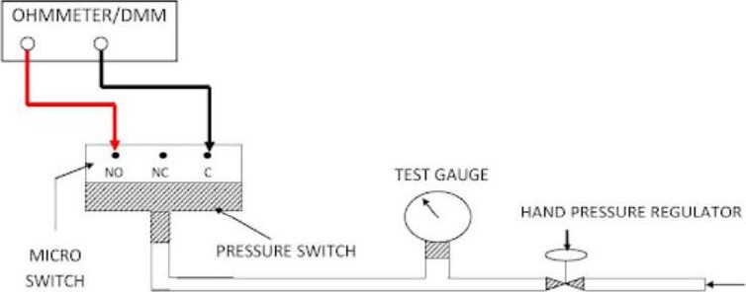
Figure 2. 16 Calibration Procedure of the Pressure Switch

- Step 1: Connect the pressure switch to a pressure source e.g air supply via a hand pressure regulator and test gauge, as shown in the diagram above.
- Step 2: Use an Ohmmeter or a Digital Multimeter (DMM) set to the continuity range to check and verify that the switch contacts are as indicated: NO (Normally open) and NC (Normally close).
- Step 3: Connect the Ohmmeter or DMM between the normally open contacts (NO) and the common terminal (C) of the switch. The meter should read "open circuit". Adjust the hand pressure regulator to increase the pressure to the setpoint of the pressure switch until the contacts change over. The meter should now read "short circuit". Note the pressure reading and write it down. This pressure is the switch setpoint for a "rising" pressure.
- Step 4: Increase the pressure to the switch to its maximum rating. Slowly reduce the pressure to the switch until the switch changes over from closed to normally open again. Note and write down this pressure reading. This pressure is the switch setting for a "falling" pressure.
- Step 5: From the readings you have taken work out the pressure difference between the rising and falling pressure settings. This is called the "dead-band" of the switch. The dead-band calculated should be equal to or less than the manufacturers' dead-band. The maximum dead-band is usually stated by the manufacturer. The switch is unserviceable if the maximum dead-band is more than the manufacturer's recommendation (dead-band on the nameplate of the switch)
- To calibrate the switch for a low pressure, go through the steps in this order: Step 1 to Step 2 to Step 4 to Step 3 to Step 5

RTD Transmitter Calibration
The RTD transmitter is usually factory calibrated to the temperature range shown on the device name plate. When the performance deteriorates and the transmitter needs recalibration, the transmitter is normally calibrated by using a resistance decade box.
Materials Required for Calibration
To calibrate the RTD transmitter, the following equipment will be required:
- Voltmeters (digital) of suitable accuracy and very high resolution - Imv
- A 24VDC power source
- A 5 dial Resistance Decade Box with high precision providing IOOQ steps
Calibration Steps:
Connect the above equipment as in the setup below: Lead simulator resistors (If required)
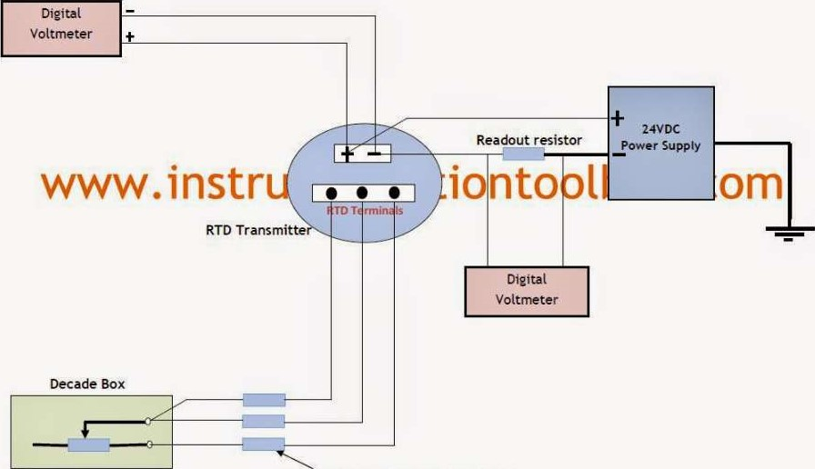
Figure 2. 17 RTD Transmitter Calibration diagram

How to Calibrate RTD Transmitter
Locate the RTD transmitter terminal by removing the housing cover
- If an RTD is already connected, remove all the RTD lead connections
- Determine the RTD resistance at the desired base(0 ⁰ C) and full scale temperatures
- Turn the power supply on
- Set resistance decade box to the resistance that corresponds to the desired base temperature. Adjust the zero pot (potentiometer) of transmitter until the output is 4mA
- Set resistance decade box to the resistance that corresponds to the desired full scale temperature. Adjust the span pot (potentiometer) of transmitter until the output is 20mA
- Repeat the above steps until both 4 and 20mA readings are obtained without readjusting span and zero potentiometers.

Thermocouple Transmitter Calibration
To calibrate a thermocouple transmitter will require a thermocouple simulator with an accuracy of at least four times greater than the thermocouple sensor we desire to calibrate.
Equipment and Materials Required
The following equipment/ materials are required to successfully calibrate a thermocouple transmitter:
  - Thermocouple Simulator (of at least four times the accuracy of sensor)
  - Digital Voltmeters (Five-digit readout) with accuracy of at least ±0.01% with resolution 1mV
  - 24 VDC Power Supply of at least 35 - 40mA current output
  - Thermocouple wire of the same type of wire the thermocouple transmitter is constructed of.
Equipment Setup
Below is the equipment set up for the calibration
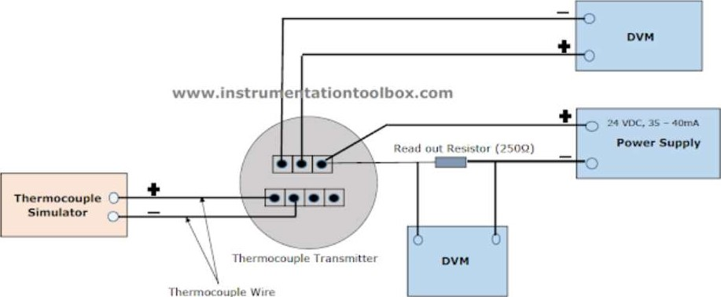
Alternative read out
Thermocouple
Figure 2. 18 Thermocouple transmitter equipment setup

Calibration Procedure:
  - Remove the thermocouple transmitter terminal housing cover
  - If the transmitter is already connected, remove all the thermocouple lead connections.
  - Determine the base and full scale temperatures. Read: How to convert thermocouple millivolt to temperature.
  - Turn power supply on.
  - Consult the thermocouple simulator manual for instructions on setting the thermocouple type and engineering units.
  - Set the simulator to the base (zero) temperature and adjust the zero pot until the output is 4mA or 40mV at the test terminals
  - Set the simulator to the full scale temperature and adjust the span pot until the output is 20mA
  - Repeat steps (1-7) above until both the 4 and 20mA readings are obtained without re-adjusting the span and zero pots.

Smart Transmitters Calibration
Smart transmitter is remarkably different from that of a conventional analog transmitter. Consequently, the calibration methods for both devices are also very different. Remember that calibration refers to the adjustment of an instrument so its output accurately corresponds to its input throughout a specified range. Therefore, a true calibration requires a reference standard, usually in the form of one or more pieces of calibration equipment to provide an input and measure the resulting output. If you got here looking for information on analog pressure transmitter calibration, you may consult:
How to Calibrate Your DP Transmitter
The procedure for calibrating a smart digital transmitter is known as Digital trimming. A digital trim is a calibration exercise that allows the user to correct the transmitter's digital signal to match plant standard or compensate for installation effects. Digital trim in a smart transmitter can be done in two ways:
- A Sensor Trim: It consist of matching the process variable (be it pressure, level, flow or temperature) reading of the transmitter to a precision input. This process normally involves trimming the digital circuit of the input Analog-to-Digital converter in the smart transmitter.
- A 4 - 20mA or Current Loop Trim: This is done by trimming the output Digital-to-Analog converter in the transmitter.
Actions That Do Not Constitute Proper Calibration in Smart Transmitters
Before we discuss in detail what constitute a proper calibration, let us mention certain common practice that are not proper calibrations:
- Changing the range (LRV and IJRV) of a smart transmitter constitute a configuration change and not a calibration. This range change merely affects the mathematical computation done by the microprocessor. It has no effect on the digital process variable as read by a hand-held digital communicator.
- Using only the zero and span adjustments to calibrate a smart transmitter often corrupts the internal digital readings. You may not notice this if you don't use a hand-held digital communicator to read the range or digital process data.
- Using a hand-held digital communicator to adjust the current loop so that an accurate input to the transmitter agrees with some readout device on the loop does not constitute a proper calibration.
Procedure for Calibrating a Smart Transmitter:
To do a proper calibration on a smart transmitter will involve both a sensor trim and/or a 4 - 20m A trim depending on the application where the transmitter is being used. A smart transmitter typically has high and low trim functions which unlike the zero and span adjustments of an analog transmitter, are non-interactive. That is adjusting the high trim function has no effect on the low trim function and vice versa.
Before proceeding to the section below note that a smart transmitter has three outputs which must be clearly understood:
- Digital Process Variable (PV) usually read by a hand-held communicator
- Digital Value of the output current in mA (PVAO) which the communicator also reads.
- The analog 4 - 20mA signal output which can be read with a suitable milliammeter but cannot be read by the digital hand-held communicator. If they are not clearly understood please see: Introduction to Smart Transmitters for a clearer understanding.
For the smart transmitter to be properly calibrated, the error between the applied input to the transmitter and the digital output (PV) must be within the error specification of the manufacturer otherwise a sensor trim will be required to correct this. Similarly, the error between the digital milliamp value (PVAO) and the analog mA value must be within the error specification of the manufacturer otherwise a 4 - 20m A trim is required.
Performing a Sensor Trim:
Before performing a sensor trim, run a test, commonly referred to as the AS-FOUND TEST to confirm the consistency of the sensor and the input Analog-to-Digital converter. Connect the test setup as shown below:
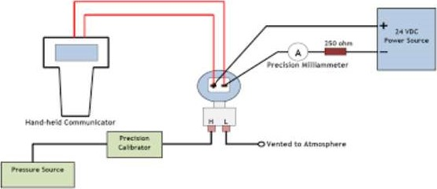
Figure 2. 19 Performing a Sensor Trim on a Smart Transmitter
Use a precision calibrator to measure the applied input to the transmitter. Read the resulting output (PV) with a hand-held communicator. Calculate the resulting error between the applied input and the output (PV) since both are in the same engineering units. Note that the desired accuracy for this test will be the manufacturer's accuracy specification. If this test does not pass, then follow the manufacturer's recommended procedure for trimming the sensor. Below are general guidelines for performing a sensor trim: (a) Apply the lower-range value stimulus to the transmitter, wait for it to stabilize
- Execute the "low" sensor trim function
- Apply the upper-range value stimulus to the transmitter, wait for it to stabilize (d) Execute the "high" sensor trim function
Stimulus as used here should be understood to mean the process variable input to the transmitter.
Performing a 4 - 20mA Trim:
Before performing a 4 - 20mA trim, run a test, commonly referred to as the AS-FOUND TEST to confirm the consistency of the output Digital-to-Analog converter and the analog output of the transmitter. This procedure may also be called a 4-20 mA trim, a current loop trim, or a Digital-to-Analog converter trim. Connect the test setup as shown below:
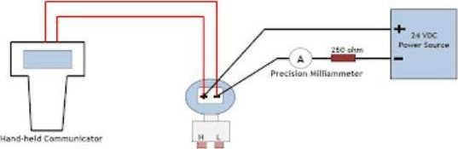
Figure 2. 20 Performing a 4 - 20mA Trim on a Smart Transmitter
Use a hand-held digital communicator to put the smart transmitter into a fixed current output mode. The input value for this test is the mA value that you instruct the transmitter to produce. The output value is obtained using a precision milliammeter to measure the resulting current. Calculate the error between the digital mA value produced by the transmitter and the analog mA value measured by the current meter. The desired accuracy for this test should also reflect the manufacturer's accuracy specification. If the test does not pass, then follow the manufacturer's recommended procedure for trimming the output section. The trim procedure should require two trim points close to or just outside of 4mA and 20 mA. Do not confuse this with any form of re-ranging or any procedure that involves using zero and span buttons on the transmitter. Below are the general guidelines for performing a 4 - 20mA trim:
- Execute the "low" output trim test function on the transmitter.
- Measure the output signal with a precision milliammeter, noting the value after it stabilizes
- Enter this measured current value when prompted by the transmitter
- Execute the "high" output trim test function
- Measure the output signal with a precision milliammeter, noting the value after it stabilizes
- Enter this measured current value when prompted by the transmitter
After both the input and output (ADC and DAC) of a smart transmitter have been trimmed (i.e. calibrated against standard references known to be accurate), the lower- and upper-range values (LRV and URV) may be set. In fact, once the trim procedures are complete, the transmitter may be ranged and ranged again as many times as desired. The only reason for re-trimming a smart transmitter is to ensure accuracy over long periods of time where the sensor and/or the converter circuitry may have drifted out of acceptable limits. The situation is very different in an analog transmitter, where re-ranging necessitates re-calibration.
Transmitter Damping:
Many HART transmitters support a parameter called damping. If this is not set to zero, it can have an adverse effect on tests and adjustments. Damping induces a delay between a change in the transmitter input and the detection of that change in the digital value for the transmitter input reading and the corresponding output value. It is advisable to adjust the transmitter's damping value to zero prior to performing tests or adjustments. After calibration, be sure to return the damping constant to its required value.

I/P or E/P pressure transducer calibration
Before using your I/P or E/P transducer, they must be properly calibrated in your system. Such things as orientation, supply pressure, temperature and flow rates could affect the output pressure, especially with the use of any of our 500 series units. Please find the instruction sheets (see section 2) for your unit below. You can also follow along with the quick start guide or watch the video below on how to calibrate your pressure transducer.
The following quick start calibration guide is for our Type 500 unit.
- Open protective covers to expose Zero and Span adjustment screws.
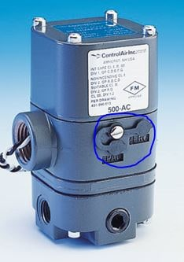
- Make appropriate air supply connections and an accurate pressure gauge to verify calibration results.
- Connect electrical signal and supply the IP or EP with the minimum input signal that corresponds to the lowest psi output range for the unit. IE.. for a 4-20 mA input unit, apply a 4 mA signal to the IP.
- Observe the output pressure and use the “Zero” screw to adjust the minimum output pressure. Turn zero screw counter-clockwise will increase pressure, clockwise to decrease pressure. Please see our calibration guide for proper screw orientation.
- Increase signal to maximum input. IE for a 4-20 mA unit, apply a 20 mA signal.
- Observe the output pressure and use the “Span” screw to adjust the maximum pressure.
- Repeat steps 3 to 6 in order to verify results. Adjust as necessary.
The zero and span screws to demonstrate what they actually control.


Figure 2. 21 zero and span screws adjustment

Current to Pressure Transducer Calibration
Current to Pressure (I/P) Converter Calibration Procedure
A “current to pressure” converter (I/P) converts an analog signal\ (4 to 20 mA) to a proportional linear pneumatic output (3 to 15 psig).
Its purpose is to translate the analog output from a control system into a precise, repeatable pressure value to control pneumatic actuators/operators, pneumatic valves, dampers, vanes, etc.
Principle:
Its force balance principle is a coil suspended in a magnetic field on a flexible mount.At the lower end of the coil is a flapper valve that operates against a precision ground nozzle to create a backpressure on the servo diaphragm of a booster relay. The input current flows in the coil and produces a force between the coil and the flapper valve, which controls the servo pressure and the output pressure.
Calibration:
1. Air Filter Regulator
2. I/P Converter
3. Master Pressure gauge (For Measurement of I/P Output pressure)
4. mA Source (to feed mA to I/P Converter)
Calibration Setup:
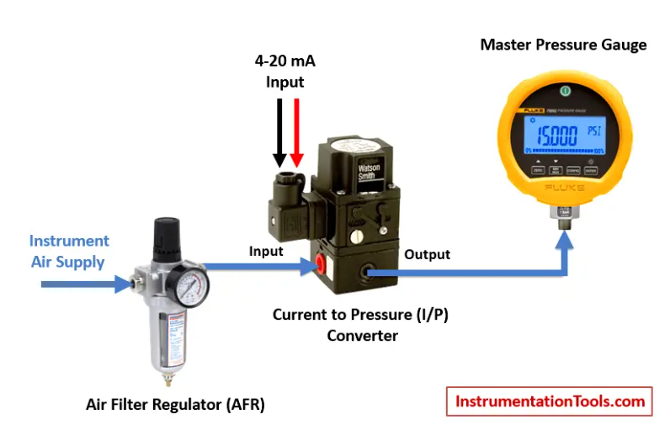
Figure 2. 22 Current to Pressure (I/P) Converter Calibration setup
Calibration Procedure:
- Inlet air supply to be set at 20 psi in AFR
- Feed 4mA from source to I/P converter
- Observe master pressure gauge, it should show 3psi
- If it is not showing (3psi) adjust I/P ZERO up to obtain the 3psi
- Feed 20mA from source to I/P converter
- Observe master pressure gauge , it should show 15 psi
- If it is not showing 15 psi- adjust I/P SPAN up to obtain the 15 psi
- After completion of above procedure again feed 4mA-observe 3psi 20mA-observe 15psi
- Up to achieve the correct output from I/P converter repeat the step 2 to 7.
After calibration following to be done:
- All the readings to be entered in calibration report.
- Calibration sticker to be adhesived.

Calibration of Temperature Sensor with Indicator
Learn the calibration of the temperature sensor with an Indicator with a temperature bath, master sensor, and multi-function calibrator. Temperature Sensor is broadly classified as RTD sensor and Thermocouple Sensor.
  - RTD Sensor is further classified as 2wire, 3wire and 4 wire RTD Sensor
  - Thermocouple Sensor is further classified as Type – B, E, J, K, N, R, S, and T.
Temperature Sensor is connected to Temperature Indicator to display Temperature directly in Units of Temperature i.e. Degree Celsius, Kelvin, Fahrenheit. This calibration procedure can be used for either RTD or thermocouple calibration and validation.
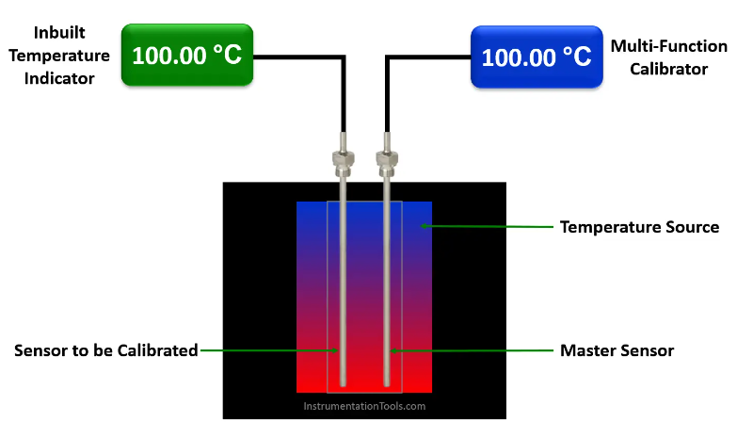
Figure 2. 23 Temperature sensor with indicator
The below 10 steps will help you to calibrate your temperature sensor using a temperature bath and a master sensor.
Step 1: Let’s choose a temperature bath for our calibration.
Even if Temperature Bath has its own Temperature Indicator/display, it cannot be used as a master for Calibration. It is used as the only source, i.e., only to generate and read the temperature in the bath. Another calibrated RTD Sensor or Thermocouple is used for Calibration and this is called a Master sensor. Temperature Bath is selected according to the range of Temperature Sensor.
Step 2:
Insert the Temperature Sensor which is to be calibrated into the temperature bath.
In this article, we considered the temperature sensor to be calibrated to have an inbuilt temperature indicator or display. We use this indicator to note down the temperature readings during the calibration. If the temperature sensor does not have an inbuilt indicator, then we have to connect a multi-function calibrator to read the temperature readings.
Insert the master RTD Sensor/Thermocouple into another slot of the same Temperature Bath.
Connect a calibrated multi-function calibrator to this master sensor to read the sensor output in temperature units like deg C. (as we don’t have an inbuilt indicator in our master sensor we need to connect a device to read the temperature readings) Make sure to insert the above two sensors at equal depth to have the ideal effects of the generated temperature. If you don’t have a multi-function calibrator then you can use calibrated multimeters. Note down the output and do the conversion to temperature using RTD or thermocouple standard temperature tables.
Step 3: Decide the calibration points of the Temperature Sensor before starting the actual calibration. For example, I want to do calibration at these points 50 deg c, 75 deg C, 100 deg C, 125 deg C, and 150 deg C.
Step 4: Set the required setpoint in the temperature bath.
Allow the temperature bath to reach its temperature to the desired setpoint. Let the bath stabilized at the required temperature.
Step 5: Note down Master Sensor reading & Temperature Sensor (unit under calibration) with Indicator reading.
As per our example set 50 deg c in the temperature bath, wait 30 seconds, note down master sensor and UUC readings.
Step 6:
Take 5 Readings of each setpoint at the interval of 30 Seconds.
For example, set 50 deg c in the temperature bath, wait 30 seconds, note down master sensor and UUC readings.
Step 7: If both readings are changing (Master and UUC). Take the average of 5 readings for a single setpoint.
Step 8: Repeat the above step 4 to step 7 for every setpoint or calibration point. That means, do the same calibration steps for 75 deg C, 100 deg C, 125 deg C, and 150 deg C setpoints.
Step 9: After Calibration is completed, set the temperature bath temperature to room temperature.
Step 10: Switch off the temperature bath after reaching room temperature.
If the Temperature bath is switched off directly at a setpoint other than room temperature, it loses accuracy, stability, and uniformity.

LRV and URV settings, digital trim (digital transmitters)
The advent of smart field instruments containing microprocessors has been a great advance for industrial instrumentation. These devices have built-in diagnostic ability, greater accuracy (due to digital compensation of sensor nonlinearities), and the ability to communicate digitally with host devices for reporting of various parameters.
A simplified block diagram of a smart pressure transmitter looks something like this:
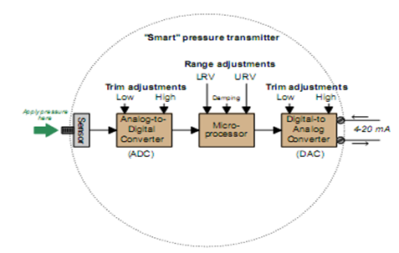
Figure 2. 24 block diagram of a smart pressure transmitter
It is important to note all the adjustments with in this device, and how this compares to the relative simplicity of an all-analog pressure transmitter:
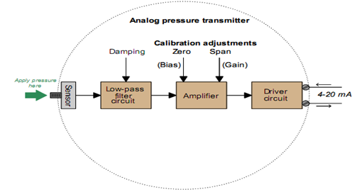
Figure 2. 25 block diagram of analog pressure transmitter
Note how the only calibration adjustments available in the analog transmitter are the zero and span settings. This is clearly not the case with smart transmitters.
Not only can we set lower- and upper-range values (LRV and URV) in a smart transmitter, but it is also possible to calibrate the analog-to-digital and digital-to-analog converter circuits independently of each other.
What this means for the calibration technician is that a full calibration procedure on a smart transmitter potentially requires more work and a greater number of adjustments than an all-analog transmitter.
A common mistake made among students and experienced technicians a like is to confuse the range settings (LRV and URV) for actual calibration adjustments.
Just because you digitally set the LRV of a pressure transmitter to 0.00PSI and the URV to 100.00PSI does not necessarily mean it will register accurately at points within that range!
The following example will illustrate this fallacy.
Suppose we have a smart pressure transmitter ranged for 0 to 100PSIwith an analog output range of 4 to 20mA, but this transmitters pressure sensor is fatigued from years of use such that an Actual applied pressure of 100PSI generates a signal that the analog-to-digital converter interprets as only 96PSI.
Assuming everything else in the transmitter is in perfect condition, with perfect calibration, the output signal will still be in error:
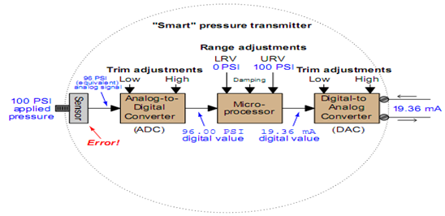
Figure 2. 26 block diagram of a smart pressure transmitter with signal reading
As the saying goes, a chain is only as strong as its weakest link. Here we see how the calibration of the most sophisticated pressure transmitter maybe corrupted despite perfect calibration of both analog/digital converter circuits, and perfect range settings in the microprocessor. The microprocessor thinks the applied pressure is only 96PSI, and it responds accordingly with a 19.36mA output signal. The only way anyone would ever know this transmitter was in accurate at 100PSI is to actually apply a known value of 100PSI fluid pressure to the sensor and note the in correct response. The lesson here should be clear: digitally setting a smart instrument LRV and URV points does not constitute a real calibration of the instrument.
For this reason, smart instruments always provide a means to perform what is called a digital trim on both the ADC and DAC circuits,
- to ensure the microprocessor sees the correct representation of the applied stimulus and
- To ensure the microprocessors output signal gets accurately converted into a DC current, respectively.
Some technicians use the LRV and URV settings in a manner not unlike the zero and span adjustments on an analog transmitter to correct errors such as this.
Following this methodology, we would have to set the URV of the worn-out transmitter to 96PSI instead of 100 PSI, so an applied pressure of 100PSI would give us the 20mA output signal we desire.
In other words, we would let the microprocessor think it was only seeing 96PSI, then skew the URV so it outputs the correct signal anyway. Such an approach will work to an extent, but any digital queries to the transmitter (e.g. using a digital-over-analog protocol such as HART) will result in conflicting information, as the current signal represents full scale (100PSI) while the digital register inside the transmitter shows 96PSI.
The only comprehensive solution to this problem is to trim the analog-to-digital converter so the transmitter’s microprocessor knows the actual pressure value applied to the sensor.
Once digital trims have been performed on both input and output converters, of course, the technician is free to re-range the microprocessor as many times as desired without re-calibration. This capability is particularly useful when re-ranging is desired for special conditions, such as process start-up and shut-down when certain process variables drift into uncommon regions.
Standard in Instrumentation
The next few subsections describe various standards used in instrument shops to calibrate industrial instruments.
- Electrical standards
Electrical calibration equipment used to calibrate instruments measuring voltage, current, and resistance must be periodically calibrated against higher-level standards maintained by outside laboratories.
In years past, instrument shops would often maintain their own standard cell batteries (often called Weston cells) as a primary voltage reference. These special-purpose batteries produced 1.0183volts DC at room temperature with low uncertainty and drift, but were sensitive to vibration and non-trivial to actually use. Now, electronic voltage references have all but displaced standard cells in calibration shops and laboratories, but these references must be checked and adjusted for drift in order to maintain their NIST traceability.
One enormous benefit of electronic calibration references is that they are able to generate accurate currents and resistances in addition to voltage (and not just voltage at one fixed value, either).
Modern electronic references are digitally-controlled as well, which lends them well to automated testing in assembly-line environments, and/or programmed multi-point calibrations with automatic documentation of as-found and as-left calibration data.
If a shop cannot afford one of these useful references for bench top calibration use, an acceptable alternative in some cases is to purchase a high-accuracy multimeter and equip the calibration bench with adjustable voltage, current, and resistance sources. These sources will be simultaneously connected to the high-accuracy multimeter and the instrument under test, and adjusted until the high-accuracy meter registers the desired value.
The measurement shown by the instrument under test is then compared against the reference meter and adjusted until matching (to within the required tolerance).
The following illustration shows how a high-accuracy voltmeter could be used to calibrate a hand held voltmeter in this fashion:
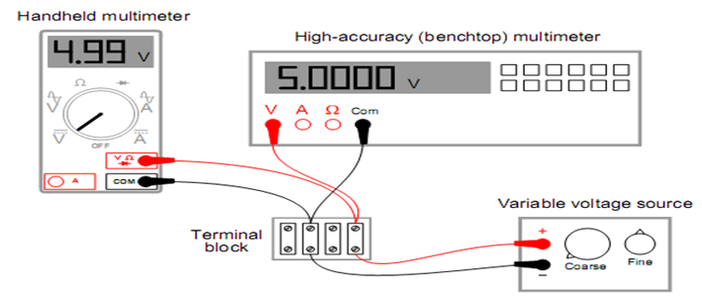
Figure 2. 27 High-accuracy voltmeter for calibration

It should be noted that the variable voltage source shown in this test arrangement need not be sophisticated. It simply needs to be variable (to allow precise adjustment until the high-accuracy voltmeter registers the desired voltage value) and stable (so the adjustment will not drift appreciably overtime).
- Temperature standards
The most common technologies for industrial temperature measurement are electronic in nature: RTDs and thermocouples. As such, the standards used to calibrate such devices are the same standards used to calibrate electrical instruments such as digital multimeters (DMMs).
However, there are some temperature-measuring instruments that are not electrical in nature. This category includes bimetallic thermometers, filled bulb temperature systems, and optical pyrometers.
In order to calibrate these types of instruments, we must accurately create the calibration temperatures in the instrument shop. A time-honored standard for low-temperature industrial calibrations is water, specifically the freezing and boiling points of water.
Pure water at sea level (full atmospheric pressure) freezes at 32degrees Fahrenheit (0 degrees Celsius) and boils at 212 degrees Fahrenheit (100degrees Celsius). In fact, the Celsius temperature scale is defined by these two points of phase change for water at sea level.
To use water as a temperature calibration standard, simply prepare a vessel for one of two conditions:
- thermal equilibrium at freezing or
- thermal equilibrium at boiling.
Thermal equilibrium in this context simply means equal temperature throughout the mixed-phase sample.
In the case of freezing, this means a well-mixed sample of solid ice and liquid water.
In the case of boiling, this means a pot of water at a steady boil (vaporous steam and liquid water in direct contact).
Temperature calibration provides a means of quantifying uncertainties in temperature measurement in order to optimize sensor and/or system accuracies.
Uncertainties result from various factors including:
a) Sensor tolerances which are usually specified according to published standards and manufacturers specifications.
b) Instrumentation (measurement) in accuracies again specified in manufacturers specifications.
c) Drift in the characteristics of the sensor due to temperature cycling and ageing.
d) Possible thermal effects resulting from the installation, for example thermal voltages created at interconnection junctions.
A combination of such factors will constitute overall system uncertainty. Calibration procedures can be applied to sensors and instruments separately or in combination.
Calibration can be performed to approve recognized standards (National and International) or may simply constitute checking procedures on an “in-house” basis.
Temperature calibration has many facts, it can be carried out thermally in the case of probes or electrically (simulated) in the case of instruments and it can be performed directly with certified equipment or indirectly with traceable standards.
Thermal (temperature) calibration is achieved by elevating (or depressing) the temperature sensor to a known, controlled temperature and measuring the corresponding change in its associated electrical parameter (voltage or resistance). The accurately measured parameter is compared with that of a certified reference probe; the absolute difference represents a calibration error. This is a comparison process. If the sensor is connected to a measuring instrument, the sensor and instrument combination can be effectively calibrated by this technique.
Absolute temperatures are provided by fixed point apparatus and comparison measurements are not used in that case.
Electrical Calibration is used for measuring and control instruments which are scaled for temperature or other parameters. An electrical signal, precisely generated to match that produced by the appropriate sensor at various temperatures is applied to the instrument which is then calibrated accordingly. The sensor is effectively simulated by this means which offers a very convenient method of checking or calibration.
A wide range of calibration “simulators” is available for this purpose; in many cases, the operator simply sets the desired temperature and the equivalent electrical signal is generated automatically without the need for computation. However this approach is not applicable to sensor calibration for which various thermal techniques are used.
- Pressure standards
In order to accurately calibrate a pressure instrument in a shop environment, we must create fluid pressures of known magnitude against two broad categories:
- devices that inherently produce known pressures
- devices that accurately measure pressures created by some (other) adjustable source.
A dead weight tester (sometimes referred to as a dead- test calibrator) is an example in the former category. These devices create accurately known pressures by means of precise masses and pistons of precise area:
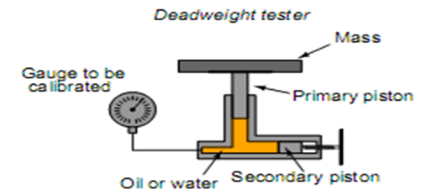
Figure 2. 28 Dead- test calibrator
After connecting the gauge (or other pressure instrument) to be calibrated, the technician adjusts the secondary piston to cause the primary piston to lift off its resting position and be suspended by oil pressure alone. So long as the mass placed on the primary piston is precisely known, Earth’s gravitational field is constant, and the piston is perfectly vertical, the fluid pressure applied to the instrument under test must be equal to the value described by the following equation:
P=F/A
Where,
P=Fluid pressure
F=Force exerted by the action of gravity on the mass (F _{weight} = mg)
A=Area of piston
The primary piston area, of course, is precisely set at the time of the dead weight tester’s manufacture and does not change appreciably throughout the life of the device.
Pneumatic dead weight tester. In these devices, a constant flow of gas such as compressed air or bottled nitrogen vents through able port operated by the primary piston.
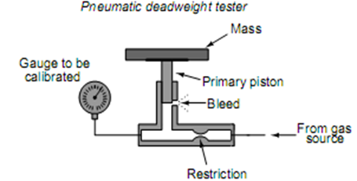
Figure 2. 29 Pneumatic dead weight tester
For low-pressure calibrations, the simple manometer is a much more practical standard. Manometers, of course, do not generate pressure on their own. Connect both devices to a source of variable fluid pressure, typically instrument air through a precision pressure regulator:
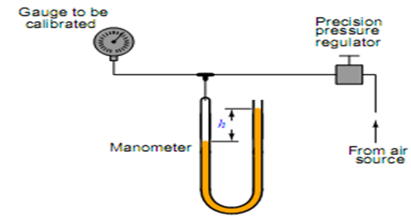
Figure 2. 30 Manometer
The difference in liquid column heights (h) within the manometer shows the pressure applied to the gauge. So long as the manometers liquid density is precisely known, Earth’s gravitational field is constant, and the manometer tubes are perfectly vertical, the fluid pressure indicated by the manometer must be equal to the value described by the following equation (two different forms given):
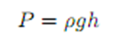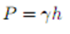
With pressure-measuring test instruments of suitable accuracy (preferably NIST- traceable), the same sort of calibration jig maybe used for virtually any desired range of pressures:
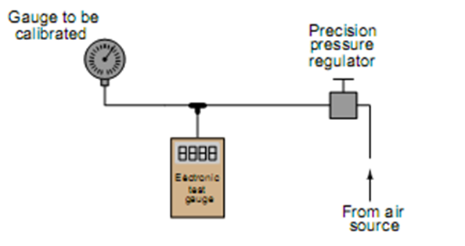
Figure 2. 31 Electronic manometers
The electronic test gauge is designed for very low pressures (inches of water column), they are sometimes referred to as electronic manometers.
- Test equipment suitable for field pressure calibrations includes lack-tube manometers made from flexible plastic tubing hung from any available anchor point near eye level, and test gauges typically of the helical bourdon tube variety.
- Portable electronic test gauges are also available for field use, many with built-in hand pumps for generating precise air pressures.
- A pneumatic pressure calibrator for field use was a device manufactured by the Wallace & Tiernan Corporation, affectionately called a Wally box by at least one generation of instrument technicians.
It consisted:
- a large dial pressure gauge (several inches in diameter)
- multi-turn needle and a very fine scale,
- Connected to a network of valves and regulators which were used to set different air pressures from any common compressed air source. The entire mechanism was housed in an impact-resistance case for ruggedness.
- One of the many nice features of this calibration instrument was a selector valve allowing the technician to switch between two different pressures output by independent pressure regulators.
- Once the two pressure regulator values were set to the instruments lower-and upper-range values (LRV and URV), it was possible to switch back and forth between those two pressures at will, making the task of adjusting an analog instrument with inter active zero and span adjustments much easier than it would have been to precisely adjust a single pressure regulator again and again.
- Flow standards
Most forms of continuous flow measurement are inferential; that is, we measure flow indirectly by measuring some other variable (such as pressure, voltage, or frequency) directly.
In the case of an orifice plate used to measure fluid flow rate, this would mean calibrating the differential pressure transmitter to measure pressure accurately and replacing the orifice plate if it shows signs of wear. Direct validation of flow measurement accuracy is needed.
Most techniques of flow rate validation take the form of measuring accumulated fluid volume over time.
For simple validation of liquid flow rates, the flow maybe diverted from its normal path in the process and into a container where either accumulated volume or accumulated weight maybe measured overtime.
If the rate of flow into this container is constant, the accumulated volume (or weight) should increase linearly overtime.
- The actual flow rate may then be calculated by
- 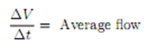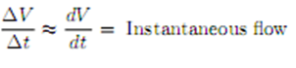
The accuracy of this technique rests on some additional factors, though:
• The accuracy of the level transmitter (as a volume measuring instrument).
• The ability to ensure only one flow path in or out of that vessel.
- Direct flow validation is the use of a device called a flow prover.
A flow prover is a precision piston-and-cylinder mechanism used to precisely measure a quantity of liquid overtime. Process flow is diverted through the prover, moving the piston over time.
Sensors on the prover mechanism detect when the piston has reached certain positions, and time measurements taken at those different positions enable the calculation of average flow.
- Analytical standards
An analyzer measures intrinsic properties of a substance sample such as its density, chemical content, or purity. In order to calibrate an analyzer, we must expose it to known quantities of substances with the desired range of properties (density, chemical composition, etc.).
The calibration of a pH analyzer PH is the measurement of hydrogen ion activity in an aqueous solution. The standard range of measurement is 0pH to 14pH, the number representing a negative power of 10 approximately describing the hydrogen ion morality of the solution
The pH of a solution is typically measured with a pair of special electrodes immersed in the solution, which generate a voltage proportional to the pH of the solution. In order to calibrate a pH instrument, you must have a sample of liquid solution with a known pH value.
For pH instrumentation, such calibration solutions are called buffers, because they are specially formulated to maintain stable pH value seven in the face of (slight levels of) contamination.
PH buffers may be purchased in liquid form or in powder form.
Liquid buffer solutions maybe used directly out of the bottle, while powdered buffers must be dissolved in appropriate quantities of de-ionized water to generate a solution ready for calibration use.
- Pre-mixed liquid buffers are convenient to use, but have a fairly limited shelf life.
- Powdered buffer capsules are generally superior for long-term storage, and also enjoy the advantage of occupying less storage space in their dry state than a liquid buffer solution.
- The following photograph shows a few 7.00pH (+/- 0.02pH) buffer capsules ready to be mixed with water to form a usable buffer solution:
After preparing the buffer solution in a cup, the pH probe is inserted into the buffer solution and given time to stabilize. One stabilized, the pH instrument maybe adjusted to register the proper pH value. Buffer solutions should not be exposed to ambient air for any longer than necessary (especially alkaline buffers such as 10.0pH) due to contamination.
Pre-mixed liquid buffer storage containers should be capped immediately after pouring into working cups. Used buffer solution should be discarded rather than re-used at a later date.
- Analyzers designed to measure the concentration of certain gases in air must be calibrated in a similar manner.
- Oxygen analyzers, for example, used to measure the concentration of free oxygen in the exhaust gases of furnaces, engines, and other combustion processes must be calibrated against known standards of oxygen concentration.
An oxygen analyzer designed to measure oxygen concentration over arrange of ambient (20.9% oxygen) to 0% oxygen maybe calibrated with ambient air as one of the standard values, and a sample of pure nitrogen gas (containing 0% oxygen) as the other standard value.
An oxygen analyzer intended for the measurement of oxygen concentrations in excess of ambient air would require a different standard, most likely a sample of 100% pure oxygen, as a calibration reference.
An analyzer designed to measure the concentration of hydrogen sulfide (H₂S), a toxic gas produced by an aerobic bacterial decomposition of organic matter, will require a sample of gas with a precisely known concentration of hydrogen sulfide mixed in it as a calibration reference.
A typical reference gas concentration might be 25 or 50 parts per million (ppm).
Gas mixtures with such precise concentration values as this may be purchased from chemical laboratories for the purpose of calibrating concentration analyzers, and are often referred to as span gases because they are used to set the span of analyzer instruments.
A self-calibration system is a system of solenoid (electrically controlled on-off) valves and reference gas bottles setup in such a way that a computer is able to switch the analyzer off-line and subject it to standard reference gases on a regular schedule to check calibration.
Many analyzers are programmed to automatically calibrate themselves against these reference gases, thus eliminating tedious work for the instrument technician.
A typical self-calibration system for a gas analyzer might look like this:
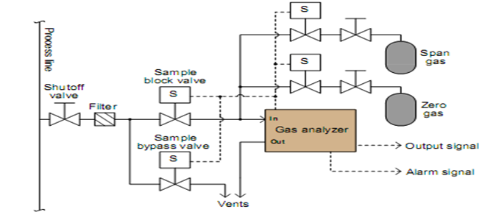
Figure 2. 32 Typical self-calibration gas analyzer
The gas analyzer is equipped with its own auto-calibration controls and programming, allowing it to periodically shut off the process sample and switch to known reference gases for ‘zero’ and ‘span’ calibration checks.
If these checks indicate excessive drift or any other questionable results, the analyzer has the ability to a gas maintenance alarm to alert an instrument technician to a potential problem that may require servicing.

Maintain configured and calibrated devices
There are five types of maintenance for machines and equipment:
  - Preventative maintenance: This type of maintenance is performed at appropriate intervals to prevent malfunction and should be proactive rather than reactive. It includes cleaning, lubrication, inspection, calibration, and replacement of worn parts.
  - Predictive maintenance: This type of maintenance is performed by monitoring the condition of the equipment to predict when maintenance is required. It includes vibration analysis, oil analysis, and thermography.
  - Corrective maintenance: This type of maintenance is performed after a failure has occurred. It includes repair or replacement of the failed component.
  - Routine maintenance: This type of maintenance is performed on a regular basis to ensure that the equipment is operating correctly. It includes cleaning, lubrication, inspection, and calibration.
  - Emergency maintenance: This type of maintenance is performed in response to an unexpected failure or breakdown. It includes repair or replacement of the failed component.

To maintain configured and calibrated devices, you need to perform calibration and preventative maintenance procedures. Calibration is a process of comparing the output of measuring instruments and devices against the input signal of a standard, verified instrument. It detects and identifies any error in the device under test. Preventative maintenance is a type of maintenance that is performed at appropriate intervals to prevent malfunction and should be proactive rather than reactive.
Calibration programs are required by regulatory authorities for equipment used in industries like power plants, oil & gas, cement, manufacturing, processing, packing, etc. Calibration requirements for laboratory instruments include specific directions, schedules, limits of accuracy and precision, remedial actions, and systems to prevent usage of instruments failing calibration.
Qualified individuals responsible for calibrating and maintaining instrumentation should exist. A second person check of all calibration and maintenance should be performed. The calibration program and procedures should be reviewed and approved by quality. An instrument/equipment master list system should be established for identification of all master equipment related to instrumentation in a manufacturing/process area or laboratory. Retired equipment records pertaining to retired/obsolete equipment must be kept according to the company’s records retention procedures.
Calibration: A comparison of two instruments or measuring devices one of which is a standard of known accuracy (traceable to national standards) to detect, correlate, report or eliminate by adjustment, any discrepancy in accuracy of the instrument measuring device being compared to the standard.
- Calibration Programs Required by Regulatory Authorities
“Automatic, mechanical, or electronic equipment or other types of equipment, including computers, or related systems that will perform a function satisfactorily, may be used in the industries like power plant, oil & gas, cement, manufacture, processing, packing etc. If such equipment is so used, it shall be routinely calibrated, inspected, or checked according to a written program designed to assure proper performance.
- Maintenance at appropriate intervals to prevent malfunction & shall be “preventative” not “reactive” maintenance.
- Calibration requirements for Laboratory Instruments
- Specific Directions
- Schedules
- Limits of accuracy & precision
- Remedial Actions
- Systems to prevent usage of instruments failing calibration
• “Control, weighing, measuring, monitoring and test equipment that is critical for assuring the quality of intermediates or APIs should be calibrated according to written procedures and an established schedule.
Each Manufacturing / Process Area:
- Written calibration procedures that use traceable calibration standards or calibration equipment.
- Preventive maintenance procedures and / or referenced manuals
- Qualified individuals (having the appropriate education, training, background and experience) responsible for calibrating & maintaining instrumentation
- Second person check of all calibration and maintenance
- Qualified individuals responsible for monitoring the calibration and maintenance program.
- Ensure the calibration program and procedures are reviewed and approved by Quality
Instrument / Equipment Master List
- System for identification of all Master equipment related to instrumentation in a manufacturing/process area or laboratory
- Include instrumentation details (serial number, model number & location)
- If automation components are tracked separately through the configuration management then it is not necessary to include (must verify)
- Procedures must exist that identify the calibration and maintenance requirements for each instrumentation / equipment on the master list
Retired Equipment
- Records pertaining to retired / obsolete equipment must be kept according to company’s records retention procedures
- Records should include date the unit was retired, person responsible and the reason for retirement / discard
Instrument Identification & Calibration Status
- Each instrument given a unique identifier
- Instrumentation details associated with this number must be documented and available (e.g. serial number, model number, location, etc.)
- Each instrument should be labeled with the unique identifier
- Calibration status of each instrument , the date of calibration, the next calibration date and the identification of person performing calibration should be readily available
- Appropriate systems to document calibration status include calibration logs, MAXIMO, and calibration stickers
- System must be in place to prevent use of an instrument that is not qualified, unusable due to damage or malfunction, or has exceeded its established calibration interval
- System must be in place that identifies instruments that do not require calibration to be performed beyond the original or factory calibration to distinguish from those instruments that do require scheduled calibrations
Documentation required for excluding equipment
Traceability of Standards / Calibration Equipment
- Calibration reference standards / calibration equipment shall be traceable to national standards and be accompanied by certificates of traceability / analysis
- If recognized standards are not available, an independent reproducible standard may be used
- The calibration tolerance of a given standard should be as tight or tighter than the tolerance of the instrument to be calibrated
- A procedure must be in place to ensure tracking and monitoring of standard’s expiration date and re-calibration / re-certification requirements
- Re-calibration records must be retained
Instrument Calibration Tolerances
Instrument calibration tolerance limits should be established so problems are identified and corrected in a timely manner
When assigning tolerances, considerations given to:
- Capability of the instrument being calibrated (what the manufacturer/OEM claims the instrument can achieve).
- Parameters at which the instrument operates (ex: if testing accuracy of + 0.5% is required, the instrument calibration tolerances should be <0.5%)
- Work environment – environmental conditions can affect the performance of the instrumentation
Practice of using “Alert” & “Action” levels
“Alert” Tolerance (“Adjustment Limit”)
- Related to instrument performance
- Level at which the instrument is adjusted back into range
- Not required – an industry “best practice”
“Action” Tolerance (“Calibration Limit” or “Out-of-Tolerance”)
- Tied to process performance
- Level at which the potential for product impact exists
- Possible atypical investigation or reporting is required
Deviations beyond “Alert” level but not at “Action” level would not require investigation – May require adjustment, changes to PMs
Setting of “Alert” and “Action” levels should be described in SOPs, be defendable and have Quality review and approval
Calibration and Maintenance Frequencies
May be determined for individual instruments or groups of instruments (similarity of construction, reliability, and stability)
Considerations when determining calibration frequency:
- Accuracy of the measurement / instrument range
- Consequences of incorrect value caused by out of calibration
- Extent & criticality of use of the instrument & tendency to wear and drift
- The manufacturer’s/OEM’s recommendations
- Environmental & physical conditions (temperature, humidity, vibration)
- Previous calibration records, history of calibration problems & repair history
- Frequency of calibration checks prior to use or in-between intervals
- Redundant / back-up systems (provides secondary source of information available from other calibrated primary instruments)
- Results of Qualification studies
- Process requirements
- Availability of built-in / automatic calibration checks
Changes to frequency must be approved per change control SOPs
References to specific instrument procedures listed in compendium (USP, BP or EP) for calibration tests for specific laboratory instruments
Calibration time “windows” should be established around calibration due dates
- Policy for Calibration and Maintenance Intervals & Schedules Include:
- Extending Intervals
- Reducing Intervals
- Maximum Intervals
- Maintenance Requirements
  - Manufacturer’s/OEM’s recommendations
  - Parts that wear: gaskets, seals & bearings
  - Parts requiring periodic replacement: filters, belts & fluids
- Parts requiring periodic inspection and cleaning
- Parts requiring periodic adjustments, tightening and lubrication
- Calibration and Maintenance Procedures
- Shall include specific directions and limits for accuracy & precision
- Shall include guidance for remedial action when accuracy & precision limits are not met
- Normally provided in the manufacturer’s/OEM’s manuals
- Some compendial requirements exist for some specific laboratory instrumentation
- Performance checks (e.g. system suitability, daily balance performance checks) are NOT suitable substitutes for regularly scheduled calibrations
Each calibration & maintenance procedure should include the following:
- Identification of department responsible to perform the calibration or maintenance
- Step-by-step calibration instructions, reference to appropriate calibration procedures or instrument manuals
- Methods for preventive maintenance or reference to appropriate instrumentation manuals
- Calibration equipment used in the calibration (e.g. spectroscopy filters, voltmeters, digital thermometers, etc)
- Calibration parameter and tolerance ( ± )
Each calibration & maintenance procedure should include the following:
- Required environmental controls or conditions, where appropriate
- Provisions for adjustments, if needed
- Requirement for recording actual measurements before (“as found”) and after adjustment or preventive maintenance (“as left”)
- Actions to be taken if instrumentation cannot be calibrated (e.g. contact appropriate service people, label and remove from service)
- A step to record all calibration & maintenance activities.
Note : “as found” recordings are not required where routine performance checks are available to provide evidence indicating instrument is operating properly and is suitable for use.
Use of Contractors / Vendor Service Personnel
- Must have a procedure for approving contractor activities
- Contractors must have appropriate training / qualification
- Responsible to review & approve the contractors calibration and maintenance procedures.
- Responsible to perform actions or steps not part of the contractors procedures.
Calibration & Maintenance Records
- All calibration records must be retained per document retention procedures
- Should include “as found” measurements, results of adjustments (“as left”) and appropriate review & approval of all results
- Tolerance or limit for each calibration point
- Identification of standard or test instrument used
- Identification of persons performing the work and checking the results with dates
- Review must ensure the approved activities have been completed and all results have passed the established acceptance criteria
- Periodic review of historic calibration & maintenance data to evaluate appropriateness of established frequencies

Unplanned events or conditions
Accidents, Malfunctions and Unplanned Events
Accidents, Malfunctions and Unplanned Events refers to events or upset conditions that are not part of any activity or normal operation of the Project as has been planned by North cliff. Even with the best planning and the implementation of preventative measures, the potential exists for accidents, malfunctions or unplanned events to occur during any Project phase, and if they occur, for adverse environmental effects to result if these events are not addressed or responded to in an environmentally appropriate manner. Many accidents, malfunctions and unplanned events are, however, preventable and can be readily addressed or prevented by good planning, design, emergency response planning, and mitigation. By identifying and assessing the potential for these events to occur, North cliff can also identify and put in place prevention and response procedures to minimize or eliminate the potential for significant adverse environmental effects, should an accidental event occur. The Project is being designed, and will be constructed and operated, according to best practice for health, safety, and environmental protection to minimize the potential environmental effects that could result from the Project, as well as those that could result from accidents, malfunctions or unplanned events. Prevention and mitigation will be accomplished by the following general principles:
- Us e best management practices and technology for carrying out the Project while controlling permitted/allowable releases to the environment and consequent environmental effects;
- Incorporate safety and reliability by design, and application of principles and practices of process and mine safety management;
- Develop and apply procedures and training aimed at safe operation of the facilities that prevent or avoid the potential upsets that might lead to accidents, malfunctions or unplanned events; and
- Implement effective emergency preparedness and response.

Self-check (2.2)
Directions: For the following questions, say TRUE if the statement is correct and FALSE if it is incorrect (wrong).
- Seaward PV150 is multi-function PV system tester.
- Performance testing verifies the correct polarity for PV dc circuits.
- Polarity testing verifies the system power and energy output.

Instruction 2: Choose the correct answer for the following question

  - What are the common types of testing conducted on PV systems?

      - Continuity and resistance testing
      - Polarity testing
      - Performance testing
      - All are correct answer

  - Conditioning control devices and controllers can involve the following except,

      - Access control systems
      - Level controllers
      - Electrical calibration
      - Process variable

Instruction 3: match the correct answer under column B to Column A

A | B
- Random Errors | - refers to the adjustment of an instrument
- Accuracy | - the region between the limits within which a quantity is measured
- Calibration ranges | - Permissible deviation from a specified value
- Drift | - occurs when the instrument responds differently to an increasing input compared to a decreasing input
- Tolerance | - tasks associated with establishing an accurate correspondence
- Calibration | - The ratio of the error to the full-scale output
- Dynamic error | - occurs when the input to the system is constant but the output tends to change slowly
- hysteresis calibration error | - caused by limitations of the measuring device
 | - caused by the instrument not responding fast enough
- Static error | - caused by random variations in the system under study

Self-check (2.2)
Instruction: Discuses & explain the following questions
- List down the purpose of Calibration
- List any types of instrument error
- Define a five-point calibration for an instrument
- What is the purpose of calibration?
- What are the three basic steps involved in the calibration of an instrument?
- What is a live zero?
- Write an equation for instrument Calibration of Zero and span adjustments?
- What are two adjustments on the actual instrument?
- The two adjustments in analog instruments are interactive, what does it mean?
- How can damping digital transmitters & pneumatic transmitters?
- What are the types of instruments?
- Write the calibration procedure for a linear instrument?
- What is Up- down calibrations?
- What is the set-point or trip-point calibration adjustment?
- Write the d/t b/n set-point & a dead band adjustment?

Operation sheet (2.1)

Pressure transmitter Calibration
Introduction
pressure is an important physical quantity. In industries it should be maintained ,controlled, monitored at specific readings so that’s why pressure transmitters are so important in industries. so calibration of pressure transmitter is what we are going to discuss now.
  - Equipment’s required for calibration of pressure transmitter
- Pressure transmitter,
- Multi meter,
- HART communicator

Basic procedure for calibration
- Isolate the Pressure Transmitter from the Process.
- Slowly open the vent plug and the vent valve to release the pressure.
- Connect the multimeter with the transmitter and ensure that output is 4ma when 0 pressures is applied.
- Connect the hand held test pump (pressure source) to the transmitter.
- Ensure there is no leak.
- Apply pressure range at 0%, 25%, 50%, 75%, 100% and check there is any error.
- If there is any error calibration should be done.

If transmitter is analog transmitter
- Apply 0% pressure as per LRV with hand held test pump and check multimeter if it is not 4ma adjust the zero pot in the transmitter and correct transmitter output to 4ma
- Apply 100%pressure as per the URV and correct 20ma in multimeter by adjusting span pot in the transmitter
- Repeat these steps to rectify error.

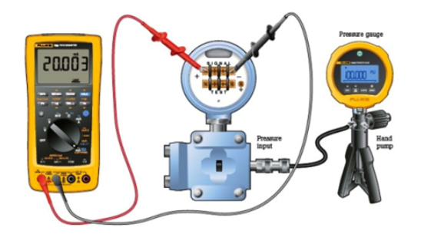
In case of SMART Transmitter
- We have to use HART communicator, connect the communicator with the transmitter select the HART Communicator Menu for lower range value trim and upper range value trim.
- Basic Set up – Calibration – Zero Trim/Sensor Trim —Lower/Upper range value trims.
- HART communicator will automatically calibrate the transmitter.
- Restore the process connection
- Take the transmitter on line. Ensure there is no leak

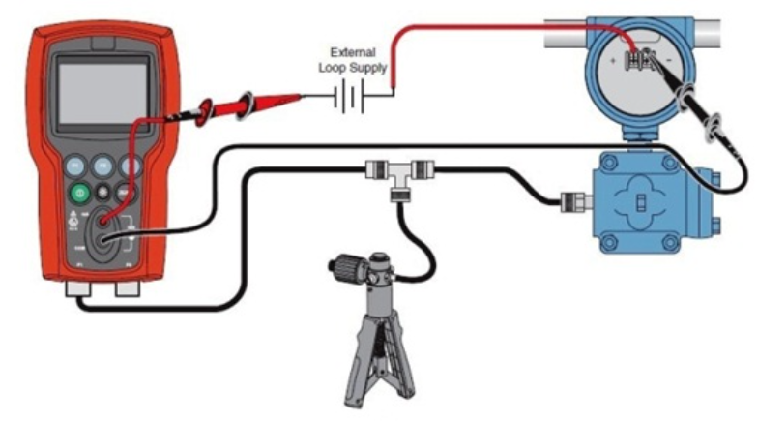
small example of five-point calibration is given below
Low range value=0psi
upper range value=200psi

Operation sheet (2.2) ------------- Calibration of P/I converter.
Current to Pressure (I/P) Converter Calibration Procedure
A “current to pressure” converter (I/P) converts an analog signal\ (4 to 20 mA) to a proportional linear pneumatic output (3 to 15 psig).
Its purpose is to translate the analog output from a control system into a precise, repeatable pressure value to control pneumatic actuators/operators, pneumatic valves, dampers, vanes, etc.
Principle:
Its force balance principle is a coil suspended in a magnetic field on a flexible mount. At the lower end of the coil is a flapper valve that operates against a precision ground nozzle to create a backpressure on the servo diaphragm of a booster relay. The input current flows in the coil and produces a force between the coil and the flapper valve, which controls the servo pressure and the output pressure.
Calibration:
1. Air Filter Regulator
2. I/P Converter
3. Master Pressure gauge (For Measurement of I/P Output pressure)
4. mA Source (to feed mA to I/P Converter)
Calibration Setup:
Calibration Procedure:
- Inlet air supply to be set at 20 psi in AFR
- Feed 4mA from source to I/P converter
- Observe master pressure gauge, it should show 3psi
- If it is not showing (3psi) adjust I/P ZERO up to obtain the 3psi
- Feed 20mA from source to I/P converter
- Observe master pressure gauge, it should show 15 psi
- If it is not showing 15 psi- adjust I/P SPAN up to obtain the 15 psi
- After completion of above procedure again feed 4mA-observe 3psi 20mA-observe 15psi
- Up to achieve the correct output from I/P converter repeat the step 2 to 7.
After calibration following to be done:
- All the readings to be entered in calibration report.
- Calibration sticker to be adhesived.

UNIT 3. Inspect, test and calibrate instruments and control devices
This learning guide is developed to provide you the necessary information regarding the following content coverage and topics:
- Calibration work inspection
- Examine instrumentation and control devices
- Report result
This guide will also assist you to attain the learning outcome stated in the cover page. Specifically, upon completion of this Learning Guide, you will be able to:
- Undertake final inspections to ensure that the calibration is done
- Check and test instrumentation and control devices
- Prepare Report

Calibration work inspection
Control of Inspection, Measuring, & Test Equipment
Purpose:
To establish and maintain the documented procedures used to control, calibrate, and maintain inspection, measuring, and test equipment.
Explanation:
The supplier shall develop procedures for the proper use and validation of inspection equipment.
Supplier Responsibilities:
The supplier shall establish and maintain documented procedures to control, calibrate, and maintain inspection, measuring, and test equipment (including test software) used by the supplier to demonstrate the conformance of product to the specified requirements. Inspection, measuring and test equipment shall be used in a manner which ensures that the measurement uncertainty is known and is consistent with the required measurement capability.
Where test software or comparative references such as test hardware are used as suitable forms of inspection, they shall be checked to prove that they are capable of verifying the acceptability of product, prior to release for use during production, installation, or servicing, and shall be rechecked at prescribed intervals. The supplier shall establish the extent and frequency of such checks and shall maintain records as evidence of control.
Where the availability of technical data pertaining to the inspection, measuring, and test equipment is a specified requirement, such data shall be made available, when required by HTNA, for verification that the inspection, measuring, and test equipment is functionally adequate.
Note: The term “measuring equipment” includes measurement devices.
Control Procedure:
The supplier shall:
    - Determine the measurements to be made and the accuracy required, and select the appropriate inspection, measuring and test equipment that is capable of the necessary accuracy and precision.
    - Identify all inspection, measuring and test equipment that can affect product quality, and calibrate and adjust them at prescribed intervals, or prior to use, against certified equipment having a known valid relationship to internationally or nationally recognized standards. Where no such standards exist, the basis used for calibration shall be documented.
    - Define the process employed for the calibration of inspection, measuring and test equipment, including details of equipment type, unique identification, location, and frequency of checks, check method, acceptance criteria and the action to be taken when results are unsatisfactory.
    - Identify inspection, measuring and test equipment with a suitable indicator or approved identification record to show the calibration status.
    - Maintain calibration records for inspection, measuring and test equipment.
    - Assess and document the validity of previous inspection and test results when inspection, measuring or test equipment is found to be out of calibration.
    - Ensure that the environmental conditions are suitable for the calibrations, inspections, measurements and tests being carried out.
    - Ensure that the handling, preservation and storage of inspection, measuring and test equipment is such that the accuracy and fitness for use is maintained.
    - Safeguard inspection, measuring and test facilities, including both test hardware and test software, from adjustments which would invalidate the calibration setting.
Inspection, Measuring, and Test Equipment Records:
The Supplier Quality System Requirements reflect the International standards Calibration/Verification Records.
Records of the calibration / verification activity on all gages, measuring, and test equipment, including employee-owned gages, shall include:
- Revisions following engineering changes (if appropriate).
- Any out of specification reading as received for calibration.
- Statement of conformance to specification after calibration.
Notification to customer if suspect material has been shipped

Examine instrumentation and control devices
Visual and Technical Checking of Instrumentation and Control System defines the minimum requirements for initial inspection, loop check, and commissioning of control systems during new plant construction, as well as those inspections, loop checks, and commissioning that might be necessary following major revisions/modifications or repair.
This topic outlines specific steps that need to be taken in the course of Calibration. The document is organized so that key sections may be extracted to be used as instructions for that identified task.
This standard applies globally to all control systems undergoing initial inspection, loop checking, and commissioning.
    - Visual inspection of devices
Typically, physical inspection is the first task to be performed once an instrument is turned over from construction. Physical inspections do not have to be done in conjunction with loop checking but depending on manpower and instrument location, physical inspections and loop checking may be done at the same time. At a minimum, physical inspections must be documented to provide evidence of what was checked and whether the device passed or failed. It is recommended that field inspection reports be filled out for every piece of instrumentation. Failed devices shall be corrected before proceeding to loop check.
- General Inspection Checks:
  - Transmitter support stands installed
  - Proper wiring, glancing, and conduit connection such as low point drains, grounding, shielding and terminations, and bottom cabinet entry
  - Verify proper labeling of all tags, warning signs, pressure ratings, etc…
  - Confirm all covers, screws, fittings, etc. are installed and properly tightened
  - Look for signs of moisture and/or corrosion in electrical conduit and process impulse line
  - Wire terminations are tightened

- Pressure Transmitters Checking:
Verify sensing line size, material, slope, tap orientation, adequate supports, etc.
- Proper installation of all compression fitting.
- Root valves installation and location.
- Manifold valve selection and proper installation.
- Verify sufficient impulse line length for heat transfer.
- Verify loop seals where required.
- Verify configuration according to specification sheet.
- Instrument accessible for routine maintenance and correctly supported
- Environment acceptable, vibration, heat, splash, etc.
- Heat traced if necessary.
- Verify proper electrical connections.
- DP (level and flow) Transmitters and orifice plate Checking:
- Verify beta ratio and flow direction for orifice plates directly from the handle or nameplate.
- Verify sensing line size, material, slope, tap location, adequate supports, etc.
- Verify HI/LO pressure tap location relative to gas or liquid measurement.
- Proper installation of all compression fitting.
- Root valves installation and location.
- Manifold valve selection and proper installation.
- Inspect and confirm all sealed capillary sensing systems used for level measurement against instrument specification.
- Verify sufficient impulse line length for heat transfer.
- Verify loop seals where required.
- Verify configuration according to specification sheet.
- Instrument accessible for routine maintenance.
- Instrument correctly supported.
- Environment acceptable, vibration, heat, splash, etc.
- Heat traced if necessary.
- Verify proper electrical connections.
- Temperature Element/ Transmitters Checking:
- Verify insertion length within process pipe and ensure firm contact with bottom of well.
- Verify that either RTD or T/C elements are connected and properly terminated to the transmitter
- Verify T/C element type and extension wire type according to specification
- Verify proper grounding and shielding according to specification and electrical installation drawings
- Confirm that all threaded connections are tight (for example, nipple-union-nipple, head cover and gasket)
- Verify transmitter configuration according to specification sheet
- Instrument accessible for routine maintenance
- Instrument correctly supported
- Environment acceptable, vibration, heat, splash, etc.
- Heat traced if necessary
- Verify proper electrical connections
- Control Valves Checking:
- Verify control valve flow direction.
- Ensure proper installation of all tubing, fittings, and solenoid valves.
- Verify positioner and solenoid wiring for proper connections and tagging.
- Inspect overall installation of valve body and actuator. Look for signs of overstressed piping or improper actuator installation causing unnecessary stress.
- For rotary valves, ensure actuator rotation is indexed correctly with valve rotation.
- Verify installation of bug screens or other means of preventing water ingress for all vented openings.
- Check fails action.
- Verify start-up flush kit has been removed where applicable.
- Verify all other ancillary valve equipment functions properly.
- Verify configuration according to specification sheet.
- Instrument accessible for routine maintenance, actuator removal, bonnet and plug removal, hand wheel operation, positioner maintenance, and solenoid maintenance.
- Valve stroke is within specified time
- Proper support.
- Correct packing for application.
- Packing gland properly tightened.
- Verify all covers, screws, fittings, etc., are installed and properly tightened.
- Field Switches Checking:
- Verify installation location, confirm against P&ID
- Verify wiring: NO/ NC contacts
- Verify wiring labeling
- Instrument accessible for routine maintenance
- Verify all covers, screws, fittings, etc., are installed and properly tightened

    - Programmable Electronic System (PES) Staging Requirements
The tasks to be performed to fully commission an entire control/safety and independent safety system are outlined in Figure below, Task Flow Diagram. All steps will be clarified with references to other standards when the content falls outside the scope of this standard. The intent of this standard is to provide the minimum requirements for initial inspection, loop check, and commissioning of a control system. The objectives of this standard are as follows:
- Verify the proper physical installation (wiring, grounding, labels, tags, pressure ratings, area classification) of instruments.
- Ensure wiring is landed on the proper termination and verify overall wiring loop integrity.
- Verify proper calibration range, engineering units, tag name, and diagnostics.
- Verify PES input range.
- Verify all logic including the interlock system
- Verify pre-alarms, bad quality, maintenance bypass switches, and proper configuration of HMI displays.
- Verify and confirm proper operation of the instrument and sensor according to supplier and Air Products specifications.
- Verify proper installation, power and grounding, backup power, network communications, system diagnostics, and operational functionality of the PES.
- Verify auxiliary systems (Foreign Device Interfaces, Historians, and Billing Systems).
- Verify remote access and remote control if applicable.
The following documents shall be available on site and shall be the latest revision:
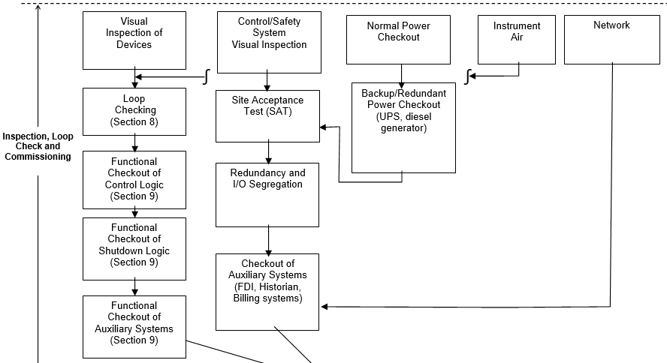
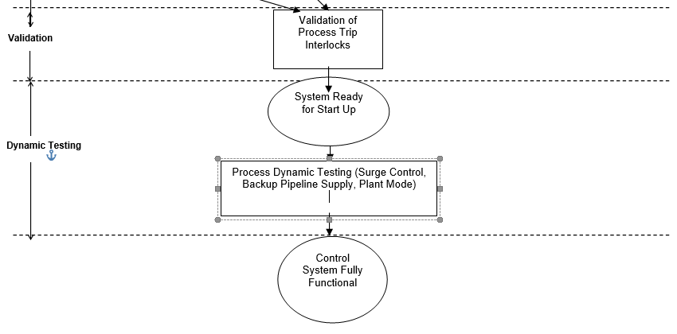

Report result
People communicate in their spare time and in the professional area. They communicate either in oral or in written form. If they communicate about technical topics, this process is called technical communication. If they communicate in written form, they write or read “technical reports”. If the technical report is communicated in oral form, it is a presentation to an audience.
Therefore, all documents in the following list are technical reports, if they deal with a technical subject:
- Reports about laboratory experiments
- Construction and design reports
- Reports about testing and measurements
Technical reports shall be written so that they reach your readers. This requires a high level of systematic order, logic and clarity. These understandability aspects must already be taken into account, when you plan the necessary work steps. This is the only way to perform all work steps accurately. As a result all facts about the described items or processes and the thoughts of the writer of a technical report become clear for the reader without any questions and without doubt.
In technical a systematic approach is used to solve tasks and larger projects. Tasks are solved in the sequence planning, realization and checking. This approved approach should be applied in a similar way when creating technical reports. Here the necessary work steps can be grouped in the phases planning, creation and finishing (with check-ups). However, before describing the single measures in the planning process we will present a general overview of all required work steps to create a technical report.

General overview of all required work steps
The following checklist 3-1 shows all required work steps to create technical reports.
- Accept and analyze the task
- Check or create the title
- Design a 4-point-structure
- Design a 10-point structure
- Search, read and cite literature
- Elaborate the text (on a computer)
- Create or select figures and tables
- Develop the detailed structure
- Perform the final check
- Print copy originals or create pdf file
- Copy and bind the report
- Distribute the report to the defined recipients
This work steps to be performed partly parallel overlapping
When you write a technical report, there is nearly always a task, which you either selected yourself or it was defined by someone else. You should analyze this task precisely during the planning of the technical report, checklist 3-2.
Checklist 3-2 analysis of the task to write a technical report
- The task defined may by:-
- A professor or an assistant (in case of a report written during your studies)
- A supervisor
- The development team
- A consulting company
- A customer
- You yourself (e.g. If you write an article for a scientific journal)
- Understand the task correctly
- Belongs to the target group
- Write the report for appropriate person
- Take notes accordingly
- The report may contain contents
- Please write that down!
The difference is in the way the results are reported, in the first case, a specific value is reported and in the second, it is reported as either in or out of tolerance (specification,) the minimum information that must be supplied is illustrated by the content of a typical NIST report. Note that a NIST report of test generally has nothing to do with calibrations, A NIST Report of Calibration gives
- The value of the item calibrated
- The uncertainty of the calibration for the accepted reference standard and details about the overall uncertainty
- The conditions under which the measurements were carried out, and
- Any special information regarding the calibration, it does not include uncertainties for effects of transport to and from the calibrating laboratory, drifts with time, effects of environmental conditions (i.e., temperature, humidity, barometric pressure, etc.)

Self-Check 3

Direction: Give short answer for the following question
- List the records of the calibration / verification activity on all gages, measuring, and test equipment. (4%)
- _______________________________________________________________
- ______________________________________________________________
- ______________________________________________________________
- ______________________________________________________________
- The _____________________System Requirements reflect the International standards Calibration/Verification Records. 2%
- List some of temperature element/ transmitters checking: (3%)
- List the technical reports? (Have three point)
- What is visual inspection?

Expert Profile
The trainers who developed the curriculum
No | Name | Qualification level | Educational background | Region | College | Mobile number | E-mail
1 | Melaku Bekele Ofgaha | A | Electri/Automation Control Technology | Oromia | Amboo poly TVET college | O921051772 | kakumalaku430@gmail.com
2 | Bahiru Demeke | A | Electri/Elec Contr | Oromia | Bishoftu Poly TVET College | O911394408 | bahirudemeke20@gmail.com
3 | Worku Biru Mekonnen | A | Electri/Automation Control Technology | Oromia | Sebeta Poly TVET College | O912106303 | workubiru3@gmail.com
4 | Sisay H/Mariam Toga | A | Electrical Power Enginering |  | Arbaminch poly & satelite College | O945234339 | sisayhailemariam971@gmail.com
5 | Hassen Husen Hamid | A | Electrical Eng | Oromia | M/G/M/B Poly TVET College | O943402001

Reference
- https://documents.uow.edu.au/content/groups/public/@web/@ohs/documents/doc/uow017046.pdf
- http://online.anyflip.com/nclgi/xptp/mobile/index.html
- 3.
- Instrumentation and control tutorial 3 – signal, www.researchgate.net
- https://www.status.co.uk/wp-content/uploads/files/Products/311.pdf
- https://pdhonline.com/courses/e444/e444content.pdf
- https://paktechpoint.com/loop-checking-procedures-of-instruments/
- https://www.tiptech.com/blog/articles/understanding-the-quality-inspection-process/
- https://www.usna.edu/ECE/ee426/Reading/Telemetry_WSN_Comms_Supp.pdf
- https://www.google.com/search?q=Obtaining++and+checking+tools,+equipment+and+testing+devices+for+instrumentation+and+control+configuration++devices+%EF%82%B7+configurator+or+programmer+%EF%82%B7+computer+%EF%82%B7+multi-meter+%EF%82%B7+calibrators+%EF%82%B7+signal+generator+%EF%82%B7+oscilloscope&ei=Slv0X6j4BZyj1fAPiPSD2AE&start=10&sa=N&ved=2ahUKEwioxd2v5YTuAhWcURUIHQj6ABsQ8tMDegQIBBA0&biw=903&bih=552
- https://www.safetyandhealthmagazine.com/articles/10994-reporting-near-misses

