Industrial Electrical/Electronic Control Technology Level III
Based on October, 2023, Curriculum Version II
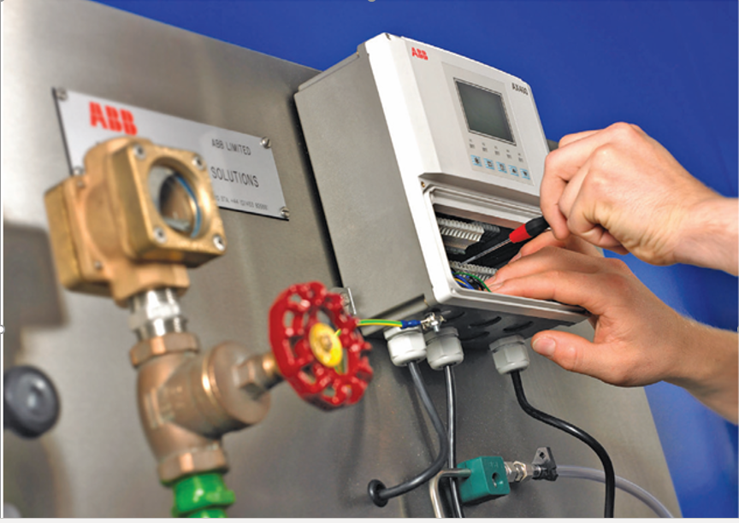
Module Title: - Maintaining and Repairing Instrumentation and Control Devices
Module Code: EIS IEC3 M09 1023
Nominal Duration:-50Hours

Prepared by: Ministry of Labor and Skill
October, 2023
Addis Ababa, Ethiopia

Contents
Acknowledgment 3
Acronym 4
Introduction to the Module 5
Maintenance vs. Repair 10
Maintenance 10
Repairs 10
Operation sheet-1 12
Preventive maintenance for instrumentation: 35
1) Calibration 35
2) Control Loop Checks 35
3) Physical Instrumentation Checks 35
Equipment Maintenance & Repair 35
Preventive Maintenance 36
Predictive Maintenance 36
Corrective Maintenance 36
Condition-based Maintenance 37
Run-to-failure Maintenance 37
The Maintenance Information Loop 40
Short Circuit Faults: - A short circuit can be defined as an abnormal connection of very low impedance between two points of different potential, whether made intentionally or accidentally. 58
Integration 79
Prerequisites 79
Activities 79
What is the purpose of workplace housekeeping? 84
Self-check-1: Key answer 86
Self-check-3 : Key- answer 86
Self-check 1 answer 86
Reference 87

Acknowledgment
The Ministry of Labor and skill would like to extend its gratitude to Regional Labor, and skill/training Bureaus, TVT College Deans, Instructors, and industry experts for their financial and technical support Maintaining and Repairing Instrumentation and Control Devices training module. Finally, MOLS extends its gratitude to the following instructors and experts who contributed to the development of this TTLM until its finalization.

Acronym
ANSI - American National Standards Institute
ESIA - Environmental Impact Assessment
ESMF- Ethiopia Environmental and Social Management Framework
FAT - Field Acceptance Test
ILO - International Labor organization
ISA- Instrumentation, Systems and Automation Society
OHS - Occupational health and safety
OHSR- Occupational Health and Safety Regulation
P&ID - Pipe and Instrument Diagram
PPE- Personal protective equipment
VDU - visual display units
WHS - workplace safety and healthy
HMI Human machine Interface

Introduction to the Module
Instrumentation & control technicians are responsible for the assembly, installation, removal and replacement, disassembly, test functionality and operability, maintenance and repair of instrumentation systems and their associated system components. Such systems can be of an electronic, electro-mechanical or pneumatic technology which may be used to indicate, record and control a wide variety of equipment, plant and machinery.
An integral aspect of the instrumentation & control technician is the ability to locate and identify faults in a timely manner to restore plant and equipment to acceptable conditions. The wide range of possible equipment and systems also require a good knowledge of, and the ability to effectively use, an equally wide range of test and measuring equipment.
Instrumentation & control technicians typically need a good understanding of engineering theory, the functions of components within systems and the effect on system operation of failure.
This unit covers the topics:
- Maintenance/ repair plan and preparation
- Instrumentation and control devices maintenance
- Repair instrumentation and control devices
- Instrumentation and control devices inspection and test
Learning Objective of the unit
- Plan and prepare Maintenance/ repair
- Maintain Instrumentation and control devices
- Repair instrumentation and control devices
- Inspect and test Instrumentation and control devices.
Module Instruction
For effective use this modules trainees are expected to follow the following module instruction:
- Read the information written in each unit
- Accomplish the Self-checks at the end of each unit
- Perform Operation Sheets which were provided at the end of units
- Do the “LAP test” giver at the end of each unit and
- Read the identified reference book for Examples and exercise

Unit One: Maintenance/ repair plan and preparation
This learning guide is developed to provide you the necessary information regarding the following content coverage and topics:
  - Maintenance or repair work plan
  - OHS policies and procedures
  - Personal protective equipment
  - Instrumentation and control standards
  - Materials, tools, equipment and testing devices
This guide will also assist you to attain the learning outcomes stated in the cover page. Specifically, upon completion of this learning guide, you will be able to:
  - Plan and prepare Maintenance or repair work
  - Follow OHS policies and procedures
  - Identify Instrumentation and control standards
  - Obtain Materials, tools, equipment and testing devices

  - Maintenance or repair work plan
Planning
Good planning provides the basis for a systematic maintenance policy. Planning requires foresight A good plan is the best tool to get a good idea of the work to be carried out
All planning is centered on the activities comprising the work to be carried out. These should be known in the greatest possible detail. This brings us to the main problem in planning. Planning provides better predictions as it becomes more detailed, which obviously requires more effort. Hence, the plan forms a model of the work to be carried out. Depending on the nature of the Project a higher or lower level of detail will be required. Effective planning includes the following three stages:
- the planning itself;
- assessment or checking;
- Correction.
these stages are not independent but should merge into each other. This is illustrated in figure 1
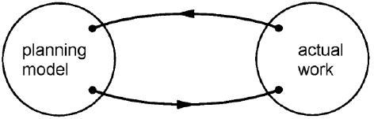
Figure 1.1
Planning Methods
- Time planning in these case we make a distinction on the basis of time. We use the common distinction between short-term and long-term plans.
- Long Term Planning- Long-term planning induces maintenance forecasts spanning several years, e.g. More than five years. This type of planning can be used to implement certain policies. For example, a replacement campaign, painting, contract and supplier management, stores and stock planning, etc. Such plans form an essential part of the maintenance policy and provide the basis for effective maintenance. As such policy decision particularly important in financial and other terms they are relatively made at higher terms.
- Short Term Planning- Short-term planning generally covers activities to be carried out within a year. Examples include planning overhauls, capacity, minor shutdowns, modifications, preventive maintenance, lubrication, etc. Sometimes, short-term planning involves developing an activity, initiated by the long-term planning, in greater detail.
Maintenance
Maintenance, in general, can be defined as efforts taken to keep the condition and performance of a machine always like the condition and performance of the machine when it is still new.
The technical meaning of maintenance involves functional checks, servicing, repairing or replacing of necessary devices, equipment, machinery, building infrastructure, and supporting utilities in industrial, business, governmental, and residential installations. Over time, this has come to include multiple wordings that describe various cost-effective practices to keep equipment operational; these activities occur either before or after a failure.
The need of maintenance is based on the actual or imminent fail. Ideally, maintenance is carried out to keep equipment and systems running efficiently during at least its usual life cycle. As such, practical functioning of equipment is a function based on time. If you want to graphically represent the failure rate of a piece of equipment in relation to time, it is probable that the graphic takes the shape of a bathtub, such as the one shown in picture 1.2, where axis Y represents the failure rate and axis X represents time.
This curve can be divided in three periods:
- Premature dead
- Lifecycle and
- Exhaustion period.
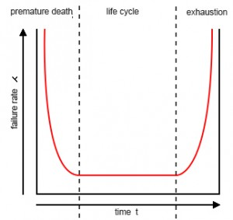
Figure1.2. the failure rate of a piece of equipment
The first period, the premature dead one, of the curve is characterized by a high rate of failure, followed by a decreasing failure period. Most of the failures related at this time are linked to bad design, bad installation or wrong use. The premature dead period is followed by a period with a nearly constant failure rate know as life cycle. There are many theories about why equipment fails in this time area. Most of them agree that poor preventive maintenance has often a key role. It is also generally agreed that exceptional practices related to predictive and preventive maintenance can extend this period in time. Exhaustion period is characterized by a higher and higher rate of failure. In most cases, this period includes a regular distribution of failures during design life but in reverse.
The lifecycle of most of equipment needs periodical maintenance. If we use the example of a car, we could say that filters must be changed, front-end alignment must be maintained, and oil change and proper lubrication are needed and so on. In some cases, certain pieces need to be replaced, for example, the timing belt, to ensure the proper functioning of the main piece of the equipment, the car in this particular case, once its design life has ended. Each time we do not carry out the maintenance activities planned by the designer, we shorten the operational lifecycle of the equipment. So, what are our options? For the last 20-30 years the different approaches to how maintenance can be carried out to ensure that the equipment reaches or exceeds its design life are focused on proactively, thus, on a proper preventive maintenance and more and more on preventive maintenance accompanied by proper predictive maintenance to complement it.

Maintenance vs. Repair
Maintenance and repair work have the same goals, and that is to keep your business running efficiently as designed. Knowing their fundamental differences, however, will help you determine when to utilize maintenance techniques over repairs and vice versa to keep your business productive and profitable without issue.

Maintenance
The goal of maintenance is to make repairs unnecessary.
From the time a business acquires an asset, they should already have a maintenance plan ready for implementation. Routine maintenance techniques like cleaning and regular inspections are often done on a weekly, monthly, and sometimes even daily basis. Cleaning, monitoring and inspecting can be done quickly and often at no cost while still contributing to an asset’s overall health and longevity.
To avoid disrupting services and productivity, maintenance activities are often scheduled on off days. For businesses who operate around the clock, planned maintenance for machine assets can be scheduled in sequence to ensure that productivity doesn’t halt and the expected output is still met.
Through special monitoring tools, businesses can also practice predictive maintenance techniques; using data gathered from asset performance and condition, they can gain insights as to when eventual wear-and-tear will need corrective maintenance to avoid unexpected machine breakdowns.

Repairs
Even with the best maintenance plan and personnel, the possibility of unexpected machine breakdown can never be completely eliminated. When this happens, businesses need to rely on swift repairs to get their assets back up and running ASAP before losses become insurmountable.
Aside from financial losses due to lost productivity, repairs often cost more than regular maintenance,; requiring businesses to pay a huge sum up front for new parts, installation, and the services of a specialist.
As much as businesses need to invest in a good maintenance program, they must have contingencies in place for unexpected downtimes since there is no way to completely prevent them from happening

Self-Check -1:- Written Test
  - ______ is defined as efforts taken to keep the condition and performance of a machine.
    - maintenance B) schedule C) efficiency D) all
  - Technical meaning of__________ involves functional checks, servicing, repairing or replacing of necessary device
    - Schedule B) Lubricant C)maintenance D) All
  - Which of the following is the general type of maintenance?
    - Drawdown maintenance B) Planned maintenance C)Preventive maintenance D)All
  - Which of the following is a type of maintenance used to, increase components life cycle extends, energy savings and failure rate decreases?
    - Preventive Maintenance
    - Breakdown Maintenance
    - Predictive Maintenance
    - Corrective Maintenance
    - Condition-based maintenance
  - Which of the following is maintenance material?
    - Oil B) Grease C) Insulation materials D) All

Answer the following question!
Note: Satisfactory rating - 5 and 10 points | Unsatisfactory - below 5and 10points
You can ask you teacher for the copy of the correct answers.
Answer Sheet
Score = ___________
Rating: ____________

Name: _________________________ Date: ______________

Operation sheet-1
Operation title: -Preparing schedule for electric motor maintenance
Purpose | To acquire the trainees with preparing maintenance plan and practice
Equipment ,tools and materials | Supplies and equipment needed or useful for fitting and adjusting cream senator  include these:  - Working table  - White paper  - Pen and penile
Conditions or situations for the operations | - All tools, equipment’s and materials should be available on time when required.  - Appropriate table, working area/ workshop to assemble cream separator practice.
Procedures | - Provide the trainees with paper and pencil  - Inform the trainees for what they plan  - Inform them to plan weekly maintenance schedule  - Permit them first to discuss how to plan maintenance schedule  - Allow to finish the plan within 1 hour  - Check the time of completion
Precautions | - The hand writing should be legible and prepared plan should be net  - The required material should be included in their plan
Quality criteria | - Did personal protective equipment worn while properly  - Did the trainees completed in required time  - Did trainees included all necessary steps of planning

  - OHS & S policies and procedures
In module (M04) we have discussed about OH&S policies and procedures in detail for more information please refer to M04. A health and safety program is a definite plan of action designed to prevent accidents and occupational diseases. Some form of a program is required under occupational health and safety legislation in most countries similarly our country (Ethiopia) also strictly considered these policies and procedures. A health and safety program must include the elements required by the health and safety legislation as a minimum.
Because organizations differ, a program developed for one organization cannot necessarily be expected to meet the needs of another. This document summarizes the general elements of a health and safety program. This approach should help smaller organizations to develop programs to deal with their specific needs.
Policy statement
An organization's occupational health and safety policy is a statement of principles and general rules that serve as guides for action. Senior management must be committed to ensuring that the policy is carried out with no exceptions. The health and safety policy should have the same importance as the other policies of the organization.
The policy statement can be brief, but it should mention:
- Management's commitment to protect the safety and health of employees.
- The objectives of the program.
- The organization's basic health and safety philosophy.
- Who is accountable for occupational health and safety programs.
- The general responsibilities of all employees.
- That health and safety shall not be sacrificed for expediency.
- That unacceptable performance of health and safety duties will not be tolerated
The policy should be:
- Stated in clear, unambiguous, and unequivocal terms.
- Signed by the incumbent Chief Executive Officer.
- Kept up-to-date.
- Communicated to each employee.
- Adhered to in all work activities.

Program elements
While organizations will have different needs and scope for specific elements required in their health and safety program, the following basic items should be considered in each case:
- Individual responsibility.
- Joint occupational health and safety committee.
- Health and safety rules.
- Correct work procedures.
- Employee orientation.
- Training.
- Workplace inspections.
- Reporting and investigating accidents/incidents.
- Emergency procedures.
- Medical and first aid.
- Health and safety promotion.
- Workplace specific items.
Responsibilities of workers
Examples of responsibilities of workers include:
- Using personal protection and safety equipment as required by the employer.
- Following safe work procedures.
- Knowing and complying with all regulations.
- Reporting any injury or illness immediately.
- Reporting unsafe acts and unsafe conditions.
- Participating in joint health and safety committees or as the representative.
Responsibilities of first-line supervisors
Examples of responsibilities of first-line supervisors include:
- Instructing workers to follow safe work practices.
- Enforcing health and safety regulations.
- Correcting unsafe acts and unsafe conditions.
- Ensuring that only authorized, adequately trained workers operate equipment.
- Reporting and investigating all accidents/incidents.
- Inspecting own area and taking remedial action to minimize or eliminate hazards.
- Ensuring equipment is properly maintained.
- Promoting safety awareness in workers.
Responsibilities of management
Examples of responsibilities of management include:
- Providing a safe and healthful workplace.
- Establishing and maintaining a health and safety program.
- Ensuring workers are trained or certified, as required.
- Reporting accidents/incidents and cases of occupational disease to the appropriate authority.
- Providing medical and first aid facilities.
- Ensuring personal protective equipment is available.
- Providing workers with health and safety information.
- Supporting supervisors in their health and safety activities.
- Evaluating health and safety performance of supervisors.
Responsibilities of safety coordinators
Examples of responsibilities of safety coordinators include:
- Advising all employees on health and safety matters.
- Coordinating interdepartmental health and safety activities.
- Collecting and analyzing health and safety statistics.
- Providing health and safety training.
- Conducting research on special problems.
- Attending joint health and safety committee meetings as a resource person.

    - OH & S guidelines
OH & S guidelines are Occupational Health and Safety Regulations 2017 (OHS Regulations) build on the OHS Act. They set out how to fulfill duties and obligations, and particular processes that support the OHS Act. For example, they include requirements for: safe operation of major hazard facilities and mines. For further information on ILO-OSH 2001, please contact:.
OHS Guidelines is a Regulatory Practices issue, the OHS Guidelines to help with the application and interpretation of sections of the Occupational Health and Safety Regulation ("OHSR") and with divisions of the Workers Compensation Act (the "Act") that relate to health and safety. OHS Guidelines are not intended to provide exclusive interpretations, but to assist with compliance. Many sections of the Act and the OHSR have associated OHS Guidelines.
OHS Guidelines are periodically updated and new ones added, in consultation with subject matter experts within the Worker and Employer Services Division. Prior to finalizing and issuing a new OHS Guideline, a draft is provided to the Policy and Practice Consultative Committee. This is a standing committee that includes representation from the worker and employer communities.
More background information on policies and guidelines, and on the hierarchy of authority among the Act, OHSR, and OHS Guidelines, is available in OHS Guideline G-P2 14, About OHS Guidelines.
    - Ethiopian environmental proclamations and regulations
The Environmental Policy of Ethiopia was approved by the Council of Ministers in 1997. It is comprised of 10 sector and 10 cross-sector components, one of which addresses Human Settlements, Urban Environment and Environmental Health. The Policy is based on the findings and recommendations of the National Conservation Strategy of Ethiopia. The Policy contains elements that emphasize the importance of mainstreaming socio-ecological dimensions in development programs and projects. The goal of the Environmental Policy of Ethiopia is to improve and enhance the health and quality of life of all Ethiopians and to promote sustainable social and economic development through sound management of the environment and use of resources so as to meet the needs of the present generation without compromising the ability of future generations to meet their own needs. The Environmental Policy provides a number of guiding principles that require adherence to the general principles of sustainable development. In particular, the need to ensure that Environmental Impact Assessment (ESIA) completes the following:
- Considers impacts on human and natural environments,
- Provides for early consideration of environmental impacts in project and program design,
- Recognizes public consultation processes as essential to effective management,
- Includes mitigation and contingency plans,
- Provides for auditing and monitoring,
- A legally binding requirement.
Environmental Proclamations Regulation and Guidelines Relevant to this project
Proclamation 513/2007, Solid Waste Management aims to promote community participation to prevent adverse impacts and enhance benefits resulting from solid waste management. It provides for preparation of solid waste management action plans by urban local governments.
Proclamation 299/2002, Environmental Impact Assessment makes ESIAs mandatory for implementation of major development projects, programs, and plans. The Proclamation is a tool for harmonizing and integrating environmental, economic, cultural, and social considerations into decision-making processes in a manner that promotes sustainable development. The proclamation clearly defines:
- Why there is a need to prepare ESIAs,
- What procedure 4fv is to be followed in order to implement ESIA
- The depth of environmental impact studies,
- Which projects require full ESIA reports,
- Which projects need partial or no ESIA report,
- To whom the report must be submitted.
For more information please read, Federal Democratic Republic of Ethiopia Environmental and Social Management Framework (ESMF), Addis Ababa, May 2019

Self-check 2
  - What is the use of following OH&S rules?
    - To increase safety B) To develop another rule C) To increase income D) To win IS award
  - _____ is a statement of principles and general rules that serve as guides for action
    - Safety Policy B) Promotion C) Agreement D) Organization
  - Who should cooperate for safety policy enforcement?
    - Worker B) Employer C) Organization D) Stakeholder
  - Which of the following is an element of OH&S regulation?
    - Work B) procedure C) Training D) Safety report

Answer the following question!
Note: Satisfactory rating - 5 and 10 points | Unsatisfactory - below 5and 10points
You can ask you teacher for the copy of the correct answers.
Answer Sheet
Score = ___________
Rating: ____________

Name: _________________________ Date: ______________

  - Personal protective equipment
PPE is defined as all equipment designed to be worn, or held, to protect against a risk to health and safety. This includes most types of protective clothing, and equipment such as eye, foot and head protection, safety harnesses, life-jackets and high-visibility clothing.
Safety signs such as those shown at Fig. 1.3 are useful reminders of the type of PPE to be used in a particular area. The vulnerable parts of the body which may need protection are the head, eyes, ears, lungs, torso, hands and feet; in addition, protection from falls may need to be considered. Objects falling from a height present the major hazard against which head protection is provided. Other hazards include striking the head against projections and hair becoming entangled in machinery.
Typical methods of protection include helmets, light-duty scalp protectors called ‘bump caps’ and hairnets.
The eyes are very vulnerable to liquid splashes, flying particles and light emissions such as ultraviolet light, electric arcs and lasers. Types of eye protectors include safety spectacles, safety goggles and face shields. Screen based workstations are being used increasingly in industrial and commercial locations by all types of personnel. Working with VDUs (visual display units) can cause eye strain and fatigue.
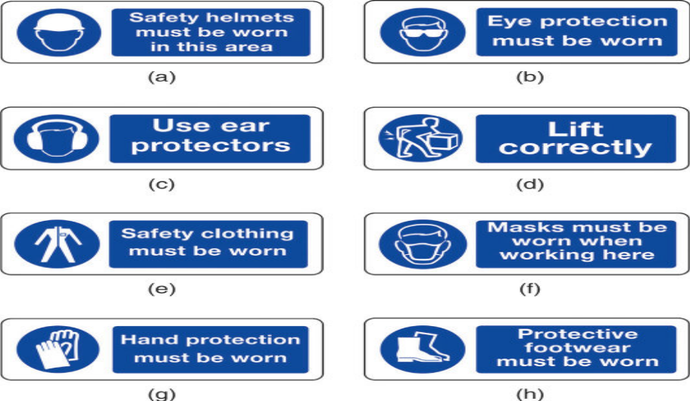
Figure 1.3 Safety signs showing type of PPE to be worn.
Advantages
Administrative controls and safe work practices to reduce workers exposure to risk
- Restricting access to certain areas to nominated times when the risk is lowest or non-existent
- Good housekeeping practices (in terms of keeping workplaces clean and tidy), including regular cleaning of work areas and regular and appropriate maintenance of workplace items and equipment
- Changing purchasing procedures so substances (such as cleaning chemicals) are supplied in ready to use containers and decanting is not required
Personal protective equipment (PPE) and clothing includes such things as:
- Eye protection – goggles, face masks, visors
- Protective clothing – aprons, thermal wear/suits, „pull off‟ ties for security staff
- Head protection – hard hats, and caps for food handlers.
- Providing trolleys to move items to reduce need for potentially harmful manual handling
- Providing accurate work instructions and methods of work (work practices, standard operating procedures) to guide workers in the safe way to perform their work
- Changing work practices to include job rotation (but note this, on its own, is generally regarded as an insufficient control method). Job rotation is the practice of moving staff between different jobs to help eliminate boredom and repetition and the associated dangers these introduce to work
- Shorter working periods for jobs performed under difficult conditions such as limiting work needing to be undertaken in extreme cold, heat, noise or where there is excessive vibration
- Training – providing necessary training in practices
Safety signs
The rules and regulations of the working environment are communicated to employees by written instructions, signs and symbols. All signs in the working environment are intended to inform. They should give warning of possible dangers and must be obeyed.

Prohibition signs
These are must not do signs. These are circular white signs with a red border and red cross-bar, and are given in Fig. 1.4. They indicate an activity which must not be done.
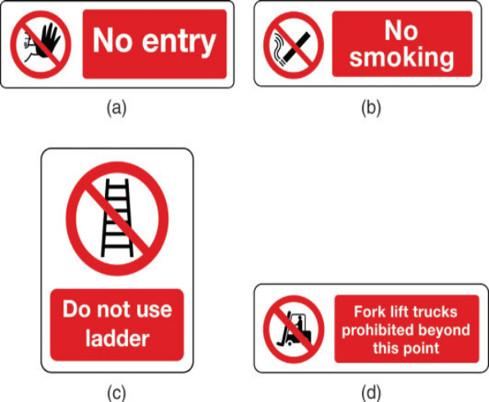
Figure 1.4 Prohibition signs.
Warning signs
These give safety information. These are triangular yellow signs with a black border and symbol, and are given in Fig.1.5 They give warning of a hazard or danger.
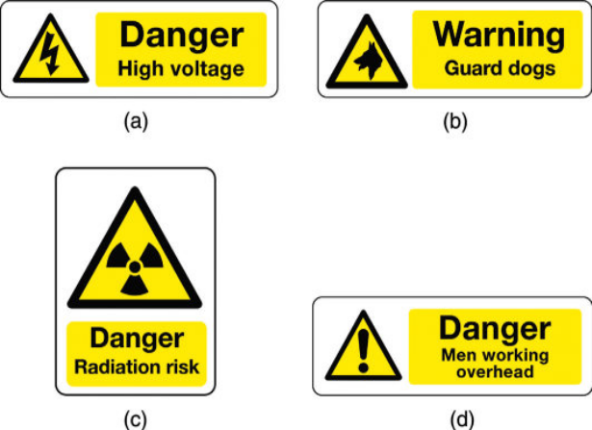
Figure 1.5 Warning sign
Mandatory signs
These are must do signs. These are circular blue signs with a white symbol, and are given in Fig.1.6 . They give instructions which must be obeyed.
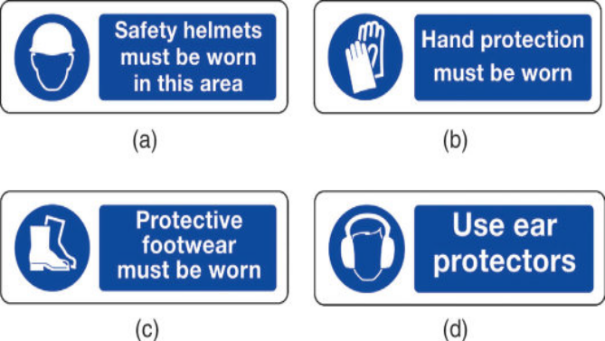
Figure 1.6 Mandatory signs.
Advisory or safe condition signs
These give safety information. These are square or rectangular green signs with a white symbol, and are given in Fig. 1.7. They give information about safety provision.
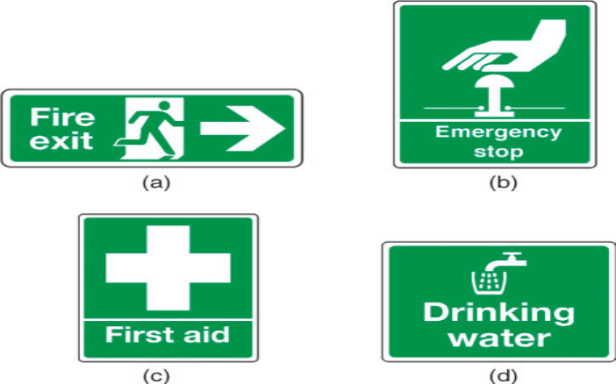
Figure 1.7 Advisory or safe condition signs.

Self-Check -1
  - equipment designed to protect against a risk to health and safety
    - Electric Machine B) Car D) Any cloth D) PPE
  - Vulnerable body that can be harmed due to emission of light unless safety action is made.
    - Hand B) Head Eye Leg
  - Which of the following is administrative safety action to workers?
- Restriction B) Allowance C) Good housekeeping D) Punishment
  - Which of the following is not safety action?
      - Following work procedures B) handling material Properly
      - Storing material properly C)quality materials
  - Which of the following is advisory sign?
      - PPE B)Hand tools C)Safety poster D) Proper storage
Answer the following question!
Note: Satisfactory rating - 8 and 15 points | Unsatisfactory - below 8and 15points
You can ask you teacher for the copy of the correct answers.
Answer Sheet
Score = ___________
Rating: ____________

Name: _________________________ Date: ______________

  - Instrumentation and control standards
Dear Trainee in module four we have discussed about general control standard in this module we discuss only about instrumentation standard. Every engineering discipline uses codes and standards. Some codes and standards are specific to an engineering discipline while some cross multiple disciplines. To identify instrumentation standard read the following please!
4. Outline of the identification system
4.1 General
Each instrument or function to be identified is designated by an alphanumeric code or tag number as shown in Figure 1.8 The loop identification part of the tag number generally is common 14 ANSI/ISA-S5.1-1984 (R 1992) to all instruments or functions of the loop. A suffix or prefix may be added to complete the identification. Typical identification is shown in Figure 1.8
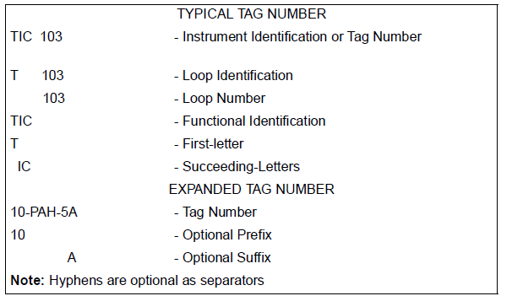
Figure 1.8 — Tag numbers
4.1.2 The instrument loop number may include coded information, such as plant area designation. It is also possible to set aside specific series of numbers to designate special functions; for instance, the series 900 to 999 could be used for loops whose primary function is safety-related.
4.1.3 Each instrument may be represented on diagrams by a symbol. The symbol may be accompanied by a tag number

4.2 Functional identification
4.2.1 The functional identification of an instrument or its functional equivalent consists of letters from Table 1 and includes one first-letter (designating the measured or initiating variable) and one or more succeeding-letters (identifying the functions performed).
4.2.2 The functional identification of an instrument is made according to the function and not according to the construction. Thus, a differential-pressure recorder used for flow measurement is identified by FR; a pressure indicator and a pressure-actuated switch connected to the output of a pneumatic level transmitter are identified by LI and LS, respectively.
4.2.3 In an instrument loop, the first-letter of the functional identification is selected according to the measured or initiating variable, and not according to the manipulated variable. Thus, a control valve varying flow according to the dictates of a level controller is an LV, not an FV.
4.2.4 The succeeding-letters of the functional identification designate one or more readout or passive functions and/or output functions. A modifying-letter may be used, if required, in addition to one or more other succeeding-letters. Modifying-letters may modify either a first-letter or succeeding- letters, as applicable. Thus, TDAL contains two modifiers. The letter D changes the measured variable T into a new variable, "differential temperature." The letter L restricts the readout function A, alarm, to represent a low alarm only.
4.2.5 The sequence of identification letters begins with a first-letter selected according to Table 1.
Readout or passive functional letters follow in any order, and output functional letters follow these in any sequence, except that output letter C (control) precedes output letter V (valve), e.g., PCV, a self-actuated control valve. However, modifying-letters, if used, are interposed so that they are placed immediately following the letters they modify.
4.2.6 A multiple function device may be symbolized on a diagram by as many bubbles as there are measured variables, outputs, and/or functions. Thus, a temperature controller with a switch may be identified by two tangent bubbles — one inscribed TIC-3 and one inscribed TSH-3. The instrument would be designated TIC/TSH-3 for all uses in writing or reference. If desired, however, the abbreviation TIC-3 may serve for general identification or for purchasing, while TSH-3 may be used for electric circuit diagrams.
4.2.7 The number of functional letters grouped for one instrument should be kept to a minimum according to the judgment of the user. The total number of letters within one group should not exceed four. The number within a group may be kept to a minimum by:
    - Arranging the functional letters into subgroups. This practice is described in Section 4.2.6 For instruments having more than one measured variable or input, but it may also be used for other instruments.
    - Omitting the I (indicate) if an instrument both indicates and records the same measured variable.
4.2.8 All letters of the functional identification are uppercase.
4.3 Loop identification
4.3.1 The loop identification consists of a first-letter and a number. Each instrument within a loop has assigned to it the same loop number and, in the case of parallel numbering, the same first letter. Each instrument loop has unique loop identification. An instrument common to two or more loops should carry the identification of the loop which is considered predominant.
4.3.2 Loop numbering may be parallel or serial. Parallel numbering involves starting a numerical sequence for each new first-letter, e.g., TIC-100, FRC-100, LIC-100, AI-100, etc. Serial numbering involves using a single sequence of numbers for a project or for large sections of a project, regardless of the first-letter of the loop identification, e.g., TIC-100, FRC-101, LIC-102, Al-103, etc. A loop numbering sequence may begin with 1 or any other convenient number, such as 001, 301 or 1201. The number may incorporate coded information; however, simplicity is recommended.
4.3.3 If a given loop has more than one instrument with the same functional identification, a suffix may be appended to the loop number, e.g., FV-2A, FV-2B, FV-2C, etc., or TE-25-1, TE-25-2, etc. However, it may be more convenient or logical in a given instance to designate a pair of flow transmitters, for example, as FT-2 and FT-3 instead of FT-2A and FT-2B. The suffixes may be applied according to the following guidelines:
1) An uppercase suffix letter should be used, i.e., A, B, C, etc.
2) For an instrument such as a multipoint temperature recorder that prints numbers for point identification, the primary elements may be numbered TE-25-1, TE-25-2, TE- 25-3, etc., corresponding to the point identification number.
3) Further subdivisions of a loop may be designated by serially alternating suffix letters and numbers. (See Section 6.9R(3).)

Self-Check -3
Answer the following questions
  - 1) Every engineering discipline uses_________.
A) Qualified B) Technician C) Codes and Standards Text Book D) Coordinator
2) All has common codes and standards
A) True B) False
3) Which loop identification parts are common for ANSI and ISA instrument loops?
A )ISA-S5.1-1984) B) TIC-103 C)10-PAH-5A D) All

Answer the following question!
Note: Satisfactory rating - 3 and 6points | Unsatisfactory – below 3 and 6 points
Answer Sheet
Name: _________________________ Date: ______________ score _______

  - Materials, tools, equipment and testing devices
Dear trainees, if you obtained necessary materials that help you for maintenance of instrumentation and control device you can precede to the next activities. What are these activities?
But the materials you obtained should be according to the standard and the job requirement. So your current role is only justifying the necessary materials that you use during maintenance of instrumentation and control device.
The following types of instrumentation test and calibration equipment:
- Standard test gauges
- Analogue or digital meters
- Special-purpose test equipment
- Manometers
- Calibrated weights
- Logic probes
- Temperature baths
- Workshop potentiometers
- Dead weight testers
- Insulation testers
- Signal sources
- Pressure sources
- Digital pressure indicators
- Current injection devices
- Comparators
- Calibrated flow meter
There are many different forms of test instrument that can be used to test electronic equipment. The digital multimeter is one of the most common, but there are many other items of test equipment including the oscilloscope, signal generator, spectrum analyzer, logic analyzer and many more. Find out about the different types of test instrument available.
Analogue multimeter
A analog or analogue multimeter is one of the trusty workhorses of the electronics test industry. Analogue multimeters have been in use for very many years and sometimes go by the name VOA as a result of the fact that they measure volts, ohms and amps. These multimeters are extremely flexible and enable very many faults to be found in an electronic circuit.
When using the meter it is possible to follow a number of simple steps:
- Insert the probes into the correct connections - this is required because there may be a number of different connections that can be used.
- Set switch to the correct measurement type and range for the measurement to be made. When selecting the range, ensure that the maximum range is above that anticipated. The range on the multimeter can be reduced later if necessary. However by selecting a range that is too high, it prevents the meter being overloaded and any possible damage to the movement of the meter itself.
- Optimise the range for the best reading. If possible adjust it so that the maximum deflection of the meter can be gained. In this way the most accurate reading will be gained.
- Once the reading is complete, it is a wise precaution to place the probes into the voltage measurement sockets and turn the range to maximum voltage. In this way if the meter is accidentally connected without thought for the range used, there is little chance of damage to the meter. This may not be true if it left set for a current reading, and the meter is accidentally connected across a high voltage point!
Like any item of test equipment an analogue multimeter or test meter has its limitations. Knowing what they are and how to overcome them is a key stage in understanding how to use an analogue multimeter to its best.
Advantages:
- Analogue movement: The meter needle gives a continuous movement from which it is very easy to gain a fast idea of the order of magnitude, or of trends for slowly moving changes. This is not always so easy using a digital multimeter.
- Low cost: Analogue multimeters can be bought very cheaply these days.
- Availability: These pieces of test equipment are still widely available from many sources despite the fact that digital multimeters tend to be more widely used.
- Preference: Some people prefer to use an analogue meter - it is very easy to glance at it and gain a very good indication of the approximate value of the reading.
Disadvantages:
- Multiple scales: Any multimeter will have a number of different scales and these can cause confusion. They were often a cause of error.
- Lower input resistance: Using analogue technology, analogue multimeters did not provide such a high input impedance as a digital one. Understanding when this may be an issue is a key element of knowing how to use an analogue multimeter.
- Polarities of test leads: Analogue multimeters do not have an auto-polarity function. Therefore it is necessary to correctly connect the test leads, otherwise the meter could deflect in a negative direction and quickly hit an end stop.
- Less accurate than a digital multimeter: Analogue multimeters are typically less accurate than digital test instruments. That said the measurements are sufficiently accurate for most of the measurements that need to be made.
Analogue multimeters or test meters formed the main form of test equipment used in many areas for many years. Although now mainly superseded by digital multimeters, analogue test meters are still found in many places, where they can still provide the measurement capabilities needed for most tests. These analogue multimeters can also still be bought new as well for those who prefer an analogue meter to read rather than a digital display.
- Arbitrary waveform generator, AWG
- Data network analyzer
- Digital Multimeter - DMM
- Dip meter, GDO
- Frequency counter
- Function generator
- LCR meter / bridge
- Logic analyzer
- Logic probe
- Multimeter basics
- Oscilloscope
- PAT testing / testers
- Power energy analyzer
- Power meter (RF & microwave)
- Pulse generator
- RF signal generator
- Signal generators
- Signature analyzer
- Spectrum analyzer
- Time domain reflectometer, TDR
- Vector Network Analyzer, VNA
The intent of this standard is to provide the minimum requirements for initial inspection, loop check, and commissioning of a control system.
The objectives checking follows:
- Verify the proper physical installation (wiring, grounding, labels, tags, pressure ratings, area classification) of instruments.
- Ensure wiring is landed on the proper termination and verify overall wiring loop integrity.
- Verify proper calibration range, engineering units, tag name, and diagnostics.
- Verify PES input range.
- Verify all logic including the interlock system
- Verify pre-alarms, bad quality, maintenance bypass switches, and proper configuration of HMI displays.
- Verify and confirm proper operation of the instrument and sensor according to supplier and Air Products specifications.
- Verify proper installation, power and grounding, backup power, network communications, system diagnostics, and operational functionality of the PES.
- Verify auxiliary systems (Foreign Device Interfaces, Historians, and Billing Systems).
- Verify remote access and remote control if applicable.
- The following documents shall be available on site and shall be the latest revision:
- PES Procurement Specification.
- Supplier Control System Manufacturing Drawings (if applicable).
- Control System Design Objectives and Control and Optimization Strategy Document (if applicable).
- HMI Console Configuration Guidelines/Control System Design Basis Paper (if applicable).
- Instrument Specifications.
- Alarm and Trip Summary.
- Electrical Schematics (both Air Products- and supplier-furnished).
- Hazardous area classification drawings.
- Relevant calculations and process data (for example, heat and material balance, sequence data, compressor curves, compressor surge lines, motor data sheets, and flow element calculations).
- Any relevant data needed for interface to supplier skids and equipment.
- Applicable configuration standards.
- P&ID.
- FAT report and punch list
Test Equipment
Other than for purposes of rectification, repair, or replacement, no test equipment shall be moved from the job site for the duration of the contract.
All calibration test equipment supplied by a contractor shall be certified for accuracy by an independent testing laboratory before use.
Each item of calibration test equipment supplied by a contractor shall exhibit a permanently fixed validation label indicating the serial number, name of certifier, and the date and duration of certification. Copies of relevant test certificates will be kept on file by the supplier of the test equipment and shall be made available for inspection by Air Products at any time.
Equipment that shall be considered calibration test equipment shall comprise, but not be limited to, the following: Hart Communicators, hand pumps, precision test gauges, portable potentiometers, deadweight tester (pneumatic only), manometers, constant temperature generator, thermocouple calibrator, RTD calibrator, transmitter simulators, pneumatic calibrators, signal generator and counter, portable oscilloscope, leak detection unit, and instrument manufacturer’s specially designed portable test sets.
Visual inspection of devices
Typically, physical inspection is the first task to be performed once an instrument is turned over from construction. Physical inspections do not have to be done in conjunction with loop checking but depending on manpower and instrument location, physical inspections and loop checking may be done at the same time. At a minimum, physical inspections must be documented to provide evidence of what was checked and whether the device passed or failed. It is recommended that field inspection reports be filled out for every piece of instrumentation. Failed devices shall be corrected before proceeding to loop check.

Unit Two: Instrumentation and control devices maintenance
This learning guide is developed to provide you the necessary information regarding the following content coverage and topics:
  - Corrective and preventive maintenance
  - Scheduled/periodic maintenance
  - Instrumentation and control device normal function test
  - Maintain unplanned events or conditions
This guide will also assist you to attain the learning outcomes stated in the cover page. Specifically, upon completion of this learning guide, you will be able to:
  - Plan Corrective and preventive maintenance
  - Perform scheduled/periodic maintenance
  - Use personal protective equipment
  - Check Instrumentation and control device normal function
  - Responding unplanned events or conditions

  - Corrective and preventive maintenance

Preventive maintenance for instrumentation:
In general, one can divide the preventive maintenance tasks for instrumentation as follows:

1) Calibration
Instrumentation devices need to be calibrated from time to time to make sure they show the right value.
The interval is different from different devices, brands and styles. Some suppliers give up to 10 years warranty on the device they sell to stay true, others are less. But, if you are a non-instrumentation manager, look for calibrations in your instrument PM’s.

2) Control Loop Checks
Part of an instrumentation preventive maintenance program is to check your loop response. For example, if you set a flow to 22 gpm, the flow should become 22 gpm. In tests by control loop experts such as Fisher and others, on average, the typical plant has about 80% of their control loops respond incorrectly.
Part of the loop response problem can be design issues. It is not uncommon to see plants select a valve that is larger than needed, which results in errors.
If a maximum flow is supposed to be 30 gpm and a larger than necessary valve is chosen, the maximum flow may be achieved at 75% open and the range will therefore be 0-75% for the corresponding 0-30 gpm, instead of 0-100%.

3) Physical Instrumentation Checks
All instrumentation should be checked physically in our opinion. Most instrumentation people I’ve met resist doing these checks. I’m not sure exactly why.
While a packing leak on a valve, a damaged transmitter, or a damaged membrane on a regulator eventually will show up on a computer screen somewhere, it is not always a problem that can be pinpointed to physical damage, or to what device(s) that have the problem.
A physical inspection route for instrumentation equipment will pinpoint physical problems and identify problems earlier. It is a must for a world-class instrumentation preventive maintenance program.
An idea may be to have your operators do physical inspections of instrumentation and mechanical equipment?

Equipment Maintenance & Repair
While some experts may disagree about how many different types of maintenance there are, it’s possible to categorize maintenance into a few common types. These can include:
- Preventative maintenance
- Predictive maintenance
- Corrective maintenance
- Condition-based maintenance
- Run-to-failure maintenance
There may be troubleshooting and maintenance issues your laboratory staff can tackle in-house that include simple preventative maintenance procedures. However, more complicated equipment maintenance procedures and repairs will most likely require the help of a certified technician, whether they work for a third-party or for the equipment’s manufacturer.

Preventive Maintenance
Preventive maintenance (PM) is scheduled in advance and aims to prevent equipment failures before they occur. This includes regular inspections, cleaning, and replacement of worn or damaged parts. The goal of preventive maintenance is to extend the life of the equipment and minimize downtime.
It is often planned and scheduled at regular intervals, from weekly to monthly to annually. By performing preventive maintenance, equipment can be kept in good working condition, in turn improving productivity and reducing repair costs.

Predictive Maintenance
Predictive maintenance (PdM) uses data and analytics to predict when equipment will fail. This allows for repairs or replacements to be made before a failure occurs.
Predictive maintenance uses tools like sensors and monitoring devices to collect data on equipment performance, which is then analyzed to identify potential issues. PdM can help determine which equipment should receive maintenance before it breaks down, reducing downtime and repair costs.

Corrective Maintenance
Corrective maintenance (CM) is used to fix equipment that has already broken down or is not functioning correctly and is typically unplanned. It includes repairs, troubleshooting, disassembly, adjustment, replacement, and realignment.
This type of maintenance is often performed due to equipment failure or when an unexpected breakdown occurs, either due to a lack of a maintenance plan or because a piece of equipment fails before its scheduled inspection or maintenance. It is more expensive than preventive maintenance.
Some labs often rely on CM more than any other type of equipment maintenance. However, solely relying on corrective maintenance instead of a balance of preventive and corrective maintenance has drawbacks.
While corrective maintenance can be effective for quickly fixing equipment that has easily accessible and replaceable parts, it can also lead to unexpected and costly downtime. It is generally recommended that 80% of maintenance efforts focus on preventive measures and 20% focus on corrective actions.

Condition-based Maintenance
Condition-based maintenance (CBM) is based on the equipment’s condition, using data and monitoring to determine when exactly care is going to be needed, and is similar to predictive maintenance. However, it doesn’t rely on scheduled maintenance. Instead, it uses monitoring and data to identify when equipment is likely to fail and schedule maintenance at that time.
While condition-based and predictive maintenance are often compared due to some similarities, there are some key distinctions between the two. Specifically, the method of measurement that is used.
Predictive maintenance involves using specific formulas and sensor readings (such as temperature, vibration, and noise) to determine when maintenance is needed. Maintenance tasks are then executed based on the analysis of these parameters, making predictive maintenance more of an exact form of care as it anticipates future maintenance requirements.
On the other hand, condition-based maintenance relies solely on real-time sensor readings. Once a reading exceeds an established threshold, maintenance personnel are dispatched to address the issue. This approach means that lab equipment maintenance is only performed when necessary, unlike predictive maintenance, which anticipates future maintenance requirements.

Run-to-failure Maintenance
Run-to-failure maintenance (RTF) is the opposite of preventive maintenance and involves waiting for equipment to fail before performing any repairs or replacement. It is a deliberate and considered strategy designed to minimize total maintenance costs.
The run-to-fail method involves having spare parts and personnel readily available to replace failed components and ensure equipment availability. This approach should not be mistaken for reactive maintenance, as a deliberate plan is in place to allow the asset to operate until failure. This strategy is helpful for any equipment that does not pose a safety hazard in the case of failure or breakdown and does not considerably impact production when it breaks down.
RTF is not usually recommended, as it increases the chance of equipment failure and downtime (in fact, it almost bets on failure happening), and it can be more expensive and time-consuming in the long run.
Maintenance activities can basically be divided into two parts:
- planned maintenance activities and
- Unplanned maintenance activities
Planned maintenance is maintenance that is organized and carried out with thought to the future, control and recording in accordance with the plans that have been determined previously.
The type of maintenance cannot be equated for each equipment, which depends on the method, cost and critical level. The following types of maintenance methods are commonly used in several industries.
- Corrective Maintenance
- Preventive Maintenance
- Predictive Maintenance(proactive)
- Breakdown Maintenance
The advantages and disadvantages of the different types of maintenance:
- Corrective Maintenance
Advantages:
- Low cost
- Fewer workers needed
Disadvantages:
- Costs increase due to unplanned equipment stops
- Labor costs increase, especially when extra time is needed
- Extra costs due to equipment repair or replacement
- Secondary equipment can suffer damage during primary equipment failure
- Inefficient use of human resources
- Preventive Maintenance
Advantages:
- Inactivity time gets shorten, so equipment availability increases
- Maintenance regularity allows better flexibility
- Components life cycle extends
- Energy savings
- Failure rate decreases
- Costs reduction around 12-18% in comparison with corrective maintenance
Disadvantages:
- It is still probable that failure happens
- Intensive workforce
- It includes activities that may not be really necessary but recommended
- These activities that may not be necessary may accidentally cause damage to other components
- Predictive Maintenance
Advantages:
- Components availability and lifetime increases
- Equipment inactivity time decreases
- Materials and labour costs decrease
- Improves employees’ spirits
- Costs reduction around 8-12% in comparison with preventive maintenance
Disadvantages:
- Significant initial investment in diagnosis equipment
- Investment in personnel training increases
- Potential savings are not easily perceived by the C-Suite
- Meaningful savings are only perceived in the long term
D) Breakdown Maintenance
It is a method where inspection and replacement of parts are not carried out, so with this method we leave the equipment damaged and then we fix it or replace it. Usually this method is applied to equipment / machines with consideration:
- Equipment is only optional (additional) so that if it is damaged it does not interfere with production
- The cost of repairing / replacing cheap parts
- Insignificant damage
- Easy and fast repair
Maintenance plan should incorporate the maintenance policy and procedures whereas the maintenance strategy defines for that season/time.
- Maintenance strategy – Next level down, typically reviewed and updated every one month or six month….etc.
- Maintenance program – Applies to an equipment system or work center, describes the total package of all maintenance requirements to care for that system.
- Maintenance checklist – List of maintenance tasks (preventive or predictive) typically derived through some form of analysis, generated automatically as work orders at a predetermined frequency.
- Short-term maintenance plan (sometimes called a “schedule of work”) – Selection of checklists and other ad-hoc work orders grouped together to be issued to a workshop team for completion during a defined maintenance period, typically spanning one week or one shift.

The Maintenance Information Loop
Figure 1 below describes the flow of maintenance information and how the various aspects fit together.
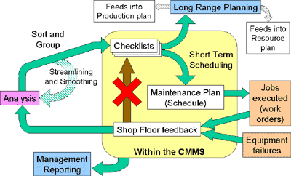
Figure 1.3 Maintenance Information Loo

  - Scheduled/periodic maintenance
    - Maintenance Schedules
Equipment maintenance schedules outline when and how often equipment should be inspected, maintained, and repaired. They ensure equipment is kept in good working condition and minimize potential equipment failures and unexpected downtime. These schedules can vary depending on the type of equipment, how it is used, and the environment in which it operates.
There are several factors to consider when setting up equipment maintenance schedules, including:
- Equipment usage: How often the equipment is used and the intensity of its use can impact the frequency of maintenance. Equipment used frequently or operating in harsh conditions may require frequent maintenance.
- Manufacturer’s recommendations: Manufacturers often provide recommendations for maintenance schedules based on their knowledge of the equipment and the environment in which it operates.
- Equipment age: Older equipment might require frequent maintenance as it is more likely to experience wear and tear or already have significant wear and tear from previous usage.
- Environmental factors: Instruments that operate in harsh environments (for example, areas with high temperatures, high humidity, or lots of dust) may require more frequent maintenance.
- Safety: Equipment that is used in safety-critical applications, such as in construction or medical equipment, requires more frequent maintenance to ensure safety.
Consider these factors when you create a maintenance schedule. It should include the type of maintenance required, the frequency, and the person or team responsible for performing the maintenance. The program should also have a plan for addressing any issues that arise between scheduled maintenance.
Equipment maintenance schedules are not set in stone, however. They should be reviewed periodically and updated as necessary to account for changes in equipment usage, age, or environmental factors.
    - Planning and Scheduling
Planning and scheduling form the “genesis” of an effective maintenance management organization. With planning, each job is analyzed, resources carefully chosen, and the process designed to accomplish the task. Scheduling allows for customer interaction to achieve desired goals. Parts, labor, and time tables are established and agreed to by the organization so work can be done safely, at the right time, and in the most efficient manner.
Formal planning and scheduling provide a work order system structured for better cost control and job progress and which provides report data on equipment and the system itself.
The advantages of planning and scheduling include the following:
  - For production—Reduces cost of maintenance while improving service; provides data on maintenance performance; provides an orderly process by which work is accomplished.
  - For maintenance—Establishes goals for the work force; eliminates delays due to waiting for materials and equipment, other skills, tools, etc.; applies specialized knowledge to planning/scheduling of shutdowns.
  - For management—Permits accurate forecasting of labor and materials; enables management to level out peak workloads; provides a full planned day’s work for each person and increases productivity.
  - For all technical staff—Provides clear instruction; fewer obstacles to accomplish tasks; and fewer interruptions and delays.
A planned maintenance program should include the following important component programs: predictive maintenance, preventive maintenance, repair, corrective maintenance, and protective programs. A total program requires using each, based on data from the history file, cost reports, and critical applications. The following are definitions of important components of a planned maintenance program:
- Planned maintenance: Each equipment piece is identified and its maintenance defined.
- Repairs maintenance: Equipment fails and the required maintenance is performed.
- Preventive maintenance: Equipment maintenance is scheduled prior to failure on an estimate of the life of the equipment.
- Predictive maintenance: Maintenance is performed when the need is indicated based on regular or continuous monitoring of the equipment.
- Corrective maintenance: Maintenance is reduced or eliminated by analyzing prior maintenance work and making changes in design, installation materials or procedures.
- Critical equipment: Equipment failure that adversely affects safety, environment, system availability, yield, quality or costs.
- Noncritical equipment: Equipment failure that can be identified and repaired within a reasonable period of time so adverse effects, if any, are within acceptable limits.
Stages of Maintenance
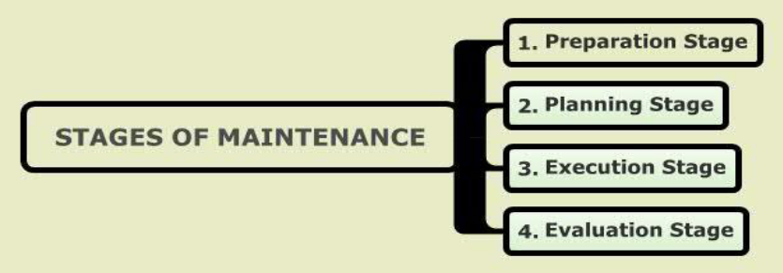
Figure 2.1 Planning stages
Preparation Stage- In the preparation stage we can distinguish three main activities:
- Estimating the costs
- Identifying the work to be carried out
- Work planning (scheduling).
Planning Stage- Once the work has been defined and prepared for we can start planning the shutdown. We can use any of the planning methods discussed earlier, from basic Gant planning to sophisticated network planning methods. During the planning stage we will generally follow a top-down approach. This means that large projects are divided into smaller units. If necessary, the level of detail can be increased to refine the planning. After that, it is relatively easy to determine the whole of the work to be carried out, as this will be the sum of the parts. It is important to be aware of the relationships between the various projects. The exact subdivision process depends greatly on the nature of the project. And experience is also most important. Once al projects have been included in the planning and all constraints and conditions have been fulfilled. the execution of the work can start.
Execution Stage- The actual maintenance operations are undertaken during the execution stage. It is very important that there is constant feedback from the shop floor to the planning department. This includes information about progress, such as starting and stopping times, repair information, problems concerning parts, tools, inspection data, etc. In this stage, the main task of the planning office is to coordinate the activities and record relevant information.
Evaluation Stage- During the evaluation stage, the way in which the shutdown was carried out is critically considered. An effective approach is to determine, together with those responsible, where and why the original planning was not followed, and where the planning can be improved in future. Important indicators can be provided by analyzing the hours spent on the project, additional work, additional orders, etc. Of course, this requires that this information is carefully recorded. This stage is often considered as an unnecessary waste of time. However, this is quite wrong. A good evaluation forms the basis for future improvement which can result in significant cost savings in the long term.
Optimization of Instrumentation and Control Devices assets depends on an effective maintenance philosophy and program. There are four types of maintenance that organizations use to varying degrees:
Reactive/Corrective - Action is taken after an event has occurred. Wait for something to happen to an instrument and then repair or replace it.
Corrective maintenance is probably the most commonly used approach, but it is easy to see its limitations. When equipment fails, it often leads to downtime in production. In most cases this is costly business. Also, if the equipment needs to be replaced, the cost of replacing it alone can be substantial. It is also Important to consider health, safety and environment (HSE) issues related to malfunctioning equipment.
Corrective maintenance can be defined as the maintenance which is required when an item has failed or worn out, to bring it back to working order. Corrective maintenance is carried out on all items where the consequences of failure or wearing out are not significant and the cost of this maintenance is not greater than preventive maintenance.
Preventive - Action is taken on a timetable based on history; that is, try to prevent something bad from happening.
So to avoid the problems of correcting unfortunate situations that have already arisen, many try to maintain equipment before it fails. By doing this, the goal is to avoid failure, unnecessary
So to avoid the problems of correcting unfortunate situations that have already arisen, many try to maintain equipment before it fails. By doing this, the goal is to avoid failure, unnecessary production loss and HSE violation. As you cannot possibly maintain your equipment at all times you need some way to decide when it is proper to perform maintenance. Normally this is done by deciding some inspection/maintenance intervals, and sticking lo this interval more or
Less affected by what you find during these activities. The result of this is that most of the maintenance performed is unnecessary; (unsubstantiated and no source cited) it even adds substantial wear to the equipment. Also, you have no guarantee that the equipment will continue to work even if you are maintaining it according to the maintenance plan.
The effectiveness of a preventive maintenance schedule depends on the RCM analysis which it was based on, and the ground rules used for cost-affectivity.
Predictive or Condition Based Maintenance - Action is taken based on field input using state-of-the-art, non-intrusive diagnostic test and evaluation devices or using smart instrumentation which is typically vibration analysis, lube oil analysis, ultrasound analysis, Thermography, etc.
Proactive Maintenance- which looks to solve the root cause of machinery failures or extend the life of machinery through proactive practices such as precision alignment, precision balancing, improved specifications and better operating practices. Proactive maintenance practices focus on the relentless pursuit or equipment condition assessment to ensure the reliability of a machine. Reactive maintenance practices focus on the quick response to machinery failures rather on focusing on the extension of machinery life through proactive, preventive and predictive maintenance activities.
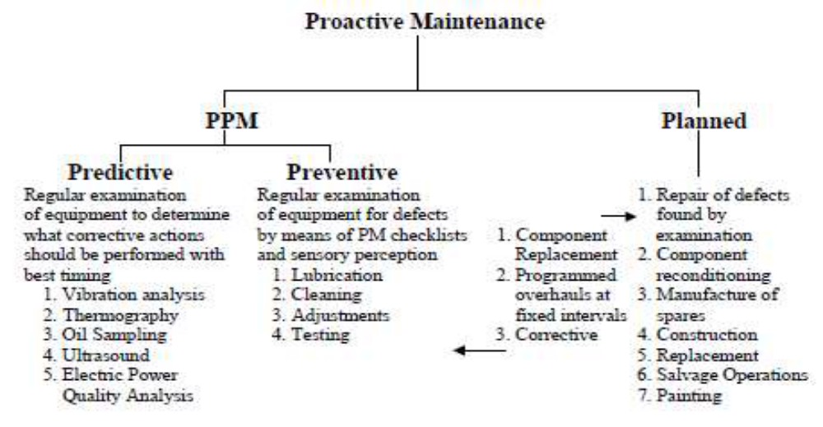

The following formats are sued to receive and maintenance equipments from clients. But don’t consider that it is the only format that you use. There are several types of formats; even you can prepare your own format
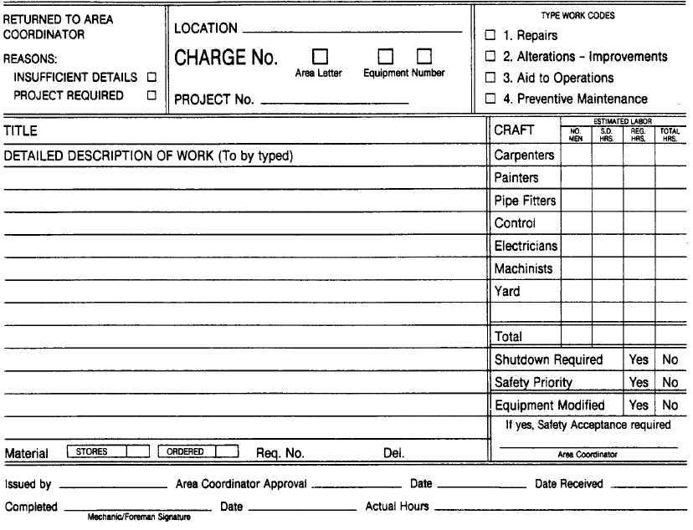

Maintenance work
Corrective __________Preventive ___________Operational_________ Priority ________ MWO#______
Submitted by | Department |  |  | Phone No. |  |  | Date
For more information contact____________________________________________ Phone No._________________
Problem Loc: Bldg#_________ Room#_________ Unit__________ System________________ Loop#__________
Problem Description:
Planner assigned |  |  | Phone No. |  |  | Date Assigned
Tech/assined |  |  | Shope/Phone |  |  | Date assigned
Corrective Action
Instrument date/part required
Manufacturer ____________________ model __________________ seriel No._______________ Part No.__________
Calibration Req. Yes No |  | Calibrated by |  |  | Cal Rec.
Completed by |  | Date |  |  | OKd by
Date Enrly By:__________ |  | Date ______
Maintenance work order format

  - Instrumentation and control device normal function test
How to check whether your installed instrumentation is in need of a health check
Where multiple instruments are used, for example for redundancy in safety critical processes, it is also advisable to check the calibration of each instrument and recalibrate if necessary, with the frequency of checking being determined by the characteristics and operating requirements of the application. This will avoid measurement discrepancies between each instrument and ensure that each instrument is operating accurately and safely. Calculating the calibration error of a device can be summarized by the following basic equation:
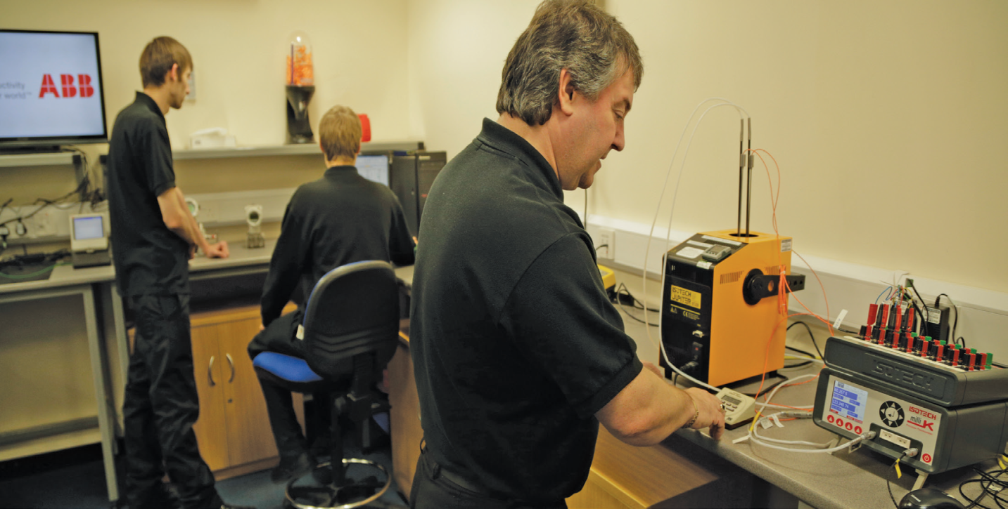
Error = actual reading - ‘true’ reading
In this equation, the ‘true’ reading is the original specified or desired accuracy for the application. The error produced by the equation will provide the basis for the correction of the device to a properly calibrated state.
Depending on the type of instrument and the nature of the production process in which it is being used, it can be desirable to be able to check and adjust its calibration without having to remove it from the line. This not only prevents disruption caused by removing and replacing the instrument, but also helps to avoid the introduction of any external factors that could affect its calibration.
The calibration of many types of instruments can be verified in-situ. ABB’s Water Master and Process Master flow meters, for example, feature on-board verification, which checks the performance of the meter sensor and transmitter and compares it to a fingerprinted value taken at the point of original calibration. This makes it possible to see whether the meters are continuing to deliver accurate measurement or whether they need to be recalibrated.
It should be emphasized that in-situ verification is not the same as calibration, and should never be considered as a replacement. If the verification reveals that the calibration of the device being checked has wandered significantly, then it must either be returned to the manufacturer for recalibration or replaced.
Figure 2.2 control and instrumentation functional check
Calibration – things to look for:
- Variations in product quality – product quality can be affected if instruments are not providing the correct data needed to help control the process properly
- If two or more instruments are used for the same measuring point, are the readings consistent?
- Unexpected readings – are the readings from the device exceeding the expected measurement parameters?
- Is there anything to show when the device was last calibrated? If there is and the device is out of calibration, it will need to at least be verified and/or recalibrated if necessary. If there is nothing to show when calibration was last performed, then the device should be calibrated in order to ensure it is performing properly
- Has the device been damaged or subjected to a shock or vibration? If so, the calibration could have been affected.

Fig. 2.3: Being able to access data from process instruments enables users to achieve significant operational and maintenance savings
Even if the system is functional we should give attention whether the operation of the device is normal or abnormal. So this can be checked before and during the operation.
  - Referring the operation whether it is in accordance with manufacturer’s instructions.
  - diagnosing problem in system or component following the operating procedures
  - Performing necessary adjustments including calibrations
Job sheet 2.1
Instruction/ Activity
STEP
    - Obtain work request and instruction from Instrumentation Trainer/Supervisor
    - Refer to Data Sheet in order to check the instrument physical characteristics and D.W. Tester oil compatibility with its relevant Process fluid. Basically all Instrument used on Utilities are suitable for recalibration check with D.W. Tester, while for Instrument used on Gas and LNG process must be tested with Only dry instrument air or nitrogen.
    - Check and inspect the internal housing parts of the Instrument and clean / remove corrosion and moisture if required.
    - To check Pressure Switch calibration with the Dead Weight Tester oil, connect it with a suitable connection fitting and without any pressure applied, check the status of relevant switch applying the electrical connection leads of multimeter to the switch terminals
    - In case of Differential Pressure Switch the instrument HP side only have to be connected while, the LP side shall remain “open” to the atmosphere
    - Close the D.W. Tester vent, apply the increasing pressure up-to the setting and check when switch status change ( from “Close” to “Open” contact or vice versa ).
    - Release the D.W. Tester pressure by vent and check the switch resetting pressure (return to the initial position)
    - If the switch change status is not correct at supposed pressure value, repeat the test and then setting must be adjusted following instructions of manufacturer Operation/Maintenance Manual
    - After adjusting of Set point, the switch Reset have to be check and adjusted as per Data Sheet or Manufacturer instructions.
    - Switches pressure setting can be done at the Rising Pressure ( “set” at High Point and “Reset” at Low Point ) or at the Failing Pressure ( “set” at Low Point and Reset at the High Point ) according to the switch setting instruction.
    - After execution of switch setting, the instrument “repeatability” have to be check with a repetition of increasing / decreasing pressure cycles in order to be sure that the switch changeover, happen at the same pressure value (five time as minimum)
    - For Pressure Switches that the D,W. Tester oil is not suitable, the Test Benches Instrument air or Nitrogen gas and relevant Pressure Calibrators shall be used. Switches pressure connection shall be done using the standard pressure leads for LP (up-to 7 Bar) and HP (more than 7 Bar from nitrogen bottle as pressure source)
    - Follow step by step the similar instructions criteria on points from 7.4 to 7.9 , shall be applied considering that the Pressure Switches shall be connected, in this case, to Test Benches Pressure Calibrators.
    - After Setting completion, all temporary pressure and electrical connections shall be removed, previous instrument connection fittings restored and relevant Calibration Label applied
    - Finally a standard Calibration Sheet with all reference data shall be issued and stored in Instrument Workshop file as record.

  - Maintain unplanned events or conditions
Many accidents, malfunctions and unplanned events are, however, preventable and can be readily addressed or prevented by good planning, design, emergency response planning, and mitigation. By identifying and assessing the potential for these events to occur, we can identify and put in place prevention and response procedures to minimize or eliminate the potential for significant adverse without major effects.
The response of unplanned event is may be planed because we don’t know what would be happen in future, the future occasion may guessed but cannot be determined. So we should be conscious while we are making planning activities, to responded unplanned events.
The potential accidents, malfunctions and unplanned events that, although unlikely, could reasonably be possible to occur during any phase of the Project and result in adverse environmental effects are described, discussed, and assessed.
Accidents, Malfunctions and Unplanned Events in combination with the planned Project activities, as well as any overlap of such Accidents, Malfunctions or Unplanned Events with other projects or activities that have been or will be carried out.
Based on the activity being performed considerations of the potential accidents, malfunctions and unplanned events will be considered:
Examples of unplanned events
- Damage of equipment during installation
- Burnout of parts during energizing
- Pipeline Leak
- On-Site Hazardous Materials Spill;
- Release of Off-Specification Effluent from the Water Treatment Plant;
- Failure of a Water Management Pond;
- Off-Site Trucking Accident;
- Vehicle Collision;
- Uncontrolled Explosion; and
- Fire accident due to electrical or other.
The potential accidents, malfunctions or unplanned events listed above, three such events should be planned with their solutions to manage them as soon as they occurred,
Mitigation of unplanned events
  - Failure Mode Analysis by qualified independent specialists
  - quality assurance and inspections by the design engineers during initial and ongoing
  - always monitoring and inspections during Operation
  - scheduled, ongoing inspections and audits of the facility by qualified technician/engineers
  - Proper checking the design by qualified person
  - Periodic check of overall analysis ……etc.

Unit Three: Repair instrumentation and control devices
This learning guide is developed to provide you the necessary information regarding the following content coverage and topics:
- Fault/s or problem/s diagnose
- Troubleshoot techniques and procedure
- Adjustments, calibrations, Replacement and correction measures
- Repair unplanned events or conditions
This guide will also assist you to attain the learning outcomes stated in the cover page. Specifically, upon completion of this learning guide, you will be able to:
- Diagnose fault/s or problem/s
- Organize troubleshoot techniques and procedure
- Adjustments, calibrations, Replacement and correction measures
- Respond to repair unplanned events or conditions

- Fault/s or problem/s diagnose
Faults can arise due to a variety of causes, both mechanical and pneumatic and many circuits will have individual peculiarities, but by following a logical and orderly procedure, even unusual faults can be deduced.
Modern microprocessor-controlled converters employ a diagnostic system. The system monitors both, the internal and the external operating conditions and responds to any faults. This is done in the manner programmed by the user. The control system retains the fault information in a non-volatile memory for later analysis. This feature is known as fault diagnostics.
There are three main levels of operator information and fault diagnostics in reputed models, as given below:
- The first level provides information about the on-going situation inside a VSD. It refers mainly to the setting parameters and the real-time operating parameters. It meters information, such as output voltage, output current, output frequency, etc.
- The second level provides diagnostic information, about the status of the protection circuits, and indicates the external faults, as described above.
- The third level provides diagnostic information about the status of internal faults, such as the identification of failed modules. Dedicated internal diagnostics are usually only found in high-performance VSDs.
Power supply | Power supply voltage, current, and frequency
DC bus | DC link voltage and current
Motor | Output voltage, current, frequency, speed, torque, temperature
Control signals | Set point, process variable, error, ramp times
Status | Protection circuits, module failures, internal temps, fans running, switching frequency, current limit, motor protection, etc.
Fault conditions | Power device fault, power supply failed, driver circuit failed, current feedback failed, voltage feedback failed, main controller failed

    - Diagnostic Testing For Motors
The following factors affect the insulation systems:
- High temperature
- Environment
- Mechanical effects such as thermal expansion and contraction, vibration, electromagnetic bar forces, and motor start-up forces in the end turns
- Voltage stresses during operating and transient conditions
All these factors contribute to loss of insulation integrity and reliability. These aging factors interact frequently to reinforce one another’s effects. For example, high-temperature operation could deteriorate the insulation of a stator winding; loosen the winding bracing system, and increase vibration and erosion. At some point, high-temperature operation could lead to delaminating of the core and internal discharge. This accelerates the rate of electrical aging and could lead to a winding failure. Nondestructive diagnostic tests are used to determine the condition of the insulation and the rate of electrical aging. The description of the recommended diagnostic tests for the insulation system of motors and the conditions they are designed to detect are discussed below.
1 | Check input power to starter. Is there power on all lines? (Three-phase motors won’t start on one phase.) | Restore power on all lines.
2 | Check starter. Is overload protection device opened? | Replace or reset device. Does it open again when starting?
3 | Is there power on all lines to motor? | Repair starter.
4 | Is voltage to motor more than 10% below nameplate voltage? | Restore proper voltage.
5 | Check motor terminal connections. Are any loose or broken? | Repair connections.
6 | May be wrong motor for application. Is starting load too high? | Install Design C or Design D motor. Install larger motor.
7 | Is driven machine jammed or overloaded? | Remove jam or overload.
8 | Are misalignments, bad bearings or damaged components causing excessive friction in driven machine or power transmission system? | Repair or replace component.
9 | Are bad bearings, bent shaft, damaged end bells, rubbing fan or rotor or other problem causing excessive friction in the motor? | Repair or replace motor.
10 | Check stator. Are any coils open, shorted, or grounded? | Repair coil or replace motor.
11 | Check rotor. Are any belts or rings broken? | Replace rotor.
    - Mechanical
Mechanical fault occurs due to physical impact or improper application of force of mechanical torque overload. Three-phase induction motors are the most popularly used motors especially in industry because of their reliability and simplicity. These motors experience different types of faults during their operation. These faults can be classified as internal and external faults.
Locked rotor occurs when the voltage is applied to a non-rotating motor. The stator current may be almost six times its rated value during this condition.
There are many causes for this fault to occur for instance, if the rotor shaft is connected to heavy load the motor may experience locked rotor conditions. Locked rotor causes high current which leads to heating the rotor. Therefore locked rotor condition cannot be withstood for a long time.
The allowed duration of the motor overloaded under locked rotor condition depends on the voltage applied to the motor terminals. Therefore, the protection system should be able to disconnect the motor when locked rotor condition exceeds the amount of allowed time.
    - Electrical
A fault in an electric power system can be defined as, any abnormal condition of the system that involves the electrical failure of the equipment, such as , transformers, generators, bus bars, …..etc.
Electrical networks, machines and equipment’s are often subjected to various types of faults while they are in operation. When a fault occurs, the characteristic values (such as impedance) of the machines may change from existing values to different values till the fault is cleared.
There may be lot of probabilities of faults to appear in the power system network, including lighting, wind, tree falling on lines, apparatus failure, etc.
Types of Faults:- Electrical faults in three-phase power system mainly classified into two types, namely open and short circuit faults. Further, these faults can be symmetrical or unsymmetrical faults. Let us discuss these faults in detail.
Open Circuit Faults:- These faults occur due to the failure of one or more conductors. The figure below illustrates the open circuit faults for single, two and three phases (or conductors) open condition.
The most common causes of these faults include joint failures of cables and overhead lines, and failure of one or more phase of circuit breaker and also due to melting of a fuse or conductor in one or more phases. Open circuit faults are also called as series faults. These are unsymmetrical or unbalanced type of faults except three phase open fault.
Thus, single and two phase open conditions can produce the unbalance of the power system voltages and currents that causes great damage to the equipment’s.

Causes: - Broken conductor and malfunctioning of circuit breaker in one or more phases.

Effects
- Abnormal operation of the system
- Danger to the personnel as well as animals
- Exceeding the voltages beyond normal values in certain parts of the network, which further leads to insulation failures and developing of short circuit faults.
Although open circuit faults can be tolerated for longer periods than short circuit faults, these must be removed as early as possible to reduce the greater damage.

Short Circuit Faults: - A short circuit can be defined as an abnormal connection of very low impedance between two points of different potential, whether made intentionally or accidentally.
These are the most common and severe kind of faults, resulting in the flow of abnormal high currents through the equipment or transmission lines. If these faults are allowed to persist even for a short period, it leads to the extensive damage to the equipment.
Short circuit faults are also called as shunt faults. These faults are caused due to the insulation failure between phase conductors or between earth and phase conductors or both.

Causes
These may be due to internal or external effects
- Internal effects include breakdown of transmission lines or equipment, aging of insulation, deterioration of insulation in generator, transformer and other electrical equipment’s, improper installations and inadequate design.
- External effects include overloading of equipment’s, insulation failure due to lighting surges and mechanical damage by public.

Effects
- Arcing faults can lead to fire and explosion in equipment’s such as transformers and circuit breakers.
- Abnormal currents cause the equipment’s to get overheated, which further leads to reduction of life span of their insulation.
- The operating voltages of the system can go below or above their acceptance values that creates harmful effect to the service rendered by the power system.
- The power flow is severely restricted or even completely blocked as long as the short circuit fault persists.

Symmetrical Faults
A symmetrical fault gives rise to symmetrical fault currents that are displaced with 1200 each other. Symmetrical fault is also called as balanced fault. This fault occurs when all the three phases are simultaneously short circuited.
These faults rarely occur in practice as compared with unsymmetrical faults. Two kinds of symmetrical faults include line to line to line (L-L-L) and line to line to line to ground (L-L-L-G) as shown in figure below.
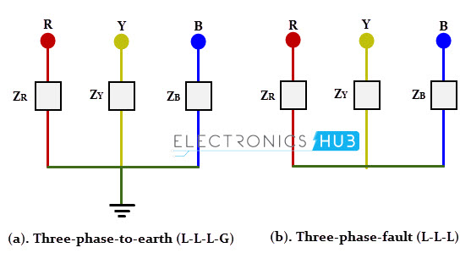
A rough occurrence of symmetrical faults is in the range of 2 to 5% of the total system faults. However, if these faults occur, they cause a very severe damage to the equipment’s even though the system remains in balanced condition.

Unsymmetrical Faults
The most common faults that occur in the power system network are unsymmetrical faults. This kind of fault gives rise to unsymmetrical fault currents (having different magnitudes with unequal phase displacement). These faults are also called as unbalanced faults as it causes unbalanced currents in the system.
Up to the above discussion, unsymmetrical faults include both open circuit faults (single and two phase open condition) and short circuit faults (excluding L-L-L-G and L-L-L).
The figure below shows the three types of symmetrical faults occurred due to the short circuit conditions, namely phase or line to ground (L-G) fault, phase to phase (L-L) fault and double line to ground (L-L-G) fault.
    - Electrical Faults on different devices
Overloading
Overloading fault may occur due to mechanical torque or overload voltage. Overloading causes increase in phase currents, over heating the machine. In a traditional relay protection system, the over current relay trips the motor off-line when the current transformers (CT) encounter over current in the line.
Phase Reversal
Phase reversal occurs when any of the two phases are reversed from the normal sequence, which leads the motor to rotate in the opposite direction. When the motor starts to rotate in the opposite direction, it can cause intensive damage. Therefore, this condition should be corrected immediately. Reverse-phase relays and negative sequence relays are used for the protection.
Ground Fault
Ground faults occur when any of the phases touches the ground. Ground faults are more frequent in motors than any other power system, because of their violent condition and frequent starts. The effects of this fault are intensive such as causing hazards to human safety and interference with telecommunication. It can be detected by measuring the ground leakage current.
Single phasing:
Single phasing is one of the unbalanced cases of the motor. It occurs when one of the three lines are open. More current flows through the other two lines and more heat is generated in stator winding
In the traditional protection systems, a high-set instantaneous trip unit relay is used. Single phasing also gives rise to negative sequence current. A negative sequence relay can also be used to protect against this fault.
Unbalanced supply voltage:
There are many causes of unbalance supply voltages such as unbalance loading, open delta transformers and unequal tap setting. This condition leads to reduction in motor efficiency, raises the motor temperature and excessive unbalanced full load current. The protection design should detect over current condition during unbalanced supply.
Under Voltage
Under voltage fault is reducing the supply voltage on the three phases by specific percentage, which makes the motor from attaining rated speed in specified time, increases the current and overheats the machine. Low voltage protection relays are used in traditional systems.
However, in order to avoid unwanted relay shutdowns due to momentary voltage drops, the AC contacts need a delay mechanism which delays the under voltage protection for a time period.
This additional mechanism needs high sensitive devices and involves calibrations.
Over Voltage
Over voltage occur if the three phase voltages are greater than rated voltage. The effect of this fault is increasing current flow which leads unacceptable stress on the motor insulation due to high heat dissipation. Conventional protection systems use the over voltage relays to protection the motor during this condition.
    - Electronics
Electronic components have a wide range of failure modes. These can be classified in various ways, such as by time or cause. Failures can be caused by excess temperature, excess current or voltage, ionizing radiation, mechanical shock, stress or impact, and many other causes. In semiconductor devices, problems in the device package may cause failures due to contamination, mechanical stress of the device, or open or short circuits. Electronics faults occur due to circuit cracked or component failure.
For example, power-handling ability of a resistor may be greatly derated when applied in high-altitude aircraft to obtain adequate service life. A sudden fail-open fault can cause multiple secondary failures if it is fast and the circuit contains an inductance; this causes large voltage spikes, which may exceed 500 volts. A broken metallization on a chip may thus cause secondary overvoltage damage. Thermal runaway can cause sudden failures including melting, fire or explosions.
Generally electronic faults can include the following
- Packaging failures
- Contact failures
- Printed circuit board failures
- Relay failures
- Semiconductor failures
- Parameter failures
- Metallization failures
- Electrical overstress
- Electrostatic discharge
- Passive element failures
- Resistors
- Potentiometers and trimmers
- Capacitors
- Electrolytic capacitors
- Metal oxide varistors
- MEMS failures
- Recreating failure modes
    - Computer-based
Prior to the late 1940’s, simple controls like a mechanical governor for a diesel driven electric generator were used to achieve reasonably constant power system frequency. Today we have sophisticated computer-based energy management systems for management of the electric poser systems. Modern automotive vehicles are full of control systems. Other control systems incorporate wire based or wireless communication systems. These can be as simple as for a remote control to switch channels on a TV to the use of global positioning systems for guidance of missiles. The controls systems of today or mostly electrical/electronic but can also be implemented using pneumatic or hydraulic technologies.
Analyzing the performance of the automatic control systems requires access to sophisticated mathematical tools and specialized knowledge how to use such tools and how to evaluate the results. Thus, control system engineering has evolved into a specialized engineering discipline devoted to study of the dynamics of the systems and to improve the performance of the systems. An example of a sophisticated control system is found in hard disk drives and optical disk drives. Various control loops are used in these devices to perform rotational speed control, seeking, track-following, and error recovery. Exponent has expertise in understanding the sensors, processors, and actuators in hard disk drives.
Computer is an electronic device which used to store and process data. Generally computer can use for the following basic purposes
- Accepts and stores data input,
- Processes the data input, and
- Generates the output in a required format.
In problem solving issues; computer based problem solving methodology can provide the following advantages:
  - Formulate the problem
  - Develop a solution algorithm
  - Encode the algorithm and its data into a program
  - Let the computer execute the program
  - Decode the result and extract the solution.
The failure of instrumentation and control system may occurs due to computer system failure Such as hard ware and software problems
A failure is a term used to describe an issue with the computer or a device that prevents it from functioning properly. For example, when a hard drive fails (hardware failure), it prevents the computer from booting and prevents it from working again until it's replaced.
Although a failure is associated with hardware, any problems with software may also be referred to as a software failure. With most software failure, you'll usually encounter an error to indicate the type of problem. A general failure is a non-specific failure that could be caused by software or hardware.
Overview of Computer-Based Instrumentation
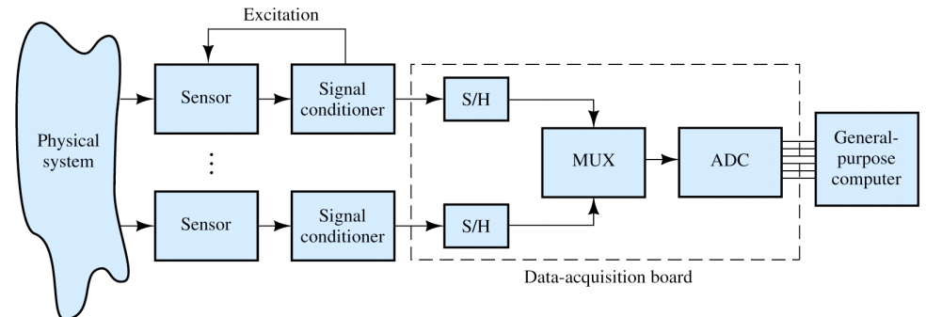
Figure 3.1 computer based instrumentation
A control system is a type of computer system that manages commands and directs other devices or systems. There are open and closed loop control systems. They usually take an input, process it and get an output.
Some Example of computer based control system
- Traffic Light
- GPS
- Automatic doors
- Heating systems
- Taxi meter
- Elevator
- Washing machine
- Process control
- Device drivers
- Cleaning robot…etc.
  - Troubleshoot techniques and procedure
Operation Sheet 3.2
Troubleshooting Chart-Pressure Transmitter
Symptoms | Corrective Actions
Milliamp Reading is Zero | - Check if Power Polarity is Reversed  - Verify Voltage Across Terminals (should be 10 to 55 V dc)  - Check for Bad Diode in Terminal Block  - Replace Transmitter Terminal Block
Transmitter is not Communicating  with Communicator | - Check Power Supply Voltage at Transmitter (Minimum 10.5 V)  - Check Load Resistance (250 V minimum)  - Check if Unit is Addressed Properly  - Replace Electronics Board
Milliamp Reading is Low or High | - Check Pressure Variable Reading for Saturation  - Check if Output is in Alarm Condition  - Perform 4–20 mA Output Trim  - Replace Electronics Board
No Response to Changes in Applied Pressure | - Check Test Equipment  - Check Impulse Piping for Blockage  - Check for Disabled Span Adjustment  - Check Transmitter Security Jumper  - Verify Calibration Settings (4 and 20 mA Points)  - Replace Sensor Module
Pressure Variable Reading is Low or High | - Check Impulse Piping for Blockage  - Check Test Equipment  - Perform Full Sensor Trim  - Replace Sensor Module
Pressure Variable Reading is Erratic | - Check Impulse Piping for Blockage  - Check Damping  - Check for EMF Interference  - Replace Sensor Module

  - Adjustments, calibrations, Replacement and correction measures
Operation Sheet 3.3
Replacing Threaded Seat Rings
Many conventional sliding-stem control valves use threaded-in seat rings. Severe service conditions can cause damage to the seat ring(s) so that the valve does not shut off satisfactorily. In that event, replacement of the seat ring(s) will be necessary. Before trying to remove the seat ring(s), check to see if the ring has been tack-welded to the valve body. If so, cut away the weld and apply penetrating oil to the seat ring threads before trying to remove the ring. The following procedure for seat ring removal assumes that a seat ring puller, such as that shown in Figure 5-4, is being used. If a puller is not available, a lathe or boring mill may be used to remove the ring(s).
  - Place the proper size seat lug bar across the seat ring so that the bar contacts the seat lugs as shown.
  - Insert drive wrench and place enough spacer rings over the wrench so that the hold down clamp will rest about 1/4-inch above the body flange. Slip hold-down clamp onto drive wrench and secure the clamp to the body with two cap screws (or hex nuts for steel bodies) from the bonnet. Do not tighten cap screws or nuts.
  - Use turning bar to unscrew the seat ring. Stuck seat rings may require additional force on the turning bar. Slip a 3-to 5-foot length of pipe over one end of the turning bar, and while applying a steady force, hit the other end of the bar with a heavy hammer to break the ring loose. In addition, a large pipe wrench can used on the drive wrench near the hold-down clamp.
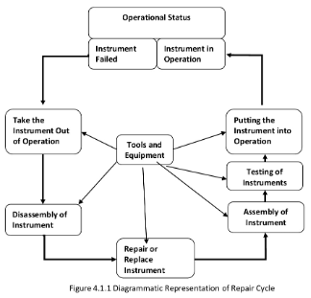
  - After the seat ring is loose, alternately unscrew the flange bolts (or nuts) on the hold-down clamp and continue to unscrew seat ring.
  - Before installing new ring(s), thoroughly clean threads in the body port(s).Apply pipe compound to the threads of the new seat ring(s).
NOTE:
On double-port bodies, one of the seat rings is smaller than the other. On direct acting valves (push-down-to-close action), install the smaller ring in the body port farther from the bonnet before installing the larger ring. On reverse-acting valves (push-down-to open action), install the smaller ring in the body port closer to the bonnet before installing the larger ring.

Screw the ring(s) into the body. Use the seat ring puller, lathe, or boring mill to tighten seat ring in the body. Remove all excess piping compound after tightening. The seat ring can be spot welded in place to ensure that it does not loosen.
Replacing Stem Packing
Bonnet packing, which provides the pressure seal around the stem of a globe-style or angle style valve body, may need to be replaced if leakage develops around the stem, or if the valve is completely disassembled for other maintenance or inspection. Before starting to remove packing nuts, make sure there is no pressure in the valve body.
If the packing is of the split ring variety, it can be removed (with considerable difficulty) without removing the actuator by digging it out of the packing box with a narrow, sharp tool. This is not recommended, because the wall of the packing box or the stem could easily be scratched, thereby causing leakage when the new packing was installed.
Don't try to blow out the old packing rings by applying pressure to the lubricator hole in the bonnet. This can be dangerous and frequently doesn't work very well anyway. (Many packing arrangements have about half of the ring below the lubricator opening.)
The approved method is to:
  - Separate the valve stem and actuator stem connection.
  - Remove the actuator from the valve body.
  - Remove the bonnet and pull out the valve plug and stem.
  - Insert a rod (preferably slightly larger than the stem) through the bottom of the packing box and push or drive the old packing out the top of the bonnet. (Don't use the valve plug stem because the threads could be damaged in the process.)
  - Clean the packing box. Inspect the stem for scratches or imperfections that could damage new packing.
  - Check the valve plug, seat ring, and trim parts as appropriate.
  - Re-assemble the valve body and put the bonnet in position.
  - Tighten body/bonnet bolting in sequence.
  - Slide new packing parts over the stem in proper sequence, being careful that the stem threads do not damage the packing rings.
  - Install the packing follower, flange, and packing nuts.
Grinding Metal Seats
A certain amount of leakage should be expected with metal-to-metal seating in any globe-style valve body. If the leakage becomes excessive, however, the condition of the seating surfaces of the valve plug and seat ring can be improved by grinding. Large nicks should be machined out rather than ground out. Many grinding compounds are available commercially. Use one of good quality or make your own with a mixture of 600-grit silicon carbide compound and solidified vegetable oil. White lead should be applied to the seat to prevent excessive cutting or tearing during grinding. In cage-style constructions the bonnet or bottom flange must be bolted to the body with the gaskets in place during the grinding procedure to position the cage and seat ring properly and to help align the valve plug with the seat ring. A simple grinding tool can be made from a piece of strap iron locked to the valve plug stem with nuts.
On double-port bodies, the top ring normally grinds faster tha the bottom ring.Under these conditions, continue to use grinding compound and white lead on the bottom ring,but use only a polishing compound (rottenstone and oil) on the ring. If either of the ports continues to leak, use more grinding compound on the seat ring that is not leaking and polishing compound on the other ring. This procedure grinds down the seat ring that is not leaking until both seats touch at the same time. Never leave one seat ring dry while grinding the other. After grinding, remove bonnet or bottom flange, clean seating surfaces, and test for shutoff. Repeat grinding procedure if leakage is still excessive.
Lubricating Control Valve Packing
A lubricator or lubricator/isolating valve is required for semi-metallic packing and is recommended for graphite asbestos and TFE-impregnated asbestos packing.
The lubricator or lubricator/isolating valve combination should be installed on the side of the valve bonnet, replacing the pipe plug used with packing types not requiring lubrication. Use Dow
Corning X-2 lubricant or equivalent for standard service up to 450°F (232°C) and Hooker
Chemical Corporation Fluor lube lubricant or equivalent for chemical service up to 300°F(149°C).With lubricator, isolating valve, and pipe nipple (if used) completely filled with lubricant and installed on bonnet, open isolating valve (if used) and rotate lubricator bolt a full turn clockwise to force lubricant into the packing box. Close the isolating valve after each lubrication.
Adjusting Travel and Connecting Stem
Sliding-Stem Control Valves
Part names used throughout the following section. The procedure is appropriate for sliding stem valves with either spring-and-diaphragm or piston actuators. When performing the travel adjustment procedure, be careful to avoid damaging the valve plug stem.
Scratches on the stem can lead to packing leakage. If the unit includes a bellows seal bonnet, the stem must not be rotate or the bellows will be damaged. On all other units, the stem may be rote for minor travel adjustment, but the valve plug should not be in contact with the seat ring during rotation of the stem.
    - Assemble the body and mount the actuator. Screw the stem locknuts onto the valve plug stem and set the travel indicator disc on the locknuts with the "cupped" portion downward. Leave enough threads exposed above the disc for the stem connector.
    - Be sure the actuator stem is in the position that equates with the "closed" valve plug position-fly "down" for push-down-to-close valve styles; fully "up “for push-down-to-open valve styles. To achieve this condition, it will often be necessary to pressure load the actuator to properly position the stem.
    - Move the valve plug to the "closed" position, contacting the seat ring.
    - Change actuator loading pressure in order to move the actuator stem 1/8-inch. Install the stem connector, clamping the actuator stem to the valve plug stem.
    - Cycle the actuator to check availability of desired total travel and that the valve plug sat before the actuator contacts the upper travel stop. Minor adjustments in total travel can be made, if necessary, by loosening the stem connector slightly, tightening the locknuts together, and screwing the stem either into or out of the stem connector by means of a wrench on the locknuts. If overall travel increase is desired, the increase must be less than the 1/8-inch the actuator rod was moved in step 4 above, or the valve will not shut off.
    - If the total travel is adequate, tighten the stem connector securely, lock the travel indicator disc against the connector with the locknuts, and adjust the indicator plate on the yoke to show valve plug position.
    - Provide a gauge to measure the pressure to the actuator. Make a final adjustment on the actuator or its positioner to set the starting point of valve travel and to obtain full travel for the desired instrument range.
Rotary-Shaft Control Valves
There are a variety of actuator mounting styles and position possible with rotary-shaft control valve bodies. Specific adjustment procedures vary depending on whether desired valve action is push-down-to close or push-down-to-close or push-down-to-open. The connecting linkage between the actuator and the valve body normally includes a lever which is attached to the valve shaft by means of a key and keyway slot or by mating multiple cut splines on the lever and shaft. A rod end bearing and turnbuckle usually connect the lever to th actuator stem. The valve shaft and disc or V-notched ball is stamped with indicating marks to show proper orientation for mating splines. Similar indicating marks are used to show shaft and lever orientation. Fine adjustment is accomplished by lengthening or shortening the turnbuckle to achieve full disc or V-notch ball closure at 0o indicated rotation.
For disc-style rotary valves, fine travel adjustment should be performed with the valve body out of the pipeline so that measurements can be made as suggested in Figure 5-9. Refer to the manufacturer's instruction manuals for specific adjustment details for the body and actuator being used.

  - Maintain unplanned events or conditions
Many accidents, malfunctions and unplanned events are, however, preventable and can be readily addressed or prevented by good planning, design, emergency response planning, and mitigation. By identifying and assessing the potential for these events to occur, we can identify and put in place prevention and response procedures to minimize or eliminate the potential for significant adverse without major effects.
The response of unplanned event is may be planed because we don’t know what would be happen in future, the future occasion may guessed but cannot be determined. So we should be conscious while we are making planning activities, to responded unplanned events.
The potential accidents, malfunctions and unplanned events that, although unlikely, could reasonably be possible to occur during any phase of the Project and result in adverse environmental effects are described, discussed, and assessed.
Accidents, Malfunctions and Unplanned Events in combination with the planned Project activities, as well as any overlap of such Accidents, Malfunctions or Unplanned Events with other projects or activities that have been or will be carried out.
Based on the activity being performed considerations of the potential accidents, malfunctions and unplanned events will be considered:
Examples of unplanned events
- Damage of equipment during installation
- Burnout of parts during energizing
- Pipeline Leak
- On-Site Hazardous Materials Spill;
- Release of Off-Specification Effluent from the Water Treatment Plant;
- Failure of a Water Management Pond;
- Off-Site Trucking Accident;
- Vehicle Collision;
- Uncontrolled Explosion; and
- Fire accident due to electrical or other.
The potential accidents, malfunctions or unplanned events listed above, three such events should be planned with their solutions to manage them as soon as they occurred,
Mitigation of unplanned events
  - Failure Mode Analysis by qualified independent specialists
  - quality assurance and inspections by the design engineers during initial and ongoing
  - always monitoring and inspections during Operation
  - scheduled, ongoing inspections and audits of the facility by qualified technician/engineers
  - Proper checking the design by qualified person
  - Periodic check of overall analysis ……etc.

Unit Four: Instrumentation and control devices inspection and test
This learning guide is developed to provide you the necessary information regarding the following content coverage and topics:
  - Instruments and control devices inspection
  - Instruments and control devices Functional test(s)
  - Instrument and control device history card
  - Test results record and report
Work area clean up This guide will also assist you to attain the learning outcomes stated in the cover page. Specifically, upon completion of this learning guide, you will be able to:
  - Inspection Instruments and control devices
  - Conduct functional test(s) for Instruments and control devices
  - Understand Instrument and control device history card
  - Record and report Instrument/ control devices test results
  - Clean up work site

  - Instruments and control devices inspection
Operation Sheet 4.1
Purpose and scope
The maintenance inspection checks of Control Valve with
Electro/Pneumatic (I/P) Positioner and the confirmation that they are functioning in
- Control Valve Operation/Maintenance Manual/Datasheet
- I/P Positioner Operation/Maintenance Manual/Datasheet
Materials and Equipment
Test Equipment to be used includes:
DRUCK Loop Calibrator or Transmission Signal Generator
Standard hand tools:
- Screw drivers
- Precision Screw Drivers
- Wrench
- Portable Compressor
- Air/Filter Regulator
Responsibilities
Instructor is responsible for raising the Work Permit and that the job is performed correctly and is aware of all hazards present, also including the recording of Maintenance details.
The Student is responsible for the execution of the work and for compliance with this Job
Sheet
Work instruction / Activity
Field Inspection Checks for Control Valves + Electro-Pneumatic Positioner
  - Obtain work permit from Supervisor
  - Obtain copies of P & ID, ILD (Instrument Loop Diagram) and Data sheets etc, as required
  - Check if v/v is direct or reverse acting.
  - Ensure with panel operator that the loop is in manual operation mode
  - Ensure panel operator applies any MOS overrides as required
  - Check Instrument tag numbers and cable numbers are correct and secure. Check for any damage.
  - Remove I to P & Positioner covers and check for damage, dust or moisture
  - Check air supply pressure to positioner.
  - Check all Instrumentation for air leaks on connectors, regulator vents, v/v diaphragm etc, using soap & water solution or Snoop.
  - Check the positioner feedback linkage is not loose or damaged Open the knife switches to the v/v I to P converter according to the ILD (Instrument Loop Diagram) for the specified loop.
  - Disconnect the input wires to the I to P in the field and connect the mA source.
  - Inject 4.0mA in to the I to P make certain that the v/v is in the fully closed position, if direct acting or inject 20mA if reverse acting
  - The v/v should just start to open at > 4.5 mA (direct acting) or < 19.5 mA (reverse acting)
  - Inject 4.0, 8.0, 12.0, 16.0 & 20.0 mA corresponding to 0, 25, 50, 75 & 100% of travel. Repeat test with both rising and falling inputs, check that the v/v movement is smooth and record input currents vs v/v position, check for any dead band or hysteresis. V/v should move smoothly. Record all results.
  - Should the positioner require calibrating follow the procedure in the manufacturers maintenance manual.
  - For other positioner. Zero adjustment is accomplished by loosening the lock nut and adjusting the zero adjusting knob, this should be adjusted as indicated in Step 13.
  - Range adjustment is accomplished by loosening the lock screw on the range adjustment arm and the turning the adjacent gear screw so that the v/v is at full stroke at the desired maximum range point. Follow Step 14.Return to the minimum signal and check the zero point. Repeat this step until the calibration is correct.
  - Tighten the range adjustment screw and the zero adjustment locking knob, ensuring the flat on the zero screw is parallel with the flat on the feedback screw.
  - For the STI type. Zero adjustment is achieved by loosening the locknut on the zero adjustment rod and then turning the adjustment nut until the desired v/v position is reached as in Step 13. Range adjustment is achieved by moving the runner on the toothed sector of the range arm until the desired stroke is reached. Follow Step 14.Return to the minimum signal and check the zero point. Repeat this step until the calibration is correct
  - Tighten the zero adjusting lock nut.
  - Check all cable glands and cable connectors are tight and shroud is in good condition
  - Apply a thin smear of silicon grease to the I to P and positioner cover seals to ensure good protection against dust and moisture
  - Check v/v stem is not damaged or scored
  - Check v/v stem gland nuts are not loose and if possible request Operations dept put v/v back into service, check v/v stem gland for any leaks.
  - Inform panel operator that all work in the field is completed.
  - Ensure that the work site is left tidy. Return the work permit to the Supervisor for signing off. Report any faults found to the Supervisor to input a job request for corrective maintenance.

  - Instruments and control devices Functional test(s)
Functional testing is critical to the performance of any complex system, as it checks the system against its design documents and specifications to ensure that it performs all of its functions as it should. And, essential to all functional test systems is the ability to collect and process data. Whether you need to test and calibrate equipment or establish characterization curves on parts tested via a hydrostatic leak test, Cincinnati Test Systems (CTS) has the experience and expertise to provide functional test systems that are custom-tailored to your application.
We design, manufacture, and support custom functional test systems and lean cell testing solutions. We are a recognized global leader in functional test system technology, providing turnkey solutions that include precision instrumentation and information software written by CTS’ expert engineers, and are supported by a team of technical application specialists.
Functional testing usually describes what the system does. Functional testing does not imply that you are testing a function (method) of your module or class. Functional testing tests a slice of functionality of the whole system.
Functional testing differs from system testing in that functional testing "verifies a program by checking it against. design document(s) or specification(s)", while system testing "validates a program by checking it against the published user or system requirements."
Concurrent maintenance is defined as testing, troubleshooting, repair or replacement of a component or subsystem while redundant component(s) or subsystem(s) are serving the load.
Functional test includes the following
- Function Test Systems
  - Calibration Test Systems
  - Dunk and Bubble Testing Systems
  - Flow Testing Techniques
  - Flow Test Systems
  - Fluid & Burst Test Systems
  - Hydrostatic Leak Test Systems
- Tracer Gas Leak Test Systems
- Mass Flow Test Systems
- Pressure Decay Test Systems
- Pressure Leak Test Gain Systems
- Pressure Testing
- Large Part Leak Test Systems
- Vacuum Leak Test Systems
- IP67 (Waterproofing Electronics) Testing
- Gas Handling Equipment
- Data Management
- In-Process Testing

Operation Sheet 4.2
Functional testing typically involves six steps
- The identification of functions that the software is expected to perform
- The creation of input data based on the function's specifications
- The determination of output based on the function's specifications
- The execution of the test case
- The comparison of actual and expected outputs
- To check whether the application works as per the customer need.
Activities
- Checking Engineering Unit of Measured Pressure
- Check the engineering unit of measured pressure, using this procedure. Here it is assumed that (kPa) is selected.
- Checking Low and High Limits of Setting Range
- Check the low and high limits of the setting range, using this procedure.
- It is assumed that the following values are set :
- -Lower Limit (LRV): 0.0000 kPa
- -Upper Limit (URV): 50 kPa
General Inspection Checks:
- Transmitter support stands installed
- Proper wiring, glanding, and conduit connection such as low point drains, grounding, shielding and terminations, and bottom cabinet entry
- Verify proper labeling of all tags, warning signs, pressure ratings, etc…
- Confirm all covers, screws, fittings, etc. are installed and properly tightened
- Look for signs of moisture and/or corrosion in electrical conduit and process impulse line
- Wire terminations are tightened
Pressure Transmitters Checking:
- Verify sensing line size, material, slope, tap orientation, adequate supports, etc.
- Proper installation of all compression fitting.
- Root valves installation and location.
- Manifold valve selection and proper installation.
- Verify sufficient impulse line length for heat transfer.
- Verify loop seals where required.
- Verify configuration according to specification sheet.
- Instrument accessible for routine maintenance and correctly supported
- Environment acceptable, vibration, heat, splash, etc.
- Heat traced if necessary.
- Verify proper electrical connections.
DP (level and flow) Transmitters and orifice plate Checking:
- Verify beta ratio and flow direction for orifice plates directly from the handle or nameplate.
- Verify sensing line size, material, slope, tap location, adequate supports, etc.
- Verify HI/LO pressure tap location relative to gas or liquid measurement.
- Proper installation of all compression fitting.
- Root valves installation and location.
- Manifold valve selection and proper installation.
- Inspect and confirm all sealed capillary sensing systems used for level measurement against instrument specification.
- Verify sufficient impulse line length for heat transfer.
- Verify loop seals where required.
- Verify configuration according to specification sheet.
- Instrument accessible for routine maintenance.
- Instrument correctly supported.
- Environment acceptable, vibration, heat, splash, etc.
- Heat traced if necessary.
- Verify proper electrical connections.
Temperature Element/ Transmitters Checking:
- Verify insertion length within process pipe and ensure firm contact with bottom of well.
- Verify that either RTD or T/C elements are connected and properly terminated to the transmitter
- Verify T/C element type and extension wire type according to specification
- Verify proper grounding and shielding according to specification and electrical installation drawings
- Confirm that all threaded connections are tight (for example, nipple-union-nipple, head cover and gasket)
- Verify transmitter configuration according to specification sheet
- Instrument accessible for routine maintenance
- Instrument correctly supported
- Environment acceptable, vibration, heat, splash, etc.
- Heat traced if necessary
- Verify proper electrical connections
Control Valves Checking:
- Verify control valve flow direction.
- Ensure proper installation of all tubing, fittings, and solenoid valves.
- Verify positioner and solenoid wiring for proper connections and tagging.
- Inspect overall installation of valve body and actuator. Look for signs of overstressed piping or improper actuator installation causing unnecessary stress.
- For rotary valves, ensure actuator rotation is indexed correctly with valve rotation.
- Verify installation of bug screens or other means of preventing water ingress for all vented openings.
- Check fails action.
- Verify start-up flush kit has been removed where applicable.
- Verify all other ancillary valve equipment functions properly.
- Verify configuration according to specification sheet.
- Instrument accessible for routine maintenance, actuator removal, bonnet and plug removal, hand wheel operation, positioner maintenance, and solenoid maintenance.
- Valve stroke is within specified time
- Proper support.
- Correct packing for application.
- Packing gland properly tightened.
- Verify all covers, screws, fittings, etc., are installed and properly tightened.
Field Switches Checking :
- Verify installation location, confirm against P&ID
- Verify wiring: NO/ NC contacts
- Verify wiring labeling
- Instrument accessible for routine maintenance
- Verify all covers, screws, fittings, etc., are installed and properly tightened
- Note: Field Inspection Reports (Appendix A) are included to provide guidance. There is a unique report template for each type of instrument and a generic form for special devices.

  - Instrument and control device history card
Keeping detailed records and logs of the maintenance performed on an instrument is an essential step to properly maintaining equipment. You will want to include any repairs or issues that arise, calibration and testing results, and additional information regarding replacement parts or upgrades made to the equipment. Assigning responsibility to a specific individual or team for maintaining equipment maintenance logs can help ensure they are accurate and up-to-date.
These records allow for a clear understanding of your equipment’s maintenance history and identify patterns or issues that may need to be addressed. Well-kept records can be used as a reference in case of equipment failure.
For example, keeping track of calibration and testing results can provide valuable information about the equipment’s performance over time. This information can be used to detect any changes in performance, which indicates a problem that needs to be addressed. Records of repairs and issues that arise can be used to identify common problems and track the repairs’ effectiveness.
Moreover, keeping detailed records of equipment upgrades and replacements can be helpful in understanding the equipment’s maintenance history, providing information on how often parts are replaced, how long they last, and even identifying whether the equipment is reaching the end of its useful life.
Having maintenance records on hand can also be beneficial in case of equipment failure. If properly documented, the record or records will provide valuable information for the technician working on the equipment. Records can also be used to demonstrate that the equipment was properly maintained, which is vital in the case of warranty or insurance claims.
Establishing a system for keeping and updating these records regularly is also essential. A robust LIMS can help you with your record keeping. However, other methods exist for keeping and maintaining maintenance records for all your equipment. These can include:
- Creating a spreadsheet using spreadsheet software like Microsoft Excel or Google Sheets to record equipment information such as model, serial number, purchase date, maintenance history, and next maintenance date.
- Using database software like Microsoft Access or MySQL to store data and allow for easy search and retrieval.
- Keeping paper records with detailed records for each piece of equipment, including information such as the maintenance date, description of the maintenance performed, and any replaced parts.
- Using a digital file storage to store electronic copies of maintenance records in a secure, shared location such as a cloud storage service or a shared network drive.
  - Test results record and report
Recording and reporting inspection and test results
After you inspect each piece of test equipment, you record inspection results for each characteristic in each operation to determine whether the recorded values are within the predefined inspection specifications. On the basis of the inspection results, you evaluate and close each characteristic and then valuate each piece of equipment. The valuation specifies whether you accept or reject the equipment at the operation level.
You can record inspection results for the equipment in an inspection lot using one of the following functions:
Work list for results recording
This is the recommended method for recording the inspection results for test equipment, especially if you want to process several inspection lots. Using this function, for example, you can generate a list of inspection lots for each work center. You can then drill down each inspection lot to display a hierarchical list of operations, equipment numbers, and characteristics.
Record inspection results for equipment
You can use this function if you want to record inspection results for a specific inspection lot. To use this function, you must know the number of the inspection lot for which you want to record results.

Integration
The valuation you make for a piece of equipment during results recording is a decision to accept or reject the equipment. When you make the usage decision for the inspection lot, the system makes a proposal on the basis of a follow-up action, so you can change the status of the equipment.

Prerequisites
You can only record inspection results for the equipment if the system:
Created an inspection lot automatically on the basis of a maintenance order
Generated inspection specifications for each piece of equipment

Activities
When you record inspection results for a piece of equipment, you:
- Enter an inspection result for each required characteristic
- Valuate and close each characteristic
- Valuate each piece of equipment at the operation level after all inspection characteristics have been valuated and closed

Note
You can evaluate the equipment manually or the system can evaluate the equipment automatically in the background. You set the valuation mode for the inspection point in the maintenance task list (QM data at the operation level).
When you evaluate the equipment, you can also make confirmations for the maintenance order (for example, inspection time).
Record items for a maintenance notification, if you:
- Reject an inspection characteristic for which the control indicator for defects recording was set
- Confirm an abnormality for which an inspection characteristic was not planned
Completing a Periodic Inspection Report:
The comments/remedial work section shall outline any breach identified and give a recommendation to resolve the breach.
Following the periodic inspection and testing of an installation, a schedule of the following shall be compiled:
- All defects, damage, deterioration of equipment or wiring, and the potential hazards from any non-compliance with the National Rules for Electrical Installations.
- Recommendations for necessary consequential remedial works.
Steps of recording
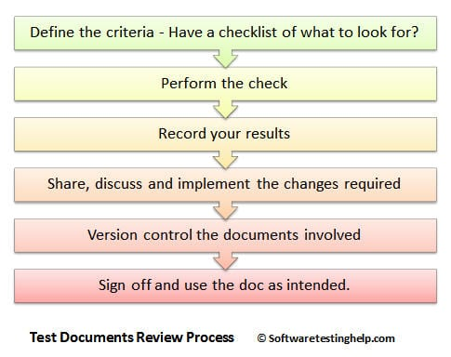
In order to make sure that everything is running smoothly, you need to perform regular maintenance checks. If your company is big, then it might not be possible for you to carry out these checks all by yourself. In that case, you need to get some people to do the checking for you and send you the maintenance invoice.
A maintenance report form is one of the main tools used by maintenance personnel to document maintenance inspections on equipment. The report involves a continuous process of checking, servicing, and repairing operating equipment to make sure that what is done, hot id done, how it operates without unwanted interruptions.
To accurately track the records of actions done for quality and safety purposes, you can use a maintenance report template.
Here are some benefits of using such a form:
- It helps maintain reliability: This ensures that operating equipment is always made available as needed and in working condition.
- It helps ensure safety: Regular checkups can prevent unexpected risks to the individuals involved in doing repairs.
- It improves efficiency: The early identification of defects and their immediate repairs can save the company both money and time in the long run.
- It promotes good recordkeeping: The regular documentation of equipment repair and diagnostics helps you identify broader trends while supporting investigations in the future.

  - Work area clean up
Cleaning is the removal of all visible soil in an approved way with the use of mechanical and chemical action or both, so that all areas are cleaned and sanitized to a high standard. Cleaning is an investment in the assets of a building
Maintenance is the upkeep of all furniture, fittings and equipment to an exacting standard within the property so that all areas look consistently new and pristine.
Why do we clean?
There are many reasons why we clean but the most important ones. If your local government authority has health regulations regarding cleaning and sanitizing, then you must know these and follow their recommendations at all times. It is important when you are cleaning that you clean to a high standard that has been set for you by your supervisor or Trainer.
Housekeeping/garbage disposal
- At all times job site shall be kept clean and free from debris, trash and rubbish.
- Clean up area before start of work or quitting.
- Do not allow garbage to accumulate at job site.
- Store all materials in a neat and orderly fashion.
- Keep aisles, passageways, stairs, platforms and ladders dear of all unnecessary obstructions. Segregate garbage according to pyrophoric and non-pyrophoric (metals, etc.) Materials. Pyrophoric materials should be buried under ground at dumpsite.
- Collect pyrophoric materials in drums and must be kept wet awaiting disposal.
- Secure permit to dispose garbage at Dumpsite from OM&S.
- Do not block firefighting equipment such as fire monitors and hydrants with garbage, materials and equipment.
- Any material, trash or debris that falls from Refinery’s vehicle shall be promptly cleaned up by Refinery.
- Hotels must be cleaned and sanitized to prevent possible cross infection from one guest to another and to prevent food poisoning
- Failure to clean properly and remove rubbish may result in pest infestation and bad smells caused by rotting rubbish
- Failure to clean will ultimately lead to a loss of business through guest complaints and investigations by local health inspectors.

Effective housekeeping results in:
- reduced handling to ease the flow of materials
- fewer tripping and slipping incidents in clutter-free and spill-free work areas
- decreased fire hazards
- lower worker exposures to hazardous products (e.g. dusts, vapours)
- better control of tools and materials, including inventory and supplies
- more efficient equipment cleanup and maintenance
- better hygienic conditions leading to improved health
- more effective use of space
- reduced property damage by improving preventive maintenance
- less janitorial work
- improved morale
- improved productivity (tools and materials will be easy to find)
Effective housekeeping can help control or eliminate workplace hazards. Poor housekeeping practices frequently contribute to incidents. If the sight of paper, debris, clutter and spills is accepted as normal, then other more serious hazards may be taken for granted.
Housekeeping is not just cleanliness. It includes keeping work areas neat and orderly, maintaining halls and floors free of slip and trip hazards, and removing of waste materials (e.g., paper, cardboard) and other fire hazards from work areas. It also requires paying attention to important details such as the layout of the whole workplace, aisle marking, the adequacy of storage facilities, and maintenance. Good housekeeping is also a basic part of incident and fire prevention.
Effective housekeeping is an ongoing operation: it is not a one-time or hit-and-miss cleanup done occasionally. Periodic "panic" cleanups are costly and ineffective in reducing incidents.
Work equipment, tools and cleaners work in all industry sectors and workplaces, from hotels to hospitals and factories to farms. They work inside and outdoors, including in public areas. Often working at night or in the early morning, sometimes alone, cleaners are found in every setting and the work they do is essential.
How and why cleaning workers are injured using their equipment?
Cleaning workers use a wide range of equipment, including hand tools, testing instruments, equipment’s, sets, tables, and where you store all necessary working tools. The hazards associated with the most commonly used tools and equipment is not easy.
The first step in preventing harm is to cleaning working areas, including from work equipment identifying according to their function. The guiding principles that should be considered throughout the risk assessment process can be broken down into a series of steps.
Step 1: identifying hazards and those at risk looking for those things at work that has the potential to cause harm and identifying workers who may be exposed to the hazards. The equipment used by cleaners is varied, ranging from a simple bucket and mop to rotary buffers and ride-on scrubber/drier machines. The work can be demanding and labor intensive, and may result in exposure to hazards and risks. These include:
- manual handling – cleaning workers are frequently required to move heavy awkward objects such as furniture and cleaning equipment, which can lead to muscle strain and back pain;
- working in awkward postures, over-extension, and carrying out repetitive tasks can be causal factors for musculoskeletal disorders (MSDs) – a variety of problems affecting the muscles, joints and nerves;
- high load on the lower limbs contributing to tiredness, discomfort, swelling, and pain in the legs;
- slips and trips – wet mopping of floors and trailing cables;
- exposure to vibration to the hand and arm from commonly used vibrating equipment such as rotary disc machines;
- exposure to noise – depending on the level of exposure, noise produced by some cleaning equipment such as industrial vacuum cleaners can be potentially damaging;
- exposure to chemicals – some cleaning solutions used in machines can be hazardous;
- Accidents from contact with machines – electric shocks from faulty electrical appliance or a machinery hazard; for example, injuries to hands caught in machines.

What is the purpose of workplace housekeeping?
Poor housekeeping can be a cause of incidents, such as:
- tripping over loose objects on floors, stairs and platforms
- being hit by falling objects
- slipping on greasy, wet or dirty surfaces
- striking against projecting, poorly stacked items or misplaced material
- cutting, puncturing, or tearing the skin of hands or other parts of the body on projecting nails, wire or steel strapping
To avoid these hazards, a workplace must "maintain" order throughout a workday. Although this effort requires a great deal of management and planning, the benefits are many.

The Experts who developed the TTLM

Self-check Answer key
Unit One :- maintenance/ repair Plan and preparation

Self-check-1: Key answer
- A) maintenance
- C) maintenance
- B) Planned maintenance
- A) Preventive Maintenance
- D) All

Self-check 2: Key answer
a) To increase safety
a) Safety Policy
e) All
e) All

Self-check-3 : Key- answer
1. B) Codes and Standards
2. A) True
3. A) ISA-S5.1-1984
Unit Two:- Maintain instrumentation and control devices

Self-check 1 answer
      - D) PPE
      - C) Eye
      - A) Restriction
      - D) quality materials
      - C) Safety poster

The trainers who developed the curriculum
No | Name | Qualification level | Educational background | Region | College | Mobile number | E-mail
 | Melaku Bekele Ofgaha | A | Electri/Automation Control Technology | Oromia | Amboo poly TVET college | O921051772 | kakumalaku430@gmail.com
 | Bahiru Demeke | A | Electri/Elec Contr | Oromia | Bishoftu Poly TVET College | O911394408 | bahirudemeke20@gmail.com
 | Worku Biru Mekonnen | A | Electri/Automation Control Technology | Oromia | Sebeta Poly TVET College | O912106303 | workubiru3@gmail.com
 | Sisay H/Mariam Toga | A | Electrical Power Enginering |  | Arbaminch poly & satelite College | O945234339 | sisayhailemariam971@gmail.com
 | Hassen Husen Hamid | A | Electrical Eng | Oromia | M/G/M/B Poly TVET College | O943402001
TTLM Developer Profile

Reference
- https://automationforum.co/what-is-maintenance-types-of-maintenance/
- https://en.wikipedia.org/wiki/Maintenance_(technical)
- https://www.fm-house.com/en/what-is-maintenance-and-why-do-we-do-it/
- https://www.reliableplant.com/Read/338/effective-maintenance-plan
- http://online.anyflip.com/nclgi/rnet/mobile/index.html
- Guidelines on occupational safety and health management systems ILO-OSH 2001
- Maintenance of Instruments & Systems, 2nd Edition, Lawrence D. Goettsche, Editor
- https://www.electronicshub.org/types-of-faults-in-electrical-power-systems/
- https://en.wikipedia.org/wiki/Functional_testing
- https://www.ccohs.ca/oshanswers/hsprograms/house.html
- https://www.coursehero.com/file/p478citc/22-Normal-function-of-instrumentation-and-control-devices-is-checked-in/

