Industrial Electrical/Electronic
Control Technology Level-IV
Based on October 2023, Curriculum Version II
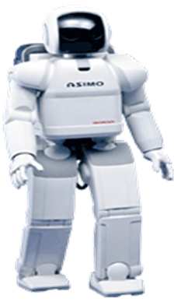
Module Title: Install Mechatronics Device
Module code: EIS IEC4 M03 1023
Nominal duration: 150Hour
Prepared by: Ministry of Labor and Skill
October, 2023
Addis Ababa, Ethiopia

Table of Contents
Acknowledgment II
Acronym III
Introduction of The Module - 1 -
UNIT ONE: Prepare and Plan To Mechatronic Device - 1 -
1.1 Introduction to Install Mechatronic Device - 2 -
1.2 Installation work preparation - 7 -
1.3Tools, equipment testing devices and materials. - 10 -
1.4. Planning Mechatronics standards to complete the work are obtained. - 22 -
Self-Check-1 - 27 -
UNIT TWO: Mechatronics Devices, Installation - 28 -
2.1 Install Mechatronics Devices - 29 -
2.2. Read and Interpret Work instructions - 93 -
2.3 Mechatronics devices installation - 100 -
2.4 Installed mechatronics device testing - 122 -
Self-Check -2 - 124 -
Unit Three: Mechatronics Devices Configuring and Adjusting - 125 -
3.1 Instruction of configuration and adjustment? - 126 -
3.2 Configure and adjust mechatronics devices according to standard operating procedures - 128 -
3.3. Testing the configured and adjusted mechatronics devices - 146 -
Self-Check -3 - 148 -

Acknowledgment

Ministry of Labor and Skills wish to extend thanks and appreciation to the many representatives of TVET instructors and respective industry experts who donated their time and expertise to the development of this Teaching, Training and Learning Materials (TTLM).

Acronym

PLC Programmable Logic Controller
PC ------------------------------------------------Personal Computer
DUTs-----------------------------------------------electronic devices under test
ATE------------------------------------------------Automatic test equipment
EMF ------------------------------------------------ Electric and Magnetic Fields
PPE Personal Protective Equipment
RC Reserve Capacity

Introduction of The Module

In Industrial Electrical/Electronic Control Technology filed provides This module covers the knowledge, skills and attitude required to perform service connection. It includes required in preparing, identifying, installing and testing mechatronic devices This module is designed to meet the industry requirement under the Industrial Electrical/Electronic Control Technology occupational standard, particularly for the unit of competency: Install Mechatronics Device.
This module covers the units:
- Prepare and plan to install mechatronic device
- Mechatronics devices, installation
- Mechatronics devices configuring and adjusting
Learning Objective of the Module
- Prepare and Plan to install mechatronic device
- Install Mechatronics devices
- Configure and adjust mechatronics devices
Module Instruction
For effective use this modules trainees are expected to follow the following module instruction:
- Read the information written in each unit
- Accomplish the Self-checks at the end of each unit
- Perform Operation Sheets which were provided at the end of units
- Do the “LAP test” giver at the end of each unit and
- Read the identified reference book for Examples and exercise

UNIT ONE: Prepare and Plan To Mechatronic Device
This unit is developed to provide you the necessary information regarding the following content coverage and topics:
- Introduction to install mechatronic device
- Installation work preparation
- Tools, equipment testing devices and materials.
- Materials and component
This unit will also assist you to attain the learning outcomes stated in above unit. Specifically, upon completion of this learning guide, you will be able to:
- Introduction to mechatronic device
- Install work preparation
- Select Tools, equipment testing devices and materials.
- Understand Materials and component

1.1 Introduction to Install Mechatronic Device
- Mechatronics standards
Mechatronics is a system-level approach to designing electromechanical systems that merges mechanical, electrical, control and embedded software design. Explore these mechatronics resources and learn how to lower your development costs, reduce risk, and produce higher-quality products.
IT is the fusion of the technologies of electronics and mechanics. Examples include numerically controlled machine tools, industrial Robots, digital clocks, and electronic calculators. Mechatronics (or Mechanical and Electronics Engineering) is the synergistic combination of mechanical engineering, electronic engineering, controls engineering and computer engineering to create useful products.
BASIC DEFINITIONS
According to Yasakawa Electric Company:
- The word, mechatronics, is composed of “mecha” from mechanism and the “tronics” from electronics.
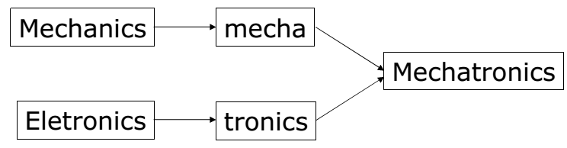
Figure .1.1: Mechatronics
- In other words, technologies and developed products will be incorporating electronics more and more into mechanisms, intimately and organically, and making it impossible to tell where one ends and the other begins.
According to Hiroshima, Tomizuka, and Fukada:
- Mechatronics is defined as the synergistic (interaction of two or more) integration of mechanical engineering, with electronics and intelligent computer control in the design and manufacturing of industrial products and processes.
According to Auslander and Kempf:
- Mechatronics is the application of complex decision making to the operation of physical systems
According to Shetty and Kolk:
- Mechatronics is a methodology used for the optimal (most favorable) design of electromechanical products.
According to W. Bolton (More recently):
- A mechatronic system is not just a marriage of electrical and mechanical systems and is more than just a control system; it is a complete integration of all of them. All of these definitions and statements about mechatronics are accurate and informative (useful or educational), yet each one in and of itself fails to capture the totality of mechatronics.
- Mechatronics Working Definition for us:
- Mechatronics is the synergistic integration of sensors, actuators, signal conditioning, power electronics, decision and control algorithms, and computer hardware and software to manage complexity, uncertainty, and communication in engineered systems.
- Or Mechatronics basically refers to mechanical - electronic systems and normally described as a synergistic combination of mechanics, electrical, electronics, computer and control which, when combined, make possible the generation of simple, more economic, and reliable systems.
- What is a mechatronic system?
Mechatronics is the intelligent control of plant, product or process.
- What does this mean?
In the case of an automated system it means that, in general, underlying intelligent controller(s) control all parts of the system (or overall process).
These controllers can take many forms:
- Personal Computer (PC)
- Microcontroller
- Embedded controller
- Programmable Logic Controller (PLC)
All of these controller types have at their heart a device called the microprocessor
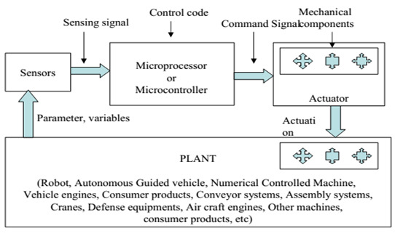
Figure 1.2 schematic diagram of a mechatronics system
- Disciplinary Foundations of Mechatronic
- Mechanical Engineering
- Electrical Engineering
- Computer Engineering
- Computer/Information System
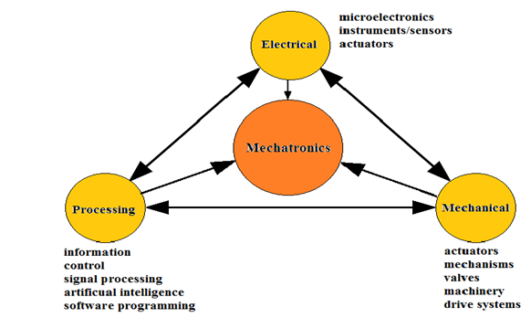
Figure 1.3 mechatronics system
Mechatronics Engineers:
Why do we need to cover so many areas when already exist many engineers in each of the fields shown above?
In some industrial design and manufacturing companies two engineers of different disciplines may be working together. One of the engineers sees something, which impinges on the other engineering discipline, but rather than deal with it directly he will talk to his manager. This manager will then talk to the second engineers’ manager the information will then travel by way of the two managers to the second engineer.
Obviously this is an extremely wasteful process. Most of the time this is done because of a lack of experience and knowledge of the other engineer’s area of work.
Mechatronics overcomes this unfamiliarity and breaks down the barriers by allowing people to work in harmony as part of a multidisciplinary engineering team. This saves companies time and money and adds to the job satisfaction of the engineer.
- By necessity, must be cross-trained in several disciplines and must also have the ability to communicate across these disciplines.
- They must be able to install machines, connect them to electronic circuits, and master their control software.
- Mechatronics Engineer solves this problem


Figure 1.4 working together
What is a mechatronic system?
Mechatronics is the intelligent control of plant, product or process.
•What does this mean?
In the case of an automated system it means that, in general, underlying intelligent controller(s) control all parts of the system (or overall process).
These controllers can take many forms:
- Personal Computer (PC)
- Embedded controller
- Microcontroller
- Programmable Logic Controller (PLC)
All of these controller types have at their heart a device called the microprocessor
- Key elements of a mechatronic system
- It can be seen from the history of mechatronics that the integration of the different technologies to obtain the best solution to a given technological problem is considered to be the essence of the discipline.
- There are at least two dozen definitions of mechatronics in the literature but most of them hinge around the ‘integration of mechanical, electronic, and control engineering, and information technology to obtain the best solution to a given technological problem, which is/ the realization of a product’; we follow this definition.
- As can be seen, the key element of mechatronics are electronics, digital control, sensors and actuators, and information technology, all integrated in such a way as to produce a real product that is of practical use to people.
The following subsections outline, very briefly, some fundamentals of these key areas. For fuller discussions the reader is invited to explore the rich and established information sources available on mechanics, electrical and electronic theory, instrumentation and control theory, information and computing theory, and numerical techniques.

1.2 Installation work preparation
1.2.1 Planning and Preparing Installation
- Planning Installation
- Describe the structure of a mechatronic system in principle with pneumatic,
- hydraulic and electric drives, sensors, controller and interfaces.
- Procure, read and apply information from technical documents, diagrams and internet.
- Analyze functional connections in automated processes, especially movement sequences and logical conditions.
- Develop solutions for problems related to automated processes and draw up in standardized diagrams.
- Read and draw up circuit diagrams (pneumatic, hydraulic and electric) for mechatronic stations.
- Develop technical drawing of mechanical parts.
- Produce mechanical parts related to handling station
- Operate industrial PLC and peripheral devices.
- Understand, modify and develop applied control programs in at least one programming language according to IEC 1131-3.
- Determine the working steps required for carrying out the mounting and installation of PLC-operated mechatronic stations.
- Dismantle and assembly mechatronic stations, change and adjust components.
- Install electrical components in mechatronic stations.
- Download programs to PLC, commission, operate and test mechatronic stations and systems.
- Carry out systematic trouble-shooting and repair in PLC-operated systems.
- Communicate with partners (customers, suppliers and colleagues)
- Develop readiness for self-learning to improve knowledge and working skills.
- Solve problems systematically in a team.
1.2.2 Electrical plan
The electrical information and layouts in construction drawings, just as the mechanical plan, are generally superimposed on the building plan and the plot plan. As an EA3, the electrical layout for both light and power is your main concern. You will be required to draw electrical drawings and layouts from notes, sketches, and specifications provided by the designing engineer. Although you are not required to design the electrical wiring system, you must be familiar with the methods, the symbols, and the nomenclature, as well as the basic functions of the components associated with the electrical systems, its transmission and distribution, and the circuits hookup. In addition, you must also be familiar with the codes (both NEC ® and local) and standards and specifications, and be able to apply that knowledge in Planning function is an initial stage of managerial process. It reflects tasks, objectives and actions choosing, in order to achieve chosen goals. It requires decision making by choosing between concurrent alternative paths of action of the future. By planning, organization can determine means and ways of how and what they will achieve specific goals. The information sheet will focus on aggregate production and aggregate capacity, which will be broken to the level of scheduling and rough-cut capacity planning. All of the system will be taken into account.
1.2.3 Installation Planning and Scheduling System
Installation planning and scheduling systems depend on the utilization of planning capacity, the volume and timing of outputs, and on balancing of outputs with capacity at desired levels for competitive effectiveness. Setting compatibility between these systems must take place on various levels of management, so that various activities support each other. As process progresses from top to bottom, intervals of time shrink, and specs of planning go from broad at the top, to very detailed at the bottom.
- Types of planning Scheduling
Don't miss deadlines or waste production time by using a bad planning schedule. Time wasted is money wasted. Deadlines missed can lose you repeat customers. You must decide if your priority is speed or timing, and then choose the appropriate schedule for your operations. Most operations schedule fall into one of five types.
- First Come First Served If you have a single item to produce, or if your products require similar processing times, you may prefer the first come first served approach to scheduling. Essentially, this means exactly what it sounds like: Schedule production based on when your product is ordered by a customer. If you have different products with different manufacturing times and deadlines, however, this can end up being less effective for meeting deadlines, as it is fairly random.
- Shortest Processing Time One favored method of scheduling to get products produced quickly is the shortest processing time approach, which prioritizes jobs that take the least amount of time to complete. One reason this method is faster is because you reduce the time that is lost when your machine switches between jobs. If three identical products are ordered that contain a quickly produced piece and a slowly produced piece, shortest processing time scheduling would have your machine make the three easy pieces first and the three hard pieces second. This is faster than having the machine alternate between difficult and easy pieces.
- Earliest Due Date
Earliest due date scheduling is based on ordering your production jobs based on deadlines. Working first on the product with the earliest due date can be especially effective with machines that have single jobs and when deadlines are spaced out. If your business specializes in one product with varying shipping deadlines, this could be the best schedule for you.
1.2.4 Slack Time Remaining
Slack time is determined through a mathematical equation. Subtract the time it takes to make the product from the time it is due. The item with the smallest slack time remaining is scheduled first. For example, if you have an item that takes five days to make and is due in six days, you would process that before an item that takes one day to make but is due in four days. This may not be the fastest method, but it can be the most effective for meeting deadlines.
1.2.5 Critical Ratio
Scheduling products using critical ratio is similar to using slack time remaining. The difference is that instead of subtracting processing time from time remaining, you divide it. This gives you a percentage of time remaining until your product is due instead of an integer. Using division versus subtraction is mostly a personal preference. The production results should be similar to those using the slack time remaining method
- Codes
Code requirements and installation procedures offer protection for the consumer against un-skilled electrical labor. Among other functions, the NEC ® serves as a basis for limiting the type and wiring to be used, the circuit size, the outlet spacing, the conduit requirements, and the like. In addition, local codes are also used when separate electrical sections are applicable to the locale in which the building will be built. Be certain that you always have a copy of the latest edition of the NEC ® available for your use. Similarly, all of the types of electrical devices and fixtures included in the materials list prepared for electrical plans are to meet certain specifications and minimum requirements. An independent organization called Underwriters.

1.3Tools, equipment testing devices and materials.
1.3.1 Necessary tools
Power tools shall be of a manufacture listed by a nationally-recognized testing laboratory for the specific application for which they are to be used
The important tools needed for installing mechatronics device are the following: -
- Pliers
- Diagonal cutters
- Standard screw driver
- Philips screw drivers
- Electrical pliers
- wrenches, hexagonal wrenches or Allen keys -Hex jaw design gives multi-sided, secure grip on all hex nuts, square nuts, unions and valve packing nuts. The extra-wide opening offset model is ideal for securing drain nuts on sinks and tubs. Thin, smooth jaws slip into the tightest places.
More commonly called an Allen wrench, a hex key is a tiny but powerful tool. hexagon wrench, is a six-sided tool used to tighten and loosen screws with a matching hexagonal shape. Hex-headed screws are used to put together furniture, and many ready-to-assemble furniture kits come with a
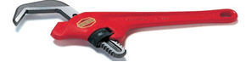
Figure 1.5 hex wrench.
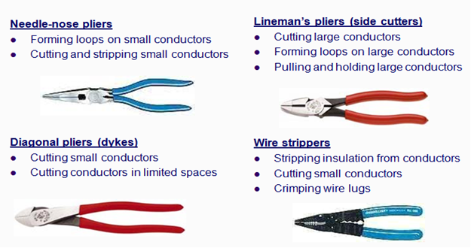
Figure 1.6: important tools needed for installing mechatronics device
• Hand and Power Tools
shall be used, inspected, and maintained in accordance with the manufacturer's instructions and recommendations and shall be used only for the purpose for which designed. A copy of the manufacturer's instructions and recommendations shall be maintained with the tools.
- Hand and power tools shall be inspected, tested, and determined to be in safe operating condition before use. Continued periodic inspections shall be made to assure safe operating condition and proper maintenance.
- Hand and power tools shall be in good repair and with all required safety devices installed and properly adjusted. Tools having defects that will impair their strength or render them unsafe shall be removed from service.
1.3.2 Equipment/Testing Devices
Electronic test equipment is used to create signals and capture responses from electronic devices under test (DUTs). In this way, the proper operation of the DUT can be proven or faults in the device can be traced. Use of electronic test equipment is essential to any serious work on electronics systems.
Practical electronics engineering and assembly requires the use of many different kinds of electronic test equipment ranging from the very simple and inexpensive (such as a test light consisting of just a light bulb and a test lead) to extremely complex and sophisticated such as automatic test equipment (ATE). ATE often includes many of these instruments in real and simulated forms.
Generally, more advanced test gear is necessary when developing circuits and systems than is needed when doing production testing or when troubleshooting existing production units in the field.
- Types of test equipment
- Basic equipment
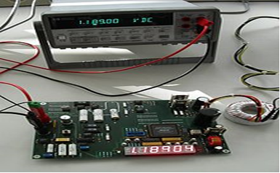
Figure 1.7: Agilent commercial digital voltmeter checking a prototype
The following items are used for basic measurement of voltages, currents, and components in the circuit under test.
- Voltmeter (Measures voltage)
- Ohmmeter (Measures resistance)
- Ammeter, e.g. Galvanometer or Milliammeter (Measures current)
- Multimeter e.g., VOM (Volt-Ohm-Milliammeter) or DMM (Digital Multimeter) (Measures all of the above)
- LCR meter - inductance (L), capacitance (C) and resistance (R) meter (measure LCR values)
The following are used for stimulus of the circuit under test:
- Power supplies
- Signal generator
- Digital pattern generator
- Pulse generator
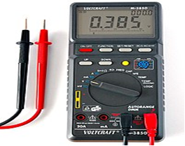
Figure 1.8: Voltcraft M-3850 portable Multimeter
- The following analyze the response of the circuit under test
- Oscilloscope (Displays voltage as it changes over time)
- Frequency counter (Measures frequency)
- And connecting it all together:
- Test probes
- Advanced or less commonly used equipment
Meters
- Solenoid voltmeter (Wiggy)
- Clamp meter (current transducer)
- Wheatstone bridge (Precisely measures resistance)
- Capacitance meter (Measures capacitance)
- LCR meter (Measures inductance, capacitance, resistance and combinations thereof)
- EMF Meter (Measures Electric and Magnetic Fields)
- Electrometer (Measures voltages, sometimes even tiny ones, via a charge effect)
- Probes
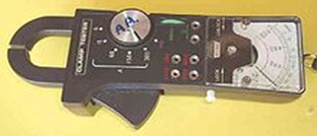
Figure 1.9: Probes
A Multimeter with a built in clamp facility. Pushing the large button at the bottom opens the lower jaw of the clamp, allowing the clamp to be placed around a conductor (wire). Depending on sensor, some can measure both AC and DC current.
- RF probe
- Signal tracer
- Analyzers
- Logic analyzer (Tests digital circuits)
- Spectrum analyzer (SA) (Measures spectral energy of signals)
- Protocol analyzer (Tests functionality, performance and conformance of protocols)
- Vector signal analyzer (VSA) (Like the SA but it can also perform many more useful digital demodulation functions)
- Time-domain reflector- meter (Tests integrity of long cables)
- Semiconductor curve tracer
- Signal-generating devices
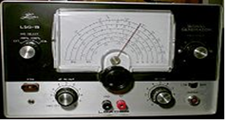
Figure 1.10: Leader Instruments LSG-15 signal generator.
- Signal generator usually distinguished by frequency range (e.g., audio or radio frequencies) or waveform type (e.g., sine, square, saw tooth, ramp, sweep, modulated, ...)
- Frequency synthesiser
- Function generator
- Digital pattern generator
- Pulse generator
- Signal injector
- Miscellaneous devices
- Boxcar average
- Continuity tester
- Cable tester
- Hipot tester
- Network analyzer (used to characterize an electrical network of components)
- Test light
- Transistor tester
- Tube tester
- Computer
How is a computer defined? Electronic device operating under the control of instructions stored in its own memory. The computer first, accepts data such as raw facts, figures, and symbol then, Processes data into information (Data that is organized, meaningful, and useful) finally, Produces and stores results.
A PLC simulation program - Simulation-based programmable logic controller (PLC) code verification is a part of virtual commissioning, where the control code is verified against a virtual prototype of an application. With today's general OPC interface, it is easy to connect a PLC to a simulation tool for, e.g., verification purposes. However, there are some problems with this approach that can lead to an unreliable verification result. In this paper, four major problems with the OPC interface are described, and two possible solutions to the problems are presented: a general IEC 61131-3-based software solution, and a new OPC standard solution.
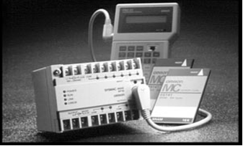
Figure 1.11: typical PLC /Small PLC type
1.3.3. Transmitter
- A transmitter is a device that converts a reading from a sensor or transducer into a standard signal and transmits that signal to a monitor or controller.
- A transmitter is a device which converts the reading from a primary sensor or transducer into a standard signal and transmits that signal to a monitor or controller. Transmitter types include:
- Pressure transmitters
- Flow transmitters
- Temperature transmitters
- Level transmitters
- Analytic (O [oxygen], CO [carbon monoxide], and pH) transmitters
- SIGNALS
There are three kinds of signals that exist for the process industry to transmit the process variable measurement from the instrument to a centralized control system.
- Pneumatic signal
- Analog signal
- Digital signal
•Pneumatic Signals- Pneumatic signals are signals produced by changing the air pressure in a signal pipe in proportion to the measured change in a process variable. The common industry standard pneumatic signal range is 3–15 psig. The 3 corresponds to the lower range value (LRV) and the 15 corresponds to the upper range value (URV). Pneumatic signaling is still common. However, since the advent of electronic instruments in the 1960s, the lower costs involved in running electrical signal wire through a plant as opposed to running pressurized air tubes has made pneumatic signal technology less attractive.
•Analog Signals- The most common standard electrical signal is the 4–20 mA current signal. With this signal, a transmitter sends a small current through a set of wires. The current signal is a kind of gauge in which 4 mA represents the lowest possible measurement, or zero, and 20 mA represents the highest possible measurement. For example, imagine a process that must be maintained at 100 °C. An RTD temperature sensor and transmitter are installed in the process vessel, and the transmitter is set to produce a 4 mA signal when the process temperature is at 95 °C and a 20 mA signal when the process temperature is at 105 °C. The transmitter will transmit a 12 mA signal when the temperature is at the 100 °C set point. As the sensor’s resistance property changes in response to changes in temperature, the transmitter outputs a 4–20 mA signal that is proportionate to the temperature changes. This signal can be converted to a temperature reading or an input to a control device, such as a burner fuel valve. Other common standard electrical signals include the 1–5 V (volts) signal and the pulse output.
•Transducers and Converters
- A transducer is a device that translates a mechanical signal into an electrical signal. For example, inside a capacitance pressure device, a transducer converts changes in pressure into a proportional change in capacitance.
- A converter is a device that converts one type of signal into another type of signal. For example, a converter may convert current into voltage or an analog signal into a digital signal. In process control, a converter used to convert a 4–20 mA current signal into a 3–15 psig pneumatic signal (commonly used by valve actuators) is called a current-to-pressure converter.
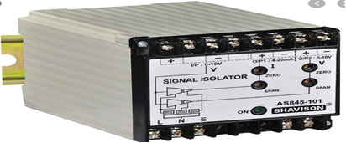
Figure 1.12: transducer and analog converter
- Actuator-An actuator is a component of a machine that is responsible for moving and controlling a mechanism or system, for example by opening a valve. In simple terms, it is a "mover".
An actuator requires a control signal and a source of energy. The control signal is relatively low energy and may be electric voltage or current, pneumatic, or hydraulic fluid pressure, or even human power. Its main energy source may be an electric current, hydraulic pressure, or pneumatic pressure. When it receives a control signal, an actuator responds by converting the source's energy into mechanical motion. In the electric, hydraulic, and pneumatic sense, it is a form of automation or automatic control.
An actuator is a mechanism by which a control system acts upon to perform an operation or task. The control system can be simple (a fixed mechanical or electronic system), software-based (e.g. a printer driver, robot control system), a human, or any other input.
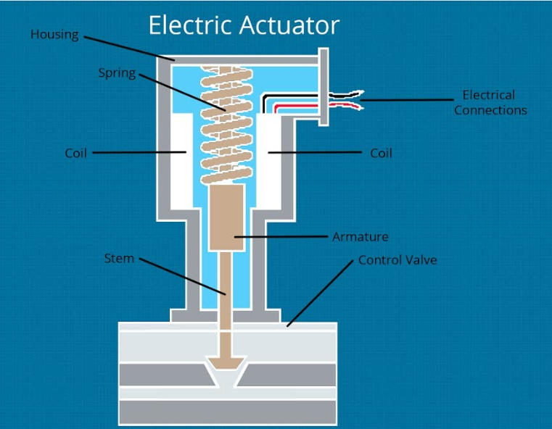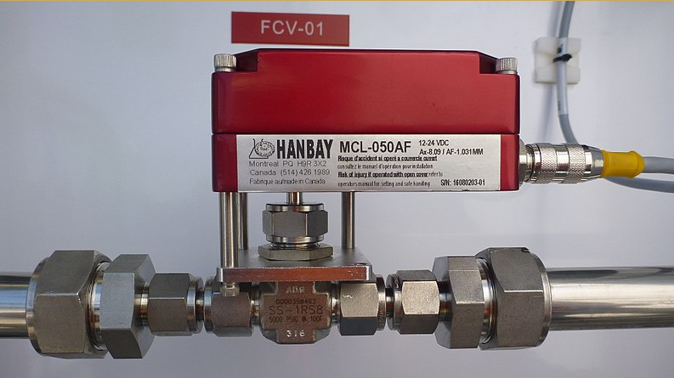
Figure 1.13: Electrical actuator

Stepper motor
- A stepper motor, also known as step motor or stepping motor, is a brushless DC electric motor that divides a full rotation into a number of equal steps. The motor's position can then be commanded to move and hold at one of these steps without any position sensor for feedback (an open-loop controller), as long as the motor is carefully sized to the application in respect to torque and speed.
- Switched reluctance motors are very large stepping motors with a reduced pole count, and generally are closed-loop commutated.
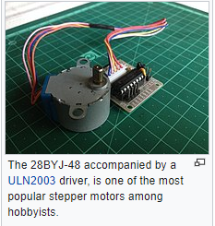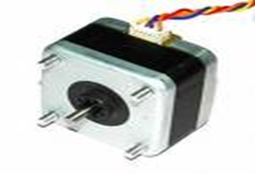
Figure 1.14: Stepper Motor
Power supply equipment-The power supply unit is the part of the hardware that is used to convert the power provided from the outlet into usable power to many parts inside an electrical device. Every energy supply must drive its load, which is connected to it. Depending on its design, a power supply unit may obtain energy from various types of energy sources, like electrical energy transmission systems, electromechanical systems such as generators and alternators, solar power converters, energy storage devices such as a battery and fuel cells, or other power supply. There are two types of power supplies existed, AC and DC power supply. Based on the electrical device’s electric specifications it may use AC power or DC power
Multi-meter-A multi-meter, also known as a volt-ohm meter, is a handheld tester used to measure electrical voltage, current (amperage), resistance, and other values. Multi-meters come in analog and digital versions and are useful for everything from simple tests, like measuring battery voltage, to detecting faults and complex diagnostics. They are one of the tools preferred by electricians for troubleshooting electrical problems on motors, appliances, circuits, power supplies, and wiring systems.
Analog Multi-meter-An analog multi-meter is based on a micro-ammeter (a device that measures amperage, or current) and has a needle that moves over a graduated scale. Analog multi-meters are less expensive than their digital counterparts but can be difficult for some users to read accurately. Also, they must be handled carefully and can be damaged if they are dropped. Analog multi-meters typically are not as accurate as digital meters when used as a voltmeter. However, analog multi-meters are great for detecting slow voltage changes because you can watch the needle moving over the scale. Analog testers are exceptional when set as ammeters, due to their low resistance and high sensitivity, with scales down to 50µA (50 microamperes).
Digital Multi-meters- Digital multi-meters are the most commonly available type and include simple versions as well as advanced designs for electronics engineers. In place of the moving needle and scale found on analog meters, digital meters provide readings on an LCD screen. They tend to cost more than analog multi-meters, but the price difference is minimal among basic versions. Advanced testers are much more expensive.
Digital multi-meters typically are better than analog in the voltmeter function, due to the higher resistance of digital. But for most users, the primary advantage of digital testers is the easy-to-read and highly accurate digital readout.
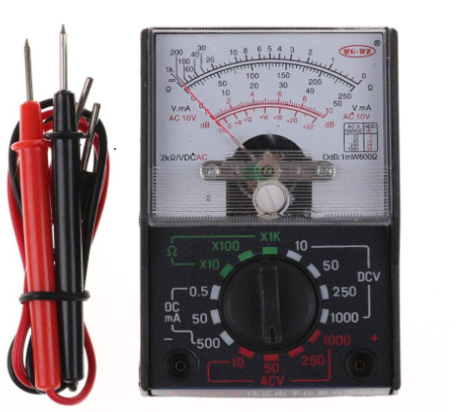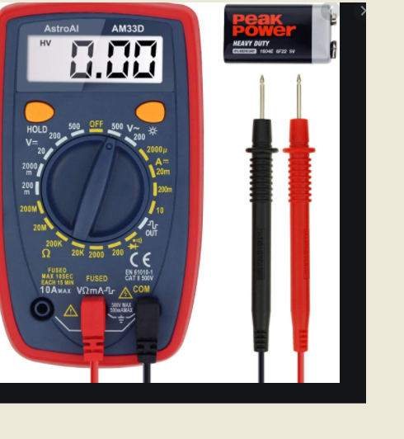
Figure 1.15: a) Analog multi-meter b) Digital multi-meter
- Calibrator/, instrument transducer
- Signal generator
- Oscilloscope -The oscilloscope is basically a graph-displaying device. It draws a graph of an electrical signal. In most applications the graph shows how signals change over time:
A) the vertical (Y) axis represents voltage
B) the horizontal (X) axis represents time.
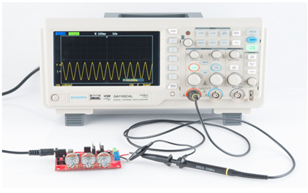
Figure 1.16: Oscilloscope
- Standard Gauges- Standard gauges are made to the nominal size of the part to be tested and have the measuring member equal in size to the mean permissible dimension of the part to be checked. A standard gauge should mate with some snugness.
Gauges Commonly used in Production Work are: -
- Plug Gauges
- Ring Gauges
- Taper Gauges
- Snap Gauges
- Thread Gauges
- Form Gauges
- Screw Pitch Gauges
- Radius and Fillet Gauges
- Feller Gauges
- Plate and Wire Gauges
- Indicating Gauges - Air Gauges

1.4. Planning Mechatronics standards to complete the work are obtained.
1.4.1. Mechatronics standards
- ACTUATORS
- An Actuator is the part of a final control device that causes a physical change in the final control device when signaled to do so. The most common example of an actuator is a valve actuator, which opens or closes a valve in response to control signals from a controller. Actuators are often powered pneumatically, hydraulically, or electrically. Diaphragms, bellows, springs, gears, hydraulic pilot valves, pistons, or electric motors are often parts of an actuator system.
- The Instrumentation, Systems, and Automation Society (ISA) is one of the leading process control trade and standards organizations. The ISA has developed a set of symbols for use in engineering drawings and designs of control loops (ISA S5.1 instrumentation symbol specification). You should be familiar with ISA symbology so that you can demonstrate possible process control loop solutions on paper to your customer. Figure 1.15. shows a control loop using ISA symbology. Drawings of this kind are known as piping and instrumentation drawings (P&ID)
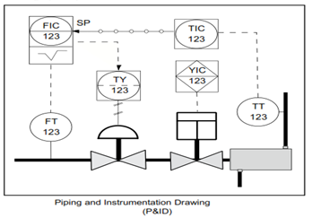
Figure 1.17: Piping and instrumentation drawing
CONTROLLERS
- A controller is a device that receives data from a measurement instrument, compares that data to a programmed set point, and, if necessary, signals a control element to take corrective action.
- Local controllers are usually one of the three types: pneumatic, electronic or programmable. Controllers also commonly reside in a digital control system.

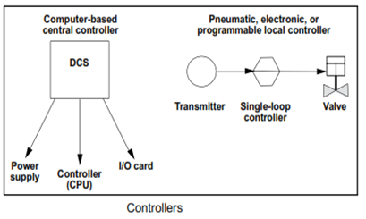
Figure 1.18: Computer based controller
Controllers may perform complex mathematical functions to compare a set of data to set point or they may perform simple addition or subtraction functions to make comparisons. Controllers always have an ability to receive input, to perform a mathematical function with the input, and to produce an output signal. Common
examples of controllers include:
- Programmable logic controllers (PLCs) —PLCs are usually computers connected to a set of input/output (I/O) devices. The computers are programmed to respond to inputs by sending outputs to maintain all processes at set point.
- Distributed control systems (DCSs) —DCSs are controllers that, in addition to performing control functions, provide readings of the status of the process, maintain databases and advanced man- machine-interface.
- Typical workshops may include some of the following:
- Pneumatic System: The student can interact with the pneumatic system. Programming, diagnostic checks may be carried out remotely.
- Di-electronics Control System: Students can control inputs and outputs remotely.
- Programmable Controller (PIC): Various control and response devices can be attached to the PIC controller and controlled remotely.
- Robotic System: The greatest challenge posed is remote control and programming of a robotic system.
- Mixed Reality Web Service for Mechatronics (artec Lab): The Mixed Reality Web Service.
- Mechatronic experiments accessible via the WWW. The system – called derive SERVER – is available 24 hours a day for exploration and experimentation. All that is necessary is to install some special plug-in on the client computer.
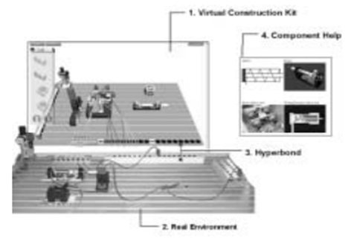
Figure 1.19: Mixed Reality Web Service for mechatronics (derive SERVER)
In addition to purely remote or local labs, where all devices are real, the derive SERVER is a ‘mixed-reality environment, for a distributed and collaborative eLearning platform that integrates real and virtual, local and remote media for electro pneumatics under a common interface. The derive SERVER is a direct outcome of the “Distributed Real and Virtual Learning Environment for Mechatronics and Tele-service” (DERIVE). The system is based on hyper bond technology, which provides the means to combine real and virtual worlds freely.
- A major goal in mechatronics training: -is that students have to acquire theoretical and operational knowledge and practical competencies in terms of core technical skills. These types of skills generally relate to the assembly and service of complex machines, plants and systems, in the field of plant construction and mechanical engineering, and in those companies that purchase and operate such mechatronic systems. Because of their complexity, mechatronic components and systems can often be installed and operated only in combination with support and after-sales services: specialist know-how and – in the case of maintenance or repair work – skilled customer support by the manufacturer’s specialists are required. Hence, there is a growing need for qualified service personnel in mechatronics, rather than pure mechanics or electronic control technologies, with the following qualifications and skills: knowledge about potential and probable causes of malfunctioning in mechatronic systems (cause-effect relationships), handling both uncertainty and complexity in sophisticated mechatronics systems a knowledge about system-related service procedures and tools.
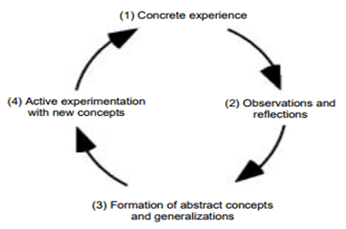
Figure 1.20: Experiential learning cycle
Plan and control work processes, monitor and evaluate the results and apply quality management systems Responsible for occupational training profiles in industry, defines the following skills for workers and technicians in the field of mechatronics
- process mechanical parts and assemble subassemblies and components into mechatronic systems;
- install electrical sub-assemblies and components;
- measure and test electrical values
- install and test hardware and software components;
- build and test electrical, pneumatic and hydraulic control systems
- program mechatronic systems
- assemble, dismantle, secure and transport machinery, systems and plant
- set up and test the functioning of mechatronic systems
- undertake the commissioning of mechatronic systems and operate such systems
- deliver mechatronic systems to clients and provide training in their operation
- carry out maintenance operations on mechatronic systems
Self-Check-1 Written Test

Name: _____________________________ Date: ___________________________
Time started: _______________________ Time finished: ____________________
Directions: For the following questions, say TRUE if the statement Is correct and FALSE if it is incorrect (wrong).
- Managers need to plan use of resources, in order to increase their exhaustion and subsequent consequences.
- Time wasted is not similar to money wasted.
- Installation planning and scheduling systems depend on the utilization of operations capacity.
- Scheduling products using critical ratio is similar to using slack time remaining.
- By planning, organization can determine means and ways of how and what they will achieve specific goals.
Part - II. Writ short answer for the following question. (2 point each)
Directions: Answer all the questions listed below. Use the Answer sheet provided in the next page:
- . _______________- is a document that provides specific instructions to carry out an Activity.
- Write the difference between Work Instructions and Procedures.

- . ________________ shows your overall process architecture and how it supports your business. (For more on this read our Guide to creating process hierarchies)
- _______________is a chain of activities that transform inputs to outputs. (Interested? read our Guide to simple process mapping

UNIT TWO: Mechatronics Devices, Installation
This unit is developed to provide you the necessary information regarding the following content coverage and topics:
- Mechatronics device
- Pneumatics & electro-pneumatics
- Hydraulics and electro-hydraulics
- Work instruction Reading and interpreting
- Mechatronics devices installation
- Installed mechatronics device testing
This unit will also assist you to attain the learning outcome stated in the above unit. Specifically, upon completion of this Learning Guide, you will be able to
- Install Mechatronics device
- install Pneumatics & electro-pneumatics
- install Hydraulics and electro-hydraulics
- Reading and interpreting Work instruction
- install Mechatronics devices
- Installed mechatronics device testing

2.1 Install Mechatronics Devices
A mechatronic device is one that is able to perceive the surrounding environment ,make appropriate decisions based on that information, and execute those decisions (take action). Mechatronic devices or “smart” devices have become common in our technologically advanced society. Mechatronics engineers can work in any company that develops, designs or manufactures and markets “smart” devices. Opportunities exist in manufacturing and sales as well as research.
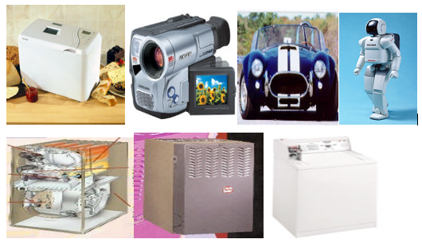
figure 2.1. Mechatronic devices

Sensors __________________ Perceive the environment
Controller _________________ Make Decisions
Actuators __________________ Take Action
A robot is a mechatronic system capable of replacing or assisting the human operator in carrying out a variety of physical tasks. The interaction with the surrounding environment is achieved through sensors and transducers, and the computer-controlled interaction systems copy human capabilities. The example investigated is the SG5-UT robot arm designed by Alex Dirks of the Crust Crawler team (see Figure below).
List of major mechanical components:
- Base and wheel plates
- Links: bicep, forearm, wrist
- Gripper
- Joints: shoulder, elbow, and wrist
- Hitec HS-475HB servos (base, wrist and gripper)
- Hitec HS-645MG servos (elbow bend)
- Hitec HS-805BB servos (shoulder bend)
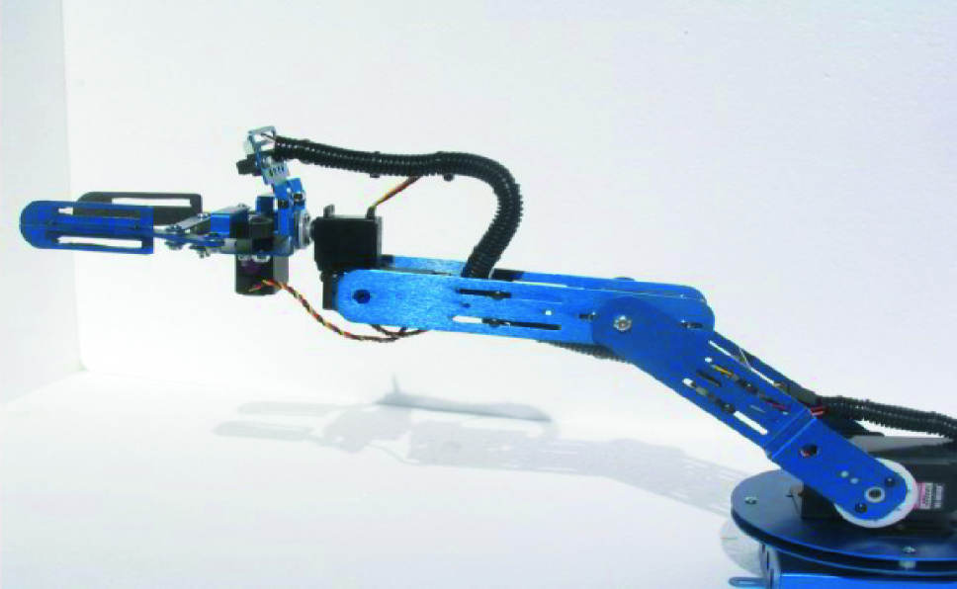
Figure 2.1AThe Crust Crawler SG5-UT robot arm

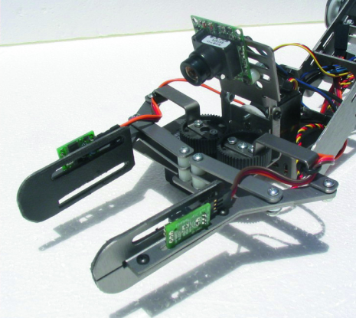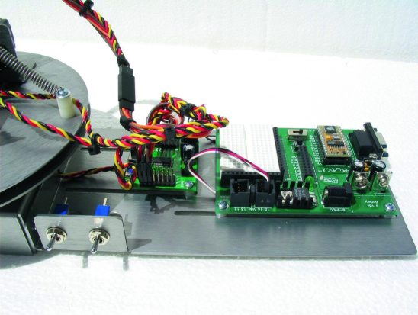

(a) Gripper (b) Microcontroller
Figure2.1B Major Components of the robot arm

The most critical aspect of any robot arm is in the design of the gripper. The usefulness and functionality of a robot arm is directly related to the ability to sense and successfully manipulate its immediate environment.
- The gripper drive system, as shown in Figure (a), consists of a resin gear train driven by an HS475HB servo. The servos are needed to provide motion to the various mechanical links as well as the gripper. The mounting site of the servos and the power routing to servos and supporting electronics are some of the important aspects to be considered in the design of this robot arm.
- The microcontroller board (Figure (b)) is essential for communication between the robot and a PC, providing users the ability to manipulate the robot. It is important to have accurate information on the pin connections and the corresponding components that are being controlled.
Computer disk drive
The computer disk drive is one of the best examples of mechatronic design because it exhibits quick response, precision, and robustness. According to mechatronic principles clothes washer features a sensor-based feedback control that maintains correct water temperature no matter the load size.
The electrical part consists of micro-electronic devices, power converters and measuring circuit electronics. Sensor controls are intended to obtain data about actual conditions of environment surroundings and objects of processing, mechanical device, blocks of drivers with subsequent processing and transmitting of this information to computer control device. Top level computer and controllers of movement control are integral parts of mechatronic system

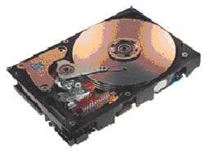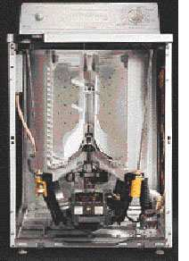
Fig.29. Computer disk drive

- Engine cooling module
The engine cooling module allows the evacuation of the heat generated by the car engine. This function needs the rotation of a fan to refresh the radiator. The control of the fan rotational speed is managed by the electronic power module which transfers up to 600 Watt of power toward the electric fan motor. A part of this power is dissipated by Joule effect in the electronic power module.

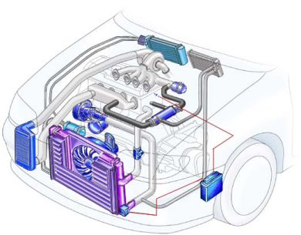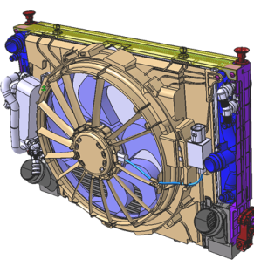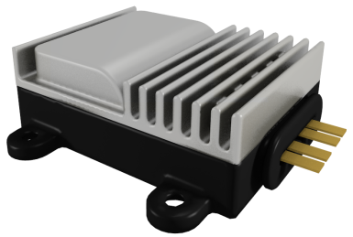
Figure 30. Engine cooling module and Electronic power module
- Electronic power modules
The electronic power module (PWM) is mainly composed by housing and the electronic card. The housing is a plastic box closed by an aluminum dissipater which surrounds the electronic card. The electronic card contains the electrical power circuit (thyristors, diodes…) which transfers a current up to 50A, and the electronic command circuit which controls the commutation of thyristors in order to prescribe the average voltage to be delivered to the fan motor.
The design of the PWM needs the accurate knowledge of the temperature distribution in order to optimize the shape of the aluminum dissipater as well as the choice of the quality class of electric components, which have a direct impact to the cost price.
Mechatronics is the synergistic combination of precision mechanical engineering, electronic control and systems thinking in the design of products and manufacturing processes. Mechatronics is the synergistic integration of sensors, actuators, signal conditioning, power electronics, decision and control algorithms, and computer hardware and software to manage complexity, uncertainty, and communication in engineered systems.
Key elements of a mechatronic system
- It can be seen from the history of mechatronics that the integration of the different technologies to obtain the best solution to a given technological problem is considered to be the essence of the discipline.
- There are at least two dozen definitions of mechatronics in the literature but most of them hinge around the ‘integration of mechanical, electronic, and control engineering, and information technology to obtain the best solution to a given technological problem, which is/ the realization of a product’; we follow this definition.
- As can be seen, the key element of mechatronics are electronics, digital control, sensors and actuators, and information technology, all integrated in such a way as to produce a real product that is of practical use to people.
- The following subsections outline, very briefly, some fundamentals of these key areas. For fuller discussions the reader is invited to explore the rich and established information sources available on mechanics, electrical and electronic theory, instrumentation and control theory, information and computing theory, and numerical techniques.
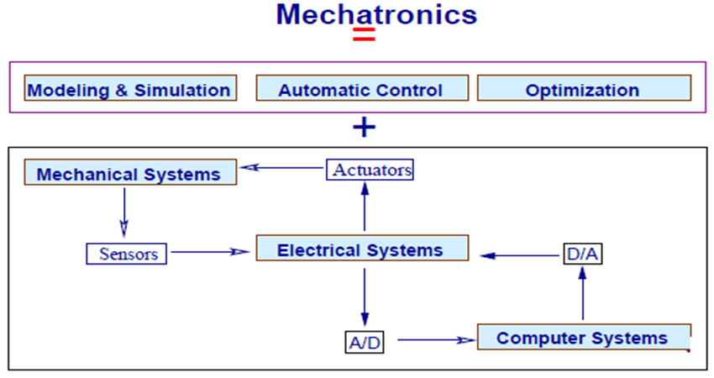
Figure 2.1C mechatronic systems
The study of mechatronic systems can be divided into the following areas of specialty:
- Physical Systems Modeling: structural, hydraulic, electrical, etc.
- Sensors and Actuators
- Signals and Systems
- Computers and Logic Systems
- Software and Data Acquisition
Data acquisition: A2D, D2A, digital I/O, counters, timers, etc.
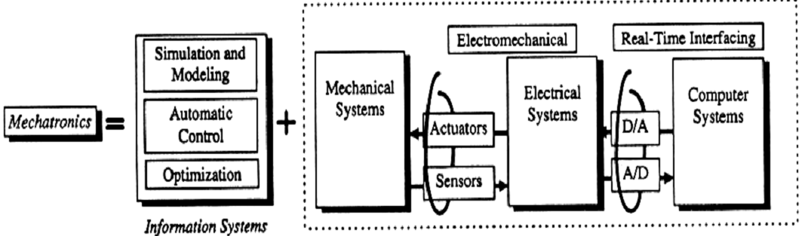
Figure 2.2 mechatronic systems
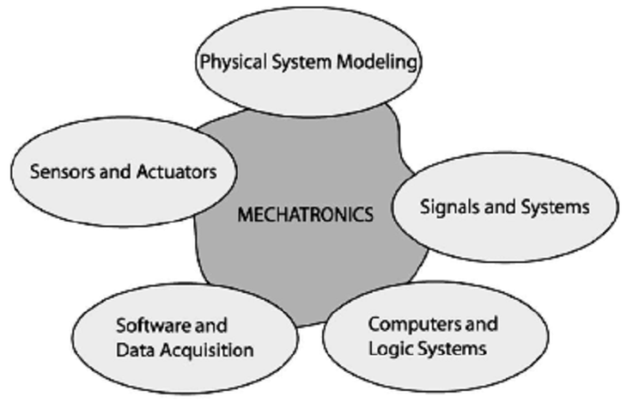
Figure 2.3 schematic diagram of a mechatronics system
Physical system:
- Physically, mechatronics system is composed of four prime components. They are sensors, actuators, controllers and mechanical components. Figure 2.2 above shows a schematic diagram of a mechatronics system integrated with all the above components.
Electrical Systems
- The following electrical components are frequently used:
  - Motors and generators
  - Transducers
  - Solid state devices including computers
  - Circuits (signal conditioning, impedance matching, amplifiers…)
  - Contact devices (relays, circuit breakers, switches…)
Sensors
- Sensors are required to monitor the performance of machines and processes. Some of the more common measurement variables in mechatronics systems are temperature, speed, position, force, torque, and acceleration.
- The characteristics that are important when one is measuring these variables include the dynamics of the sensor, stability, resolution, precision, robustness, size, and signal processing.
- The need for less expensive and precise sensors, as well as integration of the sensor and signal processing on a common carrier or on one chip, has become important.
Actuators
- Actuation involves a physical acting on the process, such as the ejection of a work piece from a conveyor system initiated by a sensor. Actuators are usually electrical, mechanical, fluid power or pneumatic based. They transform electrical inputs into mechanical outputs such as force, angle, and position.
- Actuators can be classified into three general groups.
  - Electromagnetic actuators, (e.g., AC and DC electrical motors, stepper motors, electromagnets)
  - Fluid power actuators, (e.g., hydraulics, pneumatics)
- There are also special actuators for high-precision applications that require fast responses; they are often applied to controls that compensate for friction, nonlinearities, and limiting parameters.
Information Systems
a. Modeling and Simulation
- Modeling is the process of representing the behavior of a real system by a collection of mathematical equations and logic.
- Simulation is the process of solving the model and it is performed on a computer. The process of simulation can be divided into three sections: initialization, iteration, and termination
b. Automatic Controls
- Mechatronics appears to be nothing more than control system engineering. What is the difference? The difference is the sequence of design steps
c. Optimization
- Optimization solves the problem of distributing limited resources throughout a system such that pre specified aspects of its behavior are satisfied.
- It is applied to:
  - Establish the optimal system configuration
  - Identification of optimal trajectories
  - Control system design
  - Identification of model parameters

Computer Systems
- Computer system hardware is usually restricted to computer-specific circuits and devices. These include logic networks, flip flops, counters, timers, triggers, integrated circuits, and microprocessors.
- Fast computer hardware is of little value without the appropriate software
- Assembly language was the first step toward a higher level language
- For more powerful (higher-level) programming languages to be used, compilers were developed. Some of the most well-known high-level languages are BASIC, FORTRAN, C, and Pascal.
- Visual languages, including Matrixx, EasyS, Simulink, VisSim, and LabVIEW.
Real-Time Interfacing
- It is process of fusing and synchronizing model, sensor, and actuator information is called real time interfacing or hardware-in-the-loop simulation.
- For mechatronics applications real-time interfacing includes analog to digital (A/D) and digital to analog (D/ A) conversion, analog signal conditioning circuits, and sampling theory.
- The main purpose of the real-time interface system is to provide data acquisition and control function for the computer.
- Signals transmitted through the A/D and D/ A devices fall into three categories:
  - Analog
  - Digital
  - Frequency
Disciplinary Foundations of Mechatronics
- Mechanical Engineering
- Electrical Engineering
- Computer Engineering
- Computer/Information Systems
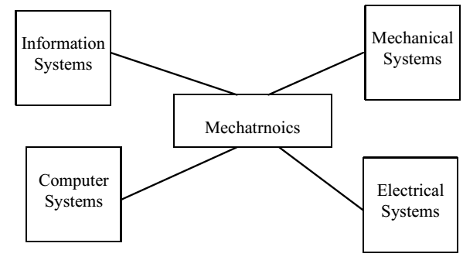
Figure 2.4 Foundations of Mechatronics
Elements of Mechatronics—Mechanical
Mechanical elements refer to:
- Mechanical structure, mechanism, thermo-fluid, and hydraulic aspects of a mechatronics system.
- Mechanical elements may include static/dynamic characteristics.
- A mechanical element interacts with its environment purposefully.
- Mechanical elements require physical power to produce motion, force, heat, etc.
Machine Components: Basic Elements
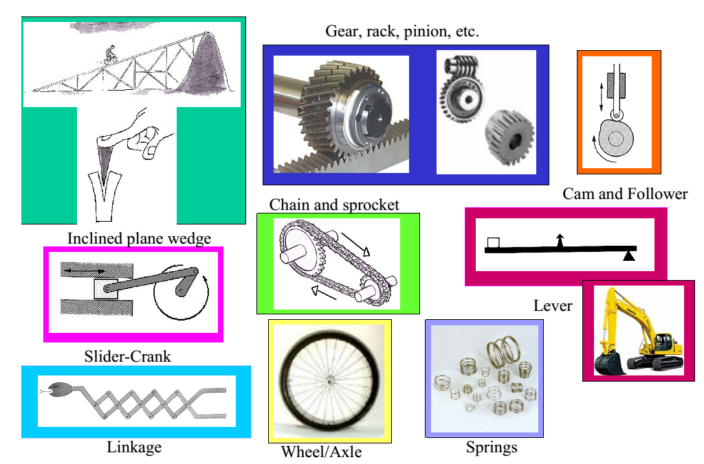
Figure 2.5 Machine Components: Basic Elements
Elements of mechatronics- Electromechanical
Electromechanical elements refer to:
- Sensors
A variety of physical variables can be measured using sensors, e.g., light using photo-resistor, level and displacement using potentiometer, direction/tilt using magnetic sensor, sound using microphone, stress and pressure using strain gauge, touch using micro-switch, temperature using thermistor, and humidity using conductivity sensor
- Actuators
DC servomotor, stepper motor, relay, solenoid, speaker, light emitting diode (LED), shape memory alloy, electromagnet, and pump apply commanded action on the physical process.
- IC-based sensors and actuators (digital-compass, -potentiometer, etc.).
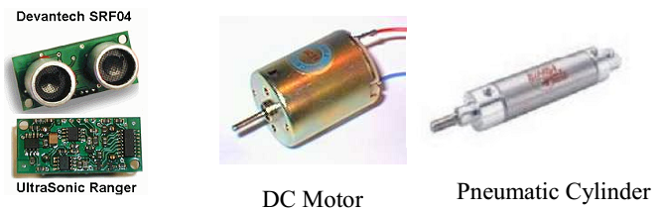
Figure 2.6 Actuators

Elements of Mechatronics -Electrical/Electronic
Electrical elements refer to:
- Electrical components (e.g., resistor (R), capacitor (C), inductor (L), transformer, etc.), circuits, and analog signals
Electronic elements refer to:
- analog/digital electronics, transistors, thermistors, opto-isolators, operational amplifiers, power electronics, and signal conditioning
The electrical/electronic elements are used to interface electromechanical sensors and actuators to the control interface/computing hardware elements
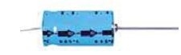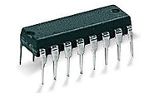
Figure 2.7 Electrical components
Elements of mechatronics -Control Interface/Computing Hardware
• Control interface/computing hardware elements refer to:
- Analog-to-digital (A2D) converter, digital-to-analog (D2A) converter, digital input/output (I/O), counters, timers, microprocessor, microcontroller, data acquisition and control (DAC) board, and digital signal processing (DSP) board
• Control interface hardware allows analog/digital interfacing
- communication of sensor signal to the control computer and communication of control signal from the control computer to the actuator
• Control computing hardware implements a control algorithm, which uses sensor measurements, to compute control actions to be applied by the actuator.
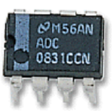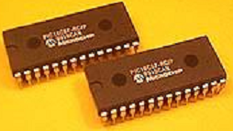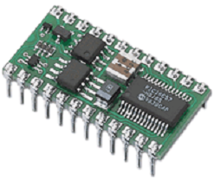
Figure 2.8 computing hardware elements
Elements of Mechatronics—Computer/Information System
Computer elements refer to hardware/software utilized to perform:
  - computer-aided dynamic system analysis, optimization, design, and simulation
  - virtual instrumentation
  - rapid control prototyping
  - hardware-in-the-loop simulation
  - PC-based data acquisition and control
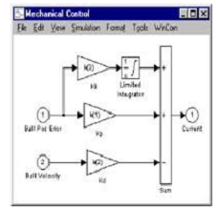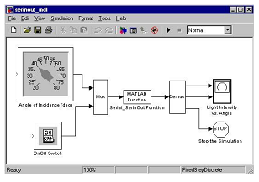
Figure 2.9 hardware/software utilized
Application area of mechatronics
- Machine-tool construction and equipment for automation of technological processes;
- Robotics (industrial and special);
- Aviation, space and military techniques;
- Motor car construction (for example, anti-blocking brake system (ABS), systems of car movement stabilization and automatic parking);
- Non-conventional vehicles (electro bicycles, cargo carriages, electro scooters, invalid carriages);
- Office equipment (for example, copy and fax machines);
- Computer facilities (for example, printers, plotters, disk drives);
- Medical equipment (rehabilitation, clinical, service);
- Home appliances (washing, sewing and other machines);
- ²Micro machines (for medicine, biotechnology, means of telecommunications);
- Control and measuring devices and machines;
- Photo and video equipment;
- Simulators for training of pilots and operators;
- Show-industry (sound and illumination systems).
- Banking system, such as cash registers and Automatic Teller Machines
- Manufacturing equipments, such as Numerically Controlled (NC) tools
Characteristics of Mechatronics
- High speed
- High accuracy
- High Strength
- Reliability
- Miniaturization
Benefits to Industry from mechatronics
- Shorter Development Cycles
- Lower Costs
- Increased Quality
- Increased Reliability
- Increased Performance
- Increased Benefits to customers
- INPUT SIGNALS OF A MECHATRONIC SYSTEM
Transducer/Sensor Input
- All inputs to mechatronic systems come from either some form of sensory apparatus or communications or from other systems
- Transducers, devices that convert energy from one form to another, are often used synonymously with sensors.
Sensor and transducer as a comparison
- Sensor' is `a device that detects a change in a physical stimulus and turns it into a signal which can be measured or recorded.
E.g. Thermistor
- ‘Transducer' is 'a device that transfers power from one system to another in the same or in the different form'.
E.g. Thermistor with it associates circuit convert heat to electricity.
- ‘Sensor' for the sensing element itself and 'transducer' for the sensing element plus any associated circuitry. All transducers would thus contain a sensor and most (not all) sensors would also be transducers.
Sensing process
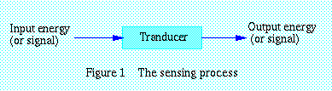
Figure 2.10 Sensing process
Definition of a transducer
- Transducer is any device that converts energy in one form to energy. The majority either converts electrical energy to mechanical displacement or convert some non-electrical physical quantity, such as temperature, sound or light to an electrical signal.
- Energy types include (but are not limited to) electrical, mechanical, electromagnetic (including light), chemical, acoustic and thermal energy.
- While the term transducer commonly implies the use of a sensor/detector, any device which converts energy can be considered a transducer. Transducers are widely used in measuring instruments.
- Transducers convert one form of energy into another
- Sensors/Actuators are input/output transducers
- Sensors can be passive (e.g. change in resistance) or active (output is a voltage or current level)
- Sensors can be analog (e.g. thermocouples) or digital (e.g. digital tachometer)
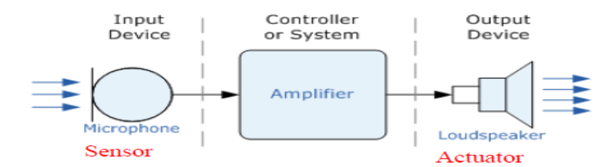
Figure 2.11 Transducer
Functions of transducer
- To sense the presence, magnitude, change in, and frequency of some measurand.
- To provide an electrical output that, when appropriately processed and applied to readout device, gives accurate quantitative data about the measurand
Transducer
Electrical output
Measurand
Excitation
Figure 2.12 Transducer input/output
Measurand – refers to the quantity, property or condition which the transducer translates to an electrical signal.

Classification of transducers
- Transducer can be classified according to their application, based primarily on the physical quantity, property, or condition that is measured. The transducer can be categories into:
The transducers can be classified as:
- Active and passive transducers.
- Analog and digital transducers.
- On the basis of transduction principle used.
- Primary and secondary transducer
- Transducers and inverse transducers.
A) Passive transducer:
- requires an external power
- Output is a measure of some variation, such resistance and capacitance. E.g. : condenser, microphone
B) Self generating transducer:
  - not require an external power, and they produce analog voltage or current when stimulated by some physical form of energy. E.g. : Thermocouple
Selecting a transducers / Transducers Selection Factors
The selection of transducer depending on the following properties/characteristics
- Operating range
- Sensitivity
- Frequency response and resonant frequency
- Environmental compatibility -
- Minimum sensitivity measurand.
- Accuracy
- Usage and ruggedness
- Electrical parameter
- Operating Principle: The transducer is many times selected on the basis of operating principle used by them. The operating principle used may be resistive, inductive, capacitive, optoelectronic, piezo electric etc.
- Sensitivity: The transducer must be sensitive enough to produce detectable output.
- Operating Range: The transducer should maintain the range requirement and have a good resolution over the entire range.
- Accuracy: High accuracy is assured.
- Cross sensitivity: It has to be taken into account when measuring mechanical quantities. There are situation where the actual quantity is being measured is in one plane and the transducer is subjected to variation in another plan.
- Errors: The transducer should maintain the expected input-output relationship as described by the transfer function so as to avoid errors.
Characteristics of Transducers
  - Ruggedness
  - Linearity
  - Repeatability
  - Accuracy
  - High stability and reliability
  - Speed of response
  - Sensitivity
  - Small size
Type of Transducer
- Temperature transducers
- Resistive Position Transducer
- Capacitive Transducer
- Inductive Transducer
- Strain Gauge Transducer
- LVDT (Linear Variable Differential Transformer) transducer
- Photoelectric transducer
- Temperature Transducers
Temperature transducers can be divided into four main categories:
  - Resistance Temperature Detectors (RTD)
  - Thermocouples
  - Thermistor
  - Ultrasonic transducers
a. Resistance Temperature Detector (RTD)
- Detectors of wire resistance temperature common employ platinum, nickel or resistance wire elements, whose resistance variation with temperature has high intrinsic accuracy. They are available in many configurations and size and as shielded or open units for both immersion and surface applications.
- 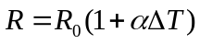The relationship between temperature and resistance of conductors can be calculated from the equation:
where
R = the resistance of the conductor at temperature t (⁰C)
R₀ = the resistance at the reference temperature, usually 20⁰C
α = the temperature coefficient of resistance
ΔT = the difference between the operating and the reference temperature
b. Thermocouple
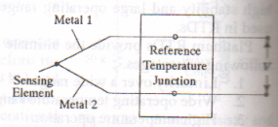
Figure 2.13 Thermocouple
- It consists of two wires of different metals are joined together at one end, a temperature difference between this end and the other end of wires produces a voltage between the wires. The magnitude of this voltage depends on the materials used for the wires and the amount of temperature difference between the joined ends and the other ends.
c. Thermistor
- A thermistor is a semiconductor made by sintering mixtures of metallic oxide, such as oxides of manganese, nickel, cobalt, copper and uranium.
- Thermistors have negative temperature coefficient (NTC). That is, their resistance decreases as their temperature rises.
Types of thermistors Resistance
Disc 1 to 1MΩ
Washer 1 to 50kΩ
Rod high resistance
- Resistive Position Transducer
- The principle of the resistance transducer is that the physical variable under measurement causes a resistance change in the sensing element.
- A common requirement in industrial measurement and control work is to be able to sense the position of an object or distance it has moved.
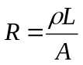

Where, R: resistance change, ρ: density, L: Length, A: area
- Capacitive Transducer
- 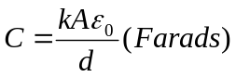The capacitance of a parallel plate capacitor is given by

Where k = dielectric constant, A = the area of the plate, in m², ε_{o} = 8.854 x 10⁻¹² F/m
d = the plate placing in m
Forms of Capacitance Transducers
- Rotary plate capacitor
- Rectilinear Capacitance Transducer
- Thin diaphragm
- Rotary plate capacitor:
- The capacitance of this unit proportional to the amount of the fixed plate that is covered, that shaded by moving plate. This type of transducer will give sign proportional to curvilinear displacement or angular velocity
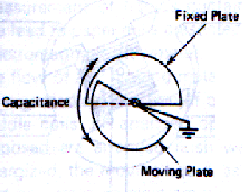
Figure2.14 Rotary plate capacitor
- Rectilinear capacitance transducer:
- It consists of a fixed cylinder and a moving cylinder. These pieces are configured so the moving piece fits inside the fixed piece but insulated from it.
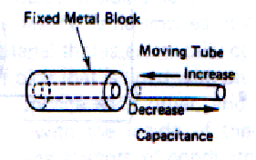
Figure2.15 Rectilinear capacitance transducer
- Thin diaphragm:
- It is the transducer that varies the spacing between surfaces. The dielectric is either air or vacuum. Often used as Capacitance microphones.
- Inductive Transducer
- Inductive transducers may be either of the self generating or passive type. The self generating type utilizes the basic electrical generator principle, i.e., a motion between a conductor and magnetic field induces a voltage in the conductor (generator action).
- This relative motion between the field and the conductor is supplied by changes in the measurand.
- An inductive electromechanical transducer is a device that converts physical motion (position change) into a change in inductance. Transducers of variable inductance type work upon one of the following principles:
  - Variation of self inductance
  - Variation of mutual inductance
- Inductive transducers are mainly used for the measurement of displacement. The displacement to be measured is arranged to cause variation in any of three variables:
- Number of turns
- Geometric configuration
- Permeability of the magnetic material or magnetic circuits
- Strain Gauge transducer
- The strain gauge is an example of a passive transducer that uses electric resistance variation in wires to sense the strain produced by a force on wires. It is a very versatile detector and transducer for measuring weight, pressure, mechanical force, or displacement.
- The construction of a bonded strain gauge (see figure 2.14) shows a fine wire element looped back and forth on a mounting plate, which is usually cemented to the member undergoing stress. A tensile stress tends to elongate the wire and thereby increase its length and decrease its cross-sectional area.
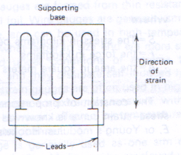
Figure2.16 Strain Gauge transducer
- The combined effect is an increase in resistance

Where,
ρ: the specific resistance of the conductor material in ohm meters
L: length of conductor (meters), A: area of conductor (m²)
- As consequence of strain, 2 physical qualities are particular interest:
    - The change in gauge resistance
    - The change in length
- The relationship between these two variables called gauge factor(K),
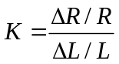 K, is expressed mathematically as

Where
K= the gauge factor, R=the initial resistance in ohms (without strain)
∆R= the change in initial resistance in ohms, L= the initial length in meters (without strain)
∆L=the change in initial length in meters
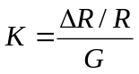 ∆L/L same unit with G, therefore

- From Hooke theory, stress, S, is defined as internal force/area
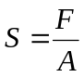

Where S= the stress in kilograms per square meter
F= the force in kilograms, A= area in square meters
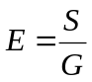Then the modulus of elasticity of material E or called Young’s modulus (Hooke’s Law) is written as

Where, E= Young modules in kg per square meter
S= the stress in kilograms per square meter, G= the strain (no units)
- Linear Variable Differential Transformer (LVDT) Transducer
- It consists basically of a primary winding and two secondary windings, wound over a hollow tube and positioned so the primary winding is between two secondary. In figure 2.15 shows the construction of the LVDT
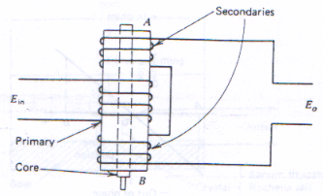
Figure2.17 LVDT
- An iron core slides within the tube and therefore affects the magnet coupling between the primary and the two secondary’s. When the core is in the centre, voltage induced in the two secondaries is equal. When the core is moved in one direction from centre, the voltage induced in one winding is increased and that in the other is decreased. Movement in the opposite direction reverses this effect
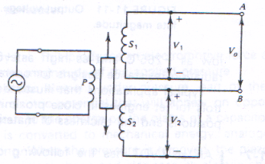
Figure2.18 LVDT circuit diagram
7. Photoelectric Transducer
Can be categorized as: photo emissive, photoconductive, or photovoltaic
- Photo emissive: - radiation falling into a cathode causes electrons to be emitted from cathode surface
- Photoconductive: - the resistance of a material is change when it’s illuminated
- Photovoltaic: - Generate an output voltage proportional to radiation intensity
Examples of Photoelectric Transducer
- Photoconductive Cells OR Photocells: the electrical resistance of the materials varies with the amount of light striking.
- The Photovoltaic Cell or solar cell
- produce an electrical current when connected to the load.
- SENSORS AND THEIR APPLICATION
- Sensors
- A sensor is a converter that measures a physical quantity and converts it into a signal which can be read by an observer or by an (today mostly electronic) instrument.
- For example, a mercury-in-glass thermometer converts the measured temperature into expansion and contraction of a liquid which can be read on a calibrated glass tube.
- A thermocouple converts temperature to an output voltage which can be read by a voltmeter. For accuracy, most sensors are calibrated against known standards.
A good sensor obeys the following rules:
- Is sensitive to the measured property only
- Is insensitive to any other property likely to be encountered in its application
- Does not influence the measured property
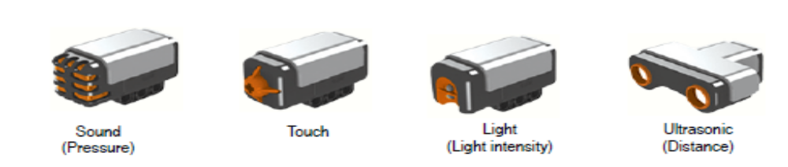
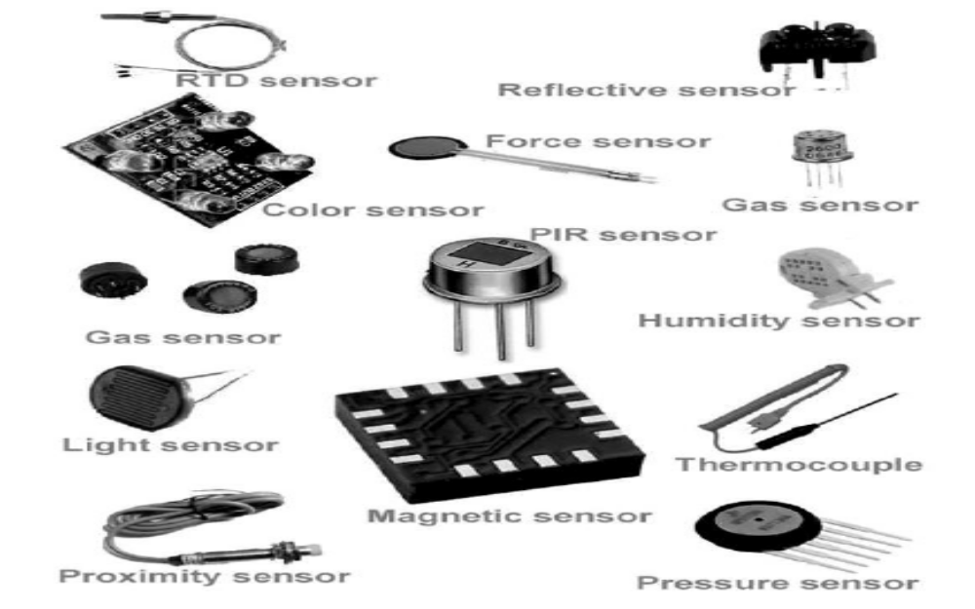
Figure2.19 Sensors
There are different types of sensors used in mechatronics. Some of them are listed below.
- POSITION SENSORS
- Position sensors report the physical position of an object with respect to a reference point. The information can be an angle, as in how many degrees a radar dish has turned, or linear, as in how many inches a robot arm has extended. Position sensors including: -
- Potentiometers: - used to convert rotary or linear displacement to a voltage
- Optical rotary encoder: -produces angular position data directly in digital form, eliminating any need for the ADC converter. absolute encoder and the incremental encoder
- Linear variable differential transformers.: - high-resolution position sensor that outputs an AC voltage with a magnitude proportional to linear position
- LOAD SENSORS
- Load sensors measure mechanical force. The forces can be large or small: for example, weighing heavy objects or detecting low-force tactile pressures. In most cases, it is the slight deformation caused by the force that the sensor measures, not the force directly. Load sensors including:
- bonded-wire strain gauges,
- semiconductor force strain gauges, and
- Low-force sensors.
- PROXIMITY SENSORS
Proximity sensors including:
- limit switches,
- optical proximity switches, and
- Hall-effect switches
- Limit Switches
- A proximity sensor simply tells the controller whether a moving part is at a certain place. A limit switch is an example of a proximity sensor.
- A limit switch is a mechanical push-button switch that is mounted in such a way that it is actuated when a mechanical part or lever arm gets to the end of its intended travel.
- For example, in an automatic garage-door opener, all the controller needs to know is if the door is all the way open or all the way closed. Limit switches can detect these two conditions. Switches are fine for many applications, but they have at least two drawbacks: (1) Being a mechanical device, they eventually wear out, and (2) they require a certain amount of physical force to actuate.
- Two other types of proximity sensors, which use either optics or magnetic to determine if an object is near, do not have these problems. The price we pay for these improved characteristics is that they require some support electronics.
- Optical Proximity Sensors
- Optical proximity sensors, sometimes called interrupters, use a light source and a photo sensor that are mounted in such a way that the object to be detected cuts the light path.
- Figure 2.16 illustrates two applications of using photo detectors. In Figure 2.16(a), a
- Photo detector counts the number of cans on an assembly line; in Figure 2.16(b), a photo detector determines whether the read-only hole in a floppy disk is open or closed.
- Optical proximity sensors frequently use a reflector on one side, which allows the detector and light source to be housed in the same enclosure. Also, the light source may be modulated to give the beam a unique “signature” so that the detector can distinguish between the beam and stray light.
- Four types of photo detectors are in general use: photo resistors, photodiodes, photo transistors, and photovoltaic cells. A photo resistor, which is made out of a material such as cadmium sulfide (CdS), has the property that its resistance decreases when the light level increases. It is inexpensive and quite sensitive that is, the resistance can change by a factor of 100 or more when exposed to light and dark
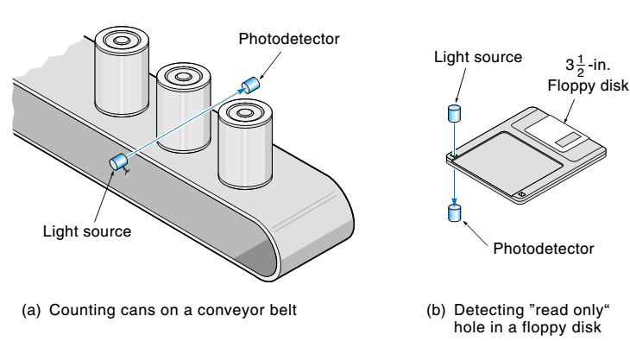
Figure 2.20 Two applications of a photo detector
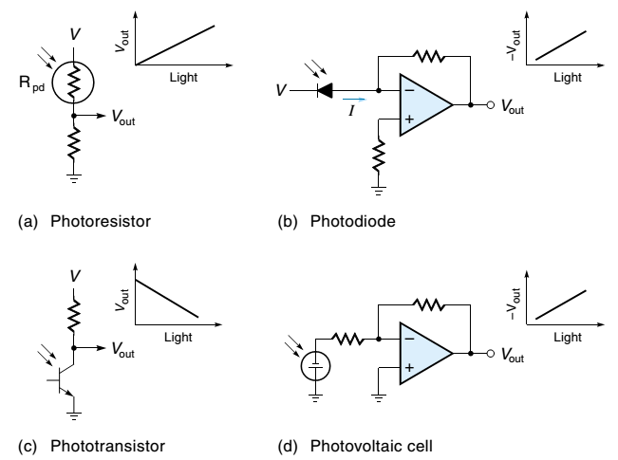
Figure 2.21 shows a typical interface circuit
- Figure 2.21(a) shows a typical interface circuit as the light increases, R_{pd} decreases, and so V_{out} increases.
- A photo diode is a light-sensitive diode. A little window allows light to fall directly on the PN junction where it has the effect of increasing the reverse-leakage current.
- Figure 2.21(b) shows the photodiode with its interface circuit. Notice that the photodiode is reversed-biased and that the small reverse-leakage current is converted into an amplified voltage by the op-amp.
- A photo transistor [Figure 2.21(c)] has no base lead. Instead, the light effectively creates a base current by generating electron-hole pairs in the CB junction the lighter, the more the transistor turns on.
- The photovoltaic cell is different from the photo sensors discussed so far because it actually creates electrical power from light, the lighter, the higher the voltage.
- (A solar cell is a photovoltaic cell.) When used as a sensor, the small voltage output must usually be amplified, as shown in Figure 2.21(d).
- Some applications make use of an optical proximity sensor called a slotted coupler, also called an opto-interrupter (Figure 6.30). This device includes the light source and detector in a single package. When an object moves into the slot, the light path is broken.
- The unit comes in a wide variety of standard housings [Figure 2.18(a)]. To operate, power must be provided to the LED, and the output signal taken from the phototransistor. This is done in the circuit of Figure 2.18(b), which provides a TTL-level (5 V or 0 V) output.
- When the slot is open, the light beam strikes the transistor, turning it on, which grounds the collector. When the beam is interrupted, the transistor turns off, and the collector is pulled up to 5 V by the resistor.
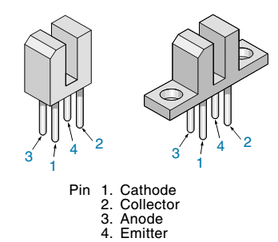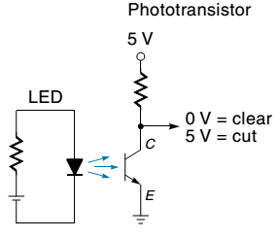
(a) Case types (b) Circuit
Figure 2.22 An optical slotted coupler
- Optical sensors enjoy the advantage that neither the light source, the object to be detected, nor the detectors have to be near each other. An example of this is a burglar alarm system.
- The light source is on one side of the room, the burglar is in the middle, and the detector is on the other side of the room. This property can be important in a case where there are no convenient mounting surfaces near the part to be measured. On the other hand, keeping the lenses clean may be a problem in some industrial situations.
- Hall-Effect Proximity Sensors
- In 1879 E. H. Hall first noticed the effect that bears his name. He discovered a special property of copper, and later of semiconductors: They produce a voltage in the presence of a magnetic field. This is especially true for germanium and indium.
- The Hall Effect, as it is called, was originally used for watt meters and gauss meters; now it is used extensively for proximity sensors. Figure 6.31 shows some typical applications. In all cases, the Hall-effect sensor outputs a voltage when the magnetic field in which it finds itself increases.
- This is done either by moving a magnet or by changing the magnetic field path (but the value of the Hall voltage does not depend on the field “moving”— only on the field being there).
- Figure 2.19 shows how the Hall Effect works. First, an external voltage source is used to establish a current (I) in the semiconductor crystal. The output voltage (VH) is sensed across the sides of the crystal, perpendicular to the current direction. When a magnetic field is brought near, the negative charges are deflected to one side producing a voltage.
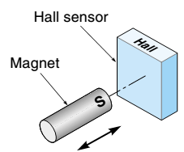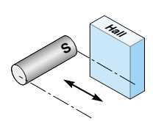
(a) Head-on (b) Slide-by
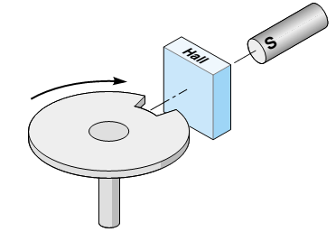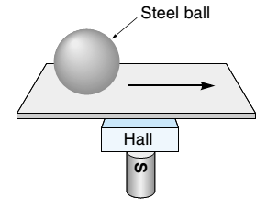
(c) Notch sensor (notch reduces flux) (d) Metal detector (ball increases flux)
Figure 2.23Typical applications of Hall-effect sensors.
- ANGULAR VELOCITY SENSORS
Angular velocity sensors, or tachometers, are devices that give an output proportional to angular velocity. These sensors find wide application in motor-speed control systems. They are also used in position systems to improve their performance.
- PRESSURE SENSORS
- Pressure is defined as the force per unit area that one material exerts on another.
- In SI units, pressure is measured in Newton’s per square meter (N/m2), which is called a Pascal (Pa). For a liquid, pressure is exerted on the side walls of the container as well as the bottom.
- Pressure sensors usually consist of two parts: The first convert’s pressure to a force or displacement, and the second converts the force or displacement to an electrical signal. Pressure measurements are made only for gases and liquids.
- The simplest pressure measurement yields a gauge pressure, which is the difference between the measured pressure and ambient pressure. At sea level, ambient pressure is equal to atmospheric pressure and is assumed to be 14.7 psi, or 101.3 kilopascals (kPa).
- A slightly more complicated sensor can measure differential pressure, the difference in pressure between two places where neither pressure is necessarily atmospheric.
- A third type of pressure sensor measures absolute pressure, which is measured with a differential pressure sensor where one side is referenced at 0 psi (close to a total vacuum).Pressure sensors including :-
- Bourdon tubes,
- bellows, and
- Semiconductor pressure sensors.
- TEMPERATURE SENSORS
- Temperature sensors give an output proportional to temperature.
- Most temperature sensors have a positive temperature coefficient (desirable), which means that the sensor output goes up as the temperature goes up, but some sensors have a negative temperature coefficient, which means that the output goes down as the temperature goes up.
- Many control systems require temperature sensors, if only to know how much to compensate other sensors that are temperature-dependent. Temperature sensors including:-
- bimetallic temperature sensors,
- thermocouples,
- resistance temperature detectors,
- Thermistors, and
- IC temperature sensors.
- FLOW SENSORS
- Flow sensors measure the quantity of fluid material passing by a point in a certain time.
- Usually, the material is a gas or a liquid and is flowing in a pipe or open channel. The flowing of solid material, such as gravel traveling on a conveyer belt, will not be considered here.
- Flow transducers come in several types—those that use differential pressure, those where the flow spins a mechanical device, and a smaller class of sensors that use more sophisticated technologies. Flow sensors including: -
- orifice plates,
- Venturis,
- pitot tubes,
- turbines, and
- magnetic flow meters

- LIQUID-LEVEL SENSORS
- Liquid-level sensors, which measure the height of a liquid in a container, have two classifications: discrete and continuous.
- Discrete-level detectors can only detect whether the liquid is at a certain level. The continuous-level detector provides an analog signal that is proportional to the liquid level.
- Liquid-level sensors including:- discrete and continuous types.
- Discrete-Level Detectors
- Discrete-level detectors determine when a liquid has reached a certain level. An application of this type would be determining when to stop the fill cycle of a washing machine.
- The simplest type of level detector uses a float and a limit switch. There are many possible configurations of a float-based level detector—one is illustrated in Figure 2.20(a). In this case, the float is attached to a vertical rod. At a certain liquid level, the cam, which is attached to the rod, activates the limit switch. The activation level can be adjusted by relocating either the cam or the switch.
- Another type of level detector is based on a photocell [Figure 2.20(b)]. When the liquid level submerges, the light path, then photo detector signal changes, thus indicating the presence of the liquid.
- Many liquids such as tap water, weak acids, beer, and coffee (to name a few) are slightly conductive, which offers another means of detection. As illustrated in Figure 2.20(c), an electric probe is suspended over the liquid. When the liquid reaches the probe, the resistance in the circuit abruptly decreases.
- A common use of this sensor is as an automotive low-coolant sensor.
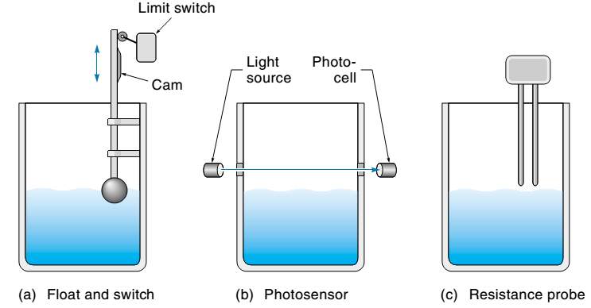
Figure 2.24 Discrete liquid-level detectors.
- Continuous-Level Detectors
- Continuous-level detectors provide a signal that is proportional to the liquid level.
- There are a number of ways in which this can be done. One of the most direct methods (used in the gas tank of your car) is a float connected to a position sensor. Figure 2.21(a) illustrates one implementation of this method.
- Another way to measure liquid level is to measure the pressure at the bottom of the container [Figure 2.21(b)]. This method is based on the fact that the pressure at the bottom of the tank (called the head) is directly proportional to the level, as expressed in
Pressure = P= dH
where
P = gauge pressure at the bottom (head)
d = weight density (liquid weight per unit volume)
H= height of liquid in the tank
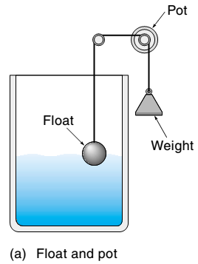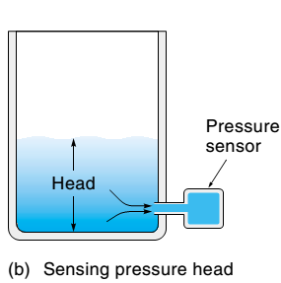
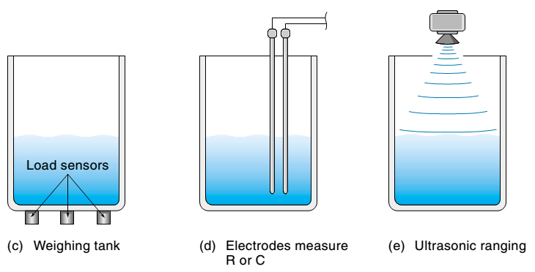
Figure 2.25 Continuous-level detection methods.
- Monitoring the weight of the liquid with load cells is another technique that can determine liquid level [Figure 2.21(c)]. The level can then be calculated knowing the diameter and weight of the tank (empty) and the density of the fluid. Note that the total weight of the tank is the sum of the weights reported by the three load cells.
- Some devices can detect the liquid level directly. The device shown in Figure 2.21(d) is simply two vertical electrodes mounted inside the tank.
- The output of the device, which must be amplified or otherwise processed, is either resistance or capacitance and is proportional to the level. Figure 2.21(e) shows another direct level-sensing system. This system uses an ultrasonic-range detector mounted over the tank.
- The complete unit, which includes the transducer and electronics, can be purchased as a module and is rather inexpensive.
- VISION SENSORS
- A vision sensor is a TV camera connected to a computer. Machine vision is being used to perform inspections and to guide machine operations. For example, a system might use machine vision to determine whether parts had been made or assembled properly, or a vision system might be used to reject blemished oranges from a fruit-processing line.
- Alternatively, a vision system might be used to provide guidance to a pick-and-place robot for doing such things as unloading boxes from a pallet or inserting components in a circuit board.
ACTUATORS
- An actuator is the device that brings about the mechanical movements required for any physical process in the factory. Internally, actuators can be broken down into two separate modules: the signal amplifier and the transducer.
- The amplifier converts the (low power) control signal into a high power signal that is fed into the transducer; the transducer converts the energy of the amplified control signal into work; this process usually involves converting from one form of energy into another, e.g. electrical motors convert electrical energy into kinetic energy.
- It is operated by a source of energy, typically electric current, hydraulic fluid pressure, or pneumatic pressure, and converts that energy into motion. An actuator is the mechanism by which a control system acts upon an environment.
- The control system can be simple (a fixed mechanical or electronic system), software-based (e.g. a printer driver, robot control system), a human, or any other input.

Types of Actuators
  - Electrical
- Ac and dc motors
- Stepper motors
- solenoids
  - Hydraulic
- Use hydraulic fluid to actuate motion
  - Pneumatic
- Use compressed air to actuate motion
- All three types of actuators are in use today. Electric actuators are the type most commonly used Hydraulic and pneumatic systems allow for increased force and torque from smaller motor
Actuator characteristics:
- Three major characteristics of actuators are accuracy, precision, and reliability. The definitions of these parameters are consistent with the corresponding definitions given earlier for sensors.
Motors
- All electric motors use electromagnetic induction to generate a force on a rotational element called the rotor. The torque required to rotate the rotor is created due to the interaction of magnetic fields generated by the rotor, and the part surrounding it, which is fixed, and called the stator.
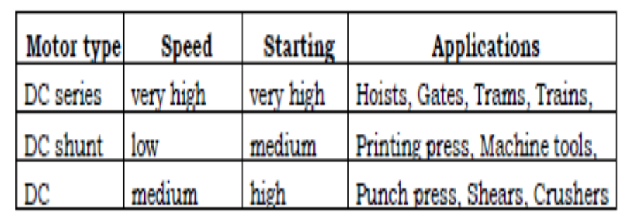
Motor Controls:
- Many motor applications are not sensitive enough to require very tight accuracy of speed or control over the motion. However, from the viewpoint of manufacturing and production automation, such considerations are critical.
- For instance, any robot actuator requires that its motion be governable in positioning, velocity and acceleration with very high accuracy.
- Similarly, most NC machines have all their actuators controlled to provide positioning accuracy that is one order of magnitude less than the required accuracy of the part being manufactured. Considering that the typical tolerance on steel parts is 0.001 inch or less, this means that the machine controller has to be able to move the machine table to less than one-thousandths of an inch of the programmed point. How are such precise motions generated?
- The two most common motor types used in such applications are stepper motors, and servo-driven motors (or simply, servomotors).
Stepper Motors
- Stepper motors rotate in discrete steps (e.g. 2° for each step); they have many uses, especially in motion for robots and locating or indexing tables.
- Their working principle is similar to DC motors, but they are controlled by digital electronics: an electronic circuit turns a series of switches ON and OFF at each electrical pulse input to the stepper motor control. The stepper motor is driven by feeding it a stream of electric pulses. Each pulse makes the motor rotate by a fixed angle.
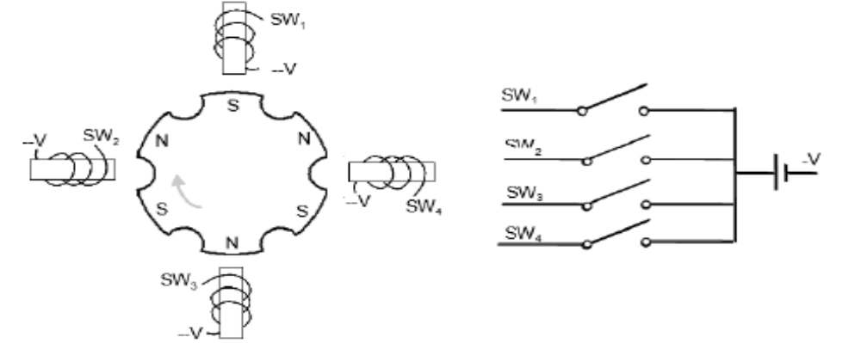
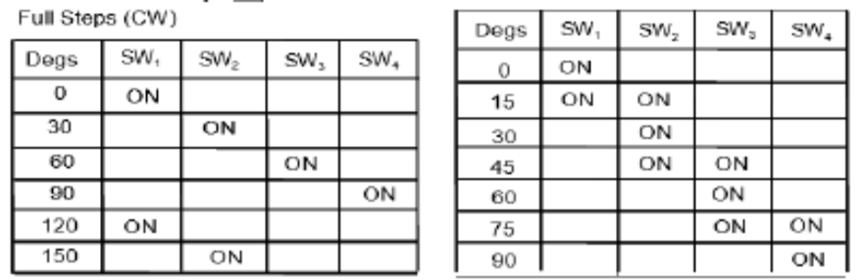
Figure 2.26. The principle of the Stepper Motor
- Stepper motors can only provide low torques. They are commonly used in laser positioning, pen positioning, disc and CDROM drives, robots, positioning tables etc.
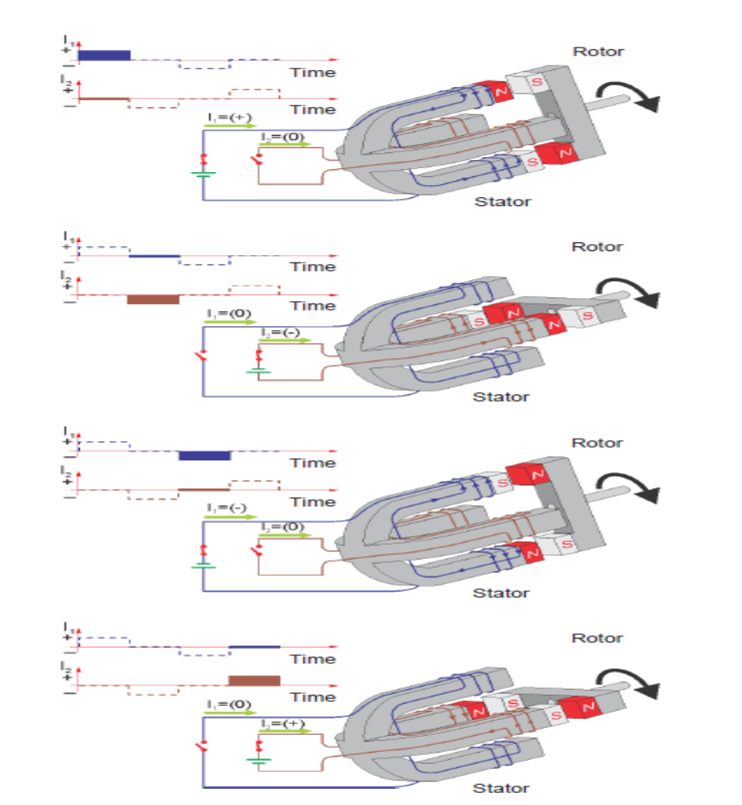
Figure2.27 Stepper Motor.
- To understand how a stepper motor is forced to move, consider the rotor (moving part of the motor) of the stepper motor as a magnet with a north and a south pole. The windings in the stator (fixed part of the motor) are electromagnets that can change polarity to modify the orientation of the resulting magnetic field.
- Upon a change in the magnetic field orientation, the rotor is forced to realign, causing the motor shaft to rotate. The stepper motor from the Electro-mechanical system contains more magnets than in this example, providing 200 different steps. Note that even more precise control can be accomplished through the stepper motor drive software by subdividing each step.
- Stepper motors can only provide low torques. They are commonly used in laser positioning, pen positioning, disc and CDROM drives, robots, positioning tables etc.
Electromechanical systems
- The Electromechanical System – Stepper Motor is a PLC application designed to practice linear motion control. Figure 2 shows the Power Supply, the PLC, and the Stepper Motor drive used to control the position and the velocity of a sliding block moving on a lead screw driven by a stepper motor.
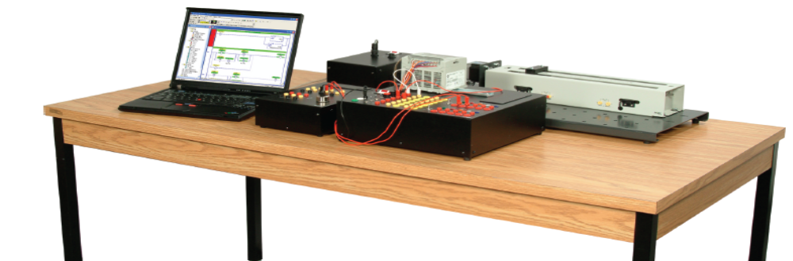
Figure 2.29 The Electromechanical System – Stepper Motor
- Figure 2.30 shows the control diagram of a stepper motor. This system performs open-loop control because no feedback is sent to the controller. For this reason, if the motor misses a step (e.g. the motor torque is too low), there is no means for the controller to sense that an error has occurred.
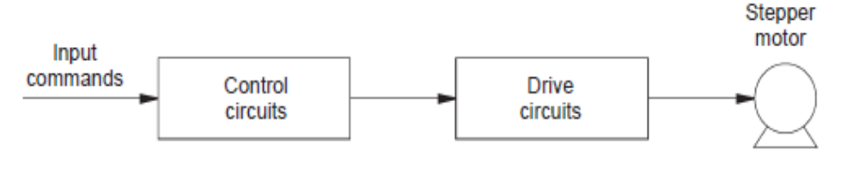
Figure 2.30 Open-loop control of a stepper motor system.
- The Electro-Electromechanical – Stepper Motor System includes three modules:
- DC Power Supply Drive – Stepper Motor (P/N 3206)
- Stepper Motor Drive (P/N 3207)
- Electromechanical – Stepper Motor Module (P/N 3294)
- Figure 4 shows the DC Power Supply – Stepper Motor. Either one of the two power connectors can be used to provide electrical power to the Stepper Motor Drive.
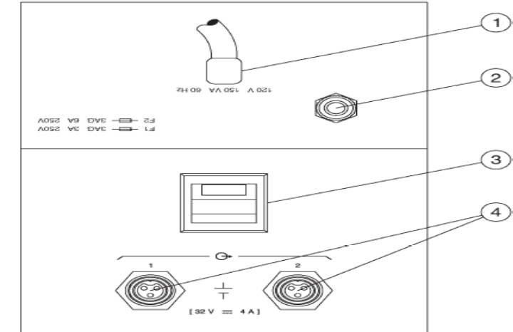
Figure 2.31. DC Power Supply – Stepper Motor, Model 3206.
  - Power Cord
  - Reset Button
  - ON/OFF Switch
  - Stepper Motor Drive Power Connectors
- Figure 5 shows the Stepper Motor Drive. The Stepper Motor Drive is used to control motor displacements. It presents eight inputs, including two jog inputs and two limit switch inputs.
- Three different outputs can be used for feedback. The drive is supplied with a communication cable and software allowing the program and control of the drive from a PC.
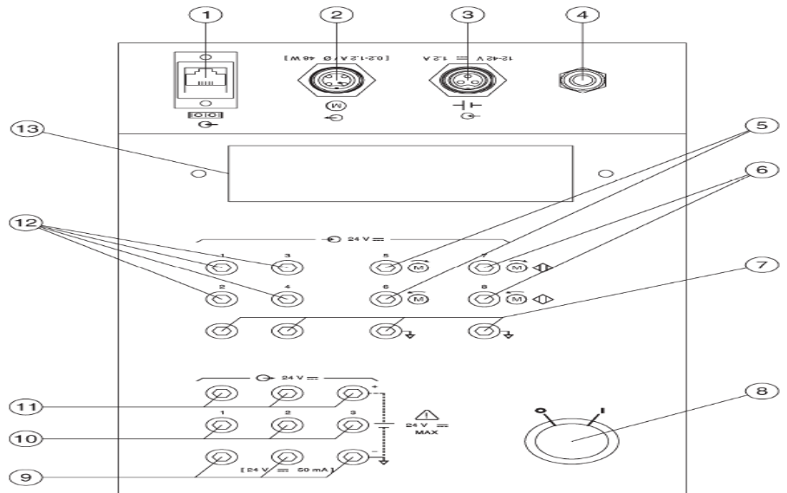
Figure 2.32. Stepper Motor Drive, Model 3207.
- Communication Port
- Motor Power Connector
- Drive Power Input Terminal
- Reset Button
- Clockwise and Counterclockwise Jog Terminals
- Clockwise and Counterclockwise Limit Switch Input Terminals
- Input Common Terminals
- ON/OFF Rotary Switch
- Output Common Terminals
- Output 1 to 3 Terminals
- Output Power (+24 V) Terminals
- Input 1 to 4 Terminals
- Fault Panel
- Figure 2.33 shows the Electromechanical – Stepper Motor module. It consists of a stepper motor coupled to a lead screw on which a sliding block is installed. Two magnetic limit switches detect when the sliding block approaches the start or end position.
- The Electromechanical – Stepper Motor is designed with a gap on both sides of the lead screw that lets the sliding block rest safely in case of overtravel.
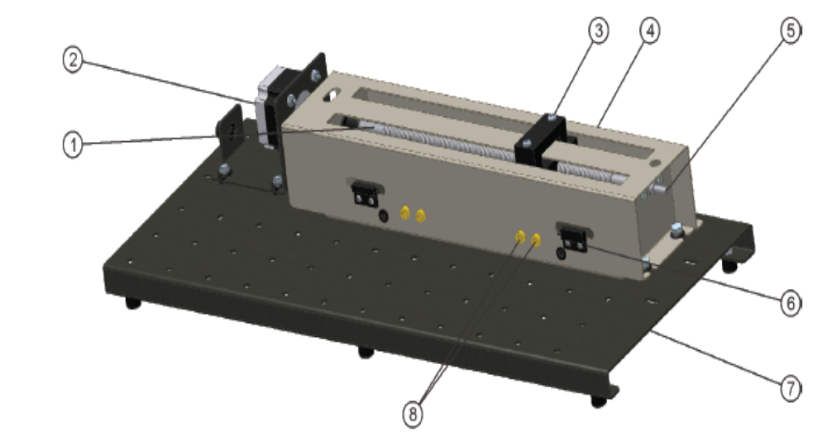
Figure 2.33. Electromechanical – Stepper Motor module.
- Lead screw
- Stepper Motor
- Sliding Block
- Cover
- Rod End
- Magnetic Contact
- Application Base
- Magnetic Limit Switch Terminals
- The system control section operates with low voltage signals (24 V dc). The PLC is programmed and monitored using a computer running ladder programming software.
Distance calculation in lead screw drive systems
- In a lead screw drive system, the pitch of the lead screw threads determines the number of rotations needed to move the sliding block over a certain distance.
- The screw thread pitch of the Electromechanical System is 0.195 cm (1/13 in), meaning that 13 screw rotations result in a linear displacement of 2.54 cm (one inch).
- The distance traveled by the sliding block during a given period of time can be determined by multiplying the number of steps that have occurred during this period by the lead screw pitch (distance between two threads) and dividing the result by the number of steps produced by the stepper motor drive for each turn (or thread), as shown below:
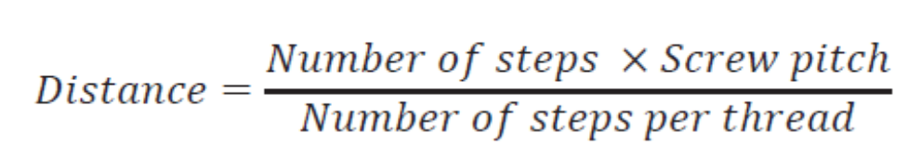
- To find the number of steps required to move the sliding block over a given distance, the formula is simply rearranged as:
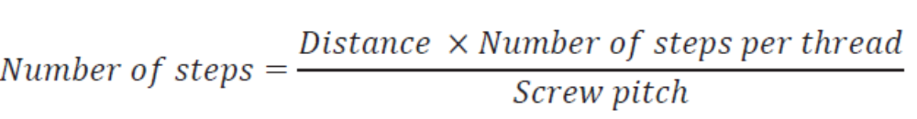
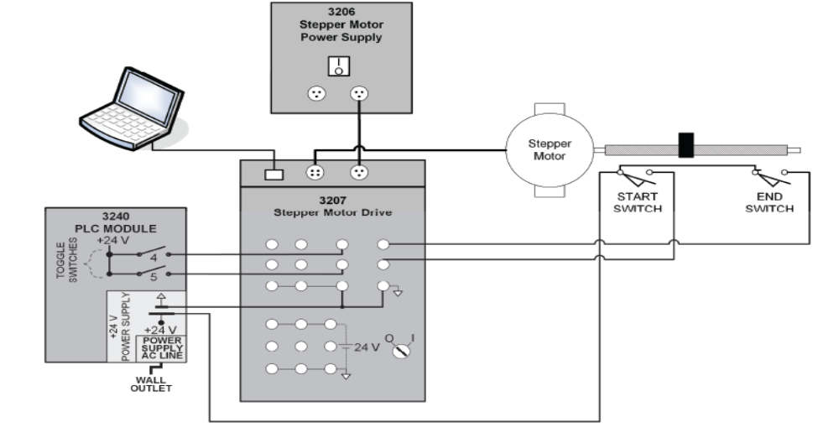
Figure 2.34. Stepper Motor Drive test circuit.
Stepper Motor Drive software
The Si™ Programmer Software accompanying the Stepper Motor Drive provides means to take full advantage of the system's stepper motor. Figure 7 shows the software's Program Window.
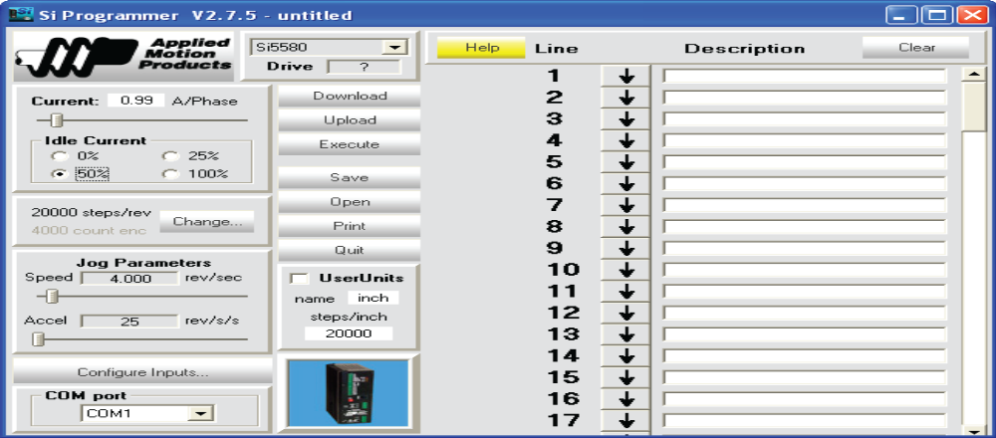
Figure 2.35. Stepper Motor Drive software program window
Servo Motors
- When higher torque and precise control are needed, servo motors are the best option. They provide high torque at all speeds, versatile speed control, very low drift (and therefore high repeatability), ability to reverse directions rapidly and smoothly etc.
- Servomotors may be AC or DC. In fact, practically any AC or DC motor can be converted to a servomotor by regulating it electronically, and using position and force feedbacks. Since the servomotors are driven through this electronic control, they are also easily interfaced with microprocessors or other high level controlling devices quite easily. The digital signal from the computer is converted to its equivalent analog level via an electronic DA converter.
Hydraulic Actuators
- Hydraulic systems are often used for driving high-power machine tools and industrial robots. They can deliver high power and forces. They also suffer from maintenance problems (e.g. leakage of the hydraulic fluid, dirt/contamination of fluid.) Hydraulic actuators may be linear, or rotary.
Pneumatic actuators
- Pneumatic actuators work, in principle, similar to hydraulic actuators. The most common pneumatic controls are linear actuators, which are basically a piston-cylinder assembly connected to a supply tube of compressed air. Since air is highly compressible, pneumatic drives are frequently not used for high force transmission, nor are much good for accurate position control. Typically, they are used for fixed motion of small objects that are very common on assembly and transfer lines.
Electro-mechanical element
- Micro-electro-mechanical systems (i.e. MEMS) are integrated systems of microelectronics (IC), micro actuator and, in most cases, micro sensors. MEMS technology offers unique advantages
- Including miniaturization, mass fabrication and monolithic integration with microelectronics, and mak77es it possible to fabricated small devices and Systems with high functionality, precision and performance. More important, MEMS technology can enable new circuit components and new functions. Therefore, MEMS have attracted considerable attention since 1987.
- Micro actuators are the key part of MEMS. For many MEMS devices such as switches, optical attenuators, pumps, valves, etc., micro actuators are required to realize their physical functions. The controlled actuation or motion of micro actuators can be achieved by several kinds of actuation mechanisms.
- Electrostatic, piezoelectric, magnetostrictive, magnetic, thermo mechanical actuators have been reported.
- Among the different actuation principles, the electrostatic actuation is predominantly employed for the electrostatic micro actuators’ characteristics of simple structures, small energy loss and being compatible with integrated circuit processes.
- However, electrostatic actuation mechanism has the disadvantages of high driving voltage and small displacement; the high driving voltage has an adverse effect on the lifetime of devices.
2.1.1. Pneumatics & electro-pneumatics
- Pneumatic and electro-pneumatic control systems
Both pneumatic and electro-pneumatic controllers have a pneumatic power section (See Fig..2.36 and 2.37.). The signal control section varies according to type.
- In a pneumatic control pneumatic components are used, that is, various types of valves, sequencers, air barriers, etc.
- In an electro-pneumatic control, the signal control section is made up of a electrical components, for example with electrical input buttons, proximity switches, relays, or a programmable logic controller. The directional control valves form the interface between the signal control section and the pneumatic power section in both types of controller.
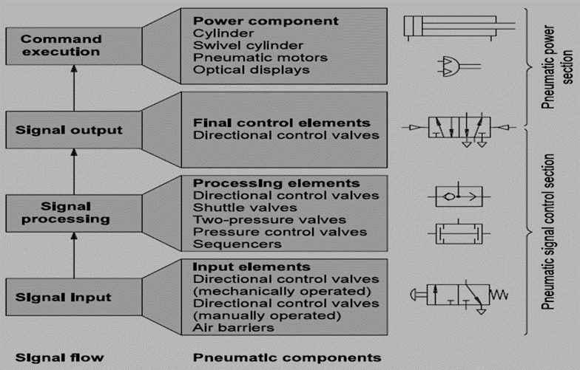
Fig.2.36. Signal flow and components of a pneumatic control system
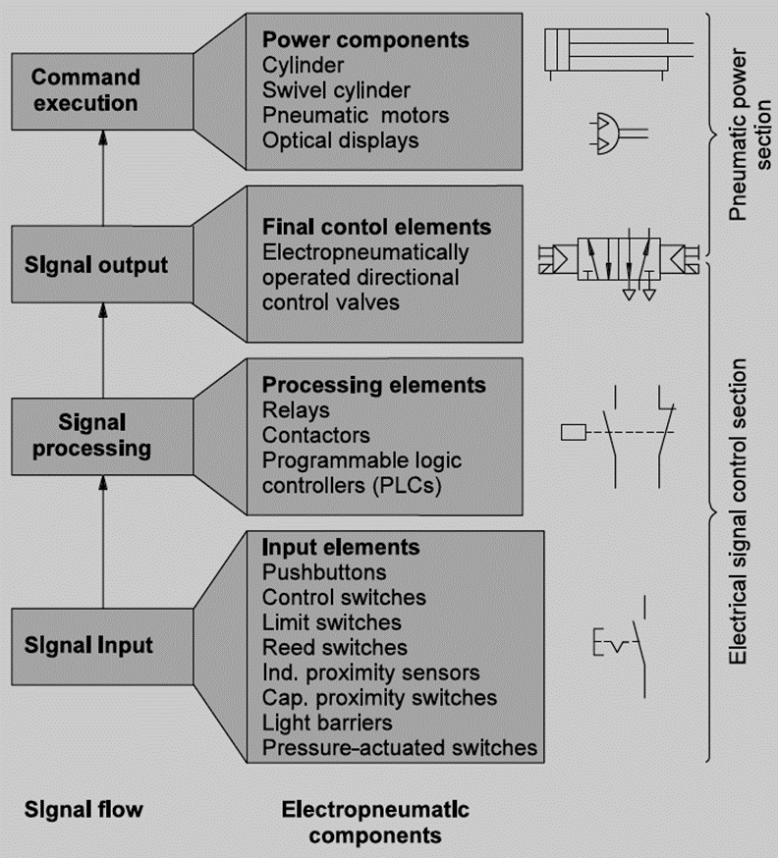
Fig 2.37. Signal flow and components of an electro-pneumatic control system
In contrast to a purely pneumatic control system, electro-pneumatic controllers are not shown in any single overall circuit diagram, but in two separate circuit diagrams - one for the electrical part and one for the pneumatic part. For this reason, signal flow is not immediately clear from the arrangement of the components in the overall circuit diagram.
- Structure and mode of operation of an electro-pneumatic controller
Fig 2.4.6 shows at the structure and mode of operation of an electro-pneumatic controller.
- The electrical signal control section switches the electrically actuated directional control valves.
- The directional control valves cause the piston rods to extend and retract
- The position of the piston rods is reported to the electrical signal control section by proximity switches.
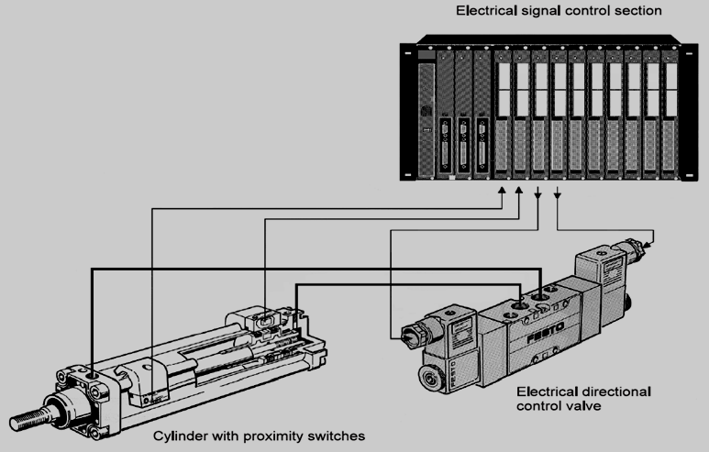
Fig 2.38. Structure of a modern operation of an electro-pneumatic controller.
  - Advantages of electro-pneumatic controllers
Electro-pneumatic controllers have the following advantages over pneumatic control systems:
- Higher reliability (fewer moving parts subject to wear)
- Lower planning and commissioning effort, particularly for complex controls
- Lower installation effort, particularly when modern components such as valve terminals are used
- Simpler exchange of information between several controllers
Electro-pneumatic controllers have asserted themselves in modern industrial practice and the application of purely pneumatic control systems is a limited to a few special applications.
2.4.7. Components specification of pneumatic and hydraulic
- The functions of various components shown in Fig. 2.39 are as follows:
- The pneumatic actuator converts the fluid power into mechanical power to perform useful work.
- The compressor is used to compress the fresh air drawn from the atmosphere.
- The storage reservoir is used to store a given volume of compressed air.
- The valves are used to control the direction, flow rate and pressure of compressed air.
- External power supply (motor) is used to drive the compressor.
- The piping system carries the pressurized air from one location to another.
fig. 2.39. component of pneumatic system
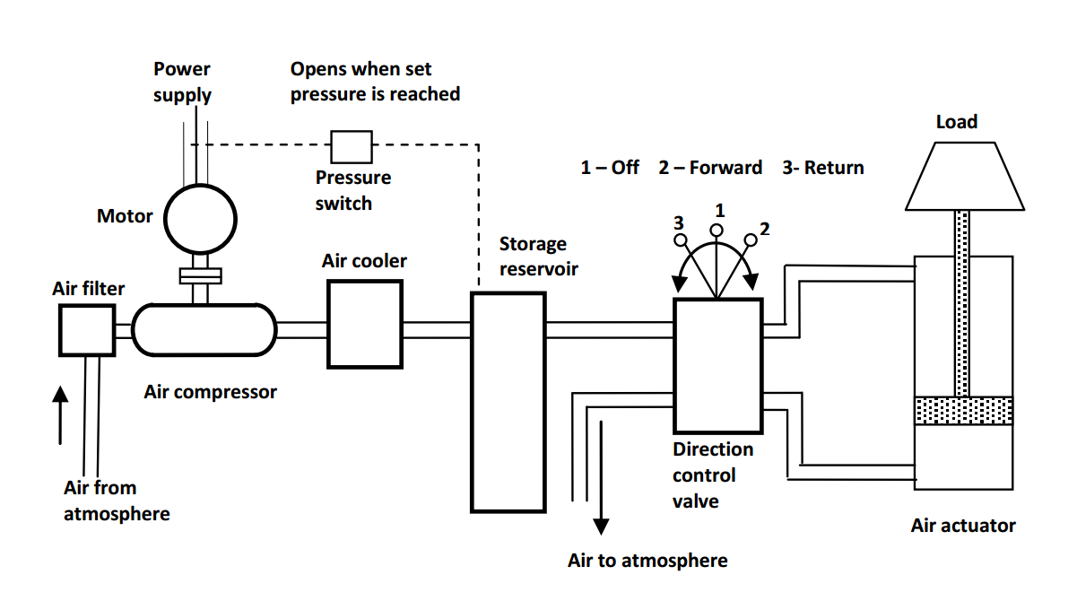
2.1.2Hydraulics and electro-hydraulics
2.4.7.1. Hydraulics
All machines require some type of power source and a way of transmitting this power to the point of operation.
- The three methods of transmitting hydraulic system power are:
- Mechanical
- Electrical
- Fluid
- Fluid power is the method of using pressurized fluid to transmit energy.
- Liquid or Gas is referred to as a fluid. Accordingly, there are two branches of fluid power; Pneumatics, and Hydraulics.
- Hydraulic systems use liquid to transfer force from one point to another.
- Pneumatic systems use air to transfer force from one point to another.
- Hydraulic systems are power-transmitting assemblies employing pressurized liquid as a fluid for transmitting energy from an energy-generating source to an energy-using point to accomplish useful work.
Figure 35. shows a simple circuit of a hydraulic system with basic components.
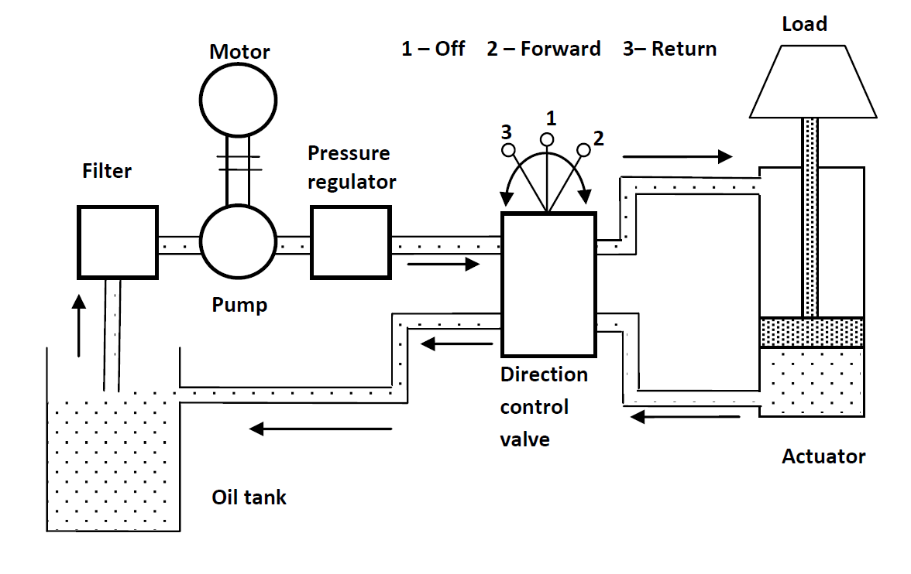
- Functions of the components shown in Fig. 2.40 are as follows:
- The hydraulic actuator is a device used to convert the fluid power into mechanical power to do useful work.
- The hydraulic pump is used to force the fluid from the reservoir to rest of the hydraulic circuit by converting mechanical energy into hydraulic energy.
- Valves are used to control the direction, pressure and flow rate of a fluid flowing through the circuit.
- External power supply (motor) is required to drive the pump.
- Reservoir is used to hold the hydraulic liquid, usually hydraulic oil.
- Piping system carries the hydraulic oil from one place to another.
- Filters are used to remove any foreign particles so as keep the fluid system clean and efficient, as well as avoid damage to the actuator and valves.
- Pressure regulator regulates (i.e., maintains) the required level of pressure in the hydraulic fluid.
- The hydraulic systems consist a number of parts for its proper functioning a movable piston connected to the output shaft in an enclosed cylinder
- storage tank
- filter
- electric pump
- pressure regulator
- control valve
- leak proof closed loop piping.
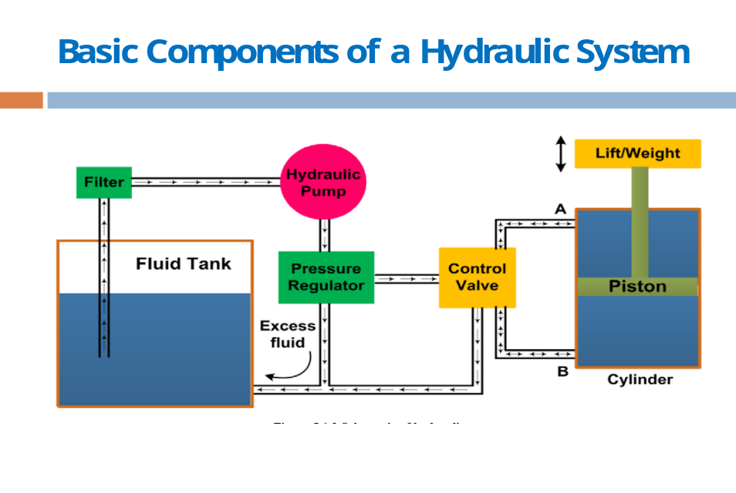
fig.2.41. Basic components of a hydraulic system

- Cylinder movement is controlled by a three-position change over a control valve.
- When the piston of the valve is changed to upper position,
- When the position of the valve is changed to lower position,
- When the valve is at center position,
- The hydraulic system discussed above can be broken down into four main divisions
  - The power device parallels the electrical generating station.
  - The control valves parallel the switches, resistors, timers, pressure switches, relays, etc.
  - The lines in which the fluid power flows parallel the electrical lines.
  - The fluid power motor (whether it is a rotating or a non-rotating cylinder or a fluid power motor) parallels the solenoids and electrical motors.
Advantages and Disadvantages of Hydraulic system
- Advantages
The hydraulic system uses incompressible fluid which results in higher efficiency.
- It delivers consistent power output which is difficult in pneumatic or mechanical drive systems.
- Hydraulic systems employ high density incompressible fluid. Possibility of leakage is less in hydraulic system as compared to that in pneumatic system. The maintenance cost is less.
- These systems perform well in hot environment conditions.
- Disadvantages
The material of storage tank, piping, cylinder and piston can be corroded with the hydraulic fluid. Therefore, one must be careful while selecting materials and hydraulic fluid. The structural weight and size of the system is more which makes it unsuitable for the smaller instruments. The small impurities in the hydraulic fluid can permanently damage the complete system, therefore one should be careful and suitable filter must be installed. The leakage of hydraulic fluid is also a critical issue and suitable prevention method and seals must be adopted. The hydraulic fluids, if not disposed properly, can be harmful to the environment
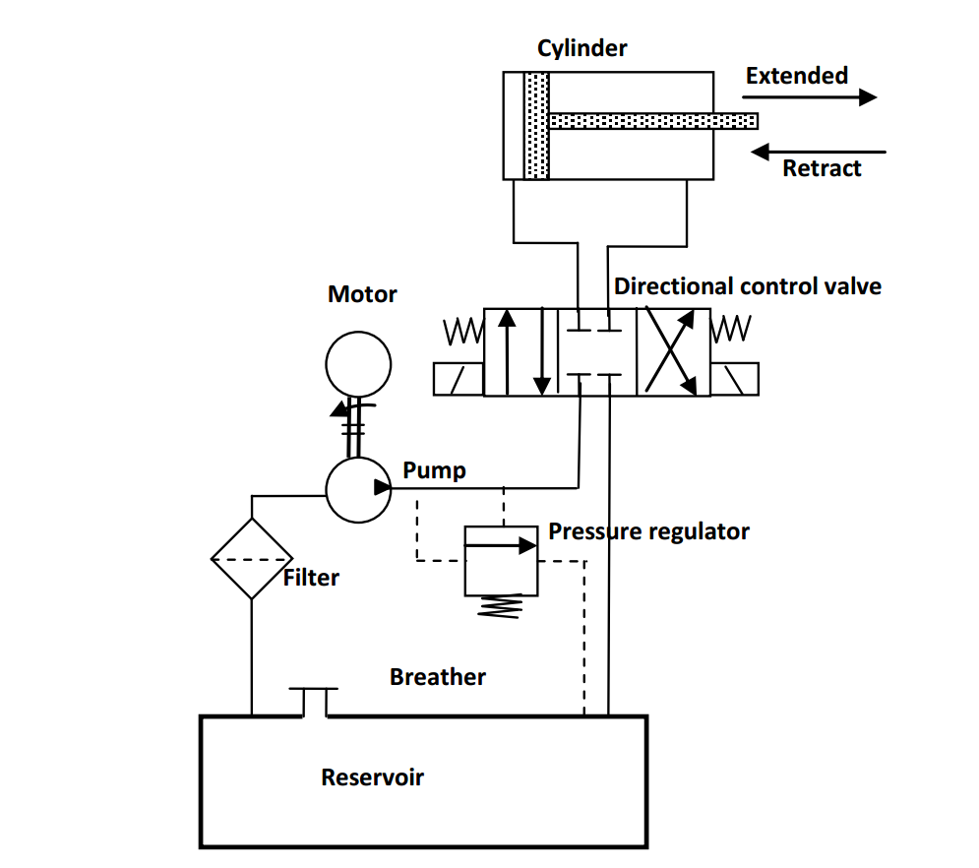
fig.2.42. hydraulic system application
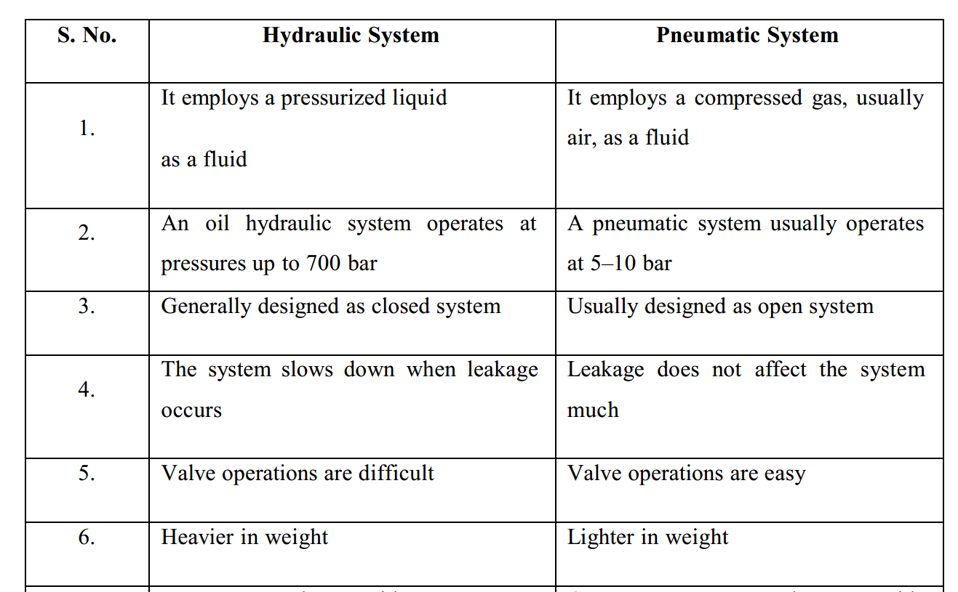Applications of hydraulic systems
The hydraulic systems are mainly used for precise control of larger forces. The main applications of hydraulic system can be classified in five categories:
1.Industrial: Plastic processing machineries, steel making and primary metal extraction applications, automated production lines, machine tool industries, paper industries, loaders, crushes, textile machineries, and robotic systems etc.
- Mobile hydraulics:
- Tractors,
- excavators
- irrigation system,
- commercial vehicles
- building and construction machineries and drilling rigs etc.
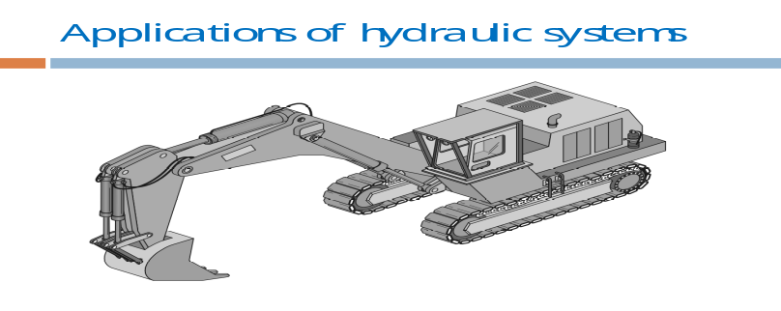
Fig.2.43. application of hydraulic system (exactor)
3. Automobiles: It is used in the systems like breaks, shock absorbers, steering system, wind shield, lift and cleaning etc.
4. Marine applications: It mostly covers ocean going vessels, fishing boats and navel equipment.
5. Aerospace equipment: There are equipment and systems used for rudder control, landing gear, breaks, flight control and transmission etc. which are used in airplanes, rockets and spaceships.
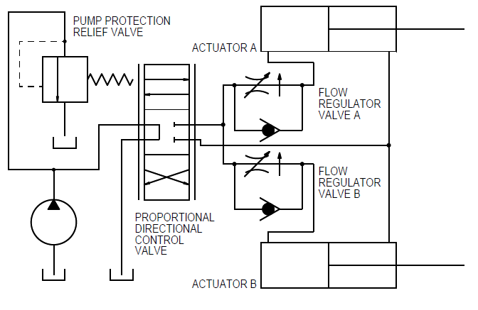
Fig.2.44. Aerospace equipment application
39.. Electro-Hydraulics System
Hydraulic systems are used wherever high power concentration, good heat dissipation
or extremely high forces are required.
- Electro-hydraulic systems are made up of hydraulic and electrical components:
- The movements and forces are generated by hydraulic means (e.g. by cylinders).
- Signal input and signal processing, on the other hand, are effected by electrical
- and electronic components (e.g. electromechanical switching elements or stored-
- program controls).
- Advantages of electro-hydraulics
The use of electrical and electronic components in the control of hydraulic systems is
advantageous for the following reasons:
Electrical signals can be transmitted via cables quickly and easily and over great distances. Mechanical signal transmission (linkages, cable-pulls) or hydraulic signal transmission (tubes, pipes) are far more complex. This is the reason why electro- hydraulic systems are being used increasingly frequently in aero-planes, for example. In the field of automation, signal processing is generally effected by electrical means. This enhances the options for the use of electro-hydraulic systems in automatic production operations (e.g. in a fully automatic pressing line for the manufacture of car wings). Many machines require complex control procedures (e.g. plastics processing). In such cases, an electrical control is often less complex and more economical than a mechanical or hydraulic control system.
- Fields of application of electro-hydraulics
Over the last 25 years, there has been rapid progress in the field of electrical control
technology. The use of electrical controls has opened up many new fields of application
for hydraulics.
- Electro-hydraulics are used in a wide range of sectors, such as:
- The machine construction sector (feed systems for machine tools, force generators
- for presses and in the field of plastics processing),
- Automobile construction (drive systems for production machines),
- Aero-plane construction (landing flap operation, rudder operation),
- In shipbuilding (rudder operation).

- Fundamental laws of Hydraulics
- All hydraulic systems operate following a defined relationship between area, force and pressure.
- Laws have been established to explain the behavior of hydraulic systems.
- Hydraulic systems use the ability of a fluid to distribute an applied force to a desired location.
- When a force (F) is applied on an area (A) of an enclosed liquid, a pressure (P) is produced as shown in Fig.
- Pressure is the distribution of a given force over a certain area.
- Pressure can be quoted in bar, pounds per square inch (PSI) or Pascal (Pa) .
- Directional control valves
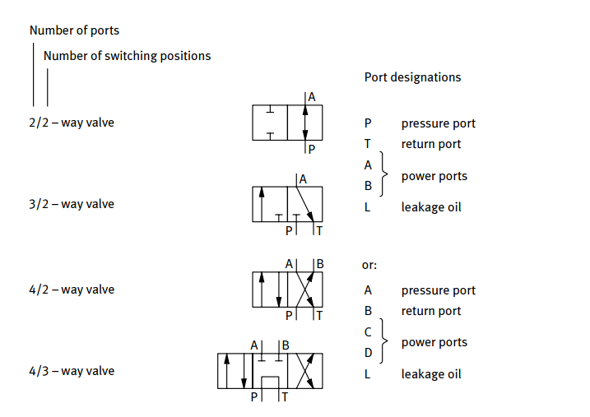
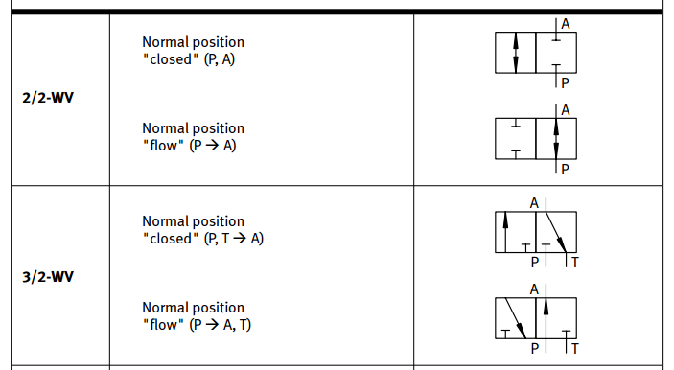
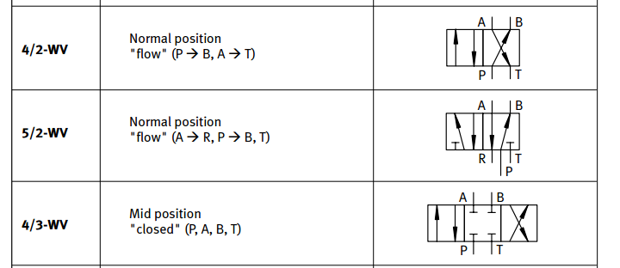
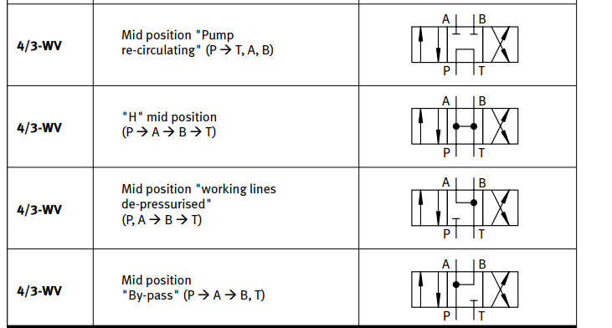
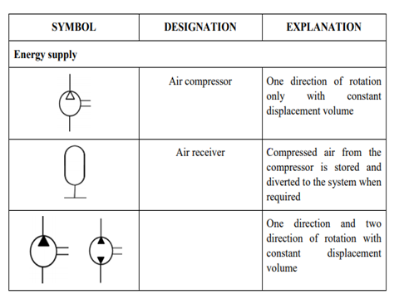
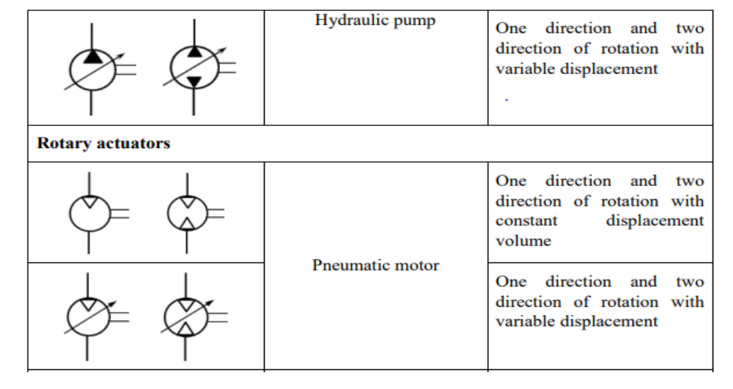
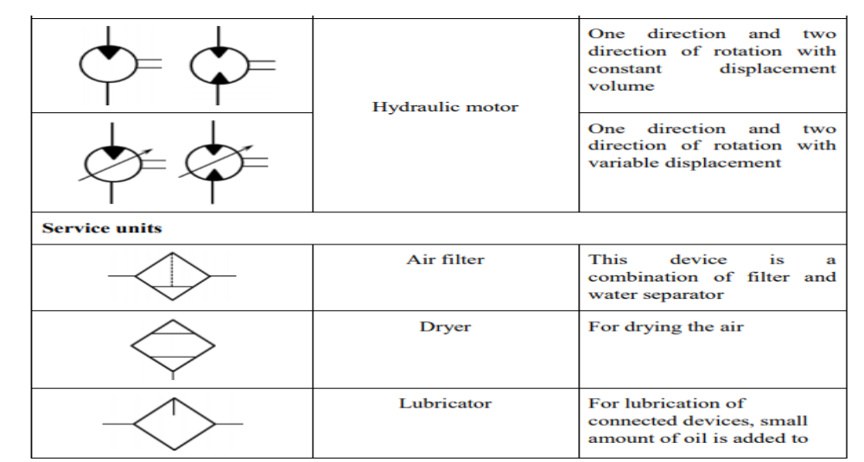
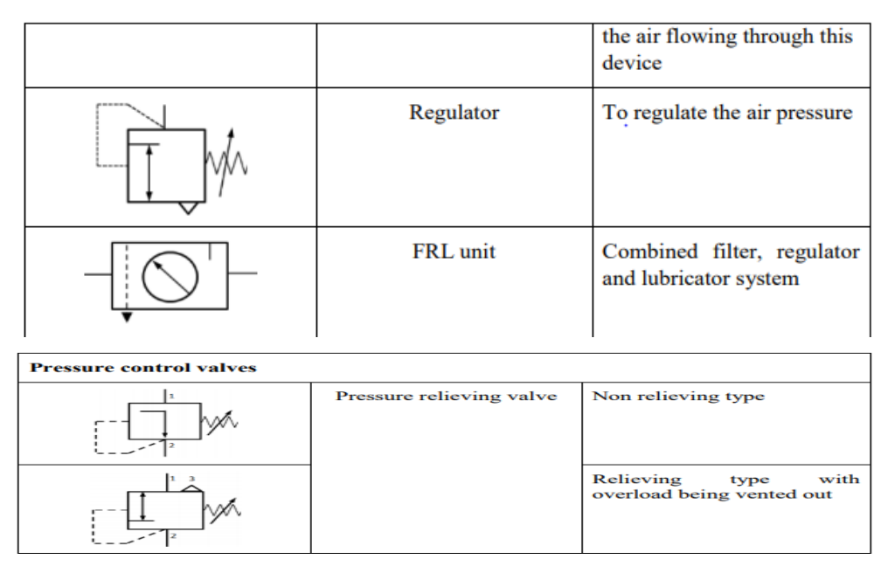
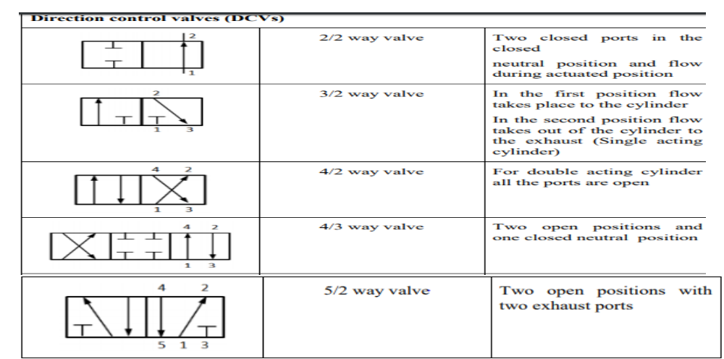
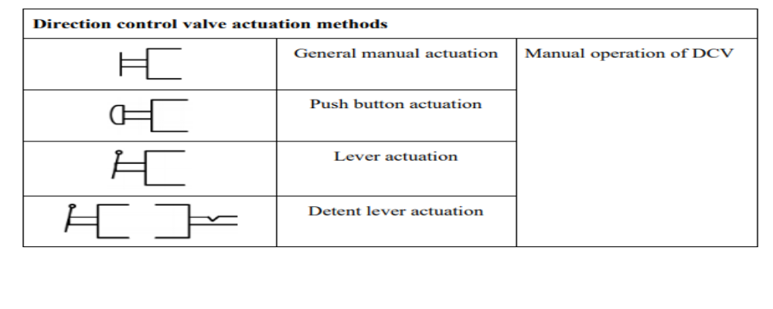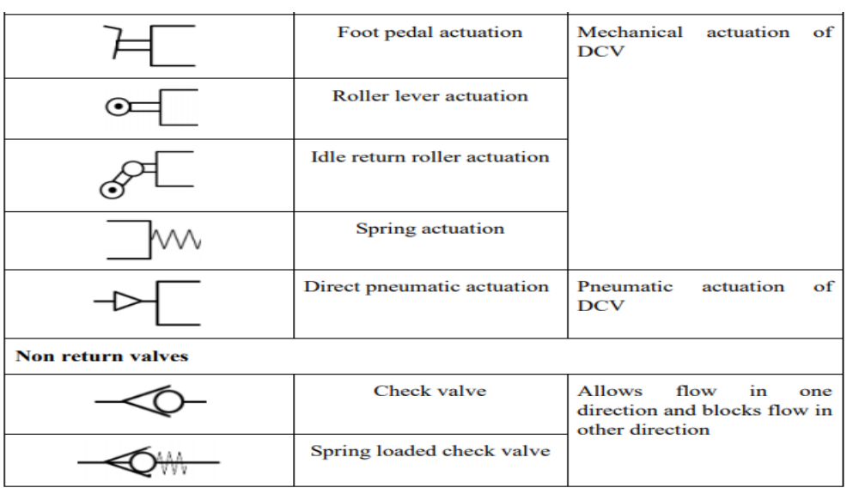
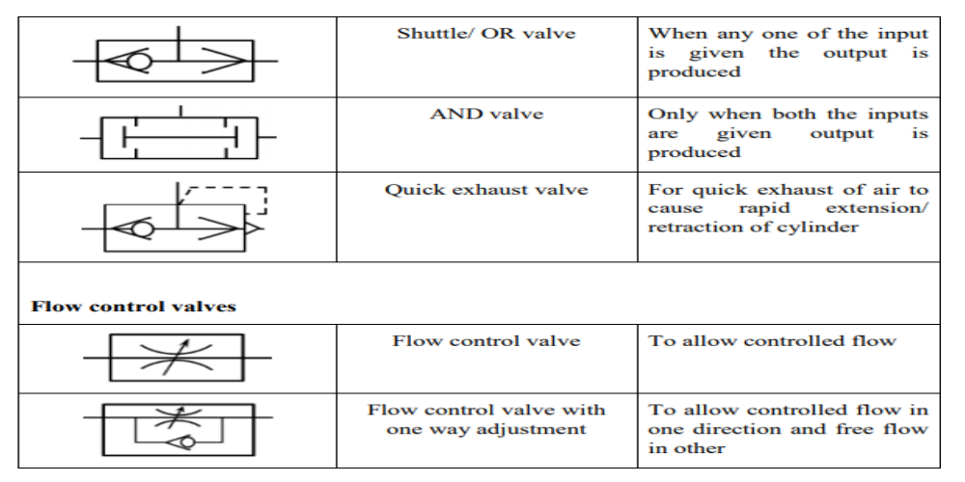
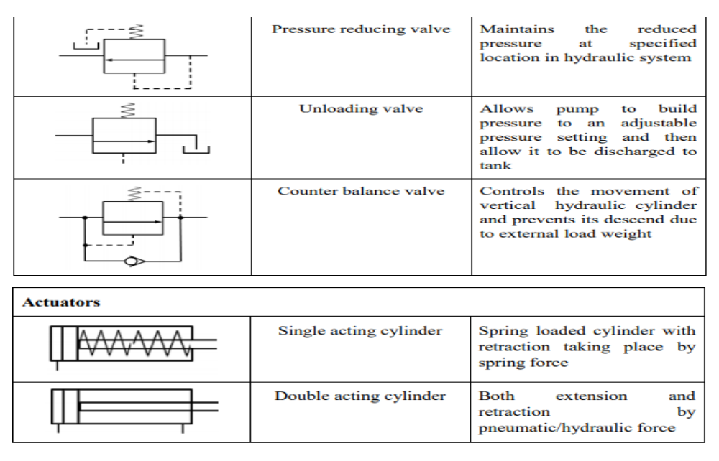

- Flow Control Valves
- In practice, the speed of actuator is very important in terms of the desired output and
- Needs to be controlled.
- The speed of actuator can be controlled by regulating the fluid flow. A flow control valve can regulate the flow or pressure of the fluid.
- The fluid flow is controlled by varying area of the valve opening through which fluid passes.

2.2. Read and Interpret Work instructions
- Work instructions
A Work Instruction is a document that provides specific instructions to carry out an Activity. A Work Instruction is a step by step guide to perform a single instruction. A Work Instruction contains more detail than a Procedure and is only created if detailed step-by-step instructions are needed.
Work instructions are key to reducing variation, allowing manufacturers to improve quality and meet demand. Even better, written work instructions are a great training tool for new employees. Standard work instructions enforce consistency when performing tasks. They allow engineers to measure quality and task time.
Hierarchy of Procedural Documents
Another way to look at this is to consider all procedure documents, from SOPs to Work Instructions, as part of a pyramid.
- Work Instructions are the “how you address satisfying the SOP” documents.
- Standards state that you must have a documented procedure for conducting audits.
- SOPs/Procedures outlines how/when audits will be performed. Work Instructions go one level down and show the exact steps required to train the auditors, prepare the documents etc.

2.2. Difference Between Work Instructions and Procedures
Another way of looking at Work Instructions v Procedures is that:
Procedures describe:
- What is the activity is?
- Who performs it
- When it is performed
Work instructions describe:
- How the activity is performed?
Purpose of Work Instructions
‘A work instruction is a tool provided to help someone to do a job correctly. This simple statement implies that the purpose of the work instruction is quality and that the target user is the worker. Unfortunately, in many workplaces, today’s work instructions have little connection with this fundamental focus. Factories have encumbered work instructions with content that has been added to satisfy auditors, lawyers, engineers, accountants and yes, even quality managers. We’ve piled on so much extraneous material that we’ve lost sight of the intended purpose of work instructions.’
- What’s the difference between work instructions, work guides, SOPs and so on?
Work instructions are also called work guides, Standard Operating Procedures (SOPs), job aids or user manuals, depending on the situation. In any case, the purpose of the work instructions is to clearly explain how a particular work task is performed. They’re like the step-by-step instructions we receive when we learn to drive a car: check gear stick is in neutral, start ignition, press clutch, change to first gear and so forth.
What’s important is that work instructions should not be confused with processes or process maps. Let’s quickly look at where work instructions fit into our overall process documentation levels:
- A process hierarchy shows your overall process architecture and how it supports your business. (For more on this read our Guide to creating process hierarchies)
- A process is a chain of activities that transform inputs to outputs. (Interested? read our Guide to simple process mapping)
- A procedure outlines how to perform a process – sequence and who does what. In Gluu we combine process and procedure into a single, simple format (since people confuse them all the time).
- A work instruction – or work guide, job aid or standard operating procedure – describes in detail how an activity within a process (or procedure) is performed.
Your work instruction should therefore be part of an overall process improvement plan.
With this clarity let’s move on to the topic of how to write work instructions.
In every realm of employment there are instructions to follow, which are often placed within directions or diagrams. It is essential to know how to dissect, analyse and complete a given set of instructions in order to complete a given task. Often when you are in your own workplace, or even visit others, you will notice a variety of signs containing directions and diagrams all around you. This is often because of health and safety, and also because it is important for the customers and staff to follow the rules as exactly as they are presented. Many such signs contain pictures and diagrams in order to attract your attention and present information simply and clearly within picture format.
Before work begins, the qualified worker should ensure that the job to be done is in fulfill with instructions relating to the Mechatronics and instrumentation control works. Mechatronics and Instrumentation control works should be performed according to written safety procedures and approved Mechatronics and Instrumentation control manuals. Mechatronics and Instrumentation control work should be directed by a supervisor, qualified by training and experience in the safety related work practices that pertain to their respective job assignments and those of their employees. Mechatronics and Instrumentation control instructions are based on a detailed analysis of the job and its hazards' the same task is repeated, it may be performed under specific work rules that are based on such analysis. Mechatronics and Instrumentation control device instructions manuals should contain the following:
- The essential safety rules for the job Terms and Conditions
- Wiring Diagram
- Installation Overview
- Mounting and Wiring Instruction
- Testing Mechanical and Electrical hookup
- System configuration
- Mounting Templates
- Equipment list
- Parts of a Mechatronics System
- Mechanical System
- Moving parts like drives, pulleys, gears, mechanisms, etc.
- Electronic and Electrical System
- Microcontroller, analog-digital and digital-analog converters, sensors, actuators, etc.
- Information System
- Software
- User Interface
- Typical Components of Mechatronics System
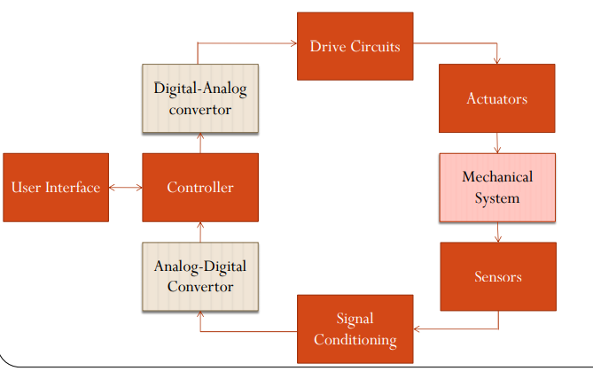
Fig.2.45: Components of Mechatronics System
- System of mechatronics
- A system can be thought as box or block diagram
- Having an input and corresponding output
- Inputs and outputs of system important
- not what goes inside the system.
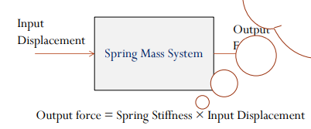
Fig.2.46: System Mechatronics
- Subsystems of Scanner System
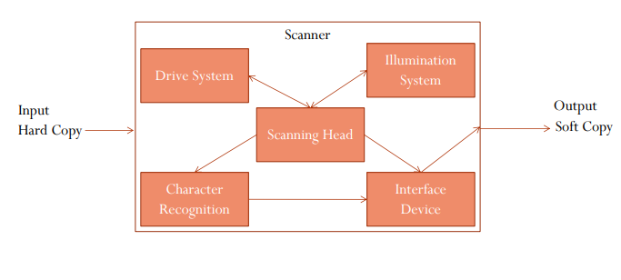
Fig.2.47: Subsystems of Scanner System
- Drive System (Mechanical)
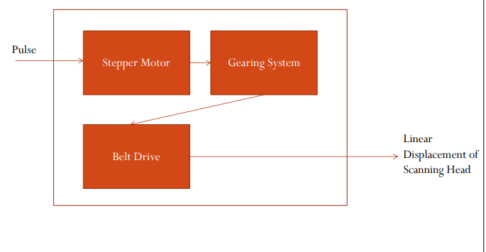
Fig.2.48: Drive System (Mechanical)
- Scanning Head (Electronic and Electrical)
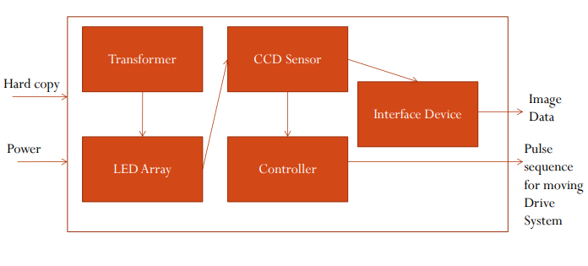
Fig.2.49: Scanning Head (Electronic and Electrical)
- Components of Mechatronics Systems
- Mechanical System
- Electrical System
- Information System
- Mechanical Systems and Analysis Types of Systems
  - Rigid – Rigid Multi-body Simulation
  - Deformable – Failure analysis, Finite Element Method (FEM)
- Fluid – Computational Fluid Dynamics (CFD)
- Some mechanical components used
- Rigid - Gears, drives, cams, bearings, etc.
- Flexible – Electro-active polymers, Shape memory alloys, fiber reinforced material
- Fluid - Hydraulic cylinder, pneumatic cylinder, etc
- Electrical Systems
- Motors and generators
- Sensors and actuators
- Solid state devices
- Circuits – signal conditioning, amplifiers, etc.
- Contact devices – relays, switches. Circuit breakers, fuses, etc.
- Information System Information System consist of four parts
- Communication Systems
- Signal Processing
- Control System
- Numerical Solvers for Optimization
- Under Information System following activities are performed
- Modeling
- Simulation
- Automatic Control
- Optimization

2.3 Mechatronics devices installation
DIGITAL CONTROL
- In recent years, microprocessors & microcomputer are used in the control system to obtain necessary controlling action. Such controllers use digital signal which exists only at finite instant .in the form of short pulses (digital controllers)
CONTROL SYSTEMS
Introduction
- Automatic control is the maintenance of a desired value of quantity or condition by measuring the existing value; compare it with the desired value and employing the difference to initiate action for reducing this difference.
- Automatic control systems are used in practically every field of our life. Since, nowadays it has become a tendency to complete the required work or a task automatically by reducing the physical and mental effort. The different applications of automatic control systems are:
- Domestically they are used in heating and air conditioning.
- Industrial applications of automatic control system include:
- Automatic control of machine tool operations.
- Automatic assembly lines.
- Quality control, inventory control.
- In process industries such as food, petroleum, chemical, steel, power etc. for the control of temperature, pressure, flow etc.
- Transportation systems, robotics, power systems also uses automatic control for their operation and control.
- Compressors, pumps, refrigerators.
- Automatic control systems are also used in space technology and defence applications such as nuclear power weapons, guided missiles etc.
- Even the control of social and economic systems may be approached from theory of automatic control.
- The term control means to regulate, direct or command. A control system may thus be defined as: "An assemblage of devices and components connected or related so as to command, direct or regulate itself or another system".
- In general, the objectives of control system are to control or regulate the output in some prescribed manner by the inputs through the elements of the control system.
Basic components of the control system are:
- Input: - objectives of control. It is the excitation applied to a control system from external source in order to produce output.
- Control System Components: - Devices or components to regulate direct or command a system that the desired objective is achieved.
- Results or Outputs: - The actual response obtained from a system.
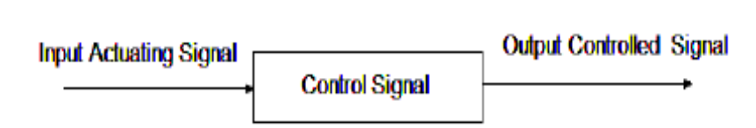
Fig2.50 Block diagram of control system.
Classification of Control Systems:
There are two basic types of control Systems:
- Open Loop System (Non-feed Back)
- Closed Loop System (Feed Back)
1. Open Loop System (Non-feed Back)
The elements of an open loop system can usually be divided into two parts: the Controller and the Controlled process as shown in Fig
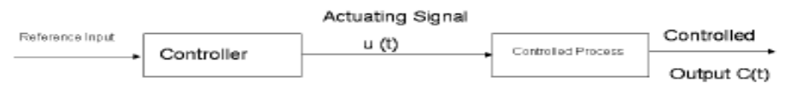
Fig 2.51 Open loop system
- An input signal or command r (t) is applied to the controller which generates the actuating signal u (t).
- Actuating signal u(t) then controls (activates) the process to give controlled output c(t). In simple cases, the controller can be an amplifier, mechanical linkage, filter, or other control element, depending on the nature of the system. In more sophisticated cases the controller can be a computer such as microprocessor.
- The control action has nothing to do with output c (t) i.e. there is no any relation between input and output.
- There is no feedback hence it is known as non-feedback system.
Examples of open loop System:
- Traffic control signals at roadway intersections are the open loop systems. The glowing of red and green lamps represents the input. When the red lamp grows the traffic stops. When green lamp glows, it directs the traffic to start.
- The red and green light travels are predetermined by a calibrated timing mechanism and are in no way influenced by the volume of traffic (output).
- Automatic washing machine: In washing machine, input is dirty clothes, water, soap and output is clean cloths. Soaking, washing and rinsing operations are carried out on a time basis. However, the machine does not measure the output signal, namely the cleanliness of the clothes.
Advantages of Open Loop System:
  - Simple in construction.
  - Economic.
  - More stable.
  - Easy maintenance.
Disadvantages of Open Loop System:
  - Inaccurate and unreliable.
  - It is affected by internal and external disturbances; the output may differ from the desired value.
  - It needs frequent and careful calibrations for accurate results.
  - Open loop systems are slow because they are manually controlled.
  - There is no feedback control. The control systems are rather unsophisticated.
2. Closed Loop System
- A closed loop control system measures the system output compares it with the input and determines the error, which is then used in controlling the system output to get the desired value.
- In closed loop system for more accurate and more adaptive control a link or feedback from the output to the input of the system is provided. The controlled signal c (t) is fed back and compared with the reference input r (t), an actuating signal e (t) proportional to the difference of the input and the output is send through the system to correct the error and bring the system output to the desired value.
- The system operation is continually correcting any error that may exit. Where r (t) = reference input e (t) = error or actuating signal b (t) = feedback signal m = manipulation
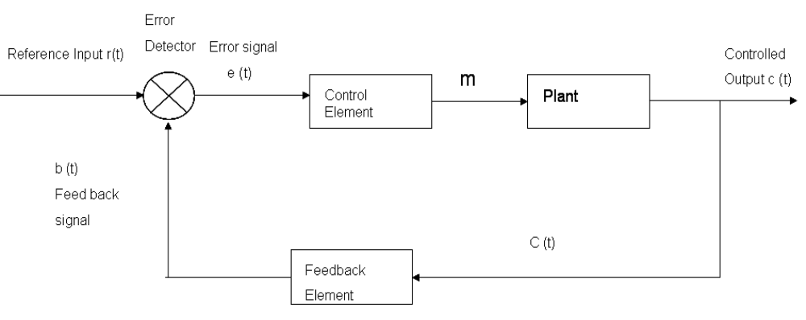
Fig2.52. Closed loop system
Advantages of Closed Loop System:
- These systems can be used in hazardous or remote areas, such as chemical plants, fertilizer plants, areas with high nuclear radiations, and places at very high or very low temperatures.
- Increased productivity.
- Relief of human beings from hard physical work and economy in operating cost.
- Improvement in the quality and quantity of the products.
- They are more reliable than human operators.
- A number of variables can be handled simultaneously by closed loop control systems.
- In such systems there is reduced effect of non-linearity’s and distortions.
- Closed loop systems can be adjusted to optimum control performance.
- Such system senses environmental changes, as well as internal disturbances and accordingly modifies the error.
- Satisfactory response over a wide range of input frequencies.
Disadvantages of Closed Loop Control System:
- It is more complex and expensive.
- Installation and adjustment is intricate.
- Maintenance is difficult as it involves complicated electronics. Moreover trained persons are required for maintenance.
- Due to feedback, system tries to correct the error time to time.
- Tendency to over correct the error may cause oscillations without bound in the system.
- It is less stable as compared to open loop system.
- Table Comparison between open loop and closed loop systems
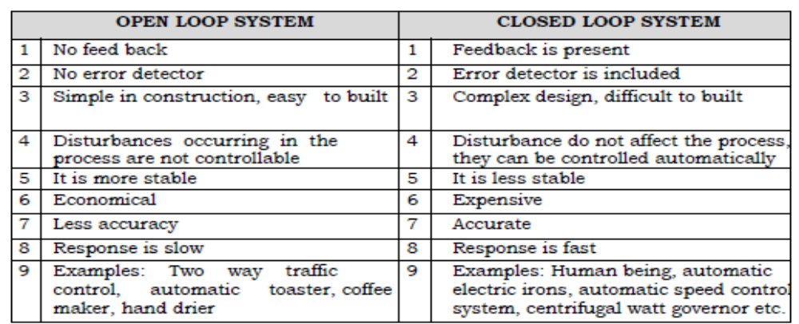
CONTROLLERS AND CONTROL ACTION
- An automatic controller compares the actual value of the plant output with the desired value of output, determines the deviation and produces a signal which will reduce the deviation to zero or to a small value.
- The manner in which the automatic controller produces the control signal is called control action. The control action may operate through mechanical, pneumatic, hydraulic or electrical means.
- Controllers can be in the form of
  - Pneumatic
  - Hydraulic
  - Analog or digital
The choice of the control action for a particular operation depends upon:
- The nature of the plant
- Operating conditions
- Size and weight
- Availability and cost
- Accuracy and reliability and
- Safety etc.
- Control Actions
Pneumatic Controller
- Pneumatic controllers use air medium (or other gases in special situations) to provide an output signal which is a function of an input error signal.
- Regulated pressurized air supply at about 20 psg is used as an input signal. Air medium has the advantage of being non-inflammable and having almost negligible viscosity compared to the high viscosity of hydraulic fluids. The danger of explosion existed due to electrical equipment is avoided by pneumatic controller.
Advantages
- The danger of explosion is avoided.
- For operating the final control elements relatively high power amplification is obtained. Due to availability of free supply of air it is relatively inexpensive.
- Comparatively simple and easy to maintain.
Limitations:
- Slow response and longer time delays.
- The lubrication of mating parts creates difficulty.
- Compressed air pipe is necessary throughout the system.
- In pneumatic system there is a considerable amount of compressibility flow so that the systems are characterized by longer time delays
Hydraulic Controllers
- In hydraulic controllers power is transmitted through the action of fluid flow under pressure.
- The fluid used is relatively incompressible such as petroleum base oils or certain non-inflammable synthetic fluids. Fig. shows schematics of a hydraulic control system.
The major components of a hydraulic controller are:
- An error detector
- an amplifier
- A hydraulic control valve, and
- An actuator.
Advantages of hydraulic controllers
- High speed response.
- High power gain.
- Long life due to self-lubricating properties of fluid.
- Simplicity of actuator system
- Easy maintenance.
Limitations of hydraulic controllers
- Hydraulic fluids require careful maintenance to remove impurities, corrosive effects etc.
- Seals should be properly maintained to prevent leakage of hydraulic fluids.
Electric controllers
- Electrical control devices are most widely used because of their accuracy and fast response with easy handling techniques. Electric controller for proportional, proportional plus integral and proportional + integral +derivative actions may be divided into two types:
  - The null balance type in which an electrical feedback signal is given to the controller from the final elements
  - The direct type in which there is no such feedback signal.
- As with the pneumatic controller, the various control actions are accomplished by modifying the feedback signal. This is done by adding properly combined electrical resistances and capacitances to feedback circuit just as restrictions and bellows were added in the pneumatic circuit.
- A very simple form of two step controller is the room-temperature thermostat. The U shaped bimetal strip fixed at one end of the thermostat frame deflects when heated, its free and moving in such a direction as to separate the fixed and moving contacts.
- When the bimetal strip cools the two contacts are once more brought in contact. The small permanent magnet ensures the opening and closing of the contacts with a snap action to minimize the damage caused by arcing. The adjusting screw varies the small range of temperature, sometimes called the differential gap between contacts opening on rising temperature and closing on falling temperature.
- Relay control electro pneumatic system
The entire signal processing needs of an electropneumatic control system can be implemented with relays. Relay control systems used to be made in large numbers. Many of these control systems are still in use in industry today.
Nowadays programmable logic controllers are commonly used for signal processing instead of relay control systems. Relays are still used in modern control systems however, for example in an EMERGENCY STOP switching device.
The principal advantages of relay control systems are the clarity of their design and the ease of understanding their mode of operation.
- Applications of relay control systems
The entire signal processing needs of an electro pneumatic control system can be implemented with relays. Relay control systems used to be made in large numbers. Many of these control systems are still in use in industry today.
Nowadays programmable logic controllers are commonly used for signal processing instead of relay control systems. Relays are still used in modern control systems however, for example in an EMERGENCY STOP switching device.
The principal advantages of relay control systems are the clarity of their design and the ease of understanding their mode of operation.
- Direct and indirect control
If a solenoid valve is controlled directly by source of input signal device and the valve controls an output device, (ex. single acting cylinder, Fig.20a, b), it is referred as direct control where as if the input signal deice does not directly control the solenoid valve but it controls via the relay and then the output device(Fig.20c), it is indirect control.

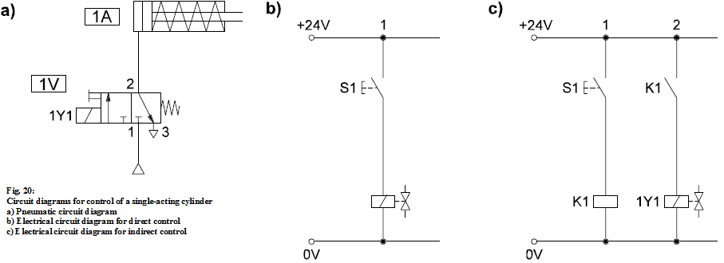
Operation
The electrical circuit diagram for direct control of a single-acting cylinder is shown in Fig.20. b. When the pushbutton is pressed, current flows through the solenoid coil 1Y1 of the 3/2-way valve. The solenoid is energized, the valve switches to the actuated position and the piston rod advances.
Releasing the pushbutton results in interruption of the flow of current.The solenoid is de-energized, the directional control valve switches to the normal position and the piston rod is retracted.
If the pushbutton is pressed in an indirect control system (Fig.20.c), current flows through the relay coil. Contact K1 of the relay closes, and the directional control valve switches. The piston rod advances.
When the pushbutton is released, the flow of current through the relay coil is interrupted. The relay is deenergised, and the directional control valve switches to the normal position. The piston rod is retracted.
The more complex indirect type of control is used whenever the following conditions apply:
- The control circuit and main circuit operate with different voltages (such as 24 V and 230 V).
- The current through the coil of the directional control valve exceeds the permissible current for the pushbutton (such as current through the coil: 0.5 A; permissible current through the pushbutton: 0.1 A).
- Several valves are operated with one pushbutton or one control switch.
- Complex links are necessary between the signals of the various pushbuttons.
Double acting cylinder control: The piston rod of a double-acting cylinder is to advance when pushbutton S1 is pressed and retracted when the pushbutton is released. The electrical signal control section is unchanged from the control system for a single-acting cylinder. As there are two cylinder chambers which have to be vented or pressurized, either a 4/2 or 5/2-way valve is used (Fig.21.a and 21.b respectively).

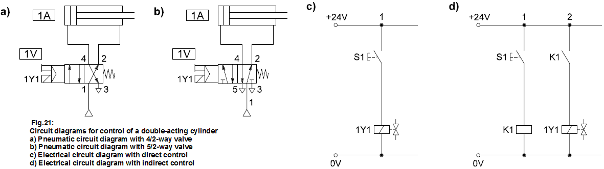
Logic operations
In order to produce the required movements by pneumatic cylinders, it is often necessary to combine signals from several control elements through logic operations.
OR logic control circuit
The aim is to be able to trigger extend of the piston rod of a cylinder with two different input elements, pushbuttons S1 and S2.
The contacts of the two pushbuttons S1 and S2 are arranged in parallel in the circuit diagram (Figs.22.c and 22.d).
- As long as no pushbutton is pressed, the directional control valve remains in the normal position. The piston rod is retracted.
- If at least one of the two pushbuttons is pressed, the directional control valve switches to the actuated position. The piston rod advances.
- When both pushbuttons are released, the valve switches to the normal position. The piston rod is retracted.

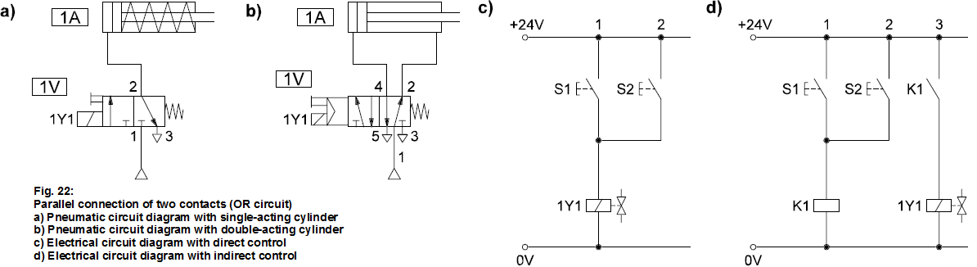
And logic control circuit
In this case the piston rod of a cylinder is to be advanced only if both pushbuttons, S1 and S2, are pressed. The contacts of the two pushbuttons are arranged in series in the circuit diagram (Figs.23.c and 23.d).
- As long as neither or only one of the two pushbuttons is pressed, the directional control valve remains in the normal position. The piston rod is retracted.
- If both pushbuttons are pressed at the same time, the directional control valve switches. The piston rod advances.
- When at least one of the two pushbuttons is released, the valve switches to the normal position. The piston rod is retracted.
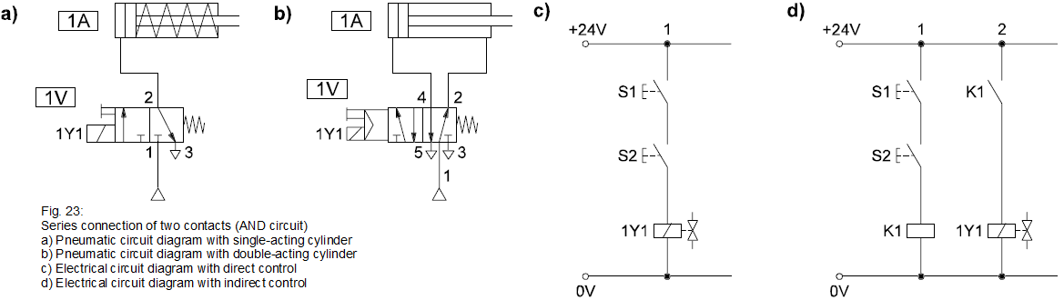

Signal storage
In the circuits that we have looked at so far, the piston rod only advances as long as the input pushbutton is actuated. If the pushbutton is released during the advancing movement, the piston rod is retracted without having reached the forward end position.
In practice it is usually necessary for the piston rod to be fully advanced even if the pushbutton is pressed only briefly. To achieve this, the directional control valve must remain in the actuated position when the pushbutton is released; in other words, actuation of the pushbutton must be stored.
A double solenoid valve maintains its switching position even when the associated solenoid coil is no longer energized. It is used as a storage element.
The piston rod of a cylinder is to be controlled by brief actuation of two pushbuttons (S1: advance, S2: retract).

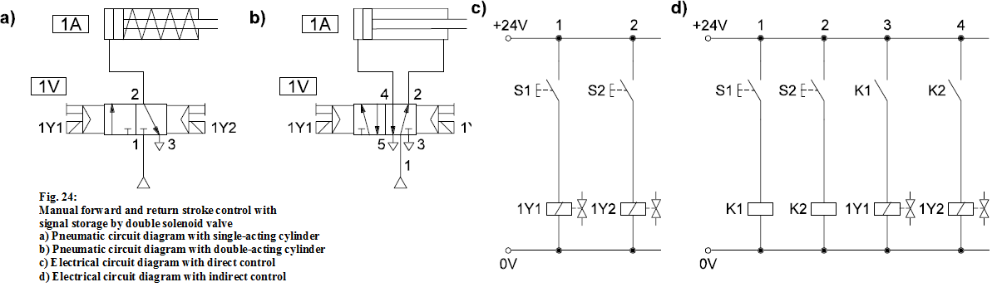
The two pushbuttons act directly and indirectly on the coils of a double solenoid valve (Figs.24.c and 24.d).
When pushbutton S1 is pressed, solenoid coil 1Y1 is energized. The double solenoid valve switches and the piston rod advances. If the pushbutton is released during the advancing movement, the piston rod continues extending to the forward end position because the valve retains its switching position.
When pushbutton S2 is pressed, solenoid coil 1Y2 is energized. The double solenoid valve switches again, and the piston rod returns. Releasing pushbutton S2 has no effect on the return movement.
The aim is for the piston rod of a double-acting cylinder to be advanced when pushbutton S1 is actuated. When the forward end position is reached, the piston rod is to return automatically.
The circuit diagram for return stroke control is shown in Figs. 24.b and c. When pushbutton S1 is pressed, the piston rod advances (see previous example). When the piston rod reaches the forward end position, current is applied to solenoid coil 1Y2 via limit switch 1S2, and the piston rod retracts.The prerequisite for the return movement is that pushbutton S1 must first have been released.
- Oscillating movement with double solenoid valve
The piston rod of a cylinder is to advance and retract automatically as soon as control switch S1 is actuated. When the control switch is reset, the piston rod is to occupy the retracted end position.
Initially the control system is in the normal position. The piston rod is in the retracted position and limit switch S1 is actuated (Figs.25.b and 25.c). When contact S1 is closed, the piston rod advances. When the forward end position is reached, limit switch 1S2 is actuated and the piston rod is retracted. Provided the contact of S1 remains closed, another movement cycle begins when the piston rod reaches the retracted end position. If the contact of S1 has been opened in the meantime, the piston rod remains at the retracted end position.

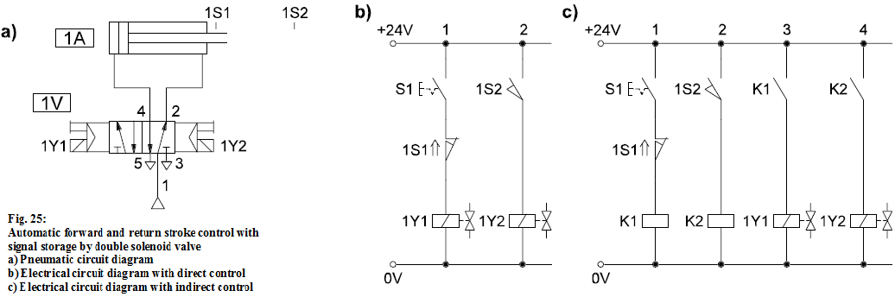
- Relay circuit with latching
Initially the control system is in the normal position. The piston rod is in the retracted position and limit switch S1 is actuated (Fig. 26.b and 26.c). When contact S1 is closed, the piston rod advances. When the forward end position is reached, limit switch 1S2 is actuated and the piston rod is retracted. Provided the contact of S1 remains closed, another movement cycle begins when the piston rod reaches the retracted end position. If the contact of S1 has been opened in the meantime, the piston rod remains at the retracted end position.
When the "ON" pushbutton is actuated in the circuit in Fig. 26.a, the relay coil is energized. The relay is energised, and contact K1 closes. After the "ON" pushbutton is released, current continues to flow via contact K1 through the coil, and the relay remains in the actuated position. The "ON" signal is stored. This is therefore a relay circuit with latching function.
When the "OFF" pushbutton is pressed the flow of current is interrupted and the relay becomes de-energised. If the "ON" and "OFF" pushbuttons are both pressed at the same time, the relay coil is energized. This circuit is referred to as a dominant ON latching circuit.
The circuit in Fig. 26.b exhibits the same behaviour as the circuit in Fig. 26.a provided that either only the "ON" pushbutton or only the "OFF" pushbutton is pressed. The behaviour is different when both pushbuttons are pressed: The relay coil is not energized. This circuit is referred to as a dominant OFF latching circuit.
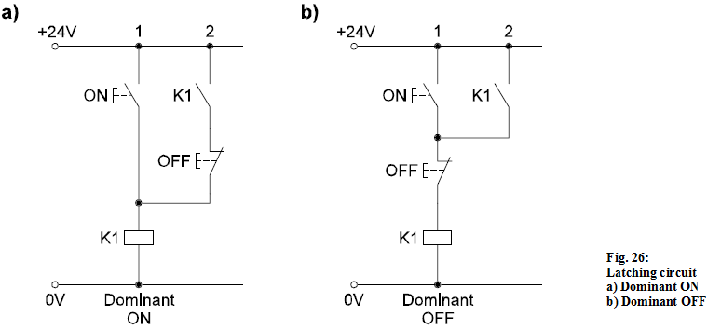
- Manual forward and return stroke control via relay with latching function
In this case the piston rod of a cylinder is to advance when pushbutton
S1 is pressed and retract when pushbutton S2 is pressed. A relay with latching function is to be used for signal storage.
When pushbutton S1 is pressed, the relay is latched (Fig. 27.c). The directional control valve is actuated via another relay contact. When the latching is released by actuation of pushbutton S2, the piston rod retracts.
As this is a dominant OFF relay circuit, actuation of both pushbuttons together results in the piston rod being retracted or in it remaining in the retracted end position.
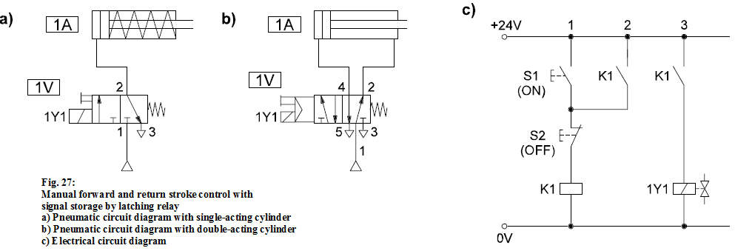

Signal storage can be effected in the power section by means of a double solenoid valve, or alternatively in the signal control section by means of a relay with latching function. The various circuits behave differently in response to the simultaneous presence of a setting and resetting signal, and in the event of failure of the electrical power supply or a wire break (Table 1).
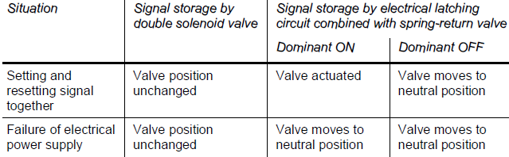
Table 1: Comparison of signal storage by latching circuit and double solenoid valve
Delay
In many applications it is necessary for the piston rod of a pneumatic cylinder to remain at a certain position for a set length of time. This is the case for the drive of a pressing device, for example, which presses two work pieces together until the adhesive has set.
Time relays with delayed switch-on or switch-off are used for tasks such
as these. When pushbutton S1 is pressed momentarily, the piston rod of a cylinder
is to advance, subsequently remain at the forward end position for ten seconds and then automatically return.
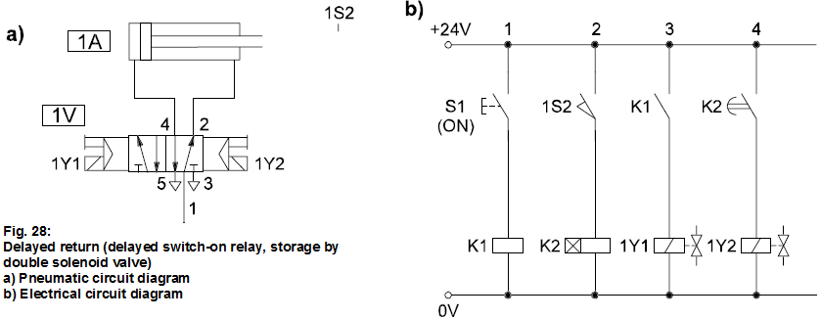
Fig. 28.b shows the electrical circuit diagram for delayed retraction.
When pushbutton S1 is actuated, the piston rod advances. When it reaches the forward end position, limit switch 1S2 closes. Current flows through coil K2. Contact K2 remains open until the variable time delay (in this case: 10 seconds) has elapsed. The contact is then closed, and the piston rod retracts.
- Sequence control with signal storage by double solenoid valves
In sequence control systems, the storage of signals is an essential feature.
It can be accomplished by means of either latching relays or double solenoid valves. The design of a circuit with signal storage by double solenoid valves is explained in the following.
The positional sketch of a feeding device is shown in Fig. 29. The end positions of the two cylinder drives 1A and 2A are detected by the positive switching inductive proximity switches 1B1 and 2B2.
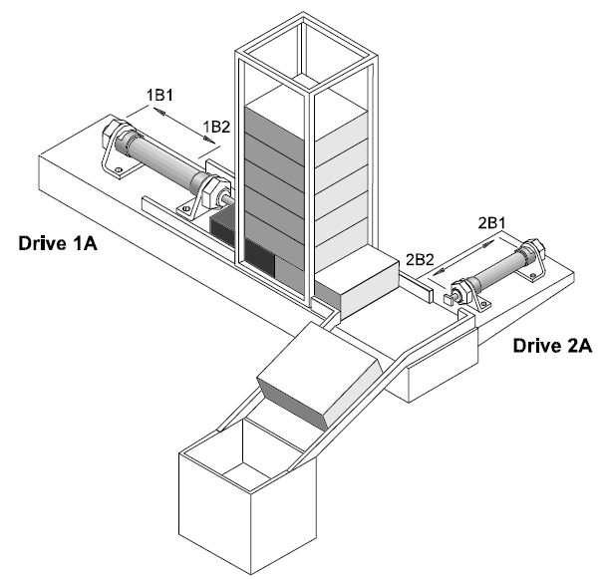
Fig. 29: Positional sketch of feeding device (application example)
The program-controlled sequence is triggered when the operator presses the "START" pushbutton. The sequence comprises the following steps:
Step 1: The piston rod of cylinder 1A advances.The workpiece is pushed out of the magazine.
Step 2: The piston rod of cylinder 2A advances.The workpiece is fed to the machining station.
Step 3: The piston rod of cylinder 1A retracts.
Step 4: The piston rod of cylinder 2A retracts.
The "START" button must be pressed again to trigger another feed operation.
The program-controlled sequence of motions of the feeding device is shown in the displacement-step diagram (Fig.29).
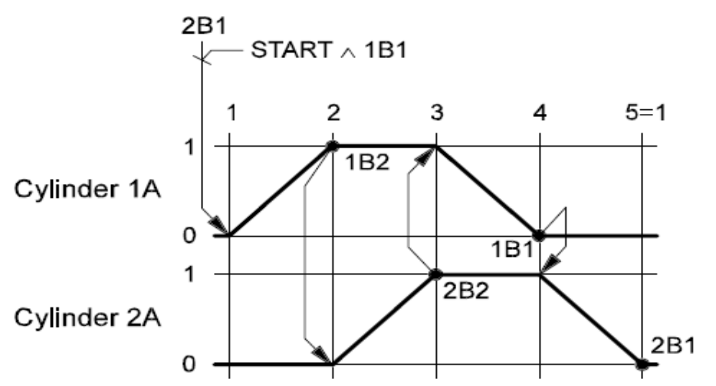
Fig.2.53 Displacement-step diagram for the feeding device

Pneumatic circuit diagram of the feeding device
The control system is implemented using double-acting cylinders and 5/2-way double solenoid valves. The pneumatic circuit diagram is shown in Fig. 2.54.
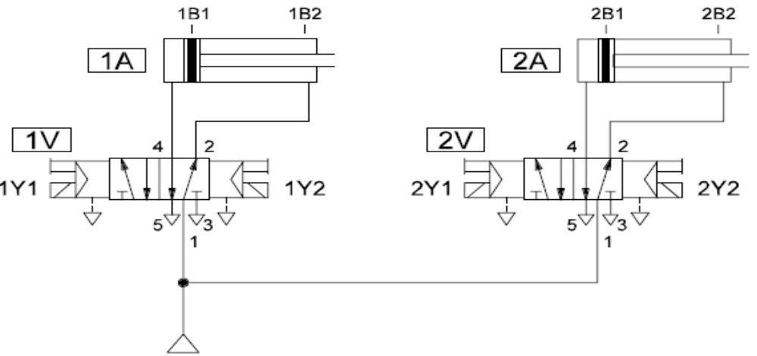
Fig. 2.54: Pneumatic circuit diagram of the feeding device
Sensor evaluation
In a relay circuit the signals are combined with each other by the contacts of control switches, pushbuttons and relays. The electronic proximity switches used here do not have contacts; instead they generate an output signal by means of an electronic circuit. Each sensor output signal therefore acts on the coil of a relay, which in turn switches the necessary contact or contacts (Fig. 32). If proximity switch 1B1 is tripped, for example, current flows through the coil of relay K1. The related contacts switch to the actuated position.
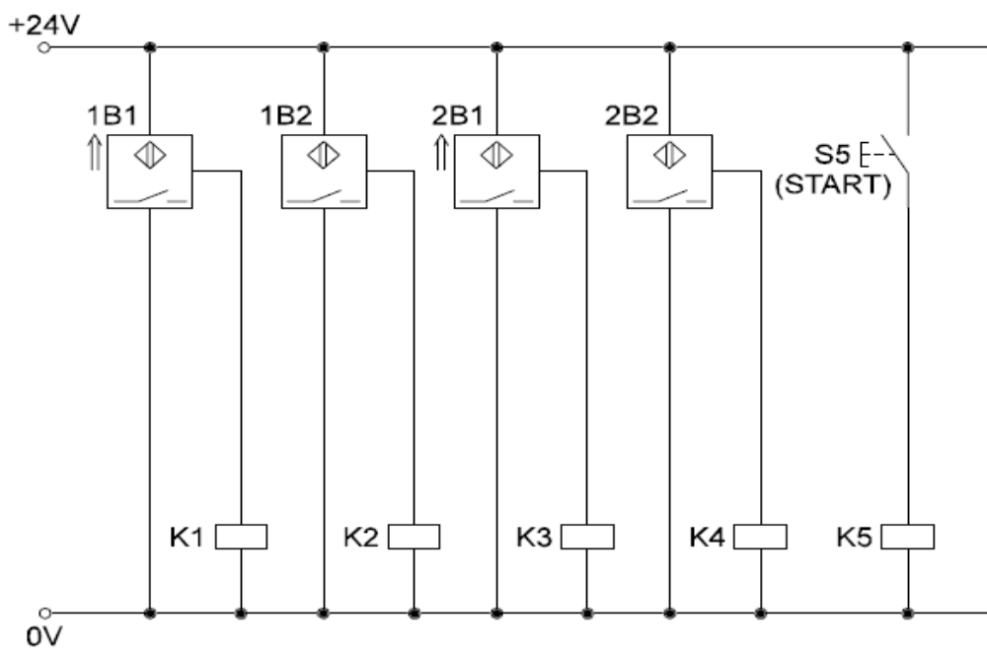
Fig. 2.55: Electrical circuit diagram with sensor evaluation

1st step: The following preconditions must be satisfied before the sequence is started:
- Piston rod of cylinder 1A in retracted end position (proximity switch 1B1 and relay K1 actuated)
- Piston rod of cylinder 2A in retracted end position (proximity switch 2B1 and relay K3 actuated)
- START pushbutton (S5) actuated.
If all of these conditions are met, relay coil K6 is energised. Solenoid coil 1Y1 is actuated, and the piston rod of cylinder 1A advances.
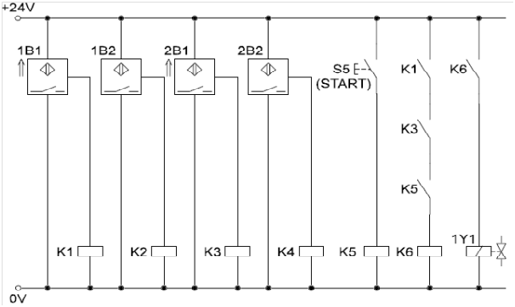
Fig. 2.56: Electrical circuit diagram with sensor evaluation and first sequence step
2nd step: When the piston rod of cylinder 1A reaches the forward end position, sensor 1B2 responds. The second step of the sequence is activated. Solenoid coil 2Y1 is actuated, and the piston rod of drive 2A advances.
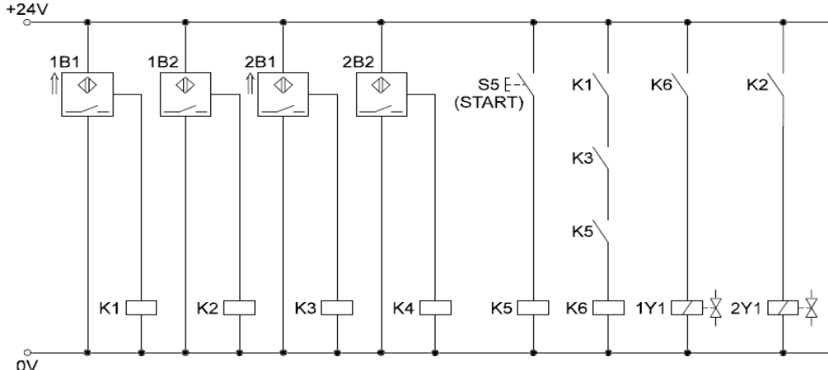
Fig. 2.57: Electrical circuit diagram with sensor evaluation and first and second steps of the sequence

3rd step:When the piston rod of cylinder 2A reaches the forward end position,sensor 2B2 responds. The third step of the sequence is activated. Solenoid coil 1Y2 is actuated, and the piston rod of drive 1A retracts.
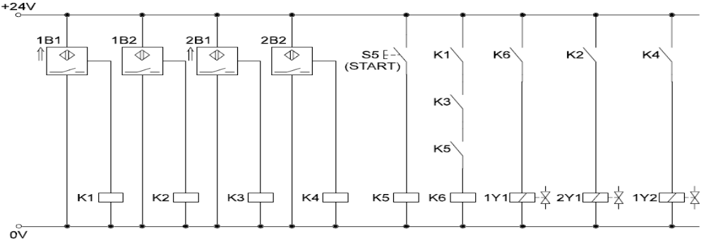
Fig. 2.58 Electrical circuit diagram with sensor evaluation and first, second and third steps of the sequence
4th step:When the piston rod of cylinder 1A reaches the retracted end position,
sensor 1B1 responds. The fourth step of the sequence is activated. Solenoid coil 2Y2 is actuated, and the piston rod of drive 2A retracts.
Fig. 37 shows the complete electrical circuit diagram of the feeding device, including contact element tables and current path designations.
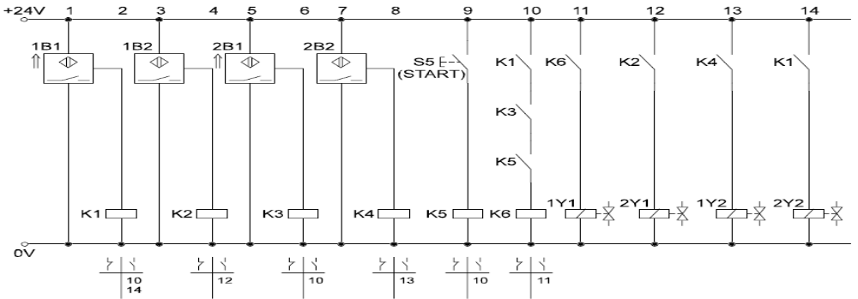
Fig. 2.59: Electrical circuit diagram of the feeding device

2.4 Installed mechatronics device testing
2.4.1. Tests without Operation of the Mechatronics Systems
If repairs are carried out during or after completion of a commissioning test, the affected partial sections of the instrumentation and control systems important to safety shall be subjected to renewed overlapping tests.
2.5.2. General requirements
The tests of the instrumentation and controls without operation of the process-engineering systems shall be performed as two partial tests, namely, the visual inspections and the function tests.
2.5.2.1. Visual inspections
- At the beginning of the tests without operation of the process-engineering systems, visual inspections of the instrumentation and control systems important to safety shall be performed both in the test field and in the power plant on the basis of the documents design-reviewed by the authorized expert.
- With these inspections it shall be verified that a correct functioning can be expected on the basis of the layout of the instrumentation and control equipment taking into account the arrangement of the other power plant components (e.g., the mechanical and electrical components, the ventilation and air filtration systems), and that maintenance possibilities are provided.
- Test criteria include:
- Completed fabrication and component assembly and software implementation in accordance with the configuration and identification documentation of that part of the instrumentation and control equipment to be tested,
- Physical integrity of that part of the instrumentation and control equipment to be tested,
- Suitable construction with regard to the function of the mechanical parts of the measurement assemblies (e.g., sensors, sampling lines, transducers),
- Comprehensive marking of all devices, modules and cabinets and their correct allocation to the redundancy groups,
- Protection against mechanical impacts (e.g., resulting from maintenance work in the plant) of that part of the instrumentation and control equipment to be tested, and
- Accessibility of the devices, modules and measurement assembly arrangements with regard to tests, servicing and repairs.
- The visual inspections shall not be carried out before all accompanying tests of those parts of the instrumentation and control systems important to safety to be tested are completed, and not before the assembly tasks in the compartments accommodating the instrumentation and control equipment to be tested has reached a stage where further assembly tasks can no longer have any detrimental effects on the systems tested with respect to the test criteria specified
2.4.2 Function tests
The function tests shall be carried out at the final location of installation and shall verify that the instrumentation and control equipment fulfills the functions specified in the documents design-reviewed by the authorized expert (e.g., overview diagrams, functional diagrams, circuit diagrams, measuring circuit data sheets, functional descriptions, specifications, explanatory reports).
Integration tests shall be performed with the instrumentation and control equipment of the power plant (e.g., process computer, hazard alarm facility, control room displays, feedback signals).
The function tests shall normally be performed together with the mechanical and electrical components by checking the feed-back signals from actuators, solenoids and circuit breakers created when triggering the components. The process- engineering systems do not need to be in operation for these tests. In the case of media-derived signals (e.g., pressure, flow) the physical values may be created by auxiliary testing aids.
The characteristics specified for the system shall be checked. This shall include checking
Those wiring and function tests of system parts which have already been carried out in the test field as well as any integral system tests already performed do not have to be repeated at the final location of installation, provided.

Self-Check -2
Directions: Answer all the questions listed below. Use the Answer sheet provided in the next page:
Part I: Write the correct Answer for the following question (2 point each)
- Write Disciplinary Foundations of Mechatronic
- list the number of parts of hydraulic
- list Mobile hydraulics elements
- write component of peumatic system
Directions: Write TRUE if the statement is correct and write FALSE if
the statement is wrong. (2 pt. each)
    - Visual inspections of electrical instruments should be performed as part of maintenance
    - Visual inspections conducted before installation during periodic routine maintenance.
    - The function tests shall be carried out at the final location of installation.
    - Without operation of the process-engineering systems, visual inspections and the function tests are the two partial tests.
    - Physical integrity of that part of the instrumentation and control equipment to be tested is not important

Unit Three: Mechatronics Devices Configuring and Adjusting
This unit is developed to provide you the necessary information regarding the following content coverage and topics:
- Instruction of configuration and adjustment
- Configuring and adjusting mechatronics devices
- Testing on the configured and adjusted mechatronics devices
This unit will also assist you to attain the learning outcome stated in the above unit. Specifically, upon completion of this Learning Guide, you will be able to
- configure and adjustment of Instruction
- Configure and adjust mechatronics devices
- Test on the configured and adjusted mechatronics devices

3.1 Instruction of configuration and adjustment?
Organize mechatronics devices
The first step to organizing tools is to do a thorough inventory. Once you have a general idea of the tools on hand, sort them into like categories. Group all of the power tools, the small hand tools, and so on. Next, create zones and use cabinetry to keep the like items together.
3.2.1. How to Organize and Store Your Electronic and Tech Devices
- Pare Down Your Stuff. As with all successful organizing projects, it's best to start by decluttering. ...
- Create a Plan For Disposing of Your Electronics. ...
- Pick One Central Storage Location. ...
- Organize By Device or Type of Use. ...
- Prioritize Safety and Efficiency. ...
- Set Up Charging Stations. ...
- Keep an Inventory List
16 Amazingly Clever Ways to Organize Your Accessories
- Make a fabulous jewelry organizer with leftover trim boards, some hooks and screws.
- Hang sunglasses and jewelry inside frames. ...
- Use a coat rack to hang necklaces and bracelets from.
- Shower curtain rings are great for hanging heavy, bulky items like purses and tote bags.
- Earrings
- Store Them on a Stand.
- DIY an Organizer from a Fancy Frame.
- Hang Them from Individual Tags.
- String Them Up on a Chain.
- Create a Stand with Copper Pipes.
- Create a Decorative Necklace Branch.
- Do Double-Duty with a Mirror.
- DIY a Jewelry Box.
- How to Organize All the Cables Under Your Desk
- Step One: Unplug Everything. It's best to start from scratch, which means unplugging everything from the power strip and separating all the cables. ...
- Step Two: Mount the Power Strip to the Desk or Wall. ...
- Step Three: Wrap Cables Up and Plug Them In. ...
- Step Four: Label Each Cable (Optional)
- Labeling Your Charging Cords
- Reusable Cord Labels.
- Velcro Cord Labels.
- Tie AND Label at the Same Time!
- Rainbow Adhesive Labels – waterproof and durable!
- Masking Tape.
- Wash Tape.
- Organize Electronics Better with 9 Genius Tricks
While technology has carved out an important place for itself in most people's lives, its physical space in your apartment or house is likely not as wonderful. Knowing how to organize home electronics in a way that's not a complete eyesore is a challenge — especially if you're strapped for space. After all, messy electronics clutter at home seems to grow twice as fast as your actual gadget count, am I right? 0ne of the best ways to organize tech stuff and electronics is consolidating your gear. Bundle like wires together, and keep all your smaller gadgets that need constant power boosts at the same charging station. (If you're in the family room one night and reading in bed another, double up on stations.) It's worth it to always know where to find your gadgets and not getting frustrated by wayward tech clutter around your home is just a bonus. Organize your household gadgets better by having a place for all your items — and most importantly, sticking to it. Straighten up your wires, cords, and electronics just once, and then the rest is just maintenance. Ahead, nine awesome tips for organizing electronics at home and the brilliant gadgets that will make the process incredibly easy.

3.2 Configure and adjust mechatronics devices according to standard operating procedures
- Configuration is the process of setting up your hardware devices and assigning resources to them so that they work together without problems. The way a system is set up, or the assortment of components that make up the system. Industrial robots come in a variety of shapes and sizes. They are capable of various arm manipulations and they possess different motion systems. Classification based on Physical configurations four basic configurations are identified with most of the commercially available industrial robots. An important feature of a smart transmitter is that it can be configured via the digital protocol. Configuration of a smart transmitter refers to the setting of the transmitter parameters. Configuration needs to be done via the communication protocol and, in order to do this, it is necessary to use some form of configuration device – typically also called a communicator – to support the selected protocol. Although a communicator can be used for configuration, it is not a reference standard and cannot be used for metrological calibration. Configuring the parameters of a smart transmitter with a communicator is not in itself a metrological calibration and will offer any assurance of accuracy.
This section describes the design, configuration and adjusting of a five-axis robotic arm used for 'pick-and-place' in a flexible mechatronic system. The arm consisted of a base, three links and a gripper. The robot was equipped with sensors for gathering data, and hence information, about its environment. The joints were actuated using four-phase hybrid stepper motors. The arm was controlled by a C program uploaded to a PIC microcontroller which read the sensors and stepped the motors to the required positions. The use of a PIC microcontroller in the design resulted in a cost-effective robot which had the capability of moving small to medium payloads (1kg) in a manufacturing setting.
The pick-and-place robot was designed around the PIC16F877microcontroller. An important functionality of the robot was that it was able to determine when an AGV arrived at the arm's workstation so that it would activate to pick up or drop off parts. The robot was also capable of determining the action to be taken (pick-up or drop off). The robot was equipped with a sensor (Figure2.1) to detect the arrival of an AGV. On detection of an AGV, the sensors end a signal to the PIC which in turn energizes the motors that control the robotic arm. The arm then moves to the object on the AGV and picks it up and places it at the destination position, which in this case is the workstation. The robot's movements and coordination of joints are preprogrammed in the PIC microcontroller.
- The robot body design and configuration
The design specification required that the arm successfully moved to a correct position to pick and place an object, and that it reached a distance of 565mm from the home position. The rotation around the base depended on the location of the pick and place stations. Stepper motors were used to attain the precision required for pick and place positioning.
A tapered bottom base was constructed in steel since as table plat form was required and weight was not an issue here. The base motor, giving the arm its horizontal movement, was fixed to this structure. The other joint stepper motors were housed above the base joint.
The arm (consisting of the shoulder, elbow, and wrist) was made from Perspex (a strong plastic) as it needed to be a slight as possible to reduce torque, as well as being reasonably long to achieve its functionality. Since the length between the motor and the wrist changed as the system operated, the sprocket could not go directly from the motor to the gripper. Instead, it went through the shoulder and the elbow, and at each joint the sprocket drove another sprocket. Since the stepper motors were the heaviest component of the arm, all the motors were placed at the base to reduce the weight and hence reduce the torque required by each motor to rotate the arms. These motors used sprockets and timing belts to drive the shafts that are fixed to the arms at the shoulder, elbow and the wrist.
Placing the motors at the base reduced the weight of the shoulder, elbow and the wrist. Therefore, less torque was required by the motor to move these links. The arrangement also balanced the weight of the arm with the weight of the base and hence reduced the turning moment at the top and bottom base joints
Arc-Flash Calculations Assume Equipment Is Maintained Calculation Required for Operation
- Inspection and Selection of Proper PPE Provides Higher Level of Reliability / Dependability
- Reduces Risk of Equipment / System Failure Minimizes Property Loss Claims / Lowers Insurance Premiums
- Minimizes Losses in Production / Service To Customers
- Strengthens Operational Learning / Training of Electrical System
- Observe Reactions of Electrical, Mechanical, and Control Systems
- Enables Equipment / System To Operate At Peak Efficiency
- 1% - 3% Energy Savings Over Non-Maintained Equipment
- Assists with Diagnostic / Troubleshooting
- Provides State of Equipment at a Particular Date / Time
- What is configuration of mechatronics?
Configuration of mechatronics system using feature model to analyze and describe the behavior and the interaction pattern of products subsystems and their components, multiple simulation models have to be developed in each engineering domain.
3.2. System Configuration
- System configuration is the process of setting up your hardware devices and assigning resources to them so that they work together without problems. The way a system is set up, or the assortment of components that make up the system.
- A properly-configured system will allow you to avoid nasty resource conflict problems, and make it easier for you to upgrade your system with new equipment in the future.
- An improperly-configured system will lead to strange errors and problems, and make upgrading a night mare.
3. 3 Types of Configuration
Configuration can refer to either hardware or software, or the combination of both. For instance, a typical configuration for a PC consists of 32MB (megabytes) main memory, a floppy drive, a hard disk, a modem, a CD-ROM drive, a VGA monitor, and the Windows operating system. Many software products require that the computer have a certain minimum configuration. For example, the software might require a graphics display monitor and a video adapter, a particular microprocessor, and a minimum amount of main memory.
When you install a new device or program, you sometimes need to configure it, which means to set various switches and jumpers (for hardware) and to define values of parameters(for software). For example, the device or program may need to know what type of video adapter you have and what type of printer is connected to the computer. Thanks to new technologies, such as plug-and-play, much of this configuration is performed automatically.
- Hardware/Device Configuration
- Actuator bench-set
Valve actuators provide force to move control valve trim. For precise positioning of a control valve, there must be a calibrated relationship between applied force and valve position. Most pneumatic actuators exploit Hooke’s Law to translate applied air pressure to valve stem position. When a control valve is assembled from an actuator and a valve body, the two mechanisms must be coupled together in such a way that the valve moves between its fully closed and fully open positions with an expected range of air pressures. A common standard for pneumatic control valve actuators is 3 to 15PSI. There are really only two mechanical adjustments that need to be made when coupling a pneumatic diaphragm actuator to a sliding – stem valve: the stem connector and the spring adjuster.
The stem connector mechanically joins the sliding stems of both actuator and valve body so they move together as one stem. This connector must be adjusted so neither the actuator nor the valve trim prevents full travel of the valve trim:
Hard ware configuration: Components/elements of instrumentation and controlling systems should be selected according to their design specification, arrange, place and fix them systematically according to work/signal flow diagram (topology) of the system, assemble/ install and connect them according to installation manual, set/select proper position of: switching devices, jumpers, timers , valves etc…
Software configuration: assigning addresses for I/O devices, determine communication ports, define parameters, set/select: jumpers, switches, types of device used…
Example look at the configuration of PID controlled closed-loop process control system in Fig.1 and Fig.2 as block diagram form and actual process form respectively. If the process variable to be controlled is temperature of liquid(process) at a given target set point, temperature sensor should be installed at the process body(fig.2) and sense( measure) the actual temperature of the liquid and then transmit the standard electrical signal to the PID controller module via the temperature transmitter(TT).The PID controller generate control variable or signal (voltage) and tune continuously the steam valve in order to eliminate the error(E) and keep the temperature to its target set value.
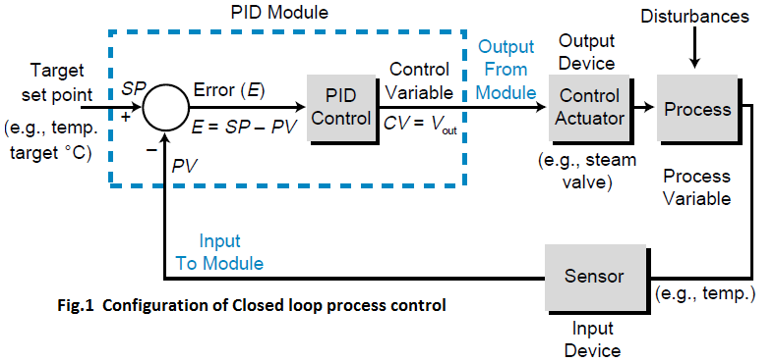
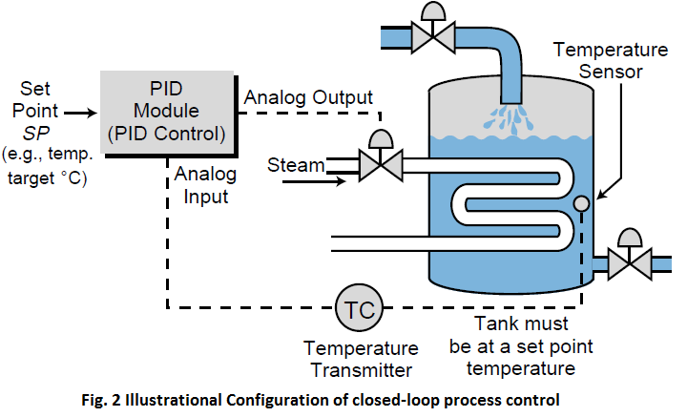
NB: PID control is often referred to as three-mode, closed-loop feedback control. Because the PID module receives the process variable in analog form and computes the error difference between the actual value and the set point value. It then uses this error difference in the algorithm computation to initiate a three step, simultaneous, corrective action through a control variable output. First, the module formulates a proportional control action based on an output control variable that is proportional to the instantaneous error value (KPE). Then, it initiates an integral control action (reset action) to provide additional compensation to the output control variable. This causes a change in the process variable in proportion to the value of the error over a period
of time (KI= KP/TI). Finally, the module initiates a derivative control action (rate action) adding even more compensation to the control output (KD =KPTD). This action causes a change in the output control variable proportional to the rate of change of error. These three steps provide the desired control action in proportional (P), proportional-integral (PI), and proportional-integral derivative (PID) control fashion, respectively. The algorithm used by PID controller to calculate control variable which compensate the error is:
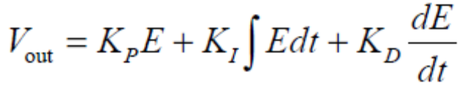
PLC configuration
There are two PLC basic configurations that commercial manufacturers offer.
- Fixed Configuration
- Modular Configuration
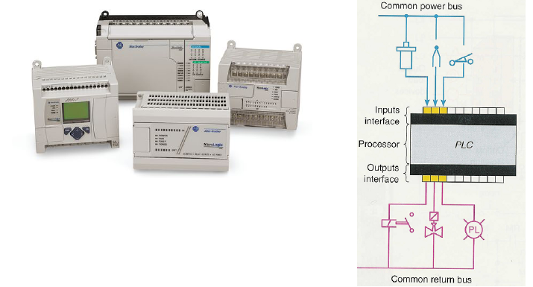
Fig.3. Fixed configuration
Modular configuration
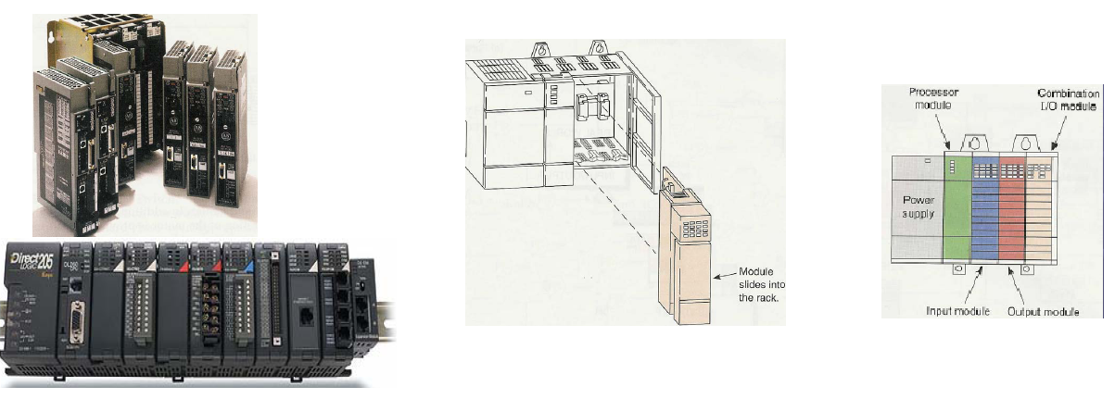
Fig.4 Modular configuration

MEMORY ORGANIZATION AND I/O INTERACTION (I/O addressing)
The memory system, as mentioned before, is composed of two major sections—the system memory and the application memory—which in turn are composed of other areas. Figure 5 illustrates this memory organization, known as a memory map. Although the two main sections, system memory and application memory, are shown next to each other, they are not necessarily adjacent, either physically or by address. The memory map shows not only what is stored in memory, but also where data is stored, according to specific locations called memory addresses. An understanding of the memory map is very useful when creating a PLC control program and defining the data table.
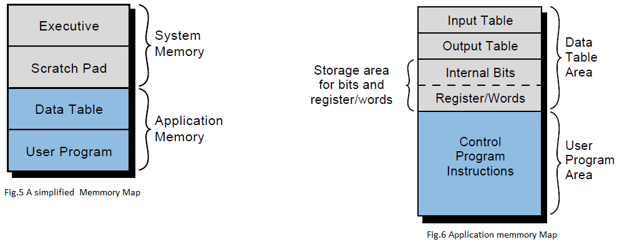
Although two different programmable controllers rarely have identical memory maps, a generalized discussion of memory organization is still valid because all programmable controllers have similar storage requirements. In general, all PLCs must have memory allocated for four basic memory areas, which are as follows:
• Executive Area. The executive is a permanently stored collection of programs that are considered part of the system itself. These supervisory programs direct system activities, such as execution of the control program, communication with peripheral devices, and other system housekeeping activities.
Scratch Pad Area. This is a temporary storage area used by the CPU to store a relatively small amount of data for interim calculations and control. The CPU stores data that is needed quickly in this memory area to avoid the longer access time involved with retrieving data from the main memory.
• Data Table Area. This area stores all data associated with the control program, such as timer/counter preset values and other stored constants and variables used by the control program or CPU. The data table also retains the status information of both the system inputs
(once they have been read) and the system outputs (once they have been set by the control program).
• User Program Area. This area provides storage for programmed instructions entered by the user. The user program area also stores the control program.
The executive and scratch pad areas are hidden from the user and can be considered a single area of memory that, for our purpose, is called system memory. On the other hand, the data table and user program areas are accessible and are required by the user for control applications. They are
called application memory.
APPLICATION MEMORY
The application memory stores programmed instructions and any data the processor will use to perform its control functions. Figure 6 shows a mapping of the typical elements in this area. Each programmable controller has a maximum amount of application memory, which varies depending on the size of the controller. The controller stores all data in the data table section of the application memory, while it stores programmed instructions in the user program section.
Data Table Section. The data table section of a PLC’s application memory is composed of several areas (see Figure 6). They are:
• the input table
• the output table
• the storage area
These areas contain information in binary form representing input/output status (ON or OFF), numbers, and codes. Remember that the memory structure contains cell areas, or bits, where this binary information is stored. Following is an explanation of each of the three data table areas.
Input Table. The input table is an array of bits that stores the status of digital inputs connected to the PLC’s input interface. The maximum number of input table bits is equal to the maximum number of field inputs that can be connected to the PLC. For example, a controller with a maximum of 64 field inputs requires an input table of 64 bits. Thus, each connected input has an analogous bit in the input table, corresponding to the terminal to which the input is connected. The address of the input device is the bit and word location of its corresponding location in the input table. For example, the limit switch connected to the input interface in Figure 7 has an address of 130078 as its corresponding bit in the input table. This address comes from the word location 1308 and the bit number 078, both of which are related to the module’s rack position and the terminal connected to the field device .
If the limit switch is OFF, the corresponding bit (130078) is 0 (see Figure 7a); if the limit switch is ON (see Figure 7b), the corresponding bit is 1.

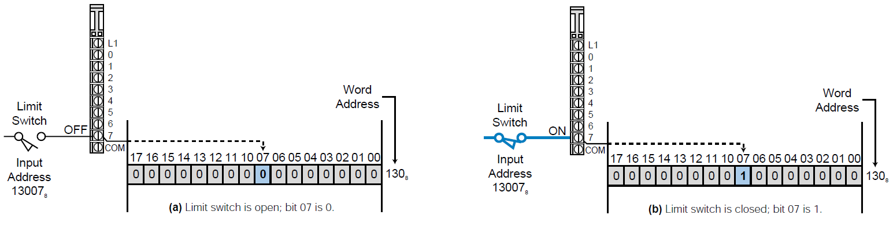
Fig.7 Limit switch connected to a bit in the input table.
Output Table. The output table is an array of bits that controls the status of digital output devices that are connected to the PLC’s output interface. The maximum number of bits available in the output table equals the maximum number of output field devices that can interface with the PLC. For example, a PLC with a maximum of 128 outputs requires an output table of 128 bits.
Like the input table, each connected output has an analogous bit in the output table corresponding to the exact terminal to which the output is connected. The processor controls the bits in the output table as it interprets the control program logic during the program scan, turning the output modules ON and OFF accordingly during the output update scan. If a bit in the table is turned ON (1), then the connected output is switched ON (see Figure 8a); if a bit is cleared, or turned OFF (0), the output is switched OFF (see Figure 8b).
Remember that the turning ON and OFF of field devices via the output module occurs during the update of outputs after the end of the scan.
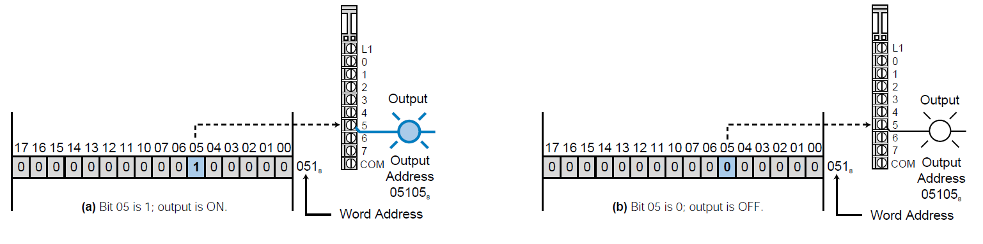
Fig.8 Field output connected to a bit in the output table.
Storage Area. The purpose of the storage area section of the data table is to store changeable data, whether it is one bit or a word (16 bits). The storage area consists of two parts: an internal bit storage area and a register/word storage area (see Figure 9). The internal bit storage area contains storage
bits that are referred to as either internal outputs, internal coils, internal (control) relays, or internals. These internals provide an output, for interlocking purposes, of ladder sequences in the control program. Internal outputs do not directly control output devices because they are stored in addresses that do not map the output table and, therefore, any output devices.
When the processor evaluates the control program and an internal bit is energized (1), its referenced contact (the contact with this bit address) will change state—if it is normally open, it will close; if it is normally closed, it will open. Internal contacts are used in conjunction with either other internals or “real” input contacts to form interlocking sequences that drive an output device or another internal output.
The register/word storage area is used to store groups of bits (bytes and words). This information is stored in binary format and represents quantities or codes. If decimal quantities are stored, the binary pattern of the register represents an equivalent decimal number. If a code is stored, the binary pattern represents a BCD number or an ASCII code character (one character per byte).
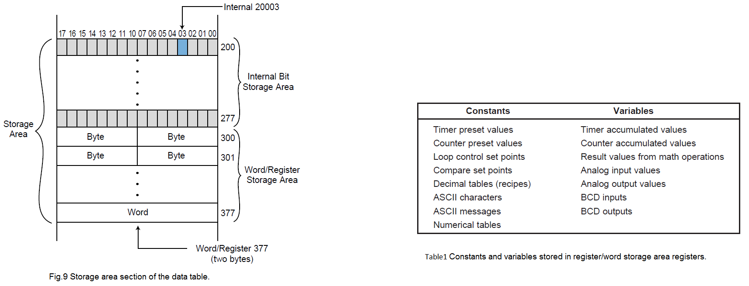
Values placed in the register/word storage area represent input data from a variety of devices, such as thumbwheel switches, analog inputs, and other types of variables. In addition to input values, these registers can contain output values that are destined to go to output interface modules connected to field devices, such as analog meters, seven-segment LED indicators (BCD), control valves, and drive speed controllers. Storage registers are also used to hold fixed constants, such as preset timer/counter values, and changing values, such as arithmetic results and accumulated timer/counter values. Depending on their use, the registers in the register/word storage area may also be referred to as input registers, output registers, or holding registers.
Table 1 shows typical constants and variables stored in these registers.
I/O RACK ENCLOSURES AND TABLE MAPPING
An I/O module is a plug-in–type assembly containing circuitry that communicates between a PLC and field devices. All I/O modules must be placed or inserted into a rack enclosure, usually referred to as a rack, within the PLC (see Figure 10). The rack holds and organizes the programmable controller’s I/O modules, with a module’s rack location defining the I/O address of its connected device. The I/O address is a unique number that identifies the input/ output device during control program setup and execution. Several PLC manufacturers allow the user to select or set the addresses (to be mapped to the I/O table) for each module by setting internal switches.

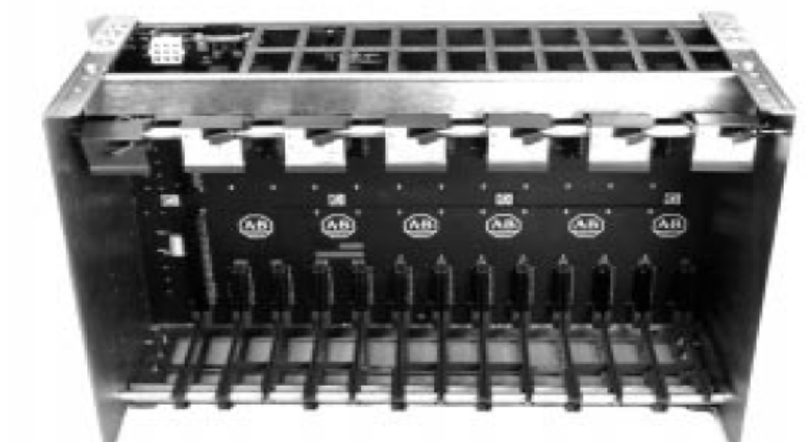
Fig.10 Example of I/O rack enclosure
A rack, in general, recognizes the type of module connected to it (input or output) and the class of interface (discrete, analog, numerical, etc.). This module recognition is decoded on the back plane (i.e., the printed circuit board containing the data bus, power bus, and mating connectors) of the rack. The controller’s rack configuration is an important detail to keep in mind throughout system configuration. Remember that each of the connected I/O devices is referenced in the control program; therefore, a misunderstanding of the I/O location or addresses will create confusion during and after the programming stages.
Generally speaking, there are three categories of rack enclosures:
- master racks
- local racks
- remote racks
The term master rack (see Figure 6-5) refers to the rack enclosure containing the CPU or processor module. This rack may or may not have slots available for the insertion of I/O modules. The larger the programmable controller system, in terms of I/O, the less likely the master rack will have I/O housing capability.
A local rack (see Figure 11) is an enclosure, which is placed in the same area as the master rack, that contains I/O modules. If a master rack contains I/O modules, the master rack can also be considered a local rack. In general, a local rack (if not a master) contains a local I/O processor that sends data to and
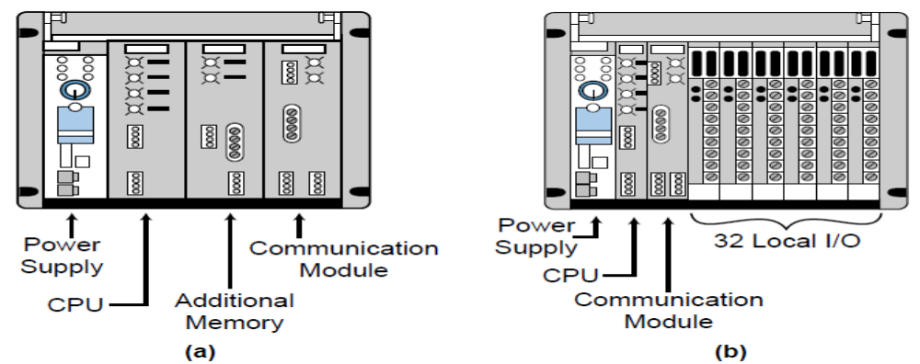
Fig.11 Master racks (a) without I/O modules and (b) with I/O modules
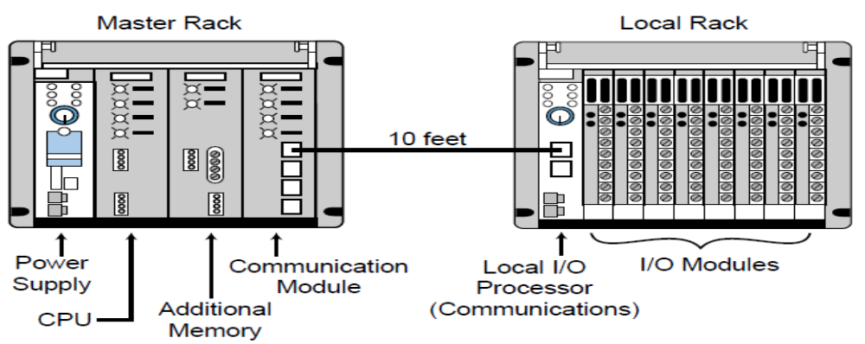
Fig.12 Local rack configuration
from the CPU. This bidirectional information consists of diagnostic data, communication error checks, input status, and output updates. The I/O image table maps the local rack’s I/O addresses.
As the name implies, remote racks (see Figure 13 ) are enclosures, containing
I/O modules, located far away from the CPU. Remote racks contain an I/O processor (referred to as a remote I/O processor) that communicates input and output information and diagnostic status just like a local rack. The I/O addresses in this rack are also mapped to the I/O table.
The rack concept emphasizes the physical location of the enclosure and the type of processor (local, remote, or main CPU) that will be used in each particular rack. Every one of the I/O modules in a rack, whether discrete, analog, or special, has an address by which it is referenced. Therefore, each terminal point connected to a module has a particular address. This connection point, which ties the real field devices to their I/O modules, identifies each I/O device by the module’s address and the terminal point where it is connected. This is the address that identifies the programmed input or output device in the control program.
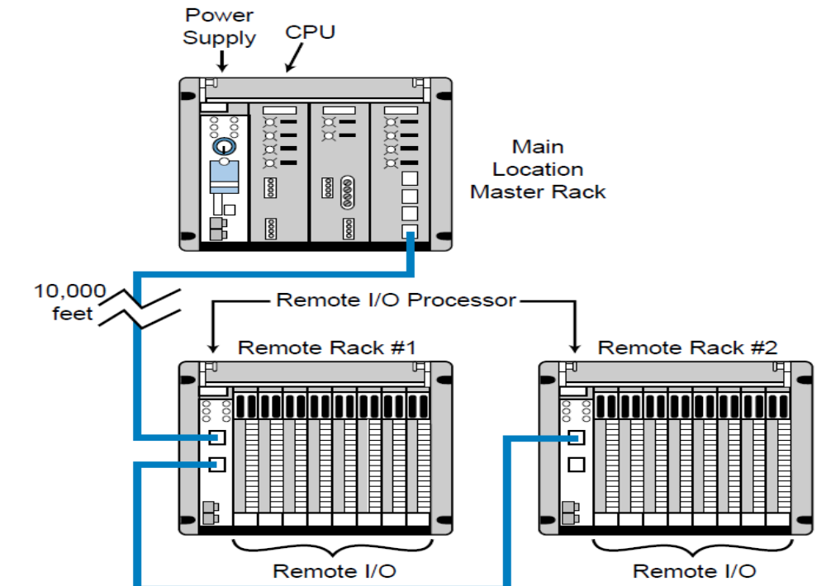
Fig.13 Remote rack configuration.

I/O RACK AND TABLE MAPPING EXAMPLE
PLC manufacturers set specifications for placing I/O modules in rack enclosures.
For example, some modules accommodate 2 to 16 field connections, while other modules require the user to follow certain I/O addressing regulations. It is not our intention in this section to review all of the different manufacturers’ rules, but rather to explain how the I/O typically maps each rack and to illustrate some possible restrictions through a generic example.
As our example, let’s use the PLC I/O placement specifications shown in Table 2. As Figure 14 illustrates, several factors determine the address location of each module. The type of module, input or output, determines the first address location from left to right (0 for outputs, 1 for inputs). The rack number and slot location of the module determine the next two address numbers. The terminal connected to the I/O module (0 through 7) represents the last address digit.
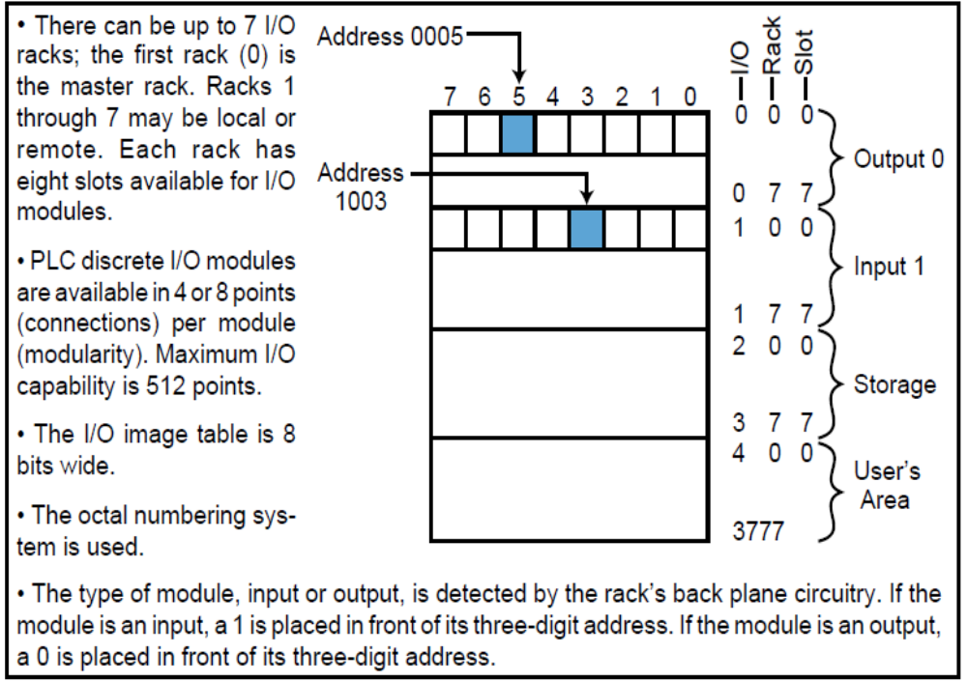
Table 2 Specifications for the I/O rack enclosure example

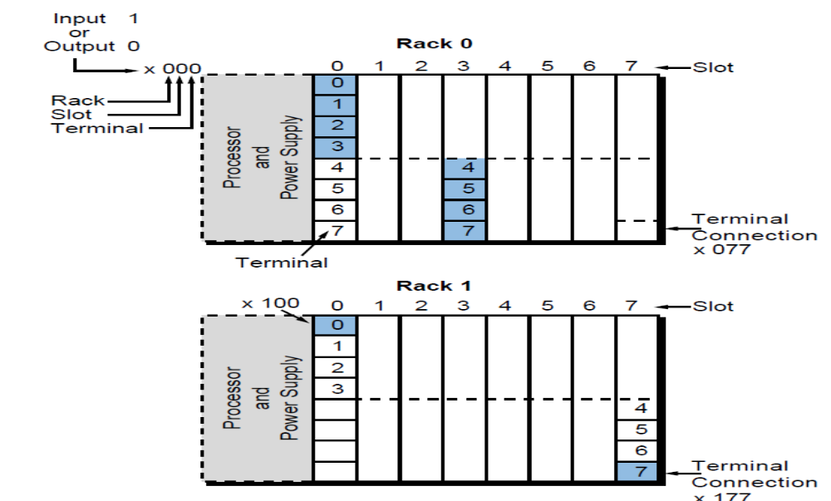
Fig.14. Illustration of the example I/O rack enclosure (x = 1 for inputs, 0 for outputs).
For instance, (see Figure 15), if a 4-point output module (see Figure 15b) is placed in rack 0, slot 0 (terminal addresses 0–3), the output table word 0008, bits 0–3, represented by the shaded area in Figure 15c, will be mapped for outputs. Consequently, the input table image corresponding to the slot location 1008, bits 0–3 (represented by the word taken) will not have a mapped reference input, since it has already been taken by outputs. If an 8-point input module is used in rack 0, slot 2 (see Figure 15a), indicating word location 1028 (input = 1), the whole eight bits of that location in the input table (location 1028 bits 0–7) would be taken by the mapping; the corresponding address in the output table (word location 0028, bits 0–7 in Figure 6-9c) would not be able to be mapped. The bits from the output table that do not have a mapping due to the use of input modules could be used as internal outputs, since they cannot be physically connected output field devices (e.g., bits 4–7 of word 000). For example, in Figure 15c, output addresses 0004 through 0007 (corresponding to word 000, bits 4–7 in the I/O table) cannot be physically connected to an output module because their map locations are taken by an input module (at word 100, bits 4–7). Therefore, these reference addresses can only be used as internal coil outputs. The use of these output bits as internal outputs is shown in Figure 16, where output 0004 (now used as an internal coil) will be turned ON if its logic is TRUE and contacts from this output can be used in other output rungs.
Fig.15 Diagrams of (a) an I/O table, (b) two 4-point I/O modu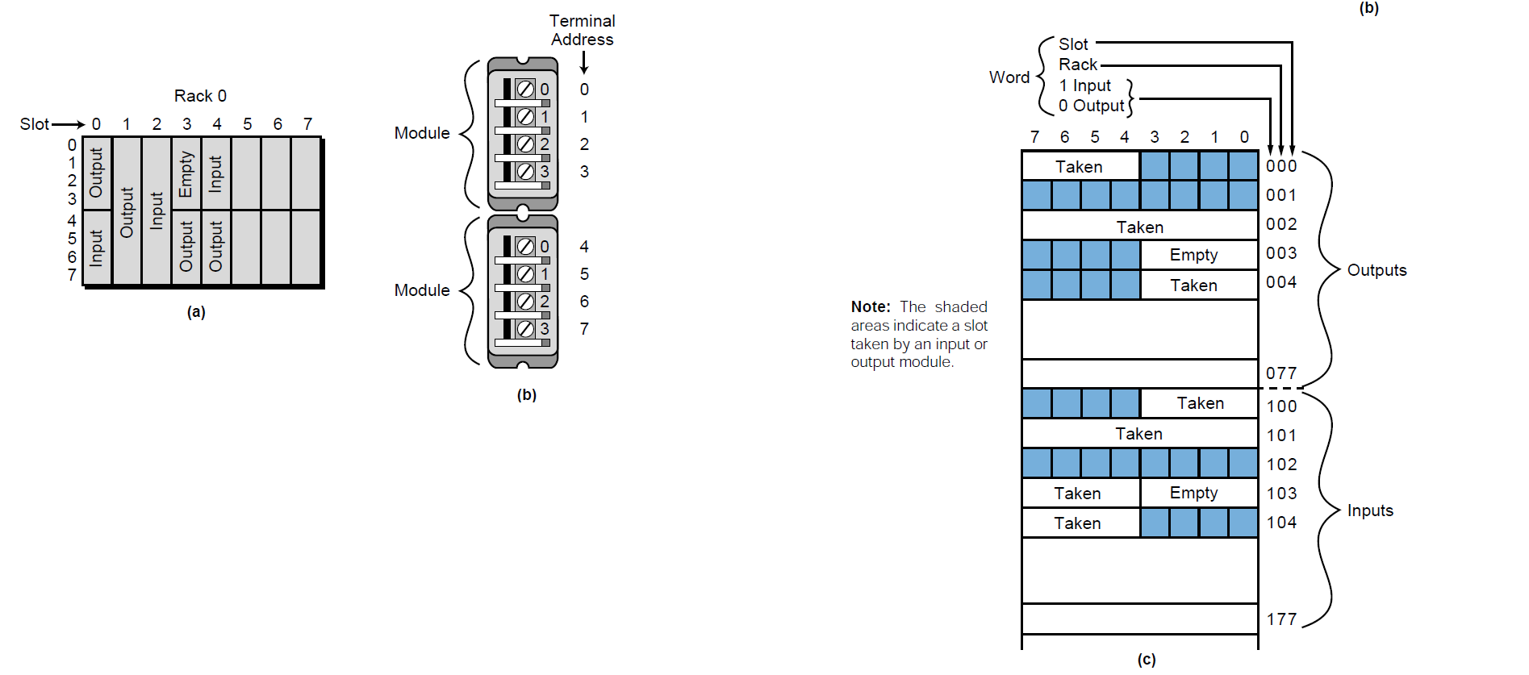les in one slot, and (c) an I/O table mapping.
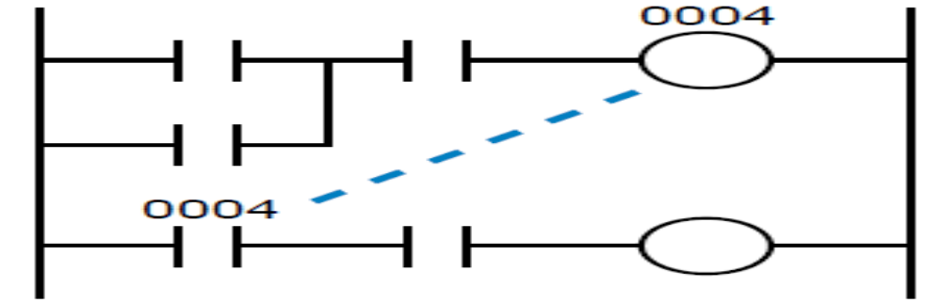
Fig. 16 output 0004 used as internal coil

3.3. Testing the configured and adjusted mechatronics devices
- Initial Testing
The software is now configured sufficiently for you to do some simple tests with the hardware. If it is convenient to connect the inputs from the manual switches such as Home, then do so now.
Run Mach3Mill and display the Diagnostics screen. This has a bank of LEDs displaying the logic level of the inputs and outputs. Ensure that the external Emergency Stop signal is not active (Red Emergency LED not flashing), and click the red Reset button on the screen. Its LED should stop flashing. If you have associated any outputs with coolant or spindle rotation, then you can use the relevant buttons on the Diagnostics screen to turn the outputs on and off. The machine should also respond, or you can monitor the voltages of the signals with a multimeter. Next, operate the home or the limit switches. You should see the appropriate LEDs glow yellow when their signal is active. These tests will let you see that your parallel port is correctly addressed and the inputs and outputs are appropriately connected. If you have two ports and all the test signals are on one, then you might consider a temporary switch off your configuration. Connect one of the homes or limit switches through the other port so that you can check its correct operation. Don't forget the Apply button when doing this sort of testing. If all is well, then you can restore the proper configuration. If you discover problems, sort them out now. It will be much easier than when you start trying to drive the axes. If you do not have a multi meter, then you will have to buy or borrow a logic probe or a D25 adaptor (with actual LEDs) to monitor the state of the parallel port pins. In brief, you need to determine if (a) the signals in and out of the computer are incorrect (i.e. Mach3 is not doing what you want or expect) or (b) the signals are not getting between the D25 connector and your machine tool (i.e. a wiring or configuration problem with the breakout board or machine).
Fifteen minutes help from a friend can work wonders in this situation, even if you only carefully explain to him/her what your problem is and how you have already looked for it.
It is amazing how often this sort of explanation suddenly stops with words like “… Oh! I see what the problem must be, it's ...”

Typical Action Items List
Item  Number | System/  Process/  Equipment | Issue/Action  Item Required | Responsible  Party | Priority | Status | Completion  Date | Comments
2.

- Planning an EPM Program
- Gather Support / Funding / Commitment from Management
- Survey All Systems / Equipment
- Perform Failure Mode Effects Analysis (FMEA) Safety of Personnel / Technicians
- Uniqueness of System / Equipment
- Impacts to Production / Service To Customers System / Equipment Redundancy (N+1)
- Determine Maintenance Intervals Based On The Following
  - Importance / Critical Nature of Equipment
  - Requirements of Manufacturer
  - Age of Equipment
  - Number of Operations / Duty Cycle
  - Demand / Load Conditions
  - Environment

Self-Check -3
Directions: Answer all the questions listed below. Use the Answer sheet provided in the next page:
Part I: Write the correct Answer for the following question (2 point each)
      - write way of determining Maintenance Intervals of mechatronics system.
      - How apply Initial Testing
      - How to Gather Support / Funding / Commitment from Management to test mechatronics device
Directions: Answer all the questions listed below. Use the Answer sheet provided in the next page:
Part II: Write the correct Answer for the following question blank space (2 piont each)
- ______________ is the process of setting up your hardware devices and assigning resources to them so that they work together without problems.
- _____________ is the process of setting up your hardware devices and assigning resources to them so that they work together without problems.
- What is configuration of mechatronics?

