Industrial lectrical/Electronic Control Technology
Level-IV
Based on October, 2023 Curriculum Version 2

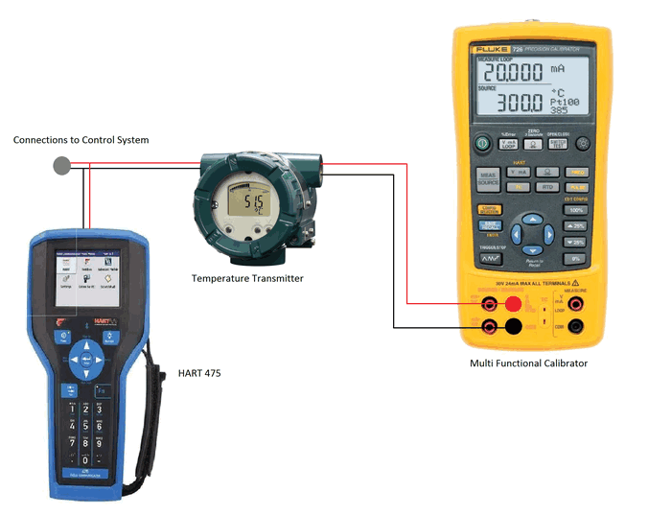
MODULE TITLE: Calibrating and repairing Measuring and analysis system
MODULE CODE EIS IEC4 M04 1023
NOMINAL DURATION: 45 Hours

Prepared by: Ministry of Labor and Skill

October, 2023
Addis Ababa, Ethiopia

Table of contents

Acknowledgment

Ministry of Labor and Skills wish to extend thanks and appreciation to the many representatives of TVT instructors and respective industry experts who donated their time and expertise to the development of this Teaching, Training and Learning Materials (TTLM).

Acronym
OSH---------- Occupational safety and health
OHSR--------- Occupational Health and Safety Regulation
PFD ------------Process Flow Diagrams
PFD-------------Process flow diagram
ISA------------- Instrument Calibration Series
SNIR ------------signal-to-noise interference ratio

Introduction to the Module
Calibrating and repairing Measuring and analysis system , calibration process begins with the design of the measuring instrument that needs to be calibrated. The design has to be able to "hold a calibration" through its calibration interval. In other words, the design has to be capable of measurements that are "within engineering tolerance" when used within the stated environmental conditions over some reasonable period of time.
This module covers the units:
- Prepare to calibrate and test/repair measuring and analysis system
- Prepare to calibrate and test/repair measuring and analysis system
- Repair and test analysis system
- Complete report of calibration, test and repair activities
Learning Objective of the Module
- Prepare to calibrate and test/repair measuring and analysis system
- Prepare to calibrate and test/repair measuring and analysis system
- Repair and test analysis system
- Complete report of calibration, test and repair activities
Module Instruction
For effective use this modules trainees are expected to follow the following module instruction:
- Read the information written in each unit
- Accomplish the Self-checks at the end of each unit
- Perform Operation Sheets which were provided at the end of units
- Do the “LAP test” giver at the end of each unit and
- Read the identified reference book for Examples and exercise

Unit One:- Calibrate and test/repair measuring and analysis system
This unit is developed to provide you the necessary information regarding the following content coverage and topics.
- OH& S procedures and risk control measures
- Measuring Instruments for Calibration
- Check Tools, Equipment and Materials
- Calibrate Measuring Instruments.
- Process specification and equipment manuals.
- Instrument/system parameters
This unit will also assist to attain the learning outcomes stated in the cover page .Specifically ,upon completion of this learning guide, you will be able to:-
- Identify OH& S procedures
- Follow and Established OH& S risk control measures
- Identify Safety hazard and control measure
- Identify Measuring instruments to be calibrated ,test/repair and gas/fluid analysis
- Check Measuring instruments and analysis system for calibration, test and repair.
- Determine Instrument/system parameters

  - OH& S procedures and risk control measures
As a consequence of health and safety awareness many measures are being taken to
ensure the security of an individual working in the industrial premises. Risk
assessment follows an extensive hazard analysis. Risk is defined as a likelihood of an
undesired event (accident injury or death) occurring within a specified period or
under specified circumstances. This may be either a frequency or a probability
depending on the circumstances.In the working atmosphere, it is not possible to avoid or eliminate risk factor completely. However it is possible to minimize the risk factor to minimal or acceptable level.
The study of risk involves following steps
1. Risk analysis
2. Risk evaluation
3. Risk control.
1. Risk Analysis:
Risk analysis follows as extensive hazard analysis. It involves the identification and
assessment of potential impact. This requires a thorough knowledge of failure
probability, credible accident scenario, vulnerability of population, etc. Much of this
information is difficult to get or generate. Consequently the risk analysis is often
confined to maximum credible accident studies. The hazard has been higher for workers directly exposed to coal handling areas where not only the danger due to failure of machinery but also inhalation of dust exists. Chemical Potential fire Hazard Consumption
1 Chlorine Reactive corrosive toxic and explosive on heating container For water treatment
2 HS D Inflammable For DG set
3 Coal Inflammable For furnace/steel
melting shop
2. Risk evaluation:
All systems natural or manmade are subject to failure. The nature of failure varies
widely as do the causes of failure and the events leading to failure. The failure of
systems could be due to:
• Misconception of systems required capability or environment.
• Design deficiencies and erroneous assumption.
• Errors in operational process
• Improper management of the systems.
• Risk evaluation to determine the acceptable level and reduce the risk level.
The nature of failure varies widely as do the causes of failure and the events leading to failures. The failure of system could be due to:
• Misconception of system requirement, capability or environment;
• Design deficiencies and erroneous assumption;
• Faulty construction, manufacture, erection and installation;
• Errors in operational processes, and
• Improper management of the system.
Attempts have been made to reduce failures of man- made systems with the
introduction of safety measures, quality control, reliability analysis, condition
monitoring and other approaches in design in order to reduce the probability of
failure. Use of measures such as factor of safety are usually resorted to in order to
improve the reliability of design and where health of the person is at great risk. Such
factor has to be very high reducing probabilities of accidents/ disaster to a very low
level.
3. Risk Control:
On Site Emergency Planning: he onsite emergency plan would be related to the final assessment and it is the responsibility of the workers management to formulate it. The plan must there fore, be specific to the site.
The plan sets out way in which designated people at the site of the incident initiate
supplementary action either inside or outside the workers at an appropriate time. An
essential of the plan is the provision for making the affected unit safe, for example,
by shutting it down. The plan also contains the full sequence of key personal to be
called in from other sections or from off site.
Off Site Emergency Plan:The offsite emergency plan is an integral part of any major hazard control systems.It was based on those accidents identified by the works management, which could affect people and the environment outside the works. Thus, the offsite plan follows logically from the analysis that took place to provide the basis for the onsite plan and the two plans was therefore complement each other. The key feature of a good offsite emergency plan is flexibility in its application to emergencies other than those specifically included in the for mation of the plan The role of the various parties that may be involved in the implementation of an offsite plan are described below. The
responsibility for the off site plan has been likely to rest either with the works
management or with the local authority.
Aspects to be included in an offsite emergency plan, some of the aspects to be
included in offsite emergency plan are as follows.
Emergency Control Centers :The emergency control center is the place from which the operations to handle the emergency will be directed and coordinated. It has been attended by the site work main controller, key personnel and the senior officers of the fire and police services. Emergency control centers had therefore contained the following:
1. An adequate number of external telephones.
2. An adequate number of internal telephones
3. A plan of the workers to show
4. Areas where there are inventories of HSD and chlorine
5. Sources of safety equipment
6. Assembly point
7. Truck parking information
8. A nominal roll of employee
9. List of personnel with addresses telephone numbers
10. Specialized monitoring equipment will be available at all the sensitive points to
deal with small to medium spillages of the chemical.
11. The equipment operators must be trained in development of the equipment.
General Safety Rules:At the existing plant where fuels chemicals and other materials are reactive in nature following general guidelines are made.
1. Fitting dress and use of personnel protective equipment recommended for
respective job has been adhered to by everyone.
2. All unsafe conditions or natural occurrences have been reported promptly to the
supervisor/ head of the department of safety.
Personal Protective Equipment: Personnel protective equipment play vital role in reducing the losses in case of an accident. They provide protection to the workmen from injuries during the execution of job. The various protective equipments are suggested as below. Gloves and protective clothing: Since the chemicals are very corrosive and toxic,
those called upon to handle has been provided with gloves and protective clothing.
Safety He lmets: Every one inside the plant and the visitors has to wear safety
shoes for protecting their toes and heels. The material of the shoes has required
being resistant to the type of chemicals available within the plant .Safety Belts: Safety belts provide protection in case of fall while working at height .Safety goggles and face shie lds : Suitable goggles protect the eyes from flying objects and harmful rays of welding and furnace flames and also heat, dust and chemicals substances. Standard welders goggles, face shield or hood has been used
  - Measuring Instruments for Calibration
Calibration is a comparison of two instruments against each other, one being the standard (the calibrator). This process is essential to document the error of the instrument being calibrated and to increase its accuracy All instruments have errors and decreasing accuracies after a certain amount of time.
Reason of Calibrate your Instruments
The biggest reason behind performing periodic calibration of instruments is to test and ensure that they make correct and accurate measurements .Regular calibration establishes efficient instrument performance, safety during operations, long term sustainability, and high instrument quality
- Timely action against drift
All electric and electronic instruments drift over time with continuous usage. Environmental conditions such as extreme temperature fluctuations, changing weather, excess or lack of humidity can affect an instrument’s drift too. In most instruments, greater usage means greater drift.In instruments requiring extreme accuracy and precision, drift can be highly critical. Drift beyond the specified tolerance also poses a safety hazard. To avoid these inaccuracies, it is important to perform periodic instrument calibration.
Calibration helps identify the amount of drift, which helps analyze instrument stability and measurement consistency.

Early detection of defects & damage
Apart from drift, instruments are also prone to damage and defects due to loose connections or faulty components. This damage can be detected at an earlier stage with the help of calibration, and a total breakdown of the instrument can be safely prevented.Once the defects are identified, the error propagation can be minimized, reducing costs and resources of handling serious damages.

Proactive Safety
In industries such as oil and gas, petrochemical, chemical, energy, power, electric, and electronic, there is a high risk of explosions, fires, and leakages. The measurement equipment used in these industries must be calibrated regularly and properly to avoid safety hazards and ensure employee safety and infrastructure safety.In other industries such as pharmaceutical, food, and beverage, the calibration of instruments is necessary for consumer/customer safety.

Reputation of Quality
Calibration is also important for social corporate responsibility, environmental and financial reasons. Most companies and their customers have a quality system that needs to be adhered to. Governments and regulatory bodies also lay down conditions that need to be met to certify the company’s quality system, such as emission monitoring and equipment testing. Measurement instruments used for these purposes should be highly accurate which is why they need to be calibrated from time to time using calibration techniques and equipment accredited to relevant ISO standards.
Labs and test equipment companies that adhere to updated standards like ISO/IEC17025:2017 establish their competence in quality management, improved lab testing environments, better customer satisfaction, an international reputation, & systematic processes.

Risks of not Calibrating Instruments
While calibration may seem like an additional cost, it must not be neglected. Calibration has long-term benefits. Not calibrating your instruments regularly can lead to undesirable results, including:
- False passes or failures
- The manufacturing industry often faces the issue of false passes or false failures. False passes may result in inferior and low-quality products being manufactured and sold, reducing the credibility of the production factory.
- False failures unnecessarily increase the manufacturing or reworking costs and may end up discarding high quality and fully functioning products.

Inaccuracies or errors in measurement
A lot of electric and electronic industries and laboratories require high precision measurements with very small acceptable errors.
Not calibrating your measurement instruments can leave these errors unnoticed and unattended, and can distort your final measurements and give highly inaccurate results.
Errors in measurements can deviate the final output from the globally agreed standards. This means the entire process of testing and measurement will need to be repeated with new or repaired measurement instruments, making the process both time-consuming and expensive.

Penalties
Regulatory bodies and agencies establish certain standards, guidelines, and regulations for instrument calibration. Not complying with these regulations can result in fines or penalties, seizure of the company’s license, and shutting down the business or plant.

Safety Hazards
- Failure to calibrate or incorrect calibration of instruments can pose significant risks to both the employees and the plant.
- Unidentified product failure can be a threat to consumer safety and can result in loss of credibility and reputation, increased manufacturing costs, and economic losses.

Benefits of Calibration
Some of the benefits of calibration are:
- Long term cost-effectiveness, high return on investment
- High instrument accuracy and precision
- Reduction of costly errors
- Longer instrument life
- Compliance with regulatory standards and certification of equipment
- Elimination of safety risks
- Less downtime for repair and maintenance of equipment
- High customer satisfaction

Types of Instrument Calibration Some of the common types of

Humidity and Temperature Calibration
It is used for businesses that use thermal cameras, thermometers, humidity generators, weather stations, and other instruments with their primary input as temperature and humidity. This type of calibration is carried out in closed environments to eliminate disturbances from the surroundings and atmosphere.

Pressure Calibration
It is used for instruments such as transmitters, test gauges, and barometers. In pressure calibration, the spectrum of hydraulic and gas pressure is measured.

Mechanical Calibration
It is used for equipment such as torque wrenches, micrometers, scales, and balances. Mechanical calibration calibrates for factors like force, mass, vibration, or torque to ensure instrument accuracy.

Electrical Calibration
It is used for testing instruments such as clamp meters, data loggers, and insulation testers. Equipment that measures frequency, voltage, or resistance should undergo electrical calibration.

Instrument Calibration period
While there is no specific single to call attention to this need, there are some ways to determine how often you should calibrate your instruments. The simplest thing to do is to follow the equipment manufacturer’s recommendation. Manufacturers often provide specifications about a device’s calibration and calibration period.
Another important factor to consider is the measurement location criticality and accuracy requirements. Some measurements require greater accuracy compared to others. The more critical locations should be calibrated frequently, while the less critical locations can be calibrated in longer intervals.
If an instrument is used often and is subjected to high workload and extreme or harsh operating conditions, it is good practice to calibrate often. The stability history of an instrument should also be factored in. If the instrument has a demonstrated history of being stable, it can be calibrated less frequently. On the other hand, if it has been shown to drift quickly, it should be calibrated more often.
  - Tools, Equipment and Materials for calibration
Instrument calibration is an essential process in determining your equipment’s accuracy and making any necessary adjustments to get a more precise result from them. Over time, your equipment can begin providing less accurate readings due to mechanical shocks, exposure to extreme pressure and/or temperatures, and other harsh operating conditions.
You should get your instruments professionally calibrated on a regular basis as inaccurate readings may not fully represent the dangers of unsafe working environments. The recommended frequency of calibration may vary, depending on manufacturer recommendations, however generally for most items no longer than 12 months is recommended. Some extremely stable items with limited parts and movement, no dissimilar metals and other factors that reduce the likelihood of drift, and are continuously stored in a controlled environment; calibration intervals over 12 months may be considered.
- Electrical calibration
Electrical calibration checks the accuracy of an electrical instrument’s full array of functions and the full range within each function. Only competent professionals should carry out this task. Electrical equipment requiring calibration includes:
- Insulation testers
- Clamp meters
- Counter timers
- Multimeters
- Multifunction Testers
- Oscilloscopes
- Data loggers
- Loop testers
- Residual-current devices

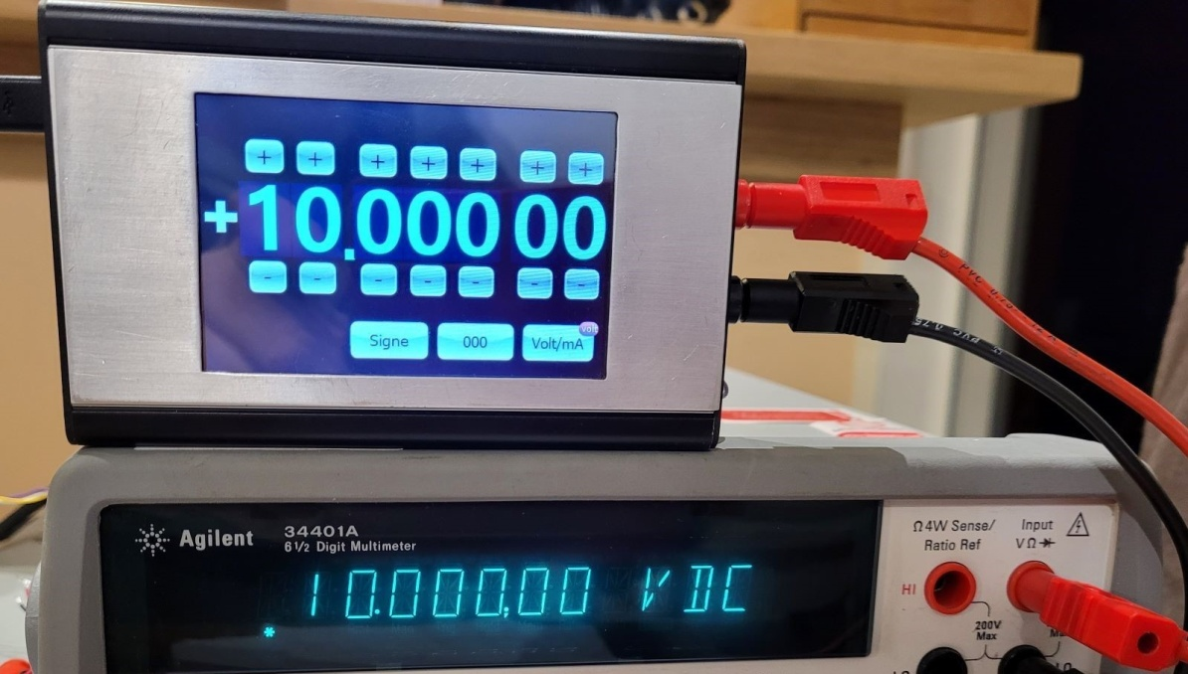
Fig 1.1 voltage and current calibration
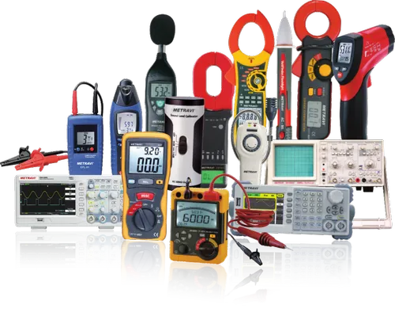
Fig 1.2 Instrument calibration

- Pressure calibration
Calibration professionals work with pneumatic and hydraulic pressure across a range of sectors with various types of pressure gauges, transducers, balances and other devices.
Frequently calibrated pressure instruments include:
- Barometers
- Analogue and digital pressure gauges
- Test Gauges
- Digital Indicators
- Pressure Transmitters
- Pressure Calibrators
- Pressure Transducers

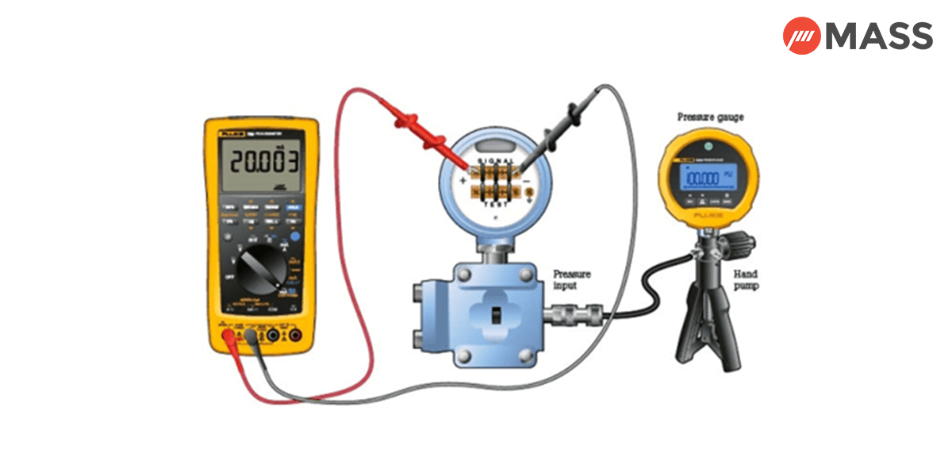
Fig1.3 Calibrate pressure Transmitter

- Temperature calibration
All processes where temperature readings play a critical role require temperature calibration. The calibration tech performs this in a controlled environment with state-of-the-art and highly precise equipment. Examples of equipment that requires periodic calibration include:
- Furnaces and chambers
- Data acquisition systems
- Weather stations
- Thermal cameras
- Thermometers and thermocouples
- Dial thermometers
- Thermistors and platinum resistance thermometer
- Infrared meters
Fig 1.4 Temperature Calibration
- Mechanical calibration
This process involves calibrating a number of elements such as force, mass, volumetric dimension, angle, flatness, torque and vibration in a temperature-controlled facility. Some of the most frequently tested instruments for mechanical calibration include:
- Torque tools (screwdrivers and wrenches)
- Load cells and force gauges
- Micrometers
- Height gauges
- Vernier calipers
- Balances and scales
- Weight and mass sets

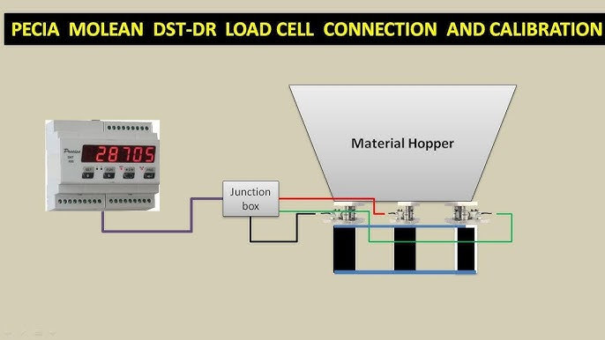

Fig 1.5 Calibrate weight Indicator
  - Calibrate Measuring Instruments.
proper instrument calibration is an essential component in good measurement practice and this chapter has been dedicated to explaining the various procedures that must be followed in order to perform calibration tasks efficiently and effectively. We have learned how working instruments are calibrated against a more accurate “reference” instrument that is carefully maintained and kept just for performing calibration tasks. We considered the importance of carefully designing and controlling the calibration environment in which calibration tasks are performed, and observed that proper training of all personnel involved in carrying out calibration tasks had similar importance. We also learned that the “first-stage” calibration of a working instrument against a reference standard is part of a chain of calibrations that provides traceability of the working instrument calibration to national and international reference standards for the quantity being measured, the latter representing the most accurate standards of measurement accuracy that are achievable. Finally, we looked at the importance of maintaining calibration records and suggested appropriate formats for these

Calibration concepts
The Instrument Calibration Series (ISA) defines calibration as “determination of the experimental relationship between the quantity being measured and the output of the device which measures it; where the quantity measured is obtained through a recognized standard of measurement.” There are two fundamental operations involved in calibrating an instrument: Testing the instrument to determine its performance.Adjusting the instrument to perform within specification.
Testing the instrument requires collecting sufficient data to calculate the instrument’s operating errors. This is typically accomplished by performing a multiple point test procedure that includes the following steps:
Using a process variable simulator that matches the input type of the instrument, set a known input to the instrument Using an accurate calibrator, read the actual (or reference) value of this input.
Read the instrument’s interpretation of the value by using an accurate calibrator to measure the instrument output.
This process is repeated for a series of different input values and sufficient data is collected to determine the instrument’s accuracy. Depending upon the intended calibration goals and the desired error calculations, the test procedure may require from 5 to 21 input points.
The first test that is conducted on an instrument before any adjustments are made is called the As-Found test. If the accuracy calculations from the As-Found data are not within the specifications for the instrument, then it must be adjusted.
Adjustment refers to the process of manipulating some part of the instrument resulting in its input to output relationship within specification. For conventional instruments, this may be zero and span screws. For HART instruments, this normally requires the use of a communicator to convey specific information to the instrument. The terms “calibrate” and “adjust” are therefore often used synonymously. After adjusting the instrument, a second multiple point test is required to characterize the instrument and verify that it is within specification over the defined operating range. This is called the As-Left test.
It is absolutely essential that the accuracy of the calibration equipment be matched to the instrument being calibrated. Earlier on, a safe rule of thumb stated that the calibrator should be an order of magnitude (10 times) more accurate than the instrument being calibrated. As the accuracy of field instruments increased, the recommendation dropped to a ratio of 4 to 1. Many commonly used calibrators today do not even meet this ratio when compared to the rated accuracy of HART instruments.

Calibration loop errors
The task of the calibration system is to estimate the static and slowly varying amplitude, phase and delay differences among the feed elements (caused by propagation impairments and changes induced by satellite and ground equipment) and to apply the appropriate correction to reduce these errors.
The calibration methods may be categorized and compared with respect to the following main characteristics .Operational representativeness of the calibration method (i.e., calibration under operational loading condition in terms of temperature, power supply loading, leakages, etc.) need for a dedicated calibration mode and capability to detect failures of payload modules
- Performance achieved for the parameters calibrated:
  - Accuracy;
  - Calibration time;
  - Number of measurements;
  - SNIR (signal-to-noise interference ratio) required versus accuracy;
  - Bandwidth calibrated
  - Use of near field probes for signal injection/extraction
Implementation aspects, such as implementation complexity, analysis of the impact of extra hardware (HW), analysis of full implementation on-board or based also on on-ground loop, scalability, heritage (HW and software (SW)), robustness, obtrusiveness, cost.
  - Process specification and equipment manual for electrical calibration
Calibrating electrical instruments is an essential process to ensure accurate and reliable measurements. Here's a general process specification for calibrating electrical instruments:
1. Identify the Instrument: Determine the type of electrical instrument you need to calibrate, such as a multimeter, oscilloscope, power analyzer, or any other specific instrument.
2. Establish Calibration Standards: Obtain a set of calibration standards that are traceable to national or international standards. These standards should have a known and documented accuracy that is higher than the instrument being calibrated.
3. Prepare the Calibration Environment: Create a controlled environment suitable for calibration. Ensure the ambient conditions, such as temperature, humidity, and electromagnetic interference, are within acceptable ranges and do not affect the calibration process.
4. Pre-Calibration Checks: Conduct a visual inspection of the instrument for any physical damage or signs of wear. Verify that all cables, connectors, and probes are in good condition. Check the instrument's power supply and ensure it is functioning correctly.
5. Perform Zero Adjustment: If applicable, perform a zero adjustment or null balance adjustment to eliminate any inherent offset or bias in the instrument's measurement circuitry. Follow the manufacturer's instructions for performing this adjustment.
6. Connect Calibration Standards: Connect the calibration standards to the instrument being calibrated. Use appropriate cables, adapters, or connectors as required. Ensure proper electrical connections and secure them tightly.
7. Execute Calibration Procedure: Follow the calibration procedure specified by the instrument manufacturer or a recognized calibration standard organization. This procedure typically involves taking a series of measurements at various points across the instrument's measurement range.
8. Record Measurement Data: Record the measurement data obtained during the calibration process. Include the instrument's readings, the corresponding calibration standard values, and any necessary correction factors or uncertainties.
9. Evaluate Calibration Results: Compare the instrument's measured values with the known values of the calibration standards. Calculate the calibration error or deviation and determine if it falls within the acceptable tolerance limits defined by the instrument's specifications or regulatory requirements.
10. Adjust Instrument if Necessary: If the instrument's calibration error exceeds the acceptable limits, make the necessary adjustments as specified by the manufacturer. This may involve adjusting internal calibration controls, replacing components, or performing software calibrations.
11. Finalize Calibration Documentation: Prepare a calibration certificate or report that includes all relevant information, such as the instrument's identification, calibration standards used, measurement data, calibration results, and any adjustments made. Sign and date the certificate, and include the details of the personnel who performed the calibration.
12. Post-Calibration Checks: After calibration, conduct additional checks to ensure the instrument is functioning correctly. Verify its performance using known reference standards or by comparing it with other calibrated instruments.
13. Calibration Interval and Maintenance: Determine the calibration interval based on the instrument's specifications, industry standards, and regulatory requirements. Establish a regular maintenance schedule to keep the instrument in optimal condition between calibrations.
Remember that this process specification provides a general guideline. The specific calibration requirements may vary depending on the type of instrument, industry standards, and regulatory guidelines applicable to your organization. Always refer to the instrument manufacturer's documentation and any relevant standards for detailed calibration procedures
  - Instrument/system parameters
A measuring instrument parameter refers to a characteristic or property that is associated with a measuring instrument or device. These parameters define the instrument's capabilities and performance in accurately measuring a particular quantity or characteristic of interest. Here are some common parameters associated with measuring instruments:
1. Accuracy: Accuracy refers to how closely the measured value corresponds to the true value of the quantity being measured. It is usually expressed as a percentage or as an error value.
2. Precision: Precision refers to the level of repeatability or consistency in the measurements obtained from the instrument. It indicates the instrument's ability to provide consistent and reproducible results.
3. Resolution: Resolution refers to the smallest increment or division that can be detected or displayed by the instrument. It represents the instrument's ability to distinguish between closely spaced values.
4. Range: The range of a measuring instrument specifies the minimum and maximum values that can be measured accurately. It defines the span within which the instrument can provide reliable measurements.
5. Sensitivity: Sensitivity refers to the instrument's responsiveness to changes in the measured quantity. It indicates how much the output of the instrument changes in response to a given change in the input.
6. Linearity: Linearity describes the relationship between the input and output of a measuring instrument. A linear instrument produces an output that is directly proportional to the input, whereas a non-linear instrument may exhibit deviations from linearity.
7. Stability: Stability refers to the instrument's ability to maintain its performance characteristics over time. It indicates the instrument's resistance to drift or changes in its calibration.
8. Response Time: The response time is the time taken by an instrument to reach and settle at the final value after a change in the measured quantity. It represents the instrument's speed of response.
9. Environmental Conditions: Measuring instruments often have specific requirements regarding operating conditions such as temperature, humidity, and pressure. These conditions can affect the instrument's performance and should be considered when using the instrument.
10. Calibration: Calibration is the process of verifying and adjusting the measuring instrument to ensure its accuracy and reliability. Calibration is typically performed periodically to maintain the instrument's performance within acceptable limits.
These parameters are crucial in evaluating and selecting the appropriate measuring instrument for a particular application, as they determine the instrument's suitability for accurate and reliable measurements.

Self Check -1
  - Say True or False
1.One of the method of minimizing a risk is follow OHS procedure
2. PPE is used to protect to the workmen from injuries during the execution of job
3. one of the advantage instrument being calibrated is to decrease its accuracy
4. The biggest reason behind performing periodic calibration of instruments is to test and ensure that they make correct and accurate measurements
5. Temperature calibration calibrates for factors like force, mass, vibration, or torque to ensure instrument accuracy

  - Choose the best answer
1. The _________confined to maximum credible accident studies.
A. Risk analysis B. Risk evaluation C. Risk control D. none of the above
2.Which one of the following is true for emergency control center
A.An adequate number of external telephones.
B. An adequate number of internal telephones
C. Sources of safety equipment D .All

3 .From the following which one is false Benefits of Calibration
A. Long term cost-effectiveness, high return on investment
B. High instrument accuracy and precision
C. Increase of costly errors D. Longer instrument life
4. From the following which one is true Electrical equipment requiring calibration inclu:
A. Insulation testers B. Clamp meters C. Counter timers
D. Oscilloscopes E. All
5.which one do not include Mechanical calibration
A. Torque tools (screwdrivers and wrenches) B. Load cells and force gauges
C. Micrometers D. Thermometers and thermocouples

Unit Two:- Calibrate measuring instrument/system
This unit is developed to provide you the necessary information regarding the following content coverage and topics
- Set up Calibration of measuring instruments
- Factors affecting instrument error
- Instrument set-point Establishment
- Measuring system adjustment
This unit is developed to provide you the necessary information regarding the following content coverage and topics
- Calibration of measuring instruments/system and set up
- Determine factors effecting instrument error
- Establish Instrument set-point and error adjustments
- Test and adjust Measuring system
- Unexpected situations are dealt with safely and with the approval of an authorized person.
- checks of the quality of process output
- Apply Calibration

2.1 Set up Calibration of measuring instruments
Measurement instruments almost always have a (small) deviation. In order to quantify the deviation and determine whether the instrument still meets the requirements, it is necessary to calibrate the instruments periodically. Calibration is therefore often an integral part of quality management.
Often all instruments are by default calibrated annually, but which steps should a good calibration process actually comply with and what else should you think about when setting up a calibration process? In this blog you can read all about it.

The calibration plan

A good calibration process is based on a well thought out calibration plan. The calibration plan defines what needs to be calibrated, how often and in what way. Do you need to create or improve a calibration plan? Then follow these steps.

Determine what you want to calibrate
List all instruments and indicate whether or not they are critical equipment. An instrument is critical if the measurements of that instrument significantly affect the safety, quality or proper operation of an installation.
Critical instruments must be calibrated. Non-critical instruments can also be calibrated, but calibration is not always necessary. In the list you compiled, each instrument must be recorded in a unique way so that instruments cannot be swapped around unnoticed. Usually, the manufacturer's serial number is used for this, sometimes together with an own ID (TAG, asset number or equipment ID).
Tip: If instruments are built into a specific installation or machine or belong to a specific technician, it is good to record this as well. You can of course only calibrate these instruments when they are not in use. If you record this properly, it will help you later when planning the calibrations.

Determine how you want to calibrate
For each instrument, record the details that are important for the calibration. These include: the measurement range, both the allowable deviation and the required accuracy of the calibration, and the calibration interval.
The permissible deviation and the calibration interval are sometimes the subject of discussion. Consider in advance what your choice is based on: will you follow the manufacturer's advice, your own (risk) assessment or are there (legal) standards that must be followed? In any case, make sure that you properly record what your choice is based on. This will help you later on to determine how to deal with deviations.
Now that you've done this, you can establish a standard operating procedure (SOP) for the calibrations. In it you lay down which steps you have to go through during the calibration, which measuring points you use, what requirements the calibration equipment should fulfill (for example, how much more accurate should the calibration standard be compared to the measurement instrument) and how the results should be interpreted.
By doing this you ensure uniformity, and the calibration process becomes verifiable and repeatable whether you perform it yourself or (partially) outsource it.
Determine how you want to document
"If it's not documented, it's not done" is a well-known saying. Keeping up-to-date records is an important aspect of the calibration process. Internal and external audits often ask for valid calibration certificates. You don't want to spend unnecessary time on this, and you want the validity of the data to be beyond dispute. Therefore, make sure that you structure the documentation process and design it efficiently. You do this by securely storing the data in a central location so that all calibration data can be easily accessed by employees and auditors.
Calibrating measuring instruments is essential to ensure their accuracy and reliability in obtaining precise measurements. Here's a general guide on how to set up the calibration process for measuring instruments:
1. Identify the Calibration Standards: Determine the appropriate calibration standards required for the measuring instrument you want to calibrate. These standards should have a known and traceable accuracy level.
2. Prepare the Calibration Environment: Create a controlled environment with stable conditions, such as temperature, humidity, and lighting, to minimize external influences on the calibration process.
3. Gather Calibration Equipment: Collect the necessary equipment for the calibration, including reference standards, calibration software or data sheets, cables, connectors, power sources, and any specialized tools required for adjustment.
4. Review Manufacturer's Guidelines: Refer to the manufacturer's documentation, manuals, or guidelines for specific instructions on the calibration procedure, recommended interval, and any additional requirements.
5. Perform Pre-Calibration Checks: Before starting the calibration, conduct a pre-calibration check to ensure the instrument is in good working condition. Inspect for physical damage, loose connections, or any signs of malfunction.
6. Establish Calibration Procedures: Develop a step-by-step calibration procedure tailored to the specific instrument. This procedure should outline the necessary measurements, adjustments, and recording methods.
7. Perform the Calibration: Follow the established procedure to perform the calibration. This typically involves comparing the instrument's readings to the known values of the calibration standards and making adjustments as necessary.
8. Document Calibration Results: Record all relevant information during the calibration process, including the instrument's serial number, date of calibration, environmental conditions, readings, adjustments made, and the personnel responsible for the calibration.
9. Evaluate Calibration Results: Analyze the calibration results to determine if the instrument meets the required accuracy specifications. Assess any deviations or uncertainties and decide if further adjustments or repairs are necessary.
10. Issue Calibration Certificates: Once the calibration is successfully completed, generate calibration certificates or reports. These documents should include details of the calibration procedure, results, and the instrument's traceability to recognized standards.
11. Schedule Routine Calibrations: Establish a calibration schedule based on the manufacturer's recommendations, industry standards, and the instrument's usage. Regularly monitor and maintain records of calibration due dates to ensure instruments are calibrated within the specified intervals.
12. Maintain Calibration Traceability: Maintain a traceable record of all calibration standards used, including their calibration certificates or traceability to national or international standards.
Remember that the specific calibration process may vary depending on the type of instrument and industry requirements. It's always advisable to consult the instrument's manufacturer and follow relevant standards and guidelines to ensure accurate and reliable calibration.
2.2 Factors affecting instrument error
- Errors
A discrepancy is defined as the difference between two or more measured values of the same quantity. However, measurements are never exact and there will always be a degree of variance regardless of the survey instrument or method used. These variances are known as errors and will need to be reduced or eliminated to maintain specific survey standards. Even when carefully following established surveying procedures, observations may still contain errors. Errors, by definition, are the difference between a measured value and its true value. The true value of a measurement is determined by taking the mean value of a series of repeated measurements. Surveyors must possess skill in instrument operation and knowledge of surveying methods to minimize the amount of error in each measurement.
1. Blunders
A blunder (or gross error) is a significant, unpredictable mistake caused by human error that often leads to large discrepancies. Blunders are typically the result of carelessness,
miscommunication, fatigue, or poor judgment. Examples of common blunders are:
• Improperly leveling the surveying instrument.
• Setting up the instrument or target over the wrong control point.
- Measurements and Errors
• Incorrectly entering a control point number in the data collector.
• Transposing numbers or misplacing the decimal point.
All blunders must be found and eliminated prior to submitting a survey for inclusion in the project mapping. The surveyor must remain alert and constantly examine measurements to eliminate these mistakes. Blunders can be detected and eliminated by reacting to “out-of- tolerance” messages by the data collector when they occur. They can also be detected by carefully examining a plot of the collected survey points while in the office.
2. Types of Errors
There are two types of errors, systematic and random. It is important for the surveyor to
understand the difference between the two errors in order to minimize them Systematic Errors
Systematic errors are caused by the surveying equipment, observation methods, and
certain environmental factors. Under the same measurement conditions, these errors will
have the same magnitude and direction (positive or negative). Because systematic errors
are repetitive and tend to accumulate in a series of measurements, they are also referred
to as cumulative errors.
Although some systematic errors are difficult to detect, the surveyor must recognize the
conditions that cause such errors. The following list includes several examples of
systematic errors:
• Using incorrect temperature and/or pressure observations.
• Not applying curvature and refraction constants.
• Using incorrect instrument heights and/or target heights.
• Using an incorrect prism offset.
• Using an imperfectly adjusted instrument.
The effect of these errors can be minimized by:
• Properly leveling the survey instrument and targets.
• Balancing foresight and backsight observations.
• Entering the appropriate environmental correction factors in the data collector.
• Entering the correct instrument heights, targets heights, and prism offset in the data
collector.
• Periodically calibrating the surveying equipment.
If appropriate corrections are not made, these errors can accumulate and cause significant
discrepancies between measured values. By keeping equipment in proper working order
and following established surveying procedures, many of the systematic errors can be
eliminated.
- Random Errors
Random (or accidental) errors are not directly related to the conditions or circumstances
of the observation. For a single measurement or a series of measurements, it is the error
remaining after all possible systematic errors and blunders have been eliminated.
As the name implies, random errors are unpredictable and are often caused by factors
beyond the control of the surveyor. Their occurrence, magnitude, and direction (positive
or negative) cannot be predicted. Errors of this type are compensating and tend to at least
partially cancel themselves mathematically. Because the magnitude is also a matter of
chance they will remain, to some degree, in every measurement.
Misclosures (or residuals) are the difference in a measurement or a series of
measurements from an established value. Random errors account for the misclosure
when systematic errors have been corrected and blunders have been removed.
Misclosures are computed when adjusting level loops, traverses, and GPS networks.
Random errors conform to the laws of probability and are therefore equally distributed
throughout the survey. Because of their random nature, correction factors cannot be
computed and applied as they are with some systematic errors. However, they can be
estimated using a procedure based on the laws of probability known as the least-squares
method of adjustment. This method computes the most probable adjusted values and the
precision of the survey. The least-squares method may also reveal the presence of large
blunders.
3. Error Sources
There are a variety of factors that can lead to measurement errors. Errors typically arise from three sources; natural errors, instrument errors, and human errors.

a. Natural Errors
Natural errors are caused by environmental conditions or significant changes in
environmental conditions. Wind speed, air temperature, atmospheric pressure, humidity,
gravity, earth curvature, and atmospheric refraction are examples of natural error sources.
Many of these environmental conditions can be compensated for by applying a correction
factor to each measurement. Commonly used correction factors are the parts per million
(ppm) and curvature and refraction constants.
The ppm correction factor is applied to slope distances to minimize the effects of
atmospheric changes. The correction is determined using observed temperature and
pressure readings. With each instrument setup, new temperature and pressure readings
should be taken and the ppm constant revised, if necessary. The curvature and refraction
constant is applied to the vertical distance measurement. The constant corrects for the
Earth’s curvature and atmospheric refraction and should be applied to the survey by the
data collector.
There are other natural phenomena that can lead to measurement errors. Intense, direct
sunlight may cause differential expansion of the components of the instrument, resulting
in minor errors. This effect can be minimized by operating on cloudy days, times of low
Measurements and Errors
Heat waves can cause distortion in lines of sight near reflective surfaces. The effects of heat waves can be minimized by surveying in cooler, cloudy periods, taking shorter measurements, or avoiding measurements taken over asphalt or concrete in excessively hot weather.
b. Instrument Errors
Instrument errors are caused by imperfectly constructed, adjusted, or calibrated surveying
equipment. Most of these errors can be reduced by properly leveling the instrument,
balancing backsight/foresight shots, reducing measurement distances, and observing
direct and reverse positions (double centering).
Prolonged storage, exposure to rapid changes in temperature, and jarring during
transportation may lead to instrument maladjustments. Collimation and other sighting
errors can be determined and compensated for by specific instrument adjustments.
Before making instrument adjustments or beginning surveying operations, allow the
instrument to adapt to the ambient temperature before proceeding.
Instrument errors can be further minimized by periodically calibrating surveying
instruments, prisms, rods, and tribrachs. Yearly maintenance agreements are purchased
to ensure that WYDOT surveying instruments are regularly cleaned, calibrated, and
adjusted by an authorized technician. Occasionally during these services visits, the data
collector’s operating system (firmware) will be replaced with a more current version.
It is equally important that equipment suspected of being out of tolerance is sent to the
appropriate service center. The Photogrammetry & Surveys Section should be notified
prior to sending equipment for unscheduled adjustment, calibration and/or repairs.
C.. Human Errors
Human errors are caused by physical limitations and inconsistent setup and observation
habits of the surveyor. For example, minor errors result from misaligning the telescope
crosshairs on the target or not holding the target rod perfectly plumb. These errors will
always be present to some degree in every observation. However, by following
established setup and collection procedures, many potential errors can be minimized.
Because any survey is only as accurate as the instrument/target setup; a secure, level
tripod is paramount. A tripod should always be used to stabilize the backsight target
when placing it over a control point. When positioning the tripod, firmly press the tripod
feet into the ground. Place the tripod legs in a position that will reduce the amount of
walking near the instrument. Minimizing movement around the tripod will reduce the
chances of bumping it. In windy conditions, it may be necessary to place sandbags on the
feet of the tripod to ensure stability. When setting up on steep slopes, position two tripod
legs on the downhill side. Periodically check the optical plummet to verify that the
instrument is still centered over the point. Periodically check the level bubble to ensure
that the instrument is still on a horizontal plane. The level bubble should hold one
position when the instrument is smoothly rotated through a complete revolution.
When taking an observation with an optical instrument, the center of the target should
coincide with the center of the reticle (or crosshair). To obtain accurate results,
consistently sight the telescope to the same part of the target. Turn the ocular (or eye
piece) until the reticle is clearly focused. Then adjust the focusing knob until the target is
clearly defined within the field of view. When the observer’s eye moves behind the
ocular, the target and reticle should not be displaced with respect to one another

2.3 Instrument set-point Establishment
Instrument set-point establishment is the process of determining the value at which an instrument will take a predetermined action. This action could be to trigger an alarm, actuate a valve, or start or stop a motor.The set-point is typically established based on the desired operating range of the process variable that the instrument is monitoring. For example, a temperature switch might be set to turn on a fan at 100 degrees Celsius and turn it off at 95 degrees Celsius. Instrument set-points are important for ensuring the safe and efficient operation of industrial processes. By properly establishing set-points, you can help to prevent accidents, maintain product quality, and reduce costs.
The following steps are typically followed to establish an instrument set-point:
- Identify the process variable and the desired operating range. What is the variable that the instrument is monitoring? What are the desired minimum and maximum values for this variable?
- Consider the instrument's accuracy and repeatability. How accurate is the instrument? How repeatable is its output?
- Determine the desired set-point value. This value should be within the instrument's accuracy and repeatability specifications and within the desired operating range of the process variable.
- Set the instrument's set-point value. This is typically done using the instrument's programming interface.
- Verify the set-point value. This can be done by simulating the process variable and observing the instrument's output.
Here are some additional considerations for establishing instrument set-points:
- Safety: Set-points for safety-related instruments should be established with a conservative margin of safety to prevent accidental trips.
- Economics: Set-points should be set in a way that optimizes the efficiency and profitability of the process.
- Regulations: Set-points for certain industries or applications may be regulated by government agencies.
It is important to note that instrument set-points should be reviewed and updated on a regular basis to ensure that they are still appropriate for the process. Changes in the process, the instrument, or the operating environment can all necessitate a change in the set-point value.
Here are some examples of instrument set-points:
- Temperature set-point for a furnace
- Pressure set-point for a steam boiler
- Flow set-point for a pump
- Level set-point for a tank
- Vibration set-point for a rotating machine
By following the steps and considerations above, you can ensure that your instrument set-points are established correctly and that they will help to ensure the safe and efficient operation of your process.
2.4 Measuring system adjustment
Measuring system adjustment is the process of correcting the output of a measuring system to ensure that it accurately reflects the true value of the measurand. This is typically done by comparing the output of the measuring system to a known reference standard.
Diagram of a measuring system adjustment:
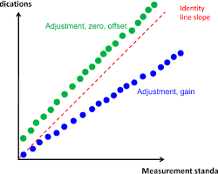
Fig2.1 measuring system adjustment diagram
The diagram shows a simple measuring system consisting of a sensor, a signal conditioner, and a display. The sensor converts the measurand (e.g., temperature, pressure, flow) into an electrical signal. The signal conditioner amplifies and filters the signal, and then converts it to a format that is compatible with the display. The display displays the measured value to the user.
To adjust the measuring system, the following steps are typically followed:
- Connect the measuring system to a reference standard.
- Set the reference standard to a known value.
- Adjust the measuring system until its output matches the value of the reference standard.
- Verify the adjustment by measuring another known value with the reference standard and comparing the output of the measuring system to the known value.
The specific steps involved in adjusting a measuring system will vary depending on the type of system and the manufacturer's instructions. However, the general principles are the same for all measuring systems.
Here are some examples of measuring system adjustments:
- Adjusting a thermometer to match the reading of a NIST-traceable reference thermometer
- Adjusting a pressure gauge to match the reading of a deadweight tester
- Adjusting a flow meter to match the reading of a calibrated flow loop
- Adjusting a level sensor to match the reading of a calibrated sight glass
Measuring system adjustment is an important part of ensuring the accuracy of measurements. By regularly adjusting measuring systems, organizations can ensure that their products and services meet quality standards and that their processes are running efficiently.

Self check -2
I.Say True or False
1. A blunder (or gross error) is a significant, unpredictable mistake caused by human error
2. Keeping up-to-date records is an important aspect of the calibration process
3. In measurement Errors means by definition, are the difference between a measured value and its true value
4. Measuring system adjustment is the process of correcting the output of a measuring system to ensure that it accurately reflects the true value of the measurand
5. Wind speed, air temperature, atmospheric pressure, humidity,
gravity, earth curvature, and atmospheric refraction are examples of Instrument Error

  - Choose the best answer
1. Which one is is true for a common blunders
A. Improperly leveling the surveying instrument.
B .Setting up the instrument or target over the wrong control point.
C. Measurements and Errors D. All
2.Instrument errors are caused by
A. imperfectly constructed B. adjusted C. Calibrated surveying equipment. D.All
3. Which one is true to adjust the measuring system
A .Connect the measuring system to a reference standard.
B. Set the reference standard to a known value.
C. Adjust the measuring system until its output matches the value of the reference standard.
D. Verify the adjustment by measuring another known value with the reference standard and comparing the output of the measuring system to the known value E.All

Operation sheet 2:- Set up Calibration of measuring instruments

Operation title:- procedure to calibrate a pressure gauge
Purpose: Calibrate a pressure gauge with calibration equipment.
Instruction:- Follow the the given step Calibrating a pressure gauge is done with pressure calibration equipment like a deadweight tester, standard pneumatic calibrator, or any other pressure gauge calibrator with an accurate reading. . You have given 50 minute for the task and you are expected to write the answer on the given paper
Step1 :-Connect the hand pump calibrator to the pressure gauge to be calibrated using the appropriate adapter or fitting.
Step2:- Set the desired pressure on the hand pump calibrator.
Step 3:-Slowly pump the hand pump calibrator until the desired pressure is reached.
Step4:-Observe the pressure gauge and ensure that it reads the same pressure as the hand pump calibrator.
Step5:-If the gauge does not read the correct pressure, adjust it according to the manufacturer's instructions.
Step6:-Repeat the process at multiple pressure points to ensure the gauge is accurate throughout its range.
Step7:-Record the results of the calibration and make any necessary adjustments.
Step8:-Once calibration is complete, disconnect the hand pump calibrator and store it properly.

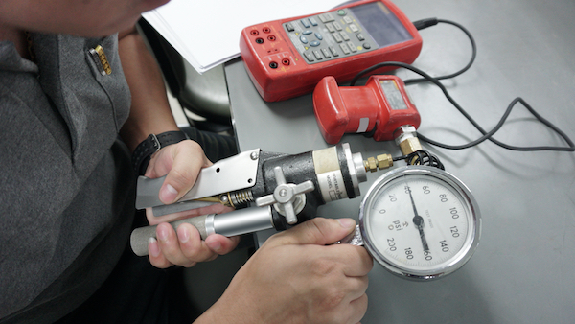
Figure 2 .2: Hand pump for pressure gauge calibration. This device offers a simple yet effective way to quickly calibrate a pressure gauge.
Lap Test 2
Instruction :-Given the necessary tools and materials you are expected to perform the following tasks within 1:20 hour.
Task 1:- :- procedure to calibrate a pressure gauge

Unit Three:- Repair and test analysis system
This unit is developed to provide you the necessary information regarding the following content coverage and topics
- Personal protective equipment
- Gas or liquid analysis system
- Diagnosing Fault/s problem/s in system or component
This unit will also assist to attain the learning outcomes stated in the cover page
Specifically ,upon completion of this learning guide, you will be able to:-
- Apply appropriate personal protective
- check normal function of gas or liquid analysis system
- Diagnose fault/s or problem/s in system

3.1 Personal protective equipment
There are many types of PPE, short for personal protective equipment, available. PPE is designed for workers to wear in dangerous environments to minimize the risk of serious injury. PPE can include everything from safety glasses & ear plugs, to hard hats & coveralls. The types of PPE required for workers varies based on the work environment, and the potential risks that exist there. Not only is it important for individuals to understand which types of PPE to wear to protect themselves, but it is also important for organizations to ensure that the appropriate PPE is available for their employees
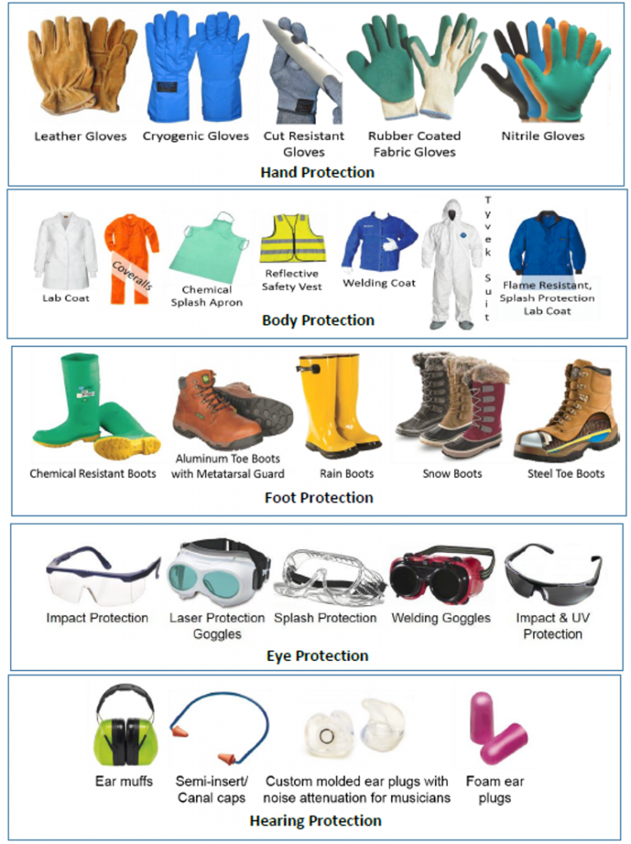
Fig 3.1 personal PPE

Eye Protection Equipment
Eye PPE is designed to protect workers’ eyes from foreign objects, splashes, burns, radiation and more. The type of eye protection equipment required varies based on the hazards present in the environment. For example, workers involved with lawn care may use safety glasses to prevent foreign objects from hitting them in the eye, while welders need welding shields to protect their eyes from burns. Below is a list of the basic types of PPE designed for eye protection
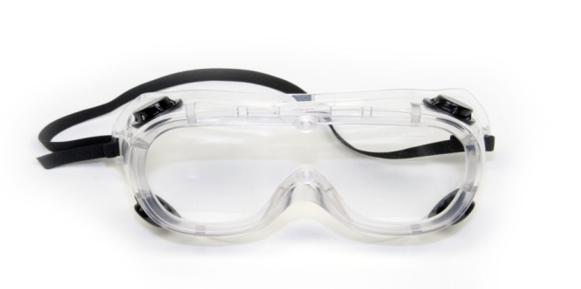
Fig 3.2 Eye Protection/Goggle

Ear Protection Equipment (Noise & Hearing Loss Prevention Equipment)
Ear protection equipment is designed to prevent hearing loss that could be caused by exposure to workplace noise. There are several layers of noise protection equipment. For example, some earplugs are designed for single use, while others are molded to the individual’s ear and can be used for a designated time period. Earmuffs are also an option. These form a physical barrier around the ear, offering increased protection from workplace noise exposure.

Fig 3.3 Ear Protection/ Earmuffs

Head Protection Equipment
Head PPE is designed to protect workers from the risk of impact, whether that is caused by bumping into objects in confined spaces, or falling objects. As such, there are several classifications of personal protection equipment designed to protect workers’ heads. For example, “bump caps” are low profile, and can even include baseball style caps. These are not ANSI rated, and will not provide adequate protection for industrial settings.

Fig 3.4 Head Protection/ bump caps

Body Protection Equipment
PPE designed to protect the body might include specialized clothing, shoes, and gloves. The types of materials from which this gear is made determines the level of protection it offers. For example, fire resistant clothing is designed specifically to be less flammable to provide an extra layer of protection to employees working in the chemical industry. Steel toe boots are designed to protect toes against falling objects and compression, and are worn by workers in many industries. The level of protection required varies based on the risks present in a work setting. Some applications may require a full HAZMAT suit to protect workers from biological substances, chemicals, etc. While other applications may only require employees to wear nitrile gloves to protect workers and end users from pathogens.



Fig3.5 Body Protection / clothing, shoes, and gloves
3.2 Gas or liquid analysis system
Process gas and liquid analytical systems are designed to monitor and analyze various parameters in industrial processes. These systems play a crucial role in ensuring the efficiency, safety, and quality of the processes. They involve the use of sensors, analyzers, and other instrumentation to measure and analyze different properties of gases and liquids in real time. Here are the key components and steps involved in processing gas and liquid analytical systems:


Fig3.6 liquid analysis system
- Liquid analytical system
Liquid analytical systems play a pivotal role in various industries, enabling precise and comprehensive analysis of liquids in a range of applications. These systems integrate cutting-edge technologies to measure and monitor crucial parameters, providing essential insights for quality control, process optimization, and environmental monitoring. In this article, we delve into the intricacies of liquid analytical systems, exploring their components, working principles, and diverse applications.
- Components and Working Principles:
Liquid analytical systems typically consist of sensors, transmitters, and control units. Sensors, tailored for specific parameters such as pH, conductivity, dissolved oxygen, or turbidity, employ various techniques including electrochemical, optical, and thermal methods. These sensors measure target properties, converting them into electrical signals. Transmitters amplify, process, and transmit these signals to the control unit, where advanced algorithms and software algorithms facilitate data analysis and interpretation.
- Applications:
The applications of liquid analytical systems are vast and varied. In the pharmaceutical industry, they ensure the quality and safety of medications by monitoring critical parameters during production processes. In wastewater treatment plants, these systems aid in maintaining optimal conditions for efficient purification. They also find applications in food and beverage production, chemical processing, and environmental monitoring.
3.3 Diagnosing Fault/s problem/s in system or component
Diagnosing faults in a system or component is a process of identifying the root cause of a problem. This can be a complex task, especially for large and complex systems. There are a number of different approaches to fault diagnosis, but the general steps are as follows:
- Gather information. The first step is to gather as much information as possible about the problem. This may include:
  - What are the symptoms of the problem?
  - When did the problem start?
  - What changes have been made to the system recently?
  - What are the environmental conditions?
- Identify potential causes. Once you have gathered information about the problem, you can start to identify potential causes. This may involve brainstorming a list of all possible causes, or using a more systematic approach such as fault tree analysis.
- Test the potential causes. Once you have identified a list of potential causes, you can start to test them to see if they are the root cause of the problem. This may involve performing physical tests, or using diagnostic tools such as software logs.
- Identify the root cause. Once you have tested all of the potential causes, you should be able to identify the root cause of the problem.
- Take corrective action. Once you know the root cause of the problem, you can take corrective action to fix it. This may involve repairing a component, replacing a component, or changing a procedure.
Here are some additional tips for diagnosing faults in systems and components:
- Start with the simplest possible explanation. Don't assume that the problem is caused by a complex or difficult-to-fix issue. Often, the simplest explanation is the correct one.
- Look for patterns. Are there any patterns in the symptoms of the problem? Do the symptoms occur at certain times of day, or under certain conditions? Identifying patterns can help you to narrow down the list of potential causes.
- Use diagnostic tools. There are a variety of diagnostic tools available, both hardware and software. These tools can help you to test the system or component and identify the root cause of the problem more quickly.
- Consult with experts. If you are unable to diagnose the fault yourself, you may need to consult with an expert. Experts can provide you with guidance and advice, and they may be able to help you to identify the root cause of the problem more quickly.It is important to note that fault diagnosis can be a complex and challenging task. There is no one-size-fits-all approach, and the best approach will vary depending on the specific system or component that is being diagnosed.
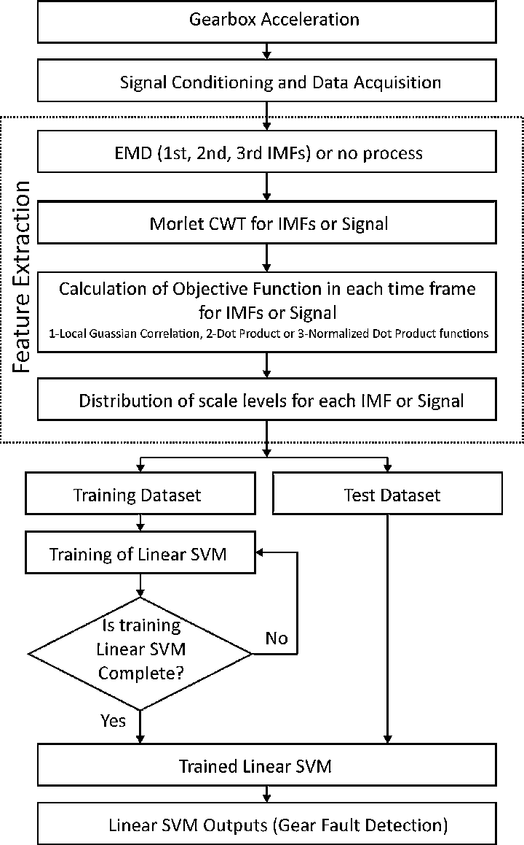
Fig 3.7 Flowchart of fault diagnosis system.

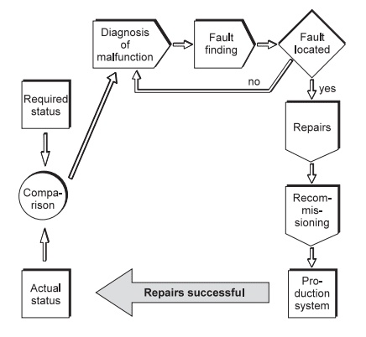
Fig 3.8 systematic fault finding flow chart

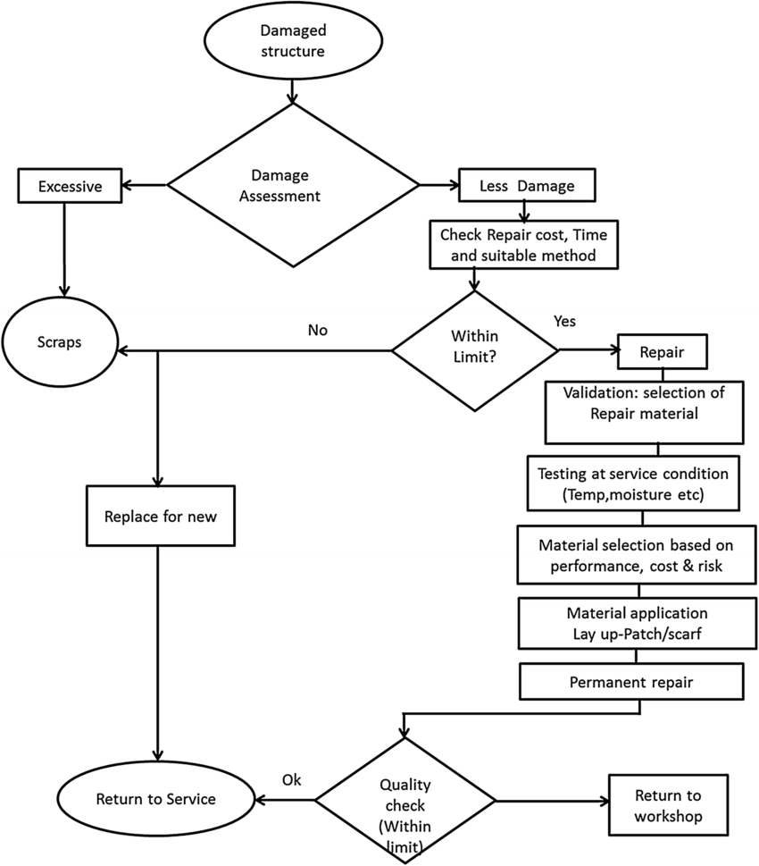

Fig 3.9 Flow chart for the repair of a damaged structure made of composite

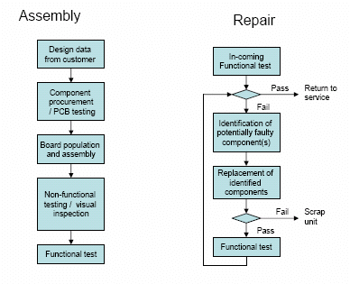

Fig3.10 Common assembly and repair processes flow chart.

Self check -3
I.Say True or False
1. Critical instruments must be calibrated. Non-critical instruments can also be calibrated, but calibration is not always necessary
2.Goggls are a type of PPE that are used to protect the hand
3.Gloves are a type of PPE that are used to protect the Eye
4. Bump caps are a type of PPE that are used to protect the workers’ heads
5. Diagnosing faults in a system or component is a process of identifying the root cause of a problem
II. Choose the best answer
1.From the following which one is used to protect the hand
A. Goggles B. Bump caps C. Gloves D. Earmuffs
2.From the following which one is used to protect the ear
A. Goggles B. Bump caps C. Gloves D. Earmuffs
3.From the following which one is used to protect the eye
A. Goggles B. Bump caps C. Gloves D. Earmuffs
4.From the following which one is used to protect the Head
A. Goggles B. Bump caps C. Gloves D. Earmuffs
5. Liquid analytical systems typically consist of
A. sensors B. transmitters C. control units D.All

Operation sheet 2:- Diagnosing Fault/s problem/s in system or component
Operation title:- Fault Management - the Overall Process and Life Cycle of a Fault

Purpose: Network management, describing the overall processes and infrastructure associated with detecting, diagnosing, and fixing faults, and returning to normal operations.
Instruction:- Follow the the given step overall process of managing the complete life cycle of a fault. . You have given 40 minute for the task and you are expected to write the answer on the given paper

Step1:-Immediate discarding of data from obviously-failed sensors, sensors already known to be failed and still likely to be under repair, or undergoing calibration
Step2:-Filtering to reduce high frequency noise
Step3:-Event generation (if needed, depending on the techniques used)
Step4:-Problem detection
Step5:-Problem diagnosis (isolation)
Step6:-Predicting the impact of the detected and diagnosed problem
Step7:-Event correlation - filtering alarms and grouping correlated messages for a simpler user interface
Step8:-Mitigation actions (steps taken while awaiting repairs, to minimize the impact of the problem
Step9:-Corrective action (action to repair the problem
Step10:-Return to normal operations after repairs are completed
Step11:-Postmortem analysis and corrective actions to prevent recurrence or optimize maintenance policy
Lap Test 3
Instruction :-Given the necessary tools and materials you are expected to perform the following tasks within 1:30 hour.
Task 1:- :- Fault Management - the Overall Process and Life Cycle of a Fault

Unit Four:- Complete report of calibration, test and repair activities
This unit is developed to provide you the necessary information regarding the following content coverage and topics
- work site Cleaning
- Calibration and repair Documenting
This unit will also assist to attain the learning outcomes stated in the cover page Specifically ,upon completion of this learning guide, you will be able to:-
- Follow OH& S risk control work
- Establish Work site clean
- Calibration and repair are documented

  - work site Cleaning
Cleaning electrical instrumentation at a work site requires careful attention to safety procedures to avoid electrical hazards. Here are some general guidelines to consider when cleaning electrical instrumentation:
1. Safety first: Always prioritize your safety and the safety of others. Make sure you are wearing appropriate personal protective equipment (PPE), such as gloves, safety glasses, and a face mask.
2. Power off: Before beginning any cleaning tasks, ensure that the power to the electrical instrumentation is turned off. This step is crucial to prevent accidental electrical shocks.
3. Lockout/tagout: Implement lockout/tagout procedures to isolate the equipment from its power source. This involves locking and tagging the electrical panel or switches to prevent them from being turned back on while cleaning is in progress.
4. Use appropriate cleaning agents: Select cleaning agents that are suitable for electrical equipment. Avoid using water or liquid-based cleaners unless they are specifically designed for use on electrical components. Always read the manufacturer's instructions and follow the recommended cleaning methods.
5. Use non-abrasive tools: When cleaning sensitive electrical instrumentation, use soft, non-abrasive tools such as lint-free cloths, cotton swabs, or small brushes. Avoid using abrasive materials or tools that could damage the equipment.
6. Avoid excessive moisture: Minimize the use of liquid cleaners and ensure that any cleaning agents applied are thoroughly dried before restoring power. Excessive moisture can damage electrical components and create electrical hazards.
7. Remove dust and debris: Use compressed air or a vacuum cleaner with an appropriate attachment to remove dust and debris from the equipment, paying close attention to vents, fans, and other openings. Be cautious not to dislodge any sensitive components.
8. Verify cleanliness: After cleaning, visually inspect the equipment to ensure that all dust, debris, and cleaning agents have been removed. Double-check that no cleaning tools or materials are left behind, as they can pose a risk if inadvertently powered on.

9. Proper disposal: Dispose of any used cleaning materials and waste in accordance with local regulations and environmental guidelines. Some cleaning agents or materials may be considered hazardous and require special disposal procedures.
10. Document the cleaning: Maintain a record of the cleaning activities performed, including the date, equipment cleaned, and any observations or issues identified during the process. This documentation can be valuable for maintenance purposes and safety compliance.
Remember, these guidelines provide general recommendations, but it's essential to consult any specific instructions or guidelines provided by the equipment manufacturer or your organization to ensure compliance and safety when cleaning electrical instrumentation at a work site.
  - Calibration and repair Documenting
When it comes to calibration and repair activities, documentation plays a crucial role in ensuring accuracy, compliance, and traceability. Here are some key points to consider when documenting calibration and repair processes
1. Calibration records: Maintain accurate and up-to-date calibration records for each instrument or equipment that requires calibration. Include information such as the instrument's unique identifier, calibration date, calibration due date, calibration standards used, reference documents, and the name of the technician who performed the calibration.
2. Repair records: Similarly, keep detailed records of any repairs conducted on instruments or equipment. Document the date of repair, a description of the issue or problem, the parts replaced or repaired, any adjustments made, and the name of the technician who performed the repair.
3. Calibration certificates: When instruments or equipment are calibrated by external calibration laboratories or service providers, ensure that you receive calibration certificates. These certificates should include information about the calibration standards used, the calibration procedure followed, the results obtained, and any adjustments made.
4. Traceability: Maintain a clear traceability chain for calibration activities. Document the traceability of calibration standards back to recognized national or international standards. Include information about calibration standards' calibration dates, certificate numbers, and the laboratory or organization that performed the calibration.
5. Calibration intervals: Document the recommended calibration intervals for each instrument or equipment based on manufacturer guidelines, industry standards, and regulatory requirements. This information ensures that instruments are calibrated at appropriate intervals to maintain accuracy and reliability.

6. Nonconformities: If any nonconformities or deviations are identified during calibration or repair processes, document them thoroughly. Include details about the nature of the nonconformity, any corrective actions taken, and verification of the effectiveness of those actions
7. Maintenance history: Maintain a comprehensive maintenance history for each instrument or equipment. This history should include records of calibration, repairs, preventive maintenance activities, and any other relevant information
8. SOPs and work instructions: Develop and maintain standard operating procedures (SOPs) or work instructions for calibration and repair processes. These documents should outline the step-by-step procedures to be followed, including specific measurements, tools, and techniques employed. Regularly review and update these documents as necessary.
9. Digital documentation: Consider using electronic document management systems or calibration management software to streamline and organize your calibration and repair documentation. These systems can help automate record-keeping, generate reports, and provide easy access to historical data.
10. Compliance and audits: Ensure that your calibration and repair documentation practices align with relevant industry standards, regulations, and quality management system requirements. Regularly conduct internal audits to verify compliance and identify opportunities for improvement.
By documenting calibration and repair activities accurately and consistently, you can demonstrate adherence to quality standards, maintain equipment performance, and facilitate effective traceability and analysis of measurement data.

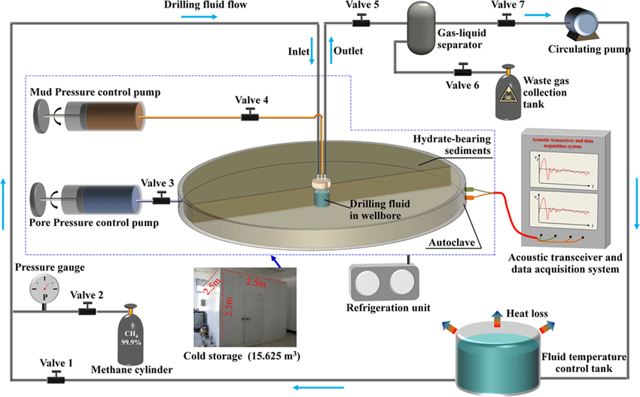

Fig4.1. Piping and instrumentation diagram

Self Check -4
I.Say True or False
1. Cleaning electrical instrumentation at a work site requires careful attention to safety procedures to avoid electrical hazards
2. calibration intervals for each instrument or equipment based on manufacturer guidelines, industry standards, and regulatory requirements
3. Before beginning any cleaning tasks, ensure that the power to the electrical instrumentation is turned on
II. Choose the best answer
1.Which one is a correct appropriate personal protective equipment (PPE),
A. gloves B.safety glasses C. a face mask D.All
2.Which one is not include under Calibration records
A. instrument's unique identifier B. calibration date C. calibration due dated.
D. calibration standards used E. none
3. Maintenance history include
A. records of calibration B. repairs C.preventive maintenance activities D.All

Reference Book
1.CIPM, Procès-Verbaux CIPM, 49th Session, 1960, pp 71–72; Comptes Rendues, 11th CGPM, 1960,
p. 85
2. P. Anderton and P. H. Bigg, Changing to the Metric System, HMSO, London, 1980.
3. The International System of Units (SI), Natl. Inst. Stand. Technol., Spec. Publ. 330, 1991 ed., U.S.
Government Printing Office, Washington, D.C., 1991.
4. B. N. Taylor, Interpretation of the SI for the United States and Metric Conversion Policy for Federal
Agencies, Natl. Inst. Stand. Technol., Spec. Publ. 814, U.S. Government Printing Office, Washington,
D.C., 1991.
5. E. R. Cohen, The Physics Quick Reference Guide, American Institute of Physics Press, New York,
1995.
6. B. N. Taylor, Guide for the Use of the International System of Units, 1995 ed., Natl. Inst. Stand.
Technol., Spec. Publ. 811, U.S. Government Printing Office, Washington, D.C., 1995.
7. Standard for Use of the International System of Units (SI): The Modern Metric System, IEEE/ASTM
SI 10-1997, IEEE Standards Co-ordinating Committee 14 (Revision and redesignation of
ANSI/IEEE Std 268-1992 and ASTM E380), IEEE, New York: 1997.
8. The International System of Units, 7th ed., BIPM, France, 1998.

Participants of this Module (training material) preparation
The trainers who developed the TTLM
No | Name | Qualification level | Educational background | Region | College | Mobile number | E-mail
1 | Melaku Bekele Ofgaha | A | Electri/Automation Control Technology | Oromia | Amboo poly TVET college | O921051772 | kakumalaku430@gmail.com
2 | Bahiru Demeke Beshah | A | Electri/Elec Control  Technology | Oromia | Bishoftu Poly TVET College | O911394408 | bahirudemeke20@gmail.com
3 | Worku Biru Mekonnen | A | Electri/Automation Control Technology | Oromia | Sebeta Poly TVET College | O912106303 | workubiru3@gmail.com
4 | Sisay H/Mariam Toga | A | Electrical Power Enginering | Southern | Arbaminch poly &satelite College | O945234339 | sisayhailemariam971@gmail.com
5 | Hassen Husen Hamid | A | Electrical Eng | Oromia | M/G/M/B Poly TVET College | O943402001

