
Industrial Electrical/ Electronic Control Technology
Level IV
Based on October, 2023 (Version-II) Curriculum 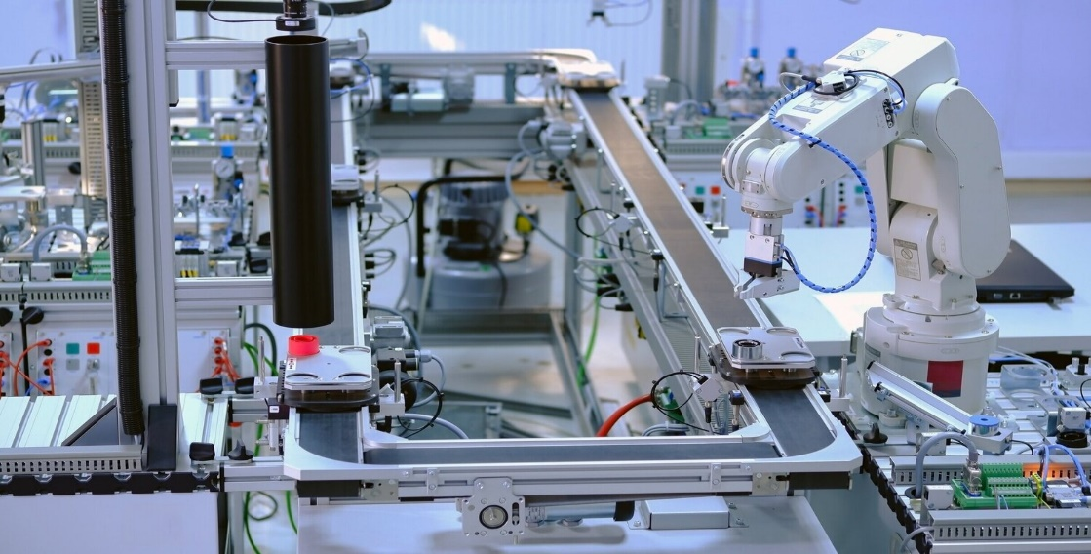
Module Title: Maintain and Troubleshooting Mechatronics Devices and process instrument
LG Code: EIS IEC4 M05 1023
Nominal Hours: 60
TTLM Code: EIS IEC4 TTLM 2023 V1-1

October 2023
Addis Abeba
Contents
Acknowledgment iv
List of Acronym v
Introduction to the Module vi
This module covers the units: vi
Learning Objective of the Module vi
Module Instruction vi
UNIT 1. Plan and prepare for maintenance/ repair 7
1.1 Following OH & S policies and procedures 8
1.2 Maintenance or troubleshooting work plan 13
1.3 Mechatronics Device standards 17
1.4 Mechatronics devices 20
1.5 Tools, equipment and testing devices 68
Self-check (1.1) 69
Operation Sheet (1.1): Troubleshooting a Sensor Using Multimeter 71
LAP Test (1.1) 72
Unit 2: Maintain Mechatronics devices 73
2.1 Scheduled/periodic maintenance 74
2.2 Normal functions of Mechatronics devices 78
2.3 Mechatronics components/parts adjustments and replacement 85
2.4 Unplanned events or conditions 86
Self-check (2.1) 87
Operation sheet (2.1): 89
LAP Test (2.1) Practical Demonstration 90
UNIT 3. Troubleshoot Mechatronics devices 91
3.1 Normal function of maintained Mechatronics device 92
3.2 Troubleshoot fault/s or problem/s in system 93
3.3 Adjustments and Correction Measure 95
3.4 Unplanned events or conditions 98
Self-check (3.1) 98
Operation Sheet (3.1): Calibrating and adjusting elements of Mechatronics systems 99
Operation Sheet (3.2): Inspecting and testing elements of Mechatronics systems 100
LAP Test (3.1) 101
Expert Profile 103
References 104

Acknowledgment
The Ministry of Labor and skill would like to extend its gratitude to Regional Labor, and skill/training Bureaus, TVT College Deans, Instructors, and industry experts for their financial and technical support Set-up industrial field control devices training module. Finally, MOLS extends its gratitude to the following instructors and experts who contributed to the development of this TTLM until its finalization.

List of Acronym
ANSI | American National Standards Institute
DAC | Digital Analog Converter
DTDP | Double Through Double Pole switch
EDS | Electrical Data Sheet
ESIA | Environmental Impact Assessment
ILO | International Labor Organization
ISA | Instrumentation, Systems and Automation Society
LS | Limit Switch
NC | Normally Closed contact
NO | Normally Open contact
OHS | Occupational Health and Safety
P&ID | Pipe And Instrument Diagram
PLC | Programmable Logic Controller
PNP/NPN | Polarity
SA | Switching distance
STSP | Single Through Single Pole
SU | Operating distance

Introduction to the Module
In Industrial Electrical Electronic Control System, Maintain and Troubleshooting Mechatronics Devices and Process Instrument is very important for the overall mechatronics system component failure. It helps to the maintenance/ diagnosis of faulty, maintenance and troubleshoot.
This module is designed to meet the industry requirement under the Industrial Electrical Electronic Control System Occupational standard with particular unit of competency: Maintain and Troubleshooting Mechatronics Devices and Process Instrument.

This module covers the units:
- Maintenance/ diagnosis of faults work
- Maintain Mechatronics devices
- Troubleshoot Mechatronics devices

Learning Objective of the Module
- Determine Plan and prepare for maintenance/ diagnosis of faults
- Maintain Mechatronics devices
- Apply Troubleshoot Mechatronics devices

Module Instruction
For effective use these modules trainees are expected to follow the following module instruction:
- Read the information written in each unit
- Accomplish the Self-checks at the end of each unit
- Perform Operation Sheets which were provided at the end of units
- Do the “LAP test” giver at the end of each unit and
- Read the identified reference book for Examples and exercise

UNIT 1. Plan and prepare for maintenance/ repair

This learning guide is developed to provide you the necessary information regarding the following content coverage and topics:
  - OH&S policies and procedures.
  - Maintenance or troubleshooting work
  - Mechatronics device standards
  - Mechatronics devices
  - Tools, equipment and testing devices

This guide will also assist you to attain the learning outcome stated in the cover page. Specifically, upon completion of this Learning Guide, you will be able to:
  - Follow OH&S policies and procedures.
  - Plan and prepare maintenance or troubleshooting work
  - Identify mechatronics device standards
  - Identify and check mechatronics devices
  - Obtain and check tools, equipment and testing devices

Following OH & S policies and procedures
A health and safety policy ensures that the employer complies with the Occupational Safety and Health. Act and relevant state legislation. It provides guidelines for establishing and implementing programs that will reduce workplace hazards, protect lives and promote employee health
    - An OHS Policy
An OHS Policy is simply a method of stating how you, your employees, contractors and visitors are expected to behave when they are on Company property or performing Company related activities. As an employer or responsible contractor, you are required by law to provide a safe system of work.
    - OHS Policies and Procedures
An OHS policy is a statement about an issue in the workplace and says what the business intends to do about the issue. a policy describes:
- The desired standard;
- A specific objective to meet
- A timeframe;
- Arrangements for reviewing the policy;
- Management’s commitment to fulfilling the policy;
- Steps to be taken to implement the policy; and what is expected of all employees in relation to the particular issue.
If the workplace is going to be successful in following that policy, all employees affected by the issue must know about and understand the policy.
An OHS procedure sets out step-by-step instructions on how to deal with an activity in the workplace.
Activities which may have specific procedures developed include:
- working in confined spaces;
- resolving issues;
- evacuations;
- the overall work flow, from materials coming into the workplace, to the final product going out;
- Workplace inspections; or administrative activity like purchasing.
Where there are workplace hazards, and risks to health and safety, the procedure sets out what to do at every stage of the activity. Procedures need to work. They need to be tested thoroughly before they are implemented.
Employees engaged in an activity must clearly understand and be able to follow any relevant written procedure.
Areas where procedures are required
You may not be able to develop a procedure for every activity in the workplace at least not in the short term. Start with those which have the most significant impact on health and safety. These might be specific activities such as handling hazardous substances, or they may be general processes such as purchasing equipment. In some cases, you will have to start from scratch. In other cases, you can build on a health and safety standard which must be followed for a particular procedure.
There are many aspects of your work environment where written procedures will help prevent workplace illness and injuries and control hazards at their source.
Some examples where written procedures may be required are:
- Specific workplace hazards
- Identification and assessment of the risks
- Risk control
- Reporting hazards;
- Issue resolution;
- Consultation on proposed change;
- Workplace inspections;
- Investigating incidents and issues, with corrective actions;
- Reactive and response activities such as:
- First aid and medical emergencies
- Reporting illness, injury
- Reporting incidents and dangerous

Health and safety policies and procedures are part of a framework for effective health and safety management. A general health and safety policy states management’s intention to provide a safe and healthy workplace, and states the health and safety goals of a workplace. It should also demonstrate the employer’s acknowledgment of their legal duties and their intention to voluntarily comply with those duties.
Specific policies and procedures address particular issues or hazards. They are administrative measures to control workplace hazards and should be used together with other hazard control measures to eliminate or reduce the risk of workplace illness or injury.
    - Using Personal Protective Equipment (PPE)
- Importance of Personal protective equipment (PPE):
The use of personal protective equipment (PPE) to reduce injuries is in the work place. It includes all clothing and accessories designed to create a barrier against workplace hazards. It should be considered a means of minimizing the hazards after engineering controls, administrative controls, and safe work practices have been implemented.
When you are in duty in your work shop, recall the following points:
- You are responsible for your own safety and for the safety of others.
- All accidents are preventable.
- Do not take shortcuts. Always follow the rules.
- If you are not trained, don’t do it.
- Use the right tools and equipment and use them in the right way.
- Assess the risks before you approach your work.
- Never wear loose clothes or slippery footwear.
- Do not indulge in horseplay while at work.
- Practice good housekeeping.
- Always wear proper protective gear.

- Types of Personal Protective Equipment (PPE)
To be ensured user's health and safety in any risky situation, a proper type of PPE must be held or worn. In this regard, there are eight types of personal protective equipment critical for the defiance of users against hazards.
    - Head protection
Wearing PPE for head protection will help you avoid any harm that may come to you from falling materials or swinging objects. Moreover, the head protectors are designed to protect you from knocking against stationary objects. Some kinds of head protection equipment (e.g. caps and hair nets) can even protect against entanglement or scalping on machinery.
Examples of head protection equipment:
- Helmets;
- Hard hats;
- Bump Caps;
- Guards;
- Accessories.
    - Hand protection
Arms, hands and fingers are often injured and, therefore, it is vital to wear hand protection equipment when it is required. The hand protection equipment can ensure protection against heat, cold, vibrations, burns, and cuts by sharp objects, bacteriological risks and chemical contamination.
Examples of hand protection equipment:
- Work gloves and gauntlets;
- Wrist cuff arm nets.
    - Eye and face protection
Numbers are scary! Every day, 600+ workers worldwide suffer from eye injuries. Such injuries can be avoided simply by wearing the proper eye and face protection equipment. As examples of such PPE can be mentioned the following ones:
- Safety glasses and goggles;
- Eye and face shields;
- Eyewear accessories;
- Over specs;
- Visors.

    - Respiratory protection
The respiratory protection covers a broad group of PPE: breathing apparatus, full face or half mask respirators, powered respirators, protective hoods, disposal face masks, detectors, monitors, etc. Adequate training on how users should use the equipment is always required.
This type of PPE must be present when being in contact with large amounts of gases, powders, dust and vapors.
    - Hearing protection
The hearing protection equipment is vital when working in an environment with high-sound levels. The type of hearing protection should not only be suitable for the working environment but also provide a level of hygiene and comfort to the users. A good practice is to provide employees with a range of protectors and then allow them to select the ones which suit them the best.
Examples of hearing protection equipment:
- Earplugs and defenders;
- Noise meters;
- Communications sets;
- Acoustic foam.
    - Foot protection
The foot protection equipment is designed to protect the feet and legs against various hazards, such as extreme temperatures, crushing, piercing, slipping, cutting, chemicals and electricity. It is typically required when users are involved in construction activities, working in very cold or hot environments, working with chemicals and forestry, or when manually handling heavy objects.
As examples of foot protection equipment can be pointed out the following ones:
- Safety boots and shoes;
- Anti-static and conductive footwear.
    - Body protection
Usually, body protection equipment is required in the following cases:
- For protection against weather conditions when working outdoors;
- Ensuring the high-visibility of users when they work in areas where there is a mixed vehicle (e.g. bikes, motors, cars and busses) and pedestrian traffic;
- For users’ protection against extreme temperatures;
- Ensuring protection against entanglement, drowning, chemical contamination, etc.
Examples of body protection equipment:
- Life jackets;
- Clothing for specific weather conditions;
- High-visibility clothing;
- Harnesses, and others.
    - Height and access protection
This type is highly specialised, and it usually requires users to undergo thorough training before they are allowed to use it. The height and access protection equipment must be inspected periodically by a competent person to ensure it is still fit for use and the health and safety of users is not threatened in any way.
As examples of height and access protection equipment can be mentioned the following ones:
- Fall-arrest systems;
- Body harnesses;
- Lowering harnesses;
- Rescue lifting;
- Energy absorbers and others.

Maintenance or troubleshooting work plan
Planning is the process of setting objectives and determining how to best accomplish them.
Planning identifies the specific results or desired outcomes that one intends to achieve.
- Steps in the planning process:
- Define your objectives.
- Determine where you stand vis-à-vis objectives.
- Develop premises regarding future conditions.
- Analyze and choose among action alternatives.
- Implement the plan and evaluate results.
- Benefits of planning:
- Improves focus and flexibility.
- Improves action orientation.
- Improves coordination.
- Improves time management.
- Improves control.
- Maintenance planning:
Planned maintenance refers to any maintenance activity that is planned, documented, and scheduled. The aim of planned maintenance is to reduce downtime by having all necessary resources on hand, such as labor and parts, and a strategy to use these resources.
There are two main types of planned maintenance. The first is planned preventive maintenance, which is scheduled maintenance aimed at repairing assets before they fail. An example would be conducting maintenance on a forklift after every 150 hours of operation.
The second is planned and unscheduled maintenance, which is based on having a strategy in place to repair or replace an asset as quickly as possible when it fails. An example would be planning to have a sufficient number of easily accessible power drills on hand so replacing a broken one is quick and easy for a technician.
- Scheduled maintenance
Scheduled maintenance activities are tasks that are set up to occur ahead of time. They are done so assets can remain functional for as long as possible without any unplanned downtime. Scheduled maintenance is determined by maintenance triggers, including time, usage, event, and condition.
- Preventive maintenance (PM)
Preventive Maintenance (PM) activities are the core element of the maintenance services to a PV plant. It comprises regular visual and physical inspections, as well as verification activities conducted with specific frequencies. It is under the responsibility of the operation & maintenance (O&M) contractor to prepare the task plan until the end of the contract.
- Corrective maintenance
Corrective Maintenance covers the activities performed by the Maintenance team in order to restore a PV plant system, equipment or component to a status where it can perform the required function. Corrective Maintenance includes:
- Fault Diagnosis: also called troubleshooting to identify fault cause and localization
- Temporary Repair: to restore the required function of a faulty item for a limited time, until a Repair is carried out
- Repair: to restore the required function permanently

- Predictive maintenance
Predictive maintenance is a Condition-based maintenance carried out by evaluating typical patterns of significant parameters of plant components degradation.
Predictive techniques help to determine the condition of in-service equipment in order to predict when and whether maintenance should be performed.
Steps to creating an effective maintenance plan
- Detail the work that you'll need to do on each asset.
- Schedule the work – Use a dating frequency, running hours, or measures that will provide insight into the condition of an asset.
- Add workers or contractors – including the estimated working hours.
- Add spare parts.
Table 1. 1 Example Maintenance Plan and format
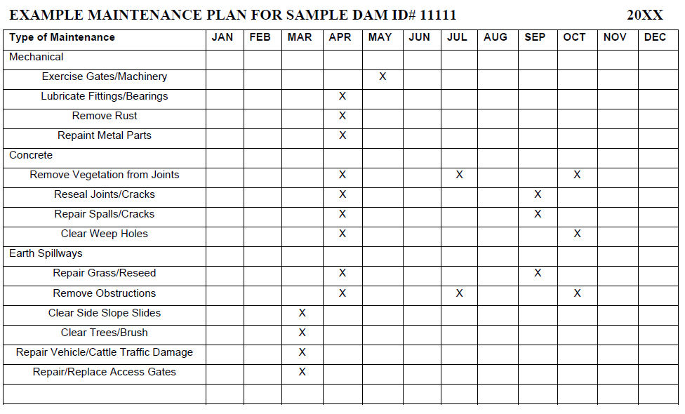

Table 1. 2 Example Maintenance Plan Format
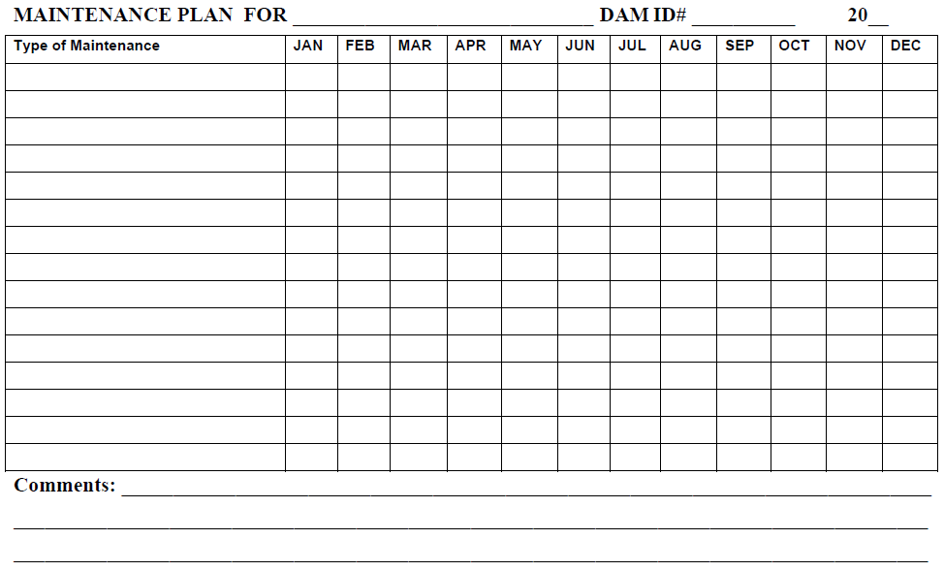

Mechatronics Device standards
    - ISA (Instrumentation, Systems and Automation) Society (formerly Instrument Society of America)
The Instrumentation, Systems, and Automation Society (ISA) is one of the leading process control trade and standards organizations. The ISA has developed a set of symbols for use in engineering drawings and designs of control loops (ISA S5.1 instrumentation symbol specification). You should be familiar with ISA symbology so that you can demonstrate possible process control loop solutions on paper to your customer. Figure 1.1. shows a control loop using ISA symbology. Drawings of this kind are known as piping and instrumentation drawings(P&ID).

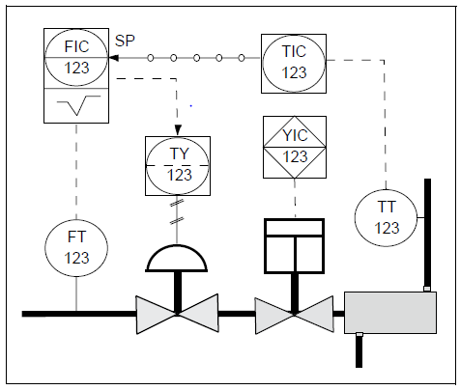
Figure 1. 1 Piping and Instrumentation Drawing (P&ID)

    - SYMBOLS
In a P&ID, a circle represents individual measurement instruments, such as transmitters, sensors, and detectors (Figure 1.2).
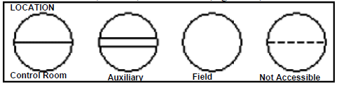
Figure 1. 2 Discrete Instruments

A single horizontal line running across the center of the shape indicates that the instrument or function is located in a primary location (e.g., a control room). A double line indicates that the function is in an auxiliary location (e.g., an instrument rack). The absence of a line indicates that the function is field mounted, and a dotted line indicates that the function or instrument is inaccessible (e.g., located behind a panel board).
A square with a circle inside represents instruments that both display measurement readings and perform some control function (Figure 1.3). Many modern transmitters are equipped with microprocessors that perform control calculations and send control output signals to final control elements.
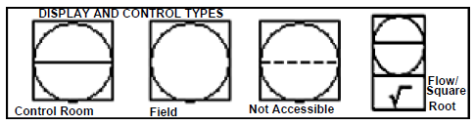
Figure 1. 3 Shared Control/Display Elements

    - American National Standards Institute (ANSI)
The American National Standards Institute (ANSI) oversees the creation and dissemination of various standards and measures, including business norms and standards in the United States.
ANSI is a private and nonprofit organization that does not develop standards itself. Rather, it oversees the creation of voluntary standards for a variety of manufacturing processes, products, systems, services, and personnel in nearly every U.S. business sector. It also works to ensure that U.S. standards are consistent with international standards enabling U.S. products to be sold and used abroad.
Key Takeaways
- The American National Standards Institute (ANSI) is a non-profit organization that coordinates standards and technical regulations that relate to how U.S. businesses, consumer groups, and government agency’s function.
- ANSI doesn't develop the standards itself but helps facilitate the development through promoting standards, accrediting procedures for developing standards undertaken by its member organizations, and approving documentation.
- ANSI oversees the standards that pertain to terminology and definitions, rules about quality and construction of goods and products, and product testing, among others.

Mechatronics devices
    - Mechatronics Control Devices
Mechatronics control devices are found everywhere; they are built into kitchen appliances, aircraft, cameras, computers, power stations, even in toilet cisterns. They may be built from micro-circuits, mechanical levers, hydraulic or magnetic devices. Though they come in diverse forms, the aim is the same to regulate or control the
behavior of the machine or process.
They often behave in strange ways, particularly when they go wrong. People often find them hard to understand.
Fortunately, we can learn to understand their behavior with a common set of fundamental principles. We can find examples of control devices in everyday life and learn to observe them to gain a better appreciation of these principles.
Mechatronics control devices Includes:
  - Sensor elements
  - Electro-mechanical elements
  - Pneumatic & electro-pneumatic elements
  - Hydraulic elements
  - Electronic logic control elements
  - Robotic control elements
  - Actuators & output devices etc.
    - Sensor elements
Sensor is a device that when exposed to a physical phenomenon (temperature, displacement, force, etc.) produces a proportional output signal (electrical, mechanical, magnetic, etc.). The term transducer is often used synonymously with sensors. However, ideally, a sensor is a device that responds to a change in the physical phenomenon. On the other hand, a transducer is a device that converts one form of energy into another form of energy. Sensors are transducers when they sense one form of energy input and output in a different form of energy. For example, a thermocouple responds to a temperature change (thermal energy) and outputs a proportional change in electromotive force (electrical energy). Therefore, a thermocouple can be called as a sensor and or a transducer.
Classification
Lists various types of sensors that are classified by their measurement objectives. Although this list is by no means exhaustive, it covers all the basic types including the new generation sensors such as:
- smart material sensors,
- micro sensors, and
- nano sensors.
Sensors can also be classified as passive or active.
- In passive sensors, the power required to produce the output is provided by the sensed physical phenomenon itself (such as a thermometer), whereas
- the active sensors require external power source (such as a strain gauge).
Furthermore, sensors are classified as analog or digital on the basis of the type of output signal.
- Analog sensors produce continuous signals that are proportional to the sensed parameter and typically require analog to digital conversion before feeding to the digital controller.
- Digital sensors on the other hand produce digital outputs that can be directly interfaced with the digital controller. Often, the digital outputs are produced by adding an analog to digital converter to the sensing unit. If many sensors are required, it is more economical to choose simple analog sensors and interface them to the digital controller equipped with a multichannel analog to digital converter.

Details of some useful sensor in mechatronics
Sensors include limit switches, photoelectric, inductive, capacitive, and ultrasonic sensors. These products are packaged in various configurations to meet virtually any requirement found in commercial and industrial applications. Each type of sensor will be discussed in detail. At the end of the information sheet an application guide is provided to help determine the right sensor for a given application.
Sensors Applications, its advantages and disadvantages:
Limit switches use a mechanical actuator input, requiring the sensor to change its output when an object is physically touching the switch. Sensors, such as photoelectric, inductive, capacitive, and ultrasonic, change their output when an object is present, but not touching the sensor.
Table 1. 3 SENSOR ADVANTAGES DISADVANTAGES APPLICATIONS
Sensor | Advantages | Disadvantages | Applications
Limit Switch Sensor | •High Current Capability  •Low Cost  •Familiar  “Low- Tech” Sensing | - Requires Physical  Contact with Target  - Very Slow Response  - Contact Bounce | •Interlocking  •Basic  End-of-  Travel  Sensing
Photoelectric  Sensor | •Senses all Kinds of Materials  •Long Life  •Longest Sensing Range  •Very Fast Response Time | •Lens Subject to  Contamination  •Sensing Range Affected by Color  And Reflectivity of Target | •Packaging  •Material Handling  •Parts Detection
Inductive  Sensor | •Resistant to Harsh Environments  •Very Predictable  •Long Life  •Easy to Install | •Distance  Limitations | •Industrial  & Machines  •Machine Tool  •Senses Metal-  Only Targets
Capacitive  Sensor | •Detects Through Some Containers  •Can Detect Non-Metallic  Targets | •Very Sensitive to Extreme Environmental Changes | •Level  Sensing
Ultrasonic  Sensor | •Senses all Materials | •Resolution  •Repeatability  •Sensitive to  Temperature  Changes | •Anti-Collision  •Doors  •Web Brake  •Level  Control

- Limit Switches
Contact Arrangement:
Contacts are available in several configurations. They may be normally open (NO), normally closed (NC), or a combination of normally open and normally closed contacts. Circuit symbols are used to indicate an open or closed path of current flow.
Contacts are shown as normally open (NO) or normally closed (NC). The standard method of showing a contact is by indicating the circuit condition it produces when the contact actuating device is in the de-energized or non- operated state. For the purpose of explanation in this text a contact or device shown in a state opposite of its normal state will be highlighted. Highlighted symbols used to indicate the opposite state of a contact or devices are not legitimate symbols. They are used here for illustrative purposes only.
Mechanical limit switches, which will be covered in the next section, use a different set of symbols. Highlighted symbols are used for illustrative purposes only.
Circuit Example
In the following diagram a mechanical limit switch (LS1) has been placed in series with a Run/Stop contact and the “M” contactor coil. The Run/Stop contact is in the Run condition and the motor is running a process. This could be a conveyor or some other device. Note that the “M” contacts and the “Run/ Stop” are shown highlighted, indicating they are normally open contacts in the closed position. LS1 is a normally closed contact of the mechanical limit switch.
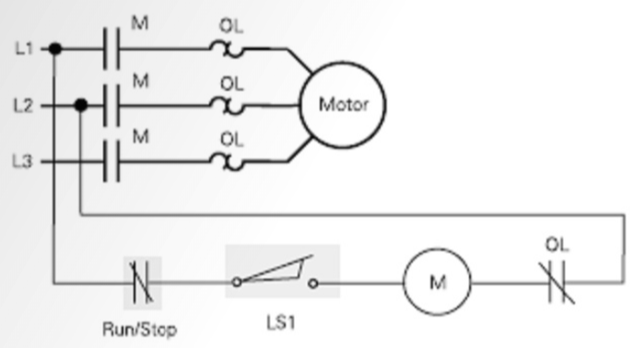
Figure 1. 4 Circuit example with limit switch
When an object makes contact with the mechanical limit switch the LS1 contacts will change state. In this example the normally closed contacts of LS1 open. The mechanical limit switch symbol is highlighted. The “M” contactor coil is de-energized, returning the normally open contacts of the “M” contactor to their normal position, stopping the motor and the process.
A typical limit switch consists of a switch body and an operating head. The switch body includes electrical contacts to energize and de-energize a circuit. The operating head incorporates some type of lever arm or plunger, referred to as an actuator.
The standard limit switch is a mechanical device that uses physical contact to detect the presence of an object (target). When the target comes in contact with the actuator, the actuator is rotated from its normal position to the operating position. This mechanical operation activates contacts within the switch body.
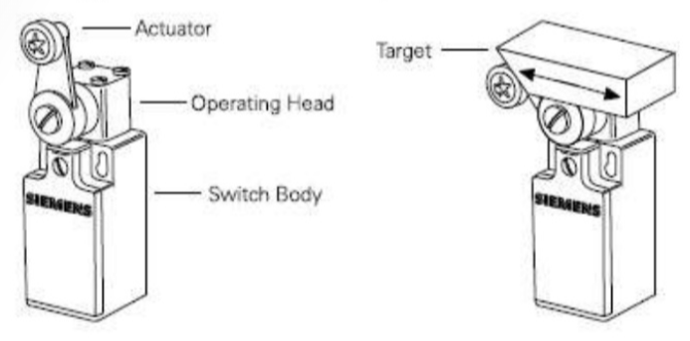
Figure 1. 5 Limit switch
Principle of Operation
- A number of terms must be understood to understand how a mechanical limit switch operates.
The free position is the position of the actuator when no external force is applied.
- Pretravel is the distance or angle traveled in moving the actuator from the free position to the operating position.
- The operating position is where contacts in the limit switch change from their normal state (NO or NC) to their operated state.
- Overtravel is the distance the actuator can travel safely beyond the operating point.
- Differential travel is the distance traveled between the operating position and the release position.
- The release position is where the contacts change from their operated state to their normal state.
- Release travel is the distance traveled from the release position to the free position.
Principle of Operation (IN ACTION):
Momentary Operation
One type of actuator operation is momentary. When the target comes in contact with the actuator, it rotates the actuator from the free position, through the pretravel area, to the operating position. At this point the electrical contacts in the switch body change state. A spring returns the actuator lever and electrical contacts to their free position when the actuator is no longer in contact with the target.
Maintained Operation
In many applications it is desirable to have the actuator lever and electrical contacts remain in their operated state after the actuator is no longer in contact with the target. This is referred to as maintained operation. With maintained operation the actuator lever and contacts return to their free position when a force is applied to the actuator in the opposite direction. A fork-style actuator is typically used for this application.
Snap-Action Contacts
There are two types of contacts, snap-action and slow-break. Snap-action contacts open or close by a snap action regardless of the actuator speed. When force is applied to the actuator in the direction of travel, pressure builds up in the snap spring. When the actuator reaches the operating position of travel, a set of moveable contacts accelerates from its normal position towards a set of fixed contacts. As force is removed from the actuator it returns to its free position. When the actuator reaches the release position the spring mechanism accelerates the moveable contact back to its original state.
Since the opening or closing of the contacts is not dependent on the speed of the actuator, snap-action contacts are particularly suited for low actuator speed applications. Snap-action contacts are the most commonly used type of contact.
Slow-Break Contacts
Switches with slow-break contacts have moveable contacts that are located in a slide and move directly with the actuator. This ensures the moveable contacts are forced directly by the actuator. Slow-break contacts can either be break-before-make or make-before-break. In slow-break switches with break-before-make contacts, the normally closed contact opens before the normally open contact closes. This allows the interruption of one function before continuation of another function in a control sequence. In slow-break switches with make-before-break contacts, the normally open contact closes before the normally closed contact opens. This allows the initiation of one function before the interruption of another function.
Contact Arrangements
There are two basic contact configurations used in limit switches: single-pole, double-throw (SPDT) and double- pole, double-throw (DPDT). This terminology may be confusing if compared to similar terminology for other switch or relay contacts, so it is best just to remember the following points. The single-pole, double-throw contact arrangement consists of one normally open (NO) and one normally closed (NC) contact. The double-pole, double-throw (DPDT) contact arrangement consists of two normally open (NO) and two normally closed (NC) contacts. There are some differences in the symbology used in the North American and International style limit switches.
Electrical Ratings
Contacts are rated according to voltage and current. Ratings are generally described as inductive ratings. typical inductive load is a relay or contactor coil.
There are three components to inductive ratings:
- Make The load a switch can handle when the mechanical contacts close. This is associated with inrush currents. This is typically two cycles or less.
- Break The load a switch can handle when the mechanical contacts are opened. This is the maximum continuous switch current.
- Continuous The load that a switch can handle without making or breaking a load.
The following ratings are typical of Siemens International and North American style limit switches.
Inductive AC Contact Ratings
Inductive DC Contact Ratings
Load Connection
Care must be made to ensure that multiple loads on one switch are properly connected. The correct way to wire a switch is so that the loads are connected to the load side of the switch. Loads should never be connected to the line side of the switch.
Actuators
Several types of actuators are available for limit switches, some of which are shown below. There are also variations of actuator types. Actuators shown here are to provide you with a basic knowledge of various types available. The type of actuator selected depends on the application.
Fork
The fork style actuator must be physically reset after each operation and is ideally suited for transverse movement control.
Roller Lever
The standard roller is used for most rotary lever applications. It is available in various lengths. When the length of the roller lever is unknown, adjustable length levers are available.
Mounting Considerations
Limit switches should be mounted in locations which will prevent false operations by normal movements of machine components and machine operators. An important aspect of limit switch mounting is cam design. Improper cam design can lead to premature switch failure.
For lever arm actuators it is always desirable to have the cam force perpendicular to the lever arm. For applications in which the cam is traveling at speeds less than 100 feet per minute a cam lever angle of 30 degrees is recommended.
Overriding and Non-Overriding Cams In overriding cam applications it is necessary to angle the trailing edge of the cam in order to prevent the lever arm from snapping back. Snapping back of the lever arm can cause shock loads on the switch which will reduce the life of the switch. Non-Overriding cams are cams which will not over-travel the actuating mechanism.
Flexible
Loop and Spring Rod Flexible loop and spring rod actuators can be actuated from all directions, making them suitable for applications in which the direction of approach is constantly changing.
Plungers
Plunger type actuators are a good choice where short, controlled machine movements are present or where space or mounting does not permit a lever type actuator. The plunger can be activated in the direction of plunger stroke, or at a right angle to its axis.
Mounting Considerations
When using plain and side plunger actuators the cam should be operated in line with the push rod axis. Consideration should be given so as not to exceed the overtravel specifications. In addition, the limit switch should not be used as a mechanical stop for the cam. When using roller top plunger the same considerations should be given as with lever arm actuators.
- Inductive Sensor
There are four types of sensors: inductive, capacitive, ultrasonic, and photoelectric. Inductive proximity sensors use an electromagnetic field to detect the presence of metal objects. Capacitive proximity sensors use an electrostatic field to detect the presence of any object. Ultrasonic proximity sensors use sound waves to detect the presence of objects. Photoelectric sensors react on changes in the received quantity of light. Some photoelectric sensors can even detect a specific color.
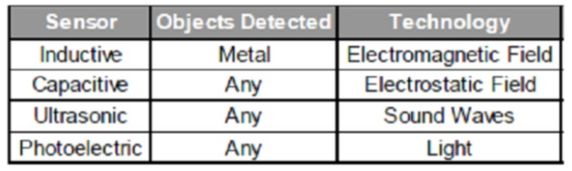
Figure 1. 6 Sensor behaviours and principle

Inductive Proximity Sensors
Theory of Operation In this section we will look at Inductive proximity sensors, and how they detect the presence of an object without coming into physical contact with it. Inductive proximity sensors are available in a variety of sizes and configurations to meet varying applications. Specific sensors will be covered in more detailed in the following section.
Electromagnetic Coil and Metal Target
The sensor incorporates an electromagnetic coil which is used to detect the presence of a conductive metal object. The sensor will ignore the presence of an object if it is not metal.
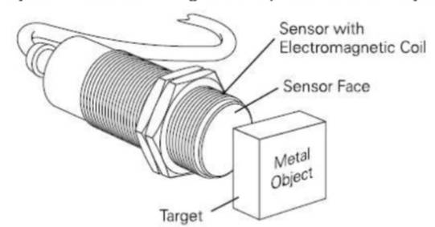
Figure 1. 7 Sensor and object
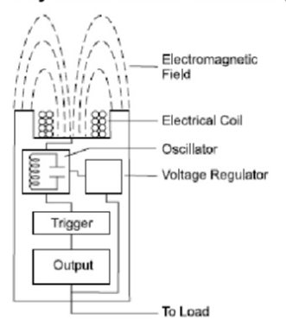
Figure 1. 8 Eddy Current Killed Oscillator (ECKO) principle
Inductive proximity sensors are operated using an Eddy Current Killed Oscillator (ECKO) principle. This type of sensor consists of four elements:
Coil, oscillator, trigger circuit, and an output.
The oscillator is an inductive capacitive tuned circuit that creates a radio frequency. The electromagnetic field produced by the oscillator is emitted from the coil away from the face of the sensor. The circuit has just enough feedback from the field to keep the oscillator going.
When a metal target enters the field, eddy currents circulate within the target. This causes a load on the sensor, decreasing the amplitude of the electromagnetic field. As the target approaches the sensor the eddy currents increase, increasing the load on the oscillator and further decreasing the amplitude of the field. The trigger circuit monitors the oscillator’s amplitude and at a predetermined level switches the output state of the sensor from its normal condition (on or off). As the target moves away from the sensor, the oscillator’s amplitude increases. At a predetermined level the trigger switches the output state of the sensor back to its normal condition (on or off).
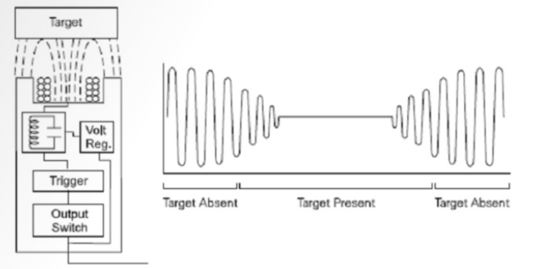
Operating Voltages
Inductive proximity sensors include AC, DC, and AC/DC (universal voltage) models. The basic operating voltage ranges are from 10 to 30 VDC, 15 to 34 VDC, 10 to 65 VDC, 20 to 320 VDC, and 20 to 265 VAC.
Direct Current Devices Direct current models are typically three-wire devices (two-wire also available) requiring a separate power supply.
The sensor is connected between the positive and negative sides of the power supply. The load is connected between the sensor and one side of the power supply. The specific polarity of the connection depends on the sensor model. In the following example the load is connected between the negative side of the power supply and the sensor.
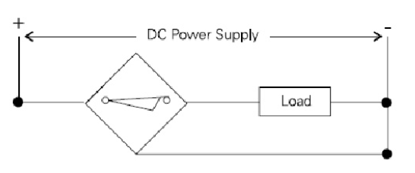
Figure 1. 9 polarity of the connection of sensor

Output Configurations
Three-wire, DC proximity sensor can either be PNP (sourcing) or NPN (sinking). This refers to the type of transistor used in the output switching of the transistor.
The following drawing illustrates the output stage of a PNP sensor. The load is connected between the output (A) and the negative side of the power supply (L-). A PNP transistor switches the load to the positive side of the power supply (L+). When the transistor switches on, a complete path of current flow exists from L- through the load to L+. This is also referred to as current sourcing since in this configuration conventional current is (+ to -) sourced to the load. This terminology is often confusing to new users of sensors since electron current flow (- to +) is from the load into the sensor when the PNP transistor turns on.
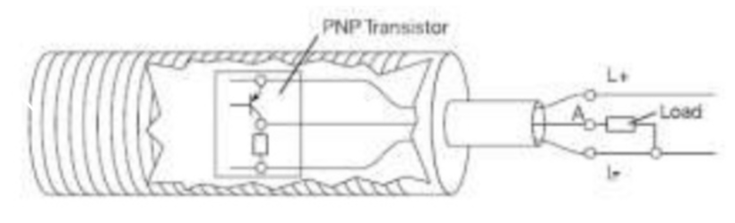
Figure 1. 10 output stage of a PNP sensor

The following drawing illustrates the output of an NPN sensor. The load is connected between the output (A) and the positive side of the power supply (L+). An NPN transistor switches the load to the negative side of the power supply (L-). This is also referred to as current sinking since the direction of conventional current is into the sensor when the transistor turns on. Again, the flow of electron current is in the opposite direction.
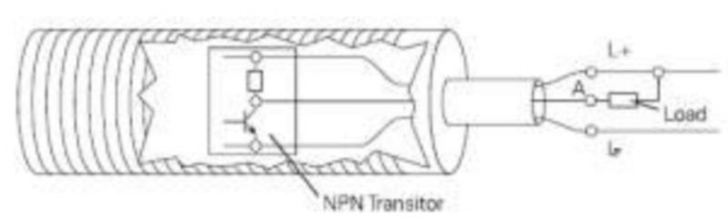
Figure 1. 11 output of an NPN sensor
Normally Open (NO)
Outputs are considered normally open (NO) or normally closed Normally Closed (NC) (NC) based on the condition of the transistor when a target is absent. If, for example, the PNP output is off when the target is absent then it is a normally open device. If the PNP output is on when the target is absent it is a normally closed device.
Complementary
Transistor devices can also be complementary (four-wire). A complementary output is defined as having both normally open and normally closed contacts in the same sensor.
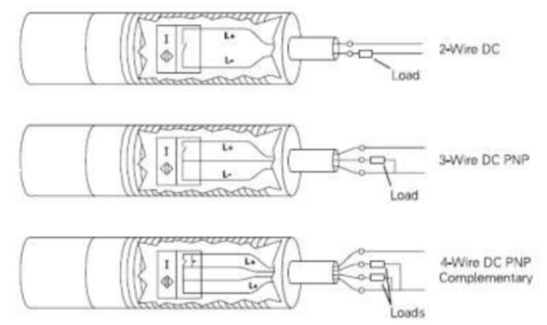
Figure 1. 12 A complementary output of sensor

Series and Parallel Connections
In some applications it may be desirable to use more than one sensor to control a process. Sensors can be connected in series or in parallel. When sensors are connected in series all the sensors must be on to turn on the output. When sensors are connected in parallel either sensor will turn the output on.
There are some limitations that must be considered when connecting sensors in series. In particular, the required supply voltage increases with the number of devices placed in series.
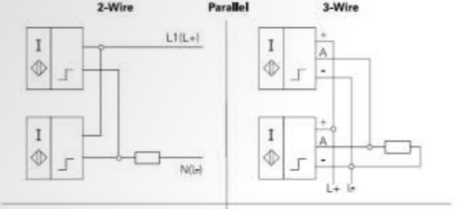
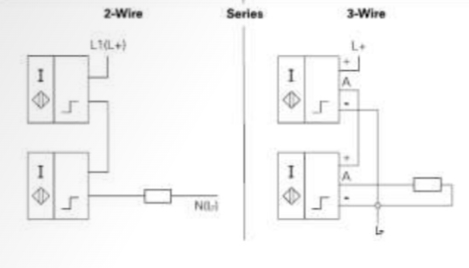
Figure 1. 13 Series and parallel connection of sensor

Shielding
Proximity sensors contain coils that are wound in ferrite cores.
They can be shielded or unshielded. Unshielded sensors usually have a greater sensing distance than shielded sensors.
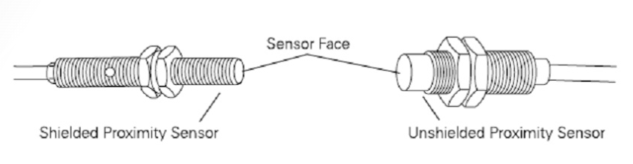
Shielded Proximity Sensors
The ferrite core concentrates the radiated field in the direction of use. A shielded proximity sensor has a metal ring placed around the core to restrict the lateral radiation of the field. Shielded proximity sensors can be flush mounted in metal. A metal-free space is recommended above and around the sensor’s sensing surface. Refer to the sensor catalog for this specification. If there is a metal surface opposite the proximity sensor it must be at least three times the rated sensing distance of the sensor from the sensing surface.
Unshielded Proximity Sensors
An unshielded proximity sensor does not have a metal ring around the core to restrict lateral radiation of the field. Unshielded sensors cannot be flush mounted in metal. There must be an area around the sensing surface that is metal free. An area of at least three times the diameter of the sensing surface must be cleared around the sensing surface of the sensor. In addition, the sensor must be mounted so that the metal surface of the mounting area is at least two times the sensing distance from the sensing face. If there is a metal surface opposite of the proximity sensor it must be at least three times the rated sensing distance of the sensor from the sensing surface.
Mounting Multiple Sensors
Care must be taken when using multiple sensors. When two or more sensors are mounted adjacent to or opposite one another, interference or cross-talk can occur producing false outputs. The following guidelines can generally be used to minimize interference.
• Opposite shielded sensors should be separated by at least four times the rated sensing range
• Opposite unshielded sensors should be separated by at least six times the rated sensing range
• Adjacent shielded sensors should be separated by at least two times the diameter of the sensor face
• Adjacent unshielded sensors should be separated by at least three times the diameter of the sensor face
These are general guidelines. Proximity sensors have individual specifications which should be followed. For
instance, some devices are rated as suitable for side-by-side mounting (see figure 1.13 and figure 1.14).
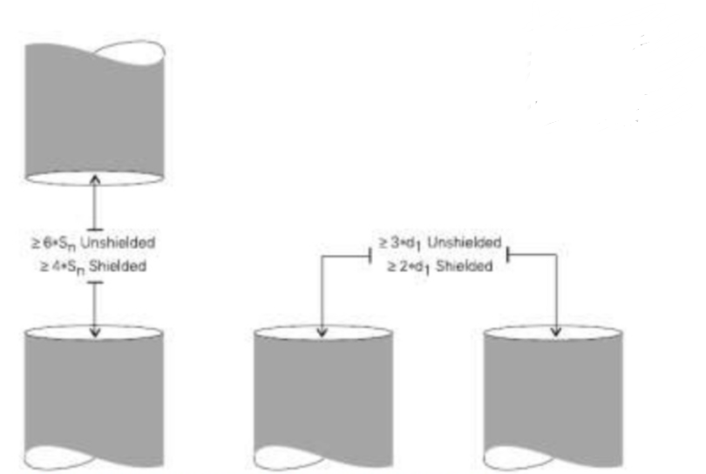
Figure 1. 14 Vertical and Horizontal Mounting
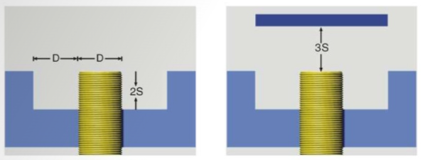
Figure 1. 15 Flush Mounting
Standard Target
A standard target is defined as having a flat, smooth surface, made of mild steel that is 1 mm (0.04”) thick. Steel is available in various grades. Mild steel is composed of a higher content of iron and carbon. The standard target used with shielded sensors has sides equal to the diameter of the sensing face. The standard target used with unshielded sensors has sides equal to the diameter of the sensing face or three times the rated operating range, whichever is greater.
If the target is larger than the standard target, the sensing range does not change. However, if the target is smaller or irregular shaped the sensing distance (Sn) decreases. The smaller the area of the target the closer it must be to the sensing face to be detected.
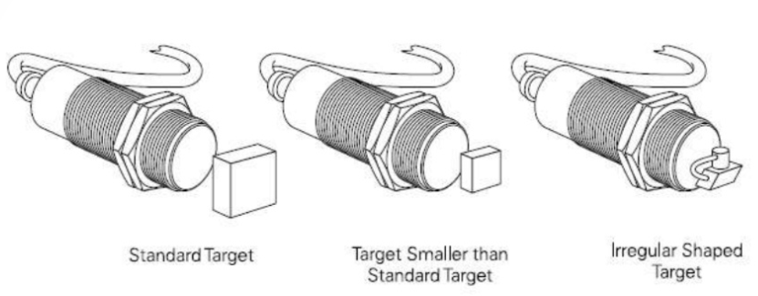
Figure 1. 16 Standard Target of sensor
Target Size Correction Factor
A correction factor can be applied when targets are smaller than the standard target. To determine the sensing distance for a target that is smaller than the standard target (SNEW), multiply the rated sensing distance (SRATED) times the correction factor (T). If, for example, a shielded sensor has a rated sensing distance of 1 mm and the target is half the size of the standard target, the new ensing distance is 0.83 mm (1 mm x 0.83).
SNEW = Srated x T SNEW = 1 mm x 0.83 SNEW = 0.83 mm
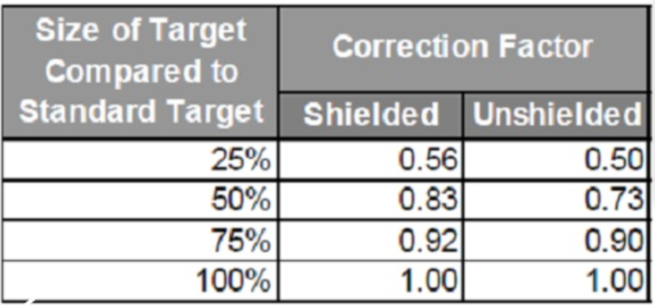
Target Thickness
Thickness of the target is another factor that should be considered. The sensing distance is constant for the standard target. However, for nonferrous targets such as brass, aluminum, and copper a phenomenon known as “skin effect” occurs. Sensing instance decreases as the target thickness increases. If the target is other than the standard target a correction factor must be applied or the thickness of the target.
Target Material
The target material also has an effect on the sensing distance. When the material is other than mild steel correction factors need to be applied.
Rated Operating Distances
The rated sensing distance (Sn) is a theoretical value which does not take into account such things as manufacturing tolerances, operating temperature, and supply voltage. In some applications the sensor may recognize a target that is outside of the rated sensing distance. In other applications the target may not be recognized until it is closer than the rated sensing distance. Several other terms must be considered when evaluating an application.
The effective operating distance (Sr) is measured at nominal supply voltage at an ambient temperature of 23°C ± 0.5°. It takes into account manufacturing tolerances. The effective operating distance is ±10% of the rated operating distance. This means the target will be sensed between 0 and 90% of the rated sensing distance. Depending on the device, however, the effective sensing distance can be as far out as 110% of the rated sensing distance.
The useful switching distance (Su) is the switching distance measured under specified temperature and voltage conditions. The useful switching distance is ±10% of the effective operating distance. The guaranteed operating distance (Sa) is any switching distance for which an operation of the proximity switch within specific permissible operating conditions is guaranteed. The guaranteed operating distance is between 0 and 81% of the rated operating distance.
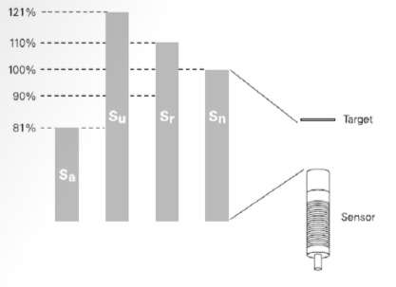
Figure 1. 17 Rated Operating Distances
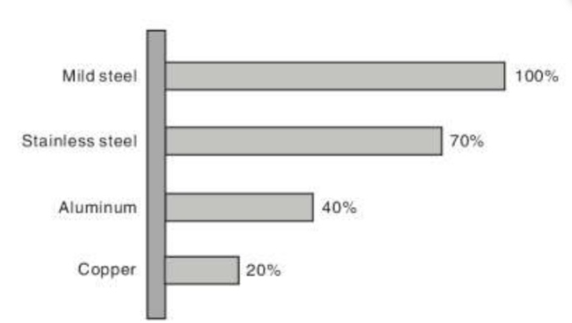
Figure 1. 18 Influence between Sensing Object & Sensing Range

Response Characteristic
Proximity switches respond to an object only when it is in a defined area in front of the switch’s sensing face. The point at which the proximity switch recognizes an incoming target is the operating point. The point at which an outgoing target causes the device switch back to its normal state is called the release point. The area between these two points is called the hysteresis zone.
Response Curve
The size and shape of the response curve depends on the specific proximity switch. The following curve represents one type of proximity switch.
- Capacitive Sensor
Capacitive Proximity Sensors
Theory of Operation Capacitive proximity sensors are similar to inductive proximity sensors. The main difference between the two types is that capacitive proximity sensors produce an electrostatic field instead of an electromagnetic field. Capacitive proximity switches will sense metal as well as nonmetallic materials such as paper, glass, liquids, and cloth.
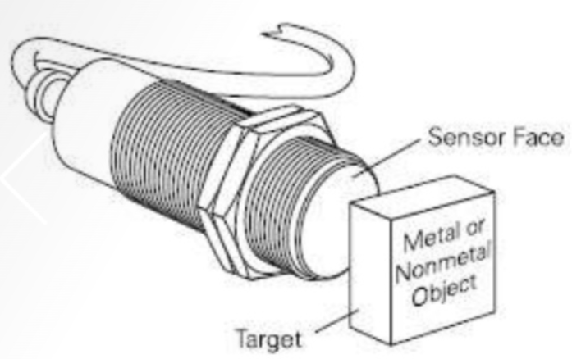
Figure 1. 19 Capacitive proximity sensors
The sensing surface of a capacitive sensor is formed by two concentrically shaped metal electrodes of an unwound capacitor. When an object nears the sensing surface it enters the electrostatic field of the electrodes and changes the capacitance in an oscillator circuit. As a result, the oscillator begins oscillating. The trigger circuit reads the oscillator’s amplitude and when it teaches a specific level the output state of the sensor changes. As the target moves away from the sensor the oscillator’s amplitude decreases, switching the sensor output back to its original state.
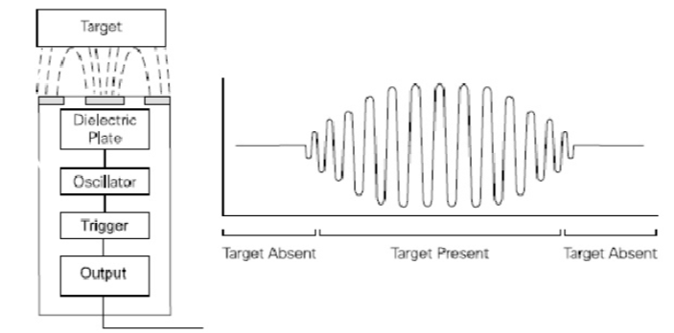
Standard Target and Dielectric Constant
Standard targets are specified for each capacitive sensor. The standard target is usually defined as metal and/or water. Capacitive sensors depend on the dielectric constant of the target. The larger the dielectric number of a material the easier it is to detect. The following graph shows the relationship of the dielectric constant of a target and the sensor’s ability to detect the material based on the rated sensing distance (Sr).
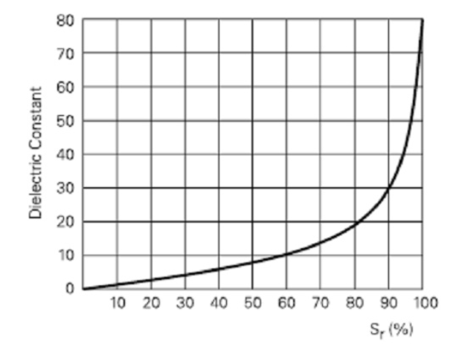
The following table shows the dielectric constants of some materials. If, for example, a capacitive sensor has a rated sensing distance of 10 mm and the target is alcohol, the effective sensing distance (Sr) is approximately 85% of the rated distance, or 8.5 mm.
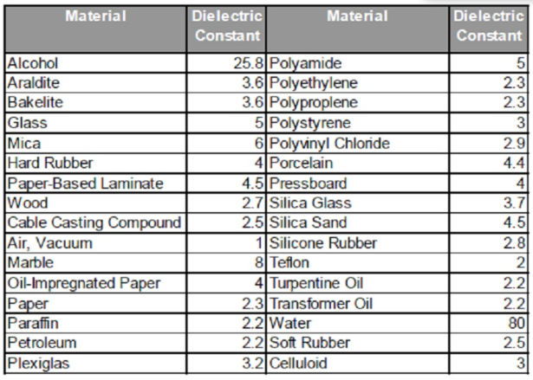
Detection through Barriers
One application for capacitive proximity sensors is level detection through a barrier. For example, water has a much higher dielectric than plastic. This gives the sensor the ability to “see through” the plastic and detect the water.
Shielding
All capacitive sensors are shielded. These sensors will detect conductive material such as copper, aluminum, or conductive fluids, and nonconductive material such as glass, plastic, cloth, and paper. Shielded sensors can be flush mounted without adversely affecting their sensing characteristics. Care must be taken to ensure that this type of sensor is used in a dry environment. Liquid on the sensing surface could cause the sensor to operate.
Capacitive Sensor Selection Guide
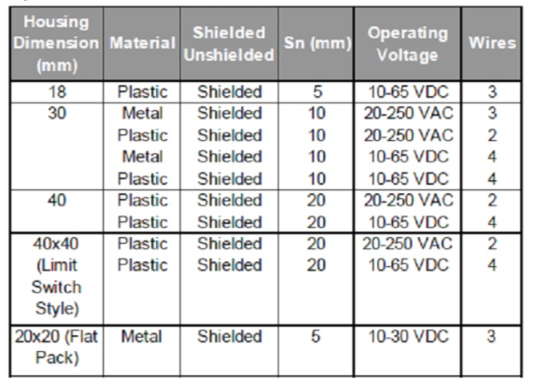
Figure 1. 20 Capacitive Sensor Selection Guide
IV. Photoelectric Sensor
Photoelectric Sensors Theory of Operation
A photoelectric sensor is another type of position sensing device. Photoelectric sensors, similar to the ones shown below, use a modulated light beam that is either broken or reflected by the target. The control consists of an emitter (light source), a receiver to detect the emitted light, and associated electronics that evaluate and amplify the detected signal causing the photoelectric’s output switch to change state. We are all familiar with the simple application of a photoelectric sensor placed in the entrance of a store to alert the presence of a customer. This, of course, is only one possible application.
Modulated Light
Modulated light increases the sensing range while reducing the effect of ambient light. Modulated light is pulsed at a specific frequency between 5 and 30 KHz. The photoelectric sensor is able to distinguish the modulated light from ambient light. Light sources used by these sensors range in the light spectrum from visible green to invisible infrared. Light-emitting diode (LED) sources are typically used.
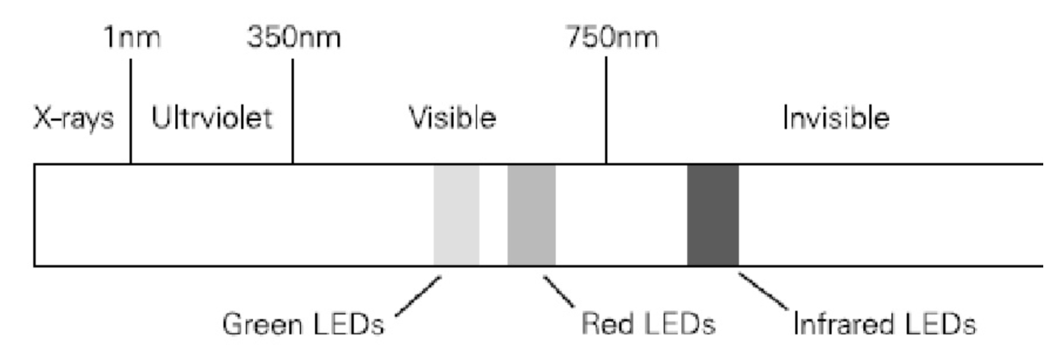
Figure 1. 21 Modulated Light
Clearance
It is possible that two photoelectric devices operating in close proximity to each other can cause interference. The problem may be rectified with alignment or covers. The following clearances between sensors are given as a starting point. In some cases it may be necessary to increase the distance between sensors.
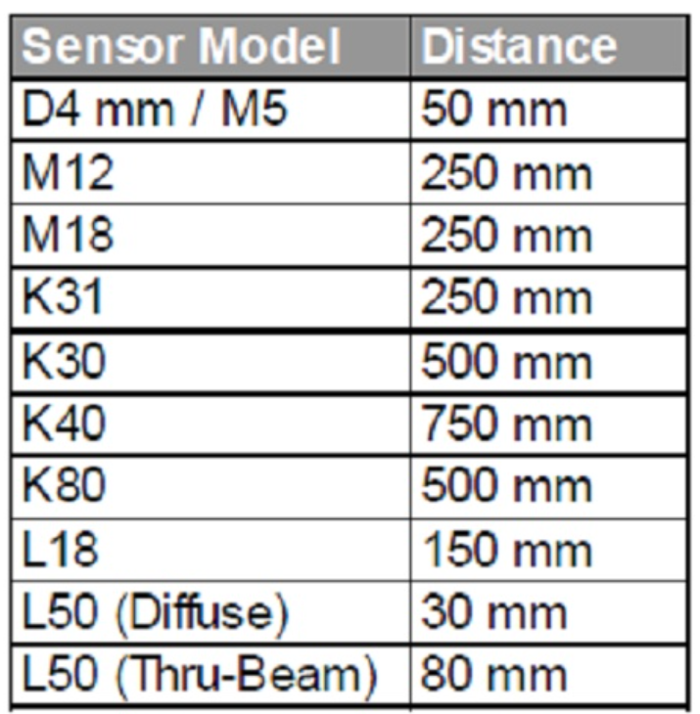
Excess Gain
Many environments, particularly industrial applications, include dust, dirt, smoke, moisture, or other airborne contaminants. A sensor operating in an environment that contains these contaminants requires lighter to operate properly.
There are six grades of contamination:
1. Clean Air (Ideal condition, climate controlled or sterile)
2. Slight Contamination (Indoor, nonindustrial areas, office buildings)
3. Low Contamination (Warehouse, light industry, material handling operations)
4. Moderate Contamination (Milling operations, high humidity, steam)
5. High Contamination (Heavy particle laden air, extreme wash down environments, grain elevators)
6. Extreme/Severe Contamination (Coal bins, residue on lens)
Excess gain represents the amount of light emitted by the transmitter in excess of the amount required to operate the receiver. In clean environments an excess gain equal to or greater than 1 is usually sufficient to operate the sensor’s receiver. If, for example, an environment contained enough airborne contaminants to absorb 50% of the light emitted by the transmitter, a minimum excess gain of 2 would be required to operate the sensor’s receiver.
Excess gain is plotted on a logarithmic chart. The example shown below is an excess gain chart for an M12 thru- beam sensor. If the required sensing distance is 1 m there is an excess gain of 30. This means there is 30 times lighter than required in clean air hitting the receiver. Excess gain decreases as sensing distance increases. Keep in mind that the sensing distance for thru-beam sensors is from the transmitter to the receiver and the sensing distance for reflective sensors is from the transmitter to the target.

Switching Zones
Photoelectric sensors have a switching zone. The switching zone is based on the beam pattern and diameter of the light from the sensor’s emitter. The receiver will operate when a target enters this area.
Diffuse Scan Correction Factors
The specified sensing range of diffuse sensors is achieved by using a matte white paper. The following correction values may be applied to other surfaces. These values are guidelines only and some trial and error may be necessary to get correct operation.
• Test Card (Matte White) 100%
• White Paper 80%
• Gray PVC 57%
• Printed Newspaper 60%
• Lightly Colored Wood 73%
• Cork 65%
• White Plastic 70%
• Black Plastic 22%
• Neoprene, Black 20%
• Automobile Tires 15%
• Aluminum, Untreated 200%
• Aluminum, Black Anodized 150%
• Aluminum, Matte (Brushed Finish) 120%
• Stainless Steel, Polished 230%
Diffuse Scan with Background Suppression
Diffuse scan with background suppression is used to detect objects up to a certain distance. Objects beyond the specified distance are ignored. Background suppression is accomplished with a position sensor detector (PSD). Reflected light from the target hits the PSD at different angles, depending on the distance of the target. The greater the distance the narrower the angle of the reflected light.
Diffuse Scan Effective Beam
The effective beam is equal to the size of the target when located in the beam pattern. Operating Modes There are two operating modes: dark operate (DO) and light operate (LO). Dark operate is an operating mode in which the load is energized when light from the emitter is absent from the receiver.
Light operate is an operating mode in which the load is energized when light from the emitter reaches the receiver.
The following table shows the relationship between operating mode and load status for thru, retroreflective, and diffuse scan.
Fiber Optics
Fiber optics is not a scan technique, but another method for transmitting light. Fiber optic sensors use an emitter, receiver, and a flexible cable packed with tiny fibers that transmit light. Depending on the sensor there may be a separate cable for the emitter and receiver, or it may use a single cable. When a single cable is used, the emitter and receiver use various methods to distribute emitter and transmitter fibers within a cable. Glass fibers are used when the emitter source is infrared light. Plastic fibers are used when the emitter source is visible light.
Fiber optics can be used with thru-beam, retroreflective scan, or diffuse scan sensors. In thru beam light is emitted and received with individual cables. In retroreflective and diffuse scan light is emitted and received with the same cable (bifurcated). Fiber optics is ideal for small sensing areas or small objects. Fiber optics have a shorter sensing range due to light losses in the fiber optic cables.
Lasers
Lasers are sometimes used as sensor light sources. Siemens uses Class 2 lasers which have a maximum radiant power of 1 mW. Class 2 lasers require no protective measures and a laser protection officer is not required. However, a warning notice must be displayed when laser sensors are used. Laser sensors are available in thru- beam, diffuse scan, and diffuse scan with background suppression versions. Lasers have a high intensity visible light, which makes setup and adjustment easy. Laser technology allows for detection of extremely small objects at a distance. The Siemens L18 sensor, for example, will detect an object of 0.03 mm at a distance of 80 cm.
Examples of laser sensor applications include exact positioning, speed detection, or checking thread thickness of 0.1 mm and over.
Photoelectric Sensors detect objects, changes in surface conditions, and other items through a variety of optical properties.
A Photoelectric Sensor consists primarily of an Emitter for emitting light and a Receiver for receiving light. When emitted light is interrupted or reflected by the sensing object, it changes the amount of light that arrives at the Receiver. The Receiver detects this change and converts it to an electrical output. The light source for the majority of Photoelectric Sensors is infrared or visible light (generally red, or green/blue for identifying colors).
Photoelectric Sensors are classified as shown in the figure below.
Through-beam Sensors
Retro-reflective Sensors
Diffuse-reflective Sensors
Operating Principles
(1) Properties of Light
Rectilinear Propagation
When light travels through air or water, it always travels in a straight line. The slit on the outside of a Through- beam Sensor that is used to detect small objects is an example of how this principle is applied to practical use.
Refraction
Refraction is the phenomenon of light being deflected as it passes obliquely through the boundary between two media with different refractive indices.
Reflection (Regular Reflection, Retroreflection, Diffuse Reflection)
A flat surface, such as glass or a mirror, reflects light at an angle equal to the incident angle of the light. This kind of reflection is called regular reflection. A corner cube takes advantage of this principle by arranging three flat surfaces perpendicular to each ther. Light emitted toward a corner cube repeatedly propagates regular reflections and the reflected light ultimately moves straight back toward the emitted light. This is referred to as retroreflection.
Most retroreflectors are comprised of corner cubes that measure several square millimeters and are arranged in a precise configuration.
Matte surfaces, such as white paper, reflect light in all directions. This scattering of light is called diffuse reflection.
This principle is the sensing method used by Diffuse-reflective Sensors.
Polarization of Light
Light can be represented as a wave that oscillates horizontally and vertically. Photoelectric Sensors almost always use LEDs as the light source. The light emitted from LEDs oscillates in the vertical and horizontal directions and is referred to as unpolarized light. There are optical filters that constrain the oscillations of un- polarized light to just one direction. These are known as polarizing filters. Light from an LED that passes through a polarizing filter oscillates in only one direction and is referred to as polarized light (or more precisely, linear polarized light). Polarized light oscillating in one direction (say the vertical direction) cannot pass through a polarizing filter that constrains oscillations to a perpendicular direction (e.g., the horizontal direction). The MSR function on Retro-reflective Sensors and the Mutual Interference Protection Filter accessory for Through-beam
Sensors operate on this principle.
(2) Light Sources
The majority of Photoelectric Sensors use pulse modulated light that basically emits light repeatedly at fixed intervals. They can sense objects located some distance away because the effects of external light interference are easily removed with this system. In models equipped with mutual interference protection, the emission cycle is varied within a specified range to handle coherent light and external light interference.
<Non-modulated Light>
Non-modulated light refers to an uninterrupted beam of light at a specific intensity that is used with certain types of Sensors, such as Mark Sensors. Although these Sensors have fast response times, their drawbacks include short sensing distances and susceptibility to external light interference.
(3) Optical Fiber Sensors Structure
With no electrical components in the sensing section (fiber), the Optical Fiber Sensor is highly resistant to noise and other environmental influences.
Detection Principles
Optical fiber is comprised of a central core with a high refractive index surrounded by cladding with a low refractive index. When light enters the core, repetitive total internal reflection at the boundary of the less refractive cladding guides the light down the optical fiber. The angle of the light traveling through the optical fiber increases to about 60° by the time the light exits the fiber and strikes a sensing object.
4) Triangulation
Distance-settable Sensors generally operate on the principle of triangulation. This principle is illustrated in the following diagram.
Light from the Emitter strikes the sensing object and reflects diffused light. The Receiver lens concentrates the reflected light on the position detector (a semiconductor that outputs a signal according to where the light strikes it). When the sensing object is located at A near the optical system, then the light is concentrated at point a on the position detector. When the sensing object is located at B away from the optical system, then the light is concentrated at point b on the position detector.
Features:
(1) Long Sensing Distance: A Through-beam Sensor, for example, can detect objects more than 10 m away. This is impossible with magnetic, ultrasonic, or other sensing methods.
(2) Virtually No Sensing Object Restrictions: These Sensors operate on the principle that an object interrupts or reflects light, so they are not limited like Proximity Sensors to detecting metal objects. This means they can be used to detect virtually any object, including glass, plastic, wood, and liquid.
(3) Fast Response Time: The response time is extremely fast because light travels at high speed and the Sensor performs no mechanical operations because all circuits are comprised of electronic components.
(4) High Resolution: The incredibly high resolution achieved with these Sensors derives from advanced design technologies that yielded a very small spot beam and a unique optical system for receiving light. These developments enable detecting very small objects, as well as precise position detection.
(5) Non-contact Sensing: There is little chance of damaging sensing objects or Sensors because objects can be detected without physical contact. This ensures years of Sensor service.
(6) Color Identification: The rate at which an object reflects or absorbs light depends on both the wavelength of the emitted light and the color of the object. This property can be used to detect colors.
(7) Easy Adjustment: Positioning the beam on an object is simple with models that emit visible light because the beam is visible.
Classification:
Classification by Sensing Method
1) Through-beam Sensors
Sensing Method
The Emitter and Receiver are installed opposite each other to enable the light from the Emitter to enter the Receiver. When a sensing object passing between the Emitter and Receiver interrupts the emitted light, it reduces the amount of light that enters the Receiver. This reduction in light intensity is used to detect an object.
The sensing method is identical to that of Through-beam Sensors and some models called Slot Sensors are configured with an integrated Emitter and Receiver.
Features
• Stable operation and long sensing distances ranging from several centimeters to several tens of meters.
• Sensing position unaffected by changes in the sensing object path.
• Operation not greatly affected by sensing object gloss, color, or inclination.
2) Diffuse-reflective Sensors: Sensing Method The Emitter and Receiver are installed in the same housing and light normally does not return to the Receiver.
When light from the Emitter strikes the sensing object, the object reflects the light and it enters the Receiver where the intensity of light is increased. This increase in light intensity is used to detect the object.
Features
• Sensing distance ranging from several centimeters to several meters.
• Easy mounting adjustment.
• The intensity of reflected light and operating stability vary with the conditions (e.g., color and smoothness) on the surface of the sensing object.
3) Retro-reflective Sensors: Sensing Method The Emitter and Receiver are installed in the same housing and light from the Emitter is normally reflected back to the Receiver by a Reflector installed on the opposite side. When the sensing object interrupts the light, it reduces the amount of light received. This reduction in light intensity is used to detect the object.
Features
• Sensing distance ranges from several centimeters to several meters.
• Simple wiring and optical axis adjustment (labor saving).
• Operation not greatly affected by the color or angle of sensing objects.
• Light passes through the sensing object twice, making these Sensors suitable for sensing transparent objects.
• Sensing objects with a mirrored finish may not be detected because the amount of light reflected back to the Receiver from such shiny surfaces makes it appear as though no sensing object is present.
This problem can be overcome using the MSR function.
4) Distance-settable Sensors
Sensing Method
The Receiver in the Sensor is either a 2-part photodiode or a position detector. The light reflected from the sensing object is concentrated on the Receiver. Sensing is based on the principle of triangulation, which states that where the beam is concentrated depends on the distance to the sensing object.
The following figure shows a detection system that uses a 2-part photodiode. The end of the photodiode nearest the case is called the N (near) end and the other end is called the F (far) end. When a sensing object reaches the preset position, the reflected light is concentrated midway between the N end and the F end and the photodiodes at both ends receive an equal amount of light. If the sensing object is closer to the Sensor, then the reflected light is concentrated at the N end. Conversely, the reflected light is concentrated at the F end when the sensing object is located farther than the preset distance. The Sensor calculates the difference between the light intensity at the N end and F end to determine the position of the sensing object.
Features of Distance-settable Sensors
• Operation not greatly affected by sensing object surface conditions or color.
• Operation not greatly affected by the background.
    - Electro-mechanical elements
Relays are some of electro-mechanical elements. Electromechanical relays are an excellent solution to separate electronic control circuitry and power circuitry. Electromechanical relays are not the best choice in high frequency switching applications and do have a limited life due to wear on the contacts inside the relay. When used in the proper application, the electromechanical relay provides safe and reliable integration between power circuits and control circuits.
Common applications of electromechanical relays are:
- Solenoid Activation Control
- Many Automotive Applications (Electric Fuel Pump)
- Motor Control
The Principle behind Electromechanical Relays:
A relay is similar to a switch; it is either open or closed. When the switch is open no current passes through the relay, the circuit is open, and the load that is connected to the relay receives no power. When a relay is closed, the circuit is completed and current passes through the relay and delivers power to the load.
To open and close a relay an electromagnet is used. When the coil controlling the electromagnet is given a voltage, the electromagnet causes the contacts in the relay to connect and transfer current through the relay.
Internal parts of Electromechanical Relays
This diagram below shows the basic parts of an electromechanical relay: a spring, moveable armature, electromagnet, moveable contact, and stationary contact. The spring keeps the two contacts separated until the electromagnet is energized, pulling the two contacts together
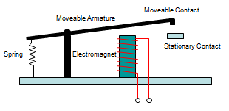
Figure 1. 22 Basic parts of an electromechanical relay

Wiring Up an Electromechanical Relay
This diagram below shows how to wire electromechanical relay. When the control circuit turns the electromagnet on, the moveable armature is drawn towards the electromagnet and connects the moveable contact and the stationary contact. This completes the circuit and delivers power to the load.
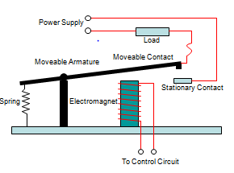
Figure 1. 23 How to wire electromechanical relay

Typical Sample Application of Relays
Suppose, there is a need to control a solenoid valve for a water drain application. Control is to be accomplished with a microcontroller. The solenoid valve requires 120 VAC to open. Assuming that a 120 VAC power supply is available, how can control of the solenoid valve be accomplished using a microcontroller that can only supply 5 VDC?
This problem is easily solved using a relay. There are many relays that are turned on and off with a 5 VDC coil. The relay provides the interface between the microcontroller and the 120 VAC power supplies that is needed to open and close the valve.
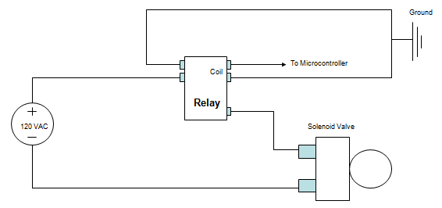
Figure 1. 24 Circuit for Control of a 120 VAC Solenoid Valve

    - Pneumatic & electro-pneumatic elements
For efficient movement and control, the following pneumatic system components include:
- Air Compressor. As an air exhausting mechanism, this pneumatic equipment component sucks in outside air, compresses it and harnesses the air for use in your process
- Pneumatic Cylinders
- Pneumatic Fittings
- Tubing
- Pneumatic Valves
Pneumatic (gas) and hydraulic (liquid) systems are fundamental important concepts to fluid power, which includes both systems, contain four basic components: reservoir/receiver, pump/compressor, valve, and cylinder.
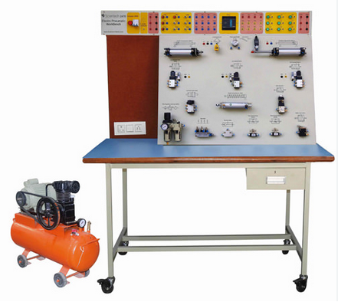
Figure 1. 25 Component of pneumatic system

Electro pneumatic Control System
Considering the fact that so many people use air compresses that are powered by electricity, you might be under the impression that electro-pneumatic technology doesn’t go any further than this. That being said, when technologists use the name electro-pneumatic control system, they normally mean a class of components that incorporate both electrical and compressed air-driven technology on a particularly close level.
Defining Electro-Pneumatic Control Systems
Various types of switches and solenoid valves have been used to compliment a physical compressed-air driven system. These utilize electrical current to switch the position of different valves and junctions. You could theoretically control the flow of compressed air with a push-button using this kind of technology. Some people prefer to wire all of these devices into a single panel, which is an attractive solution for those who have to manage a whole set of pneumatic devices from a central location.
You might also be interested in connecting a system using various types of solenoid valves, which utilize electrical coil windings to actuate a valve’s moving components. When current passes over the coil, it trips the system and moves the direction of air. The flow of air from a compressor or pressurized container is going to then remain relatively constant. Think of the flow as something like water flowing through a passage. Once it fills up, the system remains under pressure without using any more fluid.
Using these components doesn’t require a great deal of additional training either. Anyone with at least a working knowledge of basic electrical theory can install them in an existing air circuit.
    - Hydraulic elements
What are the 5 basic components of a hydraulic system?
System "Plumbing" Components
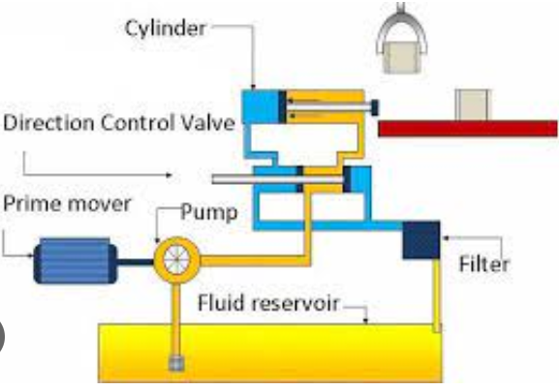
Figure 1. 26 basic components of a hydraulic system
- Reservoir. Hydraulic fluid reservoirs are required by most aircraft systems to provide a ready source of fluid for the hydraulic pump(s) and to contain a varying volume of fluid.
- Filters
- Shut Off Valves
- Control Valves
- Pressure Relief Valve
- Hydraulic Fuses
- Accumulators
    - Electronic logic control elements
A Programmable Logic Controller (PLC) is an industrial computer control system that continuously monitors the state of input devices and makes decisions based upon a custom program to control the state of output devices. That is, you can mix and match the types of Input and Output devices to best suit your application.
Components of PLC:

- Power supply
- The Central Processing Unit (CPU)
- Input/output Modules
- Software
- Programming Device
- Instruction Set
- Instruction Set

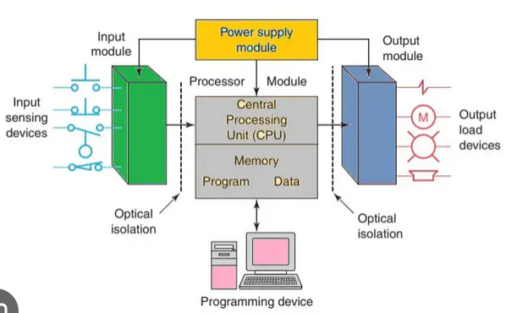
Figure 1. 27 Basic Components of PLC

A programmable logic controller (PLC) is the hardware that is adapted to control manufacturing processes or any activity that requires logic, counting, timing, and network communications. It is a good example of a tangible real-time system that produces output results within a limited time in response to input conditions. In case the input conditions are not met, it can result in an unintended operation that affects the entire process. This article discusses the main components of a PLC system to understand how they control activities that require high reliability, process fault diagnosis, and allow ease of programming.
- Power Supply
A power supply provides direct current to the central processing unit (CPU) and other modules in the rack. A PLC without power supply can be compared to a laptop without a battery or a car without fuel. They are available in different power ratings and sizes depending on the PLC itself. The common current ratings for smaller PLC systems range between 2 to 10 amps while larger powerful controllers can go up to 50 amps. The current rating of your PLC determines the amount of work that can be done by the system. However, most PLCs are designed with a backup battery to provide energy to the CPU for a limited duration in case of a power outage or supply failure.
- The Central Processing Unit (CPU)
The central processing unit provides intelligence and is considered the “brain” of the PLC. It is comprised of the microprocessor that initiates control functions, calculations, and memory storage of the program. The processor implements logic and controls communications among modules in the PLC. A CPU can perform data manipulation and arithmetic functions. It accepts input data and executes the user program before sending appropriate output commands to other control devices.
- Input/output Modules
These modules allow the processor to connect to the field devices. They establish a connection between PLC and field devices such as control valves, pressure transmitters, flow transmitters, and analyzers. Examples of I/O modules include the Analog input and output module, and the Digital input and output module. Input assemblies carry signals from the process into the PLC while output modules send data from the PLC to external sources to adjust or control the process. Analog inputs and outputs may change progressively over a variable range such as temperature, pressure, or potentiometer. Digital inputs and outputs operate with a binary or discrete change such as yes/no or on/off.
- Software
The operating system (OS) provides effective support in the creation of project structure and user programs. It is accessed through the main window also known as a graphical user interface. The main window contains all the necessary functions that are required to set up a project, write and test programs, and configure the hardware. The CPU cyclically scans and executes the main program when processing a PLC program. A program scan cycle is comprised of sequential operations such as input, program, and output scan. The CPU in the input scan updates the process image input table while the process image output table is updated in the output scan.
- Programming Device
A personal computer (PC) with the appropriate software allows users to create, edit, store, and troubleshoot various programs. The PC communicates with the PLC processor via a parallel or serial data communication link. Sometimes hand-held devices are used to program small PLCs. Although hand-held devices are compact, affordable, and easy to use, they don’t display as much logic on the screen compared to a computer monitor. They are often used in the factory floor for modification of programs, troubleshooting, and transfer of programs to multiple machines.
- Instruction Set
An instruction is a command that makes the PLC executes a certain predetermined operation. The instruction set is made up of all the main programming commands such as program control, timer and counter instructions, Bit Instructions, Move/ Logical, Sequencer, and Array shift instructions. Each type of PLC lists the different types of supported instructions. Retentive or battery-backed relays are used in circuits to ensure the PLC is shut down safely during a power failure so that it can restart appropriately.
Programmable logic controllers have become popular in both industrial and commercial applications as they produce output results within a limited time in response to input conditions. Although they span a wide range of sizes, they all perform the basic functions but on a different scale based on size. All the above physical components of a PLC work together to provide logic and fulfill the input conditions by delivering desirable outcomes.
    - Robotic control elements
- Robot any automatically operated machine that replaces human effort, though it may not resemble human beings in appearance or perform functions in a humanlike manner. By extension, robotics is the engineering discipline dealing with the design, construction, and operation of robots.
- Robotics, design, construction, and use of machines (robots) to perform tasks done traditionally by human beings. Robots are widely used in such industries as automobile manufacture to perform simple repetitive tasks and in industries where work must be performed in environments hazardous to humans.
- Control systems allow for the movement and function of various parts of the robot, as well as execute a specific set of motions and forces in the presence of unforeseen errors. ... It also aims to highlight the various issues revolving around Control Systems and the various ways of fixing it.

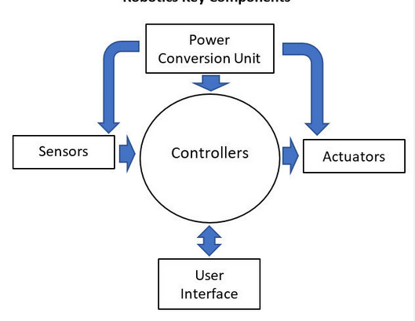
Figure 1. 28 Main component of Robot

Eight key components of every robot
- Actuation: Advertisements:
- Motors:
- Stepper motors:
- Piezo Motors:
- Air Muscles:
- Electro active polymers:
- Elastic Nan tubes:
- Manipulation:
    - Actuators & output devices
An actuator is a device that uses a form of power to convert a control signal into mechanical motion. From electric door locks in automobiles, to ailerons on aircraft, actuators are all around us.
An output device does two things in the control system: It can notify the operators about a state in the system in relation to the program uploaded to the PLC, or it can perform tasks for the user upon instruction and/or automation. It only requires that the devices be electrically controlled to become capable of being controlled by the PLC.
The previously stated devices are not the only output devices out there, obviously. There are tons of newly designed output devices that perform tasks that are more and more specific. What matters is that you choose the right output device for the design that you are working with.
    - Check Mechatronics devices
The checking and testing of the mechatronic system is performed depending on the field (mechanical, electrical, information theory). For the mechanical part, standard methods are defined for the three fields participating in the mechatronic integration.
For the mechanical field we need to specify the problem, define functions and structures, find solutions and principles, do a division of feasible modules (into sub-activities), model on components, modeling on the final product and draw up the execution plan and the instructions for use.
For the electrical and electronic field, we need to have clear specifications, a description of the system with an overview, a description of the algorithms used, of the interfaces, the logical functioning and integration needs to be done.
  - Components of Mechatronics system:
The term Mechatronics system (sometimes referred to as smart device) encompasses a myriad of devices and systems. Increasingly, microcontrollers are embedded in the electromechanical devices, creating much more flexibility and control possibilities in system design.
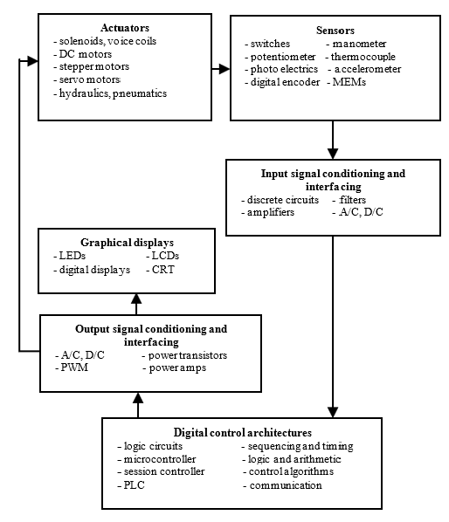
Figure 1. 29 Components of a typical Mechatronics system

Actuators: produce motion or cause some action. Solenoids, voice calls, DC motors, Stepper motor, servomotor, hydraulic, pneumatic.
Sensors: detect the state of the system parameters, inputs and outputs. Switches, potentiometer, photoelectric, digital encoder, strain gauge, thermocouple, accelerometer etc.
Input/output Signal conditioning and interfacing: provide connection between the control system circuits and the input/output devices. Discrete circuits, amplifiers, filters, A/D, D/A, power transistor etc.
Digital devices: controls the system. Logic circuits, micro controller, SBC, PLC etc
Graphic Display: provide visual feedback to users. LEDs, Digital Displays, LCD,CRT
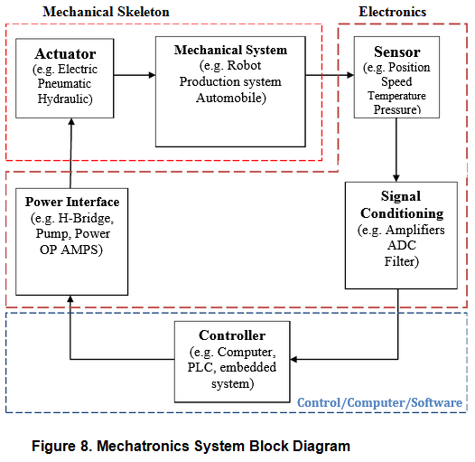
Figure 1. 30 Mechatronics System Block Diagram

Tools, equipment and testing devices

Definitions of Tools & equipment
Tools and equipment are two words that are often used synonymously, mainly due to the similarities of their meanings. A tool can be any item that is used to achieve a goal. Equipment usually denotes a set of tools that are used to achieve a specific objective.
During the maintenance and repair work, the following tools, equipment and testing devices are needed:

- Cutter
- Shaper
- Drill
- Threading tool(assorted)
- tapping
- pliers (assorted)
- screw drivers (assorted)
- soldering iron/gun
- wrenches
- maintenance bench
- instrument air supply equipment
- power supply equipment
- multi-meter
- Calibrators etc…

Self-check (1.1)

Instruction 2: Match the ISA symbols in Column A with its respective description in

1 | 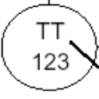 | A | Temperature transmitter
2 | 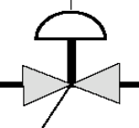 | B | Electrically actuated valve
3 | 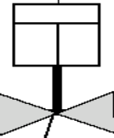 | C | Programmable logic control
4 | 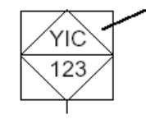 | D | Pneumatically actuated valve
Directions: Answer the following questions. (6 points)
- What is an OHS Policy?
- Mention at least 5 benefits of planning.
- Corrective Maintenance covers:
- Write eight key components of every robot
- Mention at least 5 pneumatic system components.
- Mention at least 4 PLC system main components
- What are key elements of Mechatronics system
- Give at least 4 examples of actuators
- Write principle of operation for Limit switch, Inductive sensor, Capacitive sensor, photo sensor.

Operation Sheet (1.1): Troubleshooting a Sensor Using Multimeter
Purpose | To approve whether the sensor is functional or not.
Equipment, tools and materials | Supplies and equipment needed or useful for Troubleshooting a Sensor  - Multimeter  - Sensor
Conditions or situations for the operations | - A hand washing sink that works by a sensor is not functional.
Procedures | Step 1: Disconnect the wires for the sensor at its power source.  Step 2: Plug the black probe into the COM (common) port on your  multimeter. Plug the red probe into the VΩ port.  Step 3: Set your multimeter to Continuity - the symbol looks a bit like this:  Step 4: Connect the red probe to the + wire going to the sensor, and connect the black probe to the ground wire going to the sensor.  Step 5: If the multimeter registers a reading, your circuit wiring is intact. If the multimeter does not register a reading, then there is something wrong with the wiring. Repeat these steps along the various sections of the circuit between the source and sensor to isolate the problem.  Step 6: This process can (and should!) also be performed with your  sensor’s communication wiring.
Precautions | - Wear appropriate PPE.  - Apply safety procedures  .
Quality criteria | - After trouble shooting, a hand washing sink will be functional.

LAP Test (1.1)

Instructions: Given necessary templates, tools and materials you are
required to perform the following tasks within 1 hours.

Task 1: Demonstrate how to save the life of the electric victim person within 10
minutes by following right procedure.

Task 2: Perform approval tests for a sensor by multimeter.

Unit 2: Maintain Mechatronics devices
This learning guide is developed to provide you the necessary information regarding the following content coverage and topics:
- Scheduled/periodic maintenance
- Normal function of mechatronics device.
- Mechatronics components/ parts adjustments and replacement
- Unplanned events or conditions
This guide will also assist you to attain the learning outcome stated in the cover page. Specifically, upon completion of this Learning Guide, you will be able to:
- Perform scheduled/periodic maintenance
- Check normal function of Mechatronics device
- Respond necessary adjustments, replacement of components/parts of mechatronics
- Respond unplanned events or conditions

Scheduled/periodic maintenance
Scheduled maintenance often occurs at repeating intervals, such as changing an air filter every March and September, or conducting a performance inspection at the start of each year. Maintenance may also be scheduled to fulfill a work order. Once a problem is discovered, a maintenance scheduler works with a maintenance planner to resolve the problem. A time is then scheduled to conduct necessary repairs.
    - Scheduled maintenance
Scheduled maintenance is any task that is given a deadline and assigned to a technician. It can either be a recurring task done at regular intervals or a one-time task. Scheduled maintenance includes inspections, adjustments, regular service, and planned shutdowns.
An example of scheduled maintenance occurring at repeating intervals is changing a bearing on a conveyor belt every 30 days or inspecting the condition of a motor every 90 days. Scheduled maintenance can also take the form of a one-time work order. If a problem with an asset or part is identified, a time is scheduled to check and repair the asset.
The primary goals of scheduled maintenance are to reduce reactive maintenance, equipment failure, and maintenance backlog. Standard checks help increase the lifetime of assets and reduce the number of equipment repairs and replacements. Scheduling tasks also allows you to better allocate resources in a cost-effective and efficient manner.
    - Importance of scheduled maintenance
In addition to managing the time at which maintenance tasks should occur, scheduled maintenance also deals with who performs those tasks. The time it takes for the job to be completed is compared with available work hours, which are factored into the schedule. The key here is to make sure those who should perform a given task are available to do so. Without coordinating a set time with maintenance workers and contractors, there is no guarantee that necessary work will be completed on time.

- Difference between scheduled maintenance and planned maintenance
While scheduled maintenance and planned maintenance are often used interchangeably, there are differences between the two.
Planned maintenance is the act of anticipating maintenance work and implementing a process for completing this work. This includes everything from how to identify a task, to required materials and workflows, prioritization, and procedures for analyzing completed tasks. Planned maintenance comes in all shapes and sizes, including reactive maintenance, preventive maintenance, condition-based maintenance, and predictive maintenance. As long as there is a plan in place to address a situation, whether it’s running a light bulb until it fails or lubricating a motor on a bi-weekly basis, it is planned maintenance.
Scheduled maintenance is the act of deciding when planned maintenance tasks should be completed and who should complete them. While planned maintenance establishes a process, scheduled maintenance is part of that process. When an issue or task is identified, it can be given a deadline for completion and assigned to a technician. This is when it becomes scheduled maintenance.
    - Scheduled maintenance critical percent (SMCP)
In a perfect world, maintenance is scheduled, a deadline is set, and tasks are done on time. But we don’t live in a perfect world - maintenance is overdue sometimes. When this happens, it can be hard to sort out which tasks should take priority and which can wait.
Scheduled maintenance critical percent is a tool to organize your recurring scheduled maintenance tasks (PMs). When several of these PMs are overdue, calculating SMCP helps you determine which one should be done first. It does this by calculating how late your PMs are in relation to how often they should be occurring. The higher the percentage, the higher that PM should be prioritized.
- How to calculate SMCP
The formula for scheduled maintenance critical percent starts by adding the number of days a PM is late and the number of days in the PM’s cycle. This number is divided by the number of days in the PM’s cycle and multiplied by 100.
SMCP = (No. of days late + No. of days in the PM cycle) ÷ No. of days in the PM cycle x 100
$$SMCP=\frac{No.of days late +No.ofdays in the PM cycle}{No.of days in the PM cycle}×100$$
For example, let’s say you have two overdue scheduled maintenance tasks on identical systems. One is a PM that is supposed to be done every 30 days, but is three days late (PM #1). The other is a PM that is supposed to be done every 90 days, but is five days late (PM #2). The SMCP calculation determines which task is more critical.
PM #1: (3+30) ÷ 30 x 100 = 110%
PM #2: (5+90) ÷ 90 x 100 = 105%
In this situation, the PM that is three days late has a higher critical percentage and, therefore, should be completed before the PM that is five days late.
- How is SMCP used?
Overdue maintenance can cost your facility money and uptime. Calculating SMCP is a way to mitigate these costs and use resources more effectively. SMCP is used to organize overdue tasks by the impact they have on the organization. The higher the percentage, the bigger the risk associated with that overdue task. By targeting the most important work, inefficiencies and lost production can be systematically eliminated from the shop floor.
    - Scheduled maintenance workflow
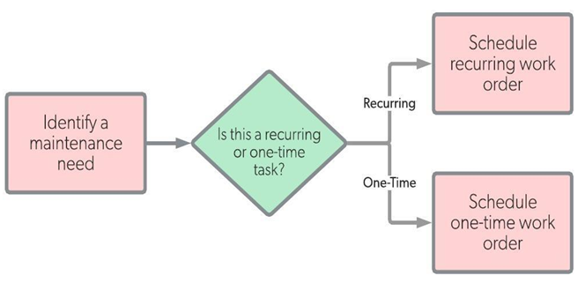
Figure11. Scheduled maintenance workflow
Benefits of scheduled maintenance
In addition to minimizing downtime, scheduled maintenance serves a variety of other purposes.
- Higher personnel utilization since maintenance workers spend more time working
- Increased asset life expectancy as breakdowns are prevented
- Lower maintenance costs as time is utilized efficiently and costly problems are prevented
- Culture of proactive efficiency as personnel perform needed tasks
- Reduced liability as assets are kept in safe working condition

Normal functions of Mechatronics devices
Checking is commonly used to verify grounding and bonding connections in electrical systems. This topic verifies the proper operation of disconnecting means and the function of overcurrent protection devices like fuses and circuit breakers.
Mechatronics devices should be thoroughly tested at the time of maintenance and periodically over their lifetime to ensure proper performance and safe operation.

    - Faults in control systems - unexpected behavior
When control systems work well for a while, they tend to be taken for granted. Failure is often marked by a sudden and dramatic change in behavior rather than a gradual deterioration seen in other machinery. This often occurs because the feedback which compensates for process variation can also mask progressive failure of a system component. The failure then only becomes evident when the controller can no longer compensate for this and the process variation combined. While each type of control system (mechanical, electronic, hydraulic, etc) has characteristic failures, there are failures common to all in principle.
    - Runaway
One of the most alarming and dangerous failures occurs when a position controller drives its load to one end of its range at maximum speed, possibly causing mechanical damage.
This type of failure emphasizes the need to cushion the load at each end, no matter how reliable the controller maybe. Hydraulic cylinders are provided with optional hydraulic cushions as part of their design. Electric drives require limit switches to disable the motor if it is driving the load towards the end, and these must be placed far enough from the ends to allow the motor to run down and stop. With large loads or inertias, rubber cushions or shock absorbers are essential.
Possible explanations for runaway are:
- Feedback sensor failure: For example, if the mechanical coupling to the position sensor fails, then the measured position will not change, even if the motor shaft rotates. When a new position is requested, the motor turns to drive the load towards the desired position. However, the feedback signal does not change so the controller drives the motor faster and faster until the load reaches the end of its allowed motion.....Bang! No external stimulus is needed—small natural perturbations can start a runaway sometime after the component failure occurs.
- Amplifier failure: Failure of the electronic switches or equivalent devices in an electrical amplifier or of the valve in a hydraulic or pneumatic controller can cause similar effects. Once again, a controller can be designed to shut off power when the error limit is exceeded. Note that the power shut-off mechanism or circuit must be independent of the amplifier. Hydraulic systems usually include an emergency shut-off valve which closes off the high-pressure supply to the servo -valves. Some hydraulic servos also include check valves between the servo-valve and the cylinder. These valves are held open during normal operation, but close if there is a power or controller failure. Electric and pneumatic servos may need a brake to stop motion safely.
- Mechanical failure: If the load is not directly driven by the motor, failure of the transmission or counterbalance can also cause runaway.
Experience suggests that wiring faults form a large proportion of all failures. Particularly with robots, wires and connectors are subjected to repeated flexure and vibration, and will fail with intermittent faults eventually.

Persistent, steady error
- Feedback sensor failure: For example, if the mechanical coupling to the position measurement encoder towards the desired position as measured by the sensor. If the error is large, this can cause a collision with the end stops. (Check the measured position when the load is at a known position. If the encoder has not slipped, check that the encoder mounting is secure.)
- In the case of an incremental encoder, false pulses may be generated by electro-magnetic interference (EMI). The interference may come from sources such as flickering fluorescent tubes or other motors starting or stopping. It can also come from the switching pulses of the servo motor—this may be the hardest to detect and confirm. Absolute encoders help to prevent this problem.
- Mechanical overload: the load on the motor is too great for the controller to compensate. Try removing or reducing the load.
- An excessive offset in amplifier or servo-valve can result in a steady error. (An offset exists if the amplifier or servo-valve input is non-zero when the motor is not moving).

Unstable transient response
After some time in operation, the control system may become less stable, with more overshoot after large position changes and more oscillation.
- If the motor drive power is reduced (or hydraulic pressure is reduced) the maximum drive power is reduced. This may cause unstable behaviour. (Measure maximum torque/force/acceleration and speed available.)
- Change in load inertia or stiffness. Usually, increased inertia causes more overshoot. However, if controller is "tuned" to the characteristics of a particular load, any change in load may reduce the controller performance. (Test controller with different loads.)
- Often the friction in mechanical systems decreases with use, and this can reduce the energy dissipated by friction. If a bearing or lubrication fails, friction can increase with age and this can also cause instability. (Measure friction changes.)
- Controller settings (such as gain) may have been accidentally changed following maintenance. Controllers should be designed such that gain settings do not have to be changed for maintenance or testing procedures. (Always record gain settings.)
- Backlash (mechanical slack movement) will occur in joints and bearings of mechanisms subject to wear. As backlash increases, unstable behavior of the controller may increase. Earlier we noted the importance of choosing an appropriate sensor location. If the backlash occurs between the actuator and the sensor, it will almost certainly cause instability. Otherwise, it will cause steady errors. However, even when the sensor is mounted on the actuator, backlash can cause unstable behavior if it occurs between the actuator and the load, because it changes the apparent load characteristics.

    - Implementing Mechatronics Testing Technologies
Mechatronics, systems that contains both mechanical components and electronics with controlling software, have become increasingly common. The systems typically include components from multiple vendors, and often are used as the basis for a product family with many variations and configurations. The same system can be used in vastly different applications, some of which are mission-critical.
Integrating computers, controls, and electronics into products that perform mechanical functions makes testing more difficult, and changes the way it is approached.
Here are two ways companies are integrating current testing technologies while developing new Mechatronics products.
      - NVH(noise, vibration and harshness) and Performance Testing: AAM Drivelines
      - Testing Siemens Fire Alarm Systems
NVH and Performance Testing: AAM Drivelines
American Axle & Manufacturing (AAM), a global Tier 1 automotive supplier of driveline and drive train products is developing a new torque transfer device and an electronic disconnect for an all-wheel drive (AWD) driveline. It provides the capability for full torque vectoring, front to rear and left to right, and is able to mechanically disconnect rotating components when not in use.
. 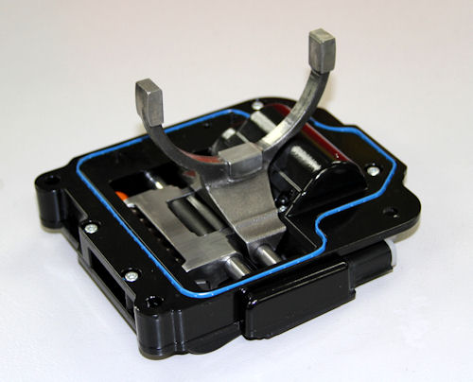
Figure 2. 1 AAM’s disconnecting AWD system actuator
There are also intelligent sensors that confirm the shifter board’s position—considered safety critical parts. There’s physical motion in the gear train, mechanical motion of the actuator, and electronic signals from the onboard controller and smart sensors.

        - Physical Test Motivations
Steyer explains that simulation technologies are used to define a robust design, allowing them to enter into the prototype phase with a high degree of confidence in the performance. During the development phase, in addition to design optimization and experimental validation, physical testing is done to confirm that the design is correct, that the assembly is to spec, and that all parts work well together.
AAM also tests prior to launch to ensure the quality of components. Steyer notes that the industry drives the company toward high levels of reliability for mission-critical components such as drive trains, where individual components have to reach fractions of incidents per thousand vehicles Internet Protocol television (IPTV).
“It takes confirmation with physical testing that we’re meeting the performance and reliability targets,” he says. “We need higher levels of assurance and confidence that we will pass testing at the end of the design phase, to proceed with the launch without impact or delay.”
        - Testing Technologies
A series of highly automated software tests are conducted on the controllers to confirm electrical functionality. Hundreds of thousands of test cycles and possible command states and operational state combinations are tested.
“We need positive confirmation that when asked to engage or disengage, it does,” Steyer says. “Testing involves sending computer command signals to cycle through the engage and disengagement, and monitoring whether the position is achieved through onboard smart sensors.”
In addition to functionality testing, AAM incorporates noise, vibration and harshness (NVH) testing to verify the durability of components mounted on the power train that will see road shock, adverse vibrations and thermal environments. Components are subject to shaker tests, where they are mounted to a shaker table and must continue functioning after a prescribed number of hours.
AAM’s actuators are also subjected to thermal chamber testing to ensure electrical and mechanical functionality is maintained before, during and after cycling through extreme temperatures.
        - Implementing NVH Testing
Steyer reports that AAM’s new product has the ability to sense and disconnect its rotating components when needed while driving. The onboard controller will anticipate when this functionality is needed, which depends on many factors, such as the driving state, speed and recent driving history. It can even gauge weather conditions to anticipate wet roads if the windshield wipers are on. When the system anticipates a need, it brings the rotating components from standstill up to speed within a fraction of a second to fully engage with the driveline. This action needs to be totally transparent to the user, however—there can be no noticeable shock or vibration.
Much effort is spent calibrating the system to engage it through tremendous acceleration as smoothly as possible. Testing is done on the vehicle with instruments measuring NVH and the “subjective feel” of the driver. An AWD NVH dynamometer is used to test the full system, including the power takeoff unit, prop shaft, torque transfer device and rear drive assembly, along with half shafts that go out to the wheel ends.
        - Testing Siemens Fire Alarm Systems
A second example of Mechatronics testing can be found in how Siemens produces and tests fire alarm systems for large buildings. These Mechatronics systems contain buzzers, alarms, smoke detectors and sprinklers controlled by a central machine. They open and close doors, control and diverge air flow, provide actions for egress, and emit voice messages to direct people to certain rooms. They have electrical sensors and actuators, mechanical interactions and intelligent software controls.
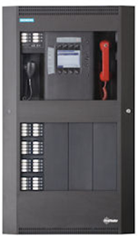 A Siemens fire panel. | In the past, testing these systems was done manually. A board would be created containing the sensors, smoke would be emitted over them, and testers would look at the control panels to see whether the sensors responded and whether they were configured properly.  Because fire alarm systems are almost always custom-configured for each customer, testing can be complicated. There are different scale systems for a small deployment, such as a store with a fire control system and 12 sensors, or a large deployment, such as an entire building with many floors and doors. Also, customers may need one type of fire system to handle a single building and another to handle an entire university campus, for example.  With such a high level of complexity at the component, system and configuration levels, automated testing technologies are needed not only to run operational tests, but to determine which tests are needed and how they should be configured.

        - Testing Implementation
Simulations are made of all the internal system components, so they can be directly interacted with and put into different states. Simulations are used to test configurations as early as possible. Instead of purchasing and setting up devices, extremes are tested under various operational conditions using simulations.
In addition to simulations, the testing environment can either consist entirely of “real parts” or be a mixture of simulated and actual sensors. “Smart hardware” can simulate multiple clients, and the software helps set up the test environment. When comparisons are desired, mixing physical testing with software can test pieces of a system that haven’t yet been developed, or were developed by multiple vendors.
Many different types of functional tests are run to see that all sensors respond. For example, operation of the fire panel controller is verified even if the power supply is cut off, or if sections are destroyed or disconnected. Operation is verified for simulated hardware failures or situations where many alerts arrive at once, and how the system scales during peak demand is observed.

Mechatronics components/parts adjustments and replacement
Maintenance is routine activities meant to prevent damage and prolong the life of appliances, fixtures, and the property itself. Examples include regular cleaning of air-conditioning units, grease traps, repainting, and the likes. In these examples, nothing is broken nor damaged, but work is still done to slow down deterioration.
    - Basic Maintenance Strategies
Mechatronics engineering involves multidisciplinary branches of engineering studies that is capable of providing the necessary skills to install, calibrate, modify, troubleshoot, repair and maintain automated systems. In industrial applications, most of the equipment or machineries are exposed to external vibration, especially in rotating machinery. Machine condition monitoring is the process of monitoring the condition of a machine with the intention to predict mechanical failures. Vibration is a key indicator of the state of the machine and widely used for predictive maintenance. Hence, a simulation rig, incorporating Mechatronics technologies such as sensors, actuators, signal processing and control, is vital to understand and implementation predictive maintenance.
The basic maintenance strategies can be divided into three parts which are breakdown maintenance, preventive maintenance and predictive maintenance.
This Information sheet deals with the conditioning of sensor signals so that they are suitable for use by other linear elements in the system.
Sensors, transducers, and converters were defined as follows:
- Sensors are devices that sense a variable and give an output (mechanical, electrical, and so on), that is directly related to the amplitude of the variable.
- Transducers are systems used to change the output from a sensor into some other energy form so that it can be amplified and transmitted with minimal loss of information.
- Converters are used to convert a signal’s format without changing the type of energy, i.e., an op-amp that converts a voltage signal into a current signal.

Unplanned events or conditions
Unplanned events are episodes that are not expected to occur during the Project’s normal construction and operational phase activities, such as accidents. The Project follows safety and engineering design criteria that aim to reduce the probability and consequences of unplanned events that could lead to adverse environmental, socio-economic or health and safety impacts
In order to know how to respond to unplanned events or conditions, one must first start in assessing or analyzing the situation. The first response should not be making an action right away, but thinking of the situation and possible solutions. After fully understanding the situation and listing down possible solutions, it's time to take action by trying all possible means to cope with the changes or unexpected events.
If working on a project, it's helpful to create a list of planned vs unplanned events so you can also think of safety measures on how to prevent the unplanned ones even before starting on the project.
Respond to unplanned events or conditions in accordance with established procedures:
- Establish procedures from appropriate personnel In accordance with procedures before any contingencies are implemented.
- Test Devices / systems and/or Machine is tested whether it conforms to requirements
- Remove parts or connections for the purpose of testing and pre-test conditions in accordance with established procedures
- Final inspections are undertaken to ensure the installed devices / systems conforms to requirements Trainers Methodology.

Self-check (2.1)

Directions 1: For the following questions, say TRUE if the statement
Is correct and FALSE if it is incorrect (wrong).
- Maintenance is routine activities meant to prevent damage and prolong the life of appliances.
- Transducers are used to convert a signal’s format without changing the type of energy.
- Converters are systems used to change the output from a sensor into some other energy.
- PPE is one of the least effective methods of controlling risk.
- Where PPE is in use, routine inspection, cleaning and maintenance is required.
- Remove all jewelry that might come in contact with electrical components.

Instruction 2: Match the followings from Column B to Column A
 | Mechanical failure |  | the measured position will not change
 | Amplifier failure |  | An excessive offset in amplifier
 | Mechanical overload |  | Failure of the electronic switches or equivalent devices
 | steady error |  | the load on the motor is too great for the controller to compensate
 | Feedback sensor failure |  | the load is not directly driven by the motor

Instruction III: Calculate and put the answer for given workout question
- Calculate the SMCP to determine which task is more critical if two overdue scheduled maintenance tasks on identical systems. One is a PM that is supposed to be done every 30days, but is three days late (PM No, 1). The other is a PM that is supposed to be done every 25 days, but is five days late (PM No. 2).

Directions IV: Answer the following question.

          - Write established procedures to respond unplanned events or conditions.
  - ……………………………………………………………………
  - ……………………………………………………………………
  - ……………………………………………………………………

Operation sheet (2.1):
Purpose | To acquire commissioning, operating, and maintaining elements of Mechatronics systems.
Equipment, tools and materials | Supplies and equipment needed or useful for commissioning, operating, and maintaining elements of Mechatronics systems:  - maintenance bench  - instrument air supply equipment  - power supply equipment  - multi-meter  - calibrators
Conditions or situations for the operations | - All tools, equipment’s and materials should be available on time when required.  - Appropriate working area/ workshop to commissioning
Procedures | Step1. Wear appropriate PPE for Testing and Adjusting of Mechatronics systems.  Step2. Check guarding against direct contact.  Step3.Check effectiveness of protective measures, in particular, fault current protective equipment, measure insulation, and short circuits.  Step4.Check the effectiveness of mechanical and electrical safety  fixtures, in particular, emergency off switches and alarm systems.  Step5.Check main circuits and gradually commission, measure  operational values, adjust target values.  Step6.Commission fluid power equipment.  Step7. Check and secure fixing, energy supply, lubrication, cooling,  and disposal Systems.  Step8. Inspect Mechatronics systems, check function of safety  systems and protocol Checks
Precautions | - Care should be taken while commissioning, operating, and maintaining Mechatronics systems.  - Should be done with concerned technician.
Quality criteria | After commissioning, operating, and maintaining; the system returns to its normal condition.
- Commissioning, operating, and maintaining elements of Mechatronics systems

LAP Test (2.1) Practical Demonstration

Name: _____________________________ Date: ________________

Time started: ________________________ Time finished: ________________

Instructions: Given necessary tools and materials you are required to perform the
following task within 3 hrs.

Task 1: Commission, operate, and maintain elements of Mechatronics systems.

UNIT 3. Troubleshoot Mechatronics devices
This learning guide is developed to provide you the necessary information regarding the following content coverage and topics:
- Normal function of mechatronics devices
- Troubleshoot fault/s or problem/s in system
- Adjustments and correction measures
- Unplanned events or conditions
This guide will also assist you to attain the learning outcome stated in the cover page. Specifically, upon completion of this Learning Guide, you will be able to:
- Check normal function of mechatronics devices
- Apply troubleshoot fault/s or problem/s in system or component
- Respond necessary adjustments and other correction measures
- Respond to unplanned events or conditions

Normal function of maintained Mechatronics device
    - Functional Test
Functional Testing is a type of software testing that validates the software system against the functional requirements/specifications. The purpose of Functional tests is to test each function of the software application, by providing appropriate input, verifying the output against the Functional requirements.
Functional testing mainly involves black box testing and it is not concerned about the source code of the application. This testing checks User Interface, APIs, Database, Security, Client/Server communication and other functionality of the Application under Test. The testing can be done either manually or using automation.
What do you test in Functional Testing?
The prime objective of Functional testing is checking the functionalities of the software system. It mainly concentrates on -
Mainline functions: Testing the main functions of an application
Basic Usability: It involves basic usability testing of the system. It checks whether a user can freely navigate through the screens without any difficulties.
Accessibility: Checks the accessibility of the system for the user
Error Conditions: Usage of testing techniques to check for error conditions. It checks whether suitable error messages are displayed.
How to do Functional Testing
Following is a step-by-step process on How to do Functional Testing:
- Understand the Functional Requirements
- Identify test input or test data based on requirements
- Compute the expected outcomes with selected test input values
- Execute test cases
- Compare actual and computed expected results
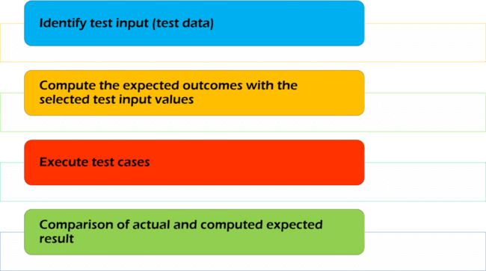
Figure 3. 1 Steps of Functional Testing
    - Check Control System of Mechatronics device
A control system is a collection of components that is designed to drive a given system (plant) with a given input to a desired output.
In a control system there is an interconnection between the constituent components. These components may be electrical, mechanical, hydraulic, pneumatic, etc.
Modification of the behavior of a system such that a desired behavior is achieved is called control. Controls are implemented by attaching a controller or compensator to the plant. The resulting combined system is called a control system. Control systems incorporate either human or machine controllers. When the controller is machine based, it is called automatic control.
- Within any control system there are variables and functions.
- Variables can be either constant or may vary with respect to some independent variable.
- Constant variables are called parameters.
- Varying variables are called signals.
Basic function of a control system is:
- To minimize the error between the actual and desired output.
- To minimize the time response to load changes in the system.
Requirement of a control system:
- Stability: for any change in the input signal, the output of the system reads or makes its response at a reasonable value.
- Accuracy: the closeness of the measured value to the true value is known as accuracy.
- Response: the quickness with which an instrument responds to a change in the output signal is known as response.
- Sensitivity: The sensitivity measures how much change is caused in the output by small changes to the reference input.
- Actuator
An actuator is a component of a machine that is responsible for moving and controlling a mechanism or system, for example by opening a valve. In simple terms, it is a "mover".
An actuator requires a control signal and a source of energy. The control signal is relatively low energy and may be electric voltage or current, pneumatic or hydraulic pressure, or even human power. Its main energy source may be an electric current, hydraulic fluid pressure, or pneumatic pressure. When it receives a control signal, an actuator responds by converting the signal's energy into mechanical motion.
An actuator is the mechanism by which a control system acts upon an environment. The control system can be simple (a fixed mechanical or electronic system), software-based (e.g. a printer driver, robot control system), a human, or any other input.
Different Types of Actuators
      - Mechanical Actuator
      - Pneumatic Actuator
      - Hydraulic Actuator
      - Electrical Actuator
      - Hybrid Actuator
- Mechanical Actuator:
In mechanical actuators normally a rotary motion is converted into linear motion to perform an operation. Such actuator normally involves gears, rails, pulley, chain, springs etc to operate.
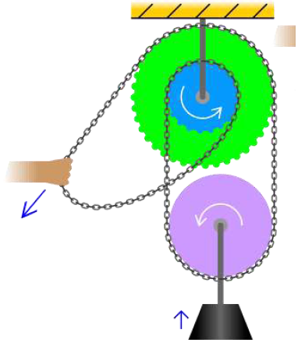
Figure 3. 2 example of a mechanical actuator

A basic example of a mechanical actuator is chain block hoisting weight in which mechanical motion of chain over the sprocket is utilized to lift a rated load.
- Pneumatic Actuator:
Pneumatic energy is most commonly used for actuators used for main engine controls. In this type, compressed air at high pressure is used which converts this energy into either linear or rotary motion.
A pneumatic actuator converts energy formed by vacuum or compressed air at high pressure into either linear or rotary motion. Pneumatic energy is desirable for main engine controls because it can quickly respond in starting and stopping as the power source does not need to be stored in reserve for operation. Moreover, pneumatic actuators are safer, cheaper, and often more reliable and powerful than other actuators.
Pneumatic actuators enable considerable forces to be produced from relatively small pressure changes. These forces are often used with valves to move diaphragms to affect the flow of liquid through the valve.
- Hydraulic Actuator:
Unlike air, liquid cannot be compressed and hence hydraulics generates higher energy than any other system. All systems involving high loads are operated by hydraulic actuators in which oil pressure is applied on mechanical actuator to give an output in terms of rotary or linear motion.
A hydraulic actuator consists of cylinder or fluid motor that uses hydraulic power to facilitate mechanical operation. The mechanical motion gives an output in terms of linear, rotatory or oscillatory motion. As liquids are nearly impossible to compress, a hydraulic actuator can exert a large force. The drawback of this approach is its limited acceleration.
The hydraulic cylinder consists of a hollow cylindrical tube along which a piston can slide. The term single acting is used when the fluid pressure is applied to just one side of the piston. The piston can move in only one direction, a spring being frequently used to give the piston a return stroke. The term double acting is used when pressure is applied on each side of the piston; any difference in pressure between the two sides of the piston moves the piston to one side or the other.
- Electrical Actuator:
It is one of the cleanest and readily available forms of actuating system as it does not involve oil; as there is no need to compress air, hence no extra machinery. Electrical energy is always available on ship. The electrical energy is used to actuate a mechanical system using magnetic field i.e. EMF.
Basic example are electrical motor operated valve and magnetic valve actuator or solenoid valve.
An electric actuator is powered by a motor that converts electrical energy into mechanical torque. The electrical energy is used to actuate equipment such as multi-turn valves. Additionally, a brake is typically installed above the motor to prevent the media from opening valve. If no brake is installed, the actuator will uncover the opened valve and rotate it back to its closed position. If this continues to happen, the motor and actuator will eventually become damaged. It is one of the cleanest and most readily available forms of actuator because it does not directly involve oil or other fossil fuels.
These are mixture of some of the above systems which control the mechanical part of the system. Common example is a thermos hydraulic Electronic actuator used in operating valves in hot water system, wherein hot water liquid is used along with electronic system acting as control for the valve .
Examples of actuators:

- Comb drive
- Digital micro mirror device
- Electric motor
- Electro active polymer
- Hydraulic cylinder
- Piezoelectric actuator
- Pneumatic actuator
- Screw jack
- Servomechanism
- Solenoid
- Stepper motor
- Shape-memory alloy
- Hydraulic actuators

- Performance metrics
Performance metrics of actuators include speed, acceleration, and force(alternatively, angular speed, angular acceleration, and torque), as well as energy efficiency and considerations such as mass, volume, operating conditions, and durability, among others.
Force
When considering force in actuators for applications, two main metrics should be considered. These two are static and dynamic loads. Static load is the force capability of the actuator while not in motion. Conversely, the dynamic load of the actuator is the force capability while in motion.
Speed
Speed should be considered primarily at a no-load pace, since the speed will invariably decrease as the load amount increases. The rate the speed will decrease will directly correlate with the amount of force and the initial speed.
Operating conditions
Actuators are commonly rated using the standard International Protection Code (IP Code)rating system. Those that are rated for dangerous environments will have a higher IP rating than those for personal or common industrial use.
Durability
This will be determined by each individual manufacturer, depending on usage and quality.

- Actuating Devices
Actuating devices in access control systems directly reduce or give access towards different areas of controlled territory or the object. Steered latches, locks, turnstiles of different variants, elevators, entrance security cabins, automatic gates and lots of others are used as actuating devices. Control of actuating devices is fulfilled by the controllers of access control system. The selection of actuating device depends upon the object’s type, upon the equipment’s service conditions, specifics of the mode and upon security requirements on the object. Depending upon these and some other factors the variant of actuating devices’ access control system can differ a lot.

Troubleshoot fault/s or problem/s in system
Checking faulty is all about diagnosis and determining which fault occurred, in other words, determining the root(s) of the out-of-control status. Process fault diagnosis involves interpreting the current status of the plant given sensor readings and process knowledge.
    - The importance of fault detection methods
Fault detection plays an important role in high-cost and safety-critical processes. Early detection of process faults can help avoid abnormal event progression. Fault detection can be accomplished through various means.
Fault diagnosis becomes an important issue in modern control systems due to their increasing complexity. An early diagnosis of faults that might occur in the supervised process, renders it possible to perform important preventing actions. Moreover, it allows one to avoid heavy economic losses involved in stopped production, replacement of elements and parts, etc.
Fault diagnosis is the process of tracing a fault by means of its symptoms, applying knowledge, and analyzing test results. Accurate diagnosis of faults in complex engineering systems requires acquiring the information through sensors, processing the information using advanced signal processing algorithms, and extracting required features for efficient classification or identification of faults. Identification of faults and subsequent remedial action can increase productivity and reduce maintenance costs in various industrial applications. Machine learning methods involving feature extraction, feature selection, and classification of faults offer a systematic approach to fault diagnosis and can be used in automated or manual environments. These are increasingly used in industrial sectors, such as manufacturing, automotive, marine, and aerospace, to maximize equipment uptime and minimize maintenance and operating costs.
    - Process of fault diagnosis technique
Through fault phenomenon, users choose equipment that conduct fault diagnosis for inquiry test, analyze fault principle starting from fault symptoms and hypothetically deduce possible causes of generating fault phenomenon and finally verify fault points tenable or not by means of test. When hypothetical fault points that test verifies is not tenable, return to previous link to come up with new hypothetical deduction for verification. When new hypothetical deduction cannot be raised, we need to return to previous link for new analytical investigation. If it is still not ok, we continue to return to previous link for circulation until fault point is found. Flow chart of fault diagnosis is shown as Figure 13.
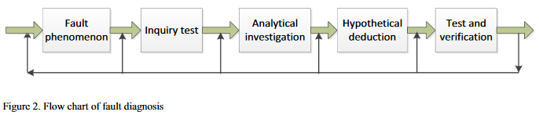
Figure 3. 3 Flow chart of fault diagnosis

    - Principle of fault diagnosis technique
Fault diagnosis technique also called condition-based technique is a kind of fault state of dynamic monitoring equipment system. When electronic instrument appears abnormal situation, it can timely analyze fault causes and provide customers with relevant information through concrete issues of archives automatically diagnosing faults. It is also a technology to predict future state of equipment and it is an effective measure to prevent accidents and also important basis for equipment maintenance. The basic principle of diagnosis technique for equipment fault is shown as Figure 14 below, including four working procedures which are fault detection, feature extract, state recognition and forecasting decision.
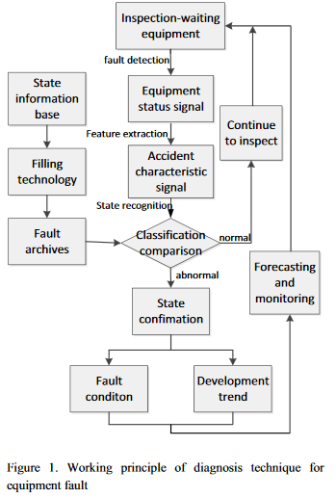
Figure 3. 4 Working principle of technique for equipment fault.

Diagnosis technique for equipment faults is a strong practical technology, widely used in various fields such as aviation, ship, chemical engineering, mechanical equipment and so on. Condition monitoring and fault diagnosis for large-scale complicated equipment can implement condition-based maintenance, ensure equipment precision, save maintenance costs, prevent accidents and effectively guarantee equipment safety, and simultaneously, can avoid environmental pollution caused by equipment accidents and bring larger economic benefit and better social benefit, owning practical value in engineering.

Adjustments and Correction Measure
This topic will help to understand why signal conditioning is required in process control and to familiarize you with signal conditioning methods.
    - Signal conditioning methods
Sensors are used to convert physical variables into a measurable energy form.
This energy form is used to directly or indirectly give a visual indication, as an actuator control signal or as a signal to a controller. Signal conditioning refers to modifications or changes necessary to correct for variations in a sensor’s input/output characteristics so that its output bears a linear relationship with the process variable being measured, and the signal is then suitable for use by other elements in the process control loop. Most sensors do not give an output that can directly be used for a visual display or for control. Pressure sensors, for instance, change their shape when pressure is applied giving linear motion, which must then be converted into a dial-type display for direct indication, or an electrical signal for an alpha numeric display.
    - Choosing of sensors
When choosing a sensor for an application, there is often little choice in the characteristics of the sensor output versus the changes in a process variable. In many cases the relation between the input and the output of a sensor is nonlinear, temperature sensitive, and offset from zero. The situation is aggravated when precise measurements are required and a linear relationship is required between the process variable and the output signal. In analog circuits, linearization is very hard to achieve and requires the use of specialized networks.
    - Pneumatic Signal Conditioning
Pneumatic signals as well as electrical signals can be used to control actuators.
The bourdon tube, capsule, or bellows convert pressure into mechanical motion which can be used for pneumatic control.
    - Visual Display Conditioning
The method of signal conditioning can vary, depending on the destination of the signal. For instance, a local signal for a visual display will not require the accuracy of a signal used for process control. Visual displays are not normally temperature compensated or linearized. They often use mechanical linkages which are subject to wear over time giving a final accuracy between 5 and 10 percent of the reading, i.e., there is little or no conditioning.
    - Electrical Signal Conditioning
The accuracy of the sensor signal is not only dependent on the sensor characteristics but mainly on the applied conditioning. Many processes require variables to be measured to an accuracy of more than 1 percent over the full range, which means not only very accurate sensing, but also temperature compensation, linearization, zero set, and span adjustment. Temperature compensation is achieved in many sensors by using them in bridge circuits but further compensation may be needed to correct for changes in the variable due to temperature.
Such things as op-amp offset and amplification are affected by supply voltages so that these will have to be regulated and care must be taken with grounding of the system to minimize noise and zero offset. Careful selection is needed in the choice of components. Quality close tolerance components and the use of impedance-matching devices are required to prevent the introduction of errors in conditioning networks.
    - Test Reports
Measurements and test results for electrical equipment should be clearly summarized in a test report that includes the following information:
- System information.
- Visual inspection record and observations.
- Identification of circuits tested, tests performed, and record of measurements.
- Interpretation and summary of results, identifying special maintenance needs or corrective actions.
- Signatures of responsible person(s) and date(s) of tests.

Unplanned events or conditions
Even with the best intentions, humans will occasionally make errors in judgment and/or decisions. and equipment will unexpectedly fail. These “unplanned events” do not occur very often, and thankfully most unplanned events are non-serious mishaps/accidents with minor equipment/property damage and/or non-serious injuries. On more rare occasions, incidents can unfortunately result in property damage, serious injuries, and fatalities.
Unplanned events are incidents that are not expected to occur during the normal repair and maintenance activities, such as accidents. The repair and maintenance activities follow safety and engineering design criteria that aim to avoid unplanned events that could lead to adverse environmental, socio-economic or health and safety impacts.
The general approach to assessing the potential environment effects of the selected accident, malfunction, or unplanned event scenarios involves:
- consideration of the potential event that could occur during the life of the Project;
- description of the Project planning and safeguards established to minimize the potential for such occurrences to happen;
- consideration of the contingency or emergency response procedures applicable to the event; and a determination of the significance of the potential residual environmental effects in the unlikely event that these accidents, malfunctions, or unplanned events do happen
An accident is an event that is unplanned, unintended and unexpected, or an unforeseen or unintended exposure to risk. This may either be a risk that has not been identified or a risk that has been identified but not adequately controlled.
As well as accident reporting procedures, all businesses should have plans in place for responding to emergencies and crises and keeping people safe. They should also have effective business continuity plans in place to help get the business back up and running afterwards.
Trainees should have a reporting system in place for all accidents, dangerous occurrences, incidents and near misses. This should include duties on employers under the Reporting of Injuries, Diseases and Dangerous Occurrences Regulations 2013 (RIDDOR).

Self-check (3.1)

Directions: Write TRUE if the statement is correct and write FALSE if
the statement is wrong.
  - Fault diagnosis is the process of tracing a fault by means of its symptoms.
  - Fault diagnosis technique also called condition-based technique.
  - Diagnosis technique for equipment faults is a strong theoretical technology.
  - The accuracy of the sensor signal is dependent only on the sensor characteristics.
  - Pneumatic signals as well as electrical signals can be used to control actuators.
  - Measurements and test results for electrical equipment should have information of visual inspection record and observations.
  - Unplanned events are incidents that are not expected to occur during the normal activities.
  - Employers should not have a reporting system in place for all accidents.
  - The repair and maintenance activities follow safety and engineering design criteria that aim to avoid unplanned events.

Directions: Fill the blank spaces for the following questions with appropriate term.

- When the controller is machine based, it is called ______________
- _____________is a component of a machine that is responsible for moving and controlling a mechanism or system.
- ____________is powered by a motor that converts electrical energy into mechanical torque
- ________________converts energy formed by vacuum or compressed air at high pressure into either linear or rotary motion.
- _______________ should be considered primarily at a no-load pace.

Operation Sheet (3.1): Calibrating and adjusting elements of Mechatronics systems
Purpose | To acquire Calibrating and adjusting elements of Mechatronics systems
Equipment, tools and materials | Supplies and equipment needed or useful for Calibrating and adjusting Mechatronics systems:  - instrument air supply equipment  - power supply equipment  - multi-meter  - calibrators
Conditions or situations for the operations | - All tools, equipment’s and materials should be available on time when required.  - Appropriate working area/ workshop to Calibrating.
Procedures | Step1. Wear proper PPE for Testing and adjusting of Mechatronics systems  Step2. Install/troubleshoot signal processing sub-assemblies and check incoming and outgoing signals  Step3. Calibrate measuring equipment for the recording of pressure and temperature  Step4. Adjust sensing distance of sensors  Step5. Install and adjust actuators in accordance with technical specifications  Step6. Locate symptoms and faults for mechanical, fluidic, and electrical equipment through visual checks, testing, and measurement.  Step7. Install, test, and debug automated manufacturing equipment.
Precautions | - Care should be taken while calibrating and adjusting elements of Mechatronics systems.  - Should be done with concerned technician.
Quality criteria | After Calibrating and adjusting; the system returns to its normal operation.

Operation Sheet (3.2): Inspecting and testing elements of Mechatronics systems
Purpose | To acquire Inspecting and testing elements of Mechatronics systems
Equipment ,tools and materials | - Supplies and equipment needed or useful for Inspecting and testing elements of Mechatronics systems  - multi-meter  - calibrators
Conditions or situations for the operations | - All tools, equipment’s and materials should be available on time when required.  - Appropriate working area/ workshop to Inspecting and testing
Procedures | Step 1- Wear appropriate PPE for Inspecting and testing Mechatronics elements.  Step 2- Identify the problem of Mechatronics elements.  Step 3- Inspect all parts present and correctly fitted.  Step 4- Test probable cause theory to determine actual cause.  Step 5- Verify full system functionality of Mechatronics system.  Step 6-Ask additional information from your instructor.  Step 7- Document the test results
Precautions | - Care should be taken while Inspecting and testing elements of Mechatronics systems.  - Should be done with concerned technician.
Quality criteria | After Inspecting and testing; the system returns to its normal operation.

LAP Test (3.1)

Name: _____________________________ Date: ________________

Time started: ________________________ Time finished: ________________

Instructions: Given necessary templates, workshop, tools and materials you are required to perform the following tasks within 6 hours.
Task 1: Identify the required material and equipment for Inspecting and testing
Mechatronics devices
Task2: Inspect and test Electrical elements.
Task3: Inspect and test Electro-mechanical elements.
Task 4: Inspect and test Electronic elements.
Task5. Inspect and test Control computing hardware elements.
Task6. Inspect and test Computer elements.

Expert Profile
The trainers who developed the curriculum
No | Name | Qualification level | Educational background | Region | College | Mobile number | E-mail
1 | Melaku Bekele Ofgaha | A | Electri/Automation Control Technology | Oromia | Amboo poly TVET college | O921051772 | kakumalaku430@gmail.com
2 | Bahiru Demeke | A | Electri/Elec Contr | Oromia | Bishoftu Poly TVET College | O911394408 | bahirudemeke20@gmail.com
3 | Worku Biru Mekonnen | A | Electri/Automation Control Technology | Oromia | Sebeta Poly TVET College | O912106303 | workubiru3@gmail.com
4 | Sisay H/Mariam Toga | A | Electrical Power Enginering |  | Arbaminch poly & satelite College | O945234339 | sisayhailemariam971@gmail.com
5 | Hassen Husen Hamid | A | Electrical Eng | Oromia | M/G/M/B Poly TVET College | O943402001

References

              - https://upkeep.com/learning/maintenance-planner/
              - A. Geddam, “Mechatronics for engineering education: undergraduate curriculum,” Mechatronics, vol. 1, p. 13,2003
              - Alexandros Mouzakitis ,Classification of Fault Diagnosis Methods for Control Systems Jaguar Land Rover, Warwick, UK, amouzak1@jaguarlandrover.com
              - Bradley, A. and Dawson, D., 1990, Mechatronics Systems Engineering 1, pp. 19-29.
              - Hanson, M., “Teaching Mechatronics at Tertiary Level,” Journal of Mechatronics,
              - IEEE/ASME Transactions on Mechatronics, IEEE Industrial Electronics Society, IEEE Robotics and Automation Society, IEEE/Lasers and Electro-Optics Society and ASME Dynamics and Controls Division, NY
              - M. Grimheden, “Mechatronics engineering education,” Ph.D. dissertation, KTH, 2006.
              - Mariappan, J., and Berry, “Mechatronics at GMI,” Proc. of Mechatronics 96 workshop, San Francisco, CA, pp. 78-83.
              - MARVEL - Mechatronics Training in Real and Virtual Environments, Concepts, Practices, andRecommendations, Bremen 2005
              - Mechatronics - An International Journal, Editors-in-Chief Daniel, R. W. and Hewit, J. R., ISSN 0957-4158, Pergamon, U.K.
              - Mechatronics Installer ,ONET Code: 17-2199.05 ,RAPIDS Code: 2014 No. 5, pp. 406-413.
              - Professional Education,” 1993,International Journal of Engineering Education, Vol. 9,
              - Venuvinod, P. K. and Rao, K. P., “A Mechatronic Engineering Curriculum for

