Industrial Electrical/Electronic Control Technology Level-IV
Based on October 2023, Curriculum Version II
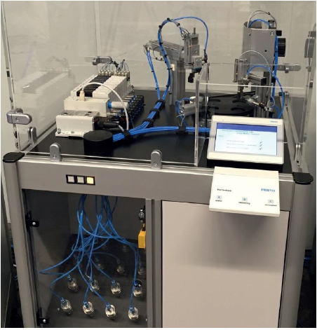
Module Title: Commission Mechatronics System
Module code: EIS IEC4 M07 10 23
Nominal duration: 40 Hours

Prepared by: Ministry of Labor and Skill
October, 2023
Addis Ababa, Ethiopia

Table of Contents
Acknowledgment ii
Acronym iii
Introduction to the Module i
1.1. OHS and polices procedures 3
1.2 Personal protective equipment 12
1.3 Tools, Equipment and testing devices 15
1.4 Necessary materials 27
1.5 Commissioning procedures with job requirements 35
1.6 Commissioning procedures against specifications and requirements 40
Self-Check 1 45
UNIT TWO. Commission Mechatronics systems 47
2.1 Mechatronics systems 47
2.2 Commissioning procedure 59
2.3 unplanned events or conditions 70
Self-Check-2 83
UNIT THREE. Test commissioned Mechatronics systems 87
3.1 Commissioned Mechatronics systems 87
3.2 Unplanned events or conditions 105
3.3 Report on the commissioning process 112
Self-Check-3 120
Reference 122

Acknowledgment

Ministry of Labor and Skills wish to extend thanks and appreciation to the many representatives of TVET instructors and respective industry experts who donated their time and expertise to the development of this Teaching, Training and Learning Materials (TTLM).

Acronym

OHS ……………………………………Occupational Health and Safety
MSDS …………………………………..Material safety data sheets
CD ……………………………………...construction documents
FTPs ……………………………………Functional Test Procedures
CA………………………………………Commissioning Agent
PPE ……………………………………..personal protective equipment
VOM…………………………………… Volt Ohm Milliammeter
DMM…………………………………… Digital Multimeter
DVOM…………………………………..Digital Volt Ohm Milliammeter
AC……………………………………….Alternatives Current
DC ……………………………………....Direct Current
PLC ……………………………………...Programmable Logic Controller
SCADA…………………………………. Supervisory control and data acquisition
DCS ………………………………………Distributed control systems
PVC……………………………………… Polyvinyl Chloride
AWG …………………………………….American Wire Gauge
VTP…………………………………….. Vertical Turbine Pumps
PM ……………………………………….Pump Motor
NFPA……………………………………. National Fire Protection Association
COSHH ………………………………….Control of Substances Hazardous to Health
OPR……………………………………… Office of Procurement Regulation
BOD ………………………………………Basis of Design
TGMS……………………………………..Track Geometry Measurement Syste

Introduction to the Module

Industrial Electrical/Electronic Control Technology field, Commission Mechatronics System is very important for the overall automation system of small and big industries. It helps to know basic commission Mechatronics concepts, commissioning process. Commissioning procedures and testing commissioned Mechatronics system.
This module is designed to meet the industry requirement under the Industrial Electrical/Electronic Control Technology occupational standard, particularly for the unit of competency: Commission Mechatronics System.
Module covers the units:
- Requirements to undertake commissioning process
- Commission Mechatronics systems
- Test commissioned Mechatronics systems
Learning Objective of the Module
- Plan and prepare Requirements to undertake commissioning process
- Check and perform Commission Mechatronics systems
- Respond and report Test commissioned Mechatronics systems
Module Instruction
For effective use this modules trainees are expected to follow the following module instruction:
- Read the information written in each unit
- Accomplish the Self-checks at the end of each unit
- Perform Operation Sheets which were provided at the end of units
- Do the “LAP test” giver at the end of each unit and
- Read the identified reference book for Examples and exercise

UNIT ONE. Requirements to undertake commissioning process
This unit is developed to provide you the necessary information regarding the following content coverage and topics:
  - OHS and polices procedures
  - personal protective equipment
  - tools, equipment and testing devices
  - Necessary materials
  - Commissioning procedures with job requirements
  - Commissioning procedures against specifications and requirements
This unit will also assist you to attain the learning outcomes stated in the cover page.
Specifically, upon completion of this learning guide, you will be able to:
  - Follow OHS and polices procedures
  - Use personal protective equipment
  - Obtain and check tools, equipment and testing devices
  - Obtain Necessary materials
  - Plan and prepare Commissioning procedures with job requirements
  - Check Commissioning procedures against specifications and requirements

1.1. OHS and polices procedures
    - Occupational Health and Safety
Machinery guarding and protection against mechanical hazards;
- Risk of loss of stability
- Machinery and its components and fittings should be stable enough to avoid overturning, falling or uncontrolled movements during use, transportation, assembly and dismantling.
- If the shape of the machinery itself or its intended installation does not offer sufficient stability, appropriate means of anchorage should be incorporated and indicated in the instructions.
- Risk of break-up during operation
- The various parts of machinery and their linkages should be able to withstand the stresses to which they are subject when used.
- The durability of the materials used should be adequate for the nature of the working environment foreseen by the manufacturer, in particular as regards the phenomena of fatigue, ageing, corrosion and abrasion, and the maintenance schedule of the owner.
- The instructions should indicate the type and frequency of inspections and maintenance required for safety reasons. They should, where appropriate, indicate the parts subject to wear and the criteria for replacement.
- Where a risk of rupture or disintegration remains despite the measures taken, the parts concerned should be mounted, positioned and guarded in such a way that any fragments will be contained, preventing hazardous situations.
- Rigid or flexible pipes carrying fluids, particularly those under high pressure, should be able to withstand foreseeable internal and external stresses and should be firmly attached and protected to ensure that no risk is posed by a rupture.
- Where the material to be processed is fed to the tool automatically, the following conditions should be met so as to prevent risks to persons:
- when the work piece comes into contact with the tool, the latter should have attained its normal working condition; and
- When the tool starts and stops (intentionally or accidentally), the feed movement and the tool movement should be coordinated.
- Risks due to falling or ejected objects
- Measures should be taken to prevent risks arising from falling or ejected objects.
- Risks due to surfaces, edges or angles
- In so far as their purpose allows parts that are accessible during use and maintenance of the machinery should have no sharp edges, sharp angles or rough surfaces likely to cause injury.
- Risks related to combined machinery
- Where the machinery is intended to carry out several different operations with manual removal of the piece between each operation (combined machinery), it should be designed and constructed in such a way as to enable each element to be used separately, without the other elements constituting a risk to exposed persons.
- Risks related to variations in operating conditions
- Where the machinery performs operations under different conditions of use, it should be designed and constructed in such a way that selection and adjustment of these conditions can be carried out safely and reliably.
- Risks related to moving parts
- Prevention of hazards due to moving parts of machinery should take into account:
- the movement of machinery parts consisting basically of rotary, sliding or reciprocating motion, or a combination of these, such as the movements of spindles, chucks, fan blades, counter-rotating gear wheels or rollers, and stroking blades; and
- the movement of machinery parts which may have the potential to cause injury, for example by entanglement, friction or abrasion, cutting, shearing, stabbing or puncture, impact, crushing, or drawing a person into a position where injury can occur.
- Moving parts of machinery should be designed and constructed in such a way as to prevent risks of contact which could lead to accidents and should, where risks persist, be fitted with guards or protective devices.
- All necessary steps should be taken to prevent accidental blockage of moving parts involved in the work. If a blockage remains possible despite the precautions taken, the necessary specific protective devices and tools should be provided to enable the equipment to be unblocked safely. The instructions and, where possible, a sign on the machinery should identify these specific protective devices and how they are to be used.
- Choice of protection against risks arising from moving parts
- Guards or protective devices designed to protect against risks arising from moving parts should be selected on the basis of the type of risk.
- Moving transmission parts
- Guards designed to protect persons against the hazards generated by moving transmission parts should be either:
- fixed guards; or
- Inter locking movable guards.
- Interlocking movable guards should be used where frequent access is envisaged.
- Moving parts involved in the process
- When a process requires access to a danger zone and a fixed guard is impracticable, an interlocking guard should be considered. Guards or protective devices designed to protect persons against the hazards generated by moving parts involved in the process should be:
- fixed guards;
- interlocking movable guards;
- protective devices; or
- A combination of the above.

Table 1. 1Apply OHS requirements, policies and procedures in the industry
Apply OHS requirements, policies and procedures in the industry | I understand
Element 1 Identify and assess risks | Easy | With help
Hazards in the work area are identified, assessed and reported to designated personnel.
Safety risks in the work area are identified, assessed and reported to designated personnel.
Safe work practices, duty of care requirements and safe work instructions are followed for controlling risks.
OHS, hazard, accident or incident reports are contributed to according to workplace procedures and Australian government and state or territory OHS legislation and relevant information.
Element 2 Identify hazardous materials and other hazards on work sites | Easy | With help
Hazardous materials on a work site are correctly identified and, if appropriate, handled and used according to company and legislated procedures.
Measures for controlling risks and construction hazards are applied effectively and immediately.
Hazardous materials that have safety implications for self and other workers are secured immediately they are identified, using appropriate signs and symbols.
Asbestos-containing materials are identified on a work site and reported to designated personnel.
Element 3 Plan and prepare for safe work practices Easily With help | Easy | With help
Correct personal protective equipment and clothing for each area of construction work are identified, worn, correctly fitted, used and stored according to enterprise procedures.
Selection of tools, equipment and materials, and organisation of tasks are performed in conjunction with other personnel on site and in accordance with enterprise procedures.
3 Required barricades and signage are determined and erected at the appropriate site location.
Material safety data sheets (MSDS), and job safety analysis (JSA) and safe work method statements relevant to the work to be carried out are identified and applied.
Element 4 Apply safe work practices | Easy | With help
Tasks are performed in a manner that is safe for operators, other personnel and the general community in accordance with legislative requirements, and enterprise policies and procedures.
2 Plant and equipment guards are used in accordance with manufacturer specifications, work site regulations and Australian standards where applicable.
Procedures and relevant authorities for reporting hazards, incidents and injuries are used.
Prohibited tools and equipment in areas with identified asbestos are recognised and not used.
Work site safety signs and symbols are identified and followed.
Work site area is cleared and maintained to prevent and protect self and others from incidents and accidents and to meet environmental requirements.
Element 5 Follow emergency procedures | Easy | With help
Designated personnel are identified in the event of an emergency for communication purposes.
Safe workplace procedures for dealing with accidents, various types of fire and other emergencies are followed, including identification or use, if appropriate, of fire equipment within scope of responsibilities.
Emergency response and evacuation procedures are known, practiced and carried out effectively when required.
Emergency first aid treatment of minor injuries is carried out correctly and details of any treatment administered are reported accurately to designated personnel as soon as possible.

Commissioning processes and procedures
An electrical system is made up of individual electronic components. Both the components and the systems made up of these components must be inspected and tested prior to being placed into service. The components must be tested prior to testing the system.
Step 1: Design Review
A qualified engineering firm designs each project. During the design process, the mechanical and electrical consultants are constantly changing their designs. Some of these mechanical changes affect the electrical system. Sometimes, these changes do not get passed onto the electrical designer.
The result can be as simple as differing equipment nomenclature Many times, bigger problems occur such as the mechanical equipment schedule not matching the electrical panel board and motor control center schedules. These mistakes can be disastrous and expensive to correct once the equipment is installed.
The electrical commissioning agent usually works directly for the owner. The agent has a fresh set of eyes and can look at the design documents from an owner’s point of view. A design review by the electrical commissioning agent will not only provide a quality control check of the design, but will provide a review of issues such as maintainability, installation problems, and “things to avoid from experience”. This review must be completed as early as possible, as but no later than at 90% CD (construction documents).
Step 2: Create Electrical Commissioning Specifications
Good communication is the key to success full commissioning. For a construction project, this means the creation of simple, easy to understand, well written, and organized commissioning specifications. A summary table is important to include at the beginning of the specifications to summarize:
- What equipment is to be tested
- Who will test the equipment
- When the equipment will be tested
- Who will witness the tests
In addition to providing this summary table, our experience has shown that dividing the electrical commissioning specifications into two sections is most effective. The first specification section should describe:
- Terminology (i.e. CA- commissioning agent , FTP – Functional test procedure)
- Test contractor qualification requirements
- Responsibilities and roles of all parties involved
- Test instrumentation to be used
- Equipment calibration requirements
- Equipment and systems to be tested
- When to test the equipment and systems
- Who shall witness the tests
- Inspections and tests to be performed
- Acceptable test result values
- Procedures for failed tests and re-tests
The second specification section should contain the Component Test Data Forms, which are blank forms for the Electrical Testing Company to fill in. It is important to create easy to understand and well organized specifications. The more complex the specifications, the greater the chance that they will be misinterpreted, misapplied or even ignored.
The next part of writing good testing specifications is to create component and system functional test procedures (FTPs). These procedures go into detail as to what must be inspected and tested. Each FTP has four different sections.
They are;
- Scope,
- Visual and Mechanical Inspections,
- Electrical Tests, and
- Test Parameters.
A sample of an FTP for capacitors is shown below;

Table 1. 2 A sample of an FTP for capacitors
Commissioning of Components Functional Test Procedures (FTPs).
Capacitors
A | Scope | 1. Test Motor Control Center Capacitor Banks.  2. Use the Component Test Data Form (CTDF) in Section 01830 to record the test data. For any additional tests performed that are not listed below, attach this additional test data to the CTDF.
B | Visual and Mechanical Inspection | 1. Compare equipment nameplate data with drawings and specifications.  2. Inspect physical and mechanical condition.  3. Inspect capacitors for correct mounting and required clearances.  4. Verify that capacitors are electrically connected in their specified configuration.  5. Verify location of capacitors. If capacitors are located downstream of overload devices, verify that overload devices are the proper rating to account for the reduced current.  6. Verify tightness of accessible bolted electrical connections by using calibrated torque-wrench method in accordance with manufacturer's published data
C | Electrical Tests | 1. Perform insulation-resistance tests from terminal(s) to case for one minute on capacitors with more than one bushing. Test voltage and minimum resistance shall be in accordance with manufacturer's instructions.  2. Measure the capacitance of all terminal combinations.  3. Measure resistance of internal discharge resistors.
D | Test Parameters | 1. Bolt-torque levels shall be specified by manufacturer.  2. Insulation-resistance values shall not be less than standard  3. Capacitance values must be 98% - 115% from manufacturer's published data.  4. Correct and retest any discharge resistor values differing from manufacturer's published data and retest. In accordance with NEC Article 460, residual voltage of a capacitor shall be reduced to 50 volts in the following time intervals after being disconnected from the source of supply:  Rated Voltage Discharge Time < 600V 1 minute

As described above, another important step in creating specifications is to create and require the contractor to use component test data forms (CTDFs). The CTDF is a form on which the contractor can write down their test data results. It lists the same visual and mechanical inspections and electrical tests that the FPT does. This serves as a checklist for the tester. Each test or inspection must be signed off by both the tester and witness along with the date the test was performed. A sample CTDF is shown at the end of this paper.
Step 3: Select a Qualified Testing Contractor
In 1972, Inter National Electrical Testing Association (NETA) formed to further promote and standardize commissioning and acceptance testing. They created Acceptance Testing Specifications and a test technician certification program. Their specifications are widely used on projects throughout the country. We highly recommend specifying a certified NETA testing contractor. By doing this, you will have trained and certified test technicians performing the tests;
Step 4: Witness Electrical Tests
There is a much debate within the industry regarding the need for the tests described in the commissioning specifications to be witnessed by the owner or commissioning agent.
The decision to witness the electrical tests is based upon budget, testing contractor qualifications, the witness qualifications, complexity of the tests, and the importance of the system or component to be tested. These factors will vary from job to job and system to system. Clearly, the goal is to inspect and test the equipment. Witnessing should be a secondary goal. A well-trained NETA testing contractor does not need supervision nor their inspections and tests witnessed.
If some witnessing is desired, but budget is an issue, we would recommend witnessing be done on the most complex and important systems that notoriously have the most problems. These include ground fault protection systems, emergency generators and automatic transfer switches, large (> 225 ampere) breakers with solid state trip units, and fire alarm systems.
Another way to optimize cost when witnessing tests is to have random test witnessing, instead of all tests witnessed by the commissioning agent. Note that Table 1 (Table of Responsibility) allows you to specify whether the commissioning agent witnesses all tests or random tests.
Step 5: Review Electrical Test Results
After the inspections and tests are completed, the commissioning agent must review the test results (CTDFs). The commissioning agent will look to verify that all equipment has been tested, all tests and inspections have been documented, and the results are within acceptable values. The commissioning agent will also verify that any document discrepancies found by the agent or testing contractor were corrected.
Step 6: Create a Commissioning Report
Finally, the commissioning agent will assemble all test result data forms and functional test procedures and create the commissioning report. This report can be used to repeat the tests in the future. These future test results can then be compared to the original startup results. This will assist the maintenance personnel in troubleshooting and determining the condition of the equipment.
Summary
All buildings and facilities must be commissioned to ensure that the equipment is operational, installed properly, and to verify that it meets the electrical designer’s requirements and design intent. The commissioning agent should use the steps and procedures listed above to assure that the commissioning process will be a success.

1.2 Personal protective equipment
The primary approach in any safety effort is to maintain or change the physical environment so that accidents cannot occur. However, it is sometimes necessary for economic reasons or in changing conditions to safeguard personnel by equipping them individually with specialized personal protective equipment (PPE)
Different occupations expose workers to the possibility of injury, illness or even death
due to the various hazards present in the workplaces. These hazards, though in some ways
minimized, cannot be entirely eliminated by both engineering and administrative control
measures. There is still a need for another form of protection that will serve as a barrier
against workplace hazards…the Personal Protective Equipment.
Personal protective equipment (PPE) refers to protective clothing, helmets, goggles, or other garment designed to protect the wearer's body or clothing from injury by electrical hazards, heat, chemicals, and infection, for job-related occupational safety and health purposes, and in sports, martial arts, combat, etc. body armor is combat-specialized protective gear. a part of standard precautions for all health care workers to prevent skin and mucous membrane exposure when in contact with blood and body fluid of any patient. Personal equipment includes protective laboratory clothing, disposable gloves, eye protection, and face masks. can also be used to protect the working environment from pesticide application, pollution or infection from the worker (for example in a microchip factory).
Personal protective equipment;
Personal protective equipment is many in engineering fields, such as;
- Safety hat
- Safety shoes
- Ear muffs
- Goggles
- Safety belt/Harness
- Gloves
- Mask
  - Safety shoes
Safety shoes come in many styles either formal or informal. However, workers require reliable and durable work shoes for their safety. Traditional safety shoes are steel toed, but it can also be made of composite materials such as thermoplastics and aluminum. Following considerations are to be made for selecting right type of safety shoes for the workers:
- Work environment and associated hazards
- Material used in safety shoes and their effectiveness to resistant hazards
- Water, heat and cold resistance
- Electric resistance
- Puncture and cut resistance

Figure 1. 1 safety shoes
Safety apparel/suit, hat, mask and gloves
Personal protective equipment (PPE) is protective clothing, helmets, goggles, or other garments or equipment designed to protect the wearer's body from injury or infection. The hazards addressed by protective equipment include physical, electrical, heat, chemicals, biohazards, and airborne particulate matter. Protective equipment may be worn for job-related occupational safety and health purposes, as well as for sports and other recreational activities. "Protective clothing" is applied to traditional categories of clothing, and "protective gear" applies to items such as pads, guards, shields, or masks, and others. PPE suits can be similar in appearance to a clean room suit.
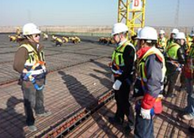
Figure 1. 2 apparel safety


Figure 1. 3 Different Personal protective equipment (PPE)

1.3 Tools, Equipment and testing devices
Self-checklist as you work through this guide you should return to this checklist and record your progress. Where you understand something and think that you can perform it ‘easily’, congratulations. Where your response is ‘with help’ revise the material in that section and/or discuss with your lecturer or other learners in your group.
Test equipment. It is important that in any test program the proper equipment is used. The equipment should be calibrated, in good condition, and used by qualified operators. Any test equipment used for calibration shall have twice the accuracy of the equipment to be tested. Care should be taken to use a quality or regulated power source for the equipment as voltage, frequency, and waveform variation can produce invalid results.
All equipment should be operated in accordance with its instruction manual. Tools, equipment s and OH &S should be obtained as listed below;
Obtaining and checking Tools:
There are a lot of Tools needed for any activity performed in Mechatronics devices, such as;
- Pliers
Sometimes you need appliers / tool that will do the tougher work, like twisting and reshaping wire. Here are the types of pliers that will help you get the job done safely and accurately. In fact people with various industry backgrounds use this tool on a daily basis. From cutting to holding to clipping to severing, pliers are a multi-use instrument.
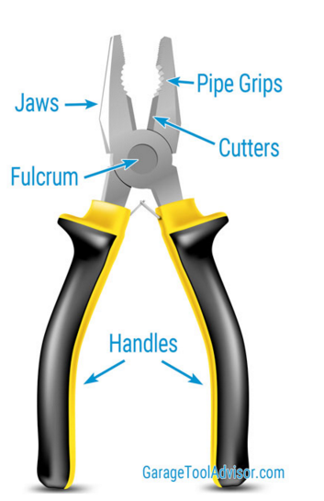
Figure 1. 4 Checking of pliers’ sharpness
- Screwdrivers( Flat and Philips)
- Flat screw driver
The standard slot screwdriver is a very simple yet useful tool. It is most commonly used to remove and replace slotted screws and a countless number of other useful applications that are only limited by the user’s imagination.
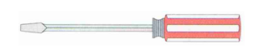
Figure 1. 5 Standard screw driver

- Philips screw drivers
Is a driver that is designed to be used with a type of screw (called a Phillips-head screw) that has a slot in its top that seems a cross;

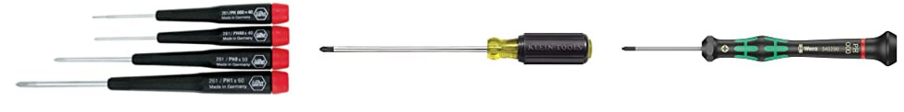
Figure 1. 6 Philips screw drivers
- Soldering iron
The solder should also be resistant to oxidative and corrosive effects that would degrade the joint over time. Solder used in making electrical connections also needs to have favorable electrical characteristics
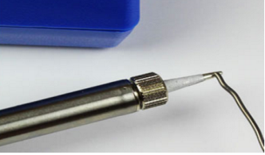
Figure 1. 7 different solder Iron
- Test equipment/instruments
It used in commissions of large numbers and samples are taken as;
- Multi-tester
A multimeter or a multitester, also known as a volt/ohm meter or VOM, is an electronic measuring instrument that combines several measurement functions in one unit. A typical multimeter may include features such as the ability to measure voltage, current and resistance. Multimeters may use analog or digital circuits—analog multimeters and digital multimeters (often abbreviated DMM or DVOM.) Analog instruments are usually based on micrometer whose pointer moves over a scale calibration for all the different measurements that can be made; digital instruments usually display digits, but may display a bar of a length proportional to the quantity measured.
A multimeter can be a hand-held device useful for basic fault finding and field service work or a bench instrument which can measure to a very high degree of accuracy. They can be used to troubleshoot electrical problems in a wide array of industrial and household devices such as electronic equipment, motor controls, domestic appliances, power supplies, and wiring systems.
Multimeters are available in a wide ranges of features and prices. Cheap multimeters can cost less than US$10, while the top of the line multimeters.
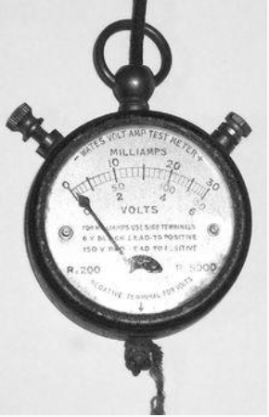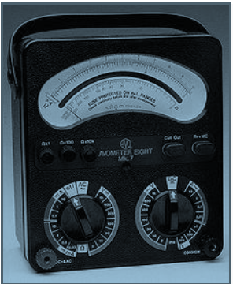
Figure 1. 8 Analog multimeter
Contemporary multimeters can measure many quantities;
The common ones are:
- Voltage, alternating and direct, in volts;
- Current, alternating and direct, in amperes; The frequency range for which AC measurements are accurate must be specified;
- Resistance in ohms;
Additionally, some multimeters measure:
- Capacitance in farads.
- Conductance in Siemens.
- Decibels.
- Duty cycle as a percentage.
- Frequency in hertz.
- Inductance in henrys.
- Temperature in degrees Celsius or Fahrenheit, with an appropriate temperature test probe, often a thermocouple
Digital multimeters may also include circuits for:
- Continuity; beeps when a circuit conducts.
- Diodes (measuring forward drop of diode junctions, i.e., diodes and transistor junctions) and transistors (measuring current gain and other parameters).
- Battery checking for simple 1.5 volt and 9 volt batteries. This is a current loaded voltage scale. Battery checking (ignoring internal resistance, which increases as the battery is depleted), is less accurate when using a DC voltage scale.
Various sensors can be attached to multimeters to take measurements such as:
- Light level
- Acidity/Alkalinity(pH)
- Wind speed
- Relative humidity edit Resolution
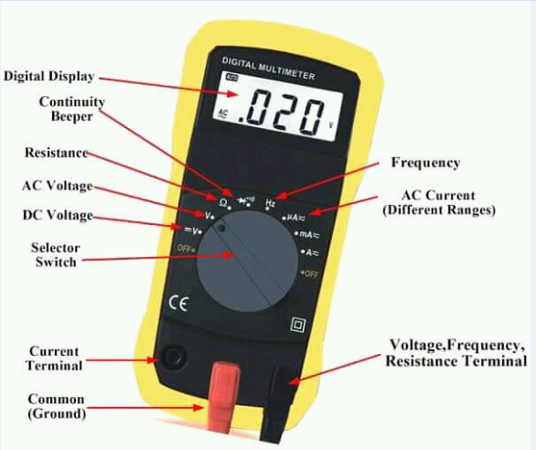
Figure 1. 9 Digital multimeter
- Signal generator
Signal sources have a variety of applications including checking stage gain, frequency response, and alignment in receivers and in a wide range of other electronics equipment. Signal source provide a variety of waveforms for testing electronic circuits, usually low power. The various waveforms are generated by several different kinds of instruments. Sinusoidal Oscillator is used for an instrument that provides only a sinusoidal output signal.
Generator is applied to an instrument that provides several output waveforms, including sine wave, triangular wave, and pulse trains as well as amplitude modulation of the output signal.

Figure 1. 10 Different Types of Signal generator

Requirement for Oscillation
Oscillator - An amplifier with positive feedback.
Gain for amplifier with positive feedback.
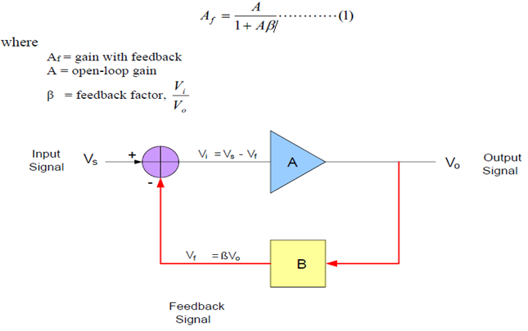
Figure 1. 11 Closed Loop System
- oscilloscope
An oscilloscope is a test & measurement instrument that rapidly measures voltage over time. It records the voltage across certain points in a circuit and displays voltage (Y-axis) as a function of time (X-axis) on a screen
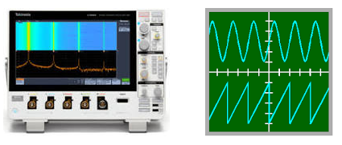
Figure 1. 12 Oscilloscope
- Programmer or PC
The programmable Logic Controller (PLC) is the central controlling unit in the industry or a process. The effective operation of the process and safety considerations if programmed appropriately can meet the required objectives. The present technical paper briefly distinguishes the present automation systems and the past technologies to identify and explore the capabilities of PLCs for any process. The relay logic and contactor logics (RLC) were practiced in the olden days which include the human intervention and errors. The advent and application of microprocessors, microcontrollers and new specific tools such as PLCs, Supervisory control and data acquisition (SCADA) and Distributed control systems (DCS) have increased productivity, accuracy, precision and efficiency.
These systems reduced human intervention and increased the flexibility in the process control. The keyword automation clearly state that the working of a process or repetition in an efficient manner by incorporating mechanisms and control sequences in the proper order several times with acceptable deviations in the output of the process.
Automation is the process of having machines follows a predetermined sequence of operation with or without human intervention in a manufacturing process. The main objectives of automation are integration of manufacturing processes, increased safety level of operator as well as work piece to increase productivity, improve quality, efficiency and reduce labour cost as well as the human errors. For the automation of a process the basic requirements are namely, power source, suitable input and out puts, proper feedback and commands. The present automation has taken series of transformation from Relay and contactor logic, Programmable logic controller (PLC), Supervisory control and data acquisition (SCADA) and Distributed control system (DCS) in steps. The choice of specific method goes with the problem and area of application. The gain and increased output is highly noticed after the installation of automatic controls incorporating suitable techniques. Currently the automation using PLCs is increasing rapidly in all the sectors to evidence efficiency and profit. The MODICON 084 was the world's first PLC commercially produced by Bedford associates
- Comparative Study of Different Techniques in Automation
It is very clear that every process for its effective operation need specific set of instructions and necessary infrastructure. The processes operated by human or non-automated yield lesser productivity and may not be energy efficient but such practices were inevitable till the advent of the concept automation. The Automation brought the revolution in every field of application to a greater extent incorporating technologies and machines to do activities in efficient manner by reducing human intervention. In the following paragraph comparative study of such methods is done.
- Relay and Contactor Logic
Relay and contactor logic use relay which is an electromagnetic switch which opens and closes the contacts to control electrical circuit like as shown in Figure1.13. The energized coil with a suitable supply controls the circuit. A simple RC circuit is usually installed across the coil to dissipate and absorb the spikes of voltages which may damage the coil winding. Similar to this a contactor is an electrically controlled switch used for switching a power circuit activated by a control input. Contactors unlike a circuit breaker are not intended to interrupt a short circuit current. A contactor generally consists of Power Contacts, Auxiliary Contacts and Contact Springs etc.

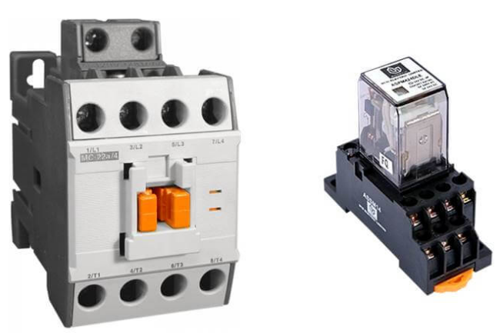
Figure 1. 13 Relay and contactor
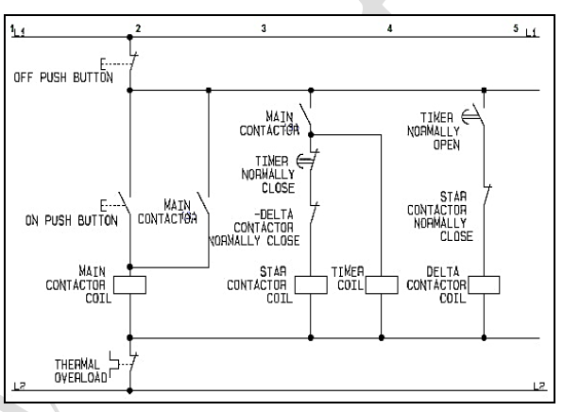
Figure 1. 14 Sample Star Delta starter circuit
The electromagnet is the main driving element which closes the contacts. Generally, it is enclosed in a housing made up of insulating materials. The major drawback of relay and contactor logic is it needs immediate rectification on failure and it does not possess any redundant system.
- Supervisory Control and Data Acquisition (SCADA)
SCADA is an acronym for Supervisory Control and Data Acquisition system. It is software with necessary hardware to accomplish the task assigned. SCADA is a computer system gathers and analyzes the data on real time. SCADA is used to monitor and control a plant or equipment in industries such as energy system, sugar, ceramic, cement, power, telecommunications, water and waste control, oil and gas refining and transportation etc.
SCADA intern need PLC, necessary control mechanism, communication systems to fetch the data or information from the field and control effectively. The role of operator in SCADA system is very important and crucial. A well-organized SCADA maximizes the system benefits. The present generation SCADA systems are very highly motivated by the strategic skills and control sets to optimize and maximize the operational benefits of its installation. The Figure 4.9 shows a typical SCADA with associated components for its proper functioning. The details of individual sub blocks are presented in the following paragraph.
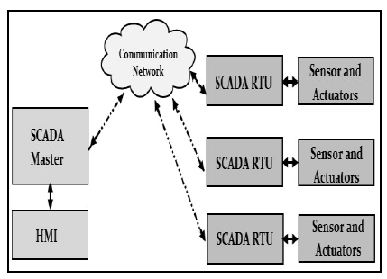
Figure 1. 15 SCADA with Field Instrumentation
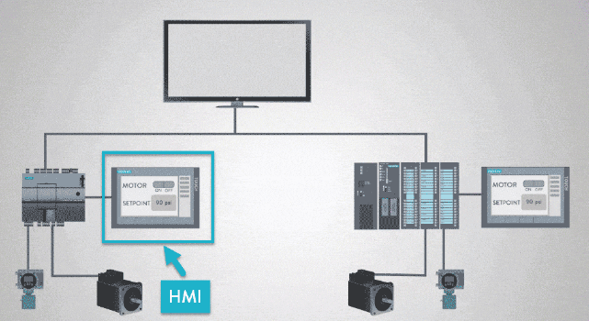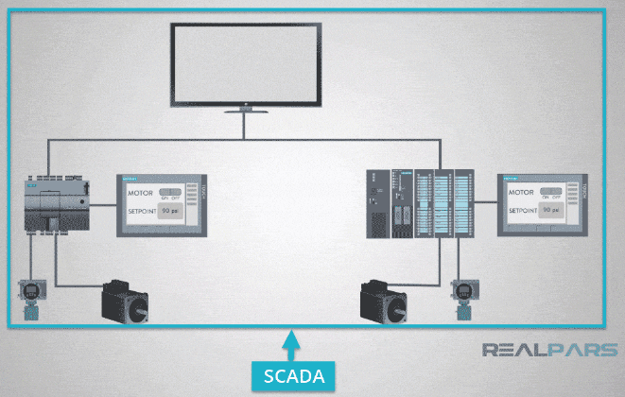
Figure 1. 16 Difference of HMI and SCADA
- Remote Terminal Unit (RTU)
RTU is a device installed in the field or a remote location from where it collects data, codes and transmits to the central station or master. The RTU may be a PLC gathering the required field data and status of all installed devices. The other role RTU collects information from the master device and implements and processes at the field for the requirements. The mode of communication involve wired and wireless as per the scope.
- Master Terminal Unit (MTU)
MTU is the infrastructure installed at the Master Station for communicating with the RTUs and PLCs, etc, through human machine / man machine interface (HMI/MMI) with suitable software running on computer terminals in the control room. This unit pre-process the data receive and stores it into the data base. Main program written to control the entire process scans and use this data and updates it. The MTU communicate with field via RTUs.
- Field Instrumentation
The SCADA needs a lot of instrumentation like, the sensors, switches, actuators, valves and other feedback devices that are connected to the equipment or machines being controlled and monitored by the SCADA system. The SCADA RTU is a PLC or small industrial computer which allows the central SCADA to communicate with the field devices.
- Distributed Control System (DCS)
Distributed control system (DCS) is a control system in which the controller elements are not central in location but are distributed throughout the system for the ease of control and management. In this system, each component or sub system is controlled by one or more controllers. The entire system of controllers is connected by a network for communication and monitoring. General examples are like large processing units or manufacturing systems, processes or any kind of dynamic system.

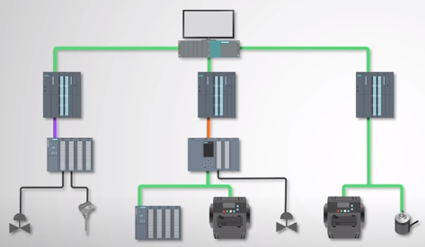
Figure 1. 17 Distributed control system (DCS)

1.4 Necessary materials
Obtaining necessary Materials in accordance with job requirements
Materials that provide guidance notes that give detailed information on the requirements of the Regulations, standards and codes of practice. Although this material does not form part of the law, it is extremely useful.
Plant and equipment Introduction the safe and efficient running of a workplace requires that all plant (machinery, appliances and tools) and equipment work as intended, when needed. In the construction industry, plant and equipment include:
Electrical systems commissioning
Electrical systems to be commissioned include the following:
- Secondary Service Electrical Systems.
- Motor Control Centers.
- Distribution and Branch Circuit Panel boards.
- Lighting Fixtures and Controls.
- Lightning Protection Equipment and Lightning Protection Systems.
- Elevator Systems.
- Equipment Monitoring.
- Fire Alarm Equipment/Fire Alarm Equipment Monitoring System.
- AC Motors.
- Grounding Equipment and Building Grounding System.
- Security System.
- Emergency Generators and Distribution System.
- Uninterruptible Power Systems.
Materials, like the followings:
- Wires
- Terminal lugs
- Terminal wire marker
- Terminal blocks
Electrical wiring needs expertise attention to every building project. It directly related to the safety of human beings and utilities / equipment people handle. The scope of electrical wiring shall cover supply, installation, testing and commissioning of all conduits and accessories, wiring, switches, socket outlets, spur outlets, junction boxes / pull boxes, GI pull wires, ceiling roses making connections etc. This Electrical Construction Article gives comprehensive details of various installation methods, materials used in each installation methods used in building construction projects.
Wires, Cables and Cords
Wires: Unless otherwise specified all wires shall be PVC insulated single core, stranded copper conductor conforming to BS 6004. All wires shall be colored as follows:
- Phase A of 1: Red Color of wire
- Phase B of 2: Yellow Color of wire
- Phase C of 3: Blue Color of wire
- Neutral: Black
- Ground: Yellow Green or Green (One color only to be used for the complete Installation).
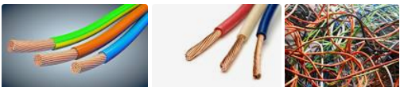
Figure 1. 18 Different size of wires.

Telephone Cables: The telephone cable used for telephone socket outlet shall be twin pairs 22 AWG, PVC insulated copper conductor wires, UL approved. The telephone cables used as main feeder connecting the telephone junction boxes to main telephone junction boxes shall be multi-pairs type, as specified on drawings.
Flexible Cords: The cords to connect short extension to the luminaries, immersion heaters, equipment etc. shall be heat resisting PVC insulated to BS 6500 - 1969 with copper conductors.

Wiring Accessories
Unless otherwise specified all wiring accessories shall be Standard British type. The exact type & model shall be as specified in the drawings, bill of quantities or herein in the specific. Outlet, Pull box, Junction Boxes and Fittings;
Each outlet, junction or pull box shall be of proper type, class and assembly to suit the specific conditions encountered. Outlet pull box or junction boxes shall be conforming to IEE regulations and other applicable requirements that have been established by the various agencies, codes and authorities.
Outlet, Pull and Junction Boxes In General, Be As Follows:
Outlets for light points, convenient socket outlets, power outlets, switch boxes, pull / junction boxes shall be code gauge 46mm deep galvanized steel, and shall be of shapes and size to suit their respective locations and installations and shall be provided with covers to suit their function and installation.
- Outlet boxes shall be equipped with fixtures or straps where required. All outlet boxes shall be provided with brass ground terminals.
- All junction boxes/pull boxes shall have suitable covers.
- Surface mounted outlet and junction boxes in the outdoor locations shall be of cast iron metal with threaded hubs.
- The surface mounted indoor boxes shall be sheet steel painted purpose made for surface installation.
Terminal Lugs
Lugs and terminals include a variety of crimping connection options for your specific application. It includes lugs, ring terminals, splices, ferrules, disconnects and more.

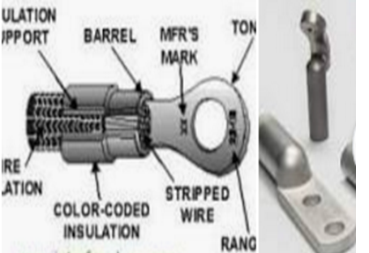
Figure 1. 19 different types of Terminal Lugs
Terminal Lug is a device attached to a conductor to permit connection to a terminal. A terminal designed to be affixed, usually at one end, to a post, stud, chassis, or the like for mounting. It has provisions for attachment of wires or similar electrical conductors in order to establish an electrical connection and could require the use of tools for attachment of wire.
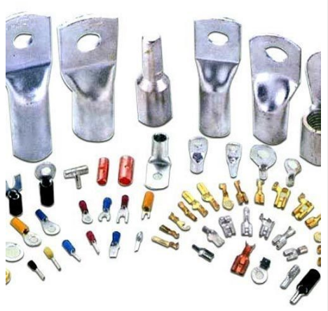
Figure 1. 20 Terminal Lugs

There are different types of terminals as we follow from the table below;
Table 1. 3 different types of terminals
SN | Symbolic representation
Battery terminals | 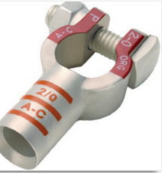
Disconnect | 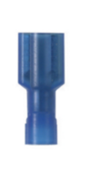
Ferrules insulated | 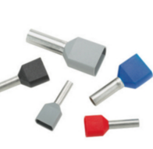
Ferrules un insulated | 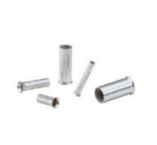
Fork terminals insulated | 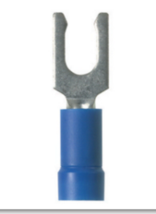
Lugs mechanical | 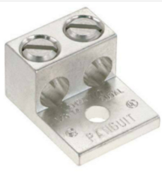
Lugs un insulated | 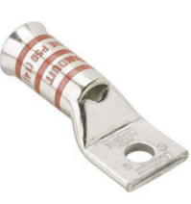
Ring terminals insulated | 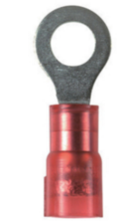
Ring terminals un insulated | 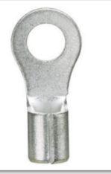
Solder sleeves | 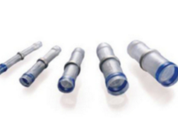
Splices insulated | 

Terminal strips/blocks
Terminal blocks are modular, insulated blocks that secure two or more wires together. Terminal blocks are used to secure and/or terminate wires and, in their simplest form, consist of several individual terminals arranged in a long strip.
A terminal block is a modular, insulated block that secures two or more wires together. Factories use terminal blocks to secure and/or terminate wires.
Terminal blocks are connectors that terminate a single wire and connect it to a circuit or other system. Terminal blocks come in a range of shapes, sizes and ratings, but always terminate a single wire (single pole) and are never multi-pole
A terminal block (also called a connection terminal or terminal connector) is a modular block with an insulated frame that secures two or more wires together. It consists of a clamping component and a conducting strip. A typical simplest terminal block is as shown in the image below.
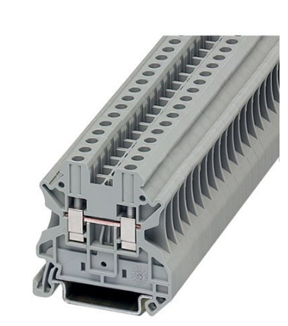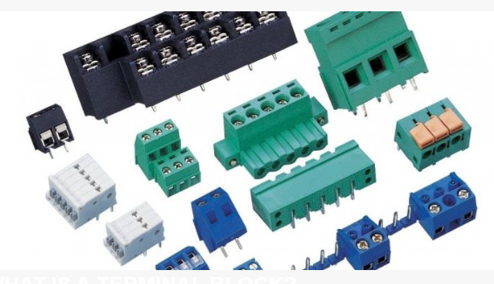
Figure 1. 21 Terminal Blocks/strips
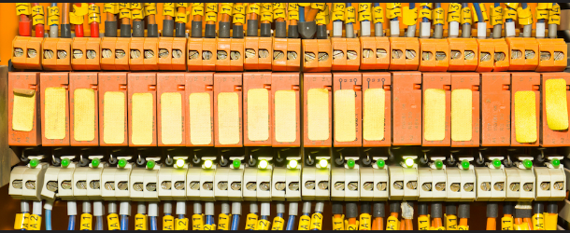
Figure 1. 22 wiring systems connected to Terminal Blocks

Quick connect fittings
A quick connect fitting is a coupling used to provide a fast, make-or break connection of fluid transfer lines. When equipped with self-sealing valves, quick connect fittings will, upon disconnection, automatically contain any fluid in the line.
The term “quick-connect” simply refers to the ability to connect tubing to a fitting very quickly. Introduced to the water treatment industry in the late seventies, and early eighties, quick-connect fittings revolutionized the way we put water equipment together.
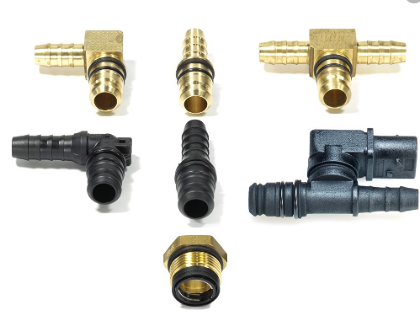
Figure 1. 23 Quick connect Fittings
Cable ties
A cable tie (also known as a hose tie, zip tie, or by the brand name Ty-Rap) is a type of fastener, for holding items together, primarily electrical cables, wires, and peoples’ wrists and ankles. Because of their low cost and ease of use, cable ties are ubiquitous, finding use in a wide range of other applications.
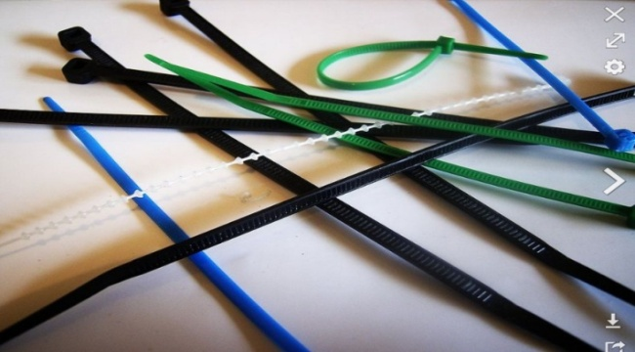
Figure 1. 24 Cable Ties

1.5 Commissioning procedures with job requirements
Commissioning is the systematic process by which a piece of equipment, system, or facility is tested to verify that it functions in accordance with the design intent and owner's operational requirements.
Commission is just one of the many things you need to consider when hiring staff. Find out more about managing payroll for small businesses.
Equipment commissioning is the process of ensuring that all systems and components of a building are designed, installed, tested, operated, and maintained according to the operational requirements of the owner and tenants. A commissioning process may be applied not only to new projects but also to existing units and systems subject to expansion, renovation or revamping. The four types are;
- commissioning,
- retro-commissioning,
- re-commissioning, and
- Continuous commissioning.
Why it Matters
Traditional Commissioning: Commissioning, retro-commissioning, and re-commissioning are capital and labor-intensive processes that require the engagement of a multitude of personnel including:
- Commissioning Provider
- Owner's Representative
- Architect and Design Engineers
- General Contractor
- Mechanical Sub-contractor
- Electrical Sub-contractor
- Specialty Sub-contractors (Controls, TAB, Security, Elevator, etc.)
- Operations and Maintenance Staff
- Equipment Suppliers’
The process and activities depend on the stage of phase of the equipment:
Design Phase: Design intent, CX plan, specifications, and review submitting prepare checklists and testing plans.
Construction Phase: Verify installation, start-up and component testing
Acceptance Phase: Functional testing, resolve deficiencies, review O&M
Warranty Phase: Diagnostic monitoring, CX report, O&M staff training, seasonal testing
Continuous Commissioning
On the other hand, continuous equipment commissioning leverages sensors and software to achieve the same results for a fraction of the cost, and on an ongoing basis. The moment after a traditional commissioning process, equipment performance will inevitably drift over time. These changes in how the equipment operates leads to wasted energy, sub-optimal output, and a higher likelihood of malfunction over time.
Though retro-commissioning has gained some traction, more landlords are opting to utilize continuous commissioning inform capital investment decisions. This process allows building operators to make adjustments the moment an issue occurs, or when performance drops below a defined threshold.
    - Planning commission
Allow as much time as you can for planning. Constraints on time are typical, but the more time you have for planning and risk assessment, the more likely it is that your move will be successful. Planning is especially important if you need to maintain production during the move. The sheer number of factors to consider can be overwhelming at first, so it can help to get them out of your head and into a project management tool as you go.
How to Commission Equipment for Better Asset Management
Wouldn’t be nice if every new piece of equipment or system worked flawlessly from the moment it was installed and initiated until the first breakdown occurred many years later. That would be an exception with most industrial equipment.
When it comes to setting up equipment, we may find some components were damaged during shipment, the field engineer has little expertise, or we’re doing the beta testing on a new design (whether we agreed to this or not). The same can apply to rehabilitated equipment being installed in the original application and position.
Why is it that cars come off an assembly line and rarely run into serious warranty issues? The reason is that car manufacturers exhaustively test, improve and inspect both the design and the production processes on thousands of cars. Industrial equipment tends to run in small manufacturing lots; hence not all the bugs get worked out.
This is why commissioning industrial equipment is an art, and a necessary one at that. I call it an art because, by definition, setting up new equipment requires creativity, craft skills and deductive reasoning. These very same attributes apply to an art in every sense of the word.
My facility, Upper Occoquan Service Authority (UOSA), has matured its maintenance and asset management approach to the point where focusing on commissioning is the next logical step. This thinking arrived as part of our overall pursuit of best practices in reliability and asset management.
Failing to follow a commissioning process is tantamount to installing your next failure. Proper commissioning of equipment can extend useful life, which is an important goal in asset management. Therefore, commissioning is an essential component of a good asset management program.
After several years of designing and implementing maintenance support processes, we will verify improved reliability by tracking mean time between failure (MTBF), mean time to repair (MTTR) and equipment availability.
A Commissioning Philosophy
The basic challenges in setting up new or rehabilitated equipment are fairly universal. They boil down to anticipation of problems, perception of problems and correction of problems. Let’s take those words (anticipation, perception and correction) and examine how they apply to the commissioning process.
It may be difficult to imagine how to anticipate problems, but a good starting point is searching out repair histories.
Repair histories can tell you what broke down, when, why, how, where and who was involved. Interviews with your operators and others who own and operate the same equipment are priceless.
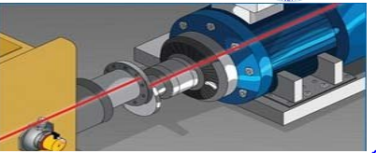
Figure 1. 25 An overview of laser alignment tools
As part of a commissioning plan, this valuable knowledge needs to be recorded in a retrievable format. This is a core part of the plan – the framework for recording information. Think of it as the rules of a game. The framework for recording should be available to participating users. The ability to change entries in the records must be monitored and controlled to ensure consistency and accuracy.
If the equipment to be commissioned is made up of sub assemblies of familiar components, then anticipated failures can be defined by individual components. For example, a centrifugal blower should have a performance curve graph, an allowable vibration limit and other specifications. When the blower operates outside of any of these values, an investigation is required and followed by appropriate corrective action.
Some problems creep up so slowly that they are not detected until damage has occurred. This is a failure to perceive. This is where determining the vital test points and establishing the acceptable values is necessary. Sometimes we don’t know what is acceptable; this is where conferring with the manufacturer or others with similar equipment provides guidance.
Once the source of a problem has been decisively established, the next step is correction. The solution should treat the core problem. For example, if a one-times-rotating speed imbalance is detected, balance the rotating body.
If the structure of the machine has a harmonic resonance so that the slightest excitation causes destructive vibration, address the structure rigidity.
When the corrective measures are completed, verify the anticipated improvements are perceivable. Use measuring tools to verify the correction did what it was supposed to do. This is where tools shine – vibration analysis, ultrasound detection, motor current signatures, oil analysis and thermograph.
None of the aforementioned efforts will produce desired results unless action is taken. Do something and document what was done. This enhances the value of the commissioning project.
    - Preparing for Commissioning
It is essential to become fully familiar with the equipment that is being commissioned. This means reading the manuals in advance (if possible), reading the cut sheets for components, studying the operations manual, getting the manufacturer to field your questions and contacting others with the same equipment to learn how they were successful.
It is useful to visit facilities where similar equipment is operating both successfully and unsuccessfully. Talk to the operators and maintenance people, as they have an intimate connection with the equipment.
I was talking with an electrician friend about some of the more interesting and difficult jobs we’d done over the years.
We were discussing how to fit wires into a congested junction box. My friend said, “You’ve got to have a plan.” This stuck with me because it shows that even the most mundane task, such as dressing wires in a tight space, requires a plan.
Commissioning also requires a plan. A plan is nothing more than a well-thought-out set of guidelines which may incorporate rules, drawings, checklists and procedures. A commissioning plan is something like a cooking recipe; you follow it but adjust as needed based on experience.
The Plan;
- Select a project leader– one who will have the time and temperament to command resources in an effective manner
- Define the absolute requirements for acceptable operation – what work must the equipment do?
- Identify and address anticipated failure modes for the overall system and all subsystems.
- Verify operating conditions (as specified by the equipment seller) will be met – i.e., operating environmental conditions (temperature, humidity, pressures, voltage, etc.).
- Define the testing steps necessary and the order of those steps in the commissioning process.
- Define the skills sets necessary – mechanical, electrical, controls and engineering
- Schedule the resources and personnel to accomplish the defined steps
- Record the observations and test point values measured (perceived) during each step
- Review the results (convert data into information)
- Take corrective actions as needed
- Verify that the corrective actions produce the desired results.
- Train the operators to make certain they will know how to operate the equipment properly in all circumstances
- Implement a preventive maintenance (PM) program that addresses best practices
- Repeat these steps as necessary until all absolute operating requirements have been met
- Record the commissioning process describing what brought success and what did not for future reference.
- Create a body of knowledge for commissioning and update it when new information is revealed as part of the commissioning processes.
- The Commissioning Leader
A commissioning project also requires a leader to manage the steps and execute the plan. This leader acts as the central hub of communication for the personnel assigned to the commissioning project. Similar to root cause investigations, it is wise to not choose a dominant personality as a leader.
People of dominant persuasions can corrupt the process with their predispositions. The optimal leader is one who follows the plan and verifies all steps are accomplished and documented. This leader must also have good organizational and communication skills in addition to being assertive.
Select a competent leader who will have sufficient time to dedicate to the project without getting pulled off to yet another project. This only makes sense and is how successful enterprises advance.
Building management professionals aren’t just tasked with managing their facility's assets. They’re also tasked with developing strategic plans for managing those assets in the future. The most successful building management teams use a systematic approach to monitoring, maintaining and planning for their facility.

1.6 Commissioning procedures against specifications and requirements
In checking of the commissioning procedures, there is a general requirement for guards. Guards and protective devices should protect against danger, including risks from moving parts. They should:
- Be of robust construction;
- Be securely held in place;
- Not give rise to any additional hazard;
- Not be easy to bypass or render non-operational, or be easily defeated;
- Be located at an adequate distance from the danger zone;
- Cause minimum obstruction of the view of the production process;
- Enable essential work to be carried out on the installation and replacement of tools and for maintenance purposes by restricting access exclusively to the area where the work has to be done, if possible without the guard having to be removed or the protective device having to be disabled.
In addition, guards should protect against the ejection or falling of materials or objects and against emissions generated by the machinery
- Fixed guards
- Fixed guards should be used whenever practicable. They should be designed so as to prevent access to the dangerous parts of the machinery.
- Fixed guards should be fixed by systems that can be opened or removed only with tools.
- Their fixing (attachment) systems should remain attached to the guards or to the machinery when the guards are removed.
- Where possible, guards should be incapable of remaining in place without their fixings (attachments
- Interlocking movable guards
- Interlocking movable guards should, as far as possible, remain attached to the machinery when open.
- Interlocking movable guards should be associated with an interlocking device.
- Where it is possible for an operator to reach the danger zone before the risk due to the hazardous machinery functions has ceased, movable guards should be associated with a guard-locking device in addition to an interlocking device which: prevents the start of hazardous machinery functions until the guard is closed and locked; and
- Adjustable guards restricting access
Adjustable guards restricting access to those areas of the moving parts strictly necessary for the work should be:
- Adjustable manually or automatically, depending on the type of work involved; and
- Readily adjustable without the use of tools.
- Special requirements for protective devices
Protective devices should be designed and incorporated into the control system in such a way that:
- Moving parts cannot start up while they are within the operator’s reach;
- Persons cannot reach moving parts while those parts are moving; and
- The absence or failure of one of their components prevents starting or stops the moving parts.
- Protective devices should be adjustable only by means of an intentional action.
1.6.1 Machinery guarding and protection against other hazards
- Electricity supply
Where machinery has an electricity supply, it should be designed, constructed and equipped in such a way that all hazards of an electrical nature are or can be prevented, in accordance with national law and practice.
- Static electricity
Machinery should be designed and constructed to prevent or limit the build-up of potentially dangerous electrostatic charges and be fitted with a discharging system.
- Energy supply other than electricity
Where machinery is powered by sources of energy other than electricity, it should be so designed, constructed and equipped as to prevent all potential risks associated with such sources of energy.
- Errors in fitting
Errors likely to be made when fitting or refitting certain parts which could be a source of risk should be precluded by the design and construction of the parts or, failing this, information explaining how to fit them correctly should be provided on the parts themselves and their housings. The same information should be provided on moving parts and their housings where the direction of movement needs to be known in order to prevent a risk. Where necessary, the instructions for use should give further information on these risks.
Where a faulty connection can be a source of risk, the design should make it impossible to connect parts incorrectly; failing this, information should be provided on the items to be connected and, where appropriate, on the means of connection.
- Extreme temperatures
Steps should be taken to eliminate any risk of injury arising from contact with, or proximity to, machinery parts or materials at very high or very low temperatures.
The necessary steps should also be taken to avoid or protect against the risk of very hot or very cold material being ejected.
- Effect of climate
When machinery is used in very high ambient temperatures and/or humidity (such as in tropical or subtropical regions) or in very low ambient temperatures, consideration in the design of machinery should be given to the following aspects:
- The effect of extreme heat, cold and humidity on machinery;
- The acceptability of PPE and the effect of climate on the protection provided by such equipment;
- The effect of high and low ambient temperatures on workers in terms of fatigue; (d) The effect of high levels of sunlight;
- Heat stress problems in non-acclimatized personnel, particularly when the use of PPE is necessary;
- The effect of climate on the stability of chemical substances used for operating machinery; and
- The effect of climate on equipment operation and maintenance.
1.6.2 Supplementary measures relating to specific machinery types
- Portable hand-held and hand-guided machinery (such as chainsaws, hedge trimmers, cartridge operated tools, grinders, etc.)
- Depending on the type of machinery, the machinery should have a supporting surface of sufficient size and a sufficient number of handles and supports of an appropriate size, arranged in such a way as to ensure the stability of the machinery under the intended operating conditions.
- Except where technically impossible, or where there is an independent control device, in the case of handles which cannot be released in complete safety, the machinery should be fitted with manual start and stop control devices arranged in such a way that the operator can operate them without releasing the handles.
- There should be no risk of accidental starting and continued operation after the operator has released the handles. Other equivalent steps should be taken if this requirement is not technically feasible.
- The machinery should, where necessary, permit visual observation of the danger zone and of the interaction of the tool with the material being processed.
- The machinery should have the handles designed and constructed to make starting and stopping simple.
In the case of chainsaws, refer to paragraph 387 of the ILO code of practice on safety and health in forestry work.
- Safety and health in the use of machinery Portable impact fixing machinery (pneumatic and explosive cartridge activated) Energy should be transmitted to the impacted element by an intermediary component that does not leave the device.
- An enabling device should prevent impact unless the machinery is positioned correctly with adequate pressure on the base material.
- Involuntary triggering should be prevented; where necessary, an appropriate sequence of actions on the enabling device and the control device should be required to trigger an impact.
- Accidental triggering should be prevented during handling or in case of shock. It should be possible for loading and unloading operations to be carried out easily and safely.
- Appropriate guard(s) should be provided by the manufacturer of the machinery and, where necessary, it should be possible to fit the device with splinter guard(s).

Self-Check 1

Part-I: Choice
Instruction: Choose the correct answer from the given choice for the following questions.
- Which of the following is the Machinery guarding and protection against other hazards?
  - Electricity supply c. Errors in fitting
  - Static electricity d. Effect of climate e. all
- Which of the following are functional test procedures (FTPs) sections?
    - Scope c. Visual and Mechanical Inspections d. Electrical Tests
    - Test Parameters. E. all of the above
- The role of operator in___________ system is very important and crucial.
- PLC b. SCADA c. HIM d. DCS
- Which of the following is instrument is is used in commissioning Mechatronics system?
  - Multimeter b. signaler generator c. oscilloscope d all of the above
Part-II: written Questions
Instruction: Answer the following questions accordingly.
1. List at least five types of terminals of different types used for Mechatronics system commissioning.
  - ________________________________________
  - ________________________________________
  - ________________________________________
  - ________________________________________
  - ________________________________________
- List the four types of commissioning process.
  - __________________________________
  - __________________________________
  - __________________________________
  - __________________________________

- Write necessary steps for Commissioning processes and procedures of the components must be tested prior to testing the system.
Step 1: __________________________________________
Step 2: __________________________________________
Step 3: __________________________________________
Step 5: __________________________________________
Step 6: __________________________________________

Part-III: Matching
Instruction: Match from column “B” to column “A” for the following matching questions.
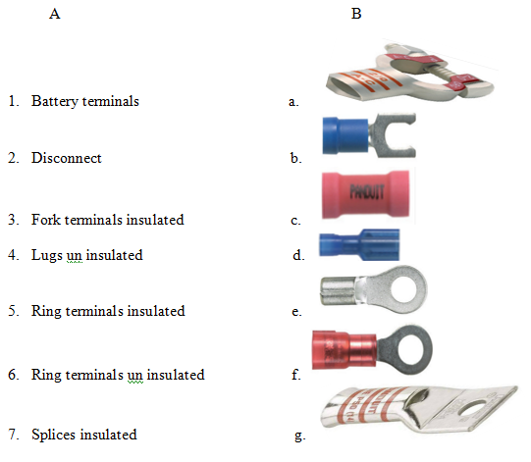

UNIT TWO. Commission Mechatronics systems
This unit to provide you the necessary information regarding the following content coverage and topics:
  - Mechatronics systems
  - commissioning procedure
  - unplanned events or conditions
This guide will also assist you to attain the learning outcomes stated in the cover page. Specifically, upon completion of this learning guide, you will be able to:
  - check Mechatronics systems
  - perform commissioning procedure
  - Respond unplanned events or conditions

2.1 Mechatronics systems
2.1.1 Checking Mechatronics systems by using specified procedures
After commissioning any commissioned Mechatronics activities, periodic checks must be done to verify that operations are running the equipment in a way that prevents failures. The best commissioning process will fail if the operators try to use the equipment in ways for which it was not intended.
Verify procedures are correctly performed or not performed at all. Failures resulting from these quarters may be unfairly attributed to faults in the commissioning process. You should review metrics, key performance indicators (KPIs) on a regular basis to verify the equipment is operating within specifications.
Failure to Get It Right (Knowing Right from Wrong)
It is a fact of our times that we are expected to dramatically increase efficiency and accuracy with the feast of computer-based tools that are laid before us. Commissioning is not a process that can be rushed.
There are occasions when commissioning teams dig too deeply looking for problems and overlook problems that are blatantly obvious. It is important to review all available information and take all reasonable steps when commissioning. Don’t be afraid to have an independent outside observer look at your processes. Expect some root cause discoveries during commissioning.
Many problems can be anticipated before new equipment is started for the first time. Getting critical tasks into the program is as much a part of commissioning as any of the other steps.
Any required maintenance tasks that are burdensome, time-consuming or messy tend to get put off. Anticipate problems with filters plugging and fan blades loading up with dirt and becoming imbalanced.
2.1.2 Lessons to Learn
During the last few years, we have learned a few valuable lessons. We have uncovered issues with the lack of a proper commissioning process as well as the benefits of having proper procedures in place. Our lessons highlight the beneficial use of predictive maintenance technologies, such as ultrasound, vibration, oil analysis, thermal imaging and motor current signature analysis, but the human senses are also part of the evaluation process.
- Actuators & output devices
Commissioning Electric Motors in Critical Applications
Whether a motor is new from the manufacturer or reconditioned, it is essential to check its condition with a motor current signature analysis instrument as soon as it arrives on site.
If this testing is not performed immediately, it tends get forgotten or done in a hurry just before the motor is installed. Who wants to find out a motor has a problem just before it’s installed or worse yet as soon as it is powered up. Our experience has been that installation is a bad time to discover equipment problems, because personnel and rigging equipment are mobilized and there may be operational constraints to deal with if the motor is not installed on schedule.
A full set of procedures must be established for quality control inspection of motors, new or rebuilt, when they are received. Vendors of motor test equipment are a good resource for developing these procedures. A set of guidelines is also needed for repair of a motor to verify what was done during repair. There are many online resources on how a motor should be repaired.
Compare recommendations from various motor shops to get a broad overview. Motors are the prime movers behind industry and must be given critical attention or process failure is certain.
Basic off-line tests should be performed before a motor is connected to its power circuit. A polarization index test and a surge test are essential.
When the motor is powered up for the first time, measuring the current in all three phases is vital. If online testing is possible, it should be performed.
If an ultrasound instrument is available, the bearing sound signatures should be recorded to obtain baseline decibel levels and time-domain graphs for future comparisons.
If the motor can be run prior to coupling it to the driven component, it is desirable to measure and record vibration characteristics. If any of these tests reveal problems, it will be necessary to halt installation and take corrective actions.
- Vertical Turbine Pumps
The water industries frequently employ VTP for processes. These pumps have their impeller mounted in a volute sitting up to 30 feet below grade. The impeller is driven by a long shaft, which is stabilized by a number of “spider” bearings along the inside of the pump column through which the water flows. The motor is mounted above ground on a pedestal in the vertical axis.
On the suggestion of technician from a neighboring water facility, we installed two hermetically sealed vibration sensors on the volume of a new VTP prior to lowering it into the wet well. The sensors were installed in the horizontal plane, positioned 90 degrees radially from each other. When the sensors detected high vibration during initial startup, the installing contractor was surprised. They’d never seen anyone test for vibration at the volute before. The motor was not vibrating significantly, so they assumed the installation was satisfactory.
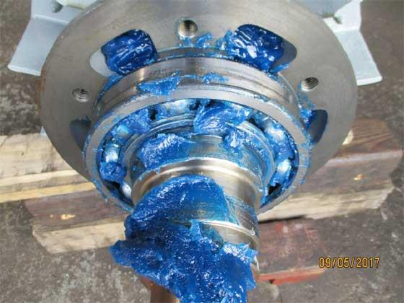
Figure 2. 1 Brand New Motor was over greased
The detection of this vibration led to the discovery that a group of mounting bolts in the sole plate was too long and bottomed out into blind threaded holes.
The split-lock washers on these bolts were not fully compressed, and this allowed resonances, which manifested as the vibration detected at the volute. We are now installing these vibration sensors on all vertical turbine pumps when they are pulled for maintenance.
We have also learned that there are a number of special considerations involved in setting up these types of pumps. The sole plate must be level and the pump column perpendicular. The sole plate must also be firmly grouted to prevent vibrations. The pump shaft sections should be within a nominal 0.005 inches of the total indicated run out.
The Hydraulics Institute (HI) vibration standards 2000 version provided a value for allowable vibration measured at the top of the motor for this type of pump. Later HI standards did not include this value. The owner must determine the allowable value. Our experience is that the pump manufacturers rarely specify a value. Generally speaking, less than 0.2 inches per second is acceptable based on our experience.
- Centrifugal Blowers
A centrifugal blower (for induced draft application) was supplied with a regenerative thermal oxidizer system. The blower wheel was mounted directly on a 7.5 HP motor shaft, and a pressure gauge calibrated for inches of the water column was installed on the blower output piping. The blower vibration increased significantly after three years of operation, the motor failed and a critical process was shut down.
After the motor was replaced, vibration continued to be high. Surge resonance was suspected of causing the blower wheel to delaminate, which resulted in dynamic imbalance and the high vibration. Before further action was taken to correct the issue, the wheel jammed in the blower housing as a result of delamination. The wheel failure caused the critical process to shut down again.
During commissioning the contractor did not specify a vibration limit for this blower. When inquiring with the blower manufacturer after the failure, we found that the vibration limit was less than 0.2 inches per second.
The blower was found to be operating at 0.7 inches per second before the failure, i.e., way out of specification. No one had taken an initial baseline vibration reading, so there was no good data for comparison.
The gauge reading on the output piping was never recorded during commissioning. No one knew what the gauge reading should be during normal operation. The gauge needle had oscillated violently during surge conditions until it jammed at 19 inches of the water column (WC). A new gauge was installed, and the pressure at normal operation was recorded as 39 inches WC.
The commissioning lessons learned are to record vibration and output pressure values, comparing these to the manufacturer’s allowable limits and instructing the operators on what conditions could cause damage. Trending of vibration was also added as a preventive maintenance (PM) task.
- Sludge Dryer Mixer Bearing Failure
When a new sludge drying system was installed, every step of commissioning was carefully performed by the contractor. However, the large ball bearings on the mixing drum shaft still failed in a spectacular manner. They were completely lacking grease from the factory and chewed themselves up into misshaped balls of scrap metal. A simple measurement with a structure borne ultrasound instrument would have detected the absence of lubricating grease while the bearings were still salvageable. Ultrasound inspection has now been added to the commissioning processes where applicable.
- Submersible Pump/Motor Units
Submersible pumps have become very popular in waste water applications. They can be lowered into process wells where they slide into a coupling flange with relative ease and then be connected to electrical power. They are as close to “plug and play” as industrial equipment gets.
We have found it to be prudent to test the power wiring with motor current signature analysis instruments prior to connecting the pump motor to the circuit. This allows the technicians to prove that the power circuit has no resistance to ground issues which may generate variable frequency drive faults. The pump motor should receive both off-line and on-line testing.
Some of these submersible pumps have an oil reservoir for the shaft seals. As part of the PM, this oil must be pumped out and checked for the amount of process water that enters through the volute seal. The PM requirement for this check is generally around a 365-day cycle.
However, when a new pump is installed, we have found that it is smart to check the water content in the oil after the first 90 days. It has revealed excess water on occasions.
- Waste water Clarifiers - Gear Drives
When the contractor installed a new, large (more than 7 feet in diameter) gear drive, they filled it with the manufacturer’s specified oil. One of our tests prior to start-up was to take an oil sample. When our tech sampled the oil, it was found to be critically low in viscosity compared to the specification.
After a bit of investigation, it was learned that the manufacturer ships these gear drives half-filled with diesel fuel. Unaware of this, the contractor added oil to the fill line, which resulted in low viscosity when the oil was tested. Rigorous oil testing was added to the commissioning checklist of all clarifier drives.
- Rotary Screw Compressors
These types of compressors offer energy conservation benefits but come with important maintenance responsibilities. Particularly, the oil condition must be closely monitored. Satisfying the warranty requirements often relies on being able to prove preventive maintenance was performed.
Many rotary screw compressor manufacturers require owners to send oil samples to their designated oil test lab. Failure to do so may void the warranty. Commissioning of these compressors includes making certain a vigilant PM program is put in place with special attention to oil analysis.
Final Thoughts
To some degree, equipment commissioning is educated guesswork when first attempted. The guessing becomes better with each experience and as more information is added to the body of knowledge. There will be a good deal of root cause discovery. In reality, what gets done is common sense.
With each project, the body of knowledge grows to become a better reference for future commissioning projects. Equipment commissioning truly is a valuable art.
Additional Articles in commissioning
In the past, the primary focus of commissioning has been on high voltage AC systems, but because of the need for increased electrical system reliability and complexity, owners are now starting to realize the importance and benefits of commissioning on-site electrical systems. Some of the advantages include:
- Electrical systems that meet the operational needs of the owner;
- Reduced downtime due to power outages caused by utility loss and/or failures within the electrical system;
- Coordinated electrical systems that balance protection with reliability and meet the recent code requirements and standards for critical facilities confidence that the electrical systems will operate correctly when required;
- Knowledge of and experience with the operation of the electrical equipment.
2.1.3 Automated Commissioning of Pneumatic Systems
A significant part of the costs of a pneumatic motion in a machine is caused by commissioning. Today every cylinder chamber needs to be connected by tube to the exactly right port of the valve terminal. In this paper a new concept for commissioning pneumatic systems is presented, where the tubes can be plugged in any arbitrary port of the valve terminal. So the commissioning can be fastened and money can be saved. The concept bases on the Festo Motion Terminal, a new valve terminal whose valve slices can exercise different valve functions. The functionality change is made only by software. This versatility can be used for the automated commissioning.
- Motivation
The commissioning of pneumatic drives as part of a machine or plant is in general a very simple process.
The technician needs to connect a defined cylinder chamber to a defined port of the valve terminal with a tube of an adequate length. Nevertheless in reality this is a complex and difficult process.
There can be lots of tubes, they are often not marked and all look the same. Sometimes the tubes are very long, they are channeled e.g. in energy chains, they are bundled together or they run all cross the machine. In such cases it is very difficult to answer the question: Which tube belongs to which port (compare Figure2.2)? Thus the commissioning of pneumatic drives is a time consuming process which causes substantial costs. The idea behind this paper is to simplify and shorten the commissioning process.
Our goal is each tube coming from the cylinders can be connected to any arbitrary port of the valve terminal. After that the valve terminal will start an identification process, which valve port is connected to which cylinder chamber. So we are allowing a “chaotic” hardware installation of the tubes and clear it up later by software.
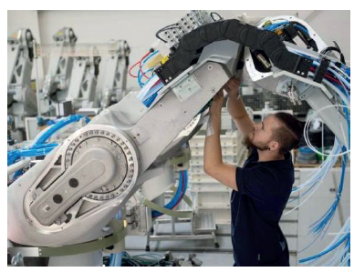
Figure 2. 2 Which tube belongs to which port?
Aiming to connect each tube to any arbitrary port of the valve terminal another benefit of the circuit configuration of the Festo Motion Terminal needs to be used. The pneumatic full bridge can be divided into two independent half bridges. For the movement of the pneumatic cylinder it is not necessary that his ports are connected to the two half bridges of the same valve slice. The cylinder can be connected to the two half bridges of different valve slices as long as this information is considered in the control strategy.
It is basic principle of the Festo Motion Terminal that every half bridge on every valve slice is identical so there is a free choice where to connect the different cylinder chambers (compare Figure2.3)
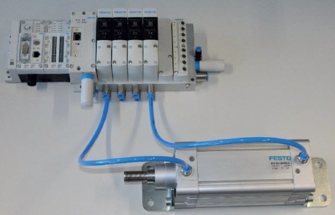
Figure 2. 3 Pneumatic double acting cylinder connected to halve bridges of different valve slices
2.1.4 Basic concept of the automated commissioning process
For comprehensibility reasons in this chapter the basic concept of the automated commissioning process is described by the example of a double acting cylinder. But certainly, the process also works with single acting cylinders, vacuum generators, rotary indexing tables, The only requirement is, that the ventilation of a valve port results in a reaction of an actuator, thus a measurable signal change of a connected sensor is generated (e.g. end-position switch, position sensor or vacuum switch).
In the starting situation, the pneumatic system is in a defined state. At both end positions of every cylinder there is an end-position switch mounted which is ready for operation. Every cylinder is placed in one of his end positions, thus the corresponding end-position switch is activated. All cylinder chambers are exhausted and all four 2/2-wayvalve of every valve slice are closed.
Then the first ventilation valve is activated, thus a rise of pressure in one cylinder chamber occurs. Then there are two possibilities.
- The pressure pushes the piston further into the end position (case A in Figure 2.3). After a while the total system pressure is reached in the cylinder chamber. In this case the cylinder chamber cannot be identified during this step, because there is no change in state of an end-position switch. Thus the valve port is exhausted again and the process goes on with the next valve port.
- The cylinder starts to move (case B in Figure 2.3). When the cylinder has left the end position, the corresponding end-position switch will change his state from activated to deactivated. This means: The connection between cylinder chamber and valve port is identified. During the further cylinder movement there will be a rise of pressure in the second cylinder chamber. Depending on cylinder size and tube length and diameter this rise of pressure will be smaller or larger. When it is large enough, that it can be measured by the pressure sensor of the second connected half bridge, the cylinder is completely identified. When it is too small, the second end position will be reached.
Thus the second end-position switch is activated and the cylinder is in a defined state again. After that the valve port is exhausted and the process goes on with the next valve port.
For an efficient commissioning process the usage of the partial stroke should be reduced to cylinders, where it is really necessary. Thus it is helpful to know, under which conditions (positions of the other cylinders) a collision may occur or vice-versa a full stroke is allowed. These information must be extracted from planning data, thus the Festo Motion Terminal needs access to a defined description of possible collisions.
  - Challenge gravity and/or process forces
In the description of the basic concept, the double acting cylinder is mounted in horizontal position and no other forces are acting on him. Thus the cylinder will be stable when he reaches the second end position or stops for a partial stroke and the cylinder chamber is exhausted. These conditions are certainly not always given in reality.
When the cylinder is in a vertical position, a mass is mounted or process forces are acting on the cylinder, a stable position is not guaranteed any more.
The first step to handle this challenge is to detect it. This can be done by using waiting times. When a cylinder has reached the second end position and the cylinder chamber is exhausted it is helpful to wait a few seconds, if the end position is left again.
Also when a partial stroke was executed a small waiting time is needed to look, if the cylinder is pushed back to the end position. When such a push back caused by gravity and/or process forces is detected, the second step is to compensate it. To hold the cylinder in the second end position the pressure control of the Festo Motion Terminal can be used.
The pressure in cylinder chamber can be controlled in closed loop to compensate the gravity and/or process forces. Because the cylinder should move when his second chamber is vented during the commissioning process it is advisable to have a low pressure in the first chamber. So a stepwise approach is recommended: Set a defined pressure, detect if the cylinder is still pushed back and if necessary enlarge the set pressure.
When a push back in a partial stroke situation should be compensated it is better to enclose an amount of air in the pressure chamber and not to use the pressure control in closed loop. Because a small movement of the piston results in pressure changes, which are directly compensated by the pressure control. Thus a continuous movement of the cylinder may happen. When the cylinder chamber is enclosed, small vibrations in the cylinder position will not lead to a continuous motion.
  - Challenge delayed movements
Due to friction and/or adhesive effects, the reaction of the cylinders to pressure changes can be delayed. An illustrative example is a vertically mounted cylinder which is loaded with a small mass. The lower position in the first end position is stable. After the movement into the second end position and the exhaust of the cylinder chamber the piston may stick on the end cap of the cylinder. This effect could be a combination of sealing friction on the one hand and adhesive forces between piston and end cap on the other hand.
After an unpredictable while this cylinder may start to move, e.g. caused by vibrations resulting from the movement of another cylinder. This can lead to an incorrect assignment because the inflating of the second cylinders triggers two signal edges.
Another example for delayed movements is a cylinder which fulfilled a partial stroke.
Then the piston is somewhere in between the end positions and the gravity forces, friction forces and pressure forces from the enclosed amount of air are balancing each other. Due to leakage the pressure in the enclosed cylinder may drop, thus the force balance is disturbed and the cylinder starts to move at an unpredictable time. This can lead to an incorrect assignment as well. To solve the challenge of delayed movements there are two steps advised. The first step is to monitor, if two or more edge signals from end-position switches or other sensors occur after venting a cylinder chamber. This should be taken into account in the commissioning strategy.
The second step is to implement control loops. When a cylinder is fully identified, it can easily be tested if the two chambers are really belonging to the same cylinder. Especially when different time intervals are used a reliable verification of a correct assignment can be ensured.
The last step is the reconfiguration process. The user don´t want to deal with the identified connections between half-bridges and cylinder chambers. His PLC-programming must be limited to “extract cylinder A” and “retract cylinder C”. During the preparation there is a chaos in tubing allowed. The firmware on the Festo Motion Terminal untangles this chaos. Only this reconfiguration generates an added value to the customer.
A further subtasks of the reconfiguration is to save the results of the identification process stable and long lasting, both for the standard pneumatic movement as well as for the Motion apps of the Festo Motion Terminal /2, 3/. After a restart, after a power failure or after whatever it needs to be guaranteed, that the system can start immediately. In every case it must be prevented, that the automated commissioning process must be repeated, because the preparation process is very complicated when the system was finished once.
Last but not least the firmware needs to be prepared for system changes in the future. It is necessary, that the maintenance staff has access to the results of the identification process, can make changes and use it for documentation purposes.
  - Dynamic demonstrator automated commissioning
To prove the functionality of the described automated commissioning process a demonstrator was build up which is shown in Figure 2.4. On the left side of the display a Festo Motion Terminal with eight valve slices is fixed – thus 16 half-bridges can be used. The pneumatic system is placed on the right side of the display. It consists of different single and double acting cylinders in vertical and horizontal mounting position. To show, that the concept is not limited to cylinders, furthermore a rotary indexing table, a pneumatic gripper and a vacuum cup with vacuum generator is integrated. All these components build a dummy process that transports a plastic work piece from a start position to an end position.
Figure 2. 4 Dynamic demonstrator automated commissioning

2.2 Commissioning procedure
Performing Commissioning procedure in accordance with requirements without damage to the surrounding environment or services is the crucial point for commissioning any types of equipment in different Mechatronics systems.
Commissioning: Is systematic process confirming that building systems have been installed, properly started, and consistently operated in strict accordance with the Contract Documents, that all systems are complete and functioning in accordance with the Contract Documents at Substantial Completion, and that Contractor has provided Owner adequate system documentation and training. Commissioning includes deferred and/or seasonal tests as approved by Owner.
2.2.1 Procedure for Equipment Commissioning
Procedure for performing equipment commissioning has associated Documents;
- EHS-00017-F1 – Equipment Commissioning Checklist
- EHS-00017-F2 – Tool Owner Matrix Form, is to be filled out and submitted as part of the submission; and it can be placed on the tool to satisfy Tool Owner labeling requirements.
- EHS-00017-F3 – EHS Equipment Safety Compliance Checklist, an optional form created to assist those involved in factory source inspections or final install locations. While comprehensive, it is not intended to be all inclusive and should be used to stimulate observation of the equipment to ensure proper safety compliance.
- EHS-00031 – Toxic Gas Monitoring System (TGMS) Operation and Maintenance Procedure
- EHS-00048-F1 – Requirements for Class 3B and 4 Lasers
- EHS-00066-F3 – Radiation Survey Sheet
- EHS-00066-F5 – Laser Inventory
- EHS-00072 - Specification for Lift Stations
Definitions for Equipment Commissioning
- The following definitions apply to this procedure and the corresponding Equipment Commissioning Checklist (EHS-00017-F1).
- Bulk Chemical Delivery System - A system that consists of chemical storage vessels located outside of the fabrication area from which chemicals are delivered, via distribution piping, to equipment located in the fabrication area.
- Tool Owner - As it relates to this procedure, the Tool Owner is the person listed as the "Applicant" on the Equipment Installation Approval Checklist. In the event that a more appropriate party exists, it shall be the responsibility of the "Applicant" to designate the person who will fulfill the responsibilities of the Tool Owner during the installation process.
- Equipment-Specific - An item is considered to be equipment-specific if it is installed specifically to accommodate, either wholly or in part, the presence of the equipment being installed or is installed internally to the equipment itself.
- Hazardous Energy - Hazardous energy includes, but is not limited to, electrical, mechanical, hydraulic, pneumatic, chemical, thermal, ionizing radiation, non-ionizing radiation, and other types of energy. Lockout/tag out procedures must consider all hazards associated with all types of energy that may be related to the activity to be performed.
- Hazardous Production Materials (HPM) - A solid, liquid, or gas associated with semiconductor manufacturing that has a degree-of-hazard rating in health, flammability, or reactivity of Class 3 or 4 as ranked by the National Fire Protection Association (NFPA 704 –2007) and is used directly in research, laboratory or production processes that have as their end products materials that are not hazardous.
- Local Dispense Chemical Delivery System - A local dispense chemical is one that is stored in and/or dispensed from a vessel that is internal to the equipment or is delivered to the equipment from storage vessel(s) located in a dispensing cabinet that is remote from the equipment but located within the fabrication area.
- Non-HPM - A solid, liquid or gas that has a degree-of-hazard rating in health, flammability, or reactivity of Class 0, 1 or 2 as ranked by the National Fire Protection Association (NFPA 704 – 2007). Non-HPM chemicals are those that pose minimal, if any, hazards to personnel who may be exposed to them. They are the only chemicals that may be introduced to the equipment upon Part 1 sign-off of the Equipment Commissioning Checklist.
- Point-of-use - The point-of-use is considered to be that point on the external surface of the equipment that is nearest to the point of connection of gas, liquid, or vacuum supply lines to the equipment. Point-of-use labels are intended to identify all gas, liquid, and vacuum lines, and electrical cords at the point of connection to the equipment.
- Fan Filter Unit (FFU) - A type of air filtering equipment used to supply purified air to microenvironments by filtering out harmful airborne particles from re circulating air.
- Clean Environment - An engineered enclosure system used to maintain low-particulate environment around a semiconductor production-related process using FFU’s. Temperature, overpressure, relative humidity, air flow and make-up air may be controlled. Interfaces are carefully designed to maintain the conditions inside the enclosure.
- Chemical Dispense Unit (CDU) - A fully enclosed, noncombustible enclosure used to provide an isolated environment for liquid chemical in storage or in use.
- Chemical Valve Manifold Box (CVMB) - A fully enclosed, noncombustible enclosure with branch valving used to provide multiple outputs from single supply chemistry.
- Make-Up Air Unit (MAU) - A HVAC unit used to control temperature, humidity, and, as required, clean room pressurization air and replenish outside air lost through exhaust systems.
- Lift Station Design A - The simplest unit designed for just water applications. Typically design A is used for condensation from equipment such as a MAU (make-up air unit) or janitorial slop sink.
- Lift Station Design B – A unit used for single chemistry (only one specific chemical drain system) or drain from a point of use (POU) abatement unit where all the chemistries are compatible with one another.
- Lift Station Design C – A unit used for multiple chemical drain systems where there is a potential of incompatible chemicals mixing in the lift station.
2.2.2 Responsibilities
- The Tool Owner requesting permission to install a tool in the concerned body Facilities will complete the Equipment Commissioning Checklist.
- Responsible parties for each checklist item are listed in the responsible columns on the checklist. This identifies the group or individual that is responsible for taking action on and ensuring completion of each checklist item. The designated organizations/company personnel from the Environmental, Health and Safety (EHS) and Facilities Operations Group Departments will review and approve the checklist and required documentation in order to begin/initiate the installation process.
- The groups to be represented on the Equipment Commissioning Sign-off Team are as follows:
- Installation Coordinator (IC)
- Tool Owner (TO)
- Tool Engineer or Equipment Engineer (TE/EE)
- company Tool Hook-up Manager
- company Environmental, Health and Safety (EHS)
- company Code Compliance Manager
- company for Facilities and Infrastructure
- company TGMS Engineer
- The number of responsible parties will vary depending on the owner status of the tool installed at the Facilities. The tool may be owned and operated by Facilities are responsible for all checklist items that are marked with an “X”. Or the tool may be owned and operated by an outside company, in this case the Tool Owner and their respective representatives are primarily responsible for all the checklist items that are marked with an “X”, with the EHS representatives responsible for verification of each associated checklist item.
- The Equipment Sign-off Team members will meet at the site as necessary to complete their assigned checklist responsibilities. Each checklist item will be verified and initialed by the appropriate responsible group. For checklist items that list more than one party that are responsible for the checklist item, all parties must initial for the group they represent verifying completion of the checklist item. If additional persons or persons other than those listed are responsible for an item, the responsibilities can be reassigned by crossing out the original party and/or adding additional parties under the same responsible box.
2.2.3 Procedure for Equipment Commissioning Checklist: Part 1
Part 1 of the Checklist is designed to ensure the equipment is ready to be energized. Once the equipment is set, leveled, and electrical and facilities connections are made, a review of the installation to that point will be performed using the Part 1 Checklist.
Upon completion of the Part 1 Checklist, electrical power, non-HPM gases, liquids and vacuum, may be supplied to the equipment. Completion of the Part 1 Checklist allows the supplier an opportunity to perform any equipment system checks that are necessary prior to the introduction of hazardous production materials (HPMs) or other hazardous energy sources associated with the equipment.
  - Electrical Matrix (Section A)
All sources of electricity to the equipment must be listed in the electrical data matrix. Upon completion of the electrical installation, the actual voltage must be verified before the equipment may be energized. All sources of electricity may be energized upon completion of the Part 1 Checklist.
  - Electrical Safety Requirements (Section B)
In general, the electrical portion of the installation must be checked for correct connections, voltages, proper grounding, the presence of lockable disconnects, correct panel, switch, disconnect and tool status indictor labeling, as well as other requirements.
  - Lockout / Tag out and Hazardous Energy Control (Section C)
Lockout / Tag out procedures must be developed specific to the equipment being installed. The Tool Owner is responsible for the development of such procedures. Prior to Part 1 sign-off, all hazardous energy sources must be completely locked out.
  - Access and Clearance Requirements (Section D)
Work space clearances about electrical equipment and HPM workstations must be verified to ensure that the actual installation meets the distances specified in the design and is compliant with applicable standards. Table 3.1 illustrates workspace clearances required by the National Electrical Code for electrical equipment that is likely to require examination, adjustment, servicing, or maintenance while energized.
Access and clearances specified by the tool manufacturer for operation and maintenance must also be adhered to.
Table 2. 1 Work Space Clearances around Electrical Equipment
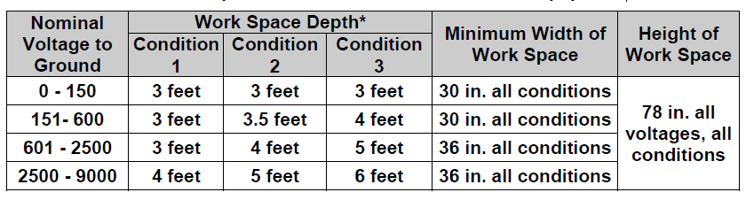
* "Conditions", as described in NEC 110-16, are as follows (see NEC 110-26 for exact phrasing and exceptions):
Condition 1 - Exposed live parts on one side and no live or grounded parts on the other side of the working space, or exposed live parts on both sides are effectively guarded by suitable insulating materials.
Condition 2 - Exposed live parts on one side and grounded parts on the other side.
Condition 3 - Exposed, non-grounded, live parts on both sides of the work space with the operator between.
  - Lasers (Section E)
Equipment that contains lasers must certify compliance with 21 CFR 1010 and 1040, and with ANSI Z136.1. This equipment must be labeled properly, must have properly functional interlocks, have the laser surrounded by protective housing, be reviewed by the companies Radiation Safety Officer and be added to the company’s Facilities Laser Inventory (using EHS-00066-F5). Additional protective measures must be implemented in cases where there is open beam exposure potential to class 3B and Class 4 Lasers (see EHS-00048-F1 Requirements for Class 3B and 4 Lasers).
  - Radiation Requirements (Section F)
All sources of ionizing (Gamma and X-ray sealed sources) and non-ionizing (Ultra-Violet, Infra-Red, Microwave and Radio Frequency) radiation must be enclosed, interlocked and properly labeled. All sources of ionizing radiation must be surveyed and registered with New York State Department of Health (NYSDOH) by Radiation Safety Officer, Radiation baseline surveys may need to be postponed until the equipment is fully functional. If this is the case, all necessary radiation surveys must be scheduled and executed in a timely manner. See EHS-00066-F3 Radiation Survey Sheet.
  - Non-HPM Gas/Liquid & Vacuum Facility Lines (Section G)
All facility lines delivering non-HPM gases or liquids (waters), or supplying vacuum to the tool, should be listed in the boxes provided in this section. Generally accepted abbreviations (e.g. CDA, UPW, etc.) may be entered, if preferred.
  - Onboard Non-Process Chemical Inventory (Section H)
The Tool Engineer lists all non-process chemicals used in the tool and/or its peripherals.
  - Guarding (Section I)
This is a review of the applicable guards and shields that should be installed on the tool.
  - Personal Protective Equipment (Section J)
EHS will assist the Tool Owner in selecting the necessary Personal Protective Equipment for all operation and maintenance tasks associated with the equipment.
  - Tool Identification (Section K)
This is a review to ensure the proper identification and a list of emergency contacts is posted on the tool.
  - Seismic Restraints (Section L)
Lists the Seismic Data and reviews the tool specific requirements.
  - HPM Delivery System (Liquids and Gases) Process Control Isolation (Section M)
Prior to the energization of the HPM delivery system Chemical/Gas Services and EHS must apply process control locks to each of the outputs/sticks. Tool Installation must apply process control locks to each of the outputs/sticks that they will be working on.
TGMS Controls and Matrix
Prior to Part 1 sign-off the tool engineer and TGMS controls contractor must agree to the interlocks that will be used to control the flow of gases and liquids to the tool. The tool engineer must also have a signed TGMS matrix which would be used to determine what TGMS components should be installed and how such components should be controlled. As part of the Part 1 sign-offs the TGMS Engineer reviews and approves the location of the installed TGMS device(s) for serviceability.
2.2.4 Equipment Commissioning Checklist: Part 2
The Part 2 Checklist is used to verify that the equipment is ready for HPM use and other hazards (i.e. radiation, laser, mechanical hazards, etc.) associated with the equipment are ready to be energized.
Upon completion of the Part 2 review, the equipment may be approved to become fully functional, and is released for process qualification and commissioning for use at companies Facilities.
General (Section A)
This section covers general safety topics that are not normally mentioned otherwise, such as: whether the Coordinator and Leaders have been informed about the installation and associated emergency procedures; whether Leader from each shift was provided an opportunity to conduct an orientation tour with a responsible tool / equipment representative; whether any new hazards, equipment or conditions exist that would require to be trained; whether such retraining has taken place; whether any confined spaces are identified and labeled; whether a noise survey is complete; and whether the work area is adequately illuminated.
Exhaust Ventilation (Section B)
A listing of all the exhausted outlets with the type of ventilation, monitoring flow devices, if any, and any required set points, must be provided here.
Exhaust Ventilation Requirements (Section C)
The exhaust ventilation requirements include details to ensure that the exhaust ducts are properly tested, balanced, and labeled. It also ensures that exhaust dusts carrying HPMs have continuous monitoring devices installed. These monitoring devices must be available in the plenum as well as in the tool, they must be tested for proper functionality, must be secured in place and have their set points tested. Where lab hoods or wet benches are utilized a face velocity between 80 – 120 cubic feet per minute must be attained.
Vacuum Pumps (Section D)
While all vacuum pumps can be checked during Part 1 sign-off, only those vacuum pumps associated with non-HPM gas or liquid, process vacuum, and exhaust ventilation may be energized upon completion of the Part 1 Equipment Commissioning Checklist. All pumps handling toxics, HPMs must remain locked-out until completion of the Part 2 sign-off.
Local Dispense and Bulk Chemical Inventory (Section E)
All chemicals (other than gases) that are supplied to the equipment must be listed in this form. The form asks for an indication of the type of container in which the chemical is stored prior to or during use by the equipment. For the purposes of this procedure, the following definitions apply:
- A bath is a container that is normally open on top during normal operation of the equipment.
- A tank is any other type of container that is normally completely enclosed during normal operation of the equipment. All bulk chemicals are assumed to originate from a tank.
Local Dispense Chemical Delivery Systems Requirements (Section F)
The systems requirements ensure that all the supply lines and containment piping are properly labeled and tested and are double contained, where required. It also sets forth requirements for testing and verification of leak detection systems, specific requirements for pressurized chemical containers and access to emergency eyewashes and/or showers.
Bulk Chemical Delivery Systems Requirements (Section G)
The systems requirements ensure that all the supply lines and containment piping are properly labeled and tested and are double contained, where required. It also sets forth requirements for testing and verification of leak detection systems, specific requirements for HPM delivery lines, HPM shut-off valves and separation of flammable and combustible materials.
Gas Delivery Systems Requirements (Section H)
The gas delivery requirements ensure that gas lines: are labeled; are traced to origin and verified; are double contained; and that gas manifolds and gas cabinets are properly labeled. This also sets forth the requirements to ensure all gas delivery systems internal and external to the tool are leak checked and that the completed Leak Check Checklist is submitted to Facility Operations Management.
Detection/Monitoring Requirements (Section I)
All gases for which monitoring is required must be listed in the Gas Detection Matrix along with the detection system that is used, all sampling point locations, the high and low set points, and the date each sampling point is tested and verified to be functional must be listed here per the requirements set forth in EHS-00031 Toxic Gas Monitoring System (TGMS) Operation and Maintenance Procedure.
EHS are responsible for ensuring that the TGMS Tool Matrix, Instrument Calibration Schedule and TGMS Zero reading documents have been updated and submitted, As well as verifying the points were selected, placed and labeled correctly.
Drain Matrix (Section J)
The drain system, the material it is constructed of, the leak check results and whether the piping is properly labeled must be listed in this section.
Chemical Disposal Requirements (Section K)
List all chemicals drain lines that carry effluent from the equipment in the form provided. HPM drain lines must be leak checked prior to use in accordance with the New York State Plumbing Code.
The tool engineer is responsible for preparing and submitting chemical drain emission calculations to EHS demonstrating that the concentration of chemical that are being discharged and treated by the water treatment plant are below required permit limit.
Post-Process Exhaust Treatment Systems (Section L)
Multiple parties are listed in the responsible column for several items in this section.
The responsibility for each checklist item depends upon the location of the post-process exhaust treatment systems within the facility. If Tool Owner is a company other than both parties listed in the responsible column has responsibilities pertaining to a specific item, both parties will verify the items by initialing the items, whichever apply.
The tool engineer is responsible for preparing and submitting air emission calculations to EHS demonstrating that the concentrations of chemicals/gases that are being discharged are treated effectively by the assigned post process exhaust treatment system.
Fire Detection (Section M)
All types of fire detection equipment that shall be utilized must be listed in this section.
Fire Protection Requirements (Section N)
This section applies to all equipment-specific fire detection, monitoring, suppression, and alarm systems. This includes systems internal to the equipment itself and systems that are installed to accommodate, either wholly or in part, the presence of the equipment that is being installed (e.g. sprinklers in the bay ceiling that service the area occupied by the equipment). Installations that are required by the New York State Fire Code that are tied to the Building Fire System must be approved, installed and verified by a New York State certified installation contractor.
Local Fire Suppression System Documentation (Section O)
This is a checkpoint to ensure the necessary tests and documents have been conducted, and provided by the fire system(s) installers.
Emergency Machine off (EMO) (Section P)
The equipment may be powered up to test EMO functionality only after all other Part 1 Equipment Commissioning Checklist items have been verified. The tool must then return to a completely locked-out state until sign-off is approved.
Interlocks (Section Q)
The supplier of the equipment must provide an interlock matrix, listing all interlocks that are specific to the equipment. This matrix should be attached to the Equipment Commissioning Checklist. All interlocks listed on the matrix must be verified to be functional. Interlocks present on peripheral equipment (i.e. vacuum pumps, exhaust treatment systems, gas detection systems, etc.) are addressed in those respective sections of the Equipment Commissioning Checklist. Section Q of the Part 2 The checklist applies only to interlock that is internal to the equipment as provided by the supplier. It is important to ensure that any changes to the equipment or the operating system do not affect the functionality of any interlock(s). Interlocks must be re-tested and verified to ensure functionality after every such change.
In case of an alarm, area alarm control panels connected to the gas detection system must have interlocks to stop the gas flow into a gas cabinet. Any other interlocks, like an EMO being pressed or a status signal from the tool or process chamber/module is not mandatory to have connected to the area alarm control panel but will be utilized if connections are available on the system.
Radiation Requirements (Section R)
All radiation producing equipment must be surveyed the first time it is turned on.
HPM Delivery System (Liquids and Gases) Process Control Isolation Lock Removal (Section S)
Prior to the turn on of the HPM lines from the HPM delivery system Tool Installation and Chemical/Gas Services must remove the process control locks to the lines/sticks that will be turned on.
Clean Environments (Section T)
Prior to the use of a clean environment all needed information must be completed on EHS-00017-F1.
Lift Station (Section U1 and U2)
Prior to the use of a lift station, the lift station must meet all the requirements for the design of lift station and all needed information must be completed on EHS-00017-F1. (For additional information see EHS-00072).
Part 2 Interim Sign-offs
This section serves two functions:
- Allows EHS to provide partial approvals in phases as the tool is prepared for use.
- Provides System Owners the opportunity to review and approve the parts of the project that they will own.
2.2.5 Part 2 Punch list Items
Any deficiencies that are discovered during the Part 1 and Part 2 reviews that do not directly impact the safety of the equipment or the installation are to be listed in the Punch list at the end of the Equipment Commissioning Checklist. The party responsible for completing each Punch list item will be listed in the Punch list, as well. Punch list items should be completed in a timely manner and must be completed before the checklist is signed off.

  - Equipment Commissioning Part 2 Approval Signatures
Successful completion of all checklist items allows approval of the Equipment Commissioning Checklist, whichever applies. Only upon completion of all checklist items, including those designated as Deficient or Punch list items, may the commissioning be approved. All parties must wait to sign the appropriate signature block until all checklist items, for which they are responsible, are verified. The Code Compliance Manager and Environmental, Health and Safety must wait until all signatures have been affixed to the checklist.
  - Records
The Equipment Commissioning Checklist serves as documentation of the individual equipment installation projects and will be archived for future reference by EHS Department.

2.3 unplanned events or conditions
Responding to Unplanned events or conditions in accordance with established procedures
The objective of this responding is to protect workers and machines from the hazards of machinery and to prevent accidents, incidents and ill health resulting from the use of machinery at work by providing guidelines for:
  - Ensuring that all machinery for use at work is designed and manufactured to eliminate or minimize the hazards associated with its use;
  - ensuring that employers are provided with a mechanism for obtaining from their suppliers necessary and sufficient safety information about machinery to enable them to implement effective protective measures for workers; and
  - Ensuring that proper workplace safety and health measures are implemented to identify, eliminate, prevent and control risks arising from the use of machinery.
Hierarchy of controls
- Unless a particular hazard is removed, the risk associated with such a hazard can never be completely eliminated.
- The approach most commonly used is referred to as the hierarchy of controls, from preferred to least desirable, as follows:
  - elimination;
  - substitution;
  - engineering controls;
  - administrative (procedural) controls; and
  - Personal protective equipment (PPE).
2.3.1 General obligations, responsibilities and duties
Roles and obligations of the competent authority
- The competent authority should formulate, implement and periodically review a coherent national policy on safety in the use of machinery, taking into account national conditions and practice and in consultation with the most representative organizations of employers and workers concerned.
- Such a policy should take due account of relevant international regulations, standards and systems, including the guidance contained in this code of practice.
- The competent authority should establish and from time review laws, regulations and standards for safety in the use of machinery, in consultation with the most representative organizations of employers and workers concerned, and relevant professional bodies.
- The competent authority should establish mechanisms to ensure compliance with national laws and regulations. These should include an adequate and appropriate system of risk-based inspection. The system of enforcement should provide for corrective measures and adequate penalties for violations of national laws and regulations concerning the policy.
- On safety and health grounds, the competent authority may justifiably:
- prohibit or restrict the use of hazardous machinery;
- Specify qualifications of workers who, for reasons of safety and health, are allowed to use specific machinery, or are allowed to use them but only under conditions prescribed in accordance with national laws and regulations.
- The competent authority should, where appropriate, require designers, manufacturers and suppliers to provide it with safety and health-related information on the assessment of the hazards and risks associated with machinery.
- The competent authority should ensure that guidance is provided to employers, workers and their representatives to help them comply with their legal obligations under the policy. The competent authority should provide assistance to employers, workers and their representatives with respect to their OSH responsibilities, obligations and rights.
- The competent authority should ensure that machinery on the market satisfies the legal OSH requirements.
- The competent authority should endeavour to promote close cooperation between designers, manufacturers, suppliers, employers, workers and their representatives on safety and health in the use of machinery.
- The competent authority should establish, apply, and periodically review a system for the recording and notification by employers of occupational accidents, occupational diseases and dangerous occurrences caused by machinery.
- The competent authority should have a system for investigating occupational accidents, diseases and dangerous occurrences as appropriate. Such investigations should make use of relevant reports and other available information.
- The competent authority should, in accordance with national law and practice:
  - periodically carry out inspections and monitor compliance with relevant laws and regulations in the use of machinery;
- inform employers, workers and their representatives of the findings of inspections for the implementation of required remedial action;
- have the authority to issue an order to stop the use of machinery in situations where there is an imminent or serious danger to the safety or health of workers; and
- produce and update safety guidance, where appropriate, in cooperation with the representative organizations of employers and workers
2.3.2 OHS principles and application;
- Many tests on electrical equipment involve the use of high voltages and currents that are dangerous, both from the standpoint of being life hazards to personnel and because they are capable of damaging or destroying the equipment under test.
- Adequate safety rules should be instituted and practiced to prevent injury to personnel, both personnel who are performing the tests and others who might be exposed to the hazard.
- Also, the test procedures used should be designed to ensure that no intentional damage to equipment will result from the testing process.
- It should be recognized, as the name implies, that over-potential or high-potential testing is intended to stress the insulation structure above that of normal system voltage.
- The purpose of the test is to establish the integrity of the insulation to withstand voltage transients associated with switching and lightning surges and hence reduce the probability of in-service equipment failures.
- If a testing program is to provide meaningful information relative to the condition of the equipment under test, then the person evaluating the test data must be ensured that the test was conducted in a proper manner and that all of the conditions that could affect the evaluation of the tests were considered and any pertinent factors reported.
- The test operator, therefore, must be thoroughly familiar with the test equipment used in the type of test to be performed and also sufficiently experienced to be able to detect any equipment abnormalities or questionable data during the performance of the tests.
2.3.3 Program and commission commercial security systems
Why You Must Commission the Electrical Components and Systems
There are many benefits in performing electrical commissioning including cost savings.
The equipment manufacturer or contractor can correct problems or replace equipment easier when they are discovered during start-up, while the equipment is under warrantee, and before the owner moves in. Other benefits may include increased personnel safety and equipment protection, reduced downtime, and reduced insurance premiums. There are many code requirements that mandate some electrical testing and commissioning.
Some of these codes include the National Electric Code (NEC) and National Fire Protection Association (NFPA). Local electrical inspectors or “authorities having jurisdiction” (AHJ) may have additional testing requirements.
The Institute of Electrical and Electronic Engineers (IEEE) Standard 493, Reliable Industrial and Commercial Power Systems (Gold Book) publishes statistics on the reliability of various electrical equipment and systems.
The results of a survey performed by the Industrial Applications Society are shown in Table 38 of the Gold Book. This table lists different failures that occurred and suspected causes. These categories are listed below:
- Manufacturer-defective component
- Application engineering-improper application
- Inadequate installation and testing prior to start-up (commissioning)
- Transportation to site – defective handling
- Inadequate operating procedures
- Inadequate maintenance
- Outside agency-personnel
- Outside agency-other
The first four categories on the list represent over 40% of the failures. Commissioning would have discovered these problems during construction and startup. Performing commissioning prior to the contractor leaving and the owner moving in, allows an orderly decision making process by the contractor, owner, equipment manufacturer, and equipment distributor, Electrical Power System Commissioning provides the following benefits:
- Identifies equipment that is damaged by transit to or mishandling at the job site prior to energization
- Determines if the electrical components and system have been properly installed
- Reduces equipment downtime
- Reduces risk of equipment failure
- Increases equipment and personnel safety
- Improves insurability
- Reduces designer and contractor liability exposure
- Improves electrical system performance
- Determines whether components and systems meet the design intent and operate properly
- Determines if components and systems are in compliance with the project specifications and design
- Saves money
The electrical components and systems are the foundations for the mechanical systems. It is the electrical systems that provide power, control, and communication to the mechanical equipment and systems. Without reliable power, control, and communication, the other systems will not function.
In commissioning of electrical or electronic equipment, you will understand the commissioning methods, techniques and procedures, and their application. You will know how the equipment/components function, the purpose of the individual components and any associated defects, in adequate depth to provide a sound basis for carrying out the commissioning activities and, where appropriate, correcting faults and solving functional problems, ensuring that the equipment performs to the required specification.
You will understand the safety precautions required when carrying out the commissioning activities, especially those for applying power in incremental stages.
You will also understand your responsibilities for safety, and the importance of taking the necessary safeguards to protect yourself and others in the workplace.
Step 1: Work safely at all times, complying with health and safety and other relevant regulations and guidelines
Step 2: follow all relevant setting up and operating specifications for the products or assets being configured
Step 3: follow the defined procedures and set up the equipment correctly ensuring that all operating parameters are achieved
Step 4: deal promptly and effectively with problems within your control and report those that cannot be solved
Step 5: check that the configuration is complete and that the equipment operates to specification
Step 6: complete all relevant documentation accurately and legibly
Commissioning electrical/electronic equipment and systems, you need to know and understand;
- The specific safety practices and procedures that you need to observe when commissioning electrical/electronic equipment (including any specific legislation, regulations or codes of practice for the activities, equipment or materials)
- the procedures to be carried out before starting work on the commissioning activities (such as obtaining permits to work, obtaining and complying with risk assessments and other health and safety requirements)
- the specific health and safety precautions to be applied during the commissioning procedure, and their effects on others
- hazards associated with carrying out electrical/electronic commissioning activities (such as dangerous voltages, stored charge, using damaged or badly maintained tools and equipment, not following laid-down commissioning procedures), and how to minimise them
- the importance of wearing personal protective equipment (PPE) during the commissioning process, and where it can be obtained ;
- how to obtain and interpret drawings, specifications, manufacturers' manuals, instructions (including BS and ISO schematics, IEE regulations, symbols and terminology)
- how to carry out currency/issue checks on the specifications you are working with
- the equipment to be commissioned, its operating procedures and function
- the checks to be carried out on the equipment prior to undertaking the commissioning operations (such as installation damage, contamination, level and alignment, security of fastenings, electrical connections are correct, moving parts are free from obstructions, all guards and safety devices are in place)
- the procedures to be applied during the commissioning activity
- the importance of making `off-load' checks before running the equipment under power
- the application and use of a range of electrical components (such as plugs, switches, sockets, lighting and fittings, junction boxes, consumer units)
- the importance of running the equipment at reduced power and/or in incremental stages to ensure satisfactory performance before applying full load checks
- how to make adjustments to components/assemblies to ensure that they function correctly (such as trip speeds, pressure, timing, sequencing)
- the fault diagnostic techniques that can be used to help identify problems with the equipment
- the uses of measuring equipment, such as multimeters, resistance testers, light meters and other measuring devices
- the calibration/care and control procedures for the tools and equipment used during commissioning
- how to conduct any necessary checks to ensure the equipment/circuit integrity, functionality, accuracy and quality
- how to recognise installation defects (such as voltage drops, damaged insulation, dry connections, ineffective components, foreign object damage, or contamination)
- the procedure for obtaining replacement parts, materials and other consumables necessary for the commissioning;
- the methods and techniques used to dismantle equipment in order to replace defective components (such as isolation procedure, proof marking of components, removal of components by de-soldering) ;
- how to re-assemble the removed components and, where necessary, how to adjust them to meet the operating specification ;
- the recording and/or reporting documentation to be completed for the activities undertaken ;
- the types of problem associated with the commissioning activity, and how they can be overcome;
- the organizational procedures to be adopted for the safe disposal of waste of all types of materials ;
- the extent of your own authority, and whom you should report to if you have a problem you cannot resolve
Additional Information in Commissioning electrical/electronic equipment and systems (Additional Information Scope/range related to performance)
1. To carry out all of the following during the commissioning activities:
- Plan the commissioning activities so as to minimize disruption to normal working.
- ensure the currency of all documentation used in the commissioning activities
- adhere to risk assessment, COSHH and other relevant safety standards
- Ensure the safe isolation of equipment during commissioning (such as mechanical, electricity, gas, air, fluids)
- ensure all tools and equipment used is within current calibration dates
- obtain clearance to carry out the commissioning activities
- provide safe access and working arrangements for the commissioning area
- dispose of any waste items in a safe and environmentally acceptable manner
- leave the work area in a safe condition and free from foreign object debris
2 gather the information required to undertake the commissioning, to include six of the following:

- client requirements

- regulations and guidelines
- commissioning procedures
- equipment specifications
- environmental requirements
- product/process specifications
- manufacturers' manuals/settings
- installation reports

Resources necessary to carry out commissioning (such as manpower, supplies, time constraints)
Carry out commissioning of installations based on two of the following power supply systems:
- single phase power circuit
- three-phase power circuit
- direct current power circuit
- combination power circuits
- low voltage (up to 115V)
Carry out commissioning activities which cover six of the following electrical installations/module/components:

- switchgear
- control devices
- emergency/standby batteries
- alarm devices
- communication equipment
- overload protection devices
- programmable controllers
- sensors and actuators
- power factor correction devices
- encoders or resolvers
- electronic modules/units
- motors and starters
- safety devices
- other electrical equipment (specify)
- luminaries
- panels or sub-assemblies

Prior to initial start-up carry out all the following checks:
The site is free from obstructions/hazards, and safety/environmental conditions have been met.
- check for damage to wiring/equipment following the installation
- the equipment has been installed and secured/ torque in position, according to specification
- all utilities are connected and operative
- all connections have been made correctly (mechanical, electrical, fluid power, PLC)
- all circuit protection devices are connected and operative
- all wiring/cables are supported/protected (tray work, conduit, clips and fastenings)
- all labels, safety and warning signs are attached in the correct locations
- all guards, fences and safety systems are in position and operable
Use all of the following commissioning techniques, methods and procedures:
- Carry out start-up procedures and confirm that the equipment/system meets specifications;
- run equipment at the recommended initial settings (e.g., reduced power/speed/flow)
- check electrical integrity (such as voltage, current, power rating, resistance values, frequency)
- make sensory checks (sight, sound, smell)
- run through the operating sequence and check for correct functioning
- load the system incrementally, and make any necessary adjustments to settings to achieve the specification parameters (such as trip defeats speeds, pressures, timing, sequence)
- conduct a trial run of the equipment at full power/speed/flow
- monitor and record measurements and observations
- shut down/isolate equipment/installations to a safe condition

Use three of the following instruments/devices during the commissioning activities:
- multimeter
- ammeter
- earth-loop impedance tester
- watt meter
- insulation resistance tester
- other specific test equipment
- voltmeter
- light meter
Dealing with two of the following conditions during the commissioning process:
- installations with no faults
- partial equipment malfunction
- complete malfunction of equipment
Dealing in one of the following ways with installations that do not meet specification requirements: either: Produce a report of the commissioning activities that includes all of the following:
- checks and tests undertaken
- where the installation fails to meet the specification requirements
- probable causes/sources of the defect
- recommended actions to correct the fault or: Rectify the faults as part of the commissioning process, to include carrying out all of the following:
- identifying the source of the fault using appropriate fault finding techniques and/or diagnostic aids;
- isolating and dismantling the equipment to unit, sub-assembly or component level;
- replacing damaged or defective items;
- Re-running commissioning checks to confirm that correct operation is now achieved.
Ensure that the commissioned equipment complies with two or more of the following standards:
- equipment manufacturer's operating spec/range
- health, safety and environmental requirements
- IEE wiring regulations
- customer standards and requirements
- BS and/or ISO standards
- company standards and procedures,
Complete the relevant paperwork, to include one of the following, and pass it to the appropriate people:
- corrective action report
- commissioning log/report
- job sheet
- customer specific documentation

Self-Check-2

Part-I: choice
Instruction: Choose the correct answer from the given choice for the following questions.
    - Which of the following instruments/devices used during the commissioning activities?
    - multimeter , ammeter, earth-loop impedance tester and voltmeter
    - insulation resistance tester , voltmeter and watt meter
    - light meter, voltmeter and watt meter
    - d. all of the above
    - Which of the following are electrical installations/module/components that commissioning activities Carry out?
  - switchgear , control devices , emergency/standby batteries and alarm devices
  - communication equipment , overload protection devices and programmable controllers
  - sensors and actuators, power factor correction devices and encoders or resolvers
  - electronic modules/units , motors and starters and signal generator
  - . all of the above

Part-II: written Questions
Instruction: Answer the following questions accordingly.

- List three benefits of commissioning on-site electrical systems.
- _________________________________________________
- _________________________________________________
- _________________________________________________
- List the two possibilities expected, when the first ventilation valve is activated, and a rise of pressure in one cylinder chamber occurred.
  - ________________________________________________________
  - ________________________________________________________

- Write meaning given for associated Documents of Procedure for performing equipment commissioning has:-
- EHS-00017-F1 ________________________________________
- EHS-00017-F2 ________________________________________
- EHS-00017-F3 – EHS ________________________________________
- EHS-00031 – (TGMS) ________________________________________
- EHS-00048-F1 – ________________________________________
- List at least five Electrical systems commissioning
- ________________________________________
- ________________________________________
- ________________________________________
- . ________________________________________
- ________________________________________
- List the benefits of Electrical Power System Commissioning provides
- __________________________________________________________
- __________________________________________________________
- __________________________________________________________
- __________________________________________________________
- __________________________________________________________
- __________________________________________________________
- __________________________________________________________
- List all the information gathering required to undertaking the commissioning.
- __________________________________________________________
- __________________________________________________________
- __________________________________________________________
- __________________________________________________________
- __________________________________________________________
Operation sheet 2: Machine protection settings and commissioning
Operation Title: settings and commissioning Machine protection
Purpose: To commission the performance of machine protection
Conditions or situations for the operations:
- Safe working area
- Properly operated tools and equipment
- Appropriate working cloths fit with the body
Equipment Tools and Materials:
- Multimeter
- Induction motor
- Glove
Steps in doing the task
An electric Induction machine of your shop can be commissioned as such manner of the following steps
Step 1: identify its Serial No., ABB Ref., speed (rpm), rating, etc
Step 2: Analysis the over current tripping
Step3: Over voltage setting
Step 4: Analysis its Vibration monitoring
Step 5: Analysis its temperature in stator winding
Step6: Analysis its mechanical progress
Step7: Analysis its sound situations
Step8: Analysis its performance progress
Finally after you completing the steps report the commissioning result of the below tables.
Quality Criteria: Assured performing of all the activities according to the procedures
Precautions:
- Wearing proper clothes, eye glass, glove
- Make working area hazard free
- Read and interpret manual which guide you how to use tools and equipment.
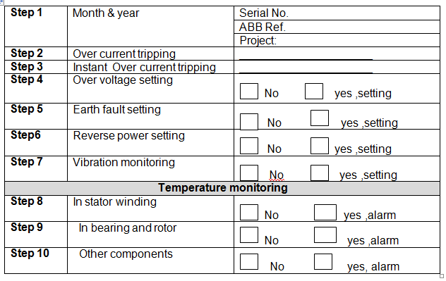
LAP Test 2
Instructions: Given necessary templates, tools and materials you are required to perform the following tasks accordingly.
Task 1: Commissioning of AC Motor
Task 2: commissioning of switchgear

UNIT THREE. Test commissioned Mechatronics systems
This learning guide is developed to provide you the necessary information regarding the following content coverage and topics:
  - Commissioned Mechatronics systems
  - unplanned events or conditions
  - Report on the commissioning process
This guide will also assist you to attain the learning outcomes stated in the cover page. Specifically, upon completion of this learning guide, you will be able to:
  - Test Commissioned Mechatronics systems
  - Respond unplanned events or conditions
  - Prepare report on the commissioning process

3.1 Commissioned Mechatronics systems
Testing Commissioned Mechatronics systems according to established procedures or manufacturer’s instructions is the crucial point for different electrical and mechanical equipments that are used in any industries.
Testing and Commissioning is a quality-oriented process for achieving, verifying, and documenting that the performance of facilities, systems, and assemblies meets defined objectives and criteria.
The commissioning process is defined as "a quality-focused process for enhancing the delivery of a project. The process focuses upon verifying and documenting that all of the commissioned systems and assemblies are planned, designed, installed, tested, operated, and maintained to meet the Owner's Project Requirements."
In the tests of the instrumentation and controls without operation of the process-engineering systems shall be performed as two partial tests, namely, the visual inspections and the function tests.
N o t e: The tests without operation of the process-engineering systems may be partitioned as;
- Tests in the test field and as,
- Tests at the final place of installation.
It is permissible to use simulators for the tests in the test field and for the commissioning tests in the power plant. The suitability of the simulators and simulation models employed shall be verified.
3.1.1 Machine commissioning Techniques
Machine commissioning condition is the process of monitoring the condition of a machine with the intent to predict mechanical wear and failure. Vibration, noise, and temperature measurements are often used as key indicators of the state of the machine. Trends in the data provide health information about the machine and help detect a machine fault early, which prevents unexpected failure and costly repair
- Visual inspections;
At the beginning of the tests without operation of the process-engineering systems, visual inspections of the instrumentation and control systems important to safety shall be performed both in the test field and in the power plant on the basis of the documents design-reviewed by the authorized expert.
With these inspections it shall be verified that a correct functioning can be expected on the basis of the layout of the instrumentation and control equipment taking into account the arrangement of the other power plant components (e.g., the mechanical and electrical components, the ventilation and air filtration systems), and that maintenance possibilities are provided. Test criteria include:
- Completed fabrication and component assembly and software implementation in accordance with the configuration and identification documentation of that part of the instrumentation and control equipment to be tested,
- Physical integrity of that part of the instrumentation and control equipment to be tested,
- Suitable construction with regard to the function of the mechanical parts of the measurement assemblies (e.g., sensors, sampling lines, transducers),
- Comprehensive marking of all devices, modules and cabinets and their correct allocation to the redundancy groups,
- Protection against mechanical impacts (e.g., resulting from maintenance work in the plant) of that part of the instrumentation and control equipment to be tested, and
- Accessibility of the devices, modules and measurement assembly arrangements with regard to tests, servicing and repairs.
- The visual inspections shall not be carried out before all accompanying tests of those parts of the instrumentation and control systems important to safety to be tested are completed, and not before the assembly tasks in the compartments accommodating the instrumentation and control equipment to be tested has reached a stage where further assembly tasks can no longer have any detrimental effects on the systems tested with respect to the test criteria.
- Function tests;
- The function tests shall be carried out at the final location of installation and shall verify that the instrumentation and control equipment fulfills the functions specified in the documents design -reviewed by the authorized expert (e.g., overview diagrams, functional diagrams, circuit diagrams, measuring circuit data sheets, functional descriptions, specifications, explanatory reports).
- Integration tests shall be performed with the instrumentation and control equipment of the power plant (e.g., process computer, hazard alarm facility, control room displays, feedback signals).
- Understanding commissioning of a Mechatronics machine condition
Machine condition commissioning monitoring is important because it provides information about the health of machine. You can use this information to detect warning signs early and help your organization stop unscheduled outages, optimize machine performance, and reduce repair time and maintenance costs. Figure (3.1) shows a typical machine failure example and the warning signs.
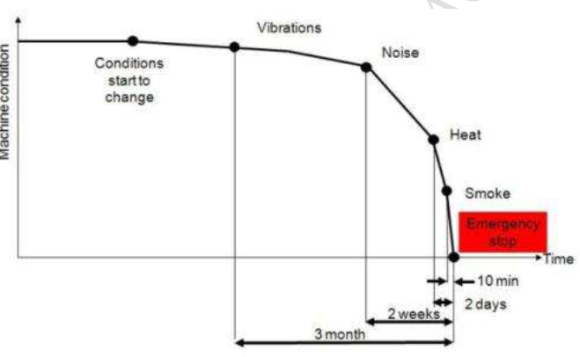
Figure 3. 1 The warning signs of machine failure:
Using a machine condition monitoring system, you can detect failure signs months before repair is required, allowing for proper maintenance scheduling and shutdown.
- Types of machine condition
Each of the five main varieties of machine condition monitoring serves a different role.
- Route-Based Monitoring
Route-based monitoring involves a technician recording data intermittently with a handheld instrument. This data is then used for trending to determine if more advanced analysis is needed.
- Portable Machine Diagnostics
Portable machine diagnostics is the process of using portable equipment to monitor the health of machinery. Sensors are typically permanently attached to a machine and portable data acquisition equipment is used to read the data.
- Factory Assurance Test
Factory assurance test is used to verify that a finished product meets its design specifications and to determine possible failure modes of the device.
- Online Machine Monitoring
Online machine monitoring is the process of monitoring equipment as it runs. Data is acquired by an embedded device and transmitted to a main server for data analysis and maintenance scheduling.
- Online Machine Protection
Online machine protection is the process of actively monitoring equipment as it runs. Data is acquired and analyzed by an embedded device. Limit settings can then be used to control turning on and off machinery.
- Monitoring of Machinery Faults
Corrosion monitoring: Since corrosion proceeds as an electro-chemical process the techniques of monitoring are directed to the identification of the electrical currents set up specifically by the corrosive activity.
Corrosion meter: This is the proprietary name for an instrument in which the electrical resistance monitoring technique uses a balanced bridge technique to measure the change in resistance of a probe as it thins away under corrosion.
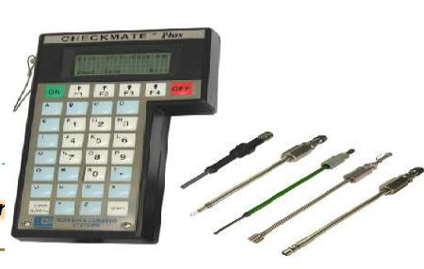
Figure 3. 2 handheld instrument provides quick metal loss measurements of ER corrosion probes.
Curator
A device or probe employed to measure current flow in a process flow. It consists of two identical electrodes, to which a small current is applied and measured, from which corrosion rates can be calculated.
Corrosion rate measurements are made using the linear polarization resistance technique. The instrument measures the current required to polarize the electrodes of a probe to a known potential. From the polarization potential and the measured current, polarization resistance can be calculated.
Then, using Faraday’s law, the instantaneous corrosion rate can be calculated from polarization resistance.
- Gas leakage monitoring
Two basic methods can be applied to test for leaks:
Sniffing: in which the leak tester responds to the gas. With sealed, unpressurized units a tracer gas filling is used. With small pressurized components, they are placed in a 'bomb' with a pressurized tracer gas and after a 'soaking' removed and sniffed for tracer leakage.
Hood method: Components are put in a hood and air is pumped round. Gas leakage in the purged gas indicates a leak in the test component.
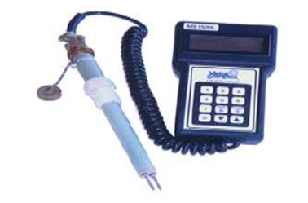
Figure 3. 3 handhold corrosion data logger
Auer detector tubes/gas testers, these testers are used by drawing air through the detector tubes which contain chemical reagents sensitive to selective gases.
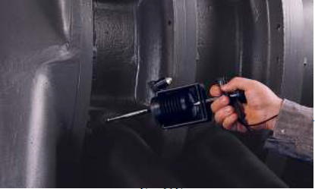
Figure 3. 4 hand held Pump with gas detection tubes.
Gas thermal conductivity testers
Change in the thermal conductivity when gases leak into a small volume provide the basis for leak sensing which responds to such gases as hydrogen, helium, methane hydrocarbons, refrigerant gases, carbon dioxide, argon etc.
In fact, this method is suitable for any gas with a different thermal conductivity from air.
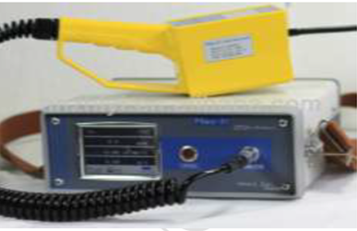
Figure 3. 5 Infrared gas detector
3.1.2 Ultrasonic
This predictive maintenance technique uses principles similar to vibration analysis. Both monitor the noise generated by plant machinery or systems to determine their actual operating condition. Unlike vibration monitoring, however, ultrasonic monitors the higher frequencies (i.e., ultrasound) produced by unique dynamics in process systems or machines. The normal monitoring range for vibration analysis is from less than 1 Hz to 30,000 Hz. Ultrasonic techniques monitor the frequency range between 20,000 Hz and 100 kHz.
Ultrasonic Applications
As part of a predictive maintenance program, ultrasonic instruments are used for three primary applications: airborne noise analysis, leak detection, or material testing.
Airborne Noise Analysis all plants are required by Occupational Safety and Health Administration (OSHA) regulations to meet ambient noise levels throughout their facilities.
These mandates have forced these plants to routinely monitor the noise levels within each area of the plant and to provide hearing protection in those areas where the ambient noise level is above acceptable levels. Ultrasound Applications;
- Steam Traps
- Heat Exchangers
- Pneumatic Systems
- Pressure / Vacuum Leaks
- Motors / Gearboxes
- Electric Arc / Corona / Tracking
- Bearing / Valves
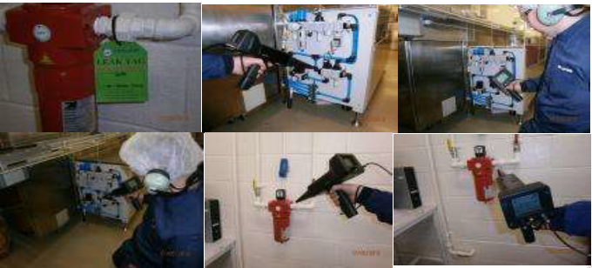
Figure 3. 6 Ultrasonic Applications
Leak Detection
The principal application for ultrasonic monitoring is in leak detection. The turbulent flow of liquids and gases through a restricted orifice (i.e., leak) will produce a high frequency signature that can easily be identified using ultrasonic techniques. Therefore, this technique is ideal for detecting leaks in valves, steam traps, piping, and other process systems.
Ultrasonic leak testing
Leaks in automobile pneumatic braking systems can be accurately located by means of an ultrasonic detector which gives both an audible and visual indication of the leak. It is a simple hand-held device no bigger than a large torch designed to provide on-site location of air or gas leaks in both pressure and vacuum pipe systems and vessels.
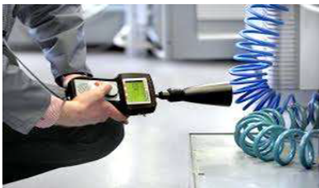
Figure 3. 7 ultrasonic leak detector
Ultrasonic Leak Detection Benefits:
- The completion of a service whose purpose is to improve energy conservation
- A report which details photos and location of all items identified for repair
- A calculation of the energy cost for each leak
- Value Cost Avoidance Calculation
Materials Testing
Ultrasonic has been, and continues to be, a primary test methodology for materials testing. Typical test frequencies start at 250 kilo Hertz (kHz), or 250,000 cycles per second (cps), up to 25 Megahertz (MHz), or 25 million cps. Testing materials generally consist of introducing an energy source into the material to be tested and recording the response characteristics using ultrasonic instruments.
These tests may be as simple as striking the material with a hammer and recording the results with an accelerometer and ultrasonic meter. Ultrasonic testing relies on the measurement of time and amplitude or strength of a signal between emission and reception.
Ultrasonic Thickness Gauge
Ultrasonic thickness measurement (UTM) is a method of performing non-destructive measurement (gauging) of the local thickness of a solid element (typically made of metal, if using ultrasound testing for industrial purposes) basing on the time taken by the ultrasound wave to return to the surface. This type of measurement is typically performed with an ultrasonic thickness gauge. Using this simple formula:
Im= $\frac{ ct }{2}$
Where:
          - lm is the thickness of the sample
          - c is the celerity of sound in the given sample
          - t is the traverse time
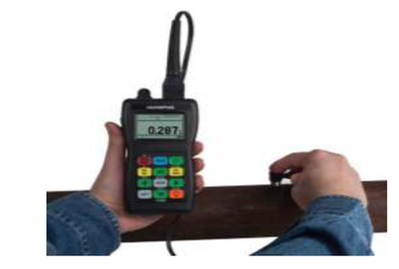
Figure 3. 8 hand held ultrasonic thickness gauge
3.1.3 Temperature
Temperature measurement (i.e., sensors, thermographs) helps detect potential failures related to a temperature change in equipment. Measured temperature changes can indicate problems such as excessive mechanical friction (i.e., faulty bearings, inadequate lubrication), degraded heat transfer (i.e., fouling in a heat exchanger), or poor electrical connections (i.e., loose, corroded, or oxidized connections). Two methods are used in the temperatures monitoring:
- Point Temperature Devices
- Infrared Thermographs
Thermocouple
A thermocouple consists of two wires of dissimilar metals joined near the measurement point (junction), a reference junction, and a measuring device.
The output is a small voltage measured between the two wires which is converted to a temperature readout by an instrument.
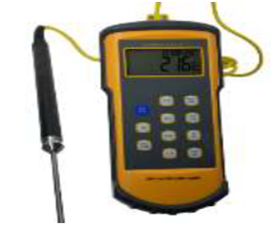
Figure 3. 9 portable thermocouple
Infrared thermometer
Is a thermometer which infers temperature from a portion of the thermal radiation sometimes called blackbody radiation emitted by the object being measured. They are sometimes called laser thermometers as a laser is used to help aim the thermometer.
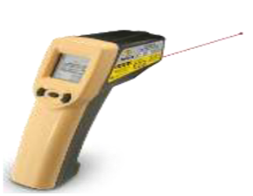
Figure 3. 10 infrared thermometer with laser beam
Infrared Thermography
This non-contact technique uses infrared cameras to measure the temperature of heat-radiating surfaces within the line of sight of the camera. The camera measures temperature variations on the surface of the object being monitored and converts the temperature data into video or audio signals that can be displayed or recorded in a wide variety of formats for future analysis.
Thermography: is a predictive maintenance technique that can be used to monitor the condition of plant machinery, structures, and systems. It uses instrumentation designed to monitor the emission of infrared energy (i.e., temperature) to determine operating condition. By detecting thermal anomalies (i.e., areas that are hotter or colder than they should be), an experienced surveyor can locate and define incipient problems within the plant.
Infrared Basics
Infrared technology is predicated on the fact that all objects with a temperature above absolute zero emit energy or radiation. Infrared radiation is one form of this emitted energy. Infrared emissions, or below red, are the shortest wavelengths of all radiated energy and are invisible without special instrumentation.
The intensity of infrared radiation from an object is a function of its surface temperature; however, temperature measurement using infrared methods is complicated because three sources of thermal energy can be detected from any object. Only the emitted energy is important in a predictive maintenance program. Reflected and transmitted energies will distort raw infrared data.
Therefore, the reflected and transmitted energies must be filtered out of acquired data before a meaningful analysis can be completed. The surface of an object influences the amount of emitted or reflected energy.
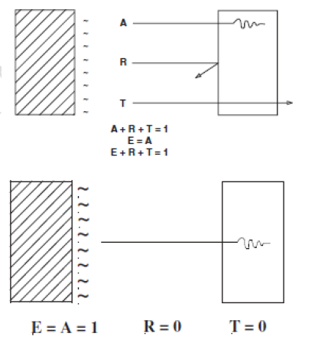
Figure 3. 11 Blackbody emissions
A perfect or blackbody absorbs all infrared energy. A = Absorbed energy. R =Reflected energy.
T = Transmitted energy. E = Emitted energy.
A perfect emitting surface, Figure 1.21 is called a “blackbody” and has an emissivity equal to 1.0. These surfaces do not reflect. Instead, they absorb all external energy and re-emit it as infrared energy.
Types of infrared problems: There are three basic types of thermal problems:
- Mechanical looseness
- Load problems
- Component failure
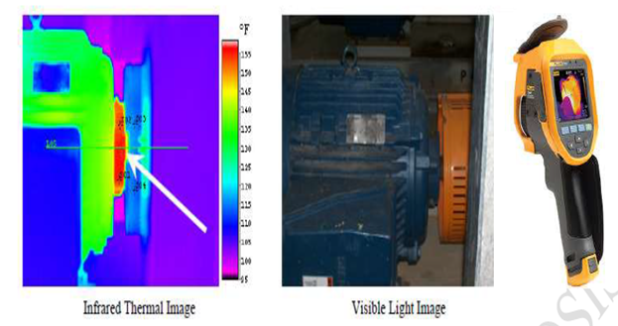
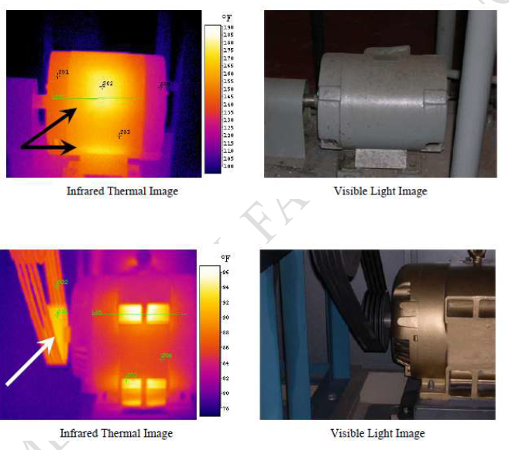
Figure 3. 12 basic types of infrared problems /thermal problems:
3.1.4 Vibration commissioning
Dynamic monitoring (i.e., spectrum analysis, ultrasonic analysis) involves measuring and analyzing energy emitted from mechanical equipment in the form of waves, such as vibration, pulses, and acoustic effects, over a period of time. Measured changes in the vibration characteristics from equipment over time can indicate problems such as wear, imbalance, misalignment, and damage. Vibration Monitoring used to monitor the health of rotational equipment. This involves the trending and analysis of certain machine performance parameters to detect and identify developing problems such as:
- Imbalance
- Miss-alignment
- Bearing Faults
- Gear Tooth Mesh
- Under/Over Lubrication
- Before failure occurs
How Vibration commissioning works?
Vibration measurements are taken on specific machine locations using piezo-electric transducers (Accelerometers) and stored in a Data Collector;
- Vibration Data is uploaded to Vibration Analysis Software and Analysed
- A vibration Report outlining Findings and Recommendations is prepared
Benefits to you from Vibration Monitoring
- Determine machine health status
- Predict failure mode
- No surprise downtime
- No unexpected failures
- No secondary damage
- Planned Maintenance program
- Vibration Analysis
Once vibration monitoring detects a problem with a piece of machinery, Taylor Condition
Monitoring will pinpoint specific machinery problems by revealing their unique vibration Characteristics. These vibration characteristics are then broken down into individual vibration frequencies, which can be matched to known defect frequencies that a range of different problems normally appear at. These frequencies will largely depend on the type of machine, speed and the type of bearings installed. With hundreds of specific operational and mechanical problems that can cause a machine to exhibit excessive vibration, knowing the frequency of vibration is paramount. The forces that cause vibration are usually generated through the rotating motion of the machine's parts, and because these forces change in direction or amplitude according to the rotational speed of the machine components, it follows that most vibration problems will have frequencies that are directly related to rotational speeds. Some of these problems have their own unique characteristics in the vibration spectrum, while other problems have similar characteristics.
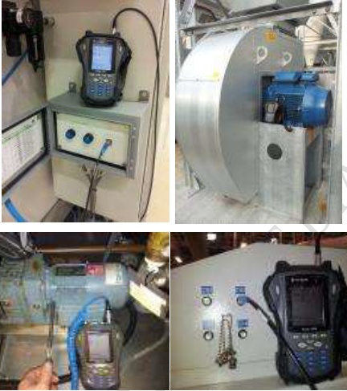
Figure 3. 13 Vibration commissioning works

3.1.5 Oil Analysis commissioning
Oil analysis (i.e., Ferrography, particle counter testing) can be performed on different types of oils such as lubrication, hydraulic, or electrical insulation oils. It can indicate problems such as machine degradation (i.e., wear), oil contamination, improper oil consistency (i.e., incorrect or improper amount of additives), and oil deterioration. Oil analysis is most often based on regularly scheduled sampling. Regular sampling allows monitoring of the rate of change of the measured parameters.
Aspects of Oil Analysis
The tests described in chapter 8 monitor all or some of these three aspects of oil:
- Lubricant condition
- Contaminants
- Machine wear
Oil Analysis Condition- commissioning Techniques
Atomic Emissions Spectroscopy
Atomic emissions spectroscopy identifies problems with contaminants and additives, and to a limited extent, corrosion and wear metals in lubrication and hydraulic oil samples, by measuring the characteristic radiation emitted when samples are subjected to high energy and temperature conditions. The test results are in parts per million (ppm) for a wide variety of elements of interest, including iron, aluminum, chromium, copper, lead, tin, nickel, and silver, and components of oil additives such as boron, zinc, phosphorus, and calcium. This technique can be used to analyze oil used in diesel and gasoline engines, compressors, transmissions, gearboxes, and hydraulic systems.
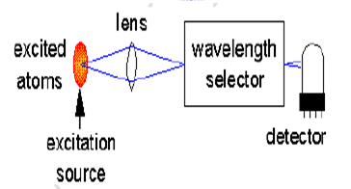
Figure 3. 14 schematic of an AES experiment
Ferrography
Ferro graphy is a technique that identifies the density and size ratio of particles in oil or grease caused by problems such as wear, fatigue, corrosion or combination. A representative sample is diluted with a fixer solvent and then passed over an inclined glass slide that is subjected to a magnetic field. The magnetic field provides separation of the ferrous particles (ferrous particles align with the magnetic field lines) and distributes them along the length of the slide (nonmagnetic and non-metallic particles are distributed randomly along the slide).
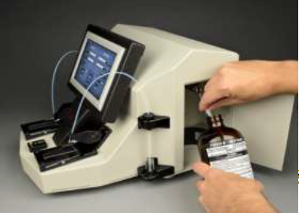
Figure 3. 15 Ferrography
3.1.6 Speed monitoring
Speed measuring instruments vary with the job. Whether measuring traveling speed, wind speed, acceleration or engine speed, there is a proper instrument for calculating that form of speed. Police use RADAR and LIDAR to measure traffic speed. Cars have speedometers for travel speed and tachometers for engine speed. Accelerometers are also used with car speed measurements.
Tachometers for Engine or Motor Speed
Tachometers measure the engine speed in revolutions per minute (rpm). This instrument determines the rotational speed. The classification of Tachometer is different in differ books. Somewhere there is just broad classification whereas at other places classification is one the basis of principal, types of uses or construction.
Tachometers classification
- Analog Tachometers
- Digital Tachometers
- Time & Frequency measuring Tachometers
- Contact and Non contact Tachometers
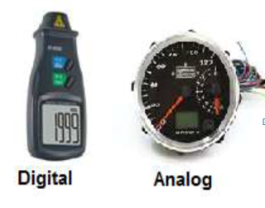
Figure 3. 16 Tachometer types
Speedometers for Travelling Speed
Speedometers measure the travelling speed of land vehicles. They are used to help drivers determine their driving speed and maintain it at save and realistic levels. These meters use magnets and a set of rotating cables connected to the transmission to determine the rate of travel, which is shown on an analog display on the vehicle's dashboard.
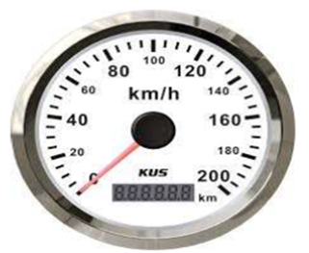
Figure 3. 17 Speedo meter

3.2 Unplanned events or conditions
3.2.1 Responding to unplanned events or conditions in accordance with established procedures
Unplanned events are episodes that are not expected to occur during the Project’s normal Construction and Operational Phase activities, such as accidents. The Project follows safety and engineering design criteria that aim to avoid unplanned events that could lead to adverse environmental, socio-economic or health and safety impacts.
This chapter provides an assessment of the potential environmental and socio-economic risks and impacts from onshore and offshore unplanned events, that could occur during the Construction and Pre-Commissioning, Operational (including Commissioning) Phases of the Project so that design controls and mitigation measures can be put in place. The approach to unplanned event management during the Decommissioning Phase is also presented herein. Project risks and impacts associated with worker occupational health and safety (OH&S) .
The assessment considers both the likelihood of unplanned event occurrence as well as the potential consequences of such events.
Scope and Approach
The overall Project Area (the geographical area within which all proposed Project Activities will occur) has been split into three main areas of activity for the purpose of the assessment of unplanned events, namely:
Onshore Landfall: Area covers all Project onshore landfall facilities and activities (from the landfall facilities of the Project to the shoreline); and
Offshore: Area includes the near shore and offshore sections.
Locations in the wider surrounding area and/or between these main areas of activity that could be affected by unplanned events are also considered. For example, onshore access road / route and shipping route;
This case focuses on those unplanned events considered to be of most relevance to the Project given the nature of the assembly activities, the operational requirements of the lines and the geographic location of the Project. In order to assist the unplanned event identification process, it has undertaken an Emergency Threat Analysis for the Project that determines the risks posed by potential emergencies and the need for an Emergency Preparedness and Response Plan and related procedures as a contingency for emergency events.
The unplanned events considered within this have been identified via the Emergency Threat Analysis. Where available, information on the likelihood of occurrence of unplanned events has been drawn from statistics from industry organisations. Data on the frequency of shipping incidents has been taken from statistics published by recognised industry bodies, including the International standards.
Given the inherent uncertain nature of potential unplanned events, the potential variability of such events in terms of geographic location and coverage, and limitations of directly relevant event statistics, a qualitative assessment methodology has been adopted herein. This methodology has entailed the following tasks:
- Screening of unplanned events to identify those which are carried forward for further consideration;
- Identifying the range of activities that could lead to the occurrence of a potential unplanned event during Construction and Pre-Commissioning and the Operational (including Commissioning) Phases of the Project;
- If possible, determining the likelihood of occurrence of such events;
- Defining and describing the geographic range of occurrence of potential unplanned events;
- For each unplanned event, definition of the potential resultant impacts in relation to potentially affected receptors; and
- Definition of appropriate risk management measures to reduce the likelihood of occurrence of each unplanned event and minimise the residual significance of any resulting impacts.
When determining the potential consequences of unplanned events, the resultant impacts have been assessed in relation to categories of receptors as follows:
- Environmental receptors; and
- Socio-economic receptors (including impacts upon community health).
Internationally recognised procedures to assure the OH&S of the workforce (including during unplanned events) along with the necessary equipment and training to make these effective; OH&S measures will be included in a Health, Safety, Security and Environmental Integrated Management System (HSSE-IMS) which will form an important part of the corporate management system (Environmental and Social Management).
In order to support the unplanned events assessment as reported herein, the following additional assessments have been undertaken: Quantitative Risk Assessment (QRA) , which considers the risks to the public as associated with the operation and maintenance of the onshore infrastructure and facilities;
Legal Context
A range of legislation has been passed in Russia that requires plans and actions to be developed should unplanned events have the potential to impact on workers, the local community and the environment. Much of the legislation applies to private organisations as well as public authorities and local government bodies.
This legislation reinforces the prevention and elimination of accidents and promulgates the need for emergency and management plans and thus the legislation needs to be taken into account as part of the Project’s unplanned event risk minimisation and management process.
The adoption of requirements for prevention of emergency situations at potentially hazardous facilities and vital infrastructure is necessary, Their requirements provide a set of measures on reduction of risk of emergency situations of technogenic character at potentially hazardous facilities, which use, produce, process, store and transport fire-explosion-hazardous substances, hazardous chemical and biological substances, including the provision of publicly vital activities (water supply and wastewater discharge, waste water treatment, heat and power supply utilities, hydro-engineering facilities). The specified requirements are as follows:
- Identification of emergency situations for population and territories, coordination and planning for monitoring, forecasting and modelling, zoning of territories by location of hazardous production facilities;
- Classification of potentially hazardous facilities and vital infrastructure by risk of emergency situation occurrence at these facilities;
- Design, construction, operation and decommissioning of facilities, which are hazardous to the population and territories;
- Management of actions for emergency situation prevention and protection of population and territories from hazardous impacts; and
- Assessment of potentially hazardous facilities preparedness to emergency situation prevention and sufficiency of measures for protection of population and territories.
IFC Requirements and Guidance
International Finance Corporation (IFC) Performance Standard (PS) 1 Assessment and Management of Environmental and Social Risks and Impacts (January 1, 2012) (Ref. 19.11) states that:
“The client, in coordination with other responsible government agencies and third parties as appropriate will conduct a process of environmental and social assessment, and establish and maintain an Environmental and Social Management System (ESMS) appropriate to the nature and scale of the project and commensurate with the level of its environmental and social risks and impacts.
The ESMS will incorporate the following elements:
- policy;
- identification of risks and impacts;
- management programs;
- organizational capacity and competency;
- emergency preparedness and response;
- stakeholder engagement; and
- Monitoring and review.”
This preparation will include the identification of areas where accidents and emergency situations may occur, communities and individuals that may be impacted, response procedures, provision of equipment and resources, designation of responsibilities, communication, including that with potentially Affected Communities and periodic training to ensure effective response. The emergency preparedness and response activities will be periodically reviewed and revised, as necessary, to reflect changing conditions”.
Guidance on the content and coverage of Emergency Preparedness and Response Plans is provided in the IFC Environmental, Health and Safety (EHS) Guidelines (IFC, 2012) (Ref. 19.12). Also of relevance are PS4 Community Health, Safety, and Security (Ref. 19.15) which addresses the client’s responsibility to avoid or minimise the risks and impacts to community health, safety, and security that may arise from project related-activities, with particular attention to vulnerable groups. PS4 states that:
“In addition to the emergency preparedness and response requirements described in Performance Standard 1, the client will also assist and collaborate with the Affected Communities, local government agencies, and other relevant parties, in their preparations to respond effectively to emergency situations, especially when their participation and collaboration are necessary to respond to such emergency situations. If local government agencies have little or no capacity to respond effectively, the client will play an active role in preparing for and responding to emergencies associated with the project.
The client will document its emergency preparedness and response activities, resources, and responsibilities, and will disclose appropriate information to Affected Communities, relevant government agencies, or other relevant parties.”
Emergency Preparedness and Response Plan
Environmental and Social Management highlights that, they will prepare an over-arching Emergency Preparedness and Response Plan for the overall project in line with IFC EHS Guidelines. The plan will be part of the HSSE-IMS as defined in Environmental and Social Management.
This plan will define response actions for material unplanned events / risks that have been identified by the Emergency Threat Analysis. The overarching plan will cover all project phases and will include details as suggested by the IFC EHS Guidelines as follows:
- Purpose and scope;
- Emergency response management strategy;
- Emergency risk analysis, Emergency Preparedness and Response Plan and definition of the relationships with Contractors’ Emergency Response Plans;
- Roles and responsibilities;
- Communication requirements;
- Emergency drill requirements (including examinations, inspections and testing); and
- Review processes.
Engineers/Construction Contractors will be responsible for preparing their own Emergency Response Plans for their work activities, and specifically those events identified by the Emergency Threat Analysis. Contractors are expected to apply Good International Industry Practices (GIIP) and applicable recognized industry standards when preparing their Emergency Response Plans.
Similarly, that contractor Emergency Response Plans appropriately integrate with the Emergency Prevention and Response Plan for the National Disaster Management Plan with regard to command and control systems, points of first contact during emergencies, local capabilities and capacity.
The prepared a Security Plan will include the following:
- Systematic identification of security threats;
- Monitoring of social and other conditions related to security threats;
- Security screening of employees and other persons, as appropriate;
- Security measures to protect the property, assets, employees and intellectual capital of South Stream Transport;
- Information, instruction and training on security practices and requirements;
- Promotion of personal and corporate security;
- Security surveillance, security guards etc.;
- Emergency response plan and crisis management plan in case of serious security incidents; and
- Analysis of security incidents to facilitate lessons learned.
Socio-Economic describes the land uses that occur within the Project Area and within adjacent areas that could be adversely affected by a fire. Sections of the Project Area are forested, interspersed with pockets of open land used primarily for agriculture (including vineyards).
There are no residential properties, either permanently occupied or holiday accommodation, within the Project Area.
Air Quality ,The nearest identified buildings are thus located near the community approximately 1 km with the intervening land being agricultural in nature with some woodland. The risk from fire to the community is minimal given the distance to Project activities and given the sparse nature of the vegetation between the Project Area and that settlement. Nevertheless, the enforcement of strict fire control measures and the fire detection and fire fighting enactments of the Contractors’ Emergency Response Plan;
Protests and Communal Violence
Local residents in the vicinity of the Project Area could potentially be impacted by unplanned events involving industry workforce unrest, civil unrest and worker-community conflict.
Measures will be undertaken to prevent unplanned events caused by the production workforce protests and disturbances. The industry contractors have the responsibility to provide for the well-being of their workers – this includes compliance with applicable employment laws and regulations, adherence to appropriate OH&S management systems, and the availability of a worker consultation and grievance process.
Environmental and Social Management), it will function through all Project phases. The Worker Grievance Procedure will be implemented in partnership with its contractors and will ensure that grievances are brought to the attention of the appropriate Project staff and addressed in an appropriate and timely way.
In addition, the well-being of workers will also be assisted through the adoption of the policies and practices including the following (Socio-Economic):
- Human health resources;
- Working relationships;
- Working conditions and terms of employment;
- Workers’ organisations; and
- Non-discrimination and equal opportunities.
In order to minimize the risks associated with workforce conflicts and civil unrest caused by Project activities, the industry adhere to considerate configuration practices, ensure that security personnel adhere to internationally recognized human rights principles in the provision of Project security services.

Fires
If leaked gas is ignited, significant acute environmental impacts could be caused by the resulting fire, potentially at large distances. In many instances, the area would recover relatively quickly from the effects of a fire (e.g. areas of grassland).
However, if the fire was within or adjacent to a woodland area, there may be longer-term environmental damage.
Gas Leakages and Fires
Gas leakages have the potential to impact upon human health receptors. Short term exposure to low concentrations of natural gas may cause headaches, dizziness, drowsiness, nausea and vomiting. High gas vapour concentrations may lead to unconsciousness due to the absence of oxygen. Natural gas is extremely flammable, forming a flammable mixture at a concentration of approximately 5% gas in air (by volume). Therefore, in the unlikely event of a gas leakage, the main risk of concern to community facilities and health is associated with fire and explosion rather than gas exposure.

3.3 Report on the commissioning process
The final commissioning report shall include an executive summary, list of participants and roles, brief building description, overview of commissioning and testing scope and a general description of testing and verification methods.
The Commissioning Report documents the commissioning process and test results. The report includes confirmation from the commissioning coordinator verifying that commissioned systems meet the conditions of the OPR, BOD, and Contract Documents.
Commissioning report: Complete a final commissioning report and submitted to the Owner. The commissioning report should summarize all the tasks, findings, and documentation of the commissioning process and will address the actual performance of the building systems in reference to the design documents.
Commissioning documentation becomes the road map for the success criteria to be met by facilities that are put in service. Commissioning documents the establishment of standards of performance for building systems and verifies that designed and constructed work meets those standards.

3.3.1 Report Preparation on the commissioning process according to the company requirements
Accidents, malfunctions, and unplanned events are accidents or upset events or conditions that are not planned as a part of routine Project activities during any Project phase. Even with the planning and application of mitigation, accidents, malfunctions, and unplanned events could occur during any phase of the Project. These could occur as a result of abnormal operating conditions, wear and tear, human error, equipment failure, and other possible causes. Many accidents, malfunctions, and unplanned events are preventable and can be readily addressed or prevented by good planning, design, equipment selection, hazards analysis and corrective action, emergency response planning, and mitigation.
In this section, the potential accidents, malfunctions, and unplanned events that could occur during any phase of the Project and potentially result in significant adverse environmental effects are described, discussed, and assessed. The focus is on credible accidents that have a reasonable probability of occurrence, and for which the resulting residual environmental effects could be major without careful management.
It is noted that accidents, malfunctions, and unplanned events are evaluated individually, in isolation of each other, as the probability of a series of accidental events occurring in combination with each other is very minimal. These possible events, on their own, generally have a very low probability of occurrence and thus their environmental effects are of low likelihood. They have an even lower probability or likelihood of occurring together – thus their combination is not considered credible, nor of any measurable likelihood of occurrence.
Accidents, malfunctions, and unplanned event scenarios have been conservatively selected that represent higher consequence events that would also address the consequences of less likely or lower consequence scenarios.
The accidents, malfunctions, and unplanned events that have been selected based on experience and professional judgment are as follows:
- Worker accident: worker accidents may occur during either assembly or operation, and may result in harm, injury, or death to one or more Project workers;
- Fire: consists of a fire in a Project component. The focus is on the consequence, and not the mechanism by which it occurs;
- Hazardous materials spill: spills of fuel, petroleum products, and/or other chemicals used on site or in Project components; and
- Vehicle accident: Project-related vehicle accidents that could occur on the road transportation network.
Assessment conclusion
The Project is being designed, and will be assembled and operated with the utmost regard for health, safety, and environmental protection to minimize its potential environmental effects that could result during the normal course of construction and operation and maintenance as well as those that could result from accidents, malfunctions, and unplanned events.
The careful planning of the Project and the implementation of proven and effective mitigation will minimize the potential for accidents, malfunctions, and unplanned events to occur. The effects of an individual accident or unplanned event could have significant effects on a localized extent.
For example, a fire could negatively affect nesting birds or a spill could affect surface or groundwater quality. However, the potential for these events to occur, given the measures that will be undertaken to prevent their occurrence, is low. In the very unlikely and improbable event that an accidents, malfunctions, and unplanned events of any considerable magnitude were to occur, it would be of a short duration, low frequency, or limited geographic extent such that major residual adverse environmental effects would be unlikely to occur.
Overall, given the nature of the Project and credible accidents, malfunctions, and unplanned events considered, and in light of the nature of the Project and proposed mitigation, the potential residual environmental effects of all Project-related accidents, malfunctions, and unplanned events on all biophysical and socioeconomic components during all phases of the Project, are assessed as minor.
Reports form
a. Submit specimen copies of report forms, for approval for their use on this project.
b. Forms shall be quarto paper for loose leaf binding, with blanks for listing of the required test ratings and for certification of report.
Provision of Test Point and accessories
- All required test points, are deemed to be included in the work and ductwork installations and included in the unit rate of these systems. The contractor shall allow sufficient points and where required by the Engineer for the correct and complete regulation, testing and commissioning. All test points shall be indicated on the working and record drawings. Test points shall be fitted with removable plugs, flanges or other approved devices appropriate to the service concerned..
- The Contractor shall prepare system loading diagrams for each system including control, regulating and test points and shall indicate their physical location in work. Environmental tests are to include, where necessary, the provision of artificial loads to simulate the full range of operating conditions. The correct operation of each system is to be demonstrated on completion of the commissioning and testing.
Recording of Test Results
- The Contractor shall give 7 days’ notice, to the Engineer in writing, prior to any regulation, testing and balancing being undertaken to enable he Engineer to witness the work.
- The Contractor shall formulate and provide all test sheets to a format agreed by the Engineer.
Each sheet shall contain the project title, the logos of the Employer and the Engineer. Each sheet shall have witnessing signatory space specific to the Contractor's Engineer, and the Engineer's designed representative.
- The test result sheets shall be fully cross-referenced to the system loading diagrams which shall be updated to include the actual test results.
- Duplicate signed test certificates shall be provided after each test, which will be countersigned by the Engineer who witnesses the test. The test certificate shall give the following particulars:
- Apparatus or Section under test
- Makers number ( if any)
- Nature, duration and conditions of test
- Result of test

- No test shall be valid until the test certificate is provided.
- No Section of the works shall be insulated or in any other way concealed prior to testing and inspection and subsequent concealment where applicable shall only take place following written authority from the Engineer.
- All necessary facilities, measuring and recording instruments including test for inspection/testing and commissioning requirements shall be provided and shall be checked or calibrated as necessary before use. The Engineer reserves the right to call for a demonstration of the accuracy of any instruments provided.
Commissioning Report
The commissioning Specialist shall prepare a Commissioning Report for submission to the Professional Team and ultimately for inclusion in the O&M Manual. The report shall
Contain the following:
- Plant run times during tests
- Volumes of the work for each system, including record sheets.
- Volume of records for all systems, including tests etc.
- Central test data including different drops, etc.
- Components performance including, performance on high and low volumes where applicable.
- Each component’s plotted performance on high and low volumes where applicable.
- Control settings for all plant
- Control selling programmed into Building Management System
- Control Panel fuse ratings and overload settings
- Record of all temperature and pressure point tests
- Equipment running current for all three phases
- Noise level recordings including sketch plan of positions where readings were taken.
- Sketch diagrams of systems indicating all equipment controls and control and regulating valves all referenced.
- Provision shall be made in the report for recording alterations made to control set points during post-commissioning and the first twelve months of plant operation.
- Provision shall be made in the report of recording test data during any re commissioning exercise.
Sample given in table below shows that a related examples of commissioning report for electric machines
Table 3. 1 electric machines commissioning report
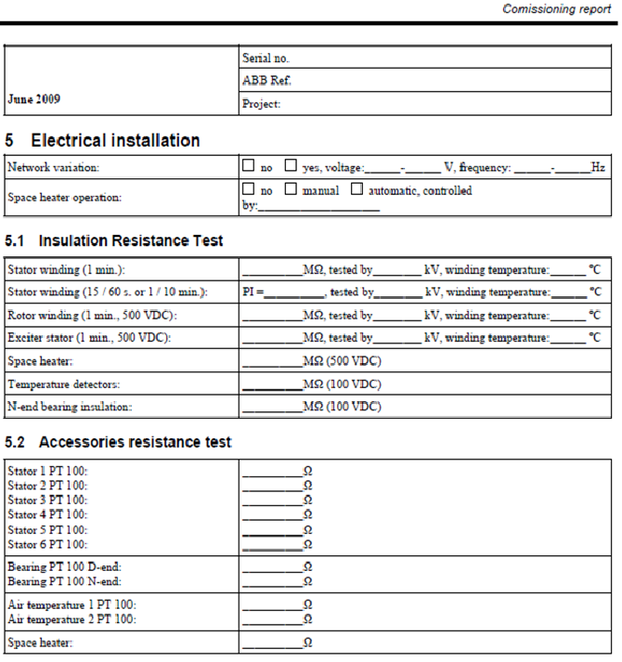
Table 3. 2 electric machines protection setting commissioning report
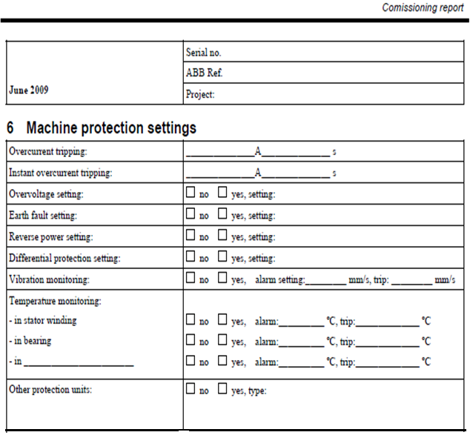

Table 3. 3 electric machines test run commissioning report
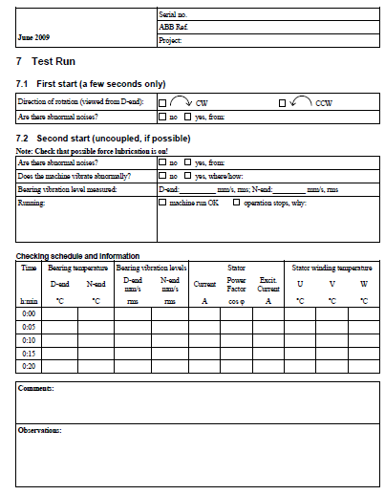

Self-Check-3
Part-I: choice
Instruction: Choose the correct answer from the given choice for the following questions.
  - __________________is defined as "a quality-focused process for enhancing the delivery of a project.
- Commissioning process b. Commissioning procedure c. Testing Commission d. all
  - ______________________condition is the process of monitoring the condition of a machine with the intent to predict mechanical wear and failure.
- Commissioning process b. Machine commissioning c. Mechatronics commissioning
  - Which of the following device or probe employed to measure current flow in a process flow?
    - corrosion data logger b. Infrared gas detector c. Curator d. Ultrasonic
  - Leaks in automobile pneumatic braking systems can be accurately located by means of _____________ which gives both an audible and visual indication of the leak.
    - an ultrasonic detector b. ultrasonic leak detector c. portable thermocouple d. all
  - Measured changes in the vibration characteristics from equipment over time can indicate problems such as :__________
    - Wear b. imbalance c. misalignment d. damage e. all of the above

Part-II: written Questions
Instruction: Answer the following questions accordingly.
  - List the two performed partial tests in the tests of the instrumentation and controls, namely?
  - _________________________________________
  - _________________________________________
  - List at least 5 Ultrasound Applications
  - _________________________________________
  - _________________________________________
  - _________________________________________
  - _________________________________________
  - _________________________________________
  - List out the three basic types of thermal problems.
  - _________________________________________
  - _________________________________________
  - _________________________________________
  - List at least 4 the elements of Environmental and Social Management System ESMS will incorporate.
- ______________________________________________
- ______________________________________________
- ______________________________________________
- ______________________________________________
  - What is the overarching plan will covered all project phases as suggested by the IFC EHS Guidelines:
- ______________________________________________
- ______________________________________________
- ______________________________________________
- ______________________________________________
- ______________________________________________
- ______________________________________________
  - What are the accidents malfunctions and unplanned events that have been selected based on experience and professional judgment:
- ___________________________________________________
- ____________________________________________________
- ____________________________________________________
- ____________________________________________________
  - List and explain the two types of Reports form
- _________________________
- _________________________

Reference

ANSI C37.50—Low-Voltage AC Power Circuit Breakers Used in Enclosures—Test Proceed Unplanned events or conditions are responded to in accordance with established procedures
IEEE 450—Recommended Practice for Maintenance, Testing and Replacement of Vented Lead Acid Batteries for Stationary Applications
IEEE 1188—Recommended Practice for Maintenance, Testing and Replacement of Valve Regulated Lead Acid Batteries for Stationary Applications
NEMA AB4—Guidelines for Inspection and Preventive Maintenance of Molded Case Circuit Breakers Used in Commercial and Industrial Applications
NETA ATS—Acceptance Testing Specifications for Electrical Power Distribution Equipment and Systems
NFPA 70B—Recommended Practice for Electrical Equipment Maintenance
NFPA 70C—National Electrical Code
NFPA 70E—Standard for Electrical Safety in the Workplace
NFPA 101—Life Safety Code
NFPA 110—Standard for Emergency and Standby Power Systems
NFPA 111—Standard for Stored Energy Emergency and Standby Power Systems
SECTION 15991 -Testing and Commissioning
Quantitative Risk Assessment Onshore Sections. Intec sea Report 10-00050-10-SR-REP-0040-0010 dated October 2013.
Black Sea Contingency Plan 2002. To the Protocol on Cooperation in Combating Pollution of the Black Sea by Oil and Other Harmful Substances in Emergency Situations – Volume 1 Response to Oil Spills. AG ESAS 8.4d.
(https://support.industry.siemens.com/cs/ww/de/view/109756217).
Mallikarjun G. Hudedmani*, Umayal R M, Shiva Kumar Kabberalli, Raghavendra Hittalamani, July 2017

Developer’s Profile
No | Name | Qualification | Field of Study | Region | Organization/ Institution | Mobile number | E-mail
1 | Melaku Bekele Ofgaha | A | Electri/Automation Control Technology | Oromia | Amboo poly TVET college | O921051772 | kakumalaku430@gmail.com
2 | Bahiru Demeke | A | Electri/Elec Contr | Oromia | Bishoftu Poly TVET College | O911394408 | bahirudemeke20@gmail.com
3 | Worku Biru Mekonnen | A | Electri/Automation Control Technology | Oromia | Sebeta Poly TVET College | O912106303 | workubiru3@gmail.com
4 | Sisay H/Mariam Toga | A | Electrical Power Enginering | SNNPR Ethiopia | Arbaminch poly &satelite College | O945234339 | sisayhailemariam971@gmail.com
5 | Hassen Husen Hamid | A | Electrical Eng | Oromia | M/G/M/B Poly TVET College | O943402001
6 | Bacha wake | A | Industrial Automation and Control Technology | Sidama | Hawassa Tegbariad poly technic college | O987065251 | bachawake@gmail.com
7 | Yidnekachew Seboka | B | Electrical Automation & Control | A.A | Akaki PTC | 920137899 | www.yidne23@gmail.com
8 | Samuel Bekele | A | Industrial Automation & Control Management | Oromia | Haramaya PTC | 910082977 | samuelbekele460@gmail.com

