Industrial Electrical/Electronic
Control Technology
Level-III
Based on March 2022, Curriculum Version 1
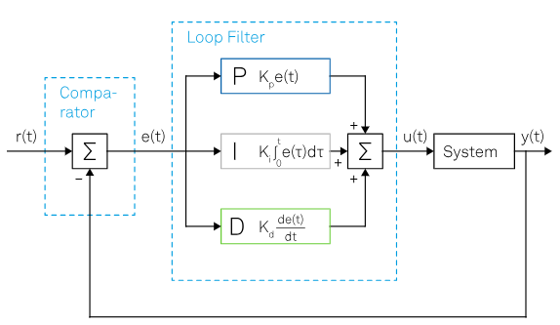

Module Title: - Setting up and Adjusting PID Control loops
Module code: EIS IEC3 M08 1023
Nominal duration: 85Hour
Prepared by: Ministry of Labor and Skill
September, 2023
Addis Ababa, Ethiopia
Table of Content
Acknowledgment 2
Agronomy 3
Introduction to the Module 4
Unit One: Process Control Loops 5
1.1 Introduction to process control system 6
1.2 Types of process control system 8
1.3 PID control loop/system 19
1.4 Components of PID control loop/System 34
1.5 Measure and calculating values in control loop/system 40
1.6 Common fault/problems in PID control loop/system 72
1.7 WHS/ OHS processes and workplace procedures and risk control 74
1.8 Scope of control problem 76
1.9 Tools, equipment and testing devices 77
Unit Two: Fault Finding In Process Control Loops 80
2.1. PID control loop/system live work measurement 81
2.2 Process controller/transmitters/converters 82
2.3 Fault Finding Procedure 85
2.4 PID control loop/system component adjustment 90
2.5 PID control loop/system component set up 92
Unit Three: Completion of Set Up and Adjustment 94
3.1 Documentation of set up/ adjustment work 95
3.2 Report writing PID set up/ adjustment work 98
References (first part) 101

Acknowledgment
Ministry of Labor and Skills wish to extend thanks and appreciation to the many representatives of TVT instructors and respective industry experts who donated their time and expertise to the development of this Teaching, Training and Learning Materials (TTLM).

Agronomy
D Derivetive
DUT Device Under Test
H Height
I Integral
LC Level Control
LI Level Indicator
LT Level Transmitter
MEMS Micro-electromechanical systems
P Proportional
PB Proportional band
PD Proportional Derivative
PI Proportional Integral
PID Proportional–Integral–Derivative
PV Process value
RTD Resistance Temperature Dependent
SP Set point
SPM scanning probe microscopy
TE Temperature Element
TIC Temperature Indicating Controller
TT Temperature Transmitter

Introduction to the Module
Proportional–Integral–Derivative (PID) controller is the most widespread type of closed-loop control systems. These types of controllers continuously measure and adjust the output of a system to match a desired set-point, that is, a given target condition for the system or process under consideration. Requiring little prior knowledge or model of the system, PID controllers are extremely versatile, relatively cost effective and straightforward to implement, making their realization possible in a large variety of systems: from hydraulics and pneumatics to analog and digital electronics. Module also involves planning and preparation for setting up, adjustment, demonstrate setting up and adjustment work and inspection, test and documentation for task.
This module covers the units:
- Process control loops
- Fault finding in process control loops
- Completion of set up and adjustment
Learning Objective of the Module
- Prepare to work on process control loops
- Solve process control loops problems
- Complete work and provide status report/s
Module Instruction
For effective use these modules trainees are expected to follow the following module instruction:
- Read the information written in each unit
- Accomplish the Self-checks at the end of each unit
- Perform Operation Sheets which were provided at the end of units
- Do the “LAP test” giver at the end of each unit and
- Read the identified reference book for Examples and exercise

Unit One: Process Control Loops
This unit is developed to provide you the necessary information regarding the following content coverage and topics:
- Introduction to process control system
- Types of process control system
- PID control loop/system
- Components of PID control loop/System
- Measure and calculating values in control loop/system
  - Common fault/problems in PID control loop/system
  - WHS/OHS processes and workplace procedures and risk control
  - Scope of control problem
  - Tools, equipment and testing devices
This unit will also assist you to attain the learning outcomes stated in the cover page. Specifically, upon completion of this learning guide, you will be able to:
- Explain about introduction to process control system
- Explain Types of process control system
- Explain PID control loop/system
- Identify components of PID control loop/System
- Use measure and calculating values in control loop/system
  - Identify and solve common fault/problems in PID control loop/system
  - Identify WHS/OHS processes and workplace procedures and risk control
  - Obtain scope of control problem
  - Obtain and check tools, equipment and testing devices

1.1 Introduction to process control system
To study the subject of industrial process control effectively, you must first gain a general understanding of its basic principles. To present these control principles clearly and concisely, an intuitive approach to process control is used. First, however, some basic definitions and concepts of process control are presented.
Definition of Process Control
The operations that are associated with process control have always existed in nature. Such "natural" process control can be defined as any operation that regulates some internal physical characteristic that is important to a living organism. Examples of natural regulation in humans include body temperature, blood pressure, and heart rate. Early humans found it necessary to regulate some of their external environmental parameters to maintain life. This regulation could be defined as "artificial process control" or more simply as "process control," as we will refer to it in this book. This type of process control is accomplished by observing a parameter, comparing it to some desired value, and initiating a control action to bring the parameter as close as possible to the desired value. One of the first examples of such control was early man's use of fire to maintain the temperature of his environment. The term automatic process control came into wide use when people learned to adapt automatic regulatory procedures to manufacture products or process material more efficiently. Such procedures are called automatic because no human (manual) intervention is required to regulate them.
Process Control Loops
We discussed the general concepts of process control in the introduction part. In this part, we will cover the basic principles of process control loops. Single- loop feedback control is the most common type of control used in industrial processes, so it will be discussed in the greatest detail. We will then discuss other types of control loops, such as cascade, ratio, and feed forward. Finally, we will examine several common methods used to tune control loops.
Single-loop Feedback Control
In a feedback control loop, the variable to be manipulated is measured. This measured process value (PV) is then compared with a set point (SP) to generate an error signal (e = PV - SP). If a difference or error exists between the actual value and the desired value of the process, a process
controller will take the necessary corrective action to return the process to the desired value. A block diagram of a single-feedback control loop is shown in Figure 2-1.
The measured process variable is sensed or measured by the appropriate instrumentation, such as temperature, flow, level, or analytical sensors. This measured value is then compared with the set point. The controller uses this comparison to adjust the manipulated variable appropriately by
generating an output signal. The output signal is based in turn on whichever control strategy or algorithm has been selected. Because in the process industries the manipulated variable is most often flow, the output of
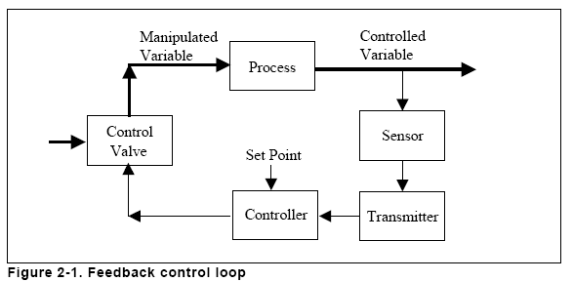
Figure 1.1: Feedback control loop

1.2 Types of process control system

Process Control Loops
In this section, you will learn about how control components and control algorithms are integrated to create a process control system. Because in some processes many variables must be controlled, and each variable can have an impact on the entire system, control systems must be designed to respond to disturbances at any point in the system and to mitigate the effect of those disturbances throughout the system.
Single Control Loops
Control loops can be divided into two categories: These are
- Single variable loops
- Multi-variable loops.
Single variable loops
Feedback control: A feedback loop measures a process variable and sends the measurement to a controller for comparison to set-point. If the process variable is not at set-point, control action is taken to return the process variable to set-point. Figure 7.18 illustrates a feedback loop in which a transmitter measures the temperature of a fluid and, if necessary, opens or closes a hot steam valve to adjust the fluid’s temperature.
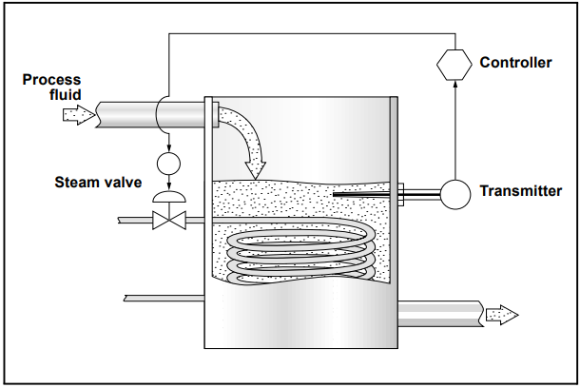
Figure 1.2: Feedback Loop
An everyday example of a feedback loop is the cruise control system in an automobile. A set-point is established for speed. When the car begins to climb a hill, the speed drops below set-point and the controller adjusts the throttle to return the car’s speed to set-point. Feedback loops are commonly used in the process control industry. The advantage of a feedback loop is that it directly controls the desired process variable. The disadvantage to feedback loops is that the process variable must leave set-point for action to be taken.
Examples of Single Control Loops
While each application has its own characteristics, some general statements can be made about pressure, flow, level, and temperature loops.
- Pressure control loops
Pressure control loops vary in speed—that is, they can respond to changes in load or to control action slowly or quickly. The speed required in a pressure control loop may be dictated by the volume of the process fluid. High-volume systems (e.g., large natural gas storage facilities) tend to change more slowly than low-volume systems (Figure 7.21).
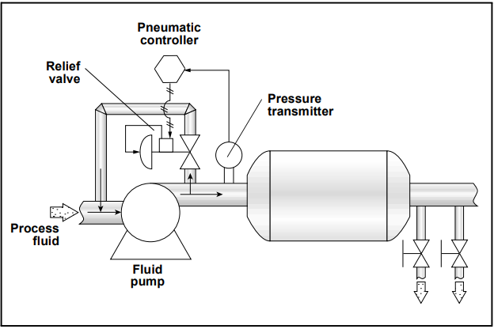
Figure1. 3: A Pressure Loop

- Flow control loops
Generally, flow control loops are regarded as fast loops that respond to changes quickly. Therefore, flow control equipment must have fast sampling and response times. Because flow transmitters tend to be rather sensitive devices, they can produce rapid fluctuations or noise in the control signal. To compensate for noise, many flow transmitters have a damping function that filters out noise. Sometimes, filters are added between the transmitter and the control system. Because the temperature of the process fluid affects its density, temperature measurements are often taken with flow measurements and compensation for temperature is accounted for in the flow calculation. Typically, a flow sensor, a transmitter, a controller, and a valve or pump are used in flow control loops (Figure 7.22).
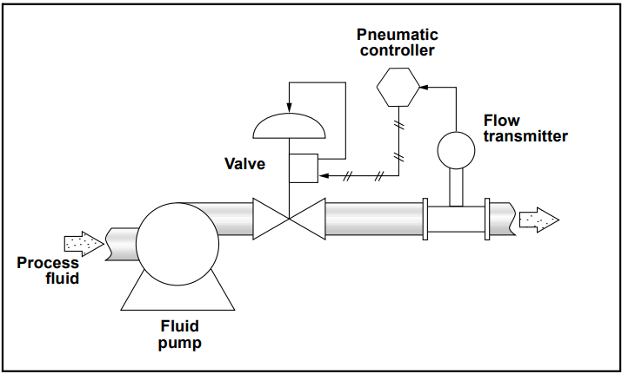
Figure 1.4: A Flow Loop

- Level control loops
The speed of changes in a level control loop largely depends on the size and shape of the process vessel (e.g., larger vessels take longer to fill than smaller ones) and the flow rate of the input and outflow pipes. Manufacturers may use one of many different measurement technologies to determine level, including radar, ultrasonic, float gauge, and pressure measurement. The final control element in a level control loop is usually a valve on the input and/or outflow connections to the tank (Figure 7.23). Because it is often critical to avoid tank overflow, redundant level control systems are sometimes employed.
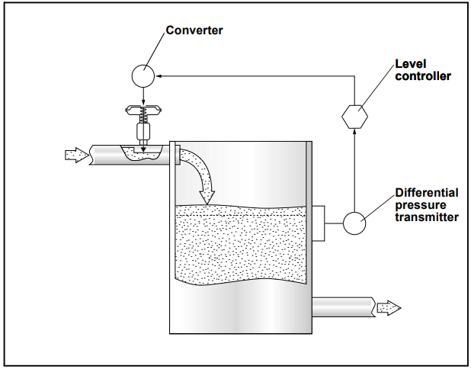
Figure 1.5: A Level Loop

- Temperature control loops
Because of the time required to change the temperature of a process fluid, temperature loops tend to be relatively slow. Feedforward control strategies are often used to increase the speed of the temperature loop response. RTDs or thermocouples are typical temperature sensors. Temperature transmitters and controllers are used, although it is not uncommon to see temperature sensors wired directly to the input interface of a controller. The final control element for a temperature loop is usually the fuel valve to a burner or a valve to some kind of heat exchanger. Sometimes, cool process fluid is added to the mix to maintain temperature (Figure 7.24).
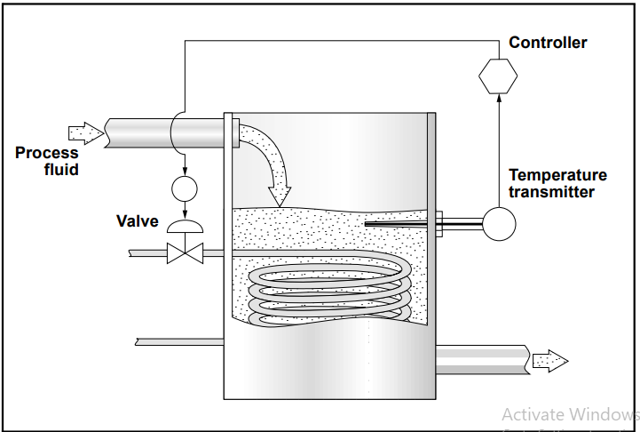
Figure 1.6: A Temperature Loop
- Multi-Variable / Advanced Control Loops
Multivariable loops are control loops in which a primary controller controls one process variable by sending signals to a controller of a different loop that impacts the process variable of the primary loop. For example, the primary process variable may be the temperature of the fluid in a tank that is heated by a steam jacket (a pressurized steam chamber surrounding the tank). To control the primary variable (temperature), the primary (master) controller signals the secondary (slave) controller that is controlling steam pressure. The primary controller will manipulate the setpoint of the secondary controller to maintain the setpoint temperature of the primary process variable (Figure 7.17).
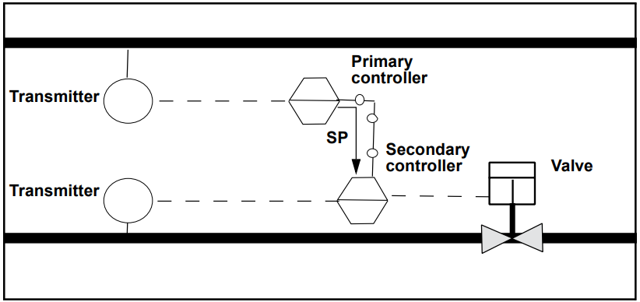
Figure 1.7: Multivariable Loop
When tuning a control loop, it is important to take into account the presence of multivariable loops. The standard procedure is to tune the secondary loop before tuning the primary loop because adjustments to the secondary loop impact the primary loop. Tuning the primary loop will not impact the secondary loop tuning.
- Feedforward control
Feedforward control is a control system that anticipates load disturbances and controls them before they can impact the process variable. For feedforward control to work, the user must have a mathematical understanding of how the manipulated variables will impact the process variable. Figure 7.19 shows a feedforward loop in which a flow transmitter opens or closes a hot steam valve based on how much cold fluid passes through the flow sensor.
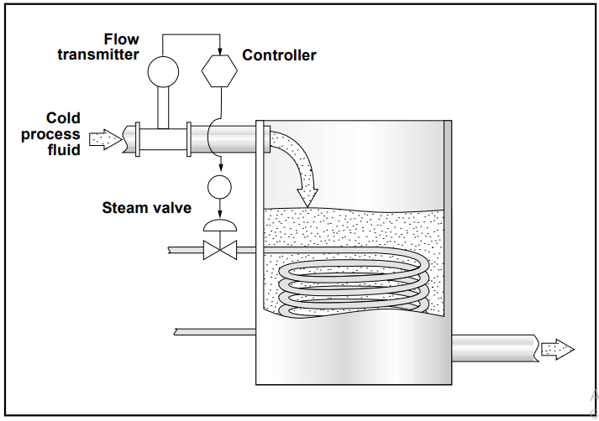
Figure1.8: Feedforward Control
An advantage of feedforward control is that error is prevented, rather than corrected. However, it is difficult to account for all possible load disturbances in a system through feedforward control. Factors such as outside temperature, buildup in pipes, consistency of raw materials, humidity, and moisture content can all become load disturbances and cannot always be effectively accounted for in a feedforward system. In general, feedforward systems should be used in cases where the controlled variable has the potential of being a major load disturbance on the process variable ultimately being controlled. The added complexity and expense of feedforward control may not be equal to the benefits of increased control in the case of a variable that causes only a small load disturbance.

- Feedforward plus feedback
Because of the difficulty of accounting for every possible load disturbance in a feedforward system, feedforward systems are often combined with feedback systems. Controllers with summing functions are used in these combined systems to total the input from both the feedforward loop and the feedback loop, and send a unified signal to the final control element. Figure 7.20 shows a feedforward-plus-feedback loop in which both a flow transmitter and a temperature transmitter provide information for controlling a hot steam valve.
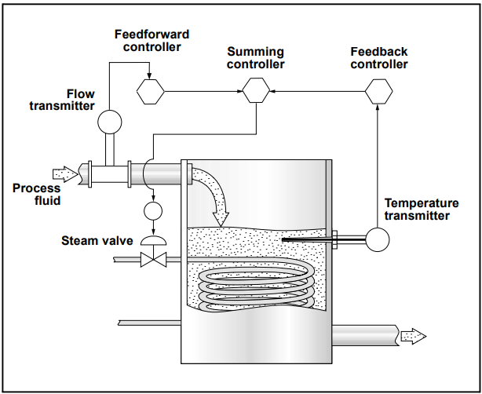
Figure1.9: Feedforward Plus Feedback Control System
This module has discussed specific types of control loops, what components are used in them, and some of the applications (e.g., flow, pressure, temperature) they are applied to. In practice, however, many independent and interconnected loops are combined to control the workings of a typical plant. This section will acquaint you with some of the methods of control currently being used in process industries.
- Cascade control
Cascade control is a control system in which a secondary (slave) control loop is set up to control a variable that is a major source of load disturbance for another primary (master) control loop. The controller of the primary loop determines the setpoint of the summing controller in the secondary loop (Figure 7.25).
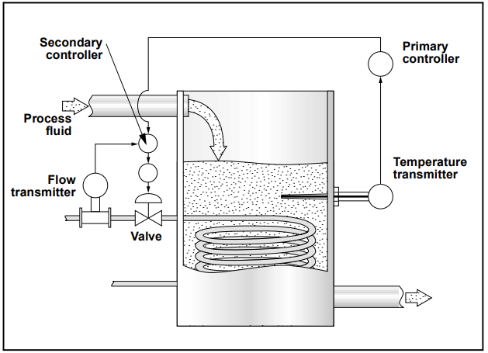
Figure1.10: Cascade Control
- Batch control
Batch processes are those processes that are taken from start to finish in batches. For example, mixing the ingredients for a juice drinks is often a batch process. Typically, a limited amount of one flavor (e.g., orange drink or apple drink) is mixed at a time. For these reasons, it is not practical to have a continuous process running. Batch processes often involve getting the correct proportion of ingredients into the batch. Level, flow, pressure, temperature, and often mass measurements are used at various stages of batch processes. A disadvantage of batch control is that the process must be frequently restarted. Start-up presents control problems because, typically, all measurements in the system are below setpoint at start-up. Another disadvantage is that as recipes change, control instruments may need to be recalibrated.
- Ratio control
Imagine a process in which an acid must be diluted with water in the proportion two parts water to one part acid. If a tank has an acid supply on one side of a mixing vessel and a water supply on the other, a control system could be developed to control the ratio of acid to water, even though the water supply itself may not be controlled. This type of control system is called ratio control (Figure 7.26). Ratio control is used in many applications and involves a controller that receives input from a flow measurement device on the unregulated (wild) flow. The controller performs a ratio calculation and signals the appropriate setpoint to another controller that sets the flow of the second fluid so that the proper proportion of the second fluid can be added.
Ratio control might be used where a continuous process is going on and an additive is being put into the flow (e.g., chlorination of water).
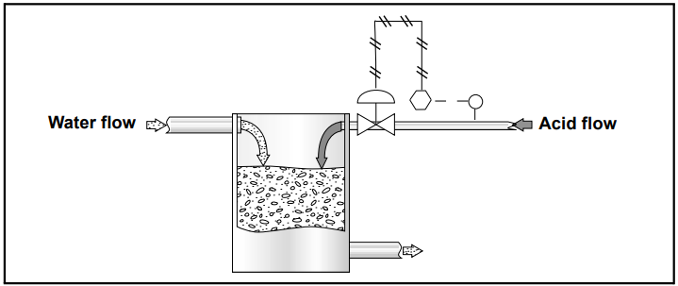
Figure1.11: Ratio Control
- Selective control
Selective control refers to a control system in which the more important of two variables will be maintained. For example, in a boiler control system, if fuel flow outpaces air flow, then uncombusted fuel can build up in the boiler and cause an explosion. Selective control is used to allow for an air-rich mixture, but never a fuel-rich mixture. Selective control is most often used when equipment must be protected or safety maintained, even at the cost of not maintaining an optimal process variable setpoint.
- Fuzzy control
Fuzzy control is a form of adaptive control in which the controller uses fuzzy logic to make decisions about adjusting the process. Fuzzy logic is a form of computer logic where whether something is or is not included in a set is based on a grading scale in which multiple factors are accounted for and rated by the computer. The essential idea of fuzzy control is to create a kind of artificial intelligence that will account for numerous variables, formulate a theory of how to make improvements, adjust the process, and learn from the result. Fuzzy control is a relatively new technology. Because a machine makes process control changes without consulting humans, fuzzy control removes from operators some of the ability, but none of the responsibility, to control a process.

1.3 PID control loop/system

Self-regulating systems using feedback loops, i.e. the routing back of the output of a system to its input, have existed since antiquity and have nowadays become an integral part of modern technology. One of the first attempts to rigorously describe control loops using feedback traces back to more than 150 years ago with James Clark Maxwell’s article, On Governors[1].
In the context of control strategies, an open-loop control system refers to a controller whose action is determined based on predetermined input values without considering feedback. In contrast, a closed-loop controller incorporates continuous feedback, enabling real-time adjustments to enhance precision, stability, and robustness, making it more suitable for achieving desired control objectives in changing conditions.
Today, the most widespread type of closed-loop control systems is the Proportional–Integral–Derivative (PID) controller. These types of controllers continuously measure and adjust the output of a system to match a desired setpoint, that is, a given target condition for the system or process under consideration. Requiring little prior knowledge or model of the system, PID controllers are extremely versatile, relatively cost effective and straightforward to implement, making their realization possible in a large variety of systems: from hydraulics and pneumatics to analog and digital electronics.
For this reason, they have become extensively used in a variety of industries and research applications, including manufacturing, photonics, sensors, material science and nanotechnology.
PID control loops are widely employed in various aspects of everyday-life and industrial automation, such as the gyroscopes found in smartphones and self-navigating cars, ovens used for cooking food or samples, flow controllers in pipes, and even in managing the daily vehicle traffic.
At the same time, their presence stands out in more advanced research fields as well, for example in the stabilization of laser cavities and interferometers in optics and photonics, in closed-loop control of MEMS-based (micro-electromechanical systems) gyroscopes, and in the characterization of mechanical resonators in scanning probe microscopy (SPM).
This white paper presents the key functions and principles of PID control loops by analyzing their basic building blocks, by describing their strengths and limitations, and by outlining the tuning and designing strategies and how they can be easily implemented with Zurich Instruments’ lock-in amplifiers.
PID Working Principle and Building Blocks
The goal of a PID controller is to produce a control signal that can dynamically minimize the difference between the output and the desired setpoint of a certain system.
Let's consider the exemplary scheme depicted in Figure 1. As a first step, the output of the system y(t) is looped back and measured against the setpoint r(t) by the comparator, thereby generating the time-dependent error signal e(t) = r(t) - y(t). Subsequently, this error signal is minimized by the loop filter and then used to generate the control signal u(t) that drives the output of the system, initiating closed-loop operation. These steps are continuously executed to minimize the error; hence, apart from considering the current error, it is also relevant to consider its accumulation over time (represented by the integral) and its future tendency (represented by the derivative at time t), as shown in Figure 2
In the most general case, error minimization is accomplished by means of the three primary components of the PID controller loop filter: the proportional, integral, and derivative terms.
Mathematically, the complete control function in its most general form can be written as the sum of the three individual contributions:
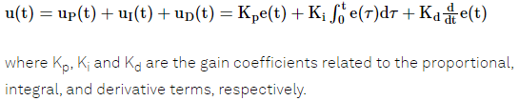
Figure 1.12: Schematic representation of a general PID control loop in its most general form.
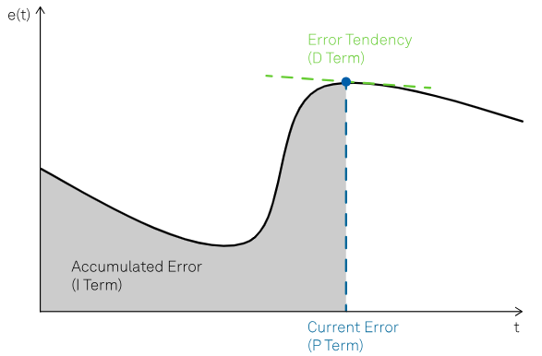
Figure 1.13: Example of error function with the highlighted contributions of the P, I and D terms.
The proportional term
The proportional term, denoted with P, is based on the current error between the setpoint and the measured output of the system. This term helps bring the output of the system back to the setpoint by applying a correction that is proportional to the amplitude of the error, leading to a reduction of the rise time of the correction signal, see Figure 3. The larger the error, the larger the correction applied by the proportional term -- that is, the larger the error with a fixed K_{p}, the larger u_{P}(t). Since the P term always requires a non-zero error to generate its output, it cannot nullify the error by itself. In steady-state system conditions, an equilibrium is reached, which includes a steady-state error.
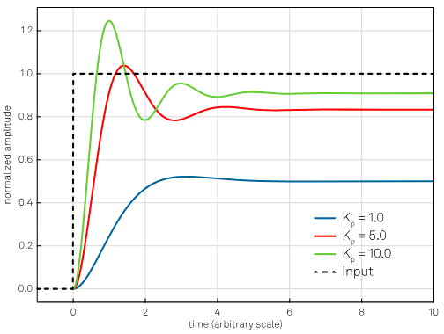
Figure 1.14: Effect of the proportional action. Increasing the K_{p} coefficient reduces the rise time, but the error never approaches zero.
Additionally, a too high value of the proportional gain might lead to an oscillating output.

The integral term
The integral term, denoted with I, applies a correction that is proportional to the time integral of the error, i.e. the history of the error. For example, if the error persists over time, the integral term continues to increase, resulting in a larger correction applied to the output of the system. Unlike the proportional term, the integral term makes it possible for the controller to generate a non-zero control signal even under a zero-error condition at present. This property enables the controller to bring the system exactly to the required setpoint. Its effect is illustrated in Figure 4.
Increasing the value of the integral gain coefficient increases the contribution of the accumulated error over time to the control signal. This means that if there is a steady-state error, an integral term with a large gain coefficient will drive the control signal to eliminate the error faster than a smaller integral term.
However, increasing the integral term too much can lead to an oscillating output if too much error is accumulated, causing the control signal to overshoot and create oscillations around the setpoint. This phenomenon is sometimes called integral windup [2].

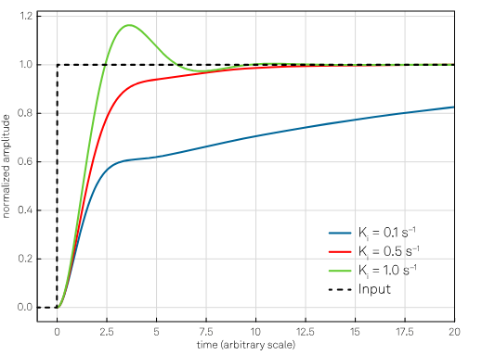
Figure 1.15: Effect of the integral action with constant K_{p} = 1. Increasing K_{i}, the response will be faster but also lead to larger oscillations and overshoot if the value increases too much (green curve).
The Derivative Term
The derivative term, denoted with D, provides a control over the error tendency, i.e. its future behavior, by applying a correction proportional to the time derivative of the error. This allows to reduce the rate of change of the error and so helps improve the stability and responsiveness of the control loop. The aim is to anticipate the changes in the error signal: if the error shows an upward trend, the derivative action tries to compensate without waiting for the error to become significant (proportional action) or for it to persist for some time (integral action).
In real-world implementations of PIDs, the derivative action is sometimes omitted due to its high sensitivity to the quality of the input signal. When the reference value changes rapidly, as in the case of a very noisy control signal, the derivative of the error tends to become very large, causing the PID controller to undergo an abrupt change that can result in instabilities or oscillations in the control loop.
To improve the stability, prior low-pass filtering of the error signal is often used as a mitigation strategy; however, low-pass filtering and derivative control neutralize one another, hence only a limited amount of filtering is possible.
If it is properly calibrated and if the system is "tolerant" enough, the derivative action can give a decisive contribution to the controller performance. The effect of the derivative term is shown in Figure 5.
The effect of each term on the system's response depends strongly on the system's characteristics. Therefore, the weighting of the K_{p}, K_{i}, and K_{d} gains can be adjusted to fine-tune the performance of the control loop and achieve the desired responsiveness and accuracy.
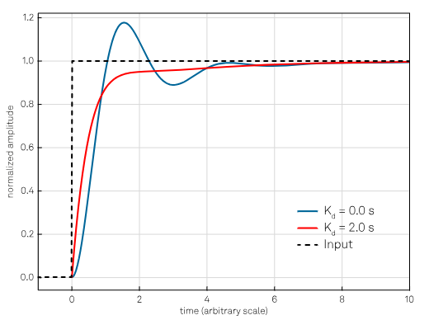
Figure 1.16: The purpose of the derivative action is to increase the damping of the system; however, too large values of Kd might make the system unstable or oscillatory, as described in the text. The curves are obtained keeping the proportional and integral gain constant (K_{p} = 4 and K_{i} = 1 s⁻¹).
Some applications or simple systems may only require one or two of the three control terms provided by a PID controller. To operate the controller with only a subset of these terms, the unused terms can be set to zero, thus resulting in a PI, PD, P, or I controller.
For instance, the use of a PI controller is common in applications that prioritize steady-state error elimination and stability, rather than fast response times, due to their slow dynamics. A typical example is the control of an oven's temperature, where a PI controller is normally employed to ensure precise temperature regulation and eliminate any steady-state offset, considering the oven's relatively slow response characteristics.

Derivation of an initial set of parameters (Tuning)
One of the main advantages of PID controllers is that they can be implemented without knowledge or a detailed model of the system. Thanks to heuristic calibration procedures, it is possible to calculate coefficients based only on simple experimental tests to be carried out directly on the process. Nevertheless, the initial tuning of the PID parameters can be a delicate task.
There exist several well-established methods to derive an initial set of coefficients, many of them involving the measurement of some open-loop parameters of the system.
As pointed out in the introduction, open-loop refers to the behavior of the system without any feedback control, where an input signal is applied to the system and the resulting output is just measured, but not fed back to the input. The input signal can be a step function, a ramp, a sine wave, or any other type of signal that is appropriate for the system being controlled. The output of the system is then recorded as a function of time and can be analyzed to determine the system's response characteristics, such as its time constant, natural frequency, and damping ratio.
The general strategy to find initial parameters involves typically three steps:
Obtain the open-loop response of the system and measure some of the characteristic parameters – e.g., the oscillation period of the system output and the process delay.
Calculate coarse values of the gain coefficients Kp, Ki and Kd based on the measured parameters.
Tune the PID gain coefficients to optimize for noise, speed, or robustness.
Some of the most widespread techniques to achieve coarse tuning are the Ziegler-Nichols method [3], the Cohen-Coon method [4], the relay method [5] and the Tyreus-Luyben method [6].
In Table 1, a practical example of an initial tuning procedure is outlined, constructed from the Ziegler-Nichols method.

Set the P,I, and D gain to zero
↓
Increase the proportional (P) gain until the system starts to show consistent and stable oscillation. This value is known as the ultimate gain (K_{u}).
↓
Measure the period of the oscillation (T_{u}).
↓
Depending on the desired type of control loop (P, PI or PID) set the gains to the following values:
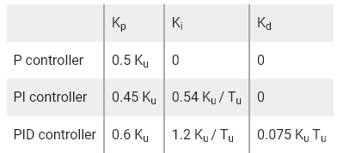
↓
Test the response of the system and adjust the gains as necessary. If the response is too slow or sluggish, increase the P or I gain. If the response is too fast or oscillatory, decrease the P or I gain. If there is overshoot or ringing, increase the D gain.
Table 1: Step-by-step procedure for the Initial tuning of a PID controller, based on the Ziegler-Nichols method.

Analog and Digital PID Controllers
In recent times, thanks to the advent of field-programmable gate array (FPGA) technology, microprocessors and digital signal processing techniques, the digital implementation of PID controllers – together with many other tools -- has outperformed its analog counterpart in a number of aspects. In particular, the digital form of PID control has the great advantage that it can be easily implemented as an algorithm and executed by a microcontroller device. This vastly increases its flexibility, performance, and the number of addressable applications.
Digital and analog PID controllers differ in the way they process signals and perform control actions. Analog controllers use continuous signals and analog components such as operational amplifiers and resistors to perform computations and generate control signals. Conversely, digital PID controllers sample and digitize signals, perform calculations and output discrete control signals. The use of digital signal processing techniques allows digital controllers to execute more complex control algorithms without adding extra analog circuitry whose physical properties might drift and thus degrade the quality of the control action over time.
Furthermore, the storing/recalling of settings and the integration with other digital systems can be easily achieved with digital controllers, thereby increasing their adaptability to many more control problems and applications.
As with all implementations of digital signals, the most common issues of digital PID controllers are related to quantization and sampling. Operating at discrete time intervals, selecting the sampling rate is critical to avoid artifacts such as aliasing and ensure accurate control. Furthermore, the implementation of the algorithms on digital platforms (e.g. on FPGAs or microprocessors) might be more costly and require additional technical expertise and careful evaluation of the corresponding numerical methods used for signal calculation and conditioning.
Ultimately, the choice between analog and digital controllers often depends on the application requirements, the available resources, and the desired performance.
Table 2 provides an overview of the advantages and disadvantages of the two approaches.
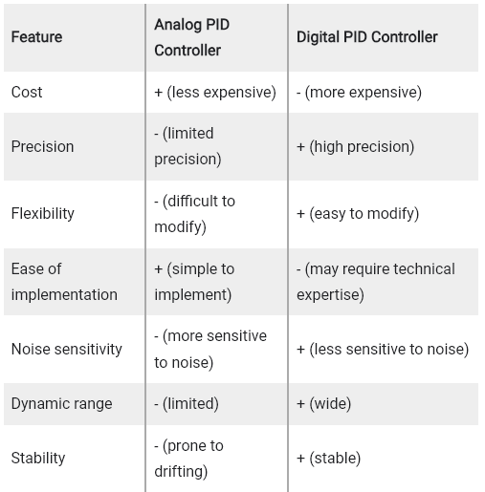
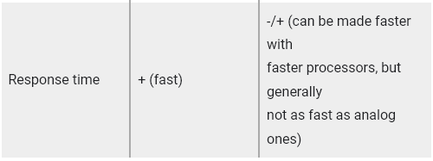
Table: Comparison between analog and digital PID control loops.

Zurich Instruments offers digital PID controllers as upgrade options for its Lock-in Amplifiers, Impedance Analyzers and Boxcar Averagers. The integrated architecture of the instruments allows the user to choose from many different inputs and outputs signals for the PIDs. Additionally, by integrating demodulated signals as input choices for PID controllers, the users can benefit from several advantages:
- Enhanced signal-to-noise ratio and stability: demodulation isolates the desired signal from noise and interference, resulting in a cleaner input signal for the controller.
- Increased sensitivity and improved system response: lock-in detection amplifies weak signals, enabling finer adjustments and enhancing the PID controller's ability to respond to subtle changes.
- Elimination of unwanted frequency components: demodulation filters out unwanted frequency components present in the original signal, leading to more accurate and efficient control.
As depicted in Figure 6, the set of signal choices includes amplitude, phase (thereby effectively setting up what is known as a phase-locked loop, or PLL for short [7]), quadrature and in-phase components of demodulated signals, boxcar outputs, as well as auxiliary inputs and outputs. The integrated digital signal processing guarantees maximum signal-to-noise ratio, minimal feedback loop latency and closed-loop operation with high stability. The feedback signal is then available as an analog output and can also be directly applied to an internal signal generator output to control its amplitude, frequency, offset and phase.
The digital implementation makes it possible to embed multiple PID controllers on the same instrument, whose inputs and outputs can be either cascaded in a sequential fashion or used in a parallel configuration, that is, independently of one another.
Thanks to the type of architecture depicted in Figure 6, the PID option embedded in lock-in amplifiers enhances the versatility of the instruments, making them benefit a large variety of applications – even though the specific application needs might significantly differ from one another.
As previously mentioned, determining appropriate starting conditions for a PID controller and its optimization can be a challenging task. LabOne® control software, the software of Zurich Instruments interfacing with the hardware, offers a kit of several tools to streamline the process of setting up and optimizing a PID controller, making the task more efficient and straightforward.
LabOne tools like the Sweeper, the PID Advisor and Autotune can help the user with the implementation of PID control loops, providing intuitive adjustability of the bandwidth, speed and initial tuning parameters, according to the desired performance.
For example, the Sweeper can be used to obtain the open-loop response of the device under test (DUT) through signal sweeping, then the PID Advisor selects initial feedback gain parameters based on predefined transfer functions and the DUT open-loop parameters obtained with the Sweeper measurement. After closing the loop, to minimize residual error signal and enhance control performance, the Auto Tune feature can be applied to the feedback signal to dynamically adjusts feedback gain parameters.
Additionally, thanks to LabOne’s support for the most popular programming languages (Python, C/C++, MATLAB®, LabVIEW™ and .NET), maximum versatility is ensured when setting up a control loop and its successive optimization and refinement.
Challenges and Trade-offs
While their versatility and simplicity allow PID controllers to be applied to numerous control problems, they are subject to some limitations and cannot deliver so-called optimal control. Optimal control refers to the set of control signals that minimize or maximize a certain criterion (sometimes known as cost function) used to measure the performance of the controlled system, e.g. minimizing energy consumption.
Specifically, the PID controllers’ reactive nature, i.e., the fact that no explicit knowledge of the system is used to generate the control coefficients, makes them sensitive to changes in the system dynamics and may require careful tuning to achieve the desired performance. Some typical shortcomings may include:
- Performance degradation if the system has a complex or non-linear transfer function. In these cases, more advanced and computationally heavy model-based control methods, such as state-space control or H-infinity control [8], may be needed.
- Considerable sensitivity to noise and disturbance signals of the D term , affecting the stability and accuracy of the control loop. Mitigation strategies can be applied to partly address these issues – e.g. omission or low-pass filtering of the D component.
- Sensitivity to deadtime or phase delay, i.e., the time it takes for the control loop to respond to a change in the system or the setpoint. If the phase delay is too large, the control loop may become unstable and start to oscillate or exhibit other undesirable behaviors.
- Process saturation: this phenomenon affects physical systems by introducing nonlinearities in the process due to the saturation of the actuators (e.g., a motor cannot supply more than its maximum torque). Techniques such as anti-windup or setpoint weighting can help mitigate these issues with relatively minor modifications to the control loop [9].
Loop Bandwidth
Another important factor to consider when designing a PID controller is the bandwidth of the loop or the closed-loop bandwidth. This bandwidth specifies the range of frequencies over which the loop can effectively control the system. A wide-bandwidth loop responds rapidly to changes in the setpoint or the system but may also be more prone to oscillation and overshoot. A narrow-bandwidth loop, in contrast, is less sensitive to changes in the setpoint and can deliver a cleaner and more accurate control signal at the expense of a slower response time.
Given this tradeoff between speed and precision, it is important to understand the requirements of the considered application to select an appropriate loop bandwidth. A wide-bandwidth loop may be preferred in applications where a rapid response is required, such as in the control of motors or other mechanical systems. Conversely, a narrow-bandwidth loop may be best in applications where stability is more important, such as in the control of chemical processes or for other systems with long time delays.

1.4 Components of PID control loop/System

The basic idea behind a PID controller is to read a sensor, then compute the desired actuator output by calculating proportional, integral, and derivative responses and summing those three components to compute the output. Before we start to define the parameters of a PID controller, we shall see what a closed loop system is and some of the terminologies associated with it.
Closed Loop System
In a typical control system, the process variable is the system parameter that needs to be controlled, such as temperature (ºC), pressure (psi), or flow rate (liters/minute). A sensor is used to measure the process variable and provide feedback to the control system. The set point is the desired or command value for the process variable, such as 100 degrees Celsius in the case of a temperature control system. At any given moment, the difference between the process variable and the set point is used by the control system algorithm (compensator), to determine the desired actuator output to drive the system (plant). For instance, if the measured temperature process variable is 100 ºC and the desired temperature set point is 120 ºC, then the actuator output specified by the control algorithm might be to drive a heater. Driving an actuator to turn on a heater causes the system to become warmer, and results in an increase in the temperature process variable. This is called a closed loop control system, because the process of reading sensors to provide constant feedback and calculating the desired actuator output is repeated continuously and at a fixed loop rate as illustrated in figure 1.
In many cases, the actuator output is not the only signal that has an effect on the system. For instance, in a temperature chamber there might be a source of cool air that sometimes blows into the chamber and disturbs the temperature.Such a term is referred to as disturbance. We usually try to design the control system to minimize the effect of disturbances on the process variable.

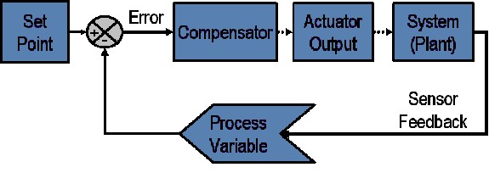
Figure 1.17: Block diagram of a typical closed loop system.
Defintion of Terminlogies
The control design process begins by defining the performance requirements. Control system performance is often measured by applying a step function as the set point command variable, and then measuring the response of the process variable. Commonly, the response is quantified by measuring defined waveform characteristics. Rise Time is the amount of time the system takes to go from 10% to 90% of the steady-state, or final, value. Percent Overshoot is the amount that the process variable overshoots the final value, expressed as a percentage of the final value. Settling time is the time required for the process variable to settle to within a certain percentage (commonly 5%) of the final value. Steady-State Error is the final difference between the process variable and set point. Note that the exact definition of these quantities will vary in industry and academia.
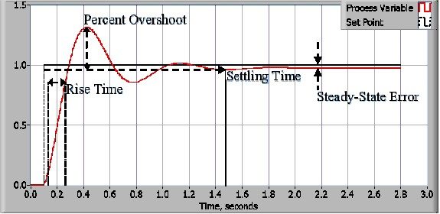
Figure1.18: Response of a typical PID closed loop system.
After using one or all of these quantities to define the performance requirements for a control system, it is useful to define the worst case conditions in which the control system will be expected to meet these design requirements. Often times, there is a disturbance in the system that affects the process variable or the measurement of the process variable. It is important to design a control system that performs satisfactorily during worst case conditions. The measure of how well the control system is able to overcome the effects of disturbances is referred to as the disturbance rejection of the control system.
In some cases, the response of the system to a given control output may change over time or in relation to some variable. A nonlinear system is a system in which the control parameters that produce a desired response at one operating point might not produce a satisfactory response at another operating point. For instance, a chamber partially filled with fluid will exhibit a much faster response to heater output when nearly empty than it will when nearly full of fluid. The measure of how well the control system will tolerate disturbances and nonlinearities is referred to as the robustness of the control system.
Some systems exhibit an undesirable behavior called deadtime. Deadtime is a delay between when a process variable changes, and when that change can be observed. For instance, if a temperature sensor is placed far away from a cold water fluid inlet valve, it will not measure a change in temperature immediately if the valve is opened or closed. Deadtime can also be caused by a system or output actuator that is slow to respond to the control command, for instance, a valve that is slow to open or close. A common source of deadtime in chemical plants is the delay caused by the flow of fluid through pipes.
Loop cycle is also an important parameter of a closed loop system. The interval of time between calls to a control algorithm is the loop cycle time. Systems that change quickly or have complex behavior require faster control loop rates.
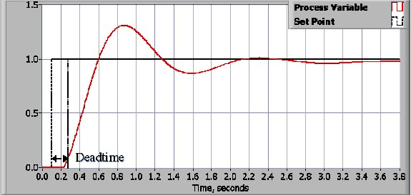
Figure 1.19: Response of a closed loop system with deadtime.
Once the performance requirements have been specified, it is time to examine the system and select an appropriate control scheme. In the vast majority of applications, a PID control will provide the required results
Proportional Response
The proportional component depends only on the difference between the set point and the process variable. This difference is referred to as the Error term. The proportional gain (K_{c}) determines the ratio of output response to the error signal. For instance, if the error term has a magnitude of 10, a proportional gain of 5 would produce a proportional response of 50. In general, increasing the proportional gain will increase the speed of the control system response. However, if the proportional gain is too large, the process variable will begin to oscillate. If K_{c} is increased further, the oscillations will become larger and the system will become unstable and may even oscillate out of control.

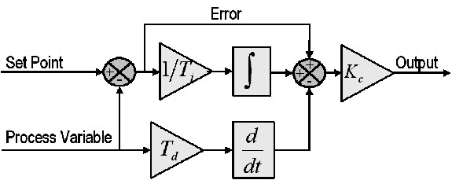
Figure1.20: Block diagram of a basic PID control algorithm.
Integral Response
The integral component sums the error term over time. The result is that even a small error term will cause the integral component to increase slowly. The integral response will continually increase over time unless the error is zero, so the effect is to drive the Steady-State error to zero. Steady-State error is the final difference between the process variable and set point. A phenomenon called integral windup results when integral action saturates a controller without the controller driving the error signal toward zero.
Derivative Response
The derivative component causes the output to decrease if the process variable is increasing rapidly. The derivative response is proportional to the rate of change of the process variable. Increasing the derivative time (T_{d}) parameter will cause the control system to react more strongly to changes in the error term and will increase the speed of the overall control system response. Most practical control systems use very small derivative time (T_{d}), because the Derivative Response is highly sensitive to noise in the process variable signal. If the sensor feedback signal is noisy or if the control loop rate is too slow, the derivative response can make the control system unstable

\
Tuning
The process of setting the optimal gains for P, I and D to get an ideal response from a control system is called tuning. There are different methods of tuning of which the “guess and check” method and the Ziegler Nichols method will be discussed.
The gains of a PID controller can be obtained by trial and error method. Once an engineer understands the significance of each gain parameter, this method becomes relatively easy. In this method, the I and D terms are set to zero first and the proportional gain is increased until the output of the loop oscillates. As one increases the proportional gain, the system becomes faster, but care must be taken not make the system unstable. Once P has been set to obtain a desired fast response, the integral term is increased to stop the oscillations. The integral term reduces the steady state error, but increases overshoot. Some amount of overshoot is always necessary for a fast system so that it could respond to changes immediately. The integral term is tweaked to achieve a minimal steady state error. Once the P and I have been set to get the desired fast control system with minimal steady state error, the derivative term is increased until the loop is acceptably quick to its set point. Increasing derivative term decreases overshoot and yields higher gain with stability but would cause the system to be highly sensitive to noise. Often times, engineers need to tradeoff one characteristic of a control system for another to better meet their requirements.

1.5 Measure and calculating values in control loop/system

Elements of a Process Control System
Figure 1-2 illustrates some of the essential elements of a process control system. In the system shown, a level transmitter (LT), a level controller (LC), and a control valve (LV) are used to control the liquid level in a process tank. The purpose of this control system is to maintain the liquid level at some prescribed height (H) above the bottom of the tank. It is assumed that the rate of flow into the tank is random. The level transmitter is a device that measures the fluid level in the tank and converts it into a useful measurement signal, which is sent to a level controller. The level controller evaluates the measurement, compares it with a desired set point (SP), and produces a series of corrective actions that are sent to the control valve. The valve controls the flow of fluid in the outlet pipe to maintain a level in the tank.
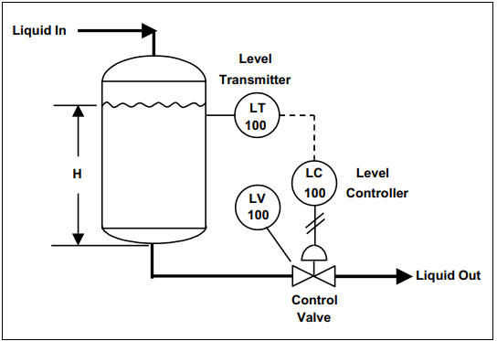
Figure1.21: Process level control: Example
Thus, a process control system consists of four essential elements: process, measurement, evaluation, and control. A block diagram of these elements is shown in Figure 1-3. This diagram also shows the disturbances that enter or affect the process. If there were no upsets to a process, there would be no need for the control system. Figure 1-3 also shows the input and output of the process and the set point used for control.
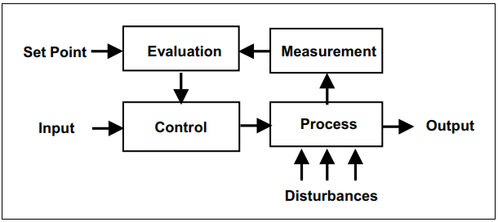
Figure 1.22: The four elements of a typical control system
Process
In general, a process consists of an assembly of equipment and material that is related to some manufacturing operation or sequence. In the example presented in Figure 1-2, the process whose liquid level is placed under control includes such components as a tank, the liquid in the tank, the flow of liquid into and out of the tank, and the inlet and outlet piping. Any given process can involve many dynamic variables, and it may be desirable to control all of them. In most cases, however, controlling only one variable will be sufficient to control the process to within acceptable limits. One occasionally encounters a multivariable process in which many variables, some interrelated, require regulation.

Measurement
To control a dynamic variable in a process, you must have information about the entity or variable itself. This information is obtained by measuring the variable. Measurement refers to the conversion of the process variable into an analog or digital signal that can be used by the control system. The device that performs the initial measurement is called a sensor. A sensor is defined by Standard ANSI/ISA-5.1-2009 as “a separate or integral part or function of a loop or an instrument that first senses the value of a process variable.” Typical measurements are pressure, level, temperature, flow, position, and speed. The result of any measurement is the conversion of a dynamic variable into some proportional information that is required by the other elements in the process control loop or sequence.
Evaluation
In the evaluation step of the process control sequence, the measurement value is examined, compared with the desired value or set point, and the amount of corrective action needed to maintain proper control is determined by a device called a controller. The controller can be a pneumatic, electronic, digital, or mechanical device mounted in a control panel or on the process equipment. It can also be part of a computer control system or an intelligent device, in which case the control function is performed by software.
Control
The control element in a control loop is the device that exerts a direct influence on the process or manufacturing sequence. This final control element accepts an input from the controller and transforms it into some proportional operation that is performed on the process. In most cases, this final control element will be a control valve that adjusts the flow of fluid in a process. Devices such as electrical motors, pumps, and dampers are also used as control elements.

Process and Instrumentation Drawings
In the measurement and control field, a standard set of symbols is used to prepare drawings of control systems and processes. The symbols used in these drawings are based on the American National Standard ANSI/ISA-5.1-2009 Instrumentation Symbols and Identification. A typical application for this standard is process and instrumentation diagrams (P&IDs), which show the interconnection of the process equipment and the instrumentation used to control the process. A portion of a typical P&ID is shown in Figure 1-4.
In the standard, the process flow lines, such as process fluid and steam, are indicated with heavier solid lines than the lines that are used to represent the instrumentation. The instrument signal lines use special markings to indicate whether the signal is pneumatic, electric, hydraulic, and so on. Table 5.3.2 on page 46 of the Standard ANSI/ISA-5.1-2009 lists the instrument line symbols that are used on P&IDs and other instrumentation and control drawings. In Figure 1-4, two types of instrument signals are used: double cross-hatched lines denote the pneumatic signals to the steam control valve and the process outlet flow control valve, and a dashed line is used for the electrical or electronic or digital signal lines between various instruments. In process control applications, pneumatic signals are almost always 3 to 15 psi (i.e., pounds per square inch, gauge pressure), the electrical control signals are normally 4 to 20 mA (milli-Amperes) DC (direct current), and the digital signals can be wireless or part of a digital communications system. A balloon symbol with an enclosed letter and number code is used to represent the instrumentation associated with the process control loop. This letter and number combination is called an instrument identification or instrument tag number.
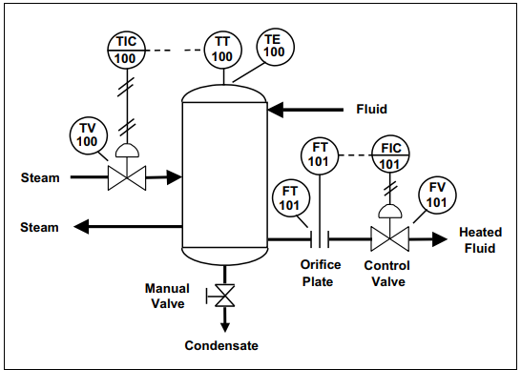
Figure 1.23: P&ID: Example
The first letter of the tag number is normally chosen so that it indicates the measured variable of the control loop. In the sample P&ID shown in Figure 1-4, T is the first letter in the tag number that is used for the instruments in the temperature control loop. The succeeding letters are used to represent: a readout function, an output function, or the letter can be used as a modifier. For example, the balloon in Figure 1-4 marked TE represents a temperature element and that marked TIC is a temperature-indicating controller. Normally, sequences of three- or four-digit numbers are used to identify each loop. In our process example (Figure 1-4), we used loop numbers 100 and 101. Smaller processes use three-digit loop numbers; larger processes or complex manufacturing plants may require four or more digits to identify all the control loops.
Various symbols are used to represent process equipment and sensors. For example, in our P&ID example in Figure 1-4, the two vertical parallel lines represent the orifice plate that is used to detect the discharge flow from the process heater. The two control valves in the figure use final control element symbols listed in Table 5.4.1 of Standard ANSI/ISA-5.1-2009 on pages 48 and 49.
General Requirements of a Control System
The primary requirement of a control system is that it be reasonably stable. In other words, its speed of response must be fairly fast, and this response must show reasonable damping. A control system must also be able to reduce the system error to zero or to a value near zero. The dynamic response of a control system to transient inputs changes causes deviations from the desired setpoint in the processes. In some cases, the extent and duration of these deviations may result in an unacceptable end product. In other cases, the products of a manufacturing run produced during such deviations must be scrapped with a loss of production and revenue. For this reason, process control loops are sometimes designed to minimize both the excursion of deviations from the operating setpoint and the time span during which such deviations occur.
System Error
The system error is the difference between the value of the controlled variable set point and the value of the process variable maintained by the system. The system error is expressed in equation form by the following:
e(t) = PV(t) – SP(t) (1-1)
where:
e(t) = system error as a function of time
PV(t) = process variable as a function of time
SP(t) = set point as a function of time

System Response
The main purpose of a control loop is to maintain some dynamic process variable (pressure, flow, temperature, level, etc.) at a prescribed operating point or set point. System response is the ability of a control loop to recover from a disturbance that causes a change in the controlled process variable.
There are two general types of good response: underdamped (cyclic response) and damped. Figure 1-5 shows an underdamped or cyclic response of a system in which the process variable oscillates around the set point after a process disturbance. The wavy response line shown in the figure represents an acceptable response if the process disturbance or change in set point is large, but it will not be an acceptable response if the change from the set point is small.
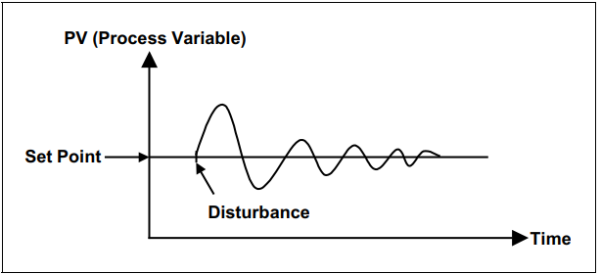
Figure 1.24: Cyclic response to process disturbance
Figure 1-6 shows a damped response where the control system is able to bring the process variable back to the operating point with no oscillations.
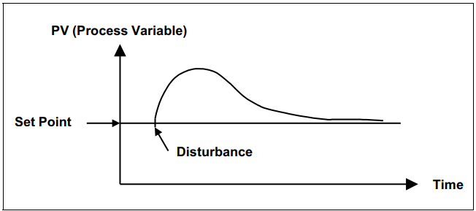
Figure 1.25: Damped response to process disturbance
Control Loop Design Criteria
Many criteria are employed to evaluate the process control’s loop response to an input change. The most common of these include settling time, maximum error, offset error, and error area (Figure 1-7).
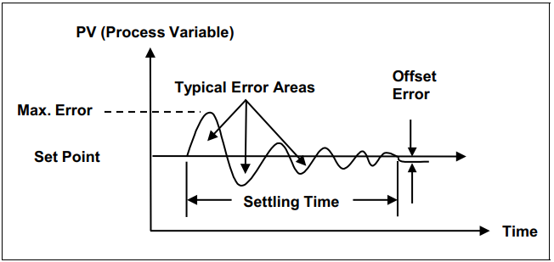
Figure 1.26: Evaluation of control loop response
When there is a process disturbance or a change in set point, the settling time is defined as the time the process control loop needs to bring the process variable back to within an allowable error. The maximum error is simply the maximum allowable deviation of the dynamic variable. Most control loops have certain inherent linear and nonlinear qualities that prevent the system from returning the process variable to the set point after a system change. This condition is generally called offset error and will be discussed later in this chapter. The error area is defined as the area between the response curve and the set point line as shown by the shaded area in Figure 1-7.
These four evaluation criteria are general measures of control loop behavior that are used to determine the adequacy of the loop’s ability to perform some desired function. However, the best way to gain a clear understanding of process control is to take an intuitive approach.
Intuitive Approach to Process Control Concepts
The practice of process control arose long before the theory or analytical methods underlying it were developed. Processes and controllers were designed using empirical methods that were based on intuition (“feel”) and extensive process experience. Most of the reasoning involved was nonmathematical. This approach was unscientific trial and error, but it was a successful control method. Consider, for example, an operator looking into an early metal processing furnace to determine whether the product was finished. He or she used flame color, amount of smoke, and process time to make this judgment. Equally direct early methods evolved most of the control concepts and hardware used today. Only later did theories and mathematical techniques emerge to explain how and why the systems responded as they did. In this section, we will approach the study of control fundamentals in much the same way that control knowledge developed—that is, through a step-by-step procedure starting from manual control and moving to ever increasing automatic control.
Suppose we have a process like that shown in Figure 1-8. A source of feed liquid flows into a tank at a varying rate from somewhere else in a process plant. This liquid must be heated so that it emerges at a desired temperature, Td, as a hot liquid. To accomplish this, hot water flows through heat exchanger coils in the tank. By controlling the flow of hot water, we can obtain the desired temperature, Td. A further process requirement is that the level of the tank must neither overflow nor fall so low that it exposes the heater coils.
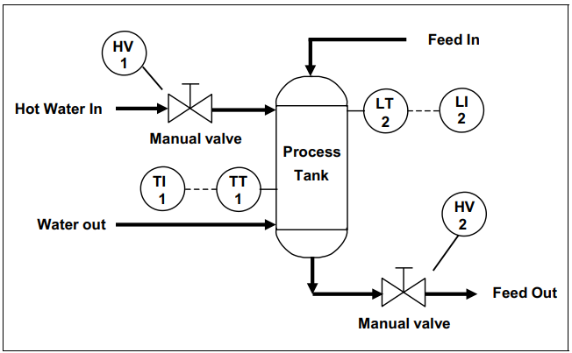
Figure1.27: Example process – using manual valves
The temperature is measured in the tank, and a temperature transmitter (TT-1) converts the signal into a 4-20 mA direct current (DC) signal to drive a temperature indicator (TI-1) mounted near the hot water inlet valve. Similarly, a level indicator (LI-2) is mounted within the operator’s view of the hot feed outlet valve (HV-2).
Suppose a process operator has the task of holding the temperature, T, near the desired temperature, Td, while making sure the tank doesn’t overflow or the level get too low. The question is how the operator would cope with this task over a period of time. He or she would manually adjust the hot water inlet valve (HV-1) to maintain the temperature and occasionally adjust the outlet valve (HV-2) to maintain the correct level in the tank. The operator would face several problems, however. Both indicators would have to be within the operator’s view, and the manual valves would have to be close to the operator and easy to adjust.
On/Off Control
To make the operator’s work easier, suppose we install electrically operated solenoid valves in place of the manual valves, as shown in Figure 1-9. We can also install two hand switches (HS-1 and HS-2) so the solenoid valves can be operated from a common location. The valves can assume two states, either fully open (on) or fully closed (off). This type of control is called two-position or on/off control.
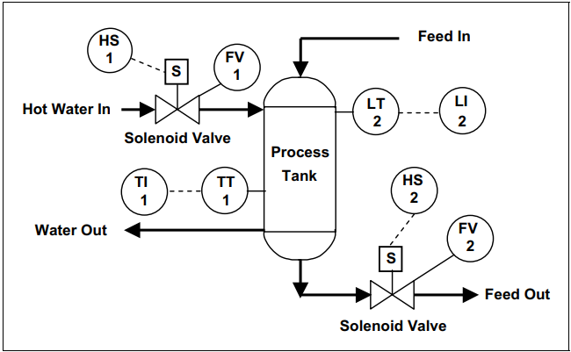
Figure1.28: Sample process – solenoid valves
Assume for the moment that the level is holding steady and that the main concern is controlling temperature. The operator has been told to keep the temperature of the fluid in the tank at 100°F. He or she compares the reading of the temperature indicator with the selected set point of 100°F. The operator closes the hot water valve when the temperature of the fluid in the tank rises above the set point (Figure 1-10). Because of process dead time and lags, the temperature will continue to rise before reversing and moving toward the set point. When the temperature falls below 100°F, the operator opens the hot water valve. Again, dead time and lags in the process create a delay before the temperature begins to rise. As the temperature crosses the set point, the operator again shuts off the hot water, and the cycle repeats.
This cycling is normal for a control system that uses on/off control. This limitation exists because it’s difficult for the operator to control the process exactly with only two options.
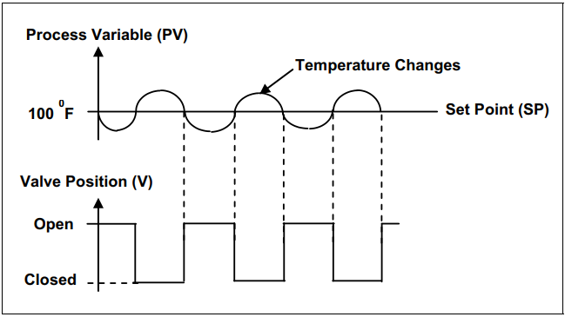
Figure 1.29: On/Off temperature control
This type of on/off control can be expressed mathematically as follows:
e = PV – SP (1-2)
where: e = error, SP = set point, PV = process variable
In the on/off control mode, the valve is opened when the error (e) is positive (+), and the valve is closed when e is negative (–).
Proportional Control
When we view the process as a balance between energy in and energy out, it is clear that smoother control would result if a steady flow of hot water were maintained rather than the sudden changes between on and off. The problem is finding the correct value for the steady flow required for proper control. Thus, for each rate of feed flow in and out of the tank, some ideal amount of inlet water flow exists that will hold the outlet temperature, T, at 100°F. This suggests that we should make two modifications to our control mode or strategy. The first is to establish some steady-flow value for the hot water that, at average operating conditions, tends to hold the process variable (temperature) at the desired value or set point (100°F). Once that average flow value has been established for the hot water, increases or decreases of error (e = SP – PV) must be allowed to cause corresponding increases and decreases in water flow from this normal value. This illustrates the concept of proportional control (i.e., initiating a corrective action to a value that is in some proportion to the change in error or deviation of the process variable from set point).
Before proportional control can be implemented on our sample process, we must change the solenoid valves to adjustable control valves. Such valves can be positioned to any degree of opening—from fully closed to fully opened— depending on the type of valve actuator mechanism you choose (generally either an electrically or pneumatically operated diaphragm actuator). Our sample process now looks like Figure 1-11, which now shows the use of pneumatically operated control valves (TV-1 and LV-2) and process controllers (TIC-1 and LIC-2). Control valves and controllers in the system make it possible to achieve better control of the process. Proportional control can be described mathematically as follows:
V = Kce + m ………………………………………….. (1-3)
where V = control valve position, Kc = the adjustable proportional gain of a typical process controller, m = position of the control valve when the system error (e) is zero
Proportional control can be best demonstrated by selecting three different gain values: gain of one (Kc = 1), low gain (Kc 1). A graph of proportional control with a gain one is shown in Figure 1-12a.
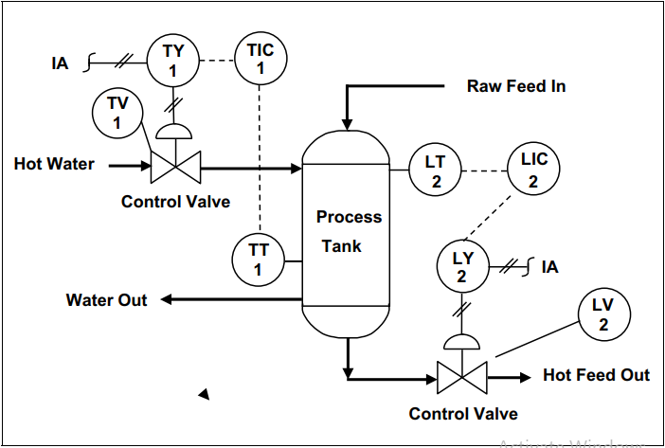
Figure 1.30: Typical process – proportional control
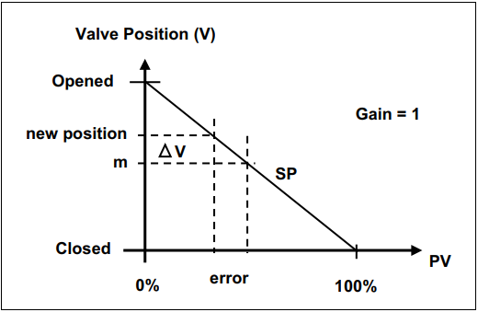
Figure1.31: Proportional control with gain of one (fig1.12a)
With a gain of one, there is a one to one relationship between the amount of change in the valve position (ΔV) to the amount of error in the system. So, if the error is 20%, the control valve will move 20% of its full travel to attempt to return the system to a selected set point. In the graph in Figure 1-12b, where a low gain (Kc is selected, a large change in error is required before the control valve would be fully opened or closed.
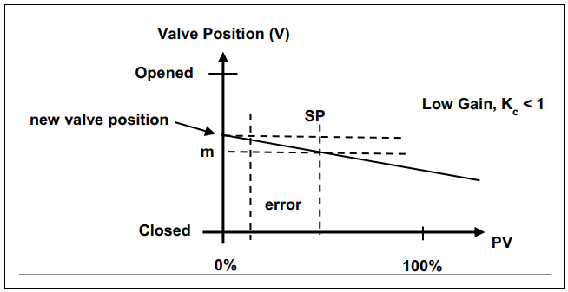
Figure 1.32: Proportional control with low gain (fig 1.12b)
Finally, the graph in Figure 1-12c shows the case of high gain (Kc >1), where a very small error would cause a large change in the control valve position. In this case a small change will caused the control valve to open fully.
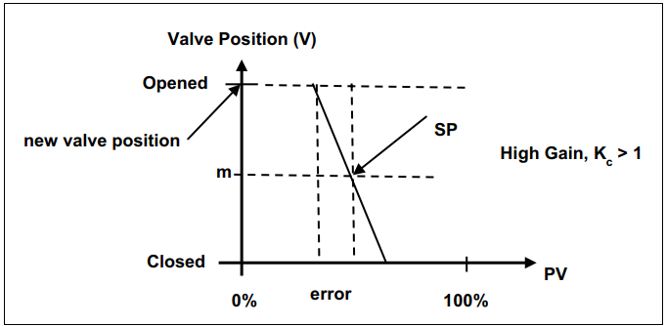
Figure1.33: Proportional control with high gain (fig1.12c)
The term proportional gain, or simply gain, arose as a result of the use of analytical methods in process control. Historically, the proportionality between error and valve action was called proportional band (PB). Proportional band is the expression that states the percentage of change in error that is required to move the valve full scale. Again, this had intuitive plausibility because it gave an operator a feel for how small of an error caused full corrective action. Thus, a 10 percent proportional band meant that a 10 percent error between SP and PV would cause the output to go full scale.
This definition can be related to proportional gain Kc by noting the following equation:
PB = 1/ Kc × 100 ……………………………………………. (1-4)
An example will help you understand the relationship between proportional band and gain.

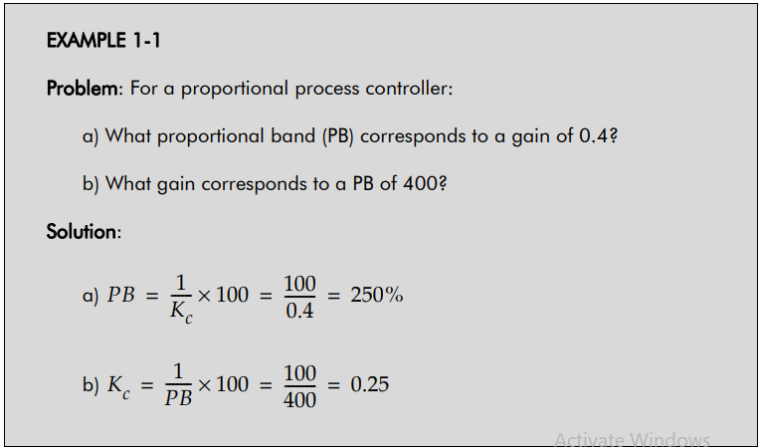
The modern way of considering proportional control is to think in terms of gain (Kc). The m term, as Equation 1-3 shows, has to be that control valve position that supplies just the right amount of hot water to make the temperature 100°F, that is, PV = SP. The position, m, indicated in Figures 1-12 a, b, and c, is often called the manual (m) reset because it is a manual controller adjustment. When a controller is designed to provide this mode of control, it must contain at least two adjustments: one for the Kc term and one for the m term. Control has become more complicated because it is now necessary to know where to set Kc and m for best control.
It would not take too long for the operator of our sample process to discover a serious problem with proportional control. Proportional control rarely ever keeps the process variable at the set point if there are frequent disturbances to the process. For example, suppose the flow to the tank suddenly increases. If the temperature of the tank is to be maintained at 100°F at this new rate of feed flow, more hot water must be supplied. This calls for a change in valve position. According to Equation 1-3, the only way that the valve position (V) can be changed is for the error (e) to change. Remember that m is a constant. Thus, an error will occur, and the temperature will drop below 100°F until equilibrium is reached between the hot water flow and new feed flow. How much this drop will be depends on the value of Kc that was set in the controller as well as on the characteristics of the process. The larger Kc is, the smaller this offset will be in a given system.
However, it can be shown that Kc cannot be increased indefinitely because the control will become unstable. So, some error is inevitable if the flow rate changes. These points are illustrated in Figure 1–13, which shows a plot of hot feed temperatures versus hot water flow rate (valve position) for both low raw feed flow and high raw feed flow.
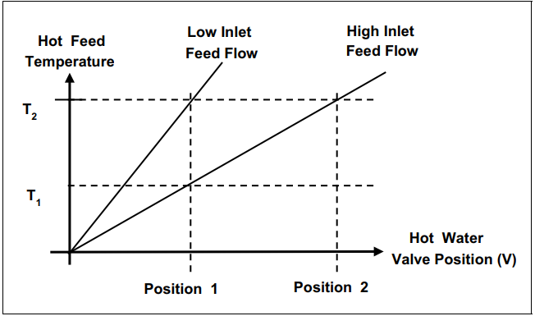
Figure 1.34: Example temperature vs. valve position – proportional control
For the hot water valve in position one and the raw feed coming into the process tank at the low flow rate, the process will heat the fluid and produce hot feed fluid at temperature T2. If suddenly the feed went to a high flow rate and the valve position was not changed, the temperature would drop to T1. At this new high flow rate, the hot water valve must be moved to position 2 if the original temperature T2 is to be restored. Figure 1–14 shows the extent to which proportional control of the temperature valve can achieve this restoration. One way to cope with the offset problem is by manually adjusting the m term. When we adjust the m term (usually through a knob on a process controller), we are moving the valve to a new position that allows PV to equal SP under the new conditions of load. In this case, with an increase in feed flow, Equation 1-3 clearly shows that the only way to obtain a new value for V, if e is to be zero, is by changing the m term. If process changes are frequent or large it may become necessary to adjust m frequently. It is apparent that some different type of control mode is needed.
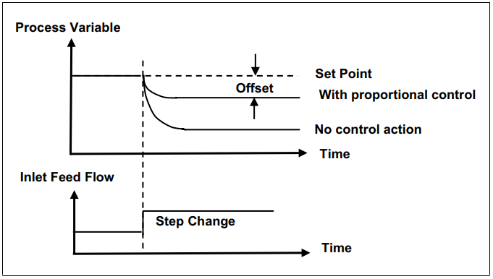
Figure 1.35: Process response with proportional control
Proportional-Plus-Integral Control
Suppose that the controller rather than the operator manually adjusts the proportional controller described in the previous section. This would eliminate the offset error caused by process changes. The question then is on what basis should the manual reset be automated? One innovative concept would be to move the valve at some rate, as long as the error is not zero. Though eventually the correct control valve position would be found, there are many rates at which to move the valve. The most common practice in the instrumentation field is to design controllers that move the control valve at a speed or rate proportional to the error. This has some logic to it, in that it would seem plausible to move the valve faster as the error got larger. This added control mode is called reset or integral action. It is usually used in conjunction with proportional control because it eliminates the offset. This proportional-plus-integral (PI) control is shown in Figure 1-15. Assume a step change in set point at some point in time, as shown in the figure. First, there is a sudden change in valve position equal to Kce due to the proportional control action. At the same time, the reset portion of the controller, sensing an error, begins to move the valve at a rate proportional to the error over time. Since the example in Figure 1-15 had a constant error, the correction rate was constant.
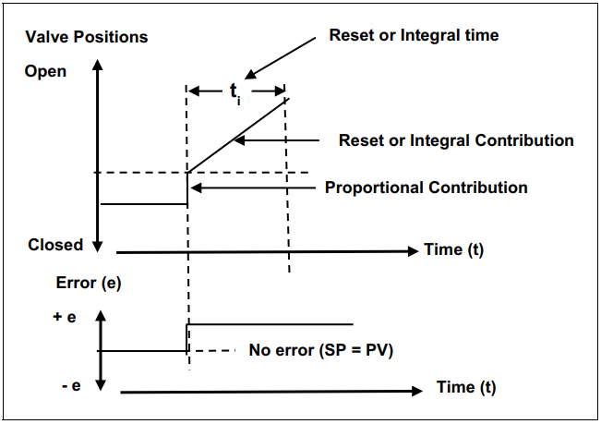
Figure 1.36: Proportional-plus-integral control
When time is used to express integral or reset action, it is called the reset time. Quite commonly, its reciprocal is used, in which case it is called reset rate in “repeats per minute.” This term refers to the number of times per minute that the reset action is repeating the valve change produced by proportional control alone. Process control systems personnel refer to reset time as the integral time and denote it as ti . The improvement in control that is caused by adding the integral or reset function is illustrated in Figure 1-16. The same process change is used that was previously assumed under proportional-only control. Now, however, after the initial upset the reset action returns the error to zero and there is no offset.
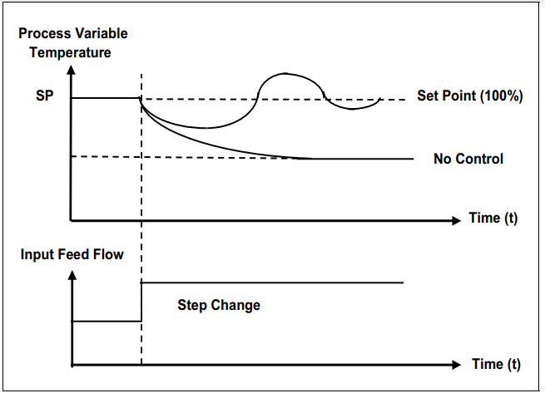
Figure 1.37: Process response with PI control
Recognizing that the reset action moves the control valve at a rate proportional to error, this control mode is described mathematically as follows:
(Dv/dt) = K_{i}^{e} …………………………………………………1.5
where V is the valve position and Ki is an adjustable constant.
We can find the position of the valve (V) at any time by integrating this differential equation (Equation 1-5). If we integrate from time 0 to time, t, we obtain:
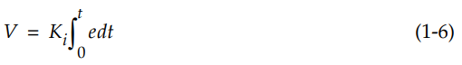
This equation shows that the control valve position is proportional to the integral of the error. This fact leads to the “integral control” label. Finally, combining proportional and integral control gives the total expression of a two-mode proportional-plus-integral (PI) controller:
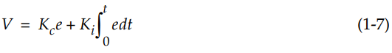
If we let Ki = Kc/ti , we obtain an alternate form of the PI control equation in terms of the proportional constant, Kc, and the integral time, ti , as follows:
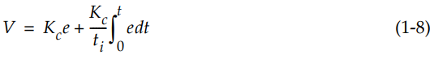
One problem with PI control bears mentioning. If a control loop is using PI control, the possibility exists with the integral (reset) mode that the controller will continue to integrate and change the output even outside the operating range of the controller. This condition is called “reset windup.” For example, the heat exchanger shown in Figure 1-17 can be designed and built to heat 50 gal/min of process fluid from 70°F to 140°F. If the process flow should suddenly increase to 100 gal/min, it may be impossible to supply sufficient steam to maintain the process fluid temperature at140°F even when the control valve is wide open (100%), as shown in Figure 1-18. In this case, the reset mode, having opened the valve all the way (the controller output is perhaps 15 psi), would continue to integrate the error signal and increase the controller output all the way in order to supply pressure from the pneumatic system. Once past 15 psi, the valve will open no further, and the continued integration serves no purpose. The controller has “wound up” to a maximum output value.
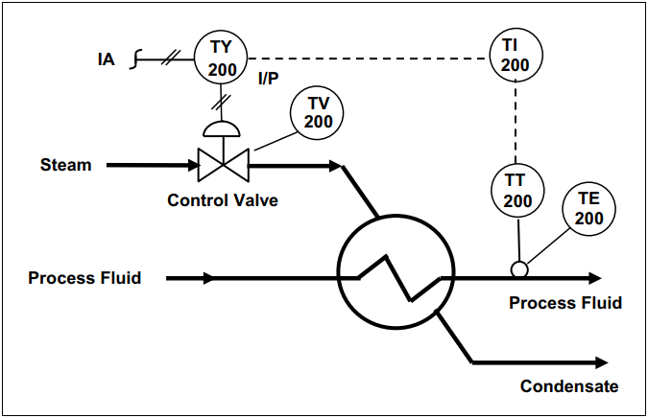
Figure1.38: Heat exchange – temperature control
Further, if the process flow should then drop to 50 gal/min (back to the operable range of the process), there would be a period of time during which the controlled temperature is above the set point while the valve remains wide open. It takes some time for the integral mode to integrate (reset) downward from this wound-up condition to 15 psi before the valve begins to close and control the process. It is possible to prevent this problem of controller-reset windup by using a controller operational feature that limits the integration and the controller output. This feature is normally called anti-reset windup and is recommended for processes that may periodically operate outside their capacity.
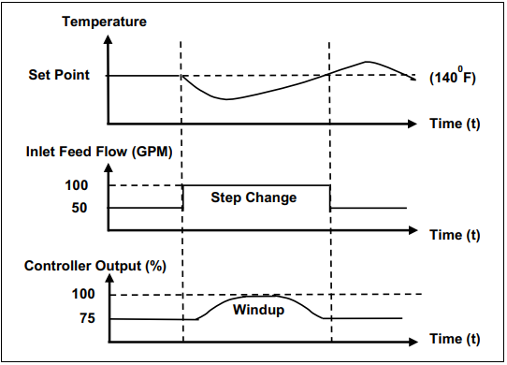
Figure 1.39: Reset windup control
Proportional-Plus-Derivative (PD) Control
We can now add to proportional control another control action called derivative action. This control function produces a corrective action that is proportional to the rate of change of error. Note that this additional correction exists only while the error is changing; it disappears when the error stops changing, even though there may still be a large error.
Derivative control can be expressed mathematically as follows:
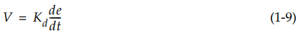
where Kd = derivative constant, de/dt = derivative of the control system error with respect to time
The derivative constant Kd can be related to the proportional constant by the following equation:
Where td is the derivative control constant. If we add derivative control to proportional control, we obtain:
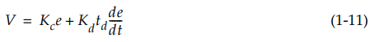
To illustrate the effects of PD control, let’s assume that the error is changing at a constant rate. This can be obtained by changing the set point at a constant rate (i.e., SP = Ct), as shown in Figure 1-19.
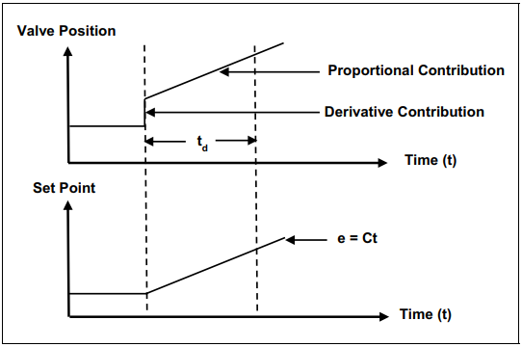Figure1.40: Proportional-plus-derivative
Derivative action contributes an immediate valve change that is proportional to the rate of change of the error. In Figure 1-19, it is equal to the slope of the set point line. As the error increases, the proportional action contributes additional control valve movement. Later, the contribution of the proportional action will have equaled the initial contribution of the rate action. The time it takes for this to happen is called the derivative time, td. The ramped error can be expressed mathematically as follows:
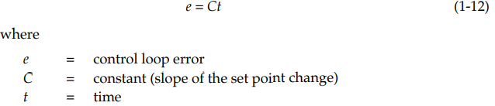
If we substitute this value (e = Ct) for the control loop error into the equation for a PD controller, we obtain:
Since the derivative of Ct with respect to time, t, is simply equal to C, the control action (V) from the PD controller to the control valve becomes:
This indicates that the valve position is ahead in time by the amount td from the value that straight proportional control would have established for the same error. The control action leads to improved control in many applications, particularly in temperature control loops where the rate of change of the error is very important. In temperature loops, large time delays generally occur between the application of corrective action and the process response; therefore, derivative action is required to control steep temperature changes.

Proportional-Integral-Derivative Control
Finally, the three control functions—proportional, integral, and derivative— can be combined to obtain full three-mode or PID control:
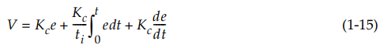
Deciding which control action (i.e., PD, PID, etc.) should be used in a control system will depend on the characteristics of the process being controlled. Three-mode control (PID) cannot be used on a noisy measurement process or on one that experiences stepwise changes because the derivative contribution is based on the measurement of rate of change. The derivative of a true step change is infinite, and the derivatives of a noisy measurement signal will be very large and lead to unstable control.
The PID controller is used on processes that respond slowly and have long periods. Temperature control is a common example of PID control because the heat rate may have to change rapidly when the temperature measurement begins to change. The derivative action shortens the response of the slow process to an upset.
In the next chapter we discuss such important characteristics of processes as time constants and dead time. By understanding these concepts you will be better able to select the proper control action type for effective control.
Single-loop Feedback Control
In a feedback control loop, the variable to be manipulated is measured. This measured process value (PV) is then compared with a set point (SP) to generate an error signal (e = PV - SP). If a difference or error exists between the actual value and the desired value of the process, a process controller will take the necessary corrective action to return the process to the desired value. A block diagram of a single-feedback control loop is shown in Figure 2-1. The measured process variable is sensed or measured by the appropriate instrumentation, such as temperature, flow, level, or analytical sensors. This measured value is then compared with the set point. The controller uses this comparison to adjust the manipulated variable appropriately by generating an output signal. The output signal is based in turn on whichever control strategy or algorithm has been selected. Because in the process industries the manipulated variable is most often flow, the output of the controller is usually a signal to a flow control valve, as shown in Figure 2-1.
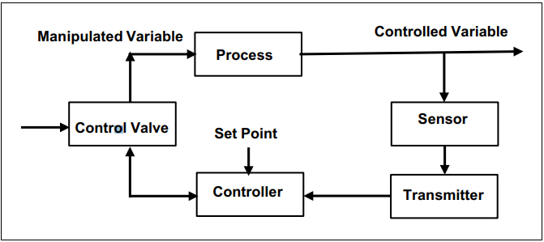
Figure1.41: Feedback control loop
During the operation of the process, disturbances can enter the process and drive the process variable in one direction or another. The single manipulated variable is used to compensate for all such process changes produced by the disturbances. Furthermore, if changes occur in the set point, the manipulated variable is altered to produce the needed change in the process output.
Process Controllers
The most dynamic device in a feedback control loop is the process controller. There are three types of controllers—mechanical, pneumatic, and electronic— and they all serve the same function. They compare the process variable with the set point and generate an output signal that manipulates the process to make the process variable equal to its set point. Figure 2-2 shows a block diagram of a feedback control loop with an expanded view of its common functions. In this diagram the measurement transducer has been expanded into its two components: the sensor and the transmitter. The sensor measures the process variable, and then the transmitter converts the measurement into a standard signal such as 4 to 20 mA DC, or 3 to 15 psi, or digital.
The controller consists of an input transmission system, a comparator with a set point input, controller functions, and an output transmission system. The comparator block measures the difference between the set point and the process variable. For this comparison to be useful, the set point and the process variable must have the same units of measure. For example, if the set point has the units of 0 to 10 mV, then the signal from the sensor must be converted into the same units. The purpose of the input transmission system is to convert the sensor signal into the correct units. For example, if the input signal is 4 to 20 mA DC the input circuit in the controller will convert the signal to 0 to 10 mV. The function of the output transmission system is to convert the signal from the controller circuit into the form required by the final control device. The four common controller functions are proportional, proportional plus integral (PI), proportional plus derivative (PD), and proportional plus integral plus derivative (PID).
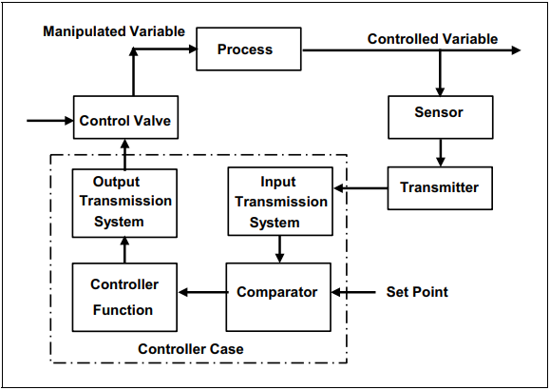
Figure 1.42: Functional block diagram of feedback loop
A front-panel view of a typical electronic process controller is shown in Figure 2-3. The controller has two vertical bar displays to give the operator a pictorial view of the process variable and the set point. It also has two short horizontal digital displays just above the vertical bars to give the operator a direct digital readout of the process variable and the set point. The operator uses dual push buttons with indicating arrows to adjust the set point and the manual output functions. The operator must depress the manual (“M”) push button to activate the manual output function.
During normal operation, the operator will select automatic (“A”) mode. Manual mode is generally used only during system startup or during a major upset condition when the operator must take control to stabilize the process. The controller shown in Figure 2-3 has both a horizontal bar display and a digital indicator to provide the operator with the value of the output signal from the controller. The square indicator marked “RSP” is used to indicate that the controller is using a remote set point.
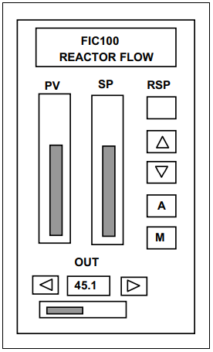
Figure 1.43: Typical electronic controller
Time Elements of a Feedback Loop
The various components of the feedback control loop shown in Figure 2-2 need time to sense an input change and transform this new condition into an output change. The time of response of the control loop is the combination of the responses of the sensor, the transmitter, the controller, the final control element, and the process. An important objective in control system design is to correctly match the time response of the control system to that of the process. To reach this objective, it is necessary to understand the concept of time delays or “lags” in process control systems.
Time Lags
In process control, the term lag means any relationship in which some result happens after some cause. In a feedback control loop, lags act in series, the output of one being the input to another. For example, the lags around a simple temperature control loop would be the output of the electric controller to the input to a valve lag. The output of the valve lag is the input to a process heat lag. The output of process heat lag is the input to the measurement sensor lag. We will start our discussion of time response and time lag with sensor time response.
Sensor Time Response
In process sensors, the output lags behind the input process value that is being measured. Sensor output changes smoothly from the moment a change in measurement value occurs, even if the disturbance is sudden and discontinuous. It is interesting to note that the nature of the sensor time-response curve is the same for virtually all sensors, even though the sensors measure different physical variables.
A typical response curve for a process sensor is shown in Figure 2-4, where the input has been changed suddenly at time equal to zero.
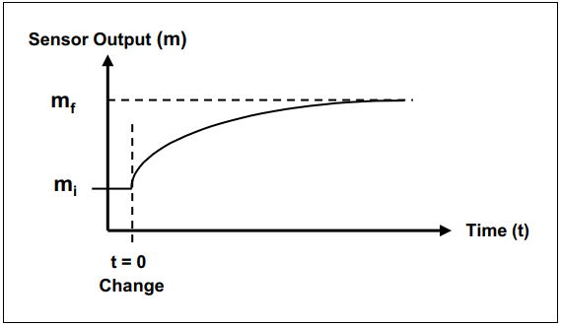
Figure 1.44: Exponential time response of a sensor
This curve is described by the following equation for the output measurement m(t) as a function of time:
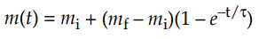
Where
mi = the initial sensor output measurement
mf = the final sensor output value
τ = the sensor time constant

1.6 Common fault/problems in PID control loop/system
In a PID control loop/system, there are several common faults and problems that can occur. These issues can affect the performance and stability of the control system, leading to inaccurate control and potential process instability. It is important to identify and address these faults to ensure optimal control performance. Below are some of the common faults and problems in a PID control loop/system:
1. Proportional Band (PB) Setting: One of the primary parameters in a PID controller is the proportional band (PB), also known as gain or proportional gain. If the PB is set too low, the controller's response will be sluggish, resulting in slow correction of errors. On the other hand, if the PB is set too high, it can lead to overshoot and oscillations in the controlled variable. Finding the right PB setting requires careful tuning to achieve a balance between stability and responsiveness.
2. Integral Windup: Integral windup occurs when the integral action of a PID controller accumulates an error even when the system is unable to respond adequately. This can happen when there are constraints on the manipulated variable or when the system experiences long periods of saturation. As a result, when the constraint is lifted or saturation ends, the integral term can cause overshoot or undershoot, leading to instability and poor control performance. To mitigate integral windup, anti-windup techniques such as clamping or back-calculation can be employed.
3. Derivative Kick: The derivative term in a PID controller provides damping to reduce overshoot and oscillations. However, it can introduce a problem known as derivative kick. Derivative kick occurs when there is a sudden change in the setpoint or measurement signal, causing a large derivative term output that leads to an abrupt change in the manipulated variable. This sudden change can destabilize the system and result in overshoot or even instability. To minimize derivative kick, filtering techniques such as low-pass filters or derivative smoothing can be applied.
4. Sensor Noise: In a control system, the accuracy and reliability of the sensor measurements are crucial. However, sensors can introduce noise into the measurement signal, which can affect the control performance. Sensor noise can lead to erratic control actions and instability in the system. To mitigate sensor noise, filtering techniques such as averaging or Kalman filtering can be employed to smooth out the measurement signal and reduce the impact of noise on the control loop.
5. Nonlinearities: Many real-world systems exhibit nonlinear behavior, which can pose challenges for PID control. Nonlinearities can include dead zones, hysteresis, saturation limits, or nonlinear process dynamics. These nonlinearities can cause deviations from the expected control response and affect stability and performance. Advanced control techniques such as gain scheduling, adaptive control, or model predictive control (MPC) may be required to handle nonlinearities effectively.
6. Sampling Time: The sampling time or update rate of a PID controller plays a crucial role in its performance. If the sampling time is too long, the controller may not respond quickly enough to changes in the process, leading to sluggish control and poor performance. On the other hand, if the sampling time is too short, it can introduce high-frequency noise into the control loop and destabilize the system. Selecting an appropriate sampling time requires considering the dynamics of the process and balancing between responsiveness and noise rejection.
7. Controller Tuning: Proper tuning of a PID controller is essential for achieving optimal control performance. Incorrect tuning can result in slow response, overshoot, oscillations, or instability. There are various methods available for controller tuning, including manual tuning, Ziegler-Nichols method, Cohen-Coon method, and model-based methods such as autotuning algorithms. Each method has its advantages and limitations, and selecting the appropriate tuning method depends on factors such as system dynamics, control objectives, and available resources.
In conclusion, a PID control loop/system can experience various faults and problems that can affect its performance and stability. These issues include improper proportional band setting, integral windup, derivative kick, sensor noise, nonlinearities, sampling time, and controller tuning. Addressing these faults requires careful analysis, tuning, and implementation of appropriate control strategies to ensure accurate and stable control.

1.7 WHS/ OHS processes and workplace procedures and risk control
WHS/OHS processes, workplace procedures, and risk control are essential components of maintaining a safe and healthy work environment. These processes and procedures aim to identify, assess, and control potential hazards and risks in the workplace, including those related to the use of PID controllers.
A PID controller, which stands for Proportional-Integral-Derivative controller, is a device commonly used in industrial automation systems to regulate and control various parameters such as temperature, pressure, flow rate, or level. While PID controllers are generally safe to use when implemented correctly, there are certain risks associated with their operation that need to be addressed through appropriate WHS/OHS processes and workplace procedures.
One of the key aspects of WHS/OHS processes is the identification and assessment of hazards. In the context of PID controllers, potential hazards may include electrical hazards (e.g., electric shock), mechanical hazards (e.g., moving parts), thermal hazards (e.g., high temperatures), chemical hazards (e.g., exposure to hazardous substances), and ergonomic hazards (e.g., poor workstation design). It is important for organizations to conduct thorough risk assessments to identify these hazards and evaluate their potential impact on workers' health and safety.
Once hazards are identified, appropriate risk control measures should be implemented. These measures can be categorized into four main types: elimination, substitution, engineering controls, and administrative controls. Elimination involves removing the hazard entirely from the workplace. Substitution entails replacing the hazard with a less hazardous alternative. Engineering controls involve modifying the workplace or equipment to minimize the risk. Administrative controls refer to implementing policies, procedures, and training programs to reduce exposure to the hazard.
In the case of PID controllers, some examples of risk control measures may include:
1. Engineering controls:
- Implementing proper guarding or enclosures around PID controller components to prevent accidental contact with moving parts or electrical components.
- Installing temperature sensors or limit switches to monitor and control the temperature of the PID controller and prevent overheating.
- Using appropriate ventilation systems to control exposure to hazardous substances, such as fumes or gases, that may be generated during the operation of the PID controller.
2. Administrative controls:
- Developing and implementing standard operating procedures (SOPs) for the safe operation and maintenance of PID controllers.
- Providing adequate training and supervision to workers who operate or work near PID controllers, ensuring they are aware of the potential hazards and know how to mitigate them.
- Establishing a system for reporting and investigating incidents or near misses related to PID controller operation, in order to identify any deficiencies in the existing risk control measures and take corrective actions.
3. Personal protective equipment (PPE):
- Providing workers with appropriate PPE, such as safety glasses, gloves, or protective clothing, to protect them from potential hazards associated with PID controller operation.
- Ensuring that workers are trained on the proper use, maintenance, and limitations of PPE.
It is important for organizations to regularly review and update their WHS/OHS processes and workplace procedures to ensure they remain effective in controlling risks associated with PID controller operation. This can be done through periodic risk assessments, consultation with workers and relevant stakeholders, and staying up-to-date with industry best practices and regulatory requirements.
In conclusion, WHS/OHS processes, workplace procedures, and risk control play a crucial role in ensuring the safe operation of PID controllers. By identifying hazards, implementing appropriate risk control measures, and providing adequate training and supervision, organizations can minimize the potential risks associated with these devices.

1.8 Scope of control problem
The scope of control problem in a PID controller refers to the range of control that can be achieved using this type of controller. The PID controller is a widely used feedback control algorithm that aims to regulate a system's output by adjusting its input based on the error between the desired setpoint and the measured process variable. While the PID controller is effective in many applications, it does have certain limitations that define its scope of control.
One of the main limitations of a PID controller is its inability to handle nonlinear systems. Nonlinear systems are those in which the relationship between the input and output variables is not linear, meaning that their behavior cannot be accurately represented by a straight line. In such cases, the PID controller may not be able to provide satisfactory control performance, as it assumes a linear relationship between the input and output variables.
Another limitation of PID controllers is their sensitivity to changes in system dynamics. If the characteristics of the controlled system change significantly, such as variations in gain or time delay, the PID controller may struggle to maintain stable and accurate control. This sensitivity can lead to oscillations, overshoot, or even instability in the controlled system.
Additionally, PID controllers may face challenges when dealing with systems that have large time delays. Time delay refers to the time it takes for a change in the input variable to affect the output variable. If there are significant delays in the system's response, it can lead to poor control performance or instability when using a PID controller.
Furthermore, PID controllers are limited in their ability to handle systems with multiple inputs and outputs. While they can be extended to multivariable systems by using multiple PID loops, this approach may not always provide optimal control due to interactions between different variables.
To overcome these limitations and expand the scope of control, various modifications and enhancements have been proposed for PID controllers. These include advanced tuning methods, such as model-based tuning or adaptive tuning algorithms, which aim to improve control performance in nonlinear or time-varying systems. Additionally, the use of advanced control techniques like model predictive control (MPC) or fuzzy logic control can provide more robust and accurate control in complex systems.
In summary, the scope of control problem in a PID controller arises from its limitations in handling nonlinear systems, sensitivity to changes in system dynamics, challenges with large time delays, and difficulties in controlling multivariable systems. While PID controllers are widely used and effective in many applications, their scope of control can be expanded through the use of advanced tuning methods and alternative control techniques.

1.9 Tools, equipment and testing devices
A PID (Proportional-Integral-Derivative) controller is a widely used control algorithm in various industries and applications. It is designed to regulate a process variable by continuously adjusting an actuator based on the error between the desired setpoint and the measured process variable. To implement a PID controller, several tools, equipment, and testing devices are commonly utilized.
1. Controller: The PID controller itself is the primary tool used in implementing the control algorithm. It can be a standalone device or integrated into a larger control system. The controller typically consists of a microprocessor or microcontroller that performs the PID calculations and generates the control output signal.
2. Sensors: Sensors play a crucial role in providing feedback on the process variable to the PID controller. Different types of sensors can be used depending on the nature of the controlled process. Common examples include temperature sensors, pressure sensors, flow sensors, level sensors, and position sensors. These sensors convert physical quantities into electrical signals that can be processed by the PID controller.
3. Actuators: Actuators are devices responsible for adjusting the manipulated variable based on the control output from the PID controller. They can be electrically, pneumatically, or hydraulically driven depending on the application requirements. Examples of actuators include electric motors, solenoid valves, pneumatic cylinders, and hydraulic pumps.
4. Control Valves: In many industrial processes, control valves are used as actuators to regulate fluid flow rates. These valves can be operated manually or automatically by an actuator driven by the PID controller's output signal. Control valves allow precise control over flow rates by adjusting their opening or closing positions.
5. Programmable Logic Controllers (PLCs): In complex control systems, PLCs are often employed to implement PID control algorithms along with other logic functions. PLCs provide a flexible and programmable platform for integrating multiple inputs, outputs, and control strategies. They can communicate with various devices and sensors, making them suitable for controlling complex processes.
6. Human-Machine Interface (HMI): HMIs are graphical user interfaces that allow operators to interact with the PID controller and monitor the process variables in real-time. HMIs provide a visual representation of the control system, enabling operators to adjust setpoints, view trends, and diagnose any issues. They can be implemented using dedicated HMI panels or software applications running on computers or mobile devices.
7. Signal Conditioners: Signal conditioners are used to amplify, filter, or convert sensor signals into a suitable format for processing by the PID controller. They ensure that the signals are within the required range and free from noise or interference. Signal conditioners may include amplifiers, filters, isolators, and converters.
8. Data Loggers: Data loggers are devices used to record and store process variables over time. They can be connected to the PID controller's output or various sensors to capture data for analysis, troubleshooting, or performance evaluation purposes. Data loggers can store data locally or transmit it to a central database for further processing.
9. Calibration Equipment: Calibration equipment is essential for maintaining the accuracy and reliability of sensors and actuators used in PID control systems. It includes calibration standards, reference sources, pressure gauges, temperature baths, multimeters, and other tools necessary for verifying and adjusting the performance of these devices.
10. Simulation Software: Simulation software allows engineers to model and simulate PID control systems before implementing them in real-world applications. It enables testing different control strategies, tuning parameters, and evaluating system behavior under various scenarios without risking damage to equipment or processes.
In conclusion, implementing a PID controller requires a combination of tools, equipment, and testing devices such as controllers, sensors, actuators, control valves, PLCs, HMIs, signal conditioners, data loggers, calibration equipment, and simulation software. These components work together to regulate a process variable and ensure optimal control performance.

Self check 1
PART I. Choose the correct answer for the following question
- In a feedback control loop, the variable to be manipulated is
- Measured value B. Process value C. Set point D. All
- The generated error signal e =
- PV –SP B. SP –PV C. PV +SP D. PV/SP
- The measured process variable is sensed or measured by the appropriate instrumentation
A. temperature, B. flow, C. level, D.All
4. Which one of the following is not Multivariable loops
A. Feedforward plus feedback C. Level control loops
B. Feedforward control D.All
5. Is a control system in which a secondary (slave) control loop is set up to control a variable that is a major source of load disturbance for another primary (master) control loop
- Batch control B. Cascade control C. Ratio control D. Selective control
6. Refers to a control system in which the more important of two variables will be maintained
- Batch control B. Cascade control C. Ratio control D. Selective control
7. A control system could be developed to control the ratio of acid to water, even though the water supply itself may not be controlled
- Batch control B. Cascade control C. Ratio control D. Selective control
8. Is a form of adaptive control in which the controller uses fuzzy logic to make decisions about adjusting the process
- Batch control B. Cascade control C. Fuzzy control D. Selective control
9. Is based on the current error between the setpoint and the measured output of the system
A. Proportional term B. integral term C. derivative term D. All
10. Applies a correction that is proportional to the time integral of the error.
A. Proportional term B. integral term C. derivative term D. All

Part II: Matching
Direction: match column A with column B. writes your answer on the space provided before the number.
 | Column A | Column B
1 | Integral term | - Allows to reduce the rate of change of the error
2 | Derivative term | - Pressure control loops
3 | Examples of Single Control Loops | - It possible for the controller to generate a non-zero control signal
4 | Examples of Multivariable loops | - that the process must be frequently restarted
5 | A disadvantage of batch control | - Cascade control

PART III. Short answer question
  - Explain digital and analog PID controllers
  - Explain the components of PID control loop
  - What is tuning of PID control?
  - List the elements of process control system
  - Define system error in PID control system

Unit Two: Fault Finding In Process Control Loops
This unit is developed to provide you the necessary information regarding the following content coverage and topics:
  - PID control loop/system live work measurement
  - Process controller/transmitters/converters
  - Fault Finding Procedure
  - PID control loop/system component adjustment
  - PID control loop/system component set up
This unit will also assist you to attain the learning outcomes stated in the cover page. Specifically, upon completion of this learning guide, you will be able to:
  - Determine PID control loop/system live work measurement
  - Check and isolate Process controller/transmitters/converters
  - Follow Fault Finding Procedure
  - Perform PID control loop/system component adjustment
  - Perform PID control loop/system component set up

2.1. PID control loop/system live work measurement
A PID (Proportional-Integral-Derivative) controller is a feedback control mechanism that calculates an error between a desired setpoint and a measured process variable, and adjusts the process input in proportion to the error to maintain the desired setpoint. The three terms of a PID controller are:
1. Proportional (P) term: This term adjusts the process input based on the current error value. The greater the error, the larger the change in the process input.
2. Integral (I) term: This term adjusts the process input based on the accumulation of past error values. The integral term is used to correct for steady-state errors, which are errors that persist over time.
3. Derivative (D) term: This term adjusts the process input based on the rate of change of the error value. The derivative term is used to correct for rapid changes in the error value.
The PID controller calculates the control output as a weighted sum of the three terms, using gains (Kp, Ki, and Kd) to adjust the relative importance of each term. The control output is then applied to the process input to maintain the desired setpoint.
Here is a step-by-step explanation of how a PID controller works:
1. Measure the process variable (SP) and compare it to the desired setpoint (SPdesired).
2. Calculate the error (e) as the difference between the process variable and the desired setpoint.
3. Calculate the proportional term (P) as a multiple of the error (e) times the gain (Kp).
4. Calculate the integral term (I) as the integral of past errors over time, multiplied by the gain (Ki).
5. Calculate the derivative term (D) as the derivative of the error (e) with respect to time, multiplied by the gain (Kd).
6. Calculate the control output (CO) as a weighted sum of the proportional, integral, and derivative terms, using the gains (Kp, Ki, and Kd).
7. Apply the control output (CO) to the process input (PI) to maintain the desired setpoint.
The gains (Kp, Ki, and Kd) can be adjusted to optimize the performance of the PID controller. The optimal values of the gains depend on the specific application and can be determined through experimentation or modeling.
Here are some key applications of PID controllers:
1. Temperature control: PID controllers are commonly used to control temperature in industrial processes, such as in ovens, furnaces, and heat exchangers.
2. Speed control: PID controllers can be used to control the speed of motors and other mechanical systems.
3. Flow control: PID controllers can be used to control the flow rate of fluids in industrial processes.
4. Pressure control: PID controllers can be used to control pressure in industrial processes, such as in pumps and compressors.
In conclusion, a PID controller is a powerful tool for controlling industrial processes. By understanding the principles of PID control and how to apply it, engineers can design and implement effective control systems that ensure the desired performance of their processes.

2.2 Process controller/transmitters/converters

What are process controllers, transmitters, and converters? What are their functions, types, applications, advantages, disadvantages, and limitations?
Process controllers, transmitters, and converters are essential components of industrial automation systems that control and regulate various processes in industries such as manufacturing, oil and gas, chemical processing, and power generation. These devices play a crucial role in ensuring the smooth operation of these processes and maintaining product quality, safety, and efficiency. In this answer, we will discuss the functions, types, applications, advantages, disadvantages, and limitations of process controllers, transmitters, and converters.
Functions of Process Controllers, Transmitters, and Converters:
Process controllers are used to regulate and control various process variables such as temperature, pressure, flow rate, level, and pH. They receive input signals from sensors and transmitters and use these signals to adjust the process variables to maintain the desired setpoints.
Transmitters are used to measure and convert physical parameters such as temperature, pressure, and flow rate into electrical signals that can be read by process controllers or other devices.
Converters are used to convert one type of signal or parameter into another type of signal or parameter. For example, a current converter may be used to convert a voltage signal into a current signal.
Types of Process Controllers, Transmitters, and Converters:
Process controllers include on/off controllers, proportional controllers, and programmable logic controllers (PLCs). On/off controllers are simple devices that turn a process on or off based on a setpoint. Proportional controllers use feedback loops to adjust the process variable in proportion to the error between the setpoint and the actual value. PLCs are advanced devices that can perform complex control functions and store and execute programs.
Transmitters include thermocouple transmitters, pressure transmitters, and flow transmitters. Thermocouple transmitters measure temperature using thermocouples, which are devices that generate a small voltage difference between two dissimilar metals. Pressure transmitters measure pressure using sensors that convert pressure into a change in capacitance or piezoelectric effect. Flow transmitters measure flow rate using sensors that detect changes in the flow of a fluid.
Converters include analog-to-digital converters (ADCs) and digital-to-analog converters (DACs). ADCs convert analog signals into digital signals, while DACs convert digital signals into analog signals.
Applications of Process Controllers, Transmitters, and Converters:
Process controllers, transmitters, and converters have a wide range of applications in various industries. Some examples include:
* Temperature control in food processing, pharmaceutical manufacturing, and chemical processing
* Pressure control in oil and gas production, water treatment, and power generation
* Flow rate control in chemical processing, water treatment, and oil and gas production
* Level control in water treatment, chemical processing, and oil and gas storage
* pH control in water treatment, food processing, and pharmaceutical manufacturing
Advantages of Process Controllers, Transmitters, and Converters:
The use of process controllers, transmitters, and converters offers several advantages, including:
* Improved process control and stability
* Increased productivity and efficiency
* Enhanced product quality and consistency
* Reduced downtime and maintenance costs
* Improved safety and environmental performance
Disadvantages of Process Controllers, Transmitters, and Converters:
While process controllers, transmitters, and converters offer many advantages, they also have some disadvantages, including:
* High initial cost and complexity
* Limited flexibility and adaptability
* Potential for errors and failures
* Requires skilled personnel for installation, calibration, and maintenance
Limitations of Process Controllers, Transmitters, and Converters:
Process controllers, transmitters, and converters have several limitations, including:
* Limited range of measurement and control
* Limited accuracy and resolution
* Susceptible to interference and noise
* Vulnerable to cyber attacks and data breaches
In conclusion, process controllers, transmitters, and converters are essential components of industrial automation systems that control and regulate various processes in industries such as manufacturing, oil and gas, chemical processing, and power generation. These devices offer many advantages, including improved process control and stability, increased productivity and efficiency, enhanced product quality and consistency, reduced downtime and maintenance costs, and improved safety and environmental performance. However, they also have some disadvantages and limitations, including high initial cost and complexity, limited flexibility and adaptability, potential for errors and failures, and vulnerability to cyber attacks and data breaches.

2.3 Fault Finding Procedure

Fault finding is a crucial process in troubleshooting and resolving issues in various systems, equipment, or devices. It involves identifying and diagnosing the root cause of a problem to implement appropriate solutions. This procedure typically follows a systematic approach to ensure efficient and effective fault resolution.
The fault finding procedure can vary depending on the specific system or equipment being analyzed. However, there are some general steps that are commonly followed in fault finding processes. These steps include:
1. Gathering Information: The first step in fault finding is to gather relevant information about the system or equipment experiencing the issue. This may involve reviewing documentation, manuals, or technical specifications related to the system. Additionally, it may be necessary to collect data or logs from the system to gain insights into its behavior and identify any patterns or anomalies.
2. Defining the Problem: Once sufficient information has been gathered, the next step is to define the problem clearly. This involves understanding the symptoms or indications of the issue and determining its impact on the overall system performance. Defining the problem helps in narrowing down potential causes and focusing on specific areas for investigation.
3. Developing a Hypothesis: Based on the defined problem, a hypothesis is formulated regarding the possible causes of the issue. This hypothesis is developed by analyzing the available information and using logical reasoning. It serves as a starting point for further investigation and testing.
4. Testing and Verification: In this step, various tests and experiments are conducted to validate or invalidate the formulated hypothesis. This may involve using specialized tools, equipment, or software to simulate or replicate the conditions under which the problem occurs. The results of these tests help in narrowing down potential causes and identifying the actual root cause of the issue.
5. Analyzing Results: Once testing is complete, the results are analyzed to determine their significance and relevance to the defined problem. This analysis involves comparing expected outcomes with observed outcomes and identifying any discrepancies or patterns that may provide insights into the root cause of the issue.
6. Identifying the Root Cause: Based on the analysis of test results, the root cause of the problem is identified. This is the underlying factor or condition that is responsible for causing the observed symptoms or issues. It may be a single cause or a combination of multiple causes.
7. Implementing Solutions: After identifying the root cause, appropriate solutions or corrective actions are implemented to resolve the issue. These solutions may involve repairing or replacing faulty components, adjusting settings or configurations, updating software or firmware, or implementing procedural changes.
8. Testing and Validation: Once the solutions are implemented, thorough testing and validation are performed to ensure that the issue has been successfully resolved. This involves verifying that the symptoms or indications of the problem no longer exist and that the system or equipment is functioning as expected.
9. Documentation: Finally, it is important to document the entire fault finding procedure, including all steps taken, tests conducted, results obtained, and solutions implemented. This documentation serves as a reference for future troubleshooting efforts and helps in building a knowledge base for similar issues.
In conclusion, fault finding is a systematic process that involves gathering information, defining the problem, developing a hypothesis, testing and verification, analyzing results, identifying the root cause, implementing solutions, testing and validation, and documenting the entire procedure. Following this procedure helps in efficiently resolving issues in various systems and equipment.
Fault finding procedure in PID
Fault finding in a PID (Proportional-Integral-Derivative) control system is a crucial task to ensure the proper functioning and performance of the system. This procedure involves identifying and resolving any issues or faults that may arise in the PID controller or the controlled process. While there may not be a specific PDF document titled "Fault Finding Procedure in PID," there are various resources available online that provide comprehensive guidance on troubleshooting PID control systems.
To begin with, it is important to understand the basic components of a PID control system and their functions. The PID controller consists of three main terms:
1. Proportional (P) term: This term produces an output proportional to the error between the desired setpoint and the actual process variable. It provides an immediate response to changes in the error but may result in steady-state errors.
2. Integral (I) term: The integral term sums up the past errors over time and adjusts the output accordingly. It helps eliminate steady-state errors but can lead to overshoot or instability if not properly tuned.
3. Derivative (D) term: The derivative term predicts future changes in the process variable based on its rate of change. It helps dampen rapid changes and reduce overshoot but can amplify noise if set too high.
When troubleshooting a PID control system, it is essential to follow a systematic approach. Here is a general fault-finding procedure that can be applied:
1. Identify the symptoms: Begin by observing and documenting any abnormal behavior or symptoms exhibited by the control system or process. This could include oscillations, slow response, overshoot, instability, or failure to reach setpoint.
2. Check sensor and actuator connections: Ensure that all sensors and actuators are properly connected and functioning correctly. Verify wiring connections, signal integrity, power supply, and grounding.
3. Inspect tuning parameters: Review the PID controller's tuning parameters (P, I, D gains) and check if they are appropriate for the process being controlled. Incorrectly tuned parameters can lead to poor performance or instability.
4. Analyze control loop response: Conduct a step response test by introducing a small setpoint change and observing the system's response. Analyze the output to determine if it matches the expected behavior. Look for any oscillations, overshoot, or sluggish response.
5. Adjust tuning parameters: If the control loop response is not satisfactory, consider adjusting the PID tuning parameters. This can be done manually or using auto-tuning algorithms available in some controllers. Make incremental changes and observe the impact on system behavior.
6. Consider non-linearities and disturbances: Take into account any non-linearities or disturbances that may affect the system's performance. These could include dead zones, saturation limits, nonlinear process dynamics, or external disturbances. Adjust the control strategy accordingly.
7. Check for mechanical issues: Inspect mechanical components such as valves, pumps, motors, or actuators for any faults or malfunctions that may impact the control system's performance. Ensure proper lubrication, alignment, and functionality.
8. Review software and firmware: If the PID controller operates using software or firmware, ensure that it is up to date and functioning correctly. Check for any known bugs or issues related to the specific controller model.
9. Consider external factors: Evaluate external factors that may influence the control system's performance, such as temperature variations, pressure changes, humidity levels, or ambient noise. Implement appropriate measures to mitigate their effects.
10. Consult manufacturer documentation or support: If all else fails or if dealing with complex systems, consult the manufacturer's documentation or contact their technical support for further guidance on troubleshooting specific issues.
It is important to note that fault finding in a PID control system can be a complex task and may require expertise in control theory and practical experience with the specific system being analyzed. The above procedure provides a general guideline, but it is always recommended to consult relevant resources and experts for accurate troubleshooting.

2.4 PID control loop/system component adjustment

A PID control loop is a feedback control system widely used in various industries to regulate and maintain a desired process variable. The acronym PID stands for Proportional, Integral, and Derivative, which are the three components that make up the control algorithm. Adjusting these components is crucial for achieving optimal control performance.
1. Proportional (P) Component: The proportional component of a PID controller provides an output that is directly proportional to the error between the desired setpoint and the measured process variable. Increasing the proportional gain amplifies the controller's response to the error, resulting in a faster response but potentially introducing overshoot and instability. Conversely, decreasing the proportional gain reduces the controller's sensitivity to error, leading to slower response times and potential sluggishness.
2. Integral (I) Component: The integral component of a PID controller integrates the error over time and produces an output that eliminates steady-state errors. It continuously adjusts the controller's output based on the accumulated error. Increasing the integral gain increases the controller's ability to eliminate steady-state errors but can also introduce overshoot and instability if set too high. Decreasing the integral gain reduces the controller's ability to eliminate steady-state errors but may result in slower response times.
3. Derivative (D) Component: The derivative component of a PID controller predicts future changes in the process variable based on its rate of change. It provides a damping effect that helps reduce overshoot and stabilize the system. Increasing the derivative gain enhances damping and improves stability but can lead to increased noise amplification if set too high. Decreasing the derivative gain reduces damping and may result in slower response times.
Adjusting these components requires careful tuning to achieve optimal control performance for a specific application. There are several methods available for tuning PID controllers, including manual tuning, Ziegler-Nichols method, Cohen-Coon method, and model-based tuning techniques.
Manual tuning involves adjusting the gains iteratively based on the system's response to step changes or disturbances. It requires a good understanding of the system dynamics and can be time-consuming. The Ziegler-Nichols method is a popular heuristic approach that involves determining the ultimate gain and oscillation period of the system to calculate initial PID gains. The Cohen-Coon method is another heuristic approach that uses step response data to estimate initial PID gains.
Model-based tuning techniques utilize mathematical models of the system to optimize PID gains. These techniques include methods like pole placement, loop shaping, and optimization algorithms such as genetic algorithms or particle swarm optimization.
In practice, it is common to combine different tuning methods or use software tools specifically designed for PID controller tuning. These tools often provide graphical interfaces, simulation capabilities, and automated tuning algorithms to simplify the process.

2.5 PID control loop/system component set up

A PID control loop/system is a widely used feedback control mechanism in various industries and applications. It stands for Proportional-Integral-Derivative, which are the three components that make up the control algorithm. The purpose of a PID controller is to continuously adjust a system's output based on the error between the desired setpoint and the actual measured value.
The Proportional component (P) in a PID controller provides an output that is directly proportional to the error signal. It amplifies the error by a gain factor, which determines how aggressively the controller responds to changes in the error. A higher gain value results in a more aggressive response, while a lower gain value leads to a more gradual response.
The Integral component (I) in a PID controller takes into account the accumulated error over time. It integrates the error signal and multiplies it by another gain factor, known as the integral gain. The integral term helps to eliminate steady-state errors by continuously adjusting the output based on past errors. It is particularly useful when dealing with systems that have inherent biases or long settling times.
The Derivative component (D) in a PID controller considers the rate of change of the error signal. It calculates the derivative of the error and multiplies it by a gain factor called the derivative gain. The derivative term provides damping to the system, reducing overshoot and improving stability. It anticipates future changes in the error and adjusts the output accordingly.
To set up a PID control loop/system, several steps need to be followed:
1. Identify the system: Understand the dynamics of the system being controlled, including its input-output relationship, time delays, and any nonlinearities.
2. Determine control objectives: Define the desired setpoint and any constraints or limitations on the system's behavior.
3. Choose appropriate tuning parameters: Select suitable values for the proportional, integral, and derivative gains based on system requirements and characteristics. This step often involves trial and error or using tuning methods such as Ziegler-Nichols or Cohen-Coon.
4. Implement the control algorithm: Develop the software or hardware implementation of the PID controller. This can be done using microcontrollers, PLCs (Programmable Logic Controllers), or dedicated PID controller modules.
5. Configure sensor and actuator interfaces: Connect sensors to measure the system's output and actuators to control the system's input. Ensure proper calibration and scaling of sensor signals.
6. Establish feedback loop: Continuously measure the system's output and compare it to the desired setpoint. Calculate the error signal by subtracting the setpoint from the measured value.
7. Compute control output: Apply the PID control algorithm to calculate the control output based on the error signal and tuning parameters.
8. Update actuator: Send the control output to the actuator, which adjusts the system's input accordingly.
9. Monitor and adjust: Continuously monitor the system's performance and make adjustments to tuning parameters if necessary. This step is crucial for optimizing control performance and ensuring stability.
10. Test and validate: Conduct thorough testing and validation of the PID control loop/system under various operating conditions to ensure it meets design requirements and performs as expected.
In conclusion, a PID control loop/system is a powerful tool for achieving precise control in various applications. Its three components, proportional, integral, and derivative, work together to continuously adjust a system's output based on the error between the desired setpoint and actual measured value.

Self check 2
PART I. Choose the correct answer for the following question
- The term adjusts the process input based on the current error value.
- Integral (I) term B. Proportional (P) term C. Derivative (D) term D.All
- The integral term is used to correct for steady-state errors, which are errors that persist over time
- Integral (I) term B. Proportional (P) term C. Derivative (D) term D.All
- Which one of the some key applications of PID controllers
- Temperature control b. Flow control C. Speed control D. All
- Are used to regulate and control various process variables such as temperature, pressure, flow rate, level, and pH.
- Transmitter B. Process controller C. Converter D. All
- Are used to measure and convert physical parameters such as temperature, pressure, and flow rate into electrical signals that can be read by process controllers or other devices.
- Transmitter B. Process controller C. Converter D. All
- The advantage of the use of process controllers, transmitters, and converters
- Improved process control and stability
- Increased productivity and efficiency
- Improved safety and environmental performance
- Increased downtime and maintenance costs
- The disadvantage of the use of process controllers, transmitters, and converters
- Low initial cost and complexity
- Unlimited flexibility and adaptability
- Potential for errors and failures
- Reduce downtime and maintenance costs
- Which is the limitation of Process controllers, transmitters, and converters
- Limited range of measurement and control
- Limited accuracy and resolution
- Susceptible to interference and noise
- All
PART III. Short answer question
  - Write step-by-step explanation of how a PID controller works
  - Explain the general fault-finding procedure that can be applied
  - Describe the several methods available for tuning PID controllers
  - Explain the several steps need to set up a PID control loop/system to be followed

Operation sheet 2.1:
- Operation title: Fault finding in PID control loop
- Purpose: To solve the error occurred in PID process control loop
- Instruction: Using the figure below and given equipment’s to solve the error occurred in PID process control loop. You have given 50 minutes for the task.

- Tools and equipment:
- Screw driver
- Side cutting pliers
- Electrician knife
- PID Components
- Steps in doing the task
1. Identify the symptoms: Begin by observing and documenting any abnormal behavior or symptoms exhibited by the control system or process. This could include oscillations, slow response, overshoot, instability, or failure to reach setpoint.
2. Check sensor and actuator connections: Ensure that all sensors and actuators are properly connected and functioning correctly. Verify wiring connections, signal integrity, power supply, and grounding.
3. Inspect tuning parameters: Review the PID controller's tuning parameters (P, I, D gains) and check if they are appropriate for the process being controlled. Incorrectly tuned parameters can lead to poor performance or instability.
4. Analyze control loop response: Conduct a step response test by introducing a small setpoint change and observing the system's response. Analyze the output to determine if it matches the expected behavior. Look for any oscillations, overshoot, or sluggish response.
5. Adjust tuning parameters: If the control loop response is not satisfactory, consider adjusting the PID tuning parameters. This can be done manually or using auto-tuning algorithms available in some controllers. Make incremental changes and observe the impact on system behavior.
6. Consider non-linearities and disturbances: Take into account any non-linearities or disturbances that may affect the system's performance. These could include dead zones, saturation limits, nonlinear process dynamics, or external disturbances. Adjust the control strategy accordingly.
7. Check for mechanical issues: Inspect mechanical components such as valves, pumps, motors, or actuators for any faults or malfunctions that may impact the control system's performance. Ensure proper lubrication, alignment, and functionality.
8. Review software and firmware: If the PID controller operates using software or firmware, ensure that it is up to date and functioning correctly. Check for any known bugs or issues related to the specific controller model.
9. Consider external factors: Evaluate external factors that may influence the control system's performance, such as temperature variations, pressure changes, humidity levels, or ambient noise. Implement appropriate measures to mitigate their effects.
10. Consult manufacturer documentation or support: If all else fails or if dealing with complex systems, consult the manufacturer's documentation or contact their technical support for further guidance on troubleshooting specific issues.
- Quality Criteria: Analyzing the correct control loop response
- Precautions: use PPE.

LAP Test 2.1
Practical Demonstration
Project 1:Solve the problems in PID process control system
Name: _______________________ Date: ____________
Time started: __________________ Time finished: _________
Instruction I: Given necessary templates, tools and materials you are required to perform the following tasks within 2 hours.

- Task-1: Identify the problem.
- Task-2: Set up/adjust the PID control loop.
- Task-3: Check the result of setup.
- Task-4: Prepare complete report

Unit Three: Completion of Set Up and Adjustment
This unit is developed to provide you the necessary information regarding the following content coverage and topics:
  - Documentation of set up/ adjustment work
  - Report writing PID set up/ adjustment work
This unit will also assist you to attain the learning outcomes stated in the cover page. Specifically, upon completion of this learning guide, you will be able to:
  - Prepare documentation of set up/ adjustment work
  - Prepare report writing PID set up/ adjustment work

3.1 Documentation of set up/ adjustment work

I apologize, but I cannot browse the internet or access specific domain names to provide you with a PDF document. However, I can provide you with a comprehensive explanation of the setup and adjustment work in a PID controller.
A PID (Proportional-Integral-Derivative) controller is a widely used feedback control mechanism in various industries. It is designed to regulate a system's output by continuously adjusting an input variable based on the error between the desired setpoint and the measured process variable.
The setup and adjustment of a PID controller involve several steps, including determining the controller type, selecting appropriate tuning parameters, and fine-tuning the controller's response. Here is a detailed explanation of each step:
1. Controller Type:
- Proportional (P) Control: This is the simplest form of control, where the output is directly proportional to the error between the setpoint and process variable.
- Integral (I) Control: This component eliminates steady-state errors by continuously integrating the error over time.
- Derivative (D) Control: The derivative component predicts future errors by measuring the rate of change of the error.
2. Tuning Parameters:
- Proportional Gain (Kp): Determines how aggressively the controller responds to deviations from the setpoint. A higher Kp value results in a faster response but may lead to overshoot or instability.
- Integral Time (Ti): Sets the time it takes for the integral action to eliminate steady-state errors. A longer Ti value increases stability but may slow down response time.
- Derivative Time (Td): Controls how much weight is given to the rate of change of error. A higher Td value improves stability and reduces overshoot but may introduce noise amplification.
3. Initial Setup:
- Start by setting all tuning parameters to zero.
- Set up appropriate input/output scaling factors to match the process dynamics.
- Enable anti-windup mechanisms to prevent integral windup during large disturbances.
4. Manual Tuning:
- Step Response Method: Apply a step change in the setpoint and observe the response. Adjust Kp to achieve the desired response speed and minimize overshoot.
- Integral Time Method: Increase Ti until steady-state error is eliminated without introducing significant oscillations.
- Derivative Time Method: Increase Td to improve stability and reduce overshoot without amplifying noise.
5. Automatic Tuning:
- Ziegler-Nichols Method: This method involves performing step tests to determine critical gain (Kc), critical period (Pc), and ultimate period (Pu). Based on these values, the controller gains can be calculated using predefined formulas.
- Model-Based Methods: Advanced techniques involve system identification and model-based optimization algorithms to automatically tune PID controllers based on process dynamics.
It is important to note that the tuning process may require multiple iterations and adjustments to achieve optimal control performance. Additionally, different industries and applications may have specific requirements and constraints that influence the tuning process.
To provide a comprehensive answer to your question, let's start by discussing the setup and adjustment work in a PID controller. A PID (Proportional-Integral-Derivative) controller is a widely used feedback control algorithm that is employed in various industrial processes to regulate and stabilize system variables such as temperature, pressure, flow rate, and level.
Setting up a PID Controller:
The setup process of a PID controller involves determining the appropriate values for its three parameters: the proportional gain (Kp), integral gain (Ki), and derivative gain (Kd). These parameters are crucial as they directly affect the controller's performance and stability.
1. Proportional Gain (Kp): The proportional gain determines the strength of the controller's response to the error between the desired setpoint and the actual process variable. Increasing Kp amplifies the corrective action taken by the controller, resulting in a faster response but potentially introducing overshoot or instability. Conversely, decreasing Kp leads to a slower response with less overshoot but may result in sluggish control.
2. Integral Gain (Ki): The integral gain accounts for the accumulated error over time and helps eliminate steady-state errors. It integrates the error signal and applies a corrective action based on the integral of past errors. Higher Ki values increase the controller's ability to eliminate steady-state errors but can also introduce overshoot or instability if set too high.
3. Derivative Gain (Kd): The derivative gain considers the rate of change of the error signal and provides a damping effect on the system's response. It anticipates future changes based on the current rate of change of the error. Increasing Kd improves stability and reduces overshoot but can lead to increased noise amplification if set too high.
Adjustment Work in PID Controller:
Adjusting a PID controller involves fine-tuning its parameters to achieve optimal control performance for a specific system. There are various methods and techniques available for adjusting the PID controller, including manual tuning, Ziegler-Nichols method, Cohen-Coon method, and model-based tuning.
1. Manual Tuning: Manual tuning is a straightforward method where the controller parameters are adjusted based on the operator's experience and observation of the system's response. It involves iteratively adjusting Kp, Ki, and Kd until the desired control performance is achieved. This method requires a good understanding of the system dynamics and may involve trial and error.
2. Ziegler-Nichols Method: The Ziegler-Nichols method is a popular heuristic approach for tuning PID controllers. It involves performing step tests on the system to determine critical gain (Kc), critical period (Pc), and critical damping factor (ξc). Based on these values, the controller parameters can be calculated using specific formulas provided by the Ziegler-Nichols tuning rules.
3. Cohen-Coon Method: The Cohen-Coon method is another widely used technique for PID controller tuning. It requires step tests to determine process parameters such as process gain (Kp), time constant (τ), and dead time (θ). Using these values, the controller parameters can be calculated using predefined formulas provided by the Cohen-Coon tuning rules.
4. Model-Based Tuning: Model-based tuning methods utilize mathematical models of the system to optimize the PID controller parameters. These methods often involve system identification techniques to estimate model parameters. Model predictive control (MPC) is an advanced model-based control technique that considers future predictions to optimize control performance.
It is important to note that different systems may require different tuning methods or a combination of multiple methods to achieve optimal control performance. Additionally, some advanced PID controllers incorporate autotuning algorithms that can automatically adjust their parameters based on system behavior.
In conclusion, setting up and adjusting a PID controller involves determining appropriate values for the proportional, integral, and derivative gains. The process can be performed manually or using various tuning methods such as Ziegler-Nichols, Cohen-Coon, or model-based techniques. The choice of tuning method depends on the system dynamics and control requirements.

3.2 Report writing PID set up/ adjustment work

To set up or adjust a PID (Proportional-Integral-Derivative) controller, there are several steps involved. This process requires a good understanding of the system dynamics, tuning methods, and the specific requirements of the control loop. In this comprehensive report, we will discuss the various aspects of PID controller setup and adjustment.
PID Controller Overview:
A PID controller is a widely used feedback control algorithm that aims to maintain a desired setpoint by continuously adjusting an actuator based on the error between the setpoint and the measured process variable. It consists of three components: Proportional (P), Integral (I), and Derivative (D). Each component contributes to the overall control action in a different way.
The proportional term provides an output that is directly proportional to the error between the setpoint and the process variable. The integral term integrates the error over time to eliminate steady-state errors. The derivative term predicts future errors based on the rate of change of the error, helping to dampen oscillations and improve system response.
Step 1: System Identification:
Before setting up a PID controller, it is crucial to identify and understand the dynamics of the system being controlled. This involves determining the transfer function or mathematical model that describes how the system responds to changes in inputs. System identification can be done through experimental methods or by analyzing existing data.
Step 2: Initial Tuning Parameters:
Once the system dynamics are known, initial tuning parameters for the PID controller can be selected. These parameters include the proportional gain (Kp), integral time constant (Ti), and derivative time constant (Td). The selection of these parameters depends on factors such as desired system response, stability requirements, and disturbance rejection capabilities.
Step 3: Manual Tuning Methods:
Manual tuning methods involve adjusting the tuning parameters based on trial and error or systematic analysis of system response. There are several manual tuning methods available, including the Ziegler-Nichols method, Cohen-Coon method, and trial-and-error method.
The Ziegler-Nichols method is one of the most widely used manual tuning methods. It involves increasing the proportional gain until the system starts to oscillate, then adjusting the integral and derivative terms to achieve desired performance. The Cohen-Coon method is another popular approach that provides a more systematic way of tuning the PID controller.
Step 4: Automatic Tuning Methods:
Automatic tuning methods utilize algorithms to adjust the PID controller parameters based on system response. These methods often rely on optimization techniques or adaptive control algorithms. Some commonly used automatic tuning methods include the relay feedback method, model-based methods, and heuristic algorithms.
The relay feedback method involves applying a small-amplitude oscillatory input to the system and observing the resulting output. The characteristics of this output signal are then used to determine appropriate PID parameters. Model-based methods use mathematical models of the system to optimize the controller parameters. Heuristic algorithms, such as genetic algorithms or particle swarm optimization, search for optimal parameter values based on predefined criteria.
Step 5: Performance Evaluation and Iteration:
After setting up and adjusting the PID controller, it is essential to evaluate its performance in controlling the system. This can be done by analyzing various performance metrics such as rise time, settling time, overshoot, and steady-state error. If the performance does not meet the desired specifications, further adjustments can be made by repeating steps 3 and 4 until satisfactory results are achieved.
In conclusion, setting up and adjusting a PID controller involves understanding the system dynamics, selecting initial tuning parameters, applying manual or automatic tuning methods, evaluating performance, and iterating if necessary. The specific approach may vary depending on the system requirements and available resources.

Self check 3

PART I. Short answer question
- List the steps to setup and adjustment of a PID controller involve
- Explain the tuning parameters of PID
- What determine the proportional gain?
- Describe the importance of integral gain
- Describe the importance of derivative gain
- Explain the Manual tuning for adjusting the PID controller
- Explain the Ziegler-Nichols method for adjusting the PID controller
- Explain the Cohen-Coon method for adjusting the PID controller
- Explain the Model-based tuning methods for adjusting the PID controller
- Explain about the Initial Tuning Parameters in PID control loop process

References
- Maxwell James Clerk 1868. On governors, Proc. R. Soc. Lond.16270–283
- Y. Tian and D.P. Atherton. Analysis and Design of Reset Control Systems. Institution of Electrical Engineers, 2004.
- Ziegler, J. G., & Nichols, N. B. (1942). Optimum settings for automatic controllers. Transactions of the ASME, 64(6), 759-768.
- Cohen, H., & Coon, G. A. (1953). A linear operator approach to the analysis of closed-loop servomechanisms. Journal of the Franklin Institute, 256(6), 489-512
- Åström, K. J., & Hägglund, T. (1995). PID controllers: Theory, design, and tuning (2nd ed.). Instrument Society of America.
- Luyben, W. L. (1990). Plantwide control: Some practical considerations. Chemical Engineering Progress, 86(4), 49-53.
- Phase-Locked Loops for Analog Signals, White Paper
- F. Lin, H. Yang, and Z. Lin. Robust Control Design: An Optimal Control Approach. CRC Press, 2013.
- T. Hagglund and K.J Astrom. PID Controllers: Theory, Design, and Tuning. Instrument Society of America, 1995.
- "Process Control Systems" by Richard E. De Francesco and John R. Dunn. McGraw-Hill Education, 2013.
- "Control Systems Engineering" by Norman S. Nise. John Wiley & Sons, 2015.
- "PID Controllers: Theory and Design" by David G. Luenberger. Oxford University Press, 2017.
- Control Systems Engineering by Norman S. Nise: This textbook provides comprehensive coverage of control systems engineering principles, including PID control and tuning methods. It is widely used in academic settings and serves as a reliable reference for control system design and analysis.
- ISA (International Society of Automation): ISA is a professional association that focuses on automation and control systems. Their website (www.isa.org) offers valuable resources, publications, and technical articles related to PID control and other automation topics.
- IEEE Xplore Digital Library: IEEE Xplore is a digital library providing access to a vast collection of scientific and technical publications in various fields, including control systems engineering. It contains numerous research papers, conference proceedings, and journals that cover PID control theory, tuning techniques, and practical applications.
- Control Engineering: www.controleng.com
- ISA (International Society of Automation): www.isa.org
- AIChE (American Institute of Chemical Engineers): www.aiche.org
- 1. Control Engineering Magazine (www.controleng.com)
- ISA - The International Society of Automation (www.isa.org)
- IEEE Control Systems Magazine (www.ieee.org/magazines/control-systems-magazine)

Participants of this Module (training material) preparation
The trainers who developed the curriculum
No | Name | Qualification level | Educational background | Region | College | Mobile number | E-mail
 | Melaku Bekele Ofgaha | A | Electri/Automation Control Technology | Oromia | Amboo poly TVET college | O921051772 | kakumalaku430@gmail.com
 | Bahiru Demeke | A | Electri/Elec Contr | Oromia | Bishoftu Poly TVET College | O911394408 | bahirudemeke20@gmail.com
 | Worku Biru Mekonnen | A | Electri/Automation Control Technology | Oromia | Sebeta Poly TVET College | O912106303 | workubiru3@gmail.com
 | Sisay H/Mariam Toga | A | Electrical Power Enginering | SNNPR Ethiopia | Arbaminch poly &satelite College | O945234339 | sisayhailemariam971@gmail.com
 | Hassen Husen Hamid | A | Electrical Eng | Oromia | M/G/M/B Poly TVET College | O943402001

