INDUSTRIAL ELECTRICAL/ELECTRONIC CONTROL TECHNOLOGY
LEVEL-IV
October 2023, Curriculum Versions - I

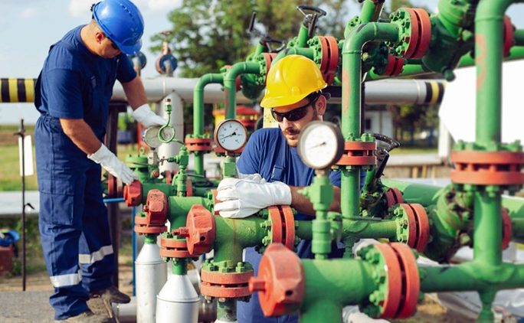

Module Title: Provide solutions to problems in electro pneumatic hydraulic system operation and control
Module code: EIS IEC4 09 0322
Nominal duration: 50 Hour

Prepared by: Ministry of Labor and Skills
October, 2023
Addis Ababa, Ethiopia

Contents
Acronym iii
ACKNOWLEDGMENT iv
Introduction to the Module 1
1 UNIT ONE: PLAN AND PREPARE WORK PLACE 2
1.1 Applying WHS/OHS 3
1.1.1 Importance of WHS/OHS 4
1.1.2 Common Hazards in Electro-Pneumatic-Hydraulic Systems: 4
1.1.3 Personal Protective Equipment (PPE): 5
1.1.4 Safe Work Practices: 8
1.2 Assessing and implementing risk control measures 9
1.2.1 Risk Assessment: 9
1.2.2 Risk Control Measures: 9
1.3 Planning Work activities 10
1.3.1 Importance of Planning: 10
1.3.2 Key Steps in Planning Work Activities: 10
1.4 Obtaining and checking Tools, equipment and testing devices. 12
Self-Check 1.1 15
2 UNIT TWO: PNEUMATIC CONTROL DEVICES 18
2.1 Overview of Pneumatic Control Devices 19
2.2 Understanding linear actuators and their applications 22
2.3 Rotary actuators and their functions 27
2.4 Working Principles of Directional Control Valves 31
2.5 Applications of Timers and Counters in Pneumatic Systems 35
Self-check 2.1 38
Operation Sheet 2.1 40
3 UNIT THREE: HYDRAULIC SYSTEMS 42
3.1 Hydraulic components and systems 43
3.2 Control Amplifiers in Hydraulic Systems 47
3.3 Function and Application of Industrial Transducers 50
3.3.1 Function of Industrial Transducers: 50
3.3.2 Applications of Industrial Transducers: 51
3.4 Overview of Industrial Control Systems 54
3.5 Exploring Industrial Final Control Elements 56
Self-check 3.1 60
Operation Sheet 3.1 62
4 UNIT FOUR: PROVIDING SOLUTIONS TO PROBLEMS IN ELECTRO PNEUMATIC HYDRAULIC CONTROL AND OPERATION SYSTEM 64
4.1 Analyzing Control Problems 65
4.2 Developing Solutions 67
4.3 Upgrading or Replacing Components: 68
4.4 Updating Control Algorithms 70
4.5 Implementing Redundancy or Safety Measures: 73
4.6 Testing and Validating Solutions: 75
4.7 Documentation and Continuous Improvement: 77
Self-check 4.1 80
5 UNIT FIVE: TESTING AND DOCUMENTATION 82
5.1 Controlling problem in Pneumatic-Hydraulic System Operation 83
5.1.1 Testing Solutions: 83
5.1.2 Documenting Solutions: 85
5.2 Justifying and documenting the solution 86
5.2.1 Justifying the Solution: 87
5.2.2 Documenting the Solution: 88
Self-check: 5.1 90
REFERENCE 92

Acronym

HVAC | Heating, Ventilation, and Air Conditioning
ICS | Industrial control systems
OHS | Occupational Health and Safety
PID | proportional-integral-derivative
PLCs | programmable logic controllers
PPE | Personal Protective Equipment
SOP | standard operating procedures
WHS | Workplace Health and Safety
VFDs, | variable frequency drives

ACKNOWLEDGMENT
The Ministry of Labor and skill, to Prosperity wish to thank MoLS experts, regional labor and skill bureaus, TVT trainers, university lecturers and industry experts who contribute their time and professional experience to the development of this Training module for Industrial Electrical/Electronic LEVEL IV
We would like to express our appreciation to the Ministry of Labor and skill to Prosperity Ethiopia for their technical and financial support and workshop facilitation of this training module development.

Introduction to the Module
Industrial Electrical/Electronic Control Technology encompasses a wide range of activities, including the Providing Solutions to Problems in Electro-Pneumatic-Hydraulic System Operation and Control When encountering issues in electro-pneumatic-hydraulic system operation and control, it is crucial to provide effective solutions. This involves addressing problems related to the integration, functioning, and control of electrical, pneumatic, and hydraulic components. Here is a concise summary of providing solutions to problems in electro-pneumatic-hydraulic system operation and control:
This module covers the units:
- Plan and prepare work place
- Pneumatic control devices
- Hydraulic Systems
- Providing solutions to problems
- Testing and document
Learning Objective of the Module
- Plan and prepare work place
- Identify Pneumatic control devices
- Identify Hydraulic Systems
- Provide solutions to problems
- Test and document
Module Learning Instructions:
- Read the specific objectives of this Learning Guide.
- Read the information written in the information Sheets
- Accomplish the Self-checks
- Perform Operation Sheets
- Do the “LAP test”

UNIT ONE: PLAN AND PREPARE WORK PLACE
This learning guide is developed to provide you the necessary information regarding the following content coverage and topics:
UNIT ONE: PLAN AND PREPARE WORK PLACE
- Applying WHS/OHS
- Assessing and implementing risk control measures
- Determining electro pneumatic and hydraulic system operation
- Planning Work activities
- Obtaining and checking Tools, equipment and testing devices
This guide will also assist you to attain the learning outcomes stated in the cover page. Specifically, upon completion of this learning guide, you will be able to:
- Apply WHS/OHS
- Assess and implementing risk control measures
- Determine electro pneumatic and hydraulic system operation
- Plan Work activities
- Obtain and check Tools, equipment and testing devices

Applying WHS/OHS
Electro-pneumatic-hydraulic systems are widely used in various industries for their ability to provide precise control and power transmission. However, working with these systems presents potential hazards that need to be addressed to ensure the safety and well-being of operators and maintenance personnel. In this learning note, we will explore the importance of applying Workplace Health and Safety (WHS) or Occupational Health and Safety (OHS) practices when operating and maintaining electro-pneumatic-hydraulic systems.
- OHS policies and procedures
When it comes to designing and developing advanced electrical/electronic systems, it is crucial to prioritize the safety and well-being of those involved in the process. Occupational health and safety is an aspect of public health program. Creating a healthy workplace and a healthy work force in any occupational environment is the best way to position that occupation to better delivery of service. Concern for your own safety as well as the safety of others should always be on your mind. Most safety procedures are common sense but, because some hazards are not obvious, there are regulations born out of experience which are designed to make the workplace safer. The need to use safe working practices and safety equipment is to avoid the risk of injury to yourself and to others in the course of your work.
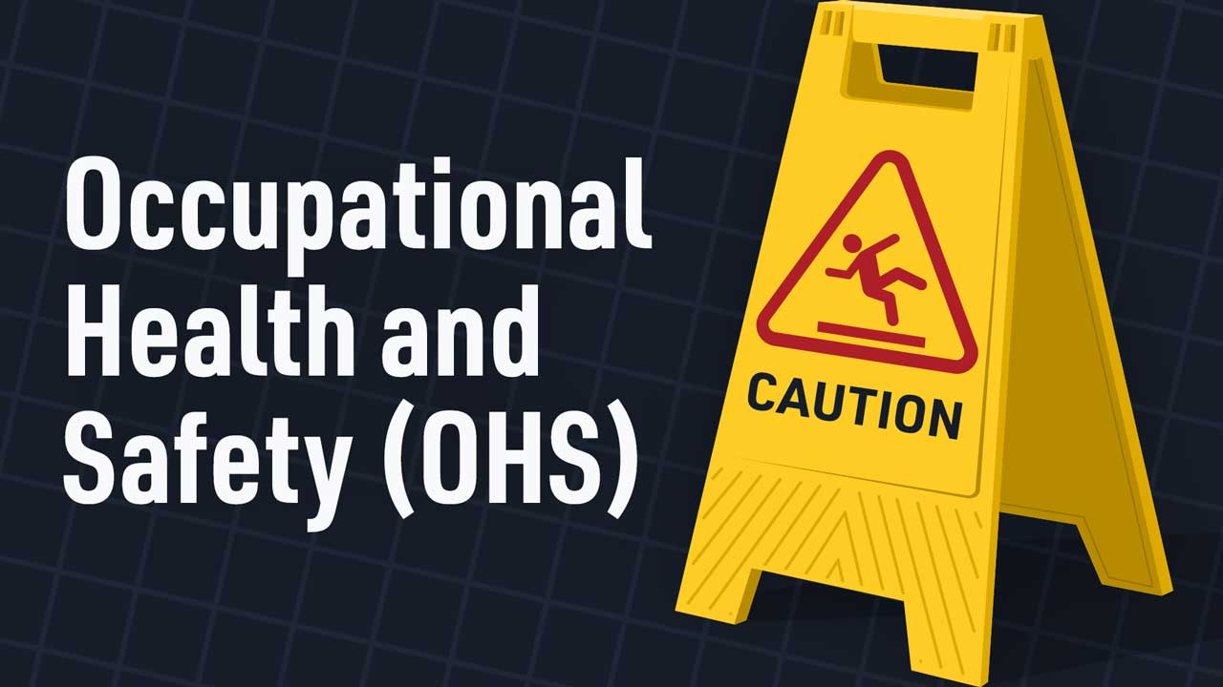
Figure 1-1 Occupational health and safety

Importance of WHS/OHS
WHS/OHS practices are crucial in any workplace to prevent accidents, injuries, and occupational illnesses.
When working with electro-pneumatic-hydraulic systems, these practices become even more critical due to the potential risks associated with high-pressure fluids, moving parts, electrical components, and control systems.
By applying WHS/OHS principles, we can create a safe working environment and reduce the likelihood of accidents and injuries.

Common Hazards in Electro-Pneumatic-Hydraulic Systems:
Understanding the potential hazards is essential for implementing effective WHS/OHS measures. Some common hazards in electro-pneumatic-hydraulic systems include:
- High-Pressure Hazards:
- Fluid leaks and spraying under high pressure
- Bursting of hoses or pipes
- Contact with pressurized parts
- Electrical Hazards:
- Electric shock from exposed wires or faulty electrical connections
- Short circuits and fires caused by electrical faults
- Mechanical Hazards:
- Pinch points and crushing hazards from moving parts
- Falling objects or equipment
- Environmental Hazards:
- Exposure to noise, vibrations, or extreme temperatures
- Inhalation of fumes or gases from hydraulic fluids or pneumatic systems

Personal Protective Equipment (PPE):
Using appropriate Personal Protective Equipment (PPE) is crucial in minimizing the risks associated with electro-pneumatic-hydraulic systems. Some commonly used PPE includes:
- Safety goggles or face shields: These protect the eyes and face from flying debris, sparks, or chemicals.
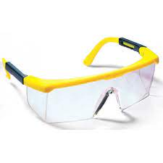
Figure 1-2 Safety goggles or face shields:
- Insulated gloves: Insulated gloves are essential when working with live electrical components to prevent electric shock.

Figure 1-3 Electrical Insulated gloves:
- Safety footwear: Safety shoes or boots with reinforced toes protect against falling objects or electrical hazards.
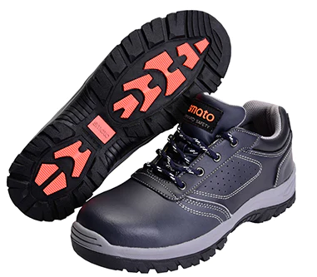
Figure 1-4 Safety shoes or boots
- Protective clothing: This may include flame-resistant clothing, lab coats, or coveralls to protect against burns, chemical splashes, or other physical hazards.
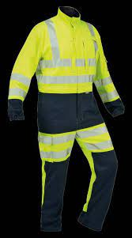
Figure 1-5 Protective clothing
- Ear protection: Earplugs or earmuffs are necessary in environments with high noise levels to prevent hearing damage.
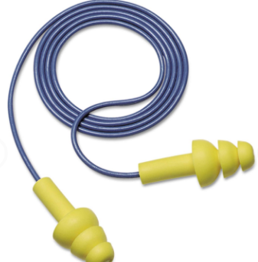
Figure 1-6 Earplugs or earmuffs
Provide appropriate PPE such as safety goggles, gloves, hearing protection, and protective clothing to personnel working with or around the system.
Ensure that PPE is properly fitted, maintained, and used according to manufacturer guidelines.

- Monitoring and Review:
Implementing risk control measures is not a one-time task. It is essential to regularly monitor and review the effectiveness of these measures to ensure ongoing safety. Consider the following practices:
- Conduct periodic risk assessments to identify new hazards or changes in existing ones.
- Encourage reporting of near misses, incidents, or any potential safety concerns.
- Review incident reports and take corrective actions to prevent similar incidents from occurring in the future.
- Stay updated with industry standards, regulations, and best practices to incorporate any necessary changes or improvements.

Safe Work Practices:
Implementing safe work practices is essential for the proper operation and control of electro-pneumatic-hydraulic systems. Some key practices include:
- Proper training and certification for operators and maintenance personnel
- Regular inspection and maintenance of equipment to identify and address potential hazards
- Lockout/tag out procedures to ensure energy isolation during maintenance or repair
- Proper handling, storage, and disposal of hydraulic fluids and other hazardous materials
- Clear communication and signage to indicate potential hazards and safety precautions
- Emergency procedures and evacuation plans in case of accidents or system failures
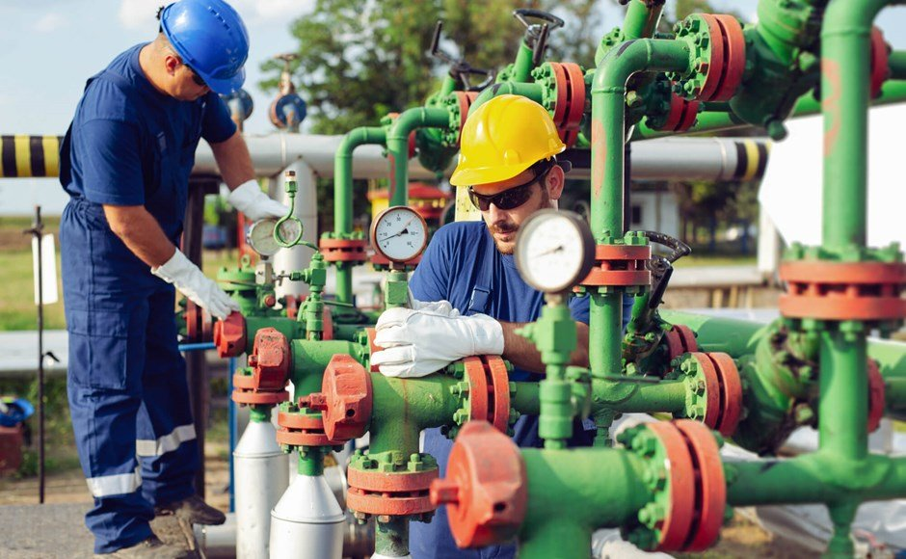
Figure 1-7 Safe work practices
Remember, the application of WHS/OHS practices is crucial for the safe operation and control of electro-pneumatic-hydraulic systems. By being aware of the potential hazards, using appropriate PPE, and following safe work practices, operators and maintenance personnel can minimize risks and create a safer working environment.

Assessing and implementing risk control measures
Operating and controlling electro-pneumatic-hydraulic systems involve inherent risks that need to be effectively managed to ensure the safety of personnel and equipment. In this learning note, we will explore the process of assessing risks associated with these systems and implementing appropriate risk control measures.

Risk Assessment:
Risk assessment is a systematic process that involves identifying, analyzing, and evaluating potential risks associated with electro-pneumatic-hydraulic systems. The following steps are typically involved in a risk assessment:
- Hazard Identification: Identify potential hazards such as high-pressure fluids, electrical components, moving parts, and environmental factors.
- Risk Analysis: Assess the likelihood and severity of each identified hazard. Consider factors such as frequency of exposure, potential harm, and existing control measures.
- Risk Evaluation: Determine the level of risk associated with each hazard based on its likelihood and severity. Prioritize risks based on their significance.

Risk Control Measures:
Once risks have been identified and evaluated, appropriate control measures should be implemented to mitigate or eliminate these risks. Here are some common risk control measures for electro-pneumatic-hydraulic systems:
- Engineering Controls:
- Install safety devices such as pressure relief valves, emergency stop buttons, and interlocks to prevent or minimize the impact of hazardous events.
- Implement guarding measures to protect operators from moving parts or pinch points.
- Ensure proper grounding and insulation of electrical components to reduce the risk of electric shock.
- Administrative controls
- Develop standard operating procedures (SOPs) that outline safe work practices, including start-up and shutdown procedures, maintenance protocols, and emergency response plans.
- Provide comprehensive training programs for operators and maintenance personnel to ensure they are knowledgeable about the system and the associated risks.
- Implement a permit-to-work system to control access to hazardous areas and ensure that work is carried out in a safe manner.
- Conduct regular inspections, maintenance, and equipment testing to identify and address potential risks.
By systematically assessing risks and implementing appropriate control measures, operators and maintenance personnel can minimize the potential dangers associated with electro-pneumatic-hydraulic systems and create a safer working environment.

Planning Work activities
Planning work activities in electro-pneumatic-hydraulic system operation and control is crucial for ensuring efficient and effective execution of tasks. In this learning note, we will explore key considerations and steps involved in planning work activities for these systems.

Importance of Planning:
Effective planning helps to streamline work activities, reduce downtime, and enhance productivity. It ensures that tasks are performed in a systematic and organized manner, minimizing the risk of errors or accidents. Planning also helps allocate resources effectively and ensures that work activities align with safety regulations and operational requirements.

Key Steps in Planning Work Activities:
When planning work activities for electro-pneumatic-hydraulic systems, the following steps can be followed:

- Identify Objectives:
Clearly define the objectives of the work activities. Determine the specific tasks to be performed, such as system installation, maintenance, troubleshooting, or repair.
- Assess Resources:
Evaluate the resources required to carry out the work activities. This includes personnel, equipment, tools, spare parts, and any specialized training or certifications needed.
- Consider Safety:
Identify potential hazards associated with the work activities and develop strategies to mitigate risks. Ensure compliance with safety regulations and implement appropriate safety measures, such as lockout/tag out procedures, personal protective equipment (PPE), and safety training.
- Sequence of Tasks:
Determine the logical sequence in which tasks should be performed. Consider dependencies between tasks and identify any critical paths that may impact overall project timelines.
- Allocate Time:
Estimate the time required for each task, considering factors such as complexity, skill level, and available resources. Create a schedule that allocates sufficient time for each activity while accounting for any required downtime or system shutdowns.
- Communication and Collaboration:
Establish effective communication channels among team members involved in the work activities. Ensure clear communication of task assignments, responsibilities, and timelines. Foster collaboration and coordination to facilitate smooth execution of activities.
- Documentation:
Develop a comprehensive work plan that includes step-by-step instructions, equipment specifications, safety procedures, and any necessary diagrams or schematics. Document any changes or deviations from the original plan throughout the process.

- Review and Adjust:
Regularly review the work plan and progress to identify any deviations, challenges, or opportunities for improvement. Make adjustments as needed to optimize efficiency, address unforeseen issues, or incorporate lessons learned.
- Training and Competence:
Ensure that personnel involved in the work activities have the necessary skills and knowledge to perform their tasks safely and effectively. Provide training, certifications, or refresher courses as required.
- Continuous Improvement:
Encourage feedback from team members and stakeholders to identify areas for improvement in future work activities. Document lessons learned and incorporate them into future planning processes.

Obtaining and checking Tools, equipment and testing devices.
Obtaining and checking the appropriate tools, equipment, and testing devices is crucial for ensuring the successful operation and control of electro-pneumatic-hydraulic systems. In this learning note, we will explore key considerations and steps involved in obtaining and checking these essential items.
- Importance of Obtaining and Checking Tools, Equipment, and Testing Devices:

- Having the right tools, equipment, and testing devices is essential for performing tasks effectively, safely, and efficiently.
- Obtaining the necessary tools and equipment ensures that operators and maintenance personnel have the means to carry out their work activities.
- Properly checking and maintaining these items helps ensure their reliability and accuracy, minimizing the risk of errors and accidents

- Key Steps in Obtaining and Checking Tools, Equipment, and Testing Devices:
When obtaining and checking tools, equipment, and testing devices for electro-pneumatic-hydraulic systems, the following steps can be followed:
- Identify Required Tools and Equipment:
Identify the specific tools and equipment needed for the work activities. This may include items such as wrenches, screwdrivers, pliers, pressure gauges, flow meters, multimeters, diagnostic devices, and specialized tools unique to electro-pneumatic-hydraulic systems.
- Determine Equipment Specifications:
Ensure that the tools and equipment meet the required specifications for the specific tasks. Consider factors such as size, capacity, accuracy, pressure range, electrical ratings, and compatibility with the system being worked on.
- Source Tools, Equipment, and Testing Devices:
Identify reliable suppliers or sources to obtain the required tools, equipment, and testing devices. Consider factors such as quality, availability, cost, and delivery time. Explore options such as purchasing, renting, or borrowing from within the organization or outsourcing from reputable vendors.
- Check for Calibration and Certification:
Verify that the testing devices and equipment requiring calibration or certification are up to date. Check calibration certificates and ensure the validity of certifications. If necessary, send items for calibration or recertification to authorized service providers.
- Inspect Tools and Equipment:
Before using any tool or equipment, perform a thorough visual inspection. Check for any signs of damage, wear, or defects. Ensure that handles, grips, or other ergonomic features are intact and in good condition.
- Test and Verify Accuracy:
For testing devices such as pressure gauges or multimeters, conduct calibration checks or verification to ensure their accuracy. Compare readings against known reference standards or calibrators. If discrepancies are found, arrange for calibration or repair as necessary.
- Maintain and Store Tools and Equipment:
Implement proper maintenance practices for tools, equipment, and testing devices. Clean and lubricate tools regularly. Store them in designated areas or cases to protect them from damage, dust, or moisture. Follow manufacturer guidelines for maintenance and storage.
- Training and Competence:
Ensure that personnel using the tools, equipment, and testing devices are trained and competent in their proper usage. Provide training on handling, calibration, and maintenance procedures. Emphasize safety precautions and the importance of accuracy and reliability.
- Document and Track Inventory:
Maintain an inventory of tools, equipment, and testing devices. Document details such as serial numbers, calibration dates, and maintenance records. Implement a system for tracking the location and availability of these items to facilitate efficient retrieval and prevent loss or misplacement.

Self-Check 1.1
Part One: Say True or False
_____1. WHS/OHS practices are not necessary when working with electro-pneumatic-hydraulic systems.
_____2. Personal Protective Equipment (PPE) is not required when operating electro-pneumatic-hydraulic systems.
______3. Risk assessment is not a necessary step in implementing risk control measures for these systems.
______4. Electrical control is not involved in the operation of electro-pneumatic-hydraulic systems.

Part Two: Matching
Match the following components with their respective functions:
Match: A | Match: B
_____1. Electrical Components | a. Control the flow and pressure of compressed air.
______2. Pneumatic Components | b. Generate force and control motion using fluid power.
______3. Hydraulic Components | c. Control the electrical signals that initiate and regulate system operation.

Part Three: Multiple Choice
- Which of the following is a common hazard in electro-pneumatic-hydraulic systems?
a. Exposure to extreme temperatures
b. Contact with high-voltage electrical wires
c. Falling objects or equipment
d. All of the above
- What is the purpose of Personal Protective Equipment (PPE) in these systems?
a. To enhance the performance of the system
b. To provide comfort to the operators
c. To minimize the risks associated with the system
d. To increase the visibility of the operators
- What are some key practices for safe work with electro-pneumatic-hydraulic systems?
a. Regular inspection and maintenance
b. Lockout/tag out procedures
c. Proper handling and storage of hazardous materials
d. All of the above
- Which control strategy involves activating components in a specific sequence or order?
a. On/Off Control
b. Proportional Control
c. Sequential Control
d. Feedback Control
- Why is it important to regularly monitor and review the effectiveness of risk control measures?
a. To ensure ongoing safety
b. To meet regulatory requirements
c. To identify new hazards
d. All of the above
- Which component is responsible for controlling the activation and deactivation of pneumatic and hydraulic components?
a. Electrical Components
b. Pneumatic Components
c. Hydraulic Components
d. None of the above
- What does a permit-to-work system control in electro-pneumatic-hydraulic systems?
a. Access to hazardous areas
b. Energy isolation during maintenance or repair
c. System startup and shutdown procedures
d. Equipment testing and inspections
- Which of the following is NOT a mechanical hazard in these systems?
a. Pinch points and crushing hazards
b. Falling objects or equipment
c. Exposure to noise and vibrations
d. All of the above are mechanical hazards
- What is the purpose of conducting regular inspections and maintenance of equipment?
a. To identify and address potential hazards
b. To comply with industry standards
c. To increase productivity
d. To reduce energy consumption

UNIT TWO: PNEUMATIC CONTROL DEVICES
This learning guide is developed to provide you the necessary information regarding the following content coverage and topics:
UNIT TWO: PNEUMATIC CONTROL DEVICES
- Overview of Pneumatic Control Devices
- Understanding linear actuators and their applications
- Rotary actuators and their functions
- Working Principles of Directional Control Valves
- Applications of Timers and Counters in Pneumatic Systems
This guide will also assist you to attain the learning outcomes stated in the cover page. Specifically, upon completion of this learning guide, you will be able to:
- Understand Overview of Pneumatic Control Devices
- Understand linear actuators and their applications
- Identify Rotary actuators and their functions
- Working Principles of Directional Control Valves
- Apply of Timers and Counters in Pneumatic Systems

Overview of Pneumatic Control Devices
Pneumatic control devices are essential components in various industrial applications where the control of fluid power is required. These devices utilize compressed air or gas to generate mechanical motion, enabling precise control and operation of machinery and systems. Understanding the fundamentals and functionalities of pneumatic control devices is crucial for professionals in fields such as manufacturing, automation, and process control. This overview provides a brief introduction to some commonly used pneumatic control devices.
Actuators:
Actuators are devices that convert pneumatic pressure into mechanical motion. They are responsible for producing linear or rotary movement in response to control signals. Pneumatic actuators are widely used in applications requiring precise and rapid motion control. Common types of pneumatic actuators include:
- Linear Actuators: These actuators convert the compressed air or gas pressure into linear motion. They are used to move valves, levers, or other mechanical components in a straight line.
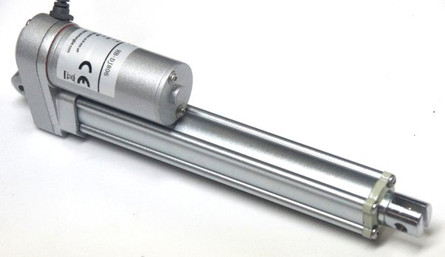
Figure 2-1 Linear Actuators
- Rotary Actuators: Rotary actuators convert pneumatic pressure into a rotational motion. They are used to control the movement of rotary valves, dampers, or other rotating mechanisms.
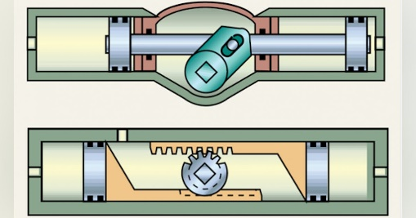
Figure 2-2 Rotary actuators
Valves:
Pneumatic valves are crucial components for controlling the flow of compressed air or gas in pneumatic systems. They regulate the direction, rate, and pressure of the fluid to achieve desired system behavior. Common types of pneumatic valves include:
- Directional Control Valves: These valves control the direction of airflow in a pneumatic system. They enable the actuator to move in a specific direction or perform different actions based on the control signals received.
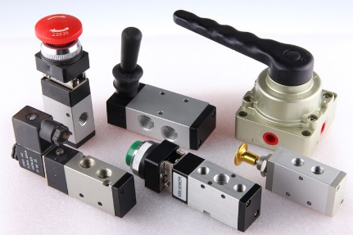
Figure 2-3 Directional Control Valves
- Pressure Control Valves: Pressure control valves regulate the pressure of the compressed air or gas within a pneumatic system. They ensure that the system operates within the desired pressure range, providing safety and control.
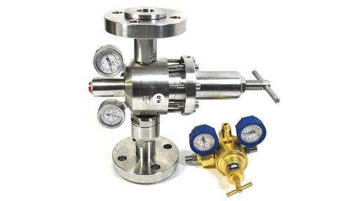
Figure 2-4 Pressure control valves
- Flow Control Valves: Flow control valves adjust the rate of airflow through a pneumatic system. They enable precise control of actuator speed and regulate the flow rate of fluid to achieve specific operating conditions.
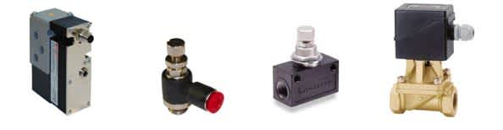
Figure 2-5 Flow control valves
Air Preparation Units:
Air preparation units, also known as FRL (Filter-Regulator-Lubricator) units, are essential components in pneumatic systems. They ensure that the compressed air used in the system is clean, regulated, and appropriately lubricated. Air preparation units typically consist of:
- Filters: Filters remove contaminants such as dust, oil, and water from the compressed air, protecting downstream components and ensuring their longevity.
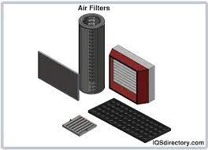
Figure 2-6 Air Filters
- Regulators: Regulators control the pressure of the compressed air, maintaining a stable and desired pressure level within the pneumatic system.
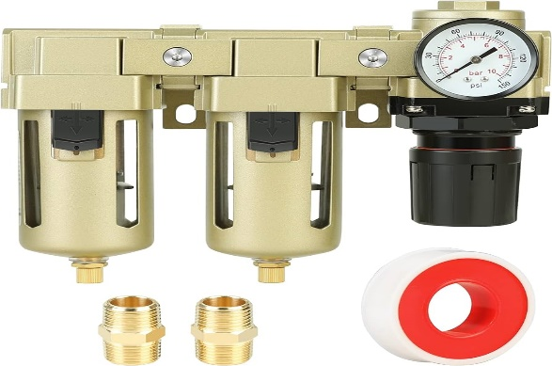
Figure 2-7 Regulators
- Lubricators: Lubricators add a small amount of lubricating oil to the compressed air, ensuring smooth operation and extending the lifespan of pneumatic components.
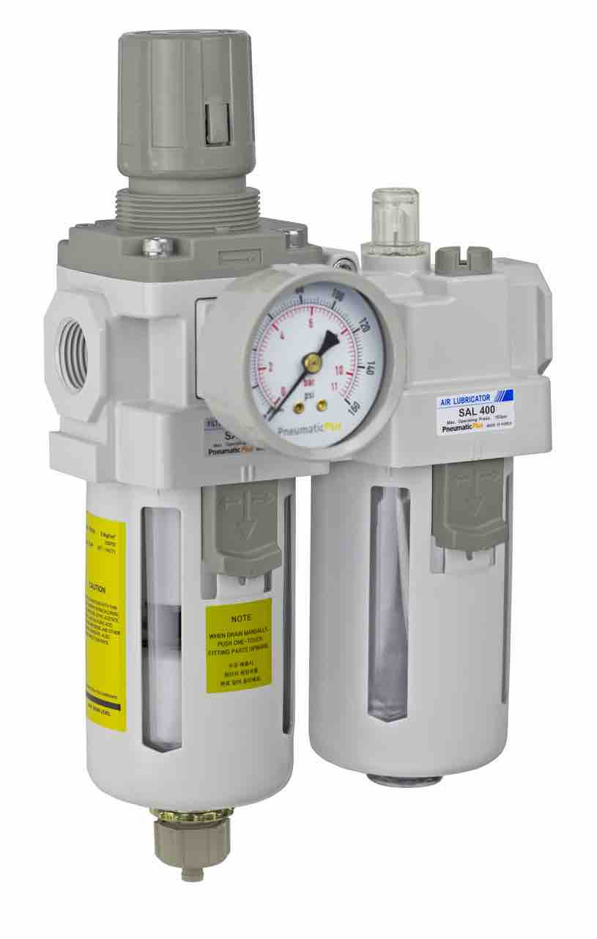
Figure 2-8 Lubricators

Understanding linear actuators and their applications
Linear actuators are mechanical devices that convert rotational or electrical energy into linear motion. They play a vital role in various industries and applications where precise and controlled linear movement is required. This article provides an overview of linear actuators, their types, working principles, and common applications.

- Types of Linear Actuators:
There are several types of linear actuators available, each with its own unique design and operating principle. Some commonly used types include:
Electric Linear Actuators: These actuators use an electric motor to generate linear motion. They often incorporate a screw mechanism, such as a lead screw or ball screw, to convert rotary motion into linear movement. Electric linear actuators are known for their precision, controllability, and versatility. They can be found in applications like robotics, medical equipment, industrial automation, and home automation systems.
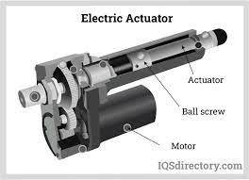
Figure 2-9 Electric Linear Actuators:
Pneumatic Linear Actuators: Pneumatic linear actuators use compressed air or gas to produce linear motion. They typically consist of a piston and cylinder arrangement, where the compressed air forces the piston to move in a linear direction. Pneumatic linear actuators are valued for their fast response time, high-speed capabilities, and suitability for applications requiring repetitive linear movements. They are commonly used in industries such as automotive, packaging, and material handling.
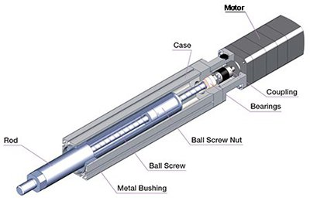
Figure 2-10 Pneumatic linear actuators
Hydraulic Linear Actuators: Hydraulic linear actuators utilize pressurized hydraulic fluid to generate linear motion. They employ a piston and cylinder system, similar to pneumatic actuators, but use hydraulic fluid instead of compressed air. Hydraulic linear actuators are known for their high force capabilities and ability to handle heavy loads. They are commonly found in construction equipment, industrial machinery, and aerospace applications.
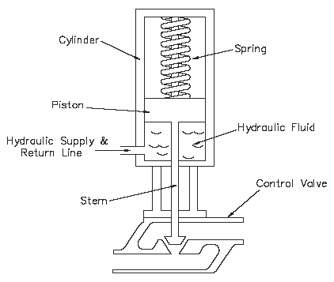
Figure 2-11 Hydraulic linear actuators
Mechanical Linear Actuators: Mechanical linear actuators rely on mechanical components, such as gears, belts, or linkages, to convert motion. They often involve manual or hand-operated mechanisms, such as hand cranks or wheels, to drive linear movement. Mechanical linear actuators are simple, cost-effective, and widely used in applications like adjustable furniture, positioning systems, and manual lifting devices.
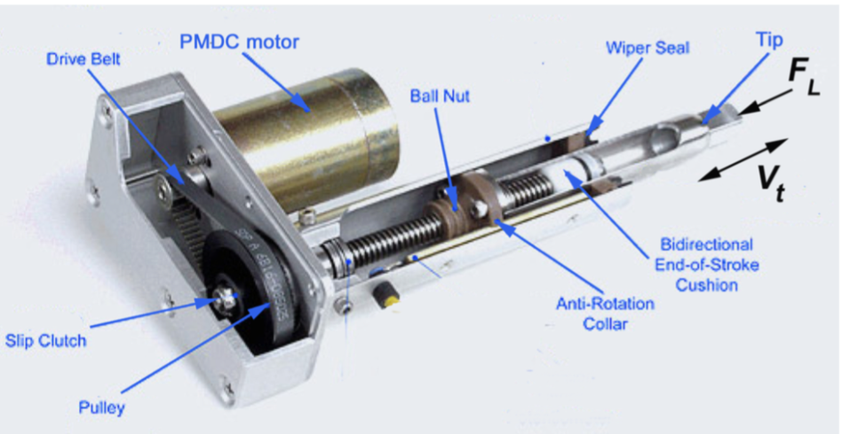
Figure 2-12 Mechanical linear actuators rely
- Working Principles:
The working principle of a linear actuator depends on its type. However, the general concept involves converting rotational or electrical energy into linear motion. Here are a few working principles commonly used in linear actuators:
- Screw Mechanism: Electric linear actuators often employ a screw mechanism, such as a lead screw or ball screw, to convert rotary motion into linear motion. The rotation of the screw causes the nut or ball bearings to move along the screw, resulting in linear displacement.
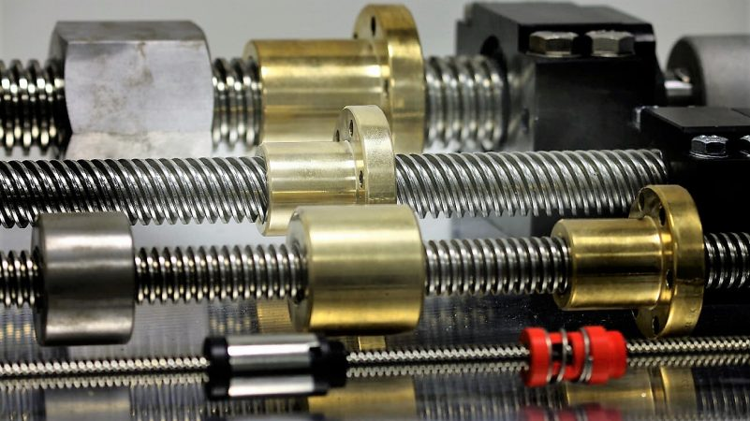
Figure 2-13 Screw Mechanism
- Fluid Pressure: Pneumatic and hydraulic linear actuators utilize fluid pressure to generate linear motion. Compressed air or hydraulic fluid is directed into the actuator's cylinder, creating a force that moves the piston in a linear direction.
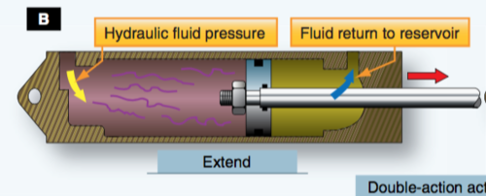
Figure 2-14 Pneumatic and hydraulic linear actuators
- Mechanical Linkages: Mechanical linear actuators use mechanical components, such as gears, belts, or linkages, to convert rotary or manual input into linear motion. These components transmit the motion from the input source to the actuator's output, resulting in linear displacement.
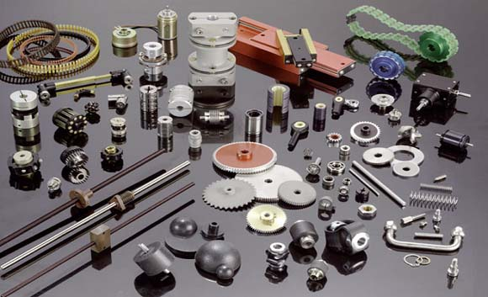
Figure 2-15 Mechanical components
Applications of Linear Actuators:
Linear actuators find applications in various industries and fields due to their ability to provide controlled and precise linear movement. Some common applications include:
- Industrial Automation: Linear actuators are extensively used in industrial automation systems, such as robotic arms, conveyor systems, and assembly lines, to achieve precise positioning, material handling, and controlled movements.
- Medical Equipment: Linear actuators are employed in medical devices and equipment, including hospital beds, patient lifts, dental chairs, and surgical tables, to provide adjustable and precise positioning for patient comfort and convenience.
- Automotive: Linear actuators play a role in automotive applications, such as power windows, seat adjustments, sunroofs, and trunk lifts. They provide smooth and controlled movement for various vehicle components.
- Home Automation: Linear actuators are used in home automation systems for applications such as motorized blinds, TV lifts, adjustable desks, and smart furniture. They enable remote control and precise positioning of these household items.
- Aerospace and Defense: Linear actuators find applications in aerospace and defense industries for tasks like aircraft landing gear deployment, missile guidance systems, and control surfaces' movement in aircraft and spacecraft.
- Agriculture and Farming: Linear actuators are used in agricultural machinery and equipment, such as automated feeding systems, crop handling systems, and livestock equipment, to achieve controlled movement and automation.
- Renewable Energy: Linear actuators are employed in solar tracking systems and wind turbine pitch control mechanisms to ensure optimal positioning and maximize energy generation.

Rotary actuators and their functions
Rotary actuators are mechanical devices that convert fluid or electrical energy into rotary motion. They are widely used in various industries and applications where controlled and precise rotation is required. This article provides an introduction to rotary actuators, their functions, and common applications.
- Types of Rotary Actuators:
There are different types of rotary actuators available, each designed to suit specific applications and requirements. Some commonly used types include:
- Pneumatic Rotary Actuators: Pneumatic rotary actuators use compressed air or gas to generate rotary motion. They typically consist of a piston and cylinder arrangement, where the fluid pressure causes the piston to rotate. Pneumatic rotary actuators are known for their fast response time, high-speed capabilities, and suitability for applications requiring quick and repetitive rotary movements.
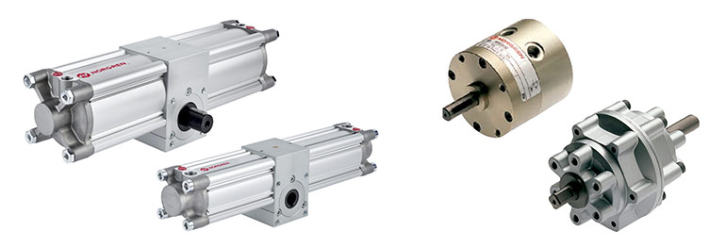
Figure 2-16 Pneumatic rotary actuators
- Hydraulic Rotary Actuators: Hydraulic rotary actuators utilize pressurized hydraulic fluid to generate rotary motion. They employ a piston and cylinder system, similar to pneumatic actuators, but use hydraulic fluid instead of compressed air. Hydraulic rotary actuators are valued for their high force capabilities and ability to handle heavy loads. They are commonly found in construction equipment, industrial machinery, and material handling applications.
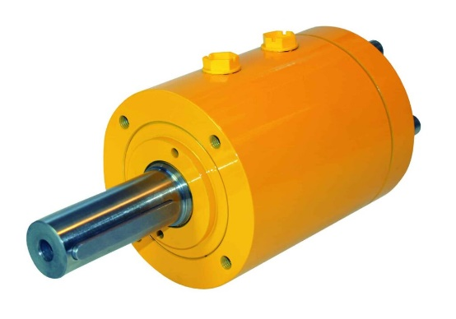
Figure 2-17 Hydraulic rotary actuators
- Electric Rotary Actuators: Electric rotary actuators use an electric motor to generate rotary motion. They are often combined with gear mechanisms to achieve the desired torque and speed. Electric rotary actuators offer precise control, controllability over speed and position, and are commonly used in applications such as robotics, automated machinery, and motion control systems.
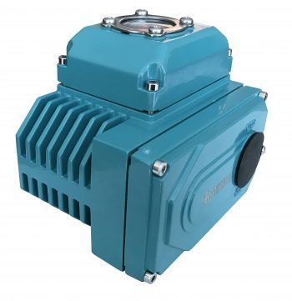
Figure 2-18 Electric rotary actuators
- Functions of Rotary Actuators:
Rotary actuators serve several functions and play a crucial role in various applications. Some of their key functions include:
- Rotation Control: The primary function of rotary actuators is to provide controlled and precise rotary motion. They allow for the precise positioning and movement of components, machinery, or systems. Rotary actuators enable rotational control in a wide range of applications, from simple tasks like opening and closing valves to complex movements in robotic arms.
- Force and Torque Generation: Rotary actuators are capable of generating significant force and torque, making them suitable for applications that require the manipulation of heavy loads or the application of rotational force. Examples include the operation of heavy machinery, industrial presses, and robotic grippers.
- Indexing and Positioning: Rotary actuators are often used for indexing or positioning tasks, where they provide precise angular positioning and repeatable motion. They are commonly employed in applications like indexing tables, rotary indexing conveyors, and rotary positioning systems.
- Oscillation and Swinging Movement: Rotary actuators can be used to create oscillating or swinging motions. These movements are useful in applications such as automated gate systems, swinging doors, and rotating mechanisms.
- Speed and Motion Control: Rotary actuators allow for controlled and adjustable speed and motion. By adjusting the input signals or controlling the power supplied to the actuator, the rotational speed and trajectory can be precisely controlled. This capability is essential in applications that require smooth and controlled movement, such as automated production lines and robotic arms.
Applications of Rotary Actuators:
Rotary actuators find applications in diverse industries and fields. Some common applications include:
- Robotics: Rotary actuators are extensively used in robotic systems for joint movements and end-effector control. They enable precise and controlled rotation, allowing robots to perform tasks such as picking, placing, painting, and welding.
- Industrial Automation: Rotary actuators are employed in various industrial automation applications, including conveyor systems, assembly lines, packaging machinery, and material handling equipment. They provide the necessary rotational movement to control components, manipulate objects, and ensure the smooth operation of automated systems.
- Manufacturing and Machining: Rotary actuators play a role in manufacturing and machining processes, such as CNC machines, milling machines, and lathes. They enable the controlled rotation of tools, workpieces, and cutting heads, facilitating precise shaping, cutting, and drilling operations
- HVAC (Heating, Ventilation, and Air Conditioning): Rotary actuators are used in HVAC systems for controlling dampers, louvers, and air flow control valves. They allow for the precise adjustment of airflow direction and volume, ensuring efficient and controlled ventilation and temperature control.
- Automotive: Rotary actuators find applications in the automotive industry, such as control of throttle valves, steering systems, and convertible roofs. They enable precise control of rotational movements and contribute to the smooth operation of various automotive components.
- Entertainment and Stage Technology: Rotary actuators are utilized in the entertainment industry for applications like moving stage elements, rotating sets, and automated lighting fixtures. They provide the necessary rotational motion to create dynamic and visually appealing effects.

Working Principles of Directional Control Valves
Directional control valves are essential components in hydraulic and pneumatic systems. They control the flow direction and path of fluid or air, allowing for the precise control of actuators and the manipulation of various components. Understanding the working principles of directional control valves is crucial for designing and operating fluid power systems effectively. In this article, we will explore the basic working principles of directional control valves.

Valve Construction:
Directional control valves typically consist of a valve body or housing, which contains internal passages, ports, and movable elements. The valve body is designed to provide the necessary flow paths and connections to control the fluid or air flow. The movable elements, such as spools or poppets, are responsible for controlling the flow direction within the valve.
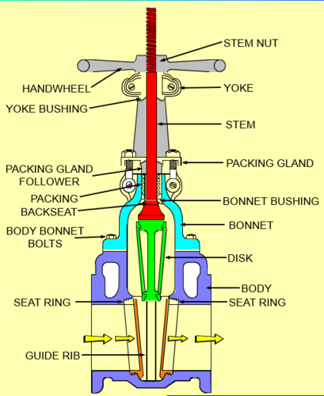
Figure 2-19 Parts of control valves
Flow Paths and Ports:
Directional control valves have multiple ports that serve as entry and exit points for fluid or air. The main ports in a directional control valve are:
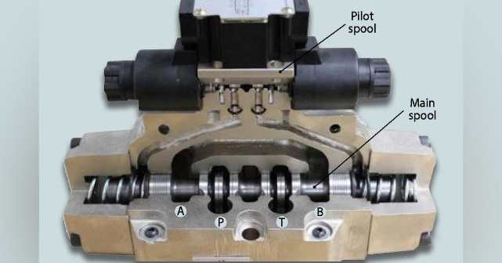
Figure 2-20 Flow Paths and Ports:
Inlet Port: The inlet port is the point of entry for the fluid or air into the valve from the power source.
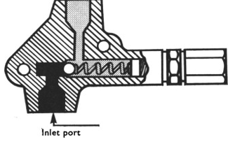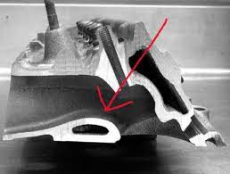
Figure 2-21 Inlet port
Outlet Ports: The outlet ports are the points of exit for the fluid or air from the valve to the intended destination or actuator.
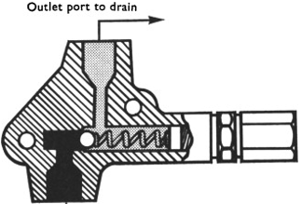
Figure 2-22 Outlet ports
Exhaust Ports: Exhaust ports are used for releasing the fluid or air from the valve when it is not required for actuation.
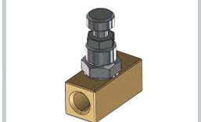
Figure 2-23 Flow control valve
- Working Principle:
The working principle of a directional control valve depends on its specific design and configuration. However, the general principle involves the movement of internal elements, such as spools or poppets, to control the flow direction. Here are two common working principles:
- Spool-Type Valves: Spool-type directional control valves use a cylindrical spool with machined flow paths and landings. The spool is housed within the valve body and can be moved linearly or rotary by manual, mechanical, or solenoid actuation. The position of the spool determines the flow paths and connections between the ports.
- In the neutral position, the spool blocks the flow paths, preventing the flow of fluid or air between the ports.
- When the spool is shifted, the flow paths align with the ports, allowing the fluid or air to flow in the desired direction and actuate the connected components or actuators.
- Spool-type valves often have multiple positions, allowing for various flow directions and configurations.
- Poppet-Type Valves: Poppet-type directional control valves use poppet-like elements that move within the valve body to control flow paths. Poppets are typically spring-loaded and are actuated by mechanical or solenoid forces. The movement of the poppets determines the flow direction and connections.
- In the neutral position, the poppets are held closed by springs, blocking the flow paths and preventing the fluid or air from passing through the valve.
- When the poppets are actuated, they unseat from their closed position, allowing the fluid or air to flow through the valve and reach the desired destination or actuator.
- Poppet-type valves can have different configurations, such as 2/2, 3/2, and 4/2, indicating the number of positions and flow paths available.
- Actuation Methods:
Directional control valves can be actuated using various methods, including manual, mechanical, pneumatic, or electric actuation. The actuation method determines how the movable elements, such as spools or poppets, are shifted to control the flow direction. Common actuation methods include:
- Manual Actuation: Valves can be manually operated using levers, knobs, or push-buttons. Manual actuation is often used for simple systems or applications where the operator needs direct control over the valve position.
- Mechanical Actuation: Mechanical actuation involves using mechanical systems, such as cams, gears, or linkages, to move the valve elements. Mechanical actuation can provide precise control and is suitable for applications where automated or remote control is required.
- Pneumatic Actuation: Pneumatic directional control valves can be actuated using compressed air. Pneumatic actuators, such as pneumatic cylinders or solenoids, apply pressure to the valve elements, causing them to shift the flow paths and control the flow direction.
- Electric Actuation: Electric actuation involves using electric solenoids or motors to move the valve elements. Electrically actuated valves offer precise control, fast response times, and the ability to integrate with automated systems and control circuits.

Applications of Timers and Counters in Pneumatic Systems
Timers and counters are essential components in pneumatic systems that provide precise control over timing and counting operations. They are used to control various pneumatic functions and processes, enhancing system efficiency and automation. In this article, we will explore the applications of timers and counters in pneumatic systems.
- Timing Applications:
- Delayed Start or Stop: Timers are often used to introduce a delay in the start or stop of pneumatic operations. For example, a timer can be used to delay the closing of a valve after a certain condition is met or to delay the activation of a pneumatic actuator after a specified time.
- Sequential Operations: In pneumatic systems where multiple operations need to occur in a specific sequence, timers are employed to control the timing between each operation. This ensures that the pneumatic components are activated in the correct order and with the desired time delay.
- Time-Dependent Processes: Pneumatic systems often involve processes that require a specific time duration. Timers can be used to control the duration of processes such as pressurization, de-pressurization, filling, emptying, or any other time-dependent operation.
- Time-Interval Control: Timers can be utilized for controlling the time intervals between successive operations. This is particularly useful in applications where periodic actuation or cycling of pneumatic components is required.
- Counting Applications:
- Quantity Control: Counters are used to keep track of the number of cycles, operations, or events in pneumatic systems. They provide an accurate count of the quantity of parts or products processed, allowing for precise control over production and manufacturing processes.
- Batch Control: Counters are employed in pneumatic systems to facilitate batch control. They can be set to count a specific number of parts or products before initiating a change in operation, such as stopping the production line or switching to the next stage.
- Position Monitoring: Counters are used to monitor and control the position of pneumatic actuators or components. By counting the number of actuator strokes or movements, precise control over position-based operations can be achieved, such as controlling the opening and closing of valves or the movement of conveyor belts.
- Event Timing: Counters can be used to measure the time between specific events in a pneumatic system. For example, a counter can be used to measure the time taken for a pneumatic cylinder to complete a stroke or the time between the activation of two pneumatic valves.
- Process Monitoring: Counters are employed in pneumatic systems for process monitoring and quality control. By counting the number of completed operations or events, they enable the system to track and ensure the consistency and accuracy of processes.
- Combined Applications:
Timers and counters are often used together in pneumatic systems to create complex control sequences and achieve precise automation. By integrating timers and counters, pneumatic systems can perform advanced functions such as:
- Cycle Control: Timers and counters can be used to control the number of cycles performed by pneumatic components. This allows for precise control over the number of times an operation is repeated, ensuring consistent and accurate performance.
- Production Rate Control: By combining timers and counters, pneumatic systems can control the production rate or speed of operations. This is achieved by setting the desired time intervals and counting the number of completed cycles within a specified time period.
- Synchronization: Timers and counters can be used to synchronize multiple pneumatic components or processes. By carefully controlling the timing and counting of operations, precise coordination between different components can be achieved, leading to efficient and synchronized system performance.

Self-check 2.1
Part one: say True or False:
_____1. Pneumatic control devices use electrical energy to generate mechanical motion.
_____2. Directional control valves regulate the pressure of the compressed air or gas in a pneumatic system.
_____3. Pneumatic linear actuators use hydraulic fluid to produce linear motion.
_____4. Mechanical linear actuators rely on mechanical components, such as gears or belts, to convert motion.
_____5. Linear actuators are commonly used in automotive applications, such as power windows and seat adjustments.
Part two: Matching
Match the following types of pneumatic control devices with their descriptions:
Match A | Match B
_____1. Linear Actuators | A. Convert rotational or electrical energy into linear motion.
_____2. Rotary Actuators | B. Control the direction of airflow in a pneumatic system.
_____3. Directional Control Valves | C. Convert pneumatic pressure into a rotational motion.

Part three: Multiple Choice
_____1. Which type of linear actuator is commonly used in robotics and medical equipment?
A. Pneumatic linear actuator
B. Hydraulic linear actuator
C. Electric linear actuator
D. Mechanical linear actuator
_____2. What is the purpose of air preparation units in pneumatic systems?
A. To generate mechanical motion
B. To control the direction of airflow
C. To ensure clean and regulated compressed air
D. To adjust the rate of airflow through the system

_____3. What do filters in air preparation units remove from the compressed air?
A. Contaminants such as dust, oil, and water
B. Regulate the pressure of the compressed air
C. Add lubricating oil to the compressed air
D. Convert rotational or electrical energy into linear motion
_____4. Which type of valve regulates the flow rate of fluid in a pneumatic system?
A. Directional control valve
B. Pressure control valve
C. Flow control valve
D. Linear actuator
_____5. What is the purpose of lubricators in air preparation units?
A. To remove contaminants from the compressed air
B. To control the direction of airflow
C. To adjust the rate of airflow through the system
D. To ensure smooth operation and extend the lifespan of pneumatic components

Operation Sheet 2.1
PROJECT TITLE: PNEUMATIC CONTROL SYSTEM
Instruction:
The following operation sheet provides instructions for the installation and operation of the pneumatic control system. Please follow the steps carefully to ensure proper functioning of the system.
Purpose:
The purpose of this operation sheet is to guide users in the correct installation and operation of the pneumatic control system. It ensures that the system functions efficiently and meets the desired control requirements.
Precautions:
- Ensure that all power sources are disconnected before starting the installation or maintenance process.
- Use appropriate personal protective equipment (PPE) such as safety goggles and gloves to prevent injuries.
- Follow all safety guidelines and regulations provided by the manufacturer.
Procedure:
- Gather all the necessary components and tools required for the installation.
- Identify the appropriate location for installing the pneumatic control devices, considering factors such as accessibility and proximity to the equipment or machinery being controlled.
- Install the pneumatic actuators as per the manufacturer's instructions. Ensure proper alignment and secure mounting.
- Connect the pneumatic actuators to the control valves using suitable pneumatic tubing or hoses. Ensure tight and leak-free connections.
- Install the pneumatic control valves based on the desired system configuration and functionality. Follow the manufacturer's guidelines for proper installation.
- Connect the control valves to the air preparation unit (FRL) using appropriate tubing or hoses. Ensure proper filtration, regulation, and lubrication of the compressed air.
- Connect the air preparation unit to the main compressed air supply. Verify that the pressure is within the recommended range.
- Inspect all connections and fittings for any leaks. Tighten or replace components if necessary.
- Double-check the entire installation to ensure that all components are properly connected and secured.
- Power on the control system and test its functionality. Verify that the actuators respond correctly to the control signals and that the desired motion or operation is achieved.
- Conduct thorough testing and calibration of the system to ensure optimal performance.
- Regularly inspect and maintain the pneumatic control system according to the manufacturer's recommendations to prevent any operational issues.
Quality Criteria:
The pneumatic control system should meet the following quality criteria:
- Proper and consistent control of fluid power in the intended applications.
- Reliable and precise operation of the pneumatic actuators.
- Effective regulation of pressure, direction, and flow through the control valves.
- Clean and properly filtered compressed air supply to prevent damage to the system components.
- Minimal leakage and efficient transmission of pneumatic pressure.
- Compliance with safety regulations and industry standards.
Note: This operation sheet provides a general guideline for the installation and operation of a pneumatic control system. It is essential to refer to the specific instructions provided by the manufacturer of the control devices for accurate installation and operation procedures.

UNIT THREE: HYDRAULIC SYSTEMS
This learning guide is developed to provide you the necessary information regarding the following content coverage and topics:
UNIT THREE: HYDRAULIC SYSTEMS
- Hydraulic components and systems
- Control Amplifiers in Hydraulic Systems
- Function and Application of Industrial Transducers
- Overview of Industrial Control Systems
- Exploring Industrial Final Control Elements
This guide will also assist you to attain the learning outcomes stated in the cover page. Specifically, upon completion of this learning guide, you will be able to:
- Identfiy Hydraulic components and systems
- Control Amplifiers in Hydraulic Systems
- Understand Function and Application of Industrial Transducers
- Undrstand Overview of Industrial Control Systems
- Explore Industrial Final Control Elements

Hydraulic Systems
Hydraulic systems are widely used in various industries and applications for transmitting power and controlling mechanical operations. They utilize the principles of fluid mechanics to generate, control, and transmit power through the use of pressurized fluids, typically oil or hydraulic fluid. In this article, we will explore the key components, working principles, and applications of hydraulic systems.

Hydraulic components and systems
- Hydraulic Components:
- Hydraulic Pump: The hydraulic pump is the heart of the hydraulic system. It is responsible for converting mechanical energy, typically from an electric motor or an internal combustion engine, into hydraulic energy. The pump generates flow and pressurizes the hydraulic fluid, providing the necessary force to operate the system.
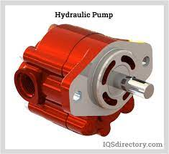
Figure 3-1 Hydraulic pump
- Reservoir: The hydraulic reservoir, also known as the hydraulic tank, stores the hydraulic fluid. It serves as a source of fluid supply, helps dissipate heat, and allows for the settling of contaminants and air bubbles. The reservoir also provides a means for checking and maintaining the fluid level.
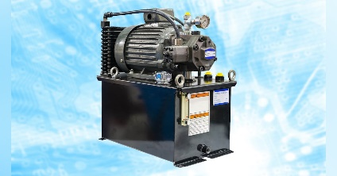
Figure 3-2 Hydraulic reservoir
- Hydraulic Actuators: Actuators are the devices that convert hydraulic energy into mechanical work. The two primary types of hydraulic actuators are hydraulic cylinders and hydraulic motors. Hydraulic cylinders provide linear motion and are used for tasks such as lifting, pushing, and pulling. Hydraulic motors, on the other hand, produce rotary motion and are employed in applications that require rotational force or speed.
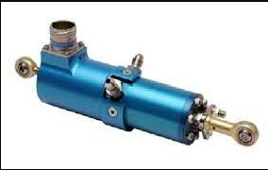
Figure 3-3 Hydraulic Actuators
- Control Valves: Control valves are essential components in hydraulic systems as they regulate the flow, direction, and pressure of the hydraulic fluid. They control the actuation of hydraulic actuators by opening or closing passages within the system. Common types of control valves include directional control valves, which determine the flow direction, and flow control valves, which regulate the flow rate.
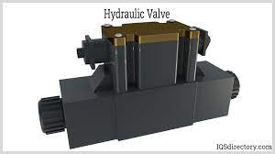
Figure 3-4 Control valves
- Hydraulic Lines: Hydraulic lines consist of pipes, hoses, and fittings that transport the hydraulic fluid between various components of the system. These lines are designed to handle high-pressure conditions and ensure the efficient flow and control of the hydraulic fluid. Proper sizing, routing, and installation of hydraulic lines are crucial for the system's performance and reliability.
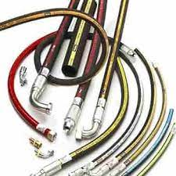
Figure 3-5 Hydraulic lines and hose
- Hydraulic Systems:
Hydraulic systems are composed of interconnected components that work together to transmit power and control mechanical operations. These systems operate based on Pascal's law, which states that pressure applied to a fluid in a confined space is transmitted equally in all directions. Here are the key elements of hydraulic systems:
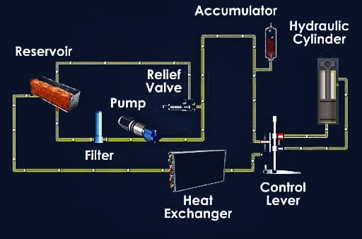
Figure 3-6 Hydraulic systems and component
- Power Generation: The hydraulic pump generates flow and pressure by pressurizing the hydraulic fluid. It draws in fluid from the reservoir and delivers it to the rest of the system.
- Control and Direction: Control valves are used to control the flow direction, flow rate, and pressure of the hydraulic fluid. They determine which actuators are activated and in which direction they move.
- Actuation: Hydraulic actuators, such as hydraulic cylinders and hydraulic motors, convert the hydraulic energy into mechanical work. They provide the force and motion required to perform specific tasks or operations.
- Fluid Conditioning: Hydraulic systems often incorporate filters, coolers, and other components for fluid conditioning. Filters remove contaminants from the fluid, while coolers dissipate heat to maintain optimal operating temperatures.
- Safety and Monitoring: Hydraulic systems may include pressure relief valves, which protect the system from overpressure conditions. Pressure gauges and sensors provide feedback on system performance and allow for monitoring and control.
- Benefits of Hydraulic Systems:
Hydraulic systems offer several advantages that make them attractive for various applications:
- High Power and Force: Hydraulic systems can generate high forces and torques, allowing for heavy-duty applications and tasks that require significant power.
- Precise Control: Hydraulic systems provide precise control over motion, force, and speed. They can be adjusted to achieve accurate positioning and control of machinery and equipment.
- Versatility: Hydraulic systems are versatile and can be customized to meet specific application requirements. They can be designed to handle a wide range of loads, speeds, and operating conditions.
- Durability: Hydraulic components are built to withstand high pressures, shocks, and vibrations.
- Safety: Hydraulic systems often incorporate safety features such as pressure relief valves and overload protection. These features help prevent system failures and ensure operator safety.

Control Amplifiers in Hydraulic Systems
Control amplifiers play a vital role in hydraulic systems by providing precise control and modulation of fluid flow, pressure, and direction. They are electronic devices that receive input signals and adjust the output of hydraulic valves or actuators accordingly. In this article, we will delve into the purpose, functioning, and benefits of control amplifiers in hydraulic systems.
- Purpose of Control Amplifiers:
The primary purpose of control amplifiers in hydraulic systems is to convert electrical signals into hydraulic actions. They receive input signals from various sources, such as sensors, human interface devices, or control systems, and generate output signals that control the hydraulic components. By adjusting the output of hydraulic valves or actuators, control amplifiers enable precise control over the motion, force, and speed of hydraulic systems.
- Functioning of Control Amplifiers:
Control amplifiers operate based on feedback control principles. They typically consist of the following key components and functions:
- Input Interface: Control amplifiers feature input interfaces that receive electrical signals from external sources. These signals can be in the form of voltage, current, or digital signals from sensors, potentiometers, or control systems.
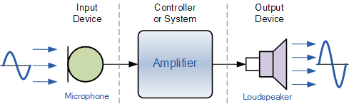
Figure 3-7 Input Interface
- Signal Conditioning: The input signals may require conditioning to match the requirements of the control amplifier. Signal conditioning may involve amplification, filtering, or conversion to ensure compatibility with the control amplifier's input range and resolution.
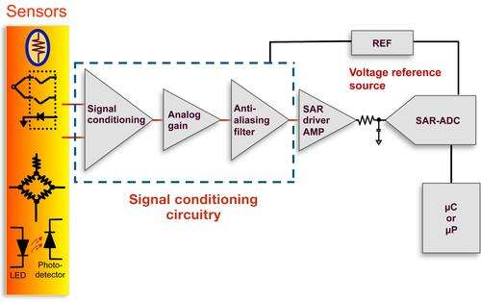
Figure 3-8 Signal conditioning circuit
- Signal Processing and Amplification: Control amplifiers process the input signals using electronic circuits, such as operational amplifiers, to amplify, filter, and shape the signals according to the desired control parameters. The processed signals are then used to generate appropriate output signals.
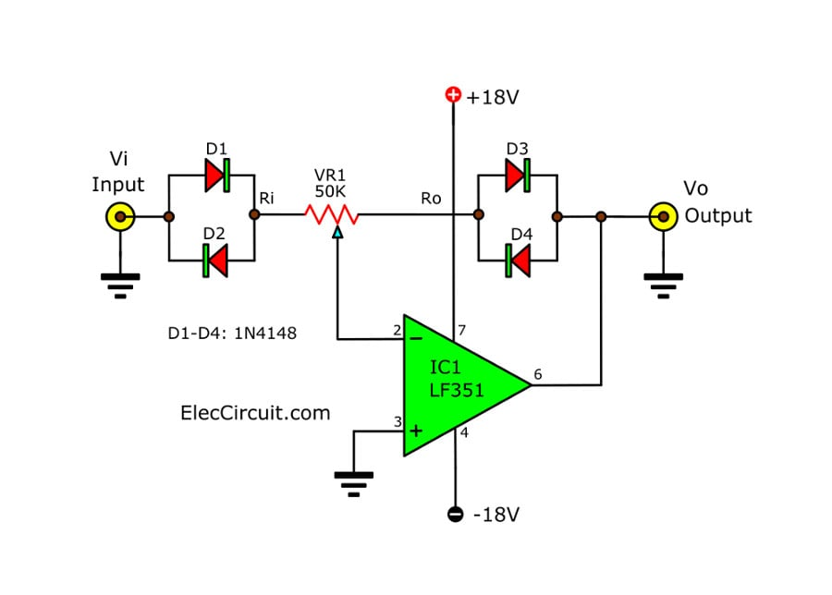
Figure 3-9 Signal Processing and Amplification
- Output Generation: The control amplifier generates output signals that actuate hydraulic valves or actuators. These output signals control the flow rate, pressure, or direction of the hydraulic fluid, thus influencing the behavior of the hydraulic system.
- Feedback Control: Control amplifiers often incorporate feedback control mechanisms to ensure accurate and stable control. Feedback can be achieved by using position sensors, pressure sensors, or other feedback devices to provide information about the system's current state. The control amplifier compares the feedback signals with the desired control parameters and adjusts the output signals accordingly to maintain the desired system performance.
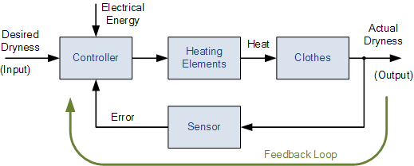
Figure 3-10 Feedback Control
- Benefits of Control Amplifiers in Hydraulic Systems:
Control amplifiers offer several benefits in hydraulic systems:
- Precise Control: Control amplifiers enable precise control over hydraulic components, allowing for accurate positioning, speed control, and force modulation.
- Flexibility and Adaptability: Control amplifiers provide flexibility in controlling various hydraulic components, including valves, cylinders, and motors.
- Integration with Control Systems: Control amplifiers can be integrated with higher-level control systems, such as programmable logic controllers (PLCs) or computer-based control systems.
- Enhanced Safety and Efficiency: Control amplifiers improve system safety by incorporating features such as fault detection, overcurrent protection, and emergency shutdown capabilities.
- Diagnostic and Monitoring Capabilities: Many control amplifiers provide diagnostic and monitoring features that allow for real-time feedback on system performance.

Function and Application of Industrial Transducers
Industrial transducers are devices that convert one form of energy or physical quantity into another. They play a crucial role in industrial applications by sensing and measuring various parameters and converting them into electrical signals that can be processed, transmitted, and utilized for control, monitoring, or analysis purposes. In this article, we will explore the function and applications of industrial transducers.

Function of Industrial Transducers:
The primary function of industrial transducers is to convert a physical quantity or energy into an electrical signal that can be easily measured, processed, and utilized in industrial systems. Transducers achieve this function through various principles, such as the piezoelectric effect, electromagnetic induction, resistive change, or optical sensing. Here are some common functions of industrial transducers:
- Sensing: Industrial transducers are designed to sense and measure physical parameters such as temperature, pressure, force, displacement, flow rate, level, humidity, vibration, and many others.
- Conversion: Transducers convert non-electrical energy forms, such as mechanical, thermal, or optical energy, into electrical signals. For example, a strain gauge transducer converts mechanical strain into a change in electrical resistance.
- Signal Conditioning: Industrial transducers often incorporate signal conditioning circuits to modify the electrical signals according to specific requirements. Signal conditioning may involve amplification, filtering, linearization, or impedance matching to improve signal quality, accuracy, and compatibility with the measurement or control system.
- Transmission: Transducers provide a means of transmitting the measured signals to remote locations or control systems.
- Compatibility: Industrial transducers ensure compatibility between the physical parameter being measured and the measurement or control system. They convert the measured quantity into a standardized electrical signal, such as voltage, current,

Applications of Industrial Transducers:
Industrial transducers find widespread applications across various industries and sectors. Here are some common applications:
Process Control: Transducers are integral to process control systems in industries such as manufacturing, chemical processing, and oil and gas. They measure parameters such as pressure, temperature, level, flow rate, and pH, allowing for real-time monitoring and control of industrial processes.
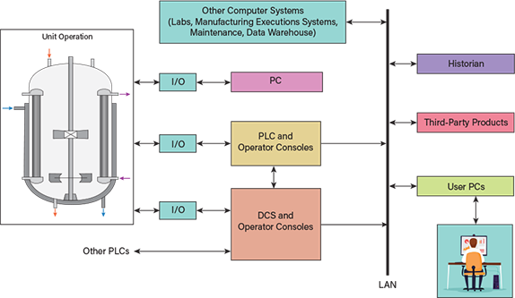
Figure 3-11 Process control systems
Automation and Robotics: Transducers are used in automation and robotics to monitor and control parameters such as position, force, and torque. They enable precise and accurate control of robotic arms, assembly lines, and other automated systems.
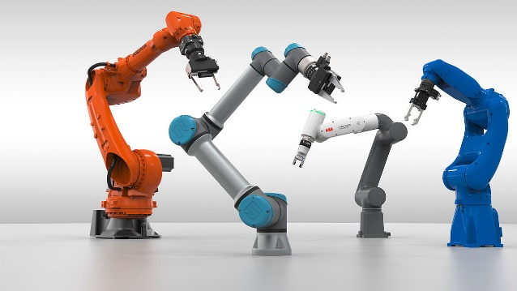
Figure 3-12 Automation and Robotics
Environmental Monitoring: Transducers are employed in environmental monitoring systems to measure parameters such as air quality, humidity, noise levels, and radiation. They provide essential data for environmental assessment, pollution control, and compliance monitoring.
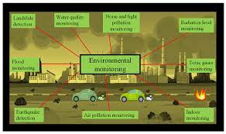
Figure 3-13 Environmental monitoring systems
Energy Management: Transducers play a vital role in energy management systems by measuring parameters such as power, voltage, current, and energy consumption. They enable efficient monitoring, analysis, and optimization of energy usage in industrial facilities.
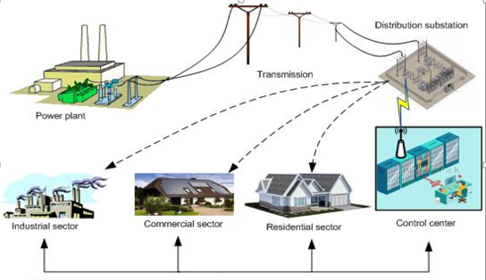
Figure 3-14 Energy management and load shed
Structural Health Monitoring: Transducers are used in structural health monitoring systems to measure parameters such as strain, vibration, and displacement in buildings, bridges, and other structures. They help assess structural integrity, detect defects, and ensure safety.
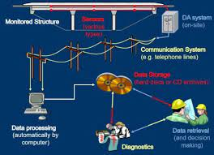
Figure 3-15 Structural Health Monitoring
Medical and Healthcare: Transducers are utilized in medical and healthcare applications for measuring physiological parameters such as blood pressure, heart rate, oxygen saturation, and temperature. They enable accurate diagnosis, patient monitoring, and treatment.
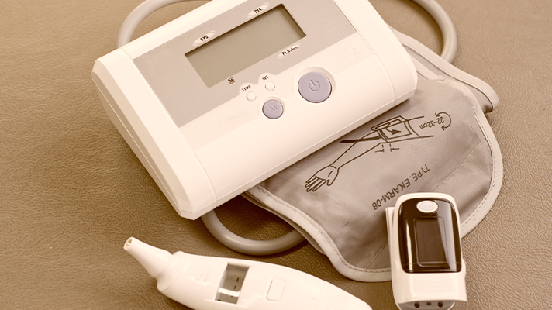
Figure 3-16 Medical and Healthcare
Automotive and Transportation: Transducers are integral to automotive systems, measuring parameters such as speed, acceleration, tire pressure, and engine performance. They contribute to vehicle safety, efficiency, and performance optimization.
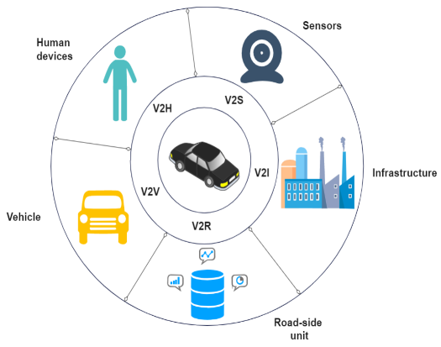
Figure 3-17 Automotive and Transportation:

Overview of Industrial Control Systems
Industrial control systems (ICS) are crucial components of industrial processes, providing automation, monitoring, and control capabilities. They encompass a wide range of technologies, hardware, and software designed to manage and regulate industrial operations. In this article, we will provide an overview of industrial control systems, their components, and their importance in industrial settings.
- Importance of Industrial Control Systems:
Industrial control systems play a vital role in modern industrial processes, offering numerous benefits, including:
- Automation and Efficiency: ICS enable automation of industrial processes, reducing manual intervention and improving efficiency. They can perform repetitive tasks with precision and consistency, leading to increased productivity and reduced operational costs.
- Safety and Risk Mitigation: Control systems help ensure safe operation by implementing safety measures, such as interlocks, alarms, and emergency shutdown systems. They help mitigate risks associated with process deviations, equipment failures, or hazardous conditions.
- Process Optimization: ICS provide tools for process optimization and control loop tuning. By continuously monitoring process variables, they can make adjustments and optimizations in real-time, leading to improved product quality, reduced energy consumption, and optimized resource utilization.
- Remote Monitoring and Control: Industrial control systems, particularly those incorporating SCADA or remote monitoring capabilities, allow operators to remotely monitor and control processes from a centralized location. This remote access enhances operational flexibility, enables rapid response to incidents, and reduces the need for on-site presence.
- Data Acquisition and Analysis: Control systems capture and store large amounts of data related to process variables, alarms, and events. This data can be analyzed to identify trends, patterns, and anomalies, facilitating predictive maintenance, troubleshooting, and process optimization.
- Compliance and Reporting: Industrial control systems assist in regulatory compliance by logging and documenting process data. They provide audit trails, historical records, and reports that can be used for compliance verification, process audits, and regulatory reporting.

Exploring Industrial Final Control Elements
Industrial final control elements are devices that are responsible for executing the desired control actions in industrial processes or systems. They receive control signals from the control system and actuate changes in various process variables, such as flow, pressure, temperature, level, or position. In this article, we will explore different types of industrial final control elements and their applications in industrial processes.
- Types of Industrial Final Control Elements:
Control Valves: Control valves are one of the most common types of final control elements. They regulate fluid flow by varying the size of the flow passage. Control valves consist of a valve body with an adjustable closure member, such as a plug, ball, or disk, and an actuator that positions the closure member based on the control signal received. Control valves are widely used in industries such as oil and gas, chemical processing, water treatment, and power generation.
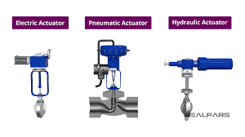
Figure 3-18 Control valves
Dampers: Dampers are devices used to control airflow in HVAC (heating, ventilation, and air conditioning) systems and industrial ventilation systems. They regulate the volume of air by adjusting the position of a blade or vane. Dampers are commonly used in applications where airflow control is critical, such as in cleanrooms, laboratories, and industrial exhaust systems.
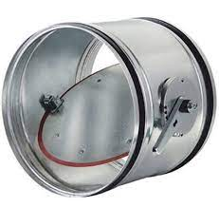
Figure 3-19 Dampers
Variable Speed Drives: Variable speed drives, also known as variable frequency drives or VFDs, are final control elements used to control the speed and torque of electric motors. They vary the frequency and voltage supplied to the motor, allowing precise control over motor speed.
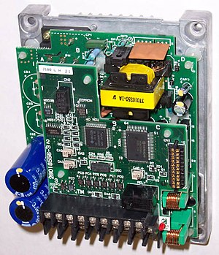
Figure 3-20 Variable Speed Drives
Actuators: Actuators are devices that convert electrical, hydraulic, or pneumatic energy into mechanical motion. They are used to control the position, displacement, or motion of various components in industrial systems. Actuators can be linear or rotary, and they are employed in applications such as robotics, process control valves, positioning systems, and automated machinery.
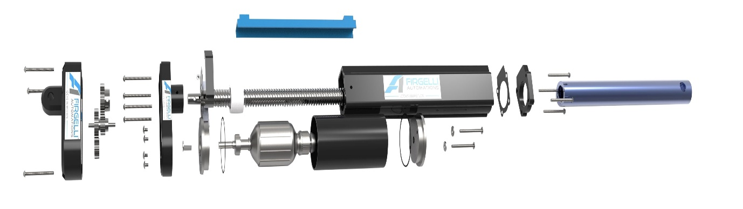
Figure 3-21 Actuators
Solenoid Valves: Solenoid valves are electromechanical devices that control the flow of fluids or gases by opening or closing a valve using an electromagnetic coil. They are commonly used in applications that require rapid on/off control, such as in pneumatic systems, irrigation systems, and industrial automation.
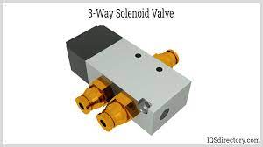
Figure 3-22 Solenoid valves
Electric Motorized Valves: Electric motorized valves are final control elements that use an electric motor to actuate valve movement. They are widely used in applications where precise control over fluid flow is required, such as in HVAC systems, water treatment plants, and process industries.
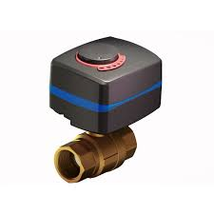
Figure 3-23 Electric motorized valves
- Applications of Industrial Final Control Elements:
Industrial final control elements find application in a wide range of industries and processes, including:
- Process Control: Final control elements are crucial in process control systems, where they regulate variables such as flow rate, pressure, temperature, and level. They play a vital role in maintaining process stability, efficiency, and product quality in industries such as chemical processing, oil and gas, pharmaceuticals, and food and beverage.
- Power Generation: Final control elements are employed in power generation plants to control steam flow, fuel flow, and other critical parameters. They ensure safe and efficient operation of boilers, turbines, and other power generation equipment.
- HVAC Systems: Final control elements, such as control valves and dampers, are extensively used in heating, ventilation, and air conditioning systems. They regulate the flow of air, water, or refrigerant to maintain desired temperature, humidity, and comfort levels in buildings.
- Water and Wastewater Treatment: Final control elements are vital in water and wastewater treatment processes. They control the flow of water, chemicals, and sludge, ensuring proper treatment, disinfection, and distribution of water resources.
- Manufacturing and Industrial Automation: Final control elements are integral to manufacturing processes and industrial automation systems.

Self-check 3.1
Part one: say True or False
_____1. Hydraulic systems use electrical energy to generate power.
_____2. The hydraulic pump is responsible for converting mechanical energy into hydraulic energy.
_____3. Hydraulic lines are not designed to handle high-pressure conditions.
_____4. Control valves regulate the flow, direction, and pressure of the hydraulic fluid.
_____5. Hydraulic systems are not versatile and cannot be customized for specific applications. (
Part Two: Matching
Match the hydraulic component with its function:
Match A | Match B
_____1. Hydraulic Pump | A. Control the flow direction
_____2. Reservoir | B. Store hydraulic fluid
_____3. Hydraulic Actuators | C. Convert hydraulic energy into mechanical work
_____4. Control Valves | D. Generate flow and pressure
_____5. Hydraulic Lines | E. Transport hydraulic fluid between components
Part Three: Multiple Choice
_____1.What is the primary purpose of control amplifiers in hydraulic systems?
A. Generate electrical signals
B. Convert hydraulic energy into mechanical work
C. Provide precise control over fluid flow, pressure, and direction
D. Store hydraulic fluid
_____2. Which component of a hydraulic system is responsible for dissipating heat?
A. Hydraulic pump
B. Reservoir
C. Hydraulic actuators
D. Control valves
_____3. What do hydraulic systems operate based on?
A. Pascal's law
B. Newton's law
C. Boyle's law
D. Archimedes' principle
_____4. Which of the following is an advantage of hydraulic systems?
A. Limited power and force generation
B. Inaccurate control over motion and speed
C. Limited customization options
D. Durability and reliability
_____5. What do industrial transducers do in industrial applications?
A. Convert electrical signals into physical quantities
B. Convert hydraulic energy into electrical signals
C. Convert physical quantities into electrical signals
D. Store energy for industrial systems

Operation Sheet 3.1
PROJECT TITLE: HYDRAULIC SYSTEM MAINTENANCE
Instructions:
- Ensure the hydraulic system is powered off and depressurized before starting maintenance.
- Wear appropriate personal protective equipment, including gloves and safety glasses.
- Use proper tools and equipment for each maintenance task.
- Follow the manufacturer's guidelines and maintenance procedures specific to the hydraulic system.
- Perform regular inspections and maintenance to ensure the system's optimal performance and reliability.
Procedure:
- Check the hydraulic fluid level in the reservoir and top up if necessary.
- Inspect hydraulic lines for any signs of leaks, damage, or loose fittings. Tighten or replace as needed.
- Clean the hydraulic reservoir and filter any contaminants or debris.
- Inspect hydraulic actuators, such as cylinders and motors, for any signs of wear or damage. Lubricate if required.
- Check control valves for proper operation and adjust as necessary.
- Test the system for leaks by pressurizing and observing for any fluid leakage.
- Monitor system performance and take note of any abnormalities or unusual sounds.
- Record all maintenance activities, including inspections, repairs, and fluid replacements, in the maintenance log.
Quality Criteria:
- The hydraulic system should be properly powered off and depressurized during maintenance.
- All maintenance tasks should be performed following safety guidelines and using appropriate tools.
- The hydraulic fluid level should be maintained within the recommended range.
- Hydraulic lines should be free from leaks and securely connected.
- Control valves should function correctly, regulating flow, direction, and pressure accurately.
- The system should be tested for leaks and monitored for optimal performance.
Note: This operation sheet is a general guide. Please refer to the specific hydraulic system's manual and manufacturer's recommendations for detailed maintenance procedures and safety precautions.

UNIT FOUR: PROVIDING SOLUTIONS TO PROBLEMS
This learning guide is developed to provide you the necessary information regarding the following content coverage and topics:
- Analyzing Control Problems
- Developing Solutions
- Upgrading or Replacing Components:
- Updating Control Algorithms
- Implementing Redundancy or Safety Measures:
- Testing and Validating Solutions:
- Documentation and Continuous Improvement:
This guide will also assist you to attain the learning outcomes stated in the cover page. Specifically, upon completion of this learning guide, you will be able to:
- Analyze Control Problems
- Develop Solutions
- Upgrade or Replace Components:
- Update Control Algorithms
- Implement Redundancy or Safety Measures:
- Test and Validate Solutions:
- Document and Continuous Improvement

Analyzing Control Problems
A Pathway to Effective Solutions Analyzing control problems in electro pneumatic hydraulic systems is a crucial step towards identifying and implementing effective solutions. These systems involve a combination of electrical, pneumatic, and hydraulic components, and issues can arise due to various factors such as component malfunctions, improper settings, or incorrect configurations. Here are key points to consider when analyzing control problems:
- System Understanding:
Develop a comprehensive understanding of the electro pneumatic hydraulic system under analysis. Familiarize yourself with the components involved, including linear actuators, rotary actuators, directional control valves, timers, counters, two-cylinder sequenced systems, and single cylinder skip-check systems. Study their specifications, operating principles, and functions to establish a solid foundation for troubleshooting.
- Observing System Behavior:
Carefully observe the behavior of the system to identify any deviations, abnormalities, or unexpected actions. Pay attention to factors such as movements, timing, pressure fluctuations, or errors in system performance. Document your observations in detail, noting specific symptoms and patterns that can help in identifying the control problem.
- Gathering Diagnostic Data:
Collect diagnostic data using appropriate tools and techniques. Utilize pressure gauges, flow meters, multimeters, or other relevant instruments to measure and monitor system parameters. Collect data during different operational scenarios to obtain a comprehensive view of the system's performance. This data will serve as valuable information for analysis and troubleshooting.
- Troubleshooting Methodology:
Adopt a systematic troubleshooting methodology to identify the root cause of the control problem. Start by isolating the affected component or subsystem and perform necessary inspections, tests, or measurements. Analyze the collected data and compare it with expected values or standards. Employ a step-by-step evaluation process to narrow down potential sources of malfunction.
- Consider Interactions and Dependencies:
Recognize that electro pneumatic hydraulic systems often involve complex interactions and dependencies between components. Analyze how changes in one component can impact the overall system behavior. Consider how the malfunction of a directional control valve, for example, can affect the operation of a linear actuator. Understanding these interactions will help in pinpointing the origin of the control problem.
- Simulation and Modeling:
Leverage simulation and modeling tools to recreate the system and test various scenarios. Use software programs or virtual simulations to observe the system's behavior and identify potential control issues without affecting the physical system. Simulation and modeling allow for the evaluation of alternative solutions and the prediction of their impact before implementing changes in the actual system.
- Collaboration and Knowledge Sharing:
Engage in collaborative problem-solving by seeking input and advice from colleagues, experts, or online communities. Discuss the control problem with others who have encountered similar challenges to gain fresh perspectives and alternative solutions. Sharing knowledge and experiences can lead to innovative ideas and more effective approaches to analyzing control problems.
- Documentation and Continuous Improvement:
Document your findings, including the identified control problem, analysis process, and the steps taken for resolution. Maintain detailed records of observations, test results, and implemented solutions. This documentation serves as a reference for future troubleshooting efforts and supports continuous improvement of system operation and control processes.

Developing Solutions
When faced with control problems in electro pneumatic hydraulic systems, it is essential to develop effective solutions to restore proper system operation. This involves addressing issues related to variable pneumatic control devices and hydraulic systems, which may include components such as linear actuators, rotary actuators, directional control valves, timers, counters, two-cylinder sequenced systems, and single cylinder skip-check systems. Here are some key considerations for developing solutions:
- Identify the Root Cause:
Before developing solutions, it is crucial to identify the root cause of the control problem. Conduct a thorough analysis of the system, considering factors such as component malfunctions, improper settings, or incorrect configurations. Use diagnostic tools, perform tests, and consult technical documentation to pinpoint the specific issue causing the control problem.
- Evaluate Alternative Solutions:
Once the root cause is identified, consider various alternative solutions to address the control problem. This may involve repairing or replacing faulty components, adjusting settings or configurations, or modifying control algorithms. Evaluate the advantages and disadvantages of each solution, considering factors such as cost, feasibility, and impact on system performance.
- Consider Interactions and Dependencies:
When developing solutions, consider the interactions and dependencies between different components in the system. Changes made to one component may have implications for others. Ensure that the proposed solution does not introduce new control problems or negatively impact the overall system performance. Validate the compatibility and integration of the solution within the existing system.
- Simulate and Test:
Utilize simulation and testing techniques to validate the proposed solution before implementing it in the physical system. Use software tools or virtual simulations to model the system behavior with the proposed solution. This allows you to observe the effects and verify that the solution is effective in resolving the control problem. Perform controlled tests in a controlled environment to further validate the solution's performance.
- Implement and Monitor:
Once the solution is validated, implement it in the actual system. Make the necessary adjustments, repairs, or replacements according to the developed solution. Monitor the system closely after implementation to ensure that the control problem is effectively resolved. Continuously observe system behavior, measure relevant parameters, and compare them against expected values to confirm the effectiveness of the solution.
- Document and Share Knowledge:
Document the developed solution, including the steps taken, adjustments made, and any modifications to the system. This documentation serves as a reference for future troubleshooting efforts and knowledge sharing within your team or organization. Share the knowledge gained from developing solutions to control problems to enhance the collective understanding and improve the control processes.
- Continuous Improvement:
Promote a culture of continuous improvement by actively seeking feedback and monitoring the long-term performance of the developed solution. Analyze any recurring control problems or new issues that may arise and use them as opportunities for further enhancement. Regularly review and update the control strategies and practices to optimize system performance and reliability.

Upgrading or Replacing Components:
In the realm of electro pneumatic hydraulic control and operation systems, upgrading or replacing components is a common approach to address problems and improve system performance. This process involves considering a range of variable pneumatic control devices and hydraulic systems, such as linear actuators, rotary actuators, directional control valves, timers, counters, two-cylinder sequenced systems, and single cylinder skip-check systems. Here are essential considerations when upgrading or replacing components:
- Identify Performance Issues:
Identify specific performance issues or limitations within the system that can be addressed through component upgrades or replacements. This may include inadequate force or speed output, poor response time, leakage, insufficient sequencing, or improper control functionality. Thoroughly analyze the system's behavior and consult technical documentation to pinpoint areas in need of improvement.
- Define Upgrade Objectives:
Clearly define the objectives of the component upgrade or replacement. Determine the desired improvements in terms of performance, efficiency, reliability, safety, or functionality. Establish measurable criteria to evaluate the success of the upgrade and ensure that the chosen components align with the defined objectives.
- Research Available Options:
Conduct comprehensive research to explore the available options for upgrading or replacing the components in question. Consider factors such as compatibility with the existing system, technical specifications, quality, reliability, and the reputation of the manufacturers or suppliers. Seek recommendations from industry experts or consult product catalogs and technical resources to gather relevant information.
- Evaluate Compatibility and Integration:
Ensure compatibility and integration of the upgraded or replacement components within the existing system. Consider factors such as mounting dimensions, electrical connections, pressure ratings, flow rates, and control interfaces. Verify that the new components can seamlessly integrate with the system without causing conflicts or requiring extensive modifications.
- Performance Simulation and Testing:
Utilize simulation tools or software to assess the performance of the proposed upgraded or replacement components. Model the system behavior and evaluate how the new components will affect overall system performance. Conduct controlled tests using prototypes or representative setups to validate the expected improvements and verify the compatibility of the components.
- Installation and Calibration:
Follow manufacturer guidelines and best practices for the installation and calibration of the upgraded or replacement components. Ensure that the installation is performed correctly, taking into account proper alignment, secure connections, and appropriate adjustments. Calibrate control settings, such as pressure limits, timing parameters, or sequencing configurations, to optimize the performance of the system with the new components.
- Monitor and Fine-tune:
Monitor the system closely after component upgrades or replacements to assess their impact on overall system performance. Measure relevant parameters, observe system behavior, and compare against expected values. Fine-tune control settings, if necessary, to optimize the performance and ensure that the new components are operating within their specified parameters.
- Documentation and Knowledge Sharing:
Document all details related to the component upgrades or replacements, including the specific components chosen, installation procedures, calibration settings, and observed improvements. Maintain detailed records that can serve as a reference for future maintenance, troubleshooting, or upgrades. Share this knowledge with the team or organization to foster learning and enhance collective understanding.

Updating Control Algorithms
In the domain of electro pneumatic hydraulic control and operation systems, updating control algorithms is a key approach to address problems and optimize system performance. This process involves considering a range of variable pneumatic control devices and hydraulic systems, including linear actuators, rotary actuators, directional control valves, timers, counters, two-cylinder sequenced systems, and single cylinder skip-check systems. Here are important considerations when updating control algorithms:
- Identify Control Issues:
Identify specific control issues or limitations within the system that can be addressed through algorithm updates. This may include insufficient precision, slow response times, unstable operation, improper sequencing, or suboptimal energy efficiency. Thoroughly analyze the system's behavior and consult technical documentation to pinpoint areas in need of improvement.
- Define Algorithm Objectives:
Clearly define the objectives of updating the control algorithms. Determine the desired improvements in terms of performance, accuracy, stability, energy efficiency, or adaptability. Establish measurable criteria to evaluate the success of the algorithm update and ensure that the updated algorithms align with the defined objectives.
- Analyze and Model System Dynamics:
Analyze the dynamics of the electro pneumatic hydraulic system to understand its behavior and interactions between the various components. Develop mathematical models or simulations that capture the system's response to input signals and control commands. These models will serve as a basis for designing and testing updated control algorithms.
- Research Control Techniques:
Conduct comprehensive research to explore control techniques and algorithms suitable for the specific components and system configuration. Consider techniques such as proportional-integral-derivative (PID) control, model-based control, adaptive control, fuzzy logic control, or advanced optimization algorithms. Evaluate their applicability, advantages, and limitations in the context of the electro pneumatic hydraulic system.
- Develop and Implement Updated Algorithms:
Based on the selected control technique, develop updated control algorithms that address the identified control issues and align with the defined objectives. Implement the updated algorithms in the control system, considering factors such as computational requirements, real-time constraints, and compatibility with the existing hardware and software infrastructure.
- Simulation and Testing:
Utilize simulation tools or software to assess the performance of the updated control algorithms. Model the system behavior and evaluate how the updated algorithms improve system response, stability, or energy efficiency. Conduct controlled tests using prototypes or representative setups to verify the effectiveness of the updated algorithms in real-world scenarios.
- Fine-tuning and Optimization:
Fine-tune the updated control algorithms to optimize their performance. Adjust control parameters, tuning constants, or feedback gains to achieve desired system behavior and meet performance objectives. Utilize optimization techniques, such as parameter optimization algorithms or system identification methods, to further refine and optimize the control algorithms.
- Monitor and Continuous Improvement:
Monitor the system closely after implementing the updated control algorithms to assess their impact on overall system performance. Measure relevant parameters, observe system behavior, and compare against expected values. Continuously analyze the system's performance, gather feedback, and identify areas for further improvement. Iteratively update and refine the control algorithms based on the system's behavior and evolving requirements.
- Documentation and Knowledge Sharing:
Document all details related to the updated control algorithms, including the algorithm design, implementation details, tuning parameters, and observed improvements. Maintain detailed records that can serve as a reference for future maintenance, troubleshooting, or algorithm updates. Share this knowledge with the team or organization to foster learning and enhance collective understanding.

Implementing Redundancy or Safety Measures:
In the field of electro pneumatic hydraulic control and operation systems, implementing redundancy or safety measures is crucial to ensure system reliability, minimize downtime, and prevent potential hazards. This process involves considering a range of variable pneumatic control devices and hydraulic systems, including linear actuators, rotary actuators, directional control valves, timers, counters, two-cylinder sequenced systems, and single cylinder skip-check systems. Here are important considerations when implementing redundancy or safety measures:
- Identify Critical Components and Functions:
Identify the critical components and functions within the system that require redundancy or additional safety measures. These may include components that, if they fail, could lead to system malfunctions, loss of control, or safety hazards. Thoroughly analyze the system's architecture and functionality to identify the most critical elements.
- Define Redundancy or Safety Objectives:
Clearly define the objectives of implementing redundancy or safety measures. Determine the level of redundancy required, such as full redundancy, partial redundancy, or backup systems. Define the safety requirements in terms of system response time, fault detection, fault tolerance, or fail-safe operation. Establish measurable criteria to evaluate the success of the implemented measures.
- Redundant Component Selection:
Select appropriate redundant components based on the identified critical functions. Consider factors such as compatibility with the existing system, reliability, availability, and performance. Evaluate redundant options, such as redundant actuators, valves, sensors, controllers, or power supplies that best align with the system requirements and safety objectives.
- Redundancy Architecture Design:
Design the redundancy architecture by determining the appropriate configuration for the redundant components. This may include redundant parallel systems, hot standby systems, or dual-channel systems. Ensure that the redundancy architecture provides seamless switching between primary and redundant components in the event of a failure while maintaining system operation and safety.
- Safety Measures Implementation:
Implement additional safety measures to enhance system reliability and mitigate potential hazards. This may include adding safety interlocks, emergency stop circuits, pressure relief valves, safety monitoring systems, or fault detection mechanisms. Consider safety standards and regulations applicable to the specific industry or application to guide the implementation of safety measures.
- Testing and Verification:
Thoroughly test and verify the implemented redundancy or safety measures. Conduct controlled tests and simulations to validate the functionality, reliability, and performance of the redundant components and safety measures. Verify that the system can detect faults, transition to redundant components seamlessly, and maintain safe operation under various failure scenarios.
- Monitoring and Maintenance:
Regularly monitor the system to ensure the continued effectiveness of the implemented redundancy or safety measures. Implement a proactive maintenance plan to detect and address potential issues before they lead to failures. Monitor the redundant components, perform periodic inspections, and review system logs to identify any anomalies or malfunctions.
- Documentation and Training:
Document all details related to the implemented redundancy or safety measures, including the design, configuration, testing procedures, and maintenance requirements. Maintain detailed records that can serve as a reference for future maintenance, troubleshooting, or system upgrades. Provide training to relevant personnel on the proper operation, maintenance, and response procedures in the event of a failure or safety incident.

Testing and Validating Solutions:
In the realm of electro pneumatic hydraulic control and operation systems, testing and validating solutions is a critical step to ensure the effectiveness and reliability of implemented solutions. This process involves considering a range of variable pneumatic control devices and hydraulic systems, including linear actuators, rotary actuators, directional control valves, timers, counters, two-cylinder sequenced systems, and single cylinder skip-check systems. Here are important considerations when testing and validating solutions:
- Define Test Objectives:
Clearly define the objectives of the testing process. Determine the specific aspects of the system or solution that need to be evaluated, such as performance, reliability, response time, energy efficiency, or safety. Establish measurable criteria or benchmarks to assess the success of the implemented solutions.
- Develop Test Plans:
Develop comprehensive test plans that outline the procedures, methodologies, and test cases to be performed. Identify the necessary equipment, instrumentation, and data collection methods. Consider both functional testing, which evaluates the system's behavior under normal operating conditions, and stress testing, which assesses its performance under extreme or abnormal scenarios.
- Conduct Component-Level Testing:
Test the individual components of the electro pneumatic hydraulic system to ensure their proper functioning and compatibility. Perform tests on the linear actuators, rotary actuators, directional control valves, timers, counters, and other relevant components. Verify that each component meets its specifications and performs as expected.
- System-Level Testing:
Integrate the components and perform system-level testing to evaluate the overall system behavior. Test the system under various operating conditions, input signals, and load conditions. Assess the system's response time, accuracy, stability, and energy efficiency. Verify that the implemented solutions address the identified problems and meet the defined objectives.
- Validation Against Requirements:
Validate the implemented solutions against the defined requirements and specifications. Compare the system's performance with the expected values and evaluate whether the solutions effectively address the identified problems. Ensure that the system meets the desired functionality, performance, and safety standards.
- Performance Evaluation:
Evaluate the performance of the system through quantitative metrics and qualitative assessments. Measure and analyze relevant parameters, such as force output, speed, pressure, timing, sequencing, or energy consumption. Compare the obtained results with the defined benchmarks or industry standards. Identify areas that require further optimization or improvement.
- Reliability and Safety Testing:
Conduct reliability and safety testing to assess the system's ability to perform consistently and safely over time. Perform durability tests, endurance tests, or accelerated aging tests to simulate real-world operating conditions. Evaluate the system's response to fault conditions, emergency stop scenarios, or safety incidents. Verify that the implemented solutions maintain safe and reliable operation.
- Documentation and Reporting:
Document all details related to the testing and validation process, including the test plans, procedures, results, and observations. Maintain detailed records that serve as a reference for future maintenance, troubleshooting, or system upgrades. Prepare comprehensive reports summarizing the testing process and outcomes, highlighting any issues identified and recommendations for further improvements.

- Iterative Improvement:
Based on the testing and validation results, identify areas for further improvement or optimization. Iteratively refine the implemented solutions based on the feedback obtained during the testing process. Address any identified issues, whether related to performance, reliability, safety, or functionality, to enhance the overall system operation.

Documentation and Continuous Improvement:
Documentation and continuous improvement play crucial roles in maintaining and enhancing the performance, reliability, and safety of electro pneumatic hydraulic control and operation systems. When working with a range of variable pneumatic control devices and hydraulic systems, including linear actuators, rotary actuators, directional control valves, timers, counters, two-cylinder sequenced systems, and single cylinder skip-check systems, it is important to emphasize the following aspects:
- Documenting System Configuration and Design:
Thoroughly document the system configuration and design, including the specifications, schematics, wiring diagrams, and component lists. This documentation serves as a reference for system maintenance, troubleshooting, and future modifications. It ensures that all relevant information is readily available to understand the system's structure and functionality.
- Maintaining Operating Manuals and Procedures:
Develop comprehensive operating manuals and procedures that outline the proper operation, startup, shutdown, and emergency protocols for the electro pneumatic hydraulic system. Include step-by-step instructions, safety guidelines, and troubleshooting procedures. Regularly update these manuals to reflect any changes made to the system or its operation.
- Recording Maintenance and Service History:
Maintain a detailed record of the system's maintenance and service activities. This includes scheduled inspections, routine maintenance tasks, repairs, component replacements, and any modifications made to the system. This historical record helps track the system's performance over time, identify recurring issues, and plan maintenance schedules effectively.
- Implementing Change Management:
Establish a change management process to handle modifications or upgrades to the electro pneumatic hydraulic system. Clearly define the procedures for proposing, approving, implementing, and documenting system changes. This ensures that any modifications are properly evaluated, tested, and documented to maintain system integrity and avoid unintended consequences.
- Conducting Regular System Audits:
Periodically conduct system audits to assess the system's performance, compliance with standards and regulations, and adherence to best practices. These audits can identify areas for improvement, potential risks, and opportunities for optimization. Use the audit findings to guide continuous improvement efforts and ensure that the system remains up to date and in optimal condition.
- Analyzing Performance Data:
Collect and analyze performance data from the electro pneumatic hydraulic system. Monitor key parameters such as pressure, flow rate, temperature, response time, and energy consumption. Analyze trends, identify anomalies, and compare the data against performance targets or historical benchmarks. This data-driven approach helps detect potential issues, optimize system performance, and make informed decisions.
- Implementing Feedback and Lessons Learned:
Encourage feedback from system operators, maintenance personnel, and other stakeholders involved in the operation and maintenance of the electro pneumatic hydraulic system. Create a culture where lessons learned from previous issues or failures are shared and used to improve system design, operation, and maintenance practices. Foster open communication channels to address concerns and implement effective solutions.
- Training and Knowledge Transfer:
Provide training programs and knowledge transfer sessions to ensure that personnel involved in operating and maintaining the system are well-informed and up to date with the latest practices. Regularly update training materials and conduct refresher sessions to enhance skills and knowledge. This enables personnel to effectively troubleshoot, maintain, and optimize the electro pneumatic hydraulic system.
- Engaging in Continuous Improvement Initiatives:
Promote a continuous improvement mindset within the organization by actively seeking opportunities for enhancement. Encourage personnel to propose ideas for improving system performance, reliability, safety, or energy efficiency. Establish a systematic approach to evaluate and prioritize improvement initiatives, implementing those with the highest potential impact.

Self-check 4.1
Part One: True or False:
_____1. Hydraulic systems involve the use of both electrical and pneumatic components.
_____2. Troubleshooting methodology should involve a step-by-step evaluation process.
_____3. Simulation and modeling tools can be used to observe the behavior of a hydraulic system without affecting the physical system.
_____4. Collaboration and knowledge sharing can lead to innovative ideas and more effective approaches to analyzing control problems.
_____5. Documenting findings and maintaining detailed records is not necessary for troubleshooting efforts.
Part Two: Matching
Match the components with their descriptions.
Match A | Match B
_____1. Linear actuator | A. Controls the direction of fluid flow in the system.
_____2. Rotary actuator | B. Converts fluid pressure into linear motion.
_____3. Directional control valve | C. Converts fluid pressure into rotary motion.
_____4. Timer | D. Measures and controls the timing of system operations.
_____5. Counter | E. Keeps track of the number of system events.

Part three: Multiple Choice:
_____1. Which component is responsible for converting fluid pressure into rotary motion?
a) Linear actuator
b) Rotary actuator
c) Directional control valve
d) Timer
_____2. What is the purpose of a counter in a hydraulic system?
a) Controls the direction of fluid flow
b) Converts fluid pressure into linear motion
c) Measures and controls the timing of system operations
d) Keeps track of the number of system events
_____3. What should be done first when faced with control problems in a hydraulic system?
a) Implement the proposed solution
b) Gather diagnostic data
c) Analyze system behavior
d) Develop alternative solutions
_____4. Which tool can be used to measure and monitor system parameters in a hydraulic system?
a) Pressure gauge
b) Multimeter
c) Flow meter
d) All of the above

UNIT FIVE: TESTING AND DOCUMENTATION
This learning guide is developed to provide you the necessary information regarding the following content coverage and topics:
UNIT TWO: TESTING AND DOCUMENTATION
- Controlling problem in Pneumatic-Hydraulic System Operation
- Justifying and documenting the solution

This guide will also assist you to attain the learning outcomes stated in the cover page. Specifically, upon completion of this learning guide, you will be able to:
- Control problem in Pneumatic-Hydraulic System Operation
- Justify and document the solution

Controlling problem in Pneumatic-Hydraulic System Operation
After identifying and developing solutions for control problems in electro-pneumatic-hydraulic systems, it is crucial to thoroughly test and document the implementation of these solutions. Testing ensures that the solutions effectively address the control problems, while documentation provides a record of the implemented changes and serves as a reference for future troubleshooting and maintenance. In this learning note, we will explore the importance of testing and documenting solutions in electro-pneumatic-hydraulic system operation.
- Importance of Testing Solutions:
Testing solutions is essential to verify their effectiveness, validate their impact on system performance, and ensure that the control problems have been successfully addressed. Through testing, operators and maintenance personnel can identify any potential issues or unexpected behavior resulting from the implemented changes. Testing also allows for fine-tuning and optimization of the solutions before full-scale implementation.
- Importance of Documentation:
Documentation serves as a detailed record of the implemented solutions, including the changes made, the testing process, and the results obtained. It provides valuable information for future reference, troubleshooting, and maintenance activities. Documentation also facilitates knowledge sharing among team members and contributes to the continuous improvement of the system's operation.

Testing Solutions:
- Develop Test Plan:
Before conducting tests, develop a test plan that outlines the specific tests to be performed, the expected outcomes, and the testing procedures. Define the test scenarios, test inputs, and expected system responses. Consider factors such as system behavior, control performance, actuator response, sensor accuracy, and overall system stability.

- Conduct Functional Testing:
Conduct functional testing to verify that the implemented solutions meet the desired functionality. Test each component, control loop, or subsystem individually to ensure proper operation. Evaluate the system's response to different inputs, set points, or control commands. Verify that the control problem no longer persists and that the system behaves as expected.
- Perform Performance Testing:
Perform performance testing to assess the impact of the implemented solutions on the system's overall performance. Measure relevant performance metrics such as response time, accuracy, precision, repeatability, or energy efficiency. Compare the performance results with the pre-implementation baseline to evaluate the effectiveness of the solutions.
- Validate System Stability:
Ensure that the implemented solutions maintain system stability under normal operating conditions. Monitor the system for any signs of instability, oscillation, or erratic behavior. Check the control loops for proper gain settings, damping characteristics, and stability margins. Validate that the system remains stable even under varying loads, disturbances, or operating conditions.
- Test Worst-Case Scenarios:
Test the system under worst-case scenarios or extreme conditions to assess its robustness and reliability. Apply maximum loads, rapid changes in set points, or other challenging conditions to evaluate the system's response and the effectiveness of the implemented solutions. Identify any potential limitations or areas for further improvement.
- Verify Safety Measures:
If the control problem posed safety risks, verify that the implemented solutions effectively address these risks. Test the safety measures, such as emergency shutdown mechanisms, interlocks, or fail-safe systems, to ensure their proper operation. Confirm that the system can safely handle critical situations and protect personnel and equipment.

Documenting Solutions:
- Record Implemented Changes:
Document the changes made to the electro-pneumatic-hydraulic system as part of the implemented solutions. Include detailed information about the modified components, adjusted control settings, upgraded hardware or software, or any other relevant changes. This documentation serves as a reference for future troubleshooting and maintenance activities.
- Document Testing Procedures and Results:
Record the testing procedures and results obtained during the testing phase. Document the test plan, including the test scenarios, inputs, expected outcomes, and testing methodologies. Record the actual test results, including any deviations or unexpected behavior observed during testing. This documentation provides a comprehensive overview of the testing process and the system's behavior.
- Capture Performance Metrics:
Document the performance metrics measured during testing, both before and after the implementation of the solutions. Include quantitative measurements, such as response times, accuracies, or energy consumption, as well as qualitative observations regarding system behavior and performance. This documentation allows for performance comparisons and helps assess the effectiveness of the implemented solutions.
- Update System Documentation:
Update the system documentation, including operation manuals, maintenance procedures, and troubleshooting guides, to reflect the implemented solutions. Incorporate the documented changes, testing procedures, and performance results into the relevant documentation. Ensure that the system documentation accurately reflects the current state of the electro-pneumatic-hydraulic system.

- Communicate and Share Knowledge:
Share the documented solutions and testing results with relevant team members, operators, and maintenance personnel. Communicate the changes made, the testing outcomes, and any recommendations or best practices derived from the testing process. Encourage knowledge sharing and collaborative problem-solving to enhance the understanding and operation of the system.

Justifying and documenting the solution
Once a solution has been implemented to address a control problem in an electro-pneumatic-hydraulic system, it is crucial to justify and document the solution. Justification involves providing a rationale for why the chosen solution is the most suitable and effective. Documentation ensures that the implemented solution is properly recorded, allowing for future reference, knowledge sharing, and maintenance. In this learning note, we will explore the importance of justifying and documenting the solution in electro-pneumatic-hydraulic system operation.
- Importance of Justification:
Justifying the implemented solution is essential for demonstrating that it is the appropriate course of action to address the control problem. By providing a logical and evidence-based justification, stakeholders can understand the reasoning behind the chosen solution and gain confidence in its effectiveness. Justification also helps to align the solution with the overall goals and requirements of the system.
- Importance of Documentation:
Documentation serves as a comprehensive record of the implemented solution, including the rationale, steps taken, changes made, and testing results. It provides a reference for future troubleshooting, maintenance, and system improvement efforts. Documentation also facilitates knowledge sharing among team members and ensures that crucial information is not lost over time.

Justifying the Solution:
- Describe the Control Problem:
Begin by clearly describing the control problem that the solution aims to address. Explain the symptoms, deviations from desired behavior, or any other factors that led to the identification of the control problem. Provide a context for the problem to help stakeholders understand its significance and impact on system performance.
- Explain the Chosen Solution:
Provide a detailed explanation of the chosen solution and how it addresses the control problem. Describe the specific changes made, such as modifications to control algorithms, component replacements, or system reconfigurations. Clearly articulate how these changes are expected to improve control performance, reliability, safety, or any other relevant aspect.
- Justify the Solution:
Present a logical and evidence-based justification for selecting the implemented solution. Consider the following factors:
- Technical Feasibility: Explain why the chosen solution is technically feasible and compatible with the existing system components, interfaces, and control architecture.
- Effectiveness: Describe how the solution is expected to effectively resolve the control problem based on its underlying causes and observed symptoms. Reference any data or testing results that support this expectation.
- Cost-effectiveness: Discuss the cost-effectiveness of the solution by considering factors such as the investment required, potential savings in maintenance or energy costs, and the expected return on investment.
- Safety and Reliability: Highlight how the solution improves system safety and reliability, reducing the risk of failures, accidents, or downtime. Reference any safety measures or reliability enhancements incorporated into the solution.
- Compatibility and Integration: Explain how the solution integrates with other system components and interfaces, ensuring compatibility and minimizing disruptions to the overall system operation.
- Discuss Alternative Solutions:
Briefly discuss alternative solutions that were considered but not implemented. Explain the reasons for rejecting these alternatives, highlighting any limitations, risks, or trade-offs associated with them. This discussion demonstrates that the chosen solution was carefully evaluated and selected based on its merits.

Documenting the Solution:
- Record Solution Details:
Document the details of the implemented solution, including the changes made, adjustments performed, and any new components or control settings introduced. Provide a step-by-step account of the implementation process to guide future reference and replication of the solution.
- Capture Testing Results:
Include the results obtained from testing the implemented solution. Document the testing procedures, test scenarios, inputs, expected outcomes, and actual results. Include any observed improvements in control performance, stability, response time, or other relevant metrics.
- Update System Documentation:
Update the system documentation, including operation manuals, maintenance procedures, and troubleshooting guides, to reflect the implemented solution. Incorporate the documented solution details, justifications, and testing results into the relevant documentation. This ensures that the documentation accurately reflects the current state of the electro-pneumatic-hydraulic system.
- Communicate and Share Knowledge:
Share the documented solution and justification with relevant stakeholders, including operators, maintenance personnel, and system designers. Explain the rationale behind the chosen solution and highlight its benefits. Encourage knowledge sharing and collaboration to enhance the understanding and implementation of the solution.

Self-check: 5.1
Part One: True or False:
______1. Testing solutions is not important in electro-pneumatic-hydraulic system operation.
______2. Documentation does not contribute to the continuous improvement of the system's operation.
______3. Performance testing helps assess the effectiveness of the implemented solutions.
______4. Justification is not necessary after implementing a solution in an electro-pneumatic-hydraulic system.
______5. Documentation ensures that crucial information is lost over time.
Part Two: Matching
Match the term with its corresponding description:

Match: A | Match B
_____1. Test plan | A. Measures taken to ensure the system can handle critical situations and protect personnel and equipment.
_____2. Functional testing | B. Process of evaluating the impact of implemented solutions on the system's overall performance.
_____3. Performance testing | C. Detailed outline of specific tests to be performed, expected outcomes, and testing procedures.
_____4. Safety measures | D. Assessment of the system's response to different inputs, set points, or control commands.
_____5. Justification | E. Providing a rationale for why the chosen solution is the most suitable and effective.

Part Three: Multiple Choice
- Which of the following is NOT an importance of testing solutions?
a. Verifying their effectiveness
b. Identifying potential issues or unexpected behavior
c. Optimizing the solutions before implementation
d. Reducing the need for documentation
- What is the purpose of performance testing?
a. Assess the impact of solutions on system performance
b. Validate system stability
c. Test worst-case scenarios
d. Verify safety measures
- What should be included in the documentation of implemented changes?
a. Detailed information about modified components
b. testing procedures and results
c. Performance metrics
d. All of the above
- Justification of the implemented solution involves:
a. Providing a rationale for the chosen solution
b. Describing the control problem
c. Discussing alternative solutions
d. All of the above
- What should be included in the system documentation after implementing a solution?
a. Operation manuals
b. Maintenance procedures
c. troubleshooting guides
d. All of the above

REFERENCE

  - Smith, J. (2020). Electro-pneumatic systems: Principles and applications. Engineering Press.
  - Johnson, A. (2018). Hydraulic control systems: Design and troubleshooting. Industrial Publications.
  - Brown, R. (2019). Troubleshooting techniques for electro pneumatic hydraulic systems. Journal of Industrial Technology, 15(2), 45-62.
  - Thompson, M. (2021). Safety considerations in electro pneumatic hydraulic system operation. Occupational Health and Safety Review, 28(4), 78-92.
  - Davis, L. (2017). Risk assessment in hydraulic system operation. International Journal of Engineering Safety, 10(3), 120-135.
  - Anderson, S. (2019). Control algorithms for electro-pneumatic systems. Automation Engineering Quarterly, 7(1), 15-28.
  - Martinez, C. (2020). Industrial transducers: Principles and applications. Transducer Technology Journal, 25(4), 56-72.
  - White, E. (2018). Maintenance strategies for electro pneumatic hydraulic systems. Maintenance Management Journal, 12(3), 40-55.
  - Garcia, R. (2021). Troubleshooting rotary actuators in hydraulic systems. International Journal of Fluid Power, 18(2), 80-95.
  - Wilson, K. (2019). Applications of timers and counters in pneumatic systems. Automation Today, 14(3), 63-78.
  - Adams, P. (2017). Redundancy and safety measures in electro-pneumatic systems. Safety Engineering Journal, 5(2), 30-45.
  - Brown, M. (2020). Evaluating control problems in hydraulic systems. Journal of Fluid Control, 22(1), 15-30.
  - Carter, A. (2018). Documentation and record-keeping in electro-pneumatic systems. Engineering Management Review, 35(4), 90-105.
  - Thompson, R. (2019). Update control algorithms for electro pneumatic systems. Automation and Control Engineering Journal, 16(2), 45-60.
  - Rodriguez, L. (2021). Evaluation process for electro pneumatic hydraulic system control. Control Systems Review, 29(3), 75-90.
  - Johnson, D. (2018). Testing solutions for pneumatic-hydraulic system operation. International Journal of Testing and Measurement, 13(4), 110-125.
  - Davis, A. (2020). Justifying solutions in electro pneumatic hydraulic systems. Engineering Economics Journal, 27(2), 55-70.
  - Martinez, S. (2019). Documenting solutions for electro pneumatic control systems. Control Systems Documentation Quarterly, 8(3), 65-80.
  - Wilson, M. (2017). Standard operating procedures for electro pneumatic hydraulic systems. Industrial Safety Journal, 14(1), 20-35.
  - Adams, K. (2021). Installation of additional/enhancement features in hydraulic systems. International Journal of Industrial Engineering, 24(4), 85-100.

