

ELECTRICAL POWER SYSTEM TECHNOLOGY

Level - II
Based on December 2022, Curriculum Version 1
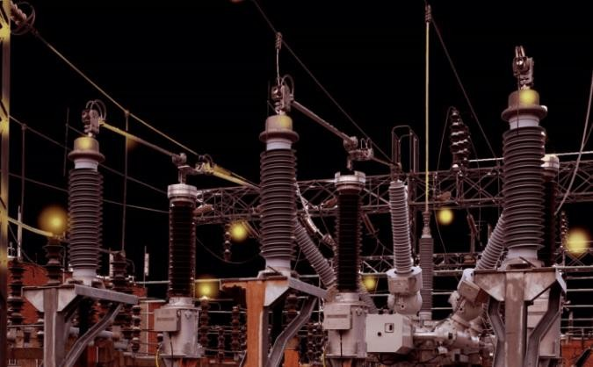
Module Title: - Installation and Maintenance of
Underground & overhead Low Voltage distribution system
Module code: EIS EPS2 M12 0123 Nominal duration: 90Hour

Prepared by: Ministry of Labor and Skill

January, 2023 Addis Ababa, Ethiopia

Contents

Acknowledgment 4
Acronym 5
UNIT ONE: BASIC CONCEPTS OF LV OVERHEAD AND UNDERGROUND DISTRIBUTION SYSTEM 7
1.1.Introduction to LV overhead and underground distribution 8
1.2.Components of Low voltage power distribution system 18
1.3.Drawing, plan, materials & schedules 20
1.4.OHS procedures & requirements 28
1.5.Tools and equipments 33
1.6. Team work & Communication skill………………………………………………
Self-check #1 44
UNIT TWO: INSTALLATION AND MAINTENANCE OF LV OVERHEAD AND UNDERGROUND SERVICES AND ASSOCIATED EQUIPMENT 46
2.1.Sustainable Energy principles and practices 47
2.2.Read & interpret Electrical drawings, plan & symbols. 47
2.3.LV overhead and underground distribution system installation 48
2.4.Earthling system installation 59
2.5.Associated hardware & fittings 65
2.6.Public lighting systems maintenance 69
2.7.testing techniques & procedures

Self-check #2 70
Operation sheet #1 72
Operation sheet #2 73
Operation sheet #3 74
Operation sheet # 4 75
Operation sheet # 5 76
Operation sheet # 6 77
LAP Test # 1 78
UNIT THREE: COMPLETION OF INSTALLATION & MAINTENANCE WORK 79
  - Testing & commissioning
3.2.Record & report work activies works 80
Reference Materials 82

Acknowledgment
Ministry of Labor and Skills wish to extend thanks and appreciation to the many representatives of TVET instructors and respective industry experts who donated their time and expertise to the development of this Teaching, Training and Learning Materials (TTLM).

Acronym

OHS Occupational Health & Safety
OSHA Occupational Health and Safety Administration PPEs – Personal Protective Equipments
LV lowVoltage
OH Overhead
DC Direct Current
AC Alternative Current
ADC analog to digital converter
DM digital multimeter
LAP Learning Activity Performance
URD underground residential distribution
MCB Miniature circuit breaker

Introduction to the Module

The Installation and Maintenance of Low Voltage overhead & underground service helps to know install, maintain and connect of LV Overhead/underground service lines, public lighting systems & associated equipment in electrical power system technology field.
This module is designed to meet the industry requirement under electrical power system technology occupational standard, particularly for the unit of competency: Installation and Maintenance of underground & overhead Low Voltage distribution system

This module covers the units:
- Basic concepts of LV overhead and underground distribution system
- Installation and maintenance of LV overhead and underground services and associated equipment.
- Completion of installation and maintenance work

Learning Objective of the Module
- Explain the concepts of LV overhead and underground services installation and maintenance
- Carry out installation and maintenance of LV overhead and underground services and associated equipment.
- Complete installation and maintenance of LV overhead services and associated equipment

Module Instruction
For effective use this modules trainees are expected to follow the following module instruction:
- Read the information written in each unit
- Accomplish the Self-checks at the end of each unit
- Perform Operation Sheets which were provided at the end of units
- Do the “LAP test” giver at the end of each unit.
- Read the identified reference book & website.

Unit One: Basic Concepts Of Lv Overhead AndUnderground Distribution System
This unit is developed to provide you the necessary information regarding the following content coverage and topics:
- Introduction to LV overhead and underground distribution.
- Components of LV overhead and underground services.
- Drawing, plan, materials & schedules
- OHS policies and procedures
- Tools and equipments
- Team work & Communication skill
This unit will also assist you to attain the learning outcomes stated in the in the above unit. Specifically, upon completion of this learning guide, you will be able to:
- Describe the fundamentals of LV overhead and underground distribution system.
- Identify the components of LV overhead and underground services.
- Identify drawings , Plans & use schedules properly
- Implement OHS workplace procedures and practices
- Obtain & identify tools, equipments, materials & associated hardware
- Demonstrate team work, communication skill & apply Kaizen

Introduction to LV overhead and underground distribution
Electrical power generation plants are located far away from the customers. Therefore, to deliver these generated electric powers for the customers; we need electric power transporting systems. For this purpose, transmission & distribution systems of conductors are developed.

Distribution system

- Definition: Distribution system is a part of electrical power system which distributes electrical power for local use. Based on their voltage level it is either Low or high Voltage distribution System. Its main function is to receive electric power from transmission sources and to distribute this power to consumers at various voltage levels with acceptable degrees of reliability.
- Classification of Distribution Systems: Distribution system is classify based on:

Nature of current:
    - AC. distribution system
    - DC distribution system

Type of construction:
  - Overhead electric power system
  - Underground electric power system.

Scheme of connection:
  - radial system
  - ring main system
  - Inter-connected system.

Types of Loads Connected to Distribution System
Generally, there are of two types of low voltage loads. These are:

  - Single Phase Loads: It operated at 220 V which are supplied by connecting them
between one phase and neutral wire of the supply system (see the figure). The examples are home appliances such as fans, bulbs, 1-phase motors etc.

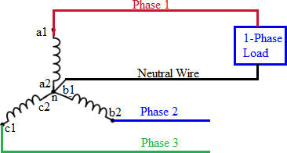

Fig 1.1: Single Phase Loads connection
  - Three Phase Loads: It operated at 380V which are supplied by connecting with three
phase wire (delta connected loads) or three phase wires with neural wire (star connected loads). Examples of 3-phase loads are 3-phase induction motors etc. The three phase loads are either star or delta connected 3-phase loads.
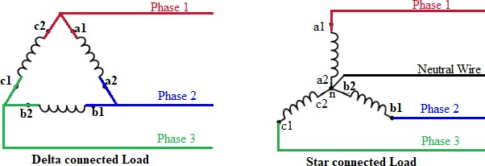

Fig 1.2: 3- Phase Loads connection

Distribution System Connection
All Distribution System Connection of electrical energy is done by constant voltage system. In practice, the following distribution circuits are generally used

- Radial System: In this system, separate feeders radiate from a single substation and feed the
distributors at one end only. it is employed only when power is generated at low voltage and the substation is located at the center of the load.

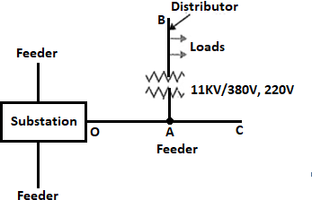

Fig 1.3: Radial system connection
This is the simplest distribution system connection circuit and has the lowest initial cost. However, it suffers from the following drawbacks:
  - The end of the distributor nearest to the feeding point will be heavily loaded.
  - The consumers are dependent on a single feeder and single distributor. Therefore, any fault on the feeder or distributor cuts off supply to the consumers who are on the side of the fault away from the substation.
  - The consumers at the distant end of the distributor would be subjected to serious voltage fluctuations when the load on the distributor changes.
  - Due to these limitations, this system is used for short distances only
- Ring main system: Loop circuit starts from the substation bus-bars, makes a loop through the area to be served & returns to the substation. The distributors are tapped from different points M, O and Q of the feeder through distribution transformers.

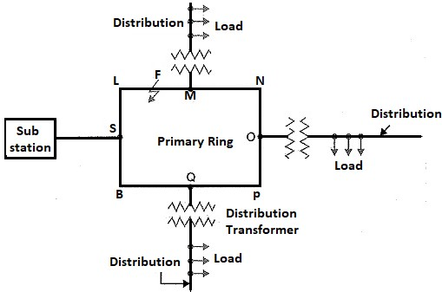

Fig 1.4: Ring main system connection The ring main system has the following advantages:

  - There are less voltage fluctuations at consumer’s terminals.
  - The system is very reliable as each distributor is fed via two feeders. In the event of fault on any section of the feeder, the continuity of supply is maintained. For example, suppose that fault occurs at any point F of section SLM of the feeder. Then section SLM of the feeder can be isolated for repairs and at the same time continuity of supply is maintained to all the consumers via the feeder SBQPONM.
- Interconnected system: When the feeder ring is energized by two or more than two gener- ating stations or substations, it is called inter-connected system. Fig. 1.10 shows the single
line diagram of interconnected system where the closed feeder ring ABCD is supplied by two substations S₁ and S₂ at points D and C respectively. Distributors are connected to points O, P, Q and R of the feeder ring through distribution transformers. The interconnected system has the following advantages :

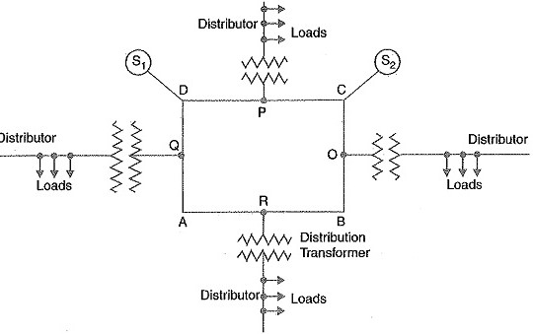

Fig 1.5: Interconnected system connection
  - It increases the service reliability.
  - Any area fed from one generating station during peak load hours can be fed from the other generating station. This reduces reserve power capacity and increases efficiency of the system.
- Requirements of a Distribution System installation
Some of the requirements of a good distribution system are

  - Proper Voltage – The voltage variations at consumer’s terminals should be as low as
possible. The statutory limit of voltage variations is ± 5 % (in Ethiopia) of the rated voltage at consumer’s terminals.
  - Availability of Power on Demand – The electric power must be available to the consumers in any amount that they may require from time to time.
  - Reliability – The modern industry is almost dependent on electric power for its operation. This calls for reliable service as much possible.

Purposes of power distribution system
- The primary purpose of an electricity distribution system is to meet the customer's demands for energy after receiving the bulk electrical energy from transmission or sub transmission
substation. There are basically two major types of distribution substations: primary substation and customer substation. The primary substation serves as a load center and the customer substation interfaces to the low voltage (LV) network.

Low Voltage power distribution system

It refers to distribution voltages below 1000V. It operates directly utilized without any further reduction. It is also known as low tension (LT) distribution system or secondary distribution system. It is the part of electrical power distribution network which carries electrical power from distribution transformer to energy meter of consumer. It is also done over short distances in some localized areas. Based on their construction it is either overhead or underground power distribution System.

Overhead power distribution system
- Definition: Overhead power distribution system is an electrical system in which the electric supply lines, conductors or other apparatus used or which may be used for
conveying, transmitting, transforming, distributing or supplying energy are placed above ground and in the open air. Overhead line is the one that uses bare conductors supported on a pole or tower for power transmission and distribution.
In this system, the line conductors are hanged in air with the help of transmission line supports installed at a certain distance. Overhead power distribution system consists:
  - Conductor: - made in bare aluminum or copper which carry electric power from the sending end to the utilization end.
  - Supports: - may be poles or steel towers that keep the line conductors at a suitable level above the ground.
  - Insulators: - used to insulate the line conductors from the support and hence from the ground which may otherwise cause fault and danger for living beings.

  - Cross-arm: - the part of an overhead line which provides housing and support to the line insulators.
  - Other auxiliary component of an overhead line is lightning arrestors, anti-climbing wires, phase and danger plates, stay rod, etc.
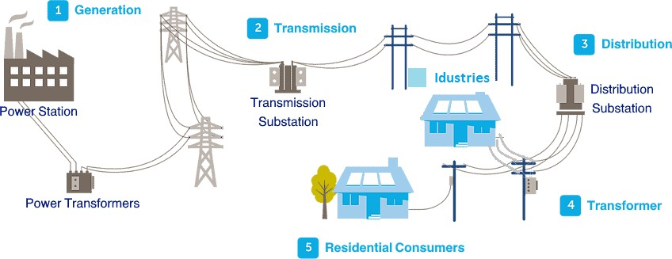

Fig 1.6: Overhead power distribution systems

- Advantage & disadvantage: - Overhead power distribution system has the following several advantages & disadvantages.

Advantages of overhead power distribution
  - It is easy to repair and maintain.
  - Lower cost. Overhead power lines are a less expensive way to get power to your home. They are also less expensive to repair and upgrade.
  - Quicker construction. Overhead lines can be installed relatively quickly, since there’s no need to trench.
  - Easier to spot damage and faults. Our linemen can see the entire line when its placed overhead, which makes it easier to spot outage causes or potential problem areas.
  - Can be built anywhere (not restricted by landscape).
  - Chances of electrocution are less as they run high above the ground.
  - Any voltage can be placed overhead.

Disadvantages of overhead power distribution
  - These lines visually pollute the areas where they are installed.
  - More disposed to bad weather, such as high winds, lightning etc.
  - More exposed to damage from trees and vegetation, this requires right of way trimming.
  - Exposed to blinks when animals and branches contact lines.
  - Susceptible to damage from vehicle collisions.
  - Less attractive.

Underground power distribution system:
- Definition: Underground power distribution system is an insulated cable which is much more hidden from view than a typical overhead circuits system, more reliable & safe. It
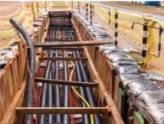
preferred in industries, sub-stations, railways and road crossings, servicing of residential installations and other similar locations. It operates at voltages ranging from 220 Volts up to 400KV. Now a day much new electric power distribution system is underground.
Fig 1.7: LV underground distribution system
When the low voltage lines are underground but the transformers and the medium voltage lines are overhead then it is called a hybrid overhead/underground electric power distribution system. But when the system is completely underground and the medium voltage lines are also buried/hidden and transformers are mounted on the ground level pads or in underground vaults. This type of power distribution system is more common in densely populated areas and in certain housing developments.

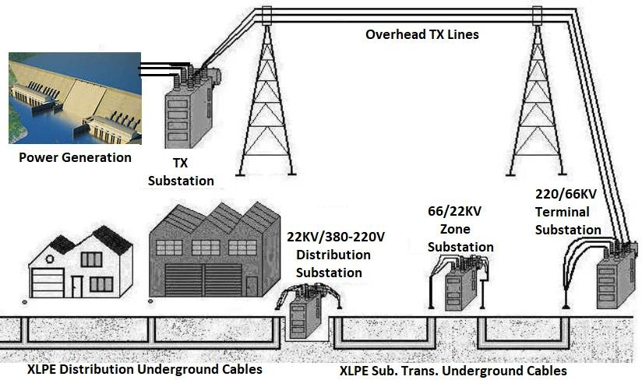

Fig 1.8: hybrid overhead/underground electric power distribution system.
For this reason, this is the main application for the “underground residential distribution” (URD) system and underground branches or loops supplying electricity to residential neighborhoods. Utilities also use an underground construction system for substation exits and drop to pad-mounted transformers serving the industrial or commercial consumers. Other uses are crossings: river crossings, highway crossings or transmission line crossings. All underground construction is widely used for decades in cities and now this system is appearing in more places.
- Advantage & disadvantage: - Underground power distribution system has the following advantages & disadvantages.

Advantages of underground power distribution
  - These lines have reduced EMFs (Electric and Magnetic Fields) and hence eliminate potential health issues.
  - It has lesser distribution losses.
  - It is less affected by extreme weather conditions and hence increases reliability of supply of power.

  - Not vulnerable to damage from tree branches; no right of way trimming required.
  - Less susceptible to damage from vehicle collisions
  - Less vulnerable to blinks when animals and branches contact lines.
  - More attractive. Some people choose to install underground power lines so the infrastructure doesn’t obstruct their view

Disadvantages of underground power distribution
  - Cost of underground cables is three times higher than overhead lines.
  - More expensive to build and repair.
  - Fed by overhead lines. At some point, all underground power lines are connected to overhead lines, which make them vulnerable to outages.
  - Susceptible to flooding
  - Limitations on voltages that can be buried underground.
  - Difficult to locate faults & maintain the defective parts
- Comparisons of overhead & underground power distribution system: there are several differences between overhead and underground power distribution systems. Shown in Table
1.1 as below.
Table 1.1 comparison

 | Overhead power distribution  system | Underground power distribution  system
Public safety | Less safe /more dangerous | More safer than overhead
Initial cost | Its initial cost is not expensive like underground system | Its initial cost More expensive due to the high cost of trenching, conduits, cables, manholes and other special equipment.  I.e. it may be five to ten times than that  of an overhead system.
Flexibility | It is much more flexible | It is less flexible
Faults | A chance of fault occur is very  high | A chance of fault occur is rare
Appearance | It has less appearance as all the  distribution lines are visible. | It has better appearance as all the  distribution lines are invisible.
Fault location  and repairs | it is easy to locate & repair on  this system. | If a fault does occur, it is difficult to  locate and repair on this system.

Current carrying capacity and voltage drop | Overhead line conductors has higher current carrying capacity in the same materials & sizes | Underground cable conductor has much lower inductive reactance because of closer spacing of conductors.
Useful life | Its useful life is half of  underground (more than 25 years). | Its useful life is much longer (more than 50 years).
Maintenance  cost | It has very high maintenance  cost | It has very low maintenance cost
Interference with communication  circuits | This system is affected by electromagnetic interference with the telephone lines. | No such interference with this system.

Components of Low voltage power distribution system

A typical distribution system can consist of

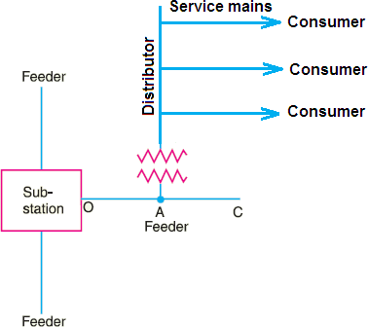

Fig 1.9: distribution system components
- Distribution Sub-Station: It is the electrical system which transfers power from transmission system to the distribution system of an area.

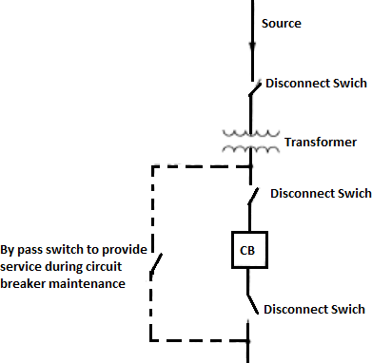
Fig 1.9: distribution substation layout
- Single source, single feeder substation
  - The one-line diagram of a single-source, single-feeder substation with the minimum equipment used.
  - A bypass switch is provided so service can continue during circuit breaker maintenance. The probability of a fault during circuit breaker maintenance is small, but still there as a result the transformer is protected by a primary fuse to back up the breaker, and provide some protection for internal transformer faults.
  - The minimum relaying is overcurrent on the secondary side of the transformer. The switches can be manually or motor operated.
- Feeders: It is a conductor which connects the distribution sub-station to the area where
power is to be distributed. The current in a feeder remains the same throughout its length because no tapings are taken from it. The main consideration in the design of a feeder being its current carrying capacity.

- Distribution Transformers: It is a step-down transformer in which primary and secondary
are delta and star connected respectively. It is also known as service transformer. The output voltage of distribution transformer is 380V in 3-phase system whereas 220V in 1-phase system in Ethiopia.
- Distributor: It is a conductor from which tapings are taken for supply to the consumers. Due to the taping is done at various places in a distributor, the current being not same throughout
its length. The main design consideration of a distributor is the voltage drop across its length because the statutory limit of voltage variations is ± 5 % of rated voltage at the consumer’s terminals.
- Service Mains: It is a small cable which connects the distributor to the consumer’s meter.

Drawing, plan, materials & schedules

Electrical Drawings: - Electrical drawings deal predominantly with circuits. Knowledge and understanding of the basic circuits used in low voltage power distribution system is necessary for those working with and interpreting electrical drawings. The four basic methods of showing electrical circuits are:
- Electrical working drawing is indicates/shows to the installer:
  - The locations of the device/where the device is found.
  - The relation between the devices.
  - The methods of the installation: That is in surface or on surface method.
  - The required materials for the given project.
- Working drawing should be:
  - Clearly representative
  - Easily understood
  - complete
  - Free from unnecessary notes (repetitive details)
  - Accurately drawn (proper also in line work)
  - Drawn with appropriate symbols and proper convention
  - Dimensional well

  - Drawn by referring building code
  - Proper in graphical representation
  - Proper titled (information panel)
  - Logically and rarely arranged to give a balanced layout on the short paper
  - Drawn in appropriate scale

Electrical plan
      - Electrical plan means simply pictorial representations / symbolic map of electrical circuits.
      - The electrical plan is containing details on public lighting wiring systems, fittings, protection devices, panel boards, electrical outlets, and electrical fixtures to be installed
in the building. Lighting fixtures are identified by symbols and letters on the lighting schedule.
      - Electrical receptacles, circuits, and circuit breakers are shown on the power
distribution plan. Specific information regarding the electrical wiring is given on the plan, but the exact location of wiring and cables is usually left up to the installing technician. The exact description of each lighting fixture is given on the fixture schedule. Electrical specifications give instructions about equipment and procedures and are sometimes listed under the General Contract specifications.
        - When planning preparing electrical installations the installer considers:
          - The nature of overhead & underground distribution system.
          - The availability of wiring material, equipment & fitting accessories.
          - Conditions of the environment.
          - Availability of man power.
          - The customer needs.

materials and fitting Accessories

- After design electrical working drawings the next step is obtain/gain materials & fitting accessories.
- To select public lighting accessories, electrical wiring material, equipment & fitting accessories, they must be considering:
  - Those wiring material, equipment & fitting accessories are approved or not
  - Qualities of those wiring material, equipment & fitting accessories.
  - Specifications those of wiring material, equipment & fitting accessories.
  - Their power consuming.
- Finally, after obtaining, the installer take responsibility to check the functionalities of
those wiring material, equipment & fitting accessories by using visual inspection or testing.
- Fitting Accessories are obtained in accordance with established procedures and to comply with requirements.
- Tools, equipment and testing devices needed to carry out the installation work are
obtained in accordance with established procedures and checked for correct operation and safety.

Symbol Identifications
Table 1.2 different types of symbols

No | Items | Electrical symbols
I
1 | - Energy meter | 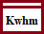
2 | - Instrumentation :- Ammeter, Voltmeter, Ohmmeter & Watt  Meter | 

3 |  | - Main Distribution Board  - Surface mounted  - Flash mounted  - Sub - Distribution Board  - Surface mounted  - Flash mounted | 
4 |  | - Single phase automatic circuit  Breaker
- Single phase thermal circuit
Breaker
5 |  | - Change over switch | 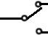
6 |  | - Three phase circuit breaker | 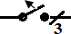
7 |  | - Current Transformer | 
8 |  | - Voltage Transformer
II. Switches that used for residential installations
9 | 9.1. One -way switches General symbols
9 | - SPST surface mounted  - SPST flash mounted
9 | - DPST surface mounted  - DPST flash mounted
9 | - TPST surface mounted  - TPST flash mounted
IV. Luminaries/ lamps that used for residential installations

11 | - Incandescent lamp generalsymbol  - Wall mounted lamp  - Lamp switch  - Emergency lamp  - Float light (projector)  - Exterior lamp (post top)
11 | - Fluorescent lamp  - Single Fluorescent lamp  - Double Fluorescent lamp  - Row of fluorescent lamp
11 | c) Ballast for Fluorescent lamp
11 | d) Starter for Fluorescent lamp | 
 | e) Fuse general symbol
 | f) 3Ø Fuse general symbol
 | g) Low voltage HRC fuse
 | h) Fuse disconnector
V. Electrical appliance which used in domestics
12 | a) Electrical appliance general symbol
12 | b) Kitchen appliance
12 | c) Electric cooker
12 | d) Electric range, general symbol
12 | e) Microwave cooker
12 | f) Baking oven
12 | g) Hotplate

 | h) Water heater | 
 | i) Washing machine
 | j) Cloth dryer
 | k) Dish washer
 | l) Fan
 | m) Air conditioner
 | n) Freezer
 | o) Deep Freezer
 | p) Door opener
 | - Motor general symbol  - 1Ø motor  - 3Ø motor | 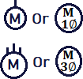
 | r) Star-delta motor starter
 | s) Direct on line starter
 | t) Generator
VI . Signal device which used in domestics
13 | a) Bell | 
13 | b) Bell indicator
13 | c) Horn
13 | d) Siren
13 | e) Call indicator panel
13 | f) Non automatic fire alarm device
13 | g) Fire alarm control & indicatingpanel

 | h) Smoke detector
 | i) Optical detector
 | j) Heat detector (fixed temperature)
 | k) Heat detector (rate of rise)
 | l) Flame detector
VI. Communication appliance
14 | a) Intercom
14 | b) Telephone exchange generalsymbol
14 | c) Automatic telephone exchange
VII . Radio, TV & accessories
15 | d) Antenna
15 | e) Amplifier
15 | f) Load speaker
15 | g) Radio set
15 | h) TV set
VII . Power supply unit
16 | a) Converter general symbol
16 | b) Rectifier (converter)
16 | c) Inverter
16 | d) Direct voltage supply
16 | e) Alternative voltage supply

 | f) Grounding
 | g) Fuse General symbol
III. Socket out let/ Receptacles that used for residential installations
16 | a) Conductor general symbol
16 | b) Flexible conductor
16 | c) Surface line
16 | d) In/ under surface line | 
16 | e) Junction of conductors for flush installation
16 | f) Junction of conductors for surface installation
16 | g) In surface installation method
16 | h) On surface installation method
16 | i) Wiring going upward
16 | j) Wiring going down
16 | k) Wiring going down & upward (wiring passing through vertical) | 
16 | Fixed connection | 
16 | Movable connection | 
16 | n) Branching box | 
16 | o) Underground line
16 | p) Overhead line | 
16 | q) Protective equipment (PE)

 | r) Single line
 | s) Telephone line
 | t) Radio line
 | u) Line to indicate component housing | 

OHS procedures & requirements

OHS is an area concerned with the development, promotion & maintenance of the workplace environment, policies and procedures that ensure the mental, physical and emotional well- being of workers, as well as keeping the workplace environment relatively free from actual or potential hazards that could injure.
Striking and damaging underground and overhead services is common in excavation work. Serious and often terminal injuries can result from hitting gas, electrical and water services, in addition to significant disruption to public services and critical business operations.
Steps to ensure & practicable, that workers and other people are not exposed to health and safety risks:

Identify hazards
Steps to ensure, so far as is reasonably practicable, that workers and other people are not exposed to health and safety risks:
- Find out what could cause harm. The following can help you identify potential hazards:
  - Observe the workplace to identify work activities and tasks that may come within an unsafe distance of overhead or underground electric lines.
  - Ask your workers, contractors and crane or plant operators about potential hazards they can see at your workplace or site.
  - Review your incident and injury records including near misses.
  - an access authority confirming the electric lines have been de-energized, or another written document from the Electricity Supply Authority that allows people to work in a no go zone.

Risk control
- Take action to control the risk. The law requires a business or undertaking do all that is reasonably practicable to eliminate or minimize risks.
- The ways of controlling risks are ranked from the highest level of protection and reliability to the lowest.
- The first thing to consider is whether hazards can be completely removed from the workplace.
- The electric line away from the work area or replacing existing overhead electric lines with underground electric lines e.g. cables.
Note: De-energizing or moving electric lines should be arranged with the Electricity Supply Authority as soon as possible because, depending on the circumstances, this may take some time to arrange.
- If it is not reasonably practicable to completely eliminate the risk then consider one or more of the following options in the order they appear below to minimize risks, so far as is
reasonably practicable:
  - substitute the hazard for something safer e.g. use alternative plant which cannot enter an unsafe zone, non-conductive tools designed to reduce the possibility of direct contact
with the electric line, or ultrasonic measuring devices instead of the mechanical types for measuring heights of overhead lines
  - isolate the hazard from people e.g. erect a physical barrier to prevent any part of the plant
or equipment or a person or anything held by a person, or attached to a person entering Zone
  - A physical barrier should be made of non-conductive material like wood or plastic and be
erected safely. This may require isolating the electricity supply while the barrier is installed
  - Use engineering controls e.g. limit movement of plant with mechanical stops, fit plant
with programmable zone limiting devices, and mechanically limit slew speed of a crane to slow or use electrically insulated plant and equipment.

- If after implementing the above control measures a risk still remains, consider
the following controls in the order below to minimize the remaining risks, so far as is reasonably practicable:
  - use administrative controls e.g. warning signs to indicate the location of
overhead electric lines and defined work areas and supervising work to ensure safe work procedures are followed, and

Personal Protective Equipments (PPEs).
      - Safety helmets: to protect the upper part of workers' heads from falling or flying objects, impact, burns and electrical hazards.

Fig1.10: Safety helmet
      - Safety Gloves /insulating (rubber) gloves with leather protectors: to protect the user's hands & fingers from unnecessary wounds such as cuts, electric shock, splinters, skin punctures or heat and chemical burns.

Fig 1.11: Safetyglove
      - Safety cloths: to protect personnel from hazards that is caused by extreme environmental conditions, or a dangerous work environment.
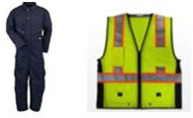

Fig 1.12: Safety close

      - Safety belt: for work positioning shall consist of a waist belt, a work positioning cord and relevant connectors.


Fig 1.13: Safety belt

      - Safety shoes: to protect foot injuries due to heavy falling or rolling objects, sharp penetrating edges, rotary machinery, hot objects, splinters, electricity, chemicals or even bad weather etc.


Fig 1.14: Safety shoes
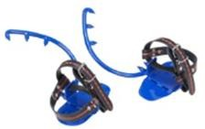
      - Safety electrical pole climber: Works at heights performed by teams of energy and telecommunication services requires appropriate protection against falling. Using pole climbers are one of the main pieces of equipment that ensures safety during such activities.
Fig 1.15: Safety pole climber

Planning and preparation
- Before starting work careful planning and preparation is essential to ensure work is done safely.This can include:

  - understanding important stages of the planned work and how to deal with changes as thework proceeds
  - understanding what plant will be used in the operations
  - identifying possible hazards and risks associated with the work
  - talking to the Electricity Supply Authority or asset owner about the proposed work if thereis a risk of people, plant or things coming within an unsafe distance of an overhead or underground electric line
  - ensuring compliance with all conditions imposed by the Electricity Supply Authority for thework
  - a competent person inspecting visual indicators on electric lines like tiger
    - tails before starting operations each day—if visual indicators have moved or been damaged the Electricity Supply Authority should be contacted so they are replaced or relocated in the correct position
  - ensuring an effective communication system is in place between workers at the site
  - providing training and verifying qualifications and competency of workers
  - providing information and instruction to operators and other workers about control measures to eliminate or minimize electrical risks
  - supervising workers to ensure safe work procedures are followed
  - checking the plant and equipment including limiting devices are working properly
  - checking proximity of people, cranes, mobile plant, material and tools to overhead electriclines
  - checking proximity of people to cranes and mobile plant
  - ensuring safe workplace entry and exit
  - checking emergency plan and rescue procedures

  - ensuring emergency equipment is provided and readily accessible on
    - site including first aid kits and fire-fighting equipment suitable for electrical fire
  - ensuring approach distances are relevant for the authorization levels of the workers doing the work
  - ensuring a safety observer is used to warn people and plant operators when they are likely to come closer than the approach distances and zones, and
  - Managing the impact of environmental factors including storms and lightning in the area.When preparing for the work you should ensure no new hazards are created.

Environmental Health and Safety

The procedures to promote a safe working environment where hand and portable power tools are used:
    - Establish regular tool inspection procedures and provide good repair facilities to ensure that tools will be maintained in safe condition.
    - Establish a procedure for control of tools such as a check-out system at tool cribs.
    - Provide proper storage facilities in the tool room and on the job.
    - The employer is responsible for the safe condition of tools and equipment used by employees, but the employees have the responsibility for properly using and maintaining tools.

Tools and equipments
Tools: they are a part of our everyday lives and help us to easily perform tasks that otherwise would be difficult or impossible. However, these simple tools can be hazardous & have the potential for causing severe injuries when used or maintained improperly. Special attention toward hand and power tool safety is necessary in order to reduce or eliminate these hazards. Workers depend upon the tools for accuracy, availability, ability, comfort and safety. This contains electricians who provide our homes illuminated, connected, and energy-efficient. So, we have made the electrician

tools list to guide and to know what types of tools select in the field of electrical installation.
- When selecting tools you should consider size, purpose & quality.
  - Always select the correct type & size of tools for the work to be done.
  - Tools should be purpose specifically for electrical work.
  - The select of quality tools last longer which saves replacement cost.
  - Select tools that are designed for the task.
  - Select comfortable tools to hold and use.
  - Inspect tools before use and keep them well maintained.
  - Inform, instruct and train workers in the selection, use and maintenance of hand tools.
  - Replace hand tools with power tools to reduce the level of force required to do the task.
- Neon tester: - It is a measuring device which measures the polarity of the wiring system.

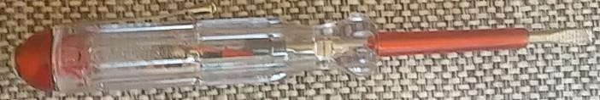

Fig 1.16: Neon tester

- Hacksaw: a fine-tooth hand saw with a blade held under tension in a frame, used for cutting materials such as metal or plastics.

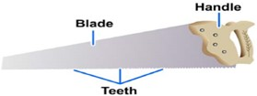
Fig 1.17: Hacksaw

- Pliers: They are main essential hand tools for electricians. They are mainly used to cut wire, grip, twist, bend or straighten wires. Every professional technician puts a bunch of

pliers in its toolbox or truck, including crimping pliers and stripping pliers which are used to tighten locks, fittings, and caps.
  - Lineman (combination) pliers: It is a standard electrician’s tool, featuring rubber sheathed grips and a plier head combined with a cutting blade. The blade is located in the two inner edges of the plier's head, by the pivot, and is used for stripping, twisting, cutting & pulling of wires will working.
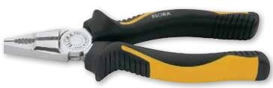
Fig 1.18: Lineman (combination) plier

  - Diagonal Cutting Pliers: Diagonal cutting pliers, sometimes called side snips or dikes, are used to cut wires. They are specially designed with a cutting edge that goes down to the tip of the jaws, allowing you to get into tight areas to trim wires.

Fig 1.19: Diagonal cutting plier

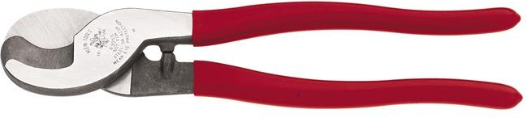
  - Cable Cutter: tools that have been designed to properly cut either wire or cable with minimal damage to the insulation or internal conductors of the wire or cable. Having a clean cut on a wire or cable can improve the quality of an electrical connection.
Fig 1.20: Cable Cutter:

Insulation Removing tools:
      - Utility (Electrical) knife: A utility knife, or box cutter, is handy for cutting sheathing from non-metallic (Romex) cable, to cut off electrical tape, and to open cardboard boxes.
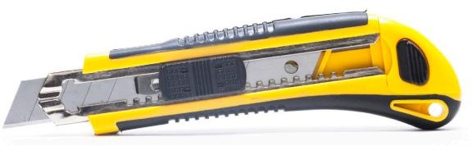
Fig 1.21: Utility knife
- Circuit tester (Voltage tick): Perhaps the most important specialty electrical tool you can own is a voltage tester. It is used for a quick safety check to make sure there's no voltage in

an electrical wire or device before you start working on it. Non-contact voltage testers, powered by batteries are the simplest and safest types of testers because they can detect electricity just by being near an outlet slot or wire.
Fig 1.22: circuit tester
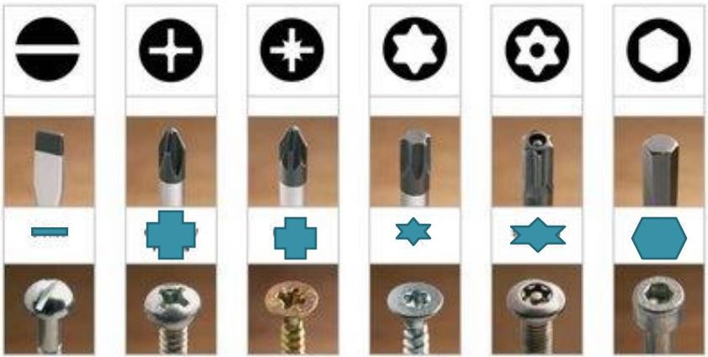
- Screw drivers: Electricians keep screwdrivers with them at all times, for loosen and fasten various pieces such as cover plates, outlets, switches and many other devices. It's best to have a few different lengths of Phillips screwdrivers, as well as #1, #2, and #3 tip sizes
Fig 1.23: Screw drivers

- Hammer: It is a tool used to deliver an impact to an object. They are mostly used to drive
nails, fit parts, or break up objects. There are many types of hammers designed for specific uses, which vary in shape and structure. Most hammers include a handle and a head, with most of the weight in the head. The two main types of hammers are claw and ball peen.
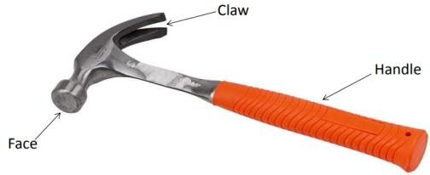
Fig 1.24: Claw hammer

- Tap-meter: A standard tape measure is used for all kinds of field measurements, such as setting heights for switches and outlets, centering lighting fixture boxes, and marking surfaces for cutouts.
Fig 1.25: Tap-meter
- Wrenches: it is a tool used to provide a mechanical advantage when torque is applied to hold and turn bolts, nuts, screws, and pipes. They are divided into two categories:
  - Nonadjustable: - They are made to work on a particular size of bolt, nut, screw, or pipe.
- Open-End Wrench: - All open-end wrenches have open jaws on one or both ends of the wrench. Most jaw openings are offset from the shank portion of the wrench by 15 degrees. The wrench length is determined by the size of the jaw opening. It grips on two sides of the nut or bolt head, with an opening that can access fasteners that a closed, or box, wrench might not reach. It has openings of different sizes on each end. The opening should fit the nut or bolt exactly to prevent mutilating the edges of the fastener.



Fig 1.26: Open end wrench
- Combination Wrench: - It has a box wrench and an open-end wrench on opposite sides of the same tool. The two ends are usually the same size.

Fig 1.27: Combination wrench
  - Adjustable: - They are made to tighten or loosen a particular size of bolt, nut, screw, or pipe. It has an adjustable end opening that comes in locking and non-locking styles. The locking style can secure the jaws in the desired position, so when properly adjusted, it will not slip. The non-locking style requires frequent readjustment and is prone to slipping. The adjustable wrench is used to tighten or loosen nuts and bolts, but never on a fastener that has been rounded off.
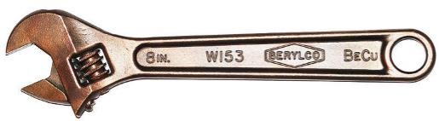
Fig 1.28: Adjustable wrench
- Pipe Wrenches: - used for turning pipe and other round objects. Teeth on the jaw will dig into the material being tightened and may damage. it do not use a pipe wrench to turn a bolt or a nut unless the components is already damaged. Do not use on hardened surfaces - may dull or chip the jaw teeth. There are four basic types of pipe wrenches: Still son wrench, Spud wrench, Strap wrench & Chain wrench.

Still son wrench Spud wrench

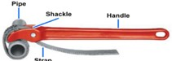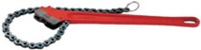
Strap wrench Chain wrench
Fig 1.29: Pipe wrench
- Electric portable drill: it is a tool used for making holes in metallic sheets or other surfaces. In electrical systems, it is used during the construction of various electrical
equipment. It is driven by an electric motor. to consider the following points before selecting a drill:

- There should be a wide range of speeds for drill.
- Texture and contour of the drill should be such that it is easy to grip.
- The drill should be of enough rating to work comfortably with voltage s of the working are
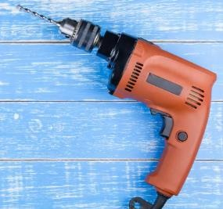
Fig 1.30: Corded drill

Equipments
Electrical measuring device and instruments are sensitive and delicate so extra care is necessary in handling them. These are used to measure currents, voltages, resistances, wattages and other important elements in electrical works.
- Phase rotation tester: - It useful portable devices designed to check the direction of phase rotation in motorized machinery with three-phase supplies. These testers provide LED indication of both clockwise and anti-clockwise rotation.

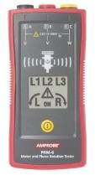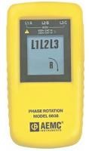

Fig 1.31: Phase Rotation Meter

- Load testers: A test load is used to provide a load between an active and neutral to allow measurements of voltage or current to be taken. The load should be 9 amps or greater.
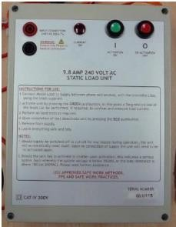

Fig 1.32: Analog multi-meters

- Multimeter: The name implies it measures multi things.

- Analog Multi-meters:- Analog multi-meters are instruments that are used to measure electrical quantities such as Dc voltage, DC current, AC voltage & resistance

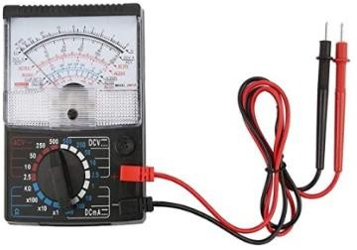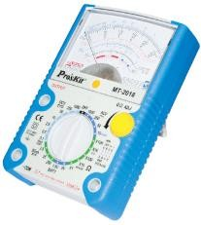

Fig 1.33: Analog multi-meters

- Operation of Analog Multimeter:- The analog multimeter is very easy to use. With the knowledge of how to make voltage, current and resistance measurements, it is only necessary to know how to use the analog multimeter. For the measurement of current and
voltage, there is no need of batteries in the analog multimeter. But, if resistance is to be measured, batteries need to be installed in the multimeter.
- Digital Multi-meters:- The name implies, a digital multimeter is designed to perform a variety of measuring tasks. With multiple inputs, settings and reading types it can give
accurate readings in most situations. It gives more accurate results. It is used to measure electrical quantities such as voltage, current, resistance & capacitance by rotating the knob to the labeled mark of the quantity that is to be measured. It can also be used for checking continuity of an electrical circuit by placing both probes at the two ends between which continuity is required to be observed.
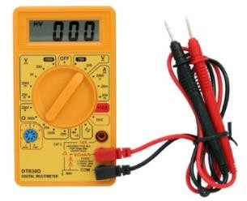
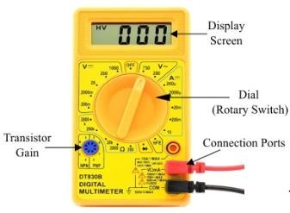
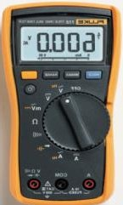

Fig 1.34: digital multimeter

Measurements using Digital Multimeter
  - In AC Voltage Mode − the applied input voltage is fed through a calibrated, compensated attenuator, to a full-wave rectifier followed by a ripple reduction filter. The resulting DC is fed to analog to digital converter (ADC) and finally to the display system.

For Current Measurement −
In DC Current Mode − the drop across an internal calibrated shunt is measured directly by the ADC.
In AC Current Mode − After AC to DC conversion, the drop across the internal calibrated shunt is measured by the ADC
  - In Resistance Mode − in the resistance range, the digital multimeter operates by measuring the voltage across the externally connected resistor, resulting from a current flowing through it from a calibrated internal current source.
- Operation of Digital Multimeter:- With the knowledge of how to make voltage, current and resistance measurements, the operation of DMM is quite easy. It is necessary to install a battery in the DMM to power it.
- Megger or Digital insulation tester: - use a high voltage, low current DC charge to measure the insulation resistance of the wires to identify current leakage and faulty or damaged insulation, which can lead to arc faults, blown circuits, and risk of electrical shock or fire.
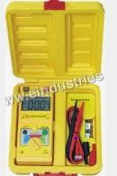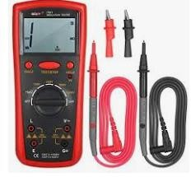
Fig 1.35: Digital insulation tester
The Megger insulation tester is a small, portable instrument that gives you a direct reading of insulation resistance in ohms or mega ohms. For good insulation, the resistance usually reads in the mega ohm range.

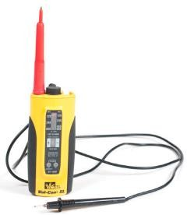
- Continuity tester: A small, battery-operated continuity tester costs less than $10. It can be used to determine whether wiring is broken and whether electrical circuits are complete.
Fig 1.36: Continuity tester
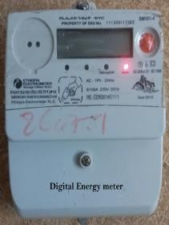
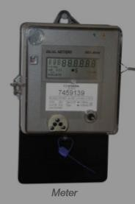
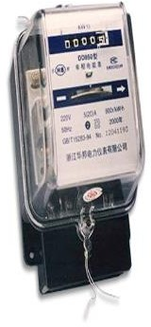
- Energy meter: - When the electricity comes into a house, it first; all goes through a energy meter so this meter measure how many ‘unit’ (kwh) of electrical energy is used. The reading is either digital or analogue system.
Fig 1.37: energy meter
- Digital Watt meter: An instrument for measuring in watts the power flowing in a circuit. An instrument for measuring in watts the power in an electric. It is used to measurements of power in distribution and transmission power.
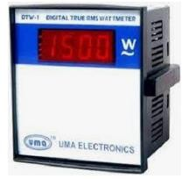
Fig 1.38: Digital watt-meter

Self-check #1

Choose the correct answer from the give alterative
  - refers to distribution voltages below 1000V
    - LT distribution B. MV distribution C. HV distribution D. all
  - Which one of the following is type of Distribution system based on the nature of construction?
    - Ac Distribution system B. overhead Distribution system
C. radial system D. all
  - Which one of the following is the simplest distribution system connection type?
    - radial system B. ring main system C. interconnected system D. none
  - one of the following measuring instruments is used to test polarity of electrical lines
    - multi-meter B. tap-meter C. neon tester D. all
  - While using measuring instruments, ensure that measurement is taken with:
    - appropriate instruments B. functional instruments
C. The correct instrument D. all
  - Which one is not categorized under had tools to measure DC current?
    - power driller B. test light C. hacksaw D. pliers
  - Basic safety rules for hand and portable powered tools include –
    - Keeping tools in good condition. C. Performing regular maintenance
    - Using the right tool for the job. D. Examining for damage before use.
E. All of the above.

II. Mach column “B” to column “A” A B
1: Overhead distribution A. always install using cables
2: Underground distribution B. install using bar conductors
3. Public lighting C Street light
4. Associated hardware D. CB
5. Components of distribution E Distribution Transformer

1.

Give short ad precise answers for the following questions
is the other name of low voltage distribution line?

- What is distribution system?
- used to test the electrical variables with a given electrical circuits.
- is a very important safety factor that you should utilize when operating hand & power tools.
- List at 4 causes of accidents while using unsafe hand and power tool.

Unit Two: Installation And Maintenance Of Lv
Overhead And Underground Services And Associated Equipment.
This unit is developed to provide you the necessary information regarding the following content coverage and topics:
    - Sustainable Energy principles and practices.
    - Read & interpret Electrical drawings, plan & symbols.
    - LV overhead and underground services installation
    - Earthling system installation
    - Associated hardware & fittings
    - Public lighting systems maintenance
    - testing techniques & procedures
This unit will also assist you to attain the learning outcomes stated in the cover page. Specifically, upon completion of this learning guide, you will be able to:
- Apply sustainable energy principles and practices
- Read, use & interpret electrical drawing, plan & symbols.
- Install, inspect and test of LV overhead/underground services, associated hardware & Public lighting systems.
- Maintain, inspect and test LV overhead/underground services, associated hardware & Public lighting systems.
- Take unplanned events during installing and maintaining of LV
overhead/underground services & associated equipment.

Sustainable Energy principles and practices
Sustainable energy can be defined as a form of energy that can be utilized again and again without putting a source in danger of getting depleted, expired, or vanished.
Sustainable energy requires a balanced composition between energy security, economic development, and environmental protection. It encompasses energy systems, which are based on three core dimensions: energy security, social equity, and environmental impact mitigation.
The use of energy is considered sustainable if it meets the needs of the present without compromising the needs of future generations. Definitions of sustainable energy typically include environmental aspects such as greenhouse gas emissions, and social and economic aspects such as energy poverty.
The most popular sources of sustainable energy, including wind, solar and hydropower, are also renewable. Biofuel is a unique form of renewable energy, as its consumption emits climate-affecting greenhouse gasses, and growing the original plant product uses up other environmental resources.

Read & interpret Electrical drawings, plan & symbols.
When performing any kinds of electrical works successfully; the worker must require the ability to read and interpret electrical drawings, diagrams, plans and understand circuit symbols and components. If an electrician misinterprets a drawing, diagram, plans & symbols when installing public lightings, Residential & industrial wiring, he/she exposes electrical wiring systems, devices & apparatus for faults. Knowing how to properly take information from an electrical drawing or diagram and apply it to the real world is essential for electricians.
  - Steps to read and interpret electrical drawings & plans of low voltage distribution system
    - Educate your self about basic electricity
    - Know your working capacity & ability.
    - Understand / know different electrical symbols correctly.

    - Identify & select the required materials & accessories used for the given project based on their specifications such as Current ratings, sizes, qualities & voltage capacities.
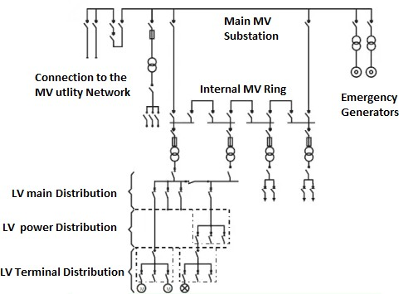
Fig 2.1: Single Line diagram

LV overhead and underground distribution system installation
- Before installing the overhead line or underground cable distribution systems & components; the trainee’s must be inspect & test:
  - The functionalities of components which used for low voltage power distribution system.
  - Any defects or modifications to public lighting accessorise, the electrical wiring components & connectors
  - The corrosiveness of selected components & accessorise specifications
  - The qualities of power distribution system components.
  - Sit selection & preparation
- After installing low voltage power distribution systems diagram & components; the trainee’s must be:
  - Inspect & test the distribution system, components & accessories are correctly installed based on the given plan.
  - Inspect & test the installation system is properly connected.

  - Check the right distribution system, components & accessories to the right place, functions & specifications.
  - Test the functionalities of final circuits of low voltage distribution system.
LV overhead service installation: - to install a new LV overhead power distribution system, the installer must be considering the following proper design criterias.
- Individual building demand loads: - Determine proposed demand loads utilizing calculation methods.
- Coincident peak demand: - Determine facility peak demand utilizing calculation methods.
- Number of circuits and voltage level: - Select number of circuits and voltage level. Number of circuits will depend upon location and magnitude of individual loads.
- Other considerations: - Balance single phase loads on multi-phase circuits. Design large starting loads to have a minimal effect on demands.

Install Overhead distribution lines
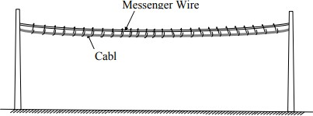
      - When overhead lines installed using cable, the cable shall be installed not to exact tension to cables directly. We use a messenger wire for hanging.
Fig 2.1: Messenger Wire and Cable

Connecting Methods of Overhead Conductors installation
  - Single Connection
    - Twist joint

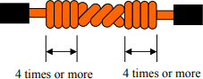

    - Britannia joint
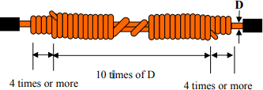
  - Separate Connection
    - Narrow conductor

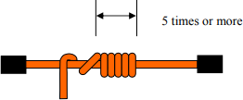
,
    - Thick conductor

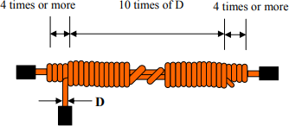
,

  - Splicing Devices
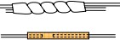
Table 2.1: Examples of Splicing Devices

Type | Classification of usage | Figure and usage situation
Straight conductor) Sleeve | Connection conductors when tension acts the connection point |  | Twist (applied to Cu conductor) Compression (applied to Cu, Al  conductor)
Branch Sleeve | Connection a conductor used as a main line and a conductor used as a branch line or jumper, when tension acts the connection point |  | Compression (applied to Cu, Al conductor)
Bolt-type  Clamp-down Connector | Connection conductors when  tension does not act the connection point | 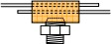 | Clamp-down  (applied to "Cu and Cu" or "Cu and Al")

  - Straight Type
  - Branch Type
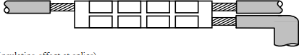
Note: When splicing insulated conductors, or an insulated conductor and a cable, the splice shall be sufficiently covered with an insulating material having an insulating power equal to or more than the insulated conductor or a splicing device having equal or larger insulating effect shall be used.

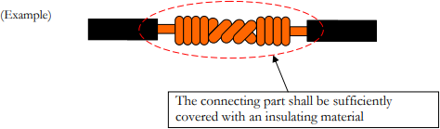

Install branches of Overhead Lines
  - If branching of overhead lines is made on the overhead line, no tension is exerted on the electrical conductor at the branch.
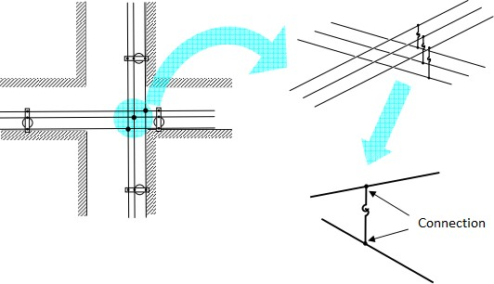
Fig 2.2: Example of Branching of Overhead Lines

LV underground distribution cable installation
Low voltage wires should be installed a foot away, at a minimum, from the home's main electrical wires, running parallel with all the cabling. The higher voltage on electrical cables can create signal interference that may affect the data cables.
- Cable Laying and Installation: Underground cables are, of course, meant to be installed or laid under the ground. The reliability of underground cable network highly depends upon proper laying of cables, quality of cable joints, branch connections, etc. There are a few points that need to be considered whilelaying and installing underground cables, which are
  - selection of the route
  - side of the street
  - route with least obstacle should be preferred

  - future load growth should be kept in mind
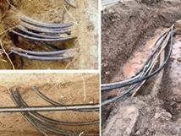

- Cable selection
Fig 2.3: undergrounding cable

Table 2 .2 Current Rating for LT Cables

No. of Cores | Size in sq. mm | Rated Current | Derated Current
4 | 25 | 195 | 85
4 | 50 | 133 | 120
4 | 150 | 249 | 185
4 | 300 | 365 | 275

- Methods of Cable Laying: There are various methods of cable lying, such as:
  - laying directly into the ground
  - drawing in ducts
  - laying on racks in air
  - laying on rack inside a cable tunnel
  - laying along building and structure
- Direct laying to the ground: It is the most popular as it is simple and cheap. This method is the most popular as it is simple and cheap. The cables to be laid using this method must have the serving of bituminized paper and hessian tape so as to provide protection against corrosion and electrolysis.

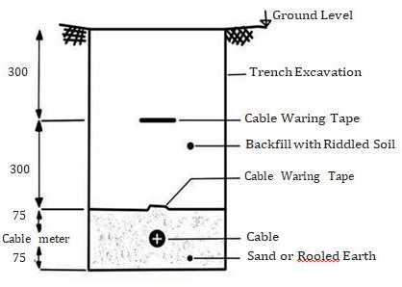

Laying Procedure
Fig 2.4: Direct laying

  - A trench of about 1.5 meters deep and 45 cm wide is dug.
  - Then the trench is covered with a 10 cm thick layer of fine sand.
  - The cable is laid over the sand bed. The sand bed protects the cable from the moisture from the ground.
  - Then the laid cable is again covered with a layer of sand of about 10 cm thick.
  - When multiple cables are to be laid in the same trench, a horizontal or verticle spacing of about 30 cm is provided to reduce the effect of mutual heating. Spacing between the cables also ensures a fault occurring on one cable does not damage the adjacent cable.
  - The trench is then covered with bricks and soil to protect the cable from mechanical injury.

- Draw in system: Ducts or conduits of cast iron or concrete or glazed stone with manholes are placed at suitable locations along the cable route. The manholes are used for pulling the cable in position
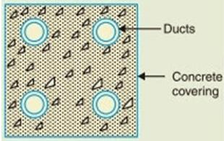

Fig 2.5: Draw in system
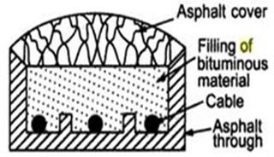
- Solid system: Underground cables are laid in open pipes or troughs along the cable route. The troughs are usually made of asphalt, stoneware or cast iron. Asphaltic compound is used for filling the troughs once the cable is laid in position
Fig 2.6: solid system
Challenges of underground cable laying
- The various challenges in the process of laying underground cables are as follows:
  - High installation cost: The initial installation cost for an underground cable system is high as costs for restoration of roads and surrounding infrastructure add to the total cost.
  - Permissions and approvals: Before starting with the digging process, a range of approvals need to be obtained from relevant authorities.
  - Cumbersome modifications: Inability to locate lines and particular sections makes making additions or modifications to the line tedious.
  - Obstacles in cable route: The cable route needs to be designed keeping in mind any obstacles that may be there in the route.
  - Insulation requirements: Layers of insulation are needed for underground cables to withstand the high voltage flows.

Associated hardware Installation
- pole fuse units
- Select the appropriate unit for the application (Voltage, Current, BIL, and Interruption Rating).
- Remove the unit from the box and inspect for loose pieces, damage or cracks on the porcelain or silicone insulator body. Fuse Base Assembly
- When supplied with a back bracket, secure the bracket first to the cross arm and make sure all hardware is tight.
- Locate the external tooth lock washer on the carriage bolt located on the L bracket, then, insert the back bracket on top of it followed by the spring washer and the nut.
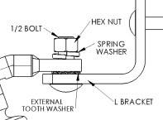
- Tighten the assembly once the cutout is aligned in a way to provide the maximum clearance between the phases and adjacent equipment.
- To connect the unit to the phase and load connectors, loosen the top and bottom nuts, taking precaution not to remove the nut completely from the bolt, and inspect the terminals
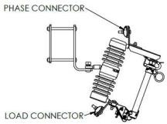
for damage or contaminants.

Fuse Holder Assembly
- Confirm that the fuse holder and fuse links are the correct ones for the application by reviewing the label located on the fiberglass tube and the fuse link package. Note:
some fuse holders will require an arc shorting rod to archive the maximum interruption rate.
- Remove the cap from the fuse holder and insert the fuse link inside the fuse holder. If
the fuse holder uses an arc shorting rod, then remove the bottom and assemble it to the arc shorting rod by firmly hand tightening both pieces. Note: do not damage or loosen the components of the fuse link.
- Once the fuse link has been inserted completely, re-assemble the cap and tighten it with a wrench to avoid gas leaks during interruption.
- Loosen the bolt located at the fuse holder trunnion hinge.
- Hold the fuse holder at the bottom end and rotate the trunnion hinge and the flipper until the flipper makes contact with the stop located at the bottom casting of the fuse
holder.
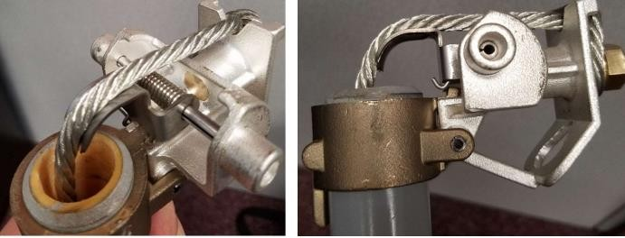
- Holding the previous step in position, locate the fuse link lead above the flipper and around the bolt following the appropriate arrows. The lead must be kept tight at all times. Finally, tighten the bolt with a wrench to hold the assembly together.

Installing the Fuse Holder into the Fuse Base
- Using a hot stick, insert the tool through the front or lateral holes located at the fuse holder trunnion hinge and lift the fuse holder to the level of the fuse base.
- Place the fuse holder into the hinge and remove the hot stick. 14. Insert the hot rod into the ring located at the top ca

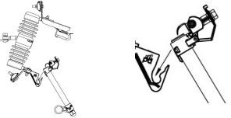
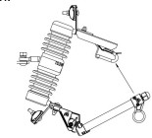
- Insert the hot rod into the ring located at the top casting of the fuse holder and rotate the assemble halfway from closing position.

- With a single firm motion, close the fuse holder against the fuse base. Once the unit is
closed, remove the hot stick from the fuse holder paying attention not to disturb the connection.
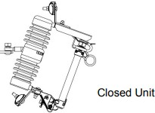

Service Pole Installation
Service mast installation for overhead service entrances may be surface-mounted or flush- mounted.
The customer must provide all the equipment provided meter, which plugs into the customer’s meter socket.

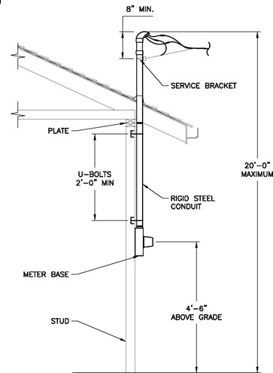

Fig 2.7: Service Pole Installation

Earthling system installation
- Earthed systems are designed and installed so that the protective devices provided in the circuit will operate and remove the faulty circuit from the system in case of any earth
Fault. In this way the faulty circuit can be isolated from rest of the system even in case of first earth fault before any damage.
- In earthed system, any earth fault is detected and isolated by automatic disconnection of supply.
- Earthing of non-current carrying metal work & conductor which is essential to the safety
of human life, animals and property is known as Equipment Earthing or Protective Earthing.

Table 2.3. Description letters
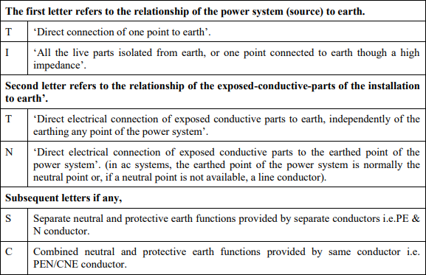

A. Connecting Earth system In LV Installations
- Protective conductor: A conductor used as a measure of protection against electric shock and intended for connecting any of the following parts:
  - Exposed conductive parts,
  - Extraneous conductive parts,
  - Main earthing terminal, and
  - Earthed point of the source or an artificial neutral.
- The letters used in European Standards are derived from the French language:
  - T - Terre which represents Earth
  - N – Neutre which represents Neutral
  - S – Separe which represents Separate
  - C – Combine which represents Combined
  - I – Isole which represents Insulated

Electrical supply systems are further classified as TN system, TT system and IT system based on system earthing. They are as given under.
- TN System it has one or more points of the source of energy directly earthed at source end. The exposed and extraneous conductive parts of the consumer installation are connected by means of protective conductors to the earthed point of the source. In this way, there is a metallic return path for earth fault currents to flow from the installation to the earthed point(s) of the source. TN systems are further sub-divided into TN-S,TN-C and TN-C-S systems.
- TN-S System : In the system where separate conductors each for neutral and
protective functions are provided throughout the system is called as TN-S system (as shown blow in figure).
  - For 230 V single phase domestic/commercial supply
- The protective conductor (PE) is the metallic covering (armour or sheath of the cable supplying the installation) or a separate conductor.
- All exposed conductive parts of an installation are connected to this protective conductor via main earthing terminal of the installation.
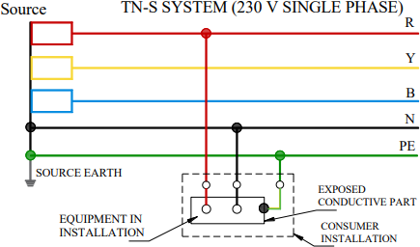
Fig 2.8: TN-S System for 230V Single Phase

  - For 415 V three-phase domestic/commercial supply
- 415 V three phase domestic/ commercial supply having three phase and single phase loads, all exposed conductive parts of the installation are connected to protective conductor via the main earthing terminal of the installation.
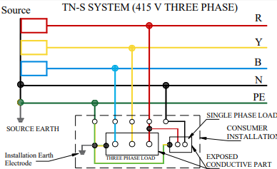
- It is necessary to install an independent earth electrode within the consumer’s premises and same to be connected as shown in the figure given below
Fig 2.9: TN-S System for 415 V three-phase domestic commercial supply
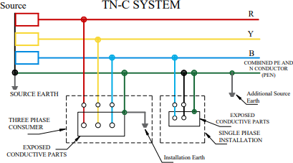
- TN-C System: In TN-C system, neutral and protective functions are combined in a single conductor throughout the system.
Fig2.10: TN-C System
  - All exposed conductive parts are connected to the PEN conductor.
  - For three phase consumer, local earth electrode has to be provided in addition

- TN-C-S System: In TN-C-S system, neutral and protective functions are
combined in a single conductor (PEN conductor)only in part of the system. Usually, the neutral and protective functions are combined in a single conductor up-to consumer’s premises and separate at installation side as shown in the figure below. All exposed conductive parts of an installation are connected through protective conductors. All the protective conductors/connections run separately inside consumer’s premises and connected to main earthing terminal (MET)and then to the PEN conductor.
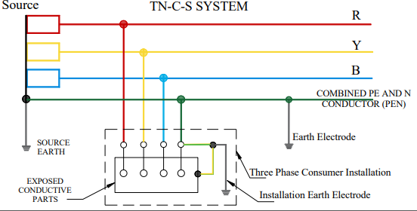
Fig 2.11: TN-C –S System
- This system requires only four conductors in public distribution (i.e. up-to incoming supply at consumer’s premises). This saves the cost of 5th conductor in public distribution.
  - TT System: TT system has one or more points of the source of energy directly earthed and the exposed and extraneous conductive parts of the installation are connected to a local earth electrode. Source and installation earth electrodes are electrically independent.

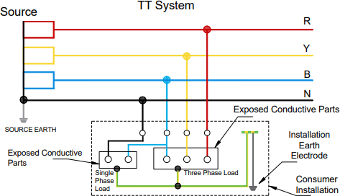

Fig2.12: TT system
    - All exposed conductive parts of an installation are connected to an independent earth electrode.
    - Single phase TT system is not present in India.
  - IT System: IT system has the source either unearthed or earthed through a high impedance and the exposed conductive parts of the installation are connected to electrically independent earth electrodes.
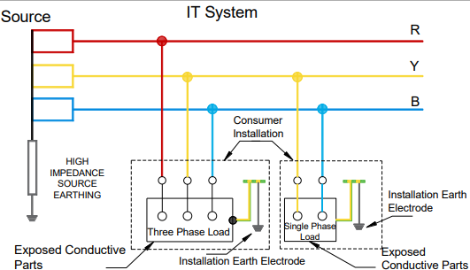
Fig 2.13: IT system

    - All exposed conductive parts of an installation are connected to an earth electrode.
    - The source is either connected to earth through deliberately introduced earthing impedance or is isolated from earth.
    - IT system is used where continuity of supply is desired.

LV overhead and underground distribution system maintenance
Repair and maintenance of distribution lines is very important for uninterrupted supply of electricity. Maintenance is done primarily twice a year, once before rainy season and the next is done after rainy season to see if any breakdown has occurred in the line. Line patrolling, maintaining ground clearance, replacement of insulators, restringing of lines, replacement of burnt jumpers, replacement of damaged conductor, replacement of damaged pole, etc. are some of the cheeks performed during maintenance.

LV overhead services maintenance
- When an overhead line trips on a sustained fault, it should be inspected to find out the
nature of fault such as loose sag, snapping of conductor, tree branches touching the lines, conductor falling on cross arms.
- An improvement with a view to avoid re-occurrence of such faults in future should be arranged and carried out soon.
- Complaints regarding no current/failure of power supply, voltage fluctuation, and load shedding and scheduled outages shall be addressed by the senior lineman as per the provisions of the regulations.
- Problems related to current such as no current or failure of power supply in premises could occur due to various reasons such as:
  - Fuse blown out/tripping of MCB
  - Burnt meter
  - Broken service line
  - Service line snapped from pole
  - Fault in distribution mains

  - Distribution transformer failure
  - Fault in LT system
  - Problem in substation
  - Planned/scheduled/emergency maintenance work
  - Load shedding y Street light complaint
- Pre-monsoon Inspection: The inspection carried out with the overhead lineswithout supply is called pre-monsoon inspection. It should be planned in advance with proper
tools and equipment

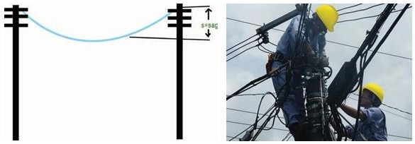

Fig 1.14: pre-monsoon inspection

- Pre-monsoon inspection involves the following
  - Tree cutting should be properly executed.
  - Sagging of lines should be minimised.
  - Leaned poles should be rectified.
  - Lines should be properly aligned by tightening with proper bolts and nuts.
  - Earthing should be checked.
  - Torn insulators/flash over insulators should
  - be replaced.
  - Jumpers at cut points should be checked up.
  - Stay wires should be properly aligned.

LV underground services maintenance
- Maintenance: The maintenance of cable installation includes inspection, routine checking of current loading, and maintenance of cables, joints and end terminations to be carried out-
  - To avoid failure.
  - To avoid environmental damage.
  - To avoid more expensive maintenance later.
  - To extend the life of the cable & related accessories.
  - To avoid risk.
  - To repair failed cables/components of accessories, if any.
- Inspection
  - Whenever the cables or joints are accessible as in manholes, ducts, distribution pillars, etc., periodical inspection should be made so that timely repairs can be made before the cables or joints actually cause by interruption to service. The frequency of inspection should be determined by customer from its own experience.
- Important: heavily loaded lines will require more frequent attention than less loaded lines.
  - Cables laid direct in the ground are not accessible for routine inspection, but such cables are often exposed when the ground is excavated by other public utilities for installing or repairing their own properties. Preventive maintenance in the form of regular inspection of all digging operations by other utilities or persons, carried out in areas where electric cables exist is of utmost importance.
- General maintenance
  - Fundamentals maintenance practices shall always be done as recommended by Original Equipment Manufacturer
  - Check physical appearance of the device
  - Clean all insulating materials. If it is necessary to use cleaning solvents, use only solvents recommended by the manufacturer.

  - Examine all bolts and connecting devices for signs of deterioration, corrosion, or overheating. Ensure that bolts and connecting devices are tight, per
manufacturer’s specifications.
  - Check the operation of the arc blades, if applicable, and ensure proper wipe of the main contacts.
  - Examine for excessive wear of moving parts.
  - Observe that operating mechanisms function properly without binding, hanging, or without delayed action.
  - Ensure any lubrication is done per the manufacture’s specifications.
  - Ensure that all moving parts are properly secured and lubricated as specified by the manufacturer. Faulty device is repaired or replaced as soon as possible.
  - Check condition of contacts.
  - Inspect insulating surfaces or bushings for cleanliness, cracks, chips, tracking.
  - Check cable and wiring condition, appearance, and terminations.
  - Inspect for proper grounding of equipment.
  - Check evidence of severe arcing or burning of contacts.
  - Check electrical operation of pilot devices, switches, meters, relays, auxiliary contacts, annunciator devices, flags, interlocks, cell switches, cubicle lighting. Visually inspect surge arrestors, for signs of damage.
  - Verify the current rating for circuit breakers and fuses as per the application
  - Check the cleanliness of the Protective device location
  - Check the insulating fluid measurement (level, density, pressure, temperature, moisture…) indicating devices for calibration and proper operation.
  - Conduct a dielectric test of the insulating fluid. Based on the results of this test, filter or replace oil as required (per manufacturer’s instruction).
  - Where applicable, check arc-quenching assemblies for carbon deposits or other contaminates.
  - Circuit breakers should be electrically trip tested to ensure proper operation of the trip elements and trip linkages.

testing techniques & procedures
All new completed electrical installation should be tested before connection to the supply, to ensure that the installation is technically sound and free from any possible short circuits, etc. the main reasons, to test a new electrical installation or house wiring before it is switched on to the mains are as follows:
LV Testing Requirements
Conditions where checks and tests must be done
- Connecting any low voltage electrical conductors or equipment after fault or repair.
- When fault finding due to e.g. Cable PI fault attendance.
- Disconnecting and reconnecting any conductors (includes earth conductors).
- Connecting any new conductors (including earth conductors).
- Installing or changing conductors that could result in a structure being energized (e.g. steel cross over or service pole with neutral bond).

Public lighting systems maintenance
The maintenance of street lighting equipment is a day to day activity that happens as a seamless process and in many instances, without the general public noticing.
All lighting systems experience deterioration of performance during operation, and so require ongoing maintenance. As the useful light distributed by a lighting system decreases, wattage stays the same, resulting in energy waste.
- Procedures to maintain public lighting:

Self-check #2

II. Choose the correct answer from the give alterative
- To install new LV power distribution system, the installer must be considering.
  - Individual building demand loads C. Underground distribution system
  - Overhead distribution lines D. all of the above
- Which one is used to install overhead cables in exact tension?
  - Poles B. connectors C. messenger wires D. cables
- is single connecting methods of overhead conductor installation?
  - Thick conductor B. twist joint C. messenger wires D. Narrow conductor
- is methods of cable laying on underground cable installation?
  - Drawing in ducts B. biritania C. messenger wires D. all
- Designed to protection equipments & installations systems form lightning & linkage current is:
  - Circuit breaker B. HRC fuse C. earthing system D. messenger wires
- Neutral and protective functions are combined in a single conductor throughout the system.
  - TN-C system B. TN-C-S system C. IT- system D. TC ststem

Mach column “B” to column “A” A B
- Cable laying method A. separate connection Method of overhead line
- High installation cost B. direct into the ground
- method of overhead connection C. Number of circuits and voltage level
- familiar to the work D. challenges of underground cable laying
- Refunction the system E. connection types of earthing
- considerations to install F. Reasons of maintenance Low voltage distribution system
- TN system G. maintenance procedures

Give short ad precise answers for the following questions

- List at least four steps to read & interpret electrical plan?
- What are the advantages of read & interpret electrical plan correctly?
- Write your considerations that underground cable laying & installing?
- List the challenges of underground cable laying?
- List the connection types of earthing system & show each system connections?
- Write down the installation procedures of low voltage distribution systems?
- Write down the maintenance techniques & procedures of low voltage distribution systems

Operation Title: Overhead power distribution system Installation Instruction: install low voltage overhead power distribution system
Purpose: install new low voltage overhead power distribution line & components. Required tools and equipment: screw driver, combination pliers, multimeter, line testers, ground testers

Precautions:
  - use safety personal protective equipments properly
  - Follow the selection instruction of the task.
  - Check tools weather it is functional or not
  - Select tools properly

Procedures:
Step 1: select correct specification of wires/ cables, protection & controlling devices, connectors & poles.
Step 2: Inspect the select wires/ cables, protection & controlling devices, connectors & poles.
Step 3: Install the select wires/ cables, protection & controlling devices, connectors & poles of low voltage overhead power distribution lines
Step 4: Test the functionality of low voltage overhead power distribution lines.
.

Quality criteria:

Operation Title: underground power distribution system Installation Instruction: install low voltage underground power distribution system
Purpose: install new low voltage underground power distribution cables & components. Required tools and equipment: screw driver, combination pliers, multimeter, line testers, cable cutter & ground testers

Precautions:
  - use safety personal protective equipments properly
  - Follow the selection instruction of the task.
  - Check tools weather it is functional or not
  - Select tools properly

Procedures:
Step 1: select correct specification of cables, protection & controlling devices, connectors & conduits
Step 2: Inspect the select cables, protection & controlling devices, connectors & conduits.
Step 3: Install the select cables, protection & controlling devices, connectors & conduits of low voltage underground power distribution cables
Step 4: Test the functionality of low voltage underground power distribution cables .
.

Operation Title: Earthing system Installation
Instruction: install earthing system installation for low voltage distribution system. Purpose: To protect (safe guard) low voltage distribution system from lightning & human beings from linkage current..
Required tools and equipment: screw driver, combination pliers, multimeter, line testers, cable cutter, electrode & ground testers

Precautions:
  - use safety personal protective equipments properly
  - Follow the selection instruction of the task.
  - Check tools weather it is functional or not
  - Select tools properly

Procedures:
Step 1: select correct specification of ground wire, earth electrodes & connectors.
Step 2: Inspect the selected ground wire, earth electrodes & connectors.
Step 3: Install the ground wire, earth electrodes & connectors according to the standard.
Step 4: Test the functionality of earth installation systems.
.

Operation Title: Overhead power distribution system maintenance
Instruction: identify the faults & maintain low voltage Overhead power distribution system & protection system.
Purpose: solve the problems of low voltage overhead power distribution system & protection system.
Required tools and equipment: screw driver, combination pliers, multimeter, line testers, ground testers

Precautions:
  - use safety personal protective equipments properly
  - Follow the selection instruction of the task.
  - Check tools weather it is functional or not
  - Select maintenance tools properly

Procedures:
Step 1: Inspect low voltage overhead power distribution lines, components, connector & protection system.
Step 2: Test low voltage overhead power distribution lines, components & connector and protection system
Step 3: Replace any defectives parts of low voltage overhead power distribution lines, components & connector and protection system
Step 4: Test the final maintenance of low voltage overhead power distribution lines, components & connector and protection system.

Operation Title: underground cable system maintenance
Instruction: identify the faults & maintain low voltage underground cable & protection system.
Purpose: solve the problems of underground cable & protection system.
Required tools and equipment: screw driver, combination pliers, multimeter, cable cutters, ground testers

Precautions:
  - use safety personal protective equipments properly
  - Follow the selection instruction of the task.
  - Check tools weather it is functional or not
  - Select maintenance tools properly

Procedures:
Step 1: Inspect the underground cable & protection systems & components.
Step 2: Test the underground cable & protection systems & components.
Step 3: Replace any defectives parts of underground cable & protection systems & components.
Step 4: Test the final maintenance of underground cable & protection systems & components.

Operation Title: street lighting system maintenance
Instruction: identify the faults & maintain street lighting wiring systems, components, poles & protection system.
Purpose: solve the problems of street lighting
Required tools and equipment: screw driver, combination pliers, multimeter

Precautions:
  - use safety personal protective equipments properly
  - Follow the selection instruction of the task.
  - Check tools weather it is functional or not
  - Select maintenance tools properly

Procedures:
Step 1: Inspect the street lighting wiring systems, components, poles & protection system.
Step 2: Test the street lighting wiring systems, components, poles & protection system.
Step 3: Replace any defectives parts of street lighting wiring systems, components, poles & protection system.
Step 4: Test the final maintenance of street lighting wiring systems, components, poles & protection system.

LAP Test # 1

Instruction I: Given necessary templates, tools and materials you are required to perform the following tasks within 10 hours.

Task 1: Install the street lighting system using overhead line distribution system Task 2: Install the street lighting system using underground cabling system Task 3: Install low voltage overhead power distribution system
Task 4: Install low voltage underground power distribution system
Task 5: maintain low voltage overhead/ underground power distribution system
Task 6: maintain overhead/ underground street lighting system

Unit Three: Completion Of Installation &Maintenance Work
This learning unit is developed to provide the trainees the necessary information regarding the following content coverage and topics:
- Testing & commissioning
- Record & report work activies
This unit will also assist you to attain the learning outcomes stated in the cover page. Specifically, upon completion of this learning guide, you will be able to:
- Inspect & teste the installing and maintaining LV overhead/underground services & public lighting system.
- Record the work completion data, documented it & report accidents or injuries for the appropriate personnels.
- Rehabilitate, clean and made safe work sits, tools, testing & measuring equipments.

3.1.Commissioning works
A condition report should be completed for all inspections, testing’s which is sufficiently detailed to demonstrate that the Installation & maintenance is sound at the time of the inspection & testing. Ideally it should include photographs to provide evidence of any issues raised.
The person undertaking the inspection will use their competency to determine if the distribution system passes its inspection and/or what issues are to be raised that needs resolution. If there is any doubt then the issue will be escalated within the company, utilizing the expertise of the overseeing or supervising person. If necessary a fully qualified electrical engineer will be used for more detailed analysis.
All power distribute system installation owners should have a healthy system in place for dealing with any issues or recommendations raised at the time of inspection, and an audit trail to demonstrate rectification.

3.2.Report , records work activities
Any defects found during checks and inspections must be recorded and reported to the responsible person. Where defects that could affect the safety of persons and require immediate rectification are found, the responsible person must also be informed to ensure that the installation & maintenance workers until the defect has been rectified.

Records
All power distribute system installation owners should also have a robust system in place for raising any significant issues identified at the inspection to any persons that may be affected by the finding, including third parties.
The primary records that should be kept include:
 Evidence of adherence to requirements covering design, checking ‘as built’ drawings and hazards, and demonstrating due diligence checking that design and ‘as built’ comply with applicable standards and associated loadings.
 Details of inspections, audits and reviews to demonstrate sound management.
 A fault history of the assembly and remedial action taken.
 Identification of similar installation to assist in identifying fault trends.

Self-check-3

Directions: Answer all the questions listed below.

Say True if the sentence is correct and false if the statement is incorrect
- Ensure all tools and equipment are cleared off the work site is important activity.
- Any items issued of the Permit for Work must be returned with the Safety Document.

Give short ad precise answers for the following questions
- List at 4 basic safety Rules that can help to prevent hazards associated with the use of hand and power tools.
- List at least four components of low voltage overhead lines
- List at 4 causes of accidents while using unsafe hand and power tool.

Reference Materials

  - " RULES FOR Overhead Electric Line Construction” . PUBLIC UTILITIES COMMISSION OF THE STATE OF CALIFORNIA GENERAL ORDER No. 95 on January 2015
  - “Low-Voltage Electrical Service Standard” E.21-10. 10th Edition June 2014
  - “Code of practice on working near electricity supply lines” electrical & mechanical department of hong kong. 2018 ddition
  - “Electric Power Distribution Systems Operations “NAVFAC MO-201 April 1990
  - “Transmission Line Design Manual” Holland H. Farr 1980

Developer Profile

No | Name | Qualification (Level) | Field of Study | Organization/ Institution | Mobile number | E-mail
1 | Tadesse Gezahegn | BSC | Electrical Engineering | BGI Ethiopia | 0913274182 | tadeeze@mail.com
2 | teshome lindi | MSC | Electrical Engineering | Mescon engineering hawsa | 0917824357 | teshelindi@gmail.com
3 | Mengistu Abiyu | MSc (A instructor) | Electrical industrial Automation & Control Managment | Lideta Manufacturing College | 0913948480 | menabiy@gmail.com
4 | Wekgari Negese | MSC | Electrical Engineering | Burayu PTC | 0913961682 | wekgari@gmail.com
5 | Hailemichael Mindaye | MSC | Electrical Engineering | A/kenenisa PLC | 0923678400 | Haile12thomus1924@gmail.com
6 | Mebratu Delelegn | MSC | Electrical Engineering | Electrical Engineering association | 0911130792 | ethiomebre@gmail.com
7 | Abreham Nigessie | MSC | Electrical Engineering | G/Wingate PTC | 0922745453 | Father.abreham1@gmail.com
8 | Eliyas Getachew | MSC | Electrical Engineering | Misrak PTC | 0913811386 | get.elias19@gmail.com
9 | Barnabas Sintayehu | BSC | Electrical Engineering | Tegbarid PTC | 0940114927 | Nabsntyh121@gmail.com

