

Electrical Power System Technology Level II
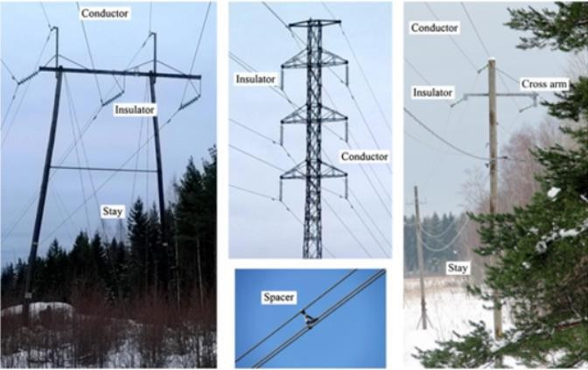
Based on December 2022, Curriculum Version I
Module Title: Inspection of Overhead Structures and Electrical Apparatus
Module Code: EIS EPS2 M17 0123 Nominal duration: 52 hours

Prepared By: Ministry of Labor and Skill

January, 2023 Addis Ababa, Ethiopia

ACKNOWLEDGEMENT
Ministry of Labor and Skills and Ministry of Health wish to extend thanks and appreciation to the many representatives of TVET instructors and respective industry experts who donated their time and expertise to the development of this Teaching, Training and Learning Materials (TTLM).

CONTENTS

Acknowledgement 2
Acronyms 5
Introduction 6
Module units 6
Learning objectives of the Module 6
Module Learning Instructions: 7
Unit one: Inspection of Overhead Structures and Electrical Apparatus 8
  - Introduction to Overhead Structure and Electrical Apparatus 9
  - Components of overhead structure and Electrical Apparatus 10
  - Alternating Current Circuit Principles 33
  - Electromagnetic Principles and induction process 33
  - OHS policies and procedures for overhead lines 37
  - Works schedule drawings and symbols 38
  - Relevant requirements and practices 42
  - Safe working on Overhead Lines 43
  - Permit to Work 45
Self-check-1 46
Unit Two: Carry Out Inspection of Overhead Structures and Electrical Apparatus Used on Towers 47
  - Occupational Health and Safety workplace procedures and practices 48
  - Sustainable energy principles and practices 50
  - Distribution and Transmission Power line inspection principles 50
  - Towers and structures inspection principles 52
  - Safely use of power tools and equipment techniques 53
  - Fundamentals of jointing Overhead and Underground LV cables 57
  - Procedures for lifting and climbing 60
  - Carry out inspection of overhead structures and electrical apparatus 62
Self-check-2 67
Operation sheet-1 68
Operation sheet-2 69
Operation sheet-3 70
Operation sheet-4 71
LAP Test 72
Unit Three: Completion Inspection of Overhead Structures and Electrical Apparatus 73
  - Commissioning works 74
  - Making work site safe and materials returning 74
  - Work records and reporting 75
Self-check-3 76
Reference 77
Developers Profile 79

ACRONYMS
LCS Lane Closure System

ABC Aerial Bunched Cables

S/S Sub Station

AAC All Aluminum Conductor

AAAC All Aluminum Alloy Conductor

ACSR Aluminum Conductor Steel Reinforced

ACAR Aluminum Conductor, Aluminum Reinforce

LST Lattice Steel Towers

TSP Tubular Steel Poles

ANSI American National Standards Institute

UAV Unmanned aerial vehicles

INTRODUCTION
An overhead power line is a structure used in electric power transmission and distribution to transmit electrical energy across large distances. It consists of one or more uninsulated electrical cables (commonly multiples of three for three-phase power) suspended by towers or poles.
Since most of the insulation is provided by the surrounding air, overhead power lines are generally the least costly method of power transmission for large quantities of electric energy.
Structures for overhead lines take a variety of shapes depending on the type of line. Structures may be as simple as wood poles directly set in the earth, carrying one or more cross-arm beams to support conductors, or "armless" construction with conductors supported on insulators attached to the side of the pole. Tubular steel poles are typically used in urban areas. High- voltage lines are often carried on lattice-type steel towers or pylons. For remote areas, aluminum towers may be placed by helicopters. Concrete poles have also been used. Poles made of reinforced plastics are also available, but their high cost restricts application.
Each structure must be designed for the loads imposed on it by the conductors. The weight of the conductor must be supported, as well as dynamic loads due to wind and ice accumulation, and effects of vibration.

Module Units
- Inspection of overhead structures and electrical apparatus
- Carry out inspection of overhead structures and electrical apparatus used on towers
- Completion of the inspection of overhead structures and electrical apparatus

Learning Objectives of the Module
At the end of this session, the students will able to:

- Prepare for the inspection of overhead structures and electrical apparatus used on towers
- Carry out inspection of overhead structures used on towers
- Carry out inspection of electrical apparatus used on towers
- Complete the inspection of overhead structures used on towers

Module Learning Instructions:
- Read the specific objectives of this Learning Guide.
- Follow the instructions described below.
- Read the information written in the information Sheets
- Accomplish the Self-checks
- Perform Operation Sheets
- Do the “LAP test”

UNIT ONE: Inspection of Overhead Structures and Electrical Apparatus
This learning unit is developed to provide the trainees the necessary information regarding the following content coverage and topics:
  - Introduction to overhead structure and electrical apparatus
  - Components of overhead structure and electrical apparatus used on towers
  - Alternating current circuit principles
  - Electromagnetic principles
  - OHS policies and procedures for overhead lines
  - Works schedule drawings and plans, and material
  - Relevant requirements and practices
  - Safe working on Overhead Lines
  - Permit to Work
This unit will also assist you to attain the learning outcomes stated in the cover page. Specifically, upon completion of this learning guide, you will be able to:
- Explain the meaning of overhead structure and electrical apparatus
- Able to receive, analyze and confirm Works schedule
- Communicate relevant requirements and established procedures for the work
- Prioritize and sequence work.
- Obtain relevant work permits to access and perform work
- Identify schedule and obtain Resources and, in working order.
- Confirm relevant personnel at work site
- Prepare Site according to the work schedule
- Identify and implement Traffic management plan

Introduction to Overhead Structure and Electrical Apparatus

Electricity is transmitted at high voltages to reduce the energy loss that occurs over long distances. Power is usually transmitted through overhead power lines. Underground power transmission has a significantly higher installation cost and greater operational limitations, but lowers maintenance costs. Underground transmission is more common in urban areas or environmentally sensitive locations.
Overhead Line Structures are the poles, towers, or structures located outside of buildings and which support circuits and their related conductors and equipment.
Distribution of electricity involves the transfer of electrical energy from one electric substation to another electrical substation (like from 220/33 KV S/S to 33/11 KV S/S and 33/11 KV S/S to 11/0.4 KV Distribution Transformer S/S etc.) through sub-transmission and distribution lines. These lines may be Overhead lines or Underground cables. The choice of Overhead Network or Underground network depends on many factors like safety requirement, Right of way, cost, aesthetic look and other factors.
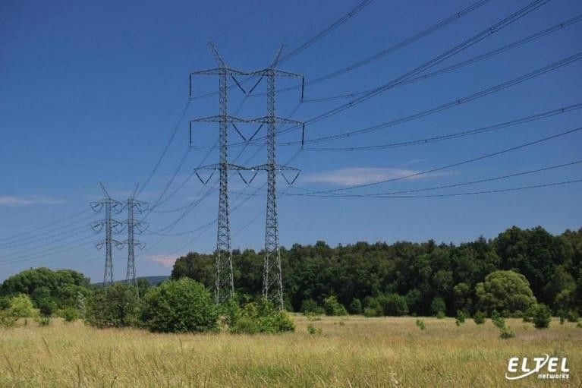
Figure 1. 1 Overhead Power Transmission Structure
Transmission lines supply distribution substations equipped with transformers which step the high voltages down to lower levels.
The transmission of large quantities of power over long distances is more economical at higher voltages.

Power transmission at high voltage can be accomplished with lower currents which lower the I 2 R (Power) losses and reduce the voltage drop. The consequent use of smaller conductors requires a lower investment.
Standard power transmission systems are 3-phase, 3-conductor, overhead lines with or without a ground conductor. Transmission lines are classed as unregulated because the voltage at the generating station is controlled only to keep the lines operating within normal voltage limits and to facilitate power flow
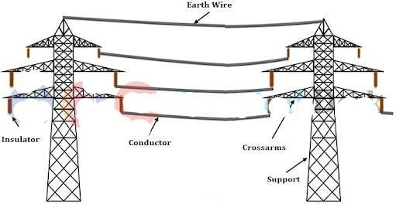

Figure 1. 2 Components of Overhead Lines

Components of overhead structure and Electrical Apparatus

    - Overhead Transmission and Distribution structure

Overhead Line Structures are the poles, towers, or structures located outside of buildings and which support circuits and their related conductors and equipment.
Structures for overhead lines take a variety of shapes depending on the type of line.
Structures may be as simple as wood poles directly set in the earth, carrying one or more cross- arm beams to support conductors, or "armless" construction with conductors supported on insulators attached to the side of the pole.

      - Overhead line Transmission Structures
Transmission structures are one of the most visible elements of the electric transmission system. They support the conductors used to transport electric power from generation sources to customer load.
Transmission lines carry electricity over long distances at high voltages, typically between 115 kV and 765 kV (115,000 volts and 765,000 volts).
Transmission tower supports an overhead power line. The other names of transmission towers are power transmission towers, power towers, and electricity pylons. The transmission towers carry high-voltage transmission line to transport power from the generating station to electrical substations. The electrical substations transport power to the end users through distribution lines. Transmission towers have to carry the heavy transmission conductors at a sufficient safe height from the ground. In addition to that, all towers have to sustain all kinds of natural calamities. Therefore, the transmission tower design is an important engineering job where civil, mechanical, and electrical engineering concepts are equally applicable.
In order to decrease the transmission losses, after the generation of power, we step-up the voltage in order to transmit it over a long distance. At receiving end, we again step down the voltage value and use it for electrical loads. There are various transmission lines at various voltage levels throughout the power system network in order to transmit the bulk power.
A transmission tower (usually a steel lattice tower) supports the overhead power line. Transmission towers have to carry the heavy transmission conductors at a sufficient safe height from the ground depending on the voltage (132kV/220kv/400kv/765kv). Thus, the transmission towers maintain the minimum ground clearance according to the system voltage.
A transmission tower (also known as a power transmission tower, power tower, or electricity pylon) is a tall structure (usually a steel lattice tower) used to support an overhead power line.
In electrical grids, they are used to carry high voltage transmission lines that transport bulk electric power from generating stations to electrical substations; utility poles are used to support lower-voltage sub-transmission and distribution lines that transport power from substations to electric customers.
Transmission towers have to carry the heavy transmission conductors at a sufficient safe height from the ground.

In addition to that, all towers have to sustain all kinds of natural calamities. So transmission tower design is an important engineering job where civil, mechanical, and electrical engineering concepts are equally applicable.

Types of transmission structures based on designs
There are many different designs for transmission structures. Two common types are:

Lattice Steel Towers (LST)
Lattice Steel Towers (LST), which consist of a steel framework of individual structural components that are bolted or welded together.

Tubular Steel Poles (TSP)
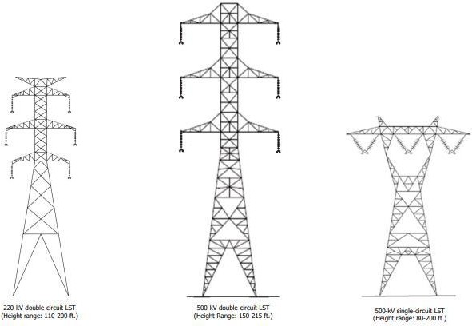
Tubular Steel Poles (TSP), which are hollow steel poles fabricated either as one piece or as several pieces fitted together.
Figure 1. 3 Lattice Steel Towers (LST)
Both LSTs and TSPs can be designed to carry either one or two electrical circuits, referred to as single-circuit and double circuit structures (see examples above).
Double-circuit structures typically hold the conductors in a vertical or stacked configuration, whereas single-circuit structures typically hold the conductors horizontally. Due to the vertical

configuration of the conductors, double-circuit structures are taller than single-circuit structures. On lower voltage lines, structures sometimes carry more than two circuits.
A single-circuit alternating current (AC) transmission line has three phases. At low voltages, a phase usually consists of one conductor. At high voltages (over 200 kV), a phase can consist of multiple conductors (bundled) separated by short spacers. A double-circuit AC transmission line has two sets of three phases. Dead-end towers are used where a transmission line ends; where the transmission line turns at a large angle; on each side of a major crossing such as a large river, highway, or large valley; or at intervals along straight segments to provide additional support.
A dead-end tower differs from a suspension tower in that it is built to be stronger, often has a wider base, and has stronger insulator strings.
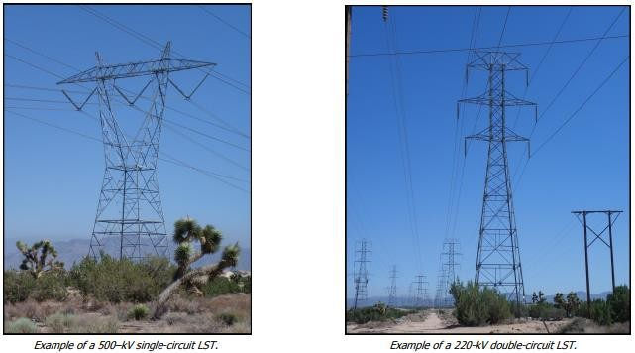
Figure 1. 4 single and double circuit Lattice Steel Towers
Structure sizes vary depending on voltage, topography, span length, and tower type. For example, double-circuit 500-kV LSTs generally range from 150 to over 200 feet tall, and single- circuit 500-kV towers generally range from 80 to 200 feet tall.

Transmission towers categories based on their role
Transmission towers are also differentiated according to the role they are to play in the line. Several criteria are considered here, the most general of which includes two types of support structure – suspension (pass-through) and section support.

Suspension (pass-through) structures
Suspension (pass-through) structures - as defined in the currently applicable standard Alternating current overhead power lines above 1 kV.
The basic type of such structures are suspension towers. They are usually used on straight sections of overhead lines where the route does not change its course by more than 2 degrees. In this location, the suspension towers are used to support the cables and therefore mainly carry vertical loads, but not the higher forces caused by cable tension.
The use of suspension structures at the positions where the line changes direction results in loads in them with the resultant force from the tension of the cables in the direction of the bisector of the break angle. Such loads can be significant and increase strongly as the angle increases. Such a positioning of the structure requires its appropriate design and it is then customarily referred to as an angle tower.

Dead-end (section) support structures
Dead-end (section) support structures - standard gives an enigmatic definition of these, talking about structures equipped with tension insulator strings. Their function in the line as structures intended to take up the tension of the conductors.
The basic types of these structures are sturdy towers. These towers are used on the straight route (to limit the length of the line section) or at the bend of the line (to absorb the resultant force from the tension of the wires).
The shape and design of the dead-end (section) tower depends on the line bend angle. An acceptable range of bend angles is specified for a given tower type.
In practice, many types of suspension and dead-end (section) structures are used on a given line to form what is known as a series of towers.

Types of tower based on property zoning
A tower is an above ground support structure specifically used for the attachment of antennas. Towers are unoccupied structures with limits based on height and placement use based on property zoning.

Monopole:
A monopole is a specific type of tower which is monolithic in design. Typically constructed of steel, monopoles are attached to a below-grade concrete caisson.

Monopoles do not have horizontal telecommunication wire attachments. A monopole can have concealment characteristics.

Transmission Tower:
A transmission tower is an above ground support structure with the principal purpose to distribute high voltage power laterally.
Transmission towers are unoccupied structures placed in designated rights of way. Antennas can be attached to transmission towers.

Overhead line Distribution Structures
Distribution facility is connected between a distribution substation and a customer, such as house, building, and factory, and it consists of a pole, conductor, and transformer and so on. A certain supply capacity is secured in present situation because distribution facilities are already constructed.
On the other hand, power demand is expected to grow significantly in the future because the large-scale development projects are planned in many places. Under such a situation, it is important to utilize existing distribution lines effectively and to expand new distribution lines in order to respond the power demand in the future.
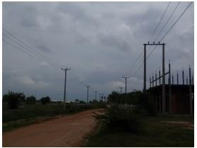
Figure 1. 5 Overhead Distribution Line

Utility Pole
A utility pole is an above ground support structure designed to support the lateral distribution of power wires and/or telecommunications wires/cables.
Utility poles are unoccupied structures typically placed in public rights of way. Antennas can be attached to utility poles.

Light Pole
A light pole is a specific type of utility pole with the principal purpose to provide outdoor lighting.
Light poles to not have primary power or telecommunication affixed to the external area of the structure. Antennas can be attached to light poles. As well as in the public rights of way, light poles can be located on private property.

Signal Pole
A signal pole is a specific type of utility pole with the principal purpose to provide communications and control for traffic.
Signal poles to not have primary power or telecommunication affixed to the external area of the structure. Antennas can be attached to signal poles

Decorative Light Pole
A decorative light pole is a specific light pole with the dual purpose to provide outdoor light and aesthetic decoration. Antennas must be concealed within decorative light poles.

Building
A building is an above ground support structure which is occupied. Antennas can be attached to the building based on limits of height and property zoning.

Distributed Antenna System (DAS)
DAS is an antenna, or a group of antennas, that is attached to utility poles (and some case buildings). The antennas are interconnected with horizontal telecommunication cables, typically fiber, to a locally-placed communication hut.

Macro Cell:
Macro cells are the localized collection of wireless communication equipment deployed at or on a support structures. The size of the equipment (i.e. antennas, cabinets, cables) and relative radio frequency (RF) power output determine if a cell site is classified as macro. The typical coverage area for a macro cell is a .5 to 5.0 miles radius.

Small Cell

Small cells are smaller self-contained versions of macro cell sites. While small cells, have diminutive characteristic in regards to antennas, cabinets, cables, coverage areas, and RF power output. However, speed of network is not compromised.

Overhead line Transmission and distribution Apparatus

There are different types of Overhead line Transmission and distribution apparatus components used on towers. Here under described are common

Overhead Conductors and Cables
An overhead power line is an electric power transmission line suspended by towers or poles. Since most of the insulation is provided by air, overhead power lines are generally the lowest- cost method of transmission for large quantities of electric power.
The weight of the conductor must be supported, as well as dynamic loads due to wind and ice accumulation, and effects of vibration. Where conductors are in a straight line, towers need only resist the weight since the tension in the conductors approximately balances with no resultant force on the structure.
It is an important component of overhead electrical transmission and distribution systems. The conductors for the overhead network can be a bare conductor or an insulated conductor (ABC) depending on the requirement.
The choice of conductor depends on the
- power carrying capacity
- cost
- growth of the load, and
- Reliability & efficiency.
While selecting an ideal conductor, some of the following features such as maximum electrical & thermal capacity and cost effectiveness etc. are considered.
Since, the insulations between the conductors is provided by air, overhead power lines are generally the lowest-cost method of power transmission for large quantities of electric energy from one point to another.

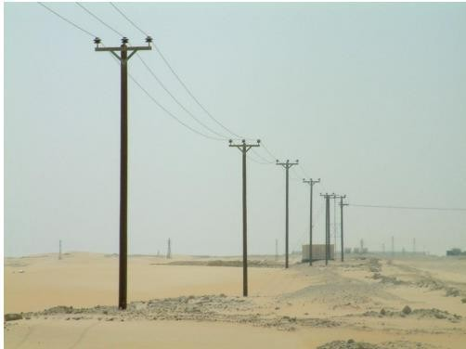

Figure 1. 6 overhead power lines

  - Types of Conductors Used in Overhead Power Lines
Selecting a proper type of conductor for overhead lines is as important as selecting economic conductor size and economic transmission voltage.
Copper: The main factor of using copper is that it holds the highest conductivity factor. The most commonly used material for conductors is copper. There are mainly three kinds of copper such as soft-drawn, medium-drawn and Hard-drawn. The hard-drawn copper is used for the construction of the conductors. The main factors for selecting hard-drawn copper as it has less elastic factor and more mechanical strength which will make the conductor withstand high currents. Due to expensive factors, copper is not directly used for overhead transmission.
Aluminum: the most commonly used conductors are made up of aluminum as it is less costly. The weight is also lighter compared to the copper, this advantage makes the pole strength factor decrease. ACSR and AAAC conductors are mainly used for the transmission lines. ACSR is made up of small strands of aluminum twisted together used for the conductors. The twisting of the aluminum strands will give more tensile strength which is used to withstand heavy currents. The main disadvantage of aluminum is it has less conductivity compared to copper and less tensile strength.

Galvanized Steel: the major advantage of Galvanized steel is it is cost-effective. It is used for short-distance power transmissions as it consists of some drawbacks such as low conductivity, high resistance and less tensile strength.
Cadmium Copper and Copper weld steel are rarely used because of their most expensive factor.
In addition to above types of bare conductors, Insulated conductors (Aerial Bunched cables) may also be used in Overhead network system.
When compared with the overhead distribution system with conventional bare conductors, ABC provides higher safety and reliability and system economy by reducing theft in the area of installation.
  - Properties of good conductor
A good conductor should have the following properties:
- high electrical conductivity
- high tensile strength to withstand mechanical stresses
- relatively lower cost without compromising much of other properties
- lower weight per unit volume
Aerial Bunched Cables is also considered to be the best choice for power distribution in congested urban areas with narrow lanes and by-lanes.

Advantages of ABC
- ABC provide safety to human life when used in congested area and narrow lane areas.
- ABC provides flexibility to use multiple circuits of different voltages strung on the same set of poles without using separate poles.
- ABC provides better adaptability to run concurrently with other overhead system with bare conductor and also with communication lines without any interference.
- ABC provides insulation resistance to earth in all seasons and negligible leakage of currents and thereby, the low losses of leakage.
- ABC is unaffected by pollution in the atmosphere.
- ABC, at the same time also reduces the theft of energy as it cannot be tapped i.e. it prevents the use of illegal hooks etc. on LT lines in the theft prone areas and helps to improve the AT&C losses of the system.

Overhead power transmission lines classification
Overhead power transmission lines are classified in the electrical power industry by the range of voltages:
Low voltage – less than 1000 volts, used for connection between a residential or small commercial customer and the utility.
Medium Voltage (Distribution) – between 1000 volts (1 kV) and to 33 kV (used for distribution in urban and rural areas).
High Voltage (Sub transmission if 33-115kV and transmission if 115kV+) – between 33 kV and about 230 kV, used for sub-transmission and transmission of bulk quantities of electric power and connection to very large consumers.

Insulators
Insulators are required to meet electrical, mechanical and pollution withstand requirements during their life time. Electrical stresses include power frequency, switching and lightning over voltages and mechanical stresses include the tensile, compressive or cantilever loadings from conductor tension and weight.
Air gap clearance refers to the minimum distance which should be maintained between the live conductor and earthed metal parts of the support to avoid flashover.
The minimum air gap clearance has to be maintained even under the conditions of system over- voltages with the insulator strings in the deflected position due to the action of wind pressure.

Types of insulators
There are three types of insulators used for overhead lines:
  - Pin type,
  - Suspension type, and
  - Strain type.

Pin type insulator
Consists of a single or multiple shells (petticoats or rain sheds) adapted to be mounted on a spindle to be fixed to the cross arm of the supporting structure. Multiple shells are provided in order to obtain sufficient length of leakage path so that the flash over voltage between the power conductor and the pin of the insulator is increased.
The design of the shells is such that when the uppermost shell is wet due to rain the lower shells are dry and provide sufficient leakage resistance.

It is to be noted that the power conductor passes through the groove at the top of the insulator and is tied to the insulator by the annealed wire of the same material as the conductor.
The pin type insulators are normally used up to 33 kV. In any case it is not desirable to use them beyond 50 kV as the cost of such insulators then increases much faster than the voltage.
The insulators and its pin should be sufficiently mechanically strong to withstand the resultant force due to combined effect of the weight of the conductor, wind pressure and ice loading if any per span length.
The pin type of insulators are uneconomical beyond 33 kV operating voltage. Also the replacement of these insulators is expensive. For these reasons for insulating overhead lines against higher voltages, suspension insulators (Fig. below) are used.
Each insulator is a single disc-shaped piece of porcelain grooved on the undersurface to increase the surface leakage path between the metal cap at the top and the metal pin at the bottom of the insulator.
The cap at the top is recessed so that it can take the pin of another unit and in this way a string of any required number of insulators can be built. The cap and the pin are secured to the insulator by means of cement.
The standard unit is 10″ × 5 34 ″ in size. The diameter is taken as 10″ as it gives optimum spark over to puncture voltage ratio. Increasing the diameter further increases the flash over or spark over voltage but it lowers the above ratio which is undesirable.
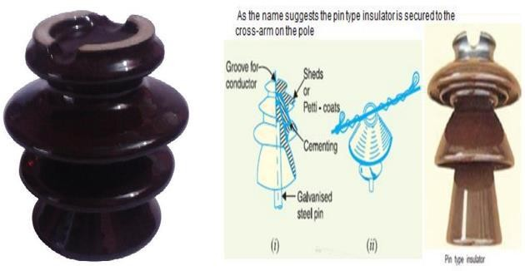
Figure 1. 7 Pin type insulator

Suspension insulators
Suspension insulators being free to swing, the clearances required between the power conductors and the supporting structure are more as compared to pin type insulators.
This means the length of the cross arm for suspension insulators is more as compared with the pin type.
The suspension insulators, in addition to being economical as compared to pin type for voltages more than 33 kV,
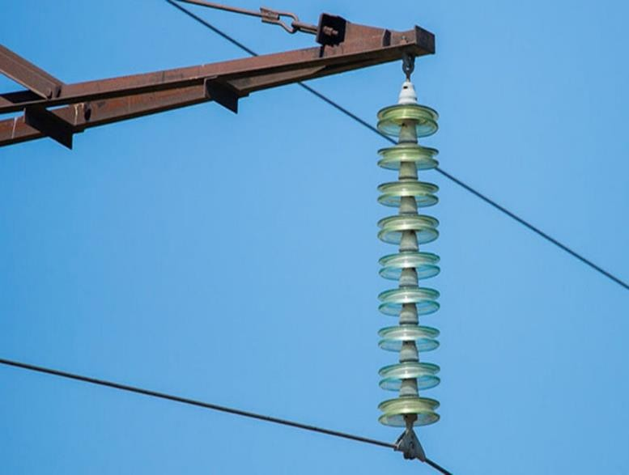
Figure 1. 8 Suspension Insulators

Underground Cables and Overhead Transition Points
For underground cables less than 345 kV, the connection from overhead to underground lines require the construction of a transition structure, also known as a riser.
Figures 1.6 depict sample transition structure designs. These structures are between 60 and 100 feet tall. They are designed so that the three conductors are effectively separated and meet electric code requirements.
The insulated conductor of the overhead line is linked through a solid insulator device to the underground cable. This keeps moisture out of the cable and the overhead line away from the supporting structure.

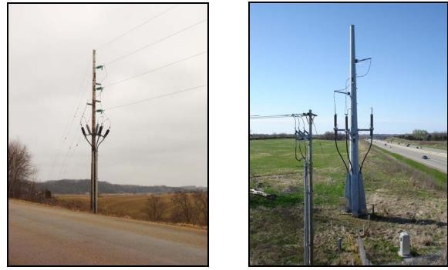
Figure 1. 9 Underground to Overhead Transition Structures
Lightning arrestors are placed close to where the underground cable connects to the overhead line to protect the underground cable from nearby lightning strikes.
The insulating material is very sensitive to large voltage changes and cannot be repaired. If damaged, a completely new cable is installed.
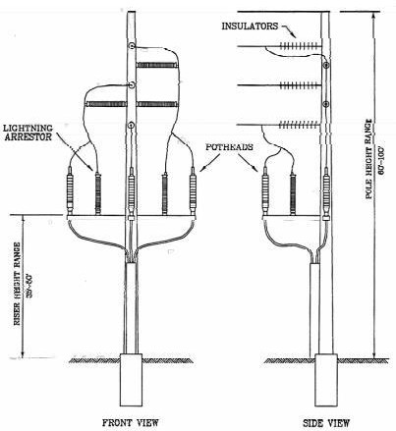
Figure 1. 10 Diagram of a Typical Transmission Riser Structure

Hardware and Earthing systems
An earthing system (UK and IEC) or grounding system (US) connects specific parts of an electric power system with the ground, typically the Earth's conductive surface, for safety and functional purposes.
The choice of earthing system can affect the safety and electromagnetic compatibility of the installation.
Regulations for earthing systems vary among countries, though most follow the recommendations of the International Electro technical Commission (IEC). Regulations may identify special cases for earthing in mines, in patient care areas, or in hazardous areas of industrial plants.
In addition to electric power systems, other systems may require grounding for safety or function. Tall structures may have lightning rods as part of a system to protect them from lightning strikes.
Radio antennas may require particular grounding for operation, as well as to control static electricity and provide lightning protection.
Any equipment, which has been isolated, must also be earthed.
Earthing is the best means of ensuring safety of personnel. No work should be performed on equipment unless it is visibly earthed.
Checking by voltage indictor prior to earthing is necessary to avoid inadvertent earthing of live conductors, thereby creating a short circuit fault. Where earth switches are available (as is the case with outdoor HV switchyards and GIS switchgear), they can be used for this purpose.
In the case of indoor switchgear panels, such earthing is normally carried out at the outgoing terminals of the feeding cubicle at the time of rendering the circuit dead. But in certain cases, the work may be getting carried out in some other remote location. In that case, a portable working earth must be used close to the point of work, in such a way that it is between the supply side and the point of work.
The correct way of performing the working earth connection involves first connecting the earth lead of the clamp, followed by the line leads one by one.

Supports
Supports are used to support the Conductors which are called poles or towers. These supports will hold the conductor from a specific height from the ground according to the operating voltage. Poles are mainly divided into four types,

    - Wooden pole
    - Steel pole
    - RCC steel towers
    - Lattice steel towers

Cross-Arms & Clamps
Cross-arms and clamps are used mainly for supporting and holding the Conductors and insulators. Cross arms are of various types which are used to hold the conductors in different angles such as Line cross-arms, power cross-arms etc. The cross-arms are mainly made up of wood or steel.

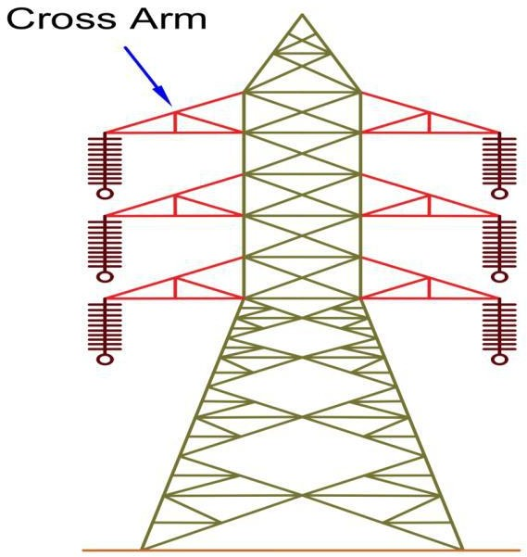

Guys & Stays
Figure 1. 11 Cross-Arms & Clamps

The Guys and Stays are used for the termination of the lateral forces by making the pole support in angle.

Lightning Arrestors
Lightning arrestors are used for the protection of the overhead lines from high voltage surges. The lightning arrestors are placed at the top of the overhead line as it collects the high voltage surges and give them to the ground. Lightning arrestors play a vital role in bad weather conditions mainly during rainy climates.

Fuses & Isolating Switches
The fuses are used to protect the appliances from high voltages and faults. The isolating switches are used for isolating the different appliances in transmission.

Earth Wire
Earth wire is used for collecting high voltage from lightning arrestors and supplying it to the earth. The earth wire will be running on the top of the tower.

Vee-Guards
These guards are used for public safety, these are provided below the overhead line along the transmission lines.

Guard Wires
These guard wires are used while crossing communication lines. They may be placed above or below the overhead lines and connected to the earth solidly.
- Miscellaneous Components:

Phase plates, bird guards, danger plates, barbed wires, vibration-dampers, top hampers, beads for jumpers, etc. The phase plates give information about various phases used, the barbed wire, and are wounded to poles at a height of 2.5 meters in order to prevent the climbing of unauthorized persons. However, danger plates are also provided at a height of 2.5 meters from the ground level.

- Overhead line Transmission Electrical Apparatus

Conductors

Overhead circuits consist of aerial cables or open-wire conductors carried on poles or towers. Aluminum conductors have, to a large degree, replaced copper in overhead installations.

Conductor sizes most commonly used vary from No. 2 AWG to 556 kcmil aluminum cable steel reinforced (ACSR) or stranded aluminum alloy. An aluminum cable stranded around a steel core

sized to give the required strength is known as ACSR. Other cables are aluminum conductor alloy-reinforced (ACAR) and all aluminum-alloy conductor (AAAC).

Hardware and Footings
Earthing and performance under high current impulse if a transmission line tower is struck by lightning and the potential of the tower is raised above the voltage impulse strength of the insulator string, a flashover will occur from the tower to a phase conductor which may lead to serious outages of the system. This type of flashover is called back flashover.
The electrical resistance of the tower footing is a significant parameter affecting back flashover voltage across the insulator(s) in transmission systems. According to IEEE Std., the individual performance of each tower is important in determining the lightning performance of the transmission line.
The overall performance of an entire transmission line is influenced by the individual performance of the towers rather than by the average performance of all the towers together.

Fittings
Common practice on phase conductors is to use compression type mid-span joints and compression dead-end fittings, with bridges employing compression lugs connected via bolted palms.
On older transmission lines with smaller conductors, dead-end fittings commonly consisted of a bolted hinge clamp with the bridging tail being connected using compression connectors or parallel groove clamps.
Fittings for the conductor shall include:
      - compression dead ends with terminal pads and matching compression lugs appropriate for the conductor rating
      - AGSU’s for conductor suspension attachments
      - trunnion clamps over preformed armour for bridging conductor support
      - Stockbridge dampers for conductor damping
      - rigid spacers for sub conductor separation
      - aerial markers
      - Provision for helicopter and UAV access to in-span hardware fitting.

Damaged conductor systems, in particular mid span joints, will require the use of specially designed fittings to enable the conductor capacity to be restored. These repair processes and fittings shall be designed to ensure that conductor ratings are not reduced as a result of the local repair.
All compression fittings shall be type tested to ensure correct pairing of fitting conductor and recommended compression dies.
Mid span joints and mid span joint repair device locations shall be recorded as “equipment” in SAP under the Span functional location and adhere to the asset handover and commissioning requirements detailed in the Asset Strategies – Line Maintenance Principles – Specification.

- Overhead line Distribution Electrical Apparatus

The transmission system voltage is stepped-down to lower levels by distribution substation transformers. The primary distribution system is that portion of the power network between the distribution substation and the utilization transformers.

The primary distribution system consists of circuits, referred to as primary or distribution feeders that originate at the secondary bus of the distribution substation. The distribution substation is usually the delivery point of electric power in large industrial or commercial applications.

Conductors
The conductor sizes most commonly used in overhead primaries range from No. 4 AWG ACSR to 336.4 kcmil stranded aluminum. Laterals, or branches, are often No. 4 or No. 2 AWG ACSR, but feeders run to the larger sizes. Aluminum, ACSR, and alloys of aluminum have largely displaced copper from primary circuit construction, although they may be specified on a copper- equivalent basis. Aerial cable is often used for primary conductors where clearances are too close for open wire or tree trimming is not 2-11 practicable.
The cable in some cases comprises three rubber-insulated, neoprene-insulated, or polyethylene- insulated conductors lashed to a bare messenger which serves as the neutral for 3-phase circuits. In other cases, the phase conductors are supported from the messenger by insulating spacers; this construction is commonly called spacer cable.
Single-phase taps, in either case, are usually one insulated conductor and messenger or an insulated conductor with neutral strands spiraled around it.

Electrical equipment
- Pole-Mounted Transformers
Pole-mounted transformers are power distribution transformers that are mounted on a power pole (wood or concrete) and usually horizontal to overhead cables.
Pole mounted transformers are common breadbox transformers used for converting distribution voltage to a 120/240 volt power source used by homes and small businesses.
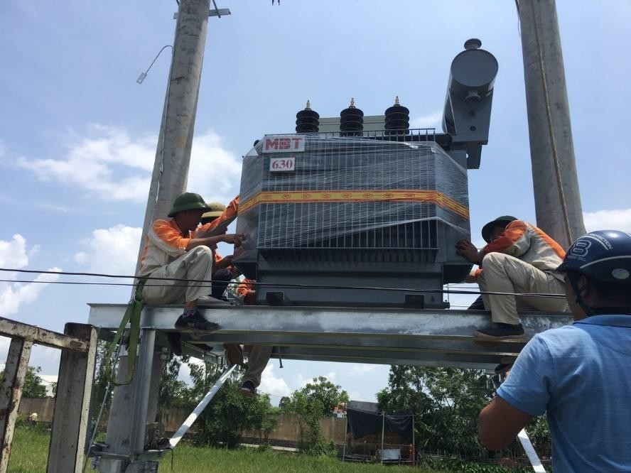
Figure 1. 12 Pole mounted three-phase transformer
Pole mounted power transformers are used in many rural areas. These transformers range from 16 kVA to 100kVA and convert 11,000 to 33,000 volts to 400 volts low.
Pole mounted transformers are reasonably small in size and mass. We can easily install on single-pole structures and larger units on two-pole structures, approximately 5 meters from the ground. This makes transformers inaccessible, reduces the risk of injury to animals and humans, and minimizes vandalism.

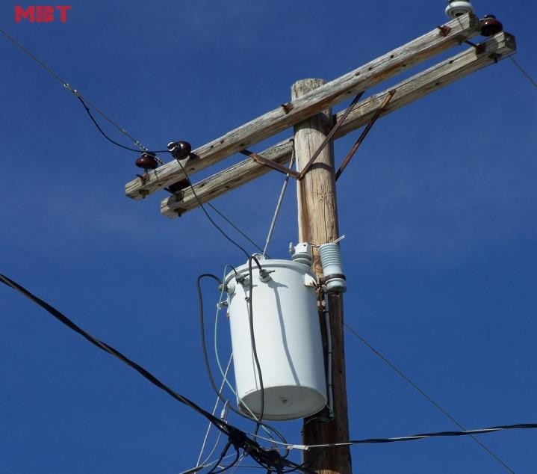

Figure 1. 13 Pole mounted single phase transformer

  - Advantage and disadvantage of pole mounted transformer

Pole-mounted transformer versions have their advantages and disadvantages. Here are the pros and cons to help you decide what will work out best.

Advantages:

- Pole mounted transformers reduce the risk of injury to residents.
- When you place transformers on the ground, they must be enclosed in a protected area because people who do not understand the risks can access that area. The transformers mounted high above will not be disturbed by the locals, and there is little chance that someone will climb up and mess up the transformer and get hurt.
- Compact: pole mounted transformers are extremely compact and don't take up precious ground space.
- If you are working on a smaller plot of land that is being developed, it may be absurd to designate such a piece of land as a ground substation. With column-mounted transformers, there is no need to worry about making use of ground space.

Disadvantages:

- Pole-mounted transformers might be more difficult to maintain.
- One of the immense damages to a transformer mounted on a pole is that when something goes wrong, you have to ask specific electrical companies to work with the know-how to

access the transformer on the pole and do the work. On the ground, accessibility is easy, so maintenance is less likely to be overlooked and if something goes wrong they can be done faster
- Pole mounted transformers may have to be replaced more quickly.
- Since these transformers are mounted high above the ground, they are in heavy contact with the elements. Although the sheaths of these transformers are designed to be highly resilient to things like wind and rain, they sometimes have to be replaced before a ground transformer would
- The unique characteristics of pole mounted transformers are not needing much space to place the machine. So that it's common in crowded residential sites.

Air-break switches
It is mostly installed in the distribution network as a switching point. It interrupts the small excitation current of a transmission line or the capacitive charging current. The maximum voltage for the switches is up to 35kV.
The switch whose contacts open in the air and quenching of an arc achieves by compressed air, such type of switch is called an air break switch. It acts as a dielectric medium for the air-break switch. It is more effective and reliable as compared to another switch. It is operated manually when their handle is placed on a ground level.
Air break switches are used to isolate equipment for maintenance and also for transfer of load from one bus to another. The air break switches install in outdoor and mainly use for switching and isolation.

Types of air-break switches
The air-break switches are classified into two types.

Single-Pole Air-Break Switch
Single pole air-break switch uses for the opening of only one conductor.

Gang Operated Air-Break Switch.
For the opening of more than one conductor at a time gang operated air break switch is used. The switches which opened together are called the gang switches.
The air-break switches are installed in two ways, i.e., either horizontally or vertically and it is placed on the pole top or in pad mounted metal enclosure. Lay-out of substation depends upon

type of Air break switches. These switches are of two type’s viz. vertical break type or horizontal break type.
Horizontal break type normally occupies more space than the vertical break type.
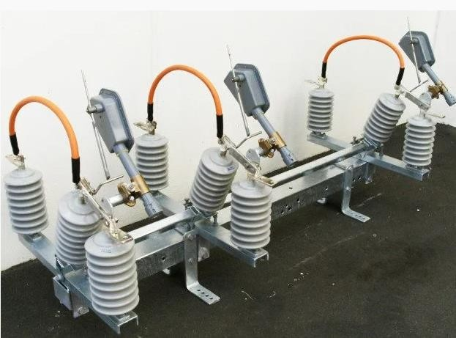
Figure 1. 14 Air-Break Switches

Working and Construction of an Air-Break Switch
The air-break switch has both the blade and the contact furnished with arcing horns. Arcing horn is the type of metal between which the arc induces due to interrupt current.
When the switch is open, the arc spreads farther and farther apart, and the arc lengthens until it finally breaks.
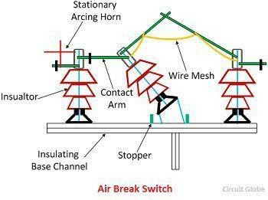

Figure 1. 15 Air-Break Switches Operation

Air break switches are of several designs. Some switches operate from the ground by a holder on the end of an insulated stick; some others are through a system of linkages and opens by a crank at the foot of the pole.

Alternating Current Circuit Principles

The majority of electrical power in the world is generated, distributed, and consumed in the form of 50- or 60-Hz sinusoidal alternating current (AC) and voltage. It is used for household and industrial applications such as television sets, computers, microwave ovens, electric stoves, to the large motors used in the industry. AC has several advantages over DC.
The major advantage of AC is the fact that it can be transformed, however, direct current (DC) cannot. A transformer permits voltage to be stepped up or down for the purpose of transmission. Transmission of high voltage (in terms of kV) is that less current is required to produce the same amount of power. Less current permits smaller wires to be used for transmission.
An alternating current can be defined as a current that changes its magnitude and polarity at regular intervals of time. It can also be defined as an electrical current that repeatedly changes or reverses its direction opposite as shown below. Alternating current (AC) is a form of energy that alternates its level with respect to time.
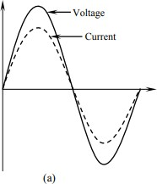

Figure 1. 16 Voltage in phase with current.

Electromagnetic Principles and induction process

Electromagnetism is a form of magnetism created when current flows through a conductor. When current is present, it generates a magnetic field around the conductor similar to that of a permanent magnet. When current is removed, the magnetic field disappears.

Electromagnetic Principles
The principle of electromagnetic induction was one of the most important discoveries in the development of modern technology. Without electrical power, our lives would certainly be different.
Electromagnetic induction, as the name implies, involves electricity and magnetism. When electrical conductors, such as alternator windings, are moved within a magnetic field, an electrical current develops in the conductors.
The electrical current produced in this way is caned an induced current. A simplified illustration showing how induced electrical current develops is shown in Figure 1.16. a conductor is placed within the magnetic field of a horseshoe magnet so that the left side of the magnet has a north polarity (N), and the right side has a south polarity (S).
Magnetic lines of force travel from the north polarity of the magnet to the south polarity. The ends of the conductor are connected to a current meter to measure the induced current. The meter is the zero-centered type, so its needle can move either to the left or to the right. When the conductor is moved, current will flow through the conductor.
Electromagnetic induction takes place whenever there is relative motion between the conductor and the magnetic field. Either the conductor can be moved through the magnetic field, or the conductor can be held stationary and the magnetic field can be moved past it. Thus, current will be induced as long as there is relative motion between the conductor and magnetic field. If the conductor shown in Figure 1.16 is moved upward, the needle of the meter will move to the right. However, if the conductor is moved downward, the needle of the meter will deflect to the left. This shows that the direction of movement of the conductor within the magnetic field determines the direction of current flow. In one case, the current flows through the conductor from the front of the illustration to the back. In the other situation, the current travels from the back to the front. The direction of current flow is indicated by the direction of the meter deflection. The principle demonstrated here is the basis for electrical power generation. In order for an induced current to be developed, the conductor must have a complete path or closed circuit. The meter in Figure 6-1 was connected to the conductor to make a complete current path. If there is no closed circuit, electromagnetic induction cannot take place. It is important to remember that an induced current causes an induced electromotive force (voltage) across the ends of the conductor.

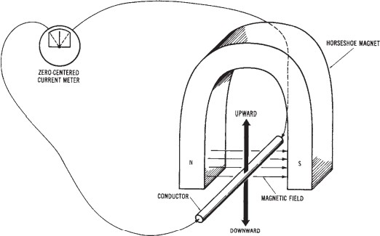

Figure 1. 17 Electromagnetic induction

Electromagnetic induction
The operation of the electrical generators used today depends upon the principle of electromagnetic induction. When conductors move through a magnetic field, or when a magnetic field is moved past conductors, an induced current develops. The current that is induced into the conductors produces an induced electromotive force or voltage.
Left-hand Rule We can determine the direction of current flow through a moving conductor within a magnetic field by using the left-hand rule. Refer to Figure 1.17 and use your left hand in the following manner:
- Arrange your thumb, forefinger, and middle finger so that they are at approximately right angles to one another.
- Point your thumb in the direction of conductor movement.

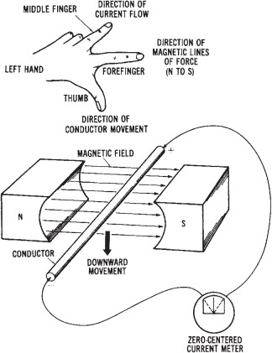

Figure 1. 18 Left-hand rule of induced current
- Point your forefinger in the direction of the magnetic lines of force (from north to south).
- Your middle finger will now point in the direction of induced current flow (negative to positive).

Key terms and words
Electromagnetism - the magnetic field around a wire or other conductor when current passes through it.
left-hand rule - when the left hand is placed around a current-carrying conductor so that the thumb points in the direction of current (electron) flow, the other fingers will point in the direction of the magnetic field; when the fingers of the left hand are placed around an electromagnet in the direction of current (electron) flow, the thumb will point to the north magnetic pole.
Field intensity - the strength of a magnetic field. Solenoid - an electromagnet with a sliding core. Plunger - the sliding core of a solenoid.

Stroke - the range of motion of a solenoid's sliding core.
Relay - an electromechanical device with contacts that are opened and closed by an electromagnet.
Armature - a relay's moving element, which is attracted by an electromagnet.
Hysteresis - the difference between a device's response to an increasing signal and a decreasing signal.
Isolation - the separation between a device's response to an increasing signal and a decreasing signal.

OHS policies and procedures for overhead lines

The project may have some degree of impact on the health and safety of workers involved in the construction as well as operation activities.
- There will be a risk of fall from pylons during construction of the overhead TL that would involve erecting towers and stretching cables.
- Project workers and equipment involved in construction of underground lines could be affected by traffic accidents as the UG lines are mainly located along existing roads that are usually very busy with high volume of vehicular traffic.
- In addition, there will be a risk of falling in trenches excavated for burying electric cables. During operational phase there can be a risk of electrocution during maintenance of the lines.
- Safety of project workers can be ensured through implementation of a safety management plan, which includes provision of proper training and awareness education and appropriate protective clothing and equipment to the project workforce; delineation or fencing of work zone or dangerous areas and providing sufficient information about the site through posting of clearly visible signs; posting proper and clearly visible signs, barricades, and reflectors at appropriate locations so that road users (drivers) are aware of the active construction works; and setting and enforcing speed limits for vehicular traffic by putting appropriate signals and assigning traffic regulators around project operational area
The first thing to understand about overhead power lines is that they are not insulated. Therefore ALL tools, ladders, poles and pipes (just to name a few items), should all be kept away from power lines.

Personnel working near overhead lines must allow for at least minimum clearances in all directions depending on voltage levels between them and live parts.
Working on overhead lines poses the following hazards:
- Induced voltages – Maintain safety distances
- Falling from height – Use safety harness
- Hazard of falling objects like tools, components etc – Wear safety helmets
- Coming in contact with live conductors, due to improper isolation, failure to earth – Systematic isolation and earthing practices
- Inadvertent re-energization of the line – Strict adherence to Lockout and tag out procedures

Works schedule drawings and symbols

    - Drawings
Single-line diagram (SLD) provide functional information about the electrical design of a system. This type of drawing is also referred to as a one-line drawing.
These drawings allow you to become familiar with the electrical distribution system layout and design. It shows how the main components of the electrical system are connected.
An example of an SLD is shown in figure 1. This drawing shows a system that has two utility sources connected to a line-up of medium voltage switchgear (MV-1).
On this drawing you can follow how power would flow through MV-1 to the lighting panel (LP- Single-line diagrams use standard symbols to represent the various components. For medium voltage equipment with ratings greater than 1,000VAC, equipment will typically be referred to using standard device numbers and by project-specific symbols or acronyms which are defined on the drawing.
In figure 1.19, the medium voltage circuit breakers are shown as a box with “52”, which is the ANSI device number for an AC circuit breaker. A list of common ANSI device numbers can be found in appendix A.
The components mounted in the medium voltage switchgear are enclosed by the dashed lines around the equipment symbols. This drawing shows the medium voltage switchgear ratings for voltage (13.8kV), current capacity (1,200 amps) and short circuit rating (25KA).

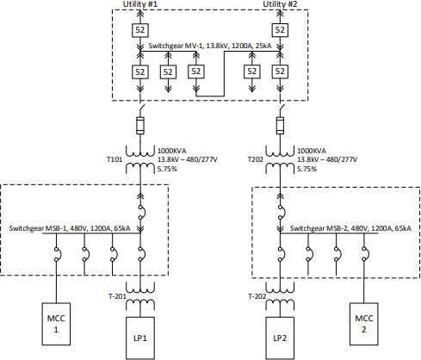

Figure 1. 19 Single-Line Diagram
Medium voltage circuit breakers do not have a protective relay or trip unit built-in that will cause the breaker to open during a fault condition, so there is a protective relay indicated by the circle labeled “PR”. There is also a power meter indicated by the circle labeled “PM”. These are not universal designations, so they should be identified in the notes on the drawing.

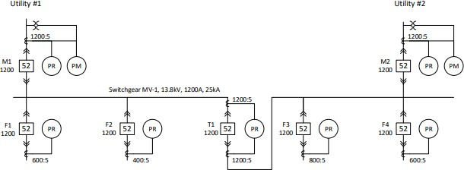

Figure 1. 20 Single-Line Diagram with more details
The protective relay and power meter have inputs from the voltage transformers (VT) and current transformers (CT). The VTs are represented by the symbol in figure 3 and the CTs are represented by the symbol in figure 4.

Symbols

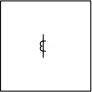

Figure 1. 21 Current Transformer (CT) Symbol Figure 1. 22 Voltage Transformer (VT) Symbol

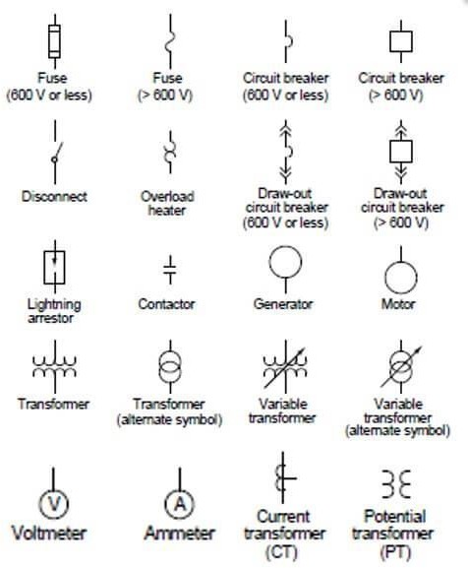

Figure 1. 23 Different Components Symbols

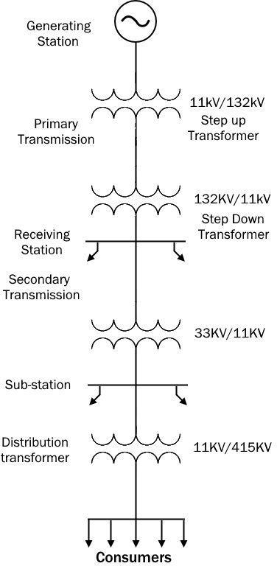

Figure 1. 24 Power Systems

Relevant requirements and practices

Before starting the design of the line supports, the following details shall be provided: The line electrical requirements such as:
  - The minimum clearances between conductors, and between conductor and the support itself.
  - Number, type and location of ground wire/wires with respect to the outermost conductor.
  - The minimum required mid-span clearance of the lowest conductor above ground level or to other conductors at intersection with other lines conductors.

  - Minimum Insulator required creep age path and hence the minimum length of the insulator assembly.
  - Electrical loading requirements (this will determine the number of conductors per phase and number of circuits per support.
  - Short circuits, Etc.

Safe working on Overhead Lines
Advice to Site Personnel When Working Near Overhead Electricity Lines
  - Working too close or causing damage to overhead lines is dangerous and can lead to flashover, explosion or fire and often results in casualties.
  - Risk of casualties will increase if details of the overhead line (e.g. voltage level, distance to ground, etc.) are not ascertained before commencement of works.

  - Overhead lines are mostly found in uninhabited or rural areas. They are clearly visible but the distance from the ground to the overhead conductors should not be ascertained by relying on visual judgement only. Treat any overhead lines found anywhere as LIVE.

Before Starting Works
Before starting works, the contractor or person responsible for the proposed works should go through the following checklist:
- Identify whether any of the proposed works are within the vicinity of any overhead lines (i.e. a horizontal distance of at least 9 m from the nearest conductor for all works except blasting work, for which the horizontal distance is extended to at least 25m).
- Obtain plans of the overhead lines in the area to ascertain the alignment if necessary.
- If any of the proposed works fall within the vicinity of the overhead lines, ascertain the voltage rating, the overhead lines' distance from the ground, and consult the electricity supplier of the lines to agree on a mutually acceptable work plan.
- Ensure that notes of all discussions held with the electricity supplier on the work plan are kept until all the proposed works are completed.
- Provide site personnel with information about the overhead electricity lines such as voltage, ground clearance and actual alignment and minimum safe working distance.

During the Course of Works
During the course of the works, all site workers should exercise the following precautions:
- Avoid working unnecessarily directly beneath the overhead lines.
- Observe any warning notices erected in the vicinity of the overhead lines.
- Determine the height of any object, including any tools, equipment, apparatus or vehicles, and maintain a safe working distance between the object and the overhead line as advised by the electricity supplier. Use suitable physical restraining devices if necessary.
- Insofar as reasonably possible, ensure that the working methods as agreed with the electricity supplier are strictly followed.
- Never handle or attempt to handle any overhead line conductor even though it may appear to be damaged.
- Do not erect structures (e.g. scaffolding) unnecessarily in the vicinity of any overhead lines.
- Do not disturb any earthing conductors connecting the overhead line poles/towers to the ground. Earthing conductors are normally buried underground and connected to the overhead line from the bottom of the poles/towers.
- Never rely on the insulating cover of any overhead line conductors as a means of protection from electric shock. Always treat the insulated conductors as LIVE.
- Ground level barriers should be erected at a horizontal distance of at least 6m from the outmost conductor of the overhead electricity lines.
- If plant or equipment will pass underneath overhead electricity lines, a passageway with gateways and goal posts should be provided. A signaler should be assigned to guide the movement of plant or equipment and maintain a safe working distance when passing underneath overhead electricity lines.

- Report any electrical accident or damage or interference to an overhead electricity line to the relevant parties, including the electricity supplier. Evacuate everyone from the immediate area of the damage/interference but do not attempt to remove any objects, retract mobile cranes or to touch the injured person if he/she is still in contact with the overhead line conductor, because the line may still be LIVE. Cooperate with the electricity supplier as requested by providing access to the works site for carrying out repairs.

Permit to Work

A work permit authorizes access to electrical apparatus or conductors after they have been made safe by isolation and earthing. The permit is a printed form containing the application, permit, clearance and employee's or workmen's declaration for the authorization of all work to be done on electrical equipment connected to a system.
The Permit System is designed primarily for the safety of personnel and safeguard electrical apparatus from damage. The Permit, once signed by both parties, is in fact a written declaration that the apparatus is safe to work on. The fundamental rule for safety in electrical systems is “No work without valid permit”.
The intention of a Work Permit System is to ensure that:
- Before personnel are permitted to work on apparatus, such apparatus has been taken out of service by isolation and earthing and made safe to work on
- All safety precautions initiated during the preparation stage are maintained during the period that work is proceeding on such apparatus
- All personnel are withdrawn on completion of work and informed that it is no longer safe to work on the apparatus, and that all tools and work equipment have been cleared so that the apparatus can be returned safely back to service
The permit to work basically consists of the following information:
  - Identifies the apparatus to be worked on
  - Nature of the job to be carried out
  - States the time work is to be commenced
  - Details of the isolation points
  - Details of secondary isolation points if any
  - Details of the number and points of earthing

SELF-CHECK-1
- Choose the correct answer from the give alterative
- is not parts of overhead line structures.
  - conductor B. Transformer C. Insulator D. All
- site workers should exercise one of the following precautions
a). Identifies the apparatus to be worked on b) Nature of the job to be carried out
b) States the time work is to be commenced d) All
- used for the protection of the overhead lines from high voltage surges.
  - Tower B. Lighting arrester
C. Earthing system D. all
- Mach column “B” to column “A”
A B
1: Safety Gloves A. lighting arrester
2: Preventative Measures B. current transformer
3: 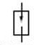 C. identify hazards
4. D. PPE
- Give short ad precise answers for the following questions
- List at 4 basic safety Rules that can help to prevent hazards associated with the use of hand and power tools.
- List at least four components of overhead lines
- Describe operation principles of electromagnetism
- List at list 3 components of overhead distribution components

UNIT TWO: Carry Out Inspection of Overhead Structures and Electrical Apparatus Used on Towers
This learning unit is developed to provide the trainees the necessary information regarding the following content coverage and topics:
  - Occupational Health and Safety workplace procedures and practices
  - Sustainable energy principles and practices
  - Transmission Power line inspection principles
  - Towers and structures inspection principles
  - Safely use of power tools and equipment techniques
  - Fundamentals of jointing Overhead and Underground LV cables
  - Procedures for lifting and climbing
  - Carry out inspection of overhead structures and electrical apparatus used on towers
This unit will also assist you to attain the learning outcomes stated in the cover page. Specifically, upon completion of this learning guide, you will be able to:
  - Monitor and follow OHS and sustainable energy principles and practices
  - Safely follow lifting, climbing, working in confined spaces and aloft,
  - Use power tools/equipment, techniques
  - Apply safe inspection of overhead structures and electrical apparatus used on towers
  - Inspection of overhead structures and electrical apparatus used on towers
  - Recognize hazard warnings and safety signs and hazards and report assessed OHS risks
  - Apply known solutions to a variety of problems
  - Undertake ongoing checks of quality of the work

  - Occupational Health and Safety workplace procedures and practices The safe work practices contained within this document protect workers from the hazardous occurrences or effects that can develop on or around overhead lines and their support structures, including:
→ Lightning;
→ Induced voltages and currents;
→ Transfer voltages;
→ Voltage gradients;
→ Line energizing; and
→ Neutral and earthing system currents.
This document sets out a range of hazardous situations, the controls (safeguards) to be implemented and describes the safe work practices which must be observed. The possible safe work practices are referenced for each situation.

Safe working of High Transmission and Low Transmission Lines Cables and Equipment
Before taking up any work, the following systematic approach shall be adhered to.
  - The appropriate circuit to be switched OFF either by availing Line clear or BLINK.
  - Proper communication shall be made between the receiver of Blink and the Operator at the Shift at Substation so as to understand the correct feeder, location, nature of work etc.
  - After availing LC or Blink, the working personnel should ensure that the supply is switched OFF as per their requirement.
  - It shall also be confirmed that there is no possibility of supply through any other source to this point with, Generators, inverters, back feeding etc.
  - After opening the appropriate switches by using PPEs, the switch shall be Locked and tagged out.
  - Though now there may not be a provision for Locking at the AB switch handles at Field, necessary arrangements for fool proof locking shall be made within a time frame at Field for all the switches in the Distribution network by the Officers concerned.
  - It is a mandatory to provide Locks with double keys to each workman in the field those who are authorized to carry out Maintenance, fuse off call etc. One key to be with the

authorized workmen and another with the Section Officer / Supervisor.(Foreman / Line Inspector)
  - The workmen shall compulsorily lock the Switches that have been opened by the Lock provided to him and the key shall be kept in safe custody with him.
  - A Danger board in Post Office red Stating that “MEN ON LINE, DO NOT OPERATE” shall be provided on the switch location.

  - Climbing in the structure shall not be made through the Operating pipe.
  - The HG / LT fuses shall be removed before starting the work.
  - Even for renewal of fuses Earth rods shall be provided at appropriate locations.
  - The equipment / Lines shall be discharged and then effectively earthed at necessary locations at work spot irrespective of Earthing provided at remote locations(at the Substation end or at the Switch Location)
  - If the scheduled work is of long duration, and if necessary, depending on the site conditions the jumpers at the nearest location shall be removed. This is in addition to the Earthing and not substitutes for earthing.
  - If the work is being carried out on one circuit of a double circuit, then it may be ensured that adequate clearances are available.
  - Further minor works such as replacement of Pin insulator / Pin binding may be carried out in one circuit of double circuit.
  - The above works shall be carryout in the supervision of a person not lower than the rank of a Line Inspector.
  - Other works if any to be carried out in a circuit of Double circuit only if both the circuits are switched “OFF”
  - If it is necessary to work on a HT line of HT / LT line with HT on Top and LT on bottom, then the LT Line shall be switched OFF.

Sustainable energy principles and practices

The 'energy-system' consists of an array of technologies, processes, appliances and practices that convert resources to energy carriers to a service
Characteristic of best practices:
    - Saving a large amount of energy at low cost and with considerable economic advantages to consumers;
    - Addressing market imperfections or barriers by enabling consumers to make informed decisions and fully benefit from their investments;
    - Targeting a significant gap in existing policy.
The provision of sustainable energy from renewable sources and improved energy efficiency is strongly interrelated with the overall aim of the 2030 Agenda to increase production and consumption patterns across all sectors of the economy that enable the sustainable management of resources.
To provide for an environmentally sustainable economic framework, UNIDO promotes industries that emphasize efficient resource management, cleaner production, reduction of waste and pollution, as well as sustainability policies in industrial production and consumption, such as the circular economy approach.

Distribution and Transmission Power line inspection principles

    - Transmission Power line
Owners of all structures should ultimately seek advice from the manufacturer on the frequency of inspections. However the manufacturer’s opinion may be regarded as ‘guidance only’ if owners can provide sufficient records and risk assessmen4ts to demonstrate that alternative frequencies can be used, and still provide adequate safe integrity of the structure factors including:
Previous maintenance records – if consistently no issues have been raised over various inspections this may extend the inspection frequency.
Age – as the structure gets older the inspection frequency may need to increase.

Loadings – structures where there is little or no information on their loading status or which are known to be highly loaded, e.g. 95% of its design criteria, may need more frequent inspections.
Location – structures in populated areas may need to be inspected more frequently than those in very rural areas; also structures in very exposed conditions (wind, rain, sea) may need inspecting more frequently than those in sheltered areas.
Areas where there are high levels of vibration from external sources.

Distribution Power line
Historically, most distribution hardware was considered as “run to failure,” and maintenance was minimal. Now, many utilities have programs for inspection and maintenance that covers much equipment. Visual inspections can find many issues, including NESC violations, cracked or broken cross arms, cutout issues, severely deteriorated poles, and so on. Many regulatory bodies now require periodic inspections.
Voltage regulators and recloses require inspection and maintenance. Inspection and maintenance of these are normally based either on a time interval or on operation counts.
The power transmission facilities mainly include power lines, towers, and insulators. These facilities are exposed to thunderstorms, thermal deviations, ice, rain, pollutions like volcanic gases and sour rains: a severe environment that may lead to material fatigue, oxidation, and corrosion.
  - Electric companies are required to inspect and maintain the power transmission equipment periodically.
  - Ground patrols partially inspect these facilities, and direct visual examination is carried out by skilled personnel climbing over de-energized power lines.
  - A common approach nowadays is to use helicopters equipped with high-resolution cameras, but in such inspection, helicopters cannot cover narrow mountainous regions due to regulatory constraints.

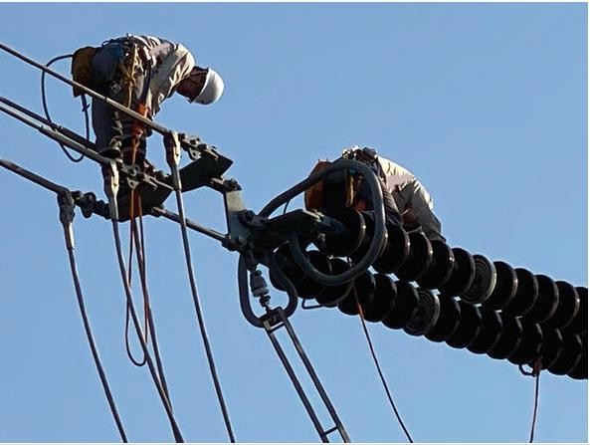
Figure 2. 1 Power line inspection Works

Unmanned aerial vehicles (UAV) are a promising solution for power line inspection because of time and cost efficiency and because UAVs can approach and inspect energized lines safely.

Image processing algorithms are also heavily employed to power lines recognition and tracking. However, in most of these studies, distance to the lines is not measured, and their robustness is challenging. It can acquire visual information and measure the joints’ electrical resistance and monitor the corrosion level of the conductors.

Towers and structures inspection principles
A successful, quality inspection incorporates proper safety procedures, a well-planned sequence, and sound inspection methods. Due to the large number of overhead structures that typically need to be inspected, it is important to have well-planned and well-managed inspection procedures to eliminate errors and inconsistencies.
Some of the factors that will affect the sequence of the inspection are the type and size of the systems, traffic density, and availability of special equipment, preferences of the inspection supervisor, and requirements for traffic control.
The inspection equipment to complete inspections of these structures shall vary depending on structure type, structure geometry, height, traffic and clear zone adjacent to the structure.

Inspectors have an array of options for inspecting overhead sign structures including climbing, bucket truck and miscellaneous tools for hands-on.

Inspection Planning and Preparation
- Identify structure elements and assessments
Review as-built drawings and identify each element. If forms exist, review and verify the element data (design, material, and quantity) matches the as-built.
Calculate quantities for each element and compute or verify the total quantity for the structure.

Prepare field forms and sketches
Prepare forms in HSI and sketches for documenting condition states in the field. Forms should accommodate all defect types as applicable and provide sufficient room for adding inspection notes.
Verify the bridge elements (number and name) on the HSI form and the associated total quantities. Leave room for additional elements that may be discovered in the field. For existing forms and sketches, review content and update as needed.

Develop inspection plan
The inspection plan should include procedures for collecting data. Consider inspection sequence and access when developing the plan. Elements are generally evaluated in 3 dimensions and may have overlapping defects. The defects will be assessed on type and severity. All defects must be considered in the determination of controlling condition states.
Review and update procedures outlined in the bridge inspection report as necessary to identify changes to the bridge or new requirements.
Record bridge specific inspection plans and procedures on the inspection form and in HSI.

Safely use of power tools and equipment techniques
    - tools and equipment HV Cable Jointers Tools
Using the correct cable tools to prepare industrial and utility cables before cable jointing and terminating reduces catastrophic cable failures.
Some of the important cable jointer tools include:

Cable cutting tool

Cable cutting tools to suit LV-HV cables with copper or aluminum conductors, steel wire armoured (SWA) / braided cables with lead sheath and insulation types including XLPE, EPR and paper types – commonly used to cut armoured LV cables and medium/high voltage power cables 11kV-33kV, single and 3 core type

Figure 2. 2, High Voltage Insulated Ratcheting Wire Cable Cutter

Cable crimping tool
Cable crimping tools using hydraulic or battery operated to crimp conductors’ 1.5sqmm- 1000sqmm suit aluminum and copper conductors with sector shaped, stranded or solid cores.

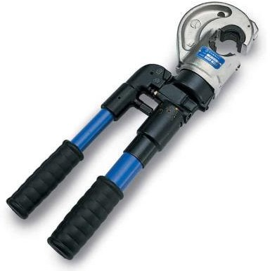
Figure 2. 3 Cembre HT131-C Hydraulic Crimping Tool



Figure 2. 4 Cembre B1350-CE Battery Operated Crimp Tool
The above tools are also suitable for the crimping and termination of LV Low Voltage category cables.
The mechanical shear bolt cable lugs, terminals and connectors are suitable for the connection and termination of MV HV cables up to 66kV with copper or aluminum conductors (stranded circular, solid, sectoral shaped) without requirement for crimping tools – installed using no specialist jointing tools.
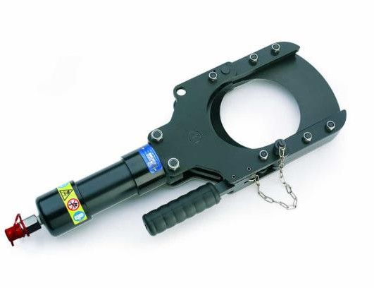
Figure 2. 5 Cable Cutting Tools

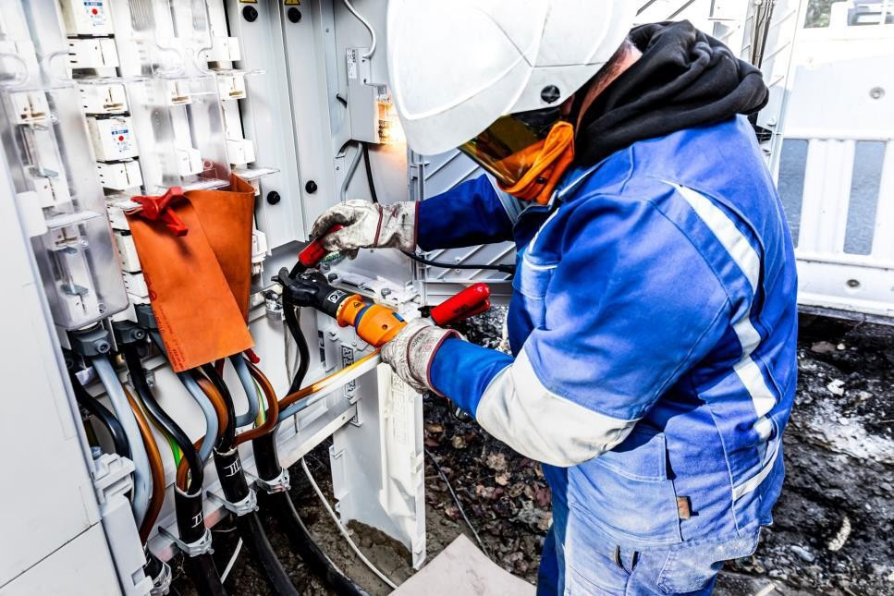

Figure 2. 6 Cable Jointing Operation

Safe use of tools and equipment
Inspection and Repair Tools should be inspected by a person qualified through training and experience to determine the safe condition of the tool.
Worn or damaged tools should be tagged “DEFECTIVE – DO NOT USE” and returned to the shop for repair or replacement. Regular inspection of all tools is necessary and should cover tool maintenance and service as outlined in the operator’s manual.
Observing proper handling and storage of tools should also be a part of the inspection process. Responsibility for inspection is usually left to the supervisor. However, tools should be checked by those who use them daily.
Hand tools that get the heaviest use and abuse, such as chisels, hammers, and wrenches, should be inspected frequently and regularly.
To maintain and repair tools properly requires the right facilities and equipment. A good workbench, repair tools, vises, and good lighting are necessities.
Only persons skilled in the repair of tools should be allowed to do the repairs. Otherwise tools should be sent out to a qualified repair depot.
All power tools can be dangerous if both general and tool specific safety instructions are not followed carefully. General safety instructions apply to all power tools, both corded and cordless. Start with a Safe Work

  - Area Keep your work area clean and well lit. Cluttered benches and dark areas invite accidents.
  - Do not operate power tools in explosive atmospheres, near flammable liquids, gases, or dust. Power tools create sparks, which may ignite the dust or fumes.
  - Keep bystanders, children, and visitors away when using a power tool. Distractions can cause you to lose control.

Electricity can be Dangerous
  - Grounded tools (three pronged cords) must be plugged into a properly grounded installed outlet. Never remove or cut off the grounding prong or modify the plug in any way. Do not use any adapter plugs.
  - Double Insulated tools have a polarized plug (one blade is wider than the other.) This plug will fit into an outlet only one way. Do not change the plug in any way. Do not use AC only rated tools with a DC power supply.
  - Store battery packs away from other metal objects like paper clips, coins, keys, nails, screws, or other small metal objects. These things can make a connection from one terminal to the other, shorting the battery terminals together and causing burns or fire.
When using a power tool, don’t touch grounded surfaces such as pipes, radiators, ranges and refrigerators. There is a higher risk of electric shock if your body is grounded.
  - In damp locations, only plug your tool into a Ground Fault Circuit Interrupter (GFCI). If the work area does not have a permanent GFCI on the outlet, use a plug-in GFCI. Wear rubber gloves and footwear. Don’t use or leave power tools in the rain or wet conditions.
  - Do not abuse the cord, carry the tool by its cord, or pull the cord to unplug it. Keep the cord away from heat, oil, sharp edges or moving parts.
  - Replace damaged cords immediately.
  - Always hold the tool by the insulated gripping surfaces. Contact with hidden wiring or its own cord will make exposed metal parts of the tool “live” and shock the operator.

  - Fundamentals of jointing Overhead and Underground LV cables Electrical joints and terminations provide the required electrical connection as well as the mechanical support and physical protection to the cable. It is important for the Cable jointing system to suit the service and operational requirements for all industrial cable jointing

environments and applications. These devices are important for jointing the cables and wires. A good cable jointing and installation provides a better supply of power (Fig. 2.7).
Cable jointing has become the preferred pick over conventional systems for cable termination, cable abandonment, and low voltage cable jointing and cable repair.
The cable termination and jointing kits are often specialized in wire installations worldwide. Cables play a very important role in the distribution system of power. There are different types of cables like LT cable, 11 KV cable and 33 KV cable.
Cables are used in places where bare conductor cannot be used due to narrow roads. Cables are costlier than the conductor and the same cannot be replaced often.
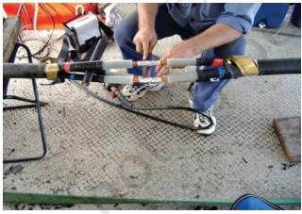
Figure 2. 7 Electrical joint and terminations

Electrical Cable Jointing Methods
Jointing of power cables should be as simple as twisting and taping the wire. For jointing of a cable variety of in-line adapters and connectors are used.
The method used for a cable joint depends on the voltage, type of cable, type of joint, type of connector, application and other factors.
Proper tools and equipment are to be used for jointing the cable.
Given below are some important factors to ensure reliable connections, such as
  - proper size of connectors should be used for a particular cable,
  - proper tools and equipment are to be used,
  - cuts and stripping should be very clean,
  - proper technique is to be used for cable jointing and

  - restoring the insulation, outer-sheath and armour The following are methods of cable jointing

 Western Union Splice Joint
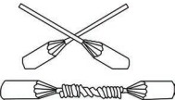
Figure 2. 8 Western union splice and straight joints

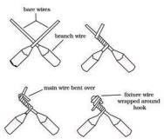
 Fixture Joint

 Knotted Tap Joint
Figure 2. 9 Fixture joint

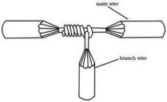

Figure 2. 10 Knotted tap joint

 Joints Using Wire Nut and Split Bolt

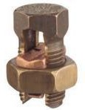

Figure 2. 11 Split bolt

The rattail joint is replaced by wire nut. The nut is usually housed in a plastic insulating casing.
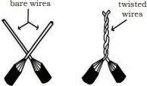
Figure 2. 12 Rattail joints

The split bolt is used to join big sized conductors. This replaces the knotted tap joint and can be used to join three ends or join a branch conductor to a continuous (main) conductor (Fig. 2.12). The bare wires are placed through the space between the two bolts, after which the nut is tightened to ensure a sound joint. The material required for making straight or branch joints for steel wired armour cables are as follows:
    - Connectors
    - Copper mesh tape
    - Constant force springs for holding the wire armour and copper mesh tape
    - Standard PVC/Vinyl tape, which provides a mechanical barrier between the over sheath layer and the armour layer.

Procedures for lifting and climbing Prevention of Climbing on Supporting Structures
As for supporting structures of electrical lines, following measures shall be taken to prevent danger to third persons.
  - Any metal steps of supporting structures shall not be installed at the height of 1.8m or less from the ground.

  - Warning signs to make third persons recognize danger shall be installed at each supporting structure.
  - As for high-voltage lines, appropriate devices shall be installed at all legs of supporting structures to prevent third persons from climbing the supporting structures.

Climbing
The support frames of the overhead sign supports should be climbed with a body harness and two lanyards per OSHA standards.
  - Attach one lanyard to the lower horizontal.
  - Stand on that member and attach the second lanyard to the next higher horizontal.
  - Release the first lanyard, and climb onto the upper horizontal and repeat until the top is reached.
  - The support frames and space frames are climbed with one lanyard attached to the structure at all times.
The lanyards should be attached to the top of the frame whenever possible to shorten the fall distance. If it must be attached to a vertical or diagonal, the lanyard should be wrapped around the member and under itself at least once, forming a hitch knot, to keep the attachment from slipping down the member. If the lanyard is attached to a lower member of the frame, and a fall occurs, the inspector may fall into the path of a passing vehicle, and will be exposed to a potentially lethal fall factor.
It is the inspector’s responsibility to have the proper lanyards for climbing a sign structure, and use the proper connection points on the sign structure.

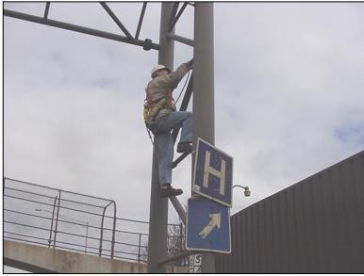

Figure 2. 13 Inspector Climbing an End Support Frame

Carry out inspection of overhead structures and electrical apparatus
    - Performing the Inspection

Record defects
  - Record type, severity, and extent of defects on the sketches and forms provided using the standard terminology and descriptors.
  - Track defects throughout the element and identify overlapping defects.
  - Identify worst case scenario defects for a given element (within a unit of measure) and record this on your inspection form.
  - Take thorough notes to identify location of worst case scenario defects, as well as structural defects. It will be necessary for the inspector to document exact location, orientation, length, and size of each defect. This will be essential for repeatability during future inspections.
  - If corrosion or debris build-up prevents visual inspection, then the inspector must clean accordingly to properly ascertain the condition of the element.
  - Where an element is not clearly visible to the inspector, an Interim inspection may need to be scheduled so that proper equipment, cleaning, access, traffic control, etc.… can be mobilized to adequately inspect, assess, and properly document any defect’s condition state.

Identify condition states and quantities

  - Identify the condition states and the associated quantities for each defect.
  - Based on defect condition states, apply the applicable condition states to the element.
  - If condition warrants analysis, indicate in the notes why it should be done; check the re-rate box; and document specific location in span and on element, through the use of measurements, pictures, and/or sketches. Measurements are particularly important for performing load ratings.

Conduct Quality Control (QC)
  - The Team Leader is responsible for adhering to their internal quality control procedure

Inspection of Lines
Lines shall be inspected frequently and thoroughly for the purpose of ensuring that they are in good condition so as to conform to these rules. Lines temporarily out of service shall be inspected and maintained in such condition as not to create a hazard.
- Ensure that all overhead line inspections in the areas of their accountability, are included in the maintenance plan and scheduled accordingly.
- Ensure that all maintenance interventions required and emanating from a condition assessment (Line Inspection) is identified, prioritized, specified (including the material requirements) and planned through the creation and management of work orders and ad-hoc Job Plans.
- Develop line inspection reports in spreadsheets, separating the line components (High Fault Level Zones to T-Offs) as specified in this guide onto separate spread sheets. Ensure that all inspection and consequential maintenance information provided by the inspection authority is secured as history of network and frequently analyzed.
- Ensure that line inspections and maintenance specified and scheduled by work order execution conform to the requirements of this Guideline.
- Issuing the inspecting authority with material, tools and equipment specified in this Guideline prior to the job commencing.
- Ensure that all conditions of statutory non-conformance or dangerous conditions be secured and corrected immediately on notification and/or identification.

    - Towers or Poles Inspection
- Poles and towers are the less affected by faults and weather. But with age it may get corroded.
- This is most likely to happen in high humidity environment. Visual inspection can help detecting any corrosion in its early stage.

Maintenance of over Head Transmission Line
Over Head Transmission line contains three important components, Insulators, tower and conductors. Making regular electrical inspection for the Over Head Transmission line network makes difference in faults and power reliability.
Hereunder maintenance process for some of overhead transmission lines components. Because, the listed parts require frequently maintenance
Insulators Maintenance
- Insulators get dirty due to the environment pollution and dusty weather.
- Visual inspection could be done without power isolation because, you could inspect them from safe distance.
- Cleaning insulators is one of the most important preventive maintenance.
- As you know that dirty insulators may pass electrical current as a flash-over.
- This flash-over can destroy the insulator as well as cause earth leakage fault.
- Cleaning insulators process takes two forms. One is by direct contact with it and using a piece of dry and smooth clothes, in this case power must be isolated.
- The second way is to clean with water jet without power isolation. Only well trained persons can do this dangerous job with special precautions.
- Sometimes the insulators get broken due to many reasons. In this case the broken one should be replaced.
- Insulators replacement could be done without power isolation but, with great precautions and special isolated tools.
- The company I work for hires third party specialists to do hot washing and live maintenance for OHTL.



Figure 2. 14 Dirty Overhead Power line insulator

Conductors Inspection and Maintenance

- Due to aging and windy weather besides short circuits and lightning strikes the overhead power line conductors are cut.
- In this case the damaged conductor could be replaced or repaired with proper connecting devices.
- This image is in workplace used this splicing device to connect a cut Over Head Transmission Line wire, found the splice itself broken during visual inspection.
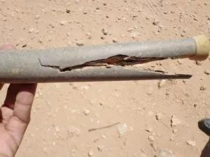

Figure 2. 15 Broken Conductor Splice

Replacement of Poles, Towers or Other Structures
The replacement of poles, towers or other structures is considered to be reconstruction and requires adherence to all strength and clearance requirements of these rules. The clearances of the spans adjacent to the new support need not be changed but the new support shall be such that when the adjacent support is replaced the span between will meet all the provisions of this Order

SELF-CHECK-2

Part I. Choose the correct answer from the give alterative
- material required for making straight or branch joints for steel wired armour cables are:
  - Tower B. Connectors C. Insulator D. All
- The method used for a cable joint depends on
A) the voltage B) type of cable C) type of joint D) All
- used for cutting wires or cables of overhead.
  - Hydraulic Crimping Tool B. Lighting testers
C. Ratcheting Wire Cable Cutter D. all

Part II. Mach column “B” to column “A”
A B

1: A. Insulated method

2: B. Western Union Splice Joint
3: conductors at or near ground C. Insulated until connected
4. Making/Breaking connections D. Knotted tap joint

Part III. Give short ad precise answers for the following questions
- List at 3 basic safety Rules that can help to prevent hazards associated with the inspection of tower structure.
- List at least four tools used to cut and crimp cables
- Describe some steps on climbing supporting structure

OPERATION SHEET-1

Operation Title: Preparing the Cable for jointing Instruction: follow the procedures provided on sheet Purpose: to develop cable splicing skills
Required tools and equipment:

Combination pliers
  - electrician knife

cables
Precautions: use tools and equipment safely Procedures:
Step 1. Prepare the cables and obtain required materials and equipment
Step 2. Remove the over sheath and the wire armor
Step 3. Separate the wire armor and bend the wires away from the cable, place the support ring under the armor at each side of the joint
Step 4. Cut back the cable insulation
Step 5. Remove the insulation from each of the conductors

Quality criteria:

- Your jointing should be neat
- Apply safety rules

OPERATION SHEET-2

Operation Title: Making Western Union Splice Joint Instruction: follow the procedures provided on sheet Purpose: to make cable joints
Required tools and equipment:

combination pliers,
  - electrician knife,

cables
Precautions: use tools and equipment safely Procedures:
Step 1. Prepare the cables and obtain required materials and equipment
Step 2. Remove the insulation of cable
Step 3. Bring the two conductors to a crossed position and then make a long bend or twist in each wire.
Step 4. Wrap the end of one of the wires around the straight portion of the other wire, and then do the same for the other wire. Repeat this for about four or five times.
Step 5. Press ends of the wires down close to the straight portions of the wire to prevent the ends from piercing through the insulation tape
Step 6. Insulate the joint using the insulation tape

Quality criteria:
- Your jointing should be neat
- Apply safety rules

OPERATION SHEET-3

Operation Title: Making Fixture Joint
Instruction: follow the procedures provided on sheet Purpose: to develop cable joint skills
Required tools and equipment:
  - combination pliers,

electrician knife,
  - cables

Precautions: use tools and equipment safely Procedures:
Step 1. Prepare the cables and obtain required materials and equipment
Step 2. Remove the insulation of wire
Step 3. Wrap the fixture wire around the branch wire
Step 4. Bend the branch wire over the completed turns
Step 5 Wrap the remaining fixture wire over the bent branch wire
Step 6. This can be followed by soldering and taping, or simply taping of the joint

Quality criteria:

- Your jointing should be neat
- Apply safety rules

OPERATION SHEET-4

Operation Title: Inspecting Towers
Instruction: follow the procedures provided on sheet Purpose: to develop inspection skills
Required tools and equipment:
  - PPE,
  - Safe Ladder,
  - Inspection checklist Precautions: use PPE and equipment safely Procedures:
Step 1. Obtain inspection checklists from your instructor/supervisor
Step 2. Remove the weather protection on the bolts at the base of the legs.
Step 3. Check all nuts and bolts are present.
Step 4. Check they are all tight and at that bolts extend at least ONE entire thread past the face of the nut.
Step 5. If known torque the bolts to the correct setting.
Step 6. Replace weather protection on the bolts.
Step 7. Check integrity of anti-climb device.
Step 8. Record the result

Quality criteria:

- Notify and report completion of work to assigned responsible personnel
- Your recorded inspection result should be readable

LAP TEST
Instruction I: Given necessary templates, tools and materials you are required to perform the following tasks within 2 hours.
Task 1: Making Fixture Joint
Task 2: Making Western Union Splice Joint Task 3: Making Fixture Joint
Task 4: Inspecting Towers

UNIT THREE: Completion Inspection of Overhead Structures and Electrical Apparatus
This learning unit is developed to provide the trainees the necessary information regarding the following content coverage and topics:
  - Commissioning works
  - Making work site safe and materials returning
  - Work records and reporting
This unit will also assist you to attain the learning outcomes stated in the cover page. Specifically, upon completion of this learning guide, you will be able to:
- Check work undertaken against works schedule

- Report accidents and/or injuries

- Rehabilitate, cleanup work site and make safe

- Clean, check tools, equipment and any surplus resources and materials and return to storage

- Sign off Relevant work permit(s) and return, overhead structures and electrical apparatus used on towers to service
- Finalize works completion records, reports

Commissioning works
A condition report should be completed for all inspections, which is sufficiently detailed to demonstrate that the site is structurally sound at the time of the inspection. Ideally it should include photographs to provide evidence of any issues raised.
The person undertaking the inspection will use their competency to determine if the site passes its inspection and/or what issues are to be raised that need resolution. If there is any doubt then the issue will be escalated within the company, utilizing the expertise of the overseeing or supervising person. If necessary a fully qualified structural engineer will be used for more detailed analysis.
All tower and mast owners should have a robust system in place for dealing with any issues or recommendations raised at the time of inspection, and an audit trail to demonstrate rectification.

Making work site safe and materials returning
When work is complete and you need to clear the Safety Document
- Ensure all tools and equipment are cleared off the work site.
- Ladders must be removed from site or secured and where ropes are being left on towers they shall be secured to the tower leg and tied above the anti-climber and the tower access gate locked.
- Communicate to all members of the working party that all work has now ceased and recover any items issued. (Flags, wristlets, Drain Earths etc.)
- Any items issued of the Permit for Work must be returned with the Safety Document.
- Sign the clearance section of the Safety Document.
- Declare any exceptions, such as ropes that have been left in position and or details of work that has not been completed.
- Return the Safety Document and other relevant items e.g. key safe keys, flags and wristlets etc. Remember the Key Safe is used to retain the Safety Lock Keys associated with the points of Isolation and Earthing.

Work records and reporting
Any defects found during checks and inspections must be recorded and reported to the crane owner. Where defects that could affect the safety of persons and require immediate rectification are found, the user of the crane must also be informed to ensure that the crane is taken out of service until the defect has been rectified.

Records
All tower and mast owners should also have a robust system in place for raising any significant issues identified at the inspection to any persons that may be affected by the finding, including third parties.
The primary records that should be kept include:
- Evidence of adherence to requirements covering design, checking ‘as built’ drawings and hazards, and demonstrating due diligence checking that design and ‘as built’ comply with applicable standards and associated loadings.
- Details of inspections, audits and reviews to demonstrate sound management.
- A fault history of the structure and remedial action taken.
- Identification of similar structures to assist in identifying fault trends.
- Other information will need to be kept, for example to enable more cost effective management of the site.
- Photographs of inspections.

SELF-CHECK-3
  - Say True if the sentence is correct and false if the statement is incorrect
- Ensure all tools and equipment are cleared off the work site is important activity.
- Any items issued of the Permit for Work must be returned with the Safety Document.
- Any defects found during checks and inspections must be recorded and reported to the crane owner
  - Give short ad precise answers for the following questions
- Describe the purposes of reporting
- Prepare final inspection results overhead structures and electrical apparatus on tower

REFERENCE
  - Mast and Tower Safety Groups, Structural Inspections of Masts and Towers, November 2015 Review date : November 2016, GN-014Issue 1.0 :
  - Code of Practice on Working near Electricity Supply Lines (2018 Edition), Electrical and Mechanical Services Department, The Government of the Hong Kong Special Administrative Region
  - Inter National Electrical Testing Association, (2007). Acceptance Testing Specifications for Electrical Power Distribution Equipment and Systems Inter, National Electrical Testing Association 2700 W. Centre Avenue, Suite A Portage, MI 49024 Voice: 888.300.6382 Facsimile: 269.488.6383 E-mail: neta@netaworld.org • Web: www.netaworld.org
  - Naval Facilities Engineering Command, (April 1990), 200 Stovall Street Alexandria, Electric Power Distribution Systems Operations Virginia 22332-2300 NAVFAC MO-201 SN 0525-LP-320-1900
  - 3M science applied to life, Power Cable Splicing and Terminating Guide.
  - Repairing of Cable Joints
  - Environmental, Health, and Safety Guidelines ELECTRIC POWER TRANSMISSION AND DISTRIBUTION,( APRIL 30, 2007) ,WORLD BANK GROUP
WEB Address
  - https://www.electricaldeck.com/2021/07/components-of-overhead-lines-and-conductor- materials-used-in-overhead-lines.html

DEVELOPERS PROFILE

No | Name | Qualification (Level) | Field of Study | Organization/ Institution | Mobile number | E-mail
1 | Tadesse Gezahegn | BSC | Electrical Engineering | BGI Ethiopia | 0913274182 | tadeeze@mail.com
2 | teshome lindi | MSC | Electrical Engineering | Mescon engineering hawsa | 0917824357 | teshelindi@gmail.com
3 | Mengistu Abiyu | MSc (A instructor) | Electrical industrial Automation & Control Managment | Lideta Manufacturing College | 0913948480 | menabiy@gmail.com
4 | Wekgari Negese | MSC | Electrical Engineering | Burayu PTC | 0913961682 | wekgari@gmail.com
5 | Hailemichael Mindaye | MSC | Electrical Engineering | A/kenenisa PLC | 0923678400 | Haile12thomus1924@gmail.com
6 | Mebratu Delelegn | MSC | Electrical Engineering | Electrical Engineering association | 0911130792 | ethiomebre@gmail.com
7 | Abreham Nigessie | MSC | Electrical Engineering | G/Wingate PTC | 0922745453 | Father.abreham1@gmail.com
8 | Eliyas Getachew | MSC | Electrical Engineering | Misrak PTC | 0913811386 | get.elias19@gmail.com
9 | Barnabas Sintayehu | BSC | Electrical Engineering | Tegbarid PTC | 0940114927 | Nabsntyh121@gmail.com

