Fashion Design
Level II
Based on March, 2022, Curriculum Version 1
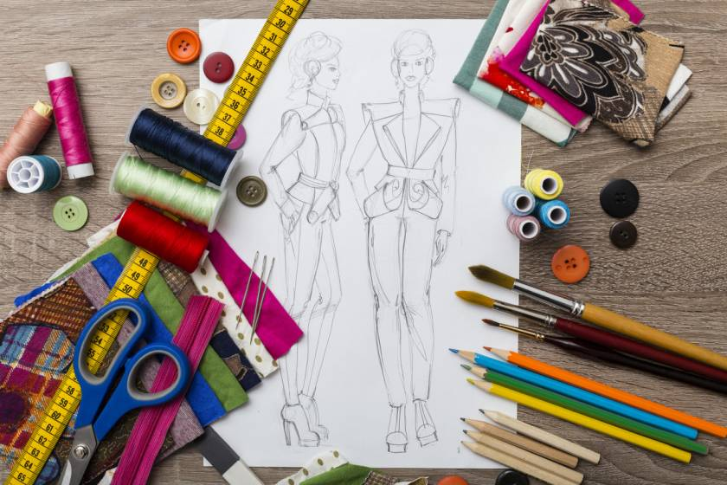

Module Title: - Drawing Techniques to Represent the Object or Idea
Module code: IND FAD2 M05 0322
Nominal duration: 60Hour

Prepared by: Ministry of Labor and Skill
April, 2022
Addis Ababa, Ethiopia

Table of content

Table of content 1
List of figures 3
List of tables 4
Acknowledgment 5
Introduction to the Module 6
Unit one: Drawing Preparation 7
1.1 Identification of tools and materials for basic drawing techniques 8
1.1.1 Introduction to drawing 8
1.2 Selection of tools and materials for basic drawing techniques 15
1.2.1 Selecting your drawing /Sketching Equipment 15
Self check-1 16
Unit Two: Basic Drawing Techniques 17
2.1 Safety on hand tools and materials 18
2.1.1 General safety rules 18
2.1.2 Dry Drawing Media 19
Range Of Drawing Techniques 21
2.2.1 Introduction 21
2.2.2 Easy Pencil Sketching/drawing Techniques 21
2.2.3 Overview of linear Perspective Drawing 23
2.2.4 Techniques of Fashion Designs Drawings 25
2.2.5 Types of Fashion Designs Drawings 26
2.2.6 Example of fashion design drawing 30
Self check-1 31
Operation sheet 2.1: Range of Drawing Techniques 32
Lap Test-2.1 33
Unit Three: link with other art organization 34
3.1.1 Fashion Communicating 35
3.1.2 Meaning of Fashion Communication 35
3.1.3 Educational Qualification 36
3.1.4 Scope in Fashion Communication 36
3.1.5 What is fashion networking organization? 37
Self check-1 38
Reference 39

List of figures
Figure 1.1 Drawing paper 9
Figure 1.2 Masking tape /scotch 10
Figure 1.3 Drawing pencil 11
Figure 1.4 Color pencil 11
Figure 1.5 Charcoal/conte 12
Figure 1.6 chalks, chalk pastels 12
Figure 1.7 Pencil Sharpeners 13
Figure 1.8 Triangular Scales 13
Figure 1.9 T-Square 14
Figure 1.10 Triangle scale 14
Figure 1.11 Drawing table 15
Fig 2.3 The Three Linear Perspective 25
Fig 2.4 Techniques in fashion design drawing 26
Fig 2.5 Flat sketch 27
Fig 2.6 Spec drawing 28
Fig. 2.7 working drawing 28
Fig. 2.8 presentation drawing 29
Fig 2.9 Example of fashion design drawing 30

List of tables
Table 1.1 Drawing paper size 9

Acknowledgment
Ministry of Labor and Skills wish to extend thanks and appreciation to the many representatives of TVET instructors and respective industry experts who donated their time and expertise to the development of this Teaching, Training and Learning Materials (TTLM).

Introduction to the Module
In fashion filed; the Use drawing techniques helps for professionals such as product designers, architects, and engineers have an intrinsic relationship with drawing, using it to represent everything from the creative sketches of a proposal to its production. In this sense, technical drawing and sketching techniques are a relevant part of design education.
This module is designed to meet the industry requirement under the fashion design occupational standard, particularly for the unit of competency: Using drawing techniques to represent the object or idea.
This module covers the units:
- Drawing Preparation
- Basic drawing techniques
- Art organizations
Learning Objective of the Module
- Prepare for drawing
- Use basic drawing techniques
- Link with other art organizations
Module Instruction
For effective use this modules trainees are expected to follow the following module instruction:
- Read the information written in each unit
- Accomplish the Self-checks at the end of each unit
- Perform Operation Sheets which were provided at the end of units
- Do the “LAP test” giver at the end of each unit and
- Read the identified reference book for Examples and exercise

Unit one: Drawing Preparation
This unit is developed to provide you the necessary information regarding the following content coverage and topics:
- Identification of tools and materials for basic drawing techniques.
- Selection of tools and materials for basic drawing techniques.
This unit will also assist you to attain the learning outcomes stated in the cover page. Specifically, upon completion of this learning guide, you will be able to:
- Identify tools and materials required for basic drawing techniques.
- Select appropriate tools and materials for basic drawing techniques.

1.1 Identification of tools and materials for basic drawing techniques

1.1.1 Introduction to drawing
Drawing fashion figures is the first step in bringing designs to life. Fashion figures serve as the template for a fashion designer’s vision. From flat fashion sketches to three-dimensional illustrations, fashion figures help bring flair and emotion from the sketchbook to the runway.
Fashion designing begins with a fashion drawing. Fashion drawings are the blueprint for a design, and can vary in style and amount of detail.
- A flat sketch is usually used to outline the shape and silhouette of a garment.
- Fashion drawings can also be three-dimensional fashion figures with texture, shading, and movement lines for fabric draping.
- A fashion illustration is a more detailed type of fashion drawing that might include color and accessories—and the fashion figure might have a detailed face or hairstyle to showcase a head-to-toe look.
From artistic drafting to drafting of structures, all require proper drafting tools for accurate output. So, we will discuss essential drafting/drawing tools in this information.
- Drawing paper is specially made for drawing on.
- From making artistic drawings to heavy structural drawings, drawing paper is vital.
- Not for making hand drawings only but also to print a hard copy of digital drawings; drawing paper is needed.
- Different types of drawings require different types of drawing papers.
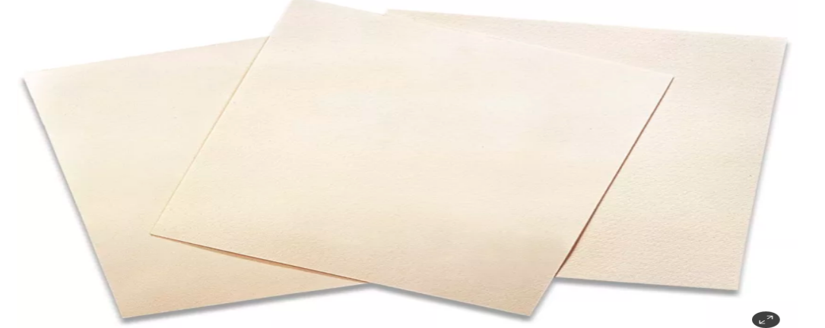

Figure 1.1 Drawing paper

- Different Sizes of Drawing Paper

Table 1.1 Drawing paper size
Paper size | Dimensions (cm) | Paper Area
Α5 | 14.8 x 21 cm | 0.03108 m2
Α4 | 21 x 29.7 cm | 0.0612 m²
Α3 | 29.7 x 42 cm | 0.125 m²
Α2 | 42 x 59.4 cm | 0.25 m²
Α1 | 59.4 x 84.1 cm | 0.50 m²
Α0 | 84.1 x 118.9 cm | 1 m²

- Masking tape /scotch
- This tape sticks the drawing paper on the drawing board.
- This tape is soft and doesn’t harm the drawing paper and table if appropriately handled.
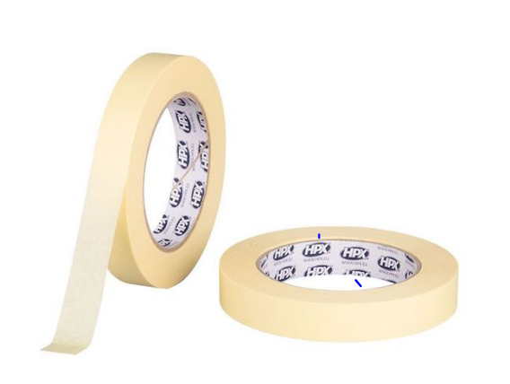

Figure 1.2 Masking tape /scotch
- Drawing pencil is an essential tool in drawing as it is used for making drawings on paper.
- For drafting, graphite pencil is commonly used.
- The grade of a pencil depends on the type of work.
- Hard Pencils are used where extreme accuracy is required especially working on graphs, diagrams and charts.
E.g., 2H pencil, 4H pencil, 6H pencil, etc.
- Medium Pencils are used for general purpose work in drawing.
E.g., HB Pencil
- Soft Pencils are too soft to be used in mechanical drafting. They are beneficial for the artwork of various kinds. E.g., 2B Pencil, 4B Pencil, 6B Pencil, etc.

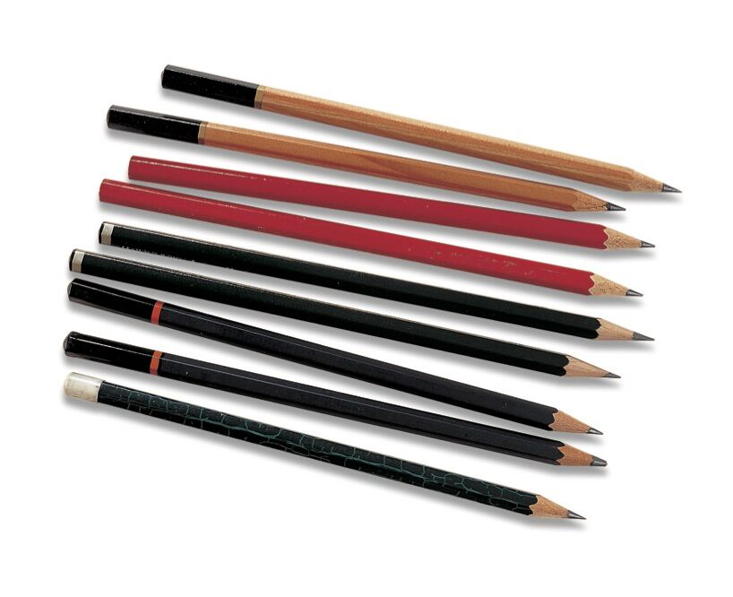

Figure 1.3 Drawing pencil

- Colored Pencils
Okay, so this one is fairly obvious. You must have colored pencils to create a colored pencil drawing. But there’s a little more to this.
The quality of the brand of colored pencil that you use greatly affects the results that you will see in your drawing. You cannot expect to use sub-par materials and get professional results.
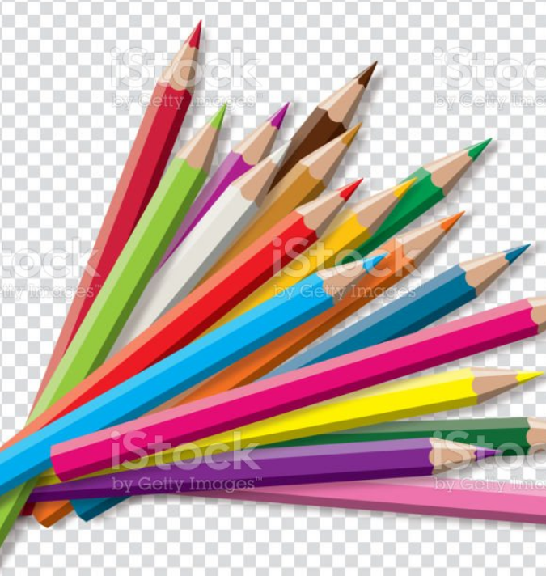

Figure 1.4 Color pencil
- Charcoal or conte
- There are more options to black and white drawing other than drawing with graphite. No artist’s toolkit would be complete without charcoal or conté.
- Charcoal provides a broader range of value and mark-making than what’s possible with graphite. The manner in which marks are made is different as well.
- Charcoal comes in both stick and pencil form. Sticks of charcoal are usually either “vine” or “compressed”. Vine charcoal is softer and produces lighter marks, while compressed charcoal – which is concentrated, produces darker marks.
- Charcoal pencils can be sharpened like graphite pencils, making them great for details.
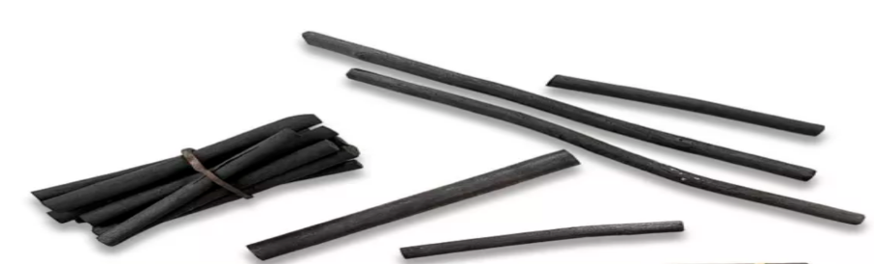

Figure 1.5 Charcoal/conte

- Chalk, Chalk Pastels, Oil Pastels
Chalk, Chalk Pastels, Oil Pastels Oil pastels are a form of chalk that has been compressed with oil. All chalks and oil pastels come in a wide range of colors. A variety of soft, blended effects can be obtained by layering several colors and using brushes, cloth or paper to blend.
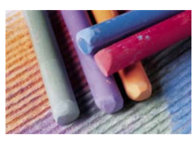

Figure 1.6 chalks, chalk pastels

- Pencil sharpener
- A pencil Sharpener is a mechanical gadget used for sharpening pencils.

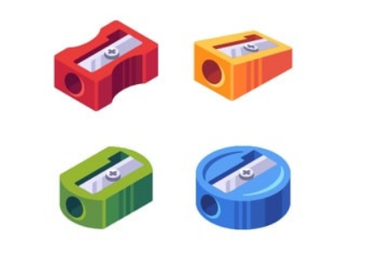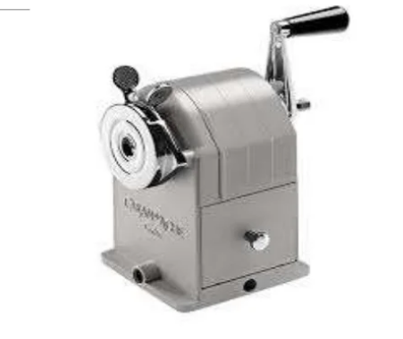

Figure 1.7 Pencil Sharpeners

- Triangular scale
- A tool generally used when reproducing a drawing in an enlarged or reduced form to some regular proportion.
- Its primary function is to reproduce the measurements of an object in full size, reduced size, and enlarged size.

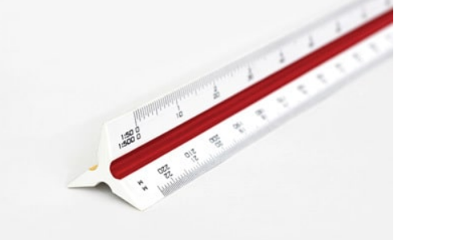

Figure 1.8 Triangular Scales

- T-square
- T-square is a drawing instrument used when making horizontal lines.
- It is also used for guiding triangles when drawing vertical lines and perpendicular lines with the help of a set square.
- It is made of wood, plastic, or a combination.

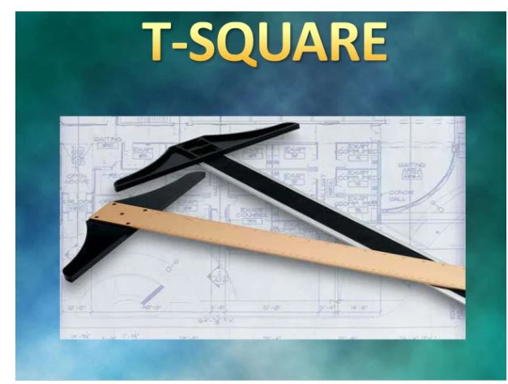

Figure 1.9 T-Square

- Triangle scale
- It is a three-sided ruler, which contains two equal sides intersecting at a 90-degree angle and the third side at 45, 30, including 60-degree angles.
- Commonly used triangles are:
  - 30 degrees X 60 degrees
  - 45 degrees X 45 degrees

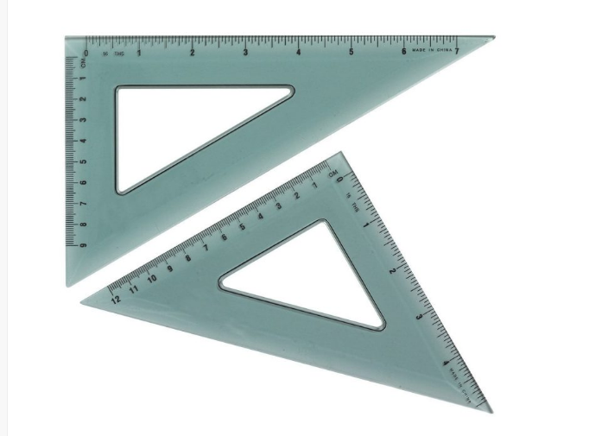

Figure 1.10 Triangle scale

- Drawing table
- The drawing table is made up of wood, plastic, or glass and has smooth surfaces where drawing paper is placed and fixed with the help of tape.

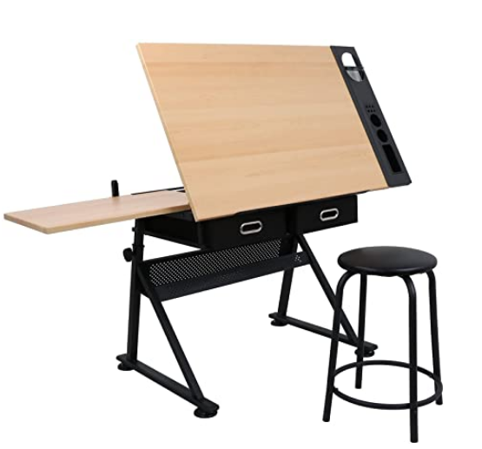

Figure 1.11 Drawing table

1.2 Selection of tools and materials for basic drawing techniques

1.2.1 Selecting your drawing /Sketching Equipment
The shades, textures and shadows you are able to create on the page are not entirely limited by your breadth of techniques. Without proper knowledge of your equipment, you could be limiting yourself significantly. Generally, softer graphite pencils will allow a darker, softer tone, while harder graphite will offer a harder line and a more pointed end. For most effective work, having a few pencil options in your sketching tool kit is essential.
Consider your personality when selecting your artistic tools. If you are a careful, meticulous perfectionist you may be most at ease with precise art materials such as a pencil or pen. If you have a more energetic, fast-and-furious approach to illustration, you may enjoy the freedom of oil pastels, charcoal or paints. Experimenting frequently with new materials will encourage you to be more innovative in your work. Brand-new pots of ink, sharp, colorful pencils and acrylic tubes just waiting to be squeezed may look inviting but, to a beginner, they also hold an element of anxiety.
It is necessary to use proper drafting/drawing materials and tools to make an excellent drawing. These materials are generally utilized by architects, drafters, engineers, painters, or other technical persons.
Drawing tools improve the accuracy and final output of any drawing.

Self-check-1
Part -I Matching
Instruction: select the correct answer for the give choice. You have given 1 Minute for each question. Each question carries 2 Point.
A B
____1. Hard pencil A. For extreme accuracy drawing
____2. Soft pencil B. For general purpose
____3. Fashion illustration C. For mechanical drawing
____4. Vine charcoal D. To outline shape of the garment
____ 5.Compressed charcoal E. Blue print of a design
____ 6. A flat sketch F. More detailed type of fashion drawing
____7. Hard pencil G. Light marks
____8. Fashion drawing H. Dark marks
Part - II: short Answer writing
Instruction: write short answer for the given question. You are provided 3 minute for each question and each point has 5Points.
- List out types papers for drawing?
- List out tools and materials for drawing?
- List out measuring tools for drawing?
Note: Satisfactory rating – above 60% Unsatisfactory - below 60%
You can ask you teacher for the copy of the correct answers

Unit Two: Basic Drawing Techniques
This unit to provide you the necessary information regarding the following content coverage and topics:
  - Safety on hand tools and materials
  - Range of drawing techniques
This guide will also assist you to attain the learning outcomes stated in the cover page. Specifically, upon completion of this learning guide, you will be able to:
- Use handle tools and materials safely
- Apply a limited range of techniques to represent the Object or idea.

2.1 Safety on hand tools and materials

2.1.1 General safety rules
The following are rules that relate to almost every laboratory and should be included in most safety policies. They cover what you should know in the event of an emergency, proper signage, safety equipment, safely using laboratory equipment, and basic common-sense rules.
- Be sure to read all fire alarm and safety signs and follow the instructions in the event of an accident or emergency.
- Ensure you are fully aware of your facility's/building's evacuation procedures.
- Make sure you know where your lab's safety equipment—including first aid kit(s), fire extinguishers, eye wash stations, and safety showers—is located and how to properly use it.
- Know emergency phone numbers to use to call for help in case of an emergency.
- Make sure you are aware of where your lab's exits and fire alarms are located.
- Always work in properly-ventilated areas.
- Do not chew gum, drink, or eat while working in the lab.
- Never use lab equipment that you are not approved or trained by your supervisor to operate.
- If you are the last person to leave the lab, make sure to lock all the doors and turn off all ignition sources.
- Do not work alone in the lab.
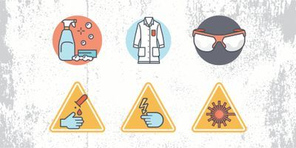
Fig.2.1 signs of cautions

Laboratory housekeeping rules also apply to most facilities and deal with the basic upkeep, tidiness, and maintenance of a safe laboratory.
- Always keep your work area(s) tidy and clean.
- Make sure that all eye wash stations, emergency showers, fire extinguishers, and exits are always unobstructed and accessible.
- Only materials you require for your work should be kept in your work area. Everything else should be stored safely out of the way.
- Only lightweight items should be stored on top of cabinets; heavier items should always be kept at the bottom.
- Solids should always be kept out of the laboratory sink.
- Any equipment that requires air flow or ventilation to prevent overheating should always be kept clear.

2.1.2 Dry Drawing Media
This includes dust-creating media such as charcoal and pastels which are often fixed with aerosol spray fixatives, and media such as crayons and oil pastels which do not create dust.
Hazards
- Pencils are made with graphite, rather than lead and are not considered a hazard. Colored pencils have pigments added to the graphite, but the amounts are small so that there is no significant risk of exposure. Over 10 years ago, a significant hazard in pencils was from lead chromate paint on the exterior of yellow pencils. However this has since been eliminated as a risk.
- Charcoal is usually made from willow or vine sticks, where wood cellulose has been heated without moisture to create the black color. Compressed charcoal sticks use various resins in a binder to create the color. Although charcoal is just considered a nuisance dust, inhalation of large amounts of charcoal dust can create chronic lung problems through a mechanical irritation and clogging effect. A major source of charcoal inhalation is from the habit of blowing excess charcoal dust off the drawing.
- Colored chalks are also considered nuisance dusts. Some chalks are dustier than others. Individuals who have asthma sometimes have problems with dusty chalks, but this is a nonspecific dust reaction, not a toxic reaction.
- Pastel sticks and pencils consist of pigments bound into solid form by a resin. Inhalation of pastel dusts is the major hazard. Some pastels are dustier than others. Pastels can contain toxic pigments such as chrome yellow (lead chromate) which can cause lung cancer, and cadmium pigments (which can cause kidney and lung damage and are suspect human carcinogens). Blowing excess pastel dust off the drawing is one major source of inhalation of pastel pigments. Pastel artists have often complained of blowing their nose different colors for days after using pastels, a clear indication of inhalation.
- Crayons and oil pastels do not present an inhalation hazard, and thus are much safer than pastels. Some oil pastels can contain toxic pigments, but this is only a hazard by accidental ingestion.
Precautions
- Use the least dusty types of pastels, chalks, etc. Asthmatics in particular might want to switch to oil pastels or similar non-dusty media.
- Don't blow off excess pastel or charcoal dust with your mouth. Instead tap off the built up dust so it falls to the floor (or paper on floor).
- Wet-mop and wet-wipe all surfaces clean of dusts.
- If inhalation of dusts is a problem, a respirator may be appropriate. Contact EHS for selection and fit-testing

Range Of Drawing Techniques

2.2.1 Introduction
Drawing techniques / skills allow the designer to communicate his/her ideas to customers/clients and consumers, so that they are clear and easy to understand. Presenting a design by using appropriate drawing and presentation techniques will ultimately lead to good business.
Fashion design includes three key parts:
- Style design,
- Construction design and
- Process design.
The main work of style design is fashion sketch drawing; the main work of construction design is pattern making; and the main work of process design is process sheet making . Fashion designers draw a fashion sketch according to a design theme; patternmakers make patterns according to a fashion sketch and technologists make production process sheets based on the fashion sketch and pattern.
These three basic designs complement each other. Generally, fashion sketch drawing belongs to artistic design however, pattern and production process design are affiliated to engineering design. This leads to different approaches between fashion sketch drawing and pattern making. Most style designers cannot make garment patterns; likewise, most pattern makers are unable to draw fashion sketches.

2.2.2 Easy Pencil Sketching/drawing Techniques
Pencil sketching has long been a popular art form, and it’s no wonder why. Sketching with a pencil is versatile, portable, and requires only a few basic art supplies. With just a few tools you can create an incredibly detailed and beautiful work of art.
There are many styles in which you can sketch with a pencil, all ranging from simplistic lines to complex drawings and sketches. Learning a variety of different sketching techniques can take your pencil drawings to a whole new level, bringing greater depth and refinement to the artwork you create. Here, we share a variety of pencil sketching techniques to try in your next creation. Read on to discover our top sketching tips and techniques.
- Hatching & Cross-Hatching
These methods are very common and effective ways to add depth to your sketches through shading. When it comes to well-known pencil drawing styles that can level up your sketches, hatching & cross-hatching is at the top of the list of skills you should learn. Hatching is essentially a series of lines drawn along the main line of your drawing to create shadow and depth. These lines shouldn’t touch. Cross-hatching is a series of lines used in the same way, but where they intersect. The closer these lines, the darker the shading in your drawing will be.
Stippling
Stippling is the art of adding dots to add shading and depth, similar to hatching or cross-hatching. The closer the dots, the deeper the effect. To ensure that your dots show up and make a better impact, it’s best to use softer graphite for this effect, as it comes out darker.
- Scribbling
Everyone has created idle scribbles on a piece of paper when waiting on hold during a telephone call. But scribbling is actually a drawing technique that can be very effective. The characteristics of a scribbled sketch can be identified by the erratic, uneven and definitely not straight lines within the piece. Using random movements across the paper will result in a somewhat deconstructed image, and the more irregular lines created closer together, the darker it will appear.
- Circling
Control the tone your pencil produces by simply adjusting the amount of pressure you place on it. To create smooth transitions you can make small circular strokes that give you a more blended appearance. It’s important to note that you shouldn’t make small circles with perceptible lines. Instead, move the pencil around in a circular motion when adding pressure. For this approach, a duller pencil works best.
- Smooth Shading & Blending
To add a cleaner shading element to your drawing, you can try smooth shading. This can be done in a number of ways, including using your finger or a rolled-up piece of paper to blend in hatching or cross-hatching This will give your sketch a smoother appearance. You can also blend simply by angling your pencil to utilise the wider edge, creating thicker lines that create the appearance of shadows and shading.
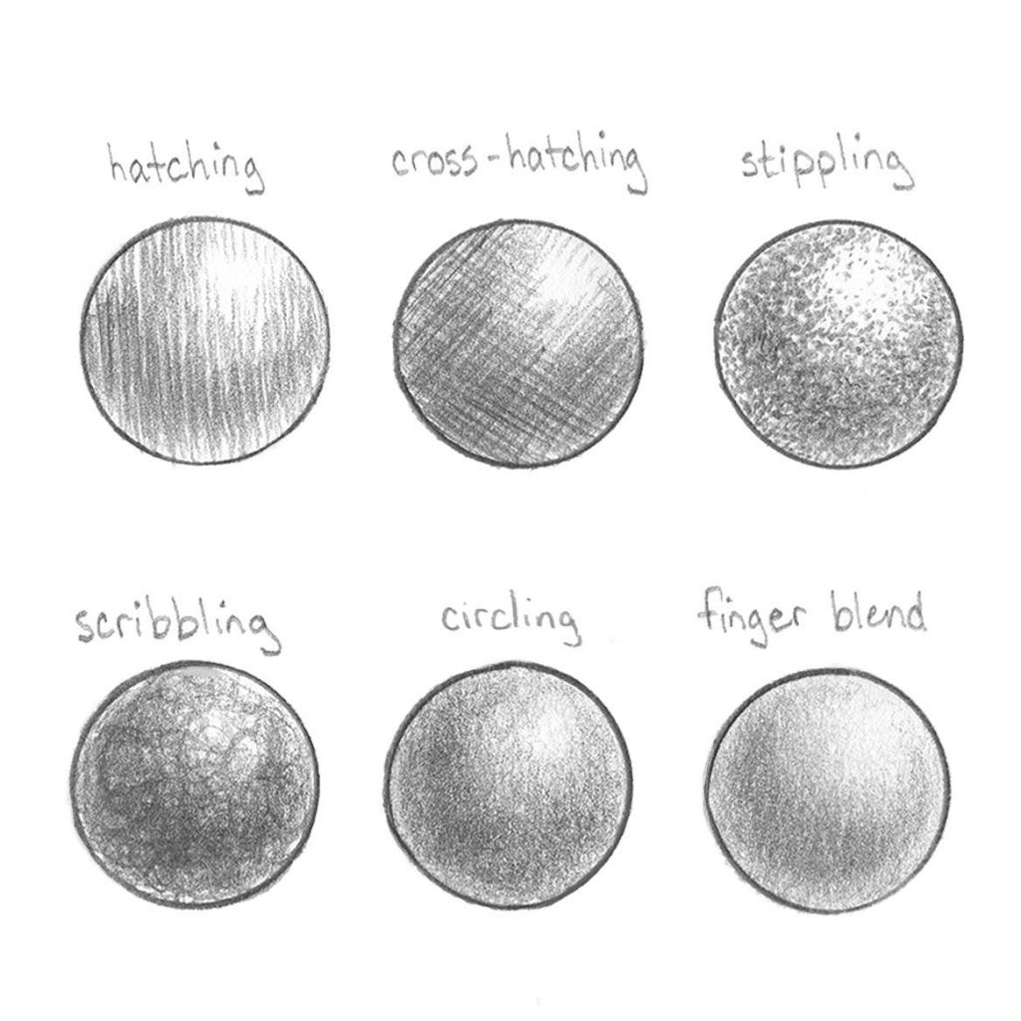
Fig 2.2 pencil drawing techniques
- Creating Highlights
Just as you would add shading to create depth and shadows to your sketch, you can also create highlights. Highlights can help indicate where your light source is coming from and add extra detail, showing reflective surfaces. One great way to create this effect is by using an eraser to remove some of the pigment or shading to create lighter areas to indicate the absence of darkness.
- Rendering
The practice of rendering takes the above technique to the next level. Rendering is essentially an approach to pencil sketching where you apply graphite to your paper, and then remove some with your eraser to add the highlighting effect. It’s an ongoing process of applying and removing the graphite and results in a very soft, almost blurred effect.

2.2.3 Overview of linear Perspective Drawing
Today we’ll be looking at the 3 main forms of linear perspective drawing that you should know if you’re looking to improve your drawing skills. This is by no means an in-depth lesson on perspective drawing but merely an overview aimed at the question: Which form of perspective should I use?
There are many types of perspective drawing. Linear perspective refers to using a set of rules that guide a drawing’s lines towards various vanishing point(s). This converging of lines is what helps an artist achieve the illusion of depth within a drawing. You’ll see exactly how an artist uses a vanishing point in the upcoming illustrations. You’ll quickly be able to use what I’m about to share in your next drawing or painting. Whether still life or landscape , knowing which form of perspective to use will serve you extremely well.
Anytime an artist creates the look of deep space within her artwork she has typically used some form of perspective drawing. Linear perspective provides one way to create this deep space in one’s artwork. Linear Perspective helps us draw geometric, box-like forms and environments that appear grid-like. As a result, linear perspective is most helpful for drawing architecture, interiors, and box-like still life objects. Perspective drawing is less helpful when drawing portraits and other organic objects.
- There are 3 main types of linear perspective:
- One Point Perspective
- Two Point perspective
- Three Point Perspective
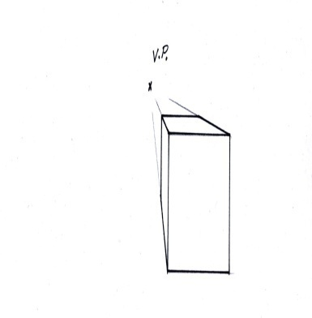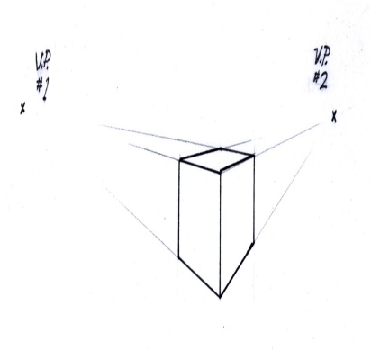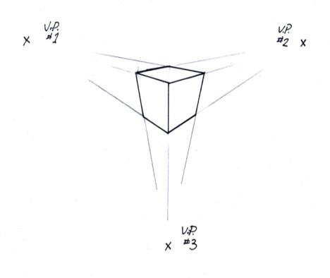

Fig 2.3 The Three Linear Perspective

2.2.4 Techniques of Fashion Designs Drawings
Fashion drawing is a skill, and can be learned or improved using a lot of techniques. Here are some useful techniques for you to improve your fashion drawing skills.
- Understand Anatomy
To be good at fashion drawing it is vital to know how to draw anatomically correct proportions of a figure. A correct drawn figure allows the garment to look appealing on it. It will be easier for you to draw certain posed figures if you know how to draw them correctly.
- Use Technology
Nowadays, with several advanced technologies in the market, every field is growing at a super-fast pace. In the fashion industry also there is a lot of software that can help you in beautifying your designs and illustrations. For example, a background of a lane or runway can be added while representing a design to the clients. This can give more clarity to the design idea like where it can be worn.
- Make Patterns
Patterns can also tell a story on their own. They can make a simple fabric very interesting. Patterns are never going out of fashion. To design various beautiful fashion drawings try to add some touch of appealing patterns to it.
- Hairstyles matter too
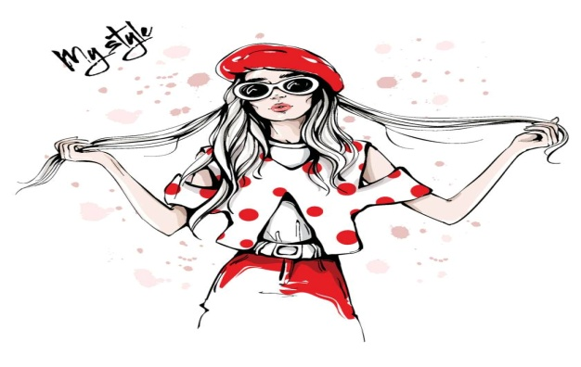

Fig 2.4 Techniques in fashion design drawing
With the figure shape and dress design, the hair of the figure also matters a lot. Learn how to illustrate different hairstyles based on hair textures and thickness. A figure can look more classy if an ideal hairstyle is illustrated with it.
- Focus on the accessories too
In the fashion world, not even a small detailing is left out. Then how can we be careless with the accessories? Accessories also play a vital role in a figure representation of a garment. Choose the accessories wisely. The final look of your drawing should tell a story. Design it carefully and beautifully.

2.2.5 Types of Fashion Designs Drawings
Fashion Design Drawings are the best friends of a fashion designer. But these drawings have a lot of varieties. Some types of these drawings are-
- Flat Sketch or Fashion Flat
Flat Sketches are also known as technical flats in the world of fashion. These sketches are linear 2-dimensional black and white illustrations of garments. The sketch is such that as if a garment is laying flat on a surface for display of its designs, stitching, and other detailing. These types of sketches are usually made using software programs.
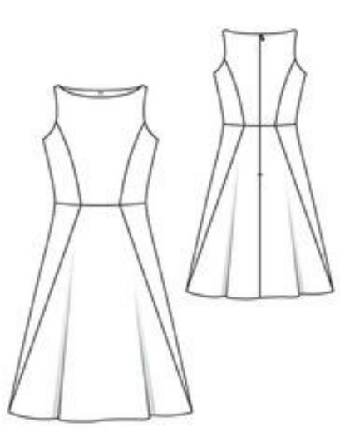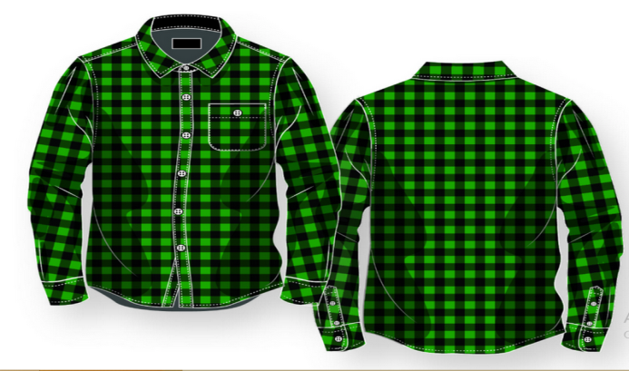

Fig 2.5 Flat sketch
- Tech Sketch
Tech Sketch is a flat sketch with details of the particular specifications of the garment in written text. These sketches are also known as callouts. Tech Sketches are mostly used by fashion designers or fashion illustrators to represent a design more precisely with detailed explanations.
- Spec
Spec or specification is a type of fashion design drawing which is usually used for the manufacturing of apparel. These drawings include a lot of detailing of the garment like the type of fabrics used, the estimated cost of production, etc.
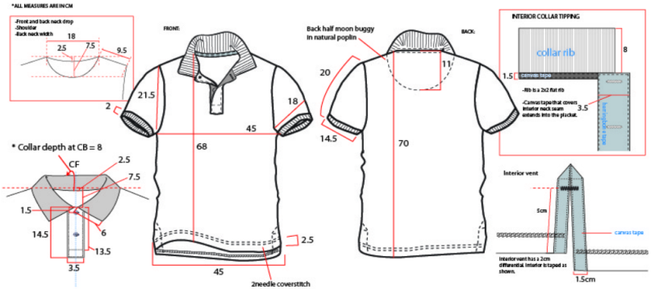

Fig 2.6 Spec drawing
- Working Drawing
These types of fashion drawings are used by pattern makers. These drawings contain all the specifications needed by the pattern maker to make the pattern pieces like the fabric swatches and fasteners used.

Fig. 2.7 working drawing

- Presentation Drawing
Presentation Drawing is the final sketch of the garment which a fashion designer presents to the client or the senior designers.
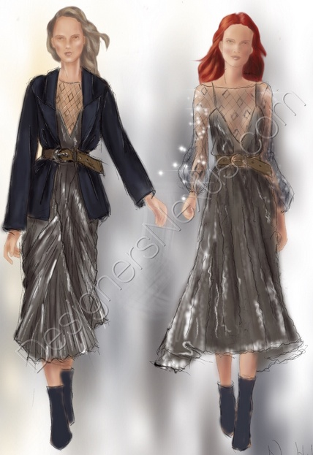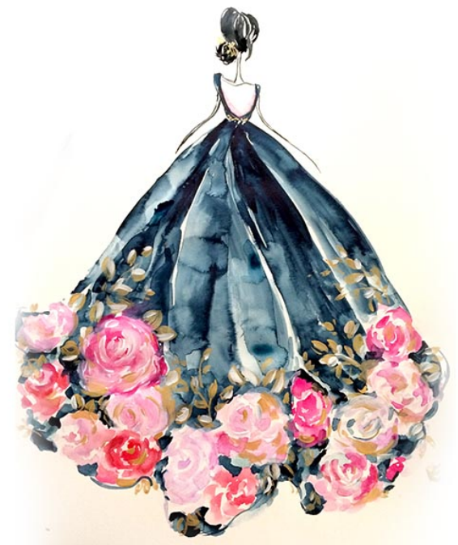

Fig. 2.8 presentation drawing
- Fashion Croquis
Fashion Croquis is the drawing of the figure of the apparel that can act as a template over which one can design the garment by tracing easily.

2.2.6 Example of fashion design drawing
Fashion Croquis is the drawing of the figure of the apparel that can act as a template over which one can design the garment by tracing easily.

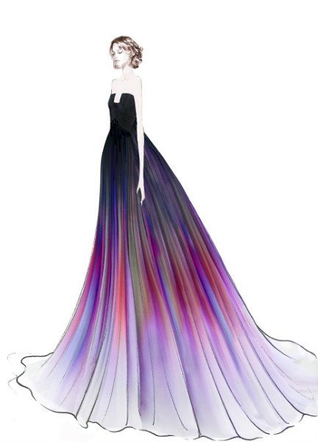

Fig 2.9 Example of fashion design drawing

Self-check-1
Part-I Matching
Instruction: select the correct answer for the give choice. You have given 1 Minute for each question. Each question carries 2 Point.
A B
_____1. Dry drawing media A. Hatching and cross hatching
_____2. Drawing techniques B. Pattern making
_____3. Construction design C. Allows to communicate with Clint
_____4. Pencil sketching techniques D. Charcoal
Part- II: short Answer writing
Instruction: write short answer for the given question. You are provided 3 minute for each question and each point has 5Points.
- What are the three main types of linear perspective?
- List out types of fashion design drawing?
Part- II: short Answer writing
Direction: Give short answer to the following questions. Time allotted for each item is 2mniut and each question carry 4 point.
- What is working drawing?

Note: Satisfactory rating – above 60% Unsatisfactory - below 60%
You can ask you teacher for the copy of the correct answers

Operation sheet 2.1: Range of Drawing Techniques
- Operation title: sketching/drawing techniques
- Purpose: To use all the techniques as required
- Instruction: Using the figure below and given equipments measure the length of each line. You have given 30Minut for the task and you are expected to write the answer on the given line.

Figure 2.2: Figure given for operation sheet 2.1
- Tools and requirement:
- A4 Paper
- Eraser
- Pencil
- Pencil sharpener
- Steps in doing the task
- Circle six different circles on the paper
- Then apply all the techniques
- Repeat the step again and again
- Complete Your work and show to your trainer
- Quality Criteria: compare with the drawing
- Precautions: let your pencil be sharp always

Lap Test-2.1
- Task-1: Perform all the sketching techniques
- Task-2: perform drawing a single garment flat drawing

Unit Three: link with other art organization
This learning guide is developed to provide you the necessary information regarding the following content coverage and topics:
  - Individuals and network are identified and communicate with art organization
This guide will also assist you to attain the learning outcomes stated in the cover page. Specifically, upon completion of this learning guide, you will be able to:
- Use industry knowledge to communicate appropriately with other arts organizations and individuals.
- Identify and use individuals and networks correctly when working in an arts organization context.

3.1 Individuals and network are identified and communicate with art

3.1.1 Fashion Communicating
When we hear the term ‘Fashion’ or ‘Fashion Communication’, many of us still think of models or something related to the business of designing and producing a garment. However, it is important to know that the term also includes two other major aspects related to fashion. They are:
- Communicating fashion
- Communicating through fashion.
It includes creating and facilitating communication for the fashion industry; verbal, written, visual or audiovisual. It is a specialized domain of fashion studies that helps students in learning communication knowledge and skills relevant to the fashion and lifestyle industry. It is also the backbone of the whole fashion business. This is among one of the newest and most exciting avenues of the fashion and lifestyle industry. It includes a consolidated study associated with different areas such as advertising, public relations, fashion journalism, visual merchandising, styling, photography, display, creative writing, etc. Apart from the creative and commercial aspects, the subject also deals with the concepts of identity and self-expression through fashion and how fashion psychology is an inevitable part of our daily lives.

3.1.2 Meaning of Fashion Communication
It becomes very important to break some of the stereotypes and clarify some of the myths related to this subject. Firstly, the term fashion is very subjective, it does not just refer to just clothing. From the way you do your hair or makeup, the tattoos and piercings you get on your body, the accessories and footwear that you wear or the bags and sunglasses that you carry, all of this is a part of fashion. The way you represent or express yourself through these and how someone perceives or receives you are a part of it too. Also, just because it is related to fashion, it is not irrelevant, too easy or difficult as an area of study. Like every other field of study, it has its own significance; it’s just about your area of interest. As many fields come under Fashion Communication and because they are all interrelated, if you feel like experimenting a bit and would want to switch from one field to another related field in future, it will not be a very difficult step to take.
Let’s not forget to mention that against the popular belief that because its fashion, it may be more appropriate for women, there should be no doubt about it that it is not at all more or less appropriate for a particular gender. It has nothing to do with your gender. Something that is beautifully changing about this industry is that it’s becoming more flexible and breaking the stereotypes attached to it every day. Whether we look at models with baby bumps or models with skin conditions, fashion bloggers from different age groups and races, professionals from different ethnicities and religions, the world of fashion has become a beautiful blend today. The good news is that if one has the talent and skills, the fashion industry has many doors open for them; it is not restricted, not anymore. With the advancement of digital media and especially the increasing craze around social media, new options are emerging and evolving not only in the print or the broadcast media but also in the digital media.

3.1.3 Educational Qualification
All opportunities do not ask for the same degree or qualification but a degree or course in fields like Media or Mass Communication, Fashion, Photography, Editing or Writing can help you to acquire the right knowledge and expertise for the job. You can also study Fashion Communication as one of the subjects or do a short term course related to it.

3.1.4 Scope in Fashion Communication
The Fashion industry is opening many exciting doors for internships and jobs for people with the right skill set and knowledge. Fashion is something that keeps evolving and gaining more popularity with time and it seems like offering a promising future. This is a creative space where you can experiment with your ideas and take a few risks. It is an unconventional space that is ever-growing and transforming.
- Most popular options that you can go for as a Fashion Communicator:
- Fashion Blogger: If you are interested in becoming a blogger, you can begin by starting a personal blog. The blog can be a written one, a photo blog, can have videos and can even have a mix of all three. It is one of the hottest options today and many bloggers who started from scratch have become popular now. Apart from having a different blog, many of them are starting their blogs on social media platforms like Instagram too.
- Fashion Journalist: Fashion journalism is something that is gaining more popularity with time. Whether you write for popular fashion magazines like Vogue, Harper’ Bazaar, Elle or cover fashion events or report the latest news related to fashion, there is a lot of scope for a fashion journalist. It has its own merits and challenges like any other field of journalism.
- Fashion Writer: If you have a flair for writing, you can become a fashion writer. It does not matter if you start from writing for a small website or any of the social media platforms; you can start anywhere and will gradually grow. You can even write articles for different magazines and newspapers and even write books on Fashion once you gain some experience and get expertise in fashion writing. From the latest trends to sustainable fashion to celebrity styles, a fashion writer can write about anything related to the industry.
- Fashion Photographer: Not a fashion enthusiast yourself but like photography? Not a problem! If you know the art of photography and are passionate about it, you can become a fashion photographer. You can start your own page or blog or you can click photographs for an E-Commerce site, a magazine or even for other bloggers. Visuals and aesthetics matter the most in the fashion industry and a good photographer can be a game-changer.
- Visual merchandiser: Ever noticed how different fashion brands market themselves through their brand’s physical aspects? Whether it’s the store layout, the standees, the display inside the store or the way the counters are arranged, everything is a part of visual merchandising that is done to attract the customers. If this sounds interesting to you, you can work with a fashion brand and get into planning and managing their visual merchandising.
Apart from these options, there are many others like marketing, brand management, doing public relations or advertising for fashion brands or celebrities. Becoming a You Tuber and making fashion videos, a video editor, creating content for different platforms, an editor for a website or magazines, a fashion stylist or an image consultant is also on the list that can be explored.
The evidence of effectively communicating with clients, target clients, media, staff and other audiences is in the results achieved as a direct outcome of the messages communicated.

3.1.5 What is fashion networking organization?
The Fashion Network is a network and marketing platform for fashion retail professionals. Our events program provides a hub for individuals within the industry to come together to learn, market themselves or their business, but also find talent, potential suppliers and partners.
The network of contacts you develop can have an immense influence on your success as an artist. Artists need exposure, for their work and for themselves.

Self-check-1
Part- I: short Answer writing
Instruction: write short answer for the given question. You are provided 3 minute for each question and each point has 5Points.
- Discuses purpose of fashion network?
- Define is fashion writer?
- Define Fashion blogger?
- Define meaning of fashion communication?

Reference
Riegelman, N. (2006). 9 heads: a guide to drawing fashion (p. 1). Los Angeles, CA: 9 Heads Media.
Donovan, B., & Donovan, W. B. (2010). Advanced fashion drawing: lifestyle illustration. Laurence King Publishing.
Szkutnicka, B. (2010). Technical drawing for fashion. Laurence king publishing.
Abling, B. (2012). Fashion Sketchbook: Studio Access Card. Bloomsbury Publishing USA.
Young, E. (1919). Student's Manual of Fashion Drawing: Thirty Lessons with Conventional Charts. John Wiley & Sons.
Galton, E. (2021). Basics fashion design 10: Jewellery design: From fashion to fine jewellery. Bloomsbury Publishing.
Bielefeld, B. (Ed.). (2018). Basics Detail Drawing. Birkhäuser.
Abling, B. (2012). Fashion Sketchbook: Studio Access Card. Bloomsbury Publishing USA.
Vebell, V. (2014). Exploring the Basics of Drawing (Book Only). Cengage Learning.
Kumar, K., Zindani, D., &Davim, J. P. (2020). Basics of Drawing. In Mastering SolidWorks (pp. 251-259). Springer, Cham.
Bielefeld, B. (Ed.). (2018). Basics Detail Drawing. Birkhäuser.

Participants of this Module (training material) preparation

No | Name | Qualification (Level) | Field of Study | Organization/ Institution | Mobile number | E-mail
1 | Yosef AbebeGetachew | B- level | Fashion design and Textile Engineering | Mary Help College | 0923684937 | Josephabebe5@gmail.com
2 | EndreyasMiftah Ahimed | B-level | Garment Engineering | burayu Polytechnic College | 0912636386 | miftahendrias2005@gmail.com
3 | MuluembetAdmassuAbebe | A-level | Garment Technology | HawasaPolytechnic College | 0985131178 | Muluembetadmassu06@gmail.com
4 | Biniyam Genet Chekol | B-level | Garment Technology | TililiTvet College | 0922440120 | Biniyamgetnet@gmail.com
5 | AbdusemedAdem | A-level | Fashion design and Garment Technology | Diredewa Polytechnic Collage | 0910075389 | Biniyamgetnet933@gmail.com

