Fashion Design
Level II
Based on March, 2022, Curriculum Version 1
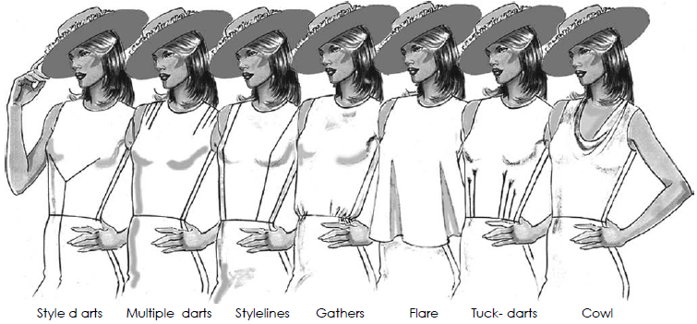

Module Title: - Modifying patterns to create basic styles
Module code: IND FAD2 M07 0322
Nominal duration: 80Hour

Prepared by: Ministry of Labor and Skill
August, 2022
Addis Ababa, Ethiopia

Table of content

Table of content 0
List of figures 3
Acknowledgment 5
Introduction to the Module 6
Unit one: pattern components 7
1.1 Identification of pattern pieces 8
1.1.1 Introduction to pattern 8
1.1.2 Identification of pattern pieces 8
1.2 Pattern making process 12
1.3 Identification of style modification 17
1.3.1 What Is Style? 17
1.3.2 What is Dart in Clothing? 17
1.3.3 Application of Dart Manipulation 18
1.3.4 Dart Manipulation Techniques: 20
1.3.5 Different Types of Darts: 23
1.3.6 Basic Dart Manipulation Process: 26
1.3.7 Asymmetric Darts Manipulation: 28
1.3.8 Changing Darts into Gathers: 33
1.3.9 Intersecting Darts: 34
1.3.10. Other Types of Darts 35
1.3.11Different Types of Dart Placement: 35
1.3.12Types of Darts All Sewist Must Know: 39
1.3.13 Built-Up Necklines 41
1.4 Pattern specification sheet VS pattern component 41
1.4.1 Introduction 41
1.4.2 Pattern components 44
Self check-1 45
Unit Two: Preparation of Pattern Modification 46
2.1 Requirement for pattern modification 47
2.2 Fabric performance VS style modification 47
2.2.1 Introduction 47
2.3 Pattern making tools and equipment 48
2.3.1 Pattern making tools 48
2.4 Select/prepare basic pattern to modify 51
2.4.1 What is a basic pattern? 51
Self check-1 52
Unit Three: Modify pattern 53
3.1 Application of OHS (Occupational Health Safety) practice 54
3.1.1 What Does Occupational Health and Safety (OHS) Mean? 54
3.1.2 How to Stay Safe on the Job 54
3.2 Modification using basic pattern making principles 55
3.2.1. Principles for Pattern Drafting 55
3.2.2Three Major Patternmaking Principles 56
3.2.3 Principles of Pattern Alteration 57
3.2.4 To measure the pattern pieces 57
3.2.5 To alter the pattern 58
3.2.6 Check the altered fit 62
3.3 Check and label pattern pieces for accuracy 63
3.3.1 Pattern checking steps 63
Self check-1 64
Operation sheet 3.1: pattern modification/alteration 65
Lap Test-3.1 70
References: 71

List of figures
Fig.1.1 Pattern types used in the apparel industry 8
Fig.1.2: Garment pattern making department 10
Fig. 1. 4 Example of Flat/manual pattern/drafting slope of a trouser with measuring information. 14
Fig. 1.5 Application of pattern making rules. 15
Fig. 1.6 Pattern Symbols 16
Fig: 1.7 Darts in flat patterns 18
Fig: 1.8 Different dart locations 19
Fig: 1.9 Dart Seam 19
Fig: 1.10 Folding Dart 20
Fig: 1.11 Pin and pivotal dart transfer technique 21
Fig: 1.15 Curved outward dart 24
Fig: 1.18 Double pointed dart 25
Fig: 1.19 Dart in interfacing 26
Fig: 1.20 Women’s shirt with dart 26
Fig: 1.21 Basic dart step-1 27
Fig: 1.22 Basic dart step-2 27
Fig: 1.23 Basic dart step-3 27
Fig: 1.24 Asymmetric Radiating Darts 28
Fig: 1.25 Asymmetric Curved Darts 29
Fig: 1.26 Asymmetric darts 29
Fig: 1.27 Asymmetric darts step-1 30
Fig: 1.28 Asymmetric darts step-2 30
Fig: 1.29 Asymmetric darts step-3 30
Fig: 1.30Asymmetric darts step-4 31
Fig: 1.31 Asymmetric darts step-5 31
Fig: 1.32 Asymmetric darts step-6 32
Fig: 1.33 Asymmetric darts step-7 32
Fig: 1.34 Changing Asymmetric dart into Gather dart 33
Fig: 1.35 Gather dart 33
Fig: 1.36 Intersecting Dart to Waist 34
Fig: 1.37 Intersecting Dart with Gathers 34
Fig: 1.38 Single dart-sewing beginners 35
Fig: 1.39 Double pointed dart 35
Fig: 1.40 Bust dart 36
Fig: 1.41 Shoulder dart 36
Fig: 1.42 Dart tuck 37
Fig: 1.43 Elbow dart 37
Fig: 1.44 Curved dart 38
Fig: 1.45 Sleeve hem dart 38
Fig: 1.46 Skirt/pant type of dart 39
Fig: 1.47 Types of darts in sewing 40
Fig: 1.48 Serged dart 40
Fig: 1.49 Converting darts to ease 41
Fig: 1.43 Neck types 41
Fig: 1.44 Part of the apparel tech pack 43
Fig: 2.1 pattern making tools and Equipment 49
Fig: 2.2 pattern making tools and Equipment 50
Fig: 2.3 Example of basic/block pattern 51
Fig:3.1 pattern measurement taking 58
Fig: 3.2 Giving seam allowance 59
Fig: 3.3 Make alteration/modification 60
Fig: 3.4 Folding 61
Fig: 3.5 Dart manipulation 61
Fig: 3.3 Manipulation procedure 62

Acknowledgment
Ministry of Labor and Skills wish to extend thanks and appreciation to the many representatives of TVET instructors and respective industry experts who donated their time and expertise to the development of this Teaching, Training and Learning Materials (TTLM).

Introduction to the Module
Pattern alteration means customize patterns to fit according to body shape. For example, shortening arms or lengthening a top. Patterns are prepared according to standard measurement chart which are based on average sizes. After measuring the human body and adding needed ease, compare this measurement to the pattern’s measurement.
This module covers the units:
- Pattern components
- Preparation of pattern modification
- Modify pattern
Learning Objective of the Module
- Identify pattern components
- Prepare to modify patterns
- Modify and finalize pattern
Module Instruction
For effective use this modules trainees are expected to follow the following module instruction:
- Read the information written in each unit
- Accomplish the Self-checks at the end of each unit
- Perform Operation Sheets which were provided at the end of units
- Do the “LAP test” giver at the end of each unit and
- Read the identified reference book for Examples and exercise

Unit one: pattern components
This unit is developed to provide you the necessary information regarding the following content coverage and topics:
- Identification of pattern pieces
- Pattern making process
- Identification of style modification
- Pattern specification sheet VS pattern components
This unit will also assist you to attain the learning outcomes stated in the cover page. Specifically, upon completion of this learning guide, you will be able to:
- Identify pattern pieces.
- Identify pattern marking process.
- Identify required style modifications.
- Check pattern components against pattern specification sheet.

1.1 Identification of pattern pieces

1.1.1 Introduction to pattern
A Pattern is a template from which part of a garment is traced onto the fabric before being cut out and assembled; patterns are usually made of paper. Pattern Making is a blueprint for the garment, on the basis of which the fabric is cut. It is the technical drawing or drafting of a garment. Standard size charts, dress forms or figure are measured, these measurements are then converted into 2D patterns and then garments are made from them.
Pattern making is an art. It is the art of manipulating and shaping a flat piece of fabric to conform to one or more curves of the human figure. Pattern making is a bridge function between design and production. A sketch can be turned into a garment via a pattern which interprets the design in the form of the garment components. A pattern is flat while the body is not. The body has height, width and depth.

1.1.2 Identification of pattern pieces
The pattern is a hard paper that is made by following each component for a style of apparel or clothing. The pattern is one of the most important parts of the apparel industry.
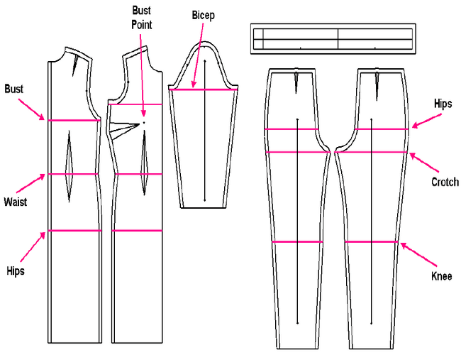

Fig.1.1 Pattern types used in the apparel industry

- Types of Pattern Used in Apparel Industry:
There are mainly two types of patterns used in the readymade apparel sector which mentioned below:
- Basic block or block pattern used in the apparel industry,
- Working pattern or apparel pattern.
All the above pattern types have discussed in the following:
- Basic block or block pattern:
A basic block or block pattern is an individual component of apparel without any design or style. It can be made into two ways such as modeling and flat method.
- Modeling:
Modeling is a primary and first method. Still, it is widely used in the apparel industry. In the modeling method, Block is made with the standard body measurement of the dummy which is known as toile. Toile is worn on the body of the dummy to check fittings. After that, toile is worn out from the body of the dummy, and individual parts of toile are drawn on board paper or hard paper. This method is the most efficient but needs more time.
- Flat method:
In the case of the flat method, the pattern of different parts of apparel especially the body and sleeve are made by technical drawing. Actually, this method comes from the modeling method and by this method fast pattern making is possible.
- Working pattern or apparel pattern:
Apparel pattern is made based on the basic block or block pattern. Individual block patterns are drawn on board paper or hard paper. Different types of allowances i.e. trimmings allowance, sewing allowance, bottom line, center front line, pleat, drat is considered in this type of pattern.

- Pattern Making Terms:
Pattern paper comes in a variety of weights and colors. Each serves a special purpose. Each paper supplier uses a code system to indicate the range of paperweights available. The manufacturer’s preference is based on personal choice and the use to which it is put. The heavy pattern papers are commonly referred to as tag board, manila, or hard paper whereas the lighter weights are called marking the paper.
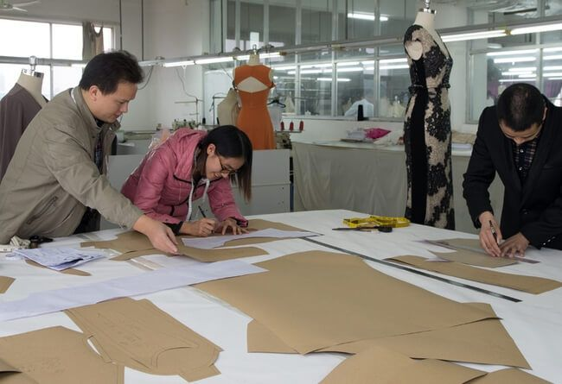

Fig.1.2: Garment pattern making department

1.1.3 Different Pattern Making Terms Used in Readymade Garment Industry:
There are different pattern making terms that are related to the workroom have pointed out in the following:
- Pattern drafting,
- Flat pattern making,
- Working pattern,
- First patterns,
- Production pattern,
- Pattern grader,
- Pattern marker maker,
- Pattern cutter,
- High ply cutter.

All the above terms have explained the below:
- Pattern drafting:
Pattern drafting is a method that totally depends on measurements taken from a form or model to make basic, foundation, or design patterns.
- Flat pattern making:
Flat pattern making is a method that is dependent on previously developed patterns. In the case of the flat pattern making method, the patterns are manipulated by using a pivotal or slash method to make design patterns.
- Working pattern:
Working pattern is that which is used as a base for manipulation when generating design patterns.
- First patterns:
The original pattern was developed for each design. This pattern is generally made from marking paper and usually requires fitting and adjustments. Half a pattern is developed unless the design is asymmetrical.
- Production Pattern:
It is one kind of pattern set that has been perfected and corrected and contains every pattern piece required to complete the garment. Production pattern is normally used by the grader for grading sizes and by the marker maker for preparing fabric layout.
- Pattern grader:
The grader proportionately increases and decreases the size of an original pattern within a size range. Here, the grade is in the circumference, length, and width.
- Pattern marker maker:
A marker is the length of paper containing a copy of all pattern pieces to be cut at one time. All patterns are interlocked and aligned on the marker papers so that when cut the grain lines will lie parallel to the selvage of the fabric. The completed marker is placed on top of layers of fabric as a guide for the cutter.
- Pattern cutter:
After the marker is made and laid on top of the layers of fabric, the garments are cut by the cutter or by a computerized cutting machine.
- High ply cutter:
Up to three inches of compressed fabric can be consistently and accurately cut using a high-efficiency vacuum hold-down system.

1.2 Pattern making process
A pattern maker interprets a design by drafting it through pattern pieces as per the body measurement following a set of instructions in order to create a style. The process is known as pattern drafting. Individual body measurements are converted into a series of straight lines and curves on template paper.
At a later stage, the lines and curves determine the overall sections of the patterns pieces to cut and eventually develop a reusable pattern and tested for fit. Pattern pieces represent the garment in sections and have information on size, grain line, balance marks, pockets, and placement for buttons, buttonholes, notch mark, seam, and hem allowances.
They are termed as 'pattern information'. Specific methods and stages of pattern drafting vary from pattern maker to pattern maker.

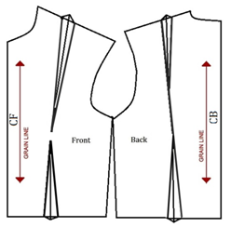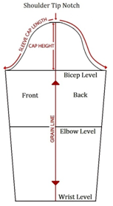
Fig. 1.3 Slope/Block
After testing or checking shapes from the first pattern, seam allowance, trimming allowance (optional), buttonhole, button attaching, dart, pleat, notch, ease, etc are included in the copied pattern known as a 'working pattern'. Working pattern is used as a base for manipulation to generate design patterns and is required for every part of garments.
Working pattern pieces are cut and labeled for parts name and garment size to which it belongs. This pattern is generally made by tracing the basic blocks on paper and requires fitting and adjustments. It is then transferred onto a fabric for a test fit purpose. The pattern pieces are stitched to get a sample garment (a prototype of the design sketch) and checked for the fit as per the particular body measurement.
After checking of the sample in case of any fitting related problem the working pattern is modified to make it eligible for a second test fit and is called 'revised pattern'. Based on the revised pattern stitching is done and checked for the fit. On necessary approval of the buyer, the revised pattern is considered to be the 'production pattern'. 3D vision of a pattern can be seen on a simulated dummy in CAD software systems / body scanner. Thus the approved production pattern goes to the fabric cutting section for marker making and cutting.
The interpretation of the design is done by following pattern making rules which are primarily acquired through experience. The pattern pieces as per the design sketch are derived from their individual basic block or slope which are usually without seams as it hinders proportioning and developing design variations. These basic pattern shapes are used by pattern cutters for every season to draft pattern as a clothing reference with different fitting ease for close-fitting, semi-fitted, fitted, loose-fitting or very loose-fitting.
Ease is the amount of space in a garment beyond the body measurement. The specific amount of ease will vary from style to style.
Different garment types have different fashion features. A fashion feature relates to the various physical components of the garment and its generic shape. Some of the fashion features are darts, design lines (lines of illusion), pleats, long/short/less sleeve, sleeve in regular/raglan style, flare skirt, collarless bodice, tapered trousers, zipper fly opening, etc. Anything that influences the garment geometry is regarded as fashion feature (Figure 4).
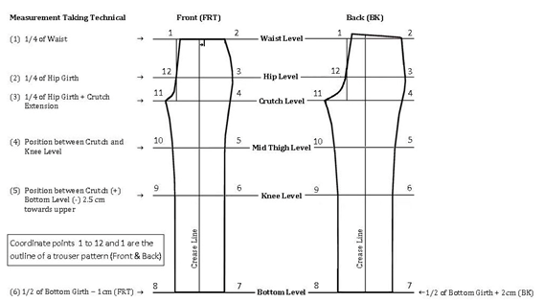

Fig. 1. 4 Example of Flat/manual pattern/drafting slope of a trouser with measuring information.
An arrangement of fashion features that are laid to a piece of garment is defined as a fashion style. The existence of a fashion feature may affect the relevant basic blocks by affecting their shapes and dimensions, involve markings to locate positions and creates added pattern pieces as per design. Accordingly, each fashion feature exclusively follow its pattern making rule stating the drafting of such pattern pieces belonging to a particular garment type. Every pattern maker, therefore, set their rules of understanding based on the garment types. Due to the variety and preconception of such rules, every pattern maker usually specializes only for making few types of garment. Hence, they categorize a new design to its applicable garment type related to their recognized set of rules to get similar intermediate style. The final design is achieved through addition, modification or deletion of the fashion features from the intermediate styl.
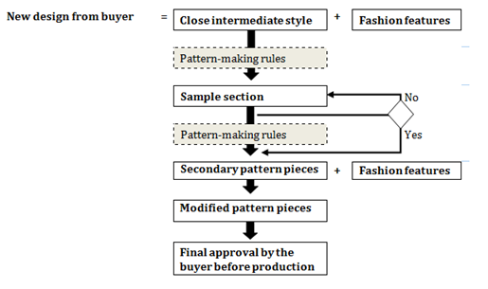

Fig. 1.5 Application of pattern making rules.
Pattern making, therefore, consists of three step namely fashion analysis, spec sheet design, and pattern drafting. New fashion designs are analyzed by disintegrating them into a look like intermediate style. The intermediate style consists of various garment segments which are further disintegrated and termed as secondary pattern pieces. The secondary pattern pieces usually have features like pleats, flares, darts, and cuts to give required shapes of the garment part. Hence, to expedite the pattern making method, often designs are adapted from existing secondary pattern pieces, in lieu of basic block because of its accuracy of sizing and pace with which ranges can be developed. These designs have minor variation in fashion styles in compare to the related secondary forms.
Pattern grading is step-wise increase and/or decrease of base size or sample size proportionate to specific instructions using a size specification sheet according to measurements. It can be done manually or by using computerized pattern cutting software and does not create a shape or change shape. Grading is an essential step that must be taken before approaching sample manufacturers or factories because they require sets of specific patterns and an order of clothing to be produced. Grading determines how the garments will fit in all sizes. Having a range of sizes for each of clothing category fills out minimum garment order cost effectively.
Although fashion trends come and go, the pattern making principles do not change. The rules and methods are always followed for designing and drafting pattern pieces. Finally, the production pattern is achieved that is correct and perfect, containing every pattern piece required completing the garment. In the production, a pattern has the seam allowance and all requisite information like grain line, style name, size, and sometimes the number of cuts. Different signs which a pattern maker uses in patterns to communicate with the buyer and the end users are:-
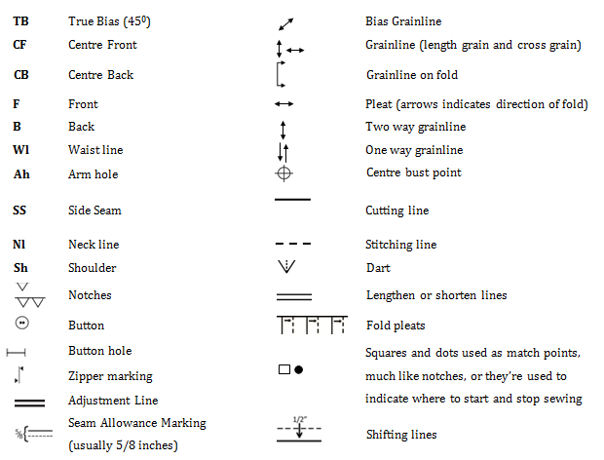

Fig. 1.6 Pattern Symbols
- Importance of pattern making
Pattern making converts a sketch into a garment hence it is a link between the design and production. There are three major elements interpretations, technique, and technology that completes the development of garment pattern making.
- Interpretation: This is the ability to read and understand the design/sketch and its objective, technical challenges can be resolved by a technician but none of it completes until design goal is achieved/accomplished.
- Technique: The pattern maker should have a large set of tools which can be implied/selected or used while making different specifications/designs and to achieve its results.
- Technology: To a huge extent, the efficient and fruitful customised production of a garment is dependent upon the technological facts interpreted into the pattern making. One (pattern maker) should have technological mindset and should understand the production implementations of each detail in the relevant pattern.

1.3 Identification of style modification

1.3.1 What Is Style?
Style refers to a person’s particular way of expressing themselves—whether that’s through clothing, writing style, or a style of architecture. In the fashion world, “style” is usually shorthand for “personal style,” or the way an individual expresses themselves through aesthetic choices such as their clothing, accessories, hairstyle, and the way they put an outfit together.

1.3.2 What is Dart in Clothing?
Darts are a dressmaker’s punctuation marks. It is an essential part of garment construction. Darts are folds and sewn into fabric to take in ease and provide shape to a garment, especially for a woman’s bust. Darts help in shaping the fabric to fit the body and thus provide comfort to the wearer. They provide fullness to natural body curves. Darts are very rarely used for decorative purposes like providing a design line. The fitting, marking, stitching and pressing of darts should be done accurately. In this article I will discuss details on dart manipulation techniques for flat patterns.
To create new designs for garments, it is specially used for ladies garments. It save fabric wastage and also use to remove excess fabric. Darts are needed to turn two-dimensional shapes into three-dimensional shapes and to fit clothes closely to the body.
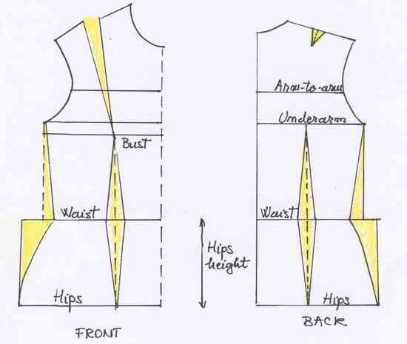

Fig: 1.7 Darts in flat patterns

1.3.3 Application of Dart Manipulation
The technique is applied when the dart of working patterns (bodice, skirt, sleeve, or any working pattern) are relocated in the process of creating design patterns. To create a design pattern, the design is analyzed first to identify the location of the dart or equivalent before manipulating the pattern.
The following design projects illustrate the beginning of pattern manipulation, and each process should be completed in the order given because each will help to prepare the pattern maker or designer for more advanced work. Both artistic and technical skills are required to successfully create design patterns.

- Different Darts Locations:
Darts can be located in a number of different places on a bodice to alter its style.
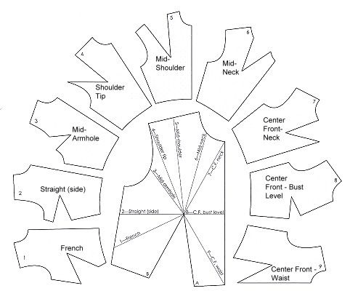

Fig: 1.8 Different dart locations
- Completing the Dart:
The dart can be finished one of two ways:
- Trim dart excess to within 1/2 inch of the seam line before stitching the dart.
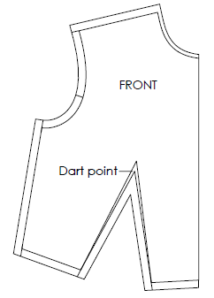

Fig: 1.9 Dart Seam
- Fold the dart excess under and stitch on the seam line.
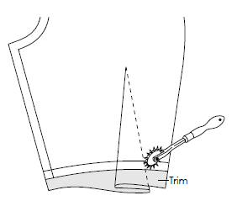

Fig: 1.10 Folding Dart

1.3.4 Dart Manipulation Techniques:
Dart manipulation is one of the most important techniques when it comes to pattern drafting. Fashion designer must identify the location of the dart before manipulating the pattern and how manipulate the dart. Dart manipulation mainly starts with a basic sloper, which they then convert into their stylish designs. Darts become princess seams, gathers, tucks or cowls. New styles lines are added or moved, necklines are reshaped.
There are three dart manipulation techniques in flat patterns. These are suitable for manipulate dart to any location. The slash and spread or pivot method mostly use to transfer darts to the bust, neck, armhole or anywhere you want!
- Pin and pivotal dart transfer technique.
- Slash-spread transfer and overlap technique
- Dart equivalent technique
- Pin and Pivotal dart rotation technique:
Pattern designers use pivoting methods to make fashion changes. They move darts or add fullness by anchoring the basic pattern with a pin and moving the pattern in, out, and around. The pattern swings back and forth like the pendulum on a grandfather clock. Use this pivoting motion to change the pattern width.
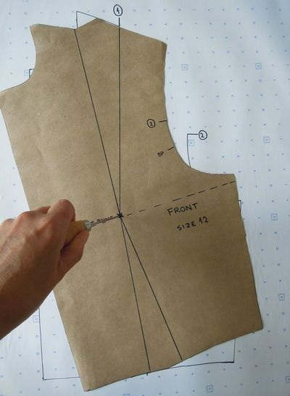

Fig: 1.11 Pin and pivotal dart transfer technique

In this method does not require the working be slashed in order to change its original shape into design pattern. It is a transfer method and with experience, it is preferred.
- Slash-spread dart rotation and overlap technique:
Pattern graders use the slide motion to change pattern sizes. They slide patterns up, down, and to the side to gradually increase or decrease from one size to the next. Use this sliding motion to add or subtract length.
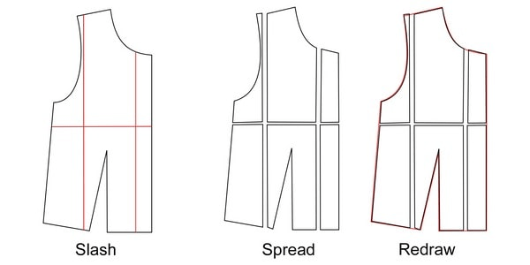 Fig: 1.12 Slash-spread transfer and overlap technique
Pivot and slide techniques combine these two motions to fit a pattern simply, yet accurately. You make all of the changes on a worksheet (pattern paper or tissue paper), keeping the original pattern intact—no more cutting and taping! By changing the pattern equally on both sides of the grain, the seam and the design lines are kept in proportion to the original pattern. Best of all, each change is easy.
- Dart equivalents technique:
Pleats or gathers in the fabric can be used as for the same purpose as a normal stitched dart. These are called dart equivalents. Darts can also be worked into style lines. The dart excess can be used to create a wide variety of other design features such as, style lines, multiple, tucks, gathers, pleats, flare and even cowls. Essentially, the dart or its equivalent is always present somewhere in the pattern. The dart or its equivalent will always radiate from the pivot point.
Fig: 1.13 Dart equivalents technique

1.3.5 Different Types of Darts:
The different types of darts are discussed below:
- Straight dart
- Curved outward dart
- Curved inward dart
- Neckline dart
- Double pointed dart
- Dart in interfacing
  - Straight dart:
It is a straight line of stitching from the point to the seam line (Fig-6). This can be noticed in the underarm of the front bodice, back skirt, shoulder, elbow and back neckline.
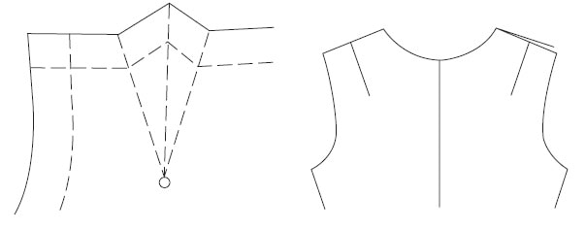 Fig: 1.14 Straight darts
  - Curved outward dart:
The stitch line curves outward along the path from the point to the seam line (Fig-7). This gives a snugger fit to the garment. This is sometimes used on a bodice front to make a mid-body fit snug.
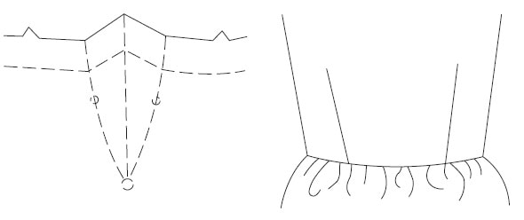

Fig: 1.15 Curved outward dart

  - Curved inward dart:
The stitch line curves inward from the point to the seam line. This facilitates a better fit along the body curve (Fig-8). It is frequently used in pant and skirt fronts.
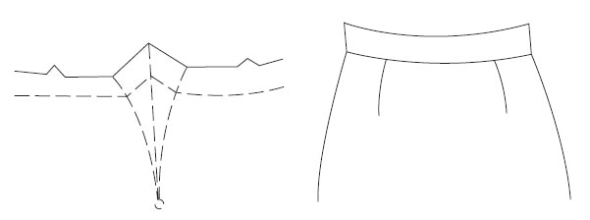 Fig: 1.16 Curved inward dart
- Neckline dart:
This is usually a solid line marking on the back neckline indicating a straight dart of 1/8″ (Fig-9).
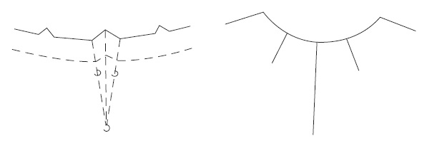 Fig: 1.17 Neckline dart
- Double pointed dart:
This dart is unique as it tapers in a straight line from the middle to both the ends (Fig-10) and is clipped at the widest part. It is usually made from the waistline (widest point). It finds application in princess and A-line dresses, over blouses and jackets.
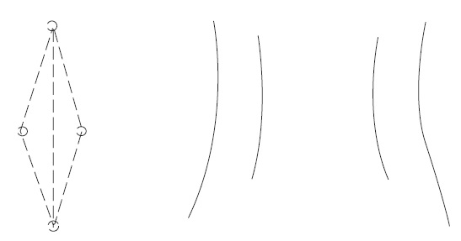

Fig: 1.18 Double pointed dart
- Dart in interfacing:
In this case, a slash is made on the fold line. Then the cut ends are lapped along the line of stitching and zigzagged to keep in place (Fig-11).
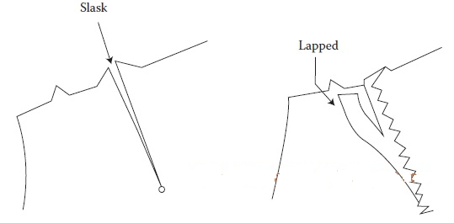

Fig: 1.19 Dart in interfacing

1.3.6 Basic Dart Manipulation Process:
The diagram above shows different dart locations. You can practice these dart manipulations as an exercise using either full size or half-scale blocks. By moving these darts around the bust point, you will begin to understand the method.
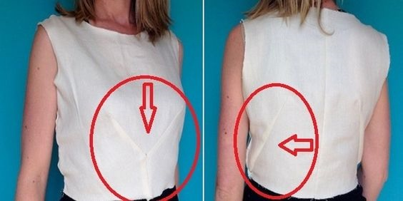

Fig: 1.20 Women’s shirt with dart
Follow the step-by-step basic dart manipulation exercise below:
The basic bodice has two darts. Start by consolidating the two darts into one side seam dart.
- Trace off the front bodice; here the bodice block is made from card, making tracing easier and more accurate.
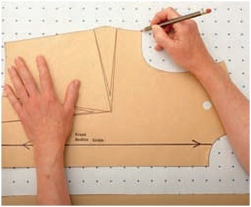

Fig: 1.21 Basic dart step-1
- Cut up the front waist dart and the side seam dart.
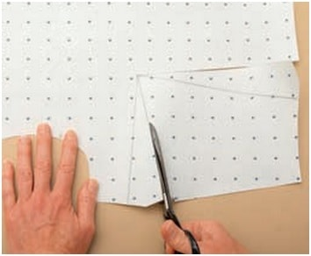

Fig: 1.22 Basic dart step-2
- Close the waist dart, and the side seam dart opens. (Remember not to cut right through; keep a small amount of paper attached to act as a hinge.)
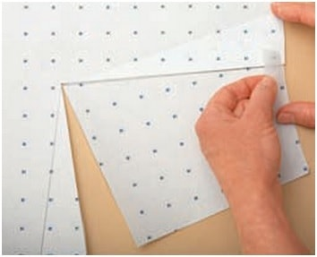

Fig: 1.23 Basic dart step-3
To continue this exercise, trace off the front bodice block onto paper. Draw in the lines to the bust point as shown on the diagram. To manipulate the darts, simply slash to the apex each time and then close and open the darts in different locations.

1.3.7 Asymmetric Darts Manipulation:
Asymmetric darts cross center front of the garment. Pattern shapes will change radically from that of the working Pattern. Asymmetric darts require special pattern handling and identification, as do all designs that differ from side to side. Compare pattern shapes with each design. Cut basic back to complete the design for test fit.
- A full front pattern is required.
- Right-side-up instructions are necessary.
- The existing dart of the working pattern may interfere with the placement of a stylized dart. If so, the dart should be transferred temporarily to another location (such as mid-armhole) before the pattern is plotted.
Seam allowance is illustrated for each pattern because of the dart’s unique shape and location (1/4 inch at neck; 1/2 inch at shoulder, armhole, and waist; and 1/2 to 3/4 inch at side seams).
- Types of Asymmetric Darts:
Basic asymmetric darts are applied on design pattern. To get different style on pattern, Asymmetric darts are changes in various ways. Mainly two types of dart variations are common. These are in below
- Asymmetric radiating darts
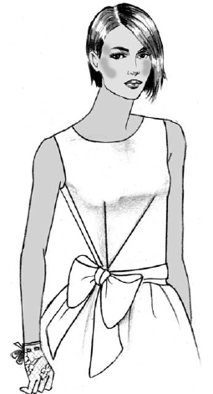

Fig: 1.24 Asymmetric Radiating Darts
- Asymmetric curved darts
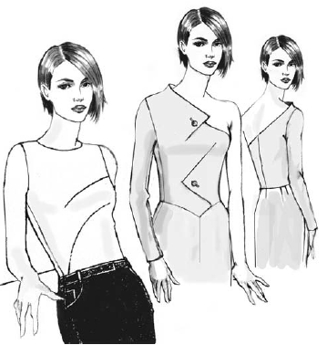

Fig: 1.25 Asymmetric Curved Darts
The step-by-step basic Asymmetric dart manipulation exercise in below:
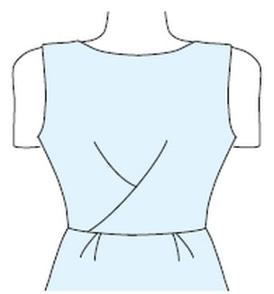

Fig: 1.26 Asymmetric darts
- To create asymmetric darts, trace off the bodice block fronts, joining the right and left sides at the CF(center front). The full bodice is traced off because the right and left sides are to be different.
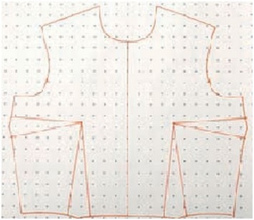

Fig: 1.27 Asymmetric darts step-1
- Cut up both waist and side darts to the apexes. Close the bust dart until its edges meet. The waist darts will open.
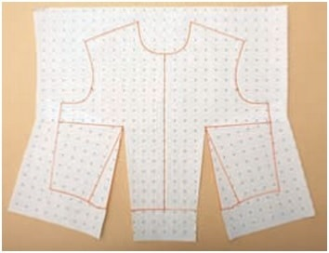

Fig: 1.28 Asymmetric darts step-2
- Draw in the new dart lines.
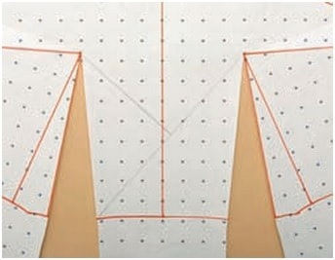

Fig: 1.29 Asymmetric darts step-3
- First cut along the long line that passes from left to right.
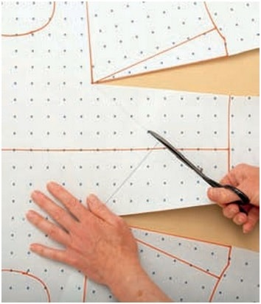

Fig: 1.30Asymmetric darts step-4
- Close the right-hand waist dart, and the long dart opens.
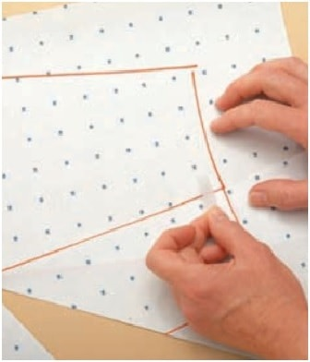

Fig: 1.31 Asymmetric darts step-5

- Cut up the shorter dart and close the left-hand waist dart. The short dart opens.
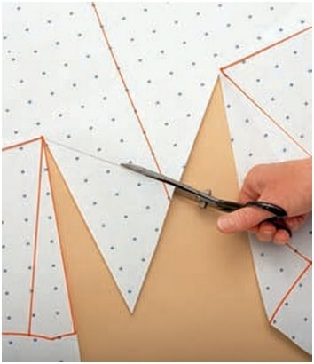

Fig: 1.32 Asymmetric darts step-6
- The pattern development is complete. Trace in new darts and back away from the apex by 4cm (11⁄2in). This is now your pattern plan. Trace this off onto a clean sheet of pattern tracing paper. Now you can add your seam allowance, notches and grain lines.
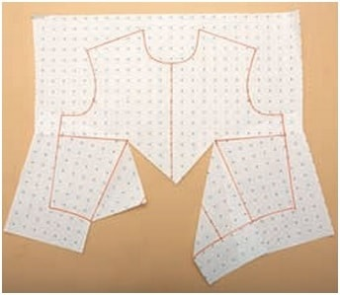

Fig: 1.33 Asymmetric darts step-7

1.3.8 Changing Darts into Gathers:
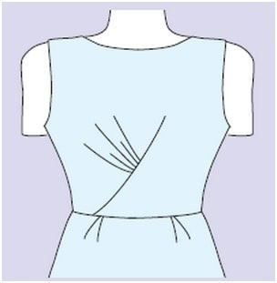

Fig: 1.34 Changing Asymmetric dart into Gather dart
Measure the right-hand dart from A to B. Including the dart, the measurement will be longer from A to C; gather the excess fullness between the notches to match the shorter side as shown.
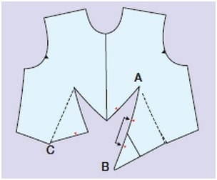

Fig: 1.35 Gather dart
This style has gathering located under the bust instead of the dart. First, repeat the first six steps from ‘Asymmetric darts’, above.

1.3.9 Intersecting Darts:
Intersecting darts resemble asymmetric darts and dart equivalents. The darts cross center front and intersect with each other. To complete the design, use basic back pattern.
- Types of Intersecting Darts:
Two common intersecting dart designs are practice in dress pattern. But variations are also available when the generated patterns are correct if they result in exact representations of the designs.
- Intersecting dart to waist
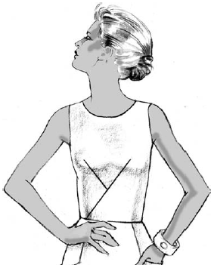

Fig: 1.36 Intersecting Dart to Waist
- Intersecting dart with gathers
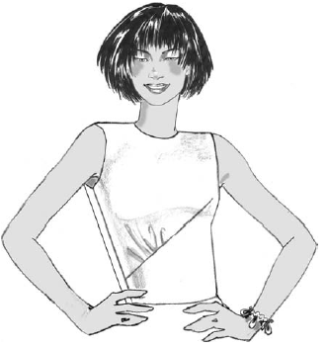

Fig: 1.37 Intersecting Dart with Gathers

1.3.10. Other Types of Darts
- There are two basic types of darts are as follows:
- Single pointed dart:
It is most common dart mostly used on skirts at waist and trousers and blouses at bust. The single dart is narrow at one end and wide at the other. With the triangular shape of an angle with single dart point and two dart lines.
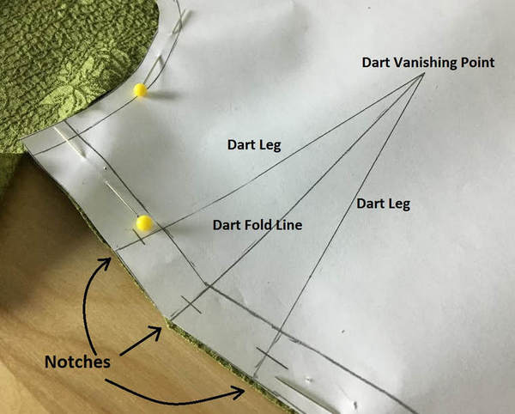

Fig: 1.38 Single dart-sewing beginners
- Double pointed dart:
It is also called fish-eyed dart and body dart. Mostly this darts is used for jackets and dresses that fit at waist. Double pointed dart is sharp and narrow at both the ends.
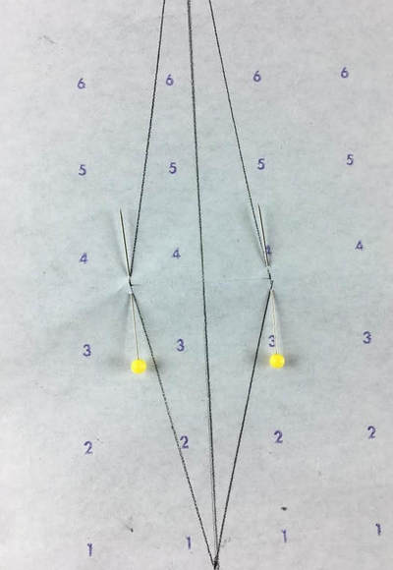

Fig: 1.39 Double pointed dart

1.3.11Different Types of Dart Placement:
There are different types of dart placement which can be found in many different sizes and as found as shoulder dart, mid armhole dart, bodice dart, mid neckline dart, standard waist dart, center front neck dart etc.

- Bust dart:
This dart is usually starting two inches below the armhole it is also called as side dart it is straight dart and fit under the arm pointing towards bust point. Also, it is used to make an innovative shape in the garment.

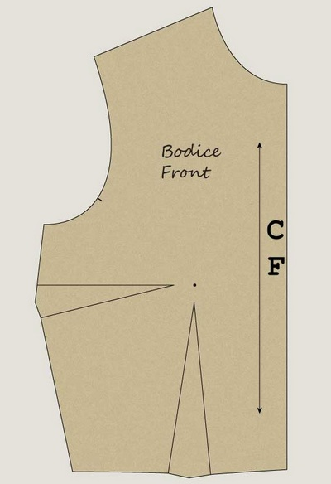

Fig: 1.40 Bust dart
- Shoulder dart:
This type of darts is used for proper fitting of garment on shoulder area the dart angle is totally dependent upon design and pattern.
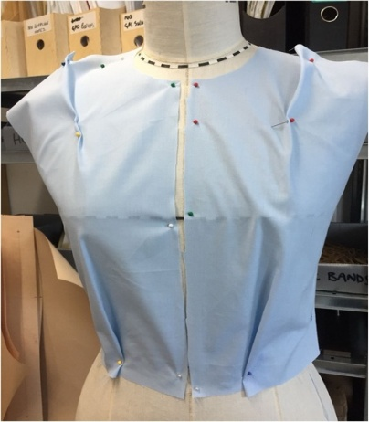

Fig: 1.41 Shoulder dart
- Dart tuck:
As we sewn the normal dart same way dart tuck tucks are sewn the difference is point of left dart is open it helps to give a pleated look to garments. And due to this process fullness is released below the stitching.
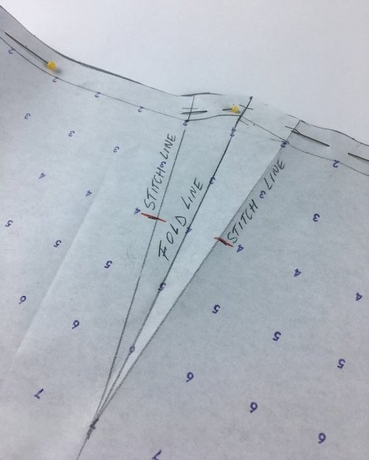

Fig: 1.42 Dart tuck
- Elbow darts:
To make sleeve more fitted dart set in elbow. They are mostly useful for generate the fitted shape in sleeve for more tailored look.
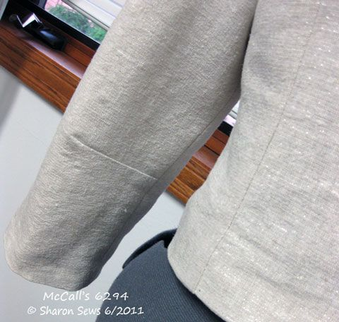

Fig: 1.43 Elbow dart
- Curved dart:
On some pattern’s darts are drawn with tender curve. These types of darts are creating fullness on skirt and pant pattern. The direction of the curve dart is depending on the concave direction or convex direction.
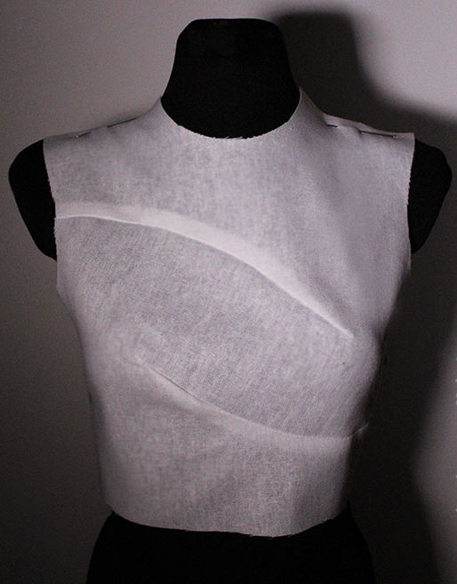

Fig: 1.44 Curved dart
- Sleeve Hem darts:
A little dart tilt from the hem at little finger boundary of the sleeve, sloping to elbow helps to decline the sleeve. It helps sleeve for proper fitting to wrist and elbow.
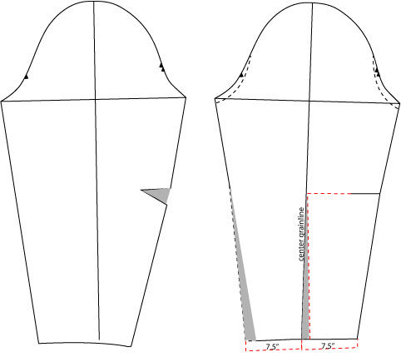

Fig: 1.45 Sleeve hem dart
- Skirt/ Pant types of darts:
This type of darts starts at the waist and slump towards hip. As per your choice how much fit you require you have two darts on either side of the center of the skirt waist or pant waist. And as waistline falls past the hips it crates fullness.
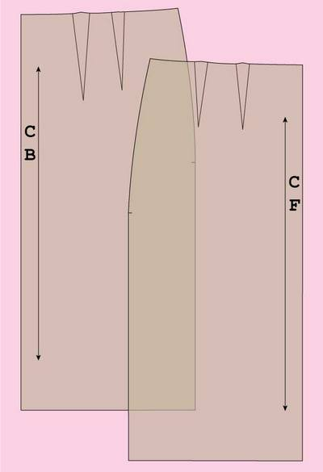

Fig: 1.46 Skirt/pant type of dart
- French dart:
This dart starts from the waistline and angles towards the bust. The dress pattern is cut in this shape then it sewn at once along the curve of dart this dart is hard to sew.
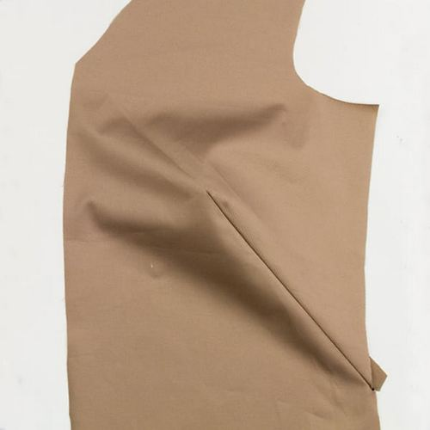
Fig: 1.46 French dart (madtosew.com)

1.3.12Types of Darts All Sewist Must Know:
- Standard dart:
An ideal dart is open at one end, and it is looking like a triangle shape on a pattern peace. and it is used at the bust or waist. It’s the most common type of dart, sometimes it is referred to as a plain dart, and it can be exploited to made various design elements that function same as a dart like princess seam.
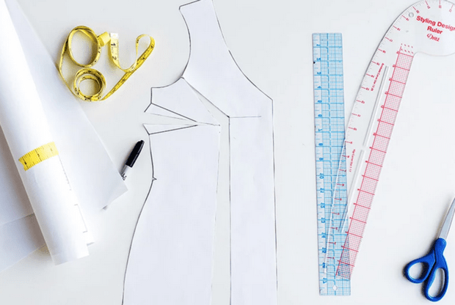

Fig: 1.47 Types of darts in sewing
To provide more shape. You can place standard darts at other points of the body. Shoulder and neck dart, helps to add a womanly shape to a garment that might otherwise look bulky. And elbow darts permit you to have a more integrated sleeve while still leaving sufficient room to proceed.
- Serged Darts:
This technique is especially practical when you must add darts to knit garments. Darts can be time-swallow (consuming) process, but if you have a serger you are in luck — using one can speed up the process. As knits do notpin well and to reduce the bulk serging can helps.
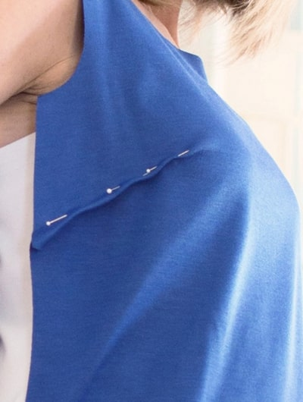

Fig: 1.48 Serged dart
- Converting Darts to Ease:
When you want a more ease silhouette than what customary dart fashion provides, it is good to change darts to ease. Performance so helps add shape, while still giving you the fit of a loose fitted garment. Mostly it works specially on skirts. Also, it is used for set in sleeves while creating sleeve cap.

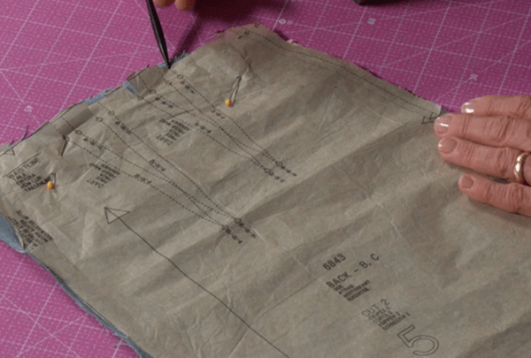

Fig: 1.49 Converting darts to ease

1.3.13 Built-Up Necklines
Built-up necklines extend above the base of the neck and must accommodate the position of the neck as it juts forward (Figure 1). There are two basic types of built-up necklines: all-in-one with the bodice (Figure 2) and set-in bands (Figure 3). Either type can be developed from any point along the shoulder and to any height. Added room is provided along the outer edge of a built-up neckline. This allows the neckline to rise up and away from the neck and shoulder of the garment to prevent strain from the neck’s forward position. The development of this type of neckline is an application of Principle #1, Dart Manipulation (when transferring dart excess to the neckline) or Principle #2, Added Fullness (when adding to the pattern’s outline). Because of the special features of this type of neckline, facings are included in the instructions.
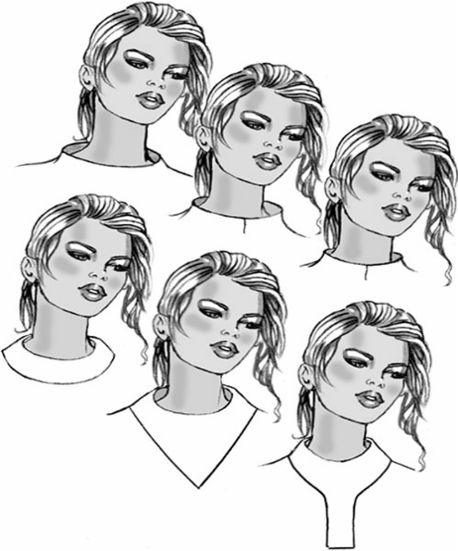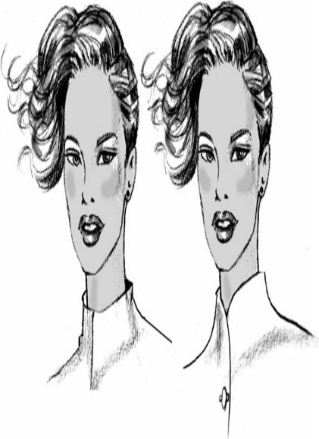

Fig: 1.43 Neck types

1.4 Pattern specification sheet VS pattern component

1.4.1 Introduction
A garment specification sheet is a technical document that contains the construction details of the product, a technical diagram/ sketch of the garment, measurements of the product. Here fashion is referred to the apparel and clothing products. The fashion designer communicates the design concept through the specification sheet. The stitch class and seam type are mentioned in the sketch. The diagram also communicates different measuring points by English letter (symbol).
To make the garment pattern, grading of the patterns for different sizes, developing a sample and sourcing of the materials, the spec sheet is followed. The initial specification sheet is made for developing a proto sample. Later the specification sheet (measurement chart) may be revised after checking the sample FIT and garment construction. In the sampling stage, the quality inspector and buyer QA follow the instruction in the specification for the sample checking and sample approval.
At each stage of sample approval, buyer adds comments of the specification sheet (tech pack). All the comments on the sample and modifications on workmanship and material are incorporated in the next sample development and bulk production. In the bulk production, the revised and approved garment specification sheet is referred for internal quality checking and the final shipment inspection.
The specification sheet also coined as a spec sheet. The specification is part of an apparel tech pack though many uses both the term interchangeably.

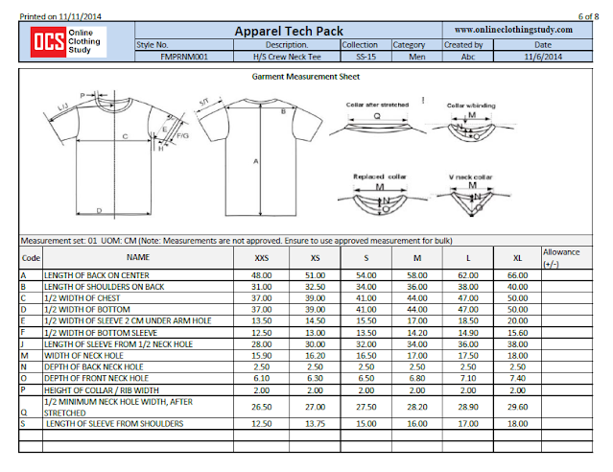

Fig: 1.44 Part of the apparel tech pack

1.4.2 Pattern components
The front and the back body, sleeve, cuff, placket, yoke, collar and pocket need to be assembled together in order to make a shirt. Hems, stitches, seams, bonding, fusing, or combination of these, is used to assemble the garment components into a complete structure.
- The basic garment components according to Glock and Kunz (1995) include:
- Top fronts and top backs
- Bottom fronts and bottom backs
- Sleeves
- Collars and neckline treatments
- Cuffs and sleeve treatments
- Plackets
- Pockets
- Waistline treatments

Self-check-1
Part -I Matching
Instruction: select the correct answer for the give choice. You have given 1 Minute for each question. Each question carries 2 Point.
A B
____1. Pattern information A. working pattern
____2. Pattern B. Grain line
____3. Fashion feature C. Made of paper
____4. Pattern making is D. Dart
____ 5. Basic block pattern E. Blue print
____ 6. Traced from the block pattern F. Types of pattern

Part - II: short Answer writing
Instruction: write short answer for the given question. You are provided 3 minute for each question and each point has 5Points.
- List out the two basic types of dart?
- List out types of asymmetric dart?
- List out types of asymmetric dart?
Part III: Choose the Right Answer
Direction: choose the right answer to the following questions. Time allotted for each item is 2mniut and each question carry 4 point.
- Terms commonly not used in pattern making?
    - First pattern
    - Working pattern
    - Production pattern
    - Sewing/assembling
Note: Satisfactory rating – above 60% Unsatisfactory - below 60%
You can ask you teacher for the copy of the correct answers

Unit Two: Preparation of Pattern Modification
This unit to provide you the necessary information regarding the following content coverage and topics:
  - Requirement for pattern modification
  - Fabric performance VS style modification
  - Pattern making tools and equipment
  - Select/prepare basic pattern to modify
This guide will also assist you to attain the learning outcomes stated in the cover page. Specifically, upon completion of this learning guide, you will be able to:
- Confirm modify pattern requirements through pattern modification.
- Identify fabric performance characteristics that may affect style modifications
- Select and prepare patternmaking tools and equipment.
- Prepare basic pattern required modification.

2.1 Requirement for pattern modification
- What are the requirement for pattern modification
- Preparation of tools and equipment
- Select/prepare basic pattern
- Prepare design to be modified
- Analyze the design to be modified
There are a number of ways to modify the pattern, for example add length to the body or sleeves, make the hips wider, etc.

2.2 Fabric performance VS style modification

2.2.1 Introduction
Fabric is the basic raw material for garment manufacturing. Right fabric selection is very important task for apparel manufacturing. Fabric quality influences not only the quality of the garment but also the ease with which a shell structure can be produced out with flat fabric. The selection of the right type of fabric for a particular garment type is the most difficult task for the manufacturers. Hence, understanding the fabric properties that affect the manufacturing process and the final garment quality is essential. Setting the right quality for fabrics is a very important part of range building. Setting the quality too high and using fabrics that can account for at least 50% of the overall garment cost will be too expensive. Set the standard too low and you will risk a high percentage of complaints and lose customer loyalty.
Our first test of a fabric is often to check if we like the feel, the handle, and the appearance and to see how it will look and drape in the finished garment. A good-quality fabric from natural fibers such as wool, silk, linen, and cotton will usually always feel and drape well, but price might be prohibitive for your target market, and they might only be dry cleaned, which then limits the customers you can sell to. There are many options of synthetic or blends of synthetic and natural fibers, which are suitable cheaper alternatives.
For example, school clothing and work wear need fabric and seams that are strong and stand up to continuous hard wear and therefore the yarn needs to be strong and the warp and weft weaved tightly together. A fashion wool jacket is likely to be the opposite in structure, designed to have an open weave and raised surface detail and to be classified more as a decorative fabric and would not be a hard wear.
There are no specific international standards for any fabric quality or performance, as this is for you to decide what is suitable for your products, but there are recognized adopted standards for general apparel.

2.3 Pattern making tools and equipment

2.3.1 Pattern making tools

To work efficiently, the patternmaker must have the proper tools and supplies. To communicate effectively in the workroom and to minimize errors due to misunderstanding, the patternmaker should know and understand terminology. This chapter introduces tools, supplies, and definitions of terms used in industry.
The professional patternmaker arrives on the job with all tools required for patternmaking. Each tool should be marked with an identity symbol and transported in a carrying case. Tools may be purchased from apparel supply houses, art stores, department stores, and yardage stores. Specialized tools, such as a rabbit punch used to punch pattern holes for hanger hooks, are generally supplied by the manufacturer.

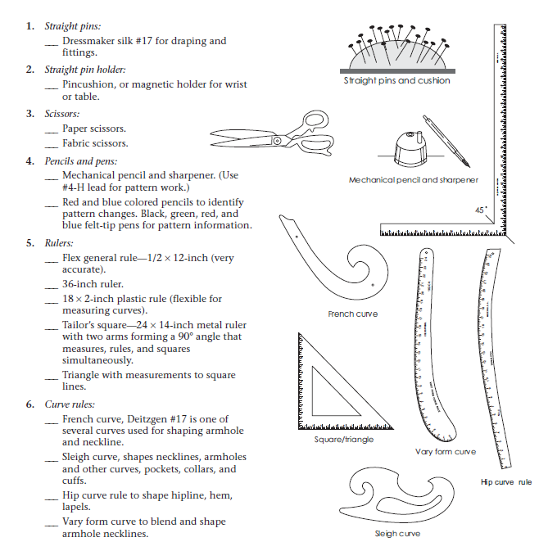

Fig: 2.1 pattern making tools and Equipment
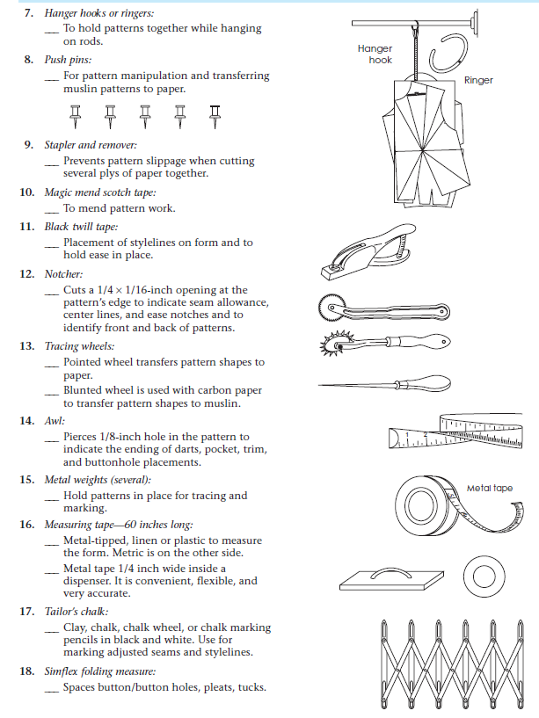

Fig: 2.2 pattern making tools and Equipment

2.4 Select/prepare basic pattern to modify

2.4.1 What is a basic pattern?
A basic pattern, also called a block pattern, maps directly back to the body measurements and only has wearing ease. Basic patterns are really important for creating fit consistency within a brand. Having consistency in fit means your customer can confidently buy their size each time they purchase a product from you and know that it will fit. The best way to create this confidence is to use a basic pattern library as a starting point for all of your style patterns.
A solid basic pattern library will provide you with patterns that only have the necessary seams required for fit and the necessary amount of wearing ease required for the type of fabrics they are intended for. Design ease, additional design lines, and other design features can be added later on at a style level.
This is an example of a simple basic block drafted with minimum ease.
Several of my basic designs are based on these basic blocks.
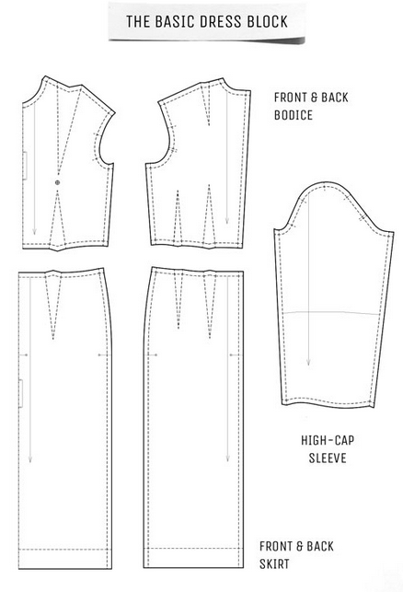

Fig: 2.3 Example of basic/block pattern

Self check-1
Part-I Matching
Instruction: select the correct answer for the give choice. You have given 1 Minute for each question. Each question carries 2 Point.
A B
_____1. Tracing Wheel A. Marking
_____2. Tailor Chalk B. Block pattern
_____3. Metal Weight C. Hold in place
_____4. Basic Pattern D. copy/trace
Part- II: short Answer writing
Instruction: write short answer for the given question. You are provided 3 minute for each question and each point has 5Points.
- List out all types of tools and equipment for pattern making?
Part III: Choose the Right Answer
Direction: choose the right answer to the following questions. Time allotted for each item is 2mniut and each question carry 4 point.
- Among the following which is not tool for pattern making
  - French curve
  - Pattern scissors
  - Hip curve ruler
  - Hand needle
Note: Satisfactory rating – above 60% Unsatisfactory - below 60%
You can ask you teacher for the copy of the correct answers

Unit Three: Modify pattern
This learning guide is developed to provide you the necessary information regarding the following content coverage and topics:
      - Application of OHS practice
      - Modification using basic pattern making principles
      - Check pattern accuracy
      - Labelling pattern pieces
This guide will also assist you to attain the learning outcomes stated in the cover page. Specifically, upon completion of this learning guide, you will be able to:
- Modifications are made applying basic pattern making principles.
- Pattern pieces are checked for accuracy, including seam allowances, ease allowance, seam match, hems and functional openings.
- Pattern pieces are labeled, including grain lines, notches, pattern information and cutting instructions.
- OHS practices are identified and followed.

3.1 Application of OHS (Occupational Health Safety) practice

3.1.1 What Does Occupational Health and Safety (OHS) Mean?
Occupational health and safety (OHS) is a branch of public health aimed at improving workplace health and safety standards. It studies injury and illness trends in the worker population and offers suggestions for mitigating the risks and hazards they encounter on the job.
Every occupation has health or safety risks associated with it, and it is every employer’s responsibility to ensure that their employees can carry out their work as safely as possible.

3.1.2 How to Stay Safe on the Job
- Some of the topics covered by OHS include the following:
- Appropriate use of PPE - It is the employer's responsibility to ensure that workers have the personal protective equipment required to work safely. Depending on the job and work environment, this can include fall protection devices, hard hats, high-visibility clothing, or safety gloves.
- Safe operation of the work equipment - Safety procedures ensure that employees can use heavy machinery, power tools, and other work equipment with minimal risk of injury. This includes not only the appropriate handling of the equipment, but also regular inspections and maintenance to ensure that it functions optimally.
- Maintaining hydration - Since they are at work for extended periods of time, workers are at risk of dehydration if clean drinking water isn't provided for them. While this affects all workers, it is especially important for those who do intense physical labor, wear heavy PPE, or work in high-heat environments.
- Good bodily movements - Musculoskeletal disorders are an extremely common type of workplace injury. To prevent them, workers need to follow ergonomic best practices. This includes safe lifting techniques, good posture, and avoiding repetitive motions while carrying out their work tasks.

3.2 Modification using basic pattern making principles

3.2.1. Principles for Pattern Drafting
Drafting can be done on ordinary brown paper which should not however be too thin.
To obtain an accurate draft, use a sharp pencil, and a ruler for, drawing straight lines. To get the corners at right angles, keep an 'L' scale or set squares ready. Before drafting, it is important to understand the procedures and instructions clearly, and to have practice in drawing a well balanced pattern with smooth curves and straight lines. You must understand the following principles before starting to attempt drafting.
Patterns must be made larger than body measurements to allow for freedom of movement, ease of action and comfort in wearing. Recommended ease allowance for various parts of the body are listed below. For bust 3' to 5' (3' for a tight fitting garment and 5' for loose fitting one); waist �' ; hip 3' to 5' ; upper arm 3' to 4'; arm hole depth 1'.
For all the garment the ease allowance must always be left before cutting out the pattern.
For symmetric designs where the right and left sides are alike, paper pattern for half front and half back only need to be made. For the bodice, start the drafting with the back part. For sleeves, full pattern must be drafted.
It is better to draft the primary or basic pattern blocks - plain bodice, plain sleeve, plain skirt without seam allowances. When this is done, be sure to leave seam allowances while laying out the pattern on the material at the time of cutting. If you do not have much experience in cutting, and want to avoid the risk of cutting without seam allowance you may add seam allowances to your paper pattern itself after completing the draft.
The following construction detailed information should be recorded and marked clearly.
Name of each piece of pattern (bodice front, bodice back, sleeve etc).
Number of pieces to be cut with each pattern piece. (For example, for a back

open dress, you have to cut 1 front, 2 backs and sleeves).
If seam allowances are not included in the draft, this should be mentioned. If seam allowances are included, seam lines and cutting lines should be clearly shown.
Lengthwise or straight grain line should be drawn with a red pencil as shown (← - →) on all pattern pieces. This line indicates that the pattern should be kept on the cloth in such a way that the line is parallel to the length of the cloth or the selvedges; it is usually drawn parallel to the centre front and centre back edges of the pattern.
Provide matching notches or balance marks if necessary along seams to show which seams are to be joined together.
Centre front and centre back line should be marked. It is advantageous to cut outward notches at centre front and centre back of pattern pieces because at the time of assembling the garment, notches on collars can be matched to notches on the neck line of garment etc.
Fold lines should be clearly shown. Fold lines appear along centre front or centre back, edges and sometimes along hems to show where the material is to be folded. Dart markings, pleat markings etc. should be clearly shown.

3.2.2Three Major Patternmaking Principles
For making flat pattern and for making alterations according to different design it is very important to know the pattern making principles. If we know the basic principles of pattern making and alteration, we can create any design without affecting the size and shape of the original pattern. Any pattern can be created and modified if we know the basic three principles, which are:
- Principle of dart Manipulation: there are many rules for creating, combining and dividing the darts and transferring dart at different places on a pattern piece. Dart can be shifted to a new place by slash and spread method and by pivot method.
- Principle of added Fullness: there are rules for adding fullness in a garment. Fullness can be provided in a garment with the help of gathers, pleats, tucks etc.
- Principle of contouring: there are rules for making contoured patterns to make it fit the curves of the human figure.

3.2.3 Principles of Pattern Alteration
Fit is an important ingredient that makes a garment a wardrobe plus or minus. Standards of good fit are influenced by many things such as the current fashion look, the hang and stretch of the fabric, the amount of ease preferred and figure size and type. For any seamstress, whether beginning or experienced, the art of fitting requires skill and patience. When this art has been mastered, garments will look better and feel more comfortable. Once the fabric is cut, however, fitting adjustments are limited to existing darts and seam allowances. Therefore, fitting problems should be solved before the garment is cut by making needed changes in the pattern. Preserve the altered pattern for later use by fusing nonwoven stabilizer on the pattern’s wrong side or redraw
the pattern and new markings onto pattern paper. Use dry heat for fusing because steam wrinkles the tissue paper and smears the ink.

3.2.4 To measure the pattern pieces
Measure each pattern piece at points that correspond with body measurements. For example, if your full hip measurement was taken 10 inches below the waist, measure the pattern’s circumference at the same point—10 inches below the waist seam line. First, smooth the pattern pieces flat. Pin in darts, pleats or gathers as though sewn.
Measure from seam line to seam line. Carefully follow the shape of the pattern piece in the area measured. For example, waist and side seam lines often curve, so the tape measure also should curve along the seam line. For a sharp curve such as the crotch, turn the tape measure on its
side for ease in following the curve. The numbered measurements in Figure 1 correspond to
the body measurements on the Personal Measurement Chart. Use these illustrations as a guide when measuring pattern pieces. Record totals in column IV of the Personal Measurement
Chart. Be sure that totals reflect how the pattern will be cut. For example, the bust pattern measurement (number 2) will be taken on all back and front pattern pieces that will be sewn
together to make the garment’s bust line. For each pattern piece cut double or on the fold, multiply by 2.
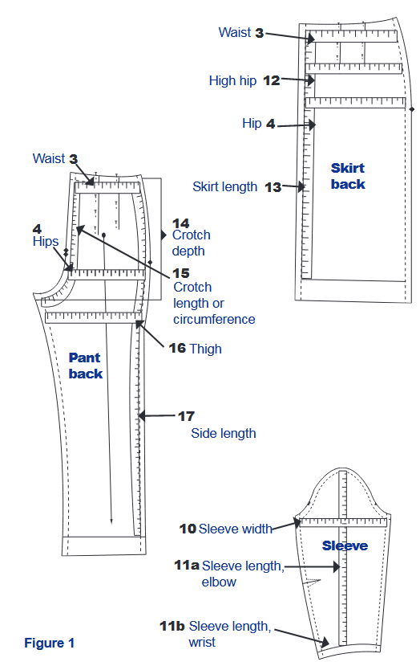

Fig:3.1 pattern measurement taking

3.2.5 To alter the pattern
After measuring the body and adding needed ease, compare this measurement to the pattern’s measurement. The difference is the amount of alteration needed, column V of the Personal Measurement Chart. The following guidelines are basic to the success of all alterations. Consider each carefully before beginning. These markings are used throughout this publication series to indicate specific alterations. Using a ruler, extend grain line markings the entire length of pattern pieces so that they can be seen dearly throughout altering and cutting. To extend the grain line, lay a ruler along the marked line. Extend the grain line to each seam line or outside edge, keeping the line straight. When pattern pieces are cut apart and then put back together, the original lengthwise grain line should be maintained whenever possible.
For garments to hang and fit correctly, the lengthwise grain of the fabric must lie at a right angle to the floor along major parts of the body such as the center front and back unless the pattern is cut on the bias.
If the alteration needed is 1 inch (2.5 cm) or less, alterations often can be made in the existing seam allowances. Exceptions include shoulder length, shoulder slope, upper arm sleeve circumference, rounded shoulders, hollow chest, sway back, bodice front and thigh bulge.
After the pattern is marked and cut apart as instructed, anchor the main pattern section with pins into corkboard or cardboard. Place tissue under any area where needed as described in the instructions. Pivot or position the other part of the pattern the amount needed and pin. Double-check the alteration and then tape pattern and tissue in place.
Make only one alteration at a time. Begin with lengthwise alterations at the shoulder or neck and work down. Finish with the alterations for width, again beginning at the neck and working down. Many problems in side seams, bust area or length disappear when the pattern is correctly fitted in the neck and shoulder area.
If alterations are made correctly, the pattern lies flat. Seam allowances often need to be clipped from the cutting line to, but not through, the seam line. The slashed seam allowance then is lapped or spread slightly to allow the pattern to lie flat (Fig.2).
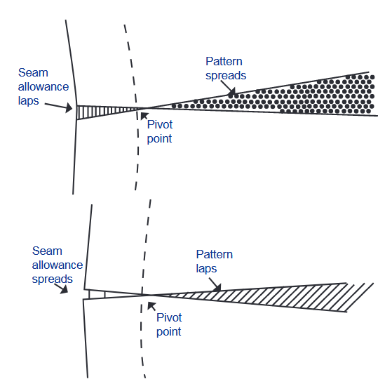

Fig: 3.2 Giving seam allowance
If the pattern does not lie flat and bubbles or wrinkles, the alteration steps or principles have not been followed correctly. Make alterations at the source of the problem. For example, when the bust measurement is larger than the pattern, increase the pattern at the fullest part of the bust rather than at the side seams to make the garment fit better. Do not change the shape of the shoulders, armholes or neckline any more than necessary. These areas are difficult to reshape and alter. Usually, it is better to buy a pattern that fits these areas and then alter other parts of the pattern. When making alterations, be certain to alter all connecting pattern pieces (facings, etc.) at corresponding points the same amount as the main piece.
Re space the buttonholes if needed so that buttons are placed at stress points such as the bust or waistline. Lines that are changed or distorted must be returned to a shape similar to the original. When in doubt about which lines to connect, see specific alteration publications for explanations and illustrations. A French curve is used to redraw curved areas such as waistlines. Move the French curve on the lines to be redrawn until the lines connect smoothly and are a shape similar to the original.
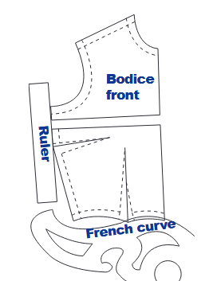

Fig: 3.3 Make alteration/modification
A straightedge, preferably a see-through 18-inch ruler, is used to redraw straight lines (Fig. 3). A T-square is helpful in drawing right angles. To find a line at right angles to the grain line, center front or center back without a T-square, fold that line on top of itself and crease where needed. The crease is at a right angle (Fig. 4).
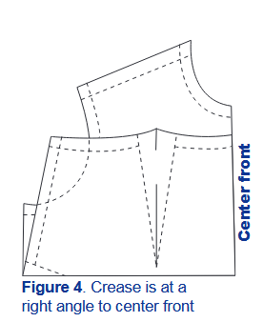

Fig: 3.4 Folding
When redrawing lines that cross darts, first fold the dart in the direction it will lie when sewn in the garment. Vertical darts press toward the center of the garment, while horizontal darts press downward (Fig. 5).
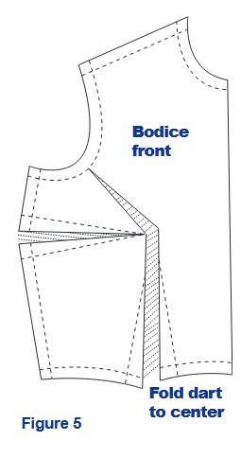

Fig: 3.5 Dart manipulation

With darts folded in place, cut along the garment’s cutting line or prick holes with pins to establish the new shape (Fig. 6).
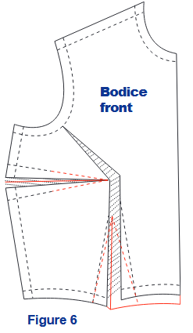

Fig: 3.3 Manipulation procedure

3.2.6 Check the altered fit
If you question the way your pattern will fit, make the garment in an inexpensive fabric or pattern-tracing product before cutting out the fashion fabric. This is especially important if you have made several changes in the pattern or are unsure of the adjustments made. To check the fit, baste only the basic parts of the garment together. Have someone help you check the fit of the garment or stand in front of a full-length mirror. Use the following checklist to help you determine if further alterations or minor fitting is needed for a good fit.
- Lengthwise grain lines, side seams, center front and center back seams hang straight or at right angles to the floor.
- Crosswise grain lines are parallel to floor.
- Adequate wearing ease is available for sitting, moving and bending.
- Armhole seams curve smoothly over the end of shoulder.
- Darts point to the fullest part of the curve.
- Shoulder seam length comes to end of shoulders.
- Sleeves are comfortable with no wrinkles.
- Hipline fits smoothly.
- Hemline is even.
- Pant legs hang smoothly and do not restrict any part of the legs.
- Crotch depth is right, neither too low and baggy nor too tight and binding.
- Pants hang smoothly from the waist. The waistband fits the body comfortably and stays
in place when bending and sitting.
- Pants have no pulls or excess fabric across the front or back crotch level.
- The length of the garment is becoming.

3.3 Check and label pattern pieces for accuracy

3.3.1 Pattern checking steps
- Check that all the pieces are labeled and marked correctly – they should say what they are (eg, back, sleeve etc), how many to cut, grain line, and fold line (if any). If you can be bothered, it’s a good idea to label pattern pieces with the garment name (eg, simple A-line skirt) so that if one piece somehow gets separated you know what it belongs to.
- Check that darts are marked using pencil markings, holes or notches.
- Check that corners are right angles at bottom and top edges of pattern pieces – waistbands, hems and that sort of thing. If your corners are not 90 degrees, you can get an interesting scalloped effect when you sew the front and back pieces together.
- Check the side seam length is the same on front and back pieces. Place the front and back on top of each other, right sides together, and check that the side seams are the same length and that notches (or diamonds) line up.
- If you’re making a skirt or trousers, the waistband should line up. You do not want it to be at different heights at the front and back!
- Check that lines that are supposed to be straight are straight and that they don’t bow out or curve inwards. It’s easy to cut off any extra but if you need to add to the pattern you can stick an extra piece of paper on with tape.
- Write the seam allowance and hem allowance on the pattern pieces – I really recommend you do this straight after drafting a pattern rather than trying to remember whether it was 1cm or 2cm when you come back to it two years later.

Self-check-1
Part-I Matching
Instruction: select the correct answer for the give choice. You have given 1 Minute for each question. Each question carries 2 Point.
A B
_____1. Dart manipulation A. Transferring dart
_____2. Principles of fullness B. Gather, pleat and tuck
_____3. Principles of contouring C. Persona protective equipment
_____4. OHE D. Occupational health safety
_____5. PPE E. Make it fit
Part- I: short Answer writing
Instruction: write short answer for the given question. You are provided 3 minute for each question and each point has 5Points.
- What are the major pattern making principles?

Operation sheet 3.1: pattern modification/alteration
- Operation title: Procedures of pattern modification (Cutting and Spreading)
- Purpose: To practice and demonstrate the knowledge and skill required in modification of pattern to any size and style.
- Instruction: Use the given figure/image below; for this operation you have given 1Hour and you are expected to perform the operation.
- Tools and requirement:
- This operation sheet
- Ruler,
- Pattern paper
- Pencil
- Pattern scissors
- Precautions: check all pattern pieces before starting modification/alteration
- Procedures in doing the task
Cutting and spreading pattern pieces are done to increase width or add fullness to the garment, as in the following examples:
- Increasing width and/or length on a pattern piece by cutting the pattern and moving the pieces apart. This is for making changes to commercial patterns, and is the opposite of Cutting & Lapping (see Image 1 below); or
- Cutting and spreading a pattern piece to add fullness for design purposes (see Images 2a - 2c); or
- Moving a dart (Images 3a-3d)
Step-1. Adding length in a Pattern Piece
- This is an alteration done on the Bodice Front to add length between the bust and the waist. The pattern piece is cut from the CF to the side seam, and the bottom piece is moved down the required amount.
- When making alterations like this to commercial patterns, you need to keep in mind the effect that the change will have on the adjoining pattern pieces. In this case, you would need to make a similar change to the Back Bodice Block. If you don't you won't have enough length in the Back, and the side seams lengths will not match.
- If you are using a cardboard block, you can trace out the new outline. If you are using a paper pattern, you place paper between the pieces and tape it together. In both cases you will need blend the side seam and the dart legs
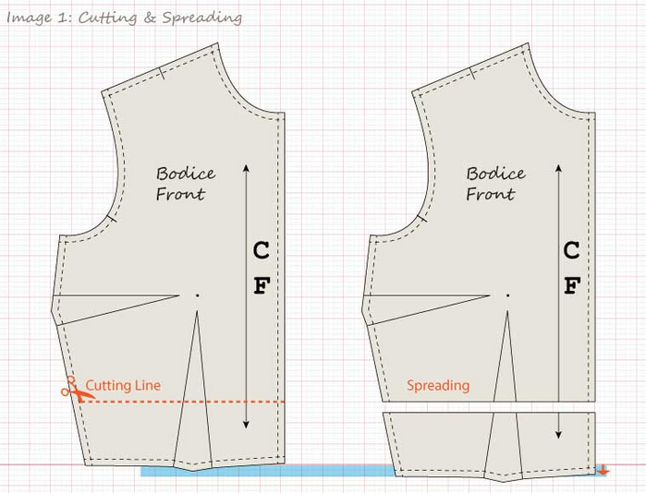
Step-2. Cutting and spreading for added fullness.
- We are going to look at cutting and spreading for fullness with this design to the left.
- This flat shows gathers along one side of the dart, which require fullness to be added.
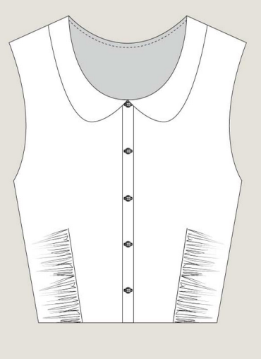

- The design lines are drawn where the fullness is to be added.
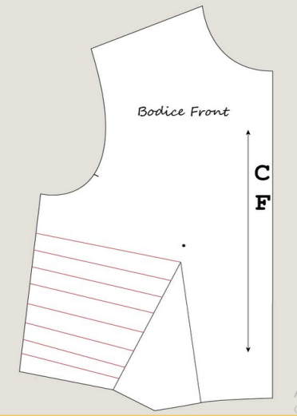

- Cut out the dart, then cut along the red lines; don't cut through the side seam.
- Spread the required amount. In this case the amount it has been spread is fairly minimal; how much it will be spread will depend on the interpretation of the design. (Note: Seam allowance still needs to be added).
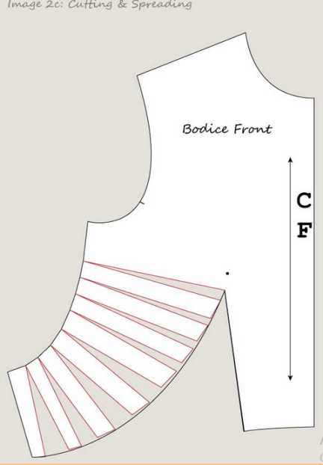

Step-3. Cutting and spreading to move a dart.
- This is original block with two darts; one in the side seam, one in the waist.
- The green line is the new design line; the side seam dart will be moved to the shoulder by cutting and spreading, creating a new block with a waist dart and a shoulder dart.
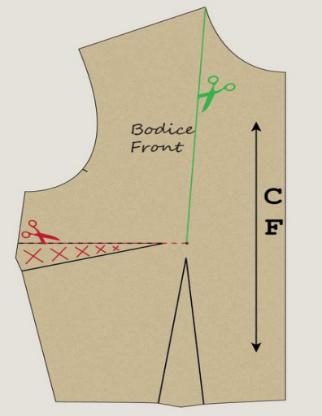

- The original block is cut along the green line and the red line. I have pulled the two pieces apart here so it can be seen clearly.
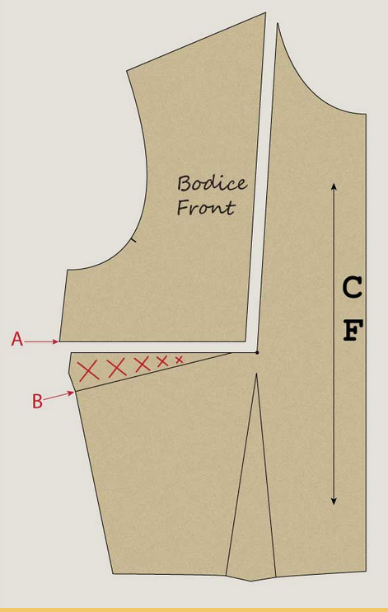

I
- After putting the pieces back together, hold them together at the Dart Point and then pivot the armhole piece so that A and B meet (i.e. close the side seam dart).
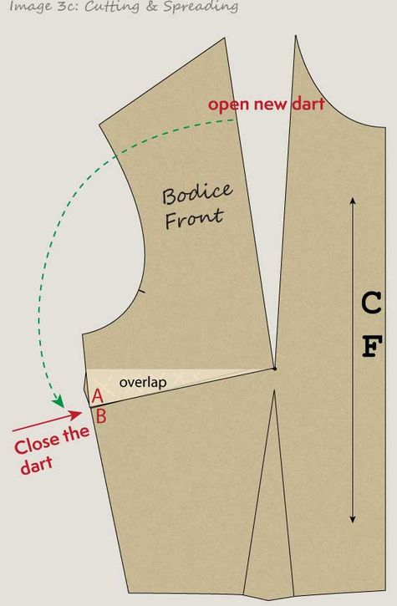

- This is the final new block with a shoulder dart instead of a side seam dart.
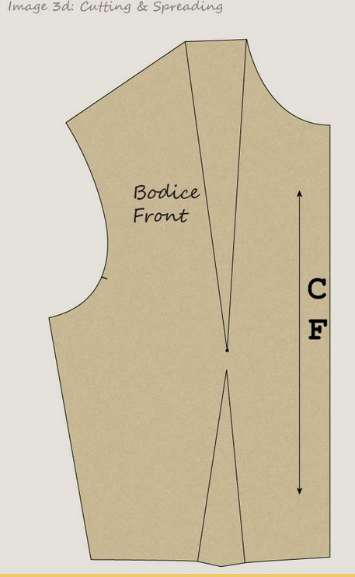

Lap Test-3.1
- Task-1: Perform dart manipulation
- Task-2: Perform fullness
- Task-3: Modify length

References:
- Patternmaking for Fashion Design by Helen Joseph Armstrong
- Garments & Technology by Prof. M. A. Kashem
- Garment Manufacturing Technology by Md. Shafiul Azam, Md. Abu Saleh & Khondokar Abu Nafiz
- Apparel Manufacturing Technology by T. Karthik, P. Ganesan, D. Gopalakrishnan
- Garment Manufacturing Technology Edited by Rajkishore Nayak and Rajiv Padhye
- Pattern Fitting with Confidence by Nancy Zieman
- Patternmaking for Fashion Design, Fifth Edition by Helen Joseph-Armstrong
- Pattern Cutting and Making UP-The Professional Approach by Martin Shoben and Janet Ward
- Apparel Manufacturing Technology by T. Karthik, P. Ganesan, D. Gopalakrishnan
- http://blog.elewa.co.uk/dart-manipulation-part-1/
- http://www.threadsmagazine.com/2008/11/02/the-merits-of-a-basic-fitting-pattern
- http://en.inthemoodforcouture.com/263/
- The Fundamentals of Quality Assurance in the Textile Industry by Stanley Bernard Brahams
- Apparel Manufacturing Technology By T. Karthik, P. Ganesan and D. Gopalakrishnan
- Textile Engineering – An Introduction Edited by Yasir Nawab
- Garment Manufacturing Technology Edited by Rajkishore Nayak and Rajiv Padhye

Participants of this Module (training material) preparation

No | Name | Qualification (Level) | Field of Study | Organization/ Institution | Mobile number | E-mail
1 | Yosef AbebeGetachew | B- level | Fashion design and Textile Engineering | Mary Help College | 0923684937 | Josephabebe5@gmail.com
2 | EndreyasMiftah Ahimed | B-level | Garment Engineering | burayu Polytechnic College | 0912636386 | miftahendrias2005@gmail.com
3 | MuluembetAdmassuAbebe | A-level | Garment Technology | HawasaPolytechnic College | 0985131178 | Muluembetadmassu06@gmail.com
4 | Biniyam Genet Chekol | B-level | Garment Technology | TililiTvet College | 0922440120 | Biniyamgetnet@gmail.com
5 | AbdusemedAdem | A-level | Fashion design and Garment Technology | Diredewa Polytechnic Collage | 0910075389 | Biniyamgetnet933@gmail.com

