FASHION DESIGN
LEVEL II
Based on March 2022, Curriculum Version 1


Module Title: - Producing Simple Garment
Module code: IND FAD2 M09 0322
Nominal duration: 160 Hours

Prepared by Ministry of Labor and Skills

August, 2022
Addis Ababa, Ethiopia

Content
Table of Content
Introduction to the Module 5
Unit one: Standard and Principle of Estimation 6
1.1. SI units and Unit conversion principles 7
1.2. Standards and code of practice 7
1.3. Civil construction terminology 7
1.4. Tolerances and Accuracy in measurement 7
1.5. Work instruction 7
Self check-1 7
Operation sheet-1 7
Lap Test-1 7
Unit Two: Measurement 8
Instruction sheet Error! Bookmark not defined.
2.1. Definition and Purpose of measurement 9
2.2. Measurement and calculation equipment 10
2.3. Ruler or tape measurement 12
2.4. Geometrical shape measurement 16
Self check-2 22
Operation sheet 2.1: Steps in measuring geometrical Shape 23
Operation sheet 2.2: Measuring the size of irrigation field 24
Lap Test-2 27
Unit Three: Calculation 28
3.1. Method of calculation 29
3.2. Factors for calculation 29
3.3. Scale and grade in material calculation 29
3.4. Percentage , Ration and Frication 29
3.5. Area and Volume Calculation in irrigation 29
Self check-3 29
Operation sheet-3 29
Lap Test-3 29
Unit Four: Irrigation project quantity Estimation 30
4.1. Type of Building Estimate 31
4.2. Purpose of material Estimation 31
4.3. Estimating material Quantity 31
4.4. Calculate material quantities for the project 31
4.5. Canal and Division box quantity Estimation 31
Self check-4 31
Operation sheet-4 31
Lap Test-4 31

Acknowledgment
Ministry of Labor and Skills wish to extend thanks and appreciation to the many representatives of TVET instructors and respective industry experts who donated their time and expertise to the development of this Teaching, Training and Learning Materials (TTLM).

Introduction to the Module
Garment designing is an art which includes aspects like preparation of fabric patterning, marking, cutting and sewing. Each of these aspects need to done with great care. Laying the pattern, marking and cutting are three important aspects in garment designing and construction. Pattern lying refers to the placement of pattern a fabric.
This module covers the units
- Workstation
- Mark & laying
- Spreading and cutting
- Labeling and bundling
- Dispatch bundling products
- Prepare garment components
- Assemble garment components
- Perform hand stitching
- Complete work

Learning Objective of the Module
- Prepare workstation
- Mark & laying
- Spreading and cutting
- Labeling and bundling
- Dispatch bundling products
- Prepare garment components
- Assemble garment components
- Perform hand stitching
- Complete work
Module Instruction
For effective use this modules trainees are expected to follow the following module instruction:
- Read the information written in each unit
- Accomplish the Self-checks at the end of each unit
- Perform Operation Sheets which were provided at the end of units
- Do the “LAP test” giver at the end of each unit and
- Read the identified reference book for Examples and exercise

Unit one: Work station
This unit is developed to provide you the necessary information regarding the following content coverage and topics:
- OHS practices.
- Adjusting and cleaning machine.
- Sewing machine needles and attachments.
- Sewing machine performance
- Equipment required for production
- Other equipment required for production
This unit will also assist you to attain the learning outcomes stated in the cover page. Specifically, upon completion of this learning guide, you will be able to:
- Apply OHS practices.
- Adjust Machine and clean for correct operation.
- Check needle parts.
- Check Performance of the machine.
- Identify and prepare other equipment required for production.

Occupational Safety and Health (OSH) practices
OHS primarily seeks to maintain the working ability of the labor force as well as identify asses and prevent hazards within the working environment.
A well designed and executed occupational health and safety (OHS) program is often said to be good for business as well as being a key legal and social obligation (making sure that employees in any size or type of business go home in the same condition that they came to work).
The main goal of safety and health programs is to prevent workplace injuries, illnesses, and deaths, as well as the suffering and financial hardship these events can cause for workers, their families, and employers.
Workstation design should satisfy the system’s performance requirements, as well as the requirements of the human user. The terms workstation, workspace and work environment are often used interchangeably and include chairs, tables, machines, tools, actual product, regular and protective clothing, lighting and climate.
Workstation and seating should be set up according to OHS practices it includes:

    - Standard operating safety procedures during developing sewing garment and assembling.
    - personal protective equipment ex. Wearing work wear
    - safe materials handling ex. Use pin cushion for pins
    - equipment or machine safety ex. Proper place for dummy, cleaning machine
    - Personal responsibilities for safety
The design of the workstation layout widely vary from one operation to another depending on the size of work, a number of components to be worked on and type of machine to handle during operation.
The first step in the process is an important one in creating the most efficient workstation lay out. This means that the workstation should be such that it does not create risks to the worker's health and safety
The right chair is only one part of creating a good workstation setup. Other elements include all garment making materials and tools. Workstation set-up is crucially important as it helps protect your health.
Ergonomics refers to how the workplace is set up, in relation to the equipment, the design of the building and how work is performed.
When arranging the workplace work processes and interaction between the work and the human should be taken into consideration, the sum of these relations and the rules constitute the ergonomic rules
Ergonomics is the science concerned with fitting the job or task to the physical and mental capabilities of the worker. Applying ergonomics principles to the workplace can reduce losses, injuries and health disorders, as well as improve productivity and quality of work.

1.2 Ergonomic arrangement of workplaces
- Standard operating safety procedures
- Protection equipment: including personal protective equipment (PPE) for ears, eyes, face.
- Protective clothing,
- Protective shield and barriers shall be provided.
- Before doing work that requires the use of PPE, the trainee must be trained.
- Personal safety protective equipment
Personal safety protections include:
- Eye and face protection
- Hearing protection
- Respiratory protection
- Safe materials handling and storage
-Keep the materials in well manner. Ex. Keep drawing tools and equipment’s in drawer.
-Use the material as enough as required.
- Equipment/machine safety
- Every morning the trainees wipe and clean the equipment’s.
- After work, they have to wipe, clean and cover the equipment’s.
- Personal responsibilities for safety
- Observe all, before, safety precautions related to your work.
- Report unsafe conditions or any equipment or materials you think might be unsafe
- Never remove safety device or safety covers from equipment
- When an accident occurs, it should be reported immediately to proper authority.
- Material Handling
- Organization is the key to make quality and accurate patterns with a professional finish. This is especially important with tools and equipment.
- It do not need a lot of expensive equipment, but good tools, well organized and maintained, are very important.

1.3 Characteristics of a good workstation layout
- All works (components) should be placed as closer as possible to the operator for easy reach.
- Work should be presented correct way for easy unbundling and quick pick up
- Nothing should stuck operators during picking up and disposing components.
- Keep bins or other means to dispose finished work.
- Operators must have enough space on the table to handle the garment parts. If required add table extension near operator and left side of the machine.
- Enough space in between two machines for operator movement.
- Provide height adjustable chair.
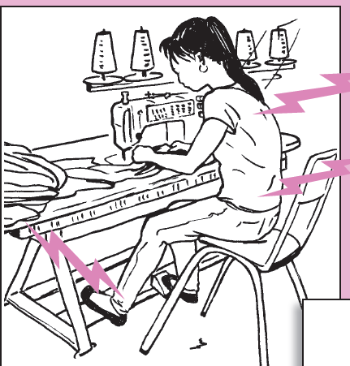
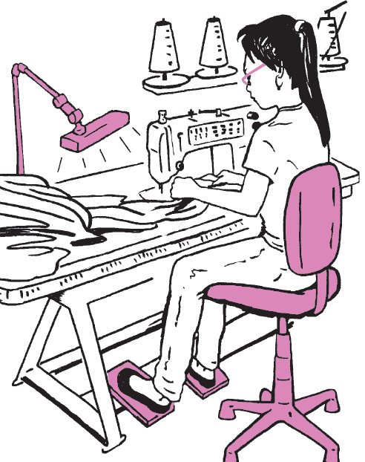
A. Position that may cause pain B. These changes may prevent pain
Figure 1.1: Seating position

1.4 Sewing machine

1.4.1 Adjusting and cleaning machine
A) Testing sewing machine
To test sewing machines a sew range of stitches including straight, zigzag, buttonhole, embroidery across to see how each machine handles different materials . The fabrics range from cotton and denim to stretchy and delicate fabrics. To assess the overall performance look at how noisy and stable each machine is as well as the range of speeds and how versatile the stitches are across the fabrics
When the sewing machine is working at peak performance, every stitch forms perfectly. Creative expression is quick and easy. Sewing is untroubled and ultimate pleasure. When the sewing machine is not working properly, the stitches often become distorted. Tensions may be spotty, Threads may gathering here or there, Seams look bad, an endless array of problems can arise
Test sewing machine, fill and load the bobbin, and sew a straight line changing the presser foot, changing the tension, machine speed, stitch type. Perform basic stitch on multiple layers of fabric, and evaluate the quality of the stitch.
The care and maintenance of a sewing machine helps to improve its working. This consists mainly of cleaning, oiling, and right handling, which contributes to good output, quality production and safety of the workers and also necessary in order to operate the machine smoothly and for its long term use.
It is very important to identify the sewing defects such as upper thread break, bobbin (lower) thread break, gathering of threads, skipped stitches, irregular stitches and stitches that are not formed properly, etc. for proper working of sewing machine and good quality production.
The needle, presser foot, and bobbin area are the main parts of the sewing machine that need to be routinely cleaned.
- Cleaning, Oiling and Handling of Sewing Machine
Cleaning is the process of removing unwanted physical substances such as dirt, infections agents and other impurities from an object or any machine or environment.
Sewing machine, like any other machine, requires regular adjustment and cleaning to operate properly.
Check for a timing issue by performing a timing test. Testing the alignment of the needle and the shuttle hook, it can determine whether the machine needs a timing adjustment. Leave the needle threaded, but remove the switch plate, base cover, and bobbin case.
Check for the condition of the needle and the performance of the bobbin and thread tension, etc. after having each of the sewing sessions.
Some example of industrial Sewing Machines
A sewing machine is a machine used to sew fabric and materials together with thread. Well- cleaned & check sewing machine are essential for achieving good results. It should be used correctly in accordance with the job requirements. These are some machines which are using in garment industries.
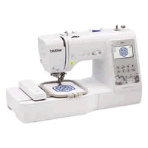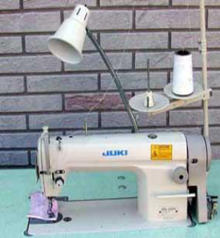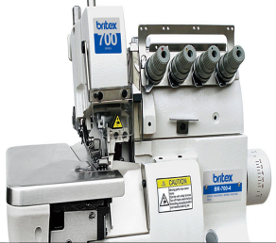
Figure 1.2: Industrial sewing machine
1. Single Needle Lock Stitch Machine: Lock stitches are formed with one needle thread and one bobbin thread. Joining two or multiple fabric plies together. The machine is used to sew lightweight, medium weight and heavy materials.
2. Double needle lock stitch Machine: This machine works on the same principle as the single lock stitch sewing machine by using two needles & two bobbins thus resulting in two parallel lines rows of lock stitch.
3. Three-thread over clock Machine: is most useful when sewing knits. It can be used to sew woven fabrics, the three-thread can make narrow rolled hems, and to finish fabric edges.
4. Four threads over lock Machine: Suitable for sewing woven and knitted fabrics can be used when sewing most shirts, blouses, skirts, dresses, lingerie, and swimwear.
5. Computerized single needle lockstitch machine: it should come with various stitch options that can make sewing a breezy job for you. The basic ones that are a must are straight stitch, zig-zag, stretch straight, tri-motion, blind hem, buttonhole, and backstitch.
A clean & well-oiled sewing machine is essential for good output and safety. The maintenance of sewing machine is also important in preventing stitching faults. When not in use, keep the machine covered with a suitable cover to prevent dust from settling on it.
- Material required for cleaning & oiling
- Flat paintbrush (½" to ¾" wide) or old toothbrush
- Cleaning solvent or fluid
- Soft disposable cloth to remove dust and lint/ Cleaning cloth
- Sewing machine manual
- Sewing machine oil / lubricating oil

- Points to be considered while cleaning
- Turn it off
- Open the slide plate and remove the bobbin case.
- Then remove the throat plate.
- Remove the face plate from the left end of the head.
- Any lint, dust, or loose threads in the area around the feed dog and rotary hook, shuttle may be brushed or blown away.
- Do not use anything hard, such as a screwdriver or scissors points, to remove the lint. Instead, carefully use a pointed instrument like a needle or pointed tweezers pick out bits of thread and lint that cannot be brushed out.
- Turn the hand wheel manually to expose any areas that might have been hidden initially. Brush again.
- Carefully tilt the machine head back until the head rests on the post on the back of the table.
- Brush out any lint, dust, or threads from the lower part of the machine.
- Use a soft, thin and clean cloth to remove any lint on the machine parts.
- Check the needle to be sure it is clean and the eye is not clogged.
- Wipe away any excess oil or dust on the head, machine bed, motor, table, and stand.
- If there is lint between the tension discs and in the thread guides, use thread to floss the tension discs and remove any lint.
- Replace the needle, if necessary.
- Wash hands after cleaning the machine.
- After completing the work, put a piece of fabric under the foot, lower the presser foot, cover the machine, and pick up any trash.
- Points to remember while oiling the sewing machine

- Before oiling, ensure that the sewing machine is turned off.
- Oil the machine using the directions given in the machine manual.
- If a manual is not available, oil the machine as per the directions of the teacher/instructor as per the required frequency
- Locate oil holes of the sewing machine.
- Put one to two drops of oil into each hole. Too much oil will clog the machine.
- Wipe off all dust and excess oil from the machine or table; clean up any spilled oil immediately.
- Sew on a few fabric scraps to remove any excess oil.
- Wash hands after oiling the machine
- Excess oil is a major problem that can spoil and damage the fabric.
- Report any injuries or accidents immediately to the instructor.
- Report a breakage to a tool or machine to the instructor. If the equipment does not operate properly, notify the instructor

1.4.2 Procedures to clean and oil the industrial sewing machine
Remove all the parts possible in order to clean the machine thoroughly
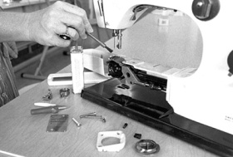
Figure 1.3: Removing machine component
- Upper thread tension: Pull a piece of cloth soaked in solvent back and forth between the discs to clean.
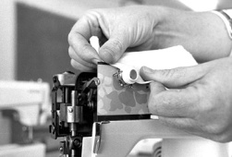
Figure 1.4: upper thread tension
- Bobbin area: Clean carefully to remove lint using a soft brush. Tweezers may be helpful in removing stray threads.
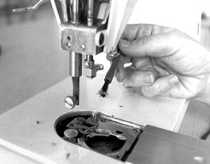
Figure 1.5: Cleaning bobbin area
- Face plate area. Remove lint from the face plate area using a soft brush. A cloth dipped in solvent can be used to remove grease and grime. Place drop or two of oil on moving parts where they slide through a housing or move against each other
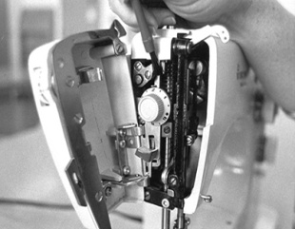
Figure 1.6: Cleaning face plate
- Oiling; Place one or two drops of oil in all holes designated by the instruction booklet.
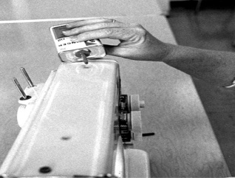
Figure 1.7: Oiling
Benefits of cleaning and oiling industrial sewing machines and equipment’s
- Improve machine and equipment performance
- Increase the life span of the machine
- Increase machine reliability
- Reduce service downtime
- In order to ensure all the moving parts continue to work as they should.
- Reduces wear on all of the moving parts of the machine.
- Preventing rust and unnecessary friction.

1.4.3 Adjust machine settings
Setting up of industrial sewing machines for production and the repair, adjustment, maintenance and testing of machines to ensure efficient working order. Operator controlled single station industrial sewing machines and high volume automatic machine.
Setting the Machine can set basic functions required to use the machine in System Settings.
- Thread guides: The thread guides are the metal devices that help regulate tension. They are various loops when run the thread through before looping it into the needle. They keep the thread from getting tangled and distribute the tension evenly from the spool to the fabric.
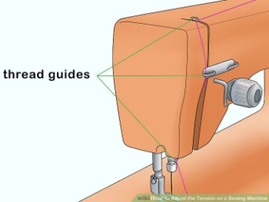
Figure 1.8: Thread guides
- Sewing Machine Tension Sewing machine tension adjustment is controlled by devices that separately control the needle thread and the bobbin thread; putting varying amounts of tension (or strength) on the threads they control to form a strong, balanced stitch. Sewing machine tension can be tightened or loosened to affect the needle thread, the bobbin thread, or both.
The tension discs and tension regulator together are called the tension assembly. The tension discs squeeze the thread as it passes between them, while the tension regulator controls the amount of pressure on the discs. When adjusted to a higher number (turned clockwise), the discs move closer together, increasing the pressure. Turned to a lower number (counter clockwise), the discs move apart, decreasing pressure.
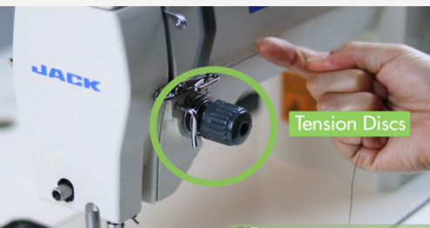
Figure1.9: tension disc
- Adjust the top tension: To increase your top tension if it’s too loose, turn your knob so that the numbers are increasing. Try ½ to 1 number higher, and then test the stitches on a piece of scrap fabric. Continue until it looks even on both sides and you can no longer see the bobbin thread on the right side of the fabric
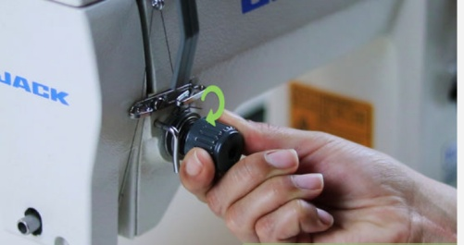
Figure 1.10: Adjust tension
Understand tension: Tension is what keeps the bottom and top stitches in equal tension with one another. In other words, it is what keeps the front and back stitches looking the same. Both the top and bottom tension must work together in order to create consistent stitching. If the top and bottom stitches aren’t even, it may be due to the tension not being right on the top or bottom.
The more thread in the stitch, then the looser the stitch. The less thread then the tighter the stitch.
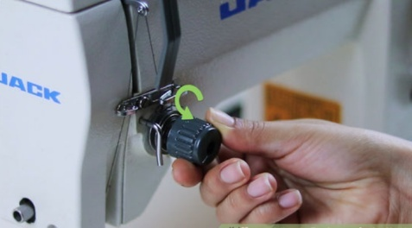
Figure1.11:Thight tension
If you are unable to get it completely even, proceed to adjusting the bobbin tension. Probably the most common sewing problem is getting correct sewing machine tension. By thread tension, it means the amount of thread that can pass through the machine to create the stitch
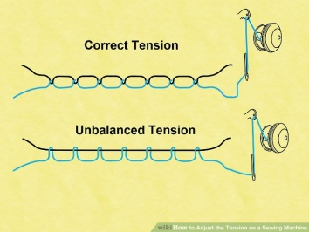
Figure 1.12: balance & unbalance Tension
The upper thread and the bobbin thread should cross near the center of the fabric. Only see the upper thread on the right side of the fabric, and the bobbin thread on the wrong side. If a stitch looks like this, the tension is balanced
The upper thread & the bobbin thread should cross near the center of the fabric. Only see the upper thread on the

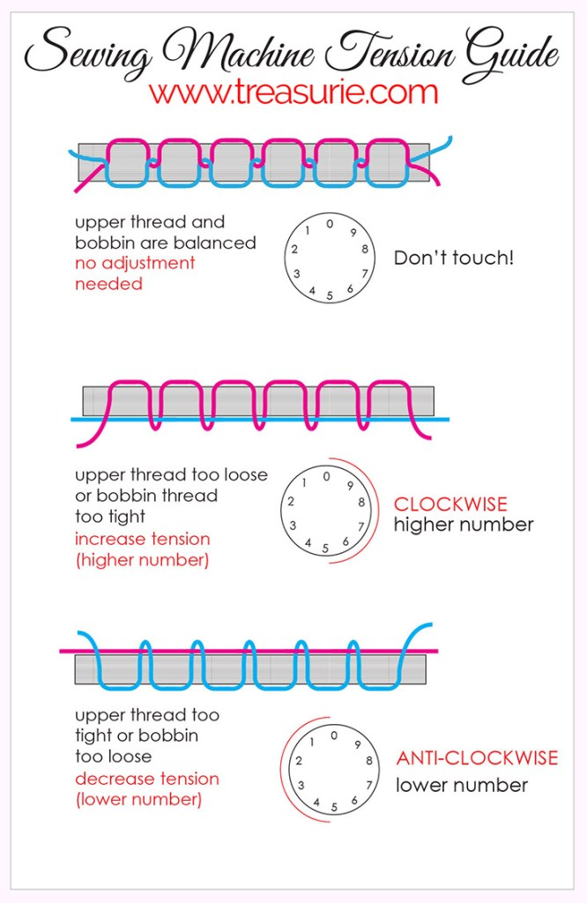

Figure 1.13: Sewing machine tension guide
Right side of the fabric, & bobbin thread on the wrong side .if the stitch looks like this, the tension is balanced.
2. Bobbin thread shows on the right side. If the bobbin thread on the right side of the fabric, the upper thread shows on the wrong side of the fabric the upper thread is too loose need tight the tension.
3. If Bobbin Thread Is Visible on Top of the Piece Being Sewn .Bobbin thread's appearance on top of the piece you are sewing could mean a couple of things.The tension that controls the thread coming

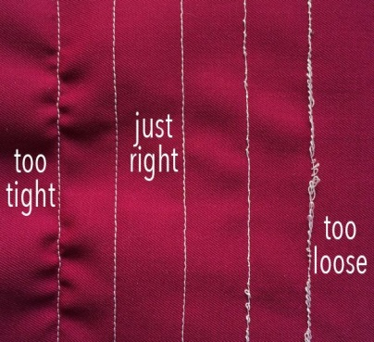
Figure 1.13: Tension effect
Through the needle is too strong, pulling the bobbin thread to the top. The tension that controls the thread coming out of the bobbin is too weak, allowing the needle thread's tension to take over

Sewing machine needle and attachments
1.5.1 Sewing machine needles
It is a fine cylindrical piece of metal with a sharp point at the lower end, a hole or eye in it, used in sewing.
Choosing the right sewing machine needle is an important factor in achieving a professional finish and also not wasting time with broken needles, holes and snags and puckered seams.
There are lots of different type needles for all types of fabrics, getting the right needle for the job is as important as selecting the right fabric. The thread will also have an impact on which needle to use. In general the lighter the weight of the fabric and thread the finer the needle will use. Needles also vary by the type of point and the size and shape of the eye, as well as in thickness.
Before you get to know the types of needles, get familiar with the various parts of a sewing needle as stated below. For it is from the parts that you can determine the type of needle, the size, and it's suitable.
- Parts and Functions of a Sewing Machine Needle
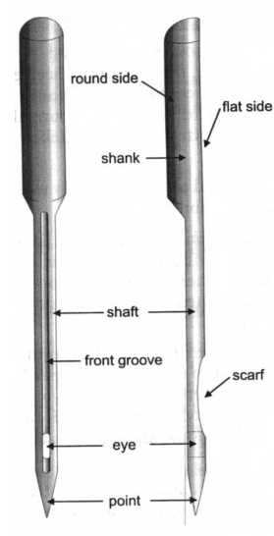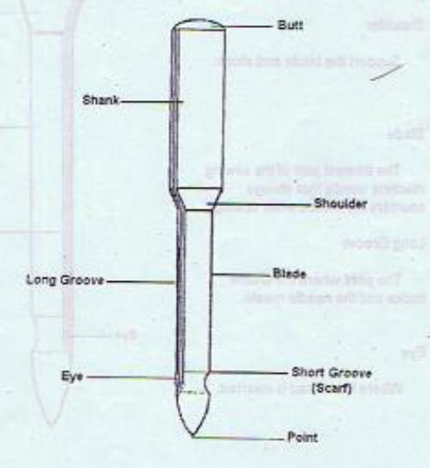
Figure 1.14: Part of sewing machine needle

  - Butt - absorbs the pressure of the needle bar
  - Shank-provides stability to the needle blades and to its part when inserted
  - Shoulder-supports the blade and shank
  - Blade-the thinnest part of the sewing machine needle that always counters the friction while sewing
  - Long Groove-the point where the shuttle hooks and the needle meet
  - Eye-it is where the thread is inserted.
  - Short Groove-the part of the needle blade
  - Point/Tip-it cuts the fiber of the material
Table 1.1: Size of needle for different types of fabric
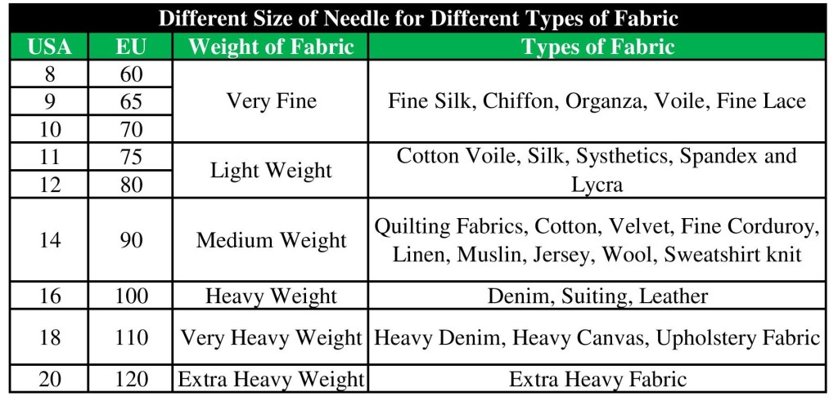
1.5.2 Set and taste stitch length against specifications.
A stitch is one unit of thread resulting from repeatedly passing a strand or strands or loop or loops of thread into or through a material at uniformly spaced intervals to form a series of stitches
Stitch Length: is specified as no. of stitches per inch (SPI)
High SPI Short stitches: High quality
      - Potential problems (seam pucker or weaken fabric).
      - Higher spi, the more time and thread, high cost.
Low SPI Long stitches: Lower quality
      - Problems: Less durable, snagging, abrasion, grin through
      - Fast, less thread, less cost.

Table 1.1: Size of needle for different types of fabric
Fabric weight | Example | Stitch length | mm | Inches
Light | Cotton , lawn, voile | short | 1.8- 2.5 | 1/16’’ -3/32
Medium | Quilting , cotton, poplin, flannel | Stan dared | 2- 3 | 1/16’’-1/8’’
Heavy | Denim, canvas | Long | 2.5 - 4 | 3/32 -3/16
1.5.3 Classification of needle according to point:
- Normal round point needle
They are used for woven materials etc example; DB X 1
- Light ball point needles
They are used for thin material, silk etc., & button hole sewing. Example: DP x Si
- Medium ball point needles
They are used for hosiery material etc., Example: IJY 128 GAS
- Heavy ball point needles
They are used for sewing heavy weight materials like rubber etc.
- Stub point needles
They are used for sewing buttons.
    - Sewing machine attachment
Swing machine attachments make sewing machines and provided a Varity of decorative sewing possibilities. The sewing machine attachments are mechanisms are attached to sewing machines without cutting through the original frame of the machine .the removal of such an attachment leaves the machine in its original condition.
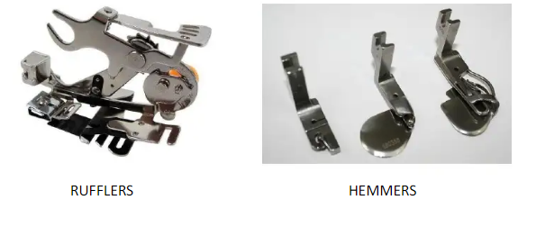
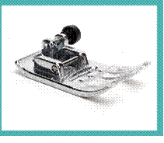
Figure 1.15: Sewing machine attachments

1.5 Other equipment required for production
May include:

- pins
- scissors
- needle and thread
- marker or chalk
- Seam Unpicked.
- Extra Sewing Feet.
- Hand-Sewing Needles.
- Pin Cushion.
- Thimble.
- Ironing Board.

Self-check-1
Part-I: Matching
Instruction: select the correct answer for the give choice. You have given 1 Minute for each question. Each question carries 1Point.
    - When the sewing machine is working at peak performance of the result will be
- Every stitch forms perfectly
- The stitches often become distorted
- Seams look bad
- Machine not working properly
    - Sewing defects creates
A. Irregular stitches B. Regular stitch C. Straight stitch D. Zigzag stitch
3. Which type of needle point used for woven materials?
- Light ball point C. Normal round point
B. Medium ball point D. Heavy ball point
4. It is the process of removing unwanted physical substances
A. Cleaning B. Oiling C. Stitching D. Cutting
5. High spi means
A. Short stitches B. Long stitches C. less cost. D. Less durable
Part- II: short Answer writing
Instruction: write short answer for the given question. You are provided 3 minute for each question and each point has 5Points.
Short answer
- write the benefit of cleaning
- write additional equipment required for production
Note: Satisfactory rating – above 60% Unsatisfactory - below 60%
You can ask you teacher for the copy of the correct answers

Operation sheet 1.1
Cleaning and Oiling of Sewing Machine
Operation title: Clean the Sewing Machine
- Purpose: To practice To practice and demonstrate the knowledge and skill required in Cleaning and Oiling of Sewing Machine
- Instruction: Use the instruction form the given manual the required materials for cleaning & oiling sewing machine. For this operation you have given 2Hour
- Tools and requirement
- Flat paintbrush (½" to ¾" wide)
- Cleaning solvent or fluid
- Soft disposable cloth to remove dust and lint/ Cleaning cloth
- Sewing machine oil / lubricating oil
- Manuals
- Precautions: Remember points while cleaning and oiling the sewing machine
Step-1: Use the given manual and procedure
Step-2: Remove all the parts possible in order to clean the machine thoroughly
Step-3: clean all parts
Step-4: Oiling according to the given procedure

Lap Test-1
- Task-1: Perform cleaning and oiling procedure
- Task-2: Remove the part
- Task-3: Clean the machine and machine part
- Task-4: Oil the machine using the directions given in the manual
- Task-4: Wipe off all dust and excess oil from the machine or table Oil the machine part
- Task-5: Clean up any spilled oil immediately.
- Task-6: Replace the removing part
- Task-7 Cover the machine

Unit Two: Marking and Laying
This unit is developed to provide you the necessary information regarding the following content coverage and topics:
- Marking pattern pieces
- Commercial patterns
- Positioning and manipulating pattern pieces
- Draw lay marker
- Marker and lay alignment.
- Fabric quality.
- Layup fabric
- Fabric faults.
This unit will also assist you to attain the learning outcomes stated in the cover page. Specifically, upon completion of this learning guide, you will be able to:
Apply marking on the required pattern pieces
Read and interpret commercially patterns
Apply pattern pieces on appropriate Positioning.
Draw lay marker.
Check marker and lay alignment.
Identify fabric quality.
Laying up and adjusting fabric tension
Identify fabric faults.

2.1 Marking pattern pieces

2.1.1 Marking
Once the pattern is graded, the fabric must be prepared for cutting. In order to spread the fabric properly, the spreader must know how the pattern pieces will be placed on the fabric. “Marking” refers to the process of placing pattern pieces to maximize the number of patterns that can be cut out of a given piece of fabric.
Characteristics of pattern pieces may limit fabric utilization. Generally the fabric utilization percentage increases when a variety of garment sizes are used in the same marker and when the marker contains both large and small pieces. Smaller pieces can often be nested with larger pieces. The shape of the pattern pieces determine how close they can be fit together (interlock). Irregular shaped pieces are difficult to fit together with other pieces. Large pattern pieces are less
flexible and often dictate the placement of other pieces.
It is an illustration of accurate and precise planning of patterns for a particular style of garment and the sizes to be cut from a single spread on a marker paper. To prepare an efficient marker, the width of the fabric to be spread in a lay as well as the number of pattern pieces to be included in the marker plan for all the required sizes should be known prior to it. Marker width that is less than fabric width leads to more fabric wastage while marker width that is wider than fabric results in incomplete cut components. Firms plan “tight” markers largely because the fabric is one of a manufacturer’s most significant business costs, often exceeding the cost of labor
Manual produced marker may be created by arranging full size pattern pieces on marker paper or directly on the top ply of fabric in a spread.
Pattern pieces are treated using a pencil or tailor chalk. Manual methods of marker making are time consuming and a great deal of space.
Full sizes pieces must be manipulated, adjusted, and readjust on normal fabric widths. Accuracy of manually made marker depends on the skill of the individual who laid out the marker and traced it.

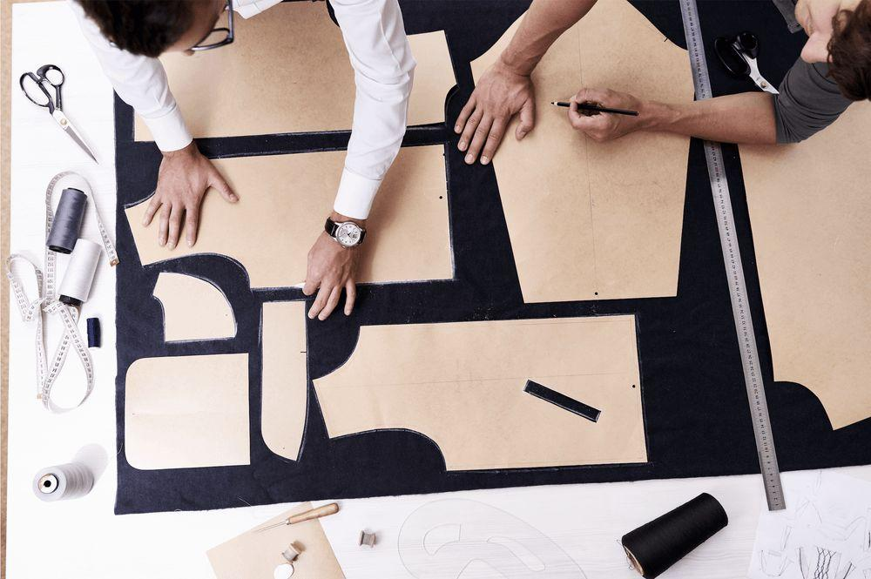
Figure 2.1: Manual marking
  - Commercial patterns
    - Definition of commercial pattern
A commercial pattern gives ideas of styles, fashion, possible fabrics to choose from sewing notion and accessories. It also provides several step by step instructions for constructing a garment
Commercial patterns are full-scale tissue paper clothing patterns used by the home-sewer to create garments and accessories issued
Commercial pattern can be one of two things. It is either the decorative design that repeats over and over a fabric, or it is a flat template, made of paper or card, that is used as the key instruction guide for cutting the separate pieces of a garment. Pattern pieces are traced to allow for size, seam allowance and fit.
A sewing pattern consists of several elements,
- Sewing pattern with different lines and symbols
- Size guide
- Finished garment measurements
- Fabric lay-plan
- Sewing instructions
The designer will not state on the pattern the different seam allowance amounts, and these can vary depending on what section is sewing.
Some patterns are created with a 1 cm seam allowance and others are designed with a half inch seam allowance the latter is about 1.25 cm.
A pattern piece is a section of the whole sewing pattern. If you were planning to sew a shirt, you would have the following sections to sew:
- Font • Sleeve • Patch pocket
- Back • Cuff • Collar stand
- Back yoke • Placket • Collar

Each of those is usually a pattern piece. Unless it is a more complicated design in which case the front or back could be made up of multiple pattern pieces. Each of these pattern pieces would have various symbols and lines as a visual guide of what needs to be done with each pattern piece.
While this isn’t a complete list, it will help learn how to read sewing patterns:
- Cutting lines • Darts
- Notches • Gathers
- Grain line • Tucks
- Bust point •Pleats
- Buttons and buttonholes
- Lengthen / shorten lines

The three information elements of a commercial pattern: The envelope, cutting out and construction instruction sheet and the pattern tissue pieces.
- Pattern Envelope: understanding body measurements, description of garment, suggested fabrics, calculating required amount of fabric, required notions, understanding nap, finished garment measurements chart.
- Instruction sheet: Cutting and lying up of fabric, different legends, symbols and terminology, garment assembly instructions and pictures.
- Tissue pattern pieces: Notches, straight grain line, transferring markings to fabric, identification information of pattern (e.g. size, name of piece, view number, style number.
- How to trace your size with the multi-sized pattern.
- Tailor tacking for transfer of dart markings.
- Samples of lengthening and shortening of the pattern piece.

2.2.2 Lines and Pattern Symbols on commercial Pattern Pieces
There are quite a few lines and symbols on pattern pieces and they will differ slightly depending on the sewing pattern brand.
Each of those is usually a pattern piece. Unless it is a more complicated design in which case the front or back could be made up of multiple pattern pieces.
Each of these pattern pieces would have various symbols and lines as a visual guide of what needs to be done with each pattern piece.

2.2.3 General information on the Pattern marking
Not every marking is on every pattern because some are specific to a certain style or construction technique. Layout and cutting markings don’t need to be transferred to the
fabric. Construction markings, on the other hand, are very helpful during the sewing process and transferring them to the fabric is a good idea.
Every pattern piece has general information printed in the center. Each piece is numbered and the number indicates the order in which the pieces are sewn together.
2.2.4 Commercial sewing pattern Symbols and Lines
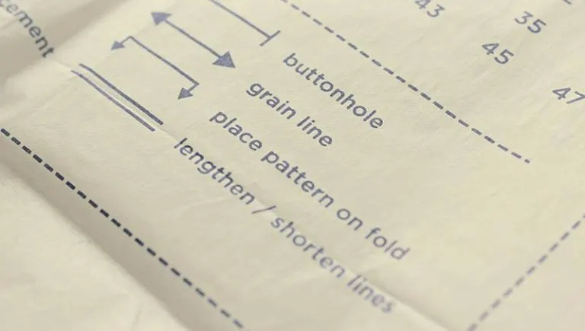
Figure 2.3: Pattern symbols
- Cutting lines are differentiated by style:
Dotted
Dash then dot
Varying dash lengths
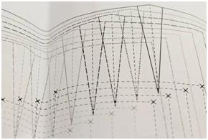
Figure 2.4: Cutting line
Each cutting line style is assigned a size and that is the line cut for all the pattern pieces.
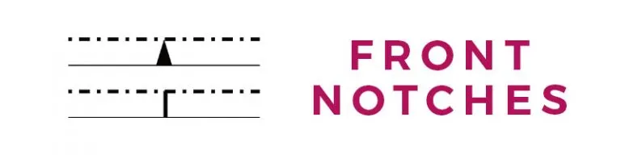
Figure 2.5: Notch mark
- Notches on a pattern are matching points. Notches to make sure that all pattern pieces are correctly matched up. It could be the sleeve notch matching up with an armsyce notch or a centre front notch on the shirt front that will line up with the centre front on the collar stand pattern piece
It is standard to have single notches for front and double notches for back pattern pieces.
As an example, a sleeve would have a single notch for the section to be sewn to the front bodice, and a double notch on the section to be sewn to the back bodice.
- Cut Notches In Sewing
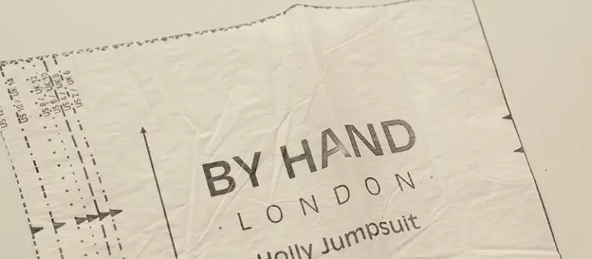
Figure 2.6: Notch mark

Most commercial sewing patterns will have little triangles on them and these are the notches.
If the sewing pattern are using has notches that extend beyond the circumference of the pattern piece, cut the triangle notches outwards too

Cut Two in Sewing
When sewing pattern tells to cut two, means to place the fabric together either right or wrongs sides facing and to place the pattern piece upon this.
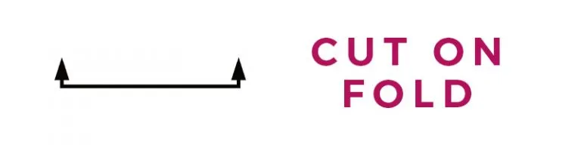
Figure 2.7: Cut on fold symbol
Sometimes pattern pieces have a fold line instead of a grain line. This is because the pattern piece is symmetrical and only needs to have one piece cut out.
The fold line marks the edge of a pattern piece that is to be placed on the fold.
That folded edge will not have seam allowance it will be a fold and no sewn seam. The centre front of a dress or the centre back of a shirt can be cut on the fold, as well as collars, collar stands and skirt fronts and backs.
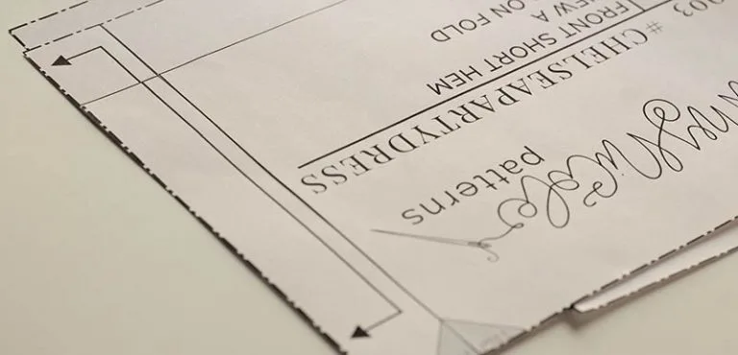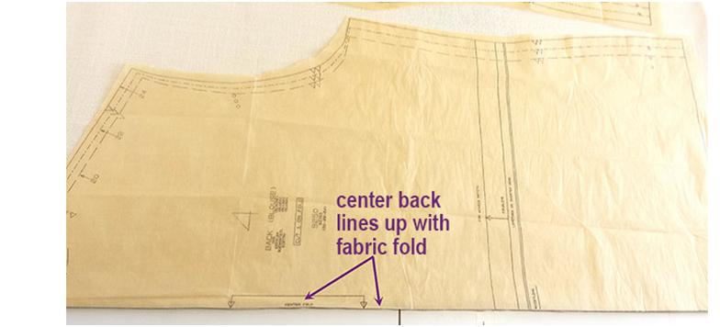
Figure 2.8: Cut on fold

Grain line on a Sewing Pattern : The grain line on a pattern piece is an arrow showing how to line up the fabric and pattern piece.

Straight Grain
This line should be placed parallel to the straight grain of the fabric.
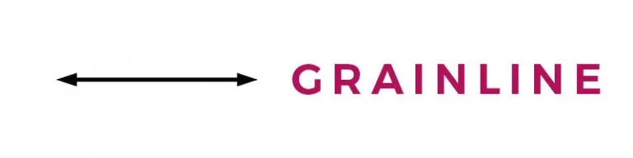
Figure 2.9: Grain line

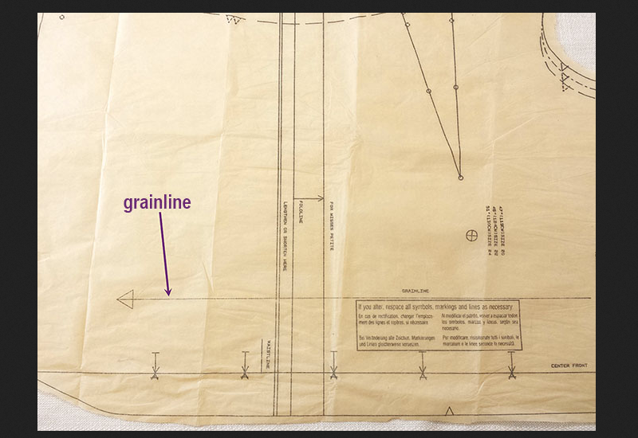
Figure 2.10: Grain line
Measuring the distance between your grain line and selvage can also be done with a tape measure.
Measure unpinned end of grain line and adjust as needed
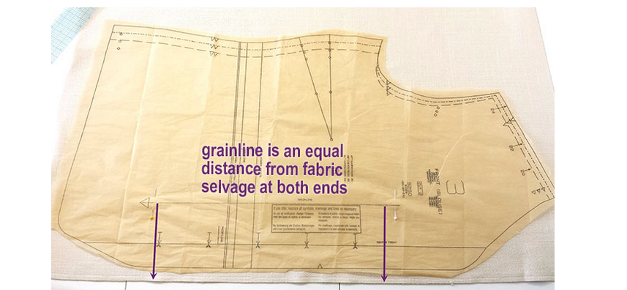
Figure 2.11: Straight grain line
The grain line is the same distance from the fabric selvage on both ends. The grain line is the straight line on the pattern piece that’s parallel to center front or center back.

Cross Grain
The cross grain is at 90º angle to the selvedge. It is rarely indicated on pattern pieces, as the grain line arrow is place in such a way that the pattern piece is always parallel to the selvedge as needed.

Bias Cut
Fabric cut at a 45º angle to the selvedge is called the bias. There is more stretch and drape on this angle, so it is frequently used for tops and dresses that have no darting.

Lengthen and Shorten Lines
Sewing patterns are designed with a certain height. If you are taller or shorter than the intended height, you will need to use the lengthen and shorten lines on a sewing pattern to make changes.
It is best to use the lines marked in by the pattern designer rather than mark in your own lines. This is because changing a pattern can sometimes affect both the length and width of the final garment.

Darts: Darts are usually marked on patterns with dashed lines known as the dart legs which connect at the dart point.
Darts are used to suppress fabric so are usually found on the front bodice to shape the fabric near the waist and bust, on the back bodice to shape the fabric over the shoulders and on the skirt front and back to shape the fabric from the waist to the hips.
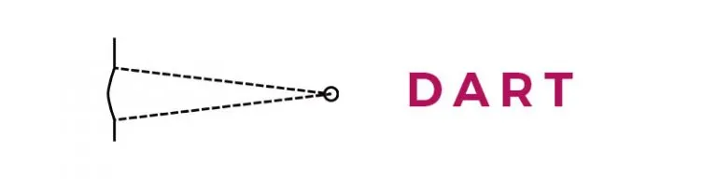
Figure 2.12: Dart

Gathering Lines: When fabric is to be gathered, it can be shown on a pattern as either a straight line or a wavy line between two points.

Tucks: Tucks are formed by bringing two points together and sewing a line parallel to the fold line created. On a pattern this can look like the image below.

Pleating: Pleats look different to tucks on sewing patterns as they are directional and not sewn all the way down.
On a sewing pattern there will be an arrow showing the direction of the pleat and a dotted line to show where the folded edge of the pleat should line up.

Pockets: Pockets need to be placed correctly when sewing and this is usually shown by circle (drill holes) on pattern pieces. These circles will usually correspond rather accurately with similar symbols on the pocket pattern.

Buttons and Buttonholes: Buttons and their button holes are marked carefully on pattern pieces to ensure an accurate placement.

Figure 2.13: Buttonhole placement
Bust point: Not always shown on front bodice pattern pieces, but the bust point it where the apex of the bust would sit. If Darts are designed to end before the bust point so that there is no sharp point at the bust point on clothing.
Pattern sizes are based upon the body measurements. Depending on the type of garment the sewing pattern is could have three measurements.
Here are some general rules when looking at pattern sizing:
- For a loose fit bodice based sewing pattern you’ll want to consider the ’roundest’ part of your upper body – usually the bust – so that the garment is comfortable when worn and not dragging across the bust.
- For a tight fitting bodice based pattern, you’ll be focusing on the under bust, high bust and waist measurements. An FBA (full bust adjustment) can be made to increase the bust if needed.
- Lower body garments should have the widest part as the focus measurement – usually the hip area as fabric suppression can fix the narrower areas of the pattern.
- Knit patterns have ease added differently to woven patterns, so changing the fabric type from knit to woven can result in very unexpected outcomes.
- Close fit stretch patterns leggings and swimwear being have ‘negative ease’ which means the pattern is smaller than the body to allow for the ‘stretch’ of the recommended fabric. Were to make this in a non-stretch woven fabric, it would be a fitting disaster!
- Woven patterns can be made from knit fabrics, but you need to be careful in your choice of knit type.

2.3 Drawing lay marker

2.3.1 Manual marker drawing and duplicating methods.
Marker is a long thin paper which contains all necessary pattern pieces for different sizes for a particular style of garments. It is planned in such a way that fabric wastage would be least.
Marker Making is the process of determining the most efficient layout of pattern pieces for a specified style, fabric, and distribution of sizes (requires time, skill and concentration)
Marker is the creation of cutting temples for the various parts of a garment. This may be done on the cardboard or paper, the former being more durable. In some cases, markers are made on continuous rolls of paper for efficiency. Form all the pattern pieces of varying size, a master marker is made. The marker is the cutting guide or pattern. Layout made on a sheet or lightweight paper the same width as the fabric.

The purpose of the marker is:
- To make a layout for the cutter to allow
- To place pattern pieces close together to avoid fabric waste
- To accommodate the cutting order (ensuring that the correct quantities of each size are cut).
The desire economical use of space is called a tight marker, which utilizes the highest percentage of fabric possible to avoid waste. Patterns are laid out so that each size and color is cut as needed (popular sizes are repeated on the marker). Grain direction, one-way prints, plaids, stripes, and naps are considered in making the marker.
It is the conventional marker planning method and is still used by the garment industries where they make single garment markers. The marker planner works easily by moving around the full-size patterns until an acceptable marker plan is obtained. Multiple copies of the marker are usually required, which can be done by reproducing the master marker with a range of duplicating methods
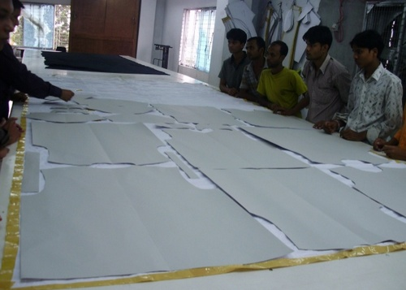
Figure 2.14: Positioning pattern pieces
Multiple copies of the marker paper are usually needed. These copies can either be made when marker plan is first drawn or the master marker can be reproduced as needed by a variety of methods:
With advantages and disadvantages

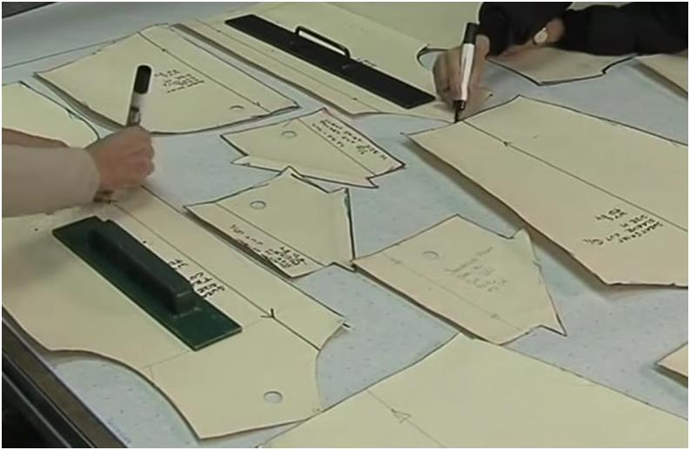
Figure 2.15: Drawing laid marker manually on paper
- Drawing Marker on Paper
- Carbon duplicating
In this method, 6 to 8 markers can be duplicated at a time. Both sided carbon papers are placed in between each two marker papers. When marking of patterns is done on the upper page by pens or pencils, duplicate markers are thus achieved.
Advantages:
- Cost and time effective in case of lower number of copies like 3 to 4.
Disadvantages:
- Labor intensive
- Time consuming as it takes long time.
- Spirit duplicating:
In spirit duplicating machine the master marker is drawn on paper with a layer of special hectograph paper underneath it. This paper transfers a blue line onto the back of the master marker as it is drawn. The master is then used to make one copy at a time in spirit duplicating m/c. It is a messy process but mane copies can be produced.
Advantages:
- A large number of copies can be developed so it is cost effective.
Disadvantages:
- Overlapping, folding or shrinkage of marker papers may cause faulty copies.
- In case of higher width of marker, it would be difficult to duplicate.
- Perforated marker:
The patterns are first placed on to the marker paper, and then marking is done with pencils. Small perforation is done along the drawn lines of the marker papers. This perforated marker is then placed onto the fabric lay and powder of French chalk is spread over the marker. French chalk slates on the fabric like bubbles outside the drawn line and thus patterns appear.
Advantages:
- This type of marker may be used several times.
Disadvantages:
- Time consuming;
- Not cost effective i.e. it incurs huge cost.
- Using Photograph or light sensitive paper:
A special kind of light sensitive paper is used in this technique. When patterns are kept on it and exposed to light, the uncovered areas of the paper change in color by reaction with light to different shades and patterns are marked.
Advantages:
- Quick process, copies can be duplicated with more precision;
- Huge number of copies can be duplicated at a time.
- Marking directly on fabric
Drawing by chalk or pencil: Fabric is first spread over the cutting table and then the pattern pieces are set up directly onto the fabric. Marking is done by a chalk or pencil. This technique usually requires more time and very rarely used in the RMG / readymade garment/ sector. In tailoring purposes it is very common.
Advantages:
- The process is convenient for tailoring process.
Disadvantages:
- Time consuming process;
- Well experienced planner is required.
Paint spraying:
Te patterns are kept onto the fabric and then paint is sprayed over the patterns. The areas covered by the patterns are not sprayed and thus patterns appear with original color of the fabric.

Advantages:
- Convenient for check fabric.
Disadvantages:
- Spray machine should be cleaned regularly which is expensive.
- Accurate lines may not be developed as the shape of pattern pieces becomes distorted.
- Not applicable for high absorbent fabric due to color migration.

2.4 Marker and lay alignment
The patterns are positioned properly on-grain, and within the usable width of the fabric for which the marker is created.
Lay marker is the marker, or cutting lay, is the arrangement of patterns on the spread fabrics.
Lay planning is a process that positions pattern templates onto fabric in the most economical way. This prevents excess wastage of fabric and as such ensures the garment is as cheap as it can be to make.
What are the factors that should be check while designing a marker?
- Check pattern size and dimension.
- Matching of check and stripe taking into consideration.
- Considering garments production plan.
- Cutting table length consideration.
A marker is generally made by keeping the patterns one after the other in the length of the marker. The marker length states the length of fabric that could be used in a lay. The marker length is defined by the following components, which are common to all markers.
- Selvedge lines: The two parallel lines should be drawn parallel to the edge of the cutting table. The gap or distance between the selvedges represents the maximum fabric width that could be used during marker planning.
- Beginning line: The beginning line is at the left side of the marker as seen by the marker planner and is perpendicular to the selvedge lines and is considered a beginning position of the marker.
- End line: The end line is marked at the end/right side of the marker (opposite the beginning line) which is located after the extent of the last pattern and is drawn parallel to the beginning line joining the selvedge line.
- Splice marks: Splice marks represent the area in the cutting table where the fabrics are overlapped during the run out of fabric rolls or elimination of fabric defects during spreading. These marks are placed along the control selvedge.
- Legend: The legend is used to give the key about the marker and normally consists of reference information about the marker.
- Placement rules: The marker planner has to consider the following general rules while marker planning:
a. The grain line in the pattern should be parallel to the fabric selvedge.
b. The patterns should be placed on the marker by considering the grain line in it.
c. The patterns should be kept as close as possible to minimize fabric wastage.
d. The patterns can be placed from largest to smallest, to get higher marker efficiency leading to the least amount of pattern manipulation as necessary.

2.5 Fabric quality
Fabric width (i.e., the usable width for which the cutting-marker is planned) should be determined in detail prior to planning the cutting-marker. The maximum width of the cutting-marker is constrained by the usable width of the fabric. The usable width is the width of the narrowest place minus the width of any unusable selvedge (i.e., considered to be the fabric’s width with selvedge excluded the net fabric width). Usable width can be equal to the net width of the smaller, for example, where a technological process causes fabric deformations parallel to the selvedge
During marker making it should be followed that fabric width must be higher than marker width (At least ½ inch). Fabric length must be higher than marker length (At least 1 inch).
Each ply of the spread must have the length and width of the marker and also the minimum possible extra outside those measurements especially in width due to the possibilities of width variation between fabric rolls as well as within the roll to a lesser extent. By considering this, generally the marker plan is created to the narrowest width of fabric. The excess fabric width could be dispersed outside the marker plan at the opposite end of an operator by aligning the fabric edges at the end or the fabric could be aligned centrally by distributing the extra width equally on both sides.

2.5.1 Fabric type
Different sizes and the type of material have a large influence on the utilization of cut marker and consumption of textile materials.
Fabric characteristics that affect utilization include differences in face and back, lengthwise directionality, crosswise symmetry, need for matching the fabric design, length of design repeat, and fabric width. These fabric characteristics frequently limit the arrangement of pattern pieces.
Matching fabric de- signs requires special marker preparation and extra piece goods. Stripe or plaid lines must be indicated on pattern pieces and markers for accurate alignment and matching to corresponding pieces. The greater the length between repeats increases the potential for fabric waste. In order to reduce the cost of cutting the order, there must be a plan for arranged pattern pieces on the top of the fabric layout Firms often establish fabric utilization standards
- Fabric width: Fabric width is a substantial criterion affecting the fabric efficiency in marker placements, so marker plans of different widths are prepared.
- Fabric width is one of the most important parameters that influence marker efficiency. Fabric width is the width of marker plan at the same time. This width needs to be usable. Usable width is the fabric width to be used in the cutting process.
- Product quantity: The available quantity of a product is the amount of that product available or currently available in the store.
- Garment sizes: When the size of the garments is increased it becomes difficult to marker maker to accommodate big pattern pieces into marker width. As a result the pattern takes the position in marker length, as a result during pattern grading when the size of the garments increases marker efficiency and consumption also increases.
- Wastage allowances: Some allowance is needed in the end of each piece of fabric during fabric spreading because of limitation of the utilized machine for fabric extensibility and fabric spreading and this allowance is usually 2″ in each end and on each ply 4″ fabric wastage. This wastage varies with the durability of the fabric.

2.6 Lay of fabric
Lying out of fabric means to place the number of layers of fabric that the production planning Process has dictated to the length of the marker plan correctly aligned as to length and width; without tension.
- The pieces that have to be cut in certain materials are nested in a rectangle that has the width of the fabric.
- The pieces are placed as efficient possible to achieve good fabric utilization.

2.6.1 Before laying a fabric you should understand the fabric by the following parameters
- The fabric should be pleasing to touch
- Shrinking the fabric if it has not been pre- shrunk by treatments
- Pressing the fabric and removing all creases
- Checking the fabric to see whether it is grain perfect
- Fabric grain: it refers to the direction of yarns in a fabric. Woven fabrics are made up of lengthwise and crosswise or filling yarns interlaced at right angles to each other or vertical and horizontal lines due to the weaving process these threads are called warp and weft threads. The warp runs vertically and the weft is perpendicular to it.
That the woven threads that are parallel to the selvage edge (lengthwise grain) are called warp and those that are perpendicular to the selvage edge (crosswise grain) are called weft.
- Bias grain is any direction on a fabric that does not exactly follow a lengthwise or a crosswise yarn. True bias makes the angle line intersects with the lengthwise and crosswise yarns at 45° angle.
- Selvage: It's tightly woven to keep fabric from unraveling and difficult to sew through and it runs lengthwise parallel to the warp threads

2.6.2 Laying-up instructions
    - According to construction
- Straight lay: In straight lay each ply of fabric is spread according to marker length, i.e. all plies can have the same length. In that case one marker is used.
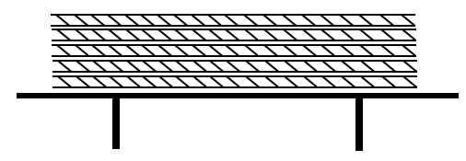

Figure 2.16: Straight lay
- Stepped lay: Ply of fabric lay is not spread according to marker length, i.e. when the plies are laid up in different lengths- a step can be formed. Different types of marker are essential for different steps. Its use is very much less because of fabric wastages and lay making if difficult.
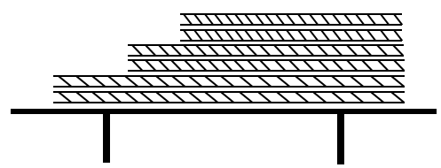
Figure 2.17: Stepped lay

Table 2.1: Difference between straight and stepped lay

Straight lay | Stepped lay
Each ply is spread according to marker length. | Ply of fabric lay is not spread according to marker length.
Mostly used | Rarely used
Fabric wastage is less. | Fabric wastage is more
Fabric spreading is simple. | Fabric spreading is difficult.
One marker is used. | Different types of marker are used.

    - According to the direction of spreading

- One way spreading (Face to underside): This method is used for open fabrics. The face can lie towards the top or bottom, but always in the same direction.
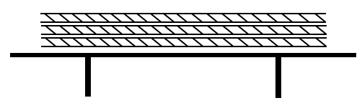
Figure 2.18: face to under side
- Laying-up in pairs (Face to face): This method is also used for open piece goods. The face side is always laid onto the previously spread face side so that- as in one way spreading-
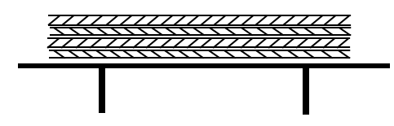
Figure 2.19: face to face
- Lap (Continuous, Zigzag) lying: This method was also developed mainly for spreading open piece goods. Contrary to one way spreading and laying-up in pairs, the pieces are not cut off at the lay end but are clamped and then continuously laid in laps. This is the easiest and most popular way of spreading.
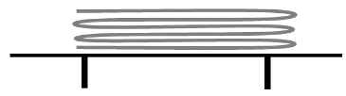
Figure 2.20:Lap (Continuous, Zigzag) lying

Fig 2.26 lap laying
Two other symbols illustrated the laying up of folded and tubular fabric .
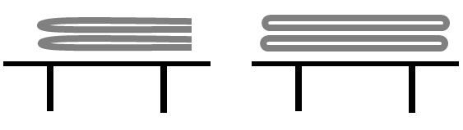
Figure 2.21: folded and tubular fabric

2.6.3 Fabric Inspection
Fabric inspection is done to find faults or defects in the fabric. Ideally 100 per cent of fabric received should be checked before it is cut.
Fabric Inspection is systematic observation of fabrics to decide whether it meets: Client’s specification in terms of count/construction, color, design, measurement specifications, hand/feel and other specific quality parameters lay down by the clients.
This will minimize the quantity of panels or garments rejected for fabric faults, thereby ensuring the quality of the finished goods. Fabric inspection is also considered as pre-production inspection for garments or other textile products
Fabric should be inspected before cutting, the defects marked and the patterns cut around the defects so that they are not included in the final garment.

The following aspects are assessed:

- Color
- Fabric faults
- Shading
- Length
- Usable width
- Fabric hand/handle
- Appearance
- Packaging
- Quantity

Fabric faults are responsible for major defects found by the garment industry. Due to the increasing demand for quality fabrics, high quality requirements are today greater since customer has become more aware of “Non-quality” problems. Generally fabric defects are found during fabric inspection. Here some major defects in fabric are discussed with causes and remedies.
- Fiber Weave. High-quality fabrics feature fibers that are closely and tightly woven together. There should be no obvious gaps between fibers as that’s often an indication of weakness in the fiber quality. These fabrics can tear easily. High quality fabrics have a more well-balanced combination of vertical and horizontal weaves, which make for a stronger fabric surface.
- Color: A good quality fabric should have a dye job to match. Look out for unevenness in tone throughout the surface of the fabric. There should be no streaks or spots. Test fabrics for color fastness as well.
- Thread Count:. This refers to the number of thread strands per inch. A higher thread count means the fabric is tighter and more durable.
- Finish. The overall finish of the fabric should show no uneven weaves, unusual creases, or stretching in the corners
One of the first things to understand about checking fabric quality knows that different types of fabrics present different characteristics and therefore the standards apply differently to each. For instance, cannot expect similar smoothness between a 100% cotton fabric and a fabric made of blended materials.
Before Cutting Procedure
- Receive marker and quality check by cutting QC.
- Fabric Spreading will be done based on Shade chart/Shade grouping provided by fabrics warehouse.
- Spreading report will be made after spreading with related all necessary data.
- Spreading Quality check point: -Table marking -Ends -Leaning –Tension -Narrow Goods -Remnants -Counts -Ply High -Marker Placing -Fabric Flaws
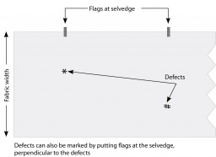
Figure 2.22: Fabric checking

Self-check-2

Part-I: Matching
Instruction: select the correct answer for the give choice. You have given 1 Minute for each question. Each question carries 5 Point.
- What are the factors that should be check while designing a marker?
    - Check pattern size and dimension.
    - Matching of check and stripe taking into consideration.
    - Considering garments production plan.
    - Cutting table length consideration.
    - All
- Which one is types of types of lay
- Straight lay
- Stepped lay
- Face one way
- A&B
Part- II: short Answer writing
Instruction: write short answer for the given question. You are provided 3 minute for each question and each point has 10Points.
Short answer
      - Write the direction of spreading?

Note: Satisfactory rating – above 60% Unsatisfactory - below 60%
You can ask you teacher for the copy of the correct answers

Unit Three : Spreading and cutting
This unit is developed to provide you the necessary information regarding the following content coverage and topics:
- OHS practices
- Cut order planning
- Quality control
- Complete documentation
- Inspection
- cutting equipment

This unit will also assist you to attain the learning outcomes stated in the cover page. Specifically, upon completion of this learning guide, you will be able to:
- Applying OHS practices.
- Interpreting cutting order for marking
- Perform Quality Controlling
- Completing documentation
- Inspect the cut work for fault and give remedies.
- Identify problem of cutting equipment

3.1 Occupational health and safety regulation in cutting room

3.1.1 Definition
The Occupational Health and Safety Regulations (OHS Regulations) build on the OHS Act. They
set out how to fulfill duties and obligations, and particular processes that support the OHS Act.
For example, they include requirements for: safe operation of major hazard facilities and mines.
Cutting
To ensure your personal safety, you should make sure you do the following:
Ensure that long hair is tied back and beards are trimmed to prevent them being caught in the moving parts of machinery.
- Remove any jeweler that dangles loosely from you, including watches, necklaces, bracelets and earrings.
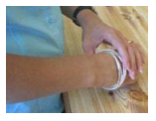
Figure 3.1: Remove jeweler

Wear tight/semi-fitting clothes as loose or baggy clothing can become caught in machinery
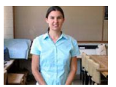

Figure 3.2: Proper dressing

Use mesh gloves to prevent accidental injury when using powered cutting equipment

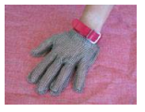
Figure 3.3: Use mesh glove

Use dust masks when working in the cutting room as cutting produces a lot of dust and lint, and some fabrics contain chemicals such as pesticides

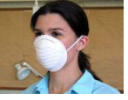
Figure 3.4: Use dust mask

Do not smoke, eat or drink in the cutting room.
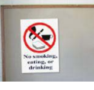
Figure 3.5: Don’t smock

Do not talk when operating machinery in the cutting room. If you need to Connect training group: turn the machine off
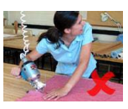
Figure 3.6: Don’t talk while working

Follow correct manual handling procedures when you need to lift or move heavy rolls of fabric or cutters onto the cutting table.
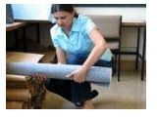
Figure 3.7: Proper handling

3.1.2 Cutting Room Safety
- There are a number of ways you can make sure that the cutting room is a safe working environment: • Divert people traffic from the cutting tables, using clearly marked paths.
- The cutting table should be stable and at a height appropriate for the cutter - 90cm is an average height.
- The work area floor should be non-slip and cleared of all fabric scraps and obstacles.
- Make sure there is good ventilation in the cutting room because cutting produces a lot of dust and lint, and some fabrics contain pesticides.
- Lay a single smooth sheet of paper between the fabric lay and the cutting table. This lets you move the fabric accurately and safely.

3.1.3 Duties of employees
You must take reasonable care of your own health and safety at work and avoid harming the health and safety of other people. Your general duties include:
• Following health and safety policy and procedures.
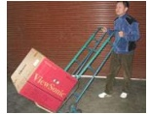

Figure 3.8: Safety rules

Wearing protective clothing, accessories and grooming yourself appropriately.
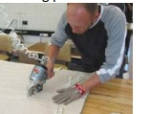
Figure 3.9: Wear protective cloth

Reporting hazard
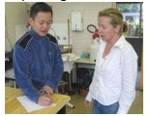
Figure 3.10: Reporting hazard

Maintaining equipment and operating it correctly.

3.2 Cut order planning
Cut order planning is the problem of planning the fabric cut for a set of apparel orders. A specified set of garments is ordered by the customer to be produced by a given date. Affiliated with this order is a set of garment sizes, and patterns for cutting each size. The fabric for cutting the order must be arranged on the cutting table in such a way as to minimize the cost of cutting the order. This plan must incorporate a partition of the pattern pieces to be arranged on top of the fabric layout.

About 70% of the garment cost is represented by the cost of the fabric; the efficiency of the cutting plan is a very important factor.
Lay height is the next important factor in an optimal cut plan. The sum of the fabric plies spread out according to the marker length so that the fabric plies are on top of each other is called a “cut” or a “lay”. Having the maximum lay height is essential in the most efficient cut plan. The number of markers created by drawing different sizes or the same size should also be minimal. Therefore, as a summary, in a most efficient cut plan, the table length should be used the maximum, the “lay” height should be used the maximum and the number of markers should be minimum.
Let’s consider how to make the most efficient cut order plan when a garment factory receives an order. The optimal cut planning should minimize fabric wastage, minimize fabric cost, and minimize time and labor.

3.2.1 Fabric Spreading:
Fabric spreading is a process by which plies of fabric are spread in order to get the required length and width as per marker dimension. It is done after marker making. This is a preparatory operation for cutting and consists of laying. It is important in the garments industry because without spreading fabric not possible to cut so many pieces of cloth at a time.
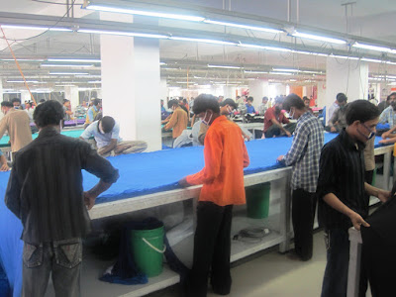
Figure 3.11: Fabric spreading

3.2.2 Fabric Cutting:
Cutting is the process that cut out the pattern pieces from specified fabric for making garments. After fabric spreading, fabric cutting is done by the cutter. It is one of the basic operations to make a garment.
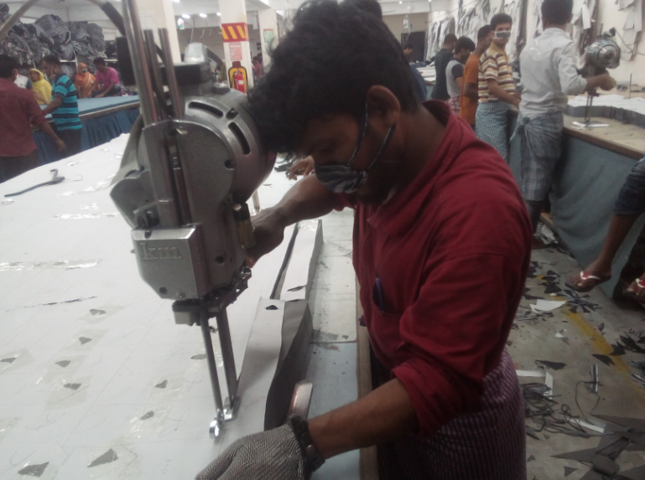
Figure 3.12: Fabric cutting

3.2.3 Planning and making markers:
After fabric spreading, the cutting master systematically spreads the pattern on the topmost surface of the fabric. First the large parts of the pattern are spread, and later the smaller parts are spread. Now these stretched patterns are traced over the fabric with the help of chalk and after marking all the parts of these patterns are removed.
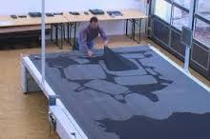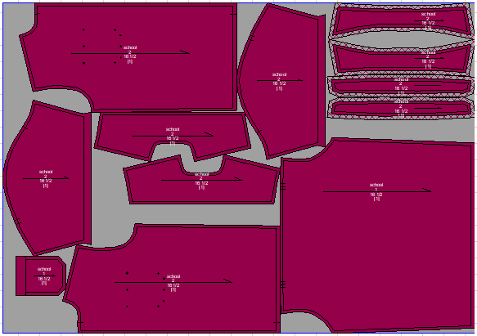
Figure 3.13: Marker
3.2.4 Pattern verification includes checking the following:
- Correctness of grade increments
- Compatibility of grading with style specifications
- Length and alignment of adjoining seam allowances
- Notch placement and alignment with adjoining pattern pieces.
- Placement of internal markings

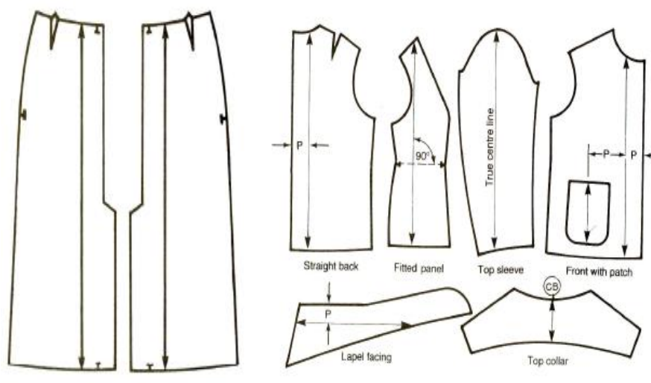
Figure 3.14: Marking placement

3.3 Quality control

3.3.1 Quality control in cutting department
Fabric cutting is a basic and important process in garment manufacturing. Cutting is one of the initial stages in apparel production. Cutting department is responsible for cutting fabrics and feeding the sewing department. Fabric cutting should be done accurately as per exact dimension of the pattern pieces in the marker. If pieces are cut too big, then that could potentially affect the size of other pieces. If a piece that is cut too small then it will be incapable of being fixed. For a perfect sewing of the garment, the cut must be very good. So, quality control in garment cutting room plays a vital role in garments because right measured cutting is required to get the right shape of garments product.
    - Parts of Quality Control in cutting department
Quality control in cutting department mainly divided into four parts. Those are:

Parts of Quality Control Cutting Section
  - Quality control of the cutting section mainly divided into four parts. Those are:
- Marker Inspection
- Spreading Control
- Cutting Quality control
- Piece Goods Inspection

In Marker Inspection following things are inspected

Marker Length
- Marker width
- Lay quantity
- Style/Lot
- Ratio
- The measure of all individual parts marked in marker
Following work in Spreading Quality control

Cut numbers
- Ends
- Leaning
- Tension
- Narrow Goods
- Remnants
- Counts
- Ply Height
- Fabric Fault

Cutting Quality Control

Number of parts
- Miss cut
- Ragged cutting
- Notches
- Matching plies

Piece Goods Inspection

Quantity
- End out
- Knot
- Spot
- Hole
- Thick yarn
- Missing yarn
- Shading
- Slab
Quality control in cutting department plays a vital role in garments because the right measured cutting is required to get the right shape of garments product. The replacement of faulty components is more convenient at this stage as it does not affect the previously finished cutting process, or the forthcoming sewing process. All the cut components are inspected and the following quality parameters are controlled: fabric quality, check miss cut, the conformity of the size and shape of cut components to their pattern pieces, the quality of notches and drill marks.
- Control of fabric quality: fabric quality of the cut components is inspected visually
- Check of fabric quality: Check for mis- cut or the failure of the Cutter to split the line. Tolerance is 1/16”. Report all defects for mis- cuts to Cutting Supervisor.
- Control of size and shape: After the manual cutting process, the size of cut components is controlled by comparing the components with their pattern pieces. The dimensions of the cut components may have certain acceptable tolerances.
These depend on the importance of the dimensions in the garment (smaller tolerances are acceptable in the horizontal dimensions of components), all dimensions of a component (the smaller its size, the smaller the acceptable tolerances) and the application of the component (larger tolerances are acceptable in interlining components).
- Control of notches and drill marks: After the manual cutting process, the quality of notches and drill marks is inspected. Their placement is compared with the corresponding marks in the pattern pieces. If inaccurately placed notches or drill marks are found during inspection

3.4 Ddocumentation
Documentation is any communicable material that is used to describe, explain or instruct regarding some attributes of an object, system or procedure, such as its parts, assembly, installation, maintenance and use. Material that provides official information or evidence or that serves as a record.
Proper documentation ensures that project expectations are met, deliverables are on track, and tasks can be easily traced.

3.5 Cut work

3.5.1 Inspect cut work
Check that all pattern pieces are laid in the same direction. Pieces that need to be a pair, (such as trouser left and right fronts) are often marked with a circle on the marker so that they are still attached at one point such as the side seam or crotch.
Need all the pattern pieces, a ruler or tape measure, a pencil, and a set square or something else with a right angle.

3.5.2 Checking cut pattern pieces:
- Iron the pattern pieces if they are very badly creased.
- Cut out the pieces outside of but fairly close to the edge – it’s hard to check the pattern if the pieces are too roughly cut out.
- Check that all the pieces are labeled and marked correctly – they should say), how many to cut, grain line, and fold line.
- Check that darts are marked using pencil markings, holes or notches.
- Check that corners are right angles at bottom and top edges of pattern pieces – waistbands, hems and that sort of thing.
- Check the side seam length is the same on front and back pieces.
- If you’re making a skirt or trousers, the waistband should line up. You do not want it to be at different heights at the front and back!
- Check that lines that are supposed to be straight are straight and that they don’t bow out or curve inwards..
- Write the seam allowance and hem allowance on the pattern pieces.

3.5.3 Sequence of Checking cut pattern pieces:
    - Pattern Layout Guide
Follow the layout guide that comes with your pattern. Pattern companies have created the best layout possibilities according to the yardage amount they recommend on the back of your pattern. This is to ensure you get the best results with the most efficient use of your fabric.
2. Pressing
Press your tissue pattern pieces before you lay them on your fabric. Your pattern pieces will have creases in them from being folded in an envelope. If you put your iron on a low setting, you can safely press the creases out without damaging your pattern pieces.
3. Grain lines
The grain line on pattern piece is very important. The grain line is there to: Tell what direction pattern piece should be placed on the fabric. The grain line is always parallel to the selvage. If the pattern piece should be lay lengthwise, cross wise or on the bias, the grain line will tell (as well as the layout guide).
4. Cutting
Cutting the fabric with one hand on your pattern piece at all times ensures that it stays in place while you cut. This means that left-handed people will cut their pieces out in clockwise direction and right handed people will cut their pieces out in a counterclockwise direction.
5. Marking
After checking the grain lines and carefully cutting out your pieces, the last and also an important step is marking them. Every symbol has a purpose and is there to aid you while you sew.

3.6 Cutting tools
A cutting tool is a pointed tool mounted in a machine tool and used for cutting materials
The basic function of a fabric cutting tool is to separate the bulk product in to pieces, to remove extra material from work piece and help in producing better finished products..

3.6.1 Types of cutting equipment’s:
- Manual cutting tools
- Fabric shears.
- Angled fabric scissors.
- Paper scissors.
- Pinking shears.
- Rotary cutters.
- Small sharp scissors.
- Duckbill scissors.
- Thread snips.
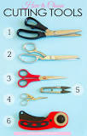
Figure 3.15: Manual cutting equipment
- Automatic fabric cutting tools
- Round knife
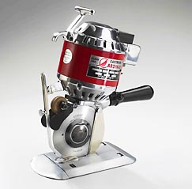
Figure 3.16: Round knife cutting machine

- Straight knife

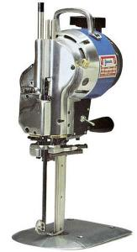
Figure 3.17: Straight knife cutting machine

- Die cutting (collars and cuffs )
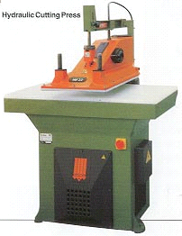

Figure 3.18: die cuter

3.6.2 Cause of equipment failure and how to prevent them
- Checking regularly performance of cutting equipment and give remedial action
- Precision of cut
- Clean edges -The raw edge of the fabric should not show fraying or snagging.
- Unescorted, unused edges
- Support of the lay
- Consistent cutting
Equipment failure happens. The impact of it can run the gamut from easily fixed with minimal losses to, depending on factors like repair costs, total downtime, health and safety implications, and impact on production and delivery of services.
There are several common reasons equipment failure can happen. Understanding each one, and how to prevent them, is the first line of defense against the serious consequences of unplanned downtime.

3.6.3 Common causes of equipment failure
- Improper operation
There are a whole bunch of people who might be in and around critical equipment on a daily basis who could have a significant impact on its overall operating condition.
One solution is to ensure that have enough trained of cutting operation
Most importantly, never allow an operator to use equipment they are not qualified to run
- Failure to perform preventive maintenance
Most equipment requires regular maintenance for optimal performance, but too often, preventive maintenance is the first task.
- Too much preventive maintenance.
Too much is also a major cause for concern. Every time you get into a machine to maintain it, you open up that piece of equipment to a whole set of risks, and over time those risks can compound and lead to machine failure.
- Failure to continuously monitor equipment.
Continuous monitoring relies on sensor data to establish a baseline for what good equipment condition looks like in order to detect subtle changes, which can be used to predict breakdowns and failures
- Bad (or no) reliability culture
Factors Influencing of cutting tools are:

1. Cutting Speed
2. Physical Properties of Work Piece
3. Area of Cutting
4. Ratio of Feed to Depth of Cutting
5. Shape and Angles of Tools
6. Effect of Lubricant
7. Nature of Cutting
8. Operator skill

How to maintain the durability of cutting tools
- Keep the tools in a dry place.
- Store tools in their original cases.
- Use rust collector or silica gel pack.
- Clean the tools properly.
- Inspect tools frequently for wear and damages.
- Maintain the batteries of tool

Self-check-3
Part-I: Matching
Instruction: select the correct answer for the give choice. You have given 1 Minute for each question. Each question carries 5 Point.
1. Pattern verification includes checking the following:
- Correctness of grade increments
- Compatibility of grading with style specifications
- Length and alignment of adjoining seam allowances
- All
    - Sequence of Checking cut pattern pieces
- Pattern Layout Guide
- Pressing
- Grain lines
- All
Part- II: short Answer writing
Instruction: write short answer for the given question. You are provided 3 minute for each question and each point has 10Points.
Short answer
      - Write types of cutting machine?
Note: Satisfactory rating – above 60% Unsatisfactory - below 60%
You can ask you teacher for the copy of the correct answers

Unit Four: Labelling and bundling
This unit is developed to provide you the necessary information regarding the following content coverage and topics:
  - OHS practices
  - cut works
  - Bundling
  - Bundled products
  - Storing bundled cut works
  - Recording bundled cut works
This unit will also assist you to attain the learning outcomes stated in the cover page. Specifically, upon completion of this learning guide, you will be able to:
  - Applying OHS practices
  - Folding and classifying cut works
  - Bundling cut works
  - Preparing bundled products for pickup and dispatch
  - Storing bundled cut works in distribution centers.
  - Recording bundled cut works

4.1 Applying OHS / Occupational Health and Safety in working area

Safety and health measures play an important role in any industry. It is essential that the workers be aware of the various occupational hazards in the industry. At the same time, it is necessary that the management take the necessary steps to protect workers from potential hazardous situations. Reducing risk or accidents or injuries by identifying and mitigating hazards. Improved efficiency and productivity due to fewer employees missing work from illness or injury
The 4 Main Objectives of the Health and Safety at Work Act
- Employer's responsibilities.
- Employee's responsibilities.
- Enforcement of health and safety legislation.
- Enforcement action.
Occupational health and safety in garment industry. In a garment unit, you need to take care of the following points at the factory level.
- First aid box.
- Maintain accident resister.
- Fire extinguishers with marked area.
- Emergency lights on the floor and in the path to the exit.
- Fire alarm.
- Exit signs.
- Exit doors should be kept open while the factory is working.

4.2 Preparing bundled products for pickup and dispatch
Bundling is a common term used in the cutting room process. It is the way of counting pieces cut in the cutting room. Bundling helps the cutting department to handle cuttings and to store cutting inventory. They send cut parts to the sewing section as per the requisition received from the sewing floor. Bundling is the process of arranging garment components from the cut stacks after layer cutting and making a bundle with a number of garment pieces. Normally, using a rope or a fabric stripe (cuttings of fabric wastage) number of garment parts are tied together to form a bundle.

Cut Piece Preparation for Sewing
After cutting, garment parts must be prepared for the sewing operation. Cut parts are separated from the lay, they are moved to a separate table or section of table for sorting, position marking, ply marking, face identification, bundling, bundle ticketing and sorting ,bundle Sorting/grouping
1. Sorting
After cutting, cut components are sorted according to production system. The simplest method of sorting cut parts/bundle is to separate and placed all components of a garments together. Size wise sorting and in case of multiple colors are cut in a single lay, color wise sorting are required.
2. Bundling
As per the production system requirement a certain number of pieces with all components are tied together. This process is known as bundling.
Many sewing rooms use the bundle system, where small batches of garments move from one workstation to another in a control way. Batches may all be the same size (ten units, one dozen, two dozen etc.)
3. Bundle ticketing
- The purpose of bundle tickets is to: Monitor the progress of each specific garment, Ensure that all the correct parts are assembled together, and. Compensate operators for their work on each garment
wherever bundles are used, they are accompanied by a bundle ticket. Tickets provide basic information about the work: style number, the size of garment, number of garment in the bundle and the date of issue.
- E.g. such as
1. Order no. : 0000
2. Bundle no. : 0000
3. Style no. : 0000
4. Qty. in bundle: 12 pcs.
5. Size: M
6. Section: Sleeve
7. Date of issue: 00/00/00.
4. Bundle Sorting/grouping
after the cut bundles are separated, (marked) and tied, the bundles are sorted and grouped together however is necessary for the sewing process. Parts that will be sewn together in the early stages of production will be tied together.

- Re-Cutting
During the process of bundling, if the method of damage control that is used is re-cutting, the
Bundle processors will look for tissue paper interspersed in each cut bundle prior to tying the bundle.
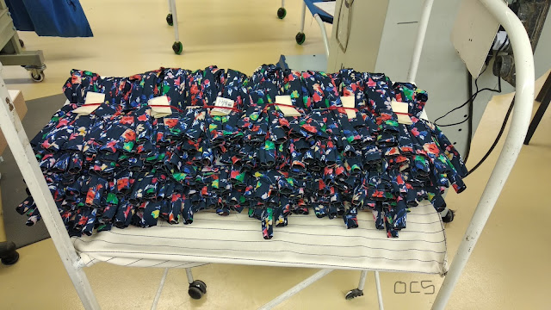
Figure 4.1: Bundle cut piece

Unit Five: Perform Labeling and bundling
This unit is developed to provide you the necessary information regarding the following content coverage and topics:
  - Checking Storage equipment
  - Bundling cut panel
  - Folding and classifying cutwork
  - Dispatching bundle product
  - Maintain Recorded bundle cut work
This unit will also assist you to attain the learning outcomes stated in the cover page. Specifically, upon completion of this learning guide, you will be able to:
  - Check Storage equipment
  - Check Labels and tags
  - Bundle cut panel
  - Fold and classifying cutwork
  - Dispatch bundle product
  - Maintain Recorded bundle cut work

5.1 Checking Storage Equipment
Storage equipment is used for holding or buffering materials over a period of time. Some storage equipment may include the transport of materials. If materials are block stacked directly on the floor, then no storage equipment is required. Storage racks are used to provide support to a load and/or to make the load accessible and it’s better to use racks rather stack the material on the floor. We should regularly check and clean the rack according to its requirement/arrangement.

5.2 Bundling Cut Panel
Bundles of cutwork are prepared according to size, color and quantities, their actual composition determined by the requirements of the sewing room. E.g. all the components for one bundle of garments can be packed into one box or each of the major components packed in its own container ready to be issued to different preparation and sub-assembly sections in the factory.
In manual handling systems garment components are tied together to form a bundle for the sewing lines. Bundle size in Ethiopian factories varies from 20 to 100 garments, which increases the ‘materials handling’ at the needle point and the level of work-in-process (WIP), reducing the working space of the worker and increasing the throughout time of each bundle. Large bundles are a Disincentive and workers make mistakes by putting the wrong components together.
During bundling garment components/ parts MUST be identified properly to ensure that the correct component parts are assembled together.
Experience has shown that smaller bundle sizes:
- reduce worker fatigue,
- reduce the time it takes to produce one bundle,
- reduce worker errors, thereby improving quality,
- reduces the number of rejects in the production line and
- reduces materials handling at the needle point.
The bundling size can be decided based on the requirement of the line, type of cut fabrics, number of work stations and total number of components in a garment to be sewn.
Bundling” is the process of disassembling the stacked and cut pieces and reassembling them in production lots grouped by garment unit, color dye lot, and number of garments. The sorter sorts the patterns according to size and design and makes bundles of them. This step requires much precision because making bundles of mismatched patterns can create severe problems. On each bundle there are specifications of the style size and the marker too is attached with it.
Manufacturers use a variety of bundling methods depending upon their needs, with four basic systems being the most common among local manufacturers:
Item bundling – all pieces that comprise a garment are bundled together.
Group bundling – several (10-20) garments are put together in a bundle and given to a single operator or team to sew.
The purpose of bundle tickets is to: Monitor the progress of each specific garment, Ensure that all the correct parts are assembled together, and. Compensate operators for their work on each garment.
Ticketing: It is a process in which each cut piece of fabric is given a unique number so that the cut pieces of different sorts/shades do not get mixed and sewn together resulting in a defective/rejected garment. Ticketing machines are available to carry out this process. After ticketing is done, pieces of each type like collar, band, cuff, back, front etc. are bundled together and taken to subsequent operations.

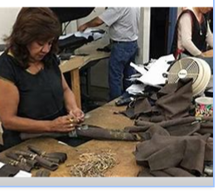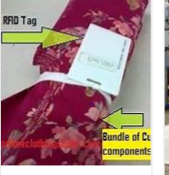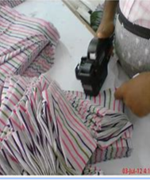
Fig.5.1 Bundling Fig.5.2. Ticketing
Progressive bundling – pieces corresponding to specific sections of the garment (such as sleeves or a collar) are bundled together and given to one operator. Other operators sew other parts of the garment, which are then assembled into the finished garment in the final phase.
Unit production system (UPS) – individual garment pieces are delivered to sewers using a computerized, fully mechanized “assembly line” that runs throughout the manufacturing facility. Using a UPS computer monitoring system, a manufacturer can fully track the production of a garment, identify where sewing slowdowns are occurring, and reroute garment pieces to other sewers who work more quickly. Gerber Garment Technology Inc. manufactures a UPS system, which eliminates the need for passing apparel piece bundles from worker to worker. This lowers labour costs because employees spend less time handling bundles and more time sewing. It also facilitates short-cycle manufacturing.
Modular or “team based” manufacturing is another type of bundling that combines some of the above characteristics. Developed in Japan, it is the grouping of sewing operators into teams of eight to ten. Rather than each sewer performing a single task, they work together on a garment from start to finish. One-third of the U.S. apparel industry has switched to either unit production or modular manufacturing. In Los Angeles, however, only a few major manufacturers engage in computerized unit productions (constituting about ten percent of total production) while the majority of contractors still use progressive bundling.

5.3 Folding and classifying cutwork
The manner of folding or superposing the plies in the bundles should be such that there is (a) minimum or no creasing, and (b) minimum or no disarraying of the cut alignment. Any deviation from these two principles increases the pick-up and positioning time for the sewing operator. If the bundle must be tied securely because of movement before the operator gets the bundle, care should be taken not to use cord or other ties which may mar the surfaces and edges of the cut plies.
Tier stack bins (or boxes) on castes are an excellent means for bundling and transporting cut sections without the necessity of bundle tying. This saves tying and untying time.
All bundles must be classified to include:
- Model/ Style type or number
- Size
- Number of parts in the bundle
- Serial number of the material
- Production order number/ Customer
- Bundles should be stored temporarily on a rack

5.4 Dispatching Bundle Product
Cut bundle are sent to stitching section as per the need of sewing floor and loaded to the line. Some factories prefer to send the whole lay to stitching section and bundling of the layer are done on the production line.
Bundler and dispatcher are different personnel who do different jobs. So, the dispatcher does the following activities:
- Check labels and tags or add if required. Basically, the tag should contain at least the following information: Style #, batch #, size, bundle #, quantity.
- Bag bundled products or otherwise prepare for pick-up or dispatch
- Ascertain dispatch instructions
- Dispatch product, or store in readiness for pick-up / dispatch using appropriate tools and equipment.
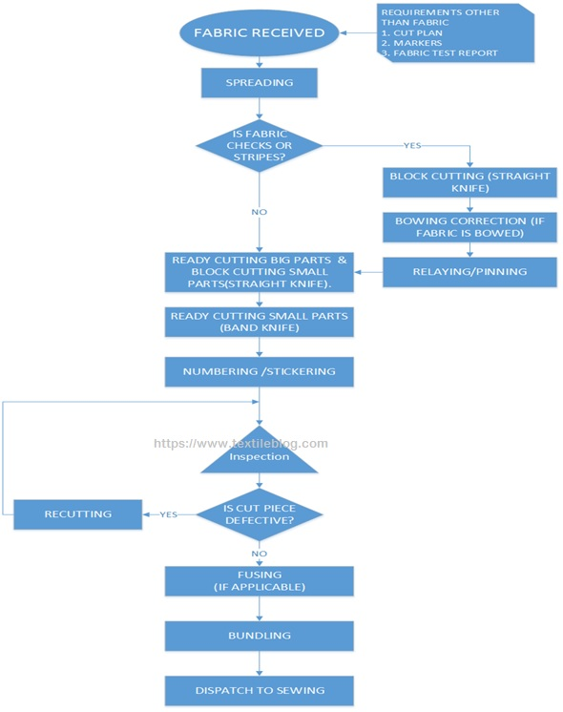
Figure 5.3: Dispatch to sewing

5.5 Maintain Recorded Bundle Cut Work
Efficient materials storage and handling. Storage and handling by themselves are not sources of additional value as during these operations goods do not acquire any new qualities. Discover why improved materials storage and handling can (among other advantages) recover misused space, and lower capital costs due to less work-in-progress and simplified stock control.
Extra stock is a waste. It requires storage, record keeping and handling. It ties up capital and some costly materials can become spoiled or obsolete. Leaving stock and work-in-progress around in the production area reduces the space available for production operations and impedes movement of workers. The more cluttered your shop-floor, the more likely materials and work-in-progress will be mixed up or lost. Workers spend valuable productive time looking for things.
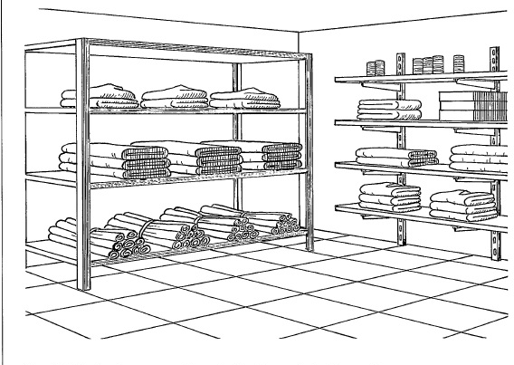
Fig.5.4: Items in stores
Bin card is used to mean a document that keeps a record of the items held in stores. Bin implies a container or space to keep materials, and with each bin, a card is placed, that comprises of details of material received, issued and returned. Moreover, it contains details relating to the number of items, their description and relevant notes (if any).
Bin card is used to quantitatively record the items received, issued and remained in the stores. As and when the transaction takes place, the entry is made in the bin card, after which the materials are taken to/given from stores.
At the time of receiving materials, the quantity is entered in the receipt column of the bin card from material requisition note (MRN), and on the transfer of goods to various departments, the entry is made in issue column of the card.
Table 5.1: Stock Card
I.E. Example of BIN/STOCK CARD
Supplier Code :
Supplier Name :
Period :
Verified By :
Verified Date :
No | Date | Item Code | Item Name | UOM | Warehouse | In | Out | Remarks

Stock Control
Maximum Qty.
Minimum Qty.
Reorder Name

Self-check-5
Test-I Choice
Instruction: Select the best answer for each question. Do this by circling the identifying letter next to your answer. You have given 1 Minute for each question. Each carries 3 Points.
- Experience has shown that smaller bundle sizes:
- reduce worker errors, thereby improving quality
- reduces the number of rejects in the production line
- reduce operators efficiency
- reduce worker fatigue
- Manufacturers use a variety of bundling methods depending upon their needs except:
- Progressive bundling
- Item bundling
- Unit production system (UPS)
- Group bundling
- Which bundling method uses a computer monitoring system, and can fully track the production of a garment.
- Unit production system (UPS)
- Item bundling
- Group bundling
- Progressive bundling
- One of the following bundling methods is the grouping of sewing operators into teams of eight to ten. Rather than each sewer performing a single task, they work together on a garment from start to finish.
- Item bundling
- Group bundling
- Unit production system (UPS)
- Progressive bundling
- Bundling” is the process of disassembling the stacked and cut pieces and reassembling them in production lots grouped by
- Garment unit,
- Color dye lot,
- Number of garments.
- All of the above
- None
- _______ is the process of disassembling the stacked?
A) Item bundling B) Group bundling C) Bundling D) A&C
- ________ is all pieces that comprise a garment are bundled together?
A) Progressive bundling C) Item bundling
B) Unit production system D) Group bundling
- ________ is several garment (10-20) are put together in a bundle?
A) Progressive bundling C) Unit production system
B) Item bundling D) Group bundling
- Which of the following are the bundler activities in inspection?
A) Inspect sample of cut fabric (cut work)
B) Don’t report damaged cut works to supervisor
C) Don’t complete documentation D) B&C
- ________is a unique number given to each cut piece of fabric?
A) Bundling C) Dispatch B) Ticketing D) A&C
- which of the following is the bundler activity in prepare finished cut works for Dispatch?
A) Fold & classify cut work B) Check storage equipment C) A & B D) All except "C"
- Which of the following is equipment of bundling?
A) Manual or powered lifting C) Banding machine
B) Manual or powered packaging D) All of the above
- Which one of the following is Tag should contain information?
A) Style Number B) Size C) Batch Number D) All of the above
- Which of the following is manner of folding or superposing?
A) Minimum or No creasing B) Minimum or No Disarraying C) A & B D) All except "C"
- ________are all bundles must be identified?
A) Model/style type B) Serial No C) Size D) All of the above
Test II: short Answer writing
Instruction: write short answer for the given question. You are provided 3 minute for each question and each point has 5 points.
- Why should we have to check storage equipments regularly?
- Write the meaning of Top Ply labeling and its uses.
- Why do we have to use Bin/Stock card to store bundled fabric?
- What do we mean when we say “Efficient materials storage and handling”

Note: Satisfactory rating – above 60% Unsatisfactory - below 60%
You can ask you teacher for the copy of the correct answers

Operation sheet 5.1 Sorting and bundling
Operation title: Sorting and bundling of cut parts according to size and shade.
Instruction: Trainees should identify the size & structure of different patterns.
Trainees should have the experience of ticketing of cut pieces of fabric.
Purpose: To show how to Sort and bundle cut parts according to size and shade.
Equipment, Tools and Materials: Cut parts; Ticket/ Tag; Strap; Bundling table; Rag/ cloth and Staple remover.
Steps
- Prepare materials, tools and equipment needed as shown.
- Clean/remove fabric dust, trimmings and staple wires on the bundling table by using a piece of cloth.
- Check ticket/tag with the cut parts for the style or job order.
- Arrange the cut parts from large to small parts
- Check sample garments for cut parts distributions.
- Spread all parts of one size on the table.
7. Remove staple wires on the cut parts by staple remover as shown.
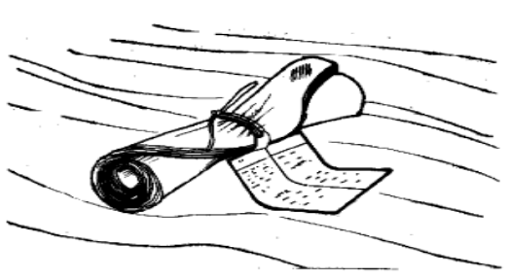
8. Count the number of ply up to the paper separator to separate style of different shade.

Note: Paper separator indicates the shade of the cut parts
9. With strap ticket/tag, tie cut parts together.

Note: The size and the name that is indicated in the ticket tags
must be the same with the cut parts
10.Put the bundled cut parts to the bundle rack/box of cuts with ticket
11. Repeat steps 7, 8, 9 and 10 for all sizes.

QUALITY CRITERIA
- Bundled cut garment parts are according to model, size and quantity or count.
- Ticket or label contains complete information
- No shade variation in the bundled pieces.
PRECAUTIONS: - Care must be taken during ticketing, sorting and bundling.
- Great attention should be taken during sorting of cut parts in order NOT to mix cut parts of different sizes and shades.

Lap Test-5
Task-1: Sort and bundle cut parts of blouse according to size and shade.

UNIT Six: Preparing garment components
This unit is developed to provide you the necessary information regarding the following content coverage and topics:
  - Determining sequence of garment assembly operations.
  - Laying out garment components sequentially.
This unit will also assist you to attain the learning objectives stated in the cover page. Specifically, upon completion of this learning guide, you will be able to:
  - Determine sequence of garment assembly operations.
  - Lay out garment components sequentially.

6.1 Determine sequence of garment assembly operations.
The readymade garment manufacturing processing depends on some steps and techniques. The clothing creation running actions and methods included in the developing outfits for the huge of creation in company time frame for company reasons is known as outfits developing technologies. Garments plants are identified according to their item kinds are as follows: Garments Factory are classified with some dept.
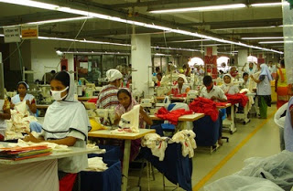
Figure 6.1: Garment assembly

Garments Production Process:
Stepwise garments manufacturing sequence on industrial basis is given below:
Design / Sketch
↓
Pattern Design
↓
Sample Making
↓
Production Pattern
↓
Grading
↓
Marker Making
↓
Spreading
↓
Cutting
↓
Sorting/Bundling
↓
Sewing/Assembling
↓
Inspection
↓
Pressing/ Finishing
↓
Final Inspection
↓
Packing
↓
Dispatch

Operations of Garments manufacturing are given below in details:
Table 6.1: Garment manufacturing process
SL No. | Operation | Job | Method
01 | Design/Sketch | It is given by buyers to manufacturers containing sketches including measurements of particular styles | Manual/Computerized
02 | Basic Block | Basic block is an individual component of garments without any style of design (without Allowance, Style, Design) | Manual/Computerized
03 | Working Pattern | When a pattern is made for a particular style with net dimension regarding the basic block along with allowance then it is called working pattern. | Manual/Computerized
04 | Sample Garments | To make a sample, this will be approved by buyer. After making a sample, it is sent to buyer for approval to rectify the faults | Manual
05 | Approved Sample | After rectify the faults, sample is again sent to buyers. If it is ok then , then it is called approved sample | Manual
06 | Costing | - Fabric Costing  - Making Charged  - Trimmings  - Profit | Manual
07 | Production Pattern | Making allowance with net dimension for bulk production | Manual/Computerized
08 | Grading | If the buyer requires different sizes, so should be grade as S, M, L, XL, XXL | Manual/Computerized
09 | Marker Making | Marker is a thin paper which contains all the components for different sizes for a particular style of garments | Manual/Computerized
10 | Fabric Spreading | To spread the fabrics on table properly for cutting | Manual/Computerized
11 | Cutting | To cut fabric according to marker dimension | Manual/Computerized
12 | Sorting & Bundling | Sort out the fabric according to size and for each size make in individual bundles | Manual
13 | Sewing | To assemble a full garments | Manual
14 | Ironing & Finishing | After sewing we will get a complete garment which is treated with steam ironing & also several finishing processes are done for example extra loose thread cutting | Manual
15 | Inspection | Should be approved as initial sample | Manual
16 | Packing | Treated by Polyethylene bag | Manual
17 | Cartooning | After packing, it should be placed In cartooning for export | Manual
18 | Dispatching | Ready for export | Manual

6.2 Lay out garment components sequentially.

The word laying out garment parts or work pieces means the arrangement of all garment components or piece that can be prepared effectively to make easy sewing production and reducing fabric wastages.
Garment parts are parts of a specific garment like trouser, skirt, blouse which need preparation from the others; and laid out them in sequence as per your machine layout.
The following may be included as garment parts/ components should check and laying in each and every piece of complete garment before sewing.
- Blouse, Shirt, Coat, Jacket, Overcoat Sleeves, plackets, collars, stand, facings, pockets, yoke/ shoulder, pocket, flap etc.
- Skirt Front, back, waistband etc.
- Trouser/ Pant Pocket, waist band, patch, fly, and belt loop, etc
Types of laying components to make full garment and classifications are:
- sleeves – puff sleeve, tailored sleeve, cup sleeve and cuffs
- waistbands – straight or shaped
- collars – sports collar, shirt collars
- plackets_ flat, rolled(folded), over lapped
- facings – neck, armholes
- binds
- zips – dress, skirt, trouser, invisible
- buttons and buttonholes
- Pocket – cut away, patch, in seam, flap
The garment marker is produced by laying all of the pattern pieces out on the fabric. The pattern pieces should be placed so that their grain lines match the straight grain of the fabric. The width of the fabric and sizes of the pattern pieces will dictate how the pieces are laid.
Much of this process is handled by computers in industry, but it is still important to be familiar with the relationship between fabric and pattern alignment or laying pieces with same size and color
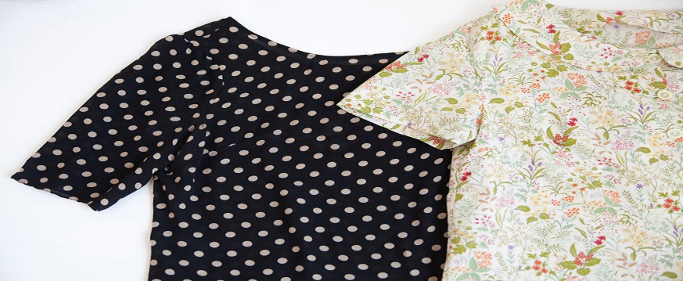
Figure 6.2: Small Scale vs. Large Scale Prints laying system:
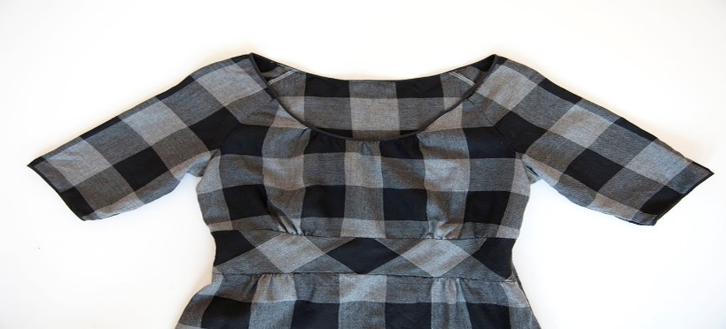
Figure 6.3: Directional vs. Non-directional lying

Laying out garment pieces according to horizontal and vertical stripe alignments:
Lying of paper pattern and garment pieces helps one to plan the placement of the pattern pieces in a tentative manner.
- Lay large pieces first and then fit in the smaller ones
- It is very economical in laying the pattern and cutting. Even a small amount of material saved in a single layer will help to bring about a large saving of money as hundreds of layers of fabric will be laid and cut simultaneously.
- When lying, the length of the garment should be parallel to the selvedge of the material. Be sure the pattern is placed in the correct grain. Fabrics drape and fall better on the lengthwise grain and also last longer.
- Parts that have to be placed on the fold should be exactly on the edge of the fold.
- All lying should be done on the wrong side of the material.
- When laying the paper pattern, consider the design of the fabric. Care should be taken to see that the design runs in the same direction throughout the garment. All checks and strips should match the seams both lengthwise and across.

The skirt components and its laying out of the garments
- The skirt covers the lower part of the body in a tubular shape, from the waist down to the desired length.
Laying of skirt Components

- A. Waistband.
- B. Center front.
- C. Side seam.
- D. Front dart.
- E. Hemline.

- F. Center back.
- G. Back dart.
- H. Back zipper.
- I. Back slit or pleat.
- 1. Button.
- K. Buttonhole.

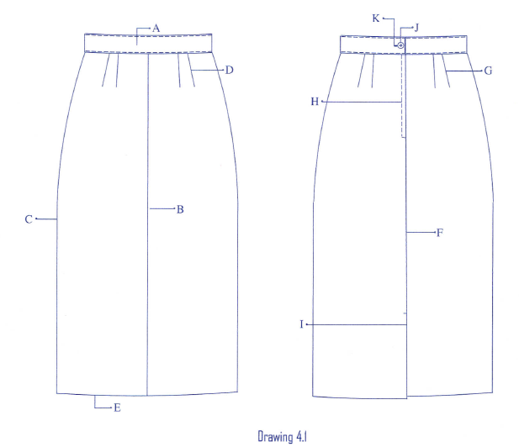

Figure 6.4: Skirt

PANTS
Pants are garments worn on the lower torso. Unlike skirts, pants have tubes surrounding each leg.
Drawing Pants laying components
- A. Waistband.
- B. Belt loop.
- C. Pants fly.
- D. Side seam.
- E. Front pleats.
- F. Crease.
- G. Hip pocket.
- H. Front pocket.
- I. Bottom hem.

Drawing Pants laying components

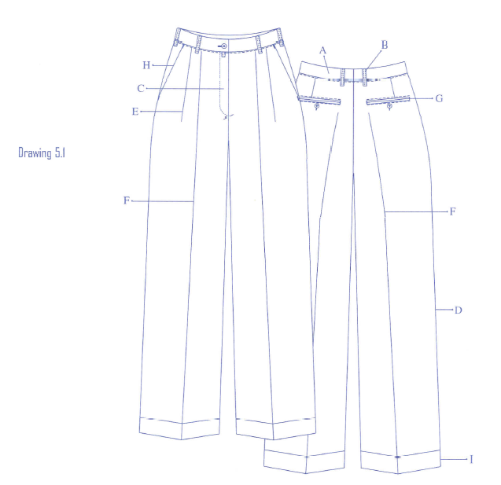

Figure 6.5: Pant (trouser)

Drawing Blouse laying components
A. Collar. J. Seam
B. Front bodice. H. Hem
C. Sleeve. L. cuff
- Armhole m. placket
- Button hole n. pleat
- Button O. back bodice
- Facing
- Dart
- Shoulder seam

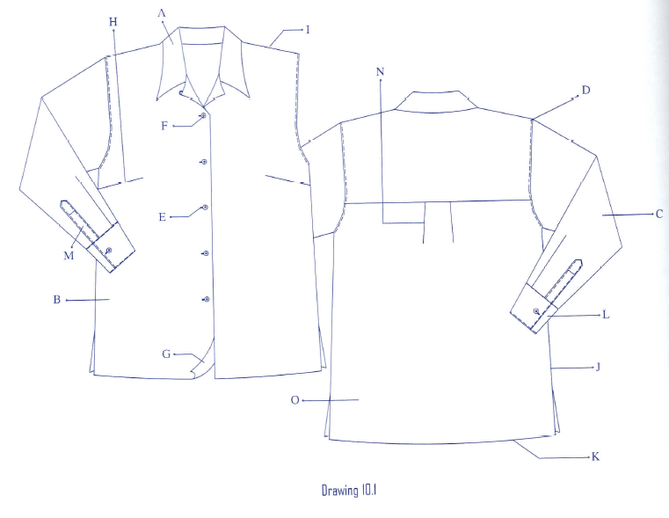
Figure 6.6: Shirt
- Generally laying out garment parts means preparing all garment pieces in order to make good quality garments from preparation to assembling process. That is the system of arrangements of every garment pieces or components with fitness in size dimension length and color type.
- Example to make garment shirts we should prepare the shirt components like: front and back body sleeve, collar, pocket, cuff, placket and buttons.

Self-Check -6 | Written Test

Directions: Answer all the questions listed below
- Describe laying out components shirt parts? (3)
- What are accents?
- How do prepare accents?
- Mention accessories?

Operation Sheet 6.1 | Prepare cut parts
Operation title: prepare cut parts
Purpose
1. To smooth away unwanted creases and crush marks:
2. To make creases where the design of the garment requires them:
3. To prepare garments for further sewing:
4. To refinish the fabric before manufacturing the garment:
5. Final presentation of the garment, ready for sale.
Material, tool and equipment needed

Quantity | Unit | Description
1 | Lot | cut parts
1 | Lot | bundle ticket/tag strap
1 | Unit | bundling table
1 | piece | rag/cloth
Condition for operation: The operator to do easily the cut component before going to sewing and the component attach in attractive and in the exact place.
Before beginning to press/iron, be sure that iron and iron board cover is clean
PROCEDURE

- Prepare materials, tools and equipment needed as shown.
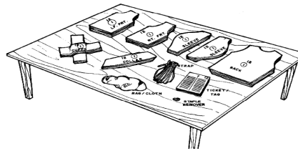

- Check ticket/tag with the cut parts for the style or job order.

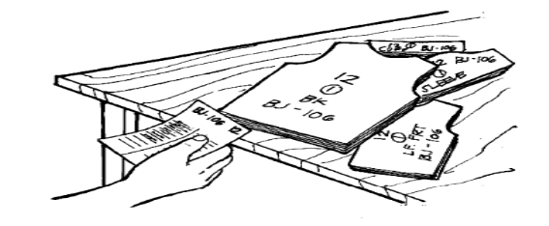

- Arrange the cut parts from large to small parts

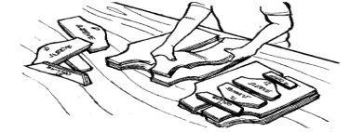

LAP Test-1 | Practical Demonstration
Time started: ________________________ Time finished: ________________
Instructions: Given necessary templates, tools and materials you are
Task -1: prepare cut parts shirt components

Unit seven: Assembling garment components
This unit to provide you the necessary information regarding the following content coverage and topics:
  - Applying OHS practices for sewing garment components.
  - Controlling machine speed and work handling according to sewing operation
  - Checking garment for correct fit and assembly quality
This guide will also assist you to attain the learning objective stated in the cover page. Specifically, upon completion of this learning guide, you will be able to:
  - Apply OHS practices for sewing garment components.
  - Control machine speed and work handling
  - Check garment for correct fit and assembly quality

7.1 Apply OHS practices for sewing garment components
It is the kind of job a person performed at his/her place of work. This jobs are describes in many ways. Some are pattern making, sewing, finishing etc…
OHS primarily seeks to maintain the working ability of the labor force as well as identify asses and prevent hazards within the working environment.
Ergonomics:-on the other hand combines all of these issues to improve workers efficiency and wellbeing and maintain industrial production through the design of an improvement work place.
OHS and Ergonomics application therefore work together to satisfy the needs of changing local people’s attitudes, local work methods and/or traditional ways of doing things.
These issues are important for many developing countries, because the effect of poor health and lack of safety facilities and non-ergonomic conditions exists in various work place are hindrance/obstacle/to the national economy and social progress. Since implementing the full concept of OHS and Ergonomics application is a priority, understanding the meaning of the term related to OHS and Ergonomics applications are a major source of work place improvement
- SAFETY PROCEDURE
Protective equipment, including personal protective equipment/PPE/for ears, eyes, face, head and extremities, protective clothing, respiratory devices and protective shields and barriers, shall be provided, used inspected and maintained in a sanitary and reliable condition wherever it is necessary . By reason of protecting in a manner capable of causing injury or impairment in the faction of any part of the body through absorption, inhalation or physical contact.
Defective or damage personal protective equipment shall not be used. It shall be tagged, DEFECTIVE DONOT USE’’ or ‘’DAMAGED DO NOT USE’’ and required manufacturer specification or disposed to prevent future use.

7.2 Control machine speed and work handling
Controlling machine speed ,Sewing techniques where the positioning, feeding and handling of work pieces involves discretionary changes, contouring or critical stopping points or involving the special handling skills required to accommodate fabric variations controlling the sewing machine in order to operate perfectly.
Here you choose the speed that you want to sew – this can be as low as 50 stitches per minute on up to 1,000 stitches per minute if your machine has the capacity for it. Two time Consumer Digest award winner based on their combination of eight criteria: performance, ease of use, features, quality of construction, warranty, efficiency, styling, and maintenance and service requirements.
This is a computerized sewing so it has an LCD screen with easy navigation keys to choose your stitch. You get 100 built-in stitches, which is plenty for any type of project a beginner can think of. Since this is computerized it has more automatic and touch button features like a start / stop button and of course speed control.
Generally controlling sewing machine speed for a better work handling mechanism to controlling following those activities
Controlling sewing machine pedal pressing activities
Adjusting the speed of machine
Properly handling and sitting position
7.3 Check garment for correct fit and assembly quality
The garment should look attractive, even and appropriate, both on and off the body. The garment fit should bebecoming and reflect current fashion trends. Constructiontechniques should not be obvious nor distract from the total garment. Fabric, trim and construction techniques must work to-gether to create a professional looking garment.
The fabricshould have the correct weight and drape for the design.Finishing details should complement the fabric and the garment.The garment should look attractive, even and appropriate, both on and off the body.The garment fit should bebecoming and reflect current fashion trends. Construction techniques should not be obvious nor distract from the total garment.
8.3.1 characteristics, style and coloring of the individual.
  - Coordinate with one another in terms of design, color, weight and texture.
  - Have a fiber content and texture suited to apparel design.
  - Have a design that is matched, centered or balanced.
  - Be used so that the nap runs in the same direction on all parts of a garment
  - Have proper waistline length and fit.
  - Have darts and design details that are properly placed.
  - Have neckline and armholes that fit the body without gapping or straining.

- Buttons and Buttonholes
Well-constructed buttons should:
• Fit the purpose to which they are intended—
functional or decorative.
• Be neat in appearance on the right and wrong sides of the garment.
• Be securely fastened with double thread and neat stitches.
• Be reinforced, according to use and fabric type, with interfacing and/or another button.
• Be spaced in good proportion between top and bottom opening.
• Be the appropriate size and style for the garment design and fabric.
• Sized in relation to the button size and thickness.
• The same length and width when the same size/shape button has been used.
- Collar
  - Be smooth and free from wrinkles.
  - The outer edge seam should not be visible from the right side.
  - Have smooth curves or sharp points (shape and length) depending on the type and
  - style of collar.
  - Have bulk properly distributed through grading/layering, notching, clipping and/or triming
  - Fit the neckline area without unsightly gaps or wrinkles.
  - Be interfaced properly to maintain shape.
  - Be understitched on the outer seam edge to roll
  - under the seam.
  - Be well pressed.
- arts, Ease, Gathers, Pleats, Shirring,
Tucks
- A well-constructed fitting dart should:
- Be directed toward the body curve.
- Usually end 1⁄2 to 1 inch from the fullest part of the body curve.
- Be tapered so it is smooth and free of puckers.
- Be even and smooth in appearance.
• Be pressed before being crossed by another line of stitching.
• Have threads secured at both ends by tying a knot, lock stitching or back stitching (use only on medium to heavy fabric or in a seam line).
C) Waistband
A well-constructed waistband should:
• Be smooth, flat, and free from bulk and wrinkles.
• Be even in width according to the garment style.
• Be on-grain and reinforced or interfaced to maintain shape.
• Have under lap under the waistband and extend beyond the placket unless the pattern indicates differently; overlap should be even with the placket unless the pattern indicates differently.
• Have square corners at the ends of the waistband.
• Be securely stitched with smooth, even stitching.
• Have appropriate fasteners that are properly located and secured in place.
- Sleeves
A well-constructed and correctly fitted set-in
sleeve should:
• Have a smooth, rounded cap with no pleats or gathers unless they are a garment design feature.
• Be applied so that there is ease in the underarm area and in the sleeve cap area.
• Have a good armhole line resulting from straight, even stitching, and well-matched seam
lines that conform to the body.
• Have a crosswise grain parallel to the floor, a lengthwise grain perpendicular to the floor, and no diagonal wrinkles.
• Have evenly distributed gathers in gathered set-in sleeves.
• Have seams finished appropriately for the fabric.
- Hems
A well-made hem should:
• Be inconspicuous on the right side, except when it is a decorative part of the garment design.
• Be an appropriate distance from the floor.
• Be even in width and an appropriate depth for the fabric and garment design.
• Be free from bulk in seams that fall within the hem area.
• Have fullness eased in and evenly distributed for a smooth, flat appearance.
• Have an edge appropriately finished for the type and weight of fabric an
F) Hand Stitching
A) well-made hand stitch will:
Be composed of a thread type, weight/thickness and color suitable to the situation for which it is used.
- Buttonhole twist is used for hand-worked buttonholes and can be used for sewing on buttons and for top stitching.
- Heavier and decorative threads, such as embroidery and metallic, can be used for decorative stitching.
- Use the same color, or slightly darker, when permanently stitching.
- Have a uniform stitch formation that is appropriate to the fabric and garment for which it is used.
- Have thread ends appropriately secured at the beginning and ending of the stitching. If a knot is used in permanent stitching, it should be out of sight against an inside layer of fabric.
- Pressing
A well-pressed garment should:
• Maintain the original texture of the fabric.
• Show no shine or press marks on the right side of the fabric.
• Have no wrinkles or crinkled areas.
• Have seams and darts pressed smoothly on the stitching line, so that the fabric does not fold over the stitching line or look bubbled.
Edges of seam allowances and fold edges of darts do not form ridges on the right side of the garment.
- Have no water-spot or steam marks.
- Help create and maintain the proper shape and curve to the garment and the various garment segments (collar, sleeve, etc.).
- Seams, Seam Finishes, Seam Treatments
A well-constructed seam should:
- Be smooth and even in appearance on the inside and outside of garment. Machine tension, stitch length and presser foot pressure are properly adjusted to suit the fabric and thread.
- Be pressed open (and with no puckers) or pressed properly according to the type of seam
it is and the way it is used in garment construction.
- Be stitched with thread appropriate to the fabric type, fabric content and color. (Thread color should match or be slightly darker than the fabric.)
- Have consistent stitch length.
- Be flat and trimmed and/or graded, if needed, to reduce bulk.
- Match fabric designs such as plaids and stripes

Self-Check -7 | Written Test
Directions: Answer all the questions listed below. Use the Answer sheet provided in the next page:
- Write characteristics checking opration? (5).
- Write Checking garment? (3)

Unit Eight: Performing hand stitching
This learning guide is developed to provide you the necessary information regarding the following content coverage and topics:
  - Laying out material in preparation for stitching process.
  - Selecting aappropriate type of stitch for particular application.
  - Determining hand stitch with the garment to be sewn according to specification.
  - Performing hand stitching from start to finish
  - Inspecting finished work
Completing hand stitching This guide will also assist you to attain the learning objectives stated in the cover page. Specifically, upon completion of this learning guide, you will be able to:
  - Lay out material in preparation for stitching process.
  - Select aappropriate type of stitch for particular application.
  - Determine hand stitch with the garment to be sewn according to specification.
  - Perform hand stitching from start to finish
  - Inspect finished work

8.1 Lay out material for preparation of stitching process.
Before starting on the machine
• Check the type of thread being used and check for proper threading
• Adequate thread and needle type for the operation
• Thread cone is placed properly (even level) over holder
• Thread guides don’t produce any unusual friction to thread
• Guides threaded correctly
• All tensioning plates threaded correctly
• All needles/bobbins/loopers are threaded properly
• Needle point is not broken
Watch the machine and evaluate its operation
• Silently softly and firmly at the maximum RPM’s
• Noisy, violently, vibrating at slow or high speeds
• Belts appropriately placed on machine pulley or motor pulley
• Belt tension is too tight or too loose
• Thread stuck on pulleys or belts
• Belt is broken or worn-out
• Belt is soaking in oil
• Machine or motor pulley is loose or damaged
Check lubrication
• Check oil gauges
• Check for leaks
Observe the operator’s position when sewing
• Is the table’s height appropriate (at elbow level)?
• Are the pedals in the right position?
Check the motor adjustments
• Clutch adjustments
• Pedal movement doesn’t engage machine
• Machine engages too easily and abruptly (too little movement of the pedal
Before opening the machine:
• Verify that the needle is:
• Located properly
• Not bent
• Not broken (specially the tip)
• Not too sharp around the tip and eyelet
• Appropriate type for the thread and fabric being used
• Check the machine for appropriate threading
• Thread guides
• Thread pullers
• Tensioners
• Needles
• Loopers
• Spreaders
• Clean all thread and oil from the sewing area
• Check the appropriate movement of the needle
• Check the presser foot, throat plate and feeders to see if they are working correctly
• Check if the minor adjustments have improved the sewing problem
  - Select appropriate type of stitch for particular application.
Stitch size has three dimensions: length, width, and depth.
- Stitch Length: is specified as no. of stitches per inch (SPI) and can be an indicator of quality.
  - High spi
      - Short stitches: High quality
      - Potential problems (seam pucker or weaken fabric).
      - Higher spi, the more time and thread, high cost.
  - Low spi
      - Long stitches: Lower quality
      - Problems: Less durable, abrasion, grin through
      - Fast, less thread, less cost.

8.2.1 Stitch Types
- There are two basic stitch formations, lock stitch and chain stitch, with a number of variations in each type.

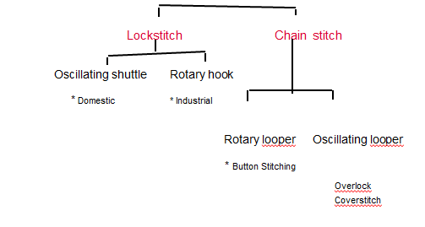
Figure 8.1: Stich type
8.3 Determine hand stitch with the garment to be sewn according to specification
- Using a Thimble
A thimble protects your finger from being pricking as you push the needle through layers of fabric. Choose a thimble those comfortable feet’s the middle finger on the hand you use during hand sewing. It is made of metal or plastic.
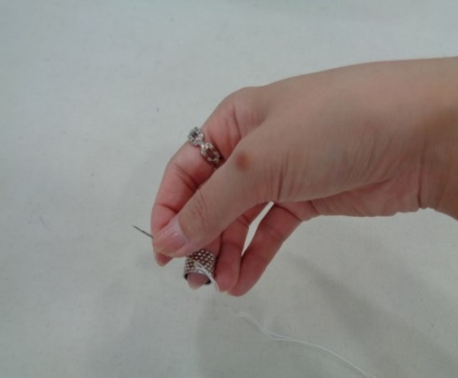

Figure 8.2: Thimble

- Place the thimble on the middle finger of your right hand if you’re right handed and vice versa if you’re a lefty.
- Hold your needle between your thumb and index finger.
- Insert the needle into the fabric and push it through with the side or end of the thimble
- Running stitch
Running stitch is the simplest, quickest and most basic of all the hand stitches and is used to ease, gather, mend, baste and sew seams that are not subject to strain. Its used for basting because the stitches are easy to remove after they are no longer needed. Running
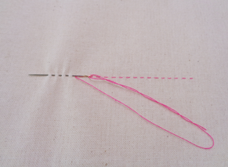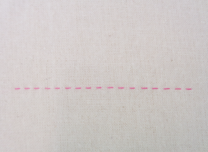
Figure 8.3: Running Stich

3. Diagonal Basting
Diagonal basting is a series of parallel, horizontal stitches that produce diagonal floats of thread on the top layer of fabric. This stitch is most often used in tailoring to hold fabric layers together (not along a stitching line). The stitches control the shifting of fabric during pressing, fitting and construction. Diagonal basting is perfect for holding a pocket in place, so it doesn’t shift during stitching.

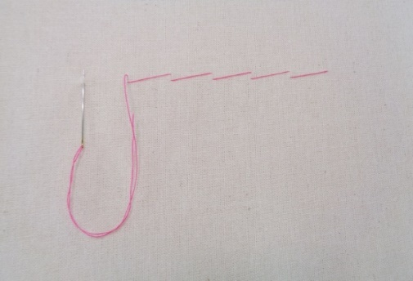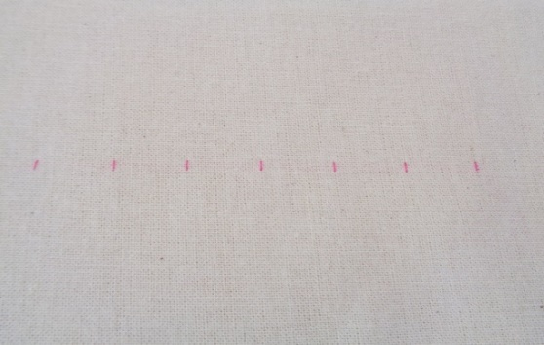
Figure 8.4: Diagonal Basting

4.Catch stitch
Herringbone tends to be a decorative, rather than a structural, stitch. Think of it as doing two parallel row of backstitch where you alternate which row youre sewing with each stitch. Is very elastic. The working surface shows a zig-zag with an X at each point. The underside shows two parallel dashed lines.
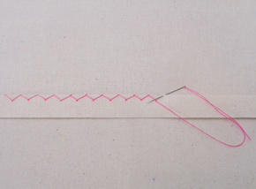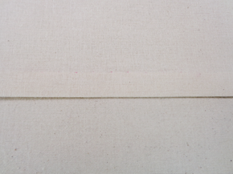
Figure 8.5: Catch stich
5.Tailor tack
Tacks are hand-sewing stitches done during marking or construction. Weave loop thread to mark dots and symbols, but you must cut the loops before you remove the pattern. A basting stitch taken with a double thread through two pieces of fabric and then cut apart with large loops being left in each piece for marking seam lines and perforations.
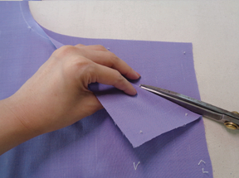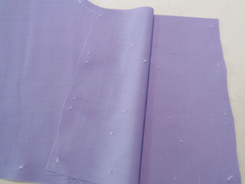
Figure 8.6: Tailor tack
Buttons can be fascinating, functional, and fashionable. They are fascinating because of their many sizes, shapes, colors, and designs. They are factional because they are one of the major methods of opening and closing garments. Buttons are fashionable because they also decorate and enhance apparel &other items. Buttons are generally sewn on by hand, though they can also be zigzagged in place on the machine as well. Buttons are traditionally placed

2. Button
There are two basic kinds of buttons- sew –thru buttons and shank buttons. Thru button Is usually fiat with two or four hole.. A shank button has a solid top and a built-in shank.
Button Attachment
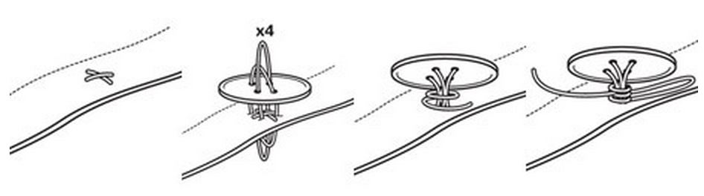
Figure 8.7: Button Attachment
  - Take twelve inches of thread, knotted securely at one end, and thread your needle. Make a single stitch in the shirt in line with the row of buttons, about 0.3cm long. And then make another stitch perpendicular to the first.
  - Hold the buttons, about 0.3cm away from the shirt and thread the needle up through one hole in the button and down the diagonally opposite hole. Do the same with the other holes and then repeat four times.
  - Wrap the thread tightly around the 0.3cm shank that has been created between the button and the cloth create a tight pillar.
  - Push the needle through this pillar a few times and cut the thread close to it.
  - Button up.
Button Hole
- Thread needle with to match button. Take a small stitch where button is to be placed. Poke needle through button hole holed button in place over small stitch.
- Place straight pin across top of holes. Sew with thread going over top of pin and down in opposite hole. Do this at least 6 times.
- Remove pin
- Poke needle so thread comes out under button, but on top of fabric so you can TIGHTLY wrap threads around the middle of the stitches 4 times. This creates a thread shank
- Poke needle to back of fabric. Stitch in place3 times to make a secure knot. Trim thread.

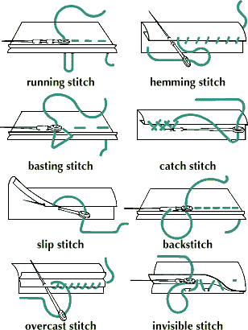
Figure 8.8: Types of stich
8.5 Inspect finished work
- The various Steps of Garments manufacturing where in-process inspection and quality control
- Quality may be defined as the level of acceptance of goods or services. are done are
- In Sample making section
- In- Marker making section
- Inspection in fabric spreading section
- Inspection in fabric cutting section
- Inspection in fabric sewn section
Inspection in pressing & finishing section
Inspection is the act of comparing a product with accepted specifications or standards laid down.
This may be visual or physical like pick counters, measuring tape, spectrometers etc.
Inspection essentially is a post-mortem operation performed on fabric after the same is manufactured. Inspection, there-fore, catches defects quickly thereby avoiding reject of complete fabric lot. “When the defects are caught it is easy to remedy”.
To decide acceptance or rejections of fabric roll (for Woven). Fabric inspection is done using 4-point system. Accurate fabric inspection is critical in verifying the quality of the product.

Operation Sheet 8.1 | Techniques of determining the type of sewing parts
Techniques to determining forward and back stitch in standard SPI (2.5) garment parts.
Purpose: | To show how to make precise forward and back stitching & required SPI (stitch per inch) using SNLS machine with the available fabric.
Conditions operation: | Trainees should know the length measurement scale (cm & inch).  Trainees should know the different sewing techniques.
Equipment, tools | Fabric, Sewing thread, SNLS Industrial Sewing Machine, Thread trimmer (Weaver’s scissor)
Procedures:
Steps: Make a back stitching (4-5 stitches) repeatedly until you get the correct ones.

- Make sewing and count the number of stitches within 1 inch (SPI).
e.g.
1 inch
Therefore, the no. of stitches in 1 inch= 9. I.e. SPI
Quality criteria: | - All steps should be done in the correct sequence.  - The collar should be symmetric.  - Top stitch should be even and be as per specification.

Operation Sheet 8.2 | Techniques of sewing pieces of sleeve cuff
Techniques to determine Preparation of different structure of sleeve cuffs
Purpose: | To show how to prepare different structure of cuffs.
Conditions: | - Trainees should know the structure of cuffs.  - Trainees should know how to prepare pattern for cuffs.
Equipment, tools and materials: | SNLS Industrial sewing machines, sewing thread, cut piece of cuffs, interlining, and dice for the cuff (optional!!).
Procedures:
Steps
- First, fuse the interlining on upper part of cuff.
- b)
Interlining Interlining

Rectangular one/two-piece cuff Hexagonal cuff
c) d) Interlining Interlining
Round cuff Pointed type cuff
- Make a rolling of the fused part of cuff.
- b)
Interlining Interlining

Rectangular one/two-piece cuff Hexagonal cuff

Interlining d) Interlining

Round cuff Pointed type cuff
- Put the right side of readymade piece of collar over the other right side of the other piece of collar, attach the two pieces together
- b)

Rectangular one/two-piece cuff Hexagonal cuff

c) d)

Round cuff Pointed type cuff
- Turn, cut off the edge and make a top stitch as shown below.
- b)

Rectangular one/two-piece cuff Hexagonal cuff
c) d)

Round cuff Pointed type cuff
PRECAUTIONS: | - Make sure that interlining is firmly fused on the fabric.  - Make sure that SPI of machine and quality of stitch is in the right mode.

LAP Test 3.1 | Practical Demonstration
Time started: ________________________ Time finished: ________________
Instructions: Given necessary templates, tools and materials you are required to perform the following tasks within --- hour.
Task 1- determine forward and back stitching & use SPI standards
Task 2- Prepare and attach different kinds of patch pockets
Task 3- determining to Prepare and attach different kinds of patch pockets
Task4-determining to Preparation of different structure of sleeve cuffs

References:
- Garments & Technology by Prof. M. A. Kashem
- Garment Manufacturing Technology by Md. Shafiul Azam, Md. Abu Saleh & Khondokar Abu Nafiz
- Apparel Manufacturing Technology by T. Karthik, P. Ganesan, D. Gopalakrishnan
- Garment Manufacturing Technology Edited by Rajkishore Nayak and Rajiv Padhye

Mazharul Islam Kiron
Founder & Editor of Textile Learner. He is a Textile Consultant, Blogger & Entrepreneur. He is working as a textile consultant in several local and international companies.
Eve Tokens (aka The Creative Curator) is a fashion designer, creative pattern cutter and sewing pattern designer.
Author of this Article:
Noor Ahmed Raaz
Asst. Merchandiser
A.M.C.S Textile Ltd
Apparel, Quality Control / By Jahanara Rony

https://www.tandfonline.com/doi/abs/10.1080/07408179808966439?journalCode=uiie20
byPrasanta Sarkar-October 22, 201
https://www.textileschool.com/474/bundling-reassembling-cut-pieces-in-garment-manufacturing/
byPrasanta Sarkar-March 16, 2014
https://www.textileschool.com/474/bundling-reassembling-cut-pieces-in-garment-manufacturing/
https://www.fiixsoftware.com/blog/5-causes-of-equipment-failure-and-what-you-can-do-to-prevent-it/

Published by Nirosh Rajapakse

http://ecoursesonline.iasri.res.in/mod/page/view.php?id=80412
https://apparelmerchandisinglearner.blogspot.com/2019/11/cut-piece-preparation-for-sewing.html

.

http://www.rsjqa.com/inspection-services/fabric-inspection

Esty, K., R. Griffin, and M. Schorr-Hirsh. (1995). Workplace diversity. A manager’s guide to solving problems and turning diversity into a competitive advantage. Avon, MA: Adams Media Corporation.
https://sites.google.com/a/qmu.ac.uk/plagiarism/students/identifying-information

