

Fashion Design
Level- IV
Based on March 2022, Curriculum Version 1
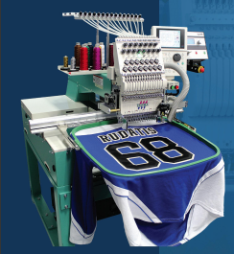
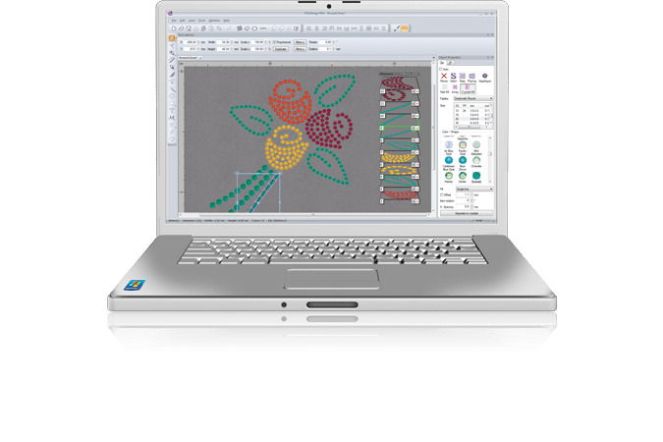

Module Title: - Designing and produce digital embroidery
Module code: IND FAD3 09 1221
Nominal duration: 50Hour

Prepared by: Rebuma Bedada Beyena
SEPTEMBER 25, 2022
Addis Abeba, Ethiopia

Table of Content
Table of Content i
Table of Figures iv
Acknowledgment 1
Introduction to the Module 2
Unit one: Identify client design brief 4
1.2 Identify and use Available software programs are identified. 5
1.3 Garment considerations are identified 10
1.4 Machine requirements are identified 13
1.4.1 Machine specification 19
Self-check-1 20
Part I From the following question choose best answer letter and circle it. 20
Unit Two: Create design 23
2.1 Applying OHS practice 24
2.2. Assessing client profile information to determine approach 25
2.3 Reviewing the design to gain approval for development. 26
2.4. Developing a design concept 27
2.5. Developing design specifications 28
2.5.1. Main points of embroidery SPEC 28
2.6. Creating design portfolio 29
Self-check-2 31
Unit Three: Editing a design 32
3.1. Editing design or image 33
3.2. Importing designs into software programs. 38
3.1.1. Drawing, importing and moving shapes 39
3.3. Editing a design based on the embroidery machine 46
3.4. Determining and considering the embroidery machine and material for production. 47
3.5. Recording a design work. 48
.6. Identifying the embroidering garment component based on production plan. 48
Self-check-3 50
Unit Four: Presenting design for feedback 51
4.1. Presenting the detail embroidering design concept for feedback. 51
4.2. Embellishing and highlighting the garment using embroidery. 51
4.3. Receiving and considering a feedback for design objectives 52
4.4. Modifying and improving a design concept. 53
Self-check 56
Unit Five: Set up digital embroidery machine for production operation 57
5.1. Interpreting production specification and determining the optimum machine setting. 57
5.2. Determining documentation related to machine settings. 58
5.3. Selecting and preparing appropriate tools and machine for the task 59
Unit Six: Set up digital embroidery machine for production operation 70
6.1. Operating embroidery machine for test 71
6.2. Examining embroidered product or sample 72
6.3. Conducting or organizing quality tests. 73
6.4. Identifying and documenting machine settings 74
Unit Seven: Collecting tools & materials 75
7.1. Collecting and arranging tools & materials 76
7.2. Checking the selected materials 88
Self-check 7 89
Unit Eight: Framing preparation 93
8.1. Selection of frame 93
8.2. Performing hooping process 95
8.3. Check-up machine functionality 99
8.4. Implementing and applying quality standards 101
Unit Nine: Preparing work pieces and workstation 102
9.1. Applying OHS practices 103
9.2. Adjusting equipment and materials for work 104
9.3. Working on laid out of fabric pieces 104
9.4. Performing routine minor maintenance 106
9.5. Reporting and recording any problems 107
Self-check. 9 113
Part I From the following question choose best answer letter and circle it. 113
Unit Ten: Producing digital machine embroidery on articles/ garments 116
10.1. Applying OHS 116
10.2. Producing the garment by applying embroidery 117
10.3. Assessing the compliance quality 118
10.4. Checking and adjusting machine to ensure the optimum performance 120
10.5. Manage production problems. 123
10.6. Controlling manufacturing details 125
10.7. Managing steps of machine troubleshooting 126
10.8. Practicing minor routine machine maintenance 127
Self-check 10 128
Part I From the following question choose best answer letter and circle it. 128
Unit Eleven: Completion of work 130
11.1. Checking a completed work 131
11.2. Reporting and recording faults 131
11.3. Directing completed work to the next operation 132
11.4. Completing required work documentation. 132
Self-check 11 133
Reference 139

Table of Figures
Figure 1: Pe-design 6
Figure 2: Stitch pattern 6
Figure 3: Text pattern 7
Figure 4: Collection Shape of pattern 7
Figure 5: Wilcom Embroidery Studio 8
Figure 6: Hatch Embroidery symbol 8
Figure 7: Embrilliance 8
Figure 8: Floriani 9
Figure 9:Sierra Embroidery Office 9
Figure 10: Janome Digitizer MBX 10
Figure 11: Aida cloth Fabric 12
Figure 12: number of stitches 15
Figure 13: specific hoop sizes 15
Figure 14: the number of thread colors used in your design 16
Figure 15: Tajima digital embroidery machine 17
Figure 16: digital embroidery software versatility 18
Figure 17: Machine specification 19
Figure 18: embroidery portfolio 30
Figure 19: Importing patterns 33
Figure 20: The imported image appears in the Design Page 34
Figure 21: Importing vector images 35
Figure 22:1st step of auto punch 36
Figure 23: 2nd step of auto punch 36
Figure 24: 3rd step of auto punch 36
Figure 25: 4th step of auto punch 37
Figure 26: select a Shapes tool 40
Figure 27: Select the shape 41
Figure 28: the sew types $ thread colors 42
Figure 29: shapes 43
Figure 30: color attribute 44
Figure 31: Sewing attribute or types 45
Figure 32: color adjusting 46
Figure 33: Production process 49
Figure 34:Set up machines procedure 61
Figure 35: Placement of Accessories 62
Figure 36: Accessories 62
Figure 37: machine uni 66
Figure 38: Machine installation 66
Figure 39: Tear-Away Stabilizer 77
Figure 40: Tear-away stabilizer 77
Figure 41: Cut-Away Stabilizer 78
Figure 42: No-Show Mesh Stabilizer 78
Figure 43: Sticky Stabilizer 79
Figure 44: Water-Soluble Topping 80
Figure 45: Wash-Away Stabilizer 80
Figure 46: water-soluble 81
Figure 47: Embroidery Backing 81
Figure 48: Applique Fabrics 82
Figure 49: Applique Fabrics 82
Figure 50: Embroidery Machine Needles 82
Figure 51: Embroidery Thread 83
Figure 52: Bobbin Thread 83
Figure 53: Placement Tools 84
Figure 54: Chalk wheel 84
Figure 55: embroidery placement stickers 84
Figure 56: Embroidery Scissors 85
Figure 57: Temporary Adhesive 85
Figure 58: USB Drive 86
Figure 59: Hoops 86
Figure 60: Alignment Laser 87
Figure 61: Embroidery Removal 87
Figure 62: Spool Huggers 87
Figure 63: bobbin clamps 88
Figure 64: types of frames 94
Figure 65: Hooping diagram 95
Figure 66: pick the stack up by folding the stabilizer 96
Figure 67: Stack the layers 97
Figure 68: Centre the stack over the outer frame 97
Figure 69: Pushing the top frame 98
Figure 70: Bracing the frame 98
Figure 71: practicing framing hoop 99
Figure 72: plugged the machine 99
Figure 73: threading the machine 100
Figure 74: Grain line 105
Figure 75: Cut on the Fold 106
Figure 76: Embroidery section in the apparel industry 117
Figure 77: stitch tension adjusting 122
Figure 78: embroidering products 125

Acknowledgment
I wish to extend my thanks and appreciation to many of my staff members, the department head, and our college’s dean for facilitating the development of these teaching, training, and learning materials. (TTLM).

Introduction to the Module
In Fashion Design filed; the Designing and produce digital embroidery helps to know the Identify client design brief; to Create design; to Edit design; to Present design for feedback; to Set up digital embroidery machine for production operation; to Test digital embroidery machine setting; to Collect tools; to Framing preparation; to Prepare work pieces and workstation; to Produce digital Machine embroidery on articles/ garments & Completion of work
This module is designed to meet the industry requirement under the Fashion design occupational standard, particularly for the unit of competency: Designing and produce digital embroidery.
This module covers the units:
- Identify client design brief
- Create design
- Edit design
- Present design for feedback
- Set up digital embroidery machine for production operation
- Test digital embroidery machine setting
- Collect tools & materials
- Framing preparation
- Prepare work pieces and workstation
- Produce digital Machine embroidery On articles/ garments
- Completion of work
Learning Objective of the Module
- Identify client design brief
- Implement Create design
- Understand Edit design
- Discus and understand Present design for feedback
- Understand Set up digital embroidery machine for production operation
- Discus and understand Test digital embroidery machine setting
- Identifies Collect tools & materials
- Understanding Framing preparation
- Understand Prepare work pieces and workstation
- Understand Produce digital Machine embroidery On articles/ garments
- Understand Completion of work
Module Instruction
For effective use this modules trainees are expected to follow the following module instruction:
- Read the information written in each unit
- Accomplish the Self-checks at the end of each unit
- Perform Operation Sheets which were provided at the end of units
- Do the “LAP test” giver at the end of each unit and
- Read the identified reference book for Examples and exercise

Unit one: Identify client design brief
This unit is developed to provide you the necessary information regarding the following content coverage and topics:
- Specifications for embroidery design are determined.
- Available software programs are identified.
- Garment considerations are identified.
- Machine requirements are identified
This unit will also assist you to attain the learning outcomes stated in the cover page. Specifically, upon completion of this learning guide, you will be able to:
- Identify Specifications for embroidery designs are determined.
- Identify and use Available software programs are identified.
- Understand Garment considerations are identified.
- Identified Machine requirements are identified

  - Identify Specifications for embroidery designs
There are different variations of embroidery. Historically it was requested for different cultural aspects. Mostly it was based on sewing threads into a fabric creating a design using single stitches for Visualization the image. Since the 20th century, embroidery became machinery based and its production reached a new level of popularity and meaning. Machine embroidery or digital embroidery is the process of creation pattern of stitches on textile. In this process to create a final good embroidery equipment and software are needed. The production contains two main stages. The first is the development of a program that is adapted to the production machine. The second is production and consuming of the final good.
Meet with clients to discuss their specific requirements and preferences for the embroidery design. Take detailed notes during the meeting to ensure accurate understanding of the client's vision. Ask clarifying questions to gather all necessary information, such as color preferences, size specifications, and design elements. Provide samples or examples of previous embroidery designs to help the client visualize different options. Offer suggestions and recommendations based on your expertise and knowledge of embroidery design techniques. Discuss any limitations or constraints that may affect the final design, such as fabric type or embroidery machine capabilities. Provide a clear timeline for the design process, including any revisions or approvals required from the client.
Create a detailed specification document outlining all the agreed-upon design elements, dimensions, and any additional instructions. Share the specification document with the client for review and approval before proceeding with the embroidery design. Make any necessary revisions or adjustments based on the client's feedback and preferences. Seek client approval before starting the actual embroidery process to ensure alignment with their expectations.
Keep open lines of communication throughout the design process, providing updates and seeking feedback as needed. Conduct a final review of the completed embroidery design to ensure it meets all the specified requirements before delivering it to the client.

1.2 Identify and use Available software programs are identified.
1. PE- DESIGN EMBROIDERY SOFTWARE
Brother PE-Design Plus: Brother PE-Design Plus is user-friendly embroidery software that allows users to create custom designs easily. It offers a range of design tools, including lettering, monogramming, and shape creation. This software is compatible with Brother Embroidery machines and supports various file formats.
PE-DESIGN PLUS is an affordable embroidery design and editing software for all embroidery machine owners. The advanced user-friendly graphical interface makes using this program as intuitive as using most popular computer-based programs. Some items that make this software a must-have include easy-to-identify program function icons, the ability to customize your favorite options on the toolbar, a built-in sewing simulator and the capability to edit your embroidery while viewing a realistic image of it.
Exceptional design and editing features
- Advanced user-friendly interface makes using PE-DESIGN PLUS as intuitive as using most popular computer based programs
- Design library, with various designs and shapes including Rectangle, Circle, Heart and Star
- Automatically convert image into embroidery with the Photo Stitch, Auto-Punch, and Cross Stitch functions
- Design stitch count is automatically recalculated when your design is resized
- Scale, Rotate and Flip Designs
- Create Custom Hoop Sizes - Perfect for most brands of embroidery machines
- Organize stitch files
- Print out your templates
- 35 Built-in Fonts
- Compatible with hoop sizes up to 12" x 8". Perfect size for Photo Stitch
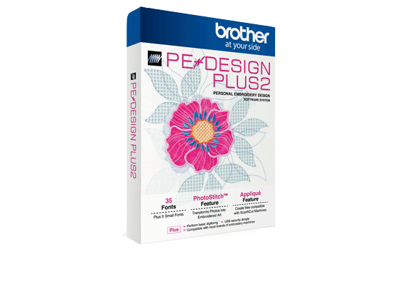

Figure 1: Pe-design

Comparison of Types of Data Created With PE-DESIGN PLUS
Three types of data are used in PE-DESIGN PLUS2.
- Stitch pattern: Most of built-in embroidery data
- Text pattern: Data created with the [Text] tools
- Shape pattern (Outline pattern): Data created with the [Shapes] tools.
- Stitch pattern
Stitch patterns can be arranged by rotating, flipping over and combining them.

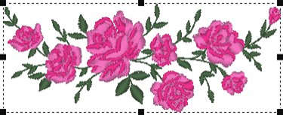

Figure 2: Stitch pattern

- Text pattern
You can edit text by entering/deleting characters, specify text attributes (such as the font or the transformation shape) and specify sewing attributes.



Figure 3: Text pattern

- Shape pattern
You can specify region and line sew types as well as sewing attributes, edit paths (by moving/deleting points, reshaping through handle movements), remove/merge overlapping regions, set hole sewing, and create offset lines.
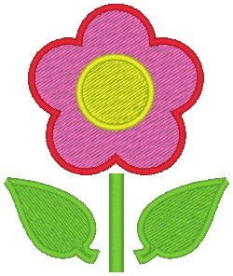

Figure 4: Collection Shape of pattern
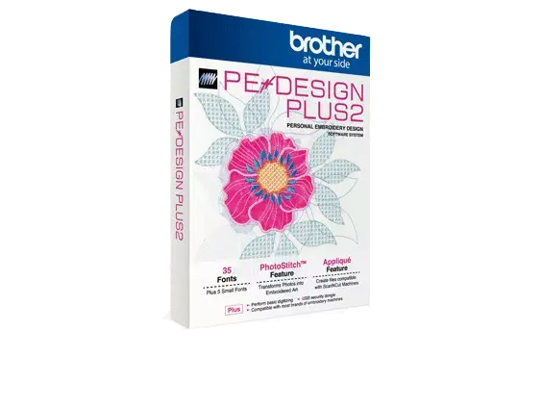

- Wilcom Embroidery Studio:
Wilcom Embroidery Studio is professional-grade software used by embroidery businesses. It offers a wide range of features, including digitizing tools, lettering options, and advanced editing capabilities. This software is known for its precision and high-quality results.



Figure 5: Wilcom Embroidery Studio

- Hatch Embroidery:
Hatch Embroidery is a popular choice for both beginners and professionals. It offers a user-friendly interface with a range of tools for creating and editing embroidery designs. It also includes a large library of built-in designs and fonts, making it easy to get started.
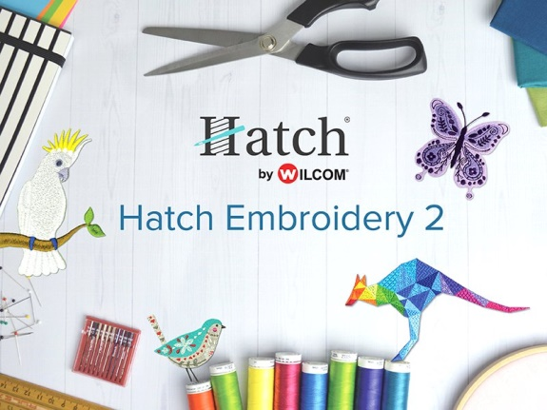

Figure 6: Hatch Embroidery symbol
- Embrilliance:

Embrilliance is comprehensive embroidery software that offers a range of tools for designing and editing embroidery patterns. It includes features such as lettering, monogramming, and appliqué design. Embrilliance also supports multiple file formats, making it compatible with various embroidery machines.

Figure 7: Embrilliance
- Floriani Total Control:

Floriani Total Control is a professional-grade embroidery software that provides advanced digitizing and editing capabilities. It offers features such as automatic image tracing, lettering options, and stitch editing tools. This software is known for its precision and ability to create intricate designs.

Figure 8: Floriani
- Sierra Embroidery Office

Sierra Embroidery Office is a feature-rich software program that caters to both beginners and professionals. It offers a wide range of tools for designing, editing, and digitizing embroidery Patterns.

Figure 9:Sierra Embroidery Office

Sierra Embroidery Office also includes advanced features like 3D preview and color sequencing.
- Janome Digitizer MBX:
Janome Digitizer MBX is powerful embroidery software that provides advanced digitizing and editing capabilities. It offers features such as automatic stitch generation, appliqué design, and 3D rendering. This software is known for its versatility and ability to create complex designs.

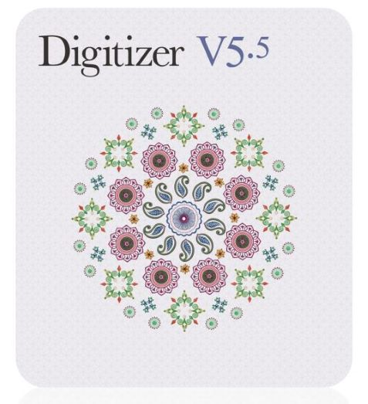

Figure 10: Janome Digitizer MBX

1.3 Garment considerations are identified
Performance wear takes even more consideration than more traditional garments. With stretch properties, slick finishes, synthetic fibers, and added athletic qualities, this ever-growing market continues to throw curveballs at embroiderers.
To increase your chances of coming out on top, be extra thoughtful with the following components in a performance job.
Garment sizing
Garment sizing is a critical factor to consider when accepting an embroidery order for a performance garment. These garments are designed to hug the body and can be less than flattering in many instances. Depending upon the garment, these shirts can run one to two sizes smaller, which means a customer who normally orders a medium can quickly find themselves in a large or extra-large garment.
Design selection
Design selection plays a critical role. Since a performance garment has stretch, it is susceptible to significant distortion. The more stitches we load into the design, the more likely distortion will occur. If you look at the embroidered logos of some of the large athletic companies that have built their brands around performance apparel, the embroidery is simple with a low-stitch count. In a custom world, we don’t always have control over the designs we sew. However, if you educate your customer in advance, they might provide a design better suited for a performance garment.
Backing
One of the roles of backing is to stabilize a garment to accept embroidery. A stretchy material defies stability. It wants to shift, stretch, contract, and dance around in the hoop. A typical “fix” to combat this is to load up on the backing to over-stabilize the material, which causes a thick, stiff look that is likely to cause skin irritation.
A great combination of backing is a poly mesh no-show backing paired with a light tearaway. This will provide stability, softness, and help prevent the backing from showing through to the front of the garment. If you require three sheets of heavy cutaway to avoid puckering, then there are design and density issues at play, rather than a backing issue. In some cases, a sticky backing or a fusible backing can be helpful.
Hooping
A really tight hooping that you can bounce a dime off of is perfect for a stretchy garment, right? Wrong! Common sense says if we want to prevent puckering, hoop it nice and tight so that the garment can’t distort. However, as said best by Sir Isaac Newton, “To every action, there is an equal and opposite reaction.” An overly tight hooping will cause the material to contract, causing more distortion than any embroidery ever could. The key is to hoop the garment tight enough so that there are no wrinkles in the material but not so tight that the material is stretching. It is also good practice to use the smallest possible hoop size for the design.
Design creation
Pathing (the traveling route) of the design is paramount. A performance garment will sew best with the same principles as pathing a design for a cap. Digitizing from the center out will significantly reduce any distortion as it keeps the fabric consistently moving away from itself. This will result in more color changes and trims in the design and significantly improve the end results.
Density also plays an imperative role. Too much density is sure to cause puckering or material distortion. A master density value of 4.0 pts., .40mm, or 63.5 SPI is a good starting point. Be prepared to adjust as needed but avoid extreme values.
Underlay
Underlay shares the responsibility with backing to stabilize a garment. If a design is comprised of a series of solid shapes, one of the best things to do with your underlay is lay it under a series of shapes. This will help hold the garment in place by adhering the garment to the backing, and, in turn, help to minimize distortion.
Embroidering on performance garments is not tricky. It merely requires you to put some additional thought into the process.
When creating embroidery designs, it's important to consider the type of garment or fabric you will be embroidering on. Here are some key considerations:
- Fabric type:
Different fabrics have different characteristics, such as stretchiness, thickness, and texture. These factors can affect the embroidery design and how it will look on the fabric. For example, a design with fine details may not show up well on a thick, textured fabric.
Generally, fabrics take the name of the fiber used to manufacture it such as fabrics made out of 100% Cashmere Fibers is named as Cashmere Fabric. However, certain fabrics although uses a particular fiber 100% or uses a blend of different fibers may be termed otherwise and are named depending on weaving patterns, texture, and the processes, etc. such as Organza fabrics were often used to produce with Silk, but even though they started using it with alternate fibers, it continued to be called as Organza Fabric.
Each fabric carries a unique name for it to be identified among others based on their textures, designs, weaving patterns, aesthetic values, fiber source, the place where the fabrics are originated, etc.
Aida cloth Fabric | Woven Fabric
Aida cloth is a cotton fabric with a natural mesh pattern generally used for cross-stitch embroidery. The open, even-weave Aida fabrics' natural stiffness enables the fabric the embroiders choice.
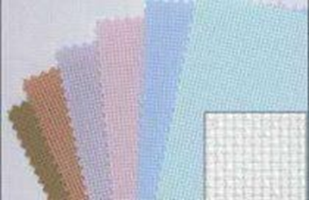

Figure 11: Aida cloth Fabric
- Fabric stability:
Some fabrics may require additional stabilization to prevent puckering or distortion during the embroidery process. This can include using backing or stabilizers to provide support and maintain the shape of the design.
Fabric stability refers to the ability of a textile to maintain its size and shape over time, without stretching or shrinking excessively. It is an important quality for many types of fabrics, particularly those used for clothing or home furnishings.
There are several factors that can affect fabric stability, including the fiber content, yarn structure, weaving or knitting technique, finishing processes, and care instructions. Fabrics made from natural fibers, such as cotton, wool, or silk, tend to be more prone to shrinking or stretching than synthetic fibers, such as polyester or nylon. The structure of the yarns used to create the fabric can also impact its stability, with tighter weaves or knits generally providing more stability.
Finishing processes, such as mercerization or heat-setting, can also improve fabric stability by reducing the likelihood of shrinkage or stretching. Care instructions, such as washing or drying temperature, can also impact fabric stability, with high heat or improper washing techniques leading to shrinking or stretching.
Top users of fabric stability include clothing manufacturers, home furnishing manufacturers, and consumers. Clothing manufacturers require fabrics that maintain their shape and size after multiple washings or wearing, while home furnishing manufacturers require fabrics that can withstand the wear and tear of daily use. Consumers also look for fabrics that maintain their appearance and fit over time.
- Embroidery placement:
Consider the placement of the embroidery design on the garment. Factors such as size, shape, and orientation of the design should be taken into account to ensure it fits and looks aesthetically pleasing on the garment.
- Design complexity:
The complexity of the design should also be considered. Intricate designs with small details may not work well on certain fabrics or garments, while simpler designs may be more suitable.
- Garment construction:
Take into consideration the construction of the garment, such as seams, pockets, or zippers. These elements may impact the placement and size of the embroidery design.
- Color choices:
Consider the color of the fabric and how it will interact with the thread colors used in the embroidery design. High contrast between the fabric and thread colors can create a visually striking design, while low contrast may result in a more subtle effect.
By considering these factors, you can ensure that your embroidery designs are well-suited to the garments or fabrics you are working with, resulting in professional and visually appealing finished products.

1.4 Machine requirements are identified
When creating digital embroidery designs, it's important to consider the requirements of the embroidery machine you will be using. Here are some key considerations:
- File format:
Different embroidery machines may require different file formats for the designs. Common file formats include .dst, .pes, .exp, and .jef. Make sure to save your design in a compatible format for your specific machine.
Well, the simplest answer is that there is no common file system because the embroidery industry brands don’t want there to be one. Having a unique file system, which is proprietary to their devices, allows them to ensure a closed ecosystem and to keep the client loyal.
Embroidery Machine File Formats
A client who has spent five years building a database of thousands of embroidery designs stored in one format, such as JEF, is going to be less likely to go out and buy a machine from another manufacturer, such as Brother. The reason is that his database would be incompatible with the new machine, which only uses PES format, and the client would either be forced to start from scratch, or remain with the old manufacturer, to save costs and time.
Because of this, and to ensure your peace of mind, when a time comes that you decide to switch machine brands with all of our embroidery designs, our embroidery digitizing team will provide you with the main embroidery machine formats at once, to reduce downtime and increase efficiency.
Different embroidery machine file formats
As outlined above, nearly every embroidery machine brand in the embroidery industry has developed and implemented their own file format for embroidery designs, which will only work on the file format specific machines.
One thing to understand is that the majority of the embroidery designs that you purchase were not originally made in the file format for home embroidery market (such as JEF and PES). In fact, most of these designs are compiled using professional grade embroidery digitizing software which usually saves the design work in a strong vector-based format (e.g., EMB or PXF). These ‘master’ files are later converted to formats such as JEF and PES embroidery machines formats so that they can be used with your machines.
You can consult the list below for a brief overlook of which file format is compatible with which embroidery machine brand. This list mentions the primary ones, and there are many more that have not been mentioned here.
Embroidery Machine Brand Embroidery Stitch File Format
Janome-----------------------------------------------------------------.JEF
Bernina----------------------------------------------------------------.ART
Husqvarna / Viking------------------------------ .HUS & .VP3 & .VIP
Brother / Babylock / Deco---------------------------------.PES / .PEC
Singer------------------------------------------------------------.XXX
Pfaff------------------------------------------------------.PCD / .PCM / .PCS
Tajima-----------------------------------------------------------------.DST
Melco / Bravo------------------------------------------------------.EXP
- Stitch count:
Embroidery machines have limitations on the number of stitches they can handle. It's important to consider the stitch count of your design and ensure it falls within the machine's capabilities. Designs with a high stitch count may require more time and resources to embroider.
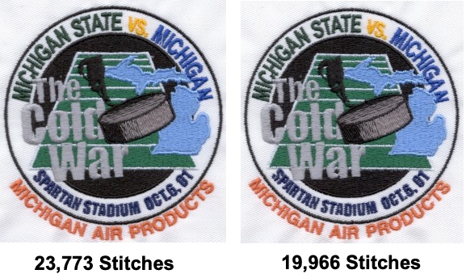
Figure 12: number of stitches
- Hoop size:
Embroidery machines use hoops to hold the fabric in place during the embroidery process. Each machine has specific hoop sizes available, and it's important to choose a design that fits within the dimensions of your machine's largest hoop.
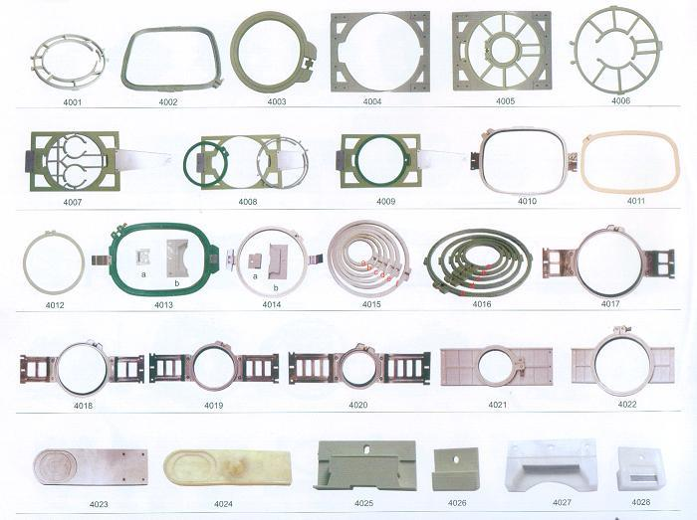

Figure 13: specific hoop sizes
- Thread: colors
Consider the number of thread colors used in your design and ensure that your machine has enough thread cones or spools to complete the design. Some machines have a limited number of thread color options, so it's important to plan accordingly.
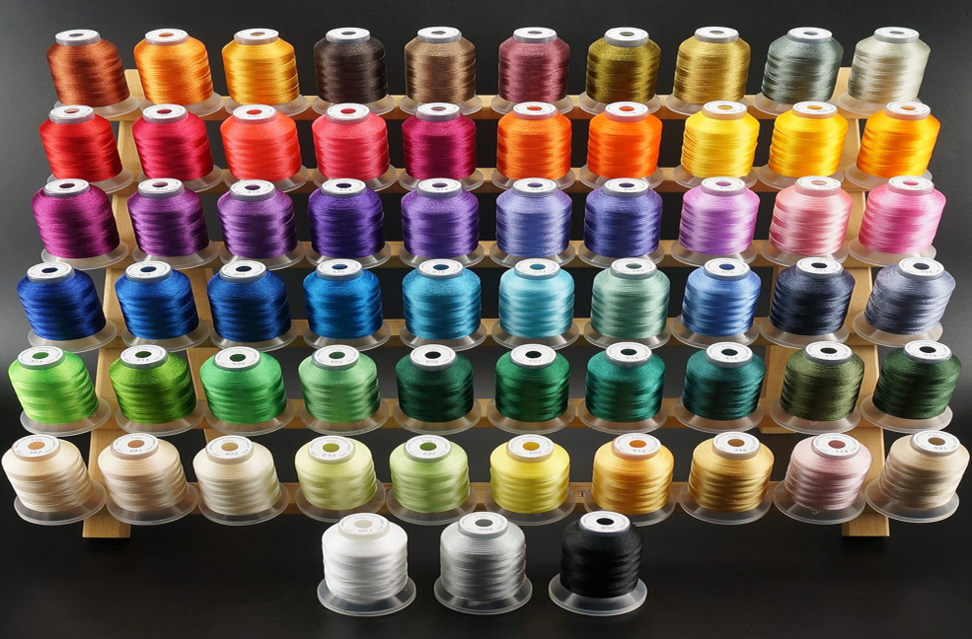
Figure 14: the number of thread colors used in your design

- Machine capabilities:
Different embroidery machines have different capabilities and features. Some machines may have built-in designs or fonts that can be used, while others may have limitations on design size or stitch types. Familiarize yourself with the capabilities of your machine and design accordingly.
By considering these machine requirements, you can ensure that your digital embroidery designs are compatible with your specific embroidery machine, resulting in successful and efficient embroidery projects.
Explore the best computer embroidery machine models and turn the simplest designs into professional-quality projects.
Embroidery is a beautiful, timeless craft that goes back thousands of years. It was first used as a way to decorate clothing and it has grown in popularity since.
Embroidery machines have been used since the 19th century, but they were expensive and available to people who could afford them. In recent years, embroidery machines have become more affordable and are now available to anyone who wants one.
There are several different types of embroidery machines available on the market, from traditional manual ones to computerized/automated ones that can create high-quality designs with no human intervention at all. Some embroidery machines are built solely for embroidery purposes, while other embroidery machines are combination machines that can accomplish both embroidery and sewing functions.
A computerized embroidery machine is an excellent investment for anyone who loves to do embroidery. It may help you enhance productivity and revenues while also streamlining your workflow and making it simpler for you and your staff to accomplish their tasks.
Buying a computerized embroidery machine might be challenging, but it does not have to be. You can make an informed decision that meets your demands and budget if you have the correct information.
If you want to buy a computerized embroidery machine, you’ve come to the right place. We evaluated the top models available and compiled this guide to assist you in making an informed decision.
A computerized embroidery machine is an embroidery machine that connects to the computer.
When you’re thinking about purchasing the best embroidery sewing machine, there are a lot of questions to ask yourself. You want to ensure you’re getting the best machine for your needs.
Whether you’re planning on using it for personal use or in your small business, here are five reasons why going with the best computer embroidery machine is the right choice:
EASY TO UNDERSTAND AND OPERATE
Computer embroidery machines are easy to understand and operate. Unlike traditional manual embroidery machines, which can be difficult to learn how to use, computerized embroidery machines are designed for simplicity.
They have a simple touchscreen interface that allows you to set up your machine and start stitching with utmost ease. You do not need any prior experience or training in order to use these machines in the most effective way.
It’s as simple as loading your design file and pressing “go!” The machine will do all the work for you, from stitching out your pattern to ensuring your thread doesn’t break or run out before completing a stitch.
DURABILITY
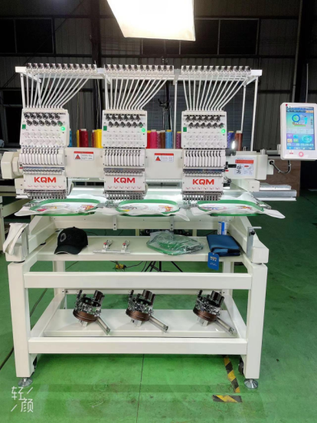
Computer embroidery machines can be used for decades if they are well-maintained and cared for. The embroidery machine for sale is made of high-quality materials, so they will not rust or break down.

Figure 15: Tajima digital embroidery machine

COST-EFFICIENCY
The best embroidery machines are built with superior-quality parts and are designed to last. They will save you money over time in repairs and replacement costs compared to other types of machines.
VERSATILITY
A good computer embroidery machine can do more than just stitch designs on fabric. It can also cut out designs from paper or cardboard!
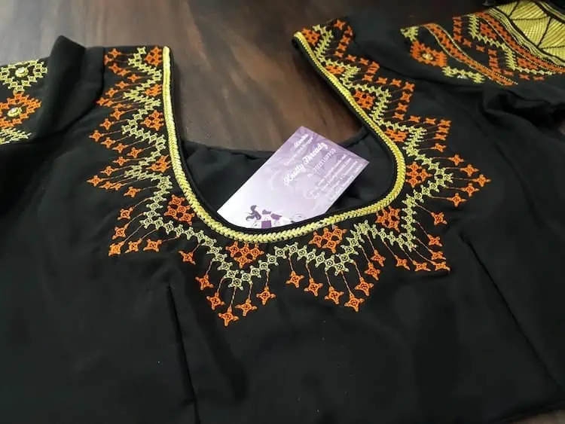
This makes it easy for crafters who want to make their own apparel or other items at home without having to head out into town every time they need something new for their hobby projects (or maybe evens their side hustle).

Figure 16: digital embroidery software versatility

MORE PRODUCTIVITY
Another reason you should go for a computer/commercial embroidery machine is that it will allow you to produce more products in less time!
This means that if you have been struggling with producing enough products for your customers, then this will be 100% solved.

1.4.1 Machine specification
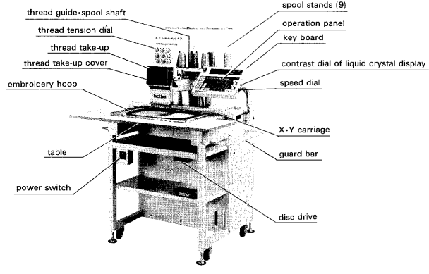

Figure 17: Machine specification

Self-check-1

Part I From the following question choose best answer letter and circle it.
1. What is the main difference between traditional embroidery and machine embroidery?
a) Traditional embroidery uses sewing threads to create designs, while machine embroidery uses digital patterns and stitches.
b) Traditional embroidery is done by hand, while machine embroidery is done using automated equipment.
c) Traditional embroidery is more popular than machine embroidery in the 20th century.
2. What are the two main stages of machine embroidery production?
a) Design development and fabric selection
b) Machine programming and final product creation
c) Client meeting and specification document creation
3. Why is it important to seek client approval before starting the actual embroidery process?
a) To ensure alignment with the client's expectations
b) To save time and avoid unnecessary revisions
c) To showcase expertise and knowledge of embroidery design techniques
4. What is the main advantage of using PE-DESIGN PLUS embroidery software?
a) It has an advanced user-friendly interface.
b) It offers a wide variety of design shapes and options.
c) It allows for easy conversion of images into embroidery designs.
5. Why is garment sizing important when accepting an embroidery order for a performance garment?
a) Performance garments can run smaller in size compared to regular garments.
b) Performance garments have stretch and are prone to distortion.
c) Garment sizing affects the overall appearance and fit of the embroidery.
6. What is the recommended combination of backing for stabilizing a performance garment for embroidery?
a) Heavy cutaway and tear away backing
b) Poly mesh no-show backing and light tear away backing
c) Sticky backing and fusible backing
7. What is the purpose of design software in digital embroidery?
a) To hold the lower thread in place
b) To pierce the fabric and carry the thread through it
c) To create or edit embroidery designs
d) To provide support and prevent fabric distortion

8. What type of stabilizer is used to dissolve in water after embroidery is complete?
a) Cut-away stabilizer
b) Tear-away stabilizer
c) Water-soluble stabilizer
d) Fusible stabilizer

9. What is the role of needles in digital embroidery?
a) To hold the lower thread in place
b) To pierce the fabric and carry the thread through it
c) To provide support and prevent fabric distortion
d) To secure the fabric during the embroidery process

10. Which type of thread offers characteristics such as sheen, strength, and color vibrancy?
a) Cotton thread
b) Polyester thread
c) Rayon thread
d) Metallic thread

11. What is the purpose of hoops or frames in digital embroidery?
a) To provide support and prevent fabric distortion
b) To add color and texture to the design
c) To hold the lower thread in place
d) To secure the fabric during the embroidery process
12. What should be considered when selecting materials for digital embroidery?
a) The compatibility with the embroidery machine and specific design requirements
b) The availability of materials at local craft stores
c) The cost of materials
d) The weight and texture of the fabric
13. What holds the lower thread that forms the underside of the embroidery stitches?
a) Needles
b) Bobbins
c) Hoops or frames
d) Stabilizers
14. What is the purpose of bobbins in digital embroidery?
a) To provide support and prevent fabric distortion
b) To hold the lower thread in place
c) To secure the fabric during the embroidery process
d) To add color and texture to the design
15. What is the purpose of stabilizers in digital embroidery?
a) To provide support and prevent fabric distortion
b) To add color and texture to the design
c) To hold the lower thread in place
d) To secure the fabric during the embroidery process
16. What is the purpose of a computerized embroidery machine?
a) To connect to a computer for design input
b) To add color and texture to the design
c) To hold the lower thread in place
d) To secure the fabric during the embroidery process

Unit Two: Create design
This unit to provide you the necessary information regarding the following content coverage and topics:
- Applying OHS practice
- Preparing Existing embroidered design details for presentation
- Reviewing the design to gain approval for development.
- Developing a design concept
- Developing design specifications
- Creating design portfolio.
- Selecting embroidery software for specific design
This guide will also assist you to attain the learning outcomes stated in the cover page. Specifically, upon completion of this learning guide, you will be able to:
  - Understand Applying OHS practice
  - Discus and understand Preparing Existing embroidered design details for presentation
  - Understand reviewing the design to gain approval for development.
  - Understand Developing a design concept
  - Identifies Developing design specifications
  - Understand Creating design portfolio.
  - Identifies and Selecting embroidery software for specific design

2.1 Applying OHS practice
The objective of this issuance is to protect every workingman against the dangers of injury, sickness or death through safe and healthful working conditions, thereby assuring the conservation of valuable manpower resources and the prevention of loss or damage to lives and properties, consistent with national development goals and with the State’s commitment for the total development of every worker as a complete human being.
When applying OHS practices to digital embroidery, there are several considerations to keep in mind:
Ergonomics: Ensure that the workstation and equipment are set up ergonomically to prevent musculoskeletal injuries. This includes having an adjustable chair, proper lighting, and positioning the embroidery machine and computer at a comfortable height.
Noise exposure: Embroidery machines can produce high levels of noise during operation. Implement measures to reduce noise exposure, such as using noise-cancelling headphones or earplugs, or scheduling regular breaks in quieter areas.
Eye safety: Embroidery machines use sharp needles and can have fast-moving parts. Wear appropriate eye protection, such as safety glasses or goggles, to prevent eye injuries from flying debris or accidental needle strikes.
Electrical safety: Ensure that the embroidery machine is properly grounded and that all electrical cords are in good condition. Avoid overloading electrical outlets and use surge protectors to prevent electrical hazards.
Hazardous materials: Some embroidery processes may involve the use of chemicals, such as solvents for cleaning or adhesives for stabilizing fabric. Follow proper handling and storage procedures for these materials, including using them in well-ventilated areas and wearing appropriate personal protective equipment (PPE) such as gloves or respirators.
Training and supervision: Provide adequate training to employees on the safe operation of embroidery machines, including proper use of tools, equipment, and PPE. Regularly supervise employees to ensure they are following safe work practices and address any concerns or issues promptly. By implementing these OHS practices, you can create a safe working environment for digital embroidery and reduce the risk of accidents or injuries.

2.2. Assessing client profile information to determine approach
When preparing existing digital embroidered design details for presentation, there are a few considerations to keep in mind
- Quality control
Before presenting the design details, ensure that the embroidery work is of high quality. Check for any loose threads, uneven stitches, or other imperfections that may affect the overall appearance of the design. Make any necessary adjustments or repairs to ensure a polished and professional result.
- Presentation format
Decide on the best format for presenting the design details. This could include creating digital images or photographs of the embroidery work, printing out physical samples, or using a combination of both. Consider the purpose of the presentation and the intended audience to determine the most effective format.
- Lighting and background
When photographing or capturing digital images of the embroidery work, pay attention to lighting and background. Use natural light or well-placed artificial lighting to highlight the details and colors of the design. Choose a clean and neutral background that does not distract from the embroidery itself.
- Documentation
Keep detailed documentation of the design details, including information such as thread colors, stitch types, and any special techniques used. This documentation can be helpful for future reference or if any modifications or reproductions of the design are needed.
- Presentation materials
If printing out physical samples, use high-quality paper or fabric that showcases the embroidery work effectively. Consider using a clear protective cover or sleeve to prevent damage or smudging during handling.
- Communication
Clearly communicate the inspiration, concept, and story behind the design details. Provide any relevant information about the materials used, the intended application or purpose of the design, and any unique features or techniques employed.

2.3 Reviewing the design to gain approval for development.
When reviewing the digital embroidery design for approval, there are a few important
- Accuracy:
Ensure that the digital design accurately represents the intended embroidery work. Compare the digital design to any reference images or sketches to confirm that all details and elements are correctly depicted.
- Technical specifications
Review the technical specifications of the design, such as stitch count, thread colors, and dimensions. Confirm that these specifications align with the desired outcome and any limitations or requirements set by the production process.
- Compatibility
Check that the digital design is compatible with the embroidery machine or software being used for production. Verify that the file format is appropriate and that any special settings or adjustments needed for the specific equipment are accounted for.
- Design integrity
Evaluate the overall design integrity, including elements such as proportion, balance, and clarity. Ensure that the design is visually appealing and effectively conveys the intended message or aesthetic.
- Feedback and revisions
If necessary, provide feedback and request revisions to the digital design. Clearly communicate any changes or adjustments that need to be made, and work collaboratively with the designer or team to achieve the desired result.
- Approval process
Establish a clear approval process for the digital embroidery design. This may involve obtaining sign-off from multiple stakeholders or following a specific workflow within your organization. Document any approvals or feedback received for future reference.
By carefully reviewing and gaining approval for the digital embroidery design, you can ensure that it meets all requirements and is ready for development and production. Accordance with the business strategy

2.4. Developing a design concept
Developing a digital embroidery design concept involves gathering all necessary information to inform the design process. This includes:
- Understanding the purpose:
Determine the purpose of the embroidery design, whether it is for branding, personalization, or decorative purposes. Clarify the desired outcome and any specific objectives or goals.
- Gathering reference materials
Collect any reference images, sketches, or inspiration that can help guide the design process. This could include logos, patterns, colours palettes, or other visual elements that are relevant to the design concept.
- Considering the medium
Understand the medium in which the embroidery design will be used. Consider factors such as the fabric type, size and shape of the embroidery area, and any technical limitations or requirements that may impact the design.
- Defining the message or theme:
Determine the message or theme that the embroidery design should convey. This could be a specific message or a broader aesthetic or style. Consider the target audience and their preferences to ensure the design resonates with them.
- Sketching and ideation
Begin the design process by sketching out ideas and exploring different concepts. Experiment with various layouts, compositions, and elements to find the most effective design solution.
- Selecting colours and textures
Choose appropriate colours and textures that align with the intended message or theme of the design. Consider how different thread colours will interact with each other and with the chosen fabric.
- Incorporating branding elements
If the embroidery design is for branding purposes, ensure that it incorporates relevant branding elements such as logos, fonts, or taglines. Maintain consistency with existing brand guidelines.
- Reviewing and refining
Continuously review and refine the design concept based on feedback and input from stakeholders. Seek input from others to ensure the design meets all requirements and effectively communicates the desired message.

2.5. Developing design specifications
The first step in embroidered custom decorated apparel is having an acceptable and accurate art file to work from.
All digital files are redrawn as virtual stitches to communicate the design to the embroidery machine. The process for redrawing a design or logo as stitches is called digitizing. The cleanest files produce the perfect embroidery.

2.5.1. Main points of embroidery SPEC
Letter Size – Letters can be no smaller than .25″ or they will not embroider well.
Detail – Super fine detail will likely be compromised. Most embroidered logos are small by nature, thread is a fixed width and the fabric adds an element of compromise.
Gradients –
Complicated gradients can sew very well. Keep in mind, however, that stitches do not blend, so the gradient will be less smooth in appearance than what you see on your computer screen.
PREFERRED FORMAT
Vector files (ai, eps, pdf) with fonts converted to outlines. This format produces the highest quality embroidery.
ACCEPTABLE FORMAT
Raster files (jpg, tif, gif, png, eps) at a minimum of 150dpi at the final image size. These images, designs, or logos are composed of pixels rather than paths. When zoomed in it is more difficult to see detail and where shapes begin and end. For this reason a digitizer must do some creative estimating. Your end embroidery may not be as exact as you would like it to be.
Developing design specifications for digital embroidery involves translating the design concept into specific technical requirements that can be implemented by embroidery machines. This includes:

- Determining the embroidery size and placement
Specify the dimensions and location of the embroidery design on the garment or fabric. Consider factors such as the available embroidery area, the desired visibility of the design, and any restrictions or guidelines provided by the manufacturer.
- Selecting appropriate stitch types
Choose the types of stitches that will be used in the embroidery design. This could include satin stitches; fill stitches, running stitches, or specialty stitches. Consider the desired effect and texture of the design when selecting stitch types.

- Defining stitch density
Specify the density of stitches within the design. This refers to the number of stitches per unit area and can impact the overall appearance and durability of the embroidery. Consider factors such as the fabric type, thread thickness, and desired level of detail when determining stitch density.
- Choosing thread colors
Specify the colors of threads that will be used in the embroidery design. Consider factors such as brand guidelines, color palettes, and the desired visual impact of the design. Provide specific color codes or references to ensure accuracy in thread selection.
- Identifying any special effects or techniques
If the embroidery design requires any special effects or techniques, such as metallic threads, sequins, or appliqué, specify these requirements. Provide detailed instructions or references to ensure proper execution.
- Providing artwork files
Prepare and provide the necessary digital artwork files for the embroidery design. This could include vector files in formats such as .ai or .eps, or high-resolution raster files in formats such as .jpeg or .png. Ensure that the artwork files are compatible with the embroidery software and machines being used.

2.6. Creating design portfolio
When creating a design portfolio for digital embroidery, it is important to showcase your skills and creativity in a visually appealing and organized manner.
1. Start with a strong introduction: Begin your portfolio with a brief introduction that highlights your experience, skills, and passion for digital embroidery. This can include a short bio and an overview of your design style.
2. Include a variety of designs: Include a diverse range of embroidery designs in your portfolio to showcase your versatility and ability to work with different styles, techniques, and themes. Include both simple and complex designs to demonstrate your proficiency.


Figure 18: embroidery portfolio
3. Organize your portfolio: Arrange your designs in a logical and organized manner. You can categorize them by theme, technique, or type of garment. This will make it easier for potential clients or employers to navigate through your portfolio.
4. Provide detailed descriptions: For each design, provide a brief description that explains the concept, inspiration, and any unique features or techniques used. This will give viewers a better understanding of your design process and creative thinking.
5. Show the design process: Consider including sketches, digital mock-ups, or work-in-progress images to show the evolution of your designs. This will give viewers insight into your design process and attention to detail.
6. Showcase finished products: If possible, include high-quality photographs of finished embroidery pieces to show how your designs translate into real-life products. This will give potential clients or employers a better sense of how your designs look when executed.
7. Highlight technical skills: In addition to showcasing your designs, highlight any technical skills or software proficiency you have in digital embroidery. This can include knowledge of specific embroidery software programs or expertise in digitizing designs.
8. Keep it visually appealing: Pay attention to the overall aesthetics of your portfolio. Use high-quality images, consistent formatting, and a cohesive color scheme to create a visually appealing and professional-looking portfolio.
9. Keep it concise: While it's important to showcase a variety of designs, be mindful of the length of your portfolio. Include your best and most representative designs, but avoid overwhelming viewers with too many examples.

10. Update regularly: As you create new designs or improve your skills, update your portfolio regularly to keep it current and relevant. This will show potential clients or employers that you are actively engaged in your craft.

Self-check-2
Direction: - Answer the following question

Unit Three: Editing a design
This learning guide is developed to provide you the necessary information regarding the following content coverage and topics:
- Editing design or image.
- Importing designs into software programs.
- Editing a design based on the embroidery machine
- Determining and considering the embroidery machine and material for production.
- Recording a design work.
- Identifying the embroidering garment component based on production plan.
This guide will also assist you to attain the learning outcomes stated in the cover page. Specifically, upon completion of this learning guide, you will be able to:
- Understand and Editing design or image.
- Understand Importing designs into software programs.
- Understand Editing a design based on the embroidery machine
- Identifies Determining and considering the embroidery machine and material for production.
- Understand recording a design work.
- Understand Identifying the embroidering garment component based on production plan.

Editing design or image
Step 1 Importing image data into Layout & Editing.
Step 2 Starting the Auto Punch wizard.
Step 3 applying an image mask and adjusting its size and position.
Step 4 creating a border from the mask outline and converting to an embroidery pattern.
To edit a design or image using PE-Design software, follow these steps:
1. Open the PE-Design software on your computer.
2. Import the design or image that you want to edit. You can do this by clicking on the "File" menu and selecting "Import" or by using the shortcut Ctrl+I.
Importing vector images (WMF/EMF/SVG)
Vector image data in the ".wmf" (Windows Metafile), ".emf" (Enhanced Metafile) and ".svg" (Scalable Vector Graphics) file formats can be converted to shape patterns.
Click the [Home] tab.
Click [Import Patterns] in the [Import] group, and then click [from Vector Image].
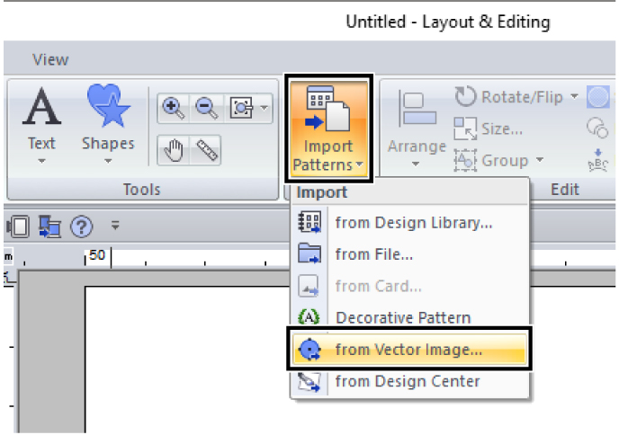

Figure 19: Importing patterns
Others option

- Select the drive, folder and file, and then click [Open].
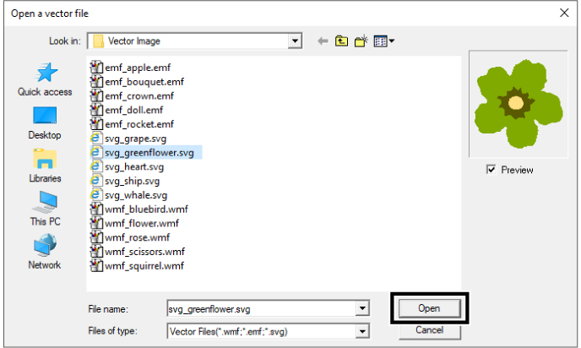
Figure 20: The imported image appears in the Design Page
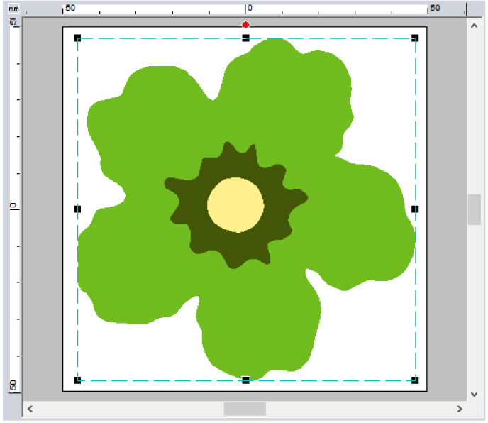
Figure 21: Importing vector images
Image, text, width of the line, gradient, opacity, and any other styles or attributes of graphics will not be imported. With files in the ".emf" and ".svg" formats, the data is converted while retaining curves.
The data on all layers of an SVG file, regardless of whether it is displayed or hidden, will be converted into the embroidery pattern.

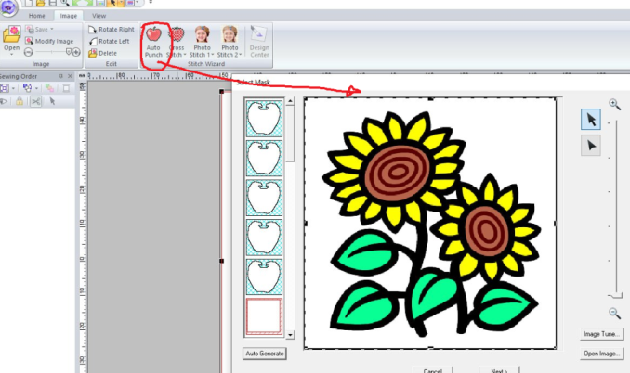

Figure 22:1st step of auto punch
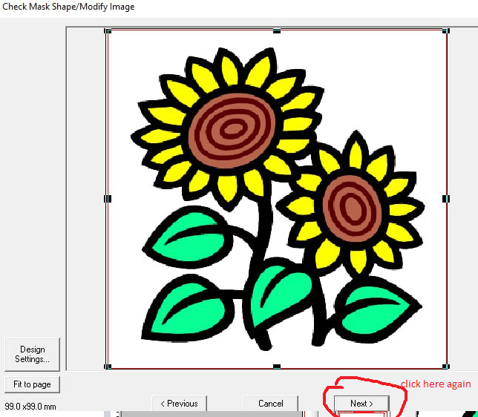

Figure 23: 2nd step of auto punch
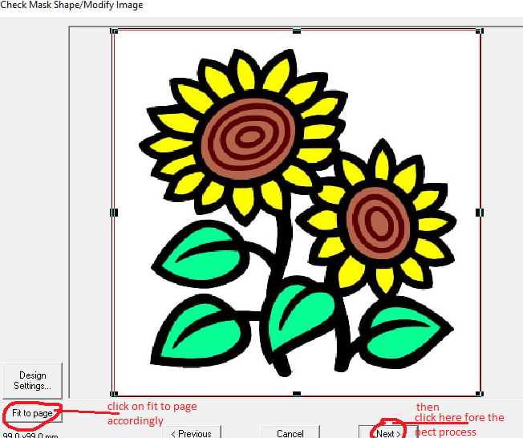

Figure 24: 3rd step of auto punch
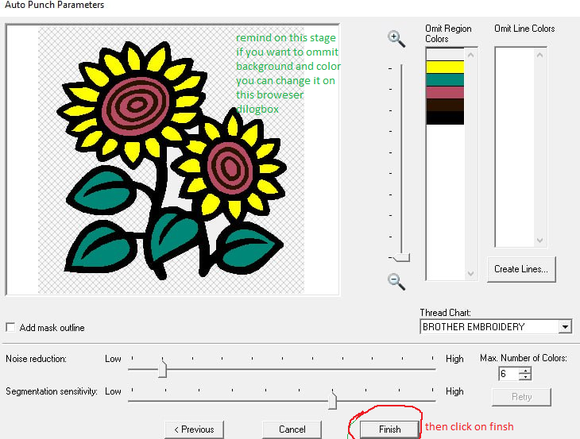

Figure 25: 4th step of auto punch
- Once the design or image is imported, you can start editing it. PE-Design offers various editing tools that you can use to modify the design.
- To resize the design or image, select the design and click on the "Edit" menu. From there, choose the "Resize" option and enter the desired dimensions or percentage.
- To change the colours of the design, select the design and click on the "Edit" menu. Choose the "colour Palette" option and select the colours you want to use.
- If you want to add text to the design, click on the "Text" tool in the toolbar. Then, click on the area where you want to add the text and type in your desired text. You can customize the font, size, and other text properties in the Text Properties panel.
- If you want to add additional shapes or elements to the design, use the drawing tools available in the toolbar. You can draw lines, curves, rectangles, circles, and more.
- After making all the desired edits, save your design by clicking on the "File" menu and selecting "Save" or using the shortcut Ctrl+S.
- If you want to export the edited design to a specific embroidery machine format, click on the "File" menu and select "Export." Choose the desired format from the list and save the file.
10. Finally, preview your edited design by clicking on the "Preview" button in the toolbar. This will show you how the design will look when embroidered.

Step 5 Importing into Layout & Editing
In Design Centre, embroidery patterns can be created from an original image. In addition, you can specify colours and sewing attributes for the lines and regions that are more detailed than those specified with the [Auto Punch] function in Layout & Editing.
An embroidery design is created in the following four stages.
Step 1  Original Image Stage | Step 2  Line Image Stage | Step 3  Figure Handle Stage | Step 4  Sew Setting Stage
 | 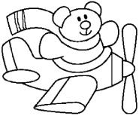 | 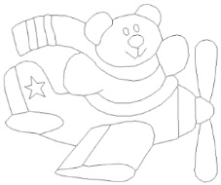 | 
Open an image file, and select the colours to be used for creating the outlines. | The original image is converted to a black-and-white line image.  Outlines can be drawn or erased. | The line image is converted to a figure handle image.  Points in the figure handle image can be edited to change the design. | The sew type and thread colours are specified in the outline to complete the embroidery design.
 | Example:  The stripes in the scarf are erased.  Stripes are added to the scarf. | Example:  The eyes are moved, and the facial expression is changed.  A star is added to the tail of the plane. | Example:  By applying colours different than in the original image, the design is given a different appearance.
- If the data is saved, work can be stopped at each stage, then started again.
- The most appropriate images to use are those with few and distinct colours. Images or photos that are intricate or have gradations are not suitable since it is difficult to extract their outlines.
- Line image data is saved in the .pel format, and figure handle data is saved in the .pem format.
- The embroidery data is saved in the .pem format. To transfer .pem data created in Design Centred to an embroidery machine, import the pattern into Layout & Editing, and then transfer the data to an embroidery machine.
Importing into Layout & Editing and Transferring Embroidery Designs to Machines

Importing designs into software programs.

To import designs into the PE-Design software program steps

- Launch the PE-Design software on your computer.


- Click on the "File" menu at the top left corner of the program's interface.

- From the drop-down menu, select "Import" or "Open" option, depending on the version of the software you are using.

- A file browser window will appear, allowing you to navigate to the location where your designs are saved

- Browse to the folder where your design files are stored, and select the design file you want to import.

- Click on the "Open" button to import the selected design into the PE-Design software.

- The imported design will appear on your workspace, where you can further edit or customize it if needed

3.1.1. Drawing, importing and moving shapes
Shapes can be created either by drawing them with the Shapes tools or by importing sample shape patterns.
- To draw a shape, select a Shapes tool, and then drag the pointer in the Design Page to draw the shape.
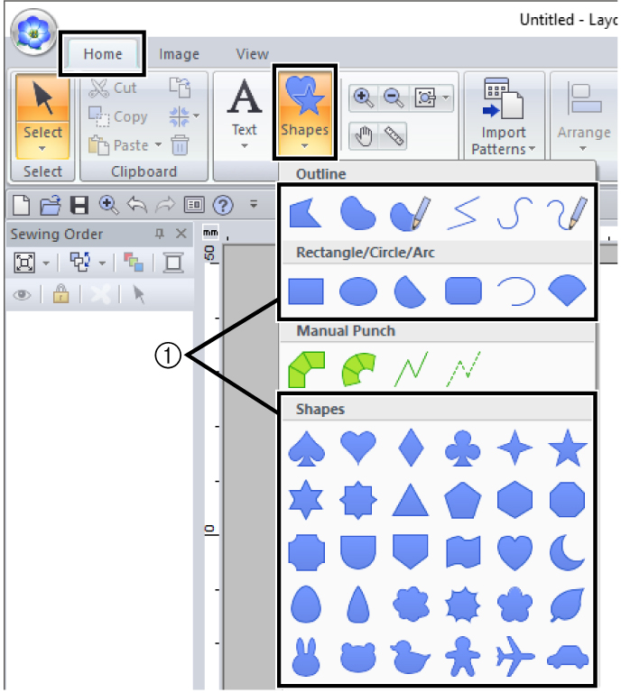

Figure 26: select a Shapes tool
- Shapes tools
- To import a shape, select [Outline Shapes] from the [From] selector of the [Import] pane, then [Basic Shapes] from the [Category] selector. Select the shape, and then click [Import].
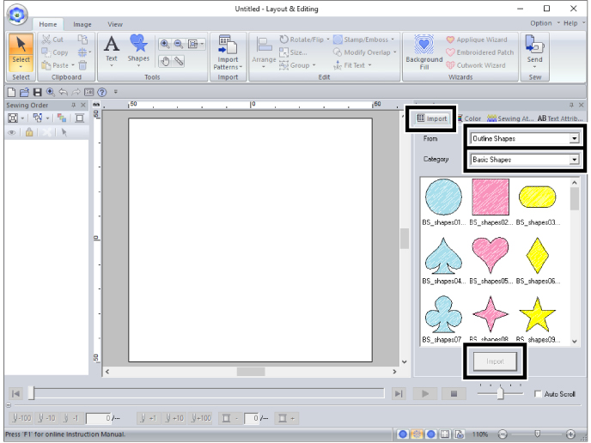

Figure 27: Select the shape

Specify the sew types for the shape on the [Shapes] tab, and the thread colours on the [Shapes] tab or the [colour] pane.
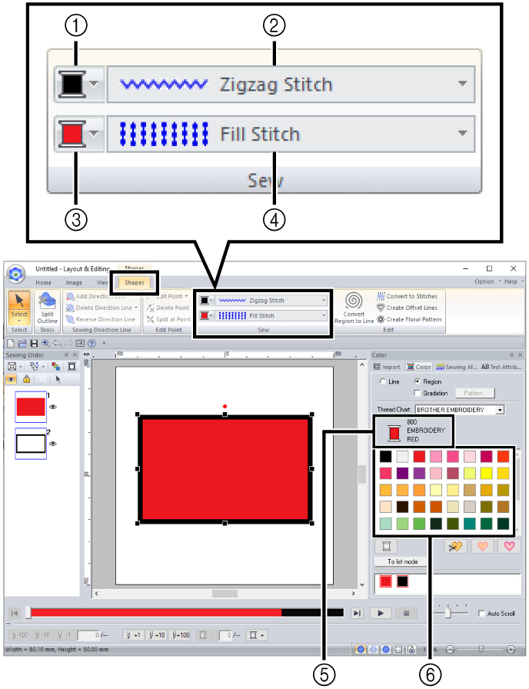
Figure 28: the sew types $ thread colors

  - Line colour button
- Line sew type selector
- Region colour button
- Region sew type selector
- Selected thread color and color name
- Thread colour palette
Draw the stem.
Click the [Home] tab.
  - Click [Shapes] in the [Tools] group, and then click.
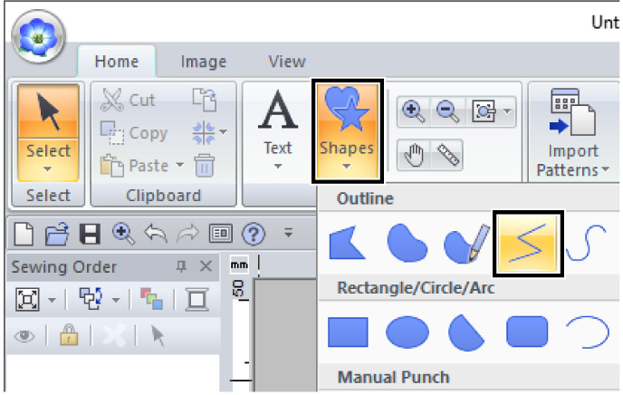

Figure 29: shapes
  - Click the [colour] tab to display the colour palette.
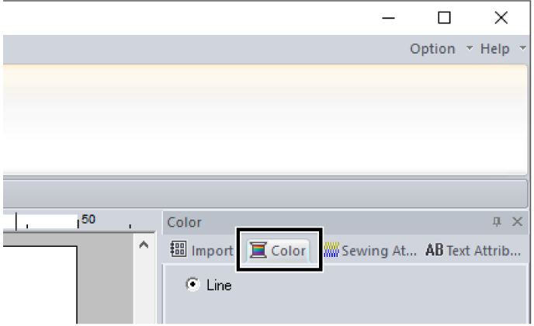
Click [LIMEGREEN].
If the desired colon is not displayed, move the scroll bar until it appears.
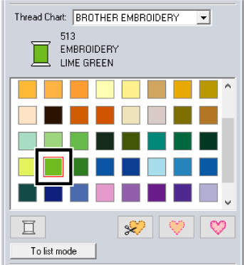
Figure 30: color attribute

To view the thread colours in a list so that the desired colour can more easily be found, click [To list mode].
Setting the sew type
  - Click the [Line sew type] selector, and then select [Zigzag Stitch].
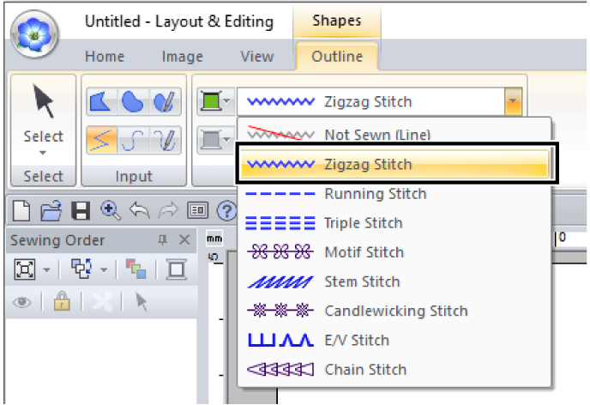
Figure 31: Sewing attribute or types
  - Click the start point 1, and then double-click the end point 2.

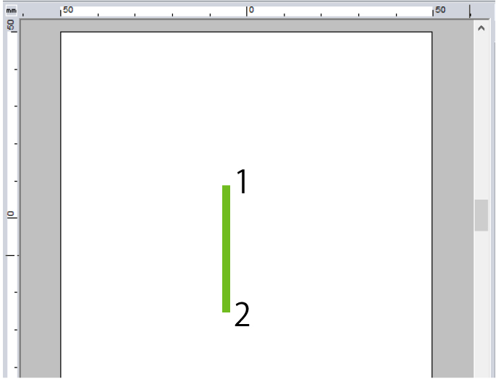
Figure 32: color adjusting
The colour, sewing attributes and size can also be changed after the shape is drawn.

Editing a design based on the embroidery machine
To edit a design in the PE-Design software for a digital embroidery machine:
1. Open the PE-Design software on your computer.
2. Click on the "File" menu and select "Open" to browse and locate the design file you want to edit. Click "Open" to load the design into the software.
3. Once the design is open, you will see various editing tools and options in the program's interface.
4. To select specific elements or parts of the design that you want to edit, use the selection tool. Click and drag to create a selection box around the desired area.
5. After selecting the desired elements, you can perform various editing functions using the appropriate tools in the software. For example, you can resize the selected elements by clicking and dragging the corner handles or entering specific dimensions in the resizing options.
6. To rotate the selected elements, click and drag the rotation handle or enter a specific angle in the rotation options.

7. If you want to mirror the selected elements, click on the mirror tool and choose the desired mirroring direction.
8. To move the selected elements, click and drag them to the desired location on the design canvas.
9. To change the colours of the design, use the colour palette or colour selector tool in the software. You can select different thread colours and apply them to different parts of the design.
10. If you want to add additional elements or text to the design, use the drawing or text tools in the software. You can create shapes, lines, curves, or add text in different fonts and sizes.
11. Once you have made the desired edits, save your changes by clicking on the "File" menu and selecting the "Save" option. You can also save the edited design under a new file name if you want to keep the original design unchanged.
12. After saving, you can transfer the edited design to your digital embroidery machine using a USB drive or other compatible methods, and proceed with the embroidery process.

Determining and considering the embroidery machine and material for production.
When editing a design in the PE-Design software for a digital embroidery machine, it is important to consider the capabilities and limitations of your embroidery machine and the material you will be using for production. Here are some factors to consider:
1. Machine Compatibility: Ensure that the design you are editing is compatible with your specific embroidery machine. Different machines have different file format requirements, so make sure the design file you are working with can be read by your machine.
2. Hoop Size: Consider the size of the hoop or embroidery area on your machine. Make sure the design you are editing fits within the maximum dimensions of your machine's embroidery area. If necessary, resize or reposition elements to fit within the available space.
3. Stitch Density: Pay attention to the stitch density of the design. Dense designs may cause issues with certain fabrics or threads, so adjust the stitch density if needed to ensure optimal results on your chosen material.
4. Thread Colours: Take into account the availability of thread colours for your machine. If the design uses specific thread colours that you do not have, consider substituting them with similar colours that are available in your thread collection.
5. Fabric Type: Consider the type of fabric you will be embroidering on. Different fabrics may require different stabilizers or techniques to achieve good results. Adjust the design accordingly to accommodate the fabric's characteristics and ensure proper stitch quality.
6. Design Complexity: Keep in mind the complexity of the design and the capabilities of your machine. Intricate or highly detailed designs may require a machine with advanced features or a slower embroidery speed to achieve accurate stitching.

7. Production Quantity: If you are producing multiple items with the same design, consider the production time required for each item. Complex designs or large quantities may require longer production times, so plan accordingly.

3.5. Recording a design work.
When recording a design work in the PE-Design software for a digital embroidery machine
  - Open the PE-Design software on your computer and create a new design file.
  - Import any existing design files or artwork that you want to use as a reference or base for your design.
  - Use the various tools and features in the software to edit and modify the design as desired. This may include resizing, rotating, mirroring, or repositioning elements of the design.
  - Adjust the stitch settings and density to ensure optimal results on your chosen fabric. You can do this by selecting the elements of the design and adjusting the stitch properties in the software.
  - Choose the thread colours for your design. You can either manually select the colours from your thread collection or use the software's colour palette to match the colours in your reference artwork.
  - Consider adding any additional elements or text to the design if desired. The software allows you to add text, shapes, and other decorative elements to enhance your design.
  - Once you are satisfied with your design, save the file in a compatible format for your embroidery machine. This may be a specific file format or a generic format such as .pes or .dst.
  - Transfer the design file to your embroidery machine using a USB drive or other compatible method.
  - Set up your embroidery machine with the appropriate hoop size and thread colors.
  - 10. Load the design file onto your embroidery machine and follow the machine's instructions to start the embroidery process.

Identifying the embroidering garment component based on production plan.
To identify the embroidering garment component based on the production plan, you would need to review the specific details mentioned in the plan. The production plan typically includes information such as the type of garment being produced, the design or pattern to be embroidered, and any specific components or areas of the garment that require embroidery.
Once you have reviewed the production plan, you can identify the embroidering garment component by determining which part or parts of the garment will be embroidered. This could include areas such as the front or back of a shirt, the sleeves, collar, pockets, or any other specific sections mentioned in the plan.

It is important to carefully analyse the production plan to ensure that all necessary components requiring embroidery are identified accurately. This will help ensure that the embroidery process is carried out correctly and efficiently according to the plan.
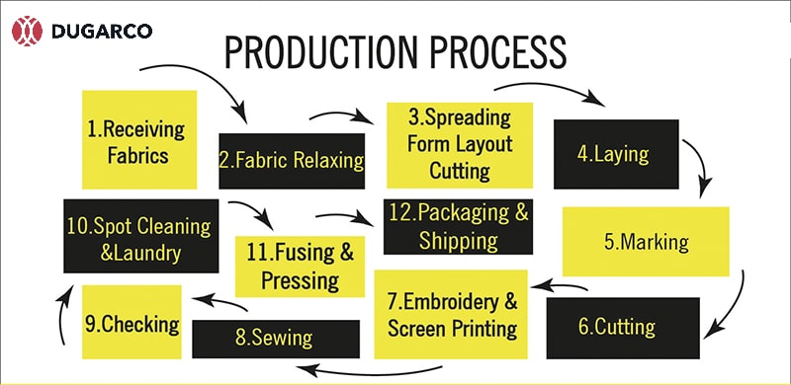
Figure 33: Production process

Self-check-3
Direction: - Answer the following question

Unit Four: Presenting design for feedback
This unit to provide you the necessary information regarding the following content coverage and topics:
- Presenting the detail embroidering design concept for feedback.

- Embellishing and highlighting the garment using embroidery.

- Receiving and considering a feedback for design objectives.

- Modifying and improving a design concept.

- Identifying material and quantities.

This guide will also assist you to attain the learning outcomes stated in the cover page. Specifically, upon completion of this learning guide, you will be able to:
- Understand presenting the detail embroidering design concept for feedback.

- Understand Embellishing and highlighting the garment using embroidery.

- Identifies Receiving and considering a feedback for design objectives.

- Understand Modifying and improving a design concept.

- Identifying material and quantities.

4.1. Presenting the detail embroidering design concept for feedback.
The detail embroidering design concept includes the specific design or pattern that will be embroidered onto the garment. This could include intricate patterns, logos, monograms, or any other desired design elements. To present the detail embroidering design concept for feedback, you would typically create a visual representation of the design. This could be in the form of a digital mock-up, a physical sample, or even a detailed description accompanied by sketches or drawings.
Once you have prepared the design concept, you can present it to relevant stakeholders such as the production team, designers, or clients for their feedback. It is important to gather their input and make any necessary adjustments or revisions based on their suggestions. Feedback on the detail embroidering design concept may include aspects such as the colour scheme, size and placement of the design, choice of stitches or thread, and overall aesthetic appeal. This feedback will help ensure that the final embroidered garment meets the desired specifications and expectations.

4.2. Embellishing and highlighting the garment using embroidery.
The detail embroidering design concept includes the specific design or pattern that will be embroidered onto the garment. This could include intricate patterns, logos, monograms, or any other desired design elements. To present the detail embroidering design concept for feedback, you would typically create a visual representation of the design. This could be in the form of a digital mock-up, a physical sample, or even a detailed description accompanied by sketches or drawings.
Once you have prepared the design concept, you can present it to relevant stakeholders such as the production team, designers, or clients for their feedback. It is important to gather their input and make any necessary adjustments or revisions based on their suggestions. Feedback on the detail embroidering design concept may include aspects such as the colour scheme, size and placement of the design, choice of stitches or thread, and overall aesthetic appeal. This feedback will help ensure that the final embroidered garment meets the desired specifications and expectations.
Embellishing and highlighting the garment using embroidery involves adding decorative elements or images to enhance its overall appearance. This can be done by incorporating intricate patterns, logos, monograms, or any other desired design elements onto the fabric. To create a visual representation of the embroidery design, you can use various techniques. One option is to create digital mock-up using design software. This allows you to experiment with different collars, stitches, and placement of the design on the garment.
Another option is to create a physical sample of the embroidery design. This can be done by stitching the design onto a piece of fabric or using embroidery machines to replicate the desired pattern. This physical sample can then be presented to stakeholders for their feedback and approval.
In addition to visual representations, it can also be helpful to provide a detailed description of the embroidery design concept. This can include information about the intended colour scheme, size and placement of the design, choice of stitches or thread, and any other specific details that are important to the overall aesthetic appeal. Once the embroidery design concept is prepared, it can be presented to relevant stakeholders for their feedback. This may include the production team, designers, or clients. It is important to gather their input and make any necessary adjustments or revisions based on their suggestions.
Feedback on the embroidery design concept may focus on aspects such as the clarity and quality of the image, the overall impact of the design on the garment, and how well it aligns with the desired aesthetic. This feedback will help ensure that the final embroidered garment meets the desired specifications and expectations.

4.3. Receiving and considering a feedback for design objectives
] detail embroidering design concept includes the specific design or pattern that will be embroidered onto the garment. This could include intricate patterns, logos, monograms, or any other desired design elements.

To present the detail embroidering design concept for feedback, you would typically create a visual representation of the design. This could be in the form of a digital mock-up, a physical sample, or even a detailed description accompanied by sketches or drawings. Once you have prepared the design concept, you can present it to relevant stakeholders such as the production team, designers, or clients for their feedback. It is important to gather their input and make any necessary adjustments or revisions based on their suggestions. Feedback on the detail embroidering design concept may include aspects such as the colour scheme, size and placement of the design, choice of stitches or thread, and overall aesthetic appeal. This feedback will help ensure that the final embroidered garment meets the desired specifications and expectations.
- When receiving feedback for design objectives, it is important to approach it with an open mind and a willingness to consider different perspectives. Here are some steps to effectively receive and consider feedback:

Listen actively: Pay attention to the feedback being provided and make sure to fully understand the points being made. Avoid interrupting or becoming defensive.

- Ask clarifying questions: If there are any aspects of the feedback that are unclear, ask for further clarification. This will help ensure that you fully understand the feedback being given.
- Take notes: Document the feedback received so that you can refer back to it later. This will help you remember the specific points raised and consider them in your design process.
- Reflect on the feedback: Take some time to reflect on the feedback and consider how it aligns with your original design objectives. Think about whether the feedback has merit and how it could potentially improve your design.
- Analyse the feedback: Evaluate the feedback objectively and consider its potential impact on the overall design. Determine whether any adjustments or revisions need to be made based on the feedback received.
- Discuss with stakeholders: Engage in a dialogue with relevant stakeholders, such as clients or production teams, to discuss the feedback and potential changes. Seek their input and opinions on how to address the feedback effectively.
- Make informed decisions: Based on the feedback received and the discussions held, make informed decisions on how to proceed with the design. Consider incorporating the feedback into your design objectives and making any necessary adjustments.
- Communicate changes: If you decide to make changes based on the feedback received, clearly communicate these changes to stakeholders involved in the design process. Ensure that everyone is aware of the updated design objectives and any modifications that have been made.

4.4. Modifying and improving a design concept.
To modify and improve a design concept for digital embroidery, consider
- Analyse the current design
Start by thoroughly examining the existing design concept. Identify its strengths and weaknesses, such as elements that may need more detail, areas that lack balance or symmetry, or colours that could be enhanced.
- Simplify the design
Sometimes, less is more. Simplify complex or overcrowded elements to ensure clarity and readability in the final embroidered piece. Remove any unnecessary details or elements that do not contribute to the overall concept.
- Refine the composition
Pay attention to the placement and arrangement of design elements. Ensure that they are visually appealing and well-balanced. Experiment with different layouts and compositions to find the most harmonious arrangement.
- Enhance colour scheme
Evaluate the colour palette used in the design. Consider adjusting or refining the colours to create a more visually striking and cohesive look. Experiment with different colour combinations and shades to find the perfect balance.
- Add depth and dimension
Embroidery designs can benefit from adding depth and dimensionality. Incorporate shading, gradients, or layering techniques to create a three-dimensional effect. This can make the design more visually interesting and lifelike.
- Consider stitch density
Assess the stitch density in the design. Adjusting the stitch density can help achieve a better balance between detail and durability. Too many stitches in a small area can lead to distortion or fabric puckering, while too few stitches may result in a lack of definition.
- Optimize for different sizes
Ensure that the design concept is scalable to different sizes without losing its integrity. Test the design at various dimensions to ensure it remains visually appealing and maintains its intended level of detail.
- Test on different fabrics
Try out the design on different types of fabrics to see how it translates. Some designs may work better on certain fabrics due to their texture or weight. Experimenting with different fabric samples will help determine the most suitable choice for the design.
- Seek feedback
Share the modified design concept with others, such as fellow designers or potential customers, to gather feedback and suggestions for improvement. Consider their perspectives and incorporate valuable insights into the final design.
- Iterate and refine
Based on the feedback received, make necessary adjustments and refinements to the design. Iterate through multiple versions until you achieve a final design concept that meets your objectives and is visually appealing.

Self-check

Unit Five: Set up digital embroidery machine for production operation
This learning guide is developed to provide you the necessary information regarding the following content coverage and topics:
- Interpreting a production specification to determining the optimum machine setting.
- Determining a documentation related to machine settings.
- Selecting and preparing appropriate tools and machine for the task.
- Set up machines
- Planning for operation
- Checking fabric feed system before operation
This guide will also assist you to attain the learning outcomes stated in the cover page. Specifically, upon completion of this learning guide, you will be able to:
- Understand and interpreting a production specification to determining the optimum machine setting.
- Discus and understand Determining a documentation related to machine settings.
- Identifies and Selecting, preparing appropriate tools and machine for the task.
- Understand Set up machines
- Understand Planning for operation
- Understand Checking fabric feed system before operation

Interpreting production specification and determining the optimum machine setting.
To interpret production specifications and determine the optimum digital embroidery machine settings, consider the following steps:
1. Review the production specifications: Carefully read and understand the production specifications provided for the embroidery project. This may include details such as the desired size of the design, the type of fabric to be used, and any specific requirements or limitations.
2. Identify the machine capabilities: Familiarize yourself with the capabilities and limitations of the digital embroidery machine you will be using. This may include factors such as maximum stitch count, maximum embroidery area, and available thread colours.
3. Determine the stitch count: Based on the design concept and production specifications, determine the approximate stitch count required for the embroidery. This will help you estimate the time and resources needed for the project.
4. Select appropriate thread colours: Choose thread colours that match or complement the design concept and the fabric being used. Consider factors such as colour fastness, thread availability, and any specific colour requirements specified in the production specifications.
5. Adjust stitch density: Experiment with different stitch densities to achieve the desired level of detail and durability. Higher stitch densities can result in more intricate designs but may require more time and thread. Lower stitch densities may be suitable for larger designs or fabrics with a looser weave.
6. Set machine speed: Determine the optimal machine speed based on the complexity of the design, fabric type, and desired production time. Higher speeds can increase productivity but may affect stitch quality, while lower speeds allow for more precise stitching.
7. Test on sample fabric: Before starting production, test the embroidery design on a sample piece of fabric. This will allow you to assess the stitch quality, thread tension, and overall appearance of the design. Make any necessary adjustments to the machine settings based on the test results.
8. Document machine settings: Once you have determined the optimum machine settings for the embroidery project, document them for future reference. This will ensure consistency and efficiency when working on similar projects in the future.
9. Monitor production process: Throughout the production process, closely monitor the machine settings, thread tension, and stitch quality. Make any necessary adjustments or troubleshooting as needed to maintain the desired results.
10. Evaluate the final product: Once the embroidery is complete, evaluate the final product against the production specifications and design concept. Assess the stitch quality, color accuracy, and overall appearance. Make note of any areas for improvement or adjustments to be made in future projects.

Determining documentation related to machine settings.
To document the digital embroidery machine settings, consideration
- . Record the machine model and serial number: Start by documenting the specific machine model and serial number being used for the embroidery project. This information will help identify the machine settings used in the future.
- Note the thread colours and types: Document the thread colours and types selected for the project. Include details such as the brand, colour code, and any special considerations or adjustments made to achieve the desired results.
- Record the stitch count: Note the estimated stitch count determined for the embroidery design. This will provide a reference point for future projects and help estimate the time and resources required.
- Document the stitch density: Record the stitch density settings used for the embroidery project. Include details such as the stitch length, stitch width, and any adjustments made to achieve the desired level of detail and durability.
- Note the machine speed: Document the optimal machine speed used for the project. Include any adjustments made based on the complexity of the design, fabric type, and desired production time.
- Include any additional machine settings: If there are any specific machine settings or adjustments made for the embroidery project, such as tension settings or hoop size, make sure to document them for future reference.
- Take photos or videos: Consider capturing photos or videos of the embroidery process and final product to visually document the machine settings and results achieved. This can serve as a visual reference for future projects.
- Store documentation in a centralized location: Keep all documentation related to digital embroidery machine settings in a centralized location, such as a physical folder or a digital file. Make sure it is easily accessible and organized for quick reference in the future.

Selecting and preparing appropriate tools and machine for the task
Embroidery supplies can help you get through the most challenging project with ease. Whether you are a beginner or a pro, you need these tools for your machine embroidery job.
There are many things to consider and prepare before starting a machine embroidery business, from pondering which machine you want to getting a stitch eraser. It can get confusing deciding which ones are needed to get started. If you are reading this, you are in the right place. We have a list of essential machine embroidery supplies.

    - Embroidery Machine
There are many things to consider in choosing an embroidery machine. Learn about the basic features you want based on your needs and preferences. One of the features you want, especially for beginners, is an embroidery machine that is easy to operate and an accessible service centre.

- Embroidery Thread
Embroidery threads are different from the threads used for sewing. One cannot use a sewing thread when dealing with an embroidery machine as it can cause mechanical problems. There are two common types of machine embroidery threads: the needle thread (topstitch) and the bobbin thread (backside). You cannot mix these two up.
- Thread Tension Gauges
With this tool, you don’t have to guess the exact method of setting thread tension. Some gauges adjust both the upper tension and the bobbin case, which is convenient. Besides, it provides precise measurements for consistency
- Threaded Tool and Needle Inserter
The threaded makes it easier to thread needles quickly. On the other hand, the needle inserter holds the needle steady so you can insert and remove the thread from the embroidery machine with ease. It’s a valuable pair of supplies that will eliminate your threading nightmares.
- Laser Alignment Tools
Are you having problems with hooping the square precisely? The laser alignment tools are the solution that you need. It allows you to make straight hooping effortless. It is the perfect tool for locating the center of pockets, quilt blocks, bags, and several others. You can also use it to illuminate your sewing path.
- Stitch Eraser
This one seems like something you don’t need, but it is handy to have when you need it. You don’t think about it until you have a use for it, just like insurance. It is an eraser that can remove stitches from patterns without damaging the material.
- Embroidery Software
Embroidery software is a computer application where you can create and manipulate embroidery designs. In addition, you can transfer designs, convert formats, and digitize a design. There are many good embroidery software that is beginner-friendly that you can consider.
If you ever need professional digitizing or vector art conversion, you can contact Affordable Digitizing at any time. They have years of experience in this area and are more than capable of delivering high-quality services.
  - Set up machines
We recommend unpacking should be done where it has enough room.

! CAUTION: To prevent accidents.
The machine is quite heavy for one person to carry.

Please use two persons when unpacking or carrying.

! CAUTION: To avoid troubles.
Make sure to hold bottom of the machine body when removing from the box. Do not hold any other place.
(Bed, moving head, control box etc.). 1

Confirm all the accessories are contained when unpacking.
Remove the machine from box
Remove 2 straps [1] from the carton.
Lift the box (upper) [2] to remove.
Take out the accessories. (Refer to the next page.)
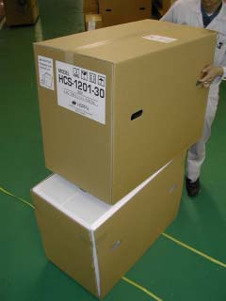
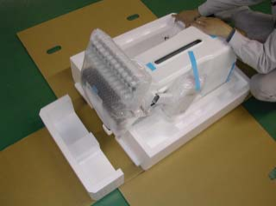
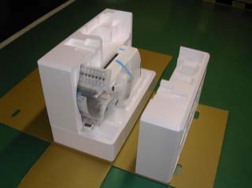
Take out the styrene foam (right) [3] and (left) [4].

Figure 34:Set up machines procedure

  - Take out the styrene foam (lower front) [5],
(Lower right) [6], and (lower left) [7].
* Be careful not fall down the machine, tilt the machine slightly when taking out the styrene form (lower right) and (lower left).
  - Carry the machine to installation location.
Lease keeps those packing materials in case of necessary for repair or other reasons.
Packing procedure is the reverse from unpacking Procedure
Placement of Accessories

- Carriage
- Spool felt (13 pieces) -USB cable
- Power line cord ass’y -Tool set
- Needle (10 pieces) -Bobbin (2 pieces) (1 piece set to rotary hook) -Fuse (6A)
- Oiler
- Thread guide pillar (2 pieces) -Thread stand pin (13 pieces) -Wave washer (13 pieces)
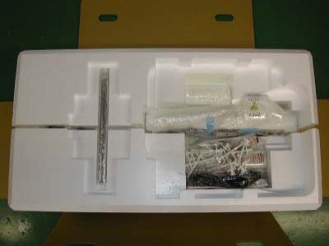
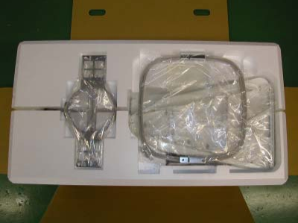
- Embroidery frame (round) -Embroidery frame (square) -Thread stand
- Thread guide bracket

Figure 35: Placement of Accessories
- Frame base
- CD-ROM (Happy Link Software) -Instruction book (Embroidery machine / Happy Link Software)
- Parts list book
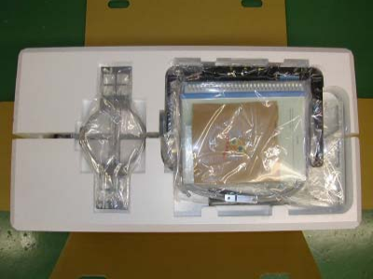

- Embroidery sample

Figure 36: Accessories


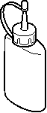



Accessories
Please confirm you have received the following.

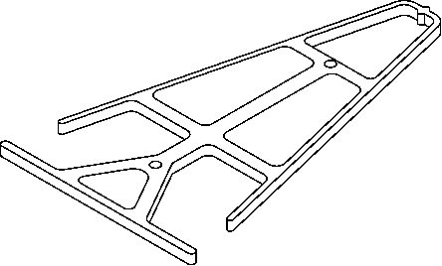
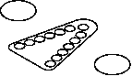


5

1 2 3 4 6

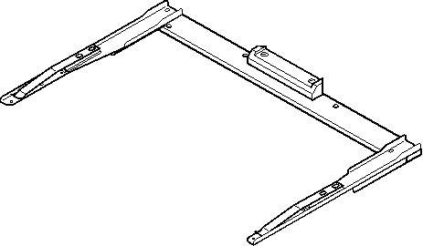


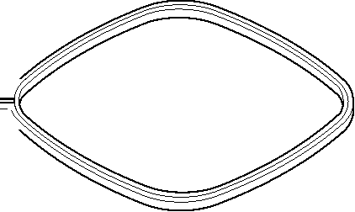


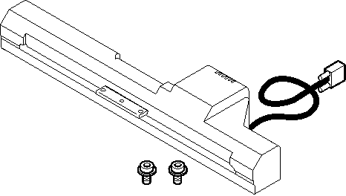
7 8 9

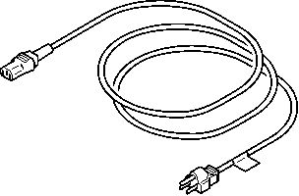
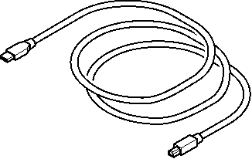


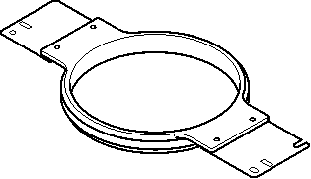
10 11 12 13 14 15

Figure 36: Accessories


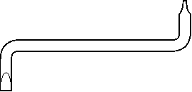

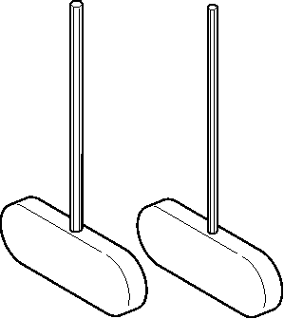
Tools

19

1. Thread guide bracket
2. Thread guide pillar (2 pcs) 3. Thread stand
4. Thread stand felt (13 pcs) 5. Thread stand pin (13 pcs) 6. Wave washer (13 pcs)
7. Carriage
8. Frame base
9. Embroidery frame (square) PTA-32320 10. Embroidery frame (Round) PTA-150-360 11. Needle (DB X K5) (10 pcs)
12. Oiler
13. Sewing machine oil 14. CD-ROM
15. Instruction book (Machine, Happy Link) 16. USB cable
17. Power line cord ass'y (A shape will be changed depending on a destination)
18. Fuse (6A)
19. off set screw driver 20. # 2 (+) Screw driver
21. 2 mm (-) Screw driver
22. 3mm hexagonal driver 23. 2.5 mm hexagonal driver 24. Brush
25. Manual lever


Assemble machine unit 1 2 1. Insert the thread stand pin with wave washer on the
Thread stand by turning clockwise, Then insert thread stand felt.
2. Put the thread stand on to the machine and insert the Turn the thread guide pillar clockwise with a 3 mm hexagonal driver until tight.
Turn the knob nut clockwise with a 3 mm hexagonal
Driver until tight. 3 3. Install the thread guide bracket with supplied screws
(Pan Head screw M6 X 10 2 pcs).
4. Loosen the screw with a offset driver and remove the red shipping collars that are equipped on the both side of the guide bar. (Keep the shipping collars. It is nec-
essay when packing.) 2 5. Put the carriage and carriage arm together with screw
(M4 X 8 2 pcs).
2 pins in the upper carriage arm will fit into holes on the lower carriage.
6. Raise slowly the control box to the front then fix it with 2 supplied screws (M4 2 pcs).
7. Connect the cable of carriage to the machine with fixed screw.
8. Install the arm for tubular embroidery. Please refer to (page 6-1) "
When taking the machine apart in case of packing, the process is opposite of assembling the machine. Please do exactly the opposite way of assembling. When packing the machine up for transportation, be sure to select the sixth needle and fix it with shipping collars on the both side of the guide bar.

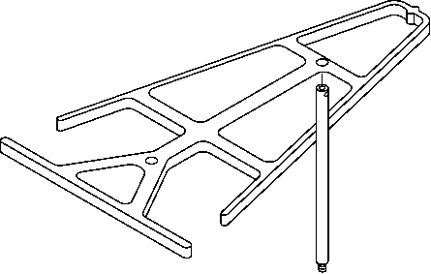


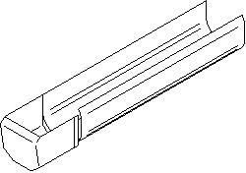
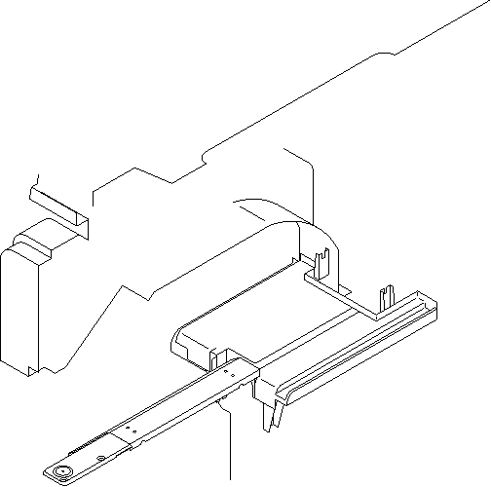

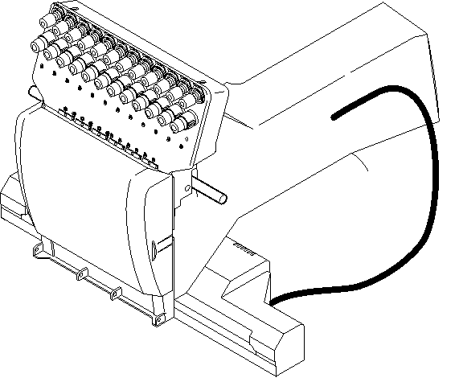
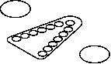

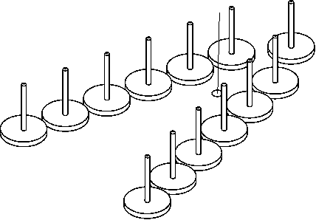
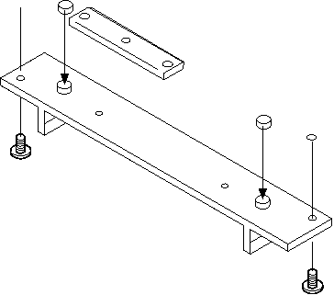


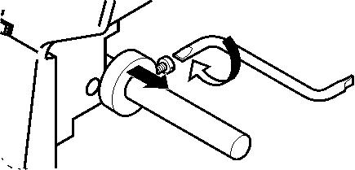
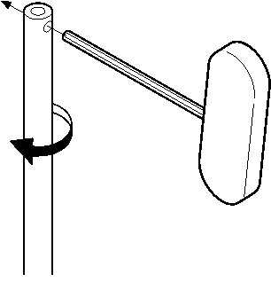
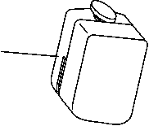
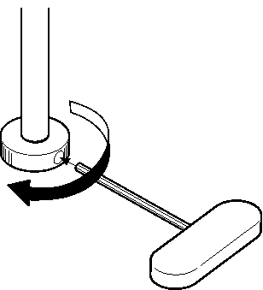
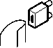
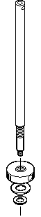
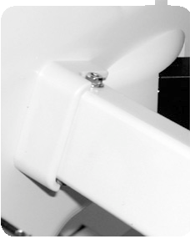
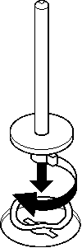


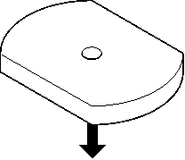


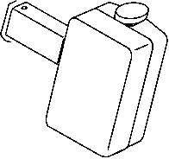
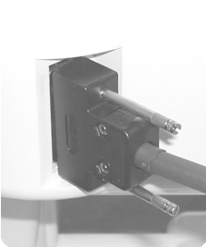


Figure 37: machine uni

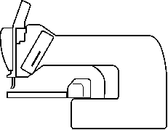
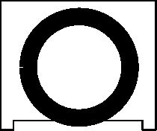
Machine installation

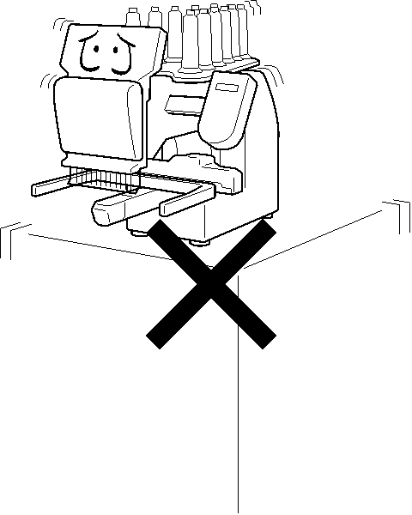
1. Please use a stout table to set the machine on.

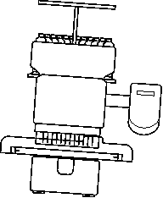
Please check for any shaking or excessive vibrat-ing of the machine table when the machine is running.
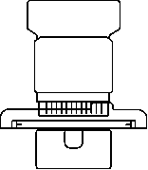


If you have a problem, Please use a stronger table for the machine.
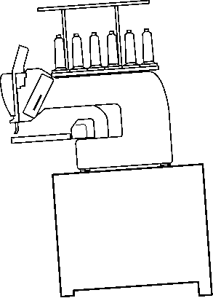

Figure 38: Machine installation

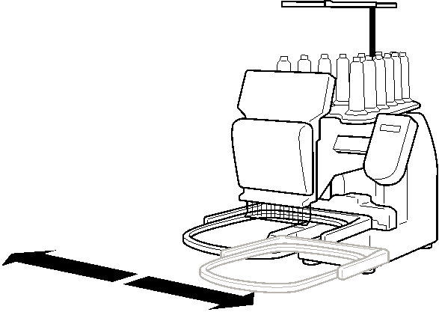

2. Please sit the machine level on the table.

3. Please be sure you have this much room around your machine for it to move.

It is possible for the embroidery frame to hit you and cause injury.

350 mm 350 mm 720 mm

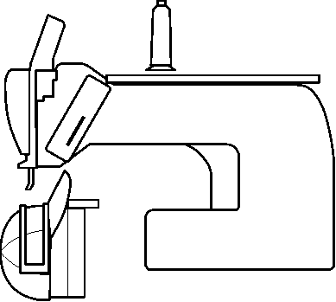
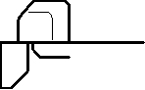

4. Please be sure you have this much room around your cap drive for it to move.

Please machine on the table positioning like right side drawing.

0 ~ 10 mm

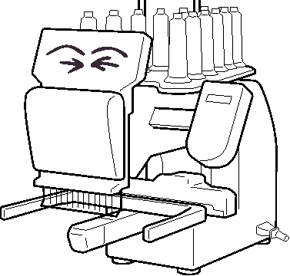

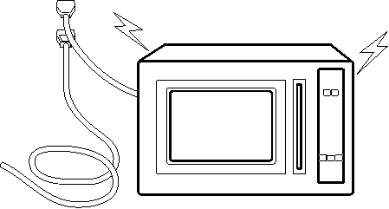
5. Please do not sit the machine near any kind of other electric equipment (Examples: Microwave or electric tool).

Has possible to wrong movement of the machine.

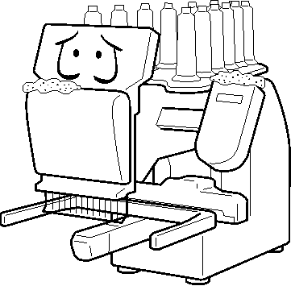
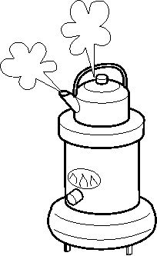
6. Please keep away from dusty and high moisture environments.

Has case of rusting or damaging.

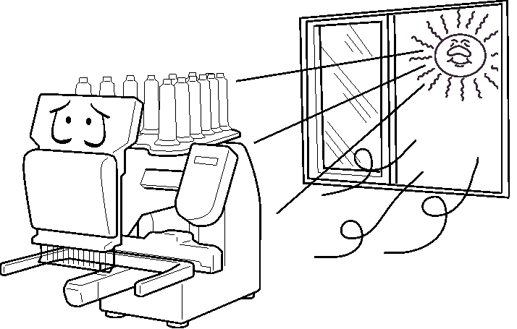
7. Please do not sit the machine in direct sunshine or windy locations.

Has case of rusting or damaging.

  - Planning for operation
To plan for operating a digital embroidery machine, consider the following steps:
Identify the embroidery design: Determine the specific design that will be embroidered using the machine. This could be a pre-made design or a custom design created using embroidery software. Select the appropriate fabric: Choose the fabric that will be used for the embroidery project. Consider factors such as the fabric type, weight, and color to ensure it is suitable for the design and machine settings.
Prepare the fabric: Prepare the fabric by washing and ironing it to remove any wrinkles or dirt. This will ensure a smooth surface for the embroidery process. Hoop the fabric: Place the fabric in the embroidery hoop, ensuring it is taut and secure. This will provide stability and prevent any shifting during the embroidery process. Thread the machine: Thread the machine with the desired thread color and type. Follow the machine's instructions for properly threading the needle and bobbin.
Set up the design on the machine: Transfer the embroidery design to the machine, either through a USB drive or by connecting it to a computer. Use the machine's software to position and scale the design as desired. Adjust machine settings: Set the appropriate machine settings for the embroidery project. This includes adjusting stitch length, stitch density, tension, and any other relevant settings based on the fabric type and desired outcome.
Test the embroidery: Before starting the actual embroidery, perform a test run on a scrap piece of fabric to ensure everything is set up correctly. This will help identify any issues or adjustments that need to be made before embroidering on the final fabric. Start the embroidery: Once everything is set up and tested, start the embroidery process. Monitor the machine throughout to ensure it is running smoothly and make any necessary adjustments if needed. Finish and clean up: Once the embroidery is complete, remove the fabric from the hoop and trim any loose threads. Clean the machine and workspace to maintain its performance and longevity.

  - Checking fabric feed system before operation
Check the fabric feed system: Before operating the digital embroidery machine, ensure that the fabric feed system is functioning properly. This includes checking the feed dogs, presser foot, and any other components that are responsible for moving the fabric smoothly through the machine. Make sure there are no obstructions or issues that could cause the fabric to get stuck or misaligned during the embroidery process.
Calibrate the machine: If necessary, calibrate the machine to ensure accurate stitching and alignment. Follow the manufacturer's instructions for calibrating the machine, which may involve adjusting needle position, hoop alignment, or other settings. Load the embroidery design: Load the desired embroidery design onto the machine's software or interface. Ensure that the design is properly aligned and positioned within the hoop area.
Set up thread colors: Choose the thread colors that will be used for the embroidery design. Load the appropriate thread spools onto the machine's thread holders and thread each color through the machine's needle and bobbin according to the manufacturer's instructions. Set embroidery parameters: Adjust the machine settings such as stitch length, density, and speed to achieve the desired embroidery outcome. Consider factors such as fabric type, design complexity, and thread thickness when setting these parameters.
Perform a test run: Before embroidering on the final fabric, perform a test run on a scrap piece of fabric to ensure that the design is stitching correctly and that the thread tension is properly adjusted. Make any necessary adjustments to the machine settings based on the test run results. Secure the fabric: Once you are confident in the machine's settings and performance, securely attach the fabric to the embroidery hoop. Ensure that it is taut and properly centered within the hoop to prevent any shifting or distortion during embroidery. Start the embroidery process: Begin the embroidery process by pressing the start button or initiating the embroidery command on the machine's interface. Monitor the machine closely during operation to ensure that the design is stitching accurately and that the fabric is feeding smoothly.
Monitor and make adjustments: Continuously monitor the embroidery process, checking for any issues such as thread breakage, needle jams, or fabric misalignment. Make any necessary adjustments to the machine settings or fabric positioning to correct these issues. Finish and inspect the embroidery: Once the embroidery is complete, remove the fabric from the hoop and inspect the design for any flaws or imperfections. Trim any loose threads and make any necessary touch-ups to ensure a clean and professional finish.

Unit Six: Set up digital embroidery machine for production operation
This learning guide is developed to provide you the necessary information regarding the following content coverage and topics:
- Operating embroidery machine for test
- Examining embroidered product or sample
- Conducting or organizing quality tests.
- Identifying and documenting machine settings
This guide will also assist you to attain the learning outcomes stated in the cover page. Specifically, upon completion of this learning guide, you will be able to:
- Understand and Operating embroidery machine for test
- Understand Examining embroidered product or sample
- Identifies Conducting or organizing quality tests.
- Identifying and documenting machine settings


6.1. Operating embroidery machine for test
Perform this function only to fix problems with the machine. When performed, all settings in the "OPTION" menu are lost.
Be sure to reset the "OPTION" menu after performing this function.



1. When the machine is stopped, press MENU

and Select "OTHER “with

Speed
2. Press the SET.



3. Select "System" with

And press SET.
System initializes OK?

Cancel

4. Select "OK" with to carry out.
System initializes OK?

If you cancel, press SET. Cancel the display returns to MENU.


5. Press the SET.
Formatting of the machines systems are carried out.

Indicate HAPPY logo in screen.

6.2. Examining embroidered product or sample
As time passed, embroidery came to represent prosperity. Nowadays, some people enjoy doing needlework. Some people use it to adorn employee uniforms or as badges of distinction, like your company or school logo.
Although embroidery is common, the quality differs greatly from one embroidery to the next. Poor quality embroidery can reflect badly on your company image or product quality; therefore, choosing a company that delivers high-quality embroidery work is important. So, how do you tell whether an embroidery work is of poor or good quality? What should you be looking out for? Read to learn more.
It’s crucial to consider whether your design accurately represents your organization when developing it. Many businesses merely use their company logo. Typically, a logo should be flexible enough to be emblazoned on almost anything, like letterheads, t-shirts and other merchandise. However, it may need a few adjustments to fit the size of your merchandise.
Creating a novel embroidery design may require more planning. There are many methods to create this design from scratch, but it’s crucial to ensure that it accurately reflects your business and works with all kinds of merchandise you may produce.
Pay attention to your sample
Once commissioned, your original artwork and design should be precisely reproduced by the embroidery company you hired. Don’t accept anything less. Don’t accept the sample as the finished product if it doesn’t match your initial design.
Also, pay attention to the spelling if your merchandise includes text or a tagline. Spelling mistakes can be embarrassing. More importantly, they could be an expensive error if they are already embroidered on 200 polo shirts.
Check the threading
Many people unfamiliar with embroideries are unaware you can’t mix and match different thread kinds with just any fabric when embroidering. A silk thread is required for a smooth, delicate fabric, whereas a thicker thread is required for thicker fabrics like canvas. If the embroidery company doesn’t use the proper thread and fabric matches, the fabric will have puckers and wrinkles.
Stitching quality
An excellent stitch comprises three layers. A thick thread makes up the top stratum – it is slightly thinner in the second covering. You can tell which stratum has the thinnest thread by looking at it. Another crucial factor affecting stitching quality is the stitch’s length. Long threads may save time, but the stitching quality suffers. A reduced margin of error for the pattern results from short stitches.
You should also examine the front and back of the pattern in addition to the stitching. The side that everyone sees will be embroidered with the precise design that you want. Excellent needlework will look identical on both the front and back sides. There won’t be any snags or loose threads in the rear. The pattern will be visible on the garment’s front and rear.

6.3. Conducting or organizing quality tests.
Define quality standards: Begin by clearly defining the quality standards for the digital machine embroidery. This includes factors such as stitch density, thread tension, colours accuracy, design alignment, and overall appearance. Create a test plan: Develop a comprehensive test plan that outlines the specific tests to be conducted and the criteria for evaluating each aspect of the embroidery. This plans should cover all relevant quality parameters identified in step one.
Prepare test samples: Create test samples that represent the different designs, fabrics, and thread types commonly used in production. These samples should be representative of the actual products and include a range of complexities and details. Perform initial tests: Conduct initial tests on the prepared samples using the digital embroidery machine. Ensure that all machine settings, such as speed, tension, and needle type, are correctly calibrated according to the test plan.
Evaluate results: Inspect the embroidered samples against the defined quality standards. Assess factors such as stitch accuracy, thread tension consistency, colours matching, design alignment, and any other specific requirements. Document any deviations from the desired standards. Adjust machine settings: If any deviations or issues are identified during the evaluation, make necessary adjustments to the machine settings. This may involve changing stitch parameters, adjusting thread tension, or modifying other relevant settings to improve the quality.
Repeat testing: Re-run the tests on the adjusted machine settings to verify if the changes have resolved the identified issues. Repeat this process until the desired quality standards are consistently met. Document results: Keep detailed records of all test results, including any adjustments made to the machine settings. This documentation will serve as a reference for future quality control purposes and can help identify patterns or trends in quality issues. Continuous improvement: Regularly review the test results and identify areas for improvement. Analyse any recurring issues and implement corrective actions to enhance the overall quality of the digital machine embroidery process.

6.4. Identifying and documenting machine settings
Identifying and documenting digital embroidery machine settings involves recording the various parameters and options available on the machine that affect the embroidery process. Here are some key settings to consider:
Thread tension: Document the range of thread tension settings available on the machine. This setting determines how tight or loose the thread is pulled during stitching. Stitch length: Record the range of stitch length options provided by the machine. This setting determines the distance between individual stitches. Stitch density: Document the range of stitch density settings available. This setting determines how closely the stitches are placed together, affecting the overall appearance and durability of the embroidery.
Needle type and size: Note the types of needles that can be used on the machine, such as ballpoint or sharp needles, as well as the various needle sizes supported. Hoop size: Identify the different hoop sizes compatible with the machine. This setting determines the maximum area that can be embroidered in a single pass. Thread colours change: Record the capability of the machine to automatically change thread colours during embroidery. This feature allows for multi-collared designs without manual intervention.
Speed control: Note the speed control options available on the machine. This setting allows users to adjust the embroidery speed according to their preferences or fabric requirements. Design editing features: Document any design editing features provided by the machine, such as resizing, rotating, mirroring, or combining designs. These features enhance customization options. Stitch type selection: Identify the various stitch types available, such as satin stitch, running stitch; fill stitch, or appliqué stitch. This setting determines the appearance and texture of the embroidery. Automatic thread trimming: Note if the machine has an automatic thread trimming feature, which cuts the thread after each colours change or at the end of stitching. This feature saves time and improves efficiency.

Thread break detection: Document whether the machine has a thread break detection system that stops the embroidery process and alerts the user if the thread breaks or runs out. USB or network connectivity: Note the connectivity options available on the machine, such as USB ports or network capabilities, which allow for easy transfer of embroidery designs from a computer or other devices.

Unit Seven: Collecting tools & materials
This learning guide is developed to provide you the necessary information regarding the following content coverage and topics:
- Collecting and arranging tools & materials
- Checking the selected materials
This guide will also assist you to attain the learning outcomes stated in the cover page. Specifically, upon completion of this learning guide, you will be able to:
- Understand Collecting and arranging tools & materials
- Identifies and Checking the selected materials

Collecting and arranging tools & materials
First, these are the things I consider essential to getting started with machine embroidery
- Embroidery Stabilizer
Embroidery stabilizer is the material that goes in the hoop on the back of the item you plan to embroider.
Stabilizer is one of the most essential machine embroidery supplies, ensuring your designs stitch accurately and efficiently on the fabric.
There are many different stabilizers available; each type has its intended usage.
My printable machine embroidery stabilizer chart has more in-depth information, but below is a summary of the types of stabilizers.

A. Tear-Away Stabilizer
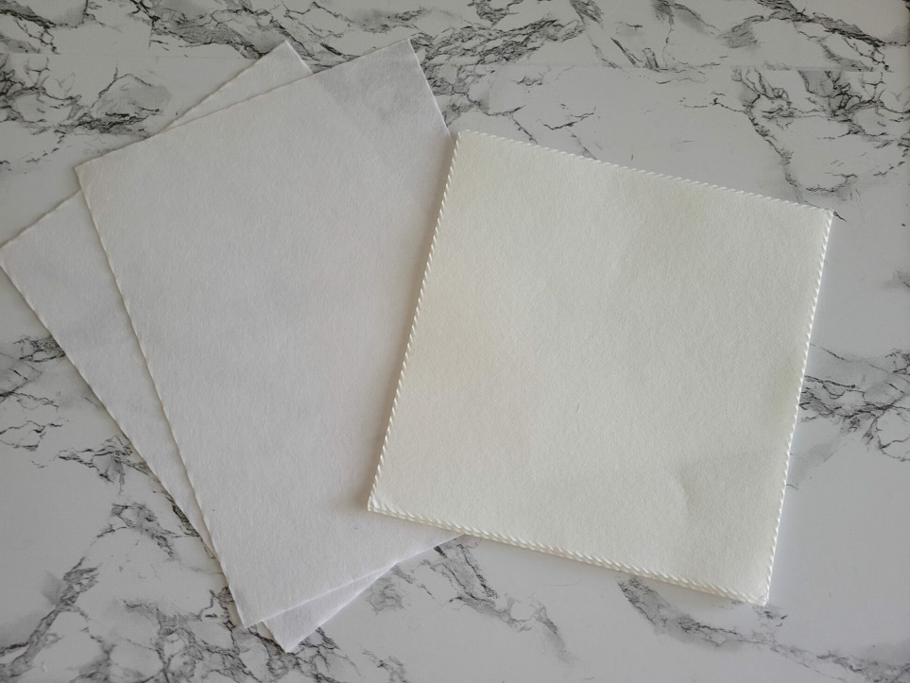

Figure 39: Tear-Away Stabilizer
Tear-away stabilizer is suitable for non-stretchy, stable fabrics such as terry towels, canvas, twill, and more.
I like to buy pre-cut stabilizer sheets to use for convenience, but you can also purchase rolls of tear-away stabilizer.
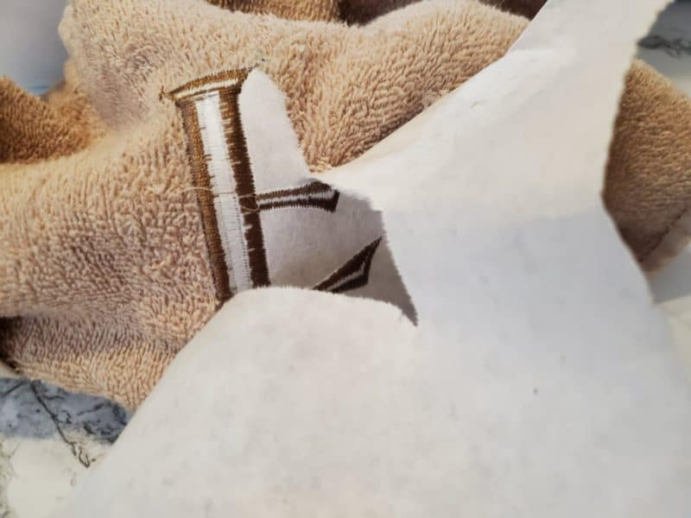

Figure 40: Tear-away stabilizer
After you stitch on the tear-away stabilizer, you gently rip it off from the back of the fabric.

B. Cut-Away Stabilizer
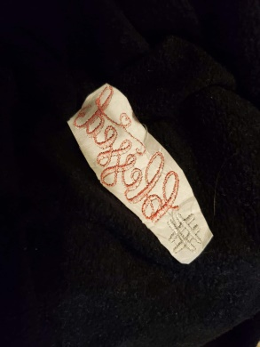

Figure 41: Cut-Away Stabilizer
Cut-away stabilizer is great for knits and other stretchy fabrics because it has less stretch and thus stabilizes better.
It also works great for densely stitched designs to prevent puckering.
Simply cut it away from the design after embroidery.

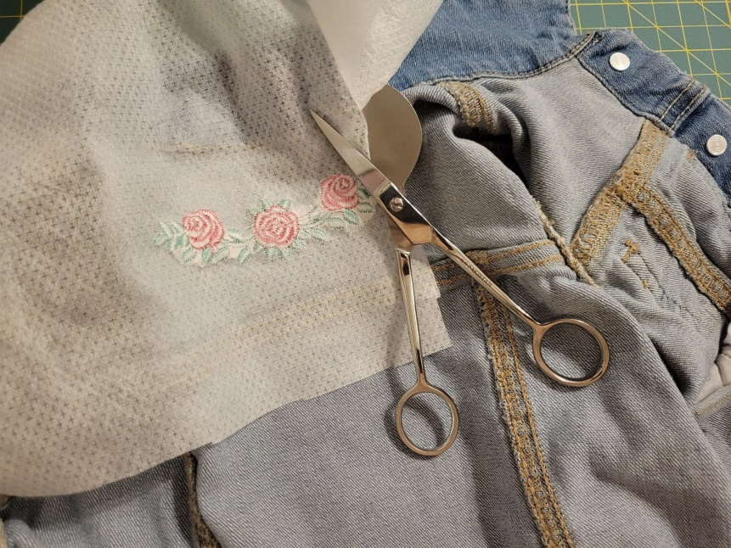
C. No-Show Mesh Stabilizer

Figure 42: No-Show Mesh Stabilizer
No-show mesh stabilizer (also known as Poly Mesh) is a soft, strong cut-away stabilizer that is great for knits when you want to minimize show-through on light fabrics. When deciding which no-show mesh stabilizer to choose, you can select between a fusible option to iron on or a non-fusible option.

D. Sticky Stabilizer
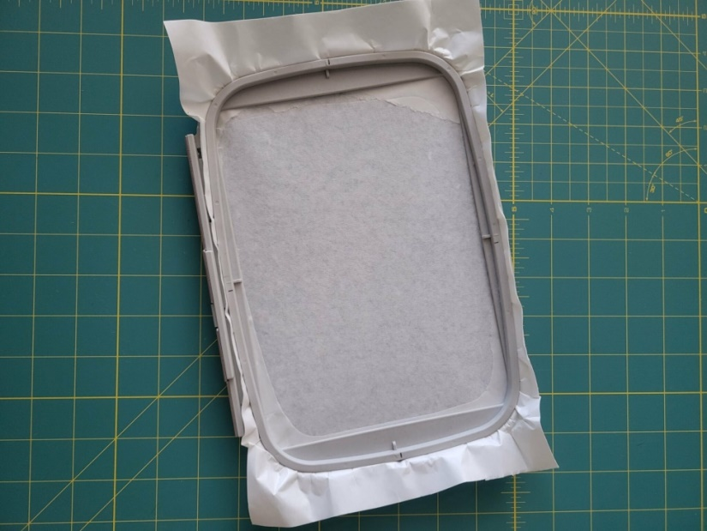

Figure 43: Sticky Stabilizer

Sticky, self-adhesive stabilizer has one sticky side that can grip your fabric without needing temporary adhesive spray. I like using this type of stabilizer when floating embroidery blanks or embroidering tricky items like caps.
You can purchase sticky tear-away, sticky wash away, or even sticky cut-away stabilizer.

E. Water-Soluble Topping
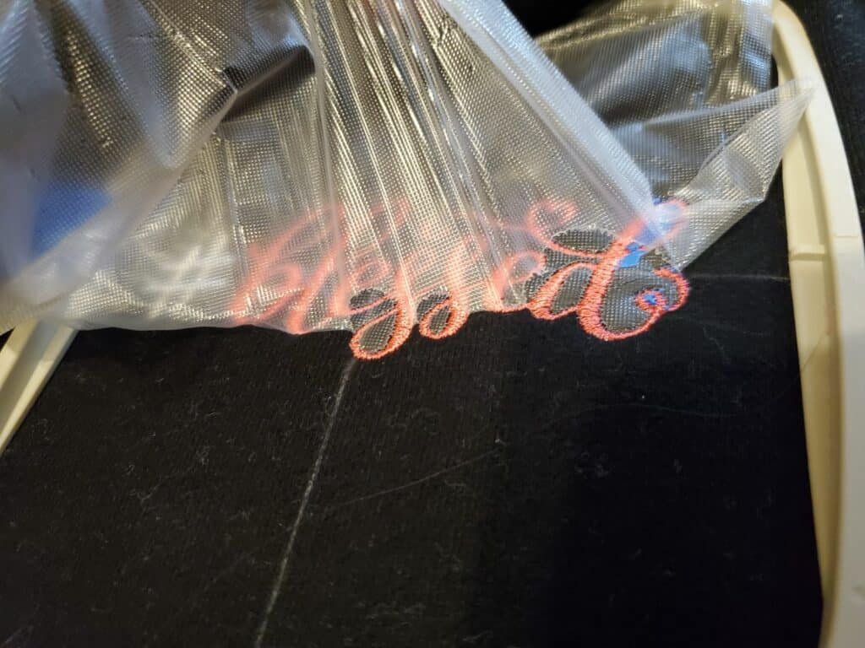

Figure 44: Water-Soluble Topping
Water-soluble topping is a MUST-HAVE when embroidering on fleece blankets, towels, or fabric with fluff or nap (and many other fabrics, such as certain knits!) This topper keeps embroidery stitching from falling into the top of the fabric and becoming lost. I prefer Sulky Solvay Water Soluble Stabilizer on top of my designs. Once done embroidering, the topping dissolves with water. If you’re in a hurry or can’t wash your fabric, you can also purchase a heat-dissolving topping that crumbles away with an iron.
F. Wash-Away Stabilizer
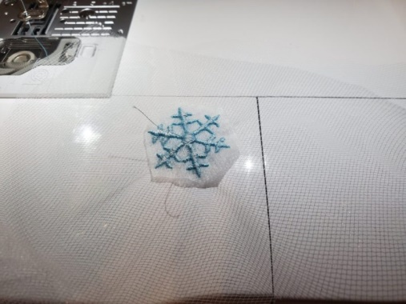

Figure 45: Wash-Away Stabilizer
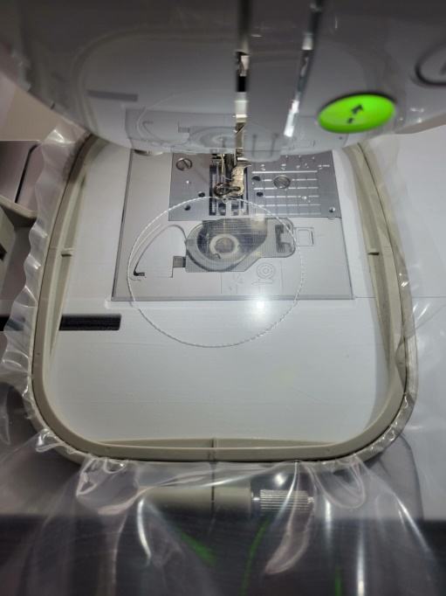
While water-soluble topping goes on the top of fabric, wash-away stabilizer goes on the back of your fabric in the hoop. It also washes away with water after embroidering and can have either a papery appearance or be a thicker clear plastic like Sulky’s Ultra Solvay.

Figure 46: water-soluble
It’s popular for its use when embroidering patches and free-standing lace, and I even recently used it when embroidering tulle.

G. Embroidery Backing
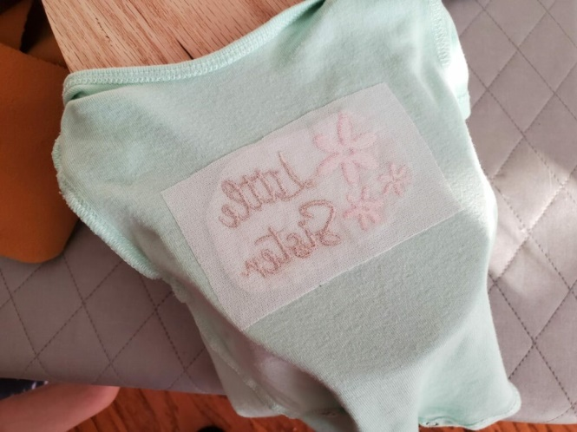

Figure 47: Embroidery Backing

Sulky Tender Touch backing is one example of an embroidery backing that you iron onto the back of your finished embroidery design.

- Embroidery Items and Applique Fabrics
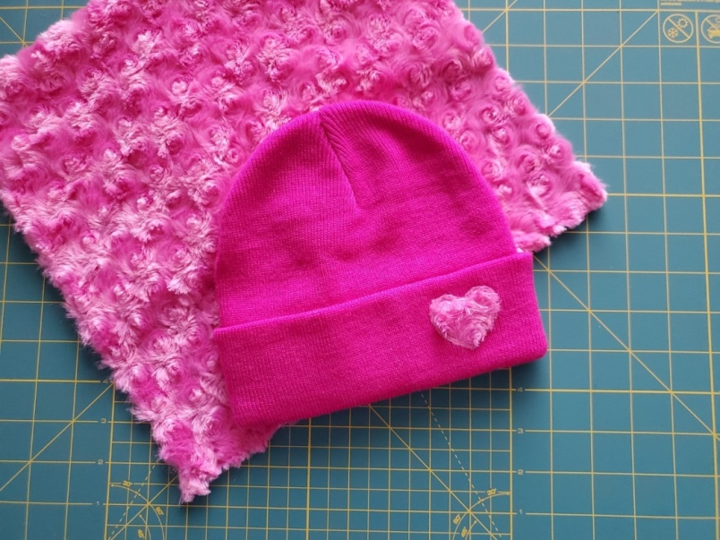

Figure 48: Applique Fabrics
These are your blank t-shirts, onesies, towels, hats, etc., that you plan to embroider.
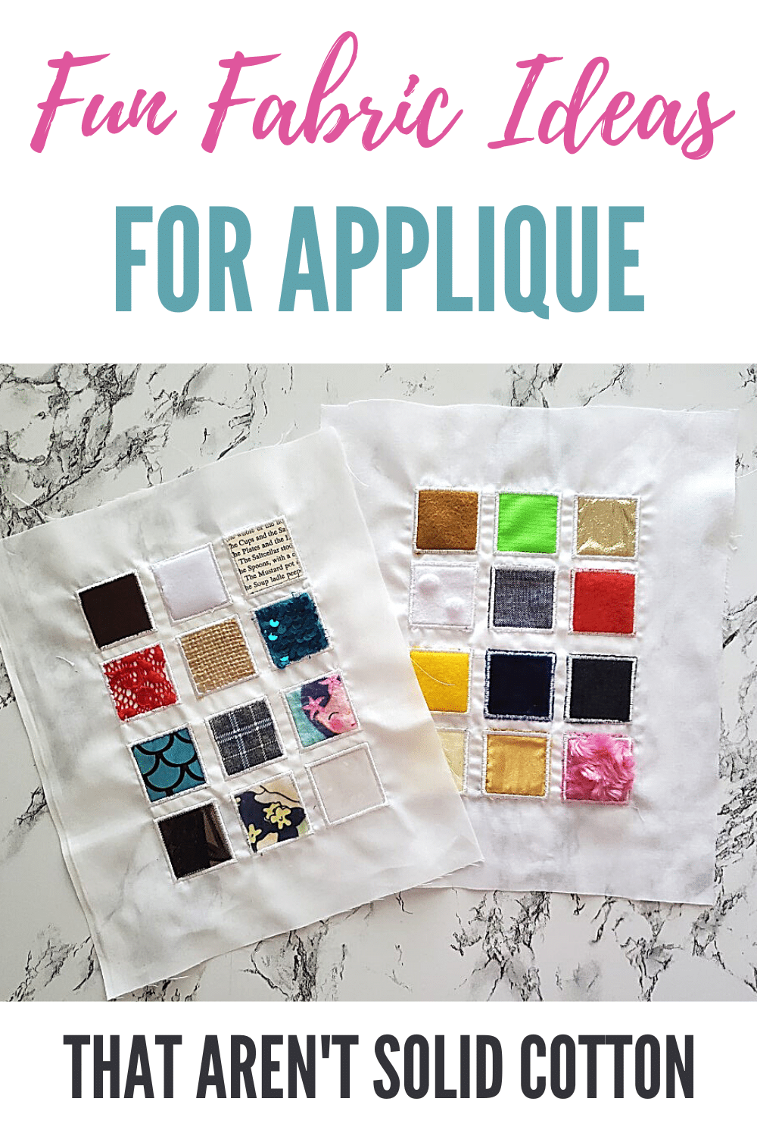

Figure 49: Applique Fabrics
While quilting cotton is my favorite for ease of use, I also like to repurpose items around the house as fabric sources. (Check out: where to buy cheap fabric online and where to find fabric to repurpose!)

- Embroidery Needles
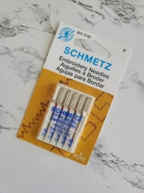

Figure 50: Embroidery Machine Needles
While you can use sewing machine needles for many projects, specialized machine embroidery needles are better in most cases. (Learn more in my post about how to choose the best machine embroidery needle.)
There are different sizes (70/10 to 90/14 and larger), points (ballpoint, sharp, or universal), and different finishes. When in doubt, a size 75/11 universal embroidery needle is a good place to start, and then fine-tune from there, if needed.
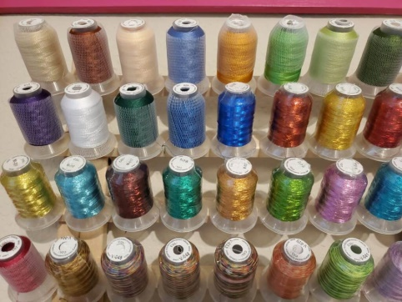
- Embroidery Thread and Bobbin Thread

Figure 51: Embroidery Thread
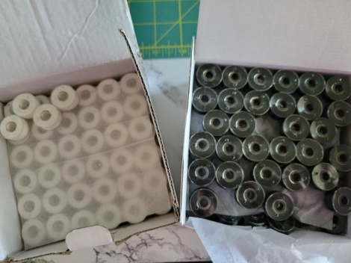
The most common fiber types of machine embroidery thread are polyester, rayon, or cotton embroidery.

Figure 52: Bobbin Thread
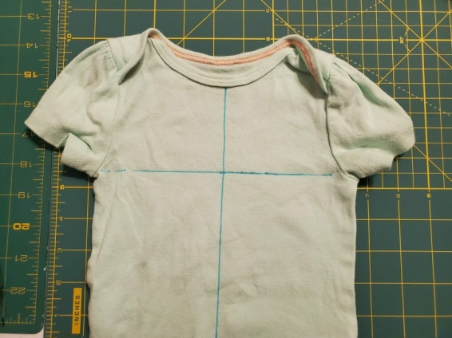
- Marking Supplies or Placement Tools

Figure 53: Placement Tools
It is important to temporarily mark the center of your fabric to line up your design
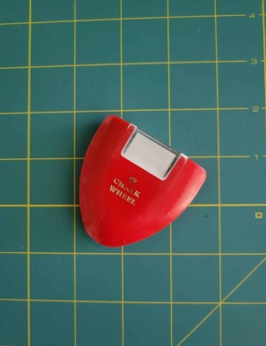
Chalk wheel

Figure 54: Chalk wheel

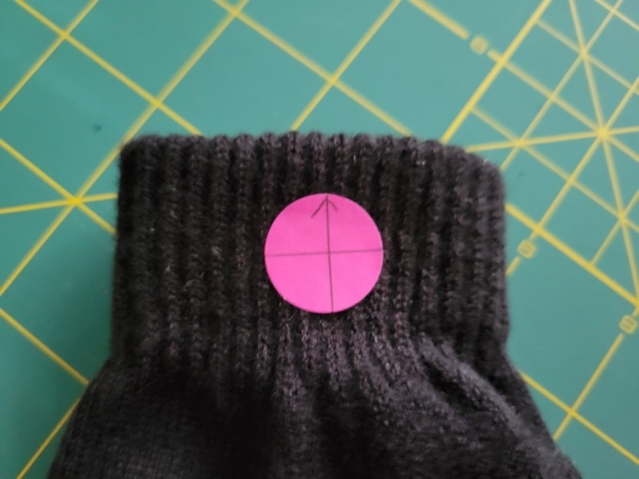

Figure 55: embroidery placement stickers
Use embroidery placement stickers for some projects
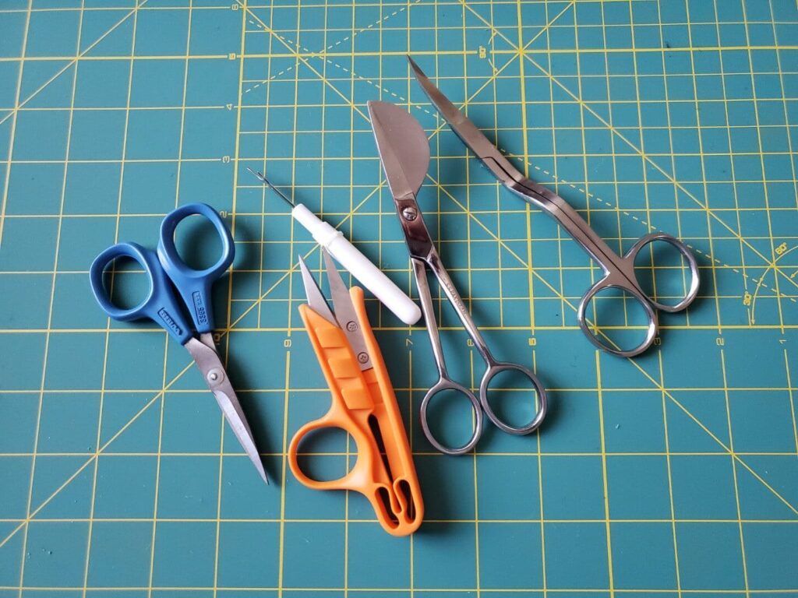
- Embroidery Scissors

Figure 56: Embroidery Scissors
Embroidery scissors are small, specialized scissors that get right next to threads and appliques to trim them.
For instance, double-curved embroidery scissors, duckbill applique scissors, and embroidery snips.
- Temporary Adhesive
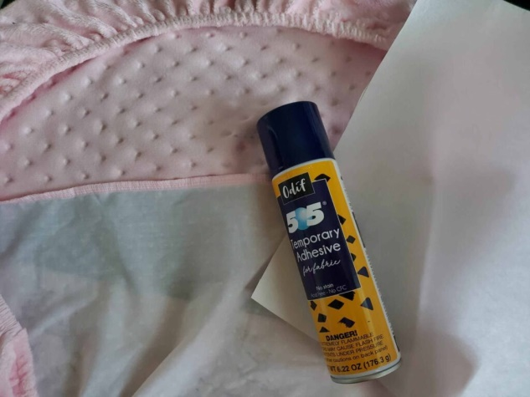

Figure 57: Temporary Adhesive
There are several instances when you will need a way to adhere fabric to your embroidery stabilizer. One example is fabric that’s floated. The beauty of temporary adhesive is you can remove and reposition your items several times without the stickiness wearing off. You can also use pins, painter’s tape, a basting box, or other methods for adhering embroidery items that aren’t easily hooped.
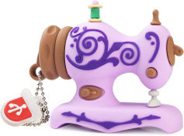
- USB Drive

Figure 58: USB Drive
Just make sure to check your machine manual to learn the import methods and any required specs for USB drives. (Hint: huge drives with millions of files take forever to load on my machine!)
- Embroidery Software
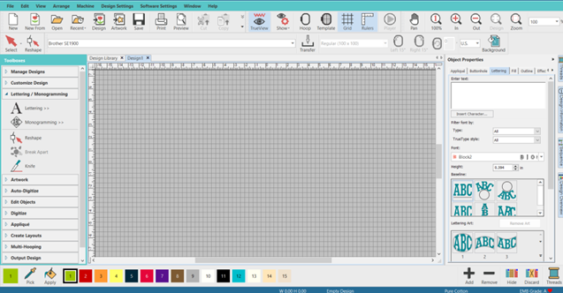

- Extra Hoops
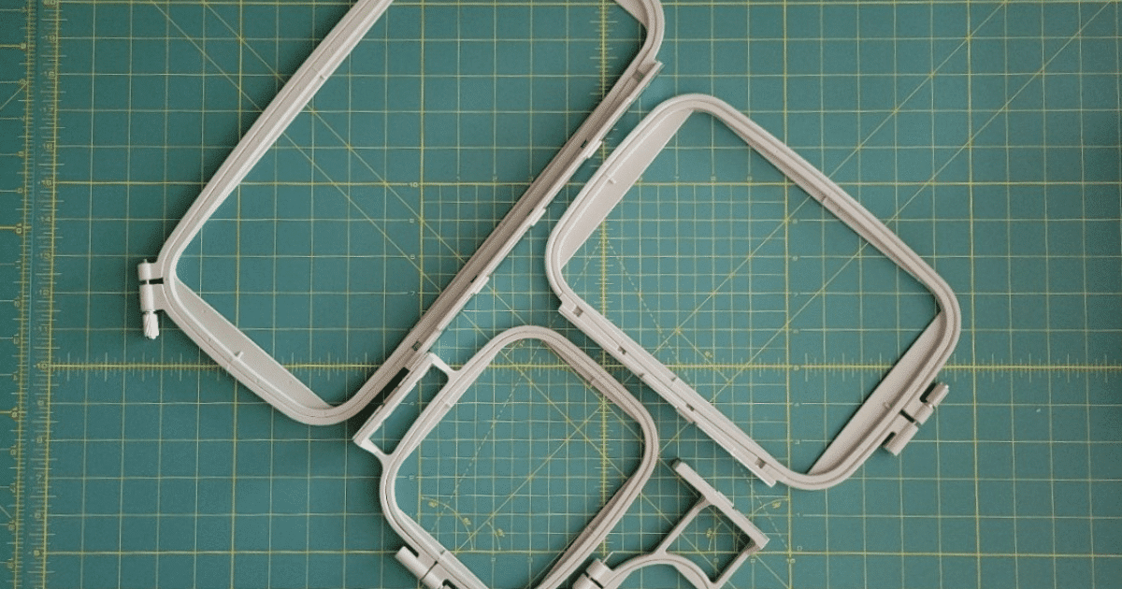

Figure 59: Hoops
If you are working on more than one project at a time, it’s nice to spend active stitching time setting up for the next project in a new hoop.
Furthermore, if your included hoop size with your embroidery machine is huge, it’s nice to have smaller hoops to use to hoop small items like baby onesies.
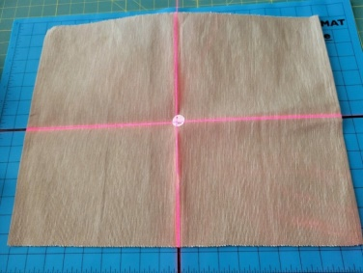
- Alignment Laser

Figure 60: Alignment Laser
- Embroidery Removal Tool
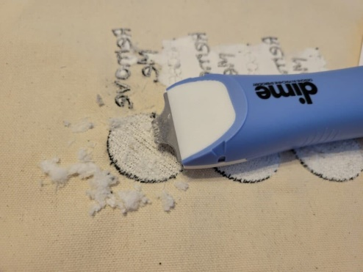

Figure 61: Embroidery Removal
However, embroidery tools like the Stitch Eraser or Stitch Ripper make the job much easier. Not easy…but easier.
- Spool Huggers and Bobbin Clamps
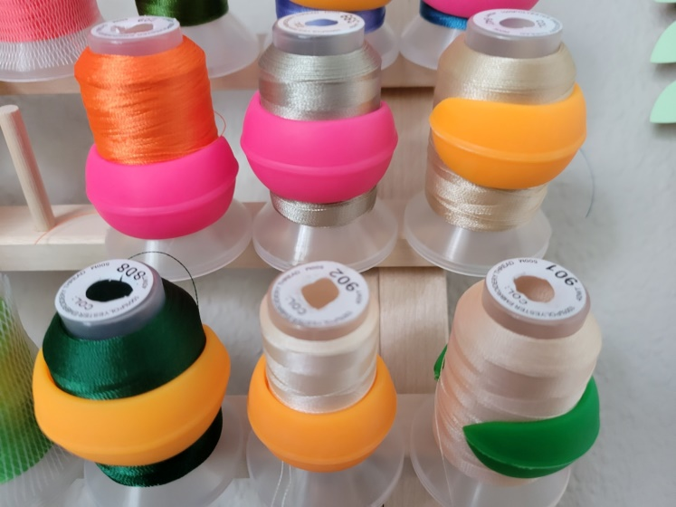
These are in no way necessary but are REALLY nice to have around to keep things tidy and organized.

Figure 62: Spool Huggers
These thread spool huggers wrap around threads and keep the ends from unraveling.
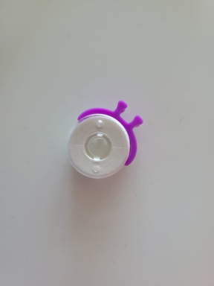
Meanwhile, bobbin clamps do the same thing for bobbin threads.

Figure 63: bobbin clamps

Checking the selected materials
When selecting materials for digital embroidery, there are several factors to consider. Here are some commonly used materials for digital embroidery:
- Fabric
The fabric is the base material on which the embroidery design will be stitched. Common fabric choices include cotton, linen, silk, polyester, and blends of these materials. The choice of fabric depends on the desired look, durability, and the type of embroidery design.
- Stabilizer
Stabilizers are used to provide support and prevent distortion of the fabric during the embroidery process. There are different types of stabilizers available, such as cut-away, tear-away, and water-soluble stabilizers. The selection of stabilizer depends on the fabric type, design complexity, and desired end result.
- Threads
Embroidery threads come in various materials, including cotton, polyester, rayon, metallic, and silk. Each thread type offers different characteristics such as sheen, strength, and color vibrancy. The choice of thread depends on the design requirements and personal preference.
- Needles
Needles play a crucial role in digital embroidery as they pierce the fabric and carry the thread through it. Embroidery needles have different sizes and shapes, such as sharp or ballpoint, depending on the fabric type and design complexity.
- Bobbins
Bobbins hold the lower thread that forms the underside of the embroidery stitches. They can be made of plastic or metal, and the choice depends on the embroidery machine's specifications.
- Hoops or frames
Hoops or frames are used to secure the fabric during the embroidery process. They come in various sizes and types, such as traditional wooden hoops or plastic frames specifically designed for machine embroidery.
- Design software
While not a physical material, design software is essential for creating or editing digital embroidery designs. There are various software options available, ranging from basic to advanced, depending on the design requirements and personal skill level.
It's important to consider the compatibility of these materials embroidery machine and the specific design you want to create. Additionally, always follow the manufacturer's recommendations and guidelines for the selected materials to ensure optimal results.

Self-check 7
1. What is the purpose of stabilizers in digital embroidery?
a) To provide support and prevent fabric distortion
b) To add color and texture to the design
c) To hold the lower thread in place
d) To secure the fabric during the embroidery process

2. Which type of thread offers characteristics such as sheen, strength, and color vibrancy?
a) Cotton thread
b) Polyester thread
c) Rayon thread
d) Metallic thread

3. What is the role of needles in digital embroidery?
a) To hold the lower thread in place
b) To pierce the fabric and carry the thread through it
c) To provide support and prevent fabric distortion
d) To secure the fabric during the embroidery process

4. What holds the lower thread that forms the underside of the embroidery stitches?
a) Needles
b) Bobbins
c) Hoops or frames
d) Stabilizers

5. What is the purpose of hoops or frames in digital embroidery?
a) To provide support and prevent fabric distortion
b) To add color and texture to the design
c) To hold the lower thread in place
d) To secure the fabric during the embroidery process

6. What type of fabric is commonly used for digital embroidery?
a) Cotton
b) Denim
c) Wool
d) Leather

7. What is the purpose of design software in digital embroidery?
a) To hold the lower thread in place
b) To pierce the fabric and carry the thread through it
c) To create or edit embroidery designs
d) To provide support and prevent fabric distortion

8. Which type of stabilizer is used to dissolve in water after embroidery is complete?
a) Cut-away stabilizer
b) Tear-away stabilizer
c) Water-soluble stabilizer
d) Fusible stabilizer

9. What is the purpose of bobbins in digital embroidery?
a) To provide support and prevent fabric distortion
b) To hold the lower thread in place
c) To secure the fabric during the embroidery process
d) To add color and texture to the design

10. What should be considered when selecting materials for digital embroidery?
a) The compatibility with the embroidery machine and specific design requirements
b) The availability of materials at local craft stores
c) The cost of materials
d) The weight and texture of the fabric

Unit Eight: Framing preparation
This learning guide is developed to provide you the necessary information regarding the following content coverage and topics:
- Selection of frame.
- Performing hooping process
- Check-up machine functionality
- Implementing and applying quality standards.
This guide will also assist you to attain the learning outcomes stated in the cover page. Specifically, upon completion of this learning guide, you will be able to:
- Understand selection of frame
- Understand Performing hooping process
- Identifies and understand Check-up machine functionality
- Understand and Implementing and applying quality standards.

8.1. Selection of frame
When selecting a frame for your digital embroidery machine, consider the size and shape of your design. Choose a frame that is large enough to accommodate your design without stretching or distorting it. Take into account the type of fabric you will be embroidering on. Some frames are better suited for lightweight fabrics, while others are designed for heavier or stretchy materials. Choose a frame that is compatible with the fabric you will be using to ensure optimal results.
Consider the stability and durability of the frame. Look for frames that are made from high-quality materials and have a sturdy construction. This will help prevent any movement or shifting of the fabric during the embroidery process, resulting in more accurate and precise stitching. Pay attention to the ease of use and versatility of the frame. Look for frames that are easy to attach and remove from the embroidery machine, as well as adjustable for different sizes and shapes of designs. This will allow you to work efficiently and adapt to various embroidery projects.
Seek recommendations or reviews from other embroiderers or professionals in the industry. They can provide insights and advice on the best frames for your specific needs and help you make an informed decision. Consider investing in a variety of frames to expand your options and capabilities. Having different sizes and types of frames on hand will allow you to tackle a wider range of embroidery projects and achieve different effects or styles. egularly clean and maintain your frames to prolong their lifespan and ensure optimal performance. Follow the manufacturer's instructions for cleaning and storage, and inspect the frames for any signs of wear or damage that may affect their functionality.
Experiment with different frame techniques and attachments to explore new possibilities in your embroidery work. Try using hoopless frames, magnetic frames, or specialized attachments for specific types of embroidery, such as caps or sleeves. This will help you push your creative boundaries and enhance your skills as an embroiderer.
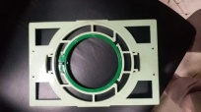
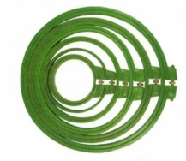
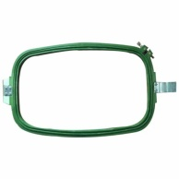
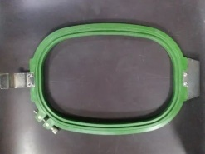
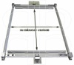
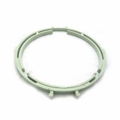
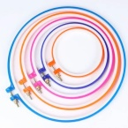
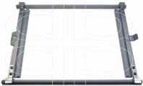
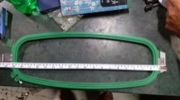

Figure 64: types of frames

8.2. Performing hooping process
Choose the appropriate hoop size for your design. The hoop should be slightly larger than the design to allow for proper stitching. Prepare the fabric by ironing it to remove any wrinkles or creases. It is important to have a smooth surface for accurate embroidery. Place the fabric on a flat surface and position the hoop on top of it. Ensure that the fabric is cantered within the hoop, with enough excess fabric around the edges to secure it. Loosen the hoop screw or lever to separate the inner and outer hoops. Remove the inner hoop and set it aside. Lay a piece of stabilizer on the bottom hoop, making sure it covers the entire area where the design will be embroidered. The stabilizer helps support the fabric during stitching and prevents puckering.
Place the inner hoop back onto the bottom hoop, sandwiching the fabric and stabilizer in between. Ensure that the fabric remains cantered and taut within the hoop. Tighten the hoop screw or lever to secure the fabric and stabilizer in place. Make sure it is tight enough to prevent shifting during embroidery but not too tight to distort the fabric. Attach the hoop to the embroidery machine, aligning it with the machine's embroidery arm or bed. Ensure that it is securely fastened to prevent any movement during stitching.
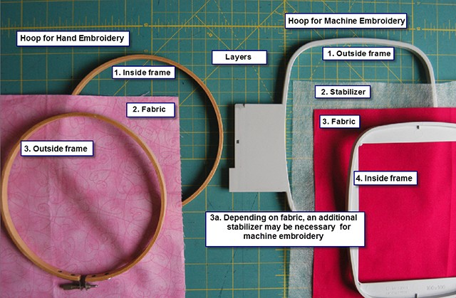
Load the desired design into the embroidery machine, making any necessary adjustments such as resizing or repositioning. Start the embroidery process according to your machine's instructions. The machine will automatically move the hoop and stitch the design onto the fabric. Once the embroidery is complete, remove the hoop from the machine by loosening the screw or lever. Be careful not to pull or tug on the fabric. Gently release the fabric from the hoop by loosening the screw or lever further. Take care not to damage the stitches. Trim any excess stabilizer from the back of the embroidered fabric, leaving a small border around the design. Give the embroidered fabric a final press with an iron to remove any remaining wrinkles or creases. Hooping is a necessary skill that must be mastered for machine embroidery. Proper hooping, including the use of an appropriate stabilizer for the project will be the difference between a finished project and a professionally, finished project.

Figure 65: Hooping diagram

Some fabrics, such as suede or terry cloth, require an additional stabilizer placed on top of the fabric to help keep the embroidery sitting “on top” of the nap. Some knit fabrics work best with an iron-on backing in addition to a stabilizer to prevent stretching during the stitching process. In general, thinner fabrics tend to be easier to hoop than thicker fabrics. Smaller hoops are easier to work with than larger ones, so use the smallest one that accommodates the chosen design.
Sulky Stabilizer is a must. “Quality” is paramount for all supplies from fabric, to design to thread and most importantly, the design’s foundation….stabilizer. Sulky offers a wonderful selection of the various types of stabilizers to fulfil every requirement ever needed in any project. Sulky stabilizers are also able to be used in multiple applications.
To demonstrate the various hooping steps, we will begin with a medium-weight, woven, cotton fabric. This fabric is the easiest to work with for both learning and perfecting hooping skills, and for learning about machine embroidery in general. The best part is the wide variety of projects that mid-weight cotton is suited for.
When hooping, it is very important to work on a hard, flat surface. I work on top of a sturdy table, and I often choose to add a quilter’s cutting mat so that the grid lines are available as a reference. The lines can easily be seen through Sulky Soft ’n Sheer Stabilizer, but even when the lines cannot be seen under the stabilizer, simply squaring the hoop’s frame to the grid lines will prove to be a huge aid in hooping fabric straight on grain.
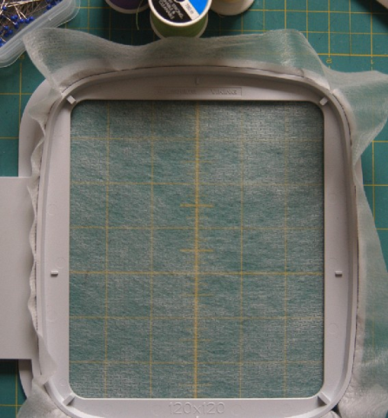
Figure 66: pick the stack up by folding the stabilizer
Step1. Make sure your fabric and stabilizer are cut larger than the hoop currently being used. Stack the layers in order beginning with the stabilizer, topped with cotton fabric and the inside hoop frame. Line up the centre marks of the hoop with the centre marks of your fabric as accurately as possible.
Keeping equal pressure on opposite sides, gently pick the stack up by folding the stabilizer/fabric up over the frame’s side anchoring with thumbs on the hoop frame.
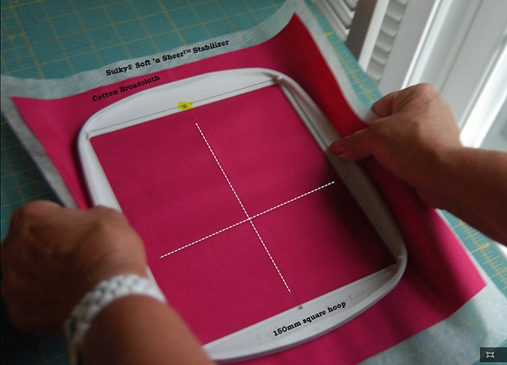
Figure 67: Stack the layers
Step2. Centre the stack over the outer frame (the piece that attaches to the embroidery machine) and seat the bundle inside. Feel for the underneath frame with the pink and ring fingers of both hands while keeping the thumb on top of the fabric bundle holding it taut and wrinkle free. With the index and middle fingers press the unit into the inside frame.
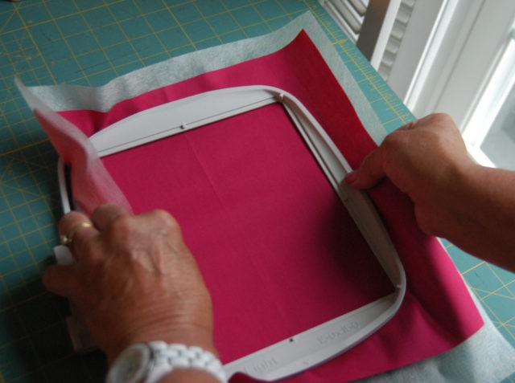
Figure 68: Centre the stack over the outer frame
Step3. Push the top frame with the stabilizer and fabric down into the outside ring which should already fit fairly close to the inside frame even with the added layers of fabric and stabilizer. Before tightening the frame, gently smooth out any wrinkles. Note that the crease of the fabric is lined up with the top and bottom frame notches to demonstrate keeping the fabric straight on grain within the hoop. If all is good, tighten the outer frame as snug as possible to the inner one.
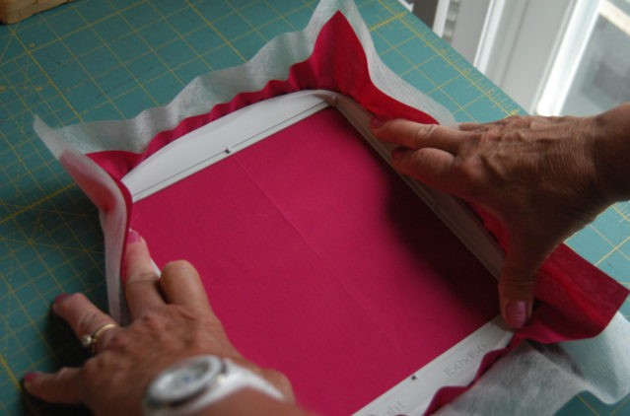
Figure 69: Pushing the top frame
Step4. However, if wrinkles are present, prior to tightening the frame, try bracing the frame with one hand while the other tugs only the stabilizer. Hold the stabilizer and pull it up and out from the frame on all four sides while anchoring the frame with the other hand.
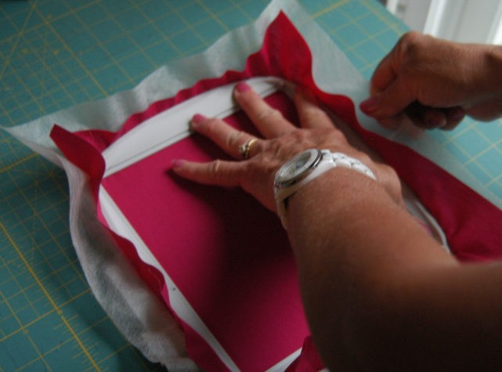
Figure 70: Bracing the frame
Technically it is actually a good idea to tighten the stabilizer but only the stabilizer, on all four sides even if wrinkles are not present. The stabilizer should be just as tight as possible in the frame.
If wrinkles are present and were not removed while tightening the stabilizer, begin the process all over again from Step 1. The tendency to tug on the fabric to tighten or to remove wrinkles is hard to resist, but it will only prove to be extremely counter-productive. Woven fabric is made from weaving fibres in a set pattern with specific spaces in between rows. Pulling on a side to remove a wrinkle causes the weave in this area to distort. Tugging on all four sides stretches the weave at uneven ratios. Therefore, once the tension of the hoop is removed, the fibres will relax. However, since they were stretched at varying degrees, they will also relax at different degrees, causing puckering.
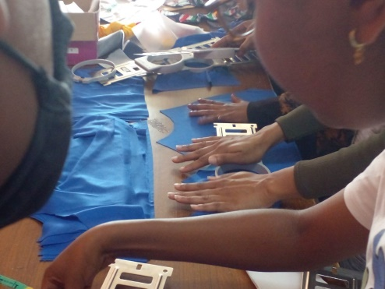

Figure 71: practicing framing hoop

Check-up machine functionality
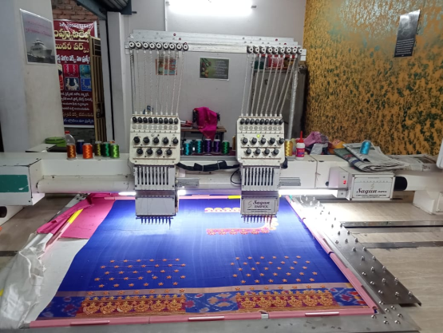
To check the functionality of a digital embroidery machine, you can follow these steps: Power on the machine:
- Ensure that the machine is properly plugged in and turned on.

Figure 72: plugged the machine
- Thread the machine: Follow the instructions provided by the manufacturer to thread the machine correctly. Make sure the thread is properly inserted and tension is adjusted as required.
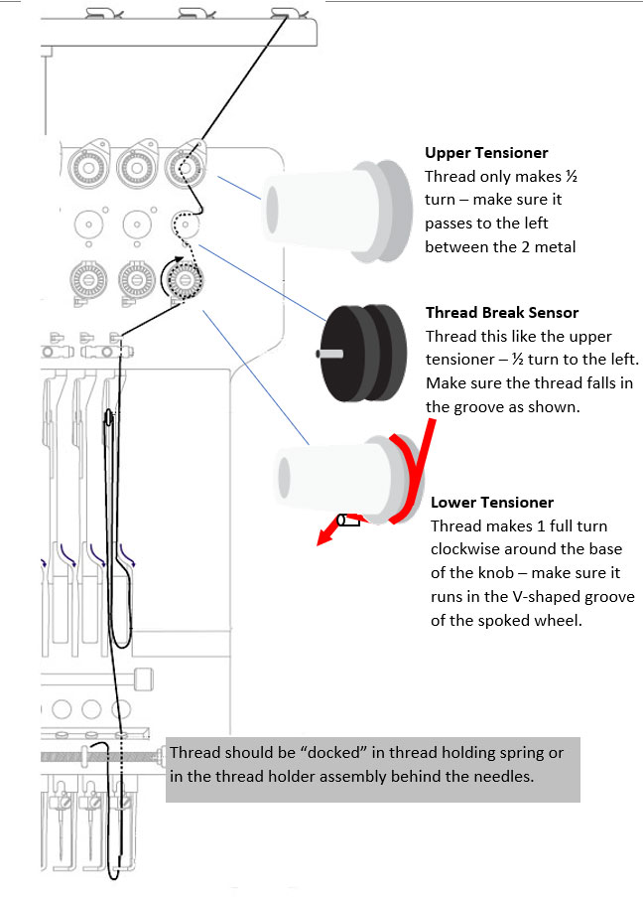
Figure 73: threading the machine
Load the design: Use the machine's software or interface to load a design or pattern onto the machine. Ensure that the design is compatible with the machine and that it is properly aligned. Hoop the fabric: Place the fabric onto the embroidery hoop, ensuring that it is securely held in place. Make sure the fabric is flat and taut to avoid any issues during embroidery. Position the hoop: Attach the hoop to the machine's embroidery arm, ensuring that it is securely fastened. Adjust the position of the hoop so that the needle is aligned with the desired starting point of the design.

Test stitch: Before starting the actual embroidery, it is recommended to run a test stitch on a scrap piece of fabric. This allows you to check if the design is properly aligned and if any adjustments are needed. Start embroidery: Once you are satisfied with the test stitch, start the embroidery process. Observe the machine closely to ensure that it is functioning smoothly, with no unusual noises or vibrations. Monitor progress: Keep an eye on the embroidery progress, ensuring that the stitches are being formed correctly and that there are no thread breaks or other issues. If any issues arise, stop the machine immediately and troubleshoot accordingly.
Check final result: Once the embroidery is complete, remove the fabric from the hoop and inspect the final result. Look for any skipped stitches, loose threads, or other imperfections. Clean and maintain: After completing your check-up, clean and maintain the machine as per the manufacturer's instructions. Regular maintenance will help ensure the longevity and optimal functionality of the digital embroidery machine.

Implementing and applying quality standards
Quality standards for digital embroidery machines may include the following:
- Stitching Accuracy
The machine should be capable of producing precise and consistent stitches, ensuring that the design is accurately embroidered onto the fabric.
  - Speed and Efficiency
The machine should be able to embroider designs quickly and efficiently, reducing production time and increasing productivity.
- Durability and Reliability
The machine should be built with high-quality materials and components to ensure its long-term durability and reliable performance.
- User-Friendly Interface
The machine should have an intuitive and easy-to-use interface, allowing operators to easily navigate through settings, design selection, and customization options.
- Versatility
The machine should be capable of embroidering a wide range of fabrics, including delicate and stretchy materials, without compromising the quality of the embroidery.
- Thread Tension Control
The machine should have precise thread tension control to prevent loose or tight stitches, ensuring the overall quality of the embroidery.
- Design Customization
The machine should offer various customization options, such as resizing, rotating, and editing designs, allowing users to create unique and personalized embroideries.
- Maintenance and Support
The manufacturer should provide clear maintenance guidelines and offer reliable technical support to ensure the machine's optimal performance and minimize downtime.
- Compatibility
The machine should be compatible with various design file formats, allowing users to import designs from different software programs.
- Safety Features
The machine should incorporate safety features, such as automatic shut-off mechanisms and emergency stop buttons, to protect operators from potential accidents or injuries.

Unit Nine: Preparing work pieces and workstation
This learning guide is developed to provide you the necessary information regarding the following content coverage and topics:
- Applying OHS practices.
- Adjusting equipment and materials for work
- Working on laid out of fabric pieces.
- Performing routine minor maintenance
- Reporting and recording any problems.
This guide will also assist you to attain the learning outcomes stated in the cover page. Specifically, upon completion of this learning guide, you will be able to:
- Understand and Applying OHS practices.
- Understand Adjusting equipment and materials for work
- Understand Working on laid out of fabric pieces.
- Identifies and Performing routine minor maintenance
- Identifies and Reporting and recording any problems.
.

9.1. Applying OHS practices
14. How do you ensure safety while operating embroidery machines?
Safety is paramount in any work environment, but it’s especially important when operating heavy machinery. The question is aimed at understanding your knowledge of safe practices, your adherence to safety rules, and your ability to maintain a safe working environment. It’s also a way for the employer to assess whether you will be able to prevent accidents or injuries, thus ensuring a secure and productive workplace.

Example: “To ensure safety while operating embroidery machines, I strictly adhere to the manufacturer’s instructions and guidelines. Regular maintenance checks are crucial to prevent any malfunctions or accidents.

I also believe in using personal protective equipment like gloves and safety glasses. It’s important to keep the work area clean and free of clutter to avoid trips and falls.

Proper training on machine usage is another key aspect. This includes understanding emergency stop functions and how to handle thread breaks or needle changes safely.

Lastly, taking regular breaks helps maintain focus and reduces the risk of fatigue-related mistakes.”

9.2. Adjusting equipment and materials for work
- Machine embroidery threads (bobbin (for the bottom) and needle (for the top) types)
- Machine embroidery needles.
- Machine embroidery stabilizers (tear-away, cut-away, wash-away film),
- Temporary spray adhesive. 3 – Helpful extras:
- Scissors,
- Pins,
- Iron,
- Fabric marker,

9.3. Working on laid out of fabric pieces
Depending on the breadth of your fabric and the version of the pattern you are sewing, this section usually offers a few different layout options. Keep these layout suggestions in mind as you go forward following the layout guide will ensure that your pieces fit on your fabric and are cut in the correct orientation. However, once you understand the process of laying out pattern pieces, you can always adjust the layout to your needs. You don’t have to follow the layout guidelines in the pattern instructions.
- Lay Out Your Fabric
It’s now time to lay out your fabric on a table, the floor, or a cutting mat. Unless you’re cutting a specialty fabric, such as velvet, sequins, or vinyl, you’ll be cutting your fabric in two layers. To prepare your fabric, fold it in half lengthwise so that the selvage edges are matched up.
Traditionally, fabric is cut while folded with right sides together. However, it really doesn’t make a difference if you fold it with right or wrong sides together for cutting. In fact, I find it easier to place my pattern pieces where I want them on a printed fabric if I fold it with the right sides facing out!
Make sure that your fabric is lying flat and that the fold at the bottom is straight. Readjust your fabric until all the edges are aligned as closely as possible. If your fabric is wrinkly, it helps to press it flat before trying to lay it out for cutting.
- Lay Your Pattern Pieces on Your Fabric
With your fabric prepared, it’s time to lay out those pattern pieces! The simplest way to do this is to select one of the layout options from the pattern instructions and arrange your pieces on your fabric as suggested.
However, as long as you keep the pattern pieces on grain (more on that in the next section), you can arrange the pieces in whatever order you like.
- Watch the Grain line
You’ll need to watch those grain lines! The straight grain runs exactly parallel to the selvage edge of your fabric. You can typically see straight threads running across your fabric along the grain if you look closely.
Each pattern piece will have a double-sided, straight arrow printed on it. This arrow should be aligned with the straight grain. On some pattern pieces, the arrow may run vertically, on some it may be horizontal, or it can even be diagonal. The key is to keep that arrow on the straight grain.
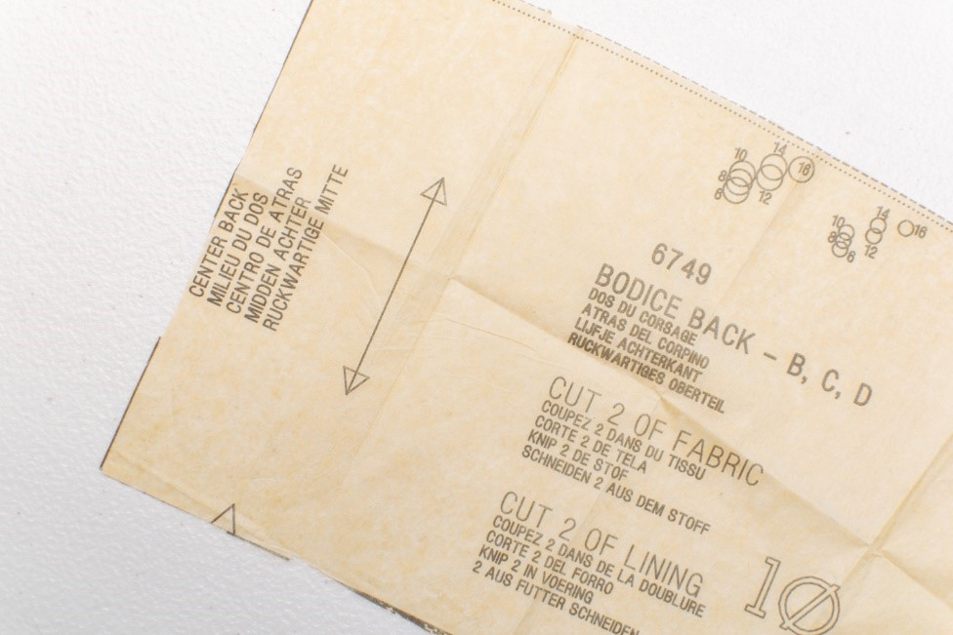
Figure 74: Grain line
You can eyeball the placement if you like, by looking at the threads running across your fabric. To be more precise, you can measure over from the selvage along the length of the arrow to make sure it’s the same distance from the selvage all the way down.
Keeping your pattern pieces on grain is extremely important for making a garment that will hang correctly and not twist. If your pieces are cut in any direction with no consideration to the grain, they will not hang straight once stitched together.
- Check for Pieces Cut on the Fold
Some pattern pieces may need to be cut with one edge on the fold of your fabric. The reason for this is so that after cutting, the piece can be unfolded into one large piece that’s symmetrical on each side. Examples of pieces commonly cut on the fold include bodice and skirt fronts and backs, sleeves, and waistbands.
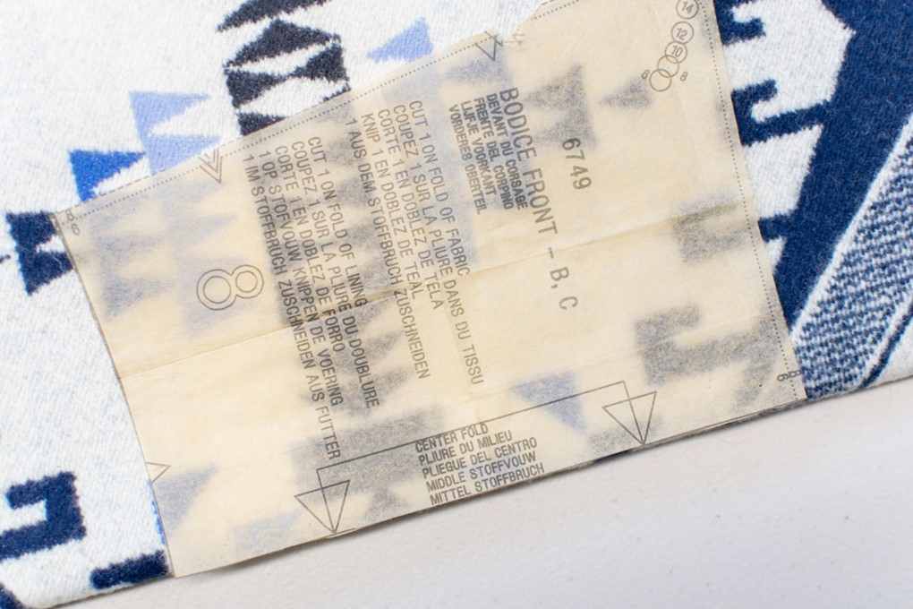
Figure 75: Cut on the Fold
If a piece needs to be cut on the fold, it will have a double-sided arrow with angled ends and the words “center fold” along one edge of the pattern piece. The edge that the arrows point to needs to be carefully aligned with the fold in your fabric.
- Cut Out Your Fabric
Once your pattern pieces have been arranged on your fabric, they need to be secured in place. You can do this with sewing pins or by weighing them down with pattern weights. I highly recommend using pattern weights only with a rotary cutter because scissors tend to shift your fabric and pattern weights out of place as you cut.
With the pattern pieces secured to your fabric, carefully cut around the edges of each piece with a rotary cutter or scissors. Focus on cutting as accurately along the pattern lines as possible.

9.4. Performing routine minor maintenance
- Regular cleaning
Dust and debris can accumulate on the embroidery machine, affecting its performance. Regularly cleaning the machine with a soft cloth and gentle cleaner can prevent build-up and ensure smooth operation.
- Lubrication
Proper lubrication of moving parts is essential for the longevity and efficiency of the embroidery machine. Follow the manufacturer's guidelines for lubrication intervals and use the recommended lubricants.
- Needle replacement:
Needles can become dull or damaged over time, leading to poor quality embroidery. Routinely inspect and replace needles as needed to maintain high-quality stitching.
- Bobbin check
Check the bobbin thread tension and ensure that the bobbin case is clean and free from any tangled thread or debris.
- Tension adjustment
Regularly check and adjust the thread tension to ensure even and consistent stitching.
- Software updates
Keep the embroidery machine's software up to date to access new features, improve performance, and address any bugs or issues.
- Inspection of electrical components
Periodically inspect the electrical components of the embroidery machine for any signs of wear, damage, or loose connections.
- Test runs
Conduct test runs of the embroidery machine to identify any irregularities or issues before starting a production run.
- Check for loose screws and bolts
Vibrations from the embroidery machine can cause screws and bolts to loosen over time. Regularly check and tighten any loose fasteners to prevent damage or malfunctions.
By performing these routine maintenance tasks, you can ensure that your multi-head digital embroidery machine operates at its best, producing high-quality embroidery products consistently.

9.5. Reporting and recording any problems
Both digitizing and embroidery are precision processes and each is impacted by a number of factors. Truly perfect embroidery – where every stitch is perfectly tensioned and placed and the embroidery is smooth and ripple-free is always the goal. However, in reality that goal is unattainable.
If embroidery results are at the opposite end of the scale, it is tempting to simply blame the digitizer for your problems. However, registration and puckering problems are the effect of improper machine setup, improper stabilization, needle, thread and fabric selection, design resizing, or digitizing singly or in combination. A reputable digitizer would not release a design that does not sewing well. If you have an acceptable sample sew out or image of sew out from the digitizer, then the problem may not be in the digitizing. Before calling the digitizer, check the following:
- Machine setup
Improperly set needle and/or bobbin tensions are the most common machine-related source of sewing problems. Although most home machines set tensions automatically, they may not be ideal for the current situation.
Symptoms of tension problems include looping in the top stitching, bobbin threads pulled to the top, little or no bobbin thread showing on the back on satin columns, and running stitches that don't show up. Registration problems are magnified by tight tensions – stitches pull more, exposing fabric between abutted areas as well as between rows of stitches in fills. Thread breaks and even needle breaks can be attributed to tension problems. Proper tensions are crucial, and understanding how to set them is imperative.
In addition to the machine's tension settings, other factors affect thread tension. These include the amount of thread on the spool or bobbin, how tightly it's wound and the thread colour. Dirt and lint build up along the thread path can also impact tension.

Fabric thickness can affect thread tensions. A digitizer factors in thicker fabrics by adding compensation during the design's creation. However, you may need to enhance the effect by adjusting your thread tension, especially if sewing a design not specifically digitized for thicker fabric, such as a stock design.

Make sure that there are no obstacles that will interfere with the movement of the hoop even little items like pins have the potential to restrict motion and interfere with registration. Large, bulky, stiff, and otherwise unwieldy items may interfere with hoop movement. Thick items can snag the needle if it does not adequately clear the fabric before moving to the next stitch. The presser foot and trimmer mechanism can also hang up on thick items and prevent smooth hoop movement.
Confirm that your hoop is properly and completely secured to the machine. It's easy to attach the hoop without latching it firmly in place, the hoop may be crooked or not fully inserted, which will affect the design placement. Flagging – the up and down movement of the hoop, may also result, which can further worsen registration.

- Stabilization equation
Proper stabilization is the key to quality sewing. The hoop, hoop tension, backing, topping, and any adhesives affect stabilization.
The purpose of the hoop is to securely support the item during sewing. The first step is to select the proper hoop, which as a rule is the smallest hoop that will comfortably accommodate the design. Remember to allow space for the presser foot! The larger the hoop, the less support and the more play, it provides the fabric. The larger the fabric area in the hoop, the more opportunity there is for stretching, shifting, and flagging – all opportunities for poor registration.
Keep in mind that when the digitizer tested the design, it was sewn in the smallest possible hoop. If you are combining small designs and sewing them in a large hoop, you are increasing your chances of registration problems.
In addition to machine tensions, another potential tension headache to be concerned with is hoop tension. Fabric must be held securely and smoothly in the hoop in a neutral tension. Fabric that is stretched during hooping will relax back to its normal state when released from the hoop – the result is puckering. If your machine was tightly tensioned and you used polyester threads, you have compounded the problem. When hooping, the inner hoop should go in with some pressure; it should not drop right in nor should you have to bounce on the hoop to get it seated. Tightening the screw after placement should be avoided but if necessary, do so with care – overly tight hoops can damage hooped goods and the hoop itself. Tightening the screw after hooping can also cause uneven hoop tension on the fabric, actually loosening the fabric at the screw area. The hooped fabric should be smooth and wrinkle free. Loose fabric can also result in puckering, as the fabric is pulled tight during the stitching process.
Take extra care when hooping knits to avoid stretching. Fusing them to a backing with a temporary embroidery spray adhesive or heat fusible product not only makes hooping easier, but also reduces shifting during sewing. Hooping the item is not always an easy task. Getting the fabric smoothly and evenly hooped in the correct position can be challenging even on a simple job. Hooping correctly and accurately takes time and practice – unfortunately it is an often-undervalued step in the process of creating good embroidery, especially for novice embroiderers.

Selecting the proper backing and hooping it correctly is vital for quality results. Backing has many functions, one of which is to provide stability for the item being sewn. In this capacity it reduces fabric shifting and hoop slippage due to the forces of sewing. Backing should be large enough to be completely gripped by the hoop. Partially hooped backing will result in uneven support.

Backing selection is based on the stability of the garment and how much stress the design will apply. A richly detailed, full coverage design has more distortion potential and needs a more stable surface than an open, airy design. Stretchy fabrics, whether woven or knit, need a more stable backing than non-stretchy fabrics. Cutaways are more resistant to needle penetrations and thus provide more support during and after sewing than a tearaway. Fusible can reduce fabric slippage, but may still perforate during sewing thus compromising continued stability. Heavy stiff backings, as well as adhesives, can contribute to embroidery thickness and thread breaks.
A topping may be required on textured or high colors contrast fabrics. On pique knit shirts, the waffle-like texture of the fabric can cause registration problems and jagged looking edges. A water-soluble topping can provide a smooth surface for stitching. On terry cloth, use a more permanent topping, such as a low melt film, to permanently tame the nap if the design was not specifically digitized for terry cloth. A colors block topping can kill two birds with one stone by providing a permanent topping to neutralize extreme colors and to smooth the texture.
- Puckered embroidery
The sample on the left above shows inadequate registration. The cloth puckered and the colors were misaligned as a result of using the incorrect stabilizer and hoops. The identical design, properly registered (upper right). There's also less puckering of the fabric.
- Needles
It's surprising how much something as small as a needle can affect embroidery quality. For the most accurate stitch placement, use the finest, sharpest embroidery needle that can carry the thread through the fabric without damage to either. A size 70 or 75 needle works well with most fabrics; use an 80 for heavier or stiffer goods. Use a light ball point for knits and loosely woven fabrics; a sharp point for firmly woven goods, leather, and vinyl.
- Thread
The trend these days is towards polyester thread, with the main reason given being reduced thread breaks (which, by the way, is the wrong reason!). Polyester thread is stronger than rayon and will stretch further before breaking. During that stretching period, stitches are sewn more tightly into the fabric. When the item is released from the hoop, the stretched thread will relax to its upstretched state and pull up the embroidery, causing, you guessed it: puckering. If the thread is stretched through the entire design due to machine tensions, puckering and poor registration can result.
Most designs are digitized for 40-weight thread. If you are using 30- or even 35-weight thread, your design will feel stiff. Unless the design was digitized for specialty threads, don't expect them to run trouble-free.
- Fabric selection
A custom design is specifically digitized for a particular fabric type and colour, while a stock design is digitized for average fabric, meaning a medium weight, firmly woven, non-stretchy, smooth, non-patterned, neutral colour fabric. The digitizer makes key decisions based on the target fabric, some of which are push-pull compensation, underlay type and amount, stitch length, and stitch density. A stock design that works well on a chambray shirt may need some adjustments for sewing on a sweatshirt; a custom design that was digitized for a left chest nylon jacket will more than likely sew poorly on a cap.
One unfortunate embroidery fact of life is that no, one design, will sew optimally on every fabric you throw at it. However, no one wants to pay to have a design optimized for every fabric they may use. If you get a poor result when sewing on a fabric other than what the design was intended for, don't assume the design is flawed. You may be able to get acceptable results through judicious hooping and stabilizing, or a little of your own editing. Do balance the trade-offs of your time. If you are sewing the design in production and your customer wants a new fabric type, it may be more economical to pay to have the original digitizer edit the design for you.
- Caps
Caps are particularly tricky. They are difficult to hoop snugly no matter whether you attempt to hoop them flat or in a cap hoop. Any item that cannot be hooped smoothly and securely is more prone to registration problems. Cap frames vary widely as does hooping techniques, making consistently good results hard to achieve. Cap styles also impact quality results. For example when sewing low profile caps on a commercial machine, if the design is too tall, the cap can be stretched by the machine during sewing. As the upper portion of the design is sewn, the cap is moved close to the machine, which pushes against the inside crown of the cap, stretching and distorting the sewing surface.
- Scaling designs
Whenever you alter a design by sizing it up or down, skewing it, and even rotating it so that it sews on the bias, you have changed it from the way it was originally digitized and tested and you run the risk of an unsatisfactory result. Due to the vast array of sizing software on the market today, there is no way a digitizer can predict how a particular program will alter the design. Some resizers change the stitch effects upon opening the design, whether or not a change is made. You must realize that you are changing the proportions of the design, which may affect registration. Stitch length, especially in satins, can be negatively affected. If you alter or modify a design, be sure to work only on a copy and to test it thoroughly!
- Testing designs
All designs should be tested before sewing in production. Custom designs should be tested under the conditions for which they were digitized. And, if you will be sewing on a different fabric, test separately. If you are having problems with a stock design, test the original design (not a scaled version) on white or off-white broadcloth using one layer of medium weight cutaway hooped with the fabric. Pay attention to your hooping methods, insert a new needle, use the type and size thread specified – both needle and bobbin – and check your tensions carefully. If you get good results, then the problem is not the design; it may be that the design is simply not compatible with your fabric. If your design has running stitch outlines, you may find that they are not perfectly placed on every sewing layout. Indeed, even under the most optimal conditions, you will find small variations in each sew out. By simply accepting that embroidery is not a perfect art form, you will be much happier!
The more I learn about embroidery, the more amazed I am when the quality is truly top notch. Puckering, poor registration, and thick, stiff embroidery are not always caused by digitizing. While you can't take a bad design and make it sewing well using the techniques we've discussed here, without proper technique neither can you make a well-digitized design sew well. Remember, you control many factors related to a high-quality finished design. It's up to you to thoroughly and objectively assess the situation so that you can make the appropriate decisions to avoid problems.

Self-check. 9

Part I From the following question choose best answer letter and circle it.
1. What can contribute to embroidery thickness and thread breaks?
a) Needle selection
b) Fabric selection
c) Backing selection
d) All of the above
2. What can help provide a smooth surface for stitching on textured fabrics?
a) Tear away backing
b) Fusible backing
c) Water-soluble topping
d) Cutaway backing
3. What can be used to permanently tame the nap of terry cloth fabric?
a) Water-soluble topping
b) Low melt film topping
c) Colors block topping
d) Fusible backing
4. What can cause puckered embroidery?
a) Incorrect needle size
b) Incorrect stabilizer and hoops
c) Incorrect threads tension
d) All of the above
5. What type of needle should be used for knits and loosely woven fabrics?
a) Size 70 or 75 needle
b) Size 80 needles
c) Light ball point needle
d) Sharp point needle
6. What type of thread is most commonly used for embroidery?
a) Rayon thread
b) Polyester thread
c) Cotton thread
d) Silk thread
7. What can polyester thread cause when used in embroidery?
a) Reduced thread breaks
b) Puckering
c) Improved stitch placement
d) All of the above
8. What type of fabric is a stock design digitized for?
a) Heavy weight, stretchy, patterned fabric
b) Medium weight, non-stretchy, smooth, neutral color fabric
c) Lightweight, loosely woven, textured fabric
d) Thick, stiff, brightly colored fabric
9. What decisions does the digitizer make based on the target fabric?
a) Thread tension and hoop size
b) Stitch length and stitch density
c) Needle type and fabric color
d) All of the above
10. What can be used to provide support during and after sewing on stretchy fabrics?
a) Tear away backing
b) Cutaway backing
c) Fusible backing
d) Water-soluble topping

Unit Ten: Producing digital machine embroidery on articles/ garments
This learning guide is developed to provide you the necessary information regarding the following content coverage and topics:
- Applying OHS
- Producing the garment by applying embroidery
- Assessing the compliance quality
- Checking and adjusting machine to ensure the optimum performance
- Managing production problems.
- Controlling manufacturing details
- Managing steps of machine troubleshooting.
- Practicing minor routine machine maintenance.
This guide will also assist you to attain the learning outcomes stated in the cover page. Specifically, upon completion of this learning guide, you will be able to:
- Understanding Applying OHS
- Discus and understand Producing the garment by applying embroidery
- Define Assessing the compliance quality
- Identifies Checking and adjusting machine to ensure the optimum performance
- Identifies and managing production problems.
- Discus and understand Controlling manufacturing details
- Understand Managing steps of machine troubleshooting.
- Understand practicing minor routine machine maintenance.

10.1. Applying OHS
14. How do you ensure safety while operating embroidery machines?
Safety is paramount in any work environment, but it’s especially important when operating heavy machinery. The question is aimed at understanding your knowledge of safe practices, your adherence to safety rules, and your ability to maintain a safe working environment. It’s also a way for the employer to assess whether you will be able to prevent accidents or injuries, thus ensuring a secure and productive workplace.
Example: “To ensure safety while operating embroidery machines, I strictly adhere to the manufacturer’s instructions and guidelines. Regular maintenance checks are crucial to prevent any malfunctions or accidents. Also believe in using personal protective equipment like gloves and safety glasses. It’s important to keep the work area clean and free of clutter to avoid trips and falls. Proper training on machine usage is another key aspect. This includes understanding emergency stop functions and how to handle thread breaks or needle changes safely.

10.2. Producing the garment by applying embroidery
The embroidery section is one of the most important sections of the apparel manufacturing industry. It is one of the special tasks which is done according to the buyer’s requirements. In the past embroidery had done by using the manual method. But now a day, it is done by applying a computerized method. In the readymade apparel sector, computerized embroidery machine helps to produce very complex design within a very short period of time.
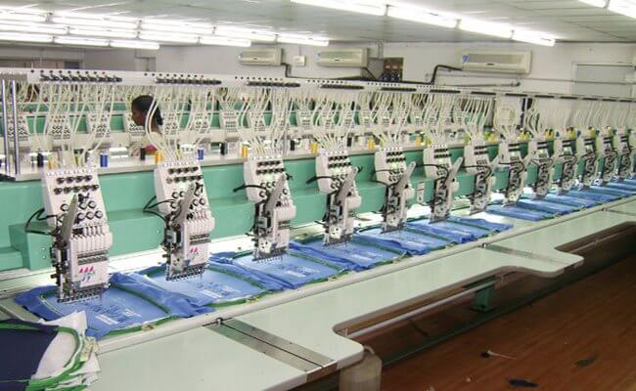
Figure 76: Embroidery section in the apparel industry

Process of Embroidery in Apparel Manufacturing Industry:
Embroidery is a decorative stitch that is placed on the garment to enhance its properties or advertise the brand of the garment. Some styles need the pocket, front, or sleeve to be embroidered. It is the embroidery section supervisor’s responsibility to get the correct embroidery disk or tape from the production coordinator. This tape is placed on the machine and the machine is set up to run 20 embroideries at once based on machine capacity.
He supervisor will adjust the machine speed so that it is suitable for the different fabric and embroidery types. The approved standard will be hanging with the machine and follow according to style. When the embroidery operation is completed in the embroidery section then all the pieces are checked 100% through the needle detector machine and send to the cutting section. Finally cutting section will include all the parts together and deliver to the sewing line. The cutting quality inspector must check each cut received from embroidery 100% for its quality and quantity. Cutting in-charge has to follow the bundled chart and ensure the entire cut received is as per its Quantity and number sequence.
Any panel is to be returned in the embroidery section for rectifying should be noted down in this report and should ensure that each panel will be returned to each bundle after correction or replacement. Q.A (Quality assurance) Manager and Cutting in-charge must ensure each bundle which is going to be issued to the sewing line will be 100% correct and acceptable with quantity too. Full responsibility delegated to the embroidery section or plant about standard quality and each panel must be check for quality point advised by the QC (Quality Controller) and its Quality Manager. QC has to submit this report to the QA Manager on daily basis. Before sewing line input, will check each bundle which is going to be passed through the metal detector machine, also will be 100% correct and acceptable with quantity.
After adjusting the machine in the embroidery section, the supervisor will check some samples to ensure that the machine is set up correctly. The embroidery operator will get the Q.C’s approval before the bulk production. The Q.C inspector will inspect the pieces in a bundle randomly. If they find one or more defects out of the pieces they inspect then the entire bundle will be rejected. If they find no defects in the bundle then the bundle will be released for the next process. Then inspection procedure is the same as the in-line Q.C system.
To ensure that the embroidery production is going to be acceptable to proceed with metal-free cut parts to the sewing line to minimize and control garment quantity and minimize garment rejection due to embroidery mistakes.

10.3. Assessing the compliance quality
- Top Embroidery Machines Compliance Issue
- Drinking water sign was not posted.
- Floor west keeping area sign was not posted.
- Notice board was not found.
- First aid Box was not found.
- Floor wise First aider, Fire fighter & Rescue team list was not posted.
- PPE Use sign was not posted.
- Artificial Respiration instruction was not posted.
- Chemical Handling was not Maintained Properly.
- Floor Evacuation Plan was not posted on Exit.
- Aisles Marking & Arrow marking was missing.
- Rubber mat missing under all SDB & MDB.
- Fire Alarm Switch & alarm sign not posted.
- Fire extinguisher user instruction was not posted every area.
- Fire hose boxes/Cabinet user instruction was not posted.
- 01 Fire hose box found but 40 mm (1.5 Inch) pipe was missing inside the box.
- Fire hose box responsible person list was not posted.
- Fire Hose box sign was not posted.
- Emergency light sign was not posted.
- Electrical wiring go through inside the floor without cable tray and lot of thread dust are gather with the cable.
- Exit light was not found.
- Toilet sign was not posted.
- Toilet (Number of toilet) layout was not posted.
- Drinking water test report was not posted.
- Drinking water sign was not posted.
- Floor west keeping area sign was not posted.
- No smoking sign not posted.
- Notice board was not found.
- First aid Box was not found.
- Floor wise First aider, Fire fighter & Rescue team list was not posted.
- PPE Use sign was not posted.
- Artificial Respiration instruction was not posted
- Chemical handling was not maintained properly
- Floor Evacuation Plan was not posted on Exit.
- Aisles Marking & Arrow marking was missing.
- Fire Alarm Switch & alarm sign not posted.
- Fire extinguisher user instruction was not posted every area.
- Fire hose boxes/Cabinet user instruction was not posted.
- 01 Fire hose box found but 40 mm (1.5 Inch) dia pipe was missing inside the box.
- Fire hose box responsible person list was not posted.
- Emergency light sign was not posted.
- Exit light was not found.
- Electric wiring found inside the Central Raw Material Store.
- “Light not used without protection” sign (Bengali & English) was not posted in storage area for Top Embroidery Machines

10.4. Checking and adjusting machine to ensure the optimum performance
- Check the fabric feed system:
Before operating the digital embroidery machine, ensure that the fabric feed system is functioning properly. This includes checking the feed dogs, presser foot, and any other components that are responsible for moving the fabric smoothly through the machine. Make sure there are no obstructions or issues that could cause the fabric to get stuck or misaligned during the embroidery process.
- Calibrate the machine
If necessary, calibrate the machine to ensure accurate stitching and alignment. Follow the manufacturer's instructions for calibrating the machine, which may involve adjusting needle position, hoop alignment, or other settings.
- Load the embroidery design
Load the desired embroidery design onto the machine's software or interface. Ensure that the design is properly aligned and positioned within the hoop area.
- Set up thread colors:
Choose the thread colors that will be used for the embroidery design. Load the appropriate thread spools onto the machine's thread holders and thread each color through the machine's needle and bobbin according to the manufacturer's instructions.
- Set embroidery parameters
Adjust the machine settings such as stitch length, density, and speed to achieve the desired embroidery outcome. Consider factors such as fabric type, design complexity, and thread thickness when setting these parameters.
- Perform a test run
Before embroidering on the final fabric, perform a test run on a scrap piece of fabric to ensure that the design is stitching correctly and that the thread tension is properly adjusted. Make any necessary adjustments to the machine settings based on the test run results.
- Secure the fabric
Once you are confident in the machine's settings and performance, securely attach the fabric to the embroidery hoop. Ensure that it is taut and properly cantered within the hoop to prevent any shifting or distortion during embroidery.
- Start the embroidery process
Begin the embroidery process by pressing the start button or initiating the embroidery command on the machine's interface. Monitor the machine closely during operation to ensure that the design is stitching accurately and that the fabric is feeding smoothly.
- Monitor and make adjustments
Continuously monitor the embroidery process, checking for any issues such as thread breakage, needle jams, or fabric misalignment. Make any necessary adjustments to the machine settings or fabric positioning to correct these issues.
- Finish and inspect the embroidery
Once the embroidery is complete, remove the fabric from the hoop and inspect the design for any flaws or imperfections. Trim any loose threads and make any necessary touch-ups to ensure a clean and professional finish.
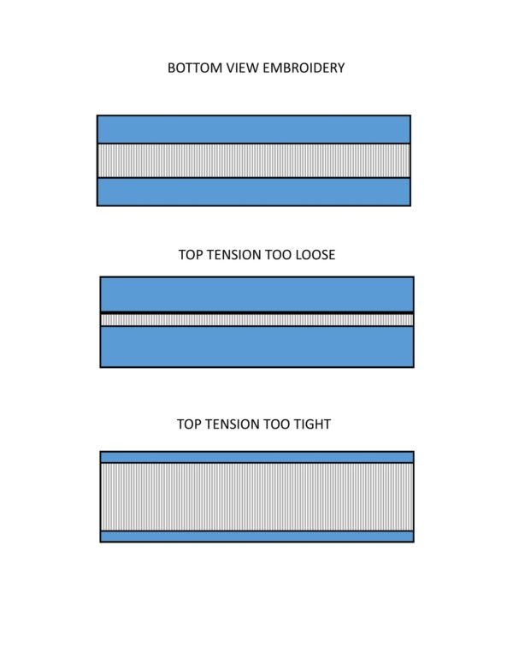

Figure 77: stitch tension adjusting

Manage production problems.
Managing production problems can be challenging, but with a systematic approach and effective communication, you can effectively address and resolve them. Here are some steps to help you manage production problems:
- Identify the problem
Clearly define the issue you are facing in the production process. This could be a decrease in productivity, quality issues, equipment breakdowns, or any other problem affecting production.
- Gather information
Collect data and gather information about the problem. This may involve analyzing production reports, talking to employees, conducting inspections, or reviewing customer feedback. The more information you have, the better you can understand the root cause of the problem.
- Determine the root cause
Analyse the information collected to identify the underlying cause of the problem. Use tools like root cause analysis, fishbone diagrams, or 5 Whys technique to dig deeper and find the real reason behind the issue.
- Develop a plan
Once you have identified the root cause, create a plan to address it. Break down the plan into actionable steps and set clear objectives. Assign responsibilities to team members who will be involved in implementing the plan.
- Implement corrective actions
Execute the plan by implementing the necessary changes or improvements. This may involve adjusting production processes, training employees, repairing or replacing equipment, or implementing new quality control measures.
- Monitor progress
Regularly track and monitor the progress of the corrective actions. Use key performance indicators (KPIs) to measure improvements and ensure that the problem is being resolved effectively. Make adjustments to the plan if needed.
- Communicate with stakeholders
Keep all relevant parties informed about the problem and the progress being made. This includes employees, management, suppliers, and customers if necessary. Effective communication ensures everyone is on the same page and can contribute to finding solutions.

- Document lessons learned
After resolving the production problem, document the entire process, including the steps taken, challenges faced, and outcomes achieved. This documentation will serve as a valuable reference for future problem-solving and continuous improvement efforts.
- Implement preventive measures:
Once the problem is resolved, identify measures to prevent similar issues from occurring in the future. This may involve implementing preventive maintenance schedules, conducting regular audits, or improving training programs.
- Continuously improve
Use the experience gained from managing production problems to drive continuous improvement in your production processes. Encourage a culture of problem-solving and empower employees to identify and address issues proactively.
Remember that managing production problems is an on-going process, and it requires a proactive and systematic approach. By following these steps, you can effectively address production problems and improve overall efficiency and productivity.

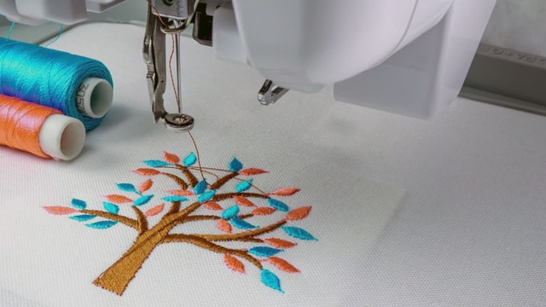
Figure 78: embroidering products
In the quest to improve the productivity of embroidering products, the production manager must understand all of the factors that come into play. Generally, the first and foremost concern is the number of stitches in the design. Everything about embroidery relates to the number of stitches and how many stitches can be generated per day. In addition there are other important components to take into consideration. Team SW takes a closer look…
How the design is digitized, what type and quality of thread is used, which machine is chosen for which job, layout of the machines, fabric and price point of the garment, and sewing stitch densities are just a few of the factors to be considered when embroidery is undertaken. In today’s production environment when speed is also a determining factor many important aspects must be addressed when looking to improve productivity.
As with garment manufacturing the single most important factor is the initial design. In embroidery, this function is accomplished by the “digitizer.” He/she is the person who converts the artwork into machine readable commands for the embroidery machine. The digitizer determines how many stitches will be in the design, how many thread trims will take place, how many color changes will take place, and how smoothly the design will run.

Controlling manufacturing details
The process of controlling manufacturing details involves monitoring and managing the various aspects of the production process to ensure that the final product meets quality standards and specifications. This includes: Quality Control: Implementing measures to inspect and test the materials, components, and finished products to ensure they meet quality standards and specifications.
Process Monitoring: Continuously monitoring the manufacturing process to identify any deviations or issues that may affect the quality of the final product. This includes monitoring equipment performance, production parameters, and environmental conditions. Corrective Actions: Implementing corrective actions to address any issues or deviations identified during the manufacturing process. This may involve adjusting production parameters, reworking defective parts, or implementing process improvements.
Documentation: Maintaining detailed records of the manufacturing process, including inspection reports, test results, and production data. This documentation provides a traceable record of the manufacturing details and helps in identifying areas for improvement. Training and Education: Providing training and education to production personnel to ensure they understand the quality standards and manufacturing requirements. This helps in preventing errors and improving overall product quality. Continuous Improvement: Implementing measures to continuously improve the manufacturing process, such as implementing new technologies, optimizing production parameters, and incorporating feedback from quality control measures.

By effectively controlling manufacturing details, companies can ensure that their products meet quality standards, customer expectations, and regulatory requirements. This ultimately leads to improved product quality, customer satisfaction, and business success.

Managing steps of machine troubleshooting
Upkeep and diagnostics for embroidery machines the purpose of is to gauge your technical proficiency and capacity for problem-solving. It is inevitable for an embroidery machine operator to occasionally have performance problems or technical difficulties. In addition to minimizing downtime, your adept handling of these circumstances guarantees the products' constant quality. Because of this, hiring supervisors are curious about your maintenance and troubleshooting abilities. Example: "Embroidery machines require routine maintenance to operate at their best. I normally begin by routinely cleaning the machine to avoid the accumulation of dust and thread, which can interfere with its functionality.
It's essential to comprehend the machine's instructions for troubleshooting. It provides insights into common problems and how to resolve them. If a problem persists after trying basic solutions, I consult with technical support or a professional technician. Maintaining a record of regular maintenance and any issues encountered helps in identifying patterns that may indicate a larger issue. This proactive approach ensures minimal downtime and consistent quality output.”

Practicing minor routine machine maintenance
What is your process for cleaning and maintaining embroidery machines?
Maintaining embroidery machines is essential to ensure their longevity and optimal performance. Clean, well-maintained machines are less likely to break down or produce poor quality embroidery. Therefore, interviewers want to see that you understand the importance of regular machine cleaning and maintenance, and that you have strategies in place to carry this out effectively.
Example: “Cleaning and maintaining embroidery machines involves several steps. Regular dusting is crucial to prevent build up in the machine’s parts. I use a soft brush or compressed air for this. The bobbin case needs cleaning after every project, using a small brush to remove lint. The needle should be replaced regularly, typically after every 8 hours of stitching.
Oiling is also important for smooth operation. However, it’s essential not to over-oil as it can stain fabrics. Periodically, I conduct a thorough check up: inspecting belts for wear, ensuring screws are tight, and checking that the thread path is clear. If any part seems worn out, I replace it promptly. I believe preventive maintenance not only extends the life of the machine but also ensures optimal performance.”
How do you handle thread breaks during the embroidery process?
One of the most frequent and annoying problems an operator of an embroidery machine encounters is thread breaks. Product quality, general efficiency, and production speed can all be impacted by how you handle these disruptions. Interviewers are interested in learning about your capacity for problem-solving, your capacity for maintaining quality under duress, and your technical proficiency in using and troubleshooting the machinery.
Example: “When a thread break occurs during the embroidery process, I first stop the machine to prevent any further damage. Then, I rethread the machine and check for any issues that may have caused the break such as needle position or tension problems. If the issue persists, I inspect the bobbin case and replace it if necessary. It’s crucial to maintain the equipment regularly to minimize these occurrences.”
Thread tension and how it affects the quality of embroidery? This question is to assess your technical knowledge and understanding of the embroidery process. Thread tension plays a critical role in the final product’s quality, and it’s important for an embroidery machine operator to have a comprehensive understanding of how to adjust and control it. This also shows your troubleshooting skills and attention to detail—both of which are essential for maintaining the highest standards of quality and efficiency in embroidery production.
Example: “Thread tension is critical in embroidery. It affects stitch quality and overall appearance of the design. If it’s too tight, stitches can pucker; if too loose, they may loop or sag. I’ve learned to adjust tension based on thread type, fabric, and design complexity. For instance, metallic threads often require looser tension due to their fragility, while dense designs need tighter tension for clean execution.

Self-check 10

Part I From the following question choose best answer letter and circle it.
1. What is the primary concern when it comes to improving the productivity of embroidering products?
a) Number of stitches in the design
b) Type and quality of thread used
c) Layout of the machines
d) Fabric and price point of the garment
2. What are some factors to consider when undertaking embroidery in a production environment where speed is a determining factor?
a) How the design is digitized
b) Sewing stitch densities
c) Layout of the machines
d) All of the above

3. Why is it important to consider the type and quality of thread used in embroidery production?
a) It affects the appearance and durability of the finished product
b) It impacts the speed at which the embroidery can be completed
c) It determines the layout of the machines
d) None of the above

4. Why is the layout of the machines important in embroidery production?
a) It affects the number of stitches in the design
b) It impacts the speed at which the embroidery can be completed
c) It determines the type and quality of thread used
d) None of the above

5. What are some key components to consider in order to improve the productivity of embroidering products?
a) Number of stitches in the design
b) Type and quality of thread used
c) Machine chosen for the job
d) All of the above

Unit Eleven: Completion of work
This learning guide is developed to provide you the necessary information regarding the following content coverage and topics:
- Checking a completed work
- Reporting and recording faults
- Directing completed work to the next operation
- Completing required work documentation.
This guide will also assist you to attain the learning outcomes stated in the cover page. Specifically, upon completion of this learning guide, you will be able to:
- Define Checking a completed work
- Understand Reporting and recording faults
- Discus and Directing completed work to the next operation
- Understand Completing required work documentation.

11.1. Checking a completed work
Checking a completed work of digital embroidery designs involves a thorough inspection of the final product to ensure that it meets quality standards. Here are the steps to explain widely: Visual Inspection: Examine the embroidery design for any irregularities, such as skipped stitches, thread breaks, or misaligned elements. Check for any loose threads or puckering of the fabric. Colour Matching: Compare the colors in the design to the original colors specifications. Ensure that the thread colors used match the intended design.
Fabric Inspection: Assess the fabric or material for any damage or distortion caused during the embroidery process. Check for any stretching, tearing, or distortion of the fabric. Tension and Texture: Feel the embroidered area to ensure that the stitches are uniform and consistent in tension. Check for any areas where the stitches may be too tight or too loose. Backing and Stabilization: Verify that the backing or stabilizer used during embroidery is properly trimmed and does not show through the design. Ensure that it provides adequate support for the stitches.
Trim and Finish: Inspect the edges of the embroidered design for any excess thread or uneven trimming. Check for any loose threads that may need to be secured. Overall Presentation: Step back and assess the overall appearance of the completed embroidery design. Ensure that it meets the aesthetic and quality standards set for the project. Record Keeping: Document any issues or observations in a quality control log, noting any necessary rework or adjustments needed to meet quality standards. By following these steps, you can effectively check a completed work of digital embroidery designs produced by a digital machine to ensure that it meets quality standards and customer expectations.

11.2. Reporting and recording faults
Keep a log of any faults or errors that occur during the embroidery process, including details such as the specific machine settings, the design file being used, and the type of fabric or material being embroidered? Document any troubleshooting steps taken to address the faults, such as adjusting tension settings, changing needles, or cleaning and maintaining the machine.
If the fault persists or requires professional maintenance, report it to the appropriate supervisor or technician and provide them with all relevant information and documentation. Keep track of any downtime caused by machine faults and report it to the appropriate personnel for scheduling repairs or maintenance to minimize production delays.
Communicate with colleagues or team members to share information about any recurring faults or issues with the digital embroidery machine and collaborate on finding solutions or improvements. Maintain a record of all fault reports and resolutions for future reference and analysis to identify patterns or trends in machine performance and potential areas for improvement.

11.3. Directing completed work to the next operation
Once the digital embroidery design is completed, transfer the high-resolution file to a USB drive or other storage device that is compatible with the digital embroidery machine. Insert the USB drive into the digital embroidery machine and locate the file in the machine's interface.
Use the machine's controls to select the design file and prepare the machine for embroidery, ensuring that the correct thread colors and needles are loaded. Once everything is set up, start the embroidery process and monitor the machine to ensure that the design is being stitched accurately and according to the digital file. After the embroidery is complete, carefully remove the finished product from the machine and inspect it for any flaws or errors.
If necessary, make any adjustments to the machine settings or the design file to improve the quality of the embroidery. Once the embroidery is deemed satisfactory, prepare it for the next operation, such as cutting, finishing, or packaging, according to the specific requirements of the project or client.
Document any issues or challenges encountered during the embroidery process, as well as any adjustments made to the machine or design file, for future reference or troubleshooting. If required, provide feedback or updates to the client or employer regarding the completion of the embroidery work and any relevant details about the finished product. Maintain a record of all completed work and any related documentation for future reference or for demonstrating your expertise in digital embroidery production.

11.4. Completing required work documentation.
Gather all necessary information and materials for the digital embroidery design project, including the design brief, reference images, and any specific requirements from the client. Open the digital embroidery design software on your computer and create a new project file.
Import the design brief and reference images into the software to use as a guide for the embroidery design. Begin creating the digital embroidery design by selecting the appropriate stitches, colors, and patterns to bring the design to life. Save the progress of the design at regular intervals to ensure that no work is lost in case of a computer crash or other technical issues.
Once the design is complete, review it carefully to ensure that it meets all the requirements outlined in the design brief and any additional client specifications Save the final version of the digital embroidery design as a high-resolution file in the required format, such as .DST or .EMB. Create a detailed documentation of the work completed, including the date, time spent on the project, any challenges faced, and any special techniques or processes used.
If required by the client or employer, submit the completed digital embroidery design and accompanying documentation through the designated channels, such as email or a project management system. Keep a copy of the completed work documentation for your records, as it may be useful for future reference or for demonstrating your skills and experience to potential clients or employers.

Self-check 11
Part I From the following question choose best answer letter and circle it.
1. What is the purpose of consistently reporting and recording faults in the embroidery process?
a) To improve machine performance
b) To minimize production delays
c) To identify and address recurring issues
d) All of the above
2. How should the completed digital embroidery design be transferred to the embroidery machine?
a) Email
b) USB drive
c) Cloud storage
d) CD-ROM
3. What should be done before starting the embroidery process on the machine?
a) Insert the USB drive
b) Select the correct thread colors and needles
c) Start the machine immediately
d) None of the above
4. What should be done after the embroidery is complete?
a) Remove the finished product from the machine
b) Inspect for flaws or errors
c) Make any necessary adjustments
d) All of the above

5. What should be done if adjustments are made to the machine or design file during the embroidery process?
a) Document the adjustments for future reference
b) Ignore the adjustments
c) Notify the client immediately
d) None of the above

6. What should be done with the completed embroidery work after it is deemed satisfactory?
a) Prepare it for the next operation
b) Send it back to the client
c) Store it in a secure location
d) None of the above

7. What should be gathered before starting a digital embroidery design project?
a) Reference images
b) Design brief
c) Client requirements
d) All of the above

8. How should the progress of the digital embroidery design be saved?
a) In a physical folder
b) In a high-resolution file format
c) At regular intervals
d) None of the above

9. What should be included in the documentation of completed work?
a) Date and time spent on the project
b) Any challenges faced
c) Special techniques or processes used
d) All of the above

10. How should the final version of the digital embroidery design be saved?
a) In a low-resolution file format
b) In a physical folder
c) In a high-resolution file format
d) None of the above

11. How should the completed digital embroidery design and accompanying documentation be submitted to the client or employer?
a) Through social media
b) Through email or a project management system
c) Through a phone call
d) None of the above

12. What should be done with a copy of the completed work documentation?
a) Keep it for your records
b) Share it on social media
c) Delete it immediately
d) None of the above

13. What is the purpose of creating a detailed documentation of completed work?
a) For future reference
b) For demonstrating skills and experience
c) For troubleshooting purposes
d) All of the above

14. How should adjustments made to the machine or design file be documented?
a) Through a phone call to the client
b) Through email to the employer
c) For future reference or troubleshooting
d) None of the above

15. What is the purpose of monitoring the machine during the embroidery process?
a) To ensure that the design is being stitched accurately
b) To prevent any errors from occurring
c) To speed up the embroidery process
d) None of the above
- Operation sheet title: create design and editing
- Instruction: Trainees should identify Design and produce something with a digital fabrication process (incorporating computer-aided design and manufacturing) not covered in another assignment, documenting the requirements that your assignment meets, and including everything necessary to reproduce it Possibilities include (but are not limited to) composites, textiles, biotechnology, robotics, folding, and cooking. Purpose: To show how to create design on the pe-design software to final product
- Equipment, Tools and Materials Computerized embroidery machine: Embroidery digitizing software: Hoops and frames:. Embroidery threads: Stabilizers: Scissors and cutting tools. Bobbins and bobbin thread: Needles: Design transfer tools: Maintenance tools
1. Creating the Design:
I am using Inscape vector drawing software) to design my artwork. As I found the the Brother 'PE-DESIGN' version 11 has very limited features in term of drawing and designing, but you could use PE-DESIGN software directly.
2. Convert to embroidery vectors and parameter:
The second step is to use embroidery Software called Brother 'PE-DESIGN' version 11 to convert my design into an embroidery object/format (embroidery vectors and parametize). Saved the embroidery file (.PES) into a usb thumb drive. The .PES file is the machine code for the embroidery machine.
Note: you might like to use a smaller storage size empty thumb drive, just in case the machine does not read your thumbdrive with larger capacity or you forgotten to remove the thumb drive from the machine after use.
3. Conduct test embroidering of design (optional)
4. Preparation and begin embroidering of design using PR-1050X Sewing Machine :
Basic operation PR-1050X (extracted and modified from operation manual) :
Step : Install the bobbin.
Step 2: Turn on the machine.
Step 3: Insert usb thumb drive with .PES file. Select the embroidery pattern.
Step 4: Check the previewed image.
Step 5: Hoop the fabric in the embroidery frame.
Step 6: Attach the embroidery frame to the machine.
Step 7: Check the embroidering settings.
Step 8: Check the embroidery area.
Step 9: Thread the upper threads.
Step 10: Unlock the machine, and then press the start/stop button to start embroidering.
Step 11: Remove the embroidery frame, and then remove the fabric from the frame.
Step 12: Turn off the machine. Remove usb thump drive.

Reference
- https://www.sewingmachinesplus.com/brother-pe-design-plus.php#:~:text=PE%2DDESIGN%20PLUS%20is%20an,most%20popular%20computer%2Dbased%20programs.
- https://blog.sulky.com/machine-embroidery-series-hooping/
- Google.

No | Name | Qualification (Level) | Field of Study | Organization/ Institution | Mobile number | E-mail
1 | Rebuma Bedada | Level- IV | Garment technology | MPTC | 0918788626 | Rebuni26@gmail.com
Participants of this Module (training material) preparation

