Fashion Design
Level III
Based on march2022, Curriculum Version
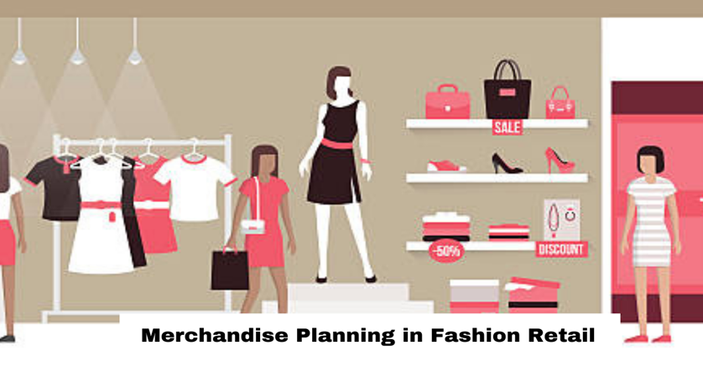
Module Title: - Develop and Perform Merchandising Strategy
Module code: IND FAD3 02 1221
Nominal duration: 50 Hours

October, 2023
Addis Ababa, Ethiopia

Acknowledgment
I wish to extend my thanks and appreciation to many of my staff members, the department head, and our college’s dean for facilitating the development of these teaching, training, and learning materials. (TTLM).

Contents
Acknowledgment 2
Introduction to the Module 6
Unit one: Determine job requirements 7
1.1Standard operation procedures are followed for merchandizing. 8
1.1.1. Concepts merchandise? 8
1.1.2. Standard operation procedures for merchandizing. 8
1.2. Work health and safety requirements at all times 11
1.2.1. What is Work health and safety? 11
1.2.2. Work health and safety requirements at all times 11
1.4. Identified Job requirements from specifications, drawings, job sheets merchandising. 13
14.1. Fashion Merchandiser Requirements 14
Self-check-1 15
Unit two: prepare to develop merchandizing plans 16
2.1. Merchandising opportunities are identified and analysed 17
2.1.1. Identifying merchandising opportunities 18
2.1.2. Analyse features of fashion product to identify promotional strengths 19
2.1.3. Researching target market 20
2.1.4. Identify buyer patterns in relation to fashion product 21
2.1.5. Analyzing distribution outlets for fashion products and merchandising activities 23
2.2. Merchandising objectives are identified and established for fashion trend. 23
2.3. Current merchandising practices and trends are analysed for relevance to fashion product. 25
2.3.1. Retail Merchandising practices that retailers their stores 26
2.3.2. Point of sale tracking 28
2.3.3. Instant communication of sales back to manufacturers 29
2.3.4. Overnight replenishment 29
2.3.5. Just-in-time system 30
2.4. Merchandising budget is determined used for fashion design product. 31
Self-check-2 35
Unit three: Develop a merchandising plan 37
3.1. In-store presentation of fashion design is determined and applied in display space 38
3.1.1What is merchandise planning? 38
3.1.2. Store layout, display spaces and customer flow 39
3.1.3. Fixtures, fittings and mannequins for display of fashion products 44
3.1.4. Presentation visuals and arrangements for optimal display of fashion design products 46
3.1.5. Packaging and folding requirements 47
3.2. The way of Advertising and promotion of fashion design is determined. 48
3.2.1. Promotional activities to support sales of fashion design 49
3.2.1. Promotional and advertising materials appropriate to fashion design product and client marketing objectives 50
3.3. Merchandising plan is developed which details presentation, promotional and advertising activities. 52
Self-check-3 53
Unit four: Assess, document and store merchandising plan 55
4.1. Understand Assesse and presented merchandising plan 56
4.2. Document and report merchandising plan 59
Self-check-4 64
Reference 65

List of figure
Figure 1: apparel merchandising process 9
Figure 2: buying patterns in relation to fashion product 22
Figure 3: Plan the window display 27
Figure 4: just in time 31
Figure 5: Color and Lighting 42
Figure 6: Atmosphere lighting 43
Figure 7: Props and Fixtures 44
Figure 8: Mannequins for display of fashion products 46
Figure 9: visuals and arrangements for optimal display of fashion design products 46
Figure 10: Advertising and promotion of fashion design 49
Figure 11:- Merchandising plan 60
Figure 12: example report merchandising document 62

Introduction to the Module
In Fashion Design filed; Develop and Perform Merchandising Strategy helps to know Fashion merchandisers are involved in all particulars of the fashion merchandising process, starting from designing to sales. Common tasks of merchandiser includes predicting market trends, overseeing production costs, managing sales, making revenue estimates, and finalizing the fashion. Even it is found that, many fashion merchandisers are specialized in retail settings, or floor displays and in set-up of various layout as sales and service representatives.
This module is designed to meet the industry requirement under the Fashion design occupational standard, particularly for the unit of competency: Develop and Perform Merchandising Strategy.
This module covers the units:
- Determine job requirements
- Prepare to develop merchandising plans
- Develop a merchandising plan
- Assess, document and store merchandising plan
Learning Objective of the Module
- Identify job requirements
- Understand Prepare to develop merchandising plans
- Understand Develop a merchandising plan
- Used Assess, document and store merchandising plan
Module Instruction
For effective use this modules trainees are expected to follow the following module instruction:
1. Read the information written in each unit
2. Accomplish the Self-checks at the end of each unit
3. Read the identified reference book for Examples and exercise

Unit one: Determine job requirements
This unit is developed to provide you the necessary information regarding the following content coverage and topics:
- Standard operation procedures are followed for merchandizing.
- Work health and safety requirements are compiled at all times.
- Appropriate personal protective equipment is used in accordance with OHS.
- Job requirements are identified from specifications, drawings, job sheets or work instructions.
This unit will also assist you to attain the learning outcomes stated in the cover page. Specifically, upon completion of this learning guide, you will be able to:
- Identify Standard operation procedures for merchandizing.
- Understand Work health and safety requirements at all times.
- Understand appropriate personal protective equipment is used in accordance with OHS.
- Identify Job requirements from specifications, drawings, job sheets or work.

1.1Standard operation procedures are followed for merchandizing.

Concepts merchandise?
Merchandise is a broader concept than a product. It includes various features with which a product is offered at the store. Merchandising is the process and function of designing and delivering the product to ensure customers satisfaction and meet the objective of profit making to the organization.
There are different opinions and definitions on merchandising.
Merchandising can be defined as “Planning, Buying, Assorting, Promoting Placing, Setting and Replenishing the Goods”. Goods bought must be sold or replenished the unsold stock will be a burden on finance. So planning need to be made what kind of product is to be brought and how it should be priced promoted and placed so that customer is attracted towards the product.
Merchandising can be defined as the planning and promotion of sales by presenting a product to the right market at the proper time, by carrying out organized, skilful advertising, using attractive displays, etc.
Merchandisers plan and manage product ranges, inventory, displays and promotions. They collaborate with buyers, suppliers, analysts and retail teams to have the right products in stock, on the shelf and in attractive displays at the right price to interest customers and produce sales.
The merchandiser plays a central role in a buying house/garment factory. The basic functions of an export merchandiser are to Co-ordinate, Follow up and facilitate. From the time the order is given by the buyer until the time it is shipped out and reaching buyer’s warehouse, merchandiser needs to coordinate with various internal departments on one hand and with the buyer. This coordination role is very crucial and important to ensure that the order is produced and shipped on time with required quality and quantity, thus, ensuring the Right Product, Right Price, Right Time and Right Place.

1.1.2. Standard operation procedures for merchandizing.
SOPs help in production and its planning, where businesses can design and execute tasks to meet sales targets. However, they are not business plans and merely act as a framework for the processes and execution.
An SOP provides a basic structure for operations. It is only a matter of figuring out the elements that go into it, how, and where to place them so that everything goes according to plan.
When one thinks of the merchandising sector, for example, the elements that make up the SOPs may include:
BOM (Bills of Materials)
TNA (Time and Action Calendars)
The fabric or material
Production files
Pre-Production meetings
No table of figures entries found.Factors to Consider When Writing a Merchandising SOP Designing and implementing merchandising SOPs in a factory setting becomes easier when export sizes are small. However, for larger businesses, it can be a complex process that may require expertise in different areas.
Also, one will need to analyze various aspects and how they impact the production process. Moreover, the drafts also need approvals before they can integrate different elements into the production process. All these steps can take time
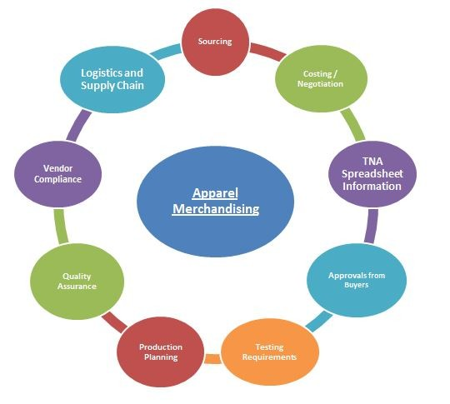
Figure 1: apparel merchandising process
Sourcing: Sourcing is the search for new sources of supply to place the orders within desired quality and price. Sourcing is responsible for developing the garment samples for the assigned product/style with close cooperation of all team. Working with Technical, QA and Mill management to ensure all quality decision and standards are met. Sourcing supports the team in problem-solving, Information sharing and counter sourcing to best placement of plan. Also manages vendor orders and relationships for a sub-category.
Costing / Negotiation: Order confirmation is an important moment for merchandisers. Well known for various accessories price, wash price and fabric price can make buying meeting successful. Merchandiser needs to follow good attitude and professional dress code in negotiation meeting. Always need to remember “Win-Win situation” for all party in costing/ Negotiation meeting.
TNA (Time and Action) Spreadsheet Information: One of the foremost and primary functions of the merchandiser is to prepare a time and action plan for all actions required for successful execution of the export order received. The action plan includes the timelines for various approvals to be taken from the buyer or buying house, various sourcing activities like fabric etc., cutting, sewing and finishing of garments, packing, various quality audits, shipping etc. TNA is very significant for merchandiser because it provides the basic framework of time and action to follow up the day to day merchandising.
Approvals from Buyers: An export merchandiser needs to get various approvals from the buyer or buying house merchants. These trims may be sent to the buyer approval as suggested, before starting the production of the garments.
Testing Requirements: Testing of piece goods, as well as final apparel, is an important requirement for the buyers. Many of the buyers require that the testing is done by a third party lab and the lab sends one copy of the report directly to the buyer.
Production Planning: Normally PPC team prepares the production plan. Merchandiser need to check the plan regularly to confirm his/her order can ship on time, also need to inform planner if need any correction/improvement. The various segment of a plan are: Batch Plan, Cut Plan, Finishing and Packing Plan, Embroidery Plan, Wash Plan, Vessel Planning
Quality Assurance: QA department is responsible to confirm the goods quality as per buyer expectation. Merchandiser needs to update QA team time to time about buyer quality standard, procedure, and new concept.
Compliance: Compliance is very important in HR practices. Merchandiser needs to follow up with compliance team to get update time to time. Merchandiser can support buyer immediately if he/she well-known about various certification.
Logistics and Supply Chain: Merchandiser always familiar with vessel lead time in different destination before ex-factory on time vessel booking need to confirm with the commercial department. Merchandisers always follow up the commercial department in logistics and supply chain issue.

1.2. Work health and safety requirements at all times

1.2.1. What is Work health and safety?
Occupational Safety and Health (OSH) is an important aspect which allows an organization to systematically manage the safety and health of the workers in a workplace. The process is an important one in creating the most efficient workstation lay out. This means that the workstation should be such that it does not create risks to the worker's health and safety. In every working area OHS \ Occupational Health &Safety is implemented. When using tool and equipment’s basic safety precautions should always be followed to reduce the risk of personal injury and damage to tools &equipment.

1.2.2. Work health and safety requirements at all times
Working on the principle of “A PLACE FOR EVERYTHING, and EVERYTHING IN ITS PLACE”, you can adapt these ideas the equipment you already have or can easily obtain.
Safe Keep work area clean
Observe work area conditions
Store idle equipment / When not in use, tools must be stored in appropriate location
Dress properly
Observe all, before, safety precautions related to your work.
Report unsafe conditions or any equipment or materials you think might be unsafe.
Report any injury
Wear protective clothing
Always inspect equipment and associated attachments for damage before using.
Select and lay out materials accordance to work specifications materials handling and safe storage of equipment. Like in any activity, gathering the proper tools for the job will make each step along the way better & more accurate.
Generally follow all precautions and regulations while working in the lab. Make sure that your working space is clean and organized, and all the required stocks and materials are kept ready & maintain the discipline in your working area
1.3. Appropriate personal protective equipment is used in accordance with OHS
Personal protective equipment in accordance with OHS (such as face masks, respirators, gloves, boots, overalls, goggles and ear-muffs) should be regarded only as a short term measure until more effective control strategies are implemented, or in very limited situations (such as emergency clean-up).
• Manual handling techniques
• Ergonomic drawing tables
• Standard operating procedures
• Safe materials handling
• Implement in work flow rest breaks
• Ergonomic arrangement of workplaces
• Following marked walkways
• Safe storage of equipment
• Cleaning of work space Reporting accidents and incidents
• Environmental practices

1.4. Identified Job requirements from specifications, drawings, job sheets merchandising.
It is important to review these documents carefully to ensure all relevant job requirements are identified and understood before starting the job.
A merchandising job description provides information about selecting and displaying products in retail stores to maximize sales and profitability. This involves planning and coordinating the availability of products, determining pricing strategies, creating visual displays and managing inventory levels. Effective merchandising requires a comprehensive understanding of consumer behavior, market trends and sales data.
Merchandising can take many forms, including product placement, advertising, promotions and special events. Ultimately, merchandising aims to create an engaging and compelling shopping experience that drives sales and customer loyalty.
Fashion merchandisers oversee the style design of garments and accessories in retail clothing stores, costume suppliers, or fashion houses. It is the fashion merchandiser's responsibility to predict fashion trends, plan and implement store layouts, purchase apparel, and collaborate with designers.
- Technical skills: The specifications, drawings, job sheets, or work instructions may outline specific technical skills required to perform the job. This could include knowledge of specific machinery, tools, equipment, or software.
- Knowledge of materials: The documents may specify the type of materials that need to be used for a particular job. This could include knowledge of different types of metals, plastics, or other materials and their properties.
- Safety requirements: The specifications, drawings, job sheets, or work instructions may highlight safety precautions or procedures that need to be followed during the job. This could include wearing personal protective equipment (PPE), following specific safety protocols, or handling hazardous materials.
- Quality standards: The documents may outline quality standards that need to be met for the job. This could include specific measurements, tolerances, or finishes that need to be achieved.
- Time constraints: The specifications, drawings, job sheets, or work instructions may specify time constraints or deadlines for completing the job. This could include specific milestones or targets that need to be achieved within a given timeframe.
- Communication skills: The documents may require effective communication with team members, supervisors, or clients. This could involve reporting progress, seeking clarification, or providing updates on the job.
- Problem-solving abilities: The specifications, drawings, job sheets, or work instructions may require problem-solving skills to address any issues or challenges that arise during the job. This could involve troubleshooting equipment, identifying and resolving technical problems, or finding alternative solutions.
- Attention to detail: The documents may emphasize the importance of being detail-oriented and meticulous in following instructions. This could include accurately interpreting specifications or drawings and ensuring precise execution of tasks.
- Physical requirements: The specifications, drawings, job sheets, or work instructions may specify physical requirements for the job. This could include lifting heavy objects, standing for long periods, or performing tasks in confined spaces.
- Teamwork and collaboration: The documents may highlight the need to work effectively as part of a team and collaborate with others. This could involve coordinating tasks, sharing information, or supporting colleagues in achieving common goals.

14.1. Fashion Merchandiser Requirements
- Degree in merchandising and/or fashion design.
- Proven experience as a fashion merchandiser or visual merchandiser.
- Proficiency in Photoshop and Illustrator.
- Strong knowledge of the latest fashion trends and developments.
- Exceptional communication and interpersonal skills.
- Ability to create original and eye-catching designs that appeal to our target market.
- Excellent time management and organizational skills

Self-check-1
Name……………………………………ID…………………Date…….time allowed 20min
Direction I:-Answer say true or false (Total Points: 2X5=10)
1. Merchandisers plan and manage product ranges, inventory, displays and promotions.
2. Sourcing is the search for new sources of supply to place the orders within desired quality and price.
3. The workstation should be creating risks to the worker's health and safety.
4. Fashion Merchandiser Strong knowledge of the latest fashion trends and developments.
5. Costing and Negotiation various accessories price, wash price and fabric price can make buying meeting successful.
Direction II:-Answer all the questions listed below (Total Points: 2X5=10)
- Define what is merchandise?
- Discuss the function of merchandise in apparel industry?
- Draw and list the apparel merchandising?
- Discuss the requirement of work health and safety in fashion industry?
- Discuss the job requirement of merchandising?

Unit two: prepare to develop merchandizing plans
This unit is developed to provide you the necessary information regarding the following content coverage and topics:
- Merchandising opportunities are identified and analysed
- Merchandising objectives are identified and established for fashion trend.
- Current merchandising practices and trends are analysed for relevance to fashion product.
- Merchandising budget is determined used for fashion design product.
This unit will also assist you to attain the learning outcomes stated in the cover page. Specifically, upon completion of this learning guide, you will be able to:
- Identify merchandise opportunities
- Identify and establish merchandising objectives for fashion trend.
- Understand Current merchandising practices and trends for relevance to fashion product.
- Understand Merchandising budget for fashion design product.

2.1. Merchandising opportunities are identified and analysed
Developing merchandising plans based on identified buying patterns, fashion brands and retailers can optimize their product assortment, pricing, and promotional strategies to meet customer demands and increase sales. This can lead to improved customer satisfaction, brand loyalty, and overall business success in the fashion industry
To develop merchandising plans based on identified buying patterns in relation to fashion products,
The following steps can be taken:-
- Determine product assortment: Based on the analysis of buying patterns, identify the specific fashion products that are most popular among different customer segments. This will help determine which products to prioritize in the merchandise assortment.
- Plan inventory levels: Use the buying patterns data to forecast demand for each fashion product. This will help in determining the appropriate inventory levels to maintain, ensuring that popular products are adequately stocked while minimizing excess inventory of less popular items.
- Pricing strategy: Analyse the price points that customers are willing to pay for different fashion products. Consider factors such as customer segment, product category, and perceived value. Adjust pricing strategies accordingly to maximize sales and profitability.
- Visual merchandising: Utilize the insights gained from buying patterns to create visually appealing displays that highlight the most popular fashion products. This can help attract customer attention and drive sales.
- Promotions and marketing campaigns: Develop targeted promotions and marketing campaigns based on the identified buying patterns. This could include offering discounts or incentives on popular products, creating special collections or collaborations, or leveraging influencers or social media platforms that align with customer preferences.
- Monitor and analyse results: Continuously monitor sales and customer feedback to evaluate the effectiveness of the merchandising plans. Adjust strategies as needed based on on-going analysis of buying patterns and customer response

2.1.1. Identifying merchandising opportunities
Merchandising is the art and science of presenting products in a way that maximizes sales and customer satisfaction. As a merchandiser to need to constantly analyze market,customers and competitors to identify opportunities and gaps in merchandising strategy.
Here are some tips on how to do that effectively.
- Start a contribution
The first step to identify merchandising opportunities and gaps is to understand who your target customers are, what they want, and how they shop. You can use various sources of data, such as sales reports, customer feedback, surveys, and loyalty programs, to segment your customers by demographics, preferences, behaviors, and needs. Then, you can tailor your merchandising decisions to appeal to each segment and create a personalized shopping ex Establishing merchandising objectives and sales targets with client patience.
- Monitor the performance
The second step to identify merchandising opportunities and gaps is to measure how well your merchandising strategy is working. You can use key performance indicators (KPIs), such as sales, margins, inventory turnover, sell-through rate, conversion rate, and customer satisfaction, to evaluate the effectiveness of your product assortment, pricing, promotion, display, and placement. You can also compare your performance to your goals, benchmarks, and industry standards to identify areas of improvement and best practices.
- Scan the environment
The third step to identify merchandising opportunities and gaps is to keep an eye on your external environment, such as your market, your competitors, and your trends. You can use various tools, such as market research, competitive analysis, trend forecasting, and social media listening, to spot emerging opportunities and threats in your industry and niche. You can also use these tools to identify customer pain points, unmet needs, and new demands that you can address with your merchandising solutions.
- Test the ideas
The fourth step to identify merchandising opportunities and gaps is to experiment with your merchandising ideas and see how they perform. You can use various methods, such as A/B testing, customer feedback, focus groups, and pilot programs, to test different aspects of your merchandising strategy, such as product selection, pricing, promotion, display, and placement. You can also use these methods to gather insights and feedback from your customers and staffs that can help you improve your merchandising decisions.
- Adapt the strategy
The fifth step to identify merchandising opportunities and gaps is to adjust your merchandising strategy based on your findings and results. You can use various techniques, such as data analysis, action planning, and change management, to implement your changes and monitor their impact. You can also use these techniques to communicate your changes to your stakeholders, such as your customers, staff, and suppliers, and get their buy-in and support. You can also use these techniques to review your strategy periodically and make sure it is aligned with your goals and market conditions.

2.1.2. Analyse features of fashion product to identify promotional strengths
One objective could be to analyse the features of the fashion product to identify its promotional strengths. This could involve conducting a thorough analysis of the product's unique selling points, such as its design, material quality, or functionality, and using this information to develop targeted marketing campaigns that highlight these strengths.
Another objective could be to conduct market research and gather customer feedback to understand which features of the fashion product are most appealing to the target audience. This information can then be used to tailor promotional messaging and strategies to effectively communicate these features and attract customers.
To create visually appealing and engaging promotional materials those effectively showcase the fashion product features. This could involve creating high-quality product images or videos, developing creative and attention-grabbing advertisements, or utilizing visual merchandising techniques in stores to highlight the product's unique features.
To collaborate with influencers or celebrities who align with the fashion product's features and brand image. By leveraging their influence and reach, these partnerships can help promote the product's strengths and generate interest and desire among their followers.
By analysing the features of a fashion product and identifying its promotional strengths, merchandising efforts can be focused on effectively communicating these strengths to the target audience, ultimately driving sales and increasing brand awareness.
Fashion promotion strategies
- Marketing mix: product, price, place, promotion (4 Ps), decisions, marketing, brand, target market.
- Promotional mix: advertising, sales promotion, visual merchandising, personal selling
- Advertising: fashion brand e.g. magazines, newspapers, television, billboards, internet, specialist trade fairs; attention grabbing techniques e.g. Attention, Interest, Desire, Action (AIDA);
- specific consumer groups: e.g. shock tactics, celebrity endorsements, promotional offers, point-of-sale, Unique Selling Proposition (USP)
- Sales promotions: short term promotions e.g. buy one get one free, student discount,
- Visual merchandising: e.g. stores, product, shop floor, window displays, point-of-sale.

2.1.3. Researching target market
A target market analysis is an assessment of how your product or service fits into a specific market and where it will gain the most traction with customers. Target market analyses help businesses establish strategies for effective marketing and sales techniques. A company's target market is its core customer base or the demographics of customers most likely to buy its product or service. A target market analysis provides a high-level perspective of the overall business field and usually outlines opportunities and restraining factors for companies hoping to enter that market.
Benefits of a target market analysis include:
- Identifying the most and least valuable markets: Target markets analyses help determine which markets are worth pursuing and which are not.
- Developing buyer personas: Often, creating an "ideal" buyer is part of the target market analysis for businesses to identify the specifics of their target demographic accurately.
- Finding gaps in the market to fill: A thorough market analysis might reveal untapped areas of the market that your company, product or service can accommodate.
- Assessing the viability of a product or service: Market testing can be a valuable part of a target market analysis, particularly for a brand new product or service. Feedback from potential customers in your target market can help determine how successful your product will be.
- Finding new markets: With surveys or other research methods, you may find a new market interested in your product.
- Improving business strategy: With the information garnered from the target market analysis, you can create a strong business strategy using data to support your decisions.

2.1.4. Identify buyer patterns in relation to fashion product
Buying patterns refer to the why and how behind consumer purchase decisions. They are habits and routines that consumers establish through the products and services they buy. Buying patterns are defined by the frequency, timing, quantity, etc.
Identifying buying patterns in relation to fashion products involves analyzing consumer behavior and preferences to understand how and why customers make purchasing decisions. This information is crucial for developing effective marketing strategies, determining product assortment, and setting pricing strategies.
Identifying buying patterns in relation to fashion products, fashion brands and retailers can tailor their marketing strategies, product assortment, and pricing to better meet customer needs and preferences. This can lead to increased sales, customer satisfaction, and overall business success
To identify buying patterns in relation to fashion products, the following steps can be taken:
1. Collect data: Gather data on customer purchasing behavior through various sources such as sales records, customer surveys, focus groups, and online analytics tools. This data should include information on what products customers are buying, when they are buying them, and at what price points.
2. Segment the data: Analyze the collected data to identify different customer segments based on demographics, psychographics, and purchasing behavior. This segmentation will help identify specific patterns within each segment.
3. Analyze trends: Look for commonalities and trends within each customer segment. This could include identifying popular styles, colors, or materials, as well as preferred price ranges and shopping channels. Analyze how these trends evolve over time to identify emerging patterns.
4. Consider external factors: Take into account external factors that may influence buying patterns, such as seasonal trends, economic conditions, cultural influences, and fashion industry trends. These factors can have a significant impact on consumer preferences and purchasing behavior.
5. Use predictive analytics: Utilize predictive analytics tools to forecast future buying patterns based on historical data and trends. This can help in anticipating demand and making informed decisions regarding inventory management and production planning.
6. Stay updated: Continuously monitor and update the analysis as new data becomes available. Buying patterns can change rapidly in the fashion industry, so it's important to stay current with consumer preferences and adapt strategies accordingly.
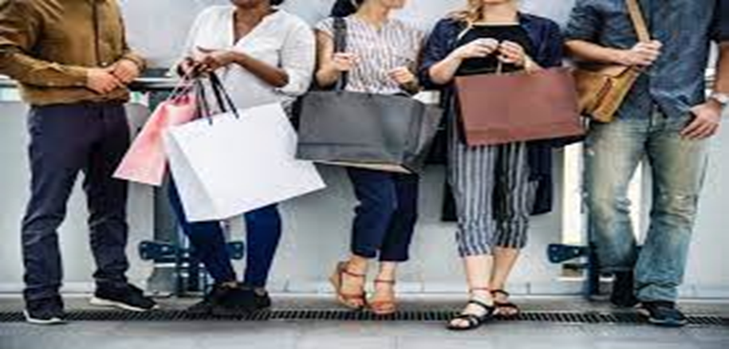Figure 2: buying patterns in relation to fashion product

2.1.5. Analyzing distribution outlets for fashion products and merchandising activities
In the fashion business, a good distribution channel has a high impact on the business. The fashion apparel manufactured should reach the retail stores at the right time to influence consumers to buy the brand's products. Any delay in making the clothes available to the consumers can result in huge losses for the fashion brand.
There are three main types of distribution channels that fashion houses can choose from:
1. Direct channel
This is a distribution channel where the retailer sources the clothes directly from the manufacturer. There are no intermediaries like wholesalers or other agents. In this channel, the manufacturer has total control over the distribution of its products, which makes it difficult for the retailer to procure the products in large quantities. However, the products are cheaper since they are directly sourced. This may work as a great advantage to fashion brands.
2. Indirect channel
In this channel, a wholesaler or an agent serves as a middleman between the manufacturer and the retailer. While this may reduce the load of distribution on the manufacturer, the retailer pays a higher price for the goods to include the middlemen's commission. However, fashion brands can order products in higher quantities from these middlemen.
3. Hybrid channels
An alliance of direct and indirect distribution channels, a hybrid channel is the base of most B2B platforms. In a hybrid channel, the manufacturer employs various distributors to advertise its products but still has control over the market. This means that the manufacturer's agents advertise its products on different channels. They then direct any interested parties to the manufacturer, who makes the final call.

2.2. Merchandising objectives are identified and established for fashion trend.
These broad objectives, there may be specific merchandising objectives for the fashion trend, such as:
- Increasing brand awareness: If the fashion trend is associated with a specific brand or designer, one objective could be to increase brand awareness and visibility through strategic merchandising efforts. This could include collaborations with influencers or celebrities, targeted marketing campaigns, or innovative visual merchandising displays.
- Maximizing sell-through: Another objective could be to maximize sell-through of the fashion trend. This involves ensuring that the trend is effectively promoted, stocked in the right quantities, and displayed prominently to attract customer attention. By optimizing sell-through, merchandising can minimize excess inventory and improve overall profitability.
- Building a cohesive collection: If the fashion trend is part of a larger collection or assortment, an objective could be to build a cohesive and complementary range of products. This involves carefully selecting and curating products that align with the trend, ensuring that they work well together and provide customers with a complete and harmonious shopping experience.
- Expanding market reach: If the fashion trend has the potential to appeal to new customer segments or markets, an objective could be to expand its market reach. This could involve targeting new demographics, exploring international markets, or partnering with retailers or online platforms that cater to specific customer groups.
- Increasing sales volume: One objective could be to increase the overall sales volume of the fashion trend. This could involve implementing marketing and promotional strategies to generate awareness and interest, optimizing product placement and visibility in stores or online platforms, and offering incentives or discounts to encourage purchases.
- Enhancing brand reputation: Another objective could be to enhance the brand reputation associated with the fashion trend. This could involve showcasing the trend in high-profile events or fashion shows, collaborating with reputable influencers or celebrities, or obtaining positive media coverage through PR efforts.
- Expanding distribution channels: If the fashion trend is currently only available in limited distribution channels, an objective could be to expand its reach by partnering with additional retailers or online platforms. This could involve negotiating contracts and agreements, ensuring consistent brand representation across different channels, and providing necessary support and resources to retailers.
- Improving product quality and design: An objective could also be to continuously improve the quality and design of the fashion trend. This could involve conducting market research and gathering customer feedback to identify areas for improvement, working closely with designers and manufacturers to implement changes, and conducting regular quality control checks to ensure customer satisfaction.
- Increasing customer engagement and interaction: Another objective could be to increase customer engagement and interaction with the fashion trend. This could involve implementing interactive displays or experiences in stores, leveraging social media platforms to encourage customer participation and sharing, or organizing events or workshops related to the trend.
- specific merchandising objectives, fashion trends can be strategically managed and promoted to achieve desired outcomes such as increased sales, improved brand reputation, and expanded market reach. Setting clear merchandising objectives and aligning strategies and tactics accordingly, fashion trends can be effectively promoted, sold, and enjoyed by customers, ultimately driving business success.
Merchandising has two broad objectives:
1. Buy and store the products that are needed by the customers.
2. Second important objective of merchandising is the growth of the business and making the business profitable. It means store or buy that products which are in demand and can be sold.

2.3. Current merchandising practices and trends are analysed for relevance to fashion product.
Retail Merchandising is the practice of showcasing the products of a store It is done in a way that attracts the audience's attention and generates sales. In large stores, the window display is a non-verbal communication between the retailer and the audience.
The Five R’s of Retail Merchandising
Retail Merchandising can lead to the success of both the retail store and the clothing brand. There are five R’s when it comes to Retail merchandising.
Retailers can follow them for the success of their stores:-
- The Right product- Displaying the right products is the first step toward successful retail merchandising.
- The Right Audience- The products displayed should appeal to the Onlookers. By selling the right products to the right audience, retailers can increase their sales.
- The Right way- Window displays should match the vibe of the merchandise.
- The Right Time- Selling sweaters in the summer just make no sense. Retailers should note that the items displayed are relevant to the current times and in trend.
- The Right Price- The above four Rs will make no sense if the product pricing is wrong. In the end, the right price is what sells the product.

2.3.1. Retail Merchandising practices that retailers their stores
Plan the window display
1. Plan the window display: visually attractive window displays, with the correct product placement, can be an asset for the business. Proper lighting and eye-level display should be incorporated. Props can be used where needed. However, the products should always be the highlight of the display. Retailers can hire a styling manager to overlook the window displays. This way, they can display the products and give styling tips to buyers.

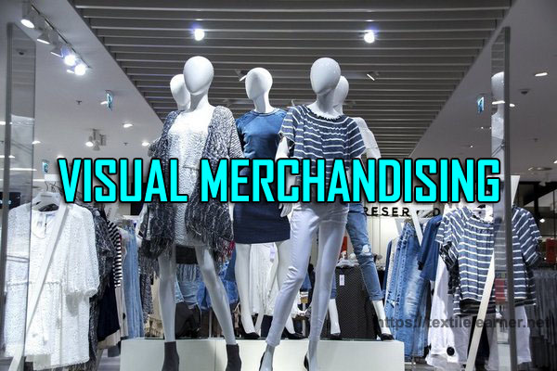

Figure 3: Plan the window display
2. Leverage sign ages to include information-Conveniently placed sign ages help customers navigate the store in a better way. Retailers should not just focus on selling their products. They should strive to create a positive shopping experience for the customer. Including informational sign ages in strategic places helps customers easily locate the items they need.
3. The power of cross-merchandising-. Retailers can place t-shirts and tops next to the jeans section. This way, customers are more likely to pick a new top with their newly purchased jeans. Socks can be placed next to the shoe section for increased sales.
4. Helpful in-store support staff-A good, helpful, friendly in-store staff can help customers gain a positive shopping experience. They should be trained to be attentive to the customer's needs.
5. In-store technology-It is the perfect way to attract the attention of today’s tech-savvy customers. Incorporating in-store techs like tablets and interactive screens can help customers make the right choice.
6. Creating the right shopping ambiance-Everything from the lighting, sound, smell, and hygiene should be on point in a retail store. A neat, de cluttered environment will attract more customers. The lighting shouldn't be too harsh or soft. Soft and slower music is known to cause buyers to spend more time in the store, increasing sales.
7. Implementing “Try before you Buy”-Customers are more likely to buy the product after trying it on themselves. Retailers can provide safe and comfortable trial rooms as a strategic move to increase sales. It is one of the easiest and most effective retail merchandising practices to follow to increase sales.
8. Monitoring sales per category-Retailers should always track which products in their stores generate more sales. They can use Key metrics such as KPIs (Key performance indicators). This way, retailers can focus on stocking up on these products that bring more sales.
9. Developing a customer-centric merchandising strategy- Involving customers in creating a merchandising strategy is the most effective way to ensure its success. Brands are now realizing the importance of customer opinions and leveraging them to create effective merchandising strategies.
10. Create Engaging retail displays-Attractive retail displays that add to the shoppers’ experience are a rage in the retail sector nowadays. Large life-size models or appealing props like neon signs create a picture-worthy background for shoppers. Some retail stores even assemble a small cozy set-up that resembles a table at a coffee shop or a living room corner.

2.3.2. Point of sale tracking
Another benefit of overnight replenishment in the fashion industry is the ability to track sales data at the point of sale. This means that retailers can gather real-time information about which products are selling well and which ones are not, allowing them to make informed decisions about inventory management and product assortment. With point of sale tracking, retailers can quickly identify trends and customer preferences, enabling them to adjust their purchasing decisions accordingly.
They can stock up on popular items and reduce or eliminate underperforming products, leading to more efficient inventory management and increased sales. Point of sale tracking also helps retailers to optimize their pricing strategies. By analysing sales data, they can determine the optimal pricing for each product, maximizing profitability and ensuring competitive pricing in the market.
Furthermore, point of sale tracking allows retailers to identify potential issues or challenges in their sales process. They can track things like return rates, customer complaints, and product defects, enabling them to address these issues promptly and improve customer satisfaction.
Overall, point of sale tracking through overnight replenishment enhances retailers' ability to make data-driven decisions, improve inventory management, and enhance customer satisfaction. It is a valuable tool for optimizing operations and driving profitability in the fashion industry.

2.3.3. Instant communication of sales back to manufacturers
Another benefit of overnight replenishment in the fashion industry is the ability to instantly communicate sales data back to manufacturers. This allows manufacturers to quickly analyse which products are selling well and which ones are not, enabling them to make informed decisions about production and inventory levels.
By receiving real-time sales data, manufacturers can adjust their production schedules and prioritize the production of popular items. This helps to prevent overstocking or under stocking of certain products, leading to more efficient inventory management and reduced costs.
Instant communication of sales data also allows manufacturers to identify emerging trends and customer preferences. They can quickly respond to market demands by producing new styles or variations of popular products, ensuring that retailers have access to the latest fashion trends.
Overall, instant communication of sales data through overnight replenishment helps to streamline the supply chain and improve collaboration between retailers and manufacturers. It enables both parties to make data-driven decisions and optimize their operations for maximum profitability.

2.3.4. Overnight replenishment
Overnight replenishment in merchandising in the fashion industry refers to the process of restocking store shelves and displays with fresh merchandise during the overnight hours when the store is closed to customers. This practice allows retailers to maintain a well-stocked and visually appealing store environment for customers during regular business hours.
During overnight replenishment, store employees typically receive deliveries of new merchandise from distribution centres or suppliers. They then unpack and sort the merchandise, replenish shelves and displays, and ensure that products are properly tagged and priced. This process may also involve restocking fitting rooms, organizing backrooms, and conducting inventory checks.
Overnight replenishment is particularly important in the fast-paced fashion industry, where trends and customer preferences can change rapidly. By restocking merchandise overnight, retailers can ensure that customers have access to the latest fashion products and styles as soon as they hit the market.
Additionally, overnight replenishment allows retailers to take advantage of quieter store hours to complete restocking tasks without disrupting the shopping experience for customers. This can help improve operational efficiency and minimize disruptions during peak business hours.
Overall, overnight replenishment plays a crucial role in maintaining a well-managed and visually appealing store environment in the fashion industry. It helps retailers meet customer demand, optimize inventory levels, and enhance the overall shopping experience.

2.3.5. Just-in-time system
Just-in-time (JIT) system in merchandising is a supply chain management strategy that aims to minimize inventory and production costs by receiving goods or materials just in time for production or sale. In the fashion industry, this system involves closely coordinating the production and delivery of fashion products to meet customer demand and reduce excess inventory.
In a JIT system, fashion brands and retailers work closely with suppliers and manufacturers to ensure that raw materials and components are delivered only when they are needed for production. This helps to eliminate excess inventory and reduce the costs associated with storing and managing large quantities of products.
The JIT system in the fashion industry requires accurate forecasting and demand planning to ensure that the right products are produced in the right quantities at the right time. This involves analysing market trends, customer preferences, and historical sales data to determine the expected demand for specific fashion products.
By implementing a JIT system, fashion brands can reduce lead times, improve efficiency, and minimize waste. This allows them to respond quickly to changing market demands, introduce new products more frequently, and reduce the risk of overstocking or selling out of popular items.
Overall, the JIT system in merchandising in the fashion industry helps brands and retailers optimize their supply chain operations, improve profitability, and enhance customer satisfaction by ensuring that products are available when and where customers want them.Just-in-time, or JIT, refers to an inventory management system where production happens in small batches as per the demand. The primary purpose of installing this system is to upgrade efficiency, control production, and reduce wastage arising during production.
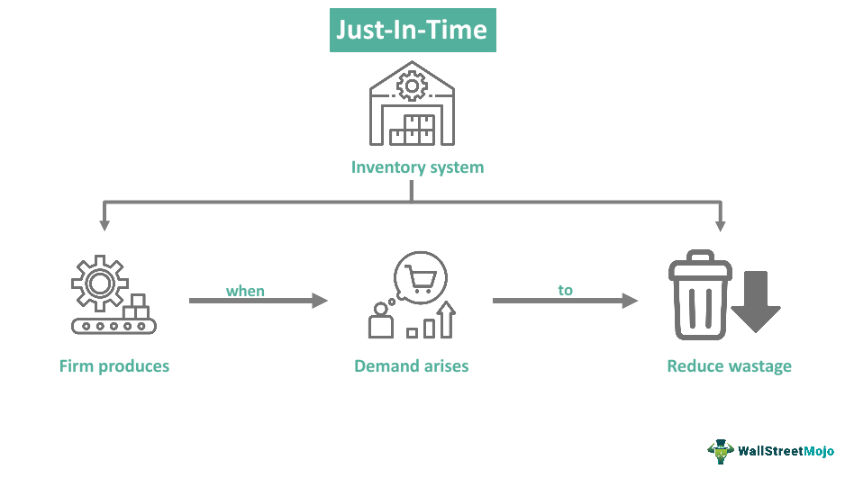
Figure 4: just in time

2.4. Merchandising budget is determined used for fashion design product.

The merchandising budget is a financial plan that determines how much money will be allocated for various aspects of the fashion design product. It includes the costs associated with sourcing materials, manufacturing the product, marketing and advertising expenses, distribution and logistics costs, as well as any other expenses related to bringing the product to market.
The merchandising budget is typically determined based on several factors, including the target market, the desired quality and design of the product, production volume, and the overall business goals and objectives.

The budget is crucial in ensuring that the fashion design product is developed and launched successfully. It helps the fashion brand or retailer allocates resources effectively, ensuring that there is enough funding for each stage of the product's lifecycle.
The merchandising budget also plays a significant role in determining the pricing strategy for the fashion design product. The costs associated with manufacturing, marketing, and distributions are taken into account when setting the retail price. The budget helps ensure that the product is priced competitively while still allowing for a reasonable profit margin.
The merchandising budget helps manage inventory levels and control costs. It allows for accurate forecasting and planning, ensuring that the right amount of inventory is ordered and produced to meet demand. This helps prevent overstocking or under stocking issues, which can lead to financial losses. Overall, the merchandising budget is a critical tool in managing the financial aspects of fashion design products. It helps determine how resources are allocated, sets pricing strategies, and ensures efficient inventory management, ultimately contributing to the success and profitability of the fashion brand or retailer.
When it comes to identifying the merchandising budget for fashion design, designers need to consider various factors such as production costs, marketing expenses, and overall business goals specially in leather sector.
Firstly, designers need to determine the cost of producing their designs. This includes factors such as pattern and fabric sourcing, manufacturing, labor costs, and any additional expenses like embellishments or trims. By understanding the production costs, designers can estimate how much budget they need to allocate for each design.
Secondly, designers should consider their marketing expenses. This includes costs associated with promoting and showcasing their designs, such as fashion shows, photo shoots, advertising, and social media campaigns. Designers need to allocate a portion of their budget to effectively market their designs and reach their target audience.
Additionally, designers should consider their overall business goals and financial projections. They need to assess how much profit they aim to make from each design and set their merchandising budget accordingly. This involves considering factors like pricing strategies, sales projections, and profit margins.
The following steps can be taken:
Fashion brands and retailers can create a comprehensive merchandising budget that covers all aspects of the product's development and launch, ensuring efficient resource allocation and ultimately contributing to the success of the fashion design product.
Define the target market: Identify the specific demographic or customer segment that the product is intended for. This will help determine the appropriate quality, design, and price range for the product.
Set business goals and objectives: Determine the overall objectives of the fashion brand or retailer. This could include increasing market share, expanding into new markets, or achieving a certain level of profitability. These goals will guide the budget allocation process.
Conduct market research: Gather information on industry trends, competitor pricing, and consumer preferences. This will provide insights into the expected demand for the product and help set realistic sales targets.
Estimate production costs: Determine the cost of sourcing materials, manufacturing the product, and any associated labour expenses. This can be done by obtaining quotes from suppliers and manufacturers or using historical data if available.
Calculate marketing and advertising expenses: Consider the costs of promoting the product through various channels such as print and digital advertising, social media marketing, influencer collaborations, and events. Budget for photography, graphic design, and any other creative services needed for marketing materials.
Determine distribution and logistics costs: Consider the expenses associated with shipping, warehousing, and fulfilling orders. This may include transportation costs, packaging materials, and any fees charged by third-party logistics providers.
Account for other expenses: Identify any additional costs related to bringing the product to market. This could include trade show participation fees, product samples, packaging design, or legal and regulatory compliance costs.

Allocate resources: Once all expenses have been estimated, allocate funds to each aspect of the merchandising process based on their importance and priority. Consider any constraints or limitations on the budget and make adjustments as necessary.

Monitor and adjust: Regularly review the actual expenses incurred against the budgeted amounts. Make adjustments as needed to ensure that resources are being allocated effectively and in line with business goals.

Self-check-2
Name……………………………………ID………………………Date…….time allow 20.min
Direction I:-answer say true or false (Total Points: 2X5=10)
Developing merchandising plans based on identified buying patterns, fashion brands and retailers.
The merchandising budget is a financial plan the fashion design product
Just in time system, fashion brands can reduce lead times, improve efficiency, and minimize waste.
Distribution and logistics costs not consider the expenses associated with shipping, warehousing, and fulfilling orders.
Indirect channel the manufacturer has total control over the distribution of its products,
Direction II:-Choose the best answer (Total Points: 2X7=14)
Which one is the develop merchandising to Adjust strategies as needed based on on-going analysis of buying patterns and customer response.
A, Monitor and analyse results B, Pricing strategy C, Plan inventory D, Visual merchandising
Which one is to identify merchandising opportunities and gaps is to understand who your target customers are, what they want, and how they shop.
A, Monitor the performance B, Start a contribution C, Scan the environment
D, Test the ideas
One of the distribution channel outlet fashion products the retailer sources the clothes directly from the manufactures.
A, direct channel B, Indirect channel C, Hybrid channel D, all
The current merchandising practices and trend for relevance to fashion products in terms of retail merchandising
A, The Right product B, The Right Audience C, The Right way D, The Right Time
E, all is the answerer
One of Merchandising in the fashion industry refers to the process of restocking store shelves and displays with fresh merchandise during the overnight hours when the store is closed to customers.
A, Just-in-time system B, Point of sale tracking C, Overnight replenishment
Fashion brands and retailers work closely with suppliers and manufacturers to ensure that raw materials and components are delivered only when they are needed for production.
A, In-store technology B, Point of sale tracking C, Overnight replenishment D, Just-in-time system
Which one is the merchandising budget is a financial plan that determines how much money will be allocated for various aspects of the fashion design product.
A, the target market B, estimate production cost C, conduct market D, distribution and logistics cost E, all are steps of merchandising budget in fashion design products
Direction II: -Answer all the questions listed below. (Total Points: 2X4=8)
Write the steps of to develop merchandising?
Discuss how to develop merchandising plans
Discuss Fashion promotion strategies
Write the merchandising objectives in fashion industry

Unit three: Develop a merchandising plan
This unit is developed to provide you the necessary information regarding the following content coverage and topics:
- In-store presentation of fashion design is determined and applied in display space.
- The way of Advertising and promotion of fashion design is determined.
- Merchandising plan is developed which details presentation, promotional and advertising activities
This unit will also assist you to attain the learning outcomes stated in the cover page. Specifically, upon completion of this learning guide, you will be able to:

- Understand and apply in-store presentation of fashion design.
- Understand the way of determining advertising and promotion of fashion design
- Identify developing merchandising plan presentation and promotional activities

3.1. In-store presentation of fashion design is determined and applied in display space

3.1.1What is merchandise planning?
Merchandise planning is a systematic approach to planning, buying, and selling merchandise based upon consumer demand. It means that if a customer wants to buy product X with color Y and size Z from your shop, you have that available when they come knocking.
To develop a merchandising plan, follow these steps:
Set goals: Determine the objectives of your merchandising plan. Are you aiming to increase sales, improve customer satisfaction, or expand market share? Clearly define your goals to guide your merchandising efforts.
Research target market: Understand your target market's demographics, preferences, and buying behaviors. Conduct market research, analyze customer data, and gather insights to identify their needs and preferences.
Analyze competition: Study your competitors' merchandising strategies and offerings. Identify gaps in the market or areas where you can differentiate yourself to attract customers.
Determine product assortment: Based on your research, select the fashion products that align with your target market's preferences and fulfill their needs. Consider factors like trends, seasonality, and customer demand.
Set pricing strategy: Determine the pricing for your fashion products based on factors like production costs, competition, perceived value, and target market's willingness to pay. Ensure your prices are competitive and aligned with your brand positioning.
Plan inventory management: Forecast demand for each fashion product based on historical data, market trends, and customer preferences. Set appropriate inventory levels to avoid stock outs or excess inventory.
Create visual merchandising displays: Develop visually appealing displays that showcase your fashion products effectively. Use creative techniques like color coordination, product grouping, and strategic placement to attract attention and encourage purchases.
Implement promotional strategies: Develop promotions and marketing campaigns to drive sales and create brand awareness. Consider offering discounts, bundle deals, loyalty programs, or collaborations with influencers or other brands. Monitor performance: Continuously track sales data, customer feedback, and market trends to evaluate the effectiveness of your merchandising plan. Identify areas of improvement and make necessary adjustments to optimize results.
Train staff: Ensure your staff is well-trained on your merchandising plan, product knowledge, and customer service. They should be able to effectively communicate with customers, provide product recommendations, and handle inquiries.
Review and refine: Regularly review your merchandising plan and make adjustments as needed. Stay updated on industry trends, customer preferences, and market dynamics to stay ahead of the competition.
Store design and layout tells a customer what the store is all about and it is very strong tool in the hands of the retailer for communicating and creating the image of the store in the mind of the customers. The design and layout of the store is a means of communicating the image of the retail store.
The environment which it creates in the retail store is a combination of the environment which it creates in the retail store, is a combination of the exterior look of the store, the store interiors, the atmosphere in the store and the events, promotions and the themes. The overall look of a store and the series of mental pictures and feelings it evokes within the beholder. For the retailer, developing a powerful image provides the opportunity to embody a single message, stand out from the competition and be remembered.

3.1.2. Store layout, display spaces and customer flow
Analyzing store layout, display spaces, and customer flow is an important aspect of establishing distribution requirements in fashion design. The way a store is laid out and products are displayed can greatly impact the customer's shopping experience and ultimately affect sales.
Designers need to consider the overall store layout and how it aligns with their brand image and target audience. For example, a high-end luxury brand may opt for a more spacious and luxurious store layout, while a trendy fast-fashion brand may choose a more compact and energetic layout.
The placement of display spaces is crucial in attracting customers' attention and showcasing the products effectively. Designers should strategically position their products in prominent areas of the store, such as near the entrance or in eye-catching displays, to maximize visibility and create a strong visual impact.
Analyzing customer flow is essential for optimizing the shopping experience. Designers should study how customers move through the store, identifying potential bottlenecks or areas where customers may lose interest. This information can help designers rearrange the store layout or adjust display spaces to create a more seamless and engaging shopping experience.
In addition to store layout and display spaces, designers should also consider factors such as lighting, signage, and product placement. These elements contribute to the overall ambiance of the store and can influence customers' perceptions of the brand and its products.
By analyzing store layout, display spaces, and customer flow, designers can create an environment that enhances the shopping experience, encourages customer engagement, and ultimately drives sales.
There are three basic types of store layouts:
- The grid, commonly used in supermarkets because of its intuitive layout
- The loop, which creates a singular, predictable path optimized for browsing
- The free flow, where the shopping experience is more relaxed and casual
Less common store layouts include the set path, as seen in Ikea. There’s also the boutique, where the space is segmented according to different assortment areas. Whichever layout you choose, it must reflect your products, brand identity and customer needs.
Three goals of store are:-
- Motivate the customer to spend money
- Protect the image of the store
- Keep expenses to minimum
As an illustration, researchers found that 64.8% of all the purchase decision were made inside a supermarket. Most people indicated they purchased the item because they saw it displayed. 67% of liquor purchased from the liquor shop is impulse items. Combining advertising and display into an integrated promotional campaign will usually be more effective.
Color and Lighting: Color contributes significantly to people’s impression of a display as well as stores overall appearance. Color in a display can catch eye and make people pause and look. The color combination of ceiling, walls, floor covering and the overall décor can affect the atmosphere of a store. Changing the color scheme can change people’s attitudes and perceptions of a store and can increase or decrease the business. Color can change the shape and interest to dull room, and can direct attention toward a specific object or away from problem areas. Warm colors (red, yellow, orange etc.) are stimulating and cheery. They make room feel warm and intimate. They make room look smaller and object inside larger
Lighting: Lighting is essential in calling attention to merchandise in a display. A shopper’s eye is drawn automatically to the brightest item or area. Lighting treatment may be used to draw attention to the part of display area or to coordinate the parts of total display area. Lighting can also be used to direct the path of the customers and to make them see various displays along the way.
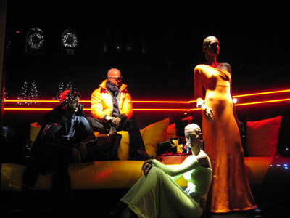
Figure 5: Color and Lighting
There are three types of lighting used:
- Primary lighting
- Store illumination
- Atmosphere lighting
Primary lighting: Primary lighting is the overall level of illumination of the store using fluorescent or incandescent light sources. Outside, it includes 150 watt bulbs used as basic window lighting, marquee lights illuminating the sidewalks and lighting for generals lobby area. Inside the store primary lighting is that which fills the selling floor from overhead lighting fixtures and provides the bare essentials of store illumination.
Accent or secondary lighting: this type of lighting provides illumination for designated display areas. Flat, shadow less overall lighting can create a tiresome selling floor. Accent lighting provides change from light to dark highlight to shadows to prevent the boredom.
Atmosphere Lighting: Atmosphere lighting is used to play light against shadow to create a distinctive effect on specific displays. Generally this category includes the use of color filters, pinpoint spotlights and black lighting to create dramatic effects. Fluorescent lights are used for primary lighting, as they cannot be focused directly on an object. 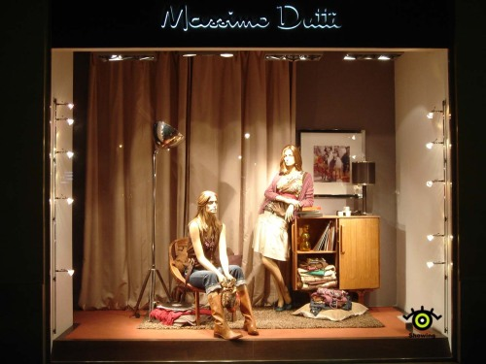
Figure 6: Atmosphere lighting
Props and Fixtures: Prop is something used with a product in a display that clarifies the function of the merchandise being sold or the story being told. Props are integral part of a display. They are used in virtual merchandising to tell a story about the product a display prop may be something that is not for sale, such as floor coverings, wall treatments, backgrounds, mannequins, shelves and steps. When using saleable merchandise as prop, be sure it is appropriate for the theme of the display and is sufficient quantity to meet an increase in demand arising from the display.
There are three basic types of store layouts:
- The grid, commonly used in supermarkets because of its intuitive layout
- The loop, which creates a singular, predictable path optimized for browsing
- The free flow, where the shopping experience is more relaxed and casual
Less common store layouts include the set path, as seen in Ikea. There’s also the boutique, where the space is segmented according to different assortment areas. Whichever layout you choose, it must reflect your products, brand identity and customer needs.
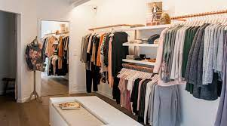Figure 7: Props and Fixtures

3.1.3. Fixtures, fittings and mannequins for display of fashion products
Goods can be effectively displayed on a variety of fixtures such as gondolas, tables, cubes, and mannequins, waterfalls and other racks, display cases. A fixture should not only complement the merchandise but also create an atmosphere in the store. It should act as silent sales person. One of the most common fixtures in store are gondolas; movable shelving approachable from all sides used in self-service retail stores to display merchandise. They can be lined up in stores as grocery or hardware stores.
Retail store fixtures are used to display products. They come in many shapes and sizes, so no matter what you’re selling, there’s bound to be a perfect fit. Effective retail display fixtures make your products irresistible to customers. They should highlight your merchandise’s best features, optimize your store layout and drive conversions.
- Retail shelves for showcasing a range of products in a neat and organized way.
- Display cases for protecting valuable items while driving exclusivity and curiosity.
- Display stands for special promotions, seasonal campaigns or mid-floor POP stands.
- Retail counters for upselling last-minute items at checkout.
- Mannequins for showing customers how your merchandise is meant to look.
- Product towers for guiding customers through a personalized store journey.
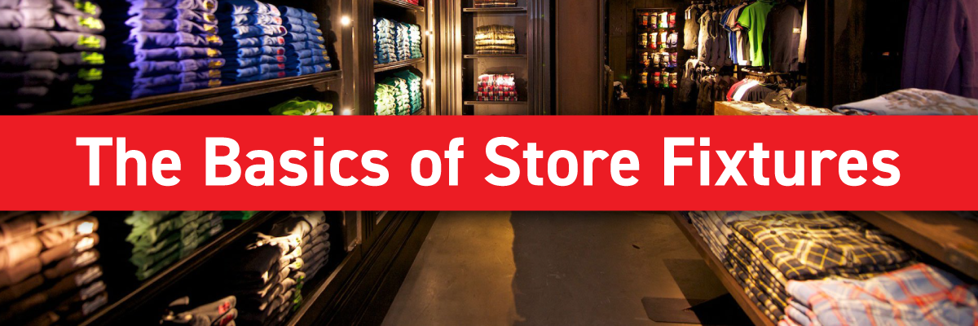
Figure7: Retail store fixtures
Mannequins come in many forms and the decision about which mannequins suit your brand the best might seem overwhelming. So, we’ve put together this guide to lay out why mannequin hire can benefit your brand and the many types of mannequins available to rent.

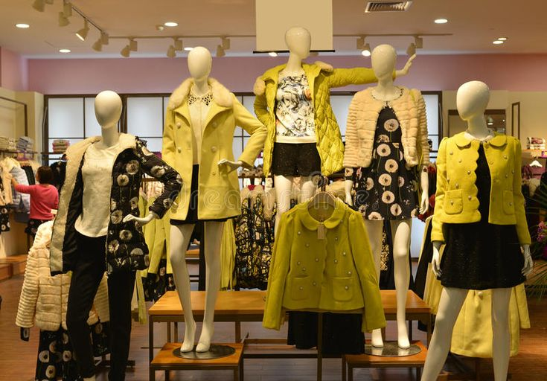
Figure 8: Mannequins for display of fashion products

3.1.4. Presentation visuals and arrangements for optimal display of fashion design products
Visual merchandising is the practice of displaying your product and organizing your store to drive sales, enhance your brand, and provide a stimulating and enjoyable shopping experience for customers. This article and our corresponding video outline a dozen of the most important visual merchandising techniques and how you can implement them in your business.
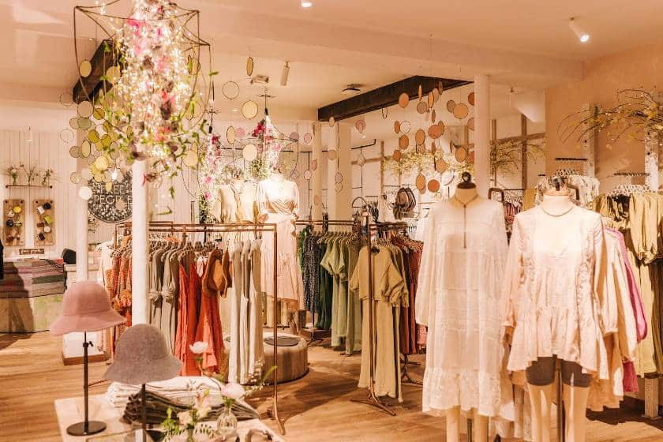
Figure 9: visuals and arrangements for optimal display of fashion design products

3.1.5. Packaging and folding requirements
The in-store presentation of fashion designs, it is also important to consider the packaging and folding requirements of the products. These packaging and folding requirements, you can ensure that your fashion designs are presented professionally and protected during the purchasing process.
Here are some key considerations:
- Choose appropriate packaging materials: Select packaging materials that are durable and protect the fashion designs during transportation and storage. Consider using boxes, bags, or tissue paper that align with your brand aesthetic and provide a premium feel.
- Ensure proper folding techniques: Train your staff on proper folding techniques to maintain the quality and appearance of the fashion designs. This includes folding garments neatly and avoiding wrinkles or creases.
- Use tissue paper or garment bags: Use tissue paper or garment bags to wrap delicate or high-end fashion designs. This adds an extra layer of protection and enhances the presentation when customers receive their purchases.
- Include branding elements: Incorporate your brand logo, name, or tagline on the packaging materials. This helps reinforce brand recognition and creates a cohesive experience from the moment customers receive their purchases.
- Consider sustainability: In today's environmentally conscious market, consider using sustainable packaging materials such as recycled or biodegradable options. This can help attract eco-conscious customers and align with their values.
- Provide clear instructions: If your fashion designs require specific care instructions or assembly, include clear instructions in the packaging. This ensures that customers can properly care for and enjoy their purchases.
- Customize packaging for special occasions: Consider offering special packaging options for holidays or special occasions. This can include gift wrapping services or themed packaging that adds a personal touch and enhances the overall customer experience.
- Streamline packaging processes: Optimize your packaging processes to ensure efficiency and minimize errors. This can include implementing standardized packaging procedures, using labeling systems, or investing in packaging automation technology.

3.2. The way of Advertising and promotion of fashion design is determined.
Fashion advertising is a sub-branch of the advertising field with the purpose of creating promotion for the fashion brand, such as garments, jewelry, shoes, purses, perfumes, and many more in the fashion industry. The goal of fashion advertising is to connect potential customers in different social classes with that specific brand.
The advertising and promotion of fashion designs can be determined through various methods and strategies. Important for fashion designers to carefully consider their target audience and choose advertising and promotion methods that align with their brand image and values. By utilizing a mix of these strategies, designers can effectively reach and engage with potential customers, ultimately driving sales and success in the market.
Here are some common approaches:
- Print Advertising: Fashion designs can be advertised through print publications such as magazines or newspapers. Advertisements can feature high-quality images of the designs along with relevant information such as pricing and availability.
- Online Advertising: With the rise of digital platforms, online advertising has become a popular way to promote fashion designs. This can include banner ads on websites, sponsored posts on social media platforms, or collaborations with fashion influencers or bloggers.
- Social Media Marketing: Social media platforms such as Instagram, Facebook, and Pinterest provide opportunities for fashion designers to showcase their designs to a large audience. By creating engaging content, utilizing hash tags, and collaborating with influencers, designers can increase brand awareness and drive traffic to their online stores or websites.
- Fashion Shows and Events: Fashion shows and events provide a platform for designers to showcase their collections to industry professionals, media, and potential customers. These events can generate buzz and excitement around the designs, leading to increased interest and sales.
- Public Relations: Building relationships with media outlets and fashion influencers can help generate positive press coverage and increase brand visibility. This can be achieved through press releases, media pitches, or collaborations with influential individuals in the fashion industry.
- Collaborations and Partnerships: Collaborating with other brands or designers can help expand the reach of fashion designs. This can involve co-creating limited-edition collections, cross-promoting each other's products, or hosting joint events.
- Email Marketing: Building a strong email list allows designers to directly communicate with their customers and promote new designs or special offers. Personalized emails can be sent to subscribers to keep them engaged and encourage repeat purchases.
- Influencer Marketing: Working with fashion influencers who have a large following and align with the brand's aesthetic can help increase brand exposure and credibility. Influencers can promote the designs through sponsored posts, product reviews, or collaborations.
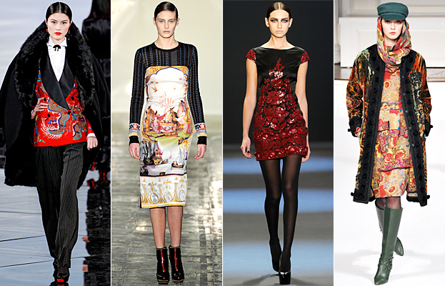Figure 10: Advertising and promotion of fashion design

3.2.1. Promotional activities to support sales of fashion design
By implementing these promotional activities, fashion designers can support their sales efforts and create a strong brand presence in the market. It's important to regularly evaluate the effectiveness of these strategies and adjust them based on customer feedback and market trends
- Sales and Discounts: Offering sales and discounts on fashion designs can help attract customers and encourage them to make a purchase. This can be done through seasonal sales, clearance events, or exclusive discounts for loyal customers.
- Fashion Styling and Personal Shopping Services: Providing fashion styling services or personal shopping experiences can enhance the customer's shopping experience and increase the likelihood of a purchase. This can be done through in-store consultations or online virtual styling sessions.
- Loyalty Programs: Implementing a loyalty program can incentivize customers to make repeat purchases. This can include offering exclusive discounts, early access to new collections, or rewards for referrals.
- Pop-up Shops and Trunk Shows: Hosting pop-up shops or trunk shows in different locations allows designers to showcase their designs to a new audience. These events can create a sense of exclusivity and urgency, leading to increased sales.
- Collaborations with Retailers: Partnering with established retailers or boutiques can help designers reach a wider customer base. By having their designs stocked in retail stores, designers can benefit from the stores existing customer traffic and brand credibility.
- Influencer gifting and Product Seeding: Sending fashion designs as gifts to influencers or celebrities can generate buzz and exposure for the brand. If these individuals are seen wearing or promoting the designs, it can lead to increased interest and sales.
- Fashion Design Competitions: Participating in fashion design competitions or submitting designs to industry awards can help gain recognition and exposure for the brand. Winning or being shortlisted in these competitions can provide valuable publicity and credibility.
- Customer Reviews and Testimonials: Encouraging customers to leave reviews or testimonials about their experience with the fashion designs can help build trust and credibility. Positive reviews can also attract new customers and increase sales.

3.2.1. Promotional and advertising materials appropriate to fashion design product and client marketing objectives
High-quality product photography: Showcase the fashion designs in a visually appealing and professional manner to attract potential customers. This can be done through a look book or an online gallery on the designer's website or social media platforms.
Social media campaigns: Utilize social media platforms such as Instagram, Facebook, and pinterest to promote the fashion designs. This can include posting outfit inspiration, behind-the-scenes content, or collaborations with influencers.
Fashion shows and runway presentations: Organize fashion shows or runway presentations to debut new collections and generate buzz around the brand. Invite industry professionals, press, and potential customers to attend the event.
Print advertisements: Place advertisements in fashion magazines or local newspapers to reach a wider audience. The advertisements should feature eye-catching visuals and compelling copy to capture the attention of readers.
Email marketing campaigns: Develop a mailing list of customers and send regular newsletters or promotional emails to keep them informed about new collections, sales, and events. Personalize the emails to make them more engaging and relevant to each recipient.
Collaborations with fashion bloggers or influencers: Partner with popular fashion bloggers or influencers to create sponsored content featuring the fashion designs. This can include blog posts, social media posts, or videos showcasing the designs and promoting them to the influencer's audience.
Public relations efforts: Engage with fashion journalists, editors, and bloggers to secure press coverage for the brand. This can include sending press releases, inviting them to fashion shows or events, or offering exclusive interviews or features.
Online advertising: Utilize online advertising platforms such as Google Ad Words or social media ads to reach a wider audience. Target specific demographics or interests to ensure that the ads are seen by potential customers who are likely to be interested in the fashion designs.
Collaborations with other brands or designers: Partner with complementary brands or designers to create limited-edition collections or collaborations. This can help expand the brand's reach and attract new customers who are fans of the collaborating brand or designer.
Influencer takeovers: Allow influencers or celebrities to take over the brand's social media accounts for a day or a week. This can help generate excitement and engagement with the brand's audience, as well as attract new followers.
By utilizing a combination of these promotional and advertising materials, fashion designers can effectively market their products and increase sales. It's important to regularly track and analyse the results of these marketing efforts to ensure they are driving the desired outcomes.

3.3. Merchandising plan is developed which details presentation, promotional and advertising activities.
A merchandising plan is a strategic document that outlines the presentation, promotional, and advertising activities for a fashion design. It is developed to ensure that the fashion design is effectively showcased and promoted to potential customers.
The presentation aspect of the merchandising plan focuses on how the fashion design will be displayed in-store or online. This includes deciding on the layout of the store or website, arranging the fashion designs in an appealing manner, and using visual merchandising techniques such as mannequins or display boards to showcase the designs. The goal is to create an attractive and visually appealing environment that captures the attention of customers and encourages them to explore and purchase the fashion designs.
The promotional activities outlined in the merchandising plan involve determining how the fashion designs will be advertised and promoted to target customers. This can include creating marketing materials such as flyers, catalogues, or digital advertisements, as well as utilizing social media platforms or influencer collaborations to increase brand awareness. The plan should also consider any special promotions or discounts that will be offered to entice customers to make a purchase.
Advertising activities are an important component of the merchandising plan, as they help to create awareness and generate interest in the fashion designs. This can involve placing advertisements in print publications, online platforms, or on billboards. The plan should also outline any collaboration with media outlets or influencers to further promote the fashion designs.
In addition to presentation, promotion, and advertising activities, the merchandising plan may also include details on pricing strategies, inventory management, and sales forecasting. These aspects are important for ensuring that the fashion designs are priced competitively, that there is sufficient stock available to meet customer demand, and that sales goals are set and monitored.
Overall, a well-developed merchandising plan is essential for effectively promoting and selling fashion designs. It provides a roadmap for how the fashion designs will be presented, promoted, and advertised, ensuring that customers are aware of and interested in the products. By carefully considering these aspects and implementing the plan effectively, fashion designers can increase their chances of success in the market

Self-check-3
Name…………………………………………… ID…………… Date…….allowed time 20min
Direction I: - answer say true or false (Total Points: 2X4=8)
1. Print advertising the rise of digital platforms, online advertising has become a popular way to promote fashion designs
2. Implementing a loyalty program can incentivize customers to make repeat purchases.
3. Offering sales and discounts on fashion designs can help attract customers
Direction II: - Choose the best answer (Total Points: 2X4=8)
- Which one is merchandising planning in trams of understands your Conduct market research, analyze customer data, and gather insights to identify their needs and preferences.
A, Research target market B, Analyze competition C, Set pricing strategy D, Implement promotional strategies
- Which one is Retail store fixtures are used to display products?
A, Display stands for special promotions B, Retail shelves for showcasing
C, Mannequins for showing customers D, all the retail store fixtures display products
- In-store presentation of fashion designs, it is also important to consider the packaging and folding requirements of the products one is select packaging materials that are durable and protect the fashion designs during transportation and storage.
A, Customize packaging for special occasions B, Ensure proper folding techniques
C, Choose appropriate packaging materials D, Streamline packaging processes
- One of advertising Building relationships with media outlets and fashion influencers can help generate positive press coverage and increase brand visibility
A, Fashion Shows and Events B, Public Relations C, Print Advertising D, Online Advertising
Direction III: -short answer all the questions listed below. (Total Points: 2X5=10)
1. What is merchandise planning?
2. Discuss store presentation of fashion design?
3. Discuss Fixtures, fittings and mannequins for display of fashion products?
4. Explain Promotional activities to support sales of fashion design?
5. Discuss Merchandising plan is developed which details presentation, promotional and advertising activities?

Unit four: Assess, document and store merchandising plan
This unit is developed to provide you the necessary information regarding the following content coverage and topics:
- Assesse and present merchandising plan
- Document and report merchandising plan
This unit will also assist you to attain the learning outcomes stated in the cover page. Specifically, upon completion of this learning guide, you will be able to:
- Understand Assesse and presented merchandising plan
- Apply Document and reports merchandising plan

4.1. Understand Assesse and presented merchandising plan
Assessing, documenting, and storing a merchandising plan is essential for retail businesses to ensure effective execution and future reference. Here is a step-by-step guide on how to carry out these tasks:
Assess the merchandising plan: Review the plan thoroughly to understand its objectives, strategies, and tactics. Evaluate the feasibility and alignment of the plan with the overall business goals. Identify any potential challenges or risks associated with the plan.
Document the merchandising plan: Create a comprehensive document that outlines all aspects of the plan. Include details such as product assortment, pricing strategy, promotional activities, visual merchandising guidelines, and target audience. Use clear and concise language to ensure easy understanding by all stakeholders.
Store the merchandising plan: Choose a secure and easily accessible location to store the document. Consider using digital storage options like cloud-based platforms or shared drives for easy sharing and collaboration with team members. Ensure that the document is regularly updated to reflect any changes or adjustments made to the plan.
Communicate the merchandising plan: Share the documented plan with relevant team members, such as store managers, visual merchandisers, and sales staff. Conduct training sessions or meetings to ensure everyone understands their roles and responsibilities in executing the plan. Encourage feedback and suggestions from team members to improve the plan's effectiveness.
Monitor and evaluate the merchandising plan: Regularly track and assess the progress of the plan's implementation. Monitor key performance indicators (KPIs) such as sales figures, customer feedback, and inventory levels to measure the plan's success. Make necessary adjustments or modifications to the plan based on the evaluation results.
Update and store revised versions: As changes are made to the merchandising plan, update the document accordingly. Clearly mark each version with a date and description to keep track of revisions. Store all versions of the plan in chronological order for future reference and analysis.
These steps, businesses can effectively assess, document, and store their merchandising plan, ensuring smooth execution and the ability to learn from past experiences.
An effective merchandising plan is crucial for retail businesses to meet their marketing objectives, timing, and budget requirements.

Here is a detailed explanation of how to assess an effective merchandising plan:
1. Marketing Objectives: Start by reviewing the marketing objectives outlined in the plan. These objectives should align with the overall business goals. Evaluate whether the objectives are specific, measurable, attainable, relevant, and time-bound (SMART). Assess if the plan includes strategies and tactics that support the achievement of these objectives.
2. Timing: Consider the timeline provided in the plan. Evaluate if it allows sufficient time for each stage of the merchandising process, such as product development, sourcing, production, and distribution. Assess if the timing aligns with market trends, seasonal demands, and promotional activities. Identify any potential bottlenecks or delays that may hinder the timely execution of the plan.
3. Budget Requirements: Review the budget allocated for executing the merchandising plan. Evaluate if the budget is realistic and sufficient to cover all necessary expenses, such as product costs, marketing materials, visual merchandising displays, and promotional activities. Identify any areas where cost-saving measures can be implemented without compromising the quality or effectiveness of the plan.
4. Feasibility: Assess the feasibility of implementing the plan based on available resources, capabilities, and constraints. Evaluate if the plan considers factors such as production capacity, inventory management, staffing requirements, and technological capabilities. Identify any potential challenges or risks that may affect the feasibility of executing the plan and propose mitigation strategies.
5. Alignment with Target Audience: Evaluate if the plan takes into account the preferences, needs, and behaviours of the target audience. Assess if the product assortment, pricing strategy, promotional activities, and visual merchandising guidelines align with the target audience's expectations and preferences. Identify any gaps or opportunities to better cater to the target audience's demands and preferences.
6. Measurement and Evaluation: Determine the key performance indicators (KPIs) that will be used to measure the success of the merchandising plan. Establish a system for tracking and evaluating these KPIs, such as sales figures, customer feedback, conversion rates, and inventory turnover. Regularly monitor and analyse the data to assess the effectiveness of the plan in meeting marketing objectives and driving business growth.
By thoroughly assessing an effective merchandising plan in terms of marketing objectives, timing, and budget requirements, businesses can ensure that their plan is well-aligned, feasible, and capable of driving desired outcomes.
Merchandising plan is presented to client proposals
Once the merchandising plan has been developed, it should be presented to the client for review and feedback. This presentation should be done in a clear and organized manner, ensuring that all aspects of the plan are explained thoroughly.
During the presentation, it is important to highlight the key objectives and goals of the plan, as well as the strategies and tactics that will be used to achieve them. This includes discussing the product assortment, pricing strategy, promotional activities, visual merchandising guidelines, and distribution channels that have been proposed.
The presentation should also include a discussion of the budget requirements and how the allocated funds will be used for various merchandising activities. This allows the client to understand the financial implications of the plan and make any necessary adjustments or revisions.
Throughout the presentation, it is important to actively listen to the client's feedback and integrate their response into the proposals. This may involve making changes to the product assortment, adjusting pricing strategies, or modifying promotional activities based on the client's preferences or specific needs.
By incorporating the client's input into the proposals, it demonstrates a willingness to collaborate and tailor the plan to their specific requirements. This helps to build trust and ensures that the final merchandising plan meets their expectations and aligns with their overall marketing objectives.
Once the client's response has been integrated into the proposals, it is important to document these changes and revise the merchandising plan accordingly. This ensures that all parties involved have a clear understanding of the agreed-upon plan and can proceed with its implementation.
Overall, presenting the merchandising plan to the client and integrating their response into proposals is a crucial step in the development process. It allows for open communication, collaboration, and ensures that the final plan meets the client's needs and expectations.

4.2. Document and report merchandising plan
The merchandising plan should be documented in a clear and organized manner, following industry practices. This includes providing detailed information about each aspect of the plan, such as product assortment, pricing strategy, promotional activities, visual merchandising guidelines, and distribution channels.
The plan should outline specific goals and objectives for each area of merchandising, such as increasing sales, improving customer satisfaction, or expanding market share. These objectives should be measurable and time-bound, allowing for easy evaluation of their success.
Additionally, the plan should include a comprehensive timeline that outlines the key milestones and deadlines for each stage of the merchandising process. This ensures that all tasks are completed in a timely manner and allows for proper coordination and allocation of resources.
The budget requirements should be clearly stated, including details on how the allocated funds will be used for various merchandising activities. This includes costs for product development, sourcing, production, marketing materials, visual merchandising displays, and promotional activities. The budget should be realistic and take into account any potential cost-saving measures that can be implemented without compromising quality or effectiveness.
Furthermore, the plan should consider the feasibility of implementation based on available resources and capabilities. This includes assessing factors such as production capacity, inventory management, staffing requirements, and technological capabilities. Any potential challenges or risks should be identified, along with proposed mitigation strategies to address them.
Figure 11:- Merchandising plan
Importantly, the plan should be aligned with the target audience's preferences, needs, and behaviours. This includes ensuring that the product assortment, pricing strategy, promotional activities, and visual merchandising guidelines cater to the target audience's expectations and preferences. Any gaps or opportunities to better meet their demands should be identified and addressed.
Finally, the plan should establish a system for measuring and evaluating its success. This includes determining the key performance indicators (KPIs) that will be used to track the effectiveness of the plan, such as sales figures, customer feedback, conversion rates, and inventory turnover. Regular monitoring and analysis of these KPIs will allow for on-going assessment of the plan's impact on marketing objectives and business growth.
In summary, an effective merchandising plan should be documented according to industry practices, with clear objectives, a comprehensive timeline, realistic budget requirements, feasibility assessment, alignment with the target audience, and a system for measurement and evaluation.
Reports on merchandising opportunities
Stakeholders are for review and feedback. These reports provide an overview of the market trends, competitive landscape, and potential opportunities for merchandising. They also outline the strategies and tactics that will be used to capitalize on these opportunities and achieve the desired objectives.
The reports should be presented in a clear and organized manner, ensuring that all relevant information is included and explained thoroughly. This includes providing data and analysis on consumer behaviour, market demand, and competitor activities. It is important to highlight the key findings and insights from the research conducted, as well as the implications for the merchandising plan.
During the presentation, it is important to actively listen to the stakeholders' feedback and address any questions or concerns they may have. This may involve providing additional information or clarification on certain aspects of the plan. It is also important to be open to suggestions and ideas from the stakeholders, as they may have valuable insights or perspectives to contribute.
After the presentation, it is important to document the feedback received and revise the merchandising plan accordingly. This may involve making changes to the strategies, tactics, or objectives based on the stakeholders' input. It is important to keep all parties involved informed of any revisions or adjustments made to the plan.
In addition to presenting the reports and receiving feedback, it is also important to regularly update stakeholders on the progress and results of the merchandising plan. This can be done through regular meetings, presentations, or written reports. It is important to keep stakeholders informed of any challenges or obstacles encountered, as well as any successes or achievements.
By documenting and presenting reports on merchandising opportunities and strategies, and actively seeking feedback from stakeholders, it ensures that all parties involved have a clear understanding of the plan and can contribute to its success. This collaborative approach helps to build trust and ensures that the final plan meets the needs and expectations of all stakeholders.
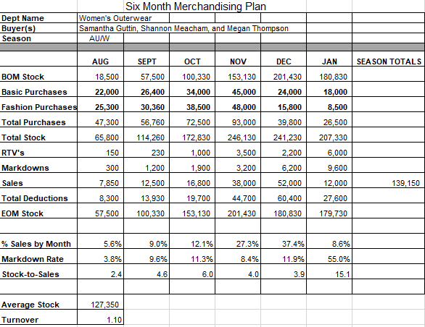
Figure 12: example report merchandising document
In the fashion industry, a store merchandising plan refers to the strategic approach taken by retailers to present and promote their fashion products in-store. It involves various elements such as product selection, visual merchandising, pricing, promotions, and customer experience to attract and engage shoppers.
When developing a store merchandising plan in the fashion industry, it is important to consider the following key aspects:
Product Selection: Retailers need to carefully curate their product assortment based on market trends, customer preferences, and brand positioning. This involves selecting the right mix of apparel, accessories, and footwear that align with the target market and store concept.
Visual Merchandising: Creating visually appealing displays is crucial in the fashion industry. Retailers need to design attractive window displays and in-store layouts that showcase their products effectively. This includes using mannequins, props, signage, and lighting techniques to create an engaging shopping environment.
Pricing Strategy: Determining the right pricing strategy is essential for success in the fashion industry. Retailers need to consider factors such as production costs, competitor prices, perceived value, and target customer segments when setting prices. Promotions and discounts can also be incorporated to drive sales and attract customers.
Promotions and Events: Fashion retailers often utilize promotional activities and events to create excitement and generate foot traffic. This can include seasonal sales, fashion shows, trunk shows, collaborations with influencers or designers, and exclusive product launches. These initiatives help to create buzz around the store and increase customer engagement.
Customer Experience: Providing an exceptional customer experience is crucial in the fashion industry. Retailers need to focus on creating a welcoming and personalized environment where shoppers feel comfortable browsing and trying on clothes. This can involve offering personalized styling services, comfortable fitting rooms, knowledgeable staff, and convenient payment options. Online Integration: In today's digital era, integrating online and offline channels is vital for success in the fashion industry. Retailers should ensure that their online presence aligns with their in-store merchandising plan. This includes having a user-friendly website, offering online shopping options, and utilizing social media platforms to promote products and engage with customers.
To develop an effective store merchandising plan in the fashion industry, it is important to involve various stakeholders such as store managers, buyers, visual merchandisers, marketing teams, and even customers. By seeking feedback and input from these stakeholders, retailers can ensure that the plan meets their expectations and aligns with market trends and customer preferences. Regular communication and collaboration with stakeholders throughout the planning and implementation process will help to create a cohesive and successful merchandising strategy.

Self-check-4
Name…………………………………………… ID………………Date…….time allow 20.min
Direction I: - Answer say true or false. (Total Points: 2X4=8)
1 Store merchandising plan Choose a secure and easily accessible location to store the document.
2. The feasibility of implementing the plan based on available resources, capabilities, and constraints.
3. The merchandising plan should be documented in a clear and organized industry practices
4. Document the merchandising plan not Create a comprehensive document that outlines all aspects of the plan
Direction II: -Answer all the questions listed below. (Total Points: 2X4=8)
  - Discuss Assessing, documenting, and storing a merchandising plan?
  - Detailed explanation of how to assess an effective merchandising plan?
  - Discuss Merchandising plan is documented according to industry practices?
  - Detail explains Reports on merchandising opportunities and strategies?

Reference
- Bell, J. & Ternus, K. 2006. Silent selling. 3rd ed. New York: Fairchild Publications.
- Bhalla, S. & Anuraag, S. 2010. Visual merchandising. New Delhi: McGraw Hill.
- Mathew, R. 2008. Apparel Merchandising. New Delhi: Book Enclave
- https://fashionchinaagency.com/fashion-advertising-promotes-fashion-brands/
- https://fashion-history.lovetoknow.com/fashion-clothing-industry/fashion-advertising
- https://www.infobloom.com/what-is-fashion-advertising.htm

Participants of this Module (training material) preparation
No | Name | Qualification (Level) | Field of Study | Organization/ Institution | Mobile number | E-mail
1 | Eyerusalem Miliyon | B-Level | Garment Engineering | Misrak Polytechnic College | 933042010 | eyerusmiliyon500@gmail.com
2 | Kebere Belihu Geze | A- level | Fashion Design and Garment Engineering | Misrak Polytechnic College | 920775168 | keberebelihu1@gmail.com
3 | Tachawot Lewoyew | A-Level | Garment Engineering | Misrak Polytechnic College | 921600140 | tachawutl@gmail.com
4 | Misgana Abdisa Jorte | B-Level | Garment Engineering | Misrak Polytechnic College | 921051791 | roberaabdisa@gmail.com
5 | Meseret Getiye | B-Level | Garment Technology | Misrak Polytechnic College | 937820842
6 | Meseret Abebe | B-Level | Garment Engineering | Misrak Polytechnic College | 910054198
7 | Hamid Detamo | B-Level | Garment Engineering | Misrak Polytechnic College | 912398119 | kemaldetamo@gmail.com
8 | Boja Mekonnen | B-Level | Garment Technology | Misrak Polytechnic College | 920623548 | bojagarment@gmail.com
9 | Temesgen Dereje | B-Level | Garment Engineering | Misrak Polytechnic College | 919866432 | kayoojaleta@gmail.com
10 | Bereket Yohannes | B-Level | Garment Technology | Misrak Polytechnic College | 923327388 | berekety26@gmail.com
11 | Rebuma Bedada Beyene | B-Level | Garment Technology | Misrak Polytechnic College | 915976670 | rebuni26@gmail.com

