
Fashion Design
Level III
Based on March, 2023, Curriculum Version 1
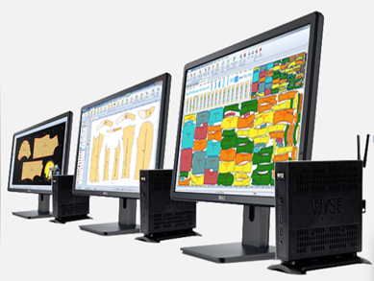

Module Title: - Develop pattern using CAD system
Module code: IND FAD3 06 1221
Nominal duration: 40Hour
Preperd By BEREKET YOHANNES BUNE

Table of Contents

Table of Contents 1
Figure of Contents 4
Acknowledgment 5
Introduction to the Module 6
Unit one: Preparing workstation 6
1.1. Applying OHS practices. 8
1.2. Setting up suitable CAD system and equipment. 8
1.3. Connecting digitizer and plotter 9
1.4. Identifying pattern making and grading tools 11
Self-check-1 13
Unit Two: Preparing the CAD operation 14
2.2. Organizing information obtained by designer on computer system 15
2.2. Determining job requirement 16
2.3. Preparing suitable software programmer. 16
Self-check-2 18
3.1. Describing types of CAD software used for pattern making. 20
3.2. Key features of CAD software 21
3.3. Analyzing types of CAD for pattern making software 21
3.4. Identifying compatibility of CAD software 21
3.5. Software features and specifications 21
3.5.1.Pattern making and grading 22
3.5.2. Markr Meking 47
3.5.3. Plotting 56

3.5.4. Cutting 62
Self – check-3 64
Operation sheet 1 64
Unit Four: Accessing CAD software and set-up for pattern construction. 65
4.1. Workplace procedure for computing technology 66
4.2. Accessing and filing software 66
4.3. Identifying the diverse templates 66
4.4. Identifying and adjusting organizational related symbol 67
4.5. Identifying save and backup. 68
Self – check-4 69
Unit Five: Producing basic pattern elements 70
5.1. Analyzing CAD functions to produce basic pattern 71
5.2. Modifying and analyzing pattern pieces 71
5.3. Exercising saving, importing and exporting 72
5.4. Industrializing Pattern Piece 72
5.5. Understanding pattern grading procedures 73
5.6. Applying grading rule 73
Self-check-5 74
Unit six. Digitizing and modifying patterns 75
6.1. Digitizing Manual pattern. 76
6.2. Preparing final pattern pieces for grading and marking. 78
6.3. Plotting Pattern. 78
6.4. Preparing tech pack. 78
Self-check-6 79
Unit Seven. Grading and modifying patterns using CAD software. 80
7.1. Drafting pattern with CAD software 81
7.2. Digiting Pattern With CAD Software 82
7.3.Digitizing the analogue pattern block. 82
7.3. Adjusting the pattern specifications. 86
7.4. Performing grading 87
7.5. Incorporating shrinkage in pattern grading. 87
Why Shrink Rule Used in Pattern Making? 88
7.6. Assessing accuracy and completeness. 89
7.7. Determining cut ratio plan 89
7.8. Producing graded pattern for toile 90
Self-check-7 91
Unit Ehight. Checking and finalizing patterns 93
8.1. Testing and fitting a toile 94
8.2. Making adjustments 94
8.3. Altering pattern. 95
8.4. Documenting alterations to patterns. 95
8.5. Demonstrating grading methods. 95
8.6. Setting CAM parameters. 96
8.7. Performing lay planning. 96
8.8. Plotting mini marker as a reference to the client’s order. 97
Self-check-8 98

Figure of Contents

Figure 1: digitizer 10
Figure 2: Plotter 10
Figure 3:marker efficiancy 16
Figure 4 Modaris window 23
Figure 5 sheet 23
Figure 6 Variant 24
Figure 7 illustration 25
Figure 8 folder 28
Figure 9 Modaris & Modaris 29
Figure 10 Model sheet title block 29
Figure 11 Variant sheet title block 30
Figure 12 Pattern sheet title block 30
Figure 13 Piece sheet title block 31
Figure 14 Creating Access path 32
Figure 15 Function Menus 34
Figure 16 FUNCTION F1 38
Figure 17 DIVISION 41
Figure 18 FUNCTION-F6 44
Figure 19 MEASURES 46
Figure 20 measurement 47
Figure 21 Marker Damino 49
Figure 22 DATA AREA 50
Figure 23 Marker generaterlites 52
Figure 24 Marker composition 54
Figure 25 open Marker 54
Figure 26 Marker piece 54
Figure 27 Constrant varint 55
Figure 28 Plotting 56
Figure 29 Justprint 56
Figure 30 Justprint 58
Figure 31batch 58
Figure 32 tools 60
Figure 33 plot 61
Figure 34 grading rule 74
Figure 35 Draft pattern 81
Figure 36 block point 83
Figure 37 Main Point pattern 85

Acknowledgment
I wish to extend my thanks and appreciation to many of my staff members, the department head, and our college’s dean for facilitating the development of these teaching, training, and learning materials. (TTLM).

Introduction to the Module

In fashion design field ; Develop pattern using CAD system sets is one most important vital operation in garment manufacturing industry.it helps to add qualities of production process , finishing and also the output of the manufacturer industry.
This module covers the units:
- Prepare workstation
- Prepare the CAD operation
- Identify key features of CAD software
- CAD software and set-up for pattern construction
- Digitize and modify patterns
Learning Objective of the Module
- Planning and preparing for workstation Perform
- Understanding how to CAD operation
- Digitize and modify patterns
Module Instruction
For effective use this modules trainees are expected to follow the following module instruction:
- Read the information written in each unit
- Accomplish the Self-checks at the end of each unit
- Perform Operation Sheets which were provided at the end of units
- Read the identified reference book for Examples and exercise

Unit one: Preparing workstation
This unit is developed to provide you the necessary information regarding the following content coverage and topics:
- .OHS practices.
- suitable CAD system and equipment.
- Connecting digitizer and plotter
- pattern making and grading tools
This unit will also assist you to attain the learning outcomes stated in the cover page. Specifically, upon completion of this learning guide, you will be able to:
  - .Applying OHS practices.
  - Setting up suitable CAD system and equipment.
  - Connecting digitizer and plotter
  - Identifying pattern making and grading tools

Applying OHS practices.
Occupational safety and health (OSH) also commonly referred to as occupational health and safety (OHS) or workplace health and safety (WHS) is an area concerned with the safety, health and welfare of people engaged in work or employment.
• The goals of occupational safety and health programs include furthering a safe and healthy work e Prepare workstation
- Set up Work area according to OHS practices
Assessment and implementation of risk reduction measures
Specific to the tasks described by this unit, and may relate to:
- manual handling techniques
- standard operating procedures
- personal protective equipment
- safe materials handling
- taking of rest breaks
- ergonomic arrangement of workplaces
- following marked walkways
- safe storage of equipment
- housekeeping
reporting accidents and nvironment.

Setting up suitable CAD system and equipment.
In the fashion world, where innovation meets craftsmanship, integrating Computer-Aided Design (CAD) tools has been nothing short of revolutionary. These sophisticated digital companions have redefined the creative process, empowering designers to transcend traditional boundaries and explore uncharted design territories. Let's look into CAD tools and software, examining their roles and impact in the field of fashion designing:
If you’re working for long periods of time from a laptop or tablet, ideally you should use a separate monitor, keyboard and mouse. This will help your posture and visual comfort.
Set the monitor height to your eye level or below, depending on what type of glasses you wear. If you don’t have a monitor available, raise your laptop on a riser..
Ideally, set up your monitor distance at about an arm’s length from where you're sitting. You can adjust the distance depending on the size of the monitor screen and what’s comfortable for your eyes
If you use two or more monitors equally throughout the day, position yourself and your keyboard at equal distance to both screens so you don’t have to twist your neck and spine. Also make sure the monitors are both at the same level.

Connecting digitizer and plotter
Digitizers are devices for introducing traditional (paper) patterns of any size into computer memory (so called patterns digitization). We offer classic electronic digitizers of various sizes and modern, innovative photo digitization devices. Especially we recommend a very fast and accurate method of photo digitization with using magnetic boards. These boards allows to digitize many of patterns in a very short time and with help of software they can be sharing in digital form for use in other CAD systems available on the market. Traditional digitizers are devices that can work directly with other CAD systems, while their speed and accuracy can be slightly smaller.
Preparation before digitizing:
- To open a new Model, go to File/New. Give the model a name. You will
- now see a Grey Sheet on your screen.
- Go to Sheet and click on New Sheet. One pattern piece will fit onto one sheet, if you have six pattern pieces you will need six sheets.
- Go to Display, and click on Title Block.
- Press F7 on your keyboard and click on IMP.EVT to select your size range and then click on the blank sheet. A window shows the size ranges that would have been created beforehand. Click on the one you would like and Open. You will see the sizes displayed in the title block.
- These sizes will be carried onto all the digitized pieces in the model. ▪ Ensure that the cursor (mouse) is inside the new sheet.
- Stick the pattern pieces on the digitizing table, use masking tape, as this is less sticky than cellotape and would therefore leave less glue on your board.

DIGITIZING PROCEDURE
- F1 menu
- Click on DIGIT
- Click “A” on the left end of the GRAINLINE
- Click “A” on the right end of the GRAINLINE
- Start with “2” on the first point and corners (extremity points)

“1” on in-between points (characteristic points) “C” on curves (bezier curve) “3” on internal points (relative points) “6” on notches “D” deletes a point To end: “F” exits current shape or line 2nd “F” exits digitizing function

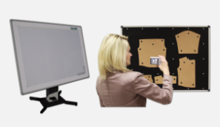
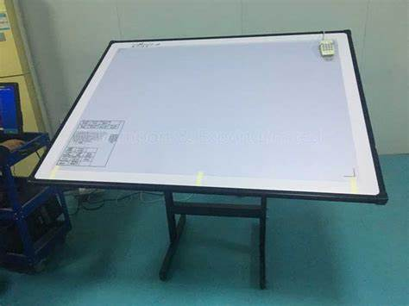

Figure 1: digitizer

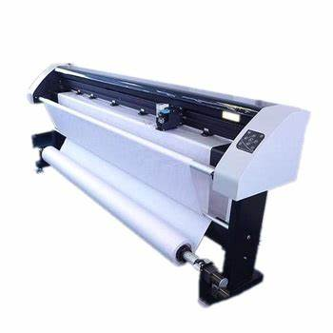
Plotters are one of the most important peripheral devices for CAD/CAM systems. They are used in the process of production in textile and garment industry. They printing a natural-size patterns and markers made in any CAD system. We offer a wide range of modern and high quality plotters. They provide satisfaction even with prolonged use. Mainly low coefficient of reliability and fast access to service parts is very important in this type of devices.

Figure 2: Plotter

Identifying pattern making and grading tools
In the fashion world, where innovation meets craftsmanship, integrating Computer-Aided Design (CAD) tools has been nothing short of revolutionary. These sophisticated digital companions have redefined the creative process, empowering designers to transcend traditional boundaries and explore uncharted design territories. Let's look into CAD tools and software, examining their roles and impact in the field of fashion designing:
2D CAD software
At the heart of many design processes lies the canvas of 2D CAD software. This digital realm allows designers to create flat sketches, technical drawings, and patterns with the precision that was once inconceivable through manual methods. Tools like Adobe Illustrator and CorelDRAW enable designers to bring their ideas to life on a virtual platform, facilitating the exploration of proportions, silhouettes, and intricate details with unparalleled accuracy.
3D CAD software
The evolution of fashion design has witnessed the transformation of flat sketches into three-dimensional realities through 3D CAD software. These tools elevate the design process by allowing designers to make virtual prototypes that can be manipulated and visualised from all angles. Software such as CLO, Browzwear, and Optitex enables designers to drape fabrics on digital avatars, offering a lifelike representation of how the garment will interact with movement and various fabrics.
Simulation and visualisation
CAD software goes beyond static images, enabling dynamic simulations and visualisations. Designers can simulate fabric behaviour, explore how garments respond to different poses, and even simulate runway walks. This not only aids in refining designs but also provides an opportunity to anticipate any potential design challenges before they manifest in physical prototypes.

Pattern making and grading
The precision required in pattern making is a cornerstone of garment construction. CAD tools streamline this process by enabling digital pattern creation and modification. Once a pattern is perfected, these tools facilitate grading, ensuring the design is seamlessly scaled to different sizes while maintaining proportions and fit.
- Lectra :-Lectra’s digital solutions are a game-changer in the fashion industry. By integrating software, hardware, services, and data, they provide a holistic approach to pattern making.
- Tuka CAD :-Tuka CAD stands out for its comprehensive functionality in 2D CAD pattern making, grading, and marker making.
- Optitex:-Optitex is a leading name when it comes to end-to-end fashion design software, especially for diverse industries like fashion, apparel, automobile, and upholstery.
- Gerber AccuMark:-Gerber Technology’s AccuMark platform is more than just a software; it’s a complete ecosystem for fashion designers.
- Richpeace:-Richpeace is not just limited to fashion and apparel but extends its intelligent cutting and sewing technology to other industries like home textiles, bags, and shoes.
- Etelestia:-Etelestia is unique as it combines CAD software with an online learning platform, making it perfect for budding designers.
- PAD System:-The PAD System is known for its advanced capabilities, making it a top choice for professionals in the fashion industry.
- StyleCAD:-StyleCAD has been a prominent name in the fashion industry for its intuitive user interface and powerful pattern design capabilities.
- CLO 3D:-CLO 3D is revolutionizing the fashion industry with its 3D garment visualization capabilities, allowing designers to see their creations come to life before they’re even produced.
- 13. Modaris:-Modaris is a powerful CAD software by Lectra, designed specifically for pattern making, grading, and prototyping in the fashion industry.
Pattern Grading is often associated with complicated calculations and laborious work in order to scale a pattern into different sizes. Pattern Grading is often associated with complicated calculations and laborious work in order to scale a pattern into different sizes.
Creator Pattern Grading CAD software introduces a unique system of grading patterns, that has simplified this process for you in a miraculous way by removing all the hard work yet leaving you in control. You will be amazed how easily you will manage to grade patterns proportionally while keeping the shape, fit and balance of the original design.
This CAD software allows you to select your grading points on your block while it grades each one automatically giving you the option to use a variety of increments.
The system uses a variety of standardized grading rules but it also allows you to insert and use your own rules if you so wish. It also has tables that help in the style interpretation when you are struggling to decide how to grade difficult design details on a garment. 3D Grading is made easy, quick and accurate

Self-check-1
Directions: Answer all the questions listed below. Use the Answer sheet provided in the next page Name --------------------------------------- Date--------
- Multiple choice Select the best answer for each question. Do this by circling the identifying letter next to your answer.
1. Why is it recommended to use a separate monitor, keyboard, and mouse when working on a laptop or tablet for long periods of time?
a) It helps improve posture and visual comfort.
b) It allows for better mobility and flexibility.
c) It enhances the performance of CAD tools and software.

2. What is the ideal height for setting up a monitor?
a) Eye level or below, depending on the type of glasses worn.
b) Above eye level to promote better focus.
c) It doesn't matter as long as the monitor is at a comfortable distance.

3. How should multiple monitors be positioned to avoid strain on the neck and spine?
a) Both monitors should be at the same level and distance from the user.
b) One monitor should be higher than the other to create a better viewing angle.
c) The user should position themselves closer to one monitor and further from the other.

Unit Two: Preparing the CAD operation
This unit to provide you the necessary information regarding the following content coverage and topics:
- Designer on computer system
- Job requirement
- Suitable software programme.
This guide will also assist you to attain the learning outcomes stated in the cover page. Specifically, upon completion of this learning guide, you will be able to:
  - Organizing information obtained by designer on computer system
  - Determining job requirement
  - Preparing suitable software programme.

2.2. Organizing information obtained by designer on computer system
Systems design is the process of defining the architecture, interfaces, and data for a system that satisfies particular requirements. After you have your requirements for your system, the next step is translating them into technical specifications so you can construct your system.
Computer-based information systems that combine models and data to enable users to solve semi structured problems with extensive interactivity are typically referred to as decision support systems. An integrated software package that provides capabilities for building specific a quickly, inexpensively, and easily to known.
Before creating markers in Lectra software, it is important to prepare the CAD operation. This involves the following steps:

Ensure that the pattern or model is properly digitized and stored in the Lectra software. This may involve scanning physical patterns or creating digital patterns from scratch using the software's drafting tools.
Verify that all pattern pieces are accurately digitized and have correct seam allowances, notches, and other necessary markings.
Check that the pattern pieces are properly graded, meaning they have been scaled up or down according to different sizes if required.
Validate the pattern pieces for any errors or inconsistencies, such as overlapping lines or gaps in the contours. Use the software's editing tools to correct any issues.
Ensure that the pattern pieces are properly labeled and identified with relevant information, such as style numbers, sizes, and fabric specifications.
A Fashion Designer is a creative professional who designs and creates clothing, accessories, and Soft wear. They research current trends, develop new styles, and oversee the production process. With expertise in design, conceptualization, and market analysis, they collaborate with teams to create fashionable clothing lines that align with business strategies.
A Fashion Designer is responsible for researching trends, creating design concepts, sketching designs, selecting fabrics and trims, and overseeing the production process. They collaborate with teams to bring their designs to life and ensure they align with the business strategy and current market trends. Ultimately, their role is to produce visually appealing and innovative fashion products.

2.2. Determining job requirement
We are looking to hire a talented CAD technician to generate surface and solid CAD models for our clients. You will be responsible for meeting with draftsmen, engineers or architects and transforming client blueprints and design plans into computer generated models using CAD software. You may be required to work as part of a team or individually on a project.
To ensure success as a CAD technician, you should have extensive working experience with CAD software, a keen eye for detail, and the ability to work as part of a team. A top-class CAD technician is a technical wizard, creating exact computer models of building and machine designs according to the client’s specifications.
CAD Technician Responsibilities
Meeting with engineers, draftsmen, and designers to review blueprints and design drawings.
Inputting design specifications into the CAD software.
Creating surface and solid CAD models according to client specifications.
Working with a design team and individually on CAD projects.
Reviewing CAD models with the client and making minor adjustments.
Conducing final model rendering and delivering the final product.
Figure 3:marker efficiancy

2.3. Preparing suitable software programmer.
From haute couture to the mass market, every sector of the fashion industry has felt the impact of CAD. As such, knowledge of CAD has become increasingly important to help secure a job in fashion design. It’s easy to see why the industry has embraced CAD. Using CAD software, designers can create new sketches more quickly and more precisely. They can also easily adapt a single design to varying materials and patterns, and build upon and alter existing designs to create new pieces.
CAD also allows designers to test out variants of their designs using different fabrics and swatches. As opposed to traditional design methods, designers using CAD can view these designs in both 2D and 3D, and make alterations immediately.
.. It has become an essential tool for many fashion designers, and the use of new design and manufacturing technologies is beginning to spread from the catwalk to the high street. CAD programs are now increasingly used in fashion to create sketches, prototypes, and designs. Fashion designers use 2D CAD software packages to create initial concepts for their designs.

Self-check-2
Directions: Answer all the questions listed below. Use the Answer sheet provided in the next page Name --------------------------------------- Date--------
- Multiple choice Select the best answer for each question. Do this by circling the identifying letter next to your answer.
Which of the following is NOT a responsibility of a Fashion Designer?
A) Researching trends
B) Creating design concepts
C) Overseeing the production process
D) Digitizing and storing patterns in software

Which of the following is a responsibility of a Fashion Designer?
A) Developing new software programs
B) Creating new styles
C) Managing financial accounts
D) Operating machinery in the production process

Which of the following is NOT a step in pattern validation?
A) Checking for errors or inconsistencies
B) Correcting any issues using editing tools
C) Scaling up or down according to different sizes
D) Labeling and identifying pattern pieces

Unit Three: Identifying key features of CAD software
This unit to provide you the necessary information regarding the following content coverage and topics:
- CAD software used for pattern making
- Features of CAD software
- CAD for pattern making software
- Compatibility of CAD software
- Software features and specifications
This guide will also assist you to attain the learning outcomes stated in the cover page. Specifically, upon completion of this learning guide, you will be able to:
  - Describing types of CAD software used for pattern making
  - .Key features of CAD software
  - Analysing types of CAD for pattern making software
  - Identifying compatibility of CAD software
  - Software features and specifications

3.1. Describing types of CAD software used for pattern making.
Computers have been used by apparel companies since the early 1980's. Pattern Design Systems (PDS) have become invaluable tools to the patternmaker, assisting in much of the repetitive tasks associated with patternmaking. PDS systems are capable of storing an incredible amount of data that can be quickly retrieved, tweaked and re-filed. Using a mouse or stylus, patternmakers are able to swiftly add style details and make changes. There are many benefits to PDS - speed, accuracy and ease of data transmission being some of the most obvious.
In today's competitive environment, software companies are zeroing in on the growing demands of the apparel manufacturer. Among these software companies, Gerber Technology, AutoMetricx, Grafis and Lectra are the major ones who backed-up the apparel industry with different software packages including known Pattern Design System (PDS) softwares.
Gerber Technology: It is a US based well known software and hardware manufacturing company; Gerber’s AccuMark Pattern Design System is a sophisticated computer-aided system for pattern design, pattern editing, pattern grading and marker making software.
AutoMetrix: It is a US based company, supplies the apparel industries with cutting systems and PDS software packages. The PDS software packages are dedicated for pattern making, pattern grading and marker planning.
Grafis: It is a German based company that produces PDS software packages containing: modern software for pattern construction, marker making software, data interfaces for importing/exporting of pattern pieces, print and plot options for the use of windows printers, control of plotters and control of digitizers.
Lectra: It is a France based world leader in the design, manufacturing and distribution of software and hardware dedicated to the major industrial uses of textile, leather, etc companies

3.2. Key features of CAD software
Integration with other systems: CAD software can often be integrated with other systems, such as inventory management or cutting machines, allowing for seamless communication and automation throughout the production process.
Overall, CAD software provides a range of powerful features that streamline the lay planning process and help you achieve maximum efficiency and fabric utilization.

3.3. Analyzing types of CAD for pattern making software
When analyzing types of CAD software for pattern making, there are a few key factors to consider:
User interface: Look for software that has an intuitive and user-friendly interface, as this will make it easier for pattern makers to navigate and use the software effectively and Compatibility: Ensure that the CAD software is compatible with the file formats used in your pattern making process, such as DXF or . It should also be able to integrate with other software or systems you use, such as design software or cutting machines.By considering these factors, you can select the most suitable CAD software for pattern making that meets your specific needs and requirements.

3.4. Identifying compatibility of CAD software
To identify the compatibility of Lectra CAD software for pattern making, you can consider the following factors:File formats: Check if Lectra CAD software supports the file formats commonly used in pattern making, such as DXF, AI, or Lectra's own proprietary formats. Ensure that it can import and export these file formats seamlessly By considering these factors, you can determine the compatibility of Lectra CAD software for pattern making and make an informed decision about its suitability for your specific requirements..

3.5. Software features and specifications
To further determine the compatibility of Lectra CAD software for pattern making, you can also consider the software's features and specifications. Some important features to look for include:
Pattern design tools: .
- Marker making capabilities.
- 3D visualization.
- Collaboration and sharing options: .
- Automation and efficiency tools: .
- Training and support.
By evaluating the features and specifications of Lectra CAD software, you can assess its compatibility with your pattern making needs and determine if it meets your requirements.

3.5.1.Pattern making and grading

Lectra’s CAD software packages:
- Modaris: It is product development software used for pattern making, grading and digitizing.
- Diamino: used for marker making.
- Just print: used for plotting
- HOW TO START WITH USING LECTRA SYSTEM
Storage of files and folders
- All Models (patterns) and size tables are stored in the MODEL directory which is found in C:\
- Lectra\Files\Models All Markers are stored in the MARKERS directory which is found in C:\Lcetra\Files\Markers The parameter files for the plotter are stored in C:\Lectra\config\VigiP\
MODARIS
1:Desktop
2: State bar
3: Active function indicator
4: Dynamic on-line help bar
5: "Trade" function selection bar
6: "Trade" function display area
7: Dynamic identification bar
8: Removable menu bar
9: Display of the Modaris version
10: Desktop scale
11: Connection to Lectra on line
The work window is a desk for the pattern maker/stylist. This work window is called the "Desk". Organization of the desk

The Modaris window
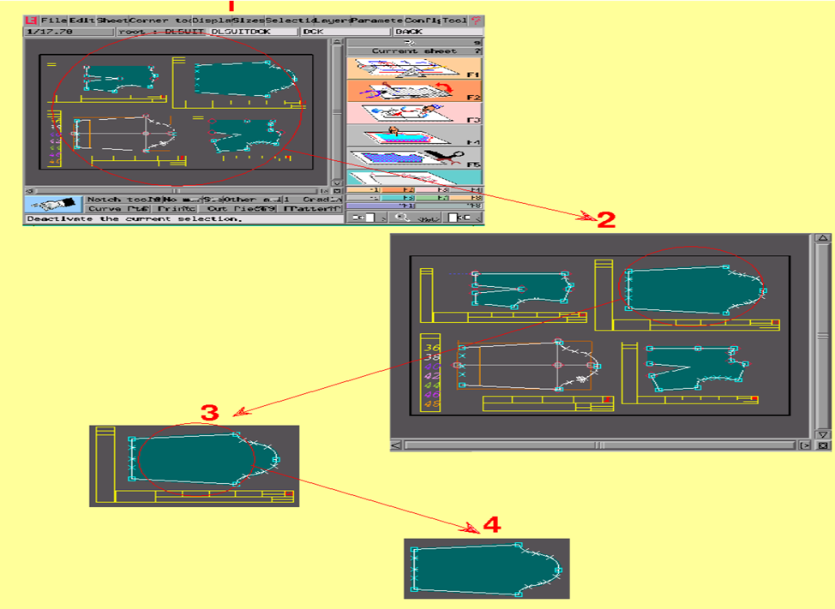

Figure 4 Modaris window

The desk is made up of "sheets". There are three types of sheet: - the sheet which identifies the model (evolution system of the model, model name ...) illustrated as follows.

Default identification sheet of a model Customized identification sheet of a model
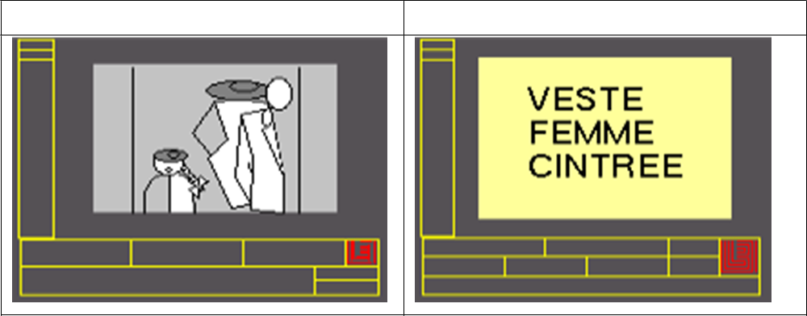
Figure 5 sheet
By default, the illustration of the model sheet corresponds to the left figure above, but it could be customized (right figure) with an illustration taken from a technical drawing. - the sheets which identify the different variants of the model illustrated as follows :

Default identification sheet of a mode Customized identification sheet of a model
Variant variant

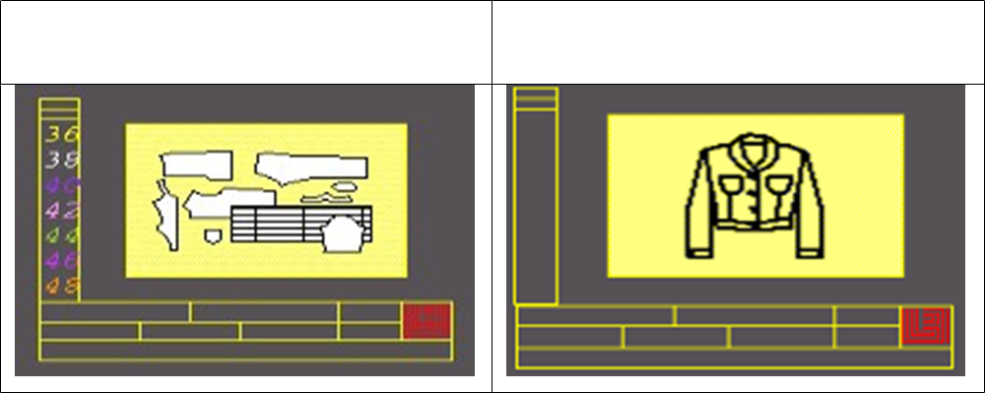
Figure 6 Variant

By default, the illustration of a variant sheet corresponds to the left figure above, but it can be customized (right figure) with an illustration taken from a technical drawing (see § Personalization of illustrations on model and variant sheets). - the sheets which contain graphic objects that can be a model, a piece, a line, a point etc :

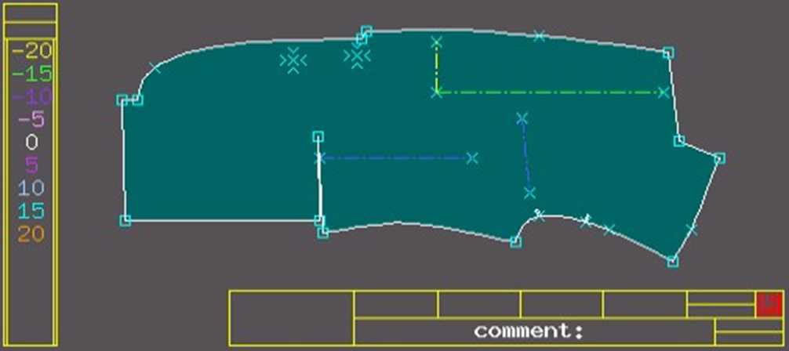

Figure 7 illustration

It is not possible to draw on a model identification sheet and on a variant sheet.
A "sheet" represents the sheet the pattern maker/stylist desk, where the patterns are created or the cardboard templates are placed.
The sheets can be translated, turned, mirrored, and associated. The sheets can be placed on the desk wherever the user likes.
A sheet can either be opaque or transparent. ✓The flat pattern is on a single sheet.
All pieces that have already been defined or are in the process of being defined, will automatically be placed on a sheet.
Pattern making and Grading Menus:
F1 – Points and Lines.
F2 – Notches, Orientation, and Tools.
F3 – Modification.
F4 – Industrialization, Piece.
F5 – Derived Pieces, Folds, and CAM.
F6 – Grading.
F7 – Evolution System, Nest Modification.
F8 – Measurements, Assembly, Variants.

Accelerator/short cut too

- Ctrl+J = Access paths
- ctrl+U = Title block
- shift+N = New sheet
- Enter = zoom in
- J = arrange desktop
- Home = visualize one piece
- Ctrl+Z = Undo
- ctrl+W = Redo
- S = Select/exit a function
- Z = delete sheet
- Page up = see previous piece
- Page down = see next piece
- 8 = Visualize all
- End = move sheets

- I = select sheets
- 7 = visualize selection
- F6+F12+F9 = visualize sizes
- F9= Nest
- F10 = hide sizes
- Shift+T = Rectangle
- Shift+X = Parallel
- B = Bezier
- Shift+H = Handles
- R = Reshape
- 0 = Straight line
- V = developed
- Shift+L+enter = show line measurement
- Ctrl+E = save

HOW TO WORK WITH MODARIS

Create Data Saving Folders
The first thing to do before starting to work with modaris is we have to create a folder on which
we save our works. Modal, Size, Marker and Reference are the four folders that folders are used to save the work we have done.

i. Modal: the pattern pieces you developed will be saved in

ii. Size: saves alphabetic or numeric sizes created in a simple notepad and used later in grading. iii. Marker: Marker will be saved in
iv. Reference: uses to feed pattern information at later stages

To do so,
- Click on all programs my computer Local disc (C:) Lectra create New Folder and rename/create 4 new folders
New folder (Rename “Model”) New folder (Rename “Size”)
New folder (Rename “Marker)
New folder (Rename “Reference”) OR
We can find my computer short cut on our desktop then we will follow the above steps

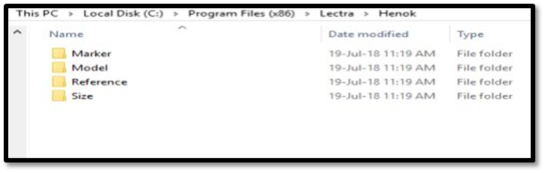
Figure 8 folder
How to enter the software
Go to start Lectra Modaris Modaris V5R1
You will notice the light on your PC, will flash.
Wait until you see black grid appear on your screen. On the blue bar on top of your software two boxes, one small and one big. By clicking the big box you will be able to increase the size of the screen to its maximum.

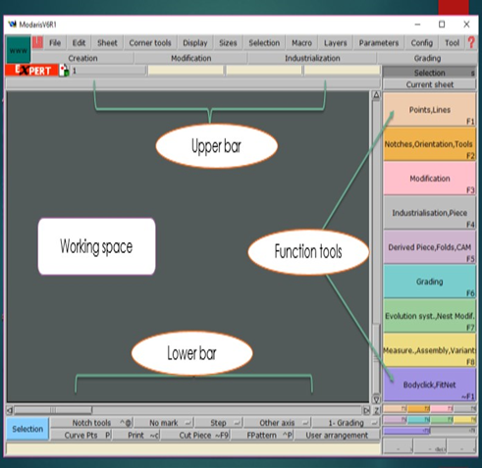
Figure 9 Modaris & Modaris

Shutting down your PC
- Make sure all your work is saved
- You must not exit Open Partner without closing all your software, remember when your software is iconize this does not mean it is closed. Close all the open or iconize software.
- In Open Partner go to FILE and then to QUIT. You will now be at the gray screen where you started.
- Double click on shutdown and wait until you see typing on the screen which has stopped scrolling. Now press Alt and F3 at the same time and wait until you read “THE SYSTEM IS HALTED.”
- Now switch your PC off and all the other equipment e.g. Printer, Plotter, and Digitizer.

Title blocks:
- To display the title blocks use Title block (CTRL + U) and (use F10) in the Displaymenu.
- On a sheet, there are two types of title blocks: the size title block by evolution type and the sheet identification title block.
- The size title block by evolution type is on the left of the sheet. This title block will only appear if there is a size system on the sheet.
- The sheet identification title block is at the bottom of the sheet. The contents of this title block vary depending on what there is to do on a Model, Variant, and Pattern or Piece sheet.
Model sheet title block

Figure 10 Model sheet title block
- name (1) : corresponds to the model name. By default, it has the model file name. The model name corresponds to the Root field of the various other sheets.
- acd (2) : corresponds to the analytical code.
- ref (3) : corresponds to the reference field compatible with LSMODEL III
- Sect (4) and Garm typ (5) : these are alphanumeric fields dedicated to the Made To Measure and corresponding to the respective coding of the activity sector and garment type of this sector.

Variant sheet title block


Figure 11 Variant sheet title block

- Root (1) : corresponds to the root of the name that will identify all sheets of a piece
- depending on the variant.
- name (2) : corresponds to the variant name. ▪ acd (3) : corresponds to the analytical code.
- gcd (4) : corresponds to the garment identification used as a base. ▪ col (5) : corresponds to the name of the collection.
- utilp (6) and utilc (7) : corresponds to the notion of utility garment dedicated to the marker. These fields can only have the value 1 or 0.

Pattern sheet title block

Figure 12 Pattern sheet title block

- root(1) : corresponds to the root of the name which identifies all sheets of the pieces
- which are dependent on the pattern. By default, this root takes the Model
- name (2) :corresponds to the pattern name. By default, the name takes the Model name.
- acd(3) : corresponds to the analytical code
- ref(4) : corresponds to the reference field compatible with LSMODEL III
The fields Sect(5), Garm typ(6), Chart, Bal and Hist are dedicated to the Made to Measure and Body Click.
Piece sheet title block


Figure 13 Piece sheet title block
- Area (9) on the left of the title block : displays the name of the variant to which the piece
- belongs followed by its quantity in the variant and its fabric type.
- root(1) : corresponds to the root of the name that will identify all piece sheets depending on the pattern.
- name(2) : corresponds to the piece name. By default it takes the pattern name ended by a figure indicating the number of sheets.
- acd(3) : corresponds to the analytical code
- ref(4) : corresponds to the reference field compatible with LSMODEL III Cut qual.(7) and Seam qual(8) : dedicated to Leather industry, these fields correspond to cutting quality and seam quality.

Creating Access path
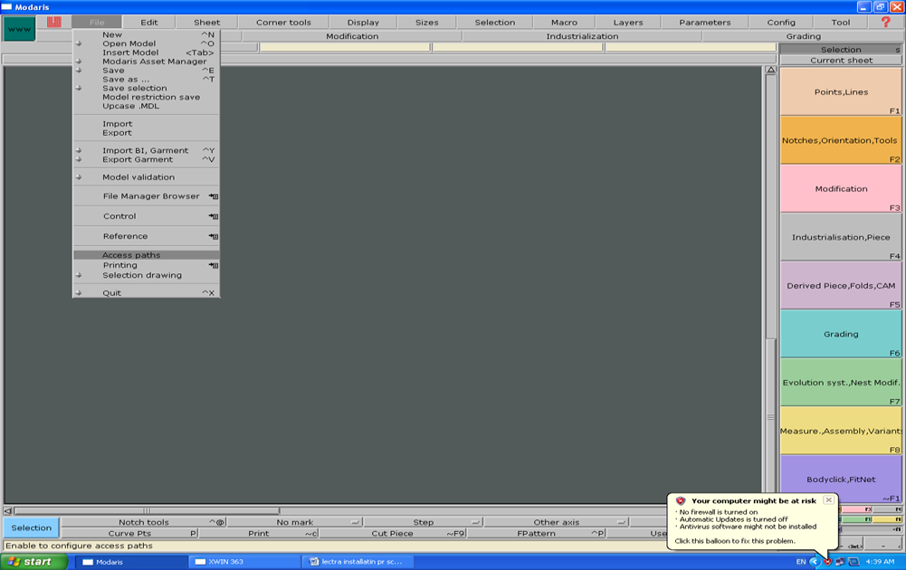
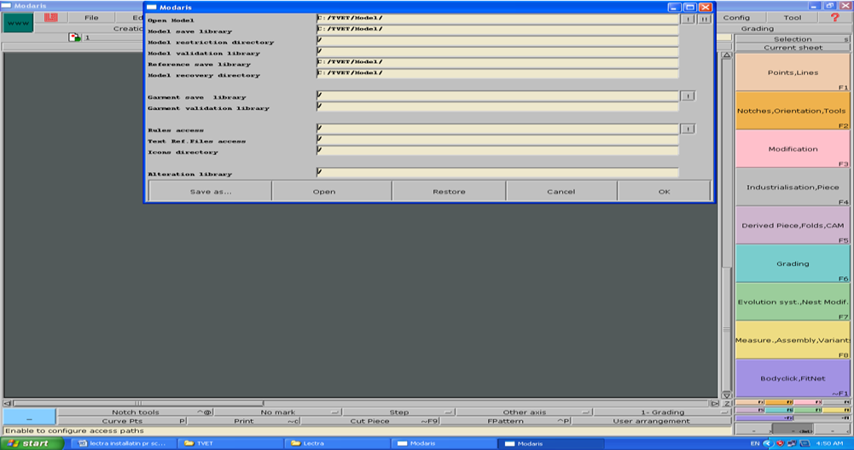
Figure 14 Creating Access path

Creating size table
All size tables (ranges) are created in the SIZETABLE directory. There are 2 types
of size tables that you can have, namely alpha and numeric. Numeric size tables comprise only of numbers e.g. 32,34,36,38 etc. Alpha size tables comprise of alphabet sizes as well as anything else which is not only numeric e.g. S, M, L, XL as well as 2_3, 3_4, 4_5 etc.
PROCEDURE
Go to Start/All Programs/Accessories/Notepad and in the notepad program type in the information required for your particular size table, following the guidelines below:

1. For an ALPHA size table comprising of S, M, L, XL type: alpha (must be in lower case)
- S
- M
- L
- XL

The word alpha must be on the top line and in lower case letters. Every size is listed one under the other with an asterisk (*) in front of the base size.
2. For a NUMERIC size table comprising of sizes 32, 34, 36, 38, 40 type:

Numeric

- 32 (tap the spacebar once) 2 *34
- 40

The space followed by a 2 shows that the size increment is 2 or every second size i.e. 32, 34 and not 32, 33, 34.

The star shows that 34 is the base size. You don’t need to input every size for a
numeric size table as the computer can work out that a size 36 is before a size 38 etc.
- Click on File/Save As and select your saving path C:\Lectra\Files\Sizetables.
- Then type in the name of the size table and click on “Save as type” arrow and change to Text Doc.
- Then click Save.
- Go to Modaris and press F7 menu and then IMP.EVT. ▪ Click on your page.
- Choose the size table you want from the list that appears and press Open.

Naming Pieces
- You must visualize the title block first, by going to DISPLAY menu, and select
TITLE BLOCK.

- You may have to zoom onto the title block if you cannot see it well (press
Enter and click and drag around area to zoom in).
- Then go to EDIT menu, and select EDIT.
- Click next to Name: of the piece in the horizontal bar of the title block, e.g. 1234FR (only 9 characters available)
- Click next to ACD: (analytic code), and type it in, e.g. FR (front)
- Click next to Comment: and type in, e.g. Jacket Front x2
- Repeat with every piece.
- Go to FILE, and SAVE the model. N.B
- Do not type next to ROOT ▪ Do not Use / - \
- If you require a spacing use an _ underscore (SHIFT and -)

F –MENUS (Application of Function Menus)

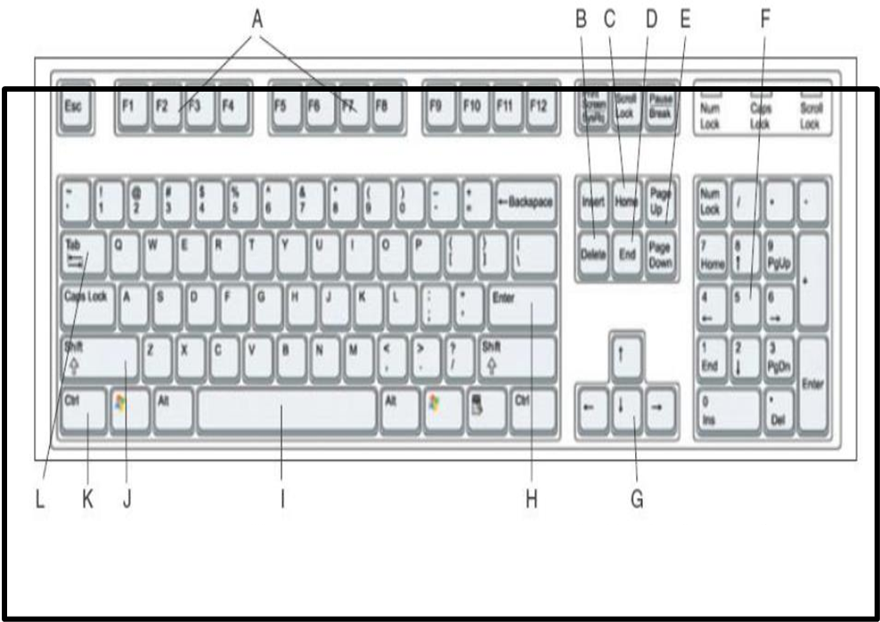
Figure 15 Function Menus
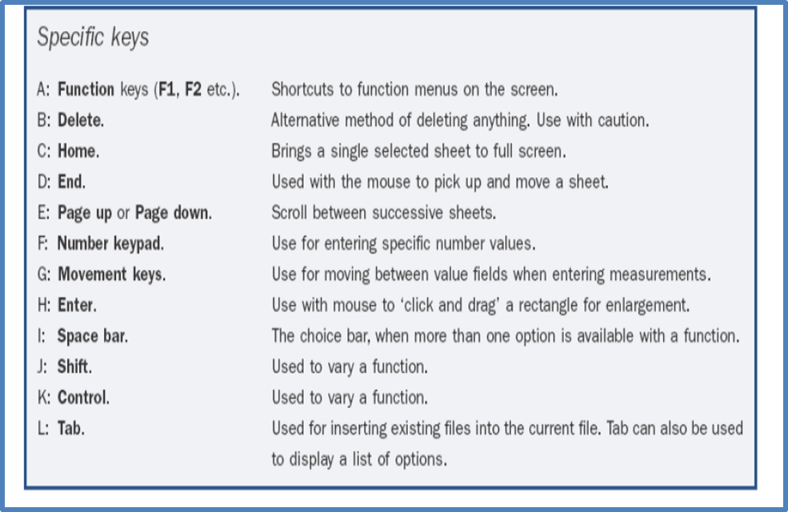

TOOLS AND APPLICATION OF FUNCTION F1 POINTS
- SLIDER

- A slider point is a reference point that slides along a line and has no real accuracy. It acts as a guide.
- Click on a reference point. ▪ Click on the line.
- By using the space bar you can change direction of the point along the line.

- No grading can be done on this type of point, the software will grade proportionally in all the sizes.
- No X and Y values can be used; it will run directly on the line. ▪ Use F3 – Insert point to change a slider to a characteristic point ▪ Use F3 – Reshape to move a slider
- DEVELOPED

- This is a measuring point. You have a standard length for all sizes from the reference point.
- Click on a reference point.

- Move the cursor along the line – you can use the spacebar to change direction.
- To be accurate you can input a value by using the down arrow key, you will notice that a window will pop up on the top left-hand side of your screen.
- This point will always be the same distance from the reference point in all sizes even if the reference point is moved.
- INTERSECTION

- This will add a point to any intersection when two lines are crossing. ▪ Click on the intersection and you will see a point is added.
- When one line of the intersection is removed this point will become a slider.
- When the lines are moved, the intersection point moves along the lines.

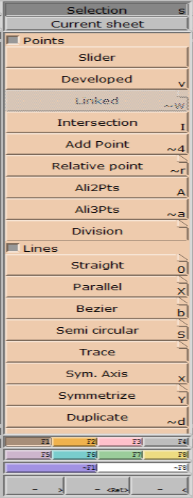
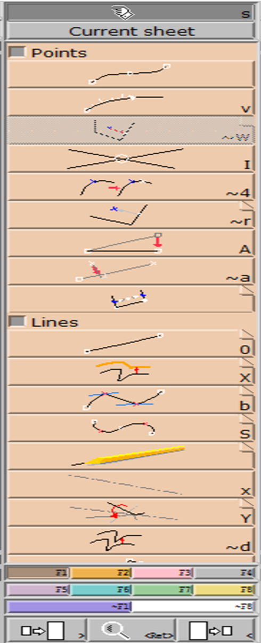
Figure 16 FUNCTION F1

- ADD POINT (Characteristic point or Curved point) This will add a characteristic point or a curved point.
- Click on a reference point.

- Use the down arrow key to type in an exact amount in Length.

- Click on the line where you want the point, for it to be added.
- For a curve point (view curve points), press the SHIFT key before clicking on this line.
- For an extremity point, first add a characteristic point and then change it in F3 - SECTION to an extremity point.
- RELATIVE
- This is what we use for internal points. It does not matter whether it is inside or outside a shape.
- Click on a reference point.
- Click the point down in to position or use your down arrow key and input the exact measurements.
- If you add a point here, for it to be plotted you need to go to F2, MARK, OR make sure that MARK TOOLS – align 2 points 35,36 or 37 are selected at the bottom of the screen before you add it.
- ALI2PTS

- This is used to putting them at the same level in the X or Y direction. ▪ Click on a reference point.
- Click on the point you would like to move. o ALI3PTS
- This is used to put 3 points in a straight line. ▪ Click on 2 reference points.
- Click on the 3rd point. It will be aligned with the reference points.

DIVISION

This function we use to divide the inside or outside of a pattern into even parts (points will not be attached to the contour)
- Click on the 2 reference points of the area you wish to divide. ▪ Type in the number of divisions you require and press enter. ▪ The area is divided up using relative points.
LINES

- STRAIGHT This allows you to draw a straight line.

- Click on your starting point and drag your line into position. ▪ Click again once you are at the end of your line.
- CTRL key will give you a straight line in X, Y or 45º. • PARALLEL
- This allows you to construct a line parallel to an existing line i.e. for back neck facings.
- Click the function and then click on the existing line from which you want to create a parallel line.
- Type in a distance from the first line to the new position and press enter.

- Depending on the shape of the curve, your new parallel line will not necessarily touch both sides of your shape.
If there is a gap, go to F3 - Len.Str.

Line and click on each side of the parallel line, extending it to outside the shape.

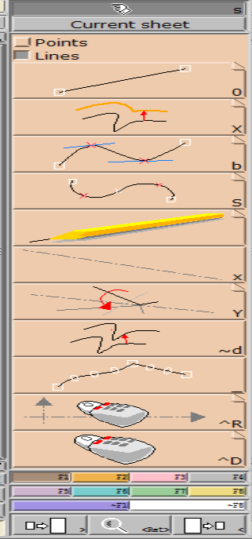
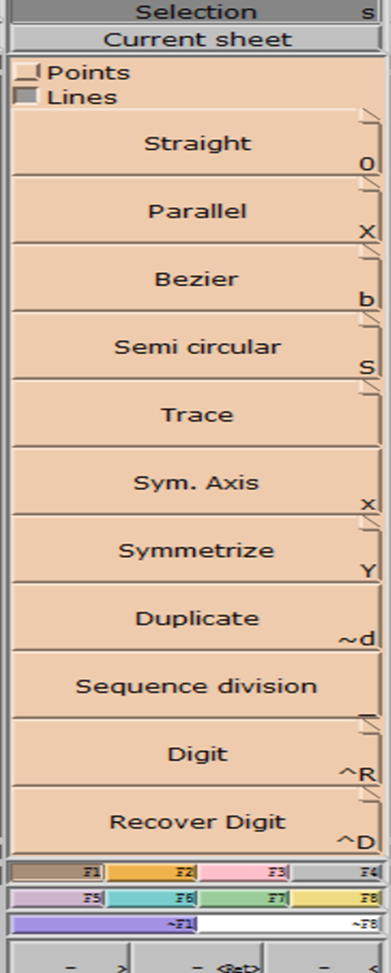

Figure 17 DIVISION

.

- BEZIER
- This allows you to draw curve lines and straight lines in one function.
- Click on the position you would like to start.
- Click again and you create a straight line.
- Hold down your SHIFT key and click to create a curve point.
- To end your line click on Right button (Right click).
- Use F3, RESHAPE to modify the position of the points if required.
- SEMI-CIRCULAR
- Works in the same way as Bezier, holding SHIFT to curve the semi-circle. The number of curve-points should be uneven.
- DUPLICATE
Allow you to copy a line or series of lines.
If you require a series of lines to duplicate, first click button 3 (right click) on the first line, hold Shift and click button 3 (right click) on the other lines.
If you want the one line only, merely click on that line. If you want the entire piece, click inside the piece.
- Use x or y (lowercase only) to flip the line into the position you require.
- q and w allow you to rotate the line by 1°
- a and s to rotate the line by 10°.

- Click it into place using shift and click button 1 (left click) to place the line exactly over another point.
- SEQUENCE DIVISION

This function we use to divide the contour of a pattern into even parts (points will be attached to the contour)
- Click on 2 points

- Type in how many divisions you would like. This will divide the line with slider points. Therefore, if the line is moved, the sliders will move with the line, keeping the proportions.
It creates slider points on the outer line. They can be changed to characteristic points using F3 and Insert Point.
- DIGIT Used to digitize patterns. If activated accidentally click button 3 (right click)

TOOLS AND APPLICATION OF FUNCTION-F6

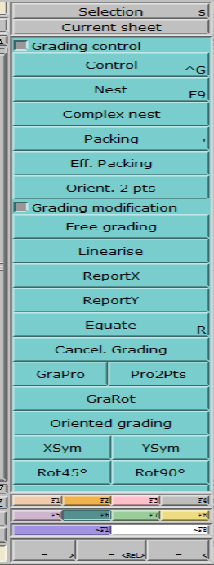
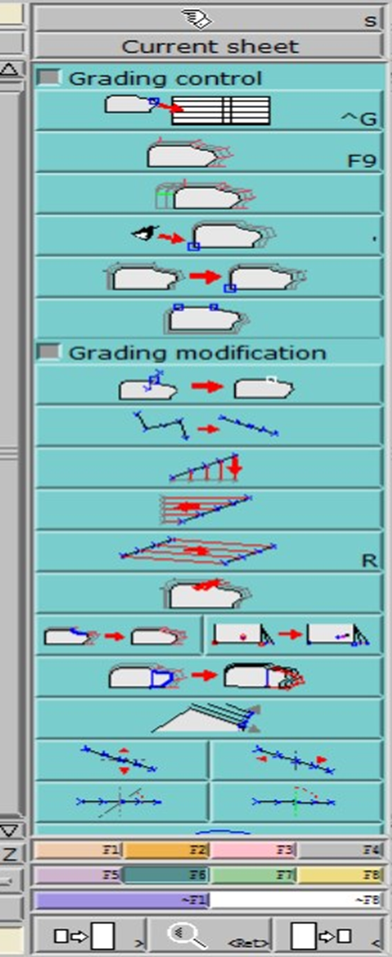
Figure 18 FUNCTION-F6

ACCELERATOR KEYS
- F9 = visualize the grading.
- F10 = hide the grading.

- F11 = visualize the 3 main sizes = small, basic and large.
- F12 = visualize all sizes.
- SIZES

- Basic size represented by white.
- Small size represented by yellow.
- Large size represented by orange.
- Break size represented by red – only if required.

GRADING PROCESS
- Click on DISPLAY and click on TITLE BLOCKS.
- You will now see a vertical box displaying your sizes.
- Click on F11 and F9 and you will see the 3 standard sizes-small, basic and large size.
- Click on F12 and F9 again to visualize the whole nest.
- For the special selection of sizes use the SHIFT key and select sizes required, then click on the F9 function and only the sizes chosen will be displayed.
CONTROL
- This function is to grade the shape, to check the grading or to modify the grading.
- Click on CONTROL.
- Click on the point.
- A window will pop up. Work with the column with ddx or ddy.

For even grading, click on the small size and drag your mouse down to the large size, highlighting all the sizes in the chart. Input the X and Y grading and press ENTER. For irregular grading, input the different values for the different sizes.

NOTE: For grading a developed point you can only use ddl. Curve points can also

have a specific grade.

- NEST: Visualize the grading = F9
- PACKING: This function is used to group the nest on a different point. ▪ It is used for TEMPORARILY grouping the sizes.
- To remove grouping, click inside the sheet outside the pattern.
- EFF. PACKING: This function is the same as Packing, but is permanent, and cannot be undone
- ORIENT 2 PTS: This will the shape and all of its grading to be stacked on the X axis.
- Click on the two points you require to be on the X axis.

INTRODUCTION TO DYNAMIC MEASURES
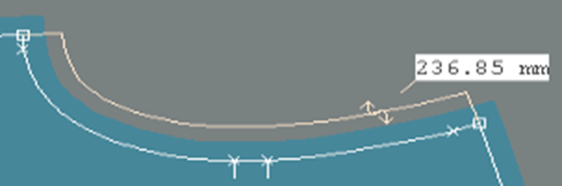

Figure 19 MEASURES

Symbols: A measurement is graphically represented as a dimension with a value (current unit) associated to a symbol found on the dimension line.
The symbols may take the following forms:
Display measurements:

- Depending on the type of your measurement, when you measure between two points, the developed length or the straight line length dl is displayed by default.
- You can display all the associated measurements (dl, dx, dy) using the Display>Show related measures command

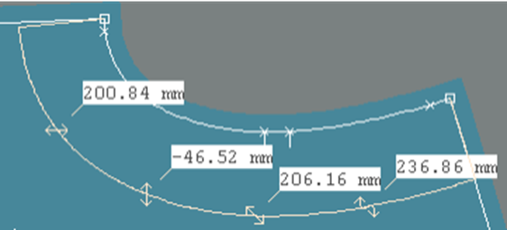
Figure 20 measurement

3.5.2. Markr Meking
CREATING PICTURES FOR DYNAMIC MEASUREMENT CHART
- In Modaris - model go to Display and Hide measures as well as the Titleblocks
- Press J to ensure pictures of the pattern pieces are small
- Press the button PrintScrn on keyboard
- Select Start – All programs – Accessories – Paint
- Go to Edit in Paint and select Paste
- Click on the Select button and make a selection of the area on the picture that’s needed to show the measurement area.
- Go to Edit in Paint and select Copy
- Go to File and select New
- Click on No for the warning that appears to save the current image
- Go to Edit in Paint and select Paste
- Click on Image – Attributes and select Black and white
- Click on Yes for the warning that appears
- Click on Image – select Invert Colours
- Click on the Curve button and select the line thickness.
- Draw the measurement line (there are only 2 moves to shape the curve line) ▪ Go to File and select Save as
- Next to Save in choose the directory where the images should be saving to ▪ e.g. Local disk C: - Lectra – Files – DMC Images
- Next to File name type the name of the picture (measurement)
- NB: Must be exactly the same in the Measurement chart – case sensitive
- Next to Save type as click on the button and select
- Click on Save
- NB: If the pictures were created after taking the measurements in Modaris: Open the Chart manager
- Click on MCM – customize Click on Measurement images tab – OK
- ASSEMBLY STACK One piece can be stacked temporarily onto another. • Click on 1 point of the piece you want to
- Click on the point on the other piece that you want to stack the first piece on. You can re-stack as necessary.
- Click j to separate the pieces again • VARIANT VARIANT
- Click the function.
- Input the variant name and enter. A new page appears.
- Pull the page to the bottom of the screen so that you can see the pattern pieces.
- Go to Create Piece Article (see below)
- CREATE PIECE ARTICLE
- Click on the function.
- Click on the pieces required in the variant, in the main fabric and fusing, etc.
- Pull the variant menu up again, so it is visible.
- Enter SINGLE, DOUBLE and FABRIC for each piece.
- Close the window.
- Press J to visualize the variant on the desktop.
- Go to FILE and SAVE the model.

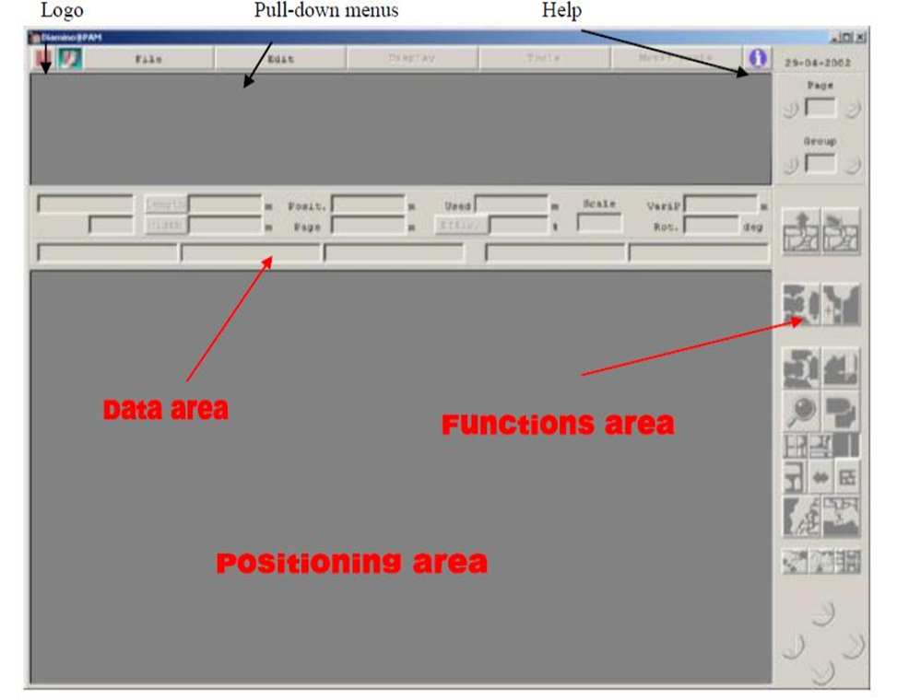

Figure 21 Marker Damino
DATA AREA: This area is used for visualizing the information and the various parameters on the work in Process: the value of the various parameters, the name of the pieces and the marker, the scale of The Marker area etc. No field can be modified in this area. The chart below lists all the indicators that can be displayed on the screen.
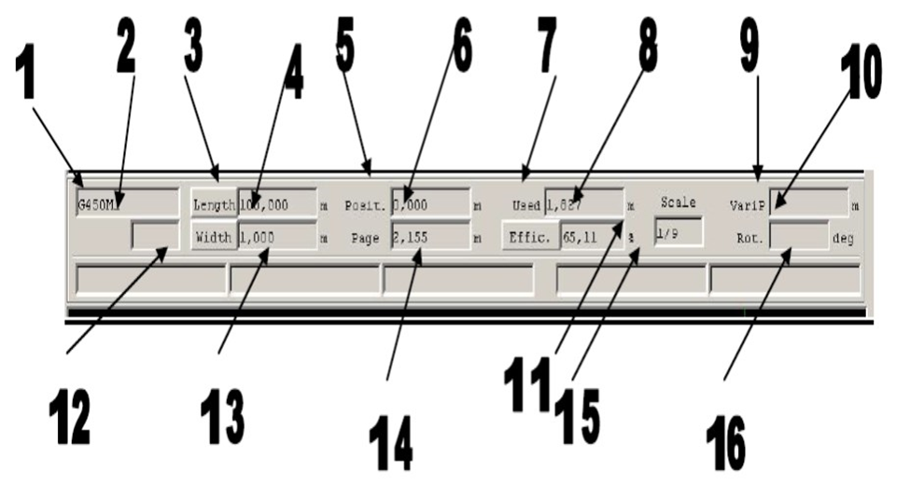
Figure 22 DATA AREA

All the information fields are blank, until a file has been loaded. The two top lines

are reserved for data concerning the marker. The bottom line concerns the marker piece when it is dotted in the Marker area.
The numbered parameters are as follows:
- Marker name.
- Information field reserved for marking on leather.
- Length Max. length of the marker.
- Width Total extent of the fabric width.
- Posit. Position of the beginning of the screen page relative to the beginning of
- the fabric width. Only a reduced part of the fabric width is visualised
- (lengthways) on the screen. Lengthways movement is possible.
- Page Length of the fabric width visualized on the screen page.
- Used Length of the fabric width used by the marker.
- Effic./Loss Efficiency percentage of the material occupied in relation to the
surface required for production. This indicator is displayed alternatively with
Loss which is also expressed as a percentage. To display this data, just click onthe enhanced button.
9. VARIP Variable position
10.Rot. Rotation angle of the piece.
11.Sca. Representation scale of the marker used in the Marker area.
12.Name of the piece selected in the Marker area associated with a Piece
Information item
13.Size, conformation, stature. The designation of conformation is separated from
the stature by a colon “:".
14.Piece analytical code.
15.Field not used.
16.Variant name to which the piece belongs, followed in brackets by its Order
number in the marker.
HOW TO CREATE A MARKER FILE



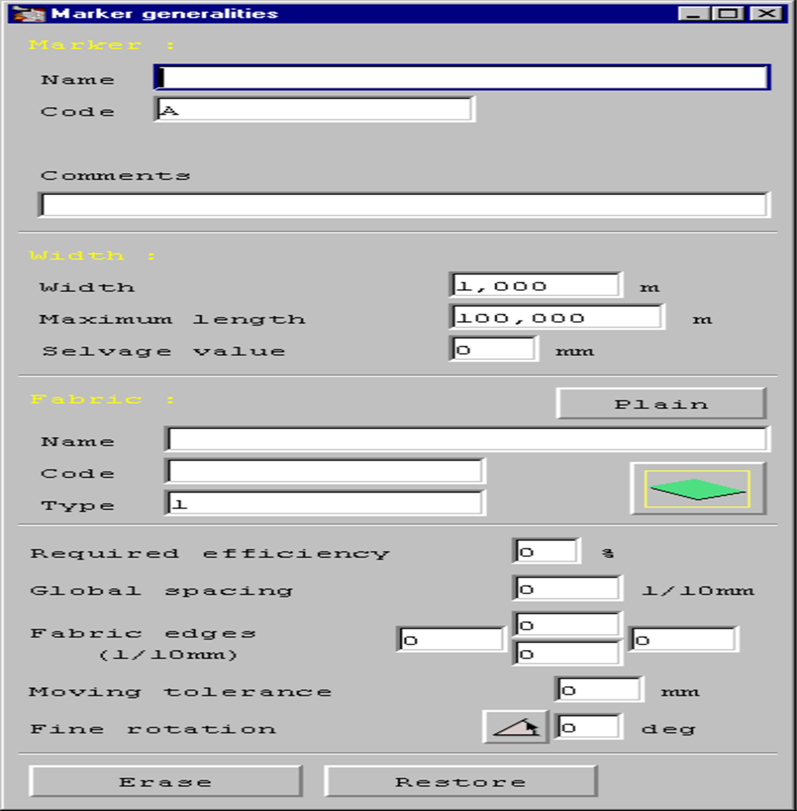

Figure 23 Marker generaterlites

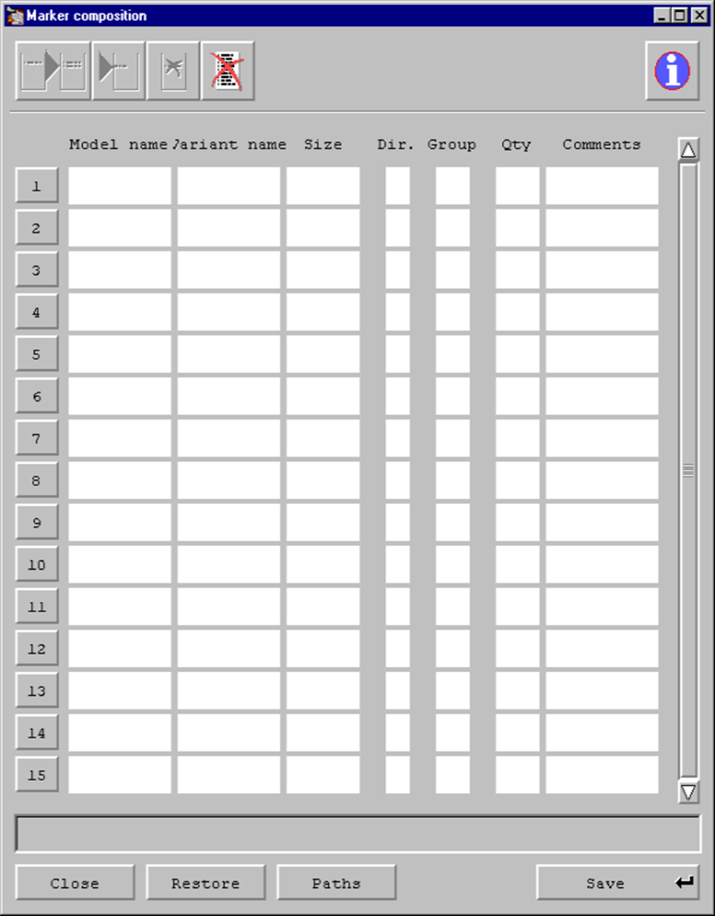

Figure 24 Marker composition
- Click the SAVE button to save this file.
- Click the CLOSE BUTTON to exit this window

HOW TO MAKE THE MARKER
- Go to FILE OPEN to open the marker file created
- Click the SELECTOR button to choose your marker from a list if the correct
name does not appear in the window.
TOP CHART: You may mark pieces in a chart presentation or graphic presentation. This can be changed in the preferences menu, or when opening a marker in the following window:

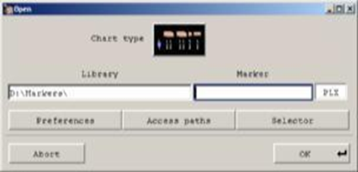
Figure 25 open Marker

Chart presentation brings the marker in with the sizes and number of pieces
displayed in chart form, as follows:
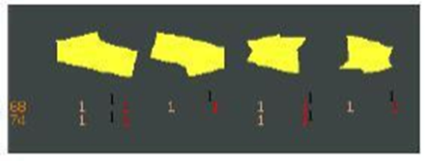
Figure 26 Marker piece
Graphic presentation brings the marker in with a pre marked marker, and a picture
of each piece, as follows:
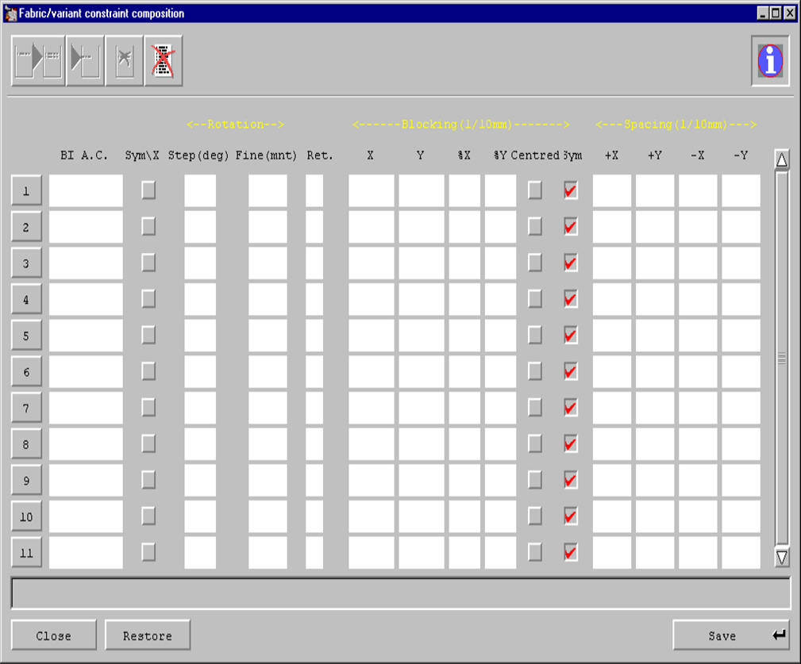

Figure 27 Constrant varint

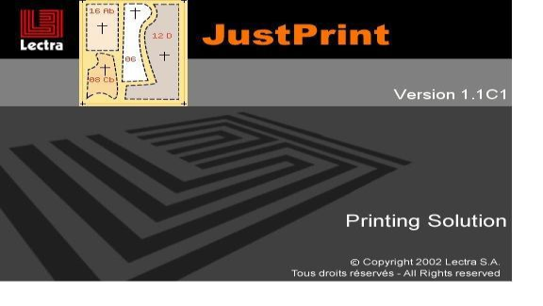
3.5.3. Plotting

Figure 28 Plotting

Just print is used to print the marker file, with the help of plotter
To start printing with just print open just print
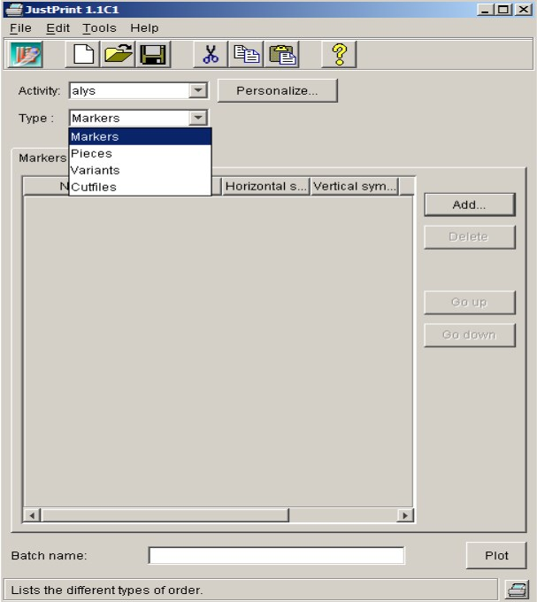

Figure 29 Justprint

.

Figure 29 open just print

Window of just print opens up,

- Select the desired file and click on icon Add
- Just clicking on Add, a new window on right side opens up (Look in:)

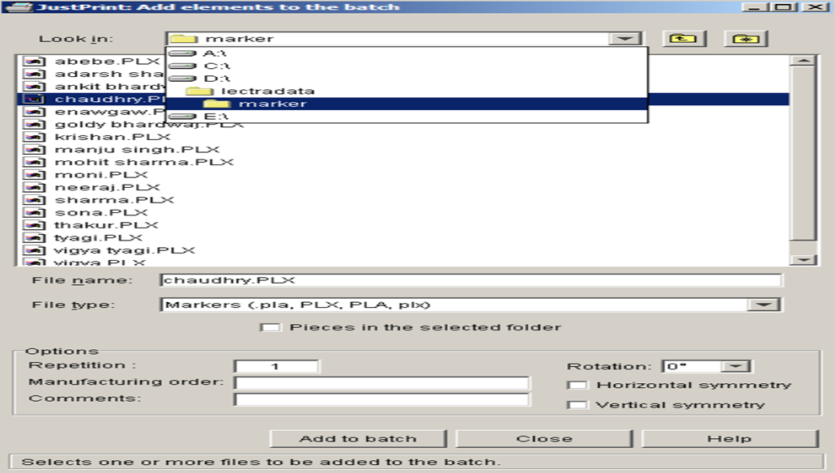

Figure 30 Justprint

From look in , select the path of file to open the file to be printed (ex- To print a
marker file select D:\ ,lectra data, marker name)

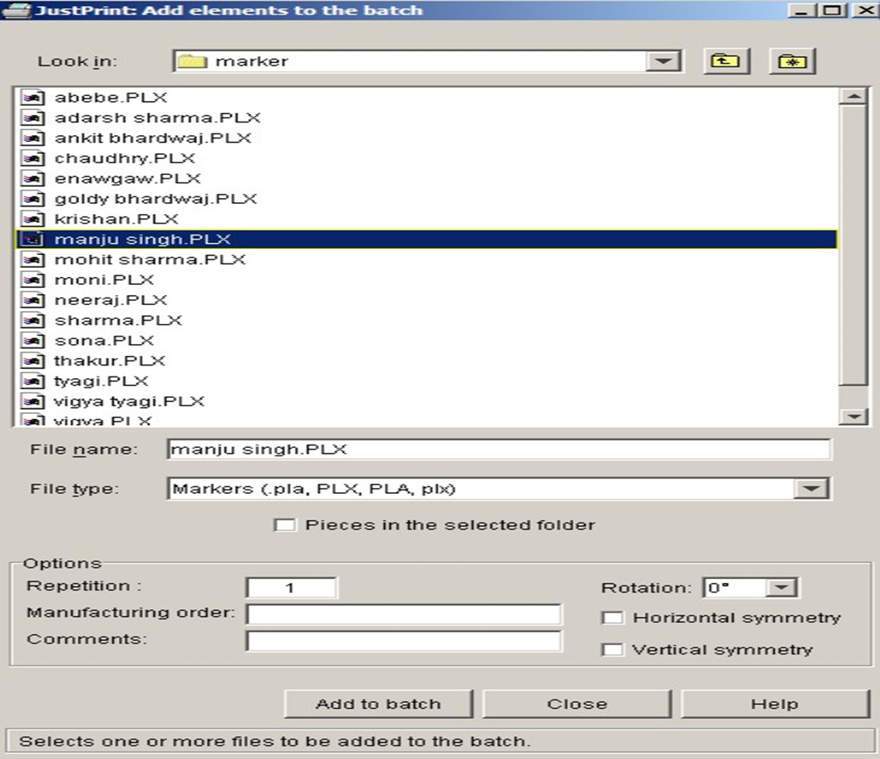
Figure 31batch

Then click on Add to batch command at the bottom.
The selected file would get added to the series of files to be printed,

In that section there are various options in relation to printing ex- if we want two copies of same marker than for that we can use the tool.
Repetition, we can add number of repetition we need, the same is for Style of printing that is horizontal and vertical printing

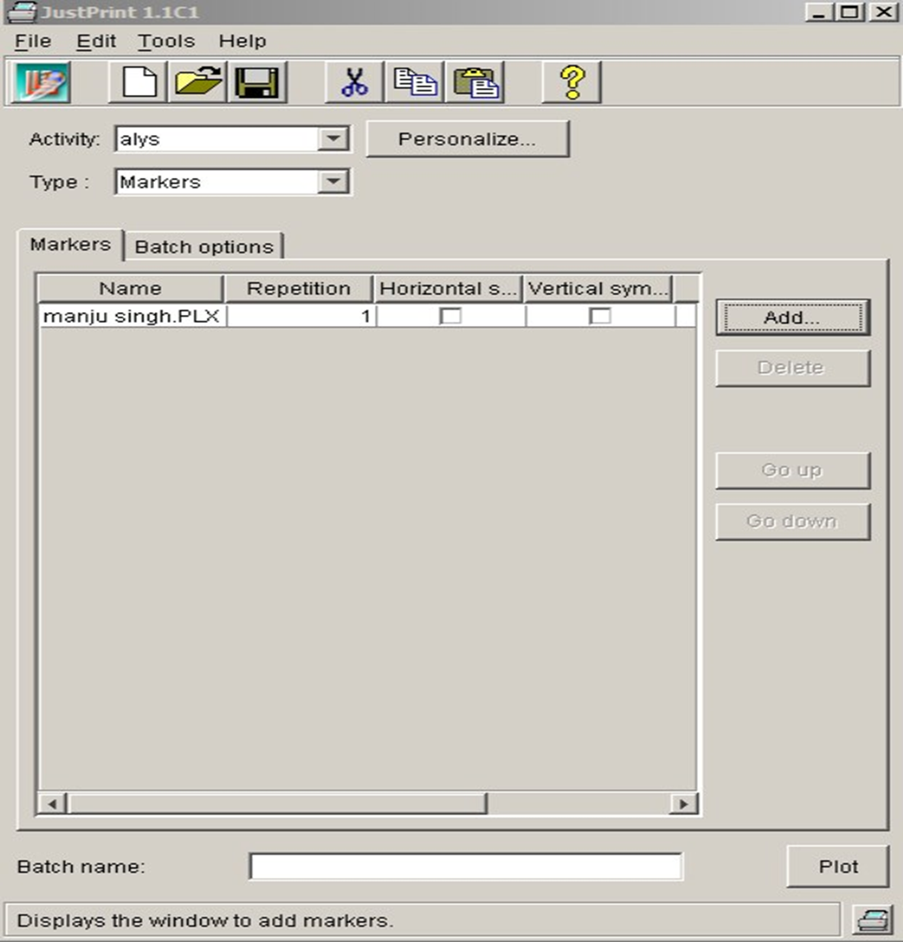
Figure 32 tools
After Adding that file, click on command Plot at the bottom, now the is ready to print

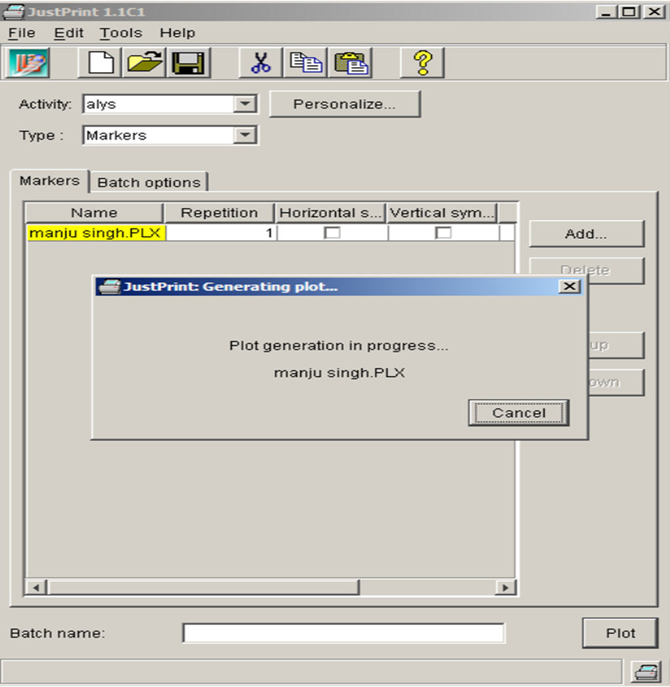

Figure 33 plot

3.5.4. Cutting
Modaris pattern cutting software is a key tool in pattern production. Using a practical approach and clear examples throughout, Pattern cutting for clothing using CAD is an essential guide for all users of Lectra Modaris. Beginning with an overview of the role of patterns in clothing manufacture,
Would you like an apparel CAD system that will allow you to create your own pattern collections, accurately, quickly, easily and in the most economical way? Then Telestia Creator is for you.
An apparel CAD system created from pattern technologists for you! Forget the tedious technical functions included in most CAD systems, moving you away from pattern creation to struggling to learn complex systems.

This unique system combines a set of easy to learn CAD tools and functions, with sound pattern cutting knowledge. You will be able to create your own blocks and styles, build-up your own style library, modify and adjust existing blocks and create fully professional collections. The software comes with built-in help and ready examples feature.
Upgrade this software with the Automatic Patterns feature and get your own pattern blocks with a click of a button. Automatically created blocks can be retrieved on your desired measurements.
The Telestia Creator Pattern Cutting CAD software is based on the Telestia pattern cutting methodology that provides accurate patterns with perfect fit, tried over thousands of users worldwide for more than 30 years.
Print your final patterns in life size on any standard printer. A plotter is not needed.

- Telestia Creator Pattern Cutting features:
- A fully featured CAD programme.
- Advanced tools to create and modify patterns.
- Easy drafting using the AB Pattern Construction template.
- Simplified tools and functions to draw, modify and adjust patterns.
- Easy to use working area, with zoom, measuring and drafting tools.
- Arrange and organise your patterns in layers.
- Work on multiple designs simultaneously.
- Create your own pattern library.
- Import EPS files and many images (jpg, gif, png, bmp, pcx, and more).
- Imports files from most competitor CAD software.
- Print full-size patterns on any printer.
- Scan ready patterns for adaptation.
- Variable width seam allowance.
- Build-in help and ready examples.
- Multi-language: English, German, French, Italian, Spanish, Greek.
This easy and affordable CAD system is ideal for pattern technologists, freelancers and clothing companies who would like to create their own apparel collections accurately in the most effortless way.

Self – check-3
Test II: short Answer writing
Instruction: write long answer for the given question. You are provided 5 minute for each question and each point has 5Points.
1. What is Modaris pattern cutting software?
2. Who is Pattern cutting for clothing using CAD essential for?
3. What are the benefits of using Teresita Creator apparel CAD system?
4. What is the unique feature of Teresita Creator software?
5. How long has the Teresita pattern cutting methodology been used worldwide?

Operation sheet 1
OPERATION TITLE:- man shirt
PURPOSE: pattern making
CONDITIONS : How to Create a product development Modaris, Diamino Marker ansd Just print File.
EQUIPMENT,TOOLS AND MATERIALS: Lectra’s CAD software packages:,
PROCEDURES:
1. Preparing Modaris
2. Diamino
3. Just print File

Unit Four: Accessing CAD software and set-up for pattern construction.
This unit to provide you the necessary information regarding the following content coverage and topics:
  - Computing technology
  - Filing software
  - diverse templates
  - Organizational related symbol
  - Save and backup
Recording data and passing on to personnel responsible for further action
This guide will also assist you to attain the learning outcomes stated in the cover page. Specifically, upon completion of this learning guide, you will be able to:
- Workplace procedure for computing technology
- .Accessing and filing software
- Identifying the diverse templates
- Identifying and adjusting organizational related symbol
- Identifying save and backup

4.1. Workplace procedure for computing technology
Garment designing is the first stage on garment production. The advancements of 3D technology and computer graphics have changed the way of garment designing. Before garment designing has been made by hand using sketches drawn in paper or draping fabric on a dress form. But now fashion designers use software tools to express their ideas. Using computer systems give them the possibility to make two-dimensional and three-dimensional product illustration and visualizations, also testing the fit in one environment. There are several CAD systems for garment visualization introduced in the clothing industry. Using 3D virtual mannequin has mostly replaced the use of physical mannequin in the fashion industry.

4.2. Accessing and filing software
Fashion is a form of self-expression that reflects a period through clothing, footwear, hairstyle, makeup, accessories, posture, and lifestyle. Professionals in the fashion industry are expected to constantly adapt to the evolving markets and their needs. Technology is crucial to the evolution of Fashion design. In this digital world, no profession has been left untouched by technology, and rightly so. The introduction of software speeds up the design process in the fashion industry.
Users can quickly automate multiple time-consuming tasks and it streamlines the process from design to production.

Identifying the diverse templates
Professional fashion design templates contain sketches in different perspectives (front & back) of the product along with manufacturing notes. All of the measurements, dimensions, materials, cuts and trim details are also included in the fashion design sketch. Some fashion design templates also include the variation of measurements for different sizes of the product including the detailed gradation of dimensions for each size. You are free to add more details which you feel are necessary to the cut sheet.
If your clothing project has intricate details, you must note these intricacies and details on the cut sheet and make sure manufacturers will easily understand them for the construction process. There is no page limit to a fashion design template and you can attach as many sub-files you want in order to be clear and transparent of what you want to relay to the clothing manufacturer.

Identifying and adjusting organizational related symbol
- In the context of fashion design, CAD (Computer-Aided Design) can be a valuable tool for identifying and adjusting organizational-related symbols. Here's how:
- Use CAD software: Utilize CAD software to create digital representations of the brand's existing symbols, such as logos or patterns. This allows for easy manipulation and adjustment of the symbols.
- Experiment with variations: Within the CAD software, explore different variations of the symbols by adjusting elements like color, size, shape, or texture. This enables designers to see how different modifications impact the overall look and feel of the symbol.
- Test with different materials: CAD software often allows designers to simulate different materials or textures. Apply these to the symbols to see how they would appear on various fashion items, such as clothing, accessories, or packaging.
- Visualize in context: Use CAD to place the adjusted symbols within the context of fashion designs, such as garments or accessories. This helps designers visualize how the symbols will appear when incorporated into actual fashion products.
- Gather feedback: Share the CAD-rendered symbols with stakeholders, including brand representatives, target audience members, or industry professionals. Collect their feedback on the adjusted symbols to ensure they accurately represent the brand's identity.
- Make refinements: Based on the feedback received, make necessary refinements to the symbols using CAD. This iterative process allows designers to fine-tune the symbols until they effectively communicate the desired brand identity.
- Export and integrate: Export the final versions of the adjusted symbols from CAD software and integrate them into various fashion design elements, such as prints, embroidery, or hardware details. Ensure that the symbols are applied consistently across different fashion items.
- By utilizing CAD software in the process of identifying and adjusting organizational-related symbols in fashion design, designers can efficiently explore variations, gather feedback, and visualize how the symbols will appear in real-world applications. This enhances the overall effectiveness and accuracy of the symbols in representing the brand's identity.

Identifying save and backup.
To save and backup a CAD (Computer-Aided Design) file in the fashion industry, you can follow these steps:
- Open the CAD software you are using for fashion design.
- Make sure your design is complete and ready for saving.
- Go to the "File" menu or look for a disk icon that represents saving.
- Click on "Save" or "Save As" to open the save dialog box.
- Choose a location on your computer or external storage device where you want to save the CAD file.
- Give the file a name that is descriptive and easy to remember.
- Select the appropriate file format for your CAD software. Common formats for fashion design CAD files include .AI (Adobe Illustrator), .DXF (AutoCAD Drawing Exchange Format), or .PDF (Portable Document Format).
- 8. Click "Save" to save the CAD file to the chosen location.
To back up your CAD files, you can use various methods:
- External Hard Drive: Connect an external hard drive to your computer and regularly copy your CAD files onto it as a backup.
- Cloud Storage: Use cloud storage services like Google Drive, Drop box, or One Drive to upload and store your CAD files securely in the cloud.
- Network Storage: If you have access to a network storage system, you can save your CAD files there for backup purposes.
- Version Control Systems: Consider using version control systems like Get to keep track of changes in your CAD files and have a history of different versions.
Remember to regularly create backups of your CAD files to ensure you don't lose any important designs in case of computer failures or accidental deletions.

Self – check-4
1. What is the primary purpose of CAD software in fashion design?
a) Creating digital representations of existing symbols
b) Designing clothing patterns
c) Generating 3D models of fashion items
d) Analyzing market trends

2. What can designers do within CAD software to experiment with symbols?
a) Create new symbols from scratch
b) Adjust elements like color, size, shape, or texture
c) Generate virtual fashion shows
d) Calculate production costs

3. How can CAD software help designers visualize symbols in the context of fashion designs?
a) By creating virtual reality experiences
b) By simulating different materials or textures
c) By placing symbols within the context of garments or accessories
d) By predicting consumer behavior

4. What is the purpose of gathering feedback on CAD-rendered symbols?
a) To showcase the designer's skills
b) To ensure the symbols accurately represent the brand's identity
c) To compare different design options
d) To determine production timelines

5. What is the final step after making necessary refinements to the symbols using CAD?
a) Presenting the designs at fashion week
b) Applying for design patents
c) Exporting the final versions of the symbols and integrating them into fashion design elements
d) Conducting market research on consumer preferences

Unit Five: Producing basic pattern elements
This unit to provide you the necessary information regarding the following content coverage and topics:
  - produce basic pattern
  - pattern pieces diverse templates
  - Importing and exporting
  - Pattern Piece
  - pattern grading procedures
  - Grading rule

Recording data and passing on to personnel responsible for further action
This guide will also assist you to attain the learning outcomes stated in the cover page. Specifically, upon completion of this learning guide, you will be able to:
- Analyzing CAD functions to produce basic pattern
- Modifying and analyzing pattern pieces diverse templates
- Exercising saving, importing and exporting
- Industrializing Pattern Piece
- Understanding pattern grading procedures
- Applying grading rule

Analyzing CAD functions to produce basic pattern
To analyze CAD functions to produce a basic pattern, you can follow these steps:
- Open the CAD software you are using for fashion design.
- Import or create the base pattern that you want to analyze.
- Use the CAD software's measurement tools to take accurate measurements of the pattern.
- Use the software's editing tools to adjust and modify the pattern according to your desired fit and style.
- Use the software's grading tools to create different sizes of the pattern if needed.
- Utilize the software's simulation or 3D rendering capabilities to visualize how the pattern will look when worn.
- Test the pattern by printing it out on paper or fabric and sewing a sample garment to check for any fit or construction issues.
- Make any necessary adjustments to the pattern based on the test garment and repeat the analysis process if needed.
- Once you are satisfied with the pattern, save it in the appropriate file format for your CAD software and backup the file using one of the methods mentioned above.
By utilizing CAD functions, you can efficiently analyze and create basic patterns, saving time and effort in the fashion design process.

Modifying and analyzing pattern pieces
To modify and analyze pattern pieces using CAD functions. Open the CAD software and import or create the pattern piece you want to modify and analyze, Use the software's editing tools to make any necessary adjustments to the pattern piece, such as lengthening or shortening, adding or removing darts, or changing the shape of the piece, Use the software's measurement tools to ensure that the modified pattern piece still aligns with the desired measurements and proportions, Once you are satisfied with the modified pattern piece, save it in the appropriate file format for your CAD software and backup the file using one of the methods mentioned above.
By utilizing CAD functions, you can efficiently modify and analyze pattern pieces, ensuring that they meet your desired fit and style requirements in the fashion design process.

Exercising saving, importing and exporting
To exercise saving, importing, and exporting in CAD software for pattern pieces, by exercising saving, importing, and exporting in CAD software, you can efficiently manage your pattern pieces and collaborate with others by sharing files in different formats.
- After making any necessary modifications and analyzing the pattern piece, go to the "File" menu in the CAD software.
- Select the "Save" or "Save As" option to save the modified pattern piece. Choose a location on your computer or network to save the file, and give it a descriptive name
- To import another pattern piece into your current project, go to the "File" menu again and select the "Import" option. Browse your computer or network to find the file of the pattern piece you want to import, and select it.
- The imported pattern piece will now appear in your current project, and you can use the CAD software's editing tools to make any necessary adjustments or modifications.
- To export the modified pattern piece as a different file format, go to the "File" menu once more and select the "Export" option. Choose the desired file format from the list of
- available options, such as DXF, PDF, or SVG.
- Specify the location on your computer or network where you want to save the exported file, and give it a name if necessary.
- Click "Save" or "Export" to complete the process. The CAD software will convert the pattern piece into the chosen file format and save it in the specified location.

Industrializing Pattern Piece
To industrialize a pattern piece in CAD software. Open the pattern piece in the CAD software and ensure that all necessary modifications and adjustments have been made. By industrializing pattern pieces in CAD software, you can streamline the production process, ensure accuracy and consistency in pattern cutting, and easily share files with manufacturers and other stakeholders.

Understanding pattern grading procedures
Pattern grading is the process of increasing or decreasing the size of a pattern piece to create multiple sizes for a garment. To understand pattern grading procedures Start by creating a base size pattern piece in CAD software. This is typically the size that will be graded up or down to create other sizes and determine the grading increments and the number of sizes you want to create. This will depend on your target market and sizing standards. Understanding pattern grading procedures and using CAD software, you can efficiently create multiple sizes for a garment, ensuring consistency and accuracy in the production process.

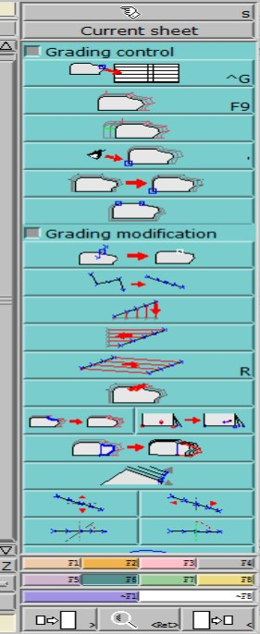
Applying grading rule

Figure 34 grading rule

Self-check-5
Test III: short Answer writing
1, list down main basic Collaborating with manufacturers and stakeholders in the pattern making process?
- list the need forCAD pattern grading.?
Directions: Answer all the questions listed below. Use the Answer sheet provided in the next page Name --------------------------------------- Date--------
I. Multiple choice Select the best answer for each question. Do this by circling the identifying letter next to your answer.
1. What is pattern grading?
a) The process of creating multiple sizes for a garment
b) The process of creating a base size pattern piece
c) The process of importing pattern files into CAD software

2. What is the purpose of creating a base size pattern piece in CAD software?
a) To determine the grading increments and number of sizes
b) To import the pattern files into manufacturers' CAD software
c) To ensure accuracy and consistency in the production process

3. How does CAD software facilitate collaboration in the pattern making process?
a) By allowing for real-time collaboration and feedback
b) By automatically grading the pattern pieces
c) By importing pattern files into manufacturers' CAD software

Unit six. Digitizing and modifying patterns
This unit to provide you the necessary information regarding the following content coverage and topics:
- Digitizing Manual pattern .
- pattern pieces for grading and marking.
- Plotting Pattern..
- personnel responsible for further action
This guide will also assist you to attain the learning outcomes stated in the cover page. Specifically, upon completion of this learning guide, you will be able to
- Digitizing Manual pattern .
- Preparing final pattern pieces for grading and marking.
- Plotting Pattern. Preparing tech pack.
- Recording data and passing on to personnel responsible for further action

6.1. Digitizing Manual pattern.
By default the slider, developed and the curve points pre-graded by the system with proportional grading. A point which is graded by the computer is WHITE in color. Once we input our own grade, the point becomes BLUE. The free grading function brings back to us the original default grading done by the system.
When we do free grading on extremity we come back to the zero grading as the extremity points have to be graded manually and there is no grading by default and
Preparation before digitizing:
- To open a new Model, go to File/New. Give the model a name. You will
- now see a Grey Sheet on your screen.
- Go to Sheet and click on New Sheet. One pattern piece will fit onto one sheet, if you have six pattern pieces you will need six sheets.
- Go to Display, and click on Title Block.

- Press F7 on your keyboard and click on IMP.EVT to select your size range and then click on the blank sheet. A window shows the size ranges that would have been created beforehand. Click on the one you would like and Open. You will see the sizes displayed in the title block.
- These sizes will be carried onto all the digitized pieces in the model. Ensure that the cursor (mouse) is inside the new sheet.
- Stick the pattern pieces on the digitizing table, use masking tape, as this is less sticky than cellotape and would therefore leave less glue on your board
- Digitizing a manual pattern involves converting a physical paper pattern into a digital format using computer-aided design (CAD) software. Here are the steps to digitize a manual pattern:
- Prepare the pattern: Ensure that the manual pattern is clean and free from any wrinkles or distortions. If necessary, trace the pattern onto a new sheet of paper to ensure clarity.
- Set up the CAD software: Open the CAD software on your computer and create a new file. Set the dimensions and units to match the scale of the pattern.
- Scan the pattern: Use a scanner or a high-resolution camera to capture an image of the manual pattern. Save the scanned image in a compatible format (such as JPEG or PNG).
- Import the image: In the CAD software, import the scanned image of the manual pattern into the new file. Adjust the size and position of the image to match the original pattern.
- Trace the pattern: Using the CAD software's drawing tools (such as lines, curves, and shapes), trace over the lines and contours of the pattern. Ensure accuracy and precision while tracing to replicate the original pattern as closely as possible.
- Add notations and markings: Include all necessary notations, markings, and labels on the digital pattern, such as grain lines, notches, dart locations, and seam allowances. Use appropriate tools in the CAD software to create these elements.
- Check and refine: Carefully review the digital pattern for any errors or discrepancies. Make any necessary adjustments or refinements to ensure accuracy and consistency with the original manual pattern.
- Save and organize: Save the digitized pattern file in a secure location on your computer or cloud storage. Create a systematic filing system to organize and easily access your digital patterns in the future. By digitizing manual patterns, you can easily modify, resize, and manipulate them using CAD software, saving time and effort in the pattern-making process.

6.2. Preparing final pattern pieces for grading and marking.
Preparing Patterns for Grading is a crucial step in the garment production process, where the base pattern is analyzed, key points and pivot points are identified, and seam allowances and notches are marked. This ensures accurate and consistent sizing across different sizes

6.3. Plotting Pattern.
Lectra CAD Plotting Pattern is a feature of Lectra's CAD software that allows you to generate and print full-scale patterns for cutting. This feature ensures accurate and precise pattern output, which is essential for the production process. It enables you to plot patterns directly from the software, eliminating the need for manual tracing or digitizing. This can save time and improve efficiency in the pattern making process.

6.4. Preparing tech pack.
A Tech Pack, also known as specification sheets, is a set of documents created by designers to explain their design to a manufacturer so that they can turn this information into a finished garment. It serves as a blueprint of a final garment that includes information like detailed flat sketches of the design, materials to be used like trims and labels, measurement specs, size grading, color ways, etc.
Here are some of the reasons why Tech Packs are a must-have when creating any fashion product:
It saves you time and money
A comprehensive and easy-to-read Tech Pack helps you get error-free samples that match your original vision. It helps with an accurate price quotation
- The more detailed your Tech Pack is, the easier it will be for your factory to gauge how much time it will take to make your product and, thus, how much it will cost.
- Tech Packs help improve fit quality
- It's a reference point for quality control
- For every round of samples,
- It helps you collaborate in teams
A Tech Pack can be transformed from a mere document to a collaborative environment where designers, product developers, buyers, and quality control planners work together to create better products faster

Self-check-6
Directions: Answer all the questions listed below. Use the Answer sheet provided in the next page Name --------------------------------------- Date--------
I. Multiple choice Select the best answer for each question. Do this by circling the identifying letter next to your answer.
1. Why is it recommended to use a separate monitor, keyboard, and mouse when working on a laptop or tablet for long periods of time?
a) It helps improve posture and visual comfort.
b) It allows for better mobility and flexibility.
c) It enhances the performance of CAD tools and software.

2. What is the ideal height for setting up a monitor?
a) Eye level or below, depending on the type of glasses worn.
b) Above eye level to promote better focus.
c) It doesn't matter as long as the monitor is at a comfortable distance.

3. How should multiple monitors be positioned to avoid strain on the neck and spine?
a) Both monitors should be at the same level and distance from the user.
b) One monitor should be higher than the other to create a better viewing angle.
c) The user should position themselves closer to one monitor and further from the other.

Unit Seven. Grading and modifying patterns using CAD software.
This unit to provide you the necessary information regarding the following content coverage and topics:
  - Drafting pattern
  - Digiting Pattern
  - Digitizing the analogue pattern block
Recording data and passing on to personnel responsible for further action
This guide will also assist you to attain the learning outcomes stated in the cover page. Specifically, upon completion of this learning guide, you will be able to
- Drafting pattern with CAD software
- Digiting Pattern With CAD Software
- Digitizing the analogue pattern block

7.1. Drafting pattern with CAD software
Pattern Drafting Software
If you’ve scooted around these parts for a while you may have noticed that I like to make fancy-dancy illustrations for my tutorials. Most of the time, those illustrations are scaled down versions of actual patterns that I either drafted on my computer or scanned and then turned into a digital
pattern.
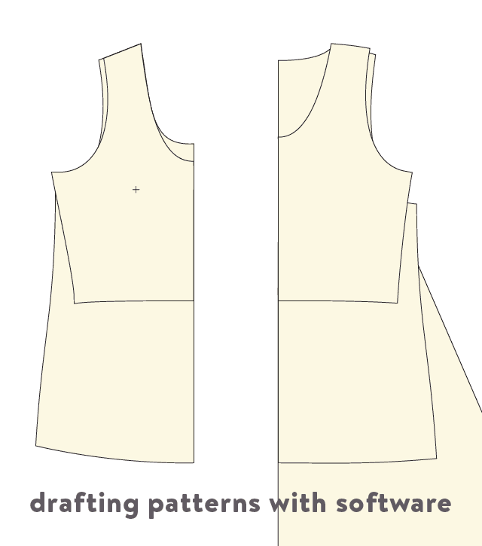
Figure 35 Draft pattern
In the software industry, CAD is short for “computer aided design”. CAD is a type of modeling software that is used in many fields including architecture design, interior design, 3D modeling and pattern drafting.
Adobe Illustrator and other vector drawing programs are not technically “CAD”, although some like to call it that, short for “computer aided drawing”. If you have ever tried to import a CAD drawing into a vector program or vice versa, you know the chaos that ensues! They are two totally different languages with different purposes.
One very important caveat about all of the CAD-based programs: they are based on Windows and only run on a Mac when you own a copy of Windows and run it through Boot camp or an emulator. (Both of which really slow down my computer…)

7.2. Digiting Pattern With CAD Software

Vector drawing software.
While vector software is not created specifically for drafting, it is a wonderful tool that puts a highly accurate ruler and pen in your hand. With this kind of software, you draw the patterns as you wish. There are a lot of little tools within a vector program that speed up the process over paper drafting.

7.3.Digitizing the analogue pattern block.
digitizers are also expensive and heavy devices, making them inconvenient, particularly in small workplaces. Transferring pattern pieces into a CAD system via a digitizer is tedious and frustrating. The fact that one can evaluate the result only after the digitizing process is ﬁnished leads to inaccuracies or untidy curve runs. Purchasing a digitizer table is expensive and requires a signiﬁcant amount of space. Roll-up digitizers are thin, flexible, and lightweight. They are stretched on a flat surface and rolled up after finishing digitizing. Roll-up digitizers cost less compared to table digitizers. Although users can roll them up, they still require a flat surface of their size, and digitizing speed is as slow as table digitizers. Scanner digitizers are scanner-like devices that scan the image of patterns from a close distance and employ image processing techniques to process the scanned image. They are much faster than the previous three digitizers but also come at a higher price. Depending on their size, they may claim some of the workspaces. Also, they may not always fit all the patterns, so patterns may have to be digitized one or two pieces at a time. Pattern digitizing software (photo digitizer) uses image processing algorithms like scanner digitizers, but the difference is that it captures the image using
The main points and lines that construct a pattern are defined, and names are assigned to apply the alteration method, as shown in
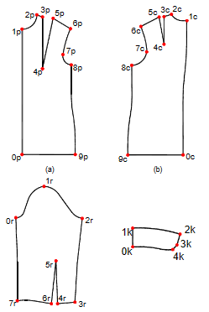
Figure 36 block point
The main points of the original patterns: front, back, sleeve, and collar. We used two different digitizing methods, such as photo digitizing and digitizing by graphic tools of PDS itself. We performed a comparative analysis of measurements for the patterns of women’s clothing. The original patterns were compared to their digital twins to compare the accuracy of the developed method. The lengths of the digital patterns’ constructive lines were measured by PDS “Julivi” tools and compared to the measurements of the same lines of the original patterns. Besides that, a comparison of the clothing blocks’ areas was performed. Pattern design system “Julivi” automatically forms a “Specification” that lists the areas of digital patterns. RESULTS AND DISCUSSION Algorithm of the method the algorithm of the developed method is as follows.
- Constructing a simple geometrical form in a graphical environment of a pattern design system by its tools (figure 2, a)
- Determining the number of main points of the pattern and inputting the same number of points to divide the lines of the original rectangular into the number of segments (figure 2, b). The names of the points are the same as those assigned for the actual pattern points.
- Determining the coordinates of the points of the original pattern in the Cartesian coordinate system. The center of coordinates is one of the main points, which a patternmaker may choose as they see fit.
- Determining the coordinates of the points of the digital rectangular in the Cartesian coordinate system. The center of coordinates is the point of the same name as in the original pattern.
- Calculating ∆x, ∆y – the difference in coordinates of the points of the same names belonging to the original pattern and the digital geometric figure.
- Shift the points of the digital geometric figure by the value of ∆x, ∆y using the pattern design system.
The main points and lines that construct a pattern are defined, and names are assigned to apply the alteration method, as shown in

Figure 37 Main Point pattern
The main points of the original patterns: front, back, sleeve, and collar. We used two different digitizing methods, such as photo digitizing and digitizing by graphic tools of PDS itself. We performed a comparative analysis of measurements for the patterns of women’s clothing. The original patterns were compared to their digital twins to compare the accuracy of the developed method. The lengths of the digital patterns’ constructive lines were measured by PDS “Julivi” tools and compared to the measurements of the same lines of the original patterns. Besides that, a comparison of the clothing blocks’ areas was performed. Pattern design system “Julivi” automatically forms a “Specification” that lists the areas of digital patterns. RESULTS AND DISCUSSION Algorithm of the method the algorithm of the developed method is as follows.
- Constructing a simple geometrical form in a graphical environment of a pattern design system by its tools (figure 2, a)
- Determining the number of main points of the pattern and inputting the same number of points to divide the lines of the original rectangular into the number of segments (figure 2, b). The names of the points are the same as those assigned for the actual pattern points.
- Determining the coordinates of the points of the original pattern in the Cartesian coordinate system. The center of coordinates is one of the main points, which a patternmaker may choose as they see fit.
- Determining the coordinates of the points of the digital rectangular in the Cartesian coordinate system. The center of coordinates is the point of the same name as in the original pattern.
- Calculating ∆x, ∆y – the difference in coordinates of the points of the same names belonging to the original pattern and the digital geometric figure.
- Shift the points of the digital geometric figure by the value of ∆x, ∆y using the pattern design system.
- Determining the minimum number of additional points on the curved sections of the original pattern and inputting them into the curved sections of the original patterns and their digital twins.
- Determining the coordinates of additional points, calculating the values ∆x, ∆y for them, and shifting the extra points of the digital geometric figure by the value of ∆x, ∆y using the pattern design system (figure 3, figure 4, c). An example of using the method is at the link.
Algorithm of the method The algorithm of the developed method is as follows. 1. Constructing a simple geometrical form in a graphical environment of a pattern design system by its tools Algorithm of the method The algorithm of the developed method is as follows. 1. Constructing a simple geometrical form in a graphical environment of a pattern design system by its tools

7.3. Adjusting the pattern specifications.

Understanding size charts on sewing patterns can help you confidently create garments that fit perfectly. Learning the basics of pattern grading, such as petite sizes and sleeve alterations, is essential to understanding how your body measurements relate to a pattern size chart.
Pattern shifting is also used for more precise adjustments in sizing. This involves drawing straight lines at each corner and connecting the different sizes with fabric muslin.
Muslining prior to cutting into fashion fabric will ensure that any necessary changes are made before stitching begins. Not only does this save time, but it also prevents frustration later down the line! With these tips in mind, you’ll be well on your way towards creating beautiful pieces tailored precisely for your shape and style.
How to Make a Toile
Adjusting a sewing pattern size can be done in several ways, including lengthening or shortening the pattern and adjusting the bust. In this discussion, we will cover how to do all three of these steps so that you can create your perfect toile.
We will go over the necessary tools and techniques for each step, ensuring that you know precisely how to make everything fit as perfectly as possible.
Once your base size pattern is created, fit is adjusted and perfected, what’s next? You’ll use what’s called pattern grading to adjust your base size pattern to create other sizes. There are different methods to grade patterns, but the end result is that you have a consistent visual across sizes. In the end, you’ll end up with measurements for each size in your range.

7.4. Performing grading
What is pattern grading?
Pattern grading is the process of turning a sample size (sometimes referred as base size) into additional smaller or larger sizes. Pattern grading is done using a size specification sheet. Grading does not create a new shape; it increases or decreases the size of the original shape of the garment.
History of pattern grading
The main purpose of pattern grading is to proportionally increase or decrease the size of a pattern, whilst also maintaining the same fit and shape of a garment.

7.5. Incorporating shrinkage in pattern grading.
Shrink rule is a special type of rule which is used to ease pattern making.
The shrink rule looks like a simple rule, just the graduation on it is bigger than a simple rule because shrinkage allowance is added to each division of the shrink rule.
It is used while making a pattern or core box.
So, before knowing the what is shrink rule first of all we have to know what is a pattern and what is shrinkage allowance so that we can better understand the uses of the shrink rule.
So without wasting time let's get started
What is Shrinkage Allowance?
Shrinkage is defined as the reduction during the cooling or solidification process.
The magnitude of shrinkage varies from material to material, but every material has to shrink.
To avoid this, the pattern is made larger than the required size of the casting product.
Then the difference between the actual pattern size and the required casting size is known as the shrinkage allowance.
What is Shrink Rule?
This type of steel rule is like a standard rule. The only difference is that its inch or mm markings are slightly larger than the standard rule.
If the shrinkage allowance is 10 mm per meter of length, the 30 cm shrinkage scale will be 3 mm longer than the normal measuring scale.
Different shrink rules are used for different pattern materials.
his scale provides a ready-made method of assigning shrinkage allowances to a pattern.
This type of rule is mostly used by pattern makers.
Shrink rule is mostly made of steel or wood.
Shrink Rule

There are following some materials shrinkage allowance given in the table in a per mm as well as per feet.

Materials | Allowances (mm/100 mm) | Allowances (inch/feet)
Cast Iron | 1.0 | 1/8
Iron | 2.1 | 1/4
Brass | 1.6 | 3/16
Copper | 1.6 | 3/16
Aluminium | 1.6 | 3/16

Why Shrink Rule Used in Pattern Making?
When the molten metal is filled in the mold that the pattern maker makes, it is red hot.
After filling the mold, when the metal cools, it shrinks a bit.
In this way, when the pattern is made of some larger size, it will make the mold of the same size and after the metal part is formed, when it cools down and shrinks, it will become almost the right size.
This type of rule is specified according to its length and shrink allowance.
The Shrink Allowance is printed above this rule.
This scale eliminates the trouble of adding this allowance every time a dimension is set. Thus, a lot of time and labor is saved and chances of mistakes are eliminated.

7.6. Assessing accuracy and completeness.
Assessing the accuracy and completeness of CAD software involves evaluating various aspects of the software to determine if it meets the required standards and specifications. By thoroughly assessing these factors, you can determine the accuracy and completeness of CAD software and make an informed decision about its suitability for your specific design requirements. Here are some key factors to consider when assessing the accuracy and completeness of CAD software:
- Drawing Tools:
- Dimensioning:
- Editing Capabilities:
- 3D Modeling:
- Rendering and Visualization:
- File Compatibility:
- Parametric Design:
- Accuracy in Measurements:
- Compatibility with Industry Standards:
- User Interface and Documentation:

7.7. Determining cut ratio plan
Determining the cut ratio plan in CAD software involves assessing how accurately and efficiently the software can calculate and optimize the cutting paths for a given design. Here are some key factors to consider:
- Nesting Capabilities: Check if the software provides nesting capabilities, which allow users to arrange multiple parts on a sheet of material to minimize waste. The software should be able to automatically calculate the optimal nesting arrangement based on the dimensions and quantities of the parts.
- Cutting Path Optimization: Evaluate the software's ability to generate efficient cutting paths that minimize the number of tool movements and reduce material waste. The software should consider factors such as part complexity, material properties, and cutting tool limitations to generate optimized cutting paths.
- Material Utilization: Assess how well the software can maximize material utilization by minimizing scrap and offcuts. The software should provide features like automatic remnant management and the ability to manually adjust nesting layouts to utilize material efficiently.
- Integration with Cutting Machines: Check if the software can generate machine-readable output files that can be directly used by cutting machines. This ensures seamless integration between the CAD software and the manufacturing process.
- Scalability and Performance: Assess how well the software performs with large and complex designs. It should be able to handle a high number of parts and efficiently calculate optimized cutting paths without significant slowdowns or errors.
By considering these factors, you can assess the accuracy and efficiency of CAD software's cut ratio plan capabilities and determine if it meets your specific requirements for material utilization and cutting path optimization.

7.8. Producing graded pattern for toile

To produce a graded pattern for a toile in CAD software, follow these steps:
Start by creating a base pattern in the desired size, Use the grading tools in the CAD software to grade the base pattern to the desired sizes, Define the grading increments for each size, Apply the grading increments to each pattern piece in the base pattern, Review and adjust the graded pattern as needed, Generate markers for cutting the fabric, Review and adjust the markers as needed, Generate output files for production. The CAD software should be able to generate machine-readable files that can be used by cutting machines or sent to manufacturers for production. By following these steps, you can use CAD software to efficiently produce a graded pattern for a toile, ensuring accurate sizing and optimized material utilization.

Self-check-7
Directions: Answer all the questions listed below. Use the Answer sheet provided in the next page Name --------------------------------------- Date--------
I. Multiple choice Select the best answer for each question. Do this by circling the identifying letter next to your answer.
1. Which step is NOT involved in producing a graded pattern for a toile in CAD software?
a) Creating a base pattern in the desired size
b) Using the grading tools to grade the base pattern to the desired sizes
c) Defining the grading increments for each size
d) Sewing the fabric pieces together

2. What is the purpose of generating markers in the process of producing a graded pattern for a toile?
a) To review and adjust the graded pattern as needed
b) To apply the grading increments to each pattern piece in the base pattern
c) To cut the fabric according to the pattern pieces
d) To generate output files for production

3. What is the advantage of using CAD software to produce a graded pattern for a toile?
a) It allows for accurate sizing and optimized material utilization
b) It eliminates the need for sewing machines
c) It reduces the cost of production
d) It speeds up the manufacturing process

4. Which step is NOT involved in producing a graded pattern for a toile in CAD software?
a) Creating a base pattern in the desired size
b) Using the grading tools to grade the base pattern to the desired sizes
c) Defining the grading increments for each size
d) Sewing the fabric pieces together

5. What is the purpose of generating markers in the process of producing a graded pattern for a toile?
a) To review and adjust the graded pattern as needed
b) To apply the grading increments to each pattern piece in the base pattern
c) To cut the fabric according to the pattern pieces
d) To generate output files for production

6. What is the advantage of using CAD software to produce a graded pattern for a toile?
a) It allows for accurate sizing and optimized material utilization
b) It eliminates the need for sewing machines
c) It reduces the cost of production
d) It speeds up the manufacturing process

Unit Ehight. Checking and finalizing patterns
This unit to provide you the necessary information regarding the following content coverage and topics:
  - Make toile to test the fit and accuracy of pattern.
6.2 Altering pattern to reflect test fitting outcomes.
6.3 Documenting alterations to patterns

Recording data and passing on to personnel responsible for further action
This guide will also assist you to attain the learning outcomes stated in the cover page. Specifically, upon completion of this learning guide, you will be able to
- Making a toile to test the fit and accuracy of pattern.
- Altering pattern to reflect test fitting outcomes.
- Documenting alterations to patterns

8.1. Testing and fitting a toile
Once the graded pattern has been created in CAD software, it is important to test and fit a toile before proceeding with production. A toile is a prototype garment made from inexpensive fabric that allows for adjustments and alterations to be made without wasting expensive materials.
Sew the toile together following the sewing instructions provided with the pattern, Try on the toile and assess the fit. Pay attention to areas such as the bust, waist, hips, shoulders, and sleeves, Make any necessary adjustments to the toile. This may involve adding or removing fabric, adjusting darts or seams, or altering the overall shape of the garment, Repeat the process of cutting and sewing a new toile using the adjusted pattern and Continue testing and fitting toile iterations until the desired fit is achieved.
Testing and fitting a toile, you can ensure that the graded pattern accurately represents the desired sizing and fit before moving forward with production. This helps to minimize errors and reduce waste in the final garment production process.

8.2. Making adjustments
In CAD software, making adjustments to the graded pattern based on the toile fitting can be done by following these steps:
- Open the original graded pattern in the CAD software.
- Use the measuring tools in the software to measure and record the adjustments made on the toile. For example, if the waist needs to be taken in by 1 inch, measure and record this change.
- Apply the recorded adjustments to the original graded pattern in the CAD software. This can be done by selecting the appropriate pattern pieces and using the software's editing tools to make the necessary changes. For example, if the waist needs to be taken in by 1 inch, select the waist area of the pattern piece and move it inward by 1 inch.
- Double-check the adjustments made in the CAD software to ensure accuracy. Use the software's simulation or 3D rendering features to visualize how the adjusted pattern will look.
- Save the adjusted graded pattern in the CAD software for future reference and use in production.
By making adjustments in CAD software based on the toile fitting, you can ensure that the graded pattern accurately reflects the desired fit and sizing. This allows for more efficient and precise production of the final garment.

8.3. Altering pattern.
To alter a pattern in CAD software,
- Open the original pattern in the CAD software.
- Use the measuring tools to measure the desired adjustments on the pattern. For example, if the bust needs to be increased by 2 inches, measure and record this change.
- Double-check the alterations made to ensure accuracy. Use the software's simulation or 3D rendering features to visualize how the altered pattern will look.
- Save the altered pattern for future reference and use in production.
By altering the pattern in CAD software, you can easily make precise adjustments to achieve the desired fit and sizing. This streamlines the production process and ensures consistency in garment sizing.

8.4. Documenting alterations to patterns.
When documenting alterations to patterns in CAD software, it is important to keep a clear record of the changes made. This will help in future reference and ensure consistency in garment sizing. Here are some steps to follow when documenting alterations:
By documenting alterations to patterns in CAD software, you can maintain a clear record of the changes made and ensure consistency in garment sizing throughout the production process.

8.5. Demonstrating grading methods.
When using CAD software to demonstrate grading methods, it is important to follow.
By demonstrating grading methods in CAD software, you can effectively communicate and visualize how a pattern can be scaled up or down to create different sizes. This can help streamline the production process and ensure consistent sizing across garments.

8.6. Setting CAM parameters.
- Set the CAM parameters in the CAD software to generate tool paths for the graded pattern. This includes specifying the cutting tools, speeds, feeds, and other machining parameters.
- Preview and simulate the tool paths to ensure they are accurate and will produce the desired results. This step helps identify any potential issues or errors before actually cutting the pattern.
- Generate the machine code or G-code necessary to control the CNC machine. This code contains instructions for the machine to follow when cutting the pattern.
- Transfer the machine code to the CNC machine and set up the machine accordingly. This involves loading the cutting tools, positioning the material, and configuring any necessary settings.
- Run a test cut to verify that the grading methods have been accurately translated to the physical cutting process. Make any necessary adjustments before proceeding with full production.
- Monitor the cutting process to ensure it is running smoothly and producing the desired results. Make any necessary adjustments or troubleshoot any issues that arise.
By following these steps, you can effectively use CAD software to demonstrate grading methods and seamlessly integrate them into the production process using CNC machines.

8.7. Performing lay planning.
In addition to using CAD software for grading methods, it can also be used for performing lay planning. Lay planning is the process of determining the most efficient way to arrange pattern pieces on the fabric to minimize waste and maximize fabric utilization. Are the for performing lay planning using CAD software: Import the graded pattern into the CAD software and create a marker, which is a virtual representation of the fabric on which the pattern pieces will be arranged.
By using CAD software for lay planning, you can streamline the process, reduce fabric waste, and increase efficiency in the cutting room.

8.8. Plotting mini marker as a reference to the client’s order.
To plot a mini marker as a reference to the client's order, you can follow these steps:
- Determine the coordinates of the client's order on the plot. This could be in terms of X and Y values.
- Choose a suitable marker symbol that represents a mini marker. For example, you can use a small circle or a square.
- Use a plotting library or software, such as Matplotlib in Python, to create the plot.
- Plot the client's order on the plot using the chosen marker symbol. Specify the coordinates of the order and set the marker symbol accordingly.
- Add any necessary labels or annotations to indicate that the marker represents the client's order.
- Customize the appearance of the marker, such as its size, color, or style, to make it visually distinct from other markers on the plot if desired.
- Ensure that the plot is properly scaled and labeled so that the client's order is clearly visible and identifiable within the context of the plot.
By following these steps, you can plot a mini marker as a reference to the client's order on a plot.

Self-check-8
Directions: Answer all the questions listed below. Use the Answer sheet provided in the next page Name --------------------------------------- Date--------
I. Multiple choice Select the best answer for each question. Do this by circling the identifying letter next to your answer.
1. Why is it recommended to use a separate monitor, keyboard, and mouse when working on a laptop or tablet for long periods of time?
a) It helps improve posture and visual comfort.
b) It allows for better mobility and flexibility.
c) It enhances the performance of CAD tools and software.

Test II: short Answer writing
Instruction: write long answer for the given question. You are provided 5 minute for each question and each point has 5Points.

1. To cut the fabric according to the pattern pieces
- It allows for accurate sizing and optimized material utilization
- To minimize fabric waste and maximize fabric utilization
- To increase efficiency in the cutting room

No_ | Name | Qualification (Level) | Field of Study | Organization/ Institution | Mobile number | E-mail
1 | Bereket Yohannes | B-Level | Garment Technology | Misrak Polytechnic College | +251923327388 | berekety26@gmail.com

