FASHION DESIGN
Level-III
Based on March, 2022 Curriculum Version-1

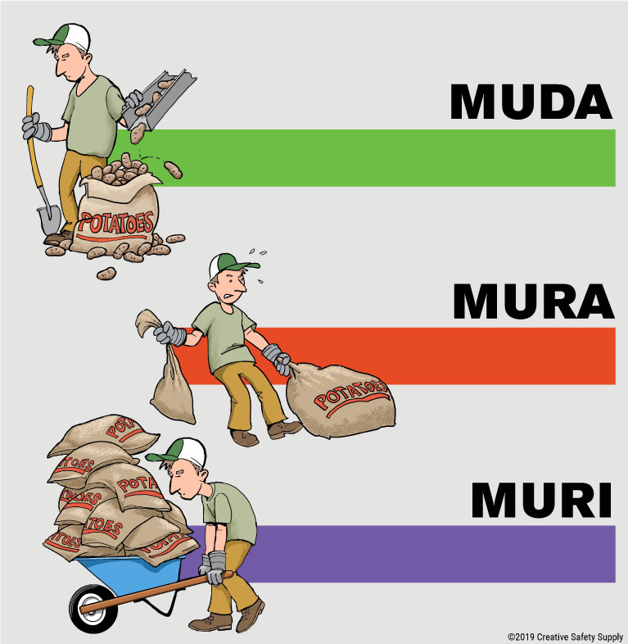

Module Title: Prevent and eliminate MUDA

Module code: IND FAD 3 M10 0322

Nominal duration: 30 Hour

Prepared by: MPTC
Based on Semte, 2023
Addis Ababa, Ethiopia

Acknowledgment

Garment section wish to extend thanks and appreciation to the many

Representatives of TVET instructors and respective industry experts who donated their time and expertise to the development of this Teaching, Training and Learning Materials (TTLM).

Table of Contents
Acknowledgment 1
Figure table content 3
Module introduction 3
This module covers the units 4
Learning Objective of the Module 4
Module Instruction 4
Unit one: work prepare 5
1.1 work instructions 6
Standard Work when used in a Lean system. 6
1.2 interpreting job specifications 6
1.2.1 Interpreter Job Description Template 6
1.2.2 Interpreter Responsibilities: 7
1.2.3 Interpreter Requirements: 7
1.3 Observing OHS requirements 9
1.4 Selecting appropriate material 10
1.4.1 Safety equipment and tools 10
1.4.2 The 4 Basic Types of PPE and Their Examples 11
1.5 Tools and Equipment used to implement 16
1.6 Tools and materials used to implement Sort activity 17
Self-Check 1.1 Written Test 18
Unit Two: Identify MUDA 19
2.1 Preparing plan of MUDA and implementing problem identification. 20
The benefits of eliminating muda 20
The challenges of eliminating muda 20
2.2 possible problems related to the process /Kaizen elements using statistical tools and techniques. 21
2.3 causes and effects of MUDA 22
2.4 Identified and measured wastes 25
2.4.1 The Three MUs. 29
2.5 To analyze current Situation of the work place use Tools and techniques 30
What is a situational analysis? 30
2.6 Waste/Muda identification. 31
Practical Demonstration 44
Self-Check 2 Written Test 46
Unit Three: Analyze causes of a problem 47
3.1. Select the root cause directly related to the problem 48
3.1.1. Define the problem 48
3.1.2. Generate alternative solutions 48
3.1.3. Evaluate and select an alternative 48
3.1.4. Implement and follow up on the solution 49
3.2 analyzed using 4M1E Cause relationships 50
3.3 identified Causes of the problems 51
3.4 selected the root cause most directly related to the problem 51
3.5 creative idea generations to eliminate the most critical root cause 51
SELF CHECK -3 53
Unit Four: Eliminate MUDA and Assess effectiveness of the solution. 54
4.1 Preparing and implementing Plan of MUDA elimination. 55
Elimination of the seven types of Wastes/Muda. 55
4.2 How to eliminate the seven types of Wastes/Muda. 55
4.3 Some Tools and Techniques to eliminate Wastes/Muda. 57
4.4 organizational requirements Wastes/MUDA are reduced and eliminated in accordance with OHS 62
Self-Check 4 Written Test 64
Unit five: prevent occurrence of wastes and sustain operation 65
5.1 Creating waste-free workplace using 5W and 1Hsheet. 66
5.2 discussed and prepared Standards required for machines, operations, defining normal and abnormal conditions, clerical procedures and procurement 67
5.3 prevent using visual and auditory control methods Occurrences of wastes/MUDA 67
5.4 create using 5W and 1Hsheet Waste-free workplace 68
5.5 The completion of required operation is done in accordance with standard procedures and practices. 69
5.1.1 Planned for material 69
5.1.2 SAFETY, HEALTH AND ENVIRONMENT 69
5.6 facilitate the updating of standard procedures and practices 70
5.6.1.Benefits of Implementing Standard Operating Procedures 71
5.7 The capability of the work team that aligns with the requirements of the procedure is ensured and trained on the new Standard Operating Procedures (SOPs). 72
Self-Check 5 Written Test 73
List of Reference Materials 74

Figure table content
Figure 1:PDCA cycle 8
Figure 2:Learn more about hearing protection. 13
Figure 3 costumer identification 21
Figure 4:U-line 58
Figure 5:In-lining 59
Figure 6:Unification 59
Figure 7: standard operating procedure 70

Module introduction

In garment production filed; this module assists to attain the learning objectives stated in the cover page. Specifically, upon completion of this Learning Guide, you will be able to
The Concept of Muda/Waste ,Methods for categorizing types of waste/Muda, Causes and effects of 7 types of wastes, Waste/Muda Identification ,Reporting methods and formats/checklists for Muda identification, Muda is a Japanese word meaning Wasteful Activity.
This module is designed to meet the industry requirement under the garment production Occupational standard, particularly for the unit of competency: Prevent and eliminate MUDA

This module covers the units
- Prepare for work
- Identify MUDA and problem Analyze causes of a problem
- Eliminate MUDA and Assess effectiveness of the solution.
- Prevent occurrence of wastes and sustain operation

Learning Objective of the Module
- Identify Working Prepare
- Identifying MUDA problem Analyzing
- Eliminating MUDA and Assess effectiveness of the solution.
- Preventing occurrence of wastes and sustain operation

Module Instruction
For effective use this modules trainees are expected to follow the following module instruction:

1. Read the information written in each unit

2. Accomplish the Self-checks at the end of each unit \

Unit one: work prepare

This unit is developed to provide you the necessary information regarding the following content coverage and topics:
1, Using work instructions

2, Reading and interpreting job specifications
3, Observing OHS requirements,
4, Selecting appropriate material

5, Identifying and checking safety equipment and tools.

This unit will also assist you to attain the learning objectives stated in the cover page. Specifically, upon completion of this learning guide, you will be able to:
1, use work instructions

2, Observe OHS
3, Select material
4, Check safety equipment and tools.

1.1 work instructions
Work instruction is a description of the specific tasks and activities within an organization. A work instruction in a business will generally outline all of the different jobs needed for the operation of the firm in great detail and is a key element to running a business smoothly. A Work Instruction is a description of how to perform a process in steps; For a step in a process, the instruction(s) on how to perform that step, sufficiently detailed to allow an inexperienced person (novice) to perform the work. Work instructions are more detailed than standard operating procedures.
Assembly instructions are common in manufacturing or when you have furniture delivered to and you have to put it together. The little piece of paper that your receive with your product explains how to assemble the furniture.

These assembly instructions are a form of work instruction.
In other words it is a document containing detailed instructions that specify exactly what steps to follow to carry out an activity. It contains much more detail than a Procedure and is only created if very detailed instructions are needed. For example, describing precisely how a Request for Change record is created in the Change Management software support tool

Standard Work when used in a Lean system.
- Job Aids, which are typically more picture than words.
- Work Guides.
- Checklists.
- Recipe when used in cooking.
- User Manuals that may explain how to use a product.
- Assembly Instructions.

1.2 interpreting job specifications
A statement of employee/workers characteristics and qualifications required for satisfactory performance of defined duties and tasks comprising a specific job or function.
Interpreters interpret verbal communication from one language to another, and act as mediums where language barriers exist. At times, Interpreters translate written communication from one language to another. Interpreters work in education, health care, insurance, legal and other industries.

1.2.1 Interpreter Job Description Template
We are looking for a competent Interpreter to provide assistance to non-English speakers across a range of activities. The interpreter will provide interpretation services during various processes, and make sight translations of documents. You will provide accurate concepts and explanations with no additions or omissions, and according to conventions of established interpretation protocol. You will identify factors that hinder your performance as an
Interpreter, and swiftly report these to relevant parties.
To ensure success you need to process and impart information swiftly, and relay intentions, emotions and tone in your interpretations. Preferred applicants have outstanding problem-solving skills, and have the ability to work to a high level of accuracy.

1.2.2 Interpreter Responsibilities:
Acting as Interpreter between a wide range of people with diverse voices, accents, speaking tempos and personalities.
Providing parties with clear and exact translations of written materials, and interpretations of verbal communication.
- Providing interpretations of questions, answers, statements, arguments, explanations and other forms of verbal communication.
- Rendering sight translations of documents and other written materials.
- Imparting thought, purpose, spirit, emotions and tone of speakers from source language into target language.
- Interpreting with no additions or omissions.
- Informing relevant parties of factors that may hinder your performance.
- Completion of daily activity logs and other documentation.
- Complying with applicable ethics and standards.

1.2.3 Interpreter Requirements:
- High school diploma, GED, or suitable equivalent.
- Valid certificate of accredited interpreting training.
- Excellent bilingual communication skills, both verbal and written.
- Valid driver’s license.
- Proficient computer skills.
- Proficient with use of office equipment.
- Outstanding listening, retention and note-taking skills.
- Proficient enunciation and pronunciation skills, and pleasant, professional voice.
- Proficient understanding of cultural sensitivity, and ability to collaborate with people from diverse cultural backgrounds.
Related Articles:
Court Clerk Job Description
Learn about the key requirements, duties, responsibilities, and skills that should be in a court clerk job description.
District Attorney Investigator Job Description
Learn about the key requirements, duties, responsibilities, and skills that should be in a district attorney investigator job description.
Legal Assistant Job Description
Learn about the key requirements, duties, responsibilities, and skills that should be in a legal assistant job description.
Interpreter Interview Questions
Top 5 interpreter interview questions with detailed tips for both hiring managers and candidates.
Court Clerk Interview Questions
Top 5 court clerk interview questions with detailed tips for both hiring managers and candidates.
District Attorney Investigator Interview Questions
Top 5 district attorney investigator interview questions with detailed tips for both hiring managers and candidates.
Legal Assistant Interview Questions
Top 5 legal assistant interview questions with detailed tips for both hiring managers and candidates
Many people confuse “procedures” with “work instructions”. In fact, most people write work instructions and call them procedures. Knowing the differences of procedures vs. work instructions can help you understand the documentation process much better and, therefore, procedure documentation.
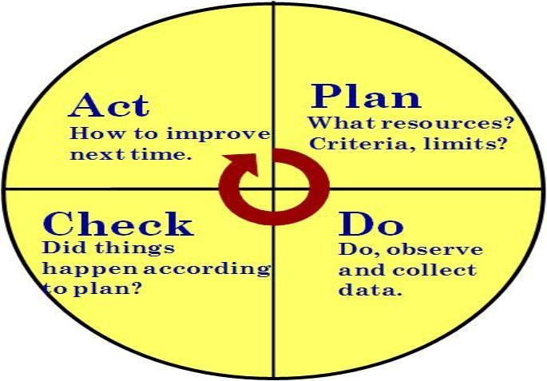
Procedures describe a process, while a work instruction describes how to perform the conversion itself. Process descriptions include details about the inputs, what conversion takes place (of inputs into outputs), the outputs, and the feedback necessary to ensure consistent results. The PDCA process approach (Plan, Do, Check, Act) is used to capture the relevant information.

Figure 1: PDCA cycle

1.3 Observing OHS requirements

OHS requirements are legislation/regulations/codes of practice and enterprise safety policies and procedures. This may include protective clothing and equipment, use of tooling and equipment, workplace environment and safety, handling of material, use of fire-fighting equipment, enterprise first aid, hazard control and hazardous materials and substances.
Personal protective equipment includes those prescribed under legislation/ regulations/codes of practice and workplace policies and practices. Safe operating procedures include the conduct of operational risk assessment and treatments associated with workplace organization. Emergency procedures include emergency shutdown and stopping of equipment, extinguishing fires, enterprise first aid requirements and site evacuation.
Occupational safety and health (OSH) also commonly referred to as occupational health and safety (OHS) or workplace health and safety (WHS) is an area concerned with
the safety, health and welfare of people engaged in work or employment. The goals of occupational safety and health programs include fostering a safe and healthy work environment. for activities outside work.
Occupational safety and health can be important for moral, legal, and financial reasons. In common-law jurisdictions, employers have a common law duty (reflecting an underlying moral obligation) to take reasonable care for the safety of their employees. Statute law may build upon this to impose additional general duties, introduce specific OSH may also protect co-workers, family members, employers, customers, and many others who might be affected by the workplace environment. In the United States the term occupational health and safety is referred to as occupational health and occupational and non-occupational safety and includes safety duties and create government bodies with powers to regulate workplace safety issues: details of this will vary from jurisdiction to jurisdiction. Good OSH practices can also reduce employee injury and illness related costs, including medical care, sick leave and disability benefit costs.

1.4 Selecting appropriate material

Tools and Equipment are required to identify and measure Waste/Muda in work stations. The following are some tools and equipment used to identify and measure Waste/Muda:
Tape (any length measuring device) Stop watch
Photo Camera Video Camera Calculator

1.4.1 Safety equipment and tools
What Does PPE Mean?
Personal Protective Equipment (PPE) refers to protective clothing for the eyes, head, ears, hands, respiratory system, body, and feet. It is utilized to protect individuals from the risks of injury and infection while minimizing exposure to chemical, biological, and physical hazards. PPE serves as the final line of defense when engineering and administrative controls are insufficient in reducing or eliminating risks.
What is PPE Safety?
PPE safety is the practice of ensuring a safe, working environment for employees and visitors through the use of Personal Protective Equipment (PPE). Safety is paramount to all businesses across industries. Using PPEs, paired with inspections such as workplace and restaurant inspections, assessments like health and safety risk assessments, and analysis such as gap analysis—is essential to protect employees from risks and hazards.
Why is it Important?
According to the hierarchy of controls by the National Institute for Occupational Safety and Health (NIOSH), PPE (sometimes also referred to as PPE equipment)—is recommended to be the last level of defense to prevent occupational injuries, illnesses, and fatalities, but some businesses combined it with other control measures to ensure a safe and healthy environment for their workers. Here are some benefits of using PPEs:
- prevent unnecessary injury in the workplace;
- protect employees from excessive chemical exposure;
- prevent the spread of germs and infectious diseases including COVID-19;
- help businesses comply with regulatory requirements(e.g., The Personal Protective Equipment at Work Regulations 1992 that’s recently been extended to limb workers); and
- improve employee productivity and efficiency.

1.4.2 The 4 Basic Types of PPE and Their Examples
However, even the strictest controls will not necessarily eliminate all the risks associated with most job tasks and this is where the need for PPE must be evaluated. A hazard assessment can help identify which specialized PPE will be required. There are numerous types of workplace safety equipment available depending on the hazard exposure and work conditions. The following are basic PPE that can help protect employees
Face and Eye Protection
PPE includes safety goggles and face shields and should be used for tasks that can cause eye damage or loss of vision, sprays of toxic liquids, splashes, and burns.
Safety Tips:
- Check if safety glasses comply with the ANSI Z87.1 eye protection standard.
- Ensure that there are no cracks or deformities on the lenses.
- Ensure the strap is in good working condition and is firmly sealed to the cheek and forehead.
- Clean and disinfect after use.
Respiratory Protection
PPE includes full-face respirators, self-contained breathing apparatus, gas masks, N95 respirators, and surgical masks are used for a task that can cause inhalation of harmful materials to enter the body. This includes harmful gas, chemicals, large-particle droplets, sprays, splashes, or splatter that may contain viruses and bacteria such as COVID-19, viral infections, and more.
Safety Tips:
- Ensure that the equipment is fit-tested and the employee has undergone proper training before wearing one.
- Carefully read the instructions to determine if it is designed to help protect against the hazards you may face.
- Change filters on half-mask or full-mask respirators frequently.
- Replace disposable respirators with every use.
- Surgical masks are not to be shared with anyone.
- Avoid touching the surgical mask after wearing it.
- Change surgical mask timely and should be disposed of after use.
- Replace the mask immediately if it is damaged or soiled.
Skin and Body Protection
PPE includes the following categories to protect employees from physical hazards:

Head Protection
PPE includes hard hats and headgears and should be required for tasks that can cause any force or object falling to the head.
Safety Tips:
- Ensure that there are no dents or deformities on the shell and connections are tightened inside.
- Do not store in direct sunlight as extreme heat can cause damage.
- Choose appropriate cleaning agents as it can weaken the shells of hard hats and may eliminate electrical resistance.
- Always replace a hard hat if it was used for any kind of impact, even if the damage is unnoticeable.
Body Protection
PPE includes safety vests and suits that can be used for tasks that can cause body injuries from extreme temperatures, flames and sparks, toxic chemicals, insect bites and radiation.
Safety Tips:
- Ensure that they are clean and free from cuts and burns.
- Always get a good fit to ensure full body protection.
- Ensure bodysuit is heat-resistant clothing when working with high-temperature hazards.
Hands Protection
PPE includes safety gloves and should be used for tasks that can cause hand and skin burns, absorption of harmful substances, cuts, fractures or amputations.
Safety Tips:
- Ensure hand protection fits perfectly with no spaces and is free from cuts, burns, and chemical residue.
- Always replace them if any sign of contamination was observed.
- Use rubber gloves when working with heat and electricity to reduce the risk of burn or electrical shock.
Foot Protection
PPE includes knee pads and safety boots and should be used for tasks that can cause serious foot and leg injuries from falling or rolling objects, hot substances, electrical hazards, and slippery surfaces.
Safety Tips:
- Ensure boots have slip-resistant soles that can protect against compression and impact.
- Ensure the sole plate is in good condition to prevent punctures.
Fall Protection
PPE includes safety harnesses and lanyards and should be strictly used for tasks that can cause falling from heights and serious injury or death.
Safety Tips:
- Ensure that the straps are free from tears, deformities, and burn marks.
- Check the buckles if connected securely and tightly.
- Dispose of the equipment if used after a falling incident.
Hearing Protection
PPE includes ear muffs and plugs and should be used for tasks that can cause hearing problems and loss of hearing.
Safety Tips:
- Ensure the equipment fit the ear canal perfectly.
- It is recommended to use formable earplugs to fit different sizes of ear canals.
- Use protectors that reduce noise exposure to an acceptable level to have room for communication.
- Ensure earplugs are clean and in good condition.

Figure 2:Learn more about hearing protection.
Other examples of PPE include:
- safety glasses or goggles
- safety shoes
- high-visibility clothing or vests
- heat-resistant gloves
- anti-vibration gloves
- welding helmets
- chemical-resistant suits or aprons
- safety harnesses and lanyards
COVID-19 Prevention and Control
The global COVID-19 pandemic widely affects the economy, businesses, and living standards around the world. The implementation of using PPE such as face mask and face shield while in public areas are mandatory in different countries to prevent and control the spread of COVID-19. This protocol, however, doesn’t guarantee that the ongoing risks have materially changed.
The World Health Organization (WHO) and the Centers for Disease Control and Prevention (CDC) set forth guidelines on the proper way of wearing face masks to protect oneself from acquiring or spreading the virus. Here are the Do’s and Don’ts of wearing masks.

Do’s | Don’ts
- Wash or sanitize hands before wearing the mask  - Check the mask for damages  - Ensure the colored-side faces outwards  - Cover the mouth, nose, and chin and adjust accordingly without leaving gaps on the side  - Ensure you can breathe properly while wearing a mask  - Avoid touching the mask while using it  - Wash or sanitize hands before removing the mask  - Remove the mask by the strap behind the ears  - Wash the mask preferably with soap and hot water at least once a day  - Dispose of the mask properly after use | - Use the mask if damaged, wet, or dirty  - Wear a loose mask Wear the mask under the nose  - Wear a mask that is difficult to breathe through  - Touch the mask while using it  - Remove the mask when talking to other people  - Share used masks to other people Reuse disposable masks
The battle against the global pandemic requires front liners including doctors and nurses to wear isolation gowns to protect them from acquiring the virus. This would help lessen the chance of getting sick even if they always interact with COVID-19 patients. Below are CDC guidelines they should follow in using PPE:
- All health workers should take comprehensive training about PPE including its appropriate usage, proper don (put on) and doff (take off) procedures, limitations, maintenance, and disposal.
- Ensure the choice of gown size is appropriate to the body size.
- Perform hand hygiene prior to donning the isolation gown.
- Put on NIOSH-approved N95 filtering facepiece respirator or higher. Use a facemask if a respirator is not available.
- Respirator straps should be placed on the crown of the head (top strap) and the base of the neck (bottom strap).
- Perform a user seal check each time you wear a respirator.
- Face mask ties should be secured on the crown of the head (top tie) and the base of the neck (bottom tie). If the face mask has loops, hook them appropriately around the ears.
- Select the proper eye protection such as a face shield or goggles.
- Ensure the correct position of eye protection. It should not affect the seal of the respirator.
- Wear gloves, which should cover the cuff (wrist) of the gown.
- Prior to entering the patient area including the isolation room, PPE must be donned appropriately.
- While on duty, PPE must remain in place and be worn correctly, especially in potentially contaminated areas.
- When attending to patients, do not adjust the PPE. For example, retying the gown or adjusting the respirator or facemask.
- PPE must be removed slowly and deliberately in a sequence to prevent self-contamination.
- Ensure glove removal does not cause additional contamination of hands.
- Gloves can be removed using the glove-in-glove or bird beak technique.
- When removing the gown, carefully reach up to the shoulders and pull the gown down and away from the body.
- After removing the gown, always perform hand hygiene.
- When removing eye protection, do not touch the front of the face shield or goggles.
- When removing respirators or face masks, do not touch the front of the respirator or facemask.
- Dispose of face masks properly.
Toolbox Talk for PPE
Workplace safety should begin with a hazard assessment. Once the hazards and risks have been identified, a plan can be put forward to prioritize and reduce the risk of injury. Useful systems and tools to perform hazard assessments include performing a risk assessment and a Job Safety Analysis (JSA).
The hierarchy of controls is a proven safety approach that helps protect employees. If elimination, substitution, engineering, and administrative controls are not enough to eliminate the risk, it is vital to choose the appropriate PPE carefully. Ensure employees are properly trained to use the safety equipment and be able to detect and report any damages before commencing work.
A toolbox talk about PPE is recommended to discuss the different kinds of PPE that can be used to minimize the likelihood and mitigate the effects of hazards. A toolbox talk template can help in assessing the sufficiency and availability of safety equipment for all employees.
PPE Safety Requirements
Safety Officers can promote safety in the workplace by following PPE safety requirements:
- Check work sites regularly for the need for PPE.
- If PPE is needed, provide employees with properly-fitted PPE.
- Train employees on OSHA PPE standards.
- Provide protective goggles or face shields when there is a danger of flying particles or corrosive materials.
- Require that safety glasses are worn at all times in worksites that pose a risk of eye punctures, abrasions, contusions, or burns.
- Provide and require protective gloves in situations where employees could be cut or possibly exposed to corrosive liquids, chemicals, blood, and other potentially infectious materials.
- Require the use of foot protection when there is a risk of foot injury from hot, corrosive, or poisonous substances, and falling objects.
- Inspect hard hats periodically for damage to the shell and suspension system.
- Maintain PPE in sanitary and ready-to-use conditions.
- Ensure that eyewash facilities and quick drench showers are easily accessible for employees when they are accidentally exposed to corrosive materials.
- Establish safe work procedures for disposing of or decontaminating PPE after hazardous exposures.

1.5 Tools and Equipment used to implement
here are various tools and equipment that can be used to implement standard procedures in the workplace. Some common examples include:

1. Standard Operating Procedures (SOPs): These are written documents that outline step-by-step instructions for carrying out specific tasks or processes. SOPs provide employees with clear guidance on how to perform their duties and ensure consistency.

2. Training materials: Organizations can develop training materials, such as manuals or videos, to educate employees on the standard procedures they need to follow. These materials can be used during onboarding or as ongoing training resources.

3. Checklists: Checklists are useful tools for ensuring that all necessary steps are followed in a standardized manner. They can be used to track progress and ensure that no critical steps are missed.

4. Quality control tools: Quality control tools, such as statistical process control charts or quality checklists, can be used to monitor and evaluate performance against established standards. These tools help identify deviations or areas for improvement.

5. Technology: Many organizations use technology to implement and enforce standard procedures. This can include software systems that automate processes, track performance metrics, and provide real-time feedback or alerts.

6. Visual aids: Visual aids, such as posters or signs, can be used to display key information or reminders about standard procedures. These aids serve as visual cues and help reinforce the importance of following established protocols.

7. Performance monitoring systems: Organizations may use performance monitoring systems to track and evaluate employee performance against established benchmarks. These systems provide data and insights that can be used to identify areas for improvement and optimize operations.

It is important to select the appropriate tools and equipment based on the specific needs and requirements of the organization. The goal is to ensure that employees have the necessary resources and support to consistently follow standard procedures and achieve desired outcomes.

You are required to prepare and use tools and equipment to implement sort, set in order and shine activities in to your work station. The following are some tools and equipment that help you in the implementation of

1.6 Tools and materials used to implement Sort activity

Tools and materials are required to implement sort, set in order and shine activities in work stations. The following are some tools and materials used to implement the first pillar of 5S-Sort.

1. Sorting Bins .r Containers: 1These can be used to separate items into different categories or groups during the sorting process.

2. Labels or Tags: Labels or tags can be attached to items or containers to indicate their category or destination during sorting.

3. Sorting Tables or Workstations: These provide a designated area for employees to sort and organize items. They may have compartments or sections to facilitate the sorting process.

4. Sorting Algorithms or Rules: These are guidelines or instructions that dictate how items should be sorted based on specific criteria, such as alphabetical order, numerical value, or color.

5. Barcode Scanners or RFID Readers: These tools can be used to quickly and accurately identify and sort items based on their unique identifiers.

6. Conveyor Belts or Chutes: These can be used to transport items from one location to another during the sorting process, making it more efficient and streamlined.

7. Computer Software or Systems: Technology-based sorting systems can automate the sorting process, track inventory, and generate reports on sorting performance.

8. Sorting Guides or Manuals: These documents provide employees with instructions and guidelines on how to properly sort items according to established standards.

9. Safety Equipment: Depending on the nature of the sorting activity, safety equipment such as gloves, goggles, or protective clothing may be required to ensure the well-being of employees.

10. Quality Control Tools: Quality control tools, such as visual inspection checklists or measuring devices, can be used to ensure that items are sorted correctly and meet quality standards.

11. Training Materials: Similar to standard procedures, training materials can be developed to educate employees on the specific sorting methods and techniques they need to follow.
By using these tools and materials, organizations can effectively implement a sorting activity in the workplace and ensure that items are sorted accurately and efficient

Self-Check 1.1 Written Test
Name of trainees ------------------------------- ----------------- sections---------------sign ---------______________
I. Match the following question
A B

1. Quality Control Tools A. visual inspection
2. Safety Equipment B. gloves, goggles
3. Sorting Guide C. automate the sorting process
4. Computer Systems D. used to transport items
5. Sorting Bins E. quickly and accurately identify
6. Conveyor Belts F. alphabetical order
7. Barcode Scanners G. designated area
8. Sorting Algorithms H. destination during sorting
9. Sorting Tables I. to separate items
10.Labels or Tag J. documents provide employees

II write /explain the following question
1. What is OHS represents
2. List at least two examples of OHS requirements in your work areas.
3. Least four workplace hazards?
4. List at least four tools and equipment used to identify and measure Muda.

Unit Two: Identify MUDA

This unit to provide you the necessary information regarding the following content coverage and

topics:

Preparing plan of MUDA and implementing problem identification Discussing causes and effects of MUDA
Listing possible problems related to the process /Kaizen elements using statistical tools and techniques.
Identifying and listing problems of kaizen on Visual Management Board/Kaizen Board. Using tools and techniques
Identifying and measuring wastes/MUDA based on relevant procedures. Reporting identified and measured wastes
This guide will also assist you to attain the learning objective stated in the cover page. Specifically, upon completion of this learning guide, you will be able to:
- Prepare plan of MUDA
- List possible problems related to the process
- Identify and measuring wastes
- Report identified and measured wastes

2.1 Preparing plan of MUDA and implementing problem identification.
Conditions using the arrow diagram. Select the product to be analyzed- Choose products with a large output and those with many production problems as starting points for your analysis of current
Prepare a factory layout diagram- Include the entire factory layout, indicating the position of machines, worktables and other equipment. Store the original in a safe place so that you can make a copy of it each time you want to analyze another product line. Make the arrow diagram- Do this on the factory floor. Use the symbols below to show the different types of activities that occur. The map will make the waste more obvious to you and your team than when you are simply standing on the factory floor observing standard operations. Connect the symbols with lines that show the direction of the flow and the sequence of product through each operation. Create other symbols as you need to.

How to identify muda
To identify muda in your warehouse operations, you must observe and analyze your current processes and performance. To do this, utilize various tools and methods such as value stream mapping, gemba walk, key performance indicators (KPIs), root cause analysis, and employee feedback. Value stream mapping is a visual representation of the flow of goods and information from the supplier to the customer, highlighting value-added and non-value-added activities as well as sources of waste and inefficiency. A gemba walk involves a regular visit to the place where the work is done, so that you can identify problems and opportunities for improvement. KPIs are quantitative measures of the effectiveness and efficiency of your warehouse operations. Root cause analysis is a systematic approach to finding the underlying causes of problems or defects. Lastly, employee feedback is a valuable source of information and ideas from those directly involved in the warehouse operations who can suggest solutions or improvements.
How to eliminate muda
To reduce muda in your warehouse operations, you should implement changes and improvements that reduce or eliminate sources of waste and inefficiency. To do this, you can use various tools and methods, such as 5S, which creates and maintains a clean, organized, and safe work environment; Kaizen, which encourages everyone to identify and solve problems; Kanban, a visual system that controls the flow of goods; Poka-yoke, a technique that prevents or detects errors; and Standard Work, a document that defines the best way to perform a task. All of these tools help to ensure quality and efficiency.

The benefits of eliminating muda
By eliminating muda in your warehouse operations, you can reap many rewards. Lower costs can be achieved by reducing the waste of resources such as time, labor, energy, and materials. Additionally, higher quality can be achieved by reducing errors and defects. Faster delivery can be accomplished by reducing delays and bottlenecks. Higher productivity is possible by reducing non-value-added activities and improving the work environment. Finally, higher morale can be achieved by reducing frustration and stress while increasing the involvement and empowerment of workers

The challenges of eliminating muda
Achieving muda elimination in warehouse operations is a long-term commitment that requires leadership support, employee engagement, customer focus, data analysis and change management. Senior management should provide the vision, direction and resources for the lean transformation. Frontline workers should provide insights, feedback and suggestions for improvement initiatives. Knowing customer needs and expectations is essential for providing value and demand for goods and services. Accurate performance data is necessary for evidence-based decision making and problem solving. Lastly, having a systematic approach to planning, implementing and sustaining changes is key for successful muda elimination.

At all conveyance points, note the conveyance distance and type of conveyance. At all retention points, note average work-in- process inventory.
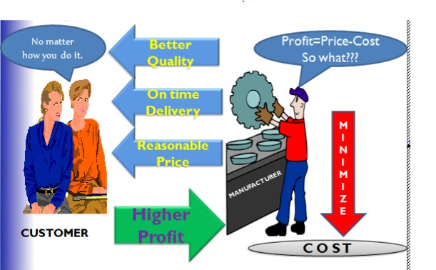

Figure 3 costumer identification

2.2 possible problems related to the process /Kaizen elements using statistical tools and techniques.
7Q quality tools are simple graphical and statistical tools but very powerful in solving quality problems and process improvement.
These statistical tools are very easy to understand and can be implemented without any complex analytical competence or skills.
7 QC Tools List | Quality Tools
- Check Sheet The check sheet is used for collecting, recording, and analyzing the data. Data collection is an important activity in the problem-solving process as it provides a basis for further action. Data may be numerical, observations and opinions, etc.
- Fishbone Diagram Fishbone diagram is also called as Cause and Effect diagram and Ishikawa diagram. It helps to Identify all possible potential causes and select the real/best potential cause which contributes to the problem/effect. The brainstorming technique is used for potential cause identification.
- Histogram A Histogram is a pictorial representation of a set of data, and the most commonly used bar graph for showing frequency distributions of data/values. Histogram frequency distribution chart is widely used in Six Sigma problem solving process.
4 ,Pareto Chart The Pareto chart helps to Narrow the problem area or prioritize the significant problems for corrective measures. The pareto principle is based on the 80-20 rule. It means that 80 percent of the problems/failures are caused by 20 percent of the few major causes/factors which are often referred to as Vital Few.
And the remaining 20 percent of the problems are caused by 80 percent of many minor causes which are referred to as Trivial Many. Hence, it gives us information about Vital few from Trivial many.

5, Control Chart A control chart is also known as the SPC chart or Shewhart chart. It is a graphical representation of the collected information/data and it helps to monitor the process centering or process behavior against the specified/set control limits.
A control chart is a very powerful tool to Investigate/disclose the source of Process Variations present in the manufacturing processes. Tells when to take necessary action to eliminate the Common or Random or Chance variations and Special causes of variations.

6 ,Scatter Diagram A Scatter diagram is also known as Correlation Chart, Scatter Plot, and Scatter Graph. A Scatter graph is used to find out the relationship between two variables. In other words, it shows the relationship between two sets of numerical data. Scatter graph shows a Positive or Negative correlation between two variables.
Independent variable data and dependent Variable data are customarily plotted along the horizontal X-axis and Vertical Y-axis respectively. Independent variable is also called controlled parameters.
- ,Stratification Diagram A technique used to analyze and divide a universe of data into homogeneous groups is called -Strata. Stratification tools are used when the data come from different sources or conditions, such as data collected from different shifts, machines, people, days, suppliers and population groups, etc.

2.3 causes and effects of MUDA
- Large-lot production
- Anticipatory production (producing product in advance of demand)
- Inability to achieve short changeover times with the large equipment used in mass production systems
- Creating enough stock to replace the number of defective parts produced
- Overstaffing or too much equipment
- Machines that turn out parts too quickly

Effects of Muda of Overproduction

Companies often have overproduction as a result of large-lot manufacturing methods or mass production. There is several unfortunate effects of over production:
➢Anticipatory buying of parts and materials ➢Blocked flow of goods
➢Increased inventory ➢No flexibility in planning ➢Occurance of defects
Causes of Muda of Inventory

➢Acceptance of inventory as normal or as a “necessary evil” ➢Poor equipment lay out
➢Long changeover times

➢Shish-kabob or large lot production ➢Obstructed flow of goods ➢Anticipatory production ➢Defective parts
➢Upstream process is too fast for the downstream process.
Effects of Muda of Inventory
➢Waste of space

➢Needs for inspection, and transportation ➢Expansion of working fund
➢ Shelf life may expire ➢ It ties up cash
 Makes FIFO inventory management more difficul
Causes of Muda of motion
➢Isolated operations ➢Low employee morale ➢Poor work layout ➢Lack of training
Effects of Muda of motion
➢Increase in manpower and processing

➢Unstable operation ➢Increases production time ➢Can cause injury

Causes of Muda of Conveyance/Transportation
➢Poor layout

➢Shish-skilled workers ➢Sitting to perform operations
➢The need for conveyance systems is assumed Effects of Muda of Conveyance/Transportation
➢Waste of space ➢Production deterioration ➢Expansion of transportation ➢ facilities
➢Occurrence of scratches ➢Increase production time and cost ➢wastes time and energy
Causes of Muda of Waiting/ Idle time
➢Obstruction of flow ➢Poor equipment layout
➢Trouble at the upstream process ➢Capacity imbalances
➢Large Lot-production

Effects of Muda of Waiting/ Idle time
➢Waste of manpower, time, & machines

➢Increase in the in-process inventory

Failed delivery dates ➢Poor workflow continuity
Causes of Muda of Defect making

➢Emphasis on downstream inspection ➢No standard for inspection work ➢Omission of standard operations ➢Material handling and conveyance
Effects of Muda of Defect making

➢Increase in material cost

➢ Productivity deterioration

➢ Increase in personnel & processes for inspection
➢ Increase in defects and claims
➢ Invite reworking costs ➢Inadequate study of processes ➢Inadequate study of operations ➢Incomplete standardization ➢Materials are not studied
Effects of Muda of Processing

➢Unnecessary processes or operation ➢Increase in manpower and man-hour ➢Lower workability
➢Increase in defects

➢Can reduce life of component

2.4 Identified and measured wastes

Classification of Waste
A number of methods for categorizing types of waste have emerged. We will review some of these models to get a deeper understanding of what waste is and how to find it and eliminate it. The three Mus
The5M+Q+S
The 5 M’s of Kaizen f or Effective Management
We often describe Kaizen as a way of looking at the world rather than a prescription for how to achieve positive change. Kaizen thinkers seek to make small changes to operations daily in search of higher quality, more efficiency, and less waste. But because the concept of Kaizen is so philosophical, it can be a challenge for people new to the idea to understand what it means in practical terms.
Related: What is Kaizen?
One useful tool for training managers to adopt the Kaizen mindset is called the 5 M’s. By consistently examining the 5 M’s, managers will be able to recognize when something in a process is not working and improve efficiency and profitability. This model can be used for risk mitigation, addressing safety issues, and improving quality. It can be used right alongside other Kaizen techniques such as the 5 Whys, 5S, and Gemba walks.

The5M’sare:
1. Human power
The heart of Kaizen is respect for people. It is the responsibility of managers to engage employees in continuous improvement. They must constantly seek feedback and create opportunities for thoughtful changes to process standards. the father of the Toyota Production System, said, “Standards should not be forced down from above but rather set by the production workers themselves.”
It is also essential that managers recognize and reward those who are contributing to positive change. In fact, improvement should be a key component of employee goals and performance management.
2. Machines (Equipment, Technology)
The need for managers to understand the operation of each piece of equipment and tool in a manufacturing plant is obvious, but technology plays an important role in other sectors as well. In a hospital, for example, “machines” might include medical equipment, electronic health records, and other software applications. Whether it’s a physical machine or a software application, managers must ensure that it works as expected and that the use of the technology is achieving the desired goal.
Another element of technology in the practice of Kaizen is software designed to support continuous improvement. Kaizen software solutions create a platform for employees to suggest opportunities for improvement and managers to guide the selected changes through the process of finding and implementing solutions.
3. Materials
The flow of materials is an important element of Kaizen. In an effort to eliminate excess inventory, a just-in-time model is adopted to chart how materials should flow in a process. Only necessary materials are in the work area. This applies to information work as well as a factory line. For example, new code should not be passed along to a QA department that does not have the current capacity to test it. In healthcare, rarely needed supplies should not be stocked in patient care areas.
4. Methods
Helping process operators develop standard methods is the foundation upon which Kaizen happens. In the words of Ohno, “Without standards, there can be no improvement.”
Once the best practice for a process is developed and implemented, managers can coach employees on doing their work correctly. Standard work documentation should be made available in the place where work is done and include any useful charts, images, or other assets.
Of course, the standard, while rigorously followed, is not set in stone. Managers lead employees though an improvement cycle whenever an opportunity for improvement is uncovered. A new standard is developed and maintained until the next opportunity comes along.
5. Measurements
In order to know if a process is running smoothly, managers need a set of performance indicators to measure. Not only will they help identify process breakdowns, but they also form the baseline from which improvement can be measured. The most effective measurement tools are visual. People can instantly see when there is an interruption in flow, a definition from typical results, or a task that has not been completed on schedule.
The seven deadly wastes
7DeadlyWastagesinGarmentManufacturing:
Major wastes of garment manufacturing are described briefly below.
1)OverProduction:
Over production generally refers the production unit that does not have any demand from the buyer. Over production mean extra materials, extra labor cost & extra energy. Too much early production also considered as over production that requires inventory. This is considered production that does not have cost but paying for nothing.
This is usually because of working with:
- Oversize batches,
- Long lead times,
- Poor supplier relations and
- A host of other reasons.
The aim should be to make only what is required when it is required by the customer, the philosophy of Just in Time (JIT), however many companies work on the principle of Just in Case!
2)Transportation:
This is a cost that does not have value in manufacturing process. If raw comes by air takes less time but high cost or if raw comes by sea takes long time but less cost. In both process ultimate product is same but the process add different cost in the both transportation.
The customer obviously not paying for the high transportation cost and so high cost transportation is really wastage.
3)InventoryorStorage:
Why inventory or storage is counted as waste? Inventory cost many in manufacturing.
Inventory has to be stored, it needs space and preserving, it needs packaging and unpacking and it has to be transported around.
It has the chance of being damaged during transport and becoming obsolete. The waste of Inventory hides many of the other wastes in systems.
4)InappropriateProcessing:
This refers to inappropriate techniques, over size equipment, perform processes that are not required by the customer. All these process cost time & money that does not have value to payer.
Inappropriate processing is caused by:
- For not having standardization of best technique.
- Unclear specification of quality acceptance standard.
5)Waiting
The Waste of Waiting disrupts flow of production. If one process takes longer time then the next operator waits idle and later gets busy to complete them in speed that create another wastage by defects goods.
Waiting results from:
- Poor man / machine coordination.
- Long changeover to be completed.
- Unreliable process or quality.
- Time required to perform rework.
- Inappropriate transportation.
6)Motion
This mean any motion of man or equipment that does not have any value to the prodcut or service.
Wasteful motion caused by:
- Inappropriate work station set up – excessive walking, bending.
- Inappropriate method design – transferring parts one hand to another.
- Work place organisation set up poorly.
- Large batch size.
- Reorientation of materials.
7)DefectsorCorrection:
The cost of reject and rework can be a big problem in production process.
Defects are caused by:
- Incorrect method due to non-standard operations.
- Differences in the way of operator at different shifts.
- Inadequate training.
- Skills shortage.
- Incapable processes.
- Incapable supplier.
- Frequent error from the operator.
- Parts damage due to excessive handling.
In conclusion waste always unfavorable to profit and efficient production. This is also a big problem for the nature and overburdening it. Waste can be considered silent enemy within the organization. This is the major defect in production process some time if not stop then the total production unit gets big loss and later business declared closed. So waste never be a friend and need to kill it as soon identified.

2.4.1 The Three MUs.
In this way of thinking about waste, the goal is to achieve a condition where capacity and load

are about equal. In other words, there are just the right amount of workers, materials and machines to make just the right amount of product that is being ordered and deliver it on time to the customer. In Japanese this is expressed with the terms muda, mura and muri.
➢Muda(waste) = Capacity exceeds load.

➢Mura (inconsistency or variation) = capacity sometimes exceeds the load and the load sometimes exceeds capacity
5 Elements of KAIZEN
Successfully practicing Kaizen comes down to cultivating a strong, supportive culture with the following five core elements:
1. Teamwork: Employees work together to achieve the common goal of improved performances and processes. Teamwork is developed within departments, through quality circles, and between levels.
2. Personal Discipline: Self-discipline when it comes to quality and time management is key to the success of Kaizen.
3. Improved Morale: When people are empowered to improve their tasks or job, people are more satisfied with their job and the whole manufacturing process benefits.
4. Quality Circles: Made up of approximately five to seven employees, quality circles allow teams to meet regularly to discuss issues arising in their work processes.
5. Suggestions for Improvement: From human resources and accounting, to manufacturing operations and the shipping department, every employee should be trained to identify wastes or improvements. All suggestions should be considered, and employees should feel comfortable either sharing them or implementing themselves.
Kaizen Visual Management Boards
Kaizen Visual Management Boards are key visual communication tools that help teams and organizations work harder to manage their continuous improvement efforts. They will help you accelerate improvements, and make sure that all your ideas flow and progress from to do to done’. Kaizen Visual management boards are widely used across various sectors including the healthcare and automotive industry, as a way of reducing waste and creating a more streamlined and agile supply chain.
Visual Management Boards are extremely popular in Organizations who are looking to pursue Lean & Continuous Improvement. Implementing Visual Management that works for your business will allow you to reduce visual clutter and establish performance standards for each job and process. Successfully implementing Visual Management will come with a number of benefits including:
- Improve Productivity – Keep your workforce organized and productive whilst reducing downtime.
- Impress Clients – Display to your Visitors that you’re invested in continuous improvement.
- Reduce Waste – Make waste reduction a daily concern through visual management.
- Promote Values – Enact your values and make them part of the culture of your working environment
- Raise Awareness – Ensure all your workforces are complying with your rules & regulations.
- analyze current

2.5 To analyze current Situation of the work place use Tools and techniques

What is a situational analysis?
A situational analysis is a collection of methods used to analyze the internal and external factors in a business. It allows you to use market research to evaluate projected growth, define your potential customers, assess your competitors and evaluate the state of your business.
An effective situational analysis includes an examination of both internal and external factors. The key elements for that analysis are:
- Strengths: Strong points about your brand, products and services and marketing programs
- Weaknesses: Aspects of your products, brand image and marketing programs that you could improve upon
- Opportunities: Includes ways you can increase success, such as new ways to reach customers or a new market you could enter
- Threats: External elements that could negatively impact your sales or profitability
Definition of a situation/problem
Perhaps the best-known step in the problem solving process is the one most people think of as the first step: ‘define the situation and problem’. To define means to establish boundaries, to encompass, to enclose, to locate, to isolate, to distinguish, to differentiate, to set apart. This first category ‘situation definition’ starts by listing tools that focus on the problem statement, then continues with tools that deal with stakeholder aspects before listing tools that define the context and the wider situation.
The problem definition consists of two parts: The preliminary definition of the problem – this is often part of the initial project brief/assignment – and the more detailed structuring and ‘dissection’ of the problem, sub-problems and relevant aspects. The main objective of a typical problem definition workshop is the exploration. What is really the problem? Phrase the problem statement in such a way that everybody can comprehend it without further clarifying questions and explanations.
Define the current situation and context of the problem and the surrounding aspects with the help of the 7 criteria listed below:
· Point of departure and brief problem description: Describe the current As-Is situation, circumstances and known issues.
· Project brief: What is the project assignment about? What is the stated objective?
· Decision makers/stakeholders: Who are the sponsors and relevant decision makers of this project (idea)? Who are the stakeholders responsible for the relevant areas?
· Success factors: What are the prerequisites and assumptions for success?
· Performance indicators and decision criteria: What are the criteria and indicators to measure and evaluate the project progress as well as the project outcome?
· Boundaries and limitations: What are the acceptable ‘go and no-go’ areas for potential solutions and/or the project? What are the existing boundaries, for example, the budget, intellectual property, existing supplier agreements or alliances, immovable assets, etc.?
· Scope: What is included in the problem/project scope and what is ‘out of bounds’? Which areas and aspects, for example, the geographic production sites, products, markets, customer segments, production methods, etc. are included

2.6 Waste/Muda identification.
Some of the benefits of identifying and eliminating waste
To the company
Benefits to the company include:
1. Cutting the hidden costs of production-It is estimated that 80 percent of production activities and associated costs are non-value-added, or waste. When factories begin to focus on identifying and eliminating waste, the impact on the bottom line is astronomical.
2.Increased customer satisfaction- Customer satisfaction rises as a direct result of implementing lean production. When waste is eliminated from production, deliveries occur on time and product quality goes up.

To Shop floor workers
Benefits to individuals include:
1.Increased job satisfaction- No longer will you spend hours looking for missing tools, waiting for materials to arrive, walking around piles of inventory ,lifting and setting down heavy parts or tools, working in unsafe conditions and all the other things you have to do that are not essential to your job. The frustrating non-value-added aspects of your job will disappear and what you are trained to do and enjoy doing will be the major part of how you spend your time.
2. Contributing to improvement- Your ideas about how to improve your job will be listened to and you will participate in taking the frustration out of the work place. Part of your job will be to find root causes and to create solutions that last. You will not have to make short-term fixes or live with some on else’s short-term fixes that no longer solves the problems you face.

There is no question that when production waste is rooted out everyone is happier. The flow of materials creates a hum in the workplace: a rhythm of the flow of materials from supplier to customer emerges as the value-added processes are freed up to operate at the rate of customer demand.

Plan and procedure for Waste/Muda Identification
It is not easy to find waste when you look at the production line or the warehouse or an operation. If you have never been involved in improvement activities you will find it even harder to discover waste that may be right infront of you. Waste is everywhere, in every operation; it is so common and you are so used to it that it is hard to see.

The steps to effective waste identification are:
1.Make waste visible
2. Be conscious of the waste
3. Be accountable for the waste.
4. Measure the waste.

1.Make waste visible
Waste can be made visible in several ways such as:
- Shop layout analysis
- Process flow analysis
- Take photos/video
- Etc
Shop layout analysis and Process flow analysis
There are several tools you can use to analyze current conditions of shop layout and process flow quickly and effectively. We will describe some of them.
The Arrow Diagram
The Arrow Diagram focuses on the flow of goods to discover waste.(Arrow diagrams have recently been renamed value stream maps.) We include here a simple method for creating an arrow diagram to get a good understanding of your production process and to see where the waste exists in your workplace.
The factors to be identified in your arrow diagram are retention, conveyance, processing and inspection. There are specific symbols you use to indicate each of these aspects of a production process as indicated below:

Analysis factors | Symbols | Description | Amount of waste
Retention |  | When the work-in-process flow is stopped (for other than conveyance, processing, or inspection) | Large
Conveyance |  | When the work-in-process is moved from one place to another | Large
Processing |  | When the work-in-process is changed physically or chemically for added value | There may be some waste in the process
Inspection |  | When goods are inspected for conformance to quality and dimensional standards | Large
Figure showing symbols used in Arrow Diagram

There are four steps for creating your arrow diagram.
1. Understand the purpose-The purpose is to discover major forms of waste. The arrow diagram will help your improvement team “see” the waste.

2.Select the product to be analyzed- You can do a product/quantity(PQ) analysis to compare products and quantity. Choose products with a large output and those with many production problems as starting points for your analysis of current conditions using the arrow diagram.
3.Prepare a factory layout diagram- Include the entire factory layout, indicating the position of machines, worktables and other equipment. Store the original in a safe place so that you can make a copy of it each time you want to analyze another product line.

4.Make the arrow diagram- Do this on the factory floor. Use the symbols below to show the different types of activities that occur. The map will make the waste more obvious to you and your team than when you are simply standing on the factory floor observing standard operations. Connect the symbols with lines that show the direction of the flow and the sequence of product through each operation. Create other symbols as you need to. At all conveyance points, note the conveyance distance and type of conveyance. At all retention points, note average work-in-process inventory.

The Summary Chart of Flow Analysis

Now that you have done an arrow diagram, write up a Summary Chart of Flow Analysis. Count the symbols you used on the arrow diagram to show totals for the number of retention and conveyance and inspection points. Also note the total amount of goods retained and the total conveyance distance. Keep track of changes after improvements are made using the same chart to compare.
With these tools in hand, brainstorm improvement ideas. In brainstorming, you must let ideas flow freely. One unlikely suggestion may trigger a good idea. Select and further analyze good ideas. The arrow diagram and the flow analysis should not take you too long or keep you away from your observation of the factory floor. Draw the arrow diagram while watching the production of the product on the floor and use it to help you see the waste there. Keep it relevant and keep looking. The whole purpose of using this tool and the others discussed is to help you gain a “sixth sense” for waste. You will start to see the waste at some point as you do this, and when you do you will never be able to not see it again.

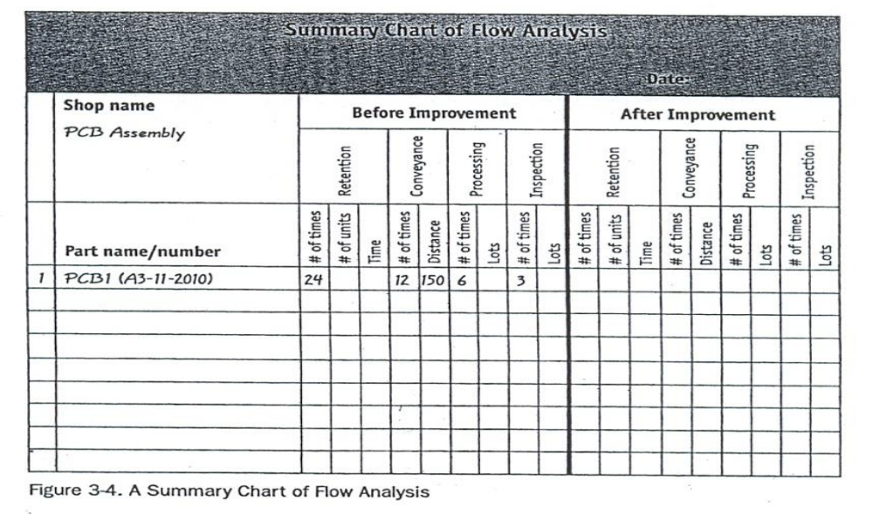
A Figure showing A Summary Chart of Flow Analysis
The Operations Analysis Table
The Operations Analysis Table focuses on people’s actions. As discussed in the previous topic, not everything you do adds value. Operations analysis tables help you identify the waste in your own operations. See the table below. Either have your supervisor fill in the table or do it as a team, filling it in for each other. It is hard to do it for yourself because you can’t watch yourself the same way someone else can. Eventually, you will develop an awareness of your own motion and be able to identify, ever more precisely, when you are not adding value. But in the beginning someone else must observe you and fill in the table.
1. Fill in the table on the factory floor- It is important to look at the real situation as you fill in the table, even if you know the situation by heart. As you fill in the form, you will see things differently.

2.Look for detail – Write everything down that you possibly can.

3.Now identify the waste – Analyze as critically as you can to distinguish work from wastefull movement. Everything that is not value-added must be counted as waste.

4. Set an improvement goal – Review all the data from your observation and decide what would be best to improve and how much improvement you expect.

5.Eliminate waste- Eliminate waste from everything except the real work operations. Write down the results of your improvement efforts on the “After Improvement” side of the table.
1 .The Standard Operation Combination Chart
Standard operations are a critical aspect of lean production. In order to create standard operations, current conditions must be understood and waste must be eliminated from all aspects of the process. A Standard Operation Combination Chart focuses on the relationship of people, goods and machines. By plotting the cycle time of all activities in the process you can discover where the waste is and design the process to create a more efficient combination and reduce overall cycle time. See the figure below for an example of a combination chart.
The Workshop Checklist for Major Waste Finding
In the previous portions you have seen detailed checklists for identifying specific instances of each one of the seven deadly wastes.The Workshop Checklist for Major Waste Finding allows you to identify – in a more general way – the seven types of waste in a work area. See the figure below. You might want to use this checklist before using the detailed checklists. Checklists are good tools for identifying waste and recording improvement ideas.
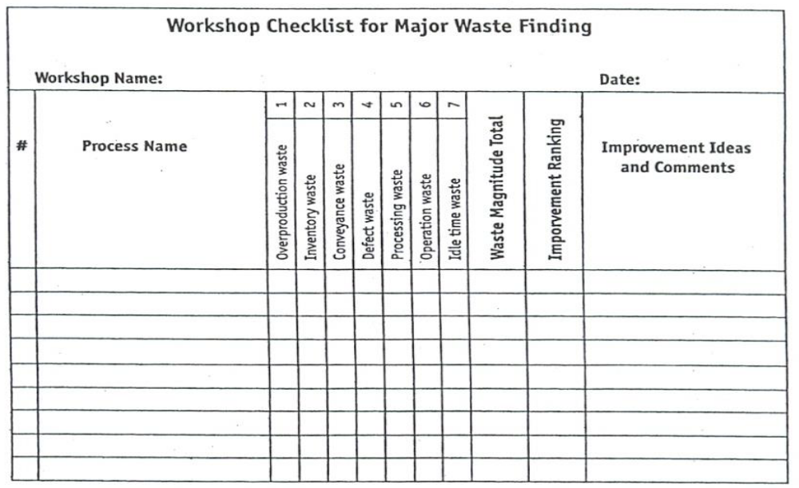

Use these four steps to follow to discover and remove waste
- Choose several processes or work areas and look for waste.
a. Using the above figure find the major forms of waste at each process.
b. Note the magnitude of each waste (Using the figure below).
- Rank the improvements that are needed. Focus improvements on the process with the greatest total when you add up the magnitude columns.

0----------No waste found

1---------Very little waste
Magnitude
of 2--------Some waste
Waste
3--------A lot of waste

Figure showing Four Level of Magnitude

- Choose the first process to be improved from the workshop checklist.
a. Using the more detailed waste-finding checklists provided, find more specific instances of waste.
b. Observe the types and magnitude of the detailed waste.
- Brainstorm improvement ideas and then carry out them.

Taking photoes/Video :- Taking photoes and videos and analyzing are also valuable techniques to find waste.

2.Be conscious of the waste
When something is denied as waste, it also cannot be stopped.

3. Be accountable for the waste
When one refuses to accept responsibility for the waste, then he/she will not eliminate it.

4. Measure the magnitude of the waste
When the waste is not measured, people may think it is small or insignificant and therefore will not be motivated to stop it. What is not measured is not improved. Appreciate its size and magnitude.
- Do time study by work element
- Measure Travel distance
- Measure Total steps
- Make list of items/products, who produces them and who uses them & those in warehouses, storages etc.

- Large-lot production
- Anticipatory production (producing product in advance of demand)
- Inability to achieve short changeover times with the large equipment used in mass production systems
- Creating enough stock to replace the number of defective parts produced
- Overstaffing or too much equipment
- Machines that turn out parts too quickly

Use of Tools and Equipment
Tape/Meter - is used to measure distances or lengthes.
Stop watch – is used to measure operation/processing or waiting/ideling times.
Photo Camera – may be necessary to take pictures ,such as shop layout, for analysis.
Video Camera – may be necessary to record video of each work element to study and identify wastes ,such as motion, processing, waiting,etc.
Calculator – required to make arithemetic calculations.
5 ,Ways of effective Waste/Muda identification.
Using Arrow Diagram
- Select the product to be analysed- Choose products with a large output and those with many production problems as starting points for your analysis of current conditions using the arrow diagram.
- Prepare a factory layout diagram- Include the entire factory layout, indicating the position of machines, worktables and other equipment. Store the original in a safe place so that you can make a copy of it each time you want to analyze another product line.
- Make the arrow diagram- Do this on the factory floor. Use the symbols below to show the different types of activities that occur. The map will make the waste more obvious to you and your team than when you are simply standing on the factory floor observing standard operations. Connect the symbols with lines that show the direction of the flow and the sequence of product through each operation. Create other symbols as you need to. At all conveyance points, note the conveyance distance and type of conveyance. At all retention points, note average work-in-process inventory.
A figure showing an Arrow Diagram of a Printed Circuit Board Assembly Shop
After preparing Arrow Diagram we continue to prepare a Summary Chart of Flow Analysis to show totals for the number of retention, conveyance and inspection points as follows:

Summary Chart of Flow Analysis

A figure showing Chart of Flow Analysis
The Operations Analysis Table
Since it is hard to do it for yourself because you can’t watch yourself the same way someone else can, either have your supervisor fill in the table or do it as a team filling it in for each other.

1. Fill in the table on the factory floor- It is important to look at the real situation as you fill in the table, even if you know the situation by heart. As you fill in the form, you will see things differently.

2.Look for detail – Write everything down that you possibly can.

3.Now identify the waste – Analyze as critically as you can to distinguish work from wastefull movement. Everything that is not value-added must be counted as waste.

4. Set an improvement goal – Review all the data from your observation and decide what would be best to improve and how much improvement you expect.

5.Eliminate waste- Eliminate waste from everything except the real work operations. Write down the results of your improvement efforts on the “After Improvement” side of the table.

2.7;Reporting methods and formats/checklists for Muda identification

Overproduction Waste-finding Checklist
Process: Date:
Description of waste |  | Yes | No | Magnitude | Causes and/or Improvement plans
1 | No production schedule of control boards.
2 | No leveling of production schedule.
3 | Productions not in synchronize with production schedule.
4 | Items missing
5 | Defective goods produced.
6 | Equipment breakdowns.
7 | Too much manual assistance required.
8 | Machines have too much capacity.
9 | Lots are grouped in to batches.
10 | Using “Push” production.
11 | Caravan style operations.
12 | Not balanced with tne next process.
Total

Inventory Waste-finding Checklist
Process: Date:
Description of waste |  | Yes | No | Magnitude | Causes and/or Improvement plans
1 | Lots of inventory on shelves and floors.
2 | Shelf and floor storage takes up lots of space.
3 | Inventory stacks block walkways.
4 | In-process inventory accumulates within individual operation.
5 | In-process inventory is stacked up between operators.
6 | In-process inventory is stacked up between processes.
7 | Impossible to visually determine quantities of in-process inventory.
Total

Motion Waste-finding Checklist
Process: Date:
Description of waste |  | Yes | No | Magnitude | Causes and/or Improvement plans
1 | Walking
2 | Turning around
3 | Leaning sideways
4 | Bending over
5 | Too wide arm movements.
6 | Unnecessary wrist movements.
7 | Left or right hand is idle.
8 | Poorly utilized idle time.
9 | Wasteful work piece set up/removal.
10 | Non-standardized repetition of operations.
11 | Worker operates using different motions each time.
12 | Operations divided into too many little segments.
Total

Conveyance/Transportation Waste-finding Checklist
Process: Date:
Description of waste |  | Yes | No | Magnitude | Causes and/or Improvement plans
1 | Pile up during conveyance.
2 | Change of conveyance devices in mid transfer.
3 | Previous and/or next process is on another floor.
4 | Conveyance requires manual assistance.
5 | Conveyance distance is too long.
Total

Waiting/Idle Time Waste-finding Checklist
Process: Date:
Description of waste |  | Yes | No | Magnitude | Causes and/or Improvement plans
1 | Work piece delay from previous process.
2 | Machine busy status.
3 | Missing item(s).
4 | Lack of balance with previous process.
5 | Lack of planning
6 | Lack of standard operations.
7 | Worker absence.
8 | Too many workers(more than two).
Total
Defect Waste-finding Checklist
Process: Date:
Description of waste |  | Yes | No | Magnitude | Causes and/or Improvement plans
1 | Complaints from next process.
2 | Defects within the process.
3 | Human errors.
4 | Defects due to missing part(s).
5 | Defects due to wrong part(s).
6 | Omission(s) in processing.
7 | Defect(s) in processing.
8 | No human automation.
9 | No mistake-proofing.
10 | No inspection within process.
11 | Defects not addressed by improvement activities.
Total

Processing Waste-finding Checklist
Process: Date:
Description of waste |  | Yes | No | Magnitude | Causes and/or Improvement plans
1 | Process is not required for product function.
2 | Process includes unnecessary operations.
3 | Process can be replaced by something less wasteful.
4 | Part of process can be eliminated without detracting from product.
Total

LAP Test | Practical Demonstration

Name: _____________________________ Date: ________________
Time started: ________________________ Time finished: ________________

Instructions: Given necessary templates, workshop, tools and materials you are required to perform the following tasks within --- hours.

Task 1: In the given operation, identify the three categories of operation, measure their magnitude interms of time and compare them.

Task 2: In the given workplace and check the existence of Mura, Muri and Muda in each process and list out them.
Task 3: Using appropriate method identify the Seven types of Muda in the workplace.
Task 4: Using the given template list out the types of Muda identified and analyze their causes and measure their magnitude.

Table 1 Overproduction Waste-finding Checklist

Overproduction Waste-finding Checklist

Process: Date:

Yes No

Description of waste
Causes and/or
Improvement plans

1 No production schedule of control boards.

2 No leveling of production schedule.

3 Productions not in synchronize with production schedule.

4 Items missing

5 Defective goods produced.

6 Equipment breakdowns.

7 Too much manual assistance required.

8 Machines have too much capacity.

9 Lots are grouped in to batches.

10 Using “Push” production.

11 Caravan style operations.

12 Not balanced with tne next process.

Total

Self-Check 2 Written Test

Name of trainees ------------------------------------------------ sections---------------sign ---------
I. True or false the following question
- eliminating muda in your warehouse operations, you can reap many rewards
- 7Q quality tools are simple graphical and statistical tools but very powerful in solving quality problems and process improvement.
- Companies often have overproduction as a result of large-lot manufacturing methods
- Over production mean extra materials, extra labor cost & extra energy
- Waste is everywhere, in every operation; it is so common

II. match the following question
A B
- Tape/Meter S. is used to measure distances or length
- Stop watch L. is used to measure operation/processing or waiting/dealing times.
- Photo Camera O. may be necessary to take pictures ,such as shop layout, for analysis.
- Video Camera O. may be necessary to record video of each work element to study
- Calculator T. required to make arithmetic calculations

III. Explain the following question
- What are the benefits of identifying and eliminating wastes/Muda to a company? (4 points)
- What are the benefits of identifying and eliminating wastes/Muda to the workers of a company? (4 points)
- Write down the steps to identify wastes/Muda. (4 points)
- List out at least three ways to make waste visible. (3 points)
- What are the four factors to be identified in arrow diagram? (4 points)
- What is the focus of Operation Analysis Table? (2 points)
- What is the focus of a Standard Operation Combination Chart? (2 points)

Unit Three: Analyze causes of a problem

This learning guide is developed to provide you the necessary information regarding the following content coverage and topics:
➢Selecting the root cause directly related to the problem ➢Listing all possible ways using creative idea generation ➢Testing and evaluating The suggested solutions
This guide will also assist you to attain the learning objectives stated in the cover page. Specifically, upon completion of this learning guide, you will be able to:
▪,Listing all possible causes of a problem ▪,Identifying causes of the problems
▪,Testing and evaluating The suggested solutions

▪,Selecting the root cause directly related to the problem

3.1. Select the root cause directly related to the problem
Problem-solving process
when identifying the causes of a problem, it is important to list all possible causes to ensure a comprehensive understanding of the issue. this can be done through techniques such as brainstorming, root cause analysis, or fishbone diagrams. by listing all possible causes, organizations can avoid overlooking any potential factors that may contribute to the problem and can develop more effective solutions. additionally, considering multiple causes can help identify any interconnected or underlying
issues that may need to be addressed to fully resolve the problem.
In order to effectively manage and run a successful organization, leadership must guide their employees and develop problem-solving techniques. Finding a suitable solution for issues can be accomplished by following the basic four-step problem-solving process and methodology outlined below

3.1.1. Define the problem
Diagnose the situation so that your focus is on the problem, not just its symptoms. Helpful problem-solving techniques include using flowcharts to identify the expected steps of a process and cause-and-effect diagrams to define and analyze root causes.
The sections below help explain key problem-solving steps. These steps support the involvement of interested parties, the use of factual information, comparison of expectations to reality, and a focus on root causes of a problem. You should begin by:
Reviewing and documenting how processes currently work (i.e., who does what, with what information, using what tools, communicating with what organizations and individuals, in what time frame, using what format).
Evaluating the possible impact of new tools and revised policies in the development of your "what should be" model.

3.1.2. Generate alternative solutions
Postpone the selection of one solution until several problem-solving alternatives have been proposed. Considering multiple alternatives can significantly enhance the value of your ideal solution. Once you have decided on the "what should be" model, this target standard becomes the basis for developing a road map for investigating alternatives. Brainstorming and team problem-solving techniques are both useful tools in this stage of problem solving.
Many alternative solutions to the problem should be generated before final evaluation. A common mistake in problem solving is that alternatives are evaluated as they are proposed, so the first acceptable solution is chosen, even if it’s not the best fit. If we focus on trying to get the results we want, we miss the potential for learning something new that will allow for real improvement in the problem-solving process.

3.1.3. Evaluate and select an alternative
Skilled problem solvers use a series of considerations when selecting the best alternative. They consider the extent to which:
- A particular alternative will solve the problem without causing other unanticipated problems.
- All the individuals involved will accept the alternative.
- Implementation of the alternative is likely.
- The alternative fits within the organizational constraints.

3.1.4. Implement and follow up on the solution
Leaders may be called upon to direct others to implement the solution, "sell" the solution, or facilitate the implementation with the help of others. Involving others in the implementation is an effective way to gain buy-in and support and minimize resistance to subsequent changes.
Regardless of how the solution is rolled out, feedback channels should be built into the implementation. This allows for continuous monitoring and testing of actual events against expectations. Problem solving, and the techniques used to gain clarity, are most effective if the solution remains in place and is updated to respond to future changes.
What are Muda?
It is a term of Japanese origin that means waste in French. This term was first implemented in Toyota's production system. When we talk about Muda, we hear about the 3M:
Muri which means excessive
Mura which means irregularity
Muda which therefore means waste
So we are not talking about Muda but about Muda. The elimination of Muda intervenes in the processes of continuous improvement because it prevents the use of disproportionate means for the realization of an operation (Muri), the deviations of realization in particular with the instability of the processes (Mura) and finally it limits the waste (Muda). This method is part of a LEAN process.
Where do the Muda come from and how can it be remedied?
Toyota's desire to eliminate waste comes from the observation that companies were often overproduction and that there was a high production of waste. To limit waste as much as possible, it is not enough to only modify the production part. This is why the 3M appeared, which made it possible to create several steps to be carried out within the company. To eliminate 3M, the use of Lean Management methods is required.
What methodology should be adopted to eliminate 3M?
Muri:
Ensure that ergonomics are taken into account before starting any improvements
Ensure that satisfactory working conditions are maintained
Mura:
Monitor process stability to improve processes
An unstable process must be corrected to avoid any kind of waste
Muda:
Take care of waste as a last resort, because with stable processes and good ergonomic conditions, there is less waste
With the 3M, we can find the 7 Muda wastes , which list the different sources of waste within companies.
Before setting up this waste hunt, it is necessary to first train / raise awareness and present the objectives to employees.
What are the objectives of the 3M?
This method is based on 7 principles:
Eliminate waste
Improving learning
Delay engagement
Deliver as fast as possible
Empowering the team
Integrating quality by design
Consider the project as a whole
To overcome the 3M, it is necessary to respect an approach. As a first step, it is necessary to check the ergonomics of the workstations. Then, it is necessary to optimize the production using LEAN Management methods. After performing these steps, we can see a decrease in waste (Muda) whether it is a loss of time or loss of raw materials.
The first M (Muri) appears as a result of problems encountered with regard to ergonomics on workstations whether in the office or in the factory. In order to avoid setting up disproportionate means, the 5s method is effective because it aims at the continuous improvement of tasks within companies and workspaces.
The second M (Mura) concerns processes that are not stable, which leads to waste of time or raw materials. In order to remedy this, the VSM method is a good way because it makes it possible to identify the various possible improvements in order to have a certain stability in the processes and therefore optimize production. In addition to VSM, it is wise to use the Jidoka which is an automatic non-conformity detection system, this avoids production errors and saves time on quality verification. On a production line, the VSM method allows a visual representation of the supply, the process... This makes it easier for employees and allows for better performance. The use of the Jidoka facilitates quality control because it detects problems and stops the machine in order to limit waste.
Several LEAN methods fix the last two steps which are Mura and Muda. First of all, the Quick Response Quality Control (QRQC) which reduces unnecessary expenses and waste because the purpose of this method is to treat defects as soon as they appear. Thanks to the QRQC we can integrate quality from the design stage. To reduce waste of time and waste, Takt-Time can be used in addition to the QRQC. The QRQC is a managerial mode because the goal is to raise problems / defects as quickly as possible to his hierarchy in order to solve them as quickly as possible, in addition to this the Takt-time comes to optimize production.

3.2 analyzed using 4M1E Cause relationships
The 4M1E framework is commonly used to analyze cause relationships. It stands for Man, Machine, Material, Method, and Environment. By examining each of these factors, organizations can identify how they may contribute to the problem at hand.

- Man: This refers to the human element involved in the problem. It includes factors such as the skills, knowledge, and behavior of individuals involved. For example, a lack of training or poor communication among employees may be a contributing cause.

- Machine: This factor relates to the equipment, tools, or technology involved in the problem. It includes factors such as equipment failure, inadequate maintenance, or outdated technology. For example, a malfunctioning machine may be causing production delays.

- Material: This factor involves the materials or resources used in the process. It includes factors such as the quality or availability of materials. For example, using low-quality materials may lead to product defects.

- Method: This factor refers to the processes or procedures followed in the organization. It includes factors such as inefficient workflows, unclear instructions, or lack of standardization. For example, a complex and convoluted process may lead to errors or delays.

- Environment: This factor considers the external conditions or circumstances that may impact the problem. It includes factors such as the physical environment, market conditions, or regulatory requirements. For example, changes in government regulations may require organizations to adapt their processes.

By analyzing each of these factors within the 4M1E framework, organizations can gain a comprehensive understanding of the cause relationships contributing to the problem. This analysis can then inform the development of effective solutions and help prevent similar issues from occurring in the future.

3.3 identified Causes of the problems
Some examples of causes of problems could include:

- Lack of proper training or knowledge
- Inadequate resources or equipment
- Poor communication or collaboration
- Inefficient processes or procedures
- External factors such as economic conditions or regulatory changes
- Human error or negligence
- Lack of accountability or responsibility
- Cultural or organizational issues
- Technical or technological limitations
- Poor leadership or managem

3.4 selected the root cause most directly related to the problem
The root cause is the underlying reason or factor that directly leads to the problem. It is important to identify the root cause in order to address it effectively and prevent similar problems from occurring in the future.

For example, if a company is experiencing frequent delays in project completion, the root cause may be identified as poor communication or collaboration. By addressing this root cause, such as implementing better communication channels or improving collaboration techniques, the company can work towards reducing delays and improving overall project efficiency.

Similarly, if a manufacturing plant consistently produces defective products, the root cause may be identified as inadequate resources or equipment. By investing in better equipment or providing additional resources, the plant can address this root cause and improve product quality.

Identifying and addressing the root cause of a problem is crucial for effective problem-solving and continuous improvement.

3.5 creative idea generations to eliminate the most critical root cause
✓Process flow ✓Other Analysis tools
✓Do time study by work element

✓Measure Travel distance ✓Take a photo of workplace ✓Measure Total steps
✓Make list of items/products, who produces them and who uses them & those in warehouses, storages etc.
✓Focal points to Check and find out existing problems ✓5S
✓Layout improvement ✓Brainstorming
✓U-line

SELF CHECK -3
Name of trainees ------------------------------------------------ sections---------------sign ---------
  - True or false the following question
- Diagnose the situation so that your focus is on the problem, not just its symptoms.
- To eliminate 3M, the use of Lean Management methods is required.
- Several LEAN methods fix the last two steps which are Mura and Muda.
- The root cause is the underlying reason or factor that directly leads to the problem.
- Identifying and addressing the root cause of a problem is crucial for effective problem-solving and

  - match the following question
A B
      - Muri A. excessive
      - Mura B. irregularity
      - Muda C. waste
      - Causes of the problems D. Lack of proper training or knowledge

      - Write or Explain the following question
    - 4M1E Cause relationships

Unit Four: Eliminate MUDA and Assess effectiveness of the solution.

This learning guide is developed to provide you the necessary information regarding the

following content coverage and topics:

 Preparing and implementing Plan of MUDA elimination.

 Adopting necessary attitude and ten basic principles for improvement  Reducing and eliminating Wastes/MUDA
 Comparing tangible results using various types of diagrams.  Reporting improvements
This guide will also assist you to attain the learning objectives stated in the cover page. Specifically, upon completion of this learning guide, you will be able to:
•, Implement Plan of MUDA elimination. •, Eliminating Wastes/MUDA.
•, reporting improvements

4.1 Preparing and implementing Plan of MUDA elimination.

Elimination of the seven types of Wastes/Muda.

Adopting the Necessary Attitude

First you must adopt an attitude that supports your ability to see waste. Waste is hard enough to find when you want to find it; if you don’t want to find it, or if your response to find it is denial or resistance, then it will never be possible for you to root out waste and make your work environment stress free.
It is very important that you understand that one purpose of discovering waste is to take the frustration out of your work.
Many people will resist seeing the waste in their work. Just don’t let it be you. You may hear yourself or others saying things like: “Let’s not fix what is not broken.” “Can’t we live well enough alone?” “This is just another attempt to make us work harder for the same amount of money.” “It looks good on paper, but it will never work on the floor.” “We tried that twenty years ago. It didn’t work then; it won’t work now.” “That is not my job.” And so on.
You know the lines. You have probably said one or two of them at one time or another. We all have. Resistance is normal. Just don’t let it keep you from learning to see the waste in your work. In the end, you are the one who suffers most from the results of waste.

The Ten Basic Principles for Improvement
- Throw out all of your fixed ideas about how to do things.
- Think of how the new method will work-not how it will not.
- Don’t accept excuses. Totally deny the status quo.
- Don’t seek perfection. A 50 percent implementation rate is fine as long as it is done on the spot.
- Correct mistakes the moment they are found.
- Don’t spend a lot of money on improvements.
- Problems give you a chance to use your brain.
- Ask “Why?” at least five times until you find the ultimate cause.
- Ten people’s ideas are better than one person’.
- Improvement knows no limit.

4.2 How to eliminate the seven types of Wastes/Muda.
How to Eliminate Overproduction Wastes
In order to balance capacity and load without overproducing, you must implement the advanced methods of lean production:
- Full work
- Line balancing
- Pull production using kanban.
- Quick-changeover operations.
- Level production - small-lot, mixed production.

How to Eliminate Inventory Wastes
- U-shaped manufacturing cells, layout of equipment by process instead of operation.
- Production leveling
- Regulating the flow of production
- Pull production using kanban
- Quick changeover operations

How to Eliminate Motion Wastes
- Gradually switch to flow production
- Create U-shaped cell layout of equipment
- Make standardization through
- Increase training
- Increase operator awareness about motion during an operation
Where as many kinds of movement may be unnecessary, work is the movement you do to add value to the product. Movement that does not add value is waste. Find ways to reduce the amount of movement to do your value added work. Start by looking at the movement of your feet, then your hips, shoulders, arms, hands and fingers.

How to Eliminate Conveyance/Transportation Wastes

Basically, conveyance waste is corrected by redesigning equipment layout to create a flow between operations. Then you will be able to take out much of the complexity in the conveyance system and decrease material handling to a minimum. Some of the lean production methods that address conveyance flow:
- U-shaped manufacturing cells
- Flow production
- Multi skill workers
- Standing to perform operations
- Higher utilization rate
- Water beetles (material handlers in the kanban system of pull production)
How to Eliminate Waiting/Idle Time Wastes
- Production leveling
- Product-specific layout
- Mistake-proofing
- Human automation
- Quick changeover
- Autonomous maintenance
- Line balancing

How to Eliminate Defect Wastes
- Standard operations
- Mistake-proofing devices
- Full-lot inspection
- Building quality in at each process
- Flow production
- Elimination of the need to pick up and set down work pieces
- Improvement of jigs using human automation
- Promotion of value analysis and value engineering
To reduce defects, their root cause must be found. Inspection that only sorts out the defective parts is not a solution to defective waste; it is actually one of the major defect-related wastes. Until you initiate back-to-the-source inspection and build quality into every process through standardization, the effects of defects will continue to disrupt the flow of goods and decrease productivity.

How to Eliminate Processing Wastes
- More appropriate process design
- Review of operations
- Improvement of jigs using automation
- Thorough standardization
- Promotion of value analysis(VA) and value engineering(VE) techniques

4.3 Some Tools and Techniques to eliminate Wastes/Muda.
- 5S
- Layout improvement
- Brainstorming
- Andon
- U-line
- In-lining
- Unification
- Multi-process handling & Multi-skilled operators
- A.B. control (Two point control)
- Cell production line
- Line balancing
- Build in quality at each process
- Etc.

5S (Five S): Implementing 5S/workplace organization to eliminate Wastes/Muda.

Layout improvement: Is to plan the placement of machineries, raw materials, workers, etc. in order to produce raw materials, parts or products economically.
When the layout of a shop floor is decided, it is necessary to plan considering production conditions and environmental conditions appropriately. Layout improvement is important technique to avoid ”Muda, Mura and Muri” due to placement in production activities.

Brainstorming

Brainstorming can be defined as the methodology used to encourage every individual in the KPT to express freely their opinions or give ideas in an open discussion. Brainstorming can be used to list down all the problems faced by an organization, their causes and the potential effects if a certain suggestion is implemented. To ensure the success of the brainstorming process, it is important for the KPT to follow the following rules:
- The subject for brainstorming should be clear and accurate. For example, members may brainstorm to identify the causes and reasons why a certain task cannot be completed on schedule.
- Each member will give only one opinion / idea at each turn regardless of the number of ideas he / she may have.
- A tension-free atmosphere must be maintained to encourage free expression of ideas.
- Every idea expressed should be written on the black / white board, flip chart or noted down by a secretary.
- At the end of the brainstorming session, all the ideas expressed should be evaluated one by one and short-listed.
- Voting is used to list the ideas according to priority. The prioritization is based on the number of votes received for each idea.

Andon: Is an indicator informing team leaders and supervisors of the current workshop situation with color boards, flash lights, and automated announcement.
Types of Andon
1) Calling “Andon” -Used for requesting parts.
2) Warning “Andon” -Used to inform occurrence of irregularities on the lines.
3) Progress “Andon” -Used to identify the progress of operation on the lines with a short Takt Time.

U-line: Is a layout in which the inlet and outlet are positioned in the same direction to avoid walking back for a single operator.

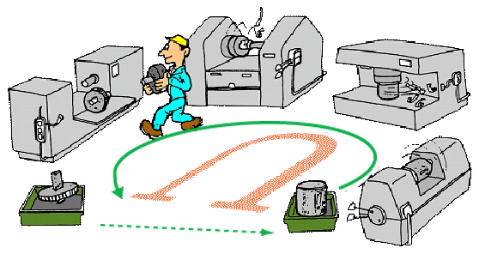

Figure 4:U-line
In-lining: Is a way to make the production lines simple and effective by integrating the parts processing into the main line in the unit production.

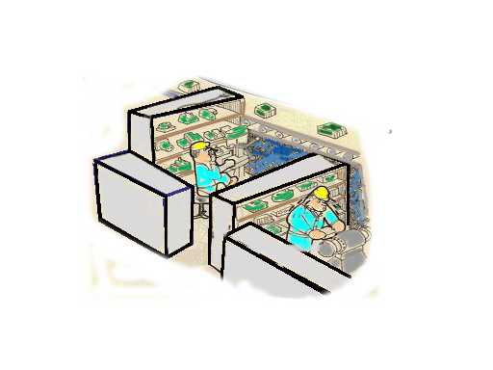

Figure 5:In-lining
Unification: Even if a flowing line cannot be formed, odd operations can be combined together in a place into an operator’s work.
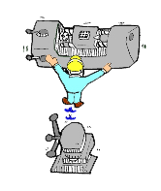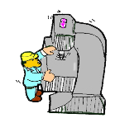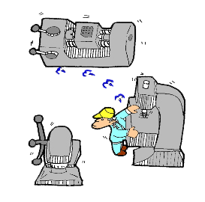

Figure 6:Unification
Multi-process handling and Multi-skilled operators
-Multi-process handling- means that a single operator manages multiple machines and processes in product processing and assembling. This is the primary factor for constructing lines by a small number of operators.
-A multi-skilled Operator- can deal with several machines or processes as described above. The supervisor can make a flexible placement of operators when someone within the same team or section is absent.

A.B. control (Two point control):Is a devised automatic control function. It controls the machine movement when they come to start or stop working depending upon the number of work pieces piled up between the preceding process and the following process.

Cell production line: This is a production line that a single operator manages all the machining or assembly operations in unit production.
Advantages
- Quality assurance can be ensured.
- The production output or efficiency of each operator can be clarified.
- Operators can obtain a feeling of work achievement.

Line balancing: Refers to the state where there is a difference in time required for each process of a production line. It is determined that the line balance is good if this difference is small (usually smaller than 15%), but in a bad case the line balance should be improved by levelling out the work time through shortening that of a very time-consuming process and increasing loads of processes consuming less time.

Build in quality at each process
1. Quality should be built into each process.
2. Guarantee the quality in each process.
    - Do not make Defect
    - Do not pass defect
    - Work to standard
The machine stops, if abnormality is caused.
  - Worker stops operation, if he/she finds abnormality.
  - Don’t send the next process the defects.
- Abnormality will understood simply.
- “Visual control” visually control the states, ANDON,
- Production analysis board, Standardized work chart etc.
Kanban System
It’s a TOYOTA Production System manufacturing tool. Kanban is not inventory control system rather it is scheduling system.
In production it tells us:
- What to produce
- When to produce it
- How much to produce
Kanban prevents over production and it is used to give instruction for production and conveyance in every process.

There are four important methods you can use for maintaining a waste-free production environment:
✓Standardization ✓Visual controls ✓Auditory controls ✓5W and 1H Sheet
5W1H signifies six words that begin questions that are needed to be answered in order to describe a fact correctly: what, when, where, who, why, and how. QCC people are recommended to follow and ask these questions in order to grasp the facts without any omission 4M1E stands for the five elements needed in production (man, machine, materials, method, and environment). Four words start with the letter m, and one with e , thus it is called 4M

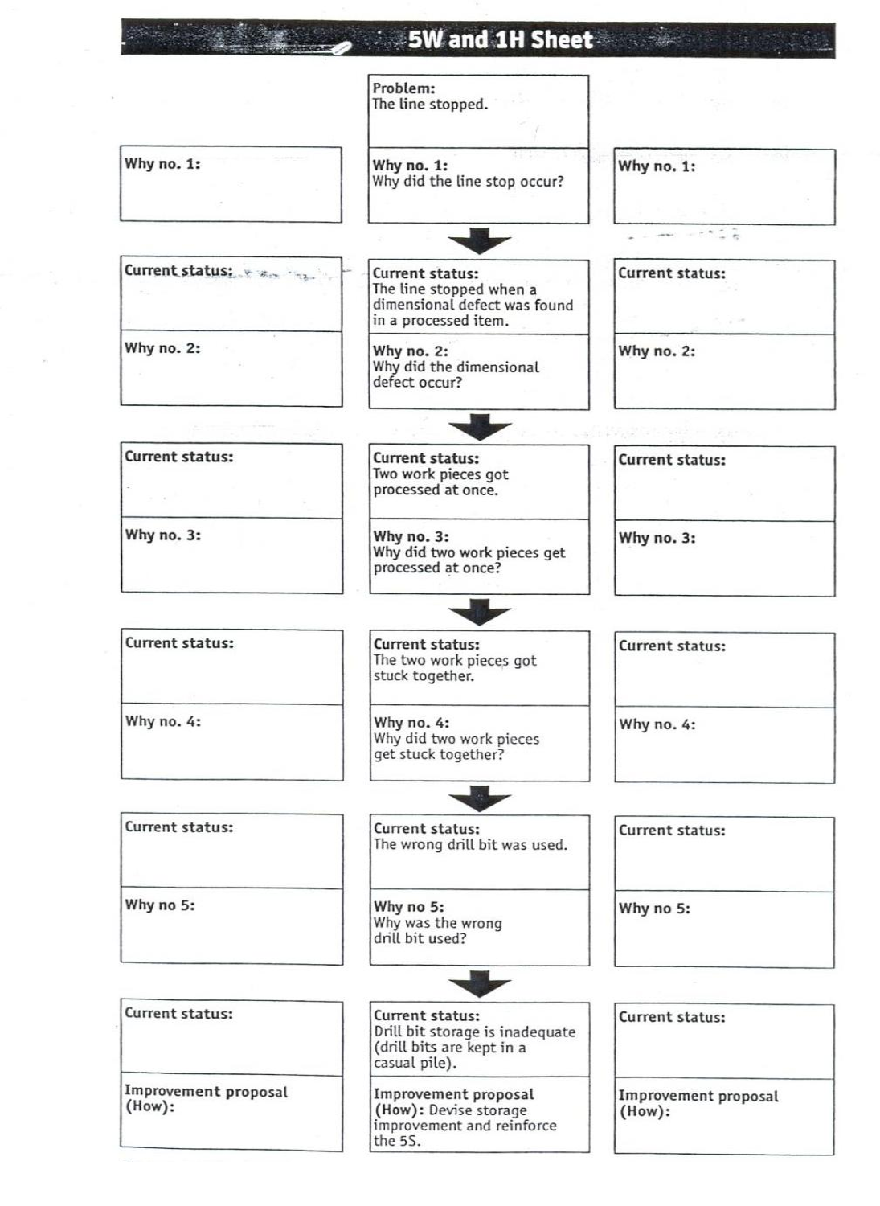

Table 4 ways of preventive muda

Adopting necessary attitude and ten basic principles for improvement 1. Throw out all of your fixed ideas about how to do things.
2. Think of how the new method will work-not how it will not. 3. Don’t accept excuses. Totally deny the status quo.
4. Don’t seek perfection. A 50 percent implementation rate is fine as long as it is done on the spot.
5. Correct mistakes the moment they are found. 6. Don’t spend a lot of money on improvements. 7. Problems give you a chance to use your brain.
8. Ask “Why?” at least five times until you find the ultimate cause. 9. Ten people’s ideas are better than one person’.
10. Improvement knows no limit. The three Categories of Operation
➔(1 ) Net Operation/Value Adding Operation

➔(2) Non-Value Adding Operation

➔(3)”Muda’

4.4 organizational requirements Wastes/MUDA are reduced and eliminated in accordance with OHS

Identify and categorize the different types of waste: Conduct a thorough analysis of the processes and activities within the organization to identify the different types of waste present. The commonly identified wastes are transportation, inventory, motion, waiting, overproduction, overprocessing, and defects (TIMWOOD).

2. Prioritize waste reduction opportunities: Evaluate the impact and severity of each type of waste and prioritize them based on their potential for improvement. Focus on areas where waste is most significant or has the highest impact on productivity, quality, or customer satisfaction.

3. Set specific goals and targets: Define clear objectives for waste reduction, such as reducing transportation time by 20% or eliminating overproduction by 30%. These goals should be measurable and aligned with the organization's overall objectives.

4. Develop an action plan: Create a detailed plan outlining specific actions and initiatives to eliminate each type of waste. Assign responsibilities to individuals or teams for implementing these actions. The plan should include timelines, resources required, and expected outcomes.

5. Implement the plan: Execute the action plan by following the defined timelines and allocating necessary resources. Ensure that all relevant stakeholders are informed and involved in the implementation process. Regularly review progress and make adjustments as needed.

6. Monitor and measure results: Establish key performance indicators (KPIs) to track progress towards waste reduction goals. Continuously monitor and measure the results achieved against the set targets. Use visual management tools like dashboards or scorecards to provide real-time visibility of performance.

7. Conduct regular reviews and improvements: Conduct periodic reviews to assess the effectiveness of the implemented actions and identify any new waste sources or areas for improvement. Engage employees at all levels to gather feedback and suggestions for further waste reduction initiatives.

8. Provide training and support: Offer training programs and workshops to educate employees about waste identification and elimination techniques. Provide support and resources to help employees implement waste reduction practices in their daily work.

9. Foster a culture of continuous improvement: Encourage a culture of continuous improvement by recognizing and rewarding efforts made towards waste reduction. Promote employee involvement and empowerment in identifying and eliminating waste. Celebrate successes and share best practices across the organization.

10. Sustain the improvements: Establish systems and processes to ensure that waste reduction efforts are sustained over time. Integrate waste elimination practices into standard operating procedures and regularly review and update them as needed.

By following these steps, an organization can effectively prepare and implement a plan for MUDA elimination, leading to improved efficiency, productivity, and customer satisfaction.

Self-Check 4 Written Test
Name of trainees ------------------------------------------------ sections---------------sign ---------
I. Match the following question
A B

1. to eliminate Wastes/Muda. A. Andon
2. Calling “Andon” B. Used for requesting parts.
3. Warning “Andon” C. Used to inform occurrence of irregularities on the lines.
4. Progress “Andon” D. Used to identify the progress of operation on the lines with a short Takt Time.
5. Kanban System E. TOYOTA Production System manufacturing tool

II. Explain the following question

1. What is Muda?
2. Why is it important to identify and eliminate Muda?.
3. What are the seven types of Muda?
4. What is overproduction Muda?
5. What is waiting Muda?
6. What is transportation Muda?
7. What is processing Muda?
8. What is motion Muda?
9. What is inventory Muda?
10. What is defects Muda?

Unit five: prevent occurrence of wastes and sustain operation

This learning guide is developed to provide you the necessary information regarding the

following content coverage and topics:

Preparing and implementing Plan of MUDA prevention.

Preparing and discussing Standards required for machines, operations, defining normal and abnormal conditions, clerical procedures and procurement
Creating waste-free workplace using 5W and 1Hsheet. Doing the completion of required operation
Training and ensuring capability of the work team on the new Standard Operating Procedures (SOPs).
This guide will also assist you to attain the learning objectives stated in the cover page. Specifically, upon completion of this learning guide, you will be able to:
- Prepare MUDA prevention.
- Creating waste-free workplace
- Reporting improvements
- Preventing occurrences of wastes/MUDA

5.1 Creating waste-free workplace using 5W and 1Hsheet.

To effectively prevent MUDA (waste) in a process or organization, the following plan can be prepared and implemented:

1. Identify and categorize waste: Conduct a thorough analysis of the current processes and operations to identify different types of waste, such as overproduction, defects, waiting time, unnecessary motion, transportation, inventory, and over-processing. Categorize them to understand the extent of each type of waste.

2. Create awareness: Educate and create awareness among employees about the concept of MUDA and its impact on productivity, quality, and customer satisfaction. Train them to identify and report waste in their respective areas.

3. Set goals: Establish specific goals and targets for waste reduction based on the identified types and extent of waste. These goals should be measurable, achievable, realistic, and time-bound.

4. Implement 5S methodology: Adopt the 5S methodology (Sort, Set in Order, Shine, Standardize, Sustain) to organize the workplace and eliminate unnecessary items and clutter. This will help reduce waste related to unnecessary motion, waiting time, and inventory.

5. Implement Just-in-Time (JIT) manufacturing: Implement JIT manufacturing principles to minimize inventory levels and reduce waste related to overproduction and excess inventory. This involves producing only what is needed, when it is needed.

6. Streamline processes: Analyze existing processes and identify opportunities for improvement. Simplify and streamline processes to eliminate non-value-added steps and reduce waste.

7. Implement visual management: Use visual management techniques such as visual controls, visual indicators, and visual instructions to make waste visible and easily identifiable. This helps in identifying and addressing waste in real-time.

8. Encourage employee involvement: Involve employees at all levels in identifying and eliminating waste. Encourage them to suggest improvements and provide feedback on the existing processes.

9. Continuous improvement: Establish a culture of continuous improvement by implementing regular review sessions to monitor progress, identify new waste sources, and implement corrective actions. Encourage employees to share their ideas and suggestions for waste reduction.

10. Measure and monitor: Implement a system to measure and monitor key performance indicators (KPIs) related to waste reduction. Regularly review and analyze the data to identify trends, areas of improvement, and the effectiveness of waste prevention initiatives.

11. Provide training and support: Provide ongoing training and support to employees to enhance their skills and knowledge related to waste prevention techniques. This will empower them to actively contribute to waste reduction efforts.

12. Recognize and reward: Recognize and reward individuals or teams that contribute significantly to waste reduction. This will encourage a positive mindset towards waste prevention and motivate others to actively participate.

By following this plan, an organization can effectively prevent MUDA and improve overall efficiency, productivity, and customer satisfaction.

5.2 discussed and prepared Standards required for machines, operations, defining normal and abnormal conditions, clerical procedures and procurement
Standards are an essential part of any organization as they provide guidelines and benchmarks for various processes and procedures. In the context of machines and operations, standards ensure that equipment and machinery meet certain quality and safety requirements. These standards may include specifications for performance, dimensions, materials, and other relevant factors.
Defining normal and abnormal conditions is crucial for efficient operations. By establishing clear criteria for what is considered normal, organizations can quickly identify deviations or abnormalities in processes or equipment. This allows for timely intervention and corrective actions to minimize disruptions and maintain productivity.
Clerical procedures also benefit from standardized guidelines. These procedures include tasks such as document management, record-keeping, data entry, and communication protocols. Establishing standards for clerical procedures ensures consistency, accuracy, and efficiency in administrative tasks.
Procurement standards are necessary to ensure that the organization acquires goods and services that meet its quality requirements while adhering to legal and ethical practices. These standards may cover aspects such as vendor selection, contract negotiation, quality control, and supplier performance evaluation.
The process of discussing and preparing these standards typically involves various stakeholders within the organization. This may include subject matter experts, engineers, quality assurance personnel, operations managers, procurement specialists, and administrative staff. Collaboration among these stakeholders is crucial to ensure that the standards reflect the organization's needs, industry best practices, and regulatory requirements.

Once the standards are established, they need to be communicated effectively to all relevant parties. Training programs, documentation, and regular updates are essential to ensure that employees understand and comply with the standards in their day-to-day activities. Additionally, periodic reviews and audits are necessary to assess the effectiveness of the standards and make any necessary revisions or improvements.

5.3 prevent using visual and auditory control methods Occurrences of wastes/MUDA
Some examples of visual and auditory control methods that can be used to prevent waste/MUDA are:
1. Visual controls: Use visual cues such as color-coded labels, signs, and markings to indicate the correct placement and organization of materials, tools, and equipment. This helps to prevent waste related to unnecessary motion and searching for items.
2. Visual indicators: Install visual indicators such as LED lights or digital displays to provide real-time information on the status of machines or processes. This helps to prevent waste related to waiting time and machine downtime.
3. Visual instructions: Create visual work instructions or standard operating procedures (SOPs) that clearly outline the steps to be followed in a process. Use diagrams, pictures, or videos to make the instructions easily understandable. This helps to prevent waste related to defects and rework.
4. Auditory controls: Use auditory signals such as alarms, buzzers, or chimes to alert employees when a process is not running smoothly or when an abnormal situation occurs. This helps to prevent waste related to defects and machine breakdowns.
5. Andon systems: Implement an Andon system, which is a visual and auditory signaling system that allows employees to quickly notify supervisors or maintenance personnel when an issue arises. This helps to prevent waste by enabling quick response and resolution of problems.
By using these visual and auditory control methods, organizations can effectively prevent waste/MUDA and improve overall efficiency and productivity.

5.4 create using 5W and 1Hsheet Waste-free workplace
The 5W and 1H sheet is a visual control method that helps identify and eliminate waste in the workplace. It stands for:

1. Who: Identify the individuals or teams responsible for each process or task. This helps to prevent waste related to unclear roles and responsibilities.

2. What: Define the specific activities or tasks that need to be performed. This helps to prevent waste related to unnecessary or redundant work.

3. When: Determine the timing or sequence of tasks to ensure smooth workflow and minimize waiting time. This helps to prevent waste related to delays and idle time.

4. Where: Identify the physical locations or workstations where each task should be performed. This helps to prevent waste related to unnecessary movement and transportation.

5. Why: Understand the purpose or objective of each task to ensure alignment with overall goals and objectives. This helps to prevent waste related to activities that do not add value.

6. How: Determine the best methods or procedures for performing each task. This helps to prevent waste related to inefficient or ineffective processes.

By using the 5W and 1H sheet, organizations can visually map out their processes and identify areas of waste or MUDA. This enables them to implement targeted improvements and create a waste-free workplace.
There are four important methods you can use for maintaining a waste-free production environment:
✓Standardization ✓Visual controls ✓Auditory controls ✓5w and 1h sheet
5W1H signifies six words that begin questions that are needed to be answered in order to describe a fact correctly: what, when, where, who, why, and how. QCC people are recommended to follow and ask these questions in order to grasp the facts without any omission 4M1E stands for the five elements needed in production (man, machine, materials, method, and environment). Four words start with the letter m, and one with e , thus it is called 4M1E.

5.5 The completion of required operation is done in accordance with standard procedures and practices.
This ensures that tasks are carried out consistently and in a standardized manner, reducing the risk of errors or deviations from the desired outcome. Following standard procedures also helps to maintain quality and safety standards, as employees are trained on the best practices for completing their tasks.

By completing operations in accordance with standard procedures, organizations can also improve efficiency and productivity. Employees are trained on the most effective and efficient methods for carrying out their tasks, allowing them to work more quickly and effectively. This can lead to cost savings and improved overall performance.

Additionally, following standard procedures allows for easier monitoring and evaluation of performance. By having a set process in place, organizations can measure performance against established benchmarks and identify areas for improvement. This allows for continuous improvement and optimization of operations.

Overall, completing operations in accordance with standard procedures is essential for ensuring consistency, quality, and efficiency in the workplace. It helps to minimize errors, improve productivity, and promote continuous improvement.

5.1.1 Planned for material
✓Zero equipment failure and break down.

✓Improve reliability and maintainability by 50 % ✓Reduce maintenance cost by 20
✓ Ensure availability of spares all the time

5.1.2 SAFETY, HEALTH AND ENVIRONMENT

✓Zero accident,

✓Zero health damage ✓Zero fires.
In this area focus is on to create a safe workplace and a surrounding area that is not damaged by our process or procedures. This pillar will play an active role in each of the other pillars on a regular basis.
To create awareness among employees various competitions like safety slogans, Quiz, Drama, Posters, etc. related to safety can be organized at regular intervals

5.6 facilitate the updating of standard procedures and practices
This can lead to increased efficiency and productivity. It also helps to ensure that employees are following the correct procedures and reducing the chances of errors or mistakes. Additionally, updating standard procedures and practices can help to incorporate new technologies or best practices, leading to continuous improvement in work methods. Overall, preventing waste related to inconsistent or incorrect work methods can result in cost savings and improved overall performance for an organization 
Figure 7: standard operating procedure
As the tired old saying goes, there are tons of moving parts in a business or organization of any size.
Often, the difference between a productive, successful business and a not-so-successful one is whether or not these myriad “parts” are moving in concert with one another. This can be the difference between a finely-tuned machine and one that regularly breaks down—and eventually falls apart.
For your organization to run like such a finely-tuned machine (and to avoid falling apart at the seams), your team members need to be on the same page at all times—both literally and figuratively.
Purpose of an Standard Operating Procedure
The fundamental purpose of an SOP is to provide clear and concise instructions for the consistent execution of routine operations within an organization. By offering a step-by-step guide on how tasks should be carried out, SOPs aim to ensure that work is performed consistently, efficiently, and safely, regardless of who is performing the task. Moreover, they serve as a key tool for companies to comply with industry regulations and standards, reducing the risk of errors and deviations.
Why Are Standard Operating Procedures Important?
The importance of standard operating procedures extends beyond their fundamental purpose of ensuring consistency and reducing miscommunication. They serve as a blueprint for success by helping organizations systematize their internal processes and progress in a unified, cohesive manner.
Imagine the consequences of not having SOPs in place - it would leave too much up to chance. Without them, there's no guarantee that best practices would be followed consistently, that team members would remain in sync, or that the organization would continue to operate optimally.
Standard operating procedures are, therefore, crucial in maintaining the operational integrity of an organization. They play a vital role in setting clear expectations, ensuring quality and efficiency, and keeping all team members aligned towards the common goals of the organization. They serve as the backbone of any successful organization and are vital for long-term growth and sustainability.

5.6.1.Benefits of Implementing Standard Operating Procedures
Let's delve deeper into the specific benefits that SOPs bring to an organization.
1. Ensures Adherence to Best Practices
An SOP mandates adherence to best practices, transforming them from mere suggestions into actionable, hierarchical steps. These practices, shaped by all involved stakeholders, ensure that your team is always acting in the company's best interest.
SOPs not only provides a "true north" but also detailed instructions to guide your team. By knowing the most effective and efficient way to handle tasks, your team can achieve optimal results while minimizing resource expenditure.
2. Ensures Consistency and Efficiency
A standard operating procedure is the blueprint for making your organization run like a finely-tuned machine. It establishes consistency in your operations, making decisions and processes more automatic, thus eliminating unnecessary deliberations or miscommunication.
3. Quality Assurance
By ensuring adherence to best practices and maintaining consistency, SOPs enhance the overall quality of work. The workers can effectively and efficiently complete a process or task, raising the quality bar.
4. Enables Proper Onboarding and Training
In clearly defining standard operating procedures within your organization, you’ll inherently make employee onboarding easier as well as improve how you train your team members with regard to best practices in certain situations.
With contingency plans clearly laid out, you can prepare your employees better to navigate potential circumstances. Absence of such detailed steps might leave your team uninformed and ill-equipped to handle challenges.
5. Preservation of Organizational Knowledge
Although your current team might be well-versed with the SOPs, it's crucial to document them for future reference. Changes in your team are inevitable - retirement, resignation, promotions, leaves, etc. When such changes occur, documented SOPs ensure that the accumulated knowledge and expertise remain within the organization, providing easy access to new members.
6. Reduction of Misunderstandings
By providing readily available and detailed instructions on task execution, an SOP ensures everyone is on the same page, thereby reducing potential misunderstandings and fostering effective communication.
7. Regulatory Compliance
Certain industries legally require SOP documentation, and having well-documented ones can demonstrate compliance with these regulatory requirements. For instance, in healthcare, SOP documents often testify to adherence to the Joint Commission's standards. Standard operating procedures can also help organizations fulfill general legal obligations, like customer complaint resolution, by outlining necessary steps to meet the terms of service.
8. Improved Safety
By detailing safe practices and procedures, SOPs can mitigate the risk of accidents or injuries. For example, an SOP for handling hazardous materials might include steps for appropriate protective gear and handling techniques, ensuring safety and risk assessment.

5.7 The capability of the work team that aligns with the requirements of the procedure is ensured and trained on the new Standard Operating Procedures (SOPs).
This training helps to ensure that employees have the necessary skills and knowledge to effectively carry out their tasks according to the updated procedures. By aligning the capabilities of the work team with the requirements of the procedure, organizations can minimize the risk of errors or inefficiencies caused by employees not fully understanding or being able to execute the procedures correctly.

Training on new SOPs also allows for consistent and standardized practices across the organization. This consistency reduces variability in work methods, making it easier to monitor and measure performance. It also enables easier collaboration and communication between team members, as everyone is working from the same set of guidelines.

Furthermore, training on new SOPs can help to identify any gaps in employee skills or knowledge. If there are areas where employees struggle or lack proficiency, additional training or support can be provided to address these gaps. This ensures that employees have the necessary capabilities to perform their tasks effectively and efficiently.

Overall, ensuring that the work team is trained on new SOPs helps to maximize the benefits of updating procedures. It promotes consistency, efficiency, and productivity while minimizing errors and waste. By aligning employee capabilities with procedure requirements, organizations can achieve improved overall performance and success.

Self-Check 5 Written Test
Name of trainees ------------------------------------------------ sections---------------sign ---------

  - Match the following question
A B
- Identify and categorize waste A. Categorize them to understand the extent of each type of waste.
- Create awareness B. implement corrective actions
- Set goals C. levels in identifying and eliminating waste
- Implement 5S methodology D. to make waste visible and easily identifiable
- Implement Just-in-Time (JIT) manufacturing E. to eliminate non-value-added steps
- Streamline processes F. principles to minimize inventory levels
- Implement visual management G. Adopt the 5S methodology
- Encourage employee involvement H. These goals should be measurable, achievable, realistic, and time-bound.
- Continuous improvement I. create awareness among employees about the concept of MUDA
- Measure and monitor
Provide training and support J. Regularly review

  - Explain the following question

- What are the four methods for maintaining waste free production environment?

- How standardization does maintain a waste free environment?

- How a visual and auditory control does maintain a waste free environment?
- 4. How 5W and 1H sheet does maintain a waste free environment?

List of Reference Materials

- Reference Book: Identifying Waste on the http://ndl.ethernet.edu.et/bitstream/123456789/89046/1/6-MDL%20.pdfShopfloor (1996). • Ethiopian Kaizen Manual (2011)

- https://www.scribd.com/document/639806417/Prevent-and-Eliminate-MUDA
- https://www.researchgate.net/publication/326713601_Using_5W-1H_and_4M_Methods_to_Analyse_and_Solve_the_Problem_with_the_Visual_Inspection_Process_-_case_study
- https://www.hilarispublisher.com/open-access/eliminating-muda-waste-in-lean-management-by-working-time-standardization-2223-5833-1000216.pdf
- https://earth911.com/business-policy/10-tips-waste-free-workplace
- Participants of this Module (training material) preparation
No | Name | Qualification (Level) | Field of Study | Institution |  | Mobile number | E-mail
1 | Boja mokonen | B | Fashion design | MPTC | 920623548 |  | bojagarment@gmail.com

